Preliminary Test Method 007 for the Determination of Cyclonic Flow Velocity Components Using a Calculation Approach to Method 2F

Scope, Application and Main Difference with/Improvement over the Current Method 2F

This method is applicable for the determination of yaw angle, pitch angle, axial velocity and the volumetric flow rate of a gas stream in a stack or duct using a three-dimensional (3–D) probe. This method may be used only when the average stack or duct gas velocity is greater than or equal to 20 ft/sec. In this document we use the same nomenclature, definitions and coordinate systems as in the description of the current Method 2F, unless otherwise noted.

The main difference of the method proposed herein with Method 2F, currently in effect, is that in the proposed method, during use of the probe in actual field tests, no yaw nulling is required, i.e. the probe does not have to be rotated in order to find the flow yaw angle by equating pressures P2 and P3 (Figure 1). Instead, at every measurement point along the stack diameter, the 5 pressures are acquired and proper data-reduction algorithms are used to generate, from these 5 pressures, both flow angles, pitch and yaw, as well as the velocity magnitude. It is anticipated that the proposed method will yield significant time savings in field stack measurements as well as better measurement accuracies since less human-operator involvement is required thus reducing the probability of human error. We anticipate that the new method will result in time savings on the order of 70%..

In what follows, we only discuss the procedures (for probe calibration and probe field use) that are different from those discussed in Method 2F.

Probe Calibration (Section 10.0 of current Method 2F)
Wind Tunnel Qualification Checks (Section 10.1 of current Method 2F)
As in Section 10.1 of current Method 2F

Probe Inspection (Section 10.2 of current Method 2F)
As in Section 10.2 of current Method 2F

Pre-Calibration Procedures (Section 10.3 of current Method 2F)

Horizontal straightness Check
As in Section 10.3.1 of current Method 2F

Leak check
As in Section 10.3.2 of current Method 2F

Calibration of all differential pressure-measuring devices
As in Section 10.3.3 of current Method 2F
Calibration of Digital Inclinometers
As in Section 10.3.4 of current Method 2F

Placement of Reference Scribe Line (Section 10.4 of current Method 2F)
In the new proposed method a scribe line is not needed. Instead a Reference Block is attached to the shaft of the probe as shown in Figures 2 and 3. The four faces of the block are perpendicular to each other. The reference block, along with the axis of the probe, uniquely define the coordinate system as shown in Figure 3. The yaw and pitch angles are defined such that positive angles result in positive (along the positive X, Y, Z axes) velocity components. The reference block can be installed on the probe by following the procedure described below:

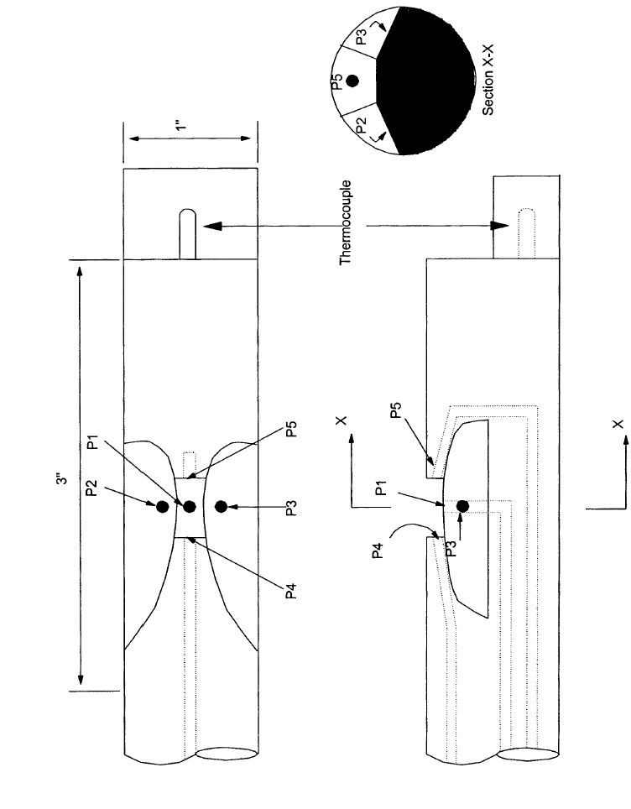
Figure 1. Illustration of a five-hole prism-shaped (DAT) probe.

The block is initially attached to the probe via set screws, such that Reference Surface YZ is approximately parallel to the line defined by pressure ports 2 and 3 (see Figure 1 for port numbering). This alignment is initially performed visually. Then Reference Surface XY is approximately parallel (within the accuracy of the visual alignment) to the plane defined by pressure port 1 and the probe axis. Then the probe is mounted on the calibration rig in the calibration wind tunnel, as shown in Figure 4, such that Reference Surface XY is approximately parallel to the free-stream velocity (the tunnel free-stream velocity is accurately known in direction from the tunnel calibration procedure). The calibration rig will be discussed later in more detail. Then the probe is rolled until pressures P2 and P3 are equal (within the accuracy specified in the current Method 2F). With the probe held in that position, the reference block set screws are loosened and the block is repositioned such that Reference Surface XY is parallel to the free-stream tunnel velocity and the set screws are tightened. For example, if the calibration is performed in a tunnel with the free-stream in the horizontal directions, then through the use of a digital inclinometer placed on Reference Surface XY, the block is rotated until the inclinometer reads zero degrees. Then the set screws are screwed in to affix the block to the probe.

However, a significantly simpler procedure is also proposed herein as an alternative. The fact that the probe, as discussed later, is calibrated in detail in the wind tunnel, facilitates the use of this simpler procedure. According to it, the block is attached to the probe via set screws, such that Reference Surface YZ is approximately parallel to the line defined by pressure ports 2 and 3. This alignment is performed visually. Assuming that this alignment is within +/- 15 deg. from the yaw-nulling position, no further refinement of the block alignment is necessary. The block reference surface XY serves as the probe alignment surface in actual field measurements and has to be aligned parallel to the stack axis. The fact that this position will not necessarily correspond to the yaw-nulling orientation is automatically taken into account by the probe calibration procedures and data-reduction algorithm.

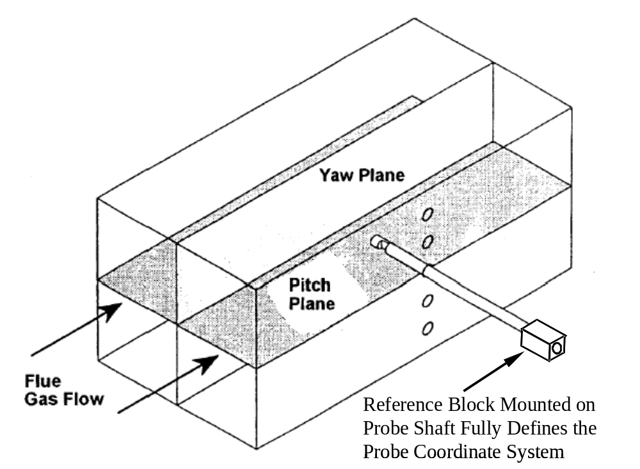

Figure 2. Schematic illustrating the definition of yaw and pitch planes and positioning of the reference block on probe shaft.

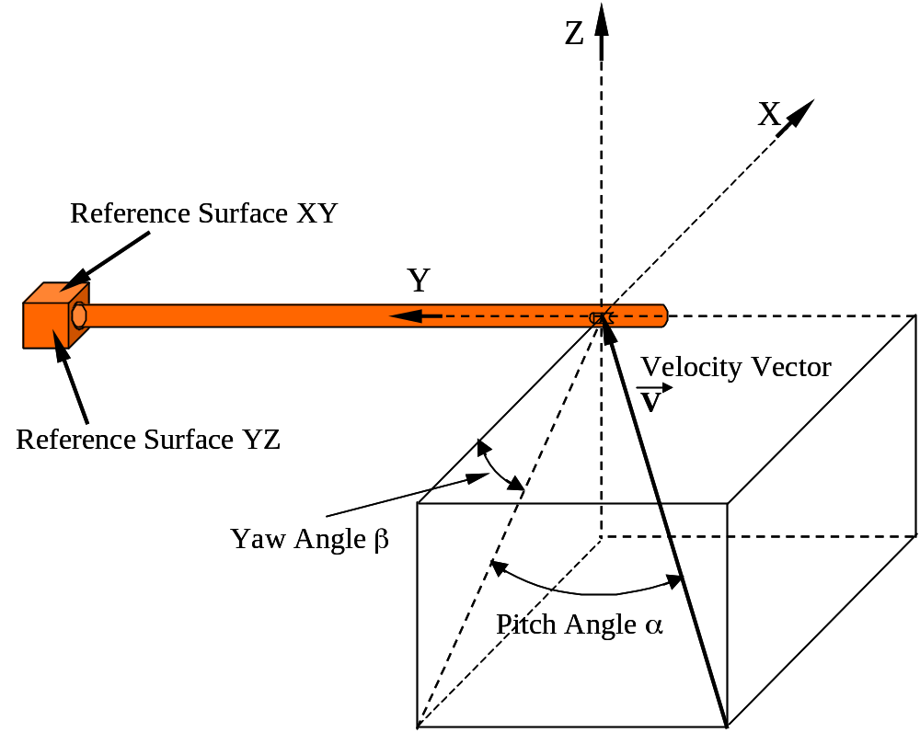

Figure 3. Schematic illustrating the definition of yaw and pitch angles and coordinate system with respect to probe and reference block.

Yaw Angle, Pitch Angle and Velocity Pressure Calibration (Sections 10.4 and 10.5 of current Method 2F)

This is one of the procedures that are different from the current Method 2F. The main difference is that the probe is calibrated not only over a range of pitch angles but also over a range of yaw angles. Although the procedure can be carried out manually, we strongly recommend probe calibration via an automated positioning system as that shown in Figure 4. As shown in the figure, The probe is mounted on a frame, which, through the use of two stepper motors, one for pitch positioning and one for yaw positioning, can place the probe at a range of (pitch angle, yaw angle) combinations, with respect to the tunnel free-stream. An example of such a system is shown in Figure 5. This system is used with a different type of 3-D probes but its principles of operation are identical to those of Figure 4.

The probe, in Figure 4, enters the wind tunnel test section through a slot along one of the test section side walls. This slot allows the probe to be moved over a range of pitch angles (of at least +/- 15 deg.). This slot is sealed (so that there is no air exchange between the interior and the exterior of the test section) through “brushes”, which have thickly distributed bristles to achieve sealing, but yet sufficiently flexible bristles in order to allow the probe to move through them. We have successfully used this way of sealing repeatedly before.

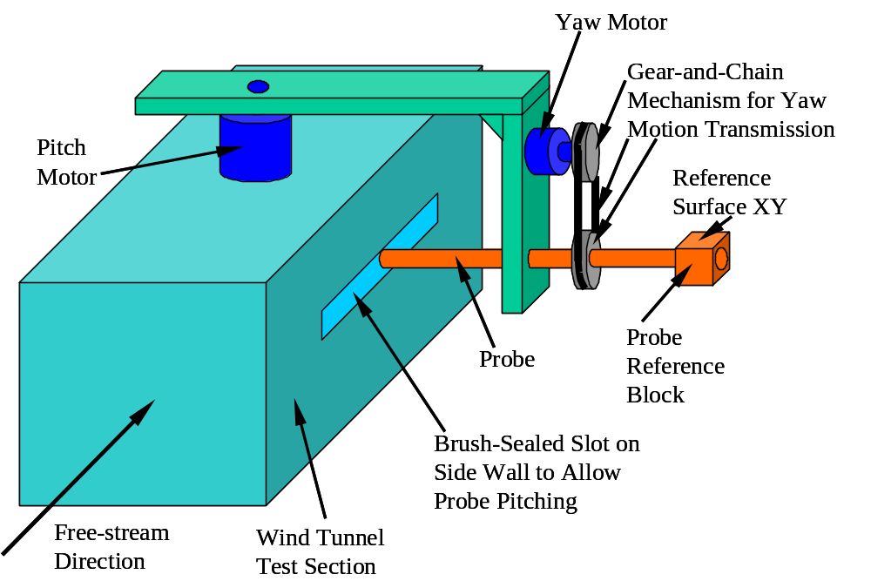

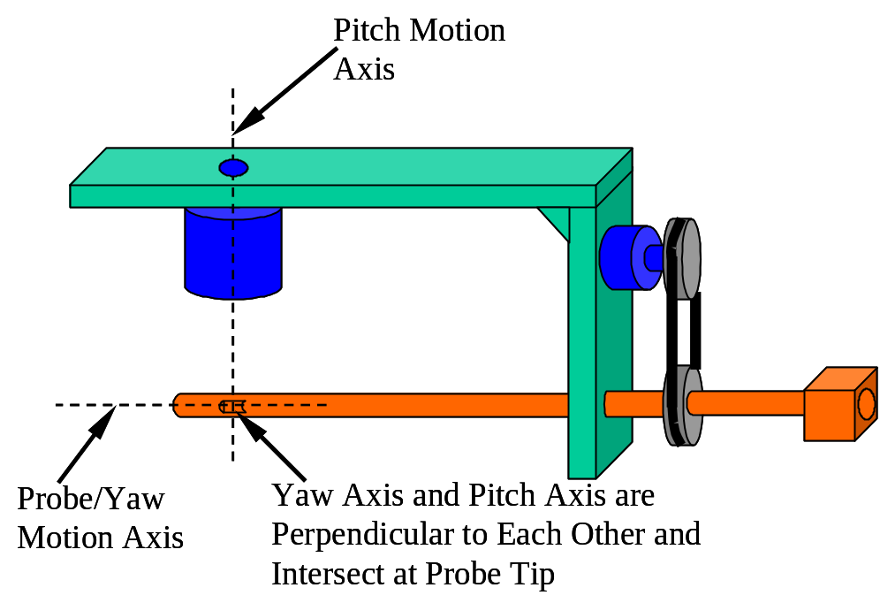

Figure 4. Automated wind-tunnel calibration of probe. Upper: complete assembly. Lower: test section removed to illustrate intersection of pitch and yaw rotational axes.

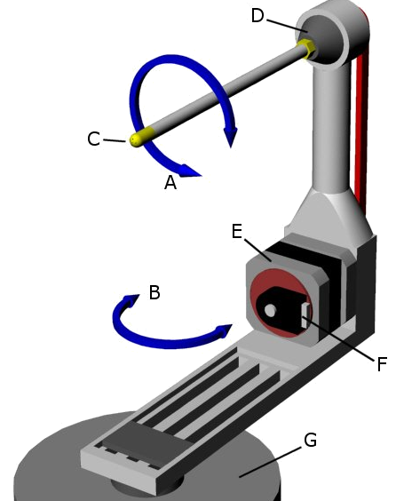
E: Yaw angle stepper motor, F: Optical encoder, G: Pitch angle stepper motor.
A: Yaw angle, B: Pitch angle, C: Probe tip, D: Probe mount
(a)
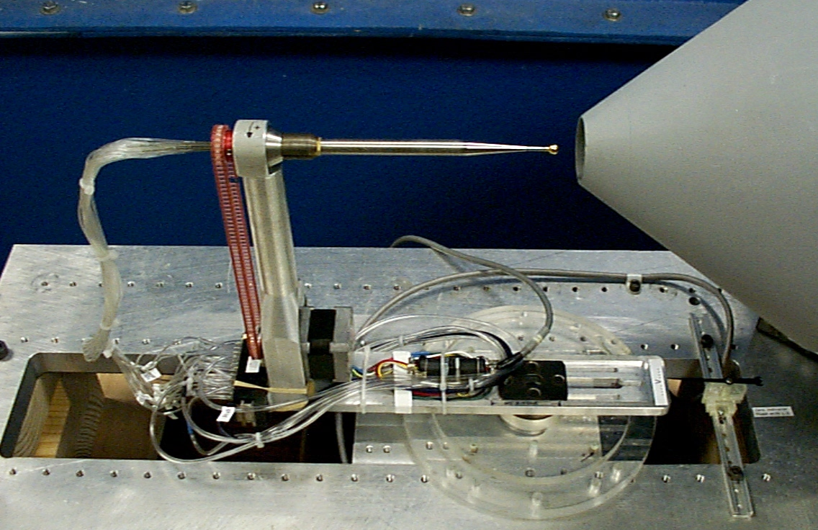
(b)
Figure 5. Example of automated calibration system. Schematic and picture of probe positioning/indexing system (a and b).

The stepper motors are equipped with optical encoders so that the position of the probe is accurately known. Also, the stepper motors can be equipped with gear boxes, if finer stepping and increased torque are desired. A typical stepper motor has a minimum step size of 0.9 deg. A 20-to-1 gear box can refine the step to 0.045 deg. and multiply the available torque by a factor of 20. The penalty is that the positioning process will be slower, which however is not an important issue, since the entire process is automated and modern stepper motor controllers can achieve speeds as high as 1000 steps per second. As an example, we are using the above calibration system and procedures with our regular 3-D probes and are repeatedly achieving calibration accuracies as high as 0.25 deg. in the pitch and yaw angles and 0.5% in the velocity magnitude, in the range +/-20 deg. in pitch and yaw.

As shown in Figure 4lower, it should be noted that the pitch axis and the yaw axis are perpendicular to each other and intersect at the probe tip (the part of the probe performing the measurements). This forces the probe tip to stay at the same physical location in the test section, regardless of the pitch and yaw angles it is rotated to. This eliminates calibration errors that could be introduced if there are spatial velocity gradients (non-uniform velocity distribution) in the test section.

A typical calibration procedure would be as follows. The probe is rolled to a yaw angle of –18 deg. Then, keeping the yaw angle fixed, the probe is pitched from –18 deg. to 18 deg. in steps of 3.6 deg. (which is 4 times the minimum stepper motor step, if gear motors are not used). For each probe location, the 5 port pressures, P1, P2, P3, P4, P5 plus the reading from the pitot tube are sampled and stored. All pressures are measured by differential pressure transducers, with the reference pressure of all transducers being the static pressure of the pitot tube. Once all pitch positions (for the fixed yaw angle of –18 deg.) are spanned (a total of 11 pitch positions: -18 deg., -14.4 deg., -10.8 deg., -7.2 deg., -3.6 deg., 0.0 deg., 3.6 deg., 7.2 deg., 10.8 deg., 14.4 deg., 18 deg.), then the probe is rolled to the next yaw position, -14.4 deg. and all the pitch angles are spanned again, and for every position the 5 pressures and the pitot reading are sampled and stored. The next yaw position will be –10.8 deg., and so on, with the final yaw position being 18 deg. In the above both yaw and pitch angles are advanced in steps of 3.6 deg. Our experience with probe calibration shows that this stepping interval is good enough to yield calibration quality and thus probe measurement accuracies quite a bit better than the minimum accuracies stipulated in the current Method 2F.

The above procedure is then repeated one more time as per the requirements of the current Method 2F. Also, before and after each calibration the temperature and barometric pressure should be recorded. Then repeat the calibration procedures at the second selected nominal wind tunnel velocity.

Then for every point of each one of the calibrations, the following coefficients are calculated:
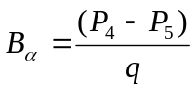 (1)
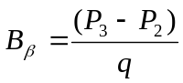 (2)
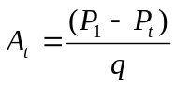 (3)
where, the pseudo dynamic pressure, q, is defined as:
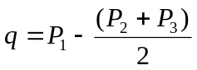 (4)
and P_{t} is the pitot tube dynamic pressure reading (already corrected by taking into account the Pitot tube calibration). It should be noted that P_{t} is also the total pressure measured with respect to the reference pressure used to reference the differential pressure transducers, which in the calibration case is equal to the free-stream static pressure.
Then for the two calibrations corresponding to each of the two nominal tunnel velocities, perform a comparison procedure similar to that described in section 10.6.13 of the current Method 2F. However, now the comparisons will have to be performed, not just for F2 (current Method 2F) but for both 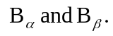Velocity drift checks (10.6.14) will not have to be performed since for every calibration point, paired readings (5 probe pressures and pitot tube pressure) have been acquired. Finally, comparison and average procedures similar to that of section 10.6.16 of the current Method 2F will have to be performed.
Finally, the collected calibration data is used to generate second-order polynomials for the two flow angles, α, β, and the dynamic pressure coefficient A_{t}, as functions of the two pressure coefficients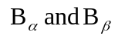, using least-squares techniques:
(5)
(6)
(7)
For each of the above functions, the least-squares technique yields the values of the coefficients: a_{i} , b_{i} , c_{i}, where i takes values from 0 to 5. These values are stored and will be used in the data reduction process.

Using the Probe in Actual Field Tests (“Sample Collection and Analysis”, Section 8.0 of current Method 2F)

All of the procedures described in Section 8.0 of the current Method 2F still hold except for the following:

- Yaw Alignment of Probe: When the probe is inserted into the test port, the only yaw alignment that is needed at every measurement point, before a measurement is taken, is to orient the reference surface YZ perpendicular to the stack axis, or reference surface XY parallel to the stack axis.
- No Yaw Nulling Necessary: At every measurement location, no yaw nulling procedure is necessary. The probe is simply traversed to the new measurement location, its reference block/surface is properly aligned and the five pressures from the five ports are sampled and stored. Any rotational offset is automatically accounted for by the probe calibration and data reduction processs.
- Data Reduction (Data Analysis): The data reduction, i.e. the conversion of the sampled data to velocity and flow angles (pitch and yaw) can be performed on-line, as the data acquisition is performed, as long as the following quantities are also measured/known:
the absolute stack or duct pressure, P_{s}
the absolute stack or duct temperature, T_{s}
the molecular weight of the stack or duct gas, wet basis, M_{s}.
Or, the sampled data can be stored for later, off-line data reduction/analysis. Regarding data analysis see also the section that follows.

Data Analysis and Calculations (Section 12.0 of current Method 2F)

This procedure is also referred to as “data reduction” and uses the five measured probe pressures to derive, at the measurement location of a field test, the yaw and pitch angles and all three velocity components, thus the flue axial gas velocity.

The five measured pressures are first plugged into Equations 1, 2 and 4 to calculate: q, . Then the calculated are plugged into Equations 5 through 7 to calculate α, β and A_{t}. Then, the actual total pressure (measured with respect to the reference pressure used to reference the differential pressure transducers during the actual field test) is calculated from the non-dimensional pressure coefficient A_{t} , as follows:
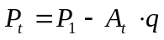 (8)
If during the actual field test the differential pressure transducers are referenced to the local barometric pressure P_{bar} , then the velocity magnitude at the measurement point is calculated from the following formula:

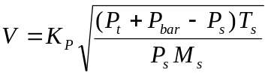 (9)
where:
P_{s} is the absolute stack or duct pressure in mm Hg
T_{s} is the absolute stack or duct temperature in degrees Kelvin
K_{P} is a conversion factor equal to 34.97 and
M_{s} is the molecular weight of the stack or duct gas, wet basis, in g/g-mole

In Equation 9, all pressures are in mm Hg and the calculated velocity magnitude is in m/sec.

Then the axial flue gas velocity at the measurement location is calculated by:

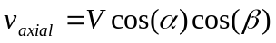 (10)

Finally the flue flow rate is calculated according to the procedures described in sections 12.3 through 12.5 of the current Method 2F.

