APPENDIX 2-5. Simazine Species Sensitivity Distribution Analysis for Aquatic Plants

SSDs were fit to toxicity data for vascular and nonvascular aquatic plants exposed to simazine. Five distributions were tested and a variety of methods were used to determine whether different subsets of data should be modeled independently. Aquatic vascular plant growth data were insufficient to derive a separate SSD. Ultimately, the results from the all aquatic plant SSDs were used. Table 1 provides a summary of the results.

Table 1. Summary statistics for SSDs fit to simazine test results.
Statistic | All  Aquatic Plants
Best Distribution (by AIC_{c}) | Logistic
Goodness of fit  P-value | 0.38
CV of the HC₀₅ | 0.87
HC₀₅ | 14.68
HC₁₀ | 29.08
HC₅₀ | 217
HC₉₀ | 1620
HC₉₅ | 3210

- Data

Data used in this analysis are detailed in Table 6 (at the end of the document) and were from registrant submitted studies as well as an ECOTOX query (APPENDIX 2-2). Table 2 provides the distribution of the test results for simazine including the number of species represented. Insufficient data were available to derive separate SSDs for vascular aquatic plants since only three species were tested. Therefore, one set of distributions was derived: all aquatic plants (combines vascular and nonvascular aquatic plants).

Table 2. Distribution of test results available for simazine.
Data Subset | Test results | Species
All Aquatic Plants | 33 | 19
Nonvascular Aquatic Plants | 24 | 16
Aquatic Plants | 9 | 3

Figure 1 shows the distribution of test results among species, indicating that a few species have been repeatedly tested (two species have been tested 5 times each), but the majority of species have been tested fewer than three times, with 14 species having only one test result.
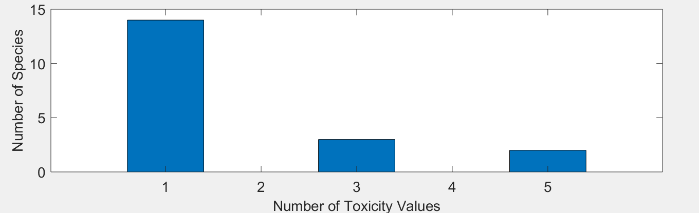
Figure 1. Distribution of the number of test results per species in simazine aquatic plant data.

Five potential distributions for the simazine data were considered, including log-normal, log-logistic, log-triangular, log-gumbel, and Burr. To fit each of the first four distributions, the toxicity values were first common log (log₁₀) transformed. Finally, effect thresholds and five quantiles from the fitted SSDs (HC₀₅, HC₁₀, HC₅₀, HC₉₀, HC₉₅) were calculated and reported.

- Comparison of distributions using AIC_{c}

Akaike’s Information Criterion corrected for sample size (AIC_{c}) was used to compare the five distributions for the aquatic plant dataset. For these comparisons all SSDs were fit using maximum likelihood. The AIC_{c} suggested that the logistic distribution provided the best fit (Tables 3).

Table 3. Comparison of distributions for all aquatic aquatic plant toxicity data for simazine.
distribution | AIC_{c} | ∆AIC_{c} | Weight | HC₀₅
logistic | 288.2030 | 0 | 0.3563 | 14.6830
gumbel | 288.9047 | 0.7017 | 0.2509 | 20.9207
normal | 289.5804 | 1.3774 | 0.1790 | 14.4400
burr | 290.1695 | 1.9665 | 0.1333 | 21.8067
triangular | 291.1774 | 2.9744 | 0.0805 | 12.4762

- Goodness of fit

The plot of the cumulative distribution functions for the best-fit distributions (as determined by AIC_{c}) suggest little evidence of lack-of-fit (Figure 2). Similarly, bootstrap goodness-of-fit tests did not show evidence for lack-of-fit (P-values > 0.05, Table 4), with the exception of the Triangular distribution. In general, the coefficient of variation for the HC₀₅ was below 1 for the competitive distributions.

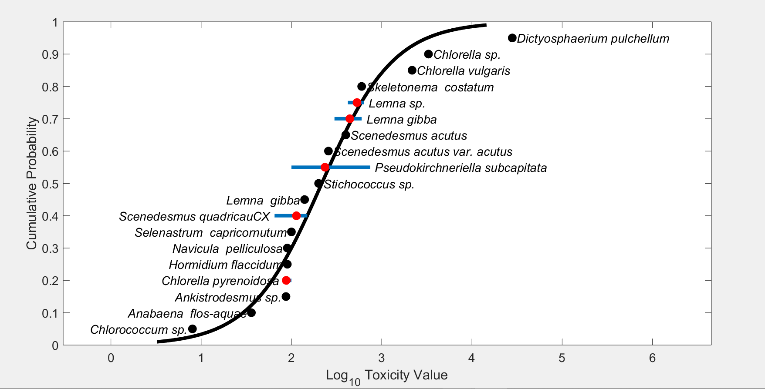
Figure 3. Log-logistic SSD for simazine toxicity values for all aquatic aquatic plants pooled. Black points indicate single toxicity values. Red points indicate average of multiple toxicity values for a single species. Blue line indicates full range of toxicity values for a given taxon.

Table 4. Range of HC05 values for simazine SSDs for all aquatic plants.
Distribution | Method | HC₀₅ | SE | CV | Lower CI | Upper CI | P
Normal | ML | 14.44 | 12.8956 | 0.893 | 4.5125 | 52.6894 | 0.1858
Normal | MO | 13.3533 | 11.605 | 0.8691 | 3.6084 | 45.8786 | 0.1409
Normal | GR | 10.9285 | 7.3966 | 0.6768 | 2.1903 | 29.826 | 0.0869
Logistic | ML | 14.683 | 11.9104 | 0.8112 | 4.4967 | 48.7862 | 0.3397
Logistic | MO | 13.8752 | 13.5293 | 0.9751 | 3.148 | 54.9421 | 0.2847
Logistic | GR | 9.3423 | 7.7781 | 0.8326 | 0.9798 | 31.5578 | 0.1828
Triangular | ML | 12.4762 | 13.4608 | 1.0789 | 6.0055 | 58.9276 | 0.035
Triangular | MO | 12.6568 | 11.6211 | 0.9182 | 4.5658 | 46.5052 | 0.0759
Triangular | GR | 12.0298 | 8.9221 | 0.7417 | 3.462 | 38.4711 | 0.0609
Gumbel | ML | 20.9207 | 11.0373 | 0.5276 | 10.3851 | 52.3048 | 0.3936
Gumbel | MO | 24.4567 | 13.2108 | 0.5402 | 10.2819 | 61.8633 | 0.5674
Gumbel | GR | 18.9381 | 10.2503 | 0.5413 | 4.8947 | 43.3259 | 0.2587
Burr | ML | 21.8067 | 15.8364 | 0.7262 | 6.0534 | 67.5482 | 0.4106
ML=maximum likelihood, MO= moment estimators, and GR=graphical methods
LCp and UCp=projections of the confidence limits of the HC₀₅ (LCx and UCx) onto the cumulative distribution function of the fitted distribution.
- Calculation of other quantiles

Table 5 provides estimates of the HC₀₅ as well as other quantiles of the fitted SSDs.

Table 5. Estimated quantiles of the fitted SSDs for simazine EC₅₀s for all aquatic plants.
Distribution | Method | HC₀₅ | HC₁₀ | HC₅₀ | HC₉₀ | HC₉₅
Normal | ML | 14.44 | 27.1294 | 250.9195 | 2.32E+03 | 4.36E+03
Normal | MO | 13.3533 | 25.5251 | 250.9195 | 2.47E+03 | 4.72E+03
Normal | GR | 10.9285 | 21.8354 | 250.9195 | 2.88E+03 | 5.76E+03
Logistic | ML | 14.683 | 29.0831 | 217.0086 | 1.62E+03 | 3.21E+03
Logistic | MO | 13.8752 | 28.9271 | 250.9195 | 2.18E+03 | 4.54E+03
Logistic | GR | 9.3423 | 21.5334 | 250.9195 | 2.92E+03 | 6.74E+03
Triangular | ML | 12.4762 | 23.5184 | 341.4509 | 4.96E+03 | 9.34E+03
Triangular | MO | 12.6568 | 22.4296 | 250.9195 | 2.81E+03 | 4.97E+03
Triangular | GR | 12.0298 | 21.527 | 250.9195 | 2.92E+03 | 5.23E+03
Gumbel | ML | 20.9207 | 31.2769 | 195.8769 | 3.49E+03 | 1.05E+04
Gumbel | MO | 24.4567 | 35.2624 | 187.1956 | 2.57E+03 | 6.99E+03
Gumbel | GR | 18.9381 | 28.8237 | 195.8527 | 3.96E+03 | 1.25E+04
Burr | ML | 21.8067 | 35.9317 | 212.2496 | 1.98E+03 | 4.44E+03

Table 6 provides all of the available EC₅₀ values for aquatic plants (within the 96-hour to 14-day timeframe-unless otherwise noted). These data sets are the same as reported in the effects characterization and provide additional data for the formulated products. Values that were included in the SSD (i.e., TGAI) are marked with an *.

Table 6. Available effective lethal concentration (EC₅₀) data for aquatic plants exposed to simazine as TGAI or formulation.
Family | Genus | Species | Common Name | EPA Group | Comparable Adjusted Mean Concentrations | Preferred Units | Ref # | Classification
Chlorococcaceae | Chlorococcum | sp. | Green Algae | Nonvascular | 8 | ug/L | 17259 | Supplemental
 | Anabaena | flos-aquae |  | Nonvascular | 36 | ug/L |  | Acceptable
Scenedesmaceae | Selenastrum | sp. | Green Algae | Nonvascular | 48.6 | ug/L | 84045
Scenedesmaceae | Selenastrum | sp. | Green Algae | Nonvascular | 57.3 | ug/L | 84045
Scenedesmaceae | Scenedesmus | quadricauCX | Green Algae | Nonvascular | 65 | ug/L | 17259 | Supplemental
Scenedesmaceae | Selenastrum | sp. | Green Algae | Nonvascular | 73.6 | ug/L | 84045
Oocystaceae | Chlorella | pyrenoidosa | Green Algae | Nonvascular | 82 | ug/L | 158793
Oocystaceae | Chlorella | pyrenoidosa | Green Algae | Nonvascular | 82 | ug/L | 61983
Oocystaceae | Ankistrodesmus | sp. | Green Algae | Nonvascular | 87 | ug/L | 17259 | Supplemental
Prasiolaceae | Hormidium | flaccidum | Algae | Nonvascular | 90 | ug/L | 17259 | Supplemental
 | Navicula | pelliculosa |  | Nonvascular | 90 | ug/L |  | Acceptable
Scenedesmaceae | Pseudokirchneriella | subcapitata | Green Algae | Nonvascular | 100 | ug/L | 17639
Oocystaceae | Chlorella | pyrenoidosa | Green Algae | Nonvascular | 100 | ug/L | 17259 | Supplemental
 | Selenastrum | capricornutum |  | Nonvascular | 100 | ug/L |  | Acceptable
 | Lemna | gibba |  | Vascular | 140 | ug/L |  | Acceptable
Scenedesmaceae | Scenedesmus | quadricauCX | Green Algae | Nonvascular | 150 | ug/L | 71458
Scenedesmaceae | Scenedesmus | quadricauCX | Green Algae | Nonvascular | 150 | ug/L | 71458
Lemnaceae | Lemna | gibba | Inflated Duckweed | Vascular | 156 | ug/L | 174511
Lemnaceae | Lemna | aequinoctialis | Lesser Duckweed | Vascular | 162.8 | ug/L | 174511
Scenedesmaceae | Pseudokirchneriella | subcapitata | Green Algae | Nonvascular | 200 | ug/L | 69584
Prasiolaceae | Stichococcus | sp. | Green Algae | Nonvascular | 200 | ug/L | 17259 | Supplemental
Lemnaceae | Lemna | aequinoctialis | Lesser Duckweed | Vascular | 209.8 | ug/L | 174511
Scenedesmaceae | Pseudokirchneriella | subcapitata | Green Algae | Nonvascular | 220 | ug/L | 69584
Scenedesmaceae | Pseudokirchneriella | subcapitata | Green Algae | Nonvascular | 220 | ug/L | 69584
Lemnaceae | Lemna | minor | Duckweed | Vascular | 226.6 | ug/L | 174511
Lemnaceae | Lemna | minor | Duckweed | Vascular | 229.1 | ug/L | 174511
Scenedesmaceae | Pseudokirchneriella | subcapitata | Green Algae | Nonvascular | 252 | ug/L | 165277
Scenedesmaceae | Scenedesmus | acutus var. acutus | Green Algae | Nonvascular | 257 | ug/L | 65945
Lemnaceae | Lemna | gibba | Inflated Duckweed | Vascular | 276.1 | ug/L | 174511
Scenedesmaceae | Pseudokirchneriella | subcapitata | Green Algae | Nonvascular | 297 | ug/L | 98204
Lemnaceae | Lemna | gibba | Inflated Duckweed | Vascular | 300 | ug/L | 60827
Lemnaceae | Lemna | gibba | Inflated Duckweed | Vascular | 400 | ug/L | 60827
Scenedesmaceae | Scenedesmus | acutus | Green Algae | Nonvascular | 400 | ug/L | 17259 | Supplemental
Lemnaceae | Lemna | gibba | Inflated Duckweed | Vascular | 420 | ug/L | 60827
Lemnaceae | Lemna | sp. | Duckweed | Vascular | 422 | ug/L | 174699
Lemnaceae | Lemna | sp. | Duckweed | Vascular | 564 | ug/L | 174699
Lemnaceae | Lemna | gibba | Inflated Duckweed | Vascular | 570 | ug/L | 60827
Lemnaceae | Lemna | gibba | Inflated Duckweed | Vascular | 600 | ug/L | 60827
 | Skeletonema | costatum |  | Nonvascular | 600 | ug/L |  | Acceptable
Lemnaceae | Lemna | sp. | Duckweed | Vascular | 636 | ug/L | 174699
Scenedesmaceae | Pseudokirchneriella | subcapitata | Green Algae | Nonvascular | 748.5 | ug/L | 83543
Oocystaceae | Chlorella | vulgaris | Green Algae | Nonvascular | 2173.8 | ug/L | 65938
Oocystaceae | Chlorella | sp. | Green Algae | Nonvascular | 3300 | ug/L | 17259 | Supplemental
Dictyosphaeriaceae | Dictyosphaerium | pulchellum | Green Algae | Nonvascular | 28000 | ug/L | 17259 | Supplemental
* Indicates study was conducted with TGAI and value used to derive SSD.
NA = Studies are acceptable for ECOTOX but have not been formally reviewed by EFED scientists.
¹If a species was not represented with a 96 hour study, and other values were available from shorter/longer duration studies (up to 10 days) then the data were included and the duration was listed next to the LC₅₀ value as an indicator. If there were multiple other durations, the value from the study closer to a 96h duration was selected and if there were multiple values for the same duration, the range is indicated.

