Appendix 2-3. Open Literature Review Summaries for Simazine

Open Literature Review Summary

ECOTOX Record Number and Citation: E178652
Sai L;Liu Y;Qu B;Yu G;Guo Q;Bo C;Xie L;Jia Q;Li Y;Li X;Ng JC;Peng C. 2015. The Effects of Simazine, a Chlorotriazine Herbicide, on the Expression of Genes in Developing Male Xenopus laevis Bull. Environ. Contam. Toxicol. 95(2): 157-163.

Purpose of Review: ESA Biological Evaluation (simazine)

Date of Review: 07/13/2020

Summary of Methodology/Study Findings:

Sai et al. (2015) exposed tadpoles (Xenopus laevis) (n = 600) at Nieuwkoop-Faber (Nieuwkoop and Faber 1994) stage 46 to simazine at designed dosages of 0.1, 1, 10 and 100 ug/L (measured as 0.1, 1.2, 11.0 and 100.9 ug/L respectively) for 100 days. Tadpoles from the same pair of brood stock were randomly divided into five groups. Each group (n = 120) was divided into eight replicate tanks (25 x 20 x 20 cm³), each containing 10 L water. The tadpoles were exposed to simazine dissolved in solvent vehicle DMSO (0.01 %) at designed dosages; control tadpoles were treated with 0.01 % DMSO only. Simazine (purity of 97 %) and dimethyl sulfoxide (DMSO) were obtained from Sigma (Chemical Co., USA).

Test materials were applied in a static-renewal exposure regime. Test solutions were renewed by 50 % replacement every 48 h. During the first 9 days of exposure, 20 mL water samples were taken immediately from each tank before and after exchange of the test solutions. Levels of simazine were measured using liquid chromatography and mass spectrometry.

Results of the study indicate mortality increased significantly in the 11.0 and 100.9 lg/L simazine treatment
groups (p<0.05). No changes to sex rations, gonadal morphology, liver weight and HSI, length or weight was noted in the study. However, gonad weight and GSI were significantly reduced in male frogs exposed to simazine at 11.0 and 100.9 ug/L compared to the controls, but the gonad weight and GSI in females were not affected.

Table 1. Mortality and gonad weight/GSI changes (from Sai et al. 2015)
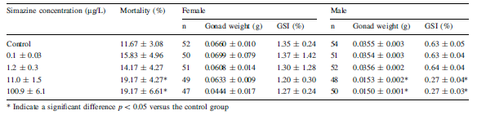

Histologic structure of ovaries was not changed, but the histologic structure of the testes was significantly changed in X. laevis treated with simazine over the entire dose range. Testes of frogs from the control group showed regular seminiferous lobules and spermatogenesis at all stages containing a few spermatogonias and spermatozoa; However, irregular shape of seminiferous lobules, hypertrophic spermatogonias and large empty spaces were observed in the frogs from the simazine treatment groups, particularly in testes of frogs from the 100.9 ug/L, where spermatogonias were hypertrophied and parts of the seminiferous lobules appeared pycnotic, a process involving necrosis in which the cell nuclei were characterized by condensation with hyperchromatic staining or pycnosis and
sheet structure, suggesting potential reproductive impairment (see Figure 1).

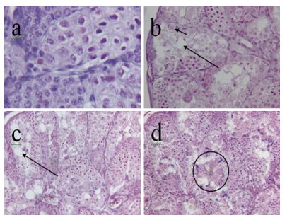
Figure 1. Histopathological changes in testicular tissue (from Sai et al. 2015) Key: a= Control, b= 1.2 ug/L dose, c= 11.1 ug/L dose and d =100.9 ug/L dose.

The NOAEC value was 1.2 ug/L (LOAEC = 11.1 ug/L) associated with a 19% increase in mortality and 57% reduction in gonad weight and GSI% (gonadosomatic index). Histopathological changes in testicular tissue were noted at all concentrations, with most notable changes at the highest test concentration.

Description of Use in Document: Quantitative for inclusion in data arrays and consideration as potential threshold values for risk estimation

Rationale for Use: Study provides useful information on the sensitivity of aquatic-phase amphibians to simazine. The NOAEL/LOAEL/MATC values from this study may serve as a source of threshold values for direct and indirect effects.

Limitations of Study: No raw data was presented. DMSO was used as a solvent, but at a low concentration and used in the solvent control. A negative control did not appear to be used, based on the information provided.

Primary Reviewer: Colleen M. Rossmeisl, DVM, Senior Biologist, OPP/EFED/ERB 3

Secondary Reviewer: Elizabeth Donovan, Senior Biologist, OPP/EFED/ERB 3

Open Literature Review Summary

ECOTOX Record Number and Citation: E178653
Sai L;Qu B;Li Y;Jia Q;Bo C;Liu Y;Yu G;Xie L;Li L;Ng JC;Peng C. 2016. Continued Studies on the Effects of Simazine on the Liver Histological Structure and Metamorphosis in the Developing Xenopus laevis Bull. Environ. Contam. Toxicol. 97(4): 517-520

Purpose of Review: ESA Biological Evaluation (simazine)

Date of Review: 07/13/2020

Summary of Methodology/Study Findings:

Sai et al. (2016) exposed tadpoles (Xenopus laevis) (n = 600) at Nieuwkoop-Faber (Nieuwkoop and Faber 1994) stage 46 to simazine at designed dosages of 0.1, 1, 10 and 100 ug/L (measured as 0.1, 1.2, 11.0 and 100.9 ug/L respectively) for 100 days. Material and methods were as previously described in Sai et al. 2015 (see open literature review for Sai et al. 2015). This paper was a continuation of research present in Sai et al 2015 to assess the effects of simazine on the liver histological structure and metamorphosis in the developing Xenopus laevis.

Results of the study did not indicate and significant changes in liver weights or hepatosomatic index
(HSI). However, in livers of frogs from the simazine-treated groups of 11.0 and 100.9 lg/L all animals had irregular array, necrosis, atrophy and vacuolization of hepatocytes in both male and female, compared to the control group which showed regular array of hepatocytes and well-defined nuclei (see Figure 1).

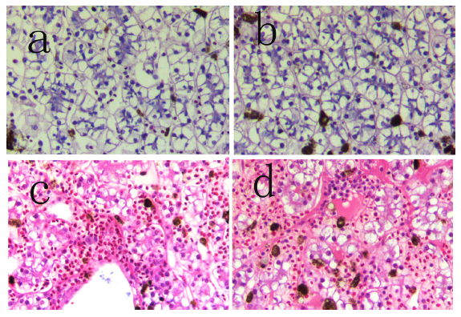
Figure 1. Histopathological changes in liver (from Sai et al. 2016) Key: a= Control female, b= Control male, c= female 100.9 ug/L dose and d = male 11.0 ug/L dose.

The percentages of tadpoles completing metamorphosis from 11.0 ug/L simazine group on days 80 and 90 were significantly lower than the control group (8.1 % lower and 22.2 % lower, respectively). Moreover, the percentages of tadpoles completing metamorphosis from the 100.9 ug/L simazine group were significantly lower than the control group on days 80 and 90 (13.5 % lower and 21.8 % lower, respectively).
Higher concentrations of simazine caused significantly the delay of time completing metamorphosis compared to that of control group (prolonged 6.3 % and 8.7 %).

The NOAEC value was 1.2 ug/L (LOAEC = 11.1 ug/L) a 22% reduction (22%) in tadpoles completing metamorphosis on Days 90 of the study and a 6.3% reduction in the number of days required to complete metamorphosis. Histopathological changes in liver tissue were noted at 11.1 and 100.9 ug/L concentrations, with most notable changes at the highest test concentration.

Description of Use in Document: Quantitative for inclusion in data arrays and consideration as potential threshold values for risk estimation

Rationale for Use: Study provides useful information on the sensitivity of aquatic-phase amphibians to atrazine, simazine and propazine. The NOAEL/LOAEL/MATC values from this study may serve as a source of threshold values for direct and indirect effects.

Limitations of Study: No raw data was presented. Data on metamorphosis changes were presented graphically and in text (mean and SD shown in graphs). DMSO was used as a solvent, but at a low concentration and used in the solvent control. A negative control did not appear to be used, based on the information provided.

Primary Reviewer: Colleen M. Rossmeisl, DVM, Senior Biologist, OPP/EFED/ERB3

Secondary Reviewer: Elizabeth Donovan, Senior Biologist, OPP/EFED/ERB3

Open Literature Review Summary

ECOTOX Record Number and Citation: E178499
Saka M; Tada N; Kamata Y. 2018. Chronic Toxicity of 1,3,5-Triazine Herbicides in the Postembryonic Development of the Western Clawed Frog Silurana tropicalis Ecotoxicol. Environ. Saf. 147: 373-381

Purpose of Review: ESA Biological Evaluation (atrazine, simazine and propazine)

Date of Review: 07/13/2020

Summary of Methodology/Study Findings:

Saka et al. (2018) exposed amphibian tadpoles (Silurana tropicalis) to seven 1,3,5- triazine (s-triazine) herbicides (ametryn, prometryn, dimethametryn, simazine, atrazine, propazine, and cyanazine). tadpoles were exposed to each s-triazine at 2 concentrations between 1/1000 and 1/10 of the 96-h acute toxicity values, until all tadpoles in the control group reached either the late prometamorphic stages or the initial stage of metamorphic climax. LC50 values were determined in the acute phase of the test and chronic toxicity tests focused on morphometric, gravimetric, and thyroid-histological endpoints.

Acute toxicity testing
96-h acute toxicity tests were performed following the test protocol (semi-static regime with water renewal at 24-h intervals). Each test consisted of a control and 5–7 test concentrations in a geometric series with a factor of 101/4 within the following range: 1.00–10.0, 2.60–26.0, 0.520–5.20, for simazine, atrazine and propazine, respectively. Each group was comprised of 10 tadpoles that were placed individually into a glass beaker with 100 mL of the test solution. During the test, the tadpoles were kept
at 25±1 °C under a consistent photoperiod (12-h light/12-h dark) without feeding or additional aeration.

Acute toxicity results are shown in Table 1 below. Results indicated 96-hr LC₅₀ values of 9.62 mg/L for atrazine, 7.55 mg/L for simazine and >5.2 mg/L for propazine. These results were used to determine the range of concentrations to use in the chronic toxicity tests.

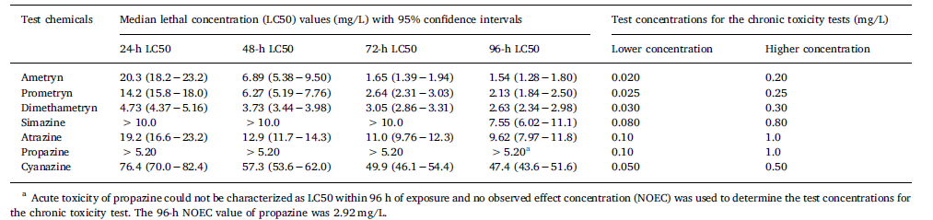

Chronic toxicity testing

During the chronic toxicity tests, tadpoles (Silurana tropicalis) were exposed to 2 concentrations equivalent to approximately 1/100 and 1/10 of the LC₅₀ (atrazine: 100 and 1000 ug/L, simazine: 80 and 800 ug/L, propazine: 100 and 1000 ug/L). In the higher test concentration groups for atrazine and propazine, mortality was noted. Measured test concentrations were in the following ranges for low and high test values for each chemical: 78.9–86.1 ug/L and 804 – 857 ug/L (simazine), 101-108 ug/L and 996 – 1,050 ug/L (atrazine), 99.4 - 104 ug/L and 983 - 1090 ug/L (propazine), Mortality at test termination was 26.7% (8/30) for atrazine and 46.7% (14/30) for propazine. Statistically significant developmental effects were noted in atrazine and propazine in both test concentration groups and in simazine for the higher test concentration group only. Developmental changes included delay in developmental stage reached, hind limb length, ratio of hindlimb length to body length and thyroid gland size. A significant decrease in total body length and body mass were noted at the highest test concentration in all 3 chemicals and significant increase in the degree of scoliosis present in atrazine and simazine.

Description of Use in Document: Quantitative for inclusion in data arrays and consideration as potential threshold values for risk estimation

Rationale for Use: Study provides useful information on the sensitivity of aquatic-phase amphibians to atrazine, simazine and propazine. The LD50/NOAEL/LOAEL/MATC values from this study may serve as a source of threshold values for direct and indirect effects.

Limitations of Study: No raw data was presented. Data on metamorphosis changes were presented graphically and in text (mean and SD shown in graphs; no tabulated data presented).

Primary Reviewer: Colleen M. Rossmeisl, DVM, Senior Biologist, OPP/EFED/ERB3

Secondary Reviewer: Elizabeth Donovan, Senior Biologist, OPP/EFED/ERB3

