APPENDIX 1-7. Determination of Overlap of Likely Simazine Exposure Area and Species Ranges and Critical Habitat for Species Located in the 48 Contiguous United States (ConUS)

The extent of overlap between likely simazine exposure areas and a species’ range (or critical habitat), integrates information on potential use sites and usage data. This approach considers overlap of the species range (or critical habitat) with areas directly treated with simazine and those receiving spray drift. To address uncertainties associated with how treated acres may be distributed within a state (relative to a species range or critical habitat), and the magnitude of usage on any given year, approaches are employed to represent a central estimate of overlap as well as upper and lower bounds. These different estimates are considered in the Weight of Evidence when deciding whether use of simazine is likely or not likely to adversely affect (LAA or NLAA) an individual of an assessed species. The estimated overlap extent of the likely exposure area and species range (or critical habitat) is used in Step 2 as a surrogate for the percent of the listed population that could be exposed to simazine. Additional details are provided in the Revised Method document. This appendix describes the approach for determining the extent of overlap.

1. Potential Use Sites

Simazine’s registered uses include both agricultural and non-agricultural sites. Potential agricultural use sites of simazine are represented by six Use Data Layers (UDLs) generated by aggregating crops originally represented by USDA’s Crop Data Layer (CDL). This process for developing theses agricultural UDL is described in detail in **APPENDIX 1-5 and APPENDIX 1-6**. The simazine specific agricultural UDLs include the following crops:

1. Corn
2. Grapes (for wine, produce, or raisins)

Potential agricultural use site for simazine also include several UDLs that represent aggregated crops; for additional detail see **APPENDIX 1-5**:

1. Citrus
2. Other crops (OR and WA) – includes alfalfa grown for seed, as well as cole crops grown for seed that include: Broccoli, Brussels sprout, cabbage, Chinese cabbage, Chinese mustard, kale, kohlrabi, radish, rutabaga, and turnip
3. Other orchards
4. Vegetables and ground fruit

Potential non-agricultural use sites of simazine are represented by 5 UDLs. The data sources used to generate these UDLs were use specific, for additional details see **APPENDIX 1-6**. The simazine specific non-agricultural UDLs include:

1. Developed - restricted to where warm season grasses grow
2. Christmas Trees - Coniferous/Evergreen/Softwood (non-food)
3. Open Space Developed - restricted to where warm season grasses grow
4. Other Crops (FL) – sod farms limited to the state of Florida Other Crops
5. Other Crops - sod farms across the ConUS restricted to where warm season grasses grow

In total, 11 UDLs represent the agricultural and non-agricultural uses for simazine. To incorporate usage, an aggregated percent crop treated (PCT) is generated for each of the UDLs. The crosswalk in **ATTACHMENT 1-4** is used to link the usage information provided by the EPA’s Science Information & Analysis Branch (SIAB) in their SIAB Use and Usage Matrix (SUUM) with the additional data needed from the Census of Agriculture for calculating the aggregated Percent Crop Treated (PCTs) for agricultural uses on a state/crop basis. **APPENDIX 1-6** uses the chemical independent information provided in **ATTACHMENT 1-4** to provide a simazine-specific crosswalk across crop data sources for simazine uses. Aggregated PCTs for non-agricultural UDLs are generated based on the information provided in the SUUM, additional details are provided in the following section.

Because available pesticide usage data are based on surveys of growers and/or other user groups, the lowest possible PCT used in the analysis is 2.5%, due to the uncertainty associated with these surveys. These surveys are designed to be statistically robust, but by definition sample the target populations rather than provide a complete accounting of all pesticide usage. Therefore, PCT estimates resulting in values below 2.5% are generally a good indicator of limited usage of an active ingredient but by using 2.5% the PCT accounts for possible usage not captured by the survey data.

1. Applying Usage Data to UDLs
   1. Agricultural Uses

The goal of this approach is to determine the amount of area within each state that is treated with simazine (referred to as “treated acres”). This is accomplished by combining data representing the potential use sites, including the UDLs and acres grown from the 2012 Census of Agriculture with available usage data. For the agricultural UDLs, multiple years of data are included to capture temporal changes such as crop rotations. The current years of the CDL included in the UDLs are 2013-2017.

For simazine’s agricultural crop uses, usage data are available to quantify the percent of crop area that has been treated (PCT). The PCT can be used to adjust the extent of the potential use overlapping with a listed species’ range or critical habitat representing the more likely extent of overlap that is directly treated with simazine. PCT data are available for specific crops and states. Simazine usage data are summarized in the Science Information and Analysis Branch (SIAB) Use and Usage Matrix (SUUM; **APPENDIX 1-4**). The simazine SUUM reports PCT data based on usage for a window of 5 years from 2013 - 2017; see **APPENDIX 1-4** for the specific years. Three statistics for PCT are reported for each state and crop combination (where crops are surveyed): average, minimum and maximum annual. The method discussed below is applied separately to the average, minimum and maximum annual PCT data in order to quantify the overlap of species range and exposure areas, while accounting for variability in usage over that 5 year time period. A flow chart describing the process to incorporate usage data to the spatial results is provided in Figure 1**.**

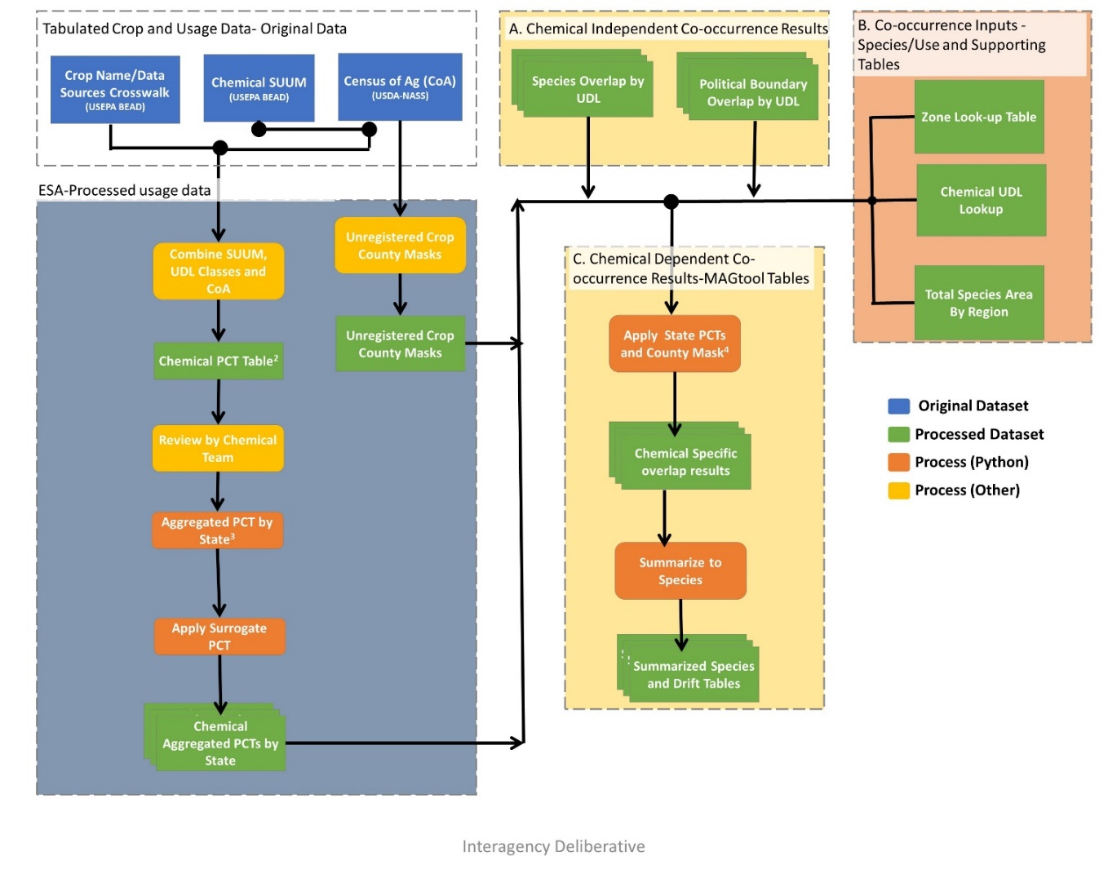

Figure 1. Flow chart of the usage application to the UDLs and species co-occurrence results.

Usage data are applied to the 6 agricultural UDLs discussed above. Crops reported in the SUUM are crossed with the categories used for the UDLs using the crosswalk in **APPENDIX 1-6**. For categories represented by a single crop in both the SUUMs and landcover UDLs (*i.e.* corn), the available PCT data for a given state are applied directly to the acres of the UDL in that state to calculate the acres treated (acres treated = acres grown x PCT). If the PCT is not available for a specific state/crop combination, a surrogate PCT is applied using the process described in the next section.

For those categories representing multiple crops in either the SUUMs or landcover UDLs (*e.g.,* vegetables and ground fruit), an aggregated PCT is calculated. In order to calculate the aggregated PCT, the acres grown and PCT for each crop in the category is needed by state. Both pieces of information are found in the SUUM for each state/crop combination with reported usage. Acreage in the SUUM can come from a variety of sources, including, but not limited to, Kynetec USA Inc data, Agricultural Statistics Service (NASS), and California’s Pesticide Use Reporting (PUR). While all these sources provide slightly different results, they are all similar to the acreage developed by NASS. If the state/crop combination does not have reported usage, the information in the SUUM is supplemented with data from the 2012[1] Census of Agriculture (USDA-NASS, 2012, see **ATTACHMENT 1-3** for details on tabulating the Census of Agriculture). The Census of Agriculture is also used to account for crops in the UDL that are not registered. In this situation, information is not provided for these crops in the SUUM, but the crops would be included in the UDL. The crosswalk in **ATTACHMENT 1-4** is used to supplement the SUUM information with the additional data needed from the Census of Agriculture for calculating the aggregated PCTs on a state/crop basis. **APPENDIX 1-6** uses the chemical independent information provided in **ATTACHMENT 1-4** to provide a simazine specific crosswalk across crop data sources for simazine uses. This process results in three scenarios:

* The Census of Agriculture crop/state combination is found in the SUUM, and the acres grown and crop specific PCT from the SUUM are used directly.
* The Census of Agriculture crop is registered but there is no state specific usage information reported in the SUUM. In this scenario the acres grown for the state are extracted from the Census of Agriculture and a surrogate for the crop specific PCT is assigned using the method described in the next section.
* The Census of Agriculture crop is not a registered use. In this scenario, the acres grown for the state are extracted from Census of Agriculture and a PCT of 0 is used in the calculation of the aggregated PCT. This is done to account for crops found in the UDL that are not registered.

At the end of this process all state/crop combinations found in the Census of Agriculture are accounted for, with acres grown and a crop specific PCT. The aggregated PCT for a state is generated by first calculating the acres treated for each crop based on the crop specific acres grown and PCT information, summing these treated acres for all crops in the UDL category. This value for total treated acres in each UDL category is then divided by the total acres grown for all crops. For state/crop combinations with usage data, the acres grown are extracted from the SUUM; for state/crops combination without usage the acres grown are extracted from the Census of Agriculture; see **ATTACHMENT 1-3** for details on tabulating the Census of Agriculture. **Equation 1** is used to generate the aggregated PCTs.

$${PCT}_{tot-j}=\frac{Acres treated}{Acres grown}=\frac{\sum_{i=1}^{n}{\left({PCT}_{i}*G_{i}\right)}}{\sum_{i=1}^{n}{G_{i}}}$$

**Equation 1**.

Where:

|  |  |
| --- | --- |
| i = | crop (within land cover class j) that is surveyed in state |
| j = | land cover class (*e.g.,* vegetables and ground fruit) |
| n = | number of crops (within land cover class j) with acres grown in state |
| PCTi = | percent crop treated of crop i (from SUUM) |
| PCTtot-j = | aggregated PCT (for land cover class j in state) |
| Gi = | acres of crop i grown (in state) (from SUUM) |

Acres treated for UDLs with multiple crops are calculated by multiplying this aggregated PCT by the area of the UDL for the state. The total area of the UDL for the state only includes those counties with at least 1 registered use as reported in the Census of Agriculture. If the Census of Agriculture reports all registered crops in a given UDL as not grown in a county, the county is excluded from the totals prior to calculating the treated acres.

One conservative assumption of this approach is that it does not account for multiple applications to the same fields. Usage data represents the potential acres where a single simazine application occurred. The data do not identify sites where multiple applications occur within the same year. The approach used here assumes that all treated acres are independent. Therefore, if the available usage data represent sites where multiple applications occurred (which is permitted on simazine labels), then the extent of the treated acres is overestimated. The aggregated UDLs will also overestimate the treated acres in a given year due to the conservative nature of the aggregation, especially when the total area in the UDL exceeds what is reported in the Census of Agriculture.

The flow chart above (Figure 1) diagrams the process for generating the data used to apply the usage method. Each dashed box is an individual workflow or tool. Blue boxes represent original data, green boxes processed data, orange boxes highlight specific steps from a tool and yellow boxes represent a review process. Tools published with the BE are highlighted with letters in the title and have yellow and peach backgrounds and non-automated workflows are indicated with a gray background.

* 1. Non-Agricultural Uses

Non-agricultural national level usage data for the contiguous United States (ConUS) are available in the SUUM (and includes all use sites from the SUUM (**APPENDIX 1-4**)**.** The usage information can be available as treated area based on survey data or reported as average pounds applied for the use.

If information on treatable acres, base acres treated for all herbicides and treated acres for simazine is available from survey data, this information is used to calculate the aggregated maximum and average PCTs (**Equation 2-1, 2-2)**. This information was provided in the Simazine Non-Agricultural PCT Estimates, 2013-2017 for turf from institutional facilities, golf courses, and ornamental sod farms. The maximum PCT is based on the ratio of base acres treated with all herbicides to the total treatable acres for the non-agricultural use while the average PCT is based on the ratio of acres treated with simazine to the total treatable acres. If treatable acres are unavailable the value is estimated based on the acres found in the associated UDL.

**Equation 2-1**.

$${PCT}_{max}=\frac{Base Acres treated}{Total Treatable Acres}$$

Where:

|  |  |
| --- | --- |
| Base Acres Treated = | Base acres for this use that is treated with any herbicide |
| Total Treatable Acres = | Total acreage for this use that could be treated |
| PCTmax = | Calculated maximum PCT |

**Equation 2-2**

$${PCT}_{avg}=\frac{Acres {treated}_{sim}}{Total Treatable Acres}$$

Where:

|  |  |
| --- | --- |
| Acres treatedsim = | Acreage that is treated with simazine |
| Total Treatable Acres = | land cover class (e.g., vegetables and ground fruit) |
| PCTavg = | Calculated average PCT |

When survey information related to treated acres is unavailable, estimates for treated area are based on the average annual pounds active ingredient (a.i.) applied, minimum label rate, and maximum label rate from the SUUM **(APPENDIX 1-4).** Where the minimum labeled rate is the minimum of the various max labeled rates or the minimum. These treated area estimates are used to develop the aggregated maximum, average, and minimum PCTs (**Equation 3-1, 3-2, 3-3**). In this situation, the maximum estimated treated acres are equal to the average annual pounds a.i. applied divided by the minimum application rate. The average number of treated acres is estimated by taking the number of pounds applied and dividing by ½ of the maximum application plus the minimum application rate.

**Equation 3-1**.

$${Treated Acres}_{max}=\frac{Annual pounds AI {applied}_{avg}}{Label {Rate}_{min}}$$

Where:

|  |  |
| --- | --- |
| Annual pounds AI appliedavg = | Annual average pounds applied of Active Ingredient |
| Label Ratemin= | Minimum application rate for the chemical in the SUUM (lb ai/a) |
| Treated Acresmax = | Estimated maximum treated acres based on label rates |
|  |  |

**Equation 3-2**.

$${Treated Acres}_{avg}=\frac{Annual pounds AI {applied}_{avg}}{\left(\frac{Label {Rate}_{min}+Label {Rate}_{max}}{2}\right)}$$

Where:

|  |  |
| --- | --- |
| Annual pounds AI appliedavg = | Annual average pounds applied of Active Ingredient |
| Label Ratemin= | Minimum application rate for the chemical in the SUUM (lb ai/a) |
| Label Ratemax = | Maximum application rate for the chemical in the SUUM (lb ai/a) |
| Treated Acresavg = | Estimated maximum treated acres based on label rates |

In contrast to the different methods for estimating the average and maximum PCT, the minimum PCT is always calculated by dividing the average pounds applied divided by the maximum application rate found in the SUUM (**Equation 3-3**). Due to the uncertainty related to estimating the treated acres based on application rates, if this method results in a minimum PCT that is greater than the average, the minimum PCT is set equal to the average.

**Equation 3-3**.

$${Treated Acres}_{min}=\frac{Annual pounds AI {applied}_{avg}}{Label {Rate}_{max}}$$

Where:

|  |  |
| --- | --- |
| Annual pounds AI appliedavg = | Annual average pounds applied of Active Ingredient |
| Label Ratemax= | Maximum application rate for the chemical in the SUUM (lb ai/a) |
| Treated Acresmin = | Estimated minimum treated acres based on label rates |

To generate the PCTs, these estimated treated acres are divided by total treatable acres reported in the SUUM if available or the estimated treatable acres based on the UDL (**Equation 4**).The following sections provides additional information for each use based on the corresponding area found in the UDL.

**Equation 4**.

$${PCT}_{i}=\frac{Treated Acres{}_{i}}{Total Treatable Acres{}_{}}$$

Where:

|  |  |
| --- | --- |
| i = | PCT Estimate, max, avg, or min |
| Treated Acres= | Estimated treated acres |
| Total Treatable Acres= | Total treated acres as reported in the SUUM or estimated based on the UDL |

Simazine is registered for five non-agricultural uses: residential or institutional grass/turf lawns, golf courses, sod farms, and Christmas tree plantations. When considering the available non-agricultural usage data for simazine, there is survey data that has values for base treated acres and total treatable acres for the four non-agricultural uses associated with ornamental lawns and turf. Only the Christmas tree use, uses data from the SUUM to create aggregated PCT estimates. Overall, the uses that have the highest average annual pounds applied nationwide are Christmas Tree Plantings (400,00 pounds) and golf courses (200,000 pounds), represented by the Christmas tree and Open Spaced Developed UDLs, respectively. Residential or Institutional lawns are represented by the Developed UDL and sod farms are represented by two Other Crops UDLs; one limited to FL and the other limited to the area of the ConUS where warm season grasses grow. While simazine also has registered non-agricultural uses for ornamental water features and ponds reliable data are not available to map the locations of the potential use sites. The spatial extents of these uses are limited and overlap with other simazine uses; it’s likely that these uses are covered by other uses or are limited to small contained systems. Simazine was also registered for use on nursery crops; however, this use was assumed to be covered by other crops contained in other orchards UDL.

## Developed

The SUUM contained usage data for institutional and residential lawns. The UDL for Developed land was assumed to encompass residential and institutional lawns. This category had additional survey information regarding the base treated acres, total treatable acres, and acres treated with simazine. This specific usage data was used to develop a max and avg PCT estimate, whereas the minimum PCT was calculated using the max label rate and average annual a.i. applied from the SUUM. Final estimates for the minimum, average, and maximum PCTs can be found in Table 3.

**Table 3. Simazine usage data (from SUUM) relevant to potential use sites with usage represented by developed landcover (includes ornamental lawns and turf applied by institutional turf facilities.**

|  |  |  |  |  |  |  |  |
| --- | --- | --- | --- | --- | --- | --- | --- |
| **Site** | **Treatable Acres a** | **Max Acres Treated b** | **Avg Acres Treated c** | **Min Acres Treated d** | **Avg. Annual Pounds**  **AI Applied e** | **Max Single Labeled Rate (lb AI/A) f** | **Min Single Labeled Rate (lb AI/A) g** |
| **Ornamental Lawns & Turf** |  | | | | | | |
| **Applied by Institutional Turf Facilities** | 7,800,000 | 2,000,000 | 30,000 | 15,000 | 70,000 | 2 | 1 |
| Total Estimated Treated Acres | | 2,000,000 | 30,000 | 15,000 |  |  |  |
| Total Treatable Developed Acres | | 7,800,000 | 7,800,000 | 7,800,000 |  |  |  |
| PCT | | 25% | <2.5%h | <2.5%h |  |  |  |

a All possible treatable acres found nationally as reported in the SUUM (**APPENDIX 1-4**).

b Base acres treated with herbicides as reported in the SUUM (**APPENDIX 1-4**).

c Base acres treated with simazine as reported in the SUUM (**APPENDIX 1-4**).

d Estimated minimum acres treated by dividing the avg. annual pounds a.i. applied in the SUUM (**APPENDIX 1-4**) and the maximum application rate of 2 pounds a.i./A.

e The pounds AI displayed in this document may differ from those displayed in the SLUA and other BEAD documents, because different calculation methods were used.

f Maximum labeled rate as reported in the SUUM (**APPENDIX 1-4**) from 2019 Simazine Pesticide Label Use Summary (PLUS) Report.

g Minimum max labeled rate from 2019 Simazine Pesticide Label Use Summary (PLUS) Report.

h Default lowest PCT value of 2.5%

-- Data unavailable (not surveyed or surveyed but undisclosed in study).

** Calculated using eq. 4, a larger min relative to avg is due to the different calculation methods and expected

## Open space developed

The available usage information for open space developed is regional and includes all use sites from the SUUM under the heading ornamental lawns and turf applied by golf courses. This non-ag use had additional survey information regarding the base treated acres, total treatable acres, and acres treated with simazine. This specific usage data was used to develop a max and avg PCT estimate, whereas the minimum PCT was calculated using the max label rate and average annual a.i. applied from the SUUM. Final estimates for the minimum, average, and maximum PCTs can be found in Table 4.

**Table 4. Simazine usage data (from SUUM) relevant to potential use sites with usage represented by Open space developed landcover (includes ornamental lawns and turf applied by golf courses).**

|  |  |  |  |  |  |  |  |
| --- | --- | --- | --- | --- | --- | --- | --- |
| **Site** | **Treatable Acres a** | **Max Acres Treated b** | **Avg Acres Treated c** | **Min Acres Treated d** | **Avg. Annual Pounds AI Applied e** | **Max Single Labeled Rate (lb AI/A) f** | **Min Single Labeled Rate (lb AI/A) g** |
| **Ornamental Lawns & Turf** |  | | | | | | |
| **Grass/Turf (Golf Courses)** | 1,700,000 | 1,300,000 | 40,000 | 100,000 | 200,000 | 2 | 1 |
| Total Estimated Treated Acres | | 1,300,000 | 40,000 | 100,000 |  |  |  |
| Total Treatable Open Spaced Developed Acres | | 1,700,000 | 1,700,000 | 1,700,000 |  |  |  |
| PCT | | 76% | <2.5%h | 5.8%** |  |  |  |

a All possible treatable acres found nationally as reported in the SUUM (**APPENDIX 1-4**).

b Base acres treated with herbicides as reported in the SUUM (**APPENDIX 1-4**).

c Base acres treated with simazine as reported in the SUUM (**APPENDIX 1-4**).

d Estimated minimum acres treated by dividing the avg. annual pounds a.i. applied in the SUUM (**APPENDIX 1-4**) and the maximum application rate of 2 pounds a.i./a.

e The pounds AI displayed in this document may differ from those displayed in the SLUA and other BEAD documents, because different calculation methods were used.

f Maximum labeled rate as reported in the SUUM (**APPENDIX 1-4**) from 2019 Simazine Pesticide Label Use Summary (PLUS) Report.

g Minimum max labeled rate from 2019 Simazine Pesticide Label Use Summary (PLUS) Report.

h Default lowest PCT value of 2.5%

-- Data unavailable (not surveyed or surveyed but undisclosed in study).

** Calculated using eq. 4, a larger min relative to avg is due to the different calculation methods and expected

## Other Crops (Sod Farms)

There was available usage information in the SUUM for Ornamental Sod Farms (Turf). While turf farms are listed in a same category as use sites such as residential lawns and golf courses, the agronomic practices of large-scale turf farms were most similar to the generalized UDL for ‘other crops’ rather than open space developed or developed land because sod farm are captured in the USDA Cropland Data Layer and summarized into this UDL. These turf farms were assumed to be growing the same warm season grasses referred to in the lawns, and ornamental grass simazine use. As a result, the ‘other crops’ UDL was geographically restricted to areas in the ConUS where warm season grasses grow, (I.e. SimOther Crops from APPENDIX 1-4). However, there were two different label rates present in the SUUM, one for general turf farms and one Florida specific rate. Separate estimates of the minimum, average, and maximum PCT for turf farms were developed using both label rates, but the same treated acres data from Table 2. These final calculations for geographically restricted warm season turf farms and Florida specific turf farms are shown respectively in Tables 5-6.

**Table 5. Simazine usage data (from SUUM) relevant to potential use sites with usage represented by Other Crops landcover (includes ornamental lawns and turf applied by Sod Farms (Turf)).**

|  |  |  |  |  |  |  |  |
| --- | --- | --- | --- | --- | --- | --- | --- |
| **Site** | **Treatable Acres a** | **Max Acres Treated b** | **Avg Acres Treated c** | **Min Acres Treated d** | **Avg. Annual Pounds AI Applied e** | **Max Single Labeled Rate (lb AI/A) f** | **Min Single Labeled Rate (lb AI/A) g** |
| **Ornamental Lawns & Turf** |  | | | | | | |
| **Sod Farms** | 320,000 | 310,000 | 40,000 | 15,000 | 30,000 | 2 | 1 |
| Total Estimated Treated Acres | | 310,000 | 40,000 | 15,000 |  |  |  |
| Total Treatable Other Crops Acres | | 320,000 | 320,000 | 320,000 |  |  |  |
| PCT | | 97% | 13% | 5% |  |  |  |

a All possible treatable acres found nationally as reported in the SUUM (**APPENDIX 1-4**).

b Base acres treated with herbicides as reported in the SUUM (**APPENDIX 1-4**).

c Base acres treated with simazine as reported in the SUUM (**APPENDIX 1-4**).

d Estimated minimum acres treated by dividing the avg. annual pounds a.i. applied in the SUUM (**APPENDIX 1-4**) and the maximum application rate of 2 pounds a.i./a.

e The pounds AI displayed in this document may differ from those displayed in the SLUA and other BEAD documents, because different calculation methods were used.

f Maximum labeled rate as reported in the SUUM (APPENDIX 1-4) from 2019 Simazine Pesticide Label Use Summary (PLUS) Report.

g Minimum max labeled rate from 2019 Simazine Pesticide Label Use Summary (PLUS) Report.

**Table 6. Simazine usage data (from SUUM) relevant to potential use sites with usage represented by Other Crops landcover (includes ornamental lawns and turf applied by Sod Farms (Turf) in Florida).**

| **Site** | **Treatable Acres a** | **Max Acres Treated b** | **Avg Acres Treated c** | **Min Acres Treated d** | **Avg. Annual Pounds AI Applied e** | **Max Single Labeled Rate ( lbAI/A) f** | **Min Single Labeled Rate (lbAI/A) g** |
| --- | --- | --- | --- | --- | --- | --- | --- |
| **Ornamental Lawns & Turf** |  | | | | | | |
| **Sod Farms (FL)** | 320000 | 310000 | 40000 | 7500 | 30,000 | 4 | 1 |
| Total Estimated Treated Acres | | 310000 | 40000 | 7500 |  |  |  |
| Total Treatable  Other Crops Acres | | 320,000 | 320,000 | 320,000 |  |  |  |
| PCT | | 97% | 13% | <2.5%h |  |  |  |

a All possible treatable acres found nationally as reported in the SUUM (**APPENDIX 1-4**).

b Base acres treated with herbicides as reported in the SUUM (**APPENDIX 1-4**).

c Base acres treated with simazine as reported in the SUUM (**APPENDIX 1-4**).

d Estimated minimum acres treated by dividing the avg. annual pounds a.i. applied in the SUUM (**APPENDIX 1-4**) and the maximum application rate of 2 pounds a.i./a.

e The pounds AI displayed in this document may differ from those displayed in the SLUA and other BEAD documents, because different calculation methods were used.

f Maximum labeled rate as reported in the SUUM (**APPENDIX 1-4**) from 2019 Simazine Pesticide Label Use Summary (PLUS) Report.

g Minimum max labeled rate from 2019 Simazine Pesticide Label Use Summary (PLUS) Report.

h  Default lowest PCT value of 2.5%

## Christmas trees

For the simazine use registered for Christmas tree farms, the PCTs were estimated using the label rates and average annual pounds applied since there was no available survey data to quantify the base treated acres or total treatable aces. While the simazine labeled use also included Shelterbelts and other nonfood timber, these uses were assumed to be off-labeled based on the commitment letters received during the initial stages of the PCT analysis (APPENDIX 1-2). An estimate for the maximum and average treated acres were calculated using the max and min label rate from the SUUM. These values for treated acres were then used to develop a maximum and average PCT. These PCT values used an estimated total acreage using the underlying UDL. The UDL for Christmas trees was developed from spatial data included in the CDL that estimates the extent of Christmas tree farms, separate from other types of managed forests. The minimum PCT was calculated using the max label rate and average annual A.I. applied from the SUUM. Final estimates for the minimum, average, and maximum PCTs can be found in Table 7.

**Table 7. Simazine usage data (from SUUM) relevant to potential use sites with usage** represented by Christmas Tree Planting landcover.

| Site | Treatable Acres a | Max Acres Treated b | Avg Acres Treated c | Min Acres Treated d | Avg. Annual Pounds AI Applied e | Max Single Labeled Rate  (lb AI/A) f | Min Single Labeled Rate (lb AI/A) g |
| --- | --- | --- | --- | --- | --- | --- | --- |
| **Christmas Trees Plantings** | 300,578 | 217,790 | 145,193 | 108,895 | 400,000 | 4 | 2 |
| Total Estimated Treated Acres | | 217790 | 145,193 | 108,895 |  |  |  |
| Total Treatable Possible Christmas tree Acres | | 300,578 | 300,578 | 300,578 |  |  |  |
| PCT | | 72% | 48% | 36% |  |  |  |

a All possible treatable acres found nationally estimated based on the UDL.

b Estimated maximum acres treated by dividing the avg. annual pounds a.i. applied in the SUUM (**APPENDIX 1-4)** and the minimum application rate of 1 pounds a.i./a.

c Estimated average acres treated by dividing the avg. annual pounds a.i. applied in the SUUM (**APPENDIX 1-4**) and ½ of maximum single labeled rate plus the minimum rate.

d Estimated minimum acres treated by dividing the avg. annual pounds a.i. applied in the SUUM (**APPENDIX 1-4**) and the maximum application rate of 2 pounds a.i./a.

e The pounds AI displayed in this document may differ from those displayed in the SLUA and other BEAD documents, because different calculation methods were used.

f Maximum labeled rate as reported in the SUUM (APPENDIX 1-4) from 2019 Simazine Pesticide Label Use Summary (PLUS) Report.

g Minimum max labeled rate from 2019 Simazine Pesticide Label Use Summary (PLUS) Report.

h Default lowest PCT value of 2.5%

-- Data unavailable (not surveyed or surveyed but undisclosed in study).

1. Applying Surrogate Usage Data

Some uses are not surveyed for usage at all and some uses are only surveyed for usage in some states. For crops without surveyed usage that are included in aggregated UDLs, usage data from the same state for other crops in the UDL will be used as surrogates. If no data for crops within a UDL are available in a state, surrogate PCT will be applied using data available for the same crop or UDL but a different state. If a UDL has no usage data for any state, the highest available PCT from all state-crop combinations will be used. The decision tree below (Figure 2) outlines the approach for determining which data will be used as surrogates.

Yes

Yes

Yes

Is crop-specific PCT available for assessed state?

No

No

Is use surveyed in other states?

Is a PCT available for a use within the same UDL and state?

No

**Figure 2. Decision framework for applying surrogate usage data.**

The surrogacy approach is designed to use the best available data to identify the likely extent of treated area when usage data are not available for a given crop. Surrogate data are ideally assigned using crops within the same landcover (UDL) and then using data from the same crop but different spatial location. If the first two options are not possible, then a conservative approach is employed where the greatest extent of usage on any crop-state combination is used as the surrogate. After applying the surrogacy method all UDL/state combinations will have an associated aggregated PCT. Use of surrogate data represents an uncertainty. In cases where a species has potential risk concerns, a Weight of Evidence analysis will be conducted prior to making the NLAA/LAA determination. In this Weight of Evidence analysis, the impact of the surrogacy assumptions on the overlap analysis will be considered.

1. Calculation of Extent of Direct Overlap of Species Range or Critical Habitat and Treated Acres

The aggregate PCT is used to calculate the total number of acres treated within a state for each UDL (PCT x total acres within a UDL = total acres treated for a UDL). The approach described above combines data that are at different spatial scales, *i.e.,* 30-meter pixel, county and state, for UDLs, Census of Agriculture and usage, respectively. Because of the differences in scales, the usage of simazine can be limited to county and sub-county areas representing potential use sites; however, the actual location of the treated acres within the state is unknown.

Three different assumptions are employed to represent how the treated acres are attributed to potential use site acres within the species range (or critical habitat): upper bound (concentrated within the species range), uniform distribution, and lower bound (concentrated outside of species range). Each of these approaches are discussed below. In all three approaches the estimated treated area within the species range (or critical habitat) is used to calculate the direct overlap of treated sites and the species range (or critical habitat). Direct overlap is equal to the total treated area within the species range divided by the total area of the species range (or critical habitat).

The upper bound approach assumes that all the treated acres in a state occur within the species range (or critical habitat). In this approach, the total acres treated for the state are calculated using the aggregated PCTs. The total treated acres for the state are compared to the total number of acres within a species’ range that overlaps with that UDL. If the number of treated acres in a state is greater than the number of acres in the UDL overlapping the species range, it will be assumed that all acres within the species range that overlap with the UDL are treated. As described above, treated acres are only placed in counties within the species range where at least 1 registered labeled use for the UDL occurs, as identified by Census of Agriculture. If the number of treated acres is less than the total overlapping with the species’ range, then the number of acres overlapping with the species range is reduced to the number of treated acres in the state.

For the uniform distribution approach, the aggregated PCT is applied directly to the acres of the UDL occurring within the species range to calculate the estimated treated acres. This approach assumes that the treated acres are distributed uniformly throughout the state.

The lower bound approach is essentially the opposite of the upper bound. In the lower bound approach, it is assumed that the treated acres are distributed outside of the species range to the greatest extent possible. The total acres treated for the state are compared to the total number of acres outside of a species’ range for the UDL. If the number of treated acres in a state is greater than the number of acres of UDL outside of the species range, it will be assumed that all acres outside the species range are treated, with the excess treated acres assumed to occur within the species range. If the number of treated acres is less than those outside of the species’ range, it is assumed that all treated acres for the state in that UDL occur outside of the range of a species.

When a species range spans multiple states, the uniform, upper, and lower bound approaches are individually applied to each state relevant to a species. The treated acres across all pertinent states are summed to calculate the number of treated acres overlapping with the whole species range (or critical habitat).

The calculation of total treated area based the temporally aggregated UDLs likely overestimates the area where crops could be found in a given year and is a conservatism in the process. The upper bound or concentrating all the treated acres in the species range (or critical habitat) results in more treated area for a given state than expected when considering all species in the state. Additional assumptions and uncertainties related to the calculation of total treated acres and the distributions of the treated acres related to the species range (or critical habitat) are presented in the Revised Method.

1. Calculation of Composite Drift Layer Overlapping with Species Range or Critical Habitat

When the action area is derived, each relevant UDL is combined into a composite layer representing all potential uses. The composite layer is generated by placing all relevant UDLs on top of each other and merging them together to set the footprint for the chemical as a single layer. This composite layer is then buffered out in all directions based on the application method with the greatest drift potential for the chemical. For simazine this is the ground application, resulting in a maximum buffer distance of 1000 ft, or approximately 300 meters. For an individual species, the composite drift area is then refined by considering only the uses with overlap when applying the maximum buffer for the chemical. The specific application methods and rates relevant to these uses and the species-specific endpoints that result in the farthest distance from the treated field, where effects may occur, are used to determine the extent of the composite drift layer for that species.

When usage data are considered, it is necessary to account for a decrease in the extent of areas receiving spray drift because the treated area has deceased. The total possible area receiving drift is based on all potential use sites found in the action area. Prior to applying usage, drift in all directions is calculated. After applying usage only, a portion of potential use sites in the action area will be treated, changing the drift extent.

Since the actual location of the treated acres within a state is unknown, specific areas are not buffered in the Step 2 approach. To account for the reduction in actual acres treated, a factor is applied to this composite drift area based on a state aggregated PCT for all of the uses combined. Additionally, a factor is applied to account for the distribution of theses acres under an upper bound (maximum acres within the species range), lower bound (maximum acres outside the species range) or uniformly distributed within the range as previously discussed. The distribution of acres within the state relative to the species range will also affect the impact of spray drift. For the upper bound scenario, no additional factor is applied to the aggregated PCT, but for the uniform and minimum scenarios, the ratio of the number of treated acres calculated for the uniform or lower bound scenario to the upper bound scenario is applied to the PCT. Lastly, to account for the uncertainty in the true spatial distribution of the use sites, as well as the uncertainty of multiple sites potentially impacting the same locations, the adjusted PCT value is rounded up to the nearest ten place value (*e.g.,* factor of 0.056 is rounded to 0.1). This composite factor is used to scale the number of acres impacted by off-site drift and subsequently lower the total predicted overlap with a species range (or critical habitat) due to drift.

Another factor often discussed for consideration in spray drift is the impact of wind direction on off-site transport for species ranges that are impacted by spray drift occurring in all directions. Methods have been proposed in the past to account for this, including the use of wind rose plots to better predict off-site movement of a chemical. As a simplified method to account for the impacts of wind direction, an additional factor is applied to spray drift based on the number of applications that can occur for the use patterns that are relevant to a species. For the composite factor determined above, a wind direction scaling factor is applied where the factor is scaled to 25% for each application allowed, to represent movement of a chemical off-site in only one direction, or essentially ¼ of a circle when one application is made. More specifically, if only one yearly application is allowed for the relevant use sites, a factor of 0.25 is applied, if 2 applications are allowed, a factor of 0.5, if 3 applications are allowed, a factor of 0.75 and if 4 or more applications are allowed, a factor of 1 (or no additional scaling is applied). The equations used to scale the spray drift overlap are provided below in **Equation 5** and **Equation 6**.

**Equation 5. $Composite drift factor=Aggregated PCT* \frac{\begin{aligned}Number of treated acres in direct overlap scenario \\ considered (upper bound, uniform, lower bound)\end{aligned}}{Number of acres in upper bound direct overlap scenario}$**

**Equation 6. $Final Drift Scaling factor= Composite drift factor rounded up to next 0.1 value * Wind factor$**

In summary, the number of acres in a species range (or critical habitat) potentially exposed due to spray drift is calculated using the equations above for each state. This total number of acres is then divided by the total acres in the species range to determine the overlap area due to drift. For predicting relative EECs in the drift zone, the number of acres is further refined to how many are in each 30-meter increment off-site; starting at 30 meters and continuing to 305 meters off-site or the limit of ground drift. Additional uncertainties and conservatism of the method for applying usage data to drift are provided in the Revised Method.

1. Determination of Overlap of Exposure Area and Species Range or Critical Habitat

To determine the total overlap exposure area, the total number of treated acres within the species range (direct overlap) are added to the scaled number of acres receiving spray drift then divided by the total number of acres of the species range (or critical habitat). This can be considered the percent of the species range/habitat that is likely to be exposed to the pesticide of interest. For species whose life history information indicates the species will not utilize the potential use site areas, overlap of direct treated sites will be zero for direct exposure and only the scaled areas receiving spray drift are considered for the species overlap.

There are 5 different overlap scenarios generated for consideration. The first represents the unadjusted or usage independent overlap, the 2nd and 3rd incorporate the chemical specific usage information and accounts for the redundancy in the UDL layers, and the 4th and 5th incorporate species life history information by removing direct overlap if the species will not utilize the potential use site and limiting the overlap extent to just the areas represented by suitable habitat. These 5 overlap scenarios are discussed in more detail in the following section.

When considering the three different assumptions related to distribution of treated acres relative to species range (*i.e.,* concentrated in species range (upper), uniform throughout state (uniform) and concentrated outside of species range (lower)) and the three different assumptions regarding the amount of usage on a given year (*i.e.,* maximum, average or minimum annual PCT), there are 9 different estimates of the overlap of the species range (or critical habitat) and the exposure area for each overlap scenario. The overlap estimates for scenarios 4 and 5 are considered in addition to the influence of using surrogate usage data when none are available as part of the Weight of Evidence. The information is considered in the Weight of Evidence to determine the likelihood that an individual will be exposed and adversely affected.

1. Background - Spatial Co-occurrence of Species Location and Potential Use Sites

The co-occurrence analysis identifies if a species range (or critical habitat) and UDL overlap, and if so by how much. Required inputs to conducting the co-occurrence analysis include a list of species, species location files, pesticide Use Data Layers (UDLs), and any additional supporting species life history information used to supplement the analysis. The species list needs to include all species and designated critical habitats subject to section 7 of the Endangered Species Act. Location files for each species range and critical habitat need to be accounted for prior to use in the co-occurrence analysis. The pesticide Use Data Layers (UDLs) representing each label use also need to be accounted for prior to completing the analysis. Finally, any additional species life history or spatial datasets, (*e.g.,* GAP/Landfire habitat layer) used to supplement the co-occurrence analysis need to be identified. Additional detail on these spatial inputs and the tools use to generated them can be found with the BE models/tools.

All inputs are finalized and standardized using the Co-occurrence Inputs-Species/Use and Supporting Tables tool. The co-occurrence analysis leverages the ArcGIS Tabulate Area tool, executed as a batch using Chemical Independent Co-occurrence Results-Parent Use Overlap Tables tool. The Chemical Dependent Co-occurrence Results-MAGtool Tables tool generates the standard output tables summarized by UDL and species used in the BE; incorporating usage and species life information into the results. The five different overlap scenarios are generated as output from this tool. Additional information on each of these tools can be found with the respective tool documentation.

The first overlap scenario provides a usage independent overlap, without any adjustments to account for usage or species life history. The remaining overlap scenarios apply usage and species information to the overlap. First the aggregated PCTs for simazine, described above, are applied to the species/UDL overlap using the three different distribution methods for the treated acres. Following the application of usage information, results are scaled to account for the redundancy in the UDLs. Additional detail on the method for applying the redundancy scaling factors is provided below. The last two overlap scenarios account for species life history information. First, if the species will not utilize the potential use site directly the overlap representing the direct overlap is excluded, limiting the results to the areas of drift overlap. Lastly, if the species is more likely to use certain habitats this can be considered by limiting the extent of overlap to just the areas of the species range with those habitats. This suitable habitat consideration is not applicable to designated critical habitat and is considered in conjunction with the results representing the full range as part of the Weight of evidence.

1. Input Data Used for Co-occurrence Analysis
   1. Master Species List

Species subject to section 7 under the Endangered Species Act are obtained from the US Fish and Wildlife Threatened and Endangered Species System[2] (TESS). The resulting table is filtered to include listing statuses[3] currently subject to section 7 or potentially subject to section 7 during the registration time period. Information from TESS for species under the jurisdiction of the National Marine Fisheries Service (NMFS) is supplemented with information from the NMFS website[4], deferring to the NMFS website if conflicts exist between the sources. The species list used for this assessment was generated in January 2019.

* 1. Species Locations

The FWS ECOS Portal (<http://ecos.fws.gov>) houses spatial data that represents species’ ranges and designated critical habitat[5]. Managed by the species experts and therefore considered the best available information for section 7 consultation, the co-occurrence analysis utilizes this information. The ECOS Portal points users to NMFS websites to access spatial information for species under NMFS jurisdiction not found on the ECOS website. For NMFS species not found in either location a request was made directly to the NMFS scientists. The last download of the species locations occurred in January 2019.

After accounting for each species, the input files used for the co-occurrence analysis are generated with the ESRI ArcGIS Union Toolbox[6]. The union tool generates the geometric union of the species files and their attributes and presents this union as non-overlapping ‘zones’. Each unique zone may be occupied by multiple species. The species found in each zone are tracked in a look-up table generated at the time of the union. By using these non-overlapping ‘zones’ a given location is only run once in the analysis, rather than for each overlapping species.

Additional information on this process can be found with the Co-occurrence Inputs-Species/Use and Supporting Tables tool.

* 1. Use Data Layers (UDLs)

The data and process to generate the Use Data Layers is described in **APPENDIX 1-5** and **APPENDIX 1-6.**

* 1. Other Inputs

In addition to the usage data and Census of Agriculture described above, species life history information can be considered. Species life history information is incorporated into two of the overlap scenarios. The first considers if the species will be found on potential use sites or exclusively off the use sites. Off use site determinations were made based on species documentation generated by the Services (*e.g.* Recovery Plan, 5-year Reviews). These determinations were reviewed and updated based on additional information provided by US Fish and Wildlife Service in the Fall of 2019[7]. The second scenario suitable habitat for a species was exacted from the GAP/Landfire [8] and overlap specific to these areas generated. The overlap for the suitable habitat is used to supplement the overlap for the full species range.

All spatial files, UDLs, species, and supplemental information, are standardized into the selected regional projections prior to use in the co-occurrence analysis. For the contiguous United States, there is only one projection used, Albers Conical Equal Area projections (Albers_Conical_Equal_Area.prj). Projected coordinated system were selected to preserve area calculations.

1. Co-occurrence Analysis

The co-occurrence analysis uses the ArcGIS Tabulate Area tool, executed as a batch with the Chemical Independent Co-occurrence Results-Parent Use Overlap Tables tool. Additional information on this tool can be found with the tool documentation. As described above, the species input files used for the co-occurrence are generated by ESRI ArcGIS Union Toolbox, which creates a series of non-overlapping ‘zones’. Each unique zone may be occupied by multiple species. **Figure 3** provides an example species range, and the same range broken up into the non-overlapping ‘zones’ used as the species input file.

In order to apply usage and Census of Agriculture information the state and county boundaries are added to the species input files using the ESRI Intersect Toolbox. The final ‘zones’ allows for the overlap of a UDL to be reported out by species for a given county or state. The state and county breaks allow for the application of the usage data. The total overlap for each county and state is also calculated so the treated acres for the state can be calculated for the upper and lower distributions of treated acres described above.

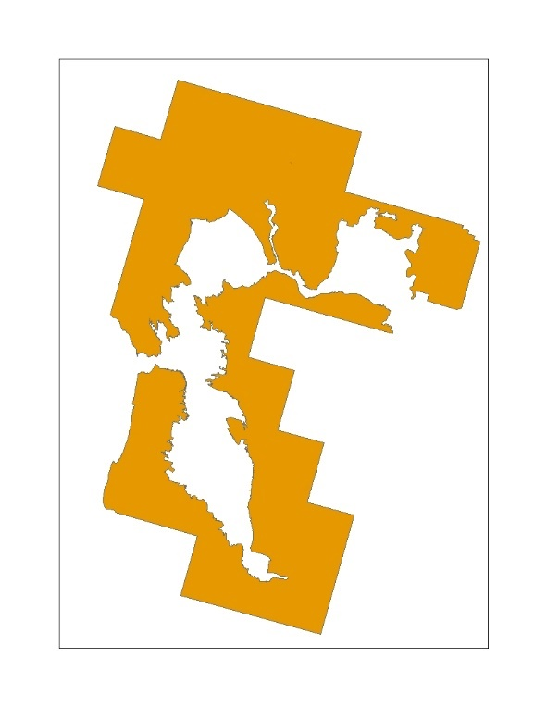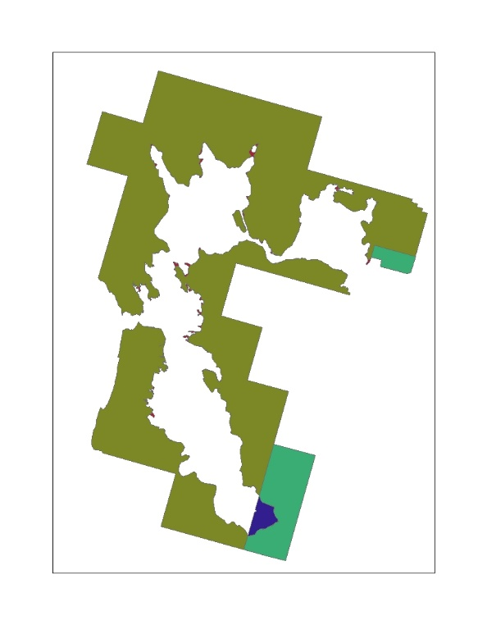

**Figure 3. Example of species range represented by zones used as the input for the co-occurrence analysis.**

* 1. Overlap Scenarios

Five different overlap scenarios are generated for consideration in the Weight of Evidence. The first is usage independent and provides results for the species with no adjustment to the overlap. This is followed by incorporating the usage data, scaling for redundancy of the UDLs, and then adding species life history information to the overlap results.

Applying the usage method described above, the aggregated PCTs and Census of Agricultural are applied to the state and county results to calculate the total treated acres for the state. This information is used for the upper and lower distribution of the treated acres. The treated acres are concentrated within the species range (or critical habitat) and the given state for the upper distribution or outside the species range (or critical habitat) and within the given state for the lower distribution. For the uniform distribution, the aggregated PCTs and Census of Agricultural are applied directly to the species results, broken down for a species in a given county and state. After calculating the treated acres for each state within the species range (or critical habitat), all states are summed to get the total treated acres for the species. This process is completed for all UDLs and each of the aggregated PCTs; minimum, maximum and average. The five overlap scenarios are:

* Overlap Scenario 1: Unadjusted
* Overlap Scenario 2: PCT Overlap
* Overlap Scenario 3:PCT and Redundancy
* Overlap Scenario 4:PCT, Redundancy, Off-site
* Overlap Scenario 5: PCT, Redundancy, Off-site, Habitat

Figure 4 provides an example of the three distributions of the treated acres. The dark gray is the extent of the UDL, the green area represents the treated area for a PCT of 10%. These treated acres are distributed into the species range, in orange, using the three different methods; upper to left, uniform in the middle and lower to the right.

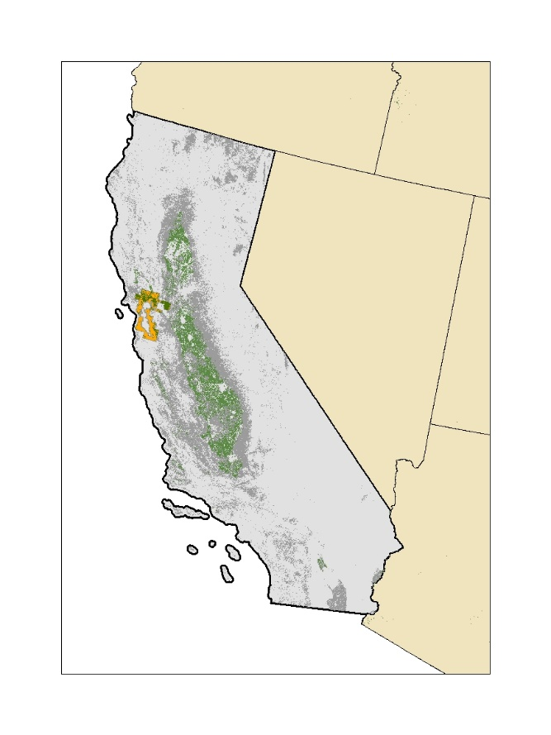

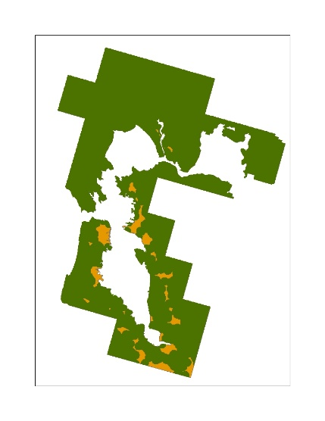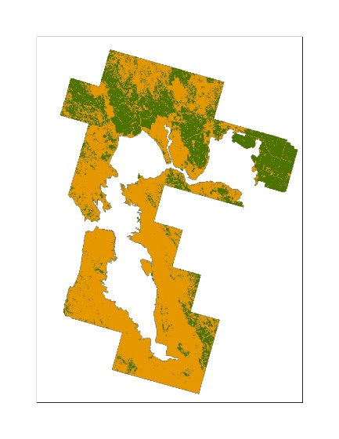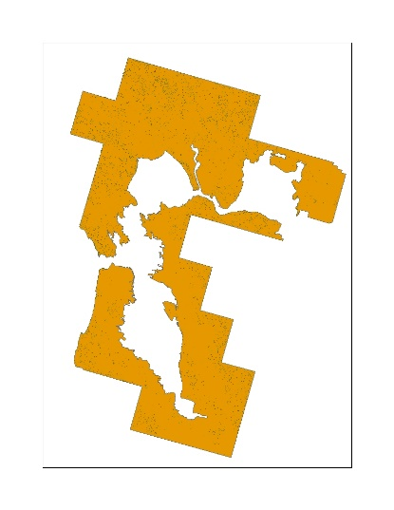

**Upper Uniform Lower**

**Figure 4: Conceptual example of the application of an aggregated PCT to a UDL and the three different distribution methods for treated acres.**

* 1. Scaling for Redundancy in the UDLs

Many UDLs overlap with each other, identifying a single location as multiple potential uses sites, causing the sum of the individual UDLs to be greater than the action area, and often greater than the 100% of the species range (or critical habitat). If each UDL was independent the sum of the UDLs would equal the action area. To account for this redundancy between use sites three different factors are applied to results for the individual UDLs; the composite factor, the agricultural factor and the non-agricultural factor.

In order to calculate the composite factor, an agricultural composite containing all agricultural UDLs and a non-agricultural composite containing all non-agricultural UDLs are generated. The composite factor is equal to the sum of the agricultural and non-agricultural composite divided by the action area. This factor accounts for the redundancy between the agricultural and non-agricultural uses. If all uses are independent the sum of the two composites would equal the action area, and the factor would be equal to 1. Each individual UDL is divided by this composite factor.

An agricultural factor is calculated by summing the results of all the agricultural UDLs and dividing by the agricultural composite. This factor is applied to all of the agricultural UDLs to account for the redundancy between agricultural UDLs. Similarly, a non-agricultural factor is calculated by summing the results of all the non-agricultural UDLs and dividing by the non-agricultural composite. This factor is applied to all of the non-agricultural UDLs to account for the redundancy between non-agricultural UDLs. If all uses are independent the sum of the individual UDLs would equal the composite, and the factor would be equal to 1.

After scaling the results to account for redundancy the sum of the individual UDLs will not exceed the action area percent overlap. Equations used in the calculation of these factors are shown below in **Equation 7-9.**

**Equation 7**. $Composite Factor=\frac{Perecent Overlap Ag Composite+Percent Overlap NonAg Composite}{Perecent Overlap Action Area}$

**Equation 8**. $Agricultural Factor=\frac{Total Percent Overlap Ag UDLs}{Percent Overlap AgComposite}=\frac{\sum_{i=1}^{n}{\left(POi\right)}}{POj}$

Where:

|  |  |
| --- | --- |
| i = | Agricultural UDLs |
| n= | Number of agricultural UDLs |
| j = | Agricultural composite layer |
| PO = | Unadjusted percent overlap |

**Equation 9**. $Non-Agricultural Factor=\frac{Total Percent Overlap Non-Ag UDLs}{Percent Overlap Non-Ag Composite}=\frac{\sum_{i}^{n}{\left(POi\right)}}{POj}$

Where:

|  |  |
| --- | --- |
| i = | Non-agricultural UDLs |
| n= | Number of non-agricultural UDLs |
| j = | Non-agricultural composite layer |
| PO = | Unadjusted percent overlap |

1. Results Co-occurrence Analysis – Examples Species for Simazine

The final results of the co-occurrence analysis provide the percent of the species range (or critical habitat) that overlaps with each UDL. This co-occurrence analysis was done using the max treated acres in the upper distribution. This metric is provided for each of the overlap scenarios. The mean percent overlap and standard deviation for the simazine UDLs across overlap scenario 1-4 for all ConUS species ranges and critical habitats are provided in Tables 8-9, respectively. The final overlap scenario incorporating species life history related to habitat is presented in Table 10.

For the ranges of the ConUS species, Simazine’s action area had a mean overlap of 17% and a mean overlap of 54% when extended out to the limit of ground drift. The in general the mean overlaps for the individual UDLs range from <1 to 5%, and some UDLs overlap decreased after incorporating usage and species life history information (e.g. corn 3% to <1%).

Table 9presents the same information for all ConUS designated critical habitats. For critical habitat simazine’s action area had a mean overlap of 5 % and a mean overlap of 19% when extended out to the limit of ground drift. The mean overlaps for the individual UDLs range from <1 to 2% and this range is unchanged after incorporating usage and species life history information.

**Table 8. Mean percent overlap and standard deviation for ConUS species range and each simazine uses in the ConUS for each overlap scenario.**

|  |  |  |  |  |  |  |  |  |
| --- | --- | --- | --- | --- | --- | --- | --- | --- |
|  | **Overlap Scenario 1: Unadjusted (mean, std)** | | **Overlap Scenario 2: PCT Overlap (mean, std)** | | **Overlap Scenario 3: PCT and Redundancy (mean, std)** | | **Overlap Scenario 4: PCT, Redundancy, Off-site (mean, std)** | |
| Use | Mean | STD | Mean | STD | Mean | STD | Mean | STD |
| Simazine Action Area | 17 | 15 | 17 | 15 | 17 | 15 | 17 | 15 |
| Citrus | <1 | 2 | <1 | 2 | <1 | 2 | <1 | 2 |
| Corn | 3 | 7 | 2 | 5 | 1 | 4 | 1 | 4 |
| FL Sim Other Crops | <1 | <1 | <1 | <1 | <1 | <1 | <1 | <1 |
| Grapes | <1 | 3 | <1 | 2 | <1 | 1 | <1 | <1 |
| ORWA Sim Other Crops | <1 | 2 | <1 | 2 | <1 | <1 | <1 | <1 |
| Other Orchards | 1 | 5 | <1 | 4 | <1 | 2 | <1 | 2 |
| Sim Developed | 5 | 9 | 5 | 9 | 5 | 8 | 4 | 8 |
| Sim Open Space Developed | 5 | 4 | 5 | 4 | 5 | 4 | 5 | 6 |
| Sim Other Crops | 2 | 4 | <1 | 2 | <1 | 1 | <1 | <1 |
| Vegetables and Ground Fruit | <1 | 2 | <1 | <1 | <1 | <1 | <1 | <1 |
| Xmas Tree | <1 | <1 | <1 | <1 | <1 | <1 | <1 | <1 |
| Limit Ground Drift (300 m or 1000 ft) | 54 | 28 | 54 | 28 | 54 | 28 | 54 | 28 |

**Table 9. Mean percent overlap and standard deviation for ConUS designated critical habitat and each simazine uses in the ConUS for each overlap scenarios.**

|  |  |  |  |  |  |  |  |  |
| --- | --- | --- | --- | --- | --- | --- | --- | --- |
|  | **Overlap Scenario 1: Unadjusted (mean, std)** | | **Overlap Scenario 2: PCT Overlap (mean, std)** | | **Overlap Scenario 3: PCT and Redundancy (mean, std)** | | **Overlap Scenario 4: PCT, Redundancy, Off-site (mean, std)** | |
| **Use** | **Mean** | **STD** | **Mean** | **STD** | **Mean** | **STD** | **Mean** | **STD** |
| Simazine Action Area | 5 | 11 | 5 | 11 | 5 | 11 | 5 | 11 |
| Citrus | <1 | <1 | <1 | <1 | <1 | <1 | <1 | <1 |
| Corn | <1 | 3 | <1 | 2 | <1 | 2 | <1 | 2 |
| FL Sim Other Crops | <1 | <1 | <1 | <1 | <1 | <1 | <1 | <1 |
| Grapes | <1 | <1 | <1 | <1 | <1 | <1 | <1 | <1 |
| ORWA Sim Other Crops | <1 | 1 | <1 | 1 | <1 | <1 | <1 | <1 |
| Other Orchards | <1 | 3 | <1 | 3 | <1 | 2 | <1 | 2 |
| Sim Developed | 1 | 4 | 1 | 4 | 1 | 4 | 1 | 4 |
| Sim Open Space Developed | 2 | 5 | 2 | 5 | 2 | 5 | 2 | 5 |
| Sim Other Crops | <1 | 3 | <1 | 1 | <1 | <1 | <1 | <1 |
| Vegetables and Ground Fruit | <1 | <1 | <1 | <1 | <1 | <1 | <1 | <1 |
| Xmas Tree | <1 | <1 | <1 | <1 | <1 | <1 | <1 | <1 |
| Limit Ground Drift (300 m or 1000 ft) | 19 | 32 | 19 | 32 | 19 | 32 | 19 | 32 |

**Figure 5** and **Figure 6** provide two species examples, the first is an example of a species with high impact to overlap from usage and the second example is a species with lower impact of usage on overlap.In these examples the dark gray is the extent of the simazine action area, which includes all potential use sites and drift. The state images show the extent of the action area with example total treated acres for simazine highlighted in pink, accounting for all uses. The aggregated maximum PCT was used to calculate treated acres.

For the species in the example presented in **Figure 5**, there are relatively few treated acres for the state relative to other states. These treated acres across all uses for the states intersecting the species range (i.e. AZ and NM), are highlighted in pink and shown in their entirety by the center map. Since there are relatively few treated acres in this example area, even the uniform distribution of treated acres (pink areas) is noticeable within and without the species range. This uniform distribution within the species range is shown in the bottom left map. The bottom right image in **Figure 5** presents the upper distribution of the treated acres, moving as many of the treated acres as possible from outside the species range into the range. Under this condition, the pink highlighted areas are more visible. and reaches the limit of the species overlap. Under the uniform distribution, the incorporation of usage information significantly impacts the overlap results for this species. This difference is seen by comparing the footprint of the action area, outlined by the gray mask, to the footprint of the estimated treated acres. Regardless of the distribution this species’ range contains an easily observable area of treated acres.

**Figure 5. Example of a species with low impact of usage for simazine; species Jaguar (Panthera onca)*.***

For the species in Figure 6 the treated acres, across all uses for the state, highlighted in pink, are not very visible (figures on left). The left image in Figure 6 represents the uniform distribution of treated acres. Since there is a comparatively high coverage of the Action Area across this state, the treated acres in the uniform distribution in pink, it is difficult to pick out relative to the gray Action area footprint. The right images in Figure 6 present the upper distribution of the treated acres, in which all treated acres are contained in the species range, but does not reach the limit of overlap for species. With this maximum distribution, the treated acres are more visible relative to the uniform distribution but are still less noticeable relative to the maximum distribution in Figure 5. While this estimate of overlap does not reach the overlap limit for the species, the impacts of usage are lower compared to the example of high impact usage species in Figure 5.

**Figure 6. Example of a species with medium impact of usage for simazine; species Florida grasshopper sparrow (Ammodramus savannarum floridanus).**

* 1. Suitable Habitat Overlap

In total suitable habitat was identified for 106 species that occur in the ConUS. Table 10 provides themean percent overlap and standard deviation for these 106 species after accounting for usage in the full range and limiting the overlap and usage extent to suitable within the range. This information is considered with the results for the full species range as part of the Weight of Evidence.

**Table 10. Mean percent overlap and standard deviation for uses in ConUS and suitable habitat species before and after limiting the overlap extent to suitable habitat.**

|  |  |  |  |  |
| --- | --- | --- | --- | --- |
| Use | **Overlap Scenario 4: PCT, Redundancy, Off-site (mean, std)** | | **Overlap Scenario 5:**  **PCT, Redundancy, Off-site, Habitat (mean, std)** | |
|  | Mean | STD | Mean | STD |
| Simazine Action Areas | 17 | 15 | 16 | 15 |
| Citrus | <1 | 2 | <1 | 1 |
| Corn | 1 | 4 | <1 | 4 |
| FL Sim Other Crops | <1 | <1 | <1 | <1 |
| Grapes | <1 | <1 | <1 | <1 |
| ORWA Sim Other Crops | <1 | <1 | <1 | <1 |
| Other Orchards | <1 | 2 | <1 | 2 |
| Sim Developed | 4 | 8 | 4 | 8 |
| Sim Open Space Developed | 5 | 6 | 5 | 6 |
| Sim Other Crops | <1 | <1 | <1 | <1 |
| Vegetables and Ground Fruit | <1 | <1 | <1 | <1 |
| Xmas Tree | <1 | <1 | <1 | <1 |
| Limit Ground Drift (300 m) | 53 | 28 | 50 | 29 |

1. At the time when the potential use site data were compiled and the UDLs were developed, only the 2012 Census of Agriculture was available. Although the 2017 census data are now available, by the time the new census data were released, there were insufficient time to incorporate them into this biological evaluation. New data will be incorporated into future analyses if time allows.
2. Query used to extract species from TESS: https://ecos.fws.gov/services/TessQuery?request=query&xquery=/SPECIES_DETAIL
3. Statuses included: Threatened, Endangered, Experimental Population Non-Essential, Proposed Threatened, Proposed Endangered, and Candidate
4. <https://www.fisheries.noaa.gov/national/endangered-species-conservation/esa-threatened-endangered-species>
5. Website for designated critical habitat: ([http://ecos.fws.gov/crithab)](http://ecos.fws.gov/crithab)
6. <http://desktop.arcgis.com/en/arcmap/10.3/tools/analysis-toolbox/union.htm>
7. USFWS, personal communication, November 2019
8. U.S. Geological Survey Gap Analysis Program, 20160513, GAP/LANDFIRE National Terrestrial Ecosystems 2011: U.S. Geological Survey: Boise, ID, http://gapanalysis.usgs.gov/gaplandcover/. doi:10.5066/F7ZS2TM0.