APPENDIX 2-6. Propazine Species Sensitivity Distribution Analysis for Terrestrial Plants

SSDs were fit to toxicity data for terrestrial plants exposed to propazine. Five distributions were tested and a variety of methods were used to determine whether different subsets of data should be modeled independently. Ultimately, the results from the vegetative vigor and seedling emergence SSDs were used. Table 1 provides a summary of the results.

Table 1. Summary statistics for SSDs fit to propazine test results.
Statistic | Vegetative Vigor | Seedling Emergence
Best Distribution (by AIC_{c}) | Gumbel | Triangular
Goodness of fit P-value | 0.63 | 0.98
CV of the HC₀₅ | 0.33 | 1.266
HC₀₅ | 0.056 | 0.0104
HC₁₀ | 0.070 | 0.0179
HC₅₀ | 0.170 | 0.1818
HC₉₀ | 0.685 | 1.8418
HC₉₅ | 1.167 | 3.1881

- Data

Data used in this analysis are detailed in Table 11 (at the end of the document) and were from registrant submitted studies; no ECOTOX studies were suitable for inclusion. Eleven species were available from each study. Distributions were created for terrestrial plants based on IC₂₅ values for biomass (height in one species) from seedling emergence and vegetative vigor studies.

Six potential distributions for the propazine data were considered, including log-normal, log-logistic, log-triangular, log-gumbel, Weibull and Burr. To fit each of the first four distributions, the toxicity values were first common log (log₁₀) transformed. Finally, effect thresholds and five quantiles from the fitted SSDs (HC₀₅, HC₁₀, HC₅₀, HC₉₀, HC₉₅) were calculated and reported.

- Comparison of distributions using AIC_{c}

Akaike’s Information Criterion corrected for sample size (AIC_{c}) was used to compare the five distributions for the terrestrial plant dataset. For these comparisons all SSDs were fit using maximum likelihood. The AIC_{c} suggested that the gumbel distribution provided the best fit for the vegetative vigor data and the triangular distribution provided the best fit for the seedling emergence data (Tables 3 and 4).

Table 3. Comparison of distributions for vegetative vigor toxicity data for propazine.
distribution | AIC_{c} | ∆AIC_{c} | Weight | HC₀₅
gumbel | -1.3276 | 0 | 0.5121 | 0.0575
logistic | 0.6445 | 1.9721 | 0.1911 | 0.0378
normal | 1.6585 | 2.9862 | 0.1151 | 0.0381
triangular | 1.9292 | 3.2568 | 0.1005 | 0.0358
burr | 2.6012 | 3.9288 | 0.0718 | 0.0575
weibull | 6.6678 | 7.9954 | 0.0094 | 0.0094

Table 4. Comparison of distributions for seedling emergence toxicity data for propazine.
distribution | AIC_{c} | ∆AIC_{c} | Weight | HC₀₅
triangular | 6.3385 | 0 | 0.3616 | 0.0194
normal | 7.4552 | 1.1168 | 0.2069 | 0.0166
gumbel | 7.9764 | 1.6380 | 0.1594 | 0.0211
logistic | 8.1870 | 1.8486 | 0.1435 | 0.0138
weibull | 8.8084 | 2.4699 | 0.1052 | 0.0062

- Goodness of fit

The plot of the cumulative distribution functions for the best-fit distributions (as determined by AIC_{c}) suggest little evidence of lack-of-fit (Figures 1 and 2). Bootstrap goodness-of-fit tests showed evidence for lack-of-fit (P-values < 0.05, Tables 5 and 6) for the Weibul and triangular distributions. The coefficient of variation for the HC₀₅ was exceeded 1 for several distributions.

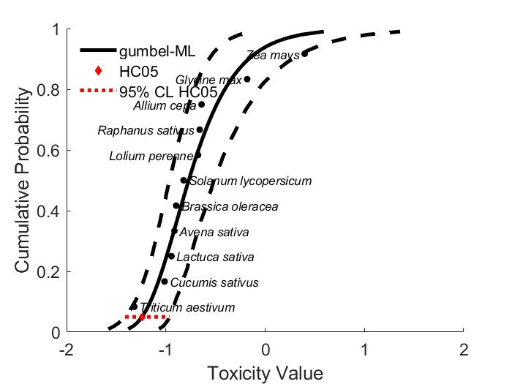
Figure 1. Log-gumbel SSD for propazine toxicity values for terrestrial plants at the vegetative vigor life stage. Black points indicate single toxicity values.

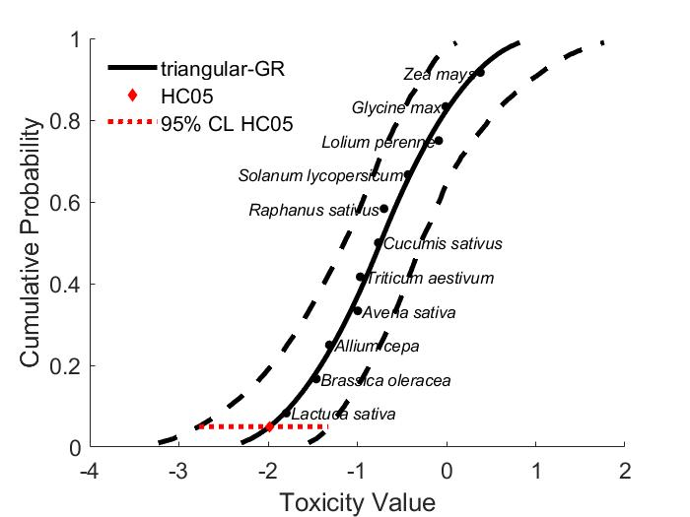
Figure 2. Log-triangular SSD for propazine toxicity values for terrestrial plants at the seedling emergence. Black points indicate single toxicity values.

Table 6. Range of HC₀₅ values for propazine SSDs for terrestrial plants at the vegetative vigor life stage.
Distribution | Method | HC₀₅ | SE | CV | Lower CI | Upper CI | P
Normal | ML | 0.0381 | 0.0227 | 0.5946 | 0.0161 | 0.1054 | 0.1169
Normal | MO | 0.0352 | 0.0212 | 0.6014 | 0.0137 | 0.0953 | 0.0829
Normal | GR | 0.0302 | 0.0168 | 0.5572 | 0.0067 | 0.0688 | 0.0410
Logistic | ML | 0.0378 | 0.0195 | 0.5170 | 0.0156 | 0.0907 | 0.3377
Logistic | MO | 0.0360 | 0.0242 | 0.6736 | 0.0106 | 0.0991 | 0.1319
Logistic | GR | 0.0267 | 0.0160 | 0.5988 | 0.0044 | 0.0662 | 0.0789
Triangular | ML | 0.0358 | 0.0254 | 0.7088 | 0.0200 | 0.1186 | 0.0729
Triangular | MO | 0.0341 | 0.0196 | 0.5761 | 0.0153 | 0.0947 | 0.0450
Triangular | GR | 0.0324 | 0.0166 | 0.5126 | 0.0110 | 0.0735 | 0.0380
Gumbel | ML | 0.0575 | 0.0178 | 0.3105 | 0.0381 | 0.1074 | 0.6513
Gumbel | MO | 0.0504 | 0.0201 | 0.3984 | 0.0245 | 0.0996 | 0.6074
Gumbel | GR | 0.0411 | 0.0179 | 0.4343 | 0.0128 | 0.0763 | 0.2348
Weibull | ML | 0.0094 | 0.0201 | 2.1456 | 0.0010 | 0.0739 | 0.0110
Weibull | GR | 0.0215 | 0.0199 | 0.9229 | 0.0015 | 0.0752 | 0.0140
Burr | ML | 0.058 | 0.0223 | 0.3880 | 0 | 0.1093 | 0.5674
ML=maximum likelihood
LCp and UCp=projections of the confidence limits of the HC₀₅ (LCx and UCx) onto the cumulative distribution function of the fitted distribution.

Table 7. Range of HC₀₅ values for propazine SSDs for terrestrial plants at the seedling emergence life stage.
Distribution | Method | HC₀₅ | SE | CV | Lower CI | Upper CI | P
Normal | ML | 0.0166 | 0.0198 | 1.1891 | 0.0052 | 0.0772 | 0.8961
Normal | MO | 0.0148 | 0.0172 | 1.1619 | 0.0035 | 0.0636 | 0.9341
Normal | GR | 0.0148 | 0.0172 | 1.1619 | 0.0035 | 0.0636 | 0.9840
Logistic | ML | 0.0138 | 0.0166 | 1.1983 | 0.0030 | 0.0620 | 0.8252
Logistic | MO | 0.8482 | 0.0172 | 1.1619 | 0.0035 | 0.0636 | 0.8482
Logistic | GR | 0.0079 | 0.0103 | 1.3057 | 0.0004 | 0.0369 | 0.9730
Triangular | ML | 0.0194 | 0.0201 | 1.0370 | 0.0099 | 0.0865 | 0.9500
Triangular | MO | 0.0141 | 0.0158 | 1.1217 | 0.0042 | 0.0548 | 0.9810
Triangular | GR | 0.0104 | 0.0126 | 1.2116 | 0.0017 | 0.0473 | 0.9830
Gumbel | ML | 0.0211 | 0.0142 | 0.6749 | 0.0098 | 0.0593 | 0.9351
Gumbel | MO | 0.0248 | 0.0155 | 0.6256 | 0.0101 | 0.0695 | 0.7183
Gumbel | GR | 0.0169 | 0.0112 | 0.6588 | 0.0031 | 0.0449 | 0.9600
Weibull | ML | 0.0062 | 0.0174 | 2.7975 | 0.0006 | 0.0613 | 0.6683
Weibull | GR | 0.0048 | 0.0099 | 2.0632 | 0.00006 | 0.0345 | 0.6134
Burr | ML | 0.0198 | 0.0182 | 0.9196 | 0 | 0.0682 | 0.9071
ML=maximum likelihood, MO= moment estimators, and GR=graphical methods
LCp and UCp=projections of the confidence limits of the HC₀₅ (LCx and UCx) onto the cumulative distribution function of the fitted distribution.

- Test for the need to model results separately by vegetative vigor and seedling emergence life stage

Examination of the cumulative distribution functions plotted on similar axes for vegetative vigor and seedling emergence studies does not support combining the datasets into one distribution. Although the 95% bootstrap confidence intervals for the separate distributions overlap substantially (Figure 5), the slopes of the response curves are appreciably different. Additionally, the distributions do not fit well at the endpoint of interest, the HC₀₅. Therefore, the vegetative vigor and seedling emergence distributions will be used separately.

Figure 5. SSDs for vegetative vibor IC₂₅s (Gumbel) and seedling emergence IC₂₅s (triangular) for propazine. Blue lines show the distribution and upper and lower confidence interval for species from vegetative vigor studies. Red lines show the distribution and upper and lower confidence interval for species from seedling emergence studies.

- Calculation of other quantiles

Tables 8 - 11 provides estimates of the HC₀₅ as well as other quantiles of the fitted SSDs.

Table 8. Estimated quantiles of the fitted SSDs for propazine IC₂₅s for terrestrial plants at the vegetative vigor life stage.
Distribution | Method | HC₀₅ | HC₁₀ | HC₅₀ | HC₉₀ | HC₉₅
Weibull | ML | 0.0094 | 0.0225 | 0.2247 | 0.9732 | 1.3419
Weibull | GR | 0.0215 | 0.0413 | 0.2268 | 0.6715 | 0.8520
Normal | ML | 0.0381 | 0.0551 | 0.2011 | 0.7320 | 1.0599
Normal | MO | 0.0352 | 0.0517 | 0.2011 | 0.7821 | 1.1495
Normal | GR | 0.0302 | 0.0459 | 0.2011 | 0.8813 | 1.3398
Logistic | ML | 0.0378 | 0.0557 | 0.1778 | 0.5448 | 0.8030
Logistic | MO | 0.0360 | 0.0557 | 0.2011 | 0.7261 | 1.1236
Logistic | GR | 0.0267 | 0.0446 | 0.2011 | 0.9067 | 1.5132
Triangular | ML | 0.0358 | 0.0511 | 0.2290 | 1.0271 | 1.4657
Triangular | MO | 0.0341 | 0.0479 | 0.2011 | 0.8446 | 1.1867
Triangular | GR | 0.0324 | 0.0459 | 0.2011 | 0.8805 | 1.2493
Gumbel | ML | 0.0575 | 0.698 | 0.1699 | 0.6851 | 1.1672
Gumbel | MO | 0.0504 | 0.0626 | 0.1689 | 0.8014 | 1.4528
Gumbel | GR | 0.0411 | 0.0534 | 0.1762 | 1.1464 | 2.3451
Burr | ML | 0.0575 | 0.070 | 0.170 | 0.685 | 1.166

Table 9. Estimated quantiles of the fitted SSDs for propazine IC₂₅s for terrestrial plants at the seedling emergence life stage.
Distribution | Method | HC₀₅ | HC₁₀ | HC₅₀ | HC₉₀ | HC₉₅
Normal | ML | 0.0166 | 0.0282 | 0.1818 | 1.1727 | 1.9892
Normal | MO | 0.0148 | 0.0257 | 0.1818 | 1.2844 | 2.2356
Normal | GR | 0.0077 | 0.0180 | 0.1818 | 1.8363 | 3.5371
Logistic | ML | 0.0138 | 0.0264 | 0.1762 | 1.1761 | 2.2429
Logistic | MO | 0.0153 | 0.0286 | 0.1818 | 1.1540 | 2.1635
Logistic | GR | 0.0079 | 0.0175 | 0.1818 | 1.8866 | 4.1804
Triangular | ML | 0.0194 | 0.0297 | 0.1812 | 1.1040 | 1.6941
Triangular | MO | 0.0141 | 0.0230 | 0.1818 | 1.4346 | 2.3404
Triangular | GR | 0.0104 | 0.0179 | 0.1818 | 1.8418 | 3.1881
Gumbel | ML | 0.0211 | 0.0298 | 0.1437 | 1.6997 | 4.6547
Gumbel | MO | 0.0248 | 0.0339 | 0.1415 | 1.3303 | 3.1316
Gumbel | GR | 0.0169 | 0.0250 | 0.1492 | 2.4549 | 7.1581
Weibull | ML | 0.0062 | 0.0168 | 0.2282 | 1.2008 | 1.7281
Weibull | GR | 0.0048 | 0.0139 | 0.2211 | 1.2923 | 1.9030
Burr | ML | 0.0198 | 0.0303 | 0.1556 | 1.4342 | 3.2567

Table 10 provides all of the available IC₂₅ values for vegetative vigor and seedling emergence studies. These data sets are the same as reported in the effects characterization and provide additional data for the formulated products. Values that were included in the SSD (i.e., TGAI) are marked with an *.

Table 11. Available effective inhibition concentration (IC₂₅) data for terrestrial plants exposed to propazine.
 | Vegetative vigor |  |  | Seedling Emergence
Species | Toxicity value | Replicates | ECDF* | Toxicity value | Replicates | ECDF*
Zea mays | 2.5 | 1 | 0.9167 | 2.4 | 1 | 0.9167
Glycine max | 0.66 | 1 | 0.8333 | 0.979 | 1 | 0.8333
Allium cepa | 0.229 | 1 | 0.75 | 0.818 | 1 | 0.7500
Raphanus sativus | 0.219 | 1 | 0.6667 | 0.370 | 1 | 0.6667
Lolium perenne | 0.211 | 1 | 0.5833 | 0.199 | 1 | 0.5833
Solanum lycopersicum | 0.151 | 1 | 0.5000 | 0.172 | 1 | 0.5000
Brassica oleracea | 0.127 | 1 | 0.4167 | 0.108 | 1 | 0.4167
Avena sativa | 0.122 | 1 | 0.3333 | 0.101 | 1 | 0.3333
Lactuca sativa | 0.114 | 1 | 0.25 | 0.049 | 1 | 0.2500
Cucumis sativus | 0.097 | 1 | 0.1667 | 0.035 | 1 | 0.1667
Triticum aestivum | 0.0481 | 1 | 0.0833 | 0.016 | 1 | 0.0833
*Empirical Cumulative Distribution Function

