APPENDIX 2-3. Open Literature Review Summaries for Propazine

Open Literature Review Summary

ECOTOX Record Number and Citation: E178499
Saka M; Tada N; Kamata Y. 2018. Chronic Toxicity of 1,3,5-Triazine Herbicides in the Postembryonic Development of the Western Clawed Frog Silurana tropicalis Ecotoxicol. Environ. Saf. 147: 373-381

Purpose of Review: ESA Biological Evaluation (atrazine, simazine and propazine)

Date of Review: 07/13/2020

Summary of Methodology/Study Findings:

Saka et al. (2018) exposed amphibian tadpoles (Silurana tropicalis) to seven 1,3,5- triazine (s-triazine) herbicides (ametryn, prometryn, dimethametryn, simazine, atrazine, propazine, and cyanazine). tadpoles were exposed to each s-triazine at 2 concentrations between 1/1000 and 1/10 of the 96-h acute toxicity values, until all tadpoles in the control group reached either the late prometamorphic stages or the initial stage of metamorphic climax. LC50 values were determined in the acute phase of the test and chronic toxicity tests focused on morphometric, gravimetric, and thyroid-histological endpoints.

Acute toxicity testing
96-h acute toxicity tests were performed following the test protocol (semi-static regime with water renewal at 24-h intervals). Each test consisted of a control and 5–7 test concentrations in a geometric series with a factor of 101/4 within the following range: 1.00–10.0, 2.60–26.0, 0.520–5.20, for simazine, atrazine and propazine, respectively. Each group was comprised of 10 tadpoles that were placed individually into a glass beaker with 100 mL of the test solution. During the test, the tadpoles were kept
at 25±1 °C under a consistent photoperiod (12-h light/12-h dark) without feeding or additional aeration.

Acute toxicity results are shown in Table 1 below. Results indicated 96-hr LC₅₀ values of 9.62 mg/L for atrazine, 7.55 mg/L for simazine and >5.2 mg/L for propazine. These results were used to determine the range of concentrations to use in the chronic toxicity tests.

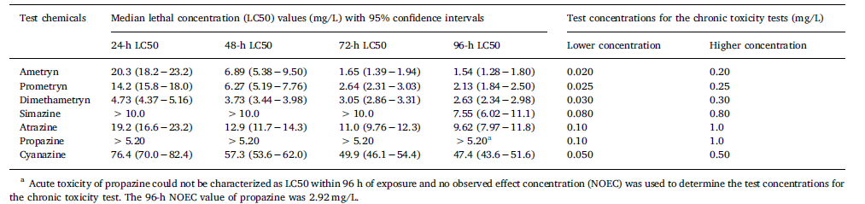

Chronic toxicity testing

During the chronic toxicity tests, tadpoles (Silurana tropicalis) were exposed to 2 concentrations equivalent to approximately 1/100 and 1/10 of the LC₅₀ (atrazine: 100 and 1000 ug/L, simazine: 80 and 800 ug/L, propazine: 100 and 1000 ug/L). In the higher test concentration groups for atrazine and propazine, mortality was noted. Measured test concentrations were in the following ranges for low and high test values for each chemical: 78.9–86.1 ug/L and 804 – 857 ug/L (simazine), 101-108 ug/L and 996 – 1,050 ug/L (atrazine), 99.4 - 104 ug/L and 983 - 1090 ug/L (propazine), Mortality at test termination was 26.7% (8/30) for atrazine and 46.7% (14/30) for propazine. Statistically significant developmental effects were noted in atrazine and propazine in both test concentration groups and in simazine for the higher test concentration group only. Developmental changes included delay in developmental stage reached, hind limb length, ratio of hindlimb length to body length and thyroid gland size. A significant decrease in total body length and body mass were noted at the highest test concentration in all 3 chemicals and significant increase in the degree of scoliosis present in atrazine and simazine.

Description of Use in Document: Quantitative for inclusion in data arrays and consideration as potential threshold values for risk estimation

Rationale for Use: Study provides useful information on the sensitivity of aquatic-phase amphibians to atrazine, simazine and propazine. The LD50/NOAEL/LOAEL/MATC values from this study may serve as a source of threshold values for direct and indirect effects.

Limitations of Study: No raw data was presented. Data on metamorphosis changes were presented graphically and in text (mean and SD shown in graphs; no tabulated data presented).

Primary Reviewer: Colleen M. Rossmeisl, DVM, Senior Biologist, OPP/EFED/ERB3

Secondary Reviewer: Elizabeth Donovan, Senior Biologist, OPP/EFED/ERB3

