APPENDIX 4-5. Analysis of Non-Spray Uses of Thiamethoxam

Contents
1. Baits and Gels 1
2. Granular Formulations 1
3. Seed Treatments 2
4. Soil Applications and Treated Poultry Litter 34

Thiamethoxam applications may be made via a variety of methods including aerial and ground foliar sprays, soil treatment (e.g., drench), and chemigation (e.g., soil incorporation or foliar). Non-flowable (non-spray) applications of thiamethoxam may be applied as bait, granule, and seed treatment. The methods developed for analyzing terrestrial exposures in this BE focus primarily on flowable uses; however, since thiamethoxam is also applied as some non-flowable formulations, additional characterization of these uses is provided in this appendix.

Baits and Gels

Thiamethoxam is registered for use as a fly bait and ant gel. Outdoor uses of fly baits are contained in bait stations that are placed in locations that are “not accessible to wildlife” (label for registration 70585-9). Outdoor uses of ant gels are applied at points of entry into structures (e.g., eaves, where pipes and wires enter structures) or in bait stations. Labels also indicate that gels should not be placed in direct sunlight, extreme temperatures or areas where it will get wet. Based on the use of bait stations for the bait and gels and the outdoor uses of gels that are close to structures and removed from the elements, it is assumed that these formulations represent de minimus exposure to non-target organisms, including listed species and those they depend upon for Prey, Pollination, Habitat and/or Dispersal (PPHD).

Granular Formulations

Thiamethoxam has some granular formulations that are registered on a variety of uses, including: Christmas trees, turf, outdoor nurseries, golf courses and playgrounds. Once the granules are applied, they are watered in either through irrigation or rainfall. Therefore, these uses were simulated as soil treatments and aquatic exposure was estimated using PWC. For terrestrial wildlife, there is potential for exposure through consumption of granules between the application of the granules and the time they are watered in.

For granular formulations and exposures to birds, the T-REX model is used to estimate the LD₅₀/ft². Conceptually, an LD₅₀/ft² is the amount of a pesticide estimated to kill 50% of exposed animals in each square foot of applied area. Although a square foot does not have defined ecological relevance, and any unit area could be used, risk presumably increases as the LD₅₀/ft² value increases. The LD₅₀/ft² value is calculated using a toxicity value (adjusted LD₅₀) and the EEC (mg a.i./ft²) and is directly compared with the Agency’s levels-of-concern (LOCs) for acute exposures. In the thiamethoxam draft risk assessment for registration review (USEPA 2017), a scenario resulting in the highest exposure (a broadcast application to a level field with no incorporation or consideration of existing furrows) was modeled using a single maximum application rate of 0.265 lb a.i./A, which is consistent with the highest application rate to soil. EFED’s risk assessment concluded that there were mortality risks to small birds (20 g) from consumption of granules and that risks were low for medium (100 g) and large (1000 g) birds. Risks were also low for mammals from consumption of granules. For all listed species of small birds (~20 g), LAA determinations are already made due to potential exposure to other formulations of thiamethoxam. Therefore, exposure to listed birds from granules is not expected to impact effects determinations; however potential exposure to granules may serve as an additional line of evidence supporting that LAA determination. It should be noted that this analysis assumes that 100% of the bait is available to be consumed. If bait is incorporated, exposure potential and associated risks would be lower.

For terrestrial invertebrates, the primary routes of exposure from the bait uses of thiamethoxam are assumed to be via ingestion or contact with bait. This approach is consistent with EFED’s risk assessment method for bees. Therefore, for terrestrial invertebrates, the estimated exposures from the flowable uses will be used to evaluate exposures from the bait uses where possible.

Seed Treatments

Because exposures related to seed treatment uses are readily modeled using current aquatic modeling approaches, these types of uses are incorporated into the aquatic exposure analysis used to help make effects determinations for listed aquatic species (and those that rely on aquatic species). As demonstrated in Chapter 3 and APPENDIX 3-1, aquatic EECs for foliar and soil treatment (flowable uses) are orders of magnitude greater than aquatic EECs from seed treatments. Therefore, exposures and associated risks from flowable uses are assumed to be protective of seed treatment uses.

In regard to seed treatments, thiamethoxam exposure to non-target organisms may also include contact with abraded seed coat dust during planting (e.g., Tapparro et al. 2012, Krupke et al. 2012). This pathway has been associated with numerous thiamethoxam incidents involving mortality to foraging honey bees. The extent to which honey bees are exposed via contact with abraded seed coat dust is influenced by many factors including the physio-chemical properties of the seed coating, seed planting equipment, use of seed lubrication agents (e.g., talc), environmental conditions (wind speed, humidity), and hive location in relation to sowing and prevailing winds. Off-site drift of contaminated seed coat dust can contribute to residues on plants, soil, and surface water to which bees may be exposed through direct contact and ingestion of surface water, pollen, and nectar. Although exposure and effects to bees via exposure to abraded seed coat dust has been documented, these data are highly variable and methods are not currently available to provide reliable estimates for this route of exposure. Therefore, this exposure route was not quantitatively considered in this assessment. Exposure of bees and other non-target insects to thiamethoxam via drift of abraded seed coat dust is considered a route of concern, given that bee kill incidents have been associated with planting of thiamethoxam-treated corn. The Agency continues to work with stakeholders to mitigate the potential for adverse effects on bees from this exposure pathway through best management practices and the development of alternative technologies to reduce dust off during planting (e.g., alternative lubricants, equipment modifications, etc.). Reductions in seed dust off will also limit exposures of other non-target insects to thiamethoxam through this route.

In this BE, risks are identified for terrestrial vertebrate species through consumption of plant matter (e.g., leaves) that have been sprayed with thiamethoxam. Residues on sprayed seeds may underpredict exposures to birds and mammals that directly consume treated seeds. In the 2017 ecological risk assessment for the registration review of thiamethoxam, EPA concluded that there were risks to birds from seed treatments, with some exceptions based on bird and seed sizes. For mammals, chronic risks were identified for small, medium and large animals for all modeled seed types, except soybeans. For all terrestrial vertebrates (birds, amphibians, reptiles and mammals) that consume seeds, potential exposure and risk from treated seeds was assessed. For those species where a LAA determination was made based on the quantitative analysis using the MAGtool and spray uses, potential exposure to treated seeds would serve as an additional line of evidence supporting that LAA determination (due to increased potential for exposure from foliar and seed treatments). In the individual effects determination output sheets from the MAGtool (APPENDIX 4-9), if a terrestrial animal range or critical habitat has overlap with a use site with foliar applications where seed uses are also permitted, it is specified that this use should be given additional consideration by the assessor by referring to this appendix. At the time of this BE, reliable usage information for seed treatment was not available. For this reason, the upper and lower limits used when applying usage information, 100% and 2.5% PCT respectively, were considered when conducting the additional review of the species. An exploratory spatial analysis, discussed in the next section, was conducted to determine where usage information would be most valuable for thiamethoxam.

In Tables 2 and 3 below, the percent overlap of range of all seed-eating birds and mammals with each UDL associated with seed treatment is provided and can be used for further characterization of potential additional risks for these species. Table 2 displays overlap without any adjustment for usage, or 100% PCT. Table 3 displays overlap with the lower limit of usage, 2.5% PCT assumed on the crops. The PCT value of 2.5% was selected because it is the lowest usage value ever applied, buffering against uncertainty associated with these surveys and low usage estimates. These two overlaps are used as upper and lower limits in this analysis.

For those species where NLAA determinations were preliminarily made using the MAGtool, indicating that no other uses are expected to impact greater than 1 individual, these determinations were reconsidered for possible impacts due to overlap with use sites that are associated with seed treatment. Preliminary NLAA determinations were made for 3 species of birds and 6 species of mammals (Table 1). For all 3 birds and 2 mammals, there was no overlap or low overlap of the agricultural landcover and the species range. Therefore, it is assumed that those 3 species of birds and 2 species of mammals are unlikely to be exposed to thiamethoxam via consumption of treated seeds and the determinations remained at NLAA. For the remaining 4 species of mammals, there was some overlap of the species’ ranges and the UDLs as shown below in Tables 2 and 3. For the 100% usage assumption, all of these species have overlap with the UDLs, but at the 2.5% usage assumption, 3 of the 4 species show a significant drop in overlap at the lower limit. When considering the weight of evidence species data gathered for the MAGtool analysis (APPENDIX 4-2), none of these species could be precluded from being on treated fields (so they could possibly consume treated seeds after they are applied). Therefore, the determinations are changed to LAA based on chronic risks identified previously (USEPA 2017) for seed-eating mammals and potential for exposure, but with the weakest evidence of LAA. Evaluation of range data for the Carolina northern flying squirrel and Florida salt marsh vole was given a yellow classification, meaning that on review, discrepancies were noted between the Service documentation and the range maps used in the analysis. For these two species, there is uncertainty in the likelihood that agricultural areas will overlap with where the species is actually located.

Table 1. Seed-eating birds and mammals with preliminary NLAA determinations based on MAGtool runs for spray applications of thiamethoxam.
Taxon | Entity ID | Scientific name | Common name | Final determination | Strength of Call
Birds | 73 | Branta (=Nesochen) sandvicensis | Hawaiian Goose | NLAA | NA
 | 80 | Amazona vittata | Puerto Rican parrot | NLAA | NA
 | 101 | Columba inornata wetmorei | Puerto Rican plain pigeon | NLAA | NA
Mammals | 28 | Microtus californicus scirpensis | Amargosa Vole | LAA | Weakest evidence of LAA
 | 42 | Glaucomys sabrinus coloratus | Carolina Northern Flying Squirrel | LAA | Weakest evidence of LAA
 | 43 | Tamiasciurus hudsonicus grahamensis | Mount Graham Red Squirrel | NLAA | NA
 | 59 | Spermophilus brunneus brunneus | Northern Idaho Ground Squirrel | NLAA | NA
 | 60 | Microtus pennsylvanicus dukecampbelli | Florida Salt Marsh Vole | LAA | Weakest evidence of LAA
 | 62 | Neotoma fuscipes riparia | Riparian Woodrat | LAA | Weakest evidence of LAA
NA = not applicable

Table 2. Seed-eating birds and mammals percent overlap with seed treatment use layers of thiamethoxam with no usage data incorporated, 100% PCT assumption. Blue species denotes those evaluated for preliminary NLAA call.
Taxa | Entity ID | Common Name | Scientific Name | CONUS_  Cotton | CONUS_  Other Crops | CONUS_  Other Grains | CONUS_  Other Row Crops | CONUS_  Soybeans | CONUS_  Vegetables and ground fruit | CONUS_  Corn | CONUS_  Rice | CONUS_  Wheat | CONUS_  Alfalfa
Birds | 69 | Hawaiian (=koloa) Duck | Anas wyvilliana | 0.00 | 0.00 | 0.00 | 0.00 | 0.00 | 0.00 | 0.00 | 0.00 | 0.00 | 0.00
Birds | 73 | Hawaiian goose | Branta (=Nesochen) sandvicensis | 0.00 | 0.00 | 0.00 | 0.00 | 0.00 | 0.00 | 0.00 | 0.00 | 0.00 | 0.00
Birds | 101 | Puerto Rican plain Pigeon | Columba inornata wetmorei | 0.00 | 0.00 | 0.00 | 0.00 | 0.00 | 0.00 | 0.00 | 0.00 | 0.00 | 0.00
Birds | 5170 | Friendly Ground-Dove | Gallicolumba stairi | 0.00 | 0.00 | 0.00 | 0.00 | 0.00 | 0.00 | 0.00 | 0.00 | 0.00 | 0.00
Birds | 6901 | Yellow-billed Cuckoo | Coccyzus americanus | 0.18 | 2.38 | 0.61 | 0.09 | 0.00 | 0.94 | 0.45 | 0.12 | 2.20 | 1.49
Birds | 87 | Micronesian megapode | Megapodius laperouse | 0.00 | 0.00 | 0.00 | 0.00 | 0.00 | 0.00 | 0.00 | 0.00 | 0.00 | 0.00
Birds | 89 | Masked bobwhite (quail) | Colinus virginianus ridgwayi | 0.01 | 0.01 | 0.00 | 0.00 | 0.00 | 0.00 | 0.00 | 0.00 | 0.00 | 0.00
Birds | 67 | Whooping crane | Grus americana | 3.06 | 6.63 | 9.54 | 2.15 | 12.52 | 2.61 | 14.29 | 0.13 | 19.96 | 2.29
Birds | 76 | Hawaiian common gallinule | Gallinula galeata sandvicensis | 0.00 | 0.00 | 0.00 | 0.00 | 0.00 | 0.00 | 0.00 | 0.00 | 0.00 | 0.00
Birds | 110 | Mississippi sandhill crane | Grus canadensis pulla | 0.45 | 0.65 | 0.00 | 0.53 | 0.18 | 0.06 | 0.08 | 0.00 | 0.07 | 0.00
Birds | 121 | Guam rail | Rallus owstoni | 0.00 | 0.00 | 0.00 | 0.00 | 0.00 | 0.00 | 0.00 | 0.00 | 0.00 | 0.00
Birds | 4679 | Whooping crane | Grus americana | 2.00 | 8.97 | 7.64 | 0.35 | 1.09 | 0.29 | 3.79 | 0.61 | 15.92 | 1.42
Birds | 4889 | Guam rail | Rallus owstoni | 0.00 | 0.00 | 0.00 | 0.00 | 0.00 | 0.00 | 0.00 | 0.00 | 0.00 | 0.00
Birds | 7342 | Whooping crane | Grus americana | 0.74 | 5.39 | 2.46 | 0.02 | 14.14 | 0.88 | 14.38 | 2.03 | 2.72 | 4.87
Birds | 10124 | Whooping crane | Grus americana | 1.19 | 7.68 | 3.01 | 0.01 | 9.53 | 0.07 | 4.01 | 3.26 | 1.32 | 0.01
Birds | 79 | Palila (honeycreeper) | Loxioides bailleui | 0.00 | 0.00 | 0.00 | 0.00 | 0.00 | 0.00 | 0.00 | 0.00 | 0.00 | 0.00
Birds | 85 | Cape Sable seaside sparrow | Ammodramus maritimus mirabilis | 0.00 | 0.95 | 0.38 | 0.00 | 0.00 | 1.18 | 0.00 | 0.00 | 0.00 | 0.00
Birds | 116 | San Clemente sage sparrow | Amphispiza belli clementeae | 0.00 | 0.06 | 0.00 | 0.00 | 0.00 | 0.00 | 0.00 | 0.00 | 0.00 | 0.02
Birds | 117 | Yellow-shouldered blackbird | Agelaius xanthomus | 0.00 | 0.00 | 0.00 | 0.00 | 0.00 | 0.00 | 0.00 | 0.00 | 0.00 | 0.00
Birds | 118 | Mariana (=aga) Crow | Corvus kubaryi | 0.00 | 0.00 | 0.00 | 0.00 | 0.00 | 0.00 | 0.00 | 0.00 | 0.00 | 0.00
Birds | 133 | Florida grasshopper sparrow | Ammodramus savannarum floridanus | 0.00 | 1.73 | 2.45 | 0.02 | 0.00 | 0.90 | 0.03 | 0.03 | 0.00 | 0.00
Birds | 137 | Inyo California towhee | Pipilo crissalis eremophilus | 0.00 | 0.09 | 0.01 | 0.00 | 0.00 | 0.00 | 0.01 | 0.00 | 0.00 | 0.16
Birds | 140 | Florida scrub-jay | Aphelocoma coerulescens | 0.01 | 2.25 | 3.41 | 0.36 | 0.00 | 0.90 | 0.13 | 0.32 | 0.00 | 0.00
Birds | 145 | Coastal California gnatcatcher | Polioptila californica californica | 0.00 | 0.83 | 0.25 | 0.01 | 0.00 | 0.16 | 0.01 | 0.00 | 1.17 | 0.21
Birds | 1241 | Rota bridled White-eye | Zosterops rotensis | 0.00 | 0.00 | 0.00 | 0.00 | 0.00 | 0.00 | 0.00 | 0.00 | 0.00 | 0.00
Birds | 4296 | Streaked Horned lark | Eremophila alpestris strigata | 0.00 | 5.57 | 0.55 | 0.23 | 0.00 | 2.41 | 1.08 | 0.00 | 1.38 | 0.16
Birds | 107 | Red-cockaded woodpecker | Picoides borealis | 2.64 | 3.64 | 1.26 | 1.73 | 4.99 | 0.61 | 3.61 | 0.35 | 2.20 | 0.00
Birds | 80 | Puerto Rican parrot | Amazona vittata | 0.00 | 0.00 | 0.00 | 0.00 | 0.00 | 0.00 | 0.00 | 0.00 | 0.00 | 0.00
Birds | 11319 | Eastern Black rail | Laterallus jamaicensis ssp. jamaicensis | 1.68 | 3.96 | 3.03 | 0.69 | 13.09 | 0.62 | 14.39 | 0.24 | 6.71 | 1.70
Birds | 68 | Hawaiian (='alala) Crow | Corvus hawaiiensis | 0.00 | 0.00 | 0.00 | 0.00 | 0.00 | 0.00 | 0.00 | 0.00 | 0.00 | 0.00
Mammals | 16 | Morro Bay kangaroo rat | Dipodomys heermanni morroensis | 0.00 | 4.42 | 4.09 | 0.02 | 0.00 | 0.84 | 0.02 | 0.00 | 0.08 | 0.05
Mammals | 17 | Salt marsh harvest mouse | Reithrodontomys raviventris | 0.00 | 2.42 | 3.98 | 0.01 | 0.00 | 0.20 | 0.09 | 0.03 | 2.09 | 0.22
Mammals | 2 | Grizzly bear | Ursus arctos horribilis | 0.00 | 4.29 | 3.14 | 0.04 | 0.00 | 1.31 | 0.06 | 0.00 | 5.15 | 2.27
Mammals | 1302 | Grizzly bear | Ursus arctos horribilis | 0.00 | 0.87 | 0.62 | 0.00 | 0.00 | 0.27 | 0.00 | 0.00 | 1.25 | 0.45
Mammals | 20 | Utah prairie dog | Cynomys parvidens | 0.00 | 0.32 | 0.29 | 0.00 | 0.00 | 0.00 | 0.43 | 0.00 | 0.05 | 2.26
Mammals | 28 | Amargosa vole | Microtus californicus scirpensis | 1.69 | 7.96 | 2.78 | 0.52 | 0.00 | 2.64 | 2.34 | 1.73 | 4.48 | 3.24
Mammals | 32 | Key Largo woodrat | Neotoma floridana smalli | 0.00 | 0.01 | 0.01 | 0.00 | 0.00 | 0.01 | 0.00 | 0.00 | 0.00 | 0.00
Mammals | 34 | Choctawhatchee beach mouse | Peromyscus polionotus allophrys | 0.01 | 0.03 | 0.02 | 0.05 | 0.03 | 0.00 | 0.01 | 0.00 | 0.01 | 0.00
Mammals | 35 | Perdido Key beach mouse | Peromyscus polionotus trissyllepsis | 0.80 | 2.07 | 0.23 | 1.22 | 1.93 | 0.03 | 1.38 | 0.00 | 0.52 | 0.00
Mammals | 37 | Fresno kangaroo rat | Dipodomys nitratoides exilis | 8.30 | 19.03 | 7.73 | 0.02 | 0.00 | 10.43 | 9.42 | 0.22 | 17.37 | 13.10
Mammals | 38 | Giant kangaroo rat | Dipodomys ingens | 5.06 | 20.18 | 5.17 | 0.00 | 0.00 | 6.54 | 1.40 | 0.05 | 7.20 | 3.57
Mammals | 39 | Stephens' kangaroo rat | Dipodomys stephensi (incl. D. cascus) | 0.00 | 3.53 | 0.98 | 0.00 | 0.00 | 0.05 | 0.00 | 0.00 | 5.36 | 0.61
Mammals | 40 | Tipton kangaroo rat | Dipodomys nitratoides nitratoides | 9.62 | 27.78 | 10.65 | 0.04 | 0.00 | 7.20 | 10.32 | 0.00 | 18.55 | 11.53
Mammals | 41 | Alabama beach mouse | Peromyscus polionotus ammobates | 0.54 | 1.54 | 0.17 | 0.81 | 1.35 | 0.03 | 0.96 | 0.00 | 0.34 | 0.00
Mammals | 42 | Carolina northern flying squirrel | Glaucomys sabrinus coloratus | 0.00 | 0.55 | 0.06 | 0.02 | 0.56 | 0.19 | 1.16 | 0.00 | 0.21 | 0.03
Mammals | 43 | Mount Graham red squirrel | Tamiasciurus hudsonicus grahamensis | 0.03 | 0.37 | 0.23 | 0.00 | 0.00 | 0.00 | 0.22 | 0.00 | 0.11 | 0.12
Mammals | 50 | Anastasia Island beach mouse | Peromyscus polionotus phasma | 0.00 | 3.00 | 0.29 | 0.09 | 0.00 | 4.13 | 1.21 | 0.00 | 0.00 | 0.00
Mammals | 51 | Pacific pocket mouse | Perognathus longimembris pacificus | 0.00 | 0.05 | 0.00 | 0.00 | 0.00 | 0.00 | 0.00 | 0.00 | 0.00 | 0.01
Mammals | 52 | Preble's meadow jumping mouse | Zapus hudsonius preblei | 0.00 | 4.26 | 1.25 | 0.38 | 0.01 | 0.39 | 1.89 | 0.00 | 4.29 | 2.79
Mammals | 53 | Southeastern beach mouse | Peromyscus polionotus niveiventris | 0.00 | 5.65 | 11.01 | 0.01 | 0.00 | 1.31 | 0.29 | 1.42 | 0.00 | 0.00
Mammals | 59 | Northern Idaho Ground Squirrel | Urocitellus brunneus | 0.00 | 0.08 | 0.05 | 0.00 | 0.00 | 0.02 | 0.01 | 0.00 | 0.01 | 0.60
Mammals | 60 | Florida salt marsh vole | Microtus pennsylvanicus dukecampbelli | 0.16 | 5.37 | 1.50 | 6.46 | 0.06 | 0.26 | 1.13 | 0.00 | 0.00 | 0.00
Mammals | 62 | Riparian woodrat (=San Joaquin Valley) | Neotoma fuscipes riparia | 0.21 | 13.45 | 30.19 | 0.14 | 0.00 | 13.97 | 23.16 | 0.26 | 19.64 | 31.74
Mammals | 63 | San Bernardino Merriam's kangaroo rat | Dipodomys merriami parvus | 0.00 | 1.93 | 0.59 | 0.00 | 0.00 | 0.03 | 0.00 | 0.00 | 3.08 | 0.39
Mammals | 4228 | Penasco least chipmunk | Tamias minimus atristriatus | 0.00 | 0.07 | 0.00 | 0.00 | 0.00 | 0.00 | 0.00 | 0.00 | 0.00 | 0.04
Mammals | 5210 | New Mexico meadow jumping mouse | Zapus hudsonius luteus | 0.00 | 0.51 | 0.20 | 0.00 | 0.00 | 0.13 | 0.09 | 0.00 | 0.21 | 1.15
Mammals | 10078 | Pacific Marten, Coastal Distinct Population Segment | Martes caurina | 0.00 | 0.90 | 0.93 | 0.00 | 0.00 | 0.37 | 0.02 | 0.00 | 0.68 | 2.29

Table 3. Seed-eating birds and mammals percent overlap with seed treatment use layers of thiamethoxam and lower limit usage value of 2.5%. Blue species denotes those evaluated for preliminary NLAA call.
Taxa | Entity ID | Common Name | Scientific Name | CONUS_  Cotton | CONUS_  Other Crops | CONUS_  Other Grains | CONUS_  Other Row Crops | CONUS_  Soybeans | CONUS_  Vegetables and ground fruit | CONUS_  Corn | CONUS_  Rice | CONUS_  Wheat | CONUS_  Alfalfa
Birds | 69 | Hawaiian (=koloa) Duck | Anas wyvilliana | 0.00 | 0.00 | 0.00 | 0.00 | 0.00 | 0.00 | 0.00 | 0.00 | 0.00 | 0.00
Birds | 73 | Hawaiian goose | Branta (=Nesochen) sandvicensis | 0.00 | 0.00 | 0.00 | 0.00 | 0.00 | 0.00 | 0.00 | 0.00 | 0.00 | 0.00
Birds | 101 | Puerto Rican plain Pigeon | Columba inornata wetmorei | 0.00 | 0.00 | 0.00 | 0.00 | 0.00 | 0.00 | 0.00 | 0.00 | 0.00 | 0.00
Birds | 5170 | Friendly Ground-Dove | Gallicolumba stairi | 0.00 | 0.00 | 0.00 | 0.00 | 0.00 | 0.00 | 0.00 | 0.00 | 0.00 | 0.00
Birds | 6901 | Yellow-billed Cuckoo | Coccyzus americanus | 0.03 | 0.02 | 0.07 | 0.01 | 0.00 | 0.05 | 0.04 | 0.01 | 0.14 | 0.11
Birds | 87 | Micronesian megapode | Megapodius laperouse | 0.00 | 0.00 | 0.00 | 0.00 | 0.00 | 0.00 | 0.00 | 0.00 | 0.00 | 0.00
Birds | 89 | Masked bobwhite (quail) | Colinus virginianus ridgwayi | 0.01 | 0.01 | 0.00 | 0.00 | 0.00 | 0.00 | 0.00 | 0.00 | 0.00 | 0.00
Birds | 67 | Whooping crane | Grus americana | 0.10 | 0.08 | 0.25 | 0.06 | 0.42 | 0.08 | 0.49 | 0.00 | 0.67 | 0.10
Birds | 76 | Hawaiian common gallinule | Gallinula galeata sandvicensis | 0.00 | 0.00 | 0.00 | 0.00 | 0.00 | 0.00 | 0.00 | 0.00 | 0.00 | 0.00
Birds | 110 | Mississippi sandhill crane | Grus canadensis pulla | 0.45 | 0.00 | 0.00 | 0.52 | 0.18 | 0.06 | 0.08 | 0.00 | 0.00 | 0.00
Birds | 121 | Guam rail | Rallus owstoni | 0.00 | 0.00 | 0.00 | 0.00 | 0.00 | 0.00 | 0.00 | 0.00 | 0.00 | 0.00
Birds | 4679 | Whooping crane | Grus americana | 0.46 | 0.09 | 0.54 | 0.02 | 0.06 | 0.03 | 0.37 | 0.02 | 0.70 | 0.10
Birds | 4889 | Guam rail | Rallus owstoni | 0.00 | 0.00 | 0.00 | 0.00 | 0.00 | 0.00 | 0.00 | 0.00 | 0.00 | 0.00
Birds | 7342 | Whooping crane | Grus americana | 0.02 | 0.00 | 0.05 | 0.00 | 0.64 | 0.08 | 0.73 | 0.05 | 0.18 | 0.28
Birds | 10124 | Whooping crane | Grus americana | 0.03 | 0.00 | 0.00 | 0.00 | 0.24 | 0.00 | 0.10 | 0.08 | 0.03 | 0.00
Birds | 79 | Palila (honeycreeper) | Loxioides bailleui | 0.00 | 0.00 | 0.00 | 0.00 | 0.00 | 0.00 | 0.00 | 0.00 | 0.00 | 0.00
Birds | 85 | Cape Sable seaside sparrow | Ammodramus maritimus mirabilis | 0.00 | 0.00 | 0.00 | 0.00 | 0.00 | 0.00 | 0.00 | 0.00 | 0.00 | 0.00
Birds | 116 | San Clemente sage sparrow | Amphispiza belli clementeae | 0.00 | 0.05 | 0.00 | 0.00 | 0.00 | 0.00 | 0.00 | 0.00 | 0.00 | 0.02
Birds | 117 | Yellow-shouldered blackbird | Agelaius xanthomus | 0.00 | 0.00 | 0.00 | 0.00 | 0.00 | 0.00 | 0.00 | 0.00 | 0.00 | 0.00
Birds | 118 | Mariana (=aga) Crow | Corvus kubaryi | 0.00 | 0.00 | 0.00 | 0.00 | 0.00 | 0.00 | 0.00 | 0.00 | 0.00 | 0.00
Birds | 133 | Florida grasshopper sparrow | Ammodramus savannarum floridanus | 0.00 | 0.00 | 0.00 | 0.01 | 0.00 | 0.06 | 0.02 | 0.02 | 0.00 | 0.00
Birds | 137 | Inyo California towhee | Pipilo crissalis eremophilus | 0.00 | 0.00 | 0.00 | 0.00 | 0.00 | 0.00 | 0.00 | 0.00 | 0.00 | 0.16
Birds | 140 | Florida scrub-jay | Aphelocoma coerulescens | 0.01 | 0.00 | 0.00 | 0.06 | 0.00 | 0.02 | 0.02 | 0.01 | 0.00 | 0.00
Birds | 145 | Coastal California gnatcatcher | Polioptila californica californica | 0.00 | 0.01 | 0.21 | 0.00 | 0.00 | 0.16 | 0.01 | 0.00 | 1.07 | 0.21
Birds | 1241 | Rota bridled White-eye | Zosterops rotensis | 0.00 | 0.00 | 0.00 | 0.00 | 0.00 | 0.00 | 0.00 | 0.00 | 0.00 | 0.00
Birds | 4296 | Streaked Horned lark | Eremophila alpestris strigata | 0.00 | 0.02 | 0.13 | 0.01 | 0.00 | 0.35 | 0.14 | 0.00 | 0.45 | 0.16
Birds | 107 | Red-cockaded woodpecker | Picoides borealis | 0.15 | 0.01 | 0.04 | 0.08 | 0.31 | 0.01 | 0.24 | 0.04 | 0.12 | 0.00
Birds | 80 | Puerto Rican parrot | Amazona vittata | 0.00 | 0.00 | 0.00 | 0.00 | 0.00 | 0.00 | 0.00 | 0.00 | 0.00 | 0.00
Birds | 11319 | Eastern Black rail | Laterallus jamaicensis ssp. jamaicensis | 0.00 | 0.47 | 0.35 | 0.01 | 0.00 | 0.40 | 0.04 | 0.00 | 0.98 | 0.58
Birds | 68 | Hawaiian (='alala) Crow | Corvus hawaiiensis | 0.00 | 0.00 | 0.33 | 0.00 | 0.00 | 0.27 | 0.00 | 0.00 | 0.52 | 0.44
Mammals | 2 | Grizzly bear | Ursus arctos horribilis | 0.00 | 0.00 | 4.09 | 0.02 | 0.00 | 0.84 | 0.02 | 0.00 | 0.08 | 0.05
Mammals | 1302 | Grizzly bear | Ursus arctos horribilis | 0.00 | 0.04 | 3.49 | 0.01 | 0.00 | 0.20 | 0.09 | 0.00 | 1.94 | 0.22
Mammals | 16 | Morro Bay kangaroo rat | Dipodomys heermanni morroensis | 0.05 | 0.01 | 0.07 | 0.02 | 0.34 | 0.01 | 0.37 | 0.01 | 0.17 | 0.04
Mammals | 17 | Salt marsh harvest mouse | Reithrodontomys raviventris | 0.00 | 0.00 | 0.00 | 0.00 | 0.00 | 0.00 | 0.00 | 0.00 | 0.00 | 0.00
Mammals | 20 | Utah prairie dog | Cynomys parvidens | 0.00 | 0.00 | 0.10 | 0.00 | 0.00 | 0.00 | 0.09 | 0.00 | 0.05 | 0.45
Mammals | 28 | Amargosa vole | Microtus californicus scirpensis | 0.04 | 0.00 | 0.09 | 0.02 | 0.00 | 0.07 | 0.07 | 0.04 | 0.14 | 0.14
Mammals | 32 | Key Largo woodrat | Neotoma floridana smalli | 0.00 | 0.00 | 0.00 | 0.00 | 0.00 | 0.00 | 0.00 | 0.00 | 0.00 | 0.00
Mammals | 34 | Choctawhatchee beach mouse | Peromyscus polionotus allophrys | 0.00 | 0.00 | 0.00 | 0.02 | 0.01 | 0.00 | 0.00 | 0.00 | 0.00 | 0.00
Mammals | 35 | Perdido Key beach mouse | Peromyscus polionotus trissyllepsis | 0.80 | 0.00 | 0.23 | 1.22 | 1.93 | 0.03 | 1.38 | 0.00 | 0.52 | 0.00
Mammals | 37 | Fresno kangaroo rat | Dipodomys nitratoides exilis | 0.00 | 0.00 | 0.00 | 0.00 | 0.00 | 0.00 | 0.00 | 0.00 | 0.00 | 1.54
Mammals | 38 | Giant kangaroo rat | Dipodomys ingens | 0.00 | 0.00 | 0.00 | 0.00 | 0.00 | 0.00 | 0.00 | 0.00 | 0.00 | 0.86
Mammals | 39 | Stephens' kangaroo rat | Dipodomys stephensi (incl. D. cascus) | 0.00 | 0.04 | 0.98 | 0.00 | 0.00 | 0.05 | 0.00 | 0.00 | 5.36 | 0.61
Mammals | 40 | Tipton kangaroo rat | Dipodomys nitratoides nitratoides | 0.00 | 0.00 | 0.00 | 0.00 | 0.00 | 0.00 | 0.00 | 0.00 | 0.00 | 1.41
Mammals | 41 | Alabama beach mouse | Peromyscus polionotus ammobates | 0.00 | 0.00 | 0.00 | 0.00 | 0.00 | 0.00 | 0.00 | 0.00 | 0.00 | 0.00
Mammals | 42 | Carolina northern flying squirrel | Glaucomys sabrinus coloratus | 0.00 | 0.08 | 0.05 | 0.00 | 0.51 | 0.06 | 1.16 | 0.00 | 0.17 | 0.02
Mammals | 43 | Mount Graham red squirrel | Tamiasciurus hudsonicus grahamensis | 0.03 | 0.00 | 0.23 | 0.00 | 0.00 | 0.00 | 0.22 | 0.00 | 0.11 | 0.12
Mammals | 50 | Anastasia Island beach mouse | Peromyscus polionotus phasma | 0.00 | 0.00 | 0.00 | 0.00 | 0.00 | 0.00 | 0.00 | 0.00 | 0.00 | 0.00
Mammals | 51 | Pacific pocket mouse | Perognathus longimembris pacificus | 0.00 | 0.05 | 0.00 | 0.00 | 0.00 | 0.00 | 0.00 | 0.00 | 0.00 | 0.01
Mammals | 52 | Preble's meadow jumping mouse | Zapus hudsonius preblei | 0.00 | 0.14 | 0.20 | 0.03 | 0.00 | 0.03 | 0.19 | 0.00 | 0.39 | 0.16
Mammals | 53 | Southeastern beach mouse | Peromyscus polionotus niveiventris | 0.00 | 0.00 | 0.00 | 0.00 | 0.00 | 0.00 | 0.00 | 0.00 | 0.00 | 0.00
Mammals | 59 | Northern Idaho Ground Squirrel | Urocitellus brunneus | 0.00 | 0.00 | 0.04 | 0.00 | 0.00 | 0.02 | 0.00 | 0.00 | 0.01 | 0.60
Mammals | 60 | Florida salt marsh vole | Microtus pennsylvanicus dukecampbelli | 0.00 | 0.00 | 0.02 | 1.78 | 0.00 | 0.26 | 0.74 | 0.00 | 0.00 | 0.00
Mammals | 62 | Riparian woodrat (=San Joaquin Valley) | Neotoma fuscipes riparia | 0.00 | 0.00 | 30.19 | 0.04 | 0.00 | 13.97 | 23.16 | 0.26 | 19.64 | 31.74
Mammals | 63 | San Bernardino Merriam's kangaroo rat | Dipodomys merriami parvus | 0.00 | 0.02 | 0.59 | 0.00 | 0.00 | 0.03 | 0.00 | 0.00 | 3.08 | 0.39
Mammals | 4228 | Penasco least chipmunk | Tamias minimus atristriatus | 0.00 | 0.00 | 0.00 | 0.00 | 0.00 | 0.00 | 0.00 | 0.00 | 0.00 | 0.02
Mammals | 5210 | New Mexico meadow jumping mouse | Zapus hudsonius luteus | 0.00 | 0.11 | 0.19 | 0.00 | 0.00 | 0.03 | 0.06 | 0.00 | 0.19 | 0.15
Mammals | 10078 | Pacific Marten, Coastal Distinct Population Segment | Martes caurina | 0.00 | 0.00 | 0.53 | 0.00 | 0.00 | 0.37 | 0.02 | 0.00 | 0.68 | 0.81

The same analysis was conducted for the percent overlap of critical habitat of all seed-eating birds and mammals with each UDL associated with seed treatment and is provided below (Tables 4-6). As was done for species range, species where NLAA determinations were preliminarily made using the MAGtool for critical habitat were reconsidered for possible impacts due to overlap with use sites that are associated with seed treatment. Preliminary NLAA determinations were made for 1 species of birds and 2 species of mammals (Table 4). For all of these species, there was no overlap or low overlap of the agricultural landcover and the species range. Therefore, it is assumed that those species are unlikely to be exposed to thiamethoxam via consumption of treated seeds and the determinations remained at NLAA.

Table 4. Seed-eating birds and mammals with preliminary NLAA determinations for critical habitat based on MAGtool runs for spray applications of thiamethoxam
Taxon | Entity ID | Scientific name | Common name | Final determination | Strength of Call
Birds | 137 | Pipilo crissalis eremophilus | Inyo California towhee | NLAA | NA
Mammals | 28 | Microtus californicus scirpensis | Amargosa Vole | NLAA | NA
 | 43 | Tamiasciurus hudsonicus grahamensis | Mount Graham Red Squirrel | NLAA | NA
NA = not applicable
Table 5. Seed-eating birds and mammals percent overlap of critical habitat with seed treatment use layers of thiamethoxam with no usage data incorporated, 100% PCT assumption. Blue species denotes those evaluated for preliminary NLAA call.
Taxa | Entity ID | Common Name | Scientific Name | CONUS_  Cotton | CONUS_  Other Crops | CONUS_  Other Grains | CONUS_  Other Row Crops | CONUS_  Soybeans | CONUS_  Vegetables and ground fruit | CONUS_  Corn | CONUS_  Rice | CONUS_  Wheat | CONUS_  Alfalfa
Birds | 69 | Hawaiian (=koloa) Duck | Anas wyvilliana | 0.00 | 0.00 | 0.00 | 0.00 | 0.00 | 0.00 | 0.00 | 0.00 | 0.00 | 0.00
Birds | 73 | Hawaiian goose | Branta (=Nesochen) sandvicensis | 0.00 | 0.00 | 0.00 | 0.00 | 0.00 | 0.00 | 0.00 | 0.00 | 0.00 | 0.00
Birds | 101 | Puerto Rican plain Pigeon | Columba inornata wetmorei | 0.00 | 0.00 | 0.00 | 0.00 | 0.00 | 0.00 | 0.00 | 0.00 | 0.00 | 0.00
Birds | 5170 | Friendly Ground-Dove | Gallicolumba stairi | 0.00 | 0.00 | 0.00 | 0.00 | 0.00 | 0.00 | 0.00 | 0.00 | 0.00 | 0.00
Birds | 6901 | Yellow-billed Cuckoo | Coccyzus americanus | 0.59 | 5.10 | 0.31 | 0.03 | 0.00 | 0.75 | 0.20 | 0.05 | 0.58 | 2.54
Birds | 87 | Micronesian megapode | Megapodius laperouse | 0.00 | 0.00 | 0.00 | 0.00 | 0.00 | 0.00 | 0.00 | 0.00 | 0.00 | 0.00
Birds | 89 | Masked bobwhite (quail) | Colinus virginianus ridgwayi | 0.00 | 0.00 | 0.00 | 0.00 | 0.00 | 0.00 | 0.00 | 0.00 | 0.00 | 0.00
Birds | 67 | Whooping crane | Grus americana | 0.06 | 0.62 | 0.93 | 0.00 | 7.33 | 0.44 | 12.28 | 0.01 | 1.04 | 1.37
Birds | 76 | Hawaiian common gallinule | Gallinula galeata sandvicensis | 0.00 | 0.00 | 0.00 | 0.00 | 0.00 | 0.00 | 0.00 | 0.00 | 0.00 | 0.00
Birds | 110 | Mississippi sandhill crane | Grus canadensis pulla | 0.01 | 0.00 | 0.00 | 0.00 | 0.03 | 0.01 | 0.00 | 0.00 | 0.00 | 0.00
Birds | 121 | Guam rail | Rallus owstoni | 0.00 | 0.00 | 0.00 | 0.00 | 0.00 | 0.00 | 0.00 | 0.00 | 0.00 | 0.00
Birds | 4679 | Whooping crane | Grus americana | 0.00 | 0.00 | 0.00 | 0.00 | 0.00 | 0.00 | 0.00 | 0.00 | 0.00 | 0.00
Birds | 4889 | Guam rail | Rallus owstoni | 0.00 | 0.00 | 0.00 | 0.00 | 0.00 | 0.00 | 0.00 | 0.00 | 0.00 | 0.00
Birds | 7342 | Whooping crane | Grus americana | 0.00 | 0.00 | 0.00 | 0.00 | 0.00 | 0.00 | 0.00 | 0.00 | 0.00 | 0.00
Birds | 10124 | Whooping crane | Grus americana | 0.00 | 0.00 | 0.00 | 0.00 | 0.00 | 0.00 | 0.00 | 0.00 | 0.00 | 0.00
Birds | 79 | Palila (honeycreeper) | Loxioides bailleui | 0.00 | 0.00 | 0.00 | 0.00 | 0.00 | 0.00 | 0.00 | 0.00 | 0.00 | 0.00
Birds | 85 | Cape Sable seaside sparrow | Ammodramus maritimus mirabilis | 0.00 | 0.17 | 0.02 | 0.00 | 0.00 | 0.09 | 0.00 | 0.00 | 0.00 | 0.00
Birds | 116 | San Clemente sage sparrow | Amphispiza belli clementeae | 0.00 | 0.00 | 0.00 | 0.00 | 0.00 | 0.00 | 0.00 | 0.00 | 0.00 | 0.00
Birds | 117 | Yellow-shouldered blackbird | Agelaius xanthomus | 0.00 | 0.00 | 0.00 | 0.00 | 0.00 | 0.00 | 0.00 | 0.00 | 0.00 | 0.00
Birds | 118 | Mariana (=aga) Crow | Corvus kubaryi | 0.00 | 0.00 | 0.00 | 0.00 | 0.00 | 0.00 | 0.00 | 0.00 | 0.00 | 0.00
Birds | 133 | Florida grasshopper sparrow | Ammodramus savannarum floridanus | 0.00 | 0.00 | 0.00 | 0.00 | 0.00 | 0.00 | 0.00 | 0.00 | 0.00 | 0.00
Birds | 137 | Inyo California towhee | Pipilo crissalis eremophilus | 0.00 | 0.00 | 0.00 | 0.00 | 0.00 | 0.00 | 0.00 | 0.00 | 0.00 | 0.00
Birds | 140 | Florida scrub-jay | Aphelocoma coerulescens | 0.00 | 0.00 | 0.00 | 0.00 | 0.00 | 0.00 | 0.00 | 0.00 | 0.00 | 0.00
Birds | 145 | Coastal California gnatcatcher | Polioptila californica californica | 0.00 | 0.25 | 0.00 | 0.00 | 0.00 | 0.00 | 0.00 | 0.00 | 0.06 | 0.02
Birds | 1241 | Rota bridled White-eye | Zosterops rotensis | 0.00 | 0.00 | 0.00 | 0.00 | 0.00 | 0.00 | 0.00 | 0.00 | 0.00 | 0.00
Birds | 4296 | Streaked Horned lark | Eremophila alpestris strigata | 0.00 | 22.07 | 2.83 | 0.13 | 0.00 | 3.60 | 1.94 | 0.00 | 3.42 | 0.22
Birds | 107 | Red-cockaded woodpecker | Picoides borealis | 0.00 | 0.00 | 0.00 | 0.00 | 0.00 | 0.00 | 0.00 | 0.00 | 0.00 | 0.00
Birds | 80 | Puerto Rican parrot | Amazona vittata | 0.00 | 0.00 | 0.00 | 0.00 | 0.00 | 0.00 | 0.00 | 0.00 | 0.00 | 0.00
Birds | 11319 | Eastern Black rail | Laterallus jamaicensis ssp. jamaicensis | 0.00 | 0.00 | 0.00 | 0.00 | 0.00 | 0.00 | 0.00 | 0.00 | 0.00 | 0.00
Birds | 68 | Hawaiian (='alala) Crow | Corvus hawaiiensis | 0.00 | 0.00 | 0.00 | 0.00 | 0.00 | 0.00 | 0.00 | 0.00 | 0.00 | 0.00
Mammals | 16 | Morro Bay kangaroo rat | Dipodomys heermanni morroensis | 0.00 | 0.00 | 0.00 | 0.00 | 0.00 | 0.00 | 0.00 | 0.00 | 0.00 | 0.00
Mammals | 17 | Salt marsh harvest mouse | Reithrodontomys raviventris | 0.00 | 0.00 | 0.00 | 0.00 | 0.00 | 0.00 | 0.00 | 0.00 | 0.00 | 0.00
Mammals | 2 | Grizzly bear | Ursus arctos horribilis | 0.00 | 2.17 | 0.67 | 0.00 | 0.00 | 0.00 | 0.00 | 0.00 | 0.00 | 0.00
Mammals | 1302 | Grizzly bear | Ursus arctos horribilis | 0.00 | 0.00 | 0.00 | 0.00 | 0.00 | 0.00 | 0.00 | 0.00 | 0.00 | 0.00
Mammals | 20 | Utah prairie dog | Cynomys parvidens | 0.00 | 0.00 | 0.00 | 0.00 | 0.00 | 0.00 | 0.00 | 0.00 | 0.00 | 0.00
Mammals | 28 | Amargosa vole | Microtus californicus scirpensis | 0.00 | 0.00 | 0.00 | 0.00 | 0.00 | 0.00 | 0.00 | 0.00 | 0.00 | 0.00
Mammals | 32 | Key Largo woodrat | Neotoma floridana smalli | 0.00 | 0.00 | 0.00 | 0.00 | 0.00 | 0.00 | 0.00 | 0.00 | 0.00 | 0.00
Mammals | 34 | Choctawhatchee beach mouse | Peromyscus polionotus allophrys | 0.00 | 0.02 | 0.02 | 0.02 | 0.02 | 0.00 | 0.00 | 0.00 | 0.01 | 0.00
Mammals | 35 | Perdido Key beach mouse | Peromyscus polionotus trissyllepsis | 0.05 | 0.16 | 0.00 | 0.24 | 0.01 | 0.00 | 0.04 | 0.00 | 0.01 | 0.00
Mammals | 37 | Fresno kangaroo rat | Dipodomys nitratoides exilis | 0.00 | 22.43 | 3.71 | 0.00 | 0.00 | 0.17 | 0.02 | 0.00 | 11.55 | 2.05
Mammals | 38 | Giant kangaroo rat | Dipodomys ingens | 0.00 | 0.00 | 0.00 | 0.00 | 0.00 | 0.00 | 0.00 | 0.00 | 0.00 | 0.00
Mammals | 39 | Stephens' kangaroo rat | Dipodomys stephensi (incl. D. cascus) | 0.00 | 0.00 | 0.00 | 0.00 | 0.00 | 0.00 | 0.00 | 0.00 | 0.00 | 0.00
Mammals | 40 | Tipton kangaroo rat | Dipodomys nitratoides nitratoides | 0.00 | 0.00 | 0.00 | 0.00 | 0.00 | 0.00 | 0.00 | 0.00 | 0.00 | 0.00
Mammals | 41 | Alabama beach mouse | Peromyscus polionotus ammobates | 0.21 | 1.52 | 0.31 | 0.21 | 0.73 | 0.26 | 0.51 | 0.00 | 0.01 | 0.00
Mammals | 42 | Carolina northern flying squirrel | Glaucomys sabrinus coloratus | 0.00 | 0.00 | 0.00 | 0.00 | 0.00 | 0.00 | 0.00 | 0.00 | 0.00 | 0.00
Mammals | 43 | Mount Graham red squirrel | Tamiasciurus hudsonicus grahamensis | 0.00 | 0.00 | 0.05 | 0.00 | 0.00 | 0.00 | 0.07 | 0.00 | 0.01 | 0.01
Mammals | 50 | Anastasia Island beach mouse | Peromyscus polionotus phasma | 0.00 | 0.00 | 0.00 | 0.00 | 0.00 | 0.00 | 0.00 | 0.00 | 0.00 | 0.00
Mammals | 51 | Pacific pocket mouse | Perognathus longimembris pacificus | 0.00 | 0.00 | 0.00 | 0.00 | 0.00 | 0.00 | 0.00 | 0.00 | 0.00 | 0.00
Mammals | 52 | Preble's meadow jumping mouse | Zapus hudsonius preblei | 0.00 | 0.04 | 0.04 | 0.00 | 0.00 | 0.00 | 0.03 | 0.00 | 0.01 | 1.25
Mammals | 53 | Southeastern beach mouse | Peromyscus polionotus niveiventris | 0.00 | 0.00 | 0.00 | 0.00 | 0.00 | 0.00 | 0.00 | 0.00 | 0.00 | 0.00
Mammals | 59 | Northern Idaho Ground Squirrel | Urocitellus brunneus | 0.00 | 0.00 | 0.00 | 0.00 | 0.00 | 0.00 | 0.00 | 0.00 | 0.00 | 0.00
Mammals | 60 | Florida salt marsh vole | Microtus pennsylvanicus dukecampbelli | 0.00 | 0.00 | 0.00 | 0.00 | 0.00 | 0.00 | 0.00 | 0.00 | 0.00 | 0.00
Mammals | 62 | Riparian woodrat (=San Joaquin Valley) | Neotoma fuscipes riparia | 0.00 | 0.00 | 0.00 | 0.00 | 0.00 | 0.00 | 0.00 | 0.00 | 0.00 | 0.00
Mammals | 63 | San Bernardino Merriam's kangaroo rat | Dipodomys merriami parvus | 0.00 | 1.49 | 0.59 | 0.00 | 0.00 | 0.01 | 0.00 | 0.00 | 2.48 | 0.23
Mammals | 4228 | Penasco least chipmunk | Tamias minimus atristriatus | 0.00 | 0.00 | 0.00 | 0.00 | 0.00 | 0.00 | 0.00 | 0.00 | 0.00 | 0.00
Mammals | 5210 | New Mexico meadow jumping mouse | Zapus hudsonius luteus | 0.00 | 0.18 | 0.02 | 0.00 | 0.00 | 0.00 | 0.11 | 0.00 | 0.01 | 1.91
Mammals | 10078 | Pacific Marten, Coastal Distinct Population Segment | Martes caurina | 0.00 | 0.00 | 0.00 | 0.00 | 0.00 | 0.00 | 0.00 | 0.00 | 0.00 | 0.00

Table 6. Seed-eating birds and mammals percent overlap of critical habitat with seed treatment use layers of thiamethoxam and lower limit usage value of 2.5%. Blue species denotes those evaluated for preliminary NLAA call.
Taxa | Entity ID | Common Name | Scientific Name | CONUS_  Cotton | CONUS_  Other Crops | CONUS_  Other Grains | CONUS_  Other Row Crops | CONUS_  Soybeans | CONUS_  Vegetables and ground fruit | CONUS_  Corn | CONUS_  Rice | CONUS_  Wheat | CONUS_  Alfalfa
Birds | 69 | Hawaiian (=koloa) Duck | Anas wyvilliana | 0.00 | 0.00 | 0.00 | 0.00 | 0.00 | 0.00 | 0.00 | 0.00 | 0.00 | 0.00
Birds | 73 | Hawaiian goose | Branta (=Nesochen) sandvicensis | 0.00 | 0.00 | 0.00 | 0.00 | 0.00 | 0.00 | 0.00 | 0.00 | 0.00 | 0.00
Birds | 101 | Puerto Rican plain Pigeon | Columba inornata wetmorei | 0.00 | 0.00 | 0.00 | 0.00 | 0.00 | 0.00 | 0.00 | 0.00 | 0.00 | 0.00
Birds | 5170 | Friendly Ground-Dove | Gallicolumba stairi | 0.00 | 0.00 | 0.00 | 0.00 | 0.00 | 0.00 | 0.00 | 0.00 | 0.00 | 0.00
Birds | 6901 | Yellow-billed Cuckoo | Coccyzus americanus | 0.57 | 0.37 | 0.24 | 0.02 | 0.00 | 0.75 | 0.20 | 0.05 | 0.56 | 2.54
Birds | 87 | Micronesian megapode | Megapodius laperouse | 0.00 | 0.00 | 0.00 | 0.00 | 0.00 | 0.00 | 0.00 | 0.00 | 0.00 | 0.00
Birds | 89 | Masked bobwhite (quail) | Colinus virginianus ridgwayi | 0.00 | 0.00 | 0.00 | 0.00 | 0.00 | 0.00 | 0.00 | 0.00 | 0.00 | 0.00
Birds | 67 | Whooping crane | Grus americana | 0.01 | 0.00 | 0.86 | 0.00 | 7.30 | 0.44 | 12.27 | 0.00 | 1.04 | 1.37
Birds | 76 | Hawaiian common gallinule | Gallinula galeata sandvicensis | 0.00 | 0.00 | 0.00 | 0.00 | 0.00 | 0.00 | 0.00 | 0.00 | 0.00 | 0.00
Birds | 110 | Mississippi sandhill crane | Grus canadensis pulla | 0.01 | 0.00 | 0.00 | 0.00 | 0.03 | 0.01 | 0.00 | 0.00 | 0.00 | 0.00
Birds | 121 | Guam rail | Rallus owstoni | 0.00 | 0.00 | 0.00 | 0.00 | 0.00 | 0.00 | 0.00 | 0.00 | 0.00 | 0.00
Birds | 4679 | Whooping crane | Grus americana | 0.00 | 0.00 | 0.00 | 0.00 | 0.00 | 0.00 | 0.00 | 0.00 | 0.00 | 0.00
Birds | 4889 | Guam rail | Rallus owstoni | 0.00 | 0.00 | 0.00 | 0.00 | 0.00 | 0.00 | 0.00 | 0.00 | 0.00 | 0.00
Birds | 7342 | Whooping crane | Grus americana | 0.00 | 0.00 | 0.00 | 0.00 | 0.00 | 0.00 | 0.00 | 0.00 | 0.00 | 0.00
Birds | 10124 | Whooping crane | Grus americana | 0.00 | 0.00 | 0.00 | 0.00 | 0.00 | 0.00 | 0.00 | 0.00 | 0.00 | 0.00
Birds | 79 | Palila (honeycreeper) | Loxioides bailleui | 0.00 | 0.00 | 0.00 | 0.00 | 0.00 | 0.00 | 0.00 | 0.00 | 0.00 | 0.00
Birds | 85 | Cape Sable seaside sparrow | Ammodramus maritimus mirabilis | 0.00 | 0.00 | 0.00 | 0.00 | 0.00 | 0.09 | 0.00 | 0.00 | 0.00 | 0.00
Birds | 116 | San Clemente sage sparrow | Amphispiza belli clementeae | 0.00 | 0.00 | 0.00 | 0.00 | 0.00 | 0.00 | 0.00 | 0.00 | 0.00 | 0.00
Birds | 117 | Yellow-shouldered blackbird | Agelaius xanthomus | 0.00 | 0.00 | 0.00 | 0.00 | 0.00 | 0.00 | 0.00 | 0.00 | 0.00 | 0.00
Birds | 118 | Mariana (=aga) Crow | Corvus kubaryi | 0.00 | 0.00 | 0.00 | 0.00 | 0.00 | 0.00 | 0.00 | 0.00 | 0.00 | 0.00
Birds | 133 | Florida grasshopper sparrow | Ammodramus savannarum floridanus | 0.00 | 0.00 | 0.00 | 0.00 | 0.00 | 0.00 | 0.00 | 0.00 | 0.00 | 0.00
Birds | 137 | Inyo California towhee | Pipilo crissalis eremophilus | 0.00 | 0.00 | 0.00 | 0.00 | 0.00 | 0.00 | 0.00 | 0.00 | 0.00 | 0.00
Birds | 140 | Florida scrub-jay | Aphelocoma coerulescens | 0.00 | 0.00 | 0.00 | 0.00 | 0.00 | 0.00 | 0.00 | 0.00 | 0.00 | 0.00
Birds | 145 | Coastal California gnatcatcher | Polioptila californica californica | 0.00 | 0.18 | 0.00 | 0.00 | 0.00 | 0.00 | 0.00 | 0.00 | 0.06 | 0.02
Birds | 1241 | Rota bridled White-eye | Zosterops rotensis | 0.00 | 0.00 | 0.00 | 0.00 | 0.00 | 0.00 | 0.00 | 0.00 | 0.00 | 0.00
Birds | 4296 | Streaked Horned lark | Eremophila alpestris strigata | 0.00 | 10.33 | 2.83 | 0.11 | 0.00 | 3.60 | 1.89 | 0.00 | 3.42 | 0.22
Birds | 107 | Red-cockaded woodpecker | Picoides borealis | 0.00 | 0.00 | 0.00 | 0.00 | 0.00 | 0.00 | 0.00 | 0.00 | 0.00 | 0.00
Birds | 80 | Puerto Rican parrot | Amazona vittata | 0.00 | 0.00 | 0.00 | 0.00 | 0.00 | 0.00 | 0.00 | 0.00 | 0.00 | 0.00
Birds | 11319 | Eastern Black rail | Laterallus jamaicensis ssp. jamaicensis | 0.00 | 0.00 | 0.00 | 0.00 | 0.00 | 0.00 | 0.00 | 0.00 | 0.00 | 0.00
Birds | 68 | Hawaiian (='alala) Crow | Corvus hawaiiensis | 0.00 | 0.00 | 0.00 | 0.00 | 0.00 | 0.00 | 0.00 | 0.00 | 0.00 | 0.00
Mammals | 2 | Grizzly bear | Ursus arctos horribilis | 0.00 | 0.00 | 0.00 | 0.00 | 0.00 | 0.00 | 0.00 | 0.00 | 0.00 | 0.00
Mammals | 1302 | Grizzly bear | Ursus arctos horribilis | 0.00 | 0.00 | 0.00 | 0.00 | 0.00 | 0.00 | 0.00 | 0.00 | 0.00 | 0.00
Mammals | 16 | Morro Bay kangaroo rat | Dipodomys heermanni morroensis | 0.00 | 0.00 | 0.67 | 0.00 | 0.00 | 0.00 | 0.00 | 0.00 | 0.00 | 0.00
Mammals | 17 | Salt marsh harvest mouse | Reithrodontomys raviventris | 0.00 | 0.00 | 0.00 | 0.00 | 0.00 | 0.00 | 0.00 | 0.00 | 0.00 | 0.00
Mammals | 20 | Utah prairie dog | Cynomys parvidens | 0.00 | 0.00 | 0.00 | 0.00 | 0.00 | 0.00 | 0.00 | 0.00 | 0.00 | 0.00
Mammals | 28 | Amargosa vole | Microtus californicus scirpensis | 0.00 | 0.00 | 0.00 | 0.00 | 0.00 | 0.00 | 0.00 | 0.00 | 0.00 | 0.00
Mammals | 32 | Key Largo woodrat | Neotoma floridana smalli | 0.00 | 0.00 | 0.00 | 0.00 | 0.00 | 0.00 | 0.00 | 0.00 | 0.00 | 0.00
Mammals | 34 | Choctawhatchee beach mouse | Peromyscus polionotus allophrys | 0.00 | 0.00 | 0.02 | 0.02 | 0.02 | 0.00 | 0.00 | 0.00 | 0.00 | 0.00
Mammals | 35 | Perdido Key beach mouse | Peromyscus polionotus trissyllepsis | 0.05 | 0.00 | 0.00 | 0.24 | 0.01 | 0.00 | 0.04 | 0.00 | 0.01 | 0.00
Mammals | 37 | Fresno kangaroo rat | Dipodomys nitratoides exilis | 0.00 | 0.00 | 3.71 | 0.00 | 0.00 | 0.17 | 0.02 | 0.00 | 11.55 | 2.05
Mammals | 38 | Giant kangaroo rat | Dipodomys ingens | 0.00 | 0.00 | 0.00 | 0.00 | 0.00 | 0.00 | 0.00 | 0.00 | 0.00 | 0.00
Mammals | 39 | Stephens' kangaroo rat | Dipodomys stephensi (incl. D. cascus) | 0.00 | 0.00 | 0.00 | 0.00 | 0.00 | 0.00 | 0.00 | 0.00 | 0.00 | 0.00
Mammals | 40 | Tipton kangaroo rat | Dipodomys nitratoides nitratoides | 0.00 | 0.00 | 0.00 | 0.00 | 0.00 | 0.00 | 0.00 | 0.00 | 0.00 | 0.00
Mammals | 41 | Alabama beach mouse | Peromyscus polionotus ammobates | 0.21 | 0.00 | 0.31 | 0.21 | 0.73 | 0.26 | 0.51 | 0.00 | 0.01 | 0.00
Mammals | 42 | Carolina northern flying squirrel | Glaucomys sabrinus coloratus | 0.00 | 0.00 | 0.00 | 0.00 | 0.00 | 0.00 | 0.00 | 0.00 | 0.00 | 0.00
Mammals | 43 | Mount Graham red squirrel | Tamiasciurus hudsonicus grahamensis | 0.00 | 0.00 | 0.05 | 0.00 | 0.00 | 0.00 | 0.07 | 0.00 | 0.01 | 0.01
Mammals | 50 | Anastasia Island beach mouse | Peromyscus polionotus phasma | 0.00 | 0.00 | 0.00 | 0.00 | 0.00 | 0.00 | 0.00 | 0.00 | 0.00 | 0.00
Mammals | 51 | Pacific pocket mouse | Perognathus longimembris pacificus | 0.00 | 0.00 | 0.00 | 0.00 | 0.00 | 0.00 | 0.00 | 0.00 | 0.00 | 0.00
Mammals | 52 | Preble's meadow jumping mouse | Zapus hudsonius preblei | 0.00 | 0.00 | 0.04 | 0.00 | 0.00 | 0.00 | 0.03 | 0.00 | 0.01 | 1.25
Mammals | 53 | Southeastern beach mouse | Peromyscus polionotus niveiventris | 0.00 | 0.00 | 0.00 | 0.00 | 0.00 | 0.00 | 0.00 | 0.00 | 0.00 | 0.00
Mammals | 59 | Northern Idaho Ground Squirrel | Urocitellus brunneus | 0.00 | 0.00 | 0.00 | 0.00 | 0.00 | 0.00 | 0.00 | 0.00 | 0.00 | 0.00
Mammals | 60 | Florida salt marsh vole | Microtus pennsylvanicus dukecampbelli | 0.00 | 0.00 | 0.00 | 0.00 | 0.00 | 0.00 | 0.00 | 0.00 | 0.00 | 0.00
Mammals | 62 | Riparian woodrat (=San Joaquin Valley) | Neotoma fuscipes riparia | 0.00 | 0.00 | 0.00 | 0.00 | 0.00 | 0.00 | 0.00 | 0.00 | 0.00 | 0.00
Mammals | 63 | San Bernardino Merriam's kangaroo rat | Dipodomys merriami parvus | 0.00 | 1.07 | 0.59 | 0.00 | 0.00 | 0.01 | 0.00 | 0.00 | 2.48 | 0.23
Mammals | 4228 | Penasco least chipmunk | Tamias minimus atristriatus | 0.00 | 0.00 | 0.00 | 0.00 | 0.00 | 0.00 | 0.00 | 0.00 | 0.00 | 0.00
Mammals | 5210 | New Mexico meadow jumping mouse | Zapus hudsonius luteus | 0.00 | 0.00 | 0.02 | 0.00 | 0.00 | 0.00 | 0.11 | 0.00 | 0.00 | 1.91
Mammals | 10078 | Pacific Marten, Coastal Distinct Population Segment | Martes caurina | 0.00 | 0.00 | 0.00 | 0.00 | 0.00 | 0.00 | 0.00 | 0.00 | 0.00 | 0.00

Exploratory Spatial Analysis to determine where seed treatment usage would be informative

Seed treatment with thiamethoxam is generally considered to be widespread in terms of the number of crops and the percentage of the crop planted with treated seed. However, quantitative seed treatment usage data are difficult to obtain due to the complexities of capturing this usage information from growers (where seed treatment typically occurs). While verifiable quantitative usage data that indicate the total pounds, active ingredient used to treat seed or the location and the number of acres planted with treated seed are not currently available, applications of thiamethoxam to seed and seed pieces may be generally characterized as commonly used on a wide variety of crop seeds and seed pieces for planting based on extension recommendations and other information. Given this difficulty in obtaining quantitative usage information, an exploratory spatial analysis was conducted to identify areas of the country where seed treatment usage data would be most beneficial and informative.

By reviewing the locations of seed-eating animals, and the locations of registered seed treatment crops for thiamethoxam, it is possible to identify the areas of the country where usage information would be the most valuable. For thiamethoxam, there are a total of 102 seed treatment crops that are associated with 10 Use Data Layers (UDL) all of which are agricultural (see APPENDIX 1-5 for additional information on the UDLs)— these include Corn, Cotton, Rice, Soybean, Wheat, Vegetable and Ground Fruit, Other Crops, Other Row Crops, Alfalfa, and Other Grains UDLs (Figure 1). The complete crosswalk for all 10 UDL classes can be found in Table 7.
Figure 1. Summary of Use Data Layer Classes for Seed Treatment of Thiamethoxam
These classes are not mutually exclusive to one another and are further reclassified into 13 national agricultural UDL classes. 10 UDLs are used to map thiamethoxam labelled seed treatment uses.
Table 1.
Corn: 10, 14, 15, 18
Cotton: 20, 25, 26, 42
Rice: 30
Soybeans: 40, 42, 45, 48, 14
Wheat: 50, 56, 58, 15, 25, 45
Vegetables & Ground Fruit: 60, 61, 68, 26, 56
Other Grains: 80, 18, 48, 58
Other Row Crops: 90
Other Crops: 100
Alfalfa/agricultural grasses: 110

Summary of Use Data Layers (UDL) Classes
Reclass Value | UDL General Classes
10 | Corn
14 | Corn/soybeans
15 | Corn/wheat
18 | Corn/grains
20 | Cotton
25 | Cotton/wheat
26 | Cotton/vegetables
30 | Rice
40 | Soybeans
42 | Soybeans/cotton
45 | Soybeans/wheat
48 | Soybeans/grains
50 | Wheat
56 | Wheat/vegetables
58 | Wheat/grains
60 | Vegetables and ground fruit
61 | (ground fruit)
68 | Vegetables/grains
80 | Other grains
90 | Other row crops
100 | Other crops
110 | Alfalfa/agricultural grasses

Table 7. Crosswalk of thiamethoxam seed treatment uses across crop sources
Use from Master Label | Crop Reported in SUUM | Census of Agriculture | Census of Agriculture | ConUS UDL
Sugar beets | Sugar Beets | SUGARBEETS | SUGARBEETS | Other Row Crops
Carrots | Carrots | CARROTS | CARROTS | Vegetables and Ground Fruit
Celeriac | Leafy Vegetables | VEGETABLES, OTHER | VEGETABLES, OTHER | Vegetables and Ground Fruit
Chervil | Leafy Vegetables | VEGETABLES, OTHER | VEGETABLES, OTHER | Vegetables and Ground Fruit
Kohlrabi | Leafy Vegetables | VEGETABLES, OTHER | VEGETABLES, OTHER | Vegetables and Ground Fruit
Arugula | Leafy Vegetables | VEGETABLES, OTHER | VEGETABLES, OTHER | Vegetables and Ground Fruit
Cilantro | Leafy Vegetables | VEGETABLES, OTHER | VEGETABLES, OTHER | Vegetables and Ground Fruit
Dandelion | Leafy Vegetables | VEGETABLES, OTHER | VEGETABLES, OTHER | Vegetables and Ground Fruit
Fennel | Leafy Vegetables | VEGETABLES, OTHER | VEGETABLES, OTHER | Vegetables and Ground Fruit
Mizuna | Leafy Vegetables | VEGETABLES, OTHER | VEGETABLES, OTHER | Vegetables and Ground Fruit
Radicchio | Leafy Vegetables | VEGETABLES, OTHER | VEGETABLES, OTHER | Vegetables and Ground Fruit
Rapini | Leafy Vegetables | VEGETABLES, OTHER | VEGETABLES, OTHER | Vegetables and Ground Fruit
Swiss Chard | Leafy Vegetables | VEGETABLES, OTHER | VEGETABLES, OTHER | Vegetables and Ground Fruit
Upland Cress | Leafy Vegetables | VEGETABLES, OTHER | VEGETABLES, OTHER | Vegetables and Ground Fruit
Other Leafy Vegetables | Leafy Vegetables | VEGETABLES, OTHER | VEGETABLES, OTHER | Vegetables and Ground Fruit
Other Brassica Vegetables | Brassica (Cole) Leafy Vegetables | VEGETABLES, OTHER | VEGETABLES, OTHER | Vegetables and Ground Fruit
Other Cucurbits | Cucurbits | VEGETABLES, OTHER | VEGETABLES, OTHER | Vegetables and Ground Fruit
Chicory | Leafy Vegetables | CHICORY | CHICORY | Vegetables and Ground Fruit
Daikon | Leafy Vegetables | DAIKON | DAIKON | Vegetables and Ground Fruit
Turnip | Leafy Vegetables | TURNIPS | TURNIPS | Vegetables and Ground Fruit
Potatoes | Potatoes | POTATOES | POTATOES | Vegetables and Ground Fruit
Celery | Leafy Vegetables | CELERY | CELERY | Vegetables and Ground Fruit
Endive | Leafy Vegetables | ESCAROLE & ENDIVE | ESCAROLE & ENDIVE | Vegetables and Ground Fruit
Other Leafy Vegetables | Leafy Vegetables | ESCAROLE & ENDIVE | ESCAROLE & ENDIVE | Vegetables and Ground Fruit
Gai Lon | Leafy Vegetables | BROCCOLI | BROCCOLI | Vegetables and Ground Fruit
Broccoli | Leafy Vegetables | BROCCOLI | BROCCOLI | Vegetables and Ground Fruit
Lettuce | Leafy Vegetables | LETTUCE | LETTUCE | Vegetables and Ground Fruit
Mustard | Leafy Vegetables | GREENS | GREENS, MUSTARD | Vegetables and Ground Fruit
Mustard Greens | Leafy Vegetables | GREENS | GREENS, MUSTARD | Vegetables and Ground Fruit
Spinach | Leafy Vegetables | SPINACH | SPINACH | Vegetables and Ground Fruit
Watercress | Leafy Vegetables | WATERCRESS | WATERCRESS | Vegetables and Ground Fruit
Other Leafy Vegetables | Leafy Vegetables | DILL | DILL, OIL | Vegetables and Ground Fruit
Other Leafy Vegetables | Leafy Vegetables | CABBAGE | CABBAGE, HEAD | Vegetables and Ground Fruit
Cabbage | Brassica Vegetables | CABBAGE | CABBAGE, HEAD | Vegetables and Ground Fruit
Napa Cabbage | Brassica Vegetables | CABBAGE | CABBAGE, HEAD | Vegetables and Ground Fruit
Other Leafy Vegetables | Leafy Vegetables | GREENS | GREENS, TURNIP | Vegetables and Ground Fruit
Other Leafy Vegetables | Leafy Vegetables | RHUBARB | RHUBARB | Vegetables and Ground Fruit
Bok Choy | Leafy Vegetables | CABBAGE | CABBAGE, CHINESE | Vegetables and Ground Fruit
Brussels Sprouts | Leafy Vegetables | BRUSSELS SPROUTS | BRUSSELS SPROUTS | Vegetables and Ground Fruit
Cauliflower | Leafy Vegetables | CAULIFLOWER | CAULIFLOWER | Vegetables and Ground Fruit
Collard Greens | Leafy Vegetables | GREENS | GREENS, COLLARD | Vegetables and Ground Fruit
Kale | Leafy Vegetables | GREENS | GREENS, KALE | Vegetables and Ground Fruit
Other Brassica Vegetables | Brassica Vegetables | CABBAGE | CABBAGE, MUSTARD | Vegetables and Ground Fruit
Soybeans | Soybeans | SOYBEANS | SOYBEANS | Soybeans
Cantaloupes | Cucurbits | MELONS | MELONS, CANTALOUP | Vegetables and Ground Fruit
Other Cucurbits | Cucurbits | MELONS | MELONS, CANTALOUP | Vegetables and Ground Fruit
Cucumbers | Cucurbits | CUCUMBERS | CUCUMBERS | Vegetables and Ground Fruit
Honeydew | Cucurbits | MELONS | MELONS, HONEYDEW | Vegetables and Ground Fruit
Other Cucurbits | Cucurbits | MELONS | MELONS, HONEYDEW | Vegetables and Ground Fruit
Pumpkins | Cucurbits | PUMPKINS | PUMPKINS | Vegetables and Ground Fruit
Squash | Cucurbits | SQUASH | SQUASH | Vegetables and Ground Fruit
Other Cucurbits | Cucurbits | SQUASH | SQUASH | Vegetables and Ground Fruit
Watermelons | Cucurbits | MELONS | MELONS, WATERMELON | Vegetables and Ground Fruit
Barley | Barley | BARLEY | BARLEY | Other Grains
Cotton | Cotton | COTTON | COTTON | Cotton
Mint | Leafy Vegetables | MINT | MINT, OIL | Vegetables and Ground Fruit
Mint | Leafy Vegetables | MINT | MINT, TEA LEAVES | Vegetables and Ground Fruit
BEANS, DRY EDIBLE, (EXCL CHICKPEAS & LIMA) | Legume (except soybeans) | BEANS | BEANS, DRY EDIBLE, (EXCL CHICKPEAS & LIMA) | Vegetables and Ground Fruit
BEANS, DRY EDIBLE, LIMA | Legume (except soybeans) | BEANS | BEANS, DRY EDIBLE, LIMA | Vegetables and Ground Fruit
BEANS, GREEN, LIMA | Legume (except soybeans) | BEANS | BEANS, GREEN, LIMA | Vegetables and Ground Fruit
BEANS, SNAP | Legume (except soybeans) | BEANS | BEANS, SNAP | Vegetables and Ground Fruit
Buckwheat | Other Cereal Grains | BUCKWHEAT | BUCKWHEAT | Other Grains
CHICKPEAS | Legume (except soybeans) | CHICKPEAS | CHICKPEAS | Vegetables and Ground Fruit
Corn (field) | Field, Corn | CORN | CORN, GRAIN | Corn
Corn (field) | Field, Corn | CORN | CORN, SILAGE | Corn
Corn (field) | Field, Corn | CORN | CORN, TRADITIONAL OR INDIAN | Corn
Teosinte | Other Cereal Grains | FIELD CROPS, OTHER | FIELD CROPS, OTHER | Other Crops
flax | Oil Seeds (black mustard seed, borage seed, crambe seed, field mustard seed, flax seed, Indian mustard seed, Indian rapeseed seed, rapeseed seed, and safflower seed) | FLAXSEED | FLAXSEED | Other Crops
GUAR | Legume (except soybeans) | GUAR | GUAR | Vegetables and Ground Fruit
Alfalfa | Alfalfa | HAY | HAY | Alfalfa
Alfalfa | Alfalfa | HAYLAGE | HAYLAGE | Alfalfa
LENTILS | Legume (except soybeans) | LENTILS | LENTILS | Vegetables and Ground Fruit
Millet | Other Cereal Grains | MILLET | MILLET, PROSO | Other Grains
black mustard | Oil Seeds (black mustard seed, borage seed, crambe seed, field mustard seed, flax seed, Indian mustard seed, Indian rapeseed seed, rapeseed seed, and safflower seed) | MUSTARD | MUSTARD, SEED | Other Crops
Oat | Other Cereal Grains | OATS | OATS | Other Grains
Onion | Onion | ONIONS | ONIONS, DRY | Vegetables and Ground Fruit
Onion | Onion | ONIONS | ONIONS, GREEN | Vegetables and Ground Fruit
Peanuts | Peanuts | PEANUTS | PEANUTS | Other Row Crops
PEAS, AUSTRIAN WINTER | Legume (except soybeans) | PEAS | PEAS, AUSTRIAN WINTER | Vegetables and Ground Fruit
PEAS, CHINESE (SUGAR & SNOW) | Legume (except soybeans) | PEAS | PEAS, CHINESE (SUGAR & SNOW) | Vegetables and Ground Fruit
PEAS, DRY EDIBLE | Legume (except soybeans) | PEAS | PEAS, DRY EDIBLE | Vegetables and Ground Fruit
PEAS, DRY, SOUTHERN (COWPEAS) | Legume (except soybeans) | PEAS | PEAS, DRY, SOUTHERN (COWPEAS) | Vegetables and Ground Fruit
PEAS, GREEN, (EXCL SOUTHERN) | Legume (except soybeans) | PEAS | PEAS, GREEN, (EXCL SOUTHERN) | Vegetables and Ground Fruit
PEAS, GREEN, SOUTHERN (COWPEAS) | Legume (except soybeans) | PEAS | PEAS, GREEN, SOUTHERN (COWPEAS) | Vegetables and Ground Fruit
POPCORN, SHELLED | Corn (pop) | POPCORN | POPCORN, SHELLED | Vegetables and Ground Fruit
rapeseed | Oil Seeds (black mustard seed, borage seed, crambe seed, field mustard seed, flax seed, Indian mustard seed, Indian rapeseed seed, rapeseed seed, and safflower seed) | RAPESEED | RAPESEED | Other Grains
Rice | Rice | RICE | RICE | Rice
Rye | Other grains | RYE | RYE | Other Grains
safflower | Oil Seeds (black mustard seed, borage seed, crambe seed, field mustard seed, flax seed, Indian mustard seed, Indian rapeseed seed, rapeseed seed, and safflower seed) | SAFFLOWER | SAFFLOWER | Other Grains
Sorghum | Sorghum | SORGHUM | SORGHUM, GRAIN | Other Grains
Sorghum | Sorghum | SORGHUM | SORGHUM, SILAGE | Other Grains
Sorghum | Sorghum | SORGHUM | SORGHUM, SYRUP | Other Grains
Sunflower | Sunflower | SUNFLOWER | SUNFLOWER | Other Row Crops
Corn (sweet) | Corn (sweet) | SWEET CORN | SWEET CORN | Vegetables and Ground Fruit
Triticale | Other Cereal Grains | TRITICALE | TRITICALE | Other Grains
Wheat | Wheat, Spring | WHEAT | WHEAT | Wheat
field mustard seed | Oil Seeds (black mustard seed, borage seed, crambe seed, field mustard seed, flax seed, Indian mustard seed, Indian rapeseed seed, rapeseed seed, and safflower seed) | MUSTARD | MUSTARD, SEED | Other Crops
Indian mustard seed | Oil Seeds (black mustard seed, borage seed, crambe seed, field mustard seed, flax seed, Indian mustard seed, Indian rapeseed seed, rapeseed seed, and safflower seed) | MUSTARD | MUSTARD, SEED | Other Crops
crambe seed | Oil Seeds (black mustard seed, borage seed, crambe seed, field mustard seed, flax seed, Indian mustard seed, Indian rapeseed seed, rapeseed seed, and safflower seed) | FIELD CROPS, OTHER | FIELD CROPS, OTHER | Other Grains
Indian rapeseed seed | Oil Seeds (black mustard seed, borage seed, crambe seed, field mustard seed, flax seed, Indian mustard seed, Indian rapeseed seed, rapeseed seed, and safflower seed) | RAPESEED | RAPESEED | Other Grains
Wheat | Wheat, Winter | WHEAT | WHEAT | Wheat
borage seed | Oil Seeds (black mustard seed, borage seed, crambe seed, field mustard seed, flax seed, Indian mustard seed, Indian rapeseed seed, rapeseed seed, and safflower seed) | VEGETABLES, OTHER | VEGETABLES, OTHER | Vegetables and Ground Fruit

For UDLs that represent single crops, Corn, Cotton, Alfalfa, Rice, Soybean and Wheat, there would be no geographically specific areas where the crops are likely to be grown based on registered crops. The exception is Rice and Cotton UDLs, which are known to be grown predominantly in the south. Figure 2 shows the states where cotton and rice are known to be commercially grown.

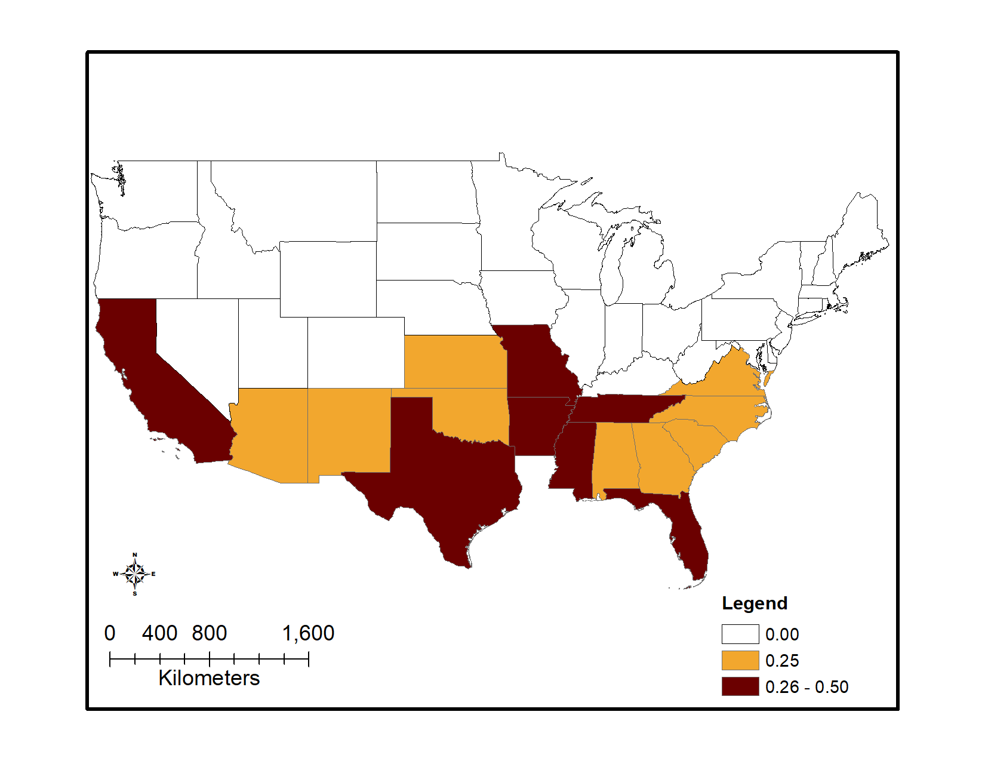
Figure 2. States where cotton, and rice are grown. Legend depicts combined maximum percent crop treated areas.

However, for the UDLs that contain multiple crops and spatial patterns based on where the registered crops are likely to be grown maybe be present. Figure 3 identifies the number of registered to non-registered crops found in each of the UDLs. This graph indicates that all Vegetables and Ground Fruit, Other Row Crops, Other Crops and Other Grains UDLs include a number of un-registered crops.

Figure 3. The number of registered to unregistered seed treatment crops found in each UDL group

Using the 2017 Census of Agriculture to identify where the registered crops are likely to be located, areas of the country are highlighted to show locations where registered seed treatment crops are more likely to be grown. In Figure 4 the top map depicts the registered seed treatment Vegetables and Ground fruit crops in red and the bottom map depicts the Other Grains seed treatment crops in green. The gradient represents the area of registered seed treatment crops to the total area of all crops in the UDL for the state. In both maps the darker the color the higher this ratio and the more likely a registered seed treatment crop would be grown in the state.
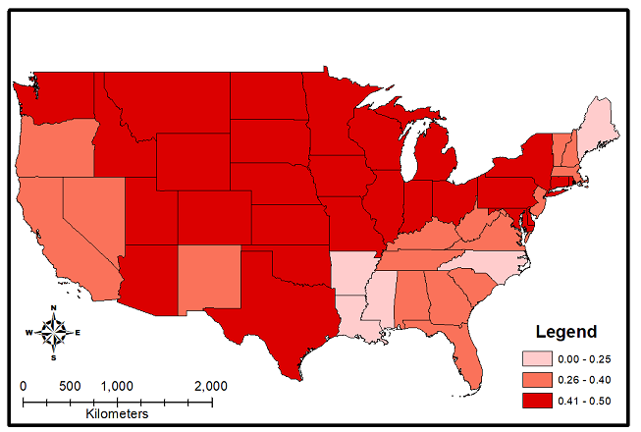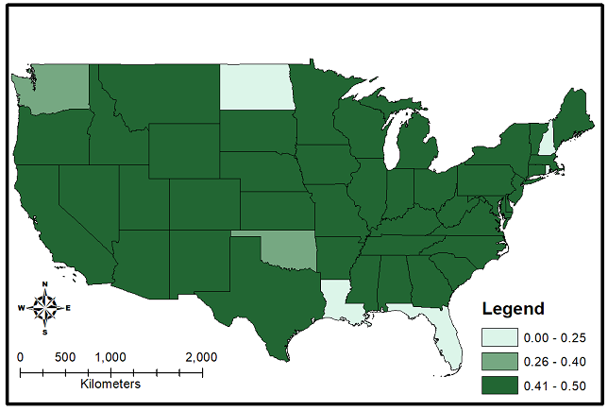
Figure 4. Ratio of the area of registered seed treatment crops to the total area of the crops found in the Vegetables and Ground Fruit UDL (top) and Other Grains (bottom)

There are several notable patterns when considering these two UDL groups (i.e., vegetables and ground fruit and other grains; Figure 4). The highest number of registered seed treatment crops occur most frequently in the more central states of the continental U.S. for both UDL groups. Both the west coast and great plains states have registered crops for both UDL groups; however, there is variability in growing patterns between the two UDL groups when considering the ratio by state. The west and east coast have a medium to low (0 -0.40) ratio of registered crops for Vegetable and Ground Fruit crops and Other Grains have highest ratio except in Florida and Louisiana.

When combining the ratios for the Vegetables and Ground and Other Grains, the areas where the registered seed treatment crops are likely to be present narrows (Figure 5). Florida, Louisiana, and New Hampshire all have a low ratio of registered crops. For this reason, these locations would not be the most useful when identifying quantitative usage data.
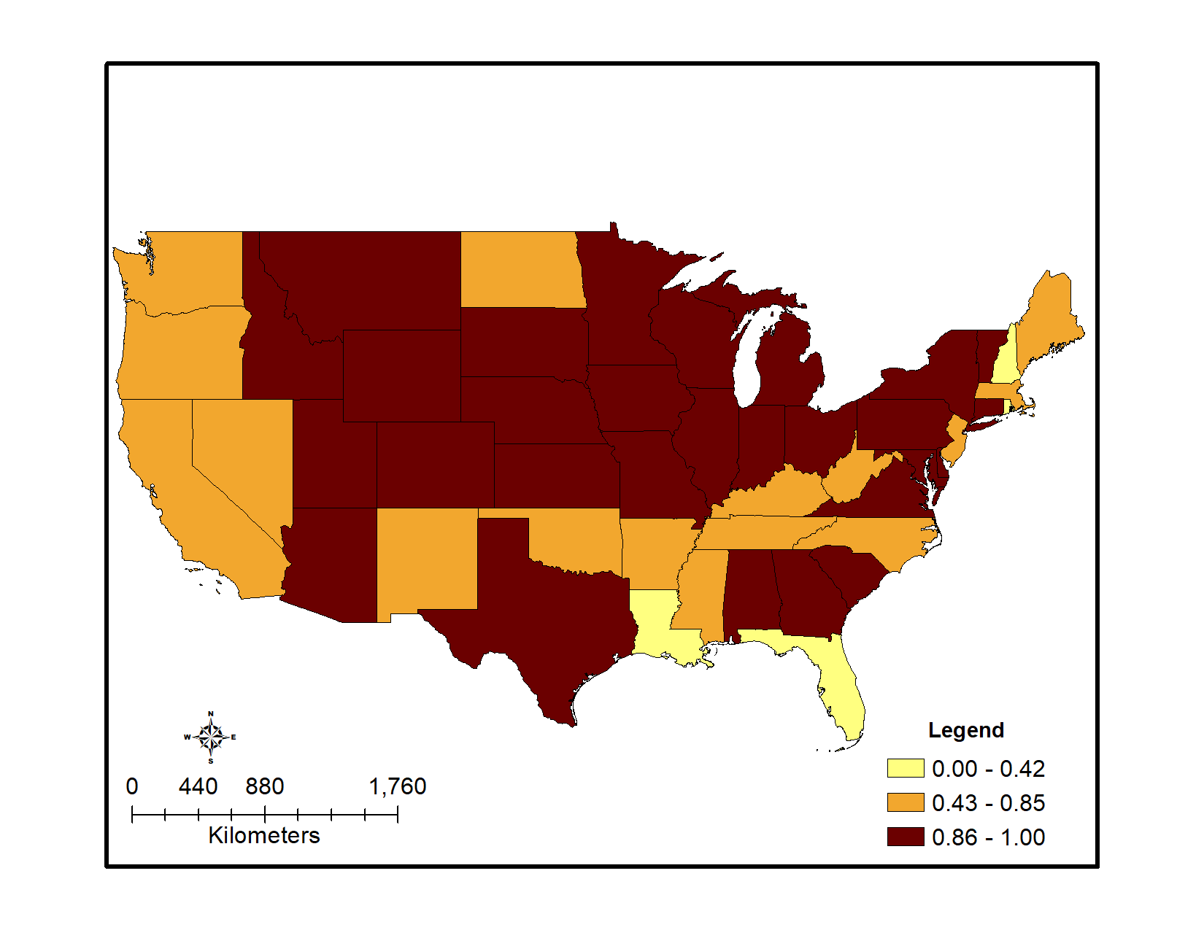
Figure 5. Combined ratio of the area of registered seed treatment crops to the total area of the crops found for Vegetables and Ground Fruit UDL and Other Grains crops

To further identify the areas where usage information would be the most valuable, the location of seed-eating birds and mammals can be overlaid on the map (Figure 6). In Figure 6, the gradient of the combine ratio of registered Vegetables and Ground Fruit and Other Grains remains the same, with seed-eating birds in the green gradient and seed-eating mammals in a purple gradient. The gradient on the species location represents the number of species found in that location; the darker the color the higher the number of seed-eating species present. To help identify the most informative locations for obtaining usage data, only areas with more than 2 or more seed-eating animals are presented in the map.
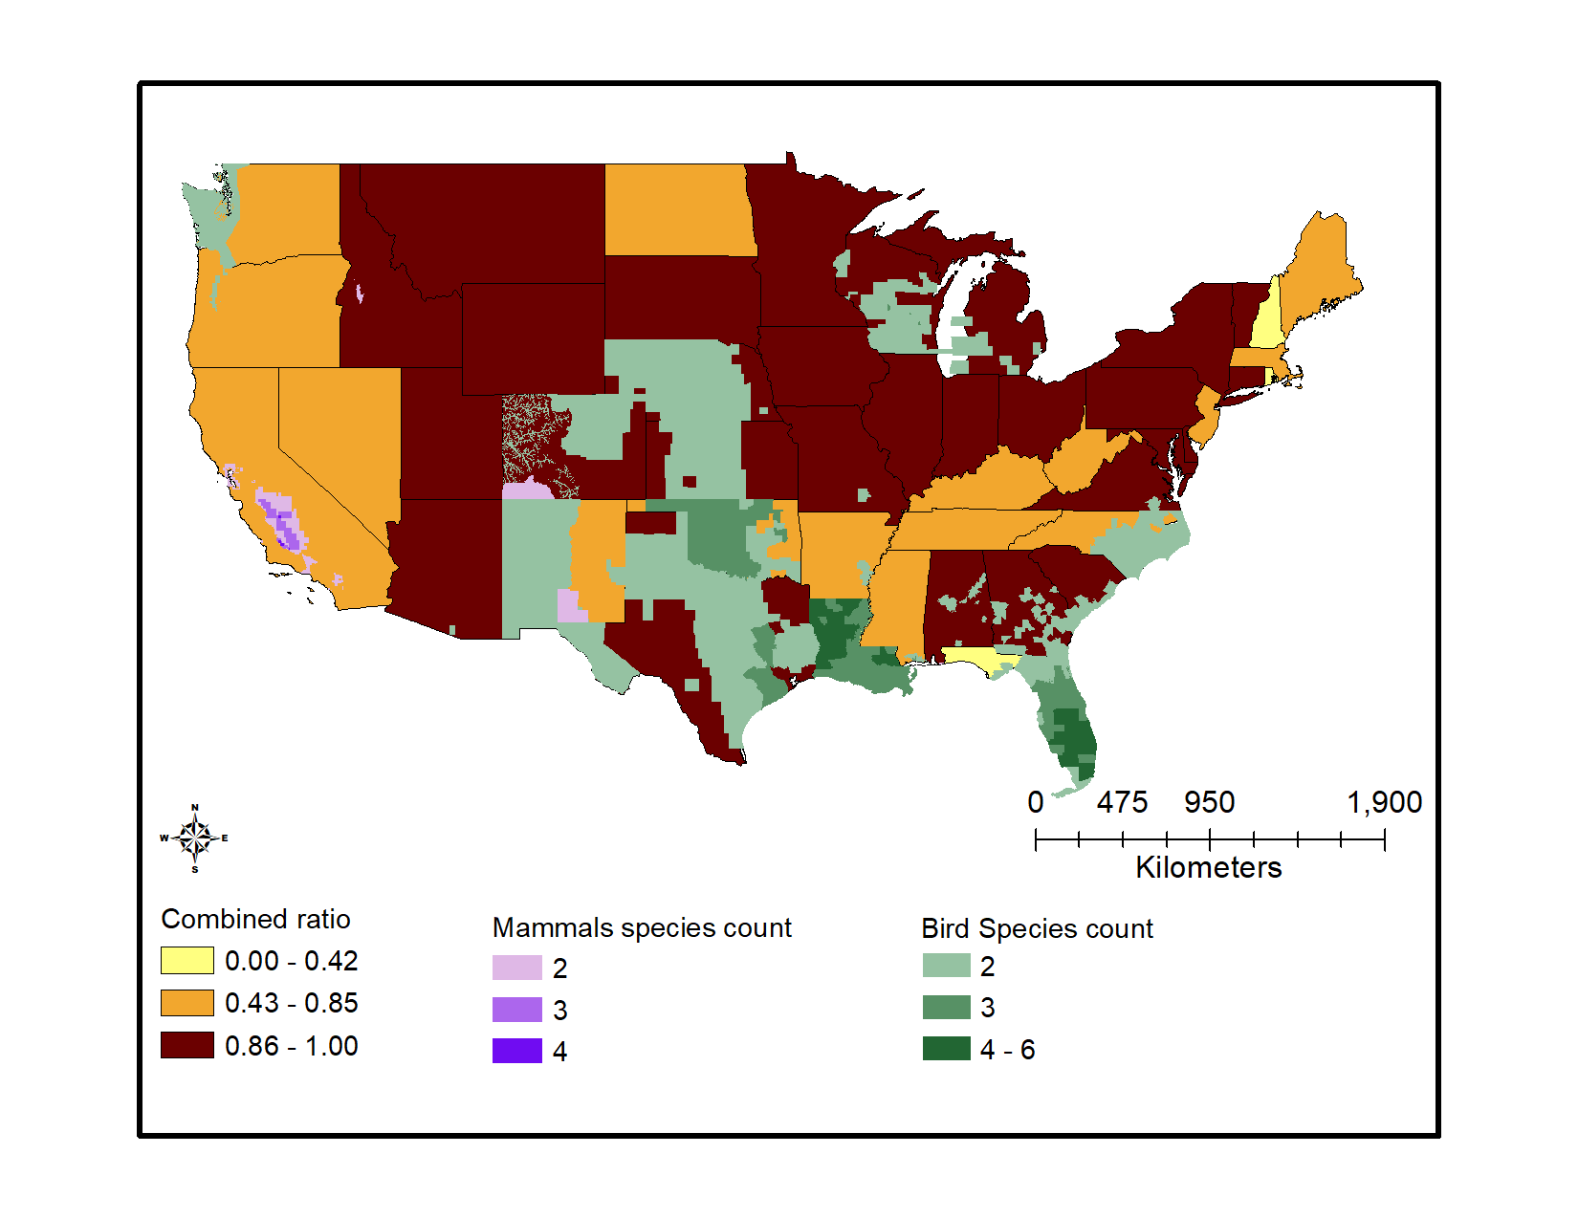
Figure 6. Combined ratio of the area of registered seed treatment crops to the total area of the crops found for Vegetables and Ground Fruit UDL and Other Grains crops with seed-eating birds and mammals

When considering the location of the seed-eating species in conjunction with the registered Vegetables and Ground Fruit and Other Grain crops, there are several notable locations. First, both Florida and Louisiana have a number of seed-eating birds but do not have a high ratio for registered seed treatment crops, when considering both Vegetables and Ground Fruit and Other Grain crops.

Figure 7 presents combined total ratio of all registered seed treatment crops. Areas where a large area of registered seed treatment crops occur include New Jersey, North Carolina, West Virginia, Virginia, South Carolina, Tennessee, Georgia, Missouri, Arkansas, Florida, Alabama, Texas, Oklahoma, Kansas, Nebraska, New Mexico, Colorado, California, Montana, North Dakota, and South Dakota.
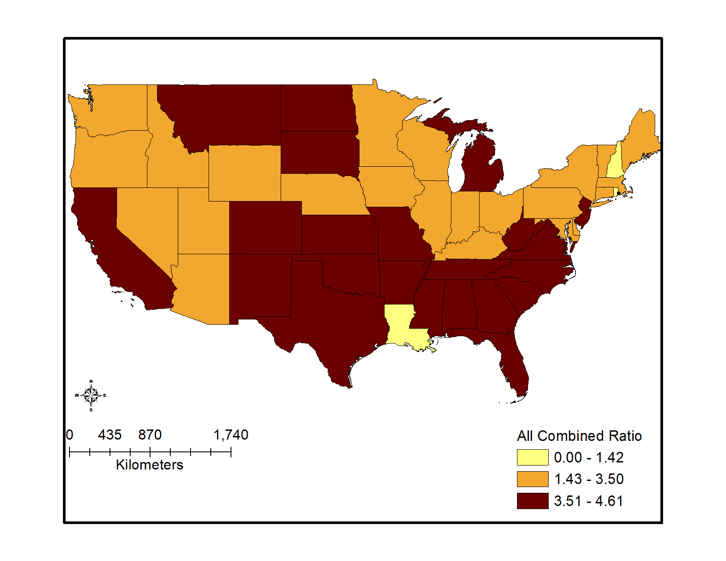
Figure 7. Combined ratio of the area of registered seed treatment crops to the total area of the crops found for all seed treatment UDLs

However, when both seed-eating species and all registered seed treatment crop areas are combined, Virginia, Tennessee, Alabama, Mississippi, Missouri, Arkansas and Texas become more important areas for obtaining seed treatment usage data (Figure 8). The top two states would be Mississippi and Texas give the number of seed eaters in these locations and the high ratio of registered crops area. Figure 8 was created by multiplying all combined ratio by both bird and mammal seed eaters counts. The greater the combined ratio and the higher the species counts, the greater the index.

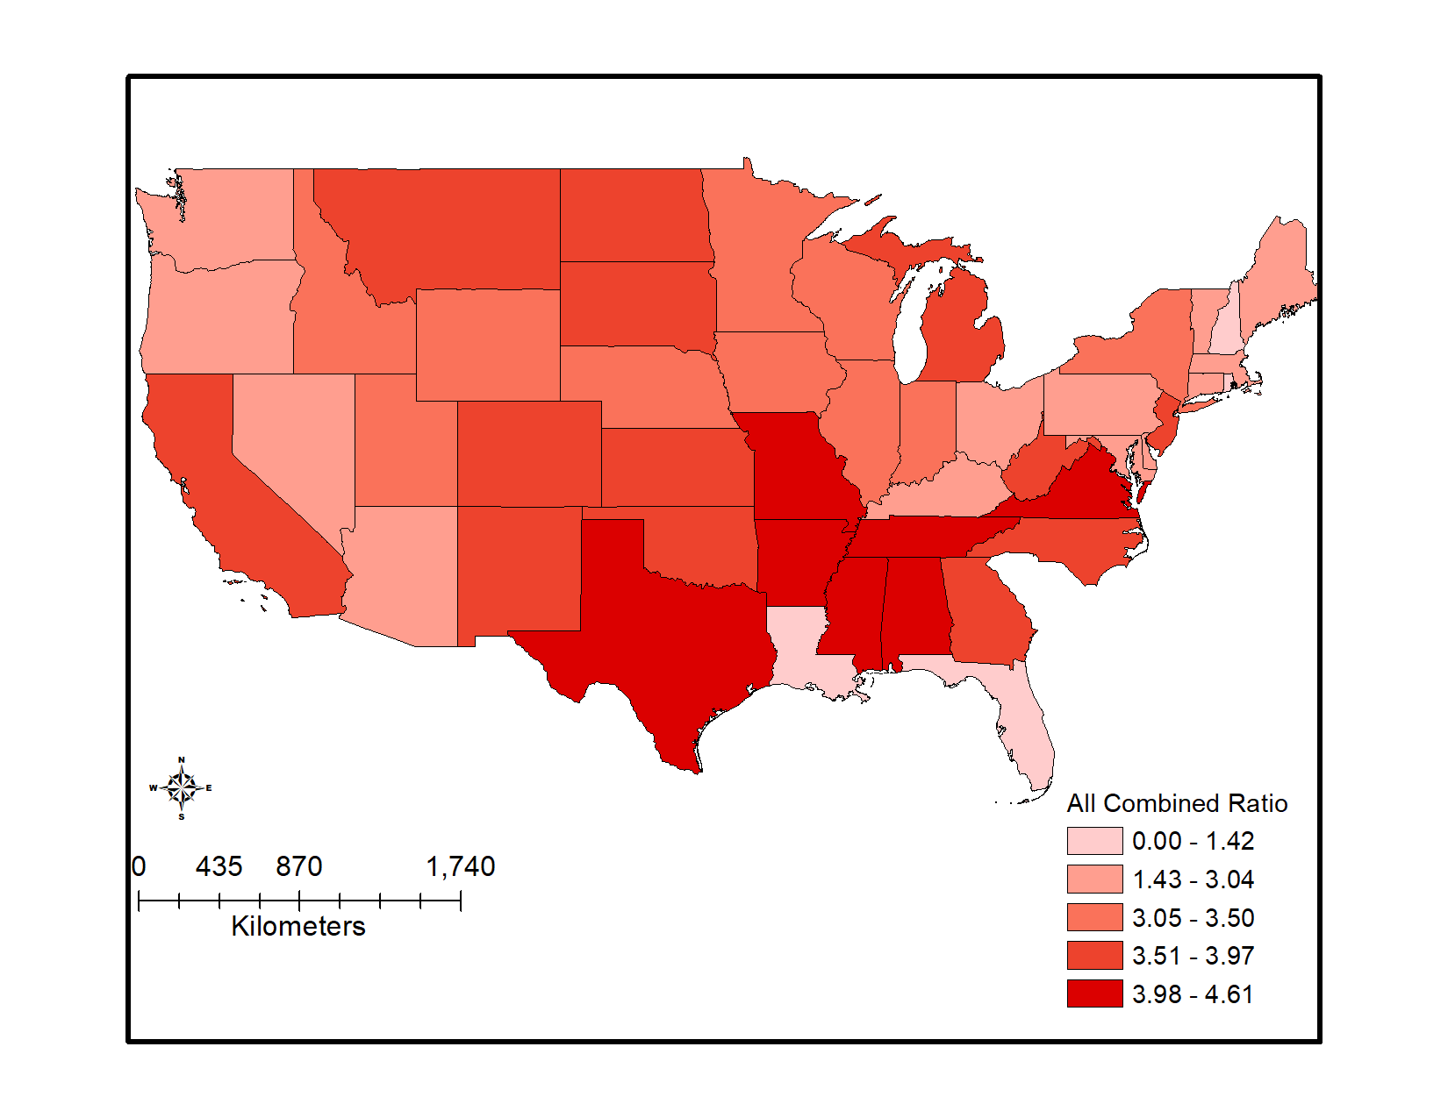
Figure 8. National-level combined ratio species count index calculated using both all the ratios of registered seed treatment crops to the total area of the crops and bird and mammal seed-eaters counts

Soil Applications and Treated Poultry Litter

Thiamethoxam also has applications associated with soil treatments for multiple use sites. Based on a comparison of application rates and anticipated EECs, for all use sites for which there are both soil and foliar applications, it is assumed that impacts predicted from flowable uses are protective of soil applications. Thiamethoxam can also be used in poultry houses to control darkling and hide beetles. The litter collected from these treated poultry houses can be later used on agricultural fields as a soil amendment. This litter can be applied to the corn, soybeans, other grains, cotton, wheat, rice, other row crops, vegetables and ground fruit and alfalfa use data layers (UDLs). These UDLs were identified based on the 24 crops reported in Kellog et al. (2000) for manure/litter application, see APPENDIX 1-6, for additional information. Although this is a soil application method, in order to capture the arthropod concentrations from soil applications for this potentially wide footprint, this use was modeled in the MAGtool along with other foliar application rates. Species that were impacted only by poultry litter applications were reevaluated after the analysis to adjust the results for species where the soil application may not be representative for concentrations from a foliar application (e.g., vertebrate herbivores). It is noted that the inclusion of all of these uses in counties where poultry operations occur could potentially overestimate the acreage where poultry litter is applied and the overlap with species ranges/critical habitats.

USEPA. 2017. Preliminary Risk Assessment to Support the Registration Review of Thiamethoxam. United States Environmental Protection Agency, Office of Pesticide Programs, Environmental Fate and Effects Division. November 29, 2017. DP 439307.
USEPA, Health Canada PMRA, & California Department of Pesticide Regulation. 2014. Guidance for Assessing Pesticide Risks to Bees. June 23, 2014. U.S. Environmental Protection Agency. Health Canada Pest Management Regulatory Agency. California Department of Pesticide Regulation. Available at http://www2.epa.gov/pollinator-protection/pollinator-risk-assessment-guidance.
http://www2.epa.gov/pollinator-protection/2013-summit-reducing-exposure-dust-treated-seed
Exceptions were noted for small/med passerines potentially consuming corn and soybean seeds and small passerines consuming cotton seeds as these seeds are considered too large to consume by these birds.

