APPENDIX 2-5. Thiamethoxam Species Sensitivity Distribution Analysis for Aquatic Insects

Summary

Species Sensitivity Distributions (SSDs) were fit to median lethal or effects (immobility) concentrations (LC₅₀ or EC₅₀ values, respectively) for aquatic insects exposed to thiamethoxam. In previous biological evaluations for other insecticides, a combined SSD was conducted for all aquatic invertebrates; however, due to the differences in sensitivity between insects and non-insects, this was not done for thiamethoxam. Additionally, separate SSDs for mollusks were also developed in previous biological evaluations; however, this was not done for thiamethoxam due to a lack of data.

Six distributions (normal, logistic, triangular, gumbel, weibull and burr) were fit to the available toxicity data for aquatic insects. For aquatic insects, the gumbel distribution provided the best fit for the datasets (Figure 1). This decision was based on the Akaike Information Criterion (AIC)_{c} weight and confidence limits for the different distributions (especially around the HC₀₅ and HC₅₀). Summary statistics from the fitted SSD for aquatic insects are provided in Table 1. The fifth and fiftieth percentiles of the SSD (abbreviated HC₀₅ and HC₅₀, respectively, where “HC” stands for “hazard concentration”) are used to calculate mortality endpoints representing effects to listed species of aquatic invertebrates associated with their prey, pollination, habitat and dispersal (PPHD).

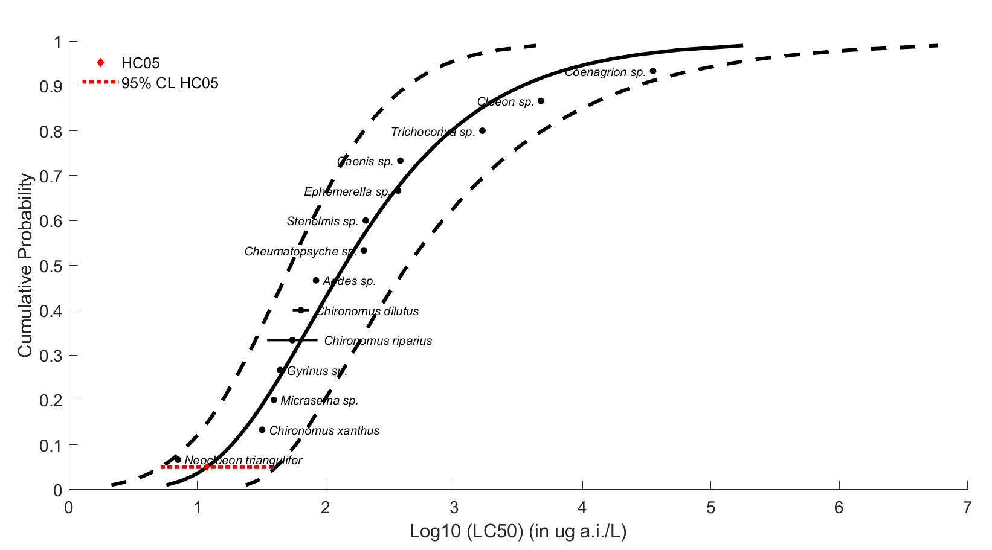
Figure 1. Gumbel SSD for thiamethoxam toxicity values for aquatic insects.
Table 1. Summary of thiamethoxam mortality endpoints for aquatic insects (values in µg a.i./L).
Statistic | Aquatic Insects
HC₀₅ (95% CI) | 11.87 (5.19-40.87)
HC₅₀ (95% CI) | 140.38 (53.55-438.30)
Slope | 1.89
CI = confidence interval

Toxicity Data

Because an SSD depicts relative sensitivities of different species exposed to the same stressor, it is necessary to standardize the data as much as possible to eliminate variables that would confound the relative sensitivities of species. Such variables can include study exposure duration, age class of organisms tested, and other study design factors. The EC/LC₅₀ values that were included in the analysis were all definitive mortality or immobility endpoints from either 48 or 96-hour tests, with a minimum of five concentrations of technical grade active ingredient, plus appropriate controls, tested within each study. Additionally, if a definitive immobility and mortality endpoint were available from the same test, the mortality endpoint was used (because immobility is intended as a surrogate for mortality). In some cases, only the genus was available, so the species is unknown. Endpoints without definitive endpoints were not used to derive SSDs.

Data used to derive SSDs are from literature that passed the ECOTOX quality screen (catalogued in APPENDIX 2-2) and data from unpublished, registrant-submitted studies. Those data are included in Table 2. There was a total of 14 aquatic insect species tested (Table 3). Note that for some of the species in Raby et al. 2018 (178290), wild caught species were only identified down to the genus level; however, they are assumed to represent the same species. For all species, there are either one or two different toxicity endpoints (LC₅₀ or EC₅₀ values) available. In cases where two endpoints were available for the same test species, values were similar (differing by only 1.3-2.5x). Using the available data, the slope was calculated for all aquatic invertebrates resulting in a median slope of 1.89. The data in Table 2 are from 5 different studies, with one study (Raby et al., 2018, ECOTOX # 178290) representing toxicity data for 12 different test species.

Table 2. Test results used to derive SSDs for thiamethoxam for aquatic insects.
Genus or Species | Acute EC/LC₅₀ value (µg/L) | Slope | Reference (ECOTOX #)
Neocloeon triangulifer | 7.07 | NA | 178290
Chironomus xanthus | 32 | NA | 183669
Chironomus riparius | 35¹ | NA | MRID 44714918
Micrasema sp. | 39.5 | 8.27 | 178290
Gyrinus sp. | 44.2 | NA | 178290
Chironomus dilutus | 55.34 | NA | 183458
Chironomus dilutus | 74.1 | 1.89 | 178290
Aedes sp. | 84 | 2.69 | 178290
Chironomus riparius | 86.41 | NA | 175180
Cheumatopsyche sp. | 198 | 2.55 | 178290
Stenelmis sp. | 205 | NA | 178290
Ephemerella sp. | 366 | 1.57 | 178290
Caenis sp. | 381 | 1.65 | 178290
Trichocorixa sp. | 1660 | 1.24 | 178290
Cloeon sp. | 4740 | NA | 178290
Coenagrion sp. | 35400 | NA | 178290
NA = Not available
¹EC₅₀ value

Table 3. Distribution of test results available for thiamethoxam.
Media | Test results | Species
Aquatic Insects | 16 | 14

Determining Distribution with Best Fit

P-values

Six potential distributions for the thiamethoxam data were considered (i.e., normal, logistic, triangular, gumbel, weibull and burr). To fit each of the six distributions, the toxicity values were common log (log₁₀) transformed. The SSD toolbox includes four different fitting methods (i.e., maximum likelihood, moment estimators, linearization and metropolis-hastings). All six distributions were fit using the maximum likelihood (ML) method. To test goodness-of-fit, all six distributions were fit to the thiamethoxam data and bootstrap goodness-of-fit tests were run with 10,000 replicates. The results of these fitting exercises are presented in Table 4. The p-value for the Weibull distribution is <0.05, indicating that this SSD is not a good fit for the available data. Therefore, the Weibull distribution will not be considered further for the insect data.

Table 4. P-values calculated for SSDs using aquatic invertebrate and insect toxicity data for thiamethoxam.
Distribution | Aquatic insect SSD
Normal | 0.27
Logistic | 0.42
Triangular | 0.12
Gumbel | 0.85
Weibull | <0.01
Burr | 0.82

Akaike’s Information Criteria Weights

Akaike’s Information Criterion corrected for sample size (AIC_{c}) was used to compare the five distributions for aquatic insects at the HC₀₅². For aquatic insects, the majority of the weight is attributed to the gumbel distribution (with ≤16% each attributed to logistic, normal, triangular and burr; Table 5). Based on the AIC weights, the gumbel distribution is used for aquatic insect data.

Table 5. Akaike’s Information Criteria (AICc) for distributions for aquatic insect toxicity data for thiamethoxam.
Distribution | AICc | Delta AICc | Wt | HC₀₅ | SE HC₀₅
Gumbel | 212.61 | 0 | 0.46 | 11.87 | 6.03
Logistic | 214.71 | 2.11 | 0.16 | 4.78 | 4.41
Normal | 214.95 | 2.35 | 0.14 | 5.79 | 5.13
Triangular | 215.07 | 2.46 | 0.14 | 6.65 | 7.37
Burr | 215.92 | 3.31 | 0.09 | 11.87 | 6.03

Conclusions

For aquatic insects, the gumbel distribution provided the best fit for the dataset. This decision was based on the AIC_{c} weight and confidence limits for the different distributions (especially around the HC₀₅ and HC₅₀). The gumbel distribution for aquatic insects will be used in the BE to derive HC₀₅ and HC₅₀ values for listed aquatic invertebrates and for assessing effects to PPHD.

M. Raby, M. Nowierski, D. Perlov, X. Zhao, C. Hao, D. G. Poirier, and P. K. Sibley. 2018. Acute Toxicity of 6 Neonicotinoid Insecticides to Freshwater Invertebrates. Environmental Toxicology and Chemistry, 37 (5): 1430–1445. ECOTOX# 178290; MRID 50776401
Etterson, M. 2011. Appendix C. Analyses of sensitivity distributions for estimation of acute hazard concentrations to aquatic animals. https://www.regulations.gov/document?D=EPA-HQ-OPP-2011-0898-0009

