APPENDIX 3-3. Imidacloprid Open Literature Monitoring Data
Tables
Table 1. Summary statistics for CDPR monitoring data (agricultural waterbodies/watersheds) 3
Table 2. Summary statistics for CDPR monitoring data 4
Table 3. Summary statistics for surface water monitoring data during storms and floods 9
Table 4. Monitoring data summary for two and three storm events 13

Figures
Figure 1. Detected concentrations of imidacloprid in a creek and river in GA (4-Oct-2011 to Apr-4-2012) 2
Figure 2. Monitored concentrations in ditches, creeks and sloughs compared to concentrations found in rivers and lakes 5
Figure 3. Imidacloprid usage in agriculture in Santa Barbra county, CA and observed concentrations during the same period from 2010 to 2013 7
Figure 4. Mixed urban and agricultural usage of imidacloprid in Imperial county, CA and observed concentrations during the period from 2010 to 2015 8
Figure 5. Spatial distribution of storm water monitoring sites 9
Figure 6. Chemo-graphs of imidacloprid concentrations in storm waters from four sites in AL and NC 10
Figure 7. Chemo-graphs of imidacloprid concentrations in storm waters from four sites in NY and MA 11
Figure 8. Monitored concentrations of imidacloprid in storm waters carried by five streams entering Suisun Marsh in CA 12

The following open literature information was available from the Preliminary Aquatic Risk Assessment to Support the Registration Review of Imidacloprid (USEPA, 2016), unless otherwise noted. Detected imidacloprid concentrations in surface waters vary and are typically within an order of magnitude of the estimated environmental concentrations (EEC) modeled in this BE.
Available monitoring data for imidacloprid may be described as relatively abundant in comparison with data for other pesticides. Most of these data contain important auxiliary information but lack specificity in terms of information on imidacloprid usage in monitored watersheds. Monitoring data reported in the literature were also included. The latter data were originally collected for research-specific goals but may be useful in providing perspective on expected concentrations in the environment at specific sites and under specific conditions.
GA Surface water monitoring data

Concentrations in surface water were monitored in a Sope creek and Chattahoochee river In Georgia (Hladik and Calhoun, 2012). Sope Creek near Marietta, Georgia, is an urban site with a catchment size of 79.5 square kilometers. Chattahoochee River near Whitesburg, Georgia (catchment size 6,290 square kilometers) is downstream of Sope Creek and of Metropolitan Atlanta, and integrates forest, urban and agricultural land uses within its basin. Monitored concentrations in the creek and river are summarized in Figure 1.

Figure 1. Detected concentrations of imidacloprid in a creek and river in GA (4-Oct-2011 to Apr-4-2012)

Data in Figure 1 indicate that Sope Creek, had imidacloprid detections throughout the sampling period of October through April. Concentrations ranged from 4.5 to 35.3 ng/L with a detection frequency of 85%. The highest concentration was detected in winter. In comparison, the Chattahoochee River had lower detections in the range of non-detect to 10.1 ng/L with a lower frequency of detection of 60%. Lower levels of detection/frequency in the river as compared to the creek could be a result of many factors although dilution could have been the main reason. No usage data were reported for the watersheds associated with the creek or the river.

CA Surface water monitoring data

A data set of surface water monitoring was downloaded from the California Department of Pesticide Regulation (CDPR) website (CDPR, 2021a) along with the associated reports (CDPR, 2021b). Monitoring covered water bodies in dominantly urban and dominantly agricultural watersheds. A summary of the data is included in Table 1 for urban waterbodies/watersheds and in Table 2 for agricultural waterbodies/watersheds.

Table 1. Summary statistics for CDPR monitoring data (agricultural waterbodies/watersheds)
Study Number | Sampling  Period | Counties | Watershed/Water Body | No. Of Sites | Detects/ Concentration (ng/L) |  |  |  | LOR (ng/L)
 |  |  |  |  | No. | % | Min. | Max.
252-262 | 2008-2010 | Santa Cruz, Monterey, San Luis Obispo, Santa Barbara, Merced, Imperial | Agriculture Areas (creeks, rivers, lakes, drainage ditches): Salinas River, Alamo River, Salton Sea: | 16 | 25/28 | 89% | 80 | 1,240 | 50
271-278 | 2011-2012 | Imperial, Merced, Monterey, Napa, San Luis Obispo, Santa Cruz, Santa Barbara, Riverside, Ventura | Agriculture & Mixed Agriculture Areas (creeks, rivers, lakes, drainage ditches): Salinas River, Old Salinas River, Pajaro River, Santa Maria River, Napa River, Russian River, San Joaquin Watershed, New River, Alamo River, Colorado River, Salton Sea: |  |  |  |  |  | 50
 |  |  | Parent | 31 | 112/163 | 69% | 50 | 6,390
 |  |  | Guanidine |  | 30/64 | 47%
 |  |  | Guanidine Olefin |  | 0/64 | 0%
 |  |  | Olefin |  | 0/64 | 0%
 |  |  | Urea |  | 2/64 | 3%
282 | 2013 | Monterey, San Luis Obispo, Santa Barbara, San Joaquin, Merced, Imperial, Riverside | Agriculture Areas (creeks, rivers, ponds, drainage ditches): Salinas River, Old Salinas River, San Joaquin River, Santa Maria River, New River, Alamo River, Colorado River, Salton Sea | 20 | 43/51 | 84% | 87 | 6,800 | 50
290 | 2014 | Monterey, San Luis Obispo, Santa Barbara, Imperial, Riverside | Agriculture Areas (creeks, rivers, lakes, drainage ditches): Salinas River, Old Salinas River, Santa Maria River, New River, Alamo River, Colorado River, Salton Sea | 23 | 51/58 | 88% | 63 | 9,140 | 50
297 | 2015 | Monterey, San Luis Obispo, Santa Barbara, Imperial, Riverside | Agriculture Areas (creeks, rivers, lakes, drainage ditches): Salinas River, Old Salinas River, Tembladero Slough, Santa Maria River, New River, Alamo River, Colorado River, Salton Sea | 26 | 62/77 | 81% | 52 | 8,640 | 50
* Time related multiple samples were collected from each site: Data for No. of sites, Detects and concentrations obtained from data from the database. * LOR= 200 for one sample (the 3,308 ng/L sample)

Table 2. Summary statistics for CDPR monitoring data
(northern and southern CA urban waterbodies/watersheds, for each watershed/water body entry: top rows for Storm drains and bottom row for Creeks)
Study Number | Sampling  Period | Counties | Watershed/Water Body | No. Of Sites | Detects/ Concentration (ng/L) |  |  |  | LOR (ng/L)
 |  |  |  |  | No. | % | Min. | Max.
- Northern California
269-  11-12 | 2011-2012 | Sacramento & Placer | Sacramento & Roseville Areas: Pleasant Grove Creek (Sacramento) & Upper American River (Folsom) | 8 | 7/32 | 22% | 62 | 1,840 | 50
 |  |  |  | 7 | 6/17 | 35% | 50 | 168 | 50
269- 12-13 | 2012-2013 | Sacramento & Placer | Same area as above | 6 | 16/24 | 67% | 51 | 386 | 50
 |  |  |  | 1 | 1/3 | 33% | 166 |  | 50
269- 13-14 | 2013-2014 | Sacramento, Placer, Alameda, Contra Costa, | Sacramento & Roseville Areas: Pleasant Grove Creek, Arcade Creek, Miner’s Ravine, (Sacramento); Upper American River, Curry Creek, Dry Creek (Placer); Kirker Creek, Walnut Creek (Contra Costa); South San Ramon Creek (Alameda) | 7 | 9/30 | 30% | 16 | 3,308 | 50*
 |  |  |  | 8 | 4/10 | 40% | 26 | 62 | 50
269- 14-15 | 2014-2015 | Sacramento, Placer, Alameda, Contra Costa, Santa Clara | Roseville & Folsom (run-off); Folsom, Roseville & Sacramento (creeks & rivers); San Francisco Bay (Dublin, Martinez & Santa Clara County Areas: Pleasant Grove Creek, Arcade Creek, Upper American River, South San Ramon Creek, Walnut Creek, Guadalupe River, Metcalfe Canyon-Coyote Creek | 6 | 6/20 | 30% | 61 | 214 | 50
 |  |  |  | 6 | 0/13 | 0% | 0 | 0 | 50
- Southern California
270-  10-14 &  270- 14-15 | 2011-2014 | Los Angeles, Orange, San Diego | Southern California Watersheds/Water bodies: Ballona Creek, Bouquet Creek; Salt Creek, Wood Canyon Creek; Chollas Creek, San Diego River | 11 | 109/158 | 69% | 20 | 12,700 | 20-50
 |  |  |  | 7 | 19/25 | 76% | 21 | 317 | 20-50
* Time related multiple samples were collected from each site: Data for No. of sites, Detects and concentrations obtained from the database. * LOR= 200 for only one sample (the 3,308 ng/L sample)

Monitoring data for water bodies in agricultural areas show the highest concentrations for drainage ditches, creeks and sloughs compared to concentrations found in rivers and lakes probably because of dilution (Figure 2).
Figure 2. Monitored concentrations in ditches, creeks and sloughs compared to concentrations found in rivers and lakes

Highest concentrations were observed for single/double storm drains of urban areas compared to tributaries of streams and streams receiving discharge from these drains. Again, dilution is probably the reason. In general, imidacloprid found in water bodies in urban areas of northern California is lower in concentrations “Conc.” and detection frequency “DF” than that observed in southern California (Conc.=16-3,308 ng/L; DF= 22-67% in northern CA compared to Conc.=21-12,700 ng/L; DF= 22-67% in southern CA; Table 1 and Table 2). The difference may be related to many factors such as usage and climate.
One of the most important factors that is expected to be directly related to concentration found in water bodies is imidacloprid usage. Therefore, monitored concentrations were displayed graphically with reported usage data for the same period. Two examples of such graphs are included: the 1st is for monitoring data/usage for agricultural areas (Figure 3), and the 2nd is for mixed urban and agriculture areas (Figure 4).

Figure 3. Imidacloprid usage in agriculture in Santa Barbra county, CA and observed concentrations during the same period from 2010 to 2013

Figure 4. Mixed urban and agricultural usage of imidacloprid in Imperial county, CA and observed concentrations during the period from 2010 to 2015

Storm water

Downloaded NWQMC data contained monitored concentrations in surface waters for samples taken during significant hydrological events including storms and floods (NWQMC, 2016; Table 3).

Table 3. Summary statistics for surface water monitoring data during storms and floods
Item | No. of Sites | No. of  Samples | Detections (ng/L) |  | LOD (ng/L)
 |  |  | Min | Max | Min | Max
Hydrologic Events: Storms (1999-2008; 2010)
Sites Sampled > 10 times | 3 | 52 | 12.0 | 3,340 | 6.8 | 106
Sites Sampled <10-5 times | 3 | 21 | 4.0 | 788 | 6.8 | 106
Sites Sampled <5-1 times | 12 | 16 | 10.0 | 4,490 | 6.8 | 106
Total Number of Detects | 18 | 89 | 4.0 | 4,490
Sites Sampled > 10 times | 7 | 100 | 0.0 | 0.0 | 6.8 | 106
Sites Sampled <10-5 times | 19 | 132 | 0.0 | 0.0 | 5 | 500
Sites Sampled <5-1 times | 105 | 184 | 0.0 | 0.0 | NR; 5 | NR; 111
Total Number of Non-Detects | 131 | 416 | 0.0 | 0.0
Grand Total | 149 | 505 | Detection: 18%
Hydrologic Events: Floods (2000-2004; 2006; 2008-2009; 2011)
Total Number of Detects ¹ | 4 | 5 | 60 | 1,470 | 6.8 | 60
Total Number of Non-Detects | 32 | 44 | 0.0 | 0.0 | NR; 6.8 | NR; 106
Grand Total | 36 | 49 | Detection: 10%
¹All Sites were sampled <5-1 times; LOD= Limit of detection

Storm water was sampled for the same site and/or the same watershed in 149 sites throughout the country. Sites included streams and others representing storm waters from urban, agricultural, and mixed-use areas (Figure 5).

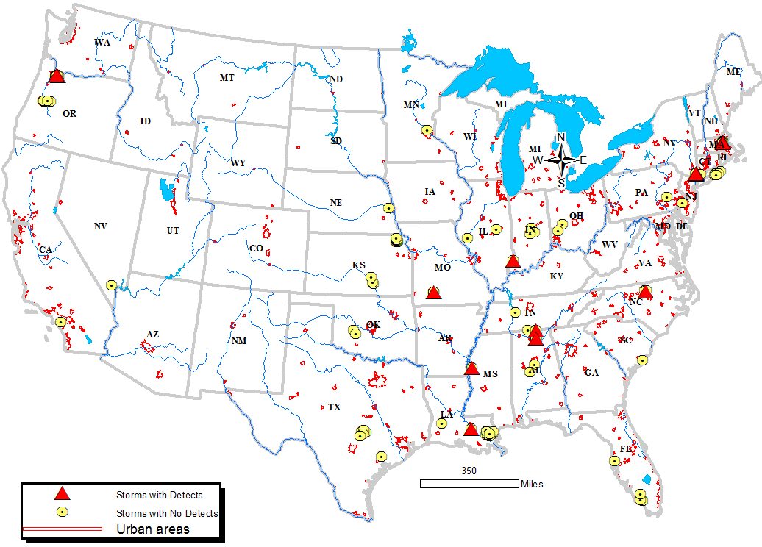
Figure 5. Spatial distribution of storm water monitoring sites

Concentrations found in storm water ranged from 4 to 4,490 ng/L with a detection frequency of 18%. Monitored concentrations appear to be episodic with highs dropping sharply into very low or non-detect concentrations. Observed high concentrations are probably associated with the first storm flush especially if that flush happened just after imidacloprid application in the watershed. Lower concentrations are expected to be associated with the distribution of the amounts of the chemical applied within the application window. Giving the high solubility and low adsorption of imidacloprid, mass available to be carried out by storm run-off is expected to be reduced by the competing process of leaching. Figure 6 and Figure 7 show chemo-graphs for eight monitored storm sites with varied concentration patterns that are probably a reflection of timing, storm duration and intensity.

Figure 6. Chemo-graphs of imidacloprid concentrations in storm waters from four sites in AL and NC

Figure 7. Chemo-graphs of imidacloprid concentrations in storm waters from four sites in NY and MA

In another study, water samples were found to contain imidacloprid at concentrations ranging from 13.5 to 1,462 ng/L in surface waters generated by a 2-day large storm in four of five creeks entering the sloughs of Suisun Marsh in San Francisco Bay area in the first winter storm of 2013/2014 (Weston et al., 2015). Imidacloprid contamination of the four creeks were related to the pesticide applications in urban and mixed land use areas. Higher concentrations were found in storm waters from urban areas as compared to areas with mixed agriculture/urban uses. Imidacloprid was not detected (LOD= 10 ng/L) in one of the creeks originating from dominantly agricultural areas. Non-detection was attributed to sample timing which is six months outside the summer application window for crops. No data were collected for the slough/marsh.
It was reported that the sampled wet season (November through March) had exceptionally little rainfall as accumulation never exceeded 1 cm in any day of the entire season up until the February storm. Therefore, higher run-off and possibly higher pesticide contamination is expected to occur in the more wet years that are expected to occur in this region of California. Figure 8 contains a summary of rainfall that generates sampled storm events and associated concentrations of imidacloprid carried in storm waters of the five steams entering the sloughs of Suisun Marsh.

Figure 8. Monitored concentrations of imidacloprid in storm waters carried by five streams entering Suisun Marsh in CA

Floods

Flood surface water was monitored by the New York Water Science Center (reported in the NWQMC 2016 dataset) at three sites on two or three different dates (Table 4). Data suggest that June storms, at these sites, appear to cause contamination of surface waters with imidacloprid at concentrations ranging from 60 to 1,470 ng/L. No other conclusions may be drawn without further information about the sites and source(s) of imidacloprid.

Table 4. Monitoring data summary for two and three storm events
Item |  | Storm date
 |  | 5-Jun-03 | 12/13-Jun-03 | 13-Apr-04
Site 1 | Detected concentrations @ site 1 | 1,470 ng/L | 1,050 | No-detect at 6.8 ng/L limit of detection
Site 2 | Detected concentrations @ site 2 | Not monitored | 64
Site 3 | Detected concentrations @ site 3 | Not monitored | 60

References

CDPR. 2021a. Surface Water Monitoring of Pesticides Database. California Department of Pesticide Regulation. https://fusiontables.google.com/DataSource?docid=1C0gNYe7stfYxicf_UnG861Hl0sd2j4eCb_DlPSZk#rows:id=1

CDPR. 2021b. Study reports. California Department of Pesticide Regulation. http://www.cdpr.ca.gov/docs/emon/pubs/ehapreps.htm?filter=surfwater

Hladik, M.L. and Calhoun, D.L. 2012. Analysis of the herbicide diuron, three diuron degradates, and six neonicotinoid insecticides in water—Method details and application to two Georgia streams. U.S. Geological Survey Scientific Investigations Report 2012–5206, 10 p.

NWQMC (National Water Quality Monitoring Council). 2016. Water Quality Portal. http://www.waterqualitydata.us/portal/ (accessed Nov. 10, 2016)

USEPA, 2016. Imidacloprid: Preliminary Aquatic Risk Assessment to Support the Registration Review of Imidacloprid. Environmental Protection Agency, Office of Pesticide Programs, Environmental Fate and Effects Division, December 22, 2016.

Weston, D.P., D. Chen, and M.J. Lydy. 2015. Stormwater-related transport of the insecticides bifenthrin, fipronil, imidacloprid, and chlorpyrifos into a tidal wetland, San Francisco Bay, California. Science of the Total Environment 527-528: 18-25.

