APPENDIX 2-6. Imidacloprid Species Sensitivity Distribution Analysis for Terrestrial Invertebrates

Summary

Species Sensitivity Distributions (SSDs) were fit to acute median lethal or effects (immobility) concentrations (LC₅₀ or EC₅₀ values, respectively) for terrestrial invertebrates exposed to imidacloprid. Five distributions (normal, logistic, triangular, gumbel, and burr) were fit to the available toxicity data.

For terrestrial invertebrates, two routes of exposure had sufficient data to run SSDs; dietary exposure measured as mg a.i./kg-food and contact (topical) exposure measured as mg a.i./kg-bw. For dietary exposure, the logistic distribution provided the best fit for the dataset and for contact exposure, the normal distribution provided the best fit. The selected distribution was based on the AIC_{c} weight, p-value, confidence limits for the different distributions (especially around the HC₀₅ and HC₅₀) and by visually examining the distributions and their consistency with the toxicity data, particularly near the HC₀₅ and HC₅₀ values. Summary statistics from the fitted SSDs are provided below in Table 1. The fifth and fiftieth percentiles of the SSD (abbreviated HC₀₅ and HC₅₀, respectively, where “HC” stands for “hazard concentration”) are used to calculate acute mortality endpoints representing effects to listed species of aquatic invertebrates associated with their prey, pollination, habitat and dispersal (PPHD).

Table 1. Summary of imidacloprid SSD mortality endpoints for terrestrial invertebrates.
Statistic | mg a.i./kg-food | mg a.i./kg-bw
HC₀₅ (95% CI) | 0.064 (0.0045-0.81) | 0.015 (0.0017-0.15)
HC₅₀ (95% CI) | 3.48 (0.79-15.8) | 0.85 (0.22-3.37)
Slope¹ | 1.8 | 1.6
CI = confidence interval
¹ Geometric mean of slopes from the tests nearest the HC₀₅

Toxicity Data

Because an SSD depicts relative sensitivities of different species exposed to the same stressor, it is necessary to standardize the data as much as possible to eliminate variables that would confound the relative sensitivities of species. Such variables can include study exposure duration, age class of organisms tested, and other study design factors. For imidacloprid, sufficient data are available to derive SSDs for terrestrial invertebrates exposed through contact and diet and are summarized in Table 2. The LC₅₀ values (dietary exposure) and LD₅₀ values (contact exposure) included in the analysis were all mortality or immobility endpoints from 48 to 96-hour tests, a minimum of four concentrations of technical grade active ingredient, plus appropriate controls, tested within each study. For contact exposure, all LC₅₀ values included in the SSD were definitive endpoints, while for dietary exposure, 5 of the 12 LD₅₀ values included for Apis mellifera were non-definitive (> values) where > 50% mortality was not observed at the highest concentration tested. For the purpose of calculating the median LC50 for A. mellifera, the non-definitive (>) LC₅₀ values were assumed equal to the highest concentration tested to minimize bias if the non-definitive values were excluded.

Table 2. Distribution of test results available for imidacloprid.
Exposure route | Test results | Species
Dietary, mg a.i./kg-food | 19 | 10
Contact, mg a.i./kg-bw | 34 | 13

Data used to derive SSDs are from literature that passed the ECOTOX quality screen (catalogued in APPENDIX 2-2) and data from unpublished, registrant-submitted studies. For dietary exposures, several unit conversions were conducted depending on the expression of the acute toxicity endpoints as follows:
- Most LC₅₀ values identified in ECOTOX that were expressed as mass a.i./mass food (e.g., mg a.i./kg-food) were actually mass a.i./volume of food (e.g., mg a.i./L-food) upon review of the underlying publication. In these cases, the endpoints were converted to a food mass basis using the density of the feeding solution.
- LC₅₀ /LD₅₀ values expressed as mass a.i./organism (e.g., µg a.i./organism) were converted to mass a.i./mass-food based on the mass of food consumed and food density when necessary.

For contact exposures, the following unit conversions were conducted when necessary:
- LD₅₀ values expressed as mass a.i./organism were converted to mass a.i./mass organism based on the body weight of the tested species when reported in the study or when available in the open literature for the same species/life stage.
- LD₅₀ values expressed as mass a.i./volume of dosing solution (e.g., mg a.i./L) were converted to mass a.i./mass organism based on the volume of dosing solution administered per organism and the organism body weight, when reported in the study or when available in the open literature for the same species/life stage.

For a given species, if acute toxicity endpoints were reported for different observation times within a test, only the most sensitive LC₅₀ or LD₅₀ was used. However, if multiple tests were conducted in a study for a given species (e.g., different instars, strains), all endpoints were included in the SSD for that species. Table 3 and Table 4 list the species and endpoints used to derive terrestrial SSDs.

Table 3. Test results used to derive SSDs for imidacloprid for dietary exposure to terrestrial invertebrates.
Species | Acute EC/LC₅₀ value  (mg/kg food) | Reference  (ECOTOX # or MRID)
Apis cerana | 37.3 | 183781
Apis mellifera | 24.1 | 183781
Apis mellifera | 5.55 | 184435
Apis mellifera | 0.18 | MRID 42273003
Apis mellifera | 7.59 | MRID 49766203
Apis mellifera | 2.00 | MRID 49766204
Apis mellifera | 3.01 | 63505
Apis mellifera | 2.49 | 101957
Apis mellifera ssp. mellifera | 0.39 | 46261
Apis mellifera ssp. caucasica | 0.53 | 46261
Bombyx mori | 0.13 | 162856
Cotesia marginiventris | 3.74 | 183558
Culex quinquefasciatus | 0.31 | 175414
Linepithema humile | 643 | 101951
Melipona scutellaris | 0.66 | 184470
Musca domestica | 31.4 | 171549
Musca domestica | 6.7 | 181113
Scaptotrigona postica | 11.6 | 184463
Bombus terrestris | 1.54 | 183814
Bold information indicates data for the most sensitive tested species

Table 4. Test results used to derive SSDs for imidacloprid for contact exposure to terrestrial invertebrates.
Species | Acute EC/LC₅₀ value  (mg/kg-bw) | Reference  (ECOTOX #)
Apis cerana | 0.040 | 183780
Apis cerana ssp. indica | 0.628 | 184373
Apis mellifera | 0.021 | 175348
Apis mellifera | 0.20 | 168903
Apis mellifera | 0.33 | 82007
Apis mellifera | 0.39 | 62997
Apis mellifera | 0.52 | 169012
Apis mellifera ssp. carnica | 0.33 | 62997
Apis mellifera ssp. carnica | 0.34 | 62997
Apis mellifera ssp. carnica | 0.48 | 62997
Apis mellifera ssp. carnica | 0.59 | 62997
Apis mellifera ssp. carnica | 0.81 | 62997
Apis mellifera ssp. caucasica | 0.10 | 46261
Apis mellifera ssp. mellifera | 0.052 | 46261
Apis mellifera ssp. mellifera | 0.19 | 46261
Bombus terrestris ssp. audax | 1.55 | 184486
Campoletis sonorensis | 0.83 | 184372
Campoletis sonorensis | 0.83 | 184372
Campoletis sonorensis | 0.99 | 184372
Coccinella septempunctata | 0.079 | 184500
Coccinella septempunctata | 4.35 | 184500
Coccinella septempunctata | 10.20 | 184500
Coccinella septempunctata | 11.40 | 184500
Coccinella septempunctata | 44.64 | 184500
Hippodamia convergens | 0.40 | 64700
Hippodamia variegata | 1.27 | 184106
Melipona scutellaris | 0.013 | 184470
Nasonia vitripennis | 0.029 | 184317
Osmia cornifrons | 7.60 | 168903
Plutella xylostella | 28.40 | 103261
Plutella xylostella | 40.70 | 103261
Scaptotrigona postica | 0.82 | 184463
Toxoneuron nigriceps | 50.60 | 184372
Toxoneuron nigriceps | 50.80 | 184372
Bold information indicates data for the most sensitive tested species

Determining distributions with best fit

Five potential distributions for the imidacloprid data were considered (normal, logistic, triangular, gumbel and burr). To fit each of the five distributions, the toxicity values were common log (log₁₀) transformed. All five distributions were fit using the maximum likelihood (ML) method. To test goodness-of-fit, all five distributions were fit to the imidacloprid data and bootstrap goodness-of-fit tests were run with 3,000 bootstrap replicates. The results of these fitting exercises are presented below (Table 5). For the terrestrial invertebrate SSDs, the p-value for all exposure routes and distributions methods were >0.05, indicating that all SSDs are a reasonably good fit for the available data (Table 5).

Table 5. P-values calculated for SSDs for invertebrate toxicity data for imidacloprid.
Distribution | Dietary  (mg a.i./kg-food) | Contact  (mg a.i./kg-bw)
Normal | 0.72 | 0.68
Logistic | 0.70 | 0.72
Triangular | 0.83 | 0.72
Gumbel | 0.68 | 0.51
Burr | 0.98 | 0.75

Akaike’s Information Criteria (AICc) weights

Akaike’s Information Criterion corrected for sample size (AIC_{c}) was used to compare the six distributions for the invertebrate data at the HC₀₅. For dietary exposure, the majority of the weight is attributed to the triangular, normal, gumbel, and logistic distributions (Table 6). Based on the AIC weights, the fit of the triangular, normal, gumbel and logistic distributions are further considered below for dietary exposure invertebrate data. For contact exposure, the majority of the weight is attributed to the triangular and normal distributions (with <15% attributed to logistic, gumbel, and burr; Table 7). Based on the AIC weights, the fit of the triangular and normal distributions are further considered below for contact exposure invertebrate data.

Table 6. Comparison of distributions for dietary invertebrate toxicity data for imidacloprid.
Distribution | AICc | Delta AICc | Wt | HC₀₅ | SE HC₀₅
gumbel | 78.6359 | 0 | 0.3202 | 0.1554 | 0.1086
triangular | 79.1807 | 0.5448 | 0.2439 | 0.1077 | 0.1396
normal | 79.4818 | 0.8459 | 0.2098 | 0.0814 | 0.0940
logistic | 79.6950 | 1.0591 | 0.1886 | 0.0636 | 0.0805
burr | 82.9231 | 4.2872 | 0.0375 | 0.1553 | 0.1088

Table 7. Comparison of distributions for contact invertebrate toxicity data for imidacloprid.
Distribution | AICc | Delta AICc | Wt | HC₀₅ | SE HC₀₅
triangular | 59.5243 | 0 | 0.5039 | 0.0206 | 0.0120
normal | 61.2388 | 1.7145 | 0.2138 | 0.0147 | 0.0154
logistic | 62.0097 | 2.4854 | 0.1454 | 0.0121 | 0.0146
gumbel | 62.5490 | 3.0247 | 0.1111 | 0.0196 | 0.0139
burr | 65.4754 | 5.9511 | 0.0257 | 0.0125 | 0.0204

Distributions

The cumulative distribution functions for terrestrial invertebrate SSDs for the respective distributions are discussed in this section.

Dietary exposure

Figure 1 through Figure 4 depict the four distributions fit to the EC/LC₅₀ values for dietary exposure. Table 8 includes the HC₀₅ and HC₅₀ values for the for distributions, along with the associated 95% confidence intervals. When comparing the four distributions to the individual toxicity data, the triangular distribution does not appear to be a good fit for the data (Figure 1).
As depicted in the four figures, the lowest available toxicity value (i.e., 0.13 mg a.i./kg-food for Bombyx mori; ECOTOX # 162856) appears to be close to the HC₀₅. Since the HC₀₅ is an important endpoint used in the BE, the estimated HC₀₅ of the three remaining distributions is used in conjunction with goodness of fit to select the endpoint. The logistic distribution is chosen because it appears visually to have the best fit both near the HC₀₅ and HC₅₀, is within the top 3 AICc for goodness of fit, has a reasonable range for its confidence interval and model fit is indicated as acceptable based on the p value.

Table 8. HC₀₅ and HC₅₀ values for distributions based on dietary invertebrate EC/LC50 values.
Distribution | HC₀₅ (95% CI) | HC₅₀ (95% CI)
gumbel | 0.16 (0.049-0.92) | 2.72 (0.75-16.9)
triangular | 0.11 (0.032-1.42) | 5.37 (1.29-21.6)
logistic | 0.064 (0.0045-0.81) | 3.48 (0.79-15.8)
normal | 0.081 (0.0084-0.99) | 4.07 (0.95-17.9)
Bold information indicates model chosen for the SSD.

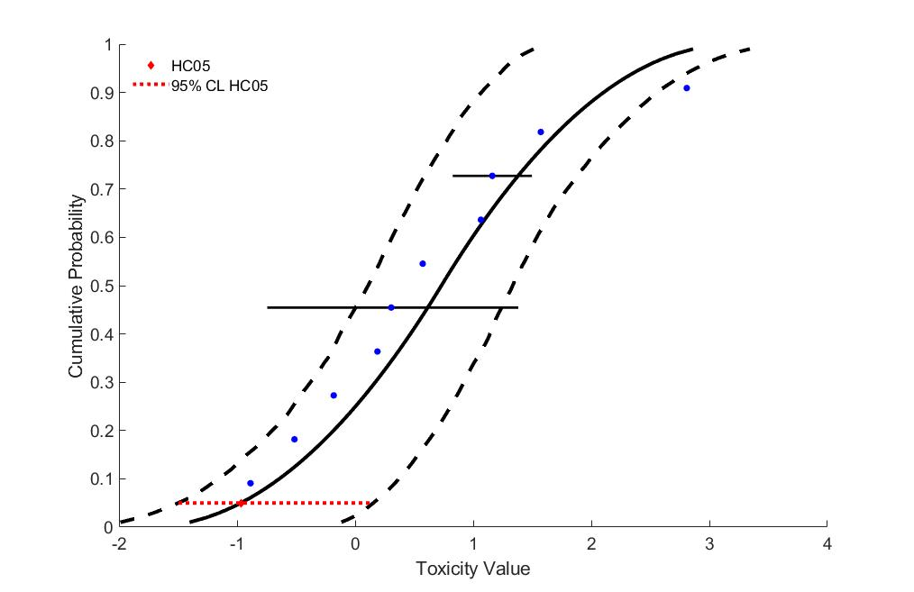
Figure 1. Triangular SSD for imidacloprid toxicity values for terrestrial invertebrates.
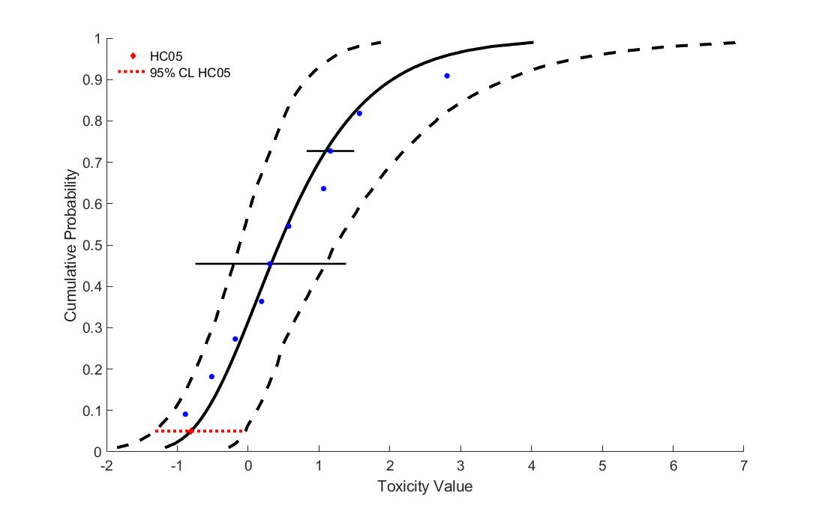
Figure 2. Gumbel SSD for imidacloprid toxicity values for terrestrial invertebrates.

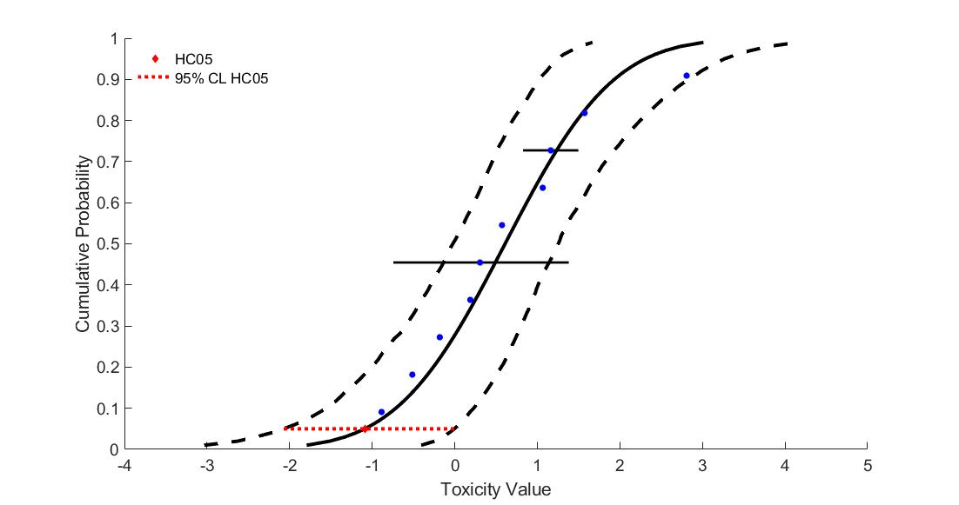
Figure 3. Normal SSD for imidacloprid toxicity values for terrestrial invertebrates.

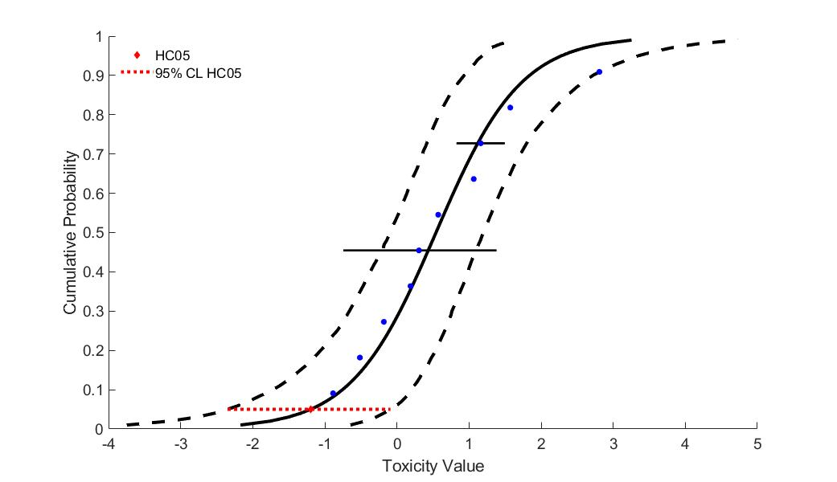
Figure 4. Logistic SSD for imidacloprid toxicity values for terrestrial invertebrates.

Contact exposure

Figure 5 and Figure 6 depict the two distributions fit to the EC/LC₅₀ values for contact exposure. Table 9 includes the HC₀₅ and HC₅₀ values for the for distributions, along with the associated 95% confidence intervals. When comparing the two distributions to the individual toxicity data, the triangular distribution does not appear to be a good fit for the data (Figure 6).
As depicted in the two figures, the lowest available toxicity value (i.e., 0.013 mg a.i./kg-bw for Melipona scutellaris; ECOTOX # 184470) appears to be close to the HC₀₅. Since the HC₀₅ is an important endpoint used in the BE, the estimated HC₀₅ of the two remaining distributions is used in conjunction with goodness of fit to select the endpoint. The normal distribution is chosen because it has a satisfactory p value, is within the top AICc weights for goodness of fit and fits the data best near the HC₀₅ and HC₅₀ values.

Table 9. HC05 and HC50 values for distributions based on contact invertebrate EC/LC50 values.
Distribution | HC₀₅ (95% CI) | HC₅₀ (95% CI)
normal | 0.015 (0.0017-0.15) | 0.85 (0.22-3.37)
triangular | 0.021 (0.0074-0.18) | 0.88 (0.28-2.87)

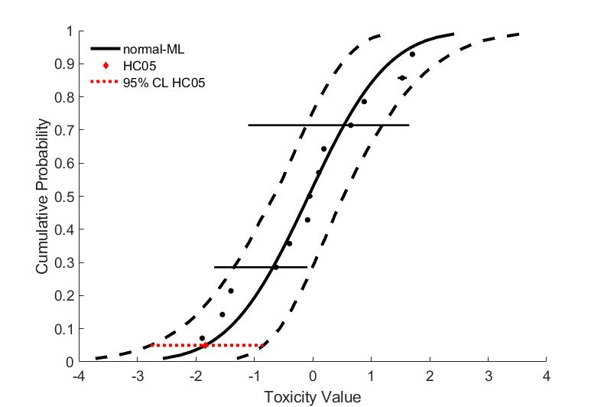
Figure 5. Normal SSD for imidacloprid toxicity values for terrestrial invertebrates.

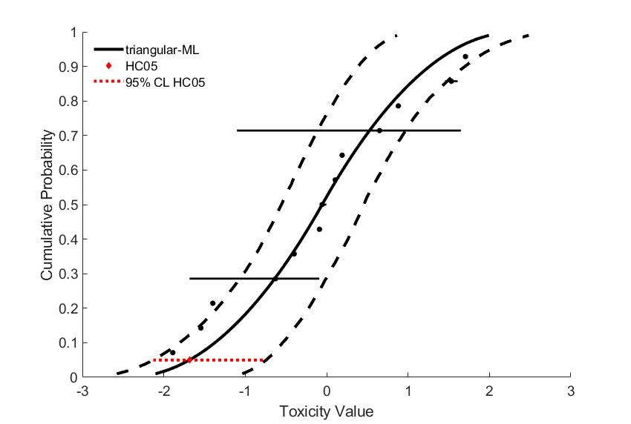
Figure 6. Triangular SSD for imidacloprid toxicity values for terrestrial invertebrates.

Conclusions

For dietary exposure to terrestrial invertebrates the logistic distribution provided the best fit for the dataset while for contact exposure the normal distribution provides the best fit. This decision was based on the AICc_{c} weight, p-value, confidence limits for the different distributions (especially around the HC₀₅ and HC₅₀) and by visually examining the distributions and their consistency with the toxicity data. The SSD logistic and normal distribution, respectively, will be used for assessing direct effects to listed terrestrial invertebrates associated wth PPHD in each category (Figure 7 and Figure 8 ).

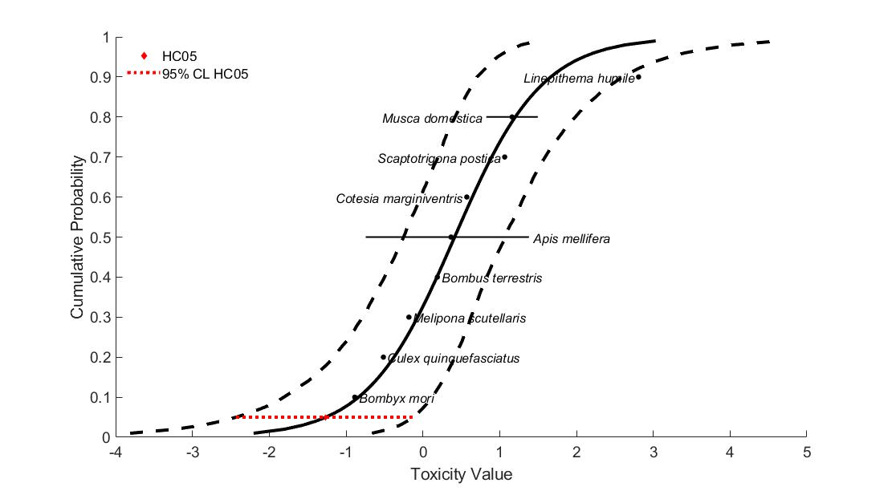
Figure 7. Logistic SSD for imidacloprid toxicity values for dietary exposure to terrestrial invertebrates.
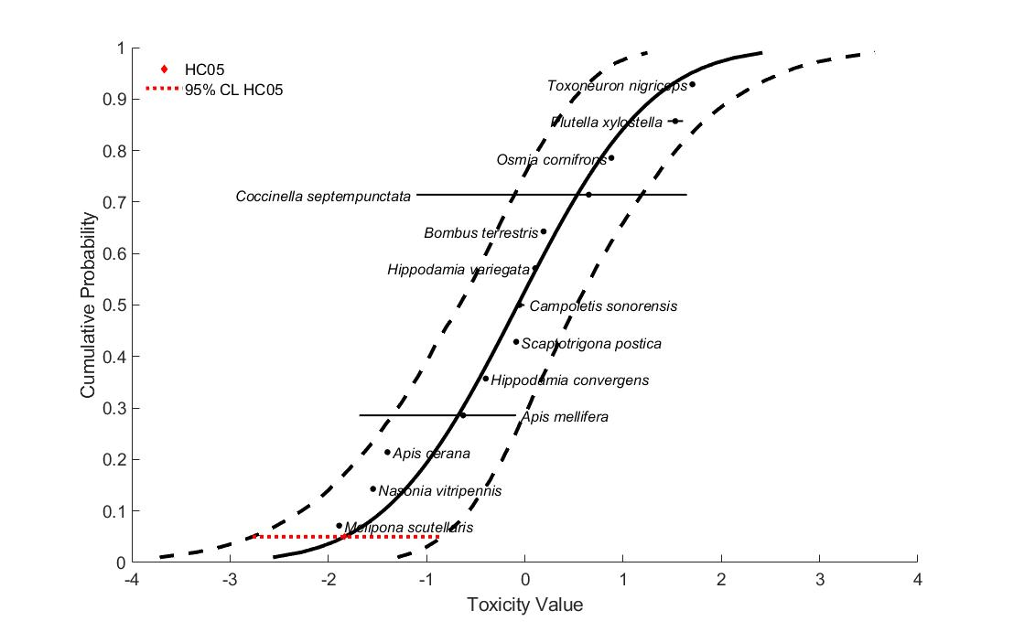
Figure 8. Normal SSD for imidacloprid toxicity values for contact exposure to terrestrial invertebrates.

Etterson, M. 2011. Appendix C. Analyses of sensitivity distributions for estimation of acute hazard concentrations to aquatic animals. https://www.regulations.gov/document?D=EPA-HQ-OPP-2011-0898-0009
Etterson, M. 2011. Appendix C. Analyses of sensitivity distributions for estimation of acute hazard concentrations to aquatic animals. https://www.regulations.gov/document?D=EPA-HQ-OPP-2011-0898-0009

