APPENDIX 2-5. Imidacloprid Species Sensitivity Distribution Analysis for Aquatic Invertebrates

Summary

Species Sensitivity Distributions (SSDs) were fit to median lethal or effects (immobility) concentrations (LC₅₀ or EC₅₀ values, respectively) for aquatic invertebrates exposed to imidacloprid. Separate aquatic freshwater and estuarine/marine (saltwater) invertebrate SSDs were developed. Additionally, to investigate potential differences in sensitivity among insect species and other aquatic invertebrate species, a separate freshwater aquatic insect SSD was also developed. In previous biological evaluations for other insecticides, separate SSDs for mollusks were also developed; however, this was not done for imidacloprid due to a lack of data.

Six distributions (normal, logistic, triangular, gumbel, weibull and burr) were fit to the available toxicity data for freshwater invertebrates and insects, and saltwater invertebrates. For freshwater invertebrates and freshwater insects, the triangular distribution provided the best fit for the datasets (Figure 1). For saltwater invertebrates the gumbel distribution provided the best fit for the dataset Figure 2). The distribution selection decision was based on the AIC_{c} weight, confidence limits for the different distributions (especially around the HC₀₅ and HC₅₀) and by visually examining the distributions and their consistency with the toxicity data. The comparison of SSDs for freshwater invertebrates and insects did not indicate a significant difference in distributions at the HC_{05.} Therefore, the triangular distribution for all freshwater invertebrates was determined to be the best fit for the imidacloprid toxicity dataset (Figure 1). Summary statistics from the fitted SSDs are provided below in Table 1. The fifth and fiftieth percentiles of the SSD (abbreviated HC₀₅ and HC₅₀, respectively, where “HC” stands for “hazard concentration”) are used to calculate mortality endpoints representing effects to listed species of aquatic invertebrates associated with their prey, pollination, habitat and dispersal (PPHD).

Table 1. Summary of imidacloprid mortality endpoints for aquatic invertebrates (values in µg a.i./L).
Statistic | Freshwater Invertebrates | Saltwater Invertebrates
HC₀₅ (95% CI) | 1.43 (0.71-5.54) | 13.15 (2.11-204.52)
HC₅₀ (95% CI) | 154 (71.8-331.5) | 636.25 (96.88-8217)
Median Slope | 1.7 | 3.63
CI = confidence interval

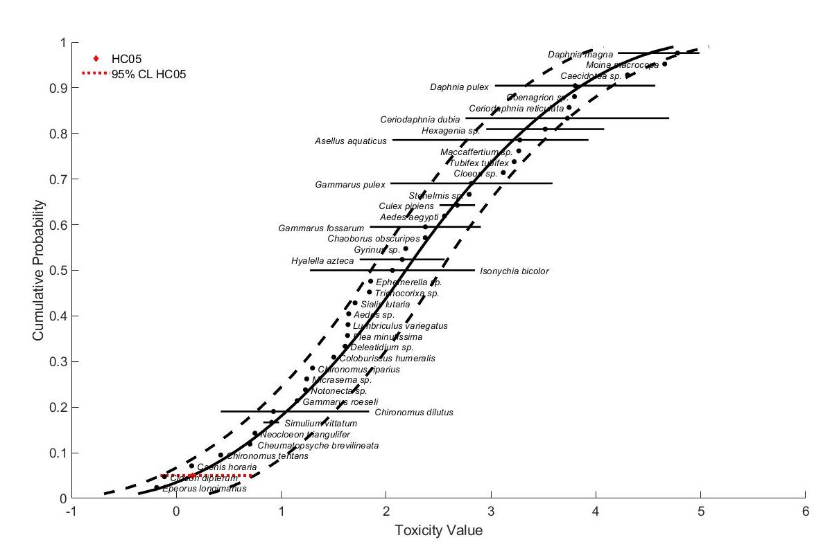
Figure 1. Normal SSD for imidacloprid toxicity values for freshwater aquatic invertebrates.
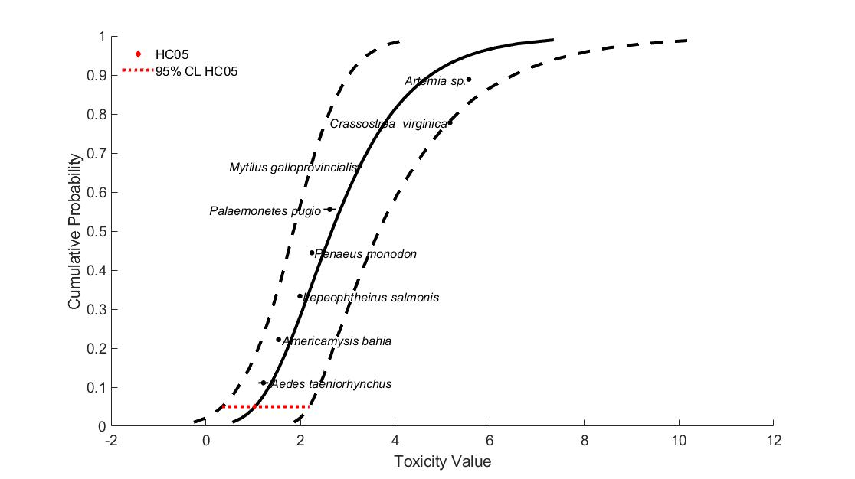
Figure 2. Gumbel SSD for imidacloprid toxicity values for saltwater aquatic invertebrates.

Toxicity Data

Because an SSD depicts relative sensitivities of different species exposed to the same stressor, it is necessary to standardize the data as much as possible to eliminate variables that would confound the relative sensitivities of species. Such variables can include study exposure duration, age class of organisms tested, and other study design factors. The EC/LC₅₀ values that were included in the analysis were all definitive mortality or immobility endpoints from either 48 or 96-hour tests, with a minimum of four concentrations of technical grade active ingredient, plus appropriate controls, tested within each study. Additionally, if a definitive immobility and mortality endpoint was available from the same test, the mortality endpoint was used (because immobility is intended as a surrogate for mortality). In some cases, only the genus was available, so the species is unknown. Endpoints without definitive endpoints were not used to derive SSDs.

Data used to derive SSDs are from literature that passed the ECOTOX quality screen (catalogued in APPENDIX 2-2) and data from unpublished, registrant-submitted studies. There was a total of 41 freshwater invertebrates tested, 28 of which were insects, and 8 saltwater aquatic invertebrate species (Table 2). Note that for some of the species in Raby et al. 2018 (178290), wild caught species were only identified down to the genus level; however, they are assumed to represent the same species. For all species, there are one to seven different toxicity endpoints (LC₅₀ or EC₅₀ values) available. In cases where multiple endpoints were available for the same test species, the full range of applicable data is used in SSD creation. Using the available data, the slope was calculated for all aquatic invertebrates resulting in a median slope of 1.7. Table 3 and Table 4 show the data used in SSD creation for freshwater and saltwater invertebrates, respectively.

Table 2. Distribution of test results available for imidacloprid.
Media | Test results | Species
Freshwater invertebrates | 65 | 41
Freshwater insects | 38 | 28
Freshwater non-insects | 27 | 13
Saltwater invertebrates | 11 | 8

Table 3. Test results used to derive SSDs for imidacloprid for freshwater aquatic invertebrates.
Genus or Species | Acute EC/LC₅₀ value (µg/L) | Slope | Reference (ECOTOX #)
Epeorus longimanus* | 0.65 | NA | 102580
Cloeon dipterum* | 0.77 | 1.18 | 166772
Caenis horaria* | 1.40 | 1.59 | 166772
Chironomus dilutus* | 2.65 | NA | 160293
Chironomus tentans* | 2.65 | NA | 167874
Chironomus dilutus* | 3.56 | NA | 184107
Chironomus dilutus* | 4.63 | NA | 183458
Cheumatopsyche brevilineata* | 4.85¹ | NA | 152279
Cheumatopsyche brevilineata* | 5.24¹ | NA | 152279
Neocloeon triangulifer* | 5.62 | 3.98 | 178290
Simulium vittatum* | 6.75 | NA | 81392
Simulium vittatum* | 8.25 | NA | 81392
Simulium vittatum* | 9.54 | NA | 81392
Chironomus dilutus* | 14.2 | 1.54 | 178290
Gammarus roeseli | 14.2¹ | 1.87 | 160124
Notonecta sp. * | 17¹ | 1.53 | 166772
Micrasema sp. * | 17.5 | 3.84 | 178290
Isonychia bicolor* | 18.8 | NA | 183979
Chironomus riparius* | 19.9 | NA | 165043
Coloburiscus humeralis* | 31.7 | NA | 184001
Deleatidium sp. * | 40.6 | NA | 184001
Plea minutissima* | 42.9 | 1.84 | 166772
Lumbriculus variegatus | 43.3 | NA | 178290
Aedes sp. * | 44 | 4.11 | 178290
Sialis lutaria* | 50.6¹ | NA | 166772
Hyalella azteca | 56 | NA | MRID42256303
Chironomus dilutus* | 68.9 | 1.69 | MRID42256304
Trichocorixa sp. * | 69.3 | NA | 178290
Gammarus fossarum | 70 | NA | 152830
Ephemerella sp. * | 71.2 | 2.03 | 178290
Gammarus pulex | 109.9 | NA | 153561
Asellus aquaticus | 115 | NA | 166772
Gyrinus sp. * | 154 | 5.52 | 178290
Chaoborus obscuripes* | 236 | 1.4 | 166772
Culex pipiens* | 323 | 6.7 | 184514
Aedes aegypti* | 360 | NA | 168249
Hyalella azteca | 362 | NA | 178290
Ceriodaphnia dubia | 571.6¹ | NA | 157952
Stenelmis sp. * | 620 | NA | 178290
Isonychia bicolor* | 702 | 1.67 | 178290
Culex pipiens* | 705 | 1.5 | 184514
Gammarus fossarum | 800 | NA | 150031
Hexagenia sp. * | 900 | NA | 183503
Daphnia pulex | 1090 | NA | 183047
Cloeon sp. * | 1310 | 1.28 | 178290
Asellus aquaticus | 1517 | NA | 183972
Tubifex tubifex | 1663 | NA | 184000
Maccaffertium sp. * | 1840 | 2.99 | 178290
Gammarus pulex | 3857 | NA | 153560
Ceriodaphnia reticulata | 5552.9¹ | NA | 157952
Coenagrion sp. * | 6250 | NA | 178290
Asellus aquaticus | 8500 | NA | 150031
Asellus aquaticus | 8500 | NA | 152830
Hexagenia sp. * | 12000 | 0.979 | 178290
Daphnia magna | 16200 | NA | 184090
Caecidotea sp. | 20000¹ | NA | 178290
Daphnia pulex | 36872¹ | NA | 157952
Daphnia magna | 43265¹ | NA | 157952
Moina macrocopa | 45271¹ | NA | 157952
Ceriodaphnia dubia | 50000 | NA | 178290
Daphnia magna | 56600¹ | 1.48 | 150163
Daphnia magna | 85200¹ | 2.61 | MRID42055317
Daphnia magna | 90680¹ | NA | 162193
Daphnia magna | 93880¹ | NA | 171489
Daphnia magna | 97000 | NA | 159937
NA = Not available
*Species is in the Insecta class. A separate SSD for insects was also developed.
¹EC₅₀ value

Table 4. Test results u sed to derive SSDs for imidacloprid for saltwater aquatic invertebrates.
Genus or Species | Acute EC/LC₅₀ value (µg/L) | Slope | Reference (ECOTOX #)
Aedes taeniorhynchus | 13 | 3.63 | 19639
Aedes taeniorhynchus | 21 | NA | 19639
Americamysis bahia | 33 | 4.2 | MRID42055319
Americamysis bahia | 36 | NA | MRID42528301
Artemia sp. | 361230 | 3.47 | 19639
Crassostrea virginica | 145000 | NA | MRID42256305
Lepeophtheirus salmonis | 97.6 | NA | 175427
Lepeophtheirus salmonis | 8400 | NA | 175427
Mytilus galloprovincialis | 1800 | NA | 166568
Palaemonetes pugio | 308.8 | NA | 102582
Palaemonetes pugio | 563.5 | NA | 102582
Penaeus monodon | 175 | NA | 184559

Determining distributions with best fit

Six potential distributions for the imidacloprid data were considered (i.e., normal, logistic, triangular, gumbel, weibull and burr). To fit each of the six distributions, the toxicity values were common log (log₁₀) transformed. The SSD toolbox includes four different fitting methods (i.e., maximum likelihood, moment estimators, linearization and metropolis-hastings). All six distributions were fit using the maximum likelihood (ML) method. To test goodness-of-fit, all six distributions were fit to the imidacloprid data and bootstrap goodness-of-fit tests were run with 10,000 replicates. The results of these fitting exercises are presented in Table 5 For the freshwater invertebrate and insect SSD as well as saltwater invertebrate SSD, for all distributions the p-value indicates acceptable distributions.

Table 5. P-values calculated for SSDs for freshwater and saltwater aquatic invertebrate toxicity data for imidacloprid.
Distribution | Freshwater Inverts | Insects | Non-insects | Saltwater Inverts
Normal | 0.56 | 0.93 | 0.68 | 0.22
Logistic | 0.34 | 0.88 | 0.60 | 0.34
Triangular | 0.79 | 0.98 | 0.81 | 0.20
Gumbel | 0.76 | 0.74 | 0.43 | 0.56
Weibull | 0.36 | 0.25 | >0.01 | 0.56
Burr | 0.62 | 0.91 | 0.57 | 0.51

Akaike’s Information Criteria (AICc) weights

Akaike’s Information Criterion corrected for sample size (AIC_{c}) was used to compare the six distributions for the freshwater and saltwater invertebrate data at the HC₀₅². For all freshwater invertebrates, the majority of the weight is attributed to the triangular distribution method (Table 6). A similar pattern was seen for freshwater insects the top distribution the triangular method carries the majority of the weight (Table 7). Based on the AIC weights, the fit of the triangular distribution is further considered below for all freshwater invertebrate and insect data.

Table 6. Akaike’s Information Criteria (AICc) for distributions for freshwater invertebrate toxicity data.
Distribution | AICc | Delta AICc | Wt | HC₀₅ | SE HC₀₅
triangular | 616.4142 | 0 | 0.6472 | 1.4295 | 0.5123
normal | 618.8981 | 2.4840 | 0.1869 | 1.2154 | 0.8513
gumbel | 620.9325 | 4.5183 | 0.0676 | 1.9336 | 0.8931
logistic | 621.2577 | 4.8435 | 0.0575 | 0.8614 | 0.6819
burr | 622.4491 | 6.0350 | 0.0317 | 1.7034 | 1.1566
weibull | 624.9395 | 8.5253 | 0.0091 | 0.1419 | 0.1730

Table 7. Akaike’s Information Criteria (AICc) for distributions for freshwater insect toxicity data.
Distribution | AICc | Delta AICc | Wt | HC₀₅ | SE HC₀₅
triangular | 349.1710 | 0 | 0.6058 | 1.1017 | 0.3821
normal | 351.6289 | 2.4578 | 0.1773 | 0.9470 | 0.6654
logistic | 352.9736 | 3.8026 | 0.0905 | 0.7568 | 0.5949
gumbel | 353.4465 | 4.2755 | 0.0714 | 1.3425 | 0.6224
burr | 355.0928 | 5.9218 | 0.0314 | 1.1362 | 0.8670
weibull | 355.6519 | 6.4809 | 0.0237 | 0.1632 | 0.1976

Table 8. Akaike’s Information Criteria (AICc) for distributions for freshwater non-insect toxicity data.
Distribution | AICc | Delta AICc | Wt | HC₀₅ | SE HC₀₅
triangular | 256.5406 | 0 | 0.4587 | 32.4291 | 23.9563
normal | 257.6587 | 1.1180 | 0.2623 | 26.0949 | 27.7743
logistic | 258.5306 | 1.9900 | 0.1696 | 22.6627 | 28.5961
gumbel | 259.9900 | 3.4493 | 0.0818 | 29.2390 | 22.1367
burr | 262.1580 | 5.6174 | 0.0277 | 22.8141 | 30.9941

For saltwater invertebrates three distributions carry the majority of the weight (Table 8). Based on the AIC weights, the fit of the gumbel, triangular, and normal distributions are further considered below for saltwater invertebrate data.

Table 9. Akaike’s Information Criteria (AICc) for distributions for saltwater invertebrate toxicity data.
Distribution | AICc | Delta AICc | Wt | HC₀₅ | SE HC₀₅
gumbel | 155.9726 | 0 | 0.3851 | 10.9818 | 11.6170
triangular | 156.9352 | 0.9626 | 0.2380 | 6.0380 | 12.6883
normal | 157.6739 | 1.7013 | 0.1645 | 2.8801 | 5.4560
logistic | 158.1471 | 2.1745 | 0.1298 | 1.4089 | 2.8796
weibull | 159.7168 | 3.7442 | 0.0592 | 0.1253 | 0.4415
burr | 161.5761 | 5.6036 | 0.0234 | 10.9837 | 11.5568

Distributions

The cumulative distribution functions for freshwater and saltwater invertebrate SSDs for the respective distributions are discussed in this section.

Freshwater invertebrates

Figure 3 depicts the triangular distribution fit to the EC/LC₅₀ values for freshwater invertebrate species (and genera). Table 10 includes the HC₀₅ and HC₅₀ values for this distribution, along with the associated 95% confidence intervals. As depicted in the figure, the lowest available toxicity value (i.e., 0.65 ug a.i./L for Epeorus longimanus; ECOTOX # 102580) is lower than the estimated HC₀₅ value (Table 10).

Table 10. HC05 and HC50 values (in µg a.i./L) for triangular distribution based on freshwater invertebrate EC/LC50 values.
Distribution | HC₀₅ (95% CI) | HC₅₀ (95% CI)
Triangular | 1.43 (0.71-5.54) | 154 (71.8-331.5)

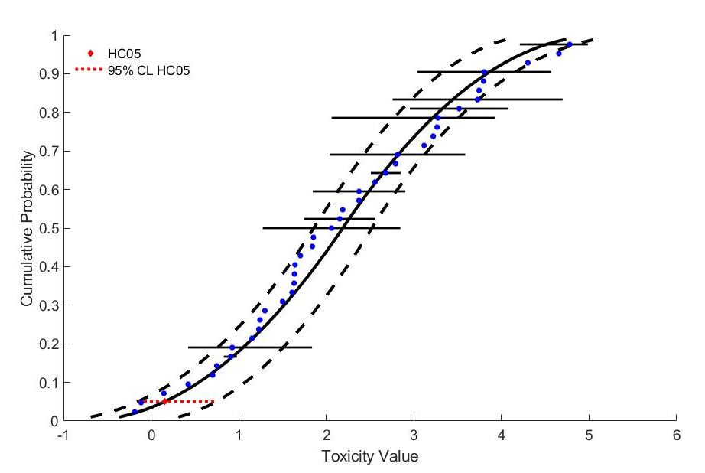
Figure 3. Triangular SSD for imidacloprid toxicity values for freshwater aquatic invertebrates.

Freshwater insects

Figure 4 depicts the triangular distribution fit to the EC/LC₅₀ values for freshwater insect species. Table 11 includes the HC₀₅ and HC₅₀ values for this distribution, along with the associated 95% confidence intervals. As depicted in Figure 4 the lowest available toxicity value (i.e., 0.65 ug a.i./L for Epeorus longimanus; ECOTOX # 102580) is less than all estimated HC₀₅ values. The lowest available toxicity value is within the 95% confidence intervals of the HC₀₅ for the triangular distribution (Table 11).
Table 11. HC05 and HC50 values (in µg a.i./L) for triangular distribution based on freshwater insect EC/LC50 values.
Distribution | HC₀₅ (95% CI) | HC₅₀ (95% CI)
Triangular | 1.10 (0.54-4.40) | 50.6 (23.0-108.4)

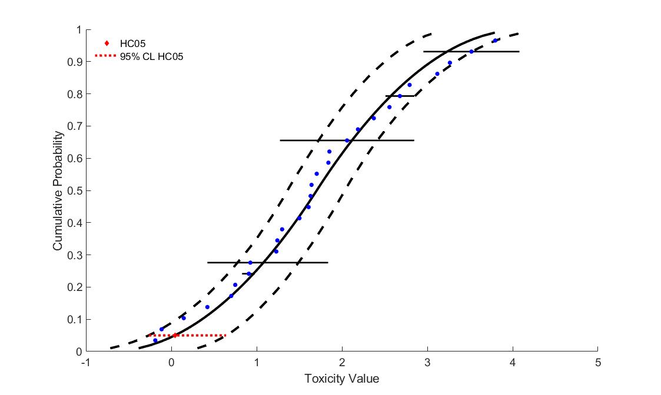
Figure 4. Triangular SSD for imidacloprid toxicity values for freshwater aquatic insects.

Freshwater non-insects

Figure 5 and Figure 6 depict the triangular and normal distribution fit to the EC/LC₅₀ values for freshwater non-insect species. Table 12 includes the HC₀₅ and HC₅₀ values for these two distributions, along with the associated 95% confidence intervals. The triangular distribution, while having the highest AIC_{c} weight it not a good visual fit for the data near the HC₀₅ nor HC₅₀. As depicted in Figure 5 and Figure 6 the lowest available toxicity value (i.e., 14.2 ug a.i./L for Gammarus roeseli; ECOTOX # 160124) is less than all estimated HC₀₅ values. The lowest available toxicity value is however within the 95% confidence intervals of the HC₀₅ for both distributions (Table 12). Therefore, the normal distribution is selected as the best fit for the non-insect invertebrate data.
Table 12. HC05 and HC50 values (in µg a.i./L) for triangular distribution based on freshwater insect EC/LC50 values.
Distribution | HC₀₅ (95% CI) | HC₅₀ (95% CI)
Triangular | 32.4 (11.4-301.8) | 1568 (473-5348)
Normal | 26.1 (4.0-234.4) | 1595 (403-6096)

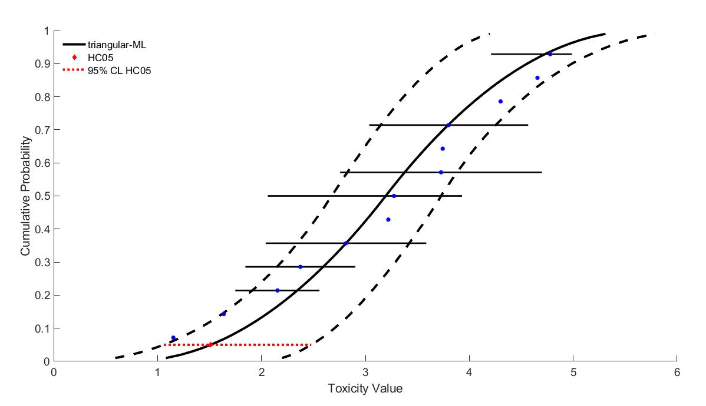
Figure 5. Triangular SSD for imidacloprid toxicity values for freshwater aquatic non-insects.
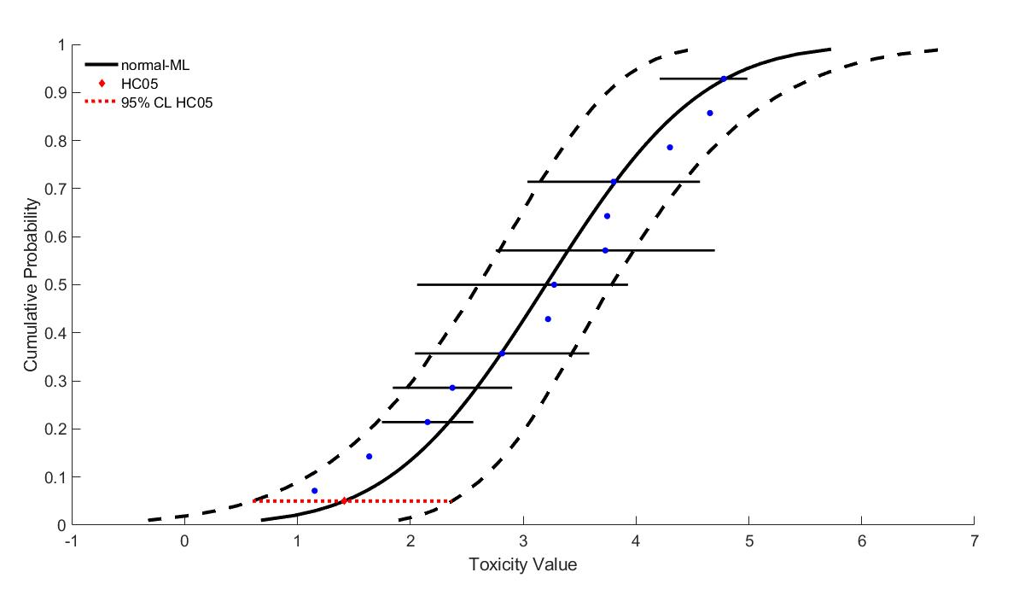
Figure 6. Normal SSD for imidacloprid toxicity values for freshwater aquatic non-insects.

Comparison of SSDs for aquatic invertebrates and insects

The triangular SSDs for all freshwater aquatic invertebrates and for freshwater aquatic insects were analyzed to determine whether there was a difference in the distributions. Figure 7 demonstrates that there is little variation between the two distributions around the HC₀₅. However, variation between the two SSD distributions did increase at higher percentiles along the curves.

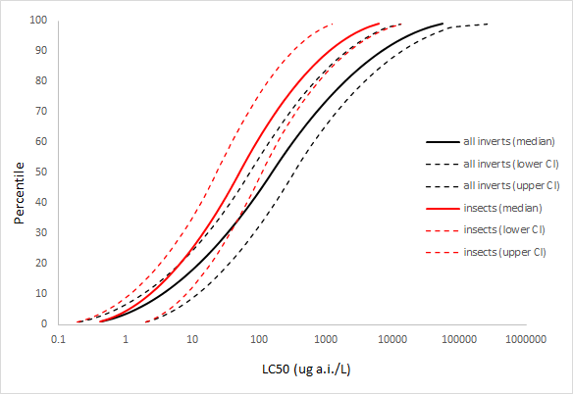
Figure 7. Comparison of triangular SSDs for imidacloprid toxicity values for all freshwater aquatic invertebrates and insects.

Saltwater invertebrates

Figure 8 through Figure 11 depict the four distributions fit to the EC/LC₅₀ values for saltwater invertebrate species (and genera). Table 13 includes the HC₀₅ and HC₅₀ values for all 4 distributions, along with the associated 95% confidence intervals. When comparing the four distributions to the individual toxicity data, the triangular distribution is not a good visual fit for the data (Figure 9).

As depicted in the four figures, the lowest available toxicity value (i.e., 13 ug a.i./L for Aedes taeniorhynchus; ECOTOX # 19639) appears to be close to or greater than the estimated HC₀₅ values. The lowest toxicity value from the open literature is however within the 95% confidence intervals of the HC₀₅ for all four distributions (Table 13). The gumbel distribution is chosen because the HC₀₅ is conservative while having the best fit to the data, a tight confidence interval, and the highest AIC_{c} weight.

Table 13. HC05 and HC50 values (in µg a.i./L) for gumbel, logistic, normal and triangular distributions based on saltwater invertebrate EC/LC50 values.
Distribution | HC₀₅ (95% CI) | HC₅₀ (95% CI)
Gumbel | 11.0 (2.21-154.9) | 459.7 (71.2-4545)
Triangular | 6.04 (1.09-312.3) | 1107 (137.2-9140)
Normal | 2.88 (0.11-181.6) | 886.8 (80.3-10690)
Logistic | 1.41 (0.02-100.4) | 573.3 (46.8-6912)
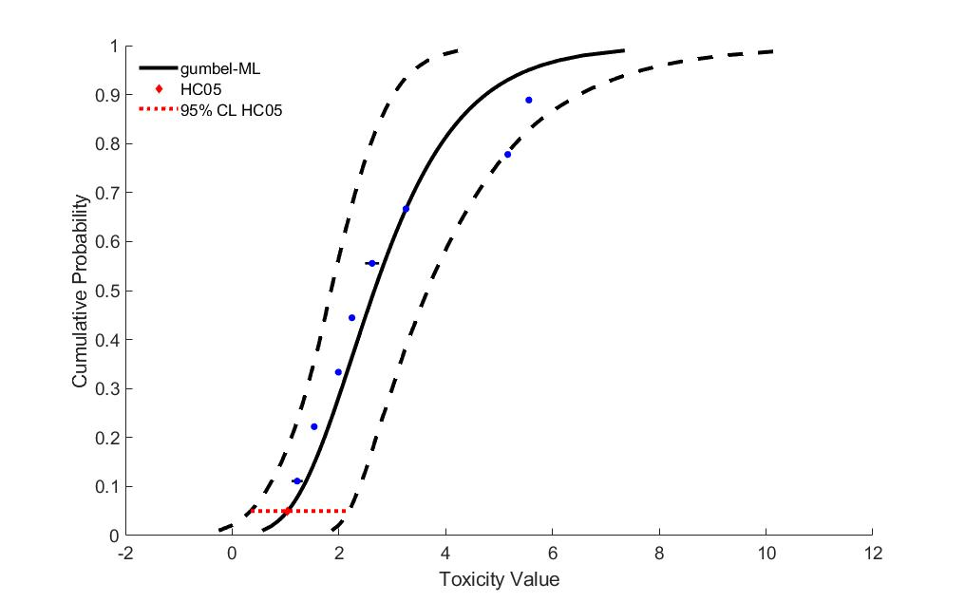
Figure 8. Gumbel SSD for imidacloprid toxicity values for saltwater invertebrates.
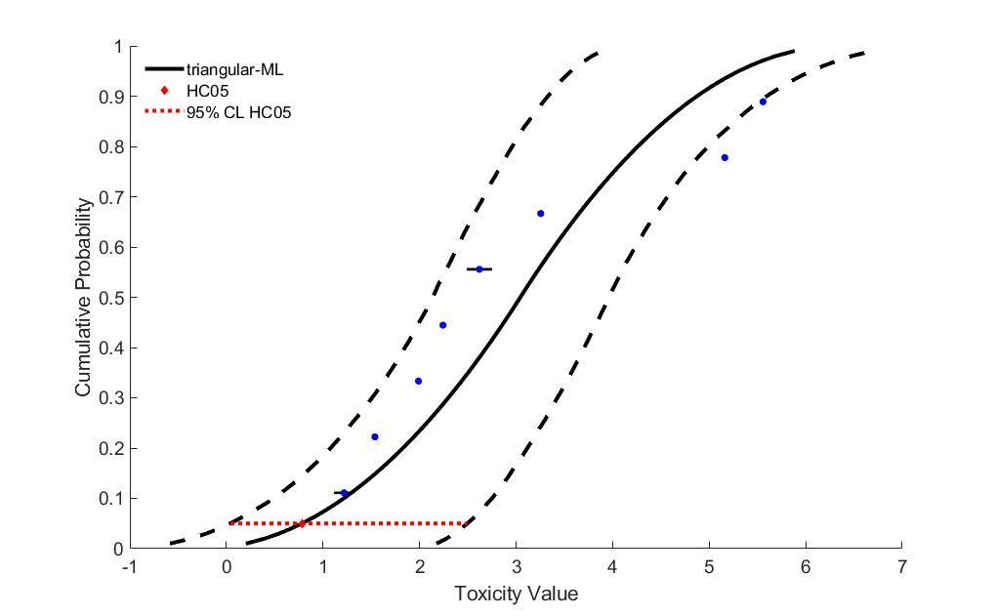
Figure 9. Triangular SSD for imidacloprid toxicity values for saltwater invertebrates.
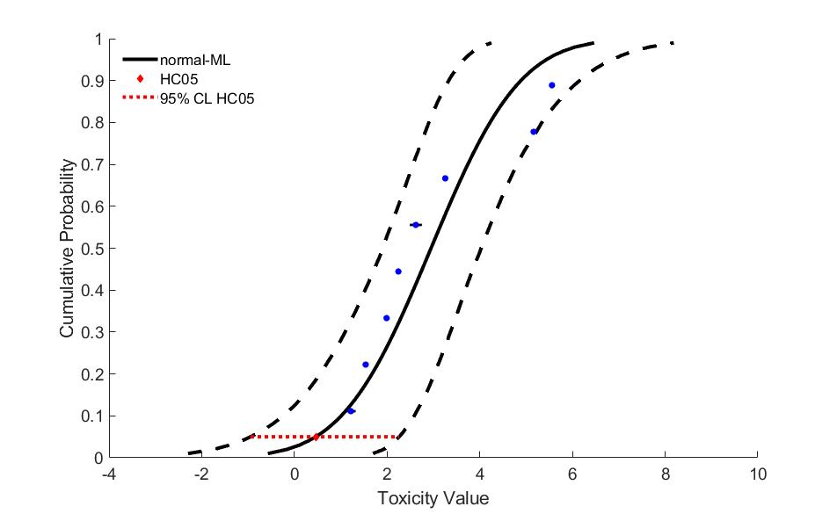
Figure 10. Normal SSD for imidacloprid toxicity values for saltwater invertebrates.
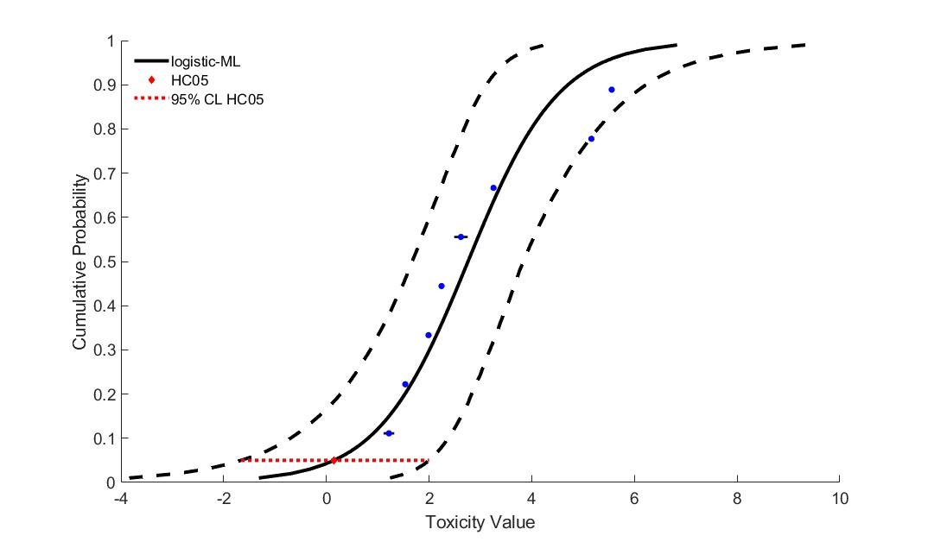
Figure 11. Logistic SSD for imidacloprid toxicity values for saltwater invertebrates.

Conclusions

For all aquatic invertebrates and for aquatic insects, the normal distribution provided the best fit for the datasets. This decision was based on the AIC_{c} weight, confidence limits for the different distributions (especially around the HC₀₅ and HC₅₀) and by visually examining the distributions and their consistency with the toxicity data. The comparison of mortality endpoints (Table 1) and median lethal or effects (immobility) concentrations for aquatic invertebrates and insects, demonstrate that there is little variation between the two distributions. Therefore, the triangular distribution for all aquatic invertebrates was determined to be the best fit for the imidacloprid toxicity dataset, and HC₀₅/HC₅₀ from this distribution are used as endpoints for assessing direct effects to all listed freshwater aquatic invertebrates and effects to aquatic invertebrates associated wth PPHD. The gumbel distribution for saltwater aquatic invertebrates provided the best fit for the data and will be used for assessing direct effects to listed estuarine and marine aquatic invertebrates and effects to these invertebrates associated wth PPHD in each category.

24 through 96 hr tests for saltwater invertebrates

