APPENDIX 1-7. Determination of Overlap of Likely Imidacloprid Exposure Area and Species Ranges and Critical Habitat Located in the 48 Contiguous United States (ConUS)

The extent of overlap of imidacloprid’s likely exposure areas and the range of a species integrates information on potential use sites and usage data. This approach considers overlap of the species range (or critical habitat) with areas directly treated with imidacloprid and those receiving spray drift as well as a poultry litter layer that accounts for imidacloprid-treated poultry litter that is used as soil amendments to agricultural fields. To address uncertainties associated with how treated acres may be distributed within a state (relative to a species range or critical habitat), and the magnitude of usage on any given year, approaches are employed to represent a central estimate of overlap as well as upper and lower bounds. These different estimates are considered in the Weight of Evidence when deciding whether use of imidacloprid is likely or not likely to adversely affect (LAA or NLAA) an individual of an assessed species. The estimated percent overlap of the range or critical habitat that overlaps with use or drift, is used as a surrogate as the percent of the population potentially exposed in Step 2. Additional details are provided in the Revised Method[1] document. This appendix describes the approach for determining the extent of overlap.

1. Potential Use Sites

Imidacloprid’s registered uses include both agricultural and non-agricultural sites. Potential agricultural use sites of imidacloprid are represented by 7 Use Data Layers (UDLs) generated by aggregating crops originally represented by USDA’s Crop Data Layer (CDL). This process for developing theses agricultural UDL is described in detail in **APPENDIX 1-5 and APPENDIX 1-6**. The imidacloprid specific agricultural UDLs include several major crops, including:

1. Soybeans
2. Citrus
3. Cotton
4. Grapes (Vineyards)

Potential agricultural use site for imidacloprid also include several UDLs that represent aggregated crops; for additional detail see **APPENDIX 1-5**:

1. Vegetables & Ground Fruit
2. Other Orchards
3. Other Row Crops
4. Other Crops

Potential non-agricultural use sites of imidacloprid are represented by 7 UDLs. The data sources used to generate these UDLs were use specific, for additional details see **APPENDIX 1-6**. The imidacloprid specific non-agricultural UDLs include:

1. Developed
2. Open Space Developed
3. Field Nurseries
4. Managed Forests
5. Poultry litter
6. Christmas Tree Plantation
7. Shrimp Use

In total 15 UDLs represent the foliar and soil agricultural and non-agricultural uses for imidacloprid. Seed treatment and other non-spray uses are considered separately, see **APPENDIX 1-6 and APPENDIX 4-5**. The crosswalk in **ATTACHMENT 1-4** is used to link the SUUM information with the additional data needed from the Census of Agriculture for calculating the aggregated percent crop treated (PCT) values for agricultural uses on a state/crop basis. **APPENDIX 1-6** uses the chemical independent information provided in **ATTACHMENT 1-4** to provide a imidacloprid specific crosswalk across crop data sources for imidacloprid uses.

To incorporate usage, an aggregated PCT is generated for each of the UDLs. The crosswalk in **ATTACHMENT 1-4** is used to link the usage information provided by the EPA’s Science Information & Analysis Branch (SIAB) in their SIAB Use and Usage Matrix (SUUM) with additional data from the Census of Agriculture (CoA) for the un-surveyed, unreported, or unregistered crops needed when calculating the aggregated PCTs for agricultural uses on a state/crop basis. For crop uses, **APPENDIX 1-6** uses the chemical independent information provided in the crosswalk **(ATTACHMENT 1-4)** to provide a imidacloprid specific crosswalk across crop data sources (SUUM, CoA, and UDL) for the imidacloprid uses. Aggregated PCTs for non-agricultural UDLs are generated based on the information provided in the SUUM, additional details are provided in the following section.

Because the pesticide usage data available are based on surveys of growers and/or other user groups, all reported PCTs below 2.5% are rounded up to 2.5%, to buffer against uncertainty associate with these surveys and low usage estimates. The surveys utilized by EPA are designed to be statistically robust, but by definition sample the target populations rather than provide a complete accounting of all pesticide usage. Therefore, PCT estimates resulting in values below 2.5% are generally a good indicator of limited usage of an active ingredient but by using 2.5% the PCT accounts for possible usage not captured by the survey data.

1. Applying Usage Data to UDLs

Nationally, among surveyed agricultural crops, imidacloprid usage (both pounds applied, and total acres treated) has shown an overall increasing trend since 2006 until 2017, before declining in 2018. During the most recent five years of available survey data (2014 -2018), agricultural usage of imidacloprid was reported in in 43 states.

Across states and all agricultural usage, the estimated average pounds applied with imidacloprid as the active ingredient is ~22,285 lb. annually, based on the yearly average 891,400 pounds of imidacloprid are applied annually to agricultural crops. The agricultural use in a single state, that had the highest annual average pounds active ingredient applied, were grapes grown for vineyards (90,000 lb.). Across all states with agricultural uses of imidacloprid, cotton had the highest average pounds active ingredient applied annually (200,000 lb.) **(APPENDIX 1-4)**.

Approximately 50% of the acres treated with imidacloprid are planted with two crops cotton and soybeans. Cotton alone accounted for the largest acreage treated with imidacloprid for all registered agricultural uses across states (1,500,000 acres). While there are fewer treated acres, imidacloprid is significant for some other registered crops. For instance, potatoes have reported imidacloprid use in 16 states, and treated the acreage amounts to ~40% of the total acreage grown across those states. **(APPENDIX 1-4)**.

National non-agricultural usage data is more limited than agricultural data. Across nonagricultural uses 245,000 pounds of imidacloprid were applied annually on nonagricultural sites including buildings, ornamentals, turf, pastures, and managed forests. Further information on non-agricultural sites treated with imidacloprid is available in **(APPENDIX 1-4)**. Usage data for seed treatment crops is unavailable. Seed treatment with imidacloprid is generally considered to be widespread in terms of the number of crops and the percentage of the crop planted with treated seed. However, quantitative seed treatment usage data are difficult to obtain due to the complexities of capturing this usage information from growers. While verifiable quantitative usage data that indicate the total pounds active ingredient used to treat seed or the location and the number of acres planted with treated seed are not currently available, applications of imidacloprid to seed and seed pieces may be generally characterized as commonly used on a wide variety of crop seeds and seed pieces for planting based on extension recommendations and other information.

* 1. Agricultural Uses

The goal of this approach is to determine the amount of area within each state that is treated with imidacloprid (referred to as “treated acres”). This is accomplished by combining data representing the potential use sites, including the UDLs and acres grown from the 2012 Census of Agriculture with available usage data. For the agricultural UDLs, multiple years of data are included to capture temporal changes such as crop rotations. The current years of the CDL included in the UDLs are 2013-2017.

For imidacloprid’s agricultural crop uses, usage data are available to quantify the percent of crop area that has been treated (PCT) for surveyed crops within surveyed states. The PCT can be used to adjust the extent of the potential use overlapping with a listed species’ range or critical habitat representing the more likely extent of overlap that is directly treated with imidacloprid. PCT data are available for specific crops and states. Imidacloprid usage data are summarized in the Science Information and Analysis Branch (SIAB) Use and Usage Matrix (SUUM; **APPENDIX 1-4**). The imidacloprid SUUM – **Table 2** reports PCT data based on agricultural usage for a window of 1, 4 or 5 years depending on the data source; see **APPENDIX 1-4** for the specific years. Three statistics for PCT are reported for each state-crop combination (where crops are surveyed): average, minimum, and maximum annual PCT. The method discussed below is applied separately to the average, minimum, and maximum annual PCT data in order to quantify the overlap of species range and exposure areas, while accounting for variability in usage over time. A flow chart describing the process to incorporate usage data to the spatial results is provided in **Figure 1**.

The flow chart below (**Figure 1**) diagrams the process for generating the data used to apply the usage method. Each dashed box is an individual workflow or tool. Blue boxes represent original data, green boxes processed data, orange boxes highlight specific steps from a tool and yellow boxes represent a review process. Tools published with the BE are highlighted with letters in the title, spatial tools have yellow backgrounds, tools that generated tabular inputs have peach backgrounds and non-automated workflows are indicated with a gray background.

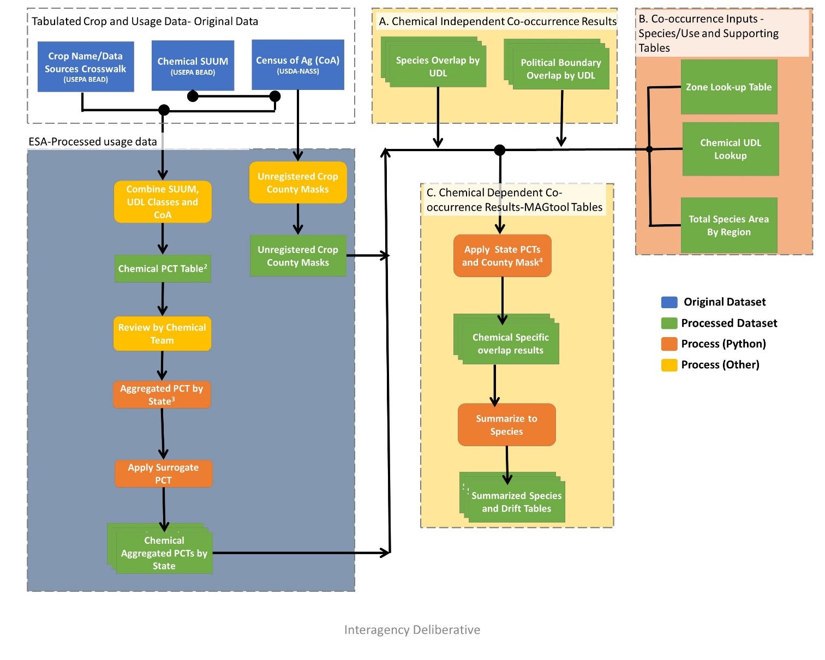

Figure 1. Flow chart of the usage application to the UDLs and species co-occurrence results.

Usage data are applied to the 8 agricultural UDLs discussed above. Crops reported in the SUUM are associated with the categories used for the UDLs using the crosswalk in **APPENDIX 1-6**. For categories represented by a single crop in both the SUUMs and landcover UDLs (*e.g.,* corn, soybean), the available PCT data for a given state are applied directly to the acres of the UDL in that state to calculate the acres treated (acres treated = acres grown x PCT). If the PCT is not available for a specific state/crop combination, because it is not surveyed, a surrogate PCT is applied using the process described in the next section.

For those categories representing multiple crops in either the SUUMs or landcover UDLs (*e.g.,* vegetables and ground fruit), an aggregated PCT is calculated. In order to calculate the aggregated PCT, the acres grown and PCT for each crop in the category are needed by state. Both pieces of information are found in the SUUM for each state/crop combination with reported usage. Acreage in the SUUM can come from a variety of sources, including, but not limited to, market research data, USDA’s National Agricultural Statistics Service (NASS), and California’s Pesticide Use Reporting (PUR). While all these sources provide slightly different results, they are all similar to, and based upon, the acreage developed by NASS’ CoA. If the state/crop combination does not have reported usage, because it was not surveyed, the information in the SUUM is supplemented with data from the 2017 Census of Agriculture (USDA-NASS, 2012, see **ATTACHMENT 1-3** for details on tabulating the Census of Agriculture). The Census of Agriculture is also used to account for crops in the UDL that are not registered. In this situation, information is not provided for these crops in the SUUM, but the crops would be included in the UDL as zero PCT. This step makes it so that the grouped UDLs do not result in assuming that exposure occurs for a crop that is not grown in the county or not registered for imidacloprid. Even though the UDL may include crops that are grown per the Census of Agricultural or not registered per the label, the overlap analysis does not. The crosswalk in **ATTACHMENT 1-4** is used to supplement the SUUM information with the additional data needed from the Census of Agriculture for calculating the aggregated PCTs on a state/crop basis. **APPENDIX 1-6** uses the chemical independent information provided in **ATTACHMENT 1-4** to provide a imidacloprid specific crosswalk across crop data sources for imidacloprid uses. This process results in three scenarios:

* The Census of Agriculture crop/state combination is found in the SUUM, and the acres grown and crop specific PCT from the SUUM are used directly.
* The Census of Agriculture crop is registered but there is no state specific usage information reported in the SUUM, because the crop was not surveyed. In this scenario the acres grown for the state are extracted from the Census of Agriculture and a surrogate for the crop specific PCT is assigned using the method described in the next section.
* The Census of Agriculture crop is not a registered use. In this scenario, the acres grown for the state are extracted from Census of Agriculture and a PCT of 0 is used in the calculation of the aggregated PCT. This is done to account for crops found in the UDL that are not registered for the active ingredient(s) assessed.

At the end of this process all state/crop combinations found in the Census of Agriculture are accounted for, with acres grown and a crop specific PCT. The aggregated PCT for a state is generated by first calculating the base acres treated for each crop by dividing the PCT (or surrogate PCT) by the crop acres grown, summing these treated acres for all crops in the UDL category. This value is then dividing by the total acres grown for all crops in the UDL. For state/crops combinations with usage data, the acres grown are extracted from the SUUM; for state/crops combination without usage the acres grown are extracted from the Census of Agriculture; see **ATTACHMENT 1-3** for details on tabulating the Census of Agriculture. **Equation 1** isused to generate the aggregated PCTs.

**Equation 1.**

$${PCT}_{tot-j}=\frac{Acres treated}{Acres grown}=\frac{\sum_{i=1}^{n}{\left({PCT}_{i}*G_{i}\right)}}{\sum_{i=1}^{n}{G_{i}}}$$

Where:

|  |  |
| --- | --- |
| i = | crop (within land cover class j) that is surveyed in state |
| j= | land cover class (e.g., vegetables and ground fruit) |
| n = | number of crops (within land cover class j) with acres grown in state |
| PCTi = | percent crop treated of crop i (from extended SUUM) |
| PCTtot-j = | aggregated PCT (for land cover class j in state) |
| Gi = | acres of crop i grown (in state) (from extended SUUM) |

Acres treated for UDLs with multiple crops are calculated by multiplying this aggregated PCT by the area of the UDL for the state. The total area of the UDL for the state only includes those counties with at least 1 registered use as reported in the Census of Agriculture. If the Census of Agriculture reports all registered crops in a given UDL as not grown in a county, the county is excluded from the totals prior to calculating the treated acres.

One conservative assumption of this approach is that it does not account for multiple applications to the same fields. Usage data represents the potential acres where at least one imidacloprid application occurred. The data do not identify sites where multiple applications occur within the same year. The approach used here assumes that all treated acres are independent. Therefore, if the available usage data represent sites where multiple applications occurred (which is permitted on imidacloprid labels), each acre is only counted one time. The aggregated UDLs will, however, overestimate the treated acres in a given year due to the conservative nature of the aggregation, especially when the total area in the UDL exceeds what is reported in the Census of Agriculture.

* 1. Non-Agricultural Uses

Non-agricultural national level usage data for the contiguous United States (ConUS) are available in the SUUM (**APPENDIX 1-4;** see Table 3 in the SUUM**).** The usage information can be available as treated area based on survey data or reported as average pound applied for the use.Similar to the agricultural uses, if a single UDL represents multiple use sites found in the SUUM these usage data are aggregated into aggregated PCTs.

If information on treatable acres, base acres treated for all neonicotinoids and/or treated acres for imidacloprid is available from the market research survey data this information is used in the calculation of the non-agricultural PCTs. Treated acres specific to imidacloprid usage are not available for many non-agricultural use sites, but when available this information is used in the calculation of non-agricultural maximum and/or average aggregated PCT. When an estimate of base acres treated is available, the maximum PCT is based on the ratio of base acres treated with imidacloprid to the total treatable acres for the non-agricultural use (**Equation 2-1)**. And the average aggregated PCT is based on the ratio of acres treated with clothianidin to the total treatable acres (**Equation 2-2)**. If the base aces treated is not available but the treated area for clothianidin is then this information is used to calculate the maximum aggregated PCT (**Equation 2-2)**.

**Equation 2-1**

$${PCT}_{max}=\frac{Acres {treated}_{chem class}}{Total Treatable Acres }$$

Where:

|  |  |  |
| --- | --- | --- |
| Acres treated chem classes = | Acres treated for the chemical class based on survey information. | |
| Total Treatable Acres= | Total treatable area for uses based on survey information |
| PCT max = | Calculated maximum PCT | |

**Equation 2-2.**

$${PCT}_{\max{or }avg}=\frac{Acres {treated}_{chem }}{Total Treatable Acres}$$

Where:

|  |  |  |
| --- | --- | --- |
| Acres treated chem classes = | Acres treated for the chemical class based on survey information. | |
| Total Treatable Acres= | Total treatable area for uses based on survey information |
| PCT max or avg = | Calculated maximum or average PCT | |

When base and/or treated acres is unavailable in the survey information related, estimates of treated area are calculated based on the avg. annual pounds active ingredient (a.i.) applied, minimum max label rate, and maximum label rate found in the SUUM (**Equation 3-1, 3-2, 3-3**). In this situation, the maximum estimated treated acres are equal to the average reported annual pounds a.i. applied divided by the minimum max labeled application rate. The average number of treated acres is estimated by taking the number of average reported pounds applied and dividing by ½ of the maximum labeled application plus the minimum max labeled application rate. The minimum is generated by dividing the average reported pounds applied divided by the maximum labeled application rate. If usage data is unavailable a PCT of 100% is used.

**Equation 3-1**.

$${Treated Acres}_{max}=\frac{Annual pounds AI {applied}_{avg}}{Label {Rate}_{min}}$$

Where:

|  |  |
| --- | --- |
| Annual pounds AI applied avg = | Annual average pounds applied of Active Ingredient |
| Label Ratemin= | Minimum application rate for the chemical in the SUUM (lb ai/a) |
| Treated Acresmax = | Estimated maximum treated acres based on label rates |

**Equation 3-2**.

$${Treated Acres}_{avg}=\frac{Annual pounds AI {applied}_{avg}}{\left(\frac{Label {Rate}_{min}+Label {Rate}_{max}}{2}\right)}$$

Where:

|  |  |
| --- | --- |
| Annual pounds AI applied avg = | Annual average pounds applied of Active Ingredient |
| Label Rate min= | Minimum application rate for the chemical in the SUUM (lb ai/a) |
| Label Rate max = | Maximum application rate for the chemical in the SUUM (lb ai/a) |
| Treated Acres avg = | Estimated maximum treated acres based on label rates |

**Equation 3-3**.

$${Treated Acres}_{min}=\frac{Annual pounds AI {applied}_{avg}}{Label {Rate}_{max}}$$

Where:

|  |  |
| --- | --- |
| Annual pounds AI appliedavg = | Annual average pounds applied of Active Ingredient |
| Label Ratemax= | Maximum application rate for the chemical in the SUUM (lb ai/a) |
| Treated Acresmin = | Estimated minimum treated acres based on label rates |

After calculating the estimated maximum, average and minimum treated acres based on the above methods, the associated aggregated PCTs equals the treated acres divided by total treatable acres reported in the SUUM when available, or the estimated treatable acres based on the area found in the UDL if the total treatable acres is not reported in the SUUM **(Equation 4)**.

**Equation 4**.

$${PCT}_{i}=\frac{ {Treated Acres}_{i}}{Total Treatable Acres}$$

Where:

|  |  |
| --- | --- |
| i = | PCT Estimate, max, avg, or min |
| Treated Acres= | Estimated treated acres |
| Total Treatable Acres= | Total treated acres as reported in the SUUM or estimated based on the UDL |

Due to limited non-agricultural usage data for imidacloprid, most uses were assumed to have 100% PCT, but when data was available this was refined, and the lower limit PCT of 2.5% when no usage was reported.

Due to the uncertainty in estimating the treated acres based on application rates, if a minimum PCT results in a value greater than the average, the minimum PCT is set equal to the average. The following sections provides additional information for each use sites based the corresponding UDL.

## Christmas Trees

Acre estimates for Christmas tree plantations application were obtained using the Cropland Data Layer (CDL) class 70, Christmas Trees, are used for ConUS. The usage information contained in in SUUM report found Max Labeled Rate Outdoor of 0.1 lbs AI/A. However, pounds applied for this use was not available and therefore 100% PCT used, with acre estimates from the Christmas Trees UDL.

## Developed

When considering the available usage data for registered developed uses of imidacloprid , the majority indicate not reported usage, these uses include Agricultural/ Farm Building, Airports/ Landing Fields, Commercial Storage/ Warehouse, Commercial/Industrial Premises (Outdoor) and Residential (Outdoor) captured under the premises/areas header. Pounds applied for these uses are not available and therefore 100% PCT used, with acre estimates from the developed UDL.

## Open space developed

When considering the available usage data for open space developed uses of imidacloprid, the majority of registered uses are not surveyed at the national level and include, lawns, turf, golf courses and sod farms. Pounds applied for these uses are not available and therefore 100% PCT used, with acre estimates from the open spaced developed UDL.

## Field Nurseries

The available usage information for field nurseries found in the SUUM is national and includes the Ornamentals (Unspecified): Covers Trees and Plants, plants intended for resale, Woody Shrubs and Vines grown in Field Nurseries. Pounds applied for these uses are not available and therefore 100% PCT used, with acre estimates from the Field nurseries UDL.

## Managed Forest

When considering the available usage data for registered uses Managed forests are contained within the Cottonwood (for pulp/timber) and Poplar (for pulp/timber) uses. These are more broadly categorized in the tree use. Pounds applied for these uses are not available and therefore 100% PCT used, with acre estimates from the Managed Forest UDL. Additional usage information was provided for trees in pasture/rangeland and for Hemlock and Ash trees. However this usage was limited to tree injection applications. These tree injections and the potential exposure related are described qualitatively in **APPENDIX 4-5**.

## Poultry Litter

Poultry litter is assumed to be applied to the corn, soybeans, other grains, cotton, wheat, rice, other row crops, vegetables and ground fruit and alfalfa use data layers (UDLs). These UDLs were identified based on the 24 crops reported in Kellog et al. (2000) for manure/litter application. Kellog et al. (2000) identified these sites for manure/litter applications based on the assimilative capacity (or land application capacity). The combined spatial footprint for the 9 UDLs where poultry litter is likely to be used was generated then limited to the counties identified with potential poultry operations using the USDA National Agricultural Statistics Service (USDA-NASS). The USDA-NASS collects data on livestock and poultry production in the United States through its ongoing survey programs as well as through the Census of Agriculture conducted every five years.

The poultry inventory data only includes turkey, rooster, broiler and layer inventories. Whereas, poultry operations with inventory data includes total poultry operations. Data with “withheld to avoid disclosing data for individual operations (data with D abbreviations)” was included to determine spatial footprint. Counties with no data probably contain developed area and have lesser chance to have poultry operations. But to be conservative and consistent with other agricultural use processing, these no data counties were also included to determine spatial footprint. These yield an entire national level poultry spatial footprint. Drift is not included with this UDL.

Uncertainties in this layer included using all of the 24 potential crops recommended by Kellog et al. (2000)for litter application, and assuming application to all fields. Each of these included crops are treated equally and does not consider other potential factors that impact litter application to the land such as crop specific application rate. Applications to corn and other grasses will have the highest application rates, which lower the number of acres to assimilate the poultry litter. Other cropland sites, such as soybean and alfalfa require very less application rates due to their nitrogen fixing abilities, and the inclusion of these crops equally increases the number of acres in the litter layer. Litter application rates for the nitrogen fixing crops are likely very low and it will be mainly based on the phosphorus needs of the crop.

Usage data is not available for this use and a PCT of 100% is assumed.

## Shrimp Use

There are two labels that allow imidacloprid to be used to control burrowing shrimp in the commercial shellfish beds located in Willapa and Grays Harbor in Washington state. However, this use was prohibited by the state of WA on September 27, 2018 because of ecological harm to the coastal estuaries. Since this label was included in the list of registered uses for imidacloprid, EPA felt the need to include this use as a standalone use layer. However, since the Washington Depart of Ecology rejected the use, actual usage in our analysis was set to 0. This was done to ensure that any listed species that fell within the use site footprint would be retained in EPA’s ESA analysis, while not directly contributing to possible routes of exposure.

1. Applying Surrogate Usage Data

Some uses are not surveyed for usage at all and some uses are only surveyed for usage in some states. For crops without surveyed usage that are included in aggregated UDLs, usage data from the same state for other crops in the UDL will be used as surrogates. If no data for crops within a UDL are available in a state, surrogate PCT will be applied using data available for the same crop or UDL but a different state. If a UDL has no usage data for any state, the highest available PCT from all state-crop combinations will be used. The decision tree below (**Figure 2**) outlines the approach for determining which data will be used as surrogates.

The surrogacy approach is designed to use the best available data to identify the likely extent of treated area when usage data are not available for a given crop. Surrogate data are ideally assigned using crops within the same UDL landcover and then using data from the same crop but different spatial location. If the first two options are not possible, then a conservative approach is employed where the greatest extent of usage on any crop-state combination is used as the surrogate. After applying the surrogacy method all UDL/state combinations will have an associated aggregated PCT. Use of surrogate data represents an uncertainty. In cases where a species has potential risk concerns, a Weight of Evidence analysis will be conducted prior to making the NLAA/LAA determination. In this Weight of Evidence analysis, the impact of the surrogacy assumptions on the overlap analysis will be considered.

Yes

Is crop-specific PCT available for assessed state?

No

No

No

Yes

Is use surveyed in other states?

Yes

Is a PCT available for a use within the same UDL and state?

**Figure 2. Decision framework for applying surrogate usage data.**

1. Calculation of Extent of Direct Overlap of Species Range or Critical Habitat and Treated Acres

The aggregate PCT is used to calculate the total number of acres treated within a state for each UDL (PCT x total acres within a UDL = total acres treated for a UDL). The approach described above combines data that are at different spatial scales, *i.e.,* 30-meter pixel, county and state, for UDLs, Census of Agriculture and usage, respectively. Because of the differences in scales, the usage of imidacloprid can be limited to county and sub-county areas representing potential use sites; however, the actual location of the treated acres within the state is unknown.

Three different assumptions are employed to represent how the treated acres are attributed to potential use site acres within the species range (or critical habitat): upper bound (concentrated within the species range), uniform distribution, and lower bound (concentrated outside of species range). Each of these approaches are discussed below. In all three approaches the estimated treated area within the species range (or critical habitat) is used to calculate the direct overlap of treated sites and the species range (or critical habitat). Direct overlap is equal to the total treated area within the species range divided by the total area of the species range (or critical habitat).

The upper bound approach assumes that all the treated acres in a state occur within the species range (or critical habitat) to the greatest extent possible. In this approach, the total acres treated for the state are calculated using the aggregated PCTs. The total treated acres for the state are compared to the total number of acres within a species’ range that overlaps with that UDL. If the number of treated acres in a state is greater than the number of acres in the UDL that overlap the species range, it will be assumed that all acres within the species range that overlap with the UDL are treated, with the excess treated acres assumed to occur outside of the species range. As described above, treated acres are only placed in counties within the species range where at least 1 registered labeled use for the UDL occurs, as identified by Census of Agriculture. If the number of treated acres is less than the total number of UDL acres that overlap with the species’ range, then it is assumed that all treated acres for the state in that UDL occur inside of the range of a species.

For the uniform distribution approach, the aggregated PCT is applied directly to the acres of the UDL occurring within the species range or critical habitat to calculate the estimated treated acres. This approach assumes that the treated acres are distributed uniformly throughout the state.

The lower bound approach is essentially the opposite of the upper bound. In the lower bound approach, it is assumed that the treated acres are distributed outside of the species range to the greatest extent possible. The total acres treated for the state are compared to the total number of acres outside of a species’ range for the UDL. If the number of treated acres in a state is greater than the number of acres of UDL outside of the species range, it will be assumed that all acres outside the species range are treated, with the excess treated acres assumed to occur within the species range. If the number of treated acres is less than those outside of the species’ range, it is assumed that all treated acres for the state in that UDL occur outside of the range of a species.

When a species range spans multiple states, the uniform, upper, and lower bound approaches are individually applied to each state relevant to a species. The treated acres across all pertinent states are summed to calculate the number of treated acres overlapping with the whole species range (or critical habitat).

The calculation of total treated area based on the temporally aggregated UDLs likely overestimates the area where crops could be found on the same land in a given year and is a conservatism in the process. The upper bound method, which concentrates all the treated acres in the species range (or critical habitat), frequently results in more treated area for a given state than expected when considering all cropped acres in the state. Additional assumptions and uncertainties related to this the calculation of total treated acres and the distributions of the treated acres related to the species range (or critical habitat) are presented in the Revised Method**.**

1. Calculation of Composite Drift Layer Overlapping with Species Range or Critical Habitat

To account for the potential effects of drift beyond the specifically treated acres, when the action area is derived, each relevant UDL is combined into a composite layer representing all potential uses. The composite layer is generated by placing all relevant UDLs on top of each other and merging them together to set the footprint for the chemical as a single layer. This composite layer is then extended out in all directions based on the application method with the greatest drift potential for the chemical. For imidacloprid this is the aerial application, resulting in a maximum buffer distance of 2600 ft, or approximately 792 meters. For an individual species, the composite drift area is then refined by considering only the uses with overlap when applying the maximum buffer for the chemical. The specific application methods and rates relevant to these uses and the species-specific endpoints that result in the farthest distance from the treated field, where effects may occur, are used to determine the extent of the composite drift layer for that species.

When usage data are considered, it is necessary to account for a decrease in the extent of areas receiving spray drift because the actual treated area is less than the total cropped acres in the UDL. The total possible area receiving drift is based on all potential use site found in the action area. Prior to applying usage, potential drift in all directions is calculated. After applying usage, only a portion of potential use sites in the action area will be treated, thus changing the drift extent originally calculated based on all potential use sites.

Since the actual location of the treated acres within a state is unknown, specific areas are not buffered in the Step 2 approach of the Revised Method[2]. To account for the reduction in acres treated based on usage data, a factor is applied to this composite drift area based on a state aggregated PCT for all of the uses combined. Additionally, a factor is applied to account for the distribution of theses acres under an upper bound (maximum acres within the species range), lower bound (maximum acres outside the species range) or uniformly distributed within the range as previously discussed. The distribution of acres within the state relative to the species range will also affect the impact of spray drift. For the upper bound scenario, no additional factor is applied to the aggregated PCT, but for the uniform and lower bound scenarios, the ratio of the number of treated acres calculated for the uniform or lower bound scenario to the upper bound scenario is applied to the PCT. Lastly, to account for the uncertainty in the true spatial distribution of the use sites, as well as the uncertainty of multiple sites potentially impacting the same locations, the adjusted PCT value is rounded up to the nearest ten place value (*e.g.,* factor of 0.056 is rounded to 0.1). This composite factor is used to scale the number of acres impacted by off-site drift and subsequently lower the total predicted overlap with a species range (or critical habitat) due to drift, when compared to the overlap which might occur if all treatable acres were assumed to be treated.

Another factor often discussed for consideration in spray drift is the impact of wind direction on off-site transport for species ranges that are impacted by spray drift occurring in all directions. Methods have been proposed in the past to account for this, including the use of wind rose plots to better predict off-site movement of a chemical. As a simplified method to account for the impacts of wind direction, an additional factor is applied to spray drift based on the number of applications that can occur for the use patterns that are relevant to a species. For the composite factor determined above, a wind direction scaling factor is applied where the factor is scaled to 25% for each application allowed, to represent movement of a chemical off-site in only one direction, or essentially ¼ of a circle when one application is made. More specifically, if only one yearly application is allowed for the relevant use sites, a factor of 0.25 is applied, if 2 applications are allowed, a factor of 0.5, if 3 applications are allowed, a factor of 0.75 and if 4 or more applications are allowed, a factor of 1 (or no additional scaling is applied). The equations used to scale the spray drift overlap are provided below in **Equation 5** and **Equation 6**.

**Equation 5. $Composite drift factor=Aggregated PCT* \frac{\begin{aligned}Number of treated acres in direct overlap scenario \\ considered (upper bound, uniform, lower bound)\end{aligned}}{Number of acres in upper bound direct overlap scenario}$**

**Equation 6. $Final Drift Scaling factor= Composite drift factor rounded up to next 0.1 value * Wind factor$**

In summary, the number of acres in a species range (or critical habitat) potentially exposed due to spray drift is calculated using the equations above for each state. This total number of acres is then divided by the total acres in the species range to determine the overlap area due to drift. For predicting relative EECs in the drift zone, the number of acres is further refined to how many are in each 30-meter increment off-site, starting at 30 meters and continuing to 792 meters off-site or the limit of aerial drift. Additional uncertainties and conservatism of the method for applying usage data to drift are provided in the Revised Method[3].

1. Determination of Overlap of Exposure Area and Species Range or Critical Habitat

To determine the total overlap exposure area, the total number of treated acres within the species range (direct overlap) are added to the scaled number of acres receiving spray drift then divided by the total number of acres of the species range (or critical habitat). This can be considered the percent of the species range/habitat that is likely to be exposed to the pesticide of interest, based on usage data and predicted spray drift. For species whose life history information indicates the species will not utilize the potential use site areas, overlap of direct treated sites will be zero for direct exposure and only the scaled areas receiving spray drift are considered for the species overlap.

There are 5 different overlap scenarios generated for consideration. The first represents the unadjusted or pesticide usage independent overlap, the 2nd and 3rd incorporate the chemical specific usage information and accounts for the redundancy in the UDL layers, and the 4th and 5th incorporate species life history information by removing direct overlap if the species will not utilize the potential use site and limiting the overlap extent to just the areas represented by suitable habitat. These 5 overlap scenarios are discussed in more detail in the following section.

When considering the three different assumptions related to distribution of treated acres relative to species range (*i.e.,* concentrated in species range (upper), uniform throughout state (uniform) and concentrated outside of species range (lower)) and the three different assumptions regarding the amount of usage on a given year (*i.e.,* maximum, average or minimum annual PCT), there are 9 different estimates of the overlap of the species range (or critical habitat) and the exposure area for each overlap scenario. The overlap estimates for pertinent scenarios are considered in addition to the influence of using surrogate usage data when none are available as part of the Weight of Evidence. This information is considered in the Weight of Evidence to determine the likelihood that an individual will be exposed and adversely affected.

1. Background - Spatial Co-occurrence of Species Location and Potential Use Sites

The co-occurrence analysis identifies if a species range (or critical habitat) and UDL overlap, and if so by how much. Required inputs to conducting the co-occurrence analysis include a list of species, species location files, pesticide Use Data Layers (UDLs), and any additional supporting species life history information used to supplement the analysis. The species list needs to include all species and designated critical habitat subjects to section 7 of the Endangered Species Act. Location files for each species range and critical habitat need to be accounted for prior to use in the co-occurrence analysis. The pesticide Use Data Layers (UDLs) representing each label use also need to be accounted for prior to completing the analysis. Finally, any additional species life history or spatial datasets, (*e.g.,* GAP/Landfire habitat layer) used to supplement the co-occurrence analysis need to be identified. Additional detail on these spatial inputs and the tools use to generated them can be found with the BE models/tools.

All inputs are finalized and standardized using the Co-occurrence Inputs-Species/Use and Supporting Tables tool. The co-occurrence analysis leverages the ArcGIS Tabulate Area tool, executed as a batch using Chemical Independent Co-occurrence Results-Parent Use Overlap Tables tool. The Chemical Dependent Co-occurrence Results-MAGtool Tables tool generates the standard output tables summarized by UDL and species used in the BE, incorporating usage and species life information into the results. The five different overlap scenarios are generated as output from this tool. Additional information on each of these tools can be found with the respective tool documentation.

The first overlap scenario provides a usage independent overlap, without any adjustments to account for usage or species life history. The remaining overlap scenarios apply usage and species information to the overlap. First the aggregated PCTs for imidacloprid, described above, are applied to the species/UDL overlap using the three different distribution methods for the treated acres. Following the application of usage information, results are scaled to account for the redundancy in the UDLs. Additional detail on the method for applying the redundancy scaling factors is provided below. The last two overlap scenarios account for species life history information. First, if the species will not utilize the potential use site directly the overlap representing the direct overlap is excluded, limiting the results to the areas of drift overlap. Lastly, if the species is more likely to use certain habitats this can be considered by limiting the extent of overlap to just the areas of the species range with those habitats. This suitable habitat consideration is not applicable to designated critical habitat and is considered in conjunction with the results representing the full range as part of the Weight of Evidence.

1. Input Data Used for Co-occurrence Analysis
   1. Master Species List

Species subject to section 7 under the Endangered Species Act are obtained from the US Fish and Wildlife Threatened and Endangered Species System[4] (TESS). The resulting table is filtered to include listing statuses[5] currently subject to section 7 or potentially subject to section 7 during the registration time period. Information from TESS for species under the jurisdiction of the National Marine Fisheries Service (NMFS) is supplemented with information from the NMFS website[6], deferring to the NMFS website if conflicts exist between the sources. The species list used for this assessment was generated in November 2020.

* 1. Species Locations

The FWS ECOS Portal (<http://ecos.fws.gov>) houses spatial data that represents species’ ranges and designated critical habitat[7]. Managed by the species experts and therefore considered the best available information for section 7 consultation, the co-occurrence analysis utilizing this information. The ECOS Portal points users to NMFS websites to access spatial information for species under NMFS jurisdiction not found on the ECOS website. For NMFS species not found in either location a request was made directly to the NMFS scientists. The last download of the species locations occurred in November 2020.

After accounting for each species, the input files used for the co-occurrence analysis are generated with the ESRI ArcGIS Union Toolbox[8]. The union tool generates the geometric union of the species files and their attributes presented as non-overlapping ‘zones’. Each unique zone may be occupied by multiple species. The species found in each zone are tracked in a look-up table generated at the time of the union. By using these non-overlapping ‘zones’ a given location is only run once in the analysis, rather than for each overlapping species.

Additional information on this process can be found with the Co-occurrence Inputs-Species/Use and Supporting Tables tool.

* 1. Use Data Layers (UDLs)

The data and process to generate the Use Data Layers is described in **APPENDIX 1-5 and APPENDIX 1-6.**

* 1. Other Inputs

In addition to the usage data and Census of Agriculture described above, species life history information can be considered. Species life history information is incorporated into two of the overlap scenarios. The first considers if the species will be found on potential use sites or exclusively off the use sites. Off use site determinations were made based on species documentation generated by the Services (*e.g.* Recovery Plan, 5-year Reviews). These determinations were reviewed and updated based on feedback provided by US Fish and Wildlife Service in the Fall of 2019[9]. The second consideration includes suitable habitat for a species, and the habitats where a species is likely to occur be are exacted from the GAP/Landfire [10] dataset and an overlap specific to these habitat areas is generated. The overlap for the suitable habitat is used to supplement the overlap for the full species range.

All spatial files, UDLs, species, and supplemental information, are standardized into the selected regional projections prior to use in the co-occurrence analysis. For the contiguous United States, there is only one projection used, Albers Conical Equal Area projections (Albers_Conical_Equal_Area.prj). Projected coordinated system were selected to preserve area calculations.

1. Co-occurrence Analysis

The co-occurrence analysis uses the ArcGIS Tabulate Area tool, executed as a batch with the Chemical Independent Co-occurrence Results-Parent Use Overlap Tables tool. Additional information on this tool can be found with the tool documentation. As described above, the species input files used for the co-occurrence are generated by ESRI ArcGIS Union Toolbox, which creates a series of non-overlapping ‘zones’. Each unique zone may be occupied by multiple species. **Figure 3** provides an example species range, and the same range broken up into the non-overlapping ‘zones’ used as the species input file.

In order to apply usage and Census of Agriculture information the state and county boundaries are added to the species input files using the ESRI Intersect Toolbox. The final ‘zones’ allows for the overlap of a UDL to be reported out by species for a given county or state. The state and county breaks allow for the application of the usage data. The total overlap for each county and state is also calculated so the treated acres for the state can be calculated for the upper and lower distributions of treated acres described above.

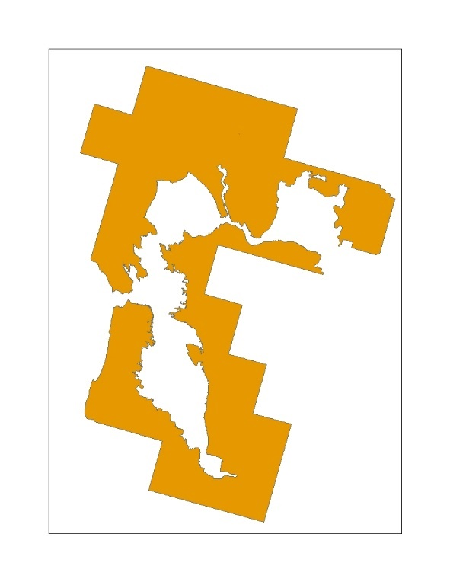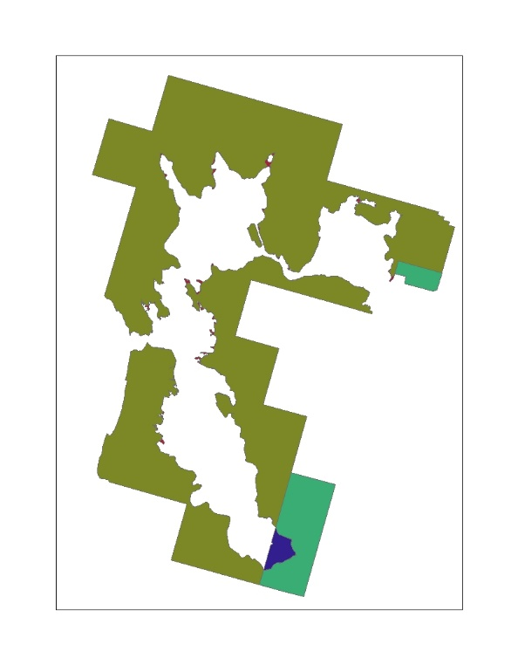

**Figure 3. Example of species range represented by zones used as the input for the co-occurrence analysis, including species location and counties boundaries.**

* 1. Overlap Scenarios

Five different overlap scenarios are generated for consideration in the Weight of Evidence. The first is usage independent and provides results for the species with no adjustment to the overlap. This is followed by incorporating the usage data, scaling for redundancy of the UDLs, and then adding species life history information to the overlap results.

Applying the usage method described above, the aggregated PCTs and Census of Agricultural are applied to the state and county results to calculate the total treated acres for the state. This information is used for the upper and lower distribution of the treated acres. The treated acres are concentrated within the species range (or critical habitat) and the given state for the upper distribution or outside the species range (or critical habitat) and within the given state for the lower distribution. For the uniform distribution, the aggregated PCTs and Census of Agricultural are applied directly to the species results, broken down for a species in a given county and state. After calculating the treated acres for each state within the species range (or critical habitat), all states are summed to get the total treated acres for the species. This process is completed for all UDLs and each of the aggregated PCTs; minimum, maximum and average. The five overlap scenarios are:

* Overlap Scenario 1: No Usage
* Overlap Scenario 2: PCT Overlap
* Overlap Scenario 3: PCT and Redundancy
* Overlap Scenario 4: PCT, Redundancy, Off-site
* Overlap Scenario 5: PCT, Redundancy, Off-site, Habitat

**Figure 4** provides an example of the three distribution of the treated acres. The dark gray is the extent of the UDL, the green area represents the treated area for a PCT of 10% for the state. These treated acres are distributed into the species range, in orange, using the three different methods: upper to the left, uniform in the middle and lower to the right. Prior to incorporating usage all area in the UDL is assumed to be treated.

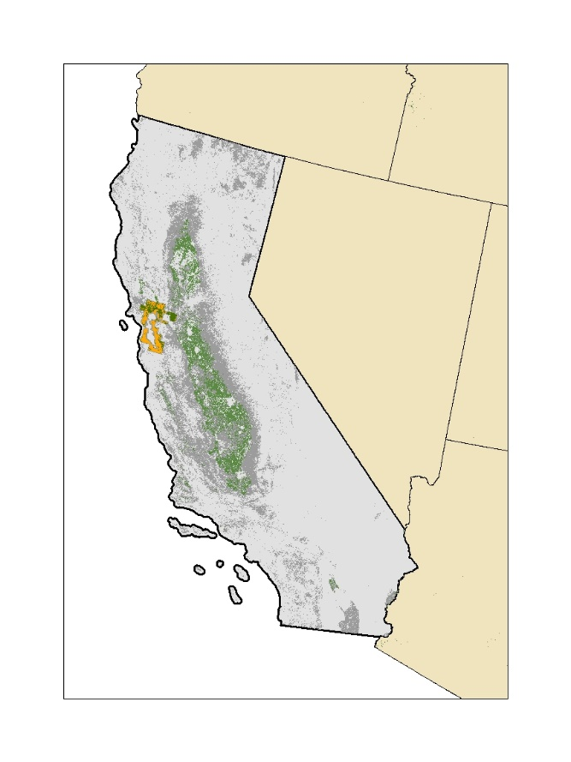

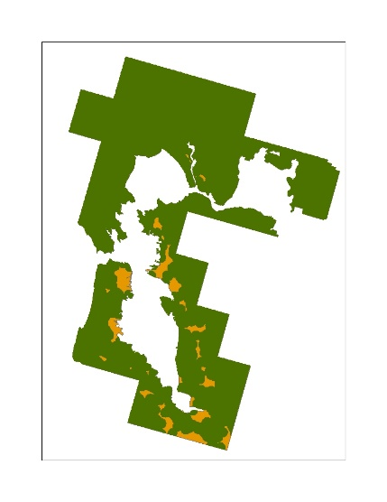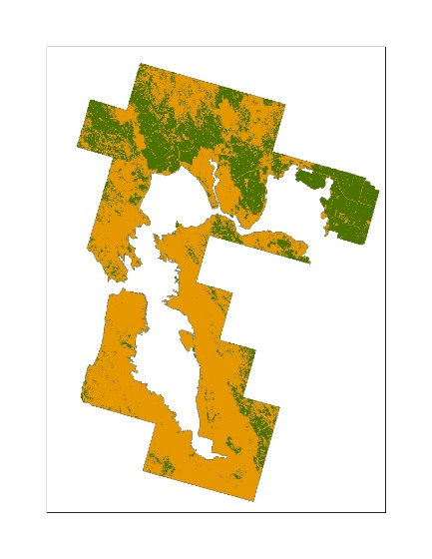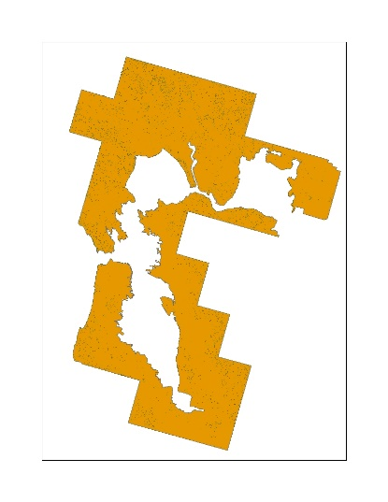

**Upper Uniform Lower**

**Figure 4: Conceptual example of the application of an aggregated PCT to a UDL and the three different distribution methods for treated acres.**

* 1. Scaling for Redundancy in the UDLs

Many UDLs overlap with each other, identifying a single location as multiple potential uses sites, causing the sum of the individual acres in the UDLs to be greater than the acres in the action area, and often greater than the 100% of the species range (or critical habitat). If each UDL was independent the sum of the UDLs would equal the action area. To account for this redundancy between use sites three different factors are applied to results for the individual UDLs: the composite factor, the agricultural factor and the non-agricultural factor.

In order to calculate the composite factor, an agricultural composite containing all agricultural UDLs and a non-agricultural composite containing all non-agricultural UDLs are generated. The composite factor is equal to the sum of the agricultural and non-agricultural composite divided by the action area. This factor accounts for the redundancy between the agricultural and non-agricultural uses. If all uses are independent the sum of the two composites would equal the action area, and the factor would be equal to 1. Each individual UDL is divided by this composite factor.

An agricultural factor is calculated by summing the results of all the agricultural UDLs and dividing by the agricultural composite. This factor is applied to all of the agricultural UDLs to account for the redundancy between agricultural UDLs. Similarly, a non-agricultural factor is calculated by summing the results of all the non-agricultural UDLs and dividing by the non-agricultural composite. This factor is applied to all of the non-agricultural UDLs to account for the redundancy between non-agricultural UDLs. If all uses are independent the sum of the individual UDLs would equal the composite, and the factor would be equal to 1.

After scaling the results to account for redundancy the sum of the individual UDLs will not exceed the action area percent overlap. Equations used in the calculation of these factors are shown below in **.**

**Equation 7**. $Composite Factor=\frac{Perecent Overlap Ag Composite+Percent Overlap NonAg Composite}{Perecent Overlap Action Area}$

**Equation 8**. $Agricultural Factor=\frac{Total Percent Overlap Ag UDLs}{Percent Overlap AgComposite}=\frac{\sum_{i=1}^{n}{\left(POi\right)}}{POj}$

Where:

|  |  |
| --- | --- |
| i = | Agricultural UDLs |
| n= | Number of agricultural UDLs |
| j = | Agricultural composite layer |
| PO = | Unadjusted percent overlap |

**Equation 9**. $Non-Agricultural Factor=\frac{Total Percent Overlap Non-Ag UDLs}{Percent Overlap Non-Ag Composite}=\frac{\sum_{i}^{n}{\left(POi\right)}}{POj}$

Where:

|  |  |
| --- | --- |
| i = | Non-agricultural UDLs |
| n= | Number of non-agricultural UDLs |
| j = | Non-agricultural composite layer |
| PO = | Unadjusted percent overlap |

1. Results Co-occurrence Analysis

The final results of the co-occurrence analysis provide the percent of the species range (or critical habitat) that overlaps with each UDL. This metric is provided for each of the overlap scenario. The mean percent overlap and standard deviation for the imidacloprid UDLs across each overlap scenarios for all ConUS species range are provided in **Table 1.** The final overlap scenario incorporating species life history related to habitat is presented in **Table 3. i**midacloprid’s action area had a mean direct overlap of 75%,The mean overlap out to the limits of ground and aerial drift were 85% and 89%, respectively. The mean overlaps for the individual UDLs range from <1 to 61% before incorporating usage and species life history information and <1 to 34% after incorporating for this information.

**Table 2** presents the same information for all ConUS designed critical habitats. For critical habitat imidacloprid’s action area had a mean overlap of 28%. The mean overlap out to the limits of ground and aerial drift were 32% and 33%, respectively. The mean overlaps for the individual UDLs range from <1 to 23% before incorporating usage and <1 to 21% after accounting for this information.

**Table 1. Mean percent overlap and standard deviation for ConUS species range and each imidacloprid uses in the ConUS for each overlap scenario.**

| **Use** | **Overlap Scenario 1: No Usage** | | **Overlap Scenario 2: PCT Overlap** | | **Overlap Scenario 3:**  **PCT and Redundancy** | | **Overlap Scenario 4:**  **PCT, Redundancy, Off-site** | |
| --- | --- | --- | --- | --- | --- | --- | --- | --- |
| Use | Mean | STD | Mean | STD | Mean | STD | Mean | STD |
| Imidacloprid Action Area | 75 | 28 | 74 | 28 | 74 | 28 | 74 | 28 |
| Citrus | 1 | 2 | <1 | 2 | <1 | 2 | <1 | 2 |
| Cotton | 1 | 2 | 1 | 2 | 1 | 2 | <1 | 1 |
| Developed | 6 | 8 | 6 | 8 | 4 | 6 | 4 | 6 |
| Federal Lands | 28 | 29 | 28 | 29 | 28 | 29 | 28 | 29 |
| Field Nurseries | 2 | 5 | 2 | 5 | 1 | 3 | 1 | 3 |
| Grapes | 1 | 2 | 1 | 2 | <1 | 1 | <1 | 1 |
| Managed Forests | 11 | 12 | 11 | 12 | 10 | 11 | 9 | 11 |
| Open Space Developed | 5 | 4 | 5 | 4 | 4 | 3 | 4 | 3 |
| Other Crops | 2 | 4 | 2 | 4 | 2 | 3 | 1 | 2 |
| Other Orchards | 1 | 5 | 1 | 5 | 1 | 2 | <1 | 2 |
| Other Row Crops | <1 | 1 | <1 | 1 | <1 | 1 | <1 | <1 |
| Poultry Litter | 61 | 31 | 61 | 31 | 49 | 22 | 34 | 30 |
| Shrimp Use | <1 | <1 | <1 | <1 | <1 | <1 | <1 | <1 |
| Soybeans | 3 | 8 | 1 | 4 | 1 | 3 | 1 | 2 |
| Vegetables and Ground Fruit | 1 | 2 | 1 | 2 | <1 | 1 | <1 | 1 |
| Xmas Trees | <1 | <1 | <1 | <1 | <1 | <1 | <1 | <1 |
| Limit Ground Drift (300 m or 1000 ft) | 85 | 23 | 85 | 23 | 85 | 23 | 85 | 23 |
| Limit Aerial Drift (792m or 2600ft) | 89 | 19 | 89 | 19 | 89 | 19 | 89 | 19 |

**Table 2. Mean percent overlap and standard deviation for ConUS designated critical habitat and each imidacloprid uses in the ConUS for each overlap scenarios.**

| **Use** | **Overlap Scenario 1: No Usage** | | **Overlap Scenario 2: PCT Overlap** | | **Overlap Scenario 3:**  **PCT and Redundancy** | | **Overlap Scenario 4:**  **PCT, Redundancy, Off-site** | |
| --- | --- | --- | --- | --- | --- | --- | --- | --- |
| Use | Mean | STD | Mean | STD | Mean | STD | Mean | STD |
| Imidacloprid Action Area | 28 | 41 | 28 | 41 | 28 | 41 | 28 | 41 |
| Citrus | <1 | <1 | <1 | <1 | <1 | <1 | <1 | <1 |
| Cotton | <1 | <1 | <1 | <1 | <1 | <1 | <1 | <1 |
| Developed | 1 | 5 | 1 | 5 | 1 | 3 | 1 | 3 |
| Federal Lands | 13 | 29 | 13 | 29 | 13 | 29 | 13 | 29 |
| Field Nurseries | <1 | 3 | <1 | 3 | <1 | 1 | <1 | 1 |
| Grapes | <1 | 1 | <1 | 1 | <1 | <1 | <1 | <1 |
| Managed Forests | 3 | 9 | 3 | 9 | 3 | 10 | 3 | 10 |
| Open Space Developed | 2 | 5 | 2 | 5 | 1 | 4 | 1 | 4 |
| Other Crops | 1 | 3 | 1 | 3 | <1 | 2 | <1 | 2 |
| Other Orchards | <1 | 3 | <1 | 3 | <1 | 1 | <1 | 1 |
| Other Row Crops | <1 | <1 | <1 | <1 | <1 | <1 | <1 | <1 |
| Poultry Litter | 23 | 38 | 23 | 38 | 21 | 33 | 21 | 33 |
| Shrimp Use | <1 | <1 | <1 | <1 | <1 | <1 | <1 | <1 |
| Soybeans | <1 | 2 | <1 | 1 | <1 | 1 | <1 | 1 |
| Vegetables and Ground Fruit | <1 | 1 | <1 | 1 | <1 | <1 | <1 | <1 |
| Xmas Trees | <1 | <1 | <1 | <1 | <1 | <1 | <1 | <1 |
| Limit Ground Drift (300 m or 1000 ft) | 32 | 44 | 32 | 44 | 32 | 44 | 32 | 44 |
| Limit Aerial Drift (792m or 2600ft) | 33 | 46 | 33 | 46 | 33 | 46 | 33 | 46 |

**Figure 5** provides an example the difference between the uniform and upper assumptions about species overlap with treated acres. In this example the dark gray is the extent of the imidacloprid action area. The state images show the extent of the action area with example total treated acres for imidacloprid highlighted in pink, accounting for all uses. The aggregated maximum PCT was used to calculate treated acres.

For the species in **Figure 5** the treated acres, across all uses for the state, highlighted in pink, are more visible. The left image in **Figure 5** represents the uniform distribution of treated acres. While this estimate of overlap does not reach the overlap limit for the species, the impacts of usage is less when compared to the species in the second image in **Figure 5,** whichpresents the upper distribution of the treated acres, reaching the limit of overlap for this species.

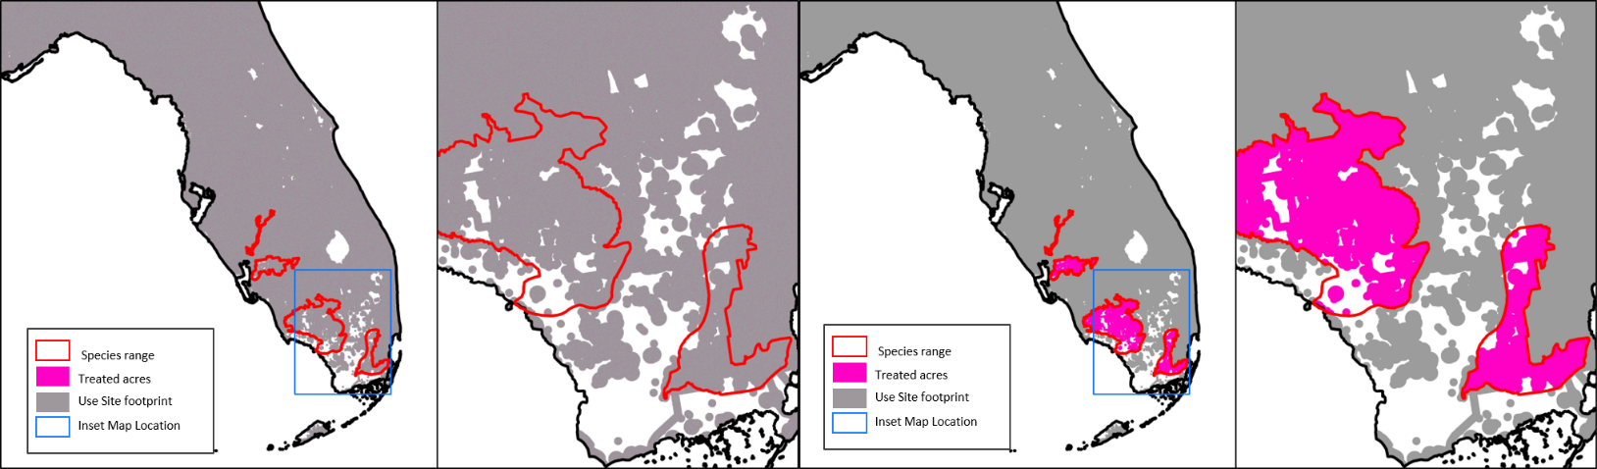 **Figure 5. Example of a species with low impact of usage for imidacloprid; Florida bonneted bat (*Eumops floridanus*).**

# Suitable Habitat Overlap

In total 132 species were designated as species for consideration of suitable habitat 113 of which occur in the ConUS. **Table 3** provides themean percent overlap and standard deviation for these 113 species after accounting for usage in the full range and limiting the overlap and usage extent to suitable habitat within the range. This information is considered with the results for the full species range as part of the Weight of Evidence.

**Table 3. Mean percent overlap and standard deviation for uses in ConUS and suitable habitat before and after limiting the overlap extent to just suitable habitat areas. Values only include the 113 species identified for inclusion in the analysis.**

| **Use** | **Overlap Scenario 4:** | | **Overlap Scenario 5:** | |
| --- | --- | --- | --- | --- |
|  | **PCT, Redundancy, Off-site** | | **PCT, Redundancy, Off-site, Habitat** | |
| Use | Mean | STD | Mean | STD |
| Imidacloprid Action Area | 74 | 28 | 70 | 30 |
| Citrus | <1 | 2 | <1 | 1 |
| Cotton | <1 | 1 | <1 | 1 |
| Developed | 4 | 6 | 4 | 6 |
| Federal Lands | 28 | 29 | 26 | 29 |
| Field Nurseries | 1 | 3 | 1 | 2 |
| Grapes | <1 | 1 | <1 | 1 |
| Managed Forests | 9 | 11 | 9 | 11 |
| Open Space Developed | 4 | 3 | 4 | 3 |
| Other Crops | 1 | 2 | 1 | 2 |
| Other Orchards | <1 | 2 | <1 | 2 |
| Other Row Crops | <1 | <1 | <1 | <1 |
| Poultry Litter | 34 | 30 | 33 | 30 |
| Shrimp Use | <1 | <1 | <1 | <1 |
| Soybeans | 1 | 2 | 1 | 2 |
| Vegetables and Ground Fruit | <1 | 1 | <1 | 1 |
| Xmas Trees | <1 | <1 | <1 | <1 |
| Limit Ground Drift (300 m or 1000 ft) | 85 | 23 | 80 | 27 |
| Limit Aerial Drift (792m or 2600ft) | 89 | 19 | 84 | 24 |

1. Available at: <https://www.epa.gov/endangered-species/revised-method-national-level-listed-species-biological-evaluations-conventional>
2. Available at: <https://www.epa.gov/endangered-species/revised-method-national-level-listed-species-biological-evaluations-conventional>
3. Available at: <https://www.epa.gov/endangered-species/revised-method-national-level-listed-species-biological-evaluations-conventional>
4. Query used to extract species from TESS: https://ecos.fws.gov/services/TessQuery?request=query&xquery=/SPECIES_DETAIL
5. Statuses included: Threatened, Endangered, Experimental Population Non-Essential, Proposed Threatened, Proposed Endangered, and Candidate
6. <https://www.fisheries.noaa.gov/national/endangered-species-conservation/esa-threatened-endangered-species>
7. Website for designated critical habitat: ([http://ecos.fws.gov/crithab)](http://ecos.fws.gov/crithab)
8. <http://desktop.arcgis.com/en/arcmap/10.3/tools/analysis-toolbox/union.htm>
9. USFWS, personal communication, November 2019
10. U.S. Geological Survey Gap Analysis Program, 20160513, GAP/LANDFIRE National Terrestrial Ecosystems 2011: U.S. Geological Survey: Boise, ID, http://gapanalysis.usgs.gov/gaplandcover/. doi:10.5066/F7ZS2TM0.