ATTACHMENT 3-2: CHARACTERIZATION OF NEONICOTINOID LEAF RESIDUE DATA

Associated Chemicals
• Clothianidin (PC code 044309)
• Thiamethoxam (PC code 060109)
• Imidacloprid (PC code 129099)

August 2021

U.S. Environmental Protection Agency
Office of Pesticide Programs
Environmental Fate and Effects Division
Washington, DC

Table of Contents
1 EXECUTIVE SUMMARY 4
2 INTRODUCTION 5
2.1 Purpose 5
3 DATA AND METHODS 5
3.1 Data Sources and Quantity 5
3.2 Data Manipulation and Interpretation 7
3.2.1 Residues of Concern 7
3.2.2 Level of Detection and Level of Quantitation 7
3.2.3 Consideration of Application Method 8
3.2.4 Consideration of Application Timing 8
3.2.5 Data Normalization 8
4 LEAF RESIDUES FROM FOLIAR APPLICATIONS 12
4.1 Clothianidin 12
4.1.1 Summary of the Available Data 12
4.1.2 Post-Bloom Foliar Applications to Orchard Crops 14
4.1.3 Pre-Bloom/At Bloom Foliar Applications to Non-Orchard Agricultural Crops 15
4.1.4 Pre-Bloom and Post-Bloom Foliar Applications to Grapes 16
4.1.5 Leaf Residues Measured 1 to 4 Days After Foliar Application 17
4.1.6 Clothianidin Summary (Foliar Applications) 19
4.2 Thiamethoxam 21
4.2.1 Summary of the Available Data 21
4.2.2 Foliar Application to Orchard Crops 25
4.2.3 Foliar Application to Non-Orchard Agricultural Crops 27
4.2.4 Foliar Applications to Ornamentals 29
4.2.5 Leaf Residues Measured Within 4 or 5 Days After Foliar Application 30
4.2.6 Thiamethoxam Summary (Foliar Applications) 39
4.3 Imidacloprid 43
4.3.1 Summary of Available Data 43
4.3.2 Post-Bloom Foliar Applications to Cherry 44
4.3.3 Pre-Bloom Foliar Applications 45
4.3.4 Leaf Residues Measured 0 to 4 Days After Foliar Application 46
4.3.5 Imidacloprid Summary (Foliar Applications) 49
5 COMPARISON OF LEAF RESIDUES FROM FOLIAR VS. SOIL APPLICATIONS 51
5.1 Clothianidin 51
5.2 Thiamethoxam 52
5.3 Foliar vs. Soil Applications Summary 54
6 OVERALL SUMMARY 55
7 REFERENCES 56

EXECUTIVE SUMMARY

For the neonicotinoid insecticides, chemical-specific data have been submitted to the Agency from field residue studies that quantify the concentrations of these active ingredients in different plant tissues (e.g., pollen, nectar, flower, leaf) following foliar, soil, and/or seed applications. This attachment summarizes the available residue data for leaf samples of agricultural crops and non-agricultural (ornamental) plants after foliar or soil applications in order to compare the neonicotinoid residues measured in leaves to the default T-REX estimated environmental concentrations (EECs) for broadleaf plant leaves after a single foliar application.

Overall, following foliar applications of neonicotinoids, very few (2.5%) of the daily average residue concentrations measured in leaves from registrant-submitted field residue studies exceeded the T-REX upper bound EECs for broadleaf plants when normalized to an application rate of 1 lb a.i./A. Twelve percent of the daily average residue concentrations measured in leaves exceeded the T-REX mean EEC for broadleaf plants when normalized to an application rate of 1 lb a.i./A. The highest residue concentrations were measured immediately after foliar applications. Generally, following foliar applications, the residues in leaves declined rapidly over time (i.e., residues often decreased by at least an order of magnitude by 10 days after the application), whereas following soil applications, the residues in leaves remained largely stable over time. When considering the same annual crop (i.e., pumpkin) and normalizing the residues to the same application rate (i.e., 1 lb a.i./A), starting at about 3 weeks after the most recent application, neonicotinoid residues in leaves following soil applications were generally higher than those following foliar applications. A similar trend was not observed for perennial crops.

The T-REX EECs for broadleaf plants are considered protective of (i.e., higher than) empirical residue concentrations in leaves that result from either foliar or soil application. However, although the vast majority of measured residues in leaves were substantially less than the default T-REX EECs, the T-REX estimates for broadleaf plants were not determined to be overly conservative; a small percentage of measured residues in leaves shortly after foliar applications exceeded the default upper bound EECs. Furthermore, because the decline curve of the default T-REX EECs is calculated using a default foliar dissipation half-life of 35 days and the exceedances of the default T-REX EECs usually occurred within the first week after foliar application, there is an opportunity for risk assessors to refine the default T-REX EECs using chemical-specific foliar dissipation rates in order to more realistically estimate residues in leaves more than a week after the foliar application.

INTRODUCTION

Purpose

As part of USEPA’s 2021 Biological Evaluation (BE) of three registered neonicotinoid insecticides (clothianidin, thiamethoxam, imidacloprid), risks to federally threatened or endangered species (i.e., listed species) are being assessed. For terrestrial listed species that consume terrestrial arthropods or plant foliage (e.g., listed birds and mammals), risk is assessed using the Terrestrial Residue Exposure Model (T-REX) with default estimates of exposure. These default estimates of exposure are based in part on a historical database of residue measurements made for a variety of pesticides after foliar applications to different crops (Fletcher et al., 1994). However, for these neonicotinoids, chemical-specific data have also been submitted to the Agency based on field residue studies that quantify the concentrations of these active ingredients in different plant tissues (e.g., pollen, nectar, flower, leaf) following foliar, soil, and/or seed applications.

This attachment summarizes the available data for residue measurements in leaf samples of agricultural crops and non-agricultural (ornamental) plants after foliar or soil applications. The objectives of this analysis are: 1) to compare the neonicotinoid residues measured in leaves from foliar applications to the T-REX default estimated environmental concentrations (EECs) for broadleaf plant leaves after a single foliar application, and 2) to compare the neonicotinoid residues measured in leaves following soil applications to those following foliar applications (and to the default T-REX EECs). The intent of these comparisons is to demonstrate the extent to which the default EECs are protective of chemical-specific residues measured in foliage of representative crops.

DATA AND METHODS

Data Sources and Quantity

All data included in the analysis for this attachment were generated in registrant-submitted field residue studies that were classified as supplemental or acceptable by USEPA’s Environmental Fate and Effects Division. The analysis included data from 25 foliar application studies and 6 soil application studies. From these 31 studies, the data set is comprised of approximately 3,000 leaf residue measurements from 16 different crops and two ornamental species (Table 1). Leaf samples collected from control trials or collected prior to application are not included in this analysis. For additional details on the data sources, review, and study designs see the bridging analyses for the neonicotinoid bee risk assessments (USEPA, 2020a; USEPA, 2020b).

To compare the residue concentrations in leaves following foliar versus soil applications, six soil application studies were selected, because there was at least one comparable foliar application study conducted using the same crop and the same active ingredient with similar application timing (i.e., pre-bloom application). One perennial orchard crop (orange) and one annual crop (pumpkin) were chosen for the comparisons. For pumpkin, data for two active ingredients (clothianidin and thiamethoxam) were included in this analysis to consider the influence of the applied chemical on leaf residues.

Typically, multiple replicate leaf samples are collected on each sampling day. Because residue concentrations can vary by an order of magnitude or more among replicate samples, the daily average residue concentration is used in this analysis instead of the raw data (except where noted).

Table 1. Number of leaf samples (by crop, applied active ingredient, application type, and application timing) included in this analysis of leaf residues¹.
Crop | Applied a.i. | Application Type | Number of Leaf Samples | MRID
Pre-/At-Bloom Applications
Apple | Thiamethoxam | Foliar | 54 | 50265504
Orange | Imidacloprid | Foliar | 115 | 49521301
 | Thiamethoxam | Foliar | 162 | 50425902
 |  | Soil | 723 | 50096601, 50096603
Blueberry | Thiamethoxam | Foliar | 102 | 50425901
Strawberry | Thiamethoxam | Foliar | 93 | 50265502
Grape | Clothianidin | Foliar | 72 | 50154305
Cotton | Clothianidin | Foliar | 91 | 49733302, 49904901
 | Thiamethoxam | Foliar | 54 | 49686801
Cucumber | Thiamethoxam | Foliar | 63 | 49804105
Potato | Clothianidin | Foliar | 72 | 49705902
Pumpkin | Clothianidin | Foliar | 110 | 49602802, 49910601
 |  | Soil | 316 | 49602801, 49705901, 49910601
 | Thiamethoxam | Foliar | 138 | 50265506
 |  | Soil | 150 | 50265501
Soybean | Imidacloprid | Foliar | 54 | 50025901, 50025902
 | Thiamethoxam | Foliar | 54 | 50265503
Tomato | Thiamethoxam | Foliar | 63 | 49804101
Watermelon | Imidacloprid | Foliar | 53 | 50357101
Mock Orange | Thiamethoxam | Foliar | 63 | 50425903
Stargazer Lily | Thiamethoxam | Foliar | 70 | 50425903
Post-Bloom Applications
Almond | Clothianidin | Foliar | 54 | 50154302
Apple | Clothianidin | Foliar | 18 | 50154304
Cherry | Imidacloprid | Foliar | 70 | 49535601
 | Thiamethoxam | Foliar | 36 | 50096606
Peach | Clothianidin | Foliar | 18 | 50154303
 | Thiamethoxam | Foliar | 36 | 50096606
Plum | Thiamethoxam | Foliar | 45 | 50096606
Grape | Clothianidin | Foliar | 72 | 50154305
¹ Additional study details are given in USEPA 2020a or USEPA 2020b, as well as in the referenced MRIDs.

Data Manipulation and Interpretation

Residues of Concern

In accordance with their respective bee risk assessments, residues of each neonicotinoid are expressed in terms of the stressor (residues) of concern as follows:

- Clothianidin: Residues are expressed as the parent chemical only (i.e., no degradates of toxicological concern).
- Thiamethoxam: Since thiamethoxam degrades to form clothianidin, residues are summed (using molar equivalents) to represent total thiamethoxam and clothianidin exposure and expressed as clothianidin equivalents (c.e.). In this approach, thiamethoxam residue data are converted to clothianidin equivalents by multiplying the thiamethoxam values by 0.856, which is the ratio of the molecular weights of clothianidin to thiamethoxam (249.7 g/mol and 291.7 g/mol, respectively).
- Imidacloprid: Since imidacloprid degrades to form two degradates of toxicological concern (imidacloprid olefin and 5-hydroxy imidacloprid), residues are summed (using molar equivalents) to represent total imidacloprid exposure and expressed as imidacloprid equivalents (i.e.). In this approach, imidacloprid olefin and 5-hydroxy imidacloprid residues data are converted to imidacloprid equivalents by multiplying the imidacloprid olefin and 5-hydroxy imidacloprid values by 1.01 and 0.941, respectively, which are the ratios of the molecular weights of imidacloprid to the degradate (imidacloprid: 255.7 g/mol, olefin: 253.6 g/mol, 5-hydroxy: 271.7 g/mol).

Level of Detection and Level of Quantitation

As outlined in previous analyses of neonicotinoid residue data (USEPA, 2020a; USEPA, 2020b), in order to support analysis of the residue data, assumptions were made for the treatment of residue values which were below the level of detection (LOD) and between the LOD and the level of quantification (LOQ) as follows:

- Concentrations < LOD: residues were assumed to be ½ the LOD
- Concentrations > LOD but < LOQ: residue values were assumed to be ½ the LOQ

For thiamethoxam and imidacloprid, when the concentration of the parent or degradate (see Section 3.2.1) was below the LOD or LOQ, the total residue concentration in the sample was calculated by summing measured concentrations (for analytes with a concentration > LOQ) and assumed concentrations (½ the LOD or LOQ). Information was retained to identify when assumed concentrations for residues < LOD or < LOQ had a substantial influence on the statistical analysis and data interpretation.

Consideration of Application Method

As was concluded in the bridging analyses (USEPA, 2020a; USEPA, 2020b), application method has substantial influence on the magnitude and duration of neonicotinoid residues in plant tissues. Specifically, residues in pollen and nectar from foliar applications made prior to bloom were typically at least one order of magnitude greater than residues from soil application. Therefore, residue concentrations in leaves following foliar applications are considered separately from residues following soil applications. Additionally, for this analysis, residues following a combination of application methods (e.g., soil + foliar applications, seed treatment + foliar applications) were not included.

Consideration of Application Timing

As was concluded in the bridging analyses (USEPA, 2020a; USEPA, 2020b), application timing can have substantial influence on the magnitude of neonicotinoid residues in plant tissues of perennial crops (i.e., orchard crops, berries/small fruits). Specifically, residues in pollen and nectar from foliar applications made prior to bloom were typically at least one order of magnitude greater than those resulting from foliar applications made after bloom with residues measured during the following season. In the data set considered for this analysis, grape is the only crop for which pre-bloom and post-bloom foliar applications were made for the same chemical (clothianidin). Therefore, for grape, residues from a pre-bloom foliar application and residues from a post-bloom foliar application were considered separately.

Data Normalization

In regulatory risk assessments used to support pesticide registrations, residue concentrations in plant tissues are widely assumed to scale in proportion to application rate under similar environmental conditions (EFSA, 2013; USEPA, 2004; USEPA et al., 2014; USEPA, 2020a; USEPA, 2020b). Therefore, when comparisons were made within or among residue trials of differing application rates, it was assumed that residues scaled proportional to application rate, and residue data were normalized to a common rate of 1 lb a.i./A. The residue values were normalized by multiplying the total residue concentration (see Section 3.2.1) by 1 lb a.i./A divided by the appropriate (i.e., single/total/total seasonal) actual application rate in lb a.i./A (as shown below).

Normalized Residue Concentration [µg a.i./kg] = Reported Residue Concentration [µg a.i./kg] * (1 [lb a.i./A] /Study-specific Application Rate [lb a.i./A])

The assumption that residues scale proportionally to application rate is complicated when residues are measured following multiple applications. As discussed in the neonicotinoid bridging analyses (USEPA, 2020a; USEPA, 2020b), the residue concentrations following multiple applications are dependent on the dissipation rate and the application interval. Described below is the rationale for normalizing residue concentrations by application rate among the different crops and application methods.

Data Normalization for Foliar Applications

For this analysis, the leaf residue values were normalized either to the total (or total seasonal) application rate or the last (single/most recent) application rate, generally following the approach outlined in the bridging analyses for foliar applications (Table 2). It should be noted that if only one foliar application occurred prior to sample collection, all normalization methodologies (total vs. last) will produce equivalent normalized residue values.

Table 2. The application rate normalization method used for each crop group relative to the foliar application timing.
Crop Group | Crop | Application Timing | Normalization Method Employed
Orchard Crops | Almond | Pre- or Post-bloom | Total seasonal foliar application rate¹
 | Apple
 | Cherry
 | Orange
 | Peach
 | Plum
Berries/Small Fruits | Grape | Pre-bloom | Last (single) foliar application rate²
 |  | Post-bloom | Total seasonal foliar application rate²
 | Blueberry | Pre-bloom | Last (single) foliar application rate
 | Strawberry
Oilseeds | Cotton | Pre-bloom | Total foliar application rate
Root & Tuber Crops | Potato | Pre-bloom | Total foliar application rate²
Legumes | Soybean | Pre-bloom | Last (single) foliar application rate
Fruiting Vegetables | Tomato | Pre-bloom | Last (single) foliar application rate
Cucurbits | Cucumber | Pre-bloom | Total foliar application rate
 | Pumpkin
 | Watermelon
Ornamentals | Mock Orange | Pre-bloom | Last (single) foliar application rate
 | Stargazer Lily
¹ Season determined by the timing of application and sampling.
² Only one application in the available study. All normalization methods are equivalent.

Data Normalization Considerations for Orchard Crops

Most of the orchard crop studies included multiple foliar applications over multiple study years with leaf samples collected up to a year after the application. When multiple foliar applications were applied within one season, the applications often occurred with two weeks of each other. Therefore, the residue values in orchard crop leaves were normalized to the total seasonal application rate where season was determined by the timing of the application and sampling (Table 2).

Data Normalization for Legumes

For legumes (i.e., soybeans), the bridging analysis (USEPA, 2020a) did not clearly outline the preferred normalization method. In the leaf residue data set, there are three soybean studies (1 for thiamethoxam, 2 for imidacloprid) with two foliar applications applied in each study at application intervals of 7 to 12 days. For this analysis, the residue concentrations on soybean leaves were normalized to a last (single) foliar application rate of 1 lb a.i./A for the following reasons:

- For both chemicals, the variation in the residue values is nearly identical regardless of the normalization method (total or last (single) application rate) used.
- The DT₅₀ for soybean leaves ranged from 1.07 to 1.82 days (MRIDs 50025901, 50025902, 50265503).
  - Section 4.5.3 in USEPA (2020a) states that for half-lives ≤ 3.5 days, it is reasonable to assume that the residue concentrations reflect the last application rate.

Additionally, it should be noted that normalization to the last (single) application rate is a more conservative approach than normalization to the total application rate. The normalized residue values will be higher if they’re assumed to result from only the last application.

Data Normalization for Ornamentals

Similarly, for ornamentals, the bridging analysis (USEPA, 2020b) did not clearly outline the preferred normalization method. In the leaf residue data set, there is one ornamental study for thiamethoxam with two foliar applications applied at an application interval of 7 days. For this analysis, the residue concentrations in mock orange and stargazer lily leaves were normalized to a last (single) foliar application rate of 1 lb a.i./A, considering the following:

- For both ornamental species, the variation in the residue values is nearly identical regardless of the normalization method (total or last (single) application rate) used.
- The DT₅₀ for total thiamethoxam residues on mock orange and stargazer lily leaves following foliar applications ranged from 0.892 to 5.81 days (MRID 50425903), with half of the trials having DT₅₀ values < 3.5 days.
  - Section 4.5.3 in USEPA (2020a) states that for half-lives ≤ 3.5 days, it is reasonable to assume that the residue concentrations reflect the last application rate.
  - Using a single-first order kinetics model, at the highest DT₅₀ of 5.81 days (for stargazer lily) approximately 41% of the pesticide would be remaining at 7 days (the application interval), and at the lowest DT₅₀ of 0.892 days (for stargazer lily) approximately 0.43% of the pesticide would be remaining at 7 days.

Given the variability in the DT₅₀ values calculated for mock orange and stargazer lily, the residue values were normalized to the last (single) application rate, because this approach is more conservative (i.e., the normalized residue values will be higher if they’re assumed to result from only the last application).

Soil Application Data Normalization

Unlike residues in plant tissues resulting from foliar applications, residues resulting from soil applications do not display a consistent declining trend over time, and instead appear to be relatively stable or even increasing for up to 2 months after application (USEPA, 2020a). It is expected that the total amount of pesticide applied to the soil could be predictive of residues in leaves as root uptake from the soil occurs over time. Therefore, the leaf residue values following soil applications were normalized to the total seasonal application rate as outlined in the bridging analysis (Table 3).

Table 3. The application rate normalization method used for selected crops relative to the soil application timing.
Chemical | Crop | Application Timing | Normalization Method Employed
Clothianidin | Pumpkin | Pre-bloom | Total seasonal soil application rate¹
Thiamethoxam | Pumpkin | Pre-bloom | Total seasonal soil application rate²
 | Orange | Pre-bloom | Total seasonal soil application rate¹
¹ Only one application per season in the available studies. Normalization to the last (single) application rate is equivalent.
² Only one application in the available study. All normalization methods are equivalent.

For pumpkin, four soil application studies (3 for clothianidin, 1 for thiamethoxam) were selected. Three of the studies had only one soil application prior to sample collection and one study was conducted for three consecutive years, but only one soil application was made each year (i.e., application intervals were > 300 days). Although the pumpkin leaf residues values were normalized to the total seasonal application rate (Table 3), this normalization approach is equivalent to normalization to the last (single) application rate, because only one application occurred per season.

In the data set for this analysis, there are two soil application studies for thiamethoxam applied to oranges. Both studies occurred over multiple years with most trials repeated for two or three seasons with one soil spray/drench made each season (i.e., application intervals were ≥ 340 days). Leaf samples were collected as much as a year after the most recent soil application. Therefore, as was done for the orange leaf residue data following foliar applications, the residue values in orange leaves were normalized to the total seasonal application rate where season was determined by the timing of application and sampling. However, because only one application occurred per season, this normalization method is equivalent to normalization to the last (single) application rate.

LEAF RESIDUES FROM FOLIAR APPLICATIONS

Clothianidin

Summary of the Available Data

For foliar applications of clothianidin, the data set includes 507 individual leaf residue measurements from seven crops: almond, apple, peach, cotton, grape, potato, and pumpkin. For orchard crops, clothianidin was applied post-bloom to almond, apple, and peach with leaves collected 156 to 314 days after application. For cotton, potato, and pumpkin, clothianidin was applied before or at bloom with leaves collected 1 to 64 days after application. For grapes, clothianidin was applied pre-bloom with leaves collected at 1 to 63 days after application and post-bloom with leaves collected 1 to 371 days after application.

The majority of the daily average clothianidin residue concentrations in leaves were below the default T-REX upper bound and mean EECs estimated for broadleaf plants (Figure 1). Exceedances of the T-REX EECs were primarily observed during the first few days following the most recent foliar application. After approximately a week following the foliar application, generally, the default T-REX EECs were substantially higher than the measured residues, indicating that empirical residue concentrations declined more rapidly than T-REX predicts when the default foliar dissipation half-life of 35 days is used (Figure 1).
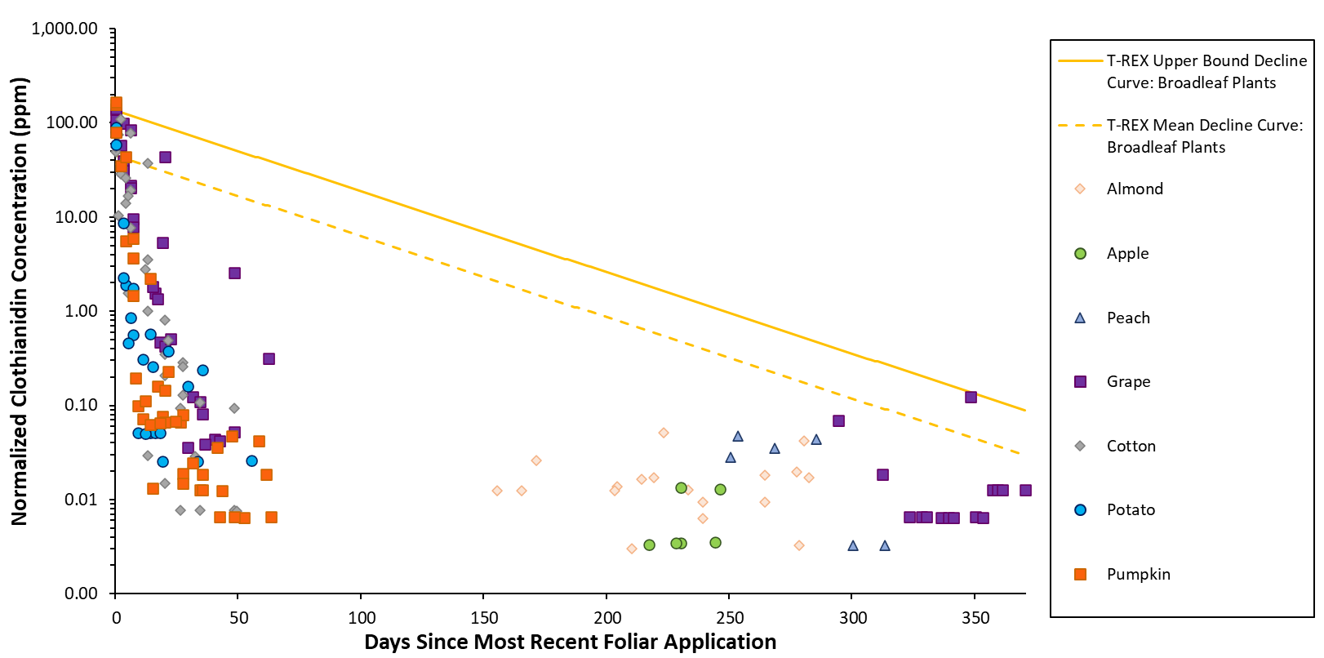
Figure 1. Normalized daily average clothianidin residue concentrations in leaves collected following foliar applications of clothianidin. Data are normalized to an application rate of 1 lb a.i./A (see Table 2 for the crop-specific application rate normalization method).

Post-Bloom Foliar Applications to Orchard Crops

Clothianidin was applied post-bloom to orchard crops, and leaves were sampled the following spring. No daily averages exceeded the default T-REX upper bound or mean EEC values for broadleaf plants across the sampling period of 156 to 314 days after the last application (Figure 2).

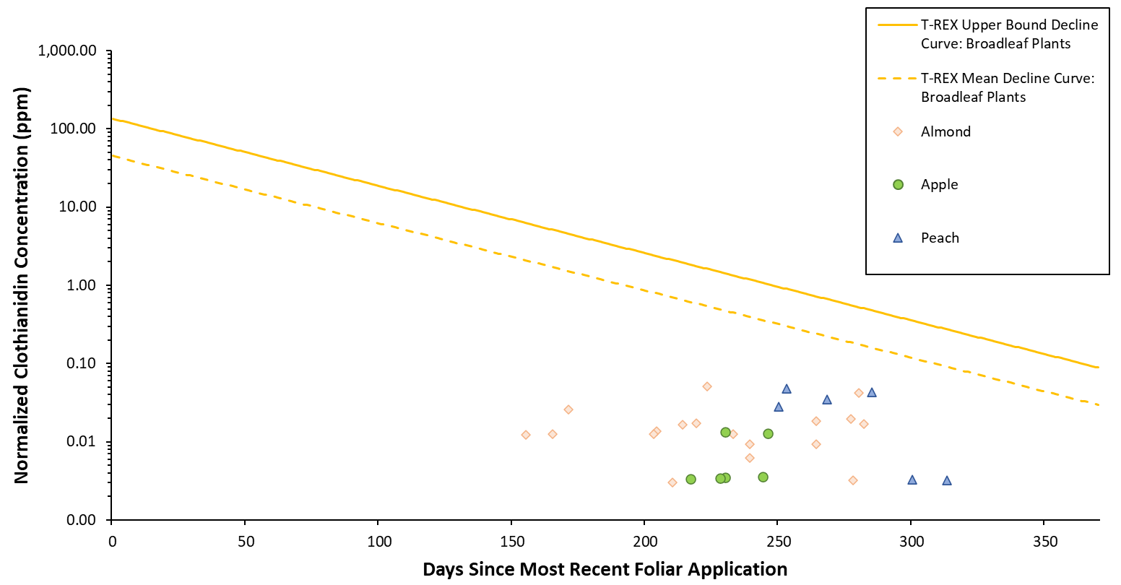
Figure 2. Normalized daily average clothianidin residue concentrations in orchard crop leaves collected following post-bloom foliar applications of clothianidin. Data are normalized to a total seasonal foliar application rate of 1 lb a.i./A.

Pre-Bloom/At Bloom Foliar Applications to Non-Orchard Agricultural Crops

Clothianidin was applied pre-bloom or at bloom to non-orchard agricultural crops, and leaves were sampled during the 2-month period immediately following application. Two of the daily averages for pumpkin exceeded the default T-REX upper bound values on day 1 (Figure 3). Collectively, 13 daily averages for cotton, potato, and pumpkin exceeded the T-REX mean EEC values for broadleaf plants during the first 2 weeks of the sampling period. After approximately 10 days following foliar application, measured residues were 1 to 3 orders of magnitude below the default EECs (upper bound and mean), suggesting more rapid foliar dissipation rates compared to the default half-life used by T-REX (35 days).

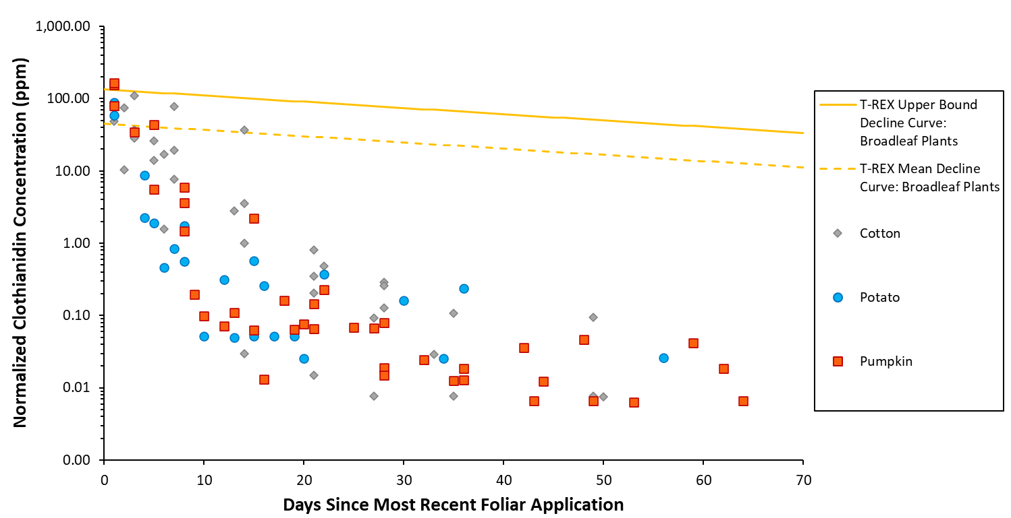
Figure 3. Normalized daily average clothianidin residue concentrations in leaves following pre-bloom or at bloom foliar applications of clothianidin. Data are normalized to a total foliar application rate of 1 lb a.i./A.

Pre-Bloom and Post-Bloom Foliar Applications to Grapes

Clothianidin was applied pre-bloom and post-bloom to grape. For the pre-bloom application, leaves were sampled during the 2-month period immediately following application. For the post-bloom application, leaves were sampled 1 to 49 days after application and again the following year at 295 to 371 days after application. Two of the daily averages for the post-bloom application exceeded the default T-REX upper bound EEC on day 1, but there were no exceedances of the T-REX upper bound EECs observed for the pre-bloom application (Figure 4). Four daily averages from the pre-bloom application and five daily averages from the post-bloom application exceeded the T-REX mean EECs for broadleaf plants during the first 3 weeks of sampling.

One daily average exceeded the T-REX mean EEC on day 349 for the post-bloom application measurements. Although the normalized residue values on day 349 were not particularly high (range: 24.9 - 220.8 ng/g), the daily average (124.4 ng/g) was in exceedance of the T-REX mean EEC for broadleaf plants and was higher than daily averages for samples collected at similar times (days 342, 351, 354). Across the three trial sites, out of the 45 leaf samples collected at least 295 days after the post-bloom foliar application, two of the replicate samples collected on day 349 represent half of the samples that had a concentration of clothianidin above the LOQ. Furthermore, the residue values in these two samples were slightly higher than the concentrations in the two samples with detectable clothianidin residues on day 295, and the daily average for day 349 was about 1.8X higher than the daily average on day 295. The residue values on day 349 could be due to an error or contamination by clothianidin spray drift; however, because there was no explanation offered in the study report and site-to-site variation cannot be dismissed as a potential explanatory factor, the data were retained in this analysis.

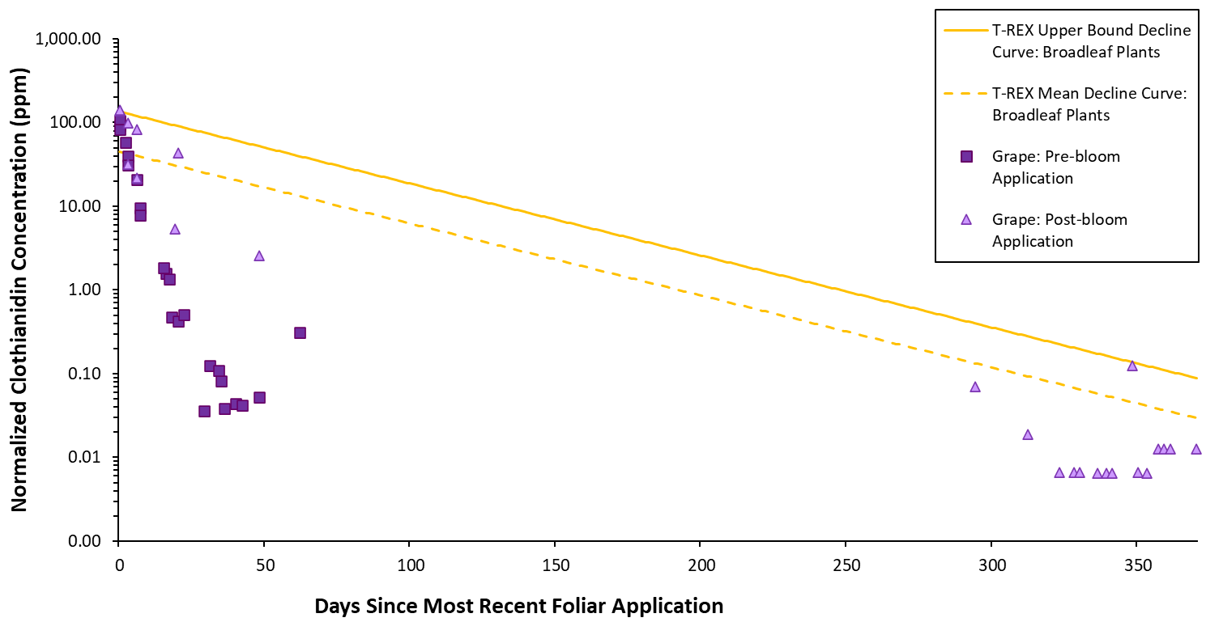
Figure 4. Normalized daily average clothianidin residue concentrations in grape leaves following pre-bloom or post-bloom foliar application of clothianidin. The pre-bloom application data are normalized to a last (single) foliar application rate of 1 lb a.i./A and the post-bloom application data are normalized to the total seasonal application rate of 1 lb a.i./A.

Leaf Residues Measured 1 to 4 Days After Foliar Application

Residues following foliar applications are expected to be highest in leaf samples collected immediately following the application. For clothianidin, the first samples were collected 1 day after the most recent application for all non-orchard agricultural crops in this analysis; orchard crop samples were not collected until 156 days after the most recent application. When focusing on the first four days following the most recent application, only daily averages from samples collected on day 1 for pumpkin (n = 2) and grape (n = 2, post-bloom application) exceeded the T-REX upper bound EEC for broadleaf plants (Figure 5). In total, 17 daily averages exceeded the T-REX mean EEC during the first 4 days with the majority of those exceedances (n = 13) occurring on day 1. When focusing on the daily average residue concentrations for only the first 4 days after application, the mean of the daily averages for grape, cotton, potato, and pumpkin exceeded the day 1 T-REX mean EEC for broadleaf plants (i.e., mean > 44.1 µg/g; Figure 6).

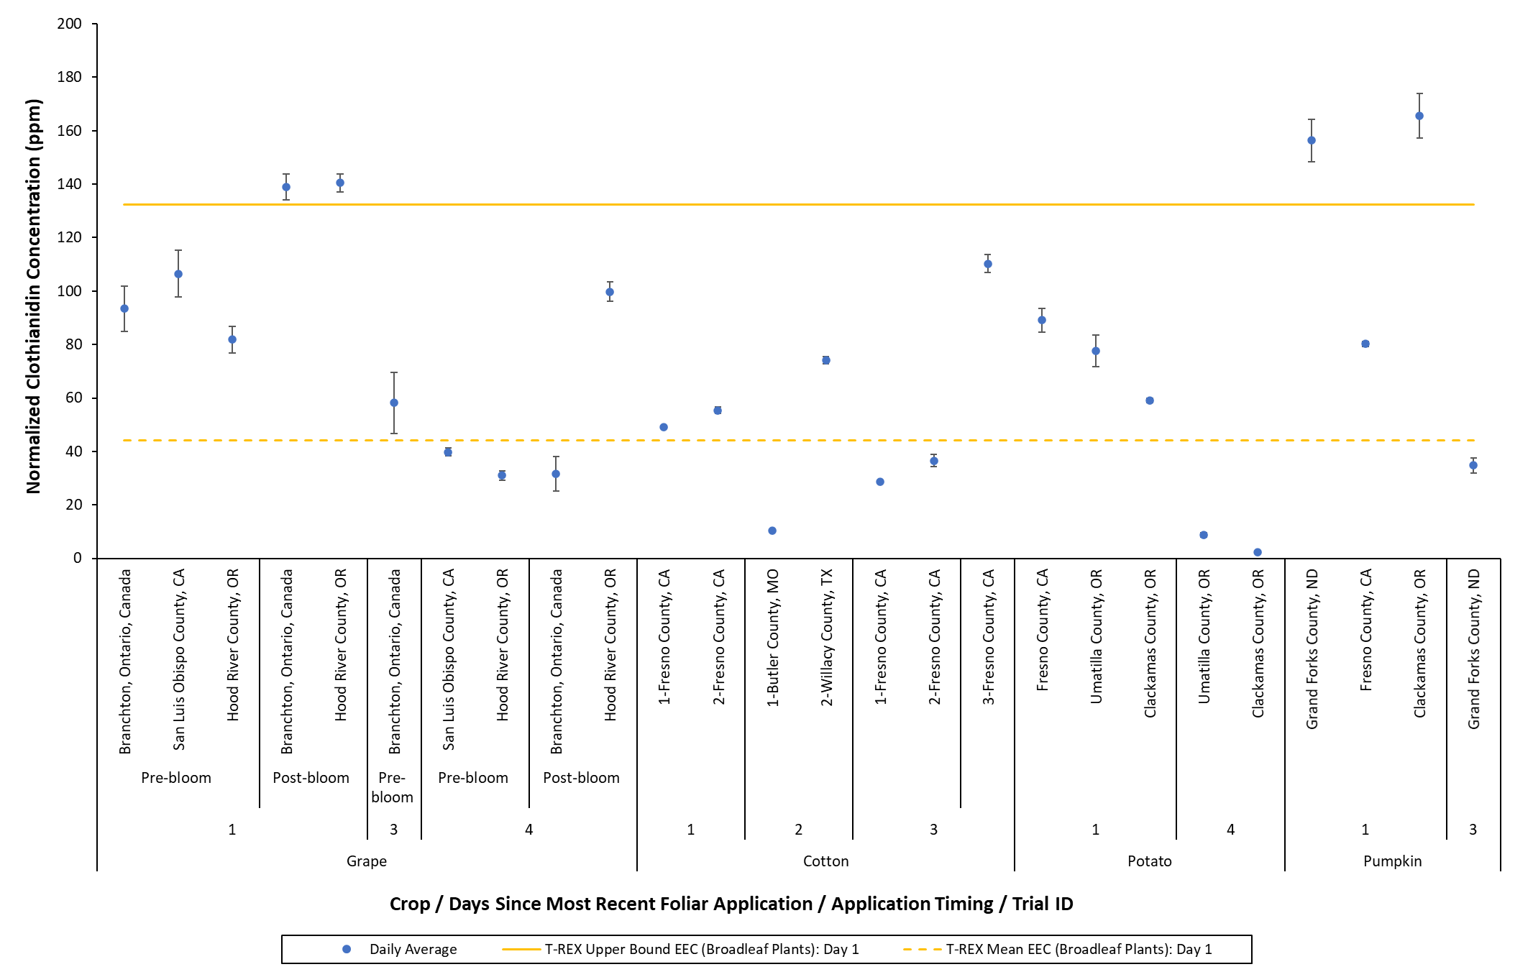
Figure 5. Normalized daily average clothianidin residue concentrations in leaves collected 1 to 4 days after the most recent foliar application of clothianidin. Daily averages are shown according to crop, sampling day, application timing, and experimental trial. Data are normalized to an application rate of 1 lb a.i./A (see Table 2 for the crop-specific application rate normalization method). Error bars represent the standard error.

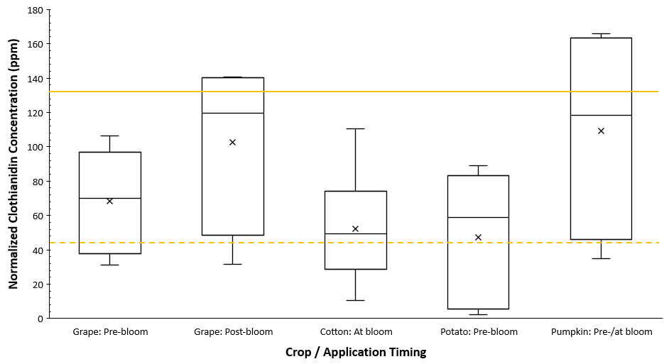
Figure 6. Range of normalized daily average clothianidin residue concentrations in leaves collected 1 to 4 days after the most recent foliar application of clothianidin. ‘x’ marker represents the mean of the daily averages; solid yellow line represents the T-REX upper bound EEC for broadleaf plants on day 1 (132.3 ppm); dashed yellow line represents the T-REX mean EEC for broadleaf plants on day 1 (44.1 ppm). Data are normalized to an application rate of 1 lb a.i./A (see Table 2 for the crop-specific application rate normalization method).

Clothianidin Summary (Foliar Applications)

The maximum daily average residue concentrations measured in almond, apple, peach, grape, cotton, potato, and pumpkin leaves following foliar applications of clothianidin ranged from approximately 13.4 to 165,700 ng/g (Table 4). For the orchard crops, the maximum daily averages are low, and all occurred more than 200 days after the post-bloom foliar applications; however, leaves were not collected before 156 days after the final foliar application. It is expected that if leaves had been collected immediately after the foliar applications, the maximum residue values would have occurred sooner. For grape, potato, and pumpkin, the maximum daily average residue concentrations were all measured on day 1. For cotton, the maximum daily average was measured 3 days after the foliar application, but leaves were not sampled sooner in this trial.

Out of 177 daily average residue concentrations, 4 exceeded the T-REX upper bound EEC and 23 exceeded the T-REX mean EEC for broadleaf plants (Table 5). Out of 507 individual leaf samples, 11 samples had residue concentrations that exceeded the T-REX upper bound EEC and 66 had residue concentrations that exceeded the T-REX mean EEC for broadleaf plants (Table 6).

Table 4. The day after the most recent foliar application when the maximum normalized daily average clothianidin residue concentration occurred for each crop and the magnitude of the maximum daily average concentration.
Crop | Days after the Most Recent Application when the Maximum Daily Average Residue Occurred | Maximum Normalized Daily  Average Concentration, ng/g
Almond | 224 | 51.0
Apple | 231 | 13.4
Peach | 254 | 47.4
Grape | 1 | 140,480
Cotton | 3 | 110,298
Potato | 1 | 89,058
Pumpkin | 1 | 165,658

Table 5. The number of normalized daily average clothianidin residue concentrations for each crop that exceed the T-REX upper bound and mean EECs for broadleaf plants on the sampling day.
Crop | Total Number of Daily Average Measurements | Number of Daily Averages Exceeding the T-REX Upper Bound EEC  (Broadleaf Plants)^{1,2} | Days after the Most Recent Application when the Daily Average Exceeds the T-REX Upper  Bound EEC | Number of Daily Averages Exceeding the  T-REX Mean EEC (Broadleaf Plants)^{1,2} | Days after the Most Recent Application when the Daily Average Exceeds the T-REX  Mean EEC
Almond | 18 | 0 | NA | 0 | NA
Apple | 6 | 0 | NA | 0 | NA
Peach | 6 | 0 | NA | 0 | NA
Grape | 48 | 2 | 1* | 10 | 1, 3, 4, 7, 21, 349**
Cotton | 35 | 0 | NA | 6 | 1-3, 7, 14
Potato | 24 | 0 | NA | 3 | 1
Pumpkin | 40 | 2 | 1 | 4 | 1, 5
Highlighted cells indicate where normalized daily average residue concentrations exceed the T-REX EECs.
NA = not applicable because no daily average residue concentrations exceeded the T-REX EECs
¹ When the leaf residues are normalized to an application rate of 1 lb a.i./A (see Table 2 for the specific normalization method).
² Exceedance is determined by comparing the daily average residue concentration and the default T-REX EEC for each daily sampling event. T-REX default EECs are based on the expected daily decline.
*The exceedances for grapes at 1 day after the most recent foliar application were for samples collected after a post-bloom application.
**At 349 days after the most recent foliar application, the normalized residue values were not particularly high (mean: 124.4 ng/g, range: 24.9 - 220.8 ng/g), nonetheless the daily average exceeded the T-REX mean EEC; this exceedance could be an error or due to contamination.
Table 6. The number of leaf samples for each crop that have normalized clothianidin residue concentrations exceeding the T-REX upper bound and mean EECs for broadleaf plants on the sampling day.
Crop | Total Number of Leaf Residue Samples | Number of Samples Exceeding the T-REX Upper Bound EEC (Broadleaf Plants)^{1,2} | Days after the Most Recent Application when the Measured Residue Exceeds  the T-REX Upper  Bound EEC | Number of Samples Exceeding the  T-REX Mean EEC (Broadleaf Plants)^{1,2} | Days after the Most Recent Application when the Measured Residue Exceeds the T-REX Mean EEC
Almond | 54 | 0 | NA | 0 | NA
Apple | 18 | 0 | NA | 0 | NA
Peach | 18 | 0 | NA | 0 | NA
Grape | 144 | 5 | 1*, 349** | 30 | 1, 3, 4, 7, 21, 349**
Cotton | 91 | 0 | NA | 15 | 1-3, 7, 14
Potato | 72 | 0 | NA | 9 | 1
Pumpkin | 110 | 6 | 1 | 12 | 1, 3, 5
Highlighted cells indicate where normalized residue concentrations in samples exceed the T-REX EECs.
NA = not applicable because no sample had a concentration that exceeded the T-REX EECs
¹ When the leaf residues are normalized to an application rate of 1 lb a.i./A (see Table 2 for the specific normalization method).
² Exceedance is determined by comparing the normalized residue concentration measured and the default T-REX EEC for each daily sampling event. T-REX default EECs are based on the expected daily decline.
*The exceedances for grapes at 1 day after the most recent foliar application were samples collected after a post-bloom application.
**At 349 days after the most recent application, the normalized residue concentration in one sample exceeds the T-REX upper bound EEC, and the normalized residue concentration in two samples exceed the mean EEC; the normalized residue values are not particularly high (mean: 124.4 ng/g, range: 24.9 - 220.8 ng/g). However, this exceedance could be an error or due to contamination.

Thiamethoxam

Summary of the Available Data

For foliar applications of thiamethoxam, the data set includes 1,033 individual leaf residue measurements from 14 species: apple, orange, peach, plum, cherry, blueberry, strawberry, cotton, cucumber, pumpkin, soybean, tomato, mock orange, and stargazer lily. For orchard crops, thiamethoxam was applied pre-bloom to apple and orange trees with leaves collected 0 to 157 days after application, and thiamethoxam was applied post-bloom to peach, plum, and cherry with leaves collected 0 to 360 days after application. For non-orchard agricultural crops, thiamethoxam was applied pre-bloom with leaves collected 0 to 74 days after application. For ornamental species, thiamethoxam was applied pre-bloom and leaves were collected 0 to 119 days after application.

The majority of the daily average concentrations of the residues of concern (thiamethoxam plus clothianidin in clothianidin equivalents) in the leaves were below the T-REX upper bound and mean EECs estimated for broadleaf plants (Figure 7). All of the daily average residue concentrations that exceed the T-REX upper bound EEC for broadleaf plants occurred in the first 5 days of sampling after foliar application (Figure 7, Figure 8). All but one of the daily average residue concentrations that exceed the T-REX mean EEC for broadleaf plants were from leaf samples collected within 8 days of the foliar application (Figure 7, Figure 8).

After approximately two weeks following the foliar application, generally, the default T-REX EECs were substantially higher than the measured residues, indicating that empirical residue concentrations declined more rapidly than T-REX predicts when the default foliar dissipation half-life of 35 days is used (Figure 7, Figure 8). Additionally, the total thiamethoxam leaf residue concentrations followed trends very similar to leaf residue concentrations of clothianidin (see Section 4.1).
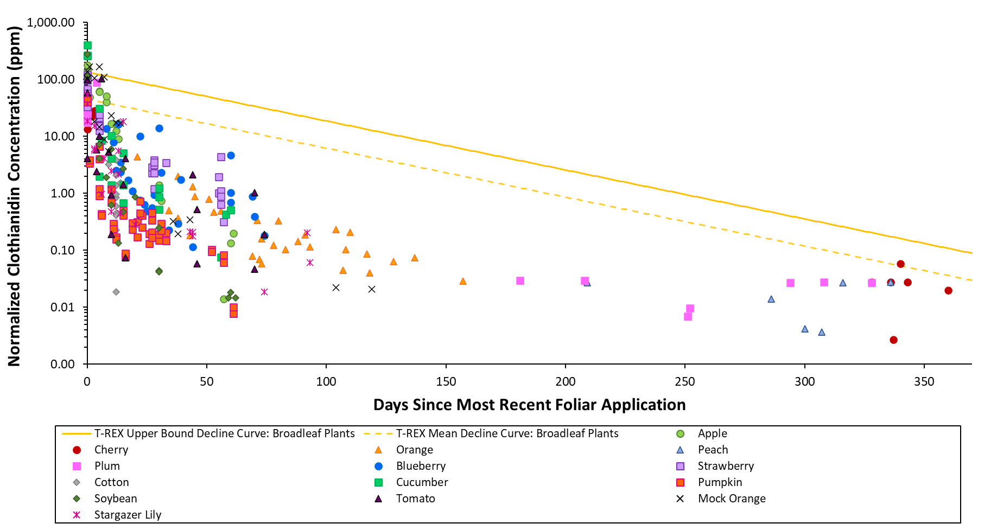
Figure 7. Normalized daily average residue concentrations of total thiamethoxam and clothianidin (in clothianidin equivalents) in leaves collected following foliar applications of thiamethoxam. Data are normalized to an application rate of 1 lb a.i./A (see Table 2 for the crop-specific application rate normalization method).
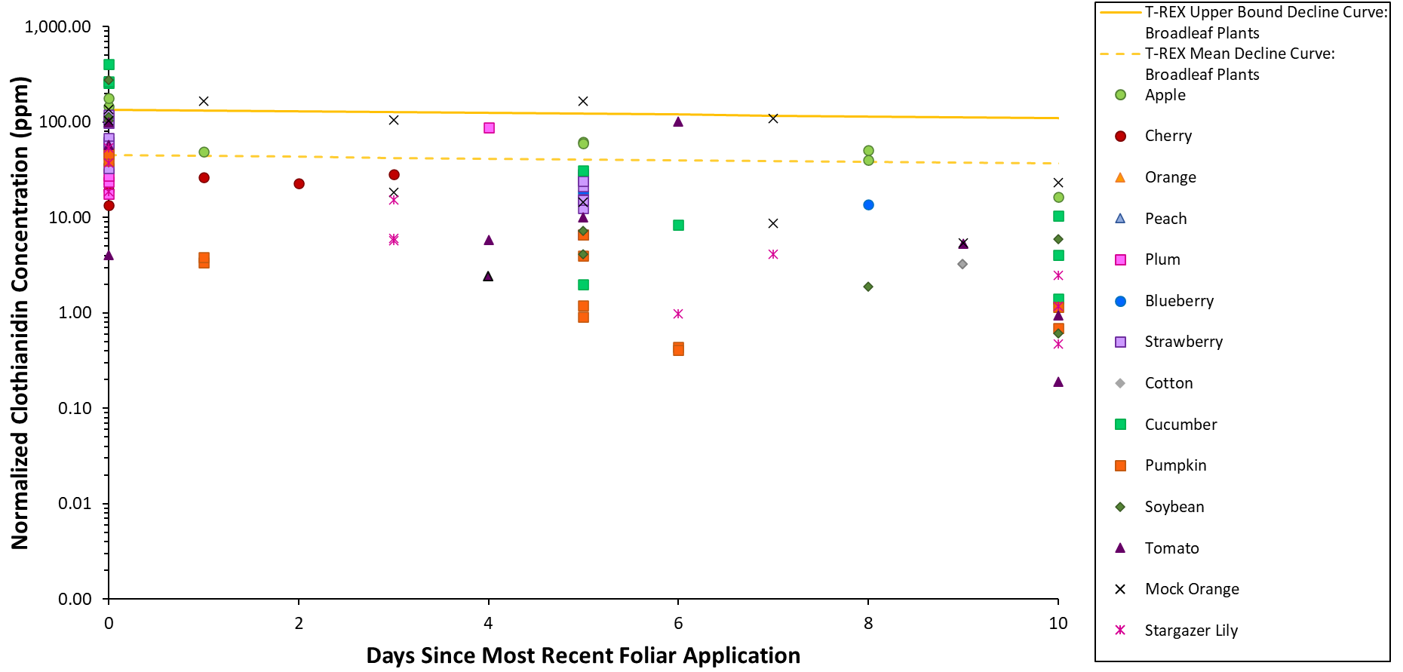
Figure 8. Normalized daily average residue concentrations of total thiamethoxam and clothianidin (in clothianidin equivalents) in leaves collected 0 to 10 days following foliar applications of thiamethoxam. Data are normalized to an application rate of 1 lb a.i./A (see Table 2 for the crop-specific application rate normalization method).

Foliar Application to Orchard Crops

Although foliar applications of thiamethoxam can occur at different times (i.e., pre-bloom or post-bloom) depending on the specific orchard crop, it is expected that residues in leaves quickly dissipate after the foliar application. The empirical residue concentrations decline rapidly from approximately 10 to 150 days after the foliar application but remained relatively stable for samples collected more than 150 days after application (Figure 9). Additionally, for samples collected more than 150 days after application, the residue concentrations are generally within an order of magnitude of the T-REX EECs (Figure 9). For leaves collected more than 5 months after the foliar application, the stability of the leaf residue concentrations (i.e., concentrations are not declining) suggests that the decline curve of the default T-REX EECs (based on a default foliar dissipation half-life of 35 days) may not accurately predict the trend of residue concentrations in orchard leaves at later sampling dates.

The only daily average residue concentrations that exceeded the T-REX upper bound EECs for broadleaf plants were for apple leaves collected immediately after the application on day 0 (Figure 9, Figure 10). Generally, the daily average residue concentrations that exceeded the T-REX mean EEC for broadleaf plants were for orchard crop leaves collected up to about a week after the foliar application (Figure 9, Figure 10); the one exception was the daily average for cherry leaves collected at 340 days after the final foliar application (Figure 9). Although the normalized residue values for cherry leaves collected on day 340 were not particularly high (range: 53.0 – 61.6 ng/g), the daily average (58.2 ng/g) was higher than the T-REX mean EEC for broadleaf plants. Across the six trials, out of the 18 leaf samples collected more than 300 days after the post-bloom foliar applications to cherry, the three replicate samples on day 340 were the only samples with a concentration of thiamethoxam above the LOQ. These few detections could be due to an error or contamination by thiamethoxam spray drift but also could be explained by site-to-site or year-to-year variability that cannot be further examined, because only 6 samples were collected in this trial (n = 3 on day 0, n = 3 on day 340).

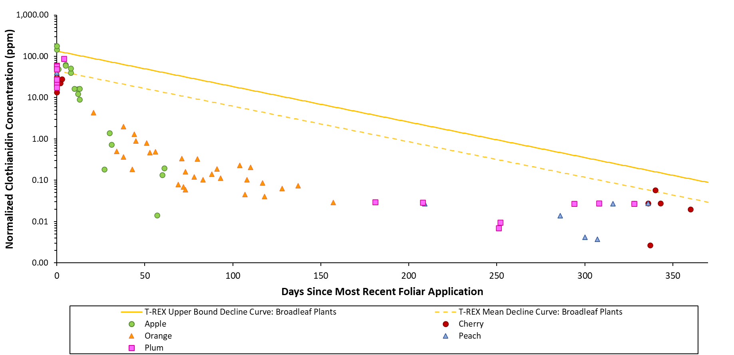
Figure 9. Normalized daily average residue concentrations of total thiamethoxam and clothianidin (in clothianidin equivalents) in orchard crop leaves collected following foliar applications of thiamethoxam. Data are normalized to a total seasonal foliar application rate of 1 lb a.i./A.

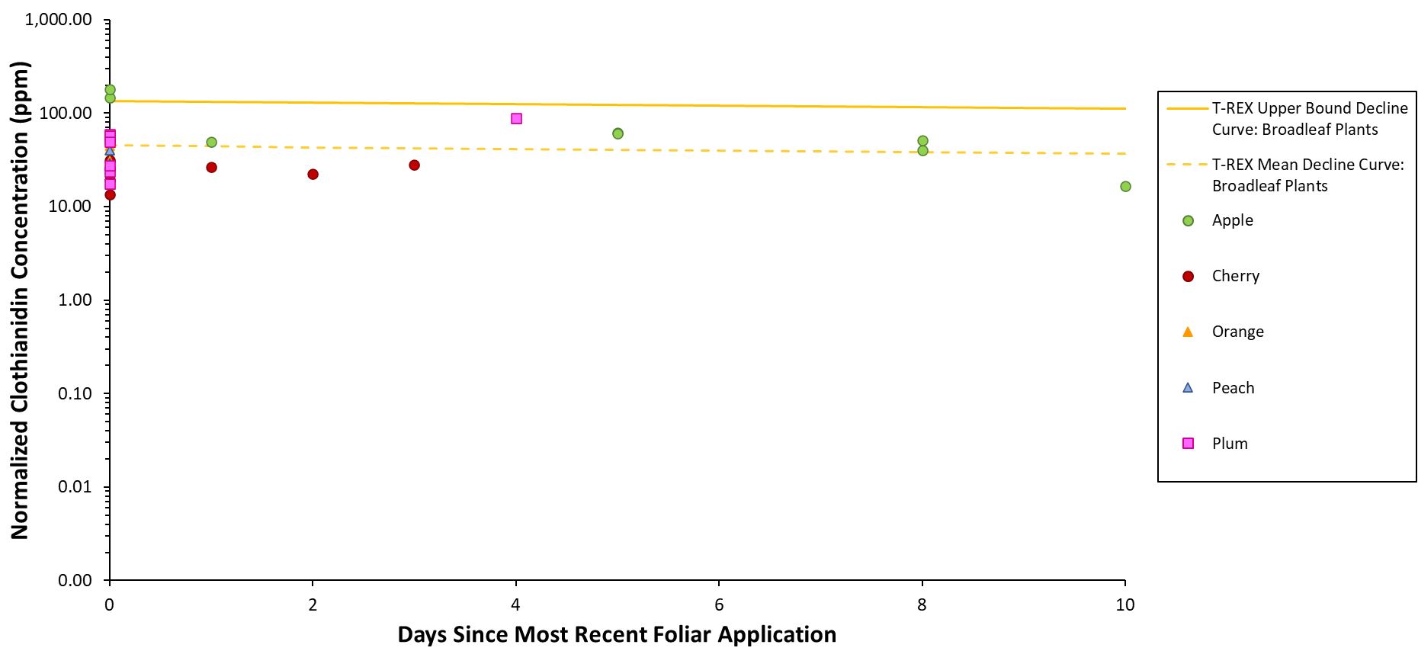
Figure 10. Normalized daily average residue concentrations of total thiamethoxam and clothianidin (in clothianidin equivalents) in orchard crop leaves collected 0 to 10 days following foliar applications of thiamethoxam. Data are normalized to a total seasonal foliar application rate of 1 lb a.i./A.

Foliar Application to Non-Orchard Agricultural Crops

For the non-orchard agricultural crop species included in this data set, only pre-bloom applications are permitted. In general, the residues were highest immediately after the foliar application and declined over time. The only daily average residue concentrations that exceeded the T-REX upper bound EEC for broadleaf plants were for cucumber and soybean leaves collected immediately after the application on day 0 (Figures 11-13). The daily average residue concentrations that exceeded the T-REX mean EEC for broadleaf plants were for leaves collected immediately after the foliar application, with the exception of the daily average residue concentration for tomato leaves collected on day 6 (Figures 11-13). For the tomato trial with the highest daily average on day 6, it should be noted that the total toxic residue values measured 6 days after the first foliar application were more than 20X higher than the total toxic residue values immediately after the second foliar application. This finding is unexpected, and it is possible that a reporting error or contamination occurred. However, there was no explanation offered in the study report, so the data were retained in this analysis.

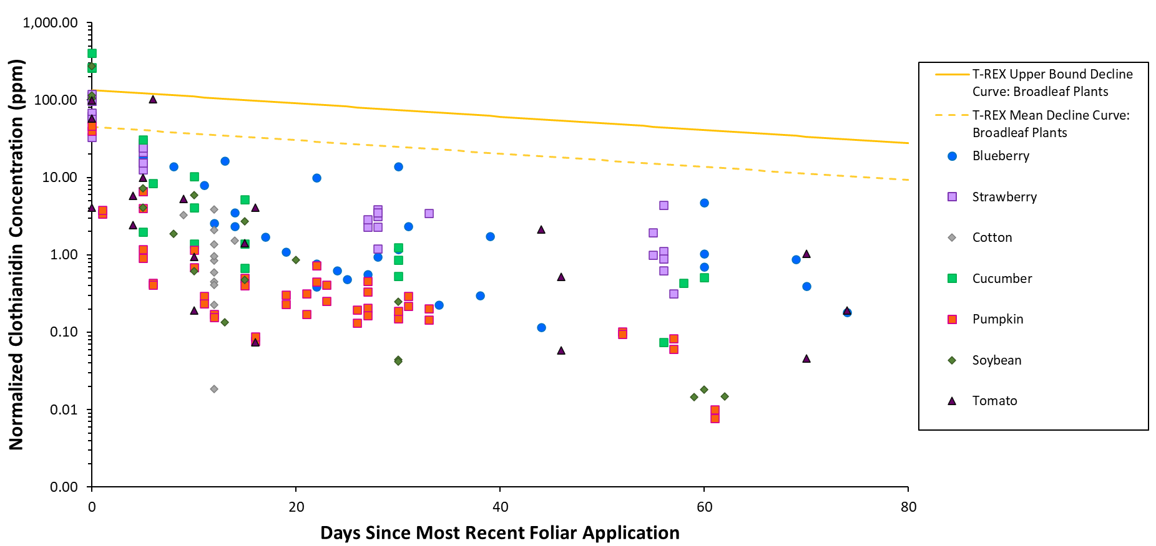
Figure 11. Normalized daily average residue concentrations of total thiamethoxam and clothianidin (in clothianidin equivalents) in non-orchard agricultural crop leaves collected following foliar applications of thiamethoxam. Data are normalized to an application rate of 1 lb a.i./A (see Table 2 for the crop-specific application rate normalization method).

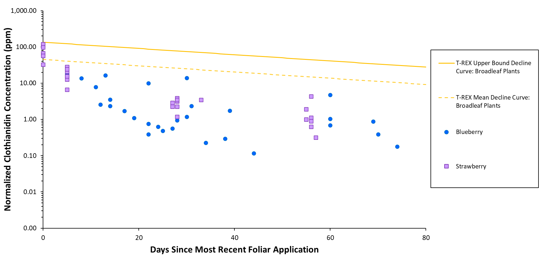
Figure 12. Normalized daily average residue concentrations of total thiamethoxam and clothianidin (in clothianidin equivalents) in berry leaves collected following foliar applications of thiamethoxam. Data are normalized to a last (single) foliar application rate of 1 lb a.i./A.

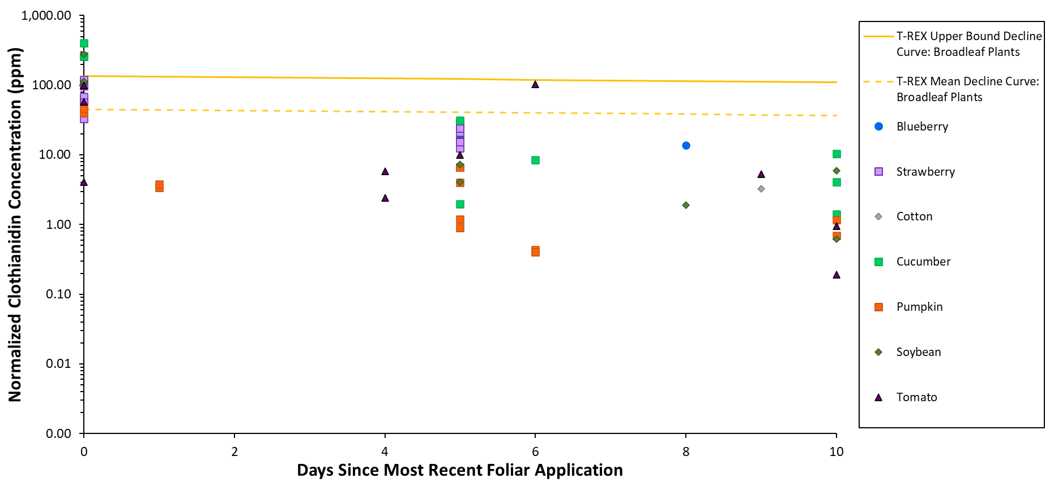
Figure 13. Normalized daily average residue concentrations of total thiamethoxam and clothianidin (in clothianidin equivalents) in non-orchard agricultural crop leaves collected 0 to 10 days following foliar applications of thiamethoxam. Data are normalized to an application rate of 1 lb a.i./A (see Table 2 for the crop-specific application rate normalization method).

Foliar Applications to Ornamentals

For the ornamental species (mock orange and stargazer lily) included in this data set, two pre-bloom applications were made. Overall, the residue concentrations declined over time. In general, the residue concentrations on mock orange leaves were higher than on stargazer lily leaves collected on the same day, and residue concentrations on mock orange leaves were high up to 5 days after the foliar application (Figure 14). The daily average residue concentrations that exceeded the T-REX upper bound EEC for broadleaf plants were for mock orange leaves collected on days 0, 1, and 5 (Figure 14). The daily average residue concentrations that exceeded the T-REX mean EEC for broadleaf plants were for leaves collected within the first week after the foliar application (Figure 14).

For mock orange, the highest overall daily average residue concentration (167 µg/g) was measured 5 days after the second foliar application in the trial at North Rose, NY; it is expected that the highest daily average would be measured immediately after foliar applications (i.e., on day 0 after application) if samples are collected then (as they were in this trial). However, the residue concentrations for this trial do not follow the expected trend (i.e., do not decrease as time increases). Specifically, for leaves that were reported to have been collected immediately after the second foliar application (i.e., 0 days after the most recent foliar application), the thiamethoxam residue concentrations are unexpectedly low. Although the study report offers no explanation for these unexpected results, it is hypothesized that on this sampling day (i.e., the day of the second foliar application) the leaves were collected prior to the second foliar application instead of immediately after the application, thereby potentially explaining why the thiamethoxam concentrations are relatively low while the clothianidin concentrations are relatively high in these samples. Because the study report does not acknowledge or address these lower-than-expected residues measured 0 days after the final foliar application, the data from the North Rose trial were retained in the data set for this analysis. However, if the North Rose data are ignored, the maximum daily average residue concentration would remain practically unchanged (166 µg/g) and would be reflective of the daily average for the first samples collected in the trial at Oregon City, OR. Furthermore, in the Oregon City trial, residues in leaves were not measured before 1 day after the final foliar application; therefore, it is expected that if leaves had been collected immediately after the foliar applications in the Oregon City trial, the maximum daily average would likely occur on day 0 (i.e., immediately after foliar application) and would likely be higher than the daily average measured on day 1 (166 µg/g).

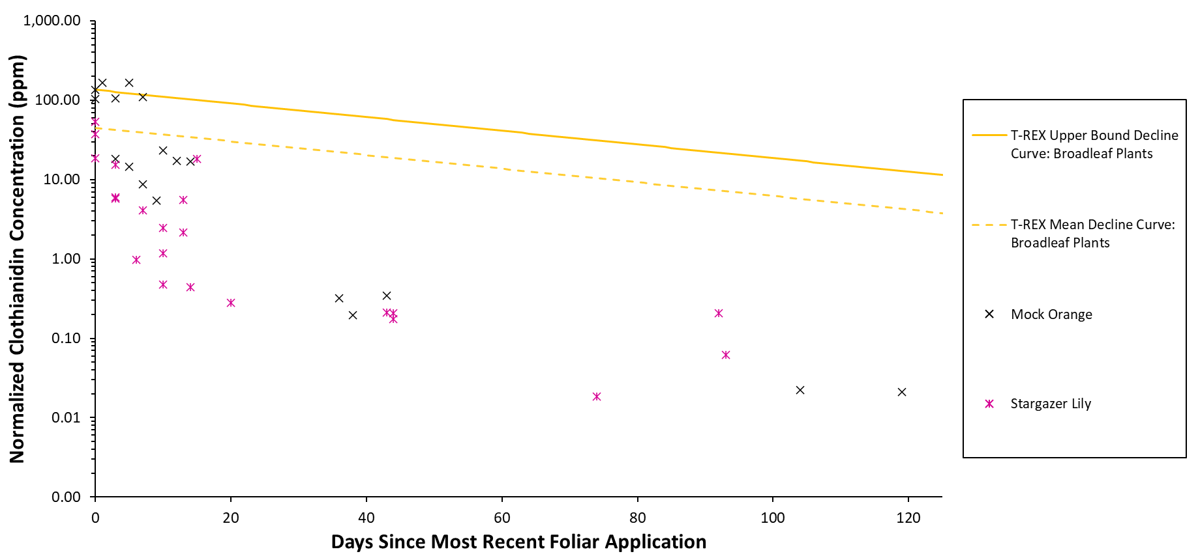
Figure 14. Normalized daily average residue concentrations of total thiamethoxam and clothianidin (in clothianidin equivalents) in ornamental leaves collected following foliar applications of thiamethoxam. Data are normalized to a last (single) foliar application rate of 1 lb a.i./A.

Leaf Residues Measured Within 4 or 5 Days After Foliar Application

In general, following foliar application, the residues in leaves are expected to be highest immediately after the foliar application (i.e., on day 0). Every test species except cotton was sampled on day 0; cotton leaves were not sampled until at least 9 days after the foliar application. Within the first 4 days after the foliar application, the daily average residue concentrations of total thiamethoxam and clothianidin (in clothianidin equivalents) exceed the T-REX upper bound EEC for apple, cucumber, soybean, and mock orange leaves collected on day 0 and for mock orange leaves collected on day 1 (Figures 15-17). Additionally, within the first 4 days after the foliar application, daily average residue concentrations exceed the T-REX mean EEC for apple, orange, plum, blueberry, strawberry, cucumber, pumpkin, soybean, tomato, mock orange, and stargazer lily leaves (Figures 15-17). As noted previously (see Section 4.2.4), the daily average residue concentration for one mock orange trial also exceeds the T-REX upper bound and mean EECs 5 days after the final foliar application (Figure 18).

In general, the daily average residue concentrations do not vary by more than 10X for leaves collected within the first four days after foliar application to agricultural crops or within the first five days after foliar application to ornamental species (Figures 19-22), with the exception of pumpkin and tomato, which had very low residue values measured on days 1 and 4, respectively (Figure 15, Figure 19). For cucumber and soybean leaves collected on day 0, the means of the daily average residue concentrations exceed the T-REX upper bound EEC for broadleaf plants (i.e., mean > 135 µg/g; Figure 21). Additionally, when considering samples collected 0 to 4 days after foliar application, the means of the daily average residue concentrations in apple, plum, blueberry, strawberry, cucumber, and soybean leaves exceed the T-REX mean EEC for broadleaf plants on day 0 (i.e., mean > 45 µg/g; Figures 19-21). If only the day 0 samples are considered, the mean of the daily average residue concentrations in tomato leaves exceeds the T-REX mean EEC for broadleaf plants on day 0 (i.e., mean > 45 µg/g; Figure 21). When considering samples collected 0 to 5 days after foliar application, the mean of the daily average residue concentrations in mock orange leaves exceed the T-REX mean EEC for broadleaf plants on day 0 (i.e., mean > 45 µg/g; Figure 22).

Immediately after foliar application, the daily average residue concentrations on cucumber leaves (MRID 49804105) are 1.4 to 98X higher than daily averages for all other test species, with the exception of the daily average measured in one soybean trial (Figure 15, Figure 17, Figure 19). This finding is consistent with the analysis of the pollen and nectar residue data, which found that mean residues in cucumber nectar and pollen can be about 100X higher than residues measured in the corresponding matrix of other cucurbits at the same sampling time after foliar application (USEPA, 2020a). The higher residue concentrations on cucumber leaves may represent a crop-specific attribute. Furthermore, the cucumber residue values included in this data set are all from one study, so this finding of high leaf residue concentrations could be study-specific.

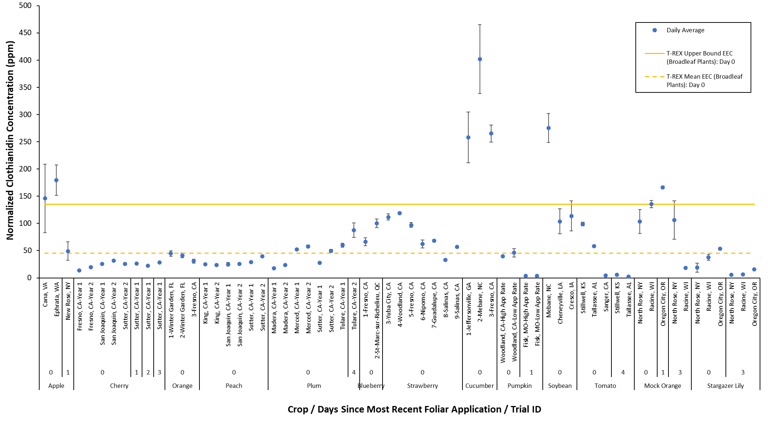
Figure 15. Normalized daily average residue concentrations of total thiamethoxam and clothianidin (in clothianidin equivalents) in leaves collected 0 to 4 days after the most recent foliar application of thiamethoxam. Daily averages are shown according to crop, sampling day, and experimental trial. Data are normalized to an application rate of 1 lb a.i./A (see Table 2 for the crop-specific application rate normalization method). Error bars represent the standard error.

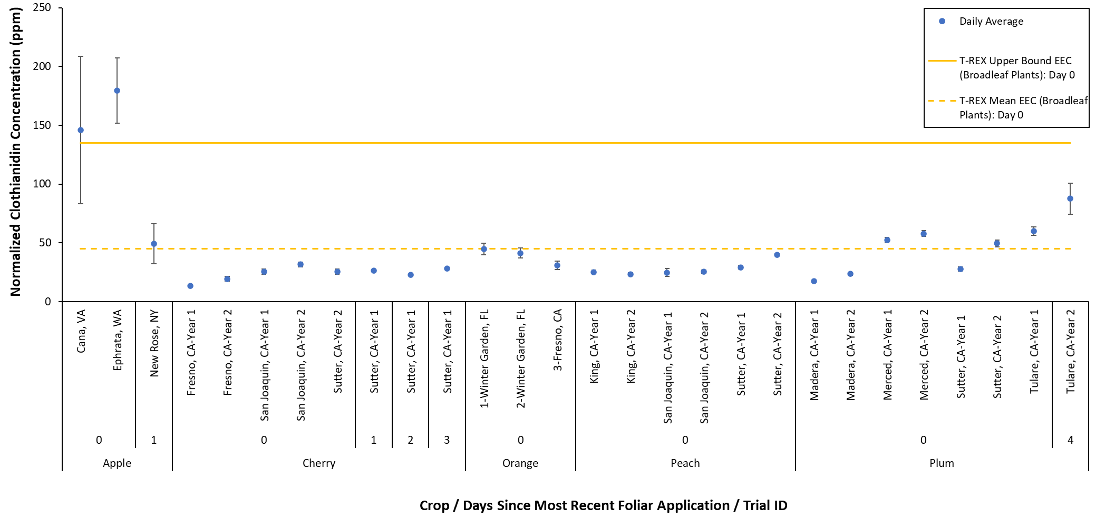
Figure 16. Normalized daily average residue concentrations of total thiamethoxam and clothianidin (in clothianidin equivalents) in orchard crop leaves collected 0 to 4 days after the most recent foliar application of thiamethoxam. Daily averages are shown according to crop, sampling day, and experimental trial. Data are normalized to a total seasonal foliar application rate of 1 lb a.i./A. Error bars represent the standard error.
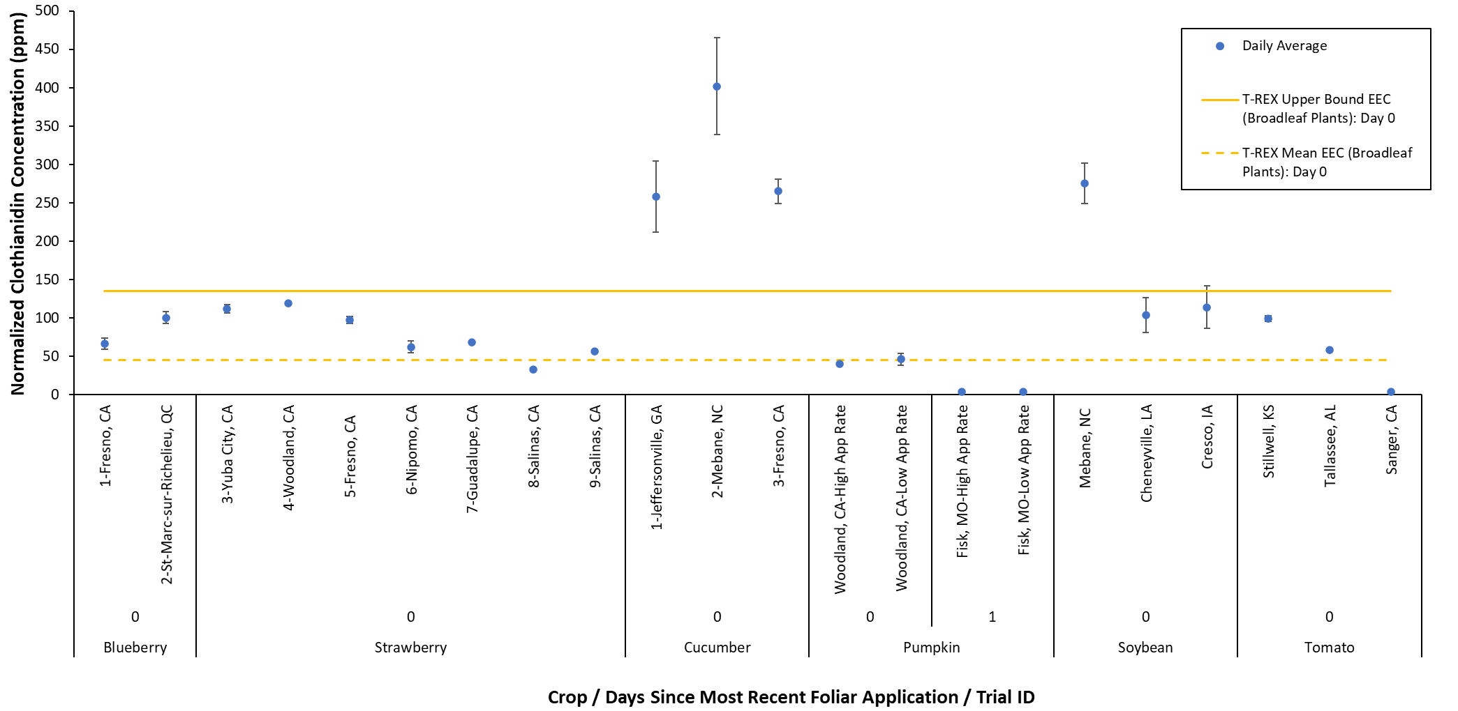
Figure 17. Normalized daily average residue concentrations of total thiamethoxam and clothianidin (in clothianidin equivalents) in non-orchard agricultural crop leaves collected 0 or 1 day after the most recent foliar application of thiamethoxam. Daily averages are shown according to crop, sampling day, and experimental trial. Data are normalized to an application rate of 1 lb a.i./A (see Table 2 for the crop-specific application rate normalization method). Error bars represent the standard error.

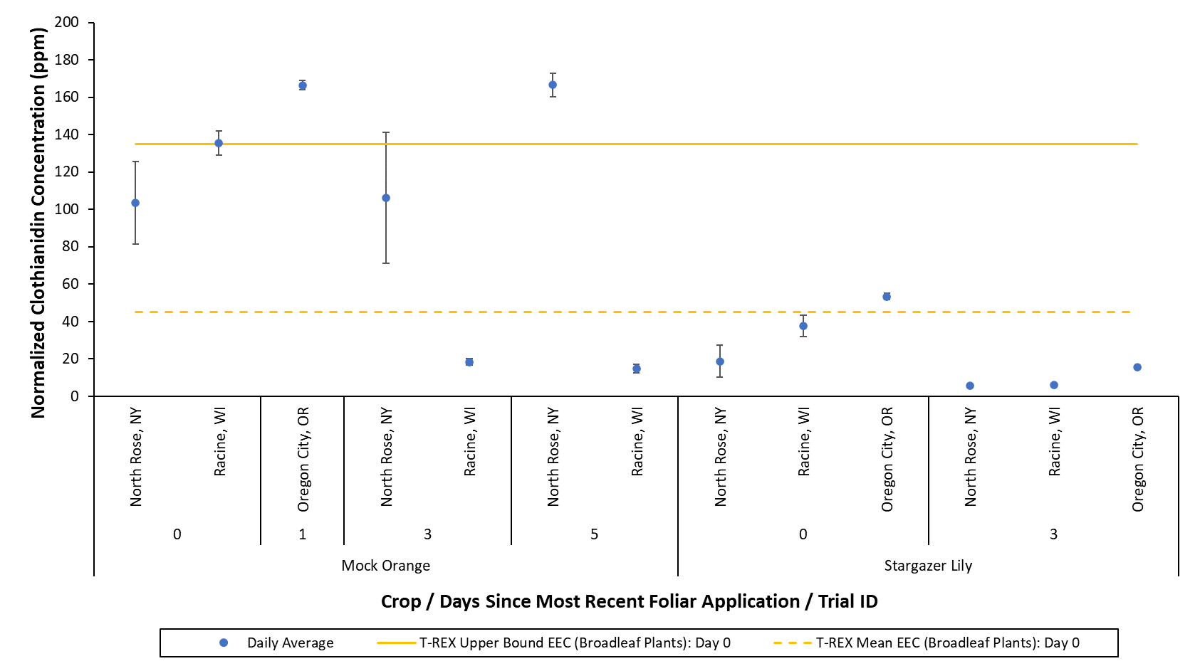
Figure 18. Normalized daily average residue concentrations of total thiamethoxam and clothianidin (in clothianidin equivalents) in ornamental leaves collected 0 to 5 days after the most recent foliar application of thiamethoxam. Daily averages are shown according to species, sampling day, and experimental trial. Data are normalized to a last (single) foliar application rate of 1 lb a.i./A. Error bars represent the standard error.

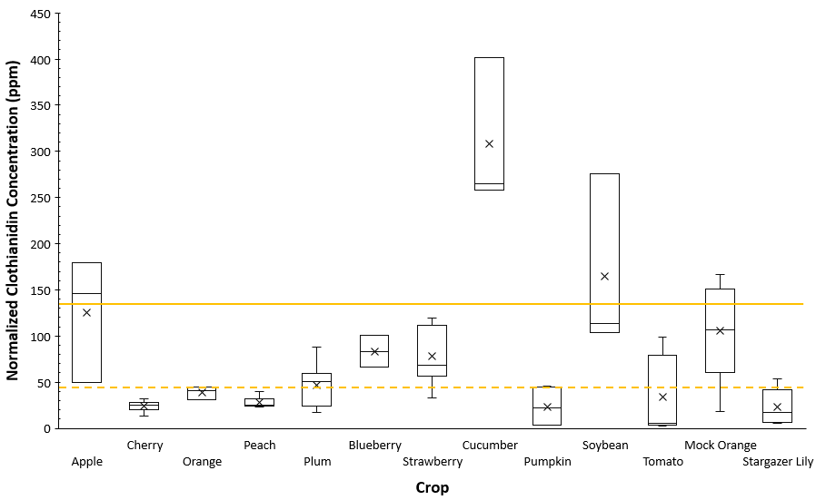
Figure 19. Range of normalized daily average residue concentrations of total thiamethoxam and clothianidin (in clothianidin equivalents) in leaves collected 0 to 4 days after the most recent foliar application of thiamethoxam. ‘x’ marker represents the mean of the daily averages; solid yellow line represents the T-REX upper bound EEC for broadleaf plants on day 0 (135 ppm); dashed yellow line represents the T-REX mean EEC for broadleaf plants on day 0 (45 ppm). Data are normalized to an application rate of 1 lb a.i./A (see Table 2 for the crop-specific application rate normalization method).

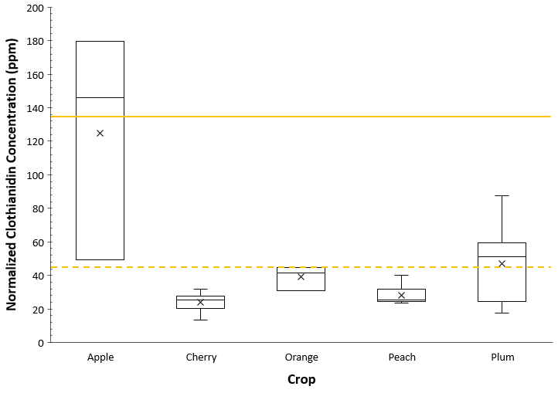
Figure 20. Range of normalized daily average residue concentrations of total thiamethoxam and clothianidin (in clothianidin equivalents) in orchard crop leaves collected 0 to 4 days after the most recent foliar application of thiamethoxam. ‘x’ marker represents the mean of the daily averages; solid yellow line represents the T-REX upper bound EEC for broadleaf plants on day 0 (135 ppm); dashed yellow line represents the T-REX mean EEC for broadleaf plants on day 0 (45 ppm). Data are normalized to a total seasonal foliar application rate of 1 lb a.i./A.

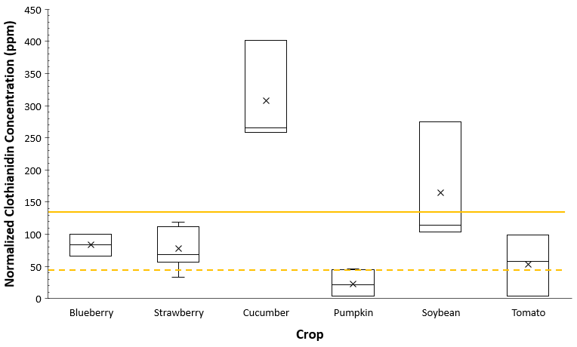
Figure 21. Range of normalized daily average residue concentrations of total thiamethoxam and clothianidin (in clothianidin equivalents) in non-orchard agricultural crop leaves collected 0 or 1 day after the most recent foliar application of thiamethoxam. ‘x’ marker represents the mean of the daily averages; solid yellow line represents the T-REX upper bound EEC for broadleaf plants on day 0 (135 ppm); dashed yellow line represents the T-REX mean EEC for broadleaf plants on day 0 (45 ppm). Data are normalized to an application rate of 1 lb a.i./A (see Table 2 for the crop-specific application rate normalization method).

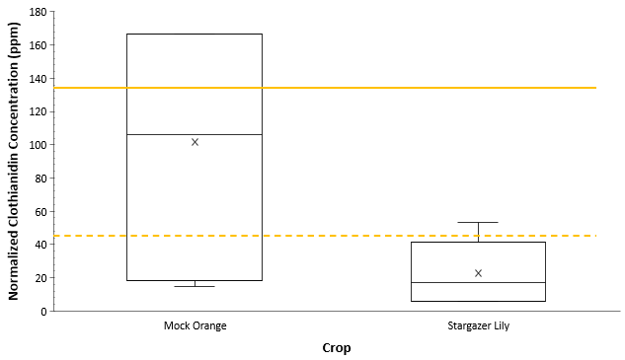
Figure 22. Range of normalized daily average residue concentrations of total thiamethoxam and clothianidin (in clothianidin equivalents) in ornamental leaves collected 0 to 5 days after the most recent foliar application of thiamethoxam. ‘x’ marker represents the mean of the daily averages; solid yellow line represents the T-REX upper bound EEC for broadleaf plants on day 0 (135 ppm); dashed yellow line represents the T-REX mean EEC for broadleaf plants on day 0 (45 ppm). Data are normalized to a last (single) foliar application rate of 1 lb a.i./A.

Thiamethoxam Summary (Foliar Applications)

In summary, the maximum daily average residue concentrations measured in the 14 test species following foliar applications of thiamethoxam ranged from approximately 3,850 to 402,000 ng/g (Table 7). For most of the test species, the maximum daily average residue concentrations were measured immediately after the foliar application (i.e., on day 0). For plum and cotton, the maximum daily average was measured 4 and 12 days after the foliar application, respectively; however, leaves were not sampled sooner in these trials. For tomato, see Section 4.2.3 for discussion regarding the maximum daily average on day 6; similarly, for mock orange see Section 4.2.4 for discussion regarding the maximum daily average on day 5.

Out of 308 daily average residue concentrations, nine exceeded the T-REX upper bound EEC and 38 exceeded the T-REX mean EEC for broadleaf plants (Table 8). Out of 1,033 leaf samples, 41 samples had residue concentrations that exceeded the T-REX upper bound EEC and 144 had residue concentrations that exceeded the T-REX mean EEC for broadleaf plants (Table 9).
Table 7. The day after the most recent foliar application when the maximum normalized daily average residue concentration of total thiamethoxam and clothianidin (in clothianidin equivalents) occurred for each crop and the magnitude of the maximum daily average concentration.
Crop | Days after the Most Recent Application when the Maximum Daily Average Residue Occurred | Maximum Normalized Daily  Average Concentration, ng/g
Apple | 0 | 179,475
Cherry | 0 | 31,692
Orange | 0 | 44,866
Peach | 0 | 39,874
Plum | 4 | 87,569
Blueberry | 0 | 100,404
Strawberry | 0 | 119,083
Cotton¹ | 12 | 3,853
Cucumber | 0 | 401,832
Pumpkin | 0 | 46,046
Soybean | 0 | 275,479
Tomato² | 6 | 102,418
Mock Orange³ | 5 | 166,550
Stargazer Lily | 0 | 53,387
¹ Cotton leaves were not sampled before 9 days after foliar application.
² The maximum daily average residue concentration for tomato was measured 6 days after the first foliar application. However, it is possible that a reporting error or contamination occurred (see Section 4.2.3).
³ The maximum daily average residue concentration for mock orange was measured 5 days after the second foliar application. However, it is possible that a sample collection error occurred in this trial (see Section 4.2.4).

Table 8. The number of normalized daily average residue concentrations of total thiamethoxam and clothianidin (in clothianidin equivalents) for each crop that exceed the T-REX upper bound and mean EECs for broadleaf plants on the sampling day.
Crop | Total Number of Daily Average Measurements | Number of Daily Averages Exceeding the T-REX Upper Bound EEC  (Broadleaf Plants)^{1,2} | Days after the Most Recent Application when the Daily Average Exceeds the T-REX Upper  Bound EEC | Number of Daily Averages Exceeding the  T-REX Mean EEC (Broadleaf Plants)^{1,2} | Days after the Most Recent Application when the Daily Average Exceeds the T-REX  Mean EEC
Apple | 18 | 2 | 0 | 7 | 0, 1, 5, 8
Cherry | 14 | 0 | NA | 1 | 340*
Orange | 33 | 0 | NA | 0 | NA
Peach | 12 | 0 | NA | 0 | NA
Plum | 15 | 0 | NA | 5 | 0, 4
Blueberry | 32 | 0 | NA | 2 | 0
Strawberry | 31 | 0 | NA | 6 | 0
Cotton | 12 | 0 | NA | 0 | NA
Cucumber | 18 | 3 | 0 | 3 | 0
Pumpkin | 46 | 0 | NA | 1 | 0
Soybean | 18 | 1 | 0 | 3 | 0
Tomato | 19 | 0 | NA | 3 | 0, 6**
Mock Orange | 18 | 3 | 0, 1, 5 | 6 | 0, 1, 3, 5, 7
Stargazer Lily | 22 | 0 | NA | 1 | 0
Highlighted cells indicate where normalized daily average residue concentrations exceed the T-REX EECs.
NA = not applicable because no daily average residue concentrations exceeded the T-REX EECs
¹ When the leaf residues are normalized to an application rate of 1 lb a.i./A (see Table 2 for the specific normalization method).
² Exceedance is determined by comparing the daily average residue concentration and the default T-REX EEC for each daily sampling event. T-REX default EECs are based on the expected daily decline.
*At 340 days after the most recent foliar application, the normalized residue values were not particularly high (mean: 58.2 ng/g, range: 53.0-61.6 ng/g), nonetheless the daily average exceeded the T-REX mean EEC; this exceedance could be an error or due to contamination, or could be explained by site-to-site or year-to-year variability.
**At 6 days after the most recent foliar application, the daily average for one trial exceeded the T-REX mean EEC. However, it is possible that a reporting error or contamination occurred (see Section 4.2.3).

Table 9. The number of leaf samples for each crop that have normalized total thiamethoxam and clothianidin residue concentrations (in clothianidin equivalents) exceeding the T-REX upper bound and mean EECs for broadleaf plants on the sampling day.
Crop | Total Number of Leaf Residue Samples | Number of Samples Exceeding the T-REX Upper Bound EEC (Broadleaf Plants)^{1,2} | Days after the Most Recent Application when the Measured Residue Exceeds  the T-REX Upper  Bound EEC | Number of Samples Exceeding the  T-REX Mean EEC (Broadleaf Plants)^{1,2} | Days after the Most Recent Application when the Measured Residue Exceeds the T-REX Mean EEC
Apple | 54 | 4 | 0 | 16 | 0, 1, 5, 8
Cherry | 36 | 0 | NA | 2 | 340*
Orange | 162 | 0 | NA | 8 | 0
Peach | 36 | 0 | NA | 0 | NA
Plum | 45 | 0 | NA | 14 | 0, 4
Blueberry | 102 | 0 | NA | 9 | 0
Strawberry | 93 | 0 | NA | 18 | 0
Cotton | 54 | 0 | NA | 0 | NA
Cucumber | 63 | 18 | 0 | 18 | 0
Pumpkin | 138 | 0 | NA | 2 | 0
Soybean | 54 | 5 | 0 | 9 | 0
Tomato | 63 | 0 | NA | 15 | 0, 6**
Mock Orange | 63 | 14 | 0, 1, 3, 5 | 23 | 0, 1, 3, 5, 7
Stargazer Lily | 70 | 0 | NA | 10 | 0, 15†
Highlighted cells indicate where normalized residue concentrations in samples exceed the T-REX EECs.
NA = not applicable because no sample had a concentration that exceeded the T-REX EECs
¹ When the leaf residues are normalized to an application rate of 1 lb a.i./A (see Table 2 for the specific normalization method).
² Exceedance is determined by comparing the normalized residue concentration measured and the default T-REX EEC for each daily sampling event. T-REX default EECs are based on the expected daily decline.
*At 340 days after the most recent foliar application, the normalized residue values were not particularly high (mean: 58.2 ng/g, range: 53.0-61.6 ng/g), nonetheless two samples had residue concentrations that exceeded the T-REX mean EEC; these exceedances could be an error or due to contamination, or could be explained by site-to-site or year-to-year variability .
**At 6 days after the most recent foliar application, the normalized reside values in one trial exceeded the T-REX mean EEC. However, it is possible that a reporting error or contamination occurred (see Section 4.2.3).
† At 15 days after the most recent foliar application, the normalized residue value in one sample is high (53 µg/g). This sample has a residue concentration that is 43 to 180X higher than concentrations in other replicate samples collected at the same time. This high value could be due to an error or contamination.

Imidacloprid

Summary of Available Data
For foliar applications of imidacloprid, the data set includes 292 leaf residue measurements from four crops: orange, cherry, soybean, and watermelon. Imidacloprid was applied to cherries post-bloom and leaves were collected 209 to 312 days after the foliar application. Imidacloprid was applied pre-bloom to oranges, soybeans, and watermelon, and leaves were collected 0 to 61 days after the foliar application. It should be noted that foliar application to watermelon is not a registered use in the U.S.

Overall, with few exceptions, the daily average total imidacloprid residue concentrations on the leaves were below the T-REX upper bound and mean EECs estimated for broadleaf plants (Figure 23).

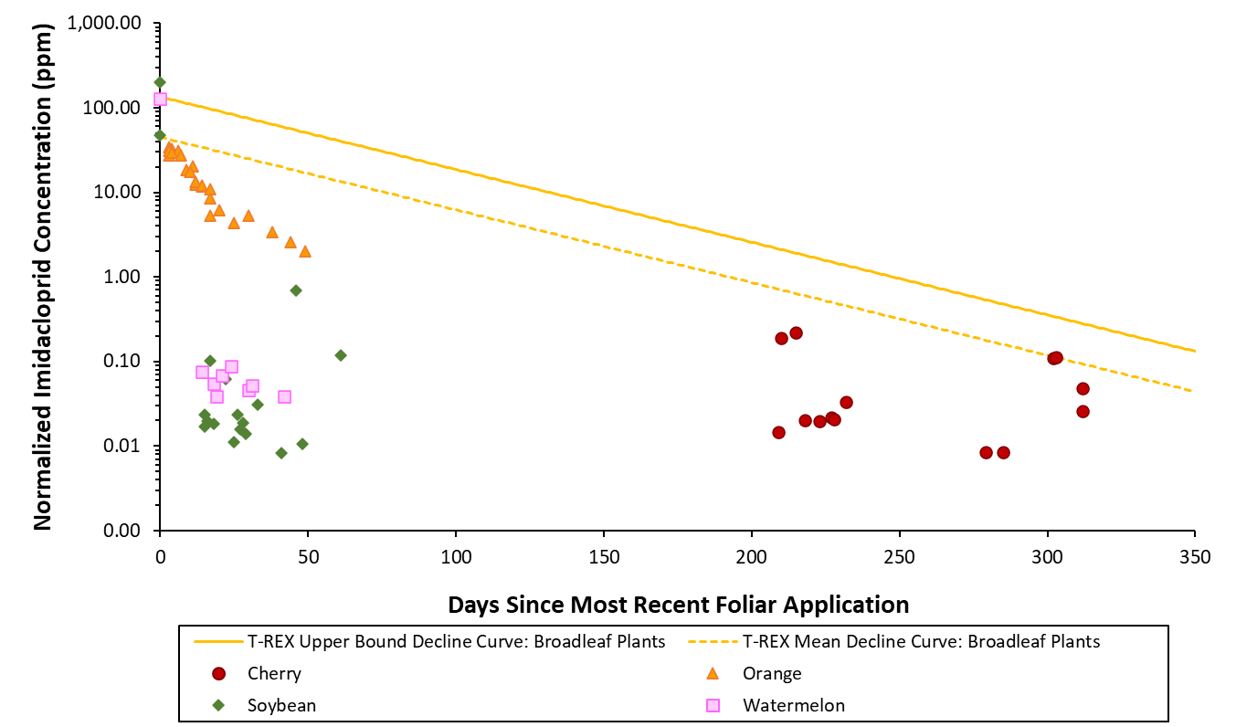
Figure 23. Normalized daily average total imidacloprid residue concentrations in leaves collected following foliar applications of imidacloprid. Data are normalized to an application rate of 1 lb a.i./A (see Table 2 for the crop-specific application rate normalization method).

Post-Bloom Foliar Applications to Cherry

Imidacloprid was applied post-bloom to cherry trees, and leaves were sampled the following spring before and during bloom. Additionally, three of the four trials were repeated for a second season (i.e., applications were made in two consecutive years). In the first season, leaves were collected 209 to 232 days after the most recent application, whereas in the second season, leaves were collected later at 279 to 312 days after the most recent application. None of the daily averages exceeded the T-REX upper bound EEC for broadleaf plants. The only daily average that exceeded the T-REX mean EEC for broadleaf plants was for leaves collected on 303 days after the most recent foliar application (Figure 24).

Although the normalized residue values for leaves collected on day 303 were not particularly high (range: 96.3 – 157 ng/g), the daily average (113 ng/g) was higher than the T-REX mean EEC for broadleaf plants. In the trial in which the daily average exceeded the T-REX mean EEC on day 303, leaf samples were only collected on 303 and 312 days after the final foliar application, and all samples had imidacloprid concentrations above the LOQ. Additionally, in this trial, the highest residue concentration on day 303 was only about 1.5X higher than the concentrations measured in the other replicate samples collected on the same day. When comparing to a similar trial at a nearby site in which samples were collected at nearly the same time (day 302 vs. 303 in year 2), the daily averages are practically equivalent (110 and 113 ng/g). At both of these sites, the corresponding year 1 trials were sampled significantly earlier (210 to 232 days after the final year 1 application) than the year 2 trials (302 to 312 days after the final year 2 application), and the daily average residue concentrations in the final year 1 samples (collected on days 227 and 232) are 3 to 5X lower than the daily average residue concentrations in the first year 2 samples (collected on days 302 and 303). Without samples collected at the same time in both seasons, it is unknown whether the slightly higher residue concentrations measured later in year 2 are due to carryover of the pesticide from year 1 to year 2 or due to variability in the data.

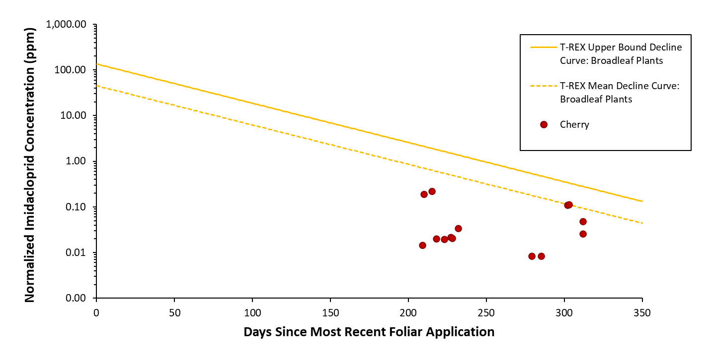
Figure 24. Normalized daily average total imidacloprid residue concentrations in cherry leaves collected following post-bloom foliar applications of imidacloprid. Data are normalized to a total seasonal foliar application rate of 1 lb a.i./A.

Pre-Bloom Foliar Applications

Imidacloprid was applied pre-bloom to oranges, soybeans, and watermelon, and leaves were collected for approximately two months after the foliar applications. The daily average residue concentrations only exceeded the T-REX upper bound and mean EECs on day 0 (Figure 25). None of the daily average residue concentrations on orange leaves exceeded the broadleaf plant EECs predicted by T-REX (Figure 25).

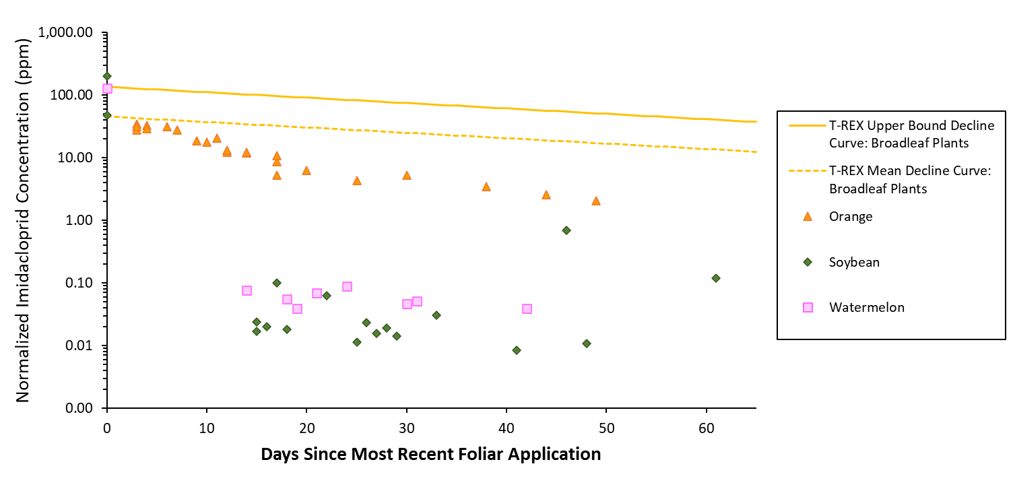
Figure 25. Normalized daily average total imidacloprid residue concentrations in leaves collected within approximately 60 days after pre-bloom foliar applications of imidacloprid. Data are normalized to an application rate of 1 lb a.i./A (see Table 2 for the crop-specific application rate normalization method).

Leaf Residues Measured 0 to 4 Days After Foliar Application

In general, following foliar application, the residues in leaves are expected to be highest immediately after the foliar application (i.e., on day 0). The only crops with day 0 samples were soybean and watermelon; orange leaves were not sampled until day 3 and cherry leaves were not sampled until day 209. Within the first four days after the foliar application, the only daily average residue imidacloprid concentrations that exceed the T-REX upper bound and/or mean EEC are those for leaves collected on day 0 (Figure 25, Figure 26).

The daily average residue concentrations do not vary by more than 5X for leaves collected within the first four days after foliar application (Figure 27). For soybean and watermelon leaves collected on day 0, the means of the daily average residue concentrations exceed the day 0 T-REX mean EEC for broadleaf plants (i.e., mean > 45 µg/g; Figure 27).

On day 0, residue concentrations on soybean leaves measured in one Brazilian study (MRID 50025901) were 4X higher than in a similar study conducted one year later at a nearby site (MRID 50025902; Figure 26). The reason for this difference is unknown; however, it could be due to year-to-year or site-to-site variation, as it has been shown that residues measured at different sites can vary up to an order of magnitude and residues measured at the same site but from trials conducted over multiple seasons typically vary up to 10-fold (USEPA, 2020a).
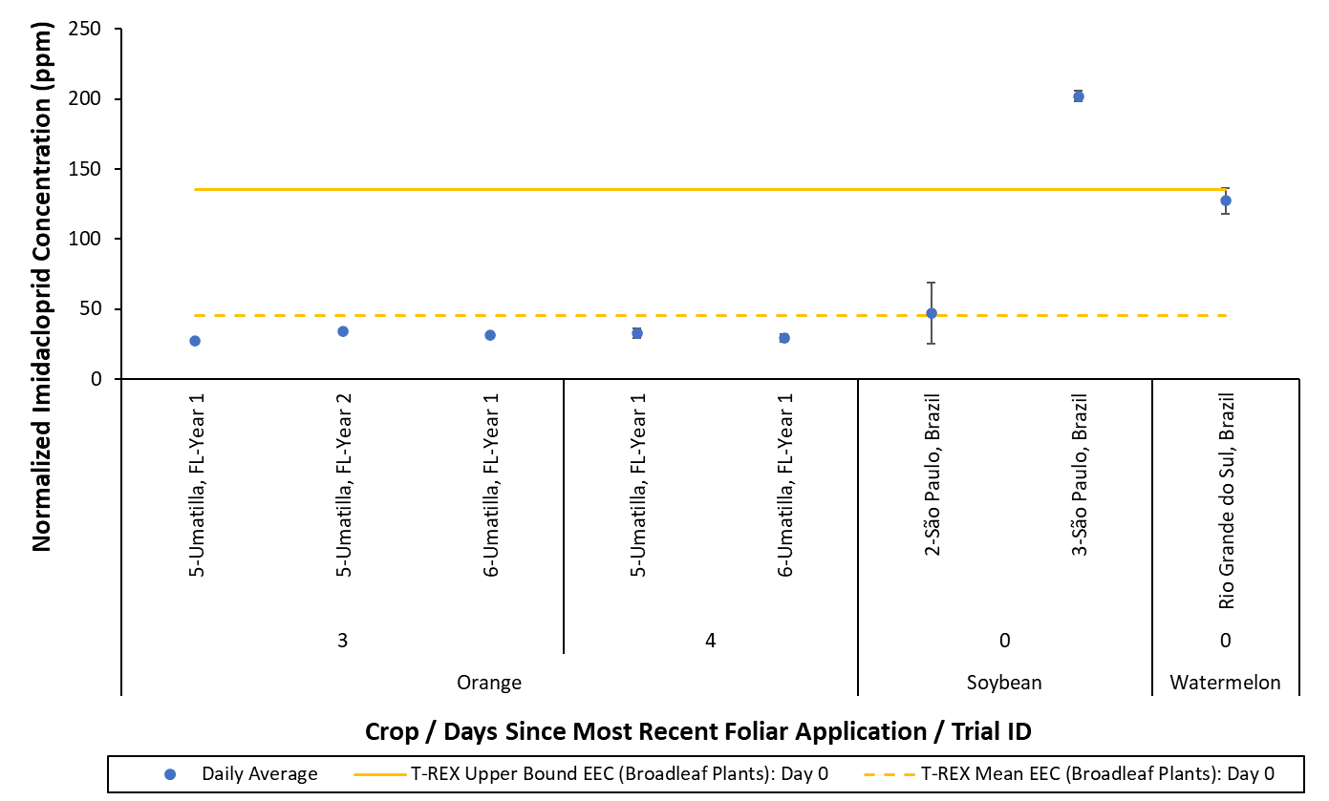
Figure 26. Normalized daily average total imidacloprid residue concentrations in leaves collected 0 to 4 days after the most recent foliar application of imidacloprid. Daily averages are shown according to crop, sampling day, and experimental trial. Data are normalized to an application rate of 1 lb a.i./A (see Table 2 for the crop-specific application rate normalization method). Error bars represent the standard error.

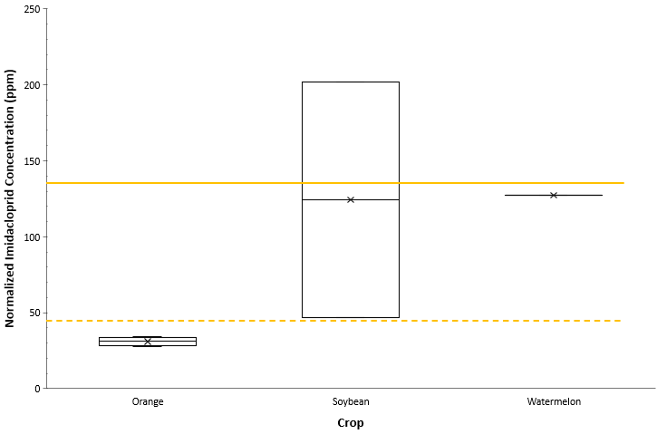
Figure 27. Range of normalized daily average total imidacloprid residue concentrations in leaves collected 0 to 4 days after the most recent foliar application of imidacloprid. ‘x’ marker represents the mean of the daily averages; solid yellow line represents the T-REX upper bound EEC for broadleaf plants on day 0 (135 ppm); dashed yellow line represents the T-REX mean EEC for broadleaf plants on day 0 (45 ppm). Data are normalized to an application rate of 1 lb a.i./A (see Table 2 for the crop-specific application rate normalization method).

Imidacloprid Summary (Foliar Applications)

In summary, the maximum daily average residue concentrations measured on cherry, orange, soybean, and watermelon following foliar applications of imidacloprid ranged from approximately 221 to 210,000 ng/g (Table 10). For soybean and watermelon, the maximum daily average residue concentrations were measured immediately after the foliar application (i.e., on day 0). For orange, the maximum daily average was measured 3 days after the foliar application; however, leaves were not sampled sooner in this study. For cherry, the maximum daily average was measured 215 days after the most recent foliar application; however, leaves were not sampled sooner in this trial.

Out of 64 daily average residue concentrations, one daily average exceeded the T-REX upper bound EEC and four exceeded the T-REX mean EEC for broadleaf plants (Table 11). Out of 292 leaf samples, six samples had residue concentrations that exceeded the T-REX upper bound EEC and 14 samples had residue concentrations that exceeded the T-REX mean EEC for broadleaf plants (Table 12).

Table 10. The day after the most recent foliar application when the maximum normalized daily average residue concentration of total imidacloprid occurred for each crop and the magnitude of the maximum daily average concentration.
Crop | Days after the Most Recent Application when the Maximum Daily Average Residue Occurred | Maximum Normalized Daily  Average Concentration, ng/g
Cherry¹ | 215 | 221
Orange² | 3 | 34,003
Soybean | 0 | 209,925
Watermelon | 0 | 127,388
¹ Cherry leaves were not sampled before 209 days after the final foliar application in the first season or before 279 days after the final foliar application in the second season.
² Orange leaves were not sampled before 3 days after foliar application.

Table 11. The number of normalized daily average total imidacloprid residue concentrations for each crop that exceed the T-REX upper bound and mean EECs for broadleaf plants on the sampling day.
Crop | Total Number of Daily Average Measurements | Number of Daily Averages Exceeding the T-REX Upper Bound EEC  (Broadleaf Plants)^{1,2} | Days after the Most Recent Application when the Daily Average Exceeds the T-REX Upper  Bound EEC | Number of Daily Averages Exceeding the  T-REX Mean EEC (Broadleaf Plants)^{1,2} | Days after the Most Recent Application when the Daily Average Exceeds the T-REX  Mean EEC
Cherry | 14 | 0 | NA | 1 | 303*
Orange | 23 | 0 | NA | 0 | NA
Soybean | 20 | 1 | 0 | 2 | 0
Watermelon | 9 | 0 | NA | 1 | 0
Highlighted cells indicate where normalized daily average residue concentrations exceed the T-REX EECs.
NA = not applicable because no daily average residue concentrations exceeded the T-REX EECs
¹ When the leaf residues are normalized to an application rate of 1 lb a.i./A (see Table 2 for the specific normalization method).
² Exceedance is determined by comparing the daily average residue concentration and the default T-REX EEC for each daily sampling event. T-REX default EECs are based on the expected daily decline.
*At 303 days after the most recent foliar application, the normalized residue values were not particularly high (mean: 113 ng/g, range: 96.3-157 ng/g), nonetheless the daily average exceeded the T-REX mean EEC. Without samples collected at the same time in both seasons, it is unknown whether this exceedance in year 2 is due to carryover of the pesticide from year 1 to year 2 or could be explained by variability in the data.

Table 12. The number of leaf samples for each crop that have normalized total imidacloprid residue concentrations exceeding the T-REX upper bound and mean EECs for broadleaf plants on the sampling day.
Crop | Total Number of Leaf Residue Samples | Number of Samples Exceeding the T-REX Upper Bound EEC (Broadleaf Plants)^{1,2} | Days after the Most Recent Application when the Measured Residue Exceeds  the T-REX Upper  Bound EEC | Number of Samples Exceeding the  T-REX Mean EEC (Broadleaf Plants)^{1,2} | Days after the Most Recent Application when the Measured Residue Exceeds the T-REX Mean EEC
Cherry | 70 | 0 | NA | 2 | 302, 303*
Orange | 115 | 0 | NA | 1 | 4**
Soybean | 54 | 3 | 0 | 5 | 0
Watermelon | 53 | 3 | 0 | 6 | 0
Highlighted cells indicate where normalized residue concentrations in samples exceed the T-REX EECs.
NA = not applicable because no sample had a concentration that exceeded the T-REX EECs
¹ When the leaf residues are normalized to an application rate of 1 lb a.i./A (see Table 2 for the specific normalization method).
² Exceedance is determined by comparing the normalized residue concentration measured and the default T-REX EEC for each daily sampling event. T-REX default EECs are based on the expected daily decline.
*At 302 and 303 days after the most recent foliar application, the normalized residue concentration in one sample exceeds the T-REX mean EEC on each day; the normalized residue values are not particularly high (195.8, 156.7 ng/g, respectively) and are at most 3X the normalized residue concentration in the other replicate samples collected at the same time. Without samples collected at the same time in both seasons, it is unknown whether these exceedances in year 2 are due to carryover of the pesticide from year 1 to year 2 or could be explained by variability in the data.
**Orange leaves were not sampled before 3 days after foliar application.

COMPARISON OF LEAF RESIDUES FROM FOLIAR VS. SOIL APPLICATIONS

Comparison of the residue concentrations in leaves following foliar applications versus soil applications was completed as part of this analysis. As the leaf residues are expected to be higher following foliar application methods than following soil application methods, the goal of this comparison was to determine the necessity of analyzing samples from both application methods. One perennial orchard crop (orange) and one annual crop (pumpkin) treated with thiamethoxam were chosen for the evaluation. For pumpkin, residue data from both foliar and soil applications were available for clothianidin as well. The residue data for clothianidin applications were included in the analysis to consider the influence of the applied parent compound on leaf residues resulting from the differing application methods.

Clothianidin

Following both foliar and soil applications, the daily average residue concentrations of clothianidin in pumpkin leaves are generally well below the T-REX upper bound and mean EECs for broadleaf plants (Figure 28). Few exceedances (3 daily averages) were observed for foliar applications. No exceedances were observed for soil applications. Starting at approximately 20 days after the most recent application, the clothianidin residues from soil applications are higher than the residues from foliar applications, but these values are still below the T-REX EECs for broadleaf plants.

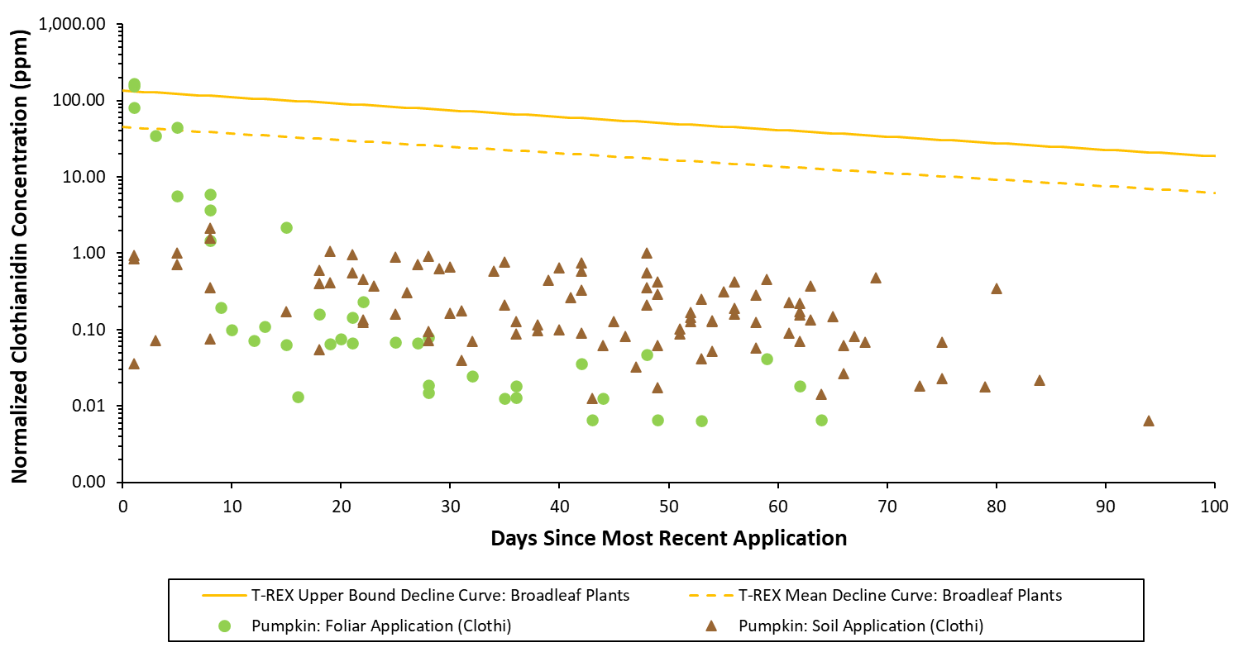
Figure 28. Normalized daily average clothianidin residue concentrations in pumpkin leaves collected following foliar or soil applications of clothianidin. Data are normalized to a total seasonal application rate of 1 lb a.i./A.

Thiamethoxam

For both foliar and soil application methods, the majority of the daily average residue concentrations of total thiamethoxam and clothianidin (in clothianidin equivalents) in pumpkin and orange leaves are well below the T-REX upper bound and mean EECs for broadleaf plants (Figure 29, Figure 30). Across both crops and both application methods, only one daily average exceedance of the T-REX mean EEC was identified for pumpkin leaves collected immediately following the final foliar application on day 0.

Starting at about 20 days after the most recent application, the total thiamethoxam and clothianidin residues in pumpkin leaves from soil applications are higher than residues from foliar applications (Figure 29); however, the daily averages remain below the default T-REX EECs. This finding is consistent with the leaf residues from clothianidin applications to pumpkin (see Section 5.1), indicating that this trend occurs regardless of the applied neonicotinoid. For orange trees, as the days since the most recent application increases, a similar trend of higher residues from soil applications than foliar applications is not apparent (Figure 30).

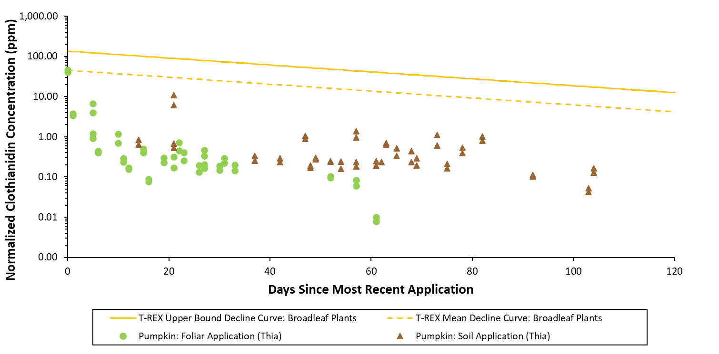
Figure 29. Normalized daily average residue concentrations of total thiamethoxam and clothianidin (in clothianidin equivalents) in pumpkin leaves collected following foliar or soil applications of thiamethoxam. Data are normalized to a total application rate of 1 lb a.i./A.

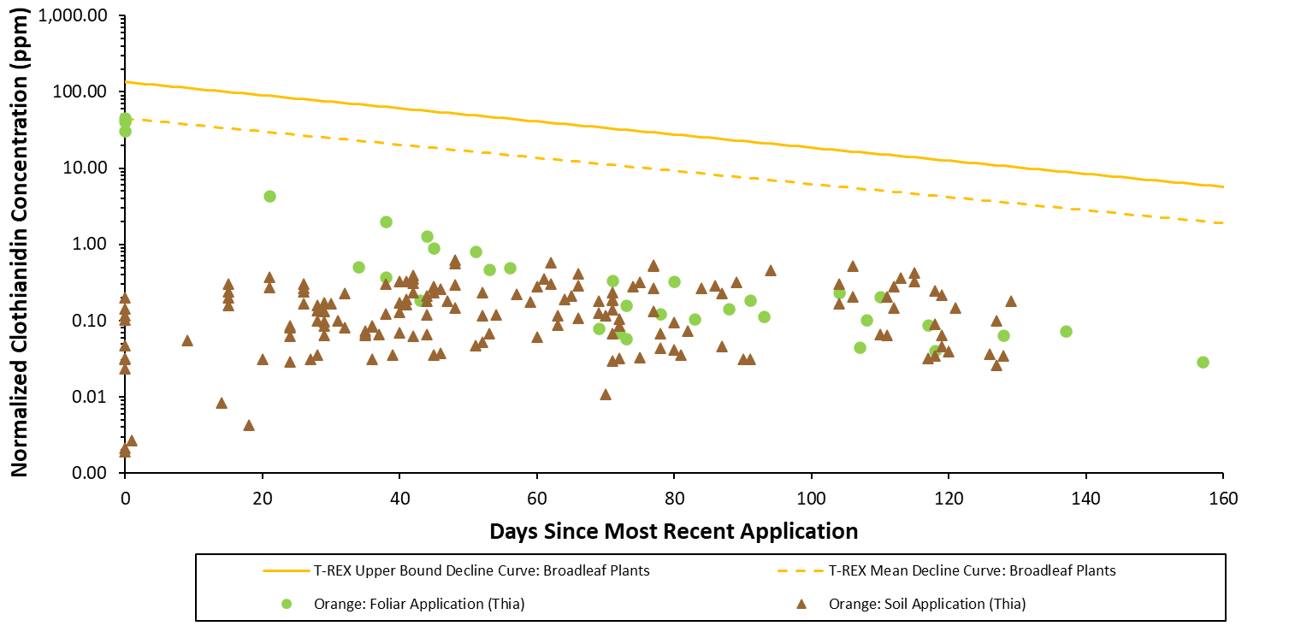
Figure 30. Normalized daily average residue concentrations of total thiamethoxam and clothianidin (in clothianidin equivalents) in orange leaves collected following pre-bloom foliar or pre-bloom soil applications of thiamethoxam. Data are normalized to a total seasonal application rate of 1 lb a.i./A.

Foliar vs. Soil Applications Summary

When comparing leaf residues resulting from foliar applications to leaf residues resulting from soil applications, it is expected that analysis of residues resulting from only foliar applications would be sufficient for determining the highest, most conservative estimates of neonicotinoid residues in leaves. This may limit the need to analyze neonicotinoid leaf residues from soil applications. Exceedances of the T-REX defaults were only observed for the daily averages of leaf residue samples following foliar applications; there were no exceedances identified for soil applications. Based on the selected crops analyzed, this was true across the crop types (perennial vs. annual) and across different parent compounds (clothianidin vs. thiamethoxam). If ingestion of neonicotinoid residues via consumption of leaves is an exposure pathway of ecological concern, it is expected that risk estimations and characterization can focus on the leaf residue data from foliar applications. Analysis of leaf residues resulting from soil applications would be redundant if equivalent leaf residue data are available from foliar applications.

OVERALL SUMMARY

Overall, following foliar applications of neonicotinoids, very few (2.5%) of the daily average residue concentrations measured in leaves from registrant-submitted field residue studies exceeded the T-REX upper bound estimated environmental concentration (EEC) for broadleaf plants when normalized to an application rate of 1 lb a.i./A. Twelve percent of the daily average residue concentrations measured in leaves exceeded the T-REX mean EEC for broadleaf plants when normalized to an application rate of 1 lb a.i./A. The highest residue concentrations were measured immediately after foliar applications. Generally, following foliar applications, the residues in leaves declined rapidly over time (i.e., residues often decreased by at least an order of magnitude by 10 days after the application), whereas following soil applications, the residues in leaves remained largely stable over time. When considering the same annual crop (i.e.., pumpkin) and normalizing the residues to the same application rate (i.e., 1 lb a.i./A), starting at about 3 weeks after the most recent application, neonicotinoid residues in leaves following soil applications were generally higher than those following foliar applications. A similar trend was not observed for perennial crops.

The T-REX EECs for broadleaf plants are considered protective of (i.e., higher than) empirical residue concentrations in leaves that result from either foliar or soil application. However, although the vast majority of measured residues in leaves were substantially less than the default T-REX EECs, the T-REX estimates for broadleaf plants were not determined to be overly conservative as a small percentage of measured residues in leaves shortly after foliar applications exceeded the default upper bound EECs. Furthermore, because the decline curve of the default T-REX EECs is calculated using a default foliar dissipation half-life of 35 days and exceedances of the default T-REX EECs usually occurred within the first week after foliar application, there is an opportunity for risk assessors to refine the default T-REX EECs using chemical-specific foliar dissipation rates in order to more realistically estimate residues in leaves more than a week after the foliar application.

REFERENCES

EFSA. 2013. Guidance on the risk assessment of plant protection products on bees (Apis mellifera, Bombus spp. and solitary bees). EFSA Journal 2013;11(7):3295, 266 pp. doi:10.2903/j.efsa.2013.3295.

Fletcher, J.S., Nellessen, J.E., & Pfleeger, T. G. 1994. Literature review and evaluation of the EPA food-chain (Kenaga) nomogram, an instrument for estimating pesticide residues on plants. Environ. Tox. and Chem. 13(9):1383-1391.

USEPA. 2004. Overview of the Ecological Risk Assessment Process in the Office of Pesticide Programs. January 23, 2004. Environmental Fate and Effects Division. Office of Pesticide Programs. U.S. Environmental Protection Agency. Available at https://www.epa.gov/sites/production/files/2014-11/documents/ecorisk-overview.pdf.

USEPA. 2020a. Attachment 2 to the Neonicotinoid Final Bee Risk Assessments: Residue Bridging Analysis of Foliar and Soil Agricultural Uses of Neonicotinoids. January 14, 2020. Environmental Fate and Effects Division. Office of Chemical Safety and Pollution Prevention. U.S. Environmental Protection Agency.

USEPA. 2020b. Attachment 3 to the Neonicotinoid Final Bee Risk Assessments: Residue Bridging Analysis for Foliar and Soil Non-Agricultural Uses of Neonicotinoids. January 14, 2020. Environmental Fate and Effects Division. Office of Chemical Safety and Pollution Prevention. U.S. Environmental Protection Agency.

USEPA, Health Canada PMRA, & California Department of Pesticide Regulation. 2014. Guidance for Assessing Pesticide Risks to Bees. June 23, 2014. U.S. Environmental Protection Agency. Health Canada Pest Management Regulatory Agency. California Department of Pesticide Regulation. Available at http://www2.epa.gov/pollinator-protection/pollinator-risk-assessment-guidance.

