APPENDIX 4-5. Analysis of Non-Spray Uses of Clothianidin

Contents
1. Gel Baits 1
2. Granular Formulations 1
3. Seed Treatments 2
4. Soil Applications and Treated Poultry Litter 28

Clothianidin applications may be made via a variety of methods including aerial and ground foliar sprays, soil treatment (e.g., drench), chemigation (e.g., soil incorporation or foliar). Non-flowable (non-spray) applications of clothianidin may be applied as gel bait, granule, and seed treatment. The methods developed for analyzing terrestrial exposures in this BE focus primarily on flowable uses; however, since clothianidin is also applied as some non-flowable formulations, additional characterization of these uses is provided in this appendix.

Gel Baits

Clothianidin is registered for use as an ant and cockroach gel bait. Outdoor uses of these gels are applied in cracks and crevices, around windows, structures adjacent to residential areas (e.g., porches, garages, under stairs) and areas where ants may be seen entering buildings. Because these gels are generally applied on or near structures and they are spot treatments, it is assumed that these formulations represent de minimus exposure to non-target organisms, including listed species and those they depend upon for Prey, Pollination, Habitat and/or Dispersal (PPHD).

Granular Formulations

Clothianidin has some granular formulations that are registered on a variety of outdoor uses, including: residential areas, commercial facilities (e.g., outside warehouses, restaurants), livestock areas, ornamental trees, shrubs and herbaceous plants, containerized plants, turf (including, sod farms, lawns, golf courses, parks and other open spaces with turf), and non-bearing fruit and nuts. Once the granules are applied, they are watered in either through irrigation or rainfall. Therefore, these uses were simulated as soil treatments and aquatic exposure was estimated using PWC. For terrestrial wildlife, there is potential for exposure through consumption of granules between the application of the granules and the time they are watered in.

For granular formulations and exposures to birds and mammals, the T-REX model is used to estimate the LD₅₀/ft². Conceptually, an LD₅₀/ft² is the amount of a pesticide estimated to kill 50% of exposed animals in each square foot of applied area. Although a square foot does not have defined ecological relevance, and any unit area could be used, risk presumably increases as the LD₅₀/ft² value increases. The LD₅₀/ft² value is calculated using a toxicity value (adjusted LD₅₀) and the EEC (mg a.i./ft²) and is directly compared with the Agency’s levels-of-concern (LOCs) for acute exposures. In the clothianidin draft risk assessment for registration review (USEPA 2017), a scenario resulting in the highest exposure (a broadcast application to a level field with no incorporation or consideration of existing furrows) was modeled using a single maximum application rate of 0.4 lb a.i./A which is consistent with the highest application rate to soil. EFED’s risk assessment concluded that there were mortality risks to small birds (20 g) and mammals (15 g) from consumption of granules and that risks were low for medium (100 g birds, 35 g mammals) and large (1000 g) birds and mammals. For all listed species of small birds (~20 g) and mammals (~15 g), LAA determinations are already made due to potential exposure to other formulations of clothianidin. Therefore, exposure to listed birds and mammals from granules is not expected to impact effects determinations; however potential exposure to granules may serve as an additional line of evidence supporting that LAA determination. If bait is incorporated, exposure potential and associated risks would be lower.

For terrestrial invertebrates, the primary routes of exposure from the bait uses of clothianidin are assumed to be via ingestion or contact with bait. This approach is consistent with EFED’s risk assessment method for bees. Therefore, for terrestrial invertebrates, the estimated exposures from the flowable uses will be used to evaluate exposures from the bait uses where possible.

Seed Treatments

Because exposures related to seed treatment uses are readily modeled using current aquatic modeling approaches, these types of uses are incorporated into the aquatic exposure analysis used to help make effects determinations for listed aquatic species (and those that rely on aquatic species). As demonstrated in Chapter 3 and APPENDIX 3-1, aquatic EECs for foliar and soil treatment (flowable uses) are orders of magnitude greater than aquatic EECs from seed treatments. Therefore, exposures and associated risks from flowable uses are assumed to be protective of seed treatment uses.

In regard to seed treatments, clothianidin exposure to non-target organisms may also include contact with abraded seed coat dust during planting (e.g., Tapparro et al. 2012, Krupke et al. 2012). This pathway has been associated with numerous clothianidin incidents involving mortality to foraging honey bees (see Section 2-13, Incident Reports). The extent to which honey bees are exposed via contact with abraded seed coat dust is influenced by many factors including the physio-chemical properties of the seed coating, seed planting equipment, use of seed lubrication agents (e.g., talc), environmental conditions (wind speed, humidity), and hive location in relation to sowing and prevailing winds. Off-site drift of contaminated seed coat dust can contribute to residues on plants, soil, and surface water to which bees may be exposed through direct contact and ingestion of surface water, pollen, and nectar. Although exposure and effects to bees via exposure to abraded seed coat dust has been documented, these data are highly variable and methods are not currently available to provide reliable estimates for this route of exposure. Therefore, this exposure route was not quantitatively considered in this assessment. Exposure of bees and other non-target insects to clothianidin via drift of abraded seed coat dust is considered a route of concern, given that bee kill incidents have been associated with planting of clothianidin-treated corn. The Agency continues to work with stakeholders to mitigate the potential for adverse effects on bees from this exposure pathway through best management practices and the development of alternative technologies to reduce dust off during planting (e.g., alternative lubricants, equipment modifications, etc.). Reductions in seed dust off will also limit exposures of other non-target insects to clothianidin through this route.

In this BE, risks are identified for terrestrial vertebrate species through consumption of plant matter (e.g., leaves) that have been sprayed with clothianidin. Residues on sprayed seeds may underpredict exposures to birds and mammals that directly consume treated seeds. In the 2017 ecological risk assessment for the registration review of thiamethoxam, EPA concluded that there were risks to birds from seed treatments, with some exceptions based on bird and seed sizes. For mammals, chronic risks were identified for small, medium and large animals for all modeled seed types, except soybeans. For all terrestrial vertebrates (birds, amphibians, reptiles and mammals) that consume seeds, potential exposure and risk from treated seeds was assessed. For those species where a LAA determination was made based on the quantitative analysis using the MAGtool and spray uses, potential exposure to treated seeds would serve as an additional line of evidence supporting that LAA determination (due to increased potential for exposure from foliar and seed treatments). In the individual effects determination output sheets from the MAGtool (APPENDIX 4-9), if a terrestrial animal range or critical habitat has overlap with a use site with foliar applications where seed uses are also permitted, it is specified that this use should be given additional consideration by the assessor by referring to this appendix. At the time of this BE reliable usage information for seed treatment was not available. For this reason, the upper and lower limits used when applying usage information, 100% and 2.5% PCT respectively, were considered when conducting the additional review of the species. An exploratory spatial analysis, discussed in the next section, was conducted to determine where usage information would be most valuable for clothianidin.

In Tables 2 and 3 below, the percent overlap of range of all seed-eating birds and mammals with each UDL associated with seed treatment is provided and can be used for further characterization of potential additional risks for these species. Table 2 displays overlap without any adjustment for usage, or 100% PCT. Table 3 displays overlap with the lower limit of usage, 2.5% PCT assumed on the crops. The PCT value of 2.5% was selected because it is the lowest usage value ever applied, buffering against uncertainty associate with these surveys and low usage estimates. These two overlaps are used as upper and lower limits in this analysis.

For those species where NLAA determinations were preliminarily made using the MAGtool (indicating that no other uses are expected to impact greater than 1 individual), the NLAA determinations were reconsidered for possible impacts due to overlap with use sites that are associated with seed treatment. Preliminary NLAA determinations were made for 3 species of birds and 6 species of mammals (Table 1). For all 3 birds and 2 mammals, there was no overlap or low overlap between agricultural land cover and the species range. Therefore, it is assumed that these 3 species of birds and 2 species of mammals are unlikely to be exposed to clothianidin via consumption of treated seeds and the determinations remained at NLAA. For the remaining 4 mammal species, there was some overlap of the species’ ranges and the UDLs as shown below in Tables 2 and 3. Using the 100% usage assumption, all of these species have overlap with the UDLs. However, at the 2.5% lower limit usage assumption, overlap between species range and agricultural land cover significantly decreases for 3 of the 4 remaining mammal species. Although none of these three species could be precluded from being on-field given the weight of evidence species data gathered for the MAGtool analysis (APPENDIX 4-2), the habitats in which they most often occur tend to be salt marshes (Amargosa vole and Florida salt marsh vole) or interior forest (Carolina northern flying squirrel and riparian woodrat), where agricultural land use, and therefore seed treatment application, may be expected to be low. Furthermore, for two of these species (the Carolina northern flying squirrel and the Florida marsh vole), evaluation of range data resulted in a “yellow” classification, meaning that USEPA EFED review of each species’ range revealed discrepancies between the Service documentation and the range maps used in the analysis. Therefore, although there is uncertainty in the likelihood that these areas of overlap will receive applications of clothianidin treated seeds and how frequently the species will actually be on the treated field, the determinations have been changed to LAA based on chronic risks identified previously (USEPA 2017) for seed-eating mammals and potential for exposure, but with the weakest evidence of LAA.

Table 1. Seed-eating birds and mammals with preliminary NLAA determinations based on MAGtool runs for spray applications of clothianidin
Taxon | Entity ID | Scientific name | Common name | Final determination | Strength of Call
Birds | 73 | Branta (=Nesochen) sandvicensis | Hawaiian Goose | NLAA | NA
 | 80 | Amazona vittata | Puerto Rican parrot | NLAA | NA
 | 101 | Columba inornata wetmorei | Puerto Rican plain pigeon | NLAA | NA
Mammals | 28 | Microtus californicus scirpensis | Amargosa Vole | LAA | Weakest evidence of LAA
 | 42 | Glaucomys sabrinus coloratus | Carolina Northern Flying Squirrel | LAA | Weakest evidence of LAA
 | 43 | Tamiasciurus hudsonicus grahamensis | Mount Graham Red Squirrel | NLAA | NA
 | 59 | Spermophilus brunneus brunneus | Northern Idaho Ground Squirrel | NLAA | NA
 | 60 | Microtus pennsylvanicus dukecampbelli | Florida Salt Marsh Vole | LAA | Weakest evidence of LAA
 | 62 | Neotoma fuscipes riparia | Riparian Woodrat | LAA | Weakest evidence of LAA
NA = not applicable

Table 2. Seed-eating birds and mammals percent overlap with seed treatment use layers of clothianidin with no usage data incorporated, 100% PCT assumption. Blue species denotes those evaluated for preliminary NLAA call.
Taxa | Entity ID | Common Name | Scientific Name | CONUS_Clothi Other Row Crops | CONUS_Corn | CONUS_Cotton | CONUS_Other Grains | CONUS_Rice | CONUS_ Soybeans | CONUS_Vegetables and ground fruit | CONUS_Wheat
Birds | 69 | Hawaiian (=koloa) Duck | Anas wyvilliana | 0.00 | 0.00 | 0.00 | 0.00 | 0.00 | 0.00 | 0.00 | 0.00
Birds | 73 | Hawaiian goose | Branta (=Nesochen) sandvicensis | 0.00 | 0.00 | 0.00 | 0.00 | 0.00 | 0.00 | 0.00 | 0.00
Birds | 101 | Puerto Rican plain Pigeon | Columba inornata wetmorei | 0.00 | 0.00 | 0.00 | 0.00 | 0.00 | 0.00 | 0.00 | 0.00
Birds | 5170 | Friendly Ground-Dove | Gallicolumba stairi | 0.00 | 0.00 | 0.00 | 0.00 | 0.00 | 0.00 | 0.00 | 0.00
Birds | 6901 | Yellow-billed Cuckoo | Coccyzus americanus | 0.00 | 0.45 | 0.18 | 0.61 | 0.12 | 0.00 | 0.94 | 2.20
Birds | 87 | Micronesian megapode | Megapodius laperouse | 0.00 | 0.00 | 0.00 | 0.00 | 0.00 | 0.00 | 0.00 | 0.00
Birds | 89 | Masked bobwhite (quail) | Colinus virginianus ridgwayi | 0.00 | 0.00 | 0.01 | 0.00 | 0.00 | 0.00 | 0.00 | 0.00
Birds | 67 | Whooping crane | Grus americana | 0.00 | 14.29 | 3.06 | 9.54 | 0.13 | 12.52 | 2.61 | 19.96
Birds | 76 | Hawaiian common gallinule | Gallinula galeata sandvicensis | 0.00 | 0.00 | 0.00 | 0.00 | 0.00 | 0.00 | 0.00 | 0.00
Birds | 110 | Mississippi sandhill crane | Grus canadensis pulla | 0.00 | 0.08 | 0.45 | 0.00 | 0.00 | 0.18 | 0.06 | 0.07
Birds | 121 | Guam rail | Rallus owstoni | 0.00 | 0.00 | 0.00 | 0.00 | 0.00 | 0.00 | 0.00 | 0.00
Birds | 4679 | Whooping crane | Grus americana | 0.00 | 3.79 | 2.00 | 7.64 | 0.61 | 1.09 | 0.29 | 15.92
Birds | 4889 | Guam rail | Rallus owstoni | 0.00 | 0.00 | 0.00 | 0.00 | 0.00 | 0.00 | 0.00 | 0.00
Birds | 7342 | Whooping crane | Grus americana | 0.00 | 14.38 | 0.74 | 2.46 | 2.03 | 14.14 | 0.88 | 2.72
Birds | 10124 | Whooping crane | Grus americana | 0.00 | 4.01 | 1.19 | 3.01 | 3.26 | 9.53 | 0.07 | 1.32
Birds | 79 | Palila (honeycreeper) | Loxioides bailleui | 0.00 | 0.00 | 0.00 | 0.00 | 0.00 | 0.00 | 0.00 | 0.00
Birds | 85 | Cape Sable seaside sparrow | Ammodramus maritimus mirabilis | 0.00 | 0.00 | 0.00 | 0.38 | 0.00 | 0.00 | 1.18 | 0.00
Birds | 116 | San Clemente sage sparrow | Amphispiza belli clementeae | 0.00 | 0.00 | 0.00 | 0.00 | 0.00 | 0.00 | 0.00 | 0.00
Birds | 117 | Yellow-shouldered blackbird | Agelaius xanthomus | 0.00 | 0.00 | 0.00 | 0.00 | 0.00 | 0.00 | 0.00 | 0.00
Birds | 118 | Mariana (=aga) Crow | Corvus kubaryi | 0.00 | 0.00 | 0.00 | 0.00 | 0.00 | 0.00 | 0.00 | 0.00
Birds | 133 | Florida grasshopper sparrow | Ammodramus savannarum floridanus | 0.00 | 0.03 | 0.00 | 2.45 | 0.03 | 0.00 | 0.90 | 0.00
Birds | 137 | Inyo California towhee | Pipilo crissalis eremophilus | 0.00 | 0.01 | 0.00 | 0.01 | 0.00 | 0.00 | 0.00 | 0.00
Birds | 140 | Florida scrub-jay | Aphelocoma coerulescens | 0.00 | 0.13 | 0.01 | 3.41 | 0.32 | 0.00 | 0.90 | 0.00
Birds | 145 | Coastal California gnatcatcher | Polioptila californica californica | 0.00 | 0.01 | 0.00 | 0.25 | 0.00 | 0.00 | 0.16 | 1.17
Birds | 1241 | Rota bridled White-eye | Zosterops rotensis | 0.00 | 0.00 | 0.00 | 0.00 | 0.00 | 0.00 | 0.00 | 0.00
Birds | 4296 | Streaked Horned lark | Eremophila alpestris strigata | 0.00 | 1.08 | 0.00 | 0.55 | 0.00 | 0.00 | 2.41 | 1.38
Birds | 107 | Red-cockaded woodpecker | Picoides borealis | 0.00 | 3.61 | 2.64 | 1.26 | 0.35 | 4.99 | 0.61 | 2.20
Birds | 80 | Puerto Rican parrot | Amazona vittata | 0.00 | 0.00 | 0.00 | 0.00 | 0.00 | 0.00 | 0.00 | 0.00
Birds | 11319 | Eastern Black rail | Laterallus jamaicensis ssp. jamaicensis | 0.00 | 14.39 | 1.68 | 3.03 | 0.24 | 13.09 | 0.62 | 6.71
Birds | 68 | Hawaiian (='alala) Crow | Corvus hawaiiensis | 0.00 | 0.00 | 0.00 | 0.00 | 0.00 | 0.00 | 0.00 | 0.00
Mammals | 16 | Morro Bay kangaroo rat | Dipodomys heermanni morroensis | 0.00 | 0.06 | 0.00 | 3.14 | 0.00 | 0.00 | 1.31 | 5.15
Mammals | 17 | Salt marsh harvest mouse | Reithrodontomys raviventris | 0.00 | 0.00 | 0.00 | 0.62 | 0.00 | 0.00 | 0.27 | 1.25
Mammals | 2 | Grizzly bear | Ursus arctos horribilis | 0.00 | 0.02 | 0.00 | 4.09 | 0.00 | 0.00 | 0.84 | 0.08
Mammals | 1302 | Grizzly bear | Ursus arctos horribilis | 0.00 | 0.09 | 0.00 | 3.98 | 0.03 | 0.00 | 0.20 | 2.09
Mammals | 20 | Utah prairie dog | Cynomys parvidens | 0.00 | 0.43 | 0.00 | 0.29 | 0.00 | 0.00 | 0.00 | 0.05
Mammals | 28 | Amargosa vole | Microtus californicus scirpensis | 0.00 | 2.34 | 1.69 | 2.78 | 1.73 | 0.00 | 2.64 | 4.48
Mammals | 32 | Key Largo woodrat | Neotoma floridana smalli | 0.00 | 0.00 | 0.00 | 0.01 | 0.00 | 0.00 | 0.01 | 0.00
Mammals | 34 | Choctawhatchee beach mouse | Peromyscus polionotus allophrys | 0.00 | 0.01 | 0.01 | 0.02 | 0.00 | 0.03 | 0.00 | 0.01
Mammals | 35 | Perdido Key beach mouse | Peromyscus polionotus trissyllepsis | 0.00 | 1.38 | 0.80 | 0.23 | 0.00 | 1.93 | 0.03 | 0.52
Mammals | 37 | Fresno kangaroo rat | Dipodomys nitratoides exilis | 0.00 | 9.42 | 8.30 | 7.73 | 0.22 | 0.00 | 10.43 | 17.37
Mammals | 38 | Giant kangaroo rat | Dipodomys ingens | 0.00 | 1.40 | 5.06 | 5.17 | 0.05 | 0.00 | 6.54 | 7.20
Mammals | 39 | Stephens' kangaroo rat | Dipodomys stephensi (incl. D. cascus) | 0.00 | 0.00 | 0.00 | 0.98 | 0.00 | 0.00 | 0.05 | 5.36
Mammals | 40 | Tipton kangaroo rat | Dipodomys nitratoides nitratoides | 0.00 | 10.32 | 9.62 | 10.65 | 0.00 | 0.00 | 7.20 | 18.55
Mammals | 41 | Alabama beach mouse | Peromyscus polionotus ammobates | 0.00 | 0.96 | 0.54 | 0.17 | 0.00 | 1.35 | 0.03 | 0.34
Mammals | 42 | Carolina northern flying squirrel | Glaucomys sabrinus coloratus | 0.00 | 1.16 | 0.00 | 0.06 | 0.00 | 0.56 | 0.19 | 0.21
Mammals | 43 | Mount Graham red squirrel | Tamiasciurus hudsonicus grahamensis | 0.00 | 0.22 | 0.03 | 0.23 | 0.00 | 0.00 | 0.00 | 0.11
Mammals | 50 | Anastasia Island beach mouse | Peromyscus polionotus phasma | 0.00 | 1.21 | 0.00 | 0.29 | 0.00 | 0.00 | 4.13 | 0.00
Mammals | 51 | Pacific pocket mouse | Perognathus longimembris pacificus | 0.00 | 0.00 | 0.00 | 0.00 | 0.00 | 0.00 | 0.00 | 0.00
Mammals | 52 | Preble's meadow jumping mouse | Zapus hudsonius preblei | 0.00 | 1.89 | 0.00 | 1.25 | 0.00 | 0.01 | 0.39 | 4.29
Mammals | 53 | Southeastern beach mouse | Peromyscus polionotus niveiventris | 0.00 | 0.29 | 0.00 | 11.01 | 1.42 | 0.00 | 1.31 | 0.00
Mammals | 59 | Northern Idaho Ground Squirrel | Urocitellus brunneus | 0.00 | 0.01 | 0.00 | 0.05 | 0.00 | 0.00 | 0.02 | 0.01
Mammals | 60 | Florida salt marsh vole | Microtus pennsylvanicus dukecampbelli | 0.00 | 1.13 | 0.16 | 1.50 | 0.00 | 0.06 | 0.26 | 0.00
Mammals | 62 | Riparian woodrat (=San Joaquin Valley) | Neotoma fuscipes riparia | 0.00 | 23.16 | 0.21 | 30.19 | 0.26 | 0.00 | 13.97 | 19.64
Mammals | 63 | San Bernardino Merriam's kangaroo rat | Dipodomys merriami parvus | 0.00 | 0.00 | 0.00 | 0.59 | 0.00 | 0.00 | 0.03 | 3.08
Mammals | 4228 | Penasco least chipmunk | Tamias minimus atristriatus | 0.00 | 0.00 | 0.00 | 0.00 | 0.00 | 0.00 | 0.00 | 0.00
Mammals | 5210 | New Mexico meadow jumping mouse | Zapus hudsonius luteus | 0.00 | 0.09 | 0.00 | 0.20 | 0.00 | 0.00 | 0.13 | 0.21
Mammals | 10078 | Pacific Marten, Coastal Distinct Population Segment | Martes caurina | 0.00 | 0.02 | 0.00 | 0.93 | 0.00 | 0.00 | 0.37 | 0.68

Table 3. Seed-eating birds and mammals percent overlap with seed treatment use layers of clothianidin and lower limit usage value of 2.5%. Blue species denotes those evaluated for preliminary NLAA call.
Taxa | Entity ID | Common Name | Scientific Name | CONUS_Clothi Other Row Crops | CONUS_Corn | CONUS_Cotton | CONUS_Other Grains | CONUS_Rice | CONUS_Soybeans | CONUS_Vegetables and ground fruit | CONUS_Wheat
Birds | 69 | Hawaiian (=koloa) Duck | Anas wyvilliana | 0.00 | 0.00 | 0.00 | 0.00 | 0.00 | 0.00 | 0.00 | 0.00
Birds | 73 | Hawaiian goose | Branta (=Nesochen) sandvicensis | 0.00 | 0.00 | 0.00 | 0.00 | 0.00 | 0.00 | 0.00 | 0.00
Birds | 101 | Puerto Rican plain Pigeon | Columba inornata wetmorei | 0.00 | 0.00 | 0.00 | 0.00 | 0.00 | 0.00 | 0.00 | 0.00
Birds | 5170 | Friendly Ground-Dove | Gallicolumba stairi | 0.00 | 0.00 | 0.00 | 0.00 | 0.00 | 0.00 | 0.00 | 0.00
Birds | 6901 | Yellow-billed Cuckoo | Coccyzus americanus | 0.00 | 0.04 | 0.03 | 0.06 | 0.01 | 0.00 | 0.03 | 0.14
Birds | 87 | Micronesian megapode | Megapodius laperouse | 0.00 | 0.00 | 0.00 | 0.00 | 0.00 | 0.00 | 0.00 | 0.00
Birds | 89 | Masked bobwhite (quail) | Colinus virginianus ridgwayi | 0.00 | 0.00 | 0.01 | 0.00 | 0.00 | 0.00 | 0.00 | 0.00
Birds | 67 | Whooping crane | Grus americana | 0.00 | 0.49 | 0.10 | 0.31 | 0.00 | 0.42 | 0.00 | 0.67
Birds | 76 | Hawaiian common gallinule | Gallinula galeata sandvicensis | 0.00 | 0.00 | 0.00 | 0.00 | 0.00 | 0.00 | 0.00 | 0.00
Birds | 110 | Mississippi sandhill crane | Grus canadensis pulla | 0.00 | 0.08 | 0.45 | 0.00 | 0.00 | 0.18 | 0.06 | 0.00
Birds | 121 | Guam rail | Rallus owstoni | 0.00 | 0.00 | 0.00 | 0.00 | 0.00 | 0.00 | 0.00 | 0.00
Birds | 4679 | Whooping crane | Grus americana | 0.00 | 0.37 | 0.46 | 0.57 | 0.02 | 0.06 | 0.01 | 0.70
Birds | 4889 | Guam rail | Rallus owstoni | 0.00 | 0.00 | 0.00 | 0.00 | 0.00 | 0.00 | 0.00 | 0.00
Birds | 7342 | Whooping crane | Grus americana | 0.00 | 0.73 | 0.02 | 0.05 | 0.05 | 0.64 | 0.03 | 0.18
Birds | 10124 | Whooping crane | Grus americana | 0.00 | 0.10 | 0.03 | 0.00 | 0.08 | 0.24 | 0.00 | 0.03
Birds | 79 | Palila (honeycreeper) | Loxioides bailleui | 0.00 | 0.00 | 0.00 | 0.00 | 0.00 | 0.00 | 0.00 | 0.00
Birds | 85 | Cape Sable seaside sparrow | Ammodramus maritimus mirabilis | 0.00 | 0.00 | 0.00 | 0.00 | 0.00 | 0.00 | 0.00 | 0.00
Birds | 116 | San Clemente sage sparrow | Amphispiza belli clementeae | 0.00 | 0.00 | 0.00 | 0.00 | 0.00 | 0.00 | 0.00 | 0.00
Birds | 117 | Yellow-shouldered blackbird | Agelaius xanthomus | 0.00 | 0.00 | 0.00 | 0.00 | 0.00 | 0.00 | 0.00 | 0.00
Birds | 118 | Mariana (=aga) Crow | Corvus kubaryi | 0.00 | 0.00 | 0.00 | 0.00 | 0.00 | 0.00 | 0.00 | 0.00
Birds | 133 | Florida grasshopper sparrow | Ammodramus savannarum floridanus | 0.00 | 0.02 | 0.00 | 0.00 | 0.02 | 0.00 | 0.03 | 0.00
Birds | 137 | Inyo California towhee | Pipilo crissalis eremophilus | 0.00 | 0.00 | 0.00 | 0.00 | 0.00 | 0.00 | 0.00 | 0.00
Birds | 140 | Florida scrub-jay | Aphelocoma coerulescens | 0.00 | 0.02 | 0.01 | 0.00 | 0.01 | 0.00 | 0.01 | 0.00
Birds | 145 | Coastal California gnatcatcher | Polioptila californica californica | 0.00 | 0.01 | 0.00 | 0.21 | 0.00 | 0.00 | 0.16 | 1.07
Birds | 1241 | Rota bridled White-eye | Zosterops rotensis | 0.00 | 0.00 | 0.00 | 0.00 | 0.00 | 0.00 | 0.00 | 0.00
Birds | 4296 | Streaked Horned lark | Eremophila alpestris strigata | 0.00 | 0.14 | 0.00 | 0.17 | 0.00 | 0.00 | 0.17 | 0.45
Birds | 107 | Red-cockaded woodpecker | Picoides borealis | 0.00 | 0.24 | 0.15 | 0.04 | 0.04 | 0.31 | 0.01 | 0.12
Birds | 80 | Puerto Rican parrot | Amazona vittata | 0.00 | 0.00 | 0.00 | 0.00 | 0.00 | 0.00 | 0.00 | 0.00
Birds | 11319 | Eastern Black rail | Laterallus jamaicensis ssp. jamaicensis | 0.00 | 0.37 | 0.05 | 0.07 | 0.01 | 0.34 | 0.01 | 0.17
Birds | 68 | Hawaiian (='alala) Crow | Corvus hawaiiensis | 0.00 | 0.00 | 0.00 | 0.00 | 0.00 | 0.00 | 0.00 | 0.00
Mammals | 2 | Grizzly bear | Ursus arctos horribilis | 0.00 | 0.04 | 0.00 | 0.38 | 0.00 | 0.00 | 0.07 | 0.98
Mammals | 1302 | Grizzly bear | Ursus arctos horribilis | 0.00 | 0.00 | 0.00 | 0.33 | 0.00 | 0.00 | 0.17 | 0.52
Mammals | 16 | Morro Bay kangaroo rat | Dipodomys heermanni morroensis | 0.00 | 0.02 | 0.00 | 4.09 | 0.00 | 0.00 | 0.84 | 0.08
Mammals | 17 | Salt marsh harvest mouse | Reithrodontomys raviventris | 0.00 | 0.09 | 0.00 | 2.20 | 0.00 | 0.00 | 0.20 | 1.94
Mammals | 20 | Utah prairie dog | Cynomys parvidens | 0.00 | 0.09 | 0.00 | 0.06 | 0.00 | 0.00 | 0.00 | 0.05
Mammals | 28 | Amargosa vole | Microtus californicus scirpensis | 0.00 | 0.07 | 0.04 | 0.06 | 0.04 | 0.00 | 0.05 | 0.14
Mammals | 32 | Key Largo woodrat | Neotoma floridana smalli | 0.00 | 0.00 | 0.00 | 0.00 | 0.00 | 0.00 | 0.00 | 0.00
Mammals | 34 | Choctawhatchee beach mouse | Peromyscus polionotus allophrys | 0.00 | 0.00 | 0.00 | 0.00 | 0.00 | 0.01 | 0.00 | 0.00
Mammals | 35 | Perdido Key beach mouse | Peromyscus polionotus trissyllepsis | 0.00 | 1.38 | 0.80 | 0.23 | 0.00 | 1.93 | 0.03 | 0.52
Mammals | 37 | Fresno kangaroo rat | Dipodomys nitratoides exilis | 0.00 | 0.00 | 0.00 | 0.00 | 0.00 | 0.00 | 0.00 | 0.00
Mammals | 38 | Giant kangaroo rat | Dipodomys ingens | 0.00 | 0.00 | 0.00 | 0.00 | 0.00 | 0.00 | 0.00 | 0.00
Mammals | 39 | Stephens' kangaroo rat | Dipodomys stephensi (incl. D. cascus) | 0.00 | 0.00 | 0.00 | 0.98 | 0.00 | 0.00 | 0.05 | 5.36
Mammals | 40 | Tipton kangaroo rat | Dipodomys nitratoides nitratoides | 0.00 | 0.00 | 0.00 | 0.00 | 0.00 | 0.00 | 0.00 | 0.00
Mammals | 41 | Alabama beach mouse | Peromyscus polionotus ammobates | 0.00 | 0.00 | 0.00 | 0.00 | 0.00 | 0.00 | 0.00 | 0.00
Mammals | 42 | Carolina northern flying squirrel | Glaucomys sabrinus coloratus | 0.00 | 1.16 | 0.00 | 0.05 | 0.00 | 0.51 | 0.10 | 0.17
Mammals | 43 | Mount Graham red squirrel | Tamiasciurus hudsonicus grahamensis | 0.00 | 0.22 | 0.03 | 0.23 | 0.00 | 0.00 | 0.00 | 0.11
Mammals | 50 | Anastasia Island beach mouse | Peromyscus polionotus phasma | 0.00 | 0.00 | 0.00 | 0.00 | 0.00 | 0.00 | 0.00 | 0.00
Mammals | 51 | Pacific pocket mouse | Perognathus longimembris pacificus | 0.00 | 0.00 | 0.00 | 0.00 | 0.00 | 0.00 | 0.00 | 0.00
Mammals | 52 | Preble's meadow jumping mouse | Zapus hudsonius preblei | 0.00 | 0.19 | 0.00 | 0.20 | 0.00 | 0.00 | 0.01 | 0.39
Mammals | 53 | Southeastern beach mouse | Peromyscus polionotus niveiventris | 0.00 | 0.00 | 0.00 | 0.00 | 0.00 | 0.00 | 0.00 | 0.00
Mammals | 59 | Northern Idaho Ground Squirrel | Urocitellus brunneus | 0.00 | 0.00 | 0.00 | 0.04 | 0.00 | 0.00 | 0.02 | 0.01
Mammals | 60 | Florida salt marsh vole | Microtus pennsylvanicus dukecampbelli | 0.00 | 0.74 | 0.00 | 0.01 | 0.00 | 0.00 | 0.26 | 0.00
Mammals | 62 | Riparian woodrat (=San Joaquin Valley) | Neotoma fuscipes riparia | 0.00 | 23.16 | 0.00 | 30.19 | 0.26 | 0.00 | 13.97 | 19.64
Mammals | 63 | San Bernardino Merriam's kangaroo rat | Dipodomys merriami parvus | 0.00 | 0.00 | 0.00 | 0.59 | 0.00 | 0.00 | 0.03 | 3.08
Mammals | 4228 | Penasco least chipmunk | Tamias minimus atristriatus | 0.00 | 0.00 | 0.00 | 0.00 | 0.00 | 0.00 | 0.00 | 0.00
Mammals | 5210 | New Mexico meadow jumping mouse | Zapus hudsonius luteus | 0.00 | 0.06 | 0.00 | 0.19 | 0.00 | 0.00 | 0.01 | 0.19
Mammals | 10078 | Pacific Marten, Coastal Distinct Population Segment | Martes caurina | 0.00 | 0.02 | 0.00 | 0.33 | 0.00 | 0.00 | 0.31 | 0.68

The same analysis was conducted for the percent overlap of critical habitat of all seed-eating birds and mammals with each UDL associated with seed treatment and is provided below (Tables 4-6). As was done for species range, species where NLAA determinations were preliminarily made using the MAGtool for critical habitat were reconsidered for possible impacts due to overlap with use sites that are associated with seed treatment. Preliminary NLAA determinations were made for 1 species of birds and 2 species of mammals (Table 4). For all of these species, there was no overlap or low overlap of the agricultural landcover and the species range. Therefore, it is assumed that those species are unlikely to be exposed to clothianidin via consumption of treated seeds and the determinations remained at NLAA.

Table 4. Seed-eating birds and mammals with preliminary NLAA determinations for critical habitat based on MAGtool runs for spray applications of clothianidin
Taxon | Entity ID | Scientific name | Common name | Final determination | Strength of Call
Birds | 137 | Pipilo crissalis eremophilus | Inyo California towhee | NLAA | NA
Mammals | 28 | Microtus californicus scirpensis | Amargosa Vole | NLAA | NA
 | 43 | Tamiasciurus hudsonicus grahamensis | Mount Graham Red Squirrel | NLAA | NA
NA = not applicable
Table 5. Seed-eating birds and mammals percent overlap of critical habitat with seed treatment use layers of clothianidin with no usage data incorporated, 100% PCT assumption. Blue species denotes those evaluated for preliminary NLAA call.
Taxa | Entity ID | Common Name | Scientific Name | CONUS_Clothi Other Row Crops | CONUS_Corn | CONUS_Cotton | CONUS_Other Grains | CONUS_Rice | CONUS_ Soybeans | CONUS_Vegetables and ground fruit | CONUS_Wheat
Birds | 69 | Hawaiian (=koloa) Duck | Anas wyvilliana | 0.00 | 0.00 | 0.00 | 0.00 | 0.00 | 0.00 | 0.00 | 0.00
Birds | 73 | Hawaiian goose | Branta (=Nesochen) sandvicensis | 0.00 | 0.00 | 0.00 | 0.00 | 0.00 | 0.00 | 0.00 | 0.00
Birds | 101 | Puerto Rican plain Pigeon | Columba inornata wetmorei | 0.00 | 0.00 | 0.00 | 0.00 | 0.00 | 0.00 | 0.00 | 0.00
Birds | 5170 | Friendly Ground-Dove | Gallicolumba stairi | 0.00 | 0.00 | 0.00 | 0.00 | 0.00 | 0.00 | 0.00 | 0.00
Birds | 6901 | Yellow-billed Cuckoo | Coccyzus americanus | 0.00 | 0.20 | 0.59 | 0.31 | 0.05 | 0.00 | 0.75 | 0.58
Birds | 87 | Micronesian megapode | Megapodius laperouse | 0.00 | 0.00 | 0.00 | 0.00 | 0.00 | 0.00 | 0.00 | 0.00
Birds | 89 | Masked bobwhite (quail) | Colinus virginianus ridgwayi | 0.00 | 0.00 | 0.00 | 0.00 | 0.00 | 0.00 | 0.00 | 0.00
Birds | 67 | Whooping crane | Grus americana | 0.00 | 12.28 | 0.06 | 0.93 | 0.01 | 7.33 | 0.44 | 1.04
Birds | 76 | Hawaiian common gallinule | Gallinula galeata sandvicensis | 0.00 | 0.00 | 0.00 | 0.00 | 0.00 | 0.00 | 0.00 | 0.00
Birds | 110 | Mississippi sandhill crane | Grus canadensis pulla | 0.00 | 0.00 | 0.01 | 0.00 | 0.00 | 0.03 | 0.01 | 0.00
Birds | 121 | Guam rail | Rallus owstoni | 0.00 | 0.00 | 0.00 | 0.00 | 0.00 | 0.00 | 0.00 | 0.00
Birds | 4679 | Whooping crane | Grus americana | 0.00 | 0.00 | 0.00 | 0.00 | 0.00 | 0.00 | 0.00 | 0.00
Birds | 4889 | Guam rail | Rallus owstoni | 0.00 | 0.00 | 0.00 | 0.00 | 0.00 | 0.00 | 0.00 | 0.00
Birds | 7342 | Whooping crane | Grus americana | 0.00 | 0.00 | 0.00 | 0.00 | 0.00 | 0.00 | 0.00 | 0.00
Birds | 10124 | Whooping crane | Grus americana | 0.00 | 0.00 | 0.00 | 0.00 | 0.00 | 0.00 | 0.00 | 0.00
Birds | 79 | Palila (honeycreeper) | Loxioides bailleui | 0.00 | 0.00 | 0.00 | 0.00 | 0.00 | 0.00 | 0.00 | 0.00
Birds | 85 | Cape Sable seaside sparrow | Ammodramus maritimus mirabilis | 0.00 | 0.00 | 0.00 | 0.02 | 0.00 | 0.00 | 0.09 | 0.00
Birds | 116 | San Clemente sage sparrow | Amphispiza belli clementeae | 0.00 | 0.00 | 0.00 | 0.00 | 0.00 | 0.00 | 0.00 | 0.00
Birds | 117 | Yellow-shouldered blackbird | Agelaius xanthomus | 0.00 | 0.00 | 0.00 | 0.00 | 0.00 | 0.00 | 0.00 | 0.00
Birds | 118 | Mariana (=aga) Crow | Corvus kubaryi | 0.00 | 0.00 | 0.00 | 0.00 | 0.00 | 0.00 | 0.00 | 0.00
Birds | 133 | Florida grasshopper sparrow | Ammodramus savannarum floridanus | 0.00 | 0.00 | 0.00 | 0.00 | 0.00 | 0.00 | 0.00 | 0.00
Birds | 137 | Inyo California towhee | Pipilo crissalis eremophilus | 0.00 | 0.00 | 0.00 | 0.00 | 0.00 | 0.00 | 0.00 | 0.00
Birds | 140 | Florida scrub-jay | Aphelocoma coerulescens | 0.00 | 0.00 | 0.00 | 0.00 | 0.00 | 0.00 | 0.00 | 0.00
Birds | 145 | Coastal California gnatcatcher | Polioptila californica californica | 0.00 | 0.00 | 0.00 | 0.00 | 0.00 | 0.00 | 0.00 | 0.06
Birds | 1241 | Rota bridled White-eye | Zosterops rotensis | 0.00 | 0.00 | 0.00 | 0.00 | 0.00 | 0.00 | 0.00 | 0.00
Birds | 4296 | Streaked Horned lark | Eremophila alpestris strigata | 0.00 | 1.94 | 0.00 | 2.83 | 0.00 | 0.00 | 3.60 | 3.42
Birds | 107 | Red-cockaded woodpecker | Picoides borealis | 0.00 | 0.00 | 0.00 | 0.00 | 0.00 | 0.00 | 0.00 | 0.00
Birds | 80 | Puerto Rican parrot | Amazona vittata | 0.00 | 0.00 | 0.00 | 0.00 | 0.00 | 0.00 | 0.00 | 0.00
Birds | 11319 | Eastern Black rail | Laterallus jamaicensis ssp. jamaicensis | 0.00 | 0.00 | 0.00 | 0.00 | 0.00 | 0.00 | 0.00 | 0.00
Birds | 68 | Hawaiian (='alala) Crow | Corvus hawaiiensis | 0.00 | 0.00 | 0.00 | 0.00 | 0.00 | 0.00 | 0.00 | 0.00
Mammals | 16 | Morro Bay kangaroo rat | Dipodomys heermanni morroensis | 0.00 | 0.00 | 0.00 | 0.00 | 0.00 | 0.00 | 0.00 | 0.00
Mammals | 17 | Salt marsh harvest mouse | Reithrodontomys raviventris | 0.00 | 0.00 | 0.00 | 0.00 | 0.00 | 0.00 | 0.00 | 0.00
Mammals | 2 | Grizzly bear | Ursus arctos horribilis | 0.00 | 0.00 | 0.00 | 0.67 | 0.00 | 0.00 | 0.00 | 0.00
Mammals | 1302 | Grizzly bear | Ursus arctos horribilis | 0.00 | 0.00 | 0.00 | 0.00 | 0.00 | 0.00 | 0.00 | 0.00
Mammals | 20 | Utah prairie dog | Cynomys parvidens | 0.00 | 0.00 | 0.00 | 0.00 | 0.00 | 0.00 | 0.00 | 0.00
Mammals | 28 | Amargosa vole | Microtus californicus scirpensis | 0.00 | 0.00 | 0.00 | 0.00 | 0.00 | 0.00 | 0.00 | 0.00
Mammals | 32 | Key Largo woodrat | Neotoma floridana smalli | 0.00 | 0.00 | 0.00 | 0.00 | 0.00 | 0.00 | 0.00 | 0.00
Mammals | 34 | Choctawhatchee beach mouse | Peromyscus polionotus allophrys | 0.00 | 0.00 | 0.00 | 0.02 | 0.00 | 0.02 | 0.00 | 0.01
Mammals | 35 | Perdido Key beach mouse | Peromyscus polionotus trissyllepsis | 0.00 | 0.04 | 0.05 | 0.00 | 0.00 | 0.01 | 0.00 | 0.01
Mammals | 37 | Fresno kangaroo rat | Dipodomys nitratoides exilis | 0.00 | 0.02 | 0.00 | 3.71 | 0.00 | 0.00 | 0.17 | 11.55
Mammals | 38 | Giant kangaroo rat | Dipodomys ingens | 0.00 | 0.00 | 0.00 | 0.00 | 0.00 | 0.00 | 0.00 | 0.00
Mammals | 39 | Stephens' kangaroo rat | Dipodomys stephensi (incl. D. cascus) | 0.00 | 0.00 | 0.00 | 0.00 | 0.00 | 0.00 | 0.00 | 0.00
Mammals | 40 | Tipton kangaroo rat | Dipodomys nitratoides nitratoides | 0.00 | 0.00 | 0.00 | 0.00 | 0.00 | 0.00 | 0.00 | 0.00
Mammals | 41 | Alabama beach mouse | Peromyscus polionotus ammobates | 0.00 | 0.51 | 0.21 | 0.31 | 0.00 | 0.73 | 0.26 | 0.01
Mammals | 42 | Carolina northern flying squirrel | Glaucomys sabrinus coloratus | 0.00 | 0.00 | 0.00 | 0.00 | 0.00 | 0.00 | 0.00 | 0.00
Mammals | 43 | Mount Graham red squirrel | Tamiasciurus hudsonicus grahamensis | 0.00 | 0.07 | 0.00 | 0.05 | 0.00 | 0.00 | 0.00 | 0.01
Mammals | 50 | Anastasia Island beach mouse | Peromyscus polionotus phasma | 0.00 | 0.00 | 0.00 | 0.00 | 0.00 | 0.00 | 0.00 | 0.00
Mammals | 51 | Pacific pocket mouse | Perognathus longimembris pacificus | 0.00 | 0.00 | 0.00 | 0.00 | 0.00 | 0.00 | 0.00 | 0.00
Mammals | 52 | Preble's meadow jumping mouse | Zapus hudsonius preblei | 0.00 | 0.03 | 0.00 | 0.04 | 0.00 | 0.00 | 0.00 | 0.01
Mammals | 53 | Southeastern beach mouse | Peromyscus polionotus niveiventris | 0.00 | 0.00 | 0.00 | 0.00 | 0.00 | 0.00 | 0.00 | 0.00
Mammals | 59 | Northern Idaho Ground Squirrel | Urocitellus brunneus | 0.00 | 0.00 | 0.00 | 0.00 | 0.00 | 0.00 | 0.00 | 0.00
Mammals | 60 | Florida salt marsh vole | Microtus pennsylvanicus dukecampbelli | 0.00 | 0.00 | 0.00 | 0.00 | 0.00 | 0.00 | 0.00 | 0.00
Mammals | 62 | Riparian woodrat (=San Joaquin Valley) | Neotoma fuscipes riparia | 0.00 | 0.00 | 0.00 | 0.00 | 0.00 | 0.00 | 0.00 | 0.00
Mammals | 63 | San Bernardino Merriam's kangaroo rat | Dipodomys merriami parvus | 0.00 | 0.00 | 0.00 | 0.59 | 0.00 | 0.00 | 0.01 | 2.48
Mammals | 4228 | Penasco least chipmunk | Tamias minimus atristriatus | 0.00 | 0.00 | 0.00 | 0.00 | 0.00 | 0.00 | 0.00 | 0.00
Mammals | 5210 | New Mexico meadow jumping mouse | Zapus hudsonius luteus | 0.00 | 0.11 | 0.00 | 0.02 | 0.00 | 0.00 | 0.00 | 0.01
Mammals | 10078 | Pacific Marten, Coastal Distinct Population Segment | Martes caurina | 0.00 | 0.00 | 0.00 | 0.00 | 0.00 | 0.00 | 0.00 | 0.00

Table 6. Seed-eating birds and mammals percent overlap of critical habitat with seed treatment use layers of clothianidin and lower limit usage value of 2.5%. Blue species denotes those evaluated for preliminary NLAA call.
Taxa | Entity ID | Common Name | Scientific Name | CONUS_Clothi Other Row Crops | CONUS_Corn | CONUS_Cotton | CONUS_Other Grains | CONUS_Rice | CONUS_ Soybeans | CONUS_Vegetables and ground fruit | CONUS_Wheat
Birds | 69 | Hawaiian (=koloa) Duck | Anas wyvilliana | 0.00 | 0.00 | 0.00 | 0.00 | 0.00 | 0.00 | 0.00 | 0.00
Birds | 73 | Hawaiian goose | Branta (=Nesochen) sandvicensis | 0.00 | 0.00 | 0.00 | 0.00 | 0.00 | 0.00 | 0.00 | 0.00
Birds | 101 | Puerto Rican plain Pigeon | Columba inornata wetmorei | 0.00 | 0.00 | 0.00 | 0.00 | 0.00 | 0.00 | 0.00 | 0.00
Birds | 5170 | Friendly Ground-Dove | Gallicolumba stairi | 0.00 | 0.00 | 0.00 | 0.00 | 0.00 | 0.00 | 0.00 | 0.00
Birds | 6901 | Yellow-billed Cuckoo | Coccyzus americanus | 0.00 | 0.20 | 0.57 | 0.24 | 0.05 | 0.00 | 0.68 | 0.56
Birds | 87 | Micronesian megapode | Megapodius laperouse | 0.00 | 0.00 | 0.00 | 0.00 | 0.00 | 0.00 | 0.00 | 0.00
Birds | 89 | Masked bobwhite (quail) | Colinus virginianus ridgwayi | 0.00 | 0.00 | 0.00 | 0.00 | 0.00 | 0.00 | 0.00 | 0.00
Birds | 67 | Whooping crane | Grus americana | 0.00 | 12.27 | 0.01 | 0.86 | 0.00 | 7.30 | 0.17 | 1.04
Birds | 76 | Hawaiian common gallinule | Gallinula galeata sandvicensis | 0.00 | 0.00 | 0.00 | 0.00 | 0.00 | 0.00 | 0.00 | 0.00
Birds | 110 | Mississippi sandhill crane | Grus canadensis pulla | 0.00 | 0.00 | 0.01 | 0.00 | 0.00 | 0.03 | 0.01 | 0.00
Birds | 121 | Guam rail | Rallus owstoni | 0.00 | 0.00 | 0.00 | 0.00 | 0.00 | 0.00 | 0.00 | 0.00
Birds | 4679 | Whooping crane | Grus americana | 0.00 | 0.00 | 0.00 | 0.00 | 0.00 | 0.00 | 0.00 | 0.00
Birds | 4889 | Guam rail | Rallus owstoni | 0.00 | 0.00 | 0.00 | 0.00 | 0.00 | 0.00 | 0.00 | 0.00
Birds | 7342 | Whooping crane | Grus americana | 0.00 | 0.00 | 0.00 | 0.00 | 0.00 | 0.00 | 0.00 | 0.00
Birds | 10124 | Whooping crane | Grus americana | 0.00 | 0.00 | 0.00 | 0.00 | 0.00 | 0.00 | 0.00 | 0.00
Birds | 79 | Palila (honeycreeper) | Loxioides bailleui | 0.00 | 0.00 | 0.00 | 0.00 | 0.00 | 0.00 | 0.00 | 0.00
Birds | 85 | Cape Sable seaside sparrow | Ammodramus maritimus mirabilis | 0.00 | 0.00 | 0.00 | 0.00 | 0.00 | 0.00 | 0.09 | 0.00
Birds | 116 | San Clemente sage sparrow | Amphispiza belli clementeae | 0.00 | 0.00 | 0.00 | 0.00 | 0.00 | 0.00 | 0.00 | 0.00
Birds | 117 | Yellow-shouldered blackbird | Agelaius xanthomus | 0.00 | 0.00 | 0.00 | 0.00 | 0.00 | 0.00 | 0.00 | 0.00
Birds | 118 | Mariana (=aga) Crow | Corvus kubaryi | 0.00 | 0.00 | 0.00 | 0.00 | 0.00 | 0.00 | 0.00 | 0.00
Birds | 133 | Florida grasshopper sparrow | Ammodramus savannarum floridanus | 0.00 | 0.00 | 0.00 | 0.00 | 0.00 | 0.00 | 0.00 | 0.00
Birds | 137 | Inyo California towhee | Pipilo crissalis eremophilus | 0.00 | 0.00 | 0.00 | 0.00 | 0.00 | 0.00 | 0.00 | 0.00
Birds | 140 | Florida scrub-jay | Aphelocoma coerulescens | 0.00 | 0.00 | 0.00 | 0.00 | 0.00 | 0.00 | 0.00 | 0.00
Birds | 145 | Coastal California gnatcatcher | Polioptila californica californica | 0.00 | 0.00 | 0.00 | 0.00 | 0.00 | 0.00 | 0.00 | 0.06
Birds | 1241 | Rota bridled White-eye | Zosterops rotensis | 0.00 | 0.00 | 0.00 | 0.00 | 0.00 | 0.00 | 0.00 | 0.00
Birds | 4296 | Streaked Horned lark | Eremophila alpestris strigata | 0.00 | 1.89 | 0.00 | 2.83 | 0.00 | 0.00 | 3.60 | 3.42
Birds | 107 | Red-cockaded woodpecker | Picoides borealis | 0.00 | 0.00 | 0.00 | 0.00 | 0.00 | 0.00 | 0.00 | 0.00
Birds | 80 | Puerto Rican parrot | Amazona vittata | 0.00 | 0.00 | 0.00 | 0.00 | 0.00 | 0.00 | 0.00 | 0.00
Birds | 11319 | Eastern Black rail | Laterallus jamaicensis ssp. jamaicensis | 0.00 | 0.00 | 0.00 | 0.00 | 0.00 | 0.00 | 0.00 | 0.00
Birds | 68 | Hawaiian (='alala) Crow | Corvus hawaiiensis | 0.00 | 0.00 | 0.00 | 0.00 | 0.00 | 0.00 | 0.00 | 0.00
Mammals | 2 | Grizzly bear | Ursus arctos horribilis | 0.00 | 0.00 | 0.00 | 0.00 | 0.00 | 0.00 | 0.00 | 0.00
Mammals | 1302 | Grizzly bear | Ursus arctos horribilis | 0.00 | 0.00 | 0.00 | 0.00 | 0.00 | 0.00 | 0.00 | 0.00
Mammals | 16 | Morro Bay kangaroo rat | Dipodomys heermanni morroensis | 0.00 | 0.00 | 0.00 | 0.67 | 0.00 | 0.00 | 0.00 | 0.00
Mammals | 17 | Salt marsh harvest mouse | Reithrodontomys raviventris | 0.00 | 0.00 | 0.00 | 0.00 | 0.00 | 0.00 | 0.00 | 0.00
Mammals | 20 | Utah prairie dog | Cynomys parvidens | 0.00 | 0.00 | 0.00 | 0.00 | 0.00 | 0.00 | 0.00 | 0.00
Mammals | 28 | Amargosa vole | Microtus californicus scirpensis | 0.00 | 0.00 | 0.00 | 0.00 | 0.00 | 0.00 | 0.00 | 0.00
Mammals | 32 | Key Largo woodrat | Neotoma floridana smalli | 0.00 | 0.00 | 0.00 | 0.00 | 0.00 | 0.00 | 0.00 | 0.00
Mammals | 34 | Choctawhatchee beach mouse | Peromyscus polionotus allophrys | 0.00 | 0.00 | 0.00 | 0.02 | 0.00 | 0.02 | 0.00 | 0.00
Mammals | 35 | Perdido Key beach mouse | Peromyscus polionotus trissyllepsis | 0.00 | 0.04 | 0.05 | 0.00 | 0.00 | 0.01 | 0.00 | 0.01
Mammals | 37 | Fresno kangaroo rat | Dipodomys nitratoides exilis | 0.00 | 0.02 | 0.00 | 3.71 | 0.00 | 0.00 | 0.17 | 11.55
Mammals | 38 | Giant kangaroo rat | Dipodomys ingens | 0.00 | 0.00 | 0.00 | 0.00 | 0.00 | 0.00 | 0.00 | 0.00
Mammals | 39 | Stephens' kangaroo rat | Dipodomys stephensi (incl. D. cascus) | 0.00 | 0.00 | 0.00 | 0.00 | 0.00 | 0.00 | 0.00 | 0.00
Mammals | 40 | Tipton kangaroo rat | Dipodomys nitratoides nitratoides | 0.00 | 0.00 | 0.00 | 0.00 | 0.00 | 0.00 | 0.00 | 0.00
Mammals | 41 | Alabama beach mouse | Peromyscus polionotus ammobates | 0.00 | 0.51 | 0.21 | 0.31 | 0.00 | 0.73 | 0.26 | 0.01
Mammals | 42 | Carolina northern flying squirrel | Glaucomys sabrinus coloratus | 0.00 | 0.00 | 0.00 | 0.00 | 0.00 | 0.00 | 0.00 | 0.00
Mammals | 43 | Mount Graham red squirrel | Tamiasciurus hudsonicus grahamensis | 0.00 | 0.07 | 0.00 | 0.05 | 0.00 | 0.00 | 0.00 | 0.01
Mammals | 50 | Anastasia Island beach mouse | Peromyscus polionotus phasma | 0.00 | 0.00 | 0.00 | 0.00 | 0.00 | 0.00 | 0.00 | 0.00
Mammals | 51 | Pacific pocket mouse | Perognathus longimembris pacificus | 0.00 | 0.00 | 0.00 | 0.00 | 0.00 | 0.00 | 0.00 | 0.00
Mammals | 52 | Preble's meadow jumping mouse | Zapus hudsonius preblei | 0.00 | 0.03 | 0.00 | 0.04 | 0.00 | 0.00 | 0.00 | 0.01
Mammals | 53 | Southeastern beach mouse | Peromyscus polionotus niveiventris | 0.00 | 0.00 | 0.00 | 0.00 | 0.00 | 0.00 | 0.00 | 0.00
Mammals | 59 | Northern Idaho Ground Squirrel | Urocitellus brunneus | 0.00 | 0.00 | 0.00 | 0.00 | 0.00 | 0.00 | 0.00 | 0.00
Mammals | 60 | Florida salt marsh vole | Microtus pennsylvanicus dukecampbelli | 0.00 | 0.00 | 0.00 | 0.00 | 0.00 | 0.00 | 0.00 | 0.00
Mammals | 62 | Riparian woodrat (=San Joaquin Valley) | Neotoma fuscipes riparia | 0.00 | 0.00 | 0.00 | 0.00 | 0.00 | 0.00 | 0.00 | 0.00
Mammals | 63 | San Bernardino Merriam's kangaroo rat | Dipodomys merriami parvus | 0.00 | 0.00 | 0.00 | 0.59 | 0.00 | 0.00 | 0.01 | 2.48
Mammals | 4228 | Penasco least chipmunk | Tamias minimus atristriatus | 0.00 | 0.00 | 0.00 | 0.00 | 0.00 | 0.00 | 0.00 | 0.00
Mammals | 5210 | New Mexico meadow jumping mouse | Zapus hudsonius luteus | 0.00 | 0.11 | 0.00 | 0.02 | 0.00 | 0.00 | 0.00 | 0.00
Mammals | 10078 | Pacific Marten, Coastal Distinct Population Segment | Martes caurina | 0.00 | 0.00 | 0.00 | 0.00 | 0.00 | 0.00 | 0.00 | 0.00

Exploratory spatial analysis to determine where seed treatment usage would be most informative

Seed treatment with clothianidin is generally considered to be widespread in terms of the number of crops and the percentage of the crop planted with treated seed. However, quantitative seed treatment usage data are difficult to obtain due to the complexities of capturing this usage information from growers (where seed treatment typically occurs). While verifiable quantitative usage data indicate the total pounds active ingredient used to treat seed or the location and the number of acres planted with treated seed are not currently available, applications of clothianidin to seed and seed pieces may be generally characterized as commonly used on a wide variety of crop seeds and seed pieces for planting based on extension recommendations and other information. Given this difficulty in obtaining quantitative usage information, an exploratory spatial analysis was conducted to identify areas of the country where seed treatment usage would be most informative.

By reviewing the locations of seed-eating animals, and the locations of registered seed treatment crops for clothianidin, it is possible to identify the areas of the country where usage information would be the most informative for the assessment for species potentially exposed to clothianidin through seed treatments (i.e., for areas relevant to those species where consumption of treated seeds may be a major route of exposure). For clothianidin there are 61 seed treatment crops that are associated with 7 Use Data Layers (UDL) all of which are agricultural, see APPENDIX 1-5 for additional information on the UDLs. For clothianidin these UDLs include Corn, Cotton, Rice, Soybean, Wheat, Vegetable and Ground Fruit, and Other Grains UDLs (Figure 1). The complete crosswalk for all 7 seed treatment UDL classes can be found in Table 7.

Figure 1. Summary of Use Data Layer Classes for Seed Treatment of Clothianidin
These classes are not mutually exclusive to one another and are further reclassified into 13 national agricultural UDL classes. 7 UDLs are represent the seed treatment crops for clothianidin.

Corn: 10, 14, 15, 18
Cotton: 20, 25, 26, 42
Rice: 30
Soybeans: 40, 42, 45, 48, 14
Wheat: 50, 56, 58, 15, 25, 45
Vegetables & Ground Fruit: 60, 61, 68, 26, 56
Other Grains: 80, 18, 48, 58

Summary of Use Data Layers (UDL) Classes
Reclass Value | UDL General Classes
10 | Corn
14 | Corn/soybeans
15 | Corn/wheat
18 | Corn/grains
20 | Cotton
25 | Cotton/wheat
26 | Cotton/vegetables
30 | Rice
40 | Soybeans
42 | Soybeans/cotton
45 | Soybeans/wheat
48 | Soybeans/grains
50 | Wheat
56 | Wheat/vegetables
58 | Wheat/grains
60 | Vegetables and ground fruit
61 | (ground fruit)
68 | Vegetables/grains
80 | Other grains

Table 7. Crosswalk of clothianidin seed treatment uses across crop sources
Use from SUUM | Census of Agriculture | ConUS UDL
Carrot (Including Top) (Seed Treatment) | CARROTS | Vegetable and Ground Fruit
Chervil (Seed Treatment) | VEGETABLES, OTHER | Vegetable and Ground Fruit
Sugar Beet (Seed Treatment) | SUGARBEETS | Vegetable and Ground Fruit
Arracacia (Persian Carrot) (Seed Treatment) | VEGETABLES, OTHER | Vegetable and Ground Fruit
Arrowroot (Seed Treatment) | VEGETABLES, OTHER | Vegetable and Ground Fruit
Artichoke, Chinese (Seed Treatment) | VEGETABLES, OTHER | Vegetable and Ground Fruit
Artichoke, Globe (Seed Treatment) | ARTICHOKES | Vegetable and Ground Fruit
Artichoke, Jerusalem (Seed Treatment) | VEGETABLES, OTHER | Vegetable and Ground Fruit
Canna (Edible) | VEGETABLES, OTHER | Vegetable and Ground Fruit
Chayote (Root) (Seed Treatment) | VEGETABLES, OTHER | Vegetable and Ground Fruit
Chufa (Ground Almond) (Seed Treatment) | VEGETABLES, OTHER | Vegetable and Ground Fruit
Ginger (Seed Treatment) | GINGER ROOT | Vegetable and Ground Fruit
Leren (Seed Treatment) | VEGETABLES, OTHER | Vegetable and Ground Fruit
Manioc (Cassava) (Seed Treatment) | VEGETABLES, OTHER | Vegetable and Ground Fruit
Potatoes (Seed Treatment) | POTATOES | Vegetable and Ground Fruit
Sweet Potato (Seed Treatment) | SWEET POTATOES | Vegetable and Ground Fruit
Tanier (Seed Treatment) | VEGETABLES, OTHER | Vegetable and Ground Fruit
Taro (Seed Treatment) | TARO | Vegetable and Ground Fruit
Turmeric (Seed Treatment) | VEGETABLES, OTHER | Vegetable and Ground Fruit
Yam (Seed Treatment) | VEGETABLES, OTHER | Vegetable and Ground Fruit
Yautia (Seed Treatment) | VEGETABLES, OTHER | Vegetable and Ground Fruit
Leek (Seed Treatment) | ONIONS, GREEN | Vegetable and Ground Fruit
Onion (Seed Treatment) | ONIONS, GREEN; ONIONS, DRY | Vegetable and Ground Fruit
Onion, Scallion (Seed Treatment) | ONIONS, GREEN; ONIONS, DRY | Vegetable and Ground Fruit
Amaranth, Chinese (Seed Treatment) | VEGETABLES, OTHER | Vegetable and Ground Fruit
Chrysanthemum, Garland (Seed Treatment) | VEGETABLES, OTHER | Vegetable and Ground Fruit
Corn, Salad (Seed Treatment) | VEGETABLES, OTHER | Vegetable and Ground Fruit
Cress, Garden (Seed Treatment) | VEGETABLES, OTHER | Vegetable and Ground Fruit
Cress, Upland (Seed Treatment) | VEGETABLES, OTHER | Vegetable and Ground Fruit
Dandelion (Seed Treatment) | VEGETABLES, OTHER | Vegetable and Ground Fruit
Dock (Sorrel) (Seed Treatment) | VEGETABLES, OTHER | Vegetable and Ground Fruit
Endive (Escarole) (Seed Treatment) | ESCAROLE & ENDIVE | Vegetable and Ground Fruit
Lettuce (Seed Treatment) | LETTUCE | Vegetable and Ground Fruit
Orach (Mountain Spinach) (Seed Treatment) | VEGETABLES, OTHER | Vegetable and Ground Fruit
Parsley (Seed Treatment) | PARSLEY | Vegetable and Ground Fruit
Purslane, Garden (Seed Treatment) | VEGETABLES, OTHER | Vegetable and Ground Fruit
Purslane, Winter (Seed Treatment) | VEGETABLES, OTHER | Vegetable and Ground Fruit
Radicchio (Seed Treatment) | VEGETABLES, OTHER | Vegetable and Ground Fruit
Roquette (Arugula) (Seed Treatment) | VEGETABLES, OTHER | Vegetable and Ground Fruit
Spinach (Seed Treatment) | SPINACH | Vegetable and Ground Fruit
Spinach, New Zealand (Seed Treatment) | VEGETABLES, OTHER | Vegetable and Ground Fruit
Broccoli (Seed Treatment) | BROCCOLI | Vegetable and Ground Fruit
Soybeans (Seed Treatment) | SOYBEANS | Soybean
Barley (Seed Treatment) | BARLEY | Other Grain
Buckwheat (Seed Treatment) | BUCKWHEAT | Other Grain
Corn (Seed Treatment) | CORN, GRAIN; CORN, SILAGE; CORN, TRADITIONAL OR INDIAN | Corn
Corn, Field (Seed Treatment) | CORN, GRAIN; CORN, SILAGE; CORN, TRADITIONAL OR INDIAN | Corn
Corn, Pop (Seed Treatment) | SWEET CORN | Vegetable and Ground Fruit
Millet (Seed Treatment) | MILLET, PROSO | Other Grain
Oats (Seed Treatment) | OATS | Other Grain
Rice (Seed Treatment) | RICE | Other Grain
Rye (Seed Treatment) | RYE | Other Grain
Sorghum (Seed Treatment) | SORGHUM, SILAGE; SORGHUM, GRAIN | Other Grain
Sweet Corn (Seed Treatment) | SWEET CORN | Vegetable and Ground Fruit
Sweet Corn (Seed Treatment) | SWEET CORN | Vegetable and Ground Fruit
Teosinte (Seed Treatment) | FIELD CROPS, OTHER | Vegetable and Ground Fruit
Triticale (Seed Treatment) | TRITICALE | Other Grain
Wheat (Seed Treatment) | WHEAT | Wheat
Canola/ Rapeseed (Seed Treatment) | CANOLA; RAPESEED | Other Grain
Mustard (Seed Treatment) | MUSTARD, SEED | Vegetable and Ground Fruit
Cotton (Seed Treatment) | COTTON | Cotton
Guayule (Rubber) | NA | Clothi Other Row Crops

As expected, for UDLs representing single crops, Corn, Soybean and Wheat, there is no geographically specific location. However, Rice and Cotton are known to be grown predominantly in the south. Figure 2 shows the states where cotton, rice and wild rice are known to be commercially grown.

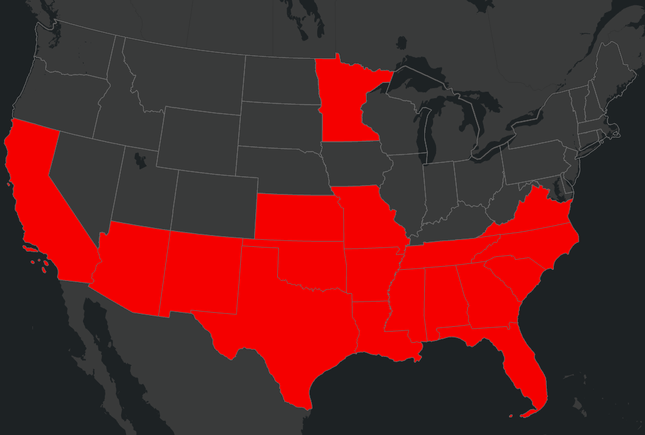
Figure 2. States where cotton, rice and/or wild rice grow

For the UDLs that contain multiple crops, such as Vegetables and Ground Fruit and Other Grains, spatial pattern based on where the registered crops within the UDLs are likely to be grown are present. Figure 3 identifies the number of registered to non-registered crops found in each of the UDLs. This graph indicated that both the Vegetables and Ground Fruit and Other Grains UDL include a number of un-registered crops that are included in the national UDLs masking the possible spatial patterns of the registered crops.

Figure 3. The number of registered to unregistered seed treatment crops found in each UDL group

Using the 2017 Census of Agriculture to identify registered crops, Figure 4 highlights locations where registered seed treatment crops are more likely to be grown. In Figure 4 the map on the left represents the registered seed treatment Vegetables and Ground Fruit crops in red, and on the right the map represents registered Other Grains seed treatment crops in green. The gradient represents the area of registered seed treatment crops to the total area of all crops in the UDL for the state. In both of these maps the darker the color the higher this ratio and the more likely a registered seed treatment crop would be grown in the state.

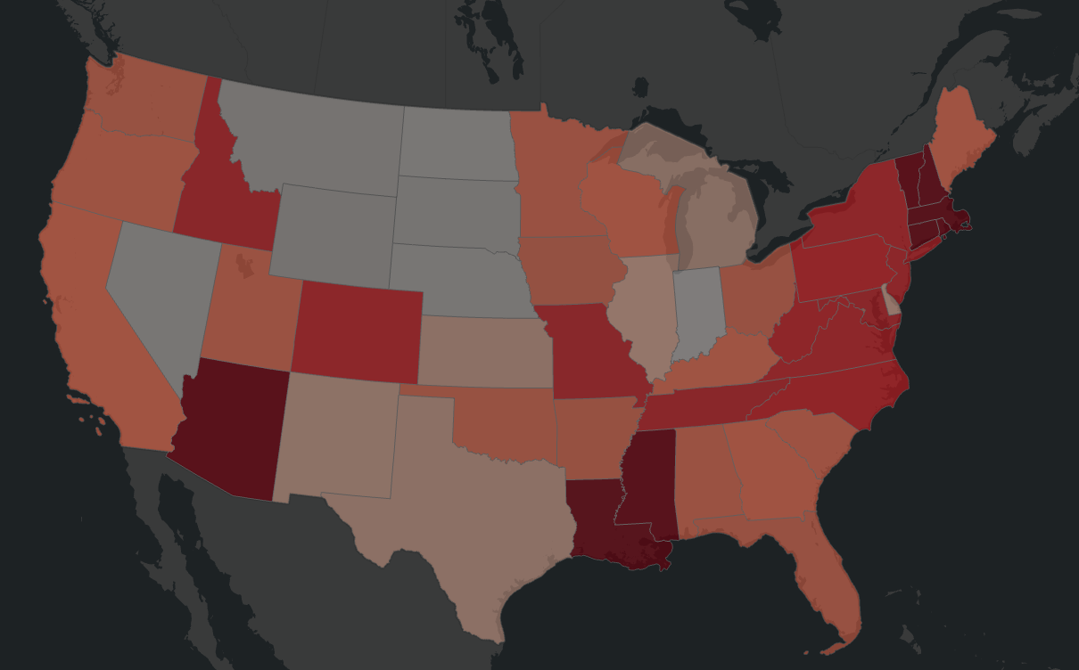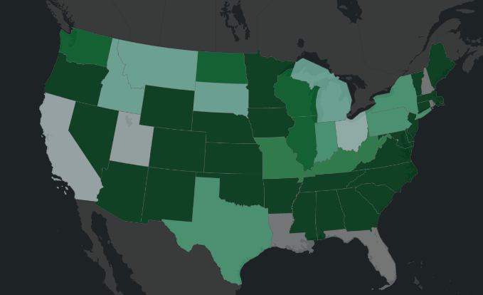
Figure 4. Ratio of the area of registered seed treatment crops to the total area of the crops found in the Vegetables and Ground Fruit UDL (on the left) and Other Grains (on the right)

There are a several of notable pattern when considering these two UDL groups (Figure 4). The highest number of registered seed treatment crops occur along the east coast for both UDL groups. The west coast and great plain states have registered crops for both UDLs groups but there is variability between the when considering the ratio by state. California, Arizona, Louisiana, Florida and Mississippi have a have a high ratio of registered crops for Vegetable and Ground Fruit crops, however, only Mississippi and Arizona have a high ratio for Other Grains seed treatment crops.

When combining the ratios for the Vegetables and Ground and Other Grains, the areas where the registered seed treatment crops are likely to be present decreases (Figure 5). Florida, Louisiana, Nevada, Montana, Wyoming, North Dakota, South Dakota, Nebraska and Indiana all have a low ratio of registered crops. For this reason, usage data in these locations would not be as informative compared to other states.

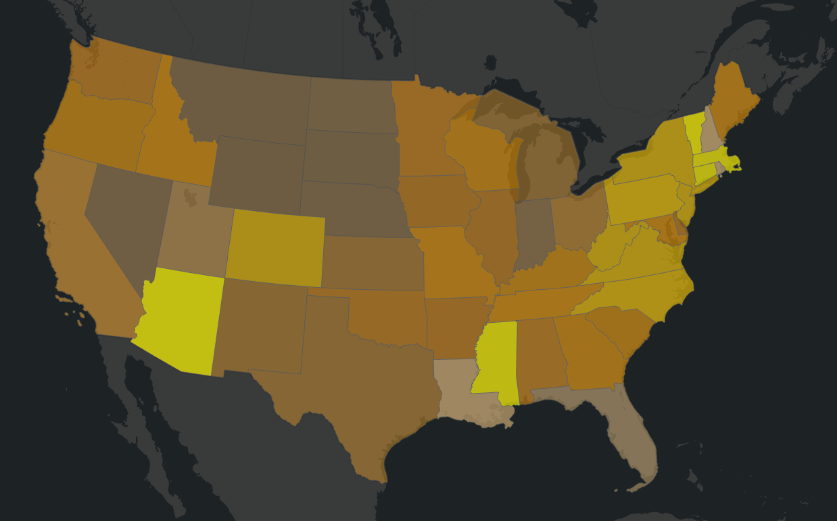
Figure 5. Combined ratio of the area of registered seed treatment crops to the total area of the crops found for Vegetables and Ground Fruit UDL and Other Grains crops

To further identify the areas where usage information would be the most informative, the ranges of seed-eating birds and mammals are overlaid on the map (Figure 6). In Figure 6, the gradient of the combined ratio of registered Vegetables and Ground Fruit and Other Grains remains the same, with seed-eating birds in the green gradient and seed-eating mammals in a purple gradient. The gradient on the species location represents the number of seed-eating species found in that location; the darker the color the higher the number of species present. To help identify the most informative locations for obtaining usage data, only areas with 2 or more seed-eating animals are presented in the map.

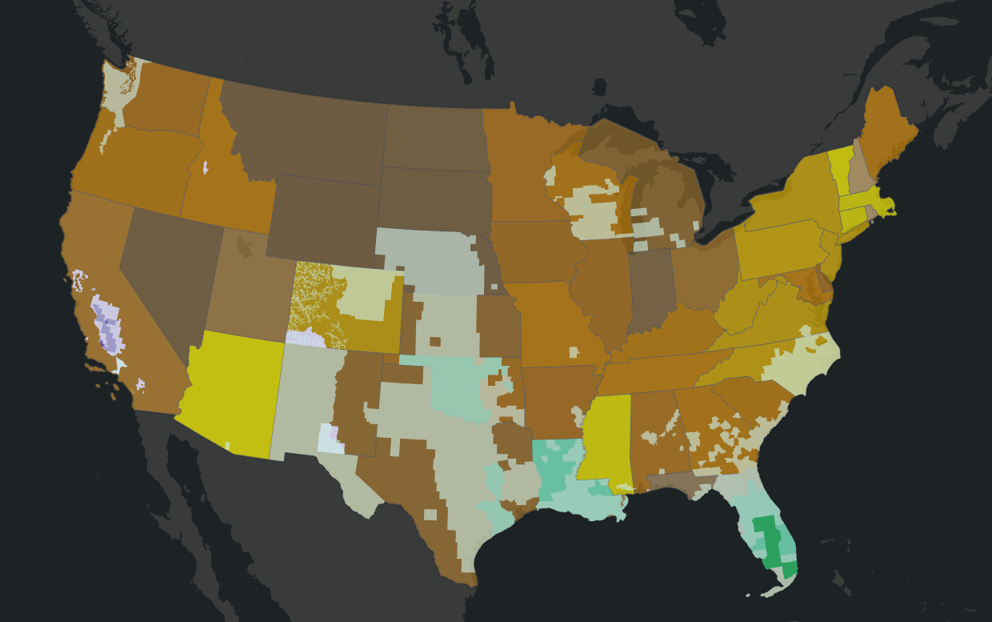
Figure 6. Combined ratio of the area of registered seed treatment crops to the total area of the crops found for Vegetables and Ground Fruit UDL and Other Grains crops with seed-eating birds and mammals

When considering the location of the seed-eating species in conjunction with the registered Vegetables and Ground Fruit and Other Grain crops there are several notable locations. First, when considering Vegetables and Ground Fruit and Other Grains crops together, both Florida and Louisiana have a number of seed-eating animals but do not have a high ratio of registered seed treatment crops for clothianidin. Areas where both seed-eating species and registered seed treatment crops occur include North Carolina, South Carolina, Georgia, Alabama, Texas, Oklahoma, Kansas, Nebraska, New Mexico, Colorado, California, Washington, Wisconsin and Michigan. When also considering the geographic location of rice and cotton (Figure 2) the list of states can be focused to those in the south and California. The most informative states when considering all registered seed treatment crops and seed-eating species are North Carolina, California, Texas, Oklahoma, Kansas, Nebraska, New Mexico, and Colorado (i.e., for areas relevant to those species where consumption of treated seeds may be a major route of exposure). Of these, the two most informative states would be California and Oklahoma given the number of seed eaters in these locations and the high ratio of registered seed treatment crops area.

These lists of states identify where usage information would be most informative based on all registered seed treatment crops, however, these lists may change if specific crops are targeted in future analyses.

Soil Applications and Treated Poultry Litter

Clothianidin also has applications associated with soil treatments for multiple use sites. Based on a comparison of application rates and anticipated EECs, for all use sites for which there are both soil and foliar applications, it is assumed that impacts predicted from flowable uses are protective of soil applications. Clothianidin can also be used in poultry houses to control darkling and hide beetles. The litter collected from these treated poultry houses can be later used on agricultural fields as a soil amendment. This litter can be applied to the corn, soybeans, other grains, cotton, wheat, rice, other row crops, vegetables and ground fruit and alfalfa use data layers (UDLs). These UDLs were identified based on the 24 crops reported in Kellog et al. (2000) for manure/litter application, see APPENDIX 1-6, for additional information. Although this is a soil application method, in order to capture the arthropod concentrations from soil applications for this potentially wide footprint, this use was modeled in the MAGtool along with other foliar application rates. Species that were impacted only by poultry litter applications were reevaluated after the analysis to adjust the results for species where the soil application may not be representative for concentrations from a foliar application (e.g., vertebrate herbivores). It is noted that the inclusion of all of these uses in counties where poultry operations occur could potentially overestimate the acreage where poultry litter is applied and the overlap with species ranges/critical habitats.

USEPA. 2017. Preliminary Aquatic and Non-Pollinator Terrestrial Risk Assessment to Support the Registration Review of Clothianidin. United States Environmental Protection Agency, Office of Pesticide Programs, Environmental Fate and Effects Division. November 27, 2017. DP 439290.
USEPA, Health Canada PMRA, & California Department of Pesticide Regulation. 2014. Guidance for Assessing Pesticide Risks to Bees. June 23, 2014. U.S. Environmental Protection Agency. Health Canada Pest Management Regulatory Agency. California Department of Pesticide Regulation. Available at http://www2.epa.gov/pollinator-protection/pollinator-risk-assessment-guidance.
http://www2.epa.gov/pollinator-protection/2013-summit-reducing-exposure-dust-treated-seed
Exceptions were noted for small/med passerines potentially consuming corn and soybean seeds and small passerines consuming cotton seeds as these seeds are considered too large to consume by these birds.

