APPENDIX 2-5. Clothianidin Species Sensitivity Distribution Analysis for Aquatic Insects

Summary

Species Sensitivity Distributions (SSDs) were fit to median lethal or effects (immobility) concentrations (LC₅₀ or EC₅₀ values) for aquatic insects exposed to clothianidin. In previous biological evaluations for other insecticides, a combined SSD was conducted for all aquatic invertebrates; however, due to the differences in sensitivity between insects and non-insects, this was not done for clothianidin. Additionally, a separate SSD for mollusks was also developed in previous biological evaluations; however, this was not done for clothianidin due to a lack of data.

Six distributions (normal, logistic, triangular, gumbel, weibull and burr) were fit to the available toxicity data for aquatic insects. For aquatic insects, the triangular distribution provided the best fit for the dataset (Figure 1). This decision was based on the AIC_{c} weight and confidence limits for the different distributions (especially around the HC₀₅ and HC₅₀). Summary statistics from the fitted SSD for aquatic insects are provided in Table 1. The fifth and fiftieth percentiles of the SSD (abbreviated HC₀₅ and HC₅₀, respectively, where “HC” stands for “hazard concentration”) are used to calculate mortality endpoints representing effects to listed species of aquatic invertebrates associated with their prey, pollination, habitat and dispersal (PPHD).

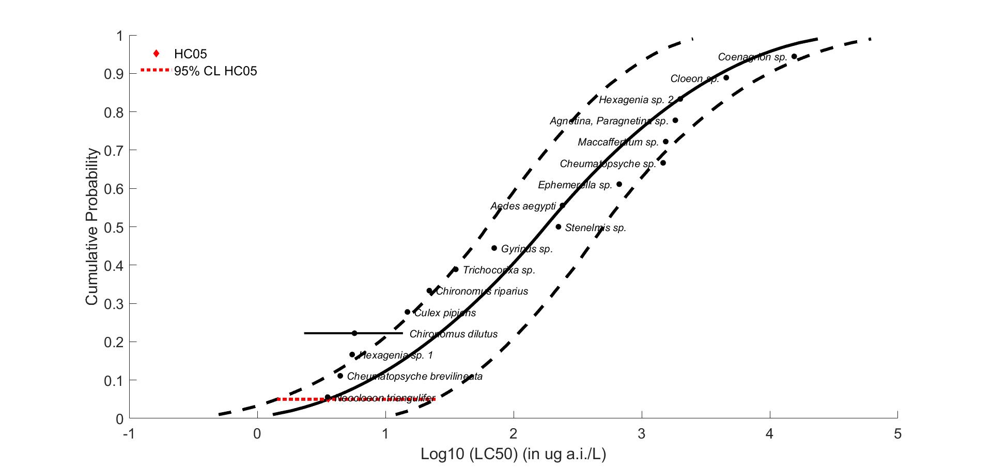
Figure 1. Triangular SSD for clothianidin toxicity values for aquatic insects.
Table 1. Summary of clothianidin mortality endpoints for aquatic invertebrates (values in µg a.i./L).
Statistic | Aquatic Insects
HC₀₅ (95% CI) | 3.58 (1.42-24-65)
HC₅₀ (95% CI) | 176.92 (62.81-500.52)
Slope | 1.69
CI = confidence interval

Toxicity Data

Because an SSD depicts relative sensitivities of different species exposed to the same stressor, it is necessary to standardize the data as much as possible to eliminate variables that would confound the relative sensitivities of species. Such variables can include study exposure duration, age class of organisms tested, and other study design factors. The EC/LC₅₀ values that were included in the analysis were all definitive mortality or immobility endpoints from either 48 or 96-hour tests, with a minimum of five concentrations of technical grade active ingredient, plus appropriate controls, tested within each study. Additionally, if a definitive immobility and a mortality endpoint were available from the same test, the mortality endpoint was used (because immobility is intended as a surrogate for mortality). In some cases, only the genus was available, so the species is unknown. Endpoints without definitive endpoints were not used to derive SSDs.

Data used to derive SSDs are from literature that passed the ECOTOX quality screen (catalogued in APPENDIX 2-2) and data from unpublished, registrant-submitted studies. Those data are included in Table 2. There was a total of 17 aquatic insect species tested (Table 3). Note that for some of the species in Raby et al. 2018 (178290), wild caught species were only identified down to the genus level; however, they are assumed to represent the same species unless noted otherwise. For all species, there are one to three different toxicity endpoints (LC₅₀ or EC₅₀ values) available. In cases where two to three endpoints were available for the same test species, values were similar for Chironomus dilutus (differing by only 6x), with more variation between the endpoints for Hexagenia sp. which differed by 360x. The variation in the endpoints for the two Hexagenia sp. was examined and it was noted that ECOTOX #178290 used an immobility-based EC₅₀ and lab cultured organisms, whereas ECOTOX #183503 used a mortality-based LC₅₀ and wild caught organisms. Additionally, since both studies only identified the organisms to genus, it is possible that two different species were used. Therefore, the Hexagenia sp. endpoints will be considered as two separate species for this analysis. Using the available data, the slope was calculated for aquatic insects resulting in a median slope of 1.69. The data in Table 2 are from 8 different studies, with one study (Raby et al., 2018, ECOTOX #178290) representing toxicity data for 12 different test species.

Table 2. Summary of clothianidin mortality endpoints for aquatic invertebrates (values in µg a.i./L).
Genus or Species | Acute EC/LC₅₀ value (µg/L) | Slope | Reference (ECOTOX #)
Chironomus dilutus | 2.32 | NA | 173368
Neocloeon triangulifer | 3.54 | NA | 178290
Cheumatopsyche brevilineata | 4.44¹ | NA | 152279
Hexagenia sp. 1 | 5.5¹ | NA | 178290
Chironomus dilutus | 5.93 | NA | 183458
Chironomus dilutus | 13.7 | 0.996 | 178290
Culex pipiens ssp. pipiens | 14.85 | NA | 183409
Chironomus riparius | 22¹ | NA | MRID 45422414
Trichocorixa sp. | 35.4 | 1.62 | 178290
Gyrinus sp. | 70.6 | 4.49 | 178290
Stenelmis sp. | 224 | 2.98 | 178290
Aedes aegypti | 241 | NA | 168249
Ephemerella sp. | 668 | 0.975 | 178290
Cheumatopsyche sp. | 1470 | 1.76 | 178290
Maccaffertium sp. | 1540 | NA | 178290
Agnetina, Paragnetina sp. | 1830 | NA | 178290
Hexagenia sp. 2 | 2000 | NA | 183503
Cloeon sp. | 4570 | 1.18 | 178290
Coenagrion sp. | 15500 | 2.08 | 178290
NA = Not available
¹EC₅₀ value

Table 3. Distribution of test results available for clothianidin.
Media | Test results | Species
Aquatic Insects | 19 | 17

Determining distribution with best fit

P-values

Six potential distributions for the clothianidin data were considered (i.e., normal, logistic, triangular, gumbel, weibull and burr). To fit each of the six distributions, the toxicity values were common log (log₁₀) transformed. The SSD toolbox includes four different fitting methods (i.e., maximum likelihood, moment estimators, linearization and metropolis-hastings). All six distributions were fit using the maximum likelihood (ML) method. To test goodness-of-fit, all six distributions were fit to the clothianidin data and bootstrap goodness-of-fit tests were run with 10,000 replicates. The results of these fitting exercises are presented in Table 4. For the aquatic insect SSD, none of the p-values are <0.05, suggesting that none of the distributions should be rejected.

Table 4. P-values calculated for SSDs using aquatic insect toxicity data for clothianidin.
Distribution |  | Aquatic insect SSD
Normal |  | 0.14
Logistic |  | 0.08
Triangular |  | 0.19
Gumbel |  | 0.10
Weibull |  | 0.26
Burr |  | 0.07

Akaike’s Information Criteria Weights

Akaike’s Information Criterion corrected for sample size (AIC_{c}) was used to compare the six distributions for aquatic insects at the HC₀₅². For aquatic insects, the majority of the weight is attributed to the triangular distribution (with ≤20% each attributed to normal, gumbel, logistic, Weibull and burr; (Table 5). Based on the AIC weights, the triangular distribution is used for insects.

Table 5. Akaike’s Information Criteria (AICc) for distributions for aquatic insect toxicity data for clothianidin.
Distribution | AICc | Delta AICc | Wt | HC₀₅ | SE HC₀₅
Triangular | 254.83 | 0 | 0.41 | 3.58 | 3.08
Normal | 256.28 | 1.44 | 0.20 | 1.91 | 1.89
Gumbel | 256.77 | 1.94 | 0.16 | 3.14 | 2.00
Weibull | 257.43 | 2.60 | 0.11 | 0.44 | 0.73
Logistic | 258.05 | 3.22 | 0.08 | 1.22 | 1.43
Burr | 259.77 | 4.93 | 0.04 | 3.14 | 1.97

Conclusions

For aquatic insects, the triangular distribution provided the best fit. This decision was based on the AIC_{c} weight and confidence limits for the different distributions (especially around the HC₀₅ and HC₅₀). This distribution will be used in the BE to derive HC₀₅ and HC₅₀ values for listed aquatic invertebrates and for assessing effects to PPHD.

M. Raby, M. Nowierski, D. Perlov, X. Zhao, C. Hao, D. G. Poirier, and P. K. Sibley. 2018. Acute Toxicity of 6 Neonicotinoid Insecticides to Freshwater Invertebrates. Environmental Toxicology and Chemistry, 37 (5): 1430–1445. ECOTOX# 178290; MRID 50776401
Etterson, M. 2011. Appendix C. Analyses of sensitivity distributions for estimation of acute hazard concentrations to aquatic animals. https://www.regulations.gov/document?D=EPA-HQ-OPP-2011-0898-0009

