Chapter 2 – Methomyl Effects Characterization

Contents
1 Introduction 5
1.1 Endpoints Used in Effects Determinations 6
2 Office of Water Aquatic Life Criteria 12
3 Effects Characterization for Fish and Aquatic-Phase Amphibians 12
3.1 Introduction to Fish and Aquatic-Phase Amphibian Toxicity 12
3.2 Threshold Values for Fish and Aquatic-Phase Amphibians 12
3.3 Effects Data for Fish and Aquatic-Phase Amphibians 14
3.3.1 Effects on Mortality of Fish and Aquatic-Phase Amphibians 14
3.3.2 Sublethal Effects to Fish and Aquatic-Phase Amphibians 18
3.4 Incident Reports for Fish and Aquatic-Phase Amphibians 21
4 Effects Characterization for Aquatic Invertebrates 24
4.1 Introduction to Aquatic Invertebrate Toxicity 24
4.2 Threshold Values for Aquatic Invertebrates 24
4.3 Effects Data for Aquatic Invertebrates 27
4.3.1 Effects on Mortality of Aquatic Invertebrates 27
4.3.2 Sublethal Effects to Aquatic Invertebrates 30
4.4 Incident Reports for Aquatic Invertebrates 32
5 Effects Characterization for Aquatic Plants 32
5.1 Introduction to Aquatic Plant Toxicity 32
5.2 Threshold Values for Aquatic Plants 32
5.3 Effects Data for Aquatic Plants 34
5.3.1 Effects on Mortality of Aquatic Plants 34
5.3.2 Sublethal Effects to Aquatic Plants 34
5.4 Incident Reports for Aquatic Plants 36
6 Effects Characterization for Birds 36
6.1 Introduction to Bird Toxicity 36
6.2 Threshold Values for Birds 37
6.3 Effects Data for Birds 38
6.3.1 Effects on Mortality of Birds 38
6.3.2 Sublethal Effects to Birds 40
6.3.3 Drinking water studies 41
6.3.4 Dermal studies 41
6.3.5 Inhalation studies 41
6.4 Incident Reports for Birds 42
7 Effects Characterization for Reptiles 45
8 Effects Characterization for Terrestrial-Phase Amphibians 45
9 Effects Characterization for Mammals 45
9.1 Introduction to Mammal Toxicity 46
9.2 Threshold Values for Mammals 46
9.3 Effects Data for Mammals 46
9.3.1 Effects on Mortality of Mammals 46
9.3.2 Sublethal Effects to Mammals 48
9.3.3 Drinking water studies 49
9.3.4 Dermal exposure studies 49
9.3.5 Inhalation studies 50
9.4 Incident Reports for Mammals 51
10 Effects Characterization for Terrestrial Invertebrates 53
10.1 Introduction to Terrestrial Invertebrate Toxicity 53
10.2 Threshold Values for Terrestrial Invertebrates 54
10.3 Effects Data for Terrestrial Invertebrates 56
10.3.1 Effects on Mortality of Terrestrial Invertebrates 56
10.3.2 Sublethal Effects to Terrestrial Invertebrates 65
10.4 Incident Reports for Terrestrial Invertebrates 67
11 Effects Characterization for Terrestrial Plants 69
11.1 Introduction to Terrestrial Plant Toxicity 69
11.2 Threshold Values for Terrestrial Plants 69
11.3 Effects Data for Terrestrial Plants 71
11.3.1 Effects on Mortality of Terrestrial Plants 71
11.3.2 Sublethal Effects to Terrestrial Plants 71
11.4 Incident Reports for Terrestrial Plants 73
12 Alternative Toxicity endpoints 76
13 References 77

Tables
Table 2-1. Terrestrial mortality endpoints used to evaluate impacts to species and impacts to methomyl. 7
Table 2-2. Terrestrial sublethal endpoints used to evaluate impacts to species and impacts to methomyl. 8
Table 2-3. Terrestrial plant endpoints used to evaluate impacts to species and impacts to methomyl. 9
Table 2-4. Aquatic mortality endpoints used to evaluate impacts to species and impacts to methomyl. 9
Table 2-5. Aquatic sublethal endpoints used to evaluate impacts to species and impacts to methomyl. 10
Table 2-6. Aquatic plant endpoints used to evaluate impacts to species and impacts to methomyl. 11
Table 2-7. Endpoints Used to Derive Mortality and Sublethal Thresholds for Listed Fish and Aquatic-phase Amphibians. 13
Table 2-8. Summary Statistics for SSDs Fit to Methomyl Test Results. 16
Table 2-9. Fish Incident Reports from IDS (Those Classified as ‘Possible’, ‘Probable’, or ‘Highly Probable’ with Legality of Use = ‘Registered’ or ‘Undetermined’). 23
Table 2-10. Aggregate Wildlife Incidents for Methomyl Involving Currently Registered Products. 24
Table 2-11. Effects Endpoints Used to Derive Mortality and Sublethal Thresholds for Determining Effects to Listed Aquatic Invertebrates 26
Table 2-12. Summary Statistics for Log-triangular SSDs Fit to Methomyl Test Results. 28
Table 2-13. Endpoints Used to Derive Thresholds for Aquatic Plant Species (TGAI Studies Only). 33
Table 2-14. Endpoints Used to Derive Thresholds for Aquatic Plant Species (Formulated Product Studies)¹. 33
Table 2-15. Endpoints Used to Derive Thresholds for Birds. 37
Table 2-16. Available Dose-Based Mortality Data (oral) for Birds Exposed to Methomyl. 38
Table 2-17. Available Dietary-Based Mortality Data for Birds Exposed to Methomyl. 38
Table 2-18. Bird Incident Reports from IDS (Those Classified as ‘Possible’, ‘Probable’, or ‘Highly Probable’ with Legality of Use = ‘Registered’ or ‘Undetermined’). 43
Table 2-19. Aggregate Wildlife Incidents for Methomyl Involving Currently Registered Products. 45
Table 2-20. Endpoints Used to Derive Thresholds for Mammals. 46
Table 2-21. Toxicity Data in the Open Literature for Methomyl Based on Drinking Water Exposure 49
Table 2-22. Acute Dermal Exposure Studies for Methomyl 49
Table 2-23. Inhalation Studies for Methomyl (reported in the 1998 RED, the 2010 Methomyl Registration Review Scoping Document, and the available 6-pack data). 50
Table 2-24. Terrestrial Mammal Incident Reports from IDS 52
Table 2-25. Aggregate Wildlife Incidents for Methomyl Involving Currently Registered Products. 53
Table 2-26. Endpoints Used to Derive Thresholds for Terrestrial Invertebrate Species. 55
Table 2-27. Dosage-Mortality Data for Honeybee Larvae Treated in the Brood Cell with Methomyl (from E070351). 64
Table 2-28. Terrestrial Invertebrate Incident Reports from IDS (Those Classified as ‘Possible’, ‘Probable’, or ‘Highly Probable’ with Legality of Use = ‘Registered’ or ‘Undetermined’). 68
Table 2-29. Aggregate Wildlife Incidents for Methomyl Involving Currently Registered Products. 69
Table 2-30. Endpoints Used to Derive Threshold Values for Terrestrial Plant Species. 70
Table 2-31. Terrestrial Plant Incident Reports for Methomyl from IDS (Those Classified as ‘Possible’, ‘Probable’, or ‘Highly Probable’ with Legality of Use = ‘Registered’ or ‘Undetermined’). 75
Table 2-32. Alternative toxicity endpoints used in weight of evidence analysis. 76

Figures

Figure 2-1. Array of methomyl toxicity data for 96 hr TGAI and TEP acute mortality to fish 15
Figure 2-2. Log-gumbel SSD for methomyl toxicity values for all aquatic vertebrates pooled 17
Figure 2-3. Fish Data Array for Mortality-related Endpoints 18
Figure 2-4. Fish Data Array for Growth Effects 19
Figure 2-5. Amphibian Data Array for Growth Effects 20
Figure 2-6. Fish Data Array for Reproductive Effects 21
Figure 2-7. Array of methomyl toxicity data for 46 - 96 hr TGAI and TEP acute mortality to aquatic invertebrates . 27
Figure 2-8. Log-Gumbel SSD for methomyl toxicity values for pooled invertebrates 29
Figure 2-9. Log-gumbel SSD for methomyl toxicity values for freshwater invertebrates 29
Figure 2-10. Aquatic Invertebrates (excluding mollusks) Survival-Hatch Data Array 30
Figure 2-10. Growth Data Array for Aquatic Invertebrates (excluding mollusks) 31
Figure 2-11. Reproduction Data Array for Aquatic Invertebrates (excluding mollusks) 31
Figure 2-12. Dietary-based Mortality Endpoints (mg/kg-diet) for Birds Exposed to Methomyl. 39
Figure 2-13. Dose-based Mortality Endpoints (mg/kg-bw) for Birds Exposed to Methomyl 39
Figure 2-14. Dietary-based Endpoints (mg/kg-diet) for Birds Exposed to Methomyl 40
Figure 2-15. Dietary-based Reproduction Endpoints (mg/kg-diet) for Birds Exposed to Methomyl 41
Figure 2-16. Mortality Endpoints for Methomyl Exposure Normalized to 15 g 47
Figure 2-17. Growth Endpoints for Methomyl Exposure Normalized to 15 g 48
Figure 2-18. Reproduction Endpoints for Methomyl Exposure Normalized to 15 g 49
Figure 2-19. Mortality Endpoints for Terrestrial Invertebrates Exposed to Methomyl (mg/kg-soil) 57
Figure 2-20. Mortality Endpoints for Terrestrial Invertebrates Exposed to Methomyl (lb a.i./acre) 59
Figure 2-21. Population-Level Endpoints for Terrestrial Invertebrates Exposed to Methomyl (lb a.i./acre) 60
Figure 2-22. Population-Level Endpoints for Terrestrial Invertebrates Exposed to Methomyl (lb a.i./acre) 61
Figure 2-23. Population-Level Endpoints for Terrestrial Invertebrates Exposed to Methomyl (lb a.i./acre) 62
Figure 2-24. Population-Level Endpoints for Terrestrial Invertebrates Exposed to Methomyl (lb a.i./acre) 63
Figure 2-25. Mortality Endpoints for Terrestrial Invertebrates Exposed to Methomyl (µg a.i./bee) 65
Figure 2-26. Reproduction Endpoints for Terrestrial Invertebrates Exposed to Methomyl (lb a.i./acre). 67
Figure 2-27. Effects Endpoints for Terrestrial Plants Exposed to Methomyl (lb a.i./acre) 71
Figure 2-28. Effects Endpoints for Monocots Exposed to Methomyl (lb a.i./acre) 72
Figure 2-29. Effects Endpoints for Dicots Exposed to Methomyl (lb a.i./acre) 73

Introduction

Methomyl (CAS number 16752-77-5) [(1E)-N-(methylcarbamoyloxy)ethanimidothioate] is a carbamate insecticide that acts by inhibiting cholinesterase activity, thereby preventing the natural breakdown of various cholines and ultimately causing the neuromuscular system to seize. This may lead to a series of various effects, which may culminate in death if exposure is sufficient. Methomyl is a foliar, non-selective insecticide used on a wide variety of terrestrial food and feed crops, terrestrial non-food crops, and non-agricultural indoor and outdoor sites.

The following sections discuss toxicity data available for methomyl divided into major taxonomic groups of fish and aquatic-phaseamphibians, aquatic invertebrates, aquatic plants, birds, reptiles, terrestrial-phase amphibians, mammals, terrestrial invertebrates, and terrestrial plants. Based on these data, mortality and sublethal effects (i.e., growth and reproduction) endpoints are determined and are used to evaluate direct effects to a listed species or effects to plants or animals that a species uses for prey, pollination, habitat, and/or dispersal.

For aquatic taxa, separate thresholds were considered for technical grade active ingredient (TGAI) and formulated methomyl to address limitations in modeling the different fate characteristics of the formulated product components. In this situation the toxicity of the formulated product would be compared to the exposure from spray drift only while the TGAI toxicity is compared to the combined exposures from runoff and spray drift. This is only necessary when the lowest toxicity value for a particular taxon is from a study with the formulated product.

In establishing the sublethal thresholds and endpoints used in the analysis, EPA used the most sensitive sublethal endpoint based on growth or reproduction or any sublethal endpoints that are strongly linked to survival, growth, or reproduction. In determining whether toxicity endpoints are strongly linked to apical endpoints, EPA staff used best professional judgment, also considering factors such as data quality and relevance to effects on survival and reproduction. Specific consideration was given to any endpoints associated with sensory or behavioral effects. It was determined that no other endpoints in these categories were more sensitive and relevant than the most sensitive growth or reproduction endpoint available for each taxon. The sublethal endpoint used for each taxon therefore represents a growth or reproductive endpoint directly. Information on additional endpoints is found in APPENDIX 2-1 and APPENDIX 2-2.

If sufficient data are available, the toxicity data for each taxon are presented as summary data arrays (developed using the Data Array Builder v.1.0; described in ATTACHMENT 2-1). Alternatively, data are presented in a tabular format if only limited data are available. The arrays contain data from both laboratory and field experiments (e.g., mesocosms). Data in these arrays are grouped by the type of effect (e.g., mortality, growth, and reproduction), and present the range of effects endpoints [e.g., LOAECs and NOAECs (NOAECs must have a corresponding LOAEC to be represented in array)] for each effect type. The effects related to mortality, growth, and reproduction are discussed in further detail within each taxon effects characterization. All endpoints are reported in terms of active ingredient (the amount of methomyl, that is mg/L reflects mg methomyl/L), unless otherwise specified. Data used in the arrays are available for each taxon in APPENDIX 2-1. Studies for which exposure units were not in or could not be converted to environmentally relevant units were not included in the data arrays. Endpoints reported in the ECOTOX database are presented in APPENDIX 2-2. Reviews of open literature studies reviewed for the effects characterization are presented in APPENDIX 2-3. Citations for registrant submitted studies are presented in APPENDIX 2-4.

Endpoints Used in Effects Determinations

Toxicity data available for methomyl was reviewed and divided into major taxonomic groups, including: fish and aquatic amphibians, aquatic invertebrates, aquatic plants, birds, reptiles, terrestrial-phase amphibians, mammals, terrestrial invertebrates, and terrestrial plants. For each of these groups, endpoints are determined for each taxon for mortality (animals only) and sublethal effects (i.e., growth or reproduction). These endpoints are used to establish thresholds, which are then used in conjunction with exposure data to make effects determinations based on the taxon with which they are associated. These data are described more fully in each relevant toxicity section below. Table 2-1 through Table 2-6 summarizes the methomyl toxicity endpoints used in the effects determinations for all taxa. The available toxicity data for each taxon is discussed further later in this chapter.

Table 2-1. Terrestrial mortality endpoints used to evaluate impacts to species and impacts to methomyl.
Type of Threshold | Taxon | Test Species | Type of endpoint | Value | Units | Slope | Weight of test animal (g) | Comments | Reference
DOSE BASED MORTALITY | Mammals | Harlan Sprague-Dawley Rat (Rattus norvegicus) | LD₅₀ | 7.14 | mg ai/kg-bw | 4.5 | 200 | LD50 CI: 6.22 - 8.19. | MRID 48226104  (Kuhn 1996)
 | Birds | Zebra Finch (Taeniopygia guttata) | LD₅₀ | 2.03 | mg ai/kg-bw | 4.5 | 13.2 | Default weight and default slope. | MRID 49054101, (Hubbard et al., 2013)
 | Reptiles | Zebra Finch (Taeniopygia guttata) | LD₅₀ | 2.03 | mg ai/kg-bw | 4.5 | 13.2 | Bird surrogate. | MRID 49054101, (Hubbard et al., 2013)
 | Terrestrial Invertebrates | Honey bee  (Apis mellifera) | LD₅₀ | 0.5 | mg ai/kg-bw | 9 | 0.128 | Converted from ug a.i./bee (adult honeybee) using Reverse BeeRex, bee weight assumed | E67983
DIETARY BASED MORTALITY | Mammals | No data available
 | Birds | Bobwhite quail (Colinus virginianus) | LC₅₀ | 1100 | mg ai/kg-diet | 4.5 | NA | default slope | MRID 00022923/ E35243  (Hill et al., 1975)
 | Reptiles | Bobwhite quail (Colinus virginianus) | LC₅₀ | 1100 | mg ai/kg-diet | 4.5 | NA | birds as surrogate | MRID 00022923/ E35243  (Hill et al., 1975)
 | Terrestrial Invertebrates | Honey bee  (Apis mellifera) | LC₅₀ | 0.5 | mg ai/kg-diet | 2.28 | NA | From AAO study. | MRID 45093001
MORTALITY | Terrestrial Invertebrates | Earthworm (Allolobophora tuberculata) | LC₅₀ | 4.75 | mg ai/kg-soil | 4.5 | NA | The most sensitive endpoint available is an EC₅₀; study was conducted in natural soil/cow dung mixture using a 25WP formulation for 37 days. Default slope. | E40226
 | Terrestrial Invertebrates | Honey bee  (Apis mellifera) | LD₅₀ | 0.068 | ug ai/bee | 9 | NA | Test used 7-day old worker bees; contact exposure; slope was 9.03 | E67983
 | Terrestrial Invertebrates | Parasitoid Aphidius rhopalosiphi | LC₅₀ | 0.00022 | lb ai/A | 5.4 | NA | 48-hr study testing effects of Methomyl 20L; test organisms were <48-hrs old; Probit slope was 5.4 | MRID 45133301

Table 2-2. Terrestrial sublethal endpoints used to evaluate impacts to species and impacts to methomyl.
Type of Threshold | Taxon | Test Species | NOAEC (or LOAEC if no NOAEC) | MATC or LOAEC | Units | Comments | Reference
DOSE BASED SUBLETHAL ENDPOINTS | Mammals | Rat (R. norvegicus) | 0.75 | 1.2 | mg ai/kg-bw | 73% reduction in body weight gain female rats at LOAEC (2 mg ai/kg-bw). MATC used as input. | MRID 44487501  (Mikles, 1998)
 | Birds | No data available
 | Reptiles
DIETARY BASED SUBLETHAL ENDPOINTS | Mammals | Rat (R. norvegicus) | 15 | 24 | mg ai/kg-diet | 73% reduction in body weight gain in female rats. MATC used, LOAEC = 40 mg ai/kg-diet. | MRID 44487501
 | Birds | Bobwhite quail (Colinus virginianus) | 150 | 262 | mg ai/kg-diet | 35% reduction in eggs laid per hen. MATC used as input; LOAEC = 458 mg ai/kg-diet. | MRID 41898602  (Beavers et al., 1991)
 | Reptiles | Bobwhite quail (Colinus virginianus) | 150 | 262 | mg ai/kg-diet | Bird surrogate. 35% reduction in eggs laid per hen. MATC used as input; LOAEC = 458 mg ai/kg-diet. | MRID 41898602  (Beavers et al., 1991)
SUBLETHAL/ MORTALITY | Terrestrial Invertebrates | Honey bee (Apis mellifera) | NA | NA | mg ai/kg-bw | NA | No studies were available that evaluated effects on a mg/kg-bw basis
 | Terrestrial Invertebrates | Honey bee (Apis mellifera) | 0.313 | 0.442 | mg ai/kg-diet | Mortality. From adult honeybee study based on reported dietary concentration, oral exposure; MATC = 0.442, LOAEC = 0.625 | MRID 49830501
 | Terrestrial Invertebrates | Earthworm (Allolobophora tuberculata) | 4.75 | 4.75 | mg ai/kg-soil | Mortality. Most sensitive endpoint, EC50 used for both values. | E40226
 | Terrestrial Invertebrates | Honey bee (Apis mellifera) | 0.0106 | 0.0135 | ug ai/bee | 10-day feeding study with technical grade methomyl; the NOAELs and LOAELs in the study were the same for both mortality and food consumption; LOAEC = 0.0172 ug ai/bee. | MRID 49830501
 | Terrestrial Invertebrates | Parasitoid (Aphidius rhopalosiphi | 0.0000053 | 0.0000053 | lb ai/A | 48-hr study using Methomyl 25 WP in the lab; LOAEC was based on a 43% decrease in number of mummies per female; a NOAEC was not observed (effects were seen at all test concentrations). | MRID 45133302

Table 2-3. Terrestrial plant endpoints used to evaluate impacts to species and impacts to methomyl.
EPA Category | Species | NOAEC | MATC or LOAEC | IC₂₅ | Units | Comments | Reference
Monocot | NA | 2.97 | 2.97 | 2.97 | lb ai/A | No observed effects. NOAEC values, LOAEC and IC25 are >2.97. | MRID 49033401
Dicot | NA | 2.97 | 2.97 | 2.97 | lb ai/A | No observed effects. NOAEC values, LOAEC and IC25 are >2.97. | MRID 49033401

Table 2-4. Aquatic mortality endpoints used to evaluate impacts to species and impacts to methomyl.
Taxon | Test Species | Type of endpoint | Value (µg/L) | Slope | Duration of study (days) | Comments | Reference
FW FISH | Freshwater and Estuarine/  Marine Fish | HC₀₅ | 335 | 4.2 | 4 | SSD for all vertebrates. | NA
E/M FISH | Freshwater and Estuarine/  Marine Fish | HC₀₅ | 335 | 4.2 | 4 | SSD for all vertebrates. | NA
AQ AMPHIBIANS | Amphibians | HC₀₅ | 335 | 4.2 | 4 | SSD for all vertebrates. | NA
FW INVERTEBRATES | Non-mollusk aquatic invertebrates | HC₀₅ | 3.94 | 4.5 | 4 | SSD for pooled invertebrates. Study durations are 2-4 days. | NA
E/M INVERTEBRATES | Non-mollusk aquatic invertebrates | HC₀₅ | 3.94 | 4.5 | 4 | SSD for pooled invertebrates. Study durations are 2-4 days. | NA
MOLLUSKS¹ | Mollusk aquatic invertebrates | HC₀₅ | 3.94 | 4.5 | 4 | SSD for pooled invertebrates. Study durations are 2-4 days. | NA
¹ For mollusks, no acute mortality (LC₅₀) data for methomyl are available, thus, other invertebrate data are used as a proxy.

Table 2-5. Aquatic sublethal endpoints used to evaluate impacts to species and impacts to methomyl.
Taxon | Test Species | NOAEC | MATC or LOAEC | Units | Duration of study (days) | Comments | Reference
FW FISH | Fathead minnow  (Pimephales promelas) | 73 | 103 | µg ai/L | 35 | 9% decrease length/19% decrease weight. MATC used as input; LOAEC = 145 µg ai/L. | MRID 46015305  (Howard, et al., 1991)
E/M FISH | Sheepshead minnow  (C. variegatus) | 260 | 357 | µg ai/L | 36 | 12.9 % reduction in length. MATC used as input; LOAEC = 490 µg ai/L. | MRID 45013202  (Boeri et al., 1998)
AQ AMPHIBIANS | African Clawed frog (Xenopus laevis) | 51.9 | 99 | µg ai/L | 21 | 4% reduction in hind limb length. MATC used as input; LOAEC = 186 µg ai/L. | MRID 48701402  (Fort, 2012)
FW INVERTEBRATES | Water flea  (Daphnia magna) | 1.6 | 2.4 | µg ai/L | 21 | 29.5% reduction in number of young per female. MATC used as input; LOAEC = 3.5 µg ai/L. | MRID 1312541  (Britelli, 1982)
E/M INVERTEBRATES | Mysid shrimp  (Americamysis bahia) | 29.1 | 41.5 | µg ai/L | 28 | 57.4% decrease in progeny counts per female. MATC used as input; LOAEC = 59.1 µg ai/L. | MRID 45013203  (Ward et al., 1999)
Mollusks¹ | Water flea  (Daphnia magna) | 1.6 | 2.4 | µg ai/L | 21 | 29.5% reduction in number of young per female. FW inverts used as surrogate; MATC used as input; LOAEC = 3.5 µg ai/L. | MRID 1312541  (Britelli, 1982)
¹ For mollusks, no sublethal data for methomyl are available, thus, D. magna data are used as a surrogate for sublethal effects.

Table 2-6. Aquatic plant endpoints used to evaluate impacts to species and impacts to methomyl.
EPA Category | Species | NOAEC | MATC or LOAEC | IC₅₀ | Units | Comments | Reference
Non-vascular | Green algae  (Pseudokirchneriella subcapitata) | 60000 | 60000 | 60000 | ug ai/L | Decreased population abundance. EC50 lower than NOAECs. | Fernandez-Alba et al., 2002; E73575
Vascular | Green algae  (Pseudokirchneriella subcapitata) | 60000 | 60000 | 60000 | ug ai/L | Decreased population abundance. EC50 lower than NOAECs; no data for vascular plants, non-vascular used as surrogate

Office of Water Aquatic Life Criteria
The U.S. EPA’s Office of Water (OW) may develop ambient water quality criteria for chemicals, including pesticides, that can be adopted by states and tribes to establish water quality standards under the Clean Water Act. At this time, OW has not published ambient water quality criteria for methomyl.

Effects Characterization for Fish and Aquatic-Phase Amphibians

Introduction to Fish and Aquatic-Phase Amphibian Toxicity

The effects of methomyl have been studied extensively in fish. Acute, early-life-stage, and full life cycle studies for fish have been submitted by the registrant. It should be noted that EPA does not typically request toxicity studies for amphibians from pesticide registrants, but rather uses data on freshwater fish to represent potential effects to amphibians in the aquatic phase. Studies were excluded from the main analysis (i.e., Species Sensitivity Distribution and data arrays) if they were considered invalid or if the exposure units could not be converted into aqueous concentrations. In cases when information is lacking for amphibians, the fish endpoints will be referenced as a surrogate.

Threshold Values for Fish and Aquatic-Phase Amphibians

The endpoints used to derive mortality and sublethal (i.e., growth and reproduction) thresholds for direct and indirect effects for listed fish and aquatic-phase amphibians are presented in Table 2-7. APPENDIX 2-3 provides the open literature reviews for studies with threshold values.

Table 2-7. Endpoints Used to Derive Mortality and Sublethal Thresholds for Listed Fish and Aquatic-phase Amphibians.
Taxa | Threshold Type | Effect (endpoint) | Value  (µg a.i./L) | Duration of exposure/Species | Source
Freshwater  Fish | Mortality | HC₀₅ | 335 | 4 days | 5th percentile LC50 from all vertebrate SSD¹  (slope: 4.2, from Channel catfish;  MRID 40098001/E6797)
 | Sublethal | NOAEC for reduced growth ↓ length and wet weight  (9 and 19% reduction at next higher concentration). | 73/145  (NOAEC/ LOAEC)  103  (MATC) | 35 days  Fathead minnow  (Pimephales promelas) | MRID 46015305  (Howard, et al., 1991)
Estuarine  Marine Fish | Mortality | HC₀₅ | 335 | 4 days | 5th percentile LC50 from all vertebrate SSD²  (slope: 4.2, from Channel catfish;  MRID 40098001/E6797)
 | Sublethal | NOAEC for reduced growth  ↓ length  (12.9% reduction at next higher concentration) | 260/490  (NOAEC/  LOAEC)  357  (MATC) | 36 days  Sheepshead minnow  (C. variegatus) | MRID 45013202  (Boeri et al., 1998)
Amphibians | Mortality | HC₀₅ | 335 | 4 days | 5th percentile LC50 from all vertebrate SSD³  (slope: 4.2, from Channel catfish;  MRID 40098001/E6797)
 | Sublethal | NOAEC for reduced growth  ↓ length (5% reduction in hind-limb length and 7% reduction in snout-vent length at next higher concentration). | 51.9/186  (NOAEC/ LOAEC)  99  (MATC) | 21-day  African Clawed frog (Xenopus laevis) | MRID 48701402  (Fort, 2012)
¹ Details on derivation of SSD are provided in APPENDIX 2-5 and in the “Mortality” characterization section below.
² An estuarine/marine fish-specific SSD is not available, based on all vertebrate SSD.
³ An amphibian-specific SSD is not available, as there is not enough acute amphibian data available, based on all vertebrate SSD.

Effects Data for Fish and Aquatic-Phase Amphibians

Effects on Mortality of Fish and Aquatic-Phase Amphibians

The LC₅₀ values presented in this section are from studies with 96-hour exposure duration, which is standard for acute aquatic vertebrate toxicity tests to ensure comparability of results. The endpoint used to derive the mortality threshold for freshwater fish are based on the HC₀₅ from the all aquatic vertebrate Species Sensitivity Distribution (SSD) (APPENDIX 2-5). For Estuarine/Marine Fish (E/M) and aquatic-phase amphibians, an HC₀₅ based on the all aquatic vertebrate SSD endpoint was used to derive the mortality threshold.

Acute toxicity estimates (96-hour LC₅₀) for methomyl range from 300 (MRID 40098001) -32,000 µg/L (MRID 40098001) and span two orders of magnitude (Figure 1), indicating a wide range of sensitivity to methomyl among fish. The lowest definitive LC₅₀ for methomyl is for a formulation (24% a.i.) tested on the channel catfish, Ictalurus punctatus (LC₅₀ = 300 µg/L; Meyer and Ellersieck, 1986; MRID 40098001). Since the lowest three LC₅₀ values are from formulation products both the TGAI LC₅₀ values (used for the SSD) and TEP LC₅₀ values (excluded from SSDs) have been plotted together as a data array in Figure 1. Despite the lowest three LC₅₀ values (300 – 370 µg/L) being derived from studies that used formulated methomyl products, the lowest TGAI derived LC₅₀ values (417 – 425 µg/L) are close in magnitude. The most sensitive species, channel catfish, is represented by a TGAI study used in the all aquatic vertebrate SSD used to derive the HC₀₅ value, so it should be noted that all species represented by 96-hour TEP studies are also represented by at least one 96-hour TGAI study that has been incorporated in the all vertebrate SSD.

For the fish families for which methomyl toxicity data are available, Atheriniformes (Ictaluridae and Centrarchidae families), in general, appear to be the most sensitive to methomyl with LC₅₀ values ranging from 320-2800 µg/L. The Cyprinodontidae family (the only saltwater representative, with the exception that one salmonid inhabits both freshwater and saltwater habitats) only had one data point for comparison but all represented families (also including Cyprinidae, Salmonidae and Cichlidae) had somewhat similar toxicity ranges, with Salmonidae having the widest range of sensitivities (from 560 to 32,000 µg/L) (APPENDIX 2-5)

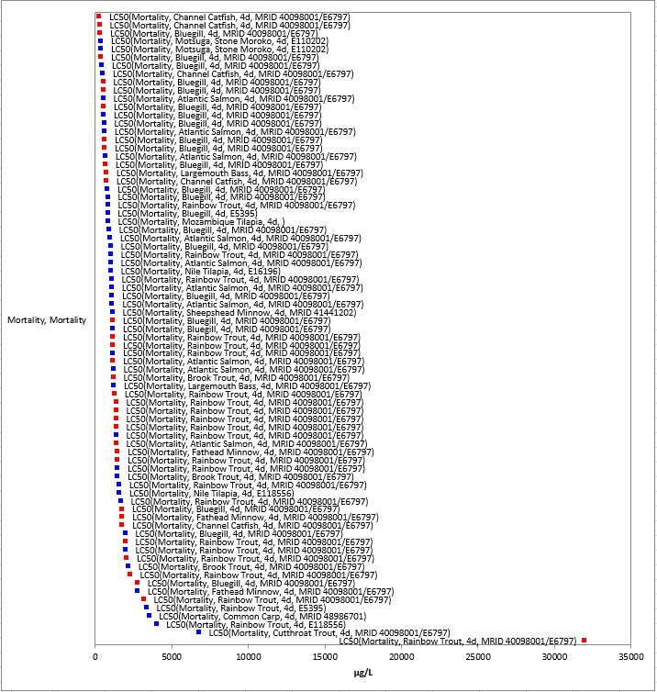
Figure 2-1. Array of methomyl toxicity data for 96 hr TGAI and TEP acute mortality to fish expressed in terms of µg a.i./L. Blue squares represent TGAI LD₅₀ values. Red squares represent TEP LD₅₀ values. Parenthesis describe the endpoint, species common name, study duration, and study reference (MRID or ECOTOX #).

Amphibians- For aquatic-phase amphibians, acute mortality (96 h-unless otherwise noted; LC₅₀) data for methomyl are available for 3 species. The values range from 15,400-1,100,000 µg/L and span two orders of magnitude. The lowest LC₅₀ value of 15,400 µg/L is for the marbled pygmy frog (Microhyla pulchra) (Lau et al., 1015; E171543) at 25°C. In this study, three amphibian species (also including the Asian common toad, Polypedates melanosticutus, and the brown tree frog, Polypedates megacephalus) were tested at temperatures ranging from 15-35ºC to analyze patterns in the temperature-dependence enhancement of methomyl toxicity.

Species Sensitivity Distribution for Acute Mortality Data

The acute mortality studies conducted with technical grade methomyl were used to derive SSDs, which were fit to test results for fish exposed to methomyl. Five distributions were tested and a variety of methods were used to determine whether different subsets of data should be modeled independently. No SSD results were available for estuarine/marine fish or amphibians alone due to insufficient data. By comparing results from all fish with those of freshwater fish, alone, these results do not support separating the data into SSDs for freshwater and all fish (Table 2-8). Similarily, by comparing results from all vertebrates to those of all fish also do not support separating out the aquatic-phase amphibian data. Therefore, the SSD for all aquatic vertebrates will be used for freshwater fish, and for estuarine/marine fish (E/M) and aquatic-phase amphibians. These values are reported in Table 2-7. APPENDIX 2-5 includes further details of how these SSDs were derived.

The HC₀₅ value of 335 µg/L is less than the lowest 96-hour TGAI LC₅₀ value used to derive the all vertebrate SSD (417 µg/L), but is above the lowest TEP LC₅₀ value of 300 µg/L, putting the HC₀₅ in between two of the lowest measured values. However, they are all very similar and support using the HC₀₅ from the all vertebrate SSD as the quantitative endpoint to calculate risk.

Table 2-8. Summary Statistics for SSDs Fit to Methomyl Test Results.
Statistic | All  Vertebrates | FW  Vertebrates | All  Fish | FW  Fish
Best Distribution (by AIC_{c}) | gumbel | gumbel | triangular | triangular
Goodness of fit  P-value | 1.00 | 0.999 | 1.00 | 1.00
CV of the HC₀₅ | 0.452 | 0.546 | 0.239 | 0.274
HC₀₅ | 335 | 312 | 472 | 472
HC₁₀ | 462 | 446 | 560 | 564
HC₅₀ | 2010 | 2300 | 1160 | 1200
HC₉₀ | 20200 | 30100 | 2400 | 2540
HC₉₅ | 49000 | 80400 | 2850 | 3030

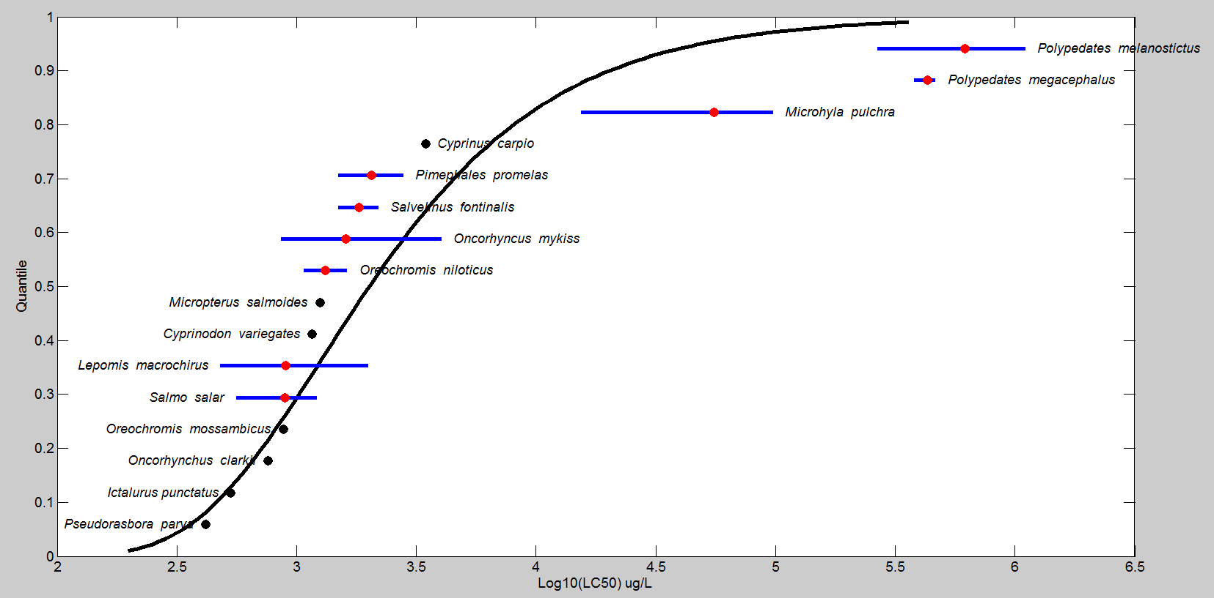
Figure 2-2. Log-gumbel SSD for methomyl toxicity values for all aquatic vertebrates pooled. Black points indicate single toxicity values. Red points indicate average of multiple toxicity values for a single species. Blue line indicates full range of toxicity values for a given taxon.

Mortality Effects Other than Acute LC₅₀ values

Fish - Aside from the acute mortality endpoints, other mortality-related endpoints include reduced survival and hatch. The values range from a NOAEC/LOAEC of 57/117 µg/L for mortality in the fathead minnow (P. promelas- Driscoll, 1982; MRID 131255/00118511) to an LC₂₀ of 710 µg/L for mortality in the Mozambique tilapia (Oreochromis mossambicus; E110907), and a NOAEC/LOAEC of 490/1000 µg/L for mortality in the sheepshead minnow (C. variegatus - Boeri et al., 1998; MRID 45013202). Figure 2-3 presents the array of available data (Range: ≤ 1000 ug/L for presentation purposes).

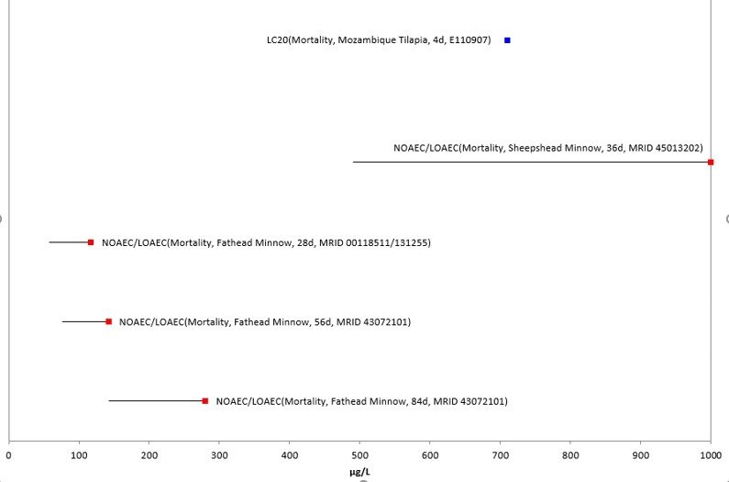
Figure 2-3. Fish Data Array for Mortality-related Endpoints. Data from registrant submitted studies (red) and open literature (blue). Data label key: Endpoint (measured effect, family, duration in days, reference).

Amphibians- There are no data available in this effects category, thus, the fish data are used as a surrogate.

Sublethal Effects to Fish and Aquatic-Phase Amphibians

Effects on Growth of Fish and Aquatic-Phase Amphibians

The available acceptable endpoint values for growth in fish and aquatic-phase amphibians range from 73 to 1030 µg/L, spanning 2 orders of magnitude. Figure 2-4 provides a data array of the distribution (range ≤1200 ug/L). An additional lower growth-related endpoint value is available for the fathead minnow, with a length and dry weight LOAEC (without a NOAEC) of 46 µg/L (Call et al., 1989; E14097); however, it is not suitable for quantitative use.

Therefore, the lowest values for growth-related endpoints are for the fathead minnow, with a length NOAEC/LOAEC of 73/145 µg/L and an MATC of 103 (Howard, et al., 1991; MRID 46015305). The data range extends to a NOAEC (without an accompanying LOAEC) of 1030 µg/L (Hicks, 2012; MRID 48701401). The former was based on significant inhibitions (p<0.05) of 9% reduction in length and 19% reduction in wet weight in the 145 µg/L treatment. Although, in that study, neither egg hatchability nor fry survival were significantly reduced at the highest concentration tested (261 µg/L), another two studies are available to support effects in this treatment range—with significant reduction in length of the F1 generation at 142 µg/L (NOAEC/LOAEC for fathead minnow of 76/142 µg/L; Strawn et al., 1993; MRID 43072101), and survival at 117 µg/L (NOAEC/LOAEC for fathead minnow of 57/142 µg/L; Driscoll, 1982; MRID 131255/00118511). With this additional support for effects in the range of NOAEC/LOAEC = 73/145 µg/L (MRID 46015305), this study provides the lowest sublethal effects endpoint for growth and freshwater vertebrate species and is used to derive threshold values (see Table 2-7).

The only other species represented is also an E/M species, the sheepshead minnow (Cyprinodon variegatus) with a NOAEC/LOAEC of 260/490 µg/L and an MATC of 357 for significantly reduced growth (12.9% reduction in length) (Boeri et al., 1998; MRID 45013202). This study provides the growth endpoints for E/M species and is used to derive threshold values for this taxon (see Table 2-7).

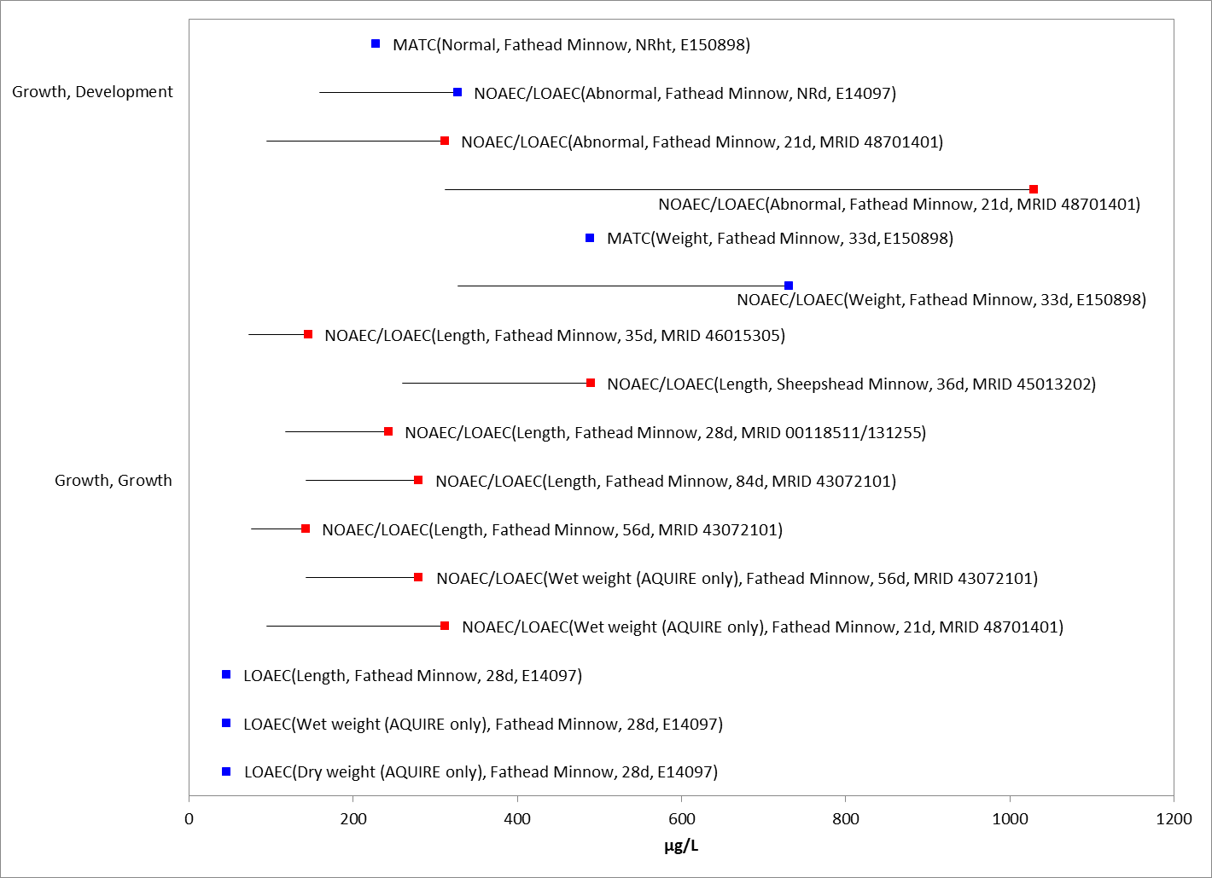

Figure 2-4. Fish Data Array for Growth Effects. Data from registrant submitted studies (red) and open literature (blue). Data label key: Endpoint (measured effect, family, duration in days, reference).

Amphibians-There is one study representing one order and one species for aquatic-phase amphibians. The growth endpoints in the dataset range from 51.9 to 186 µg/L. The lowest value was a NOAEC/LOAEC of 51.9/186 µg/L and an MATC of 99 for 5% reduction in hind-limb length and 7% reduction in snout-vent length in the African clawed from (Xenopus laevis) in the submitted amphibian metamorphosis assay (Fort, 2012; MRID 48701402). In this study, other sublethal effects measured (deformation, metamorphosis, thyroid histopathology and wet weight) did not have measurable effects at the highest concentration tested (186 µg/L). The available endpoints for growth are provided in Figure 2-5.

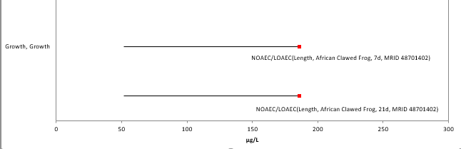
Figure 2-5. Amphibian Data Array for Growth Effects. Data from registrant submitted studies (red) and open literature (blue). Data label key: Endpoint (measured effect, family, duration in days, reference).

Effects on Reproduction of Fish and Aquatic-Phase Amphibians

The reproductive effects of methomyl on fish identified from registrant-submitted studies and open-literature studies range from 94.7-312 µg/L. There were 2 studies, representing 1 species. Figure 2-6 provides a data array (range ≤1000 ug/L).

The lowest value is from a 21-day registrant submitted short term reproduction assay with the fathead minnow (P. promelas) (Hicks, 2012; MRID 48701401). In this assay, fecundity (eggs per surviving female per reproductive day) and fertilization success were significantly reduced (23.3 and 1.6%, respectively) at 312 µg/L (NOAEC/LOAEC of 94.7/312 µg/L). The slight reduction of 1.6% would not provide convincing evidence of an effect alone; however, the dose/response pattern followed at the next higher concentration with a 33% reduction and the GSI (gonad-somatic index) was also significantly affected at this concentration.

The only other available study had a NOAEC/LOAEC for F1 hatching success in the same concentration range (142/280 µg/L); hatching success was significantly (p≤0.05) reduced (8.5%) in the 280 µg/L treatment (MRID 43072101). Significant effects were also seen in length and wet weight at this treatment level (and in length at 142 µg/L), as mentioned in the growth and development section above. However, no significant effects were seen in time to first spawn, F0 hatching success, mean eggs per spawn, mean spawning days or spawns per pair at the highest test concentration (280 µg/L).

For an estuarine/marine fish, no data were available in this effects category, thus, the freshwater fish data are used as a surrogate.

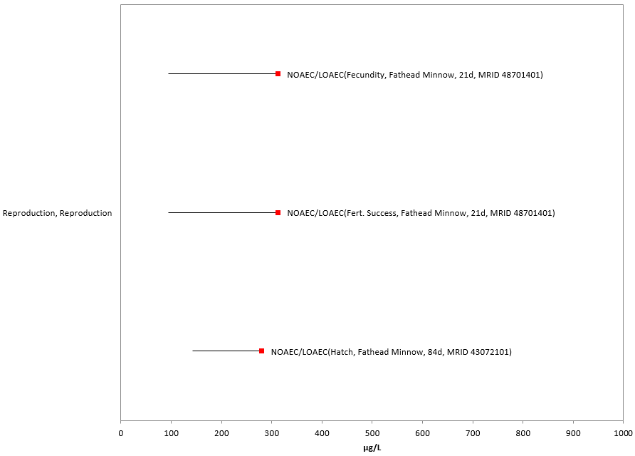
Figure 2-6. Fish Data Array for Reproductive Effects. Data from registrant submitted studies (red) and open literature (blue). Data label key: Endpoint (measured effect, family, duration in days, reference).

Amphibians-There are no data available in this effects category, thus, the fish data are used as a surrogate.

Incident Reports for Fish and Aquatic-Phase Amphibians

There are currently (as of Jan. 22, 2020) two aquatic animal incident reports in the Incident Data System (IDS) with a certainty index of ‘possible’, ‘probable’ or ‘highly probable’. For these two incidents, the legality of use was undetermined (see Table 2-9 and ATTACHMENT 2-2, for details). The following discussion only includes those incident reports with a certainty index of ‘possible’, ‘probable’ or ‘highly probable’ and a legality classification of ‘registered’ and ‘undetermined’ (the incidents that were caused by a misuse are not reported further).

The dates of the fish-kill incident reports range from 1992 to 2001 (see Table 2-9) and both are fairly large (from approximately 125 dead fish to “several thousand”). The incidents involve a variety of fish species (bluegill, bowfin, carp, catfish and threadfin shad) and in one, methomyl residues of 5.08 ppm were reported in composited gill samples. One of the incidents is associated with the corn use, but for the other, the use site is not reported or unknown. The methomyl product involved is Lannate LV for one incident but not reported for the other incident; both incidents involve at least one pesticide in addition to methomyl (see Table 2-9). Overall, the incident data that are available indicate that exposure pathways for methomyl are complete and that exposure levels are sufficient to result in field-observable effects.

Reports contained in the database must be interpreted in the context that 1) not all incidents are expected to be reported and 2) in many instances it is difficult to establish a direct cause-effect relationship. Generally, if there are a significant number of incidents associated with the use of a certain pesticide, it is an indication that the pesticide may pose a higher environmental risk. However, the lack of reported incidents does not necessarily indicate a lack of incidents.

Table 2-9. Fish Incident Reports from IDS (Those Classified as ‘Possible’, ‘Probable’, or ‘Highly Probable’ with Legality of Use = ‘Registered’ or ‘Undetermined’).
INCIDENT NUMBER | YEAR | CHEMICAL(S) INVOLVED (PC CODE) | CERTAINTY INDEX (for methomyl) | STATE | LEGALITY  (for methomyl) | USE SITE | SPECIES AFFECTED | DISTANCE | EFFECT/ MAGNITUDE | PRODUCT
I000108-001 | 1992 | Methomyl  (090301) | Probable | GA | Undetermined | Corn - 200 acre field | Bluegill (Lepomis macrochirus), bowfin (Amia calva), and carp (Cyprinus carpio) | Measured concentrations of methomyl were taken from a pond and pond-overflow area receiving runoff from corn field. Distance given was 85-185 feet (assume this meant distance from edge of field). | 125 fish killed | During a rainy two-week period prior to the fish kill, the corn plot had been treated with 5 applications of methomyl (aerial, 1.5 pints/acre), 4 applications of chlorpyrifos, 4 applications of fertilizer, and 2 applications of borax. The suspected cause of the fish kill was methomyl, as Lannate® LV.
Chlorpyrifos
(059101)
I013436-001 | 2001 | Ammonia  (005302) | Possible | CA | Undetermined | Unknown (the fish fill was in the San Joaquin River near the town of Lathrop) | 29 fish species from 9 families including threadfin shad (Dorosoma petenense) and catfish (Ictalurus sp.) | Pesticide use in the watershed adjacent to the incident site in the San Joaquin River was not determined; evidence of pesticides use was from fish gill tissue samples. | Several thousand fish killed | Not reported. upon further review of the incident, it was acknowledged by California Fish and Game that un-ionized ammonia was the primary cause of the fish kill. Analyses of composited gill samples found the presence of several pesticides (dioxathion = 121.1 ppm; carbaryl = 1.75 ppm; carbofuran = 4.51 ppm; fenurin = 0.78 ppm; methomyl = 5.08 ppm; monuron = 5.83 ppm). However, these pesticides were not detected in the water samples.
Monuron
(035501)
Dioxathion
(037801)
Carbaryl
(056801)
Azinphos-methyl
(058001)
Methomyl
(090301)
Carbofuran
(090601)

In addition to the non-aggregated aquatic incident reports available in IDS, there have also been a total of 12 aggregate wildlife incidents and 1 other non-target incident reported to the Agency. Of these 13, seven are associated with active registrations (six involve products either no longer registered or no registration numbers reported) (see ATTACHMENT 2-2 and Table 2-10).

Table 2-10. Aggregate Wildlife Incidents for Methomyl Involving Currently Registered Products.
PRODUCT REGISTRATION NUMBER | PRODUCT NAME | NUMBER OF AGGREGATE WILDLIFE INCIDENTS | YEAR(S)
000352-00342 | DUPONT LANNATE  SP INSECTICIDE | 1 | 2003
002724-00274 | GOLDEN MALRIN  RF-128 FLY KILLER | 6 | 2011, 2012, 2013 2017

Since 1998, incidents that are allowed to be reported aggregately by registrants [under FIFRA 6(a)(2)] include those that are associated with an alleged effect to wildlife (birds, mammals, or fish) without differentiation between species or terrestrial and aquatic environments; therefore, the same incidents are seen below in Table 2-19, Table 2-25 and Table 2-29. Typically, the only information available for aggregate incidents is the date (i.e., the quarter) that the incident(s) occurred, the number of aggregate incidents that occurred in the quarter, and the PC code of the pesticide and the registration number of the product involved in the incident. Because of the limited amount of data available on aggregate incidents it is not possible to assign certainty indices or legality of use classifications to the specific incidents. Therefore, the incidents associated with currently registered products are assumed to be from registered uses unless additional information becomes available to support a change in that assumption.

Effects Characterization for Aquatic Invertebrates

Introduction to Aquatic Invertebrate Toxicity

The effects of methomyl on aquatic invertebrates have been studied extensively, including both freshwater and estuarine/marine (E/M) invertebrates. APPENDIX 2-4 includes the bibliography of studies that are included in this effects characterization and those that were excluded. Studies were excluded in the main analysis (i.e., Species Sensitivity Distribution and data arrays) if they were considered invalid or the exposure units could not be converted into environmentally relevant concentrations.

In this effects characterization, when sufficient data are available for methomyl, different endpoints are identified for freshwater and estuarine/marine invertebrates. Also, sensitivity of mollusks versus other aquatic invertebrates are discussed as lines of evidence, although, separate endpoints are not derived for mollusks in this assessment due to lack of sufficient data.

Threshold Values for Aquatic Invertebrates

The aquatic invertebrates mortality threshold is based on the HC₀₅ value from the pooled freshwater and estuarine/marine SSD for the taxon. SSDs were generated for non-mollusks aquatic invertebrates, as no acute mortality (LC50) data for mollusks are available, thus, non-mollusks aquatic invertebrate data are used as a proxy. SSDs were based on acute 48 and 96-hr LC₅₀ values from studies using TGAI only (LC₅₀ values from formulation/mixture testing were not included). For non-mollusks, the most sensitive toxicity value suitable for establishing a sublethal threshold is a Daphnia magna life-cycle reproduction study (MRID 1312541). The endpoints used to derive mortality and sublethal (i.e., growth and reproduction) thresholds for direct and indirect effects for aquatic invertebrates are presented in Table 2-11. APPENDIX 2-3 provides the open literature reviews for studies with endpoints used to derive threshold values.

Table 2-11. Effects Endpoints Used to Derive Mortality and Sublethal Thresholds for Determining Effects to Listed Aquatic Invertebrates
Taxa | Threshold Type | Effect (endpoint) | Value  (µg a.i./L) | Duration of exposure | Source
Freshwater Invertebrates | Mortality | HC₀₅ | 3.94 | 48 or 96 hours | 5th Percentile LC50 from  pooled invertebrates SSD¹  (slope: 4.5)
 | Sublethal | Reproduction  ↓29.5% reduction number young/female | 1.6/3.5  (NOAEC/LOAEC)  2.4  (MATC) | 21 days  Water flea  (Daphnia magna) | MRID 1312541  (Britelli, 1982)
Estuarine/  Marine Invertebrates | Mortality  (non-mollusk) | HC₀₅ | 3.94 | 48 or 96 hours | 5th Percentile LC50 from  pooled invertebrates SSD¹  (slope: 4.5)
 | Mortality  (mollusk) | No data | No data | No data | No data
 | Sublethal  (non-mollusk) | Reproduction  ↓57.4% in progeny counts/female | 29.1/59.1  (NOAEC/LOAEC)  41.5  (MATC) | 28 days  Mysid shrimp  (Americamysis bahia) | MRID 45013203  (Ward et al., 1999)
¹ Details on derivation of SSD are provided in APPENDIX 2-6 and in the “Mortality” characterization section below.

Effects Data for Aquatic Invertebrates

Effects on Mortality of Aquatic Invertebrates

For aquatic invertebrates, immobility is also considered as a surrogate measure for mortality (EC₅₀) since the size of the organisms makes determination of mortality difficult. Due to the large number of listed mollusks, there will be a separate discussion for the effects within the mollusk group, although little data were available for this taxon. For aquatic invertebrates overall, when considering the acute mortality data from either a 48 or 96-hour exposure duration, there is a large range in sensitivity with a three orders of magnitude difference in the values from 2.11 µg/L [Water flea (Ceriodaphnia reticulata); Mano et al., 2010; E154905] to 8930 µg/L [Northern house mosquito (Culex pipiens); E167166]. The reported EC₅₀/LC₅₀ values are from studies with either a 48 or 96-hour exposure duration, which is standard for acute aquatic invertebrate toxicity tests and ensures comparability of results. From the data available from the 48 and 96-hour exposure durations, the values from tests conducted with the active ingredient, methomyl, form the basis of the SSD (see the revised methods for an explanation of the SSD method; see APPENDIX 2-6 for tests conducted with a.i., indicated with a * in SSD column). Mortality data for all formulations and for 48 to 96 hour durations is available in the data array presented in Figure 2-7, however, it is noted that there were no species that are not represented in APPENDIX 2-6 that have EC₅₀/LC₅₀ values lower than 2.11 µg/L (the lowest value in APPENDIX 2-6). The mortality thresholds for aquatic invertebrates are based on the HC₀₅ as determined from the pooled freshwater and estuarine/marine invertebrate SSD.

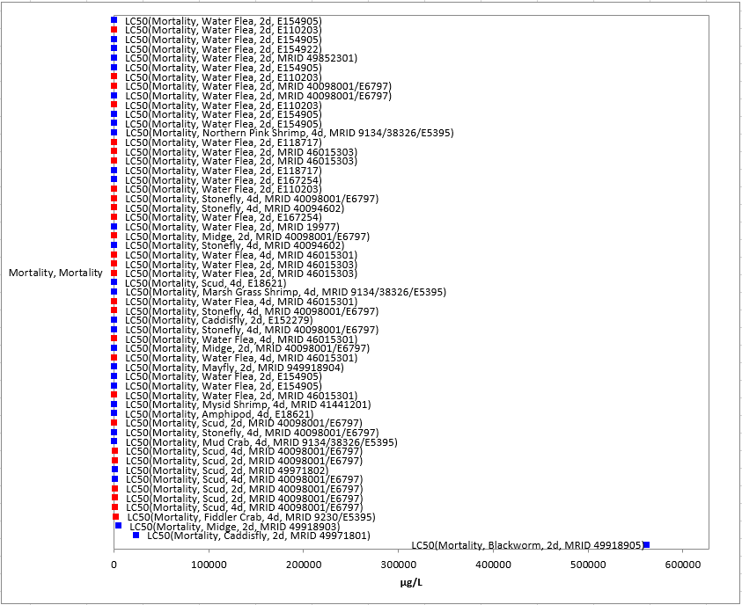
Figure 2-7. Array of methomyl toxicity data for 46 - 96 hr TGAI and TEP acute mortality to aquatic invertebrates expressed in terms of µg a.i./L. Blue squares represent TGAI LC/EC₅₀ values. Red squares represent TEP LC/EC₅₀ values. Parenthesis describe the endpoint, species common name, study duration, and study reference (MRID or ECOTOX #).

Mollusks-For mollusks, no acute mortality (LC₅₀) data for methomyl are available, thus, other invertebrate data are used as a proxy.

Species Sensitivity Distribution (SSD)

The available acute toxicity studies conducted with technical grade methomyl were used to derive SSDs for aquatic invertebrates. In order to generate SSDs, five potential distributions were considered (log-normal, log-logistic, log-triangular, log-gumbel and Burr) and the log-gumbel distribution was found to provide the best fit. Model-averaged SSDs and model-averaged quantiles, including the HC₀₅ were estimated and are presented in Table 2-12. By comparing results from pooled invertebrates with freshwater invertebrates alone; the SSD results support pooling the data into a single SSD for all invertebrates (Table 2-12). Therefore, the pooled SSD alone will be used for freshwater invertebrates and estuarine/marine invertebrates combined to establish thresholds for freshwater and estuarine/marine invertebrates. APPENDIX 2-6 includes further the details of how these SSDs were derived.

Table 2-12. Summary Statistics for Log-triangular SSDs Fit to Methomyl Test Results.
Statistic | Pooled Results | Freshwater Results
Goodness of fit P-value | 0.920 | 0.731
CV of the HC₀₅ | 0.610 | 0.806
UCp¹ of the HC₀₅ | 10.9 | 10.8
HC₀₅ | 3.94 | 3.28
HC₁₀ | 6.70 | 5.76
HC₅₀ | 75.5 | 74.9
HC₉₀ | 3380 | 4190
HC₉₅ | 14400 | 19500
¹ UCp=projections of the upper confidence limit of the HC₀₅ onto the cumulative distribution function of the fitted distribution.

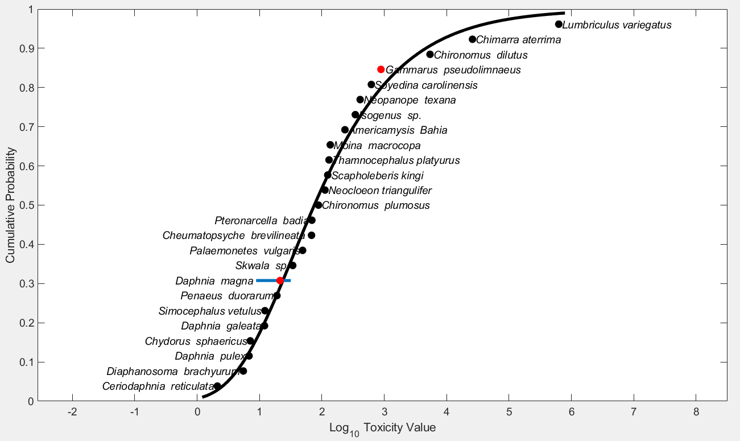
Figure 2-8. Log-Gumbel SSD for methomyl toxicity values for pooled invertebrates. Black points indicate single toxicity values. Red points indicate average of multiple toxicity values for a single species. Blue line indicates full range of toxicity values for a given species.

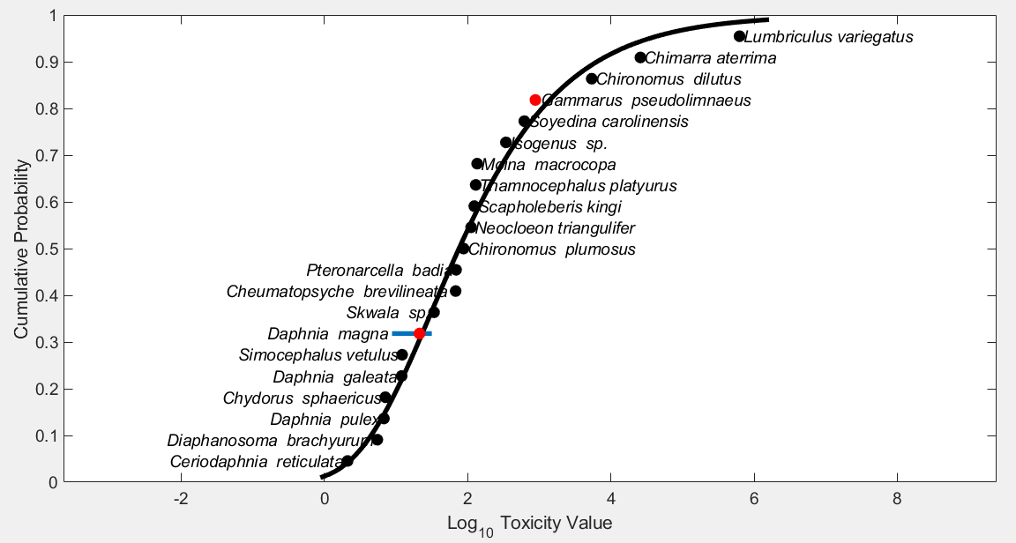
Figure 2-9. Log-gumbel SSD for methomyl toxicity values for freshwater invertebrates. Black points indicate single toxicity values. Red points indicate average of multiple toxicity values for a single species. Blue line indicates full range of toxicity values for a given species.

Mortality Effects Other than Acute EC/LC₅₀ values

Aside from the acute mortality and immobility endpoints, other mortality-related endpoints are for reduced survival/survivorship, hatch and lifespan. Figure 2-10 presents the array of available data.

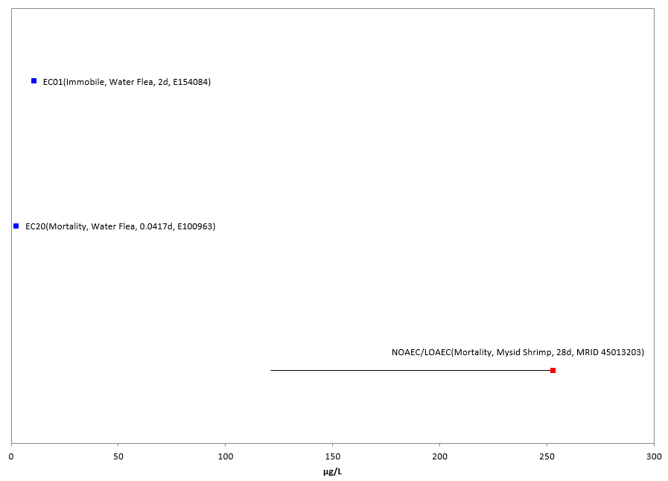
Figure 2-10. Aquatic Invertebrates (excluding mollusks) Survival-Hatch Data Array. Data from registrant submitted studies (red) and open literature (blue). Data label key: Endpoint (measured effect, family, duration in days, reference).

Mollusks-For mollusks, there were no studies available with effects to survival, thus, other invertebrate data are used as a proxy.

Sublethal Effects to Aquatic Invertebrates

Effects on Growth of Aquatic Invertebrates

The growth endpoint, excluding mollusks, was a NOAEC/LOAEC of 6.9/10.4 µg/L based on significantly reduced (p<0.05) “somatic growth rate/day” (based on length measurements) in the daphnid (Daphnia magna; Pereira et al., 2009; E167254). Figure 2-11 presents the array of available data.

Mollusks-There are no data available in this effects category, thus, the other invertebrate data are used as a surrogate.

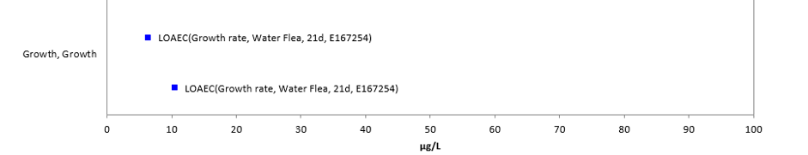
Figure 2-11. Growth Data Array for Aquatic Invertebrates (excluding mollusks). Data from registrant submitted studies (red) and open literature (blue). Data label key: Endpoint (measured effect, family, duration in days, reference).

Effects on Reproduction of Aquatic Invertebrates

For this group of effects data, effects range from a 21-day NOAEC/LOAEC of 1.6/3.5 µg/L, and an MATC of 2.4 based on reduction number of young/female (29.5% decrease) for the daphnid (D. magna; Britelli, 1982; MRID 1312541) to a 21-day NOAEC/LOAEC of 20/80 µg/L for a significant (p<0.05) change in gamete production in the scud (Gammarus fossarum; Geffard et al., 2010; E154902). Figure 2-12 provides an overview of the distribution (range ≤100 µg/L). By providing the lowest sublethal endpoint for freshwater invertebrates, the former (MRID 1312541) study is used to set the freshwater invertebrate sublethal threshold.

Reproductive effects are noted at similar concentrations for estuarine/marine aquatic invertebrates, although only one study is available. The reproduction NOAEC/LOAEC of 29.1/59.1, and an MATC of 41.5 is from a 28-day early mysid shrimp (Americamysis bahia) chronic toxicity study (Ward et al., 1999; MRID 45013203), where 64% reduction was measured in young/surviving female.

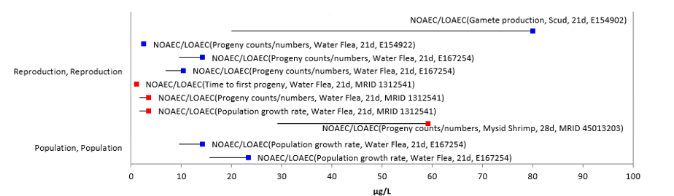
Figure 2-12. Reproduction Data Array for Aquatic Invertebrates (excluding mollusks). Data from registrant submitted studies (red) and open literature (blue). Data label key: Endpoint (measured effect, family, duration in days, reference).

Mollusks-There are no data available in this effects category, thus, the other invertebrate data are used as a surrogate.

Incident Reports for Aquatic Invertebrates

There are currently (as of January 22, 2020) two aquatic animal incident reports in IDS with a certainty index of ‘possible’, ‘probable’ or ‘highly probable’ (see Table 2-9 and ATTACHMENT 2-2, for details). None of the reported incidents involved aquatic invertebrates (although one incident in the IDS aggregate database was classified as “other non-target” and could have involved aquatic invertebrates); however, absence of reported incidents does not ensure that none occurred. Overall, the incident data that are available indicate that exposure pathways for methomyl are complete and that exposure levels are sufficient to result in field-observable effects to aquatic organisms, in general.

Effects Characterization for Aquatic Plants

Introduction to Aquatic Plant Toxicity

Available toxicity studies with aquatic plants have focused on growth/biomass, population abundance, and biochemical effects such as phosphorous and nitrogen content. Most of the available toxicity endpoints for aquatic plants involves non-vascular plant species, although vascular plant data are available for one species, Lemna gibba.

All of the threshold values for aquatic plants are based on effects to growth or biomass (i.e., frond number, biomass yield).

Threshold values and effects data arrays in this assessment are based on endpoints expressed in, or readily converted to, environmentally relevant concentrations (i.e., mg a.i./L). Because of the variability in study designs and endpoints, it was not possible to derive an SSD with the available plant data. Therefore, the aquatic plant thresholds are based on the most sensitive endpoints available for the taxon. Thresholds are provided for endpoints from studies conducted using technical grade methomyl (TGAI) – these are used to compare to aquatic EECs based on runoff and spray drift. Thresholds are also provided for endpoints from studies conducted using TGAI or formulated products (if they are more sensitive that the endpoints derived using the TGAI) – these endpoints are used to compare to aquatic EECs based on spray drift alone. Endpoints are provided for multiple groupings including aquatic plants, non-vascular aquatic plants, and vascular aquatic plants.

Threshold Values for Aquatic Plants

The endpoints used to derive threshold values for direct and indirect effects for aquatic plants are provided in Table 2-13..

Table 2-13. Endpoints Used to Derive Thresholds for Aquatic Plant Species (TGAI Studies Only).
Taxon | Threshold | Endpoint | Effect(s) | Species | Study ID | Comments
All Aquatic Plants¹ | IC₅₀ | 60 mg a.i./L | Population abundance | Green algae  (Pseudokirchneriella subcapitata) | Fernandez-Alba et al., 2002; E73575 | This IC₅₀ is also used in lieu of a NOAEC endpoint since it is more sensitive than all available NOAECs from studies using TGAI.
Non-vascular plants¹
Vascular plants | Data not available
¹The endpoints for aquatic plants and non-vascular aquatic plants are the same.

Table 2-14. Endpoints Used to Derive Thresholds for Aquatic Plant Species (Formulated Product Studies)¹.
Taxon | Threshold | Endpoint | Effect(s) | Species | Study ID | Comments
Aquatic plants² | NOAEC/LOAEC | 3.69/7.24 mg a.i./L | Biomass yield | Green algae  (Pseudokirchneriella subcapitata) | Rebstock, 2012; MRID 48983401 | Studies were conducted using Lannate 90 SP formulation for methomyl. Both used freshwater species.
 | IC₅₀ | 43.1 mg a.i./L | Biomass yield | Green algae  (P. subcapitata) | Rebstock, 2012; MRID 48983401
Non-vascular aquatic plants² | NOAEC/LOAEC | 3.69/7.24 mg a.i./L | Biomass yield | Green algae  (P. subcapitata) | Rebstock, 2012; MRID 48983401
 | IC₅₀ | 43.1 mg a.i./L | Biomass yield | Green algae  (P. subcapitata) | Rebstock, 2012; MRID 48983401
Vascular aquatic plants | NOAEC/LOAEC | 29.8/59.5 mg a.i./L | Frond number yield | Duckweed  (Lemna gibba) | Rebstock, 2012; MRID 48983402
 | IC₅₀ | 182 mg a.i./L | Frond number yield | Duckweed  (L. gibba) | Rebstock, 2012; MRID 48983402
¹ Formulation data are only used for evaluating risk based on spray drift exposure.
²The endpoints for aquatic plants and non-vascular aquatic plants are the same.

Effects Data for Aquatic Plants

Effects on Mortality of Aquatic Plants

There are no mortality data available for effects of methomyl on aquatic plants.

Sublethal Effects to Aquatic Plants

Effects on Growth of Aquatic Plants

Endpoints related to growth (i.e., biomass, frond number yield), physiology (i.e., effects to phosphorus and glucose uptake), and population (i.e., photosynthesis, abundance) are considered as ‘growth’ effects for aquatic plants. For non-vascular aquatic plants (data are available for several algae), effects to growth are seen at methomyl concentrations from 7.24 to 700 mg a.i./L. For vascular aquatic plants, effects to growth are seen at methomyl concentrations from 29.8 to 531 mg a.i./L (data are only available for duckweed).

Effects on Growth of Aquatic Plants (from Studies Conducted Using TGAI)

NOAEC/LOAEC Values

Most aquatic plant data for methomyl were conducted using a formulated product. Two open literature studies were conducted on freshwater green algae using methomyl TGAI. In one of these studies (Kobbia et al., 1991; E6605), dry weight was significantly (p≤0.05) reduced by 13% from 7-days exposure to 100 mg/L methomyl in the blue-green algae (Tolypothrix tenuis), the lowest concentration tested, providing a LOAEC without an accompanying NOAEC. At this treatment level, glucose and phosphorus uptake were also significantly affected, though they were increased rather than decreased, and carotenes were significantly reduced by 9.5%.

IC₅₀ Values

Based on the available data for aquatic plants, the most sensitive IC₅₀ for methomyl (TGAI) is 60 mg a.i./L for reduced population abundance in the freshwater green algae P. subcapitata (Fernandez-Alba et al., 2002; E73575). Abundance was measured by optical density after three days of exposure. Based on the reduced population abundance, this study provides an IC₅₀ of 60 mg/L which is also used to set the non-vascular plant threshold for runoff. Because it is lower than any available NOAEC/LOAEC endpoints using TGAI, it is used in lieu of those endpoints, as well.

Effects on Growth of Aquatic Plants (from Studies Conducted Using TGAI or Formulated Products)

NOAEC/LOAEC Values

The lowest NOAEC and LOAEC values for aquatic plants and methomyl are for reduced yield in the freshwater green algae P. subcapitata (NOAEC = 3.69 mg a.i./L; LOAEC = 7.24 mg/ ai/L; Rebstock, 2012; MRID 48983401). In this 96-hour acute toxicity study, growth inhibition was tested in P. subcapitata that were exposed to the Lannate 90 SP formulation (90.3% purity) under static conditions. The % growth inhibition for yield in the treated algal culture as compared to the control ranged from 1 to 89%. The LOAEC of 7.24 mg a.i./L represents a 9% reduction in both yield and cell density and a 2% inhibition in mean growth rate (following a dose:response pattern) as compared to the control, which were statistically significant (p ≤0.05). Based on the reduced yield, cell density and mean growth rate, this study provides a NOAEC/LOAEC of 3.69/7.24 mg/L which is also used to set the non-vascular plant threshold for drift.

IC₅₀ Values

The most sensitive IC₅₀ for methomyl is 43.1 mg a.i./L for reduced yield in the freshwater green algae P. subcapitata (Rebstock, 2012; MRID 48983401). In this 96-hour acute toxicity study, growth inhibition was tested in P. subcapitata that were exposed to the Lannate 90 SP formulation (90.3% purity) under static conditions. The IC₅₀ for growth rate was 150.4 mg a.i./L. The IC₅₀ for area under the curve was 45.9 mg a.i./L. Based on reduced yield, this study provides an IC₅₀ of 43.1 mg/L which is also used to set the non-vascular plant threshold for drift.

Effects on Growth of Non-Vascular Aquatic Plants

Effects on Growth of Non-Vascular Aquatic Plants (from Studies Conducted Using TGAI)

NOAEC/LOAEC and IC₅₀ Values

The thresholds for all non-vascular aquatic plants and methomyl (TGAI) are the same as the “all aquatic plant” thresholds for TGAI. Most aquatic plant data for methomyl were conducted using formulated product. NOAEC/LOAEC values were not available from available studies on non-vascular aquatic plants (see E73575 and E118717).

The most sensitive IC₅₀ for methomyl (TGAI) for non-vascular aquatic plants is 60 mg a.i./L for reduced population abundance in the freshwater green algae P. subcapitata (E73575).

Effects on Growth of Non-Vascular Aquatic Plants (from Studies Conducted Using TGAI or a Formulated Product)

NOAEC/LOAEC and IC₅₀ Values

The thresholds for all non-vascular aquatic plants and methomyl are the same as the “all aquatic plant” thresholds. The lowest NOAEC and LOAEC values for non-vascular aquatic plants and methomyl are for reduced yield in the freshwater green algae P. subcapitata (NOAEC = 3.69 mg a.i./L; LOAEC = 7.24 mg/ ai/L; MRID 48983401). The most sensitive IC₅₀ for non-vascular aquatic plants for methomyl is 43.14 mg a.i./L for reduced yield in the freshwater green algae P. subcapitata (MRID 48983401).

Effects on Growth of Vascular Aquatic Plants

Effects on Growth of Vascular Aquatic Plants (from Studies Conducted Using TGAI or a Formulated Product)

NOAEC/LOAEC Values

There is only one study available that provides quantitative endpoints for vascular aquatic plants and methomyl. This was a 7-day acute toxicity study conducted on Lemna gibba (duckweed) that were exposed to the Lannate 90 SP formulation (90.3% purity) under static renewal conditions (see MRID 48983402). The lowest NOAEC (29.8 mg a.i./L) and LOAEC (59.5 mg a.i./L) values were for reduced frond number yield and frond number growth rate. The 59.5 mg a.i./L value for the LOAEC represents a 19% reduction in frond number yield and a 7% reduction in frond number growth rate as compared to the control, which were statistically significant (p≤0.05). Final biomass, biomass yield and biomass growth rate were also reduced by 14-31% in the next higher concentration (120 µg/L). Based on the reduced frond number yield, this study provides a NOAEC/LOAEC of 29.8/59.5 mg/L which is also used to set the vascular plant threshold for drift.

IC₅₀ Values

The lowest IC₅₀ value for vascular aquatic plants was 182 mg a.i./L for reduced frond number yield from the same Lemna gibba study which furnished the lowest NOAEC/LOAEC values reported above (MRID 48983402). Based on reduced frond number yield, this study provides an IC₅₀ of 182 mg/L which is also used to set the vascular plant threshold for drift.

Incident Reports for Aquatic Plants

Pesticide incidents involving aquatic plants are not typically submitted to the Agency. There are no methomyl incident reports in the IDS involving aquatic plants (based on a search conducted in January 22, 2020).

Effects Characterization for Birds

Introduction to Bird Toxicity

There are open literature and registrant submitted studies involving birds, including acute oral, sub-acute dietary, reproduction and field studies with technical or formulated methomyl. APPENDIX 2-4 includes the bibliography of studies that are included in this effects characterization. Studies were excluded if they were considered invalid or not associated with an environmentally relevant exposure route. In addition to the reported studies, there are several ecological incident reports involving methomyl exposures to birds.

As acute toxicity data was only available for six species and did not allow for a calculation of a species sensitivity distribution, thresholds are based on the most sensitive lethal and sublethal effects identified among registrant-submitted studies and open literature in the ECOTOX database.

Threshold Values for Birds

To determine the most sensitive endpoint, data tables generated by the data array builder are sorted for the major effects groups. The data are sorted based on endpoints normalized to 100 g body weight for the dose-based endpoints and displayed in arrays with the normalized value. However, for discussion purposes herein and in associated tables, the original study dose is used. As per the methodology for creating the arrays, reported NOAEL values without LOAELS are excluded from the arrays.

The endpoints used to derive mortality and sublethal (i.e., growth and reproduction) thresholds for direct and indirect effects for birds are presented in Table 2-15.

Table 2-15. Endpoints Used to Derive Thresholds for Birds.
THRESHOLD | ENDPOINT | EFFECT(S) | SPECIES  (Common Name) | SPECIES (Scientific Name) | STUDY ID
Mortality–  dose based | LD₅₀ = 2.03 mg/kg-bw; slope = 4.5¹ | Mortality | Zebra Finch | Taeniopygia guttata | MRID 49054101, (Hubbard et al., 2013)
Mortality– dietary based | LC₅₀ = 1100 mg/kg-diet; slope = 4.5¹ | Mortality | Northern Bobwhite Quail | Colinus virginianus | MRID 00022923/ E35243  (Hill et al., 1975)
Sublethal | 150 mg/kg-diet (NOAEL)  458 mg/kg-diet (LOAEL)  262 mg/kg-diet (MATC) | Reproduction – (35% reduction in number of eggs laid per hen and 36% reduction in eggs set per hen) | Northern Bobwhite Quail | C. virginianus | MRID 41898602  (Beavers et al., 1991)
¹A default slope value of 4.5 was used for the mortality endpoints.

Effects Data for Birds

Effects on Mortality of Birds

The data set for mortality to birds, includes 10 references representing 15 endpoints and 6 species (zebra finch, Japanese quail, mallard/pekin duck, ring-necked pheasant, northern bobwhite quail, and domestic chicken). Available dose-based mortality data (LC₅₀, LOAEL and NR-LETH) are available for 5 species of birds (zebra finch, mallard duck, ring-necked pheasant, northern bobwhite quail, and domestic chicken) with a reported mortality effect range from 2.03 to 60 mg/kg-bw (Table 2-16.). LC₅₀ data are available for 4 species of birds (Northern bobwhite quail, mallard/pekin duck, ring-necked pheasant, and Japanese quail) with a reported mortality effect range from 1100 to 5080 mg/kg-diet (Table 2-17.). The endpoints considered for the mortality line of evidence are included in Figures 2-11 (dietary-based) and 2-12 (dose-based).

Table 2-16. Available Dose-Based Mortality Data (oral) for Birds Exposed to Methomyl.
Genus | Species | Common Name | LD₅₀  (mg/kg-bw) | TGAI/  Formulation | Duration (d) | MRID/  ECOTOX ref #
Taeniopygia | guttata | Zebra Finch | 2.03 | TGAI | 14 | MRID 49054101
Phasianus | colchicus | Ring-Necked Pheasant | 15 | TGAI | 14 | MRID 00160000/ E50386
Anas | platyrhynchos | Mallard Duck | 15.9 | TGAI | 14 | MRID 00160000/ E50386
Colinus | virginianus | Northern Bobwhite Quail | 24.2 | TGAI | 14 | MRID 00161886
Gallus | domesticus | Domestic Chicken | 41 | TGAI | NR | E74129
Genus | Species | Common Name | Other endpoint  (mg/kg-bw) | TGAI/  Formulation | Duration (d) | MRID/  ECOTOX ref #
Anas | platyrhynchos | Mallard Duck | LOAEL = 7.5 | TGAI | 30 | MRID 00160000/ E50386
Gallus | domesticus | Domestic Chicken | NR-LETH= 60 | TGAI | 0.0521 | E74129
NR – Not Reported

Table 2-17. Available Dietary-Based Mortality Data for Birds Exposed to Methomyl.
Genus | Species | Common Name | LC₅₀  (mg/kg-diet) | TGAI/  Formulation | Duration (d) | MRID/  ECOTOX ref #
Colinus | virginianus | Northern Bobwhite Quail | 1100 | TGAI | 8 | MRID 00022923/ E35243
Anas | platyrhynchos | Pekin Duck | 1890 | TGAI | NR | MRID 00007820
Phasianus | colchicus | Ring-Necked Pheasant | 1975 | TGAI | 8 | MRID 00022923/ E35243
Anas | platyrhynchos | Mallard Duck | 2883 | TGAI | 8 | MRID 00022923/ E35243
Coturnix | japonica | Japanese Quail | 3436 | TGAI | 8 | MRID 40910905/ E50181
Anas | platyrhynchos | Mallard Duck | 3602 | TGAI | 8 | MRID 45299802
Colinus | virginianus | Bobwhite Quail | 3680 | TGAI | NR | MRID 00007820
Colinus | virginianus | Northern Bobwhite Quail | 5080 | TGAI | 8 | MRID 45299801
NR – Not Reported

Multiple test species have been used in acute oral toxicity studies under varying conditions, yielding LD₅₀ values that range from 2.03-60 mg/kg-bw for 5 species of birds tested. Based on the lowest LD₅₀ values, methomyl is considered very highly toxic (i.e., LD₅₀<10 mg/kg-bw) to birds. Dietary-based LC₅₀ values are also available for several test species. Values range from 1100-5080 mg/kg-diet. Based on the lowest LC₅₀ values, methomyl is considered slightly toxic to birds. Figure 2-13 and Figure 2-14 provide a graphical illustration of the range of lethal data points for dose and dietary based endpoints.

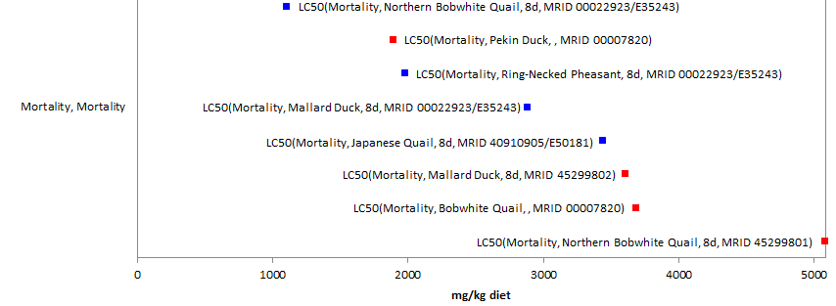
Figure 2-13. Dietary-based Mortality Endpoints (mg/kg-diet) for Birds Exposed to Methomyl.
Data from registrant-submitted studies (red) and open literature studies (blue). (LCx=x% mortality). Data label key: Endpoint (measured effect, common name, duration in days, ref#).

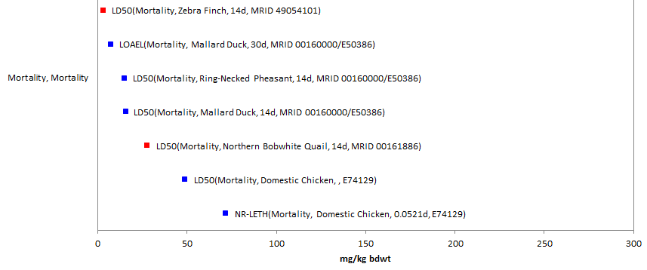
Figure 2-14. Dose-based Mortality Endpoints (mg/kg-bw) for Birds Exposed to Methomyl. Data from registrant-submitted studies (red) and open literature studies (blue). Mortality data endpoints for methomyl exposure were normalized to 100 g. (LDx=x% mortality, LOAEL, NR-LETH=100% mortality). Data label key: Endpoint (measured effect, common name, duration in days, ref#).

Based on the available data for mortality studies, the most sensitive LD₅₀ for methomyl is 2.03 mg/kg-bw for the zebra finch (Taeniopygia guttata). Zebra finch were exposed to methomyl in deionized water at 0.25, 0.50, 1.0, 1.36 and 4.0 mg/kg-bw over 14 days (MRID 49054101, Hubbard et al., 2013). All deaths were observed within 24 hours (20% and 100% mortality observed in the 1.36 and 4.0 mg mg/kg-bw treatment groups at 24 hours, respectively). This is the acute oral endpoint is used to derive the mortality thresholds for birds.

Based on the available data for mortality studies, the most sensitive LC₅₀ for methomyl is 1100 mg/kg-diet for the northern bobwhite quail (Colinus virginianus). Bobwhite quail were exposed to methomyl in food at four dietary concentrations over 8 days (MRID 00022923/E35243, Hill et al., 1975). This is the subacute dietary endpoint used to derive the mortality thresholds for birds.

Sublethal Effects to Birds

Effects on Growth of Birds

The data set for growth effects in birds includes 2 references representing 2 endpoints and 2 species. No oral dose-based studies are available that captured growth endpoints. For dietary studies, the range of reported growth effects are 458 to 1120 mg/kg-diet. The most sensitive endpoint is a NOAEL/LOAEL of 150/458 mg/kg-diet (based on mean-mesured test concentrations – nominal concentrations were 150 and 500 mg/kg-diet), and an MATC of 262 based on a dose responsive weight loss reduction in female body weight in the bobwhite quail (MRID 41898602; discussed further in Section 6.3.2.2 Reproduction). The reported growth endpoints are displayed in Figure 2-15.

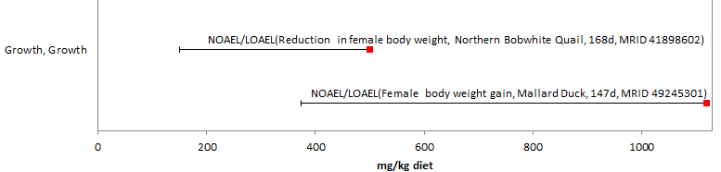
Figure 2-15. Dietary-based Endpoints (mg/kg-diet) for Birds Exposed to Methomyl. Data from registrant-submitted studies (red) only. Bars represent NOAEL/LOAEL ranges. Data label key: Endpoint (measured effect, common name, duration in days, ref#).

Effects on Reproduction of Birds

The data set for reproductive effects for birds includes 2 references representing 4 endpoints and 2 species. No oral dose-based studies are available that captured reproductive endpoints. Reproductive endpoints for dietary studies ranged from 150 to 1120 mg/kg-diet. All reported reproductive effects endpoints are displayed in Figure 2-16.

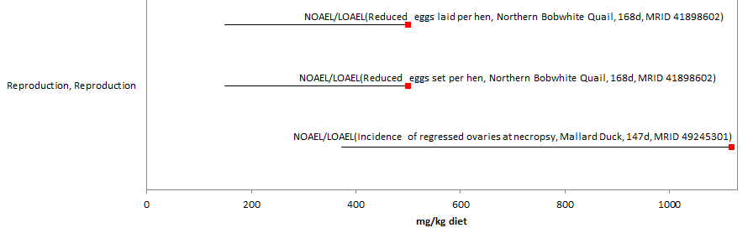
Figure 2-16. Dietary-based Reproduction Endpoints (mg/kg-diet) for Birds Exposed to Methomyl. Data is from registrant-submitted studies (red) only. Bars represent NOAEL/LOAEL range. Data label key: Endpoint (measured effect, common name, duration in days, ref#).

The most sensitive NOAEL value for methomyl is 150 mg/kg-diet (LOAEL = 458 mg/kg-diet, MRID 41898602, Beavers et al., 1991) for reproductive effects (35% reduction in number of eggs laid per hen compared to controls, and 36% reduction in eggs set per hen) and represents the sublethal threshold value for direct effects. Additional effects were seen in adults in this study at the 458 mg/kg-diet level and included a dose responsive weight loss reduction in female body weight; however, it is noted that this effect was not statistically significant. However, it should be noted that there was an error in the premix diet, and the test treatment level that was supposed to receive 50 ppm initially received 4-weeks treatment at 150 ppm. This was corrected and continued with the correct treatment level for the duration of the study. The statistical analysis was completed with and without the inclusion of the 50 ppm treatment level, and the inclusion of the data did not impact the data analysis or NOAEL/LOAEL determinations.

Based on the available data for bird species for dietary based studies, the most sensitive LOAEC value for methomyl is 458 mg/kg-diet for reduction in the number of eggs laid and eggs set per hen, and adult female body weight in the bobwhite quail (MRID 41898602, Beavers et al., 1991). This study was previously reviewed and qualified as acceptable. Therefore, by providing the lowest sublethal endpoint for birds, MRID 41898602 is used to set the sublethal threshold values for birds based on dietary exposure at 458 mg/kg-diet.

Drinking water studies

No studies involving avian exposure via drinking water were identified in registrant studies or the ECOTOX database.

Dermal studies

No studies involving avian exposure via dermal exposure were identified in registrant studies or the ECOTOX database.

Inhalation studies

No studies involving avian exposure via inhalation were identified in registrant studies or the ECOTOX database.

Incident Reports for Birds

There are currently (as of January 22, 2020) nine bird incident reports in IDS with a certainty index of ‘possible’, ‘probable’ or ‘highly probable’. Of these nine incidents, two are from a registered use, four are from misuse (either accidental or intentional), and in three of the incidents, the legality of use was undetermined (see Table 2-18. and ATTACHMENT 2-2, for details). The following discussion only includes those incident reports with a certainty index of ‘possible’, ‘probable’ or ‘highly probable’ and a legality classification of ‘registered’ and ‘undetermined’ (the incidents that were caused by a misuse are not reported further). There were two additional bird incidents attributed to methomyl in the AIMS database; however, both these incidents were from misuse, ‘abuse’ of the product, and therefore are not reported further.

The dates of the bird incident reports range from 1989 to 2016 (see Table 2-18.). The bird incident reports involve a variety of bird species (e.g., songbirds, doves, and raptors). In most of the known incidents, the use site is not reported or is unknown. For those incidents that do report a use site, the incidents were associated with the following use sites: cabbage (2); and an agricultural field (1). The methomyl product involved in the incidents is not reported or not specified beyond ‘Lannate 20L’ in most of the incidents. In most of the incident reports, methomyl was the only pesticide noted in the report. There are, however, two incident reports that involve at least one pesticide in addition to methomyl (see Table 2-18.).

Table 2-18. Bird Incident Reports from IDS (Those Classified as ‘Possible’, ‘Probable’, or ‘Highly Probable’ with Legality of Use = ‘Registered’ or ‘Undetermined’).
INCIDENT NUMBER | YEAR | CHEMICAL(S) INVOLVED (PC CODE) | CERTAINTY INDEX (for methomyl) | STATE | LEGALITY  (for methomyl) | USE SITE | SPECIES AFFECTED | DISTANCE | EFFECT/ MAGNITUDE | PRODUCT
I006382-001 | 1989 | Methomyl (090301) | Probable | France | Registered use  (in France) | Cabbage | Finches | In the field the day after application | At least 52 bull finches and 6 gold finches | Lannate 20L
I006382-002 | 1992 | Methomyl (090301) | Probable | France | Registered use  (in France) | Cabbage | Finches (i.e., green finches, and goldfinches) and linnets | Unknown | Death of 35 birds, and intoxication of 31 birds; after birds were observed drinking dew from cabbage field the morning of application. Detection of 0.018 ppm methomyl in a dead bird. | Lannate 20L
 |  | Mancozeb (014504)
I018980-010 | 2004 | Methomyl (090301) | Possible | VI, UK | Undetermined | No data | 13 laughing gulls (Larus articilla) & 1 cattle egret (Bubulcus ibis) | Unknown | Mortality of 14 birds total; the cause was toxicosis by methomyl and oxamyl. | Methomyl
Oxamyl
(103801)
I021455-003 | 2009 | Methomyl (090301) | Highly probable | FL | Undetermined | N/R | Vultures (Cathartidae) & Virginia opossum (Didelphis marsupialis) | Unknown | 31 vultures and 3 opossums found sick or dead. Diagnostic evaluation found methomyl toxicosis. 82% ChE inhibition with complete reversal upon incubation. Report states no bait or human presence was found. | Methomyl
I024528-002 | 2010 | Methomyl (090301) | Probable | CA | Undetermined | River | Blackbird (Icteridae), Dove (Columbina sp.)  and finch (Fringillidae) | On field | Approx. 60 birds (mourning doves, finches and blackbirds) were found dead in a strawberry field. It was suggested that the seed may have been poisoned with methomyl. The seed found in the crop contents of dead birds detected 0.00326 ppm and 0.0013 ppm of methomyl. | Methomyl

In addition to the terrestrial incident reports available in IDS, there have also been a total of 13 aggregate wildlife incidents. Of these 13, seven are associated with active registrations (six involve products either no longer registered or no registration numbers reported) (see ATTACHMENT 2-2 and Table 2-19).

Table 2-19. Aggregate Wildlife Incidents for Methomyl Involving Currently Registered Products.
PRODUCT REGISTRATION NUMBER | PRODUCT NAME | NUMBER OF AGGREGATE WILDLIFE INCIDENTS | YEAR(S)
000352-00342 | DUPONT LANNATE  SP INSECTICIDE | 1 | 2003
002724-00274 | GOLDEN MALRIN  RF-128 FLY KILLER | 6 | 2011, 2012, 2013, 2017

Since 1998, incidents that are allowed to be reported aggregately by registrants [under FIFRA 6(a)(2)] include those that are associated with an alleged effect to wildlife (birds, mammals, or fish) without differentiation between species or terrestrial and aquatic environments. Typically, the only information available for aggregate incidents is the date (i.e., the quarter) that the incident(s) occurred, the number of aggregate incidents that occurred in the quarter, and the PC code of the pesticide and the registration number of the product involved in the incident. Because of the limited amount of data available on aggregate incidents it is not possible to assign certainty indices or legality of use classifications to the specific incidents. Therefore, the incidents associated with currently registered products are assumed to be from registered uses unless additional information becomes available to support a change in that assumption.

Effects Characterization for Reptiles

There are no data available for reptiles exposed to methomyl.

As no additional data are available on reptilian toxicity to methomyl, the available toxicity data for birds are used as a surrogate for reptiles for all lines of evidence in addition to the study discussed above. Direct and indirect mortality thresholds are based on those established for birds. There is notable uncertainty in using birds as surrogates for terrestrial-phase reptiles as it is assumed that they will have similar responses to methomyl.

Effects Characterization for Terrestrial-Phase Amphibians

No toxicity data are available for terrestrial-phase amphibians exposed to methomyl. The available toxicity data and thresholds for birds are used as a surrogate for amphibians. There is notable uncertainty in using birds as surrogates for amphibians as it is assumed that they will have similar responses to methomyl.

Effects Characterization for Mammals

Introduction to Mammal Toxicity

The effects of methomyl on mammals have been studied extensively. APPENDIX 2-4 includes the bibliography of studies that are included in this effects characterization. Studies were excluded if they were considered invalid or not associated with an environmentally relevant exposure route. As acute toxicity data was only available for three species and did not allow for a calculation of a species sensitivity distribution, thresholds are based on the most sensitive lethal and sublethal effects identified among registrant-submitted studies and open literature in the ECOTOX database.

Threshold Values for Mammals

To determine the most sensitive endpoint, data tables generated by the data array builder are sorted for the major effects groups. The data are sorted based on endpoints normalized to 15 g body weight and displayed in arrays with the normalized value. However, for discussion purposes herein and in associated tables, the original study dose is used. As per the methodology for creating the arrays, reported NOAEL values without LOAELS are excluded from the table.

The endpoints used to derive mortality and sublethal (i.e., growth and reproduction) thresholds for direct and indirect effects for mammals are presented in Table 2-20.

Table 2-20. Endpoints Used to Derive Thresholds for Mammals.
THRESHOLD | ENDPOINT | EFFECT(S) | SPECIES  (Common Name) | SPECIES (Scientific Name) | STUDY ID
Mortality – dose based | LD₅₀ = 7.14 (6.22-8.19) mg/kg-bw; slope = 4.5¹ | Mortality | Harlan Sprague-Dawley Rat | Rattus norvegicus | MRID 48226104  (Kuhn 1996)
Sublethal | NOAEL/LOAEL = 0.75/2.0 mg/kg-bw  1.2 mg/kg-bw (MATC) | Growth - ↓ 73% reduction in body weight gain in female rats (days 2-8) | Rat | R. norvegicus | MRID 44487501  (Mikles, 1998)
¹ A default slope value of 4.5 was used for the mortality endpoints.

Effects Data for Mammals

Effects on Mortality of Mammals

All values for any reported mortality effect range from 7.14 to 5367 mg/kg-bw (MRID 48226104 to MRID 43692201, respectively). The endpoints considered for the mortality line of evidence are included in Figure 2-17. The mortality endpoints are discussed below.

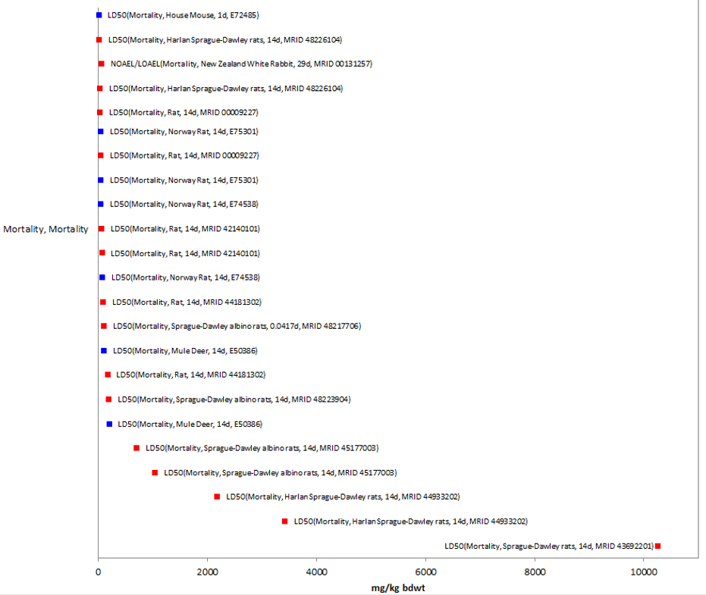
Figure 2-17. Mortality Endpoints for Methomyl Exposure Normalized to 15 g. Data are from registrant-submitted studies (red) and open literature (blue). Bars represent NOAEL/LOAEL range with the LOAEL value represented by the colored data point. Data label key: Endpoint (measured effect, common name, duration in days, ref#).

Therefore, based on the available information, the lowest 14d LD₅₀ value for methomyl was 7.14 (6.22-8.19) mg/kg-bw for female Harlan Sprague-Dawley albino rats (MRID 48226104, Kuhn 1996). Rats were exposed to the formulation ROTAM 90SP of methomyl (90% a.i.) by oral gavage with doses ranging from 5.0 to 25.0 mg/kg-bw. All deaths occurred within the first two hours after dosing, and there were no deaths in the 5 and 8 mg/kg-bw dose level females/males, respectively; but deaths were observed at all other test levels (6.5/17 mg/kg-bw or greater for females/males, respectively). Signs of toxicity were seen in all animals (females/males) in all dose groups, except those dying within the first hour of dosing, and they included piloerection, activity decrease, salivation, body tremors, sensitivity to sound, gasping, rapid breathing, polyuria, ptosis and muzzles stained red. Survivors recovered by day 8. The gross necropsy for rats observed matted muzzles, clear or white liquid in stomachs, orange gel in small intestines, and/or green paste in large intestines. However, surviving rats had no observable abnormalities. This endpoint is used to derive the thresholds for mammals.

Sublethal Effects to Mammals

Effects on Growth of Mammals

Growth endpoints range from 2.0 mg/kg-bw to 30 mg/kg-bw. The lowest growth effect endpoint of 2.0 mg/kg-bw (NOAEL/LOAEL 0.75/2.0 mg/kg-bw and an MATC of 1.2; MRID 44487501) was based on decreased body weight gain (73%) in the female rats during days 2-8 (MRID 44487501). The highest growth effect endpoint reported is decreased body weight in the female rat at 113 mg/kg-bw (NOAEL/LOAEL = 11.2/113 mg/kg-bw; MRID 44666201); the male NOAEL/LOAEL was 9.4/94.9 mg/kg-bw for the same study (MRID 44666201). The reported growth endpoints are displayed in Figure 2-18.

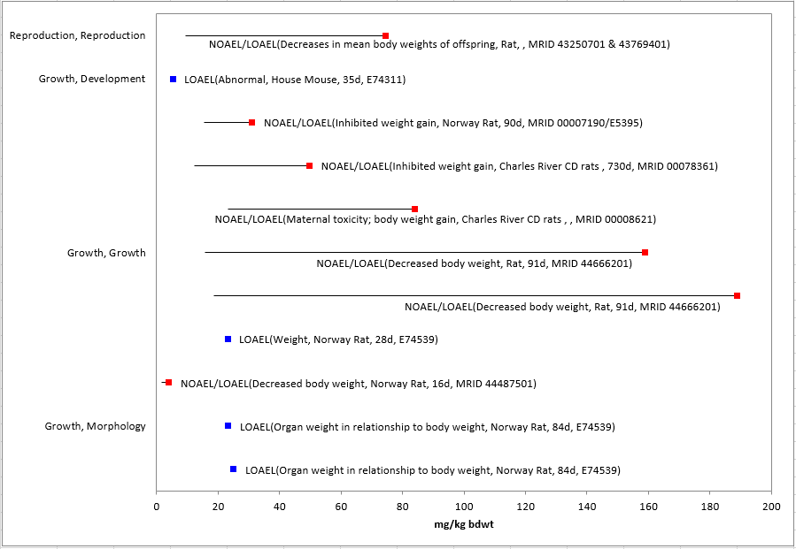
Figure 2-18. Growth Endpoints for Methomyl Exposure Normalized to 15 g. Data are from registrant-submitted studies (red) and open literature (blue). Bars represent NOAEL/LOAEL range with the LOAEL value represented by the colored data point. Data label key: Endpoint (measured effect, common name, duration in days, ref#).

Effects on Reproduction of Mammals

The reproduction endpoints for methomyl are a NOAEL/LOAEL of 3.75/30 mg/kg-bw based on decreased number of live pups (MRID 43250701 & 43769401; Lu, 1983 & Hurtt, 1995). The reported effects endpoints in the reproduction group tend to be similarly or slightly less sensitive than other major effects group. All reported reproductive effects endpoints are displayed in Figure 2-19.
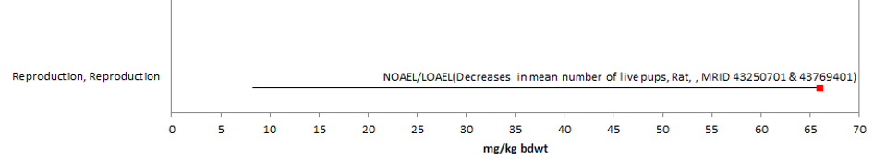
Figure 2-19. Reproduction Endpoints for Methomyl Exposure Normalized to 15 g. Data are from registrant-submitted studies (red) and open literature (blue). Bars represent NOAEL/LOAEL range with the LOAEL value represented by the colored data point. Data label key: Endpoint (measured effect, common name, duration in days, ref#).

Drinking water studies

There is one study that evaluated methomyl effects from drinking water exposure available (Table 2-21.). In the Norway rat, effects on weight was reported at 0.41 mg/org/d in a 21-d study (E171537).

Table 2-21. Toxicity Data in the Open Literature for Methomyl Based on Drinking Water Exposure
Species | Endpoint | Duration (d) | Endpoint Concentration | UNITS | Reference #
Norway rat | Weight | 21 | 0.41 (LOAEL) | mg/org/d | Djeffal A., et al. 2015; E171537

Dermal exposure studies

Multiple studies for dermal exposure are available from information provided by HED as reported in USEPA’s HED RED (USEPA 1998), and Methomyl Registration Review Scoping Document (USEPA 2010) (see Table 2-22.). The available acute dermal values are presented in Table 2-22.. According to the HED RED document (USEPA 1998), the acute dermal LD₅₀ value for methomyl in rabbits is a Toxicity Category III. Based on the primary dermal irritation study with technical methomyl in rabbits. In addition to the suite of acute studies listed in the HED RED, there are additional available acute data studies submitted to support product registrations for registered formulations of methomyl. All the acute dermal studies available for methomyl are included in Table 2-22..

Table 2-22. Acute Dermal Exposure Studies for Methomyl
STUDY | MRID Number | RESULTS
Acute Dermal LD₅₀ - rat | 44248101 (29% a.i.) | >2000 mg/kg (both sexes)
 | 42679902 (1.00% a.i.) | >2000 mg/kg (both sexes)
 | 48223904 (29% a.i.) | >2000 mg/kg (both sexes)
Acute Dermal LD₅₀ - rabbit | 42074602 (98% a.i.; TGAI) | >2000 mg/kg (both sexes)
 | 44924101 (1.00% a.i.) | >2010 mg/kg (both sexes)
 | 48217706 (98% a.i.; TGAI) | >5050 mg/kg (both sexes)
 | 48226104 (91.12% a.i.) | >5050 mg/kg (both sexes)
There are no studies associated with dermal exposure of methomyl in the ECOTOX database.

Inhalation studies

Multiple studies for inhalation exposure are available from information provided by HED as reported in USEPA’s HED RED (USEPA 1998), and Methomyl Registration Reviews Scoping Document (USEPA 2010) (see Table 2-23). There is only acute inhalation data available for methomyl, and the data are presented in Table 2-23. According to the HED RED document (USEPA 1998), the acute inhalation LC₅₀ for methomyl in rats is a Toxicity Category II based on a four-hour exposure (nose only) to technical grade methomyl aerosol. In addition to the TGAI data listed in the HED RED, there are additional available acute data studies submitted to support product registrations for registered formulations of methomyl (see Table 2-23).

Table 2-23. Inhalation Studies for Methomyl (reported in the 1998 RED, the 2010 Methomyl Registration Review Scoping Document, and the available 6-pack data).
EXPOSURE SCENARIO | DOSE  (mg/L) | ENDPOINT | STUDY
Acute Inhalation  LC₅₀ rats | LC₅₀ = 0.258 mg/L (both sexes) | Mortality. Clinical signs among rats that died included abnormal gait, tremors, hyperactivity, hyperreactivity, muscle fasciculation and hunched or low posture. | MRID 42140102  (TGAI; 98% a.i.)
Acute Inhalation  LC₅₀ rats | LC₅₀ > 0.053 mg/L (both sexes) | Only two dose levels were tested, 0.053 and 0.35 mg/L. All animals survived in 0.053 mg/L level (appeared active, gained weight and appeared healthy throughout study period). All animals exposed to 0.35 mg/L died within 1.25 hr of exposure; no clinical signs were observed prior to death; at necropsy - discoloration and edema of lungs were observed in all descendants. | MRID 48223904  (29% a.i.)
Acute Inhalation  LC₅₀ rats | LC₅₀ = 0.40 mg/L | Animals exhibited tremors, irregular breathing; grooming actions, salivation, lacrimation during the first minutes of exposure and bulging red trimmed eyes near the end of exposure. Post-exposure no signs of toxicity were seen except moderate weight loss the first day; growth was normal thereafter. | MRID 00008980  (90% a.i.)
Acute Inhalation  LC₅₀ rats | LC₅₀ < 0.60 mg/L | 8/10 rats died; apparently in the first 2½ hrs following initiation of exposure. The 2 surviving rats showed piloerection, slight to moderate decreased activity, very slight to slight body tremors, and very slight to slight respiratory gurgle. The male had red fluid around the eyes. These signs (except eyes) were still present on day 1 and gone on day 2; and survivors were normal for remainder of study. | MRID 48217706  (98%; TGAI)
Acute Inhalation  LC₅₀ rats | LC₅₀ >0.114 < 0.299 mg/L | All rats exposed to 0.299 mg/L were dead in 2.5 hrs into the scheduled 4 hr exposure. Signs of toxicity in 1 F rat 1 hr in (all other 9 rats were dead at this time); included piloerection, extreme body tremors and moderate polyuria. There was no mortality in rats exposed to 0.114 mg/L. Signs of toxicity in the 0.114 mg/L group included polyuria, decreased activity, piloerection, red ocular discharge, body tremors, unsteady gait, withdrawn testes, nasal discharge, lacrimation, ptosis, fur coated with feces and/or urine, and crust around the eyes. | MRID 48226104 (91.12% a.i.)
Acute Inhalation  LC₅₀ rats | LC₅₀ = 1.1 mg/L | Mortality | MRID 44324901  (29% a.i.)
Acute Inhalation  LC₅₀ rats | LC₅₀ > 2.10 mg/mL (both sexes) | No mortality. Symptoms of toxicity included increased or decreased rate of respiration, piloerection and hunched posture. One male showed ptosis. All animals appeared normal on day 2. | MRID 43681601  (1.00% a.i.)
Acute Inhalation  LC₅₀ rats | LC₅₀ > 2.31 mg/mL (both sexes) | No mortality. Clinical signs included decreased activity, blue staining around nose and piloerection in both sexes. Animals appeared normal by day 2. | MRID 44933203  (1.00% a.i.)

There are no studies associated with inhalation exposure of methomyl in the ECOTOX database.

Incident Reports for Mammals

A review of the incident databases showed a total of 20 reported ecological incidents associated with the use of methomyl, of which 16 are terrestrial incidents. Methomyl has been reported as the ‘probable’ or ‘highly probable’ causative agent for seven terrestrial incidents, including birds, mammals, and plants. There are currently (as of January 22, 2020) seven mammal incident reports in the IDS with a certainty index of ‘possible’, ‘probable’ or ‘highly probable’. Of these seven incidents, four are from misuse (either accidental or intentional), and in three of the incidents, the legality of use was undetermined (see Table 2-24 below, for details). The following discussion only includes those incident reports with a certainty index of ‘possible’, ‘probable’ or ‘highly probable’ and a legality classification of ‘registered’ and ‘undetermined’ (the incidents that were caused by a misuse are not reported further).

The dates of the mammalian incident reports range from 2007 to 2016 (see Table 2-24). The mammal incident reports involve a variety of different kinds of mammals (e.g., opossums, cats, raccoons, and squirrels). In most of the known incidents, the use site is not reported or is unknown. The methomyl product involved in the incidents is not reported nor specified beyond ‘Golden Marlin’ in one of the reported incidents. In most of the incident reports, methomyl was the only pesticide noted in the report. There was, however, one mammalian incident report that involved at least one pesticide in addition to methomyl (see Table 2-24).
Table 2-24. Terrestrial Mammal Incident Reports from IDS
NUMBER | YEAR | CHEMICAL  INVOLVED  (PC CODE) | CERTAINTY INDEX | State | LEGALITY | USE SITE | SPECIES | DISTANCE | EFFECT/ MAGNITUDE | PRODUCT
I021455-003 | 2009 | Methomyl (090301) | Highly probable | FL | Undetermined | N/R | Vultures (Cathartidae)  &  Virginia opossum (Didelphis marsupialis) | Unknown | 31 vultures &  3 opossums found sick  or dead. Diagnostic evaluation found methomyl toxicosis. 82% ChE inhibition with complete reversal upon incubation. Report states no bait or human presence was found. | Unknown
I024767-006 | 2007 | Methomyl (090301) | Highly probable | MI | Undetermined | Unknown | Squirrel | N/R | 3 squirrels found dead in a backyard. Diagnosis was poisoning by methomyl | Unknown
I024767-008 | 2012 | Methomyl (090301) | Probable | OH | Undetermined | Residential | Cat | Unknown | Death of a neighborhood cat | Golden Marlin
(Z)-9-tricosene
(103201)

In addition to the terrestrial incident reports available in IDS, there have also been a total of 13 aggregate wildlife incidents. Of these 13, seven are associated with active registrations (six involve products either no longer registered or no registration numbers reported) (see ATTACHMENT 2-2 and Table 2-25).

Table 2-25. Aggregate Wildlife Incidents for Methomyl Involving Currently Registered Products.
PRODUCT REGISTRATION NUMBER | PRODUCT NAME | NUMBER OF AGGREGATE WILDLIFE INCIDENTS | YEAR(S)
000352-00342 | DUPONT LANNATE  SP INSECTICIDE | 1 | 2003
002724-00274 | GOLDEN MALRIN  RF-128 FLY KILLER | 6 | 2011, 2012, 2013, 2017

Since 1998, incidents that are allowed to be reported aggregately by registrants [under FIFRA 6(a)(2)] include those that are associated with an alleged effect to wildlife (birds, mammals, or fish) without differentiation between species or terrestrial and aquatic environments. Typically, the only information available for aggregate incidents is the date (i.e., the quarter) that the incident(s) occurred, the number of aggregate incidents that occurred in the quarter, and the PC code of the pesticide and the registration number of the product involved in the incident. Because of the limited amount of data available on aggregate incidents it is not possible to assign certainty indices or legality of use classifications to the specific incidents. Therefore, the incidents associated with currently registered products are assumed to be from registered uses unless additional information becomes available to support a change in that assumption.

Effects Characterization for Terrestrial Invertebrates

Introduction to Terrestrial Invertebrate Toxicity

Methomyl is an insecticide that acts through inhibition of acetylcholinesterase and is used to kill a broad range of insects and mites. As an insecticide, methomyl’s effects on terrestrial invertebrates have been well documented in the literature. Most available studies have focused on mortality endpoints, however, there are also data available for describing sublethal effects, including those related to growth, and reproduction.

The acute mortality thresholds are based on the most sensitive LC₅₀ or LD₅₀ values (<96 hr exposure) available for terrestrial invertebrates, since an SSD could not be derived using the available data. Sublethal thresholds are also derived to represent the most sensitive non-acute mortality effects for both direct and indirect effects. In the case of methomyl and terrestrial invertebrates, however, the lowest endpoints, considering both lethal and sub-lethal effects, were almost always mortality endpoints. Therefore, mortality endpoints are used to represent the most sensitive non-acute thresholds in many cases. Threshold values in this assessment are based on endpoints expressed in, or readily converted to, environmentally relevant concentrations that can be used to assess risks to terrestrial invertebrates using current methods [i.e., mg/kg-soil; mg/kg-bw (body weight); µg a.i./bee, and lb a.i./acre].

Threshold Values for Terrestrial Invertebrates

The endpoints used to derive threshold values for terrestrial invertebrates are provided in Table 2-26.

Table 2-26. Endpoints Used to Derive Thresholds for Terrestrial Invertebrate Species.
EXPOSURE UNIT | THRESHOLD VALUE | ENDPOINT | EFFECT(S) | SPECIES | STUDY ID | COMMENTS
Most Sensitive Endpoint (Relatable to Growth, Reproduction, and/or Mortality)
mg/kg-soil | 4.75 mg/kg-soil | LC₅₀ | Mortality | Earthworm (Aporrectodea calignosa) | E40226 | The most sensitive endpoint available is an EC₅₀; study was conducted in natural soil/cow dung mixture using a 25WP formulation for 37 days
mg/kg bw | -- | -- | -- | -- | -- | No studies were available that evaluated effects on a mg/kg-bw basis
µg a.i./bee | 0.0106 µg a.i./bee¹ | NOAEL | Mortality and Behavior (food consumption) | Honey bee (Apis mellifera) | MRID 49830501 | 10-day feeding study with technical grade methomyl; the NOAELs and LOAELs in the study were the same for both mortality and food consumption
 | 0.0172 µg a.i./bee | LOAEL
Lb a.i./acre | 0.0000053 lbs a.i./acre | LOAEC (no NOAEC observed in the study) | Fecundity | Parasitoid (Aphidius rhopalosiphi) | MRID 45133302 | 48-hr study using Methomyl 25 WP in the lab; LOAEC was based on a 43% decrease in number of mummies per female; a NOAEC was not observed (effects were seen at all test concentrations).
Most Sensitive LD₅₀/LC₅₀ Value(s)
mg/kg-soil | 4.75 mg/kg-soil | LC₅₀ (37-day) | Mortality | Earthworm (Aporrectodea calignosa) | E40226 | The most sensitive endpoint available is an EC₅₀; study was conducted in natural soil/cow dung mixture using a 25WP formulation for 37 days.
mg/kg bw | No Data | -- | -- | -- | -- | No studies were available that evaluated effects on a mg/kg-bw basis
 | No Data
µg a.i./bee | 0.068 µg a.i./bee² | LD₅₀ (contact) | Mortality | Honey bee  (A. mellifera) | E67983 | Test used 7-day old worker bees; contact exposure; slope was 9.03
Lb a.i./acre | 0.00022 lb a.i./acre | LC₅₀ | Mortality | Parasitoid Aphidius rhopalosiphi | MRID 45133301 | 48-hr study testing effects of Methomyl 20L; test organisms were <48-hrs old; Probit slope was 5.4
¹ Endpoints correspond to 0.313 mg a.i./kg-diet (NOAEL) and 0.625 mg a.i./kg-diet (LOAEL).
² Based on the body weight of test bee of 0.128 g for adult honey bee, endpoint converts to 0.5 mg a.i./kg-bw

Effects Data for Terrestrial Invertebrates

Effects on Mortality of Terrestrial Invertebrates

Most of the toxicity data available for methomyl and terrestrial invertebrates involve mortality endpoints. In most cases, mortality is actually the most sensitive endpoint available for the different environmentally relevant exposure units.

Mortality Threshold Values (mg/kg-soil)

For the exposure unit of mg/kg-soil, the most sensitive LC₅₀ value available is 4.75 mg a.i./kg-soil for earthworms (Aporrectodea calignosa) (E40226). In this study, four concentrations were tested along with the control: 25, 50, 100, and 200 mg/kg-dry soil (Methomyl 25 WP). The concentrations corrected for purity (25%) were 6.25, 12.5, 25, and 50 mg/kg-soil, respectively. One adult worm was placed in a glass vessel with 75 g of soil-cow dung mixture. There were five replicates at each test concentration and each replicate was repeated three times (for a total of 15 worms/treatment group). The experiment was conducted for 37 days and the survival and body mass of each worm was recorded after 8, 17, 27, and 37 days.

The LC₅₀ value from this study of 4.75 mg/kg-soil (E40226) is more sensitive than any of the available NOAEC or LOAEC values for this exposure unit, therefore, it will be used to derive the mortality and ‘sublethal’ thresholds for direct and indirect effects (although this endpoint is based on mortality, it is more sensitive than any endpoint available for sublethal effects).

Mortality Data Array (mg/kg-soil)

Based on the available data, methomyl is associated with mortality of terrestrial invertebrates at concentrations ranging from 4.75 to 50 mg/kg-soil (Figure 2-20).

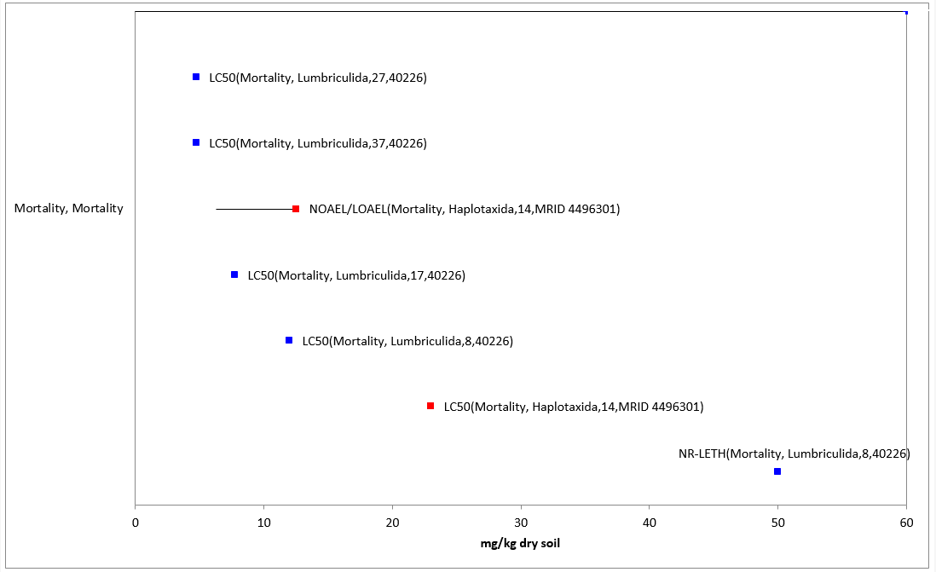
Figure 2-20. Mortality Endpoints for Terrestrial Invertebrates Exposed to Methomyl (mg/kg-soil). Data label key: Endpoint (measured effect, order, duration in days, reference number).

Mortality Thresholds (mg/kg-bw)

There are currently no methomyl toxicity data available for terrestrial invertebrates with the exposure unit of ‘mg/kg-bw’.

Mortality Thresholds (lb a.i./acre)

For the exposure unit ‘lb a.i./acre’, the most sensitive terrestrial invertebrate LC₅₀ value is 0.00022 lb a.i./acre in a parasitoid (Aphisdius rhopalosiphi) based on 48-hr exposure (MRID 45133301). In this study, Methomyl 20L was applied to glass plates at concentrations equivalent to 0.0000054, 0.000017, 0.00005, 0.00015, and 0.00045 lb a.i./acre. Adult (less than 48 hours old) parasitic wasps (A. rhopalosiphi) were exposed to the glass plates for 48 hours. By 48 hours, cumulative mortality rates were 13, 10, 15, 25, and 95% in the 0.0000054, 0.000017, 0.00005, 0.00015, and 0.00045 lb a.i./acre treatment groups, respectively. The 0.00005, 0.00015, and 0.00045 lb a.i./acre treatment groups had statistically significantly higher mortality rates than their control (control mortality was 3%). There were no significant differences observed for fecundity (based on the number of mummies per female) in any of the treatment groups when compared to the controls. The study resulted is an LC₅₀ value of 0.00022 lb a.i./acre with a probit slope of 5.4. The NOAEC was 0.000017 lb a.i./acre, based on mortality.

Therefore, 0.00029 lb a.i./acre and 0.00013 lb a.i./acre, will be used to assess the potential for direct and indirect effects related to the mortality of terrestrial invertebrates.

A set of semi-field tunnel studies were submitted that tested the effect of different time intervals between application and hive exposure on honey bee mortality, flight exposure, and brood development. Generally, the studies tested application rates of 0.074 – 0.079 lbs a.i./A applied 1, 5, and 10 days before hive exposure. Treatment groups exposed to 0.077 – 0.079 lbs a.i./A resulted in increased mortality, reduced flight intensity, and reduced brood development (only at 0.079 lbs a.i./A). There was no clear relationship between time intervals and toxic effects. In another semi-field tunnel study (MRID 49918901) methomyl was applied at a rate of 0.223 lb a.i./A that also evaluated the effect of different time intervals between application (early and full flowering) and hive exposure on honey bee mortality, flight exposure, and brood development. The treatment group exposed during full flowering observed increased mortality, reduced flight intensity, and reduced colony size (number of bees and number of brood cells).

Beneficial insect studies were performed to analyze the effects of field applications of methomyl to variety of terrestrial invertebrate species (e.g., spider mites, predatory mites, predatory wasps, carabid beetle, rove beetle etc.). In general, application rates between 0.0002 – 1.16 lbs a.i./acre resulted in deleterious effects (in certain studies the increased mortality observed with methomyl applications surpassed the reference toxicant) and then after a certain amount of time most species exhibited an observed recovery in the field.

Mortality Data Arrays (lb a.i./acre)

Regarding mortality, methomyl is associated with increased mortality of terrestrial invertebrates at concentrations from 0.000017 to 20 lb a.i./acre (Figure 2-21). Most of the endpoints for methomyl and terrestrial invertebrates reported in the lb a.i./acre exposure unit are for population-level effects (all related to abundance/biomass/control which are assumed to be related to mortality; and are, therefore included in this mortality section). These effects are seen at concentrations from 0.039 to 20 lb a.i./acre (Figure 2-22, Figure 2-23, Figure 2-24, and Figure 2-25).

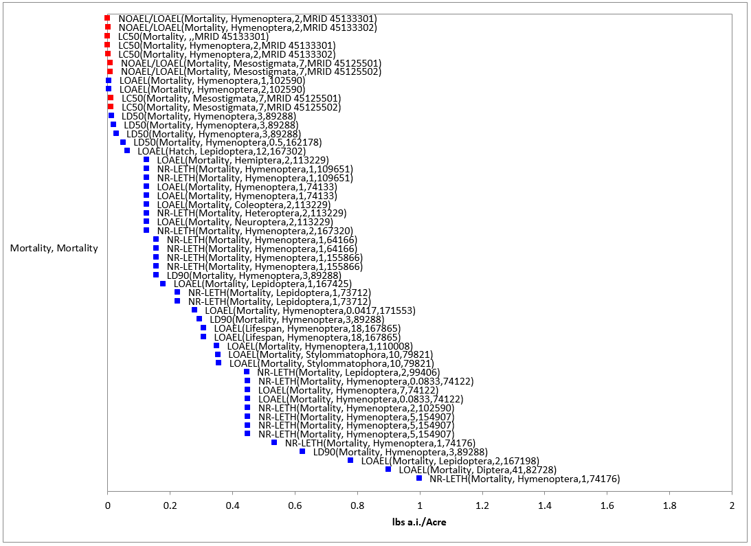
Figure 2-21. Mortality Endpoints for Terrestrial Invertebrates Exposed to Methomyl (lb a.i./acre). Data label key: Endpoint (measured effect, order, duration in days, reference number). Although most of the available mortality endpoints occur at concentration < 2 lb a.i./acre, there is 1 mortality endpoint that is greater than 2 lb a.i./acre (i.e., an LC₅₀ of 20 lb a.i./acre for the earthworm, Lumbricus terrestris) (this has been removed from the figure for presentation purposes).

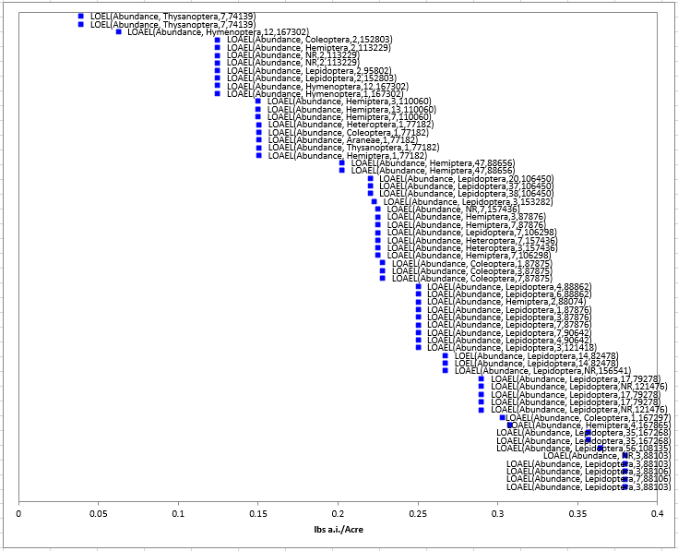
Figure 2-22. Population-Level Endpoints for Terrestrial Invertebrates Exposed to Methomyl (lb a.i./acre) – Exposure Values from 0 to 0.4 lb a.i./acre (the data are presented across several figures due to the number of endpoints). Data label key: Endpoint (measured effect, order, duration in days, reference number).
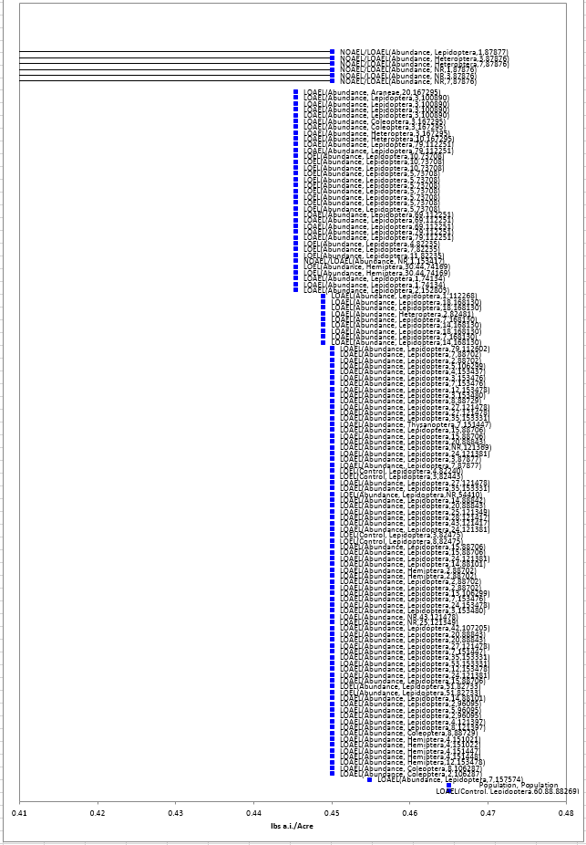
Figure 2-23. Population-Level Endpoints for Terrestrial Invertebrates Exposed to Methomyl (lb a.i./acre) – Exposure Values from 0.41 to 0.48 lb a.i./acre (the data are presented across several figures due to the number of endpoints). Data label key: Endpoint (measured effect, order, duration in days, reference number).
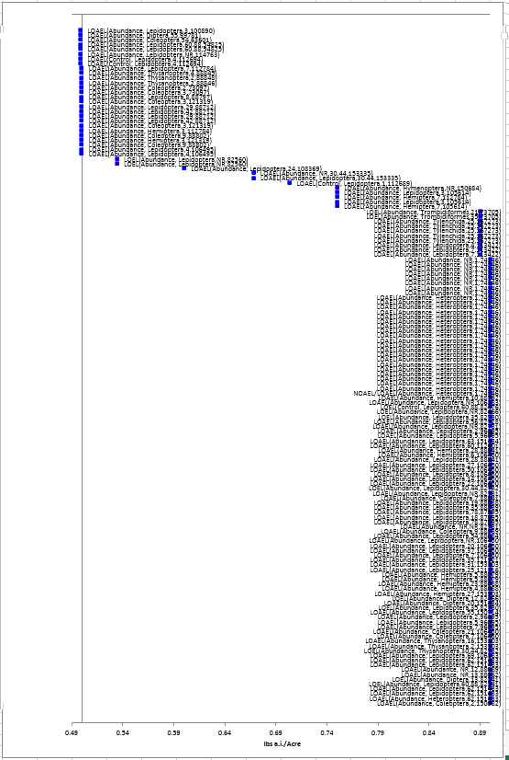
Figure 2-24. Population-Level Endpoints for Terrestrial Invertebrates Exposed to Methomyl (lb a.i./acre) – Exposure Values from 0.49 to 0.9 lb a.i./acre (the data are presented across several figures due to the number of endpoints). Data label key: Endpoint (measured effect, order, duration in days, reference number).
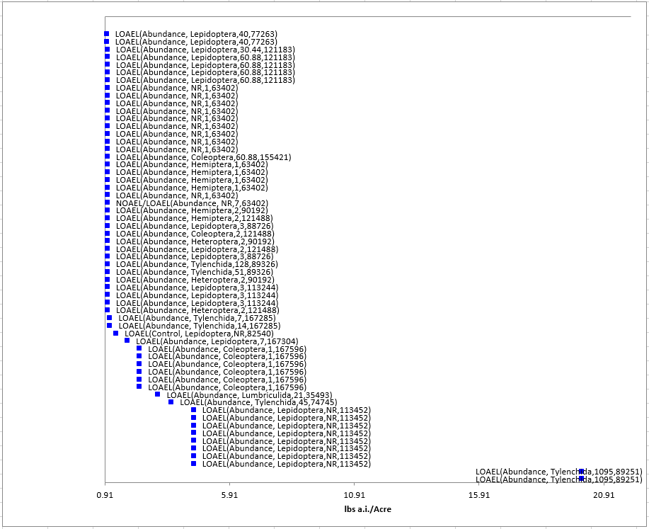
Figure 2-25. Population-Level Endpoints for Terrestrial Invertebrates Exposed to Methomyl (lb a.i./acre) – Exposure Values from 0.91 to 22 lb a.i./acre (the data are presented across several figures due to the number of endpoints). Data label key: Endpoint (measured effect, order, duration in days, reference number).

Mortality Thresholds (µg a.i./bee)

For the exposure unit of µg a.i./bee, the most sensitive LD₅₀ value available is 0.068 µg a.i./bee for contact exposure to adult honey bees (Apis mellifera) (E67983). In this study, adult 7-day old worker bees, were exposed to five different concentrations plus a solvent control. All data were corrected for purity (90% methomyl). Each treatment group involved five replicates, each with 10 bees. The experiment was repeated three times. One µl of the test solutions were applied to the mediodorsal thoracic surface of each bee with a microapplicator syringe. The treated bees were placed in beakers with cups containing 25% sucrose solution. Mortalities were recorded 24 hours after treatment and adjusted using Abbott’s formula.

For the exposure unit ‘µg a.i./bee’, the most sensitive endpoint available for terrestrial invertebrates is NOAEL value for both mortality and food consumption of 0.0106 µg a.i./bee for exposure to adult honey bees (Apis mellifera) (MRID 49830501). The corresponding LOAEL value is 0.0172 µg a.i./bee. These endpoints will be used to derive the ‘sublethal’ thresholds for direct and indirect effects, respectively (although this endpoint is based on mortality and food consumption, it is more sensitive than any endpoint available for sublethal effects).

In this study, young adult worker bees (newly hatched; 1 – 2 days old) were exposed to methomyl (TGAI; 99.4% pure) in their diet for 10 days. Nominal dietary concentrations in the diet were 0.313, 0.625, 1.25, 2.50, and 5.00 mg a.i./kg-diet, plus a control. The corresponding mean accumulated intake doses were 0.0106, 0.0172, 0.0260, 0.0509, and 0.0541 µg a.i./bee/day, respectively. There were four replicates for each control and treatment group and each replicate contained 10 bees (for a total of 40 bees per treatment level). Feeding solutions (treatment in 50% sucrose solution) were provided daily using 5 mL-plastic syringes. After 10 days, mortality was 2.5, 0, 20, 63, 73, and 100% in the control and nominal 0.313, 0.625, 1.25, 2.5, and 5.0 mg ai/kg-diet groups, respectively. The mean daily feed consumption was 33.8, 33.8, 27.5, 20.8, 20.4, and 10.8 mg/bee in the control and nominal 0.313, 0.625, 1.25, 2.5, and 5.0 mg ai/kg-diet groups, respectively.

There was one lower mortality endpoint available from the open literature than the one being used here [an LD₁₀ value of 0.001 ug a.i./bee from a honey bee (Apis mellifera) larvae study (E070351)]. The endpoint is from 1 to 2-day old larvae, but the difference in the LD₁₀ and LD₉₀ for this age group was over 5 orders of magnitude, suggesting inconsistent exposures or other issues for this life stage (see Table 2-27). Therefore, this value was not used as a threshold (however it is still included in the data arrays).

Table 2-27. Dosage-Mortality Data for Honeybee Larvae Treated in the Brood Cell with Methomyl (from E070351).
DATUM | AGE OF TREATED LARVAE (DAYS)
 | 1 – 2 | 3 – 4 | 5 - 6 | ALL
SLOPE | 0.325 | 1.34 | 1.45 | 1.18
INTERCEPT | 5.05 | 5.27 | 5.24 | 5.32
LD₁₀ | 0.001 | 0.071 | 0.099 | 0.045
LD₅₀ | 0.726 | 0.632 | 0.682 | 0.539
LD₉₀ | >620 | 5.67 | 5.12 | 6.53

Mortality Data Arrays (µg a.i./bee)

Most of the data available for methomyl and terrestrial invertebrates in exposure units of µg a.i./bee involve mortality endpoints. The available mortality endpoints for methomyl range from 0.001 to 36.4 µg a.i./bee (see Figure 2-26).

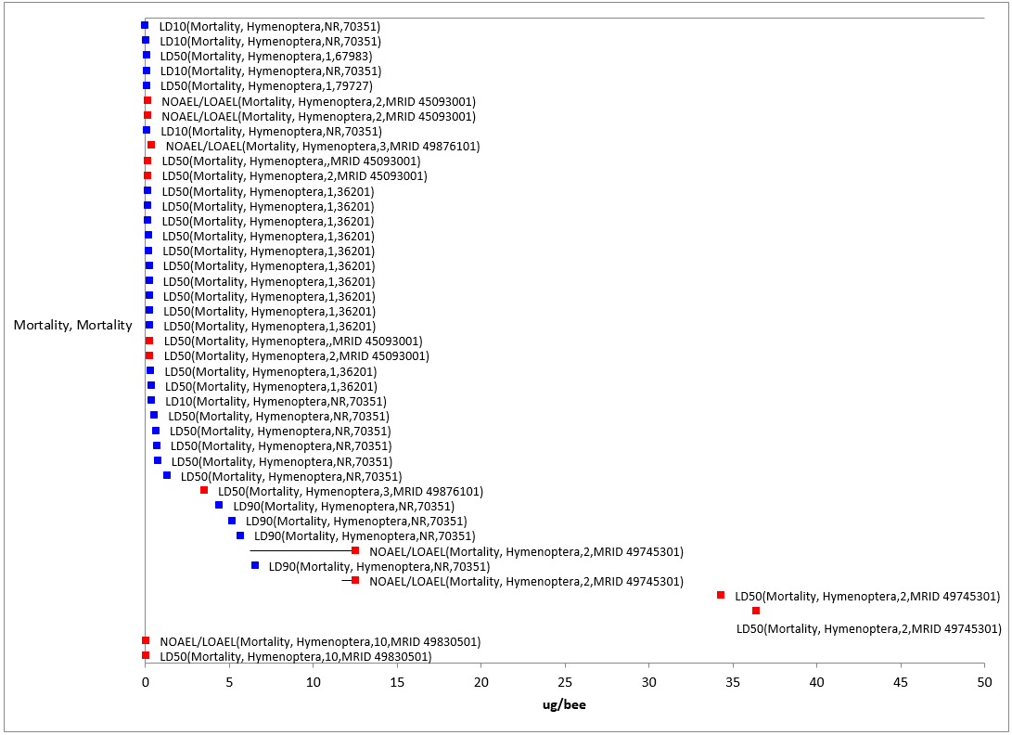
Figure 2-26. Mortality Endpoints for Terrestrial Invertebrates Exposed to Methomyl (µg a.i./bee). Data from registrant submitted studies (red) and open literature (blue). Data label key: Endpoint (measured effect, order, duration in days, reference number).

Sublethal Effects to Terrestrial Invertebrates

Effects on Growth of Terrestrial Invertebrates

There are far fewer data available for growth effects compared to mortality when considering the available terrestrial invertebrate toxicity data for methomyl. There is only one growth endpoint available for terrestrial invertebrates and methomyl; a LOAEL of 6.25 mg/kg-soil for effects on weight in a 37-day earthworm (Aporrectodea caliginosa) study (E40226) (this is from the same study described above in the mortality discussion). For the exposure units ‘mg/kg-bw’, ‘lb a.i./acre’, and ‘µg a.i./bee’, there are no effects data related to growth.

Effects on Reproduction of Terrestrial Invertebrates

Most of the reproductive effects seen in terrestrial invertebrates with exposure to methomyl involve effects to the number of progeny produced and effects on emergence. Data on reproductive effects are only available for the environmentally relevant exposure unit of ‘lb a.i./acre’ (there are no reproductive endpoints currently available for methomyl and the ‘mg/kg-soil’, ‘mg/kg-bw’, or the ‘µg a.i./bee’ exposure units).
Lb a.i./acre:

For the exposure unit ‘lb a.i./acre’, the most sensitive endpoint available for terrestrial invertebrates is a LOAEC value of 0.0000053 lb a.i./acre for a parasitic wasp (Aphidius rhopalosiphi) based on the number of mummies per female (MRID 45133302). This endpoint is the most sensitive endpoint available, therefore, it will be used as the sublethal threshold for direct and indirect effects for this exposure unit and terrestrial invertebrates.

In this study, parasitic wasps (A. rhopalosiphi) were exposed to Methomyl 25 WP at concentrations equivalent to 0.0000054, 0.000017, 0.00005, 0.00015, and 0.446 lb a.i./acre (MRID 45133302). Adult (less than 48 hours old) parasitic wasps were exposed to treated glass plates for 48 hours. Fecundity (the number of mummies produced per female) was statistically significantly reduced at all test concentrations when compared to controls. The number of mummies per female was 6.16, 5.25, 4.74, and 4.19 in the 0.0000054, 0.000017, 0.00005, and 0.00015 lb a.i./acre treatment groups, respectively, compared to 10.75 in the control group (95% of the wasps in the 0.446 lb a.i./acre treatment group died during the study).

Reproductive effects (including effects to emergence, general reproductive success, viability and number of progeny) are seen at concentrations from 0.0000053 to 3.6 lb a.i./acre (see Figure 2-27).

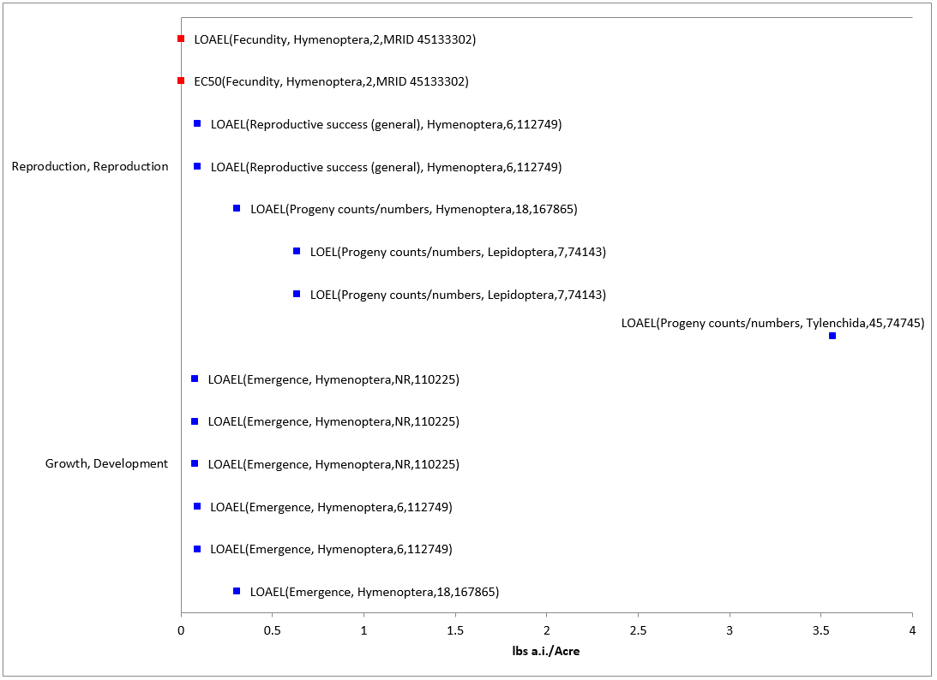
Figure 2-27. Reproduction Endpoints for Terrestrial Invertebrates Exposed to Methomyl (lb a.i./acre). Data from registrant submitted studies (red) and open literature (blue).Data label key: Endpoint (measured effect, order, duration in days, reference number).

Incident Reports for Terrestrial Invertebrates

There are currently (as of January 22, 2020) two terrestrial invertebrate incident reports in the Incident Data System (IDS) with a certainty index of ‘possible’, ‘probable’ or ‘highly probable’. For these two incidents the legality of use was undetermined (see Table 2-28 and ATTACHMENT 2-2, for details). The following discussion only includes those incident reports with a certainty index of ‘possible’, ‘probable’ or ‘highly probable’ and a legality classification of ‘registered’ and ‘undetermined’ (the incidents that were caused by a misuse are not reported further).

The dates of the bee-kill incident reports ca. 2014 (see Table 2-28) ranging from approximately 12 dead bees to “thousands”. Both of these incidents (I026976-001 and I026963-002) are classified as undetermined legality and of probable certainty, are related to each other. A bee keeper provided a bee kill incident report from the Massachusetts Department of Agriculture and Resources. Methomyl residues were detected in the dead bees at levels of 100 ppb but lambda-cyhalothrin from Warrior was not detected (likely below the level of detection, 53 ppb) (see Table 2-28). Overall, the incident data that are available indicate that exposure pathways for methomyl are complete and that exposure levels are sufficient to result in field-observable effects.

Reports contained in the database must be interpreted in the context that 1) not all incidents are expected to be reported and 2) in many instances it is difficult to establish a direct cause-effect relationship. Generally, if there are a significant number of incidents associated with the use of a certain pesticide, it may be an indication that the pesticide may pose a higher environmental risk. However, the lack of reported incidents does not necessarily indicate a lack of incidents.

Table 2-28. Terrestrial Invertebrate Incident Reports from IDS (Those Classified as ‘Possible’, ‘Probable’, or ‘Highly Probable’ with Legality of Use = ‘Registered’ or ‘Undetermined’).
INCIDENT NUMBER | YEAR | CHEMICAL(S) INVOLVED (PC CODE) | CERTAINTY INDEX (for methomyl) | STATE | LEGALITY  (for methomyl) | USE SITE | SPECIES AFFECTED | DISTANCE | EFFECT/ MAGNITUDE | PRODUCT
I026963-002 | 2014 | Methomyl  (090301) | Probable | MA | Undetermined | Residential | Honey bee (Apis mellifera) | Bee keeper is convinced pesticide applied to sweet corn in vicinity is responsible for death of bees. | Thousands | This incident is related to I026976-001; a bee keeper provided a bee kill incident report from the MA Dept. of Agriculture and Resources that is applicable to both reports (I026976-001 and I026963-002); methomyl was detected in the dead bees but lambda-cyhalothrin from Warrior was not.
Lambda-cyhalothrin
(128897)
I026976-001 | 2014 | Methomyl  (090301) | Probable | MA | Undetermined | Agricultural area | Honey bee (Apis mellifera) | Approx. a dozen bees were observed dying in the vicinity of application | Mortality/12 | Lannate LV. Bees were collected and delivered to the Massachusetts Pesticide Analytical Lab (MAPL) on July 23, 2014. Results were positive for methomyl (100ppb) and no detection for cyhalothrin (active ingredient used by a local farmer; which was likely below the detection limit of 53 ppb. This incident is related to I026963-002; a bee keeper provided a bee kill incident report from the MA Dept. of Agriculture and Resources that is applicable to both reports (I026976-001 and I026963-002); methomyl was detected in the dead bees but lambda-cyhalothrin from Warrior was not.

In addition to the non-aggregated terrestrial incident reports available in IDS, there have also been a total of 12 aggregate wildlife incidents and one other non-target incident reported to the Agency. Of these 13, seven are associated with active registrations (six involve products either no longer registered or no registration numbers reported) (see ATTACHMENT 2-2 and Table 2-29).

Table 2-29. Aggregate Wildlife Incidents for Methomyl Involving Currently Registered Products.
PRODUCT REGISTRATION NUMBER | PRODUCT NAME | NUMBER OF AGGREGATE WILDLIFE INCIDENTS | YEAR(S)
000352-00342 | DUPONT LANNATE  SP INSECTICIDE | 1 | 2003
002724-00274 | GOLDEN MALRIN  RF-128 FLY KILLER | 6 | 2011, 2012, 2013, 2017

Since 1998, incidents that are allowed to be reported aggregately by registrants [under FIFRA 6(a)(2)] include those that are associated with an alleged effect to wildlife (birds, mammals, terrestrial invertebrates or fish) without differentiation between species or terrestrial and aquatic environments. Typically, the only information available for aggregate incidents is the date (i.e., the quarter) that the incident(s) occurred, the number of aggregate incidents that occurred in the quarter, and the PC code of the pesticide and the registration number of the product involved in the incident. Because of the limited amount of data available on aggregate incidents it is not possible to assign certainty indices or legality of use classifications to the specific incidents. Therefore, the incidents associated with currently registered products are assumed to be from registered uses unless additional information becomes available to support a change in that assumption.

Effects Characterization for Terrestrial Plants

Introduction to Terrestrial Plant Toxicity

Methomyl has not demonstrated toxicity to terrestrial plants in available studies. Most available toxicity studies with plants have focused on growth endpoints. Endpoint values and effects data arrays in this assessment are based on endpoints expressed in, or readily converted to, environmentally relevant concentrations (i.e., lb a.i./acre).

Because of the variability in study designs and endpoints, it was not possible to derive a species sensitivity distribution with the available plant data. Therefore, the endpoints used to derive terrestrial plant thresholds are based on the lowest toxicity values available for the taxon (see Table 2-30. , and the discussion below). Threshold values are provided in exposure units of ‘lb a.i./acre’. Thresholds for all terrestrial plants, as well as for monocots and dicots are provided.

Threshold Values for Terrestrial Plants

Endpoints used to derive threshold values for direct and indirect effects are provided in Table 2-30. .

Table 2-30. Endpoints Used to Derive Threshold Values for Terrestrial Plant Species.
TAXON | THRESHOLD | ENDPOINT | EFFECT(S) | SPECIES | STUDY ID | COMMENTS
All Terrestrial Plants¹ | NOAEC/  LOAEC | NOAEC - 2.97 lb a.i./acre  LOAEC - >2.97 lb a.i./acre | N/A | N/A | MRID 49033401 | Neither monocot nor dicot species were inhibited by methomyl exposure in multiple concentration seedling emergence testing
All Dicots¹ | IC₂₅ | >2.97 lb a.i./acre | N/A | N/A | MRID 49033401 | The NOAEC for all dicot species tested is 2.97 lb a.i./acre
All Monocots | NOAEC/  LOAEC | NOAEC - 2.97 lb a.i./acre  LOAEC - >2.97 lb a.i./acre | N/A | N/A | MRID 49033401 | There were no effects noted to the four-monocot species tested
 | IC₂₅ | >2.97 lb a.i./acre | N/A | N/A | MRID 49033401 | There were no effects noted to the four-monocot species tested
¹ The endpoints for ‘All Terrestrial Plants’ and ‘All Dicots’ are the same.

Effects Data for Terrestrial Plants

Effects on Mortality of Terrestrial Plants

There are currently no toxicity data available for terrestrial plants and methomyl that have mortality as an endpoint.

Sublethal Effects to Terrestrial Plants

Regarding whole organism effects to terrestrial plants from methomyl, most of the endpoints from the available studies occur at application rates of >2 lb a.i./acre (see Figure 2-28).
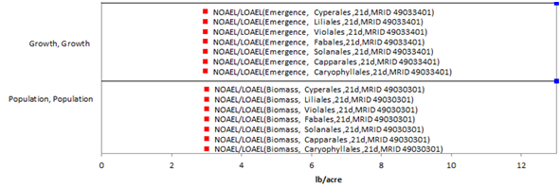
Figure 2-28. Effects Endpoints for Terrestrial Plants Exposed to Methomyl (lb a.i./acre). Data from registrant submitted studies (red) and open literature (blue). Data label key: Endpoint (measured effect, family, duration in days).

Sublethal Effects to Terrestrial Plants (All Plants)

NOAEC/LOAEC Values (lb a.i./acre)

Based on the available data for terrestrial plants, the most sensitive NOAEC and LOAEC values for methomyl are 2.97 lb a.i./acre and >2.97 lb a.i./acre, respectively, based on no adverse effects to any of the ten crop species tested (MRID 49033401). In this multiple concentration (a.k.a. “Tier II”) seedling emergence study, the effect of Methomyl 90SP (90% a.i.) on four monocot [corn (Zea mays), onion (Allium cepa), ryegrass (Lolium perenne), and oat (Avena sativa)] and six dicot species [cucumber (Cucumis sativus), Pea (Pisum sativum), soybean (Glycine max), tomato (Lycopersicon esculentum), oilseed rape (Brassica napus), and sugar beet (Beta vulgaris)] crops at measured application rates of <LOQ (negative control), 0.037, 0.11, 0.332, 0.996, and 2.972 lbs a.i./acre was studied. On day 21, the surviving plants per pot were recorded, and plant height and weight were measured. There was no difference in % emergence from control in any species or concentration tested and there were no effects to height or weight for any species tested.

EC₂₅/IC₂₅ Values (lb a.i./acre)

Based on the available data for terrestrial plants, definitive IC₂₅ values could not be determined for the monocot or dicot species tested (all of the available IC₂₅ values are ‘greater than’ values) (MRID 49033401). Monocot and dicot IC₂₅ values for methomyl (pre-emergent exposure) are >2.97 lbs a.i./acre.

Sublethal Effects to Terrestrial Plants (Monocots)

There are no definitive toxicity data available for methomyl and monocot plants on either a pre-emergent or post-emergent basis. No significant effects to growth or population level endpoints were noted in the available studies, which tested methomyl at concentrations as high as 2.97 lb a.i./acre in pre-emergence exposure and 3.01 lb a.i./acre in post-emergence exposure (see Figure 2-29).
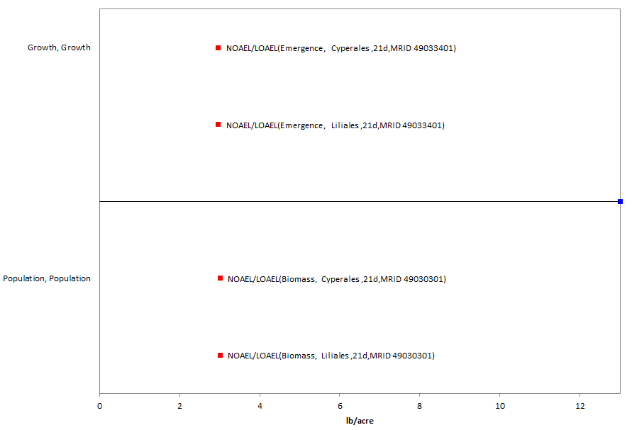
Figure 2-29. Effects Endpoints for Monocots Exposed to Methomyl (lb a.i./acre). Data label key: Endpoint (measured effect, family, duration in days, reference).

NOAEC/LOAEC Values

Based on the available data for terrestrial plants, the most sensitive NOAEC and LOAEC values for methomyl are 2.97 lb a.i./acre and >2.97 lb a.i./acre, respectively, based on no adverse effects to any of the four monocot crop species tested (MRID 49033401). In this multiple concentration (a.k.a. “Tier II”) seedling emergence study, the effect of Methomyl 90SP (90% a.i.) on four monocot crops [corn (Zea mays), onion (Allium cepa), ryegrass (Lolium perenne), and oat (Avena sativa)] at measured application rates of <LOQ (negative control), 0.037, 0.11, 0.332, 0.996, and 2.972 lbs a.i./acre was studied. On day 21, the surviving plants per pot were recorded, and plant height and weight were measured. There was no difference in % emergence from control in any species or concentration tested and there were no effects to height or weight for any species tested.

EC₂₅/IC₂₅ Values

In a multiple concentration (a.k.a. “Tier II”) seedling emergence study, the effect of Methomyl 90SP (90% a.i.) on four monocot crops [corn (Zea mays), onion (Allium cepa), ryegrass (Lolium perenne), and oat (Avena sativa)] was studied at measured application rates of <LOQ (negative control), 0.037, 0.11, 0.332, 0.996, and 2.972 lbs a.i./acre (MRID 49033401). In this study, there were no effects to the monocots tested at application rates up to and including 2.97 lbs a.i./acre in any of the endpoints measured (% emergence, shoot length, or dry weight); resulting in IC₂₅ and NOAEC values of >2.97 and 2.97 lb a.i./acre, respectively.

Sublethal Effects to Terrestrial Plants (Dicots)

For dicots, methomyl impacted growth at concentrations between 2 lb a.i./acre and ~4 lb a.i./acre, based on NOAEC/LOAEC values (see Figure 2-30). The available IC₂₅ values for dicots are non-definitive (i.e., greater than 2.97 lb a.i./Acre).

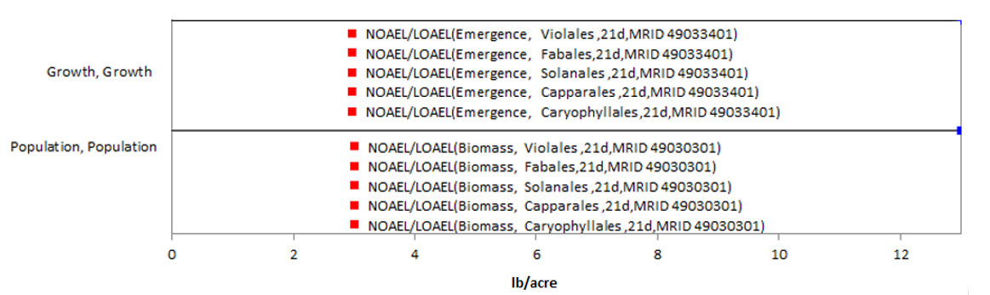

Figure 2-30. Effects Endpoints for Dicots Exposed to Methomyl (lb a.i./acre). Data from registrant submitted studies (red) and open literature (blue). Data label key: Endpoint (measured effect, family, duration in days, reference).

NOAEC/LOAEC and EC₂₅/IC₂₅ Values

The thresholds for dicot terrestrial plants and methomyl are the same as the ‘All Terrestrial Plant’ thresholds [i.e., NOAEC and LOAEC values of 2.97 lb a.i./acre and > 2.97 lb a.i./acre (MRID 49033401) and IC₂₅ > 2.97 lb a.i./acre (MRID 49033401)].

Incident Reports for Terrestrial Plants

There are currently (as of January 22, 2020) two terrestrial plant incident reports in IDS with a certainty index of ‘possible’ or ‘highly probable’. Of these three incidents, one is from a misuse (either accidental or intentional), and in two of the incidents, the legality of use was undetermined (see Table 2-31 and ATTACHMENT 2-2 for details). The following discussion only includes those incident reports with a certainty index of ‘possible’, ‘probable’ or ‘highly probable’ and a legality classification of ‘registered use’ or ‘undetermined’.

The dates of the incident reports are exclusively from 2010. The terrestrial plant incident reports involve damage to the crop treated (i.e., from direct application) of a tank mix application of the products DuPont Lannate® S (a.i. methomyl, PC Code 090301) and Valent Danitol (a.i. Fenpropathrin, PC Code 127901) insecticides. Two days after the ground application the symptoms were observed, which included older leaves on the melon plants having very light speckling.

Table 2-31. Terrestrial Plant Incident Reports for Methomyl from IDS (Those Classified as ‘Possible’, ‘Probable’, or ‘Highly Probable’ with Legality of Use = ‘Registered’ or ‘Undetermined’).
INCIDENT NUMBER | YEAR | CHEMICAL(S) INVOLVED (PC CODE) | CERTAINTY INDEX | STATE | LEGALITY | USE SITE | SPECIES AFFECTED | DISTANCE | EFFECT/ MAGNITUDE | PRODUCT(S)
I022338-001 | 2010 | Methomyl & Fenpropathrin | Possible | AZ | Undetermined | Melon | Melon | Direct application | Plant leaf damage/NR | DuPont Lannate® S and Valent Danitol
I022338-002 | 2010 | Methomyl & Fenpropathrin | Possible | AZ | Undetermined | Melon | Melon | Direct application | Plant leaf damage/NR | DuPont Lannate® S and Valent Danitol

Since 1998, plant incidents that are allowed to be reported aggregately by registrants [under FIFRA 6(a)(2)] include those that are associated with an alleged effect to plants that involves less than 45 percent of the acreage exposed to the pesticide. Typically, the only information available for aggregate incidents is the date (i.e., the quarter) that the incident(s) occurred, the number of aggregate incidents that occurred in the quarter, and the PC code of the pesticide and the registration number of the product involved in the incident. Because of the limited amount of data available on aggregate incidents it is not possible to assign certainty indices or legality of use classifications to the specific incidents. Therefore, the incidents associated with currently registered products are assumed to be from registered uses unless additional information becomes available to support a change in that assumption.

Alternative Toxicity endpoints

In addition to the thresholds provided in the section tables above, alternative toxicity endpoints were also developed to use in the weight of evidence analysis for a species where appropriate (see Revised Methods Document). The alternative toxicity endpoints provide consideration of endpoints that may reflect variation in the available data (such as using the HC₅₀ values from the SSD instead of an HC₀₅ value or considering other endpoints within the data set for a particular taxon). Toxicity values for the technical grade were used for the alternative analysis, when available and less sensitive than the formulated product. Alternatively, if a taxon did not include enough data to select a specific alternative toxicity endpoint, a 10x factor was applied to the original threshold. The alternative endpoints allow for consideration of the possibility a listed species is toxicologically less sensitive than the tested species in the alternative weight of evidence analysis, which is captured for the analysis of any species that reaches that point of the analysis. Alternative endpoints are listed in Table 2-32 and brief additional comments are provided to clarify the alternative endpoint selection, as appropriate. Endpoints are analyzed for a subset of available units.

Table 2-32. Alternative toxicity endpoints used in weight of evidence analysis.
Alternative toxicity endpoints - Mortality |  | Type of endpoint (HC₅₀, etc.) | Value | Slope | Weight of test animal (g) | Comments
Units | Taxa
mg ai/kg-bw | MAMMALS | LD₅₀ | 71.4 | 4.5 | 350 | 10x applied
mg ai/kg-bw | BIRDS | LD₅₀ | 20.3 | 4.5 | 13.2 | 10x applied
mg ai/kg-bw | REPTILES/TERRESTRIAL AMPHIBIAN | LD₅₀ | 20.3 | 4.5 | 13.2 | 10x applied
mg ai/kg-bw | TERRESTRIAL INVERTS | LD₅₀ | 5 | 9 | 0.128 | 10x applied
ug ai/L | FW FISH | HC₅₀ | 2010 | 4.2 |  | HC50 value for all verts
ug ai/L | E/M FISH | HC₅₀ | 2010 | 4.2 |  | HC50 value for all verts
ug ai/L | AQ AMPHIBIANS | HC₅₀ | 2010 | 4.2 |  | HC50 value for all verts
ug ai/L | FW INVERTEBRATES | HC₅₀ | 49 | 4.5 |  | HC50 value for pooled inverts
ug ai/L | E/M INVERTEBRATES | HC₅₀ | 49 | 4.5 |  | HC50 value for pooled inverts
ug ai/L | MOLLUSKS | HC₅₀ | 49 | 4.5 |  | HC50 value for pooled inverts
Alternative toxicity endpoints - Sublethal
Units | Taxa | Type of endpoint (HC₅₀, etc.) | MATC or LOAEC | Description of effect | Duration of study (days) | Comments
mg ai/kg-diet | MAMMALS | MATC | 240 |  |  | 10x applied
mg ai/kg-diet | BIRDS | MATC | 2620 |  |  | 10x applied
mg ai/kg-diet | REPTILES/TERRESTRIAL AMPHIBIAN | MATC | 2620 |  |  | 10x applied
mg ai/kg-diet | TERRESTRIAL INVERTS | NOAEC | 3.13 |  |  | 10x applied
µg ai/L | FW FISH | MATC | 1030 |  |  | 10x applied
µg ai/L | E/M FISH | MATC | 3570 |  |  | 10x applied
µg ai/L | AQ AMPHIBIANS | MATC | 990 |  |  | 10x applied
µg ai/L | FW INVERTEBRATES | MATC | 24 |  |  | 10x applied
µg ai/L | E/M INVERTEBRATES | MATC | 415 |  |  | 10x applied
µg ai/L | MOLLUSKS | MATC | 24 |  |  | 10x applied
TERRESTRIAL PLANTS |  | Type of endpoint (HC₅₀, etc.) | MATC or LOAEC | IC₂₅ | Description of effect | Comments
lb ai/A | SUBLETHAL- MONOCOTS | NOAEC | 2.97 | 2.97 |  | No effects seen
lb ai/A | SUBLETHAL- DICOTS | NOAEC | 2.97 | 2.97 |  | No effects seen
AQUATIC PLANTS (TGAI) |  | Type of endpoint (HC₅₀, etc.) | MATC or LOAEC | IC₅₀ | Description of effect | Comments
µg ai/L | NON-VASCULAR | MATC | MATC | 600000 | 600000
µg ai/L | VASCULAR | MATC | MATC | 600000 | 600000

References

For full ECOTOX citations, see APPENDIX 2-2.

For Full MRID citations, see APPENDIX 2-4.

Terrestrial invertebrate semi-field tunnel study results are contained in MRIDs 49991504, 49991505
Study results contained in MRIDs 50082301, 50082302, 50082303, 50082304, 50082305, 50082306, 50082307, 50082308, 50082309, 50082310, 50082311, 50082312, 50082313, 50082314, 50082315, 50082316, 50082317, 50082318, 50082319, 50082320, 50082321, 50082322, 50082323

