APPENDIX 2-6. Methomyl Species Sensitivity Distribution Analysis for Aquatic Invertebrates

SSDs were fit to toxicity data for aquatic invertebrates exposed to methomyl. EC₅₀ values for “Immobility” were used as a proxy for mortality in addition to the mortality LC₅₀ values. Five distributions were tested and the gumbel distribution was found to provide the best fit.

The results from the pooled aquatic invertebrate SSD were used to represent saltwater and freshwater taxa. This decision was based on the AICc weight, confidence limits for the different distributions (especially around the HC05) and by visually examining the distributions and their consistency with the toxicity data. The fifth percentile of the SSD (abbreviated HC05 where “HC” stands for “hazard concentration”) is used to calculate mortality thresholds representing effects to listed species of aquatic invertebrates. The comparison of mortality thresholds (Table 1) or effects (immobility) concentrations for pooled aquatic invertebrates and freshwater aquatic invertebrates, demonstrate that there is little variation between the two distributions. Therefore, the gumbel distribution for pooled aquatic invertebrates was determined to be the best fit for the methomyl toxicity dataset (Figure 3). Important summary statistics from the fitted SSDs are provided below in Table 1. Detailed results follow.

Table 1. Summary statistics for the maximum likelihood log-gumbel SSDs fit to methomyl test results.
Statistic | Pooled Results | Freshwater Results
Goodness of fit P-value | 0.920 | 0.731
CV of the HC₀₅ | 0.610 | 0.806
UCp¹ of the HC₀₅ | 10.9 | 10.8
HC₀₅ | 3.94 | 3.28
HC₁₀ | 6.70 | 5.76
HC₅₀ | 75.5 | 74.9
HC₉₀ | 3380 | 4190
HC₉₅ | 14400 | 19500
¹ UCp=projections of the upper confidence limit of the HC₀₅ onto the cumulative distribution function of the fitted distribution.

- Data

Data used to derive SSDs are from literature that passed the ECOTOX quality screen (catalogued in APPENDIX 2-2) and data from unpublished, registrant-submitted studies. Those data are detailed in Table 9 (end of document). The EC/LC₅₀ values that were included in the analysis were all mortality or immobility endpoints from either 48 or 96-hour tests with technical grade active ingredient. Table 2 provides the distribution of the test results and the number of species represented. Since only 4 saltwater species were tested, there were insufficient data to derive a separate saltwater invertebrate SSD.

Table 2. Distribution of test results available for methomyl.
Media | Test results | Species
All | 29 | 25
Freshwater | 25 | 21
Saltwater | 4 | 4

Fig. 1 shows the distribution of test results among subsets of invertebrate test results. In general, most species have been tested once, with only one species tested 4 times.

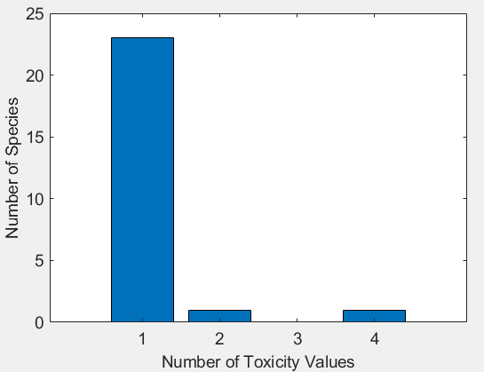
Figure 1. Distribution of test results among taxa in all methomyl test results.

Five potential distributions for the Methomyl data were considered (log-normal, log-logistic, log-triangular, log-gumbel, and Burr). To fit each of the first four distributions, the toxicity values were first common log (log₁₀) transformed. Finally, effect thresholds and five quantiles from the fitted SSDs (HC₀₅, HC₁₀, HC₅₀, HC₉₀, HC₉₅) were calculated and reported.

- Comparison of distributions using AIC_{c}

Akaike’s Information Criterion corrected for sample size (AIC_{c}) was used to compare the five distributions for both datasets, the freshwater dataset versus the full dataset combining freshwater and saltwater tests. For this comparison all SSDs were fit using maximum likelihood. For pooled aquatic invertebrates, the majority of the weight is attributed to the gumbel, and burr distributions (with <10% each attributed to logistic, normal, and triangular distributions; Table 3). A similar pattern is observed for freshwater aquatic invertebrates (Table 4).

Based on the AIC_{c} ranking (i.e., lowest AIC value and largest Weight), for all five datasets, AIC_{c} suggested that the gumbel distribution provided the best fit (Tables 3 and 4).

Table 3. Comparison of distributions for pooled aquatic invertebrate toxicity data for methomyl.
distribution | AIC_{c} | ∆AIC_{c} | Weight | HC₀₅
gumbel | 358.6 | 0 | 0.699 | 3.94
burr | 361.3 | 2.64 | 0.187 | 3.94
logistic | 362.8 | 4.19 | 0.086 | 1.31
normal | 365.2 | 6.63 | 0.025 | 1.31
triangular | 369.8 | 11.1 | 0.003 | 0.81

Table 4. Comparison of distributions for freshwater invertebrate toxicity data for methomyl.
distribution | AIC_{c} | ∆AIC_{c} | Weight | HC₀₅
gumbel | 306.5 | 0 | 0.693 | 3.28
burr | 309.3 | 2.80 | 0.171 | 3.29
logistic | 310.7 | 4.17 | 0.086 | 0.89
normal | 312.3 | 5.72 | 0.040 | 0.98
triangular | 314.9 | 8.40 | 0.010 | 0.70

- Comparison of SSDs for Pooled Aquatic Invertebrates and Freshwater Aquatic Invertebrates

The gumbel SSDs for pooled aquatic invertebrates and for freshwater aquatic invertebrates were plotted to determine whether there was a difference in the distributions. Figure 1 demonstrates that there is little variation between the two distributions, which is expected since the pooled aquatic invertebrate SSD has only 4 additional values (saltwater species data) than the freshwater invertebrate SSD.

Figure 1. Log-gumbel SSDs for freshwater and pooled aquatic invertebrate test results, showing overlap of confidence limit coverage of the separate freshwater and saltwater results.

- Goodness of fit & Uncertainty

To test goodness-of-fit, all five distributions were fit to two datasets (pooled and freshwater toxicity data) and bootstrap goodness-of-fit tests with 5,000 bootstrap replicates were used. Three different fitting methods (maximum likelihood, moment estimators, and graphical methods) were used, though, not all methods are available for all distributions. Tables 5 and 6 give results of these fitting exercises. For the pooled invertebrate SSD, the p-value for the Triangular distribution is <0.05, indicating that this SSD is not a good fit for the available data (Table 5). For the freshwater invertebrate SSD, the p-value for the Triangular and Weibull distributions are <0.05, indicating that these SSDs are not a good fit for the available data (Table 6).

In general, the gumbel distribution (determined to be the best by AIC_{c}), and along with the burr distribution had the highest HC₀₅ values, though HC₀₅ values, as well as their standard errors and coefficients of variation, were fairly similar among the distributions for pooled and freshwater data (Tables 5 and 6; Figures 2 and 3). Additionally, the gumbel distribution had the highest AIC weight.

Table 5. Range of HC₀₅ values for methomyl SSDs fit to all invertebrates.
Distribution | Method¹ | HC₀₅ | SE | CV | LCp | UCp | P
normal | ML | 1.31 | 2.11 | 1.61 | 0.277 | 7.65 | 0.144
normal | MO | 1.19 | 1.73 | 1.46 | 0.22 | 6.35 | 0.111
normal | GR | 1.01 | 1.30 | 1.29 | 0.106 | 4.56 | 0.074
logistic | ML | 1.31 | 1.84 | 1.41 | 0.234 | 6.83 | 0.824
logistic | MO | 1.26 | 2.18 | 1.72 | 0.171 | 8.11 | 0.264
logistic | GR | 0.825 | 1.10 | 1.34 | 0.043 | 3.75 | 0.150
triangular | ML | 0.806 | 2.89 | 3.58 | 0.27 | 8.08 | 0.001
triangular | MO | 1.09 | 1.57 | 1.43 | 0.255 | 5.59 | 0.054
triangular | GR | 1.13 | 1.53 | 1.35 | 0.200 | 5.32 | 0.049
gumbel | ML | 3.94 | 2.40 | 0.610 | 1.81 | 10.9 | 0.920
gumbel | MO | 3.08 | 2.49 | 0.808 | 0.833 | 10.4 | 0.929
gumbel | GR | 2.18 | 1.66 | 0.760 | 0.367 | 6.65 | 0.584
burr | ML | 3.94 | 2.54 | 0.646 | 1.63 | 11.5 | 0.898
¹ML=maximum likelihood, MO= moment estimators, and GR=graphical methods
LCp and UCp=projections of the confidence limits of the HC₀₅ (LCx and UCx) onto the cumulative distribution function of the fitted distribution.

Table 6. Range of HC₀₅ values for methomyl SSDs fit to freshwater invertebrates.
Distribution | Method¹ | HC₀₅ | SE | CV | LCp | UCp | P
normal | ML | 0.977 | 2.23 | 2.28 | 0.162 | 7.56 | 0.120
normal | MO | 0.867 | 1.99 | 2.30 | 0.117 | 6.66 | 0.094
normal | GR | 0.673 | 1.21 | 1.80 | 0.046 | 4.21 | 0.068
logistic | ML | 0.891 | 1.97 | 2.21 | 0.120 | 6.41 | 0.501
logistic | MO | 0.925 | 2.44 | 2.64 | 0.092 | 8.30 | 0.188
logistic | GR | 0.534 | 0.98 | 1.84 | 0.016 | 3.23 | 0.129
triangular | ML | 0.702 | 2.81 | 4.01 | 0.209 | 8.77 | 0.007
triangular | MO | 0.792 | 1.81 | 2.29 | 0.138 | 5.75 | 0.058
triangular | GR | 0.773 | 1.35 | 1.74 | 0.096 | 4.39 | 0.046
gumbel | ML | 3.28 | 2.65 | 0.806 | 1.39 | 10.8 | 0.731
gumbel | MO | 2.42 | 2.78 | 1.15 | 0.564 | 10.6 | 0.845
gumbel | GR | 1.56 | 1.62 | 1.03 | 0.184 | 5.99 | 0.514
burr | ML | 3.29 | 2.64 | 0.803 | 1.16 | 10.9 | 0.668
¹ML=maximum likelihood, MO= moment estimators, and GR=graphical methods
LCp and UCp=projections of the confidence limits of the HC₀₅ (LCx and UCx) onto the cumulative distribution function of the fitted distribution.

Another step to assess goodness-of-fit was to visually inspect the fit for evidence of problems. Figures 4 and 5 below plot the data points against the fitted SSDs for pooled and freshwater test results. These plots suggest that the gumbel distribution is a good fit for the empirical data, especially around the HC05 and HC50 values (which are used as thresholds in the BE).

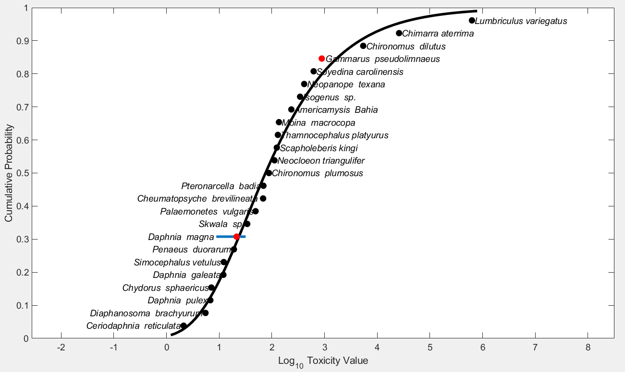
Figure 2. Log-Gumbel SSD for methomyl toxicity values for pooled invertebrates. Black points indicate single toxicity values. Red points indicate average of multiple toxicity values for a single species. Blue line indicates full range of toxicity values for a given species.
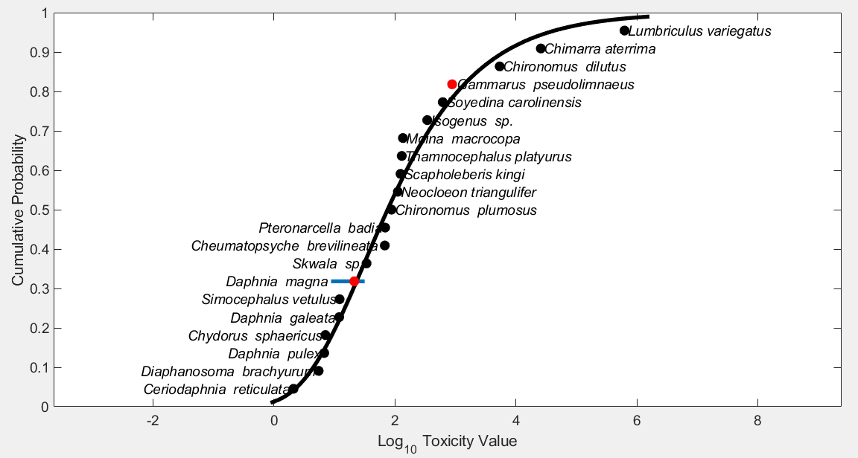
Figure 3. Log-gumbel SSD for methomyl toxicity values for freshwater invertebrates. Black points indicate single toxicity values. Red points indicate average of multiple toxicity values for a single species. Blue line indicates full range of toxicity values for a given species.

- Calculation of other quantiles

Tables 7 and 8 provide estimates of the HC₀₅ as well as other quantiles of the fitted SSDs.

Table 7. Estimated quantiles of the fitted SSDs for all invertebrate toxicity tests for methomyl.
Distribution | Method | HC₀₅ | HC₁₀ | HC₅₀ | HC₉₀ | HC₉₅
normal | ML | 1.31 | 3.54 | 119.7 | 4.04e+03 | 1.10e+04
normal | MO | 1.19 | 3.30 | 119.7 | 4.35e+03 | 1.20e+04
normal | GR | 1.01 | 2.89 | 119.7 | 4.95e+03 | 1.42e+04
logistic | ML | 1.31 | 3.80 | 87.8 | 2.03e+03 | 5.90e+03
logistic | MO | 1.26 | 4.01 | 119.7 | 3.57e+03 | 1.13e+04
logistic | GR | 0.825 | 2.92 | 119.7 | 4.91e+03 | 1.74e+04
triangular | ML | 0.806 | 2.41 | 243.5 | 2.47e+04 | 7.36e+04
triangular | MO | 1.09 | 2.69 | 119.7 | 5.32e+03 | 1.31e+04
triangular | GR | 1.13 | 2.77 | 119.7 | 5.18e+03 | 1.26e+04
gumbel | ML | 3.94 | 6.70 | 75.5 | 3.38e+03 | 1.44e+04
gumbel | MO | 3.08 | 5.48 | 75.5 | 4.63e+03 | 2.23e+04
gumbel | GR | 2.18 | 4.16 | 79.9 | 8.23e+03 | 8.23e+03
burr | ML | 3.94 | 6.74 | 75.7 | 3.25e+03 | 1.36e+04

Table 8. Estimated quantiles of the fitted SSDs for freshwater invertebrate toxicity tests for methomyl.
Distribution | Method | HC₀₅ | HC₁₀ | HC₅₀ | HC₉₀ | HC₉₅
normal | ML | 0.977 | 2.85 | 124.5 | 5.44e+03 | 1.59e+04
normal | MO | 0.867 | 2.60 | 124.5 | 5.97e+03 | 1.79e+04
normal | GR | 0.673 | 2.13 | 124.5 | 7.27e+03 | 2.30e+04
logistic | ML | 0.891 | 2.85 | 87.2 | 2.67e+03 | 8.54e+03
logistic | MO | 0.925 | 3.21 | 124.5 | 4.83e+03 | 1.68e+04
logistic | GR | 0.534 | 2.13 | 124.5 | 7.28e+03 | 2.90e+04
triangular | ML | 0.702 | 2.14 | 235.2 | 2.59e+04 | 7.88e+04
triangular | MO | 0.792 | 2.09 | 124.5 | 7.43e+03 | 1.96e+04
triangular | GR | 0.773 | 2.05 | 124.5 | 7.58e+03 | 2.01e+04
gumbel | ML | 3.28 | 5.76 | 74.9 | 4.19e+03 | 1.95e+04
gumbel | MO | 2.42 | 4.49 | 75.8 | 6.40e+03 | 3.48e+04
gumbel | GR | 1.56 | 3.18 | 81.1 | 1.31e+04 | 9.13e+04
burr | ML | 3.29 | 5.80 | 74.9 | 4.02e+03 | 1.84e+04

Table 9 provides all of the available EC/LC₅₀ values (based on immobility and mortality) for aquatic invertebrates (within the 24 or 48 hour timeframe-unless otherwise noted). These data sets are the same as reported in the effects characterization and provide additional data for the formulated products. Values that were included in the SSD (i.e., TGAI) are marked with an *.

Table 9. Available median lethal concentration (LC₅₀) data for aquatic invertebrates exposed to methomyl as TGAI or formulation.
Family | Genus | Species | 48-96h EC₅₀/LC₅₀ (µg/L) | MRID/ECOTOX Ref. # | Comments
Freshwater Species:
Baetidae | Neocloeon | triangulifer | 112* | MRID 49918904 | Acceptable
Chironomidae | Chironomus | plumosus | 32 | MRID 40098001 | Supplemental
Chironomidae | Chironomus | plumosus | 88* | MRID 40098001 | Supplemental
Chironomidae | Chironomus | dilutus | 5410* | MRID 49918903 | Supplemental
Chydoridae | Chydorus | sphaericus | 7.10* | E154905 | NA
Daphnidae | Ceriodaphnia | reticulata | 2.11* | E154905 | Quantitative - for SSD
Daphnidae | Daphnia | longispina | 4.71 | E110203 | NA
Daphnidae | Daphnia | magna | 5.0 | MRID 40098001 | Supplemental
Daphnidae | Daphnia |  | 6.4 | E154922 | NA
Daphnidae | Daphnia | pulex | 6.79* | MRID 49852301 | Acceptable
Daphnidae | Daphnia | longispina | 7.43 | E110203 | NA
Daphnidae | Daphnia | magna | 8.8* | MRID 40098001 | Supplemental
Daphnidae | Daphnia | longispina | 9.78 | E110203 | NA
Daphnidae | Daphnia | galeata | 12.0* | E154905 | NA
Daphnidae | Daphnia | magna | 21 | E118717 | NA
Daphnidae | Daphnia |  | 21.4 | MRID 46015303 | Acceptable
Daphnidae | Daphnia |  | 21.6 | MRID 46015303 | Acceptable
Daphnidae | Daphnia | magna | 24* | E118717 | NA
Daphnidae | Daphnia | magna | 24 | E67254 | NA
Daphnidae | Daphnia | magna | 24.2 | E110203 | NA
Daphnidae | Daphnia | magna | 31* | E67254 | NA
Daphnidae | Daphnia | magna | 31.7* | MRID 00019977 | Acceptable
Daphnidae | Daphnia | magna | 34.5 | MRID 46015301 | Supplemental/  Quantitative
Daphnidae | Daphnia | magna | 39.9 | MRID 46015303 | Acceptable
Daphnidae | Daphnia | magna | 40.8 | MRID 46015303 | Acceptable
Daphnidae | Daphnia | magna | 56.4 | MRID 46015301 | Supplemental/  Quantitative
Daphnidae | Daphnia | magna | 84 | MRID 46015301 | Supplemental/  Quantitative
Daphnidae | Daphnia | magna | 98 | MRID 46015301 | Supplemental/  Quantitative
Daphnidae | Daphnia | magna | 146 | MRID 46015301 | Supplemental/  Quantitative
Daphnidae | Scapholeberis | kingi | 124* | E154905 | NA
Daphnidae | Simocephalus | vetulus | 12.2* | E154905 | NA
Gammaridae | Echinogammarus | tibaldii | 250 | E18621 | NA
Gammaridae | Gammarus | italicus | 47 | E18621 | NA
Gammaridae | Gammarus | pseudolimnaeus | 340 | MRID 40098001 | Supplemental
Gammaridae | Gammarus | pseudolimnaeus | 720 | MRID 40098001 | Supplemental
Gammaridae | Gammarus | pseudolimnaeus | 750 | MRID 40098001 | Supplemental
Gammaridae | Gammarus | pseudolimnaeus | 850* | MRID 49971802 | Supplemental
Gammaridae | Gammarus | pseudolimnaeus | 920* | MRID 40098001 | Supplemental
Gammaridae | Gammarus | pseudolimnaeus | 1050 | MRID 40098001 | Supplemental
Hydropsychidae | Cheumatopsyche | brevilineata | 68.1* | E152279 | Quantitative - for SSD
Lumbriculidae | Lumbriculus | variegatus | 627000* | MRID 49918905 | Supplemental
Moinidae | Moina | macrocopa | 136* | E154905 | NA
Nemouridae | Soyedina | carolinensis | 620* | MRID 49918907 | Supplemental
Perlodidae | Isogenus | sp. | 29 | MRID 40098001 | Supplemental
Perlodidae | Isogenus | sp. | 343* | MRID 40098001 | Supplemental
Perlodidae | Skwala | sp. | 29 | MRID 40098001 | Supplemental
Perlodidae | Skwala | sp. | 34* | MRID 40098001 | Supplemental
Philopotamidae | Chimarra | aterrima | 25900* | MRID 49971801 | Supplemental
Pteronarcyidae | Pteronarcella | badia | 60 | MRID 40098001 | Supplemental
Pteronarcyidae | Pteronarcella | badia | 69* | MRID 40098001 | Supplemental
Sididae | Diaphanosoma | brachyurum | 5.49* | E154905 | NA
Thamnocephalidae | Thamnocephalus | platyurus | 120 | E118556 | NA
Thamnocephalidae | Thamnocephalus | platyurus | 130* | E118556 | NA
Estuarine/Marine Species:
Mysidae | Americamysis | Bahia | 234* | MRID 41441201 | Acceptable
Ocypodidae | Uca | pugilator | 2380 | MRID 00009230 | Supplemental
Palaemonidae | Palaemonetes | vulgaris | 49* | MRID 00009134 | Acceptable
Palaemonidae | Palaemonetes | vulgaris | 130 | MRID 00009230 | Supplemental
Penaeidae | Penaeus | duorarum | 19* | MRID 00009134 | Acceptable
Xanthidae | Neopanope | texana | 410* | MRID 00009134 | Acceptable
Mollusks:
NA³ | -- | -- | -- | -- | --
* Indicates study was conducted with TGAI and value used to derive SSD.
NA = Studies are acceptable for ECOTOX but have not been formally reviewed by EFED scientists.
¹ Methomyl formulation H-8385 (24% active ingredient, E.C.).
² RED says this is methomyl formulation H-7946 (90% a.i.).
³ No definitive LC₅₀ data available for mollusks; one available study (Ward and Boeri, 1991; MRID 42074601), was not used in SSD because EC₅₀ is for shell deposition, rather than mortality, and objective was to compare only similar endpoints. In addition, that data point was non-definitive.

