APPENDIX 2-5. Methomyl Species Sensitivity Distribution Analysis for Fish

SSDs were fit to toxicity data for freshwater and saltwater fish and amphibians exposed to methomyl. Five distributions were tested and a variety of methods were used to determine whether different subsets of data should be modeled independently. Amphibian and saltwater fish mortality data were insufficient to derive separate SSDs. Ultimately, the results from the all vertebrates SSDs were used to represent freshwater fish, saltwater fish, and amphibians. Table 1 provides a summary of the results.

Table 1. Summary statistics for SSDs fit to methomyl test results.
Statistic | All  Vertebrates | FW  Vertebrates | All  Fish | FW  Fish
Best Distribution (by AIC_{c}) | gumbel | gumbel | triangular | triangular
Goodness of fit  P-value | 1.00 | 0.999 | 1.00 | 1.00
CV of the HC₀₅ | 0.452 | 0.546 | 0.239 | 0.274
HC₀₅ | 335 | 312 | 472 | 472
HC₁₀ | 462 | 446 | 560 | 564
HC₅₀ | 2010 | 2300 | 1160 | 1200
HC₉₀ | 20200 | 30100 | 2400 | 2540
HC₉₅ | 49000 | 80400 | 2850 | 3030

- Data

Data used in this analysis were from an ECOTOX query (APPENDIX 2-2) plus data from submitted studies are detailed in Tables 15 and 16 (end of document). Table 2 provides the distribution of the test results for methomyl including the number of species represented. Since only two saltwater species were tested and three amphibians were tested, insufficient data were available to derive separate SSDs for these two taxa. Two sets of distributions were derived: freshwater fish and all vertebrates (combines freshwater fish, saltwater fish and amphibians).

Table 2. Distribution of test results available for methomyl.
Data Subset | Test results | Species
All Aquatic Vertebrates | 56 | 16
Freshwater Vertebrates | 47 | 14
All Fish¹ | 43 | 13
Freshwater Fish | 34 | 11
Saltwater Fish | 9 | 2
Aquatic Amphibians | 13 | 3

Figure 1 shows the distribution of test results among species, indicating that a few species have been repeatedly tested (three species have been tested at least 8 times each), but the majority of species have been tested fewer than six times, with 7 species having only one test result.
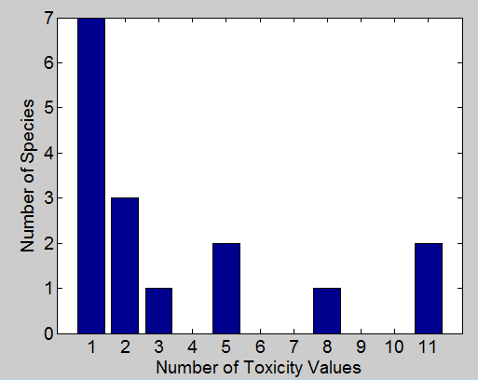
Figure 1. Distribution of the number of test results per species in Methomyl aquatic vertebrate data.

Five potential distributions for the methomyl data were considered, including log-normal, log-logistic, log-triangular, log-gumbel, and Burr. To fit each of the first four distributions, the toxicity values were first common log (log₁₀) transformed. Finally, effect thresholds and five quantiles from the fitted SSDs (HC₀₅, HC₁₀, HC₅₀, HC₉₀, HC₉₅) were calculated and reported.

- Comparison of distributions using AIC_{c}

Akaike’s Information Criterion corrected for sample size (AIC_{c}) was used to compare the five distributions for all four datasets. For these comparisons all SSDs were fit using maximum likelihood. For all of the datasets that included amphibians, AIC_{c} suggested that the triangular distribution provided the best fit (Tables 3 and 4). For all fish and freshwater fish, AIC_{c} suggested that the gumbel distribution provided the best fit (Table 5 and 6).

Table 3. Comparison of distributions for all aquatic vertebrate toxicity data for methomyl.
distribution | AIC_{c} | ∆AIC_{c} | Weight | HC₀₅
gumbel | 323.5 | 0 | 0.80 | 335
burr | 326.6 | 3.09 | 0.17 | 334
logistic | 330.8 | 7.33 | 0.02 | 78
normal | 332.8 | 9.28 | 0.01 | 82
triangular | 333.4 | 9.91 | 0.01 | 59

Table 4. Comparison of distributions for freshwater vertebrate toxicity data for methomyl.
distribution | AIC_{c} | ∆AIC_{c} | Weight | HC₀₅
gumbel | 290.8 | 0 | 0.77 | 312
burr | 294.2 | 3.32 | 0.15 | 311
logistic | 296.9 | 6.03 | 0.04 | 66
normal | 297.8 | 6.93 | 0.02 | 80
triangular | 297.8 | 6.98 | 0.02 | 66

Table 5. Comparison of distributions for pooled fish toxicity data for methomyl.
distribution | AIC_{c} | ∆AIC_{c} | Weight | HC₀₅
triangular | 208.4 | 0 | 0.36 | 472
normal | 209.1 | 0.72 | 0.25 | 459
logistic | 209.4 | 1.05 | 0.21 | 446
gumbel | 210.2 | 1.86 | 0.14 | 490
burr | 212.8 | 4.46 | 0.04 | 467

Table 6. Comparison of distributions for freshwater fish toxicity data for methomyl.
distribution | AIC_{c} | ∆AIC_{c} | Weight | HC₀₅
triangular | 179.3 | 0 | 0.48 | 472
logistic | 180.6 | 1.32 | 0.25 | 415
gumbel | 181.1 | 1.74 | 0.20 | 468
burr | 184.6 | 5.22 | 0.04 | 433
normal | 185.2 | 5.86 | 0.03 | 223

- Test for the need to model results separately by freshwater fish vs. all aquatic vertebrates

Examination of the cumulative distribution functions plotted on similar axes for all vertebrates versus freshwater-only vertebrates does not lend support to modeling the datasets separately. The 95% bootstrap confidence intervals for the separate distributions overlap and are not very different (Figure 2). The confidence limits on the HC₀₅ for both separate distributions are relatively precise, with the upper confidence limit falling at the 22nd and 24th percentile, respectively (Tables 9 and 10). Also, in both cases the CV of the HC₀₅ is below 1. When looking at the endpoints of interest (i.e., HC05 and HC50) across the SSDs for all vertebrates and freshwater fish, the percentile differences are not great, however, it is noted that a visual inspection of the plot indicates a divergence at the upper end (70th percentile) of the SSDs. Given the overlap of the confidence intervals of the distributions around the HC₀₅ and HC₅₀, the all vertebrate distribution is used.

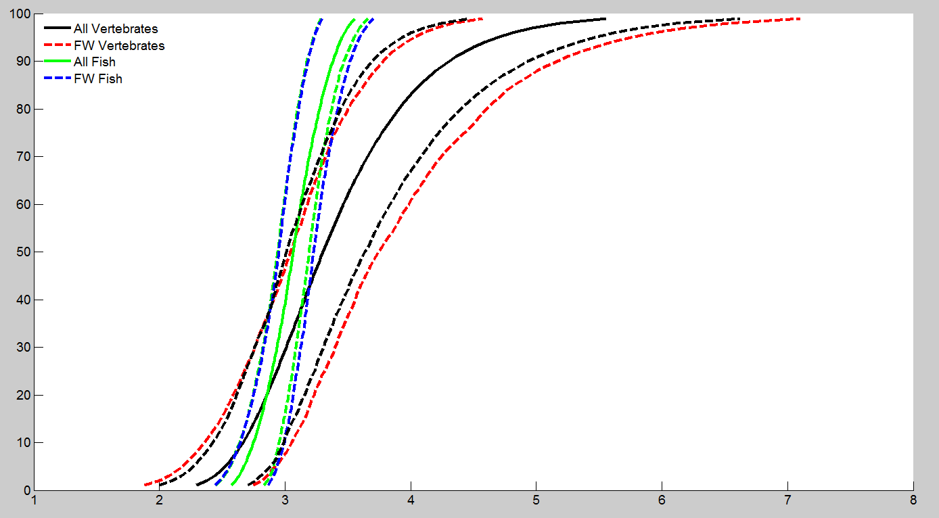
Figure 2. SSDs for combined and freshwater-only vertebrate LC₅₀s (gumbel), and combined and freshwater-only fish LC₅₀s (triangular) for methomyl. [Black lines show the distribution and upper and lower confidence interval for the combined aquatic vertebrate distribution. Red lines show the upper and lower confidence interval for freshwater-only vertebrates. Green lines show the distribution and upper and lower confidence interval for all fish combined. Blue lines show the upper and lower confidence intervals for freshwater-only fish].

- Goodness of fit

Plots of the cumulative distribution functions for the best-fit distributions (as determined by AIC_{c}) suggest little evidence of lack-of-fit (Figs. 3, 4, 5 and 6). Similarly, bootstrap goodness-of-fit tests did not show evidence for lack-of-fit (P-values > 0.05, Tables 7, 8, 9 and 10), with the exception of the Burr distribution, which frequently showed significant lack-of-fit. In general, the coefficient of variation for the HC₀₅ was below 1 for the competitive distributions.

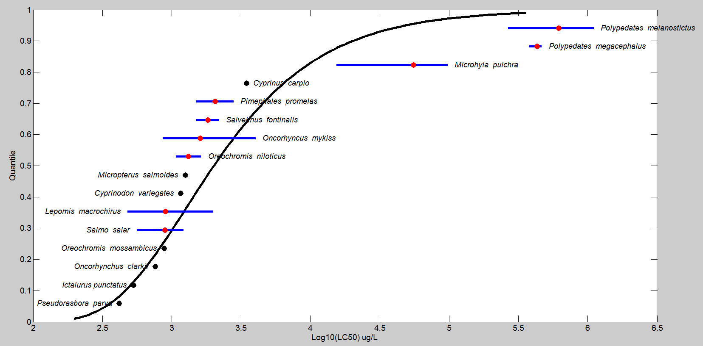
Figure 3. Log-gumbel SSD for methomyl toxicity values for all aquatic vertebrates pooled. Black points indicate single toxicity values. Red points indicate average of multiple toxicity values for a single species. Blue line indicates full range of toxicity values for a given taxon.

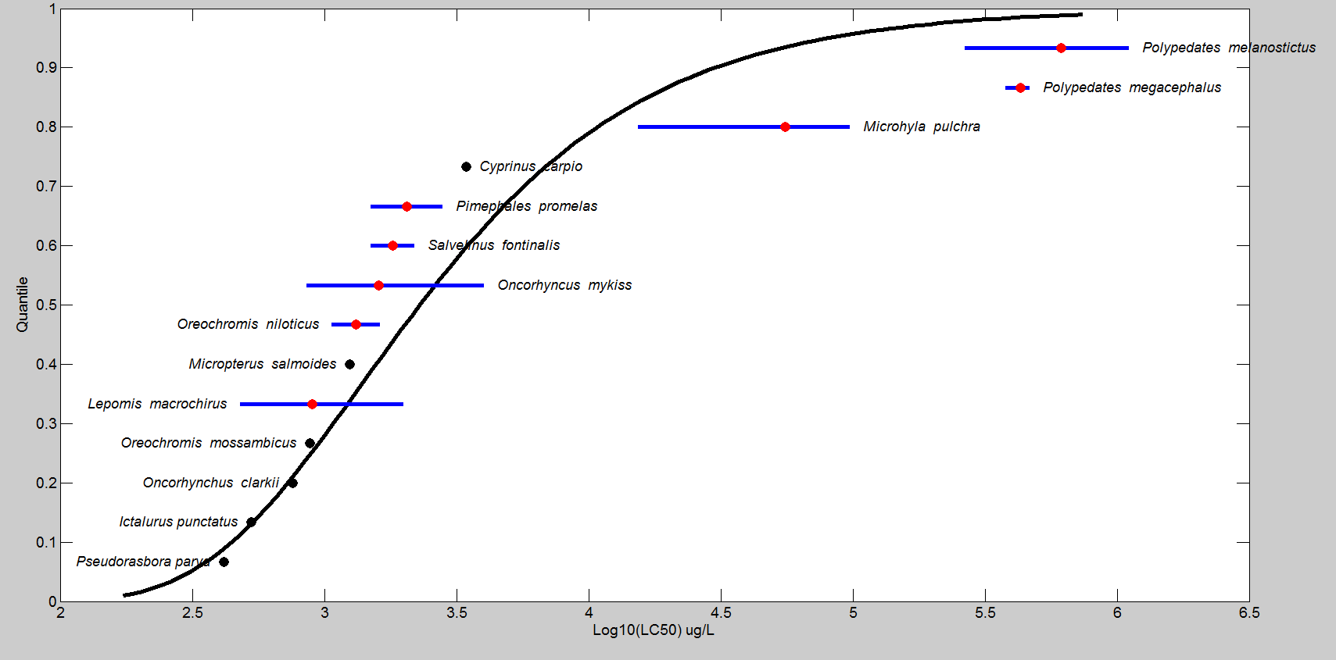
Figure 4. Log-gumbel SSD for methomyl toxicity values for freshwater aquatic vertebrates pooled. Black points indicate single toxicity values. Red points indicate average of multiple toxicity values. Blue line indicates full range of toxicity values for a given species.

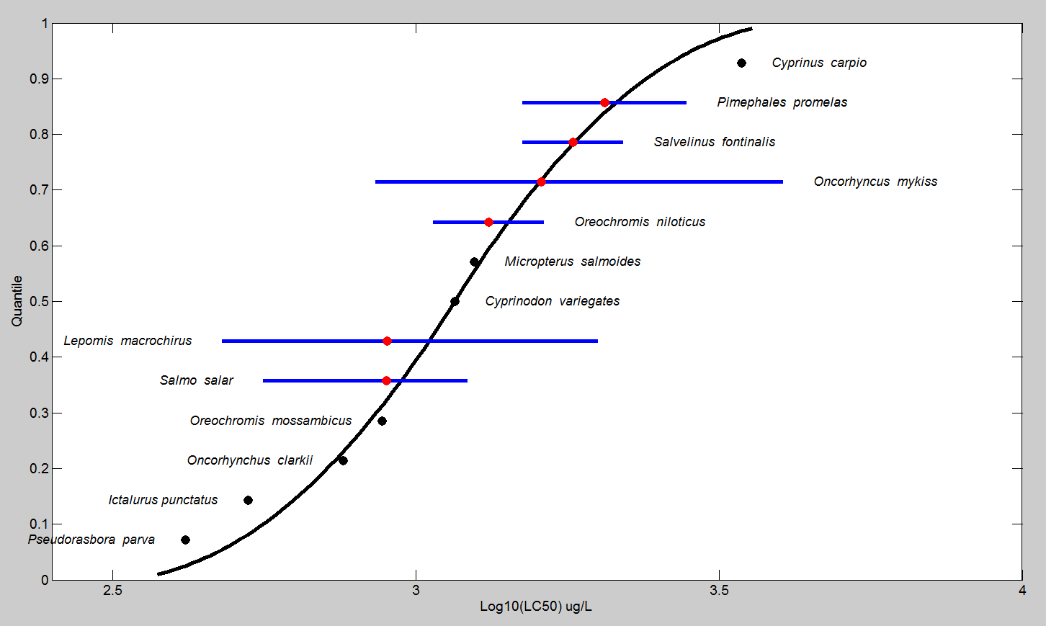
Figure 5. Log-triangular SSD for methomyl LC₅₀s for all fish. Black points indicate single toxicity values. Red points indicate average of multiple toxicity values for a single species. Blue line indicates full range of toxicity values for a given species.

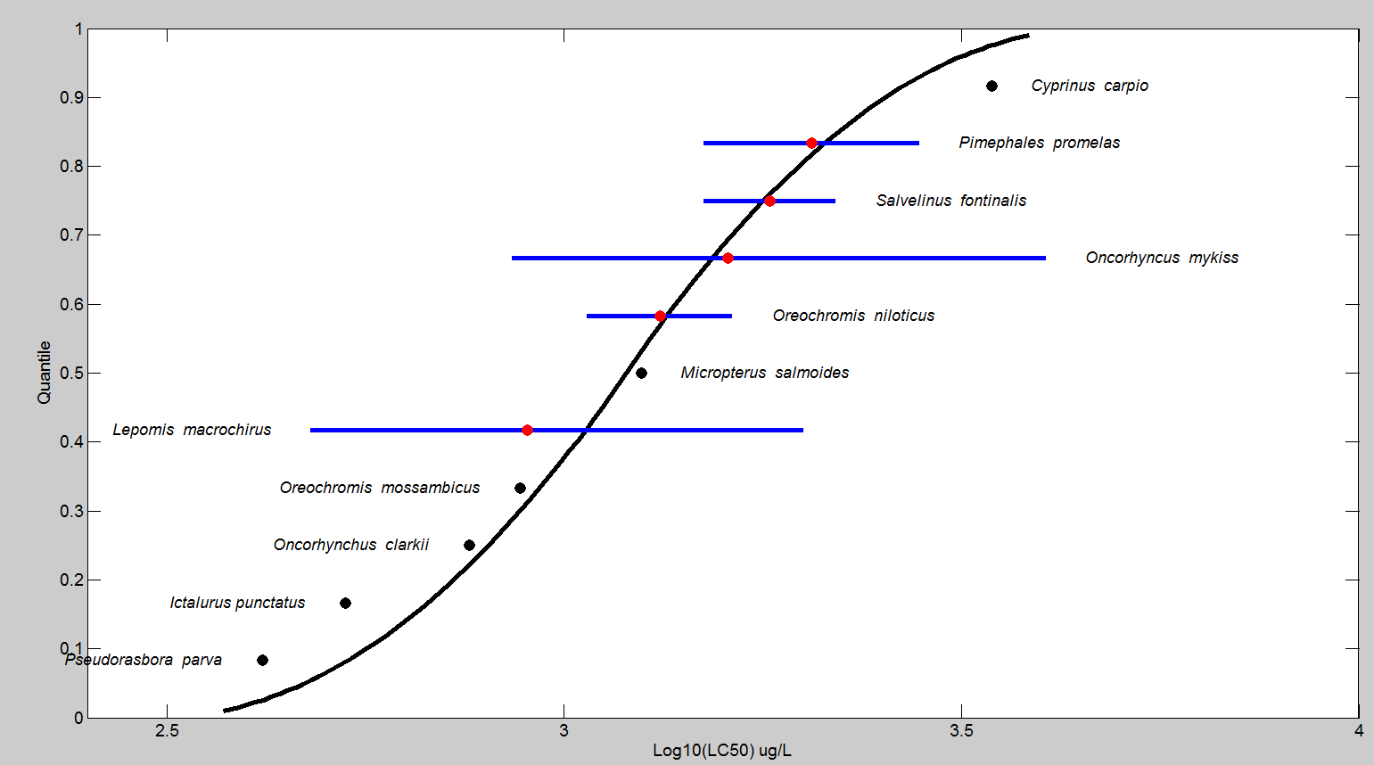
Figure 6. Log-triangular SSD for methomyl LC₅₀s for freshwater fish. Red points indicate single toxicity values. Black points indicate average of multiple toxicity values for a single species. Blue line indicates full range of toxicity values for a given species.

Table 7. Range of HC05 values for methomyl SSDs for all aquatic vertebrates.
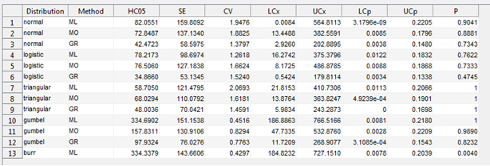
ML=maximum likelihood, MO= moment estimators, and GR=graphical methods
LCp and UCp=projections of the confidence limits of the HC₀₅ (LCx and UCx) onto the cumulative distribution function of the fitted distribution.

Table 8. Range of HC05 values for methomyl SSDs for freshwater vertebrates.
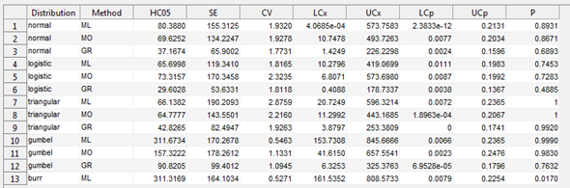
ML=maximum likelihood, MO= moment estimators, and GR=graphical methods
LCp and UCp=projections of the confidence limits of the HC₀₅ (LCx and UCx) onto the cumulative distribution function of the fitted distribution.

Table 9. Range of HC₀₅ values for methomyl SSDs for all fish pooled.
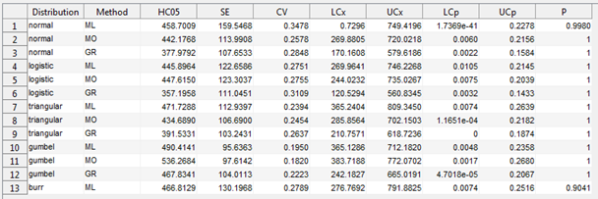
ML=maximum likelihood, MO= moment estimators, and GR=graphical methods
LCp and UCp=projections of the confidence limits of the HC₀₅ (LCx and UCx) onto the cumulative distribution function of the fitted distribution.

Table 10. Range of HC₀₅ values for methomyl SSDs for freshwater fish.
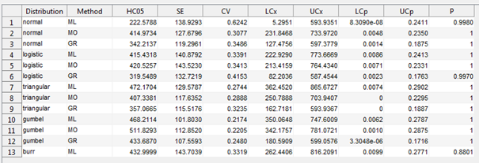
ML=maximum likelihood, MO= moment estimators, and GR=graphical methods
LCp and UCp=projections of the confidence limits of the HC₀₅ (LCx and UCx) onto the cumulative distribution function of the fitted distribution.

- Calculation of other quantiles

Tables 11, 12, 13 and 14 provide estimates of the HC₀₅ as well as other quantiles of the fitted SSDs.

Table 11. Estimated quantiles of the fitted SSDs for methomyl LC₅₀s for all aquatic vertebrates.
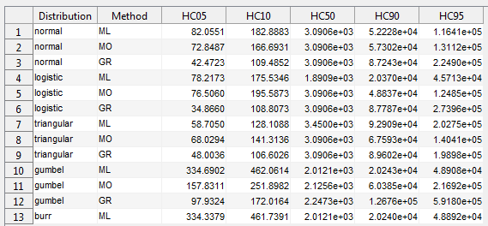

Table 12. Estimated quantiles of the fitted SSDs for methomyl LC₅₀s for freshwater aquatic vertebrates.
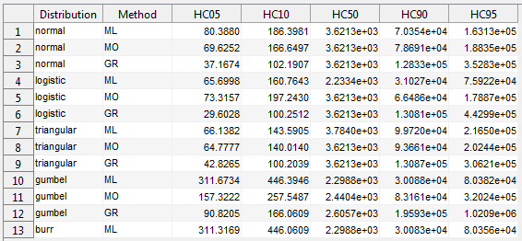

Table 13. Estimated quantiles of the fitted SSDs for Methomyl LC₅₀s for all fish.
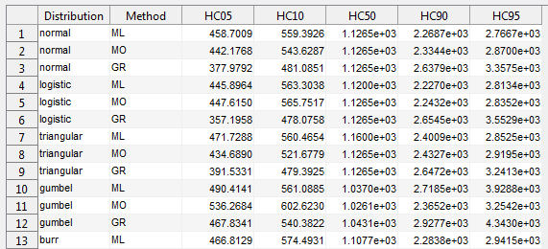

Table 14. Estimated quantiles of the fitted SSDs for methomyl LC₅₀s for freshwater fish.
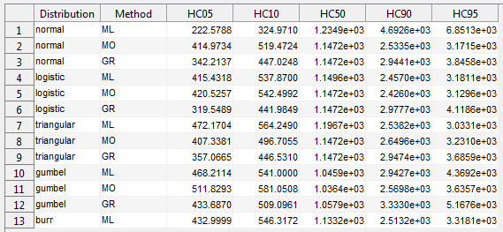

Tables 15 and 16 provide all of the available LC₅₀ values for fish and amphibians, respectively (within the 96-hour timeframe-unless otherwise noted). These data sets are the same as reported in the effects characterization and provide additional data for the formulated products. Values that were included in the SSD (i.e., TGAI) are marked with an *.

Table 15. Available median lethal concentration (LC₅₀) data for fish exposed to methomyl as TGAI or formulation.
Family | Species | Common Name | LC₅₀ (µg/L)¹ | MRID/ ECOTOX Ref. # | Classification
Centrarchidae | Lepomis macrochirus | Bluegill Sunfish | 370 | MRID 40098001/E6797 | Supplemental
Centrarchidae | Lepomis macrochirus | Bluegill Sunfish | 430 | MRID 40098001/E6797 | Supplemental
Centrarchidae | Lepomis macrochirus | Bluegill Sunfish | 480* | MRID 40098001/E6797 | Supplemental
Centrarchidae | Lepomis macrochirus | Bluegill Sunfish | 560 | MRID 40098001/E6797 | Supplemental
Centrarchidae | Lepomis macrochirus | Bluegill Sunfish | 560 | MRID 40098001/E6797 | Supplemental
Centrarchidae | Lepomis macrochirus | Bluegill Sunfish | 600* | MRID 40098001/E6797 | Supplemental
Centrarchidae | Lepomis macrochirus | Bluegill Sunfish | 600 | MRID 40098001/E6797 | Supplemental
Centrarchidae | Lepomis macrochirus | Bluegill Sunfish | 620* | MRID 40098001/E6797 | Supplemental
Centrarchidae | Lepomis macrochirus | Bluegill Sunfish | 670 | MRID 40098001/E6797 | Supplemental
Centrarchidae | Lepomis macrochirus | Bluegill Sunfish | 670 | MRID 40098001/E6797 | Supplemental
Centrarchidae | Lepomis macrochirus | Bluegill Sunfish | 710 | MRID 40098001/E6797 | Supplemental
Centrarchidae | Lepomis macrochirus | Bluegill Sunfish | 840* | MRID 40098001/E6797 | Supplemental
Centrarchidae | Lepomis macrochirus | Bluegill Sunfish | 860* | MRID 40098001/E6797 | Supplemental
Centrarchidae | Lepomis macrochirus | Bluegill Sunfish | 875* | E5395 | NA
Centrarchidae | Lepomis macrochirus | Bluegill Sunfish | 940* | MRID 40098001/E6797 | Supplemental
Centrarchidae | Lepomis macrochirus | Bluegill Sunfish | 1050* | MRID 40098001/E6797 | Supplemental
Centrarchidae | Lepomis macrochirus | Bluegill Sunfish | 1150* | MRID 40098001/E6797 | Supplemental
Centrarchidae | Lepomis macrochirus | Bluegill Sunfish | 1200* | MRID 40098001/E6797 | Supplemental
Centrarchidae | Lepomis macrochirus | Bluegill Sunfish | 1200 | MRID 40098001/E6797 | Supplemental
Centrarchidae | Lepomis macrochirus | Bluegill Sunfish | 1800 | MRID 40098001/E6797 | Supplemental
Centrarchidae | Lepomis macrochirus | Bluegill Sunfish | 2000* | MRID 40098001/E6797 | Supplemental
Centrarchidae | Lepomis macrochirus | Bluegill Sunfish | 2800 | MRID 40098001/E6797 | Supplemental
Centrarchidae | Micropterus salmoides | Largemouth Bass | 760 | MRID 40098001/E6797 | Supplemental
Centrarchidae | Micropterus salmoides | Largemouth Bass | 1250* | MRID 40098001/E6797 | Supplemental
Cichlidae | Oreochromis mossambicus | Mozambique Tilapia | 880* | E110907 | NA
Cichlidae | Oreochromis niloticus | Nile Tilapia | 1070* | E16196 | NA
Cichlidae | Oreochromis niloticus | Nile Tilapia | 1630* | E118556 | NA
Cyprinidae | Cyprinus carpio | Common Carp | 3550* | MRID 48986701 | Supplemental/  Quantitative
Cyprinidae | Pimephales promelas | Fathead Minnow | 1500* | MRID 40098001/E6797 | Supplemental
Cyprinidae | Pimephales promelas | Fathead Minnow | 1800 | MRID 40098001/E6797 | Supplemental
Cyprinidae | Pimephales promelas | Fathead Minnow | 2800* | MRID 40098001/E6797 | Supplemental
Cyprinidae | Pseudorasbora parva | Topmouth gudgeon | 417* | E110202 | Quantitative – for SSD
Cyprinodontidae | Cyprinodon variegates | Sheepshead Minnow | 1160* | MRID 41441202 | Acceptable
Ictaluridae | Ictalurus punctatus | Channel Catfish | 320 | MRID 40098001/E6797 | Supplemental
Ictaluridae | Ictalurus punctatus | Channel Catfish | 530* | MRID 40098001/E6797 | Supplemental
Ictaluridae | Ictalurus punctatus | Channel Catfish | 760 | MRID 40098001/E6797 | Supplemental
Ictaluridae | Ictalurus punctatus | Channel Catfish | 1800 | MRID 40098001/E6797 | Supplemental
Salmonidae | Oncorhynchus clarkii | Cutthroat Trout | 760* | MRID 40094602 | Supplemental
Salmonidae | Oncorhyncus mykiss | Rainbow Trout | 860* | MRID 40098001/E6797 | Supplemental
Salmonidae | Oncorhyncus mykiss | Rainbow Trout | 1050* | MRID 40098001/E6797 | Supplemental
Salmonidae | Oncorhyncus mykiss | Rainbow Trout | 1100* | MRID 40098001/E6797 | Supplemental
Salmonidae | Oncorhyncus mykiss | Rainbow Trout | 1200* | MRID 40098001/E6797 | Supplemental
Salmonidae | Oncorhyncus mykiss | Rainbow Trout | 1200 | MRID 40098001/E6797 | Supplemental
Salmonidae | Oncorhyncus mykiss | Rainbow Trout | 1200 | MRID 40098001/E6797 | Supplemental
Salmonidae | Oncorhyncus mykiss | Rainbow Trout | 1300 | MRID 40098001/E6797 | Supplemental
Salmonidae | Oncorhyncus mykiss | Rainbow Trout | 1400* | MRID 40098001/E6797 | Supplemental
Salmonidae | Oncorhyncus mykiss | Rainbow Trout | 1400 | MRID 40098001/E6797 | Supplemental
Salmonidae | Oncorhyncus mykiss | Rainbow Trout | 1400 | MRID 40098001/E6797 | Supplemental
Salmonidae | Oncorhyncus mykiss | Rainbow Trout | 1400 | MRID 40098001/E6797 | Supplemental
Salmonidae | Oncorhyncus mykiss | Rainbow Trout | 1400 | MRID 40098001/E6797 | Supplemental
Salmonidae | Oncorhyncus mykiss | Rainbow Trout | 1500* | MRID 40098001/E6797 | Supplemental
Salmonidae | Oncorhyncus mykiss | Rainbow Trout | 1500 | MRID 40098001/E6797 | Supplemental
Salmonidae | Oncorhyncus mykiss | Rainbow Trout | 1600* | MRID 40098001/E6797 | Supplemental
Salmonidae | Oncorhyncus mykiss | Rainbow Trout | 1700* | MRID 40098001/E6797 | Supplemental
Salmonidae | Oncorhyncus mykiss | Rainbow Trout | 2000* | MRID 40098001/E6797 | Supplemental
Salmonidae | Oncorhyncus mykiss | Rainbow Trout | 2000 | MRID 40098001/E6797 | Supplemental
Salmonidae | Oncorhyncus mykiss | Rainbow Trout | 2100 | MRID 40098001/E6797 | Supplemental
Salmonidae | Oncorhyncus mykiss | Rainbow Trout | 2300 | MRID 40098001/E6797 | Supplemental
Salmonidae | Oncorhyncus mykiss | Rainbow Trout | 3200 | MRID 40098001/E6797 | Supplemental
Salmonidae | Oncorhyncus mykiss | Rainbow Trout | 3400* | E5395 | NA
Salmonidae | Oncorhyncus mykiss | Rainbow Trout | 4040* | E118556 | NA
Salmonidae | Oncorhyncus mykiss | Rainbow Trout | 32,000 | MRID 40098001/E6797 | Supplemental
Salmonidae | Salmo salar | Atlantic Salmon | 560* | MRID 40098001/E6797 | Supplemental
Salmonidae | Salmo salar | Atlantic Salmon | 640* | MRID 40098001/E6797 | Supplemental
Salmonidae | Salmo salar | Atlantic Salmon | 700* | MRID 40098001/E6797 | Supplemental
Salmonidae | Salmo salar | Atlantic Salmon | 1000* | MRID 40098001/E6797 | Supplemental
Salmonidae | Salmo salar | Atlantic Salmon | 1050* | MRID 40098001/E6797 | Supplemental
Salmonidae | Salmo salar | Atlantic Salmon | 1120* | MRID 40098001/E6797 | Supplemental
Salmonidae | Salmo salar | Atlantic Salmon | 1150* | MRID 40098001/E6797 | Supplemental
Salmonidae | Salmo salar | Atlantic Salmon | 1200 | MRID 40098001/E6797 | Supplemental
Salmonidae | Salmo salar | Atlantic Salmon | 1220* | MRID 40098001/E6797 | Supplemental
Salmonidae | Salmo salar | Atlantic Salmon | 1400 | MRID 40098001/E6797 | Supplemental
Salmonidae | Salvelinus fontinalis | Brook Trout | 1220 | MRID 40098001/E6797 | Supplemental
Salmonidae | Salvelinus fontinalis | Brook Trout | 1500* | MRID 40098001/E6797 | Supplemental
Salmonidae | Salvelinus fontinalis | Brook Trout | 2200* | MRID 40098001/E6797 | Supplemental
* Indicates study was conducted with TGAI and value used to derive SSD.
NA = Studies are acceptable for ECOTOX but have not been formally reviewed by EFED scientists.
¹If a species was not represented with a 96 hour study, and other values were available from shorter/longer duration studies (up to 10 days) then the data were included and the duration was listed next to the LC₅₀ value as an indicator. If there were multiple other durations, the value from the study closer to a 96h duration was selected and if there were multiple values for the same duration, the range is indicated.

Table 16. Available median lethal concentration (LC₅₀) data for amphibians exposed to methomyl as TGAI or formulation.
Family | Species | Common Name | LC₅₀ (µg/L)¹ | Reference Number | Classification
Bufonidae | Polypedates melanostictus | Asian Common Toad | 848,000*  15°C | E171543 | NA²
Bufonidae | Polypedates melanostictus | Asian Common Toad | 941,000*  25°C | E171543 | Quantitative²
Bufonidae | Polypedates melanostictus | Asian Common Toad | 378,000*  30°C | E171543 | NA²
Bufonidae | Polypedates melanostictus | Asian Common Toad | 266,000*  35°C | E171543 | NA²
Bufonidae | Polypedates melanostictus | Asian Common Toad | 1,110,000*  20°C | E171543 | NA²
Microhylidae | Microhyla pulchra | Marbled Pygmy Frog | 97,700*  15°C | E171543 | Qualitative
Microhylidae | Microhyla pulchra | Marbled Pygmy Frog | 88,800*  20°C | E171543 | Qualitative
Microhylidae | Microhyla pulchra | Marbled Pygmy Frog | 46,600*  30°C | E171543 | Qualitative
Microhylidae | Microhyla pulchra | Marbled Pygmy Frog | 84,600*  25°C | E171543 | Quantitative– for Threshold Use
Microhylidae | Microhyla pulchra | Marbled Pygmy Frog | 15,400*  35°C | E171543 | Qualitative
Rhacophoridae | Polypedates megacephalus | Tree Frog | 467,000*  20°C | E171543 | NA²
Rhacophoridae | Polypedates megacephalus | Tree Frog | 380,000*  25°C | E171543 | Quantitative²
Rhacophoridae | Polypedates megacephalus | Tree Frog | 449,000*  30°C | E171543 | NA²
Rhacophoridae | Polypedates megacephalus | Tree Frog | 35°C | E171543 | Invalid³
* Indicates study was conducted with TGAI and value used to derive SSD.
NA = Studies are acceptable for ECOTOX but have not been formally reviewed by EFED scientists.
¹ If a species was not represented with a 96 hour study, and other values were available from shorter/longer duration studies (up to 10 days) the data were included and the duration was listed next to the LC₅₀ value as an indicator. If there were multiple other durations, the value from the study closer to a 96 hour duration was selected and if there were multiple values for the same duration, the range is indicated. These data also have temperature notations due to the particular study design; in one case a 48-hour data point with a different temperature regime is also included despite having 96-hour data available, to display the range.
² For the Asian Common Toad and the Tree Frog, the temperature ranges should be confirmed in order to use their endpoints quantitatively. The temperature range was only confirmed for the Marbled Pygmy Frog for the review since one of those endpoints was a candidate for threshold use.
³ 96-hour LC50 for the brown treefrog from the 35ºC treatment due to high (30%) control mortality.

