APPENDIX 2-3. Open Literature Review Summaries for Methomyl
Included in this appendix are the open literature review summaries for studies that were reviewed for the effects characterization for methomyl. Below in Table 1 are the ECOTOX numbers associated with the available reviews.
Table 1. ECOTOX numbers associated with the available open literature reviews.
E006605
E070351
E014097
E020421
E040226
E067983
E068422
E073575
E074457
E10443
E110202
E110203
E152279
E154905
E166086
E167186
E167254
E167277
E171543
E182730
E182757
E182788

Open Literature Review Summary

Chemical Name: Methomyl

CAS Numbers: 16752-77-5

PC Codes: 090301

ECOTOX Record Number and Citation: E006605
Kobbia,I.A., E.F. Shabana, Z. Khalil, and F.I.Y. Mostafa. Fate of 14C-Labelled Methomyl as Affected by Nostoc muscorum and Tolypothrix tenuis and Its Role in Their Metabolic Activities. J. Environ. Sci. Health Part B Pestic. Food Contam. Agric. Wastes, 1991. 26(4): 409-425.

Purpose of Review (Note: DP Barcode required for Quantitative studies): Registration Review (Methomyl ESA Pilot Biological Evaluation).

Date of Review: January 30, 2020

Summary of Study Findings:
From the abstract:
“The insecticide methomyl inhibited the growth and total carbohydrate content of Nostoc muscorum and Tolypothrix tenuis, even at the lowest concentration (100 ppm). Glucose absorption and chlorophyll "a" content in Nostoc cells were retarded; while they increased in Tolypothrix. Carotene content was decreased in both cyanobacteria. Total nitrogen content of both organisms was significantly decreased whereas total nitrogen fixed, nitrogen released, and protein content were increased in both organisms. The total phosphorus content of either cyanobacteria was sharply fluctuated, a trend that was reflected in similar effects of almost all phosphorus fractions. Although phosphorus uptake by Tolypothrix was increased, yet it was decreased in Nostoc especially at lower and moderate concentrations. ¹⁴C-labelled methomyl could be metabolized by both organisms. Of the total radioactivity recovered (89 and 85.6 % for Nostoc and Tolypothrix, respectively), the polar products accounted for about 25 %- TLC analysis revealed the presence of small amounts of two unknown metabolites with R_{f} values of 0-44 and 0-76. The ¹⁴C activity detected at R_{f} 0-44 is believed to be methyl mercaptan. Of the administered dose, about 15.0 % was found to be unextractable or bound compounds in both organisms.”

Results:
The data revealed that the lower concentrations of methomyl markedly inhibited the growth (i.e., dry weight) of Nostoc muscorum and Tolypothrix tenuis, an effect that was intensified by further increase of concentration (Table 1). It was also observed that the drop in dry weight gain in Tolypothrix cells far exceeded that of Nostoc cells under the same treatments. The results of the present investigation (Table 1) further show that, except at the lowest dose (100 ppm), methomyl significantly retarded the biosynthesis and accumulation of chlorophyll "a" in Nostoc cells. Tolypothrix, however, the pigment content was significantly increased up to 500 ppm, beyond which a gradual decline in the pigment content was displayed, but it remained all the time above control level.
Table 1. Effects of Different Concentrations of Methomyl on the Dry Weight Gain and Pigment Contents of the Cyanobacteria Nostoc muscorum and Tolypothrix tenuis after 7 days incubation.

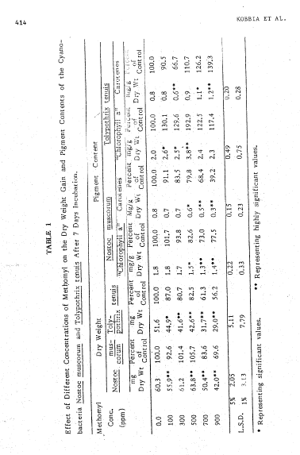.

Description of Use in Document (QUAL, QUAN, INV): QUAL

Rationale for Use: The study is scientifically sound, although the endpoints identified are not quantitatively used for the risk assessment. The study showed that 100mg/L methomyl (the lowest concentration tested) significantly reduced dry weight from 7-days exposure in the blue-green algae (Tolypothrix tenuis).
Limitations of Study:
- The study authors provided a LOAEC without an accompanying NOAEC.
- The study results cannot be confirmed as raw data is not provided.
- Other measures of productivity, including glucose uptake, carbohydrate content, and other rough measures of photosynthesis, tended to be increased, rather than decreased.

Reviewer Comments: The reviewers found a methomyl TGAI study with a NOAEC/LOAEC endpoint that was more sensitive.

Primary Reviewer: Tamara Johnson, Biologist, Environmental Fate and Effects Division/Environmental Risk Branch 2

Secondary Reviewer (required if study results are used quantitatively): Amy Blankinship, Branch Chief, Environmental Fate and Effects Division/Environmental Risk Branch 2

Open Literature Review Summary

Chemical Name: Methomyl

PC Code: 090301

ECOTOX Record Number and Citation: E70351
Atkins EL and D. Kellum. (1986) Comparative Morphogenic and Toxicity Studies on Effect of Pesticides on Honeybee Brood. Journal of Apricultural Research 25(4):242-255.

Purpose of Review (DP Barcode or Litigation): Registration Review (Methomyl ESA Pilot Biological Evaluation).

Date of Review: 01/28/2020

Summary of Study Findings:
Focus of paper was Bee Larval Morphogenic Tests (BLMGT), which “allowed the effects of pesticides on individual larvae to be determined in the hive.” In the test, the queen was allowed to lay larvae in the comb, and the food source for the colony was contaminated with the pesticide. Bees were evaluated for survival following adult emergence. Authors note “the analyzed data were then compared with laboratory data obtained for adult bees.” Adult LD50 data is presented in Table 4 and Table 6. Authors do not cite a specific source for this data, although it may have come from other testing at their laboratory. No specific test procedures are described for the adult LD₅₀.

For the larval test, authors tested Methomyl 1 8L (liquid). They do not discuss whether data presented were corrected for percent technical. Authors dosed food in the bottom of the hive cells with the pesticide dissolved in acetone. Acetone-treated controls were maintained. Reported adult mortality associated with acetone was ≤5% (Table 2). For the larval data, authors used Abbott’s formula (1925) to correct for control mortality and probit analysis to determine LD_{X} and slope (Table 6). Authors present a brood LD₅₀ in terms of µg/larvae but are not specific as to how they derived this number. Raw data are not available to confirm any statistics or calculations. Results of this test are interpreted by reviewer as an oral dose.
For methomyl, the data for all ages of larvae are as follows (from Table 6 in study):

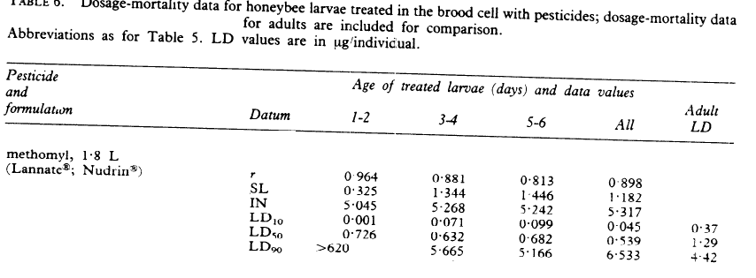
Description of Use in Document (QUAL, QUAN, INV):
QUAL-LDx data for larvae, especially LD₁₀
INV-Adult LD50

Rationale for Use:
Provides line of evidence for underrepresented taxa likely to be affected by use of this pesticide. Although this study does represent a lower mortality endpoint; this endpoint is from 1 to 2-day old larvae, and the difference in the LD₁₀ and LD₉₀ for this age group was over 5 orders of magnitude suggesting inconsistent exposures or other issues for this life stage. Therefore, this value should not be used as a threshold value. However, it is still appropriate for use in the data arrays.

Limitations of Study:
Raw data were not available to confirm calculations and statistics. It is uncertain whether data was corrected for percent technical. Test procedure, data, and analysis for adult LD₅₀ value were not provided in this publication.

Primary Reviewer:
Christina Wendel, Biologist, ERB2

Secondary Reviewer
Tamara Johnson, Biologist, ERB2

Open Literature Review Summary

Chemical Name: Methomyl

CAS No: 16752-77-5

PC Code: 090301

ECOTOX Record Number and Citation: E014097
Call, D.J., S.H. Poirier, C.A. Lindberg, S.L. Harting, T.P. Markee, L.T. Brooke, N. Zarvan and C.E. Northcott. 1989. Toxicity of Selected Uncoupling and Acetylcholinesterase-inhibiting Pesticides to the Fathead Minnow (Pimephales promelas). In: Weigmann, D.L. (ed.) Pesticides in Terrestrial and Aquatic Environment, Proceedings of a National Research Conference, May 11-12, 1989, Virginia Polytechnic Institute and State University, Blacksburg, VA. pp. 317-336.

Purpose of Review (Note: DP Barcode required for Quantitative studies): Methomyl ESA pilot (Registration Review)

Date of Review: 7/28/2016 (updated 04/13/2018 and 05/15/2019))

Summary of Study Findings:
The 29-day posthatch fathead minnow (Pimephales promelas) LOAEC was determined to be 46 µg a.i./L (mean measured concentration) for significantly reduced (visually determined by no overlap between control and lowest treatment 95-99% C.I.) length and dry weight. No NOAEC was determined due to effects at the lowest concentration tested.

From Abstract: “The toxicity of various pesticides to the fathead minnow (Pimephales promelas) following short and long-term exposures was studied. Pesticides were grouped into three categories: (1) uncouplers of oxidative phosphorylation, (2) organophosphate acetylcholinesterase (AChE) inhibitors, and (3) carbamate AChE inhibitors. Exposures were conducted in flow-through systems with toxicant concentrations continuously renewed and regularly measured. The dilution water was a relatively soft, dechlorinated tap water (hardness of about 50 mg/L as CaC0₃) with a pH of about 7.2. Acute toxicities (96-hr LC₅₀ in μg/L) of fourteen pesticides to juvenile fathead minnows (28 to 38 days old) were reported to be: (1) for the uncouplers - 4,6-dinitro-2-cresol, 1,540; 2,4-dinitrophenol, 6,580; dinoseb, 410; and hexachlorophene, 21; (2) for the organophosphates - carbophenothion. 237; disulfoton, 1,870; EPN, 79; fensulfothion, 43.100; and terbufos. 13; and (3) for the carbamates - aminocarb, 2,210; carbofuran, 844: methomyl, 2,110; oxamyl, 5.480; and propoxur, 3,800. The carbamate pirimicarb was tested in a range-finding test only and found to be the least toxic of all tested chemicals (three of five fish died at a nominal concentration of 200,000 μg/L). The acute toxicity of the carbamates to fathead minnows was compared to their inhibition of AChE activity in rainbow trout (Oncorhynchus mykiss) brain tissue in vitro. A rather weak relationship was observed overall, with the most acutely toxic carbamate to fathead minnows, carbofuran, inhibiting AChE to the greatest extent and the least toxic carbamate. Pirimicarb, inhibiting AChE the least. Toxicity following continuous exposure of embryos, fry, and juvenile fish (through 24 to 29 days post-hatch) was expressed as a "chronic" value, the geometric mean of the highest concentration producing no observable effect (NOEC) and the lowest concentration producing an observable effect (LOEC) on one or more parameters. Test parameters were hatching success, appearance of abnormalities in hatched fry, survival of juvenile fish and growth (i.e., wet weight, dry weight and length). "Chronic"' values in μg/L were: (1) for the uncouplers - 4,6-dinitro-2-cresol, 273; 2,4,dinitrophenol, 790: dinoseb, 134; and hexachlorophene. 12.2; (2) for the organophosphates - carbophenothion, 8.5: disulfoton. 231; EPN. 14.9: fensulfothion. 6,690; and terbufos, 2.86; and (3) for the carbamates - aminocarb. 277; carbofuran, 184; methomyl, <46; and propoxur, 961. "Chronic" values were not obtained for oxamyl and pirimicarb. Ratios of acute toxicity to subchronic toxicity were calculated for 12 of the pesticides. For uncouplers, the ratios ranged from 1.7 to 8.3 with a mean ratio of 4.7. For the organophosphates, the ratios ranged from 4.5 to 27.9 with a mean ratio of 10.4. For the carbamates, the range was 4.6 to 9.1 with a mean of 7.3. A definitive ratio was not obtained with the carbamate methomyl but appeared to be greater than 46. The ratios for the tested organophosphates and carbamates indicate greater variability than for the uncouplers and a need for somewhat larger chronicity factors for establishing safe concentrations of pesticides to fish from acute data only. Toxicity data were analyzed by a quantitative structure-activity relationship (QSAR) approach. The importance of chemical lipophilicity as a major determinant of toxicity was noted with the uncouplers. Toxicity prediction models were developed for the uncouplers based upon the n-octanol/water partition coefficient for both acute and early life-stage toxicity.”

For methomyl, the technical product used had 99% purity.
Results:
The range of mean exposure for the acute test component (mean measured using HPLC, high-pressure liquid chromatography) was 1120-4820 ug/L and for the ELS (early life-stage) test was 46-731 ug/L (with mean 103 (± 8.5 S.D.) % spike recovery); see Table 3, below, which is an excerpt from the paper.
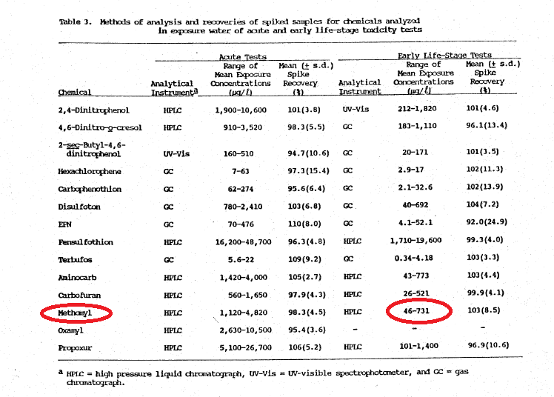
5-Methyl-N-[methylcarbamoyl)oxy]thioacetimidate (Methomyl or Lannate^{R}): Mean (± s.d.) measured test concentrations for five exposures of methomyl in the acute test were 1.120 ± 226: 1.580 ± 252; 2,303 ± 247; 3,250 ± 278; and 4,820 ± 240 μg/L. No mortalities occurred in the control. The 96-hr LC₅₀ (author calculated value) was 2.110 μg/L with 95-percent confidence limits of 1,840 and 2,420 μg/L. Mean (± s.d.) measured test concentrations for five exposures in the ELS test were 46 ± 6,82 ± 9,159 ± 16,327 ± 30, and 731 ± 45 μg/L. The parameter of hatching success was not affected at any of the exposures (Table 6 below is an excerpt from the paper). Increased numbers of dead and abnormal appearing larvae were observed at 327 and 731 μg/L. Survival of juvenile fish was significantly reduced at the highest exposure of 731 μg/L. Significant reductions in all of the growth parameters occurred at all of the exposures. Therefore, the chronic value was less than 46 μg/L.

The study authors’ reported the “chronic value” of <46 ug/L for methomyl is theoretically the geometric mean between the NOAEC and LOAEC. However, this was determined by significant growth reduction at the lowest concentration tested (46 µg/L), which is by definition, also the LOAEC (see Table 6, which is an excerpt from the paper).

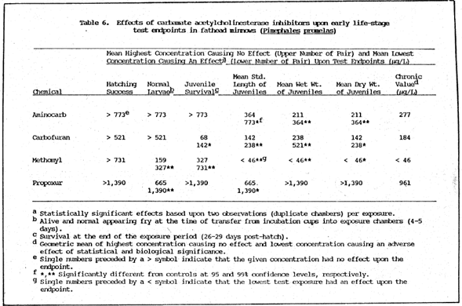

Description of Use in Document (QUAL, QUAN, INV): QUAL
The growth endpoint may be used qualitatively (QUAL): LOAEC of 46 µg a.i./L (mean measured concentration) for significantly reduced (visually determined by no overlap between control and lowest treatment 95-99% C.I.) length and dry weight.

Rationale for Use:
For the growth data:
- controls were free from mortality,
- five concentrations with two replicate chambers per treatment were used, and
- test concentrations were measured.
This information support qualitative use of the growth data and as a TGAI (technical grade active ingredient, 99%) endpoint. The LOAEC of 46 ug a.i./L is based on significant difference from controls (99% C.I.) in mean length, dry weight and wet weight of juveniles. This value may be used qualitatively for characterization and the LC50 value may also be used qualitatively for risk characterization.
Limitations of Study:
- Raw data were not available to confirm calculations and statistics.
- The results cannot be verified, and there are no details regarding what the individual effects were and at what rates they occurred at, it just noted the highest rate at which effects had occurred.
- Only two replicates were used per dose level.
- Overall, not enough information is provided in the study report for the individual chemical.

Primary Reviewer: Donna R. Judkins, Ph.D., ERB2

Secondary Reviewer: Melissa Panger, Ph.D., ERB2
And
Christina Wendel Biologist, US EPA, Office of Pesticide Programs, ERB2

Open Literature Review Summary

Chemical Name: Methomyl

CAS No: 16752-77-5

PC Code: 090301

ECOTOX Record Number and Citation: E020421
Tejada, A.W., C.M. Bajet, M.G. Magbauna, N.B. Gambalan, L.C. Araez and E.D. Magallona. 1994. Toxicity of Pesticides to Target and Non-Target Fauna of the Lowland Rice Ecosystem. In: B.Widianarko, K.Vink, and N.M.Van Straalen (Eds.), Environmental Toxicology in South East Asia, VU University Press, Amsterdam : 89-103.

Purpose of Review (Note: DP Barcode required for Quantitative studies): Methomyl ESA pilot (Registration Review)

Date of Review: 08/08/2016 (updated 03/16/2018)

Summary of Study Findings:
Nile tilapia fingerlings (of approximately one-inch length) and guppy fish were used for the test. The two week old Nile tilapia were fed with rice bran for at least three days in a large aerated aquarium before toxicity tests were conducted. The fish were starved for 24 hours prior to, and until the completion of the test. For methods, the authors state that the “procedures inherent in fish toxicity testing were observed.” The “acetone solution of insecticides was added to 750 mL of aged tap water.” The water was aged by allowing tap water to stand overnight. The water was contained in two-liter capacity aquaria and five fish were introduced per treatment. The weight of all the fish in a test container did not exceed 1 gram per liter of the liquid medium being tested. Moribund fish were counted as dead.

The pesticides tested were ranked based on the standard set by Nishiuchi (1974) for fish toxicity. The ranking standards were determined as follows:

Rank | Carp (mg/L) | Daphnids (mg/L) | Remarks
A | > 10 | > 0.5 | Low toxicity: can be used practically without any special precaution.
B | 0.5-10 | < 0.5 | These chemicals will not constitute a hazard unless a large amount of them contaminate the waters.
c | < 0.5 |  | These chemicals have a high change of injuring aquatic organisms even when a slight amount contaminates the waters.

The same procedure for toxicity testing of fish was used for the tadpoles. Tadpoles of the same size were tested as soon as they were collected from the field.

Golden snails reared in a fish pond were collected and allowed to acclimatize in an aquarium for 3-5 days. A toxicity test was conducted in a similar manner as for fish. The snails were considered dead when they floated on the water surface or when there was no movement after gently tapping the shell.

Results:
Excerpt:
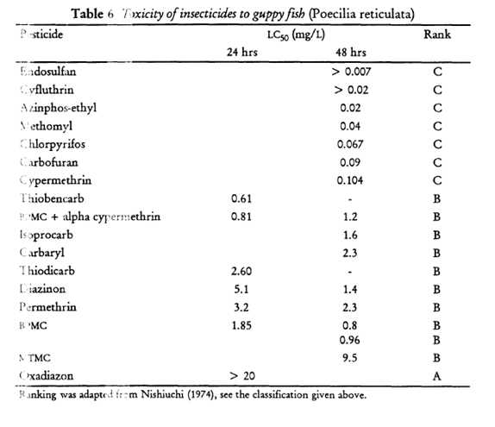
Description of Use in Document (QUAL, QUAN, INV):
INV Insufficient information for use.

Limitations of Study:
- This guppy LC₅₀ (of 40 ug a.i./L) is much lower than others – the next one is 204 ug a.i./L for the Nile tilapia – most fish LC₅₀s are in the hundreds range. This data point is an outlier.
- The paper has very little information on materials and methods.
- Obvious problems with the study design:
  - The 2-week old fingerlings were starved for 24h prior to test and during the test (may have been compromised).
  - Authors used acetone as solvent but do not mention the concentration that was used (potential solvent effects).
  - Dilution water was tapwater that had stood overnight, apparently to dissipate the chlorine (no mention of purity except to state that the ditch where the water was collected was not near pesticide use).
- Information available for this test besides the LC₅₀ was reasonable, but insufficient: 750 mL in 2 liter aquaria, 5 fish per treatment (total weight <1 gram/L).
- Not enough information to use the data quantitatively or qualitatively, especially without the specific mention of a control—a control was mentioned in the context of another test they ran but not the methomyl-guppy one.

Primary Reviewer: Donna R. Judkins, Ph.D., Biologist, US EPA, Office of Pesticide Programs, ERB2

Secondary Reviewer: Christina Wendel, Biologist, US EPA, Office of Pesticide Programs, ERB2
Open Literature Review Summary

Chemical Name: Methomyl

CAS No: 16752-77-5

PC Code: 090301

ECOTOX Record Number and Citation: E040226
Mohamed, A.I., G. Achuthan, H.H. Kassem, and M. Nuruzzaman (1995). Impacts of pesticides on the survival and body mass of the earthworm Aporrectodea caliginosa (Annelida: Oligochaeta). Acta Zool. Fennica, 196: 344 – 347.

Purpose of Review: Methomyl ESA pilot (Registration Review)

Date of Review: 07/07/16

Summary of Study:
Tests were conducted to determine the effects (survival and growth) of earthworms (Aporrectodea caliginosa) from exposure to insecticides (lebaycid and methomyl), herbicides (paraquat and glyphosate), and a fungicide (remiltine). The results for methomyl only are reported here. Adult A. caliginosa trapezoides were collected from pesticide-free soils in Libya and transferred to the laboratory and maintained in climate chambers. For the tests, individual worms with uniform lengths (~15.0 cm) and weights (~1.5 g) were kept in glass vessels (6 cm diameter and 4 cm height) and fed a 2:1 soil-cow dung mixture using soil from the same area where the worms were collected. Four different concentrations of methomyl (using Methomyl 25 WP; 25% a.i.) were used in the test: 25, 50, 100, and 200 mg product/kg dry soil (6.25, 12.5, 25, and 50 mg a.i./kg-dry-soil, corrected for purity). The pesticides were mixed thoroughly with 75 g of the soil-cow dung mixture. The earthworms were weighed prior to being placed in the glass vessels. There were five replicates for the controls and each treatment group, and each replicate was repeated three times (i.e., there were 15 worms tested at each concentration). The worms were exposed for 37 days and the survival and body mass of each worm was recorded on day 8, 17, 27, and 37.

Results:
There were no control mortalities in the study. Methomyl showed effects on mortality at all of the concentrations tested. The LC₅₀ values after 8, 17, 27, and 37 days are 48, 31, 19, and 19 mg product/kg-dry soil, respectively. The LC₅₀ values corrected for percent purity after 8, 17, 27, and 37 days are 12, 7.75, 4.75, and 4.75 mg a.i./kg-dry soil, respectively. There were statistically significant differences (p < 0.01) in the body mass of the control worms when compared to all treatment groups. Figure 1, from the study, shows the changes in the mean body mass (%) of the control and methomyl-treated worms over time. None of the worms in the 50 mg a.i./kg-dry soil treatment group survived past day 8. Those exposed to all of the lower concentrations of methomyl showed uniform decreases in body mass when compared to the controls.
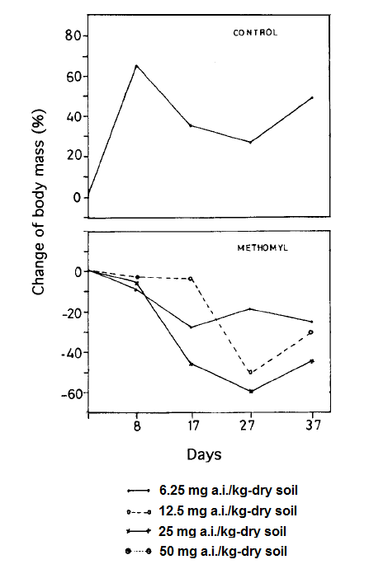
Figure 1. Change of body mass (%) of worms exposed to different concentrations of methomyl for 37 days (none of the earthworms exposed to 50 mg a.i./kg-dry soil survived past day 8, so they are not included in the figure). All values are corrected for chemical purity.

Description of Use in Document (QUAL, QUAN, INV): QUAN

Rationale for Use:
This review was conducted because the reported methomyl LC₅₀ value of 4.75 mg a.i./kg-dry soil currently represents the most sensitive endpoint for terrestrial invertebrates exposed to methomyl with an exposure unit of ‘mg/kg-soil’.

Limitations of Study:
Raw data were not available to confirm calculations and statistics. The study involved a non-native species. The reported LC₅₀ value was extrapolated (it is slightly below the lowest concentration tested).
Primary Reviewer:
Melissa Panger, Ph.D., Senior Scientist, US EPA, Office of Pesticide Programs, ERB2

Secondary Reviewer
Christina Wendel, MS, Biologist, US EPA, Office of Pesticide Programs, ERB2
Open Literature Review Summary

Chemical Name: Methomyl

CAS No: 16752-77-5

PC Code: 090301

ECOTOX Record Number and Citation: E067983
Mansour, S.A., and M.K. Al-Jalili (1985). Determination of residues of some insecticides in clover flowers: A bioassay method using honeybee adults. Journal of Apicultural Research, 24(3): 195-198.

Purpose of Review: Methomyl ESA pilot (Registration Review)

Date of Review: 07/18/16

Summary of Study:
Tests were conducted to determine the effects of six insecticides (primiphos-methyl, methomyl, propoxur, chlorpyrifos, carbaryl, and fenitrothion) on adult honeybees (Apis mellifera). The results for methomyl only are reported here. Seven-day-old worker bees were used in the tests. To determine the dosage-mortality relationship, a stock solution was prepared using TGAI (90% methomyl) dissolved in acetone. Five different concentrations plus a solvent control were tested. Each concentration involved five replicates (each with 10 bees). Bees were anaesthetized with CO₂ and a 1 µl of solution was applied to its mediodorsal thoracic surface. The treated bees were placed in glass beakers (10 bees/beaker) and were provided with a 25% sucrose solution. Mortalities were recorded 24-hr after treatment. This experiment was repeated three times. All reported results were corrected for purity.

For the residue portion of the study, a clover field in flower, in Baghdad, Iraq, was sprayed with insecticide (Methomyl 25% WP, at a rate of 27.2 g a.i./400m² = 0.61 lb a.i./acre). Flower samples were collected 0, 2, 4, 7, and 10 days post-application plus a control plot. Each sample contained approximately 1,000 flowers collected at random from different heights of the plants. Each sample was mixed gently and a 30 g subsample (~ 120 – 150 flowers) was collected and blended at high speed with acetone for three minutes. This was repeated three times for each flower sample. The extracts were concentrated under vacuum and were then topically applied to the bees, using the same method described above. The concentrations of insecticide in the flower samples were calculated as parts per million (wt/wt) of fresh material.

Results:
There were no detectable control mortalities in the study. The LD₅₀ value of methomyl was determined to be 0.068 µg a.i./bee with a Probit slope of 9.03. The residues in the clover flowers were 9.0, 8.3, 8.3, 6.8, and 4.2 ppm after 0, 2, 4, 7, and 10 days after application, respectively.
Description of Use in Document (QUAL, QUAN, INV): QUAN

Rationale for Use:
This review was conducted because the reported methomyl LD₅₀ value of 0.068 µg a.i./bee currently represents the most sensitive endpoint for terrestrial invertebrates exposed to methomyl with an exposure unit of ‘µg a.i./bee’.

Limitations of Study:
Neither the concentrations tested nor the raw data were available to confirm calculations and statistics.

Primary Reviewer:
Melissa Panger, Ph.D., Senior Scientist, US EPA, Office of Pesticide Programs, ERB2

Secondary Reviewer
Christina Wendel, MS, Biologist, US EPA, Office of Pesticide Programs, ERB2

Open Literature Review Summary

Chemical Name: Methomyl

CAS No: 16752-77-5

PC Code: 090301

ECOTOX Record Number and Citation: E068422
Ahrens, W.H. 1990. Enhancement of soybean (Glycine max) injury and weed control by thifensulfuron-insecticide mixtures. Weed Technology, 4(3): 524 – 528.

Purpose of Review (Note: DP Barcode required for Quantitative studies): Methomyl ESA pilot (Registration Review)

Date of Review: 05/19/2016

Summary of Study Findings: Soybeans (Glycine max) were exposed to single chemicals (thifensulfuron, carbaryl, chlorpyrifos, malathion, and methomyl) and combinations of these insecticides with thifensulfuron (an herbicide). Pesticidal combinations were also tested with kochia and yellow foxtail (species not specified). Commercial pesticide formulations were used, but neither the formulations nor percent a.i. were specified. A nonionic surfactant [X-77; 0.25% (v/v)] was added to all treatments. Treatments were applied using a moving nozzle pot sprayer. Exposure to single chemicals were at concentrations of 0 (control), 140, 280, and 560 g/ha (0, 0.125, 0.25, and 0.5 lb a.i./acre, respectively). There were three plants per 0.5-L plastic pots. Soybeans were treated at the unifoliolate stage and were harvested 17 days after treatment. At harvest, injury was estimated visually (0% = no injury to 100% = complete necrosis). Fresh weight of shoots was determined after removal at soil level. The experiments were conducted in greenhouses from January to April. Temperatures during the test ranged from 22º to 26º C. Experiments were arranged as a randomized complete block design having four of five replicates and each experiment was repeated. Differences between means were determined using the least significant difference (0.05).

Results (for methomyl and carbaryl only):

Exposure to Single Chemicals:
For methomyl, there were no statistically significant differences from control in percent injury at any concentration tested (see Table 1). There was a 6, 14, and 12% reduction in fresh weight at the 0.125, 0.25, and 0.5 lb/acre concentrations, respectively. The differences were statistically significant from controls at the 0.25 and 0.5 lb/acre concentrations, resulting in NOAEC and LOAEC values of 0.125 lb/acre and 0.25 lb/acre, respectively, based on a reduction in fresh weight.

For carbaryl, there were significant differences in percent injury between the control and the 0.25 and 0.5 lb/acre concentrations. There was an 8, 20, and 20% reduction in fresh weight at the 0.125, 0.25, and 0.5 lb/acre concentrations, respectively. The fresh weight differences were statistically significantly different from controls at the 0.125, 0.25, and 0.5 lb/acre concentration, resulting in NOAEC and LOAEC values of < 0.125 lb/acre and 0.125 lb/acre, respectively, based on a reduction in fresh weight.

Table 1. Effects to Soybeans from Exposure to Methomyl and Carbaryl.
CHEMICAL | RATE | % INJURY | % FRESH WEIGHT REDUCTION
Methomyl | 140 g/ha (0.125 lb/acre) | 1 | 6
 | 280 g/ha (0.25 lb/acre) | 2 | 14*
 | 560 g/ha (0.5 lb/acre) | 3 | 12*
Carbaryl | 140 g/ha (0.125 lb/acre) | 5 | 8*
 | 280 g/ha (0.25 lb/acre) | 11* | 20*
 | 560 g/ha (0.5 lb/acre) | 19* | 20*
* Statistically significantly different from the control

Exposure to Mixtures:

When the herbicide, thifensulfuron, was applied with methomyl or carbaryl to soybeans, kochia, and yellow foxtail (at varying concentrations), methomyl and carbaryl showed signs of synergism with soybeans (based on injury and %weight reduction) when the actual results were compared to expected results (no synergy). Potential synergistic effects were not noted for kochia or yellow foxtail and these chemical mixtures.

Description of Use in Document (QUAL, QUAN, INV): Results for single chemical (methomyl and carbaryl) and single test species = QUAN; results for mixtures = QUAL

Rationale for Use: This review was conducted because the reported methomyl NOAEC value of 0.125 lb/acre for reduction in weight currently represents the most sensitive NOAEC value for terrestrial plants and methomyl.

Limitations of Study: The purity of the chemicals used in the study were not reported. Raw data were not provided; therefore, the statistics could not be verified.

Primary Reviewer: Nathan Miller

Secondary Reviewer: Melissa Panger

Open Literature Review Summary

Chemical Name: Methomyl

CAS No: 16752-77-5

PC Code: 090301

ECOTOX Record Number and Citation: E073575
Fernandez-Alba, A.R., D. Hernando, A. Aguera, J. Caceres and S. Malato. 2002. Toxicity Assays: A Way for Evaluating AOPs Efficiently. Water Research 36:4255-4262.

Purpose of Review (Note: DP Barcode required for Quantitative studies): Methomyl ESA pilot (Registration Review)

Date of Review: 08/05/2016

Summary of Study Findings:

The IC₅₀ for the freshwater green algae, Selanastrum (now Pseudokirchneriella) subspicatus, was 60 mg a.i./L for reduced population abundance. Abundance was measured by optical density after three days of exposure to TGAI (technical-grade active ingredient; 98% purity).

The luminescent bacterium, Vibrio fischeri, and the daphnid, Daphnia magna, were also tested but these data were not reviewed at this time.

Stock solutions were prepared by dilution in specific culturing medium using Algaltoxkit. Authors claim reproducibility of the bioassay response was evaluated on EC₅₀ measurements to be 26%. This was evaluated by executing six replicates of the measurements using the same toxicant solution and the same organism test on different days. Authors state that the OECD Guideline 201 was followed using a commercially available Toxkit Algaltoxkit (Creasel, Belgium); the kit contained microalgal beads in an inert matrix. After “de-immobilisation” and transfer into an adequate culturing medium, the microalgae were observed to resume growth “immediately.” The initial number of algal cells was adjusted to 10⁶ cells/mL and the test tubes were then kept at 25ºC in an incubator under continuous illumination. Test tubes were incubated for 3 days and inhibition of algal growth relative to control was determined by measuring the OD (optical density) using a spectrophotometer with a filter at 670 nm. The 72-h EC50 was calculated based on 50% reduction in growth relative to control.

The study was designed to test breakdown of methomyl and the influence on toxicity using two techniques to break down the methomyl molecule (Ti0₂ and H₂0₂). These chemicals added to the water for photocatalysis of the methomyl molecule were removed prior to bioassay. The Ti0₂ was removed by filtration and the H₂O₂ by quenching with catalase and iron by coagulation and filtration. Data from the parts of the study that altered the methomyl molecule were not considered for quantitative use due to the alteration. Only the baseline data point of 60 mg/L was considered for quantitative use. Interestingly, the toxicity actually increased after the degradation processes, suggesting the production of toxic intermediate products from these processes.

Results:
Copied from paper (p. 4258):
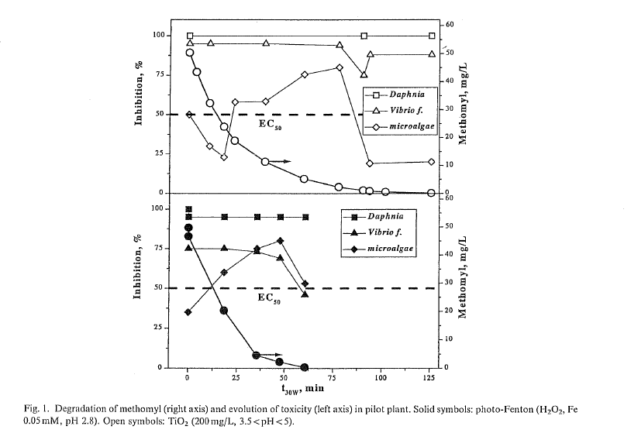
Available data from the baseline (time zero exposure to each breakdown process, i.e. top and bottom graph) show the following available data for the microalgae part of the study (estimates from visual inspection of Figure 1):

Datapoint at t = 0 min of breakdown process | Inhibition, % | Methomyl, mg/L
Top Graph, top datapoint | 95 | 54
Top Graph, bottom datapoint | 50 | 28
Bottom Graph, single datapoint | 30 | 21

These data points do not appear to comprise all the data used to calculate the IC₅₀ of 60 mg/L; these suggest an IC₅₀ closer to 30 mg/L. These data points are arranged and calculated in a different way here to show the change in inhibition brought on by the two processes for breaking down methomyl. This ballpark estimate is close to the estimate of 60 mg/L, however.

Description of Use in Document (QUAL, QUAN, INV):
The 72-h IC₅₀ for P. subspicatus of 60 mg a.i./L for reduced population abundance may be used quantitatively (QUAN). The study design seems to be scientifically sound even though some details were not provided.

The endpoints associated with the two methods (TiO₃ and H₂O₂) for breaking down methomyl may not be used quantitatively due to alteration of the methomyl molecule and any qualitative use should be used only within that context.

The baseline endpoints for D. magna and V. fischeri were not reviewed here for quantitative use but are not excluded from consideration for quantitative use.

Rationale for Use:
Authors state that the OECD Guideline 201 was followed. Though detailed information was not available, the following points were confirmed by authors:
- algal cells were transferred into an “adequate” culturing medium and following this, the microalgae were observed to resume growth “immediately;”
- the initial number of algal cells was adjusted to 10⁶ cells/mL;
- inoculated test tubes were incubated at 25ºC under continuous illumination;
- exposure was 3 days;
- inhibition of algal growth was compared to a control;
- cell growth was determined by measuring the OD (optical density) using a spectrophotometer with a filter at 670 nm; and
- the 72-h EC50 was calculated based on 50% reduction in growth relative to control.

Limitations of Study:
The following limitations of the study are acknowledged:
- For the P. subspicatus baseline IC₅₀, many details were not available, including toxicant concentrations in the treatments, beyond a statement that OECD Guideline 201 was used. This method requires that at least five concentrations be used that are in a geometric series and states that the series should be selected to preferably cover 0-90% growth inhibition. The test design is also recommended to include three replicates for each treatment and six for the control. It is assumed that these guidelines applied to these data.
- Presence or absence of a solvent was not clearly stated. This is an uncertainty.
- For the D. magna and V. fischeri baseline data, no review was conducted on the quantitative usability of those data.
- As previously stated, endpoints associated with the two methods (TiO₃ and H₂O₂) for breaking down methomyl are based on altered molecules and therefore are only qualitatively useable within that context.

Primary Reviewer: Donna R. Judkins, Ph.D., Biologist, US EPA, Office of Pesticide Programs, ERB2

Secondary Reviewer: Melissa Panger, Ph.D., ERB2

Open literature Review Summary
Chemical Name: Methomyl

CAS No: 16752-77-5

PC Code: 090301

ECOTOX Record Number and Citation: E074457
Samaan H; Sadek M; El-Garawany A; and Habib O. 1989. Comparative Acute and Short-Term Chronic Toxicity Studies of Some Insecticides in Rats. J. Drug Res. Egypt 18(1-2): 145-152.
Purpose of Review (Note: DP Barcode required for Quantitative studies): Methomyl ESA Pilot (Registration Review)

Date of Assessment: 07/27/2016 (updated 03/16/2018)

Summary of Study Findings:
Albino rats were exposed to acute and subchronic (90d) toxicity doses of methomyl. The study included three (3) insecticides (obtained from the Ministry of Agriculture, Egypt): malathion, fenvalerate, and methomyl. The results presented are for methomyl only, this study also contains data for malathion, fenvalerate; however, that data is not included here.

Methods:
The first two insecticides were used as an oily solution in cotton seed oil, and the third (methomyl) was used as an aqueous solution in water. The acute toxicity studies used 20 groups (6 animals each) of equal sex distribution and average weight (100 grams). The animals of each group received a single increasing dose of the tested insecticides. Twenty-four (24) hours mortality data were subjected to probit analysis by the method of Litchfield and Wilcoxon (1949).

The subchronic toxicity studies were carried out using 17 groups of 10 rats (average weight 50 grams each). Five (5) groups were used for each test insecticide at five (5) dose levels chosen from pilot experiments. Two groups served as controls and received vehicle materials only (cotton seed oil). The insecticides were orally administered daily for 90 days, mortalities were recorded to determine the 90 day LD50 by the method of Litchfield and Wilcoxon (1949). For methomyl the doses administered to the rats in the 90 day subchronic study were 0, 0.1, 0.25, 0.5, 1.0 mg/kg bdwt. Rats were weighed every 21 days, and, in addition to the LD50 values obtained for the subchronic portion of the study, a statistical analysis was performed to determine the difference in the percentage of increase in body weight of rats between test concentrations.

Results (for methomyl only):
The acute (24 hours/1 d) LD50 value was determined to be 24 mg/kg bdwt, reported slope 2.055 (see Table 1 below; from the study). The subchronic (90d) LD50 value was determined to be 0.56 mg/kg bdwt, reported slope 0.6 (see Table 1 below; from the study).
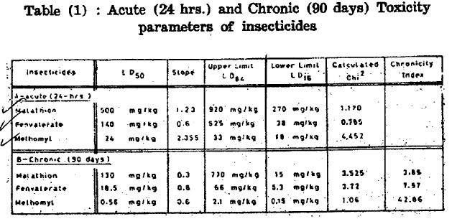
For methomyl, significant differences in body weight as compared to the control was noted in all test concentrations including the lowest test concentration (0.1 mg/kg bdwt), (see Figure 4 below; from study).
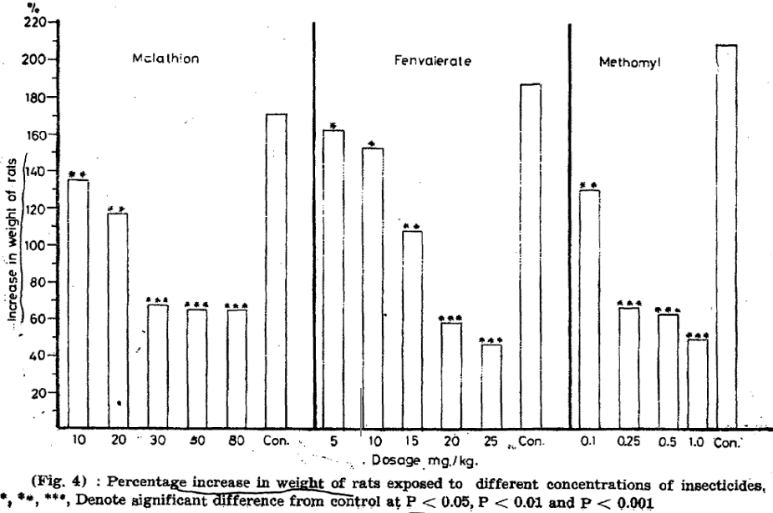

Description of Use in Document (QUAL, QUAN, INV): INV

Limitations of the Study: The source of chemical and % purity are not provided in the study. No details are provided on housing, general health of the rats or origin of the test species. No negative control was used, only ‘two groups receiving vehicles served as controls’ was utilized. Either cotton seed oil or aqueous water was used as the vehicle solvent, it is not clear. Individual test results are not reported (although changes in weight of some of the test groups was tracked). Feed was not analyzed for contaminants. Only nominal test concentrations are reported for only one part of the study. Raw data were not provided; therefore, the statistics could not be verified.

Primary Reviewer: Christina Wendel, MS, Biologist, US EPA, Office of Pesticide Programs, ERB2

Chemical Name: Methomyl

CAS No: 16752-77-5
PC Code: 090301

ECOTOX Record Number and Citation:
ECOTOX Reference: E10443
Roberts M.H. Jr, Warinner J.E. Tsai C.F., Wright D., Cronin L.E. (1982). Comparison of Estuarine Species Sensitivities to Three Toxicants. Archives of Environmental Contamination and Toxicology, 11 (6): 681–692.

Purpose of Review: ESA risk assessment—for quantitative threshold use.

Date of Review: 10/29/20

Summary of Study Findings (methomyl exposures of Menidia menidia and Cyprinodon variegatus only):

Experimental Design: M. menidia (59.4 ± 5.1 mm total length) collected in the wild from the Chesapeake Bay near the mouth of the Patuxent River and commercially purchased C. variegatus (25.8 ± 2.87 mm) were held separately in two 893-L (236-gal) flow-through tanks receiving ambient bay water (salinity 8-15‰) for at least one week. After holding period, tanks were refilled with filtered bay water (temperature 22 ± 1°C), and salinity was adjusted to 10 ‰ by adding synthetic sea salts or well water. Fish were acclimated at least 7 days and fed commercial fish flakes 3 times per day. Feeding halted 48 hrs prior to exposure.

Both species were simultaneously exposed for 96 hrs to 5 concentrations of Lannate L (24% Lannate in methanol), in 2 replicate 5-gal aquaria (10 fish each) for each concentration. Aquaria were aerated and pH, DO, and salinity were measured daily. Dead fish were recorded and removed at 6 to 12 hr intervals.

Results:

The LC₅₀ for C. variegatus was 0.34
The LC₅₀ for M. menidia was 0.96

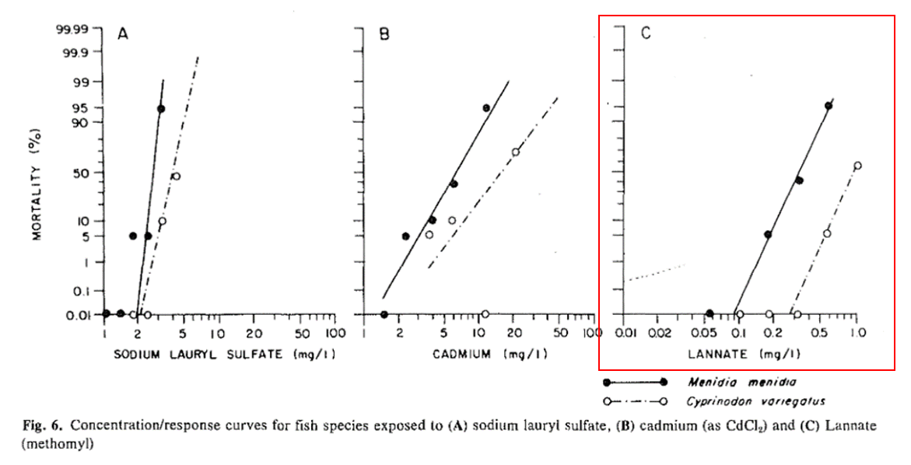

Description of Use in Document (QUAL, QUAN, INV): INV

Limitations of Study:
- No negative or vehicle control group reported in methods for M. menidia or C. variegatus
  - No control group plotted in Fig 6
- M. menidia were wild-caught from Chesapeake Bay; exposure history likely, but unknown
- Concentrations not measured
- Unclear what concentrations were tested (between 0.05 and 1.0 mg/L, based on Fig 6 x-axis)
- Description of experimental design unclear
- Lack of detail about holding and exposure conditions
  - Water quality measurements mentioned in methods not reported in results
  - Ambient bay water used for holding – possible contamination
  - Unclear whether sea salt and/or well water was used

Primary Reviewer: Matthew Urich, OPP/HED/RAB8
Secondary Reviewer: Jerrett Fowler, OPP/EFED/ERB2

Open Literature Review Summary

Chemical Name: Methomyl

CAS No: 16752-77-5

PC Code: 090301

ECOTOX Record Number and Citation: E110202
Li, Huixian, Hui Jiang, Xiwu Gao, Xiaojun Wang, Weigang Qu, Ronghua Lin and Jiao Chen. 2008. Acute toxicity of the pesticide methomyl on the topmouth gudgeon (Pseudorasbora parva): mortality and effects on four biomarkers. Fish Physiol Biochem (2008) 34:209–216

Purpose of Review: Methomyl ESA pilot (Registration Review)

Date of Review: 08/08/2016 (updated 03/16/2018)

Summary of Study Findings:
The 96-hour LC₅₀ value was found to be useable for SSD use.
Abstract Excerpt: “In this study, the acute toxicity of the pesticide methomyl on the topmouth gudgeon (Pseudorasbora parva) was evaluated using mortality and the activity of the enzymes acetylcholinesterase (AChE), glutathione S-transferases (GSTs), glutamic oxaloacetic transaminase (GOT) and glutamic pyruvic transaminase (GPT) as endpoints. LC₅₀ values were 1.228, 0.782, 0.538, and 0.425 mg/L at 24, 48, 72, and 96h of exposure, respectively. Methomyl caused a sharp decrease in specific activity of brain AChE around 48% at concentrations between 0.043 and 0.213 mg/l. A reduction higher than 40% in liver GST activity at concentrations between 0.085 and 0.213 mg/l was found, whereas no significant effects were observed in intestinal GST. A significant concentration-dependent decrease of GOT activity was found after 24 h of exposure to the pesticide but not after 96 h. No significant effects on GPT activity were observed. These results indicate that at the concentrations tested, methomyl is acutely toxic to the species P. parva, causing mortality, neurotoxic effects, and changes in some hepatic enzymes.”

Live fingerlings of topmouth gudgeon (3.39 ± 0.29 g body weight and 7.24 ± 0.38 cm body length) were used. Stock solution was prepared at 1% in acetone and diluted to the desired concentrations with acetone, and the highest concentration of acetone in the test media was less than 1%.

Thirty fingerlings (three groups of ten each) of approximately equal size were released into three each 34-l glass aquaria containing 20 l of test substance and “corresponding volume of acetone as control sets,” which is assumed to mean solvent control.

Temperature was maintained at 23 ± 1ºC with aeration and a photoperiod of 14:10 (light:dark).

The fish were not fed during the experiment and survival at the end of every 24, 48, 72, and 96h was recorded. Dead fish were removed immediately.

Four sublethal concentrations (1/2, 1/3, 1/5, and 1/10 of 96h LC₅₀) were selected for bioassays. Approximately 100 fingerlings were selected and divided into five equal groups of 20. These groups were exposed to methomyl for 96h, and at the end of each 24-h period, water containing the methomyl from each aquarium was replaced.

Results:
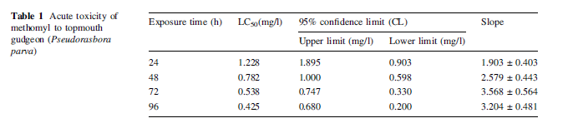

Description of Use in Document (QUAL, QUAN, INV):
QUAN – LC50 for use in the SSD

Rationale for Use:
- The 96-hour LC₅₀ is useable for SSD use
Limitations of Study:
- Unclear how much acetone in test solutions – only says <1% Stock solution was prepared at 1% in acetone and diluted to the desired concentrations with acetone, and the highest concentration of acetone in the test media was less than 1%. The recommended limit for solvent concentration is 0.1 ml/L, or 0.01%.
- Unclear whether all test solutions had equal solvent.
- Unclear whether there was any control mortality.
- Control seems to be solvent control (no negative control) but not clear, only verbiage found says “corresponding volume of acetone as control sets.”

Acetone issue: The fact that their reported LC₅₀ values were comparable to those from other species is reassuring. While more details would have been desirable in the methods section, the study design seems to be sound enough to not provide a reason to limit the usage of their data.

Primary Reviewer: Donna R. Judkins, Ph.D., Biologist, US EPA, Office of Pesticide Programs, ERB2

Secondary Reviewer: Christina Wendel, Biologist, US EPA, Office of Pesticide Programs, ERB2

Open Literature Review Summary

Chemical Name: Methomyl

CAS No: 16752-77-5

PC Code: 090301

ECOTOX Record Number and Citation: E110203
Pereira, J.L, and F. Goncalves. 2007. Effects of food availability on the acute and chronic toxicity of the insecticide methomyl to Daphnia spp. Science of the Total Environment (2007) 386:9–20.

Purpose of Review: Methomyl ESA pilot (Registration Review)

Date of Review: 04/13/2018

Summary of Study Findings:

Abstract Excerpt: “The widespread increase of pesticides application in crops threats vicinal freshwater lentic ecosystems, frequently leading to their contamination. Due to their position in the aquatic food web, the responses to these pesticide inputs of freshwater filter-feeding zooplankters, as daphnids, provide relevant information the general risk to the ecosystem of xenobiotics. Moreover, cladoceran grazers often face fluctuations in food availability due to the phytoplankton dynamics in lentic water bodies, and food acquisition naturally conditions their fitness. In this study, the responses of Daphnia magna, and of three genotypes within the Daphnia longispina complex, to acute and chronic exposures of methomyl, were assessed. In addition, we focused on whether the food level can model the Daphnia life-history responses to the insecticide. Results showed that methomyl was acutely and chronically toxic to both D. magna and the D. cf longispina populations at very low concentrations, and remarkable differences in sensitivity were noticed when comparing the responses to the toxic among taxa/genotypes. Furthermore, food availability conditioned the overall fitness of the species although not interacting specifically on the response to the toxicant stress.”

Monoclonal Daphnia spp. bulk cultures were continually reared in the lab under 16:8h light:dark photoperiod, at 20± 2ºC in synthetic ASTM hard water, supplied with additive an organic additive extracted from algae Ascophyllum nodosum. Cultures were renewed every other day, and organisms were fed with Pseudokircheriella subcapitata at 3.0 x 10⁵ cells/mL for D. magna and 1.5 x 10⁵ cells/mL for D. cf longispina.

The stock solution of methomyl was a direct dilution of commercial formulation Lannate® (200 g/mL methomyl concentrated) in distilled water.

Daphnids only <24 hours old were used in the tests. The mean body size at the start 1.18, 0.70, 0.71, and 0.71 mm for D. magna, D. longispina M, D. longispina V, and D. longispina T, respectively. Twenty newborns per treatment (four replicates with five animals each) were exposed in glass vessels (test volume 100 mL), without food or organic additive supply. Dissolved oxygen and pH were monitored at the beginning and end of the test, and the tests were screened for immobilized individuals at 24 and 48 hours.

In the chronic experiments, the daphnids were individually exposed in glass vessels (test solution 50 mL) along 21 days, to five nominal concentrations of methomyl, plus one ASTM negative control (10 replicates per treatment). Renewal occurred every other day to freshly prepared test solutions. Dissolved oxygen and pH were monitored at the beginning and end of the test, and the tests were checked daily for eventual mortality and progeny releasing.

Description of Use in Document (QUAL, QUAN, INV): QUAL

Limitations of Study:
- It is unclear what the test material (% a.i.) that was used in the study
- It is unclear what the nominal or actual test levels were that were tested, as neither were reported in the study.
- It is unclear whether there was any control mortality.

Primary Reviewer: Christina Wendel, Biologist, US EPA, Office of Pesticide Programs, ERB2

Open Literature Review Summary

Chemical Name: Methomyl

CAS No: 16752-77-5

PC Code: 090301

ECOTOX Record Number and Citation: E152279
Yokoyama, A., K. Ohtsu, T. Iwafune, T. Nagai, S. Ishihara, Y. Kobara, T. Horio and S. Endo. 2009. A Useful New Insecticide Bioassay Using First-Instar Larvae of a Net-Spinning Caddisfly, Cheumatopsyche brevilineata (Trichoptera: Hydropsychidae). J. Pestic. Sci. 34(1): 13-20.

Purpose of Review: Methomyl ESA pilot (Registration Review)

Date of Review: 08/08/2016

Summary of Study Findings:

Abstract Excerpt: A new insecticide bioassay for assessing the effects of acute insecticide toxicity on lotic insects was developed. It uses first-instar larvae of a net-spinning caddisfly, Cheumatopsyche brevilineata. The test method was suitable for 30 insecticides with a range of action mechanisms. Caddisfly larvae were much more sensitive than daphnids to neonicotinoids. The new bioassay is thus a useful and reliable method for assessing the impact of chemicals such as neonicotinoids, whose risks for lotic insects might be underestimated by the daphnid bioassay.

Acute toxicity of 30 insecticides were studied, with insecticides falling into seven categories according to the IRAC Mode of Action Classification Scheme, Ver. 5.3. (see paper for reference). All stocks and serial dilutions of were prepared in acetone, except for cartap hydrochloride and thiocyclam hydrogen oxalate, which we prepared in methanol. Authors state that all chemicals were of analytical grade (methomyl was 98% purity). Glass vials (2.2 ml) were generally used as test vessels. Additionally, polystyrene 48-well dishes (2.0 ml/well) could also be used in tests of insecticides with an octanol-water partition coefficient (log Kow) <4.5 (applying to both methomyl and carbaryl) since authors cite a previous study showing no significant difference in acute toxicity results for these insecticides between tests using glass vials and polystyrene 48-well dishes (unpublished data).

Range-finding tests were preliminarily conducted to determine the range of concentrations for the definitive test. In definitive tests, a geometric series of five to ten concentrations was used with separation factors of 1.1 to 1.3 in the test solutions. Appropriate volumes of insecticide stock solutions were added to dechlorinated tap water (hardness: ca. 70 mg/l as CaCO3, pH 7) that had been filtered through a membrane filter with 0.22-µm pores and then aerated. The final concentration of solvent in the test solution did not exceed 0.1% (v/v), the level at which no adverse effects were observed in the tested larvae (data not shown). The volume of the test solution was 2 ml in the glass vials or 1.5 ml in the wells. Only actively swimming or crawling larvae (less than 24 hr after hatching) were chosen for the tests, and were placed individually into a test vial or well using a glass pipette.

Twenty larvae were used at each concentration and for the control.

To avoid trapping larvae at the water surface, authors state that they illuminated larvae continuously from beneath with white fluorescent light (ca. 4000 lux), because newly hatched larvae of the caddisfly swim toward light, as Hydropsyche cockerelli has been reported to do.

Results:
Summary of Applicable Data from Table 1. Insecticides tested
 | Active ingredients | Purity (%) | Log Kow | 48-h EC50 for D.magna  ug ai/L
 | benfuracarb | 98.0 | 4.22 | 9.9
 | carbaryl | 99.0 | 1.85 | 5.6
 | carbosulfan | 98.0 | 5.4 | 1.03
1A (Carbamates) | fenobucarb | 98.0 | 2.79 | 10.3
 | methomyl | 98.0 | 0.093 | 8.8

These data were included in the paper but do not appear to be generated by this study; therefore, do not use the 8.8 ug/L LC₅₀ for daphnia – not primary source.

Summary of Applicable Data from Table 2. Susceptibilities of Cheumatopsyche brevilineata to 30 insecticides
 |  | 48-hr EC50, (ug/l) | 95% Confidence interval
 | benfuracarb | 6.66 | (6.32–7.02)
 | carbaryl | 21.4 | (20.3–22.7)
 | carbosulfan | 1.49 | (1.41–1.58)
1A (Carbamates) | fenobucarb | 9.48 | (9.16–9.81)
 | methomyl | 68.1 | (65.1–71.1)

These data were generated in this study and are usable.
Description of Use in Document (QUAL, QUAN, INV):
QUAN – EC₅₀ values of Cheumatopsyche brevilineata

Rationale for Use:
The methomyl EC₅₀ of 68.1 µg/L for Cheumatopsyche brevilineata was reviewed for use as an SSD quartile representative data point; it was determined to be quantitatively useable for SSDs and effects descriptions.

Limitations of Study:
- The Ceriodaphnia data were not generated by this study but included for comparison; they are not useable since this was not the primary source.
- Raw data were not available to confirm calculations and statistics.

Primary Reviewer: Donna R. Judkins, Ph.D., ERB2

Open Literature Review Summary

Chemical Name: Methomyl

CAS No: 16752-77-5

PC Code: 090301

ECOTOX Record Number and Citation: E154905
Mano, Hiroyuki, Masaki Sakamoto and Yoshinari Tanaka. 2010. A comparative study of insecticide toxicity among seven cladoceran species. Ecotoxicology (2010) 19:1620–1625.

Purpose of Review: Methomyl ESA pilot (Registration Review)

Date of Review: 08/08/2016

Summary of Study Findings:
The methomyl EC₅₀ of 0.00211 µg/L for Ceriodaphnia reticulate was reviewed for use as an SSD quartile representative data point; it was determined to be quantitatively useable for SSDs and effects descriptions.

Abstract Excerpt: The sensitivities of seven cladoceran species (Ceriodaphnia reticulata, Chydorus sphaericus, Daphnia galeata, Diaphanosoma brachyurum, Moina macrocopa, Scapholeberis kingi, and Simocephalus vetulus) to carbamate insecticides (carbaryl and methomyl) were investigated by acute toxicity tests. The sensitivities to carbaryl and methomyl were highly correlated among the tested organisms, but the co-tolerance level varied markedly among species. C. reticulata showed the highest sensitivity, whereas M. macrocopa and S. kingi showed the lowest sensitivities to the two insecticides. These results indicate that the degree of chemical impacts on natural communities can vary depending on cladoceran species composition. The highly positive correlation between the EC₅₀ values for both insecticides indicates that the two chemicals have a shared mode of action on cladoceran species. Unlike previous reports, acute toxicity was not correlated with body size. The results are discussed in relation to community level experiments, the functions of freshwater ecosystems, and ecological risk assessment.

Authors state that bioassays were performed following OECD guideline no. 202 (OECD 2004) with slight modifications. Female neonates (<24 h old) from the second or later broods were used in all tests. The nominal concentrations of carbaryl and methomyl, common ratio, and number of treatments for tests of the seven species are shown in Tables 1 and 2 (copied below).
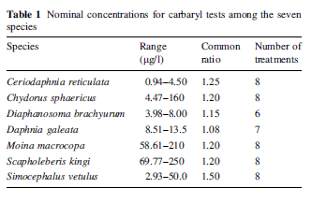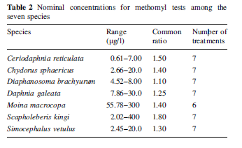
For each combination of cladoceran species and insecticide more than five chemical concentrations were used and for each concentration, four replicates, each with five neonates. For each species, the control and the solvent (ethanol) control for carbaryl assay and the control for methomyl assay were prepared as well.
Authors state that both insecticides were of 99% purity.

Authors also state that o keep D. galeata individuals out of the water surface, approximately 2 mg of cetyl alcohol [CH3(CH2)14CH2OH] was gently dropped onto the water surface in the glass beakers; cetyl alcohol is a surfactant to decrease the surface tension that might entrap the D. galeata individuals. Such a low level of cetyl alcohol has no effect on the survivorship of Daphnia individuals (Desmarais 1997; see paper for reference).

The dissolved oxygen and pH were measured at the beginning and end of the tests in the controls and the highest test substance concentrations. Those physicochemical conditions met the criteria: values at the start and the end were 7.8 ± 0.14 mg/l (mean ± SD) and 7.56 ± 0.16 mg/l for DO, and pH was 8.13 ± 0.05 and 8.16 ± 0.04, respectively.

Results:
In each of the controls and the solvent controls, not more the 10 percent of tested neonates were immobilized.

The results for carbaryl and methomyl were as follows:
Species | EC₅₀, 95% confidence limits, µg ai/L
 | Carbaryl | Methomyl
M. macrocopa | 103.21, 97.79–109.09 | 135.67, 116.23–160.29
S. kingi | 114.76, 105.75–125.83 | 124.17, 86.92–348.98
C. sphaericus | 10.02, 9.18–11.53 | 7.10, 6.14–8.57
D. galeata | 11.32, 10.90–11.90 | 11.99, 10.97–13.07
S. vetulus | 14.24, 11.17–25.78 | 12.15, 10.91–14.04
D. brachyurum | 5.65, 5.35–5.96 | 5.49, 5.31–5.71
C. reticulata | 2.25, 1.93–2.94 | 2.11, 1.61–3.43
The concentrations reported in the table above are apparently nominal concentrations. No mention of analytical verification was found.
Description of Use in Document (QUAL, QUAN, INV):
QUAN – EC₅₀ values

Rationale for Use:
The methomyl EC₅₀ of 0.00211 µg/L for Ceriodaphnia reticulate was reviewed for use as an SSD quartile representative data point; it was determined to be quantitatively useable for SSDs and effects descriptions.

Limitations of Study:
- No mention was found of analytical verification of test concentrations; however, since the treatment concentrations were not near the solubility limit for methomyl, this was not likely a problem. Therefore, the nominal concentrations may be used quantitatively, although some uncertainty is acknowledged. For similar use for carbaryl, the solubility limit would need to be considered.
- Raw data were not available to confirm calculations and statistics.

Primary Reviewer: Donna R. Judkins, Ph.D., ERB2

Chemical Name: Methomyl

CAS No: 16752-77-5
PC Code: 090301

ECOTOX Record Number and Citation:
ECOTOX Reference: E166086
Rehan A, Freed S. Resistance selection, mechanism and stability of Spodoptera litura (Lepidoptera: Noctuidae) to methoxyfenozide. Pesticide Biochemistry and Physiology (2014). DOI: 10.1016/j.pestbp.2014.02.001.

Purpose of Review: ESA risk assessment—for quantitative threshold use.

Date of Review: 11/02/20

Summary of Study Findings (methomyl only):

Experimental Design:
Introduction Excerpt:
“[This study] investigated the potential of S. litura to develop resistance against methoxyfenozide through selection pressure and the mechanism of resistance through the synergistic experiments. In addition the cross resistance of methoxyfenozide in S. litura to various insecticides was also examined.”
S. litura larvae were collected from cabbage plants in order to generate a methoxyfenozide resistant (MR) strain, and from cotton plants in another location to generate a susceptible (reference) strain. The larvae collected from cabbage plants were divided into 2 groups: one group (MR) was exposed to increasing concentrations of methoxyfenozide for 13 generations (Table 2), and the other (UNSEL) was reared without methoxyfenozide.
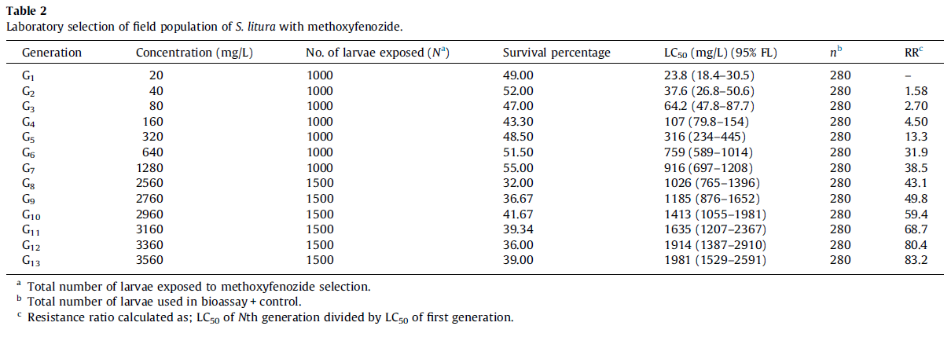
Methomyl is one of the insecticides examined for cross resistance in S. litura. LC⁵⁰ data were generated for “unselected,” “selected (MR),” and reference population
Methods Excerpt:
“The bioassays were conducted through diet incorporation methods in which 280 second instars larvae of S. litura were used in each treatment including the control, while each treatment (6 levels) was repeated five times. The data was taken after 72 h for new chemistry insecticides, while 48 h in case of conventional insecticides. The mortality was recorded by touching the larvae with a brush to provoke movement; non-moving larvae were considered to be dead.”

Results (methomyl only):

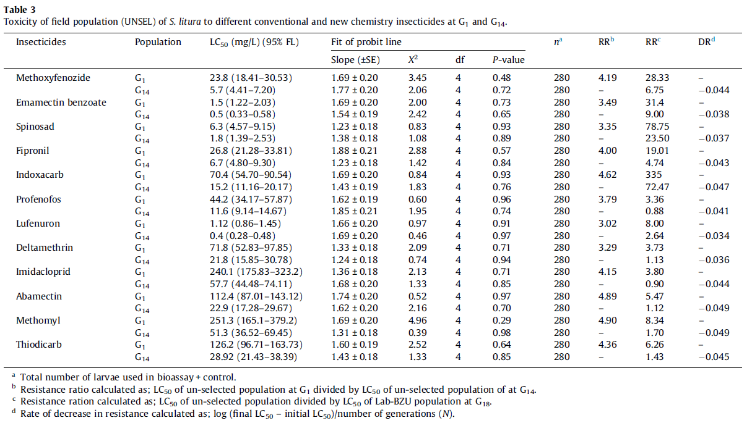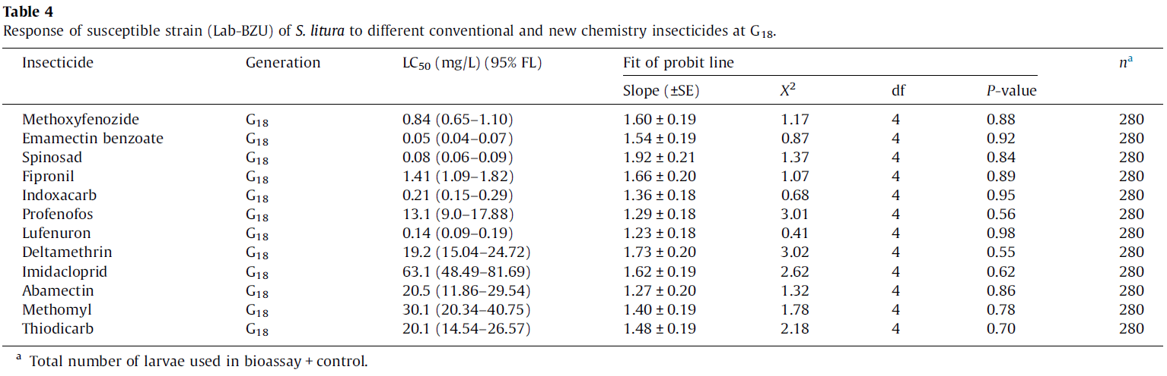

Description of Use in Document (QUAL, QUAN, INV): INV

Limitations of Study:
- No description of what is meant by “control,” simply that a control was included
- No control mortality data reported, but control mortality apparently did occur
  - “Abbott’s formula was used to correct the data when mortality was recorded in the control”
- No description about how larvae were exposed, except that “diet incorporation methods” were used
  - LC₅₀’s in the tables are listed as mg/L (95% FL)
    - “FL” not defined
  - Table 1 indicates Lannate 40 SP was used for methomyl exposures (40% methomyl)
    - No indication whether purity was adjusted in reported values
- Effects of methomyl found to be statistically insignificant (p > 0.05)
- Statistical methods are extremely vague and are summed up in one sentence:
  - “The LC50 and P-values were calculated by using the POLO PC software while Abbott’s formula was used to correct the data when mortality was recorded in the control”
- Concentrations not measured

Primary Reviewer: Matthew Urich, OPP/HED/RAB8
Secondary Reviewer: Jerrett Fowler, OPP/EFED/ERB2

Open literature Review Summary
Chemical Name: Methomyl

CAS No: 16752-77-5

PC Code: 090301

ECOTOX Record Number and Citation: E167186
Mossa, A-T. and Abbassy, M. 2012. Adverse Haematological and Biochemical Effects of Certain Formulated Insecticides in Male Rats. Research Journal Environ. Tox. 6(4):160-168.
Purpose of Review (Note: DP Barcode required for Quantitative studies): Methomyl ESA Pilot (Registration Review)

Date of Assessment: 4/13/2018

Summary of Study Findings:
Male Wistar rats were exposed to repetitive oral doses of a formulated product for 90 consecutive days, to evaluate hematological and biochemical parameters of male rats. The study included three (3) insecticides: chlorpyrifos-ethyl, chlorpyrifos-methyl, and methomyl. The results presented are for methomyl only, this study also contains data for chlorpyrifos-ethyl, and chlorpyrifos-methyl; however, that data is not included here.

Methods:
Male Wistar rats (weighing 100-120g), from Animal Health Research Center, Cairo, Egypt, were exposed to oral doses of methomyl for 90 consecutive days. Animals were housed in clean plastic cages with free access to food (standard pellet diet), and tap water (ad libitum), under 12h light:dark cycle. The temperature was 22±1°C, with a minimum relative humidity of 40%. The test animals were divided into 4 groups of six (6) animals each, comprised as follows – group one - chlorpyrifos-methyl, group two - chlorpyrifos-ethyl, group three – methomyl, and group four – control. Again this summary will be reporting the results of methomyl only.

The tested insecticides were prepared fresh daily, adjusted weekly for body weight changes, and administered orally for 90 consecutive days. Methomyl (Lannate® 90% WP), was dosed at 1.7 mg/kg-bdwt, and the control group received and equivalent volume of distilled water (0.5 mL/rat).

In all groups, body weights were recorded weekly. At the end of the exposure period, blood samples were drawn from all rats. Data were analyzed using SPSS, paired t-test was used to compare the data between the control and treatment groups.

Description of Use in Document (QUAL, QUAN, INV): INV

Limitations of the Study:
- Only one group of six (6) animals was tested per chemical; there was no replication in this study.
- No details are provided general health of the rats or origin of the test species.
- No description was provided on the type of feed that was used, and the feed was not analyzed for contaminants.
- Only one dose level was tested; however, no information was provided if it was the nominal or actual test concentration. No information was provided if the test concentrations were analyzed.

Primary Reviewer: Christina Wendel, MS, Biologist, US EPA, Office of Pesticide Programs, ERB2

Open Literature Review Summary

Chemical Name: Methomyl

CAS No: 16752-77-5

PC Code: 090301

ECOTOX Record Number and Citation: E167254
Pereira, J.L, Mendes, C.D., and F. Goncalves. 2009. Acute and Chronic Effects of a Mixture of Formulated Pesticides and Its Corresponding Active Ingredients in Daphnia magna. Fresenius Environmental Bulletin (2009) 18:1282–1289.

Purpose of Review: Methomyl ESA pilot (Registration Review)

Date of Review: 04/20/2018

Summary of Study Findings:
The study included two (2) insecticides: propanil and methomyl, and commercial formulations of each. The results presented are for methomyl only.

Abstract Excerpt: “Agricultural practices worldwide include the use of pesticides either as single-chemical or multiple-chemical applications aiming higher efficiency in controlling grass weeds and animal pests. Pesticides may easily reach and contaminate surface waterbodies mainly through drainage and spray drift, and hence are currently viewed as a major contamination issue. Following recent discussion on the ability of adjuvant chemicals added to marketed formulations to contribute for pesticide toxicity, this study focuses the acute and chronic toxicity of the insecticide Lannate® and the herbicide Stam Novel Flo®, as well as that of their active ingredients Methomyl and Propanil, to the freshwater cladoceran Daphnia magna. Furthermore, acute and chronic toxicity of mixtures is addressed, through the evaluation of D. magna responses to joint exposures comprising both active ingredients and both commercial formulations. Regarding acute exposures, the mixture comprising commercial solutions was shown to have a more than additive action, while the opposite (less than additive action) was found when testing the joint action of the active ingredients. Chronic exposures can provide additional information on chemicals' toxicity in reproductive endpoints, which is of particular relevance when considering that pesticides are often repeatedly applied within a single agricultural season. Life-history endpoints assessed under mixture exposures indeed indicated higher long-term than short-term toxicity, and showed a distinct pattern of joint action when compared to acute toxicity assessments. These results suggest that long-term exposures can provide relevant complementary information on mixtures' toxicity that should be taken into account within pesticide risk assessment procedures.”

Monoclonal bulk cultures of Daphnia magna (clone A sensu) were continually reared in the lab under 16:8h light:dark photoperiod, at 20± 2°C in synthetic ASTM hard water, supplied with an organic additive. Cultures were renewed every other day, and organisms were fed with Pseudokircheriella subcapitata at 3.0 x 10⁵ cells/mL for D. magna. All organisms used in the tests were newborns <24 hours old, yielded by cultured females within 3rd-5th brood.

Test materials that were used included technical grade methomyl (99.5% purity), and commercial solutions of Lannate® (200 g/mL methomyl concentrated). Main stock solutions were prepared on a weekly basis during testing by dilution or dissolution of commercial or technical grade materials, respectively, and stored in the dark at 4°C.

Acute assays were conducted within general accordance of a related protocol by OECD. Each treatment consisted of four (4) replicates with five (5) individuals in each glass vial containing a final test volume of 100 mL. The nominal concentrations were 18.6, 24.2, 31.4, 40.9, 53.1 and 69.1 µg a.i./L for technical grade methomyl, and 16.9, 22.0, 58.6, 37.1, 48.3, and 62.7 µg a.i./L for (methomyl formulation). The test solutions were not renewed, and the organisms were not fed during the tests; the dissolved oxygen and pH were monitored at the beginning and end of the test. Immobilized individuals were counted after 48 hours.

The chronic assays were also conducted within related OECD guidelines. The daphnids were
individually exposed in glass vessels (test solution 50 mL) along 21 days, to five nominal concentrations of methomyl (technical and formulation), plus one ASTM negative control (10 replicates per treatment). Renewal occurred every other day to freshly prepared test solutions. Dissolved oxygen and pH were monitored at the beginning and end of the test. The nominal concentrations were 6.9, 10.4, 15.6, 23.3, and 35 µg a.i./L for technical grade methomyl, and 4.2, 6.3, 9.5, 14.2, 21.3 µg a.i./L for (methomyl formulation). Tests were screened daily, and when present, neonates were counted for fecundity-related calculations, and immediately discarded. The daily growth rate, g (day⁻¹), of tested females was calculated.

Results:
The results presented are for methomyl only.

All the 48 h EC₅₀ values and respective 95% confidence limits were determined using Probit analysis. Table 1 (which is an excerpt from the paper) summarizes the EC₅₀ values. Both the active ingredient and commercial solution exhibited comparable acute toxicity to D. magna with resulting EC₅₀ values of 24 and 31 µg a.i./L, respectively, based on immobilization.

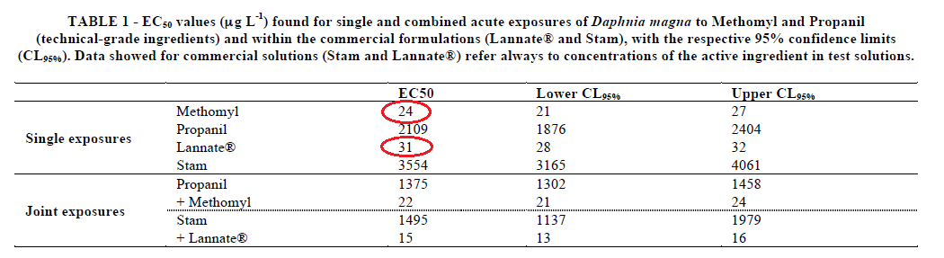

For the chronic toxicity data, one-way ANOVA followed by the Dunnett post-hoc test, when applicable was used to detect and assign significant differences between control and treatment groups for each life history endpoint (significance level, α of 0.05 was always used); Table 2.
Both the active ingredient and commercial solution have impaired fecundity (total offspring number) and somatic growth rate in all test concentrations except the lowest (6.9 and 4.2 µg a.i./L, technical methomyl and methomyl formulation, respectively) and control. The reported NOAEC/LOAEC for technical grade methomyl is 6.9/10.4 µg a.i./L, and for methomyl formulation is 6.3/9.5 µg a.i./L, based on reduced fecundity and somatic growth rate (see Table 2 and Figure 1, which are an excerpt from the paper, below).
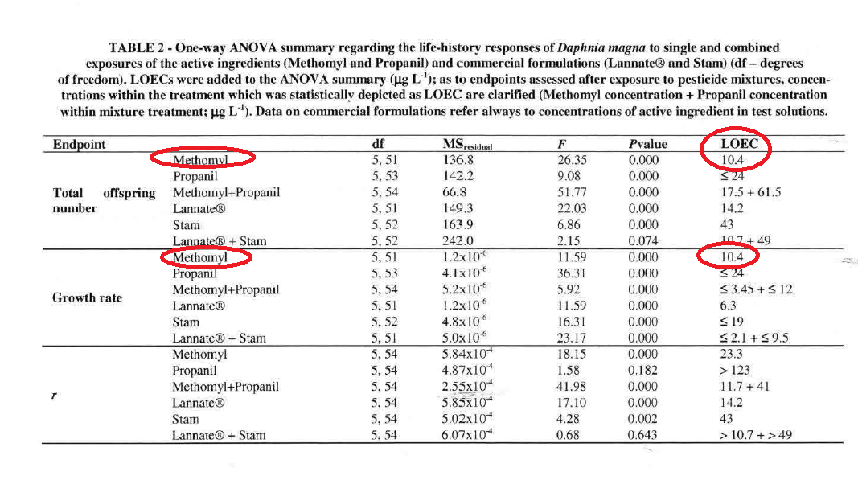
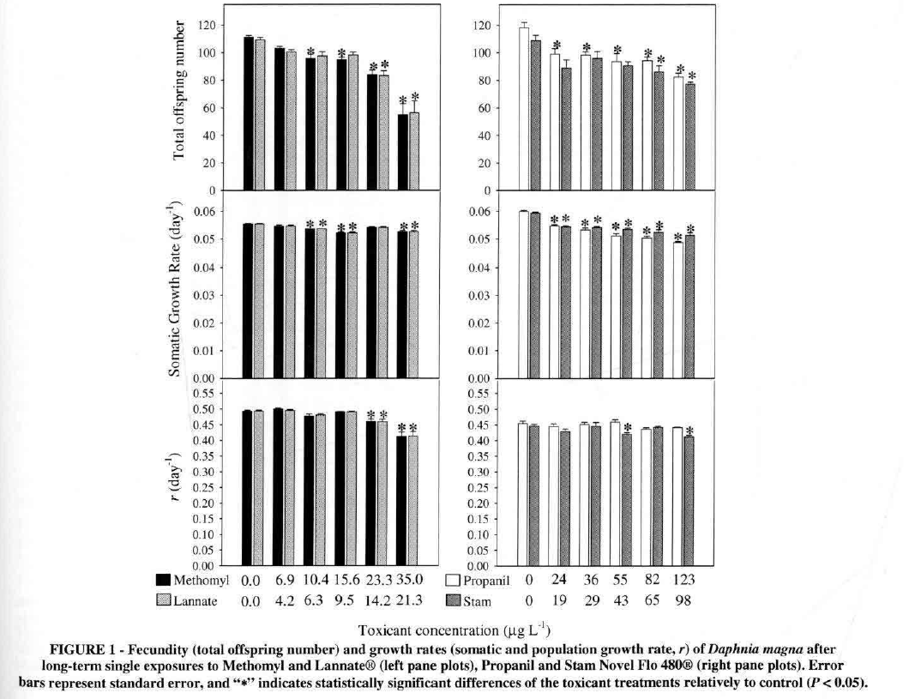

For technical methomyl, based on Figure 1 above, the total number of offspring was reduced by approximately 16% at 10.4 µg a.i./L (~110 control reduced to 92). For both technical and for methomyl formulation, based on Figure 1 above, the somatic growth rate was reduced by approximately 7% at 10.4/6.3 µg a.i./L, respectively, (0.056 reduced to approx. 0.052/d). Although, for both endpoints the measurements and percent reductions are only approximant, as it is very difficult to be accurate based on the values presented in the graph, and what is available in the study report.

Description of Use in Document (QUAL, QUAN, INV):
The immobilization and growth endpoints may be used quantitatively (QUAN):

48-hour EC₅₀ values of 24 and 31 µg a.i./L, for technical grade methomyl and methomyl formulation, respectively, based on immobilization.

NOAEC/LOAEC of 6.9/104 µg a.i./L for technical grade methomyl for significantly reduced total number of offspring and somatic growth rate; and a NOAEC/LOAEC of 6.3/9.5 µg a.i./L for methomyl formulation for significantly reduced somatic growth rate only.

The results presented are for methomyl only.

Rationale for Use:
- Five nominal concentrations with four replicate chambers per treatment were used.
This information supports an adequate study design for quantitative use of the EC₅₀ value, the somatic growth rate data and the fecundity (number of offspring) as a methomyl technical (99.5%) endpoint. In addition, both the EC₅₀ value and the somatic growth rate data can also be used as a methomyl formulation (Lannate®, 200 g/L) endpoint. The 48-hour EC₅₀ value for D. magna is 24 µg a.i./L (technical grade methomyl) and 31 µg a.i./L (methomyl formulation), respectively, based on immobilization. The NOAEC/LOAEC of 6.9/10.4 µg a.i./L (technical grade methomyl) is based on a significant reduction from controls in both the fecundity (number of offspring) and the somatic growth rate. The NOAEC/LOAEC of 6.3/9.5 µg a.i./L (methomyl formulation) is based on a significant reduction from controls in the somatic growth rate, only.

Limitations of Study:
- Raw data were not available to confirm calculations and statistics.

Primary Reviewer: Christina Wendel, Biologist, US EPA, Office of Pesticide Programs, ERB2

Secondary Reviewer: Melissa Panger, Ph.D., Senior Scientist, US EPA, Office of Pesticide Programs, ERB2

Open Literature Review Summary

Chemical Name: Methomyl

CAS No: 16752-77-5

PC Code: 090301

ECOTOX Record Number and Citation: E167277
Shalaby, M.A., H.Y. El Zorba, and R. M. Ziada. 2010. Reproductive toxicity of methomyl insecticide in male rats and protective effect of folic acid. Food and Chemical Toxicology. (2010) 48:3221-3226.

Purpose of Review: Methomyl ESA pilot (Registration Review)

Date of Review: 04/13/2018

Summary of Study Findings:
The acute toxicity of methomyl and its effects on male reproduction in rats were carried out based on a 65-day oral exposure.

Methods:
Male and female Sprague Dawley strain rats (weighing 160±20g and 16-18 weeks of age), from Animal House of Pharmacology Department, Cairo University, Egypt. Were exposed to oral doses of methomyl for 65 consecutive days. Animals were housed in controlled hygienic conditions with free access to food (pellet diet -10% wheat bran, 44% soy bean powder, 22% protein, 4.7% fat, 3.3% fish meal, molasses, salts and methionine), and tap water (ad libitum). The temperature was 25±2°C, with a relative humidity of 50±5%, and a photoperiod of 12h light:dark.

For the acute test, 50 male Sprague Dawley were distributed into five (5) groups of ten (10) animals each. Rats were given methomyl (Methomex®) orally via a stomach tube in graded doses. Toxic symptoms, and the number of rats that died in each group after 48 h observations were recorded. The LD₅₀ of methomyl was then calculated according to the method described in Gad and Weil (1982).

Methomyl was provided to male rats at two doses (1/20 and 1/40 LD₅₀), equivalent to 0.5 and 1.0 mg/kg-bdwt and folic acid was also provided at an acceptable daily intake of 1.1 mg/kg bdwt. Both were used to examine the impacts on fertilizing capacity of males, by mating treated males with normal (untreated) females of regular oestrous cycle. After serial mating, the fertility index for each male rat was determined by the number of females which become pregnant in relation to mated females (i.e., pregnancy rate). A total of 30 mature male rats were allocated into six equal groups. Oral administration continued for 65 consecutive days.

Description of Use in Document (QUAL, QUAN, INV): INV

Limitations of the Study:
- No information regarding the chemical purity or test concentration was provided, it is not known what was actually given to the test organisms.
- No details are provided general health of the rats or origin of the test species.
- No information was provided if the test concentrations were analyzed.
- No information was provided regarding the acute dose levels that were used, only dose levels that were provided were those that were used in the fertility index portion of the study.

Primary Reviewer: Christina Wendel, MS, Biologist, US EPA, Office of Pesticide Programs, ERB2

Open Literature Review Summary

Chemical Name: Methomyl

CAS No: 16752-77-5

PC Code: 090301

ECOTOX Record Number and Citation: E171543
Lau, Edward Tak Chuen, Nancy Elizabeth Karraker, and Kenneth Mei Yee Leung. 2015. Temperature-Dependent Acute Toxicity of Methomyl Pesticide on Larvae of 3 Asian Amphibian Species. Environmental Toxicology and Chemistry, Vol. 34, No. 10, pp. 2322–2327.

Purpose of Review (Note: DP Barcode required for Quantitative studies): Methomyl ESA pilot (Registration Review)

Date of Review: 08/05/2016 (updated 03/16/2018 and 05/19/2019)

Summary of Study Findings:
The LC₅₀ value of 15,400 µg/L for the marbled pygmy frog (Microhyla pulchra), was reviewed due to its sensitivity and taxon representation.

In this study, three amphibian species (also including the Asian common toad, Polypedates melanosticutus, and the tree frog, Polypedates megacephalus) were tested at temperatures ranging from 15-35ºC to analyze patterns in the temperature-dependence enhancement of methomyl toxicity. The endpoints for the tree frog (P. megacephalus) were 1 to 2 orders of magnitude greater than for the marbled pygmy frog.

Excerpt from Abstract: “The authors determined the acute toxicity, in terms of 96-h median lethal concentrations, of the carbamate pesticide methomyl on larvae of 3 Asian amphibian species, the Asian common toad (Duttaphrynus melanostictus), the brown tree frog (Polypedates megacephalus), and the marbled pygmy frog (Microhyla pulchra), at 5 different temperatures (15ºC, 20ºC, 25ºC, 30º C, and 35ºC) to examine the relationships between temperature and toxicity. Significant interspecific variation in methomyl sensitivity and 2 distinct patterns of temperature-dependent toxicity were found. Because high proportions of malformation among the surviving tadpoles were observed, a further test was carried out on the tree frog to determine effect concentrations using malformation as the endpoint. Concentrations as low as 1.4% of the corresponding 96-h median lethal concentrations at 25ºC were sufficient to cause malformation in 50% of the test population.”

Authors collected egg masses of the target species from Long Valley, Hong Kong Special Administrative Region, China (2285070N, 11481130E), from February to September 2011 and 2012. Hatchlings from different clutches that hatched within 1 d of each other were pooled together to minimize parental effects on experiments. Hatchlings were fed ground commercial fish flakes TetraMin (Tetra) ad libitum. Tadpoles at the free-swimming Gosner stage 25 [27] and within 2 wk of hatching were used for experiments.

TGAI and No Solvent USED: Technical-grade methomyl (98% purity, CAS no. 16752-77-5) was sourced from Tin Hang Technology. A stock solution of 16 g methomyl/L was prepared by dissolving the methomyl powder in Millipore water. Appropriate amounts of stock solution were dispersed in dechlorinated tap water (pH 6.9–7.2; conductivity _95% confidence interval [CI], 0.1494_5.5_10–4 mS/cm) to produce working solutions at the desired nominal concentrations.

Test Concentrations: Nominal test concentrations and analytical verification results from Days 0 and 2 were added as supplemental data at the end of the publication and those excerpts copied below.

Excerpts from paper:
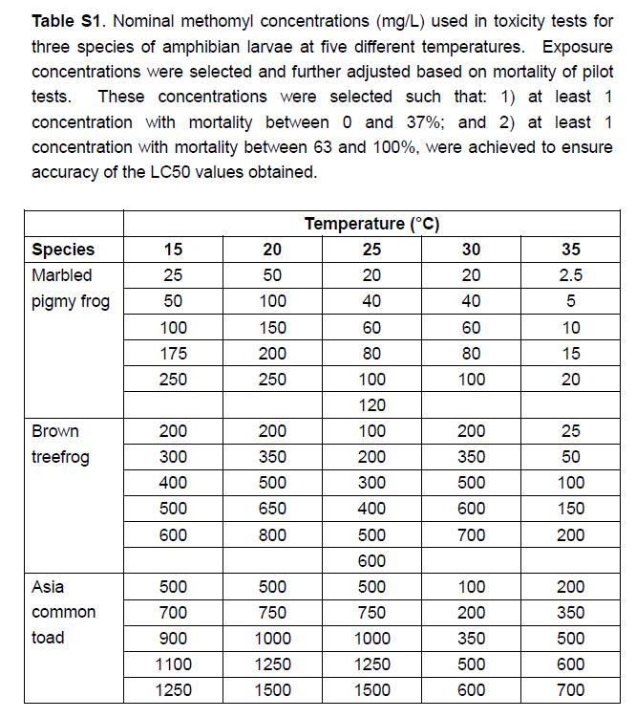

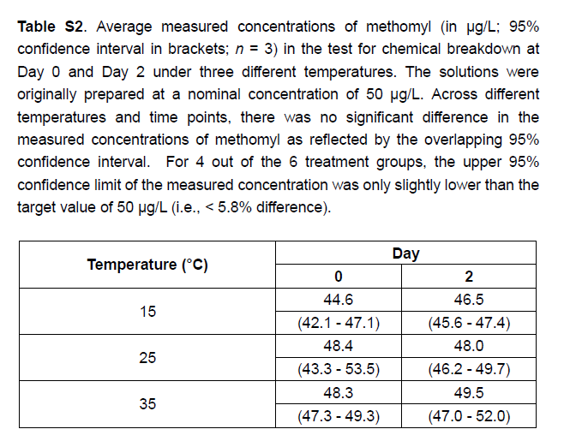

Limited Analytical Verification: Authors stated that verification of all treatment exposures was impractical because of its laborious nature, and therefore, tested the accuracy and stability of nominal treatment concentrations as follows: Tests for chemical breakdown were conducted by diluting the stock solution to a nominal concentration of 50mg/L and incubating it in water baths at 15ºC, 25ºC, and 35ºC, respectively, for 2 d. Samples were taken from each replicate at day 0 and day 2 for concentration verification. Methomyl was extracted from the samples using liquid–liquid Extraction.

Acute Toxicity: Authors then conducted 96-h semistatic acute aquatic toxicity tests at 5 temperatures: 15ºC, 20ºC, 25ºC, 30ºC, and 35ºC, which fall within the (author-claimed) thermal limits of the target species. Tadpoles were exposed to a minimum of 5 methomyl concentrations as well as a control containing no pesticide at each temperature. In general, the study design fit the fish acute test guidelines. However, the test concentrations to which they were exposed to were not reported.

Statement of randomization: Authors “haphazardly” allocated 10 tadpoles each to 1-L glass jars, each holding 800 mL of test solution. Each treatment was replicated 3 times, and a randomized block design was employed. Tadpoles were not fed during experimentation. A constant 12:12-h light:dark photoperiod was maintained throughout the exposure. Test solutions were renewed at 48 h, and exposure was terminated at 96 h.

Sublethal Endpoints: An additional experiment was conducted to study the sublethal effect of methomyl, in terms of malformation, on tree frog larvae. The experiment was only conducted with the tree frog as it was the only species with sufficient samples available when this experiment was performed. The methods used were similar to those used for determination of LC₅₀, except that the test was only conducted at 25ºC, at much lower concentrations, and that malformation in the form of axial abnormality (determined following the procedures described in Bantle et al. [Bantle JA, Dumont JN, Finch RA, Linder G. 1991. Atlas of Abnormalities: A Guide for the Performance of FETAX. Printing Services, Oklahoma State University, Stillwater, OK, USA.]) was used as the experimental endpoint instead of mortality. The endpoints included effect concentrations that caused 10% and 50% of the test population to develop abnormally (i.e., 96-h EC₁₀ and EC₅₀, respectively).

Results:
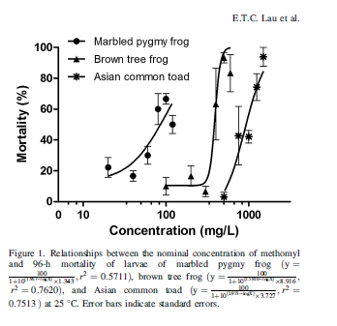
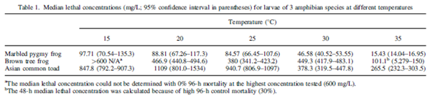
For the sublethal effect of abnormality:
At 25ºC, EC₁₀ and EC₅₀ values of methomyl, based on malformation of tree frog larvae, were determined as 2.159mg/L (95% CI 1.492–3.126mg/L) and 5.343 mg/L (95% CI 4.591–6.220mg/L), respectively. Putting these values into perspective, the EC₁₀ and EC₅₀ values were as low as 0.6% and 1.4%, respectively, of the 25ºC LC₅₀ value (380 mg/L; Table 1) of the tree frog.

Temperature Ranges: The temperature ranges to which the amphibians were exposed to ranged up to warmer temperatures than most test conditions used for toxicity testing (although temperature recommendations vary by species tolerance ranges), and a major point of the paper is that temperature affects toxicity, as would be expected. The authors claim that all temperatures used in the test are within the specie’s range. This is supported by information published on-line by the International Union for Conservation of Nature (https://www.iucnredlist.org/species/57891/136565884; accessed 08/05/2016), showing (below) that the marbled pygmy frog has a distribution that includes the tropics and is native to Cambodia; China; Hong Kong; Lao People's Democratic Republic; Macao; Thailand; Viet Nam and surface water temperatures could reasonably be expected to reach this temperature. Also, the authors of the paper state, “Across all temperature treatments, larvae of the 3 amphibian species in the controls generally showed no more than 10% mortality throughout the 96-h toxicity test, except that the control of the tree frog at 35°C had a high 96-h mortality of 30%.”
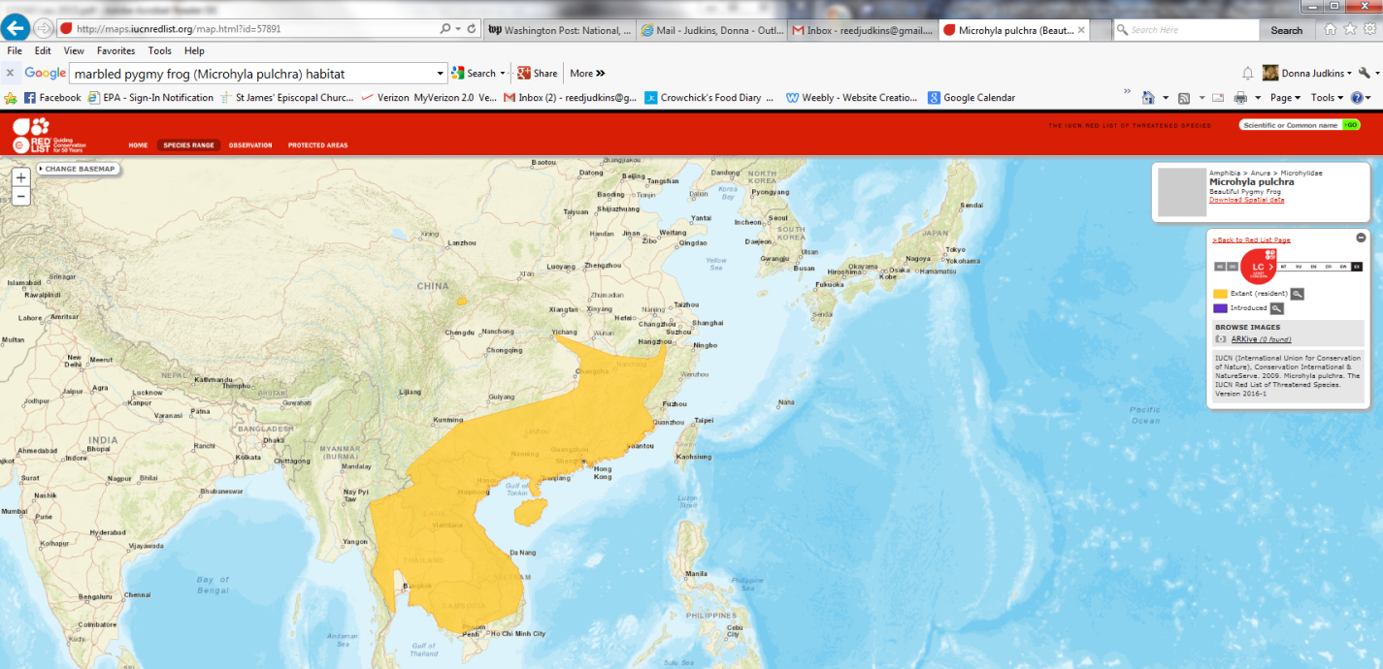
Citation: van Dijk, P.P., Stuart, B., Zhao Ermi & Geng Baorong. 2009. Microhyla pulchra. The IUCN Red List of Threatened Species 2009: e.T57891A11688269. http://dx.doi.org/10.2305/IUCN.UK.2004.RLTS.T57891A11688269.en. Downloaded on 05 August 2016.
In addition, organisms were acclimated to temperatures according to the following statement by authors: The larvae were acclimatized to the target treatment temperature by a stepwise increase or decrease of 1ºC/h from an initial temperature of 25ºC. After reaching the target temperature, larvae were acclimated for 48 h before commencement of the acute toxicity tests.”

Appropriate test temperature depends on the species and home range, and for the species tested, the lowest control mortality tended to be in the mid-range (25-30 ºC; see excerpt below).

Excerpt from Supplemental Data at end of paper:
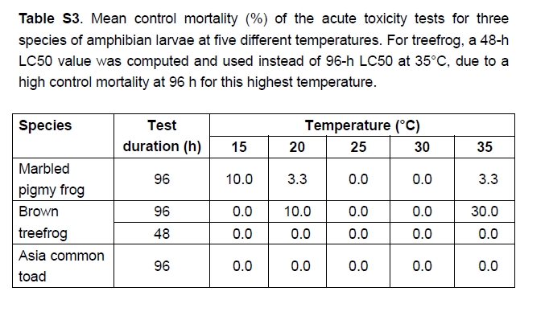
For Xenopus laevis (South African clawed frog) in the FETAX (frog embryo Teratogenicity Assay – Xenopus; American Society for Testing and Materials Guideline E1439 and OSCPP 890.1100) EPA recommends 22±1ºC and that inter-replicate and inter-treatment differentials should not exceed 0.5º C. Xenopus tropicalis is often kept at a slightly higher temperature (25-26ºC in one EPA sponsored study: accessed on May 19, 2019 at: https://apps.dtic.mil/dtic/tr/fulltext/u2/a553581.pdf ). The ASTM FETAX protocol might be useful as a reference, in addition to our AMA and LAGDA test guidelines. In this case, use of the mid-range result in the 25ºC treatment was determined to be the best option for quantitative endpoints.

Description of Use in Document (QUAL, QUAN, INV):

QUAN– LC₅₀s from the 25ºC treatment:

Most sensitive: Marbled pygmy frog LC₅₀ = 84.6 (66.5-108) mg a.i./L.

Excerpt from Table 1 of study, showing LC₅₀s of three species from only the 25ºC column:
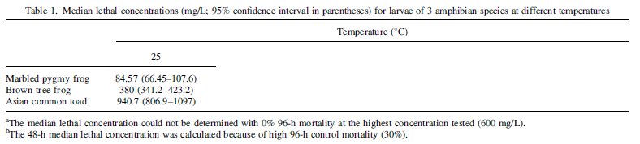

Rationale for Use:
- The 96-hour LC₅₀ values are useable quantitatively for threshold (if needed), to calculate risk, or for SSD use.

Limitations of Study:

QUAL– LC₅₀s from the 15, 20, 30, and 35ºC treatments and sublethal malformation endpoints.
Excerpt from Table 1 of study, with the 25ºC column removed:

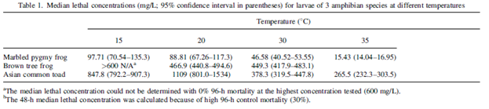

Sublethal Malformation Endpoints: At 25ºC, EC₁₀ and EC₅₀ values of methomyl, based on malformation of tree frog larvae, were determined as 2.16 mg/L (95% CI 1.49–3.13 mg/L) and 5.34 mg/L (95% CI 4.59–6.22 mg/L), respectively.

Rationale for Use:
- The 96-hour LC₅₀ values from 15, 20, 30, and 35°C studies and the sublethal malformation endpoints, are useable for SSD use or qualitatively to characterize risk.

INV– 96-hour LC₅₀ for the brown treefrog from the 35ºC treatment due to high (30%) control mortality.

Limitations of Study:
- The study was designed to compare toxicity for three frog species at different temperatures. The LC₅₀s generated at the mid-range temperature (25°C) were determined to be the most defensible based on control performance, appropriateness for species natural ranges, and comparability to supported protocols for other species (see discussion above).
- Some information was not reported in the paper, or only presented in summary form, such as:
  - Mortality data on test organism cultures prior to testing (however, control survival was very good at 25°C and adequate at all temperatures except for 35°C for the brown treefrog); and
  - Raw data showing mortality and test concentrations, summary data available in an attachment to the paper.

Primary Reviewer: Donna R. Judkins, Ph.D., Biologist, US EPA, Office of Pesticide Programs, ERB2

Secondary Reviewers: Melissa Panger, Ph.D., Senior Scientist, US EPA, Office of Pesticide Programs, ERB2
And
Christina Wendel, Biologist, US EPA, Office of Pesticide Programs, ERB2

Chemical Name: Methomyl

CAS No: 16752-77-5
PC Code: 090301

ECOTOX Record Number and Citation:
ECOTOX Reference: E182730
Gaete, H., Olivares, Y., Escobar, C. Assessment of the Effect of a Commercial Formulation of Methomyl on Reproduction of Daphnia Obtusa Kürz (1874)." Latin American Journal of Aquatic Research. 41.5 (2013): 979.

Purpose of Review: ESA risk assessment—for quantitative threshold use.

Date of Review: 10/29/20

Summary of Study Findings:

Abstract Excerpt:
“The aim of this study was to evaluate the effect of a commercial formulation of Methomyl on the reproduction in Daphnia obtusa. Neonates (<24 h) were exposed to concentrations of insecticide (1.0, 1.5, 2.0, 2.5, 3.0 µg L-1) for a period of 21 days. The results showed a significant decrease in the number of molts, total neonates, fertility and sex ratio index. Significant regressions were found between reproductive parameters and concentrations of the insecticide: molts (R2= 0.96), fertility (R2= 0.97), number of female neonates born per female (R2= 0.90), and the number of male neonates born per female (R2= 0.94). Embryotoxicity was also observed; the number of neonates born with malformations increased in the highest concentrations of Methomyl 90 SP® tested. In conclusion, Methomyl 90 SP® inhibits reproduction of D. obtusa. However, a clear effect as an endocrine disrupter was not observed. This insecticide is embryotoxic; it causes malformations in neonates of Daphnia obtusa.”

Experimental Design:
D. obtusa neonates (<24 h) were exposed to 5 concentrations of Methomyl 90 SP® (90% methomyl): 1.0, 1.5, 2.0, 2.5, 3.0 µg/L for a period of 21 days in 40 mL glass containers at 20 ± 0.2°C. In addition, a negative control was included that was presumably only exposed to culture water. Exposure water was renewed 3 times per week. A stock solution of methomyl was prepared from powder in distilled water and refrigerated (4°C) throughout the study; renewed after 14 days. Each of 10 replicates per treatment group each contained one female, and environmental conditions were altered (reduced photoperiod, reduced feeding) to encourage the production of male neonates. Culture conditions (pH, conductivity, dissolved oxygen and temperature) were measured weekly.
Response variables measured: number of males born per female, number of molts per female and number of malformed neonates per female according to Leblanc et al. (2000); under-developed first antennae, curved shell spine, unextended shell spine and survival at 21 days of exposure

Results:
- Number of molts per female decreased significantly compared to control (9 ± 0.7 molts.)
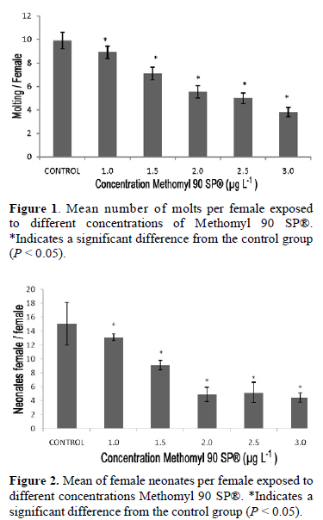
- Significant regression between number of molts and concentration of methomyl (p < 0.001; negative slope; Table 1).
- Significant regression between the number of females born per female and concentrations of the insecticide (p < 0.01; negative slope; Table 1).
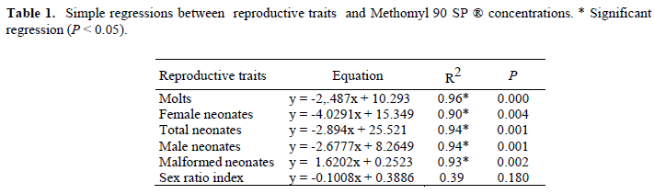

- The number of female neonates decreased significantly at all concentrations (p < 0.05; Fig. 2).

- Significant decrease in the total number of neonates per female (p < 0.05; Fig. 3); concentration-dependent.
- Significant decrease in number of males born per female (p < 0.05; Fig. 4); concentration-dependent.
- Sex ratio index was highest in controls and lowest in 3.0 μg/L group (p < 0.05; Fig. 5).
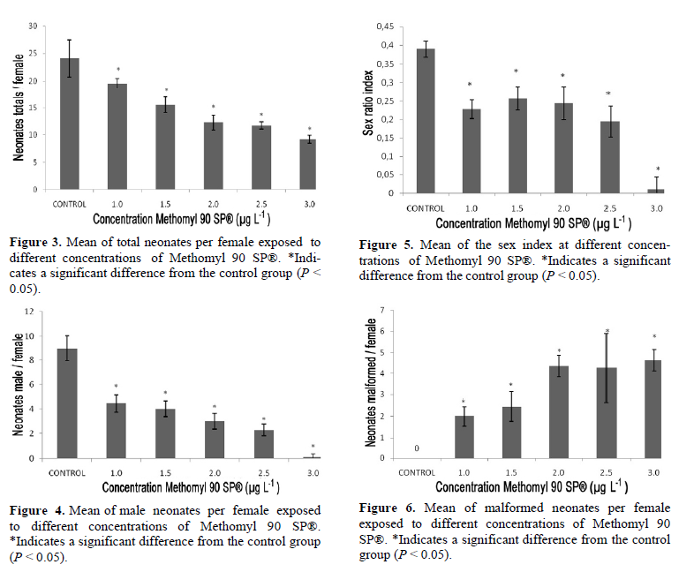

- Number of neonates with malformations increased in a concentration-dependent manner (Figs. 6, 7; p < 0.01; Table 1).
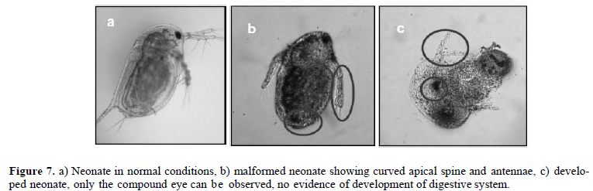

Description of Use in Document (QUAL, QUAN, INV): QUAL

Rationale for Use:

Exposure to Methomyl 90 SP® shows clear concentration-dependent relationships with reproductive endpoints. Statistical methods, experimental design, and exposure conditions are mostly clearly described and sufficient to suggest adverse reproductive and morphological effects of exposure to Methomyl 90 SP®. Data are suitable for qualitative purposes; however, due to limitations listed below, the magnitude of responses may be artificially inflated due to flaws in the experimental design.

Limitations of Study:
- Formulation (Methomyl 90 SP®; 90% AI) used instead of TGAI
  - Effects of unknown inert ingredients in formulation may act as confounding factor
- Control treatment is not clearly described.
  - Briefly described as “non-toxic” under “Experimental Design” on pg. 980
    - Presumably negative controls that adhere to the described culture conditions.
- No mention of spatial randomization/interspersion of treatment groups.
- No mention of how environmental conditions are achieved and maintained.
  - E.g., environmental chamber, water bath, etc.
- Concentrations not measured.
- Daphnids were exposed to stressful conditions (reduced photoperiod and amount of food) in an attempt to increase the sensitivity of the assay.
  - Though conditions were presumably the same for the control group, the introduction of additional stressors raises the possibility of interactions between effects of environmental stressors and exposure to methomyl

Primary Reviewer: Matthew Urich, OPP/HED/RAB8
Secondary Reviewer: Jerrett Fowler, OPP/EFED/ERB2

Chemical Name: Methomyl

CAS No: 16752-77-5
PC Code: 090301

ECOTOX Record Number and Citation:
ECOTOX Reference: E182757
Trachantong, W., Saenphet, S., Saenphet, K., & Chaiyapo, M. (2017). Lethal and sublethal effects of a methomyl-based insecticide in Hoplobatrachus rugulosus. Journal of toxicologic pathology, 30(1), 15–24. https://doi.org/10.1293/tox.2016-0039

Purpose of Review: ESA risk assessment—for quantitative threshold use.

Date of Review: 10/27/20

Summary of Study Findings:

Experimental Design:
This study evaluated lethal (96-hr LC₅₀) and sublethal (growth, metamorphosis, organ biomolecular analysis, gonad histopathological evaluation) endpoints in 7-d old Hoplobatrachus rugulosus tadpoles (2.46 ± 0.034 cm) exposed to a methomyl-based insecticide (Lannate, 40% methomyl formulation) in two separate experiments.

Lethality experiment: One negative control, and seven methomyl concentrations tested: 0 (“pesticide-free water”), 3, 5, 7, 9, 10, 15, or 20 ppm Lannate. n=2 replicate 4-L plastic tanks per group, with 13.75 tadpoles per replicate (220 total, divided by 8 treatment groups = 27.5, divided by 2 replicates = 13.75). Test solutions were renewed every 24 hrs.

Sublethal experiment: One control and one methomyl concentration tested: 0 (control, “pesticide-free water”) and 0.144 ppm Lannate (although 1.44 ppm is mentioned once in the Results section, presumably a typo). n=3 replicate tanks per group, with 18 tadpoles per replicate (108 total, divided by 2 treatment groups = 54, divided by 3 replicates = 18). Test solutions were renewed every 3 days.

Results:
Lethality Experiment: The 96-hr LC⁵⁰ for methomyl was 8.69 ppm (Table 1; nominal; calculated as 3476 µg AI /L purity-adjusted concentration).
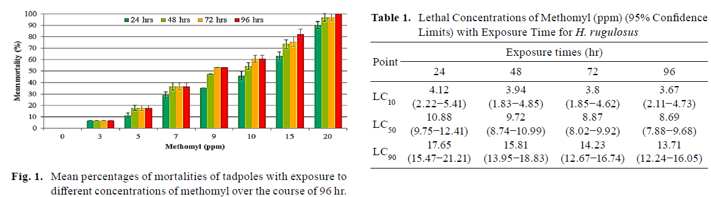
Sublethal Experiment: Cumulative mortality over 50 days significantly higher in methomyl-exposed animals (Fig. 2). Growth (snout-vent length, SVL) significantly lower in methomyl exposed animals on d 7, 12, 30, and 37, but no significant difference at the end of study (Fig 3).
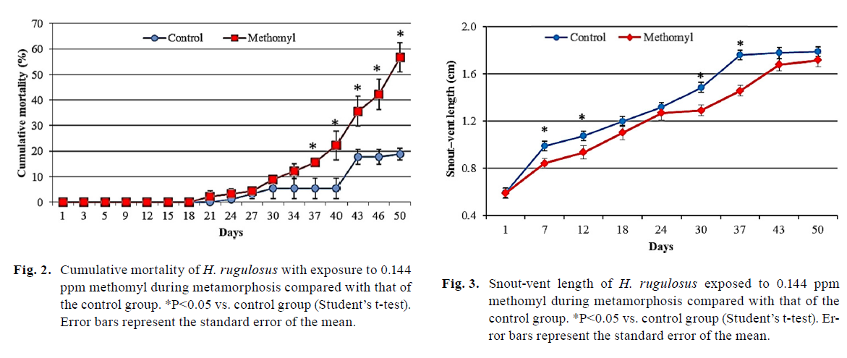

Mean days to metamorphosis and SVL (snout-vent length) at metamorphosis both significantly lower in methomyl treatment group (Table 2).
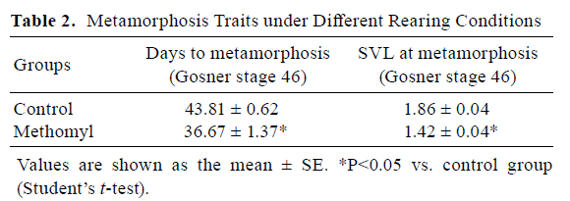

Liver and kidney MDA significantly higher in exposed group. Hepatic glycogen and kidney NO significantly lower in exposed group.
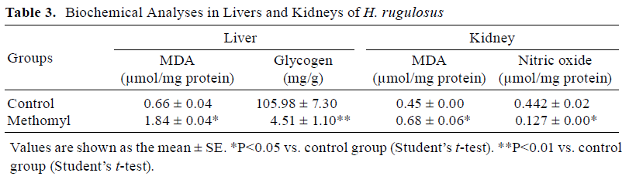

Lethal and Sublethal concentrations showed histological abnormalities in liver and kidney, but no damage was reported in the gonad.

Description of Use in Document (QUAL, QUAN, INV): QUAL

Rationale for Use:
Lethality experiment demonstrates clear concentration-dependent trend in mortality, but 96-hr LC₅₀ (3476 µg AI /L) is well above the existing amphibian mortality threshold. Sublethal experiment reports significant differences in biochemical endpoints. Apical endpoints (reduced growth) is significantly different from control group at some time points during the study, but this effect is not significant (student’s t-test p > 0.05) by the end of the 50-day trial. These data may be useful for qualitative comparison, but lack of significance in apical endpoints by the end of the study, in addition to other limitations listed below, diminish this study’s utility for quantitative purposes.

Limitations of Study:
- Negative control groups were kept in “pesticide-free water” and therefore effects of methomyl are confounded by effects of other formulation ingredients.
- Inadequate description of exposure conditions
  - No water quality measurements (DO, pH, hardness, etc.) or aeration of tanks reported.
- No measured concentrations reported.
- Organismal concentrations (dose) not reported.
- Control mortality for sublethal experiment ~ 15-20% (Fig. 2)
- Exposure conducted in plastic tanks.
- Lethality experiment:
  - Total number of animals used divided by replicates not an even sample size
    - “Two hundred and twenty tadpoles were randomly divided into eight groups.”
    - 220/8=27.5
      - 27.5/2 replicates = 13.75 tadpoles/rep
        - Either some replicates contained unequal number of organisms, or this number is incorrect.
  - Only 2 replicates per group
- Nonlethal experiment:
  - Only 1 concentration tested
  - Exposure conditions unclear – assuming similar to lethality experiment?
  - Cumulative control mortality ~15-20%
  - Histological data not quantified, no statistical comparison

Primary Reviewer: Matthew Urich, OPP/HED/RAB8
Secondary Reviewer: Jerrett Fowler, OPP/EFED/ERB2

Chemical Name: Methomyl

CAS No: 16752-77-5
PC Code: 090301

ECOTOX Record Number and Citation:
ECOTOX Reference: E182788
Bodnaryk, R. P., Luo, M., Kudryk, l. Effects of modifying the phytosterol profile of canola, Brassica napus L., on growth, development, and survival of the bertha armyworm, Mamestra configurata Walker (Lepidoptera: Noctuidae), the flea beetle, Phyllotreta cruciferae (Goeze) (Coleoptera: Chrysomelidae) and the aphids, Lipaphis erysimi (Kaltenbach) and Myzus persicae (Sulzer) (Homoptera: Aphididae). Canadian Journal of Plant Science. 77(4): 677-683. https://doi.org/10.4141/P97-011

Purpose of Review: ESA risk assessment—for quantitative threshold use.

Date of Review: 11/02/20

Summary of Study Findings (methomyl only):
Abstract Excerpt: “The sterol profile of canola, Brassica napus, was altered by treatment with 5 ppm of the systemic fungicides fenpropimorph and tridemorph. The usual Æ5-phytosterols sistosterol, campesterol, and stigmasterol were depleted in leaves and roots and replaced by unusual 4-alpha-methyl and 4-desmethyl sterols that were never observed in untreated plants. Growth, development, and survival of the bertha armyworm, Mamestra configurata, fed leaves of treated canola in the laboratory were affected adversely at specific stages in the life cycle. Larval survival was high and not significantly different in treated and control groups. Most of the mortality in the treated group occurred at pupation and during pupal-adult development. At ecolosion a high proportion of adults were deformed (crumpled wings, failure to exit the pupal case). The adverse effects of feeding on fenpropimorph-treated canola were not attributable to the fungicide itself because larvae fed an artificial diet containing a 10-fold higher concentration of fenpropimorph had normal growth, development, and survival. Although larvae of M. configurata fed canola with a modified sterol profile showed no obvious physiological symptoms, the larvae were more susceptible to the insecticide methomyl (Lannate). Phytosterol modification of the plant in combination with insecticide application may lead to a synergistic interaction in the pest insect. Fewer larvae, prepupae and pupae of the flea beetle, Phyllotreta cruciferae, were recovered from soil samples in field plots with canola treated with fenpropimorph or tridemorph in the laboratory. Adult beetles began to emerge from the soil later, emergence progressed more slowly and fewer were trapped in plots with treated canola. Fewer larvae and adults (up to 50% reduction) of the aphids M. persicae and Lipaphis erysimi, were produced on canola treated with tridemorph. Since aphids harbour sterol-synthesizing mycetocyte-symbionts and are not dependent on a dietary source of sterols, factors other than a deficiency of Æ5-phytosterols must be responsible for the reduction in aphid numbers on treated plants.”

Experimental Design: “Various doses of methomyl (Lannate) (an insecticide commonly used to control bertha armyworm) were dissolved in ethanol and applied to larvae of M. configurata using an ouse. The loop of the ouse was fabricated by twisting a fine wire (ca 0.1 mm diameter) around an 18-gauge hypodermic needle. The dose delivered by the ouse was estimated using [1-14C] ethanol (1.85 – 2.2 GBq mM–1, Amersham) and varied less than 10% over 50 test applications.
Larvae of M. configurata were reared on 4-wk-old B. napus ‘Westar’ that had been grown hydroponically on Hoagland’s medium or on Hoagland’s medium containing 5 ppm of fenpropimorph.
In another experiment, larvae were reared on artificial diet or on artificial diet containing 50 ppm of fenpropimorph. Eight to fifteen larvae selected to weigh 0.10 ± 0.01 g were used for each dose of methomyl and an ethanol only control. A minimum of four doses, replicated three times, were used. Estimates of LD50 values were obtained by log-probit analysis (Finney 1971).”

Results (methomyl exposure only):

72-hr LD₅₀ for was 0.18 µg per larva (oral). Larvae weighed 0.10 ± 0.01 g (Table 2).
- 0.18 µg/larva divided by 0.10 g per larva = 1.8 µg/g-bw (equivalent to mg/kg-bw)
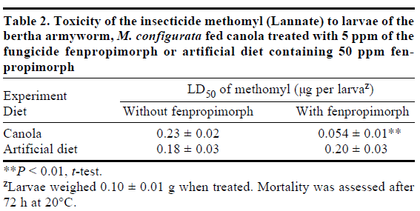

Description of Use in Document (QUAL, QUAN, INV): INV

Limitations of Study:
- The focus of this study was not the toxicity of methomyl, but rather the effects of different diets on the toxicity of methomyl. Information relevant to the toxicity of methomyl specifically is limited, and many pertinent details about the methomyl assay are not reported.
- Some of the M configurata larvae used in the experiments were fed canola that had been treated with fenpropimorph (fungicide), or an artificial diet containing fenpropimorph. Treatments other than methomyl exposure are confounding, and therefore these data are not useful for methomyl risk assessment.
- Inclusion of negative or vehicle (ethanol) control group not reported
- Dose was estimated by measuring mass-labeled solvent, not the toxicant itself
- Only four doses were included in at least one of the experiments; otherwise, the number of dose levels is not reported.
- Only 3 replicates per group
- Dose levels not reported

Primary Reviewer: Matthew Urich, OPP/HED/RAB8
Secondary Reviewer: Jerrett Fowler, OPP/EFED/ERB2

