APPENDIX 1-6. Use Site Footprints for Methomyl

- Agriculture Uses

Use site footprint layers represent the application sites for agricultural and non-agricultural label uses. The best available data to spatially characterize specific agricultural crops in the continuous United States (ConUS) is the Cropland Data Layer (CDL), produced by the U.S. Department of Agriculture. Several methods have been employed to minimize data errors within the CDL. The CDL is a landcover dataset that has over 100 cultivated classes that were grouped into 13 general classes (see APPENDIX 1-5). Lumping classes reduces the likelihood of errors of omission and commission between similar crop categories. In selecting how to group crops from the CDL, EPA referred to the grouping used by the U.S. Geological Survey (Baker and Capel, 2011) and the Generic Endangered Species Task Force (Amos et al, 2010). This information considers environmental factors that influence the location of crops and the error matrices provided by USDA with the original CDL data. By considering these agronomic factors in addition to the error matrices it is possible to improve the accuracy and year-to-year matches for these UDLs while retaining agronomic similarities. This categorical aggregation into the UDL crop groups does not account for changes in agricultural practices but the temporal aggregation does. The UDLs used in this assessment include 5 years of the CDL, 2013-2017, aggregated to account for changes year to year such as crop rotations. Anywhere a class occurs within those 5 years would be represented in the footprint layer. These temporally aggregated and categorially grouped layers generated from the CDL are referred to as Use Data Layers or UDLs.

The agricultural classes were further refined by comparing county level National Agricultural Statistics Service (NASS) 2012 Census of Agriculture (CoA) acreage reports to county level UDL acreages (additional detail can be found in the tool documentation, “Processing the Census of Agriculture Data” section). The UDL acreages represent the temporally aggregated and categorically grouped processing steps previously described, summarized at the county level. If a county’s UDL acreage for a given class was lower than the NASS acreage, the UDL extent was expanded within cultivated areas until the UDL acreage matched or exceeded the NASS CoA. Using the temporally and categorially aggregated UDL as an input, a script was developed that compares each UDL in each county to the corresponding NASS CoA acreage report. If the UDL acreage was less than NASS, the raster was expanded in 1 pixel iterations until the NASS acreage value was reached, exceeded, or the area within the cultivated mask was built out. Region growing was restricted using the UDL Cultivated Layer from the last year of the CDL as a mask (2017). This avoids buffering into any non-agricultural landcover types. This method reduces uncertainty related to landcover mapping by ensure the acres mapped on the ground in the UDL corresponds to the reported acreage from the CoA in this case, 2012. This helps addresses the uncertainty in acreage estimates in the landcover data given the known downward area bias in area estimates related to remotely sensed data. Additional details and the python scripts for this process can be found in with the tool documentation, Generating Use Data Layers, “CDL to UDL Processing and Action Area Python Scripts” section.
Every assessment begins with cross-walking registered uses into a landcover category. Chemicals are often not represented by all 13 UDLs. Some chemicals specify geographic restrictions for a given use (i.e., application on wheat is limited to the state of Idaho). Geographic limitations for registered uses are imposed on the dataset downstream in the data processing workflow. The geographic restriction should be extracted from the use layer before it is aggregated with all other chemical uses to generate the action area for the chemical. Methomyl’s agricultural uses are crosswalked to 11 of the UDLs classes with geographic restrictions on wheat and citrus, and 2 additional UDLs are non-standard, Bermuda grass and Alley Crops. A complete crosswalk for the methomyl agricultural uses is provided in Table 1 generated from Attachment 1-4. This crosswalk includes the label use name, the name(s) from the Census of Agriculture, SUUM use site (APPENDIX 1-4), and the UDL.
In addition to the potential use site each UDL is buffered in all directions using the ESRI ArcGIS Euclidean distance tool. This buffered area represents the potential exposure area associated with drift.
The CDL is not available for areas outside of the contiguous United States (ConUS). The CoA is often unavailable outside of ConUS as well. The Agricultural UDL Data Sources section describes how agriculture was spatially modeled by regions outside of ConUS, referred to as the non-lower 48 (NL48).

- Non-Agricultural Uses

Non-agricultural label uses include a wide range of landcover and land use categories. Each label use was carefully considered and cross-walked with the best available landcover data. Where available, the 2011 National Land Cover Dataset (NLCD) was used to represent many non-agricultural label uses. Where NLCD wasn’t available, the NOAA C-CAP dataset and corresponding landcover classes were used. Details on the data sources for each non-agricultural UDL are provided in the Non-Agricultural UDL Data Source section. A complete crosswalk for the methomyl non-agricultural uses is provided in Table 2. This crosswalk includes the label use name, SUUM use site (APPENDIX 1-4), and the UDL data sources used to generate each layer are provided in the UDL data source section.

- Action Area

To create the action area for methomyl all pertinent agricultural UDLs are combined, there are no non-agricultural UDLs for methomyl. This is completed by placing the UDLs on top of each other and combining them into one footprint. The resulting layer includes all locations found in each of the UDLs and with the buffered areas (non-use site locations) represented as minimum distance to a potential use site across all UDLs. This sets the exposure area for methomyl related to drift. For additional detail on how the action area is generated see the tool documentation, “CDL to UDL Processing and Action Area Python Scripts” section.

- UDL Data Sources

  - Agricultural UDL Data Sources for the CONUS and NL48

- ConUS
  - Corn, Cotton, Soybeans, Wheat (only in ID, OR and WA), Alfalfa/other agricultural grasses (non-grazing areas), Citrus (only in CA, AZ, HI), Other Orchards, Vegetables and ground fruit, Other grains, Other row crops, Other crops UDLs generated from the Cropland Data Layer (CDL) 2013-2017. See APPENDIX 1-5 for additional detail on the specific crops found in each UDL. National UDLS were used unless otherwise specified.

  - Alley Cropping: Alley cropping is a practice of planting a crop between orchard rows. In the case of methomyl, beans and soybeans are planted between nonbearing orchard rows in California (almonds, plums, prunes, peaches and walnuts). The NASS Census of Agriculture (CoA) publishes an Alley Cropping and Silvapasture category, which aids in characterizing this registered use. The CoA category is attributed by, “Practices, Alley Cropping & Silvapasture - Number Of Operations”, by county. Process for identifying Alley Cropping locations included, selecting California counties, from the selection of counties in California select CoA Alley Cropping counites, from the selection, select counties with beans and soybeans (also from CoA). The final selection of counties is the mask. Using the mask, extract the Other Orchards UDL.

  - Bermuda Grass Pasture: Bermuda Grass pasture is a registered use for methomyl. It occurs throughout the southern US. This warm season turf grass species is typically grown in the warm season region and the transition zone region of the United States. The USDA defines these zones known as Plant Hardiness Zones (PHZ) based on long term temperature data. It was assumed that Warm Season Grasses are grown in approximately Zone 8 to 11, and transition grasses are grown in approximately Zone 6 to 7. The USDA PHZ 6-11 were combined into a single boundary that was used to refine the range where methomyl could be used on warm season grass. The mask provided in Figure 1 is a published map outlining where these zones occur.
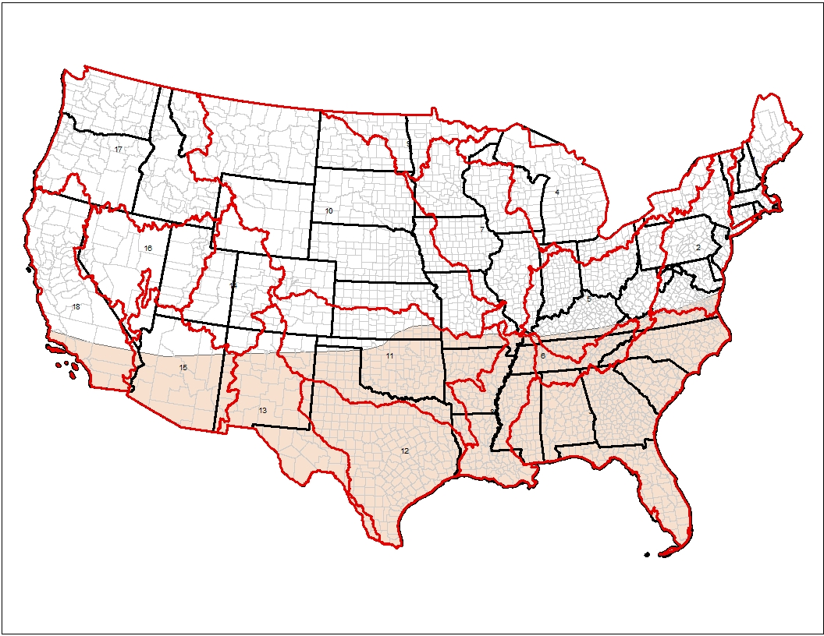
Figure 1. Spatial extent of Bermuda Grass.
- NL48 – Agricultural UDL (Ag)
- Alaska (AK)
  - National Land Cover Dataset (NLCD) Cultivated Class (82)
- Hawaii (HI)
  - National Oceanic & Atmospheric Administration (NOAA) Coastal Change Analysis Program (CCAP), Cultivated Class (6)
- Puerto Rico (PR)
  - NLCD Cultivated Class (82)
- Guam (GU)
  - CCAP Cultivated Class (6)
- Commonwealth of the Marianas (CNMI)
  - CCAP Cultivated Class (6)
- American Samoa (AS)
  - CCAP Cultivated Class (6)
- Virgin Islands (VI)
  - CCAP Cultivated Class (6)
  - Non-Agricultural UDL Data Sources ConUS and NL48

Non-agricultural label uses include a wide range of landcover and land use categories. Each label use was carefully considered and cross-walked with the best available land cover data. Where available, the 2011 National Land Cover Dataset (NLCD) was used to represent many non-agricultural label uses (see below). Where NLCD wasn’t available, the NOAA C-CAP and other dataset outlined below were used. Below is a sample of label classes that were represented using NLCD Developed or Open Space Developed land use categories.
- Grain/cereal/flour bins
- Grain/cereal/flour elevators
- Household/domestic dwellings (perimeter outdoor only)
- Non-agricultural outdoor building structures
- Ornamental and/or shade trees
- Ornamental herbaceous plants
- Ornamental non-flowering plants
- Ornamental woody shrubs and vines
- Refuse/solid waste containers (outdoors)
- Refuse/solid waste sites (outdoors)
- Commercial/Institution-Al/ Industrial Premises/ Equip. (Indoor and Outdoor) – Broadcast, Crack and Crevice/Void
- Domestic Dwellings Outdoor Premises;
- Food Processing Plant Premises (Nonfood Contact) – Crack and Crevice
- Nonagricultural Outdoor Buildings/Structures
- Poultry Litter
- Recreational Areas
- Sewer Manhole Covers and Walls
- Utilities – Broadcast
- Wood Protection Treatment to Buildings/Products Outdoor

Fly bait – Not mapped due to limited and highly dispersed in spatial scale, reliable data is not available. Use is not expected to result in substantial exposure to non-target organisms.

Table 1. Crosswalk of methomyl agricultural uses across crop sources.
Use from Master Label | Crop Reported in SUUM | Census Of Agriculture | ConUS UDL | NL48 UDL | Notes UDL
Alfalfa | Alfalfa | HAY, HAYLAGE | Alfalfa | Ag
Anise (fennel) | Anise | FIELD CROPS, OTHER | Other Grains | Ag
Apple | Apples | APPLES | Other Orchards | Ag
Asparagus | Asparagus | ASPARAGUS | Vegetables and Ground Fruit | Ag
Avocado | Avocado | AVOCADOS | Other Orchards | Ag
Bean, dry | Beans/Peas, Dried Type | BEANS, DRY EDIBLE, (EXCL LIMA) | Vegetables and Ground Fruit | Ag
Bean, dry | Beans/Peas, Dried Type | GUAR | Vegetables and Ground Fruit | Ag
Bean, dry | Beans/Peas, Dried Type | PEAS, DRY EDIBLE | Vegetables and Ground Fruit | Ag
Bean, dry | Beans/Peas, Dried Type | PEAS, DRY, SOUTHERN (COWPEAS) | Vegetables and Ground Fruit | Ag
Bean, Succulent | Lima Beans | BEANS, DRY EDIBLE, LIMA | Vegetables and Ground Fruit | Ag
Bean, Succulent | Lima Beans | BEANS, GREEN, LIMA | Vegetables and Ground Fruit | Ag
Bean, Succulent | Beans, Succulent | BEANS, SNAP | Vegetables and Ground Fruit | Ag
Beet, table | Beets, Table | BEETS | Vegetables and Ground Fruit | Ag
Bermudagrass pasture | Bermuda Grass | GRASSES, BERMUDA GRASS, SEED | Bermuda Grass | Ag
Blueberry | Blueberries | BLUEBERRIES, TAME | Vegetables and Ground Fruit | Ag
Blueberry | Blueberries | BLUEBERRIES, WILD | Vegetables and Ground Fruit | Ag
Broccoli | Broccoli | BROCCOLI | Vegetables and Ground Fruit | Ag
Broccoli raab | Broccoli raab, Broccoli Raab/ Rapini | BROCCOLI | Vegetables and Ground Fruit | Ag | CA only
Brussels Sprouts | Brussels Sprouts | BRUSSELS SPROUTS | Vegetables and Ground Fruit | Ag
Cabbage | Cabbage | CABBAGE, CHINESE | Vegetables and Ground Fruit | Ag
Cabbage | Cabbage | CABBAGE, HEAD | Vegetables and Ground Fruit | Ag
Cabbage | Cabbage | CABBAGE, MUSTARD | Vegetables and Ground Fruit | Ag
Carrot | Carrots | CARROTS | Vegetables and Ground Fruit | Ag
Cauliflower | Cauliflower | CAULIFLOWER | Vegetables and Ground Fruit | Ag
Celery | Celery | CELERY | Vegetables and Ground Fruit | Ag
Chicory | Chicory | CHICORY | Vegetables and Ground Fruit | Ag
Chinese broccoli | Broccoli, Chinese , Chinese broccoli | BROCCOLI | Vegetables and Ground Fruit | Ag | CA only
Chinese cabbage | Cabbage, Chinese | CABBAGE, CHINESE | Vegetables and Ground Fruit | Ag
Collards | Collards | GREENS, COLLARD | Vegetables and Ground Fruit | Ag
Corn | Corn | CORN, GRAIN | Corn | Ag
Corn | Corn | CORN, SILAGE | Corn | Ag
Corn | Corn | POPCORN, SHELLED | Vegetables and Ground Fruit | Ag
Corn, sweet | Sweet Corn | SWEET CORN | Vegetables and Ground Fruit | Ag
Cotton | Cotton | COTTON | Cotton | Ag
Cucumber | Cucumbers | CUCUMBERS | Vegetables and Ground Fruit | Ag
Eggplant | Eggplant | EGGPLANT | Vegetables and Ground Fruit | Ag
Endive, escarole | Endive/Escarole | ESCAROLE & ENDIVE | Vegetables and Ground Fruit | Ag
Garlic | Garlic | GARLIC | Vegetables and Ground Fruit | Ag
Grapefruit | Grapefruit | GRAPEFRUIT | Citrus | Ag | CA, AZ and HI only
Horseradish | Horseradish | HORSERADISH | Vegetables and Ground Fruit | Ag
Leafy Green Vegetables (Beet tops, dandelions, kale, mustard greens, parsley, Swiss chard, turnip greens) | Leafy Greens - Kale | GREENS, KALE | Vegetables and Ground Fruit | Ag
Leafy Green Vegetables (Beet tops, dandelions, kale, mustard greens, parsley, Swiss chard, turnip greens) | Leafy Greens- Mustard | GREENS, MUSTARD | Vegetables and Ground Fruit | Ag
Leafy Green Vegetables (Beet tops, dandelions, kale, mustard greens, parsley, Swiss chard, turnip greens) | Leafy Greens- Turnip | GREENS, TURNIP | Vegetables and Ground Fruit | Ag
Leafy Green Vegetables (Beet tops, dandelions, kale, mustard greens, parsley, Swiss chard, turnip greens) | Leafy Greens- Parsley | PARSLEY | Vegetables and Ground Fruit | Ag
Lemon | Lemons | LEMONS | Citrus | Ag | CA, AZ and HI only
Lentils | Lentils | LENTILS | Vegetables and Ground Fruit | Ag
Lettuce | Lettuce | LETTUCE | Vegetables and Ground Fruit | Ag
Melon | Melons- Cantaloupe | MELONS, CANTALOUP | Vegetables and Ground Fruit | Ag
Melon | Melons- Honeydew | MELONS, HONEYDEW | Vegetables and Ground Fruit | Ag
Melon | Melons- Watermelon | MELONS, WATERMELON | Vegetables and Ground Fruit | Ag
Mint | Mint | MINT, OIL | Vegetables and Ground Fruit | Ag
Mint | Mint | MINT, TEA LEAVES | Vegetables and Ground Fruit | Ag
Nectarine | Nectarine | NECTARINES | Other Orchards | Ag | CA, AZ only
Non-Bearing fruit, nut, grape | Not in SUUM | Alley Crop | Alley Crop | NA | CA only
Non-Bearing fruit, nut, grape | Tree Nuts (non-bearing) l - Almonds | ALMONDS | Other Orchards | Ag | CA only
Non-Bearing fruit, nut, grape | Pistachios | PISTACHIOS | Other Orchards | Ag | CA only
Non-Bearing fruit, nut, grape | Plums/Prunes (non-bearing) | PLUM-APRICOT HYBRIDS, INCL PLUMCOTS & PLUOTS | Other Orchards | Ag | CA only
Non-Bearing fruit, nut, grape | Plums/Prunes (non-bearing) | PLUMS & PRUNES | Other Orchards | Ag | CA only
Onions | Onions | ONIONS, DRY | Vegetables and Ground Fruit | Ag
Onions | Onions | ONIONS, GREEN | Vegetables and Ground Fruit | Ag
Orange | Oranges | ORANGES | Citrus | Ag | CA, AZ and HI only
Pea, succulent | Peas, Succulent | PEAS, AUSTRIAN WINTER | Vegetables and Ground Fruit | Ag
Pea, succulent | Peas, Succulent | PEAS, CHINESE (SUGAR & SNOW) | Vegetables and Ground Fruit | Ag
Pea, succulent | Peas, Succulent | PEAS, GREEN, (EXCL SOUTHERN) | Vegetables and Ground Fruit | Ag
Pea, succulent | Peas, Succulent | PEAS, GREEN, SOUTHERN (COWPEAS) | Vegetables and Ground Fruit | Ag
Peach | Peaches | PEACHES | Other Orchards | Ag
Peanut | Peanuts | PEANUTS | Other Row Crops | Ag
Pear | Pears | PEARS | Other Orchards | Ag | CT, DE, CA,NH, NJ, NY, MD, ME, MA, PA, RI and VT only
Pecan | Pecans | PECANS | Other Orchards | Ag | AL, AR, CA, FL, GA, LA, KY, NC, MS, SC, TN, VA and WV only.
Peppers | Peppers | PEPPERS, BELL | Vegetables and Ground Fruit | Ag
Peppers | Peppers | PEPPERS, CHILE | Vegetables and Ground Fruit | Ag
Pomegranate | Pomegranate | POMEGRANATES | Other Orchards | Ag
Potato | Potatoes | POTATOES | Vegetables and Ground Fruit | Ag
Pumpkin | Pumpkins | PUMPKINS | Vegetables and Ground Fruit | Ag
Radish | Radish | RADISHES | Vegetables and Ground Fruit | Ag | CA and FL
Sorghum | Sorghum Milo | SORGHUM, GRAIN | Other Grains | Ag
Sorghum | Sorghum Milo | SORGHUM, SILAGE | Other Grains | Ag
Sorghum | Sorghum Milo | SORGHUM, SYRUP | Other Grains | Ag
Soybean | Soybeans | SOYBEANS | Soybeans | Ag
Spinach | Spinach | SPINACH | Vegetables and Ground Fruit | Ag
Sugar beet | Sugar Beets | SUGARBEETS | Other Row Crops | Ag
Summer squash | Squash | OKRA | Vegetables and Ground Fruit | Ag
Summer squash | Squash | SQUASH | Vegetables and Ground Fruit | Ag
Sweet Potato | Sweet Potato | SWEET POTATOES | Vegetables and Ground Fruit | Ag
Tangelo, tangerine | Tangelo | TANGELOS | Citrus | Ag | CA, AZ and HI only
Tangelo, tangerine | Tangerines | TANGERINES | Citrus | Ag | CA, AZ and HI only
Tobacco | Tobacco | TOBACCO | Other Row Crops | Ag
Tomatillo | Tomatillo | VEGETABLES, OTHER | Vegetables and Ground Fruit | Ag
Tomato | Tomatoes | TOMATOES | Vegetables and Ground Fruit | Ag
Wheat | Wheat - Spring/Wheat - Winter | WHEAT | Wheat | Ag | Use in ID, OR & WA only

Table 2. Crosswalk of methomyl non-agricultural uses.
Use from Master Label | Use Site Reported in SUUM | Census Of Agriculture | ConUS UDL | NL48 UDL | Notes UDL
Fly bait | Fly bait | NA | NA | NA | Not mapped due to limited and highly dispersed in spatial scale, reliable data is not available. Use is not expected to result in substantial exposure to non-target organisms.

- References
- National Land Cover Dataset (NLCD) 2011
  - Homer, C.G., Dewitz, J.A., Yang, L., Jin, S., Danielson, P., Xian, G., Coulston, J., Herold, N.D., Wickham, J.D., and Megown, K., 2015, Completion of the 2011 National Land Cover Database for the conterminous United States-Representing a decade of land cover change information. Photogrammetric Engineering and Remote Sensing, v. 81, no. 5, p. 345-354
- National Oceanic and Atmospheric Administration (NOAA) Coastal Change Analysis Program (CCAP)
  - National Oceanic and Atmospheric Administration, Coastal Services Center. 1995-present. The Coastal Change Analysis Program (C-CAP) Regional Land Cover. Charleston, SC: NOAA Coastal Services Center. Accessed at https://coast.noaa.gov/digitalcoast/data/
- United States Census Bureau’s Topologically Integrated Geographic Encoding and Referencing database (TIGER)
  - 2015 TIGER/Line Shapefiles (machine readable data files) / prepared by the U.S. Census Bureau, 2015, https://www.census.gov/geographies/mapping-files/time-series/geo/tiger-geodatabase-file.html
- United States Department of Agriculture Cropland Data Layer (CDL) 2013-2017
  - United States Department of Agriculture (USDA), National Agricultural Statistics Service (NASS), Research and Development Division (RDD), Geospatial Information Branch (GIB), Spatial Analysis Research Section (SARS), Cropland Data Layer for the United States, https://www.nass.usda.gov/Research_and_Science/Cropland/SARS1a.php
- United States Department of Agriculture Plant Hardiness Zones
  - United States Department of Agriculture. 2012. Plant hardiness zone map. Accessed on May 14, 2019 at https://planthardiness.ars.usda.gov/PHZMWeb/

Baker, N.T., and Capel, P.D., 2011, Environmental factors that influence the location of crop agriculture in the conterminous United States: U.S. Geological Survey Scientific Investigations Report 2011–5108, 72 p.
Amos, J.J., C.M. Holmes, C.G. Hoogeweg, and S.A. Kay. 2010. Development of Datasets to Meet USEPA Threatened and Endangered Species Proximity to Potential Use Sites Data Requirements. Report Number: 437.01-Overview. Prepared by Waterborne Environmental, Inc. for the Generic Endangered Species Task Force.

