APPENDIX 2-6. Glyphosate Species Sensitivity Distribution (SSD) Analysis for Terrestrial Plants

An SSD was fitted to vegetative vigor toxicity data of terrestrial plants exposed to glyphosate formulations. Seedling emergence was not fitted with an SSD due to low toxicity and lack of definitive endpoints. Five distributions were tested. Ultimately, the results from the vegetative vigor SSDs combining monocots and dicots were used. Table 1 provides a summary of the results. Unless otherwise noted, units for application rates are lb a.e./A.

Table 1. Summary statistics for SSD fit to glyphosate test results.
Statistic | Vegetative Vigor
Best Distribution (by AIC_{c}) | Triangular
Goodness of fit  P-value | 0.9950
CV of the HC₀₅ | 0.2358
HC₀₅ | 0.0209
HC₁₀ | 0.0287
HC₅₀ | 0.1110
HC₉₀ | 0.4286
HC₉₅ | 0.5903

- Data

Data used in this analysis are detailed in Table 6 (at the end of the document) and were from registrant submitted studies as well as an ECOTOX query (APPENDIX 2-2). Table 2 provides the distribution of the test results for glyphosate including the number of species represented. Distributions were created for terrestrial plants based on IC₂₅ values for various metrics of growth from 21-, 27- and 28-d vegetative vigor studies.

Table 2. Distribution of test results available for glyphosate.
Data Subset | Test results | Species
Vegetative Vigor | 67 | 36

Figure 1 shows the distribution of test results among species from the vegetative vigor studies. Several species have been repeatedly tested (up to six times), but the majority of species have been tested fewer than three times, with 20 species having only one test result.
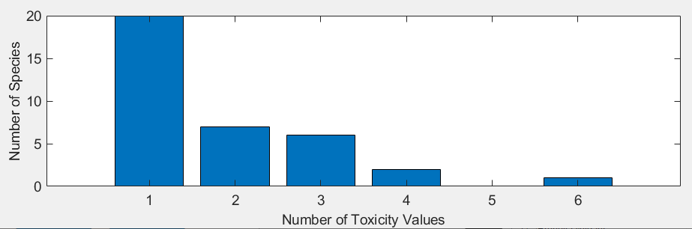
Figure 1. Distribution of the number of test results per species in glyphosate vegetative vigor data.

Five potential distributions for the glyphosate data were considered, including log-normal, log-logistic, log-triangular, log-gumbel, and Burr. To fit each of the first four distributions, the toxicity values were first common log (log₁₀) transformed. Finally, effect thresholds and five quantiles from the fitted SSDs (HC₀₅, HC₁₀, HC₅₀, HC₉₀, HC₉₅) were calculated and reported.

- Comparison of distributions using AIC_{c}

Akaike’s Information Criterion corrected for sample size (AIC_{c}) was used to compare the five distributions for the aquatic plant dataset. For these comparisons all SSDs were fit using maximum likelihood. The AIC_{c} suggested that the triangular distribution provided the best fit for the vegetative vigor data (Table 3).

Table 3. Comparison of distributions for vegetative vigor toxicity data for glyphosate.
distribution | AIC_{c} | ∆AIC_{c} | Weight | HC₀₅
triangular | -51.3071 | 0 | 0.5276 | 0.0209
normal | -49.9742 | 1.3329 | 0.2709 | 0.0215
logistic | -48.5158 | 2.7913 | 0.1307 | 0.0201
burr | -46.2101 | 5.0970 | 0.0413 | 0.0215
gumbel | -45.5448 | 5.7623 | 0.0296 | 0.0235

- Goodness of fit

The plot of the cumulative distribution functions for the best-fit distributions (as determined by AIC_{c}) suggest little evidence of lack-of-fit (Figure 2). Bootstrap goodness-of-fit tests did not show evidence for lack-of-fit (P-values > 0.05, Table 4) for any of the distributions. The coefficient of variation for the HC₀₅ was below 1 for all distributions.

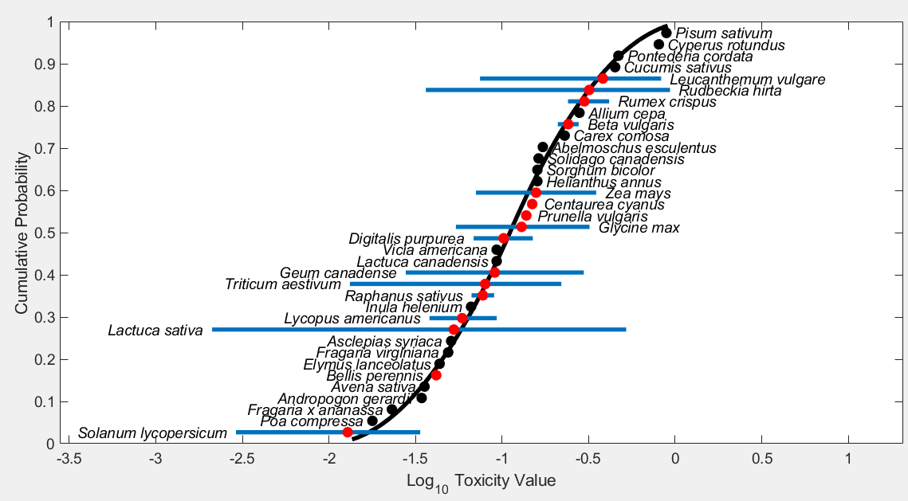
Figure 2. Log-normal SSD for glyphosate toxicity values for terrestrial plants at the vegetative vigor life stage. Black points indicate single toxicity values. Red points indicate average of multiple toxicity values for a single species. Blue line indicates full range of toxicity values for a given taxon.

Table 4. Range of HC₀₅ values for glyphosate SSDs for terrestrial plants at the vegetative vigor life stage.
Distribution | Method | HC₀₅ | SE | CV | Lower CI | Upper CI | P
Normal | ML | 0.0242 | 0.0066 | 0.2717 | 0.015 | 0.0407 | 0.8132
Normal | MO | 0.0237 | 0.0063 | 0.2657 | 0.0143 | 0.0386 | 0.7802
Normal | GR | 0.0213 | 0.0061 | 0.2844 | 0.0108 | 0.0346 | 0.6424
Logistic | ML | 0.0234 | 0.0071 | 0.3052 | 0.0132 | 0.0415 | 0.6683
Logistic | MO | 0.0242 | 0.007 | 0.2893 | 0.0131 | 0.0394 | 0.8002
Logistic | GR | 0.0203 | 0.0058 | 0.287 | 0.0089 | 0.0318 | 0.8002
Triangular | ML | 0.0235 | 0.0063 | 0.2672 | 0.0177 | 0.0414 | 0.0629
Triangular | MO | 0.023 | 0.0058 | 0.2536 | 0.0142 | 0.0373 | 0.5784
Triangular | GR | 0.022 | 0.0057 | 0.2583 | 0.0129 | 0.0354 | 0.4745
Gumbel | ML | 0.0282 | 0.0051 | 0.1828 | 0.0209 | 0.0409 | 0.2607
Gumbel | MO | 0.0333 | 0.0066 | 0.199 | 0.0227 | 0.0489 | 0.2787
Gumbel | GR | 0.0302 | 0.0061 | 0.2022 | 0.0177 | 0.0408 | 0.3077
Burr | ML | 0.0264 | 0.0082 | 0.3117 | 0.0146 | 0.0463 | 0.5764
ML=maximum likelihood, MO= moment estimators, and GR=graphical methods
LCp and UCp=projections of the confidence limits of the HC₀₅ (LCx and UCx) onto the cumulative distribution function of the fitted distribution.

- Calculation of other quantiles

Table 5 provides estimates of the HC₀₅ as well as other quantiles of the fitted SSDs.

Table 5. Estimated quantiles of the fitted SSDs for glyphosate IC25s for terrestrial plants at the vegetative vigor life stage.
Distribution | Method | HC₀₅ | HC₁₀ | HC₅₀ | HC₉₀ | HC₉₅
Normal | ML | 0.0242 | 0.0347 | 0.1233 | 4.38E-01 | 6.27E-01
Normal | MO | 0.0237 | 0.0341 | 0.1233 | 4.46E-01 | 6.41E-01
Normal | GR | 0.0213 | 0.0314 | 0.1233 | 4.83E-01 | 7.12E-01
Logistic | ML | 0.0234 | 0.0355 | 0.1207 | 4.10E-01 | 6.22E-01
Logistic | MO | 0.0242 | 0.0366 | 0.1233 | 4.15E-01 | 6.28E-01
Logistic | GR | 0.0203 | 0.032 | 0.1233 | 4.74E-01 | 7.50E-01
Triangular | ML | 0.0235 | 0.0335 | 0.1502 | 6.73E-01 | 9.59E-01
Triangular | MO | 0.023 | 0.0317 | 0.1233 | 4.79E-01 | 6.61E-01
Triangular | GR | 0.022 | 0.0306 | 0.1233 | 4.96E-01 | 6.90E-01
Gumbel | ML | 0.0282 | 0.0357 | 0.1062 | 5.86E-01 | 1.13E+00
Gumbel | MO | 0.0333 | 0.0409 | 0.1045 | 4.56E-01 | 8.00E-01
Gumbel | GR | 0.0302 | 0.0378 | 0.1061 | 5.35E-01 | 9.93E-01
Burr | ML | 0.0264 | 0.0374 | 0.1173 | 4.39E-01 | 7.01E-01

Table 6 provides the IC₂₅ values included in the SSD for vegetative vigor. If a species was not represented with a 96 hour study, and other values were available from shorter/longer duration studies (up to 10 days) then the data were included. If there were multiple other durations, the value from the study closer to a 96h duration was selected and if there were multiple values for the same duration, all values are presented.

Table 6. Nontarget Terrestrial Plant Vegetative Vigor Toxicity (Tier II). All definitive endpoints are used quantitatively in the SSD.
Genus | species | IC₂₅
Abelmoschus | esculentus | 0.17
Allium | cepa | 0.28
Andropogon | gerardii | 0.034
Asclepias | syriaca | 0.051
Avena | sativa | 0.036
Bellis | perennis | 0.039
Bellis | perennis | 0.044
Beta | vulgaris | 0.21
Beta | vulgaris | 0.28
Carex | comosa | 0.23
Centaurea | cyanus | 0.14
Centaurea | cyanus | 0.15
Cucumis | sativus | 0.45
Cyperus | rotundus | 0.81
Digitalis | purpurea | 0.068
Digitalis | purpurea | 0.10
Digitalis | purpurea | 0.15
Elymus | lanceolatus | 0.044
Fragaria | virginiana | 0.049
Fragaria | x ananassa | 0.023
Geum | canadense | 0.028
Geum | canadense | 0.30
Glycine | max | 0.054
Glycine | max | 0.13
Glycine | max | 0.32
Helianthus | annus | 0.16
Inula | helenium | 0.066
Lactuca | canadensis | 0.093
Lactuca | sativa | 0.0021
Lactuca | sativa | 0.0048
Lactuca | sativa | 0.070
Lactuca | sativa | 0.22
Lactuca | sativa | 0.27
Lactuca | sativa | 0.52
Leucanthemum | vulgare | 0.075
Leucanthemum | vulgare | 0.54
Leucanthemum | vulgare | 0.64
Leucanthemum | vulgare | 0.83
Lycopus | americanus | 0.038
Lycopus | americanus | 0.057
Lycopus | americanus | 0.093
Pisum | sativum | 0.89
Poa | compressa | 0.018
Pontederia | cordata | 0.47
Prunella | vulgaris | 0.13
Prunella | vulgaris | 0.14
Raphanus | sativus | 0.067
Raphanus | sativus | 0.09
Rudbeckia | hirta | 0.036
Rudbeckia | hirta | 0.35
Rudbeckia | hirta | 0.86
Rudbeckia | hirta | 0.93
Rumex | crispus | 0.24
Rumex | crispus | 0.27
Rumex | crispus | 0.42
Solanum | lycopersicum | 0.0029
Solanum | lycopersicum | 0.022
Solanum | lycopersicum | 0.034
Solidago | canadensis | 0.16
Sorghum | bicolor | 0.16
Triticum | aestivum | 0.013
Triticum | aestivum | 0.18
Triticum | aestivum | 0.22
Vicia | americana | 0.093
Zea | mays | 0.071
Zea | mays | 0.35

