APPENDIX 2-5. Glyphosate Species Sensitivity Distribution Analysis for Aquatic Plants

SSDs were fit to toxicity data for vascular and nonvascular aquatic plants exposed to technical grade glyphosate. Aquatic vascular plant growth data were insufficient to derive a separate SSD, therefore the results from the all aquatic plants were used for the SSD. Table 1 provides a summary of the results.

Table 1. Summary statistics for SSDs fit to glyphosate test results.
Statistic | All  Aquatic Plants
Best Distribution (by AIC_{c}) | Gumbel
Goodness of fit  P-value | 0.1269
CV of the HC₀₅ | 0.15
HC₀₅ | 5.0
HC₁₀ | 5.5
HC₅₀ | 8.4
HC₉₀ | 16.4
HC₉₅ | 21.1

- Data

Data used in this analysis are detailed in Table 6 (at the end of the document) and were from registrant submitted studies as well as an ECOTOX query (APPENDIX 2-2). Table 2 provides the distribution of the test results for glyphosate including the number of species represented. Insufficient data were available to derive separate SSDs for vascular aquatic plants because only one vascular species was tested. Therefore, one set of distributions was derived: all aquatic plants (combines vascular and nonvascular aquatic plants).

Table 2. Distribution of test results available for glyphosate.
Data Subset | Test results | Species
All Aquatic Plants | 20 | 9
Nonvascular Aquatic  Plants | 16 | 8
Vascular Aquatic Plants | 4 | 1

Figure 1 shows the distribution of test results among species, indicating that a few species have been repeatedly tested (one species has been tested four times), but the majority of species have been tested fewer than three times, with 14 species having only one test result.
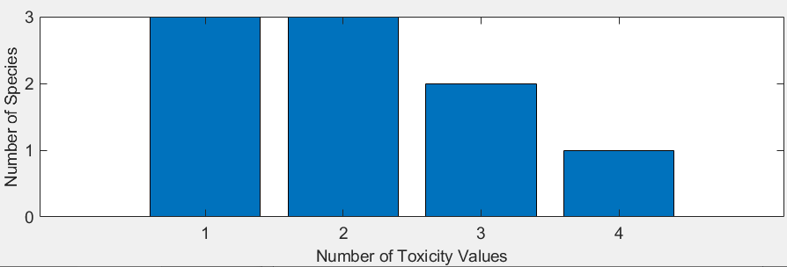
Figure 1. Distribution of the number of test results per species in glyphosate aquatic plant data.

Six potential distributions for the glyphosate were considered, including log-normal, log-logistic, log-triangular, log-gumbel, Weibull, and Burr. To fit each of the first four distributions, the toxicity values were first common log (log₁₀) transformed. Finally, effect thresholds and five quantiles from the fitted SSDs (HC₀₅, HC₁₀, HC₅₀, HC₉₀, HC₉₅) were calculated and reported.

- Comparison of distributions using AIC_{c}

Akaike’s Information Criterion corrected for sample size (AIC_{c}) was used to compare the five distributions for the aquatic plant dataset. For these comparisons all SSDs were fit using maximum likelihood. The AIC_{c} suggested that the gumbel distribution provided the best fit (Table 3).

Table 3. Comparison of distributions for all aquatic plant toxicity data for glyphosate.
distribution | AIC_{c} | ∆AIC_{c} | Weight | HC₀₅
gumbel  triangular  normal  logistic  weibull  burr | 180.3159  180.6375  181.3515  182.2892  182.7830  185.1183 | 0  0.3216  1.0356  1.9733  2.4671  4.8023 | 0.3123  0.2659  0.1861  0.1164  0.0910  0.0283 | 5.03  4.89  4.37  3.92  3.20  5.03

- Goodness of fit

The plot of the cumulative distribution functions for the best-fit distributions (as determined by AIC_{c}) suggest little evidence of lack-of-fit (Figure 2). Similarly, bootstrap goodness-of-fit tests did not show evidence for lack-of-fit (P-values > 0.05, Table 4). The coefficient of variation for the HC₀₅ was below 1 for all distributions.

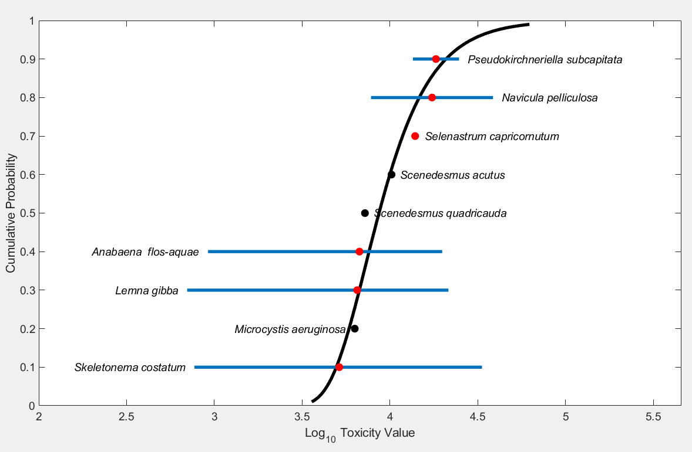
Figure 2. Log-logistic SSD for glyphosate toxicity values for all aquatic plants pooled. Black points indicate single toxicity values. Red points indicate average of multiple toxicity values for a single species. Blue line indicates full range of toxicity values for a given taxon.

Table 4. Range of HC₀₅ values for glyphosate SSDs for all aquatic plants (mg a.e./L).
Distribution | Method | HC₀₅ | SE | CV | Lower CI | Upper CI | P
Normal | ML | 4.3793 | 1.0854 | 0.2479 | 2.9952 | 7.2796 | 0.0939
Normal | MO | 4.1874 | 1.1029 | 0.2634 | 2.5712 | 6.8974 | 0.0959
Normal | GR | 3.685 | 1.0759 | 0.292 | 1.749 | 5.8525 | 0.1738
Logistic | ML | 3.9247 | 1.1695 | 0.298 | 2.2881 | 6.9581 | 0.0529
Logistic | MO | 4.2305 | 1.2099 | 0.286 | 2.3443 | 7.1347 | 0.0829
Logistic | GR | 3.4931 | 1.1187 | 0.3203 | 1.1508 | 5.5822 | 0.1808
Triangular | ML | 4.8992 | 1.0012 | 0.2044 | 4.0332 | 7.8928 | 0.0669
Triangular | MO | 4.1279 | 1.08 | 0.2616 | 2.6745 | 6.9761 | 0.1249
Triangular | GR | 3.8168 | 1.0407 | 0.2727 | 2.1181 | 6.0195 | 0.1708
Gumbel | ML | 5.0335 | 0.7621004 | 0.1514 | 4.041 | 6.9918 | 0.1269
Gumbel | MO | 4.922 | 0.8563381 | 0.174 | 3.6261 | 7.0347 | 0.2248
Gumbel | GR | 4.3761 | 1.0282 | 0.235 | 2.3459 | 6.3566 | 0.3906
Burr | ML | 5.0325 | 0.6461294 | 0.1284 | 4.0964 | 6.6196 | 0.1329
ML=maximum likelihood, MO= moment estimators, and GR=graphical methods
LCp and UCp=projections of the confidence limits of the HC₀₅ (LCx and UCx) onto the cumulative distribution function of the fitted distribution.
- Calculation of other quantiles

Table 5 provides estimates of the HC₀₅ as well as other quantiles of the fitted SSDs.

Table 5. Estimated quantiles of the fitted SSDs for glyphosate EC₅₀s for all aquatic plants (mg a.e./L).
Distribution | Method | HC₀₅ | HC₁₀ | HC₅₀ | HC₉₀ | HC₉₅
Normal | ML | 4.3793 | 5.1554 | 9.1668 | 16.299 | 19.188
Normal | MO | 4.1874 | 4.9785 | 9.1668 | 16.878 | 20.067
Normal | GR | 3.685 | 4.5066 | 9.1668 | 18.646 | 22.803
Logistic | ML | 3.9247 | 4.8241 | 8.8494 | 16.233 | 19.953
Logistic | MO | 4.2305 | 5.1477 | 9.1668 | 16.324 | 19.863
Logistic | GR | 3.4931 | 4.4621 | 9.1668 | 18.832 | 24.056
Triangular | ML | 4.8992 | 5.5481 | 9.3777 | 15.851 | 17.95
Triangular | MO | 4.1279 | 4.8096 | 9.1668 | 17.471 | 20.356
Triangular | GR | 3.8168 | 4.5143 | 9.1668 | 18.614 | 22.016
Gumbel | ML | 5.0335 | 5.5226 | 8.4314 | 16.377 | 21.107
Gumbel | MO | 4.922 | 5.4274 | 8.4768 | 17.064 | 22.294
Gumbel | GR | 4.3761 | 4.9468 | 8.6537 | 20.812 | 29.104
Burr | ML | 5.0325 | 5.5221 | 8.4319 | 16.376 | 21.104

Table 6 provides all the available EC₅₀ values for aquatic plants. If a species was not represented with a 96 hour study, and other values were available from shorter/longer duration studies (up to 10 days) then the data were included. If there were multiple other durations, the value from the study closer to a 96h duration was selected and if there were multiple values for the same duration, all values were included.
Table 6. Available effective lethal concentration (EC₅₀) data for aquatic plants exposed to technical grade glyphosate.
Genus | species | EC₅₀
Scenedesmus | quadricauda | 7.2
Scenedesmus | acutus | 10.2
Pseudokirchneriella | subcapitata | 13.5
Skeletonema | costatum | 2.27
Pseudokirchneriella | subcapitata | 24.7
Lemna | gibba | 18.3
Microcystis | aeruginosa | 6.3
Selenastrum | capricornutum | 13.8
Navicula | pelliculosa | 38.6
Skeletonema | costatum | 0.77
Anabaena | flos-aquae | 16.5
Lemna | gibba | 21.5
Selenastrum | capricornutum | 14.0
Anabaena | flos-aquae | 19.82
Skeletonema | costatum | 12.0
Lemna | gibba | 0.70
Skeletonema | costatum | 33.4
Anabaena | flos-aquae | 0.92
Navicula | pelliculosa | 7.8
Lemna | gibba | 11.9

