APPENDIX 1-8. Determination of Overlap of Likely Glyphosate Exposure Area and Species Ranges and Critical Habitat for Species Located Outside of the 48 Contiguous States (NL48)

The overlap extent of glyphosate’s likely exposure areas and the range (or critical habitat) of a species integrates information on potential use sites and usage data. This approach considers overlap of the species range (or critical habitat) with areas directly treated with glyphosate and those receiving spray drift. To address uncertainties associated with how treated acres may be distributed within a state (relative to a species range or critical habitat), and the magnitude of usage on any given year, approaches are employed to represent a central estimate of overlap as well as upper and lower bounds. These different estimates are considered in the Weight of Evidence when deciding whether use of glyphosate is likely or not likely to adversely affect (LAA or NLAA) an individual of an assessed species. The estimated overlap extent of the likely exposure area and species range (or critical habitat) is used in Step 2 as a surrogate for the percent of the listed population that could be exposed to glyphosate. Additional details are provided in the Revised Method[1] document. This appendix describes the approach for determining the extent of overlap.

Outside of the 48 contiguous states (ConUS), usage data relevant to glyphosate are only available for Alaska, Hawaii and Puerto Rico. For the Commonwealth of the Northern Mariana Islands, Guam, America Samoa and the US Virgin Island usage is assumed to be 100% for both agricultural use sites and for non-agricultural use sites.

1. Potential Use Sites

The landcovers representing potential glyphosate use sites in Hawaii, Puerto Rico, and the United States Virgin Islands include the following:

* 1. Agriculture
  2. Aquatic Herbicide
  3. Conservation Reserve Program (CRP)
  4. Developed
  5. Forest Trees
  6. Noncultivated land
  7. Nurseries
  8. Open Space Developed
  9. Pasture
  10. Right of Way

Some of these landcovers are not available in the remaining territories. Landcovers representing potential use sites in the Commonwealth of the Northern Mariana Islands and Guam include:

1. Agriculture
2. Aquatic Herbicide
3. Conservation Reserve Program (CRP)
4. Developed
5. Forest Trees
6. Noncultivated land
7. Open Space Developed
8. Pasture
9. Right of Way

Landcovers representing potential use sites in America Samoa include:

1. Agriculture
2. Aquatic Herbicide
3. Conservation Reserve Program (CRP)
4. Developed
5. Noncultivated land
6. Open Space Developed
7. Pasture
8. Right of Way
9. Applying Usage Data to UDLs

Since glyphosate is registered for all these use sites, this method considers all these potential use sites and relevant usage data. The sections below discuss the usage data available for each potential use site. As part of the Weight of Evidence analysis, maximum, average and minimum assumptions regarding the amount of usage are considered with different distributions of the treated acres. **APPENDIX 1-6** provides a glyphosate specific crosswalk across crop data sources for glyphosate uses.

* 1. Agriculture and Pasture

For glyphosate, a review of available usage data has concluded that there are no comprehensive, pesticide-specific usage data for Hawaii, Alaska or the territories that are considered suitable for incorporating quantitatively into the biological evaluations.

Pesticide usage data for broad categories, (*i.e.,* insecticide, herbicide and fungicide) are collected as part of USDA’s Census of Agriculture (CoA) for the U.S., including for Hawaii, Alaska and Puerto Rico. Although these data are not pesticide specific, they are useful in defining the proportion of agricultural areas where herbicides may be applied when more specific active ingredient level data are not available. In Hawaii and Alaska this method relies upon the 1997, 2002, 2007, 2012, and 2017 of the CoA and the 2018 CoA in Puerto Rico. Regardless of the year that is used, the assumption that the usage data for all herbicides represents only usage of glyphosate is highly conservative.

Table 1 includes the total cropland acres treated with herbicides as reported in the CoA and the total cropland acres found in the UDL. These values were used to derive surrogate estimate percent crop treated (PCT) values for potential use sites represented by agriculture located in Alaska, Hawaii and Puerto Rico. For Alaska and Hawaii maximum, minimum and average estimate were calculated across the available years of the CoA, but in Puerto Rico, with one year of the CoA, only one estimate is generated. This approach is conservative and overrepresents the usage of a single active ingredient because it assumes that all applications of herbicide (which include multiple active ingredients) represent only glyphosate usage. These PCT estimates are used for both the agricultural and pasture UDLs.

Table . 2012 CoA data for acres treated with all herbicide and total acres grown of crop in Hawaii (HI), Alaska (AK) and Puerto Rico (PR)

| **Region a** | **Max Acres Treated** | **Min Acres Treated** | **Avg Acres Treated** |
| --- | --- | --- | --- |
| Alaska Total Estimated Treated Acres | 15,518 | 6,294 | 11,155 |
| Alaska Total Possible Treatable Acres b: | 71,054 | 71,054 | 71,054 |
| Alaska PCT | 22% | 9% | 16% |
|  |  |  |  |
| Hawaii Total Estimated Treated Acres | 122,576 | 93.195 | 105,943 |
| Hawaii Total Possible Treatable Acres b: | 142,206 | 142,206 | 142,206 |
| Hawaii PCT | 86% | 66% | 75% |
|  |  |  |  |
| Puerto Rico Total Estimated Treated Acres | 67,990 | 67,990 | 67,990 |
| Puerto Rico Total Possible Treatable Acres b: | 48,710 | 48,710 | 48,710 |
| Puerto Rico PCT | 100% | 100% | 100% |

a AK and HI Census of Agriculture year 1997,2002,2007,2012,2017; PR 2018

b All possible treatable acres found regionally estimated based on the UDL.

No pesticide-specific or general herbicides usage data are available for any of the other US territories where federally listed species occur, and there is no available reliable surrogate to allow for a reliable estimate of usage in other territories at this time. Therefore, usage data will not be considered for territories other than Puerto Rico. When no usage data are applied, to overlap of potential use sites and species ranges represents an overestimate of the area where individuals of a listed species are expected to be exposed glyphosate.

* 1. Non-Agricultural Uses: Aquatic Herbicide, Conservation Reserve Program, Developed, Non-cultivated, Open Space Developed, Right of Way

For glyphosate, usage on non-agricultural use site in the NL48 is not available. Due to variety of use and the high usage found in the ConUs, 100% PCT was assumed for these use sites. Further refinement may be considered in the final glyphosate BE assessment if necessary.

1. Calculation of Extent of Direct Overlap of Species Range or Critical Habitat and Treated Acres

The aggregate surrogate PCTs calculated above from the CoA are used to calculate the total number of acres treated within a state for each UDL (surrogate PCT x total acres within a UDL = total acres treated for a UDL). The approach described above combines data that are at different spatial scales, *i.e.,* 30-meter pixel, county and state, for UDLs, Census of Agriculture and usage, respectively. Because of the differences in scales, the usage of glyphosate can be limited to county and sub-county areas representing potential use sites; however, the actual location of the treated acres within the state is unknown.

Three different assumptions are employed to represent how the treated acres are attributed to potential use site acres within the species range (or critical habitat): upper bound (concentrated within the species range), uniform distribution, and lower bound (concentrated outside of species range). Each of these approaches are discussed below. In all three approaches the estimated treated area within the species range (or critical habitat) is used to calculate the direct overlap of treated sites and the species range (or critical habitat). Direct overlap is equal to the total treated area within the species range divided by the total area of the species range (or critical habitat).

The upper bound approach assumes that all the treated acres in a state occur within the species range (or critical habitat) to the greatest extent possible. In this approach, the total acres treated for the state are calculated using the aggregated PCTs. The total treated acres for the state are compared to the total number of acres within a species’ range that overlaps with that UDL. If the number of treated acres in a state is greater than the number of acres in the UDL that overlap the species range, it will be assumed that all acres within the species range that overlap with the UDL are treated , with the excess treated acres assumed to occur outside of the species range. As described above, treated acres are only placed in counties within the species range where at least 1 registered labeled use for the UDL occurs, as identified by Census of Agriculture. If the number of treated acres is less than the total number of UDL acres that overlap with the species’ range, then it is assumed that all treated acres for the state in that UDL occur inside of the range of a species.

For the uniform distribution approach, the aggregated PCT is applied directly to the acreage of the UDL occurring within the species range or critical habitat to calculate the estimated treated acres. This approach assumes that the treated acres are distributed uniformly throughout the state.

The lower bound approach is essentially the opposite of the upper bound. In the lower bound approach, it is assumed that the treated acres are distributed outside of the species range to the greatest extent possible. The total acres treated for the state are compared to the total number of acres outside of a species’ range for the UDL. If the number of treated acres in a state is greater than the number of acres of UDL outside of the species range, it will be assumed that all acres outside the species range are treated, with the excess treated acres assumed to occur within the species range. If the number of treated acres is less than those outside of the species’ range, it is assumed that all treated acres for the state in that UDL occur outside of the range of a species.

When a species range spans multiple states, the uniform, upper, and lower bound approaches are individually applied to each state relevant to a species. The treated acres across all pertinent states are summed to calculate the number of treated acres overlapping with the whole species range (or critical habitat).

The calculation of total treated area based on the aggregated UDLs likely overestimates the area where crops could be found on the same land in a given year and is a conservatism in the process. The upper bound or method, which concentrates all the treated acres in the species range (or critical habitat) , frequently results in more treated area for a given state than expected when considering all cropped acres in the state. Additional assumptions and uncertainties related to this the calculation of total treated acres and the distributions of the treated acres related to the species range (or critical habitat) are presented in the Revised Method**.**

1. Calculation of Composite Drift Layer Overlapping with Species Range or Critical Habitat

To account for the potential effects of drift beyond the specifically treated acres, when the action area is derived, each relevant UDL is combined into a composite layer representing all potential uses. The composite layer is generated by placing all relevant UDLs on top of each other and merging them together to set the footprint for the chemical as a single layer. This composite layer is then extended out in all directions based on the application method with the greatest drift potential for the chemical. For glyphosate this is the aerial application, resulting in a maximum buffer distance of 2600 ft, or approximately 792 meters. For an individual species, the composite drift area is then refined by considering only the uses with overlap when applying the maximum buffer for the chemical. The specific application methods and rates relevant to these uses and the species-specific endpoints that result in the farthest distance from the treated field, where effects may occur, are used to determine the extent of the composite drift layer for that species.

When usage data are considered, it is necessary to account for a decrease in the extent of areas receiving spray drift because the actual treated area is less than the total cropped acres in the UDL. The total possible area receiving drift is based on all potential use site found in the action area. Prior to applying usage, potential drift in all directions is calculated. After applying usage only, a portion of potential use sites in the action area will be treated, thus changing the drift extent originally calculated based on all potential use sites.

Since the actual location of the treated acres within a state is unknown, specific areas are not buffered in the Step 2 approach of the Revised Method[2]. To account for the reduction in acres treated based on usage data, a factor is applied to this composite drift area based on a state aggregated PCT for all of the uses combined. Additionally, a factor is applied to account for the distribution of theses acres under an upper bound (maximum acres within the species range), lower bound (maximum acres outside the species range) or uniformly distributed within the range as previously discussed. The distribution of acres within the state relative to the species range will also affect the impact of spray drift. For the upper bound scenario, no additional factor is applied to the aggregated PCT, but for the uniform and minimum scenarios, the ratio of the number of treated acres calculated for the uniform or lower bound scenario to the upper bound scenario is applied to the PCT. Lastly, to account for the uncertainty in the true spatial distribution of the use sites, as well as the uncertainty of multiple sites potentially impacting the same locations, the adjusted PCT value is rounded up to the nearest ten place value (*e.g.,* factor of 0.056 is rounded to 0.1). This composite factor is used to scale the number of acres impacted by off-site drift and subsequently lower the total predicted overlap with a species range (or critical habitat) due to drift, when compared to the overlap which might occur if all treatable acres were assumed to be treated.

Another factor often discussed for consideration in spray drift is the impact of wind direction on off-site transport for species ranges that are impacted by spray drift occurring in all directions. Methods have been proposed in the past to account for this, including the use of wind rose plots to better predict off-site movement of a chemical. As a simplified method to account for the impacts of wind direction, an additional factor is applied to spray drift based on the number of applications that can occur for the use patterns that are relevant to a species. For the composite factor determined above, a wind direction scaling factor is applied where the factor is scaled to 25% for each application allowed, to represent movement of a chemical off-site in only one direction, or essentially ¼ of a circle when one application is made. More specifically, if only one yearly application is allowed for the relevant use sites, a factor of 0.25 is applied, if 2 applications are allowed, a factor of 0.5, if 3 applications are allowed, a factor of 0.75 and if 4 or more applications are allowed, a factor of 1 (or no additional scaling is applied). The equations used to scale the spray drift overlap are provided below in **Equation 1** and **Equation 2**.

**Equation 1**. $Composite drift factor=Aggregated PCT* \frac{\begin{aligned}Number of treated acres in direct overlap scenario \\ considered (upper bound, uniform, lower bound)\end{aligned}}{Number of acres in upper bound direct overlap scenario}$

**Equation 2**. $Final Drift Scaling factor= Composite drift factor rounded up to next 0.1 value * Wind factor$

In summary, the number of acres in a species range (or critical habitat) potentially exposed due to spray drift is calculated using the equations above for each state. This total number of acres is then divided by the total acres in the species range to determine the overlap area due to drift. For predicting relative EECs in the drift zone, the number of acres is further refined to how many are in each 30-meter increment off-site; starting at 30 meters and continuing to 792 meters off-site or the limit of aerial drift. Additional uncertainties and conservatism of the method for applying usage data to drift are provided in the Revised Method.

1. Determination of Overlap of Exposure Area and Species Range or Critical Habitat

To determine the total overlap exposure area, the total number of treated acres within the species range (direct overlap) are added to the scaled number of acres receiving spray drift then divided by the total number of acres of the species range (or critical habitat). This can be considered the percent of the species range/habitat that is likely to be exposed to the pesticide of interest, based on usage data and predicted spray drift. For species whose life history information indicates the species will not utilize the potential use site areas, overlap of direct treated sites will be zero for direct exposure and only the scaled areas receiving spray drift are considered for the species overlap.

There are 5 different overlap scenarios generated for consideration. The first represents the unadjusted or pesticide usage independent or pesticide independent overlap, the 2nd and 3rd incorporate the pesticide specific usage information and accounts for the redundancy in the UDL layers, and the 4th and 5th incorporate species life history information by removing direct overlap if the species will not utilize the potential use site and limiting the overlap extent to just the areas represented by suitable habitat. These 5 overlap scenarios are discussed in more detail in the following section.

When considering the three different assumptions related to distribution of treated acres relative to species range (*i.e.,* concentrated in species range (upper), uniform throughout state (uniform) and concentrated outside of species range (lower)) and the three different assumptions regarding the amount of usage on a given year (*i.e.,* maximum, average or minimum annual PCT), there are 9 different estimates of the overlap of the species range (or critical habitat) and the exposure area for each overlap scenario. The overlap estimates for pertinent scenarios are considered in addition to the influence of using surrogate usage data when none are available as part of the Weight of Evidence. This information is considered in the Weight of Evidence to determine the likelihood that an individual will be exposed and adversely affected.

1. Background - Spatial Co-occurrence of Species Location and Potential Use Sites

The co-occurrence analysis identifies if a species range (or critical habitat) and UDL overlap, and if so by how much. Required inputs to conducting the co-occurrence analysis include a list of species, species location files, pesticide Use Data Layers (UDLs), and any additional supporting species life history information used to supplement the analysis. The species list needs to include all species and designated critical habitat subjects to section 7 of the Endangered Species Act. Location files for each species range and critical habitat need to be accounted for prior to use in the co-occurrence analysis. The pesticide Use Data Layers (UDLs) representing each label use also need to be accounted for prior to completing the analysis. Finally, any additional species life history or spatial datasets, (*e.g.,* GAP/Landfire habitat layer) used to supplement the co-occurrence analysis need to be identified. Additional detail on these spatial inputs and the tools use to generated them can be found with the BE models/tools.

All inputs are finalized and standardized using the Co-occurrence Inputs-Species/Use and Supporting Tables tool. The co-occurrence analysis leverages the ArcGIS Tabulate Area tool, executed as a batch using Chemical Independent Co-occurrence Results-Parent Use Overlap Tables tool. The Chemical Dependent Co-occurrence Results-MAGtool Tables tool generates the standard output tables summarized by UDL and species used in the BE; incorporating usage and species life information into the results. The five different overlap scenarios are generated as output from this tool. Additional information on each of these tools can be found with the respective tool documentation.

The first overlap scenario provides a usage independent overlap, without any adjustments to account for usage or species life history. The remaining overlap scenarios apply usage and species information to the overlap. First the aggregated PCTs for glyphosate, described above, are applied to the species/UDL overlap using the three different distribution methods for the treated acres. Following the application of usage information, results are scaled to account for the redundancy in the UDLs. Additional detail on the method for applying the redundancy scaling factors is provided below. The last two overlap scenarios account for species life history information. First, if the species will not utilize the potential use site directly the overlap representing the direct overlap is excluded, limiting the results to the areas of drift overlap. Lastly, if the species is more likely to use certain habitats this can be considered by limiting the extent of overlap to just the areas of the species range with those habitats. This suitable habitat consideration is not applicable to designated critical habitat and is considered in conjunction with the results representing the full range as part of the Weight of evidence.

1. Input Data Used for Co-occurrence Analysis
   1. Master Species List

Species subject to section 7 under the Endangered Species Act are obtained from the US Fish and Wildlife Threatened and Endangered Species System[3] (TESS). The resulting table is filtered to include listing statuses[4] currently subject to section 7 or potentially subject to section 7 during the registration time period. Information from TESS for species under the jurisdiction of the National Marine Fisheries Service (NMFS) is supplemented with information from the NMFS website[5], deferring to the NMFS website if conflicts exist between the sources. The species list used for this assessment was generated in January 2019.

* 1. Species Locations

The FWS ECOS Portal (<http://ecos.fws.gov>) houses spatial data that represents species’ ranges and designated critical habitat[6]. Managed by the species experts and therefore considered the best available information for section 7 consultation, the co-occurrence analysis utilizing this information. The ECOS Portal points users to NMFS websites to access spatial information for species under NMFS jurisdiction not found on the ECOS website. For NMFS species not found in either location a request was made directly to the NMFS scientists. The last download of the species locations occurred in January 2019.

After accounting for each species, the input files used for the co-occurrence analysis are generated with the ESRI ArcGIS Union Toolbox[7]. The union tool generates the geometric union of the species files and their attributes presented as non-overlapping ‘zones’. Each unique zone may be occupied by multiple species. The species found in each zone are tracked in a look-up table generated at the time of the union. By using these non-overlapping ‘zones’ a given location is only run once in the analysis, rather than for each overlapping species.

Additional information on this process can be found with the Co-occurrence Inputs-Species/Use and Supporting Tables tool.

* 1. Use Data Layers (UDLs)

The data and process to generate the Use Data Layers is described in **APPENDIX 1-5 and APPENDIX 1-6.**

* 1. Other Inputs

In addition to the usage data described above, species life history information can be considered in two of the overlap scenarios. The first considers if the species will be found on potential use sites or exclusively off the use sites. Off use site determinations were made based on species documentation generated by the Services (e.g. Recovery Plan, 5-year Reviews). These determinations were reviewed and updated based on feedback provided by US Fish and Wildlife Service in the Fall of 2019[8]. The second scenario was a proof of concept and considers if a species is found exclusively in specific habitats. For this suitable habitat was exacted from the GAP/Landfire layer Fall of 201[9] and used to supplement the overlap for suitable habitat found is used to supplement the overlap for the full species range.

All spatial files, UDLs, species, and supplemental information, are standardized into the selected regional projections prior to use in the co-occurrence analysis. The regions found in the non-contiguous United States under U.S jurisdiction are represented by 5 projected coordinate systems; selected to preserve area calculations. Each one is specific to a region with the exception of Guam and the Commonwealth of the Northern Mariana Islands that share the same projection (Table 2).

Table . Regional projections used for all spatial files, UDLs and species input files.

|  |  |
| --- | --- |
| Region | Projections |
| Hawaii (HI) | NAD_1983_UTM_Zone_4N.prj |
| Puerto Rico (PR) | Albers_Conical_Equal_Area.prj |
| United States Virgin Islands (VI) | WGS_1984_UTM_Zone_20N.prj |
| American Samoa (AS) | WGS_1984_UTM_Zone_2S.prj |
| Guam (GU) and Commonwealth of the Northern Mariana (CNMI) | WGS_1984_UTM_Zone_55N.prj |

1. Co-occurrence Analysis

The co-occurrence analysis uses the ArcGIS Tabulate Area tool, executed as a batch with the Chemical Independent Co-occurrence Results-Parent Use Overlap Tables tool. Additional information on this tool can be found with the tool documentation. As described above, the species input files used for the co-occurrence are generated by ESRI ArcGIS Union Toolbox, which creates a series of non-overlapping ‘zones’. Each unique zone may be occupied by multiple species. Figure 1provides an example species range, and the same range broken up into the non-overlapping ‘zones’ used as the species input file.

In order to apply usage and Census of Agriculture information the state and county boundaries are added to the species input files using the ESRI Intersect Toolbox. The final ‘zones’ allows for the overlap of a UDL to be reported out by species for a given county or state. The state and county breaks allow for the application of the usage data. The total overlap for each county and state is also calculated so the treated acres for the state can be calculated for the upper and lower distributions of treated acres described above.

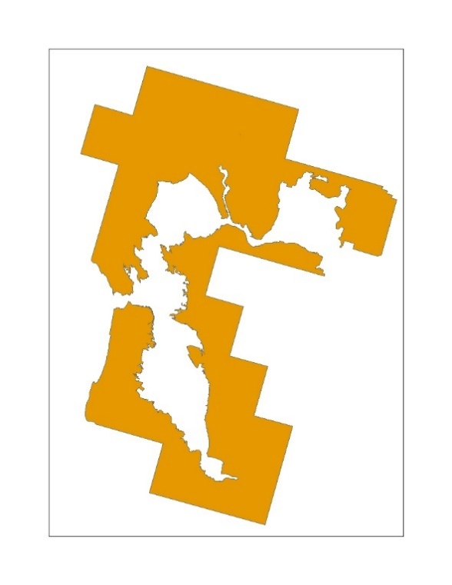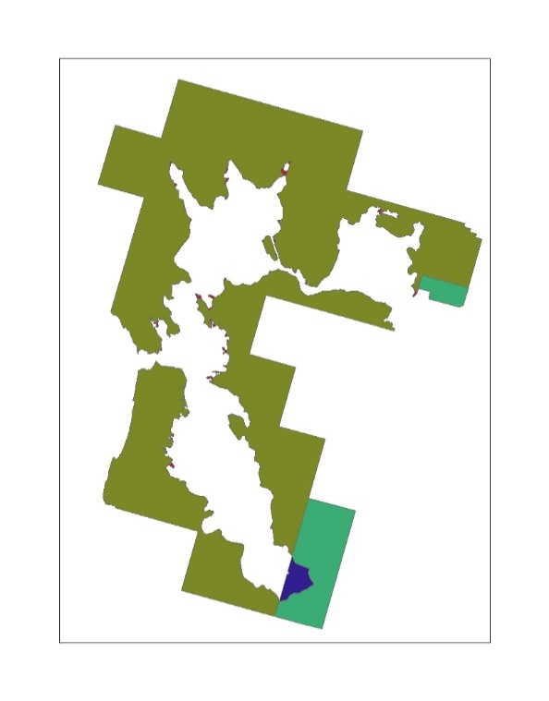

Figure . Example of species range represented by ‘zones’ used as the input for the co-occurrence analysis, including species location and counties boundaries.

* 1. Overlap Scenarios

Five different overlap scenarios are generated for consideration in the Weight of Evidence. The first is usage independent and provides results for the species with no adjustment to the overlap. This is followed by incorporating the usage data, scaling for redundancy of the UDLs, and then adding species life history information to the overlap results.

Applying the usage method described above, the aggregated PCTs and Census of Agricultural are applied to the state and county results to calculate the total treated acres for the state. This information is used for the upper and lower distribution of the treated acres. The treated acres are concentrated within the species range (or critical habitat) and the given state for the upper distribution or outside the species range (or critical habitat) and within the given state for the lower distribution. For the uniform distribution, the aggregated PCTs and Census of Agricultural are applied directly to the species results, broken down for a species in a given county and state. After calculating the treated acres for each state within the species range (or critical habitat), all states are summed to get the total treated acres for the species. This process is completed for all UDLs and each of the aggregated PCTs; minimum, maximum and average. The five overlap scenarios are:

* Overlap Scenario 1: Unadjusted
* Overlap Scenario 2: PCT Overlap
* Overlap Scenario 3: PCT and Redundancy
* Overlap Scenario 4: PCT, Redundancy, Off-site
* Overlap Scenario 5: PCT, Redundancy, Off-site, Habitat

Figure 2 provides an example of the three distribution of the treated acres. The dark gray is the extent of the UDL, the green area represents the treated area for a PCT of 10% for the state. These treated acres are distributed into the species range, in orange, using the three different methods; upper to left, uniform in the middle and lower to the right.

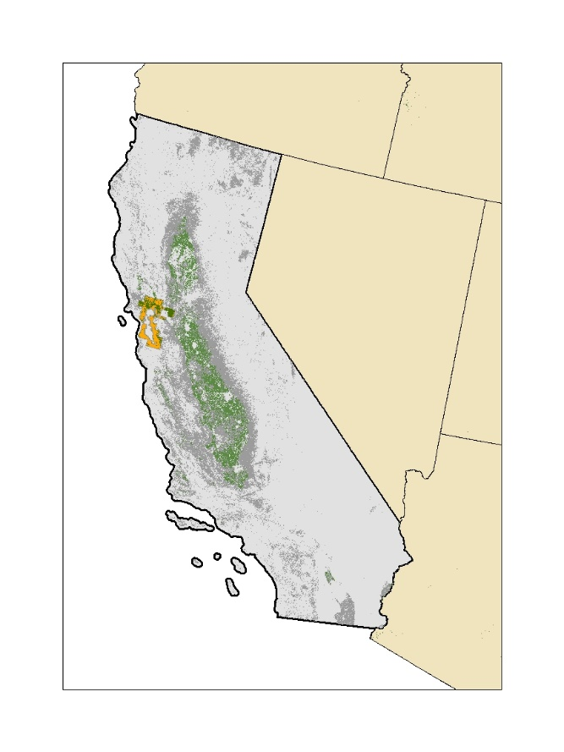

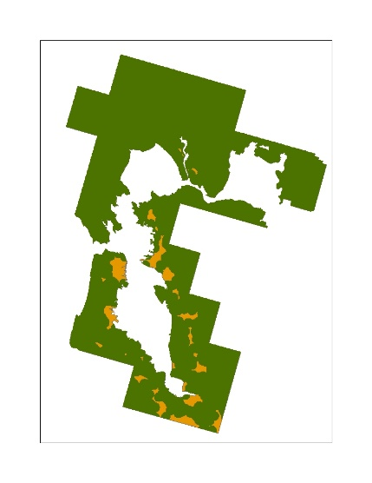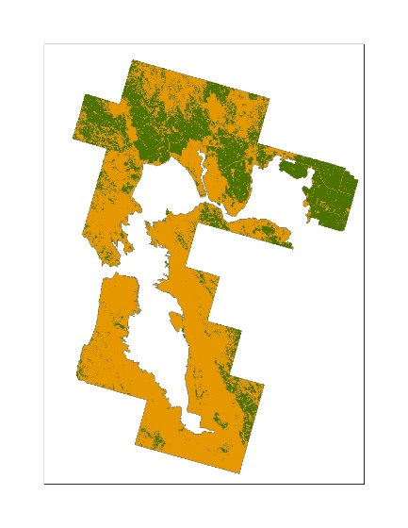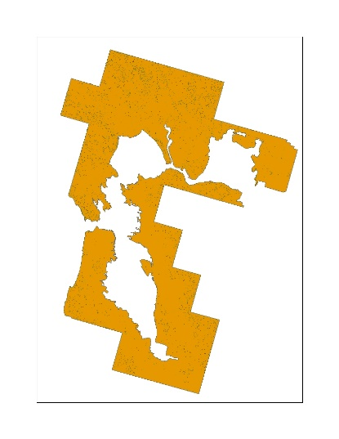

**Upper Uniform Lower**

Figure . Conceptual example of the application of an aggregated PCT to a UDL and the three different distribution methods for treated acres.

* 1. Scaling for Redundancy in the UDLs

Many UDLs overlap with each other, identifying a single location as multiple potential uses sites, causing the sum of the individual acres in the UDLs to be greater than the acres in the action area, and often greater than the 100% of the species range (or critical habitat). If each UDL was independent the sum of the UDLs would equal the action area. To account for this redundancy between use sites three different factors are applied to results for the individual UDLs; the composite factor, the agricultural factor and the non-agricultural factor.

In order to calculate the composite factor, an agricultural composite containing all agricultural UDLs and a non-agricultural composite containing all non-agricultural UDLs are generated. The composite factor is equal to the sum of the agricultural and non-agricultural composite divided by the action area. This factor accounts for the redundancy between the agricultural and non-agricultural uses. If all uses are independent the sum of the two composites would equal the action area, and the factor would be equal to 1. Each individual UDL is divided by this composite factor.

An agricultural factor is calculated by summing the results of all the agricultural UDLs and dividing by the agricultural composite. This factor is applied to all of the agricultural UDLs to account for the redundancy between agricultural UDLs. Similarly, a non-agricultural factor is calculated by summing the results of all the non-agricultural UDLs and dividing by the non-agricultural composite. This factor is applied to all of the non-agricultural UDLs to account for the redundancy between non-agricultural UDLs. If all uses are independent the sum of the individual UDLs would equal the composite, and the factor would be equal to 1.

After scaling the results to account for redundancy the sum of the individual UDLs will not exceed the action area percent overlap. Equations used in the calculation of these factors are shown below in **Equation 1-3.**

**Equation 1**. $Composite Factor=\frac{Perecent Overlap Ag Composite+Percent Overlap NonAg Composite}{Perecent Overlap Action Area}$

**Equation 2. $Agricultural Factor=\frac{Total Percent Overlap Ag UDLs}{Percent Overlap AgComposite}=\frac{\sum_{i=1}^{n}{\left(POi\right)}}{POj}$**

Where:

|  |  |
| --- | --- |
| i = | Agricultural UDLs |
| n= | Number of agricultural UDLs |
| j = | Agricultural composite layer |
| PO = | Unadjusted percent overlap |

**Equation 3. $Non-Agricultural Factor=\frac{Total Percent Overlap Non-Ag UDLs}{Percent Overlap Non-Ag Composite}=\frac{\sum_{i}^{n}{\left(POi\right)}}{POj}$**

Where:

|  |  |
| --- | --- |
| i = | Non-agricultural UDLs |
| n= | Number of non-agricultural UDLs |
| j = | Non-agricultural composite layer |
| PO = | Unadjusted percent overlap |

1. Results Co-occurrence Analysis

The final results of the co-occurrence analysis provide the percent of the species range (or critical habitat) that overlaps with each UDL. This metric is provided for each of the overlap scenario. The mean percent overlap and standard deviation for the glyphosate UDLs across each overlap scenario for all NL48 species range are provided in Table 3. The final overlap scenario incorporating species life history related to habitat is presented in Table 5. Glyphosate’s action area had a mean overlap of 98%. The mean overlaps out to the limits of ground and aerial drift stayed at 98% due to the minimal drift in the action area. A separate drift layer not presented in these tables was developed for consideration of the impacts of drift. The mean overlaps for the individual UDLs range from <1 to 100% before incorporating usage and species life history information. After incorporating this information, the range remains the same, <1 to 100%, but significant differences are observed in 7 of the 10 UDLs.

Table 4presents the overlap information for all NL48 designated critical habitats. For critical habitat, glyphosate’s action area had a mean overlap of 98%. Similar to the range results the mean overlaps out to the limits of ground and aerial drift remains the same due to the minimal drift in the action area. The mean overlaps for the individual UDLs range from <1 to 100% before incorporating usage. After incorporating this information, the range remains the same but significant differences are observed in 3 of the 10 UDLs.

Table . Mean percent overlap and standard deviation for all NL48 species ranges and each glyphosate uses.

| **Use** | **Overlap Scenario 1: Unadjusted (mean, std)** | | **Overlap Scenario 2: PCT Overlap (mean, std)** | | **Overlap Scenario 3:**  **PCT and Redundancy (mean, std)** | | **Overlap Scenario 4:**  **PCT, Redundancy, Off-site**  **(mean, std)** | |
| --- | --- | --- | --- | --- | --- | --- | --- | --- |
| Use | Mean | STD | Mean | STD | Mean | STD | Mean | STD |
| Glyphosate Action Area | 98 | 13 | 98 | 13 | 98 | 13 | 98 | 13 |
| Agriculture | 2 | 3 | <1 | 1 | <1 | 1 | <1 | 0.5 |
| Aquatic Herbicide | 98 | 13 | 98 | 13 | 98 | 13 | 98 | 13 |
| Conservation Reserve Program | 3 | 4 | 3 | 4 | 2 | 3 | 1 | 2 |
| Developed | 4 | 7 | 4 | 7 | 2 | 4 | 2 | 4 |
| Forest Trees | 24 | 20 | 24 | 20 | 16 | 12 | 16 | 12 |
| Noncultivated | 98 | 5 | 98 | 5 | 67 | 14 | 67 | 14 |
| Nurseries | <1 | 0.02 | <1 | 0.02 | <1 | 0.01 | <1 | 0.01 |
| Open Space Developed | 1 | 2 | 1 | 2 | 1 | 1 | 1 | 1 |
| Pasture | 4 | 8 | 4 | 8 | 3 | 6 | 2 | 4 |
| Right of Way | 7 | 9 | 7 | 9 | 4 | 6 | 4 | 6 |
| Limit Ground Drift (300m or 1000 ft) | 98 | 13 | 98 | 13 | 98 | 13 | 98 | 13 |
| Limit Aerial Drift  (792m or 2600ft) | 98 | 13 | 98 | 13 | 98 | 13 | 98 | 13 |

Table . Mean percent overlap and standard deviation for all NL48 designated critical habitat and each glyphosate use.

| **Use** | **Overlap Scenario 1: Unadjusted (mean, std)** | | **Overlap Scenario 2: PCT Overlap (mean, std)** | | **Overlap Scenario 3:**  **PCT and Redundancy (mean, std)** | | **Overlap Scenario 4:**  **PCT, Redundancy, Off-site**  **(mean, std)** | |
| --- | --- | --- | --- | --- | --- | --- | --- | --- |
| Use | Mean | STD | Mean | STD | Mean | STD | Mean | STD |
| Glyphosate Action Area | 98 | 13 | 98 | 13 | 98 | 13 | 98 | 13 |
| Agriculture | <1 | 0.2 | <1 | 0.1 | <1 | 0.03 | <1 | 0.03 |
| Aquatic Herbicide | 99 | 11 | 99 | 11 | 98 | 11 | 99 | 11 |
| Conservation Reserve Program | <1 | 1 | <1 | 1 | <1 | 1 | <1 | 0.5 |
| Developed | 1 | 1 | 1 | 1 | <1 | 1 | <1 | 1 |
| Forest Trees | 31 | 24 | 31 | 24 | 21 | 13 | 21 | 14 |
| Noncultivated | 99 | 11 | 99 | 11 | 75 | 16 | 75 | 16 |
| Nurseries | <1 | 0.004 | <1 | 0.004 | <1 | 0.003 | <1 | 0.003 |
| Open Space Developed | <1 | 0.3 | <1 | 0.3 | <1 | 0.2 | <1 | 0.2 |
| Pasture | 1 | 9 | 1 | 9 | 1 | 5 | <1 | 3 |
| Right of Way | 1 | 3 | 1 | 3 | 1 | 2 | 1 | 2 |
| Limit Ground Drift (300 m or 1000 ft) | 98 | 13 | 98 | 13 | 98 | 13 | 98 | 13 |
| Limit Aerial Drift (792m or 2600ft) | 98 | 13 | 98 | 13 | 98 | 13 | 98 | 13 |

* 1. Suitable Habitat Overlap

In total suitable habitat was identified for 21 species that occur in the NL48. Table 5provides themean percent overlap and standard deviation for these 21 species with the same overlap metrics but limited to just the areas of suitable habitat. Both the suitable habitat results and the full range results account for usage and species life history. This information is considered with the results for the full species range as part of the Weight of Evidence. The mean overlaps for the individual UDLs range from <1 to 100% for the full species range and <1 to 45% when considering suitable habitat areas.

Table . Mean percent overlap and standard deviation for uses in ConUS and suitable habitat species before and after limiting the overlap extent to suitable habitat.

| **Use** | **Overlap Scenario 4: PCT, Redundancy, Off-site (mean, std)** | | **Overlap Scenario 5:**  **PCT, Redundancy, Off-site, Habitat (mean, std)** | |
| --- | --- | --- | --- | --- |
| Use | Mean | STD | Mean | STD |
| Glyphosate Action Area | 98 | 13 | 42 | 19 |
| Agriculture | <1 | 0.5 | <1 | 0.02 |
| Aquatic Herbicide | 100 | 4 | 45 | 21 |
| Conservation Reserve Program | 1 | 2 | 0 | 1 |
| Developed | 2 | 4 | 2 | 2 |
| Forest Trees | 16 | 12 | 1 | 3 |
| Noncultivated | 67 | 14 | 29 | 14 |
| Nurseries | <1 | 0.01 | <1 | 0.01 |
| Open Space Developed | 1 | 1 | 1 | 1 |
| Pasture | 2 | 4 | 1 | 2 |
| Right of Way | 4 | 6 | 5 | 4 |
| Limit Ground Drift (300 m or 1000 ft) | 98 | 13 | 42 | 19 |
| Limit Aerial Drift (792m or 2600ft) | 98 | 13 | 42 | 19 |

1. Available at: <https://www.epa.gov/endangered-species/revised-method-national-level-listed-species-biological-evaluations-conventional>
2. Available at: <https://www.epa.gov/endangered-species/revised-method-national-level-listed-species-biological-evaluations-conventional>
3. Query used to extract species from TESS: https://ecos.fws.gov/services/TessQuery?request=query&xquery=/SPECIES_DETAIL
4. Statuses included: Threatened, Endangered, Experimental Population Non-Essential, Proposed Threatened, Proposed Endangered, and Candidate
5. <https://www.fisheries.noaa.gov/national/endangered-species-conservation/esa-threatened-endangered-species>
6. Website for designated critical habitat: ([http://ecos.fws.gov/crithab)](http://ecos.fws.gov/crithab)
7. <http://desktop.arcgis.com/en/arcmap/10.3/tools/analysis-toolbox/union.htm>
8. USFWS, personal communication, November 2019
9. U.S. Geological Survey Gap Analysis Program, 20160513, GAP/LANDFIRE National Terrestrial Ecosystems 2011: U.S. Geological Survey: Boise, ID, http://gapanalysis.usgs.gov/gaplandcover/. doi:10.5066/F7ZS2TM0.