Chapter 2 – Thiamethoxam Effects Characterization
Contents
1 Introduction 5
2 Endpoints used in Effects Determinations 6
3 Office of Water Aquatic Life Criteria 12
4 Effects Characterization for Fish 12
4.1 Introduction to Fish Toxicity 12
4.2 Effects on Mortality of Fish 12
4.3 Effects on Growth and Reproduction of Fish 13
4.4 Other Sublethal Effects to Fish 14
4.5 Comparison of Thiamethoxam and Clothianidin Fish Acute Toxicity Endpoints 15
4.6 Comparison of Thiamethoxam and Clothianidin Fish Growth and Reproduction Endpoints 16
5 Effects Characterization for Aquatic-phase Amphibians 17
5.1 Introduction to Aquatic-phase Amphibian Toxicity 17
5.2 Effects on Mortality of Aquatic-phase Amphibians 17
5.3 Effects on Growth and Reproduction of Aquatic-phase Amphibians 17
5.4 Other Sublethal Effects to Aquatic-phase Amphibians 17
5.5 Comparison of Thiamethoxam and Clothianidin Aquatic-Phase Amphibian Acute Toxicity Endpoints 17
5.6 Comparison of Thiamethoxam and Clothianidin Aquatic-Phase Amphibian Growth and Reproduction Toxicity Endpoints 18
6 Effects Characterization for Aquatic Invertebrates 18
6.1 Introduction to Aquatic Invertebrate Toxicity 18
6.2 Effects on Mortality of Aquatic Invertebrates 18
6.3 Effects on Growth and Reproduction of Aquatic Invertebrates 19
6.4 Other Sublethal Effects to Aquatic Invertebrates 21
6.5 Comparison of Thiamethoxam and Clothianidin Aquatic Invertebrate Acute Toxicity Endpoints 22
6.5.1 Species Sensitivity Distribution (SSD) 23
6.6 Comparison of Thiamethoxam and Clothianidin Aquatic Invertebrate Growth and Reproduction Endpoints 23
7 Effects Characterization for Aquatic Plants 24
7.1 Introduction to Aquatic Plant Toxicity 24
7.2 Effects on Aquatic Plants 25
7.3 Effects on Aquatic Plant Communities 26
7.4 Comparison of Thiamethoxam and Clothianidin Aquatic Plant Toxicity Data 26
8 Effects Characterization for Birds 27
8.1 Introduction to Bird Toxicity 27
8.2 Effects on Mortality of Birds 27
8.3 Effects on Growth and Reproduction of Birds 28
8.4 Other sublethal effects to Birds 29
8.5 Drinking water studies 29
8.6 Dermal studies 29
8.7 Inhalation studies 30
8.8 Comparison of Thiamethoxam and Clothianidin Avian Acute Toxicity Endpoints 30
8.9 Comparison of Thiamethoxam and Clothianidin Avian Sub-Acute Toxicity Endpoints 30
8.10 Comparison of Thiamethoxam and Clothianidin Avian Growth and Reproduction Endpoints 31
9 Effect Characterization to Reptiles 31
10 Effect Characterization to Terrestrial-phase Amphibians 32
11 Effects Characterization for Mammals 32
11.1 Introduction to Mammal Toxicity 32
11.2 Effects on Mortality of Mammals 32
11.3 Effects on Growth and Reproduction of Mammals 33
11.4 Other Sublethal Effects to Mammals 34
11.5 Drinking water studies 37
11.6 Dermal exposure studies 37
11.6.1 Inhalation studies 38
11.7 Comparison of Thiamethoxam and Clothianidin Mammalian Acute Toxicity Endpoints 38
11.8 Comparison of Thiamethoxam and Clothianidin Mammalian Growth and Reproduction Endpoints 38
12 Effects Characterization for Terrestrial Invertebrates 39
12.1 Introduction to Terrestrial Invertebrate Toxicity 39
12.2 Effects on Mortality of Terrestrial Invertebrates 39
12.2.1 Mortality Endpoints Expressed as mg/kg-soil 39
12.2.2 Contact Exposure Mortality Endpoints Expressed as mg/kg-bw 40
12.2.3 Mortality Endpoints Expressed as lb/acre 41
12.2.4 Oral Exposure Mortality Endpoints Expressed as mg/kg-diet 43
12.3 Effects on Growth and Reproduction of Terrestrial Invertebrates 44
12.3.1 Growth and Reproduction Endpoints Expressed as mg/kg-soil 44
12.3.2 Contact Exposure Growth and Reproduction Endpoints Expressed as mg/kg-bw 45
12.3.3 Growth and Reproduction Endpoints Expressed as lb/acre 45
12.3.4 Oral Exposure Growth and Reproduction Endpoints Expressed as mg/kg-diet 46
12.4 Other Sublethal Effects to Terrestrial Invertebrates 47
12.5 Comparison of Thiamethoxam and Clothianidin Terrestrial Invertebrate Acute Toxicity Endpoints 50
12.6 Comparison of Thiamethoxam and Clothianidin Terrestrial Invertebrate Growth and Reproduction Endpoints 51
13 Effects Characterization for Terrestrial Plants 51
13.1 Introduction to Terrestrial Plant Toxicity 51
13.2 Effects Data for Terrestrial Plants 52
13.3 Clothianidin Effects Data for Terrestrial Plants 53
14 Incident Reports 53
15 Alternative Toxicity endpoints 54

Tables
Table 2-1. Terrestrial animal mortality endpoints used to evaluate impacts to species and impacts to PPHD 8
Table 2-2. Terrestrial animal sublethal endpoints used to evaluate impacts to species and impacts to PPHD 9
Table 2-3. Aquatic animal mortality endpoints used to evaluate impacts to species and impacts to PPHD 10
Table 2-4. Aquatic animal sublethal endpoints used to evaluate impacts to species and impacts to PPHD 11
Table 2-5. Aquatic plant endpoints used to evaluate impacts to species and impacts to PPHD 11
Table 2-6. Terrestrial plant endpoints used to evaluate impacts to species and impacts to PPHD 12
Table 2-7. Comparison of Fish Acute Mortality Toxicity Data for Clothianidin and Thiamethoxam¹ 16
Table 2-8. Comparison of Fish Growth and Reproduction Toxicity Data for Clothianidin and Thiamethoxam¹ 17
Table 2-9. Comparison of Aquatic Phase Amphibian Acute Mortality Toxicity Data for Clothianidin and Thiamethoxam¹ 19
Table 2-10. Summary Statistics for SSD Fit to Thiamethoxam Test Results (toxicity values reported as µg/L) 20
Table 2-11. 96-h LC50 values (µg/L, based on nominal concentrations) for thiamethoxam and clothianidin. Values calculated by EFED using raw data provided by Raby et al. (2018a). 23
Table 2-12. HC₀₅ and HC₅₀ values (in µg a.i./L) based on the gumbel distribution for thiamethoxam and the triangular distribution for clothianidin 24
Table 2-13. Comparison of Aquatic Invertebrate Growth and Reproduction Toxicity Data for Clothianidin and Thiamethoxam¹ 25
Table 2-14. Aquatic Plant Toxicity Data for Thiamethoxam 26
Table 2-15. Comparison of Aquatic Plant Toxicity Data for Thiamethoxam and Clothianidin 27
Table 2-16. Avian Acute Toxicity Data for Thiamethoxam¹ 28
Table 2-17. Avian Subacute Toxicity Data for Thiamethoxam 29
Table 2-18. Avian Chronic Toxicity Data for Thiamethoxam 30
Table 2-19. Comparison of Avian Acute Dose Based Toxicity Data for Clothianidin and Thiamethoxam¹ 31
Table 2-20. Comparison of Avian Growth and Reproduction Toxicity Data for Clothianidin and Thiamethoxam¹ 32
Table 2-21. Summary of the Most Sensitive Mammalian Mortality Endpoints for Thiamethoxam 34
Table 2-22. Summary of the Most Sensitive Reproductive and Developmental Mammalian Endpoints for Thiamethoxam 35
Table 2-23. Summary of the Most Sensitive Reproductive and Developmental Mammalian Endpoints for Thiamethoxam 36
Table 2-24. Mammalian Dermal Exposure Studies for Thiamethoxam 38
Table 2-25. Mammalian Inhalation Studies for Thiamethoxam 39
Table 2-26. Comparison of Mammalian Acute Dose Based Toxicity Data for Clothianidin and Thiamethoxam¹ 39
Table 2-27. Comparison of Mammalian Growth and Reproduction Endpoints for Clothianidin and Thiamethoxam¹ 40
Table 2-28. Comparison of Terrestrial Invertebrate Acute Mortality Toxicity Data for Clothianidin and Thiamethoxam¹ 52
Table 2-29. Comparison of Terrestrial Invertebrate Sublethal Toxicity Data for Clothianidin and Thiamethoxam¹ 52
Table 2-30. Overview of Reported Incidents by Taxa 55
Table 2-31. Alternative Toxicity Endpoints Used in Weight of Evidence Analysis 56

Figures
Figure 2-1. Array of mortality toxicity data for fish expressed in terms of µg a.i./L. 14
Figure 2-2. Array of growth toxicity data for fish expressed in terms of µg a.i./L. 15
Figure 2-3. Summary array of toxicity data for fish expressed in terms of µg a.i./L. 16
Figure 2-4. SSD for mortality toxicity values for aquatic insects for thiamethoxam 20
Figure 2-5. Array of growth toxicity data for freshwater aquatic invertebrates expressed in terms of µg a.i./L. 21
Figure 2-6. Array of sublethal toxicity data for aquatic invertebrates expressed in terms of log µg a.i./L 22
Figure 2-7. Comparison of gumbel SSD for thiamethoxam and triangular SSD for clothianidin toxicity values 24
Figure 2-8. Mortality Endpoints for Terrestrial Invertebrates Exposed to Thiamethoxam (mg/kg-soil). 41
Figure 2-9. Contact Exposure Mortality Endpoints for Terrestrial Invertebrates Exposed to Thiamethoxam (mg/kg-bw). 42
Figure 2-10. Mortality Endpoints for Terrestrial Invertebrates Exposed to Thiamethoxam (lb/acre). 43
Figure 2-11. Oral Exposure Mortality Endpoints for Terrestrial Invertebrates Exposed to Thiamethoxam (mg/kg-diet). 44
Figure 2-12. Sublethal Endpoints for Terrestrial Invertebrates Exposed to Thiamethoxam (mg/kg-soil). 45
Figure 2-13. Growth and Reproduction Endpoints for Terrestrial Invertebrates Exposed to Thiamethoxam (lb/acre). 47
Figure 2-14. Growth and Reproduction Endpoints for Terrestrial Invertebrates Exposed to Thiamethoxam (mg/kg-diet). 48
Figure 2-15. Summary array of toxicity data for terrestrial invertebrates expressed in terms of mg a.i.kg-bw. 49
Figure 2-16. Summary array of toxicity data for terrestrial invertebrates expressed in terms of mg a.i./kg-diet. 50
Figure 2-17. Summary array of toxicity data for terrestrial invertebrates expressed in terms of lbs a.i./A. 51

Introduction

Thiamethoxam is a systemic, neonicotinoid insecticide which acts on the insect nicotinic acetylcholine receptors (nAChRs) of the central nervous system via competitive modulation. Thiamethoxam is in the N-nitroguanidine group of neonicotinoids (IRAC subclass 4A) along with imidacloprid, clothianidin, and dinotefuran. The mode of action on target insects (terrestrial and aquatic) involves out-competing the neurotransmitter, acetylcholine for available binding sites on the nAChRs (Zhang et al. 2008). At low concentrations, neonicotinoids cause excessive nervous stimulation and at higher concentrations, insect paralysis and death will occur (Tomizawa and Casida 2005). Thiamethoxam is systemic in plants; as such, it kills feeding insects via ingestion or direct contact routes of exposure. Target pests include the chewing and sucking pests such as aphids, whiteflies, thrips, leafhoppers, scales, and leaf miners.

On an acute exposure basis, thiamethoxam is very highly toxic to aquatic invertebrates. Tested insect species (class Insecta) are more sensitive on an acute exposure basis compared to tested species in other classes (e.g., daphnids and mysid shrimp). By comparison, fish and aquatic plants are several orders of magnitude less sensitive following acute exposure. On a chronic exposure basis, a decrease in survival was observed in aquatic insects. As with acute exposure, daphnids and mysid shrimp are orders of magnitude less sensitive compared to insects when chronically exposed to thiamethoxam. Fish are also orders of magnitude less sensitive than aquatic insects on a chronic basis.

In terrestrial organisms, thiamethoxam is characterized as highly toxic to bees and slightly toxic to birds and mammals on an acute exposure basis. Available data suggest potential effects to honey bee and bumble bee colonies, that manifest as impacts to numbers of adults and decreases in brood. Chronic exposures to birds and mammals led to decreases in body weight. Generally, minimal effects are seen in terrestrial plant studies; however, some effects on plant height were observed in some species of dicots.

Thiamethoxam degrades into clothianidin, a separate active ingredient (a.i.) in the neonicotinoid class of chemicals which is subject to its own biological evaluation (BE). Available fate and residue data indicate that the major route of formation of clothianidin (as a degradate) is from metabolism of thiamethoxam within plants. Clothianidin is also a major degradate in three of eight aerobic soil metabolism studies, forming up to 37% in a silt loam soil. Therefore, both thiamethoxam and clothianidin are considered residues of concern for terrestrial and aquatic organisms. There were no other major residues of concern.

The following sections discuss toxicity data available for thiamethoxam and clothianidin from both registrant-submitted and open literature studies divided into major taxonomic groups of fish, aquatic amphibians, aquatic invertebrates, aquatic plants, birds, reptiles, terrestrial-phase amphibians, mammals, terrestrial invertebrates and terrestrial plants. Based on these data, mortality and sublethal effects (i.e., growth and reproduction) endpoints are determined and are used to evaluate direct effects to a listed species or effects to plants or animals that a species uses for prey, pollination, habitat, and/or dispersal (PPHD).

In establishing the sublethal thresholds and endpoints used in the analysis, EPA used the most sensitive sublethal endpoint based on growth or reproduction or any sublethal endpoints that are strongly linked to survival, growth or reproduction. In determining whether toxicity endpoints are strongly linked to apical endpoints, EPA staff used best professional judgement, also considering factors such as data quality and relevance to effects on survival and reproduction.

If sufficient data are available, the toxicity data for each taxon are presented as summary data arrays (developed using the Data Array Builder v.1.0; described in ATTACHMENT 2-1). Alternatively, data are presented in a tabular format if only limited data are available. The arrays contain data from both laboratory and field experiments (e.g., mesocosms). Data in these arrays are grouped by the type of effect (e.g., mortality, growth, and reproduction), and present the range of effects endpoints [e.g., Lowest Observed Adverse Effect Concentration (LOAECs) and No Observed Adverse Effect Concentrations (NOAECs; NOAECs must have a corresponding LOAEC to be represented in array)] for each effect type. The effects related to mortality, growth, and reproduction are discussed in further detail within each taxon effects characterization. All endpoints are reported in terms of amount of active ingredient, unless otherwise specified. Data used in the arrays are available for each taxon in APPENDIX 2-1. Studies for which exposure units could not be converted to environmentally relevant units were not included in the data arrays. Endpoints reported in the ECOTOX database are presented in APPENDIX 2-2. Reviews of open literature studies are presented in APPENDIX 2-3. Citations for registrant submitted studies are presented in APPENDIX 2-4.

Endpoints used in Effects Determinations

Toxicity data available for thiamethoxam and clothianidin were reviewed and organized into major taxonomic groups, including fish, aquatic amphibians, aquatic invertebrates, aquatic plants, birds, reptiles, terrestrial-phase amphibians, mammals, terrestrial invertebrates and terrestrial plants. For each of these groups, endpoints are determined for each taxon for mortality (animals only) and sublethal effects (i.e., growth or reproduction). These endpoints are used to establish thresholds, which are then used in conjunction with exposure data to make effects determinations based on the taxon with which they are associated. The thiamethoxam data are described more fully in each relevant toxicity section below. The clothianidin data are briefly compared to thiamethoxam data below. A more complete discussion is provided in chapter 2 of the clothianidin BE. The most sensitive reliable endpoint from either clothianidin or thiamethoxam was used to represent thresholds for effects. Endpoints for both clothianidin and thiamethoxam were not corrected to be in common mass units. Table 2-1 through Table 2-6 summarizes the thiamethoxam and clothianidin toxicity endpoints used in the effects determinations for all taxa. The available toxicity data for each taxon is discussed more later in this chapter.
Table 2-1. Terrestrial animal mortality endpoints used to evaluate impacts to species and impacts to PPHD
Type of Threshold | Taxon | Test Species | Type of endpoint | Value | Units | Slope | Weight of test animal (g) | Comments | Reference
DOSE BASED MORTALITY | Mammals | Mouse (Mus musculus) | LD50 | 425 | mg ai/kg-bw | 4.5 | 29.6 | 95% CI: 619-1000; assumed slope; clothianidin endpoint | MRID 44703315
 | Birds | Japanese quail (Coturnix japonica) | LD50 | 423 | mg ai/kg-bw | 4.5 | 102 | 95% CI: 306-593 mg a.i./kg-bw; assumed slope; thiamethoxam endpoint | MRID 44703307
 | Reptiles | Japanese quail (Coturnix japonica) | LD50 | 423 | mg ai/kg-bw | 4.5 | 102 | 95% CI: 306-593 mg a.i./kg-bw; assumed slope; thiamethoxam endpoint | MRID 44703307
 | Terrestrial Invertebrates | Asiatic Honey Bee (Apis cerana) | LD50 | 0.032 | mg ai/kg-bw | 3.5 | NA | Contact exposure; thiamethoxam endpoint | ECOTOX # 183780; Yasuda et al. 2017
DIETARY BASED MORTALITY | Mammals | No Data
 | Birds | Mallard Duck (Anas platyrhynchos) | LC50 | 5200 | mg ai/kg-diet | 4.5 | NA | Non-definitive (>) value; assumed slope; thiamethoxam endpoint | MRID 44703309
 | Reptiles | Mallard Duck (Anas platyrhynchos) | LC50 | 5200 | mg ai/kg-diet | 4.5 | NA | Non-definitive (>) value; assumed slope; thiamethoxam endpoint | MRID 44703309
 | Terrestrial Invertebrates | Honey Bee (Apis mellifera) | LC50 | 0.014 | mg ai/kg-diet | 2.3 | NA | Calculated using reverse BeeREX; thiamethoxam endpoint | ECOTOX # 183532; Liu et al. 2017
MORTALITY | Terrestrial Invertebrates | Earthworm (Eisenia fetida) | LC50 | 0.93 | mg ai/kg-soil | 4.5 | NA | Assumed slope; clothianidin endpoint | ECOTOX # 173321; Wang et al. 2015
 | Terrestrial Invertebrates | Chalcid Wasp (Spalangia endius) | LC50 | 0.0037 | lb ai/acre | 2.2 | NA | Thiamethoxam endpoint | ECOTOX # 171549; Burgess et al. 2015

Table 2-2. Terrestrial animal sublethal endpoints used to evaluate impacts to species and impacts to PPHD
Type of Threshold | Taxon | Test Species | NOAEC (or LOAEC if no NOAEC) | MATC or LOAEC | Units | Comments | Reference
DOSE BASED SUBLETHAL ENDPOINTS | Mammals | Lab Rat (Rattus norvegicus) | 8 | 16 | mg ai/kg-bw | MATC used, LOAEC = 32; decreased body weight gain in offspring; clothianidin endpoint | ECOTOX Ref No. 173326
 | Birds | House Sparrow (Passer domesticus) | 63 | 88.7 | mg ai/kg-bw | MATC used; LOAEC = 125; food consumption, body weight reduction; clothianidin endpoint | MRID 49104802
 | Reptiles | House Sparrow (Passer domesticus) | 63 | 88.7 | mg ai/kg-bw | MATC used; LOAEC = 125; food consumption, body weight reduction; clothianidin endpoint | MRID 49104802
DIETARY BASED SUBLETHAL ENDPOINTS | Mammals | Lab Rat (Rattus norvegicus) | 30 | 173 | mg ai/kg-diet | MATC used, LOAEC = 1000; decreased body weight gain in offspring; thiamethoxam endpoint | MRID 44718707
 | Birds | Bobwhite quail (Colinus virginianus) | 205 | 328 | mg ai/kg-diet | MATC used; LOAEC = 525; reduced eggshell thickness; clothianidin endpoint | MRID 45422421
 | Reptiles | Mallard Duck (Anas platyrhynchos) | 300 | 520 | mg ai/kg-diet | MATC used; LOAEC = 900; parental male weight reduction; thiamethoxam endpoint | MRID 45422421
SUBLETHAL/Mortality | Terrestrial Invertebrates | Asiatic Honey Bee (Apis cerana) | 0.032 | 0.032 | mg ai/kg-bw | Contact exposure; mortality endpoint; thiamethoxam endpoint | ECOTOX # 183780; Yasuda et al. 2017
 | Terrestrial Invertebrates | Honey Bee (Apis mellifera) | 0.001 | 0.0014 | mg ai/kg-diet | MATC used; LOAEC = 0.002; based on a 12% increase in mortality; clothianidin endpoint calculated using reverse BeeREX | MRID 48414901
 | Terrestrial Invertebrates | Springtail (Folsomia candida) | 0.02 | 0.032 | mg ai/kg-soil | MATC used; LOAEC = 0.051; based on a 40% increase in mortality; clothianidin endpoint | ECOTOX # 183406; Ritchie et al. 2019
 | Terrestrial Invertebrates | Seven-spotted lady beetle (Coccinella septempunctata L.) | <0.0011 | 0.0011 | lb ai/acre | Based on a 52% increase in mortality; Non-definitive (<) NOAEC; clothianidin endpoint | ECOTOX # 183576; Jiang et al. 2018

Table 2-3. Aquatic animal mortality endpoints used to evaluate impacts to species and impacts to PPHD
Taxon | Test Species | Type of endpoint | Value  (ug ai/L) | Slope | Duration of study (days) | Comments | Reference
FW FISH | Rainbow Trout  (Oncorhynchus mykiss) | LC50 | >101,500* | 4.5 | 4 | Clothianidin endpoint | MRID 45422406
E/M FISH | Sheepshead Minnow (Cyprinodon variegatus) | LC50 | >91,400* | 4.5 | 4 | Clothianidin endpoint | MRID 45422411
AQ AMPHIBIANS | Rainbow Trout  (Oncorhynchus mykiss) | LC50 | >101,500* | 4.5 | 4 | Clothianidin endpoint | MRID 45422406
FW INVERTEBRATES | NA | HC05 | 3.58 | 1.69 | 2-4 | Derived from thiamethoxam aquatic insect Species Sensitivity Distribution (SSD) from clothianidin | APPENDIX 2-5
E/M INVERTEBRATES | Mysid Shrimp (Mysidopsis bahia) | LC50 | 51 | 4.5 | 4 | Clothianidin endpoint | MRID 45433403
Mollusks | Eastern oyster (Crassostrea virginica) | LC50 | >119,000 | 4.5 | 4 | Based on 13% decrease in shell deposition; thiamethoxam endpoint | MRID 44714921
NA = not applicable
*No mortality or sublethal effects observed

Table 2-4. Aquatic animal sublethal endpoints used to evaluate impacts to species and impacts to PPHD
Taxon | Test Species | NOAEC | MATC or LOAEC | Units | Duration of study (days) | Comments | Reference
FW FISH | Fathead minnow  (Pimephales promelas) | 9,700 | 13,928 | µg ai/L | 28 | MATC used; LOAEC = 20,000; decrease in length and weight; clothianidin endpoint | MRID 45422413
E/M FISH | Sheepshead minnow  (Cyprinodon variegates) | 1,700 | 2,640 | µg ai/L | 33 | MATC used; LOAEC = 4,100; 5.5% decrease in length; thiamethoxam endpoint | MRID 49489511
AQ AMPHIBIANS | Fathead minnow  (Pimephales promelas) | 9,700 | 13,928 | µg ai/L | 28 | MATC used; LOAEC = 20,000; decrease in length and weight; clothianidin endpoint; no acceptable amphibian endpoint, so freshwater fish endpoint used as a surrogate | MRID 45422413
FW INVERTEBRATES | Midge (Chironomus dilutus) | <0.05 | 0.05 | µg ai/L | 40 | LOAEC based on decreased emergence; clothianidin endpoint | MRID 50344701
E/M INVERTEBRATES | Saltwater mysid shrimp (Americamysis bahia) | 5.1 | 7.0 | µg ai/L | 39 | MATC used; LOAEC = 9.7; based on effects to reproduction; clothianidin endpoint | MRID 45422405
Mollusks | Eastern oyster (Crassostrea virginica) | >119,000 | NA | µg ai/L | 4 | Based on 13% decrease in shell deposition; Non-definitive (>); thiamethoxam endpoint | MRID 44714921

Table 2-5. Aquatic plant endpoints used to evaluate impacts to species and impacts to PPHD
EPA Category | Species | NOAEC | MATC or LOAEC | IC50 | Units | Comments | Reference
Non-vascular | SW diatom  (Skeletonema costatum) | 6,350 | 10,174 | 17,600 | ug ai/L | Reduced Biomass; MATC used; LOAEC= 16,300; clothianidin endpoint | MRID 48720603
Vascular | Lemna gibba | 520 | 739 | 280,000 | ug ai/L | Reduced biomass and yield; MATC used; LOAEC = 1,050; IC50 is non-definitive; clothianidin endpoint | MRID 49281301

Table 2-6. Terrestrial plant endpoints used to evaluate impacts to species and impacts to PPHD
EPA Category | Species | NOAEC | MATC or LOAEC | IC₂₅ | Units | Comments | Reference
Monocot | Oat (Avena sativa) | 0.265 | 0.265 | 0.265 | lb ai/A | No effects observed; NOAEC is highest tested concentration; LOAEC and IC₂₅ are non-definitive values; thiamethoxam endpoint | MRID 50121103
Dicot | Lettuce (Lactuca sativa) | 0.26 | 0.26 | 0.26 | lb ai/A | No effects observed; NOAEC is highest tested concentration; LOAEC and IC₂₅ are non-definitive values; thiamethoxam endpoint | MRID 49105801

Office of Water Aquatic Life Criteria

The U.S. EPA’s Office of Water (OW) may develop ambient water quality criteria for chemicals, including pesticides, that can be adopted by states and tribes to establish water quality standards under the Clean Water Act. At this time, OW has not published ambient water quality criteria for thiamethoxam.

Effects Characterization for Fish

Introduction to Fish Toxicity

Acute and chronic studies for fish have been submitted by the registrant and are available in the open literature. APPENDICES 2-2 and 2-3 include the bibliographies of studies that are included in this effects characterization and those that were excluded, respectively. Studies were excluded if they were considered invalid or not associated with an environmentally relevant exposure route. Thresholds are based on the most sensitive lethal and sublethal effects identified among the available registrant-submitted studies and open literature in the ECOTOX database.

Effects on Mortality of Fish

The available data for acute mortality to fish is provided in Figure 2-1 below. There were no fish endpoints based on mortality identified from studies in the ECOTOX acceptable database that were either more sensitive than the endpoints identified above, or reliable for use as a threshold. The most sensitive reliable endpoint from either clothianidin or thiamethoxam was used to represent thresholds for mortality effects.

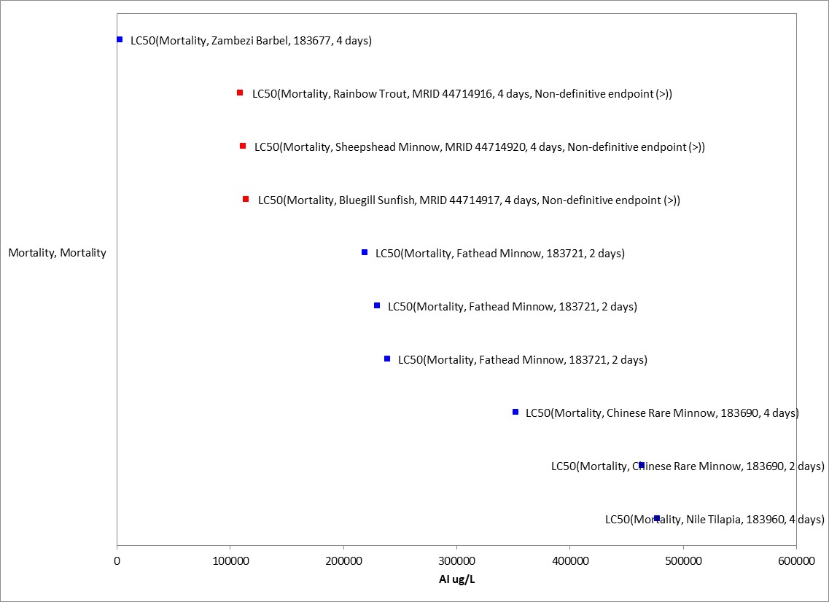
Figure 2-1. Array of mortality toxicity data for fish expressed in terms of µg a.i./L.
Blue squares represent LC₅₀ values from open literature studies found in the ECOTOX database. Red squares represent LC₅₀ values from registrant submitted studies. Parentheses present the endpoint measurement, species, study reference (i.e., MRID, ECOTOX #), and study duration. If endpoint is non-definitive, that is also noted.

For freshwater fish, the lowest reliable LC₅₀ for thiamethoxam based on the TGAI (Technical Grade Active Ingredient) was >114,000 µg a.i./L tested on the bluegill sunfish (MRID 44714917). Toxicity data for thiamethoxam when tested as a formulated product are also available but were either not suitable for use as a threshold value due to study uncertainty or were less sensitive than the TGAI.

For estuarine/marine fish, the lowest reliable LC₅₀ for thiamethoxam based on the TGAI was >111,000 µg a.i./L tested on the sheepshead minnow (MRID 44714920). No other acute mortality data for estuarine/marine fish exposed to thiamethoxam were reported in ECOTOX.

Effects on Growth and Reproduction of Fish

The available data for effects on growth of fish is provided in Figure 2-2 below. There were no studies on reproduction available. No endpoints were identified from studies in the ECOTOX acceptable database that were either more sensitive than the endpoints identified above, or reliable for use as a threshold. The most sensitive reliable NOAEC/LOAEC was used to represent thresholds for growth and reproductive effects.

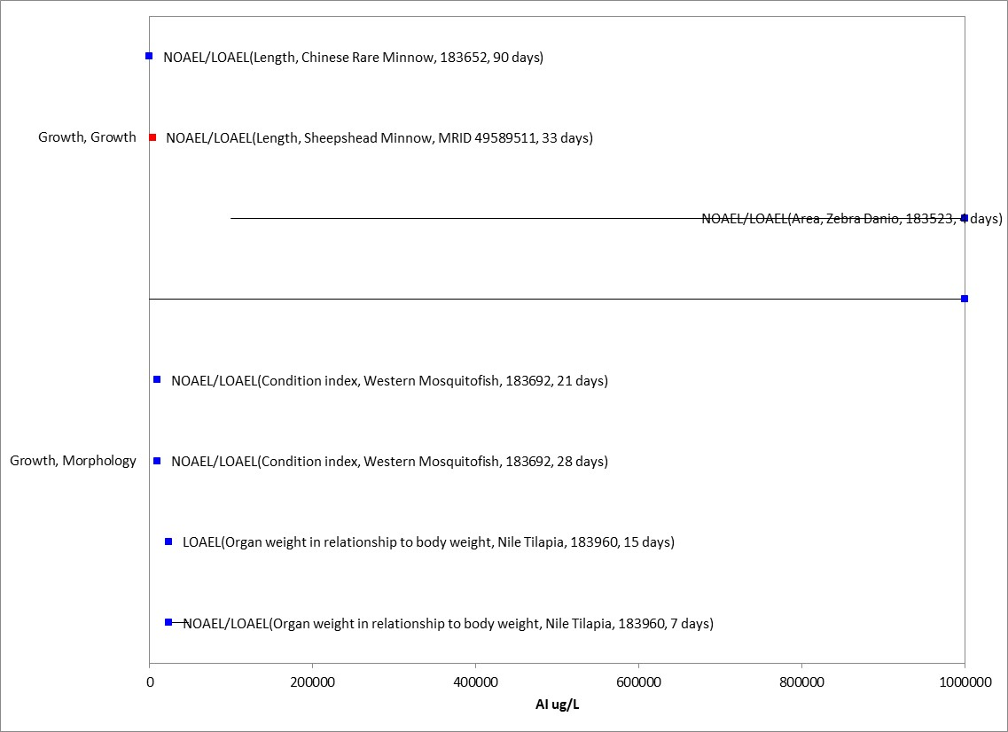
Figure 2-2. Array of growth toxicity data for fish expressed in terms of µg a.i./L.
Blue squares represent LOAEC/LOAEL values from open literature studies found in the ECOTOX database. Red squares represent LOAEC/LOAEL values from registrant submitted studies. Solid lines display the range between the LOAEC/LOAEL and NOAEC/NOAEL values. Parentheses present the endpoint measurement, species, study reference (i.e., MRID, ECOTOX #), and study duration. If endpoint is non-definitive, that is also noted.

For freshwater fish, the available chronic data reports a NOAEC value of 20,000 µg a.i./L tested on rainbow trout (MRID 44714923). In this study, no effects were observed at the highest test concentration and a LOAEC was not determined. The chronic endpoint for estuarine/marine fish associated with growth in the sheepshead minnow (MRID 49489511; NOAEC = 1,700 µg a.i./L; LOAEC = 4,100 µg a.i./L; MATC = 2,640 µg a.i./L) will be used as a surrogate for freshwater fish.

For estuarine/marine fish, the most sensitive chronic exposure endpoint was associated with growth in the sheepshead minnow (MRID 49489511; NOAEC = 1,700 µg a.i./L; LOAEC = 4,100 µg a.i./L; MATC = 2,640 µg a.i./L).

Other Sublethal Effects to Fish

Additional literature is available on the sublethal effects of thiamethoxam on fish. No endpoints were identified from studies in the ECOTOX acceptable database that were either more sensitive than the endpoints identified above or reliable for use as a threshold and relatable to an apical endpoint. Figure 2-3 illustrates the summary data available for other sublethal endpoints.

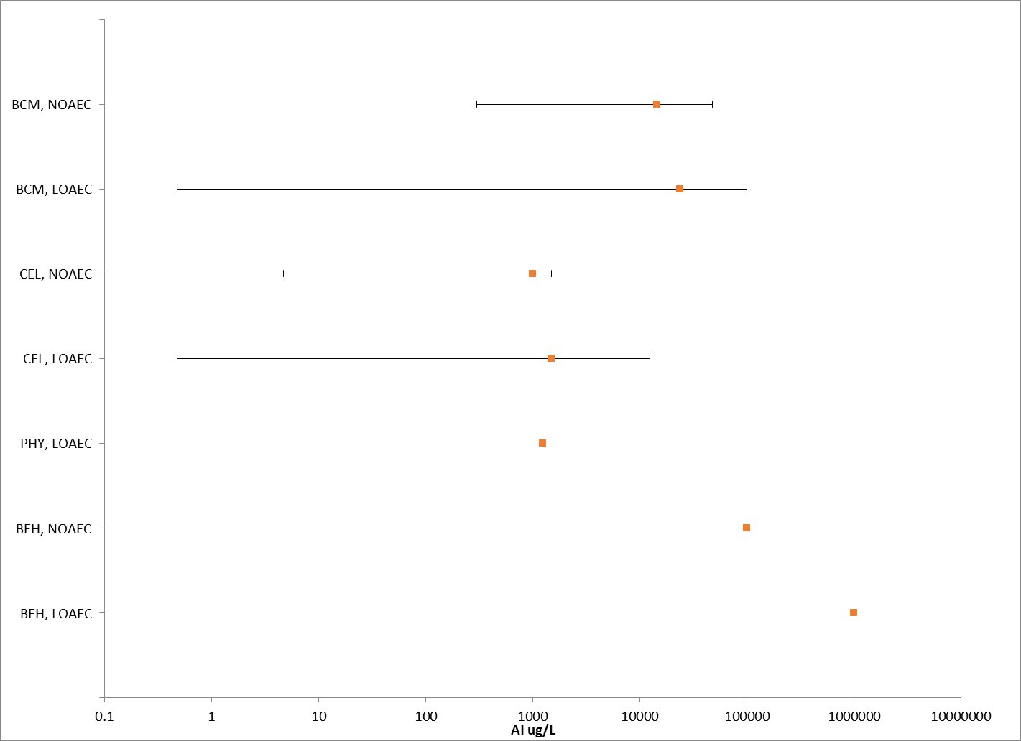
Figure 2-3. Summary array of toxicity data for fish expressed in terms of µg a.i./L.
Orange squares represent the mid-point of the data. Solid lines display the range between the LOAEC and NOAEC values. BCM = biochemical; BEH = behavior; CEL = celluar; PHY = physiological.

Comparison of Thiamethoxam and Clothianidin Fish Acute Toxicity Endpoints

The comparison of acute mortality fish toxicity endpoints, where tests on the same species are available for both clothianidin and thiamethoxam, show a similar toxicity profile between the chemicals. All endpoints for both freshwater and estuarine/marine fish are non-definitive and no effects on mortality were observed. The most sensitive freshwater LC₅₀ overall is >101,500 µg/L from the clothianidin study with rainbow trout (MRID 45422406). This endpoint will be used for the evaluation, and the alternative endpoint analysis will rely upon the thiamethoxam bluegill sunfish endpoint (>114,000 µg/L; MRID 44714917). The most sensitive estuarine/marine LC₅₀ overall is >91,400 µg/L from the clothianidin study with sheepshead minnow (MRID 45422411). This endpoint will be used for the evaluation, and the alternative endpoint analysis will rely upon the thiamethoxam sheepshead minnow endpoint (>111,000 µg/L; 44714920).

Table 2-7. Comparison of Fish Acute Mortality Toxicity Data for Clothianidin and Thiamethoxam¹
Common name | Scientific name | Clothianidin | Thiamethoxam | Reference  Clothianidin;  Thiamethoxam | Relative toxicity and comments
 |  | LC₅₀ µg/L | LC₅₀ µg/L
Freshwater Fish
Bluegill sunfish | Lepomis macrochirus | >117,000 | >114,000 | MRID 45422407; MRID 44714917 | Both endpoints are non-definitive. No effects observed.
Rainbow trout | Oncorhynchus mykiss | >101,500 | NA | MRID 45422406;  NA | Non-definitive. No effects observed. Most sensitive endpoint overall for FW fish.
Estuarine/Marine Fish
Sheepshead minnow | Cyprinodon variegatus | >91,400 | >111,000 | MRID 45422411; MRID 44714920 | Both endpoints are non-definitive. No effects observed.
¹ NA = study not available

Comparison of Thiamethoxam and Clothianidin Fish Growth and Reproduction Endpoints

There were no tests on the same fish species available for both clothianidin and thiamethoxam. The most sensitive freshwater fish endpoint was from the clothianidin study with fathead minnow (MRID 45422413; NOAEC = 9,700 µg/L, LOAEC = 20,000 µg/L, MATC = 14,000 µg/L). This endpoint will be used for the evaluation, and the alternative endpoint analysis will rely upon the thiamethoxam rainbow trout endpoint (MRID 45422413; NOAEC = 20,000 µg/L, LOAEC > 20,000 µg/L). With the available data, clothianidin appears to be more toxic than thiamethoxam to freshwater fish. The most sensitive estuarine/marine endpoint was from the thiamethoxam study with sheepshead minnow (MRID 49589511; NOAEC = 1,700 µg/L, LOAEC = 4,100 µg/L, MATC = 2,600 µg/L). This endpoint will be used for the evaluation. There are no alternative endpoints available for the analysis.

Table 2-8. Comparison of Fish Growth and Reproduction Toxicity Data for Clothianidin and Thiamethoxam¹
Common name | Scientific name | Clothianidin | Thiamethoxam | Reference  Clothianidin;  Thiamethoxam | Relative toxicity and comments
 |  | LOAEC/NOAEC  µg/L | LOAEC/NOAEC  µg/L
Freshwater Fish
Rainbow trout | Oncorhynchus mykiss | NA | LOAEC > 20,000  NOAEC = 20,000 | NA;  MRID 44714923 | No effects observed at highest test concentration.
Fathead minnow | Pimephales promelas | LOAEC = 20,000  NOAEC = 9,700 | NA | MRID  45422413;  NA | Effects observed on length and weight. Most sensitive endpoint overall for FW fish.
Estuarine/Marine Fish
Sheepshead minnow | Cyprinodon variegatus | NA | LOAEC = 4,100  NOAEC = 1,700 | NA;  MRID 49589511 | Most sensitive endpoint overall for E/M fish.
¹ NA = study not available

Effects Characterization for Aquatic-phase Amphibians

Introduction to Aquatic-phase Amphibian Toxicity

Toxicity studies for aquatic-phase amphibians have not been submitted by the registrant but are available in the open literature. Studies were excluded from the main analysis if they were considered invalid or if the exposure units could not be converted into aqueous concentrations (mass a.i./volume).

Effects on Mortality of Aquatic-phase Amphibians

Although no registrant data was available for aquatic-phase amphibians, one mortality study was available in the ECOTOX report. The most sensitive mortality endpoint for aquatic-phase amphibians was an LC₅₀ value of 4,500 µg a.i./L for wood frogs (E182994, Pochini et al. 2017) based on exposure to a formulated product (Optigard Flex; 21.6% a.i.). Therefore, the freshwater fish value of >114,000 µg a.i./L will be used to derive the TGAI acute mortality threshold for aquatic-phase amphibians.

Effects on Growth and Reproduction of Aquatic-phase Amphibians

No registrant data was available for growth and reproduction endpoints relevant to aquatic-phase amphibians. There were no studies on reproduction available in the ECOTOX acceptable database. Toxicity data related to growth based on thiamethoxam exposure to aquatic-phase amphibians were available in ECOTOX but were either unacceptable or not suitable for use as a threshold. Due to the limited data on growth and reproductive effects of thiamethoxam to aquatic-phase amphibians, the most sensitive chronic endpoint for freshwater fish from the clothianidin study associated with growth in the fathead minnow (MRID 45422413; NOAEC = 9,700 µg/L, LOAEC = 20,000 µg/L, MATC = 14,000 µg/L). This endpoint will be used for the evaluation, and the alternative endpoint analysis will rely upon the thiamethoxam rainbow trout endpoint (MRID 45422413; NOAEC = 20,000 µg/L, LOAEC > 20,000 µg/L).

Other Sublethal Effects to Aquatic-phase Amphibians

Additional literature is available on the sublethal effects of thiamethoxam on aquatic-phase amphibians. Two studies related to population effects (i.e., sex ratio) were reported but had unbound NOAECs. No endpoints were identified from studies in the ECOTOX acceptable database that were either more sensitive than the endpoints identified above or reliable for use as a threshold and relatable to an apical endpoint.

Comparison of Thiamethoxam and Clothianidin Aquatic-Phase Amphibian Acute Toxicity Endpoints

Toxicity studies for aquatic-phase amphibians have not been submitted by the registrant but are available in the open literature. The studies related to mortality for aquatic-phase amphibians were not suitable for comparison. The most sensitive aquatic-phase amphibian LC₅₀ overall is 4,500 µg/L from the thiamethoxam study with wood frogs (E182994). This endpoint will be used for the Typical End-Use Product (TEP) evaluation.

Table 2-9. Comparison of Aquatic Phase Amphibian Acute Mortality Toxicity Data for Clothianidin and Thiamethoxam¹
Common name | Scientific name | Clothianidin | Thiamethoxam | Reference  Clothianidin;  Thiamethoxam | Relative toxicity and comments
 |  | LC₅₀ µg/L | LC₅₀ µg/L
Wood frog | Lithobates sylvaticus | NA | 4,500 | E182994 | Based on exposure to a formulated product.
Gray tree frog; green frog; leopard frog | Hyla versicolor; Lithobates clamitans; Lithobates pipiens | >327,000 | NA | E183651 | Based on exposure to a formulated product.
¹ NA = study not available

Comparison of Thiamethoxam and Clothianidin Aquatic-Phase Amphibian Growth and Reproduction Toxicity Endpoints

Toxicity studies for aquatic-phase amphibians have not been submitted by the registrant but are available in the open literature. The studies related to growth and reproduction for aquatic-phase amphibians were not reliable for use as a threshold. Therefore, there were no toxicity endpoints suitable for comparison.

Effects Characterization for Aquatic Invertebrates

Introduction to Aquatic Invertebrate Toxicity

The effects of thiamethoxam on aquatic invertebrates have been studied extensively, including both freshwater and estuarine/marine (E/M) invertebrates. APPENDIX 2-2 includes the bibliography of studies that are included in this effects characterization and those that were excluded. Studies were excluded from the main analyses (i.e., Species Sensitivity Distribution and data arrays) if they were considered invalid or the exposure units could not be converted into environmentally relevant concentrations (e.g., µg a.i./L). In this effects characterization, when sufficient data are available for thiamethoxam, different endpoints are identified for freshwater and estuarine/marine invertebrates. Additionally, toxicity data are available for several different groups of aquatic invertebrates. Where available, sensitivity of aquatic insects versus other aquatic invertebrates are discussed. The available data indicate that thiamethoxam is more toxic to insects compared to other species of aquatic invertebrates (e.g., Daphnia sp., mollusks). Therefore, in the BE, separate thresholds are used for direct toxicity to listed insects, mollusks and all other species of aquatic invertebrates.

Effects on Mortality of Aquatic Invertebrates

For freshwater aquatic insects, several acute toxicity studies involving freshwater invertebrates were identified in ECOTOX. Therefore, a Species Sensitivity Distribution (SSD) based on acute mortality studies was developed for freshwater aquatic insects. SSDs are based on acute 48 or 96-hr EC/LC₅₀ values from studies using TGAI only (values from formulation/mixture testing were not included). There were a total of 14 aquatic insect species. The hazardous concentration for 5% of species (HC₀₅) = 11.87 µg a.i./L for aquatic insects (Table 2-10). The gumbel distribution function for aquatic insects is presented in Figure 2-4. The SSD report for aquatic insects is provided in APPENDIX 2-5 and includes the details of how this SSD was derived.

Table 2-10. Summary Statistics for SSD Fit to Thiamethoxam Test Results (toxicity values reported as µg/L)
Statistic | Aquatic Insects
HC₀₅ (95% CI) | 11.87 (5.19-40.87)
HC₅₀ (95% CI) | 140.38 (53.55-438.30)
Slope | 1.89
CI = confidence interval

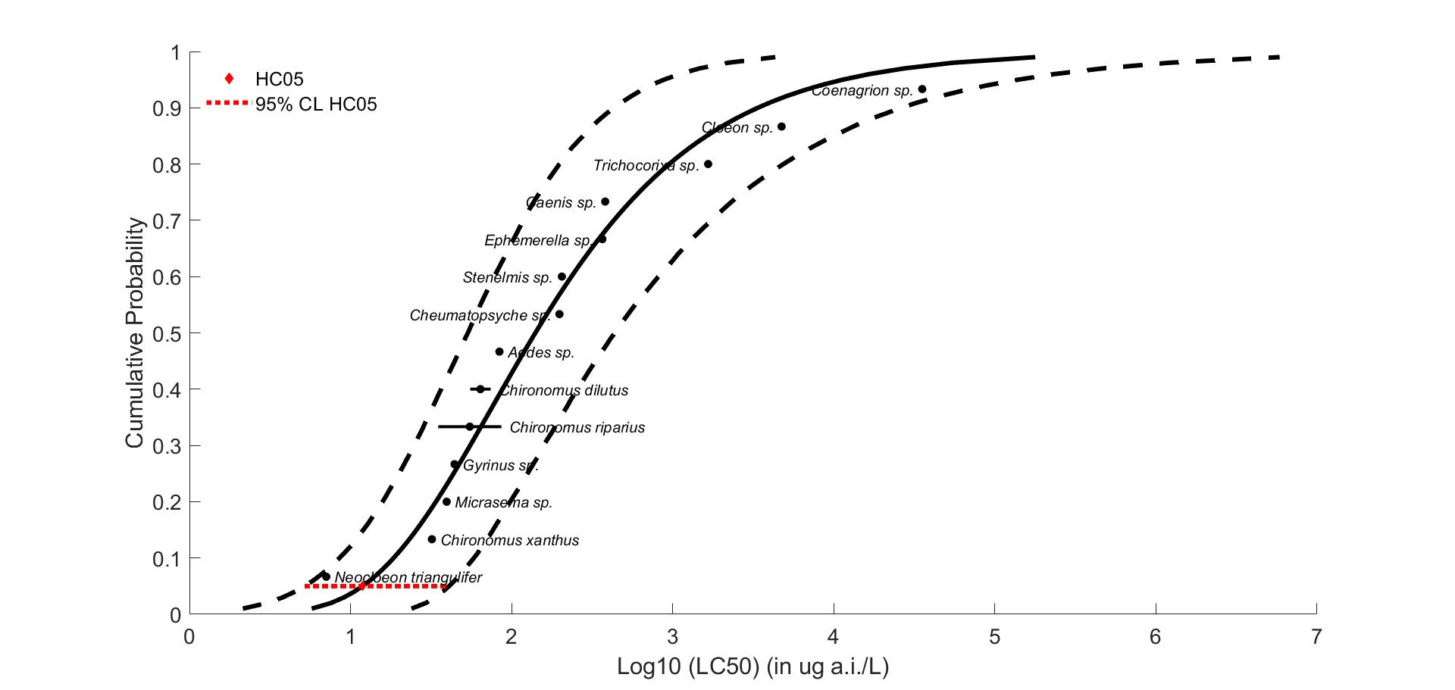

Figure 2-4. SSD for mortality toxicity values for aquatic insects for thiamethoxam
Black points indicate toxicity values. Black horizontal line indicates full range of toxicity values for a given taxon. Dotted lines represent the confidence interval.

For freshwater aquatic invertebrates outside of the class Insecta, the most sensitive mortality endpoint was a 96-hr LC₅₀ = 967 µg a.i./L in the red swamp crayfish (Procambarus clarkii; E120043). Additionally, the most sensitive mollusk endpoint was a 48-hr LC₅₀ > 691 µg a.i./L in the wavy-rayed lampmussel (Lampsilis fasciola; E173464).

For estuarine/marine toxicity data, the most sensitive mortality endpoint reported is a 96-hr LC₅₀ = 6900 µg a.i./L in the mysid shrimp (Mysidopsis bahia; MRID 44714922). No additional acute toxicity data involving estuarine/marine invertebrates were identified in ECOTOX.

Effects on Growth and Reproduction of Aquatic Invertebrates

The available data for effects on growth of aquatic invertebrates is provided in Figure 2-5 below. No data for effects on reproduction were available. No endpoints were identified from studies in the ECOTOX acceptable database that were either more sensitive than the endpoints identified above, or reliable for use as a threshold. The most sensitive reliable NOAEC/LOAEC was used to represent thresholds for growth and reproductive effects.

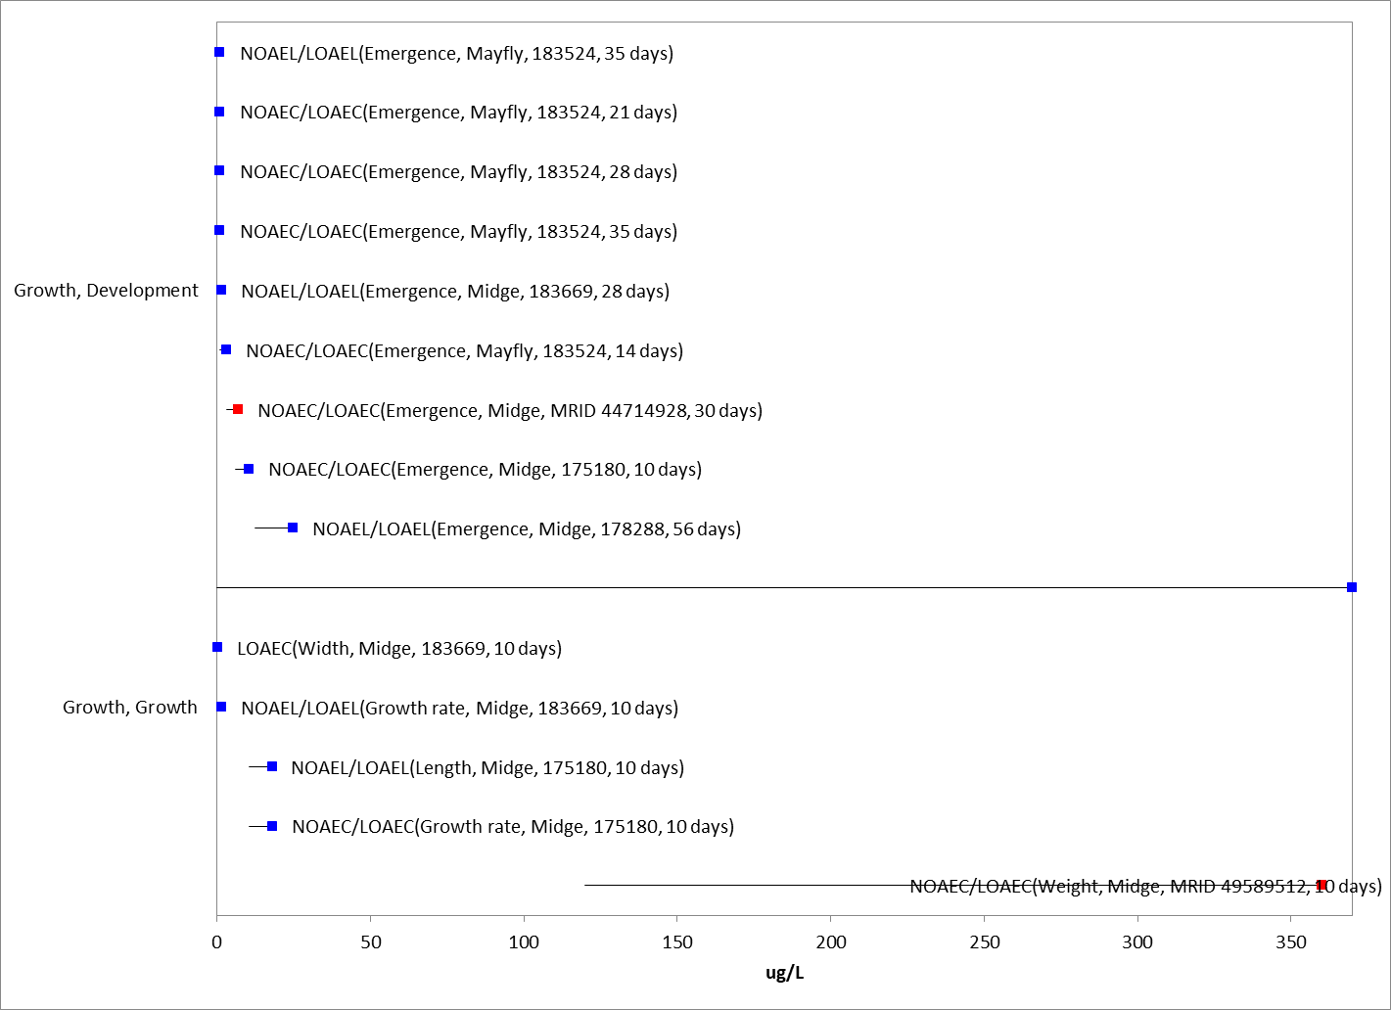

Figure 2-5. Array of growth toxicity data for freshwater aquatic invertebrates expressed in terms of µg a.i./L.
Blue squares represent LOAEC/LOAEL values from open literature studies found in the ECOTOX database. Red squares represent LOAEC/LOAEL values from registrant submitted studies. Parentheses present the endpoint measurement, species, study reference (i.e., MRID, ECOTOX #), and study duration. If endpoint is non-definitive, that is also noted.

For freshwater aquatic insects, the most sensitive growth and reproduction endpoint was based on a 25% decrease in larval survival in the midge (Chironomus riparius; E175184; NOAEC = 0.74 µg a.i./L, LOAEC = 2.23 µg a.i./L, MATC = 1.28 µg a.i./L). For freshwater aquatic invertebrates outside of the class Insecta, the most sensitive growth and reproduction endpoint was based on a 16% decrease in the number of offspring in the waterflea (Daphnia magna; MRID 44714924; NOAEC = 50,000 µg a.i./L, LOAEC = 101,000 µg a.i./L, MATC = 71,000 µg a.i./L). Additionally, the most sensitive mollusk endpoint was based on a no-effect study on wavy-rayed lampmussel (Lampsilis fasciola; E173464; NOAEC > 691 µg a.i./L).

For estuarine/marine aquatic invertebrates, the most sensitive growth and reproduction endpoint was based on a 14% decrease in parent survival in the mysid shrimp (Mysidopsis bahia; MRID 49589510; NOAEC = 1,100 µg a.i./L, LOAEC = 2,000 µg a.i./L, MATC = 1,483 µg a.i./L). For estuarine/marine aquatic invertebrates, no additional sublethal toxicity data were identified in ECOTOX.

Other Sublethal Effects to Aquatic Invertebrates

Additional literature is available on the sublethal effects of thiamethoxam on aquatic invertebrates. No endpoints were identified from studies in the ECOTOX acceptable database that were either more sensitive than the endpoints identified above or reliable for use as a threshold and relatable to an apical endpoint. Figure 2-6 illustrates the data available for other sublethal endpoints.

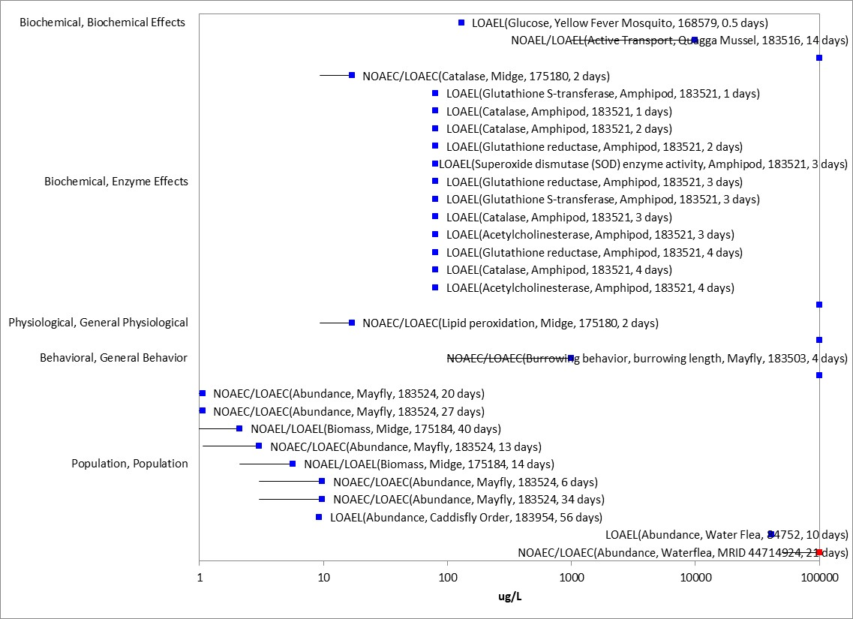
Figure 2-6. Array of sublethal toxicity data for aquatic invertebrates expressed in terms of log µg a.i./L
Blue squares represent LOAEC/LOAEL values from open literature studies found in the ECOTOX database. Red squares represent LOAEC/LOAEL values from registrant-submitted studies. Solid lines display the range between the LOAEC/LOAEL and NOAEC/NOAEL values. Parentheses present the endpoint measurement, species, study reference (i.e., MRID, ECOTOX #), and study duration. If endpoint is non-definitive, that is also noted.

Comparison of Thiamethoxam and Clothianidin Aquatic Invertebrate Acute Toxicity Endpoints

For the majority of the species tested, the two chemicals are either of similar toxicity or clothianidin is more toxic. The most acutely sensitive species for both thiamethoxam and clothianidin was a mayfly (Neocloeon triangulifer). When considering the toxicity data for the mayfly, both chemicals are similar, with 95% confidence intervals that overlap. For the midge, there are slight differences in toxicity among the chemicals, where thiamethoxam is slightly less toxic than clothianidin (LC₅₀ values are 5x higher than clothianidin; confidence bounds do not overlap with those of clothianidin; Table 2-11).

Table 2-11. 96-h LC50 values (µg/L, based on nominal concentrations) for thiamethoxam and clothianidin. Values calculated by EFED using raw data provided by Raby et al. (2018a).
Common name | Scientific name | Clothianidin | Thiamethoxam | Relative toxicity and comments
 |  | LC50  (95% CI) | LC50  (95% CI)
Aquatic pillbug | Caecidotea sp. | 18,900  (9,650-124,000) | >40,000 ^{A} | Clothianidin is more toxic
Aquatic worm | Lumbriculus variegatus | 231  (208-219) | 4,010  (3,400-4,740) | Clothianidin is more toxic
Beetle | Stenelmis sp. | 224  (152-328) | 205  (171-246) | Similar
Caddisfly (net-spinning) | Cheumatopsyche sp. | 1,470  (843-6,540) | 198  (65.8-326) | Thiamethoxam is more toxic
Damselfly | Coenagrion sp. | 15,500 (8,110-24,500) | 35,400 (13,600-91,900) | Similar
Mayfly | Cloeon sp. | 4,570  (2,340-14,900) | 4,740  (3,180-7,090) | Similar
 | Ephemerella sp. | 668  (289-7,600) | 366  (204-899) | Similar
 | Hexagenia spp. | >20,000 ^{A} | >40,000 ^{A} | Unknown
 | Isonychia bicolor | >2,000 ^{A} | >8,000 ^{A} | Unknown
 | McCaffertium sp. | 1,540  (1,320-1,790) | >1,000 ^{A} | Unknown
 | Neocloeon triangulifer | 3.54  (2.5-5) | 7.07  (5-10) | Similar
Midge | Chironomus dilutus | 13.7  (8.08-20.9) | 74.1  (42.5-199) | Clothianidin is more toxic
Scud | Hyalella azteca | 6.1  (5.46-6.82) | 1,150  (495-149,000) | Clothianidin is more toxic
Stonefly nymph | Agnetina, Paragnetina sp. | 1,830  (1,640-2,040) | >8,000 ^{A} | Clothianidin is more toxic
Water boatmen | Trichocorixa sp. | 35.4  (19.1-58.7) | 1,660  (825-8,740) | Clothianidin is more toxic
Water flea | Ceriodaphnia dubia | >100,000 ^{A} | >100,000 ^{A} | Unknown
Whirligig beetle | Gyrinus sp. | 70.6  (51.5-96.7) | 44.2  (31.3-62.5) | Similar
NA = not available
CI = confidence interval
A = Less than 50% mortality observed at highest test concentration, preventing quantification of LC₅₀

Species Sensitivity Distribution (SSD)

For aquatic insects, the gumbel SSD for thiamethoxam and the triangular SSD for clothianidin were analyzed to determine whether there was a difference in the distributions. The median estimate of the SSD for clothianidin is lower than that of thiamethoxam, suggesting clothianidin is more toxic. However, because their 95% confidence intervals overlap, we assume the chemicals have similar toxicity to aquatic invertebrates (Figure 2-7 and Table 2-12). The clothianidin HC₀₅ will be used for the evaluation, and the alternative endpoint analysis will rely upon the thiamethoxam HC_{05.}

Table 2-12. HC₀₅ and HC₅₀ values (in µg a.i./L) based on the gumbel distribution for thiamethoxam and the triangular distribution for clothianidin
Distribution | HC₀₅ (95% CI) | HC₅₀ (95% CI)
Thiamethoxam | 11.87 (5.19-40.87) | 140.38 (53.55-438.30)
Clothianidin | 3.58 (1.42-24.65) | 176.92 (62.81-500.52)

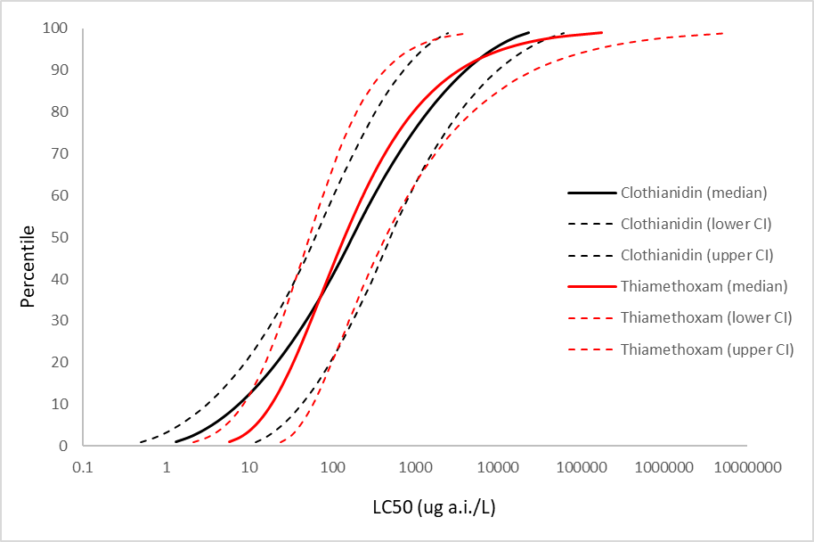
Figure 2-7. Comparison of gumbel SSD for thiamethoxam and triangular SSD for clothianidin toxicity values

Comparison of Thiamethoxam and Clothianidin Aquatic Invertebrate Growth and Reproduction Endpoints

In the first acute toxicity study (Raby et al. 2018b), the two most sensitive species, i.e., the midge (C. dilutus) and mayfly (N. triangulifer), were tested in a static-renewal system. Measurements included the apical endpoints of survival, growth and reproduction for the midge, but only survival for the mayfly. The sublethal NOAEC values for these species are shown in Table 2-13 and are based on the endpoint that was generally the most sensitive across the neonicotinoids (percent emergence/survival). For the mayfly and midge, clothianidin was more toxic than thiamethoxam. Similar to the acute toxicity data, for the mayfly, the two chemicals were relatively similar in toxicity on a chronic exposure basis (NOAECs within an 8x difference); and for the midge, there was a difference in sensitivities observed among chemicals (20x difference).

Data from the second chronic toxicity study (Cavallaro et al. 2016) with the midge (Chironomus dilutus) were used to compare toxicity between thiamethoxam and clothianidin. The sublethal NOAEC values for these species are shown in Table 2-13. Based on the endpoints for both the larval and adult midge, clothianidin was more toxic than thiamethoxam. For adult emergence, there is a large difference in sensitivities observed among chemicals (18-42x difference). For larval survival, the two chemicals were relatively similar in toxicity (3.5x difference). The most sensitive freshwater endpoint was from the clothianidin study with the midge (E175184; NOAEC <0.05 µg/L, LOAEC = 0.05 µg/L). This endpoint will be used for the evaluation, and the alternative endpoint analysis will rely upon the thiamethoxam midge endpoint (E175184; NOAEC = 0.74 µg/L, LOAEC =2.23 µg/L, MATC = 1.78 µg/L).

Table 2-13. Comparison of Aquatic Invertebrate Growth and Reproduction Toxicity Data for Clothianidin and Thiamethoxam¹
Common name | Scientific name | Clothianidin | Thiamethoxam | Reference  Clothianidin;  Thiamethoxam | Relative toxicity and comments
 |  | LOAEC/NOAEC  µg/L | LOAEC/NOAEC  µg/L
Mayfly | Neocloeon triangulifer | LOAEC = 0.5  NOAEC = 0.25 | LOAEC = 4.0  NOAEC = 2.0 | E178290 | Effects observed based on survival to adult stage. Clothianidin is more toxic.
Midge | Chironomus dilutus | LOAEC = 0.63  NOAEC = 0.31 | LOAEC = 12.5  NOAEC = 6.3 | E178290 | Effects observed based on emergence. Clothianidin is more toxic.
Midge | Chironomus dilutus | LOAEC = 0.05  NOAEC <0.05 | LOAEC = 5.69  NOAEC = 2.11 | E175184 | Effects observed based on emergence of adult midge. Clothianidin is more toxic. Most sensitive endpoint overall for aquatic invertebrates.
Midge | Chironomus dilutus | LOAEC = 0.42  NOAEC = 0.21 | LOAEC = 2.23  NOAEC = 0.74 | E175184 | Effects observed based on survival of larval midge. Clothianidin is more toxic.

Effects Characterization for Aquatic Plants

Introduction to Aquatic Plant Toxicity

Most of the available toxicity studies with aquatic plants have focused on growth, reproduction, physiological effects, and population effects. Threshold values and effects data arrays in this assessment are based on endpoints expressed in, or readily converted to, environmentally relevant concentrations in terms of the amount of the thiamethoxam (i.e., µg a.i./L).

Discussion of endpoints are provided for effects on aquatic plants and aquatic plant communities. These serve as a surrogate for effects on an individual of a listed species and the effects on the pollination, prey, habitat, or dispersal of a listed species.

Effects on Aquatic Plants

Single-species aquatic plant toxicity studies are used as one of the measures of effect to evaluate whether thiamethoxam may affect primary production and diversity in aquatic ecosystems. Based on the available studies, EC₅₀ values for aquatic vascular plants were not established, with <50% effects observed at concentrations 90,200 µg a.i./L and higher. There were significant effects to growth observed at 43,900 µg a.i./L and higher (NOAEC = 22,000; MATC = 31,077 µg a.i./L. The most sensitive non-vascular species was the cyanobacterium Anabaena flos-aquae with an EC₅₀ of 105,000 and a NOAEC established at 47,000 µg a.i./L). While no other aquatic non-vascular plant studies had established EC₅₀ values, a lower NOAEC (12,000 µg a.i./L) was established for the saltwater diatom Skeletonema costatum, based on 17% reduction in area under the curve at 24,000 µg a.i./L. No aquatic plant toxicity data were identified in ECOTOX. Table 2-14 summarizes the available aquatic plant toxicity data for thiamethoxam.

Table 2-14. Aquatic Plant Toxicity Data for Thiamethoxam
Species  (% a.i.) | Endpoint | Toxicity Value  (µg a.i./L) | MRID | Comment
Aquatic Vascular Plants
Duckweed (Lemna gibba)  (TGAI, 98.6%) | EC50  NOAEC  LOAEC | >90,200  22,000  43,900 | MRID 44714925 | No effects to frond number at 90.2; NOAEC based on phytotoxicity observed > 43.9 µg a.i./L
Aquatic Nonvascular Plants
Green Algae  Raphidocelis subcapitata (TGAI, 98.6%) | EC₅₀  NOAEC  LOAEC | >97,000  97,000  >97,000 | MRID 44714926 | No effects observed
FW diatom (Navicula pelliculosa)  (TGAI, 99.8%) | EC50  NOAEC  LOAEC | >98,000  98,000  >98,000 | MRID 49346606 | No effects observed
SW diatom (Skeletonema costatum)  (TGAI, 99.8%) | EC50  NOAEC  LOAEC | >99,000  12,000  24,000 | MRID 49346607 | 17% reduction in area under the curve at 24000 µg a.i./L
Cyanobacteria (Anabaena flos-aquae)  (TGAI, 99.8%) | EC50  NOAEC  LOAEC | 105,000  47,000  97,000 | MRID 49346605 | 44% decline in cell density at 97000 µg a.i./L

Effects on Aquatic Plant Communities

No studies on thiamethoxam or clothianidin toxicity to plant communities were available in open literature or submitted to the agency.

Comparison of Thiamethoxam and Clothianidin Aquatic Plant Toxicity Data

Clothianidin is a major degradate of thiamethoxam. A comparative analysis of aquatic plant toxicity is provided here. The aquatic vascular plant studies for both chemicals did not result in a definitive EC₅₀, however effects on growth were observed for both chemicals. The clothianidin data were more sensitive with a LOAEC of 1,050 µg a.i./L compared to 43,900 µg a.i./L for thiamethoxam. For aquatic non-vascular plants, the clothianidin endpoints also suggested a more sensitive response with EC₅₀s derived from all 4 non-vascular plant studies. The most sensitive EC₅₀ was from the saltwater diatom (EC₅₀ = 17,600 µg a.i./L) had a LOAEC of 16,300 µg a.i./L based on reduced biomass.

Therefore, the clothianidin endpoints will be used to evaluate the potential risks to aquatic plants, and thiamethoxam endpoints will be included in the alternative endpoint analyses.

Table 2-15. Comparison of Aquatic Plant Toxicity Data for Thiamethoxam and Clothianidin
Species  (% a.i.) | Endpoint | Thiamethoxam Toxicity Value  (µg a.i./L) | Clothianidin Toxicity Value  (µg a.i./L) | Clothianidin Study MRID | Comment
Duckweed (Lemna gibba)  (TGAI, 97.6%) | EC₅₀  NOAEC  LOAEC  MATC | >90,200  22,000  43,900  31,077 | >280,000  520  1,050  739 | MRID 49281301 | Based on effects to yield and biomass
Green Algae  (Raphidocelis subcapitata)  (TGAI, 97.6%) | EC₅₀  NOAEC  LOAEC | >97,000  97,000  >97,000 | 64,000  3,500 | MRID 45422504 | Based on effects to biomass
FW diatom (Navicula pelliculosa)  (TGAI, 99.7%) | EC50  NOAEC  LOAEC | >98,000  98,000  >98,000 | 26,300  15,000 | MRID 48720602 | Based on effects to yield
SW diatom (Skeletonema costatum)  (TGAI, 99.7%) | EC50  NOAEC  LOAEC  MATC | >99,000  12,000  24,000  16,970 | 17,600  6,350  16,300  10,174 | MRID 48720603 | Based on cumulative biomass
Cyanobacteria (Anabaena flos-aquae)  (TGAI, 99.7%) | EC50  NOAEC  LOAEC  MATC | 105,000  47,000  97,000  67,520 | 31,600  2,700 | MRID 48720601 | Based on effects to yield

Effects Characterization for Birds

Introduction to Bird Toxicity

There are open literature and registrant-submitted studies involving birds, including acute oral, sub-acute dietary and chronic reproduction with technical grade or formulated thiamethoxam. APPENDIX 2-4 includes the bibliographies of studies that are included in this effects characterization. Studies were excluded if they were considered invalid or not associated with an environmentally relevant exposure route. Thresholds are based on the most sensitive lethal and sublethal effects identified among registrant-submitted studies and open literature in the ECOTOX database.

Effects on Mortality of Birds

In an acute toxicity study with mallard duck, the 14-day LD50 was 576 mg a.i./kg bw and in another study with bobwhite quail the 21-day LD50 was 1552 mg a.i./kg-bw. The NOAEL for mortality was 125 mg a.i./kg-bw. Two studies with passerines have been submitted to the agency conducted under the OECD TG223. One (MRID 49025801) study tested with house sparrows derived an LD₅₀ of 786 mg/kg-bw, the other (MRID 49755701) determined an LD50 value of 431 mg/kg-bw based on mortality for the canary.

Table 2-16. Avian Acute Toxicity Data for Thiamethoxam¹
Surrogate  Species | % a.i. | LD₅₀, mg/kg-bw (probit slope) | NOAEL  (mg/kg-bw) | Effects | MRID, Author, Year
Bobwhite Quail  (Colinus virginianus) | 98.6; TGAI | 1552  (NA) | 125 | Clinical signs, mortality and reduced weight and reduced feeding, lethargy and unsteadiness. | 44703307
Mallard Duck  (Anas platyrhynchos) | 98.6; TGAI | 576  (NA) | < 76 | Regurgitation observed at all test concentrations > 76 mg/kg-bw | 44703307
Canary (Serinus canaria) | 99.0; TGAI | 431 (5.6) | 190 | Mortalities observed at > 260 mg/kg=bw.  Regurgitation observed at > 530  Signs of toxicity and reduced food consumption at > 190 | 49755701
House sparrow (Passer domesticus) | 99.0; TGAI | 786 (3.2) | 140 | Mortality, reduced feed consumption (day 1) and clinical signs observed at > 140 mg/kg=bw. | 49025801
Eared Dove (Zenaida auriculata) | Formulated Product, % a.i. not reported | 4366 (1.49) | NA | All birds showed signs of toxicity | Addy-Orduna et al. 2019.
¹ NA = not available.

There were no mortalities in sub-acute dietary (LC50>5200 mg a.i./kg-diet) tests for either the mallard duck or the bobwhite quail. Decreased body weight was the only sub-lethal effect seen (in the 2,600 mg a.i./kg diet and 5,200 mg a.i./kg diet treatment groups) for the bobwhite quail, while the mallard duck exhibited a reduction in both feed consumption and body weight gain (in the 1,300 mg a.i./kg diet and higher dose levels). Additionally, a slight reduction in feed consumption was noted in birds at 325 mg a.i./kg diet and 650 mg a.i./kg diet treatment levels so the NOAEC was determined to be 163 mg a.i./kg diet.

Table 2-17. Avian Subacute Toxicity Data for Thiamethoxam
Species | % a.i. | LC₅₀ (mg a.i./kg-diet) (conf. interval) | NOAEC (mg a.i./kg-diet) | Effects | MRID
Bobwhite Quail  (Colinus virginianus) | TGAI; % a.i. not reported | >5,200 | 1,300 | Reduced body weight at > 2600 mg a.i./kg-diet. No mortality. | 44703309
Mallard Duck  (Anas platyrhynchos) | 99.1; TGAI | >5,200 | 163 | Reduction in food consumption and body weight at > 325 mg a.i./kg-diet. No mortality. | 44703310

Effects on Growth and Reproduction of Birds

Several registrant-submitted toxicity studies include sublethal effects to birds. In an acute toxicity study with mallard duck, there were sub-lethal effects observed, including vomiting, lethargy, unsteadiness, and inability to stand. There was a reduction in feed consumption and body weights in treated birds as compared to the controls. Regurgitating birds were observed at all treatment levels, although the study report was unclear if this was regurgitation directly after dosing or later in the study. A study with the bobwhite quail observed sublethal effects, including unsteadiness, lethargy, ruffled feathers and morbidity. There was also a reduction in feed consumption and body weights in treated birds as compared to the controls. The NOAEL for mortality and clinical signs was 125 mg a.i./kg body weight. A passerine test with canary (MRID 49755701), observed regurgitation in several of the test doses, ultimately all regurgitating birds died during the test period.

In the previously described dietary studies (Table 2-18), decreased body weight was the only sub-lethal effect seen (in the 2,600 mg a.i./kg diet and 5200 mg a.i./kg diet treatment groups) for the bobwhite quail, while mallard duck exhibited a reduction in both feed consumption and body weight gain (in the 1,300 mg a.i./kg diet and higher dose levels). Additionally, a slight reduction in feed consumption was noted in birds at 325 mg a.i./kg diet and 650 mg a.i./kg diet treatment levels which lead to the NOAEC determination of 163 mg a.i./kg diet.

Chronic toxicity studies are available for birds, where observed endpoints focused on growth and reproduction. There were no significant treatment-related effects on mortality, clinical symptoms, feed consumption or body weights at the dietary levels of thiamethoxam used in the reproductive effects test on the bobwhite quail. However, six mortalities (adults) occurred and were attributed to pair aggression, getting caught in the caging, and euthanasia (based on an inability to walk). The NOAEC for reproductive effects was determined to be 900 mg a.i./kg diet (the highest dose tested). In the chronic toxicity test with the mallard duck, there was a significant reduction in body weights in males in the highest dose group as compared to the controls; females were not affected. There were no reproductive effects at any treatment level. The NOAEC based on weight loss in parental males was determined to be 300 mg a.i./kg diet.

No additional studies on growth and reproduction effects due to oral thiamethoxam exposure in birds were identified in the ECOTOX database.

Based on the available data on growth and reproduction, the sublethal toxicity threshold based on reproductive effects in the mallard duck is a NOAEC value of 300 mg a.i./kg-diet (LOAEC = 900 mg a.i./kg-diet, MATC = 520 mg a.i./kg-diet).

Table 2-18. Avian Chronic Toxicity Data for Thiamethoxam
Species | % a.i. | NOAEC | LOAEC | Effects | MRID
Bobwhite Quail  (Colinus virginianus) | TGAI; % a.i. not reported | 900 | >900 | No mortality, clinical signs, body weight reduction or food consumption reduction, no reproductive effect. | 44703312
Mallard Duck  (Anas platyrhynchos) | TGAI; % a.i. not reported | 300 | 900 | Parental (male) weight loss. | 44703311

Other sublethal effects to Birds

One study on organ weight and immuno suppression effects due to oral thiamethoxam exposure in chickens was identified in the ECOTOX database but was not more sensitive than the endpoints identified above or reliable for use as a threshold and relatable to an apical endpoint (E183866).

Drinking water studies

No studies involving avian exposure via drinking water were identified in registrant studies or the ECOTOX database.

Dermal studies

No studies involving avian exposure via dermal exposure were identified in registrant studies or the ECOTOX database.

Inhalation studies

No studies involving avian exposure via inhalation were identified in registrant studies or the ECOTOX database.

Comparison of Thiamethoxam and Clothianidin Avian Acute Toxicity Endpoints

The comparison of acute dose based avian toxicity endpoints, where tests on the same species are available for both clothianidin and thiamethoxam, show a similar toxicity profile between the chemicals (Table 2-19). There are some data that suggest clothianidin may be generally slightly more toxic than thiamethoxam, with the exception of the bobwhite quail study. The relative toxicity across species is also similar with mallard duck, Japanese quail, house sparrow and canary all having similar LD₅₀s (range 423 – 528 mg/kg-bw). The most sensitive LD₅₀ overall is 423 mg/kg-bw from the clothianidin study with Japanese quail. This endpoint will be used for the evaluation, and the alternative endpoint analysis will rely upon the thiamethoxam canary endpoint (431 mg/kg-bw).

Table 2-19. Comparison of Avian Acute Dose Based Toxicity Data for Clothianidin and Thiamethoxam¹
Common name | Scientific name | Clothianidin | Thiamethoxam | Relative toxicity and comments
 |  | LD₅₀ mg/kg-bw  (95% CI) | LD₅₀ mg/kg-bw  (95% CI)
Mallard duck | Anas platyrhynchos | 503 | 576 | Similar toxicity
Bobwhite quail | Colinus virginianus | >2,000 | 1,552 | Thiamethoxam more toxic
South American eared dove | Zenaida auriculata | 4,248 | 4,366 | Similar toxicity
Japanese quail | Coturnix japonica | 423 (306-593) | NA | Most sensitive endpoint overall
House sparrow | Passer domesticus | 528 (351-829) | 786 (440 - 1476) | Clothianidin study resulted in a more sensitive endpoint. Less toxic than thiamethoxam passerine study endpoint with Canary (Serinus canaria) LD₅₀ = 431 mg/kg-bw (95% CI: 311-767)
¹ NA = study not available

Comparison of Thiamethoxam and Clothianidin Avian Sub-Acute Toxicity Endpoints

The comparison of sub-acute dietary based avian toxicity endpoints, where tests on the same species are available for both clothianidin and thiamethoxam, suggests a similar lack of subacute toxicity as the available toxicity studies did not define LC₅₀s for either compound.

Comparison of Thiamethoxam and Clothianidin Avian Growth and Reproduction Endpoints

The comparison of sub-lethal avian toxicity endpoints, where tests on the same species are available for both clothianidin and thiamethoxam, suggests a similar response across species and chemical (Table 2-20). Generally, responses either from dose based or dietary based studies suggest that an immediate response to chemical exposure (clinical signs of toxicity) are observed at lower doses than those that result in mortality or regurgitation (functionally equivalent to mortality in risk assessment). Comparison across chemicals for tested species is limited to bobwhite quail and mallard duck, where clothianidin and thiamethoxam were each more toxic respectively. There is more confidence in the established NOAEC and LOAECs derived from the chronic testing because of study designs, therefore the endpoint relied upon here is the NOAEC of 205 mg/kg-diet (LOAEC = 525 mg/kg-diet) from the bobwhite quail reproduction study with clothianidin.

Table 2-20. Comparison of Avian Growth and Reproduction Toxicity Data for Clothianidin and Thiamethoxam¹
Common name | Scientific name | Clothianidin | Thiamethoxam | Relative toxicity and comments
 |  | LOAEC/LOAEL (NOAEC/NOAEL) | LOAEC/LOAEL (NOAEC/NOAEL)
Mallard duck | Anas platyrhynchos | LOAEC > 525  NOAEC = 525 mg/kg-diet | LOAEC= 900  NOAEC = 300 mg/kg-diet | Thiamethoxam more toxic
Bobwhite quail | Colinus virginianus | LOAEC = 525  NOAEC = 205 mg/kg-diet | LOAEC > 900  NOAEC = 900 mg/kg-diet | Clothianidin more toxic
Japanese quail | Coturnix japonica | LOAEL = 200  NOAEL = 100 mg/kg-bw | NA | Dose based endpoint, based on 3% reduced body weight
House sparrow | Passer domesticus | LOAEL = 125  NOAEL = 63 mg/kg-bw | NA | Dose based endpoint
¹ NA = study not available

Effect Characterization to Reptiles

A series of studies by Wang et al. (2018, 2019a, 2019b, 2019c, 2020) tested the toxicity of thiamethoxam on the Mongolian race runner (Eremias argus). These dietary and gavage-based studies report effects at 20-40 mg a.i./kg-bw for several sublethal biochemical or cellular response endpoints observed after 12 hr or 28–36-day durations of exposure. Because these endpoints have not been linked to apical endpoints of growth, survival or reproduction, the available toxicity data for birds are used as a surrogate for reptiles.

Effect Characterization to Terrestrial-phase Amphibians

As no additional data are available on terrestrial-phase amphibians to thiamethoxam, the available toxicity data for birds are used as a surrogate for terrestrial-phase amphibians.

Effects Characterization for Mammals

Introduction to Mammal Toxicity

The effects of thiamethoxam on mammals has been evaluated in acute and chronic toxicity studies. APPENDICES 2-2 and 2-3 include the bibliographies of studies that are included in this effects characterization and those that were excluded, respectively. Studies were excluded if they were considered invalid or not associated with an environmentally relevant exposure route. Thresholds are based on the most sensitive lethal and sublethal effects identified among the available registrant-submitted studies and open literature in the ECOTOX database.

Effects on Mortality of Mammals

Thiamethoxam generally has low acute toxicity to mammals, is minimally irritating to the eyes, is not irritating to the skin, and is not a dermal sensitizer. Transient clinical signs of toxicity were observed in rats following acute oral exposure. In the oral toxicity test with the rat, all observed mortalities (in each sex) in the 1,500, 2,300, 3,800 and 6,000 mg/kg-bw groups occurred within 6 hours of treatment. Clinical signs included ptosis (all doses), decrease in spontaneous movement and tonic convulsion (1,500 mg/kg-bw and above). The surviving animals returned to normal on the day following dosing. Reduced body weight gain was observed in all treated animals for the first two days following dosing.

The most sensitive acute toxicity endpoint was an acute LD₅₀ study on the mouse (Mus musculus), LD₅₀ values with TGAI were 783 and 964 mg a.i./kg-bw for males and females, respectively. No deaths were observed in the 500 mg/kg-bw dose group. Two males and one female died at 700 mg/kg-bw, four males and three females died at 1,000 mg/kg-bw, all males and four females died at 1,400 mg/kg-bw and all animals died at 2,000 mg/kg-bw. All deaths occurred between 15 minutes and 1 day following administration of the test material. Clinical signs of toxicity included clonic convulsion, decrease in spontaneous movement or prone position, beginning five minutes after dosing. The surviving animals returned to normal on the day following dosing. Retarded body weight gain was observed in females on the day following dosing. Dark reddening of the lungs was observed in the two males that died on the day following dosing. Necropsy did not reveal any other abnormal findings.

Based on the available acute mammalian toxicity data, the endpoint used to derive the acute oral toxicity threshold, based on mortality observed in the male mouse, is an LD₅₀ of 783 mg a.i./kg-bw (Table 2-21).

Table 2-21. Summary of the Most Sensitive Mammalian Mortality Endpoints for Thiamethoxam
Guideline No./ Study Type/Test Species | MRID No. / Test Material (%a.i.) | Results
870.1100  Acute – Mammalian Oral  Rat (Rattus norvegicus) | 44703314  TGAI (98.6%) | LD₅₀ = 1,563 mg/kg-bw (male and female)  NOAEL = 900 mg/kg-bw  LOAEL =1,500 mg/kg-bw based on mortality  Bodyweight reduction in all groups but recovered by day 2.
870.1100  Acute – Mammalian Oral  Mouse (Mus musculus) | 44703315  TGAI (98.6%) | LD₅₀ = 783 mg/kg-bw (male)  LD₅₀ = 964 mg/kg-bw (female)  NOAEL = 500 mg/kg-bw  LOAEL =700 mg/kg-bw based on mortality  Bodyweight reduction in all females but recovered by day 2.

Effects on Growth and Reproduction of Mammals

Reproductive and developmental mammalian toxicity studies provide adequate toxicity data on chronic developmental and reproductive effects of thiamethoxam (Table 2-22). In a 2-generation reproduction study, body weight gain (parents) was slightly lower in the 2,500 mg/kg-food group during the first six weeks of the study, and F0 and F1 generations, in males only. However, the effect was marginal and was not considered to be toxicologically significant. Decreased testis weight was observed in the F1 generation at 2,500 mg/kg-food, and increased incidence and severity of tubular atrophy was observed in the testes in the F1 generation at 30 mg/kg-food and above. There were no other adverse, treatment-related effects on reproductive parameters (mating, gestation, fertility, viability) noted at any dose level tested for the parents. For offspring, body weight gain was lower in the 2,500 mg/kg-food group during the lactation period in the F1a, F1b, F2a and F2b litters, both sexes, resulting in lower body weights on days 7, 14 and/or 21 postpartum. Slightly lower body weight gains and body weights (days 7, 14 and/or 21 postpartum) were also noted in the 1,000 mg/kg-food group for F2a and F2b females. However, the effect was marginal (≤8% lower than the control group values), F1a and F1b pups were not affected and males were not affected, and so this finding was not considered to be toxicologically significant. Based on reduced body weight gain during the lactation period in all litters, the NOAEL was determined to be 1,000 mg/kg-food (61 mg/kg bw/day in males and 79 mg/kg bw/day in females).

In the rat and rabbit developmental studies, there were decreases in body weights and some skeletal anomalies observed in offspring. In the rat developmental neurotoxicity study, reduced brain weight and changes in brain morphometric measurements in the pups, which were considered to be more severe than effects observed in the dams. In the two 2-generation rat reproduction studies, evidence of increased incidence and severity of testicular tubular atrophy in one study and sperm abnormalities.

Based on the available data on growth and reproduction, the sublethal toxicity threshold is based on decreased fetal body weight and maternal mortality in rabbit offspring (NOAEL = 50 mg a.i./kg-bw; LOAEL = 150 mg a.i./kg-bw, MATC = 86.6 mg a.i./kg-bw).

Table 2-22. Summary of the Most Sensitive Reproductive and Developmental Mammalian Endpoints for Thiamethoxam
Guideline No./ Study Type | MRID No. / Test Material (%a.i.) | Results
870.3800  2-generation Chronic mammalian reproduction  Rat (Rattus norvegicus) | 44718707  TGAI (98.6%) | Reproductive (Females): NOAEL = 202 mg/kg-bw/day  LOAEL > 202 mg/kg-bw/day; No effects.  Parental systemic toxicity (Females): NOAEL 202 mg/kg-bw/day; LOAEL > 202 mg/kg/day, no effect.  Offspring toxicity (Males): NOAEL = 61 mg/kg-bw/day  LOAEL = 158 mg/kg-bw/day  Offspring toxicity (Females): NOAEL = 79 mg/kg-bw/day  LOAEL = 202 mg/kg-bw/day  Based on reduced body weight gain during lactation period in all litters.
Prenatal Developmental Study  870.3700  Rat (Rattus norvegicus) | 44718706  TGAI (98.6) | Maternal NOAEL = 30 mg/kg-bw/day; LOAEL = 200 mg/kg-bw/day  Based on lower body weight and body weight gain, decreased food consumption.
Prenatal Developmental Study  870.3700  Rabbit | 44718705  TGAI (98.6) | Maternal NOAEL = 50 mg/kg-bw/day; LOAEL = 150 mg/kg-bw/day  Based on maternal deaths, hemorrhagic uterine contents and hemorrhagic discharge, decreased body weight and food intake.  Developmental NOAEL = 50 mg/kg-bw/day; LOAEL = 150 mg/kg-bw/day  Based on decreased fetal weights, increased incidence of post-implementation loss (also observed slight increase in incidence of skeletal anomalies/variations).

Other Sublethal Effects to Mammals

In the studies described above, there were often other sub-lethal effects reported. Many of these were occurring at similar concentrations as direct apical endpoints of growth, survival or reproduction were being impacted. This section discusses these other effects that were observed; however, they were not considered to be directly tied to the apical endpoints, nor occurring at concentrations that would result in refinement of the most sensitive apical endpoints identified above.

Kidney effects occurred in both sexes of rats but were primarily in males. They were observed following oral or dermal exposure and comprised primarily of hyaline changes in the renal tubules. Effects on the thyroid were noted in the rat (follicular cell hypertrophy) and dog (increase in weight). Adrenal changes consisting of fatty change and inflammatory cell infiltration of the cortex were observed in subchronic rat studies.

Liver effects occurred across species, sexes and routes of administration. Subchronic rat studies indicated hepatocellular changes with females appearing to be more sensitive than males. Mice showed hepatocellular changes as well as Kupffer cell alteration and increased mitotic activity. Males appeared to be more sensitive than females. Chronic exposure resulted in an increase in the number of males and females with benign and malignant liver tumors. In both rats and mice there was an apparent increase in severity of effects with increasing doses.

Hematological effects were observed in the rat, dog, and mouse. With the dog being the most sensitive species; In the rat, there were increased spleen weights as well as increases in the incidence and severity of hemosiderosis and/or extramedullary hematopoiesis. Mice showed a slight reduction in erythrocytes, hemoglobin and hematocrit. Leukopenia and slight microcytic anemic were observed in the subchronic oral dog study.

Long-term studies in rats and mice indicated an increase in the incidence of liver adenomas and carcinomas in male and female mice. It was concluded that these tumors arose through a non-genotoxic mode of action characterized by a series of key events that included perturbation of cholesterol biosynthesis, hepatotoxicity, cell death (single cell necrosis and apoptosis) and a sustained increase in cell replication rates. Mice appeared to be uniquely sensitive to this mode of action.

Testicular effects were observed in rats and dogs. In rats, findings included decreased testes weights, increased incidence and severity of seminiferous tubular atrophy as well as sperm abnormalities. In the subchronic dog study the following were noted: decreased testes weights, microscopic evidence of reduction in spermatogenesis and occurrence of spermatic giant cells. There was atrophy of the seminiferous, tubules in the chronic dog study. Testicular effects were reported in both of the 2-generation reproduction studies in rats. Male reproductive effects appeared in the form of increased incidence and severity of testicular tubular atrophy in one study and sperm, abnormalities in the other study.

There was no indication in the submitted studies that thiamethoxam is mutagenic (MRIDs: 44968301, 44710404, 44710405, 44710403, 44710406, 44710407).

There were no additional mammalian toxicity data reported in ECOTOX.

Table 2-23. Summary of the Most Sensitive Reproductive and Developmental Mammalian Endpoints for Thiamethoxam
Guideline No./ Study Type | MRID No. / Test Material (%a.i.) | Results
870.3800  2-generation Chronic mammalian reproduction  Rat (Rattus norvegicus) | 44718707  TGAI (98.6%) | Reproductive (Males): NOAEL = 0.6 mg/kg-bw/day  LOAEL = 1.8 mg/kg-bw/day  Based on incidence and severity of tubular atrophy in F1 testes  Parental systemic toxicity (Males): NOAEL 1.8 mg/kg-bw/day; LOAEL = 61 mg/kg/day, based on increased incidence of hyaline change in renal tubules in F0 and F1 animals.
870.3100  Chronic mammalian reproduction  Rat (Rattus norvegicus) | 44718703  TGAI (98.4%) | NOAEL = 1.7 mg/kg-bw/day (males)  NOAEL = 92.5 mg/kg-bw/day (females)  LOAEL = 17.6 mg/kg/day (males)  LOAEL = 17.6 mg/kg/day (females),  based on increased incidence of hyaline change in renal tubular epithelium and chronic tubular lesions in male kidneys at 250 ppm and increased incidence of chronic tubular lesions and severity of nephrocalcinosis in female kidneys at 2500
870.3100  Sub-Chronic mammalian reproduction  Dog (Canis lupus familiaris) | 44718702  TGAI (98.6%) | NOAEL = 8.2 mg/kg-bw/day (males)  NOAEL = 9.3 mg/kg-bw/day (females)  NOAEL = 32 mg/kg-bw/day (males)  NOAEL = 34 mg/kg-bw/day (females)  Based on hematology and clinical chemistry (reduction in plasma albumin and AG ratio, reduced calcium in females, reduced cholesterol and phospholipid in males), decreased ovary and testes weights.
Oral 1-year dog dietary study, 870.3150  Dog (Canis lupus familiaris) | 44718704  TGAI (98.6%) | NOAEL = 4.1 mg/kg-bw/day (males)  NOAEL = 4.5 mg/kg-bw/day (females)  NOAEL = 21 mg/kg-bw/day (males)  NOAEL = 25 mg/kg-bw/day (females)  Based on clinical chemistry (increased creatinine and urea) for both sexes, incidence of atrophy of seminiferous tubules (in males)
Prenatal Developmental Study  870.3700  Rat (Rattus norvegicus) | 44718706  TGAI (98.6) | Developmental NOAEL = 200 mg/kg-bw/day; LOAEL = 750 mg/kg-bw/day  Based on increased incidence of skeletal anomalies (delays in ossification considered secondary and related to maternal toxicity response)
870.6200  Acute Neurotoxicity  Rat (Rattus norvegicus) | 44703320  TGAI (98.7%) | NOAEL = 100 mg/kg-bw  LOAEL = 500 mg/kg-bw  Based on lower temperature, drooped palpebral closure, and decreased locomotor activity.
870.6200  13-week Subchronic Neurotoxicity  Rat (Rattus norvegicus) | 44703325  TGAI (98.7%) | NOAEL = 95.4 mg/kg-bw (males)  NOAEL = 216.4 mg/kg-bw (females)  LOAEL > 95.4 mg/kg-bw (males)  LOAEL >216.4 mg/kg-bw (females)  No treatment related effects observed.
870.4200  Carcinogenicity- feeding study  Mouse (Mus musculus) | 44703326  TGAI (98.6%) | NOAEL = 2.63 mg/kg-bw/day (males)  NOAEL = 3.68 mg/kg-bw/day (females)  LOAEL = 63.8 mg/kg-bw/day (males)  LOAEL = 87.6 mg/kg-bw/day (females)  Based on incidents of microscopic pathology observations in the liver and increased liver weight. Increase in incidence of hepatocellular adenoma with increasing doses and increase of number of animals with multiple tumors.
870.4300  Combined chronic toxicity/ oncogenicity feeding study  Rat (Rattus norvegicus) | 44718708  TGAI (98.6%) | NOAEL = 21 mg/kg-bw/day (males)  NOAEL = 50 mg/kg-bw/day (females)  Based on histopathologic changes in the kidneys  LOAEL = 63 mg/kg-bw/day (males)  LOAEL = 155 mg/kg-bw/day (females)  Based on reduction in body weight gain and incidence of foci of cellular alteration in the liver and chronic tubular lesions in the kidneys.

Drinking water studies

No studies involving mammalian exposure via drinking water were identified in the ECOTOX database or in review of registrant submitted studies.

Dermal exposure studies

Table 2-24 presents the acute and longer-term dermal exposure data available from registrant-submitted data. No effects were noted in any of the available acute dermal toxicity studies with rabbits or rats. In a 28-day repeated dose rat study, there were observations similar to those seen in oral dose and dietary based studies discussed above.

Table 2-24. Mammalian Dermal Exposure Studies for Thiamethoxam
Exposure Scenario | Dose  (mg a.i./kg/day) | Endpoint | Study
Acute Dermal  (Rat) | LD₅₀ > 2,000 mg/kg/day (male and female) | Mortality  No observed effects. | MRID 44703316
Dermal toxicity (rabbit) | 500 mg/kg/day | No observed effects | MRID 44703319
Subchronic dermal toxicity, 28-day repeated dose study in rat | NOAEL 250 mg/kg-bw/day (males)  NOAEL 60 mg/kg-bw/day (females) | Male: based on hyaline change in renal tubes at 1000 mg/kg-bw/day  Female: based on observed liver pathology, including incidence of inflammatory cell infiltration, necrosis of single hepatocytes and clinical chemistry findings (plasma glucose, triglyceride, and alkaline phosphatase increases) | MRID 44710402

Inhalation studies

Table 2-25 presents the available inhalation studies for mammals. There were no observations of mortality, a slight reduction of female body weight (2 rats) but considered transient, and no other effects were observed.

Table 2-25. Mammalian Inhalation Studies for Thiamethoxam
Exposure Scenario | Dose  (mg a.i./L) | Endpoint | Study
Acute inhalation-rat test model | LC₅₀>3.72 mg/L (male and female) | No Mortality  Reduction of female body weight at 56.6 mg a.i./L on day 7, full recovery by day 14. | MRID 44703317

Comparison of Thiamethoxam and Clothianidin Mammalian Acute Toxicity Endpoints

The comparison of acute dose-based mammalian toxicity endpoints, where tests on the same species are available for both clothianidin and thiamethoxam, show a similar toxicity profile between the chemicals. In the Norway rat, thiamethoxam derived an LD₅₀ whereas there was not 50% mortality observed in the clothianidin study. The most sensitive LD₅₀s were observed in the house mouse. The clothianidin study suggests that it may be about 2 times more toxic than thiamethoxam. This clothianidin endpoint (LD₅₀ = 389 mg/kg-bw) will be used for the evaluation, and the alternative endpoint analysis will rely upon the thiamethoxam endpoint (783 mg/kg-bw).

Table 2-26. Comparison of Mammalian Acute Dose Based Toxicity Data for Clothianidin and Thiamethoxam¹
Common name | Scientific name | Clothianidin | Thiamethoxam | Relative toxicity and comments
 |  | LD₅₀ mg/kg-bw  (95% CI) | LD₅₀ mg/kg-bw  (95% CI)
Norway Rat | Rattus norvegicus | >5,000 | 1,563 | Thiamethoxam more toxic
House mouse | Mus musculus | 389 | 783 | Similar toxicity
¹ NA = study not available

Comparison of Thiamethoxam and Clothianidin Mammalian Growth and Reproduction Endpoints

The comparison of mammalian growth and reproduction toxicity endpoints, where tests on the same species are available for both clothianidin and thiamethoxam, suggest that clothianidin is more toxic within and across tested species. The clothianidin studies suggests that it may be about 2-5 times more toxic than thiamethoxam. In the two clothianidin rat studies the LOAECs were essentially the same (32 mg/kg-bw) based on reduction in body weights.

This clothianidin endpoint (NOAEC = 9.8; LOAEC = 31.2; MATC = 17.5 mg/kg-bw) will be used for the evaluation, and the alternative endpoint analysis will rely upon the thiamethoxam endpoint (NOAEC 50; LOAEC = 150; MATC = 87 mg/kg-bw).

Table 2-27. Comparison of Mammalian Growth and Reproduction Endpoints for Clothianidin and Thiamethoxam¹
Common name | Scientific name | Clothianidin | Thiamethoxam | Relative toxicity and comments
 |  | LOAEC/LOAEL (NOAEC/NOAEL) | LOAEC/LOAEL (NOAEC/NOAEL)
Norway Rat | Rattus norvegicus | 31.2 (9.8) mg/kg-bw | 158 (61) mg/kg-bw | Clothianidin more toxic
Winstar Rat | Rattus norvegicus | 32 (8) mg/kg-bw | NA | NA
Rabbit | NA | 75 (25) mg/kg-bw | 150 (50) mg/kg-bw | Similar toxicity
¹ NA = study not available

Effects Characterization for Terrestrial Invertebrates

Introduction to Terrestrial Invertebrate Toxicity

Thiamethoxam is a neonicotinoid insecticide that acts on the insect nicotinic acetylcholine receptors (nAChRs) of the central nervous system via competitive modulation and is used to kill a broad range of insects. As an insecticide, thiamethoxam’s effects on terrestrial invertebrates have been well documented in the literature. Most available studies have focused on mortality endpoints, but there are also data available describing sublethal effects, including those related to growth, behavior, and reproduction.

The acute mortality thresholds are based on the most sensitive LC₅₀ or LD₅₀ values (2-14 d exposure) available for terrestrial invertebrates, because a species sensitivity distribution (SSD) could not be derived due to a lack of available data. Although it is preferred that growth and reproduction endpoints are used to represent sublethal effects thresholds, in many cases, the most sensitive endpoint available was mortality. In those cases, mortality endpoints are used to represent the most sensitive thresholds for all effects. Threshold values in this assessment are based on endpoints expressed in, or readily converted to, environmentally relevant concentrations that can be used to assess risks to terrestrial invertebrates using current methods [i.e., mg/kg-soil; mg/kg-bw (body weight); mg/kg-diet, and lbs/acre]. The endpoints used to derive threshold values for terrestrial invertebrates are provided in Table 2-1 and 2-2.

Effects on Mortality of Terrestrial Invertebrates

Most of the toxicity data available on the effects of thiamethoxam on terrestrial invertebrates involve mortality endpoints. In some cases, mortality is the most sensitive endpoint available for the different environmentally relevant exposure units.

Mortality Endpoints Expressed as mg/kg-soil

The available mortality data for terrestrial invertebrates associated in units of mg/kg-soil are provided in Figure 2-8 below. Endpoints were identified from studies in the ECOTOX acceptable database that were reviewed for use as a threshold in this assessment (APPENDIX 2-2). Data are available for 3 classes (i.e., Entognatha, Arachnida, and Clitellata), represented by 3 orders, 3 families, 3 genera, and 3 species, none of which are insects. Based on the available data, thiamethoxam is associated with mortality of terrestrial invertebrates at concentrations ranging from 0.24 to >1,000 mg/kg-soil (Figure 2-8).

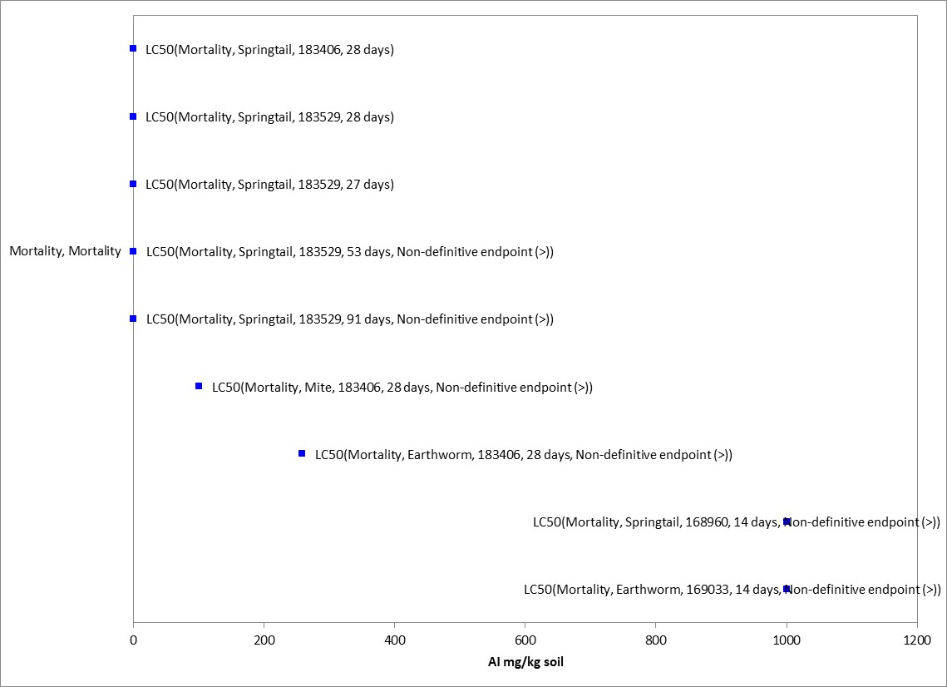
Figure 2-8. Mortality Endpoints for Terrestrial Invertebrates Exposed to Thiamethoxam (mg/kg-soil).
Blue squares represent LC₅₀ values from open literature studies found in the ECOTOX database. Parentheses present the endpoint measurement, species, study reference (i.e., MRID, ECOTOX #), and study duration. If endpoint is non-definitive, that is also noted.

The most sensitive LC₅₀ value available is >1,000 mg/kg-soil for earthworms (Eisenia andrei; E169033) and springtails (Folsomia candida). At this test level, no significant mortality was observed. The two test species for which we have data available are not insects, which are known to be more sensitive to thiamethoxam compared to other invertebrates. No terrestrial insect endpoints were identified from studies in the ECOTOX acceptable database for the exposure unit of mg/kg-soil.

Contact Exposure Mortality Endpoints Expressed as mg/kg-bw

The available mortality data for terrestrial invertebrates is provided in Figure 2-9 below. Endpoints were identified from studies in the ECOTOX acceptable database that were reviewed for use as a threshold in this assessment (APPENDIX 2-2). Mortality data associated with the contact exposure unit of mg/kg-bw are available for 1 class (i.e., Insecta), represented by 2 orders, 2 families, 3 genera, and 4 species, all of which are insects. Based on the available data, thiamethoxam is associated with mortality of terrestrial invertebrates at doses ranging from 0.032 to 0.97 mg/kg-bw (see Figure 2-9).

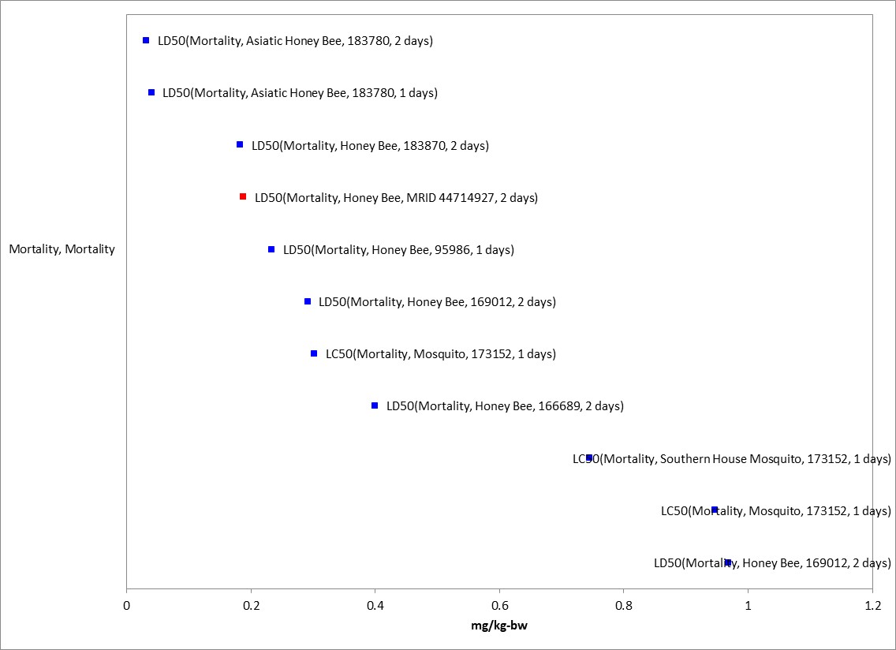
Figure 2-9. Contact Exposure Mortality Endpoints for Terrestrial Invertebrates Exposed to Thiamethoxam (mg/kg-bw).
Blue squares represent LD₅₀ values from open literature studies found in the ECOTOX database. Red squares represent LD₅₀ values from registrant submitted studies. Parentheses present the endpoint measurement, species, study reference (i.e., MRID, ECOTOX #), and study duration. If endpoint is non-definitive, that is also noted.

For contact exposure, the most sensitive LD₅₀ value available is a 48-h value of 0.032 mg a.i./kg-bw for Asiatic honey bees (Apis cerana; E183780). The LD₅₀ value from this study of 0.032 mg/kg-bw (E183780) is more sensitive than any of the available NOAEL or LOAEL values expressed as mg/kg-bw (contact exposure). Therefore, it will be used for mortality and sublethal effects thresholds. No terrestrial non-insect endpoints were identified from studies in the ECOTOX acceptable database for the exposure unit of mg/kg-bw.

Mortality Endpoints Expressed as lb/acre

The available data for mortality data to terrestrial invertebrates associated with the exposure unit of lb/acre is provided in Figure 2-10 below. Endpoints were identified from studies in the ECOTOX acceptable database that were reviewed for use as a threshold in this assessment (APPENDIX 2-2). Mortality data associated with the exposure unit of lb/A are available for 3 classes (i.e., Insecta, Arachnid, and Clitellata), represented by 3 orders, 4 families, 4 genera, and 6 species. Based on the available data, thiamethoxam is associated with mortality of terrestrial insects at concentrations ranging from 0.000027 to 0.0037 lb/A, while non-insect concentrations range from 0.093 to 38 lb/A (see Figure 2-10). Generally, insect species appear to be more sensitive to thiamethoxam than non-insect species. However, comparisons across studies in ECOTOX should be done with caution due to differences in study designs.

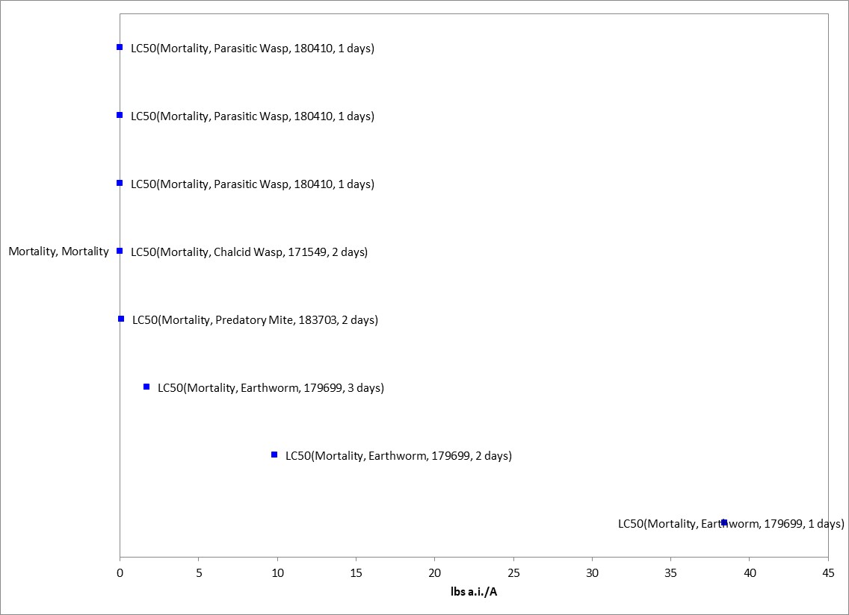
Figure 2-10. Mortality Endpoints for Terrestrial Invertebrates Exposed to Thiamethoxam (lb/acre).
Blue squares represent LC₅₀ values from open literature studies found in the ECOTOX database. Parentheses present the endpoint measurement, species, study reference (i.e., MRID, ECOTOX #), and study duration. If endpoint is non-definitive, that is also noted.

For the exposure unit of lb/acre, the most sensitive LC₅₀ value available for terrestrial insects was for chalcid wasps (Spalangia endius; E171549) at 0.0037 lb/A. The LC₅₀ value from this study of 0.0037 lb/A (E171549) is more sensitive than any of the available NOAEC or LOAEC values for all endpoints expressed at lb/A. Therefore, it will be used for mortality and sublethal effects thresholds. For all non-insect terrestrial invertebrates, the most sensitive LC₅₀ value available is 0.093 lb/A for a predatory mite (Neoseiulus cucumeris; E183703) for risk characterization only (APPENDIX 2-3).

Oral Exposure Mortality Endpoints Expressed as mg/kg-diet

The available data for mortality data to terrestrial invertebrates associated with the exposure unit of mg/kg-diet is provided in Figure 2-11. Oral Exposure Mortality Endpoints for Terrestrial Invertebrates Exposed to Thiamethoxam (mg/kg-diet).Figure 2-11 below. Endpoints were identified from studies in the ECOTOX acceptable database that were reviewed for use as a threshold in this assessment (APPENDIX 2-2). Several honey bee endpoints in the array below were converted from ug/bee to mg/kg-diet by multiplying by the daily food consumption of 0.292 g for adult foragers. Mortality data associated with the exposure unit of mg/kg-diet are available for 2 classes (i.e., Insecta and Gastropoda), represented by 3 orders, 4 families, 7 genera, and 10 species. Based on the available data, thiamethoxam is associated with mortality of terrestrial insects at concentrations ranging from 0.001 to 150 mg/kg-diet, while the available non-insect concentration for land snails was the highest at 313.8 mg/kg-diet (see Figure 2-11).

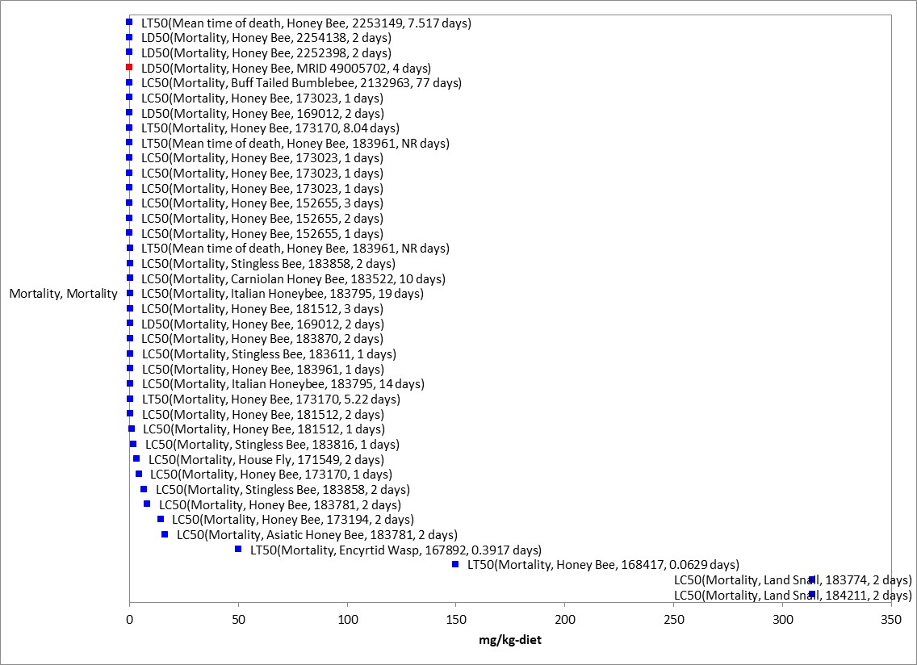
Figure 2-11. Oral Exposure Mortality Endpoints for Terrestrial Invertebrates Exposed to Thiamethoxam (mg/kg-diet).
Blue squares represent LC₅₀ values from open literature studies found in the ECOTOX database. Red squares represent LC/EC₅₀ values from registrant submitted studies. Parentheses present the endpoint measurement, species, study reference (i.e., MRID, ECOTOX #), and study duration. If endpoint is non-definitive, that is also noted.

For the exposure unit of mg/kg-diet, the most sensitive LD₅₀ value available is 0.014 mg a.i./kg-diet (0.0041 µg/bee) for honey bees (Apis mellifera; E183532). The LD₅₀ value from this study of 0.014 mg/kg-diet (E1835320) is more sensitive than any of the available NOAEC or LOAEC values for mg/kg-diet. Therefore, it will be used for mortality and sublethal effects thresholds. For all non-insect terrestrial invertebrates, the most sensitive LC₅₀ value available is 313.8 mg/kg-diet for a land snail (Theba pisana; E183774) for risk characterization only (APPENDIX 2-3).

Effects on Growth and Reproduction of Terrestrial Invertebrates

Several studies were reported in the ECOTOX database for growth and reproduction effects to terrestrial invertebrates and are summarized by exposure unit below.

Growth and Reproduction Endpoints Expressed as mg/kg-soil

Several growth and reproduction toxicity studies involving terrestrial invertebrates were identified in ECOTOX. Endpoints were identified from studies in the ECOTOX acceptable database that were reviewed for use as a threshold in this assessment (APPENDIX 2-2). Growth and reproduction data associated with the exposure unit of mg/kg-soil are available for 3 classes (i.e., Entognatha, Clitellata and Arachnida), represented by 3 orders, 3 families, 3 genera, and 3 species, none of which are insects. Based on the available data, thiamethoxam is associated with growth and reproduction effects of terrestrial invertebrates at concentrations ranging from 0.27 to 500 mg/kg-soil (Figure 2-12).

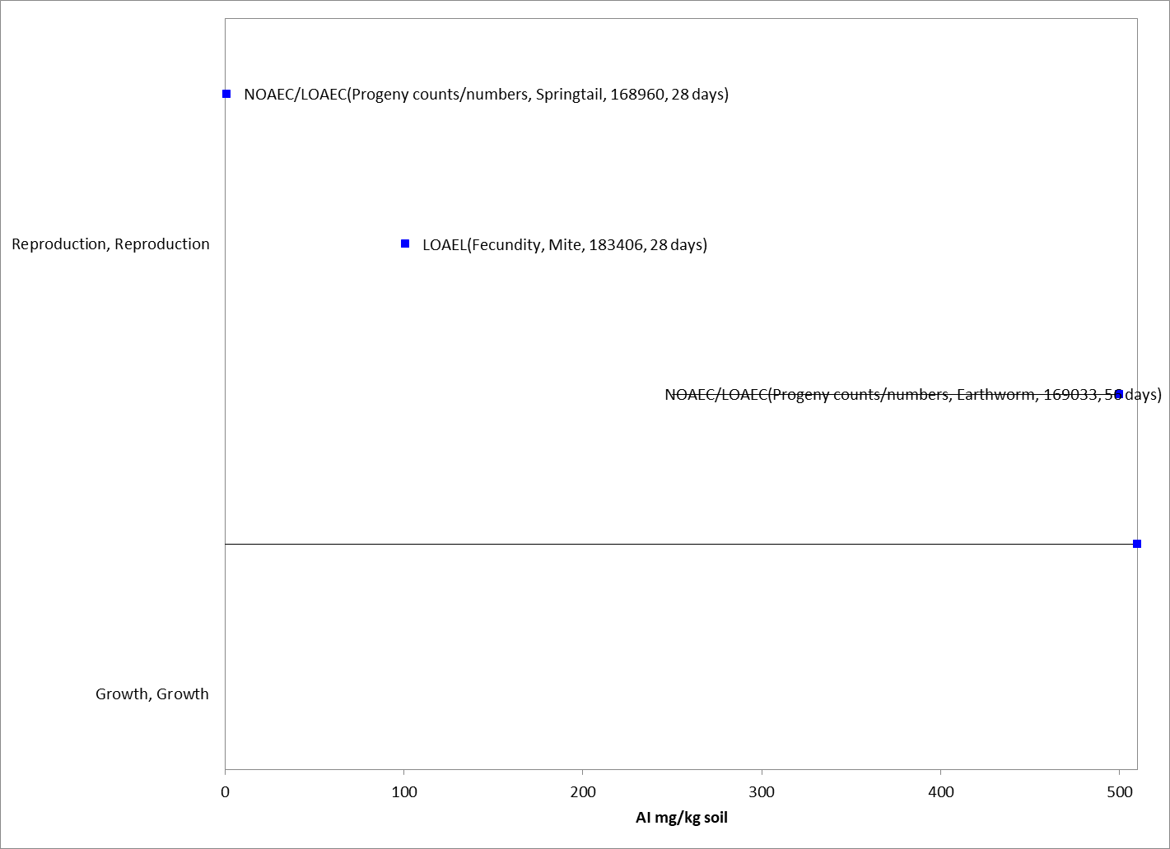
Figure 2-12. Sublethal Endpoints for Terrestrial Invertebrates Exposed to Thiamethoxam (mg/kg-soil).
Blue squares represent LOAEC/LOAEL values from open literature studies found in the ECOTOX database. Solid lines display the range between the LOAEC/LOAEL and NOAEC/NOAEL values. Parentheses present the endpoint measurement, species, study reference (i.e., MRID, ECOTOX #), and study duration.

For the exposure unit of mg/kg-soil, the most sensitive sublethal endpoint reported a 27-d NOAEC and LOAEC of 0.12 and 0.37 mg/kg-soil in the springtail (Folsomia candida), based on a 19% (NOAEC/LOAEC visually determined) decrease in number of progeny (E183529, De Lima et al. 2018).

Contact Exposure Growth and Reproduction Endpoints Expressed as mg/kg-bw

No growth and reproduction toxicity studies involving terrestrial invertebrates were identified in ECOTOX. Therefore, the mortality based LD₅₀ value from this study of 0.032 mg/kg-bw (E183780) is more sensitive than any of the available NOAEL or LOAEL values expressed as mg/kg-bw (contact exposure). Therefore, it will be used for mortality and sublethal effects thresholds.

Growth and Reproduction Endpoints Expressed as lb/acre

Several growth and reproduction toxicity studies involving terrestrial invertebrates were identified in ECOTOX. Growth and reproduction data associated with the exposure unit of lb/A are available for 2 classes (i.e., Insecta and Arachnida), represented by 2 orders, 6 families, 6 genera, and 6 species. Based on the available data, thiamethoxam is associated with growth and reproduction effects of terrestrial insects at concentrations ranging from 0.004 to 4.46 lb/A (Figure 2-13). There do not appear to be differences in toxicity between insect and non-insect species.

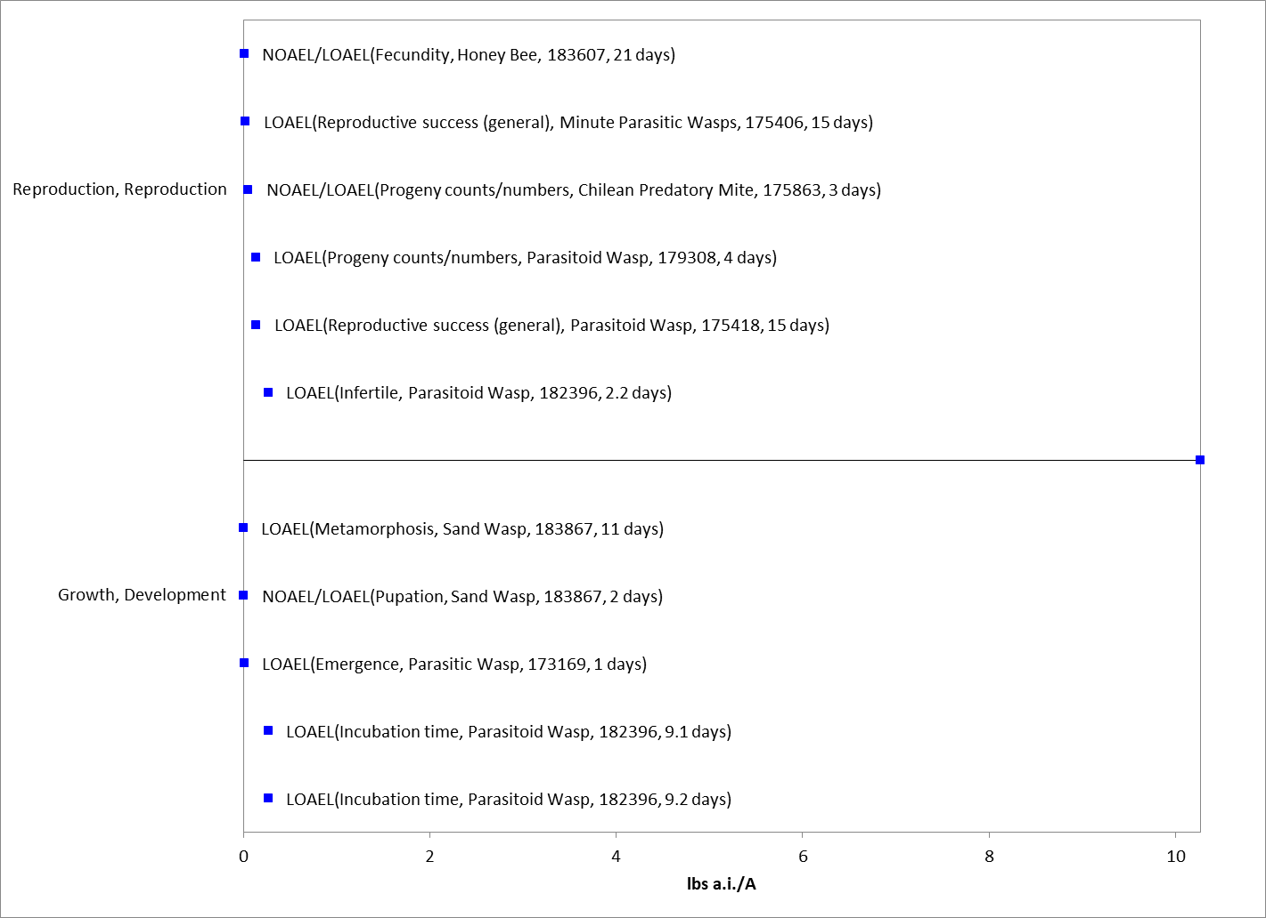
Figure 2-13. Growth and Reproduction Endpoints for Terrestrial Invertebrates Exposed to Thiamethoxam (lb/acre).
Blue squares represent LOAEC/LOAEL values from open literature studies found in the ECOTOX database. Solid lines display the range between the LOAEC/LOAEL and NOAEC/NOAEL values. Parentheses present the endpoint measurement, species, study reference (i.e., MRID, ECOTOX #), and study duration.

No endpoints were identified from studies in the ECOTOX acceptable database that were either more sensitive than the mortality endpoint identified above or reliable for use as a threshold and relatable to an apical endpoint. The LC₅₀ value from the chalcid wasp study of 0.0037 lb/A (E171549) is more sensitive than any of the available NOAEC or LOAEC values for all endpoints expressed at lb/A. Therefore, it will be used for mortality and sublethal effects thresholds.

Oral Exposure Growth and Reproduction Endpoints Expressed as mg/kg-diet

Several growth and reproduction toxicity studies involving terrestrial invertebrates were identified in ECOTOX. Growth and reproduction data associated with the exposure unit of mg/kg-diet are available for 4 classes (i.e., Insecta, Gastropoda and Arachnida), represented by 4 orders, 4 families, 6 genera, and 6 species. Based on the available data, thiamethoxam is associated with growth and reproduction effects of terrestrial insects at concentrations ranging from 0.00001 to 0.01 mg/kg-diet, while the mite concentrations are both at 25,000 mg/kg-diet (Figure 2-14). There do not appear to be differences in toxicity between insect and non-insect species.
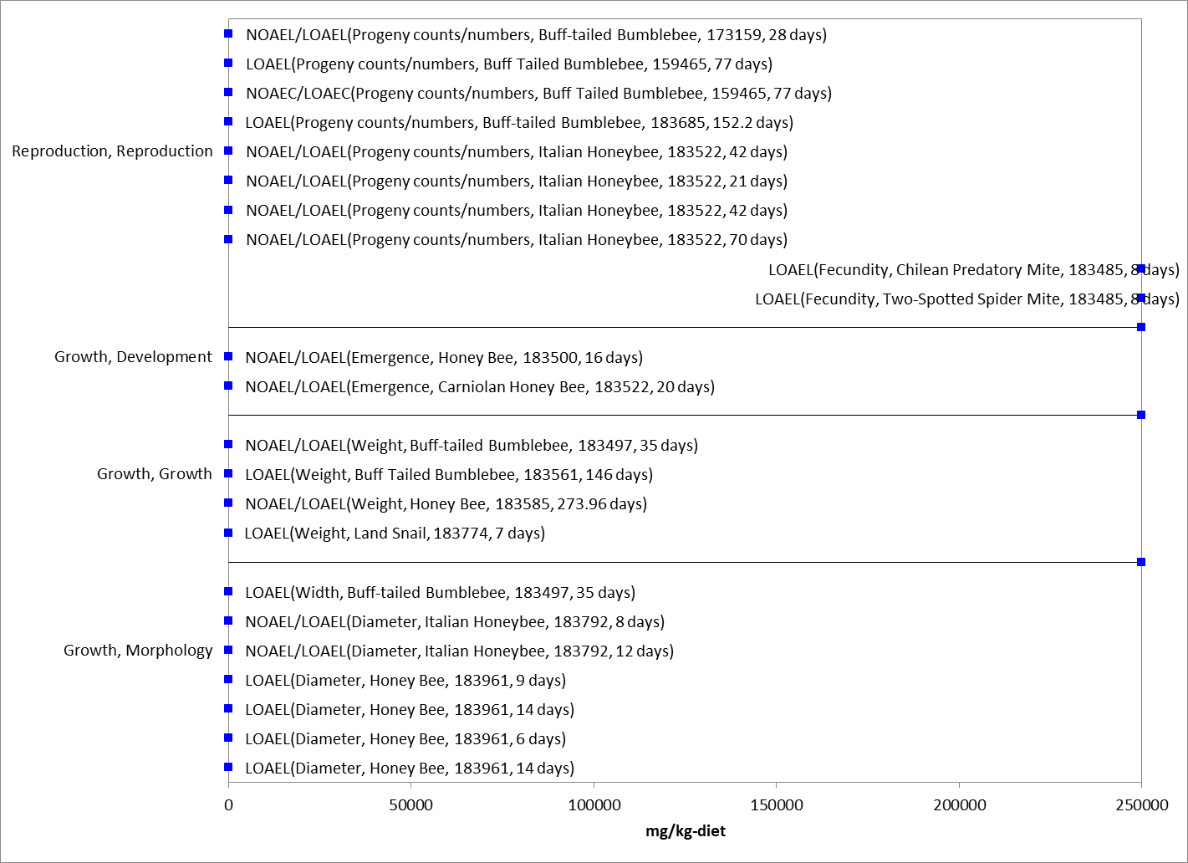
Figure 2-14. Growth and Reproduction Endpoints for Terrestrial Invertebrates Exposed to Thiamethoxam (mg/kg-diet).
Blue squares represent LOAEC/LOAEL values from open literature studies found in the ECOTOX database. Solid lines display the range between the LOAEC/LOAEL and NOAEC/NOAEL values. Parentheses present the endpoint measurement, species, study reference (i.e., MRID, ECOTOX #), and study duration.

No endpoints were identified from studies in the ECOTOX acceptable database that were either more sensitive than the mortality endpoint identified above or reliable for use as a threshold and relatable to an apical endpoint. The LD₅₀ value from the honey bee study of 0.014 mg/kg-diet (E1835320) is more sensitive than any of the available NOAEC or LOAEC values for mg/kg-diet. Therefore, it will be used for mortality and sublethal effects thresholds.

Other Sublethal Effects to Terrestrial Invertebrates

Additional literature is available on the sublethal effects of thiamethoxam on terrestrial invertebrates. No endpoints were identified from studies in the ECOTOX acceptable database that were either more sensitive than the endpoints identified above or reliable for use as a threshold and relatable to an apical endpoint. For mg/kg-soil, there is one chemical avoidance study on the earthworm (Eisenia andrei), with a NOAEC = 2.5 mg/kg-soil and a LOAEC = 5 mg/kg-soil. Figure 2-15, Figure 2-16, and Figure 2-17 illustrate the data available for sublethal and chronic effects to terrestrial invertebrates measured in mg/kg-bw, mg/kg-diet, and lbs/A respectively.

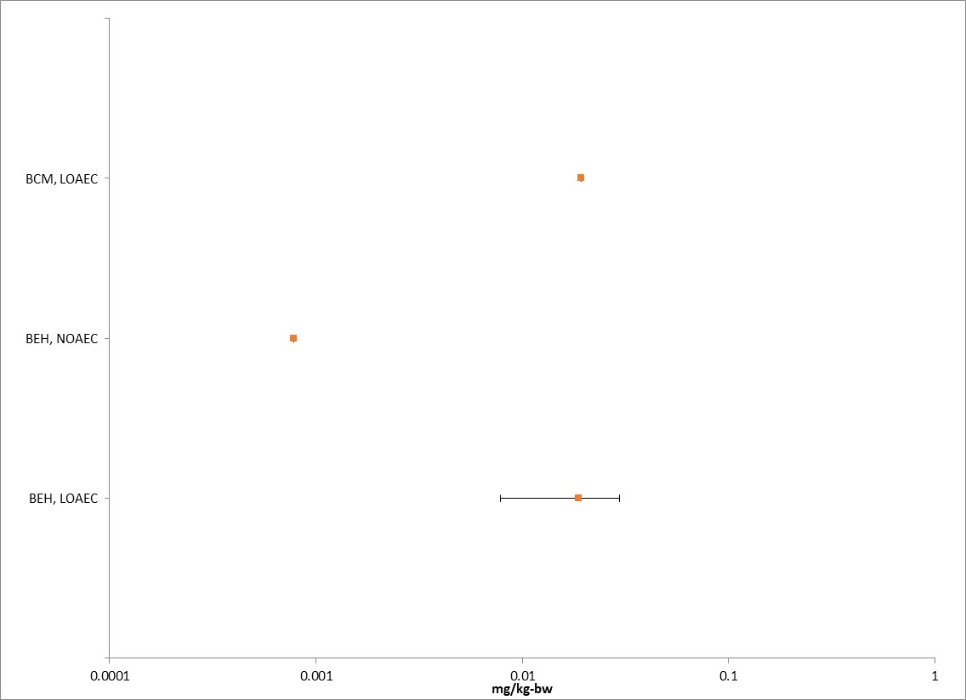
Figure 2-15. Summary array of toxicity data for terrestrial invertebrates expressed in terms of mg a.i.kg-bw.
Orange squares represent the mid-point of the data. Solid lines display the range between the LOAEC and NOAEC values. BCM = biochemical; BEH = behavior.

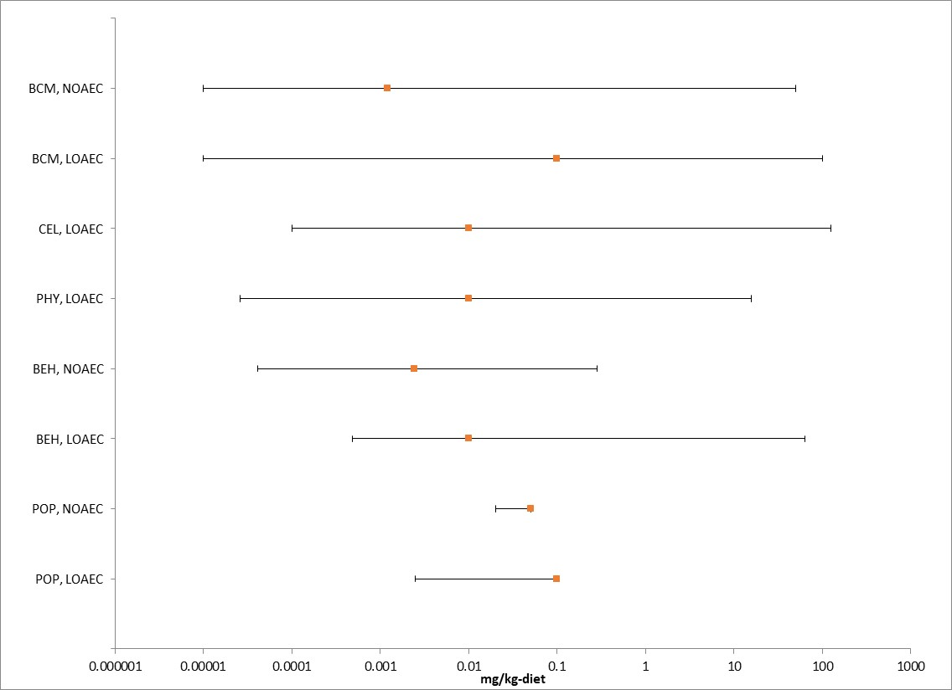
Figure 2-16. Summary array of toxicity data for terrestrial invertebrates expressed in terms of mg a.i./kg-diet.
Orange squares represent the mid-point of the data. Solid lines display the range between the LOAEC and NOAEC values. BCM = biochemical; BEH = behavior; CEL = cellular; PHY = physiological; POP = Population.

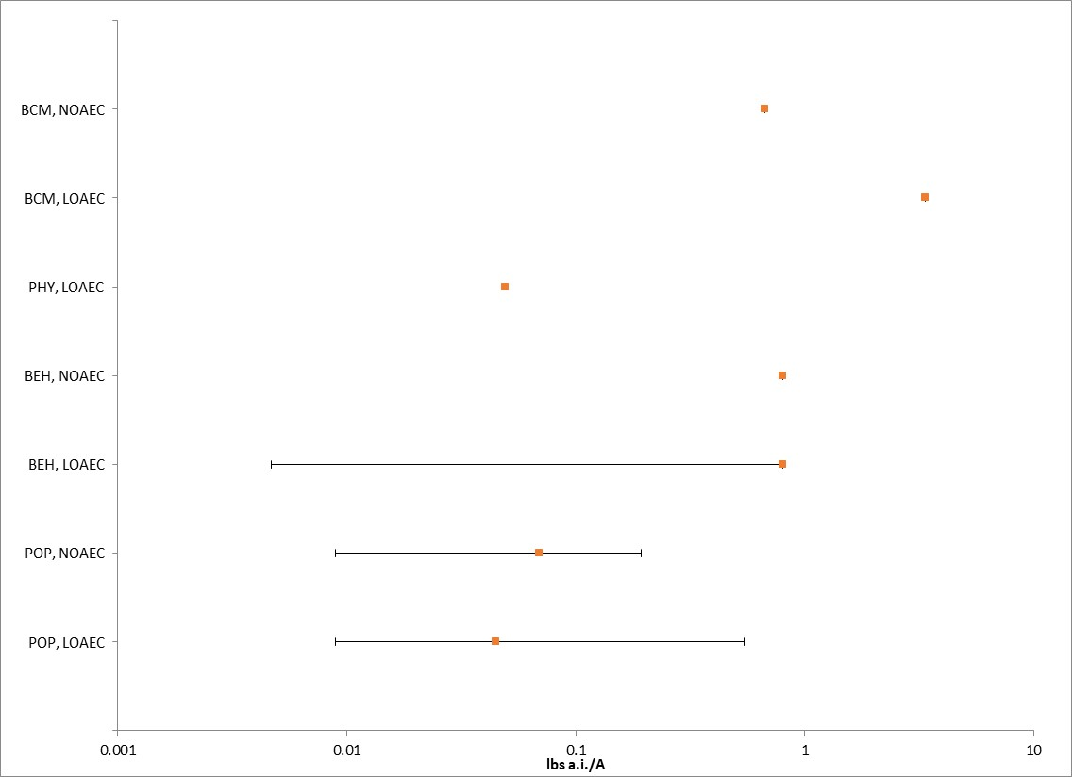
Figure 2-17. Summary array of toxicity data for terrestrial invertebrates expressed in terms of lbs a.i./A.
Orange squares represent the mid-point of the data. Solid lines display the range between the LOAEC and NOAEC values. BCM = biochemical; BEH = behavior; PHY = physiological; POP = Population.

Comparison of Thiamethoxam and Clothianidin Terrestrial Invertebrate Acute Toxicity Endpoints

The comparison of acute oral and contact mortality terrestrial invertebrate toxicity endpoints, where tests on the same species are available for both clothianidin and thiamethoxam, show a similar toxicity profile between the chemicals. For contact exposure, the most sensitive LD₅₀ overall is 0.032 mg/kg-bw from the thiamethoxam study with the Asiatic honey bee (Apis cerana; E183780). This endpoint will be used for the evaluation. For oral exposure, the most sensitive LC₅₀ overall is 0.014 mg/kg-diet from the thiamethoxam study with the honey bee (Apis mellifera; E183532). This endpoint will be used for the evaluation. For soil exposure, the most sensitive LC₅₀ overall is 0.93 mg/kg-soil from the clothianidin study with the earthworm (Eisenia fetida; E173321). This endpoint will be used for the evaluation. In terms of lb/acre, the most sensitive LC₅₀ overall is 0.0037 lb/acre from the thiamethoxam study with the chalcid wasp (Spalangia endius; E171549/MRID). This endpoint will be used for the evaluation.

Table 2-28. Comparison of Terrestrial Invertebrate Acute Mortality Toxicity Data for Clothianidin and Thiamethoxam¹
Common name | Scientific name | Clothianidin | Thiamethoxam | Reference  Clothianidin;  Thiamethoxam | Relative toxicity and comments
 |  | LD₅₀ µg/bee/day | LD₅₀ µg/bee/day
Honey bee | Apis mellifera | 0.0275 | 0.021 | MRID 49950102; MRID 44714927 | Adult acute contact toxicity. Similar toxicity.
Honey bee | Apis mellifera | 0.0037 | 0.0038 | MRID 45422426; MRID 49005701 | Adult acute oral toxicity. Similar toxicity.

Comparison of Thiamethoxam and Clothianidin Terrestrial Invertebrate Growth and Reproduction Endpoints

The comparison of growth and reproduction oral and contact mortality terrestrial invertebrate toxicity endpoints, where tests on the same species are available for both clothianidin and thiamethoxam, show clothianidin to be more toxic. For contact exposure, the mortality endpoint is used to represent the most sensitive threshold, with the most sensitive LD₅₀ overall of 0.032 mg/kg-bw from the thiamethoxam study with the Asiatic honey bee (Apis cerana; E183780). For oral exposure, the most sensitive endpoint was based on a 12% increase in mortality in the honey bee (Apis mellifera; MRID 48414901; NOAEC = 0.001 mg/kg-diet, LOAEC = 0.002 mg/kg-diet, MATC = 0.0014 mg/kg-diet) in the clothianidin study. For soil exposure, the most sensitive endpoint was based on a 40% increase in mortality in the springtail (Folsomia candida; E183406; NOAEC = 0.02 mg/kg-soil, LOAEC = 0.051 mg/kg-soil, MATC = 0.032 mg/kg-soil) in the clothianidin study. For soil exposure in lb/A, the most sensitive endpoint was based on a 52% increase in mortality in the seven-spotted lady beetle (Coccinella septempunctata L.; E183576; NOAEC < 0.0011 lb/A, LOAEC = 0.0011 lb/A) in the clothianidin study.

Table 2-29. Comparison of Terrestrial Invertebrate Sublethal Toxicity Data for Clothianidin and Thiamethoxam¹
Common name | Scientific name | Clothianidin | Thiamethoxam | Reference  Clothianidin;  Thiamethoxam | Relative toxicity and comments
 |  | LOAEC/NOAEC  µg/bee/day | LOAEC/NOAEC  µg/bee/day
Honey bee | Apis mellifera | LOAEC = 0.00072  NOAEC = 0.00036 | LOAEC = 0.0049  NOAEC = 0.0025 | MRID 48414901; MRID 50084901 | Adult chronic oral toxicity. Clothianidin is more toxic.

Effects Characterization for Terrestrial Plants

Introduction to Terrestrial Plant Toxicity

Plant toxicity data from both registrant-submitted studies and studies in the scientific literature have been reviewed for this assessment. Registrant-submitted studies are conducted under conditions and with species defined in OCSPP test guidelines. Sub-lethal endpoints such as plant growth, dry weight, and biomass are evaluated for both monocots and dicots, and effects are evaluated at both seedling emergence and vegetative life stages. Studies were excluded if they were considered invalid or not associated with an environmentally relevant exposure route.

Discussion of endpoints are provided for effects on terrestrial plants and terrestrial plant communities. These serve as a surrogate for effects on an individual of a listed species and the effects on the pollination, prey, habitat, or dispersal of a listed species, respectively.

Effects Data for Terrestrial Plants

Single-species terrestrial plant toxicity studies are used as one of the measures of effect to evaluate whether thiamethoxam may affect primary production and diversity in terrestrial ecosystems. Several terrestrial plant toxicity studies have been submitted to the EPA and/or published in the open literature.

The registrant-submitted data represent the most sensitive endpoints for effects to listed species. The results of the seedling emergence and vegetative vigor toxicity tests on non-target plants are summarized in the paragraphs below.

In the registrant-submitted seedling emergence test (maximum rate tested: 0.26 lb a.i./A; MRID 49108701) the only species with measured effects was cucumber, a dicot. Based on reductions in height ranging from 21-33% (from lowest to highest test concentrations), the resulting NOAEC and EC25 values of <0.017 and 0.028 lb a.i./A were established. The observed effects did not present in a significant dose response pattern with and were variable in magnitude of effect across doses. Based on these results, another seedling emergence test was submitted with cucumber (MRID 50131103). This new study tested the same test material in the effort to establish a NOAEC. The results of this study showed no effects on emergence, survival, length or weight at any test concentration. Therefore, the EC25, NOAEC and LOAEC values (nominal concentration) were set at the highest tested concentration, > 0.265, 0.265, and >0.265 lb a.i./A respectively.

In a vegetative vigor test (maximum rate tested: 0.26 lb a.i/A; MRID 49105801), oilseed rape (dicot) was the only species to exhibit biologically meaningful effects (12% reductions in plant height). For soybean, a statistically significant reduction of 22% was detected for weight at the 0.033 lb a.i./A test level. For sugar beet a statistically significant reduction of 12% was observed for height at the highest test level. However, the inhibitions at the test levels above and below fluctuated for soybean and sugarbeet, and effects did not demonstrate a dose response relationship. Consequently, the effects observed in soybean and sugarbeet were not considered as responsive to thiamethoxam. None of the other species showed effects.

In the open literature, there are many studies that tested thiamethoxam on plant growth or survival. Nearly all of these studies are studies that investigated the effects of thiamethoxam on invertebrate pests and the response of the plant to the changing invertebrate pressure. Since those studies do not represent a direct effect of thiamethoxam they are not included here for the consideration of thiamethoxam impacts to plants. A few studies did report effects on plant biochemistry (e.g., chlorophyll content; vitamin C levels) and some others reported reductions in growth (particularly root mass and elongation) but these studies either had effects observed at concentrations above the maximum rate concentrations or were in experimental units that are not readily translatable to modeling their exposure.
Twenty five percent inhibition concentration (IC₂₅) values for terrestrial plants are used to derive the threshold for effects to the PPHD of an individual of a listed species. Studies with effects on measures of growth (e.g., height, weight, and biomass) for both monocots and dicots were conducted; no study provided confident estimates of the IC₂₅ or consistent negative effects. Therefore, it is unlikely that direct effects from thiamethoxam on plants would impact community level organization of terrestrial plant communities.

Clothianidin Effects Data for Terrestrial Plants

Single-species terrestrial plant toxicity studies are used as one of the measures of effect to evaluate whether clothianidin may affect primary production and diversity in terrestrial ecosystems. Several terrestrial plant toxicity studies have been submitted to the EPA and/or published in the open literature.

The registrant submitted data represents the most sensitive endpoints for effects to listed species. The results of the seedling emergence and vegetative vigor toxicity tests on non-target plants are summarized in the paragraphs below.

Clothianidin was not toxic to terrestrial plants in vegetative vigor and seedling emergence tier I tests, with EC₂₅ and NOAEC levels being above the highest tested dose of 0.19 lb/acre Table A. The study relied upon the exposure through a typical end-use product (TEP) and showed no growth or survival effects on any of the 10 tested species.

In the open literature, there are many studies that tested clothianidin on plant growth or survival. Nearly all of these studies are studies that investigated the effects of clothianidin on invertebrate pests and the response of the plant to the changing invertebrate pressure. Since those studies do not represent a direct effect of clothianidin they are not included here for the consideration of clothianidin impacts to plants.

Incident Reports

A review of the Incident Data System (IDS) for ecological incidents involving thiamethoxam was completed on February 22, 2021. This search excluded incidents classified as ‘unlikely’ or ‘unrelated’ and only includes incidents with the certainty categories of ‘possible’, ‘probable’, and ‘highly probable’. From 2002-2018, 25 incidents have been reported. Of these incidents, 22 (88%) involved honey bees. The remaining incidents were to birds and plants. The review of the IDS yielded no new results since 2018. Therefore, the results of the terrestrial animal and plant, and aquatic animal incidents can be found in the most recent risk assessments (USEPA 2020, DP455645; USEPA 2017, DP439307).

In addition to the incidents recorded in IDS, additional incidents are reported to the Agency in aggregated form. Pesticide registrants report certain types of incidents to the Agency as aggregate counts of incidents occurring per product per quarter. Ecological incidents reported in aggregate reports include those categorized as ‘minor fish and wildlife’ (W-B), ‘minor plant’ (P-B), and ‘other non-target’ (ONT) incidents. ‘Other non-target’ incidents include reports of adverse effects to insects and other terrestrial invertebrates. For thiamethoxam, there are seven aggregate incidents that impacted wildlife, plants, and other nontarget taxa (USEPA 2021, DP458917. The number of actual incidents associated with thiamethoxam may be higher than what is reported to the Agency. Incidents may go unreported since side effects may not be immediately apparent or readily attributed to the use of a chemical. Although incident reporting is required under FIFRA Section 6(a)(2), the absence of reports in IDS does not indicate that the chemical has no effects on wildlife; rather, it is possible that incidents are unnoticed, unreported or reports are currently in the backlog of incidents within IDS.

Table 2-30. Overview of Reported Incidents by Taxa
Taxa | Test species (mortality) | Test species (sublethal) | Incident Data? (Yes/No)
Terrestrial
Plants | Oat, lettuce | Oat, lettuce | Yes
Mammals | Mouse | Lab rat | No
Birds | Japanese quail, mallard duck | House sparrow, bobwhite quail | Yes
Reptiles | Japanese quail, mallard duck | House sparrow, bobwhite quail | No
Amphibians | Japanese quail, mallard duck | House sparrow, bobwhite quail | No
Terrestrial Invertebrates | Asiatic honey bee, honey bee, earthworm, chalcid wasp | Asiatic honey bee, honey bee, springtail, chalcid wasp | Yes
Aquatic
Amphibians | Rainbow trout | Fathead minnow | No
Freshwater Fish | Rainbow trout | Fathead minnow | No
Estuarine/Marine Fish | Sheepshead minnow | Sheepshead minnow | No
Aquatic Invertebrates | SSD, mysid shrimp | Midge, mysid shrimp | No
Mollusks | Wavy-rayed lampmussel | Wavy-rayed lampmussel | No
Aquatic Plants | Diatom, Duckweed | Diatom, Duckweed | No

Alternative Toxicity endpoints

In addition to the thresholds provided in Table 2-1 through Table 2-6 above, alternative toxicity endpoints were also developed to use in the weight of evidence analysis for a species where appropriate (see Revised Methods Document). The alternative toxicity endpoints provide consideration of endpoints that may reflect variation in the available data (such as using the HC₅₀ values from the SSD instead of an HC₀₅ value or considering other endpoints within the data set for a particular taxon). Alternatively, if a taxon did not include enough data to select a specific alternative toxicity endpoint, a 10x factor was applied to the original threshold. The alternative endpoints allow for consideration of the possibility a listed species is toxicologically less sensitive than the tested species in the alternative weight of evidence analysis, which is captured for the analysis of any species that reaches that point of the analysis. Alternative endpoints are listed in Table 2-31 and brief additional comments are provided to clarify the alternative endpoint selection, as appropriate. Endpoints are analyzed for a subset of available units.

Table 2-31. Alternative Toxicity Endpoints Used in Weight of Evidence Analysis
Units | Taxa | Type of endpoint (HC50, etc.) | Value | Slope | Weight of test animal (g) | Comments
Alternative toxicity endpoints - Mortality
mg ai/kg-bw | Mammals | LD50 | 783 | 4.5 | 29.6 | Thiamethoxam mouse study
mg ai/kg-bw | Birds | LD50 | 431 | 5.6 | 18.1 | Thiamethoxam Canary study
mg ai/kg-bw | Reptiles/Terrestrial Amphibian | LD50 | 431 | 5.6 | 18.1 | Thiamethoxam Canary study
mg ai/kg-bw | Terrestrial inverts | LD50 | 0.32 | 4.5 |  | 10x applied
µg ai/L | FW FISH | LC50 | 99999 | 4.5 |  | No change, non-definitive
µg ai/L | E/M FISH | LC50 | 99999 | 4.5 |  | No change, non-definitive
µg ai/L | AQ AMPHIBIANS | LC50 | 99999 | 4.5 |  | No change, non-definitive
µg ai/L | FW INVERTEBRATES | HC05 | 11.87 | 1.89 |  | Thiamethoxam aquatic insect SSD
µg ai/L | E/M INVERTEBRATES | LC50 | 6900 | 4.5 |  | Thiamethoxam mysid shrimp study
µg ai/L | Mollusks | LC50 | 99999 | 4.5 |  | No change; non-definitive
Alternative toxicity endpoints - Sublethal
Units | Taxa | Type of endpoint (HC50, etc.) | MATC or LOAEC | Description of effect | Duration of study (days) | Comments
mg ai/kg-bw | Mammals | MATC | 87 | Reduced body weight
mg ai/kg-diet | Birds | MATC | 520 | Reduced body weight |  | Mallard duck, thiamethoxam data
mg ai/kg-diet | Reptiles/Terrestrial Amphibian | NA | NA |  |  | No data available in these units
mg ai/kg-diet | Terrestrial inverts | MATC | 0.0014 |  |  | 10x applied
µg ai/L | FW FISH | MATC | 139280 |  |  | 10x applied
µg ai/L | E/M FISH | MATC | 26400 |  |  | 10x applied
µg ai/L | AQ AMPHIBIANS | MATC | 139280 |  |  | 10x applied
µg ai/L | FW INVERTEBRATES | MATC | 1.28 |  |  | Thiamethoxam midge study
µg ai/L | E/M INVERTEBRATES | MATC | 1483 |  |  | Thiamethoxam mysid shrimp study
µg ai/L | Mollusks | MATC | 99999 |  |  | No change; non-definitive
TERRESTRIAL PLANTS |  | Type of endpoint (HC50, etc.) | MATC or LOAEC | IC25 | Description of effect | Comments
lb ai/A | Monocots | MATC | 2.65 | 2.65 |  | 10x applied
lb ai/A | Dicots | MATC | 2.6 | 2.6 |  | 10x applied
AQUATIC PLANTS |  | Type of endpoint (HC50, etc.) | MATC or LOAEC | IC25 | Description of effect | Comments
µg ai/L | Non-vascular | MATC | 16,971 | 99,000 | Reduced biomass | Thiamethoxam based endpoint
µg ai/L | Vascular | MATC | 31,077 | 90,200 | Phyto-toxicity | Thiamethoxam based endpoint

http://www.irac-online.org/modes-of-action/
Zhang, Y, Liu, S, Gu, J, Song,F, Yao, X, Liu, Z. 2008. Imidacloprid acts as an antagonist on insect nicotinic acetylcholine receptor containing the Y151M mutation. Neuroscience Letters. 446:97– 100.
Tomizawa, M, Casida, J. 2005. Neonicotinoid insecticide toxicology: mechanisms of Selective Action. Annual Review of Pharmacology and Toxicology, 45, 247–268.
OECD (2016), Test No. 223: Avian Acute Oral Toxicity Test, OECD Guidelines for the Testing of Chemicals, Section 2, OECD Publishing, Paris, https://doi.org/10.1787/9789264264519-en.
Wang YH;Zhang Y;Xu P;Guo BY;Li W. 2018. Metabolism Distribution and Effect of Thiamethoxam After Oral Exposure in Mongolian Racerunner (Eremias argus). J. Agric. Food Chem. 66(28): 7376-7383. ECOTOX#183545
Wang Y;Zhang Y;Zeng T;Li W;Yang L;Guo B. 2019a. Accumulation and Toxicity of Thiamethoxam and Its Metabolite Clothianidin to the Gonads of Eremias argus. Sci. Total Environ. 667: 586-593. ECOTOX#183412
Wang Y;Zhang Y;Li W;Han Y;Guo B. 2019b. Study on Neurotoxicity of Dinotefuran, Thiamethoxam and Imidacloprid Against Chinese Lizards (Eremias argus). Chemosphere 217: 150-157. ECOTOX#183525
Wang Y;Zhang Y;Li W;Yang L;Guo B. 2019c. Distribution, Metabolism and Hepatotoxicity of Neonicotinoids in Small Farmland Lizard and Their Effects on GH/IGF Axis. Sci. Total Environ. 662: 834-841. ECOTOX#183775
Wang YH;Xu P;Chang J;Li W;Yang L;Tian HT. 2020. Unraveling the Toxic Effects of Neonicotinoid Insecticides on the Thyroid Endocrine System of Lizards. Environ. Pollut. 258: 113731-113731. ECOTOX#183547

