**Exposure Characterization for Malathion**

Contents

1 Environmental Transport and Fate Characterization 3

2 Measures of Aquatic Exposure 5

2.1 Aquatic Exposure Models 5

2.2 HUC and Use Site Crosswalk 7

2.3 Scenario Selection 7

2.4 Application Practices 9

2.4.1 Application Method 9

2.4.2 Spray Drift 9

2.4.3 Application Timing 9

2.5 Special Agricultural Considerations 10

2.5.1 Multiple Crop-cycles Per Year 10

2.5.2 Hedgerow Uses 10

2.5.3 Rice and Watercress Use 10

2.6 Nonagricultural Uses and Considerations 11

2.6.1 Ultra Low Volume Wide Area Uses 11

2.6.2 Homeowner Uses 11

2.7 Aquatic Modeling Input Parameters 14

2.8 Aquatic Modeling Results 19

2.9 Aquatic Modeling Sensitivity Analysis 23

2.10 Available Monitoring Data 28

2.10.1 Field Studies 28

2.10.2 General Monitoring Data 28

2.11 Monitoring Results, WARP Model and Extrapolation of Monitoring Results 29

2.12 Aquatic Exposure Summary 29

2.13 Uncertainties in Aquatic Modeling and Monitoring Estimates 29

2.13.1 Surface Water Aquatic Modeling 29

2.13.2 Aquatic Bins 3 and 4 30

2.13.3 Monitoring Data 31

3 Measures of Terrestrial Exposure 32

3.1 Introduction 32

3.2 Estimated concentrations in terrestrial food items (mg a.i./kg-food) 33

3.2.1 Terrestrial invertebrates 36

3.2.2 Terrestrial plants (seeds, fruit, nectar and leaves) 36

3.2.3 Terrestrial vertebrates (birds, mammals, amphibians, reptiles) 39

3.3 Estimated concentrations in aquatic food items (mg a.i./kg-food) 39

3.3.1 Aquatic plants 39

3.3.2 Aquatic invertebrates 40

3.3.3 Fish 41

4 References 42



Figures

Figure 3-1. The Major Hydrologic Unit “Water Resource” Regions (HUC-2) in the Continental United States, Overlain on State Boundaries 6

Figure 3-2.  Residential conceptual model of malathion applications.  PRZM scenarios are represented in green (Residential), yellow (Rights of Way), and red (Impervious). 14

Figure 3-3. Applications of malathion to cotton over all calendar days as date of initial application for flowing aquatic bins 27

Figure 3-4. Applications of malathion to cotton over all calendar days as date of initial application for static aquatic bins 27

Figure 3-5. Effect of Pesticide Concentration via Advective Dispersion 31

Figure 3-6. Mean and upper bound estimated concentrations of malathion on above ground terrestrial invertebrates. 35

Figure 3-7. Mean and upper bound estimated concentrations of malathion on seeds and fruit. 36

Figure 3-8. Mean and upper bound estimated concentrations of malathion on broadleaves. 37

Figure 3-9. Mean and upper bound estimated concentrations of malathion on short grass. 37

Figure 3-10. Mean and upper bound estimated concentrations of malathion on tall grass. Note that tall grass EECs are used as a surrogate for nectar. 38

Figure 3-11. Malathion concentrations in aquatic plants resulting from bioconcentration different aqueous concentrations. 39

Figure 3-12. Estimated concentrations of malathion in aquatic invertebrates resulting from bioconcentration at different aqueous concentrations. 40

Figure 3-13. Estimated concentrations of malathion in fish resulting from bioconcentration at different aqueous concentrations. 40

Tables

Table 3-1. Chemical properties and environmental fate parameters for malathion and degradates with registrant submitted data. 4

Table 3-2. High/Low malathion conventional uses for each Cropland Data Layer re-classified land cover class 8

Table 3.3. High/Low malathion ultra low volume uses for each Cropland Data Layer re-classified land cover class 8

Table 3-4. Application information for modeled homeowner scenario based on maximum labeled application rates. 15

Table 3-5. Input values used for Tier II surface water modeling with PRZM5/VVWM 15

Table 3-6. PFAM Inputs for Malathion Use 18

Table 3-7.  Summaries of registrant submitted and open literature malathion aerobic soil metabolism data 19

Table 3-8 Range of PRZM5/VVWM Peak EECs 20

Table 3-9 Range of PRZM5/VVWM Peak Pore Water EECs 21

Table 3-10. Parameter Sensitivity analysis for malathion 25

Table 3-11. Sensitivity of EECs to application date and fate parameters 26

Table 3-12. Mean and upper bound dietary based EECs calculated for food items consumed by listed birds, terrestrial-phase amphibians or reptiles. Values represent potential exposures for animals feeding on the treated field or in adjacent habitat directly adjacent to the field. 34

# Environmental Transport and Fate Characterization

Physical chemical properties and dissipation parameters for malathion and its major degradates of concern are provided in **Table 3-1**. Malathion will enter the environment via spray directly onto soil, foliage, or impervious surfaces. Spray drift and runoff are primary routes of offsite transport with volatilization and leaching occurring under certain conditions. Rainfall transports malathion off-field through runoff, soil erosion, and leaching. These mechanisms may transport malathion to surface water. In waterbodies, it will be present primarily in the water column but also substantially in sediment. Microbial metabolism to malathion dicarboxylic and monocarboxylic acids is the primary transformation occurring in natural systems. Hydrolysis rates of malathion vary dramatically with pH, with reduced hydrolysis in acidic environments. Based on aerobic aquatic metabolism half-lives ranging from 0.5 to 10 days, malathion will not persist, so it is the degradates that are typically available in sediment and water column. FAO classifies malathion as moderately mobile. It is unlikely to reach ground water except in vulnerable soils with low organic-carbon content and/or the presence of shallow ground water. Based on a relatively low Henry's Law Constant (1.2*10-7 atm-m3/mol), and moderate soil/water partitioning, malathion has low volatilization potential from soil. However, malathion has been detected in air and rain water in several studies in several locations. Non-agricultural uses involving impervious surfaces or ultra-low volume (ULV) applications may have an increased tendency toward volatilization due to slower degradation and less sorption to surfaces. Log KOW values range from 2.3 to 3.3 suggesting it is not likely to have the potential to accumulate in terrestrial organisms. In this assessment, the Log Kow value of 2.8 (Kow of 628; MRID 00157054) was used when estimating terrestrial invertebrate EECs. Data summarized here include data submitted to the U.S. EPA and open literature data including ECOTOX studies classified as ECOTOX plus. Open literature data were included when the information was determined to add to the overall understanding of the environmental fate of malathion and malaoxon. **APPENDIX 3-2** summarizes the listing of ECOTOX plus studies listed as fate related and salient monitoring studies are summarized in **APPENDIX 1-10**.

Table 3-1. Chemical properties and environmental fate parameters for malathion and degradates with registrant submitted data.

| **Property** | **Malathion** | **Malaoxon** | **Monocarboxylic acid** | **Dicarboxylic acid** |
| --- | --- | --- | --- | --- |
| IUPAC Name | Diethyl (dimethoxyphophinothioylthio)succinate | Diethyl 2-(dimethoxyphosphorylsulfanyl)butanedioate | ((dimethoxyphosphinothioioyl)thio)-,4-ethyl ester butanedioc acid | ((dimethoxyphosphinothioioyl)thio) butanedioc acid |
| Structure | C:\Users\ashelb02\Desktop\malathion structure.jpg | C:\Users\ashelb02\Desktop\malaoxon structure.jpg | C:\Users\ashelb02\Desktop\monocarboxylic acid.png | C:\Users\ashelb02\Desktop\dicarboxylic acid structure.png |
| Chemical Formula | C10H19O6PS2 | C10H19O7PS | C8H15O6PS2 | C6H11O6PS2 |
| Molecular Mass | 330.3 g/mol | 314.3 g/mol | 302.3 g/mol | 274.3 g/mol |
| Vapor Pressure (25°C) | 2.3*10-5 torr1 | 3.4*10-6 torr2 | - | 4.5*10-6 torr2 |
| Henry’s Law Constant | 8.4*10-10 atm∙m3/mol2 | 8.4*10-10 atm∙m3/mol2 | - | 4.7*10-15 atm∙m3/mol2 |
| Solubility (25°C) | 145 ppm1 | 78 ppm2 | - | 3218 ppm2 |
| Hydrolysis half-life (25°C) | pH 5: 107 days  pH 7: 6 days  pH 9: 0.5 day1 | pH 5: 32 days  pH 7: 9 days  pH 9: 0.16 day1 | - | - |
| Aqueous photolysis half-life | 98 days at pH 41 | - | - | - |
| Soil photolysis half-life (days) | 173 days1 | - | - | - |
| Aerobic soil metabolism half-life range | 0.3 to 7 days3 | 0.2-0.6 day1 | - | - |
| Aerobic aquatic metabolism half-life range | 0.5 to 10 days1 | 0.8 to 6 days1 | - | - |
| Anaerobic aquatic metabolism half-life range | 2.5 days1 | - | - | - |
| Soil partition (adsorption) coefficients (Koc) | 151-308 mL/g o.c. 1 | 81 – 327 mL/g o.c. 1 | - | 7 – 76 mL/g o.c.1 |
| Terrestrial field dissipation DT50 | <1 day1 | - | - | - |
| Octanol-water partition coefficient (Kow) | 195-20001 | 32 | 5622 | 72 |
| Bioconcentration factor | 4.2 to 18L/kg wet-wt1 | - | - | 3.2 L/kg wet-wt2 |

1. Derived from registrant submitted study
2. Derived from EPISuite
3. Derived from registrant submitted studies and open literature

# Measures of Aquatic Exposure

In general, maximum application rates and minimum application retreatment intervals were modeled based on the master use summary table (**APPENDIX 1-3**), unless otherwise noted.

## Aquatic Exposure Models

Aquatic exposures (surface water and benthic sediment pore water) were quantitatively estimated for malathion for all currently registered uses by HUC 2 Regions (**Figure 3-1**) and by aquatic bin using the PRZM5/VVWM[1]. To do this, malathion specific modeling scenarios were developed for each use that included selecting PRZM5/VVWM scenarios, agronomic practices (*e.g.*, applications methods, dates). **APPENDIX 3-1** contains fate and transport information used to develop inputs for the aquatic modeling. Additional information for aquatic modeling can be found in Chapter 3, Section 2.7, as well as Appendices 1-7 (Scenario Development) and 3-3 (Spray Drift). Additionally, the general approach for the aquatic modeling used is described below.

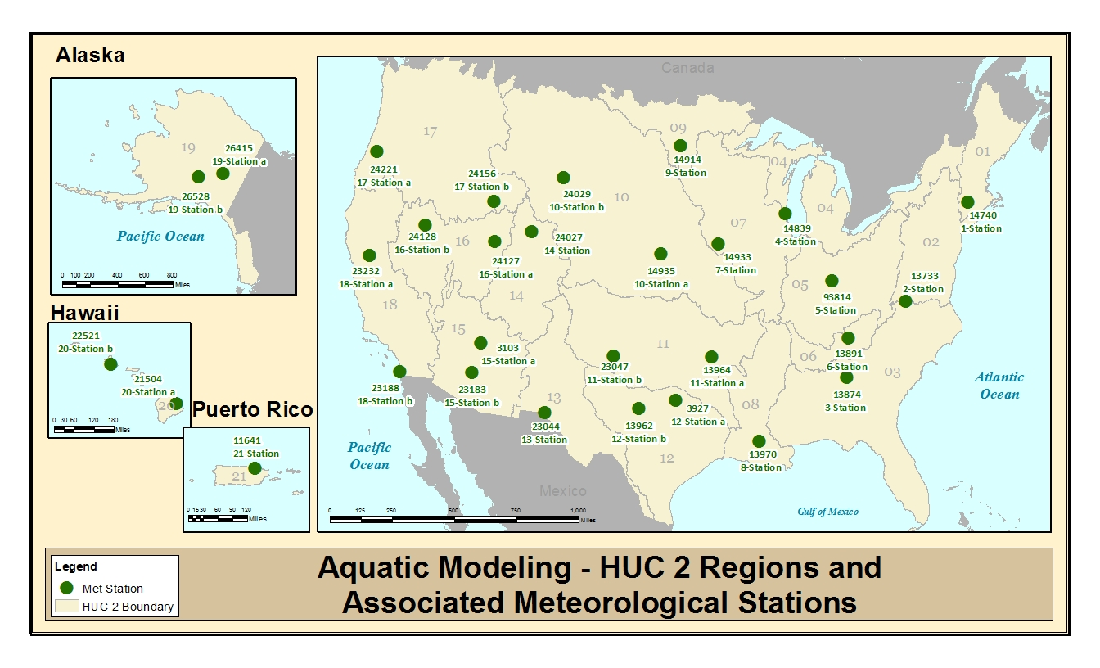Figure 3-1. The Major Hydrologic Unit “Water Resource” Regions (HUC-2) in the Continental United States, Overlain on State Boundaries

## HUC and Use Site Crosswalk

Unless the label limited a use pattern to a particular geographic area, the National Agricultural Statistics Census of Agriculture 2012 (NASS CoA) data along with cropland data were used to determine which crops would be modeled for each represented HUC 2 region. If the NASS data indicated any amount of acres of a crop grown (even if small acreage) in a specific HUC 2 region it was assumed that the crop was grown in that HUC 2 region and malathion may be used on that crop within the HUC 2 region. If there were no reported NASS Cropped acres grown in a particular HUC 2 region, it was assumed that the use did not occur in the HUC. NASS CoA data are not available for Hawaii and Puerto Rico and it was assumed that all uses could occur in Hawaii and Puerto Rico.

## Scenario Selection

To generate spatially relevant exposure concentrations PRZM5/VVWM-scenarios used in model simulations were selected based on the crop group HUC 2 Region scenario matrix provided in **APPENDIX 1-6**. Detail on all agricultural uses of malathion are also presented in **APPENDIX 1-6**. An explanation of how the PRZM5/VVWM scenario matrix was developed is provided in **APPENDIX 1-7**.

Due to malathion’s many agricultural uses, many uses would result in substantially similar model parameterizations. For instance, there are 44 uses of malathion represented by the Vegetable/Ground Fruit land cover class. These 44 uses can be modeled with the same PRZM5/VVWM scenario and same application date though application rates, interval, and number are variable across uses. The range of potential EECs from Vegetable/Ground Fruit uses are represented by modeling the use with highest rate, lowest application interval, and highest application number (*i.e.*, the use with maximum exposure) as well as the use with the lowest rate, highest application interval, and lowest application number (*i.e.*, the use with minimum exposure). In the case of the high exposure use for Vegetable/Ground Fruit land cover class, it is represented by strawberry (2 lbs a.i./A; 7 day interval; 4 applications/year). Though several uses have shorter reapplication intervals and one use has more applications (cabbage), the use on strawberry has the highest exposure potential when considering all application restrictions. In the case of the low exposure use for Vegetable/Ground Fruit land cover class, it is represented by melons (1 lb a.i./A; 7 day interval; 2 applications/year). Though use on mint has a slightly lower application rate (0.94 lb a.i./A), the use on melons has the lowest exposure potential when considering all application restrictions. The same logic was used when selecting uses with the highest and lowest exposure potential for each of the other land classes. Uses with highest and lowest exposure potentials used for modeling and representing the range of exposures for given land cover classes and conventional uses are presented in **Table 3-2.** Uses with highest and lowest exposure potentials for given land cover classes with an ultra-low volume (ULV) application method are presented in **Table 3-3**.

Table 3-2. High/Low malathion conventional uses for each Cropland Data Layer re-classified land cover class

|  |  |  |  |  |  |
| --- | --- | --- | --- | --- | --- |
| **Land Cover Class** | **Use** | **Representative of high, low, or all exposure** | **Rate (lbs a.i./A)** | **Number of applications per year** | **Reapplication Interval (days)** |
| Corn | Corn (field) | High | 1 | 2 | 5 |
| Corn (sweet and pop) | Low | 1 | 2 | 7 |
| Cotton | BWEP | High | 1.24 | 25 | 3 |
| Non-BWEP | Low | 2.5 | 3 | 7 |
| Grassland | Alfalfa Trefoil Vetch | All | 1.25 | 2 | 14 |
| Non-Specified Landcover | Nursery | All | 2.5 | 2 | 10 |
| Other Crop | Clover | All | 1.25 | 2 | 14 |
| Orchard | Citrus | High | 7.5 | 1 | NA |
| Guava | Low | 1.25 | 13 | 3 |
| Other Grain | Rye | High | 1 | 3 | 7 |
| Flax | Low | 0.5 | 3 | 7 |
| Other Row | Beets | High | 1.25 | 3 | 7 |
| Hops | Low | 0.63 | 3 | 7 |
| Other Tree | Christmas Tree2 | All | 3.2 | 2 | 3 |
| Vegetable/Ground Fruit | Strawberry | High | 2 | 4 | 7 |
| Melons | Low | 1 | 2 | 7 |
| Wheat | Wheat2 | All | 1 | 2 | 7 |

NA – Not Applicable

BWEP – boll weevil eradication program, APHIS, USDA

Table 3.3. High/Low malathion ultra-low volume uses for each Cropland Data Layer re-classified land cover class

| **Land Cover Class** | **Use** | **Representative of high, low, or all exposure** | **Rate (lbs a.i./A)** | **Number of applications per year** | **Reapplication Interval (days)** |
| --- | --- | --- | --- | --- | --- |
| Corn | Corn (field) | Low | 0.61 | 2 | 7 |
| Corn (sweet and pop) | High | 0.61 | 2 | 5 |
| Cotton | Cotton | All | 1.22 | 3 | 7 |
| Orchard/Vineyard | Cherries (tart) | High | 1.22 | 6 | 7 |
| Kumquat | Low | 0.175 | 2 | 7 |
| Other Crop | Clover | All | 0.61 | 2 | 14 |
| Other Grains | Sorghum | All | 0.61 | 2 | 7 |
| Other Tree | Christmas tree plantations | All | 0.9375 | 2 | NS |
| Pasture/Hay | Pasture rangeland | All | 0.92 | 1 | NA |
| Rice | Rice; Wild Rice | All | 0.61 | 2 | 7 |
| Vegetables and Ground Fruit | Beans | All | 0.61 | 2 | 7 |
| Wheat | Wheat (spring and winter) | All | 0.61 | 2 | 7 |

NA – Not Applicable

NS – Not Specified; 3 days assumed

## Application Practices

### Application Method

During application of pesticides, methods of application as well as product formulation used by an applicator can impact the off-site transport of the active ingredient. Label directions (such as spray drift buffers, and droplet size restrictions) as well as product formulation are considered as part of the development of use scenario used in modeling. Malathion can be applied foliarly whenever pest pressures indicated on the label are present.



### Spray Drift

Spray drift buffers to water bodies of 25 feet for all non-ULV aerial agronomic applications and 50 feet for all non-ULV aerial applications was stipulated in the 2006 RED mitigations. The Boll Weevil Eradication Program is exempted from this buffer requirement. While spray drift buffers reduce exposure to aquatic environments from direct deposition of finished spray on water via drift, they do not impact modeled estimates run-off received by the waterbody. Detail on spray drift values for all spray drift regimes and all aquatic bins are presented in **APPENDIX 3-3**.

### Application Timing

Pesticide applications are modeled annually on the same Julian days over a 30 year time span. Variability in weather conditions is present with the selection of an application date as the weather varies from year to year on a given day. This variability is reflected and conservatively accounted in the use of EECs with a 1-in-10-year or 1-in-15-year return frequency. A modeled single application can realistically occur over a span of weeks to months for given crops and pest pressures. However, moving single application dates in which 100% of a watershed is treated in a single day in small increments can have a substantial impact on peak EECs and smaller impacts on chronic EECs. Though EEC differences can be substantial, changes of application day by less than one week should not be construed as a model refinement and should only be considered a demonstration of model sensitivity.

For detail on application date selection for use of malathion, see **APPENDIX 1-7**.

## Special Agricultural Considerations

### Multiple Crop-cycles Per Year

Some labels permit applications on crops that may be planted in rotation or may have multiple crop seasons (*e.g.*, various vegetables) per year that could result in multiple applications on the same field. While crop rotations are highly likely for some malathion use sites including corn-wheat such rotations were not modeled but the potential higher exposure is noted. Planting of the same crop on the same plot of land is less likely than crop rotation but can occur. As a conservative approach, when maximum label application rates are specified on a crop cycle basis, it is assumed that multiple crops per year could be planted on the same plot of land for crops. It should be noted that modifications to the PRZM5/VVWM-scenarios (*i.e.*, the curve number) are not made to reflect the change in cropping pattern (*i.e.*, various crop stages or various crops) as the impact on the estimated environmental concentrations are minimal based on a sensitivity analysis that examined the impact of adjusting the crop coverage within the PRZM5/VVWM-scenarios. Furthermore, malathion dissipates rapidly and residues from an application from an initial crop, with respect to a crop rotation or crop cycle, are not expected to increase EECs resulting from an application to a subsequent crop on the same field.

### Hedgerow Uses

Reg. Nos. 67760-35 and 67760-40 are the only approved labels for non-homeowner fence row/hedge row applications of malathion. The use is intended for treatment around agriculture fields that can receive applications of malathion. However, the registrant has agreed to restrict the use on fencerows and hedgerows to non-agricultural settings only (see **APPENDIX 1-5)**. This non-agricultural use pattern is addressed through the homeowner uses in section 3 b) of this document. No hedgerow specific modeling is needed and this use will be embedded in the non-agriculture modeling?

### Rice and Watercress Use

For rice and watercress applications, Pesticides in Flooded Applications (PFAM version 1.0) is used. The model simulates two linked compartments: a water column and a sediment zone (benthos). Each compartment is completely mixed and at internal equilibrium with respect to sorption of the chemical (USEPA, 2004). Pesticide moves between the compartments via a time-limited, first-order mass-transfer process. The model accounts for hydrolysis, photolysis, and metabolism in water, sediment, and soil (when no water is present), sorption, and volatilization. Water, sediment, and pesticide may flow out of the flooded field. Changes in water body conditions (temperature, water levels, wind speed, *etc.)* and resulting changes in degradation rates occur on a daily time step. Pesticide application and flooding sequences are mapped onto the time series in 1-year cycles for the duration of 30 year simulation. Malathion use on rice is modeled as a direct application to the flooded rice paddy and EECs are derived from paddy water concentrations.

For watercress, preliminary information indicates current industry standard is to hold water or prevent water flow through for a period of time after pesticide applications. These management practices are not specified on malathion labels but a 24 hour period after application before re-flood is industry practice and expected to be added to labels. EECs are derived by applying the maximum watercress application rate (1.25 lbs a.i./A) with the maximum number of reapplications (2) at the minimum retreatment interval (7 days) to a dry field. 24 hours after the last application, the field is re-flooded to a depth of 2 inches to achieve an initial EEC (McHugh *et al.*, 1987). At the time of flooding, available malathion residues in the soil equilibrate with the flood waters. Prior to flooding, malathion residues are metabolized at a rate dictated by the aerobic soil metabolism input parameter (half-life = 1 day). Following field flooding, malathion residues are metabolized at rates dictated by the aerobic aquatic input parameter. EECs are derived from field flood waters 24 hours after the last malathion application.

## Nonagricultural Uses and Considerations

### Ultra Low Volume Wide Area Uses

Aerial ULV applications for public health use are released higher above the ground (100 ft), at lower wind speeds (no restriction), and smaller droplet sizes (median diameter of 60 µm and a 90th% diameter of 100 µm) than agricultural uses and therefore have different spray drift and application efficiency estimates. With a swath width of 168 feet, swath displacement of 0 feet, and a wind speed of 1 mph, AGDISP results in an application efficiency of 0.29 and spray drift corresponding to each aquatic bin is presented in **APPENDIX 3-3**. ULV ground application field studies and indicates peak deposition ranges from 2% to 33% of the application rate for all pesticides and from 9% to 33% of the application rate for malathion (Mickle *et al., 2005;* Tucker *et al* 1987; Tietze *et al* 1994; Schleier and Peterson 2010)**.** Based on comparable deposition rates and lower application rates, ground ULV applications are conservatively represented by spray drift modeling from aerial ULV applications. Aerial ULV applications conservatively account for ground ULV applications with wind speeds of more than two miles per hour (EPA, 2013; MRID 46963401)

### Homeowner Uses

Malathion is registered for on many distinct homeowner uses which, when assessed as a whole, can encompass a substantial use footprint on a typical residential plot. Malation homeowner uses are: various garden uses, house perimeter, along fences, patios, garbage cans, under porches, shrubbery, firewood piles, and ornamentals. USEPA has developed a standard residential exposure scenario using a quarter acre lot and houses with a 1000 ft2 footprints to assess this list of co-occurring uses.  Houses are assumed to be square with sides of 31.6 feet and a 15 feet wide driveway to the house.  Therefore, the perimeter of the house that is treated on sod or lawn (pervious surfaces) within 2 feet of the house foundation is:

$$\left(31.6\text{ft}×2\text{sides}+\left(31.6\text{ft+4ft}\right)×2\text{sides}-15\text{ft driveway}\right)×2\text{ft}=238.8{\text{ft}}^{2}$$

Where:  31.6 ft is the length of the house; and 4 ft is twice the perimeter widths to account for the additional corner areas of the perimeter. There is an additional 2 ft of the walls of the house that is treated which has the potential to wash-off to this same area of pervious surface:

$$\left(31.6\text{ft}×4\text{sides}-15\text{ft driveway}\right)×2\text{ft}=222.8{\text{ft}}^{2}$$

Therefore the total area of treatment that may drain through pervious area is 461.6 ft2 (238.8 ft2 + 222.8 ft2).It is assumed that treatment to both horizontal and vertical surfaces (lawn, flower beds, driveway, walls, and garage door) are available to run off the treated area.  Malathion homeowner use, however, is not limited to perimeter treatment and also includes patios, garbage cans, under porches, shrubbery, along fences, firewood piles, ornamental vegetation, and gardens.  To address these additional uses, additional treated surfaces have been added to the standard residential exposure scenario.

To address applications along fences, a fence is assumed to surround the quarter acre lot aside from a 15 foot area for driveway access and malathion is assumed to be applied in a two foot swath.  Fence along property lines is assumed to be in contact with grass or other pervious surfaces, however, fence facing a road is assumed to be in direct contact with an impervious surface.  Fences in contact with pervious surfaces are modeled using the PRZM Rights of Way (Curve number = 93) scenario, to represent surfaces from turf to loose soil to packed soil, while those in contact with impervious surfaces are modeled using the PRZM Impervious scenario (Curve number = 98), to represent paved surfaces.  Therefore, area of application on a given lot along fences with pervious surfaces modeled using the Rights of Way scenario is:

$$2 ft*104 ft+2*2 ft*100 ft=608 {ft}^{2}$$

Area of application on a given lot along fences with impervious surfaces modeled using the Impervious scenario is:

$$2 ft*104 ft-2 ft*15 ft=178 {ft}^{2}$$

To address applications to patios, garbage cans, under porches, shrubbery, firewood piles, and ornamental vegetation, simplifying assumptions were made.  It is assumed that the sum of the list of uses encompasses 1,000 ft2 on a quarter acre lot.  This is represented, to scale, in **Figure 3-2** by ten 100 ft2 squares and is modeled using the Rights of Way scenario. To address applications to home gardens, HED’s recommended point estimate for garden size of 1,200 ft2 is used (EPA, 2012).  This garden size fits reasonably within the established quarter acre lot seen in Figure 1 and is modeled using the PRZM Residential scenario (Curve number = 83).

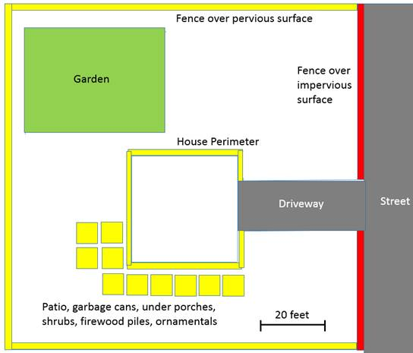

Figure 3-2.  Residential conceptual model of malathion applications.  PRZM scenarios are represented in green (Residential), yellow (Rights of Way), and red (Impervious).

For modeling purposes, all uses with like scenarios and like application rates are summed.  House perimeter treatments, fences over pervious surfaces, patios, garbage cans, under porches, shrubs, firewood piles, and ornamentals are modeled with the Rights of Way scenario at an application rate of 0.0054 lb a.i. /1000 ft2. As calculated above, house perimeter treatment accounts for 2.5% of the quarter acre lot, and therefore the watershed, treated.  Fences over pervious surfaces account for 608 ft2 of treated area or 5.6% of the quarter acre lot.  Patios, garbage cans, under porches, shrubs, firewood piles, and ornamentals account for 1,000 ft2 of treated area or 9.0% of the quarter acre lot.  Together, these Rights of Way PRZM scenario uses account for 17.1% of the total area.  Fences over impervious surfaces account for 178 ft2 of treated area or 1.6% of the quarter acre lot.  As the only Impervious PRZM scenario use, it accounts for 1.6% of the total area.  The garden use accounts for 1,200 ft2 of treated area or 11% of the quarter acre lot.  As the only Residential PRZM scenario use, it accounts for 11% of the total area. **Table 3-4** summarizes theses uses, rates, intervals and percent use areas.

Table 3-4. Application information for modeled homeowner scenario based on maximum labeled application rates.

|  |  |  |  |
| --- | --- | --- | --- |
| **PRZM Scenario** | **Residential** | **Rights of Way** | **Impervious** |
| **Included uses** | Garden | House perimeter, along fences, patios, garbage cans, under porches, shrubbery, firewood piles, ornamentals | Along fences over impervious surfaces |
| **Application rate** | 5.1 lbs a.i./A1 | 0.24 lb a.i./A2 | 0.24 lb a.i./A2 |
| **Application interval** | 10 days | 7 days | 7 days |
| **Percent Use Area** | 11% | 17.1% | 1.6% |

1  Highest homeowner garden use rate (outdoor ornamentals; EPA Reg. No. 28293-123)

2  Registrant agreed upon maximum application rate for homeowner non-garden uses

## Aquatic Modeling Input Parameters

For Step 1 analysis, aquatic exposure modeling was not performed, as the action area for malathion encompasses the entire United States. The following sections discuss methods used for modeling under Step 2.  Complete results of the Step 2 analysis are provided with the release of the complete BE. Summaries of the environmental fate model input parameters used in the PRZM5/VVWM and PFAM are presented in **Tables 3-5** and **3-6**, respectively. Input parameters were selected in accordance with EFED’s following guidance documents:

* Guidance for *Selecting Input Parameters in Modeling the Environmental Fate and Transport of Pesticides*, Version 2.1 (USEPA, 2009),
* *Guidance for Evaluating and Calculating Degradation Kinetics in Environmental Media* (NAFTA, 2012; USEPA, 2012c), and
* *Guidance on Modeling Offsite Deposition of Pesticides Via Spray Drift for Ecological and Drinking Water Assessmen*t (USEPA, 2013)

Registrant submitted studies and open literature studies have been considered for the derivation of an aerobic soil metabolism input parameter. Summaries of these studies are presented in the following table (**Table 3-7**).

Table 3-5. Input values used for Tier II surface water modeling with PRZM5/VVWM

| **Parameter (units)** | **Residue** | **Value (s)** | **Source** | **Comments** |
| --- | --- | --- | --- | --- |
| Organic-carbon Normalized Soil-water Distribution Coefficient (KOC (L/kg-OC)) | Malathion | 217 | 41345201 | Average of five KOC estimates from five soils ranging 151 to 308 L/kg-OC. |
| Water Column Metabolism Half-life or Aerobic Aquatic Metabolism Half-life (days @25C) | Malathion | 3.4 | 48906401;  42271601 | 1.03 (SFO), 3.35 (SFO), 0.33 (IORE), 2.69 (SFO); 1.09 (SFO)  3.29 days represents the 90 percent upper confidence bound on the mean of five representative half-life values. The registrant provided a half-life estimate of 3.4 days after adjusting for hydrolysis. This value cannot be reproduced but can be conservatively considered to be the half-life. If pH 7 were assumed for all aerobic aquatic metabolism half-lives, adjusting the aerobic aquatic input parameter for the associated pH 7 hydrolysis (half-life = 6.2 days) would result in a 4.8 day half-life. Water pH in aerobic aquatic metabolism studies ranged from 5.1 to 8.1. Hydrolysis is also tested at pH 5 resulting in a half-life of 109 days. Given the range of pH in the study and the sensitivity of pH to hydrolysis, some hydrolysis can be assumed to occur. An input value between 3.29 days (assuming no hydrolysis or alkaline conditions) and 4.8 days (pH 7 hydrolysis) is appropriate. |
| Benthic Metabolism Half-life or Anaerobic Aquatic Metabolism Half-life (days) and Reference Temperature | Malathion | 3.3 | 42216301 | 1.09 days in water pH 8.5  1.09 days in sediment Sand pH 7.8  1.09 days in total system  Representative half-life value from one study times three. |
| Aqueous Photolysis Half-life @ pH 7 (days) and Reference Latitude 40o N latitude, 25oC | Malathion | Stable (0) at 40oN (PRZM5/VVWM)  1e8 (PFAM) | 41673001 | Degradation occurring in photolysis study is dominated by hydrolysis. Degradation through photolysis is assumed stable to avoid double counting. |
| Hydrolysis Half-life (days) | Malathion | Stable (0) (PRZM5/VVWM)  1e8 (PFAM) | 40941201 | Half-lives are 107 days (pH 5), 6.2 days (pH 7), and 0.5 days (pH 9) but hydrolysis is accounted through the water column metabolism parameter |
| Soil Half-life or Aerobic Soil Metabolism Half-life (days) and Reference Temperature | Malathion | 1 | 41721701  46769501  47834301 | 90th% mean on seven half-lives from registrant submitted guideline studies results in 0.5 day half-life input parameter (See Table 4). However, GLN 835.4100 stipulates soil moisture at 40%-60% of water holding capacity and malathion rapidly hydrolyzes. Non-guideline studies indicate that persistence is increased in soils with low moisture and low microbial activity (Walker and Stojanovic 1973). To account for the contribution of hydrolysis to in metabolism studies, the input parameter is doubled. |
| MWT or Molecular Weight (g/mol) | Malathion | 330.36 | Product Chemistry |  |
| Vapor Pressure (Torr) at 30oC | Malathion | 4 × 10-5 | Product Chemistry |  |
| Solubility in Water @ 25 OC, pH not reported (mg/L) | Malathion | 145 | Product Chemistry |  |
| Foliar Half-life (days) | Malathion | 6.1 | Willis & McDowell, 1987 | 90th% mean on 37 malathion residue foliar persistence half-lives ranging from 0.3 to 10.9 days |
| Heat of Henry | Malathion | 54,000 J/mol | EPI Suite |  |
| Number of Applications | Malathion |  | Malathion Use Summary table |  |
| Dates | Malathion | See Results Table | Assumed based on type of application | Date selected within wettest month which malathion could be reasonably applied to a given crop. |
| Amount |  | Malathion Use Summary table | Maximum single application rate for the crop or use pattern |
| Application method | Malathion | Foliar | Malathion Use Summary table |  |
| Application Efficiency | Malathion | Aerial: 0.95 | Input parameter guidance (USEPA, 2009) |  |
| Drift | Malathion | Aerial: 0.0733  Ground: 0.0071 | Offsite transport guidance (EPA, 2013) | Through RED mitigation, a 50 foot buffer for ULV aerial applications, a 25 foot buffer for conventional aerial applications, and no buffer for ground applications to water bodies is required.  Spray drift values reflect that mitigation. |
| PRZM5/VVWM Scenario | Malathion | See Results Table |  |  |

Table 3-6. PFAM Inputs for Malathion Use

| **Input Parameter** | **Value** | **Source** | **Comment** |
| --- | --- | --- | --- |
| **Chemical Tab, see Table 11** | | | |
| **Applications Tab** | | | |
| Application rate | 1.25 lbs a.i./A | Malathion Use Summary Table |  |
| Number of Applications per Year | 2 (rice)  5 (watercress) | --- | --- |
| Application Interval (days) | 7 (rice)  3 (watercress) |  |  |
| Initial application date | 6-10 | --- | For rice, apply from when first rice blades appear to milk or dough stage (2 months after planting)1. Same application date selected for watercress, as EECs are driven by the flooded paddy rather than weather. |
| Slow Release 1/day | 0 | -- | Conservative assumption |
| Drift Application | 0 | -- | Drift to an adjacent water body or mixing cell was not modeled. EECs are taken from within paddy. |
| Watercress Flood Tab | | | |
| Number of Flood Events | 3 |  | Flooding regime models release of water 24 hours prior to malathion treatment and reflooding 24 hours after last application. Flood height is two inches (McHugh *et al.*, 1987). |
| Date of Event 1 (Month-Day) | 6-8 |  |
| Turn Over (1/day) | 0 |  |
| **Days After (Month-day)** | **Fill Level, Min Level (m)** | **Wier (m)** |
| **0 (June-8)** | **0.05** | **0.2** |
| 1  (June-9) | 0 | 0 |
| 15 (June-24) | 0.05 | 0.2 |
| **Rice Flood Tab** | | | |
| Number of Flood Events | 2 | -- | Flooding to 4 inches. Initial flood date selected to precede planting in Arkansas and California |
| Date of Event 1 (Month-Day) | 4-10 | -- |
| Turn Over (1/day) | 0 | Assumed |
| **Days After (Month-day)** | **Fill Level, Min Level (m)** | **Wier (m)** |
| 0  (April-10) | 0.1016 | 0.2 |
| 184 (Oct-11) | 0 | 0 |

Table 3-7.  Summaries of registrant submitted and open literature malathion aerobic soil metabolism data

|  |  |  |
| --- | --- | --- |
| **Source** | **Degradation Rate Value** | **Comments** |
| MRID 41721701 | T1/2 = 0.098 days (SFO)  T1/2 = 0.152 days (SFO) | Loam; 2.0% OM; 10.6 CEC  Loam; 2.7% OM; 10.1 CEC |
| MRID 46769501 | T1/2 = 0.102 days (SFO)  T1/2 = 0.166 days (IORE)  T1/2 = 0.264 days (SFO)  T1/2 = 0.279 days (SFO) | Silty clay; 3.6% OM; 28 CEC  Silty loam; 2.5% OM; 13 CEC  Sand; 0.9% OM; 5 CEC  Silty loam; 2.2% OM; 13 CEC |
| MRID 47834301 | T1/2 = 1.15 days (IORE) | Loamy sand; 0.5% OM; 3.41 CEC |
| Miles and Takashima 1991 | t½ = 8.2 h (laboratory)  t½ = 2 h (field) | Malathion was mixed with Lihue soil and incubated at 22oC in lab experiment. Sterilization decreased rate by 2-fold. |
| Walker and Stojanovic 1974 | 47-95% at 7 days | Malathion was incubated with various Arthrobacter species. Degradation in the presence of the 5 most efficient species was reported. |
| Walker and Stojanovic 1973 | t½ = ~ 2 days under non-sterile unfavorable degradation conditions. | In 3 Mississippi soils examined at 25-26oC, soil microflora were important in degradation. Slowest degradation occurred in soils with low nitrogen, moisture, and carbon content and increased acidity. |
| CalEPA 1994 | DT50 = 4.2-6.9 days on sand | Measured at 5 sites under the conditions of the medfly eradication program. Each site consisted of 10 aluminum trays containing 500g of playground sand. Between applications trays were covered. |
| CalEPA 1993 | DT50 < 12 h on sand | Application was under controlled conditions, but temperature was not noted. |
| CalEPA 1993 | 38% remaining at 12 hours  15% remaining at 20 days | 66% sand, 24% silt, 10% clay, 0.78% water, pH 6.3. Malathion was applied under controlled conditions. Degradation was biphasic. |
| Kearney *et al* 1969 | 75-100% degradation in 1 week | Field persistence |
| Lichtenstein and Schultz 1964 | 85% dissipation in 3 days | Conducted under field conditions |
| Howard 1991 | Reported average literature  t½ = 6 d | In this review, persistence is stated to vary with moisture content and pH. |

## Aquatic Modeling Results

The estimated environmental concentrations (EECs) derived from the PRZM5/VVWM modeling, by HUC2 and aquatic bin, are summarized in **Table 3-8**. High EECs primarily result from orchard, non-specified land cover, cotton and vegetable/ground fruit scenarios. Low EECs primarily result from the combination of scenarios resulting from the residential exposure assessment. The complete set of modeling results are available in **APPENDIX 3-4**.

Table 3-8 Range of PRZM5/VVWM Daily Average EECs

|  |  |  |  |  |  |  |
| --- | --- | --- | --- | --- | --- | --- |
| **HUC 2** | **Range of 1-in-15 year Daily Average EECs (µg/L)** | | | | | |
| **Bin 2** | **Bin 3** | **Bin 4** | **Bin 5** | **Bin 6** | **Bin7** |
| HUC 1 | 19.9 - 889 | 8.80 - 267 | 8.09 - 209 | 4.22 - 945 | 0.731 - 92.8 | 0.363 - 17 |
| HUC 2 | 17.2 - 863 | 11.80 - 410 | 11.40 - 402 | 1.87 - 915 | 0.529 - 89.4 | 0.267 - 15.9 |
| HUC 3 | 22.5 - 913 | 11.10 - 287 | 11.10 - 285 | 2.84 - 972 | 1.41 - 103 | 0.7 - 21.9 |
| HUC 4 | 17.9 - 808 | 7.52 - 239 | 6.62 - 229 | 2.37 - 856 | 0.618 - 89.4 | 0.31 - 19.6 |
| HUC 5 | 21.1 - 866 | 15.30 - 349 | 15.20 - 340 | 2.61 - 923 | 0.68 - 91 | 0.345 - 15.9 |
| HUC 6 | 21.4 - 923 | 16.60 - 652 | 16.20 - 635 | 1.14 - 982 | 0.488 - 97.9 | 0.248 - 16.9 |
| HUC 7 | 16.2 - 817 | 11.80 - 264 | 11.80 - 268 | 9.08 - 944 | 1.66 - 99.3 | 0.835 - 22.8 |
| HUC 8 | 20.5 - 786 | 11.80 - 270 | 11.60 - 255 | 0.467 - 839 | 0.398 - 82.4 | 0.15 - 14.6 |
| HUC 9 | 19.7 - 775 | 5.97 - 157 | 5.24 - 136 | 16.4 - 822 | 3.34 - 81.3 | 0.775 - 22.8 |
| HUC 10a | 17.8 - 827 | 11.50 - 352 | 11.50 - 352 | 13.1 - 1000 | 12.4 - 625 | 5.62 - 300 |
| HUC 10b | 15.2 - 911 | 9.41 - 294 | 9.34 - 295 | 4.34 - 993 | 5.99 - 228 | 2.38 - 90.4 |
| HUC 11a | 17.2 - 837 | 16.20 - 317 | 16.30 - 322 | 5.85 - 896 | 9.45 - 290 | 4.01 - 131 |
| HUC 11b | 12.2 - 817 | 13.30 - 387 | 15.70 - 390 | 3.95 - 876 | 6.55 - 341 | 2.86 - 163 |
| HUC 12a | 18 - 808 | 16.90 - 430 | 17.50 - 440 | 6.76 - 884 | 3.41 - 149 | 1.31 - 57 |
| HUC 12b | 15.1 - 752 | 14.00 - 367 | 15.40 - 371 | 4.07 - 800 | 3.99 - 152 | 1.83 - 64 |
| HUC 13 | 11.4 - 745 | 12.90 - 288 | 10.50 - 284 | 119 - 9880 | 20 - 1690 | 7.6 - 651 |
| HUC 14 | 14.6 - 795 | 7.57 - 279 | 7.51 - 277 | 35 - 2890 | 4.71 - 745 | 1.51 - 349 |
| HUC 15a | 19.5 - 822 | 19.10 - 590 | 18.80 - 588 | 131 - 4870 | 55.2 - 1780 | 11.8 - 376 |
| HUC 15b | 15.5 - 888 | 14.80 - 652 | 14.60 - 631 | 71.2 - 3000 | 24.7 - 1180 | 5.22 - 250 |
| HUC 16a | 14.5 - 794 | 16.10 - 469 | 6.21 - 197 | 50.3 - 1450 | 14.8 - 409 | 5.9 - 186 |
| HUC 16b | 9.77 - 795 | 7.57 - 422 | 2.31 - 124 | 28.2 - 1090 | 5.26 - 209 | 1.36 - 76 |
| HUC 17a | 22.1 - 886 | 11.90 - 329 | 11.50 - 325 | 8.09 - 942 | 9.82 - 474 | 3.97 - 213 |
| HUC 17b | 10.1 - 909 | 3.60 - 145 | 3.52 - 129 | 0.366 - 962 | 2.73 - 121 | 1.05 - 29.9 |
| HUC 18a | 21 - 1370 | 12.80 - 562 | 13.40 - 576 | 21.9 - 1410 | 3.81 - 181 | 0.874 - 65.1 |
| HUC 18b | 15.4 - 1330 | 8.89 - 532 | 9.00 - 540 | 20 - 1380 | 3.4 - 146 | 0.813 - 50.7 |
| HUC 19a | 6.45 - 836 | 4.50 - 272 | 4.02 - 233 | 0.0722 - 851 | 0.682 - 99.6 | 0.346 - 30.3 |
| HUC 19b | 15.3 - 845 | 10.60 - 211 | 8.93 - 182 | 0.749 - 863 | 5.58 - 142 | 2.8 - 51.9 |
| HUC 20a | 21.8 - 748 | 10.90 - 281 | 11.10 - 285 | 54.7 - 1430 | 9.35 - 251 | 4.26 - 105 |
| HUC 20b | 15.7 - 741 | 5.91 - 170 | 5.55 - 175 | 19.2 - 789 | 3 - 139 | 1.04 - 57.2 |
| HUC 21 | 21.2 - 737 | 15.60 - 284 | 15.30 - 270 | 8.56 - 782 | 0.967 - 68.2 | 0.487 - 11.5 |

Pore water EECs are presented below in **Table 3-9**.

Table 3-9 Range of PRZM5/VVWM Pore Water EECs

|  |  |  |  |  |  |  |
| --- | --- | --- | --- | --- | --- | --- |
| **HUC 2** | **Range of 1-in-15 year EECs (µg/L)** | | | | | |
| **Bin 2** | **Bin 3** | **Bin 4** | **Bin 5** | **Bin 6** | **Bin7** |
| HUC 1 | 0.712 - 430 | 0.56 - 1,910 | 0.56 - 2,130 | 0.236 - 61.5 | 0.0506 - 9.77 | 0.0258 - 4.36 |
| HUC 2 | 0.476 - 235 | 0.46 - 828 | 0.44 - 660 | 0.0639 - 79.7 | 0.0225 - 12.2 | 0.0118 - 3.49 |
| HUC 3 | 1.1 - 109 | 0.66 - 457 | 0.63 - 502 | 0.165 - 87.3 | 0.124 - 13.6 | 0.0643 - 2.72 |
| HUC 4 | 0.388 - 302 | 0.37 - 1,320 | 0.37 - 1,390 | 0.0712 - 46 | 0.0228 - 9.42 | 0.0121 - 5.68 |
| HUC 5 | 0.521 - 97.8 | 0.51 - 342 | 0.50 - 324 | 0.106 - 55 | 0.0367 - 7.26 | 0.0191 - 2.17 |
| HUC 6 | 0.878 - 98.5 | 0.65 - 419 | 0.61 - 475 | 0.0639 - 96.1 | 0.0402 - 14.7 | 0.0214 - 2.69 |
| HUC 7 | 0.44 - 83.2 | 0.45 - 491 | 0.49 - 502 | 0.288 - 42.4 | 0.0628 - 6.04 | 0.0324 - 3.27 |
| HUC 8 | 0.97 - 208 | 0.46 - 701 | 0.44 - 567 | 0.0142 - 36.7 | 0.0154 - 3.97 | 0.00633 - 1.1 |
| HUC 9 | 0.724 - 395 | 0.66 - 2,390 | 0.69 - 2,830 | 0.777 - 50.6 | 0.246 - 25.6 | 0.128 - 20.1 |
| HUC 10a | 0.502 - 67.9 | 0.54 - 249 | 0.56 - 250 | 0.383 - 47.8 | 0.627 - 28.3 | 0.323 - 14.9 |
| HUC 10b | 0.694 - 86.7 | 0.64 - 199 | 0.66 - 186 | 0.253 - 82.9 | 0.5 - 23.9 | 0.26 - 8.8 |
| HUC 11a | 0.341 - 41.3 | 0.61 - 137 | 0.79 - 179 | 0.208 - 45.7 | 0.475 - 14.3 | 0.216 - 7.16 |
| HUC 11b | 0.331 - 38.8 | 0.55 - 105 | 0.70 - 123 | 0.145 - 41.4 | 0.328 - 14.3 | 0.151 - 7.24 |
| HUC 12a | 0.371 - 37.4 | 0.62 - 127 | 0.77 - 158 | 0.26 - 41 | 0.239 - 9.23 | 0.0801 - 3.97 |
| HUC 12b | 0.31 - 36.1 | 0.55 - 93 | 0.69 - 222 | 0.124 - 41.5 | 0.152 - 6.86 | 0.0832 - 2.81 |
| HUC 13 | 0.305 - 40.4 | 0.61 - 293 | 0.31 - 29 | 4.24 - 316 | 0.821 - 69.5 | 0.321 - 28.9 |
| HUC 14 | 0.539 - 106 | 0.50 - 135 | 0.47 - 70 | 3.02 - 200 | 0.5 - 66.3 | 0.158 - 31.4 |
| HUC 15a | 0.983 - 177 | 0.70 - 429 | 0.64 - 299 | 5.67 - 203 | 3.09 - 90.1 | 0.685 - 20.1 |
| HUC 15b | 0.42 - 106 | 0.69 - 365 | 0.60 - 331 | 4.04 - 132 | 1.86 - 68.5 | 0.402 - 16.6 |
| HUC 16a | 0.603 - 88.8 | 0.94 - 215 | 0.48 - 13 | 3.34 - 161 | 1.46 - 46.6 | 0.582 - 20.2 |
| HUC 16b | 0.444 - 182 | 0.50 - 27 | 0.24 - 15 | 1.89 - 199 | 0.838 - 44.6 | 0.175 - 13.3 |
| HUC 17a | 1.29 - 79.5 | 1.20 - 352 | 1.12 - 334 | 0.659 - 114 | 0.889 - 66 | 0.416 - 32 |
| HUC 17b | 0.373 - 73.5 | 0.31 - 24 | 0.37 - 33 | 0.0213 - 79.4 | 0.234 - 12.6 | 0.105 - 3.22 |
| HUC 18a | 0.696 - 74.7 | 0.39 - 248 | 0.48 - 494 | 1.77 - 103 | 0.377 - 24.1 | 0.1 - 9.15 |
| HUC 18b | 0.392 - 65.6 | 0.28 - 137 | 0.41 - 299 | 0.993 - 69.5 | 0.221 - 14.3 | 0.0535 - 4.56 |
| HUC 19a | 0.244 - 71.7 | 0.20 - 21 | 0.22 - 56 | 0.0060 - 71.9 | 0.0869 - 11.4 | 0.0469 - 3.5 |
| HUC 19b | 0.599 - 86.1 | 0.39 - 62 | 0.42 - 140 | 0.0472 - 98.3 | 0.514 - 18.8 | 0.267 - 6.73 |
| HUC 20a | 0.646 – 28.4 | 0.61 - 67 | 0.70 - 81 | 2.11 – 54.7 | 0.44 – 13.2 | 0.183 – 6.19 |
| HUC 20b | 0.387 - 27.3 | 0.13 - 40 | 0.14 - 49 | 0.691 - 38.1 | 0.136 - 7.12 | 0.0462 - 2.86 |
| HUC 21 | 0.889 - 92.2 | 0.40 - 407 | 0.40 - 426 | 0.314 - 22.8 | 0.0415 - 2.8 | 0.022 - 1.14 |

In the draft BEs, there was little confidence in the EECs derived using the PRZM5/VVWM model for Bin 3 (moderate flow aquatic bin) and Bin 4 (high flow aquatic bin) as (a) the maximum EECs exceeded the active ingredient’s water solubility limit, (b) the EECs were higher than those estimated for Bin 2, which should not have occurred as the higher flowrates in Bins 3 and 4 should have contributed to dilution as well as advective dispersion, (c) the EECs for Bin 3 were higher than those estimated for Bin 4, which again, given the higher flowrate for Bin 4, was contrary to what one would expect, and (d) the EECs were higher, by several orders of magnitude, than those derived for the static bins, which have no outlet for the release of pesticide. As a result, a qualitative approach was considered in the draft BEs, where Bin 2 EECs were generated using the PRZM5/VVWM, Bin3 EECs were characterized as being conservatively 5 and 10 times lower than the Bin 2 EECs, and the Bin 4 EECs were characterized as being conservatively 5 and 10 times lower than the Bin 3 EECs.

During the public comment period, recommendations were discussed that were subsequently incorporated into EFED’s methodology for estimating PRZM5/VVWM model generated Bin 3 and 4 EECs.

Perhaps most importantly, daily (24-hour) mean concentrations have been adopted in place of the initial (time zero) concentrations that EFED had previously employed as acute EECs. From an exposure perspective, daily mean concentrations provide a more meaningful metric, than do initial concentrations, for comparison against the results of acute toxicity studies, where organisms are exposed to a pesticide for at least 48 hours. Additionally, the initial concentrations are essentially a hypothetical construct that is inherent in the way EFED currently calculates daily mean concentrations. When a modeled receiving water body is relatively large compared with its watershed and has a residence time (i.e., the amount of time water spends in a waterbody) on the order of months, which is the case for EFED’s Index Reservoir, or is assumed to have no flow out of it, which is the case for the EFED standard pond, daily mean and initial concentrations are typically very close to each other. However, as the size (volume) of receiving water body shrinks in comparison to its watershed, and particularly as residence times decline below one day, as is the case for the flowing bins used in the BEs, the initial and daily mean concentrations begin to diverge, with smaller residence times resulting in a larger divergence. This is a result of the assumptions inherent in the calculation methodology, and not a reflection of fundamental differences in physical or chemical processes at work in smaller receiving water bodies.

Another recommendation that has been adopted is incorporation of baseflow into the flow for Bins 3 and 4. Baseflow is the portion of streamflow that comes from subsurface discharge to a stream or river (as opposed to direct overland runoff). Baseflows for use in modeling were derived from regionally-representative estimates of baseflow index (BFI), defined as the fraction of total (long-term) stream flow that consists of baseflow. BFI values were extracted from EPA’s Stream-Catchment (StreamCat) dataset, which provides estimates of this property for the millions of flowing reaches across the country that are represented in the National Hydrography Dataset (NHD). Within each HUC 2, the average BFIs for reaches with flows similar to those of Bins 3 and 4 were calculated and tabulated. The HUC/Bin specific BFIs are currently applied to the annual average flowrate assigned for each bin (1 m3/s and 100 m3/s for Bin 3 and 4, respectively), in order to provide a HUC 2-specific baseflow value for use in each simulation.

Lastly, a third recommendation that has been adopted into the Bin 3 and 4 simulations provides adjustments that are intended to account for how long it takes moving water to transport pesticide to the end of the bin from different starting points in the watershed. A pesticide that is deposited (via runoff or spray drift) into a headwater stream may not reach a downstream waterbody of interest until days later, while a pesticide deposited directly into the downstream waterbody is present immediately. The watersheds of Bins 3 and 4 are sufficiently large that their stream drainage networks include upstream zones that take multiple days for the pesticide and water to be transported to the end of the bin. To account for this, “time-of-travel” adjustments have been implemented, so that the watersheds associated with Bin 3 and 4 waterbodies are divided into fractions that represent the nominal number of days required to move the pesticide through the stream network of the bin. Portions of the total pesticide load (mass) introduced by a runoff or drift event are offset by time lags that reflect their nominal distance, in days, upstream from the end of the bin. Following apportionment by watershed area fraction and offsetting by the appropriate time lag, the time series from each upstream section are superimposed to generate an overall time series reflecting circumstances at the end of the bin. The time series for the runoff volume (flow) and pesticide mass are each treated in this manner. At this time hydrodynamic dispersion, or the flattening of a pesticide concentration in the direction of the flow, is not included in the simulations, although EFED is considering this as a potential, future modification of the new methodology. Representative area fractions for Bin 3 and 4 watersheds are based on mean upstream area fractions within each HUC 2, from NHD data for reaches that have mean flowrates within 5% of the defined flowrates for Bins 3 and 4 (1 and 100 m3/s, respectively). It should be noted that, as this methodology is still under development, EFED has not incorporated this refinement into the BE’s for the three OP’s; however, EFED does intend to incorporate this adjustment into the BEs for carbaryl and methomyl.

Results from PFAM for use on rice indicate a peak aquatic EEC with a 1-in-15-year return frequency of 20 parts per million and is generally in the range but on the high end of EECs generated using PRZM5/VVWM. Results from PFAM for use on watercress indicate a peak aquatic EEC with a 1-in-15-year return frequency of 481 parts per billion and is generally in the range of EECs generated using PRZM5/VVWM.

## Aquatic Modeling Sensitivity Analysis

A key recommendation of the NAS report on ESA was to characterize model sensitivities and to quantify, where possible, the impact of the assumptions surrounding those inputs on model outputs. In the case of EPA’s aquatic exposure assessment, the model sensitivities have been examined and documented by various agencies (Carbonne, et al 2002; EPA, 2004; Young, 2014). The sensitivity of the various input parameters was also evaluated during the development of the underlying models the PRZM5 and the VVWM (replacement model for EXAMS) (Burns, 2004; FEMVTF, 2001).

Pesticide runoff is sensitive to a combination of factors including pesticide application date, application method, curve number, pesticide degradation rate, pesticide sorption coefficient, and rainfall timing and amount. In more arid regions such as California, spray drift may contribute more to surface water EECs than runoff. The California Department of Pesticide Regulation’s evaluation of pesticide runoff has indicated that as much as 95% of the variability in surface runoff from PRZM5 can be accounted for by a few select fate parameters and the curve number (Luo et al 2012). Curve number is an empirical parameter used in PRZM to predict direct runoff from a field. A curve number is dependent on the hydrologic soil group, land use treatment, or cover, and the hydrologic condition of the field (*i.e.*, poor or good). Pesticide runoff is also sensitive to the application rate, as the potential for runoff and drift increases with greater chemical application. However, as EPA regulates pesticides based on the label to ensure that the maximum label rate does not result in adverse effects to aquatic species, the application rate is not considered a factor in the sensitivity of the modeling but rather a factor examined during risk mitigation.

For waterbodies, the input parameters having the greatest effect on the EEC are aerobic aquatic metabolism, sorption, and to a lesser extent aqueous photolysis and volatility. Photolysis is of lesser importance because it is sensitive to light intensity, and thus more active in the upper portion of the water column. While EECs in a waterbody are expected to be lower for volatile chemicals, detections of volatile chemicals would only likely be observed if the chemical is transported to the waterbody. In flowing waterbodies, flow rate through the waterbody also has an impact on EECs, as the lower the flow rate, the longer the residence time in the waterbody and the higher the concentration.

For surface water modeling, the variability and uncertainty in the model input parameters and their impact on EECs are captured in a number of ways. Variability in model output due to curve number selection is captured by the spatial variation in soil types represented by EPA’s PRZM5/VVWM scenarios. The sensitivity to rainfall timing and intensity is similarly captured by varying scenarios across the landscape and also by utilizing multiple years of meteorological data (*i.e.*, precipitation). Sensitivity to application date selection is captured by varying the selected application date across a window of anticipated application dates typically derived from a variety of sources including label information, USDA Crop Profiles, USDA Usual Planting and Harvesting Dates, Usage data (both public and proprietary), and available information on pest pressures, such as information available in the crop profiles from the Integrated Pest Management Center (http://www.ipmcenters.org//index.cfm/center-products/crop-profiles/). Finally, EPA typically has the ability to characterize the potential influence of known variability in key fate input parameters, and explore alternative assumptions. For example, **Table 3-10** shows the range of soil metabolism and adsorption properties that can be varied for sensitivity analysis purposes.

Table 3-10. Parameter Sensitivity analysis for malathion

|  |  |  |  |
| --- | --- | --- | --- |
|  | **Modeled1** | **Low** | **High** |
| **KOC (mL/g o.c.)** | 217 | 151 | 308 |
| **Aerobic aquatic t1/2 (days)** | 3.4 | 1.03 | 4.8 |
| **Anaerobic aquatic t1/2 (days)** | 3.32 | 1.12 | - |
| **Aerobic soil t1/2 (days)** | 1 | 0.1 | 7 |

1 Input parameters used in developing reported EECs (Table 3.X). Low are the minimum values reported in fate table, while high are the maximum values.

2 Only one value available. Input parameter is 3X the half-life in one available study. 3.3 days used in High parameterization

EPA currently employs an approach that selects scenarios, application timing and chemical properties from a distribution of available data that are intended to provide reasonable upper bound estimates of exposure. In order to address the NAS recommendations, EPA evaluated the impact of the current assumptions within the range of available data. EPA employed this type of analysis for representative scenarios within the BE to provide a sense of how the EECs can vary based on these parameters. The variables selected capture the impact of alternate assumptions of vulnerability using varying assumptions of application timing and fate inputs. The model input parameters selected for the parameter sensitivity analysis include those summarized in **Table 3-10** as well as application timing (see discussion below). The sensitivity analysis provides information on how much higher or lower the EECs could be with alternative assumptions.

EPA believes that the estimated modeled exposures provide reasonable high-end estimates of exposure and represent a good predictor of upper level pesticide concentrations from small but ecologically important upland streams, such as those represented by Bins 2 (low flow waterbody) and 5-7 (static waterbodies). Typically, the Agency evaluates exposure using the EEC based on the 1-in-10 year return frequency. The use of the overall maximum EEC from a 30-year simulation run, while protective, represents a peak value that occurs rather infrequently (*i.e.*, one day in 30 years). In the case of the pilot chemicals, the 1-in-15 year return frequency has been selected to reflect the need to characterize the likelihood of an adverse effect during the course of the federal action, which has a defined duration of 15 years based on the registration review cycle.

The PRZM5/VVWM scenarios used in the modeling have been developed to represent a combination of factors that can be reasonably expected to occur, although the combination of these parameters is expected to result in EECs in the upper end of the distribution. For example, the PRZM5/VVWM scenarios are developed to represent a combination of soil hydrologic group and land cover type to yield a high end curve number for a use site, which would result in maximum plausible runoff and erosion from the area. This combination is expected to occur within a given area; however, it is feasible that other combinations of soil and land cover types that are characteristic of a lower curve number may occur in other areas. Variation in curve number is captured by using a large suite of PRZM5/VVWM scenarios to represent variability across the landscape. More details on scenarios and scenario development may be found at: <https://nepis.epa.gov/Exe/ZyPDF.cgi?Dockey=P100K3R4.txt>.

Similarly, EPA selects chemical-specific model inputs in an effort to ensure exposure is not underestimated by selecting a chemical input value from somewhere in the upper, rather than lower, tail of possible mean half-lives. As a result, most characterization of model uncertainty for these parameters tends to be on the less conservative side. Details on model inputs can be found at: <https://www.epa.gov/pesticide-science-and-assessing-pesticide-risks/guidance-selecting-input-parameters-modeling>.

EPA evaluated the sensitivity of the application date by varying it across a 365-day window of time for the simulations that resulted in the highest and lowest EECs and using the input assumptions for the main model runs. A summary of the variability in outputs for a representative scenario is captured in **Table 3-11**. Complete results are provided in **APPENDIX 3-4**. Sensitivity analysis results suggest that varying application day across 365 days of the year can reduce peak EECs by up to 61X but can also increase EECs by as much as 3X for the given use site, HUC2 region, and aquatic bin, while the alternate selection of chemical inputs may not significantly change EECs but can yield a roughly to 30X variation in peak concentrations depending on aquatic bin. Overall, the standard parameterization of malathion fate inputs result in EECs between the low-end and high-end parameterizations but closer to the high-end parameterization.

Table 3-11. Sensitivity of EECs to application date and fate parameters

|  |  |  |  |  |  |  |  |
| --- | --- | --- | --- | --- | --- | --- | --- |
| **Modeling Scenario** | **Parmaterization** | **Range of Daily Average (1-in-15 year) EEC (µg/L) for Each Aquatic Bin** | | | | | |
| **Bin 2** | **Bin 3** | **Bin 4** | **Bin 5** | **Bin 6** | **Bin 7** |
| 2.5 lbs a.i./A, 3x, 7 day interval, aerial application, scenario | Selected app date and parameters | 511 | 352 | 352 | 877 | 625 | 300 |
| Range of all other application days | 480-763 | 39.3-366 | 14.2-366 | –532-891 | 83.5-625 | –17.4-300 |
| low fate parameters | 382 | 30.3 | 9.42 | 410 | 36.3 | 6.37 |
| high fate parameters | 519 | 476 | 476 | 949 | 757 | 367 |

**Figures 3-3** and **3-4** below demonstrate the sensitivity of malathion daily average 1-in-15-year EECs to application date. The scenario and HUC2 producing the highest peak EEC, use on cotton at a single application rate of 2.5 lbs a.i./A in HUC 10a, was selected to demonstrate variability in EECs across application days and across aquatic bins. Small adjustments to application date on the order of a few days yield larger differences in EEC than seasonal changes in application date. This can be attributed to the timing of large run-off events and malathion’s rapid metabolism in soil. If malathion is applied immediately prior to a large run-off event, EECs are high, but if even a single day of metabolism occurs, run-off concentrations can be substantially lower.

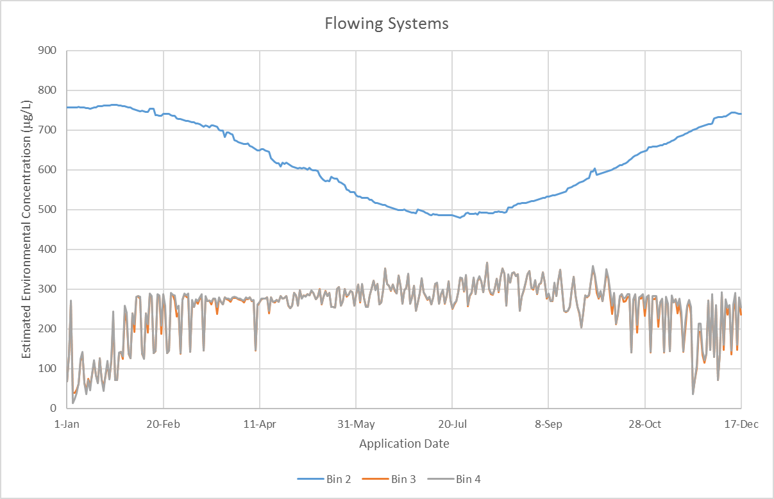

Figure 3-3. Applications of malathion to cotton over all calendar days as date of initial application for flowing aquatic bins

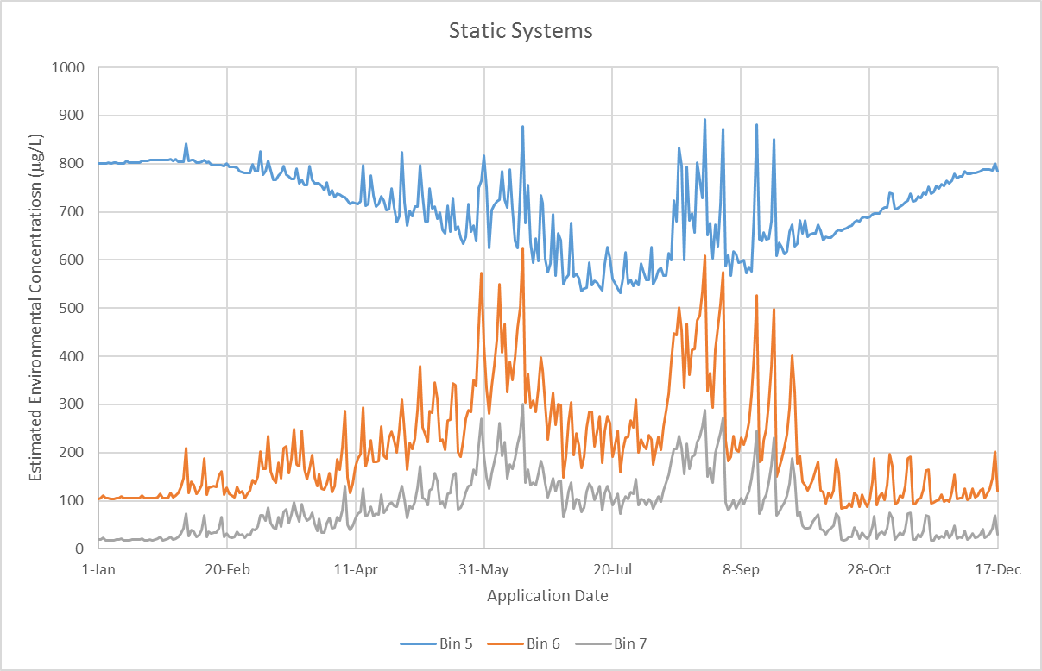

Figure 3-4. Applications of malathion to cotton over all calendar days as date of initial application for static aquatic bins

## Available Monitoring Data

### Field Studies

Edge of field monitoring data are available for known application events and provide a range for the highest environmental concentrations that can be expected. Field study monitoring data found concentrations in runoff 20 feet from the edge of a field applied with malathion as high as 146 ppb as part of Boll Weevil Eradication Program (BWEP) monitoring on cotton with an aerial ULV application rate of 0.75 lb a.i./A. Though runoff concentrations are not directly applicable to concentrations in aquatic bins as spray drift is not considered, this monitoring effort characterizes run-off concentrations for the given use conditions. Though this data is associated with the BWEP, it is also relevant to the conventionally registered use on cotton as the maximum single application rate (2.5 lbs a.i./A for aerial/ground; 1.22 lbs a.i./A for ULV) remains the same and within the same range as other agricultural uses. Stormwater concentrations of malathion as high as 583 ppb and concentrations of malaoxon as high as 328 ppb were found in streams during surface water monitoring associated with the Mediterranean Fruit Fly Eradication Program. However, these concentrations are less relevant given current use as the baited droplet used for this eradication program may affect the dissipation of malathion and the formulation is not currently used. The Medfly applications during this field study monitoring effort used larger baited droplets which also increase deposition and are not comparable to current use ULV applications. Furthermore, the watersheds sampled were heavily residential and several homeowner uses, including residential lawn (broadcast), residential pressurized can formulation, and residential dust formulation uses, have been eliminated since the time of monitoring.

### General Monitoring Data

Extensive general monitoring data from the Water Quality Portal and California Department of Pesticide Regulation (CDPR) are available for malathion and malaoxon (see full summary in Appendix X). More than 70,000 samples for malathion have been collected since mitigation was enacted in 1988 with 3,709 malathion detections and 53 detections between one and 22 parts per billion. These concentrations above one part billion occur in streams with flows as high as 700 cubic feet per second. Higher concentrations are more commonly associated with lower flow streams. The range of concentrations above one part per billion was selected as an arbitrary demarcation to characterize water bodies with high detections of malathion. Data from these monitoring studies are not correlated with known applications of pesticides under well-described conditions (*e.g.*, application rate, field characteristics, water characteristics, and meteorological conditions). Therefore, general monitoring data cannot be used to estimate pesticide concentrations after a pesticide application or to evaluate performance of fate and transport models (NRC 2013). While general monitoring data may underestimate potential exposure, they provide useful information for describing water quality trends and the environmental baseline condition of species habitats including the occurrence of chemical mixtures and the presence of abiotic stressors that can increase risk.

Air monitoring from the California Department of Pesticide Regulation from 2011 to 2014 for measuring pesiticides in Montery, Kern, and San Joaquin Counties included detections for malathion. 24-hour samples were taken weekly in populated areas. No detections above trace concentrations (*i.e.*, 12.6 ng/m3) were found in the four years of monitoring (CDPR 2013a, 2013b, 2014, 2015).

A full characterization of monitoring data can be found in **APPENDIX 1-10**.

## Monitoring Results, WARP Model and Extrapolation of Monitoring Results

No WARP-MP Map Application modeling or monitoring results are available for malathion.

## Aquatic Exposure Summary

Modeled EECs represent an upper bound on potential exposure as a result of the use of malathion. The highest modeled values are approximately four orders of magnitude above ambient concentrations. As recommended by the NRC in the 2013 NAS report, ambient monitoring data are not recommended to be used to estimate pesticide concentrations after a pesticide application or to evaluate the performance of EPA’s fate and transport models. However, EPA believes monitoring data can be used as part of the weight-of-evidence evaluation to present a lower bound on known exposure.

## Uncertainties in Aquatic Modeling and Monitoring Estimates



### Surface Water Aquatic Modeling

Exposure to aquatic organisms from pesticide applications is estimated using PRZM/VVWM EECs. Regional differences in exposure are assessed using regionally-specific PRZM scenarios (*e.g.*, information on crop growth and soil conditions) and meteorological conditions at the HUC 2 level (**Section 2.3 Scenario Selection**). The information used in these scenarios is designed to reflect conditions conducive to runoff. In instances where PRZM scenarios do not exist in a HUC2, surrogate scenarios from other HUCs are used. For fields where agricultural practices that result in less conservative scenario parameters are employed (*i.e.*, conditions less conducive to runoff and pesticide loading of waterbodies), the potential for lower EECs would be expected.

The static waterbodies modeled with VVWM are fixed volume systems with no outlet, resulting in the potential for accumulation of pesticide over time. Effects due to the increase and/or decrease of the water level in the waterbody and thus the concentration of pesticide in the waterbody are not modeled.

Flowing waterbodies are modeled in the VVWM using the constant volume and flow through custom waterbody option. Effects due to the increase and/or decrease of the water level and flowrate in the waterbody and thus the concentration of pesticide in the waterbody are not modeled. Watershed areas are developed using NHDPlus data for each HUC2 region and a log-log regression of drainage area to flowrate. Where contributing watershed areas are smaller than those predicted, this would result in less mass loading and runoff contributions to the waterbody and lower concentrations

The assessment relies on maximum use patterns (**Section 2 Measures of Aquatic Exposure**). In situations where use patterns are less than the labeled maximums, environmental exposures will be lower.

The aquatic modeling conservatively assumes that the waterbody abuts the treated area. As such, any reduction in loading from runoff that could occur as the result of managed vegetative filter strips or unmanaged naturally-occurring interfaces between treated areas and waterbodies are not taken into account.

The aquatic modeling assumes a constant wind of 10 mph blowing directly toward the waterbody (**Section 2.4.2 Spray Drift**). These assumptions are conducive to drift transport and result in maximum potential loading to the waterbody. However, in many situations the wind will not be blowing constantly and directly toward the water body at this speed; therefore, aquatic deposition will likely be less than predicted. Additionally, many labels and applicator best management practices encourage not applying pesticides when the wind is blowing in the direction of sensitive areas (*i.e.*, listed species habitat). Lastly, reductions in spray drift deposition due to air turbulence, interception of spray drift on nearby plant canopy, and applications during low wind speeds are not taken into account in the spray drift estimates; therefore, loading due to spray drift may be over-estimated.

There is uncertainty associated with the selection of PRZM/VVWM input parameters. In this regard, one of the important parameters that can impact concentration estimates is the selection of application dates (**Section 2.4.3 Application Timing**); runoff and potential pesticide loading are greatest when applications immediately precede major precipitation events. Although the pesticide application dates are selected to be appropriate and protective (*i.e.*, selected with consideration for label restrictions and simulated cropping dates, pest pressures, and high precipitation meteorological conditions), uncertainty nevertheless results because the application window (the time span during a season that a pesticide may likely be applied) for a pesticide may be wide and actual application dates may vary over the landscape. While data sources exist that allow for determination of historical application dates (*e.g.*, California’s Pesticide Use Report and pesticide use surveys), it is uncertain how these dates reflect future application events. Additionally, the PRZM/VVWM models use the same application dates for the 30-year simulation. While it is unlikely that an application would occur on the same dates every year for 30 years, this modeling process allows for a distribution of EECs to be developed that captures the peak loading events.

In the case of applications to rice paddies or cranberry bogs, the PFAM model is used to estimate concentrations in the flooded field (**Section 2.5.2 Cranberry Modeling**). For listed species that may visit a paddy or bog, the water column and sediment estimates are intended to be protective of exposures they may encounter. However, for listed species whose habitat is outside the flooded area, the use of water column and sediment concentrations from the paddy or bog is likely to overestimate exposure due to dilution and dispersion of the pesticide when discharged to a flowing waterbody. Additionally, as these flooded field systems tend to have water management controls which regulate the maximum release of paddy or bog water, the pesticide concentration in the water, and allow for manual releases in the fall during harvest, exposure could be limited to a specific time of year and not year-round.

### Aquatic Bins 3 and 4

PRZM/VVWM are a field-scale models. Flowing water bodies such as streams and rivers with physical parameters consistent with aquatic bins 3 and 4 have watershed areas well beyond those of typical agricultural fields. Watershed sizes assumed for bin 3 habitats exceeded 10,000 acres and bin 4 watersheds were assumed to be greater than 4 million acres. Initial modeling efforts, applying the field-scale model to these large watersheds and using the same scenario parameters as those used for the other bins, results in extremely high EECs which have not been observed in the environment, nor would be expected to occur due to fluid dynamic processes such as advective dispersion (**Figure 3-5**), where the peak concentration is dampened as it moves from a low flowing stream (bin 2) to a higher flowing river (bins 3 and 4). Several adjustments, discussed in **ATTACHMENT 3-1 Background Document Aquatic Exposure Estimation for Endangered Species**, have been made to the inputs and outputs to reflect changes that would be anticipated in modeling such scenarios. It is acknowledged that a watershed/basin-scale model capable of evaluating the impact of pesticide and water transport at the field-scale and aggregating these loadings to waterbodies at the larger watershed-scale is needed to evaluate these flowing aquatic systems.

Figure 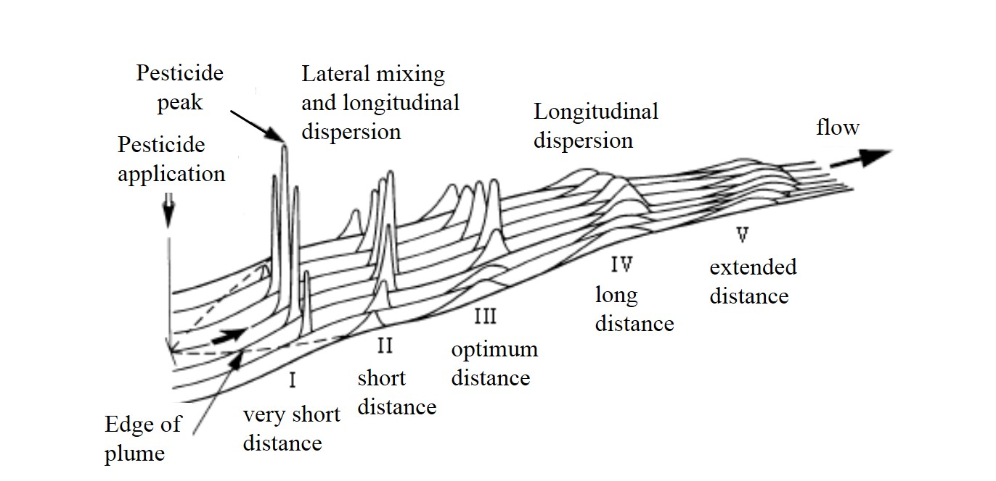-5. Effect of Pesticide Concentration via Advective Dispersion

### Monitoring Data

While general monitoring data may indicate lower levels of the active ingredient in surface water, general monitoring is typically not focused in use areas or conducted during times of known use. As the delineated by NAS (2013), general monitoring studies “are not associated with specific applications of pesticides under well-described conditions” and “cannot be used to estimate pesticide concentrations after a pesticide application or to evaluate the performance of fate and transport models.” Additionally, sampling intervals for general monitoring datasets are sporadic and as such may not reflect potential peak concentrations that may occur in surface waters when runoff events occur shortly after application. Adding to this uncertainty, reporting limits for some of the datasets have varied over the years. Although monitoring datasets may report trace levels (*e.g.*, levels above the method detection limit but below the reporting limit), consistent detection limits would facilitate interpretation of the monitoring results from year to year and across datasets. As a result, general monitoring data are used in this assessment as part of the weight of evidence analysis to present a lower bound on known exposure.

The preceding discussion outlined the uncertainties associated with the modeling techniques used to derive EECs, particularly the methods used to derive EECs for the moderate and high flowing aquatic bins, bins 3 and 4. Alternative recommendations from stakeholders, the scientific community, and the public at large on how to estimate pesticide exposure in these waterbodies on a watershed scale or to improve the proposed modeling methodology are encouraged.

# Measures of Terrestrial Exposure

## Introduction

Terrestrial animals may be exposed to malathion through multiple routes of exposure, including diet, drinking water, dermal and inhalation. If the species consumes plants, invertebrates or vertebrates (amphibians, reptiles, birds or mammals) that inhabit terrestrial areas, T-REX is used by EFED. If the species consumes aquatic organisms, then KABAM is used. As noted in the Problem Formulation, to improve efficiency and expand EFED’s modeling capabilities to other, non-dietary routes of exposure for terrestrial organisms, the Terrestrial Effects Determination (TED) tool was developed. This tool integrates T-REX, T-HERPS and the earthworm fugacity model, along with several other models used by EFED. When this document indicates that T-REX or the earthworm fugacity models should be run for a species, the TED tool will be run. Assessors could also run the current version of T-REX. As discussed in the terrestrial exposure appendix, KABAM will not be run for chlorpyrifos, diazinon or malathion. In its place, BCF values will used to estimate exposure through consumption of aquatic food items. The spray drift model, AgDRIFT, will be used in the effects determinations to characterize the distance from the edge of the field to which exposure is at levels of concern for a species.

Two major parameters are used in Tier I modeling to represent species: body weight and diet. Estimates of body weights are necessary to estimate dose-based exposures through diet, drinking water, inhalation and dermal exposure routes. Information on the dietary requirements of listed species are necessary to determine relevant exposures through consumption of contaminated prey. Species-specific assumptions related to diet and body weight are provided in **ATTACHMENTS 1-16 THRU 1-19**.

This section characterizes the estimated exposures of malathion on different food items in the terrestrial environment and in fish (which may be consumed by piscivorous mammals and birds). These values are used to generate dose-based dietary exposure estimates. Species specific dose-based exposures through diet, drinking water, dermal and inhalation routes will be provided in the TED tool outputs. **ATTACHMENT 1-7** discusses the methods for estimating dose-based exposures. Upper bound exposure estimates are used in Step 1 of the ESA process, with upper bound and mean residues over time being used in Step 2.

Four different malathion application scenarios were used to estimate terrestrial exposure: 1) a minimum single application rate; 2) an upper-bound single application rate; 3) a maximum single application rate; and 4) a multiple application scenario. These application scenarios are meant to be representative of the range of application rates and uses for malathion. Single maximum foliar application rates of malathion range from 0.5 to 7.5 lb a.i./A. The highest single application rate of 7.5 lb a.i./A is for use on citrus and is restricted to use in California only; other single application rate for citrus range up to 4.5 lb a.i./A. The next highest single application rate is 5.1 lb a.i./A, based on a homeowner garden use (outdoor ornamentals (woody shrubs and vines); EPA Reg. No. 28293-123). It is noted that this outdoor ornamental use rate is based on lb a.i./1000 sq ft and has been converted to lb a.i./A. With regards to modeling, the single application rate of 0.5 lb a.i./A (use on flax) was used as the minimum use rate. A rate of 2.0 lb a.i./A was used as the upper bound single maximum use rate as the single application rate for many uses are around 2.0 lb a.i./A (i.e., rates of 1.5-2 lb a.i./A for use on cotton, orchard/vineyard crops, caneberries, lettuce, peppers, and other vegetables). While the single maximum application rate is 7.5 lb a.i./A, given that this use is restricted to California citrus, the next highest rate of 5.1 lb a.i./A was used. This use is represented by the developed land class layers, and there is a high degree of species range overlap with the developed land class layer (>90% of species has range data that overlaps with developed land class layer). For the multiple application scenario, the mean single application rate, based on malathion uses, was 1.5 lb a.i./A; the mean single application rate based on all uses as well as for uses with either 2 or 3 applications ranged from 1.4-1.5 lb a.i./A. Additionally, the mean application interval for uses with either 2 or 3 applications was 6.8 or 7.8 days. As such, the multiple application scenario used was 3 applications at 1.5 lb a.i./A with a 7-day application interval.

## Estimated concentrations in terrestrial food items (mg a.i./kg-food)

The TED tool generates estimates of pesticide concentrations in above-ground terrestrial invertebrates, grass (tall and short), broadleaves, fruit and seeds. Recent additions to the model have allowed for calculation of pesticide concentrations in soil-dwelling invertebrates (using earthworm partitioning model) and in terrestrial vertebrates (*i.e.*, birds and mammals; using the T-HERPS model).

The T-REX model is intended to simulate foliar spray applications of pesticides. In order to bound exposure estimates, minimum and maximum application scenarios are used to run T-REX. These single rates are modeled (0.5, 2.0 and 5.1 lb a.i./A), along with the multiple application scenario, which is 3 applications of 1.5 lb a.i./A made at 7 d intervals. T-REX accounts for dissipation of pesticide residues on food items. A foliar dissipation half-life of 6.1 days is used for malathion (Willis & McDowell, 1987), **Table 3-12** summarizes the mean and upper bound dietary-based EECs. Additional description of the estimated malathion concentrations on food items is provided in the following sections.

Table 3-12. Mean and upper bound dietary based EECs calculated for food items consumed by listed birds, terrestrial-phase amphibians or reptiles. Values represent potential exposures for animals feeding on the treated field or in adjacent habitat directly adjacent to the field.1

|  |  |  |  |  |  |  |  |  |  |
| --- | --- | --- | --- | --- | --- | --- | --- | --- | --- |
| **Food Item** | **Model** | **Minimum single application rate**  **(0.5 lb a.i./A)** | | **Upper-bound single application rate (2.0 lb a.i./A)** | | **Multiple application scenario**  **(3 applications of 1.5 lb a.i./A)** | | **Maximum single application rate**  **(5.1 lb a.i./A)** | |
| **Mean** | **Upper bound** | **Mean** | **Upper bound** | **Mean** | **Upper bound** | **Mean** | **Upper bound** |
| Terrestrial invertebrates (above ground) | T-REX | 33 | 47 | 130 | 188 | 172 | 249 | 332 | 479 |
| Terrestrial invertebrates (soil dwelling) | Earthworm fugacity | NA | 8.1 | NA | 32 | NA | 24 | NA | 83 |
| Short grass | T-REX | 43 | 120 | 170 | 480 | 211 | 596 | 434 | 1224 |
| Tall grass (surrogate for nectar and flowers) | T-REX | 18 | 55 | 72 | 220 | 89 | 273 | 184 | 561 |
| broadleaves | T-REX | 23 | 68 | 90 | 270 | 111 | 335 | 230 | 689 |
| Seeds and fruit | T-REX | 3.5 | 7.5 | 14 | 30 | 17 | 37 | 36 | 77 |
| Birds (small, insectivore)*** | T-HERPS | 100 | 145 | 400 | 579 | 671 | 971 | 1021 | 1476 |
| Mammals (small, herbivore)*** | T-HERPS | 47 | 133 | 188 | 532 | 243 | 687 | 481 | 1357 |
| Amphibians/reptiles (small, insectivore) | T-HERPS | 4.9 | 7.1 | 20 | 28 | 33 | 47 | 50 | 72 |
| Aquatic plants | BCF* | 0.00023-2.3** | | | | | | | |
| Aquatic invertebrates | KABAM | 0.00024-2.4** | | | | | | | |
| Fish | BCF* | 0.0013-13** | | | | | | | |

1 Additional EECs are available in the TED tool.

*Based on empirical BCFs.

**Varies based on EECs in water. Higher end set to 0.1 mg/L.

***Also represent residues in carrion

NA = not applicable

### Terrestrial invertebrates

For terrestrial invertebrates inhabiting the treated field (above ground), upper bound peak EECs range 47-479 mg a.i./kg-food. Mean values range 33-332 mg a.i./kg-food. **Figure 3-6** depicts the estimated concentrations of malathion on above ground terrestrial invertebrates over time (to aid in reading the figures, the exposure concentrations for the single application of 2.0 lb a.i./A were not shown). When malathion is applied at a single application of 0.5 lb a.i./A, malathion upper bound residues are <0.01 mg a.i./kg-food 75 days after the application. For the multiple application scenario, upper bound residues of malathion reach <0.01 mg a.i./kg-food at 104 days after the first application. It should be noted that if the interval between applications were longer than 7 days, the residues would persist at levels >0.01 mg a.i./kg-food for a greater period of time.

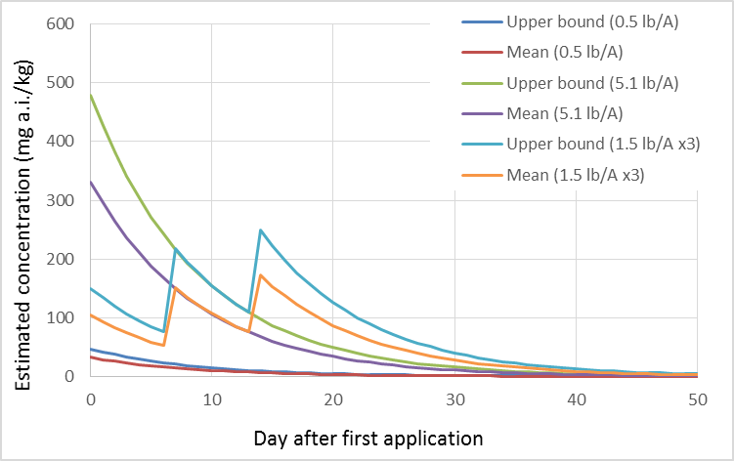

Figure 3-6. Mean and upper bound estimated concentrations of malathion on above ground terrestrial invertebrates.

The earthworm fugacity model was used to estimate pesticide concentrations in soil-dwelling invertebrates located on treated fields. For applications of 0.5 and 5.1 lb/A, the steady state concentration of malathion in soil-dwelling invertebrates is estimated at 8.1 and 83 mg a.i./kg-food, respectively. These values were estimated using a Koc of 217 L/kg-soil and a Log Kow of 2.8 (see fate characterization).

### Terrestrial plants (seeds, fruit, nectar and leaves)

Many listed species consume plant matter, including seeds, fruit, nectar and leaves. T-REX EECs for these food items are depicted in **Figures 2-5**. Among these food items, residues on short grass are the highest, followed by broadleaves, tall grass and then seeds and fruit. Since insufficient data are available for estimating pesticide residues in nectar, the tall grass EEC is used as a surrogate for this food item. This is based on an analysis completed for the risk assessment methodology for honey bees[2].

For seeds and fruit located on the treated field, upper bound peak EECs range 7.5-77 mg a.i./kg-food. Mean values range 3.5-36 mg a.i./kg-food. **Figure 3-7** depicts the estimated concentrations of malathion on seeds and fruit over time. When malathion is applied at a single application of 0.5 lb a.i./A, malathion upper bound residues are <0.01 mg a.i./kg-food 59 days after the application. For 3 applications at 1.5 lb a.i./A (7 d interval), upper bound residues of malathion reach <0.01 mg a.i./kg-food at 87 days after the first application.

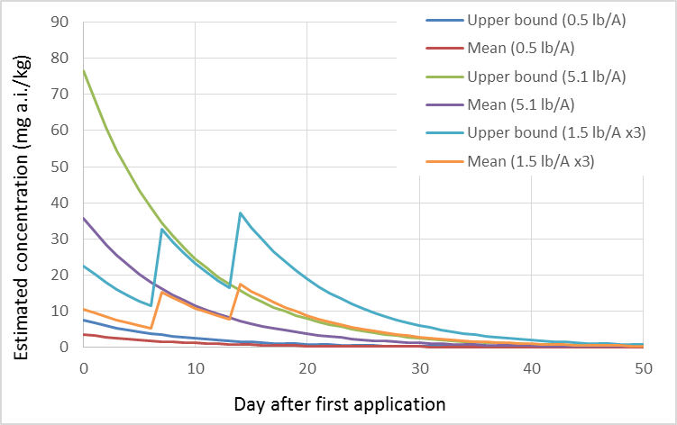

Figure 3-7. Mean and upper bound estimated concentrations of malathion on seeds and fruit.

For broadleaf plants located on the treated field, upper bound peak EECs range 68-689 mg a.i./kg-food. Mean values range 23-230 mg a.i./kg-food. **Figure 3-8** depicts the estimated concentrations of malathion on broadleaf plants over time. When malathion is applied at a single application of 0.5 lb a.i./A, malathion upper bound residues are <0.01 mg a.i./kg-food 78 days after the application. For 3 applications at 1.5 lb a.i./A (7 d interval), upper bound residues of malathion reach <0.01 mg a.i./kg-food at 106 days after the first application.

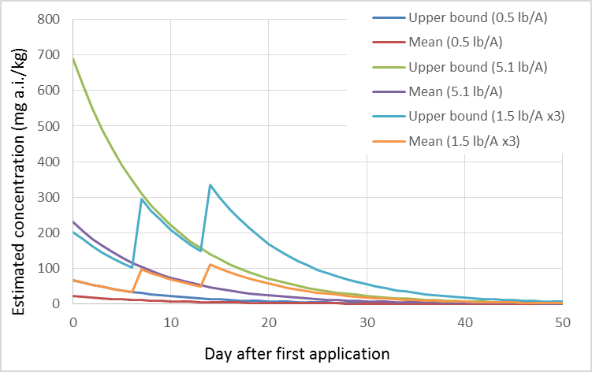

Figure 3-8. Mean and upper bound estimated concentrations of malathion on broadleaves.

For grass located on the treated field, upper bound peak EECs range 55-561 mg a.i./kg-food for tall grass and 120-1224 for short grass. Mean values range 18-184 mg a.i./kg-food for tall grass and 43-434 for short grass. **Figures 3-9 and 3-10** depicts the estimated concentrations of malathion on grass over time. When malathion is applied at a single application of 0.5 lb a.i./A, malathion upper bound residues are <0.01 mg a.i./kg-food at 76 and 83 days after the application for tall and short grass, respectively. For 3 applications at 1.5 lb a.i./A (7 d interval), upper bound residues of malathion reach <0.01 mg a.i./kg-food at 104 and 111 days after the first application for tall and short grass (respectively).

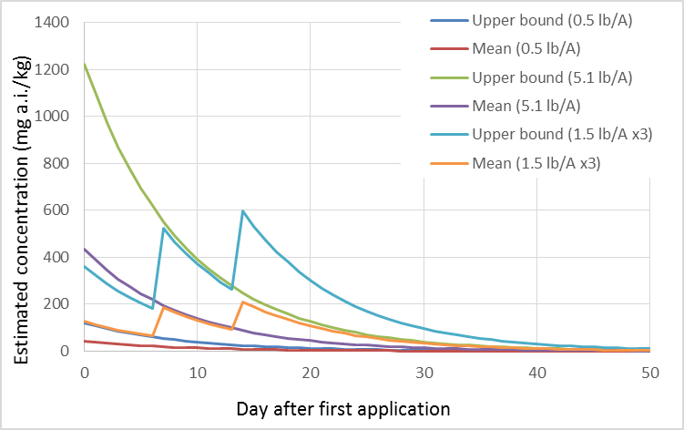

Figure 3-9. Mean and upper bound estimated concentrations of malathion on short grass.

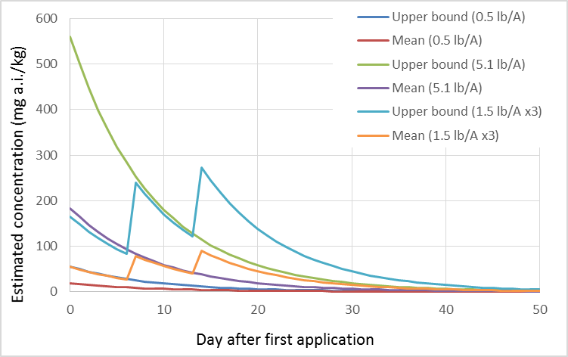

Figure 3-10. Mean and upper bound estimated concentrations of malathion on tall grass. Note that tall grass EECs are used as a surrogate for nectar.

### Terrestrial vertebrates (birds, mammals, amphibians, reptiles)

Malathion concentrations in terrestrial vertebrate prey consuming grass or insects from treated areas are presented in **Table 3-12**. These estimates represent the peak values from mean and upper bound residues on food items directly sprayed with malathion. As malathion residues on grass and insects dissipate, residues would be expected to decrease in terrestrial vertebrate prey. In addition, malathion residues would likely be metabolized by terrestrial vertebrates to the non-toxic metabolites, dicarboxylic acid (DCA) and monocarboxylic acid (MCA). Therefore, EECs in **Table 3-12** represent conservative estimates of malathion concentrations in vertebrate prey.

The estimated concentrations of malathion in terrestrial vertebrates are also used to represent concentrations in carrion. It is possible that exposed animals may die due to malathion or other factors. For birds, some of the EECs overlap with levels where mortality is expected acute (LD50 values range from 136 to >2400 mg a.i./kg-bw). For mammals, the acute LD50s range from 209 to 8150 mg a.i./kg-bw.

## Estimated concentrations in aquatic food items (mg a.i./kg-food)

### Aquatic plants

An empirically-based BCF of 23 from a study involving aquatic vascular plants is used to predict concentrations of malathion in aquatic plants. **Figure 3-11** depicts the estimated malathion concentrations in aquatic plants exposed at different concentrations in water.

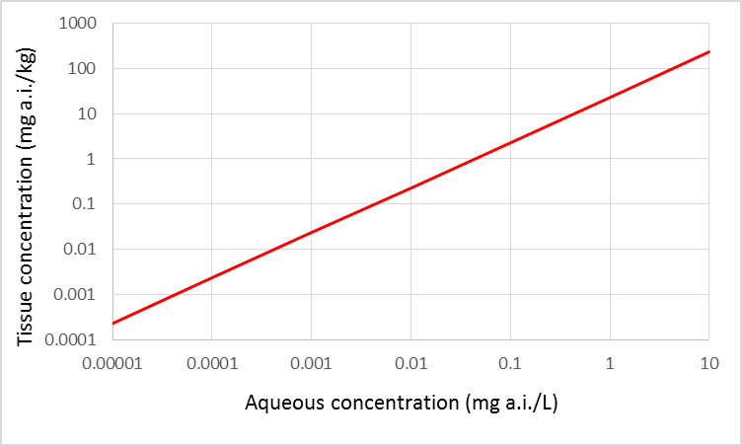

Figure 3-11. Malathion concentrations in aquatic plants resulting from bioconcentration different aqueous concentrations.

### Aquatic invertebrates

No empirical bioconcentration factor (BCF) values are available for aquatic invertebrates exposed to malathion. Therefore, the KABAM generated BCF for aquatic invertebrates, 24 (based on Log Kow of 2.8)), is used to estimate malathion concentrations in aquatic invertebrates that could potentially be consumed by listed species. **Figure 3-12** depicts the estimated malathion concentrations in aquatic invertebrates exposed at different concentrations in water. It should be noted that tissue concentrations in aquatic invertebrates will likely be bound by toxicity of malathion on these organisms. For instance, the acute LC50 values for aquatic invertebrates exposed to malathion range from 0.06 to 20500 µg a.i./L.

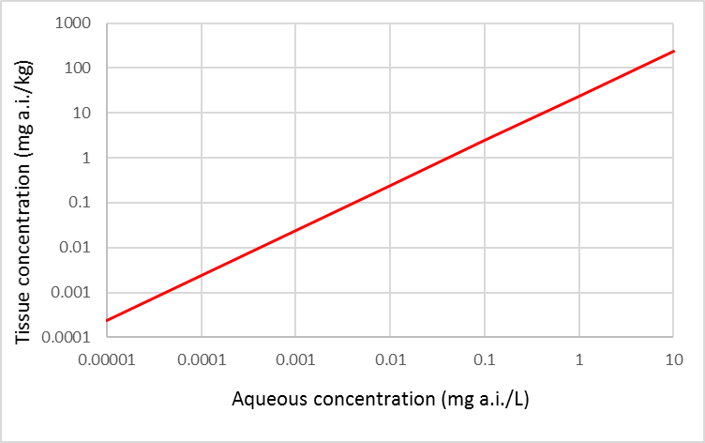

Figure 3-12. Estimated concentrations of malathion in aquatic invertebrates resulting from bioconcentration at different aqueous concentrations.

### Fish

An empirically based BCF of 131 is used to estimate malathion concentrations in fish. **Figure 3-13** depicts the estimated malathion concentrations in fish tissues resulting from environmentally relevant aqueous concentrations. Although fish are less sensitive to malathion exposures compared to aquatic invertebrates, mortality to fish may also be a limitation of how much malathion may be bioconcentrated in fish (available acute LC50 values for fish range 4.1 to 448,000 µg/L).

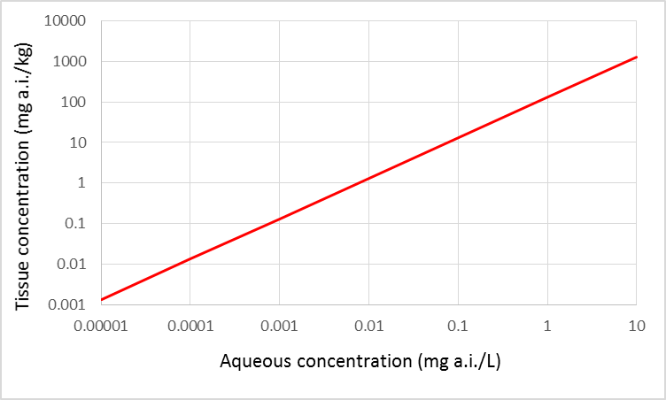

Figure 3-13. Estimated concentrations of malathion in fish resulting from bioconcentration at different aqueous concentrations.

# References

Burns, L. 2Exposure Analysis Modeling System (EXAMS): User Manual and System Documentation (EPA/600/R-00/081)004. September, 2000, Revision G (May 2004).

(http://www2.epa.gov/sites/production/files/documents/EXAMREVG.PDF)

Carbone, J.P., Havens, P.L., and Warren-Hicks, W, 2002. Validation of Pesticide Root Zone Model 3.12:

Employing Uncertainty Analysis. Environmental Toxicology and Chemistry, Vol. 21, No. 8, pp.

1578–1590, 2002. http://www.epa.gov/scipoly/sap/meetings/2004/march/chapter4.pdf.

FAO. 2000. Appendix 2. Parameters of pesticides that influence processes in the soil. In FAO Information Division Editorial Group (Ed.), *Pesticide Disposal Series 8. Assessing Soil Contamination. A Reference Manual*. Rome: Food & Agriculture Organization of the United Nations (FAO). Available at <http://www.fao.org/DOCREP/003/X2570E/X2570E06.htm> (Accessed July 10, 2009).

FIFRA Environmental Model Validation Task Force. 2001. Comparative Evaluation of PRZM to Measured

Data. Main report and Appendices 1-4 and 6. (http://femvtf.com/femvtf/)

FEMVTF. 2001. *Comparative Evaluation of PRZM to Measured Data. Main report and Appendices 1-4 and 6*. FIFRA Environmental Model Validation Task Force. Available at <http://femvtf.com/femvtf/> (Accessed November 17, 2015).

Luo, Y and Deng, X, 2012. Methodology for Evaluating Pesticides for Surface Water Protection II: Refined Modeling. CEPA, CDPR. Sacramento, CA.

Mickle, R.E., G. Rosseau, and O. Samuel. 2005. Direct Comparison of Deposit from Aerial and Ground ULV

Applications of Malathion with AGDISP Predictions. Unpublished study performed by REMSpC

Consulting, Ontario, Canada; sponsored and submitted by Cheminova A/S, Denmark. REMSpC

Report No: 2005-02. Experiment initiated October 6, 2004 (Appendix 3, pp. 60-64 and Appendix

4, pp. 66-75); completion date not reported. Final report issued February 10, 2005.

NAFTA. 2012. *Guidance for Evaluating and Calculating Degradation Kinetics in Environmental Media*. December 2012. NAFTA Technical Working Group on Pesticides. Available at <http://www2.epa.gov/pesticide-science-and-assessing-pesticide-risks/guidance-calculate-representative-half-life-values> (Accessed November 13, 2015).

NRC. 2013. *Assessing Risks to Endangered and Threatened Species from Pesticides*. Committee on Ecological Risk Assessment under FIFRA and ESA. National Research Council. Available at <http://www.nap.edu/catalog.php?record_id=18344> (Accessed June 13, 2014).

Schleier, J. III and Peterson, R. 2010. *Deposition and air concentrations of permethrin and naled used for adult mosquito management*. Archives of Environmental Contamination and Toxicology. 58(1):105-111

Tietze, N.S., Hester, P.G., and Shaffer, K.R.. 1994. *Mass recovery of malathion in simulated open field mosquito adulticide tests*. Archives of Environmental Contamination and Toxicology 26:473-477

Tucker, J., Thompson, C., Wang, T., and Lenahan, R. 1987. *Toxicity of organophosphorus insecticides to estuarine copepods and young fish after field applications*. J Florida Anti-Mosquito Association 58:1-6

USEPA. 2004. *A Discussion with the FIFRA Scientific Advisory Panel Regarding the Refined (Level II) Terrestrial and Aquatic Models. Chapter 4. The Aquatic Level II Refined Risk Assessment Model (Version 2.0)*. 3/16/2004. Environmental Fate and Effects Division. Office of Pesticide Programs. U.S. Environmental Protection Agency. Available at <http://archive.epa.gov/scipoly/sap/meetings/web/pdf/chapter4.pdf> (Accessed November 16, 2015).

USEPA. 2012b. *Standard Operating Procedure for Using the NAFTA Guidance to Calculate Representative Half-life Values and Characterizing Pesticide Degradation*. November 30, 2012. Environmental Fate and Effects Division. Office of Pesticide Programs. U.S. Environmental Protection Agency. Available at <http://www2.epa.gov/pesticide-science-and-assessing-pesticide-risks/guidance-calculate-representative-half-life-values> (Accessed November 13, 2015).

USEPA. 2009a. *Guidance for Selecting Input Parameters in Modeling the Environmental Fate and Transport of Pesticides, Version 2.1*. Environmental Fate and Effects Division. Office of Pesticide Programs. U.S. Environmental Protection Agency. Available at <http://www2.epa.gov/pesticide-science-and-assessing-pesticide-risks/guidance-selecting-input-parameters-modeling> (Accessed June 22, 2014).

USEPA. 2013. Spray Drift Analysis for the Etofenprox Label Amendment (Petition No.1£7925). PC Code: 128965; DP Barcode: 407817. March 28, 2013. Office of Pesticide Programs. Environmental Fate and Effects Division.

Wauchope, R.D. The Pesticide Content of Surface Water Draining from Agricultural Fields – A Review. Journal of Environmental Quality 7:459-472. October-December 1978

Young, Dirk, 2014. The Variable Volume Water Model and the USEPA Standard Water Bodies for Pesticide Risk Assessments. Environmental Fate and Effects Division, Office of Pesticide Programs, U.S. Environmental Protection Agency, Washington, D.C. 20460.

1. The exposure models can be found at: <http://www.epa.gov/pesticides/science/models_pg.htm>
2. USEPA. 2012. White Paper in Support of the Proposed Risk Assessment Process for Bees. Submitted to the FIFRA Scientific Advisory Panel for Review and Comment September 11 – 14, 2012. Office of Chemical Safety and Pollution Prevention Office of Pesticide Programs Environmental Fate and Effects Division, Environmental Protection Agency, Washington DC; Environmental Assessment Directorate, Pest Management Regulatory Agency, Health Canada, Ottawa, CN; California Department of Pesticide Regulation http://www.regulations.gov/#!documentDetail;D=EPA-HQ-OPP-2012-0543-0004