Effects Characterization for Malathion

Table of Contents

1. Introduction 9
2. Effects Characterization for Fish and Aquatic-phase Amphibians 10
2.1. Introduction to Fish and Aquatic-phase Amphibian Toxicity 10
2.2. Threshold Values for Fish and Aquatic-phase Amphibian 10
2.3. Summary Data Arrays for Fish and Aquatic-phase Amphibians 16
2.4. Lines of Evidence for Fish and Aquatic-phase Amphbians 18
2.4.1 Effects on Mortality to Fish and Aquatic-phase Amphibians 18
2.4.2 Sublethal Effects to Fish and Aquatic-phase Amphibians 36
2.4.2.1 Effects on Growth of Fish and Aquatic-phase Amphibians 36
2.4.2.2. Effects on Reproduction of Fish and Aquatic-phase Amphibians 41
2.4.2.3. Effects on Behavior of Fish and Aquatic-phase Amphibians 41
2.4.2.4. Effects on Sensory Function of Fish and Aquatic-phase Amphibians 44
2.4.2.5. Other Effects Reported for Fish and Aquatic-phase Amphibians 44
2.5. Effects to Fish and Aquatic-phase Amphibians Not Included in the Arrays 50
2.6. Concentrations Where No Effects Were Observed in Fish and Aquatic-phase Amphibian Studies 52
2.7. Incident Reports for Fish and Aquatic-phase Amphibians 55
2.8. Summary of Effects to Fish and Aquatic-phase Amphibians 63
3. Effects Characterization for Aquatic Invertebrates 63
3.1. Introduction to Aquatic Invertebrate Toxicity 63
3.2. Threshold Values for Aquatic Invertebrates 63
3.3. Summary Data Arrays for Aquatic Invertebrates 67
3.4. Lines of Evidence for Aquatic Invertebrates 69
3.4.1. Effects on Mortality of Aquatic Invertebrates 69
3.4.2. Sublethal Effects to Aquatic Invertebrates 88
3.4.2.1. Effects on Growth of Aquatic Invertebrates 88
3.4.2.2. Effects on Reproduction of Aquatic Invertebrates 91
3.4.2.3. Effects on Behavior of Aquatic Invertebrates 93
3.4.2.4. Effects on Sensory Function of Aquatic Invertebrates 94
3.4.2.5. Other Effects Reported for Aquatic Invertebrates 95
3.5. Effects to Aquatic Invertebrates Not Included in the Arrays 100
3.6. Concentrations Where No Effects Were Observed in Aquatic Invertebrate Studies 100
3.7. Incident Reports for Aquatic Invertebrates 102
3.8. Summary of Effects to Aquatic Invertebrates 103
4. Effects Characterization for Aquatic Plants 104
4.1. Introduction to Aquatic Plant Toxicity 104
4.2. Threshold Values for Aquatic Plants 104
4.3. Summary Data Arrays for Aquatic Plants 105
4.4. Lines of Evidence for Aquatic Plants 107
4.4.1. Effects on Mortality of Aquatic Plants 107
4.4.2. Sublethal Effects to Aquatic Plants 108
4.4.2.1. Effects on Growth of Aquatic Plants 108
4.4.2.2. Effects on Reproduction of Aquatic Plants 110
4.4.2.3. Other Effects Reported for Aquatic Plants 110
4.5. Effects to Aquatic Plants Not Included in the Arrays 112
4.6. Concentrations Where No Effects Were Observed in Aquatic Plant Studies 112
4.7. Incident Reports for Aquatic Plants 113
4.8. Summary of Effects to Aquatic Plants 114
5. Effects Characterization for Aquatic Communities (from studies examining aquatic communities) 115
6. Effects Characterization for Birds 121
6.1. Introduction to Bird, Terrestrial-phase Amphibians, and Reptile Toxicity 121
6.2. Threshold Values for Birds, Terrestrial-phase Amphibians and Reptiles 121
6.3. Summary Data Arrays for Birds 122
6.4. Lines of Evidence for Birds, Terrestrial-phase Amphibians, and Reptiles 124
6.4.1. Effects on Mortality of Birds 125
6.4.2. Sublethal Effects to Birds 129
6.4.2.1. Effects on Growth of Birds 129
6.4.2.2. Effects on Reproduction of Birds 134
6.4.2.3. Effects on Behavior of Birds 135
6.4.2.4. Effects on Sensory Function of Birds 136
6.4.2.5. Other Effects Reported for Birds 136
6.4.3. Field Studies for Birds 141
6.5. Effects to Birds Not Included in the Arrays 143
6.6 Concentrations or Doses Where No Effects Were Observed in Birds 146
6.7. Incident Reports for Birds 148
6.8. Summary of Effects to Birds 149
8. Effect Characterization to Terrestrial-phase Amphibians 150
9. Effect Characterization to Mammals 151
9.1. Introduction to Mammal Toxicity 151
9.2. Threshold Values for Mammals 152
9.3. Summary Data Arrays for Mammals 153
9.4. Lines of Evidence for Mammals 154
9.4.1. Effects on Mortality of Mammals 155
9.4.2. Sublethal Effects to Mammals 156
9.4.2.1. Effects on Growth of Mammals 156
9.4.2.2. Effects on Reproduction of Mammals 159
9.4.2.3. Behavioral Effects 160
9.4.2.4. Effects on Sensory Function of Mammals 162
9.4.2.5. Other Effects Reported for Mammals 162
9.4.3. Field Data for Mammals 172
9.5. Effects to Mammals Not Included in the Arrays 173
9.6. Concentrations or Doses Where No Effects Were Observed in Mammal Studies 177
9.7. Incident Reports for Mammals 179
9.8. Summary of Effects to Mammals 179
10. Effects Characterization for Terrestrial Invertebrates 180
10.1. Introduction to Terrestrial Invertebrate Toxicity 180
10.2. Threshold Values for Terrestrial Invertebrates 180
10.3. Summary Data Arrays for Terrestrial Invertebrates 185
10.4. Lines of Evidence for Terrestrial Invertebrates 186
10.4.1. Effects on Mortality of Terrestrial Invertebrates 186
Registrant-Submitted Terrestrial Invertebrate Toxicity Data 197
10.4.2. Sublethal Effects to Terrestrial Invertebrates 199
10.4.2.1. Other Effects Reported for Terrestrial Invertebrates 200
10.5. Effects to Terrestrial Invertebrates Not Included in the Arrays 201
10.6. Concentrations Where No Effects Were Observed in Terrestrial Invertebrate Studies 202
10.7. Incident Reports for Terrestrial Invertebrates 204
10.8. Summary of Effects to Terrestrial Invertebrates 208
11. Effects Characterization for Terrestrial Plants 209
11.1. Introduction to Terrestrial Plant Toxicity 209
11.2. Threshold Values for Terrestrial Plants 209
11.3. Summary Data Arrays for Terrestrial Plants 211
11.4. Lines of Evidence for Terrestrial Plants 212
11.4.1. Effects on Mortality of Terrestrial Plants 212
11.4.2. Sublethal Effects to Terrestrial Plants 213
11.4.2.1. Effects on Growth of Terrestrial Plants 213
Sublethal Effects to Terrestrial Plants (Pre-emergence Exposure) 213
Sublethal Effects to Terrestrial Plants (Post-emergence Exposure) 213
Sublethal Effects to Terrestrial Plants (Monocots) 214
Sublethal Effects to Terrestrial Plants (Dicots) 214
Growth Effects Array 214
11.4.2.2. Effects on Reproduction of Terrestrial Plants 215
11.5. Effects to Terrestrial Plants Not Included in the Arrays 216
Units other than lb a.i./A (monocots and dicots) 216
Species other than monocots and dicots 217
11.6. Concentrations Where No Effects Were Observed in Terrestrial Plant Studies 217
11.7. Incident Reports for Terrestrial Plants 219
11.8. Summary of Effects to Terrestrial Plants 222
12 References 223

List of Tables
Table 2-1. Mortality and Sublethal Threshold Values for All Fish and Aquatic-phase Amphibians 9
Table 2-2. Most Sensitive Toxicity Value for Different Effect Types for Fish and Aquatic-phase Amphibians for Potential Use as a Refinement for Malathion 10
Table 2-3. Available 96-hr Median Lethal Concentration (LC₅₀) Data for Fish and Amphibians Exposed to Malathion as TGAI or Formulation 18
Table 2-4. Summary Statistics for SSDs Fit to Malathion Test Results (toxicity values reported in units of µg/L) 28
Table 3-1. Mortality and Sublethal Threshold Values for Aquatic Invertebrates. 65
Table 3-2. Most Sensitive Toxicity Value for Different Effect Types for Aquatic Invertebrates for Potential Use as a Refinement for Malathion. 65
Table 3-3. 48 and 96 hr EC/LC₅₀ Toxicity Values for Arthropods and Mollusks. 75
Table 3-4. Summary Statistics for SSDs Fit to Malathion Test Results (toxicity values reported as µg/L) 86
Table 3-5. Effects on Acetyl-Cholinesterase Observed in Studies Involving Malathion. 98
Table 3-6. Toxicity Data for Malathion Based on lb a.i./A (not in arrays) 103
Table 4-1. Mortality and Sublethal Threshold Values for Aquatic Plants. 108
Table 4-2. Sensitive Toxicity Value for Aquatic Vascular Plants for Potential Use As a Refinement for Malathion 108
Table 6-1. Direct Effects Thresholds for Determining Effects to Listed Birds 123
Table 6-2. Indirect Effects Thresholds for Determining Effects to Listed Species 124
Table 6-3. Available Median Lethal Doses (oral) for Birds Exposed to Malathion 129
Table 6-4. Summary Statistics for SSDs Fit to Malathion Test Results for Birds 130
Table 6-5. Median Lethal Concentrations Resulting from Sub-acute Dietary Exposures 131
Table 6-6. Growth Effects in Birds Exposed to Malathion 132
Table 6-7. Reproductive Effects in Birds Exposed to Malathion. 136
Table 6-8. Behavior Effects in Birds Exposed to Malathion 137
Table 6-9. Cholinesterase Effects in Birds Exposed to Malathion Based on mg/kg-diet 140
Table 6-10. Toxicity Data for Malathion Based on lb/A (not in arrays) 145
Table 6-11. Toxicity Data for Malathion Based on External Application Methods 146
Table 6-12. Studies in ECOTOX with Reported Toxicity Units of % (all studies conducted in laboratory) 148
Table 7-1. Toxicity Data for Reptiles 151
Table 8-1. Toxicity Data for Terrestrial-phase Amphibians 152
Table 9-1. Direct Effects Thresholds for Determining Effects to Listed Mammals 154
Table 9-2. Indirect Effects Thresholds for Determining Effects to Listed Species 154
Table 9-3. Most Sensitive Toxicity Value for Different Effect Types for Mammals for Potential Use As a Refinement for Malathion. 155
Table 9-4. Body Weight Effects in Submitted Mammalian Toxicity Studies 161
Table 9-5. Summary of AChE Inhibition Results in Registrant-submitted Studies. 167
Table 9-6. Reported Biochemical and Cellular Endpoints for Malathion. 171
Table 9-7. Toxicity Data from Registrant-submitted Studies for Malathion Based on Dermal Application Methods 176
Table 9-8. Toxicity Data in the Open Literature for Malathion Based on Dermal Application Methods 177
Table 9-9. Toxicity Data from Registrant-submitted Studies for Malathion Based on Inhalation Exposure 178
Table 9-10. Toxicity Data in the Open Literature for Malathion Based on Drinking Water Exposure 179
Table 10-1. Thresholds for Malathion and All Terrestrial Invertebrate Species 185
Table 10-2. 24-hr Mortality of Malathion (technical grade and pure) to A. cerana indica. 189
Table 10-3. 96-hr Mortality of Malathion (50% EC) to Earthworms.* 191
Table 10-4. Toxicity of Malathion (5% EC) to Larval and Adult Anopheline Mosquitoes. 192
Table 10-5. 72-hr Mortality of Technical Grade Malathion to Hemlock Sawflies* 194
Table 10-6. Dosage-Mortality Data for Larvae and Adult Mosquitoes Treated with Malathion. 197
Table 10-7. Available Honey Bee (Apis mellifera) Toxicity Data from Guideline Studies (Acute Contact and Oral). 200
Table 10-8. Terrestrial Invertebrate Incident Reports from EIIS (Those Classified as ‘Possible’, ‘Probable’, or ‘Highly Probable’ with Legality of Use = ‘Registered’ or ‘Undetermined’). 208
Table 11-1. Thresholds for Malathion and Terrestrial Plant Species 212
Table 11-2. Effects of Malathion on Pink Sundew and Venus Flytrap Survival 214
Table 11-3. Terrestrial Plant Incident Reports from EIIS (Those Classified as ‘Possible’, ‘Probable’, or ‘Highly Probable’ with Legality of Use = ‘Registered’ or ‘Undetermined’). 222
Table 11-4. Aggregate Plant Incidents for Malathion Involving Currently Registered Products. 223

List of Figures
Figure 2-1. Summary Array of Fish (freshwater and estuarine/marine) Exposed to Malathion. 20
Figure 2-2. Summary Array of Aquatic-phase Amphibians Exposed to Malathion. 21
Figure 2-3. Mortality Effects for Fish. 23
Figure 2-4. Mortality Effects for Aquatic-phase Amphibians. . 24
Figure 2-5. SSD for Malathion Toxicity Values for All Aquatic Vertebrates Pooled. 36
Figure 2-6. SSD for Malathion LC50s for All Fish. 37
Figure 2-12. Behavioral Effects for Aquatic-phase Amphibians. 48
Figure 2-15. Physiological Effects for Aquatic-phase Amphibians. 54
Figure 3-1. Summary Data Array for Aquatic Invertebrates. 72
Figure 3-2. Summary Data Array for Mollusks. 73
Figure 3-3. Mortality Effects for Freshwater Aquatic Invertebrates (excluding mollusks); includes population abundance endpoints. 75
Figure 3-4. Mortality Effects for Estuarine/marine (Saltwater) Aquatic Invertebrates. 76
Figure 3-5. Mortality Effects for Mollusks. 77
Figure 3-6. Immobility (mortality) Effects for Aquatic Invertebrates. 78
Figure 3-7. SSD for Malathion Toxicity Values for All Aquatic Invertebrates. 91
Figure 4-1. Summary Toxicity Data Array of Aquatic Plants (freshwater and estuarine/marine (saltwater), vascular and non-vascular). 111
Figure 4-2. Mortality and Population-level Effects for Aquatic Plants. . 113
Figure 4-3. Growth (including physiological) Effects for Aquatic Plants. . 115
Figure 4-4. Biochemical Effects for Aquatic Plants. 116
Figure 4-5. Concentrations Where No Effects Were Observed in Aquatic Plant Studies. 118
Figure 6-1. Summary Data Array of Birds (based on mg/kg-body wt) Exposed to Malathion. 128
Figure 6-2. Summary Array of Birds (based on mg/kg-diet) Exposed to Malathion. 129
Figure 6-3. Mortality Effects for Birds Based on mg/kg-diet. 130
Figure 6-4. Mortality Effects for Birds Based on mg/kg-bw. 131
Figure 6-5. SSD for Mortality for Birds. 133
Figure 6-6. Growth Effects for Birds Based on mg/kg-diet. 136
Figure 6-7. Growth Effects for Birds Based on mg/kg-bw. 137
Figure 6-8. Cholinesterase Effects for Birds Based on mg/kg-bw. 142
Figure 6-9. Biochemical and Cellular Effects for Birds Based on mg/kg-bdwt. 144
Figure 6-10. Biochemical and Cellular Effects for Birds Based on mg/kg-diet. 145
Figure 6-11. Concentrations or Doses Where No Effects Were Observed in Birds Based on mg/kg-diet. 152
Figure 6-12. Concentrations or Doses Where No Effects Were Observed for Birds Based on mg/kg-bw. 153
Figure 9-1. Summary Array of Mammals (based on mg/kg-body wt) Exposed to Malathion. 159
Figure 9-2. Mortality Effects for Mammals Based on mg/kg-bw. 160
Figure 9-3. Growth Effects for Mammals Based on mg/kg-bw. 162
Figure 9-4. Reproduction Effects for Mammals Based on mg/kg-bw. 165
Figure 9-5. Behavioral Effects for Mammals Based on mg/kg-bw. 166
Figure 9-6. Cholinesterase Effects for Mammals Based on mg/kg-diet. 168
Figure 9-7. Biochemical and Cellular Effects for Mammals Based on mg/kg-bw. 172
Figure 9-8. Physiological Effects for Mammals Based on mg/kg-bw. 176
Figure 9-9. Concentrations or Doses Where No Effects Were Observed in Mammals Based on mg/kg-bw. 183
Figure 10-1. Summary Data Array for Endpoints Adjusted for Body Weight (ug/g-bw). 189
Figure 10-2. Summary Data Array for Endpoints Reported in Terms of Experimental Unit (ug/eu). 189
Figure 10-3. Summary Data Array for Endpoints Reported in Terms of Soil Residues (ug/g soil). 190
Figure 10-4. Summary Data Array for Endpoints Reported in Terms of Treatment Rate (lbs/A). 190
Figure 10-5. Summary Data Array for Endpoints Reported in Terms of Parts Per Million (ppm). 190
Figure 10-6. Data Array for Mortality Endpoints Adjusted for Body Weight (ug/g-bw). 192
Figure 10-7. Data Array for Mortality Endpoints Based on Soil Residues (ug/g soil). 193
Figure 10-8. Data Array for Mortality Endpoints Based on Experimental Unit (ug/eu). 195
Figure 10-9. Data Array for Mortality Endpoints Based on Treatment Rate (lbs/A). 197
Figure 10-10. Data Array for Population (e.g., abundance) Based on Treatment Rate (lbs/A). 198
Figure 10-11. Data Array for Mortality Endpoints Reported in Parts Per Million (ppm). 201
Figure 10-12. Data Array for Reproduction (i.e., progeny counts) and Growth (i.e., weight) Endpoints Based on Soil Residue (ug/g-soil). 203
Figure 10-13. Data Array for Reproduction (i.e., progeny counts) and Growth (i.e., emergence) Endpoints Based on Treatment Rate (lbs/acre). 204
Figure 10-14. Data Array for Behavior (i.e., number of movements), Reproduction (i.e., progeny counts and fecundity), and Growth (i.e., emergence and pupation) Endpoints Reported in Parts Per Million (ppm). 204
Figure 10-15. Data Array for Sub-organism Effect Endpoints Reported in Parts Per Million (ppm). . 205
Figure 10-16. Data Array for Endpoints with No Observed Effects Based on Soil Residue (ug/g-soil). 206
Figure 10-17. Data Array for Endpoints with No Observed Effects Based on Treatment Rate (lbs/A). 208
Figure 10-18. Data Array for Endpoints with No Observed Effects Reported in Parts Per Million (ppm). 208
Figure 11-1. Summary Data Array for Dicot Plant Endpoints in Terms of Treatment Rate (lbs/A). 215
Figure 11-2. Data Array for Mortality Endpoints in Terms of Treatment Rate (lbs/A). 217
Figure 11-3. Data Array for Growth Endpoints in Terms of Treatment Rate (lbs/A). 219
Figure 11-4. Data Array for Reproduction Endpoints in Terms of Treatment Rate (lbs/A). 220
Figure 11-5. Concentrations Reported in Terms of Treatment Rate (lbs/A) Where No Effects Were Observed in Monocot Terrestrial Plants. 222
Figure 11-6. Concentrations Reported in Terms of Treatment Rate (lbs/A) Where No Effects Were Observed in Dicot Terrestrial Plants.. 223

1. Introduction
Malathion is an insecticide that acts by inhibiting cholinesterase activity, thereby preventing the natural breakdown of various cholines and ultimately causing the neuromuscular system to seize. This may lead to a series of various effects, which may culminate in death. The effects of malathion have been studied extensively in many taxa, particularly in fish and aquatic and terrestrial invertebrates. Studies include acute and chronic laboratory studies with either technical or formulated malathion, and include both registrant-submitted and open literature studies. Discussions regarding toxicity to taxon from exposure to other chemical stressors of concern (i.e., malaoxon, mixtures) and non-chemical stressors (e.g., temperature) are discussed in Section 1.4.2.2.e and 1.4.2.2.f of the Problem Formulation. Additionally, indirect effects to a particular taxon from effects to prey and/or habitat are described in their respective direct effect sections (e.g., effects to fish prey items (i.e., aquatic invertebrates) are discussed in the characterization section for aquatic invertebrates).
Toxicity studies, including registrant submitted studies as well as open literature studies and government reports contained within the ECOTOX database, are used to derive thresholds and to characterize effects to a taxon in a weight of evidence (WoE) approach. Thresholds are discussed in Sections 1.4.1.1.b and 1.4.2.2.b.1 of the Problem Formulation and the process for selecting thresholds is described in ATTACHMENT 1-4. For malathion, it is noted that in deriving threshold values, toxicity studies where information about the test material source/impurity profile was known (given the historical issue with malathion toxic impurities, see Chapter 1) were used when available. However, all the available toxicity data are presented in summary graphs/arrays to allow for an understanding of the breath of the toxicity data available. More information on the ECOTOX database and methods for reviewing studies can be found in ATTACHMENT 1-8.
The following sections present direct effects thresholds for listed species and indirect effects thresholds for species which rely upon another taxon (e.g., as a food source). The sections discuss direct effects to a taxon for the different lines of evidence, when available, addressed in the WoE approach including mortality, decreases in growth, decreases in reproduction, altered behavior, and changes in sensory function. For aquatic taxa, separate thresholds may be provided for technical grade and formulated malathion to address limitations in modeling the different fate characteristics of the formulated product components. In this situation the toxicity of the formulated product is compared to the exposure from spray drift while the technical a.i. toxicity is compared to the combined exposures from runoff and spray drift. This is only necessary when the lowest toxicity value for a particular taxa is from a study with the formulated product.
The toxicity data for each taxon are generally presented as summary data arrays (referred to as data arrays) developed using the Data Array Builder v.1.0. The arrays contain data from both laboratory and field experiments (e.g., mesocosm). Data in these arrays are grouped by the type of effect (e.g., behavior, reproduction, mortality), and present the range of LOAECs and NOAECs (NOAECs must have a corresponding LOAEC to be represented in array) along with other endpoint types (e.g., LD50s) for each effect type. When both no effect and lowest effect levels (e.g., NOAEC/LOAEC values) are determined by a study, a line to the left of the data point represents the difference between these two values. Each of the effect types are discussed in further detail within each taxon effect characterization. For aquatic organisms, the data in the array represents exposure units of µg/L. For birds (and terrestrial-phase amphibians and reptiles) and mammals, the data is expressed in units of mg/kg-diet, mg/kg-body weight (bw), and/or lb a.i./Acre. Toxicity data for terrestrial invertebrates are expressed as µg/g-bw, µg/g-soil and lb a.i./Acre. Data are expressed as lb a.i/Acre for terrestrial plants. Data used in the arrays are available for each taxon in APPENDIX 2-1. Studies for which unit conversion to one of the above units for a particular taxon was not possible (e.g., %) were not included in the data arrays. However, a discussion of studies not converted to one of those units are presented further on the effect characterization (i.e., summary of data not included in the arrays). Reported endpoints in ECOTOX are presented in APPENDIX 2-2. Reviews of open literature studies reviewed for the effects characterization are presented in APPENDIX 2-3. Citations for registrant submitted studies are presented in APPENDIX 2-4. Citations for studies not included in this effects characterization are presented in APPENDIX 2-5.

Effects Characterization for Fish and Aquatic-phase Amphibians

Introduction to Fish and Aquatic-phase Amphibian Toxicity

This section presents direct effects thresholds for listed fish and amphibians and indirect effects thresholds for species which rely upon fish and amphibians (e.g., as a food source). This section also discusses direct effects on fish and aquatic-phase amphibians for the different lines of evidence, when available, addressed in the WoE approach including mortality, decreases in growth, decreases in reproduction, altered behavior, and changes in sensory function.

2.2. Threshold Values for Fish and Aquatic-phase Amphibian

The threshold toxicity values are used for evaluating exposures from runoff plus spray drift as well as from spray drift exposure alone. Studies from which threshold values were derived are discussed in more detail in their respective line of evidence.

Mortality

Many acute mortality LC50 values are available for malathion; however, there is generally uncertainity regarding test material source and its impurity profile. Using toxicity data for which test material source is known are available to calculate species sensitivity distributions (see ATTACHMENT 1-5 for SSD methodology). Therefore, the fish direct effect mortality threshold is based on the 1 in a million effect from the HC₀₅ from the SSD for the taxon-which in this case is the aquatic vertebrate taxa (see Table 2-1, and the discussion below). Mortality threshold for indirect effects are based on 10% of the HC₀₅ from the SSD. SSDs were based on acute 96-hr LC₅₀ values from studies using TGAI only (LC₅₀ values from formulation/mixture testing were not included). For aquatic-phase amphibians, the number of acute mortality studies is limited, particularly when considering test material source/impurity profile. As such, since fish are used as surrogates for aquatic-phase amphibians, the SSD for all aquatic vertebrates was used as the thresholds (the most sensitive acute LC50 value for aquatic-phase amphibians can be used as a refinement) to evaluate risk to this taxon.

Sublethal

While not a sublethal effect, a mortality endpoint from an early-life stage toxicity test using estuarine/marine sheepshead minnow fish is the most sensitive toxicity value that was suitable for use as a threshold value for malathion.

Table 2-1. Mortality and Sublethal Threshold Values for All Fish and Aquatic-phase Amphibians
TAXON | THRESHOLD |  | ENDPOINT  (µg a.i./L-ppb) | EFFECT(S) | SPECIES | TEST MATERIAL | STUDY ID | COMMENTS
All Fish and Aquatic-phase Amphibians¹ | Mortality (SSD) | Direct (1/million) | 0.54 | Mortality | NA | NA | NA | HC05 of 20.9 from SSD; slope 3
 |  | Indirect (10%) | 7.8
 | Sublethal² | Direct (NOAEC) | 8.2 | Mortality | Cyprinodon variegatus (Estuarine/ marine fish) | TGAI | MRID 48705301 | Early-life cycle study; 24% reduction in survival at 16 ppb; No effect on growth (>8.2 ppb
 |  | Indirect (LOAEC) | 16
¹ Based on the available limited toxicity data for aquatic-phase amphibians and whereas toxicity values for fish are more sensitive than for aquatic-phase amphibians, toxicity thresholds for fish will be used as surrogates for aquatic-phase amphibians.
² Based on the available data, the most-sensitive toxicity value suitable for use as a sublethal threshold is mortality from an early-life stage study with sheepshead minnow.

In addition to the overall mortality and sublethal threshold values to represent all fish and aquatic-phase amphibians presented above in Table 2-1. Table 2-2 below presents additional effect values (mortality and sublethal) for either freshwater fish, estuarine/marine fish or aquatic-phase amphibians only as a potential refinement when evaluating potential risk to a more specific taxon/species. For these taxon, the mortality threshold for freshwater fish, estuarine/marine (saltwater) fish and aquatic-phase amphibians are based on the either a SSD for fish or lowest acute LC₅₀ value (based on studies where test material source/impurity profile is known). Additionally, NOAEC and LOAEC toxicity values are presented for sublethal effects that are reflective of potential impact on growth, behavior, and reproduction, when data are available.

Table 2-2. Most Sensitive Toxicity Value for Different Effect Types for Fish and Aquatic-phase Amphibians for Potential Use as a Refinement for Malathion
TAXON | EFFECT TYPE |  | ENDPOINT  (µg a.i./L-ppb) | EFFECT(S) | SPECIES | TEST MATERIAL | STUDY ID | COMMENTS
All Fish and Aquatic-phase Amphibians | Mortality (SSD) | Direct (1/million) | 0.54 | Mortality | NA | NA | NA | HC05 of 20.9 from SSD; slope 3
 |  | Indirect (10%) | 7.8
 | Mortality (other than SSD) | Direct (NOAEC) | 8.2 | Mortality | Cyprinodon variegatus (Estuarine/ marine (EM) fish) | TGAI | MRID 48705301 | Early-life cycle study; 24% reduction in survival at 16 ppb; No effect on growth (>8.2 ppb
 |  | Indirect (LOAEC) | 16
 | Growth | Direct (NOAEC) | 21 | Body length | Oncorhynchus mykiss  (Freshwater (FW) fish) | TGAI | MRID 41422401 | Early-life cycle study; 7.5% decrease in standard length @ 60 days post-hatch at 44 ppb; effects on survival at 44 and 84 ppb
 |  | Indirect (LOAEC) | 44
 | Reproduction | Direct (conc. w/o sign. effects) | 220 | Fecundity | Pimephales promelas (FW, fish) | TGAI | Palmer et al. 2011 / MRID 48617506 | 21-d short-term reproduction screening study; 48% decrease in fecundity @ 690 ppb (statistically significantly different from control)
 |  | Indirect (conc. w sign. effects) | 690
 | Behavior | Direct (NOAEC) | 21 | Abnormal swimming/ lethargy | Oncorhynchus mykiss (FW, fish) | TGAI | MRID 41422401 | Early-life cycle study; abnormal behavior (lethargy) as well as discoloration/spinal curvature visually observed
 |  | Indirect (LOAEC) | 44
All Freshwater (FW) Fish¹ | Mortality | Lowest LC50 | 48 | Mortality | Lepomis macrochirus | TGAI | MRID 47540304 | Based on 96-hr LC50 of 48 ppb; slope = 4.5 (default)
All Estuarine/Marine (E/M) Fish | Mortality | Lowest LC50 | 20.9 | Mortality | Gasterosteus aculeatus | TGAI | MRID 48998006 | Based on 96-hr LC50 of 20.9 ppb; slope = 3
 | Growth | Direct and Indirect  (NOAEC) | >18 | Weight and length | Cyprinodon variegatus (EM, fish) | TGAI | Hansen and Parrish, 1977 (E5074); MRID 48705301 | Partial life-cycle; No effect on growth or reproduction; As no-effect on growth in early life-stage study (reproduction not evaluated in this study)
 | Reproduction |  |  | Fecundity, hatching success
All Fish¹ | Mortality (SSD) | Direct (1/million) | 0.50 | Mortality | NA | NA | NA | HC05 of 19.4 from SSD; Slope = 3
 |  | Indirect (10%) | 7.3
Aquatic-phase Amphibians² | Mortality | Lowest LC50 | 4700 | Mortality | Xenopus laevis | TGAI | MRID 48409302 | Based on 96-hr LC50 of 4,700 ppb; slope = 7.1
 | Growth, Development | Direct and Indirect (conc. w/o sign effect) | 320 | Body length/weight, meta-morphosis | X. laevis | TGAI | MRID 48617501 | No effect on survival, growth (body weight/length), metamorphosis stage after 21- d exposure at all test concentrations
1 For growth, behavior and reproduction effect types, endpoints from all fish and aquatic-phase amphibians are used since they are based on freshwater fish species.
2 Based on the available toxicity data, sublethal endpoints for freshwater fish will be used as surrogates for aquatic-phase amphibians
FW= freshwater; EM=estuarine/marine

2.3. Summary Data Arrays for Fish and Aquatic-phase Amphibians

The following data arrays provide a visual summary of the available data for malathion effects on fish and aquatic-phase amphibians (Figures 2-1 and 2-2). Effects concentrations are on the horizontal (X) axis and the effect and endpoint type (e.g., MORtality, LC₅₀) are identified on the vertical (Y) axis. A discussion of effects follows the arrays. The data are obtained from registrant-submitted ecotoxicity studies and from open literature studies which have been screened as part of the US EPA ECOTOX database review process.

Figure 2-1. Summary Array of Fish (freshwater and estuarine/marine) Exposed to Malathion. Orange symbols represent median endpoint values and bars represent the data range of combined acute and chronic toxicity data (BCM=Biochemical; CEL=Cellular; PHY=Physiological; BEH=Behavioral; REP=Reproduction; GRO=Growth; MOR=Mortality; POP=Population

Figure 2-2. Summary Array of Aquatic-phase Amphibians Exposed to Malathion. Orange symbols represent median endpoint values and bars represent the data range of combined acute and chronic toxicity data (BCM=Biochemical; CEL=Cellular; PHY=Physiological; BEH=Behavioral; REP=Reproduction; GRO=Growth; MOR=Mortality; POP=Population

2.4. Lines of Evidence for Fish and Aquatic-phase Amphbians

In examining direct effects to a species, different lines of evidence used in the WoE approach include mortality, decreases in growth, decreases in reproduction, altered behavior, and changes in sensory function. The available toxicity data for fish and aquatic-phase amphibians from exposure to malathion for each line of evidence are described in this section.

2.4.1 Effects on Mortality to Fish and Aquatic-phase Amphibians

Mortality data are available (submitted by registrants or available in ECOTOX database) for 13 different orders of fish with 77 different species, and 2 orders of aquatic-phase amphibians (i.e., Anura and Caudata) with 22 different species (one study did not report species). Mortality data for fish and aquatic-phase amphibians are presented in Figures 2-3 and 2-4, respectively.

Species-sensitivity distributions (SSD) based on acute mortality studies are developed for fish and aquatic vertebrates. Additionally, a discussion of mortality effects from studies not included in the SSDs are also presented, including data from the study that is the overall sublethal threshold for all fish and aquatic-phase amphibians.

Incident reports are available for malathion which involve reported fish mortalities. These incidents are discussed in the incident section below (Section 2.7).

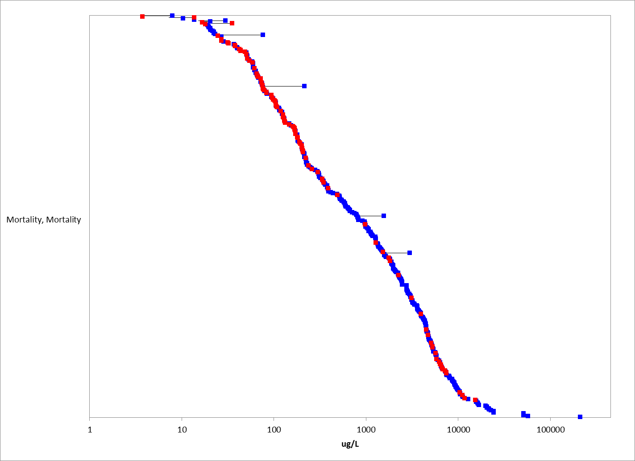
Figure 2-3. Mortality Effects for Fish. Blue data points are from open literature, and red data points are from registrant-submitted studies. Note X-axis is in log10 scale.

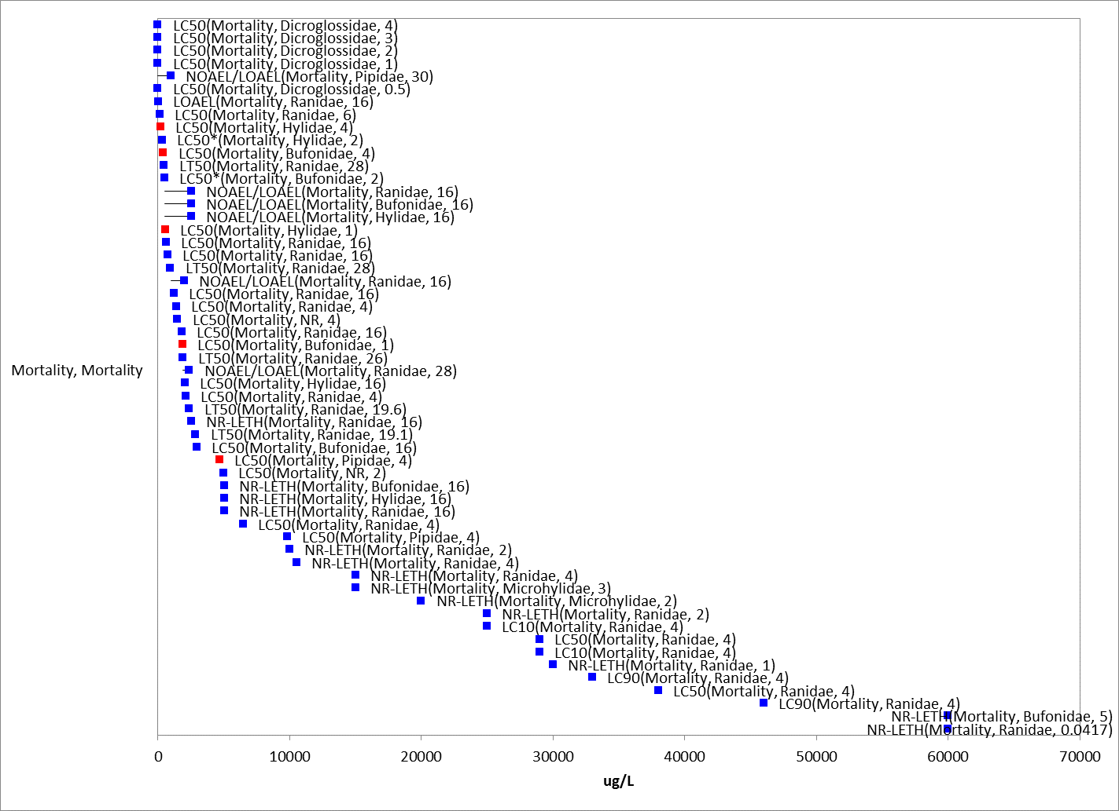
Figure 2-4. Mortality Effects for Aquatic-phase Amphibians. Endpoint labels include measured endpoint, test species family and test duration. Blue data points are from open literature, and red data points are from registrant-submitted studies.

Acute Mortality (96-hr LC50s)

Acute mortality data (96-hr LC₅₀s) are available for 13 different orders of fish with 66 different species, and 1 order of aquatic-phase amphibians (i.e., Anura) with 8 different species (one study did not report species) (Table 2-3); a 96-hr test duration is common for acute mortality toxicity testing. This table summarizes studies that are included in the derivation of SSDs (i.e., studies using TGAI and 96-hr duration, see ATTACHMENT 1-5 for details on SSD methodology)

For fish, the reported mortality data for malathion encompasses a wide range of toxicity values from acute LC₅₀ values of 4.1 to 448,000 µg/L (Table 2-3). For amphibians, acute LC₅₀ values range from 0.59 to 38,000 µg/L.

The most sensitive acute LC₅₀ value for fish is for rainbow trout (Oncorhynchus mykiss, Soap Lake strain) (MRID 40098001, Ecotox # 6797, Mayer and Ellersieck, 1986) with a 96-hr value of 4.1 µg/L. Nine additional rainbow trout acute 96-hr LC₅₀ values using TGAI (which were used in the SSD) are available with a range of 33 to 200 µg/L (median value of 100 µg/L). It is also noted that the 4.1 μg/L LC₅₀ value is approximately five times lower than the chronic NOAEC value of 21 μg/L (based on growth) from a fish early life-stage study with rainbow trout (MRID 41422401). Therefore, there is uncertainty in this lowest acute LC₅₀ value for rainbow trout; however, it is included in the SSD. The next most sensitive value is for striped bass (Morone saxatilis) with a 96-hr LC₅₀ value of 12 µg/L using TGAI (94.2%) (Fujimura et al. 1991; ECOTOX15472).

For aquatic-phase amphibians, the lowest acute 96-hr LC₅₀ is 0.59 μg/L for the Indian frog Rana hexadactyla using a malathion formulation (50 EC) (Khangarot et al., 1985; Eco ref. 011521). However, review of this study indicated limited reported information on the testing methods and apparatus, and exposure concentrations were not provided. Beyond this value, the range of acute mortality endpoints for aquatic-phase amphibians is 200 to 38,000 μg/L.

Table 2-3. Available 96-hr Median Lethal Concentration (LC₅₀) Data for Fish and Amphibians Exposed to Malathion as TGAI or Formulation
Order | Species Name | Common Name | LC50 Value (µg/L) | Test Material | Reference No.
Anura | Euphlyctis hexadactylus | True Frog | 0.59 | Formulation | E11521
Salmoniformes | Oncorhynchus mykiss | Rainbow Trout | 4.1 | TGAI | MRID 40089001; E6797
Perciformes | Morone saxatilis | Striped Bass | 12 | TGAI | E15472
Perciformes | Lepomis macrochirus | Bluegill | 20 | TGAI | MRID 40089001; E6797
Gasterosteiformes | Gasterosteus aculeatus | Three-spined stickleback | 20.9* | TGAI | MRID 48998006
Salmoniformes | Oncorhynchus tshawytscha | Chinook Salmon | 23 | Formulation | E522
Perciformes | Morone saxatilis | Striped Bass | 24.5 | Unknown² | E11334
Perciformes | Lepomis macrochirus | Bluegill | 30 | TGAI | MRID 40089001; E6797
Salmoniformes | Oncorhynchus mykiss | Rainbow Trout | 33 | TGAI | MRID 48078003
Cyprinodontiformes | Cyprinodon variegatus | Sheepshead Minnow | 33 | TGAI | MRID 41174301
Perciformes | Lepomis macrochirus | Bluegill | 40 | TGAI | MRID 40089001; E6797
Perciformes | Tilapia sp. | Tilapia | 45.99 | Formulation | E157374
Perciformes | Lepomis macrochirus | bluegill sunfish | 48* | TGAI | MRID 47540304
Cyprinodontiformes | Cyprinodon variegatus | Sheepshead Minnow | 51 | TGAI | E5074
Cyprinodontiformes | Cyprinodon variegatus | Sheepshead Minnow | 51.9* | TGAI | MRID 49055701
Perciformes | Lepomis macrochirus | Bluegill | 53 | Formulation | MRID 49051202
Perciformes | Lepomis macrochirus | Bluegill | 55 | TGAI | MRID 40089001; E6797
Cyprinodontiformes | Cyprinodon variegatus | Sheepshead Minnow | 55 | TGAI | MRID 41252101
Perciformes | Lepomis microlophus | Redear Sunfish | 62 | TGAI | MRID 40089001; E6797
Perciformes | Morone saxatilis | Striped Bass | 64 | TGAI | E15472
Perciformes | Sander vitreus | Walleye | 64 | TGAI | MRID 40089001; E6797
Perciformes | Morone saxatilis | Striped Bass | 65 | Unknown | E11334
Perciformes | Morone saxatilis | Striped Bass | 66 | TGAI | E15472
Salmoniformes | Oncorhynchus mykiss | Rainbow Trout | 66 | TGAI | MRID 40089001; E6797
Salmoniformes | Oncorhynchus tshawytscha | Chinook Salmon | 68.4 | Formulation | E2159
Salmoniformes | Salvelinus namaycush | Lake Trout, Siscowet | 76 | TGAI | MRID 40089001; E6797
Gasterosteiformes | Gasterosteus aculeatus | Threespine Stickleback | 76.9 | Formulation | E522
Osteoglossiformes | Notopterus notopterus | Asiatic Knifefish | 77 | TGAI | E4022
Salmoniformes | Oncorhynchus mykiss | Rainbow Trout | 80 | TGAI | MRID 40089001; E6797
Cyprinodontiformes | Fundulus heteroclitus | Mummichog | 80 | Unknown | E628
Anguilliformes | Anguilla rostrata | American Eel | 82 | Unknown | E628
Perciformes | Lepomis macrochirus | Bluegill | 84 | TGAI | MRID 40089001; E6797
Perciformes | Lepomis macrochirus | Bluegill | 87 | TGAI | MRID 40089001; E6797
Salmoniformes | Oncorhynchus mykiss | Rainbow Trout | 94 | TGAI | MRID 40089001; E6797
Gasterosteiformes | Gasterosteus aculeatus | Threespine Stickleback | 94 | Formulation | E522
Perciformes | Morone saxatilis | Striped Bass | 100 | TGAI | E15472
Salmoniformes | Oncorhynchus mykiss | Rainbow Trout | 100 | TGAI | MRID 40089001; E6797
Salmoniformes | Salmo trutta | Brown Trout | 101 | TGAI | MRID 40089001; E6797
Perciformes | Lepomis macrochirus | Bluegill | 103 | TGAI | MRID 40089001; E6797
Perciformes | Lepomis macrochirus | Bluegill | 110 | TGAI | MRID 40089001; E6797
Characiformes | Nannostomus unifasciatus | Oneline Pencilfish | 111 | Formulation | E162408
Cyprinodontiformes | Gambusia affinis | Western Mosquitofish | 112.2 | Formulation | E5806
Siluriformes | Clarias batrachus | Walking Catfish | 125 | Formulation | E120903
Atheriniformes | Menidia menidia | Atlantic Silverside | 125 | Unknown | E628
Perciformes | Lepomis cyanellus | Green Sunfish | 130* | TGAI | MRID 49364101
Salmoniformes | Oncorhynchus mykiss | Rainbow Trout | 138 | TGAI | MRID 40089001; E6797
Perciformes | Oreochromis niloticus | Nile Tilapia | 140 | Unknown | E3296
Salmoniformes | Salvelinus namaycush | Lake Trout, Siscowet | 142 | TGAI | MRID 40089001; E6797
Perciformes | Lepomis cyanellus | Green Sunfish | 146 | TGAI | MRID 40089001; E6797
Salmoniformes | Oncorhynchus mykiss | Rainbow Trout | 152 | TGAI | E12182
Cypriniformes | Danio rerio | Zebra Danio | 155 | Unknown | E12047
Perciformes | Oreochromis mossambicus | Mozambique Tilapia | 165 | Formulation | E118389
Perciformes | Oreochromis mossambicus | Mozambique Tilapia | 165 | Formulation | E11603
Perciformes | Lepomis cyanellus | Green Sunfish | 170 | TGAI | MRID 40089001; E6797
Salmoniformes | Oncorhynchus kisutch | Silver Salmon | 170 | TGAI | MRID 40089001; E6797
Salmoniformes | Oncorhynchus mykiss | Rainbow Trout | 170* | TGAI | MRID 47540302
Salmoniformes | Oncorhynchus clarkii | Cutthroat Trout | 174 | TGAI | MRID 40089001; E6797
Perciformes | Lepomis cyanellus | Green Sunfish | 175 | TGAI | MRID 40089001; E6797
Salmoniformes | Oncorhynchus kisutch | Silver Salmon | 177 | TGAI | MRID 40089001; E6797
Anura | Pseudacris triseriata | Striped, Northern Chorus Frog | 200 | TGAI | MRID 40089001; E6797
Salmoniformes | Oncorhynchus mykiss | Rainbow Trout | 200 | TGAI | MRID 40089001; E6797
Salmoniformes | Oncorhynchus clarkii | Cutthroat Trout | 230 | TGAI | MRID 40089001; E6797
Salmoniformes | Oncorhynchus clarkii | Cutthroat Trout | 237 | TGAI | MRID 40089001; E6797
Characiformes | Paracheirodon axelrodi | Neon | 247 | Formulation | E162408
Perciformes | Micropterus salmoides | Largemouth Bass | 250 | TGAI | MRID 40089001; E6797
Cyprinodontiformes | Fundulus majalis | Striped Killifish | 250 | Unknown | E628
Characiformes | Hyphessobrycon erythrostigma | Bleeding Heart Tetra | 252 | Formulation | E162408
Perciformes | Perca flavescens | Yellow Perch | 263 | TGAI | MRID 40089001; E6797
Salmoniformes | Oncorhynchus clarkii | Cutthroat Trout | 270 | TGAI | MRID 40089001; E6797
Salmoniformes | Oncorhynchus clarkii | Cutthroat Trout | 280 | TGAI | MRID 40089001; E6797
Perciformes | Micropterus salmoides | Largemouth Bass | 285 | TGAI | MRID 40089001; E6797
Salmoniformes | Oncorhynchus mykiss | Rainbow Trout | 290 | Formulation | MRID 47540308
Cyprinodontiformes | Gambusia affinis | Western Mosquitofish | 300 | Unknown | E20475
Salmoniformes | Salmo salar | Atlantic Salmon | 313.6 | TGAI | E16946
Perciformes | Lepomis macrochirus | Bluegill | 336.6 | TGAI | E77525
Cyprinodontiformes | Jordanella floridae | Flagfish | 349 | TGAI | E995
Cypriniformes | Leuciscus cephalus | Chub | 361.4 | Formulation | E104602
Cyprinodontiformes | Fundulus heteroclitus | Mummichog | 400 | Unknown | E628
Anura | Bufo woodhousei ssp. fowleri | Fowler's Toad | 420 | TGAI | MRID 40089001; E6797
Perciformes | Oreochromis mossambicus | Mozambique Tilapia | 444 | Formulation | E118389; E11603
Cypriniformes | Puntius sophore | Pool Barb | 495 | Formulation | E765
Perciformes | Channa punctata | Snake-Head Catfish | 522 | Formulation | E765
Mugiliformes | Mugil cephalus | Striped Mullet | 550 | Unknown | E628
Perciformes | Trichogaster pectoralis | Snake-Skinned Gourami | 560 | Formulation | E118389
Perciformes | Oreochromis niloticus | Nile Tilapia | 604.2 | Formulation | E161048
Cypriniformes | Cyprinus carpio | Common Carp | 710 | Formulation | E6999
Salmoniformes | Oncorhynchus kisutch | Silver Salmon | 720* | TGAI | MRID 49479003
Cypriniformes | Labeo rohita | Rohu | 750 | Formulation | E154643
Cypriniformes | Danio rerio | Zebra Danio | 759 | Unknown | E93401
Perciformes | Channa punctata | Snake-Head Catfish | 874 | Unknown | E17200
Perciformes | Channa punctata | Snake-Head Catfish | 894 | TGAI | E14673
Siluriformes | Otocinclus affinis | Dwarf Sucking Catfish | 1067 | Formulation | E162408
Cypriniformes | Cirrhinus mrigala | Carp, Hawk Fish | 1125 | Formulation | E9277
Anura | Hoplobatrachus tigerinus | Indian Bullfrog | 1410 | Unknown | E61878
Perciformes | Colisa fasciata | Giant Gourami | 1480 | TGAI | E74220
Perciformes | Oreochromis niloticus | Nile Tilapia | 1500 | TGAI | E162438
Anura | NR Anura | Frog And Toad Order | 1500 | Formulation | E20421
Beloniformes | Oryzias latipes | Japanese Medaka | 1500* | TGAI | MRID 49364102
Characiformes | Colossoma macropomum | Blackfin Pacu | 1507 | Formulation | E162408
Cypriniformes | Cyprinus carpio | Common Carp | 1575 | Formulation | E9277
Cypriniformes | Puntius sophore | Pool Barb | 1600 | Formulation | E9276
Anura | Euphlyctis cyanophlyctis | Indian Skittering Frog | 1762 | Formulation | E158906
Anura | Euphlyctis cyanophlyctis | Indian Skittering Frog | 1794 | Formulation | E158906
Perciformes | Oreochromis niloticus | Nile Tilapia | 1980 | Formulation | E89874
Perciformes | Oreochromis mossambicus | Mozambique Tilapia | 2000 | TGAI | MRID 40089001; E6797
Atheriniformes | Melanotaenia fluviatilis | Crimson-Spotted Rainbowfish | 2090 | Formulation | E15030
Cypriniformes | Cyprinus carpio | Common Carp | 2100 | Formulation | E6999
Perciformes | Colisa fasciata | Giant Gourami | 2120 | TGAI | E74220
Anura | Rana boylii | Foothill Yellow-Legged Frog | 2137 | TGAI | E92498
Perciformes | Oreochromis niloticus | Nile Tilapia | 2200 | TGAI | E20087
Perciformes | Oreochromis mossambicus | Mozambique Tilapia | 2400 | TGAI | MRID 40089001; E6797
Cypriniformes | Labeo rohita | Rohu | 2490 | Formulation | E9277
Perciformes | Channa punctata | Snake-Head Catfish | 2500 | Unknown | E89754
Cypriniformes | Carassius auratus | Goldfish | 2610 | Unknown | E563
Cyprinodontiformes | Gambusia affinis | Western Mosquitofish | 2900* | TGAI | MRID 49422801
Cypriniformes | Nemacheilus angorae | River Loach | 3024 | Unknown | E106641
Cyprinodontiformes | Poecilia reticulata | Guppy | 3069 | TGAI | E5370
Cypriniformes | Carassius auratus | Goldfish | 3150 | Unknown | E563
Tetraodontiformes | Sphoeroides maculatus | Northern Puffer | 3250 | Unknown | E628
Cypriniformes | Alburnus alburnus | Bleak | 3591 | TGAI | E14861
Cypriniformes | Barbus dorsalis | Two Spot African Barb | 3700 | Formulation | E6722
Perciformes | Channa punctata | Snake-Head Catfish | 3890 | Formulation | E11888
Cypriniformes | Barbus ticto | Two-Spot Or Tic Tac Toe Barb | 4000 | TGAI | E10763
Cypriniformes | Rasbora daniconius | Slender Rasbora | 4000 | TGAI | E10763
Cypriniformes | Barbus ticto | Two-Spot Or Tic Tac Toe Barb | 4000 | TGAI | E10764
Cypriniformes | Labeo rohita | Rohu | 4500 | Formulation | E158903
Cypriniformes | Labeo rohita | Rohu | 4500 | Formulation | E118200
Cypriniformes | Labeo rohita | Rohu | 4500 | Formulation | E118295
Perciformes | Channa punctata | Snake-Head Catfish | 4510 | TGAI | E11888
Anura | Xenopus laevis | African Clawed Frog | 4710* | TGAI | MRID 48409302
Cypriniformes | Rhodeus sericeus ssp. amarus | Bitterling | 4807 | TGAI | E14861
Perciformes | Oreochromis mossambicus X niloticus | Hybrid Tilapia | 4939 | Technical (84%) | E166
Cypriniformes | Rasbora daniconius | Slender Rasbora | 6000 | TGAI | E10764
Anura | Lithobates clamitans | Green Frog | 6470 | Formulation | E161203
Cypriniformes | Cyprinus carpio | Common Carp | 6590 | TGAI | MRID 40089001; E6797
Perciformes | Channa punctata | Snake-Head Catfish | 6610 | Formulation | E81095
Perciformes | Channa punctata | Snake-Head Catfish | 6650 | Formulation | E81095
Perciformes | Channa orientalis | Smooth-Breasted Snakefish | 6950 | Formulation | E5736
Perciformes | Channa orientalis | Smooth-Breasted Snakefish | 7050 | Formulation | E5736
Cypriniformes | Pimephales promelas | Fathead Minnow | 7125 | Formulation | E2155
Cypriniformes | Pimephales promelas | Fathead Minnow | 7125 | Formulation | E2155
Perciformes | Channa orientalis | Smooth-Breasted Snakefish | 7350 | Formulation | E5736
Cypriniformes | Cirrhinus mrigala | Carp, Hawk Fish | 7500 | Formulation | E118383
Siluriformes | Mystus tengara | Catfish | 7600 | TGAI | E94525
Perciformes | Channa orientalis | Smooth-Breasted Snakefish | 7600 | Formulation | E5736
Siluriformes | Ictalurus punctatus | Channel Catfish | 7620 | TGAI | MRID 40089001; E6797
Cypriniformes | Pimephales promelas | Fathead Minnow | >7980 | TGAI | MRID 48998004
Cypriniformes | Carassius auratus | Goldfish | 8066 | TGAI | E13456
Siluriformes | Heteropneustes fossilis | Indian Catfish | 8500 | Unknown | E17539
Cypriniformes | Pimephales promelas | Fathead Minnow | 8650 | TGAI | MRID 40089001; E6797
Siluriformes | Ictalurus punctatus | Channel Catfish | 8970 | TGAI | MRID 40089001; E6797
Cypriniformes | Ptychocheilus lucius | Colorado Squawfish | 9140 | TGAI | E13270
Siluriformes | Ictalurus punctatus | Channel Catfish | 9650 | Formulation | E822
Beloniformes | Oryzias latipes | Japanese Medaka | 9700 | TGAI | E89099
Anura | Xenopus laevis | African Clawed Frog | 9810 | TGAI | E66506
Cypriniformes | Cyprinus carpio | Common Carp | >10000 | TGAI | MRID 48998005
Cypriniformes | Carassius auratus | Goldfish | 10700 | TGAI | MRID 40089001; E6797
Cypriniformes | Pimephales promelas | Fathead Minnow | 11000 | TGAI | MRID 40089001; E6797
Perciformes | Anabas testudineus | Climbing Perch | 11210 | TGAI | E94525
Siluriformes | Ameiurus melas | Black Bullhead | 11700 | TGAI | MRID 40089001; E6797
Siluriformes | Ameiurus melas | Black Bullhead | 12900 | TGAI | MRID 40089001; E6797
Cypriniformes | Cyprinus carpio | Common Carp | 12930 | Formulation | E6999
Cypriniformes | Lepidocephalichthys thermalis | Common Spiny Loach | 13790 | Unknown | E17207
Cypriniformes | Pimephales promelas | Fathead Minnow | 14100 | TGAI | E12859
Siluriformes | Heteropneustes fossilis | Indian Catfish | 15000 | Formulation | E15179
Cypriniformes | Gila elegans | Bonytail | 15300 | TGAI | E13270
Perciformes | Anabas testudineus | Climbing Perch | 16000 | Unknown | E88437
Cypriniformes | Cyprinus carpio | Common Carp | 16600 | Formulation | E89874
Siluriformes | Ictalurus furcatus | Blue Catfish | 17000 | TGAI | E112921
Cypriniformes | Cyprinus carpio | Common Carp | 23180 | TGAI | E14861
Cypriniformes | Pimephales promelas | Fathead Minnow | 28300* | TGAI | MRID 49252802
Siluriformes | Heteropneustes fossilis | Indian Catfish | 28500 | TGAI | E94525
Anura | Pelophylax ridibundus | Lowland Frog | 29000 | Formulation | E104561
Anura | Pelophylax ridibundus | Lowland Frog | 38000 | TGAI | E104561
Siluriformes | Heteropneustes fossilis | Indian Catfish | 38000 | Formulation | E470
Siluriformes | Heteropneustes fossilis | Indian Catfish | 42000 | Formulation | E470
Siluriformes | Heteropneustes fossilis | Indian Catfish | 45000 | Formulation | E5064
Siluriformes | Heteropneustes fossilis | Indian Catfish | 45000 | Formulation | E470
Siluriformes | Clarias batrachus | Walking Catfish | 448000 | TGAI | E89006
*=Included in SSD given known information regarding test material source.

Species-sensitivity distributions (SSD)

SSDs are calculated for all aquatic vertebrates and fish (see ATTACHMENT 1-5 for SSD methodology). SSDs are based on acute 96-hr LC₅₀ values from studies using TGAI from studies with known source of test material (LC₅₀ values from formulation/mixture testing were not included). There are six different orders and 9 different species of fish (2 estuarine/marine (saltwater)) species were included in the analysis). For amphibians, there was only one species. Based on the number of species used, separate SSDs for freshwater and saltwater species or aquatic-phase amphibians were not developed. The HC₀₅ values are similar across the different subset for all vertebrates and for fish only, with values of 20.9 and 19.4 µg/L for all vertebrates and all fish, respectively. It is noted that the CV and the resulting 95% confidence intervals for the HC₀₅ are relatively large for both aquatic vertbrates and all fish. Also, for direct effects, the threshold for mortality is one-millionth the HC₀₅ with calculated values of 0.50 and 0.54 µg/L for the different groups. For indirect effects thresholds (10% HC₀₅), the values are 7.3 and 7.8 µg/L.

Model-averaged SSDs and model-averaged quantiles, including the HC₀₅ are estimated and are presented in Table 2-4. The cumulative distribution function for the SSDs for all vertebrates and fish are presented in Figures 2-5 through 2-6, respectively. The SSD reports are provided in APPENDIX 2-6 and includes the details of how these SSDs were derived.

Table 2-4. Summary Statistics for SSDs Fit to Malathion Test Results (toxicity values reported in units of µg/L)
Statistic | All  Vertebr. | All  Fish
CV of the HC₀₅ | 1.6 | 1.4
HC₀₅ | 20.9 | 19.4
HC₁₀ | 34.0 | 30.5
HC₅₀ | 315 | 242
HC₉₀ | 10317 | 6270
HC₉₅ | 39143 | 21724
Mortality Thresh.¹  (slope = 3) | 0.54 | 0.50
Indirect Effects Threshold¹  (slope = 3) | 7.8 | 7.3
¹Slope of dose-response curve = 3 as slope was available for study near the HC05

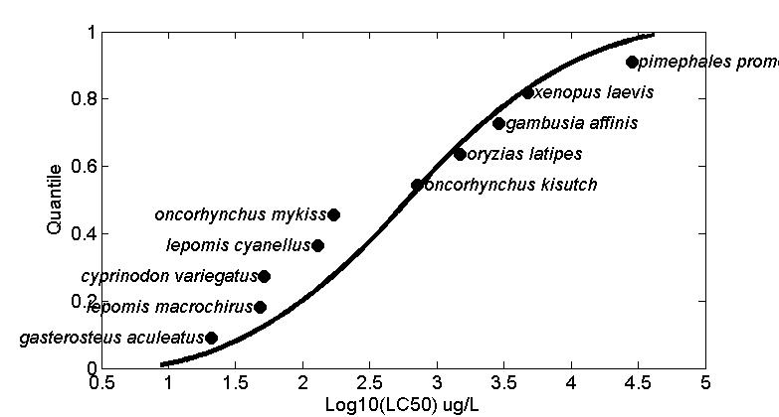
Figure 2-5. SSD for Malathion Toxicity Values for All Aquatic Vertebrates Pooled.
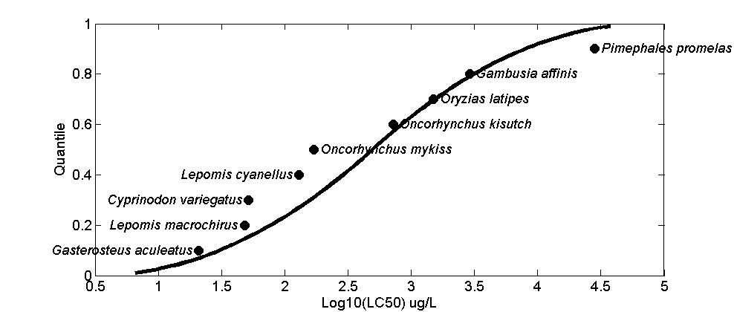
Figure 2-6. SSD for Malathion LC50s for All Fish.

Acute Mortality (endpoints other than LC50, test duration of ≤4 days)

There are 7 studies in ECOTOX encompassing 10 species that report acute toxicity values other than LC₅₀ for fish and aquatic-phase amphibians. LCx toxicity endpoints range from LC_{0.1} to LC₉₀ with values ranging from 570 to 46000 µg/L. Twenty-four other studies report lethal values (coded as NR-leth in ECOTOX) with toxicity values ranging from 26 to 60,000 µg/L.

Mortality data from exposures greater than 4 days

There are 31 studies with 27 species that evaluated mortality for durations greater than 4 days (which may be relatable to sub-chronic or chronic exposures). Effects ranged from a LOAEL of 9 µg/L for sheepshead minnow (Hansen and Parrish, 1977; E5074) to 60,000 µg/L for a toad (NR-LETH; 5 day exposure which is likely more of an acute effect; Rosenbaum et al., 1988 (E89111)). A couple of the more sensitive studies are described below.

The overall “sublethal” threshold for all fish and aquatic-phase amphibians is a sensitive mortality endpoint in a sheepshead minnow early life-stage study (MRID 48705301; 2011; 96% malathion [test material source/impurity profile known]). In this study, survival 28 days post hatch was significantly reduced 26 and 86% at 16 and 33 µg a.i./L with a NOAEC value of 8.2 µg a.i./L.

Additionally, a 20-week partial life-cycle study (Hansen and Parrish, 1977 (E5074)) conducted with technical grade malathion (95%) using sheepshead minnow (Cyprinodon variegatus) with a sensitive mortality endpoint was available. However, given the uncertainties in test material source, it was not used as the “sublethal” threshold. In this study, survival of the parental (F0) generation was significantly decreased at ≥18 µg/L (mean measured) after 140 days of exposure, with 50% mortality at 18 µg/L and 100% mortality at 37 and 86 µg/L (mean measured); the NOAEC for parental survival was 9 µg/L. Additionally, survival of offspring (fry) after 28 days was significantly reduced at 9 and 18 µg/L (14 and 15%, respectively) with a NOAEC value of 4 µg/L.

Another reported low NOAEC value in the ECOTOX database is a study where Xenopus laevis tadpoles were exposed to malathion at 1.0 ng/L, 1.0 μg/L, and 1.0 mg/L for 30 days (Webb and Crain 2006 (E118382)). Significant effects on mortality along with observations of bent tails (captured under ‘Growth’ in ECOTOX summary figure) and unusual swimming behavior were reported at 1.0 mg/L (1000 µg/L) with a NOAEC of 1.0 µg/L. Given that the test concentrations tested are too far apart to be able to discern a reasonable dose-response relationship for the endpoints evaluated, this study was not used to establish a threshold value.

Other types of mortality data in ECOTOX

There are additional toxicity data related to mortality coded in ECOTOX as “survival” and “hatch”. Endpoints for these types of effects are reported as LOEC/LOAEL, LC50, NR-LETH, and ATCN (along with many NOEC/NOAEL values). Toxicity values for these endpoints range from 3.1 µg/L (LOEC) as survival to leopard frogs in a community-based study (Groner and Relyea, 2011 (E159029)) to 9,800 µg/L (LOEC) for zebrafish (Nguyen and Janssen, 2001 (E68928)) (Figures 2-7 and 2-8).

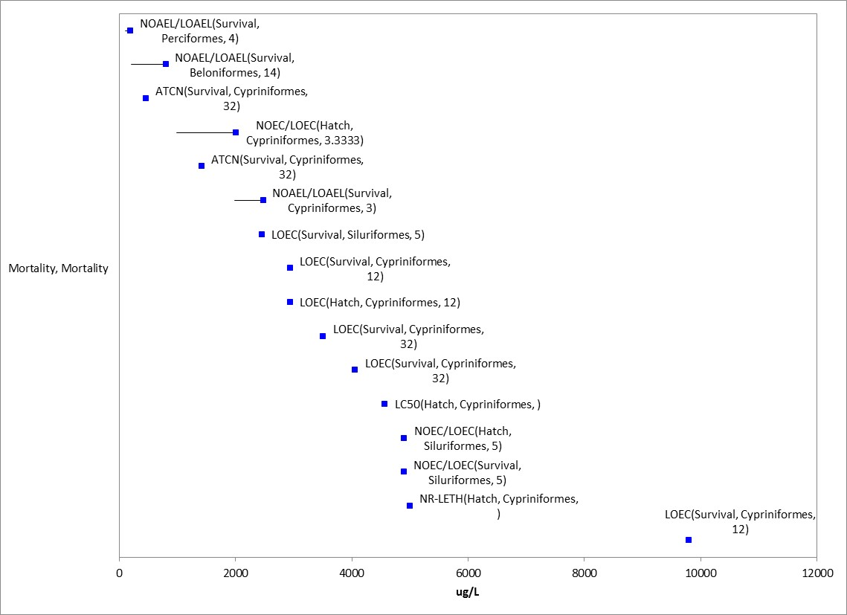
Figure 2-7. Mortality Effects (as survival or hatch) for Fish. Endpoint labels include measured endpoint, test species order and test duration. Blue data points are from open literature.

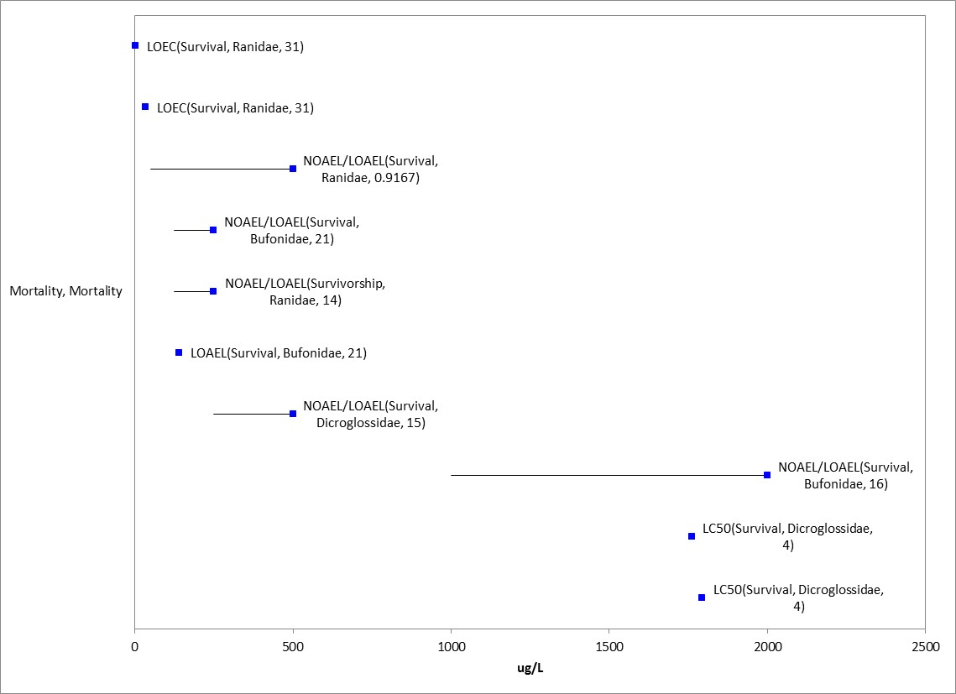
Figure 2-8. Mortality Effects (as survival or hatch) for Aquatic-phase Amphibians. Endpoint labels include measured endpoint, test species family and test duration. Blue datapoints are from open literature.

2.4.2 Sublethal Effects to Fish and Aquatic-phase Amphibians

Toxicity data pertaining to the sublethal effects for fish and aquatic-phase amphibians such as decreases in growth, decreases in reproduction, altered behavior, and changes in sensory function are discussed in the following sections.

2.4.2.1 Effects on Growth of Fish and Aquatic-phase Amphibians

Growth data are available for ECOTOX and registrant-submitted studies for 14 different species of fish, and 10 different species of aquatic-phase amphibians (species not identified for two studies), making a total of 40 studies available for evaluating growth effects. Growth endpoints reported include alterations in weight, length, biomass, condition factor as well as changes in growth rates (Figures 2-9 and 2-10). Morphological changes in organ weight as well as abnormal developmental are also reported. Effects on metamorphosis are also reported for aquatic-phase amphibians. In fish, the range of exposure concentrations with reported growth effects range from 10.9 µg/L (Hermanutz 1978 (E995), MRID 4878002) up to 3510 µg/L for weight effects in Colorado squawfish (Beyers 1994 (E13270)). Below is a discussion of previously reviewed studies and those community-based studies reporting sensitive growth endpoints.

In laboratory studies with amphibians, effects range from 90 µg/L (effects on embryo length (Snawder and Chambers, 1989 (E66506)) up to 28,000 µg/L (length effects on early-life stages of tadpoles; Sayim, 2008 (E104561)). In Snawder and Chambers, 1989, the length of surviving embryos exposed to malathion (test concentrations not measured) for 96 hours was measured and compared to the control group. Based on visual interpretation of the figure in the study report, it appears that all test concentration were significantly different from controls (percent difference not easily interpreted). Additionally, community-based studies evaluating metamorphosis which were generally conducted outdoors were also available for amphibians. Some of these studies also included fish. These community-based studies are discussed in the aquatic community effects section.

The most sensitive growth endpoint for fish is a rainbow trout early-life stage study using TGAI (known test material source/impurity profile). In this study, effects on growth (body length; 7.5% reduction) was reported at 44 µg/L (NOAEC 21 µg/L) after 97 days of exposure (MRID 41422401). At the higher concentration, 84 ppb, all the fish died by test termination.

In an additional study with growth effects include a life-cycle study using the freshwater flagfish (Jordanella floridae) (Hermanutz 1978 (E995), MRID 4878002). In this study, mean body length in the parental (F0) generation after 30 days of exposure to malathion (95%; test material impurity profile unknown) was significantly reduced 11% or greater at ≥10.9 µg/L with a NOAEC value of 8.6 µg/L.

In a fathead minnow life-cycle study (MRID 49723701), there were no effects on hatching or survival in the parental (F0) generation. At 28, 56 and 78 days post-hatch, growth was significantly reduced (standard length by 5-8% and wet weight by 23% (day 78 only)) at the highest test concentration of 1350 µg a.i./L (NOAEC 661 µg a.i./L). Difficulties in maintaining test concentrations was encountered early in the reproductive phase of the study (first spawn recorded on day 105, study terminated on day 156), and reliable conclusions regarding fecundity could not be determined (mean number of spawns per pair reported in the control and treatments was 1 or 2, except for a mid-concentration with a mean of 4); although, it is noted that at the highest concentration only one spawn consisting of four eggs was produced. As such, there was no available information for offspring (Fl) generation hatch, survival, or growth. From day 0 through day 98, mean measured concentrations of malathion ranged from 82-90% of nominal, whereas, from day 105 through day 126, the last day on which regularly schedules samples were collected, mean measured concentrations ranged from 29 to 59% of the nominal concentrations.

In a study by McCarthy and Fuiman, 2008, using estuarine/marine red drum (Sciaenops ocellatus) larvae exposed to malathion concentrations of 0.7 and 7.4 µg/L (measured on Day 0; TGAI; 8 day study), the study authors reported that there was a significant effect (reported as small but significant depression; p=0.03) on average growth rate (as wet weight) (E103059). However, based on the information in the study, it is unclear what concentration(s) were significantly different from the control. They also reported a significant increase in protein synthesis on day 2 (not significant on day 4 or 8). There were no effects on growth rate as total length or protein content. In an additional study from the same laboratory (Del Carmen Alvarez and Fuiman, 2006 (E96028)) that reported a similar test design and the same exact test concentrations, there were no significant effects (p=0.30) on growth rate (as dry weight), or effects on routine or escape behavior, or resting metabolic rate. Therefore, based on the uncertainty in the placement of the statistical significance and the additional data from the other citation, the reported effect on growth rate (as wet weight), and was not used as a threshold value. In the other available studies with estuarine/marine fish, there were no effects on growth in the partial life-cycle or early life-cycle studies with sheepshead minnow at concentrations up to 18 µg/L (Hanson and Parrish, 1977 (E5074); MRID 48705301).

Total length and body weight were significantly decreased (4 and 18% for length and weight, respectively) in Nile tilapia (Oreochromis niloticus) fed a diet containing 0.17 mg/kg malathion (purity not reported) for 120 days.

For amphibians, there were no effects on developmental stage or growth (snout-vent length (SVL) and body weight) in a 21-d screening assay with Xenopus laevis tadpoles up to test concentrations of 400 µg a.i./L (significant increase in SVL (11%) and body weight (28%) at lowest test concentration (40 µg a.i./L) at day 7, but not significant in other treatments or on day 21 (96% malathion; MRID 48617501).
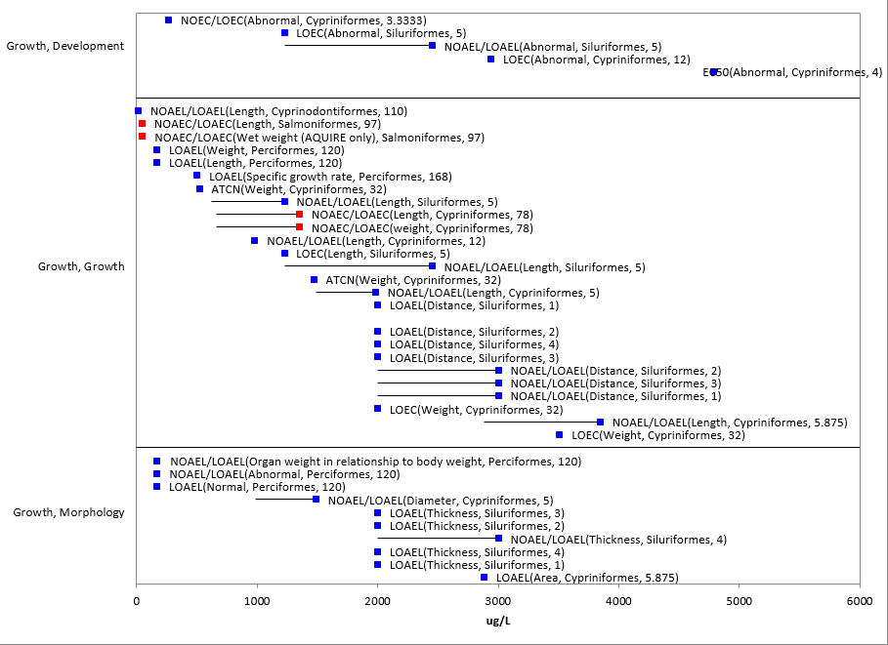
Figure 2-9. Growth Effects for Fish. Endpoint labels include measured endpoint, test species order and test duration. Blue data points are from open literature. Red data points are from registrant-submitted studies. There was one endpoint >6000 µg/L (10 mg/L ED50) that was not included for presentation purposes.

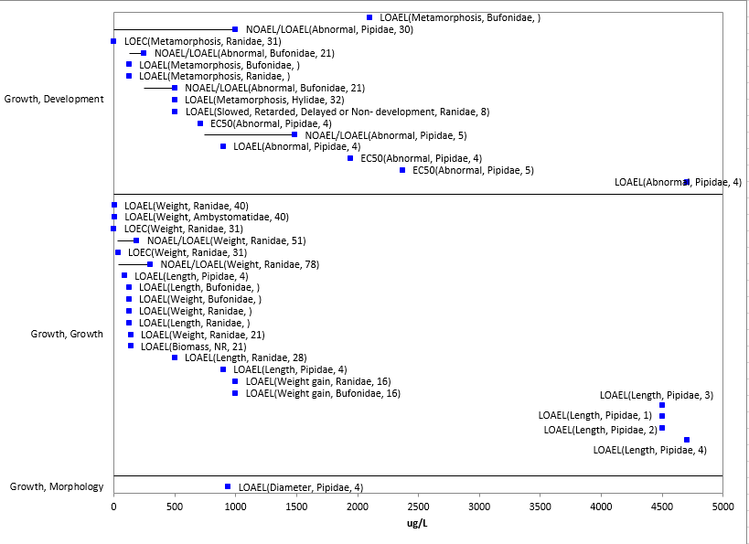
Figure 2-10. Growth Effects for Aquatic-phase amphibians. Endpoint labels include measured endpoint, test species family and test duration. Blue datapoints are from open literature. Two endpoints >5000 µg/L (22 and 28 mg/L LOEC) were not presented on figure for presentation purposes.

2.4.2.2. Effects on Reproduction of Fish and Aquatic-phase Amphibians

There are limited data evaluating malathion effects on reproduction for fish. Reproduction data were not available for aquatic-phase amphibians, therefore, toxicity data for fish will be used as a surrogate for amphibians.

There were no effects on reproduction (i.e., fecundity, hatching success) in either the life-cycle study with the flagfish (E995) or partial life-cycle study with sheepshead minnow (E5074) at concentrations up to 31.5 µg/L. As mentioned above for the fathead minnow life-cycle study (MRID 49723701), due to the abbreviated test duration, results of fecundity/fertility were not considered reliable.

In a 21-d screening assay with newly sexually-mature fathead minnows (Pimephales promelas), fecundity was significantly decreased 48% at 690 µg a.i./L compared to control; no significant difference in fecundity was observed at 250 µg a.i./L (MRID 48617506). In this study, at 690 µg a.i./L, alterations in male and female gondal histopathology, increases (21%) in female gonadal-somatic weight, and decreases in male secondary sex characteristics were also observed, as well as clinical signs of toxicity including erratic swimming, loss of color, and lethargy.

In a study with Nile tilapia (Oreochromis niloticus), fish fed a diet containing 0.17 mg/kg malathion (purity not reported) for 120 days had significantly lower numbers of ripened eggs than controls (156 vs. 245, mean values). Significant differences (p<0.05) in semen quality and gonadal weight were also observed in the malathion treatment (El-Gawad, 2011 (E160043).

      - Effects on Behavior of Fish and Aquatic-phase Amphibians

Behavioral data are available in ECOTOX for 4 different species of fish, and 8 different species of aquatic-phase amphibians; twelve studies were available for evaluating behavioral effects (Table 2-5 and Figures 2-11 and 2-12). Reported behavioral endpoints include alterations in swimming, activity, and ability to perform an acquired task. For aquatic-phase amphibians, effects on food consumption and equilibrium were also reported. In fish, effect concentrations range from 20 or 40 µg/L for locomotion (distance moved, swimming) in rainbow trout (Brewer et al. 1999 (E85991) and Beauvais et al., 2000) up to 4750 µg/L for accuracy of learned task for goldfish (Woodward, 1970 (E13456)). For amphibians, effects range from 50 µg/L (effects on general activity in bullfrogs (Relyea and Edwards 2010 (E162550)) up to 1500 µg/L (effects on food consumption in Boie’s wart frog (Gurushankara et al. 2007 (E104555)). Considering studies with known test material impurity profiles, abnormal swimming behavior was observed in the early life-cycle study with rainbow trout at 44 µg a.i./L (MRID 41422401). For amphibians with X. laevis, no abnormal behavior was observed up to 320 µg a.i./L in a 21-day study (MRID 48617501), but abnormal swimming was observed in a 4-day study at 1,300 µg a.i./L (MRID 48409302).

Table 2-5. Behavioral Effects for Fish and Aquatic-phase Amphibians
Test species | Effect Level (µg/L)¹ | Effect¹ | % Purity¹ | Reference
Goldfish (Carassius auratus) | 475/950  (3d NOAEL/LOAEL) | Acquired task | 95 | Woodward 1970; E13456
 | 4750 (1-d LOAEL) | Accuracy of learned task
Rainbow Trout (Oncorhynchus mykiss) | 20 (4-d LOAEL) | Swimming | 98 | Beauvais et al. 2000
 | 20 (1-d LOAEL) | General behavior changes | ≥98 | Brewer et al. 2001; E65887
 | 20/40 (4-d NOAEL/LOAEL) | Distance moved | 100 | Brewer et al. 1999; E85991
 | 40 (4-d NOAEL) | Swimming
 | 21/44 (97-d NOAEC/LOAEC)² | Swimming | 94 | MRID 41422401
Red drum fish (Sciaenidae sciaenops) | 7.42 (3-d NOAEL) | General activity | 98 | Alvarez 2005; E81672
 | 7.42 (7-d NOAEL) | Swimming |  | Del carmen Alvarez & Fuiman 2006; E96028
Zebrafish (Danio rerio) | 990/2013 (1 dpf NOEC/LOEC) | Number of movements | 100 | Fraysse et al. 2006; E108092
Bullfrog (Rana catesbeiana) | 480/960 (20 and 12-d NOAEL/LOAEL) | Equilibrium | 96 | Fordham et al. 2001; E56687
Boie’s Wart Frog (Fejervarya limnocharis) | 1000/1500 (14-d NOAEL/LOAEL) | Food consumption | 50 | Gurushankara et al. 2007; E104555
Xenopus laevis | 1000 (18-d NOAEL) | General activity | 100 | Webb & Crain 2006; E118382
 | 320 (21-d NOAEC)² | General activity | 96 | MRID 48617501
 | 540/1300 (NOAEC/LOAEC)² | Swimming | 96 | MRID 48409302
Wood frog (Lithobates sylvaticus) | 125 (14-d LOAEL) | Food consumption | 50 | Krishnamurthy & Smith 2011; E162410
Bronze frog (L. clamitans) | 50/500 (1-hr NOAEL/LOAEL) | General activity | 50 | Relyea & Edwards 2010; E162550
Bullfrog & Grey treefrog (Hyla versicolor) | 50 (1-hr LOAEL)
Salamander (Notophthalmusviridescens) | 50 (1.5 hr NOAEL) | Feeding efficiency and food source strikes
¹ As reported in ECOTOX (except for MRID 41422401, 48409302); all studies conducted in laboratory.
² Visually observed
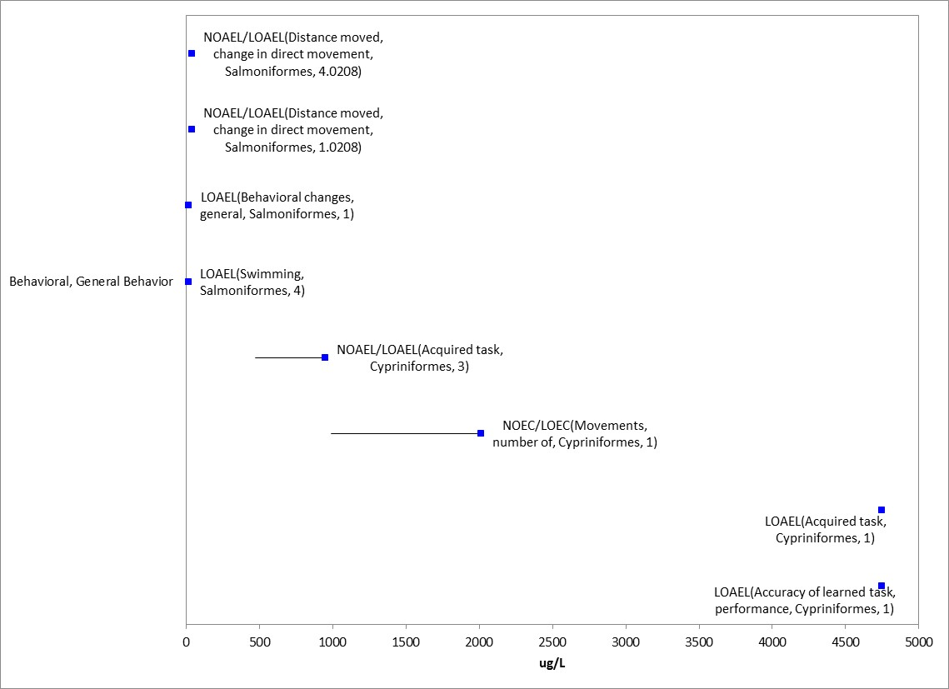
Figure 2-11. Behavioral Effects for Fish. Endpoint labels include measured endpoint, test species order and test duration. Blue data points are from open literature.

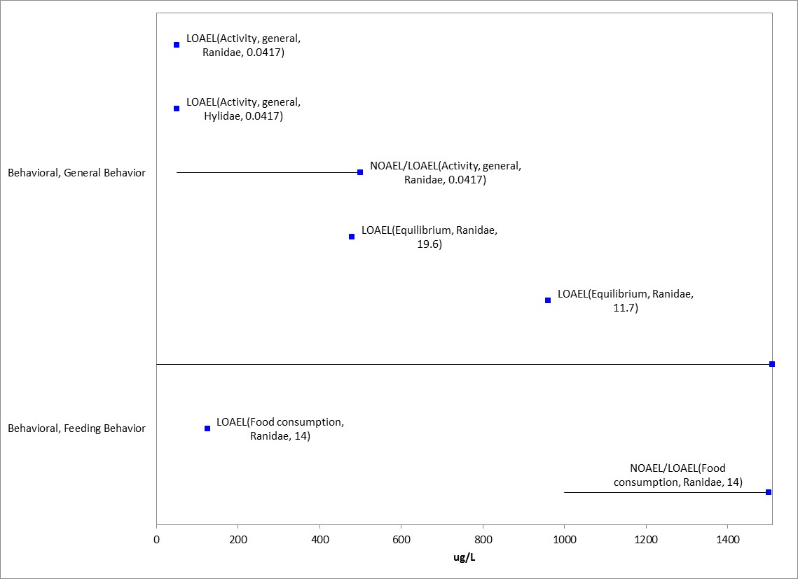
Figure 2-12. Behavioral Effects for Aquatic-phase Amphibians. Endpoint labels include measured endpoint, test species family and test duration. Blue datapoints are from open literature.

      - Effects on Sensory Function of Fish and Aquatic-phase Amphibians

There is only one study for sensory data in which no effect on chemical avoidance in sheepsheed minnow was reported at 1.0 mg/L with a study duration of one hour (Hansen, 1969 (E5145)).

      - Other Effects Reported for Fish and Aquatic-phase Amphibians

Effects other than those identified as mortality (survival), behavior, sensory, growth, and reproduction are reported for malathion. These include cellular, biochemical (in addition to effects on acetyl-cholinesterase), and physiological. A summary of each of these effect types are discussed below.

Biochemical and Cellular

Biochemical effects include alterations in enzymes and hormones (generally thyroid-related). Enzymatic effects include, but are not limited to, alterations in glutathione (S-transferase/reductase/peroxidase), cytochrome P450s, alanine transaminase, superoxide dismutase enzymes, and lysozyme activity (Figure 2-15). Additionally, effects such as alterations in protein content, cholesterol, antioxidant activity are also reported. The lowest reported value is for an alteration in hematological parameters at 6 µg/L (Kundu and Roychoudhury, 2009 (E119267)). The highest value was for changes in ali esterase, AChE and protein content in toads (Rhinella arenarum) at 44,000 µg/L (Rosenbaum et al. 1988; E89111)

Acetyl-cholinesterase (AChE) Inhibition

Given the mode of action of malathion, it is anticipated that the chemical should have an impact on acetyl-cholinesterase (AChE) which ultimately may lead to impacts to individual fitness including sublethal effects and death. The available data (open literature) report effects on acetylcholinesterase at concentrations ranging from 61 to 30,000 µg/L (Table 2-6). In Laetz, et al. (2009; E114293), juvenile coho salmon were exposed to malathion (98% from Chem Service) for 96 hours and brain AChE was evaluated. The 4-d EC50 value for this study was 79.4 µg/L. Although there is uncertainty in the test material impurity profile, given the lack of a study evaluating AChE with a known impurity profile, this study could be used as an endpoint for AChE effects for fish and aquatic-phase amphibians.

Table 2-6. Effects on Acetyl-cholinesterase Observed in Studies Involving Malathion
Test species | Effect Level (µg/L)¹ | Other Effects Reported (µg/L)¹ | Field or Lab | % Purity¹ | Reference
Mozambique tilapia | 61.5 (2-d LOAEC) | NA | Lab | 50 | Rao et al. 1984; E10519
Pacific salmon | 79.4 (4-d EC50) | NA | Lab | 98 | Laetz et al. 2009; E114293
Walking catfish | 190 (120-d LOAEC) | 4-d LC50= 448,000 | Lab | 100 | Das and Sengupta, 1993; E89006
Motsuga | 475 (2-dLOAEC) | Mortality: 15-d NR-Zero=1900 | Lab | 95 | Gu et al., 2001; 105039
Hawkfish (carp) | 1500 (5-d LOAEC) | 4-d LC50= 7500;  5-d Total protein: LOAEC=1500 | Lab | 50 | David et al. 2007; E118383
Channel catfish | 1800 (20-d IC50) | NA | Field | 100 | Carter, 1971; E14034
Blue Catfish | 250 & 5000 (4-d LOAEC)  2300 & 8500 (4-d IC50) | 4-d LC50= 3100 & 17,000 | Lab | 98.1 | Aker et al., 2008; E112921
Common carp | 30,000 (0.04d LOAEC) | NA | Lab | 100 | Kozlovskaya et al. 1984; E1256739
Toad (Rhinella arenarum) | 4000 (2-d LOAEL) | 1 & 2-d Ali esterase and mixed function oxidases LOAEL = 4000 | Lab | 100 | Venturino et al., 2001; 65749
Reported effects on other forms of cholinesterase
Toad (Rhinella arenarum) | 44,000 (5-d LOAEL)² | 2-4 d Ali esterase, total protein LOAEL = 44000;  5-dNR-LETH= 60000 | Lab | 94.6 | Rosenbaum et al. 1988; E89111
Frog (Rana boylii) | 1,250 (4-d LOAEL)³ | 4-d LC50=2137 | Lab | 99 | Sparling et al. 2007; E92496
Blue Catfish | 3700-9790000 (4-d IC50) ² | 4-d LC50= 3100 & 17,000 | Lab | 98.1 | Aker et al., 2008; E112921
¹ As reported in ECOTOX; no NOAECs were reported for any study
² Endpoint measured was buterylcholinesterase
³ Endpoint measured was chlolinesterase

Other Biochemical and Cellular Effects

In Kundu and Roychoudhury, 2009, hematological parameters are evaluated in field-collected cricket frogs, Fejervarya limnocharis, after exposure to 6.0 ppb (assumed to represent µg/L) malathion (50EC) for 240 hours. Relative to controls, total erythrocyte and leucocyte counts are significantly lower following the malathion exposure. Frogs exposed to malathion also had significant reductions in neutrophil counts and increases in eosinophil and lymphocyte counts compared to frogs in the control group. A dose-response relationship cannot be inferred from this study because it included only one malathion exposure concentration.

Cellular effects include general cellular effects, genetic effects and histological effects. The types of effects reported included changes in: components of the immune system (e.g., white blood cells, leukocytes), red blood cells, DNA/RNA concentration, mitotic index, micronuclei, and observations of edema. Again, the most sensitive effect reported was for the study on cricket frogs by Kundu and Roychoudhury, 2009, with effects ranging up to 100 ppm for walking catfish on red blood cells (Shammi and Qayyum, 1993; E94517).

Figure 2-13. Biochemical and Cellular Effects for Fish. Endpoint labels include measured endpoint, test species family and test duration. Blue datapoints are from open literature. Given the number of endpoints and the range of concentrations with reported effects (6 ppb to 100 ppm), only endpoints up to 1000 µg/L (1 mg/L) and without endpoint labels (measured endpoint, duration, test species) are shown for presentation purposes. The horizontal lines without corresponding blue data points along the right-hand side represent the the NOAEC values (left-side of side) without the corresponding LOAEC datapoint since it is at a concentration greater than 1000 µg/L.

Physiological

Physiological effects include alterations in immune system parameters (e.g., antibody titres, macrophage activity) as well as changes in general physiology (e.g., respiration, pigmentation, osmotic regulation) (Figures 2-14 and 2-15). The most sensitive endpoint is for oxygen consumption in bluegill fish (Dowden, 1966, E7856) which is described in more detail below. The highest reported effect is alteration in digestion at 40 ppm in Nile tilapia (Desai, 1987, E89194).

The most sensitive toxicity endpoint for fish and aquatic-phase amphibians in the ECOTOX database is a study by Dowden (1966) which examined changes in oxygen consumption rates in juvenile bluegill sunfish (Lepomis macrochirus) after exposure to malathion (TGAI). Significant decrease in oxygen consumption (mL O₂/gm body wt/hr) compared to the control was reported at all malathion treatments (approximately 50, 13, and 50% reduction at 0.1, 1.0 and 5.0 µg/L, respectively (visual observation from figure in report)). Fish were noted to produce excess mucus when exposed to malathion compared to the control. There is uncertainty in these results as data used in the comparison were measured over a 48 hour duration for the control and only for 10 hours for the test treatments due to reported mortality (several chemicals evaluated in this study and reviewer unsure where mortality occurred). Given the uncertainty in the analysis of the data in this study and the unknown impurity profile, it was not used to provide a threshold value. Reported acute 96-hr LC₅₀ values for bluegill fish range from 20-337 µg/L, which are much greater than the concentrations tested in the oxygen consumption study. Other studies in the open literature report effects on oxygen consumption at concentrations above the sublethal threshold, as well as for several other lines of evidence, including effects at 285 µg/L in Nile tilapia and 450 or 4500 µg/L in rohu fish (Labeo rohito) (E118200, 118295, and 162586). Effects and no effects in oxygen uptake were also reported in Indian catfish at 2000 µg/L (Adhikari et al., 1998, E89148). No effects on oxygen consumption/uptake were reported at 340 µg/L in fathead minnow after 2 hour test duration (Sanchez et al., 2008, E112907).

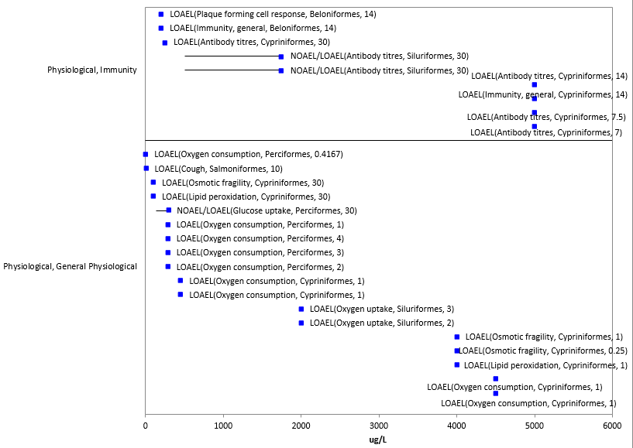
Figure 2-14. Physiological Effects for Fish. Endpoint labels include measured endpoint, test species order and test duration. Blue data points are from open literature. One endpoint >6000 µg/L (40 mg/L LOEC) was not included for presentation purposes.

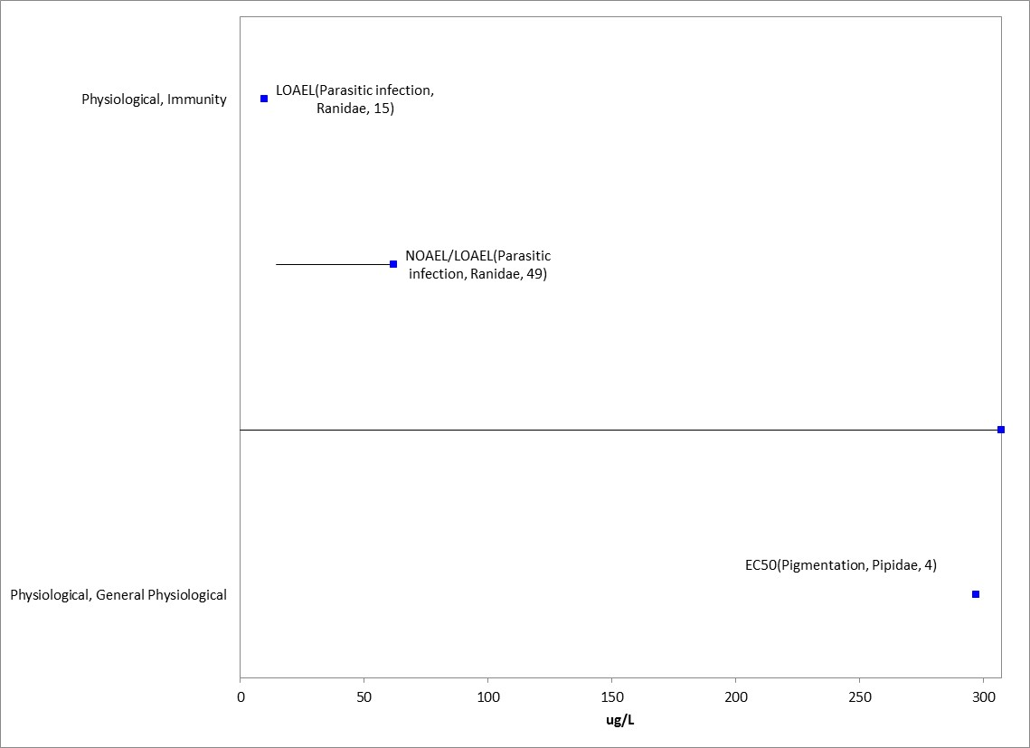
Figure 2-15. Physiological Effects for Aquatic-phase Amphibians. Endpoint labels include measured endpoint, test species family and test duration. Blue datapoints are from open literature.

2.5. Effects to Fish and Aquatic-phase Amphibians Not Included in the Arrays

Data Reported in Units of Mass/acre

A few studies in the ECOTOX database reported endpoints in units of lb/acre or kg ai/ha or oz/acre. A summary table of those studies/results are presented below in Table 2-7. While these studies may be used for evaluating potential effects in comparison to field application rates, they report no effects at application rates less than or effects at rates much greater than allowable rates.

Table 2-7. Toxicity Data for Malathion Based on lb a.i./A or kg a.i./ha (not in arrays)
Species | Effect Group | Endpoint | Media | Duration (d) | Endpoint Concentration | UNITS | Test Location | Reference #
Azcco platypus (Oikawa) | MOR | 0% mortality | FW | 3 | 0.7 | Kg ai/ha | Field | MRID00057057 & E8977 (Shim & Self, 1973)
Pimephales promelas (Fathead minnow) | MOR | 0% mortality | FW | 5 | 0.1 | Lb ai/acre | Lab (fed contaminated food) | E2904 (Hilsenhoff, 1959)
Pimephales promelas (Fathead minnow) | MOR | NOAEL/ LOAEL Survival | FW | 7 | 50/100 | Lb ai/acre | Lab (fed contaminated food) | E2904 (Hilsenhoff, 1959)
Actinopte spp. (spiny rayed fish class) | BCM | AChE (NOAEL) | FW | 9 | 4.5 | Oz/acre | Field | E89523 (McLean et al., 1975)

Non-environmentally-relevant exposure units

In addition to the effects described above for biochemical, cellular and physiological effects, there are other fish and aquatic-phase amphibian data available that are not included in the data arrays because the exposure units are not in or cannot be converted to environmentally-relevant concentrations based on the information in the ECOTOX toxicity table; or, there are NOAEC values available from a study without corresponding LOAEC or endpoints reported as no effect (NR-ZERO) (i.e., there were no effects noted in the study for a given endpoint).

The exposure unit listed in the ECOTOX toxicity table that could not be converted to an environmentally-relevant unit was %. The types of effects noted in the studies that are in units that could not be converted to environmentally-relevant concentrations are discussed below; these only include effects noted – and do not include those associated with a NOAEC value not associated with a LOAEC or ICx value. At the sub-organisms level, effects noted include changes in enzyme levels (alanine transaminase) and packed cell volume and red blood cells. Physiological effects on immune response (macrophage activity) and also mortality. Therefore, most of the effects associated with the sub-organism, whole organism or population are already captured in the terrestrial vertebrate toxicity arrays presented above.

Concentrations Where No Effects Were Observed in Fish and Aquatic-phase Amphibian Studies

For the exposure unit µg a.i./L there are data available that show concentrations where effects are not seen [i.e., labeled as ‘no effect’ (NE) concentrations in the data array below]. The NE endpoints include NOAEC/NOAEL and NR-Zero values as reported in ECOTOX. Below are the data arrays showing the NE endpoints for malathion and fish and aquatic-phase amphibians (Figures 2-16 and 2-17). For fish, the available ‘NE’ endpoint concentrations range from 0.34 to 22,500 µg a.i./L. For aquatic-phase amphibians, the ‘NE’ concentrations range from 1 to 44,000 µg a.i./L.

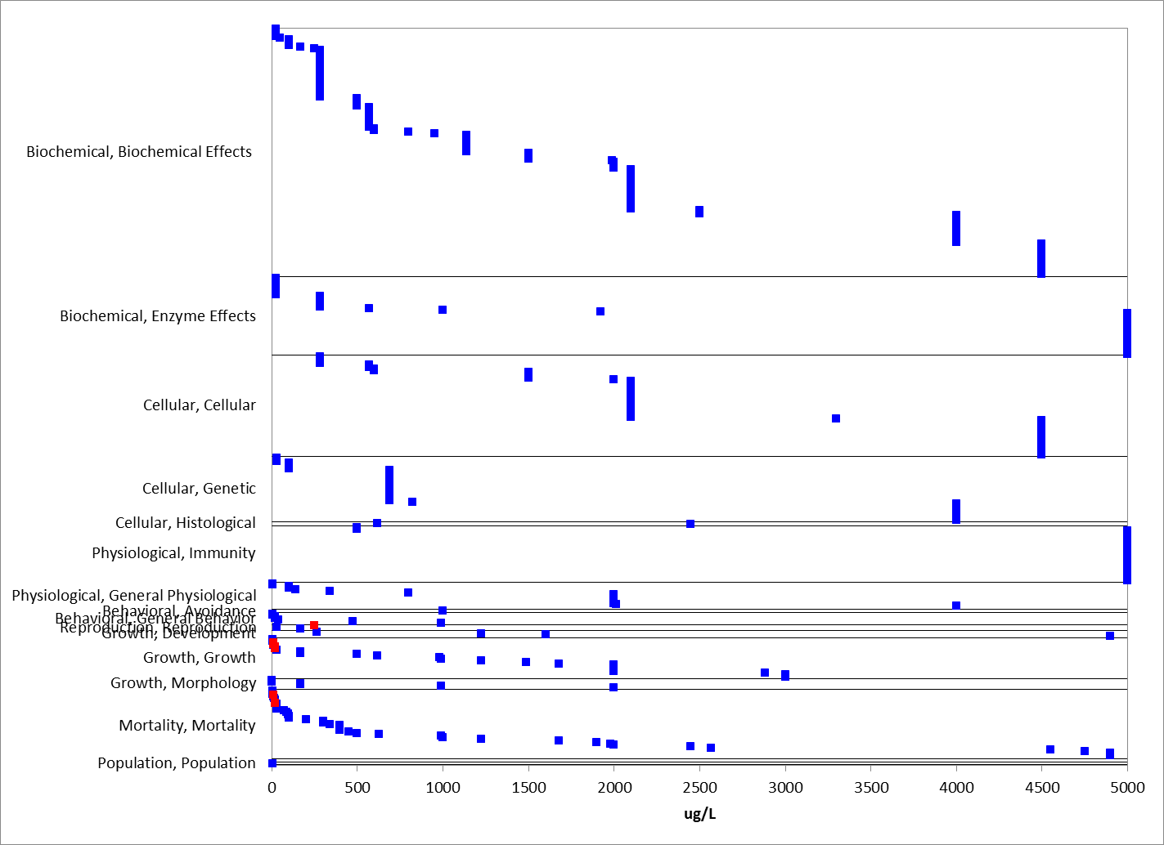
Figure 2-16. Concentrations with No Reported Effects for Fish. Endpoint labels removed for presentation purposes (measured endpoint, test species order and test duration. Blue data points are from open literature. Red data points are from registrant submitted studies. Given the number of endpoints and range of effect concentrations, three endpoints >5000 µg/L are not included for presentation purposes.

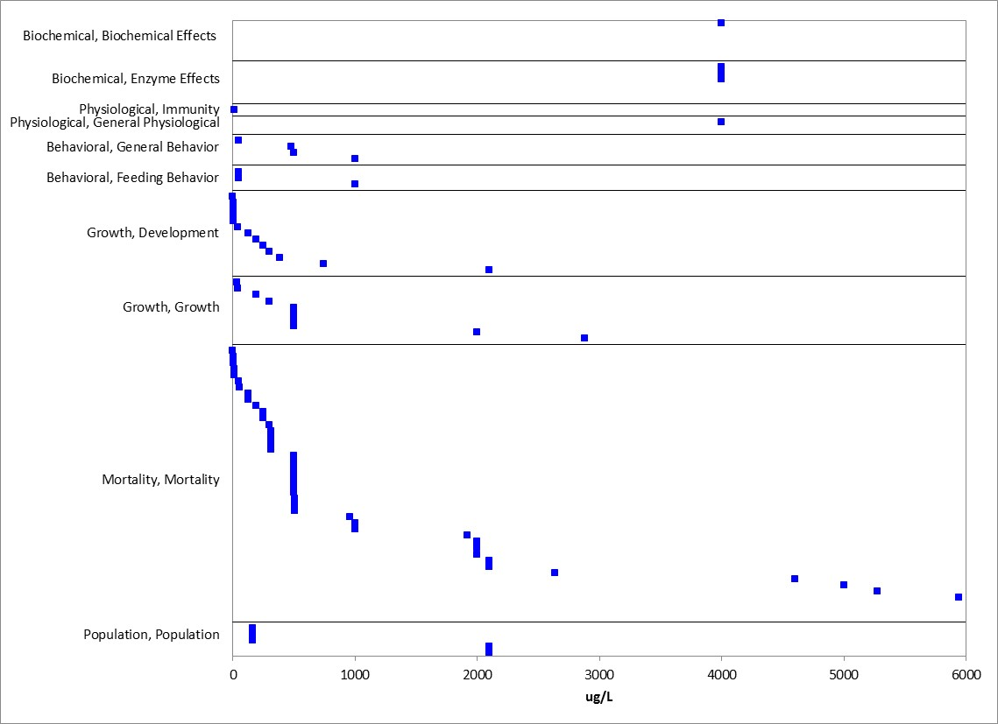
Figure 2-17. Concentrations with No Reported Effects for Aquatic-phase Amphibians. Endpoint labels removed for presentation purposes (measured endpoint, test species family and test duration). Blue data points are from open literature. Given the number of endpoints and range of effect concentrations, twelve endpoints >6000 µg/L (8-44 mg/L) were not included for presentation purposes.
  - Incident Reports for Fish and Aquatic-phase Amphibians

EFED’s incident database (EIIS), accessed October 26, 2015, contains 23 fish mortality incidents, excluding incidents associated with misuses or spills and those with a certainty level less than possible, that are associated with malathion (Table 2-8). There were no identified incidents with aquatic-phase amphibians. Aquatic incidents occurred in both freshwater and saltwater habitats. Incidents were associated with both agricultural uses and mosquito control uses of malathion. For both of these use types, there were numerous incidents with a high certainty level (“probable” or “highly probable”), providing evidence that both agricultural and mosquito control uses of malathion can sometimes result in mortality of fish. In several of the incidents, particulary in the southern United States when temperatures were higher, deleption of oxygen was often cited as another potential stressor source. There were 6 additional aquatic incidents with a certainty level of at least “possible” that were associated with known misuses of malathion.

Table 2-8. Summary of Aquatic Animal Incidents Associated with Malathion Use, by Certainty.
Incident Type | Use Type | Certainty
 |  | All (excluding unlikely) | Unlikely | Possible | Probable | Highly Probable
Aquatic (excluding misuse) | Agricultural sites | 10 (9) | 1 | 4 | 4 | 1
 | Mosquito control | 7 | 0 | 1 | 4 | 2
 | Unknown | 7 | 0 | 4 | 2 | 1
 | All | 24 (23) | 1 | 9 | 10 | 4
Aquatic (misuse only, includes spills) | Agricultural sites | 3 (2) | 1 | 0 | 1 | 1
 | Mosquito control | 1 | 0 | 1 | 0 | 0
 | Unknown | 3 | 0 | 3 | 0 | 0
 | All | 7 (6) | 1 | 3 | 1 | 1

A summary of the 23 incidents is presented in Table 2-9, and a more detailed description of some of the incidents are provided below in Table 2-10.

Table 2-9. Summary of Reported Incidents (for registered or unknown uses and certainty of possible or greater).
Incident ID | Use Site | Chemicals Involved (other than malathion) | Species affected | Effect/ magnitude | Legality | Certainty | State | Year
B0000-500-14 | Cotton | parathion, toxaphene | unknown | mortality/ unknown | REGISTERED USE | Probable | GA | 1989
B0000-500-16 | Cotton | profenofos | bream | mortality/ many | REGISTERED USE | Possible | GA | 1989
B0000-502-04 | Wide area | NR | pompano | mortality/ 200 | Registered Use | Highly Probable | SC | 1977
B0000-502-26 | Wide area | NR | bluegill, carp, golden shiner, goldfish | mortality/ 15-200 | REGISTERED USE | Probable | MD | 1980
B0000-503-52 | Cotton | NR | catfish | mortality/ 15 | REGISTERED USE | Possible | MS | 1998
B0000-600-01 | Cotton | NR | bream, sunfish | mortality/ hundreds | REGISTERED USE | Possible | TN | 1998
B0000-600-04 | Cotton | NR | catfish | mortality/ 16 | REGISTERED USE | Possible | TN | 1998
I002059-001 | Agricultural Area (near cotton field) | NR | largemouth bass | mortality/ some out of 30 | Registered use | Highly Probable | AL | 1994
I002059-002 | Agricultural Area (near cotton field) | NR | largemouth bass | mortality/ unknown | REGISTERED USE | Probable | AL | 1994
B0000-300-27 | N/R | NR | unknown | mortality/ unknown | Undetermined | Possible | SC | 1978
B0000-300-30 | N/R | NR | eel, shad | mortality/ 500 each | Undetermined | Possible | SC | 1981
B0000-300-33 | N/R | diquat | drum, mullet, spot, trout | mortality/ unknown | Undetermined | Probable | SC | 1982
B0000-300-86 | N/R | NR | unknown | mortality/ 300 | Undetermined | Possible | SC | 1973
B0000-500-29 | Cotton | NR | NA | mortality/unknown | Undetermined | Probable | GA | 1990
B0000-500-32 | Cotton | chlopyrifos, sluprofos, diflubenzuron, chlordimeform | unknown | mortality/unknown | Undetermined | Probable | GA | 1988
B0000-502-05 | N/R | NR | bass, bream, crappie | mortality/ 100 each | Undetermined | Probable | SC | 1979
B0000-502-08 | Wide area | aldrin, dieldrin | bream | mortality/ 11 | Undetermined | Probable | SC | 1981
B0000-502-13 | Wide area | 2,4-D | bream, croaker, spot tail bass | mortality/ 100 each | Undetermined | Possible | SC | 1984
B0000-502-14 | N/R | NR | unknown | mortality/ 1000 | Undetermined | Possible | SC | 1985
B0000-502-22 | Wide area | NR | menhaden | mortality/ thousands | Undetermined | Probable | MD | 1976
B0000-502-25 | Wide area | NR | eel, golden shiner, green sunfish, largemouth bass, minnow, pumpkinseed, redin pickerel, warmouth | mortality/ unknown | Undetermined | Highly Probable | MD | 1979
I000804-025 | Wide area | NR | walleye, yellow perch | mortality/thousands | Undetermined | Probable | SD | 1987
I009790-001 | N/R | NR | bluegill, unknown | mortality/ 14 bluegill, 1500 unknown | UNDETERMINED | Highly Probable | NY | 1999

Table 2-9. Details Regarding Some of the Reported Fish Incidents¹
Location and Date | Incident # | Description | Probability
Florida Medfly report-  1997 Spray operations  Hillsborough Area  USDA Report | 6 reports from 7129-  8/28 | 40 Sites of Fish kills investigated-malathion  detected in varying amounts in ponds and  pools. Fish species effected include-various  sunfish, bass, perch, and carp. 3 tropica.1 fish  farms hit. Mortality ranged from 5 to 1000  fish per site. Aerial drift generally blamed  though some runoff events did occur | Probable-residues  detected in water  and sometimes  tissues
South Dakota, Minihaha  Co., 7/6/87 | I000804-025 | 10,000 dead fish-incl. walleye and yellow  perch-aerial-Clean Crop -near Lake Madison | Probable
North Carolina, Wake  Co., 511 7/73 | B0000-225 | 10,000 panfish killed from 'A gallon spill of  forrnulation(l2.2 % Malathion/l2.2.4  endosulfan into a pond | Highly probable
Mississippi, Silver Creek,  7/6/89 | I000389-001 | 166 fish, mostly carp, were killed-pest control  company applied Aqua Malathion 8 in area | Possible
Missouri, 5/5/70 | I000636-002 | 33 fish kill reports-one sick dog from  ingestion of contaminated water | Possible
South Dakota, 7/3/87 | I000804-025 | 35 other incidents besides Lake Madison fish  kill-birds, fish, bees effected | Possible
Alabama | I0002059-002 | 2 fish kills-Cotton field application of malathion-bass and sunfish killed | Possible
New Jersey, Delaware  River 8/9/91 | none | Malathion distributed in sewage effluent to  kill flies-15 gal malathion product /13000 gal  effluent-1000 to 5000 white perch killed at  discharge point | Probable
Maryland, Cherry Hill-  5/12/80 | EPA report | 350 fish found dead- 10,000 acre lake  municipal pest control - Malathion | Probable
Missouri, Wentzvil1e.-  6/29/80 | EPA report | 6,790 dead fish counted-Malathion treated  municipal sewage discharge to McCoy Creek | Probable
South Carolina, Hilton  Head-5/25/81 | EPA report | 1500 dead fish-Sea Pine Lagoons-estuary-pesticide spraying operations using Malathion | Probable
Virginia, Norfolk-8/14/81 | EPA report | 1500 dead fish-Mason Creek-industrial  operations using Malathion | Possible
Florida, near Miami -  Summer, 1956 | Old report from Mr.  J.E. McCurdy-  Florida Mosquito  Control | Extensive observations of numerous canals,  ponds, ditches, and pools after aerial  application of Malathion-some species killed  others not-mortality to thousands of mojarra  silversides was immediate after sprayingsnook,  mollies, cyprinids, pinfish , bass; and  killifish also killed in ditch and canal areas strangely  gambusis were not sensitive | Probable
Massachusetts-four  incidents  White Island Pond near  Plymouth  Glen Charles Pond near  Waneham | 6a2 Report from American Cyanamid Oct. 4, 1990, #281720 | 4 fish kills reported from treatment of 700,000 Probable  American Cyanamid acres of estuarine areas with Malathion for  Oct. 4, 1990 control of mosquitoes. Many of the dead fish were estuarine killifish species | Probable
New York, Thornwood-  5/14/84  . | EPA report | 500 dead fish-Pond in Carroll park-agriculture  operations using malathion adjacent to pond | Possible
California-Monitored  3quatic incidents during  road scale aerial  application over San  Francisco, Bay area  198 1. Administrative  Report 82-2, Dept. Of  Fish and Game,  Environmental Services  Branch, 1982 | Medfly control | 23 fish poisoning incidents were investigated-  8 were confirmed as caused by malathion - 10  were listed as undetermined causes-2 were caused by chlorine discharge at sewer plants.  Malathion incidents included observed  mortality of over 2300 fish including  stickleback(Stevens, San Tomas Aquino,  Pescadero Creeks), carp(Adobe and ]Mission  Creeks), mosquitofish(Mission Creek),topsmelt, flounder, striped bass, and gobies(Sea1 and Redwood Creek, and  Mayfileld Sloughs), and largemouth bass and  crappie in San Jose Pond | Probable-  Malathion residues  detected in water tissue  concentrations in  gill filaments, liver,  skeletal muscle and  whole body tissues
Alabama, Tennessee  1995 Southeast  Bollweevil Eradication  Program, Environmental  Monitoring Report | USDA/APHIS 1995 report | Leighton, Alabama-Catfish Farm-dead  catfish-600 ft from aerially treated field(#295)  Lincoln Co., TN-2 acre stream fed pond-4  cotton fields upstream-dead bass, catfish,  sunfish.  Lighten, AL.-Big Nance Creek-30,000-40,000  Fish affected  Colbert Co.,AL.-Donnegan's Slough-fish kill both followed heavy rains 814-818 resulting  from hurricane  Fish pond near Site 139-dead sunfish, catfish malathion residues in water-5 to 6 ppb  Catfish Farm-2 ponds-dead catfish near field  # 19- 150 feet from ponds-9 old day samples  did not show high concentration levels-only  trace levels  Fishkill-1/10 acre pond near field #303-dead  adult catfish sampled-malathion detected in water.  Fish, turtle, frog, and crayfish kill-5 acre  wetland-2 to 3 ft. Depth-cotton field 503  located 600 ft. away-drainage ditch leads to  wetland-6 day old samples-malathion still  detected in water and fish tissues. | Probable- inspection  was too late in many  cases- 1 week after  Possible-  Endosulfan,  malathion and  methyl parathion all  suspect.  Probable-  Probable  Possible  Probable-fish tissue  residues 35-85 ppb.  Probable-though not  likely from  bollweevil aerial  treatment, 6 weeks  previous
Alabama, Tennessee  1995 Southeast  Bollweevil Eradication  Program, Environmental  Monitoring Report  (continued) | USDA /APHIS  1995 report | Fish Kill(bass, sunfish, catfish)-8 acre pond-  20ft. From application site (cotton field #1180)-residues of 77.8 ppb in one water  sample. Other chemicals used in area-Larvin  and Pyrat  Fishkill - 114 acre farm pond near cotton fields  # 118 and 119-malathion residues in all 4 water samples-fish tissue sample contained  35l ppb malathion.  Fishkill(catfish)- 1/4 acre pond near field# 166-70 ftfrom pond-malathion detected in 8 day post-application samples | Probable-residue levels in tissues were high  Possible-sampling  too late-cotton field  treated 8 days  earlier
California-4 Incidents  near Fremont, Lorna Mar, San Jose, and San Mateo  Co. 9/30/81-10/9/81 | EPA report | 2000 dead fish-Fremont Creek-crop treatment  200 dead fish-Pescadero creek-crop treatment  75 dead fish-pond near San Jose-crop treated  12 dead fish-Adobe creek-crop treatment | Possible
¹ Table cited in 2000 U.S. EPA Reregistration Ecological Risk Assessment for malathion

In additional to the reports in EIIS, the Aggregate Incident Reports database identified an additional four incidents linked to malathion use as aggregated counts of minor fish/wildlife incidents (W-B). They were all associated with the registration number 239-00739, however, the corresponding product names did differ (Malathion 50 Insect spray, Malathion Ready Spray, Malathion Plus). The four incidents were reported during the years 2001, 2007, 2008, and 2009. Because details about these incidents were not reported, no information was available on the use site, the certainty level, or on the types of organisms that were involved.

Significance of Reported Incidents

Though malathion has been used for many years, the greatest numbers of detailed reports of fish kill incidents involved heavily monitored programs such as USDA's boll weevil eradication program and the Mediterranean fruit fly eradication efforts. Other incidents appeared linked to uses near aquatic habitats where direct drift may have occurred, such as mosquito control. In many of the incidents, use rates and residue levels following the incidents are not clear and kills are investigated days after the event probably occurred. In two of the incidents, sewage discharge was treated with malathion to control flies and then released directly into tributaries. In all cases, where residue levels are provided they are within the limits expected to prove toxic to sensitive fish species (>4 ppb). One of the points that should be included when discussing fish kill incidents is that invertebrates are likely to have been more severely affected since fish are less sensitive to malathion than a majority of the invertebrate species tested in laboratories to date. In most of the fish kill incidents there appears to have been no effort to investigate the effects to the other components of the ecological community in the adversely effected sites.

  - Summary of Effects to Fish and Aquatic-phase Amphibians

Based on the available toxicity information, malathion can effect survival of fish and aquatic-phase amphibians both on an acute and chronic exposure basis. However, aquatic-phase amphibians appear to be acutely less sensitive than fish. While there is a large range in fish acute mortality data with LC₅₀ values ranging from 4.1 µg/L to 448,000 µg/L, the majority of the values within the SSD data set were less than 700 µg/L which would fall under the category of “highly toxic” according to the EPA classification. For amphibians, excluding an acute LC₅₀ value of 0.59 µg/L, the range of acute LC₅₀ values is 200-38,000 µg/L. Additionally, effects on growth for fish were also reported at concentrations of 11 µg/L (NOAEC=8.9 µg/L). There are limited reported reproductive effects as survival and growth appear to be more sensitive than fecundity. Decreases in fecundity were observed at 820 µg/L. While there are limited data identified as behavioral effects, effects on swimming (locomotion) were reported at concentrations around 20 µg/L which is at similar concentrations reporting acute mortality. There is only one study evaluating sensory effects (no effects on chemical avoidance), and there are no data evaluating other sensory functions such as olfaction. The available data report effects on acetylcholinesterase at concentrations ranging from 61 to 30,000 µg/L.

Effects Characterization for Aquatic Invertebrates

Introduction to Aquatic Invertebrate Toxicity

This section presents direct effects thresholds for listed aquatic invertebrates and indirect effects thresholds for species which rely upon aquatic invertebrates (e.g., as a food source). This section also discusses the WoE available for lines of evidence for effects to aquatic invertebrates, including mortality, decreases in growth, decreases in reproduction, and impacts on behavior.

Threshold Values for Aquatic Invertebrates

The threshold toxicity values may be used for evaluating exposures from runoff plus spray drift as well as from spray drift exposure alone. Studies from which threshold values were derived will be discussed in more detail in their respective line of evidence.

Mortality

Many acute mortality toxicity values for aquatic invertebrates are available; however, generally, there is uncertainity regarding test material source and its impurity profile. Using toxicity data with known test material source are available to calculate species sensitivity distributions. Therefore, the aquatic invertebrates direct effect mortality threshold is based on the 1 in a million effect from the HC₀₅ from the SSD for the taxon (see Table 3-1, and the discussion below). The mortality threshold for indirect effects is based on 10% of the HC₀₅ from the SSD. SSDs were based on acute 48 and 96-hr LC₅₀ values from studies using TGAI only (LC₅₀ values from formulation/mixture testing were not included).

Sublethal

The most sensitive toxicity value suitable for establishing a sublethal threshold is a Daphnia magna reproduction study (MRID 41718401).

Table 3-1. Mortality and Sublethal Threshold Values for Aquatic Invertebrates.
TAXON | THRESHOLD |  | ENDPOINT  (µg a.i./L) | EFFECT(S) | SPECIES | TEST MATERIAL | STUDY ID | COMMENTS
All Aquatic invertebrates | Mortality (SSD) | Direct (1/million) | 0.091 | Mortality | NA | NA | NA | HC05 of 1.0 from SSD; slope 4.5
 |  | Indirect (10%) | 0.54
 | Sublethal | Direct (NOAEC) | 0.06 | Decreased Reproduction | Daphnia magna (Freshwater) | TGAI | MRID 41718401 | 21-day exposure
 |  | Indirect (LOAEC) | 0.10

In addition to the overall mortality and sublethal threshold values to represent all aquatic invertebrates presented above in Tables 3-1 and 3-2 presents additional effect values (mortality and sublethal) for either freshwater invertebrates, estuarine/marine invertebrates or mollusks only as a potential refinement when evaluating potential risk to a more specific taxon/species. For these taxon, there was insufficient suitable (known impurity profile) toxicity data to calculate species sensitivity distributions for freshwater invertebrates, and estuarine/marine (saltwater) invertebrates separately. Therefore, the most sensitive EC/LC50 values (along with the 1/million and 10% values) are provided in Table 3-2 for all aquatic invertebrates, as well as for freshwater and estuarine/marine invertebrates only, to allow for refined effects characterizations. Additionally, NOAEC and LOAEC toxicity values are presented for sublethal effects that are reflective of potential impact on growth, behavior, and reproduction.

Table 3-2. Most Sensitive Toxicity Value for Different Effect Types for Aquatic Invertebrates for Potential Use as a Refinement for Malathion.
TAXON | EFFECT TYPE |  | ENDPOINT  (µg a.i./L) | EFFECT(S) | SPECIES | TEST MATERIAL | STUDY ID | COMMENTS
All Aquatic Invertebrates | Mortality (SSD) | Direct  (1/million) | 0.091 | Mortality | NA | NA | NA | HC05 of 1.0 from SSD / Slope = 4.5 (default)
 |  | Indirect  (10%) | 0.54
 | Behavior | EC01 | 0.26 | Swimming | Chironomus tentans (Freshwater) | TGAI | 56553 | 96-hr exposure
 |  | EC50 | 1.5
 | Growth | NOAEC | 0.1 | Length | Daphnia magna (Freshwater) | TGAI | 41718401 | 21-day exposure; 3.7% decrease in body length; 17% decrease in fecundity
 |  | LOAEC | 0.25
 | Reproduction | NOAEC | 0.06 | Fecundity
 |  | LOAEC | 0.1
All Estuarine/Marine (E/M) Invertebrates | Mortality | Lowest LC50 | 4.8 | Mortality | Americamysis bahia | TGAI | 49389401 | 96-hr LC50 = 4.8; slope = 4.5
 | Growth | NOAEC | 0.29 | Body Length (male) | Americamysis bahia | TGAI | 4875290 | 39-day exposure; 4% decrease in male body length; 97% decrease in fecundity
 |  | LOAEC | 0.58
 | Reproduction | NOAEC | 0.58 | Fecundity
 |  | LOAEC | 1.2
Freshwater Invertebrates (FW)¹ | Mortality | Lowest LC50 | 2.1 | Mortality | Gammarus pseudolimnaeus | TGAI | 49389402 | 48-hr LC50 2.1; Slope = 4.5 (default)
Mollusks¹ | Mortality | LC50 | >7500 | Mortality | Crassostrea virginica | TGAI | 49389403 | Based on a 96-hr EC50 study (0% mortality);
 | Growth | NOAEC | 530 | Shell deposition
 |  | LOAEC | 1300
- For behavior and reproduction effect types, endpoints from all aquatic invertebrates are used.

Summary Data Arrays for Aquatic Invertebrates

The following data arrays provide a visual summary of the available data for malathion effects on aquatic invertebrates (freshwater and estuarine/marine (saltwater) (Figures 3-1 and 3-2). Effects concentrations are on the horizontal (X) axis and the effect and endpoint type (e.g., MORtality, LC₅₀) are identified on the vertical (Y) axis. A discussion of effects follows the arrays. The data are obtained from registrant-submitted ecotoxicity studies and from open literature studies which have been screened as part of the US EPA ECOTOX database review process.
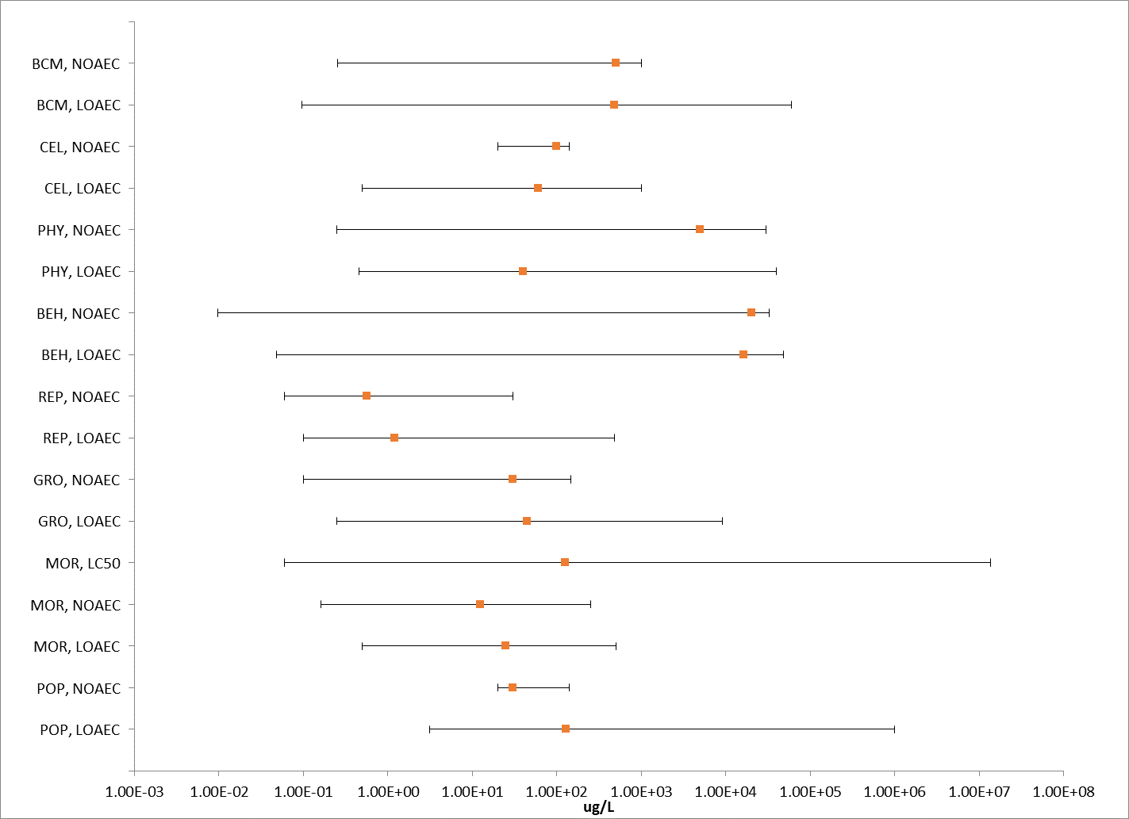
Figure 3-1. Summary Data Array for Aquatic Invertebrates. Orange symbols represent median endpoint values and bars represent the data range for combined acute and chronic toxicity data (BCM=Biochemical; CEL=Cellular; PHY=Physiological; BEH=Behavioral; REP=Reproduction; GRO=Growth; MOR=Mortality; POP=Population).

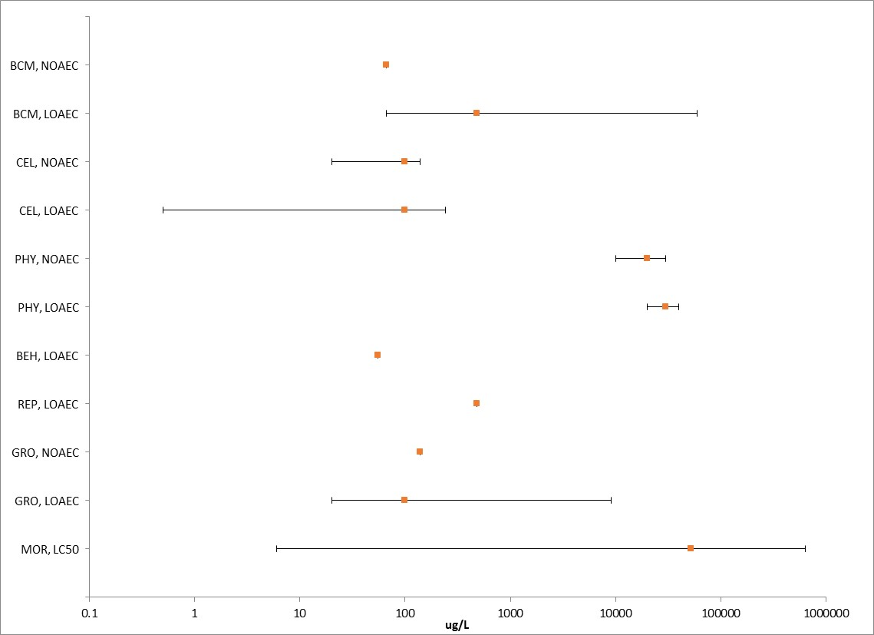
Figure 3-2. Summary Data Array for Mollusks. Orange symbols represent median endpoint values and bars represent the data range for combined acute and chronic toxicity data (BCM=Biochemical; CEL=Cellular; PHY=Physiological; BEH=Behavioral; REP=Reproduction; GRO=Growth; MOR=Mortality; POP=Population).

Lines of Evidence for Aquatic Invertebrates

In examining direct effects to a species, different lines of evidence used in the WoE approach include mortality, decreases in growth, decreases in reproduction, altered behavior, and changes in sensory function. The available toxicity data for aquatic invertebrates from exposure to malathion for each line of evidence will be described in this section.

Effects on Mortality of Aquatic Invertebrates

Species-sensitivity distributions (SSD) based on acute mortality studies are developed for aquatic invertebrates. Additionally, a discussion of mortality effects from studies not used in the SSDs are also included.

Mortality data are available (submitted by registrants or available in ECOTOX database) for 38 different orders of aquatic invertebrates with 9 of them as mollusks. Studies coded as “population” in ECOTOX were included in the data arrays for mortality, although it is noted that other effect types may have contributed to the overall population effect. Additionally, community-based studies (generally conducted outdoors) are also available with invertebrates and are included in these arrays. Discussions regarding community-based studies are in the aquatic community effects characterization section.

For freshwater aquatic invertebrates, the most sensitive mortality endpoint reported is a 50% lethal time (LT50) of 0.01 µg/L for the water flea (Wong et al. 1995, E16371). The highest mortality endpoint is 200 mg/L (NR-Leth) for trematodes (Tchounwou et al. 1992; E4696) (Figure 3-3). Effects on populations (abundance) are also reported for aquatic invertebrates; no effects are reported for mollusks at a test concentration of 162 µg/L (Relyea 2005; E89112). Reported effects on populations range from 3.1 µg/L (mesocosm study; E118292) to 1000 mg/L (midge family abundance- field study; Winterbourn 1990; E91912).

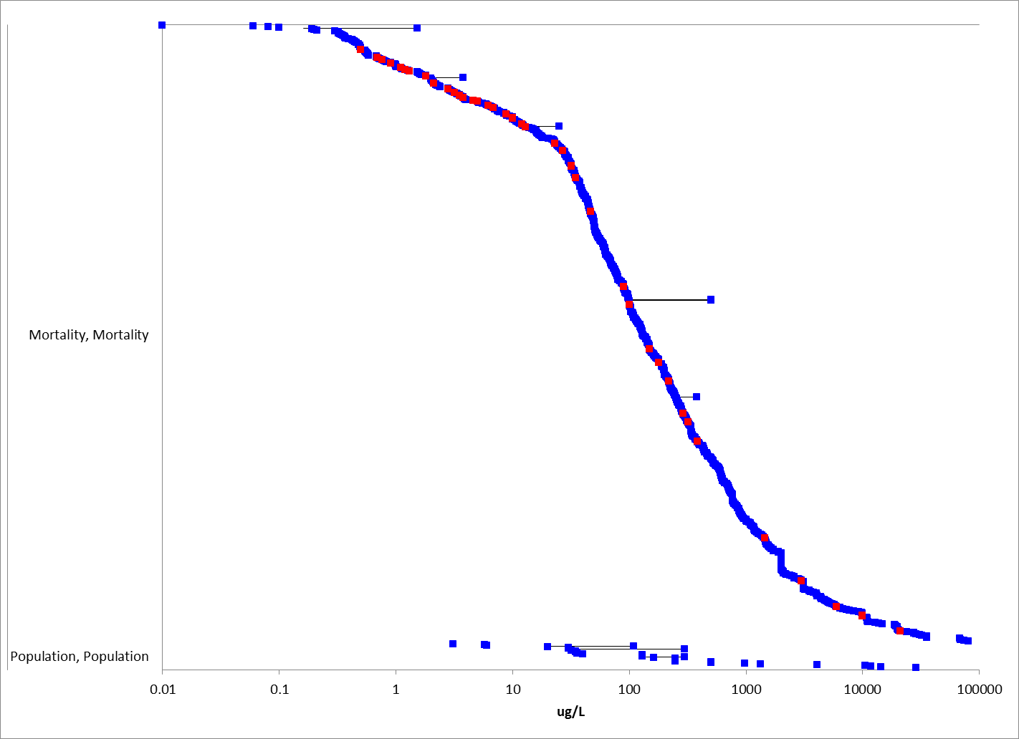
Figure 3-3. Mortality Effects for Freshwater Aquatic Invertebrates (excluding mollusks); includes population abundance endpoints. Effects without endpoint labels (measured endpoint, duration, test species) are shown for presentation purposes. Blue data points are from open literature, and red data points are from registrant-submitted studies. Note the x-axis is in log10 scale. Three datapoints were not included in this figure (>100,000 µg/L (100 mg/L)) for presentation purposes.

For estuarine/marine (saltwater) species, mortality effects ranged from 1.2 µg/L (LC₅₀ for Dungenes crab; Caldwell 1977, E6793) to 140 mg/L (EC₅₀ for brine shrimp; Guzzella et al. 1997; E18363) (Figure 3-4).

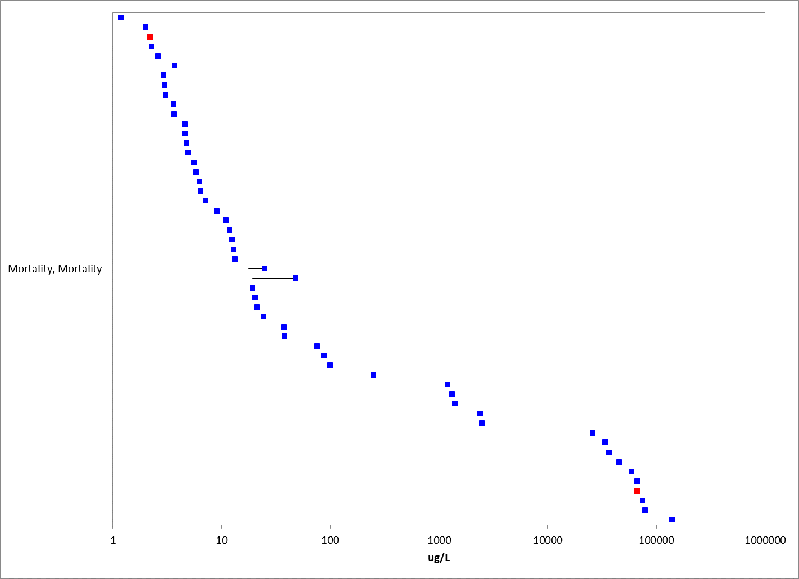
Figure 3-4. Mortality Effects for Estuarine/marine (Saltwater) Aquatic Invertebrates. Effects without endpoint labels (measured endpoint, duration, test species) are shown for presentation purposes. Blue data points are from open literature, and red data points are from registrant-submitted studies. Note the x-axis is in log10 scale

Mortality values for mollusks ranged from 6 µg/L to 640 mg/L (Figure 3-5).

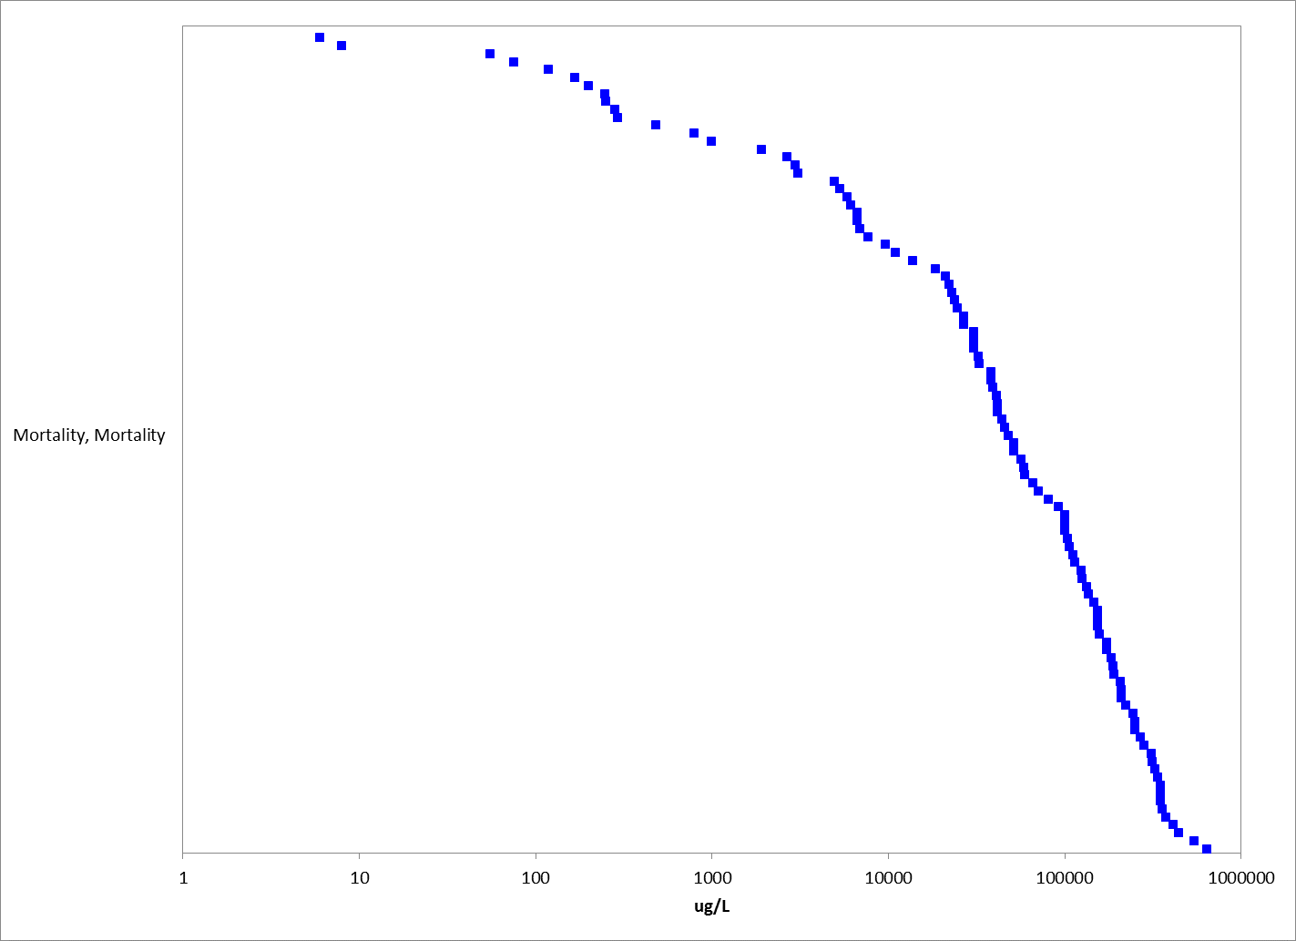
Figure 3-5. Mortality Effects for Mollusks. Effects without endpoint labels (measured endpoint, duration, test species) are shown for presentation purposes. Blue datapoints are from open literature. Note the x-axis is in log10 scale.

Immobility in aquatic invertebrates is often used as a surrogate for mortality. Endpoints for immobility are presented in Figure 3-6. Effects ranged from 0.34 to 29,700 µg/L, with most endpoints representing water flea and midge toxicity. A 21-d NOAEC value of 0.25 µg/L with effects at 0.46 µg/L was reported for Daphnia magna (MRID 41718401).

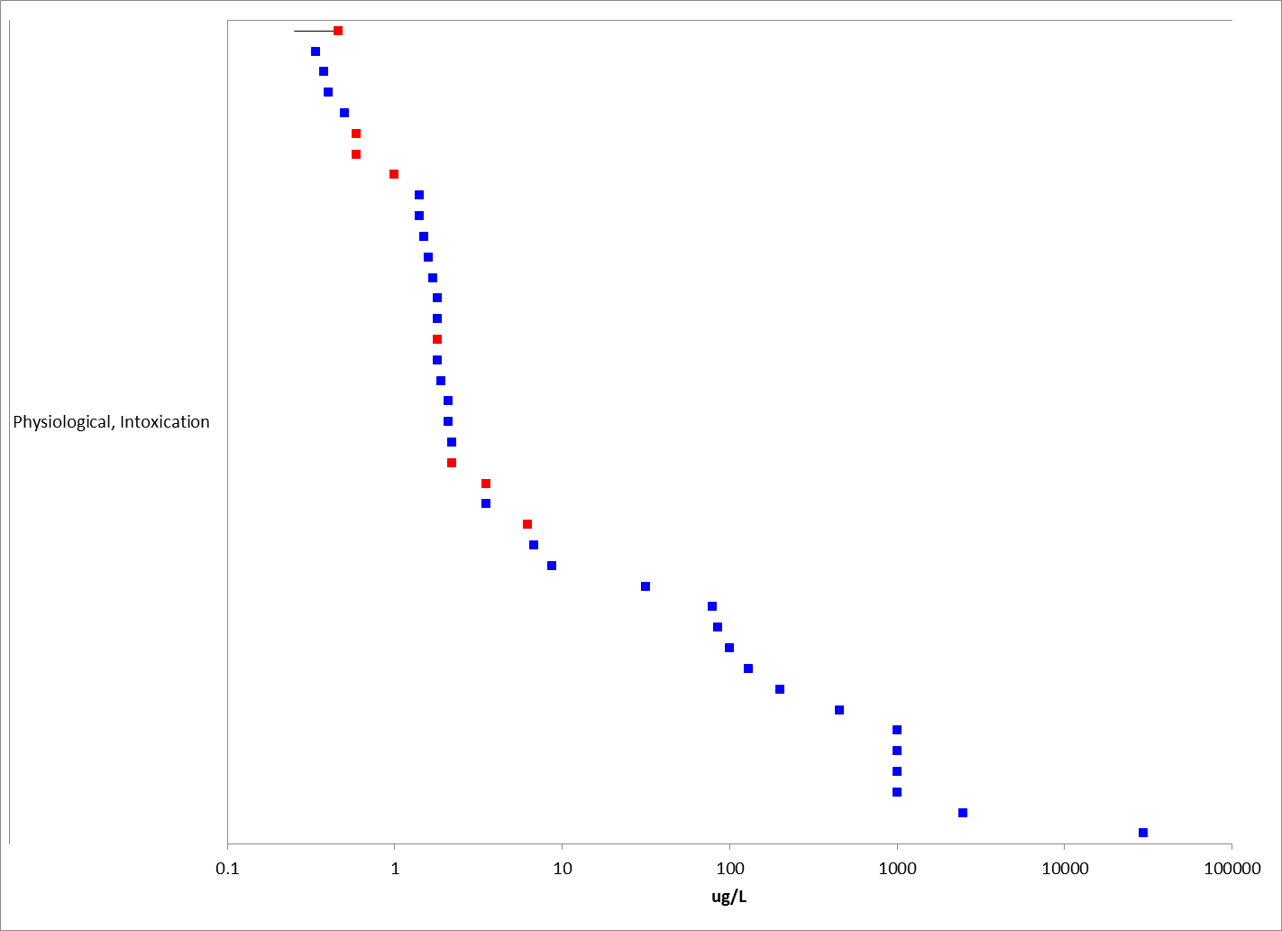
Figure 3-6. Immobility (mortality) Effects for Aquatic Invertebrates. Effects with endpoint labels (measured endpoint, duration, test species order) are shown for presentation purposes. Blue data points are from open literature, and red data points are from registrant-submitted studies. Note x-axis is in log10 scale.

Acute Mortality (48 or 96 hr EC/LC50s)

Acute mortality data (48 and 96 hr EC/LC₅₀s) are available for 28 different orders of aquatic invertebrates with 83 species (some studies only denote to genus level), and 5 order of mollusks with 18 different species (Table 3-3); a 48 or 96-hr test duration is common for acute mortality toxicity testing.

For mollusks, acute LC₅₀ values range from 6 to 350,400 µg/L. For non-mollusks, the reported mortality data for malathion encompass a wide range of toxicity values from acute LC₅₀ values of 0.06 to 67,000 µg/L (Table 3-3). For freshwater invertebrates, the most-sensitive mortality value reported is a 96-hr LC₅₀ value of 0.06 µg/L for Hyalella sp. (E120900, Cothran et al. 2009).

Table 3-3. 48 and 96 hr EC/LC₅₀ Toxicity Values for Arthropods and Mollusks.
Order | Species name | Common Name | EC/LC50 Value (µg/L) | % Purity | Reference No.
Amphipoda | Hyalella sp. | Scud | 0.06 | 99.1 | 120900
Amphipoda | Hyalella sp. | Scud | 0.08 | 99.1 | 120900
Amphipoda | Hyalella sp. | Scud | 0.19 | 99.1 | 120900
Amphipoda | Gammarus pulex | Scud | 0.33 | 100 | 153561
Decapoda | Cancer | Dungeness Or Edible Crab | 0.4 | 95 | 6793
Amphipoda | Gammarus fasciatus | Scud | 0.5 | 100 | 887
Amphipoda | Gammarus fasciatus | Scud | 0.5 | 95 | MRID 40089001; 6797
Diplostraca | Ceriodaphnia | Water Flea | 0.5 | 100 | 67777
Diplostraca | Ceriodaphnia dubia | Water Flea | 0.58 | 98 | 121216
Diplostraca | Simocephalus | Water Flea | 0.59 | 95 | MRID 40089001; E6797
Cladocera | Simocephalus | water flea | 0.59 | TGAI | MRID40098001
Amphipoda | Gammarus pulex | Scud | 0.68 | 97.78 | 153560
Plecoptera | Isoperla sp. | Stonefly | 0.69 | 95 | MRID 40089001; E6797
Amphipoda | Gammarus fasciatus | Scud | 0.76 | 95 | MRID 40089001; E6797
Diplostraca | Daphnia magna | Water Flea | 0.9 | 100 | 104559
Amphipoda | Gammarus fasciatus | Scud | 0.9 | 95 | MRID 40089001; E6797
Diptera | Anopheles quadrimaculatus | Common Malaria Mosquito | 1 | 100 | 56989
Diplostraca | Daphnia | Water Flea | 1 | 95 | MRID 40089001; E6797
Diplostraca | Ceriodaphnia dubia | Water Flea | 1.02 | 98 | 121216
Plecoptera | Pteronarcella badia | Stonefly | 1.1 | 95 | MRID 40089001; E6797
Amphipoda | Gammarus pulex | Scud | 1.1385 | 100 | 153561
Decapoda | Cancer magister | Dungeness Or Edible Crab | 1.2 | 95 | 6793
Trichoptera | Limnephilus sp. | Caddisfly | 1.3 | 95 | MRID 40089001; E6797
Diplostraca | Ceriodaphnia | Water Flea | 1.4 | 100 | 67777
Diplostraca | Ceriodaphnia dubia | Water Flea | 1.5484 | 98 | 121216
Diplostraca | Daphnia magna | Water Flea | 1.584 | 99 | 5370
Diplostraca | Daphnia | Water Flea | 1.6 | 99 | 6449
Amphipoda | Gammarus lacustris | Scud | 1.62 | 100 | 528
Diplostraca | Daphnia | Water Flea | 1.7 | 99 | 6449
Diplostraca | Ceriodaphnia dubia | Water Flea | 1.799 | 99.4 | 158065
Diplostraca | Daphnia | Water Flea | 1.8 | 100 | 96171
Diplostraca | Daphnia | Water Flea | 1.8 | 95 | MRID 40089001; E6797
Trichoptera | Cheumatopsyche | Caddisfly | 1.81 | 100 | 152279
Diplostraca | Ceriodaphnia dubia | Water Flea | 1.9979 | 99.4 | 158065
Cyclopoida | Eucyclops sp. | Cyclopoid Copepod | 0.561 | 56.1 | 786
Podocopida | Cypria sp. | Ostracod | 1.122 | 56.1 | 786
Diplostraca | Alonella sp. | Water Flea | 1.122 | 56.1 | 786
Calanoida | Diaptomus sp. | Calanoid Copepod | 1.122 | 56.1 | 786
Diptera | Culex pipiens | Northern House Mosquito | 15.2 | 95 | 160217
Amphipoda | Gammarus fasciatus | Scud | 2 | 100 | 887
Diplostraca | Ceriodaphnia dubia | Water Flea | 2.03 | 98 | 121216
Diplostraca | Ceriodaphnia dubia | Water Flea | 2.0776 | 98 | 121216
Amphipoda | Gammarus pseudolimnaeus | scud | 2.1* | 96.8 | MRID 49389402
Diplostraca | Daphnia | Water Flea | 2.1 | 99 | 6449
Diplostraca | Ceriodaphnia dubia | Water Flea | 2.19 | 98 | 121216
Mysida | Americamysis bahia | mysid shrimp | 2.2 |  | MRID41474501
Diplostraca | Daphnia | Water Flea | 2.2 | 99 | 6449
Cladocera | Daphnia | water flea | 2.2 | form | MRID41029701
Amphipoda | Gammarus palustris | Gammarid Amphipod | 2.29 | 100 | 51439
Mysida | Americamysis bahia | Opossum Shrimp | 2.6 | 71.5 | 968
Diplostraca | Daphnia magna | Water Flea | 2.8 | 99.1 | 162471
Plecoptera | Claassenia sabulosa | Stonefly | 2.8 | 95 | MRID 40089001; E6797
Diplostraca | Simocephalus vetulus | Water Flea | 2.9 | 100 | 104624
Mysida | Americamysis bahia | Opossum Shrimp | 2.944 | 92 | 2280
Mysida | Americamysis bahia | Opossum Shrimp | 3 | 71.5 | 968
Mysida | Americamysis bahia | Opossum Shrimp | 3.1 | 71.5 | 968
Diplostraca | Ceriodaphnia dubia | Water Flea | 3.3232 | 99.2 | 95923
Diptera | Chironomus tentans | Midge | 3.5* | 96.8 | MRID 49479002
Diplostraca | Simocephalus | Water Flea | 3.5 | 95 | MRID 40089001; E6797
Diplostraca | Daphnia | Water Flea | 3.53 | 100 | 80724
Decapoda | Paratya compressa ssp. improvisa | Freshwater Shrimp | 3.62 | 100 | 18945
Decapoda | Homarus americanus | American Lobster | 3.626 | 98 | 104603
Mysida | Americamysis bahia | Opossum Shrimp | 3.68 | 92 | 2280
Mysida | Americamysis bahia | Opossum Shrimp | 4.6 | 92 | 2280
Amphipoda | Gammarus palustris | Gammarid Amphipod | 4.65 | 100 | 51439
Mysida | Americamysis bahia | Opossum Shrimp | 4.784 | 92 | 2280
Mysida | Americamysis bahia | Opossum shrimp | 4.8* | 96.8 | MRID 49389401
Mysida | Americamysis bahia | Opossum Shrimp | 4.968 | 92 | 2280
Trichoptera | Hydropsyche sp. | Caddisfly | 5 | 95 | MRID 40089001; E6797
Veneroida | Katelysia opima | Marine Bivalve | 6 | 50 | 14269
Plecoptera | Pteronarcella badia | Stonefly | 6.2 | 95 | MRID 40089001; E6797
Diplostraca | Simocephalus | Water Flea | 6.2 | 95 | MRID 40089001; E6797
Plecoptera | Hesperoperla pacifica | Golden Stonefly, Willow Fly | 6.65 | 95 | 2667
Podocopida | Cypris | Ostracod | 6.8 | 100 | 151495
Plecoptera | Hesperoperla pacifica | Golden Stonefly, Willow Fly | 7 | 100 | 528
Harpacticoida | Tigriopus brevicornis | Harpacticoid Copepod | 7.2 | 100 | 19281
Diptera | Chironomus plumosus | Midge | 8.4 | 100 | 118362
Plecoptera | Pteronarcella badia | Stonefly | 8.8 | 95 | MRID 40089001; E6797
Decapoda | Palaemonetes pugio | Daggerblade Grass Shrimp | 8.94 | 100 | 92616
Decapoda | Palaemonetes pugio | Daggerblade Grass Shrimp | 9.06 | 100 | 14346
Zygoptera | Lestes congener | Damselfly | 10 | 95 | MRID 40089001; E6797
Plecoptera | Pteronarcys californica | Stonefly | 10 | 95 | MRID 40089001; E6797
Diplostraca | Daphnia magna | Water Flea | 10.754 | >95.0 | 156795
Mysida | Americamysis bahia | Opossum Shrimp | 11 | 100 | 13513
Plecoptera | Hesperoperla pacifica | Golden Stonefly, Willow Fly | 11.4 | 95 | 2667
Decapoda | Penaeus duorarum | Northern Pink Shrimp | 12 | 100 | 13513
Decapoda | Palaemonetes kadiakensis | Grass Shrimp, Freshwater Prawn | 12 | 95 | MRID 40089001; E6797
Diptera | Chironomus plumosus | Midge | 12.25 | 100 | 118362
Decapoda | Palaemonetes pugio | Daggerblade Grass Shrimp | 13.24 | 100 | 14346
Diptera | Chironomus plumosus | Midge | 16.1 | 100 | 118362
Harpacticoida | Tigriopus brevicornis | Harpacticoid Copepod | 20.5 | 100 | 19281
Decapoda | Litopenaeus vannamei | White Shrimp | 21.46 | 100 | 16752
Trichoptera | Hydropsyche californica | Caddisfly | 22.5 | 100 | 528
Ephemeroptera | Centroptilum triangulifer | mayfly | 23* | 96.8 | MRID 49479001
Diptera | Culex pipiens ssp. molestus | Mosquito | 24 | 30 | 5162
Harpacticoida | Tigriopus brevicornis | Harpacticoid Copepod | 24.3 | 100 | 19281
Decapoda | Palaemonetes kadiakensis | Grass Shrimp,Freshwater Prawn | 25 | 100 | 887
Diptera | Chironomus plumosus | Midge | 28.18 | 100 | 118362
Trichoptera | Arctopsyche grandis | Caddisfly | 32 | 100 | 528
Decapoda | Palaemonetes kadiakensis | Grass Shrimp,Freshwater Prawn | 32 | 95 | MRID 40089001; E6797
Diptera | Culex quinquefasciatus | Southern House Mosquito | 32.2 | 100 | 101101
Coleoptera | Hydrophilus sp. | Black Beetle | 34.5 | 100 | 162408
Decapoda | Homarus americanus | American Lobster | 38 | 100 | 73331
Decapoda | Palaemonetes pugio | Daggerblade Grass Shrimp | 38.19 | 100 | 14346
Decapoda | Palaemonetes pugio | Daggerblade Grass Shrimp | 39.92 | 100 | 92616
Diptera | Chironomus plumosus | Midge | 40.55 | 100 | 118362
Heteroptera | Anisops sardeus | Backswimmer | 42.2 | 100 | 59962
Podocopa | Cypridopsis vidua | Ostracod, Seed Shrimp | 47 | 95 | MRID 40089001; E6797
Plecoptera | Pteronarcys californica | Stonefly | 47.5 | 95 | 2667
Diptera | Toxorhynchites splendens | Mosquito | 49.8 | 100 | 4139
Plecoptera | Pteronarcys californica | Stonefly | 50 | 100 | 528
Isopoda | Alitropus typus | Sowbug | 52.5 | 100 | 89498
Diptera | Chironomus plumosus | Midge | 52.92 | 100 | 118362
Diptera | Simulium vittatum | Blackfly | 54.2 | >=98 | 71060
Unionoida | Lamellidens marginalis | Mussel | 55.63 | 50 | 12537
Decapoda | Macrobrachium lamarrei | Prawn | 65 | 50 | 71773
Diptera | Chironomus plumosus | Midge | 65.29 | 100 | 118362
Decapoda | Palaemonetes pugio | Daggerblade Grass Shrimp | 67* | 96.8 | MRID 49534902
Heteroptera | Notonecta undulata | Backswimmer | 75.2 | 94 | 7775
Unionoida | Anodonta anatina | Fresh-Water Mussel | 76 | 95 | 6665
Diptera | Chironomus plumosus | Midge | 77.66 | 100 | 118362
Diplostraca | Daphnia magna | Water Flea | 80 | 100 | 94536
Decapoda | Palaemonetes kadiakensis | Grass Shrimp,Freshwater Prawn | 90 | 95 | MRID 40089001; E6797
Diptera | Chironomus plumosus | Midge | 90.03 | 100 | 118362
Decapoda | Palaemonetes kadiakensis | Grass Shrimp,Freshwater Prawn | 100 | 100 | 887
Ephemeroptera | Drunella grandis | Mayfly | 100 | 100 | 528
Diplostraca | Daphnia | Water Flea | 100 | 100 | 5194
Diptera | Chironomus plumosus | Midge | 102.4 | 100 | 118362
Heteroptera | Notonecta undulata | Backswimmer | 103.4 | 94 | 7775
Diptera | Chironomus plumosus | Midge | 114.77 | 100 | 118362
Unionoida | Lamellidens corrianus | Mussel | 118.55 | 50 | 12537
Diptera | Chironomus plumosus | Midge | 146.75 | 100 | 118362
Unionoida | Lamellidens marginalis | Mussel | 168.36 | 50 | 12537
Plecoptera | Pteronarcys californica | Stonefly | 171 | 95 | 2667
Diptera | Chironomus plumosus | Midge | 178.73 | 100 | 118362
Decapoda | Orconectes nais | Crayfish | 180 | 95 | MRID 40089001; E6797
Diptera | Chironomus plumosus | Midge | 244.98 | 100 | 118362
Unionoida | Lamellidens corrianus | Mussel | 248.97 | 50 | 12537
Diptera | Chironomus plumosus | Midge | 261.99 | 100 | 118362
Unionoida | Lamellidens corrianus | Mussel | 284.11 | 50 | 12537
Unionoida | Anodonta cygnea | Swan Mussel | 294.5 | 95 | 6665
Diptera | Atherix variegata | Snipefly | 385 | 95 | MRID 40089001; E6797
Decapoda | Macrobrachium ferreirai | Freshwater Shrimp | 398 | 100 | 162408
Lepidoptera | Palustra laboulbeni | Moth | 426 | 100 | 162408
Coleoptera | Eretes sticticus | Beetle | 430 | 100 | 5182
Decapoda | Macrobrachium lamarrei | Prawn | 630.5 | 50 | 11557
Odonata | Orthetrum albistylum ssp. speciosum | Dragonfly | 730 | 100 | 7119
Unionoida | Lamellidens marginalis | Mussel | 797.78 | 50 | 12537
Decapoda | Macrobrachium lamarrei | Prawn | 843.5 | 50 | 11557
Decapoda | Macrobrachium lar | Monkey River Prawn | 851 | form | 157374
Decapoda | Procambarus clarkii | Red Swamp Crayfish | 875 | 50 | 71856
Coleoptera | Peltodytes sp. | Beetle | 940 | 94 | 7775
Decapoda | Cancer magister | Dungeness Or Edible Crab | 1330 | 95 | 6793
Decapoda | Procambarus clarkii | Red Swamp Crayfish | 1340 | 100 | 20475
Decapoda | Metapenaeus monoceros | Sand Shrimp | 1406 | 95 | 89575
Coleoptera | Peltodytes sp. | Beetle | 1410 | 94 | 7775
Unionoida | Anodonta anatina | Fresh-Water Mussel | 1928.5 | 95 | 6665
Basommatophora | Lymnaea stagnalis | Great Pond Snail | 2960 | 40 | 77206
Decapoda | Paratelphusa hydrodromus | Crab | 3000 | 50 | 13437
Isopoda | Caecidotea brevicauda | Aquatic Sowbug | 3000 | 95 | MRID 40089001; E6797
Basommatophora | Lymnaea stagnalis | Great Pond Snail | 4960 | 40 | 77206
Diptera | Chironomus riparius | Midge | 5280 | 40 | 77206
Basommatophora | Lymnaea stagnalis | Great Pond Snail | 5320 | 40 | 77206
Basommatophora | Lymnaea stagnalis | Great Pond Snail | 5840 | 40 | 77206
Architaenioglossa | Viviparus bengalensis | Snail | 6136 | 100 (form) | 14311
Unionoida | Lampsilis siliquoidea | Lamp-Mussel | 6720 | 96 | 17860
Basommatophora | Lymnaea stagnalis | Great Pond Snail | 6720 | 40 | 77206
Diptera | Chironomus riparius | Midge | 8400 | 40 | 77206
Unionoida | Anodonta cygnea | Swan Mussel | 9699.5 | 95 | 6665
Decapoda | Orconectes nais | Crayfish | 10000 | 95 | MRID 40089001; E6797
Diptera | Chironomus riparius | Midge | 10760 | 40 | 77206
Architaenioglossa | Viviparus bengalensis | Snail | 10970 | 100 (form) | 14311
Isopoda | Asellus aquaticus | Aquatic Sowbug | 12840 | 40 | 77206
Diptera | Chironomus riparius | Midge | 14880 | 40 | 77206
Architaenioglossa | Pomacea canaliculata | Snail | 18680 | 100 | 20421
Isopoda | Asellus aquaticus | Aquatic Sowbug | 20000 | 40 | 77206
Diptera | Chironomus riparius | Midge | 20240 | 40 | 77206
Decapoda | Procambarus clarkii | Red Swamp Crayfish | 21000* | 96.8 | MRID 49534901
Architaenioglossa | Pomacea dolioides | Golden Apple Snail | 22075 | 100 | 162408
Unionoida | Lampsilis straminea ssp. claibornensis | Southern Fatmucket | 23040 | 96 | 17860
Isopoda | Asellus aquaticus | Aquatic Sowbug | 24000 | 40 | 77206
Basommatophora | Planorbis corneus | Great Ramshorn Snail | 24800 | 40 | 77206
Unionoida | Lampsilis subangulata | Shiny-Rayed Pocketbook | 26880 | 96 | 17860
Isopoda | Asellus aquaticus | Aquatic Sowbug | 28680 | 40 | 77206
Unionoida | Elliptio icterina | Variable Spike | 30720 | 96 | 17860
Basommatophora | Planorbis corneus | Great Ramshorn Snail | 32520 | 40 | 77206
Basommatophora | Planorbis corneus | Great Ramshorn Snail | 32840 | 40 | 77206
Decapoda | Litopenaeus stylirostris | Blue Shrimp | 34197 | 100 | 73317
Isopoda | Asellus aquaticus | Aquatic Sowbug | 35720 | 40 | 77206
Unionoida | Utterbackia imbecillis | Paper Pondshell | 38400 | 96 | 17860
Basommatophora | Planorbis corneus | Great Ramshorn Snail | 41880 | 40 | 77206
Basommatophora | Planorbis corneus | Great Ramshorn Snail | 44440 | 40 | 77206
Unionoida | Lampsilis siliquoidea | Lamp-Mussel | 56640 | 96 | 17860
Anostraca | Streptocephalus sudanicus | Fairy Shrimp | 67750 | 100 | 59962
Unionoida | Villosa lienosa | Little Spectacle Case | 71040 | 96 | 17860
Unionoida | Utterbackia imbecillis | Paper Pondshell | 71040 | 96 | 17860
Archaeopulmonata | Melampus bidentatus | Salt Marsh Snail | 100000 | 100 | 7917
Unionoida | Lamellidens marginalis | Mussel | 100980 | 100 | 126
Unionoida | Villosa lienosa | Little Spectacle Case | 104640 | 96 | 17860
Unionoida | Villosa lienosa | Little Spectacle Case | 106560 | 96 | 17860
Unionoida | Villosa villosa | Downy Rainbow Mussel | 114240 | 96 | 17860
Unionoida | Villosa villosa | Downy Rainbow Mussel | 136320 | 96 | 17860
Unionoida | Villosa villosa | Downy Rainbow Mussel | 172800 | 96 | 17860
Unionoida | Utterbackia imbecillis | Paper Pondshell | 206400 | 96 | 17860
Unionoida | Utterbackia imbecillis | Paper Pondshell | 210240 | 96 | 17860
Unionoida | Utterbackia imbecillis | Paper Pondshell | 311040 | 96 | 17860
Tricladida | Dugesia tigrina | Flatworm | 4400 | 54.4 | 13793
Haplotaxida | Tubificida sp. | Tubificid worm | 9790-19240 | 40 | 77206
Lumbriculida | Lumbriculus variegatus | Oligochaete worm | 20500 | 100 (reagent) | 6502
*= used in SSD (test material source/impurity profile known).

Species-sensitivity distributions (SSD)

An SSD is calculated for all aquatic invertebrates (see ATTACHMENT 1-5 for SSD methodology). SSDs are based on acute 48 or 96-hr EC/LC₅₀ values from studies using TGAI only (EC/LC₅₀ values from formulation/mixture testing were not included); these types of studies are generally conducted using juvenile stages of invertebrates. Given the lack of suitable toxicity data (known test material source/ impurity profile), separate SSDs were not calculated for freshwater and saltwater invertebrates separately. There were 5 orders and 6 species of invertebrates used in the SSDs. It is noted that the CV value for this SSD is large, and therefore, the confidence intervals around the HC05 is also large. The HC₀₅ value is 1.0 µg/L for all aquatic invertebrates. For direct effects, the threshold for mortality is one-millionth the HC₀₅ with calculated value of 0.091 µg/L, and the indirect effects threshold (10% HC₀₅) is 0.54 µg/L (Table 3-4). If using the most sensitive suitable aquatic invertebrate acute toxicity value (96-hr LC50 of 2.1 µg/L for Gammarus pseudolimnaeus), the direct and indirect threshold using a default slope of 4.5 would be 0.18 and 1.1 µg/L.

The cumulative distribution function for the SSD for all invertebrates is presented in Figure 3-7. The SSD report for aquatic invertebrates is provided in APPENDIX 2-8 and includes the details of how this SSD was derived.

Table 3-4. Summary Statistics for SSDs Fit to Malathion Test Results (toxicity values reported as µg/L)
Statistic | All  Invertebrates
CV of the HC₀₅ | 3.3
HC₀₅ | 1.0
HC₁₀ | 1.7
HC₅₀ | 17.7
HC₉₀ | 684
HC₉₅ | 2766
Mortality Thresh.¹  (slope = 4.5) | 0.091
Indirect Effects Threshold¹  (slope = 4.5) | 0.54

¹ Slope = default slope of 4.5 used as no slope was available for species near the HC05.
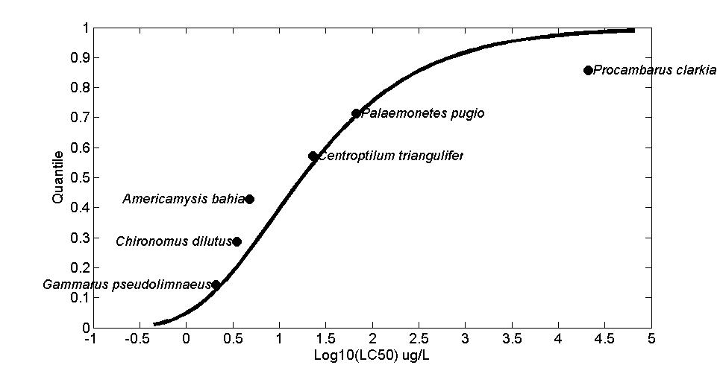
Figure 3-7. SSD for Malathion Toxicity Values for All Aquatic Invertebrates.

Mortality data from exposures greater than 4 days

There are 11 studies with 12 species that evaluated mortality for durations greater than 4 days (which may be relatable to sub-chronic or chronic exposures). Effects range from LT₅₀ (lethal time) for waterfleas (Wong et al. 1995; E16371) at 0.01 µg/L to lethality for Dungeness crabs at 2400 µg/L (Caldwell 1977; E6793). A study representing the lower range of toxicity values is described below.

In Wong et al. 1995 (E16371), median lethal time (LT50) values were reported for the chronic exposure of Moina macrocopa (waterflea) for each concentration tested in that study (test concentrations 0.01- 10 µg/L with reported LT50 values of 0.75 to 5.5 days). In that study, the study authors reported significant differences in survival and reproduction (cumulative number of young) at all test concentrations. However, while there does appear to be a visual decrease in mean survival and reproduction at the test concentration compared to the controls (variability around the mean value not provided), there is uncertainty in the time component of these comparisons as control survival appeared to be around 10-25% (visual inspection of figures in study) by day 8 of an 11 day test duration, which may confound the ability to discern treatment-related effects, especially if the test duration encompassed the natural life-span of the test organism.

Other types of mortality data in ECOTOX

There are additional toxicity data related to mortality coded in ECOTOX as “survival”, “survivorship”, and “hatch” as oppose to “mortality”. Endpoints for these types of effects are reported as LOEC/LOAEL, LC₅₀, MATC, along with many NOEC/NOAEL values (Figure 3-8). Toxicity values for these endpoints range from 0.16 µg/L (LOEC) as survival to juvenile blue crabs (E119266, Wendel and Smee 2009) to 162 mg/L (NR-Leth) for time to death for the trematode (Cercaria sp.) in Khan and Haseeb 1976 (E7817) . For mollusks, there was a single study in which a 28-d NOAEL for survival at 9.6 µg/L was reported for the marsh rams-horn snail, Planobella trivolvis (Rohr et al. 2008, E112912).

For estuarine/marine species, the most sensitive mortality value (coded as “survival” in ECOTOX) is for juvenile blue crabs (Callinectes sapidus), with a significant 26% increase in mortality at 1.0 µg/L (0.5 µg a.i./L adjusted for purity (50%EC); personal communication Wendel 2014) after 5 days exposure with a NOAEC of 0.32 µg/L (0.16 µg a.i./L adjusted for purity; E119266, Wendel and Smee 2009).

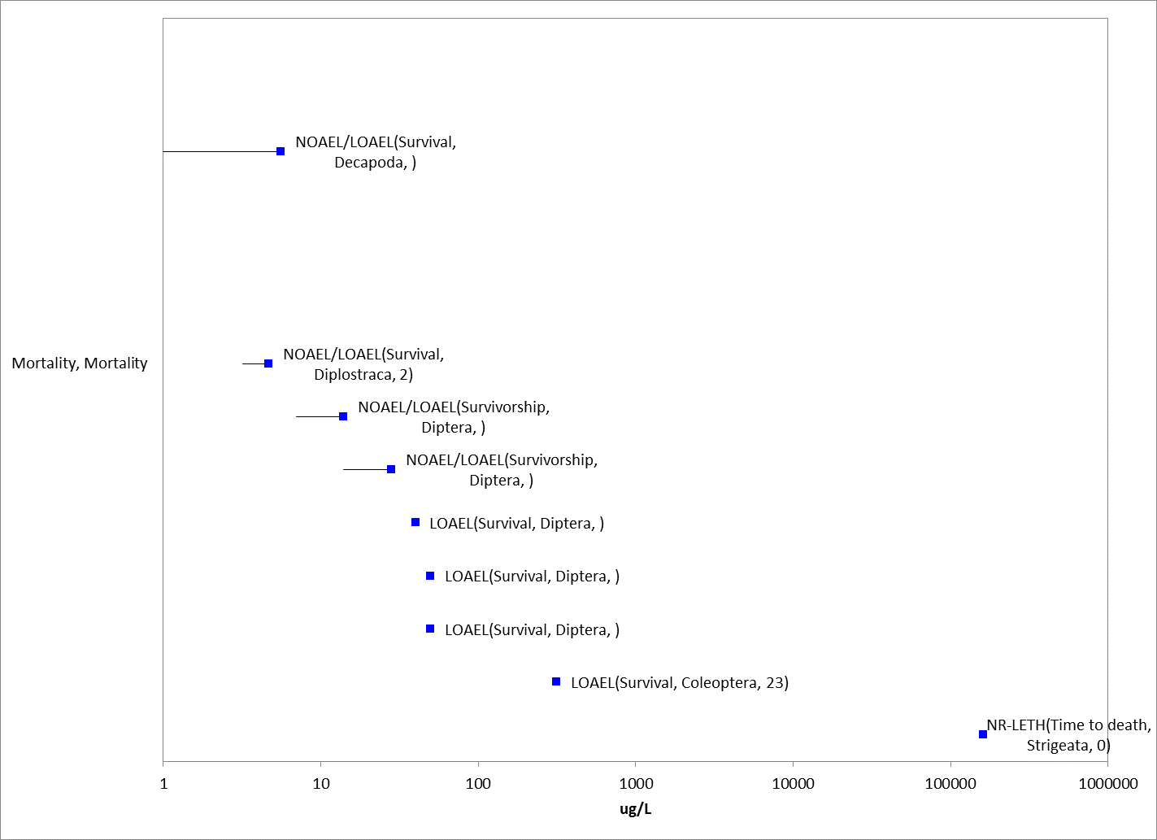
Figure 3-8. Mortality Effects (as survival or hatch) for Freshwater and Estuarine/Marine (saltwater) Aquatic Invertebrates. Endpoint labels include measured endpoint, test species order and test duration. Blue datapoints are from open literature.

Sublethal Effects to Aquatic Invertebrates

Toxicity data pertaining to the sublethal effects for aquatic invertebrates such as decreases in growth, decreases in reproduction, altered behavior, and changes in sensory function are discussed in the following sections.

      - Effects on Growth of Aquatic Invertebrates

Growth data are available in ECOTOX and registrant submitted studies for 7 different species of arthropods, and 6 different species of mollusks (Figures 3-9 and 3-10). A single study evaluating growth is also available for trematodes, nematodes, protozoa and euglena where either no effects were reported or only reported at higher concentration than in arthropods or mollusks. In arthropods, growth endpoints reported include alterations in weight, length, and morphological changes in length; developmental effects included delayed/slowed development or changes in pupation or emergence were also reported. For mollusks, changes in shell deposition or abnormal or general developmental changes are reported; morphological changes include alterations in diameter or length. For arthropods, effect concentrations range from 0.25 µg/L (MRID 41718401) up to 50 µg/L for length effects in yellow fever mosquitos (Muturi et al. 2011, E162480). In mollusks, effects range from 20 µg/L (effects on diameter in mussel (Mane & Muley 1990; E88989) up to 9070 µg/L (general developmental effects in American oyster; Davis et al. 1969; E1038486).

The most sensitive growth endpoint for aquatic invertebrates is a 21-day LOAEC of 0.25 µg/L (NOAEC 0.1 µg/L) in Daphnia magna based on a 3.7% decrease in body length. A decrease of 11% in body length was observed at 0.46 µg/L, which was the highest test concentration with surviving adults (MRID 41718401). This study was used as the sublethal threshold for all aquatic invertebrates.

For estuarine/marine invertebrates, male mysid shrimp (Americamysis bahia) body length was significantly reduced 4% at 0.58 µg/L after 39-days of exposure (NOAEC 0.29 µg/L) (MRID 4875290). In this study, an 8% decrease in male body length was observed at 1.2 µg/L, the highest concentration tested.

Four day IC₅₀ values based on reductions in shell deposition for the Eastern (American) oyster, Crassostrea virginica, were reported as either 1,990 (Cythion 50% EC formulation) or 2,700 µg/L (TGAI) (MRID 41320201, 49389403). For MRID 41320201, the NOAEC for shell growth was 380 µg a.i./L with 27% shell growth inhibition reported at 1,630 µg a.i./L The NOAEC for shell growth was 530 µg a.i./L in MRID 49389403 with 30% shell growth inhibition reported at 1,300 µg a.i./L.

Based on ECOTOX, no effect on shape was observed at 48 mg/L in Euglena gracilis (E162413), and no effects on development were observed in the trematode Echinostoma trivolvis at 9.2 µg/L (Raffel et al. 2009; E153845). A 4-day LOAEC of 220 µg/L for abnormal development was reported in the horsehair worm (Chordode sp) after 4 days (Achiorno et al. 2009; E118256; NOAEC = 146 µg/L). Finally, a 1-d EC₅₀ for abnormal development of 39 mg/L was reported for the protozoa, Spirostomum ambiguum (Nalecz-Jawecki et al. 2002; E69821).

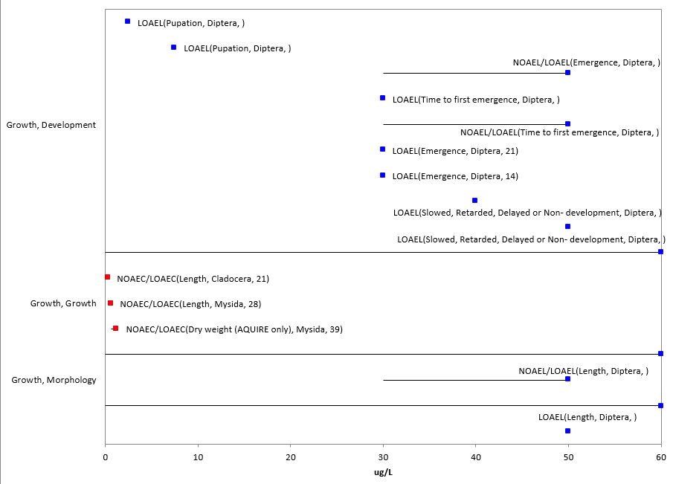
Figure 3-9. Growth Effects for Freshwater and Estuarine/Marine (Saltwater) Arthropods. Endpoint labels include measured endpoint, test species order and test duration. Blue data points are from open literature, and red data points are from registrant-submitted studies.

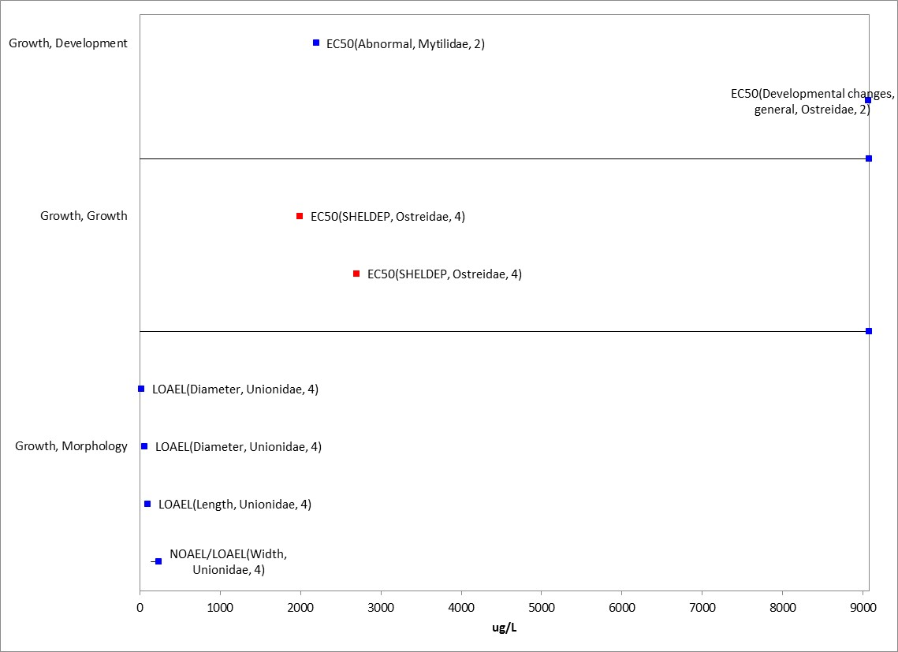
Figure 3-10. Growth Effects for Mollusks. Endpoint labels include measured endpoint, test species order and test duration. Blue datapoints are from open literature, red datapoints are from registrant-submitted studies.

      - Effects on Reproduction of Aquatic Invertebrates

Reproduction data are available in ECOTOX and submitted studies for 6 different species of arthropods, and 2 different species of mollusks (snails); a total of 10 studies available for evaluating reproduction effects (Figure 3-11). Effects on reproduction were reported as alterations in fecundity, fertilization, progeny counts/number, offspring, or general effects on reproduction. According to ECOTOX, for nematodes, rotifers, and bryozoan, a single study evaluating reproduction for each of those taxa was available where either no effects (i.e., nematode) were reported or only reported at higher concentration than in arthropods or mollusks.

For arthropods, effect concentrations ranged from 0.1 µg/L (MRID 41718401) up to 50 µg/L for fecunidty effects in yellow fever mosquitos (Muturi et al. 2011, E162480).

The lowest reproduction endpoint for aquatic invertebrates was for Daphnia magna with a 21-d LOAEC value of 0.1 µg/L based on a 17% decrease in fecundity (NOAEC 0.06 µg/L). A 33, 51 and 86% decrease in reproduction was observed at 0.25, 0.46 and 0.94 µg/L, respectively (MRID 41718401).

For estuarine/marine invertebrates, mysid shrimp (Americamysis bahia) fecundity was significantly reduced 97% at the highest test concentration of 1.2 µg/L (NOAEC 0.58 µg/L) (MRID 4875290).

In mollusks, effects on progeny counts/numbers were reported at 480 µg/L (18-d LOAEL; no NOAEL) for Helisoma duryi (Bakry et al. 2011, E157366). No effects on progeny were reported in Marsh Rams-Horn snails, Planorbella trivolus, at 9.6 µg/L (Rohr et al. 2008; E112912).

Based on ECOTOX, for the bryozoan, Plumatella casmiana, 10-d LD₅₀ germination values ranging from 100-560 µg/L were reported in Shrivastava and Singh, 1986 (E4564). The 3-d IC₅₀ for number of eggs incubated for the rotifer, Philodina acuticornis, was reported as 5 x 10⁻⁷ M (165 µg/L) (Nogrady and Keshmirian, 1986, E74964).

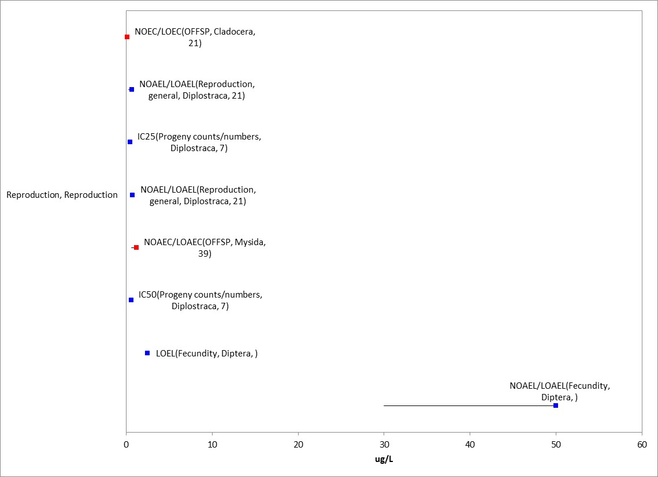
Figure 3-11. Reproductive Effects for Freshwater and Estuarine/marine (Saltwater) Arthropods. Endpoint labels include measured endpoint, test species order and test duration. Blue datapoints are from open literature, red datapoints are from registrant-submitted studies.

      - Effects on Behavior of Aquatic Invertebrates

Behavioral data are available in ECOTOX for 4 different species of arthropods, 2 different species of mollusks (snails), and one species of tremadotes and euglena; eight studies were available for evaluating behavioral effects (Figure 3-12). Behavioral endpoints reported in ECOTOX for arthropods include alterations in general behavior, coordination, and swimming. For arthropods, behavioral changes are reported at 0.048 µg/L (net spinning behavior; Tessier et al., 2000; E65789) to general behavioral changes in the midge, Chironomus tentans, with a 4-d EC50 of 18.9 µg/L. The only behavioral effect in mollusks reported is an effect on predatory vulnerability in the freshwater snail (Haitia pomilia) with a 2-d LOAEL value of 55.5 µg/L (Salice and Kimberly, 2013, E162589 no NOAEL; 22.2% purity).

Belden and Lydy (2000; E56553), 4th instar Chironomus tentans midges were exposed to malathion (TGAI, >98%, provided by Cheminova) for 96 hours and evaluated for normal swimming motion (figure 8). The reported EC1, EC5, EC15, and EC50 values were 0.26, 0.44, 0.70, and 1.5 µg a.i./L, respectively. The EC01 and EC50 values of 0.26 (95% CI of 0.13-0.40) and 1.5 (95% CI 1.2-1.9) µg a.i./L were used as the behavioral threshold for aquatic invertebrates (direct and indirect, respectively).

In Tessier et al., 2000, (E65789) increases in abnormalities in capture nets of freshwater caddisfly larvae (Hydropsyche slossonae) exposed to malathion at 0.05 µg/L (0.048 µg a.i./L adjusted for purity) for 20 days was reported (due to uncertainties in test material source/impurity profile, this study was not used as a sublethal threshold). Abnormalities included loss of symmetry and midline distortion occurring at rates of increase of approximately 50% at days 10, 15 and 20. Head capsule AChE decreased approximately 40% on day 20 (based on figure) at 0.1µg/L (0.0962 µg a.i./L adjusted for purity) with a NOAEC of 0.05 µg/L.

In addition to effects on survival in blue crabs (Callinectes sapidus), a significant increase (40 sec) in the time required to right themselves compared to controls was also observed at 5.6 µg a.i./L after 1 hour of exposure (NOAEC 0.5 µg a.i./L; adjusted for purity) (E119266, Wendel and Smee 2009).

Caldwell, 1977 (E6793) reported a 96-hr EC₅₀ of 0.4 µg/L (using TGAI) for inhibition of swimming in first instar (zoeae) dungeness crab (Cancer magister). The acute 96-hr LC₅₀ value for the same life-stage was 1.2 µg/L. However, variability (i.e., confidence intervals) around the EC/LC₅₀ value as well as control performance was not provided.

Based on results reported in ECOTOX, in Euglena gracilis, effects on swimming and orientation were reported at concentrations of 32.6 and 48 mg/L (LOAELs) after one or three days of exposure (NOAELs of 20 and 32.6 mg/L, respectively for one and three days; Azizullah et al. 2011; E162413) In Rohr et al., 2008, (E112912) no effects on prey penetration for the trematode, Echinostoma trivolvis, after 4 hours of exposure or on migration in marsh rams-horn snails (Planorbel trivolvis) after 28 days were reported at 9.6 µg/L.
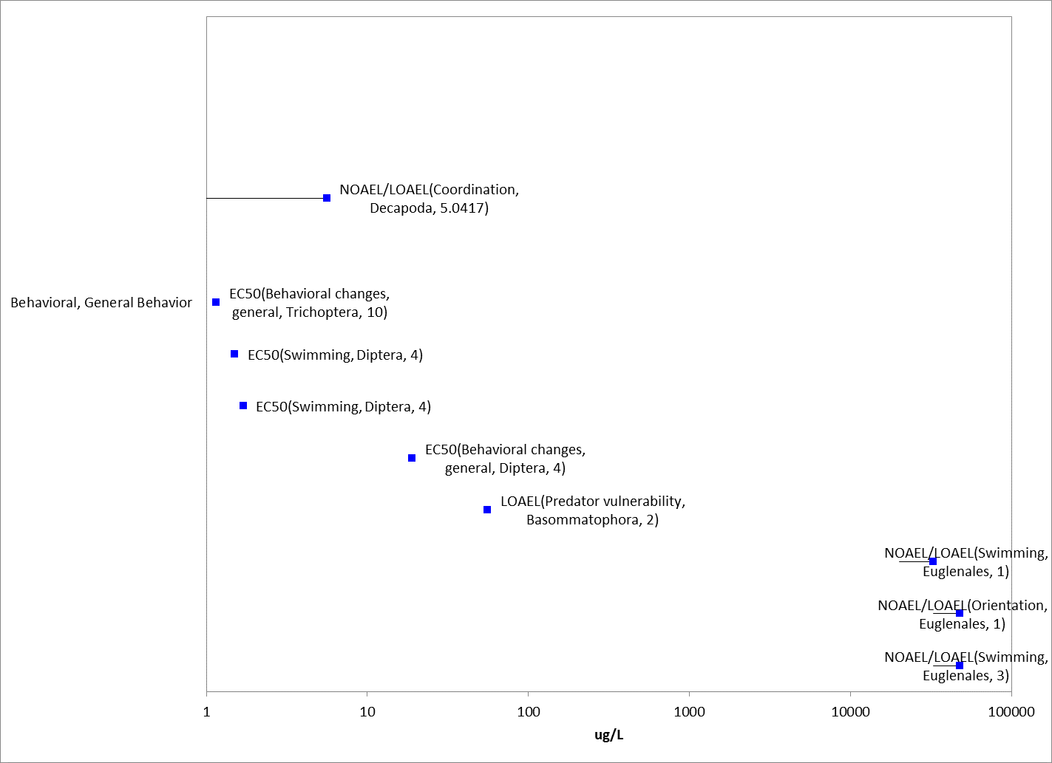
Figure 3-12. Behavioral Effects for Freshwater and Estuarine/Marine (saltwater) Arthropods. Endpoint labels include measured endpoint, test species order and test duration. Blue datapoints are from open literature.

      - Effects on Sensory Function of Aquatic Invertebrates

There was one study available for sensory function in which the study evaluated chemical avoidance in grass shrimp (Palaemonetes pugio) with no effects at 1.0 mg/L after one hour (Hansen, 1969; E5145).

      - Other Effects Reported for Aquatic Invertebrates

Effects other than those identified as mortality (survival), behavior, sensory, growth, and reproduction are reported for malathion. These include cellular, biochemical (in addition to effects on acetyl-cholinesterase (AChE)), and physiological effects. A summary of each of these effect types are discussed below. It is noted that these effects occur in the same general concentration range as reported effects on mortality, growth and/or reproduction.

Biochemical and Cellular

Biochemical effects included alterations in enzymes and enzymatic effects include, but were not limited to, alterations in glutathione (S-transferase), testosterone, AChE, catalase, ATPase, and glutaminase (Figures 3-15 and 3-16). Additionally, effects such as alterations in protein content, lipid and glucose or glycogen were also reported. The lowest reported value was for alteration in AChE at 0.1 µg/L (Tessier et al., 2000; E65789). The highest value was for changes in protein content in snails (Stagnicola spp.) at 60,000 µg/L (Martinez-Tabche et al. 2002; E67329).

Acetyl-Cholinesterase (AChE) Inhibition

Given the mode of action of malathion, it is anticipated that the chemical should have an impact on AChE. The available data (open literature) report effects on acetyl-cholinesterase at concentrations ranging from 0.1 to 60,000 µg/L (Table 3-5). In the study by Belden et al. (2001; E62046), Chironomus tentans were exposed to malathion (98%; provided by Cheminova) for 24 hours and whole body AChE activity was measured. In this study, AChE was significantly decreased at 1.47 µg/L (about 70% based on figure), but not 0.25 µg/L when compared to the control. This study could be used to evaluate effects on AChE in aquatic invertebrates.

Table 3-5. Effects on Acetyl-Cholinesterase Observed in Studies Involving Malathion.
Test species | Effect Level (µg/L)¹ | Other Effects Reported (µg/L)¹ | % Purity¹ | ECOTOX #²
Hydropsyche slossonae | 15-d NOAEL=0.05;  LOAEL= 0.1 | Behavior, general: 20-d LOAEL= 0.05 | 96.7 | Tessier et al., 2000; E65789
Chironomus tentans | 1-d NOAEL=0.25; LOAEC=1.47 | NA | >98 | Belden et al. 2001; E62046
Daphnia magna | 2-d LOAEL=3.3 | Immobile: 2-d EC50 = 3.53 | 100 | Rider & LeBlanc, 2005; E80724
Daphnia magna | 1-d IC50=3.95 | 1-d LC50 = 3.88 | 95 | Barata et al., 2004; E72805
Palaemonetes pugio³ | EC20=3.8-12;  EC50=7.33-61 (1-4 d duration) | 4-d LC50 = 8.94-39.9; LOEC=3.75-25 | 100 | Key & Fulton 2006; E92616
Palaemonetes pugio³ | 1-d EC50= 7.53, 24.86 | 4-d LC50 =6.27; LOEC=3.75-25 | 100 | Key 1996; E72741
Palaemonetes pugio³ | 1-d EC50=29.93-55.53 | NA | 100 | Lund et al. 2000; E51679
Crassostrea gigas | 1-d LOAEL=66 | Catalase: 1-d LOEL= 228 | 100 | Damiens et al. 2004; E76793
Macoma baltica; Mytilus edulis | NOAEL (3,7-d) =100 | NA | 100 | Lehtonen & Leinio 2003; E71688
Ruditapes decussatus | 1-d LOAEL=100 | Protein content, Catalase, Lipid: 1-d LOAEL = 100 | 100 | Nadji et al. 2010; E162613
Metapenaeus monocercos | 4-d LOAEL=475⁴ | 4-d LC50=1406; Glutamine: LOAEL=500 | 95 | Reddy et al. 1990; E89575
Stagnicola sp. | 0.5-d LOAEL=60,000 | Protein content: 0.5-d LOAEL=60,000 | 100 | Martinez-Tabche et al. 2002; E67329
¹ As reported in ECOTOX
² All studies conducted in laboratory
³ Contain similar author (Key) and therefore, may contain similar information
⁴ Endpoint was buterylcholinesterase

Other Biochemical and Cellular Effects

Effects on gene expression in yellow fever mosquitos were reported at 50 µg/L (Muturi 2013; E162398), and effects on DNA concentration in Indian fiddler crabs were reported at 8 and 20 µg/L (Yeragi et al. 2002; E104660). Cellular effects are reported for mollusks with cellular changes in diameter, width, and length for the marine bivalve (Katelysia opima) at concentrations ranging from 0.5 to 260 µg/L (Mane & Muley 1990; E88989 and Akarte et al. 1986; E14269) (Figure 3-13 and 3-14).

According to ECOTOX, in the tubificid worm, Tubifex tubifex, cellular swelling (histology) was reported at 1 mg/L (Fischer 1982, E90779). A IC₅₀ value of 5 mg/L for effects on esterases were reported in the protozoan, tetrahymena pyrifomis.

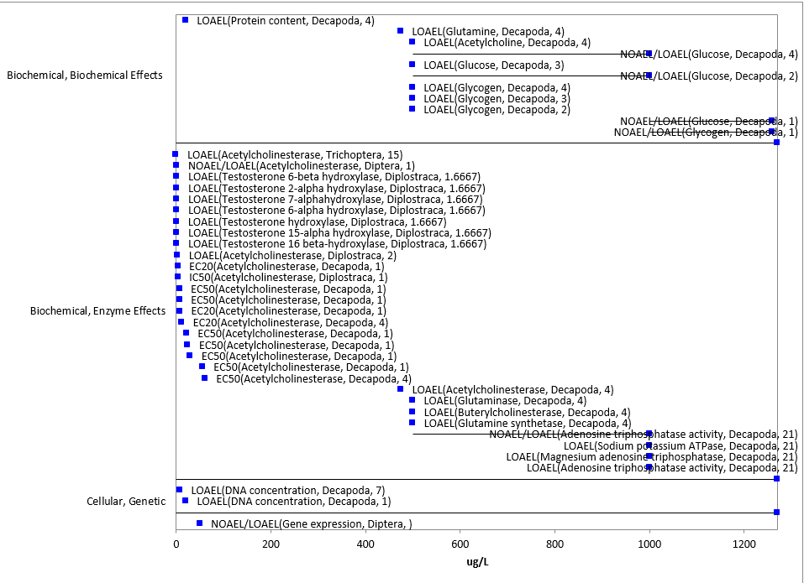
Figure 3-13. Biochemical and Cellular Effects for Freshwater and Estuarine/Marine (Saltwater) Arthropods. Endpoint labels include measured endpoint, test species order and test duration. Blue data points are from open literature.

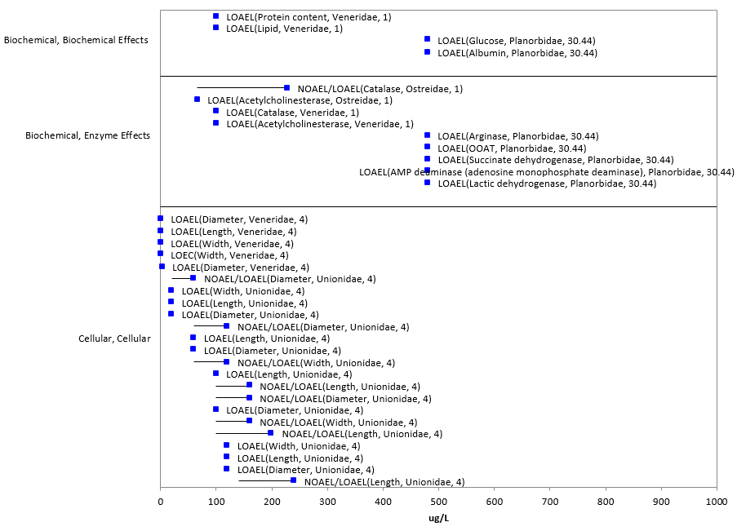
Figure 3-14. Biochemical and Cellular Effects for Mollusks. Endpoint labels include measured endpoint, test species order and test duration. Blue data points are from open literature. One data point not on array (effects on protein content and AChE at 60 mg/L).

Physiological

Physiological effects include alterations in immune system parameters (e.g., phagocytosis and infected) as well as changes in general physiology (e.g., immobility, oxygen consumption and heart rate) (Figure 3-15). The most sensitive endpoint is for immobility in Daphnia magna at 310 µg/L (EC50) (MRID 41718401). Immobility in aquatic invertebrates is often regarded as equivalent to mortality with EC and LC₅₀ values considered collectively; these values were included in the discussion on mortality. For mollusks, the only reported effect is an alteration in heart rate at 20 or 40 ppm (2-d LOEL; 10 or 30 ppm NOEL) in mussel (Lamellidens marginalis, Ramana et al., 1983, E1258067).

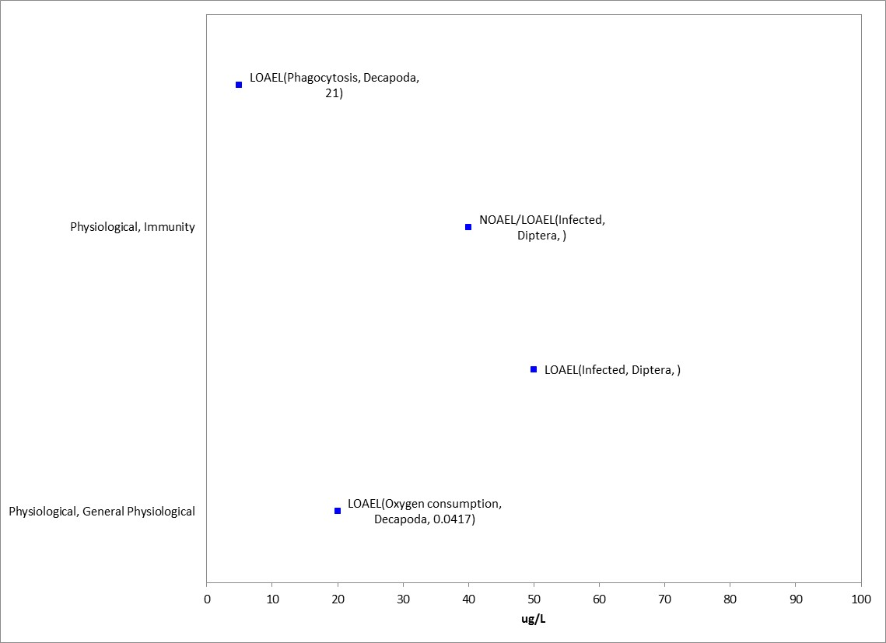
Figure 3-15. Physiological Effects in Arthropods. Endpoint labels include measured endpoint, test species order and test duration. Blue data points are from open literature.

Data Reported in Units of Mass/Acre

A few studies in the ECOTOX database report endpoints in units of lb/acre (Table 3-6). A summary table of those studies/results are presented below. There were no studies based on mass/acre for mollusks.

Table 3-6. Toxicity Data for Malathion Based on lb a.i./A (not in arrays)
Species | Effect Group | Endpoint | Media | Duration (d) | Endpoint Concentration | UNITS | Test Location | Reference #
Chironomus plumosus (midge) | MOR | LOEL (survival) | FW | 7 | 0.025 | Lb ai/acre | Lab | Hilsenhoff, 1959 (E2904)
Cryptochirus digitatus  (midge) | MOR | 100% mortality | FW | 7 | 0.04 | Lb/acre | Lab | Hilsenhoff, 1962 (E17319)
Psorophora confinnis (mosquito) | POP | LOAEL/ NOAEL (abundance) | FW | 3 or 5 | 0.05 (3-d LOAEL); 0.1 (5-NOAEL) | Lb/ acre | Field | Craven & Steelman, 1968 (E48426)
Diptera spp. (fly/mosquito) | POP | LOAEL (abundance) | FW | 9 | 300 | Lb/acre | Field | Stevens et al. 1998 (E60146)
Chironomidae (midge family) | POP | LOAEL (abundance) | FW | 4 | 300 | Lb ai/acre | Field

  - Effects to Aquatic Invertebrates Not Included in the Arrays

Other data available are not included in the toxicity arrays because the exposure units provided in ECOTOX are not in or cannot be converted to environmentally-relevant concentrations.

There are several exposure units listed in the ECOTOX toxicity table that could not be converted to environmentally-relevant units and include units reported as %, mL/L, or a volume alone (i.e., lit). The studies reported effects on mortality, a response for which there are abundant data that can be expressed in terms of environmentally-relevant concentrations. The study based on mL/L, reported effects on oxygen consumption which other data for this endpoint are available.

  - Concentrations Where No Effects Were Observed in Aquatic Invertebrate Studies

For the exposure unit µg a.i./L, there are data available that show concentrations where effects are not seen [i.e., ‘no effect’ (NE) concentrations]. The NE endpoints include NOAEC/NOAEL and NR-Zero values as reported in ECOTOX. Below are the arrays showing the NE endpoints for malathion and fish and aquatic-phase amphibians (Figures 3-16 and 3-17). For arthropods, the available ‘NE’ endpoint concentrations range from 0.01 µg a.i./L to 1000 mg/L. For mollusks, the ‘NE’ concentrations range from 0.5 µg a.i./L to 37 mg/L.

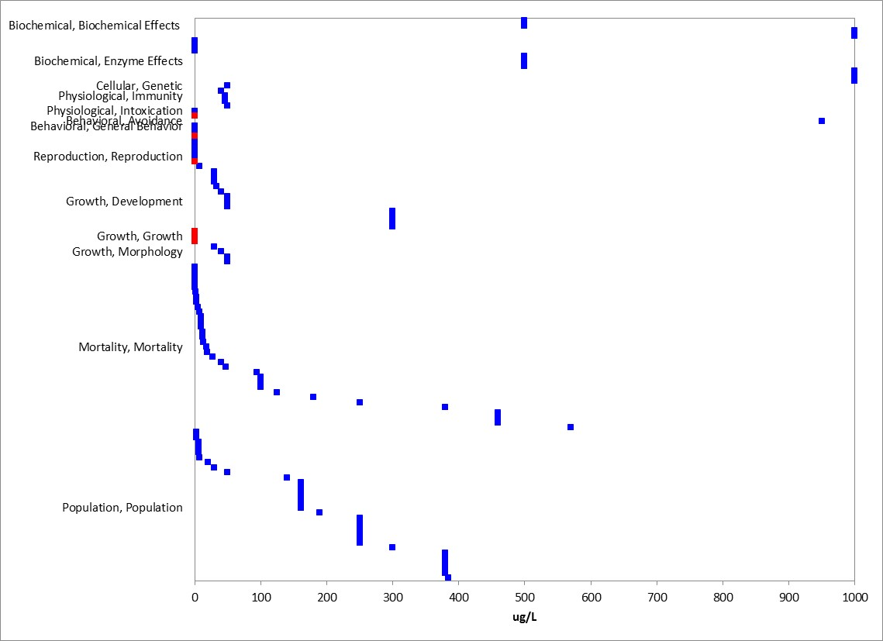
Figure 3-16. Concentrations Where No Effects Were Observed in Aquatic Arthropods. Only effects up to 1000 µg/L (1 mg/L) and without endpoint labels (measured endpoint, duration, test species) are shown for presentation purposes. Blue datapoints are from open literature and red datapoints are from registrant-submitted studies.

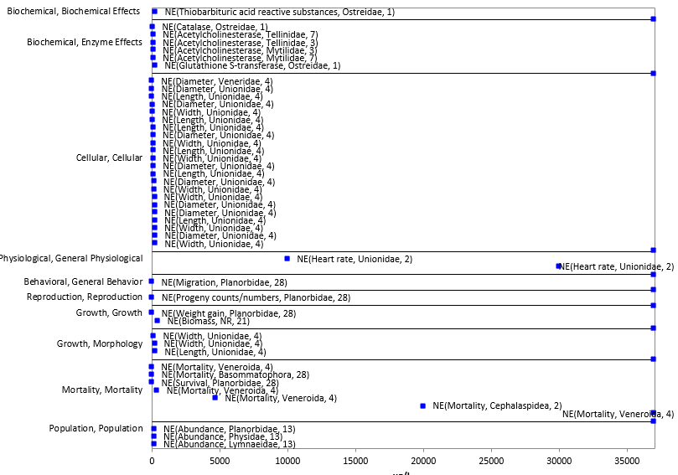
Figure 3-17. Concentrations Where No Effects Were Observed for Mollusks. Endpoint labels include: measured endpoint in µg/L, duration, test species. Blue endpoints are from open literature.

  - Incident Reports for Aquatic Invertebrates

EFED’s incident database (EIIS), accessed October 26, 2015 includes one incident which involved the death of 500 blue crabs (Callinectes sapidus) along with eel and shad in Beaufort SC (B0000-300-30, 6/25/1981). Additionally, crayfish mortality was reported in the USDA/APHIS 1995 report (see fish incident section). The Aggregate Incident Reports database identified an additional four incidents linked to malathion use as aggregated counts of minor aquatic invertebrates/wildlife incidents (W-B). Because details about these incidents were not reported, no information was available on the use site, the certainty level, or on the types of organisms that were involved.

Additionally, in 1999, population of the American lobster (Homarus americanus) in Long Island Sound suffered a severe mortality event. This die-off occurred following extensive aerial spraying of pesticides for vector control in the summer of 1999, which was undertaken in response to a widespread outbreak of West Nile Virus that was occurring at that time in the Northeast. Malathion had been applied in New York. Two pyrethroids (resmethrin and sumithrin) and methoprene were applied in both New York and Connecticut. Extensive research was undertaken after this event to identify the cause and to determine the role of exposure to these pesticides, if any, in the mortality event. The research ultimately concluded that an outbreak of a parasitic amoebae, Neoparamoeba pemaquidensis, was the proximal cause of the lobster mortality, but that multiple other stressors, including pesticide exposure, may have contributed to the die-off by physiologically weakening the lobsters, making their immune response too weak to fend off the disease (Pearce and Balcom, 2005).

  - Summary of Effects to Aquatic Invertebrates

Based on the available toxicity information, malathion can effect survival of aquatic invertebrates both on an acute and chronic exposure basis with mollusks being less sensitive than arthropods. For both taxa, the range of reported acute mortality data is large with ranges of 0.06-67,000 and 6 to 350,400 µg/L, for arthropods and mollusks, respectively. Additionally, sublethal effects were observed at concentrations similar to concentrations were acute mortality is observed. Effects on reproduction and growth were reported at concentrations of 0.1 and 0.25 µg/L for freshwater invertebrates, and 0.6 and 1.2 µg/L for estuarine/marine invertebrates, respectively. Effects on behavior were also observed at concentrations of 0.1 µg/L (capture net abnormalities in caddisflies) and 5.6 µg/L in crabs.

Effects Characterization for Aquatic Plants

Introduction to Aquatic Plant Toxicity

This section presents the thresholds for direct effects to listed species of aquatic plants and thresholds for effects to aquatic plants that may indirectly effect listed species that depend upon aquatic plants (e.g., food source and habitat). This section also discusses direct effects on aquatic plants for the different lines of evidence, when available, addressed in the WoE approach including mortality, decreases in growth, and decreases in reproduction.

Toxicity data for aquatic plants are available for both non-vascular (e.g., algae, diatoms) and vascular (i.e., duckweed) species; a total of 26 studies were available. In several of these studies, the test species are characterized as algae or aquatic plants without designating specific species. For studies where a species was identified, all but one, Dunaliella tertiolecta (saltwater green algae) was designated as a freshwater species according to ECOTOX. Species-specific studies encompassed 18 species (and 8 different orders) of non-vascular plants (primarily cyanobacteria (i.e., blue-green algae) and green algae) and seven different species (and 5 families) of vascular plants.

For malathion, there are studies which examine effects on aquatic communities (e.g., mesocoms evaluating effects on aquatic invertebrates, aquatic plants, and aquatic-phase amphibians). These studies can be used, in addition to laboratory toxicity data, to evaluate potential effects in the environment, and may be particularly useful in evaluating potential indirect effects to a given taxon. In these studies, there are likely multiple interactions occurring simultaneously among the different organisms which can influence the effects seen across taxa. Because of this potential interaction, endpoints from toxicity studies involving exposure to multiple taxa may not be measuring direct toxicity to each taxon. Therefore, endpoints from cosm studies are not being considered for aquatic plant threshold values, however, the endpoints from cosm studies are included in the toxicity arrays discussed below.

Threshold Values for Aquatic Plants

The threshold toxicity values may be used for evaluating exposures from runoff plus spray drift as well as from spray drift exposure alone. Studies from which threshold values are derived will be discussed in more detail in their respective line of evidence.

There is insufficient toxicity data to calculate species sensitivity distributions. Therefore, the aquatic plants direct effect mortality threshold is based the most sensitive toxicity values for the taxon (see Table 4-1, and the discussion below).

The most sensitive toxicity value suitable for establishing a sublethal threshold for aquatic non-vascular plants is a study evaluating cell density from a freshwater green algae study (Pseduokirchneriella subcapitata) (MRID 48963311). In addition, the threshold values to represent aquatic vascular plants is also presented.

Table 4-1. Mortality and Sublethal Threshold Values for Aquatic Plants.
TAXON | THRESHOLD | ENDPOINT  (µg a.i./L) | EFFECT(S) | SPECIES | TEST MATERIAL | STUDY ID | COMMENTS
Aquatic Non-vascular Plants | Direct (NOAEC)  (Growth) | 1000 | Decrease in cell density | Pseduokirc-hneriella subcapitata (Freshwater, green algae) | TGAI | MRID 48963311 | Based on a 96-hr exposure ; 96-hr IC50 = 12,240 ppb
 | Indirect (LOAEC)  (Growth) | 2500
Aquatic Vascular plants | Direct (NOAEC)  (Growth) | 12,000 | Decrease in Biomass Yield | Lemna gibba (FW) | TGAI | 48998003 | Based on 7-d exposure; 7-d IC50= 45,000 ppb
 | Indirect (LOAEC)  (Growth) | 24,000

Summary Data Arrays for Aquatic Plants

The following data array provides a visual summary of the available data for malathion effects on aquatic plants (Figure 4-1). Effects concentrations are on the horizontal (X) axis and the effect and endpoint type (e.g., POPulation, NOAEC) are identified on the vertical (Y) axis. A discussion of effects follows the arrays. The data are obtained from registrant-submitted ecotoxicity studies and from open literature studies which have been screened as part of the US EPA ECOTOX database review process..

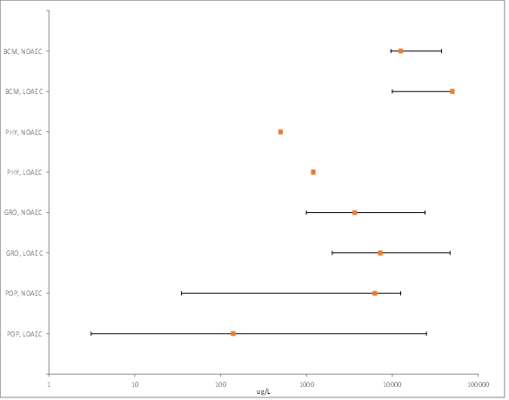
Figure 4-1. Summary Toxicity Data Array of Aquatic Plants (freshwater and estuarine/marine (saltwater), vascular and non-vascular). (BCM=Biochemical; CEL=Cellular; PHY=Physiological; BEH=Behavioral; REP=Reproduction; GRO=Growth; MOR=Mortality; POP=Population

Lines of Evidence for Aquatic Plants

In examining direct effects to a listed plant species, different lines of evidence used in the WoE approach include mortality, decreases in growth, and decreases in reproduction. The available toxicity data for aquatic plants from exposure to malathion for each line of evidence will be described in this section. Toxicity data reported as effects to reproduction are not available for aquatic plants.

Effects on Mortality of Aquatic Plants

Mortality effects including results from the “population” effect group from ECOTOX are included in this discussion (Figure 4-2).

Effects on mortality (NR-leth; 100% mortality) were reported for green algae, Chlorella variegata and Chlorella vulgaris at concentrations of 10 and 100 ppm (assumed to be adjusted for purity; 5% formulation), respectively, after either 30 or 45 days of exposure (Agrawal and Manisha 2007; E104317). Additionally, lethality (NR-leth, 100% mortality) was reported for the aquatic vascular plant, water meal, Wolffia papulifera at 100 mg/L (Worthley and Schott, 1972; E9184).

Population effects, reported as effects on abundance, biomass, chlorophyll concentration and photosynthesis are reported for individual algal species and for populations of aquatic plants. Fourteen different studies report effects on plant populations. Effect concentrations ranges from 3.1 to 159,000 µg/L. Effects on abundance on an algae population are reported at 3.1 µg/L for an aquatic community-based study which also exposed aquatic invertebrates and amphibians (Groner and Relyea, 2011; E159029).

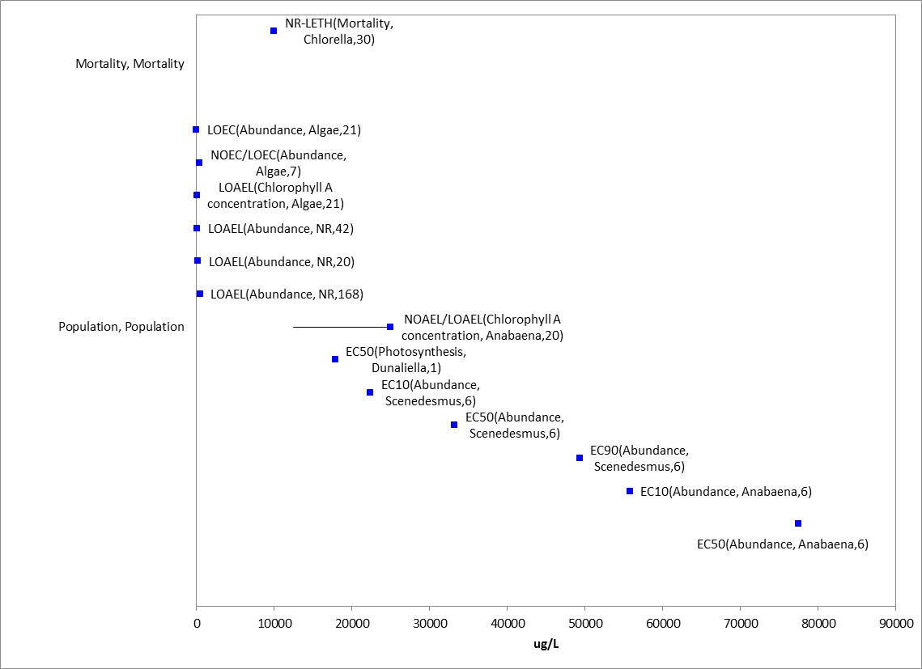
Figure 4-2. Mortality and Population-level Effects for Aquatic Plants. Endpoint labels include measured endpoint, test species genus (if available), and test duration. Blue datapoints are from open-literature studies. There are 2 additional endpoints that are >90 mg a.i./L (>90,000 µg/L) (they are 108 and 159 mg a.i./L). These endpoints were removed from this figure for presentation purposes to allow for greater resolution at the lower end of the effect concentration spectrum.

Sublethal Effects to Aquatic Plants

Sublethal data related to effects on growth are discussed in this section.

Effects on Growth of Aquatic Plants

Growth endpoints as well as physiological effects are reported collectively as potential growth effects to aquatic plants (Figure 4-3).

The most sensitive growth endpoint for aquatic plants, based on cell density, is from a 48-hr study conducted under air tight conditions for green algae (Pseduokirchneriella subcapitata) with a 37% reduction in cell density at 2,000 µg/L (NOAEC 500 µg/L) and an IC₅₀ value of 2,320 µg/L (E85816, Yeh and Chen 2006). In addition to the decrease in cell density in green algae in Yeh and Chen, 2006, a significant 29% decrease in oxygen production (reported as a change in dissolved oxygen production, but coded as effects to “photosynthesis” in ECOTOX) was reported at 1,200 µg/L (NOAEC 500 µg/L); the EC₅₀ value for this endpoint was reported as 2,040 µg/L. However, given the uncertainties in test material source, this study was not used as a threshold value.

The 4-day IC₅₀ value for effects on biomass for freshwater diatom (Navicula pelliculosa) was reported as 19,900 µg a.i./L, with NOAEC/LOAEC concentrations of 6,100/12,000 µg a.i./L based on a 15% reduction in growth (MRID 48963310). The green algae (Pseduokirchneriella subcapitata) IC50 value was 12,240 µg a.i./L based on cell growth (area under the curve), with a NOAEC of 1,000 µg a.i./L based on a 9% inhibition in growth at 2,500 µg a.i./L (MRID 48963311). The green algae study (MRID 48963311) was used as the threshold value for aquatic non-vascular plants.

For aquatic vascular plants, based on a 7-d exposure, a 18% decrease in biomass yield in Lemna gibba was observed at 24,000 µg/L (NOAEC 12,000 µg/L) with an EC₅₀ value of 45,000 µg/L (MRID 48998003). This study was used to establish threshold values for aquatic vascular plants. No effects on biomass for large duckweed, Spirodela polyrhiza, was reported at 24 mg/L (Sinha et al. 1995; E54278).

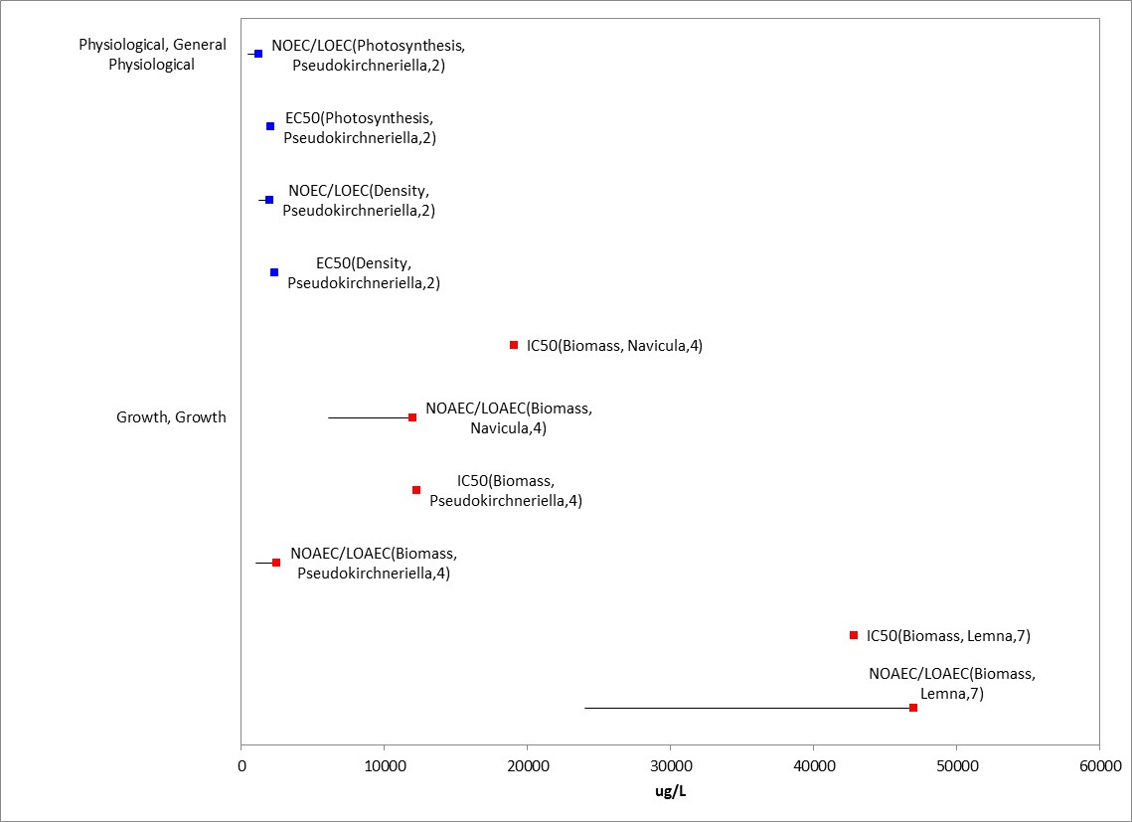
Figure 4-3. Growth (including physiological) Effects for Aquatic Plants. Endpoint labels include measured endpoint, test species genus (if available), and test duration. Blue datapoints are from open-literature studies, and red datapoints are from registrant-submitted studies.

Effects on Reproduction of Aquatic Plants

Reproduction toxicity data are not available for aquatic plants for malathion.

Other Effects Reported for Aquatic Plants

Effects to aquatic plants other than those identified as mortality (survival) and growth are reported for malathion and include cellular and biochemical effects. A summary of each of these effect types are discussed below.

Biochemical and Cellular

Biochemical effects on aquatic plants includes effects such as alterations in nitrogen content, hydrogen peroxide, malondialdehyde, sucrose, and glycogen (Figure 4-4). No effect on genetic mutation was reported for cyanobacteria (i.e., blue-green algae) at 200 mg/L (Pandey 1999, E89877).

For the fern, water velvet (Azolla pinnata) exposed to a formulation (50%), a 21-day LOAEL on nitrogen content was reported at 10 mg/L with a reported NOAEL at 5 mg/L (Kalita 1997, E72931). A 1-day effect (LOAEL) at 24 mg/L on protein content was reported for large duckweed, Spirodela polyrhiza (NOAEL 9.6 mg/L) after exposure to technical-grade malathion (Sinha et al. 1995; E54278). After a 20-day exposure to a malathion formulation, alterations in several biochemical endpoints (e.g., hydrogen peroxide, malondialdehyde) for cyanobacteria (Anabaena variabilis) were reported at 12.5 mg/L with effects on sucrose, catalase, glycogen) at 50 mg/L (LOAEL) (Ningthoujam et al. 2013; E162397).

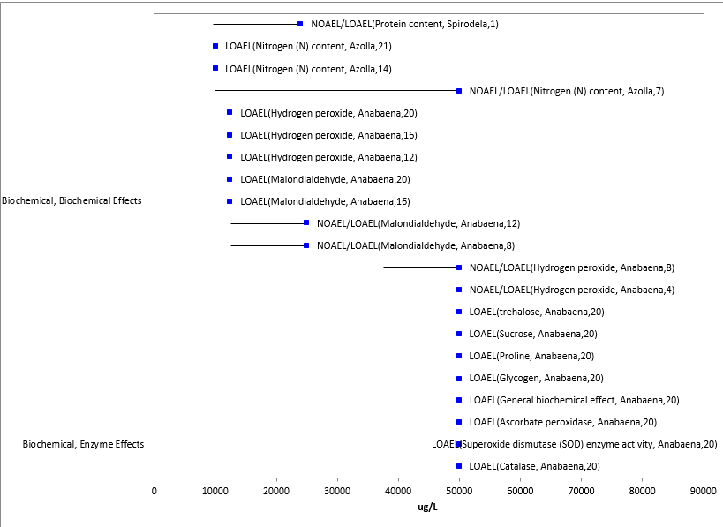
Figure 4-4. Biochemical Effects for Aquatic Plants. Endpoint labels include measured endpoint, test species genus (if available), and test duration. Blue data points are from open-literature studies.

Data Reported in Units of Mass/Acre

There is one study in ECOTOX which report effects in units of mass/acre. In Stevens et al., 1998, (E60146), malathion was applied to rice seeds which were then placed in a field (experimental unit). In this study, at 15 days, there were no reported effects on abundance or length at an application rate of 300 g a.i./ha (0.27 lb a.i./acre).

Effects to Aquatic Plants Not Included in the Arrays

There was an additional study that was not included in the discussions above because the exposure units could not be converted to environmentally-relevant concentrations. In Hemlata, 2009, (E118161) effects to phycobiliprotiens in blue-green algae (Anabaena sp.) were reported at a malathion concentration of 0.003% (27-d LOAEL).

Concentrations Where No Effects Were Observed in Aquatic Plant Studies

For the exposure unit µg a.i./L (including both vascular and non-vascular species), there are data available that show concentrations where effects are not observed [i.e., reported as ‘no effect’ (NE) concentrations in the data array below]. The NE endpoints include NOAEC/NOAEL and NR-Zero values as reported in ECOTOX. Below are the arrays showing the NE endpoints for malathion and vascular aquatic plants and non-vascular aquatic plants (Figure 4-5). For vascular aquatic plants, the available ‘NE’ endpoints (n = 5) concentrations range from 5,000 to 24,000 µg a.i./L. For non-vascular aquatic plants, the ‘NE’ concentrations range from 3.1 to 250,000 µg a.i./L.

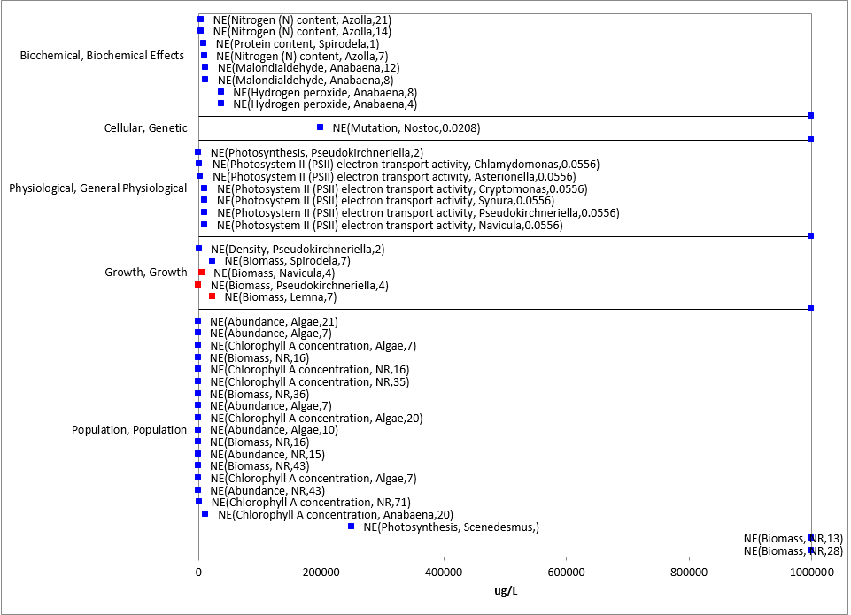
Figure 4-5. Concentrations Where No Effects Were Observed in Aquatic Plant Studies. Endpoint labels include measured endpoint, test species genus (if available), and test duration. Blue datapoints are from open-literature studies and red datapoints are from registrant-submitted studies.

Incident Reports for Aquatic Plants

EFED’s incident database (EIIS), accessed October 26, 2015, did not contain any incidents concerning aquatic plants specifically. In addition to the terrestrial plant incident reports available in EIIS, there have also been a total of 231 aggregate plant incidents reported to the Agency. Beyond product information and year, additional details about these incidents were not reported, such as no information was available on the use site, the certainty level, or on the types of organisms that were involved.

Summary of Effects to Aquatic Plants

While available data are limited, based on the available toxicity information, malathion can effect growth of aquatic plants with aquatic vascular plants being less sensitive than non-vascular plants. However, aquatic plants collectively are less sensitive than aquatic animals. Impacts to growth (based on reductions in oxygen production) for green algae were observed at 1200 µg/L (NOAEC= 500 µg/L). Effects on growth for aquatic vascular plants were reported at 24,000 µg/L (NOAEC=12,000 µg/L).

5. Effects Characterization for Aquatic Communities (from studies examining aquatic communities)

For malathion, there are studies which examine effects on aquatic communities (e.g., mesocoms evaluating effects on aquatic invertebrates, aquatic plants, and aquatic-phase amphibians). These studies can be used, in addition to laboratory toxicity data, to evaluate potential effects in the environment, and may be particularly useful in evaluating potential indirect effects to a given taxon. In these studies, there are likely multiple interactions occurring simultaneously among the different organisms which can influence the effects seen across taxa. Because of this potential interaction, endpoints from toxicity studies involving exposure to multiple taxa may not be measuring direct toxicity to each taxon.
Discussed below are studies that were reviewed when establishing aquatic taxon thresholds as well as additional studies presented in other USEPA documents (e.g., USEPA RED). Toxicity data for some of these studies are also contained in the data arrays for a given taxon, but are not discussed in detail in the representative line of evidence.
In the study by Groner and Relyea, 2011, (E159029), aquatic communities consisting of leopard frog tadpoles (Rana pipiens Schreber), periphyton, phytoplankton and zooplankton were exposed to varying malathion (Malathion Plus (50% active ingredient) exposure scenarios: a 25 µg/L (assumed to represent malathion only) applied weekly (5 total applications; referred to as weekly low concentration), 250 (single medium) or 2500 (single high) µg/L applied once; measured concentrations were 12-15% of nominal resulting in reported malathion concentrations of 3.1, 35 and 384 µg/L (study author did not provide a specific reason for lower measured values stated could be due to a variety of reasons such as precipitation, binding, degradation of stored samples). Tadpole development and periphyton, phytoplankton and zooplankton were evaluated for the course of the study (97 days total). Water quality parameters were reported to be significantly affected in the study; on Day 7, the single medium and single high treatments had increased pH and dissolved oxygen and single high treatment had increased temperature. For the leopard frog, survival was significantly reduced 8% in weekly low and single medium and 22% in single high; and few tadpoles remained when ponds were dried. Mean time to metamorphosis in the weekly low malathion treatment was 17 days longer than control; however, there were no differences between the single medium and high concentrations compared to control. The mass of the frogs was 15% lower in the weekly low treatment at metamorphosis and was 13-15% higher in the single concentrations compared to the control. Zooplankton abundance was also significantly affected in all malathion treatments (reduced 86-99% for cladocerans and increased 235-288% for copepods at weekly low and medium, 216% at high but not significant). Periphyton biomass was significantly increased 20% in the single high malathion treatment on day 7, but was reduced 70% by day 21 in the single medium concentration. Phytoplankton was increased 320-790% by day 21.
In a similar study by Relyea and Diecks, 2008 (E118292) aquatic communities consisting of two species of larval amphibians (wood frogs, Rana sylvatica, and leopard frogs, Rana pipiens) as well as zooplankton, phytoplankton, and periphyton, and larval amphibians were exposed to varying malathion (Malathion Plus (50% active ingredient) exposure scenarios for a total of 79 days: 50 or 250 µg/L (at start of experiment; assumed to represent malathion only); 50 or 250 µg/L (later in the experiment); and 10 µg/L applied once per week for 7 weeks; measured concentrations were 9.5 (weekly), 40 and 32 (50 µg/L, initial and later, respectively) and 300 and 190 µg/L (initial and later, respectively). Tadpoles were also tested at two different densities (low and high). For the wood frog, the results indicated that the pesticide treatments did not affect the frogs compared to the control. However, for the leopard frogs, reductions in growth (18-22%, weekly and 250 µg/L treatments) and delayed development were observed, which led to subsequent mortality (43% decrease in survival in weekly treatment) as the mesocosms dried up. By day 8, cladocerans were reduced almost 100% in the weekly and malathion concentration dosed at start of experiment, but did increase in abundance at end of experiment, except for weekly treatment; copepod abundance increased over time in treatment groups compared to controls. Additionally, there was an increase in phytoplankton and then decline in periphyton.
Aquatic communities consisting of two geographically distinct amphibian assemblages, (Rana sylvatica (PA)) or Rana cascadae (OR)) along with populations of zooplankton (copopods and cladocerans), periphyton and phytoplankton were exposed to malathion (Malathion Plus (50%)) initially at 1 or 10 µg/L and then later increased to 5 or 50 µg/L (measured concentrations 3 hours after exposure of 6 and 40 µg/L, respectively, assumed to represent malathion only) in the presence or absence of a zooplankton predator, salamander larvae (Ambystoma spp.) (Hue and Relyea 2012; E161049). The study duration was 40 days, but zooplankton, periphyton and phytoplankton endpoints were measured on day 22. Light attenuation was increased at the 40 µg/L treatments compared to control. After 22 days, copepod abundance was greater (approx. 60-70%) in the 6 µg/L treatment group compared to controls, and cladoceran abundance was lower (abundance approx. 0%) in both malathion treatment groups compared to control. Additionally, periphyton biomass was significantly lower (approx. 20-70%) at 40 µg/L compared to control, and phytoplankton biomass was greater (>100%) in both malathion treatments. Amphibian metamorphs’ mass was significantly greater (approx. 30%) in both species compared to control, but time to metamorphosis was not affected. Salamander mass was also significantly lower in both treatments (approx. 30-70%).
Two species of larval amphibians (gray tree frogs, Hyla versicolor and leopard frogs, Rana pipiens) in addition to zooplankton, phytoplankton, and periphyton were exposed to five TGAI insecticides (malathion, carbaryl, chlorpyrifos, diazinon, and endosulfan) and five herbicides (glyphosate, atrazine, acetochlor, metolachlor and 2,4-D) (E114296, Relyea 2009). There were no effects on survival, mass at metamorphosis, or time to metamorphosis for either species of frog when exposed to malathion only at 5.8 µg/L (initial measured concentration); however, exposure to diazinon and endosulfan alone affect survival of leopard frog tadpoles. Malathion alone also did not affect the abundance of phytoplankton, periphyton or zooplankton species, except for Ceriodaphnia sp.. When exposed to the mixture of the five insecticides and all pesticides (10 total), survival of the leopard tadpoles was significantly reduced (99% mortality). For the gray tree frog, there were no significant effects on survival or time to metamorphosis when exposed to the mixture of the five insecticides and all pesticides, but mass at metamorphosis was significantly increased at both treatments. Additionally, there were effects on zooplankton and/or periphyton/phytoplankton abundance was exposed to the mixtures.

The effects of three pesticides (carbaryl (Sevin®, 22.5%), malathion (50% a.i., liquid), and permethrin (Cutter’s Bug Free Back Yard, 2.5%, or 98% technical grade) on survival, growth, and development (considering metamorphosis) in the American toad (Bufo americanus) and in the green frog (Rana clamitans) in mesocosm systems were examined (Boone, 2008; E104182). Concurrent effects on periphyton abundance in the mesocosms were also evaluated. Each treatment consisted of five replicates (i.e., mesocosms) with either 60 American toad tadpoles or 20 green frog tadpoles per replicate. Test concentrations were 1.75 mg a.i./L, 3 mg a.i./L, and 9 µg a.i./L for carbaryl, malathion and permethrin, respectively. Studies using combinations of the pesticides with the same individual concentrations were also conducted. Initial (1-hour) recoveries in experiment 1 were 120% (2.10 mg a.i./L) for carbaryl, 72% (2.16 mg a.i./L) for malathion, and 30% (2.67 µg a.i./L) for permethrin. Recoveries (16-hour) in experiment 2 were 38% (0.66 mg a.i./L) for carbaryl, 70% (2.1 mg a.i./L) for malathion, and 39% (3.5 µg a.i./L) for permethrin. Malathion exposure at 3 mg a.i./L (nominal) did not significantly affect American toad survival to metamorphosis; however, the larval period (i.e., time to metamorphosis) was longer in American toad tadpoles exposed to malathion. Mass at metamorphosis was significantly (p<0.05) reduced in American toads exposed to both carbaryl (1.75 mg a.i./L, nominal) and malathion, but not in toads exposed only to malathion. Malathion exposure at 3 mg a.i./L (nominal) had no significant effects on survival, mass, or Gosner development stage in green frog tadpoles at study termination (day 74). However, statistically significant interactions of carbaryl (1.75 mg a.i./L, nominal) and malathion and of carbaryl, malathion, and permethrin (9 µg a.i./L, nominal) were detected and associated with an increase in development stage at study termination. Periphyton abundance increased significantly (p = 0.0199) in the presence of malathion but not with other treatments.
A study examining the influence of malathion (50% a.i.) and cypermethrin (25% ai) on the survivability and time of metamorphosis of tadpoles of the common paddy field frog, Fejervarya limnocharis was conducted (Nataraj and Krishnamurthy, 2012: E158899). F. limnocharis, were collected from paddy fields in India as egg masses (>25 spawns) from different individual frogs. The test concentrations were 25 and 50 µg/L concentrations for cypermethrin and 250, and 500 µg/L for malathion; effects from combinations of these test concentrations were examined and test solutions were renewed every 6 days. Each treatment group used two replicates each with 20 tadpoles. For each 10 L of aged tap water, 250 mL of plankton concentration from 20 L of habitat water was inoculated as food and provided every 6 days during the study. Mortality was recorded daily until the hind limbs appeared in surviving tadpoles. The time required for the emergence of surviving tadpoles as metamorph was recorded until Day 145. For malathion, the differences in survivability were marginally significant (p = 0.076) for both treatment groups (95.94-96.25%) compared to the control (98.75%). Based on combination treatments, a statistically significant reduction in survivability of 19.89% was observed at the constant 25 µg/L cypermethrin concentration with increasing malathion concentrations. For combinations using 50 µg/L cypermethrin and increasing malathion concentrations, the survivability reduction was significant at 71.33%. For all treated groups excluding the 250 µg/L malathion, the metamorphosis of tadpoles into froglets was delayed and extended up to 130th day and only 20-45% of the surviving tadpoles emerged as froglets.

In Sweilum 2006 (E92183), the effects of malathion (purity not reported) on growth and haematological properties of Nile tilapia (Oreochromis niloticus L.; initial size of 12 cm and 40 g) as well as abundance of phyto- and zooplankton were evaluated. At malathion concentrations of 500, 1,000 and 2,000 µg/L after 24 weeks, significant changes in water quality were observed at all test concentrations. (decreased dissolved oxygen; increased ammonia, nitrate and phosphate). Significant reductions in both phyto- and zooplankton were also observed (27, 33, 42% for phytoplankton and 25, 30 and 37% for zooplankton at 500, 1,000 and 2,000 µg/L, respectively). Survival rate in fish after 24 weeks was 87, 57, 50 and 47% for the control, 500, 1,000 and 2,000 µg/L, respectively. Also, effects on tilapia growth were observed at all concentrations including reductions in specific growth rate (17-27%) and normalized biomass index (6-12%). Furthermore, reductions in blood parameters (i.e., erythrocytes, haematocrit, glucose) and muscle protein levels were reported at all concentrations.
In a study of the effect of aerially applied malathion to juvenile brown and white shrimp, Penaeus aztecus and Penaeus setiferus, Conte and Parker ( Texas A&M University, 1975) reported varying rates of mortality in relation to type of site and time after application for water concentrations which ranged from 2.0 to 3.2 ppb immediately after application. Three bayous and an estuarine lake were monitored. Mean water depth was 61 cm. Wild caught shrimp placed in cages were aerially sprayed at a rate of 85.7 g/hectare by aircraft at a speed of 145 km/hr. Seven to 3 passes were made at each site. In Test I within 9 hours after treatment 73% of all mortality occurred (24 of 50 shrimp died). Test II produced 50% mortality in 49 hours after application. Only 12% mortality occurred in Test III (estuarine lake).
Mortality of post larval and juvenile shrimp from exposure to malathion under laboratory and field conditions was examined by Proctor, Corliss, and Lightner of the National Marine Fisheries Service's Galveston Laboratory in 1966. Postlarval white shrimp and brown shrimp were exposed for 48 hrs. in laboratory tanks and caged shrimp were exposed in estuarine areas to application of malathion (95% ai) at 77.8 ml/acre. Water depth during the field study was about 1.2 meters (high-tide) for the first application and 0.3 meters at the time of the second application (mean tide). In the laboratory study the calculated 50% lethality levels for adults were 25.5 to 21.3 ppb for post larval brown shrimp and 100% mortality of larvae was seen at concentrations as low as 18 ppb.

In the field, environmental concentrations reached 8.9 ppb at high tide and 69 ppb at mean tide level. Some contamination of control areas occurred possibly from drift. 14% mortality was observed in controls and 80% mortality was seen in the test marsh. In the second application 65-69 ppb residue levels were seen 6 hours after treatment. Initial mortality was 48% in treated area and 4% in control area. After 10 hours white shrimp mortality increased to 96% in treated area and 7% in control area at mid depth levels. By 24 hours the residue levels had decreased to 1.08 ppb. White shrimp caged on the bottom level showed a similar trend after second application. Brown shrimp mortality results were inconclusive as treated areas showed 55% mortality while controls showed 44% mortality.

Tagatz (1974) observed the effects to fish and invertebrates from two types of ground applications of malathion near saltmarsh environments in northwestern Florida. Both thermal fog and ULV application were monitored. Malathion was applied during low tide with 2 week intervals between applications. Thermal fog was applied at 6 oz/Acre (Sept. & Oct 1972) to a saltmarsh pond with fuel oil carrier. The thermal fog application produced high mortality of adult grass shrimp after 7 days. Some reduced AChE levels were observed in fish. No mortality of blue crabs or juvenile sheepshead minnow occurred. Three applications of ULV formulation at 0.64 fl oz/Acre were made by truck mounted aerosol generator, with a 330 foot swath. Grass shrimp, blue crabs, and sheepshead minnow were exposed in 18" diameter polyethylene tubs. No adverse effects or treatment related mortality was observed for the exposed organisms. Residue levels were 0.28 - 0.34 ppb after the 3rd application.

In a 1970 study effects of malathion to a freshwater ponds community were observed (Kennedy and Walsh, USFWS, 1970). 12 ponds containing bluegills and channel catfish were exposed. Four applications were made at concentrations of 0.02 and 0.002 ppm over an 11 week summer period. Pond surface areas were 688 m2 with average depth of 0.76 m. and volume of 602 m³. The observed 8-44% fish loss was not felt to be treatment related as controls also had similar losses. The major treatment related effects appeared to be reductions of aquatic insects particularly midges at high and low doses (0.02 ppm and 0.002 ppm). Mayflies were also reduced with a significant reduction occurring after the 3rd application.

In a 1981 study investigating potential impact on fish and wildlife during aerial malathion applications in South San Francisco Bay region the California Fish and Game Department Pesticide Investigation Unit, (Water Pollution Control Laboratory) summarizes extensive monitoring performed during 198 1 Medfly control programs. In general, most of the 200 fish and invertebrate tissue samples taken contained no detectable levels of malathion residues (~0.5 ppm). This was not true in the case of samples taken at fish kill sites. Steelhead trout populations were monitored in the San Lorenzo drainage area. Aquatic insect populations in the drainage were also monitored (number per sq. Cm). No discernable effects were noted for steelhead trout populations or appearance or size measurements when compared to control sites. There were significant reductions in either diversity or population counts for aquatic insects (33-50% reduction): Eight fish kills were associated with malathion spraying efforts, while 15 were either not determined as to cause or not attributed to malathion (see incident report section of this document). Many of the fish losses were sticklebacks (highly sensitive to malathion) while carp and channel catfish appeared unaffected at the same locations (Finlayson, B.J., G. Faggella, H. Jong, E. Littrell, and T.Lew, 1981).

The effects of malathion on fish and aquatic invertebrate communities in Stewart Creek, Fayette County, Alabama were monitored following applications for control of bollweevil in adjacent cotton fields. Stewart Creek is located in west-central Alabama near Winfield and has an approximately 11 square mile drainage basin. Samples were taken upstream, at the entry point, and 0.5 mi. downstream from the application site on two small cotton fields ( 7.6 and 11.6 acres). Fields were within 25 feet of the stream bank. There were no trees along the banks, only grasses and kudzu vines. Sample sites were sampled for three years-the first two during malathion applications, the last during which malathion was not applied. Captured fish were identified, counted, and some analyzed for AChE inhibition. Invertebrates were captured (by kicking up sediments into a dipnet), recorded, and then preserved in ethanol. Thirty-nine samples from each location were taken over a 34 month period. Only one sample date represented pre-spray conditions. Concentrations recorded ranged from ND to 10.89 ppb (mean=3.49 ppb) for the nine 1993 applications and from 0.88 to 3 1.1 ppb (mean=2.08 ppb) during the four 1994 applications. Fish of 48 different species were collected during the study. It was reported that not all species were equally distributed at the three sites and some population differences may be attributable to the differences in habitat preferences and availability at the three sites. Numerous specimens of rough shiner, Notropis baileyi were collected and analyzed for AChE and significant depression was noted during the spray periods when compared to the upstream control site. Aquatic invertebrate populations which were collected included 87 taxa, and a total of 6,088 individual organisms. Some difference is apparent in numbers and diversity of species collected near the spray site when compared to the upstream site, but significant differences were less apparent at the downstream location. The upstream location did have more taxa present, however, than either of the other two sites for all periods of this study. The study author was not certain that this could be attributable to malathion influence as natural variability could also have played some part. (Kuhajda, B.R. et al, Dept. Of Biological Sciences, University of Alabama,
1996).

6. Effects Characterization for Birds

Introduction to Bird, Terrestrial-phase Amphibians, and Reptile Toxicity

This section presents direct effects thresholds for listed birds and indirect effects thresholds for species which rely upon birds (e.g., as a food source). A summary of the available terrestrial-phase amphibian and reptile data which is based on a limited number of available studies is also included at the end of this section. This section also discusses direct effects on birds for the different lines of evidence, when available, addressed in the WoE approach including mortality, decreases in growth, decreases in reproduction, altered behavior, and changes in sensory function.

Threshold Values for Birds, Terrestrial-phase Amphibians and Reptiles

The available data can be broken out into three groups of units: mg ai/kg-bw (oral dose), mg ai/kg-diet and lb a.i./A. Endpoints are available to establish thresholds for lethality and sublethal effects to birds for mg ai/kg-bw and mg ai/kg-diet. Direct and indirect effects thresholds for birds are presented in Tables 6-1 and 6-2, respectively. Due to uncertainties associated with the available lb a.i./A endpoints, these data were not used to establish individual thresholds; however, they are still considered scientifically valid and are discussed below. Studies from which threshold values were derived will be discussed in more detail in their respective line of evidence. Given the limited data available for terrestrial-phase amphibians and reptiles, the thresholds established for birds will be used as surrogate thresholds.

Mortality

While there is sufficient toxicity data to calculate a SSD for birds, there is enough uncertainty in the purity of the test compound across studies that it can not be used to derive direct and indirect effects thresholds. Therefore, the bird direct effect mortality threshold is based on the 1 in a million effect from the most sensitive LD₅₀ for which purity of the test material was representative of current technical grade malathion (Table 6-1). The mortality threshold for indirect effects is based on 10% of the LD₅₀. For comparative purposes, SSDs were also calculated based on acute 96-hr LD₅₀ values from studies using TGAI only (LD50 values from formulation/mixture testing were not included), though the purity of the test material is uncertain.

Sublethal

The sublethal threshold for exposure unit, mg ai/kg-bw, is based on inhibition of acetyl cholinesterase, and for mg ai/kg-diet is based on necropsy effects in a reproduction study (i.e., regressed ovaries, affected gizzards).

Table 6-1. Direct Effects Thresholds for Determining Effects to Listed Birds
Effect (endpoint) | Value | Unit | Test species | Source
Mortality (1/million) | 25.6 | mg ai/kg-bw | Ring-necked pheasant (Phasianus colchicus) | MRID 48963305; slope of 6.6
 | 300 | mg ai/kg-diet | Northern bobwhite quail | MRID 48153106;  LC50 = 2022 mg/kg-diet; slope = 5.74
AChE Inhibition (LOEL) | 87.4 | mg ai/kg-bw | Ring-necked pheasant | ECOTOX 63276
Reproduction (NOEC) | 110 | mg ai/kg-diet | Northern bobwhite quail | MRID 43510501

Table 6-2. Indirect Effects Thresholds for Determining Effects to Listed Species
That Depend upon Birds
Effect (endpoint) | Value | Unit | Test species | Source
Mortality (10%) | 86.7 | mg ai/kg-bw | multiple (see above) | HC05 of 108 from SSD; slope of 6.6
 | 1210 | mg ai/kg-diet | Northern bobwhite quail | MRID 48153106;  LC50 = 2022 mg/kg-diet; slope = 5.74
AChE Inhibition (LOEL) | 87.4 | mg ai/kg-bw | Ring-necked pheasant | ECOTOX 63276
Reproduction (LOEC) | 350 | mg ai/kg-diet | Northern bobwhite quail | MRID 43510501

Summary Data Arrays for Birds

The following data arrays provide a visual summary of the available data for malathion effects on birds (Figures 6-1 and 6-2). Effects concentrations are on the horizontal (X) axis and the effect and endpoint type (e.g., MORtality, LD₅₀) are identified on the vertical (Y) axis. A discussion of effects follows the arrays. The data are obtained from registrant-submitted ecotoxicity studies and from open literature studies which have been screened as part of the US EPA ECOTOX database review process.

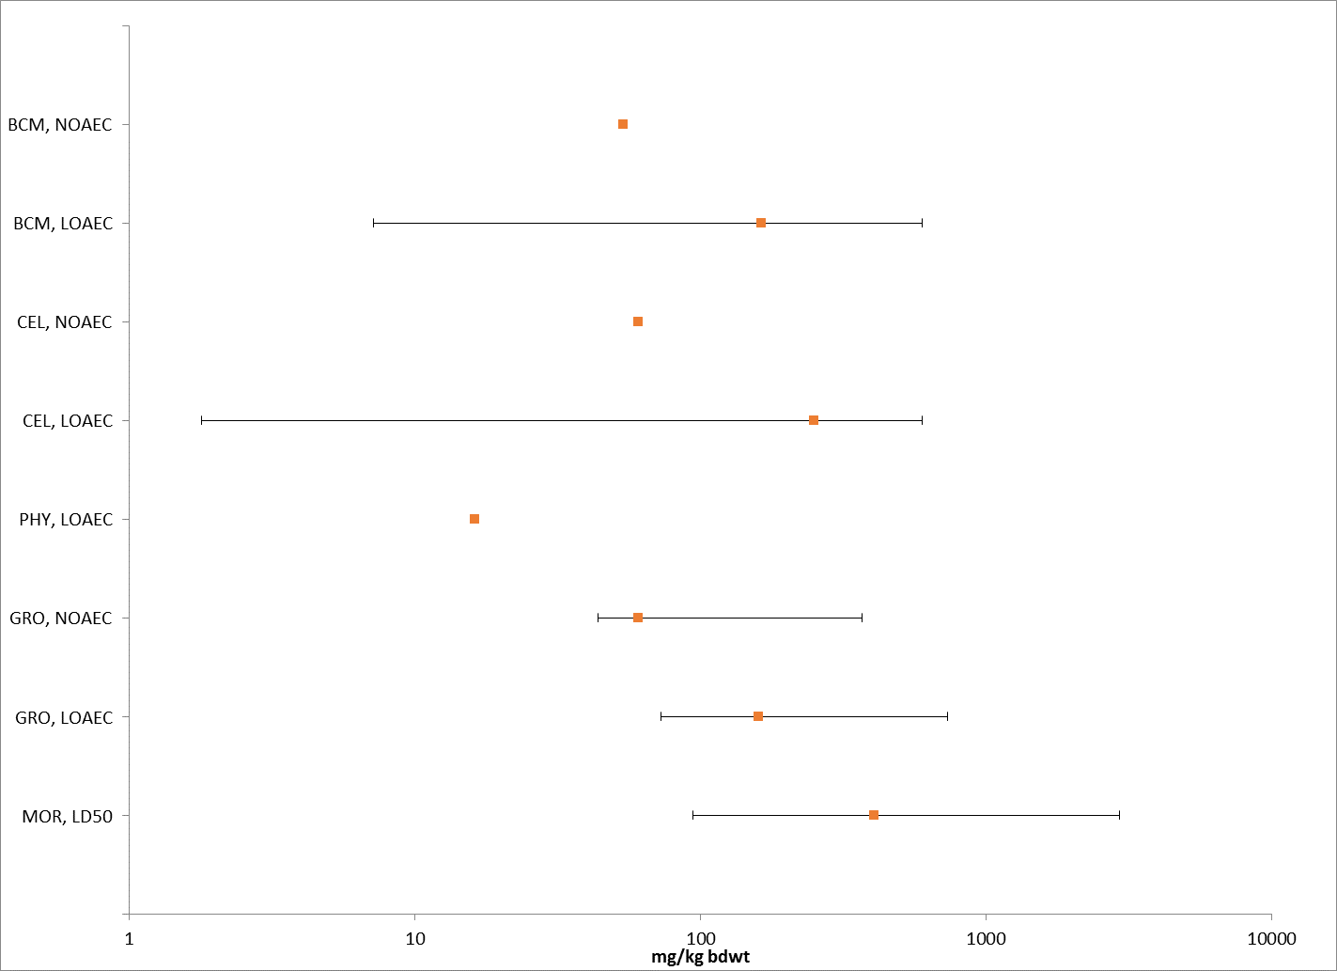
Figure 6-1. Summary Data Array of Birds (based on mg/kg-body wt) Exposed to Malathion. Orange symbols represent median endpoint values and bars represent the data range for combined acute and chronic data. Data was normalized for 100g bird. (BCM=Biochemical; CEL=Cellular; PHY=Physiological; GRO=Growth; MOR=Mortality).

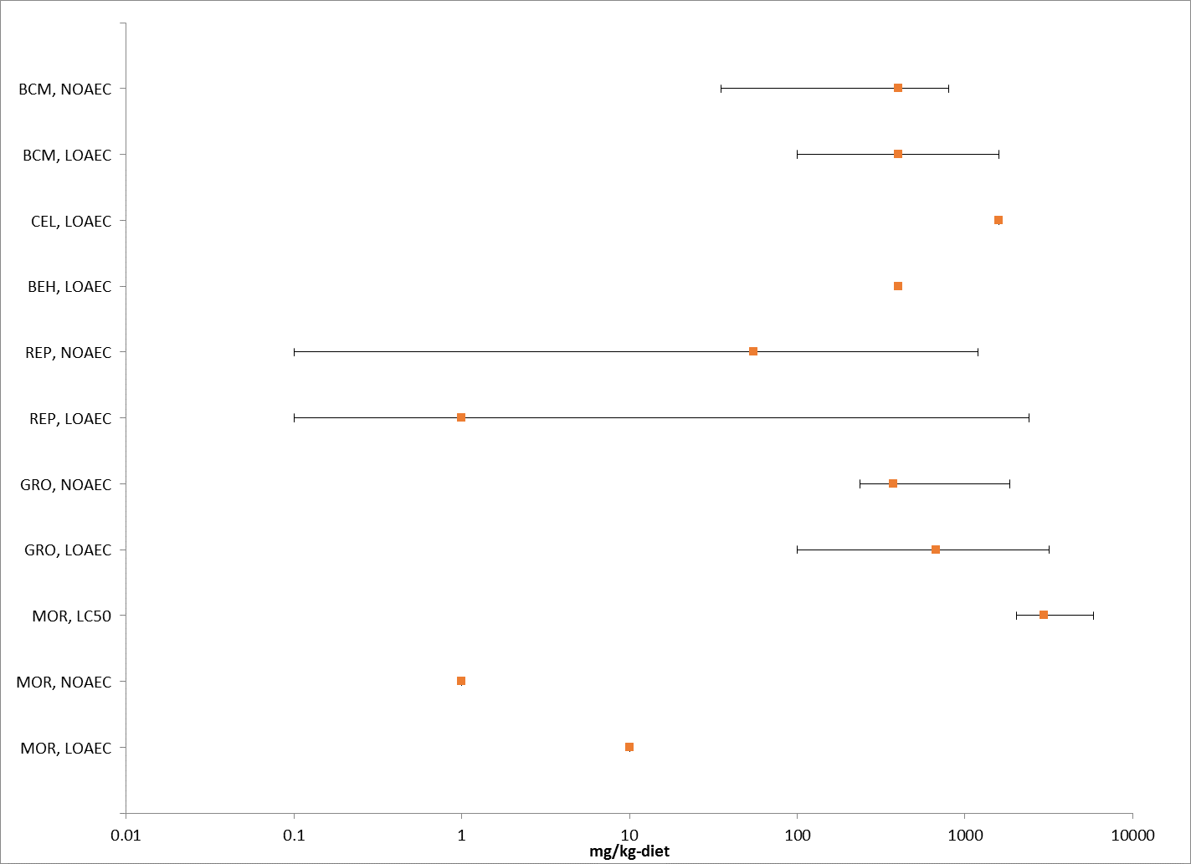
Figure 6-2. Summary Array of Birds (based on mg/kg-diet) Exposed to Malathion. Orange symbols represent median endpoint values and bars represent the data range for combined acute and chronic data (BCM=Biochemical; CEL=Cellular; BEH=Behavior; REP=Reproduction; GRO=Growth; MOR=Mortality.

Lines of Evidence for Birds, Terrestrial-phase Amphibians, and Reptiles

In examining direct effects to a species, different lines of evidence used in the WoE approach include mortality, decreases in growth, decreases in reproduction, altered behavior, and changes in sensory function. The available toxicity data for birds (which will be used as surrogates for reptiles and terrestrial-phase amphibians) from exposure to malathion for each line of evidence will be described in this section.

Effects on Mortality of Birds

SSDs based on acute mortality studies are developed for birds. Additionally, mortality effects from studies not used in the SSDs are also presented, which includes chronic studies.

Mortality data are available (submitted by registrants or available in ECOTOX database) for 3 different orders of birds (i.e., Galliformes, Passeriformes, and Anseriformes) with 10 different species. Mortality data based on both diet and body weight are presented in Figures 6-3 and 6-4. Toxicity values for dietary-based studies ranged from 10 mg/kg-diet (LOAEL for chick survival from a chronic reproduction study with chickens, Sauter et al. 1972, E38642) to an 8-d LC50 value of >5850 mg/kg/diet for mallard ducks (MRID 48963303). For dose-based studies, toxicity values ranged from a 14-d LD50 of 136 mg a.i./kg-bw (Ring-Necked Pheasant; MRID 48963305) to >2400 mg/kg-bw for canary (MRID 48571805).

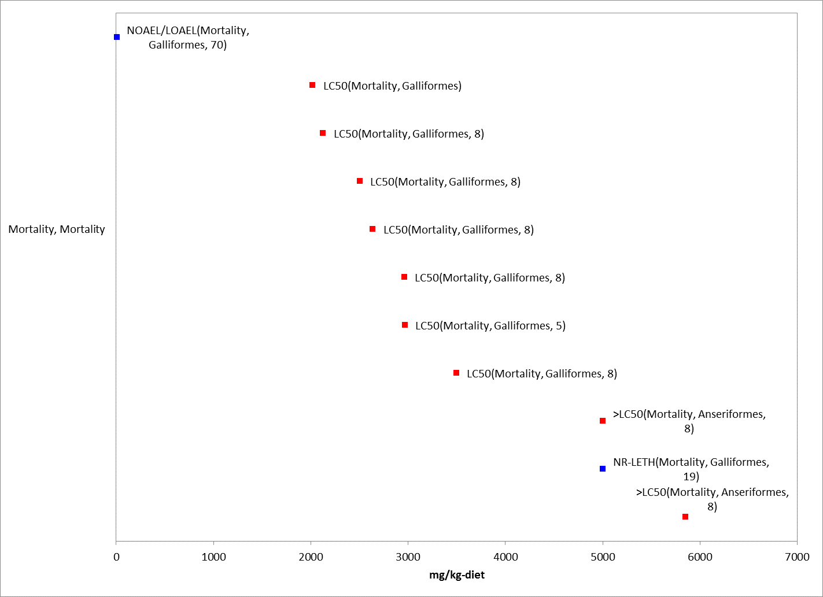
Figure 6-3. Mortality Effects for Birds Based on mg/kg-diet. Endpoint labels include measured endpoint, test species order and test duration. Blue data points are from open literature, and red data points are from registrant-submitted studies.

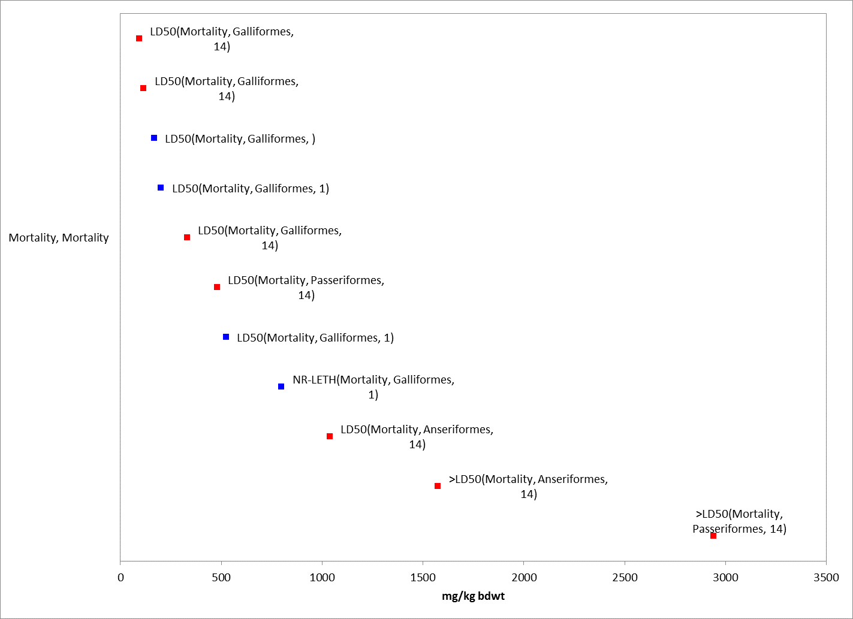
Figure 6-4. Mortality Effects for Birds Based on mg/kg-bw. Values are adjusted to 100g bird for presentation purposes. Endpoint labels include measured endpoint, test species order and test duration. Blue data points are from open literature, and red data points are from registrant-submitted studies.

As mentioned above, several different test species have been subjected to acute oral toxicity studies, yielding LD50 values that range from 136 to >2400 mg a.i./kg-bw (Table 6-3). Based on this, malathion is considered moderately toxic to practically non-toxic to birds. A subset of the available data were used to derive a species sensitivity distribution (SSD) for comparison to the dose-based mortality thresholds. LD₅₀ values were used in the SSD if they were conducted with TGAI and adult birds. The species sensitivity distribution for dose-based exposures to birds is depicted in Figure 6-5. Summary statistics for the SSD are provided in Table 6-4. The SSD report for birds is provided in APPENDIX 2-9 and includes the details of how this SSD was derived.

Table 6-3. Available Median Lethal Doses (oral) for Birds Exposed to Malathion
Species Tested | % ai | LD50 (mg a.i./kg-bw) | Confidence Intervals  (where available) | Reference MRID or ECOTOX
Mallard Duck (Anas platyrhynchos) | 95 | 1485* | (1020-2150) | MRID 00160000; Hudson et. al. 1984 (ECOTOX 50386)
Mallard Duck (Anas platyrhynchos) | 96 | >2250 | NA | MRID 48963307
Ring-Necked Pheasant (Phasianus colchicus) | 95 | 167* | (120-231) | MRID 00160000
Ring-Necked Pheasant¹ (Phasianus colchicus) | 96 | 136* | 108-170 | MRID 48963305
Sharp tailed grouse (Tympanuchus phasianellus) | tech | 220* | (171-240) | Crabtree, D.G., 1965, Denver Wildlife Res. Center, USFWS as cited in RED
Northern Bobwhite Quail (Colinus virginianus) | 96 | 361* | 298-440 | MRID 48153114
Canary (Serinus canaria) | 96 | >2400 | NA | MRID 48571805
Horned lark (Eremophila alpestris) | 95 | 403* | (247-658) | MRID 00160000
Domestic chicken (Gallus domesticus) | 97.7 | 524.8* | NR | Gupta and Paul, 1971 (ECOTOX 36916)
Domestic chicken (Gallus domesticus) | 50 | 281 | NR | McDonald et al. 1964 (ECOTOX 162524)
*Value used to derive SSD; NR = not reported; NA= not applicable
1 = default body wt for pheasant is 1135 g.

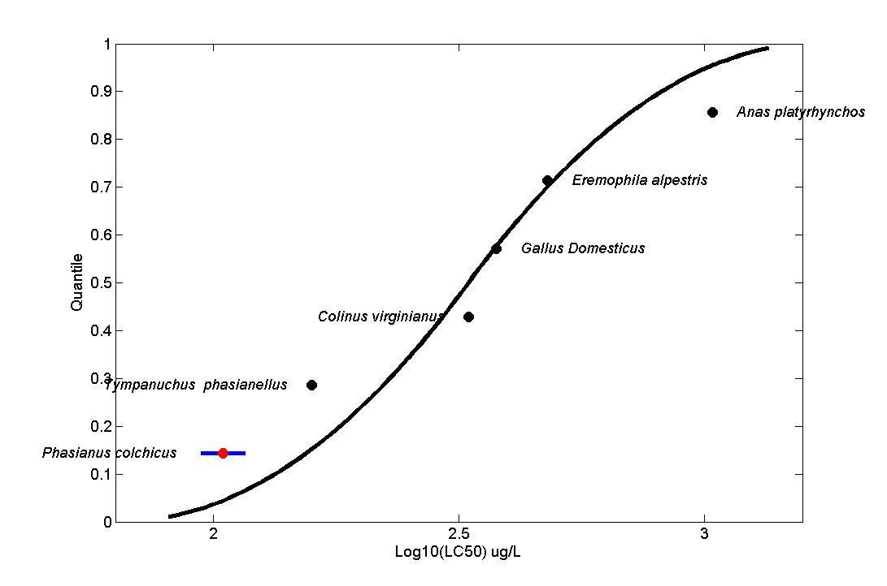
Figure 6-5. SSD for Mortality for Birds. Black points indicate single toxicity values. Red points indicate multiple toxicity values. Blue line indicates full range of toxicity values for a given taxon. All values standardized to a 100 g bird using Mineau Scaling Factor = 1.15 (default).

Table 6-4. Summary Statistics for SSDs Fit to Malathion Test Results for Birds
Statistic | Birds
Best Distribution (by AIC_{c}) | Triangular
Goodness of fit P-value | 1.0
CV of the HC₀₅ | 0.5476
HC₀₅ | 107.97
HC₁₀ | 133.82
HC₅₀ | 331.1
HC₉₀ | 819.1
HC₉₅ | 1015
Mortality Threshold (slope = 6.6)¹ | 20.6
Indirect Effects Threshold (slope = 6.6) | 69.0
¹ Dose-response slope for study near the HC05 (MRID 48963305).

Dietary-based LC₅₀ values are also available for several test species. Values range from 2022 to >5850 mg a.i./kg-diet (Table 6-5). For many of the studies, these dietary toxicity data were obtained from studies conducted at the US Fish and Wildlife Service (Heath et al., 1972; Hill et al., 1975; Hill and Camardese, 1986), and were subsequently obtained by EPA and given MRID numbers (MRID 00022923, 00062489, 40910905). Based on these data, malathion is considered slightly toxic to practically non-toxic to birds. The LC₅₀ value of 2022 mg a.i./kg-diet was used to derive the food-based mortality thresholds for birds.

Table 6-5. Median Lethal Concentrations Resulting from Sub-acute Dietary Exposures
Species Tested | % ai | LC50 (mg a.i./kg-diet) | Confidence Intervals  (where available) | Reference MRID or ECOTOX
Ring-Necked Pheasant (Phasianus colchicus) | 95 | 2639 | 2220-3098 | MRID 00022923; Hill et al. 1975 (ECOTOX 35243)
Ring-Necked Pheasant (Phasianus colchicus) | 96 | 2505 | 2074-3025 | MRID 48963301
Northern Bobwhite Quail (Colinus virginianus) | 95 | 3497 | 2959-4011 | MRID 00022923
Northern Bobwhite Quail (Colinus virginianus)¹ | 96 | 2022* | 1565-2612 | MRID 48153106
Japanese Quail (Coturnix japonica) | 95 | 2962 | 2453-3656 | MRID 00022923
Japanese Quail (Coturnix japonica) | 100 | 2128 | 1780-2546 | MRID 00062489; Heath et al. 1972 (ECOTOX 35214)
Japanese Quail (Coturnix japonica) | 95 | 2968 | NA | MRID 40910905  Hill et al. 1986 (ECOTOX 50181)
Mallard Duck (Anas platyrhynchos) | 95 | >5000 | NA | MRID 00022923
Mallard Duck (Anas platyrhynchos) | 96 | >5850 | NA | MRID 48963303
*Value used to derive mortality threshold; dose-response slope of this study is 5.74.;
- default body wt for quail is 178 g.

Sublethal Effects to Birds

Sublethal effects including effects on growth, reproduction, behavior and sensory function to birds are discussed in this section.

Effects on Growth of Birds

Effects on growth are observed in several registrant submitted studies, including both body weight gains and losses, as well as in open literature studies (Table 6 and Figures 5 and 6). A couple of the studies reported effects on liver weight or other organs.

Table 6-6. Growth Effects in Birds Exposed to Malathion
Test species | Growth Effect | NOEC(L)/ LOEC(L) | Test material | Source
mg/kg-diet
Acute
Ring-necked pheasant | Decreased body wt gain from day 0-5 at ≥551 ppm-diet;  Overall body wt gain reductions at ≥1010 | 304/ 551 | TGAI | MRID 48963301
Mallard duck | Decreased body wt gain from day 0-5, reduced body wt | 1845 / 3170 | TGAI | MRID 48963303
Japanese quail | Increased liver wt (61 d) | NA/100 | TGAI | Cecil et al. 1974 (Ecotox 35083)
Domestic chicken | No effect on wt | 100/NA | NR | Pym et al. 1984  (Ecotox 38417)
Domestic chicken | No effect on wt | ≥100/NA | NR | McDonald et al. 1964  (Ecotox 162521)
Domestic chicken | Decreased body wt (90 days) | 400/800 | NR | Varshneya et al. 1986 & 1988  (Ecotox 89120, 90699)
 | Effects on liver wt | NA/ 400
Chronic
Northern Bobwhite quail | Decreased body wt (@ 2wks and test termination day 161) | 350/1200 | TGAI | MRID 43501501
Mallard duck | Decreased body wt (test termination day 161) | 1200/2400 | TGAI | MRID 42782101
Domestic chicken | Effects on weight gain (252 d duration) | 237.5/475 | TGAI | Lillie et al. 1973 (Ecotox 37706)
mg/kg-bw
(all acute duration)
Ring-necked pheasant | No effect on body wt | 218.5 / NA | TGAI | Day et al. 1995 (Ecotox 63276)
 | Effects on thymus and spleen organ weights (3 d) | 87.4/ 218.5
Ring-necked pheasant | Decreased average female body wt from days 0-3 | 63/ 105 | TGAI | MRID 48963305
Canary | Decreased (NS) in average female body weight (wt) from day 0-14;  No effect on male or overall (combined sex) body wt. | 300 / 600 | TGAI | MRID 48571805
NA = not available (effects at all doses/concentration tested, or no effect at all doses/concentrations tested); NR = not reported; NS = not statistically different from control

Figures 6-5 and 6-6 present studies with growth effects for dietary-based and dose-based studies, respectively. Discussion of effects on body weight/weight gain for several studies are described below.

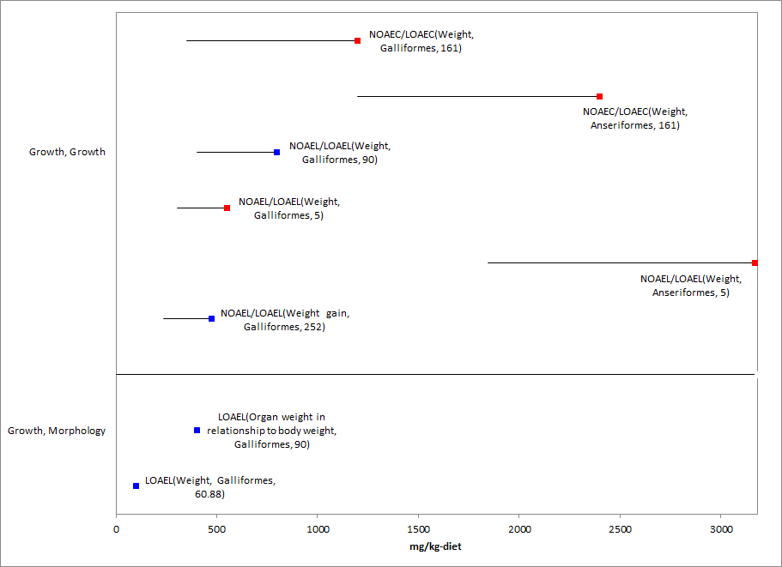
Figure 6-6. Growth Effects for Birds Based on mg/kg-diet. Endpoint labels include measured endpoint, test species order, and test duration. Blue data points are from open literature, and red data points are from registrant-submitted studies.

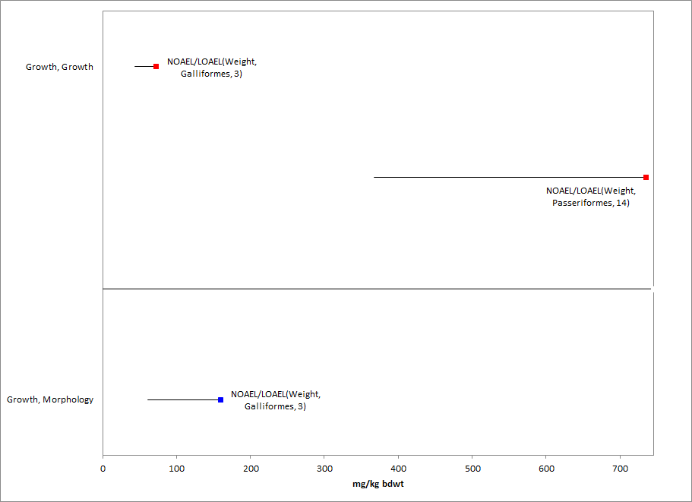
Figure 6-7. Growth Effects for Birds Based on mg/kg-bw. Endpoints normalized to 100g for presentation purposes. Endpoint labels include measured endpoint, test species order and test duration. Blue data points are from open literature, and red data points are from registrant-submitted studies.

Acute Studies

In an acute oral toxicity study with the canary (Serinus canaria), birds were exposed to technical malathion by oral gavage at nominal levels of 0 (vehicle control), 150, 300, 600, 1200, and 2400 mg ai/kg bw (adjusted for purity) (MRID 48571805). There was a significant (p<0.05) reduction in food consumption during week 1 in the 600 mg ai/kg bw group, compared to the control. While not statistically different from control, average female body weights exhibited a loss between days 0 to 14 at this treatment level, while gains were evident for all other treated levels, including the control. There were no apparent effects on male or overall (combined sex) body weight changes at any level.

In an acute oral toxicity study with ring-necked pheasant (Phasianus colchicus), malathion technical was administered to the birds by gavage at nominal levels of 0 (vehicle control), 63, 105, 175, 292 and 486 mg ai/kg bw (MRID 48963305). There was a loss of mean body weight from Days 0 to 3 for surviving females from the 105 and 175 mg ai/kg dose levels (loss of 29 and 56g at 105 and 175 mg ai/kg-bw compared to loss of 3 g in control); all birds died at higher test concentrations. An increase of mean body weight gain was then noted from Days 7 to 14 for surviving females in the 105 and 175mg ai/kg bw dose levels relative to the control. In addition, mean food consumption appeared to be reduced in females from Days 0 to 3 at the 105 and 175 mg ai/kg bw levels relative to the control.

In another study with the ring-necked pheasant, the acute dietary toxicity of malathion technical to 13-day old was assessed (MRID 48963301). Malathion technical was administered to the birds in the diet at nominal concentrations of 0 (vehicle control), 100, 178, 316, 562, 1000, 1780, 3160 and 5620 mg ai/kg. Mean-measured concentrations were <25.0 (<LOQ, control), 96.7, 171, 304, 551, 1010, 1730, 3190 and 5840 mg ai/kg diet, respectively. Reductions in body weight gain from Days 0 to 5 were observed for surviving birds in the 551, 1010, 1730, and 3190 mg ai/kg diet levels (weight gain of 30, 28, 17 and loss of 18 g at 551, 1010, 1730, and 3190 mg ai/kg diet compared to weight gain of 38 in control). Day 5 and Day 8 mean body weights were reduced compared to the control at both the 1730 and 3190 mg ai/kg diet levels, and the change in body weight from Days 5 to 8 was reduced compared to the control at the 3190 mg ai/kg diet level. Overall, body weight gain was reduced compared to the control at the 1010, 1730, and 3190 mg ai/kg diet levels (gain of 58, 47 and 14g for 1010, 1730, and 3190 mg ai/kg diet vs. gain of 67g in control). There was an apparent reduction in feed consumption for the 5840 mg ai/kg diet level when compared to the control from Days 1 to 2.

The acute dietary toxicity of malathion to 9-day old mallard duck (Anas platyrhynchos) was assessed over 8 days (MRID 48963303) with exposure to malathion technical via the diet at nominal concentrations of 0 (vehicle control), 562, 1000, 1780, 3160 and 5620 mg ai/kg. Mean-measured concentrations were <100 (<LOQ, control), 585, 1065, 1845, 3170, and 5850 mg ai/kg diet, respectively. No treatment-related mortality, clinical signs of toxicity, or effect on food consumption were observed at any test level. However, there was a reduction in mean body weight gain from Days 0 to 5 for birds in the 3170 and 5850 mg ai/kg diet levels (gain of 82 and 55g for 3170 and 5850 mg ai/kg diet vs. gain of 151g in control). Also at these levels, the Day 5 and Day 8 mean body weights were reduced compared to the control, and overall body weight changes were reduced compared to the control.

In an additional study, eight week old ring-necked pheasants were exposed to a single oral dose of malathion at 87.4, and 218.5 mg/kg-bw (Day et al. 1995; ECOTOX 63276). Body weights were not affected at either dose compared to control, but effects were observed on absolute and relative organ weights for the thymus and spleen (coded as growth, morphological effects in ECOTOX). This study is discussed in greater detail in the section on AChE as it represents the sublethal threshold value.

Chronic Studies

In the one-generation reproductive study with Northern bobwhite quail (Colinus virginianus), a statistically significant reduction was noted in male and female body weight at the 1200 mg ai/kg-diet treatment group during first two weeks of study (NOAEC = 350 mg ai/kg-diet). Many of the birds which showed a large body weight loss at the beginning of study subsequently died. There was also a statistically significant 14.4% reduction in female body weight at the 1200 mg ai/kg-diet treatment group at test termination (MRID 43501501).

In the one-generation reproduction study with mallard ducks (Anas platyrhychos), a significant 7.5% decrease in body weights was noted only among the males at 2400 mg ai/kg-diet at study termination (NOAEC = 1200 mg ai/kg-diet). No significant differences were noted among the females at this level. Although not statistically significant except at termination, the males at 2400 mg/kg-diet displayed weight loss at each successive interval throughout the study. This finding was considered to be treatment-related (MRID 42782101).

In Varshneya et al. 1986 (ECOTOX 89120), the body weight of cockerels (Gallus domesticus) exposed to dietary concentrations of malathion at 800 and 1600 ppm were significantly reduced after 90 days with no effect reported at 400 ppm (1.22 kg in control vs. 1.02 and 0.86 kg at 800 and 1600 ppm). Additionally, liver weights were significantly increased at all test concentrations.

In Cecil et al. 1974, E35083, while not an effect on body weight or other parameters typically considered growth effects, liver weights were increased in Japanese quail exposed to malathion at 100 ppm (considered to be mg/kg-diet; 99.7% purity) for two months (this effect is coded under growth, morphology in ECOTOX). Additionally, lipid content was increased at this dose.

      - Effects on Reproduction of Birds

Several studies are available that investigate the reproductive effects of malathion on birds (Table 6-7). The dietary-based (i.e., units of mg a.i./kg-diet) thresholds for direct and indirect sublethal effects are based on the effects data from the registrant study with the bobwhite quail (MRID 43501501). In this study, no significant differences in reproductive parameters were observed between controls and the 110 mg a.i./kg-diet treatment group. Adverse effects observed at necropsy, including regressed ovaries and enlarged/flaccid gizzards were observed in some of the female birds at 350 mg a.i./kg-diet and the LOAEC was based on this finding. Decreases in number of eggs, egg viability (i.e., decrease in number of viable embryos per egs set) and eggshell thickness were observed at 1200 mg a.i./kg-diet. Although the data from ECOTOX 38642 represents a more sensitive endpoint than the NOEC and LOEC values from MRID 43501501, the endpoints from the former study were not chosen to represent the threshold for avian reproduction because of considerable uncertainties associated with the study. In particular, the test formulation was not identified, the control and treatment birds were maintained in separate buildings, a low number of replicates, and lack of reporting of statistical methods or variability.

Table 6-7. Reproductive Effects in Birds Exposed to Malathion.
Test species | Reproductive effects observed at LOEC (percent of control) | NOEC/LOEC (mg a.i./kg-food) | Test material | Source
Domestic chicken | 1. Decrease in egg production (11%) | None/0.1 | Formula | Sauter et al. 1972 (ECOTOX 38642)
Bobwhite quail | 1. Regressed ovaries and enlarged flaccid gizzards observed during necropsy  2. Decrease in number of eggs laid (75%)  3. Decrease in egg viability (~75%)  4. Decrease in eggshell thickness (15%) | 110/350 | TGAI | MRID 43501501
Mallard Duck | 1. Decrease in male body weight  2. Decrease in eggshell thickness  3. Decrease in egg viability | 1200/2400 | TGAI | MRID 42782101
Domestic Chicken | 1. Decrease in egg production | 100/none | TGAI | Pym et al. 1984 (ECOTOX 38417)
Domestic Chicken | 1. Decrease in chick growth  2. Decrease in weight gain | 237.5/475 | TGAI | ECOTOX 37706

      - Effects on Behavior of Birds

Behavioral effects are observed in several acute oral and acute dietary toxicity tests submitted by the registrant, including labored breathing, piloerection, wing droop, ruffled appearance, loss of coordination, lower limb weakness, prostate posture, convulsions, shallow and rapid respiration, tremors, loss of righting reflex, and depression (Table 6-8). Details on each of the studies are provided below.

Table 6-8. Behavior Effects in Birds Exposed to Malathion
Test species | Behavioral Effect | NOEC(L)/ LOEC(L) | Test material | Source
Canary | Labored breathing, piloerection, tremors, loss of righting reflex, lethargy, wing droop | 300 / 600 mg a.i./kg-bw | TGAI | MRID 48571805
Ring-necked pheasant | Wing droop, ruffled appearance, loss of coordination, lower limb weakness and rigidity, respiration abnormality, prostrate posture, convulsions, and salivation | 63/ 105 mg a.i./kg-bw | TGAI | MRID 48963305
Japanese quail | Righting response | 75 / NA mg/kg/d | Formula (56.5%) | Meydani and Post, 1979 (Ecotox 52202)
Mallard duck | lower limb weakness and loss of coordination | 292 / 486 mg a.i/kg-bw | TGAI | MRID 48963307
Domestic chicken | Alterations in pentobarbital sleeping time | NA / 400 mg/kg-diet | NR | Varshneya et al. 1986 (Ecotox 89120)
Ring-necked pheasant | ruffled appearance, lethargy, wing droop, loss of coordination, depression, lower limb weakness, loss of righting reflex, and prostrate posture | 1010 / 1730 mg a.i./kg-diet | TGAI | MRID 48963301
NA = not available (effects at all doses/concentration tested, or no effect at all doses/concentrations tested); NR = not reported

In the acute oral toxicity study with the canary (S.canaria) discussed in the growth effects section, the 14-day behavioral observed NOAEL was determined to be 300 mg ai/kg bw based on transient sublethal effects, including labored breathing and piloerection at the 600 and 1200 mg a.i./kg bw groups, and tremors, labored breathing, loss of righting reflex, lethargy, and wing droop at the 2400 mg a.i./kg bw group (MRID 48571805).

In addition to the growth effects discussed above in MRID 48963305 with ring-necked pheasant (P. colchicus), clinical signs of toxicity were observed at the ≥105 mg ai/kg bw dose levels. Effects included wing droop, ruffled appearance, loss of coordination, lower limb weakness, prostrate posture, convulsions, shallow and rapid respiration, lower limb rigidity and salivation. Effects had abated in all survivors by Day 2. Gross necropsies were performed on three mortalities each from the 105, 175, 292 and 486 mg ai/kg bw dose levels. Similar findings observed in at least half of the birds included pale breast muscle, pale spleen, distended gizzard, gizzard lining sloughing and a portion or whole gizzard was flaccid. These findings were considered a result of treatment.

In the other study with the ring-necked pheasant (MRID 48963301), clinical signs of toxicity were observed in birds from the ≥1730 mg ai/kg diet levels. Effects were first noted on Day 2 and included ruffled appearance, lethargy, wing droop, loss of coordination, depression, lower limb weakness, loss of righting reflex, and prostrate posture.

The acute oral toxicity of malathion to 31-week old mallard duck (Anas platyrhynchos) was assessed over 14 days (MRID 48963307) with malathion technical administered by gavage at nominal levels of 0 (vehicle control), 292, 486, 810, 1350 and 2250 mg ai/kg bw. Clinical signs of toxicity were observed at the ≥486 mg ai/kg dose levels. Effects included lower limb weakness and loss of coordination. All surviving birds appeared normal in appearance from Day 1 and thereafter. Gross necropsies were performed on the two mortalities from the 2250 mg ai/kg bw dose level; one bird was noted with a slightly flaccid gizzard and the other with areas of intracranial bleeding.

In addition to the registrant submitted studies discussed above, Varshneya et al. 1986 (ECOTOX study 89120) describes a behavioral effect. In this study, white leghorn cockerels were fed a diet containing 0, 400, 800 and 1600 mg/kg-diet of malathion (purity not reported) for 90 days. In addition to observed effects on body weights and liver/body weight ratios for treated birds, the pentobarbital sleeping time was longer in malathion-treated cockerels at all concentrations than in control birds (18.4 min in control vs. 39, 34.5, and 57 min. in 400, 800 and 1600 ppm, respectively).

In a study with Coturnix coturnix quail (Meydani and Post, 1979; E52202), there were no reported effects (41-d NOAEL) on righting response at malathion concentrations of 75 mg/kg/d (purity 56.5%).

      - Effects on Sensory Function of Birds

There are no studies specific to sensory for birds.

      - Other Effects Reported for Birds

Effects other than those identified as mortality (survival), behavior, sensory, growth, and reproduction are reported for malathion. These include cellular, biochemical (in addition to effects on acetyl-cholinesterase), and physiological. A summary of each of these effect types are discussed below.

Biochemical and Cellular

Biochemical effects in addition to alterations in acetyl-cholinesterase (AChE) are reported for birds exposed to malathion. These effects include alterations in lipids, cholesterol, antipyrine, N-demthylases, aniline hydroxylase, and noradrenaline. Cellular effects include alterations in white blood cell count, micronuclei, and leukocytes and reduced corticle volume (histology).

Cholinesterase (ChE) Inhibition

Given the mode of action of malathion, it is expected that the chemical will have an impact on AChE. While registrant submitted studies did not measure AChE, numerous studies in the open literature report increases and/or decreases in AChE as well as other forms of cholinesterase activity across various species of birds. Eight studies reported effects on cholinesterase activity (6 were from dose-based studies and 2 from a dietary-based study) (Figure 6-7 and Table 6-9).

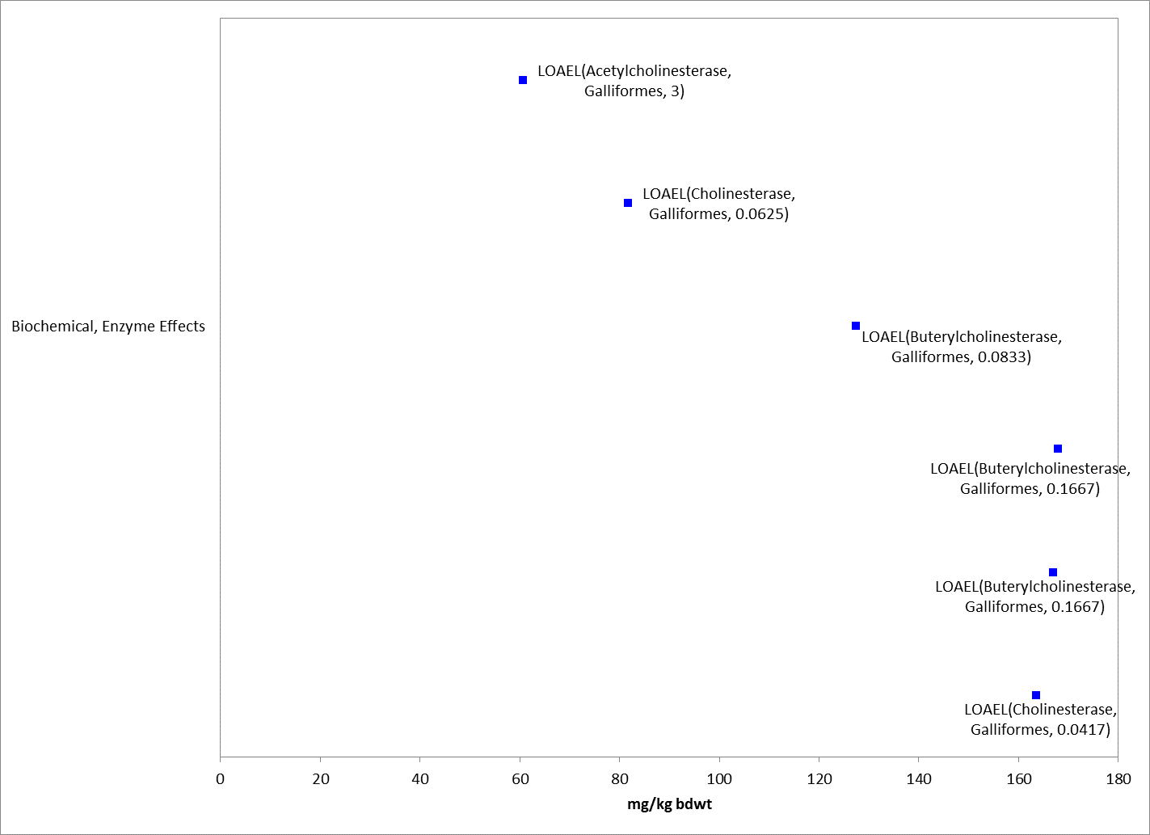
Figure 6-8. Cholinesterase Effects for Birds Based on mg/kg-bw. Values are adjusted to 100g bird for presentation purposes. Endpoint labels include measured endpoint, test species order and test duration (all effects are presented in APPENDIX 2-2). Blue datapoints are from open literature studies.

Table 6-9. Cholinesterase Effects in Birds Exposed to Malathion Based on mg/kg-diet
Test species | Form of Cholinesterase | NOEC/ LOEC mg/kg-diet | Test material | Source
European starling | Acetylcholinesterase | 35 / 160 | Not reported | Dieter et al. 1975 (Ecotox 35129)
Domestic chicken | Cholinesterase | NA/ 400 | Not reported | Varshneya et al. 1988 (Ecotox 90699)

In one study (ECOTOX 35129), study authors report that starlings fed 160 mg/kg-diet of malathion for 12 weeks showed 30% decrease in plasma AChE and 50% decrease in 1 acetate dehydrogenase activity. While other toxicological endpoints were not measured in this study, effects on AChE were observed within the range of lethal effects endpoints from available studies described in sections above.
In Varshneya et al. 1988 (ECOTOX 90699), serum cholinesterase in cockerels (Gallus domesticus) exposed to dietary concentrations of malathion at all test concentrations (400, 800 and 1600 ppm (assumed to be dietary based)) were significantly reduced after 90 days (126 units/mL in control vs. 114, 111, and 108 units/mL in 400, 800, and 1600 ppm, respectively).
In an additional study, which provides the direct and indirect sublethal effects thresholds, eight week old ring-necked pheasants were exposed to malathion (95%) at doses of 0 (negative control; 2.5 ml of corn oil; n= 10), 87.4 (40% of the observed LD50 value; n= 10), and 218.5 (the observed LD50 value; n= 20) mg/kg-bw (Day et al. 1996, ECOTOX 63276). Dose selection, exposure route, and age of test organism were selected to correlate with potential field conditions (i.e., young birds feeding exclusively on insects). Seven birds in the high dose group died within 4 hours of exposure. Brains were harvested from these birds and frozen at -80°C. Surviving birds had blood drawn 3 days after dosing prior to being euthanized. Body weight and lymphoid organ (bursa of Fabricius [BOF], thymus and spleen) weights were measured; histomorphometric and histopathological evaluations were conducted on lymphoid organs; and brain AChE levels were measured. The study also ran a concurrent test on immunosuppressed birds, which suggests toxic effects of malathion are aggravated. Body and organ weights and histomorphometric measures of birds exposed to the low dose (92 mg/kg-bw; 87.4 mg a.i./kg-bw) were not statistically different from the controls. However, histopathological changes in the thymus (i.e., the number of cortical macrophages per field and the number of cortical lymphocyte necrosis per field) were observed in birds exposed to the low dose and brain AChE levels were significantly reduced (~15% from controls). For the 13 birds that survived exposure to the high dose (230 mg/kg-bw; 218.5 mg a.i./kg-bw), effects were observed on absolute and relative organ weights (thymus and spleen); all histomorphometric measures for the BOF, thymus and spleen; all histopathological measures for the BOF, thymus and spleen; and brain AChE levels were significantly reduced (~15% from controls). It should be noted that dosages associated with this study are within the range of lethal effects endpoints from available studies described in sections above. The sublethal threshold for birds is based on decreases in AChE at 87.4 mg a.i./kg-bw (LOAEL, lowest dose tested, no NOAEL).

Other Biochemical and Cellular Effects

Biochemical and cellular effects for birds other than ChE inhibition were available (Figures 6-8 and 6-9). Studies reviewed when establishing the sublethal threshold are discussed below.

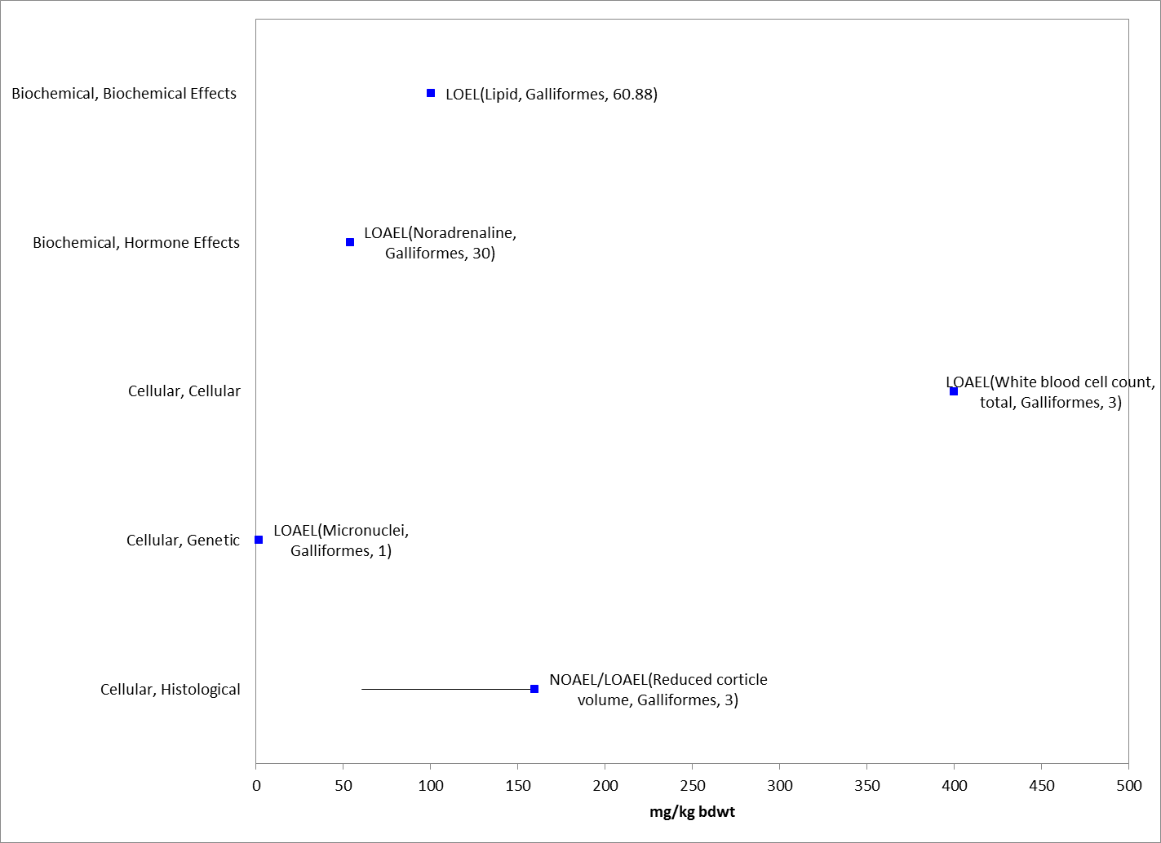
Figure 6-9. Biochemical and Cellular Effects for Birds Based on mg/kg-bdwt. Values adjusted to 100g for presentation purposes. Endpoint labels include measured endpoint, test species order and test duration. Blue data points are from open literature.

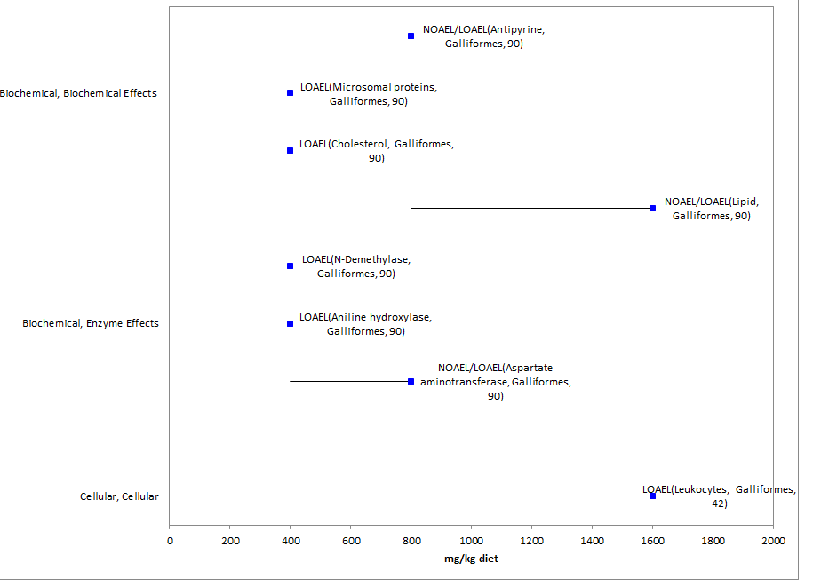
Figure 6-10. Biochemical and Cellular Effects for Birds Based on mg/kg-diet. Endpoint labels include measured endpoint, test species order and test duration. Blue data points are from open literature studies.

In Goyal et al. 1986 (E90624) 6-10 week old white-leg horn chicks were orally administered technical malathion (97.2%) dissolved in arachis (peanut) oil at 75 mg/kg and 150 mg/kg malathion, respectively, for 15 or 30 consecutive days after which adrenal glands were removed to estimate ascorbic acid, cholesterol, corticosterone, and catecholamines. Control group (arachis oil only) was included. Malathion exposure for 15 days did not result in significant effects on any of the parameters studied for either the 75 mg/kg or 150 mg/kg dose. A decrease in ascorbic acid and adrenal cholesterol combined with an increase in corticosterone was observed at 30 days.
In Sodhi et al. 2008 (E104560) day old broiler chicks were vaccinated against New Castle disease and an infectious bursal disease. At one week of age chicks were given 10 mg/kg bw of malathion (purity not reported) orally each day for 60 days. Another group were given the same dose of malathion plus α tocopherol and selenium combination (α tocopherol 150 IU/kg feed and selenium 0.1 mg/kg feed), daily for 60 days. Control group was included. In the malathion only group, plasma lipid peroxidation was increased compared to control, and erythrocytic glutathione peroxidase activity and plasma vitamin E concentration were decreased. In the liver, it was noted that moderate to severe degenerative and necrotic changes such as, bile duct proliferation and congestion of hepatic sinusoids with infiltration of lymphomononuclear cells were observed in the malathion-only chicks. The number and severity of histopathological changers in the liver was decreased in the malathion plus α tocopherol and selenium combination chicks.

The frequency of micronuclei in bone marrow of Gallus domesticus chicks were reported to be significantly increased at malathion (purity not reported) doses of 2.5, 5, and 10 mg/kg bw (oral dose) compared to control after 24 or 48 hours of dosing (Giri et al. 2002, E120759).

Physiological Effects

One study reported alterations in physiological parameters in ECOTOX. Rishi and Garg, 1993 (ECOTOX 90659) reported increases in antibody titres in white leg-horn chickens at malathion (purity not reported) doses of 22.6 and 45.2 mg/kg at 10 and 20 day exposures. Decreases in antibody titres were reported at a dose of 90.4 mg/kg (assumed to be dose-based).

Field Studies for Birds

The following discussions refer to avian field studies with malathion and birds. These studies provide in-field lines of evidence that can be used to evaluate malathion risks to birds (and by extension risks to terrestrial-phase amphibians).

In a Montana study (1966), live-trapped sharptailed grouse were given oral doses of dieldrin, malathion, and lactose (controls) and released after tagging. They were subsequently observed by capture or radio tracking. The lethal dose of malathion was observed to occur between 200-240 mg/kg (note: this is consistent with lethal effects levels in laboratory studies described above). Reaction to malathion occurred within 72 hours - either death or full recovery. Sublethal signs included depression, slow reactions, blinking, head nodding, and eventual heart or respiratory failure. Radio tracked grouse displayed normal to severe reactions once released. Eight of twelve birds were recovered. Predators are suspected in the disappearance of unrecovered birds (in one case a bird moderately dosed with dieldrin was confirmed killed by a coyote). Grouse that were dosed carried transmitters up to 12 days after release. All confirmed predator kills had received what were considered sublethal doses of the test material. Other birds were discovered to have been attacked and injured. The radio transmitters did not hinder all birds as many were recovered in healthy condition. The sublethal effects of the malathion and dieldrin on survivability are suspected. All controls (n=14) survived and successfully bred (MRID 00113233).

An aerial application of malathion was made over Winnipeg in July 1983 as an ULV solution (95% malathion). Application rate was 210 ml/ha over the entire city to control mosquitoes. Forty one sparrows and thirty nine pigeons were collected within 2 weeks of spraying. Caged exposed sparrows were sacrificed and examined as well. Slight, but not statistically significant, differences were noted (6-12% variation) in AChE levels of post spray to prespray birds. Some reservation is expressed that study birds may all have been exposed to ground fogging applications prior to aerial application exposure (Kucera, 1987).

An experimental program to control melon flies on the Island of Bota (Northern Marianas Islands) provided the USFWS with an opportunity to monitor avian populations while subjected to exposure to malathion laced bait sprays (Cue-lure) that were aerially applied. Applications were made at 3 week intervals beginning in Oct. 1988 at up to 5 -30 g/hectare depending on bait type. Of the 10 native species counted, 5 increased in number and 5 decreased. The author was not certain if this was a normal annual fluctuation or one caused by pesticides. Populations of the white throated ground dove, the Philippine turtle dove, and possibly the bridled white eye were significantly lower in the following year. No acute mortality was reported. The other 20 native species were observed and populations appeared unaffected. Even insectivorous species did not appear to suffer population decreases (Engbring 1989).

During 1964-1968 boll weevil control programs on cotton, game and non-game bird populations near cotton fields were observed. Applications were aerial at 12 to 16 oz. (approx. 1.2 lb ai) of technical malathion per acre, with up to 7 applications made at 5-22 day intervals. No major differences in weight gain were noted between treated and control birds. No toxicant related mortality was noted after 3 applications of malathion. No dead birds were located adjacent to fields. However, sublethal indicators other than weight were not measured (Parsons and Davis 1971).

The following study evaluated multiple species including birds (summary obtained from USEPA RED 2000 document). In "The Ecology of a Small Forested Watershed Treated with the Insecticide Malathion S35."(S.Giles, Robert H., Jr., 1970), Aerial Application to 2 adjoining Ohio watersheds was observed -with one treated and the other untreated. Malathion was radio tagged with Sulfur 35 radio nuclide. Two 20 acre watersheds (primarily deciduous forests) were selected for comparison. Application rate was 2 lbs/acre and 4 applications were made. Spray residue: cards were placed under application areas for residue analysis. Residue collection discs were also suspended above the canopy using helium filled balloons. Glass discs were placed in the trees as well as the shrubs and in soil/litter surfaces. Radioactivity was high in the tissues of plant sampled in the treated areas indicating active systemic uptake of malathion. New shoots and leaves showed especially high levels of radioactivity. Metabolites of malathion showed up in new stem and leaf growth up to one year after application.

Birds showed some reaction up to 48 hours post application, but no lasting effects were noted. Lack of singing was observed throughout treated areas immediately after application and persisted for 2 days. By day 4 singing intensity was equal in treated and control areas. Possible explanations include sublethal insecticidal response, behavioral response due to loss of food, or possibly temporary emigration from the treated areas. Some radioactivity was detected in collected bird's whole organ tissues. Insectivorous birds had the highest detection of radioactivity on feathers.

Data Reported in Units of Mass/acre

A few studies in the ECOTOX database report endpoints in units of lb/acre or g/ha or oz/acre. Table 6-10 summarizes those studies/results are presented below with the units converted to lb/acre.

Table 6-10. Toxicity Data for Malathion Based on lb/A (not in arrays)
Species | Effect Group | Endpoint | Duration | Endpoint Concentration | Reference #
Bobwhite quail (Colinus virginianus) | MOR | Mortality | 5 wks | NR-ZERO = 0.38 | Joseph et al. 1972, E2901
House sparrow (Passer domesticus) | POP | Abundance | 43 or 70d | NOAEL = 0.184 | Hill et al. 1971, E37115
Bird class | POP | Abundance | 7 d | NOAEL = 0.425 | McEwen et al. 1972, E37883
Blue tit (Parus caeruleus) | GRO, REP, MOR | Brood development, weight, nest abandoned, mortality | 14 or 26 d | NOAEL = 1.05 | Pascual , 1994, E39598
Bird class | POP | Abundance | 28 d | LOAEL = 0.31 | Norelius and Lockwood, 1999, E52733
Brewer’s sparrow (Spizella breweri) | GRO, | Length, biomass | 2 yrs | LOAEL = 0.53 | Howe et al. 1996, E89113
 | DVP, BEH, MOR | Brood development, flight, mortality |  | NOAEL=0.53
Sage Thrasher (Oreoscoptes montanus) | GRO, BEH, MOR | Size, Brood development, flight, mortality |  | NOAEL=0.53
Bird class | BCM | Acetylcholinesterase | 9 d | NOAEL=0.28 | McLean et al. 1975, E89523

  - Effects to Birds Not Included in the Arrays

Exposure Routes other than Dietary or Dose-based

Exposure to malathion by routes other than dietary (via feed or oral) are available and include direct application and drinking water.

Topical/Direct or Indirect Spray/Drench

Studies with exposure types of topical, drench, or spray (direct or indirect) were reported in ECOTOX and are presented in Table 6-11.

Table 6-11. Toxicity Data for Malathion Based on External Application Methods
Species | Effect Group | Endpoint | Exposure Type | Duration (d) | Endpoint Concentration | UNITS | Test Location | Reference #
Domestic Chicken (Gallus domesticus) | BCM | ChE | Topical | 0.04 (1hr) | NOAEL=100 | Mg/kg bw | Lab | Srivastava 1971, E38887
Domestic Chicken (Gallus domesticus) | BCM | Urea, SGOT | Drench | 21 or 14 | LOAEL=10 | Mg/kg bw | Lab | Sodhi et al. 1996, E89019
Domestic Chicken (Gallus domesticus) | PHY, BCM, GRO | General immunity, total protein, weight | Drench | 7 or 14 | LOAEL=10 | Mg/kg bw | Lab | Sodhi et al. 1996, E89387
Red-legged partridge (Alectoris rufa) | BCM | EROD, AEPX, MCPR | Spray¹ | 7 | NOAEL=600 | µg a.i/L | Field | Johnston, 1996, E40317
 | BCM | BChE, P450 |  | 1 | LOAEL=600
 | GRO | Organ wt, weight |  | 7 | NOAEL = 600
¹ bird enclosures sprayed, but authors reported birds maintained distances during spray application and not directly sprayed
ChE= cholinesterase; BChE = buterylcholinesterase; EROD= Ethoxyresorufin O-deethylase; AEPX = aldrin epoxidase; P450= cytochrome 450; MCPR = microsomal proteins; SGOT= Serum glutamate oxalo acetate transaminase

Drinking Water

Two studies that evaluated malathion effects from drinking water exposure are available.

In Nain et al. 2011 (E162409), 54 three week old male Japanese quail were exposed to malathion (Spectracide Malathion®) at nominal concentrations of 0, 1, and 10 ppm via drinking water for eight weeks. Water consumption was measured in each pen, and the study authors used the water consumption data to calculate estimated daily malathion intake rates in the 1 and 10 ppm exposure groups to be 0.2 and 2.1 mg/kg bodyweight, respectively. Following the sixth week of exposure, a strain of E. coli was injected subcutaneously (doses were selected according to a separate challenge study with quail).
No frank effects associated with organophosphate toxicity were observed in any of the treated birds. An innate immunity test evaluating phagocyte activity (determined via chemoluminescence assay of whole blood) in the malathion treatments and control and skin thickness changes following phyohemagglution injection did not reveal significant differences in response between birds exposed to malathion and those of the control. Total white blood cell and lymphocyte counts were significantly lower (p< 0.05) in the 10 ppm treatment than the control. Total granulocyte count was lower in the malathion treatments than the control, but not significantly so. However, mean thrombocyte counts were not reduced in the malathion treatments compared to the control. Secondary antibody response to the administered dinitro-phenol-keyhole limpet hemocyanin (DNP-KLH) vaccine, as determined through an ELISA, was significantly reduced (p< 0.05) in the 10 ppm treatment compared to the control. Primary immune response, also measured via ELISA, was reduced in the 10 ppm treatment compared to the control, but not significantly so. According to the study authors, histopathology of bursa of Fabricius of treated birds identified direct immunotoxic effects of malathion. In both malathion treatments, lymphocyte density in bursa of Fabricius was significantly reduced (p< 0.05) compared to the control density. Increasing epithelial thickness in the bursa of Fabricius correlated with decreasing lymphocyte density, with epithelial thickness significantly greater (p< 0.05) in the 10 ppm treatment compared to the control. Granulocyte counts in splenic red pulp revealed a dose-dependent increase with exposure to malathion (r² = 0.98), with a significant difference between the control and 10 ppm groups (p< 0.05). There were no significant differences between groups in spleen size, number of germinal centers, or relative percentage of white pulp in the spleen. The ability of the malathion-treated quail to successfully overcome the bacterial challenge was reduced compared to control, albeit not statistically significantly. The 50% mortality in the 10ppm treatment following the bacterial challenge compared to 22% mortality in the control was considered biologically significant by the study authors, and 10 ppm is considered the LOAEC.
In Narahrisetti et al. 2009 (E162552), domestic chickens were exposed to malathion in drinking water at 500 ppm. After 28 days exposure, none of the birds exhibited any clinical signs or symptoms of toxicity, however, decreases in weight gain (36% at 500 ppm vs. 56% in control) were reported. Additionally, liver, kidney and heart organ weights were decreased whereas brain weights were increased; however, it is noted that for these organs only either absolute or relative weights were significantly different from control, except for liver which was always decreased. Levels of cytochrome P450 were also reduced as were hepatic microsomal enzymes.
Study with increasing dose over test duration

In Deshmukh et al. 1991 (E103758 and 89390), the administered dose to the domestic chicken was increased over the 10-week study from 800 to 1600 ppm; therefore, since the dose increased over time, this study was not included in the data arrays. In these studies, decreases in weight gain and feed consumption were reported compared to the control. Levels of total erythrocyte counts or haemoglobin were not affected.

Other data with non-environmentally-relevant exposure units

In addition to the effects described above, there are other avian data available that are not included in the toxicity arrays because, based on the information in ECOTOX, the exposure units are not in or cannot be converted to environmentally-relevant concentrations. Additionally, NOAEC values available from a study without corresponding LOAEC or endpoints reported as no effect (NR-ZERO) (i.e., there were no effects noted in the study for a given endpoint) are not captured in the toxicity arrays.

There are several exposure units listed in the ECOTOX toxicity table that could not be converted to environmentally-relevant units and include % and cc/org (one study with no effect on cholinesterase at 50 cc/org in domestic chicken). The types of effects noted in these studies are discussed below; these only include effects noted – and do not include those associated with a NOAEC value not associated with a LOAEC or ICx value. At the sub-organism level, effects noted include changes in biochemical markers such as cholesterol, lactic acid, triglycerides, and lipds. No effects on mortality were also reported. Therefore, most of the types of effects associated with the sub-organism or whole organism are already captured in the avian toxicity arrays presented above (Table 6-11).

Table 6-12. Studies in ECOTOX with Reported Toxicity Units of % (all studies conducted in laboratory)
Species | Endpoint |  | Duration (d) | Purity (%)¹ | Endpoint Concentration (%) | Reference #
Chicken (Gallus domesticus) | MORTALITY | NR-ZERO | 2 | 50 | 0.05 | 54135
Chicken (Gallus domesticus) | LACTIC ACID | LOAEL | 0.5 | 50 | 0.5 | 95593
Chicken (Gallus domesticus) | CHOLESTEROL | NOAEL/LOAEL | 7 | 50 | 0.5/1 | 89051
Chicken (Gallus domesticus) | PHOSPHOLIPID CONTENT | NR-ZERO | 45 | 99.6 | 0.5 | 38471
Chicken (Gallus domesticus) | TRIGLYCERIDES | LOAEL | 7 | 50 | 1.5 | 91030
 | MORTALITY | NOAEL | 7 | 50 | 1.5
 | TRIGLYCERIDES | NOAEL | 7 | 50 | 1.5
 | LIPIDS | NOAEL/LOAEL | 7 | 50 | 0.5/1
 | CHOLESTEROL | NOAEL | 7 | 50 | 1
Chicken (Gallus domesticus) | MORTALITY | NR-ZERO | 28 | 100 | 4 | 162520
¹ as reported in ECOTOX

6.6 Concentrations or Doses Where No Effects Were Observed in Birds

For the exposure unit mg/kg-diet or mg/kg-bw there are data available that show concentrations where effects are not seen [i.e., ‘no effect’ (NE) concentrations]. The NE endpoints include NOAEC/NOAEL and NR-Zero values as reported in ECOTOX. Below are the arrays showing the NE endpoints for birds (see Figures 6-11 and 6-12).

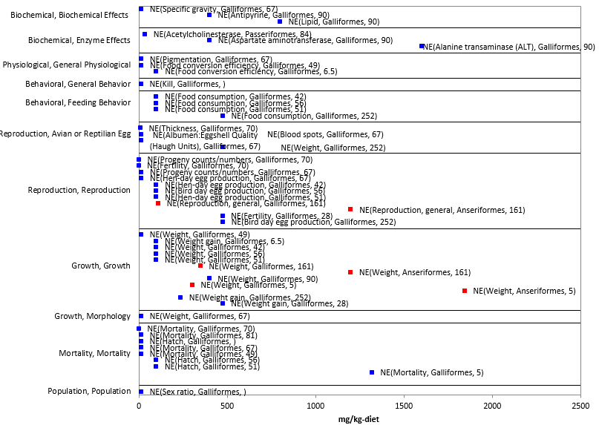
Figure 6-11. Concentrations or Doses Where No Effects Were Observed in Birds Based on mg/kg-diet. Endpoint labels contain measured endpoint, test species order and test duration. Blue data points are from open literature and red data points from registrant submitted studies. One study >2500 mg/kg-diet (no mortality at 5000 mg/kg-diet) was not included in figure for presentation purposes.

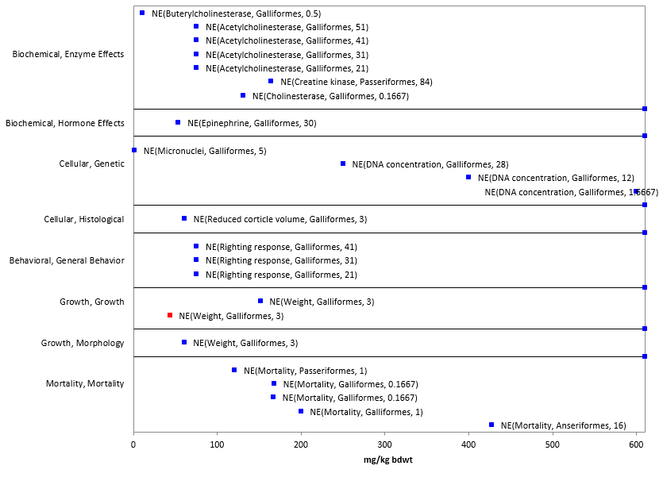
Figure 6-12. Concentrations or Doses Where No Effects Were Observed for Birds Based on mg/kg-bw. Endpoint labels contain measured endpoint, test species order and test duration. Blue data points are from open literature and red data points from registrant submitted studies.

  - Incident Reports for Birds

EFED’s incident database (EIIS), accessed October 26, 2015, contains two incidents associated with malathion use and mortality of birds, and the certainty level was “possible.” In the one case (I005754-011, 1973), birds were exposed to one or more pesticide, other than malathion, which is highly toxic to wildlife. In the reported incident, 17 western sandpipers were killed and the birds also were exposed to temephos, an insecticide that is much more toxic to birds than malathion. It is uncertain how much exposure to malathion contributed to these mortalities. In another incident (I017087-001, 2005), 37 grackles exhibited severe neurologic signs and died in Georgia. Ten additional grackles were reportedly found dead approximately three miles west of the area the following day. Malathion was detected in the gastrointestinal content of the birds. Brain cholinesterase activity was not reduced. Corn and grit were observed in the prventriculum and ventriculum of the four birds examined. Very little corn is grown in this area, which raises the possibility that the birds were intentionally poisoned.

A query of the AIMS database identified two additional bird kill incidents that were linked to exposure to malathion; however, in both cases, the probable cause of death was diazinon exposure. The AIMS Event IDs for these two additional incidents are 190 and 254. These incidents were entered in EIIS as B0000-400-51 and B0000-400-82, respectively, but malathion was not recorded in the EIIS as a possible cause of death. In both cases, residue analysis of the 128 carcass revealed very large amounts of diazinon and only trace amounts of malathion.

The Aggregate Incident Reports database identified an additional four incidents linked to malathion use as aggregated counts of minor fish/wildlife incidents (W-B). Because details about these incidents were not reported, no information was available on the use site, the certainty level, or on the types of organisms that were involved.

  - Summary of Effects to Birds

Based on the available toxicity information, malathion can affect survival of birds both on an acute and chronic exposure basis. Acute oral toxicity LD50 values range from 136 to >2400 mg a.i./kg-bw, and dietary-based LC₅₀ values range from 2022 to >5850 mg a.i./kg-diet. Effects on growth and reproduction were also reported. Effects on growth were reported at dietary concentrations of ≥551 mg a.i./kg-diet, and at dose-based values of ≥105 mg a.i./kg-bw. Reproductive effects were reported across a wide range of concentrations from 0.1 to 2400 mg a.i./kg-diet. While there are limited behavioral effects data in the available dataset, effects on coordination were reported at concentrations affecting cholinesterase and resulting in acute mortality in other studies. There are no data for sensory effects. Additionally, there are limited data for terrestrial-phase amphibians and reptiles, and as such toxicity data for birds will be used as surrogates for these listed species.

7. Effect Characterization to Reptiles

Limited toxicity data are available for reptiles exposed to malathion. Table 7-1 summarizes the available toxicity data for reptiles. Generally, there were no effects in the measured endpoint, except for alterations in motility in the Western fence lizard at 81 days, as well as acute mortality and ChE data for the green anole. In regards to incident reports, there was one report concerning a spill (alleged dumping in North Carolina) in 2003 in which mortality was reported for turtles and snakes (species and number unknown; I014123-006) along with fish.

Table 7-1. Toxicity Data for Reptiles
Species | Endpoint |  | Endpoint Value | Exposure Units | Duration (d) / test location | Purity (%)¹ | Reference #
Western Fence Lizard  (Sceloporus coelestinus) | Mortality | NR-ZERO | 2 | mg/kg bdwt | 81  (lab) | 100 | Holem et al. 2008, E104558
 | Motility | NOAEL/LOAEL | 20/100
 | Food consumption | NOAEL | 100
 | Weight | NOAEL | 100
Green Anole  (Anolis carolinensis) | ChE | NOAEL/LOAEL | 648/1080 | mg/kg bw | 1 (lab) | 99 | Hall et al., 1982, E36970
 | Mortality | NR-ZERO | 1800
 |  | LD50 | 2324
 |  | NR-LETH | 3000
Tree Lizard  (Anolis coelestinus) | ACHE | NOAEL | 4.5 | oz/acre | 9 (field) | 100 | McLean et al. 1975, E89523
- as reported in ECOTOX

8. Effect Characterization to Terrestrial-phase Amphibians

Limited toxicity data are available for terrestrial-phase amphibians exposed to malathion. Table 1 summarizes the available toxicity data for terrestrial-phase amphibians. Studies with toads and bullfrogs examining dermal exposure to malathion followed by an injection of bacteria indicated effects on survival and brain AChE (Willens, 2005 and Taylor et al. 1999). Decreases in brain AChE were reported in the slimy salamanders, however, no effect on behavior was noted.

Table 8-1. Toxicity Data for Terrestrial-phase Amphibians
Species | Endpoint |  | Endpoint Value | Exposure Units | Duration (d)  (all tested in lab) | Purity (%)¹ | Reference #
Bullfrog  (Lithobates catesbeianus) | Mortality | LD50 | 1760 | mg/kg-bw | 14 | 96 | MRID 49693705
 | Food consumption, body weight, snout length | LOAEL | 435
Bullfrog (Rana catesbeiana) | Mortality³ | NR-LETH | 0.011 | ug | 2 | 96.5 | Willens 2005 (Ph.D thesis),  E89001
 | ACHE | NOAEL | 0.011
Cane Toad (Rhinella marina) | Mortality³ | NR-LETH | 0.011
 | ACHE² | LOAEL (↓45%, brain) | 0.011
Woodhouse's Toad (Bufo woodhousei) | Liver wt in relation to body wt (enlarged liver) | LOAEL | 0.0011 | mg/g org | 30 | 96.5 | Taylor et al. 1999, E89577
 | Mortality² | NR-ZERO | 0.0011
 | Mortality³ | LOAEL (4/5 dead) | 0.0011
 | Mortality³ | NR-LETH (5/5 dead) | 0.011
Slimy Salamander (Plethodon glutinosus) | Swimming | NOAEL | 5.6 | kg/ha (cages treated with malathion solution) | 17 | 57 | Baker, 1985, E40014⁴
 | # of times food source struck | NOAEL | 5.6 |  | 43
 | ChE | LOAEL ((↓34%, brain) | 5.6 |  | 25
Eastern Red Backed Salamander (Plethodon cinereus) | ChE | NOAEL⁵ | 8.97 |  | 25
 | Swimming | NOAEL | 8.97 |  | 17
 | # of times food source struck | NOAEL | 8.97 |  | 25
Leopard Frog (Lithobates pipiens) | Mortality | LD50 | 150 | ppm (exposed to 20 mL of malathion solution in glass jar) | 15 | 100 | Kaplan and Glaczenski, 1965, E50823
¹ as reported in ECOTOX
² Toads exposed to malathion (applied to ventral skin using a micro syringe) and then given an dose of saline (intraperitoneal).
³ Toads exposed to malathion (applied to ventral skin using a micro syringe) and then bacteria (A. hydrophila) was injected via intraperitoneal.
⁴ Study authors stated that a companion set of field studies in North Carolina indicated that after 10 applications of malathion, adult and juvenile P. glutinosus showed no ChE inhibition, decreases in abundance or effects on lipid storage patterns.
⁵ A decreasing trend was significant, but pair-wise comparisons were not significant. 19% decrease in brain ChE at 8.97 kg/ha, 9 and 5% decrease at 5.6 and 2.24 kg/ha.

Effect Characterization to Mammals

Introduction to Mammal Toxicity

This section presents direct effects thresholds for listed mammals and indirect effects thresholds for species which rely upon mammals (e.g., as a food source). This section also discusses direct effects on mammals for the different lines of evidence, when available, addressed in the WoE approach including mortality, decreases in growth, decreases in reproduction, altered behavior, and changes in sensory function.

Threshold Values for Mammals

The available data are presented as units of mg a.i./kg-bw (oral route of exposure). If the endpoints were originally presented in terms of diet (i.e., mg a.i./kg-diet), then the effect concentrations were converted to a dose-based value (i.e., mg a.i./kg-bw) using a body weight, when available (i.e., WHO 2009 Dose Conversion Table). Endpoints are available to establish thresholds for lethality and sublethal effects to mammals for mg a.i./kg-bw. Direct and indirect effects thresholds for mammals are presented in Tables 9-1 and 9-2, respectively. Studies from which threshold values were derived will be discussed in more detail in their respective line of evidence.

Mortality

There are insufficient toxicity data to calculate species sensitivity distributions. Therefore, the mammal direct effect mortality threshold is based on the 1 in a million effect from a rat acute mortality study from the available toxicity data for malathion.

Sublethal

The sublethal threshold is based on inhibition of red blood cell (RBC) acetyl cholinesterase (AChE).

Table 9-1. Direct Effects Thresholds for Determining Effects to Listed Mammals
Effect (endpoint) | Value | Unit | Test species | Source
Mortality (1/million) | 137 | mg ai/kg-bw | Rat (Albino [Crl: CD(SD)BR strain], 7-w old) | Fischer, 1991 (MRID 49127003);  LC50 = 1560 mg/kg-bw; slope = 4.5
Sublethal (BMDL₁₀¹) | 9.1 | mg ai/kg-bw | Rat | MRID 46822201 (CCA study)
¹ lower limit of the benchmark dose level associated with 10% RBC Cholinesterase inhibition (BMDL₁₀); further described in cholinesterase inhibition section.

Table 9-2. Indirect Effects Thresholds for Determining Effects to Listed Species
That Depend upon Mammals
Effect (endpoint) | Value | Unit | Test species | Source
Mortality (10%) | 810 | mg ai/kg-bw | Rat (Albino [Crl: CD(SD)BR strain], 7-w old) | Fischer, 1991 (MRID 49127003);  LC50 = 1560 mg/kg-bw; slope = 4.5
AChE Inhibition (BMD₁₀) | 13.3 | mg ai/kg-bw | Rat | MRID 46822201 (CCA study)
¹ benchmark dose level associated with 10% RBC Cholinesterase inhibition (BMDL₁₀); further described in cholinesterase inhibition section.

In addition to the overall mortality and sublethal threshold values to represent all mammals presented above in Tables 9-1 and 9-2, Table 9-3 presents additional sublethal effect values as a potential refinement when evaluating potential risk for additional lines of evidence (i.e., growth, behavior, reproduction).

Table 9-3. Most Sensitive Toxicity Value for Different Effect Types for Mammals for Potential Use As a Refinement for Malathion.
Effect Type |  | Unit | Value | Test species | Source
Behavior | Direct | mg ai/kg-diet | 640 (LOEC) | rat | Geraldi et al. 2008; E153607; only one conc tested
 | Indirect
 | Direct | mg ai/kg-bw | 100 (LOEC) | rat | Acker et al. 2011; E162509; no NOEC
 | Indirect
Growth | Direct | mg ai/kg-diet | 1700 (NOEC) | rat | MRID 41583401
 | Indirect |  | 5000 (LOEC)
 | Direct | mg ai/kg-bw | 10 (LOEC) | rat | Samaan et al. 1989; E74457; no NOEC
 | Indirect
Reproduction | Direct | mg ai/kg-diet | 7500 (NOEC) | rat | MRID 41583401; no effects
 | Indirect
 | Direct | mg ai/kg-bw | 25 (NOEC) | rat | MRID 40812001 increase in reabsorbed embryos
 | Indirect |  | 50 (LOEC)

Summary Data Arrays for Mammals

The following data arrays provide a visual summary of the available data for malathion effects on mammals (Figure 9-1). Effects concentrations are on the horizontal (X) axis and the effect and endpoint type (e.g., Mortality, LD₅₀) are identified on the vertical (Y) axis. A discussion of effects follows the arrays. The data are obtained from registrant-submitted ecotoxicity studies and from open literature studies which have been screened as part of the US EPA ECOTOX database review process.

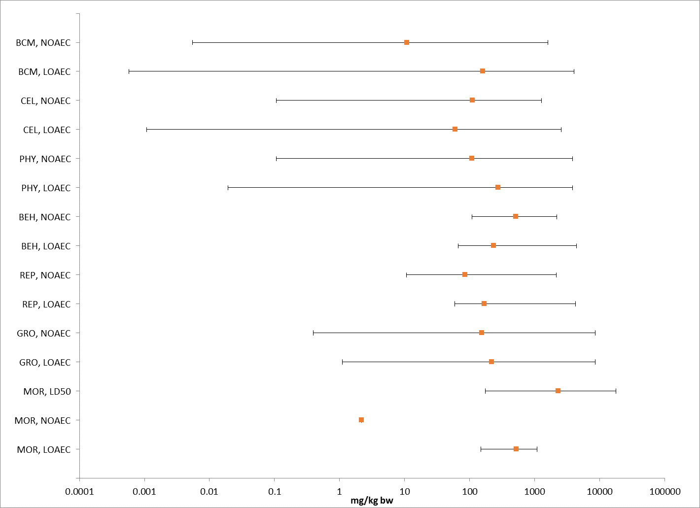
Figure 9-1. Summary Array of Mammals (based on mg/kg-body wt) Exposed to Malathion. Orange symbols represent median endpoint values and bars represent the data range. Data was normalized for 15g mammal. (BCM=Biochemical; CEL=Cellular; PHY=Physiological; BEH=Behavior; REP=Reproduction; GRO=Growth; MOR=Mortality).

Lines of Evidence for Mammals

In examining direct effects to a species, different lines of evidence used in the WoE approach include mortality, decreases in growth, decreases in reproduction, altered behavior, and changes in sensory function. The available toxicity data for mammals from exposure to malathion for each line of evidence will be described in this section.

Effects on Mortality of Mammals

Mortality data are available (submitted by registrants or available in ECOTOX database) for a limited number of mammals including the rat, mouse, domestic sheep, and water buffalo. Mortality data based on body weight are presented in Figure 9-2, and comprise 22 different studies. For dose-based studies, toxicity values ranged from a 8-d NR-lethal dose of 25 mg a.i./kg-bw (domestic sheep; 198 mg/kg-bw (normalized to 15g); Al-Qarawi and Adam, 2003(E88957) to 14-D LD₅₀ of 4780 mg/kg-bw (rat; 10505 mg/kg-bw (normalized to 15g) MRID 113245).

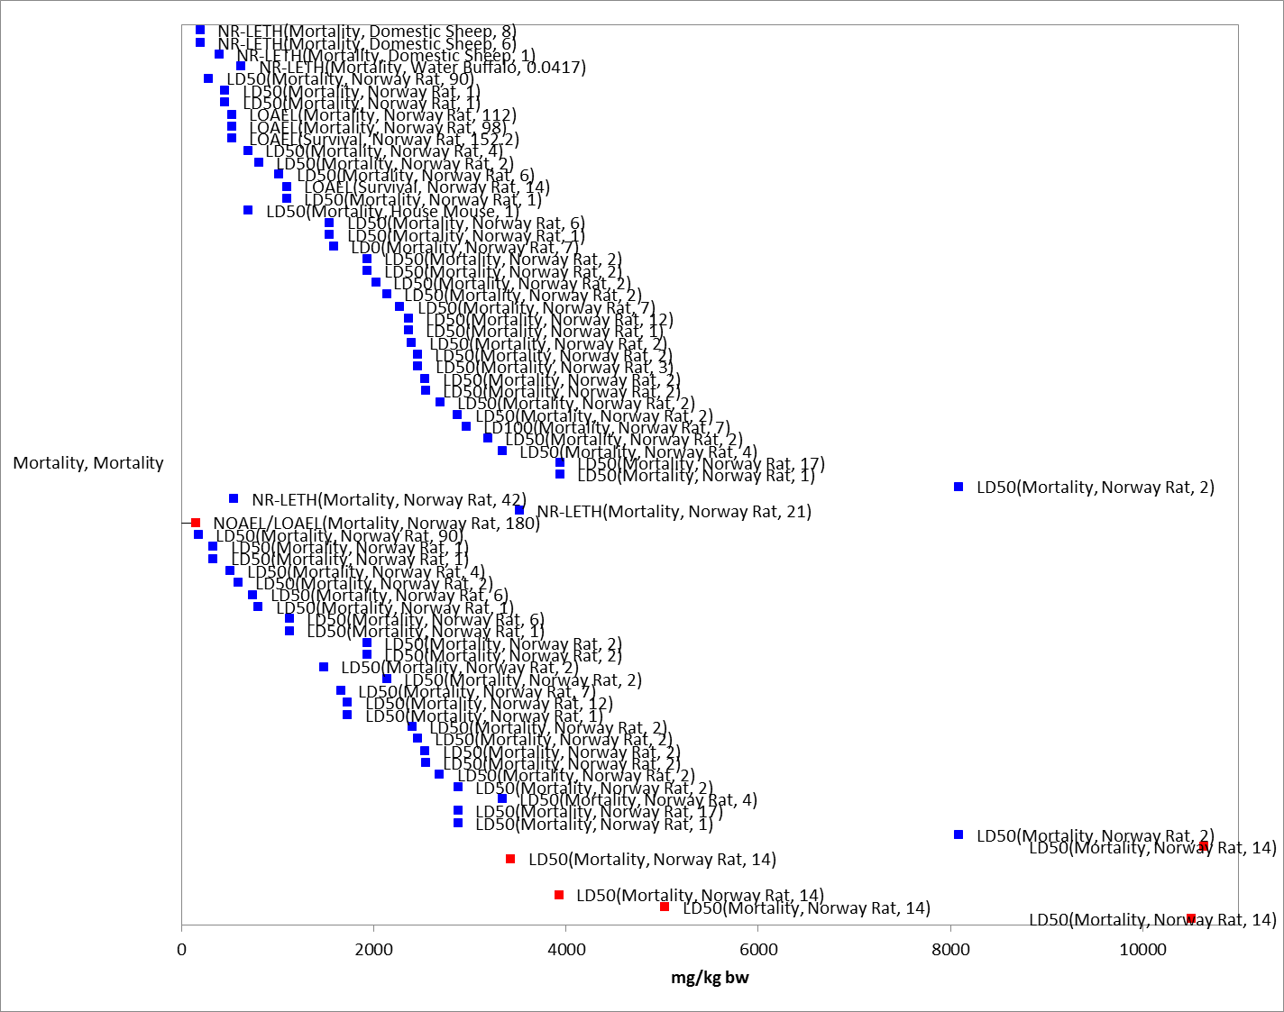 Figure 9-2. Mortality Effects for Mammals Based on mg/kg-bw. Values are adjusted to 15g mammal for presentation purposes. Endpoint labels include measured endpoint, test species and test duration. Blue data points are from open literature, and red data points are from registrant-submitted studies.

Based on the available data for mortality studies, the most sensitive LD₅₀ for malathion is 209 mg a.i./kg-bw in the rat (Rattus norvegicus; Wistar strain). One-day old rat pups were exposed to malathion (99.3%) in corn oil at four different doses (mg/kg-bw) (Mendoza 1976, E35348, MRID 45046301). The number of pups per litter was adjusted to 8 or 10 and were not separated by sex. After dosing, pups were returned to mothers and monitored for 5 hours. However, given uncertainties in the test substance, the mortality threshold value is based on the next most sensitive LD50 for malathion with known chemical purity. In the 14-day acute oral study (MRID 49127003), 7-week old male and female albino rats (Crl: CD(SD)BR strain) were dosed with nominal concentrations 625, 1250, and 2500 mg a.i./kg-bw and observed daily for overt signs of toxicity throughout the 14-day test period. The resulting LD₅₀ value was 1560 mg/kg-bw. Based on this LD₅₀, a mortality threshold value was calculated using a default slope of 4.5 (slope not reported in study). The direct morality threshold was calculated to be 137 mg a.i./kg-bw. The indirect effects mortality threshold was also based on this LD₅₀ and slope and was calculated to be 810 mg a.i./kg-bw.

Sublethal Effects to Mammals

Sublethal effects including effects on growth, reproduction, behavior and sensory function to mammals are discussed in this section.

Effects on Growth of Mammals

Effects on growth are observed in several registrant submitted studies, including effects on body weight and body weight gain. Additionally, alterations in organ weights (GRO, Morphology) are reported for several studies. There were 22 studies with reported effects with three species (i.e., rat, mouse, rabbit). Figure 9-3 presents studies with growth effects. The most sensitive value was for an organ weight change in the rat at 5.9 mg/kg-bw (normalized for 15 g) with a NOAEL of 0.395 mg/kg-bw (Akay et al., 1990; E89875). The highest value was also for an alteration in organ weight at 8596.6 mg/kg-bw (normalized for 15 g) for a rat (Lal and Nath, 1998; E51311).

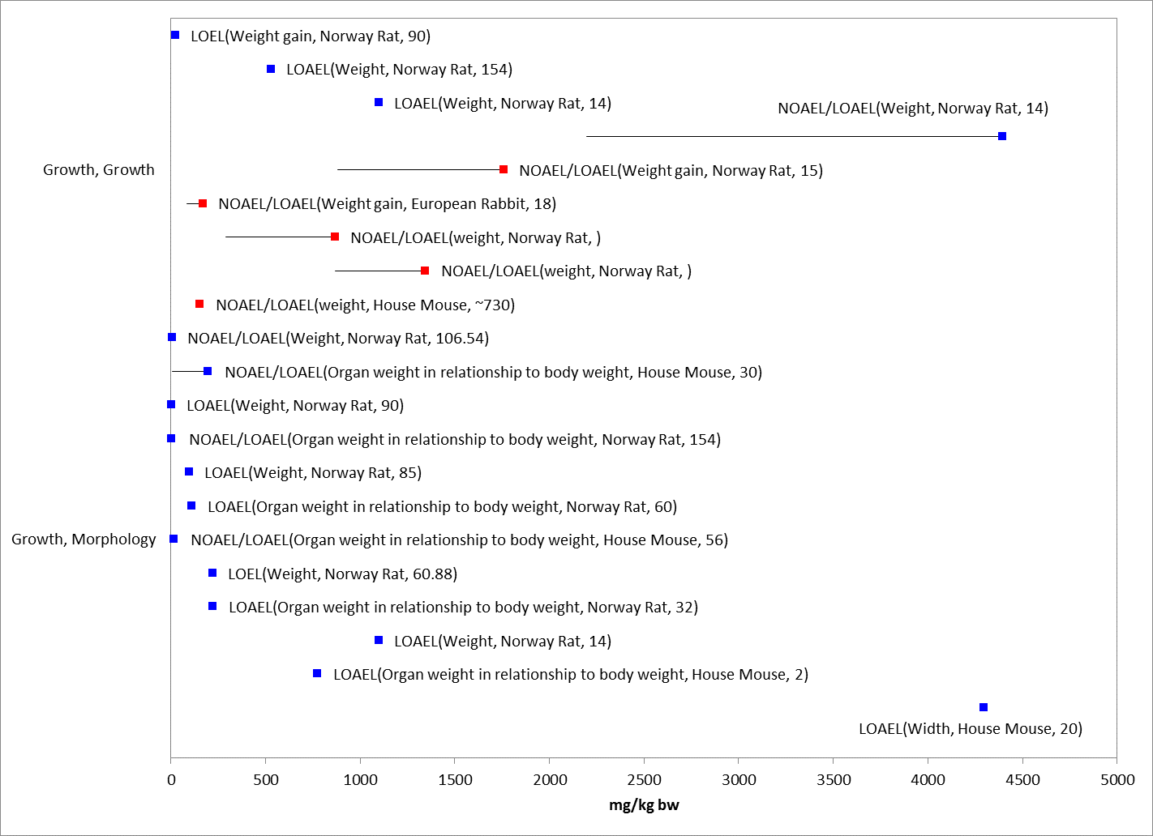
Figure 9-3. Growth Effects for Mammals Based on mg/kg-bw. Endpoints normalized to 15g for presentation purposes. Endpoint labels include measured endpoint, test species order and test duration. Blue data points are from open literature and red data points are from registrant-submitted studies. A value at 8000 mg/kg-bw for alterations in organ weight were not presented in figure for presentation purposes (E51311).

Several studies are available for malathion in the open literature in which different types of dietary items (e.g., lentil, wheat, grains) were treated with malathion, stored (often for 12 months) and then malathion-residues were extracted with solvents (ECOTOX codes: 89620, 89273, 89271, 89875, 90627, and 90776). The remaining ‘bound’ residues were then fed to mammals (rats or mice) and animals were monitored for alterations in body weight, feed consumption, organ weight, and/or a variety of biochemical markers. Given that the treated feed was stored for an extended period of time, washed with solvents to remove extractable residues, and often characterization of the ‘bound’ residues was not complete (unknown residual 14C activity), these studies were not considered for establishing a threshold value (they were however maintained in the arrays).

In a study evaluated when establishing the sublethal threshold, in Akay, et al. 1992 (E89273), lentil grains (Lens culinaris L. variety winter Pul 21) were treated with malathion (10 and 50 ppm) and stored for 12 months, after which the non-bound residues were removed. Swiss albino rats (145-161g) were exposed to lentil grains containing malathion bound residues. The rats were fed for 3 months one of two concentrations: group one- lentils dosed at 10 ppm, bound residues of the grain 0.95 pm; group two- lentils dosed at 50 ppm, bound residues of the grain 6.51 ppm). A control group was included. At the end of exposure, rats were sacrificed and organs excised and weighed. Cholinesterase activity was measured in brain, red blood cells and plasma. Blood biochemistries were also measured including: serum enzyme activities (amylase, alkaline phosphatase, creatine kinase, GPT and GOT), blood urea nitrogen, uric acid, total protein, albumin, as well as other hematological parameters including white and red blood cells. In this study, there were no significant effects on body weight, organ weight, and water or food consumption compared to control. Additionally, none of the rats exhibited any signs of toxicity during the 3 month exposure. Serum ChE activity was significantly reduced 34% at the high dose; no significant difference at low dose (10% reduction). There were no significant difference in brain or RBC ChE activity. Significant decreases in serum AP (decreased 31.5%) and GPT (decreased 27.5%) were reported at 6.51 ppm. Urea nitrogen levels were significantly increased 14.9 and 18.6% at 0.95 and 6.51 ppm, respectively. White blood cells were also significantly increased at both doses (44 and 41% at 0.95 and 6.51 ppm, respectively), and lymphocytes were also increased (49%) at the high concentration; there were no other significant effects for hematology endpoints.

In addition, effects on body weight and body weight gain are monitored in registrant-submitted mammalian toxicity studies. Table 9-4 presents studies with reported body weight effects.

Table 9-4. Body Weight Effects in Submitted Mammalian Toxicity Studies
Guideline Number/ Study Type | MRID(s)/ Year  Doses/Classification | Results
870.3700a -  Developmental-Rat  (94%, a.i.) | MRID 41160901 (1989)  Doses: 0, 200, 400, 800 mg/kg/d (Days 6-15 of gestation)  Acceptable/guideline | Maternal NOAEL= 400 mg/kg/day  Maternal LOAEL= 800 mg/kg/day, based on reduced mean body weight gains and reduced mean food consumption.
870.3700b -  Developmental-Rabbit  (92.4%, a.i.) | MRID 00152569 (1985) and Supplemental Report MRID 40812001 (1985)  Doses: 0, 25, 50, 100 mg/kg/d (Days 6-18 of gestation)  Acceptable/guideline | Maternal NOAEL= 25 mg/kg/day  Maternal LOAEL= 50 mg/kg/day, based on reduced mean body weight gains during period of malathion exposure (Days 6-18 of gestation).
870.3800 -  Two-generation Reproduction-Rat  (94%, a.i.) | MRID 41583401 (1997)  Doses: 0, 550, 1700, 5000, 7500 ppm in feed (equivalent to 0, 43, 131, 394, and 612 mg/kg/d in males and 0, 51, 153, 451, and 703 mg/kg/d in females)  Acceptable/guideline | Parental LOAEL= 612 /703 mg/kg/day (M/F), based on decreased F0 generation body weights during gestation and lactation (females) and decreased F1 pre-mating body weights (males and females).  Offspring NOAEL= 131 /153 mg/kg/day (M/F)  Offspring LOAEL= 394 /451 mg/kg/day (M/F), based on decreased pup body weights during the late lactation period in F1 and F2 pups.
870.4300 -  Carcinogenicity-B6C3F1 mice  (96.4%, a.i.) | MRID 43407201 (1994)  Dose levels: 0, 100, 800, 8000, 16000 ppm  0, 17.4/20.8,143/167, 1476/1707, 2978/3448 mg/kg/d, M/F).  Acceptable/guideline | Systemic NOAEL= 143/167 mg/kg/day (M/F)  Systemic LOAEL: 1476/1707 mg/kg/day (M/F), based on decreased body weights and food consumption, increased liver weight, and increased hepatocellular hypertrophy in males and females.

For dietary-based studies, the most sensitive growth endpoint (excluding bound residue studies discussed above and alterations in organ weight) was a decrease in pup body weight at 5000 mg a.i./kg-diet (NOAEL of 1700 mg a.i./kg-diet) in the two-generation reproduction study in the rat (MRID 41583401). For dose-based studies, the sensitive growth endpoint was an approximate 22% decrease in body weight gain (based on figure in study) in rats at 10 mg/kg-bw after 90 days of oral exposure to malathion (purity not reported) (Samaan et al. 1989; E74457).

Effects on Reproduction of Mammals

Several studies are available that investigate the reproductive effects of malathion on mammals (Figure 9-4). The effects (from 7 different studies) were primarily concerning alterations in sperm or developmental endpoints regarding alterations in implantations or reabsorbed embryos (NOAEL/LOAEL of 25/50 mg/kg/d; MRID 00152569, 40812001). No reproductive toxicity effects were observed in the 2-generation rat reproduction study (MRID 41583401 (1997) up to doses of 612/703 mg/kg/day (7500 mg/kg-diet) for males and females, respectively.

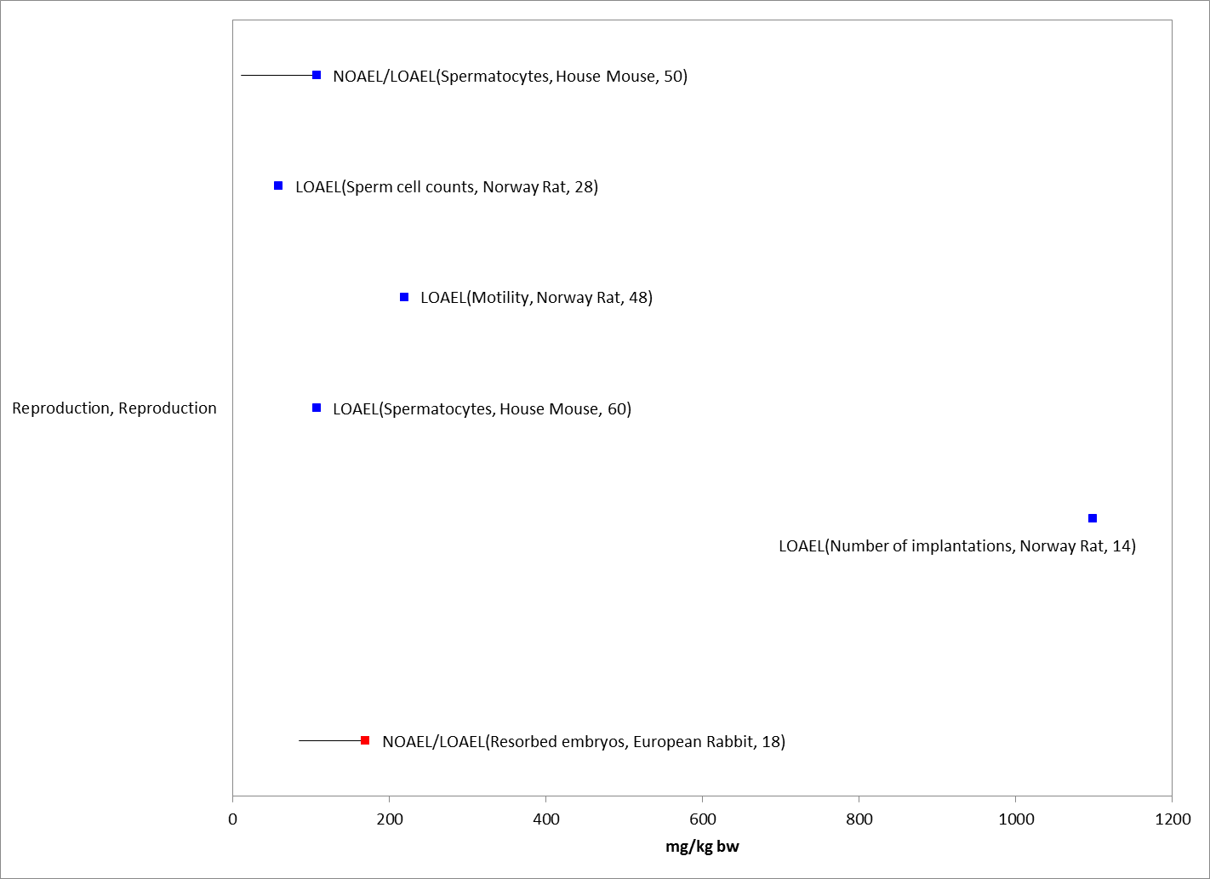
Figure 9-4. Reproduction Effects for Mammals Based on mg/kg-bw. Endpoints normalized to 15g for presentation purposes. Endpoint labels include measured endpoint, test species order and test duration. Blue datapoints are from open literature and red datapoints are from registrant-submitted studies. A NOAEL/LOAEL value of 2000/4000 mg/kg-bw for alterations in spermatocytes were not presented in figure for presentation purposes (E40178).

Behavioral Effects

Behavioral effects in mammals are reported for nine studies in the rat and two in the mouse. The effects include alterations in general activity, feeding behavior, and grip strength. It is noted that effects on behavior are monitored in the registrant-submitted mammalian toxicity studies (i.e., rat, rabbit, and mice); however, the toxicity value presented below represent reported behavioral effects in the ECOTOX database and summary tables for submitted mammalian toxicity studies. All reported behavior effects endpoints are displayed in Figure 9-5. In the data arrays, the most sensitive behavior endpoint was a LOAEL of 32 mg a.i./kg-bw based on alterations in general activity in the Norway rat (adjusted for dose-based and a 15g animal: 640 mg/kg in study diet-based) (Geraldi et al. 2008; E153607). The highest behavior effect endpoint reported was also alterations in general activity in the rat at 4395 mg a.i./kg-bw (adjusted for 15 g (2000 mg a.i./kg-bw; NOAEL=1000 mg a.i./kg-bw, MRID 43146701). A 49% decrease in muscular strength/coordination (grip strength) were reported at 100 mg/kg-bw in rats after 4 days of exposure to malathion (49.7% formulation) by oral gavage compared to control (Acker et al. 2011; E162509); a 50% decrease reported at high dose of 200 mg/kg-bw. The alterations in general activity reported in Geraldi et al. 2008 at 640 mg/kg (diet) was the lowest dietary-based study endpoint.

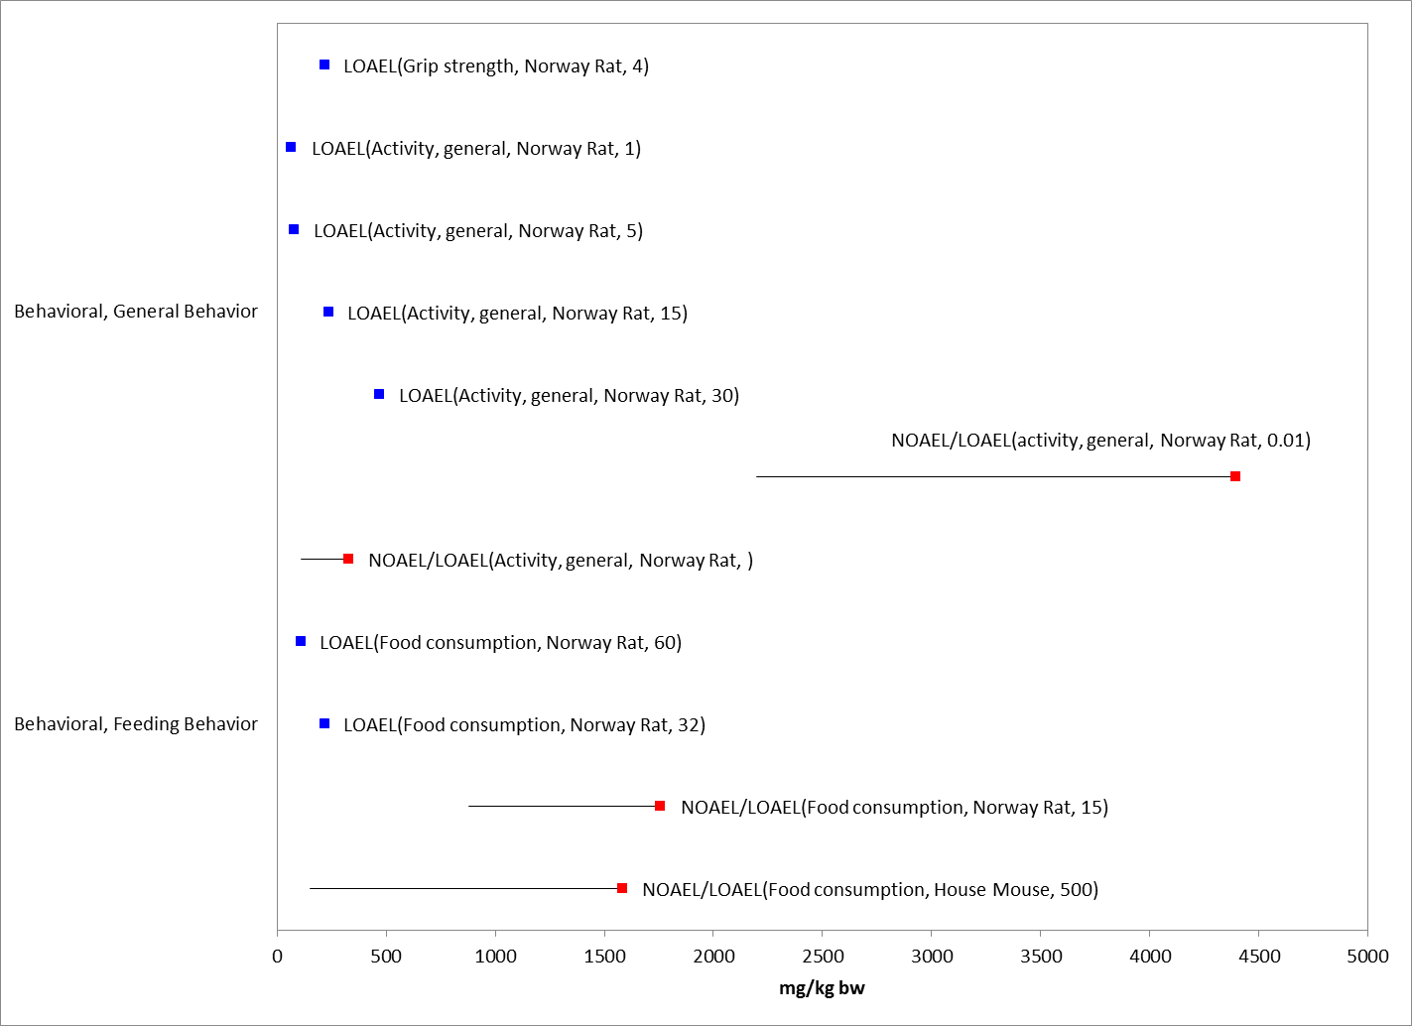
Figure 9-5. Behavioral Effects for Mammals Based on mg/kg-bw. Values are adjusted to 15g mammal for presentation purposes. Endpoint labels include measured endpoint, test species, and test duration in days. Blue data points are from open literature and red data points are from registrant-submitted studies.

Effects on Sensory Function of Mammals

There are no studies specific to sensory effects for mammals.

Other Effects Reported for Mammals

Effects other than those identified as mortality (survival), behavior, sensory, growth, and reproduction are reported for malathion. These effects include cellular, biochemical (in addition to effects on cholinesterase), and physiological. A summary of each of these effect types are discussed below.

Biochemical and Cellular

The types of reported biochemical and cellular effects and the doses at which they occur vary across studies and species. In general, a variety of alterations are reported at the lower end of the array including changes in glutathione, 7-ethoxyrresorufin O-deethylase, urea nitrogen, and changes in meiotic indices and chromosomal aberrations. Other effects include alterations in: lipids, cholesterol, ALT, and urea, among others. Cellular effects included alterations in white blood cell count, micronuclei, and leukocytes and histology.

Cholinesterase (ChE) Inhibition

Given the mode of action of malathion, it is expected that the chemical will have an impact on acetyl-cholinesterase (AChE). Alterations in cholinesterase were monitored in both registrant-submitted and open literature studies.

The Health Effects Division in the USEPA Office of Pesticide Programs uses a benchmark dose approach when evaluating inhibition of AChE. HED determines a BMD10 (benchmark dose)/BMDL10 (Benchmark dose Lower Bound) levels. BMD/BMDL10 levels corresponded to the dose at which a 10% decrease in cholinesterase was predicted (from evaluated available data) (BMDL is the 95% lower confidence limit around the BMD). For malathion, the BMDL₁₀ ranged from 9-14 mg/kg/day (for pups among acute and repeat dose studies), and the data suggested that the steady state of RBC AChE inhibition may have been reached within a few days of exposure (USEPA 2015). The most sensitive BMDL₁₀ and associated BMD₁₀ values were selected for use as the direct and indirect sublethal effects threshold, respectively. The BMDL₁₀ value of 9.1 mg/kg-bw/day was used as the sublethal threshold for direct effects and the BMD₁₀ value of 13.3 mg/kg-bw/day was used as the sublethal threshold for indirect effects for this assessment.

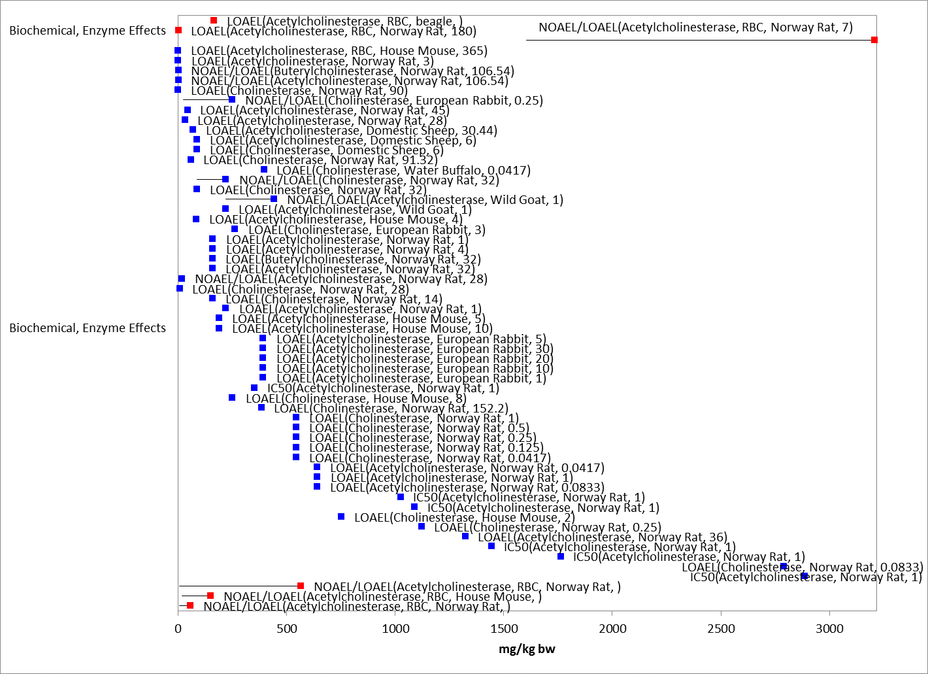
Figure 9-6. Cholinesterase Effects for Mammals Based on mg/kg-diet. Endpoint labels include measured endpoint, test species order and test duration. Blue data points are from open literature. Red data points are from registrant-submitted studies.

Table 9-5 presents a summary of AChE effects in the registrant submitted oral studies. Included in the table are a few studies which evaluated neurotoxicity.

Table 9-5. Summary of AChE Inhibition Results in Registrant-submitted Studies.
Guideline Number/ Study Type | MRID(s)/ Year  Doses/Classification | Results
870.4100 -  Chronic toxicity-dogs  (95%, a.i.) | MRID 40188501 (1987)  Dose level:0,62.5,125,250 mg/kg/day (gelatin capsule)  Acceptable/non-guideline | Systemic NOAEL: >250 mg/kg/day (HDT)  AChEI NOAEL= Not established.  AChEI LOAEL <62.5 mg/kg/day based on plasma and RBC AChEI.
870.4200 -  Combined chronic toxicity/  carcinogenicity-F344 rats  (97.1%, a.i.) | MRID 43942901 (1996)  Dose levels: 0, 50/100, 500, 6000, 12000 ppm  (4/5, 29/35, 359/415, 739/868 mg/kg/d (M/F)  Acceptable/guideline | AChEI NOAEL= 3 mg/kg/day (see note below)  AChEI LOAEL= 35 mg/kg/day, based on significant RBC AChEI in females.  NOTE: The low dose level was 100 ppm in the diet for three months which was dropped to 50 ppm for the remainder of the study (21 more months). The calculated dose for the three-month exposure was 7 (M) and 8 (F). The calculated dose from the 21 month exposure was 2 (M) and 3 (F) mg/kg/d. Assuming that a LOAEL for AChEI could be 8 mg/kg/d for three months [based on effects observed in females at that time), then a reasonable NOAEL would be 3 mg/kg/day for the 24 month study (the 21-month exposure value for females).
870.4200 -  Combined chronic toxicity/  carcinogenicity-F344 rats  (96.4%, a.i.) | MRID 43975201 (1996)  Dose levels: 0,  20, 1000, 2000 ppm in feed (equivalent to 0, 1, 57, 114 mg/kg/d in males and 0, 1, 68, 141 mg/kg/d in females).  Acceptable/guideline | AChEI NOAEL= not determined  AChEI LOAEL= 1 mg/kg/day based on 19-21% RBC AChEI males at 6 months.
870.4300 -  Carcinogenicity-B6C3F1 mice  (96.4%, a.i.) | MRID 43407201 (1994)  Dose levels: 0, 100, 800, 8000, 16000 ppm  0, 17.4/20.8,143/167, 1476/1707, 2978/3448 mg/kg/d, M/F).  Acceptable/guideline | AChEI NOAEL= 17.4/20.8 mg/kg/day (M/F)  AChEI LOAEL= 143/167 mg/kg/day (M/F), based on plasma and RBC AChEI in males and females.
870.6100 -  Acute Oral Delayed Neurotoxicity in the Hen  (93.6%, a.i.) | MRID 40939301 (1988)  Doses: 0, 10007.5 mg/kg followed by 852.5 mg/kg/d 21 days later (all hens pre-treated with atropine before each dose)  Acceptable/guideline | Neither gross necropsies nor histopathological examination revealed any treatment-related effects in treated hens. Negative for any evidence of acute delayed neurotoxicity.
870.6200a  Acute neurotoxicity-Rat  (96.4%, a.i.) | MRID 43146701 (1994)  Doses: 0, 500, 1000, 2000 mg/kg/d)  Acceptable/guideline | NOAEL = 1000 mg/kg  LOAEL = 2000 mg/kg (limit dose), based on decreased motor activity and clinical signs at the peak time of effect on day 1 (15 min post dosing) and plasma and RBC AChEI at day 7.
870.6200b  Subchronic neurotoxicity- Rat (96.4%, a.i.) | MRID 43269501 (1994)  Doses: 0, 50, 5000, 20,000 ppm in diet (equivalent to 0, 4, 352, 1486 mg/kg/d in males and 0, 4, 395, 1575 mg/kg/d in females).  Acceptable/guideline | NOAEL= 4 mg/kg/day (M/F)  LOAEL= 352/395 mg/kg/day (M/F), based on plasma, RBC AChEI in males and females and brain AChEI in females.
870.6300  Developmental neurotoxicity – rat (96%, a.i.) | MRID 45646401 (2002)  Doses: 0, 5, 50, 150 mg/kg/d  Acceptable/guideline | Maternal NOAEL= 50 mg/kg/day  Maternal LOAEL= 150 mg/kg/day, based on increased incidence of post-dosing salivation  Offspring NOAEL= 50 mg/kg/day)  Offspring LOAEL= 150 mg/kg/day, based on clinical signs (whole body tremors, hypoactivity, prostrate posture, partially closed eyelids) and brain morphometrics (increased thickness of the corpus callosum in PND 63-67 males and females.)
870.6300  Comparative ChE study – rat (96.0%) | MRID 45566201 (2001)  Acute exposures (adults and pups, PND 11) - 0, 5, 50, 150, 450 mg/kg/d.  Repeat exposures (11 days to both adults and pups PND 11-21): 0, 5, 50, 150 mg/kg/d.  Acceptable/nonguideline | Acute exposures  BMDL₁₀ = 13.6/14.1 mg/kg (offspring, M/F). This benchmark dose (BMD) is the lower 95% confidence interval for the estimated mean dose at which 10% RBC AChEI is observed. BMD₁₀= 16.9/18.3 mg/kg (offspring, M/F). No model had good fit for adult male and female data.  Repeated exposures (11 days)  BMDL₁₀ = 11.2/12.2 mg/kg/d (offspring, M/F) and 24.7/21.0 mg/kg (adult, males/females). This benchmark dose (BMD) is the lower 95% confidence interval for the estimated mean dose at which 10% RBC AChEI is observed. BMD₁₀= 14.3/14.4 mg/kg/d (offspring, M/F) and 27.9/24.0 mg/kg/d (adult, M/F)
870.6300  Comparative ChE study – rat  (malathion, 96%; and malaoxon 97.7%) | MRID 46822201 (2006)  Repeat exposures (pups at PND 11-21):  Malathion: 0, 5, 25, 50, 150 mg/kg/d.  Malaoxon: 0.1, 1, 2.5, 4 mg/kg/day  Acceptable/nonguideline | Repeated exposures (PND 11-21)  Malathion:  BMDL₁₀ = 9.1/9.7 mg/kg/d (M/F). This benchmark dose (BMD) is the lower 95% confidence interval for the estimated mean dose at which 10% RBC AChEI is observed. BMD₁₀=13.3/13.1 mg/kg/day (M/F)  Malaoxon:  BMDL₁₀ = 0.53/0.51 mg/kg/d (males/females). This benchmark dose (BMD) is the lower 95% confidence interval for the estimated mean dose at which 10% RBC AChEI is observed. BMD₁₀= 0.84/0.61 mg/kg/day (M/F)
870.6300  Comparative ChE study – rat  (malathion, 96%; and malaoxon 97.7%) | MRID 47373704 (2008)  Acute dose (PND 11)  Malathion: 0,10,25,50,100,150 mg/kg  Malaoxon: 0,1.0,3.5,7.0,10.0,12.5 mg/kg  Acceptable/nonguideline | Acute exposure (PND 11)  Malathion:  BMDL₁₀ = 11.5/10.3 mg/kg (M/F). This benchmark dose (BMD) is the lower 95% confidence interval for the estimated mean dose at which 10% RBC AChEI is observed. BMD₁₀=13.8/12.9 mg/kg/day (M/F)  Malaoxon:  BMDL₁₀ = 0.43 mg/kg (females). This benchmark dose (BMD) is the lower 95% confidence interval for the estimated mean dose at which 10% RBC AChEI is observed. BMD₁₀= 0.60 mg/kg/day (females). No model had good fit for male data.

Other Biochemical and Cellular Effects

Biochemical effects in addition to alterations in AChE are reported for mammals exposed to malathion. A few of these studies that were reviewed when establishing thresholds are discussed. Biochemical and cellular effects are categorized into several different bins in ECOTOX which are presented in Figure 9-7. Table 9-6 summarizes the major categories for biochemical and cellular effects with the reported measured endpoints.

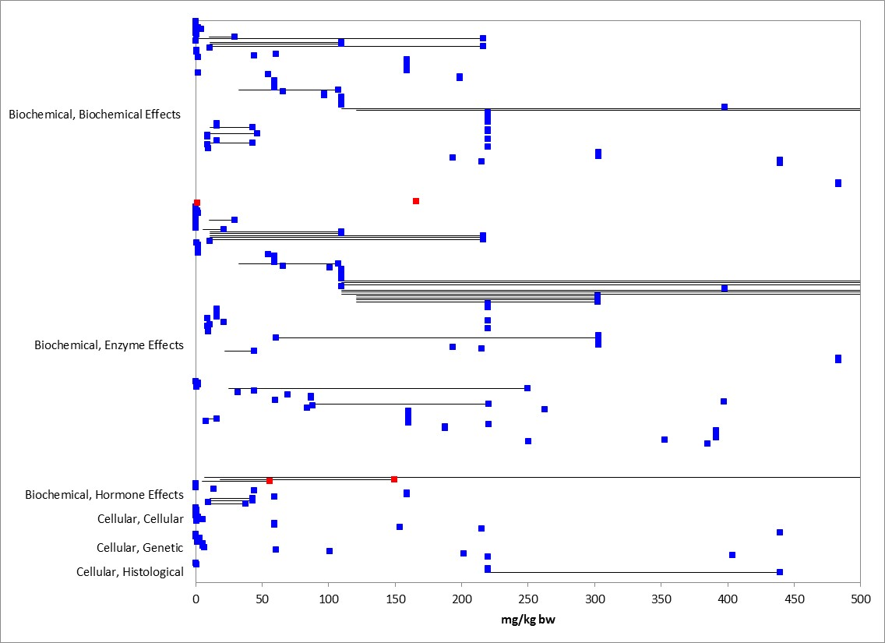
Figure 9-7. Biochemical and Cellular Effects for Mammals Based on mg/kg-bw. Endpoints normalized to 15 g body weight. Blue data points are from open literature studies. Red data points are from registrant-submitted studies. Studies with endpoints 500 mg/kg-bw or less are shown for presentation purposes.

Table 9-6. Reported Biochemical and Cellular Endpoints for Malathion.
Effect Group | Effect | Measured Endpoints
BCM (Biochemical) | BCM | Glutathione (reduced glutathione)  Urea nitrogen  Hydrogen peroxide  Histamine  Sulfhydryl  Urea  Hemoglobin  Thiobarbituric acid reactive substances  Antioxidant activity  Glucose  Malondialdehyde  Lipid  Protein, total  Protein content  Very low density lipoprotein  Cholesterol  Triglycerides  Albumin  Mean corpuscular (cell) hemoglobin concentration  Mean corpuscular volume  Mean corpuscular hemoglobin  Hematocrit (anemia)  Creatinine  Uric acid  Phosphorus content  Calcium content  Ascorbic acid  Albumin to globulin ratio  Globulin  Phosphate  Ammonia  Bilirubin  Glycogen  Methionine  Choline  "Phosphatidyl choline (phospholipid)  content"  Glycine  Platelets  Potassium content
BCM | ENZ (enzyme) | Glutamic-oxaloacetic transaminase  Glycogen phosphorylase  Enzyme activity  Choline phosphokinase  Catalase  Glutamic pyruvic transaminase  Alpha-amylase  Alkaline phosphatase  Glutathione reductase  Glutathione peroxidase  Cytochrome P-450  Glutathione S-transferase  Ali esterase  Dehydroascorbatase  Sorbitol dehydrogenase  Acid phosphatase  Aspartate aminotransferase  Cathepsin  beta-Glucuronidase  Glucose-6-phosphate dehydrogenase  Arginase  Esterase  Lactic dehydrogenase  Transaminase  Serum glutamate oxalo acetate transaminase  Alanine transaminase (ALT)
BCM | HMR (hormone) | Triiodothyronine  Thyrotropin  Thyroxine  Insulin  Progesterone  Follicle stimulating hormone  Testosterone
CEL (Cellular) | CEL | Leukocytes  Red blood cell  Number of cells  Cell changes  Polychromatic cells, micronucleated  White blood cell count, total  Thrombocytes  Lymphocyte  Viability  Foci  Diameter
CEL | GEN (genetic) | Meiotic Index  Chromosomal aberrations  Chromosomal breaks  Gene expression  Corticotropin-releasing factor mRNA  DNA concentration  GCKM  Genetics, general  Mitotic index (# mitoses/total cells)
CEL | HIS (histology) | Atrophy  Degeneration  Lesions

In Hoda et al., 1993, Eight week old mice (Mus musculus) were orally exposed to malathion (formulation, 50% malathion, Cyanamid Company, India) at a dose of 0.2 µg/kg-bw/day for 10 days. Treatment groups consisted of: 1) control group (received only diet (Gulmohar, Hindustan Lever Ltd)); 2) mice given supplementary dose of either vitamin C or B-complexes; 3) mice exposed to malathion or dimethoate alone; and 4) mice exposed to pesticide and vitamin C or B-complex concurrently. Ten mice were used in each treatment group and the average weight was approximately 25 grams. Vitamins were injected daily intraperitoneally (0.25 mL of 1% ascorbic acid and 0.3 mL of 1% vitamin B-complex). Treatment was 10 days after which mice were sacrificed. In the testis, the total number of spermatocytes and their different dividing phases were counted (using 5 random foci in each slide). The meiotic index (%) for malathion was significantly reduced compared to the control (60.77% control vs. 54.9% malathion (decreased 9.6%). Additionally, the phase frequency % of prophase 1 was significantly reduced (58.64% control vs. 50.98% malathion (decreased 13%)) and diakinesis metaphase 1 was significantly increased (1.27% control vs. 3.13% malathion (increased 146%)) for malathion compared to the control; ana-telophase 1 was not significantly different. There were no significant differences between the control and vitamin alone treatment groups. While they were still statistically significant compared to the control (p<0.05), the malathion plus vitamin treatment groups had an increase in meiotic-index (%) compared to the control.

Six-week old male (CBA strain, obtained from Division of Biology in Zagreb) mice were fed ad libitum wheat grains (obtained from Agricultural Institute, Osijek) treated with malathion at a concentration of 5 x 10-6 mg/kg (0.55 ppb bw/day); malathion (formulation, Fyfanon 50EC 500g/L, Cheminova, Denmark) was dissolved in corn oil (Hackenberger et al. 2010; E162358). There were 6 replicates each with 10 mice for each treatment; control was included. Twelve mice were sacrificed every 3 months for one year. At 12 months, due to mortality from exposure to malathion only 11 mice were available for further analysis; no mortality occurred in the control. Livers were removed, processed and enzyme analyses were conducted. 7-ethoxyresorufin-O-deethylase (EROD; CYP1A1), glutathione (GSH), Cholinesterase activity (ChE), protein content were measured. No significant difference in body weight was observed during the study. For the EROD endpoint, the study authors stated there were no significant differences compared to control (reviewer noted that Figure 1 in paper indicates significance at 9 months). Additionally, the study authors stated that GSH was significantly reduced (27.58%) at 3 months; Figure 1 also indicates significant increases at 12 months. AChE activity was significantly increased (18% of initial value) at 9 months, and then was significantly decreased at 12 months compared to control (approximately 10% based on Figure 1).

Physiological Effects

Several studies reporting physiological effects are available for malathion, with 17 studies reporting effects for either the rat or mouse (Figure 9-8). Effects on the immune system as well as those related to carcinogenicity were reported. Additionally, general physiological alterations were reported. Studies that were evaluated when establishing thresholds are discussed.

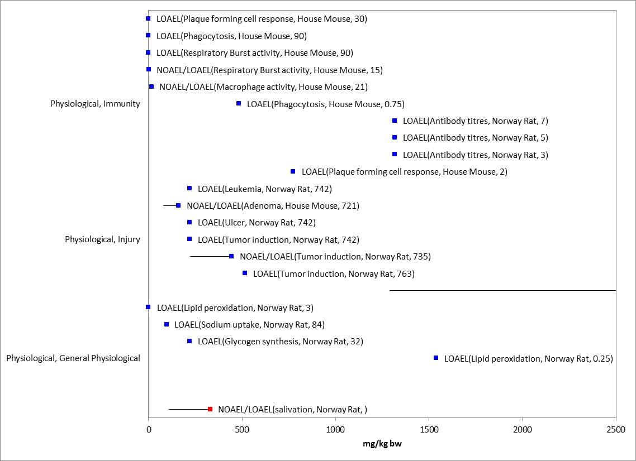
Figure 9-8. Physiological Effects for Mammals Based on mg/kg-bw. Endpoints normalized to 15g for presentation purposes. Endpoint labels include measured endpoint, test species order and test duration. Blue data points are from open literature, and red data points are from registrant-submitted studies. A LOAEL value of 3846 mg/kg-bw for alterations in clotting time/ prothrombin time were not presented in figure for presentation purposes (E37756).

Female mice (SJL/J,5-6 wks old, 16-20 g) were dosed via oral gavage with malathion formulation (Malathion 500 EC; 50% malathion; corn oil used as vehicle) at 0.018, 7.2 and 180 mg/kg on alternate days for 28 days (Johnson et al. 2002; E90644). A control group was added. On day 25, mice were immunized with 0.2mL of 10% sheep red blood cell (SRBC) suspension via intraperitoneal injection. One mouse per treatment was immunized with sterile phosphate buffered saline (PBS) as a negative assay control animal. On day 30 (2 days after last malathion administration), mice were sacrificed, and spleen, liver, kidneys and brains removed and weighed. Brain acetylcholinesterase activity was measured. Spleens were used to determine effects of malathion on anti-SRBC humoral immune response, mitogen-induced splenic lymphocyte proliferation, and splenic cell phagocytosis. There were no clinical evidence of organophosphate poisoning in treatment groups, and there were no effects on brain acetylcholinesterase. There were also no effects on body weight or food and water consumption. Splenic cellularity and viability of splenocytes was not affected. Additionally, it was reported that there was no significant differences for lymphocyte blastogenesis, and malathion exposure did not alter conA- or PHA-P-induced T-lymphocyte proliferation or LPS-induced B-lymphocyte proliferation (when expressed as CPM or SI). Malathion exposure also did not affect the phagocytic function of splenic macrophages. However, the study authors reported a significant increase in the numbers of plaques per 106 cells compared to the control (50, 48, and 33% increase in 0.018, 7.2, and 180 mg/kg groups, respectively). Additionally, the numbers of plaques per spleen were also increased 47, 48 and 43% in the 0.018, 7.2 and 180 mg/kg groups, respectively (Figure 2 in paper).

In a dietary exposure study with the mammal (mouse) Mus musculus albinus, test animals were exposed to challenge doses of 0.0078125, 0.03125, 0.125, and 0.5 mL malathion per kg body weight daily (not reported in units of mass/mass) for 5, 10, and 15 days and subsequently exposed to parasitic worms (Kaskhedikar et al. 1994; E50842). Each treatment group consisted of 20 animals. All treated mice were intubated with a single dose of 500 viable nematode eggs and the parasitic worm burden was evaluated 21 days after exposure. A control group fed untreated diet was also intubated with a single dose of 500 nematode eggs. Worm burden was positively correlated with increasing malathion concentrations and duration of exposure, although the study authors acknowledge that “the mechanism by which malathion exerts its influence on the development and retention of worms in the host is obscure.”

In the registrant-submitted immunotoxicity study, there were no effects noted for immunotoxicity up to doses of 1215 mg/kg bw/day (7000 mg/kg-diet) (MRID 48550501). Alterations in RBC AChE were noted at 126.8 mg/kg bw/day.

Field Data for Mammals

Data Reported in Units of Mass/acre

Two studies in the ECOTOX database reported endpoints in units of lb/acre or oz/acre. Joseph et al., 1972, reported no mortality at 0.38 lb a.i./acre in mice that were placed in cages in the field (E56947). Additionally, for the Jamaican fruit eating bat no effect on acetylcholinesterase was reported at 4.5 oz/acre (McLean et al. 1975; E89523).

The following study evaluated multiple species including mammals (summary obtained from USEPA RED 2000 document). In "The Ecology of a Small Forested Watershed Treated with the Insecticide Malathion S35."(S.Giles, Robert H., Jr., 1970), aerial application to 2 adjoining Ohio watersheds was observed -with one treated and the other untreated. Malathion was radio tagged with Sulfur 35 radio nuclide. Two 20 acre watersheds (primarily deciduous forests) were selected for comparison. Application rate was 2 lbs/acre and 4 applications were made. Spray residue: cards were placed under application areas for residue analysis. Residue collection discs were also suspended above the canopy using helium filled balloons. Glass discs were placed in the trees as well as the shrubs and in soil/litter surfaces. Radioactivity was high in the tissues of plants sampled in the treated areas indicating active systemic uptake of malathion. New shoots and leaves showed especially high levels of radioactivity. Metabolites of malathion showed up in new stem and leaf growth up to one year after application.

Observed small mammal populations effects were mixed. Up to a 45% reduction in population of white footed mice Peromyscus leucopus novaboracensis was estimated for the treated areas, based on pre and post treatment trapping counts. However, no difference in populations of shorttailed shrews or black-tailed shrews was determined, though residues were detected in costal cartilage, kidney, and heart tissues samples. Chipmunk populations were reduced 55% in treated areas following applications. The study author concludes "As with the mice this is not a lethal effect, but apparently one of productivity and survival." Larger mammals appeared unaffected.

Effects to Mammals Not Included in the Arrays

Exposure Routes other than Dietary or Dose-based

Exposure to malathion by routes other than dietary (via feed or oral) are available and include direct application (dermal), inhalation, and drinking water.

Dermal

Toxicity data from dermal exposure to mammals are available for malathion both from the open literature as well as registrant-submitted studies (Tables 9-7 and 9-8). For acute mortality from dermal exposure, the LD₅₀ is greater than 2000 mg/kg (MRID 00159877); effects on AChE inhibition were noted in this study. Studies in the open literature reported genetic effects or alterations in biochemical markers (histamine, Glutamic-oxaloacetic transaminase) after dermal exposure to malathion. In Cushman and Street, 1983 (E36303), no effect on delayed hypersensitivity was observed (exposure units in mg/mL). Other studies reported in units of % were also available for dermal exposure.

Table 9-7. Toxicity Data from Registrant-submitted Studies for Malathion Based on Dermal Application Methods
Guideline Number/ Study Type | Study Details | Results
870.3200 -  21-Day dermal toxicity (NZ rabbit)  (94%, a.i.) | MRID 41054201 (1989)  Doses: 0, 50, 300, 1000 mg/kg/day  Acceptable/ guideline | BMDL₂₀ of 135 mg/kg/d (males) and 143 mg/kg/d (females). This benchmark dose (BMD) is the lower 95% confidence interval for the estimated mean dose at which 20% RBC AChEI is observed.
870.3200 –  21-Day dermal toxicity (NZ rabbit)  (96%, a.i.) | MRID 46790501 (2006)  Doses: 0, 75, 100, 150, 500 mg/kg/day  Acceptable/guideline | BMDL₁₀ = 80 mg/kg/d (females) and BMD₁₀ = 124 mg/kg/d. This benchmark dose (BMD) is the lower 95% confidence interval for the estimated mean dose at which 10% RBC AChEI is observed. (No model fit for male data at BMD₁₀ level.)  BMDL₂₀=92.2/119.6 mg/kg/day (M/F)  BMD₂₀=123.9/145.2 mg/kg/day (M/F))  Dermal irritation noted at all doses.
870.1200 / Acute dermal (rat) | MRID 00159877 | LD₅₀ >2000 mg/kg (M)(F)
870.2400 / Acute eye irritation [Rabbit] | MRID 00159880 | Slight conjunctival irritation;  Clear by 7 days
870.2500 / Acute dermal irritation [Rabbit] | MRID 00159879 | Slight dermal irritation  (PIS=1.1)
870.2600 / Skin sensitization [Guinea pig] | MRID 00159881 | Not a skin sensitizer

Table 9-8. Toxicity Data in the Open Literature for Malathion Based on Dermal Application Methods
Species | Effect Group | Endpoint | Duration (d) | Endpoint Concentration | UNITS | Reference #
House mouse | BCM | Histamine | 0.17 | 2 / 20  (NOAEL/ LOAEL) | mg/kg | Rodgers & Xiong 1997; E89046
Norway rat |  |  |  | 2  (LOAEL)
Norway rat | CEL | # of cells | 30 | 44.4 (LOAEL) | mg/kg/d | Abdel-Rahman et al. 2004; E89117
 | BCM | Acetyl-cholinesterase |  | 44.4 (NOAEL)
 | PHY | Cholinergic muscarinic receptor binding |  | 44.4 (NOAEL)
 | BEH | Grip strength |  | 44.4 (NOAEL)
House mouse | CEL | Mitotic index / general genetics | 12-13 | 250  (LOAEL, general) ; 500/1000 (NOAEL/ LOAEL, mitotic index) | mg/kg bw | Salvadori et al. 1988; E89186
Guinea pig | BCM | Glutamic-oxaloacetic transaminase | 30 | 200 (LOAEL) | mg/kg/d | Dikshith et al. 1987; E95133
 | GRO | Organ wt/body wt |  | 200 (LOAEL)
Norway rat | BCM | Cholinesterase | 0.13 | >1000 (ID50) | mg/kg | Murphy 1980; E86574
House mouse | PHY | Delayed hypersensitivity | 8,36 | 177.6 (NOAEL) | mg/mL | Cushman & Street 1983; E36303
Water buffalo | BCM | Aspartate aminotransferase | 7 | 0.5/1 (NOAEL/LOAEL) | % | Gupta and Paul, 1978; E36919
 | MOR | Mortality | 3 | 5 (NR-lethal)
House Mouse | PHY | General immunity | 27 | 8 (NOAEL) | % | Relford et al. 1989; E89141
House mouse | MOR | Mortality | 21 | 2 (NR-ZERO) | % | Sogorb et al. 1993; E90688
Domestic sheep; wild goat | BCM | Cholinesterase | 0.08 | 0.05 (LOAEL; animals suffering from mange and parasite infection) | % | Mohammad et al. 2007; E100491
American bison | MOR | Mortality | 30 | 5 (NR-ZERO) | % | Malik et al. 1979; E107371
House mouse | BCM | Glucose | <=1 | 0.1/1 (NOAEL/LOAEL) | % | Sadeghi-Hashjin et al. 2008; E118162
 | GRO | Weight |  | 1 (NOAEL)

Inhalation

Toxicity studies evaluating effects from inhalation of malathion are available from registrant-submitted studies (Table 9-9). The acute LC50 value from inhalation exposure is >5.2 mg/L (MRID 00159878). Inhibition of AChE was observed at 0.45 mg/L in a 90-d inhalation study with rats as well as lesions in the nasal cavity and larynx at 0.1 mg/L (MRID 43266601).

Table 9-9. Toxicity Data from Registrant-submitted Studies for Malathion Based on Inhalation Exposure
Guideline Number/ Study Type | MRID(s)/ Year  Doses/Classification | Results
870.3465 -  90-day Inhalation- Rat  (96.4% a.i.) | MRID 43266601 (1994)  Whole-body inhalation exposures of: 0, 0.1, 0.45, 2.01 mg/L  Acceptable/guideline | Portal-of Entry NOAEL= not established; LOAEL= 0.1 mg/L (LDT), based on histopathological lesions of the nasal cavity and larynx in males and females.  Systemic AChEI NOAEL= 0.1 mg/L  Systemic AChEI LOAEL= 0.45 mg/L, based on RBC AChEI. BMDL₁₀= 0.082/0.049 mg/L (M/F); BMD₁₀= 0.167/.0126 mg/L (M/F).
870.1300 / Acute inhalation [Rat] | MRID 00159878 | LC₅₀> 5.2 mg/L(M)(F)

Drinking Water

Studies that evaluated malathion effects from drinking water exposure are available (Table 9-10). In the brush tail rat, effects on potassium clearance/excretion, but not sodium, were reported at 23.8 mg/kg bw (E47700). In Lox, 1985, alterations in clotting time was reported at 1950 ppm after 14 or 21 days with reported effects on prothrombin time and weight gain reported after longer exposure durations (Lox & Davis 1983). In Barlas, 1996, alterations in ALT/ALP were reported, however, units were reported as µg/day.

Table 9-10. Toxicity Data in the Open Literature for Malathion Based on Drinking Water Exposure
Species | Effect Group | Endpoint | Duration (d) | Endpoint Concentration |  | UNITS | Reference #
Brush tail rat | BCM | Potassium content | 90 | 23.8 (LOAEL) |  | mg/kg bw | Bosco et al. 1997; E47700
 | PHY | Potassium clearance / excretion; transtubular potassium gradient |  | 23.8 (LOAEL)
 |  | sodium clearance/ excretion, Glomerular filtration rate |  | 23.8 (NOAEL
Norway rat | BCM | Platelets, hematocrit | 14, 21 | 1950 (NOAEL) |  | ppm | Lox 1985; E91913
 | PHY | Clotting time / Thrombosis | 14, 21 | 650/ 1950 (NOAEL/ LOAEL)
 |  | Prothrombin time |  | 1950 (NOAEL)
 | GRO | Weight gain | 14 | 1950 (NOAEL)
Norway rat | PHY | Prothrombin time | 182 | 1 (LOAEL) |  | ppm | Lox & Davis 1983; E84764
 | GRO | Weight gain | 182
House mouse | BCM | Alanine transaminase, Alkaline phosphatase; Urea | 105 | 100 (LOAEL, ALT, ALP); 100 (NOAEL, urea) |  | µg/d | Barlas 1996; E88955

Data in non-environmentally-relevant exposure units

In addition to the effects described above for biochemical, cellular and physiological effects, there are other mammal data available that are not included in the toxicity data arrays because the exposure units are not in or cannot be converted to environmentally-relevant concentrations based on the information in the ECOTOX toxicity table or, there are NOAEL values available from a study without corresponding LOAEL or endpoints reported as no effect (NR-ZERO) (i.e., there were no effects noted in the study for a given endpoint). However, for unbounded NOAEL or NR-ZERO values, an array with No effect concentrations were presented above.

There are several exposure units listed in the ECOTOX toxicity table that could not be converted to environmentally-relevant units; they include the following: units reported as %: 1) % (dermal exposure), 2) % of diet (no effect on food consumption or growth in rats at 0.1%) amd 3) % AI (one study with goats, no growth effects). Additionally there was one study with no effect on growth at 0.185 oz ai/25 lb bw in wild goat, and in vitro (pig/mouse cells) effects (µM or mM) The types of effects noted in the studies that are in units that could not be converted to environmentally-relevant concentrations. At the sub-organisms level, effects for the studies reported in % include changes in biochemical markers such as cholinesterase, glucose, and aspartate aminotransferase. No effects on measured endpoint for general immunity, behavior, or growth were reported in these studies. Additionally, no mortality was observed in these studies for the mouse and American bison; mortality was observed in water buffalo at 5% (dermal exposure). Therefore, most of the types of effects associated with the sub-organism or whole organism are already captured in the mammal toxicity arrays presented above.

Concentrations or Doses Where No Effects Were Observed in Mammal Studies

For the exposure unit mg/kg-bw there are data available that show concentrations where effects are not seen [i.e., ‘no effect’ (NE) concentrations]. The NE endpoints include NOAEC/NOAEL and NR-Zero values as reported in ECOTOX. Below are the arrays showing the NE endpoints for mammals (Figure 9-9).

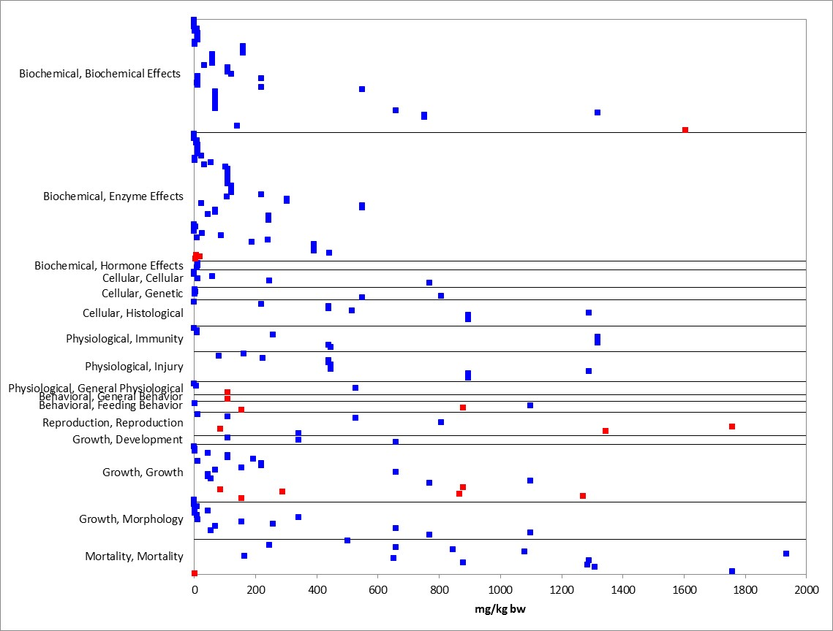
Figure 9-9. Concentrations or Doses Where No Effects Were Observed in Mammals Based on mg/kg-bw. Endpoints normalized to 15g body weight. Blue data points are from open literature, and red data points from registrant submitted studies. Given the number of endpoints, endpoint values ≤2000 mg/kg bw are shown for presentation purposes.

Incident Reports for Mammals

EFED’s incident database (EIIS), accessed October 26, 2015, contains only one incident associated with malathion use and mortality of mammals with a certainty level of “possible.” Mortality of 10 fox squirrels was reported and the squirrels also were exposed to zinc phosphide, a rodenticide which frequently causes mortality of nontarget mammals.

The Aggregate Incident Reports database identified an additional four incidents linked to malathion use as aggregated counts of minor fish/wildlife incidents (W-B), accessed October 26, 2015. Because details about these incidents were not reported, no information was available on the use site, the certainty level, or on the types of organisms that were involved.

Summary of Effects to Mammals

Based on the available toxicity information, malathion can affect survival of mammals both on an acute and chronic exposure basis. However, it is noted that the majority of the mammalian toxicity data are comprised of relatively few mammals (i.e., rats, mice, rabbits). For dose-based mortality studies, toxicity values ranged from a 8-d lethal dose of 25 mg a.i./kg-bw (domestic sheep) to 14-D LD₅₀ of 4780 mg/kg-bw (rat). Effects on growth and reproduction were also reported. Reproductive effects were primarily concerning alterations in sperm or developmental endpoints regarding alterations in implantations or reabsorbed embryos (at a dose of 50 mg/kg/d). Decreases in AChE were also reported, and the sublethal threshold for mammals is based on decreases in RBC AChE at 1 mg a.i./kg-bw .While there are limited behavioral effects data in the available dataset, effects included alterations in general activity, feeding behavior, and grip strength. There are no data for sensory effects.

Effects Characterization for Terrestrial Invertebrates

Introduction to Terrestrial Invertebrate Toxicity

As an insecticide, malathion’s effects on terrestrial invertebrates have been well documented in the literature. Most available studies have focused on mortality endpoints, however, there are also data available for describing sublethal effects, including those related to enzyme activity, growth, behavior, and reproduction. In many cases, due to its mode of action and dose-response curves, when sublethal effects are noted in terrestrial invertebrates, they occur at concentrations near or at the concentration resulting in mortality. This section presents direct effects thresholds for listed terrestrial invertebrates and indirect effects thresholds for species which rely upon terrestrial invertebrates (e.g., as a food source). This section also discusses direct effects on terrestrial invertebrates for the different lines of evidence, when available, addressed in the weight of evidence approach including mortality, decreases in growth, decreases in reproduction, altered behavior, and changes in sensory function.

Threshold Values for Terrestrial Invertebrates

The threshold values for terrestrial invertebrates are based on experimentally determined endpoints for malathion with varying test durations, exposure routes, and study designs. Threshold values for direct and indirect effects are provided in Table 10-1. The acute mortality thresholds are based on the most sensitive LC₅₀ or LD₅₀ (<96 hr exposure) available for terrestrial invertebrates, since a species sensitivity distribution (SSD) could not be derived using the available data. As described in the Problem Formulation (above), sublethal thresholds are also derived to represent the most sensitive non-acute mortality effects for both direct and indirect effects. In the case of malathion and terrestrial invertebrates; however, the most sensitive non-acute mortality endpoints were almost always mortality endpoints, therefore, they are used to represent the most sensitive non-acute mortality thresholds. Studies from which threshold values were derived will be discussed in more detail in the respective line of evidence below.

Threshold values and data arrays (next section) in this assessment are based on endpoints expressed in, or readily converted to, the following exposure units: microgram per gram body weight (ug/g bw), microgram per organism (e.g., ug/bee or ug/larvae), microgram per gram substrate (ug/g substrate), or microgram per gram dry food (ug/g dry food). For mass per unit area exposures (e.g., pounds per acre, lbs/A) , rather than determining a single most sensitive endpoint, the data are considered together in the data arrays to illustrate the range of treatment levels which have elicited various effects in terrestrial invertebrates in situ and ex situ. A species sensitivity distribution is not provided given the variation in experimental designs and types of exposure.

Across the exposure units, toxicity data are available for 23 different terrestrial invertebrate orders (i.e., Araneae, Coleoptera, Collembola, Dermaptera, Diptera, Haplotaxida, Hemiptera, Heteroptera, Homoptera, Hymenoptera, Ixodida, Lepidoptera, Lumbriculida, Moniligastrida, Neuroptera, Orthoptera, Parasitiformes, Rhabditida, Siphonaptera, Strigeatida, Stylommatophora, Thysanoptera, and Trombidiformes). Within these orders, toxicity data are available for 58 different families represented by 117 genera and 145 species.

Table 10-1. Thresholds for Malathion and All Terrestrial Invertebrate Species
EXPOSURE UNIT |  | THRESHOLD VALUE |  |  | ENDPOINT | EFFECT(S) | SPECIES | STUDY ID | COMMENTS
Most Sensitive Endpoint (Relatable to Growth, Reproduction, and/or Mortality)
ug/g bw | Direct Effects |  | 1.22 µg/g-bw¹ |  | 48-hr LD₅₀ = 1.22 µg/g-bw | Mortality | Honey Bee (Apis mellifera) | MRID 49270301 | Endpoint based on adults (mixed sex); topical exposure; slope = 3.19 (1.81-4.57); TGAI
 | Indirect Effects
ug/g-soil | Direct Effects |  | 17.4 mg a.i./kg dry soil¹ |  | 14-d LOAEC = 17.4 mg a.i./kg dry soil¹ | Body wt | Earthworm (Eisenia foetida) | MRID 49086402 | Endpoint based on juvenile worms; conducted under laboratory conditions (20±2 ºC) in a modified artificial soil; CHA 3110
 | Indirect Effects
Lb a.i./acre | Direct Effects |  | 0.00875 lb a.i./acre¹ |  | 72-hr LD₅₀ = 0.00875 lb a.i./A | Mortality | Hemlock sawfly  (Neodriprion tsugae) | E89288 | Endpoint was based on 4th and 5th instars combined; slope = 5.6 (±0.68 SE); exposure to treated spray for 1 minute; TGAI
 | Indirect Effects
Threshold Value(s)
ug/g bw | Direct Effects (1 in a million chance of mortality) |  |  | 0.0395 µg/g-bw | LD₅₀ (contact) = 1.22 µg/g-bw | Mortality | Honey Bee (Apis mellifera) | MRID 49270301 | Endpoint based on adults (mixed sex); topical exposure; slope = 3.19 (1.81-4.57); TGAI
 | Indirect Effects (10% chance of mortality) |  |  | 0.484 µg/g-bw
ug/g-soil | Direct Effects (1 in a million chance of mortality) |  |  | 10.2 mg a.i./kg dry soil² | LC₅₀ (14-D) = 116 ug a.i./ g dry soil | Mortality | Earthworm (Eisenia foetida) | MRID 49086402 | Endpoint based on juvenile worms; conducted under laboratory conditions (20±2 ºC) in a modified artificial soil; CHA 3110
 | Indirect Effects (10% chance of mortality) |  |  | 60.2 mg a.i./kg dry soil²
Lb a.i./acre | Direct Effects (1 in a million chance of mortality) |  |  | 0.0012 lb a.i./A | LD₅₀ = 0.00875 lb a.i./A | Mortality | Hemlock sawfly  (Neodriprion tsugae) | E89288 | Endpoint was based on 4th and 5th instars combined; slope = 5.6 (±0.68 SE); exposure to treated spray for 1 minute; TGAI
 | Indirect Effects (10% chance of mortality) |  |  | 0.0052 lb a.i./A
¹ No NOAEC value is available (effects at all levels (LOAEC value), the same endpoint is used for both direct and indirect effects.
²This is based on a default slope of 4.5.

Summary Data Arrays for Terrestrial Invertebrates

The following data arrays provide a visual summary of the available data for malathion effects on terrestrial invertebrates (Figures 1-5). Effects concentrations are on the horizontal (X) axis and the effect and endpoint type (e.g., MORtality, LD₅₀) are identified on the vertical (Y) axis. A discussion of effects follows the arrays. The data are obtained from registrant-submitted ecotoxicity studies and from open literature studies which have been screened as part of the US EPA ECOTOX database review process.
Data arrays are provided for each of the unit types identified for thresholds (previous section). Additional details are provided for data presented in terms of milligram per kilogram wet weight (mg/kg wet weight), milligram per kilogram soil (mg/kg soil or mg/kg dry soil), and micrograms per experimental unit (ug/eu). For the mass per unit area exposures (e.g., lbs/A), there is greater uncertainty in the identification of a most sensitive endpoint due to the variation in factors such as experimental design and actual relevance to field-scale exposure scenarios. Therefore, the identified thresholds should be considered within the context of the full data arrays. Following the summary arrays, more detailed data arrays are presented in the subsequent sections arranged by lines of evidence.

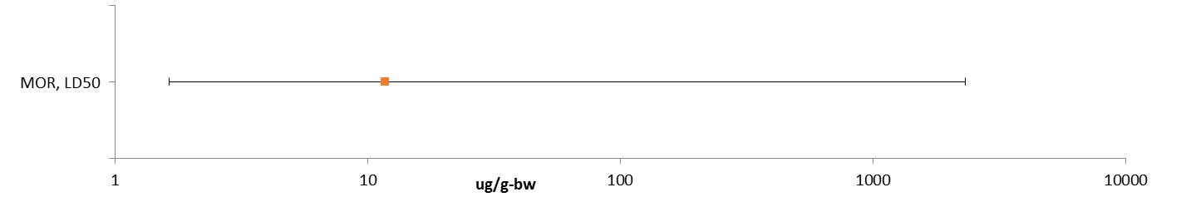
Figure 10-1. Summary Data Array for Endpoints Adjusted for Body Weight (ug/g-bw).
^{MOR:} Mortality.

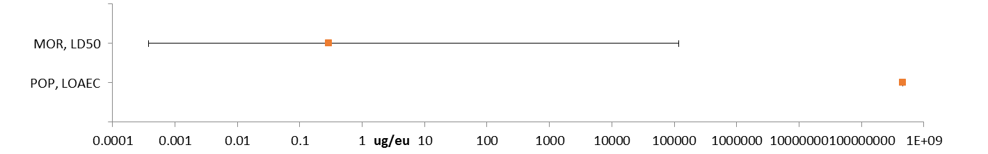
Figure 10-2. Summary Data Array for Endpoints Reported in Terms of Experimental Unit (ug/eu).
^{MOR:} Mortality. ^{POP:} Population (e.g., abundance).

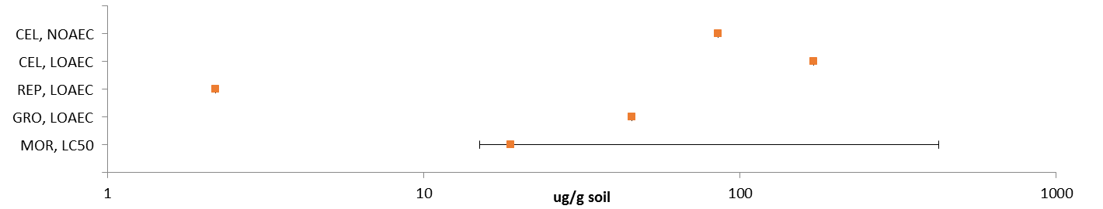
Figure 10-3. Summary Data Array for Endpoints Reported in Terms of Soil Residues (ug/g soil).
^{CEL:} Cellular. ^{REP:} Reproduction. ^{GRO:} Growth. ^{MOR:} Mortality.

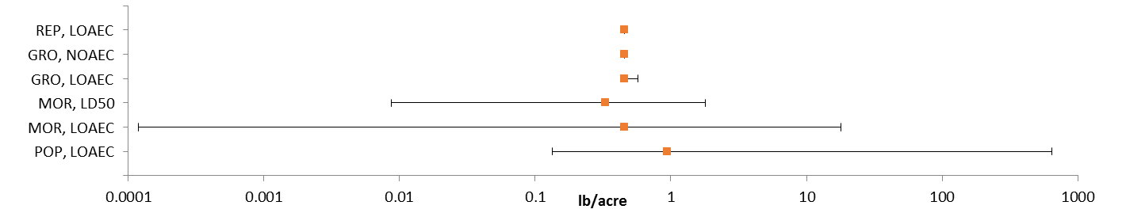
Figure 10-4. Summary Data Array for Endpoints Reported in Terms of Treatment Rate (lbs/A).
^{MOR:} Mortality. ^{POP:} Population (e.g., abundance). ^{REP:} Reproduction. ^{GRO:} Growth.

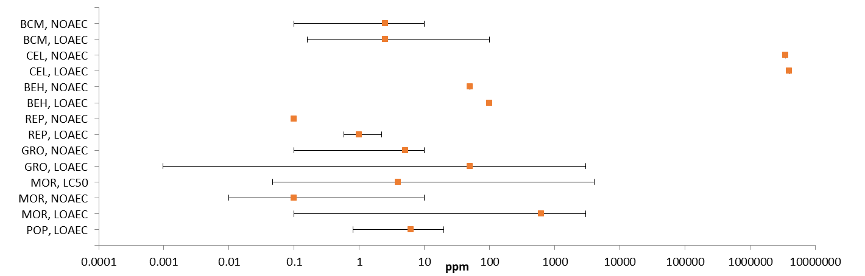
Figure 10-5. Summary Data Array for Endpoints Reported in Terms of Parts Per Million (ppm).
^{BCM:} Biochemical. ^{CEL:} Cellular. ^{BEH:} Behavioral. ^{REP:} Reproduction. ^{GRO:} Growth. ^{MOR:} Mortality. ^{POP:} Population (e.g., abundance).

Lines of Evidence for Terrestrial Invertebrates

Effects on Mortality of Terrestrial Invertebrates
The majority of the toxicity data available for malathion and terrestrial invertebrates involve mortality endpoints. In all cases, mortality is the most sensitive endpoint available for the different environmentally relevant exposure units.

Figures 10-6 through 10-11 provide an overview of the dataset for malathion-related mortality in terrestrial invertebrates, including data discussed below. A red box around the data label signifies that the data point was used to establish a threshold value for effects to listed species. Unless noted otherwise, all data are specific to arthropods. Data arrays in subsequent sections are formatted similarly.
NOAEC/LOAEC and LC₅₀/LD₅₀ Threshold Value (ug/g-bw):

For the exposure unit ‘ug/g-bw’, the most sensitive endpoint available for terrestrial invertebrates is an LD₅₀ value of 0.156 ug a.i./bee for the honey bee, Apis mellifera (MRID 49270301). The standard body weight value for the honey bee is used to convert the LD₅₀ value reported in ug a.i./bee to 1.22 ug a.i./g-bw (0.156 ug a.i./bee ÷ 0.128 g/bee = 1.22 ug a.i./g-bw). This endpoint is more sensitive than any of the available NOAEC or LOAEC values; therefore, it is used as the ‘sublethal’ threshold for direct and indirect effects for this exposure unit (although this endpoint is based on mortality, it is more sensitive than any endpoint available for sublethal effects). It is used for the acute mortality thresholds for direct and indirect effects. An LD₅₀ value of 1.22 ug a.i./g-bw results in mortality thresholds for direct and indirect effects of 0.0395 and 0.484 ug a.i./g-bw, respectively (based on a slope of 3.19 from the study).

In this acute contact study, 30 bees per test level were exposed to nominal concentrations of 0 (negative and solvent control), 0.025, 0.05, 0.10, 0.20, 0.40, and 0.80 ug a.i./bee for 48 hours. Mortality and sublethal effects, including immobility and lethargy, were observed at 2.25/3, 24 and 48 hours. Results are provided in Table 10-2.

Table 10-2. 48-hr Mortality of Malathion (TGAI) to Apis mellifera.

 |  | Observations of mortality and sublethal effects
Dose  (µg ai/bee) | No. bees | 2.25/3 hours Number dead (% mortality) | 24 hours Number dead (% mortality) | 48 hours Number dead (% mortality)
Negative control | 30 | 0 (0%) | 0 (0%) | 0 (0%)
Acetone control | 30 | 2 (7%) | 2 (7%) | 2 (7%)
0.025 | 30 | 0 (0%) | 0 (0%) | 2 (7%)
0.05 | 30 | 0 (0%) | 0 (0%) | 1 (3%)
0.10 | 30 | 1 (3%) | 2 (7%) | 5 (17%); 1L
0.20 | 30 | 0 (0%); 2L | 12 (40%); 1I; 1L | 16 (53%); 1L
0.40 | 30 | 10 (33%); 5I, 2L | 30 (100%) | 30 (100%)
0.80 | 30 | 22 (73%); 4I; 2L | 30 (100%) | 30 (100%)
I – immobile; L - lethargic

Mortality Effects Array (ug/g-bw):

Mortality data associated with the exposure unit of mg/mg-bw are available for 4 orders (i.e., Coleoptera, Diptera, Hymenoptera, and Lepidoptera) represented by 8 families, 10 genera, and 14 species. Based on the available data, malathion is associated with mortality of terrestrial invertebrates at concentrations ranging from 1.64 to 2320 ug/g-bw (Figure 7.6).

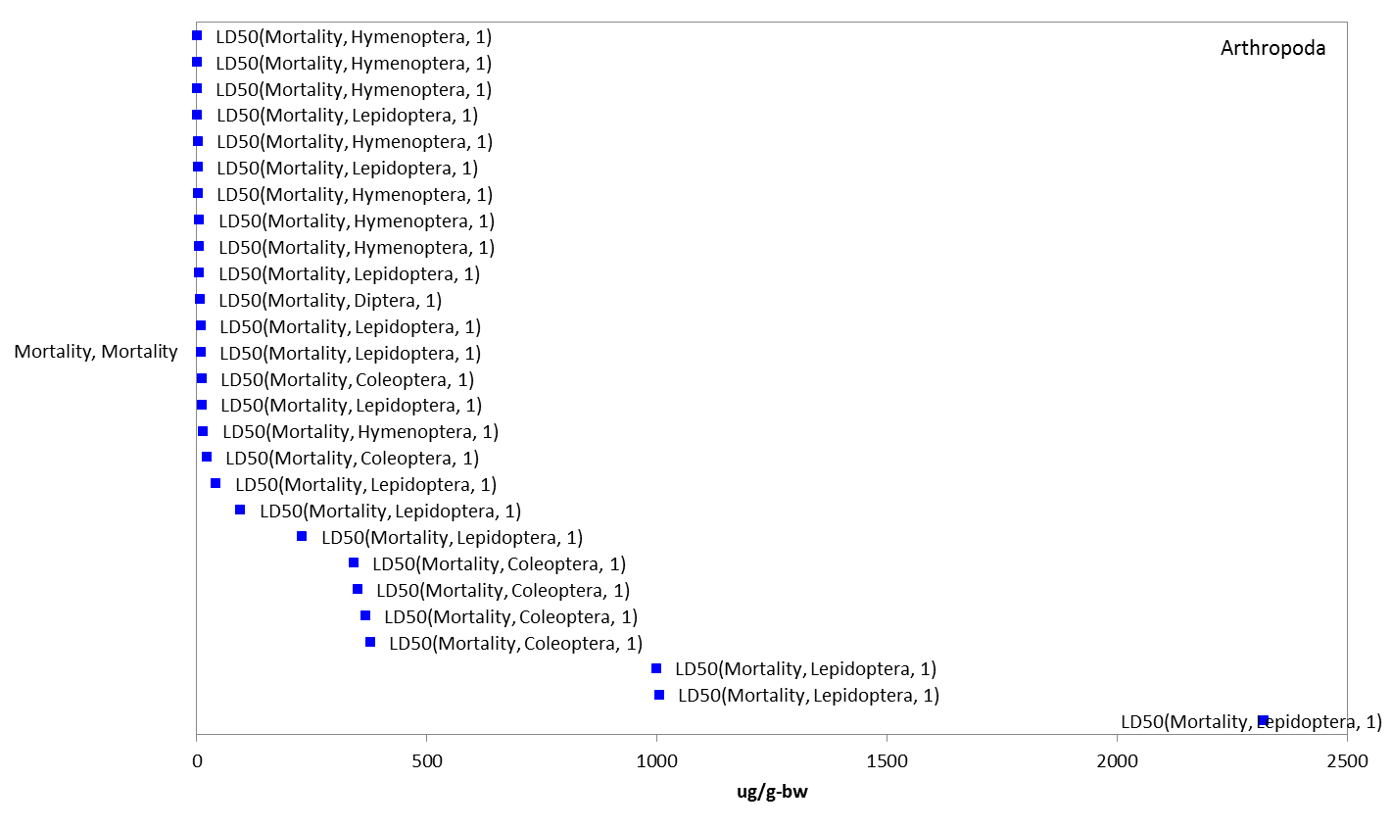
Figure 10-6. Data Array for Mortality Endpoints Adjusted for Body Weight (ug/g-bw). Data are only available for the phylum arthropoda. Blue data points are from open literature studies.

NOAEC/LOAEC and LC₅₀/LD₅₀ Threshold Value (ug/kg-soil):

For the exposure unit ‘ug/kg-soil’, the most sensitive suitable endpoint available for terrestrial invertebrates is an LC₅₀ value of 7.54 ug a.i./g-soil for juvenile earthworms (Eisenia foetida) which were exposed to a malathion formulation (CHA 3110 ; 40.6%; MRID 49086402). However, given uncertainty in the test material, it is not used as the threshold endpoint. A similar study with earthworms (Eisenia foetida) (MRID 49086402) using a CHA 3110 reported a 14-day LC50 of 116 mg a.i./kg dry soil. Effects on body weight was affected at all test concentrations (LOAEC = 17.4 mg a.i./kg-soil). After 14-days of exposure, mortality in the control and the two lowest treatment groups (17.4 and 38.1 mg a.i./kg soil). Mortality was 33, 78, and 100% at 84, 185, and 406 mg a.i./kg soil.

Mortality was recorded after 14 days (Table 10-3).

Table 10-3. 14-d Mortality and Efffects on Body Weight of Malathion (CHA 3110) to Earthworms.*
Insecticide | 14-d LC50 (ug/g soil) | Body Weight (ug/g soil)
 | LC₅₀ | LOAEC
Malathion | 116 | 17.4 (71% reduction
- Corrected for % purity (40.6%)

Mortality Effects Array (ug/g-soil):

Mortality data associated with the exposure unit of ug/g-soil are available for 2 orders of earthworm (i.e., E. fetida; Order: Lumbriculida and D. willsi; Order: Moniligastrida) represented by 2 families, genera, and species. Based on the available data, malathion is associated with mortality of terrestrial invertebrates at concentrations ranging from 15 to 426 ug/g-soil (Figure 10-7).

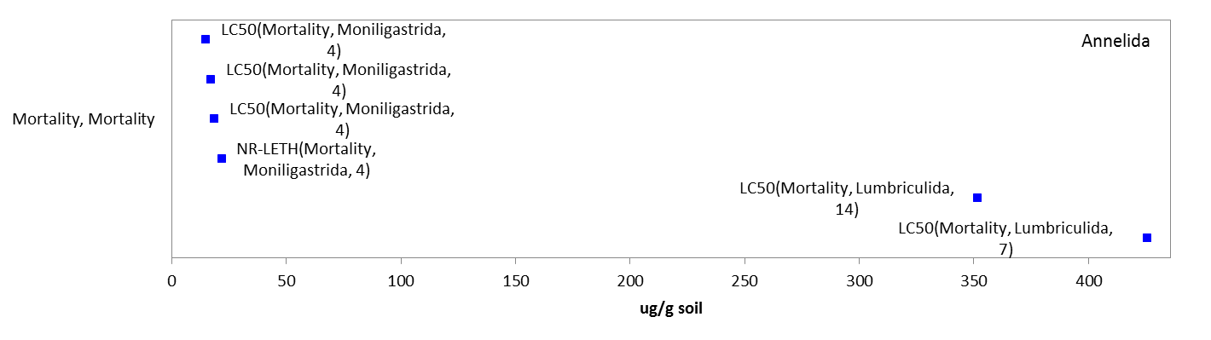
Figure 10-7. Data Array for Mortality Endpoints Based on Soil Residues (ug/g soil). Data are only available for the phylum Annelida. Blue datapoints are from open literature studies.

Most Sensitive NOAEC/LOAEC and LC₅₀/LD₅₀ Value (ug/e.u.):

For the exposure unit ‘ug/e.u.’, the most sensitive endpoint available for terrestrial invertebrates is an LD₅₀ value of 0.000375 µg a.i./organism for contact exposure to 2 to 3 day old female adult Anopheline mosquitoes (A. albimanus) (E111057). This endpoint is more sensitive than any of the available NOAEC or LOAEC values.

In this study, conventional insecticides [including malathion (5% a.i., source was not reported)] were conducted to evaluate the larvicidal and adulticidal efficacy against several species of adult and larvae Anopheline mosquitoes (A. stephensi, A. gambiae, A. albimanus, and A. farauti) in laboratory bioassays. Only the bioassays of malathion to larval and adult Anopheline mosquitoes with the exception of A. farauti species are reported here. Mosquitoes were reared at 25°C and 60% relative humidity, under a 16:8 (light: dark) photoperiodic regime. 2-3 days old female adults and fourth instar larvae were used. Adults were fed with 3% sugar solution. A 0.3 µl acetone solution of the emulsifiable concentrate of malathion was applied topically to the dorsal mesothorax of adult mosquitoes; while the larvae (n=30) were released into 150 ml of the malathion formulation diluted with deionized water at appropriate concentrations. The number of treatment levels and replicates were not reported. Also not reported was whether acetone was used in the control groups. Mortality was recorded after 24 hours. The mortality of adults and % of emergence were corrected to of the control. Bliss’s probit (1934) was used to determine the LD₅₀ values.

For malathion, the most sensitive LD₅₀ value is reported as 0.0075 µg formulation/female, which is 0.000375 µg a.i/female when corrected for % malathion in the formulation. The most sensitive life-stage is female adults (see Table 10-4).

Table 10-4. Toxicity of Malathion (5% EC) to Larval and Adult Anopheline Mosquitoes.
Species | Adult LD₅₀ (µg formulation/female) | Larvae LD₅₀ (ppm)
A. stephensi | 0.017 | 0.35
A. gambiae | 0.018 | 0.19
A. albimanus | 0.0075 | 0.12

Mortality Effects Array (ug/eu.):

Mortality (including population-level effects on abundance) data associated with the exposure unit of ug/eu. are available for 6 orders (i.e., Coleoptera, Diptera, Heteroptera, Homoptera, Hymenoptera, and Lepidoptera) represented by 16 families, 23 genera, and 28 different species. The data shown in Figure 10-8 involve only mortality endpoints (e.g., EC₅₀, EC₉₉, LC₅₀, LD₁₀, LD₅₀, LD₉₀, LD₉₉, and LT₅₀). The available LD₅₀ values for malathion range from 0.000375 to 870 mg/eu and the LC₅₀ values range from 0.006 to 117,000 ug/eu. The population-level effect is limited to one LOAEC value of 4.54x10⁸ ug/eu., which is 1000x greater than the highest mortality value.

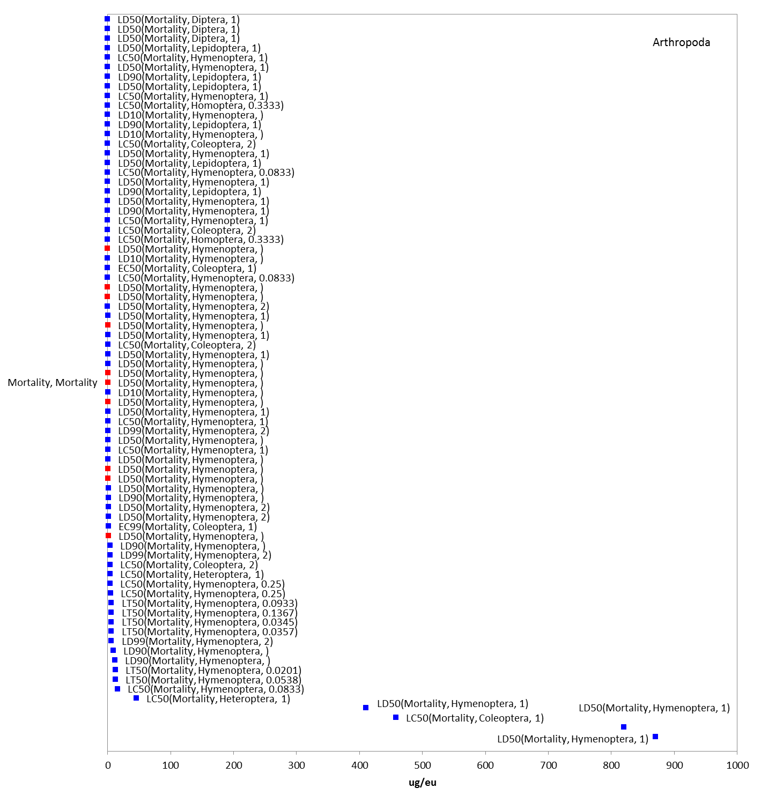
Figure 10-8. Data Array for Mortality Endpoints Based on Experimental Unit (ug/eu). Data are only available for the phylum Arthropoda. Blue data points are from open literature studies, and red data points are from registrant-submitted studies. Note that there is an LC₅₀ value of 117,000 ug/eu that has been removed from the array for presentation purposes.

NOAEC/LOAEC and LC₅₀/LD₅₀ Threshold Values (lb/acre):

For the exposure unit ‘lb/acre’, the most sensitive terrestrial invertebrate is an LC₅₀ value of
0.00875 lb/acre (reviewer adjusted reported values of oz/acre to lb/A) for mortality in a Hemlock sawfly (Neodriprion tsugae)(E89822). This endpoint is more sensitive than any of the available NOAEC or LOAEC values for terrestrial invertebrates; therefore, it is used as the sublethal threshold for direct and indirect effects for this exposure unit (although this endpoint is based on mortality, it is more sensitive than any endpoint available for sublethal effects). It is also used for the acute mortality thresholds for direct and indirect effects. An LC₅₀ value of 0.00875 lb/acre results in mortality thresholds for direct and indirect effects of 0.0012 and 0.0052 lb/acre, respectively (based on a slope of 5.6 from the study).

This paper discussed the thirteen insecticides tested in a laboratory spray chamber on 4th and 5th instar hemlock sawfly, Neodriprion tsugae Middleton. Only the results on the toxicity of malathion to the hemlock sawfly species are reported here. Technical grade malathion was dissolved in Dowanol TPM (tripropyleneglycol monomethyl ether). Serial dilutions were made from stock solutions prepared on the basis of weight-volume concentration of the active ingredient. Each test was replicated at least three times and a control group was included in each trial. Controls were treated with Dowanol TPM alone. Test organisms were 4th and 5th instars (collected from McKenzie Inlet, Alaska and fed western hemlock foliage) in groups of 10 into 9 cm diameter paper lids, held in a laboratory spray chamber. Identification by using the head capsule measurements of Beal (1993), and treated as described by Robertson (1972). Spray was introduced into the chamber for 10 seconds and the insects were exposed to the spray for 1 minute. Dosage was measured in the spray chamber as µg/cm² AI by weighing deposits on 9 cm diameter filter paper; then converted to oz./acre by the formula -- µg/cm² divided by 0.7 = oz./acre. After treatment, sawflies were transferred to sterile 100x20 mm petri dishes lined with filter paper and fed western hemlock foliage. Numbers of dead and moribund insects were recorded after 72 hours. Probit was used to determine the LD₅₀ and LD₉₀, fiducial limits, and slope.

The results for malathion are reported below (see Table 10-5).

Table 10-5. 72-hr Mortality of Technical Grade Malathion to Hemlock Sawflies*
Insecticide |  | No. of Insects | SlopeSE |  | LD₅₀ | 95% F.L. | LD₉₀ | 95% F.L.
Malathion |  | 180^{A} | 5.36±0.74 |  | 0.15 | 0.12-0.17 | 0.25 | 0.21-0.36
 |  | 258^{B} | 5.60±0.68 |  | 0.14 | 0.12-0.16 | 0.24 | 0.21-0.32
* oz./acre
FL = fiducial limits
^{A} Fourth instars only
^{B} Fourth and fifth instars combined

Mortality Effects Array (lb/acre):

Mortality data associated with the exposure unit of lb/acre are available for 9 orders (i.e., Coleoptera, Heteroptera, Hymenoptera, Ixodida, Lepidoptera, Lumbriculida, Parasitiformes, Siphonaptera, and Stylommatophora) represented by 16 families, 17 genera, and 17 species. Regarding mortality, malathion is associated with increased mortality of terrestrial invertebrates at concentrations from 0.00012 to 18 lb a.i./acre (Figure 10-9). Most of the endpoints for malathion and terrestrial invertebrates reported in the lb a.i./acre exposure unit are for population-level effects (all related to abundance/control which are assumed to be related to mortality; and are, therefore included in this mortality section). These effects are seen at concentrations from 0.1 to 645 lb a.i./acre (Figure 10-10).

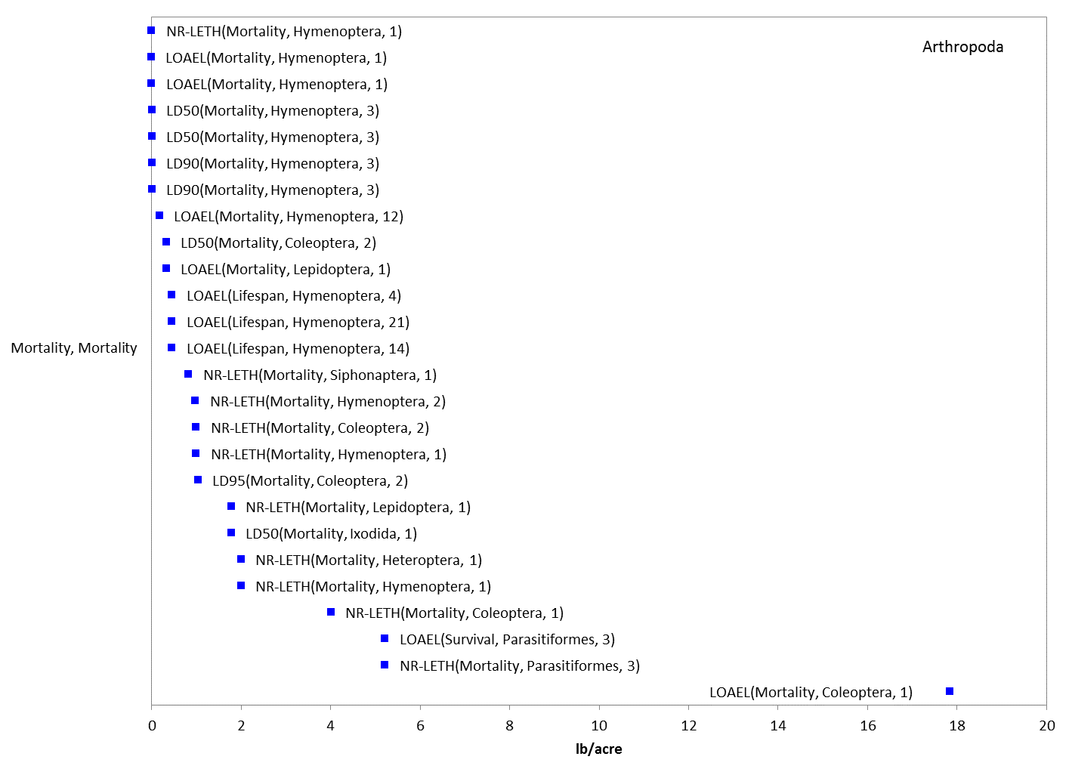
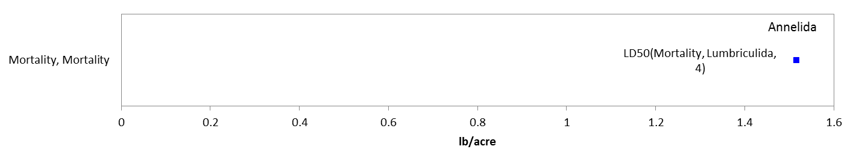

Figure 10-9. Data Array for Mortality Endpoints Based on Treatment Rate (lbs/A). Data are available for the phyla Arthropoda and Annelida. Blue data points are from open literature studies.

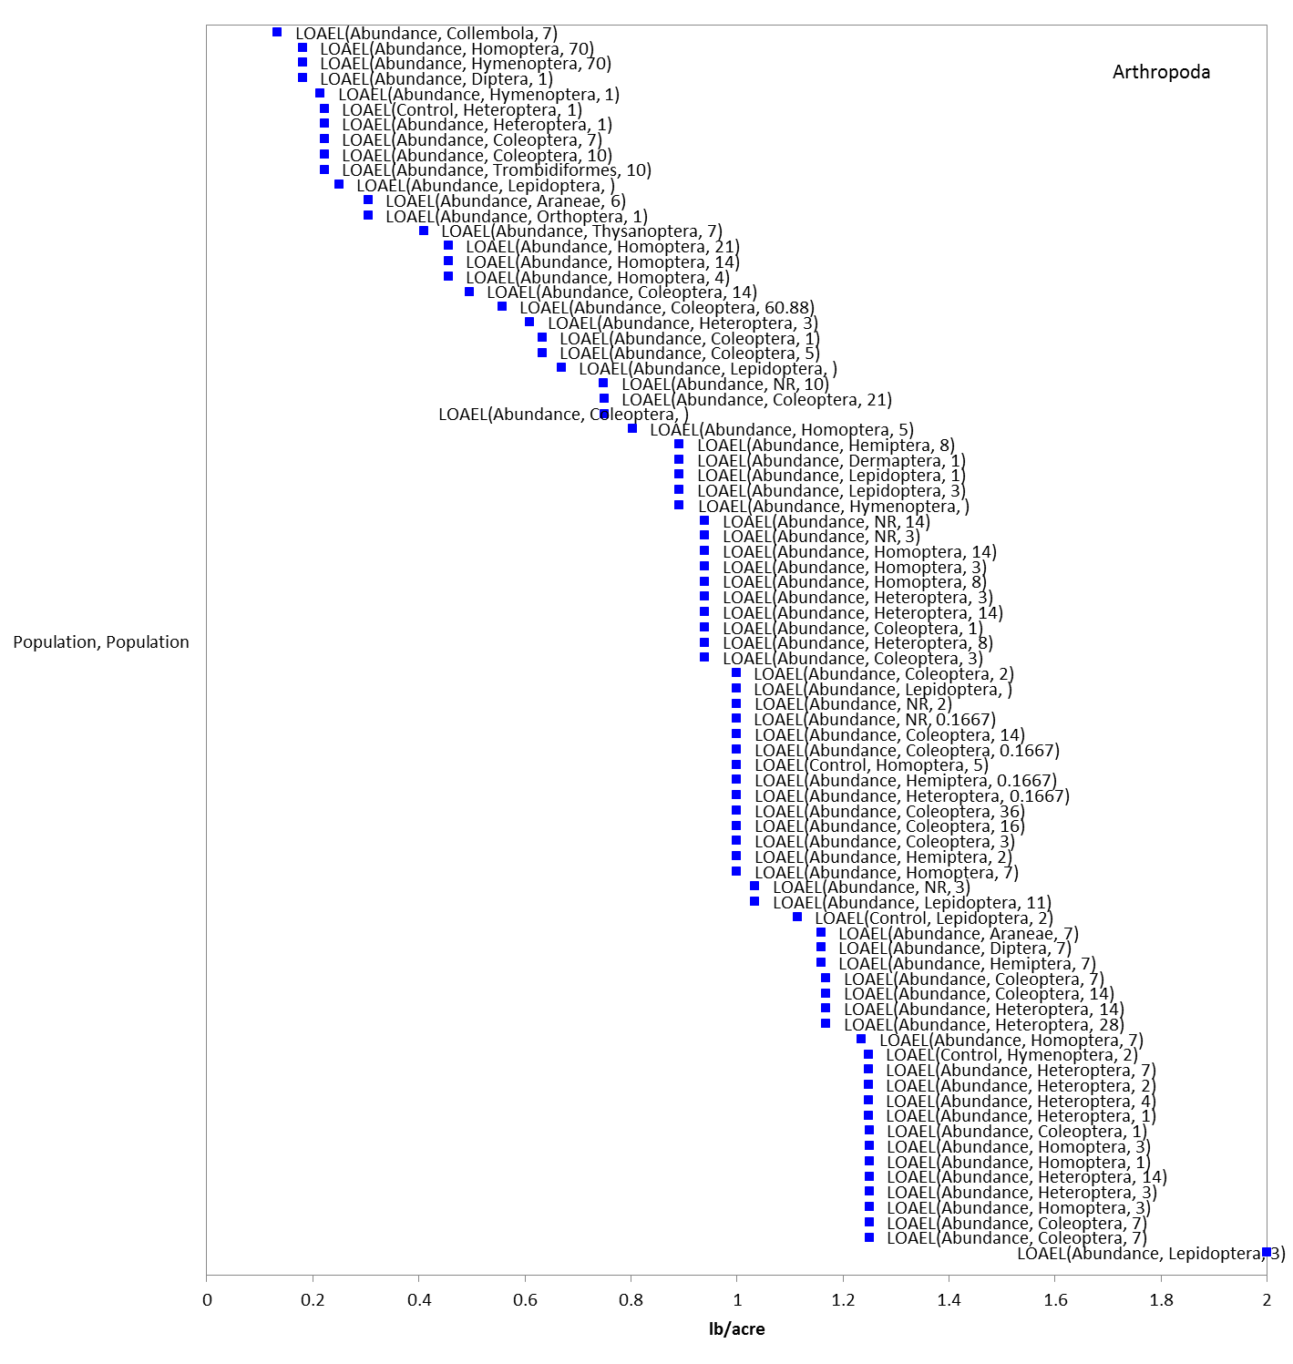
Figure 10-10. Data Array for Population (e.g., abundance) Based on Treatment Rate (lbs/A). Data are available for the phylum Arthropoda only. Blue data points are from open literature studies. Note that there is one value at 645 lb/A that has been removed from the array for presentation purposes.

Most Sensitive NOAEC/LOAEC and LC₅₀/LD₅₀ Value (ppm):

For the exposure unit ‘ppm’, the most sensitive endpoint available for terrestrial invertebrates is an LC₅₀ value of 0.047 mg a.i./L (ppm) for mosquito (Culex quinquefascatus) (E82047). This endpoint is more sensitive than any of the available NOAEC or LOAEC values for terrestrial invertebrates.

The focus of the study was the evaluation of Culex quinquefascatus (mosquito) resistance against malathion. The technical grade (95% a.i.) from M/S Cynamide India LTD was tested. Only the results of the bioassays are reported here. In the test, larvae were collected from major mosquito breeding sites in South India villages of K.K. Nagar, Malaipatti, Makkalakottai, and Kuthiparai. Additionally, a susceptible C. quinquefasciatus population collected from Madurai and reared for several generations at the Centre for Research in Medical Entomology was used too. The larvae were acclimated in the laboratory at ambient conditions (29-31°C, 80% relative humidity) in enamel trays and fed yeast and dog biscuits as described by Poopathi et al. (1999). Newly emerged fourth instars were used in the larval bioassays. For adult bioassays, pupae were allowed to emerge in cages and sexed; newly emerged mated female mosquitoes were fed blood meal from a live chicken; then the fully blood fed mosquitoes were used in the bioassays. Stock solutions were titrated in the appropriate volume of double distilled water to produce concentrations ranging from 0.02 to 1 mg/L as described by WHO (1992). The treatment solution for the larval bioassay was added into polythene disposable cups containing 150 ml of double distilled water. For the adult contact bioassay as described by Poopathi and Raghunatha Rao (1995), the solution was impregnated on Whatman No. 1 filter papers. Three replicates of 25 early fourth instars of C. quinquefasciatus larvae were added to each treatment level and water alone, fed, and after 24 h mortality was recorded; while 3 replicates of 25 adults were added to treated papers with different concentrations and untreated filter papers and were exposed for 1 hour, then removed and transferred to observation cages, then after 1 hour mortality was recorded. Any moribund larvae were considered dead. ASSAY, a dosage mortality regression analysis, was used to determine the LC₅₀, LC₉₀, and LC₉₅ values. The Abbott’s formula (1925) was used to correct the data if control mortality exceeded 5 to 20%.

For malathion, the laboratory strain LC₅₀ value is reported as 0.047 mg/L; the most sensitive field-collected strain (K.K. Nagar) LC₅₀ value is reported as 0.1 mg/L. Adult mosquitoes were more sensitive than larval mosquitoes (see Table 10-6).

Table 10-6. Dosage-Mortality Data for Larvae and Adult Mosquitoes Treated with Malathion.
DATUM | Strains (Collection Site)
 | Madurai¹ | K.K. Nagar | Malaipatti | Nakkalakottai | Kuthiparai
Adult mosquitoes (Contact exposure)
LD₅₀ | 0.047 mg/L | 0.1 mg/L | 0.689 mg/L | 0.413 mg/L | 1.63 mg/L
LD₉₀ | 0.488 mg/L | 0.545 mg/L | 1.6 mg/L | 2.66 mg/L | 7.15 mg/L
LD₉₅ | 0.95 mg/L | 0.879 mg/L | 2.04 mg/L | 4.51 mg/L | 10.87 mg/L
Larvae mosquitoes (Aquatic exposure)
LD₅₀ | 0.126 mg/L | 0.31 mg/L | 0.21 mg/L | 0.18 mg/L | 0.19 mg/L
LD₉₀ | 0.718 mg/L | 2.09 mg/L | 0.96 mg/L | 0.74 mg/L | 0.96 mg/L
LD₉₅ | 1.175 mg/L | 3.61 mg/L | 1.48 mg/L | 1.11 mg/L | 1.52 mg/L
¹ susceptible, laboratory strain.

Mortality Effects Array (ppm):

Mortality data (including population-level effects on abundance/control) with the exposure unit of ppm are available for 10 orders (i.e., Coleoptera, Diptera, Heteroptera, Homoptera, Hymenoptera, Lepidoptera, Lumbriculida, Neuroptera, Rhabditida, and Strigeatida) represented by 24 families, 35 genera, and 41 species. Based on the available data, malathion is associated with mortality of terrestrial invertebrates at concentrations ranging from 0.047 to 3999 ppm (Figure 10-11). Population-level effects (all related to abundance/control which are assumed to be related to mortality; and are, therefore included in this mortality section) from malathion (i.e., control and abundance) are seen at concentrations ranging from 0.8 to 20 ppm (see Figure 10-11).

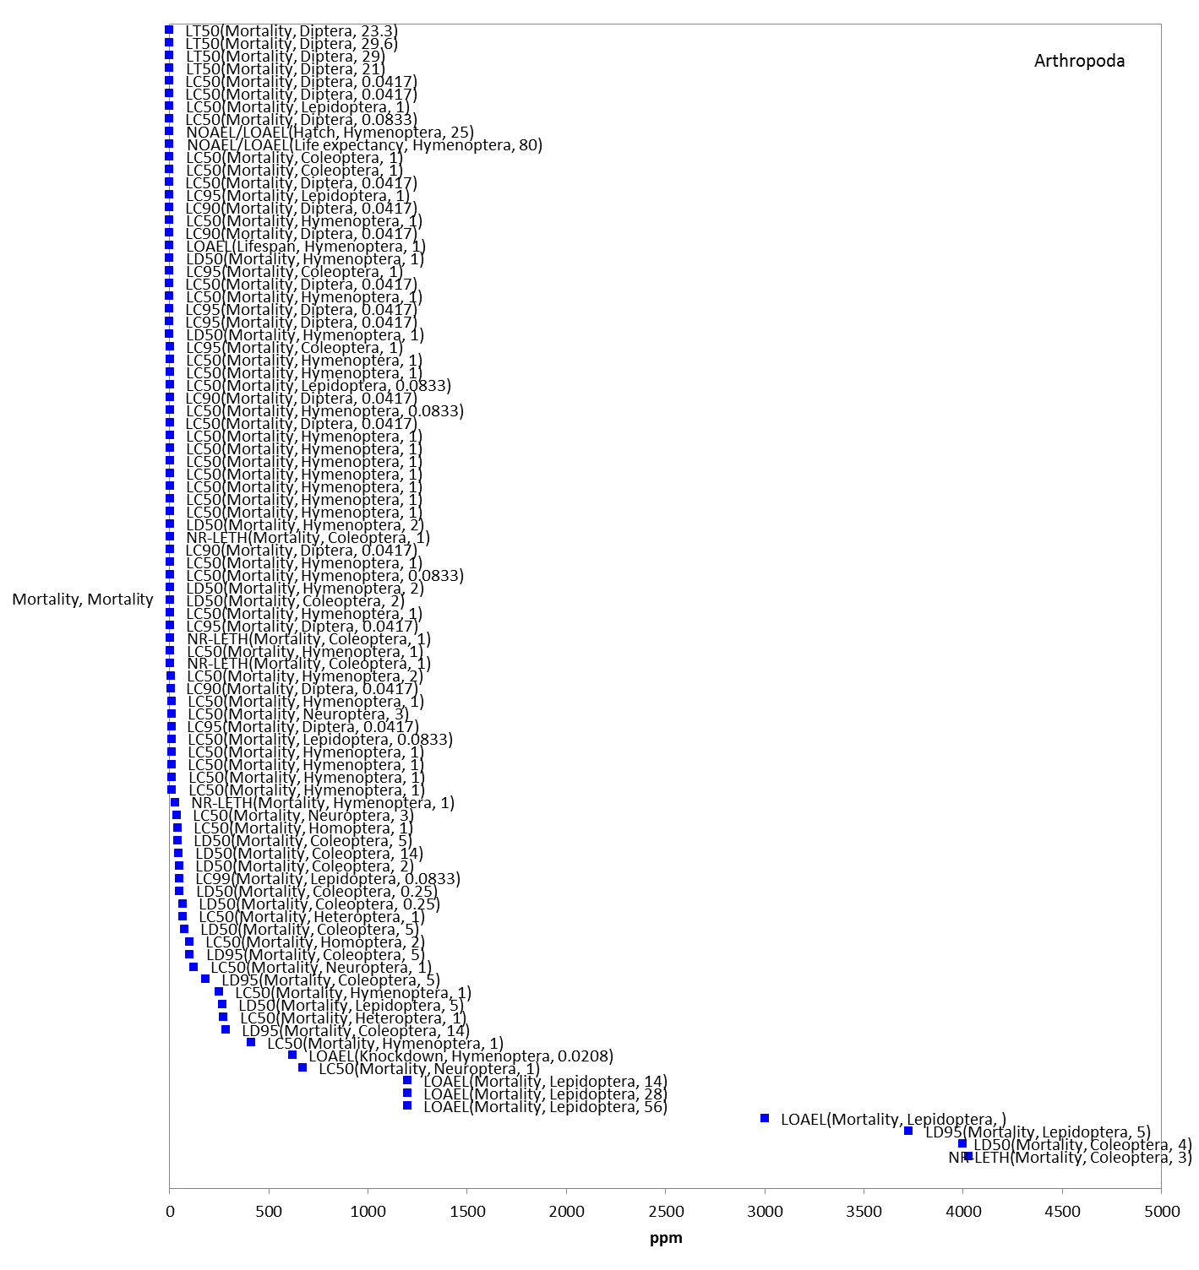
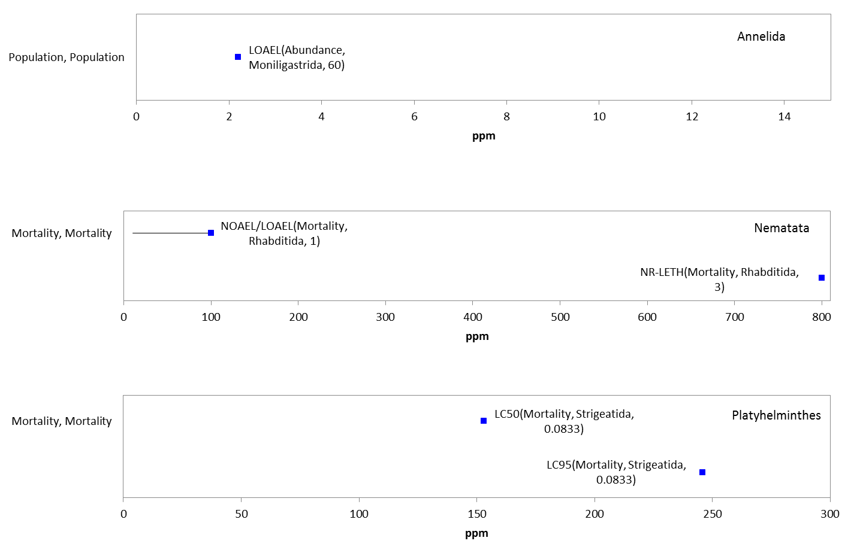
Figure 10-11. Data Array for Mortality Endpoints Reported in Parts Per Million (ppm). Data are available for the phyla Arthropoda, Annelida, Nematata, and Platyhelminthes. Blue data points are from open literature studies.

Registrant-Submitted Terrestrial Invertebrate Toxicity Data

Because of the complexities associated with the terrestrial invertebrate toxicity data available in the open literature and screened through ECOTOX (e.g., variable methodologies, exposure routes, exposure units, species), a brief discussion of the available guideline studies conducted with honeybees (Apis mellifera) and submitted by the registrants is provided here. This discussion is meant to provide context for the available terrestrial invertebrate thresholds for malathion.

Based on the submitted data, malathion is classified as very highly toxic to bees. The LD₅₀ values from the acceptable acute honey bee (contact) studies are 0.27 µg a.i./bee (MRID 05001991), 0.25 µg a.i./bee (MRID 05001451), 0.709 µg a.i./bee (MRID 0001999), 0.46 µg a.i./bee (MRID 05008990), 0.189 µg a.i./bee (MRID 49270301) and 0.3662 µg product/bee (MRID 49051205; 42% a.i.) (Table 10-7). Additionally, the LC₅₀ values from the acceptable acute honeybee (oral) studies are 0.38 µg a.i./bee (MRID 05001991), 0.38 µg a.i./bee (MRID 05001451), 1.66 µg a.i./bee (MRID 49270302) and 0.9635 µg product/bee (MRID 49051205; 42% a.i.).

Table 10-7. Available Honey Bee (Apis mellifera) Toxicity Data from Guideline Studies (Acute Contact and Oral).
% AI | LD₅₀/LC₅₀  (µg a.i./bee) | MRID | CLASSIFICATION | COMMENTS
TGAI | 0.27 (contact) | 05001991 | Acceptable | Results appear to be the 1964 study as reported in MRID 05004151. Slope = 8.5; 24-hr
 | 0.38 (oral)
 | 0.25 (contact) | 05004151 | Acceptable | Results are weighted means of mean values reported for two tests conducted in 1964 and three tests conducted in 1965. Slope = 8.3; 24-hr
 | 0.38 (oral) |  |  | Results based on test conducted in 1964. Slope = 3.5; 24-hr
 | 0.709 (contact) | 0001999 | Acceptable | 96-hr value; slope = 8.04
 | 0.46 (contact) | 05008990 | Acceptable | 72-hr values
 | 0.156 (contact) | 49270301 | Acceptable | 48-hr; 95% C.I. = 0.1-0.2 µg/bee
 | 1.66 (oral) | 49270302 | Acceptable | 48-hr
42% | 0.3662 (contact) | 49051205 | Acceptable | 48-hr values
 | 0.9635 (oral)

Other submitted data indicate that residues on alfalfa foliage samples from application of Cythion 57% EC (This formulation is no longer registered for use in the United States) at 1.6 lb a.i./acre were highly toxic between 8 to 24 hours to the honeybee (Apis mellifera). At 24 hours, residues on alfalfa foliage were not toxic to the honeybee (MRID 41208001).

Another study examining effects of aged residues of Fyfanon ULV (96% purity) on alfalfa foliage to the honeybees (MRID 49574801). Mortality and sublethal effects such as changes in behavior were evaluated. Bees in each treatment group were confined for approximately 24 hours to treated alfalfa foliage from each of the residue aging intervals at 3, 24, 48, 96 and 192 hours. Percent immobility/mortality of bees in the 3, 24, 48, 96 and 192 hour residue aging groups following an application rate of 1.22 lb a.i./A was 100, 100, 100, 97.3 and 2.7%, respectively. Mortality in the negative control group were <2.7%. The RT₂₅, the residual toxicity of treated foliage in hours, as measured by a decline in mortality of a bee population to 25%, was calculated to be 154 hours with 95% C.I. of 152-156 hours. The 96 and 192 hour aging intervals were the only aging time intervals utilized in the analysis since all other intervals resulted in 100% mortality. Mean residues for malathion were 317 ± 99.5 ppm a.i., 522 ± 313 ppm a.i., 320 ± 97.6 ppm a.i., 84.8 ± 36.6 ppm a.i., 19.7 ± 5.8 ppm a.i for 3, 24, 48, 96 and 192 hours, respectively.

Sublethal Effects to Terrestrial Invertebrates
For malathion, there are far fewer data available for growth, reproduction, and behavior effects compared to mortality; therefore, the discussion of effects has been consolidated into a single section. Data for growth and reproduction are available in exposure units of ‘ug/g-soil’, ‘lb/acre’, and ‘ppm’. Data for growth are available for the ‘ppm’ exposure unit only.

For the ‘lb/acre’ exposure unit, growth and reproduction data available for one order (i.e., Hymenoptera), represented by 1 family, genus and species (i.e., Aphididae Diaeretiella rapae); for the ‘mg/kg-soil’ exposure unit, there are growth and reproduction data for two orders (i.e., Moniligastrida and Lumbriculida), represented by two families, genera and species (i.e., Moniligastrida Drawida willsi and Lumbricidae Eisenia fetida), and for the ‘ppm’ exposure unit, there are growth, reproduction, and behavior available for 4 orders (i.e., Hymenoptera, Moniligastrida, Lepidoptera and Rhabditida), represented by 6 families, 6 genera and 7 species.

Reproductive-level effects are seen at concentrations from 0.576 to 2.2 ppm (i.e., progeny counts/numbers, fecundity, and general reproduction); at 1100 ug/g-soil (i.e., progeny counts/numbers); and at 0.45672 lb/acre (i.e., progeny counts/numbers). Growth effects are seen at concentrations from 0.00096 to 3000 ppm (i.e., emergence and pupation); at 45600 ug/g-soil (i.e., weight); and at 0.45672 and 250 lb/acre (i.e., emergence). A behavioral effect on the number of movements is seen at a concentration of 100 ppm (Figure 10-12 for ug/g-soil, Figure 10-13 for lb/acre, and Figure 10-14 for ppm).

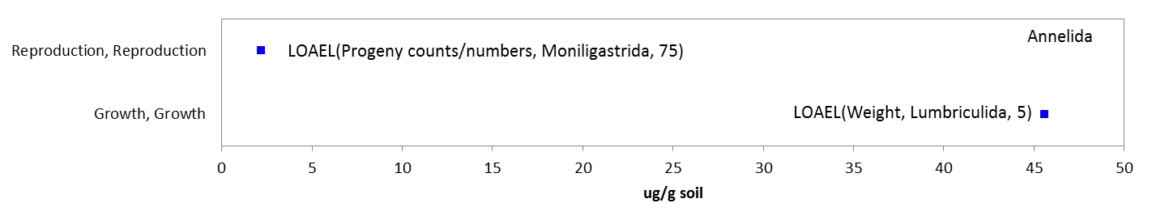
Figure 10-12. Data Array for Reproduction (i.e., progeny counts) and Growth (i.e., weight) Endpoints Based on Soil Residue (ug/g-soil). Data are only available for the phylum Annelida. Blue data points are from open literature studies.

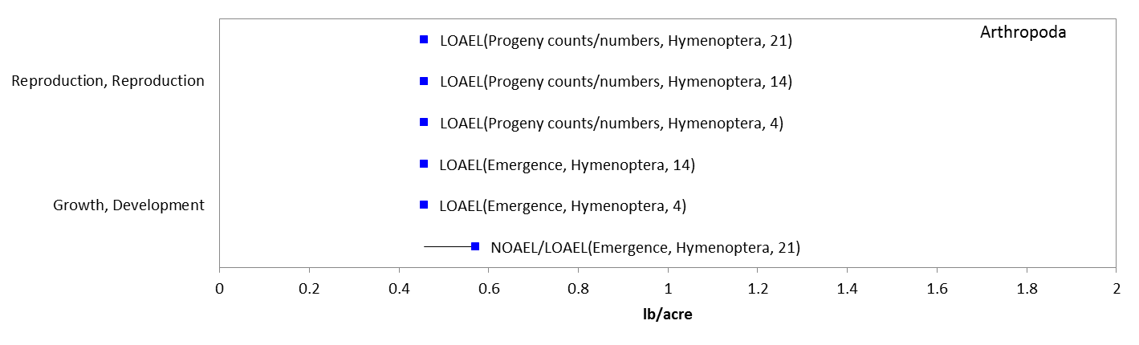
Figure 10-13. Data Array for Reproduction (i.e., progeny counts) and Growth (i.e., emergence) Endpoints Based on Treatment Rate (lbs/acre). Data are only available for the phylum Arthropoda. Blue data points are from open literature studies.

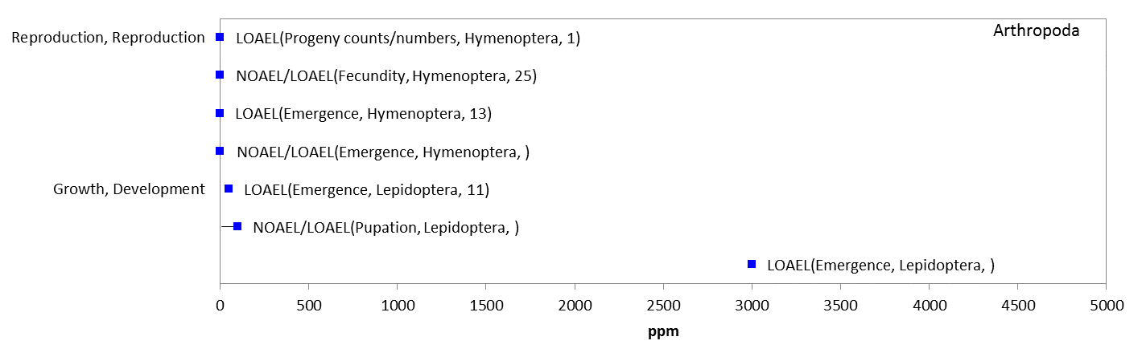
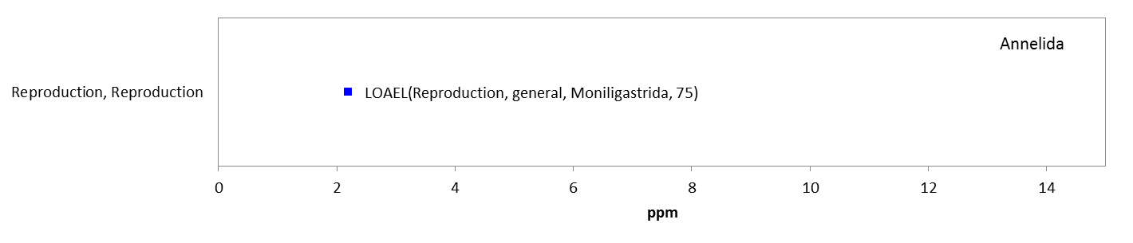
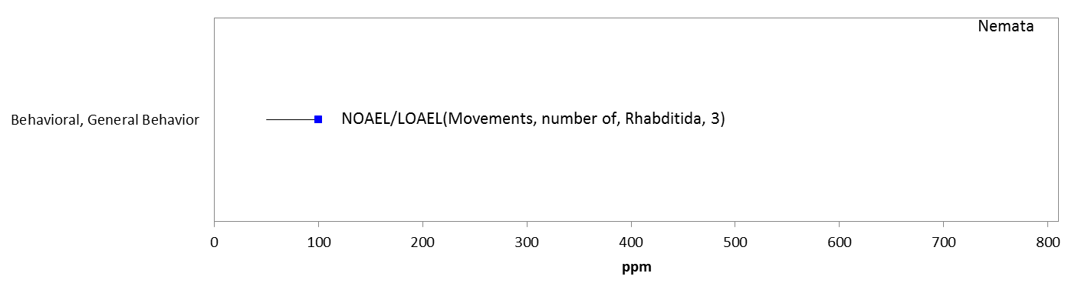
Figure 10-14. Data Array for Behavior (i.e., number of movements), Reproduction (i.e., progeny counts and fecundity), and Growth (i.e., emergence and pupation) Endpoints Reported in Parts Per Million (ppm). Data are available for the phyla Arthropoda, Annelida, and Nemata. Blue datapoints are from open literature studies.

10.4.2.1. Other Effects Reported for Terrestrial Invertebrates

There are toxicity data available for malathion and terrestrial invertebrates in addition to those directly related to mortality, growth, reproduction, behavior, and sensory effects. These are described below. The ‘sub-organism’ endpoints generally occur at concentrations similar to those seen for the endpoints discussed above; however, how these endpoints directly relate to mortality, growth, reproduction, behavior, and sensory effects in terrestrial invertebrates is unclear.

There are only limited data available for malathion and sub-organism (biochemical) effects to terrestrial invertebrates to the ‘ppm’ exposure unit. For the ‘ppm’ exposure unit, data are only available for 5 orders (i.e., Haplotaxida, Hymenoptera, Lepidoptera, Moniligastrida, and Rhabditida), represented by 6 families, 7 genera, and 5 species. The only sub-organism effect seen include changes in biochemical and enzyme levels (A-naphthyl acetate esterase, acetylcholinesterase, amylase, cellulase, invertase, malathion carboxylesterase, and malondialdehyde) at concentrations from 0.16 to 100 ppm (Figure 10-15). There are currently no toxicity data with sub-organism endpoints available for malathion and terrestrial invertebrates with the exposure units of lb/acre, mg/e.u., mg/kg-soil or mg/mg-bw.

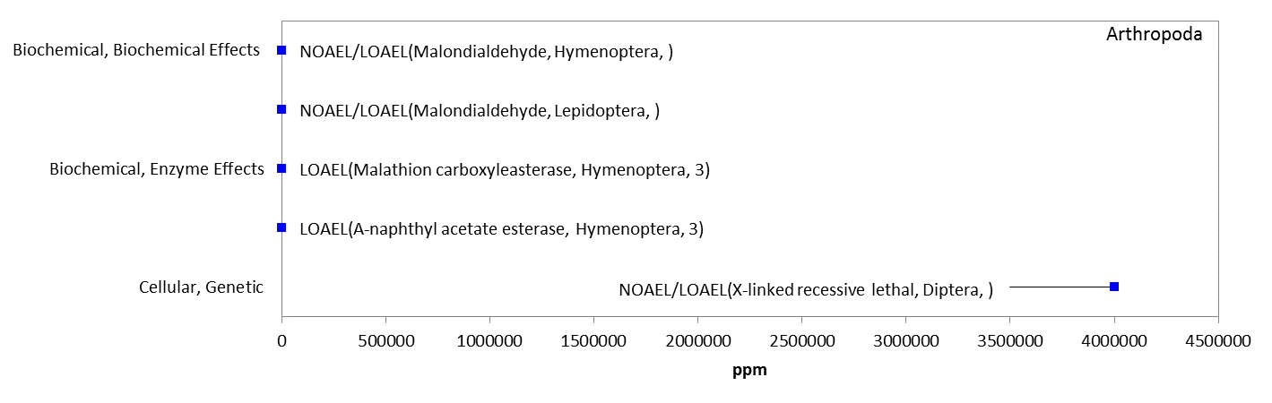
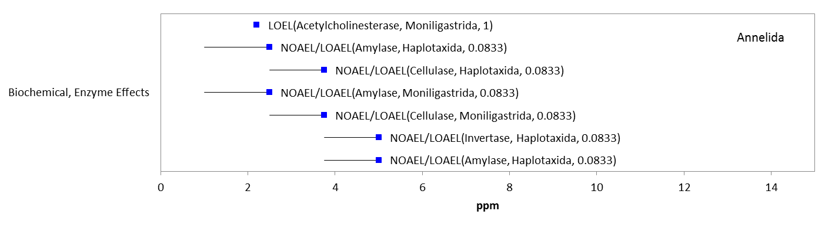
Figure 10-15. Data Array for Sub-organism Effect Endpoints Reported in Parts Per Million (ppm). Data is available for the phyla Arthropoda and Annelida. Blue data points are from open literature studies.

Effects to Terrestrial Invertebrates Not Included in the Arrays

There are other terrestrial invertebrate data available that are not included in the toxicity arrays because the exposure units are not in or cannot be converted to environmentally-relevant concentrations based on the information in the ECOTOX toxicity table; or, there are NOAEC values available from a study without corresponding LOAEC or IC_{x} values (i.e., there were no effects noted at all in the study).

There are several exposure units listed in the ECOTOX toxicity table that could not be converted to environmentally-relevant units; they include the following: units reported as % (including % w/v, and a.i. %), ml/liquid volume (e.g., ml/L and ml/100L) or ml/area (e.g., ml/ha), and those reported as a mass unit alone (e.g., g, M, mM, ng, nM, oz, uM, and µg), weight/area of filter paper or petri dish (e.g., µg/cm2, ng/cm2, and mg/cm2), L/area or L/weight (e.g., L/ha and L/1000 bu), and substance/weight (e.g., nmol/L, umol/kg and umol/mi/g).

The types of effects noted in the studies that are in units that could not be converted to environmentally-relevant concentrations are discussed below; these only include effects noted – and do not include those associated with a NOAEC value not associated with a LOAEC or IC_{x} value. See APPENDIX 2-2 for details. At the sub-organisms level, effects noted include changes in enzyme levels (i.e., cholinesterase, glutathione peroxidase, and reactive oxygen species) and cellular effects (i.e., genetic mutations). At the organism level, effects noted include behavioral changes (i.e., chemical avoidance, forage behavior, pollen collected, and jumping); changes in development (i.e., emergence); reproductive changes (i.e., number of progeny and general reproductive success); and mortality (i.e., mean time of death, knockdown, lifespan, mortality, and survival). Population-level effects include changes in abundance, weight, and level of control. Therefore, most of the effects associated with the sub-organism, whole organism or population are already captured in the terrestrial invertebrate toxicity arrays presented above.

Concentrations Where No Effects Were Observed in Terrestrial Invertebrate Studies

For the environmentally relevant exposure units, there are data available that show concentrations where effects were not observed [i.e., ‘no effect’ (NE) concentrations]. The NE endpoints include NOAEC/NOAEL and NR-Zero values as reported in ECOTOX. Below is an array for each environmentally relevant exposure unit and the corresponding NE endpoints for malathion and terrestrial invertebrates (except for the mg/mg-bw and mg/e.u. exposure units; there are no ‘no effect’ endpoints associated with these units) (Figures 10-16 through 10-18).

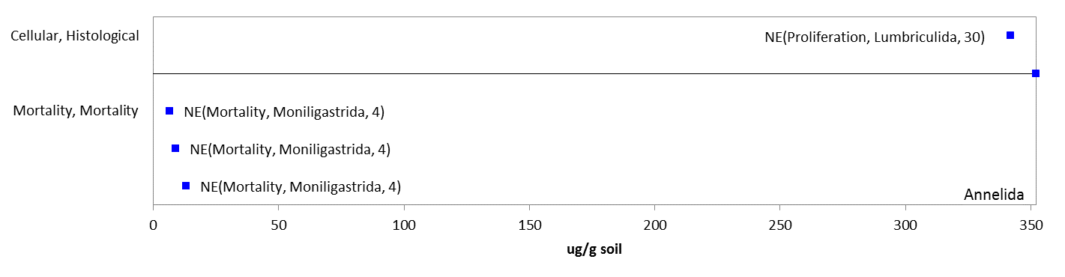
Figure 10-16. Data Array for Endpoints with No Observed Effects Based on Soil Residue (ug/g-soil). Data are only available for the phylum Annelida. Blue data points are from open literature studies.

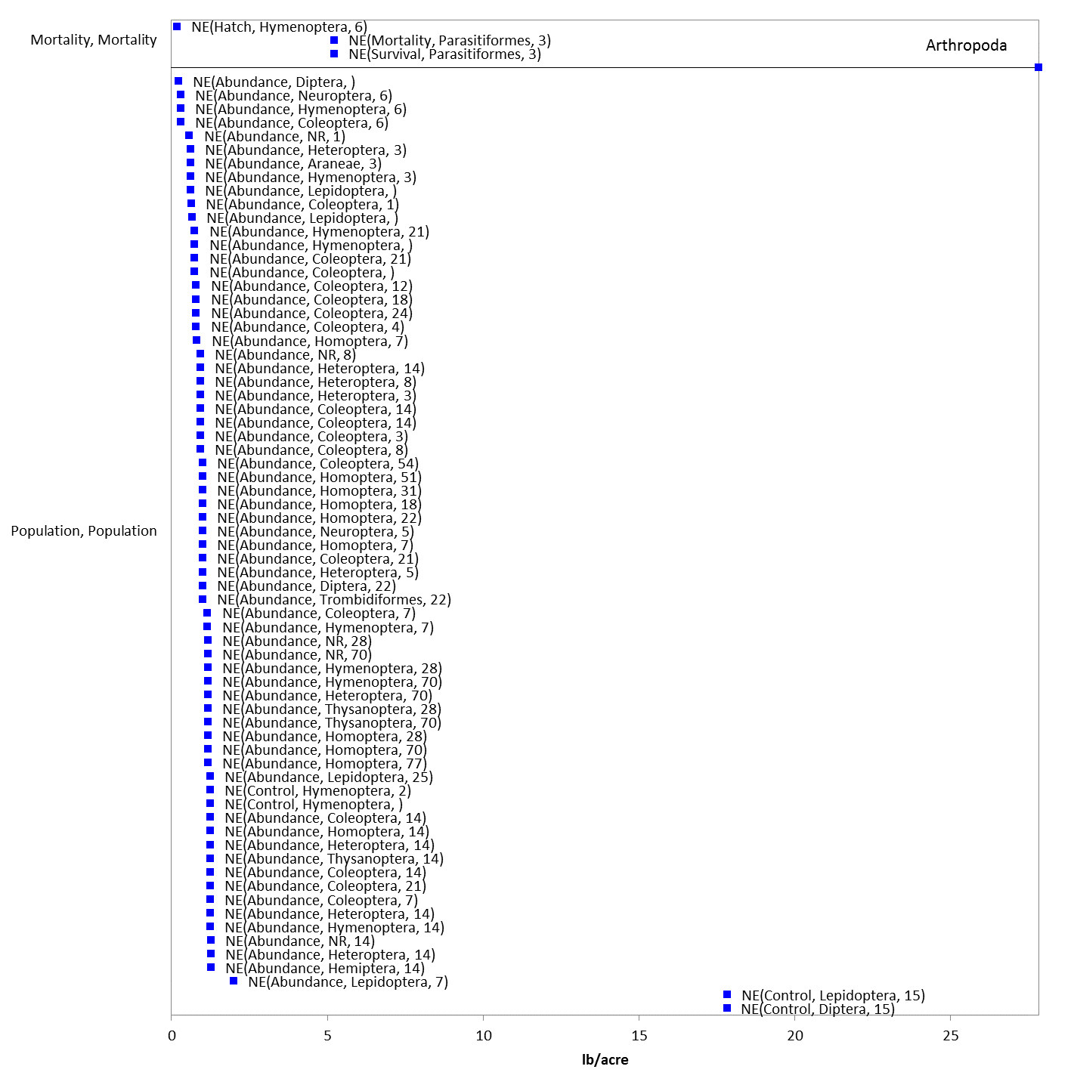
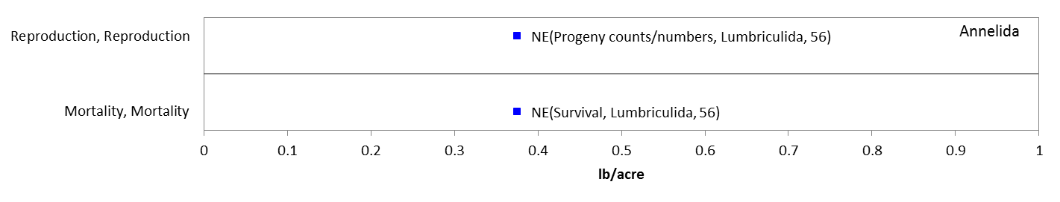
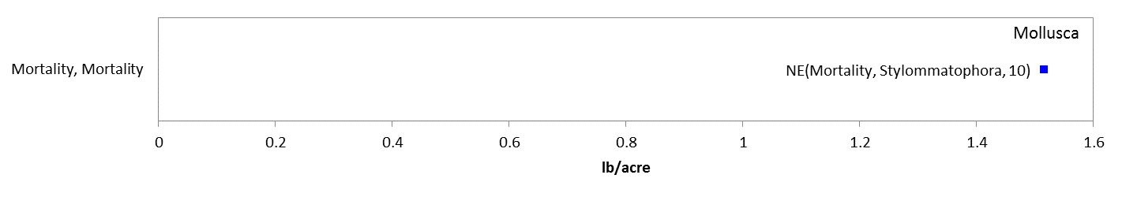
Figure 10-17. Data Array for Endpoints with No Observed Effects Based on Treatment Rate (lbs/A). Data are available for the phyla Arthropoda, Annelida and Mollusca. Blue data points are from open literature studies.

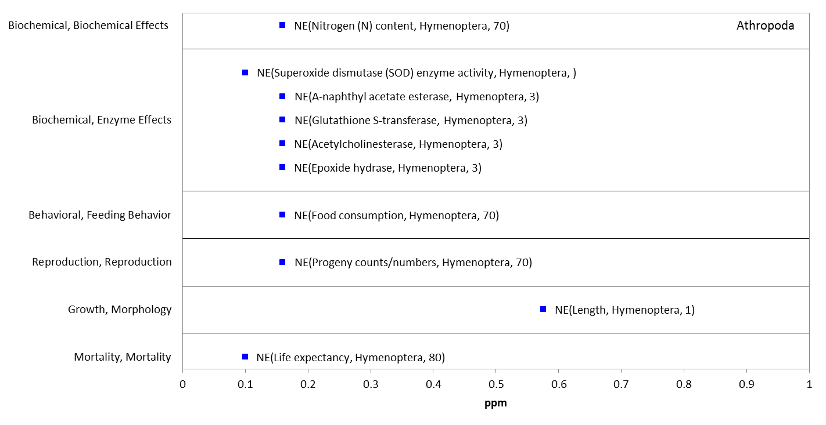
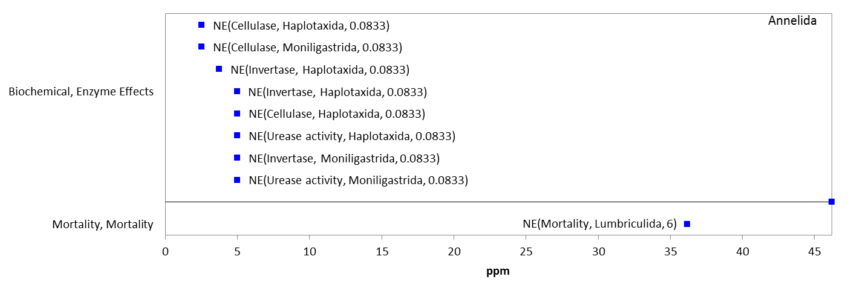
Figure 10-18. Data Array for Endpoints with No Observed Effects Reported in Parts Per Million (ppm). Data are available for the phyla Arthropoda and Annelida. Blue data points are from open literature studies.

Incident Reports for Terrestrial Invertebrates

There are currently (as of October 26, 2015) 11 terrestrial invertebrate incident reports (all for bees) in the EIIS with a certainty index of ‘unlikely’, ‘possible’, ‘probable’ or ‘highly probable’. Of these 11 incidents, 3 are from a registered use and in 8 of the incidents; the legality of use was undetermined (Table 10-8).

The dates of the incident reports range from 1985 to 2015. All of the terrestrial invertebrate incident reports involve honeybees with bees being exposed via spray drift. Most of the bee incidents are associated with agricultural uses; however, there is one bee incident reported in a residential area and one bee incident reported in a greenhouse. In most cases the malathion product involved in the incident is not specified.

In addition to the terrestrial invertebrate incident reports available in EIIS, there were two aggregate ‘Other Non-Target’ (ONT) incidents reported in 2013 (product not identified) to the Agency.

Table 10-8. Terrestrial Invertebrate Incident Reports from EIIS (Those Classified as ‘Possible’, ‘Probable’, or ‘Highly Probable’ with Legality of Use = ‘Registered’ or ‘Undetermined’).
INCIDENT NUMBER | YEAR | CHEMICAL(S) INVOLVED | CERTAINTY INDEX | STATE | LEGALITY | USE SITE | SPECIES AFFECTED | DISTANCE | EFFECT/ MAGNITUDE | PRODUCT
I013883-036 | 1997 | Malathion | Highly probable | WA | Registered use | Agricultural area | Honey bee | Not reported (NR) | Mortality / 137 hives | NR
I000130-001 | 1985 | Malathion | Probable | OR | Registered use | Alfalfa | Honey bee | Vicinity | Mortality / Unknown | NR
I014341-043 | 2000 | Malathion | Highly probable | WA | Undetermined | Cherry | Honey bee | 130 yards: Drift from aerial spray | Mortality / 56 hives | Foley Orchard Malathion ULV
I014341-044 | 2000 | Malathion | highly probable | WA | Undetermined | Cherry | Honey bee | Vicinity | Unknown | NR
B0000-600-02 | 1998 | Malathion | Highly probable | MS | Registered use | Cotton | Honey bee | 50 feet; Drift from aerial spray | Mortality / Unknown | NR
I014409-052 | 1992 | Malathion | Possible | WA | Undetermined | NR | Honey bee | NR | Mortality / Unknown | NR
I020627-03 | 2001 | Malathion | Probable | WA | Undetermined | Cherry | Honey bee | Vicinity | Mortality / 13 hives | NR
I024875-001 | NR | Malathion | Unlikely | UT | Undetermined | Agricultural area | Honey bee | NR | Mortality / 3,972 hives | NR
I025028-001 | 2013 | Malathion | Possible | FL | Undetermined | NR | Honey bee | Vicinity | Mortality / 400 colonies | NR
I025169-001 | NR | Malathion | Possible | NC | Undetermined | Residential | Honey bee | Vicinity | Mortality / 50,000 bees | Bonide Fruit Tree Spray
I026463-001 | 2014 | Malathion | Possible | CO | Undetermined | Greenhouse | Honey bee | Vicinity | Mortality / 1 hive | NR

Summary of Effects to Terrestrial Invertebrates

Based on the toxicity data available in open literature and registrant-submitted studies, malathion is highly toxic to terrestrial invertebrates. This is expected given that this taxon represents the target organisms for malathion. Effects on mortality were observed at concentrations ranging from 1.64 to 2320 ug/g-bw, 2.2 to 426 ug/g-soil, and 0.0001 to 645 lbs/A. Sublethal effects, including effects on growth and reproduction, were observed at concentrations ranging from 2.2 to 46 ug/g-soil and 0.38 to 0.46 lbs/A.

Effects Characterization for Terrestrial Plants

Introduction to Terrestrial Plant Toxicity

While the mechanism of action in plants is not well understood, the available data suggest that malathion is toxic to terrestrial plants, primarily dicotyledon plants (dicots). The effects of malathion have been studied for both monocotyledon plants (monocots) and dicots. Most of the available toxicity studies for plants focus on growth endpoints; however, data are also available for biochemical, mortality, reproduction and population-level effects. The available toxicity data for malathion are provided below for terrestrial plants along with a discussion of the incident reports. The discussion of the data is formatted to broadly follow the lines of evidence, specifically those related to mortality, growth, and reproduction. These data are used to help assess the potential for direct effects to listed terrestrial plants and their designated critical habitats (if applicable), and the indirect effects for any listed species or critical habitat that relies on listed plants.

Threshold Values for Terrestrial Plants

The threshold values for terrestrial plants are based on experimentally determined endpoints for malathion based on varying durations, exposure routes, and study designs. Threshold values for direct and indirect effects are provided in Table 11-1.
Threshold values and effects data arrays in this assessment are based on endpoints expressed in, or readily converted to, environmentally relevant exposure concentrations (i.e., lb a.i./acre). However, the effects seen using other exposure units are also discussed. Across the exposure unit of lb a.i./acre, toxicity data are available for malathion and one order of monocotyledon plants (monocots) (i.e., Poales) and one family (i.e., Poaceae) represented by six genera and seven species. For dicotyledon plants (dicots), toxicity data are available for the lb a.i./acre exposure unit and 10 orders (i.e., Brassicales, Caryophyllales, Ericales, Fabales, Malvales, Plantaginales, Rosales, Scrophuliarales, Solanales, and Violales), represented by 11 families (i.e., Brassicaceae, Chenopodiaceae, Cucurbitaceae, Droseraceae, Ericaceae, Fabaceae, Malvaceae, Pedaliaceae, Rosaceae, and Solanaceae), 22 genera, and 23 species.
Because of the variability in study designs and endpoints, it is not possible to derive a species sensitivity distribution with the available plant data. Therefore, the terrestrial plant thresholds are based on the lowest toxicity values available for the taxon (Table 11-1, and the discussion below). Threshold values are provided in exposure units of ‘lb a.i./acre’ and are provided for pre-emergence (e.g., seedling emergence studies) and post-emergence (e.g., vegetative vigor studies) exposures. Thresholds for all terrestrial plants, as well as for monocots and dicots are provided.

Table 11-1. Thresholds for Malathion and Terrestrial Plant Species
TAXON | THRESHOLD | EXPOSURE | ENDPOINT  (lb a.i./acre) | EFFECT(S) | SPECIES | STUDY ID | COMMENTS
All Terrestrial Plants¹ | NOAEC/  LOAEC | Pre-emergence | 4.64 / >4.64 | N/A | N/A | MRID 49076001 | For all species tested, no endpoints were significantly inhibited compared to the control
 |  | Post-emergence | NOAEC/LOAEC:  1.17 / 2.39;  IC25: >4.86 | Reduced weight | Cabbage (Brassica oleracea) | MRID 49076002 | The LOAEC is 2.39 lb a.i./acre (12% inhibition in dry weight at this treatment concentration)
Dicots | NOAEC/ LOAEC; IC₂₅ | Pre-emergence | NOAEC/LOAEC:  4.64 / >4.64; IC25: >4.64 | N/A | N/A | MRID 49076001 | For all species tested, no endpoints were significantly inhibited compared to the control
 |  | Post-emergence | NOAEC/LOAEC:  1.17 / 2.39;  IC25: >4.86 | Reduced weight | Cabbage (Brassica oleracea) | MRID 49076002 | The LOAEC is 2.39 lb a.i./acre (12% inhibition in dry weight at this treatment concentration)
Monocots | NOAEC/ LOAEC; IC₂₅ | Pre-emergence | NOAEC/LOAEC: 4.64 / >4.64; IC25: >4.64 | N/A | N/A | MRID 49076001 | For all monocot species tested, no endpoints were significantly inhibited compared to the control
 |  | Post-emergence | NOAEC/LOAEC: 4.7 / >4.7;  IC25: >4.7 | N/A | N/A | MRID 49076002 | For all monocot species tested, no endpoints were significantly inhibited compared to the control

Summary Data Arrays for Terrestrial Plants

The following data array provides a visual summary of the available data for malathion effects on terrestrial plants. No effects to monocot species are observed in the available studies, therefore effects to dicot species only are presented. Effects concentrations are on the horizontal (X) axis and the effect and endpoint type (e.g., MORtality, LOAEC) are identified on the vertical (Y) axis. Since the ECOTOX database does not readily distinguish between pre-emergence and post-emergence exposures, the data arrays present both.

For terrestrial plants there is a wide range of effects, from biochemical to population-level effects, and concentrations at which effects occur, from 0.5 lb a.i./acre to 19.5 lb a.i./acre. Most effects are at malathion concentrations between 0.5 and 5 lb a.i./acre (Figure 11-1).

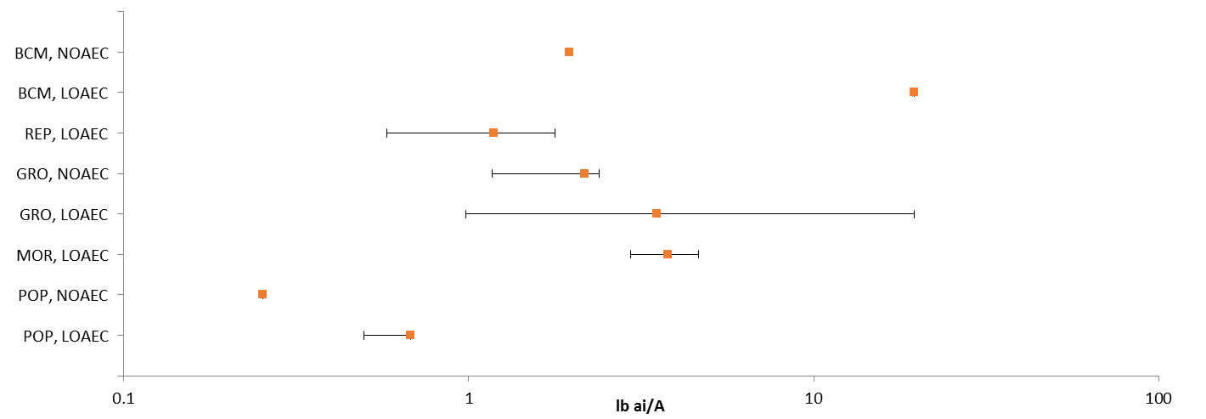
Figure 11-1. Summary Data Array for Dicot Plant Endpoints in Terms of Treatment Rate (lbs/A).
^{BCM:} Biochemical. ^{REP:} Reproduction. ^{GRO:} Growth. ^{MOR:} Mortality. ^{POP:} Population (e.g., abundance).

Lines of Evidence for Terrestrial Plants

Figures 11-2 through 11-4 provide an overview of the dataset for malathion-related effects in terrestrial plants, including data discussed below. In general, each array presents data for lbs a.i./A with values plotted against the horizontal (X) axis. The data labels identify the type of effect observed, the phylogenetic order, and the study duration (when known). Both open literature data captured in ECOTOX and unpublished studies submitted to the Agency are included, when available. Data points for Agency-reviewed, unpublished studies are red. When both no effect and lowest effect levels (e.g., NOAEC/LOAEC values) are determined by a study, a line to the left of the data point represents the difference between these two values.

Effects on Mortality of Terrestrial Plants

Figure 11-2 is the data array summarizing the available mortality data for malathion. While the majority of the malathion terrestrial plant dataset is focused on growth endpoints, there is one open literature study that evaluated the effects of malathion exposure on plant survival (E162475; Jennings et al. 2011). This study, using a combination of lab- and field-based experiments, tested the effects of technical grade and formulated malathion (Spectracide, 50% a.i.) on the survival of pink sundews (Drosera capillaris) and Venus flytraps (Dionaea muscipula). It also evaluated the effects of technical grade and formulated malathion on the expression of carnivorous traits (e.g., the number of mucilage-producing leaves in pink sundews or the number of traps in Venus flytraps; this data is captured in the summary arrays presented above). The study authors found that pink sundews are more sensitive to malathion exposure than Venus flytraps under field conditions and that the formulated malathion is more toxic than the technical grade under both lab and field conditions. Table 11-2 presents the results of the study for malathion.

Table 11-2. Effects of Malathion on Pink Sundew and Venus Flytrap Survival
Experiment | Test Species | Test Material | Lab or Field | NOAEC | LOAEC
I | Pink Sundew | Formulated product | Lab | -- | 4.63 lb a.i./A
II | Pink Sundew | TGAI | Lab | 46.3 lb a.i./A | >46.3 lb a.i./A
III | Pink Sundew | Formulated product | Field | -- | 2.94 lb a.i./A
 |  | TGAI | Field | 2.94 lb a.i./A | > 2.94 lb a.i./A
IV | Venus Flytrap | Formulated product | Field | 4.63 lb a.i./A | > 4.63 lb a.i./A
 |  | TGAI | Lab | 4.63 lb a.i./A | > 4.63 lb a.i./A

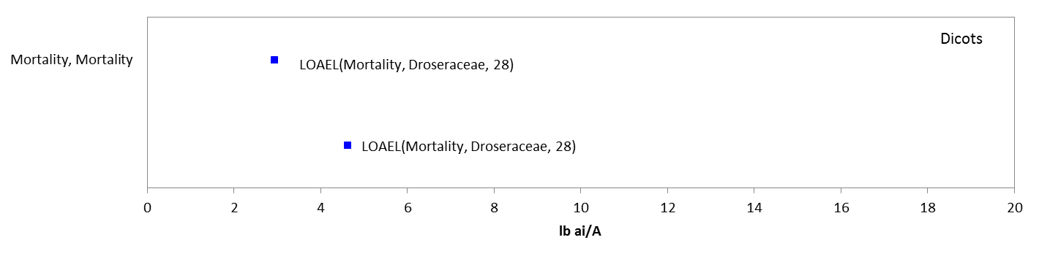
Figure 11-2. Data Array for Mortality Endpoints in Terms of Treatment Rate (lbs/A). Effects were only observed in dicot species of terrestrial plants. Blue data points are from open literature studies.

Sublethal Effects to Terrestrial Plants

Effects on Growth of Terrestrial Plants

Sublethal Effects to Terrestrial Plants (Pre-emergence Exposure)

No effects to terrestrial plants (monocot or dicot) are reported from pre-emergence exposure to malathion in either the un-published submitted studies or open literature studies. Therefore, the threshold value of 4.64 lb a.i./A is based on the study where the highest concentration was tested, which is an un-published seedling emergence study (MRID 49076001). In this study, the effect of malathion (Cheminova malathion 57%, EPA reg no. 67760-40) on the seedling emergence of monocot (corn, Zea mays; onion, Allium cepa; ryegrass, Lolium perenne; and wheat, Triticum aestivum) and dicot (oilseed rape, Brassica napus; cabbage, Brassica oleracea; soybean, Glycine max; lettuce, Lactuca sativa; tomato, Lycopersicon esculentum, and carrot, Daucus carota) crops was measured at application rates of 0.20, 0.35, 0.88, 2.23 and 4.91 lbs a.i./A for corn, wheat, oilseed rape, soybean and tomato and 0.28, 0.54, 1.15, 2.26 and 4.64 lbs a.i./A for onion, ryegrass, carrot, cabbage, and lettuce. On day 21 the surviving plants per pot were recorded; plant emergence, height, and dry weight were measured weekly. No treatment-related effects on percent survival or emergence as well as for height or dry weight were reported.

Sublethal Effects to Terrestrial Plants (Post-emergence Exposure)

In this study, The effect of malathion (Cheminova malathion 57%, EPA reg no. 67760-40) on the vegetative vigor of monocot (corn, Zea mays; onion, Allium cepa; ryegrass, Lolium perenne; and wheat, Triticum aestivum) and dicot (oilseed rape, Brassica napus; cabbage, Brassica oleracea; soybean, Glycine max; lettuce, Lactuca sativa; tomato, Lycopersicon esculentum;, and carrot, Daucus carota) crops was studied at nominal concentrations of 0 (negative control), 0.29, 0.59, 1.2, 2.4 and 4.7 lbs a.i./A. Measured application rates were <LOQ (<0.000045 lbs a.i./A negative control), 0.29, 0.56, 1.19, 2.32 and 4.72 lbs a.i./A for onion, ryegrass, corn, carrot, and tomato; <LOQ (< 0.000045 lbs a.i./A negative control), 0.29, 0.58, 1.17, 2.39 and 4.86 lbs a.i./A for wheat, oilseed rape, cabbage, soybean, and lettuce. On day 21 the surviving plants per pot were recorded; plant dry weight and height were measured. No treatment-related effects on height were reported; however, there were adverse effects for dry weight for cabbage, lettuce and soybean. Cabbage dry weight was significantly reduced (p < 0.05) from the negative control by 12% and 16%, in the 2.39 and 4.86 lbs a.i./A treatment groups, respectively. Soybean weight was significantly reduced (p < 0.05) by 19% at the 4.86 lbs a.i./A treatment group compared to the negative control. Based on the results of this study, the most sensitive dicot species was cabbage, with NOAEC, LOAEC and IC25 values of 1.17, 2.39, and >4.86 lb a.i./A, respectively.

There is an additional study with reported NOAEC and LOAEC values that are more sensitive than those described in the above study; however, the malathion formulation used in the study was not reported. Therefore, this study was not considered for use as a threshold value. However, it is included in the data arrays and details of the study are described below.

The lowest NOAEC and LOAEC values for post-emergent exposure to terrestrial plants are for a percent reduction in fresh weight in soybean (Glycine max; dicot), with a reported NOAEC value of 0.25 lb a.i./acre and LOAEC value of 0.5 lb a.i./acre (E068422). In this study, soybeans were exposed to single chemicals (thifensulfuron, carbaryl, malathion, malathion, and methomyl) and combinations of these insecticides with thifensulfuron (an herbicide) – formulations were not specified. Pesticidal combinations were also tested with kochia and yellow foxtail (species not specified). At harvest, injury was estimated visually (0% = no injury to 100% = complete necrosis), and fresh weight of shoots was determined after removal at soil level. For malathion, there were no statistically significant differences from control in percent injury at any concentration tested. There was, however, a 5, 5, and 12% reduction in weight at the 0.125, 0.25, and 0.5 lb/acre malathion concentrations, respectively, when compared to controls. The differences were statistically significant from controls at the 0.5 lb/acre concentration, resulting in NOAEC and LOAEC values of 0.25 lb/acre and 0.5 lb/acre, respectively, based on a reduction in weight.

Sublethal Effects to Terrestrial Plants (Monocots)

The thresholds for monocot terrestrial plants are the same as the ‘All Terrestrial Plant’ thresholds for pre-emergent exposure with NOAEC and LOAEC values determined to be 4.64 and >4.64 lbs a.i./A, respectively and the IC₂₅ >4.64 lbs a.i./A (MRID 49076001). For post-emergent exposure there were no effects observed in any of the available studies; therefore, the thresholds are based on the highest concentration tested across the studies. The NOAEC and LOAEC values are set at 4.86 and >4.86 lbs a.i./A, respectively and the IC₂₅ >4.86 lbs a.i./A (MRID 49076002).

Sublethal Effects to Terrestrial Plants (Dicots)

The thresholds for dicot terrestrial plants and malathion are the same as the ‘All Terrestrial Plant’ thresholds [i.e., Pre-emergence: NOAEC and LOAEC values were determined to be 4.64 and >4.64 lbs a.i./A, respectively and the IC₂₅ >4.64 lbs a.i./A (MRID 49076001); Post-emergence: NOAEC and LOAEC values of 1.17 lb a.i./A and 2.39 lb a.i./A based on reduced weight in cabbage (Brassica oleracea) (MRID 49076002) and the IC₂₅ was determined to be >4.86 lbs a.i./A (MRID 49076002)].

Growth Effects Array

Growth data, at the individual and population level, are available for five orders of terrestrial plants (i.e., Asterales, Brassicales, Caryophyllales, Fabales, and Rosales), represented by five families, eight genera and eight species. Effects on terrestrial plant growth are observed at concentrations ranging from 0.25 to 19.62 lbs a.i./A, with the majority of the endpoints falling between 1 and 5 lbs a.i./A (Figure 11-3). Effects on measurements of weight, biomass, number of leaves and abundance are observed.

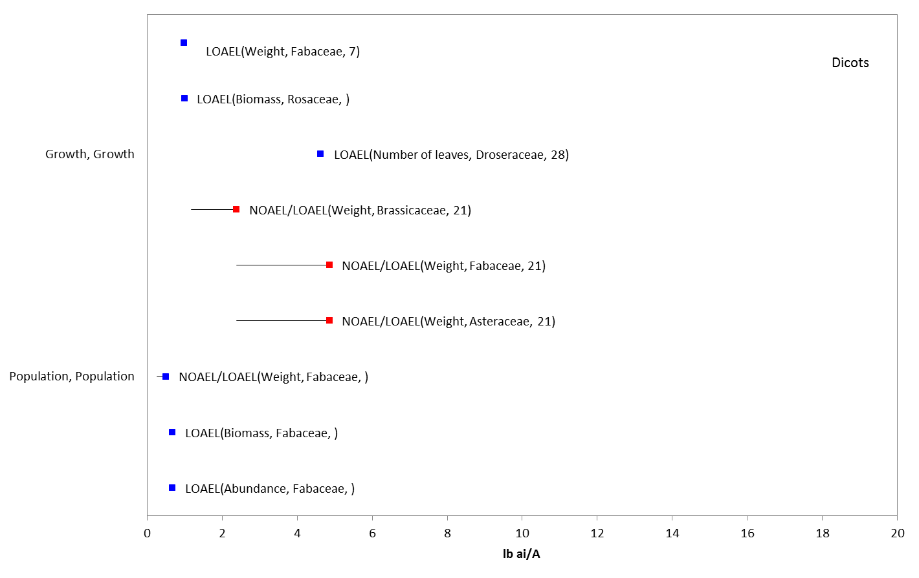
Figure 11-3. Data Array for Growth Endpoints in Terms of Treatment Rate (lbs/A). Data are only available for dicot species of terrestrial plants. Blue data points are from open literature studies, and red data points are from registrant-submitted studies.

      - Effects on Reproduction of Terrestrial Plants

Two endpoints in the ECOTOX database are characterized as effects on reproduction (Figure 11-4). The first endpoint comes from a study on the effects of insecticides, including malathion, on cotton development and yield under field conditions (E90706; Loyd 1987). Cotton plants were exposed to five applications of malathion at a rate of 0.58 lb a.i./A every ten days. Various growth measurements, including height, number of nodes per plant, total number of leaves, leaf area, number of floral buds and number of fruits per plant, were taken 30 and 60 days post application. Effects on growth were positive (e.g., increase in number of nodes) and are captured in the arrays presented in the previous section. Effects on yield were determined based on measurements of the number of bolls per 10m², the mass per 100 bolls, and the lint yield per hectare. The study authors found that malathion increased the number of bolls per 10m² without impacting the overall lint yield per hectare. It is unclear whether the potential benefits of malathion exposure to cotton plants is an indirect effect resulting from decreased pest pressure.

The second endpoint comes from a study on the effects of granular insecticides, including a malathion formulation, on seed germination of forage crops (E29591; Ram 1975). Cowpea (Vigna sp.), alfalfa (Medicago sativa), and sorghum (Sorghum sp.) were exposed to a 5% granular formulation of malathion in field plots. The malathion was incorporated 2.5 cm into the soil prior to sowing the seeds. Germination counts were recorded seven days after sowing. The study authors report decreased germination of cowpea and alfalfa seeds at 1.78 lbs malathion/A, while there was no effect observed on sorghum germination. It is important to note that there are no current registrations for a granular formulation of malathion; therefore, this endpoint is of limited value in the current assessment.
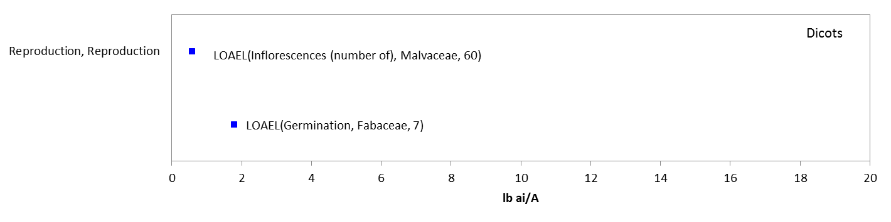
Figure 11-4. Data Array for Reproduction Endpoints in Terms of Treatment Rate (lbs/A). Data are only available for dicot species of terrestrial plants. Blue data points are from open literature studies.

Effects to Terrestrial Plants Not Included in the Arrays

There are other terrestrial plant data available that are not included in the toxicity arrays because the exposure units are not reported in, or cannot be converted to, environmentally-relevant concentrations based on the information in the ECOTOX database, and/or the data are from species other than monocots or dicots. This data is described briefly in the following sections.

Units other than lb a.i./A (monocots and dicots)

Exposure units listed in the ECOTOX database that could not be converted to environmentally-relevant units include the following: units related to seed treatments (since non-target seeds would not be treated with malathion in the same way as a ‘seed treatment), units reported as mass/eu (’eu’ refers to ‘experimental unit’, and it is not clear what the unit is – e.g., single plant, field, acre, etc.); units reported as mass/length (a measurement of mass per unit area is needed); units reported as a volume/area (it is not clear how much mass is in the volume); and % or ‘ppm’ (‘ppm’ refers to ‘parts per million’; ppm and % can actually be reflective of different, specific concentration units - e.g., concentrations in soil, concentrations in the formulation applied, etc.)

The types of effects noted in these studies are discussed below; these only include effects noted – and do not include those associated with a NOAEL value not associated with a LOAEL or IC_{x} value. See APPENDIX 2-2 for details. For units in ppm, at the sub-organism level, effects noted include changes in 7-ethoxyresorufin O-deethylase, sterols, ATP, phospholipid content, ADpase, acid and alkaline pyrophosphatase, nitrate reductase, acid phosphatase, protein content, chromosomal aberration, mitotic index, cell division rate and RNA concentration (all LOAELs in units of 0.00108 to 200 ppm). At the organism level, effects noted include effects on length, weight, abnormal development (all LOAELs in units of ppm from 30-200 ppm), and germination (LOAEL at 2.5 ppm and ED50 at 500 ppm). For units in percent (%), effects at the sub-organism level included genetic effects and changes in protein, oil or phosphorous content (at 1E-7 to 5%). Effects on fertility, height, conductivity, plant injury, growth rate and compression and tensile strength were reported at rates of 0.02 to 0.5%. For grams per kilogram seed, effects on germination were reported at 3 grams/kg/seed. Therefore, most of the effects associated with a whole organism or population are already captured in the terrestrial plant toxicity arrays presented above.

In the open literature, a study examining biochemical responses (i.e., sterols, ADPase, acid pyrophosphatase, total phospholipid content) in germinating seeds (Vigna sinensis) was reported (Chakraborti et al. 1982; E25359). However, the study was conducted in petri dishes with exposure units of ppm (LOAELs of either 50 or 100 ppm after 72 hours) which could not be converted to environmentally-relevant concentrations.

Species other than monocots and dicots

Regarding the effects data available for non-dicot and non-monocot plants, the available endpoints are associated with units other than lb a.i./acre and most are NOAEC values (i.e., no effects noted after exposure to malathion). For yellow spruce, effects on weight (biomass) were reported at 5040 ppm.

Concentrations Where No Effects Were Observed in Terrestrial Plant Studies

For the exposure unit lbs a.i./A there are data available that show concentrations where effects are not seen [i.e., ‘no effect’ (NE) concentrations]. The NE endpoints include NOAEC/NOAEL and NR-Zero values as reported in ECOTOX. Below are the arrays showing the NE endpoints for malathion and terrestrial plants (Figures 11-5). For monocot plants with application rates in lb a.i./A, there are no reported effects at rates from 0.23 to 4.64 lb a.i./A. This data is available for one order (i.e., Poales) represented by one family, six genera, and seven species. For dicots, no reported effects occurred at rates from 0.2 to 645 lb a.i./A. This data is available for nine orders (i.e., Brassicales, Caryophyllales, Ericales, Fabales, Malvales, Plantaginales, Scrophuliarales, Solanales, and Violales) represented by 10 families, 20 genera, and 23 species.

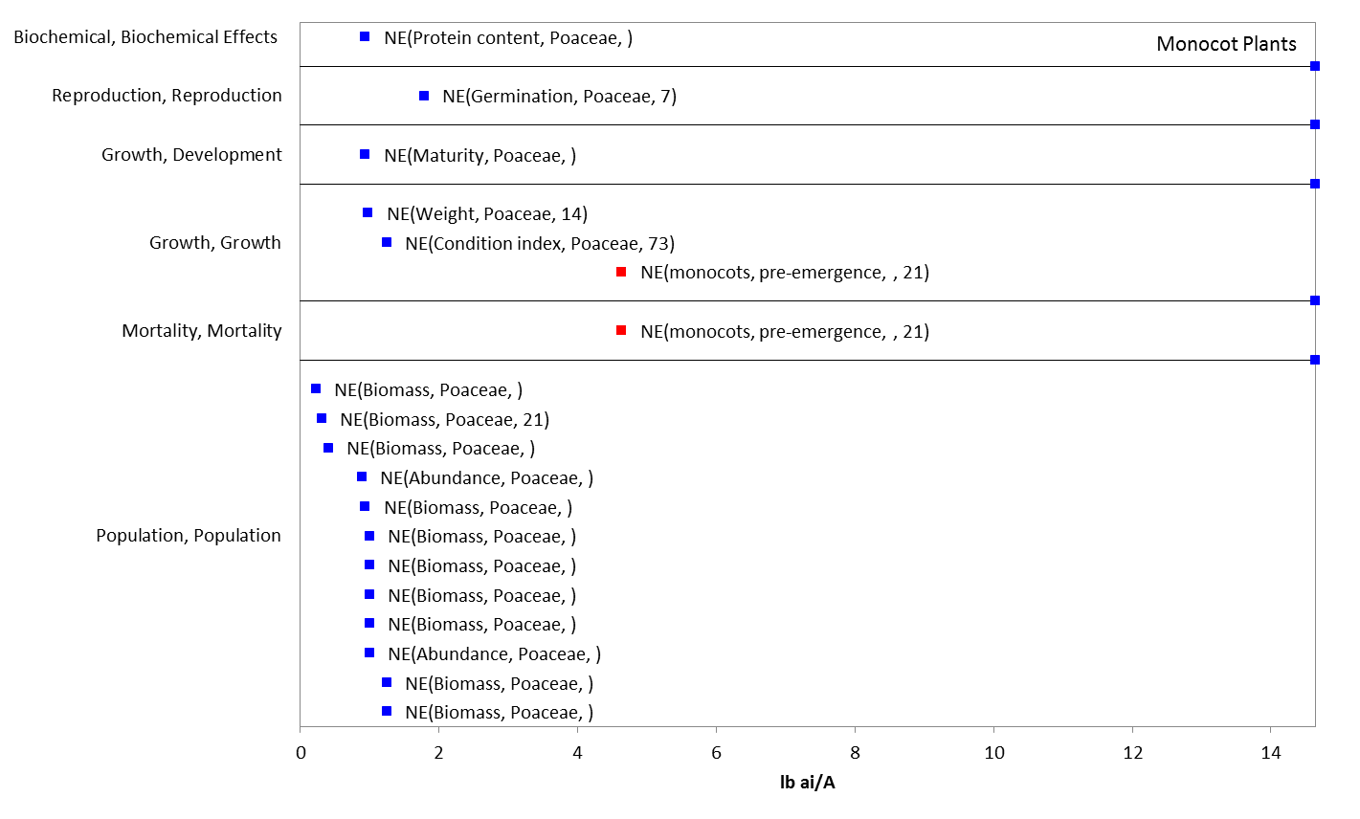
Figure 11-5. Concentrations Reported in Terms of Treatment Rate (lbs/A) Where No Effects Were Observed in Monocot Terrestrial Plants. Blue data points are from open literature studies, and red data points are from registrant-submitted studies.

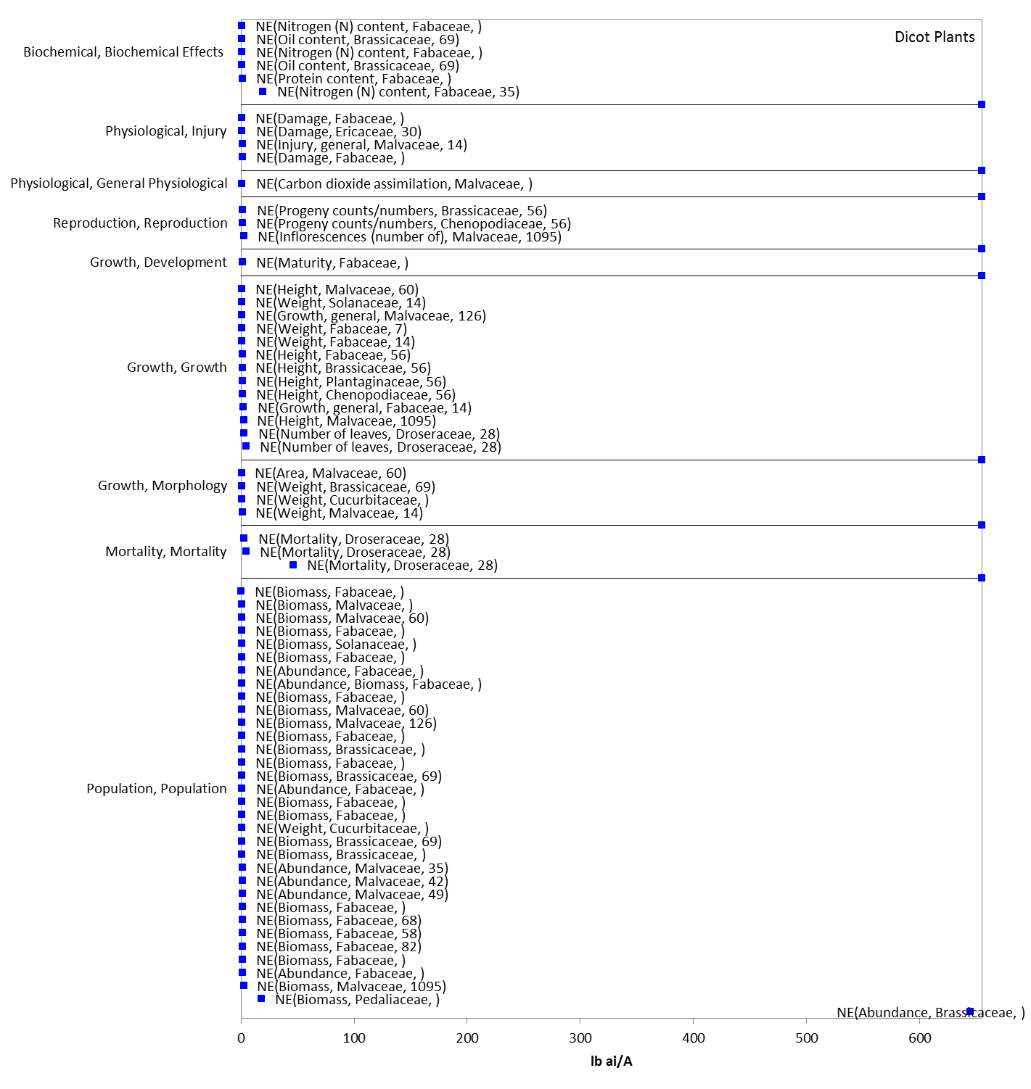
Figure 11-6. Concentrations Reported in Terms of Treatment Rate (lbs/A) Where No Effects Were Observed in Dicot Terrestrial Plants. Blue data points are from open literature studies.

Incident Reports for Terrestrial Plants

There are currently (as of October 26, 2015) six terrestrial plant incident reports in the EIIS with a certainty index of ‘unlikely’, ‘possible’, or ‘highly probable’. Of these six incidents, three are from a misuse (either accidental or intentional), and in three of the incidents, the legality of use is undetermined (Table 11-3). The following discussion only includes those incident reports with a certainty index of ‘possible’ or ‘highly probable’ and a legality classification of ‘undetermined’.

The dates of the incident reports range from 1987 to 2012. There is one report associated with spray drift, in which aerial application of a pesticide mixture (product not identified) containing plant growth regulators ethephon and merphos to an adjacent cotton field (150 feet away) was reported to have defoliated pecan trees in a grower’s orchard; leaf residue analysis detected merphos (3.59 ppm), malathion (5.6 ppm), and azinphos-methyl (8.05 ppm) (B0000-500-12). The specific effects to plants from malathion in this incident are unclear because of the analytical detections of merphos, a plant growth regulator. In the other incidents, malathion was the only pesticide noted in the report.

Table 11-3. Terrestrial Plant Incident Reports from EIIS (Those Classified as ‘Possible’, ‘Probable’, or ‘Highly Probable’ with Legality of Use = ‘Registered’ or ‘Undetermined’).
INCIDENT NUMBER | YEAR | CHEMICAL(S) INVOLVED | CERTAINTY INDEX | STATE | LEGALITY | USE SITE | SPECIES AFFECTED | DISTANCE | EFFECT/ MAGNITUDE | PRODUCT
B0000-500-12 | 1987 | Malathion | Possible | GA | Undetermined | Cotton | Pecan | Drift- 150 feet | Defoliation/  Unknown | Not reported
I009262-112 | 1999 | Malathion | Possible | CA | Undetermined | Rose | Rose | Treated directly | Browning/ 35-40 roses | Malathion 50 Plus insect spray
I017719-001 | 2006 | Malathion | Possible | CA | Misuse (accidental) | Wild rice | Wild rice | Treated directly | Plant damage/ 126 acres | Unknown
I017893-021 | 2006 | Malathion | Unlikely | CA | Misuse (accidental) | Agricultural area | Alfalfa | Adjacent field | Plant damage/  $49,999 | Malathion 8.  4 oz per 10 gallon  (EPA reg no. 10163-00021)
I023931-056 | 2012 | Malathion | Highly Probable | CA | Misuse | Greenhouse tomatoes | Tomatoes | Treated directly | Plant damage/ >45% of tomatoes | Max Malathion Insect Spray (EPA reg no. 000239-00739)
I024071-207 | 2012 | Malathion | Possible | TX | Undetermined | Residential | Rose | Treated directly | Mortality/ >45% of roses | Max Malathion Insect Spray (EPA reg no. 000239-00739)

In addition to the terrestrial plant incident reports available in EIIS, there have also been a total of 231 aggregate plant incidents reported to the Agency. Of these 231, 188 are associated with active registrations (38 involve a product no longer registered, and five are from malathion formulations without EPA registration numbers, and these 43 are not reported in Table 11-4).

Since 1998, plant incidents that are allowed to be reported aggregately by registrants [under FIFRA 6(a)(2)] include those that are associated with an alleged effect to plants that involves less than 45 percent of the acreage exposed to the pesticide. Typically, the only information available for aggregate incidents is the date (i.e., the quarter) that the incident(s) occurred, the number of aggregate incidents that occurred in the quarter, and the PC code of the pesticide and the registration number of the product involved in the incident. Because of the limited amount of data available on aggregate incidents it is not possible to assign certainty indices or legality of use classifications to the specific incidents. Therefore, the incidents associated with currently registered products are assumed to be from registered uses unless additional information becomes available to support a change in that assumption.

Table 11-4. Aggregate Plant Incidents for Malathion Involving Currently Registered Products.
PRODUCT REGISTRATION NUMBER | PRODUCT NAME | NUMBER OF AGGREGATE PLANT INCIDENTS | YEARS
000239-00739 | Ortho Malathion 50 emulsifiable concentrate | 180 | 1995-2014
046515-00019 | SUPER K-GRO MALATHION 50 INSECT SPRAY soluble concentrate | 8 | 2001, 2002, 2004, 2005

Summary of Effects to Terrestrial Plants

Toxicity data available from open literature and registrant-submitted studies suggest that malathion is toxic to certain types of terrestrial plants (i.e., dicots). Effects on mortality are observed at concentrations ranging from 2.9 to 4.6 lbs/A in one species of carnivorous plant. While growth effects are observed at a wide range of concentrations (from 0.2 to 645 lb/A), the majority of effects, including effects on biomass and weight, are observed at 1 lb/A. Reproductive effects, including an increase in reproductive measures, are also observed in the data at concentrations of 1.7 lb/A.

References
Conte, F. S. and Parker, J. C. (1975). Effect of Aerially-Applied Malathion on Juvenile Brown and White Shrimp Penaeus aztecus and P. setiferus. Trans. Am. Fish. Soc. 104: 793-799.

Engbring, John (1989). Fluctuations in Bird Populations on the Island of Biota as Related to an Experimental Program to Control The Melon Fly. U.S. Fish and Wildlife Service, Honolulu, Hawaii

Finlayson, B.J., G. Faggella, H. Jong, E. Littrell, and T. Lew, (1981). Impact on Fish and Wildlife from Broad Scale Aerial Malathion Applications in South San Francisco Bay Region, Pesticide Investigation Unit, Water Pollution Control Laboratory, California Fish and Game Department

Hackenberger B.K, D. Jaric, D. Hackenberger and S. Stepic. 2010. Effects of Chronic Dietary Exposure to a Low-Dose of Malathion, Aroclor-1254 and 3-Methylcholanthrene on Three Biomarkers in Male Mice. Acta Biol. Hung. 61(4): 423-433

Hoda Q, M.A. Azfer, and S.P. Sinha. (1993). Modificatory Effect of Vitamin C and Vitamin B-Complex on Meiotic Inhibition Induced by Organophosphorus Pesticide in Mice Mus musculus. Int. J. Vitam. Nutr. Res. 63(1): 48-51. ECOTOX # 75127

J. Giles and Robert, 1970, Giles, R.H. Jr. (1970). The Ecology of a Small Forested Watershed Treated With the Insecticide Malathion-S35. Wildl. Monogr. 24:81

Kennedy, H. D. and Walsh, D. F. (1970). Effects of Malathion on Two Warmwater Fishes and Aquatic Invertebrates in Ponds. Tech. Pap. No. 55, Bureau of Sport Fish. Wildl., Fish Wildl. Service, U.S.D.I., Washington, D.C., 13 p

Kucera, E. (1987). Brain Cholinesterase Activity in Birds after a City-Wide Aerial Application of Malathion. Bull. Environ. Contam. Toxicol. 38: 456-460

Kuhajda, B.; Blanco, C.; and Green, M. (1996). Impact of Malathion on Fish and Aquatic Invertebrate Communities and On Acetylcholinesterase Activity in Fishes within Stewart Creek, Fayette County, Alabama: Final Report. Unpublished study prepared by University of Alabama. MRID 47587601

Parsons, Jack K. and Billy Don Davis, (1971). The Effects on Quail, Migratory Birds and Non-Game Birds from Application of Malathion and Other Insecticides. Texas Parks and Wildlife Dept., Study conducted from 1964 to 1968

Proctor, Raphael R. Jr., Jane P. Corliss, and Donald Lightner (1966). Mortality of Post larval and Juvenile Shrimp Caused by Exposure to Malathion -A Laboratory and Field Study. National Marine Fisheries Service, Galveston Laboratory

Straw N.A., N.J. Fielding, and A. Waters. (1996). Phytotoxicity of Insecticides Used to Control Aphids on Sitka Spruce, Picea sitchensis (Bong.) Carr. Crop Prot. 15(5): 451-459. ECOTOX # 67965

Tagatz, M.E., 1974. Effects of Ground Application of Malathion on Saltmarsh Environments in Northwestern Florida. USEPA Gulf Breeze, Environmental Research Laboratory, Gulf Breeze, Florida

