APPENDIX 4-2: Mixture and Abiotic Stressors Analysis for Malathion

The current risk assessment focuses on malathion and its degradates. The approach is based on data describing the environmental fate, estimated exposure concentrations and potential toxicity of malathion. There is uncertainty in the potential effects of malathion because the approach does not quantitatively consider the presence of other chemicals in the environment of the assessed species. Of particular concern would be cases where the presence of other chemicals results in an increase in the toxicity of malathion, thus the effects characterization may under predict the potential effects of malathion on listed species. Although there are some data to indicate that this may occur, effects of chemical mixtures on the expected toxicity of malathion are not consistent across species, taxa or concentrations of the stressors. This section discusses the available information on environmental exposures to chemical mixtures that include malathion as well as toxicity data describing whether chemicals mixed with malathion may result in expected toxicity based on additivity, synergism or antagonism. Toxicity data available for exposures involving technical grade and formulated malathion are described in the effects characterization section.

Environmental Mixtures
Mixtures may be present in ESA-listed species’ habitats following the offsite transport of pesticides and other chemical constituents (e.g., other active ingredients, inerts, adjuvants, etc.) through the use of co-formulated products or tank mixes at individual or multiple locations. Species and their habitats exposed to pesticide mixtures may be at greater risk of adverse effects than when exposed to single pesticides. Recent review articles indicate that additivity (i.e., concentration- or response-addition) is the appropriate default assumption when considering mixture toxicity (Cedergreen 2014; Belden et al 2007). Experimental results from numerous studies indicate that exposure to OP-containing mixtures produces additive and synergistic toxicity, as measured by activity of the neurological enzyme acetylcholinesterase (AChE), in several taxa groups including mammals, fish, birds, amphibians, and aquatic insects.
Due to the large number of pesticides that may be present in a species’ habitat at any one time, it is not feasible to estimate exposure concentrations for all possible mixture combinations. Furthermore, it is not practical to test the toxicity of every mixture combination in every ESA-listed species or appropriate surrogate. However, qualitative assessments of mixture toxicity can be made using expected exposures, principles of additive toxicity, and known toxic responses in published scientific literature. The mixtures line of evidence is considered qualitatively using available product labels, usage information, monitoring data, and taxa-specific toxicity data.

Composition of malathion mixtures in terrestrial and aquatic environments
Chemical mixtures are present in terrestrial and aquatic environments. This may be due to application of multiple chemicals contained in formulations and tank mixtures of formulations, resulting in a direct application to the terrestrial environment or spray drift of the mixtures onto adjacent terrestrial, wetland or aquatic habitats. Chemical mixtures may also be present in aquatic systems due to transport from upstream applications.
Most formulated products contain multiple chemicals (referred to as “inert ingredients”), and may also contain multiple active ingredients. A listing of inert ingredients that are formulated with pesticide active ingredients is available on the EPA website. Malathion products that are applied to agricultural crops do not contain other active ingredients. Active ingredients are routinely used together as tank mixtures in agricultural practices, as a means to enhance the effectiveness of the active ingredient, as well as to treat multiple pest pressures at the same time and avoid the need to conduct multiple applications. Pesticide labels routinely provide instructions for tank mixtures, indicating to the applicator which chemicals can and cannot be used with the product. Table 4-2.1 includes the information on malathion labels that involves recommended tank mixtures (i.e., for applications to agricultural crops).
Table 4-2.1. Recommended tank mixtures on malathion labels registered for use on orchards or field crops.
Product name (registration number) | Label statement relevant to application with other pesticide products
Malathion 50% EC (4-99) | For the mosquitocide application: "Mix… in 1 gallon of water or oil-based carrier (such as kerosene, fuel oil, or diesel oil)."
Ortho Malathion 50 Insect Spray (239-739) | Label instructions say to dilute with water.  "Ortho RosePride Rose and Shrub Disease Control (or other EPA-registered product labeled for control of diseases on roses) may be mixed with this product when listed insect(s) and diseases are found on roses. Follow directions and precautions on both labels."  "FRUITS - USE IN COMBINATION WITH VOLCK OIL SPRAY."
Fyfanon 8 lb emulsion (5905-250) | APPLICATION THROUGH IRRIGATION SYSTEMS - CHEMIGATION section: "Do not tank mix this product with other pesticides surfactants or fertilizers unless prior use has shown the combination non-injurious under your conditions of use."
Hi-Yield 55% Malathion (7401-10) | Outdoor residential product. Label instructions say to dilute with water.
Malathion 50% EC (9779-5) | Label instructions say to dilute with water.
Malathion 57% (10088-56) | For the mosquitocide application "OIL SOLUTION": "1 part concentrate to 28 parts of a mixture consisting of 4 parts kerosene to 1 part toluene..."
Malathion 8 (10163-21) | In Mixing Directions: only specifies addition of water. "Do not combine with wettable powders unless previous use of the mixture has proven physically compatible and safe to plants. Always thoroughly emulsify this product with at least half of total water before adding wettable powders."  Applications through chemigation section: "This product should not be tank-mixed with other pesticides, surfactants or fertilizers unless prior use has shown the combination non-injurious under your conditions of use. Follow precautionary statements and directions for all tank-mix products."
Drexel Malathion 5EC (19713-217) | Applications through chemigation section: "This product should not be tank-mixed with other pesticides, surfactants or fertilizers unless prior use has shown the combination non-injurious under your conditions of use. Follow precautionary statements and directions for all tank-mix products."
Acme Malathion 50% Spray (33955-394) | Mosquitoes: "Mix 11 tablespoons of product per gallon of water, fuel oil, or diesel oil."
Malathion 57 EC (34704-108) | "Do not combine emulsifiable liquids with wettable powders in the same spray tank unless previous use of the materials being combined has proven them to be physically compatible."  Chemigation: "This product should not be tank-mixed with other pesticides, surfactants, or fertilizers unless prior use has shown the combination non-injurious under your conditions of use. Follow precautionary statements and directions for all tank-mixed products."
Malathion 8E Insecticide (34704-452) | Chemigation: "This product should not be tank-mixed with other pesticides, surfactants, or fertilizers unless prior use has shown the combination non-injurious under your conditions of use. Follow precautionary statements and directions for all tank-mixed products."  Mosquito control: "This product can be mixed with a synergized pyrethrin emulsifiable concentration (such as 6% pyrethrin + 60% PBO) in accordance with the most restrictive of label limitations and precautions indicated on both this and the tank-mixed product."
Malathion 8 Aquatmul (34704-474) | Chemigation: "Do not tank mix this product with other pesticides, surfactants or fertilizers unless prior use has shown the combination non-injurious under your conditions of use. Follow precautionary statements and direction for all tank-mixed products."  Applications: For the treatment of dried fruit beetle and vinegar flies in figs mix "2.0 pts [malathion] plus 2.0 gals unsulfurized molasses as a bait spray". For treatment of fruit flies in guava, mango, and passion fruit mix "0.75 pt [malathion] + 1.0 lb partially hydrolyzed yeast protein or enzymatic yeast hydrolyzate."  Mosquito control: "This product can be mixed with a synergized pyrethrin emulsifiable concentrate (such as 6% pyrethrin + 60% PBO) in accordance with the most restrictive of label limitations and precautions indicated on both this and the tank-mixed product. Label rates must not be exceeded. This product may not be mixed with any product bearing a label which specifically prohibits such mixing. Prior to tank mixing large quantities, mix a small amount in a glass jar to verify that the products are physically compatible. Depending on your operation needs, the amount of synergized pyrethrin can be reduced or adjusted. Application rates of this product and droplet distribution requirements remain the same as for this product used alone."
Chem-Tox Mal 50-OS (45385-66) | "An oil soluble malathion concentrate containing 4.5 lbs of malathion active ingredient per gallon. For formulating thermal fogging and mist spraying oils for mosquito control work and outdoor application."  Fly Control: "Dilute this concentrate 1 part to 22 parts No. 2 fuel oil to make a 3% ready-to-use spray."  Mosquito Control: "Apply a 3% to 5% Malathion in fuel oil at a rate of 1/2 lb actual malathion a.i. per acre".
Super K-Gro Malathion 50 Insect Spray (46515-19) | "In a tank sprayer, mix the specified amounts of this product in water until the spray mixture is uniform."
Prozap Malathion 57% Emulsifiable Liquid Insecticide-B (47000-107) | "Do not combine emulsifiable liquids with wettable powders in the same spray tank unless previous use of the materials being combined has proven them to be physically compatible."  Pasture and Rangeland: "Use 1 pint in 1 gallon fuel oil as a ULV spray per acre."  Mosquitos: "1 part to 28 parts water, fuel oil or diesel oil."  Restrictions: "Avoid applying oil based formulations to valuable ornamental plants as injury may occur."  Grasshoppers: "ULV Application: 1.2 - 1 pints in 1 gallon of diesel fuel oil per acre."  Chemigation: "This product should not be tank-mixed with other pesticides, surfactants or fertilizers unless prior use has shown the combination non-injurious under your conditions of use. Follow precautionary statements and directions for all tank-mixed products."
Malathion 5 EC (66330-220) | "Do not combine emulsifiable liquids with wettable powders in the same spray tank unless previous use of the materials being combined has proven them to be physically compatible."
Fyfanon ULV Mosquito (67760-34) | "*There is a great variation in the chemical composition of fuel oils which may be used as thermal fog solvents. These differences may cause sludge and/or affect the solubility of the Fyfanon ULV Mosquito."
Fyfanon ULV AG (67760-35) | "Fyfanon ULV AG can by mixed with a synergized pyrethrin emulsifiable concentrate (6% pyrethrin + 60% PBO) in accordance with the most restrictive label limitations and precautions indicated on both this and the tank-mixed product. Label rates must not be exceeded. This product may not be mixed with any product bearing a label which specifically prohibits such mixing. Prior to tank mixing large quantities mix a small amount in a glass jar to verify that the products are physically compatible... Depending on your operational needs for knock-down, the amount of synergized pyrethrin can be reduced or adjusted. Application rates of Fyfanon ULV AG and droplet distribution requirements remain the same as for Fyfanon ULV AG used alone."
Fyfanon 57% EC (67760-40) | For use on guava, mango, passion fruit: "Apply with 1 lb partially hydrolyzed yeast protein or enzymatic yeast hydrolyzate."  For use on nectarines: "May be mixed with spray oil for dormant and delayed dormant applications. Follow spray oil manufacturer's directions."
Fyfanon Plus ULV (67760-108) | Agricultural Crop Use: "Dilute Fyfanon PLUS ULV in once-refined cottonseed or vegetable oil sufficient to make at least one quart of finished spray per acre."
Cheminova Malathion 57% Low VOC (67760-119) | For use on guava, mango, passion fruit: "Apply with 1 lb partially hydrolyzed yeast protein or enzymatic yeast hydrolyzate."  For use on nectarines: "May be mixed with spray oil for dormant and delayed dormant applications. Follow spray oil manufacturer's
Malathion 851 g/L + Gamma-Cyhalothrin 12.8 g/L EC (67760-131) | Mixing directions: "Malathion 851 g/L + Gamma-cyhalothrin 12.8 g/L EC is compatible with insecticides, miticides, and fungicides and non-pressure fertilizer solutions commonly recommended, except for alkaline materials such as Bordeaux mixture lime. It is always recommended that a small jar compatibility test be run prior to tank mixing. Prepare tank mixtures in the same manner as recommended above for use of Malathion 851 g/L + Gamma-cyhalothrin 12.8 g/L EC alone. When tank mixing with herbicides, add wettable powders first, flowable second, and emulsifiable concentrates last. When a fertilizer solution is involved, it is strongly recommended that a fertilizer pesticide compatibility agent such as Unite or Compex be used."  Chemigation: "As local recommendations differ, consult your local State Extension Service or other local experts for recommendations on adjuvant or diluent types (See Tank Mix Application), rates, and mixing instructions. These recommendations should be proven, through university and extension field trials, to be effective with Declare applied by chemigation."
Malathion-5 Emulsifiable Concentrate (84009-6) | "Do not combine emulsifiable liquids with wettable powders in the same spray tank unless previous use of the materials being combined has proven them to be physically compatible."  Mosquito control: "For a 2% spray, dilute 1 part Malathion-5 EC with 28 parts of water, fuel oil, or diesel oil. For a 5% spray, dilute 1 part Malathion-5 EC with 11 parts of water, fuel oil, or diesel oil."
Prentox 5 lb Malathion Spray (89459-36) | Chemigation: "Do not tank mix this product with other pesticides, surfactants or fertilizers unless prior use has shown the combination non-injurious under your conditions of use. Follow precautionary statements and direction for all tank-mixed products."

Unless a pesticide label explicitly prohibits tank mixing of specific active ingredients or formulated products, other products not identified on a label may be applied at the same time. A review of available pesticide application sources, such as California’s Pesticide Use Report (CAPUR), reports from the United States Department of Agriculture’s National Agricultural Statistics Service, and proprietary use information (i.e., the GfK’s pesticide use database), depict applications of multiple pesticide active ingredients to a field at the same time. SUPPLEMTNAL INFORMATION 1 provides an analysis of the available CAPUR data for 2008-2012, depicting the top 25 active ingredients with which malathion was applied. When malathion was applied as a mixture (66,406 times), 15% of the time it was with maneb (a carbamate fungicide), 14% of the time with permethrin (a pyrethroid insecticide), 11% of the time lambda-cyhalothrin (a pyrethroid insecticide), 9% of the time with imidacloprid (a neonicotinoid insecticide), and 8% of the time with spinetoram (an insecticide), boscalid (a carboximide fungicide), spirotetramet (an insecticide), and chlorantraniliprole (an insecticide). All other active ingredients were applied with malathion less than 8% of the time malathion was applied. Figures S-1 and S-2 in SUPPLEMENTAL INFORMATION 1 also displays the ratio of the application rate of the active ingredients to the application rate of malathion. Of the chemicals discussed above, only a minor fraction of the maneb:malathion applications (20%) occurred where maneb is applied at an application rate greater than that of malathion. Of the remaining four active ingredients, the majority of the applications had a ratio where the application rate of malathion was 10x that of the active ingredient. This suggests chemicals that are applied in a tank mix with malathion are not always mixed at the maximum labeled application rates.
Monitoring data from state and federal agencies have indicated that multiple pesticides often co-occur in aquatic habitats located throughout the US. Studies conducted by the United States Geological Survey, under the National Water Quality Assessment program, have routinely detected the presence of multiple chemicals in surface water and groundwater samples (Gilliom et al, 1999, 2006; Gilliom, 2007).
USGS summarized the composition of pesticide mixtures observed in surface water samples collected throughout the US during the 1990s. The analysis determined that herbicides were the most commonly detected pesticides within agricultural areas, with atrazine and its degradates being the most frequently detected (found in 2/3 of all samples taken from streams with agricultural landcovers representing their watersheds). More than 50% of the steam samples had ≥5 different active ingredients. Atrazine and metolachlor were the most commonly detected mixture in agricultural watersheds, followed by atrazine, prometon and metolachlor (USGS 1999). A review of NAWQA data collected between 1992 and 2001 showed that atrazine, metolachlor, and cyanazine were the most frequently detected herbicides in agricultural watersheds, while diazinon, chlorpyrifos and carbaryl were the most frequently detected insecticides (USGS 2006). Mixture composition varied over time, with different compositions of chemicals and relative amounts measured. Table 4-2.2 includes the most frequently detected mixtures of pesticide active ingredients in streams with agricultural watersheds. It should be noted that these data are based on non-targeted sampling collected throughout the US.
Table 4-2.2. The most common unique mixtures of pesticides and degradates found in stream waters with agricultural watersheds. From USGS 2006.
Number of chemicals in mixture | Chemicals present | Frequency of detection in agricultural streams  (percentage of time )
2 | Atrazine Metolachlor | 77
 | Atrazine Deethylatrazine* | 77
 | Atrazine Simazine | 64
 | Atrazine Prometon | 50
 | Prometon Simazine | 41
3 | Deethylatrazine Metolachlor | 69
 | Deethylatrazine Simazine | 57
 | Atrazine Deethylatrazine Prometon | 48
 | Atrazine Prometon Simazine | 41
 | Atrazine Diazinon Simazine | 16
 | Atrazine Diazinon Prometon | 10
 | Diazinon Prometon Simazine | 9
4 | Atrazine Deethylatrazine Metolachlor | 69
 | Atrazine Deethylatrazine Simazine | 57
 | Atrazine Metolachlor Simazine | 57
 | Atrazine Deethylatrazine Metolachlor Simazine | 52
 | Atrazine Deethylatrazine Metolachlor Prometon | 45
 | Alachlor Atrazine Deethylatrazine Metolachlor | 42
 | Atrazine Deethylatrazine Prometon Simazine | 39
 | Atrazine Metolachlor Prometon Simazine | 38
 | Atrazine Diazinon Prometon Simazine | 9
5 | Atrazine Deethylatrazine Metolachlor Prometon Simazine | 37
 | Alachlor Atrazine Deethylatrazine Metolachlor Prometon | 33
 | Alachlor Atrazine Deethylatrazine Metolachlor Simazine | 33
 | Atrazine Cyanazine Deethylatrazine Metolachlor Simazine | 33
 | Alachlor Atrazine Deethylatrazine Prometon Simazine | 26
 | Atrazine Deethylatrazine Metolachlor Simazine Tebuthiuron | 19
 | Atrazine Deethylatrazine Prometon Simazine Tebuthiuron | 16
 | Atrazine Diazinon Metolachlor Prometon Simazine | 8
 | Atrazine Deethylatrazine Diazinon Prometon Simazine | 8
 | Atrazine Carbaryl Diazinon Prometon Simazine | 2
*degradate of atrazine

Influence of other chemicals on malathion toxicity
Several studies were located in the open literature that evaluated the potential toxicological interactions of malathion and other pesticides. These studies are summarized in Table 3. According to the available data, other pesticides may combine with malathion to produce synergistic, additive, and/or antagonistic toxic effects. Greater than additive effects have been demonstrated in birds, fish and invertebrates when exposure to malathion was paired with exposure to other pesticides, including atrazine, carbaryl, carbofuran, chlorpyrifos, coumaphos, diazinon, EPN, fenthion, parathion, and trichlorfon (Table 4-2.3). If chemicals that show such effects are present in the environment in combination with malathion, the toxicity of malathion may be increased, offset by other environmental factors, or even reduced by the presence of antagonistic contaminants if they are also present in the mixture. Acute mammalian toxicity data for formulated products that contain malathion and other active ingredients (six-pack data) are not available. The variety of chemical interactions presented in the available data set suggest that the toxic effect of malathion, in combination with other pesticides used in the environment, can be a function of many factors including, but not necessarily limited to: (1) the exposed species, (2) the co-contaminants in the mixture, (3) the ratio of malathion and co-contaminant concentrations, (4) differences in the pattern and duration of exposure among contaminants, and (5) the differential effects of other physical/chemical characteristics of the environment.
Table 4-2.3. Summary of Available Data that Evaluated Interactive Effects on the Toxicity of Malathion
Chemicals Tested (malathion +chemical names) | Species Tested | Reported Effect | Endpoint Evaluated | Citation
Coumaphos (Co-Ral) | Japanese Quail and ring-necked pheasants | Additive | Mortality | Kreitzer and Spann, 1973
EPN | Japanese Quail and ring-necked pheasants | Greater than additive | Mortality | Kreitzer and Spann, 1973
Parathion | Japanese Quail and ring-necked pheasants | Additive | Mortality | Kreitzer and Spann, 1973
Trichlorfon | Japanese Quail and ring-necked pheasants | Greater than additive | Mortality | Kreitzer and Spann, 1973
Aroclor 1262 | Japanese Quail and ring-necked pheasants | Additive | Mortality | Kreitzer and Spann, 1973
Parathion | Bluegill | Greater than additive | Mortality | Macek, 1975
Fenthion (Baytex) | Bluegill | Greater than additive | Mortality | Macek, 1975
Carbaryl (Sevin) | Bluegill | Greater than additive | Mortality | Macek, 1975
EPN | Bluegill | Greater than additive | Mortality | Macek, 1975
Ethylan (Perthane) | Bluegill | Greater than additive | Mortality | Macek, 1975
DDT | Bluegill | Additive | Mortality | Macek, 1975
Toxaphene | Bluegill | Additive | Mortality | Macek, 1975
Copper Sulfate | Rainbow trout | Less than additive | Mortality | Macek, 1975
Diazinon | Coho Salmon | Greater than additive | Acetylcholinesterase inhibition | Laetz et al., 2009
Chlorpyrifos | Coho Salmon | Greater than additive | Acetylcholinesterase inhibition | Laetz et al., 2009
Carbaryl | Coho Salmon | Greater than additive | Acetylcholinesterase inhibition | Laetz et al., 2009
Carbofuran | Coho Salmon | Greater than additive | Acetylcholinesterase inhibition | Laetz et al., 2009
Atrazine | Midge | Greater than additive | Mortality | Pape-Lindstrom and Lydy, 1997
Endrin | Flagfish | Additive | Growth | Hermanutz et al., 1985

Based on this information, the toxicity of malathion may increase, decrease, or remain the same in the presence of other pesticides.

Abiotic Stressors
Potential impacts of environmental conditions on the effects of malathion are discussed qualitatively. Environmental factors that are known to alter the toxicity of a chemical include, pH, temperature, and low oxygen content. Evidence is available that suggest that changes in temperature can enhance the susceptibility of some taxa to OPs. However, evidence was not available on changes in pH or bacterial/viral prevalence affecting toxicity to OPs. Multiple experimental results from separate studies indicate that increases in temperature can result in more pronounced toxic effects from OPs compared to exposures at non-elevated temperatures in some taxa, particularly freshwater fish and aquatic invertebrates (Mayer and Ellersieck 1986; Osterauer and Kohler 2008; Laetz et al 2014). Less is known about the responses of other taxa following exposure to the three OPs under elevated temperature conditions.
Acute lethality bioassays with OPs show a distinct, robust relationship between toxicity (measured by 96 h LC50s) and temperature (Mayer and Ellersieck, 1986). The experiments have been conducted with several species of fish and OPs including bluegill sunfish (phosmet, parathion, malathion, trichlorfon), rainbow trout (phosmet, chlorpyrifos, trichlorfon), yellow perch (azinphos methyl), Atlantic salmon (trichlorfon), and brook trout (trichlorfon). Most pesticides show a 2- to 4-fold increase in toxicity for each 10 ◦C rise in temperature. Therefore, elevated temperatures in habitats of aquatic invertebrates and fish are considered qualitatively as adverse impacts on listed aquatic species. Future enhancements to this line of evidence may include a review of 303-d listed surface waters for temperature within the action area.

References
Belden, JB, Gillion, RJ, Lydy, MJ. 2007. How well can we predict the toxicity of pesticide mixtures to aquatic life? Integrated Environmental Assessment and Management 3(3): 364-372.
Cedergreen N. 2014. Quantifying synergy: A systematic review of mixture toxicity studies within environmental toxicology. PLoS ONE 9(5): e96580.
Hermanutz, R. O., Eaton, J. G., and Mueller, L. H. (1985). Toxicity of Endrin and Malathion Mixtures to Flagfish (Jordanella floridae). Arch.Environ.Contam.Toxicol. 14: 307-314.
Kreitzer, J. F. & J.W. Spann. 1973. Tests of pesticidal synergism with young pheasants and Japanese quail. Bull.Environ.Contam.Toxicol. 9(4): 250-256.
Laetz C.A., D.H. Baldwin, T.K. Collier, V. Hebert, J.D. Stark, and N.L. Scholz. 2009. The Synergistic Toxicity of Pesticide Mixtures: Implications for Risk Assessment and the Conservation of Endangered Pacific Salmon. Environ Health Perspect 117(3):348-353.
Laetz CL, Baldwin DH, Herbert V, Stark JD, Scholz NL. 2014 Elevated temperatures increase the toxicity of pesticide mixtures to juvenile coho salmon. Aquatic Toxicology 146:38-44.
Macek, K.J. 1975. Acute toxicity of pesticide mixtures to bluegills. Bull. Environ. Contam. Toxicol. 14(6):648-651.
Mayer FL, Ellersieck MR. 1988. Manual of acute toxicity: interpretation and data base for 410 chemicals and 66 species of freshwater animals. U.S. Fish and Wildlife Service Publication number 160.
Osterauer R., Kohler H. 2008. Temperature-dependent effects of the pesticide thiaclopyrid and diazinon on the embryonic development of zebrafish (Danio rerio). Aquatic Toxicology 86: 485-494.
Pape-Lindstrom, P.A. and M.J. Lydy. 1997. Synergistic toxicity of atrazine and organophosphate insecticides contravenes the response addition mixture model. Environ. Toxicol. Chem. 16: 2415-2420.

SUPPLEMENTAL INFORMATION 1.
Table S-1. CDPR mixture data for malathion, 2008-2012
Rank | Chemical | Count | App Rate (lbs/A) |  |  | Ratio AI:Malathion App Rates |  |  | % Mixture Apps | % Malathion  Apps
 |  |  | Min | Avg | Max | Min | Avg | Max
1 | MANEB | 10,037 | 2.21E-03 | 1.45E+00 | 6.89E+01 | 8.08E-04 | 9.81E-01 | 3.24E+01 | 15.11% | 13.34%
2 | PERMETHRIN | 9,579 | 3.70E-07 | 1.76E-01 | 8.39E+00 | 1.55E-07 | 1.04E+01 | 9.81E+04 | 14.42% | 12.73%
3 | LAMBDA-CYHALOTHRIN | 7,490 | 2.61E-06 | 2.93E-02 | 9.27E-01 | 1.55E-05 | 2.44E-02 | 2.07E+00 | 11.28% | 9.95%
4 | IMIDACLOPRID | 6,016 | 1.51E-07 | 5.25E-02 | 3.61E+01 | 9.14E-04 | 1.47E-01 | 6.43E+02 | 9.06% | 8.00%
5 | SPINETORAM | 5,595 | 5.23E-04 | 6.87E-02 | 1.50E+00 | 1.63E-03 | 5.91E-02 | 3.21E+01 | 8.43% | 7.44%
6 | BOSCALID | 5,584 | 3.94E-03 | 3.91E-01 | 5.40E+00 | 2.78E-03 | 2.84E-01 | 3.24E+01 | 8.41% | 7.42%
7 | SPIROTETRAMAT | 5,442 | 8.52E-04 | 9.67E-03 | 4.26E-01 | 4.55E-04 | 6.10E-03 | 2.00E-01 | 8.20% | 7.23%
8 | CHLORANTRANILIPROLE | 5,316 | 2.98E-03 | 7.68E-02 | 3.97E+01 | 7.34E-04 | 4.76E-02 | 1.94E+01 | 8.01% | 7.07%
9 | ABAMECTIN | 5,175 | 9.51E-08 | 1.40E-02 | 2.53E+00 | 2.64E-07 | 1.09E-01 | 2.81E+02 | 7.79% | 6.88%
10 | PYRACLOSTROBIN | 4,573 | 2.42E-03 | 1.83E-01 | 3.20E+00 | 1.41E-03 | 1.16E-01 | 1.64E+01 | 6.89% | 6.08%
11 | MANCOZEB | 4,031 | 7.26E-05 | 1.43E+00 | 1.73E+01 | 5.45E-04 | 5.09E+02 | 2.05E+06 | 6.07% | 5.36%
12 | METHOXYFENOZIDE | 3,735 | 1.37E-03 | 1.61E-01 | 2.26E+00 | 6.70E-04 | 1.82E+02 | 6.78E+05 | 5.62% | 4.96%
13 | (S)-CYPERMETHRIN | 3,516 | 2.71E-04 | 4.78E-02 | 1.99E+01 | 2.70E-04 | 2.04E-01 | 5.94E+02 | 5.29% | 4.67%
14 | INDOXACARB | 3,365 | 5.57E-03 | 7.29E-02 | 7.20E-01 | 3.82E-03 | 5.32E-02 | 1.06E+01 | 5.07% | 4.47%
15 | CAPTAN | 3,301 | 1.30E-02 | 1.73E+00 | 2.88E+01 | 6.64E-03 | 1.36E+00 | 1.02E+03 | 4.97% | 4.39%
16 | CAPTAN, OTHER RELATED | 3,291 | 3.00E-04 | 3.86E-02 | 6.15E-01 | 1.53E-04 | 3.03E-02 | 2.29E+01 | 4.96% | 4.37%
17 | ACETAMIPRID | 2,845 | 3.02E-06 | 8.19E-02 | 9.75E-01 | 1.59E-04 | 5.03E-02 | 8.51E-01 | 4.28% | 3.78%
18 | PROPAMOCARB HYDROCHLORIDE | 2,757 | 6.10E-02 | 1.17E+00 | 1.20E+01 | 2.98E-02 | 6.72E-01 | 1.31E+01 | 4.15% | 3.66%
19 | CHLOROTHALONIL | 2,741 | 1.87E-05 | 1.65E+00 | 7.49E+01 | 3.31E-03 | 1.27E+00 | 6.04E+01 | 4.13% | 3.64%
20 | SPINOSAD | 2,698 | 1.45E-07 | 8.32E-02 | 1.04E+00 | 6.09E-08 | 1.43E+01 | 3.83E+04 | 4.06% | 3.59%
21 | DIMETHOMORPH | 2,695 | 1.97E-03 | 4.31E-02 | 1.88E+00 | 1.16E-03 | 2.76E-02 | 7.83E-01 | 4.06% | 3.58%
22 | PROPICONAZOLE | 2,608 | 1.64E-03 | 1.16E-01 | 1.11E+01 | 1.02E-03 | 9.12E-02 | 1.30E+01 | 3.93% | 3.47%
23 | SULFUR | 2,395 | 8.33E-06 | 3.19E+00 | 3.43E+01 | 4.80E-05 | 3.43E+00 | 1.67E+03 | 3.61% | 3.18%
24 | BETA-CYFLUTHRIN | 2,277 | 7.84E-04 | 1.64E-02 | 1.08E+00 | 7.80E-04 | 1.46E-02 | 2.98E+00 | 3.43% | 3.03%
25 | COPPER HYDROXIDE | 2,180 | 1.60E-05 | 5.95E-01 | 2.31E+01 | 1.41E-03 | 4.26E+03 | 9.24E+06 | 3.28% | 2.90%

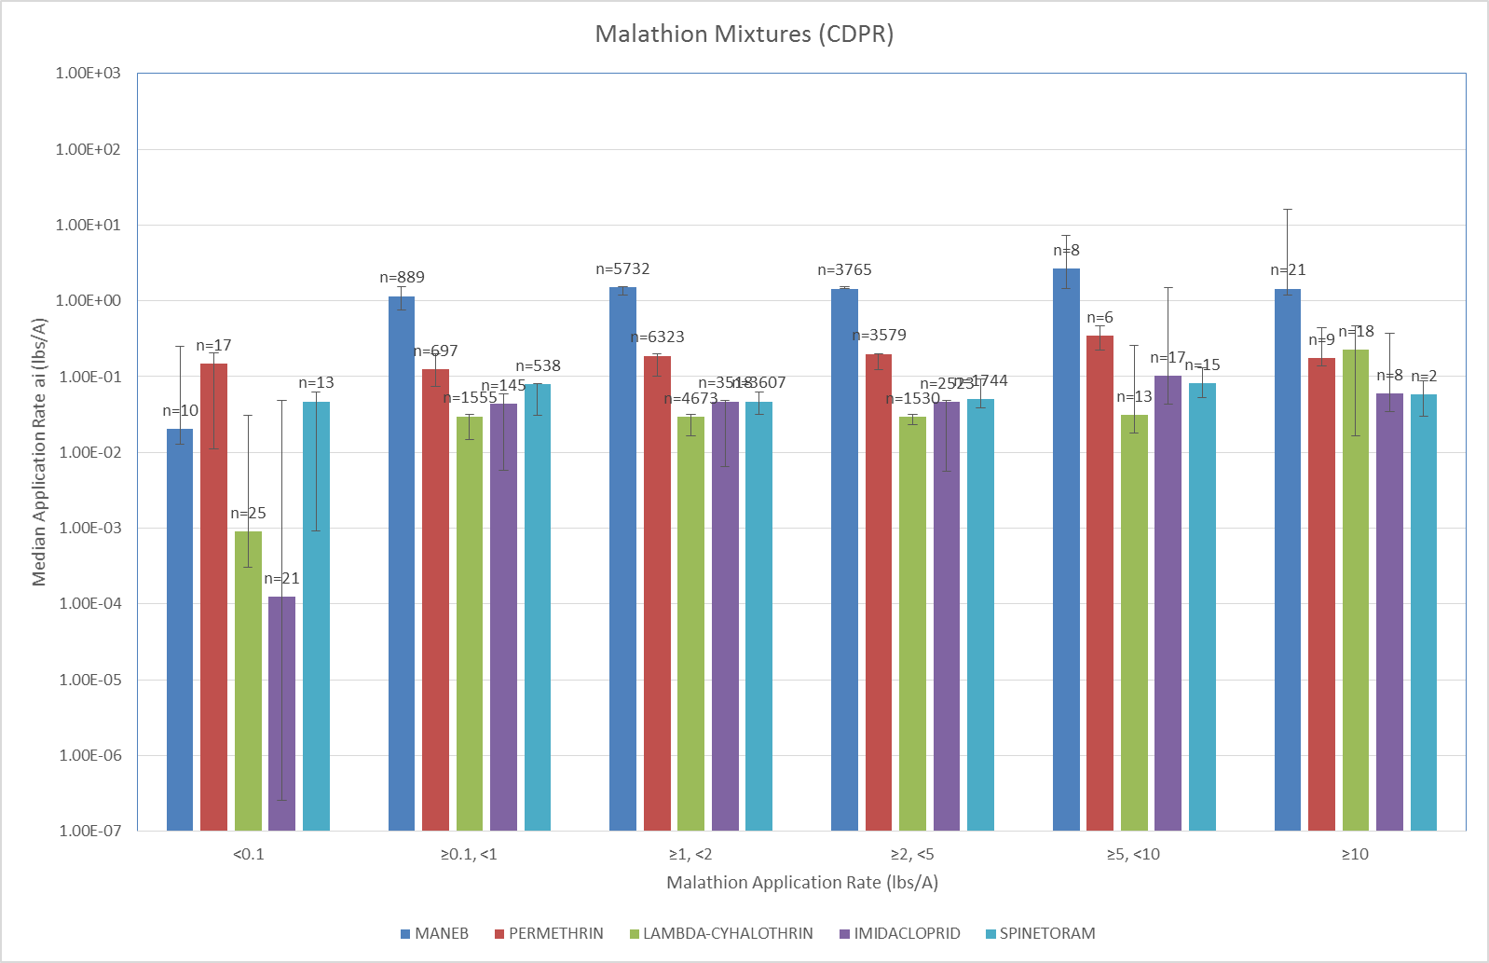
Figure S-1. Application rates for common malathion mixtures based on CAPUR data. Error bars represent range of 5th percentile application rate to 95th percentile application rate for ai.
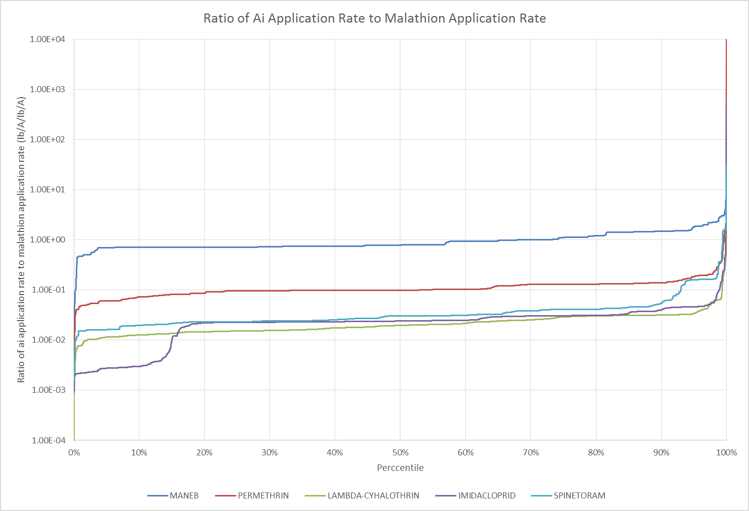
Figure S-2. Ratio of active ingredient application rate to malathion application rate for common mixtures.

http://www.epa.gov/opprd001/inerts/
http://pubs.usgs.gov/circ/circ1225/
http://pubs.usgs.gov/circ/2005/1291/pdf/circ1291.pdf

