APPENDIX 2-9: Malathion Species Sensitivity Distribution Analysis for Birds

Summary

SSDs were fit to test results for birds exposed to Malathion. Five distributions were used and the triangular distribution provided the best fit. Summary statistics from the fitted SSDs are provided below in Table B 2-9.1. Detailed results follow.

Table B 2-9.1 Summary statistics for SSDs fit to Malathion test results
Statistic | Birds
Best Distribution (by AIC_{c}) | Triangular
Goodness of fit P-value | 1.0
CV of the HC₀₅ | 0.5476
HC₀₅ | 107.97
HC₁₀ | 133.82
HC₅₀ | 331.1
HC₉₀ | 819.1
HC₉₅ | 1015
Mortality Threshold (slope = 6.6)¹ | 20.6
Indirect Effects Threshold (slope = 6.6) | 69.0
¹ Dose-response slope for study near the HC05 (MRID 48963305). 95% Confidence Intervals were not reported in study DER.

Data

Available bird toxicity data for SSDs included studies standard test duration (typically around 14 days) and used technical grade active ingredient. The dataset contained 7 test results on 6 species. Data were first standardized to 100g body weight using Eq (1):

In Eq. (1), AT = adjusted toxicity value, AW = mean weight of the assessed birds, TW = the mean weight of the tested birds (i.e., from which the LD₅₀ estimate was derived), and x = 1.15 = default Mineau scaling factor (Mineau et al. 1996). Toxicity data are presented in Table B 2-9.2.

Table B 2-9.2 Acute LD₅₀ values for birds
Species | Acute LD50 (from study)  (mg a.i./kg-bw) | Adjusted LD50 (adjusted to 100g)  (mg a.i./kg-bw) | Slope | Reference
Ring-necked pheasant  (Phasianus colchicus) | 136 | 94.47 | 6.6 | MRID 48963305
Ring-necked pheasant  (P. colchicus) | 167 | 116.0 | NA | MRID 00160000/ E50386
Northern Bobwhite Quail  (Colinus virginianus) | 361 | 331.1 | 9.42 | MRID48153114
Horned Lark  (Eremophila alpestris) | 403 | 479.5 | NA | MRID 00160000/ E50386
Mallard Duck  (Anas platyrhynchos) | 1485 | 1039 | NA | MRID 00160000/ E50386
Sharp tailed Grouse  (Typanuchus phasianellus) | 220 | 158.6 | NA | Crabtree, 1965
Domestic Chicken  (Gallus domesticus) | 524.8 | 377.2 | NA | E36916

Five potential distributions for the Malathion data were considered (log-normal, log-logistic, log-triangular, log-gumbel, and Burr). To fit each of the first four distributions, the toxicity values were common log (log₁₀) transformed. A comparison of the separate distributions using Akaike’s information criterion (AICc) was conducted. Finally, direct and indirect effect thresholds and report five quantiles from the fitted SSDs (HC₀₅, HC₁₀, HC₅₀, HC₉₀, HC₉₅) were calculated.

Comparison of distributions using AICc

AIC_{c} was used to compare the five distributions for the avian dataset and for this comparison the SSD was fit using maximum likelihood.

For birds, AIC_{c} suggested that the triangular distribution provided the best fit (Table B 2-9.3).

Table B 2-9.3. Comparison of distributions for avian toxicity data for Malathion
distribution | HC05 | AIC_{c} | ∆AIC_{c} | Weight
Triangular | 107.9764 | 89.7592 | 0 | 0.3689
Normal | 93.5473 | 90.6179 | 0.8587 | 0.2401
Logistic | 87.4570 | 91.0199 | 1.2607 | 0.1964
Gumbel | 104.1528 | 91.0516 | 1.2925 | 0.1933
burr | 91.1602 | 101.0161 | 11.2570 | 0.0013

Goodness of fit and the importance of fitting method

To test goodness-of-fit, all five distributions for the avian toxicity data for Malathion were fit and ran bootstrap goodness-of-fit tests with 10,000 bootstrap replicates. Maximum likelihood (ML) was used. None of the distributions showed a significant lack of fit. The best distribution, as determined by AIC_{c}, also had a lower coefficient of variation for the HC₀₅ (Table B 2-9.4).

Table B 2-9.4. Range of HC₀₅ values for Malathion SSDs fit to bird dataset.
distribution | method | HC05 | SE | CV | LCL | UCL | P
Triangular | ML | 107.9764 | 59.1306 | 0.5476 | 72.9875 | 284.2096 | 1
Normal | ML | 93.5473 | 60.4611 | 0.6463 | 2.4731 | 267.3054 | 0.9980
Logistic | ML | 87.4570 | 57.2776 | 0.6549 | 33.6570 | 245.6303 | 0.9950
Gumbel | ML | 104.1528 | 46.0393 | 0.4420 | 63.9591 | 236.4019 | 1
Burr | ML | 91.1602 | 74.6627 | 0.8190 | 0 | 275.1692 | 0.7592

A plot of the data is shown in Figure B 2-9.1.

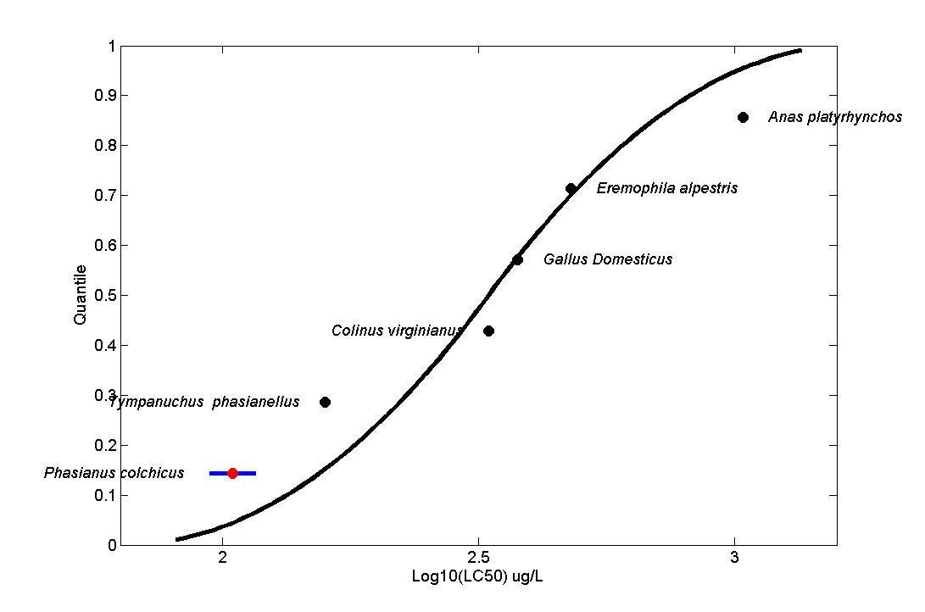
Figure B 2-9.1. Log-triangular SSD for Malathion LC₅₀s for birds. Red points indicate single toxicity values. Black points indicate multiple toxicity values. Blue line indicates full range of toxicity values for a given species.
Calculation of other quantiles
Table B 2-9.5 provides estimates of the HC₀₅ as well as other quantiles of the fitted SSDs.

Table B 2-9.5. Estimated quantiles of the fitted SSDs for avian tests for Malathion
dist | method | HC05 | HC10 | HC50 | HC90 | HC95
Triangular | ML | 107.97 | 133.8 | 331.1 | 819.1 | 1015
Normal | ML | 93.54 | 122.5 | 317.94 | 824.7 | 1080
Logistic | ML | 87.45 | 121.6 | 320.5 | 845.0 | 1175
Gumbel | ML | 104.1 | 124.5 | 281.4 | 1012 | 1650
Burr | ML | 91.16 | 123.2 | 314.7 | 867.5 | 1234

Calculation of thresholds
Thresholds were calculated using a probit curve with the HC₀₅ as the mean and three different slopes (2, 4.5, and 9). Calculated thresholds are provided in Table B 2-9.6.

Table B 2-9.6. Thresholds for determination of action area for Malathion avian test results
distrib. | method | Mortality Threshold (10⁻⁶) |  |  | Indirect Effects Threshold (10⁻¹)
 |  | slope = 6.6 | slope = NA | slope = NA | slope = 6.6 | slope = NA | slope = NA
Triangular | ML | 20.6 | -- | -- | 69.0 | -- | --

