APPENDIX 2-8: Malathion Species Sensitivity Distribution Analysis for Aquatic Invertebrates

Summary

SSDs were fit to test results for aquatic invertebrates exposed to Malathion. Four distributions were used to fit the pooled results. There were not enough datapoints to generate separate freshwater and saltwater SSDs. The gumbel distribution provided the best fit for the dataset. This decision was based on the AICc weight, CVs and confidence limits for the different distributions. It is noted that the confidence limits are large for the HC05 and that the CV HC₀₅ was greater than 1, therefore, there is uncertainty in this HC05 value. Summary statistics from the fitted SSDs are provided below in Table B 2-8.1. Detailed results follow.

Table B 2-8.1. Summary statistics for SSDs fit to Malathion test results
Statistic | Pooled Results (FW and SW)
Best Distribution (by AIC_{c}) | Gumbel
Goodness of fit P-value | 0.52
CV of the HC₀₅ | 3.3
HC₀₅ | 1.0
HC₁₀ | 1.7
HC₅₀ | 17.7
HC₉₀ | 684
HC₉₅ | 2766
Mortality Threshold (slope)¹ | 0.091
Indirect Effects Threshold (slope) | 0.54
¹ Slope = default slope of 4.5 used as no slope was available for species near the HC05.

I. Data

Available aquatic invertebrate toxicity data for SSDs included studies with a 48 or 96 hour duration and used technical grade active ingredient with known source and therefore known impurity profile.

The dataset contained 6 species (Table B 2-8.2).

Table B 2-8.2. Distribution of test results available for Malathion
Species | LC50 (ug/L) | MRID
Gammarus pseudolimnaeus | 2.1 | 49389402
Procambarus clarkia | 21000 | 49534901
Palaemonetes pugio | 67 | 49534902
Centroptilum triangulifer | 23 | 49479001
Chironomus dilutus | 3.5 | 49479002
Americamysis bahia | 4.8 | 49389401

Four potential distributions for the Malathion data were considered (log-normal, log-logistic, log-triangular, log-gumbel,). To fit each of the four distributions, the toxicity values were common log (log₁₀) transformed. An evaluation for fitting separate distributions using Akaike’s information criterion (AICc) was conducted. Finally, direct and indirect effect thresholds and report five quantiles from the fitted SSDs (HC₀₅, HC₁₀, HC₅₀, HC₉₀, HC₉₅) were calculated.

II. Comparison of distributions using AICc

AIC_{c} was used to compare the four distributions for the dataset. For this comparison all SSDs were fit using maximum likelihood.

For the pooled and freshwater datasets, AIC_{c} suggested that the gumbel distribution provided the best fit (Table B 2-8.3).

Table B 2-8.3. Comparison of distributions for all aquatic invertebrate toxicity data for Malathion
distribution | HC05 | AIC_{c} | ∆AIC_{c} | Weight
Gumbel | 1.0308 | 77.8060 | 0 | 0.5281
Logistic | 0.1424 | 80.0988 | 2.2928 | 0.1678
Triangular | 0.3429 | 80.1813 | 2.3754 | 0.1610
Normal | 0.1889 | 80.4173 | 2.6113 | 0.1431

III. Distributions

The cumulative distribution functions for the full SSDs is presented in Figure B 2-8.1 below.

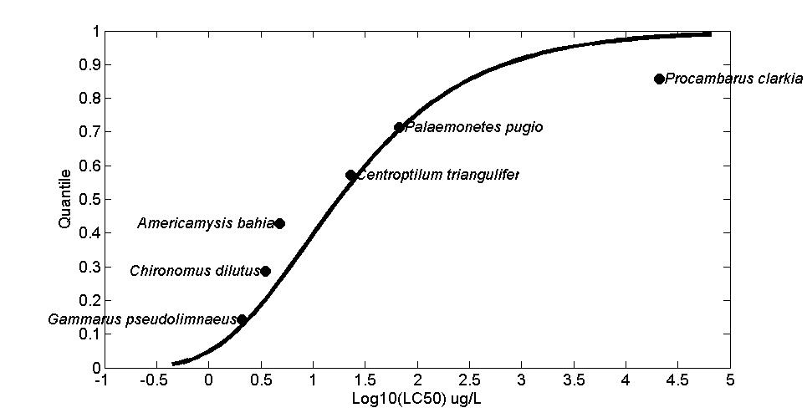
Figure B 2-8.1. Log-gumbel SSD for Malathion toxicity values for all aquatic invertebrates.

IV. Goodness of fit and the importance of fitting method

Finally, to test goodness-of-fit, all four distributions for Malathion were fit and ran bootstrap goodness-of-fit tests with 10,000 bootstrap replicates. Maximum likelihood (ML) was used. In general, the best distribution, as determined by AIC_{c}, also had a lower coefficient of variation for the HC₀₅ (Table B 2-8.4).

Table B 2-8.4. Range of HC05 values for Malathion SSDs fit to all invertebrates.
distribution | method | HC05 | SE | CV | LCL | UCL | P
Normal | ML | 0.1889 | 8.2056 | 43.4355 | 0.0059 | 15.4644 | 0.2877
Logistic | ML | 0.1424 | 4.5850 | 32.2044 | 0.0043 | 6.4450 | 0.2657
Triangular | ML | 0.3429 | 17.4496 | 50.8841 | 0.0479 | 33.1623 | 0.4086
Gumbel | ML | 1.0308 | 3.3532 | 3.2531 | 0.2592 | 10.9675 | 0.5195

V. Calculation of other quantiles

Table B 2-8.5 provide estimates of the HC05 as well as other quantiles of the fitted SSDs.

Table B 2-8.5. Estimated quantiles of the fitted SSDs for pooled toxicity tests for Malathion
dist | method | HC05 | HC10 | HC50 | HC90 | HC95
Normal | ML | 0.1889 | 0.5882 | 32.3290 | 1.7768e+03 | 5.5324e+03
Logistic | ML | 0.1424 | 0.4874 | 18.1719 | 677.5533 | 2.3194e+03
Triangular | ML | 0.3429 | 0.9080 | 55.3102 | 3.3691e+03 | 8.9209e+03
Gumbel | ML | 1.0308 | 1.7179 | 17.6612 | 683.9821 | 2.7659e+03

VI. Calculation of thresholds
Thresholds were calculated using a probit curve with the HC₀₅ as the mean and the lower and upper limits based on the slope. Calculated thresholds are provided in Table B 2-8.6. The distribution shown is the chosen distributions for each dataset based on AICc weight, CV of the HC05 and the confidence limits.

Table B 2-8.12. Thresholds for determination of action area for Malathion aquatic invertebrate pooled test results
distrib. | method | Mortality Threshold (10⁻⁶) |  |  | Indirect Effects Threshold (10⁻¹)
 |  | slope = 4.5 | Lower Limit | Upper Limit | slope = 4.5 | Lower Limit | Upper Limit
Gumbel | ML | 0.091 | 0.023 | 0.96 | 0.54 | 0.13 | 5.7

