APPENDIX 2-6: Species Sensitivity Distribution analysis for Fish

SSDs were fitted to test results for aquatic vertebrates exposed to Malathion. Four distributions were used to fit the data (Burr was not used in this evaluation). Summary statistics for SSDs modeled are presented below. For both datasets (all vertebrates, and all fish), the HC05 value from the gumbel distribution was chosen. These decisions were based on the AICc weight, CVs and confidence limits for the different distributions. For both datasets, it is noted that the confidence limits are large for the HC05 and that the CV HC₀₅ was greater than 1, therefore, there is uncertainty in this HC05 value. It is also noted that the HC05 value for both datasets are close to the lowest LC50 value which is for the three-spine stickleback. There were not enough toxicity values to generate separate freshwater and saltwater fish SSDs.

Table B 2-6.1. Summary statistics for SSDs fit to Malathion test results
Statistic | All  Vertebr. | Fish
Best Distribution (by AIC_{c}) | Triangular² | Gumbel
Goodness of fit  P-value | 0.62 | 0.63
CV of the HC₀₅ | 1.6 | 1.4
HC₀₅ | 20.9 | 19.4
HC₁₀ | 34.0 | 30.5
HC₅₀ | 315 | 243
HC₉₀ | 10317 | 6270
HC₉₅ | 39143 | 21724
Mortality Thresh.¹  (slope = 3) | 0.54 | 0.50
Indirect Effects Threshold¹  (slope = 3) | 7.8 | 7.3
¹Slope of dose-response curve = 3 (based on HC05 being close to empirical LC50 value)
² While the best distribution by AICc was triangular, overall the results from the gumbel distribution were selected and these results are presented in the subsequent results

I. Data

Available aquatic invertebrate toxicity data for SSDs included studies with a 96 hour duration and used technical grade active ingredient with known source and therefore, known impurity profile.

The dataset contained 10 species, each with 1 result (Table 2-6.2).

Table B 2-6.2. Distribution of test results available for Malathion
Species | LC50  (ug/L) | MRID
Lepomis macrhirus | 48 | 47540304
Oncorhynchus kisutch | 720 | 497479003
Pimephales promelas | 28300 | 49252802
Lepomis cyanellus | 130 | 49364101
Oryzias latipes | 1500 | 49364102
Oncorhynchus mykiss | 170 | 47540302
Gambusia affinis | 2900 | 49422801
Cyprinodon variegatus | 51.9 | 49055701
Gasterosteus aculeatus | 20.9 | 48998006
Xenopus laevis | 4710 | 48409302

Four potential distributions for the Malathion data (log-normal, log-logistic, log-triangular, and log-gumbel) were considered. To fit each of the first four distributions, the toxicity values were common log (log₁₀) transformed. Also, fitting separate distributions using linear models and Akaike’s information criterion (AICc) was conducted. Finally, the direct and indirect effect thresholds and report five quantiles from the fitted SSDs (HC₀₅, HC₁₀, HC₅₀, HC₉₀, HC₉₅) were calculated.

II. Comparison of distributions using AICc

AIC_{c} was used to compare the five distributions for both datasets. For these comparisons all SSDs were fit using maximum likelihood.

For the all vertebrate dataset, AIC_{c} suggested that the triangular distribution provided the best fit (Tables 2-6.3 to 2-6.4), and all fish using the gumbel distribution.

Table B 2-6.3. Comparison of distributions for all aquatic vertebrate toxicity data for Malathion
distribution | HC05 | AIC_{c} | ∆AIC_{c} | Weight
Triangular | 20.8 | 172.3 | 0 | 0.3200
Gumbel | 20.9 | 172.5 | 0.175 | 0.2931
Normal | 12.0 | 172.9 | 0.632 | 0.2333
logistic | 8.1 | 173.8 | 1.4 | 0.1536

Table B 2-6.4. Comparison of distributions for fish toxicity data for Malathion
distribution | HC05 | AIC_{c} | ∆AIC_{c} | Weight
Gumbel | 19.4 | 150.5 | 0 | 0.3767
Triangular | 15.8 | 151.3 | 0.833 | 0.2484
Normal | 9.7 | 151.7 | 1.16 | 0.2106
Logistic | 6.7 | 152.2 | 1.66 | 0.1644

III. Distribution Fits
The cumulative distribution functions for the separated and full SSDs are presented in Figure B 2-6.1 and B 2.6.2 below.

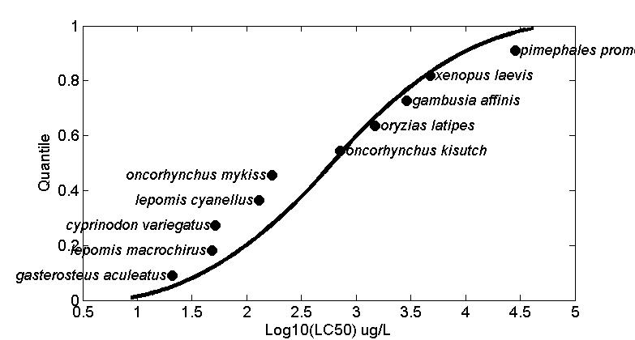
Figure B 2-6.1. Log-gumbel SSD for Malathion toxicity values for all aquatic vertebrates pooled.

Figure B 2-6.2. Log-gumbel SSD for Malathion LC50s for fish.

IV. Goodness of fit and the importance of fitting method

To test goodness-of-fit, all four distributions the toxicity data for Malathion were fit and bootstrap goodness-of-fit tests with 10,000 bootstrap replicates were run. The maximum likelihood (ML) fitting method was used. Tables B 2-6.5 to B 2-6.6 give results of these fitting exercises. In general, goodness of fit was above 0.6 for the distributions and the coefficient of variation for the HC₀₅ was above 1 for the competitive distributions.

Table B 2-6.5. Range of HC05 values for Malathion SSDs for all aquatic vertebrates
distribution | method | HC05 | SE | CV | LCL | UCL | P
Normal | ML | 12.0433 | 33.2033 | 2.7570 | 0.1172 | 105.2170 | 0.6563
Logistic | ML | 8.0986 | 28.7022 | 3.5441 | 0.5456 | 107.1404 | 0.4156
Triangular | ML | 20.7828 | 61.0278 | 2.9365 | 7.9701 | 202.8903 | 0.9910
Gumbel | ML | 20.9110 | 33.7872 | 1.6158 | 7.3420 | 112.0394 | 0.6214

Table B 2-6.5. Range of HC05 values for Malathion SSDs for fish
distribution | method | HC05 | SE | CV | LCL | UCL | P
Normal | ML | 9.7105 | 33.1157 | 3.4103 | 0.7097 | 113.1821 | 0.6234
Logistic | ML | 6.6970 | 31.7564 | 4.7419 | 0.4495 | 85.0237 | 0.3636
Triangular | ML | 15.8391 | 54.0599 | 3.4131 | 5.6928 | 192.8826 | 0.9790
Gumbel | ML | 19.3911 | 27.9818 | 1.4430 | 6.5850 | 103.3621 | 0.6324

V. Calculation of other quantiles
Tables B 2-6.6 to B 2-6.7 provide estimates of the HC05 as well as other quantiles of the fitted SSDs.

Table B 2-6.6. Estimated quantiles of the fitted SSDs for Malathion LC50s for all aquatic vertebrates
dist | method | HC05 | HC10 | HC50 | HC90 | HC95
Normal | ML | 12.0433 | 26.9998 | 465.7551 | 8.0344e+03 | 1.8012e+04
Logistic | ML | 8.0986 | 22.1246 | 424.9447 | 8.1619e+03 | 2.2298e+04
Triangular | ML | 20.7828 | 39.6334 | 604.2642 | 9.2128e+03 | 1.7569e+04
Gumbel | ML | 20.9110 | 34.0478 | 314.7381 | 1.0317e+04 | 3.9143e+04

Table B 2-6.7. Estimated quantiles of the fitted SSDs for Malathion LC50s for fish
dist | method | HC05 | HC10 | HC50 | HC90 | HC95
Normal | ML | 9.7105 | 21.5699 | 360.1689 | 6.0140e+03 | 1.3359e+04
Logistic | ML | 6.6970 | 17.6241 | 303.2529 | 5.2180e+03 | 1.3732e+04
Triangular | ML | 15.8391 | 30.6262 | 494.9930 | 8.0003e+03 | 1.5469e+04
Gumbel | ML | 19.3911 | 30.5416 | 242.6296 | 6.2701e+03 | 2.1724e+04

VI. Calculation of thresholds
Thresholds were calculated using a probit curve with the HC₀₅ as the mean and the lower and upper limits based on the slope. Calculated thresholds are provided in Tables B 2-6.8 to B 2-6.9. The distributions are the chosen distributions for each dataset based on AICc weights, CVs of the HC05, and confidence limits.

Table B 2-6.8. Thresholds for determination of action area for Malathion LC50s for all aquatic vertebrates
distrib. | method | Mortality Threshold (10⁻⁶) |  |  | Indirect Effects Threshold (10⁻¹)
 |  | slope = 3 | Lower Limit | Upper Limit | slope = 3 | Lower Limit | Upper Limit
Gumbel | ML | 0.54 | 0.19 | 2.9 | 7.8 | 2.7 | 42

Table B 2-6.9. Thresholds for determination of action area for Malathion LC50s for fish
distrib. | method | Mortality Threshold (10⁻⁶) |  |  | Indirect Effects Threshold (10⁻¹)
 |  | slope = 3 | Lower Limit | Upper Limit | slope = 3 | Lower Limit | Upper Limit
Gumbel | ML | 0.50 | 0.17 | 2.7 | 7.3 | 2.5 | 39

