Chapter 2 – Imidacloprid Effects Characterization
Contents
1 Introduction 6
2 Endpoints used in Effects Determinations 7
3 Office of Water Aquatic Life Criteria 12
4 Effects Characterization for Fish 12
4.1 Introduction to Fish Toxicity 12
4.2 Effects on Mortality of Fish 12
4.3 Effects on Growth and Reproduction of Fish 13
4.4 Other Sublethal Effects to Fish 14
5 Effects Characterization Aquatic-phase Amphibians 15
5.1 Introduction to Aquatic-phase Amphibian Toxicity 15
5.2 Effects on Mortality of Aquatic-phase Amphibians 15
5.3 Effects on Growth and Reproduction of Aquatic-phase Amphibians 16
5.4 Other Sublethal Effects to Aquatic-phase Amphibians 16
6 Effects Characterization for Aquatic Invertebrates 17
6.1 Introduction to Aquatic Invertebrate Toxicity 17
6.2 Effects on Mortality of Aquatic Invertebrates 17
6.3 Effects on Growth and Reproduction of Aquatic Invertebrates 20
6.4 Other Sublethal Effects to Aquatic Invertebrates 23
7 Effects Characterization for Aquatic Plants 24
7.1 Introduction to Aquatic Plant Toxicity 24
7.2 Effects on Aquatic Plants 24
7.3 Effects on Growth of Vascular and Non-Vascular Aquatic Plants 25
8 Effects Characterization for Birds 26
8.1 Introduction to Bird Toxicity 26
8.2 Effects on Mortality of Birds 27
8.3 Effects on Growth and Reproduction of Birds 27
8.4 Other sublethal effects to Birds 28
8.5 Drinking water studies 30
8.6 Dermal studies 30
8.7 Inhalation studies 30
9 Effect Characterization to Reptiles 31
10 Effect Characterization to Terrestrial-phase Amphibians 31
11 Effects Characterization for Mammals 31
11.1 Introduction to Mammal Toxicity 31
11.2 Effects on Mortality of Mammals 31
11.3 Effects on Growth and Reproduction of Mammals 31
11.4 Other Sublethal Effects to Mammals 33
11.5 Drinking water studies 34
11.6 Dermal exposure studies 34
11.7 Inhalation studies 35
12 Effects Characterization for Terrestrial Invertebrates 35
12.1 Introduction to Terrestrial Invertebrate Toxicity 35
12.2 Mortality to Terrestrial Invertebrates 36
12.2.1 Topical Contact Exposure 36
12.2.2 Dietary Exposure 38
12.2.3 Environmental Exposure via Soil 40
12.2.4 Environmental Exposure via Contaminated Surfaces 41
12.3 Most Sensitive Growth, Reproduction and Mortality Endpoints of Terrestrial Invertebrates 42
12.3.1 Topical Contact Exposure 43
12.3.2 Most Sensitive Dietary Exposure 45
12.3.3 Most Sensitive Environmental Exposure via Soil 46
12.3.4 Most Sensitive Environmental Exposure via Contaminated Surfaces 47
12.4 Other Sublethal Effects to Terrestrial Invertebrates 48
13 Effects Characterization for Terrestrial Plants 49
13.1 Introduction to Terrestrial Plant Toxicity 49
13.2 Effects Data for Terrestrial Plants 49
14 Incident Reports 50
14.1 Aquatic Incidents 50
14.2 Terrestrial Incidents 51
14.2.1 Terrestrial Invertebrate Incidents 53
15 Alternative Toxicity endpoints 58

Tables
Table 2-1. Terrestrial mortality endpoints used to evaluate impacts to species and PPHD. 8
Table 2-2. Terrestrial sublethal endpoints used to evaluate impacts to species and PPHD. 8
Table 2-3. Aquatic mortality endpoints used to evaluate impacts to species and PPHD. 10
Table 2-4. Aquatic sublethal endpoints used to evaluate impacts to species and PPHD. 10
Table 2-5. Aquatic plant endpoints used to evaluate impacts to species and PPHD. 11
Table 2-6. Terrestrial plant endpoints used to evaluate impacts to species and impacts to PPHD. 11
Table 2-7. Summary of imidacloprid toxicity endpoints used for assessing risk to aquatic invertebrates 18
Table 2-8. Summary of imidacloprid mortality endpoints for aquatic invertebrates (values in µg a.i./L). 19
Table 2-9. Avian Acute Toxicity Data for Imidacloprid. 28
Table 2-10. Avian Subacute Toxicity Data for Imidacloprid. 28
Table 2-11. Summary of the Most Sensitive Reproductive and Developmental Mammalian Endpoints for Imidacloprid 33
Table 2-12. Dermal Exposure Studies for Imidacloprid. 36
Table 2-13. Inhalation Studies for Imidacloprid 36
Table 2-14. Summary of imidacloprid toxicity endpoints used for assessing risk to terrestrial invertebrates 36
Table 2-15. Summary of imidacloprid acute mortality endpoints for topical contact exposure of terrestrial invertebrates to imidacloprid. 38
Table 2-16. Summary of imidacloprid acute mortality endpoints for dietary exposure of terrestrial invertebrates to imidacloprid. 40
Table 2-17. Overview of reported incidents by taxa 52
Table 2-18. Overview of reported aquatic use incidents by taxa 53
Table 2-19. Overview of reported terrestrial incidents by taxa 53
Table 2-20. Overview of reported terrestrial incidents by taxa 56
Table 2-21. Alternative toxicity endpoints used in weight of evidence analysis. 60

Figures
Figure 2-1. Array of acute mortality toxicity data for freshwater fish expressed in terms of mg a.i./L. Blue squares represent LC50 values from open literature studies found in the ECOTOX database. Red squares represent LC50 values from registrant submitted studies. Parentheses present the endpoint measurement, species, study reference (i.e., MRID, ECOTOX #), and study duration. 13
Figure 2-2. Summary array of sublethal toxicity data for fish expressed in terms of mg a.i./L. Solid lines display the range between the LOAEC and NOAEC values while the orange dot is the average. Endpoints are summarized by effect group. 14
Figure 2-3. Array of acute mortality toxicity data for amphibians expressed in terms of mg a.i./L. Blue squares represent LC50 values from open literature studies found in the ECOTOX database. Parentheses present the endpoint measurement, species, study reference (i.e., MRID, ECOTOX #), and study duration. 16
Figure 2-4. Array of sublethal toxicity data for aquatic-phase amphibians expressed in terms of mg a.i./L. Blue squares represent LOAEC values from open literature studies found in the ECOTOX database. Solid lines display the range between the LOAEC and NOAEC values. Parentheses present the effect, species, study duration and reference (i.e., MRID, ECOTOX #). 17
Figure 2- 5. Species sensitivity distribution of imidacloprid toxicity values for freshwater aquatic invertebrates. Selected model was logistic, fit using maximum likelihood, selected based on the lowest AIC and confidence interval for model fit. Black points are single estimates, lines are range of endpoints. 19
Figure 2-6. Species sensitivity distribution of imidacloprid toxicity values for saltwater aquatic invertebrates. Selected model was gumbel, fit using maximum likelihood, selected based on the lowest AIC and confidence interval for model fit. Black points are single estimates, lines are range of endpoints. 20
Figure 2-7. Array of growth and reproduction toxicity data for freshwater invertebrates expressed in terms of µg a.i./L. Blue squares represent LOAEC values from open literature studies found in the ECOTOX database. Red squares represent LC₅₀ values from registrant submitted studies. Solid lines display the range between the LOAEC and NOAEC values. Parentheses present the effect, species, study duration and reference (i.e., MRID, ECOTOX #). 21
Figure 2-8. Array of growth and reproduction toxicity data for freshwater invertebrates focused on endpoints less than 15 µg a.i./L. Blue squares represent LOAEC values from open literature studies found in the ECOTOX database. Solid lines display the range between the LOAEC and NOAEC values. Parentheses present the effect, species, study duration and reference (i.e., MRID, ECOTOX #). 22
Figure 2-9. Array of sublethal toxicity data for saltwater aquatic invertebrates expressed in terms of the log10 transformation of ug a.i./L. Blue squares represent LOAEC values from open literature studies found in the ECOTOX database. Red squares represent LC₅₀ values from registrant submitted studies. Solid lines display the range between the LOAEC and NOAEC values. Parentheses present the effect, species, study duration and reference (i.e., MRID, ECOTOX #). 24
Figure 2-10. Summary array of sublethal toxicity data for freshwater aquatic invertebrates expressed in terms of µg a.i./L. Solid lines display the range between the LOAEC and NOAEC values while the orange dot is the average. Endpoints are summarized by effect group. 25
Figure 2-11. Array of toxicity data for nonvascular aquatic plants expressed in terms of mg a.i./L. Blue squares represent values from open literature studies found in the ECOTOX database. Red squares represent values from registrant submitted studies. Solid lines display the range between the LOAEC and NOAEC values. Parentheses present the effect, aquatic plant grouping, study reference (i.e., MRID, ECOTOX #), and study duration. 27
Figure 2-12. Array of growth and reproductive toxicity data for effects to birds expressed in terms of mg a.i./kg-diet. Blue squares represent values from open literature studies found in the ECOTOX database. Red squares represent values from registrant submitted studies. Solid lines display the range between the LOAEC and NOAEC values. Parentheses present the effect, aquatic plant grouping, study reference (i.e., MRID, ECOTOX #), and study duration. 29
Figure 2-13. Summary array of toxicity data for sublethal effects to birds expressed in terms of mg a.i./kg-bdwt. Solid lines display the range between the LOAEC and NOAEC values while the orange dot is the average. Endpoints are summarized by effect group. 30
Figure 2-14. Summary array of toxicity data for sublethal effects to birds expressed in terms of mg a.i./kg-diet. Solid lines display the range between the LOAEC and NOAEC values while the orange dot is the average. Endpoints are summarized by effect group. 31
Figure 2-15. Array of toxicity data for growth and reproduction effects to mammals expressed in terms of mg a.i./kg-bw. Blue squares represent values from open literature studies found in the ECOTOX database. Red squares represent values from registrant submitted studies. Solid lines display the range between the LOAEC and NOAEC values. Parentheses present the effect, aquatic plant grouping, study reference (i.e., MRID, ECOTOX #), and study duration. 34
Figure 2-16. Array of toxicity data for sublethal effects to mammals expressed in terms of mg a.i./kg-bw. Solid lines display the range between the LOAEC and NOAEC values while the orange dot is the average. Endpoints are summarized by effect group. 35
Figure 2-17. Species sensitivity distribution of imidacloprid acute contact toxicity values for terrestrial invertebrates. Selected model was normal, fit using maximum likelihood, selected based on the lowest AIC, confidence interval around the HC₀₅ and visual inspection of model fit. Black points are single estimates, horizontal lines are range of endpoints. 38
Figure 2-18. Toxicity data array for topical exposure of terrestrial invertebrates to imidacloprid (mg a.i./kg bw) from all exposure durations. Data labels include common name, exposure duration, endpoint type and ECOTOX reference number. 39
Figure 2- 19. Species sensitivity distribution of imidacloprid acute dietary toxicity values for terrestrial invertebrates. Selected model was logistic, fit using maximum likelihood, selected based on the lowest AIC, confidence interval around the HC₀₅ and visual inspection of model fit. Black points are single estimates, horizontal lines are range of endpoints. 41
Figure 2-20. Toxicity data array for oral exposure of terrestrial invertebrates to imidacloprid (reported as mg a.i./kg bw) from all exposure durations. Data labels include common name, exposure duration, endpoint type and ECOTOX reference number. 42
Figure 2- 21. Array of mortality toxicity data for terrestrial invertebrates expressed in terms of mg a.i./kg-soil. Data labels include common name, exposure duration, endpoint type and ECOTOX reference number. 43
Figure 2- 22. Array of mortality toxicity data for terrestrial invertebrates expressed in terms of lb a.i./A. Data labels include common name, exposure duration, endpoint type and ECOTOX reference number. 45
Figure 2-23. Array of all apical toxicity data for terrestrial invertebrates expressed in terms of ug a.i./ g-bw. Data labels include common name, exposure duration, endpoint type and ECOTOX reference number. 46
Figure 2-24. Array of all apical toxicity data for terrestrial invertebrates expressed in terms of ug a.i./ g-food. Data labels include common name, exposure duration, endpoint type and ECOTOX reference number. 48
Figure 2-25. Array of apical toxicity data less than 5 mg a.i./kg-soil for terrestrial invertebrates. Data labels include common name, exposure duration, endpoint type and ECOTOX reference number. 49
Figure 2-26. Array of all apical toxicity data for terrestrial invertebrates expressed in terms of lb a.i./A. Data labels include common name, exposure duration, endpoint type and ECOTOX reference number. 50

Introduction

The following sections discuss toxicity data available for imidacloprid divided into major taxonomic groups of fish and aquatic amphibians, aquatic invertebrates, aquatic plants, birds, reptiles, terrestrial-phase amphibians, mammals, terrestrial invertebrates and terrestrial plants. Based on these data, mortality and sublethal effects (i.e., growth and reproduction) endpoints are determined and are used to evaluate direct effects to a listed species or effects to plants or animals that a species uses for prey, pollination, habitat, and/or dispersal (PPHD).

In establishing the sublethal thresholds and endpoints used in the analysis, EPA used the most sensitive sublethal endpoint based on growth or reproduction or any sublethal endpoints that are strongly linked to survival, growth or reproduction. In determining whether toxicity endpoints are strongly linked to apical endpoints, EPA staff used best professional judgement, while also considering factors such as data quality and relevance to effects on survival and reproduction.

If sufficient data are available, the toxicity data for each taxon are presented as summary data arrays (developed using the Data Array Builder v.1.0; described in ATTACHMENT 2-1). Alternatively, data are presented in a tabular or text format if only limited data is available. The arrays contain data from both laboratory and field experiments. Data in these arrays are grouped by the type of effect (e.g., mortality, growth, and reproduction), and present the range of effects endpoints [e.g., LOAECs and NOAECs (NOAECs must have a corresponding LOAEC to be represented in array)] for each effect type. The effect related to mortality, growth, and reproduction are discussed in further detail within each taxon effects characterization. All endpoints are reported in terms of amount of active ingredient, unless otherwise specified. Data used in the arrays are available for each taxon in APPENDIX 2-1. Studies for which exposure units could not be converted to environmentally relevant units were not included in the data arrays. Endpoints reported in the ECOTOX database are presented in APPENDIX 2-2. Reviews of open literature studies are presented in APPENDIX 2-3. Citations for registrant submitted studies are presented in APPENDIX 2-4.

On an acute exposure basis, imidacloprid is classified as very highly toxic to aquatic invertebrates. The available data suggest that aquatic insect species (class Insecta) are more sensitive on an acute exposure basis compared to other species of aquatic invertebrates (e.g., crustaceans). By comparison, fish and aquatic plants are several orders of magnitude less sensitive following acute exposure to imidacloprid. On a chronic exposure basis, a decrease in survival was observed in aquatic insects. As with acute exposure, daphnids, mysid shrimp, and fish are orders of magnitude less sensitive compared to aquatic insects when chronically exposed to imidacloprid.

For terrestrial organisms, imidacloprid is characterized as highly toxic to bees, highly toxic to birds and moderately toxic to mammals on an acute exposure basis. Available data suggest potential effects to honey bee and bumble bee colonies, that manifest as impacts to numbers of adults and decreases in brood. Chronic exposures to birds and mammals lead to decreases in body weight and egg production in birds. Generally, no effects were observed in terrestrial plant studies that tested up to the currently registered single maximum application rate.

Endpoints used in Effects Determinations

Toxicity data available for imidacloprid was reviewed and divided into major taxonomic groups, including: fish, aquatic amphibians, aquatic invertebrates, aquatic plants, birds, reptiles, terrestrial-phase amphibians, mammals, terrestrial invertebrates and terrestrial plants. For each of these groups, endpoints are determined for each taxon for mortality (animals only) and sublethal effects (i.e., growth or reproduction). These endpoints are used to establish thresholds, which are then used in conjunction with exposure data to make effects determinations based on the taxon with which they are associated. These data are described more fully in each relevant toxicity section below. Table 2-1 through Table 2-6 summarizes the imidacloprid toxicity endpoints used in the effects determinations for all taxa. Later in this chapter, the available toxicity data for each taxon is discussed further.
Table 2-1. Terrestrial mortality endpoints used to evaluate impacts to species and PPHD.
Type of Threshold | Taxon | Test Species | Type of endpoint | Value | Units | Slope | Weight of test animal (g) | Comments | Reference
DOSE BASED MORTALITY | Mammals | Lab Rat | LD₅₀ | 424 | mg ai/kg-bw | 4.5 | 238 | For males; assumed slope | MRID 42055331
 | Birds | Japanese quail | LD₅₀ | 17 | mg ai/kg-bw | 4.5 | 268 | Assumed slope | MRID 44457401
 | Reptiles and Amphibians | Japanese quail | LD₅₀ | 17 | mg ai/kg-bw | 4.5 | 268 | Bird used as a surrogate; Assumed slope | MRID 44457401
 | Terrestrial Invertebrates | SSD | LD₅₀ | 0.015 | mg ai/kg-bw | 1.6 | NA | HC₀₅ from SSD; mean of slopes nearest HC₀₅ | APPENDIX 2-6
DIETARY BASED MORTALITY | Mammals | No Data
 | Birds | Northern bobwhite quail | LC₅₀ | 1536 | mg ai/kg-diet | 1.2 | NA |  | MRID 42055310
 | Reptiles and Amphibians | Northern bobwhite quail | LC₅₀ | 1536 | mg ai/kg-diet | 1.2 | NA | Bird used as a surrogate | MRID 42055310
 | Terrestrial Invertebrates | SSD | LC₅₀ | 0.064 | mg ai/kg-diet | 1.8 | NA | HC₀₅ from SSD, slopes nearest HC₀₅ | APPENDIX 2-6
MORTALITY | Terrestrial Invertebrates | Earthworm | LC₅₀ | 0.55 | mg ai/kg-soil | 4.5 | NA | Assumed slope, soil exposure | ECOTOX 184175
 | Terrestrial Invertebrates | Parasitic wasp | LC₅₀ | 0.00017 | lb ai/A | 4.2 | NA | Reported slope, contact exposure | ECOTOX 184109
LD₅₀ – dose at which 50% mortality occurs
SSD – Species sensitivity distribution
HC₀₅ - hazardous concentration at which 5% of the species are exposed to a concentration above their LD₅₀
LC₅₀ – concentration at which 50% mortality occurs
NA = not applicable

Table 2-2. Terrestrial sublethal endpoints used to evaluate impacts to species and PPHD.
Type of Threshold | Taxon | Test Species | NOAEC | MATC | Units | Comments | Reference
DOSE BASED SUBLETHAL  ENDPOINTS | Mammals | Lab Rat | 10.0 | 14.1 | mg ai/kg-bw | MATC used, LOAEC = 20; decreased food consumption (20%) and decreased body weight gain (47%) | ECOTOX 168931 & 169053
 | Birds | Mallard duck | 11.7 | 16.0 | mg ai/kg-bw | MATC used, LOAEC = 21.9; Calculated using average BW female controls | MRID 42055313
 | Reptiles | Mallard duck | 11.7 | 16.0 | mg ai/kg-bw | MATC used, LOAEC = 21.9; Calculated using average BW female controls; Bird used as a surrogate | MRID 42055313
DIETARY BASED SUBLETHAL  ENDPOINTS | Mammals | Lab Rat | 250 | 418 | mg ai/kg-diet | MATC used; LOAEC = 700; 9-12% decreased parental and offspring body weight | MRID 42256340
 | Birds | Mallard duck | 125 | 171 | mg ai/kg-diet | MATC used, LOAEC = 234; reduction in egg production and hatchability and female body weight. | MRID 42055313
 | Reptiles and Amphibians | Mallard duck | 125 | 171 | mg ai/kg-diet | Bird used as a surrogate; MATC used, LOAEC = 234; reduction in egg production and hatchability and female body weight. | MRID 42055313
 | Terrestrial Invertebrates | Bumble bee | 0.00081 | 0.0018 | mg ai/kg-diet | MATC used, LOAEC = 0.0039; 20% increase in time to emergence and 20% decrease in nest weight | ECOTOX 184438
SUBLETHAL / MORTALITY | Terrestrial Invertebrates | Spined soldier bug | 0.0023 | NA | mg ai/kg-bw | 5-day LC₅₀ mortality | ECOTOX 39981
 | Terrestrial Invertebrates | Springtail | <0.01 | NA | mg ai/kg-soil | LOAEC = 0.01; Effects to fecundity at all levels | ECOTOX 184605
 | Terrestrial Invertebrates | Parasitic wasp | 0.00017 | NA | lb ai/A | 2-day LC₅₀ mortality | ECOTOX 184109
NOAEC - No Observed Adverse Effect Concentration
LOAEC - Lowest Observed Adverse Effect Concentration
MATC - Maximal Acceptable Toxicant Concentration

Table 2-3. Aquatic mortality endpoints used to evaluate impacts to species and PPHD.
Taxon | Test Species | Type of endpoint | Value  (µg ai/L) | Slope | Duration of study (days) | Comments | Reference
FW Fish | Zebrafish  (Danio rerio) | LC₅₀ | 26,400 | 4.5 | 4 | Assumed slope | ECOTOX 184102
E/M Fish | Sheepshead Minnow  (Cyprinodon variegatus) | LC₅₀ | 163,000 | 6.82 | 4 | -- | MRID 42055318
AQ Amphibians | Montevideo Tree Frog  (Boana pulchella) | LC₅₀ | 52,600 | 4.5 | 4 | Assumed slope | ECOTOX 168449
Other FW Invertebrates | Species sensitivity distribution | LC₅₀ | 1.43 | 1.7 | 2-4 | -- | APPENDIX 2-5
E/M Invertebrates | Species sensitivity distribution | LC₅₀ | 13.15 | 3.63 | 2-4 | -- | APPENDIX 2-5
Mollusks | File Rams-horn snail  (Planorbella pilsbryi) | LC₅₀ | 3,980 | 4.5 | 7 | Assumed slope | ECOTOX 173464
NA = not applicable

Table 2-4. Aquatic sublethal endpoints used to evaluate impacts to species and PPHD.
Taxon | Test Species | NOAEC (µg ai/L) | MATC (µg ai/L) | Duration of study (days) | Comments | Reference
FW Fish | Rainbow Trout (Oncorhynchus mykiss) | 9,000 | 15,560 | 91 | MATC used as input; LOAEC = 26,900; timing of hatch and swim-up | MRID 49602703
E/M Fish | Rainbow Trout (Oncorhynchus mykiss) | 9,000 | 15,560 | 91 | FW fish used as surrogate; MATC used as input; LOAEC = 26,900; timing of hatch and swim-up | MRID 49602703
AQ Amphibians | Rainbow Trout (Oncorhynchus mykiss) | 9,000 | 15,560 | 91 | FW fish used as surrogate; MATC used as input; LOAEC = 26,900; timing of hatch and swim-up | MRID 49602703
Other FW Invertebrates | Midge  (Chironomus riparius) | 0.125 | 0.280 | 28 | MATC used as input; LOAEC = 0.625; reduction in mean emergence time | ECOTOX 183987
E/M Invertebrates | Saltwater mysid (Americamysis bahia) | 0.163 | 0.231 | 28 | MATC used as input; LOAEC = 0.326; reduction in length and weight | MRID 42055322
Mollusks | Colombian ramshorn apple snail  (Marisa cornuarietis) | 10,000 | 15,811 | 9 | MATC used as input; LOAEC = 25,000; decreased larval heart rate | ECOTOX 112105
NA = not applicable

Table 2-5. Aquatic plant endpoints used to evaluate impacts to species and PPHD.
EPA Category | Species | NOAEC (ug ai/L) | MATC  (ug ai/L) | IC50  (ug ai/L) | Comments | Reference
Non-vascular | Diatom  (Navicula pelliculosa) | 6,700 | 10,672 | 12,400 | LOAEC = 17000; reduced growth rate; MATC used as input; 96 -hour exposure | MRID 44187102
Vascular | Lemna gibba | 5,830 | 8,571 | >105,000 | LOAEC = 12600; 42% reduction in number of fronds; MATC used as input; 7-d exposure | MRID 48648601

Table 2-6. Terrestrial plant endpoints used to evaluate impacts to species and impacts to PPHD.
EPA Category | Species | NOAEC | MATC | IC25 | Units | Comments | Reference
Monocot | None | >0.5 | >0.5 | >0.5 | lb ai/A | At the maximum allowable single application rate there were no significant effects to any tested plant species | MRID 48648602
Dicot | None | >0.5 | >0.5 | >0.5 | lb ai/A |  | MRID 48648603

Office of Water Aquatic Life Criteria

The U.S. EPA’s Office of Water (OW) may develop ambient water quality criteria for chemicals, including pesticides, that can be adopted by states and tribes to establish water quality standards under the Clean Water Act. At this time, OW has not published ambient water quality criteria for imidacloprid.

Effects Characterization for Fish

Introduction to Fish Toxicity

Acute and chronic studies for fish have been submitted by the registrant and are available in the open literature. Data for amphibians are also available in the open literature. Studies were excluded from analysis if they were considered invalid or if the exposure units could not be converted into aqueous concentrations (mass a.i./volume).

Effects on Mortality of Fish

The available data for acute mortality to fish is provided in Figure 2-1 below. Mortality values for fish reported in registrant submitted studies and the open literature varied by several orders of magnitude ranging from 1 mg a.i./L to 550 mg a.i./L. Several of the lowest reported concentrations in ECOTOX were reviewed for this assessment or previous assessments and found to be unacceptable for varying reasons (APPENDIX 2-3). The most sensitive reliable endpoint was used to represent thresholds for mortality effects.

For freshwater fish, the lowest quantitative LC₅₀ based on the TGAI (Technical Grade Active Ingredient) was 26.4 mg a.i./L tested on the zebrafish (ECOTOX# 184102). There is also data available based on the TEP (Typical End-use Product). The lowest quantitative LC₅₀ for TEP was 13.36 mg a.i./L tested on Nile tilapia (ECOTOX# 166820). These values will therefore be used to derive the acute mortality thresholds for freshwater fish.

For estuarine/marine fish, limited acute mortality data were available. The most sensitive endpoint for estuarine/marine fish was an LC₅₀ value of 163 mg a.i./L (Sheepshead minnow, Cyprinodon variegatus, MRID 42055318). This value will be used to derive the acute mortality threshold for estuarine/marine fish.

Figure 2-1. Array of acute mortality toxicity data for freshwater fish expressed in terms of mg a.i./L. Blue squares represent LC50 values from open literature studies found in the ECOTOX database. Red squares represent LC50 values from registrant submitted studies. Parentheses present the endpoint measurement, species, study reference (i.e., MRID, ECOTOX #), and study duration.

Effects on Growth and Reproduction of Fish

The most sensitive chronic exposure endpoint for fish was reported in an early life-stage study with rainbow trout (Oncorhynchus mykiss; MRID 49602703). There were significant (p>0.05) effects on timing of hatch and swim-up following exposures at 26.9 mg a.i./L (NOAEC = 9.0 mg a.i./L; MATC = 18.0 mg a.i./L). Alterations in the timing of hatching and fry swim-up could adversely affect the ecological fitness of fry populations, if such alterations resulted in asynchronous development relative to important environmental (e.g., temperature) and ecological cues (e.g., food availability, predation).

For saltwater fish, no chronic toxicity data were submitted by the registrant nor were relevant chronic data identified in the open literature. Therefore, the freshwater fish endpoint will be used to evaluate all fish.

Other Sublethal Effects to Fish

Additional literature is available on the sublethal effects of imidacloprid on fish. No endpoints were identified from studies in the ECOTOX acceptable database that were either more sensitive than the endpoints identified above, or reliable for use as a threshold and relatable to an apical endpoint. Figure 2-2 illustrates the data available for sublethal and chronic effects to fish. The lowest value by several orders of magnitude as shown on the figure below is from a study with Nile tilapia that was reviewed and determined to be not valid for use in this assessment.

Figure 2-2. Summary array of sublethal toxicity data for fish expressed in terms of mg a.i./L. Solid lines display the range between the LOAEC and NOAEC values while the orange dot is the average. Endpoints are summarized by effect group.

Effects Characterization Aquatic-phase Amphibians

Introduction to Aquatic-phase Amphibian Toxicity

Acute and chronic studies for amphibians are also available in the open literature. Data for amphibians was also submitted by the registrant but was not suitable for use in this assessment. All registrant- submitted studies found no effects of imidacloprid exposure to amphibians. Studies from the open literature were excluded from the main analysis if they were considered invalid or if the exposure units could not be converted into aqueous concentrations (mass a.i./volume).

Effects on Mortality of Aquatic-phase Amphibians

The available data for characterizing the acute mortality to aquatic-phase amphibians is provided in Figure 2-3 below. Mortality values for amphibians reported in the open literature varied depending on duration of exposure and ranged from 52 mg a.i./L to 268 mg a.i./L. The most sensitive quantitative endpoint was used to represent thresholds for mortality effects. Although no registrant-submitted data were adequate for aquatic-phase amphibians, aquatic-phase amphibian data were available in the ECOTOX report. The most sensitive acute endpoint for aquatic-phase amphibians was an LC₅₀ value of 52.6 mg a.i./L (ECOTOX#168449, Perez-Iglesias et al. 2014). This value will be used to derive the acute mortality threshold for aquatic-phase amphibians.

Figure 2-3. Array of acute mortality toxicity data for amphibians expressed in terms of mg a.i./L. Blue squares represent LC50 values from open literature studies found in the ECOTOX database. Parentheses present the endpoint measurement, species, study reference (i.e., MRID, ECOTOX #), and study duration.

Effects on Growth and Reproduction of Aquatic-phase Amphibians

Aquatic-phase amphibian data was available in the ECOTOX report. However, the endpoints for chronic effects to aquatic-phase amphibians were non-definitive and did not show impacts to amphibians at the highest tested concentration. In totality, there were limited studies available and for limited species. Therefore, surrogate data from fish will be used for chronic effects to aquatic-phase amphibians.

Other Sublethal Effects to Aquatic-phase Amphibians

Additional literature is available on the sublethal effects of imidacloprid on aquatic-phase amphibians. No endpoints were identified from studies in the ECOTOX acceptable database that were either more sensitive than the endpoints identified above or reliable for use as a threshold and relatable to an apical endpoint. Figure 2-4 illustrates the data available for other sublethal endpoints for aquatic-phase amphibians.

Figure 2-4. Array of sublethal toxicity data for aquatic-phase amphibians expressed in terms of mg a.i./L. Blue squares represent LOAEC values from open literature studies found in the ECOTOX database. Solid lines display the range between the LOAEC and NOAEC values. Parentheses present the effect, species, study duration and reference (i.e., MRID, ECOTOX #).

Effects Characterization for Aquatic Invertebrates

Introduction to Aquatic Invertebrate Toxicity

Studies available on the effects of imidacloprid on aquatic invertebrates were reviewed, including both freshwater and estuarine/marine (E/M) invertebrates. Mollusks were evaluated separately as they had very different toxicity effects than other invertebrates. APPENDIX 2-2 and 2-4 includes the bibliography of studies that are included in this effects characterization and those that were excluded, respectively. Studies were excluded from the main analysis if they were considered invalid or the exposure units could not be converted into environmentally relevant concentrations. In this effects characterization, when sufficient data are available for imidacloprid, different endpoints are identified for freshwater and estuarine/marine invertebrates. A summary of the selected toxicity endpoints are reported in Table 2-7.

Table 2-7. Summary of imidacloprid toxicity endpoints used for assessing risk to aquatic invertebrates
Taxa group | Threshold Value (ug ai/L) | Endpoint | Effect(s) | Species | Study ID
Most Sensitive Mortality Value (LD₅₀/LC₅₀)
Freshwater | 1.43 | HC₀₅ | Mortality | N/A | Multiple
Mollusks | 3980 | 7-day LC₅₀ | Mortality | File Rams-horn snail  (Planorbella pilsbryi) | E173464
Estuarine Marine | 13.15 | HC₀₅ | Mortality | N/A | Multiple
Most Sensitive Endpoint (Relatable to Growth or Reproduction)
Freshwater | 0.125 | 28-day NOAEC | Emergence | Midge  (Chironomus riparius) | E183987
Mollusks | 10000 | 9-day NOAEC | Heart rate | Colombian ramshorn apple snail  (Marisa cornuarietis) | E112105
Estuarine Marine | 0.163 | 28-day NOAEC | Growth | Saltwater mysid (Americamysis bahia) | MRID 42055322

Effects on Mortality of Aquatic Invertebrates

Across all taxa, mollusks show very low sensitivity to imidacloprid. There is acute toxicity data available for mollusks to be evaluated separately from other aquatic invertebrates in the ECOTOX database and registrant submitted studies. The threshold for mollusks is 3.98 mg ai/L based on a 7-day LC₅₀ for the File Rams-horn snail (Planorbella pilsbryi). There was data available for bivalve mollusks indicating they are less sensitive than the snail endpoint selected.

For other non-mollusk invertebrates, the available data for acute mortality to freshwater invertebrates is provided in the species sensitivity distributions (SSD) shown in Figure 2-5 and Figure 2-6 below. For the SSD, six distributions were tested, utilizing the maximum likelihood method with full details described in APPENDIX 2-5. The triangular distribution and maximum likelihood (ML) method was selected to represent HC₀₅ through HC₉₅ values for freshwater invertebrate endpoints. Table 2-8 and Figure 2-5 provide a summary of the results. The threshold for freshwater invertebrates is 1.43 ug ai/L based on the HC₀₅ from the SSD.

Due to the specific mode of action for imidacloprid, different aquatic invertebrate taxa show differing toxic sensitivity, with insects being most sensitive and mollusks the least. The selected SSD includes data for insect as well as non-insect species. To compare sensitivities of different groups sensitivity distributions were also run for insect and non-insect invertebrates separately. As insect species drive the lower end of the distribution the HC₀₅ for the insect specific SSD was very similar to the full SSD described here. The non-insect SSD demonstrated the expected lower sensitivity with an HC₀₅ of 26.1 ug ai/L.

Table 2-8. Summary of imidacloprid mortality endpoints for aquatic invertebrates (values in µg a.i./L).
Statistic | Freshwater Invertebrates | Saltwater Invertebrates
HC₀₅ (95% CI) | 1.43 (0.71-5.54) | 13.15 (2.11-204.52)
HC₅₀ (95% CI) | 154 (71.8-331.5) | 636.25 (96.88-8217)
Median slope | 1.7 | 3.63
CI = confidence interval

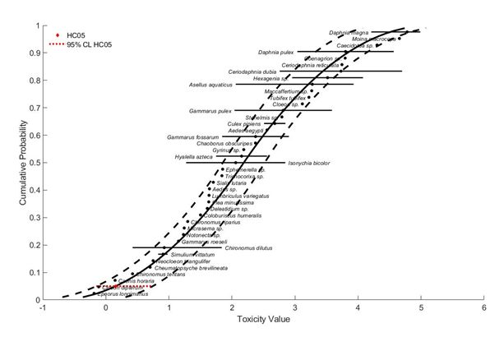
Figure 2- 5. Species sensitivity distribution of imidacloprid toxicity values for freshwater aquatic invertebrates. Selected model was logistic, fit using maximum likelihood, selected based on the lowest AIC and confidence interval for model fit. Black points are single estimates, lines are range of endpoints.

There is less acute toxicity data available for estuarine/marine invertebrates in the ECOTOX database and registrant submitted studies relative to freshwater invertebrates. However, there was sufficient data to produce an SSD specific to estuarine\marine invertebrates. The gumbel distribution and maximum likelihood (ML) method were selected to represent the HC₀₅ through HC₉₅ values estuarine/marine invertebrate endpoints. Table 2-7 and Figure 2-6 provide a summary of the results. The threshold for saltwater invertebrates is 13.15 ug ai/L based on the HC₀₅ from the SSD.

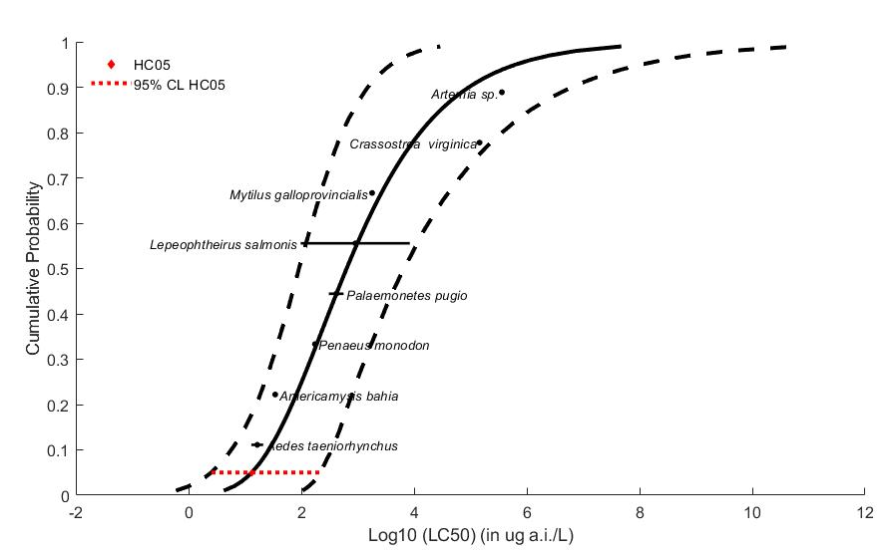
Figure 2-6. Species sensitivity distribution of imidacloprid toxicity values for saltwater aquatic invertebrates. Selected model was gumbel, fit using maximum likelihood, selected based on the lowest AIC and confidence interval for model fit. Black points are single estimates, lines are range of endpoints.

Effects on Growth and Reproduction of Aquatic Invertebrates

A freshwater invertebrate (D. magna) life-cycle test using TGAI was submitted for imidacloprid and determined a NOAEC of 1,800 μg ai/L based on significant reductions in Daphnia length at 3,600 μg ai/L (MRID 42055321). As a non-insect taxa, the water fleas (Branchiopoda), appear among the least sensitive group of aquatic invertebrates to chronic imidacloprid exposures. While daphnia are less sensitive to imidacloprid there are non-insect species with reported NOAEC values as low as 1 μg ai/L. Chronic NOAEC values were available for 6 species of dipteran insects which varied from 0.3 μg ai/L for the midge, Chaoborus obscuripes to 150 μg ai/L for the yellow fever mosquito, Aedes aegypti. However, most NOAECs were approximately 2 μg ai/L or less. Consistent with their high acute sensitivity the mayfly species, C. dipterum and C. horaria were the most sensitive species based on chronic testing, with NOAEC values for survival and immobilization of 0.03 and 0.01 μg ai/L, respectively. This study was conducted with TEP and will be used as an alternative toxicity endpoint. Overall, the most sensitive study suitable for risk assessment conducted with TGAI was from Njattuvetty Chandran et al (2018; ECOTOX# 183987). In a 28-day chronic toxicity test with Chironomus riparis, the mean emergence time (EmT₅₀ - the time needed for 50% successful emergence) was significantly accelerated at the LOAEC of 0.625 ug ai/L giving a NOAEC of 0.125 ug ai/L. This study is supported by another study by Raby et al (2018; MRID 50776201) which found significant reductions in emergence and adult lifespan of Chironomus dilutus at the NOAEC/LOAEC of 0.156/0.312 ug ai/L.

Figure 2-7. Array of growth and reproduction toxicity data for freshwater invertebrates expressed in terms of µg a.i./L. Blue squares represent LOAEC values from open literature studies found in the ECOTOX database. Red squares represent LC₅₀ values from registrant submitted studies. Solid lines display the range between the LOAEC and NOAEC values. Parentheses present the effect, species, study duration and reference (i.e., MRID, ECOTOX #).

A registrant-submitted chronic mysid toxicity study using the saltwater mysid (Americamysis bahia) resulted in a NOAEC of 0.163 μg ai/L and a LOAEC of 0.326 μg ai/L based on significant reductions in length and weight (MRID 42055322). No endpoints were identified from studies in the ECOTOX acceptable database that were either more sensitive than the endpoints identified above or reliable for use as a threshold.

The sublethal toxicity endpoint based on time to emergence effects in the freshwater midge (Chironomus riparis) is a NOAEC value of 0.125 µg a.i./L (LOAEC = 0.625 µg a.i./L, MATC = 0.375 µg a.i./L) and will be used to derive the sublethal threshold for all freshwater invertebrates. The sublethal toxicity threshold based on growth effects in the saltwater mysid (Americamysis bahia) is a NOAEC value of 0.163 µg a.i./L (LOAEC = 0.326 µg a.i./L, MATC = 0.245 µg a.i./L). This value is used to derive the sublethal threshold for all saltwater aquatic invertebrates.

Figure 2-8. Array of growth and reproduction toxicity data for freshwater invertebrates focused on endpoints less than 15 µg a.i./L. Blue squares represent LOAEC values from open literature studies found in the ECOTOX database. Solid lines display the range between the LOAEC and NOAEC values. Parentheses present the effect, species, study duration and reference (i.e., MRID, ECOTOX #).

There are no registrant submitted sublethal toxicity data for mollusks but there were several studies in the open literature ECOTOX report. Most open literature studies did not identify effects up to the highest concentration tested. A study with the Colombian ramshorn apple snail (Marisa cornuarietis) determined an endpoint based on reduced heart rate with a NOAEC value of 10 mg a.i./L (LOAEC = 25 mg a.i./L, MATC = 17.5 mg a.i./L) and will be used to derive the sublethal threshold for all mollusks (ECOTOX# 112105).

Other Sublethal Effects to Aquatic Invertebrates

Additional literature is available on the sublethal effects of imidacloprid on aquatic invertebrates. No endpoints were identified from studies in the ECOTOX acceptable database that were either more sensitive than the endpoints identified above or reliable for use as a threshold and relatable to an apical endpoint. Figure 2-9 and Figure 2-10 illustrates the data available for sublethal and chronic effects to freshwater and saltwater aquatic invertebrates.

Figure 2-9. Array of sublethal toxicity data for saltwater aquatic invertebrates expressed in terms of the log10 transformation of ug a.i./L. Blue squares represent LOAEC values from open literature studies found in the ECOTOX database. Red squares represent LC₅₀ values from registrant submitted studies. Solid lines display the range between the LOAEC and NOAEC values. Parentheses present the effect, species, study duration and reference (i.e., MRID, ECOTOX #).

Figure 2-10. Summary array of sublethal toxicity data for freshwater aquatic invertebrates expressed in terms of µg a.i./L. Solid lines display the range between the LOAEC and NOAEC values while the orange dot is the average. Endpoints are summarized by effect group.

Effects Characterization for Aquatic Plants

Introduction to Aquatic Plant Toxicity

A majority of the available toxicity studies with aquatic plants have investigated growth and population effects. Threshold values and effects data arrays in this assessment are based on endpoints expressed in, or readily converted to, environmentally relevant concentrations in terms of the amount of imidacloprid (i.e., mg a.i./L).

Discussion of endpoints are provided for effects on aquatic plants and aquatic plant communities. These serve as a surrogate for effects on an individual of a listed species and the effects on the pollination, prey, habitat, or dispersal of a listed species.

Effects on Aquatic Plants

Single-species aquatic plant toxicity studies are used as one of the measures of effect to evaluate whether imidacloprid may affect primary production and diversity in aquatic ecosystems. There are no available aquatic vascular plant toxicity studies from the open literature, and only one submitted to the EPA.

Effects on Growth of Vascular and Non-Vascular Aquatic Plants

One study is available from the open literature and registrant submitted studies on vascular aquatic plants. Several aquatic non-vascular plant toxicity studies have been submitted to EPA and/or published in the open literature (APPENDIX 2-2 and 2-4), representing a diversity of unicellular phytoplankton collectively referred to as “non-vascular aquatic plants”. These single-species toxicity studies serve as the foundation for evaluating whether imidacloprid may affect primary production and diversity in the aquatic ecosystem.

The threshold for vascular aquatic plants is derived from the registrant-submitted toxicity test with Lemna gibba (MRID 48648601) with a NOAEC, LOAEC, and MATC of 5.83, 12.6, and 9.22 mg/L, respectively, based on a 42% decrease in frond number. The most sensitive quantitative endpoint for non-vascular aquatic plants comes from the registrant submitted toxicity test with Navicula pelliculosa (MRID 44187102) with NOAEC, LOAEC, and MATC of 6.7, 17, and 11.9 mg/L, respectively.
The median effect concentration (EC₅₀) values for aquatic plants are used to derive the threshold for effects to the PPHD of an individual of a listed species. Studies with effects on measures of growth (e.g., biomass, cell counts, number of fronds, etc); were conducted with technical grade imidacloprid; and had 3 to 7-day exposure durations. The threshold for vascular aquatic plants comes from the registrant- submitted toxicity test with Lemna gibba (MRID 48648601) with an EC₅₀ of > 105 mg/L. The most sensitive quantitative endpoint for non-vascular aquatic plants comes from the registrant submitted toxicity test with Navicula pelliculosa (MRID 44187102) with an EC₅₀ of 12.4 mg/L.

Figure 2-11. Array of toxicity data for nonvascular aquatic plants expressed in terms of mg a.i./L. Blue squares represent values from open literature studies found in the ECOTOX database. Red squares represent values from registrant submitted studies. Solid lines display the range between the LOAEC and NOAEC values. Parentheses present the effect, aquatic plant grouping, study reference (i.e., MRID, ECOTOX #), and study duration.

Effects Characterization for Birds

Introduction to Bird Toxicity

There are open literature and registrant-submitted studies investigating the effects of imidacloprid on birds, including acute oral, sub-acute dietary and chronic reproduction with technical grade or formulated imidacloprid. APPENDIX 2-2 and 2-4 includes the bibliographies of studies that are included in this effects characterization. Studies were excluded if they were considered invalid or not associated with an environmentally relevant exposure route. Thresholds are based on the most sensitive lethal and sublethal effects identified among registrant-submitted studies and open literature in the ECOTOX database.

Effects on Mortality of Birds

Acute oral toxicity data are summarized in Table 2-9. Imidacloprid is classified as highly toxic to birds on an acute exposure basis. The acute oral toxicity of imidacloprid is based on a 14-day study to Japanese quail (Coturnix coturnix japonica) (MRID 44457401). The onset of clinical signs of toxicity (e.g., ataxia, apathy, hyperactivity) were observed at concentrations of 3.6 mg a.i./kg-bw and above.

Table 2-9. Avian Acute Toxicity Data for Imidacloprid.
Surrogate  Species | % a.i. | LD₅₀, mg/kg-bw (95% CI, slope) | MRID or ECOTOX #
Japanese quail (Coturnix coturnix japonica) | TEP (69%) | 17 (13 – 23; NA) | MRID 44457401
Japanese quail (Coturnix coturnix japonica) | TGAI (95%) | 33 (23 – 48; 3.4) | MRID 43310401
House sparrow (Passer domesticus) | TEP (2.5G) | 41 (24 – 260; 2.5) | MRID 42055309
Eared Dove (Zenaida auriculata) | TGAI (100%) | 59 (NA, NA) | ECOTOX #183555
Northern bobwhite quail (Colinus virginianus) | TGAI (97%) | 152 (103 – 227; 2.7) | MRID 42055308
Mallard duck (Anas platyrhynchos) | TGAI (97%) | 283 (182 – 439; 6.6) | MRID 44059401

In contrast to findings from acute oral toxicity studies where the chemical is administered via gavage, imidacloprid is slightly to practically non-toxic to birds on a subacute, dietary basis (bobwhite quail LC₅₀ = 1,536 ppm; mallard duck LC₅₀ >4,797 ppm; Table 2-10). For bobwhite quail, the onset of clinical signs of toxicity (ataxia, wing drop) occurred at 69 ppm diet while that for mallard (ataxia) occurred at 2,474 ppm diet. A review of the open literature via ECOTOX revealed no data on the subacute dietary toxicity of imidacloprid to birds that were considered acceptable for quantitative or qualitative use in risk assessment.

Table 2-10. Avian Subacute Toxicity Data for Imidacloprid.
Species | % a.i. | LD₅₀, mg/kg-diet (95% CI, slope) | MRID
Northern bobwhite quail (Colinus virginianus) | 95 | 1536 (797 – 4775; 1.2) | MRID 42055310
Mallard duck  (Anas platyrhynchos) | 95 | >4797 (NA; NA) | MRID 42055311

Effects on Growth and Reproduction of Birds

The available avian reproductive studies determined NOAECs between 47 and 519 mg a.i./kg-diet, based on effects to growth and reproduction. In MRID 42055313, a one-generation reproduction study with the mallard duck, statistically-significant reductions in egg production, egg hatchability, and adult female body weight at the LOAEL of 234 mg/kg-diet.

Several additional studies on growth and reproduction effects from oral imidacloprid exposure in birds were identified in the ECOTOX database. After review, these studies were either not suitable for use in risk assessment or was not more sensitive than the selected endpoint. Based on the available data on growth and reproduction, the sublethal toxicity threshold based on reproductive effects in the mallard duck is a NOAEC value of 125 mg a.i./kg-diet (LOAEC = 234 and MATC = 180 mg a.i./kg-diet).

Figure 2-12. Array of growth and reproductive toxicity data for effects to birds expressed in terms of mg a.i./kg-diet. Blue squares represent values from open literature studies found in the ECOTOX database. Red squares represent values from registrant submitted studies. Solid lines display the range between the LOAEC and NOAEC values. Parentheses present the effect, aquatic plant grouping, study reference (i.e., MRID, ECOTOX #), and study duration.

Other sublethal effects to Birds

Additional literature is available on the sublethal effects of imidacloprid to birds. There were no endpoints identified from studies in the ECOTOX acceptable database that were either more sensitive than the endpoints identified above or reliable for use as a threshold and relatable to an apical endpoint. Figure 2-13 and Figure 2-14 illustrates the data available for sublethal and chronic effects to birds.

Figure 2-13. Summary array of toxicity data for sublethal effects to birds expressed in terms of mg a.i./kg-bdwt. Solid lines display the range between the LOAEC and NOAEC values while the orange dot is the average. Endpoints are summarized by effect group.

Figure 2-14. Summary array of toxicity data for sublethal effects to birds expressed in terms of mg a.i./kg-diet. Solid lines display the range between the LOAEC and NOAEC values while the orange dot is the average. Endpoints are summarized by effect group.

Drinking water studies

No studies involving avian exposure via drinking water were identified in registrant studies or the ECOTOX database that identified effects.

Dermal studies

No studies involving avian exposure via dermal exposure were identified in registrant studies or the ECOTOX database.

Inhalation studies

No studies involving avian exposure via inhalation were identified in registrant studies or the ECOTOX database.

Effect Characterization to Reptiles

There are open literature studies investigating the effects of imidacloprid to reptiles, including acute oral and sublethal endpoints. Studies were excluded if they were considered invalid or not associated with an environmentally relevant exposure route. There were no suitable studies from the open literature to set environmental thresholds. APPENDICES 2-2 and 2-3 include the bibliographies of studies that were excluded from this effects characterization. Therefore, the available toxicity data for birds are used as a surrogate for reptiles.

Effect Characterization to Terrestrial-phase Amphibians

As no additional data are available on terrestrial-phase amphibians to imidacloprid, the available toxicity data for birds are used as a surrogate for terrestrial-phase amphibians.

Effects Characterization for Mammals

Introduction to Mammal Toxicity

There are open literature and registrant-submitted studies investigating the effects of imidacloprid to mammals, including acute oral, sub-acute dietary and chronic reproduction with technical grade or formulated imidacloprid. APPENDICES 2-2 and 2-3 include the bibliographies of studies that are included in this effects characterization and those that were excluded, respectively. Studies were excluded if they were considered invalid or not associated with an environmentally relevant exposure route. Thresholds are based on the most sensitive lethal and sublethal effects identified among the available registrant-submitted studies and open literature in the ECOTOX database.

Effects on Mortality of Mammals

The most sensitive acute toxicity endpoint was an acute LD₅₀ study on the rat (Rattus norvegicus), LD₅₀ value with TGAI was 424 mg a.i./kg-bw for males, (MRID 42055331). The corresponding LD₅₀ value for the TGAI in mice is 1,838 mg a.i./kg-bw (MRID 42679601). There are open literature studies for acute toxicity to mammals, but these were excluded if they were considered invalid, not associated with an environmentally relevant exposure route, or not more sensitive than the available registrant submitted study. Based on the available acute mammalian toxicity data, the endpoint used to derive the acute oral toxicity threshold, based on mortality observed in the laboratory rat, is 424 mg a.i./kg-bw.

Effects on Growth and Reproduction of Mammals

Reproductive and developmental mammalian toxicity studies provide toxicity data on chronic developmental and reproductive effects of imidacloprid (Table 2-11). Chronic studies using laboratory rats show frequent reductions in adult body weight gain and adult or offspring body weight. One study also showed reductions in food consumption. There was also some evidence of impacts to reproduction, but the endpoints reported were not directly relatable to apical endpoints.

Based on the available data on growth and reproduction, the toxicity threshold based on decreased food consumption (20%) and decreased body weight gain (47%) is a NOAEC value of 10 mg a.i./kg-bw (LOAEC = 20, MATC = 15 mg a.i./kg-bw). The most sensitive endpoint reported as diet concentration was from MRID 42256340 with a NOAEC value of 250 mg a.i./kg diet (LOAEC = 700, MATC = 418 mg a.i./kg diet). In the ECOTOX database there was a study with similar endpoints conducted with TEP which reported a NOAEC value of 9 mg a.i./kg-bw (LOAEC = 45, MATC = 20.1 mg a.i./kg-bw). All other more sensitive endpoints were determined to be not useable in this risk assessment. Figure 2-15 illustrates the data available for growth and reproduction effects to mammals.

Table 2-11. Summary of the Most Sensitive Reproductive and Developmental Mammalian Endpoints for Imidacloprid
Species/ Study Type | Source / Classification | Results
Norway rat (Rattus norvegicus)  Chronic, 2-Gen. Repro. | MRID 42256340  (Acceptable) | NOAEL: 16.5 mg a.i./kg-bw/d (250 ppm-diet)  LOAEL: 47.3 mg a.i./kg-bw/d) (700 ppm-diet)  (9-12% decreased parental and offspring body weight for both generations)
Norway rat (Rattus norvegicus)  Subchronic oral gavage (60d;  adult female; n=6/treatment) | Vohra et al. 2014;  ECOTOX 168931  (Quantitative) | NOAEL: 10 mg a.i./kg/d  LOAEL: 20 mg a.i./kg/d  (20% ↓ food consumption, body weight not affected)
Norway rat (Rattus norvegicus)  Subchronic oral gavage (90d;  adult female; n=10/treatment) | Kapoor et al. 2011;  ECOTOX 169053  (Quantitative) | NOAEL = 10 mg a.i./kg/d;  LOAEL = 20 mg a.i./kg/d  (47% ↓ body wt. gain)

Figure 2-15. Array of toxicity data for growth and reproduction effects to mammals expressed in terms of mg a.i./kg-bw. Blue squares represent values from open literature studies found in the ECOTOX database. Red squares represent values from registrant submitted studies. Solid lines display the range between the LOAEC and NOAEC values. Parentheses present the effect, aquatic plant grouping, study reference (i.e., MRID, ECOTOX #), and study duration.

Other Sublethal Effects to Mammals

Additional open literature is available on the sublethal effects of imidacloprid on mammalian species. There were no apical endpoints identified from studies in the ECOTOX acceptable database that were more sensitive than the endpoints identified above, reliable for use as a threshold and/or relatable to an apical endpoint. Figure 2-15 illustrates the data available for dose based (mg a.i./kg-bw) endpoints for the data as entered in ECOTOX.

Figure 2-16. Array of toxicity data for sublethal effects to mammals expressed in terms of mg a.i./kg-bw. Solid lines display the range between the LOAEC and NOAEC values while the orange dot is the average. Endpoints are summarized by effect group.

Drinking water studies

No studies involving mammalian exposure via drinking water were identified in the ECOTOX database or in review of registrant submitted studies.

Dermal exposure studies

Table 2-12 presents the acute and longer-term dermal exposure data available from registrant-submitted data. No effects were noted in any of the available dermal exposure studies.

Table 2-12. Dermal Exposure Studies for Imidacloprid.
Exposure Scenario | Dose  (mg a.i./kg/day) | Endpoint | Study
Acute Dermal | LD₅₀ > 5000 mg/kg/day | Mortality | MRID 42055332
Dermal toxicity (rabbits) | 0 or 1000 mg/kg/day | NOAEL = 1000 mg/kg/day; LOAEL = not identified | 870.3200; 21/28-Day dermal toxicity  MRID 42256329 (1990)

Inhalation studies

Table 2-13 presents the available inhalation studies for mammals. No effects were noted in any of the available inhalation studies.

Table 2-13. Inhalation Studies for Imidacloprid
Exposure Scenario | Dose  (mg a.i./L) | Endpoint | Study
Acute inhalation-rat test model | LC₅₀ > 5.33 mg/L | Mortality | MRID 42256317
Inhalation toxicity | 0, 0.0055, 0.035 or 0.191 mg/L/day | NOAEL = 0.191 mg/L/day;  LOAEL = not identified | 870.3465; 4-week inhalation toxicity  MRID 42273001 (1989)

Effects Characterization for Terrestrial Invertebrates

Introduction to Terrestrial Invertebrate Toxicity

The toxicity of imidacloprid to terrestrial invertebrates has been measured using multiple exposure routes (contact, oral, environmental) and expressed in different units of exposure. The following sections will cover three routes of imidacloprid exposure to terrestrial invertebrates. For this risk assessment, topical contact exposure is measured as mass of a.i. per organism weight (e.g., mg a.i./kg-bw) resulting from direct application to the body of the organism. Dietary exposure is measured as mass of a.i. per mass food (e.g., mg a.i./kg-food) given in the diet. Environmental exposure is measured as mass of a.i. per mass soil for soil dwelling organisms (e.g., mg a.i./kg-soil) and mass of a.i. per acre (e.g., lb a.i./A) for exposure from contaminated surfaces. A summary of the toxicity endpoints used for assessing the risk to terrestrial invertebrates associated with the registered uses of imidacloprid are shown in Table 2-14. Additional information on the derivation of these endpoints are provided in the following sections.

Table 2-14. Summary of imidacloprid toxicity endpoints used for assessing risk to terrestrial invertebrates
Exposure Route (Unit) | Threshold Value | Endpoint | Effect(s) | Species | Study ID
Most Sensitive Mortality Value (LD₅₀/LC₅₀)
Topical Contact (mg/kg-bw) | 0.015 mg/kg-bw | HC₀₅ | Mortality | N/A | Multiple
Oral  (mg/kg-food) | 0.064 mg/kg-food | HC₀₅ | Mortality | N/A | Multiple
Environmental (mg/kg-soil) | 0.55 mg/kg-soil | 14-d LC₅₀ | Mortality | Earthworm,  Eisenia andrei | E184175
Environmental (lb/A) | 0.00017 lb/A | 2-d LC₅₀ | Mortality | Parasitic Wasp,  Telenomus podisi | E182716
Most Sensitive Endpoint (Relatable to Growth, Reproduction, and/or Mortality
Topical Contact (mg/kg-bw) | 0.0023 mg/kg-bw | 5-d LC₅₀ | Mortality | Spined soldier bug, Podisus maculiventris | E39981
Oral  (mg/kg-food) | 0.0018 | 13-wk MATC | Emergence, Growth | Bumble bee,  Bombus impatiens | E184438
Environmental (mg/kg-soil) | 0.01 mg/kg-soil | 28-d LOAEC | Reproduction | Springtail,  Folsomia candida | E184605
Environmental (lb/A) | 0.00017 lb/A | 2-d LC₅₀ | Mortality | Parasitic Wasp,  Telenomus podisi | E182716

Mortality to Terrestrial Invertebrates

With the exception of environmental exposures via soil, acute mortality data were identified from ECOTOX data based on endpoints with exposure durations ranging between 2 and 4 days. This duration reflects standard acute test durations of terrestrial insects and other taxa. For soil-dwelling invertebrates, established acute toxicity test methods from the Organization of Economic Cooperation and Development (OECD) consider exposure durations up to 14 days duration. Therefore, acute toxicity data for soil-dwelling terrestrial invertebrates were filtered to include only those LC₅₀ values from 14 days duration or less. In addition, mortality data from all exposure durations are summarized using toxicity data arrays in order to provide context to the acute mortality endpoints selected.

Topical Contact Exposure

The available data (registrant submitted and open literature) for acute mortality to terrestrial invertebrates associated with topical contact exposure is provided in the species sensitivity distributions (SSD) shown in Figure 2-16 below. Where possible, all data were convered to a common exposure unit (mg a.i./kg bw) based on organism weights and dosage. A total of 13 insect species are represented in this SSD and are distributed among 3 orders (10 Hymenoptera, 2 Coleoptera and 1 Lepidoptera). No suitable mortality data for acute contact exposure of non-insect species were identified. For the acute contact mortality SSD, six distributions were tested using the maximum likelihood (ML) model fitting method. The normal distribution method was selected to represent HC₀₅ through HC₉₅ values for terrestrial invertebrate endpoints from topical contact exposure. Table 2-15 provides a summary of the results.

The threshold for terrestrial invertebrates is 0.015 mg ai/kg-bw based on the HC₀₅ from the SSD. This value lies just above the most sensitive acute LC₅₀ of 0.013 mg a.i./kg-bw identified for the stingless bee, Melipona scutellaris (Costa et al., 2015; E184470). The least sensitive LC₅₀ of 50.8 mg a.i./kg-bw bis associated with tobacco budworm, Toxoneuron nigriceps (Nelson 2018; E184372) which is about 4000X less acutely sensitive than M. scutellaris. The 2nd most sensitive species identified was the chalcid wasp, Nasonia vitripennis, with an acute LC₅₀ of 0.029 mg a.i./kg-bw (Tappert et al., 2017; E184317). A total of 13 LC₅₀ values were identified for the European honey bee, Apis mellifera, which represented 6 different studies and toxicity tests of different strains. The geometric mean LC₅₀ for A. mellifera is 0.23 mg a.i./kg-bw, but the range in LC₅₀ values varies from 0.021 to 0.81 mg a.i./kg-bw; this maximum approaches the HC₅₀ from the SSD. The 40-fold variation in LC₅₀ values observed for A. mellifera suggests that intraspecies variability in sensitivity may contribute substantially to observed differences in LC₅₀ values among species. For more detailed description of SSD creation and model selection see APPENDIX 2-5.

Table 2-15. Summary of imidacloprid acute mortality endpoints for topical contact exposure of terrestrial invertebrates to imidacloprid.
Statistic | SSD Endpoint (mg a.i./kg-bw)
HC₀₅ (95% CI) | 0.015 (0.0017-0.15)
HC₅₀ (95% CI)  Slope¹ | 0.85 (0.22-3.37)  1.6
CI = confidence interval
¹ Geometric mean of slopes from the tests nearest the HC₀₅

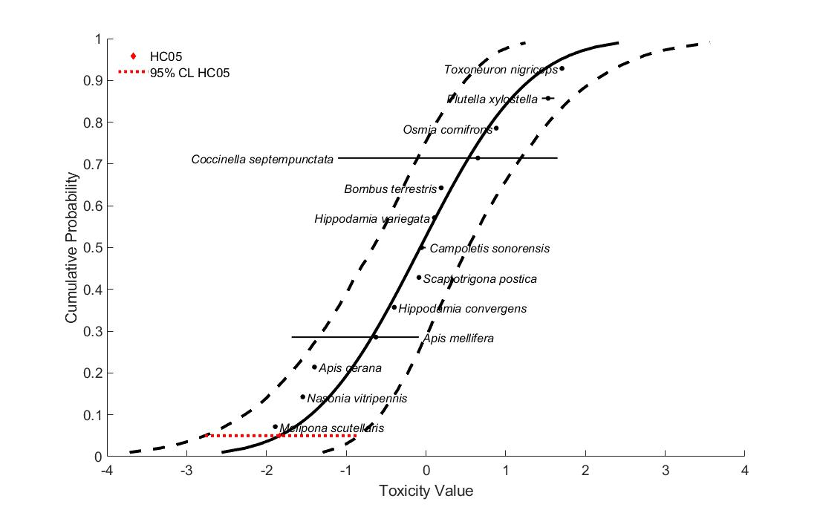
Figure 2-17. Species sensitivity distribution of imidacloprid acute contact toxicity values for terrestrial invertebrates. Selected model was normal, fit using maximum likelihood, selected based on the lowest AIC, confidence interval around the HC₀₅ and visual inspection of model fit. Black points are single estimates, horizontal lines are range of endpoints.

A summary of mortality data from all exposure durations involving topical exposure of terrestrial invertebrates to imidacloprid (reported as, or converted to, mg a.i./kg-bw) are shown in Figure 2-18 below.

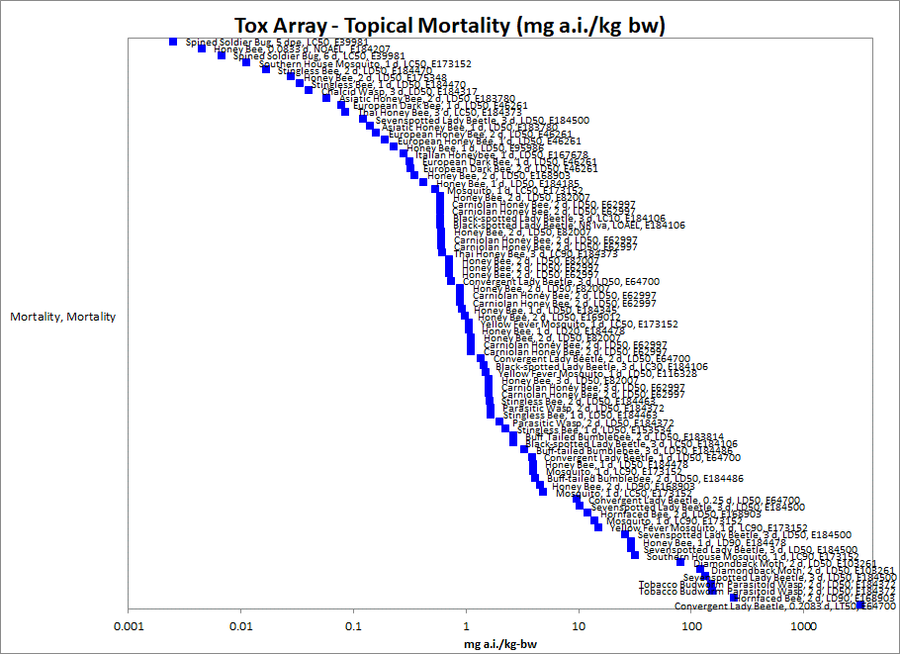
Figure 2-18. Toxicity data array for topical exposure of terrestrial invertebrates to imidacloprid (mg a.i./kg bw) from all exposure durations. Data labels include common name, exposure duration, endpoint type and ECOTOX reference number.

Dietary Exposure

The available data for acute mortality to terrestrial invertebrates resulting from dietary exposure expressed as mg a.i./kg-food is provided in the SSD shown in Figure 2-19 below. A total of 10 insect species are represented in this SSD and are distributed among 3 Orders (7 Hymenoptera, 2 Diptera and 1 Lepidoptera). No suitable mortality data for acute dietary exposure of non-insect species were identified. For the acute dietary SSD, six distributions were tested using the ML fitting method. The logistic distribution was selected to represent HC₀₅ through HC₉₅ values for terrestrial invertebrate endpoints from dietary exposure. Table 2-16 provide a summary of the results.

The threshold for terrestrial invertebrates is 0.064 mg a.i./kg-food based on the HC₀₅ from the SSD which is about 2X below the most sensitive LC50 of 0.13 mg a.i./kg-food for the silkworm, Bombyx mori (Sun et al., 2012; E162856). The least sensitive LC₅₀ of 643 mg a.i./kg-food belongs to the Argentine ant, Linepithema humile (Rust et al., 2004) which is about 5000X less acutely sensitive than B. mori. The 2nd most sensitive species identified was the southern house mosquito, Culex quinquefasciatus, with an acute LC₅₀ of 0.31 mg a.i./kg-food (Shah et al., 2016; E175414). A total of 9 definitive LC₅₀ values were identified for the European honey bee, Apis mellifera, from 8 studies. The geometric mean LC₅₀ for A. mellifera is 2.02 mg a.i./kg-food, but the range in LC₅₀ values varies from 0.18 to 24 mg a.i./kg-bw; this maximum approaches the HC₈₀ from the SSD and the minimum value approaches the HC₀₅. The 100-fold variation in LC₅₀ values observed for A. mellifera suggests that intraspecies variability in sensitivity may contribute substantially to observed differences in LC₅₀ values among species. For more detailed description of SSD creation and model selection see APPENDIX 2-5.

Table 2-16. Summary of imidacloprid acute mortality endpoints for dietary exposure of terrestrial invertebrates to imidacloprid.
Statistic | SSD Endpoint (mg a.i./kg-food)
HC₀₅ (95% CI) | 0.064 (0.0045-0.81)
HC₅₀ (95% CI)  Slope¹ | 3.48 (0.79-15.8)  1.8
CI = confidence interval
¹ Geometric mean of slopes from the tests nearest the HC₀₅

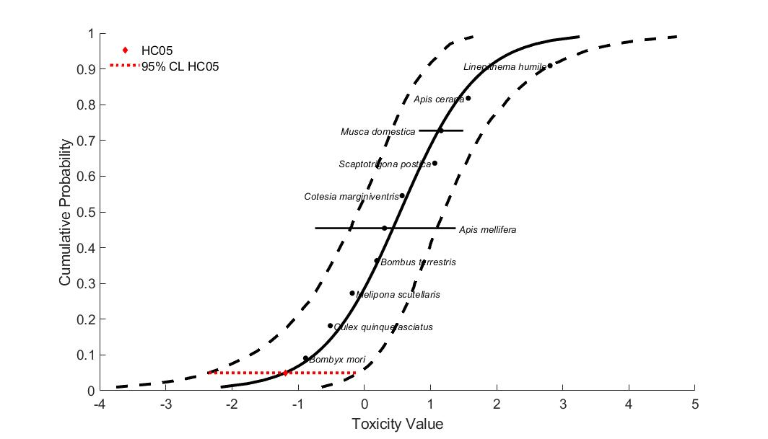
Figure 2- 19. Species sensitivity distribution of imidacloprid acute dietary toxicity values for terrestrial invertebrates. Selected model was logistic, fit using maximum likelihood, selected based on the lowest AIC, confidence interval around the HC₀₅ and visual inspection of model fit. Black points are single estimates, horizontal lines are range of endpoints.

A summary of mortality data from all exposure durations involving dietary exposure of terrestrial invertebrates to imidacloprid (reported as mg a.i./kg-diet basis) are shown in Figure 2-20 below.

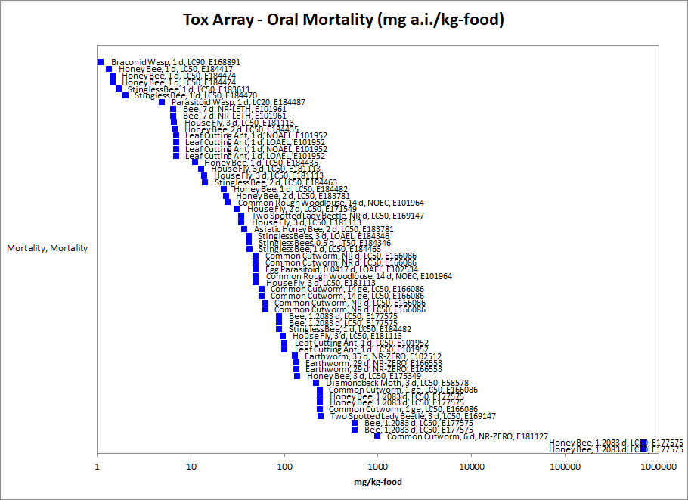
Figure 2-20. Toxicity data array for oral exposure of terrestrial invertebrates to imidacloprid (reported as mg a.i./kg bw) from all exposure durations. Data labels include common name, exposure duration, endpoint type and ECOTOX reference number.

Environmental Exposure via Soil

The available data for acute mortality of imidacloprid to terrestrial invertebrates exposed through soil is provided in Figure 2-21. Based on established test methods from the OECD, acute tests with soil invertebrates generally include exposures up to 14 days duration. Therefore, acute toxicity data for soil-dwelling terrestrial invertebrates were filtered to include only those LC₅₀ values from 14 days duration or less. Reliable acute LC₅₀ values reported in the open literature were available for 6 species distributed in two Phyla (Arthropoda; Annelida) and two Orders: Collembola and Lumbriculida and ranged by 50X from 0.55 to 25.5 mg a.i./kg soil. The most sensitive acute endpoint for terrestrial invertebrates from exposure through soil was an LC₅₀ value of 0.55 mg a.i./kg soil (Bandeira et al., 2020; ECOTOX#184175) for the earthworm (Eisenia andrei). This value will be used to derive the acute mortality threshold for terrestrial invertebrates from exposure through soil. The next most sensitive LC₅₀ value (1.8 mg a.i./kg-soil) is from a test on the springtail, Folsomia candida (Idinger et al., 2002; E79036). Overall, acute LC₅₀ values for springtails (two species in the Order Collembola) varied from 1.8 to 25.1 mg a.i./kg soil. Overall, acute LC₅₀ values for four Lumbriculida species ranged from 0.55 to 25.5 mg a.i./kg soil. The overlap in these ranges of toxicity values suggests the sensitivity of tested springtails and earthworms are not substantially different such that a single toxicity threshold is appropriate for both taxonomic groups.

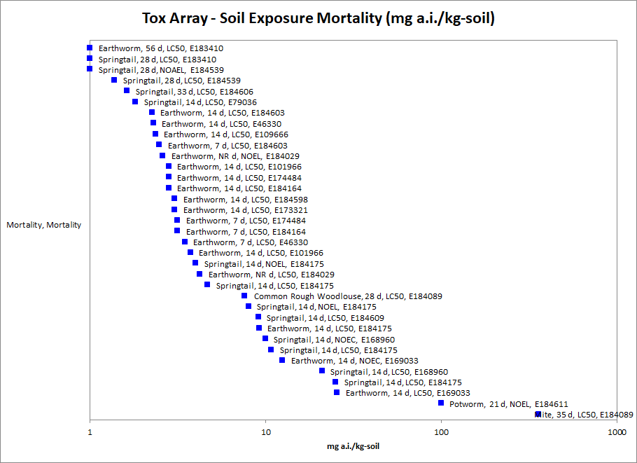
Figure 2- 21. Array of mortality toxicity data for terrestrial invertebrates expressed in terms of mg a.i./kg-soil. Data labels include common name, exposure duration, endpoint type and ECOTOX reference number.

Environmental Exposure via Contaminated Surfaces

The available data for acute mortality to terrestrial invertebrates from exposure through other environmental surfaces is provided in Figure 2-22 below. Reliable acute LC₅₀ values were identified for 9 species of terrestrial invertebrates reported in the open literature which varied between 0.00017 to 8.0 lb a.i./A (a factor of approximately 50,000X). These acute LC₅₀ values are distributed among 3 Classes (Insecta, Clitellata and Arachnida) comprising 3 Orders of insects (Hymenoptera, Coleoptera, Diptera and Heteroptera) 1 Order of Arachnids (Parasitiformes) and 1 Order of Clitellata (Lumbriculida). The acute LC₅₀ values for 8 tested insect species ranged from 0.00017 to 8.0 lb a.i./A. For the single tested Clitellata species (the earthworm, Eisenia fetida), acute LC₅₀ values ranged from 0.0024 to 0.0045 lb a.i./A. The single tested Arachnida species (the predatory mite, Neoseiulus cucumeris) had a reported acute LC₅₀ of 0.076 lb a.i./A. Given only 1 species from each of these two other non-insect orders were tested, it is not possible to make broad generalizations about the relative acute sensitivity of insects vs. non-insects to imidacloprid.

While a sufficient number of species were available to construct an SSD, this was not performed due to the widely varying nature of the test designs and exposures. For examples, some test designs used residues dried on glass surfaces, others used filter paper and others used leaves dipped in test solutions. This varied nature of the test designs likely contributes substantially to the 50,000X range observed in acute toxicity.

The most sensitive acute endpoint for terrestrial invertebrates from exposure through environmental contact was an LC₅₀ value of 0.00017 lb a.i./A (ECOTOX #182716) for the parasitic wasp (Telenomus podisi) exposed to imidacloprid on dried glass surfaces. This value will be used to derive the acute mortality threshold for terrestrial invertebrates from exposure through environmental contact on a mass per area basis. The 2nd most sensitive value (0.00093 lb a.i./A; E182716) is from another parasitic wasp, Urolepis rufipes also exposed via residual contact with glass surfaces. A summary of mortality data from all exposure durations involving environmental exposure of terrestrial invertebrates to imidacloprid (reported or converted to lb a.i./A) are shown in Figure 2-22 below.

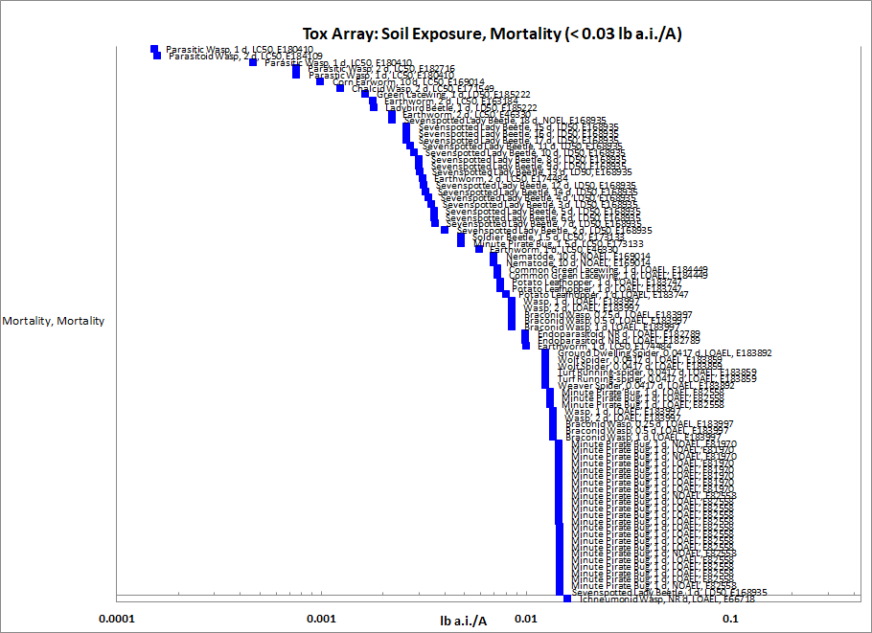
Figure 2- 22. Array of mortality toxicity data for terrestrial invertebrates expressed in terms of lb a.i./A. Data labels include common name, exposure duration, endpoint type and ECOTOX reference number.

Most Sensitive Growth, Reproduction and Mortality Endpoints of Terrestrial Invertebrates

Topical Contact Exposure

The available data for terrestrial invertebrate toxicity through topical contact exposure were reviewed for the most sensitive apical endpoint representing growth, reproduction or mortality from all durations of exposure (i.e., acute and chronic exposures)(Figure 2-23). The overall range in the 93 reliable apical endpoints was between 0.0023 to 800 mg a.i./kg-bw and reflects 19 insect species distributed among 5 orders (Hymenoptera, Diptera, Coleoptera, Lepidoptera and Heteroptera). The toxicity data for topical contact exposure did not show a growth or reproductive endpoint more sensitive than the available mortality endpoints. Therefore, the most sensitive reliable endpoint overall was used to represent thresholds for growth and reproduction effects. This is different than the SSD described above which was limited to just durations between 2-4 days and mortality effects. Therefore, the most sensitive endpoint for terrestrial invertebrates from exposure through environmental contact was a 5-day LC₅₀ value of 0.0023 mg/kg-bw (ECOTOX #39981) for the spined soldier bug (Podisus maculiventris). This value will be used to derive the overall threshold for terrestrial invertebrates from exposure through direct topical contact.

Figure 2-23. Array of all apical toxicity data for terrestrial invertebrates expressed in terms of ug a.i./ g-bw. Data labels include common name, exposure duration, endpoint type and ECOTOX reference number.

Most Sensitive Dietary Exposure

The available data for growth and reproduction to terrestrial invertebrates from exposure through diet is provided in Figure 2-24 below. The most sensitive reliable endpoint was used to represent thresholds for growth and reproduction effects. The selected endpoint was a 13-week NOAEC of 0.00081 and a LOAEC of 0.0039 mg a.i./kg-food (ECOTOX#184438) for the bumble bee (Bombus impatiens). The LOAEC is based on statistically significant 20% increase in time to emergence of bumble bee brood and a 20% decrease in nest weight relative to controls. The lowest MATC from this test is 0.0018 mg a.i./kg-food. This value will be used to derive the sublethal dietary threshold for terrestrial invertebrates from exposure through dietary exposure.

Figure 2-24. Array of all apical toxicity data for terrestrial invertebrates expressed in terms of ug a.i./ g-food. Data labels include common name, exposure duration, endpoint type and ECOTOX reference number.

Most Sensitive Environmental Exposure via Soil

The available data for growth and reproduction to terrestrial invertebrates from exposure through contact with soil is provided in Figure 2-25 below. The most sensitive reliable endpoint was used to represent thresholds for growth and reproduction effects. The most sensitive endpoint was a 28-day LOAEC value of 0.01 mg a.i./kg-soil (ECOTOX#184605) for effects on fecundity of springtail, Folsomia candida. The NOAEC from this study is < 0.01 mg a.i./kg-food since statistically significant effects on springtail fecundity were observed at all treatment levels relative to controls. This LOAEC reflects approximately a 17% reduction in fecundity relative to controls. This value will be used to derive the overall sublethal environmental exposure for terrestrial invertebrates from exposure through environmental contact with soil. The next two most sensitive NOAEC values for apical endpoints are 0.019 and 0.03 mg a.i./kg soil for the earthworm, Lumbriculus terrestris (ECOTOX #155987) and springtail, F. candida (ECOTOX #185089).

Figure 2-25. Array of apical toxicity data less than 5 mg a.i./kg-soil for terrestrial invertebrates. Data labels include common name, exposure duration, endpoint type and ECOTOX reference number.

Most Sensitive Environmental Exposure via Contaminated Surfaces

The most sensitive apical endpoint related to growth, reproduction or mortality resulting from exposure to contaminated surfaces is a 2-d LC₅₀ value of 0.00017 lb a.i./A used previously to represent acute mortality effects to the parasitic wasp (Scelionidae podisi; ECOTOX#184109). This value reflects exposure via imidacloprid residues on surfaces of a glass vial. There was no sublethal endpoint more sensitive than the available data for mortality to terrestrial invertebrates from exposure through other environmental surfaces (Figure 2-26). The 2nd most sensitive endpoint is a 1-d LC50 of 0.00054 lb a.i./A for the parasitic wasp, Trichogrammatidae trichogramma (Cheng et al., 2018; Ecotox #180410). It is evident that parasitic wasps are highly sensitive to residual contact exposure of imidacloprid given that short-term LC₅₀ values for parasitic wasps represent the three most sensitive endpoints identified among all taxa for growth, reproduction and mortality effects.

Figure 2-26. Array of all apical toxicity data for terrestrial invertebrates expressed in terms of lb a.i./A. Data labels include common name, exposure duration, endpoint type and ECOTOX reference number.

Other Sublethal Effects to Terrestrial Invertebrates

Additional literature is available on the sublethal effects of imidacloprid on terrestrial invertebrates. No endpoints were identified from studies in the ECOTOX acceptable database that were either more sensitive than the endpoints identified above or reliable for use as a threshold and relatable to an apical endpoint.

Effects Characterization for Terrestrial Plants

Introduction to Terrestrial Plant Toxicity

Plant toxicity data from both registrant-submitted studies and studies in the scientific literature have been reviewed for this assessment. Registrant-submitted studies are conducted under conditions and with species defined in OCSPP test guidelines. Sub-lethal endpoints such as plant growth, dry weight, and biomass are evaluated for both monocots and dicots, and effects are evaluated at both seedling emergence and vegetative life stages. Studies were excluded if they were considered invalid or not associated with an environmentally relevant exposure route.

Discussion of endpoints are provided for effects on terrestrial plants and terrestrial plant communities. These serve as a surrogate for effects on an individual of a listed species and the effects on the pollination, prey, habitat, or dispersal of a listed species, respectively. There were no open literature studies that examined seedling emergence and vegetative vigor endpoints. The registrant submitted data represents the most sensitive endpoints for effects to terrestrial plants.

Effects Data for Terrestrial Plants

Single-species terrestrial plant toxicity studies are used as one of the measures of effect to evaluate whether imidacloprid may affect primary production and diversity in terrestrial ecosystems. Terrestrial plant toxicity studies have been submitted to the EPA. Seedling emergence and vegetative vigor were studied on ten non-target crops (including sugar beet, oilseed rape, cucumber, soybean, tomato, sunflower, barley, wheat, corn, and onion) following application of imidacloprid SC 240D G at 0.5 lb a.i./A (MRIDs 48648602 and 48648603). At the maximum allowable application rate for imidacloprid there were no significant effects to any plant species. The registrant submitted data represents the most sensitive endpoints for effects to listed species.

The majority of open literature studies that report endpoints for plants express increased growth and yield for plants that are released from pest pressure after application of imidacloprid. There is some evidence in the open literature that plants grown in soil contaminated with imidacloprid have reduced growth and seed germination. These studies were conducted at concentrations of imidacloprid in soil well above the maximum modeled EEC for imidacloprid in soil. Additionally, there is some evidence in the open literature that imidacloprid seed treatment, under certain conditions and certain plants, can impact germination rate. However, this type of exposure is not expected for non-target plant species under registered use patterns. Specifically, seeds soaked in an imidacloprid liquid solution before planting. Even if non-target seeds were exposed to an imidacloprid application the effects presented in the open literature were usually at higher concentrations than the highest allowable label rate.

Based on the available data and expected lower predicted concentrations away from the treated field, it is unlikely that imidacloprid will cause adverse effects to non-target plant species.

Incident Reports

A review of the Incident Data System (IDS) for ecological incidents involving Imidacloprid was completed on March 26, 2020. The results of this review for terrestrial animal, plant, and aquatic animal incidents are discussed below. The Aggregate Incident Summary report in IDS shows 85 imidacloprid related incidents with 8 wildlife, 285 plant damage and 12 other nontarget listed. There are also about 100 imidacloprid incidents listed in the IDS database with detailed narrative of an incident is contained in an EIIS report such as magnitude of the number of organisms impacted, location, date, product used, use pattern, whether the use was a registered use, and any confirmatory residue analysis if available (Table 2-17). The total number of actual incidents associated with the use of imidacloprid may be higher than what is reported to the EPA. Incidents may go unreported since effects may not be immediately apparent and/or readily attributed to the use of a chemical. Included in the sections below are only those incidents that have been reported since the publication of the imidacloprid registration review risk assessment documents (DP442930, DP435477, and DP443668). For information on incidents prior to 2015 please refer to the incident report sections included therein.

Table 2-17. Overview of reported incidents by taxa
Terrestrial or Aquatic | Taxa | Incident Data Available? (Yes/No)
Terrestrial | Plants | Yes
 | Mammals | No
 | Birds | Yes
 | Reptiles | No
 | Amphibians | No
 | Terrestrial Invertebrates | Yes
Aquatic | Amphibians | No
 | Freshwater Fish | Yes
 | Estuarine/Marine Fish | No
 | Aquatic Invertebrates | Yes
 | Mollusks | No
 | Aquatic Plants | No

Aquatic Incidents

A review of the incident database yielded 2 additional wildlife incident reports concerning aquatic organisms (i.e. fish and invertebrates). Both incidents were registered uses, one in a residential area another on soybean fields. With both incidents there is uncertainty associated with multiple applications of various chemicals and attributing the adverse effect to any one product. These incidents are summarized in Table 2-18 and include effects to multiple species.

Table 2-18. Overview of reported aquatic use incidents by taxa
Incident # | Date /  Location | Use Pattern / Product | Legality / Certainty | Comments
I029267-00001 | 09/2016  FL | Residential  NR | Registered Use  Possible | In the summer of 2016 butterflies, bees, and fish died after a mosquito spraying in the Ft Lauderdale Florida area. Also hummingbirds, woodpeckers. bees, and butterflies have not been seen since the mosquito control efforts which is abnormal. Caller reported that last year Bayer Advance 12 month Tree and Shrub Protection (ai imidacloprid and Clothianidin) was applied as a soil drench to several trees in the yard for termites.
I026789-001 | 08/2014  IL | Soybean  Leverage 360 | Registered Use  Possible | Rainbow Trout and Brook Trout found dead in the vicinity of imidacloprid application. A grower in the El Paso, IL area reported the issue to a BCS sales representative and described the issue where the grower had two separate applications in the same vicinity between 11:00 a.m. and Noon on Friday, August 1st.
NR – not reported

Terrestrial Incidents

A review of the incident database yielded an additional 4 reported incidents. There are also some incident reports submitted to the EPA that have not yet been cataloged into the incident database and these are included in Table 2-19 as uncatalogued. Three of the incidents report damage to plants, whereas the last reports the death of birds attributed to imidacloprid. There were two residential and two agricultural incidents reported.

Table 2-19. Overview of reported terrestrial incidents by taxa
Incident # | Date /  Location | Use Pattern / Product | Legality / Certainty | Comments
I023213-041 | 04/2011  CA | Squash Provado 1.6f | Undetermined Possible | On April 2, 2011 in San Diego, County, 100% of 24 acres of squash was suffered leaf scarring after an application of the product Provado 1.6f (a.i. imidacloprid) . Alleged phytotoxic reaction to product following application to squash crop. The Compliance Manager for the Registrant suggested the probable causes were tank mix partner and the adjuvant.
I024071-367 | 04/2012  TX | Residential Rose & Flower Insect Plus Mg Gran | Undetermined Possible | In April of 2012 it was alleged that an application of the product Rose & Flower Insect Control Plus MG Gran (a.i. imidacloprid) used in a garden resulted in the death of 18 rose brushes.
I024202-025 | 04/2012  NJ | Lettuce Admire Pre | Registered Use Possible | On April 20, 2012 in Cumberland County, NJ 90% of 0.9 acres of lettuce experienced stand reduction after an application of the products Admire Pre (a.i. imidacloprid) and another unidentified product (a.i. N/R). Alleged phytotoxic reaction to product following application to lettuce crop. Retailer suggested a nozzle that produces a wider band of material instead of dribbling and to use more carrier to dilute the Admire or reduce Admire's application rate.
I030474-00001 | 01/2017  FL | Residential NR | Undetermined Exposure only | Deaths of 4 laughing gulls, which fell from the sky, near Tampa, Florida on January 9, 2017. Two other gulls appeared dazed at the site. Imidacloprid and D-Limonene were detected in carcasses. Consumption of contaminated food (fly larvae in gut) or seed was expected cause of deaths.
Uncatalogued incidents reports
032244 - 00001 | 3/17/2017  CA |  |  | Science Daily June 26 article, song birds die after city drenches trees with imidacloprid.
032519 - 00001 | 7/18/2019  TX | Macho 4.0 |  | Includes 1 plant incident. Symptoms include yellowing and leaf wilting.
032741 - 00001 | 5/21/2019  CA | Montana 4F insecticide |  | On May 24, 2019, a property operator notified the Fresno County Agricultural Commissioner's Office about alleged pesticide damage to a 40 acre grape vineyard. The grower believed the damage was caused by an application that a third party performed for him on May 21, 2019. On May 28, 2019, the property operator submitted a Report of Loss, Nonperformance or Damage.
033873 - 00001 | 1/1/2016 CA | Seresto Small (Unspecified) |  | Numerous incidents involving the Seresto flea collar including wildlife incident reports.
NR: Not reported

Terrestrial Invertebrate Incidents

All of the 13 new incidents summarized in Table 2-20 below are reports from beekeepers or homeowners reporting bee kills with no follow-up investigation or confirmatory residue analysis. The summarized incidents include several residential uses, agricultural use, and a large event in Florida orange groves. Five of the reported incidents are from bee keepers in southern Florida who had substantial loss when their bees were foraging in orange tree orchards. There are also some incident reports available that have not yet been cataloged into the incidents database and these are included in Table 2-20 as uncatalogued.

Table 2-20. Overview of reported terrestrial incidents by taxa
Incident # | Date / Location | Use Pattern / Product | Legality /  Certainty | Comments
I026607-001 | 2016  MA | NR | Undetermined Possible | A longtime, beekeeper in Middlesex County, MA claims that he can no longer keep bees due to the introduction of imidacloprid to the market. Before 2009 he had 60,000 healthy worker bees. No laboratory test results on tissues were provided.
I026927-001 | 2016  CT | Residential Bayer Advance | Undetermined Possible | A caller, a master gardener, sought information about imidacloprid and clothianidin. Caller reported that one month ago she noticed a beehive that was only partially built and there was not bee activity in or near the hive.  A company which is treating the home with pesticides and used Bayer Advance (a.i. imidacloprid, clothianidin). Caller reported that because of this she thinks that the company may be continuing to use this product as a soil drench for the past three years. Caller reported that she thinks the application of this product has caused harm to the bees on the property.
I028123-002 | 06/2015  IN | Corn seed  NR | Undetermined Possible | On 2 June 2015 it was noticed the approximately 1,500 bees were dead in Boone County, IN. with the beekeeper contacting Office of Indiana State Chemist (OISC). It was believed that the dead of the bees was from neighboring farmer planting corn and seed treatment dust. Samples were collected and analyzed. Aparivar, a miticide, had been applied to the hives. The OISC residue laboratory tested for clothianidin, thiamethoxam, Imidacloprid, Fipronil, Thiacloprid, and Acetamiprid and all were below the detection level in the dead bee samples.
I023051-001 | 07/2011 MD | Pepper, sweet/bell  Bayer Advance | Registered Use  Possible | On July 18, 2011 an incident occurred in Calvert County, MD in a garden where bumble bees (6) were dying in close proximity to sweet pepper plants. However, the bumble bees foraging on clover did not appear impaired. The only known pesticide exposure was a soil treatment in April for Japanese beetles using Bayer Advance (a.i. imidacloprid). The property owner cut off blooms and collected bee samples in a glass jar, however no testing was reported.
I025067-001 | 04/2012  NC | Holly tree Bonide Annual | Registered Use  Probable | A reporter in Brunswick County, NC reported following label directions while applying BONIDE ANNUAL TREE & SHRUB INSECT CONTROL WITH SYSTEMAXX (a.i. imidacloprid) to holly trees. Dead bumble bees were reported on the sidewalk next to the treated holly trees.
I025013-001 | 03/2013  FL | Agricultural area  NR | Undetermined Probable | A beekeeper in On March 18, 2013 in Polk County, FL reported a cluster of 5-6 (roughly 600 colonies) bee yards in a 4-6 mile radius of orange orchards have an increase of dead bees piled at the entrances to the bee colonies. The beekeeper observed bees on their sides-shaking. The beekeeper noted that other beekeepers in the area have reported elevated numbers of dead bees. Empty containers of imidacloprid have been found burned in the vicinity of the colonies.
I025019-001 | 03/2013  FL | Orchard, orange  Montana 2F | Undetermined Probable | On March 21, 2013 a beekeeper in Polk County, FL reported by phone to EFED that 400 of his 1,600 colonies were adversely affected after an application of the product Montana F2 (a.i. imidacloprid) to orange orchards while his bees were foraging in the vicinity. The affected colonies lost 25-40% of their field force. Beekeeper was notified before spraying to move bees to another location.
I025023-001 | 03/2013  FL | Orchard, orange Montana 2F | Undetermined Probable | On March 27, 2013 a commercial beekeeper in Polk County, FL reported to EFED that the adult bee population had been reduced by 60% in his bee colonies adjacent to orange orchards. The complainant has heard of other bee losses by beekeepers in the area and that these losses have been attributed to the use of Montana insecticide (a.i imidacloprid). There are least 3 reported bee die-off incidents reported from this county during this time period. According to the complainant, all of the losses were in close proximity to the same grower that was alleged to have applied imidacloprid. In total, the beekeeper has had 253 colonies affected where the forage strength of the colonies has been depleted and the ability of the colonies to produce a honey crop off of the orange trees has been lost.
I025027-001 | 03/2013  FL | Orchard, orange  NR | Undetermined Possible | On March 22, 2013 a bee kill incident in Indian River County, FL, was reported to EFED. The beekeeper indicated that 100 of his honey bee colonies have been affected by the application Admire (a.i. imidacloprid). Roughly 10% of the colonies were completely dead and the remainder had piles of dead bees (adult and brood) at their entrances. The kill appeared to have bee going on for at least a week; however bees are continuing to die. Roughly 50% of the colonies have lost their queen and haven't attempted to replace the queen through supersedure. Beekeepers in his vicinity are experiencing similar losses. Admire is the suspected pesticide, but the growers did not admit to using Admire.
I025052-001 | 03/2013  FL | Orchard, orange  Montana 2F | Undetermined Probable | On March 21, 2013 a beekeeper reported to EFED that he has 600 bee colonies located in the orange orchards of Polk County, FL and 300 of these bee colonies are dying. Beekeeper inspected the affected yards and observed dead/dying bees everywhere. Bees that were alive were exhibiting a jerky movement. According to the foreman of the nearby orange groves Montana 2F (a.i. imidacloprid) via helicopter will be applied again on April 1. FL Dept. of Agriculture and Consumer Services has been notified and an inspector has investigated the incident, EPA did not receive an update from that investigation.
I025560-001 | 2013  NE | Garden Bayer Advanced Flower Care | Registered Use  Possible | Bayer Advanced Rose and Flower Care (a.i. imidacloprid) was applied as a drench around 5 rose bushes in a garden during the spring of 2013 in Douglas County, NE. The reporter did not any see dead or dying insects around the treated plants, just marked the absence of them where in previous springs they were numerous.
I026288-002 | 04/2013  CA | Residential CoreTech and Merit 2f | Registered Use  Possible | In Santa Barbara County, California, 12 hives were located within 300 yards of an area treated by CDFA for control of the Asian Citrus Psyllid in April of 2013. According to the beekeeper, the state has an emergency exemption to apply pesticides to citrus trees during full bloom against label recommendations not to apply the compound while bees are foraging or trees are in bloom. The beekeeper expressed concern regarding the proposed use of Merit 2F (imidacloprid), CoreTect (a.i. imidacloprid) and Tempo (a.i. cyfluthrin) to control the Asian psyllid.
I027112-001 | 10/2014  FL | Orchard, orange  Premier | Undetermined Possible | On 10/31/2014 a bee keeper noted bee die-off in his bee yard adversely affecting 100 bee hives. The beekeeper believes an adjacent orange orchard to his bee yard was sprayed. It is possible an application of the product Premier (a.i Imidacloprid ) resulted in the rapid die-off of 2 hives. No lab test results were provided. The beekeeper reported that the colonies that were most affected from the application of other pesticides to an adjacent citrus orchard.
I029267-00001 | 09/2016  FL | Residential  NR | Undetermined Possible | In the summer of 2016 butterflies, bees, and fish died after a mosquito spraying in the Ft Lauderdale Florida area. Also hummingbirds, woodpeckers, bees, and butterflies have not been seen since the mosquito control efforts which is abnormal. Caller reported that last year Bayer Advance 12 month Tree and Shrub Protection (ai imidacloprid and Clothianidin) was applied as a soil drench to several trees in the yard for termites.
Uncatalogued incidents reports
032224 - 00001 | 06/2019  CA | NR |  | On June 18, 2019, Merced County Agricultural Commissioner's (CAC) staff was notified by a beekeeper that he had a significant bee loss at two different bee drop locations. One of the bee drop locations is between cotton fields and the other bee drop is by the San Joaquin river and surrounded by alfalfa fields and herb fields. The Merced CAC staff will be taking swab and bee samples.
032296 - 00001 | 07/2019  CA | NR |  | July 2019, bee kill under investigation in Merced, CA.
032516 - 00001 | 08/2019  VA | NR |  | Aug. 2019, reported bee losses in Arlington, VA, imidacloprid and tau-fluvalinate use suspected in the bee losses.
032568 - 00001 | 09/2019  PA | NR |  | Sept. 2019, a bumble bee kill incident in Lycoming County, PA, the bees were found dead beneath a linden tree which had been applied with imidacloprid.
032688 - 00001 | NR  OH | NR |  | Ohio bee kill report involving imidacloprid.
032962 - 00001 | 06/2019  CA | NR |  | On June 18, 2019, CAC staff was notified by beekeeper that he had a significant bee loss at two different locations operated by Bowles Farming. CAC staff conducted a query for pesticide applications made to the area surrounding both bee locations. They discovered that several different applications with the active ingredients clothianidin, imidacloprid, abamectin, and cyfluthrin were made by various property operators surrounding the apiary locations.
033115 - 2, 033627 - 1, 032710 - 9 | 2019/2020  NC | NR |  | North Carolina bee kill incident reports for 2019 and 2020
NR – not reported

Alternative Toxicity endpoints

In addition to the thresholds provided in the introduction above, alternative toxicity endpoints were also developed to use in the weight of evidence analysis for a species where appropriate (see Revised Methods Document). The alternative toxicity endpoints provide consideration of endpoints that may reflect variation in the available data (such as using the HC₅₀ values from the SSD instead of an HC₀₅ value or considering other endpoints within the data set for a particular taxon). Alternatively, if a taxon did not include enough data to select a specific alternative toxicity endpoint, a 10x factor was applied to the original threshold. The alternative endpoints allow for consideration of the possibility a listed species is toxicologically less sensitive than the tested species in the alternative weight of evidence analysis, which is captured for the analysis of any species that reaches that point of the analysis. Alternative endpoints are listed in Table 2-21 and brief additional comments are provided to clarify the alternative endpoint selection, as appropriate. Endpoints are analyzed for a subset of available units.

Table 2-21. Alternative toxicity endpoints used in weight of evidence analysis.
Alternative toxicity endpoints - Mortality
Units | Taxa | Type of endpoint (HC50, etc.) | Value | Slope | Weight of test animal (g) | Comments
mg ai/kg-bw | Mammals | LD50 | 4,240 | 4.5 | 238 | 10x applied
mg ai/kg-bw | Birds | LD50 | 170 | 4.5 | 268 | 10x applied
mg ai/kg-bw | Reptiles/Terrestrial Amphibian | LD50 | 170 | 4.5 | 268 | 10x applied
mg ai/kg-bw | Terrestrial inverts | LD50 | 0.85 | 1.6 |  | HC₅₀
mg ai/L | FW FISH | LC50 | 264 | 4.5 |  | 10x applied
mg ai/L | E/M FISH | LC50 | 1,630 | 4.5 |  | 10x applied
mg ai/L | AQ AMPHIBIANS | LC50 | 526 | 4.5 |  | 10x applied
µg ai/L | FW INVERTEBRATES | LC50 | 154 | 1.7 |  | HC₅₀
µg ai/L | E/M INVERTEBRATES | LC50 | 636 | 4.5 |  | HC₅₀
mg ai/L | Mollusks | LC50 | 39.8 | 4.5 |  | 10x applied
Alternative toxicity endpoints - Sublethal
Units | Taxa | Type of endpoint (HC50, etc.) | MATC or LOAEC |  |  | Comments
mg ai/kg-bw | Mammals | MATC | 141.4 |  |  | 10x applied
mg ai/kg-diet | Birds | MATC | 1710 |  |  | 10x applied
mg ai/kg-diet | Reptiles/Terrestrial Amphibian | MATC | 1710 |  |  | 10x applied
mg ai/kg-diet | Terrestrial inverts | LOAEC | 0.0081 |  |  | 10x applied
mg ai/L | FW FISH | MATC | 155.6 |  |  | 10x applied
mg ai/L | E/M FISH | MATC | 155.6 |  |  | 10x applied
mg ai/L | AQ AMPHIBIANS | MATC | 155.6 |  |  | 10x applied
µg ai/L | FW INVERTEBRATES | MATC | 2.80 |  |  | 10x applied
µg ai/L | E/M INVERTEBRATES | MATC | 2.31 |  |  | 10x applied
mg ai/L | Mollusks | MATC | 158.1 |  |  | 10x applied
TERRESTRIAL PLANTS |  | Type of endpoint (HC50, etc.) | MATC or LOAEC | IC25 | Description of effect | Comments
lb ai/A | SUBLETHAL- Monocots | MATC | 99999 | 99999 |  | No change, non-definitive
lb ai/A | SUBLETHAL- Dicots | MATC | 99999 | 99999 |  | No change, non-definitive
AQUATIC PLANTS (TGAI) |  | Type of endpoint (HC50, etc.) | MATC or LOAEC | IC50 | Description of effect | Comments
mg ai/L | Non-vascular | MATC | 106.7 | 124 |  | 10x applied;
mg ai/L | Vascular | MATC | 85.7 | 1,050 |  | 10x applied;

EFED acute toxicity classifications are available here: https://www.epa.gov/pesticide-science-and-assessing-pesticide-risks/technical-overview-ecological-risk-assessment-0#Ecotox

