Appendix 4-2. Mixtures and abiotic analysis for diazinon

The current risk assessment focuses on diazinon and its degradates. The approach is based on data describing the environmental fate, estimated exposure concentrations and potential toxicity of diazinon. There is uncertainty in the potential effects of diazinon because the approach does not quantitatively consider the presence of other chemicals in the environment of the assessed species. Of particular concern would be cases where the presence of other chemicals results in an increase the toxicity of diazinon, thus the effects characterization may under-predict the potential effects of diazinon on listed species. Although there are some data to indicate that this may occur, effects of chemical mixtures on the expected toxicity data are not consistent across species, taxa or concentrations of the stressors. This section discusses the available information on environmental exposures to chemical mixtures that include diazinon as well as toxicity data describing whether chemicals mixed with diazinon may result in expected toxicity based on additivity, in synergism, or in antagonism. Toxicity data available for exposures involving technical grade and formulated diazinon are described in the effects characterization section.
1.1 Environmental mixtures
Mixtures may be present in ESA-listed species’ habitats following the offsite transport of pesticides and other chemical constituents (e.g., other active ingredients, inerts, adjuvants, etc.) through the use of co-formulated products or tank mixes at individual or multiple locations. Species and their habitats exposed to pesticide mixtures may be at greater risk of adverse effects than when exposed to single pesticides. Recent review articles indicate that additivity (i.e., concentration- or response-addition) is the appropriate default assumption when considering mixture toxicity (Cedergreen 2014; Belden et al. 2007). Experimental results from numerous studies indicate that exposure to OP-containing mixtures produces additive and synergistic toxicity, as measured by activity of the neurological enzyme acetylcholinesterase (AChE), in several taxa groups including mammals, fish, birds, amphibians, and aquatic insects.
Due to the large number of pesticides that may be present in a species’ habitat at any one time, it is not feasible to estimate exposure concentrations for all possible mixture combinations. Furthermore, it is not practical to test the toxicity of every mixture combination in every ESA-listed species or appropriate surrogate. However, qualitative assessments of mixture toxicity can be made using expected exposures, principles of additive toxicity, and known toxic responses in published scientific literature. The mixtures line of evidence is considered qualitatively using available product labels, usage information, monitoring data, and taxa-specific toxicity data.
1.1.1 Composition of mixtures in terrestrial and aquatic environments
Chemical mixtures are present in terrestrial and aquatic environments. This may be due to application of multiple chemicals contained in formulations and tank mixtures of formulations, resulting in a direct application to the terrestrial environment or spray drift of the mixtures onto adjacent terrestrial, wetland or aquatic habitats. Chemical mixtures may also be present in aquatic systems due to transport from upstream applications.
Most formulated products contain multiple chemicals (referred to as “inert ingredients”), and may also contain multiple active ingredients. A listing of inert ingredients that are formulated with pesticide active ingredients is available on the EPA website. Diazinon products that are applied to orchards and field crops do not contain other active ingredients; however, some cattle ear tags containing diazinon also contain coumaphos or chlorpyrifos (both OP insecticides). Active ingredients are routinely used together as tank mixtures in agricultural practices, as a means to enhance the effectiveness of the active ingredient, as well as to treat multiple pest pressures at the same time and avoid the need to conduct multiple applications. Pesticide labels routinely provide instructions for tank mixtures, indicating to the applicator which chemicals can and cannot be used with the product. Table B 4-2.1 includes the information on diazinon labels that involves recommended tank mixtures (i.e., for applications to orchards and field crops).
Table B 4-2.1. Recommended tank mixtures on diazinon labels registered for use on orchards or field crops.
Product name (registration number) | Label statement relevant to application with other pesticide products
Diazinon AG500 Insecticide (5905-248) | - “Diazinon AG500 may be applied alone or in combination with other pesticides registered for application through irrigation systems.”  - “Do not mix Diazinon AG500 with any formulation of captan or Captec® because crop injury may occur.”  - “This product should not be tank-mixed with other pesticides, surfactants or fertilizers unless prior use has shown the combination noninjurious under your conditions of use. Follow precautionary statements and directions for all tank-mix products.”  - “Diazinon is physically compatible with most insecticide and fungicide products; if you are not certain of the physical compatibility of Diazinon AG500 with other tank mix partners, please contact your local Helena Chemical Company sales representative.”  - When using Diazinon AG500 in tank mixtures, observe all directions for use, crops/sites, use rates, dilution ratios, precautions, and limitations which appear on the tank mix products' labels. Confirm that the tank mixture is safe to the crop by spraying a small area first, and evaluating crop safety after an appropriate period. Do not treat larger areas until crop safety has been confirmed.”
Drexel diazinon insecticide (19713-91) | 1) “Do not mix this product with any formulation of captan or Captec® because crop injury may occur.”  2) “This product is compatible with most insecticide and fungicide products”  3) “Add tank-mix partners in this order: all products in water-soluble packaging, wettable powders, wettable granules (dry flowables), liquid flowables, liquids and emulsifiable concentrates.”  4) “When using this product in a tank mixture, observe all directions for use, crops/sites, use rates, dilution ratios, precautions, and limitations which appear on the tank mix products' labels. Confirm that the tank mixture is safe to the crop by spraying a small area first, and evaluating crop safety after an appropriate period. Do not treat larger areas until crop safety has been confirmed.”
Drexel diazinon 50 WP insecticide (19713-492) | 1) “Do not mix this product with any formulation of Captan or Captec^{tm} because crop injury may occur.”  2) “This product is compatible with most insecticide and fungicide products”  3) “Add wettable powders and water dispersible granular products first, then liquid flowables, and emulsifiable concentrates last.”  4) “When using this product in a tank mixture, observe all directions for use, crops/sites, use rates, dilution ratios, precautions, and limitations which appear on the tank mix products' labels. Confirm that the tank mixture is safe to the crop by spraying a small area first, and evaluating crop safety after an appropriate period. Do not treat larger areas until crop safety has been confirmed.”
Diazinon 50W (66222-10) | 1) “do not mix Diazinon 50WSB with any formulation of captan or Captec because crop injury may occur.”  2) Diazinon is physically compatible with most insecticide and fungicide products”  3) “Add tank mix partners in this order: all products in water-soluble packaging, wettable powders, wettable granules (dry flowables), liquid flowables, liquids, and emulsifiable concentrates.”  4) “When using Diazinon 50WSB in tank mixtures, observe all directions for use, crops/sites, use rates, dilution ratios, precautions, and limitations which appear on the tank mix products' labels. Confirm that the tank mixture is safe to the crop by spraying a small area first, and evaluating crop safety after an appropriate period. Do not treat larger areas until crop safety has been confirmed.”
Diazinon AG600 (66222-103) | 1) “do not mix Diazinon AG600WBC with any formulation of captan or Captec® because crop injury may occur.”  - “Diazinon is physically compatible with most insecticide and fungicide products”  3) “Add tank-mix partners in this order: all products in water-soluble packaging, wettable powders, wettable granules (dry flowables), liquid flowables, liquids, and emulsifiable concentrates.”  4) “When using Diazinon AG600WBC in tank mixtures, observe all directions for use, crops/sites, use rates, dilution ratios, precautions, and limitations which appear on the tank mix products' labels. Confirm that the tank mixture is safe to the crop by spraying a small area first, and evaluating crop safety after an appropriate period. Do not treat larger areas until crop safety has been confirmed.”

Unless a pesticide label explicitly prohibits tank mixing of specific active ingredients or formulated products, other products not identified on a label may be applied at the same time. In the case of diazinon, all labels in Table B 4-2.1 prohibit mixing with products that contain the active ingredient captan, which is a fungicide. A review of available pesticide application sources, such as California’s Pesticide Use Report (CAPUR), reports from the United States Department of Agriculture’s National Agricultural Statistics Service, and the GfK Kynetec database (market research data), depict applications of multiple pesticide active ingredients to a field at the same time. Supplemental Table B 4-2.1 provides an analysis of the available CAPUR data for 2008-2012, depicting the top 25 active ingredients that diazinon was applied with. When diazinon was applied as a mixture (41,958 times), 44% of the time it was with maneb (a carbamate fungicide), 18% of the time with imidacloprid (a neonicotinoid insecticide), 11% of the time with (S)-cypermethrin and lambda-cyhalothrin (pyrethroid insecticides), and 10% of the time with permethrin (a pyrethroid insecticide), boscalid (a carboximide fungicide), and propyzamide (a benzamide herbicide). All other ais were applied with diazinon less than 10% of the time diazinon was applied. Median application rates for diazinon mixtures, based on the CAPUR data, are illustrated in Supplemental Figure B 4-2.1. Supplemental Figure B 4-2.2 displays the ratio of the application rate of the active ingredients to the application rate of diazinon. Of the seven chemicals discussed above, only the maneb:diazinon combination has the majority of the applications (95%) where maneb is applied at an application rate twice that of diazinon. Of the remaining six active ingredients, the majority of the applications had a ratio where the application rate of diazinon was 1-10x that of the active ingredient.
Monitoring data from state and federal agencies have indicated that multiple pesticides often co-occur in aquatic habitats located throughout the US. Studies conducted by the United States Geological Survey, under the National Water Quality Assessment program, have routinely detected the presence of multiple chemicals in a sample of water from sources of surface water and groundwater (Gilliom et al, 1999, 2006; Gilliom, 2007).
USGS summarized the composition of pesticide mixtures observed in surface water samples collected throughout the US during the 1990s. The analysis determined that herbicides were the most commonly detected pesticides within agricultural areas, with atrazine and its degradates being the most frequently detected (found in 2/3 of all samples taken from streams with agricultural landcovers representing their watersheds). More than 50% of the steam samples had ≥5 different active ingredients. Atrazine and metolachlor were the most commonly detected mixture in agricultural watersheds, followed by atrazine, prometon and metolachlor (USGS 1999). A review of NAWQA data collected between 1992 and 2001 showed that atrazine, metolachlor, and cyanazine were the most frequently detected herbicides in agricultural watersheds, while diazinon, chlorpyrifos and carbaryl were the most frequently detected insecticides (USGS 2006). Mixture composition varied over time, with different compositions of chemicals and relative amounts measured. Table B 4-2.2 includes the most frequently detected mixtures of pesticide active ingredients in streams with agricultural watersheds. Diazinon was detected in combination with atrazine and simazine (triazine herbicides) in 16% of samples collected. In 10% of samples collected, diazinon was detected along with atrazine and prometon (triazine herbicides). In 9% of samples, diazinon was detected with atrazine, prometon and simazine. In 2% of cases, diazinon was detected along with atrazine, prometon, simazine and carbaryl (a carbamate insecticide). It should be noted that these data are based on non-targeted sampling collected throughout the US.
Table B 4-2.2. The most common unique mixtures of pesticides and degradates found in stream waters with agricultural watersheds. From USGS 2006.
Number of chemicals in mixture | Chemicals present | Frequency of detection in agricultural streams  (percentage of time )
2 | Atrazine Metolachlor | 77
 | Atrazine Deethylatrazine* | 77
 | Atrazine Simazine | 64
 | Atrazine Prometon | 50
 | Prometon Simazine | 41
3 | Deethylatrazine Metolachlor | 69
 | Deethylatrazine Simazine | 57
 | Atrazine Deethylatrazine Prometon | 48
 | Atrazine Prometon Simazine | 41
 | Atrazine Diazinon Simazine | 16
 | Atrazine Diazinon Prometon | 10
 | Diazinon Prometon Simazine | 9
4 | Atrazine Deethylatrazine Metolachlor | 69
 | Atrazine Deethylatrazine Simazine | 57
 | Atrazine Metolachlor Simazine | 57
 | Atrazine Deethylatrazine Metolachlor Simazine | 52
 | Atrazine Deethylatrazine Metolachlor Prometon | 45
 | Alachlor Atrazine Deethylatrazine Metolachlor | 42
 | Atrazine Deethylatrazine Prometon Simazine | 39
 | Atrazine Metolachlor Prometon Simazine | 38
 | Atrazine Diazinon Prometon Simazine | 9
5 | Atrazine Deethylatrazine Metolachlor Prometon Simazine | 37
 | Alachlor Atrazine Deethylatrazine Metolachlor Prometon | 33
 | Alachlor Atrazine Deethylatrazine Metolachlor Simazine | 33
 | Atrazine Cyanazine Deethylatrazine Metolachlor Simazine | 33
 | Alachlor Atrazine Deethylatrazine Prometon Simazine | 26
 | Atrazine Deethylatrazine Metolachlor Simazine Tebuthiuron | 19
 | Atrazine Deethylatrazine Prometon Simazine Tebuthiuron | 16
 | Atrazine Diazinon Metolachlor Prometon Simazine | 8
 | Atrazine Deethylatrazine Diazinon Prometon Simazine | 8
 | Atrazine Carbaryl Diazinon Prometon Simazine | 2
*degradate of atrazine
1.1.2 Influence of other chemicals on diazinon toxicity
Several studies were located in the open literature that evaluated the potential toxicological interactions of diazinon and other pesticides or environmental contaminants. According to the available data, other chemicals may combine with diazinon to produce synergistic, additive, or antagonistic toxic effects. If chemicals that show such effects are present in the environment in combination with diazinon the toxicity of diazinon may be increased, offset by other environmental factors, or even reduced by the presence of antagonistic contaminants if they are also present in the mixture. The variety of chemical interactions presented in the available data set suggest that the toxic effect of diazinon, in combination with other pesticides used in the environment, can be a function of many factors including, but not necessarily limited to: (1) the exposed species, (2) the co-contaminants in the mixture, (3) the ratio of diazinon and co-contaminant concentrations, (4) differences in the pattern and duration of exposure among contaminants, and (5) the differential effects of other physical/chemical characteristics of the environment.
Available mixture toxicity studies indicate that the toxicity of diazinon may increase, decrease, or remain the same, depending upon the constituents of the mixture, the test species, and/or the concentrations of the chemicals present in the mixture. The sections below summarize some of the available toxicity studies involving effects of other chemical stressors on the toxicity of diazinon. Acute mammalian toxicity data for formulated products that contain diazinon and other active ingredients (six-pack data) are not available.
Other AChE inhibitors: Macek (1975) provides acute toxicity values for 29 two-chemical mixture tests conducted with blue gill (lepomis macrochirus) to discern possible trends for combinations that are less than additive (antagonistic), additive (expected toxicity-no interaction), or greater than additive (synergism). Macek (1975) observed a 1.6 fold increase in the mortality of bluegill sunfish exposed to diazinon (100-140 µg/L) and the OP insecticide, parathion (70-90 µg/L). In this study, there were additional combinations of AChE inhibitors that resulted in higher toxicity than expected (Malathion/Parathion; Baytex/Malathion; Sevin/Malathion; and EPN/Malathion), while others demonstrated the expected toxicity, (Sevin/methyl parathion; Sevin/Methyl Parathion). Another study with Coho salmon (Oncorhynchus kisutch-E114293; Laetz et al., 2009) tested binary mixtures of all possible combinations of five AChE inhibitors (diazinon, malathion, chlorpyrifos, carbaryl, and carbofuran) and all combinations produced toxicity that was either additive or synergistic. In an in vitro study involving chinook salmon olfactory gland extracts, Scholz et al., (2006) found that a mixture of carbaryl, carbofuran, diazoxon, maloxon and chlorpyrifos-oxon (carbamate and OP insecticides) resulted in the expected decrease in AChE activity, indicating additive toxicity for the mixture. While this summary is not a comprehensive review of all available AChE inhibitor mixture data, the available information suggests that there is some uncertainty with assuming the toxicity of AChE inhibitors will be strictly additive.
Atrazine: Anderson and Lydy (2002) demonstrated that atrazine (10-200 µg/L), in combination with diazinon (0.9-4.3 µg/L), chlorpyrifos (0.0003-0.0427 µg/L) or methyl parathion (0.3-2.1 µg/L), resulted in an increase in toxicity of the OP insecticide to Hyalella azteca. Tested concentrations were as follows: atrazine, 10-200 ug/L; diazinon, 0.9-4.3 µg/L; chlorpyrifos (0.0003-0.0427 µg/L); and methyl parathion 0.3-2.1 µg/L. The magnitude of the increase in toxicity to exposed organisms was related to the concentration of atrazine. At a concentration of 40 µg/L, atrazine increased the LC50 of chlorpyrifos by a factor of 1.6, but did not increase the toxicity of diazinon or methyl parathion. At an atrazine concentration of 80 µg/L, the toxicity of chlorpyrifos, diazinon and methyl-parathion increased by factors of 2.0, 2.0 and 1.7, respectively. At an atrazine concentration of 200 µg /L, the toxicities of chlorpyrifos, diazinon and methyl-parathion increased by factors of 2.8, 3.0 and 2.9, respectively. Concentrations of atrazine ≤10 µg/L did not increase the toxicity of the three OPs. Belden and Lydy (2000) determined that exposure to atrazine at concentrations from 40-200 µg/L increased toxicity in midge (Chironomus riparius) exposed to diazinon, chlorpyrifos, or methyl parathion and hypothesized that the underlying mechanism was an increase in biotransformation rate of the organophosphates. The same authors exposed house files (Musca domestica) to atrazine and the three OPs (separately) via topical exposures. Atrazine did not alter the expected toxicity of the OPs to the house fly.
Piperonyl butoxide (PBO): PBO is co-formulated with pyrethroid insecticides as a synergist, acting by inhibiting cytochrome P450, which prevents metabolism of many pesticides. Ankley and Collyard (1995) demonstrated that PBO reduced the toxicity of diazinon, chlorpyrifos, and azinphos-methyl (all OP insecticides that require activation to their oxon forms) to H. azteca and Chironomus tentans. A reduction in toxicity was not observed for dichlorvos, which does not work through activation to an oxon. For diazinon and PBO (46.9-375 µg/L) exposures to H. azteca, the toxicity of diazinon was reduced by a factor of 5. For C. tentans exposed to PBO (125-1000 µg/L) and diazinon at concentrations 5 times the LC50 for diazinon alone (10.7 µg/L), no toxicity was observed. L. variegatus did not follow the same trend as the other two test species. When PBO (312-2500 µg/L) was applied in combination with diazinon, the toxicity of diazinon did not decrease, but rather was slightly higher.
Copper: van der Geest et al. (2000) investigated the toxicity of mixtures of copper and diazinon on mayflies (Ephoron virgo). The authors concluded that effects to survival were less than additive, meaning that the toxicity of the mixture of diazinon and copper was less (by a factor of 1.3) than expected when considering their individual effects on survival to mayflies. Tested concentrations of diazinon ranged 1-100 µg/L and copper ranged 20-300 µg/L. Banks et al. (2005) identified additive toxicity in Ceriodaphnia dubia exposed to technical grade atrazine (5-40 µg/L, nominal) and technical grade diazinon (0.10-0.60 µg/L, nominal), when comparing the ratio of doses giving the same effect in the study (p<0.05); however, the dose-response slopes for the diazinon treatments versus diazinon plus atrazine treatments were not significantly different.
Piperonyl butoxide (PBO): PBO is co-formulated with pyrethroid insecticides as a synergist, acting by inhibiting cytochrome P450, which prevents metabolism of pesticides. Ankley and Collyard (1995) demonstrated that PBO reduced the toxicity of diazinon, chlorpyrifos, and azinphos-methyl (all OP insecticides that require activation to their oxon forms) to H. azteca and Chironomus tentans. A reduction in toxicity was not observed for dichlorovos, which does not work through activation to an oxon. For diazinon and PBO (46.9-375 µg/L) exposures to H. azteca, the toxicity of diazinon was reduced by a factor of 5. For C. tentans exposed to PBO (125-1000 µg/L) and diazinon at concentrations 5 times the LC₅₀ for diazinon alone (10.7 µg/L), no toxicity was observed. For chlorpyrifos, PBO (at 46.9-187 µg/L) also effectively reduced the toxicity to H. azteca with at least some survival occurring at insecticide concentrations an order of magnitude greater than the initial LC₅₀ of 0.04 µg/L and for C. tentans, the toxicity was markedly reduced with PBO concentrations ranging from (350-900 µg/L). L. variegatus did not follow the same trend as the other two test species. When PBO (312-2500 µg/L) was applied in combination with diazinon, the toxicity of diazinon did not decrease, but rather was slightly higher.

Prochloraz (fungicide): Johnston et al. (1994) examined potential impacts of prochloraz (180 mg/kg-bw) on the effects of diazinon (4.3 mg/kg-bw) on AChE inhibition in the plasma of Hybrid Red-legged partridge (Alectoris rufa + A. graeca + A. chukar). The authors reported no significant difference in plasma ChE inhibition of birds exposed to the combination compared to birds exposed to diazinon only. The authors also examined potential impacts of prochloraz on AChE inhibition of chlorpyrifos (9 mg/kg-bw) and dimethoate (3 mg/kg-bw). The results of the chlorpyfrifos experiment were similar to those of diazinon, i.e., no significant impact to AChE inhibition of chlorpyrifos alone. In contrast, in the dimethoate experiment, AChE inhibition was significantly lower in birds exposed to the combination when compared to dimethoate alone.
In summary, the available data indicate that other pesticides in combination with diazinon show additive, synergistic, or antagonistic toxicity in different taxa exposed to different chemical combinations. Therefore, the assumption that the toxicity of AChE inhibitors is strictly additive does not always hold across species, across endpoints, and may also be influenced by the ratio of compounds in the mixture, and other environmental factors. Of most concern is the study by Anderson and Lydy, where a 2-3 fold increase in the expected toxicity of diazinon was observed in H. azteca exposed to atrazine (80-200 µg/L). Given the available information that diazinon commonly occurs in combination with atrazine, an increase in toxicity may be possible; however, the magnitude of the increase would depend upon the magnitude of atrazine present in water. Macek demonstrated an increase in the expected mortality of bluegill sunfish when exposed to some combinations of OPs, but no increase in expected toxicity for other combinations. There are also instances of pesticides, specifically copper and PBO, which may actually decrease the toxicity of diazinon. If these chemicals are also present in a mixture with diazinon, use of endpoints based on diazinon alone may over predict the effects of diazinon on animals. For the species and pesticide combinations tested, the available data indicate that exposure of animals to diazinon in combination with other pesticides may result in an less than an order of magnitude factor increase or decrease of the expected toxicity of diazinon. This level of uncertainty is within the confidence interval already associated with the most sensitive thresholds used for birds, fish and invertebrates, i.e., the 1/million threshold for mortality, which has confidence bounds that span several orders of magnitude.

SUPPLEMENTAL Table B 4-2.1. CDPR Mixture Data for Diazinon, 2008-2012
Rank | Chemical | Count | App Rate (lbs/A) |  |  | Ratio AI:Diazinon App Rates |  |  | % Mixture Apps | % Diazinon  Apps
 |  |  | Min | Avg | Max | Min | Avg | Max
1 | MANEB | 18,489 | 6.90E-06 | 1.42E+00 | 7.39E+01 | 6.82E-03 | 2.99E+00 | 3.94E+02 | 44% | 39%
2 | IMIDACLOPRID | 7,557 | 3.76E-06 | 6.17E-02 | 2.66E+00 | 7.24E-04 | 7.67E-01 | 4.87E+03 | 18% | 16%
3 | (S)-CYPERMETHRIN | 4,557 | 2.56E-04 | 4.37E-02 | 3.25E+00 | 2.03E-04 | 8.69E-02 | 6.55E+00 | 11% | 10%
4 | LAMBDA-CYHALOTHRIN | 4,518 | 3.12E-04 | 2.87E-02 | 3.15E+00 | 4.99E-04 | 5.51E-02 | 6.34E+00 | 11% | 10%
5 | PERMETHRIN | 4,377 | 1.47E-05 | 1.33E-01 | 1.84E+00 | 3.97E-04 | 2.72E-01 | 3.40E+01 | 10% | 9%
6 | BOSCALID | 4,195 | 1.92E-02 | 4.03E-01 | 7.00E+00 | 1.39E-02 | 8.31E-01 | 2.26E+01 | 10% | 9%
7 | PROPYZAMIDE | 4,169 | 0.00E+00 | 5.83E-01 | 9.87E+00 | 0.00E+00 | 7.30E-01 | 4.39E+01 | 10% | 9%
8 | MEFENOXAM | 3,719 | 6.25E-07 | 4.42E-01 | 2.51E+01 | 3.02E-04 | 4.58E-01 | 9.63E+01 | 9% | 8%
9 | ACETAMIPRID | 2,907 | 0.00E+00 | 6.65E-02 | 1.75E+00 | 0.00E+00 | 1.39E-01 | 7.56E+00 | 7% | 6%
10 | OXYDEMETON-METHYL | 2,759 | 1.39E-02 | 8.56E-01 | 1.15E+01 | 8.24E-02 | 1.77E+00 | 7.09E+01 | 7% | 6%
11 | CYCLOATE | 2,664 | 1.17E-01 | 1.53E+00 | 1.19E+01 | 5.88E-02 | 1.36E+02 | 1.80E+05 | 6% | 6%
12 | ABAMECTIN | 2,510 | 1.82E-07 | 9.37E-03 | 1.05E-01 | 1.24E-04 | 1.96E-02 | 6.72E-01 | 6% | 5%
13 | EDTA, TETRASODIUM SALT | 2,453 | 2.50E-07 | 3.77E-03 | 4.71E-02 | 1.55E-04 | 9.38E-03 | 2.24E+00 | 6% | 5%
14 | TETRAPOTASSIUM PYROPHOSPHATE | 2,453 | 6.25E-07 | 9.43E-03 | 1.18E-01 | 3.88E-04 | 2.35E-02 | 5.61E+00 | 6% | 5%
15 | DODECYLBENZENE SULFONIC ACID | 2,453 | 4.06E-06 | 6.13E-02 | 7.65E-01 | 2.52E-03 | 1.52E-01 | 3.65E+01 | 6% | 5%
16 | SODIUM XYLENE SULFONATE | 2,453 | 1.25E-06 | 1.89E-02 | 2.35E-01 | 7.76E-04 | 4.69E-02 | 1.12E+01 | 6% | 5%
17 | TRIETHANOLAMINE | 2,453 | 1.59E-06 | 2.40E-02 | 3.00E-01 | 9.89E-04 | 5.98E-02 | 1.43E+01 | 6% | 5%
18 | ESFENVALERATE | 2,358 | 2.09E-03 | 4.33E-02 | 5.53E-01 | 2.56E-03 | 7.40E-02 | 1.05E+01 | 6% | 5%
19 | IPRODIONE | 2,276 | 1.72E-05 | 9.92E-01 | 1.50E+01 | 5.91E-03 | 2.01E+00 | 3.03E+01 | 5% | 5%
20 | ACEPHATE | 2,133 | 2.34E-06 | 9.42E-01 | 1.29E+01 | 6.26E-02 | 2.18E+00 | 2.48E+02 | 5% | 5%
21 | METHOMYL | 2,090 | 2.50E-02 | 7.48E-01 | 2.05E+00 | 7.13E-02 | 1.50E+00 | 2.90E+01 | 5% | 4%
22 | SPINETORAM | 2,081 | 5.23E-04 | 5.34E-02 | 1.50E+00 | 1.89E-02 | 1.01E-01 | 1.50E+00 | 5% | 4%
23 | COPPER HYDROXIDE | 2,069 | 7.07E-06 | 2.83E+00 | 3.97E+01 | 3.20E-02 | 4.48E+03 | 9.24E+06 | 5% | 4%
24 | BENSULIDE | 2,066 | 3.10E-02 | 2.49E+00 | 1.49E+01 | 1.56E-02 | 2.85E+00 | 1.28E+02 | 5% | 4%
25 | METHOXYFENOZIDE | 2,009 | 1.41E-03 | 1.38E-01 | 1.56E+00 | 2.85E-02 | 3.38E+02 | 6.78E+05 | 5% | 4%

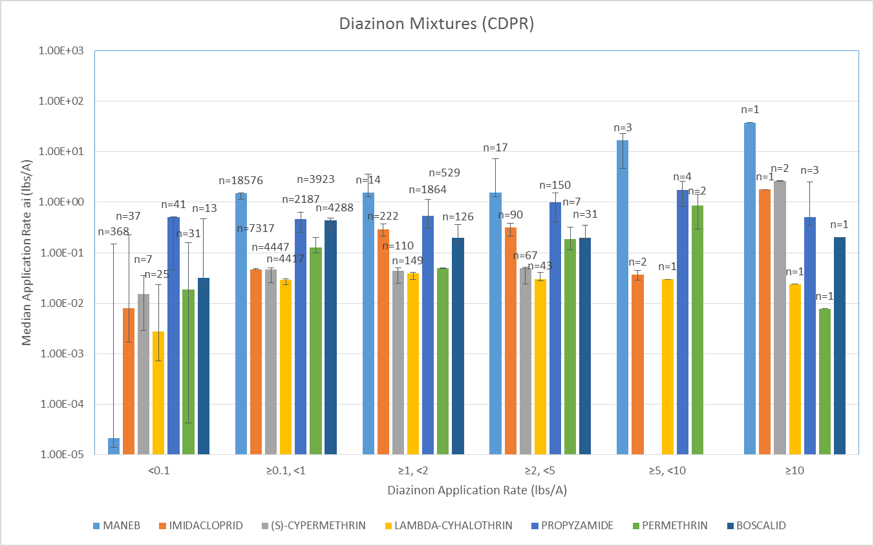
Supplemental Figure B 4-2.1. CALDPR Mixture Rate Data Error bars represent range of 5th percentile application rate to 95th ]]percentile application rate for ai.

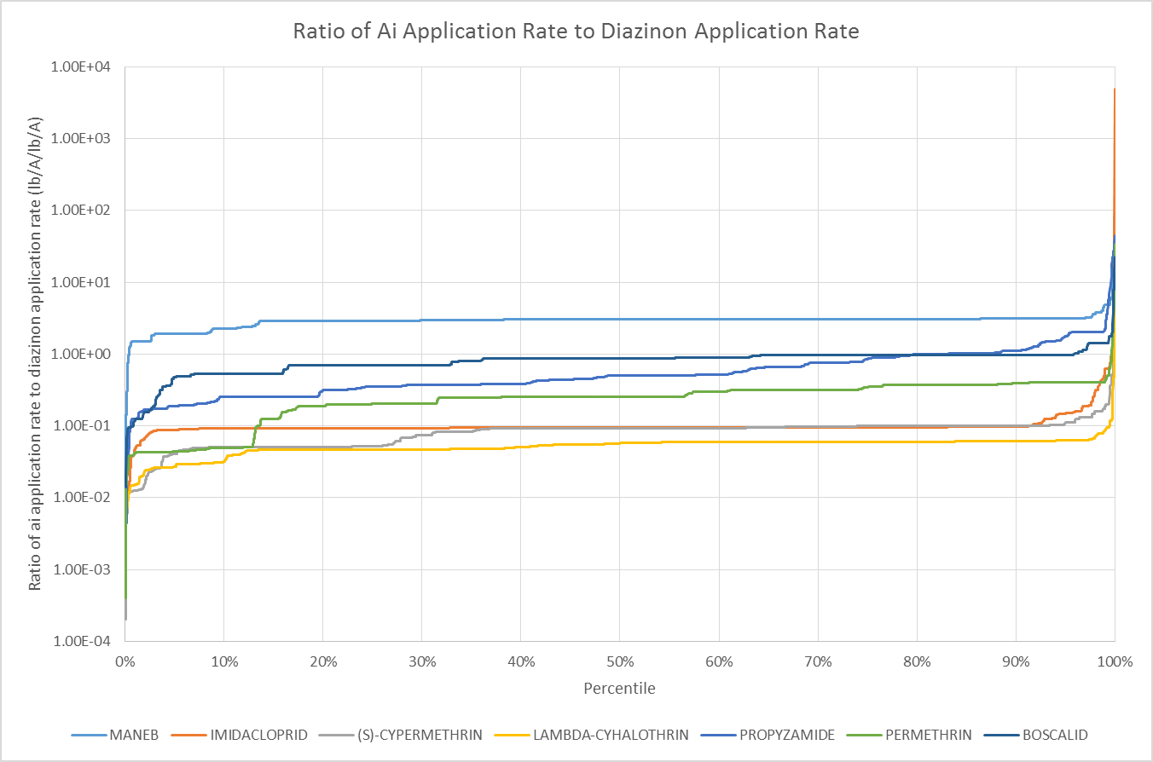
Supplemental Figure B 4-2.2. Ratio of AI Application Rate to Diazinon Application Rate

http://www.epa.gov/opprd001/inerts/
http://pubs.usgs.gov/circ/circ1225/
http://pubs.usgs.gov/circ/2005/1291/pdf/circ1291.pdf

