Appendix 3-4e. Example Aquatic Modeling EECs Figures with Effects Endpoints

Example, Temporal Variability of EECs

The following two figures provide examples of the variability of the aquatic EECs (example is for HUC 1, Bin 7) for the scenarios modeled for diazinon uses. These types of figures will be developed for all of the HUC2 and aquatic bin combinations throughout the United States and can be developed for each PRZM5/VVWM scenario. Additional figures for the different HUC2 and aquatic bin combinations will be developed in conjunction with the effects determination and will be made available with the completed BE in January 2017.

The first figure (Figure B 3-4e.1), depicts the variability of the overall daily EECs for Bin 7, depicting the EECs for the high-end 1-in-15 year peak scenario (cranberry) and the low-end 1-in-15 year peak scenario (ornamentals) and a comparison of the percentage of how often these EECs fall above or below the aquatic thresholds. For instance, all of the daily EECs are below the aquatic plant thresholds (yellow and blue lines at top of graph); however, the high end EECs fall below the freshwater fish threshold (red line) only 10% of the time.

Figure B 3-4e.1
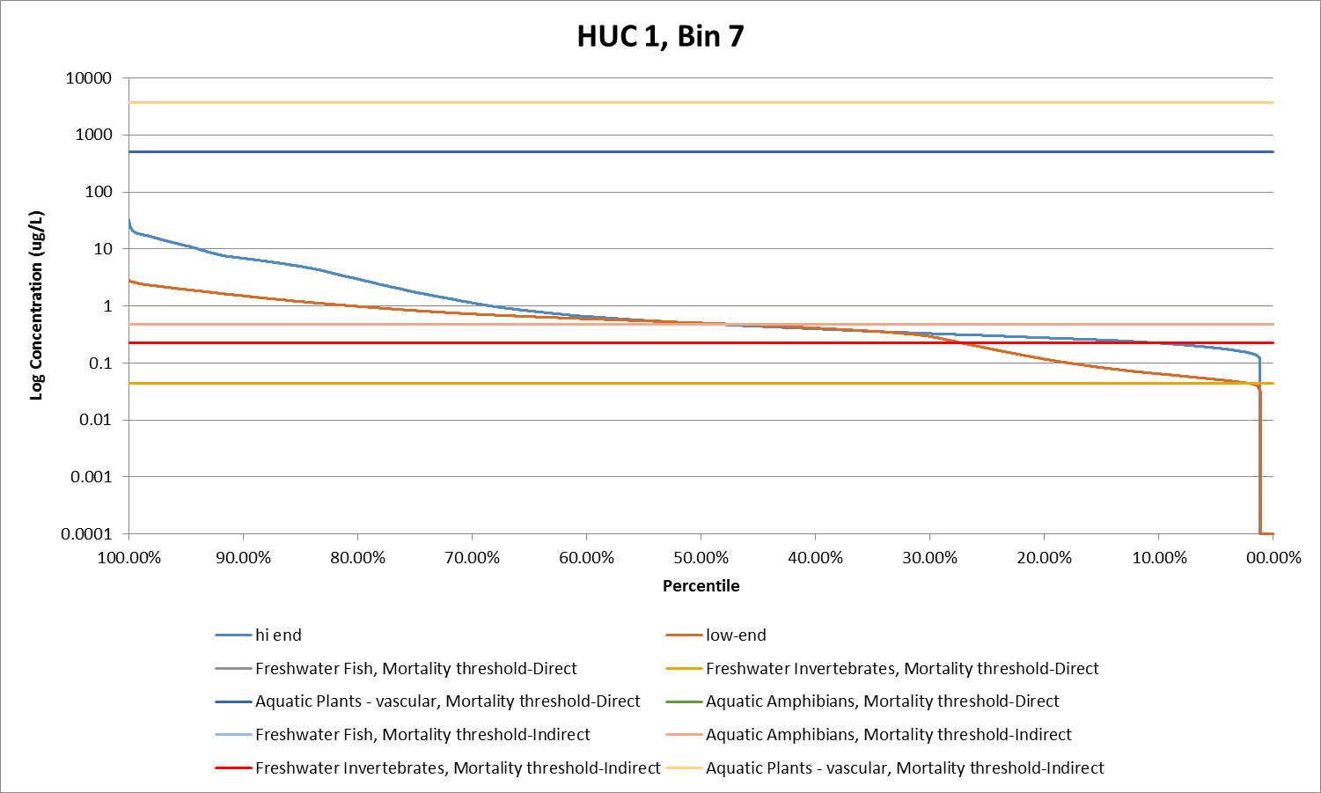

The second figure (Figure B 3-4e.2), depicts how the EECs vary during the time for the year for the high-end scenario (cranberry). The high-end scenario is below the aquatic threshold for plants during the entire year, but is above the aquatic amphibians indirect mortality threshold (light blue line) for part of the year and over the freshwater invertebrate direct mortality threshold (red line) all of the year.

Figure B 3-4e.2
