Chapter 2 – Clothianidin Effects Characterization
Contents
1 Introduction 5
2 Endpoints used in Effects Determinations 6
3 Office of Water Aquatic Life Criteria 14
4 Effects Characterization for Fish and Aquatic-phase Amphibians 14
4.1 Introduction to Fish and Aquatic-phase Amphibian Toxicity 14
4.2 Effects on Mortality of Fish and Aquatic-phase Amphibians 14
4.3 Effects on Growth and Reproduction of Fish and Aquatic-phase Amphibians 15
4.4 Other Sublethal Effects to Fish and Aquatic-phase Amphibians 16
4.5 Clothianidin Degradate Effects on Fish 17
4.6 Effects on Aquatic Vertebrates at the Community-Level 18
5 Effects Characterization for Aquatic Invertebrates 18
5.1 Introduction to Aquatic Invertebrate Toxicity 18
5.2 Effects on Mortality of Aquatic Invertebrates 18
5.3 Effects on Growth and Reproduction of Aquatic Invertebrates 20
5.4 Other Sublethal Effects to Aquatic Invertebrates 21
5.5 Degradate Toxicity Effects on Aquatic Invertebrates 22
5.6 Effects on Aquatic Invertebrate Communities 25
6 Effects Characterization for Aquatic Plants 25
6.1 Introduction to Aquatic Plant Toxicity 25
6.2 Effects on Aquatic Plants 25
6.3 Effects on Aquatic Plant Communities 27
7 Effects Characterization for Birds 27
7.1 Introduction to Bird Toxicity 27
7.2 Effects on Mortality of Birds 27
7.3 Effects on Growth and Reproduction of Birds 29
7.4 Other Sublethal Effects on Birds 30
7.5 Drinking water studies 31
7.6 Dermal studies 31
7.7 Inhalation studies 31
8 Effects Characterization for Reptiles 31
9 Effects Characterization for Terrestrial-phase Amphibians 32
10 Effects Characterization for Mammals 32
10.1 Introduction to Mammal Toxicity 32
10.2 Effects on Mortality of Mammals 32
10.3 Effects on Growth and Reproduction of Mammals 32
10.4 Other Sublethal Effects on Mammals 34
10.5 Drinking water studies 36
10.6 Dermal exposure studies 37
10.7 Inhalation studies 37
11 Effects Characterization for Terrestrial Invertebrates 37
11.1 Introduction to Terrestrial Invertebrate Toxicity 37
11.2 Effects Data on Mortality of Terrestrial Invertebrates 38
11.2.1 Mortality Endpoints Expressed as mg/kg-soil 38
11.2.2 Contact Exposure Mortality Endpoints Expressed as mg/kg-bw 39
11.2.3 Mortality Endpoints Expressed as lb/acre 40
11.2.4 Oral Exposure Mortality Endpoints Expressed as mg/kg-diet 41
11.3 Effects on Growth and Reproduction of Terrestrial Invertebrates 42
11.3.1 Growth and Reproduction Endpoints Expressed as mg/kg-soil 42
11.3.2 Contact Exposure Growth and Reproduction Endpoints Expressed as mg/kg-bw 43
11.3.3 Growth and Reproduction Endpoints Expressed as lb/acre 44
11.3.4 Oral Exposure Growth and Reproduction Endpoints Expressed as mg/kg-diet 45
11.4 Other Sublethal Effects to Terrestrial Invertebrates 46
12 Effects Characterization for Terrestrial Plants 48
12.1 Introduction to Terrestrial Plant Toxicity 48
12.2 Effects Data for Terrestrial Plants 48
12.3 Terrestrial Degradate Toxicity Data 49
13 Incident Reports 49
13.1 Terrestrial Incidents 50
13.2 Aquatic Incidents 52
14 Alternative Toxicity endpoints 53

Tables
Table 2-1. Terrestrial mortality endpoints used to evaluate impacts to species and impacts to PPHD. 8
Table 2-2. Terrestrial sublethal endpoints used to evaluate impacts to species and impacts to PPHD. 9
Table 2-3. Aquatic mortality endpoints used to evaluate impacts to species and impacts to PPHD. 10
Table 2-4. Aquatic sublethal endpoints used to evaluate impacts to species and impacts to PPHD. 11
Table 2-5. Aquatic plant endpoints used to evaluate impacts to species and impacts to PPHD. 12
Table 2-6. Terrestrial plant endpoints used to evaluate impacts to species and impacts to PPHD. 13
Table 2-7. Acute Effects of Clothianidin on Fish and Aquatic-phase Amphibians 14
Table 2-8. Chronic Effects of Clothianidin on Fish and Aquatic-phase Amphibians 16
Table 2-9. Other Sublethal Effects of Clothianidin on Fish and Aquatic-phase Amphibians 17
Table 2-10. Clothianidin Degradate Toxicity Data for Fish 17
Table 2-11. Summary Statistics for SSD Fit to Clothianidin Test Results (toxicity values reported as µg/L) 19
Table 2-12. Acute Degradate Toxicity Data for Aquatic Invertebrates 23
Table 2-13. Chronic Degradate Toxicity Data for Aquatic Invertebrates (Class Insecta) 24
Table 2-14. Aquatic Plant Toxicity Data for Clothianidin 26
Table 2-15. Clothianidin Degradate Toxicity Data for Algae 27
Table 2-16. Avian Acute Toxicity Data for Clothianidin¹. 28
Table 2-17. Avian Subacute Toxicity Data for Clothianidin 29
Table 2-18. Avian Chronic Toxicity Data for Clothianidin 30
Table 2-19. Reproductive and Developmental Chronic Mammalian Endpoints Available for Clothianidin 33
Table 2-20. Other Sublethal Chronic Mammalian Endpoints Available for Clothianidin 34
Table 2-21. Dermal Exposure Studies for Clothianidin 37
Table 2-22. Inhalation Studies for Clothianidin 37
Table 2-23. Terrestrial Invertebrate acute toxicity data available for clothianidin in units of lb/A. 41
Table 2-24. Overview of Reported Incidents Involving Clothianidin by Taxa 50
Table 2-25. Ecological Incidents Involving Bees in the U.S. Associated with Clothianidin. 51
Table 2-26. Ecological Incidents Involving Clothianidin in the U.S. by year (2010-2020). 52
Table 2-27. Alternative toxicity endpoints used in weight of evidence analysis. 53

Figures
Figure 2-1. Triangular distribution SSD for mortality toxicity values for aquatic insects for clothianidin. 19
Figure 2-2. Array of acute mortality data for aquatic invertebrates expressed in terms of µg a.i./L. 20
Figure 2-3. Array of growth toxicity data for freshwater aquatic invertebrates expressed in terms of µg a.i./L. 21
Figure 2-4. Array of sublethal toxicity data for aquatic invertebrates expressed in terms of µg a.i./L. 22
Figure 2-5. Mortality Endpoints for Terrestrial Invertebrates Exposed to Clothianidin (mg/kg-soil). 41
Figure 2-6. Contact Exposure Mortality Endpoints for Terrestrial Invertebrates Exposed to Clothianidin (mg/kg-bw). 42
Figure 2-7. Mortality Endpoints for Terrestrial Invertebrates Exposed to Clothianidin (mg/kg-diet) (Oral Exposure). 44
Figure 2-8. Sublethal Endpoints for Terrestrial Invertebrates Exposed to Clothianidin (mg/kg-soil). 45
Figure 2-9. Growth and Reproduction Endpoints for Terrestrial Invertebrates Exposed to Clothianidin (lb/acre). 47
Figure 2-10. Growth and Reproduction Endpoints for Terrestrial Invertebrates Exposed to Clothianidin (mg/kg-diet). 48
Figure 2-11. Summary array of toxicity data for terrestrial invertebrates expressed in terms of lbs/A. 49
Figure 2-12. Summary array of toxicity data for terrestrial invertebrates expressed in terms of mg/kg-diet. 50

Introduction

Clothianidin (IUPAC name: (E)-1-(2-chloro-1,3-thiazol-5-ylmethyl)-3-methyl-2-nitroguanidine) is a systemic, neonicotinoid insecticide which acts on the insect nicotinic acetylcholine receptors (nAChRs) of the central nervous system via competitive modulation. Clothianidin is in the N-nitroguanidine group of neonicotinoids (IRAC subclass 4A) along with imidacloprid, thiamethoxam, and dinotefuran. The mode of action on target insects (terrestrial and aquatic) involves out-competing the neurotransmitter, acetylcholine for available binding sites on the nAChRs (Zhang et al. 2008). At low concentrations, neonicotinoids cause excessive nervous stimulation and at higher concentrations, insect paralysis and death will occur (Tomizawa and Casida 2005). Clothianidin is mobile in xylem and phloem in plants and readily taken up by the roots of the plant and translocated throughout the plant via the transpiration stream. As such, clothianidin kills feeding insects via ingestion or direct contact routes of exposure. Target pests include chewing and sucking pests such as aphids, whiteflies, thrips, leafhoppers, scales, and leaf miners.

Clothianidin is practically non-toxic to fish on an acute toxicity basis, with effects on growth observed following chronic exposure. For aquatic invertebrates, the level of sensitivity varies greatly among species on an acute toxicity basis. For example, clothianidin is practically non-toxic to water fleas (Daphnia magna), but is very highly toxic to other taxa such as aquatic insects. Reproduction (i.e., reduced number of offspring) was affected in both freshwater and estuarine/marine invertebrates. Effects on development were also observed in benthic invertebrates. Effects on yield were observed in both aquatic vascular and non-vascular plants, but only at relatively high test concentrations compared to aquatic invertebrates (~2 µg a.i./L vs. >1,000µg a.i./L).

In terrestrial organisms, clothianidin is characterized as moderately toxic to birds on an acute oral exposure basis and practically nontoxic on a subacute dietary exposure basis. Effects on eggshell thinning represented the most sensitive chronic toxicity endpoint, which was observed in the Northern bobwhite quail. Clothianidin is classified as moderately toxic to mammals on an acute oral exposure basis. Chronic exposure with the Norway rat (Rattus norvegicus) resulted in effects on growth and maturation in offspring. Clothianidin is also highly toxic to bees, and available data suggest potential effects to honey bee and bumble bee colonies, that manifest as decreases in reproduction and the number of adult bees. Clothianidin has low toxicity to terrestrial plants; no effects were observed in terrestrial plant studies that tested up to dose levels of 0.19 lb/acre (NOAEC=0.19 lb a.i./A).

Clothianidin may degrade into various products through multiple pathways (USEPA, 2017). In the available fate studies, minor degradate formation (<10% of the applied dose) was reported for the aerobic soil metabolism study. In the aquatic photolysis study, five major degradates (>10% of applied residue) were identified including TZMU (N-(2-chloro-5-thiazolyl-methyl)-N’- methylurea; 39.7% formation) among others. TZMU was also observed at 10% in one of the terrestrial dissipation field studies. Another major degradate, TMG (N-(2-chlorothiazol-5-ylmethyl)-N’- methylguanidine), was observed in the sediment compartment (24.5%) in the aerobic aquatic metabolism study. Unextracted residues formed at 83% in the anaerobic aquatic metabolism study. Acute degradate toxicity data available for fish, aquatic invertebrates, aquatic plants, and terrestrial mammals indicates that, in general, these degradates are of similar and lesser toxicity than parent clothianidin, except TMG (N-(2-chlorothiazol-5-ylmethyl)-N’- methylguanidine), which appears to be of concern to benthic invertebrates. However, because the mobility of clothianidin and its degradates indicate that they do not readily bind to soil or sediment, unextracted residues were not considered for further analysis. Therefore, the stressors of concern for the aquatic assessment are determined to be parent clothianidin as well as the degradate TMG. For the terrestrial assessment, the stressor of concern is parent clothianidin only.

The following sections discuss toxicity data available for clothianidin divided into major taxonomic groups of fish and aquatic amphibians, aquatic invertebrates, aquatic plants, birds, reptiles, terrestrial-phase amphibians, mammals, terrestrial invertebrates and terrestrial plants. Based on these data, mortality and sublethal effects (i.e., growth and reproduction) endpoints are determined and are used to evaluate direct effects to a listed species or effects to plants or animals that a species uses for prey, pollination, habitat, and/or dispersal (PPHD).

In establishing the sublethal thresholds and endpoints used in the analysis, EPA used the most sensitive sublethal endpoint based on growth or reproduction or any sublethal endpoints that are strongly linked to survival, growth or reproduction. In determining whether toxicity endpoints are strongly linked to apical endpoints, EPA staff used best professional judgement, also considering factors such as data quality and relevance to effects on survival and reproduction. Specific consideration was given to any endpoints associated with sensory or behavioral effects. It was determined that no other endpoints in these categories were more sensitive and relevant than the most sensitive growth or reproduction endpoint available for each taxon. The sublethal endpoint used for each taxon therefore represents a growth or reproductive endpoint directly. Information on additional endpoints is found in APPENDIX 2-1 and APPENDIX 2-2.

If sufficient data are available, the toxicity data for each taxon are presented as summary data arrays (developed using the Data Array Builder v.1.0; described in ATTACHMENT 2-1). Alternatively, data are presented in a tabular format if only limited data is available. The arrays contain data from both laboratory and field experiments (e.g., mesocosms). Data in these arrays are grouped by the type of effect (e.g., mortality, growth, and reproduction), and present the range of effects endpoints [e.g., LOAECs and NOAECs (NOAECs must have a corresponding LOAEC to be represented in array)] for each effect type. If limited data are available, they are presented in a tabular format. The effect related to mortality, growth, and reproduction are discussed in further detail within each taxon effects characterization. All endpoints are reported in terms of amount of active ingredient, unless otherwise specified. Data used in the arrays are available for each taxon in APPENDIX 2-1. Studies for which exposure units could not be converted to environmentally relevant units were not included in the data arrays. Endpoints reported in the ECOTOX database are presented in APPENDIX 2-2. Reviews of open literature studies are presented in APPENDIX 2-3. Citations for registrant submitted studies are presented in APPENDIX 2-4.

Endpoints used in Effects Determinations

Toxicity data available for clothianidin were reviewed and divided into major taxonomic groups, including fish and aquatic amphibians, aquatic invertebrates, aquatic plants, birds, reptiles, terrestrial-phase amphibians, mammals, terrestrial invertebrates and terrestrial plants. For each of these groups, endpoints were determined for each taxon for mortality (animals only) and sublethal effects (i.e., growth or reproduction). These endpoints were used to establish thresholds, which were then used in conjunction with exposure data to make effects determinations based on the taxon with which they are associated. These data are described more fully in each relevant toxicity section below . Table 2-1 through Table 2-6 summarize the clothianidin toxicity endpoints used in the effects determinations for all taxa. The available toxicity data for each taxon are discussed more later in this chapter.

Table 2-1. Terrestrial mortality endpoints used to evaluate impacts to species and impacts to PPHD.
Type of Threshold | Taxon | Test Species | Type of endpoint | Value | Units | Slope | Weight of test animal (g) | Comments | Reference
DOSE BASED MORTALITY | Mammals | Mouse (Mus musculus) | LD₅₀ | 425 | mg/kg-bw | 4.5 | 29.6 | Slope assumed. | MRID 45422622
 | Birds | Japanese Quail (Coturnix japonica) | LD₅₀ | 423 | mg ai/kg-bw | 4.5 | 102 | 95% CI: 306-593 mg a.i./kg-bw. Slope assumed. | MRID 45422418
 | Reptiles | Japanese Quail (Coturnix japonica) | LD₅₀ | 423 | mg ai/kg-bw | 4.5 | 102 | 95% CI: 306-593 mg a.i./kg-bw. Slope assumed. | MRID 45422418
 | Terrestrial invertebrates | Honey bee  (Apis mellifera) | LD₅₀ | 0.21 | mg ai/kg-bw | 4.5 | 0.128 | 48-hour LD₅₀; Contact exposure; mortality endpoint | MRID 49950102
DIETARY BASED MORTALITY | Mammals | No Data
 | Birds | Bobwhite quail (Colinus  virginianus) | LC₅₀ | 5,230 | mg/kg-diet | NA | 14.65 | Non-definitive (>) value | MRID 45422419
 | Reptiles | Bobwhite quail (Colinus  virginianus) | LC₅₀ | 5,230 | mg/kg-diet | NA | 14.65 | Bird used as a surrogate. Non-definitive (>) value | MRID 45422419
 | Terrestrial Invertebrates | Honey bee  (Apis mellifera) | LC₅₀ | 0.15 | mg ai/kg-diet | 4.5 | 0.3 | Slope assumed | MRID 45422426
MORTALITY | Terrestrial Invertebrates | Earthworm  (Eisenia fetida) | LC₅₀ | 0.93 | mg ai/kg-soil | 4.5 | 9.45 | Slope assumed | E173321; Wang et al. 2015
 | Terrestrial Invertebrates | Earthworm  (Eisenia fetida) | LC₅₀ | 0.025 | lb ai/A | 4.12 | 9.45 | Qualitative | E163184; Wang et al. 2012

Table 2-2. Terrestrial sublethal endpoints used to evaluate impacts to species and impacts to PPHD.
Type of Threshold | Taxon | Test Species | NOAEC (or LOAEC if no NOAEC) | MATC or LOAEC | Units | Comments | Reference
DOSE BASED SUBLETHAL ENDPOINTS | Mammals | Rat (Rattus norvegicus) | 9.8 | 17.5 | mg ai/kg-bw | MATC used; LOAEL = 31.2. Decreased body weight gains in male offspring and and increased stillbirths (F1 and F2 litters). | MRID 45422714
 | Birds | House Sparrow  (Passer domesticus) | 63 | 88.7 | mg ai/kg-bw | House Sparrow; MATC used; LOAEC = 125; LOAEC based on 200% increase in mortality | MRID 49104802
 | Reptiles/Terrestrial Amphibians | House Sparrow  (Passer domesticus) | 63 | 88.7 | mg ai/kg-bw | House Sparrow; MATC used; LOAEC = 125; LOAEC based on 200% increase in mortality | MRID 49104802
DIETARY BASED SUBLETHAL ENDPOINTS | Mammals | Rat (Rattus norvegicus) | 150 | 274 | mg ai/kg-diet | MATC used  NOAEL/C (M/F) = 9.8/11.5  mg ai/kg-bw/day (150/500 mg ai/kg-diet)  LOAEL/C (M/F) = 31.2/36.8  Mg ai/kg-bw/day (500/500 mg ai/kg-diet)  LOAEL/C based on decreased body weight gains in male offspring and and increased stillbirths (F1 and F2 litters). | MRID 45422714
 | Birds | Bobwhite Quail  (Colinus virginianus) | 205 | 329 | mg ai/kg-diet | MATC used; LOAEC (525) based on 3.5% reduction in eggshell thickness | MRID 45422421
 | Reptiles/Terrestrial Amphibians | Bobwhite Quail  (Colinus virginianus) | 525 | >525 | mg ai/kg-diet | Bird used as a surrogate; LOAEC non-definitive (>) because eggshell thickness not biologically relevant for reptiles and no other effects noted in study | MRID 45422421
SUBLETHAL/Mortality | Terrestrial Invertebrates | Honeybee  (Apis mellifera) | 0.21 | 0.21 | mg ai/kg-bw | 48-hour LD₅₀; Contact exposure; mortality endpoint | MRID 49950102
 | Terrestrial Invertebrates | Honeybee  (Apis mellifera) | 0.001 | 0.0014 | mg/kg-diet | MATC used; LOAEC (0.002) based on mortality (~12% increase); Calculated using reverse Bee-R; endpoints multiplied by 10-day study period | MRID 48414901
 | Terrestrial Invertebrates | Springtail  (Folsomia candida) | 0.020 | 0.032 | mg ai/kg-soil | MATC used; LOAEC (0.051) based on mortality (~40% increase). | MRID 183406; Ritchie et al. 2019
 | Terrestrial Invertebrates | Seven-spotted lady beetle  (Coccinella septempunctata) | 0.0011 | 0.0011 | lb ai/acre | Qualitative; LOAEC based on mortality (52% increase); Non-definitive (<) NOAEC | E183576;  Jiang et al. 2018

Table 2-3. Aquatic mortality endpoints used to evaluate impacts to species and impacts to PPHD.
Taxon | Test Species | Type of endpoint | Value  (ug ai/L) | Slope | Duration of study (days) | Reference
FRESHWATER FISH | Rainbow trout (Oncorhynchus  mykiss) | LC₅₀ | >101,500* | NA | 4 | MRID 45422406
ESTUARINE/MARINE FISH | Sheepshead Minnow (Cyprinodon variegatus) | LC₅₀ | >91,400* | NA | 4 | MRID 45422411
AQUATIC-PHASE AMPHIBIANS | Rainbow trout (Oncorhynchus  mykiss) | LC₅₀ | >101,500* | NA | 4 | MRID 44714917
FRESHWATER INVERTEBRATES | HC₀₅ from Species Sensitivity Distribution | HC₀₅ | 3.58 | 1.69 | 2-4 | SSD-derived; See Appendix 2-6
ESTUARINE/MARINE INVERTEBRATES | Mysidopsis bahia | LC₅₀ | 51 | 4.5 | 39 | MRID 45422403
Mollusks | Eastern oyster (Crassostrea virginica) | EC50 | >129,100 | 4.5 | 4 | MRID 45422404
NA = not applicable
*No mortality or sublethal effects observed

Table 2-4. Aquatic sublethal endpoints used to evaluate impacts to species and impacts to PPHD.
Taxon | Test Species | NOAEC | MATC or LOAEC | Units | Duration of study (days) | Comments | Reference
FW FISH | Fathead Minnow (Pimephales promelas) | 9,700 | 1,3928 | µg ai/L | 28 | LOAEC (20,000) based on 6 and 15% reductions in length and weight, respectively. | MRID 45422413
E/M FISH | Fathead Minnow (Pimephales promelas) | 9,700 | 1,3928 | µg ai/L | 28 | Chronic estuarine/marine fish toxicity data not available. Chronic freshwater fish toxicity data will be used as a surrogate for estuarine/marine fish. | MRID 45422413
AQ AMPHIBIANS | Fathead Minnow (Pimephales promelas) | 9,700 | 13,928 | µg ai/L | 28 | FW Fish used as surrogate. LOAEC (20,000) based on 6 and 15% reductions in length and weight, respectively. | MRID 45422413
FW INVERTEBRATES | Midge (Chironomus dilutus) | 0.05 | 0.05 | µg ai/L | 40 | LOAEC based on 42% reduction in emergence; Non-definitive (<) NOAEC | E175184; Cavallero et al. 2016
FW INVERTEBRATES  (Non-Insect) | Waterflea  (Daphnia magna) | <42 | 42 | µg ai/L | 40 | LOAEC based on reduction in dry weight | MRID 45422412
E/M INVERTEBRATES | Mysid shrimp (Mysidopsis bahia) | 5.1 | 7.0 | µg ai/L | 39 | LOAEC (9.7); Based on 34% reduction in reproduction | MRID 45422405
Mollusks | Eastern Oyster  (Crassostrea virginica) | 129,100 | 129,100 | µg ai/L | 4 | EC₅₀; shell disposition endpoint as surrogate; non-definitive (>) | MIRD 45422404

Table 2-5. Aquatic plant endpoints used to evaluate impacts to species and impacts to PPHD.
EPA Category | Species | NOAEC | MATC or LOAEC | IC50 | Units | Comments | Reference
Non-vascular | Green Algae  (Raphidocelis subcapitata) | 1,460 | 2,100 | 10,0000 | µg ai/L | Reduced yield at the LOAEC (3,020); Degradate TMG; 4-day exposure  Clothianidin based endpoint selected as alternative endpoint | MRID 45422505
Vascular | Duckweed (Lemna gibba) | 520 | 739 | >280,000 | µg ai/L | reduction in yield and biomass number of fronds at the LOAEC (1,050); 14-d exposure | MRID 49281301

Table 2-6. Terrestrial plant endpoints used to evaluate impacts to species and impacts to PPHD.
EPA Category | Species | NOAEC | MATC or LOAEC | IC25 | Units | Comments | Reference
Monocot | N/A | 0.19 | ≥0.19 | ≥0.19 | lb ai/A | Acceptable. No treatment-related effects up to the highest tested dose. TEP used was TI435 50% WDG. NOAEC is highest tested concentration. LOAEC and IC25 are non-definitive values | MRID 45422501
Dicot | N/A | 0.19 | ≥0.19 | ≥0.19 | lb ai/A | Acceptable. No treatment-related effects up to the highest tested dose. TEP used was TI435 50% WDG. NOAEC is highest tested concentration. LOAEC and IC25 are non-definitive values | MRID 45422502

Office of Water Aquatic Life Criteria

The U.S. EPA’s Office of Water (OW) may develop ambient water quality criteria for chemicals, including pesticides, that can be adopted by states and tribes to establish water quality standards under the Clean Water Act. At this time, OW has not published ambient water quality criteria for clothianidin.

Effects Characterization for Fish and Aquatic-phase Amphibians

Introduction to Fish and Aquatic-phase Amphibian Toxicity

Acute and chronic studies for fish have been submitted by the registrant and are available in the open literature. Data for amphibians are also available in the open literature. Studies were excluded from the main analysis if they were considered invalid or if the exposure units could not be converted into aqueous concentrations (mass a.i./volume).

Effects on Mortality of Fish and Aquatic-phase Amphibians

Registrant-submitted acute toxicity data are available for two species of freshwater fish (rainbow trout [Oncorhynchus mykiss] and bluegill sunfish [Lepomis macrochirus]) and one estuarine/marine fish (sheepshead minnow [Cyprinodon variegates]). No treatment-related effects on mortality were observed in the three tested fish species up to the highest concentration tested (91,400-117,000 µg a.i./L). One open literature study is available for acute mortality effects on the freshwater fathead minnow from ECOTOX (E#173368; De Perre et al. 2015). Similarly, no mortality or sublethal effects were observed up to the highest concentration tested (LC₅₀ >500 µg/L). However, neither the test material nor its purity were reported (Table 2-7).

ECOTOX data are available for aquatic-phase amphibians. In Miles et al., 2017 (ECOTOX Ref. No. 183651), three species of aquatic-phase amphibians (Hyla versicolor, Lithobates clamitans, and
Lithobates pipiens) were exposed for 96-hrs to an end-use product formulation of clothianidin (Arena, 0.25%). The resulting 96-hr LC₅₀ values for all three species were > 327,000 µg/L (assumed to be in units of µg a.i./L, but uncertain). No treatment-related mortality was observed.

Even though there are no definitive mortality endpoints, the LC₅₀ value of >101,500 µg a.i./L based on rainbow trout is conservatively used to derive the acute morality threshold for freshwater fish and aquatic-phase amphibians. Similarly, for estuarine/marine fish, the endpoint used to conservatively derive the acute toxicity threshold is an LC₅₀ of >91,400 µg a.i./L based on data from the sheepshead minnow.

Table 2-7. Acute Effects of Clothianidin on Fish and Aquatic-phase Amphibians
Species (% a.i.) | Endpoint (Duration) | Toxicity Value (µg a.i./L) | MRID/  ECOTOX#
Freshwater Fish
Rainbow Trout Oncorhynchus mykiss (TGAI, 96%) | LC50  (Acute, 96-hr) | >101,500 | 45422406
Bluegill Sunfish Lepomis macrochirus (TGAI, 97.6%) | LC50  (Acute, 96-hr) | >117,000 | 45422407
Fathead Minnow  (Pimephales promelas) | LC50  (Acute, 96-hr) | >500 | ECOTOX#173368; De Perre et al. 2015
Estuarine/marine Fish
Sheepshead minnow  Cyprinodon variegates  (TGAI, 97.6%) | LC50  (Acute, 96-hr) | >91,400 | 45422411
Aquatic-phase Amphibians
Hyla versicolor; Lithobates clamitans;  L. pipiens  (TEP, 0.25%) | LC50  (Acute, 96-hr) | >327,000 | ECOTOX# 183651; Miles et al. 2017

Effects on Growth and Reproduction of Fish and Aquatic-phase Amphibians

The most sensitive chronic exposure endpoint for freshwater fish was reported in a registrant-submitted early life-stage study with fathead minnow (Pimephales promelas). This study resulted in a NOAEC value of 9,700 µg a.i./L based on effects on growth (length and weight) at the LOAEC (20,000 µg a.i./L) (Table 2-8). Two additional chronic freshwater fish studies are available from the open literature via ECOTOX with the zebrafish (Zebra danio) (ECOTOX Ref. No. 182827; Truong et al. 2014) and sockeye salmon (Oncorhynchus nerka) (ECOTOX Ref. No. 183650; Marlatt et al. 2019); however, neither provided more sensitive endpoints. In the zebrafish embryo study, no significant treatment-related toxicity effects were noted for any endpoint, including mortality, fin growth, blood flow, and pigmentation up to the highest tested concentration (16,000 µg a.i./L). Similarly, in an early life stage test with sockeye salmon (Oncorhynchus nerka), no significant treatment-related effects of clothianidin were observed on survival, hatching, growth, or testosterone levels up to the highest tested concentration (≥150 μg a.i./L). No chronic data are available for estuarine/marine fish. However, given the lack of effects in available acute fish toxicity data and no other evidence to suggest that different species of fish would be differentially sensitive to clothianidin, the chronic toxicity value from the fathead minnow will be used to represent effects from chronic exposure to both freshwater and estuarine/marine fish.

No registrant data are available for chronic effects of clothianidin on aquatic-phase amphibians; however, one open literature study is available via ECOTOX. In a non-guideline mesocosm study, Robinson et al. 2019 (ECOTOX Ref. No.183407) exposed leopard frog (Lithobates pipiens) and wood frog (Lithobates sylvaticus) larvae to clothianidin (TEP Titan; 500 g/L) and thiamethoxam (TEP Actara; 240 g/L) at concentrations of 2.5 and 250 ug/L. No significant treatment-related effects were observed on any frank sublethal endpoint (survival, sex ratio, body length or weight, and development) up to the highest concentration tested (250 µg/L).

Based on the available data, the sublethal toxicity threshold for freshwater fish is a NOAEC value of 9,700 µg a.i./L based on effects on growth (length and weight) at the LOAEC (20,000 µg a.i./L). Due to a lack of data for estuarine/marine fish and a lack of chronic toxicity effects observed in available open literature studies, the freshwater fish endpoint will be used as a surrogate for estuarine/marine fish and aquatic-phase amphibians given the effects observed (morality, growth effects) could be translatable to other aquatic vertebrate species.

Table 2-8. Chronic Effects of Clothianidin on Fish and Aquatic-phase Amphibians
Species (% a.i.) | Endpoint (Duration) | Toxicity Value (µg a.i./L) | MRID/  ECOTOX#
Freshwater Fish
Fathead Minnow Pimephales promelas (TGAI, 97.6%) | NOAEC  LOAEC  (28 d post  hatch) | 9,700  20,000 (length and weight) | 45422413
Zebrafish  Zebra danio | NOAEC  LOAEC | 16,000  ≥16,000 | ECOTOX# 182827; Truong et al. 2014
Sockeye salmon Oncorhynchus nerka  (TGAI, 98%) | NOAEC  LOAEC | 150  ≥150 | ECOTOX# 183650; Marlatt et al. 2019
Aquatic-phase Amphibians
Wood frogs (Lithobates sylvaticus); Northern leopard frogs (Lithobates pipiens)  (TEP, 9.5%) | NOAEC  LOAEC | 250 µg/L  ≥250 µg/L  (nominal concentrations) | ECOTOX# 183407; Robinson et al. 2019

Other Sublethal Effects to Fish and Aquatic-phase Amphibians

Both of the open literature studies mentioned above examining chronic toxicity in zebra fish and sockeye salmon (ECOTOX Ref No. 182827, 183650; Truong et al. 2014, and Marlatt et al. 2019) also included data on other sublethal effects from clothianidin exposure on fish (Table 2-9). Truong et al. 2014 detected no effects of clothianidin exposure on edema, abnormal growth, pigmentation, or blood flow up to the highest tested concentration (16,000 μg a.i./L) in zebrafish embryos. Marlatt et al. 2019 detected significant decreases in sockeye salmon hepatic expression of the gene encoding glucocorticoid receptor 2 at the highest test concentration (165 μg/L).

Two open literature studies are available for aquatic-phase amphibians that examined the effects of clothianidin exposure on non-frank sublethal effects (ECOTOX Ref No. 183651, 183401; Miles et al. 2017, Gavel et al. 2019). Miles et al. 2017 examined the effects of clothianidin exposure on northern leopard frog tadpole behavior in the lab and observed no effects up to the highest tested treatment concentration (1000 µg/L). In an outdoor mesocosm experiment assessing the effects of commercial formulations of clothianidin (Titan; 600 g/L) and thiamethoxam (Actara; 240 g/L) on blood cell profiles and corticosterone concentrations, Gavel et al. 2019 detected reduced levels of erythrocytes in the blood of wood frogs at the highest tested concentration (250 µg/L). Although some of the above studies indicate other sublethal effects in both fish and aquatic-phase amphibians, none of these significantly impacted endpoints were reliable for use as a threshold and relatable to an apical endpoint.

Table 2-9. Other Sublethal Effects of Clothianidin on Fish and Aquatic-phase Amphibians
Species (% a.i.) | Endpoint (Duration) | Toxicity Value (µg a.i./L) | MRID/  ECOTOX#
Freshwater Fish
Zebrafish  Zebra danio | NOAEC  LOAEC | 16,000  ≥16,000 | ECOTOX# 182827; Truong et al. 2014
Sockeye salmon Oncorhynchus nerka  (98%) | NOAEC  LOAEC | 15  150 | ECOTOX# 183650; Marlatt et al. 2019
Aquatic-phase amphibians
Wood frogs (Lithobates sylvaticus)  (TEP, 9.5%) | NOAEC  LOAEC | 2.5  250 | ECOTOX# 183401; Gavel et al. 2019
Northern leopard frogs (Lithobates pipiens)  (TEP, 0.25%) | NOAEC  LOAEC | 1,000  ≥1,000 | ECOTOX# 183651;  Miles et al. 2017

Clothianidin Degradate Effects on Fish

Acute and chronic toxicity studies with fish are also available for clothianidin degradates TZNG, MNG, and TMG (Table 2-10). The majority of the studies are with rainbow trout, while one is available with the fathead minnow for NTG. Similar to parent clothianidin, TZNG, MNG, and TMG degradates are practically non-toxic on an acute exposure basis to fish with acute 96-hr LC50 values of >105 mg/L (MRIDs 45422408 -45422410). Additionally, acute and chronic toxicity values for NTG with fathead minnow and rainbow trout were greater than 100 mg/L. Given the apparently similar or lesser toxicity of clothianidin’s degradates, both acute and sublethal toxicity thresholds for fish and aquatic-phase amphibians will be based on the parent compound only.

Table 2-10. Clothianidin Degradate Toxicity Data for Fish
Species  (Degradate) | Endpoint  (Duration) | Toxicity Value  (mg a.i./L) | MRID / Citation  (source)
Rainbow Trout Oncorhynchus mykiss  (TZNG, 99%) | 96-hr LC50 | >160 | MRID 45422410
Rainbow Trout  O. mykiss  (MNG, 99%) | 96-hr LC50 | >105 | MRID 45422409
Rainbow Trout  O. mykiss  (TMG, 99%) | 96-hr LC50 | >110 | MRID 45422408
Rainbow Trout  O. mykiss  (NTG, 99.9%) | 96-hr LC50  28-d NOAEC  28-d LOAEC | 1,550  1,520  >1,520 | Burton et al. 1993 (E17395; Open lit)
Fathead minnow  P. promelas  (NTG, 99.9) | 96-hr LC50  28-d NOAEC  28-d LOAEC | 3,320  1,050  2,030 | Burton et al. 1993 (E17395; Open lit)

Effects on Aquatic Vertebrates at the Community-Level

Two mesocosm studies are available from the open literature that include data on community-level effects from clothianidin exposure on aquatic-phase amphibians. First, in Miles et al. 2017 (ECOTOX Ref No. 18361), an aquatic mesocosm study was conducted using the formulation Arena (0.25%) at test concentrations of 0.6, 5, and 352 µg/L with predatory invertebrates (i.e., water bugs, backswimmers, dragonfly larvae, and crayfish) and prey organisms including aquatic snails and aquatic-phase amphibian tadpoles (leopard and green frogs [Lithobates clamitans]) to evaluate community-level effects. Although no effects were observed in the green frog, leopard frog tadpole survival increased by ~10% at the highest tested concentration of clothianidin due to increased invertebrate predator mortality. Second, in a mesocosm host-parasite study conducted using technical grade clothianidin, Robinson et al. 2019b (ECOTOX Ref No. 183649) detected no effects on larval leopard frog susceptibility to infection by trematode parasites. Therefore, based on data for aquatic-phase amphibians, there may be indirect effects to aquatic vertebrate predators from clothianidin exposure.

Effects Characterization for Aquatic Invertebrates

Introduction to Aquatic Invertebrate Toxicity

The effects of clothianidin on aquatic invertebrates have been studied extensively, including both freshwater and estuarine/marine (E/M) invertebrates. When considering the available toxicity data for aquatic organisms, aquatic invertebrates are the most well tested. APPENDIX 2-2 includes the bibliography of studies that are included in this effects characterization and those that were excluded. Studies were excluded from the main analyses (i.e., Species Sensitivity Distribution [SSD] and data arrays) if they were considered invalid or the exposure units could not be converted into environmentally relevant concentrations. Species tested include multiple insects (from several classes), mollusks and other aquatic invertebrates (e.g., cladocerans, amphipods). Among the species tested, aquatic insects appear to be the most sensitive, with mollusks, cladocerans and amphipods being orders of magnitude less sensitive. Due to that difference in sensitivity by taxon, different thresholds are established for insects and non-insects. Because there are many different listed species of mollusks and there are mollusk specific toxicity data available, separate mollusk thresholds are also set.

Effects on Mortality of Aquatic Invertebrates

For freshwater aquatic insects, several acute toxicity studies involving freshwater invertebrates were identified in ECOTOX (Figure 2-2). Therefore, an SSD based on acute mortality studies was developed for freshwater aquatic insects. SSDs are based on acute 48 or 96-hr EC/LC₅₀ values from studies using TGAI only (values from formulation/mixture testing were not included). There were a total of 17 aquatic insect species used in the SSD. The HC₀₅ = 3.58 µg a.i./L for aquatic insects (Table 2-11) and will be used as a threshold. The triangular distribution function for aquatic insects is presented in Figure 2-1. The SSD report for aquatic insects is provided in APPENDIX 2-5 and includes the details of how this SSD was derived.

Table 2-11. Summary Statistics for SSD Fit to Clothianidin Test Results (toxicity values reported as µg/L)
Statistic | Aquatic Insects
HC₀₅ (95% CI) | 3.58 (1.42-24-65)
HC₅₀ (95% CI) | 176.92 (62.81-500.52)
Slope | 1.69
CI = confidence interval

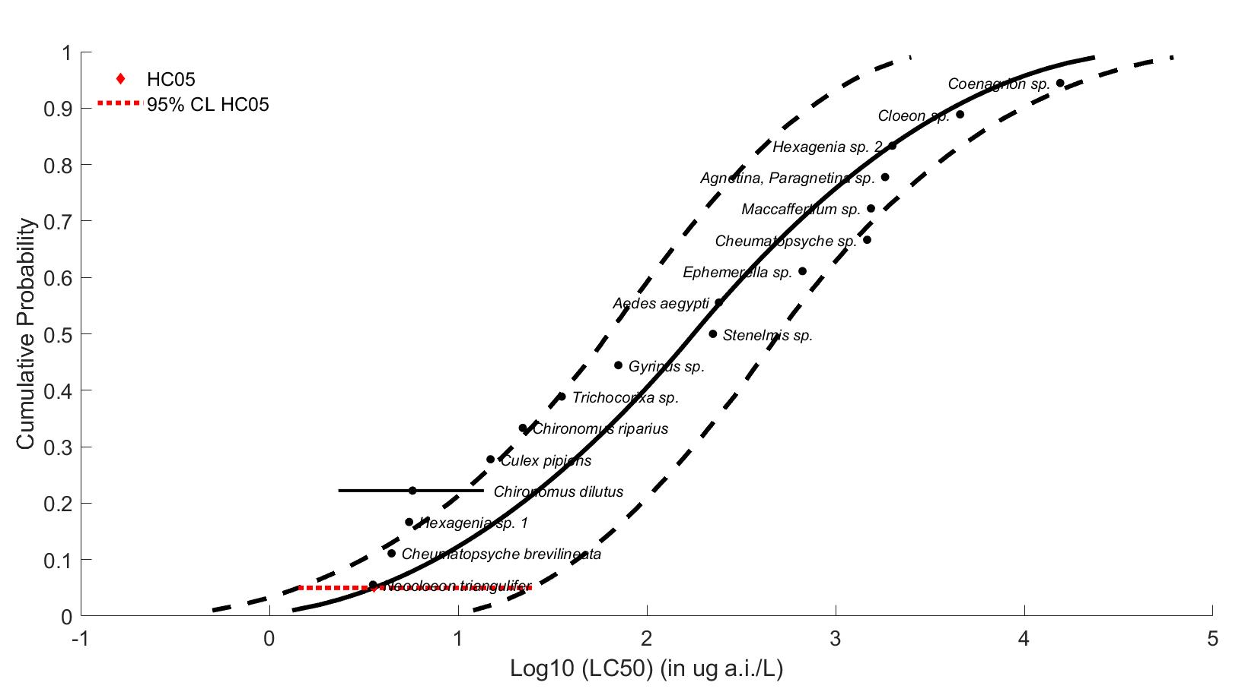
Figure 2-1. Triangular distribution SSD for mortality toxicity values for aquatic insects for clothianidin. Black points indicate toxicity values. Black horizontal line indicates full range of toxicity values for a given taxon. Dotted lines represent the confidence interval.

For freshwater aquatic invertebrates outside of the class Insecta, the most sensitive mortality endpoint was a 96-hr LC₅₀ = 6.1 µg a.i./L in the amphipod (Hyalella azteca; E178290). For estuarine/marine toxicity data, the most sensitive mortality endpoint reported is a 96-hr LC₅₀ = 53 µg a.i./L in the mysid shrimp (Mysidopsis bahia; MRID 45433403). No additional acute toxicity data involving saltwater invertebrates were identified in ECOTOX. The most sensitive mollusk endpoint was a 96-hr EC₅₀ > 129,100 µg a.i./L in the eastern oyster (Crassostrea virginica; MRID 45422404).

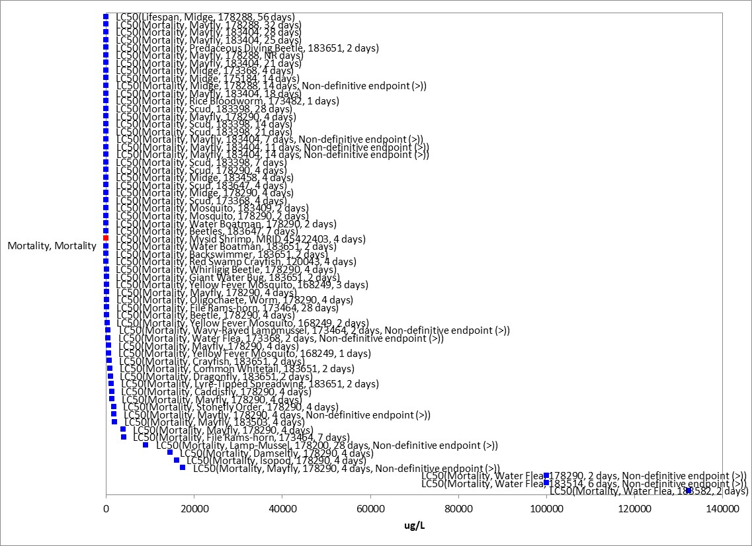
Figure 2-2. Array of acute mortality data for aquatic invertebrates expressed in terms of µg a.i./L.
Blue squares represent LC/EC50 values from open literature studies found in the ECOTOX database. Red squares represent LC/EC50 values from registrant submitted studies. Parentheses present the endpoint measurement, species, study reference (i.e., MRID, ECOTOX #), and study duration. If endpoint is non-definitive, that is also noted.

Effects on Growth and Reproduction of Aquatic Invertebrates

The available data for effects on growth and reproduction of aquatic invertebrates is provided in Figure 2-3 below. No endpoints were identified from studies in the ECOTOX acceptable database that were either more sensitive than the endpoints identified above, or reliable for use as a threshold. The most sensitive reliable NOAEC/LOAEC was used to represent thresholds for growth and reproductive effects.

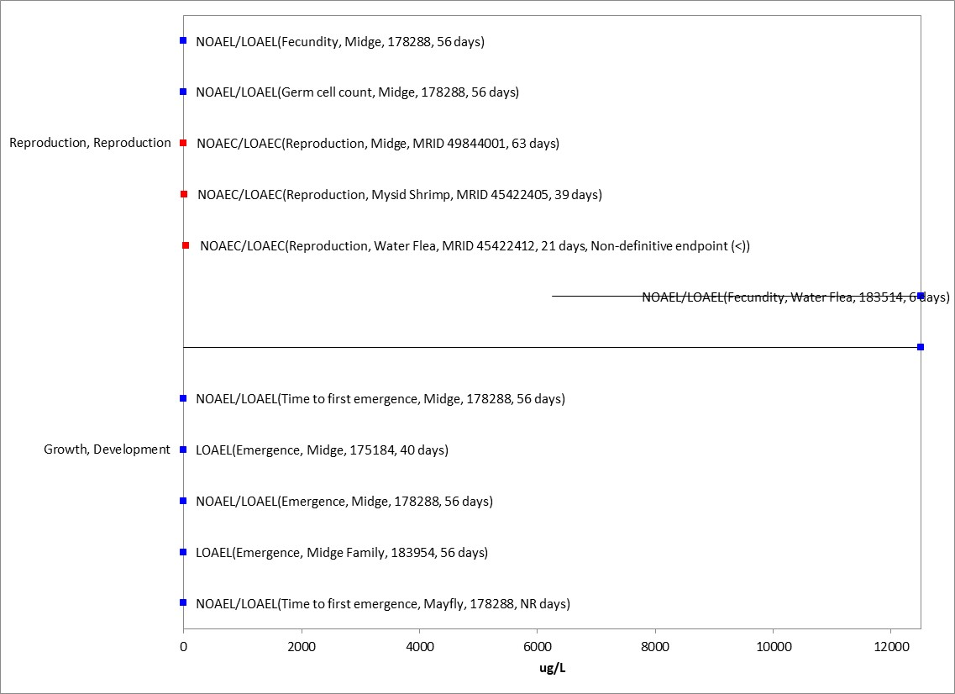
Figure 2-3. Array of growth toxicity data for freshwater aquatic invertebrates expressed in terms of µg a.i./L. Blue squares represent LC₅₀ values from open literature studies found in the ECOTOX database. Red squares represent LC₅₀ values from registrant submitted studies. Parentheses present the endpoint measurement, species, study reference (i.e., MRID, ECOTOX #), and study duration. If endpoint is non-definitive, that is also noted.

For freshwater aquatic invertebrates, the most sensitive growth and reproduction endpoint was based on a 42% decrease in emergence in the midge (Chironomus dilutus; ECOTOX# 175184; NOAEC <0.05 µg a.i./L, LOAEC = 0.05 µg a.i./L). Several other growth and reproduction studies were available for Chironomus dilutus, with growth LOAECs ranging from 0.63 to 1.26 µg a.i./L and reproduction LOAECs ranging from 0.63 to 2.5 µg a.i./L. For freshwater aquatic invertebrates outside of the class Insecta, the most sensitive growth and reproduction endpoint was based on effects to dry weight in the waterflea (Daphnia magna; MRID 45422412; NOAEC < 42 µg a.i./L, LOAEC = 42 µg a.i./L). For estuarine/marine aquatic invertebrates, the most sensitive growth and reproduction endpoint was based on a 34% decrease in reproduction in the mysid shrimp (Mysidopsis bahia; MRID 45422405; NOAEC = 5.1 µg a.i./L, LOAEC = 9.7 µg a.i./L, MATC = 7.0 µg a.i./L). For estuarine/marine aquatic invertebrates, no additional sublethal toxicity data were identified in ECOTOX. Additionally, the most sensitive mollusk endpoint was based on a no-effect shell disposition study on the eastern oyster (Crassostrea virginica; MRID 45422404; 96-hr EC₅₀ > 129,100 µg a.i./L).

Other Sublethal Effects to Aquatic Invertebrates

Additional literature is available on the sublethal effects of thiamethoxam on aquatic invertebrates. No endpoints were identified from studies in the ECOTOX acceptable database that were either more sensitive than the endpoints identified above or reliable for use as a threshold and relatable to an apical endpoint. Error! Reference source not found.4 illustrates the data available for other sublethal endpoints.

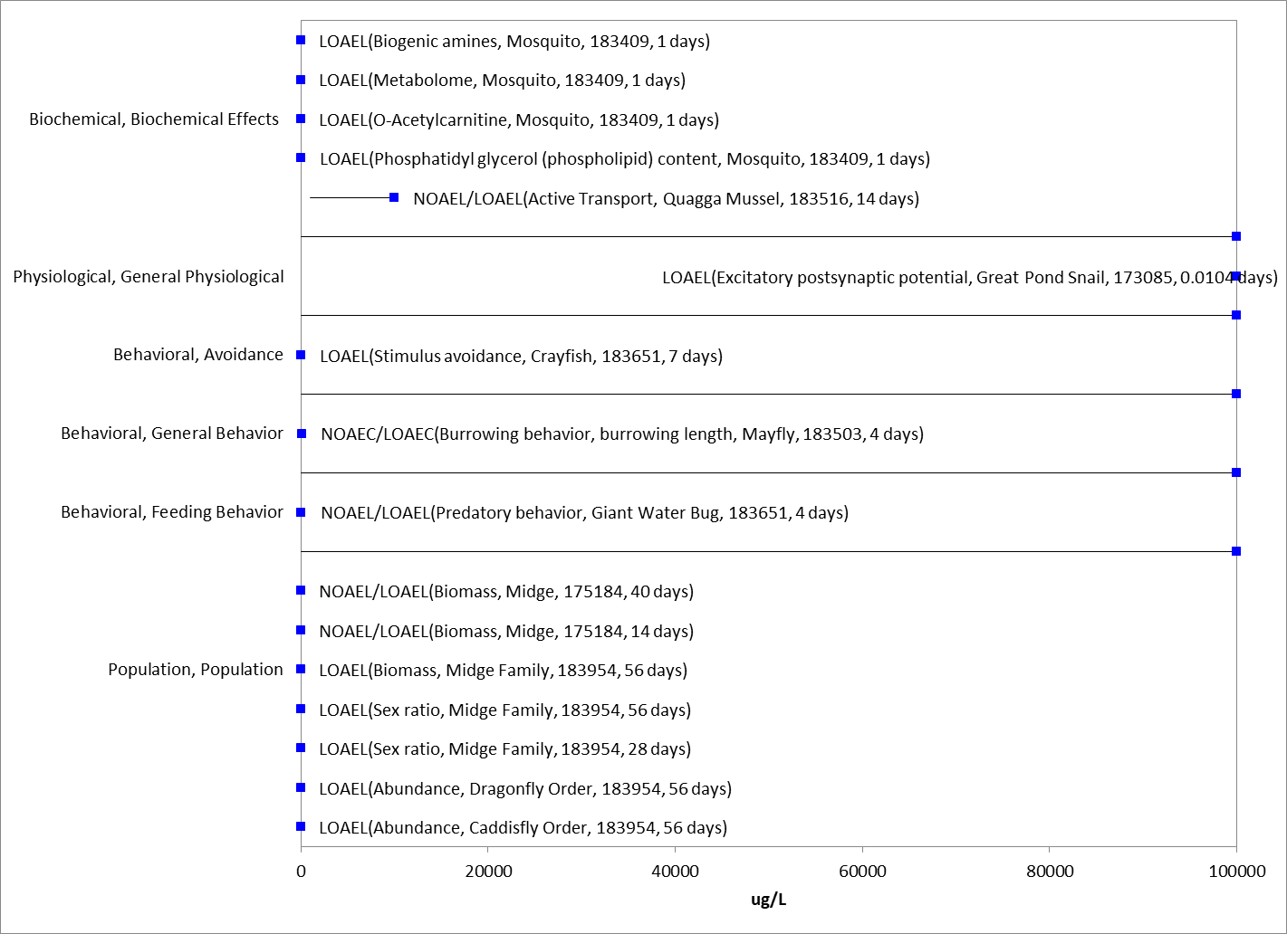
Figure 2-4. Array of sublethal toxicity data for aquatic invertebrates expressed in terms of µg a.i./L. Blue squares represent LOAEC/LOAEL values from open literature studies found in the ECOTOX database. Solid lines display the range between the LOAEC/LOAEL and NOAEC/NOAEL values. Parentheses present the endpoint measurement, species, study reference (i.e., MRID, ECOTOX #), and study duration. If endpoint is non-definitive, that is also noted.

Degradate Toxicity Effects on Aquatic Invertebrates

Registrant-submitted and open literature acute degradate toxicity data are available for insect and non-insect classes of aquatic invertebrates (Table 2-12). No degradate toxicity data are available for mollusks. For insects, data are available with two Chironomus species, whereas non-insects are represented by five species in four orders (Branchiopoda, Hydrozoa, Hexanauplia, Euratoria). Of the degradates, TZNG appears to be the most toxic to aquatic invertebrates on an acute basis, exhibiting slight toxicity to non-insect invertebrates and moderate toxicity to insects. Similarly, aquatic insects are the most sensitive class to parent clothianidin (see Section 5.2). MU is slightly toxic to non-insect aquatic invertebrates based on testing with the rotifer Brachionus calyciflorus and no more than slightly toxic to insects. The degradates TMG, NTG, MNG, and TZMU are all generally or no more than practically non-toxic on an acute basis. Additionally, recently submitted data (yet to be reviewed by EFED) on several other minor degradates (i.e., NTG, MG, HMIO) also suggest that they are no more than slightly toxic to midge larvae (EC₅₀>10,000) (MRID 50227902-04).

None of the acute degradate toxicity studies resulted in more sensitive endpoints than can be found among open-literature and registrant-submitted studies with parent clothianidin. Additionally, both the SSD-derived HC₀₅ and HC₅₀ for aquatic insects above are more sensitive than available acute degradate toxicity endpoints; therefore, acute toxicity thresholds for aquatic invertebrates will be based on the parent clothianidin.

Table 2-12. Acute Degradate Toxicity Data for Aquatic Invertebrates
Species  (Metabolite) | Endpoint  (Duration) | Toxicity Value  (ug a.i./L) | MRID or Citation | Study Classification  / Comment
Insects (Insecta)
Chironomus riparius  (TZMU, 98.8%) | EC50  (48-hr; immobility) | >102,000 | MRID 45422414 | Supplemental
C. riparius  (MU, 98.1) | EC50  (48-hr; immobility) | >83,600
C. riparius  (TZNG, 98.6%) | EC50  (48-hr; immobility) | 386
C. riparius  (MNG, 99.2%) | EC50  (48-hr; immobility) | >102,000
Non-Insects (Branchiopoda, Hydrozoa, Hexanauplia, Euratoria)
Daphnia magna  (TMG, 95.1%) | EC50  (48-hr; immobility) | ~115,200 | MRID 45422339 | Supplemental / 50% in highest  treatment
Daphnia magna  (MNG, 99.0%) | EC50  (48-hr; immobility) | >100,800 | MRID 45422340 |  | Supplemental
Daphnia magna  (TZNG, 99.0%) | EC50  (48-hr; immobility) | 64,000 | MRID 45422401 |  | Supplemental
Ceriodaphnia dubia  (NTG, 99.9%) | LC50 (48-hr) 7-d NOAEC  7-d LOAEC | 2,698,000  260,000  440,000 | Burton et al. 1993 (E17395; Open lit) |  | Qualitative
Hydra littoralis  (NTG, 99.9%) | LC50 (48-hr) | 2,061,000 | Burton et al. 1993  (E17395; Open lit) |  | Qualitative
Nitocra spinipes  (NTG) | LC50 (96-hr) | >85,000 | Dave et al. 2000  (E157913; Open lit) |  | Qualitative
Brachionus calyciflorus (MU) | EC50 (48-hr;  population) LC50 (24-hr) | 14,300  1,932,000 | Zarrelli et al. 2014 (E173370; Open lit) |  | Qualitative

Chronic toxicity data are only available for the degradate TMG with freshwater insects (Table 2-13). In both submitted studies, significant reductions in larval emergence were observed at all concentrations tested (down to 15 µg/L). Neither of these studies resulted in more sensitive NOAEC/LOAEC than the endpoints identified for the parent clothianidin, but rather support the reproductive effects observed at lower concentrations for freshwater aquatic invertebrates.

Table 2-13. Chronic Degradate Toxicity Data for Aquatic Invertebrates (Class Insecta)
Species  (Metabolite) | Endpoint  (Duration) | Toxicity Value  (ug a.i./L) | MRID or Citation | Study Classification  / Comment
Insects (Insecta)
C. riparius  (TMG, 98.2%) | 28-d NOAEC  28-d LOAEC | <18  18 | MRID 45422510 | Supplemental (qualitative) / based on effects to emergence at all treatments; values represent pore water  concentrations
C. dilutus  (TMG) | 63-d NOAEC  63-d LOAEC | <15  15 | MRID 49844002 | Supplemental (qualitative) / based on effects to emergence at all treatments; values represent pore water  concentrations

Effects on Aquatic Invertebrate Communities

Two aquatic mesocosm (simulated pond system) studies have been submitted by the registrant (MRID 47483004 and 50227907). In MRID 47483004, a single application of a clothianidin formulation (TI-435 50 WG; 49.3% a.i.) was sprayed overtop the water surface of the mesocosm at initial nominal application rates of 0.1, 0.31, 1.0, 3.1 and 10 μg a.i./L. Results indicate that ecological effects on benthic macroinvertebrates were not seen up to the maximum concentration (10 μg a.i./L) tested. In emergent insects, there were no consistent concentration-dependent toxic effects detected on community parameters up to 1 ug ai/L (NOEC); however, transient toxic effects in the form of reduced taxa abundance, diversity and evenness, and population density were observed at the 3.1 (LOEC) and 10 ug ai/L treatment levels. In MRID 50227907, a single application of clothianidin formulation (Dantop 50 WG; 49.2% a.i.) was poured over the water’s surface and mixed in to the mesocosm at initial nominal application rates of 0.125, 0.250, 0.500, 1.00, and 10.00 μg a.i./L. The study author’s results indicate that clothianidin concentrations of 1 ug a.i./L and above may affect macroinvertebrate richness and abundance. Similar to MRID 47483004, at treatment levels of 1 ug/L and above, the abundance of dipterans and hemipterans decreased and species richness declined in crustaceans and the emergent insect community.

In Miles et al. 2017 (ECOTOX Ref. No. 183651), an aquatic mesocosm was conducted using the formulation Arena (0.25%) at test concentrations of 0.6, 5, and 352 µg/L using both predatory invertebrates (i.e., water bugs, backswimmers, dragonfly larvae, and crayfish) and prey organisms including aquatic-phase amphibians and aquatic snails to evaluate community-level effects. In the study, mortality of invertebrate predators such as backswimmers and crayfish increased with clothianidin concentration by up to 30%. With increased predator mortality, prey survival of predator consumption increased by up to 50% at the highest clothianidin concentration.

Effects Characterization for Aquatic Plants

Introduction to Aquatic Plant Toxicity

Most of the available toxicity studies with aquatic plants have focused on growth, reproduction, physiological effects, and population effects. Threshold values and effects data arrays in this assessment are based on endpoints expressed in, or readily converted to, environmentally relevant concentrations in terms of the amount of the clothianidin (i.e., µg a.i./L).

Discussion of endpoints are provided for effects on aquatic plants and aquatic plant communities. These serve as a surrogate for effects on an individual of a listed species and the effects on the habitat of a listed species.

Effects on Aquatic Plants

Single-species aquatic plant toxicity studies are used as one of the measures of effect to evaluate potential effects of clothianidin on primary production and diversity in aquatic ecosystems (Table 2-14). Based on the available studies, EC50 values for aquatic vascular plants were not established, with <50% effects observed at concentrations 121,000 µg a.i./L and higher. The most sensitive NOAEC for vascular aquatic plants (520 ug a.i./L; LOAEC = 1,050; MATC = 739 ug a.i./L) was established based on significant reductions in plant growth (MRID 49281301).

Several studies testing non-vascular aquatic plants are available. The most sensitive of these species was the estuarine/marine diatom Skeletonema costatum (MRID 48720603). This study established an EC₅₀ at 17,600 ug a.i./L and had significant reductions in biomass (NOAEC = 6,350; LOAEC = 16,300; MATC = 10,174 µg a.i./L). No additional aquatic plant toxicity data were identified in ECOTOX.

Table 2-14. Aquatic Plant Toxicity Data for Clothianidin
Species  (% a.i.) | Endpoint | Toxicity Value  (µg a.i./L) | MRID | Comment
Aquatic Vascular Plants
Duckweed (Lemna gibba)  (TGAI, 97.6%) | EC50  NOAEC | >121,000  59,000 | MRID 45422503 | based on observation of necrotic fronds
Duckweed (Lemna gibba)  (TGAI, 97.6%) | EC₅₀  NOAEC  LOAEC | >280,000  520  1,050 | MRID 49281301 | based on effects to yield and biomass
Aquatic Nonvascular Plants
Green Algae  (Raphidocelis subcapitata)  (TGAI, 97.6%) | EC₅₀  NOAEC | 64,000  3,500 | MRID 45422504 | based on effects to biomass
FW diatom (Navicula pelliculosa)  (TGAI, 99.7%) | EC50  NOAEC | 26,300  15,000 | MRID 48720602 | based on effects to yield
SW diatom (Skeletonema costatum)  (TGAI, 99.7%) | EC50  NOAEC  LOAEC  MATC | 17,600  6,350  16,300  10,174 | MRID 48720603 | based on cumulative biomass
Cyanobacteria (Anabaena flos-aquae)  (TGAI, 99.7%) | EC50  NOAEC | 31,600  2,700 | MRID 48720601 | based on effects to yield

Additionally, toxicity data for several degradates with green algae and 96-hr EC₅₀ values were greater than 100,000 µg/L when aquatic plants were exposed to MNG and TZNG (Table 2-15). However, TMG with a 96-hr EC₅₀ of 10,000 µg/L (NOAEC = 1,460; LOAEC = 3,020; MATC = 2,100 µg/L) is more toxic than parent clothianidin (Raphidocelis subcapitata EC₅₀ = 64,000). Therefore, the TMG endpoint will be used as the threshold for aquatic plants exposed to clothianidin residues of concern. The clothianidin Skeletonema endpoints will be used in the alternative endpoint analysis.

Table 2-15. Clothianidin Degradate Toxicity Data for Algae
Species  (Degradate) | Endpoint | Toxicity Value  (µg a.i./L) | MRID | Comment
Green algae (Raphidocelis subcapitata)  (MNG, 99%) | EC50  NOAEC | >100,600  100,600 | MRID 45422506 | limit test
Green algae (Raphidocelis subcapitata)  (TZNG, 99%) | EC50  NOAEC | >103,000  <103,000 | MRID 45422507 | limit test
Green algae (Raphidocelis subcapitata)  (TMG, 99%) | EC50  NOAEC  LOAEC  MATC | 10,000  1,460  3,020  2,100 | MRID 45422505 | based on effects to yield

Effects on Aquatic Plant Communities

As mentioned above in Section 5.6, two aquatic mesocosm (simulated pond system) studies have been submitted (MRID 47483004) by the registrant (MRIDs 47483004 and 50227907). The results of both of these studies indicate that ecological effects on phytoplankton, macrophytes and periphyton were not seen up to the maximum concentration (10 μg a.i./L) tested.

Effects Characterization for Birds

Introduction to Bird Toxicity

There are open literature and registrant-submitted studies involving birds, including acute oral, sub-acute dietary and chronic reproduction with technical grade or formulated clothianidin. Additionally, in 2020, the technical registrant for both clothianidin and imidacloprid (Bayer CropScience) voluntarily submitted multiple avian toxicity, treated seed/food palatability, and field monitoring studies that were not part of the suite of required studies identified in Title 40 of the Code of Federal Regulations Part 158 (40CFR158). EFED determined that the majority of these studies did not warrant further review (USEPA 2020; DP443798) due to various data deficiencies and guideline deviations. APPENDIX 2-4 includes the bibliographies of studies that are included in this effects characterization. Studies were excluded if they were considered invalid or not associated with an environmentally relevant exposure route. Thresholds are based on the most sensitive lethal and sublethal effects identified among registrant-submitted studies and open literature in the ECOTOX database.

Effects on Mortality of Birds

Acute oral toxicity data are summarized in Table 2-16. Clothianidin is classified as moderately toxic to practically non-toxic on an acute exposure basis based on available data with six species of birds: the mallard duck (Anas platyrhynchos), Japanese quail (Coturnix japonica), bobwhite quail (Colinus virginianus), house sparrow (Passer domesticus), red-winged blackbird (Agelaius phoeniceus), and South American eared dove (Zenaida auriculata). The acute oral toxicity study with the mallard duck (MRID 50354901) is a newly submitted registrant study since the 2017 DRA, and has been classified as supplemental (qualitative) due to regurgitation at the three highest treatment levels (rendering exposure concentrations uncertain) and the addition of the two lowest treatment levels several days after the beginning of the experiment. Additionally, one new open literature study was found via ECOTOX: (ECOTOX Ref. No. 183555; Addy-Orduna et al. 2018). In this study, the oral acute toxicity of three neonicotinoids, imidacloprid, clothianidin (formulated product PONCHO 50 FS, 48% a.i.), and thiamethoxam, was determined in the South American eared dove via oral gavage. The LD50 resulting from this study is higher than all previously reported endpoints at 4,248 mg ai/kg bw. Therefore, LD₅₀s ranged from 423 to 4,248 mg/kg-bw, with Japanese quail being the most sensitive species tested with an LD₅₀ of 423 mg/kg-bw. Available data with the house sparrow and mallard duck suggest that passerines and waterfowl exhibit similar toxicity as the Japanese quail to clothianidin (528 and 503 mg/kg-bw vs. 423 mg/kg-bw). Based on the available data, the acute oral toxicity threshold for birds for clothianidin is 423 mg/kg-bw based on data with the Japanese quail.

Table 2-16. Avian Acute Toxicity Data for Clothianidin¹.
Surrogate  Species | % a.i. | LD₅₀, mg/kg-bw | NOAEL, mg/kg-bw | Effects | MRID
Red-winged Blackbird  (Agelaius phoeniceus) | 96 | >18 | >18 | No treatment-related effects detected | 49104801
Japanese quail  (Coturnix japonica) | 97.6 | 423 | 100 | Mortality, clinical  signs of toxicity,  bodyweight, and  food consumption | 45422418
Mallard duck  (Anas platyrhynchos) | 99.6 | 503 | 250 | Mortality, signs of toxicity, body weight, and food consumption | 50354901
House sparrow  (Passer domesticus) | 99.6 | 528 | 63 | Mortality, food consumption, body weight | 49104802
Bobwhite quail (Colinus virginianus) | 96.0 | >2,000 | 500 | Body weight,  mortality, and  clinical effects | 45422417
South American eared dove (Zenaida auriculata) | 48% | 4,248  (1.93) | NA | Mortality, food consumption, body weight | ECOTOX#183555; Addy-Orduna et al. 2018  Quantitative
¹ NA = not available

Sub-acute dietary toxicity data available for the domestic pigeon (Columbia livia), mallard duck, the bobwhite quail indicate that clothianidin is practically non-toxic on a sub-acute dietary basis to birds (Table 2-17). All studies showed no significant treatment-related toxic effects on mortality. However, sublethal effects occurred in all studies that included reductions in body weight gain and treated-seed avoidance. LC₅₀s were generally greater than 5,000 mg/kg-diet, with a highest tested concentration of 5,230 mg/kg-diet. Based on the available data, the LC₅₀ value of 5,230 mg/kg-diet based on the bobwhite quail is conservatively used to derive the sub-acute mortality threshold for birds.

Lastly, EFED’s screen of the series of avian studies submitted by Bayer CropScience (USEPA 2000; DP 443798) found most of the data to concern the palatability of neonicotinoid treated seeds to some avian species. Similar data have previously been reviewed and discussed in the clothianidin risk assessment (USEPA, 2017), and as noted therein, these types of studies generally show that the neonicotinoid‐treated seeds are less preferred, in open choice tests, than untreated seeds. It is unclear whether foraging birds in the natural environment, potentially presented with few available alternate seed sources, would avoid clothianidin‐treated or imidacloprid‐treated seeds, whether additional avian species would behave similarly as the tested birds, or whether other seed and formulated seed treatment combinations might have differing attractiveness. As part of the public comment period on the neonicotinoid non‐pollinator risk assessments, additional data was submitted (Roy et al. 2019) documenting a full exposure pathway for a number of avian species on treated seeds. Therefore, the avian palatability studies, while they provide potentially insightful information on avian species preferences, cannot reliably be incorporated into this biological evaluation to preclude the potential exposure of avian species to neonicotinoid‐treated seeds.

Table 2-17. Avian Subacute Toxicity Data for Clothianidin
Species | % a.i. | LC₅₀ (mg/kg-diet) | NOAEC (mg/kg-diet) | Effects | MRID, Year
Domestic Pigeon  Columba livia | TEP  607.2 g/L Seed  Treatment | >23.85 g  a.i./unit | 23.85 g  a.i./unit | No effects on mortality or other signs of intoxication observed. Avoidance factor (food intake rate of treatment/food intake rate of control) = 0.45 | 45422517
Mallard duck  (Anas platyrhynchos) | 96 | >5,040 | 646 | Sublethal effects; Reduction in body weight gain | 45422420  (1998)  Acceptable
Bobwhite quail (Colinus virginianus) | 96 | >5,230 | 309 | Sublethal effects; Body weight gain | 45422419  (1998)  Acceptable

Effects on Growth and Reproduction of Birds

Two chronic reproduction studies are available for birds (Table 2-18). A 28-week chronic reproductive toxicity study with the bobwhite quail resulted in a NOAEC/LOAEC of 205/525 mg a.i./kg diet based on a 3.5% decrease in eggshell thickness at the highest treatment level. In contrast, no significant treatment-related effects or frank signs of toxicity were observed up to the highest tested concentration (525 mg/kg-diet) in a 21-week chronic reproductive toxicity study with the mallard duck. However, several endpoints were not monitored and it was not reported if chicks were observed daily for behavioral changes or signs of toxicity.

No chronic avian reproduction registrant-submitted studies are available for the most sensitive tested species, Japanese quail, which was much more sensitive on an acute basis than the bobwhite quail. In the open literature, one study examined the reproductive function of young (4-week old) Japanese quail by orally-administered 0, 0.01, 0.1, 1 or 10 mg clothianidin (purity not reported)/kg-bw daily for six weeks (Hoshi et al, 2014. ECOTOX Ref No. 173183). The majority of endpoints that the study authors evaluated were non-apical endpoints (e.g., histopathological data from the testes, ovaries, liver and spleen). However, the study did evaluate egg weights, rates of fertilization, egg laying and normal development. The study authors concluded that clothianidin did not impact fertilization or normal development but found the highest treatment (10 mg a.i./kg-bw) to have a significantly lower (~15%) egg-laying rate than control birds (p<0.05). Egg-laying rate as an endpoint is not typically evaluated in the EPA OCSPP 850.2300 guideline studies, and the study did not define how this metric was determined [the EPA EDSP Tier 2 avian reproduction guideline (OCSPP 890.2100) does define eggs laid per hen in units of number of eggs per day]. Since the study did not report decreases in total number of eggs produced or eggs produced per female, the significance of this endpoint to apical endpoints is highly uncertain. Additionally, it was unclear whether the study used technical grade clothianidin or a formulation. Raw data was not available to verify the study’s conclusions; however, based on the study figures, it appears that standard deviations overlap between the control and the highest treatment group. Given the uncertainties described here, the study is considered qualitative and was not used to evaluate chronic risks to birds. A second chronic toxicity study (ECOTOX Ref No. 166771; Tokumoto et al. 2013) in which males of an unidentified species of quail were orally exposed to clothianidin (TEP Dantotsu, 16% a.i.) in water showed no effects on growth or reproduction up to the highest tested dose (≥ 50 mg/kg-bw). No other chronic apical endpoints were identified from studies in the ECOTOX acceptable database that were more sensitive than the endpoints identified above, reliable for use as a threshold, and/or relatable to an apical endpoint.

Based on the available data on growth and reproduction, the sublethal toxicity threshold based on effects on eggshell thickness in the bobwhite quail is a NOAEC value of 205 mg a.i./kg-diet (MATC = 329, LOAEC = 525 mg a.i./kg-diet).

Table 2-18. Avian Chronic Toxicity Data for Clothianidin
Species | % a.i. | NOAEC/LOAEC (mg/kg-diet) | Effects | MRID
Bobwhite quail (Colinus virginianus) | 97.6 | 205/525 | Eggshell thickness was decreased by ~3.5% in at the highest treatment level (525 mg/kg-diet). | 45422421
Mallard duck  (Anas platyrhynchos) | 97.6 | 525/≥525 | Highest concentration tested did not elicit an  adverse effect; therefore, LOAEC was not  established. | 45422422
Japanese quail  (Coturnix japonica) | Not reported | 1/10 mk/kg-bw | 15% lower egg-laying rate at the highest test concentration compared to the control | E173183, Hoshi et al. 2014
Quail sp. | 16 | 50/≥50 mg/kg-bw | No effects up to the highest concentration tested | E166771; Tokumoto et al. 2013

Other Sublethal Effects on Birds

Both of the open literature studies mentioned above that provided data on growth and reproductive toxicity to birds from chronic exposure to clothianidin (ECOTOX Ref. No. 166771 and 173183) also provided data on other sublethal effects. These effects, solely related to the male reproductive system, were testes weight and cellular damage to the seminiferous tubules. Both studies found significant increases in damage to the seminiferous tubules in Japanese quail and an unspecified species of quail at concentrations of 0.1 and 8 mg/kg-bw. Although these seminiferous tubule effects were noted at significantly more sensitive concentrations than those for growth or reproduction, the data were not reliable for use as a threshold, and/or relatable to an apical endpoint.

In the registrant-submitted acute dose based Japanese quail study (MRID 45422418), sublethal effects were reported for all tested birds dosed > 25 mg/kg-bw (NOAEL = 12.5 mg/kg-bw). These were observed immediately following dosing and were considered severe by the study authors. The observed clinical signs of toxicity included ruffled appearance, lethargy, wing droop, lower limb weakness, prostate posture, loss of righting reflex, shallow and rapid respiration, depression, reduced reaction to external stimuli (sound and motion), lower limb rigidity, salivation, and hyperexcitability. Most signs of toxicity disappeared prior to study termination in surviving birds. There was also a dose-responsive reduction in body weight gain or body weight loss for surviving males in the 200 mg/kg-bw treatment group (NOAEL = 100 mg/kg-bw) and surviving males and females at the 400 and 800 mg/kg-bw treatment levels from day 0-3. Food consumption was reduced over days 0 to 3 in the 400 mg/kg-bw treatment group (females; NOAEL =200 mg/kg-bw) and 800 mg/kg-bw treatment group. Effects on bodyweight and food consumption could not be determined for the 1600 mg/kg-bw treatment group, due to mortality.

Drinking water studies

No studies involving avian exposure via drinking water were identified in registrant studies or the ECOTOX database.

Dermal studies

No studies involving avian exposure via dermal exposure were identified in registrant studies or the ECOTOX database.

Inhalation studies

No studies involving avian exposure via inhalation were identified in registrant studies or the ECOTOX database.

Effects Characterization for Reptiles

No additional acute toxicity data are available for reptiles exposed to clothianidin; therefore, the available acute toxicity data for birds will be sued as a surrogate for reptiles. For chronic exposure to reptiles, one open literature study was available via ECOTOX that examined the toxicity of thiamethoxam and clothianidin (TGAI; 99% a.i.) to the gonads of the Mongolia racerunner (Eremias argus) (ECOTOX Ref. No. 183412; Wang et al. 2019). Sixty lizards (30:30 female:male) were orally dosed twice per week for 28 days at one concentration: 20 mg/kg-bw. Treatment appears to have consisted of one replicate per tested chemical. The only sublethal effects measured consisted of biochemistry, hormone, and cellular effects. Significant decreases at the test dose were noted only for testosterone and prostaglandin D2, while significant increases were observed in various mRNA receptors and proteins in the testes, liver, and ovaries. As only one test concentration and replicate were included in this study, the test material was not administered in the diet, and none of the significantly impacted endpoints were more sensitive or reliable for use as a threshold and relatable to an apical endpoint, the available chronic toxicity data for birds will also be used as a surrogate for reptiles.

Effects Characterization for Terrestrial-phase Amphibians

As no additional data are available on terrestrial-phase amphibians to clothianidin, the available toxicity data for birds are used as a surrogate for terrestrial-phase amphibians.

Effects Characterization for Mammals

Introduction to Mammal Toxicity

APPENDICES 2-2 and 2-3 include the bibliographies of studies that are included in this effects characterization and those that were excluded, respectively. Studies were excluded if they were considered invalid or not associated with an environmentally relevant exposure route. Thresholds are based on the most sensitive lethal and sublethal effects identified among the available registrant-submitted studies and open literature from the ECOTOX database.

Effects on Mortality of Mammals

The most sensitive acute toxicity endpoint was an acute LD₅₀ from a study with the house mouse (Mus musculus) with a LD₅₀ of 389/465 mg a.i./kg-bw/day (males/females). Acute mammalian oral toxicity data are also available for the Norway rat (Rattus norvegicus), which resulted in a non-definitive (>) LD₅₀ of 5,000 mg a.i./kg-bw. Sublethal effects observed in this study included lethargy at all treatment levels, discoloration of urine in females in the two highest treatment levels, decreased weight gain in the three highest treatment levels during the first post-treatment week. No ECOTOX open literature data are available for acute exposure of mammals to clothianidin. Based on the available acute mammalian toxicity data, the endpoint used to derive the acute oral toxicity threshold, based on mortality observed in the house mouse, is 389 mg a.i./kg-bw/day.

Effects on Growth and Reproduction of Mammals

Reproductive and developmental toxicity of clothianidin has been studied extensively in mammals (Table 2-19). Chronic and subchronic studies using laboratory rats, mice, dogs (Canis lupus familiaris) and the rabbit (Oryctolagus cuniculus) show consistent effects on reproduction such as offspring mortality and offspring development such as decreased body weight gain and food consumption. Toxicity effects on growth and reproduction from exposure to clothianidin occurred at test concentrations ranging from 31.2 to 249 mg a.i/kg-bw/day.

The most sensitive quantitatively acceptable chronic toxicity endpoint was the NOAEL from the study with the laboratory rat at 9.8/11.5 mg a.i./kg-bw/day (males/females) (MRID 45422714). The LOAEL in this study was 31.2 mg a.i./kg-bw/day based on reduced offspring body weight. One open literature study resulting in an apparently more sensitive endpoint was found via ECOTOX (ECOTOX Ref No. 173326; Bal et al. 2012). A 90-day oral toxicity study with male Wistar albino rat pups resulted in a NOAEL/LOAEL of 8/32 mg a.i./kg-bw/day based on a 15% reduction in body weight. However, because the actual NOAEL in this study is somewhere between 32 and 8 mg a.i./kg-bw/day, the value is close to the current chronic mammal toxicity endpoint, and the LOAEL in the study is higher than the current LOAEL, this study was evaluated to be supportive of evidence of chronic effects on mammals from clothianidin exposure rather than presenting a new lower endpoint for risk assessment. Additionally, an increase in premature deliveries was observed in a pre-natal development chronic toxicity study with the rabbit at a NOAEL/LOAEL of 25/75 mg a.i./kg-bw/day (MRID 45422713-14). No other chronic apical endpoints were identified from studies in the ECOTOX acceptable database that were more sensitive than the endpoints identified above, reliable for use as a threshold, and/or relatable to an apical endpoint.

Based on the available data on growth and reproduction, the sublethal toxicity threshold based on decreased body weight is a NOAEL value of 9.8 mg a.i./kg-bw/day (MATC = 17.5; LOAEL = 31.2 mg a.i./kg-bw/day).

Table 2-19. Reproductive and Developmental Chronic Mammalian Endpoints Available for Clothianidin
Guideline No./ Study Type | MRID No. / Test Material (%a.i.) | Results
Non-guideline  Subchronic 90-day oral toxicity (rat) | E173326; Bal et al. 2012  TEP (50% WDG) | NOAEL = 8 mg/kg/day  LOAEL = 32 mg/kg/day based on 15% decrease in body weight
870.3150  Chronic 2-generation (rat) | 45422714 | NOAEL = 9.8 mg/kg/day (M); 11.5 mg/kg/day (F)  LOAEL = 31.2 mg/kg/day (M); 36.8 mg/kg/day (F) based on decreased body weight gains increased stillbirths (F1 and F2 litters).
870.3150  Subchronic Feeding (Beagle) | 45422810 | NOAEL = 19.3/42.1 mg/kg/day  LOAEL = 40.9/61.8 mg/kg/day based on decreased body weight, decreased body weight gain
Non-guideline  Subchronic 90-day oral toxicity (rat) | E173325; Bal et al. 2013  TEP (50% WDG) | NOAEL = 24 mg/kg/day  LOAEL ≥ 24 mg/kg/day. No significant treatment-related effects.
870.3700b  Developmental Toxicity (New Zealand white rabbits) | 45422713 | NOAEL = 25 mg/kg/day  LOAEL = 75 mg/kg/day based on mortalities, decreased food consumption, abortion, and decreased body weight gain
870.3100  Subchronic Feeding (Sprague Dawley) | 45422809 | NOAEL = 27.9/34.0 mg/kg/day  LOAEL = 202.0/254.2 mg/kg/day based on decreased body weight and body weight gain
Non-guideline  4-week Dietary Study (Beagle) – Range- finding Study | 45422808 | NOAEL = 34.3/35.8 mg/kg/day  LOAEL = 36.9/53.5 mg/kg/day based on mortality, decrease in food consumption, body weight gains
Non-guideline  Subchronic 28-day oral toxicity (mouse) | E173326; Hirano et al. 2015  TGAI (99.8%) | NOAEL = 50 mg/kg/day  LOAEL = 250 mg/kg/day based on reductions in food consumption (41%) and body weight (10%)
870.4300  Combined Chronic  Feeding and  Carcinogenicity  (rat) | 45422719  45422720  46339010 | NOAEL = 82.0/32.5 mg/kg/day  LOAEL = 156.5/97.8 mg/kg/day based on decreased  body weight and food consumption
870.4200  4-week Dietary  Toxicity (mouse) | 45422709 | NOAEL = 90/122 mg/kg/day  LOAEL = 190/248 mg/kg/day based on decreased food  consumption
870.3100  28-day Oral Toxicity  (Sprague Dawley rat) | 45422708 | NOAEL = 120/137 mg/kg/day  LOAEL = 249/228 mg/kg/day based on decreased  body weight gains and food consumption
870.3700a  28-day Oral Toxicity  (gavage (rat) | 45422710 | NOAEL ≤125 mg/kg/day  LOAEL < 125 mg/kg/day (LDT) based on decreased  body weight and food consumption

Other Sublethal Effects on Mammals

Sublethal toxicity other than reproductive and developmental effects of clothianidin has also been studied extensively in mammals (Table 2-20). Chronic and subchronic studies using laboratory rats, mice, dogs and the rabbit show changes in organ function and weight, blood cell profiles, neurological function, hormone signaling, and other biochemistry-related effects (glutathione and thiobarbituric acid reactive substances) at similar concentrations as above, ranging from 31 to 250 mg/kg/day.
The most sensitive chronic toxicity endpoint based on effects other than reproduction or development is from one of the open literature toxicity studies mentioned above: ECOTOX Ref No. 173326; Bal et al. 2012. NOAEL/LOAEL from this study is ≤2/2 mg/kg day based on male reproductive system effects in rats; there were effects at all tested concentrations. The LOAEL is based on a 66% decrease in glutathione levels. An increase in the rate of abnormal sperm produced was also detected at dose levels as low as 8 mg a.i./kg-bw/day. Similarly, in a sub-chronic 90-day oral toxicity study by Bal et al. 2013 (ECOTOX Ref No. 173325), the absolute and relative weights of male reproductive organs such as the seminal vesicles was observed to decrease at concentrations as low as 2 mg/kg bw. Although other sublethal effects have been noted at lower concentrations than current chronic thresholds, these data were not reliable for use as a threshold and/or directly relatable to an apical endpoint.

Table 2-20. Other Sublethal Chronic Mammalian Endpoints Available for Clothianidin
Guideline No./ Study Type | MRID No. / Test Material (%a.i.) | Results
Non-guideline  Subchronic 90-day oral toxicity | E173326; Bal et al. 2012  TEP (50% WDG) | NOAEL ≤ 2 mg/kg/day  LOAEL = 2 mg/kg/day based on a 66% decrease in glutathione levels
Non-guideline  Subchronic 90-day oral toxicity | ECOTOX#173325; Bal et al. 2013  TEP (50% WDG) | NOAEL = 2 mg/kg/day  LOAEL = 8 mg/kg/day based on decreased absolute and relative weight of the seminal vesicles and relative weight of the epididymis
870.3150  Chronic 2-generation (rat) | 45422714 | NOAEL = 9.8 mg/kg/day (M); 11.5 mg/kg/day (F)  LOAEL = 31.2 mg/kg/day (M); 36.8 mg/kg/day (F) based on absolute thymus weight in F1 pups (both sexes)
870.6300  Developmental neurotoxicity (Sprague- Dawley Rat) | 45422804 | NOAEL = 12.9 mg/kg/day  LOAEL = 42.9 mg/kg/day based on decreased body weights and body weight gains in offspring
870.3150  Subchronic Feeding (Beagle) | 45422810 | NOAEL = 19.3/42.1 mg/kg/day  LOAEL = 40.9/61.8 mg/kg/day based on thinness, decreased body weight gain and anemia (1 M); decreased white blood cells, albumin, and total protein (F)
Non-guideline Neurotoxicity and Pharmacology  (rat, mouse, and guinea pig) | 45422823 | NOAEL = 25 mg/kg  LOAEL = 50 mg/kg based on transient signs of decreased spontaneous motor activity, tremors, and deep respirations
870.3700  Developmental Toxicity (New Zealand white rabbits) | 45422713 | NOAEL = 25 mg/kg/day  LOAEL = 75 mg/kg/day based on increased incidences of clinical signs (scant feces and orange urine), early delivery, decreased gravid uterine weights, an increased litter incidence of a missing lobe of the lung and decreased litter average for ossified sternal centra per fetus
Non-guideline  4-week Dietary Study (Beagle) – Range- finding Study | 45422808 | NOAEL = 34.3/35.8 mg/kg/day  LOAEL = 36.9/53.5 mg/kg/day based on erythrocytes and leukocytes, and on bone marrow hypocellularity, lymphoid deletion, and changes in clinical chemistry.
870.4100  Chronic Feeding  (Beagle) | 45422717  45422718 | NOAEL = 46.4/40.1 mg/kg/day  LOAEL = not established/52.9 mg/kg/day based on  clinical evidence of anemia in females. Note: dose-  related decreases in ALT activity observed in mid- and  high-dose males and females.
Non-guideline  Subchronic 28-day oral toxicity | E73326; Hirano et al. 2015  TGAI (99.8%) | NOAEL = 50 mg/kg/day  LOAEL = 250 mg/kg/day based on an increase in anxiety-like behaviors
870.3700b  28-day Oral Toxicity  (New Zealand white  rabbits) | 45422712 | Maternal:  NOAEL < 62.5 mg/kg/day  Recommended doses 0, 10, 25, 75, 100 mg/kg/day  LOAEL ≤ 62.5 mg/kg/day based on clinical signs  (LDT)
870.4300  Combined Chronic  Feeding and  Carcinogenicity  (Sprague-Dawley) | 45422719  45422720  46339010 | NOAEL = 82.0/32.5 mg/kg/day  LOAEL = 156.5/97.8 mg/kg/day based on altered  hepatocellular eosinophilic focus of the liver in both  sexes; ovary interstitial gland hyperplasia and  increased lymphohistiocytic infiltrate in females; and  slightly increased incidences of pelvic mineralization  and transitional cell hyperplasia in the kidney, mottled  livers of males. No evidence of carcinogenicity.
870.4200  4-week Dietary  Toxicity (mouse)  Supplementary  Range-finding Study | 45422709 | NOAEL 90/122 mg/kg/day  LOAEL = 190/248 mg/kg/day based increased relative (to body) lung weights in females, and decreased food efficiency.
870.3700a  Developmental Toxicity (Sprague-Dawley) | 45422711 | NOAEL = 125 mg/kg/day (HDT)  LOAEL ≥ 125 mg/kg/day
870.6200  Subchronic Neurotoxicity (Fisher 344 Rat) | 45422803  45422825 | NOAEL = 177.0/200.1 mg/kg/day (HDT)  LOAEL ≥ 177.0/200.1 mg/kg/day (HDT)
Non-guideline Developmental Immunotoxicity  (Sprague-Dawley Rat) | 47526501 | Maternal:  NOAEL: = 500 ppm  LOAEL = 2000 ppm based on increased incidence of ptosis, and decreased body weights, body weight gains, and food consumption  Offspring:  LOAEL = 2000 ppm based on decreased body weights, body weight gains, and food consumption  NOAEL = 500 ppm
870.7800  Immunotoxicity (Sprague-Dawley Rat) | 46356502 | NOAEL = >253 mg/kg/day  LOAEL ≥ 253 mg/kg/day

Drinking water studies

No studies involving mammalian exposure via drinking water were identified in the ECOTOX database or in review of registrant submitted studies.

Dermal exposure studies

Table 2-21 presents the acute and longer-term dermal exposure data available from registrant-submitted data. No effects were noted in any of the available dermal exposure studies.

Table 2-21. Dermal Exposure Studies for Clothianidin
Exposure Scenario | Dose  (mg a.i./kg/day) | Endpoint | Study
Acute Dermal (rat) | LD₅₀ > 2000 mg/kg | Mortality | MRID 45422634
21/28- Day Dermal toxicity (rat) | 0, 100, 300 or 1000 mg/kg/day | Systemic NOAEL = 1000 mg/kg/day; systemic LOAEL = not identified | MRID 45422707
Non-guideline dermal penetration/dermal absorption (monkey) | Undiluted FS 600 (10% a.i.) for 8 hours with subjections monitored for 120 hours, 6.13 µg/cm² | Dermal absorption was low at 0.24% of the AD. A value of 1% dermal absorption has been recommended as appropriate for use in risk assessment | 45868001

Inhalation studies

Table 2-22 presents the available inhalation studies for mammals. There were no observations of mortality and no other frank sublethal effects were observed. Inhalation of clothianidin does not appear to be more toxic than the oral exposure route; however, there exists some uncertainty as the most sensitive tested oral species is a mouse and no inhalation LD50 was established for the rat.

Table 2-22. Inhalation Studies for Clothianidin
Exposure Scenario | Dose  (mg a.i./L) | Endpoint | Study
Acute inhalation-rat test model | LC₅₀> 5.54 mg/L | Mortality | MRID 45422636
21/28-day inhalation | 0, 0.105, 0.317, 0.732 mg/L (0/0,  22.6/24.8, 69.3/74.9, 157.5/173.5  mg/kg/day [M/F]) | NOAEL = 22.6/24.8 mg/kg/day; LOAEL = 69.3/74.9 mg/kg/day based on decreased  activity and partially closed eyes | 870.3465; 21/28- Day Inhalation  Toxicity  49148503  49148501  49148502  49315001

Effects Characterization for Terrestrial Invertebrates

Introduction to Terrestrial Invertebrate Toxicity

Clothianidin is a neonicotinoid insecticide that acts on the insect nicotinic acetylcholine receptors (nAChRs) of the central nervous system via competitive modulation and is used to kill a broad range of insects. As an insecticide, clothianidin’s effects on terrestrial invertebrates have been well documented in the literature. Most available studies have focused on mortality endpoints, but there are also data available describing sublethal effects, including those related to growth, behavior, and reproduction.

A species sensitivity distribution (SSD) could not be derived using available data. Instead, the acute mortality thresholds are based on the most sensitive LC₅₀ or LD₅₀ values (2-14 d exposure) available for terrestrial invertebrates. As described in the Problem Formulation, sublethal thresholds are also derived to represent the most sensitive non-acute mortality effects for both direct and PPHD effects. In the case of clothianidin and terrestrial invertebrates, however, the lowest endpoints, considering both lethal and sub-lethal effects, were often mortality endpoints. Therefore, mortality endpoints are used to represent the most sensitive non-acute thresholds in some cases. Threshold values in this assessment are based on endpoints expressed in, or readily converted to, environmentally relevant concentrations that can be used to assess risks to terrestrial invertebrates using current methods [i.e., mg/kg-soil; mg/kg-bw (body weight); mg/kg-diet, and lbs/acre].

Effects Data on Mortality of Terrestrial Invertebrates

Most of the toxicity data available on the effects of clothianidin on terrestrial invertebrates involve mortality endpoints. In some cases, mortality is actually the most sensitive endpoint available for the different environmentally relevant exposure units.

Mortality Endpoints Expressed as mg/kg-soil

The available data for terrestrial invertebrate mortality associated with the exposure unit of mg/kg-soil is provided in Figure 2-5 below. Endpoints were identified from studies in the ECOTOX acceptable database that were reviewed for use as a threshold in this assessment (Appendix 2-2). Data are available for only one species: earthworms (Eisenia fetida). Based on the available data, clothianidin is associated with mortality of terrestrial invertebrates at concentrations ranging from 0.23 to 7.4 mg/kg-soil.

For the exposure unit of mg/kg-soil, the most sensitive, quantitatively acceptable LC50 value available is 0.93 mg/kg-soil (ECOTOX Ref No. 173321). Although two more sensitive endpoints were available at a test level of 0.227 mg/kg-soil (ECOTOX Ref No. 173368 and 183647), both were determined to be of qualitative use only due to insufficient data provided to independently verify results. No terrestrial insect endpoints were identified from studies in the ECOTOX acceptable database for the exposure unit of mg/kg-soil; therefore, this threshold will be used to represent both insect and non-insect terrestrial invertebrates.

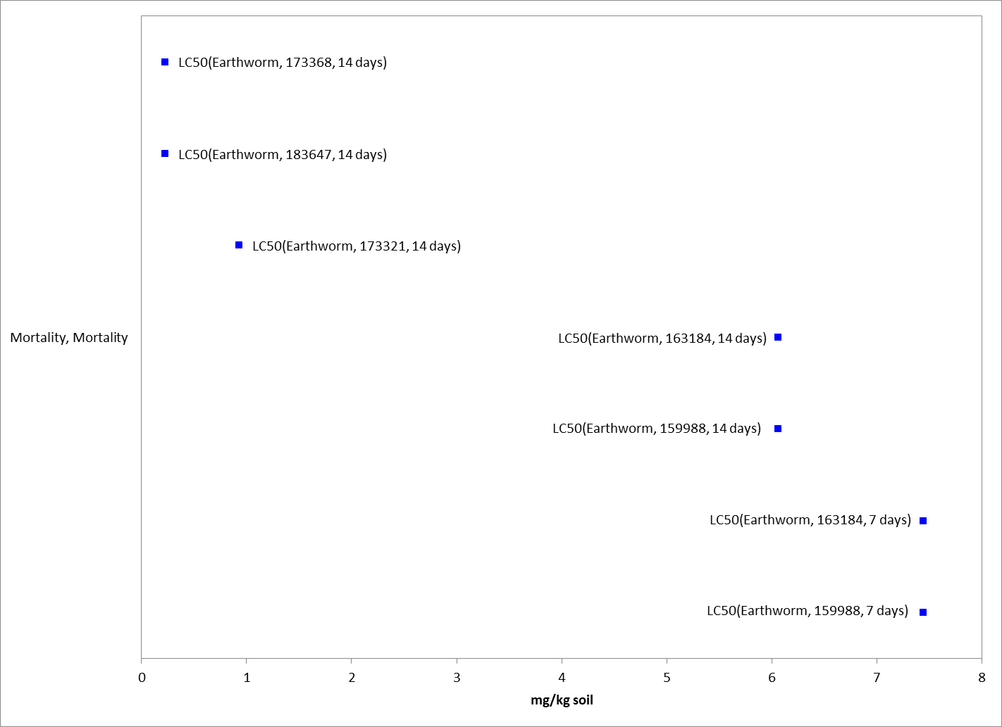
Figure 2-5. Mortality Endpoints for Terrestrial Invertebrates Exposed to Clothianidin (mg/kg-soil).
Blue squares represent LC₅₀ values from open literature studies found in the ECOTOX database. Parentheses present the endpoint measurement, species, study reference (i.e., MRID, ECOTOX #), and study duration.

Contact Exposure Mortality Endpoints Expressed as mg/kg-bw

The available data for terrestrial invertebrate mortality associated with the exposure unit of mg/kg-bw is provided in Figure 2-6 below. Endpoints were identified from studies in the ECOTOX acceptable database that were reviewed for use as a threshold in this assessment (Appendix 2-2). Data are available only for three species of arthropods in class Insecta: honey bees, Asiatic honey bees (Apis cerana) and bumble bees (Bombus terrestris). Based on the available data, clothianidin is associated with mortality of terrestrial invertebrates at concentrations ranging from 0.034 to 0.48 mg/kg-bw.

For the exposure unit of mg/kg-bw, the most sensitive, quantitatively acceptable LD50 value available was determined to be 0.21 mg/kg-bw from a registrant-submitted study with the honey bee (MRID 49950102 at the time of analysis. A more sensitive quantitatively-acceptable endpoint has since been found in the open literature: 0.0034 mg/kg-bw with the asiatic honey bee from Yasuda et al. 2018 (E183780). This endpoint will be considered in future analyses. No data in the units of mg/kg-bw are available for non-insect terrestrial invertebrates; therefore, insect thresholds will be used to represent non-insects in this assessment.

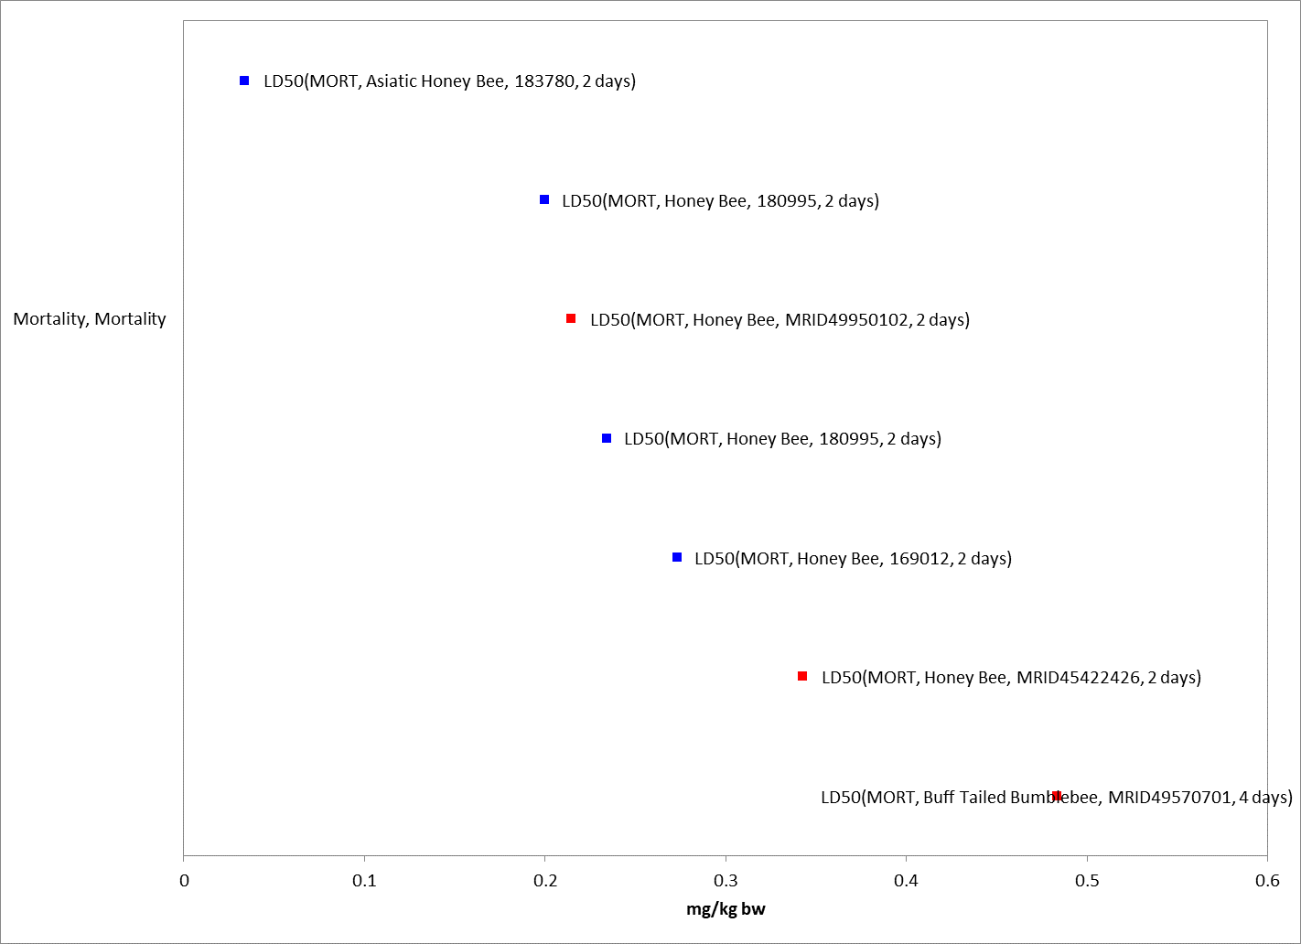
Figure 2-6. Contact Exposure Mortality Endpoints for Terrestrial Invertebrates Exposed to Clothianidin (mg/kg-bw). Blue squares represent LD50 values from open literature studies found in the ECOTOX database. Parentheses present the endpoint measurement, species, study reference (i.e., MRID, ECOTOX #), and study duration.

Mortality Endpoints Expressed as lb/acre

For the exposure unit lb/acre, three studies are available from the open literature (Table 2-23). Endpoints were identified from studies in the ECOTOX acceptable database that were reviewed for use as a threshold in this assessment (Appendix 2-2). Data are available for two species: earthworms and seven-spotted ladybirds (Coccinella septempunctata). Based on the available data, clothianidin is associated with mortality of terrestrial invertebrates at concentrations of 0.01and 0.025 lb/A. For the exposure unit of lb/A, the most sensitive LC50 value available is 0.01 lb/A for the seven-spotted lady bird (E183576). For other all non-insect terrestrial invertebrates, the most sensitive LCD0 value available is 0.025 lb/cre from two studies with the earthworm (E163184 and E173321).

Table 2-23. Terrestrial Invertebrate acute toxicity data available for clothianidin in units of lb/A.
Species (% a.i.) | Endpoint (Duration) | Toxicity Value (mg/kg-bw) | MRID/  ECOTOX#
Seven-spotted ladybird (Coccinella septempunctata) | 72-hr LD₅₀ | 0.01 | ECOTOX#183576; Jiang et al. 2018
Earthworm  (Eisenia fetida) | 14-d LD₅₀ | 0.025 | ECOTOX#163184; Wang et al. 2012
Earthworm  (Eisenia fetida) | 14-d LD₅₀ | 0.025 | ECOTOX#173321; Wang et al. 2015

Oral Exposure Mortality Endpoints Expressed as mg/kg-diet

The available data for terrestrial invertebrate mortality associated with the exposure unit of mg/kg-diet is provided in Figure 2-7 below. Endpoints were identified from studies in the ECOTOX acceptable database that were reviewed for use as a threshold in this assessment (Appendix 2-2). Data are available for 4 genera in the orders of Hymenoptera and Diptera in the class Insecta. Based on the available data, clothianidin is associated with mortality of terrestrial invertebrates at concentrations ranging from 0.00015 to 7.4 mg/kg-diet.

For the exposure unit of µg/g-diet, the most sensitive acute oral LD50 value available is 0.15 mg/kg-diet for the honey bee (MRID 4542242). Although a number of more sensitive endpoints were available at lower test levels down to 0.00015 mg/kg-bw, all were determined to be of qualitative use only due to insufficient data provided to independently verify results.

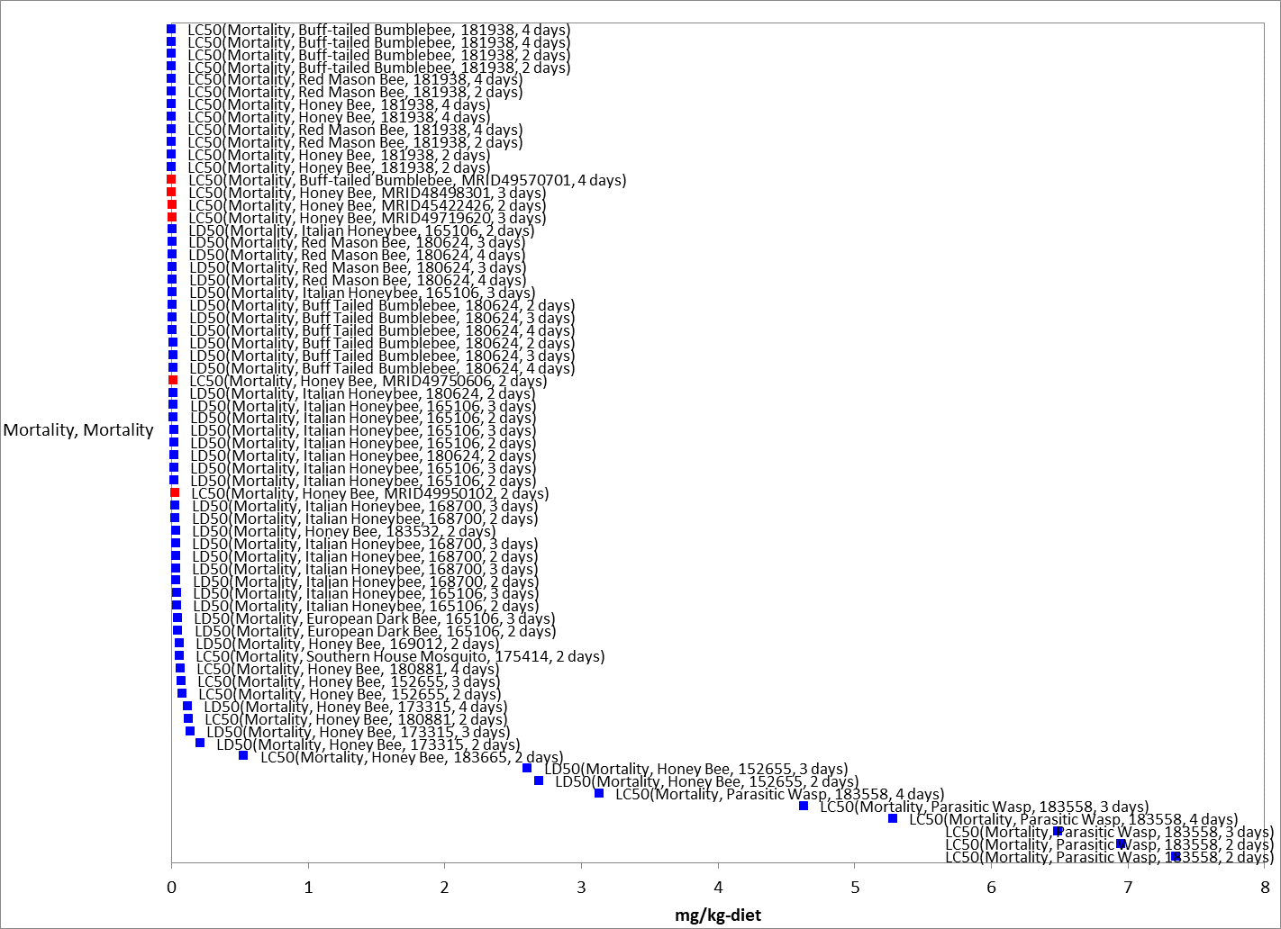

Figure 2-7. Mortality Endpoints for Terrestrial Invertebrates Exposed to Clothianidin (mg/kg-diet) (Oral Exposure). Data from registrant submitted (red) and open literature (blue). Data label key: Endpoint (species, reference number, duration in days).

Effects on Growth and Reproduction of Terrestrial Invertebrates

Several studies were reported in the ECOTOX database for growth and reproduction effects to terrestrial invertebrates and are summarized by exposure unit below

Growth and Reproduction Endpoints Expressed as mg/kg-soil

Several growth and reproduction toxicity studies in the units of mg/kg-soil involving terrestrial invertebrates were identified in ECOTOX. Endpoints were identified from studies in the ECOTOX acceptable database that were reviewed for use as a threshold in this assessment (APPENDIX 2-2). Growth and reproduction data associated with the exposure unit of mg/kg-soil are available for 3 classes (i.e., Entognatha, Clitellata and Arachnida), represented by 3 orders, 3 families, 3 genera, and 4 species, none of which are insects. Based on the available data, clothianidin is associated with growth and reproduction effects of terrestrial invertebrates at concentrations ranging from 0.03 to 2.7 mg/kg-soil (Figure 2-8).

For the exposure unit of mg/kg-soil, the most sensitive, directly relevant sublethal endpoint reported a NOAEC and LOAEC of 0.02 and 0.051 mg ai/kg-soil in the springtail (Folsomia candida), based on a ~40% decrease in adult survival (E183406, Ritchie et al. 2019). Although a study with earthworms (ECOTOX Ref. No. 173321, Wang et al. 2015) produced a slightly more sensitive NOAEC/LOAEC of 0.01/0.025 mg/kg-soil, the springtail endpoint was used as the threshold due to the direct apical effect measured (adult survival vs. cocoon weight) and the magnitude of the effect (40% vs. 8%).

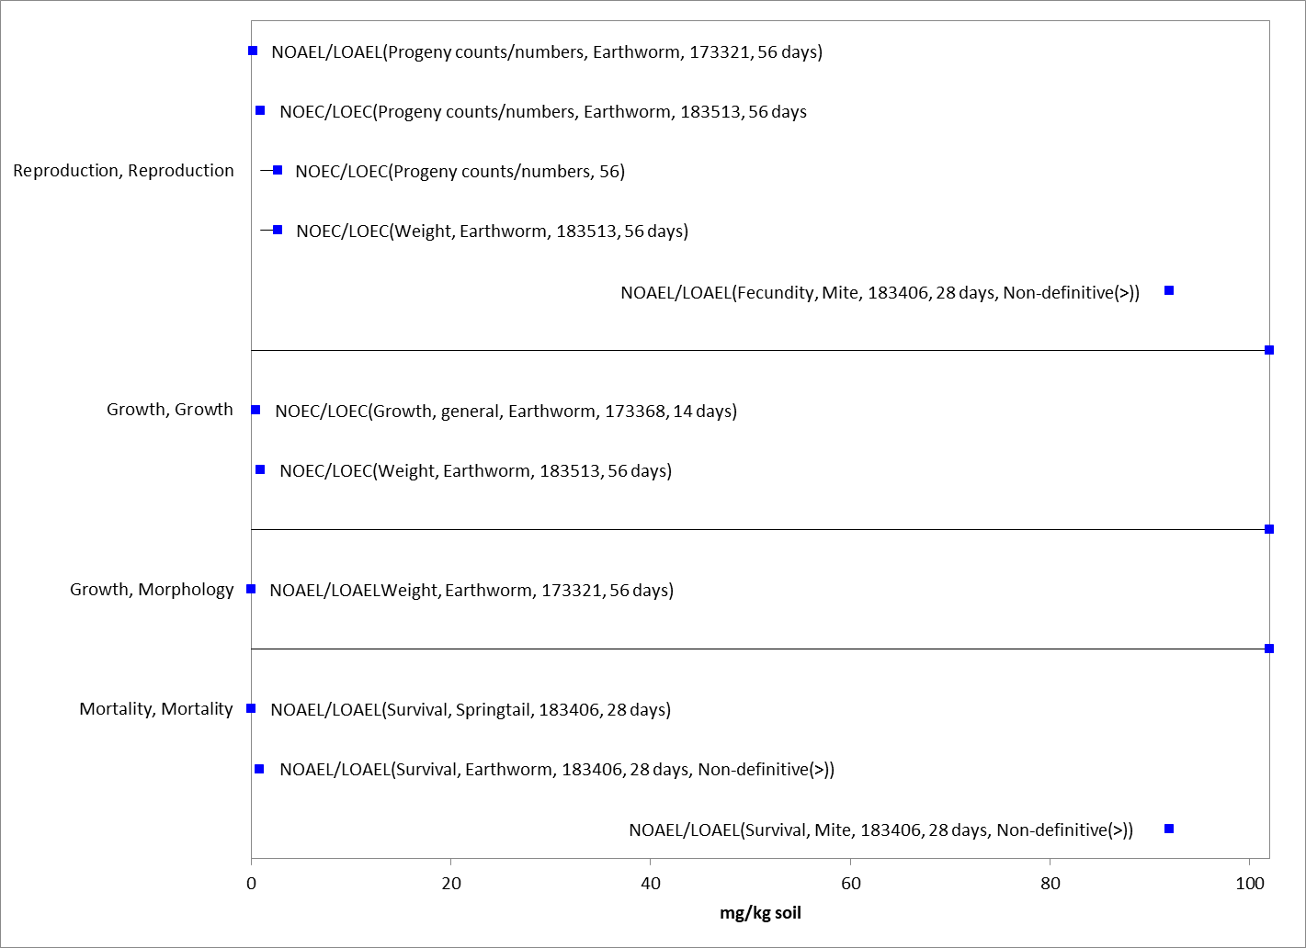
Figure 2-8. Sublethal Endpoints for Terrestrial Invertebrates Exposed to Clothianidin (mg/kg-soil). Blue squares represent LOAEC/LOAEL values from open literature studies found in the ECOTOX database. Solid lines display the range between the LOAEC/LOAEL and NOAEC/NOAEL values. Parentheses present the endpoint measurement, species, study reference (i.e., MRID, ECOTOX #), and study duration. If endpoint is non-definitive, that is also noted.

Contact Exposure Growth and Reproduction Endpoints Expressed as mg/kg-bw

No growth and reproduction toxicity studies in the units of mg/kg-bw involving terrestrial invertebrates were identified in ECOTOX. Two studies examining the effects of efficacy of clothianidin product Arena 50WDG in the control of the flatheaded Appletree borer (Chrysobothris femorata) (E15679) and potato leafhopper (Empoasca fabae) (E159495) in red maple (Acer rubrum) were available via ECOTOX; however, as efficacy studies do not represent a direct effect of clothianidin, these studies were not considered further. Therefore, as the mortality-based LD₅₀ value of 0.21 mg/kg-bw from MRID 49950102 above is more sensitive than any of the available NOAEL or LOAEL values expressed as mg/kg-bw (contact exposure), it will be used for mortality and sublethal effects thresholds.

Growth and Reproduction Endpoints Expressed as lb/acre

Several growth and reproduction toxicity studies involving terrestrial invertebrates in the units of lb/acre were identified in ECOTOX. Endpoints were identified from studies in the ECOTOX acceptable database that were reviewed for use as a threshold in this assessment (APPENDIX 2-2). Growth and reproduction data associated with the exposure unit of lb/acre are available only for the class Insecta, represented by 3 orders, 5 families, 6 genera, and 6 species. Based on the available data, clothianidin is associated with growth and reproduction effects of terrestrial invertebrates at concentrations ranging from 0.000045 to 0.46 lb/acre (Figure 2-9).

For the exposure unit of lb/acre, the most sensitive, directly relevant sublethal endpoint reported a NOAEC and LOAEC of <0.001 and ≤0.0011 lb/acre in the seven-spotted lady-beetle, based on a 52% increase in cumulative lethality, or the proportion of dead larvae, pupae, and adults that failed to emerge (ECOTOX Ref. No. Jiang et al. 2018). Although a number of more sensitive endpoints were available, all were determined to be of qualitative use only due to insufficient data provided to independently verify results. For other all non-insect terrestrial invertebrates, only efficacy studies measuring abundance are available (which do not represent a direct effect of clothianidin) (ECOTOX Ref. No. 169080,162315, 167829, 93017); therefore, the most sensitive NOAEC and LOAEC for insect and non-insect terrestrial invertebrates for the exposure unit of lb/acre is <0.001/ ≤0.0011 lb/acre.
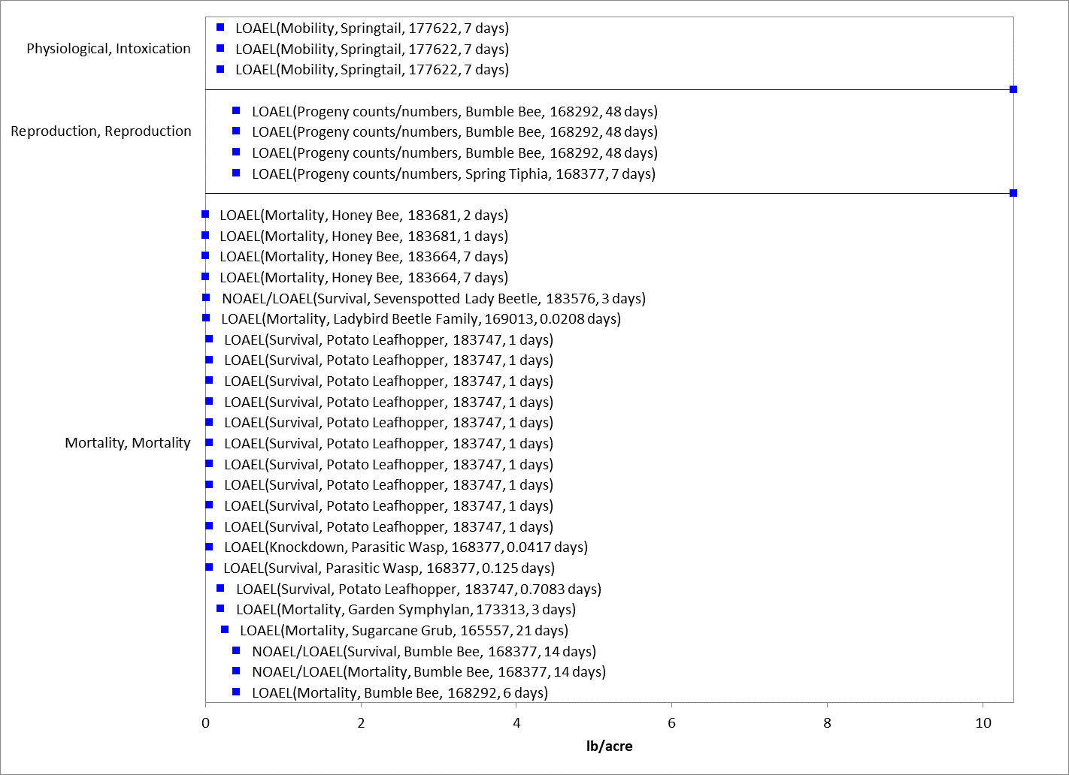

Figure 2-9. Growth and Reproduction Endpoints for Terrestrial Invertebrates Exposed to Clothianidin (lb/acre). Blue squares represent LOAEC/LOAEL values from open literature studies found in the ECOTOX database. Solid lines display the range between the LOAEC/LOAEL and NOAEC/NOAEL values. Parentheses present the endpoint measurement, species, MRID, and study duration.

Oral Exposure Growth and Reproduction Endpoints Expressed as mg/kg-diet

Many growth and reproduction toxicity studies involving terrestrial invertebrates in the units of mg/kg-diet were identified in ECOTOX. Endpoints were identified from studies in the ECOTOX acceptable database that were reviewed for use as a threshold in this assessment (APPENDIX 2-2). Growth and reproduction data associated with the exposure unit of mg/kg-diet are available for 3 classes (Clitellata, Arachnida, and Insecta), represented by 4 orders, 5 families, 8 genera, and 12 species. Based on the available data, clothianidin is associated with growth and reproduction effects of terrestrial invertebrates at concentrations ranging from 0.0007 to7 mg/kg-diet (Figure 2-10).

For the exposure unit of mg/kg-diet, the most sensitive, directly relevant sublethal endpoint reported a NOAEC and LOAEC of 0.0001 and 0.0002 mg/kg-diet in the honey bee, based on a 14% increase in mortality (MRID 48414901). Although several more sensitive endpoints were available (ECOTOX Ref. No. 183656, 183552, 183663, 165449) all were determined to be of qualitative use only due to a combination of only one test concentration included and insufficient data provided to independently verify results. One study examining the effects of clothianidin on growth and reproduction in the earthworm is available via ECOTOX for this exposure unit (ECOTOX Ref. No. 183599; Basley and Goulson 2017); however, this study has been classified as qualitative due to the lack of test material information. Therefore, the NOAEC/LOAEC of 0.0001/0.0002 mg/kg-diet with the honey bee will be used as the threshold for both insect and non-insect terrestrial invertebrates.

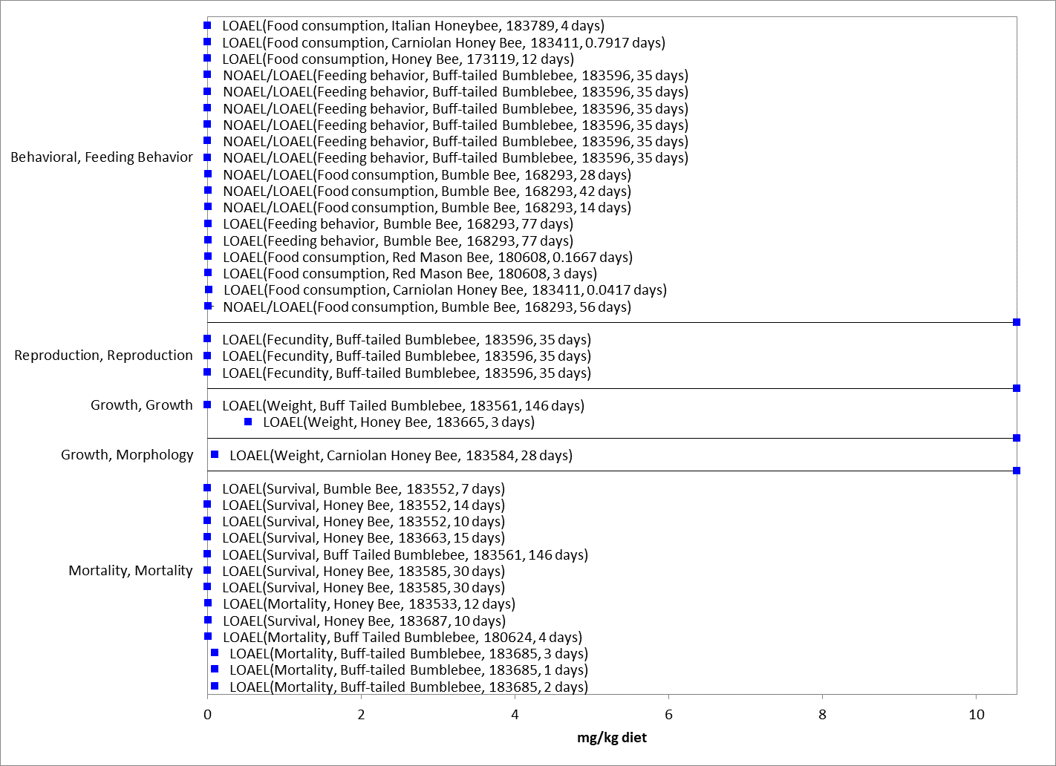
Figure 2-10. Growth and Reproduction Endpoints for Terrestrial Invertebrates Exposed to Clothianidin (mg/kg-diet). Blue squares represent LOAEC/LOAEL values from open literature studies found in the ECOTOX database. Red squares represent registrant-submitted studies. Solid lines display the range between the LOAEC/LOAEL and NOAEC/NOAEL values. Parentheses present the endpoint measurement, species, study reference (i.e., MRID, ECOTOX #), and study duration.

Other Sublethal Effects to Terrestrial Invertebrates

Additional literature is available on the sublethal effects of clothianidin on terrestrial invertebrates. No endpoints were identified from studies in the ECOTOX acceptable database that were either more sensitive than the endpoints identified above or reliable for use as a threshold and relatable to an apical endpoint. For mg/kg-bw, there is one immunocompetence study in the honey bee that resulted in a NOAEL of ≤ 0.16 mg/kg-bw and a LOAEL of 0.16 mg/kg-bw due to effects such as decreases in adipaecins type 14 mRNA (ECOTOX Ref No. 167678; Di Prisco et al. 2013). For mg/kg-soil, there are several studies available that provide some information on the effects of clothianidin exposure on biochemical and cellular effects such as increases in enzyme and mRNA levels and activity (ECOTOX Ref No. 183457 and 173321; Liu et al. 2017 and Wang et al. 2015). However, only one study (ECOTOX Ref No. 183513; Ge et al. 2018) established endpoints—a NOAEL/LOAEL of 0.5/1.1 mg/kg-soil based on chemical avoidance in the earthworm. Figure 2-11 and Figure 2-12 illustrate the data available for sublethal and chronic effects to terrestrial invertebrates measured in lbs/A and mg/kg-diet, respectively.

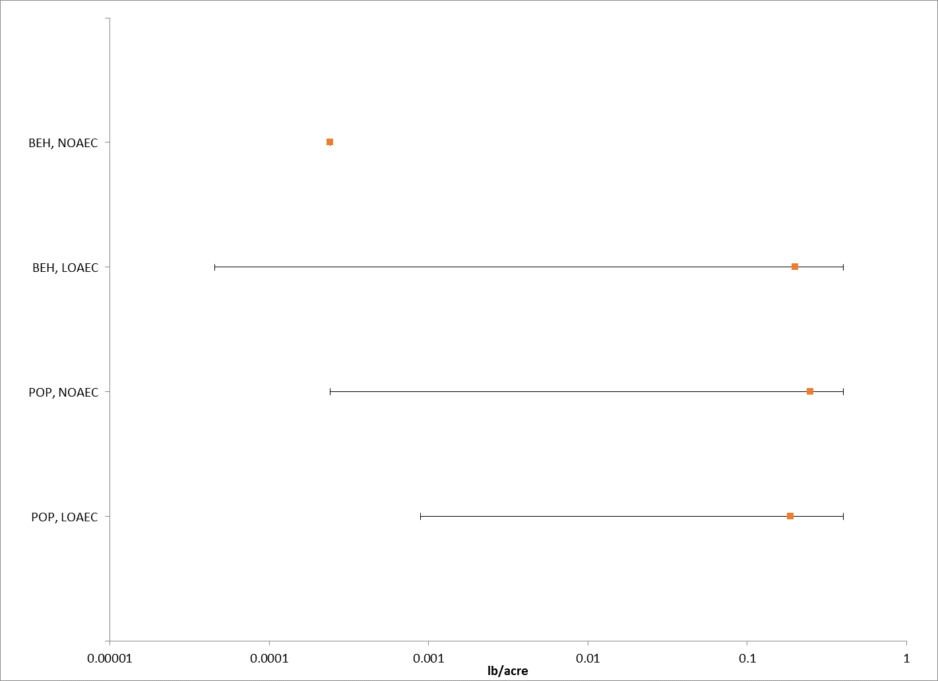
Figure 2-11. Summary array of toxicity data for terrestrial invertebrates expressed in terms of lbs/A.
Orange squares represent the mid-point of the data. Solid lines display the range between the LOAEC and NOAEC values. BEH = behavior. POP = population.

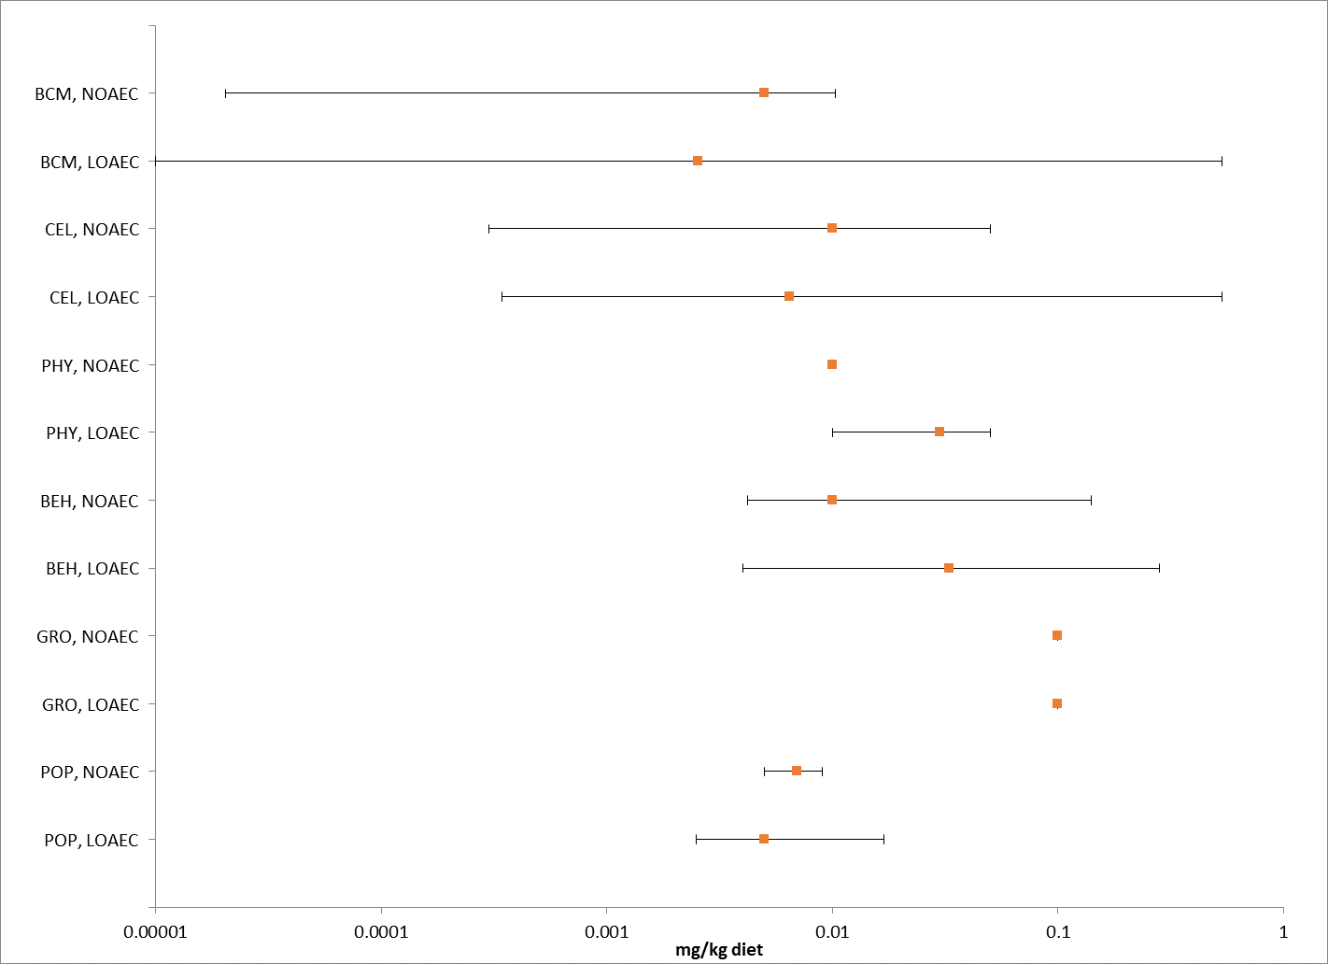
Figure 2-12. Summary array of toxicity data for terrestrial invertebrates expressed in terms of mg/kg-diet. Orange squares represent the mid-point of the data. Solid lines display the range between the LOAEC and NOAEC values. BCM = biochemical; BEH = behavior; CEL = cellular; PHY = physiological; POP = Population.

Effects Characterization for Terrestrial Plants

Introduction to Terrestrial Plant Toxicity

Plant toxicity data from both registrant-submitted studies and studies in ECOTOX have been reviewed for this assessment. Registrant-submitted studies are conducted under conditions and with species defined in OCSPP test guidelines. Sub-lethal endpoints such as plant growth, dry weight, and biomass are evaluated for both monocots and dicots, and effects are evaluated at both seedling emergence and vegetative life stages. Studies were excluded if they were considered invalid or not associated with an environmentally relevant exposure route.

Discussion of endpoints are provided for effects on terrestrial plants and terrestrial plant communities. These serve as a surrogate for effects on an individual of a listed species and the effects on the pollination, prey, habitat, or dispersal of a listed species, respectively.

Effects Data for Terrestrial Plants

Single-species terrestrial plant toxicity studies are used as one of the measures of effect to evaluate whether clothianidin may affect primary production and diversity in terrestrial ecosystems. Several terrestrial plant toxicity studies have been submitted to the EPA and/or published in the open literature.

The registrant-submitted data represent the most sensitive endpoints for effects to listed species. The results of the seedling emergence and vegetative vigor toxicity tests on non-target plants are summarized in the paragraphs below.

Clothianidin was not toxic to terrestrial plants in vegetative vigor and seedling emergence tier I tests, with EC₂₅ and NOAEC levels being above the highest tested dose of 0.19 lb/acre Table A. The study relied upon the exposure through a typical end-use product (TEP) and showed no growth or survival effects on any of the 10 tested species.

In the open literature, there are many studies that tested clothianidin on plant growth or survival. Nearly all of these studies are studies that investigated the effects of clothianidin on invertebrate pests and the response of the plant to the changing invertebrate pressure. Since those studies do not represent a direct effect of clothianidin they are not included here for the consideration of clothianidin impacts to plants.

Terrestrial Degradate Toxicity Data

MNG and TZNG have been observed at up to 9.5% formation in aerobic soil metabolism studies, while TZMU has been observed at up to 10.1% formation in the terrestrial field dissipation studies. TZNG and TZMU have also been frequently identified in pollen and nectar of plants (USEPA, 2017). Although acute mammalian laboratory studies with the most sensitive organism (mouse) are not available, EPA does have acute mammalian toxicity studies with TZNG (MRID 45422626) and TZMU (MRID 45422624) metabolites using the laboratory rat. TZNG’s acute oral LD50 was non-definitive for male rats (>1450 mg/kg-bw) and was 1481 mg/kg-bw (95% C.I. 1257—1882 mg/kg-bw) for female rats. TZMU’s acute oral LD50 was 1424 mg/kg-bw (95% C.I. 1104—1824) for males and 1282 mg/kg-bw (95% C.I. 912—1613) for female rats. These results indicate both metabolites are somewhat more toxic than parent clothianidin (MRID 45422621 with acute LD50 > 5000 mg/kg-bw for both male and female rats).

Because all three degradates show limited formation in the available terrestrial studies (max formation of 10.1% for TZMU), they are not considered in the terrestrial risk assessment. Although the available empirical pollen and nectar residue data indicate that in some cases, TZNG and TZMU may form in plants at higher rates following systemic uptake of parent clothianidin, the assumptions in T-REX (upper bound Kenaga nomogram) are highly conservative for overall parent residues in plant dietary items following spray applications and would be considered protective of the empirical parent and metabolite concentrations observed in plant pollen and nectar.

Incident Reports

A review of the Incident Data System (IDS) for ecological incidents involving clothianidin was completed on March 31, 2021. This search excluded incidents classified as ‘unlikely’ or ‘unrelated’ and only includes incidents with the certainty categories of ‘possible’, ‘probable’, and ‘highly probable’. From 2010 to 2018, there were 49 ecological incidents reported in the IDS databases that occurred in the U.S., that were categorized as possible to highly probable in their certainty that clothianidin was the pesticide involved in the incident. There are 4 additional backlogged incidents from 2017-2020 that have not been fully investigated, and do not have a certainty classification, but appear to be related to clothianidin usage. One of these backlogged incidents was not considered here because no clothianidin was detected and the investigation was closed. Ecological incidents involving clothianidin have been reported for all assessed taxa except reptiles, amphibians, aquatic invertebrates, and aquatic plants (Table 2-24). The results of this review are discussed further below in Section 13-1 and Section 13-2.

In addition to the incidents recorded in IDS, additional incidents are reported to the Agency in aggregated form. Pesticide registrants report certain types of incidents to the Agency as aggregate counts of incidents occurring per product per quarter. Ecological incidents reported in aggregate reports include those categorized as ‘minor fish and wildlife’ (W-B), ‘minor plant’ (P-B), and ‘other non-target’ (ONT) incidents. ‘Other non-target’ incidents include reports of adverse effects to insects and other terrestrial invertebrates. For clothianidin, registrants have reported no minor fish and wildlife incidents, nor minor plant incidents, but did report 1 other non-target incident between July-Sept. 2011, and 6 other non-target incidents between Jan-June 2012. Since June 2012, no other aggregate incidents have been reported. The number of actual incidents associated with clothianidin may be higher than what is reported to the Agency. Incidents may go unreported since side effects may not be immediately apparent or readily attributed to the use of a chemical.

Table 2-24. Overview of Reported Incidents Involving Clothianidin by Taxa
Habitat | Taxa | Incident Data Available? (Yes/No)
Terrestrial | Plants | Yes
 | Mammals | Yes
 | Birds | Yes
 | Reptiles | No
 | Amphibians | No
 | Terrestrial Invertebrates | Yes
Aquatic | Amphibians | Yes
 | Freshwater Fish | Yes
 | Estuarine/Marine Fish | Yes
 | Aquatic Invertebrates | No
 | Mollusks | No
 | Aquatic Plants | No

Terrestrial Incidents

The majority of incidents reported in the IDS involve bee (Apis and non-Apis) mortalities, ranging from a single hive to more than 1300 hives. The incidents from 2010-2018 are described in the Final Bee Risk Assessment for Clothianidin and Thiamethoxam, published in 2020 (DP 455645). In that assessment, 54 incidents are described; these also included those classified as “unlikely”. A table summarizing the findings from the assessment is replicated here (Table 2-25):

Table 2-25. Ecological Incidents Involving Bees in the U.S. Associated with Clothianidin.
Species | Legality of Use (# of incidents) | Use Site  (# of incidents) | Response | Effects/Notes
Apis (honey bee) | Registered (18) | Corn (9) | Mortality | Bee Kills ranging from 100s of individual bees to many colonies.
 |  | Agricultural Area (6) |  | Individual bees to 12 hives. Five of these incidents were associated  with corn seed planting.
 |  | Potato (2) |  | 1 hive each. Aerial foliar  applications.
 |  | Residential (1) |  | Dozens of bees. Soil treatment to  trees.
 | Undetermined (33) | Agricultural Area (5) |  | Single hive to 800 colonies affected. Four of these incidents were associated with corn seed  planting.
 |  | Corn (9) |  | 100s of individual bees to up to 1300 hives affected
 |  | Cotton (3) |  | Up to 50% of worker bees
 |  | Residential (1) |  | 1 hive
 |  | Unknown/Not reported (15) |  | Up to 48 colonies.
Bumble bee (Bombus sp) | Registered (1) | Urban (1) | Mortality | Extent Not reported. Application  was to ornamental trees.
 | Undetermined  (1) | Not Reported (1) |  | >1000 dead bees. Application was  made to ornamental trees.

A review of the 49 incidents classified as possible to highly probable showed the most frequently reported use in an incident was clothianidin-treated corn seeds (30), and the likely mechanism in these cases is dust from the abraded seed drifted off the treated field and killed bees, hives and bee drops near the field. Approximately half of the incidents (23) have reported residues of clothianidin in dead bee tissue or in pollen, flowers or vegetation in proximity to bee hives and bee foraging areas. The range of clothianidin found in dead bees was 2.4 – 38.2 ppb. One incident related to dust from abraded seed in 2013 also documented dead birds in a field near 5 bee hives that had 75% mortality of foraging bees.

The USEPA and USDA held a summit on the issue of pollinators being exposed to pesticides from dust from seed treatments in 2013 (https://www.epa.gov/pollinator-protection/2013-summit-reducing-exposure-dust-treated-seed), to address this issue with various stakeholders, and new technologies were introduced to diminish the dust off risk (i.e., lubricant or talc applied to treated seeds). Most of the incidents in the database occurred from 2012-2014, and started tapering off to lower levels after 2014 (see Table 2-26 below). However, incidents still occurred, and one incident in South Dakota in 2015 (I027719-001) affected 800 out of 4000 hives at an apiary. The report states “It was believed that the bees deaths were caused by treatment on agricultural field flowers and treated seed used in the area. The SD Agricultural Laboratories detected Clothianidin at 2.5 ppb and 2.7 in samples #1 and #2. The seed corn planted in the fields were treated with Clothianidin (Poncho). The seed was planted with a pressurized system with no graphite or talc lubrication on the seed.”

Table 2-26. Ecological Incidents Involving Clothianidin in the U.S. by year (2010-2020).
Year | Number of incidents in U.S.
2010 | 3
2011 | 1
2012 | 11
2013 | 7
2014 | 12
2015 | 7
2016 | 6
2017 | 1
2018 | 1
Backlog (2017-2020) | 4

Beyond the dust from abraded corn seed, there are several incidents involving clothianidin products applied via aerial spray and soil drench. 5 incidents in IDS are from foliar spray (frequently associated with Belay, a flowable TEP) to fields impacting bees (3 incidents on cotton fields: I024221-001, I024877-001, I025675-001; 1 incident on a potato field affecting one residential hive: I031630-00001; 1 incident on a sod farm affecting a neighboring hive: I027767-001). In addition, 3 of the 4 backlogged incidents are related to a foliar spray (2 on orchards: I032710 – 00001, I033627 – 00001; 1 on alfalfa/cotton/herbs: I032224 – 00001). Two of these three mention the use of Belay.

There were three incidents from use of a soil drench containing clothianidin. One in 2014 in Connecticut (I026927-001) involved use of Bayer Advance, and affected one bee hive on a residential property. One incident in 2016 in Florida (I029267-00001) also involved Bayer Advance applied as a soil drench to several trees in a residential yard, and killed butterflies, bees, and fish (and possibly impacted hummingbirds, woodpeckers, bees, and butterflies). The Oregon Department of Agriculture also reported an incident (I028034-001, I029019-00003) in a commercial area with ornamental (linden) trees that had been treated with imidacloprid via soil drench in 2013 and with clothianidin via soil drench in 2014 to control for aphids. Residues of imidacloprid, imidacloprid olefin, desnitroimidacloprid HCl and clothianidin were detected in bumble bee samples and in linden leaves, while linden flowers contained parent imidacloprid and clothianidin alone. Hundreds of bumblebees were found dead in front of the linden trees in 2015, and in 2016 thousands of bumblebee deaths were reported in the same area.

An incident from the backlog describes a river flooding event in North Carolina in 2017 that inundated wetlands in close proximity to a farm where clothianidin-treated corn seed was stored. Multiple orders of insects were observed dead or dying or absent after the flood (lepidoptera, diptera, hymenoptera, odonata, coleoptera, ephemeroptera, and hemiptera), as well as frogs, birds and bats. Clothianidin was detected at 0.106 ppb in water samples, and other pesticides were also present.

One incident involving plants and clothianidin has been reported. I027400-001 in Idaho (2014) involved damage and yield reduction to approximately 600 acres of sugar beets, from drift from multiple pesticides (florasulam, metalaxyl, clothianidin, beta-cyfluthrin). One of two tested fields found positive results of these pesticides, and it was classified as “possible” as a certainty index.

Aquatic Incidents

One incident, previously mentioned, from a soil drench application in a residential yard in FL, affected multiple taxa and fish were mentioned. No details were given on the species, and the certainty was labeled “possible”, although other pesticides were applied in the area for mosquito control (I029267-00001).

The total number of actual incidents associated with the use of clothianidin may be higher than what is reported to the EPA. Incidents may go unreported since effects may not be immediately apparent and/or readily attributed to the use of a chemical.

Alternative Toxicity endpoints

In addition to the thresholds provided in Table 2-1 through Table 2-6 above, alternative toxicity endpoints were also developed to use in the weight of evidence analysis for a species where appropriate (see Revised Methods Document). The alternative toxicity endpoints provide consideration of endpoints that may reflect variation in the available data (such as using the HC₅₀ values from the SSD instead of an HC₀₅ value or considering other endpoints within the data set for a particular taxon). Alternatively, if a taxon did not include enough data to select a specific alternative toxicity endpoint, a 10x factor was applied to the original threshold. The alternative endpoints allow for consideration of the possibility a listed species is toxicologically less sensitive than the tested species in the alternative weight of evidence analysis, which is captured for the analysis of any species that reaches that point of the analysis. Alternative endpoints are listed in Table 2-27 and brief additional comments are provided to clarify the alternative endpoint selection, as appropriate. Endpoints are analyzed for a subset of available units.

Table 2-27. Alternative toxicity endpoints used in weight of evidence analysis.
Units | Taxa | Type of endpoint (HC50, etc.) | Value | Slope | Weight of test animal (g) | Comments
Alternative toxicity endpoints - Mortality
mg ai/kg-bw | Mammals | LD50 | 4250 | 4.5 | 29.6 | 10x applied
mg ai/kg-bw | Birds | LD50 | 4,230 | 4.5 | 158 | 10x applied
mg ai/kg-bw | Reptiles/Terrestrial Amphibian | LD50 | 4,230 | 4.5 | 158 | 10x applied
mg ai/kg-bw | Terrestrial inverts | LD50 | 2 | 4.5 | 0.128 | 10x applied
µg ai/L | FW FISH | LC50 | 99999 | 4.5 |  | No change, non-definitive (>)
µg ai/L | E/M FISH | LC50 | 99999 | 4.5 |  | No change, non-definitive (>)
µg ai/L | AQ AMPHIBIANS | LC50 | 99999 | 4.5 |  | No change, non-definitive (>)
µg ai/L | FW INVERTEBRATES | HC05 | 35.8 | 1.69 |  | HC05
µg ai/L | E/M INVERTEBRATES | LC50 | 510 | 4.5 |  | 10x applied
µg ai/L | Molluscs | LC50 | 1291000 | 4.5 |  | 10x applied
Alternative toxicity endpoints - Sublethal
Units | Taxa | Type of endpoint (HC50, etc.) | MATC or LOAEC | Description of effect | Duration of study (days) | Comments
mg ai/kg-diet | Mammals | MATC | 175 |  |  | 10x applied
mg ai/kg-diet | Birds | MATC | 3280 |  |  | 10x applied
mg ai/kg-diet | Reptiles/Terrestrial Amphibian | MATC | 5250 |  |  | 10x applied; non-definitive (>) LOAEC
mg ai/kg-diet | Terrestrial inverts | MATC | 1.5 |  |  | 10x applied
µg ai/L | FW FISH | MATC | 139280 |  |  | 10x applied
µg ai/L | E/M FISH | MATC | 139280 |  |  | 10x applied. Chronic freshwater fish toxicity data used as a surrogate.
µg ai/L | AQ AMPHIBIANS | MATC | 13928 |  |  | 10x applied. FW fish endpoint used as surrogate.
µg ai/L | FW INVERTEBRATES | LOAEC | 50 |  |  | 10x applied; non-definitive (<) NOAEC
µg ai/L | E/M INVERTEBRATES | MATC | 70 |  |  | 10x applied
µg ai/L | Mollusks | LOAEC | 1291000 |  |  | 10x applied. No effects up to highest tested concentration.
TERRESTRIAL PLANTS (TGAI) |  | Type of endpoint (HC50, etc.) | MATC or LOAEC | IC25 | Description of effect | Comments
lb ai/A | YerrestriaSUBLETHAL- Monocots | MATC | 1.9 | 1.9 |  | 10x applied. no effects up to highest tested concentration
lb ai/A | SUBLETHAL- Dicots | MATC | 1.9 | 1.9 |  | 10x applied. no effects up to highest tested concentration
AQUATIC PLANTS (TGAI) |  | Type of endpoint (HC50, etc.) | MATC or LOAEC | IC50 | Description of effect | Comments
µg ai/L | Non-vascular | MATC | 10174 | 17600 |  | Endpoint based on clothi parent. LOAEC = 16,300
µg ai/L | Vascular | MATC | 7390 | 2800000 |  | 10x applied to MATC. No change in IC50, non-definitive (>) endpoint

http://www.irac-online.org/modes-of-action/
Zhang, Y, Liu, S, Gu, J, Song,F, Yao, X, Liu, Z. 2008. Imidacloprid acts as an antagonist on insect nicotinic acetylcholine receptor containing the Y151M mutation. Neuroscience Letters. 446:97– 100.
Tomizawa, M, Casida, J. 2005. Neonicotinoid insecticide toxicology: mechanisms of Selective Action. Annual Review of Pharmacology and Toxicology, 45, 247–268.

