Contents
1 Environmental Transport and Fate Characterization 3
2 Measures of Aquatic Exposure 7
2.1 Aquatic Exposure Models 7
2.2 HUC and Use Site Crosswalk 2
2.3 Scenario Selection 2
2.4 Application Practices 2
2.4.1 Application Method 2
2.4.2 Spray drift 3
2.4.3 Application Timing 4
2.5 Special Agricultural Considerations 5
2.5.1 Multiple Crop-cycles Per Year 5
2.5.2 Cranberry Modeling for Surface Water 6
2.5.2.1 PFAM 6
2.5.2.2 PRZM5/VVWM 7
2.6 Non-Agricultural Uses and Considerations 7
2.6.1 Urban Exposure Model 8
2.7 Aquatic Modeling Input Parameters 10
2.8 Aquatic Modeling Results 13
2.9 Aquatic Modeling Sensitivity Analysis 21
2.10 Available Monitoring Data 25
2.10.1 Field Studies 25
2.10.2 General Monitoring Data 26
2.10.2.1 Surface Water 26
2.10.2.2 Sediment 28
2.10.2.3 Atmospheric 30
2.11 Monitoring Results 33
2.11.1 WARP Model and Extrapolation of Monitoring Results 33
2.12 Aquatic Exposure Summary 35
2.13 Uncertainties in Aquatic Modeling and Monitoring Estimates 35
2.13.1 Surface Water Aquatic Modeling 35
2.13.1.1 Aquatic Bins 3 and 4 36
3 Measures of terrestrial exposure 37
3.1 Introduction 37
3.2 Estimated concentrations in terrestrial food items (mg a.i./kg-food) 38
3.2.1 Terrestrial invertebrates 1
3.2.2 Terrestrial plants (seeds, fruit, nectar and leaves) 1
3.2.3 Terrestrial vertebrates (birds, mammals, amphibians, reptiles) 4
3.3 Estimated concentrations in aquatic food items (mg a.i./kg-food) 4
3.3.1 Aquatic plants 4
3.3.2 Aquatic invertebrates 5
3.3.3 Fish 6

Figures

Figure 3-1. Hydrologic Unit Code (HUC) 2-digit Regions and Associated Metrological Data 1
Figure 3-2. Urban Lot Conceptual Model 9
Figure 3-3. Application Sensitivity Analysis HUC 2 Region 5 For Water Column Estimated Environmental Concentrations 24
Figure 3-4. Orestimba Creek Water Monitoring Data (May 1, 1996 to April 30, 1997) 25
Figure 3-5. Effect of Pesticide Concentration via Advective Dispersion 37
Figure 3-5. Mean and upper bound estimated concentrations of chlorpyrifos on above ground terrestrial invertebrates. 1
Figure 3-6. Mean and upper bound estimated concentrations of chlorpyrifos on seeds and fruit. 2
Figure 3-7. Mean and upper bound estimated concentrations of chlorpyrifos on broadleaves. 3
Figure 3-8. Mean and upper bound estimated concentrations of chlorpyrifos on short grass. 3
Figure 3-9. Mean and upper bound estimated concentrations of chlorpyrifos on tall grass. Note that tall grass EECs are used as a surrogate for nectar. 4
Figure 3-10. Chlorpyrifos concentrations in aquatic plants resulting from bioconcentration different aqueous concentrations. 5
Figure 3-11. Upper (red) and mean (blue) of chlorpyrifos concentrations in aquatic invertebrates resulting from bioconcentration at different aqueous concentrations. 6
Figure 2-12. Upper (red) and mean (blue) of chlorpyrifos concentrations in fish resulting from bioconcentration at different aqueous concentrations. 7

Tables
Table 3-1. Physical/Chemical and Environmental Fate Properties of Chlorpyrifos and the Degradate of Concern, Chlorpyrifos-oxonª 4
Table 3-2. Spray Drift Estimates for Aquatic Bins for Various Aquatic Buffer Combinations for Liquid Formulations 3
Table 3-3. Ultra Low Volume Spray Drift Estimates for Aquatic Bins 4
Table 3-4. Multiple crop rotation simulations 6
Table 3-5. Adjusted Percent Area Treated 9
Table 3-6. Input Values Used for Tier II Surface Water Modeling Using the PRZM5/VVWM and PFAM 11
Table 3-7. PFAM Specific Input Values Used for Tier II Surface Water Modeling 12
Table 3-8. The range of PRZM5/VVWM Daily Average Water Column EECs for Chlorpyrifosª 14
Table 3-9. The range of PRZM5/VVWM Pore Water EECs for Chlorpyrifosª 15
Table 3-10. The range of PRZM5/VVWM Daily Average Water Column EECs for Chlorpyrifos for Seed Treatment Only Use Sites 15
Table 3-11. The range of PRZM5/VVWM Pore Water EECs for Chlorpyrifos for Seed Treatment Only Use Sites 16
Table 3-12. PRZM5/VVWM Daily Average Water Column EECs for the Urban Use Scenario for Chlorpyrifos 17
Table 3-13. PRZM5/VVWM Pore Water EECs for the Urban Use Scenario for Chlorpyrifos 18
Table 3-14. Parameter Sensitivity Analysis for Chlorpyrifos 22
Table 3-15. Sensitivity of EECs to Application Date and Fate Parameters 23
Table 3-16. Surface Water Monitoring Data Summary for Chlorpyrifos and Chlorpyrifos-oxon 27
Table 3-17. Sediment Monitoring Data Summary for Chlorpyrifos and Chlorpyrifos-oxon 29
Table 3-18. Air Monitoring Data Summary for Chlorpyrifos and Chlorpyrifos-oxonª 31
Table 3-19. Precipitation Monitoring Data Summary for Chlorpyrifos and Chlorpyrifos-oxon 32
Table 3-20. WARP Map Application Estimated 4-day Moving Average Concentrations for Chlorpyrifos 34
Table 3-21. Mean and upper bound dietary based EECs calculated for food items consumed by listed birds, terrestrial-phase amphibians or reptiles. Values represent potential exposures for animals feeding on the treated field or in adjacent habitat directly adjacent to the field.¹ 40

Exposure Characterization

Environmental Transport and Fate Characterization

Chlorpyrifos will initially enter the environment via direct application (e.g., liquid spray and granular) to use sites (e.g., soil, foliage, seed treatments, urban surfaces). It may move off-site via spray drift, volatilization (primarily following foliar applications), and runoff (generally by soil erosion rather than dissolution in runoff water). Major routes of chlorpyrifos transformation in the environment include alkaline hydrolysis, photolysis in air, and soil and aquatic metabolism (both aerobic and anaerobic). Chlorpyrifos is known to form chlorpyrifos-oxon, 3,5,6-trichloro-2-pyridinol (TCP), and 3,5,6-trichloro-2-methoxypyridine (TMP). TCP and TMP are not considered residues of toxicological concern and therefore are not discussed in great detail in this section.

Physical chemical properties and dissipation parameters for chlorpyrifos and its environmental transformation product chlorpyrifos-oxon, are provided in Table 3-1. A summary of the environmental fate and transport of chlorpyrifos and chlorpyrifos-oxon is provided below, with a detailed discussion of the fate and transport of these two chemicals provided in APPENDIX 3-1. Data summarized here include data submitted to the U.S. EPA and open literature data including ECOTOX studies classified as ECOTOX plus. Open literature data are included when the information was determined to add to the overall understanding of the environmental fate of chlorpyrifos and chlorpyrifos-oxon. APPENDIX 3-2 summarizes the listing of ECOTOX plus studies listed as fate related.

Table 3-1. Physical/Chemical and Environmental Fate Properties of Chlorpyrifos and the Degradate of Concern, Chlorpyrifos-oxonª
Chemical Fate/Parameter | Range of Values (Number of Values) Source(s)
 | Chlorpyrifos | Chlorpyrifos-oxon
IUPAC Name | O,O-diethyl o-(3,5,6-trichloro-2-pyridyl phosphorothioate | O,O-diethyl O-3,5,6-trichloropyridin-2-yl phosphate  Diethyl 3,5,6-trichloro-2,6-pyridin-2-yl phosphate
Chemical Abstracts Service (CAS) Registry Number | 2921-88-2 | 5598-15-2
Chemical Formula | C₉H₁₁Cl₃NO₃PS | C₉H₁₁Cl₃NO₄P
Smiles | S=P(OC1=NC(=C(C=C1Cl)Cl)Cl)(OCC)OCC | O=P(Oc1nc(c(cc1Cl)Cl)Cl)(OCC)OCC
Chemical Structure
Molecular Mass (g/mol) | 350.57 | 334.52
Vapor Pressure (Torr, 25°C) | 1.87 x 10⁻⁵ | 6.65 x 10⁻⁶
Henry’s Law Constant (atm - m³/mol) | 6.2 x 10⁻⁶ | 5.5 x 10⁻⁹
Solubility (20°C) (ppm) | 1.4 | 26.0
Octanol-water partition coefficient (Log K_{ow}) | 4.7 | 2.89
Hydrolysis half-life (days) | pH 5 (25°C) 73  pH 7 (25°C) 72-81 (n=2)  pH 9 (25°C) 16  MRIDs 00155577, 40840901 | pH 4 (20°C) 37.7  pH 7 (20°C) 4.8  pH 9 (20°C) 1.5  MRID 48355201
Aqueous photolysis half-life at pH 7 (days) | 29.6  MRID 41747206 | No data
Soil photolysis half-life (days) | Stable  MRID 42495403 | No data
Air photolysis half-life (hours)
indirect | 2 | 11
direct | 6 | 6
 | MRID 48789701 | MRID 48789701
Aerobic soil metabolism half-life range (days) at 25 °C | 19 – 297 (n=8)  MRIDs 00025619, 42144911 | < 1 (n=4)  MRID 48931501
Anaerobic soil metabolism half-life range (days) at 25 °C | 78 – 171 (n=2)  MRID 00025619 | No data
Aerobic aquatic metabolism half-life range (days) at 25 °C | 30.5 (n=1)  MRID 44083401 | No data
Anaerobic aquatic metabolism half-life range (days) at 25 °C | 50.2-125 (n=2)  MRID 00025619 | No data
Soil –water distribution coefficients
K_{d} or K_{f} mL/g | 49.9 – 99.7 (n=3) | 1.3 – 4.3 (n=5)
K_{oc or} K_{foc} mL/g_{oc} | 4960 – 7300 (n=3) | 146 – 270 (n=5)
 | Acc. 260794 | MRID 48602601
Terrestrial field dissipation DT₅₀s (days) | 33 – 56 (n=3)  MRID 40395201 | No data
Aquatic field dissipation DT₅₀s | No data | No data
Bioconcentration factor | 2183^{b} (rainbow trout; whole organism)  MRID 40056401 | No data
874^{c} (eastern oysters; whole organism)
MRID 42495406
- Half-life values are estimated according to the Standard Operating Procedure for Using the NAFTA Guidance to Calculate Representative Half-life Values and Characterizing Pesticide Degradation. November 30, 2012. Environmental Fate and Effects Division. Office of Pesticide Programs. U.S. Environmental Protection Agency. Available at http://www2.epa.gov/sites/production/files/2015-08/documents/ftt_nafta_guidance_evaluate_calculate_degradation_kinetics.pdf
- BCF is based on 80% of the total radioactivity at end of the study excluding transformation products.
- BCF is based on maximum concentration of 46% of chlorpyrifos and excludes transformation products.

Chlorpyrifos hydrolysis is pH dependent. At pH 9, chlorpyrifos hydrolyzes with a half-life of approximately 2 weeks; however, at the more environmentally relevant pH of 7, hydrolysis occurs more slowly with a half-life of 72-81 days.

Chlorpyrifos is stable to photolysis on soil, but photodegrades in water with a half-life of approximately 30 days. In air, chlorpyrifos undergoes direct and indirect photolysis with a half-life of a few hours.

Chlorpyrifos degrades slowly in soil under both aerobic (half-life: 19 - 193 days) and anaerobic (half-life: 78 - 171 days) conditions. Metabolism in the aquatic environment is slightly more rapid than in soil, with a half-life of 30 days under aerobic conditions and half-lives of 50 to 125 days under anaerobic conditions. In summary, chlorpyrifos is expected to be persistent in the environment.

Transformation of chlorpyrifos generally begins with cleavage of the phosphorus ester bond to yield the major environmental transformation product 3,5,6-trichloro-2-pyridinol (TCP). Aerobic and anaerobic soil metabolism studies also suggest TCP can be converted to 3,5,6-trichloro-2-methoxypyridine (TMP) at relatively low concentrations (<10%).

Environmental fate studies (except field volatility and air photolysis studies) submitted to EPA do not identify (look for or report) chlorpyrifos-oxon as a transformation product, yet organophosphates that contain a phosphothionate group (P=S), such as chlorpyrifos, are known to transform to the corresponding oxon analogue containing a phosphorus-oxygen double bond (P=O) instead. This transformation occurs via oxidative desulfonation and can occur through photolysis and aerobic metabolism, as well as other oxidative processes. Chlorpyrifos-oxon (Table 3-1) is considered less persistent than chlorpyrifos and may be present in air, soil, water, and sediment.

Chlorpyrifos leaching through the soil profile is limited (k_{d} :50 - 100 mL/g), while chlorpyrifos-oxon shows more mobility than the parent compound. In surface water and sediment, chlorpyrifos is present in both the water column and bound to sediment, with sorption data suggesting partitioning primarily to sediment.

Terrestrial field dissipation studies (MRID 40395201) showed half-life values of 33 to 56 days, with little leaching. Based on the conceptual model developed from the laboratory studies, it is possible that volatility played a role in chlorpyrifos dissipation in these studies.

Measured bioconcentration factors indicate chlorpyrifos may bioconcentrate in fish and other aquatic organisms, however, rapid depuration was observed in the bioconcentration studies when exposure was ceased. While chlorpyrifos was not detected in the National Lake Fish Tissue Study conducted by the EPA, chlorpyrifos has been detected in biota as part of other monitoring programs. For example, the USDA Pesticide Data Program (PDP) detected chlorpyrifos in catfish; however, the source of exposure cannot be determined as both wild caught and farm-raised domestic and imported catfish are included in the PDP monitoring program. Open literature studies also suggest that chlorpyrifos may bioconcentrate., However, the BCFs range varies depending on the organism and the study design.

With respect to the potential for biomagnification of chlorpyrifos via the food chain (i.e., trophic transfer), Varo et al., reported biomagnification factor (BMF) values (uptake in prey) of 0.7-0.3 (decreasing over exposure period) in a two-level food chain experiment with Artenia spp. and fish (Aphanus iberius). With a BMF of less than 1, and a decrease in BMF over time, chlorpyrifos is not expected to biomagnify. This conclusion is supported by the moderate log K_{OW} and rapid depuration (e.g., eliminated after 24 hours of feeding on uncontaminated prey) as seen in the available studies.

Measures of Aquatic Exposure

In general, maximum application rates and minimum application retreatment intervals are modeled to estimate the exposure to chlorpyrifos based on the master use summary document (APPENDIX 1-3) developed for chlorpyrifos, unless otherwise noted.

Aquatic Exposure Models

Aquatic exposures (surface water and benthic sediment pore water) are quantitatively estimated for all chlorpyrifos uses included on the master use summary document (APPENDIX 1-3) by HUC 2 Regions (Figure 3.1) and by aquatic bin (2-7) using the Pesticide Root Zone Model (PRZM5) and the Variable Volume Water Model (VVWM). As mentioned elsewhere, the flowing aquatic bins include bin 2 low flow, bin 3 moderate flow, and bin 4 high flow. The static aquatic bins include bin 5 low volume, bin 6 moderate volume, and bin 7 high volume. Additional information on aquatic bins is available in ATTACHMENT 3-1. Aquatic bin 1 represents aquatic habitats associated with terrestrial habitats and is not simulated using the PRZM5/VVWM. Aquatic bin 9 is subtidal near shore habitat and aquatic bin 10 is the offshore marine habitat. EFED does not currently have models designed to estimate EECs for the estuarine/marine systems. EFED and the Services have assigned surrogate freshwater flowing or static systems to evaluate exposure for these estuary and marine bins. Aquatic bin 5 will be used as
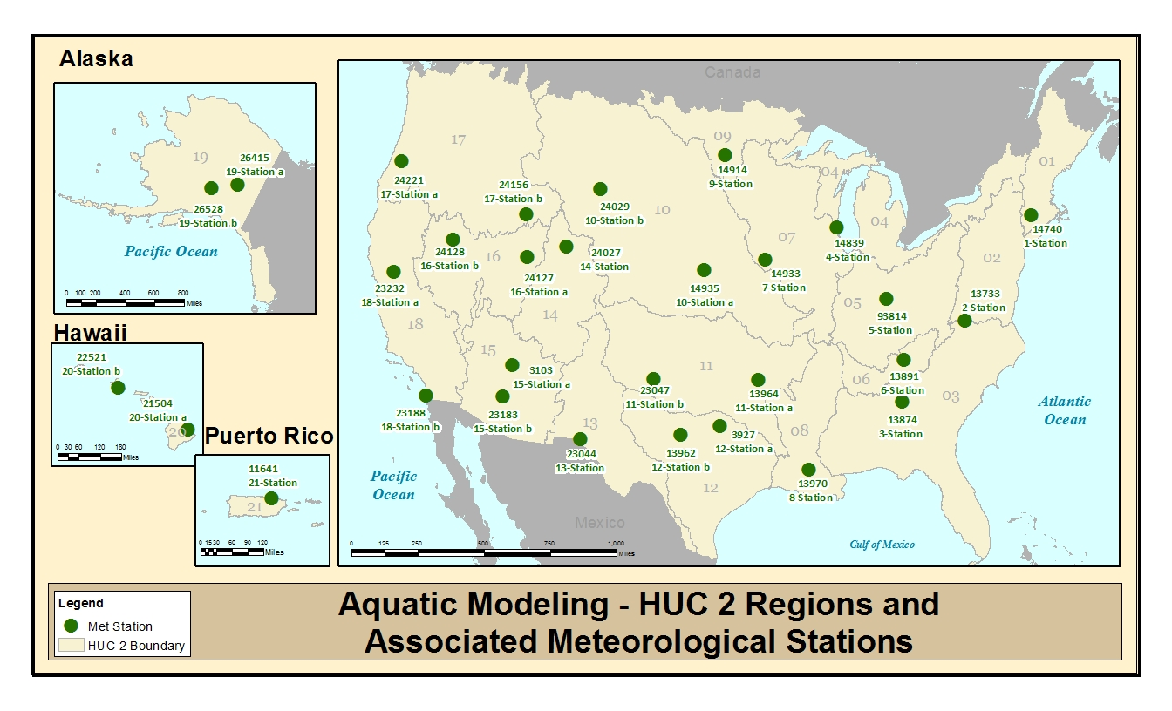
Figure 3-1. Hydrologic Unit Code (HUC) 2-digit Regions and Associated Metrological Data

surrogate for pesticide exposure to species in tidal pools; aquatic bins 2 and 3 will be used for exposure to species at low and high tide, and aquatic bins 4 and 7 will be used to assess exposure to marine species that occasionally inhabit offshore areas.

Chlorpyrifos-specific modeling scenarios are used for modeling each use. This includes the selection of PRZM5/VVWM scenarios and agronomic practices (e.g., applications methods, dates). Tables 3-6 and 3-7 include all the model input parameters as well as the justification for selecting these parameters; however, the general approaches used are described below. Although environmental fate data are available for chlorpyrifos-oxon, model runs are not provided for chlorpyrifos-oxon as little data are available on the formation (rate or percent) of chlorpyrifos-oxon from chlorpyrifos in the environment. Characterization of the potential exposure to chlorpyrifos-oxon is described in APPENDIX 1-9.

HUC and Use Site Crosswalk

Unless a use pattern is restricted to a particular geographic area (e.g., ginseng use is only allowed in Michigan and Wisconsin), the National Agricultural Statistics Census of Agriculture 2012 (NASS) data along with cropland data are used to determine which crops would be modeled for each represented HUC 2 region. If the NASS data indicated any amount of acres of a crop grown (even if small acreage) in a specific HUC 2 region, it is assumed that the crop is grown in that HUC 2 region and chlorpyrifos may be used on that crop. If there are no reported NASS cropped acres grown in a particular HUC 2 region, it is assumed that the use did not occur in the HUC. A crop use-HUC 2 Region matrix for chlorpyrifos is provided in Appendix 1-6.

Scenario Selection

To generate spatially relevant exposure concentrations, PRZM5/VVWM-scenarios used in model simulations are selected based on the crop group HUC 2 Region scenario matrix provided in APPENDIX 1-6. An explanation of how the PRZM5/VVWM scenario matrix was developed is provided in ATTACHMENT 3-1.

Application Practices

Application Method

During application of pesticides, methods of application as well as product formulation used by an applicator can impact the off-site transport of the active ingredient. Label directions (such as spray drift buffers, droplet size restrictions, application equipment and agronomic practices such as soil incorporation) as well as product formulation are considered as part of the development of the use scenario modeled.

There are many different types of chlorpyrifos applications included in the master use summary document (APPENDIX 1-3) including those that occur in both agricultural and non-agricultural settings. Application equipment include aircraft, tractors, and irrigation systems as well as backpack and handheld sprayers. Chlorpyrifos applications may occur at different times throughout the year including multiple application to the same crop occurring at different crop stages. When multiple types of applications are allowed on a crop within one calendar year, such as pre-plant or soil incorporation applications along with foliar applications, all applications are simulated considering the appropriate application timing (e.g., dormant, foliar, and post-harvest applications to a crop).

There are several types of chlorpyrifos formulations; however, for modeling purposes these formulations are subdivided into liquid [emulsifiable concentrate (EC), water dispersible granular (WDG), wettable powder (WP), or ready to use (RTU)] or dry (granular and seed treatment) applications. Microencapsulated formulations are also modeled as a liquid formulation since data on the mechanism or rate of release of chlorpyrifos from the microcapsule is not available. This assumes that all the chlorpyrifos contained within the microcapsule is released into a liquid solution prior to application. This approach provides a conservative peak concentration; however, it may result in an underestimation of longer term exposure as some chlorpyrifos may remain in the microcapsule and as a result not be as susceptible to microbial degradation or volatilization, the primary dissipation routes for chlorpyrifos in the environment. Nevertheless, it is unclear how encapsulation (either in the form of a microcapsule or granular formulation) impacts the rate of dissipation of chlorpyrifos in the environment, which leads to uncertainty in the exposure estimates derived for these formulations.

For seeds treated with chlorpyrifos, all of the chlorpyrifos applied to the seeds is assumed to be available for runoff and erosion, since no seed leaching data are available for chlorpyrifos. This approach provides a conservative peak concentration; however, it may over estimate actual exposure as some chlorpyrifos may remain on the seed coat.

Spray drift

All agricultural chlorpyrifos labels include buffer restrictions [25 ft. (ground), 50 ft. (air-blast), and 150 ft. (aerial)] for aquatic water bodies as well as spray droplet restrictions. Using Tier 1 AgDRIFT (version 2.2.1) drift factors are calculated for each aquatic bin for each application method, corresponding buffer distance, and droplet size distribution. The results of this analysis are presented in Table 3-2. A more detailed discussion of spray drift considerations for chlorpyrifos is provided in APPENDIX 3-3.

Table 3-2. Spray Drift Estimates for Aquatic Bins for Various Aquatic Buffer Combinations for Liquid Formulations
Bin |  |  |  | Spray Drift Fractionª
Number | Generic Habitat | Depth (m, ft) | Width (m, ft) | Ground^{b} | Air-blast^{c} | Aerial^{d}
Aquatic Spray Drift Buffer Distances |  |  |  | 25 ft | 50 ft | 150 ft
2 | Low-flow | 0.1, 0.33 | 2, 6.6 | 0.02 | 0.03 | 0.06
3 | Moderate-flow | 1, 3.3 | 8, 26.2 | 0.02 | 0.03 | 0.06
4 | High-flow | 2, 6.6 | 40, 131.2 | 0.009 | 0.01 | 0.04
5 | Low-volume | 0.1, 0.33 | 1, 3.3 | 0.02 | 0.04 | 0.06
6 | Moderate-volume | 1, 3.3 | 10, 32.8 | 0.01 | 0.02 | 0.06
7 | High-volume | 2, 6.6 | 100, 328.1 | 0.006 | 0.005 | 0.03
- Spray drift fraction used in model runs based on application method and corresponding buffer required on label.
- Ground: ASAE Fine to medium/course [dv_{0.5} = 341 µm; labels specify 255-340 µm which is larger than ASAE very fine to fine (dv_{0.5} = 175 µm); high-boom; 90th percentile
- Air-blast: droplet size not specified; sparse (young, dormant)
- Aerial: ASAE fine to medium (dv_{0.5} = 255 µm; labels specify 255-340 µm)

No spray drift is assumed for granular formulations and chlorpyrifos-treated seeds.

Mosquito adulticide applications do not require a spray drift buffer. In addition, the application is made using an ultralow volume (ULV) technique. The resulting application efficiency is 0.21 and spray drift fractions for each aquatic bin are listed in Table 3-3 with spray drift fractions for standard aerial applications for comparison. A more detailed discussion of spray drift considerations for ULV chlorpyrifos application is provided in APPENDIX 3-3. Ground ULV applications are not simulated as aerial applications are expected to result in the most drift.

Table 3-3. Ultra Low Volume Spray Drift Estimates for Aquatic Bins
Bin |  |  |  | Spray Drift Fraction  (unitless)ª
Number | Generic Habitat | Depth (m, ft) | Width (m, ft) | Aerial
2 | Low-flow | 0.1, 0.33 | 2, 6.6 | 0.023
3 | Moderate-flow | 1, 3.3 | 8, 26.2 | 0.022
4 | High-flow | 2, 6.6 | 40, 131.2 | 0.017
5 | Low-volume | 0.1, 0.33 | 1, 3.3 | 0.024
6 | Moderate-volume | 1, 3.3 | 10, 32.8 | 0.022
7 | High-volume | 2, 6.6 | 100, 328.1 | 0.011

Some labels that contain other non-agriculture chlorpyrifos uses with the exception of turf, right-of-ways, utilities, and wide area uses do not have the aquatic buffers requirement previously mentioned. In general, these types of applications occur using handheld or backpack spray equipment. Data are not available on the spray drift that result from these types of applications; however, these application methods are not expected to result in substantial drift like a ground boom application, therefore, no spray drift is assumed for these application methods.

Application Timing

In selecting application dates for aquatic modeling, EPA considers a number of factors including label directions, timing of pest pressure, meteorological conditions, and pre-harvest restriction intervals. Agronomic information is consulted to determine the timing of pest pressure and seasons for different crops. General sources of information include crop profiles (http://www.ipmcenters.org/cropprofiles/), agricultural extension bulletins, and/or available state-specific use information. A general discussion of the considerations is provided below; however, an explanation of the reasoning behind selected application dates is provided in APPENDIX 1-7.

Chlorpyrifos may be applied during different seasons of the year and the directions for use indicate the timing of application, such as, at plant, dormant season, foliar (i.e., when foliage is on the plant), etc. For most chlorpyrifos uses, application dates are chosen based on these timings, the crop emergence and harvest timings specified in the PRZM5/VVWM scenario, and precipitation data for the meteorological station for the PRZM5/VVWM. At plant applications are specified as occurring seven days before crop emergence. While not all crops emerge 7 days after planting 7 days is assumed given that difference in potential exposure based on slight variations in the application date is compensated for by using 30 year weather simulation. Foliar applications are assumed to occur when the crop is on the field (i.e., between emergence and harvest) in the PRZM scenario. When choosing an application date within a time window (i.e., dormant season or foliar application), the first or fifteenth of the month with the highest amount of precipitation (for the meteorological station for the PRZM5/VVWM scenario) for that time window is chosen. Once the first day of application is selected, minimum retreatment intervals are assumed to determine when subsequent applications would occur. If multiple types of applications are allowed on one crop within one year, such as pre-plant or soil incorporation along with a foliar application(s), the retreatment interval is selected to reflect the specified timings. All application scenarios considered the pre-harvest intervals (the minimum time between an application and harvest) required on the labels; therefore, applications are not specified to occur during the pre-harvest interval.

Meteorological information is also considered, as pesticide loading to surface water may be directly affected by precipitation events. The wettest month (e.g., the month with the highest cumulative precipitation) is identified and a random date (e.g., the first of the month, the middle of the month as mentioned above) is considered in an effort to maintain the probability of the distribution of environmental exposure concentrations generated. In some cases, the wettest month is the same month that emergence occurs.

Special Agricultural Considerations

Multiple Crop-cycles Per Year
Some labels permit applications on crops that may be planted in rotation or may have multiple crop seasons (e.g., various vegetables) per year that could result in multiple applications on the same field. While crop rotations are highly likely for some chlorpyrifos use sites including corn-wheat and wheat-sunflower, such rotations were not modeled but the potential higher exposure is noted. Planting of the same crop on the same plot of land is less likely than crop rotation but does occur sometimes. As a conservative approach, when maximum label application rates are specified on a crop cycle basis, it is assumed that multiple crops per year could be planted on the same plot of land for crops. OPP’s BEAD summarized some common crop rotation scenarios for vegetable crops grown in four regions where PRZM5/VVWM scenarios are readily available for vegetables (California, Florida, Texas, and Michigan, Table 3-4). It should be noted that modifications to the PRZM5/VVWM -scenarios (i.e., the curve number) are not made to reflect the change in cropping pattern (i.e., various crop stages or various crops) as the impact on the estimated environmental concentrations are minimal based on a sensitivity analysis that examined the impact of adjusting the crop coverage within the PRZM5/VVWM-scenarios.

Table 3-4. Multiple crop rotation simulations
State Simulated | HUC | Crops Simulated | Application Simulation
 |  |  | Crop 1 | Crop 2 | Crop 3
California | 18 | Spinach, Cauliflower, Lettuce | At plant on 1/1 at 4.5 kg/ha, incorporate 2 inches | At plant 3/20 at 4.5 kg/ha with no incorporation | At plant 7/31 at 2.24 kg/ha with 2 inch incorporation; Foliar aerial on 8/30 at 0.6 kg/ha
Florida | 3 | Radish, Cabbage, Lettuce | At plant 10/1 at 4.5 kg/ha incorporate 2 inches | 11/18 ground at 4.5 kg/ha incorporate 2 inches | At plant 4/10 at 2.24 kg/ha with 2 inch incorporation; foliar aerial on 5/10 at 0.6 kg/ha
Michigan | 7 | Cabbage, Melon | 4/8 ground at 4.5 kg/ha incorporate 2 inches | At plant 7/21 at 4.5 kg/ha and incorporate 2 inches. | --
Texas | 12 | Carrot, onion | 7/1 ground at 4.5 kg/ha incorporate 2 inches | At plant 10/15 at 4.5 kg/ha incorporate 3 inches | --

Cranberry Modeling for Surface Water

Some cranberries are grown in bogs where the field is temporarily flooded to control pests, prevent freezing, and to facilitate harvest. Some cranberries are grown in a more traditional field like setting. Water from flooding a cranberry bog may be held in a holding system, recirculated to other cranberry growing areas, or released to adjacent waterbody (rivers, streams, lakes, or bays). The Pesticides in Flooded Applications Model (PFAM, version 1.09) and PRZM5/VVWM are used to estimate chlorpyrifos exposure as a result of applications to cranberry. Together the results from PFAM and PRZM5/VVWM are used to represent the various agronomic practices utilized for growing cranberry as well as to evaluate the potential exposure associated with the use of chlorpyrifos on cranberries.

PFAM

PFAM was developed specifically to estimate exposure to pesticides used in flooded agriculture, such as rice paddies and cranberry bogs. The model considers the environmental fate properties of the pesticide, and allows for the specifications of common management practices that are associated with flooded agriculture, such as scheduled water releases and refills. It estimates both acute and chronic concentrations over different durations, allows for defining different receiving water bodies, and allows for more flexibility in refinement of assessments when needed.

PFAM is used to estimate the concentration of chlorpyrifos in the flood water released from a bog. The reported concentrations represent water introduced to the field and not mixed with any additional water (i.e., receiving water body). The infield concentration of chlorpyrifos is expected to be more than what would be expected in adjacent water bodies due to additional degradation and dilution. The difference in the concentration of chlorpyrifos in the flood water to that in an adjacent waterbody depends on 1) the length of time chlorpyrifos is in the flooded bog, 2) the distance the water travels between the bog and the adjacent waterbody, 3) the amount of dilution, and 4) whether the flood water is mixed with additional water that also contains chlorpyrifos. PFAM simulates application of pesticide to a dry field and degradation in soil before water is introduced to the bog. While PFAM does have the capability of simulating release of cranberry bog water into a mixing cell or waterbody, this is not simulated because a conceptual model is not currently available.

PRZM5/VVWM

To account for the potential exposure to chlorpyrifos as a result of a runoff event that occurs prior to or after a flooding event (i.e., not directly associated with an intentional flooding event) in a cranberry bog, as well as to represent cranberries grown in a more traditional field setting, PRZM5/VVWM is used to estimate chlorpyrifos concentrations in various aquatic bins as result of the use of chlorpyrifos on cranberry. While the typical surface runoff simulated in the PRZM5/VVWM does not apply to cranberries grown in bogs, residues related to runoff from cranberries will occur and the PRZM5/VVWM is the tool available to capture exposure due to transport in runoff and spray drift. Additionally, some cranberries are dry harvested and may not be grown in a depressed area or in these hydrologically unique areas. Therefore, the PRZM5/VVWM simulations for cranberry may also be used to estimate chlorpyrifos applications to cranberries that are dry harvested.

Non-Agricultural Uses and Considerations

As described in the master use summary document (APPENDIX 1-3) there are a number of non-agricultural use sites for chlorpyrifos; however, these are primarily (with the exception of bait stations and adult mosquito control) non-residential developed use sites such as commercial, institutional, industrial premises and equipment, nonagricultural outdoor building structures, as well as general area use. Examination of the applications method permitted on current labels for these uses indicate that backpack and hand wand spray equipment are the primary methods of application. The exception being wide areas use which is modeled as a broadcast application like agricultural uses and is not further discussed in this section.

In addition, examination of the targeted pests (e.g., ants and flies) and type of applications (e.g., drench, crack and crevice, and perimeter) listed on the non-agricultural chlorpyrifos labels suggest that these applications are not expected to occur on a large scale (i.e., field or watershed). Therefore, these uses are not expected to result in the magnitude of exposure that may result from traditional broadcast applications of chlorpyrifos to multiple acres of agricultural crops is not expected to be treated in one day and as such does not fit the standard modeling paradigm employed by EPA to assess pesticide exposure (i.e, where pesticides are uniformly applied over large areas at specific intervals during a growing season).

Nevertheless, the aforementioned non-agricultural uses of chlorpyrifos may result in exposure to non-target species and a reasonable upper bound of the exposure is derived. This is done using an urban exposure conceptual model (based on EPA’s residential exposure conceptual model) as described below.

Urban Exposure Model

An urban exposure conceptual model similar to the residential exposure model previously employed by EPA to assess exposure to pesticides in residential settings is used to assess exposure to chlorpyrifos from urban uses sites where applications may occur. Use of this conceptual model is more realist than assuming the entire watershed is treated with chlorpyrifos for these type of uses for the reasons described above. The assumption is that the houses in the residential exposure model scenario represent commercial, non-agriculture buildings or areas (footprint) that would not be treated directly with chlorpyrifos but that chlorpyrifos applications may be applied around the structure (Figure 3-2). Exposure estimates for each non-agricultural use are derived individually. In some cases, an aggregation of multiple scenarios (developed and impervious) was used in a summation approach. An explanation of the assumptions for building perimeter, utilities, fences, and trash bins for model simulation is provided below. It is possible that multiple urban chlorpyrifos uses and/or applications may occur within an urban watershed. It should be noted the contribution of other chlorpyrifos uses such as run-off and erosion from ornamentals that may also occur in urban environments are not considered. These applications, could result in treatment over a larger area such as a park or nursery. Therefore, such uses are considered separately and are expected to provide a higher exposure estimate on a broader scale than the uses aggregated as part of this urban exposure model.

The urban exposure conceptual model (Figure 3-2.) consists entirely of quarter acre (10,890 ft²; 104.36 ft x 104.369 ft) lots. Each lot contains one 1000 square feet commercial or non-agricultural building. The building is assumed to be square with sides of 31.6 feet with a 15 feet x 25 feet driveway. In addition, adjacent to the driveway is a trash storage area that is assumed to be equal in size to the driveway. On the opposite side of the lot is a utility easement of 10 feet wide that runs the entire length of the property. A 6 feet tall wood fence (including a gate in front of the trash storage area and drive way) that runs the perimeter of the lot is also assumed. The contribution or adjusted percent area treated (APAT) of each of the corresponding chlorpyrifos uses is described below.

Calculation of the APAT for outdoor commercial applications of chlorpyrifos is based on a 10 feet (Reg. No. 84575-5) perimeter band (soil broadcast; pervious surface) treatment adjacent to a building along with a 3 feet high foundation treatment (Reg. No. 84575-5) as shown below:

Perimeter
$$\left((31.6 \text{ft}×2 \text{sides)}+\left((31.6 \text{ft+ 20 ft}\right)×2 \text{sides)}-30 \text{ft driveway and trash storage area}\right)×10 \text{ft}=1364 {\text{ft}}^{2}$$
1364 ft² /10,890 ft² =0.13*1.1 lb a.i./A = 0.14 lb a.i./A (developed scenario)

Foundation
$\left(31.6\text{ft}×4 \text{sides}-30 \text{ft driveway and trash storage area}\right)×3 \text{ft}={\text{289 ft}}^{2}$ (developed scenario)

$\left(30 \text{ft driveway and trash storage area}\right)×3 \text{ft}={\text{90 ft}}^{2}$ (impervious scenario)

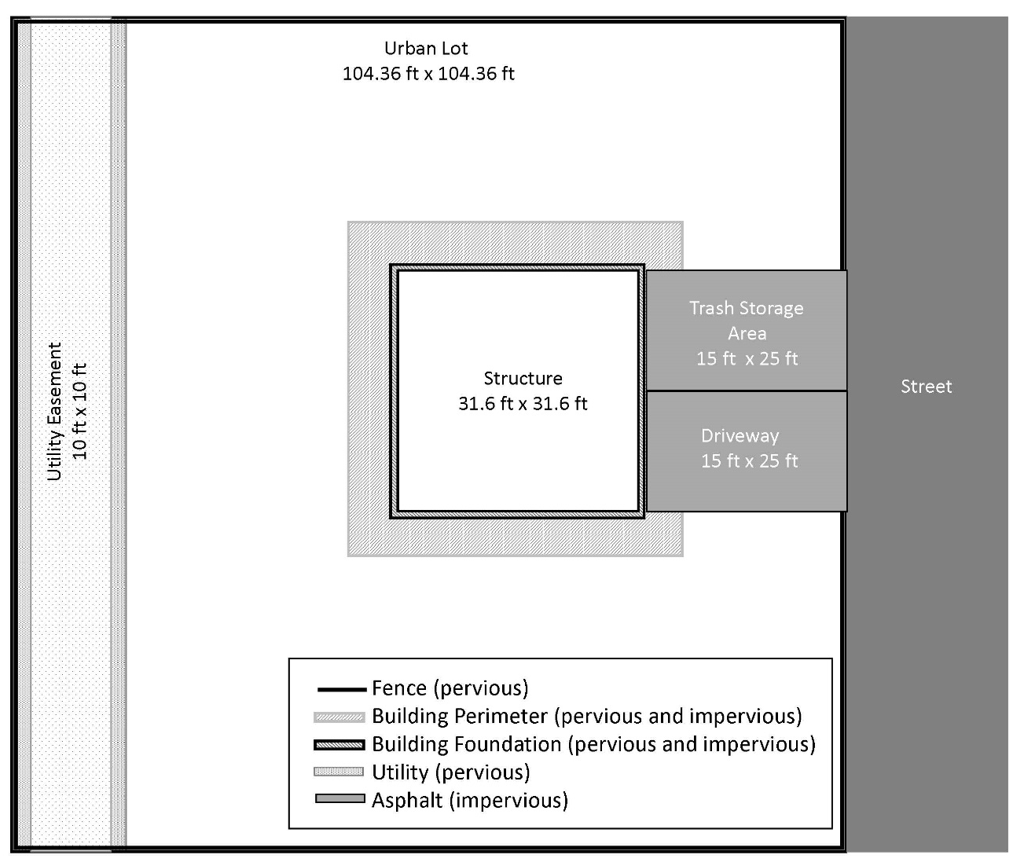
Figure 3-2. Urban Lot Conceptual Model

The total area that may be treated with perimeter treatment of chlorpyrifos and drain through a perimeter and foundation area is 1653 square feet (1364 ft² + 289 ft²) and 90 square feet, respectively, assuming that 100% of the chlorpyrifos applied to both horizontal (soil) and vertical surfaces (walls/foundation) are available to run off the treated area. The perimeter treatment was assessed by adjusting the application rate by the APAT while the foundation application was assessed using a post processing strategy to combine contributions result from application to developed and impervious areas. APATs are summarized in Table 3-5 by use site and urban scenario [impervious or pervious (right-of-way)].

Table 3-5. Adjusted Percent Area Treated
Use Site | Impervious | Developed | Maximum Application Rate  (lb a.i./A)
Perimeter |  | 0.13 | 1.1
Foundation/Wall | 0.01 | 0.03 | 1.0
Trash Storage | 0.03 |  | 4.9
Utility |  | 0.13 | 1.0
Fence | 1 | 1 | 16.65 lb a.i./ 10,000 ft² wood
The contribution of a targeted chlorpyrifos spray application to trash storage area in an urban setting is derived using the calculation below (impervious surface) and the APAT is provided in Table 3-5. No over spray to adjacent areas is assumed. The application rate was adjusted to reflect the APAT.

$\left(15 \text{ft trash storage}\right)×25 \text{ft}={\text{375 ft}}^{2}$(impervious scenario)

A chlorpyrifos application to a 10 feet utility pad or easement the length (104.36 ft) of the property with a 2 ft spray buffer on either side of the easement (Reg. No. 13283-14) is estimated based on the equation below and the APAT also provided in Table 3-5:

$\left(104.36 \text{ft}×(10 ft+4 ft)\right)={\text{1461}\text{ ft}}^{2}$ (developed scenario)

Chlorpyrifos may also be applied as a wood protectant (16.65 lb a.i./10,000 ft² wood). A 6 foot wood fence is assumed to be located on the perimeter of the property with a wood gate that extends over the driveway and trash area. No wood leaching data are available for chlorpyrifos. Therefore, all the applied chlorpyrifos is assumed to be available to leach out of the wood or runoff the treated wood to adjacent surfaces, the equations below are used to determine the potential contribution of this chlorpyrifos use to the overall exposure to chlorpyrifos in an urban environment. This is done by adjusting the application rate for wood to area based on the described scenario and assuming APAT of one hundred percent. No overspray is assumed.

$\left(104.36 \text{ft}×4 slides)-30 ft\right) x 6 \text{ft})={\text{2,325 ft}}^{2} wood$ (developed scenario)
$(30 ft x 6 ft)={\text{180 ft}}^{2}wood$ (impervious scenario)

2,325 ft² wood x 16.65 lb a.i./ 10,000 ft² wood = 3.9 lb a.i./ lot or 15.5 lb a.i./A (developed)
180 ft² wood x 16.65 lb a.i./ 10,000 ft² wood= 0.30 lb a.i./ lot or 1.2 lb a.i./A (impervious)

Aquatic Modeling Input Parameters

For Step 1 analysis, aquatic exposure modeling was not performed, as the action area for chlorpyrifos encompasses the entire United States. The following sections discuss methods used for modeling under Step 2. Summaries of the environmental fate model input parameters used in the PRZM5/VVWM and the Tier 1 Rice Model/PFAM modified for cranberries for the modeling of chlorpyrifos are presented in Tables 3-6 and 3-7, respectively. Input parameters are selected in accordance with the following EPA guidance documents:
- Guidance for Selecting Input Parameters in Modeling the Environmental Fate and Transport of Pesticides, Version 2.1 (USEPA, 2009),
- Guidance for Evaluating and Calculating Degradation Kinetics in Environmental Media (NAFTA, 2012; USEPA, 2012c), and
- Guidance on Modeling Offsite Deposition of Pesticides Via Spray Drift for Ecological and Drinking Water Assessment (USEPA, 2013)

Table 3-6. Input Values Used for Tier II Surface Water Modeling Using the PRZM5/VVWM and PFAM
Parameter (units) | Value | Source | Comments
Organic-carbon Normalized Soil-water Distribution Coefficient (K_{OC} (L/kg-_{OC})) | 6040 | Acc. # 260794 | Soil binding for chlorpyrifos is correlated with organic carbon content (i.e., the coefficient of variation for K_{oc} values is less than that for K_{d} values). The mean K_{oc} value (K_{oc} values = 7300, 5860 and 4960 mL/g) is used for modeling.
Water Column Metabolism Half-life or Aerobic Aquatic Metabolism Half-life (days) 25 ˚C | 91.2 | MRID 44083401 | Only one half-life value is available, so this value (30.4 days) is multiplied by 3 to get 91.5 days. The 30.4 day half-life value is not corrected for hydrolysis as hydrolysis data conducted under the same experimental conditions are not available. In addition, the aerobic aquatic metabolism study was conducted under slightly basic conditions (pH 7.7). Chlorpyrifos hydrolysis is pH dependent and faster under basic conditions.
Benthic Metabolism Half-life or Anaerobic Aquatic Metabolism Half-life (days) and Reference Temperature | 202.7 | MRID 00025619 | The 90th percentile confidence bound on the mean chlorpyrifos half-life value determined following the NAFTA kinetics guidance is 87.6 + [(3.078 x 52.9)/√2)] = 202.7 days.
Aqueous Photolysis Half-life at pH 7 (days) and 40° Latitude, 25ºC | 29.6 | MRID 41747206
Hydrolysis Half-life (days) | 0 | MRIDs 00155577 (Acc. # 260794) and 40840901 | Since the aerobic aquatic metabolism half-life value was not corrected for hydrolysis, it is possible that hydrolysis would be double-counted in the model simulation. Therefore, hydrolysis is set to 0 (stable) here as it is already accounted for in the aerobic aquatic metabolism study and input parameter.
Soil Half-life or Aerobic Soil Metabolism Half-life (days) and Reference Temperature | 170.6, 25 ˚C | Acc. # 241547 and MRID 42144911 | Half-life values of 19, 36.7, 31.1, 33.4, 156, 297, 193, and 185 days are obtained from empirical data following the NAFTA kinetics guidance. The 90th percentile confidence bound on the mean chlorpyrifos half-life value is 118.9 + [(1.415 x 103.3)/√8)] = 170.6 days.
Molecular Weight (g/mol) | 350.57 | product chemistry
Vapor Pressure (Torr) at 25 ºC | 1.87 x 10⁻⁵ torr | product chemistry  BC 2062713
Solubility in Water at 25 ˚C (mg/L) | 1.4 | MRID 41829006 | The water solubility of chlorpyrifos is reported to be between 0.5-2.0 mg/L for temperatures between 20 - 25 °C. Based on data submitted to EPA, 1.4 mg/L was used in modeling.
Foliar Half-life (days) | 35 | Default value
Application Efficiency | 0.99 (ground; air-blast))  0.95 (aerial) | Default Values
Application Drift | See Section 2.4.2 | AgDRIFT modeling based on label restrictions | Labels contain aquatic buffer distances of 25, 50 and 150 ft. for ground, airblast and aerial applications.

For cranberries, a 12-inch flood is modeled on October 1, followed by draining the bog on October 4th. The modeled flood date is selected as a plausible date of harvest. A winter flood is also simulated on December 1, followed by draining the bog on March 16. Crop stages are estimated. The maximum aerial coverage for berry crops used in the OR berries PRZM5/VVWM scenario was used in PFAM. Table 3-7 summarizes the PFAM inputs used to model chlorpyrifos applications. Release of water into a receiving water body is not simulated because a conceptual model for this is not currently available.

Table 3-7. PFAM Specific Input Values Used for Tier II Surface Water Modeling
Input Parameter | Value | Source | Comment
Chemical Tab, see Table 3.7
Applications Tab
Application rate | 1.5 lb a.i./A  1.68 kg a.i./ha | Chlorpyrifos Use Summary Table (APPENDIX 1-3)
Number of Applications | 2 | --- | ---
Application dates | 07/01  7/11 | --- | 10 day minimum retreatment interval
Slow Release 1/day | 0 | -- | Not applicable
Drift Application | 0 | -- | Drift to an adjacent water body or mixing cell was not modeled.
Flood Tab
Number of Flood Events | 4 | -- | Harvest occurs between September and November. Field is flooded just prior to harvest. Field may also be flooded over the winter from December through March 15 (Cape Cod Cranberry Growers Association, 2001). The winter flood height was assumed to be similar to the harvest flood height. In some areas, there is also a late water flood to control spring frost where the bog is flooded in late April for one month. This was not simulated.
Date of Event 1 (Month-Day) | 10-01 | --
Turn Over (1/day) | 0 | Assumed
Days After (Month-day) | Fill Level, Min Level (m) | Weir (m)
0 (Oct-1) | 0.305 | 0.458
3 (Oct-4) | 0 | 0
61 (Dec-1) | 0.305 | 0.458
105 (March-15) | 0 | 0
Crop Tab
Zero Height Reference | 05/01 | Information from Maine Cooperative Extension (Armstrong, 2015)
Days from Zero Height to Full Height | 120 (08/29) | Assumed
Days from Zero Height to Removal | 153 (10/1) | Assumed
Maximum Fractional Areal Coverage | 0.2 | Value from OR berries PE scenario
Physical Tab
Meteorological files | CT W14740  NJ W14734  WI_2 W14839  WI W14920  OR W24221 | Weather stations from cranberry growing areas
Latitude | 42.3 | Latitudes are CT 41.6, 40.0 NJ, 44.5 in WI, and 44.0 in Oregon. These are close enough that a default latitude was chosen.
Area of Application (m²) | 526,090 | Represents 10x the area of the Index Reservoir
Weir Leakage (m/d) | 0 | PFAM default
Benthic Leakage (m/d) | 0 | PFAM default
Water-sediment mass transfer coefficient (m/s) | 1x10⁻⁸ | PFAM default
Reference depth (m) | 0.458 | Set to same depth as weir height.
Benthic depth (m) | 0.05 | PFAM default
Benthic porosity | 0.50 | PFAM default
Dry bulk density (g/cm³) | 1.35 | PFAM default
F_{OC} Water Column on SS | 0.04 | PFAM default
F_{OC} benthic | 0.01 | PFAM default
Suspended Sediment (mg/L) | 30 | PFAM default
Water column DOC (mg/L) | 5.0 | PFAM default
Chlorophyll CHL (mg/L) | 0.005 | PFAM default
Dfac | 1.19 | PFAM default
Q10 | 2 | PFAM default

Aquatic Modeling Results

The estimated environmental concentrations (EECs) derived from the PRZM5/VVWM modeling based on maximum labeled rates included in the master use summary document, by HUC 2, are summarized for the various aquatic bins in Table 3-8 and Table 3-9, for water column and pore water, respectively. The complete set of modeling results are available in APPENDIX 3-4. Note that Table 3-8 and Table 3-9 do not include the results for chlorpyrifos use sites that only have seed treatments (i.e., beans, cucumber, pea, pumpkin, and triticale) or EECs generated for the urban use scenario developed for chlorpyrifos. Table 3-10 and Table 3-11 includes the EECs for water column and pore water for seed only treatments while Table 3-12 and Table 3-13 includes the EECs water column and pore water for the chlorpyrifos urban use scenario.

Some of the resulting EECs exceed the solubility limit in water of chlorpyrifos. The water solubility of chlorpyrifos is reported to be between 0.5-2.0 mg/L for temperatures between 20 - 25 °C. Based on data submitted to EPA, 1.4 mg/L was used in modeling; however, the chlorpyrifos EECs are conservatively capped at the upper end (2.0 mg/L) of the reported solubility limit. These values are shown in red in the table below. While EECs would not normally be expected to exceed the water solubility limit, variations in waterbody conditions (e.g., pH, temperature, turbidity, hardness) could be different than those used to determine the solubility, such that EECs could be above the water solubility limit; however, concentrations are not expected to be orders of magnitude higher than the solubility reported for laboratory studies. Use of solubility is more appropriate for defining an upper bound exposure estimate.
Table 3-8. The range of PRZM5/VVWM Daily Average Water Column EECs for Chlorpyrifosª
HUC 2 | Range of 1-in-15 year Daily Average EECs (µg/L)
 | Bin 2 | Bin 3 | Bin 4 | Bin 5 | Bin 6 | Bin7
HUC 1 | 1.29-1,240 | 1.27 - 856 | 1.27 - 485 | 0.28 - 70 | 0.19 - 24 | 0.09 - 12
HUC 2 | 1.28-382 | 1.32 - 250 | 1.32 - 160 | 0.26 - 69 | 0.22 - 20 | 0.11 - 10
HUC 3 | 1.25-138 | 1.30 - 117 | 1.31 - 117 | 0.20 - 68 | 0.21 - 19 | 0.12 - 11
HUC 4 | 1.32-1,400 | 1.34 - 912 | 1.34 - 500 | 0.36 - 90 | 0.30 - 47 | 0.16 - 28
HUC 5 | 1.28-294 | 1.31 - 204 | 1.33 - 153 | 0.30 - 71 | 0.24 - 22 | 0.12 - 12
HUC 6 | 1.26-302 | 1.23 - 285 | 1.23 - 261 | 0.19 - 68 | 0.18 - 18 | 0.08 - 6
HUC 7 | 1.30-2,000 | 1.32 - 2,000 | 1.37 - 1,820 | 0.70 - 674 | 0.39 - 373 | 0.22 - 223
HUC 8 | 1.24-319 | 1.31 - 251 | 1.31 - 160 | 0.17 - 67 | 0.16 - 16 | 0.07 - 6
HUC 9 | 1.37-1,470 | 1.49 - 1,400 | 1.50 - 1,750 | 1.11 - 575 | 0.81 - 405 | 0.46 - 234
HUC 10a | 1.33-206 | 1.43 - 177 | 1.46 - 182 | 0.82 - 87 | 3.21 - 359 | 1.94 - 248
HUC 10b | 1.36-223 | 1.47 - 171 | 1.51 - 178 | 0.48 - 71 | 1.64 - 196 | 0.94 - 123
HUC 11a | 1.25-154 | 1.38 - 165 | 1.45 - 156 | 0.47 - 72 | 2.02 - 305 | 1.22 - 199
HUC 11b | 1.27-136 | 1.43 - 185 | 1.50 - 188 | 0.41 - 69 | 1.74 - 224 | 1.06 - 136
HUC 12a | 1.23-147 | 1.42 - 161 | 1.53 - 170 | 0.41 - 72 | 0.97 - 113 | 0.60 - 77
HUC 12b | 1.24-129 | 1.46 - 176 | 1.50 - 360 | 0.42 - 67 | 1.30 - 150 | 0.78 - 91
HUC 13 | 1.42-187 | 1.66 - 386 | 1.54 - 202 | 18.50 - 2,000 | 8.43 - 1,230 | 4.07 - 603
HUC 14 | 1.42-210 | 1.61 - 207 | 1.63 - 209 | 5.56 - 691 | 5.00 - 541 | 2.83 - 325
HUC 15a | 1.42-262 | 1.47 - 302 | 1.48 - 273 | 8.83 - 1,490 | 10.20 - 1,750 | 2.70 - 456
HUC 15b | 1.52-228 | 1.66 - 284 | 1.67 - 219 | 4.23 - 1,020 | 5.05 - 1,040 | 1.38 - 255
HUC 16a | 1.31-364 | 1.54 - 586 | 1.21 - 177 | 4.98 - 782 | 3.59 - 600 | 2.10 - 382
HUC 16b | 1.28-287 | 1.56 - 383 | 1.07 - 154 | 2.57 - 495 | 1.71 - 317 | 0.95 - 188
HUC 17a | 1.31-1,180 | 1.28 - 823 | 1.28 - 616 | 0.40 - 71 | 8.04 - 1,640 | 5.54 - 1,100
HUC 17b | 1.34-1,080 | 1.37 - 820 | 1.36 - 704 | 0.25 - 70 | 1.24 - 592 | 0.71 - 346
HUC 18a | 1.37-716 | 1.53 - 1,020 | 1.54 - 983 | 2.27 - 760 | 3.29 - 1,090 | 1.95 - 622
HUC 18b | 1.35-775 | 1.53 - 655 | 1.59 - 642 | 1.84 - 779 | 1.99 - 906 | 1.22 - 482
HUC 19a | 1.42-1,170 | 1.41 - 863 | 1.40 - 679 | 0.99 - 291 | 1.02 - 468 | 0.58 - 254
HUC 19b | 1.42-1,150 | 1.37 - 820 | 1.36 - 541 | 1.16 - 362 | 1.55 - 533 | 1.03 - 348
HUC 20a | 1.19-415 | 1.12 - 386 | 1.17 - 349 | 2.64 - 1,230 | 2.52 - 1,280 | 1.57 - 798
HUC 20b | 1.26-495 | 1.35 - 457 | 1.40 - 402 | 2.78 - 504 | 1.64 - 362 | 0.89 - 205
HUC 21 | 1.19-436 | 1.23 - 407 | 1.23 - 361 | 0.69 - 137 | 0.26 - 40 | 0.58 - 23
a. Excludes seed treatment only use sites (see Table 3.10) and the urban use scenarios discussed in Section 1 the urban use scenario model (Table 3.12)
Red italic font indicates EECs that are capped at the chlorpyrifos solubility limit (2.0 mg/L) in water.

Table 3-9. The range of PRZM5/VVWM Pore Water EECs for Chlorpyrifosª
HUC 2 | Range of 1-in-15 year EECs (µg/L)
 | Bin 2 | Bin 3 | Bin 4 | Bin 5 | Bin 6 | Bin7
HUC 1 | 0.26 - 317 | 0.13 - 797 | 0.14 - 1,100 | 0.11 - 13 | 0.09 - 10 | 0.05 - 6
HUC 2 | 0.27 - 128 | 0.15 - 296 | 0.15 - 334 | 0.11 - 9 | 0.10 - 8 | 0.05 - 5
HUC 3 | 0.24 - 51 | 0.15 - 141 | 0.15 - 157 | 0.08 - 7 | 0.08 - 6 | 0.04 - 5
HUC 4 | 0.29 - 425 | 0.15 - 1,120 | 0.15 - 1,410 | 0.05 - 16 | 0.11 - 20 | 0.07 - 15
HUC 5 | 0.25 - 88 | 0.15 - 273 | 0.15 - 326 | 0.10 - 9 | 0.10 - 8 | 0.06 - 5
HUC 6 | 0.25 - 52 | 0.15 - 97 | 0.15 - 104 | 0.06 - 8 | 0.08 - 6 | 0.04 - 3
HUC 7 | 0.26 - 1,360 | 0.15 – 2,000 | 0.19 – 2,000 | 0.13 - 88 | 0.13 - 135 | 0.08 - 113
HUC 8 | 0.24 - 122 | 0.18 - 486 | 0.18 - 629 | 0.04 - 4 | 0.06 - 4 | 0.03 - 2
HUC 9 | 0.31 - 988 | 0.20 - 2,000 | 0.22 – 2,000 | 0.18 - 82 | 0.23 - 152 | 0.17 - 112
HUC 10a | 0.29 - 130 | 0.20 - 413 | 0.21 - 451 | 0.14 - 14 | 0.62 - 89 | 0.53 - 79
HUC 10b | 0.31 - 71 | 0.17 - 239 | 0.20 - 235 | 0.14 - 12 | 0.35 - 40 | 0.28 - 36
HUC 11a | 0.20 - 30 | 0.22 - 151 | 0.31 - 303 | 0.10 - 9 | 0.43 - 77 | 0.36 - 68
HUC 11b | 0.21 - 23 | 0.18 - 202 | 0.25 - 289 | 0.10 - 8 | 0.33 - 44 | 0.28 - 38
HUC 12a | 0.20 - 25 | 0.22 - 157 | 0.32 - 313 | 0.09 - 6 | 0.24 - 34 | 0.19 - 30
HUC 12b | 0.20 - 23 | 0.22 - 205 | 0.34 - 610 | 0.08 - 5 | 0.23 - 27 | 0.18 - 24
HUC 13 | 0.22 - 45 | 0.32 - 506 | 0.26 - 70 | 0.80 - 100 | 1.15 - 141 | 0.81 - 96
HUC 14 | 0.33 - 106 | 0.18 - 188 | 0.19 - 303 | 0.43 - 58 | 0.85 - 128 | 0.72 - 115
HUC 15a | 0.38 - 237 | 0.25 - 504 | 0.24 - 386 | 1.15 - 163 | 3.76 - 548 | 1.46 - 209
HUC 15b | 0.22 - 127 | 0.19 - 405 | 0.18 - 356 | 0.25 - 37 | 0.72 - 121 | 0.27 - 45
HUC 16a | 0.26 - 44 | 0.27 - 914 | 0.21 - 36 | 0.38 - 67 | 0.75 - 151 | 0.63 - 135
HUC 16b | 0.23 - 27 | 0.21 - 556 | 0.16 - 33 | 0.25 - 28 | 0.43 - 61 | 0.34 - 54
HUC 17a | 0.37 - 778 | 0.29 - 1,880 | 0.28 - 1,870 | 0.13 - 14 | 2.18 - 855 | 1.94 - 731
HUC 17b | 0.27 - 322 | 0.10 - 567 | 0.09 - 651 | 0.10 - 11 | 0.32 - 180 | 0.25 - 147
HUC 18a | 0.35 - 472 | 0.28 - 2,350 | 0.30 - 2,900 | 0.24 - 74 | 0.60 - 258 | 0.51 - 215
HUC 18b | 0.28 - 412 | 0.23 - 1,500 | 0.25 - 1,910 | 0.16 - 59 | 0.37 - 204 | 0.31 - 165
HUC 19a | 0.38 - 455 | 0.13 - 1,140 | 0.12 - 1,090 | 0.20 - 46 | 0.26 - 132 | 0.18 - 112
HUC 19b | 0.40 - 500 | 0.19 - 1,340 | 0.19 - 1,280 | 0.30 - 78 | 0.62 - 218 | 0.50 - 189
HUC 20a | 0.22 - 249 | 0.21 - 1,280 | 0.24 - 1,670 | 0.24 - 115 | 0.41 - 246 | 0.35 - 222
HUC 20b | 0.20 - 117 | 0.15 - 448 | 0.17 - 554 | 0.15 - 32 | 0.23 - 70 | 0.19 - 63
HUC 21 | 0.20 - 160 | 0.16 - 473 | 0.17 - 708 | 0.07 - 7 | 0.06 - 7 | 0.13 - 6
a. Excludes seed treatment only use sites (see Table 3.10) and the urban use scenarios discussed in Section 1 the urban use scenario model (Table 3.12)
Red italic font indicates EECs that are capped at the chlorpyrifos solubility limit (2.0 mg/L) in water.

Table 3-10. The range of PRZM5/VVWM Daily Average Water Column EECs for Chlorpyrifos for Seed Treatment Only Use Sites
HUC 2 | Range of 1-in-15 year Daily Average EECs (µg/L)
 | Bin 2 | Bin 3 | Bin 4 | Bin 5 | Bin 6 | Bin7
HUC 1 | 0.00 - 19.30 | 0.00 - 12.40 | 0.00 - 6.08 | 0.00 - 0.91 | 0.00 - 0.48 | 0.00 - 0.28
HUC 2 | 0.00 - 21.50 | 0.00 - 14.00 | 0.00 - 7.56 | 0.00 - 0.89 | 0.00 - 0.67 | 0.00 - 0.37
HUC 3 | 0.00 - 2.22 | 0.00 - 1.98 | 0.00 - 1.72 | 0.00 - 0.10 | 0.00 - 0.19 | 0.00 - 0.13
HUC 4 | 0.00 - 3.21 | 0.00 - 3.31 | 0.00 - 3.30 | 0.00 - 0.44 | 0.00 - 0.30 | 0.00 - 0.17
HUC 5 | 0.00 - 3.96 | 0.00 - 2.53 | 0.00 - 1.83 | 0.00 - 0.40 | 0.00 - 0.34 | 0.00 - 0.20
HUC 6 | 0.00 - 2.22 | 0.00 - 1.98 | 0.00 - 1.71 | 0.00 - 0.05 | 0.00 - 0.08 | 0.00 - 0.06
HUC 7 | 0.00 - 11.60 | 0.00 - 7.92 | 0.00 - 5.26 | 0.00 - 2.58 | 0.00 - 1.25 | 0.00 - 0.74
HUC 8 | 0.00 - 4.41 | 0.00 - 4.51 | 0.00 - 4.49 | 0.00 - 0.10 | 0.00 - 0.33 | 0.00 - 0.14
HUC 9 | 0.00 - 4.39 | 0.00 - 2.22 | 0.00 - 1.66 | 0.00 - 1.34 | 0.00 - 1.19 | 0.00 - 0.61
HUC 10a | 0.00 - 4.66 | 0.00 - 3.31 | 0.00 - 2.11 | 0.00 - 1.31 | 0.00 - 5.42 | 0.00 - 3.08
HUC 10b | 0.00 - 4.26 | 0.00 - 2.24 | 0.00 - 1.49 | 0.00 - 0.94 | 0.00 - 3.18 | 0.00 - 1.49
HUC 11a | 0.00 - 3.91 | 0.00 - 3.86 | 0.00 - 4.45 | 0.00 - 1.01 | 0.00 - 5.36 | 0.00 - 3.28
HUC 11b | 0.00 - 3.01 | 0.00 - 3.67 | 0.00 - 3.96 | 0.00 - 0.72 | 0.00 - 3.64 | 0.00 - 2.07
HUC 12a | 0.00 - 3.77 | 0.00 - 3.92 | 0.00 - 5.03 | 0.00 - 0.82 | 0.00 - 2.45 | 0.00 - 1.48
HUC 12b | 0.00 - 3.02 | 0.00 - 4.04 | 0.00 - 4.02 | 0.00 - 0.79 | 0.00 - 2.11 | 0.00 - 1.14
HUC 13 | 0.00 - 2.98 | 0.00 - 4.16 | 0.00 - 3.01 | 0.00 - 28.80 | 0.00 - 12.30 | 0.00 - 4.82
HUC 14 | 0.00 - 3.61 | 0.00 - 4.07 | 0.00 - 4.12 | 0.00 - 13.20 | 0.00 - 9.08 | 0.00 - 4.78
HUC 15a | 0.00 - 6.66 | 0.00 - 8.59 | 0.00 - 5.93 | 0.00 - 46.60 | 0.00 - 54.20 | 0.00 - 13.30
HUC 15b | 0.00 - 6.81 | 0.00 - 6.47 | 0.00 - 6.08 | 0.00 - 25.60 | 0.00 - 27.10 | 0.00 - 6.23
HUC 16a | 0.00 - 2.84 | 0.00 - 4.04 | 0.00 - 2.23 | 0.00 - 10.00 | 0.00 - 7.61 | 0.00 - 4.25
HUC 16b | 0.00 - 2.63 | 0.00 - 4.00 | 0.00 - 1.61 | 0.00 - 5.05 | 0.00 - 4.65 | 0.00 - 2.30
HUC 17a | 0.00 - 4.45 | 0.00 - 4.08 | 0.00 - 3.64 | 0.00 - 0.41 | 0.00 - 11.90 | 0.00 - 8.11
HUC 17b | 0.00 - 5.21 | 0.00 - 4.54 | 0.00 - 4.01 | 0.00 - 0.15 | 0.00 - 3.08 | 0.00 - 1.76
HUC 18a | 0.00 - 4.39 | 0.00 - 4.08 | 0.00 - 3.86 | 0.00 - 5.01 | 0.00 - 7.45 | 0.00 - 4.67
HUC 18b | 0.00 - 4.45 | 0.00 - 4.09 | 0.00 - 4.15 | 0.00 - 4.67 | 0.00 - 5.13 | 0.00 - 2.83
HUC 19a | 0.00 - 5.47 | 0.00 - 4.59 | 0.00 - 3.92 | 0.00 - 1.81 | 0.00 - 2.35 | 0.00 - 1.30
HUC 19b | 0.00 - 5.37 | 0.00 - 4.43 | 0.00 - 3.54 | 0.00 - 2.39 | 0.00 - 3.26 | 0.00 - 2.25
HUC 20a | 0.00 - 2.65 | 0.00 - 2.64 | 0.00 - 2.62 | 0.00 - 10.30 | 0.00 - 10.40 | 0.00 - 6.19
HUC 20b | 0.00 - 2.82 | 0.00 - 2.87 | 0.00 - 2.90 | 0.00 - 2.36 | 0.00 - 1.53 | 0.00 - 0.91
HUC 21 | No Use

Table 3-11. The range of PRZM5/VVWM Pore Water EECs for Chlorpyrifos for Seed Treatment Only Use Sites
HUC 2 | Range of 1-in-15 year EECs (µg/L)
 | Bin 2 | Bin 3 | Bin 4 | Bin 5 | Bin 6 | Bin7
HUC 1 | 0.00 - 5.39 | 0.00 - 23.90 | 0.00 - 35.30 | 0.00 - 0.09 | 0.00 - 0.12 | 0.00 - 0.11
HUC 2 | 0.00 - 5.73 | 0.00 - 17.70 | 0.00 - 19.90 | 0.00 - 0.08 | 0.00 - 0.18 | 0.00 - 0.15
HUC 3 | 0.00 - 1.29 | 0.00 - 2.89 | 0.00 - 2.95 | 0.00 - 0.02 | 0.00 - 0.07 | 0.00 - 0.06
HUC 4 | 0.00 - 0.43 | 0.00 - 0.22 | 0.00 - 0.21 | 0.00 - 0.03 | 0.00 - 0.06 | 0.00 - 0.05
HUC 5 | 0.00 - 1.75 | 0.00 - 3.22 | 0.00 - 2.57 | 0.00 - 0.05 | 0.00 - 0.11 | 0.00 - 0.09
HUC 6 | 0.00 - 1.17 | 0.00 - 3.05 | 0.00 - 3.08 | 0.00 - 0.01 | 0.00 - 0.03 | 0.00 - 0.02
HUC 7 | 0.00 - 3.17 | 0.00 - 17.10 | 0.00 - 23.10 | 0.00 - 0.23 | 0.00 - 0.36 | 0.00 - 0.31
HUC 8 | 0.00 - 0.71 | 0.00 - 1.20 | 0.00 - 1.08 | 0.00 - 0.01 | 0.00 - 0.04 | 0.00 - 0.03
HUC 9 | 0.00 - 1.93 | 0.00 - 4.22 | 0.00 - 3.35 | 0.00 - 0.17 | 0.00 - 0.32 | 0.00 - 0.25
HUC 10a | 0.00 - 2.33 | 0.00 - 7.77 | 0.00 - 6.51 | 0.00 - 0.13 | 0.00 - 1.37 | 0.00 - 1.03
HUC 10b | 0.00 - 1.65 | 0.00 - 3.33 | 0.00 - 2.46 | 0.00 - 0.08 | 0.00 - 0.77 | 0.00 - 0.55
HUC 11a | 0.00 - 0.72 | 0.00 - 4.16 | 0.00 - 9.29 | 0.00 - 0.09 | 0.00 - 1.44 | 0.00 - 1.27
HUC 11b | 0.00 - 0.50 | 0.00 - 2.47 | 0.00 - 4.46 | 0.00 - 0.05 | 0.00 - 0.79 | 0.00 - 0.65
HUC 12a | 0.00 - 0.59 | 0.00 - 4.68 | 0.00 - 8.21 | 0.00 - 0.07 | 0.00 - 0.57 | 0.00 - 0.50
HUC 12b | 0.00 - 0.46 | 0.00 - 2.75 | 0.00 - 6.27 | 0.00 - 0.05 | 0.00 - 0.38 | 0.00 - 0.32
HUC 13 | 0.00 - 0.87 | 0.00 - 4.16 | 0.00 - 0.61 | 0.00 - 1.44 | 0.00 - 1.83 | 0.00 - 1.14
HUC 14 | 0.00 - 1.49 | 0.00 - 2.92 | 0.00 - 3.16 | 0.00 - 0.99 | 0.00 - 2.08 | 0.00 - 1.59
HUC 15a | 0.00 - 6.02 | 0.00 - 13.70 | 0.00 - 11.70 | 0.00 - 3.59 | 0.00 - 12.50 | 0.00 - 4.73
HUC 15b | 0.00 - 3.70 | 0.00 - 10.10 | 0.00 - 7.44 | 0.00 - 0.92 | 0.00 - 3.12 | 0.00 - 1.17
HUC 16a | 0.00 - 0.62 | 0.00 - 3.59 | 0.00 - 0.49 | 0.00 - 0.84 | 0.00 - 1.87 | 0.00 - 1.55
HUC 16b | 0.00 - 0.40 | 0.00 - 1.83 | 0.00 - 0.27 | 0.00 - 0.46 | 0.00 - 0.90 | 0.00 - 0.67
HUC 17a | 0.00 - 2.61 | 0.00 - 5.56 | 0.00 - 5.56 | 0.00 - 0.09 | 0.00 - 5.35 | 0.00 - 4.71
HUC 17b | 0.00 - 1.17 | 0.00 - 1.79 | 0.00 - 2.00 | 0.00 - 0.02 | 0.00 - 0.91 | 0.00 - 0.77
HUC 18a | 0.00 - 1.38 | 0.00 - 5.78 | 0.00 - 6.61 | 0.00 - 0.40 | 0.00 - 1.30 | 0.00 - 1.14
HUC 18b | 0.00 - 1.13 | 0.00 - 3.79 | 0.00 - 4.48 | 0.00 - 0.26 | 0.00 - 0.85 | 0.00 - 0.73
HUC 19a | 0.00 - 1.59 | 0.00 - 3.53 | 0.00 - 3.39 | 0.00 - 0.19 | 0.00 - 0.60 | 0.00 - 0.52
HUC 19b | 0.00 - 1.74 | 0.00 - 3.83 | 0.00 - 3.92 | 0.00 - 0.43 | 0.00 - 1.23 | 0.00 - 1.10
HUC 20a | 0.00 - 0.59 | 0.00 - 1.35 | 0.00 - 1.76 | 0.00 - 0.62 | 0.00 - 1.27 | 0.00 - 1.14
HUC 20b | 0.00 - 0.30 | 0.00 - 0.56 | 0.00 - 0.67 | 0.00 - 0.14 | 0.00 - 0.29 | 0.00 - 0.26
HUC 21 | No Use

Table 3-12. PRZM5/VVWM Daily Average Water Column EECs for the Urban Use Scenario for Chlorpyrifos
HUC 2 | Range of 1-in-15 year Daily Average EECs (µg/L)
 | Bin 2 | Bin 3 | Bin 4 | Bin 5 | Bin 6 | Bin7
HUC 1 | 10.90 - 1,300 | 3.45 - 1,530 | 3.46 - 1,590 | 1.34 - 81 | 0.68 - 36 | 0.44 - 20
HUC 2 | 12.80 - 1,760 | 3.48 - 1,980 | 3.48 - 1,980 | 0.98 - 92 | 0.87 - 65 | 0.59 - 36
HUC 3 | 11.50 - 1,630 | 3.57 - 1,740 | 3.57 - 1,750 | 0.64 - 49 | 0.96 - 62 | 0.61 - 38
HUC 4 | 11.90 - 1,290 | 3.56 - 1,430 | 3.56 - 1,450 | 1.78 - 163 | 1.45 - 110 | 0.94 - 62
HUC 5 | 11.40 - 1,320 | 3.56 - 1,710 | 3.60 - 1,800 | 1.34 - 95 | 1.06 - 78 | 0.69 - 50
HUC 6 | 11.30 - 1,310 | 3.46 - 1,500 | 3.46 - 1,510 | 0.22 - 16 | 0.28 - 19 | 0.19 - 13
HUC 7 | 11.00 - 1,170 | 3.55 - 2,000 | 3.68 - 2,000 | 3.61 - 233 | 1.97 - 114 | 1.21 - 75
HUC 8 | 14.30 - 1,770 | 3.57 - 2,000 | 3.57 - 2,000 | 0.27 - 14 | 0.62 - 30 | 0.27 - 12
HUC 9 | 14.60 - 1,970 | 3.89 - 2,000 | 3.97 - 2,000 | 7.09 - 448 | 4.98 - 308 | 3.00 - 198
HUC 10a | 13.80 - 1,910 | 3.76 - 2,000 | 3.85 - 2,000 | 4.56 - 321 | 18 - 1,190 | 11 - 701
HUC 10b | 14.20 - 1,530 | 3.85 - 2,000 | 3.92 - 2,000 | 2.67 - 175 | 10 - 633 | 6.55 - 385
HUC 11a | 9.16 - 1,230 | 3.69 - 1,980 | 3.86 - 2,000 | 3.18 - 199 | 17 - 1,190 | 11 - 709
HUC 11b | 14.20 - 1,190 | 3.89 - 1,990 | 4.06 - 2,000 | 3.87 - 234 | 19 - 1,090 | 11 - 613
HUC 12a | 9.74 - 1,380 | 3.82 - 2,000 | 3.89 – 2,000 | 2.38 - 215 | 6.63 - 586 | 4.29 - 329
HUC 12b | 13.10 - 1,110 | 3.78 - 2,000 | 4.03 - 2,000 | 3.05 - 175 | 7.80 - 475 | 4.68 - 302
HUC 13 | 26.20 - 2,000 | 4.31 – 2,000 | 4.16 - 2,000 | 211 - 2,000 | 92 - 2,000 | 41 - 2,000
HUC 14 | 20.70 - 2,000 | 4.07 - 2,000 | 4.13 - 2,000 | 64 - 2,000 | 51 - 2,000 | 31 - 2,000
HUC 15a | 22.90 - 2,000 | 3.83 – 2,000 | 3.82 - 2,000 | 78 - 2,000 | 101 - 2,000 | 28 - 1,880
HUC 15b | 26.80 - 2,000 | 4.14 – 2,000 | 4.15 - 2,000 | 54 - 2,000 | 16 - 2,000 | 15 - 1,210
HUC 16a | 16.30 - 1,630 | 4.08 – 2,000 | 3.36 - 1,560 | 61 - 2,000 | 18 - 2,000 | 28 - 2,250
HUC 16b | 18.60 - 1,750 | 4.06 – 2,000 | 2.45 - 987 | 43 - 1,810 | 13 - 1,350 | 18 - 799
HUC 17a | 18.60 - 1,420 | 3.73 - 1,490 | 3.71 - 1,480 | 1.53 - 100 | 0.63 - 1,980 | 30 - 1,220
HUC 17b | 20.00 - 1,830 | 3.56 - 2,000 | 3.52 - 2,000 | 0.89 - 63 | 0.27 - 1,260 | 11 - 725
HUC 18a | 23.90 - 1,860 | 4.05 - 2,000 | 4.11 - 2,000 | 17 - 1,080 | 6.69 - 1,290 | 15 - 769
HUC 18b | 25.40 - 1,880 | 4.13 - 2,000 | 27.90 - 2,000 | 20 - 1,070 | 5.51 - 1,090 | 12 - 611
HUC 19a | 21.00 - 1,493 | 3.78 - 1,650 | 3.75 - 1,620 | 5.18 - 318 | 5.77 - 342 | 3.62 - 201
HUC 19b | 15.50 - 1,630 | 3.65 - 1,760 | 3.63 - 1,750 | 6.51 - 603 | 9.43 - 648 | 6.84 - 386
HUC 20a | 8.99 - 1,150 | 3.47 - 1,280 | 10.80 - 1,400 | 14 - 1,190 | 4.14 - 1,020 | 5.48 - 701
HUC 20b | 10.70 - 1,070 | 3.54 - 1,200 | 12.80 - 1,330 | 17 - 956 | 4.53 - 567 | 5.53 - 313
HUC 21 | 10.70 - 1,240 | 3.43 - 1,380 | 3.43 - 1,390 | 1.57 - 198 | 0.49 - 59 | 0.28 - 33
Red italic font indicates EECs that are capped at the chlorpyrifos solubility limit (2.0 mg/L) in water.

Table 3-13. PRZM5/VVWM Pore Water EECs for the Urban Use Scenario for Chlorpyrifos
HUC 2 | Range of 1-in-15 year EECs (µg/L)
 | Bin 2 | Bin 3 | Bin 4 | Bin 5 | Bin 6 | Bin7
HUC 1 | 2.35 - 77 | 0.34 - 56 | 0.35 - 57 | 0.19 - 5 | 0.26 - 7 | 0.23 - 6
HUC 2 | 2.61 - 78 | 0.34 - 54 | 0.34 - 54 | 0.14 - 5 | 0.33 - 11 | 0.30 - 9
HUC 3 | 2.18 - 75 | 0.38 - 64 | 0.39 - 64 | 0.08 - 3 | 0.34 - 11 | 0.30 - 10
HUC 4 | 2.66 - 86 | 0.38 - 60 | 0.38 - 62 | 0.26 - 10 | 0.58 - 22 | 0.52 - 20
HUC 5 | 2.35 - 80 | 0.37 - 63 | 0.39 - 67 | 0.18 - 6 | 0.39 - 13 | 0.35 - 12
HUC 6 | 2.18 - 77 | 0.36 - 60 | 0.36 - 61 | 0.03 - 1 | 0.11 - 4 | 0.10 - 3
HUC 7 | 2.21 - 76 | 0.42 - 67 | 0.51 - 81 | 0.44 - 15 | 0.67 - 22 | 0.59 - 20
HUC 8 | 2.01 - 74 | 0.42 - 68 | 0.42 - 67 | 0.02 - 1 | 0.16 - 4 | 0.10 - 3
HUC 9 | 3.00 - 94 | 0.48 - 82 | 0.55 - 103 | 0.88 - 28 | 1.82 - 56 | 1.62 - 50
HUC 10a | 2.76 - 101 | 0.46 - 79 | 0.50 - 87 | 0.54 - 21 | 6.30 - 242 | 5.62 - 214
HUC 10b | 2.64 - 94 | 0.43 - 72 | 0.50 - 89 | 0.28 - 11 | 3.27 - 126 | 2.91 - 114
HUC 11a | 1.70 - 59 | 0.54 - 77 | 0.79 - 131 | 0.34 - 11 | 5.21 - 175 | 4.66 - 159
HUC 11b | 1.67 - 57 | 0.47 - 76 | 0.76 - 120 | 0.23 - 10 | 3.56 - 150 | 3.18 - 133
HUC 12a | 1.50 - 51 | 0.57 - 84 | 0.83 - 124 | 0.26 - 10 | 2.16 - 79 | 1.92 - 70
HUC 12b | 1.47 - 45 | 0.49 - 85 | 0.85 - 131 | 0.21 - 8 | 1.72 - 70 | 1.52 - 63
HUC 13 | 2.30 - 85 | 0.69 - 150 | 0.58 - 192 | 9.73 - 453 | 14 - 687 | 9.40 - 472
HUC 14 | 3.84 - 107 | 0.40 - 117 | 0.46 - 134 | 5.71 - 209 | 13.40 - 481 | 12.00 - 426
HUC 15a | 4.02 - 118 | 0.61 - 100 | 0.53 - 99 | 11 - 374 | 38.30 - 1,300 | 14.60 - 499
HUC 15b | 2.62 - 99 | 0.51 - 114 | 0.45 - 126 | 3.38 - 123 | 2.99 - 413 | 4.30 - 161
HUC 16a | 2.44 - 75 | 0.61 - 107 | 0.49 - 85 | 5.87 - 217 | 5.23 - 502 | 12 - 443
HUC 16b | 2.12 - 78 | 0.44 - 120 | 0.32 - 117 | 2.63 - 113 | 3.20 - 270 | 4.79 - 246
HUC 17a | 2.76 - 91 | 0.71 - 64 | 0.68 - 62 | 0.28 - 9 | 0.25 - 550 | 15.40 - 492
HUC 17b | 2.80 - 78 | 0.22 - 55 | 0.22 - 54 | 0.07 - 3 | 0.08 - 159 | 3.80 - 142
HUC 18a | 2.72 - 104 | 0.67 - 96 | 0.72 - 105 | 1.72 - 63 | 1.55 - 213 | 5.18 - 193
HUC 18b | 2.42 - 84 | 0.51 - 88 | 1.70 - 107 | 1.24 - 47 | 1.09 - 155 | 3.61 - 139
HUC 19a | 3.31 - 104 | 0.34 - 51 | 0.33 - 49 | 0.63 - 27 | 2.04 - 91 | 1.83 - 83
HUC 19b | 3.24 - 123 | 0.46 - 75 | 0.45 - 74 | 1.28 - 53 | 4.16 - 172 | 3.71 - 154
HUC 20a | 1.19 - 67 | 0.51 - 71 | 0.86 - 86 | 1.42 - 73 | 1.26 - 145 | 2.48 - 129
HUC 20b | 1.14 - 39 | 0.42 - 34 | 0.82 - 43 | 0.76 - 30 | 0.67 - 59 | 1.31 - 53
HUC 21 | 1.32 - 60 | 0.37 – 56 | 0.38 - 56 | 0.12 - 7 | 0.11 - 6 | 0.09 - 5
Red italic font indicates EECs that are capped at the chlorpyrifos solubility limit (2.0 mg/L) in water.

In the draft BEs, there was little confidence in the EECs derived using the PRZM5/VVWM model for Bin 3 (moderate flow aquatic bin) and Bin 4 (high flow aquatic bin) as (a) the maximum EECs exceeded the active ingredient’s water solubility limit, (b) the EECs were higher than those estimated for Bin 2, which should not have occurred as the higher flowrates in Bins 3 and 4 should have contributed to dilution as well as advective dispersion, (c) the EECs for Bin 3 were higher than those estimated for Bin 4, which again, given the higher flowrate for Bin 4, was contrary to what one would expect, and (d) the EECs were higher, by several orders of magnitude, than those derived for the static bins, which have no outlet for the release of pesticide. As a result, a qualitative approach was considered in the draft BEs, where Bin 2 EECs were generated using the PRZM5/VVWM, Bin3 EECs were characterized as being conservatively 5 and 10 times lower than the Bin 2 EECs, and the Bin 4 EECs were characterized as being conservatively 5 and 10 times lower than the Bin 3 EECs.

During the public comment period, recommendations were discussed that were subsequently incorporated into EFED’s methodology for estimating PRZM5/VVWM model generated Bin 3 and 4 EECs.

Perhaps most importantly, daily (24-hour) mean concentrations have been adopted in place of the initial (time zero) concentrations that EFED had previously employed as acute EECs. From an exposure perspective, daily mean concentrations provide a more meaningful metric, than do initial concentrations, for comparison against the results of acute toxicity studies, where organisms are exposed to a pesticide for at least 48 hours. Additionally, the initial concentrations are essentially a hypothetical construct that is inherent in the way EFED currently calculates daily mean concentrations. When a modeled receiving water body is relatively large compared with its watershed and has a residence time (i.e., the amount of time water spends in a waterbody) on the order of months, which is the case for EFED’s Index Reservoir, or is assumed to have no flow out of it, which is the case for the EFED standard pond, daily mean and initial concentrations are typically very close to each other. However, as the size (volume) of receiving water body shrinks in comparison to its watershed, and particularly as residence times decline below one day, as is the case for the flowing bins used in the BEs, the initial and daily mean concentrations begin to diverge, with smaller residence times resulting in a larger divergence. This is a result of the assumptions inherent in the calculation methodology, and not a reflection of fundamental differences in physical or chemical processes at work in smaller receiving water bodies.

Another recommendation that has been adopted is incorporation of baseflow into the flow for Bins 3 and 4. Baseflow is the portion of streamflow that comes from subsurface discharge to a stream or river (as opposed to direct overland runoff). Baseflows for use in modeling were derived from regionally-representative estimates of baseflow index (BFI), defined as the fraction of total (long-term) stream flow that consists of baseflow. BFI values were extracted from EPA’s Stream-Catchment (StreamCat) dataset, which provides estimates of this property for the millions of flowing reaches across the country that are represented in the National Hydrography Dataset (NHD). Within each HUC 2, the average BFIs for reaches with flows similar to those of Bins 3 and 4 were calculated and tabulated. The HUC/Bin specific BFIs are currently applied to the annual average flowrate assigned for each bin (1 m3/s and 100 m3/s for Bin 3 and 4, respectively), in order to provide a HUC 2-specific baseflow value for use in each simulation.

Lastly, a third recommendation that has been adopted into the Bin 3 and 4 simulations provides adjustments that are intended to account for how long it takes moving water to transport pesticide to the end of the bin from different starting points in the watershed. A pesticide that is deposited (via runoff or spray drift) into a headwater stream may not reach a downstream waterbody of interest until days later, while a pesticide deposited directly into the downstream waterbody is present immediately. The watersheds of Bins 3 and 4 are sufficiently large that their stream drainage networks include upstream zones that take multiple days for the pesticide and water to be transported to the end of the bin. To account for this, “time-of-travel” adjustments have been implemented, so that the watersheds associated with Bin 3 and 4 waterbodies are divided into fractions that represent the nominal number of days required to move the pesticide through the stream network of the bin. Portions of the total pesticide load (mass) introduced by a runoff or drift event are offset by time lags that reflect their nominal distance, in days, upstream from the end of the bin. Following apportionment by watershed area fraction and offsetting by the appropriate time lag, the time series from each upstream section are superimposed to generate an overall time series reflecting circumstances at the end of the bin. The time series for the runoff volume (flow) and pesticide mass are each treated in this manner. At this time hydrodynamic dispersion, or the flattening of a pesticide concentration in the direction of the flow, is not included in the simulations, although EFED is considering this as a potential, future modification of the new methodology. Representative area fractions for Bin 3 and 4 watersheds are based on mean upstream area fractions within each HUC 2, from NHD data for reaches that have mean flowrates within 5% of the defined flowrates for Bins 3 and 4 (1 and 100 m3/s, respectively). It should be noted that, as this methodology is still under development, EFED has not incorporated this refinement into the BE’s for the three OP’s; however, EFED does intend to incorporate this adjustment into the BEs for carbaryl and methomyl.

Simulations using different meteorological data for different wet-harvested cranberry growing areas results in similar EECs. Results from PFAM indicate peak 1-in-15 year aquatic EECs are 36.4 to 61.9 µg/L for concentrations of chlorpyrifos in cranberry bogs and are generally in the range of EECs generated using PRZM5/VVWM for the different HUC2 regions and static aquatic bins (4.51 to 114 µg/L). Peak EECs occurred during the winter flood in January, and not during the three day harvest flood simulated in October. Peak aquatic EECs in the harvest flood water ranged from 23.8 to 31.83 µg/L.

Aquatic Modeling Sensitivity Analysis

A key recommendation of the NAS report on ESA was to characterize model sensitivities and to quantify, where possible, the impact of the assumptions surrounding those inputs on model outputs. In the case of EPA’s aquatic exposure assessment, the model sensitivities have been examined and documented by various agencies (Carbonne, et al 2002; EPA, 2004; Young, 2014). The sensitivity of the various input parameters was also evaluated during the development of the underlying models (Burns, 2004; FEMVTF, 2001).

Pesticide runoff is sensitive to a combination of factors including pesticide application date, application method, curve number, pesticide degradation rate, pesticide sorption coefficient, and rainfall timing and amount. In more arid regions such as California, spray drift may contribute more to surface water EECs than runoff. The California Department of Pesticide Regulation’s evaluation of pesticide runoff has indicated that as much as 95% of the variability in surface runoff from PRZM5/VVWM can be accounted for by a few select fate parameters and the curve number (Luo et al 2012). Curve number is an empirical parameter used in PRZM5/VVWM to predict direct runoff from a field. A curve number is dependent on the hydrologic soil group, land use treatment, or cover, and the hydrologic condition of the field (i.e., poor or good). Pesticide runoff is also sensitive to the application rate, as the potential for runoff and drift increases with greater chemical application. However, EPA assess risk to non-target species based on label rates. As such, maximum label rates were used to derive exposure estimates and the application rate is not considered a factor in the sensitivity analysis.

For waterbodies, the input parameters having the greatest effect on the EEC are aerobic aquatic metabolism, sorption, and to a lesser extent aqueous photolysis and volatility. Photolysis is of lesser importance because it is sensitive to light intensity, and thus more active in the upper portion of the water column. While EECs in a waterbody are expected to be lower for volatile chemicals, detections of volatile chemicals would only likely be observed if the chemical is transported to the waterbody. In flowing waterbodies, flow rate through the waterbody also has an impact on EECs, as the lower the flow rate, the longer the residence time in the waterbody and the higher the concentration.

For surface water modeling, the variability and uncertainty in the model input parameters and their impact on EECs are captured in a number of ways. Variability in model output due to curve number selection is captured by the spatial variation in soil types represented by EPA’s PRZM5/VVWM scenarios. The sensitivity to rainfall timing and intensity is similarly captured by varying scenarios across the landscape and also by utilizing multiple years of meteorological data (i.e., precipitation). Sensitivity to application date selection is captured by varying the selected application date across a window of anticipated application dates typically derived from a variety of sources including label information, USDA Crop Profiles, USDA Usual Planting and Harvesting Dates, Usage data (both public and proprietary), and available information on pest pressures, such as information available in the crop profiles from the Integrated Pest Management Center (http://www.ipmcenters.org//index.cfm/center-products/crop-profiles/). Finally, EPA typically has the ability to characterize the potential influence of known variability in key fate input parameters, and explore alternative assumptions. For example, Table 3-1 shows the range of soil metabolism and adsorption properties derived for chlorpyrifos that can be varied for sensitivity analysis purposes.

EPA currently employs an approach that selects scenarios, application timing and chemical properties from a distribution of available data that are intended to provide reasonable upper bound estimates of exposure. In order to address the NAS recommendations, EPA evaluated the impact of the current assumptions within the range of available data. EPA employed this type of analysis for representative scenarios within the BE to provide a sense of how the EECs can vary based on these parameters. The variables selected capture the impact of alternate assumptions of vulnerability using varying assumptions of application timing and fate inputs. The model input parameters selected for the parameter sensitivity analysis include those summarized in Table 3-14 as well as application date (see discussion below). The sensitivity analysis provides information on how much higher or lower the EECs could be with alternative assumptions.

Table 3-14. Parameter Sensitivity Analysis for Chlorpyrifos
Parameter | Modeledª | Low | High
K_{OC} (mL/g o.c.) | 6040 | 4960 | 7300
Aerobic aquatic t_{1/2} (days) | 91.2 | 30.5 | only one study available
Anaerobic aquatic t_{1/2} (days) | 202.7 | 50.2 | 125
Aerobic soil t_{1/2} (days) | 170.6 | 19 | 297
a. Input parameters used in developing reported EECs (Tables 3-8 through 3-13). Low are the minimum values reported in fate table, while high are the maximum values

Typically, the Agency evaluates exposure using the EEC based on the 1-in-10 year return frequency. The use of the overall maximum EEC from a 30-year simulation run, while protective, represents a peak value that occurs rather infrequently (i.e., one day in 30 years). In the case of the pilot chemicals, the 1-in-15 year return frequency has been selected to reflect the need to characterize the likelihood of an adverse effect during the course of the federal action, which has a defined duration of 15 years based on the registration review cycle.

The PRZM5/VVWM scenarios used in the modeling have been developed to represent a combination of factors that can be reasonably expected to occur, although the combination of these parameters is expected to result in EECs in the upper end of the distribution. For example, the PRZM5/VVWM scenarios are developed to represent a combination of soil hydrologic group and land cover type to yield a high end curve number for a use site, which would result in maximum plausible runoff and erosion from the area. This combination is expected to occur within a given area; however, it is feasible that other combinations of soil and land cover types that are characteristic of a lower curve number may occur in other areas. Variation in curve number is captured by using a large suite of PRZM5/VVWM scenarios to represent variability across the landscape. More details on scenarios and scenario development may be found at: http://www2.epa.gov/exposure-assessment-models/przm-version-index

Similarly, EPA selects chemical-specific model inputs in an effort to ensure exposure is not underestimated by selecting a chemical input value from somewhere in the upper, rather than lower, tail of possible mean half-lives. As a result, most characterization of model uncertainty for these parameters tends to be on the less conservative side. Details on model inputs can be found at: http://www2.epa.gov/pesticide-science-and-assessing-pesticide-risks/guidance-selecting-input-parameters-modeling

EPA evaluated the sensitivity of the application date by varying it across a year (i.e., 365-days). This was done for a hypothetical application of 1 lb a.i./A to corn once per year in HUC 2 region 7 (Ohio Region). A hypothetical scenario is used for this analysis because a number of chlorpyrifos use sites have multiple applications per year at various crop stages. Furthermore, many of the chlorpyrifos uses are not permitted in every HUC 2 region. A summary of the variability in EECs for a representative scenario is captured in Table 3-15 for column water. Figure 3-3 provides 1-in-15 peak concentration by date of application. It should be noted that for some uses including corn (the represented crop) the labeled applications are not permitted to occur on any given day within a calendar year. For example, applications are restricted by the pre-harvest interval or by the timing of applications (e.g., foliar or at-plant). Complete results are provided in APPENDIX 3-4. Results suggest that the application date has little impact on the daily average 1-in-15 year EECs for the static bins. The applications date is more critical for the flowing bins. For example, EECs in Bin 2 can vary by as much as 2.7x depending on the application date. The application date selected by EPA results in daily average EECs that are within an order of magnitude of the highest EEC and the lowest EEC.

Table 3-15. Sensitivity of EECs to Application Date and Fate Parameters
Modeling Scenario | Application Date | Range of Daily Average Water Column (1-in-15 year) EEC (µg/L) for Each Aquatic Bin
 |  | 2 | 3 | 4 | 5 | 6 | 7
1 lb a.i./A aerial application, HUC 2 Region 5 | May 14 | 72.7 | 46.5 | 25.6 | 23.7 | 6.46 | 4.24
 | 1/1 – 12/31 | 23.5-79.9 | 13.7-51.8 | 12.1-28.1 | 23-26.6 | 6.22-7.28 | 3.49-5.13
 | May 14; Koc = 7300 | 67.8 | 45.3 | 24.6 | 20.2 | 6.20 | 4.04
 | May 14; Koc = 4960 | 76.4 | 47.9 | 27.2 | 27.6 | 6.71 | 4.44
 | May 14; AAM = 30.5 | 72.7 | 46.5 | 25.6 | 23.6 | 6.28 | 3.93
 | May 14; AnAm = 50.2 | 70.6 | 46.5 | 25.6 | 23.1 | 5.95 | 3.66
 | May 14; AnAm = 125 | 71.8 | 46.5 | 25.6 | 23.4 | 6.19 | 3.96
 | May 14; ASM = 19 | 68.4 | 44.4 | 23.9 | 23.6 | 6.37 | 4.02
 | May 14; ASM = 297 | 73.8 | 47.5 | 26.6 | 23.7 | 6.49 | 4.32
Red italic font indicates EECs exceed the chlorpyrifos solubility limit (1.4 mg/L) in water.
Koc (organic-carbon normalized soil-water distribution coefficient in L/Kg_{-OC})
AAM (aerobic aquatic metabolism half-life value in days)
AnAM (anaerobic aquatic metabolism half-life value in days)
ASM (aerobic soil metabolism half-life value in days)

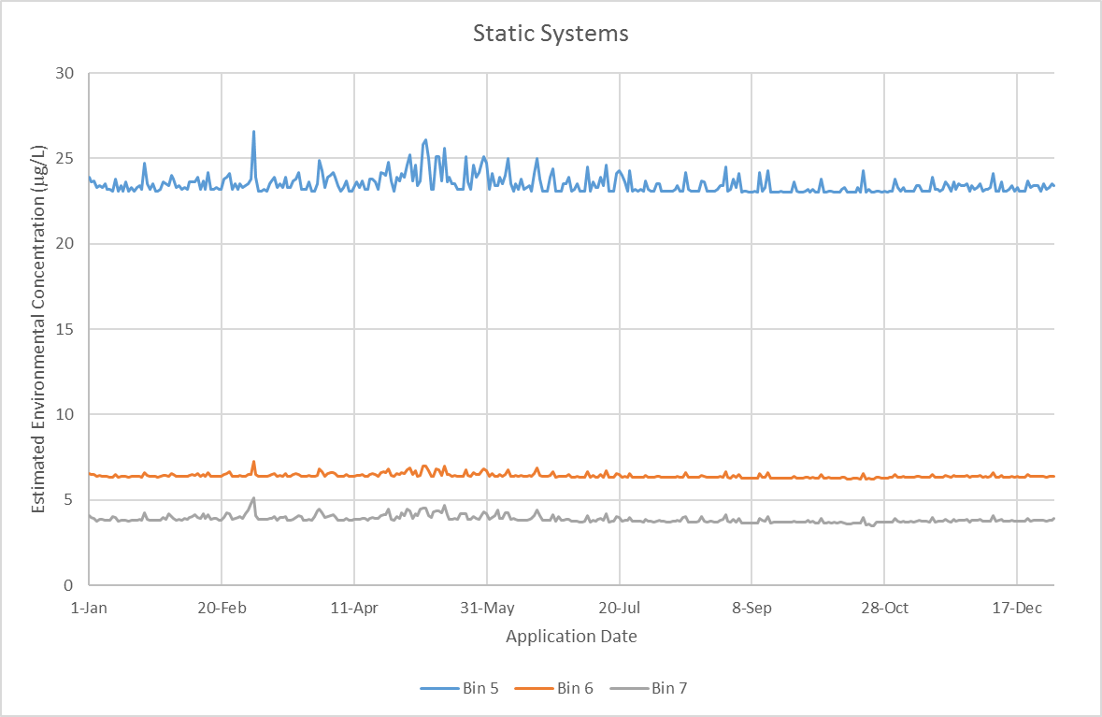

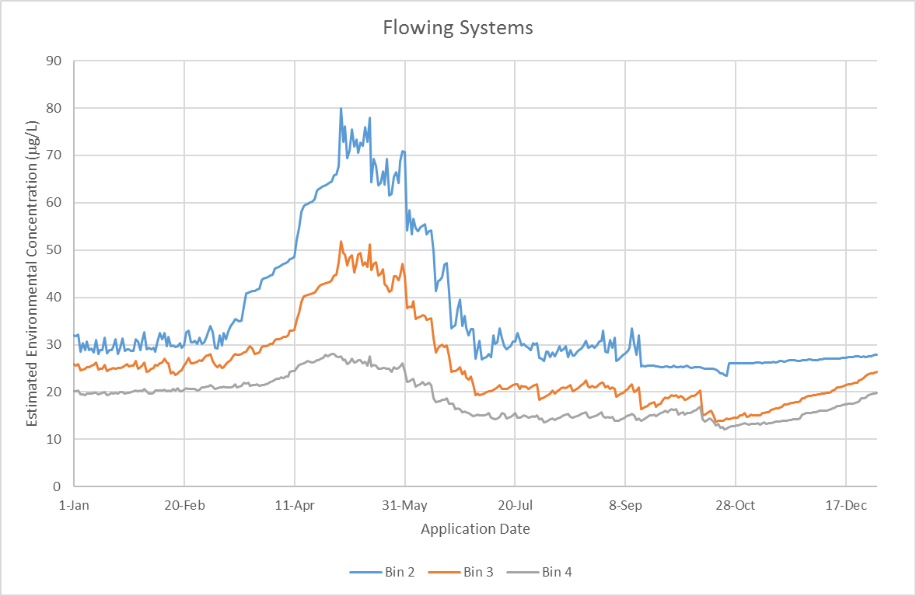
Figure 3-3. Application Sensitivity Analysis HUC 2 Region 5 For Water Column Estimated Environmental Concentrations

Available Monitoring Data

Field Studies

There are no targeted monitoring studies available for chlorpyrifos that assess surface water concentrations resulting from applications of chlorpyrifos to fields.

In a semi-field water monitoring study (MRID 44711601), sampling was conducted at three locations on the lower reach of Orestimba Creek (California) for one year (May 1, 1996 to April 30, 1997). This is considered a semi-field water monitoring study since sampling occurred in regions with noted chlorpyrifos use following application and runoff events. Daily time-proportional composite samples were collected, along with weekly samples. The report included chlorpyrifos use information for fields that drained into the creek or had the potential to contribute spray drift into the creek. All chlorpyrifos applications were made to alfalfa and walnut by aerial equipment and were made during the irrigation season. The total mass of chlorpyrifos applied to all the fields that were identified to have the potential to impact the creek was 2.2 lb a.i./A (1308 kg). Applications occurred throughout the study period (or the day prior to study initiation) with, at most, three fields treated in the study area on the same day. The report suggests that typical chlorpyrifos use occurred during the study period, with the exception of dormant season applications to tree crops, which were limited due to the rainy weather during the study. The measured concentrations at the three sample locations are provided in Figure 3-4. The highest measured concentration was 2.2 µg/L and was associated with a chlorpyrifos application to alfalfa followed by flood irrigation.

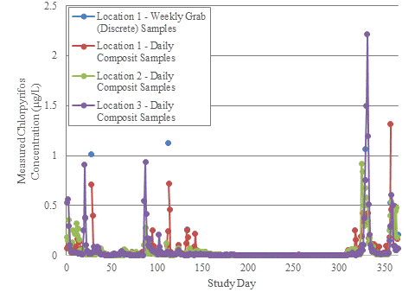
Figure 3-4. Orestimba Creek Water Monitoring Data (May 1, 1996 to April 30, 1997)

In several cases, the weekly grab samples were observed to have higher concentrations of chlorpyrifos. This suggests that the composite sampling methodology used in the study for daily samples resulted in the dilution of peak daily concentrations. Thirteen chlorpyrifos peak concentrations could be associated with specific events. The report authors suggest that nine of the events were related to spray drift (peak concentrations occurring within a three day window of application,) and were not linked to an irrigation event. The other four events were linked to irrigation tail water. Flood irrigation was reportedly used in the treated fields. Most of the peak concentrations were observed following chlorpyrifos applications to walnuts. The report noted that many of the walnut orchards are planted adjacent to the creek with an outside row located on the creek bank. This practice was done to maximize drainage from the orchard floor directly into the stream channel. It is unclear if any buffer zones were in place during application, but the observed concentrations suggest that the spray drift occurred during application even in the absence of adverse wind conditions.

General Monitoring Data

Chlorpyrifos has been sampled for in various monitoring programs. A summary of these programs as related to chlorpyrifos are provided below. It should be noted that for all summarized monitoring data below, it is possible that results may be reported for the same sample in multiple databases evaluated and summarized here. For example, data might be included in both the California Department of Pesticide Regulation (CDPR) and NAWQA (National Water-Quality Assessment) datasets. In addition, some data may not be currently captured in an easily accessible database; however, the data may have been submitted directly to EPA for review. For example, some California data included in this assessment are not included in the California Environmental Data Exchange Network (CEDEN); however, the database is expected to be updated to include such data.

Surface Water

According to surface water monitoring data available for both agricultural as well as non-agricultural areas (see summary in Table 3-16) available at the time of this assessment, the two highest concentrations of chlorpyrifos measured in surface water are 14.7 μg/L [STORET Data Warehouse; US Army; 2006] and 3.96 μg/L [California Department of Pesticide Regulation (CDPR); 2003]. The highest surface water detection of chlorpyrifos-oxon was 0.05 μg/L [USGS National Water-Quality Assessment Program (NAWQA); 2008]. Regional Water Boards within California noted detections of chlorpyrifos in agricultural drains and receiving water bodies as well as storm water runoff drains and at waste water treatment facilities. High detection frequencies in agricultural drains and receiving water bodies are noted, approximately 96 and 90%, respectively. Examination of the EPA 303(d) list of impaired waters indicate that 95 impairments are caused by chlorpyrifos. These impaired waters are located in California, Idaho, Oklahoma, Oregon and Washington.

Table 3-16. Surface Water Monitoring Data Summary for Chlorpyrifos and Chlorpyrifos-oxon
Monitoring Data Source  (type) | Scale | Years of Sampling (number of samples) | Detection Frequency  (%) | Maximum Concentration  (µg/L) | Years of Sampling (number of samples) | Detection Frequency  (%) | Maximum Concentration  (µg/L)
 |  | Chlorpyrifos |  |  | Chlorpyrifos-oxon
USGS NAWQA  (ambient) | National | 1991-2014  (30,251) | 15 | 0.57 | 1999-2014  (8850) | <1% | 0.054
California Department of Pesticide Regulation  (ambient) | State | 1991-2012  (13,120) | 20 | 3.96 | 1991-2012  (1,059) | 0 | na
Washington State Department of Ecology and Agriculture Cooperative Surface Water Monitoring Program  (ambient) | State | 2003-2013  (4,091) | 8.4 | 0.4 | 2009-2013  2359 | 0 | na
USDA Pesticide Data Program  (ambient) | National | 2004-2013 (raw water; 1,691) | 0 | na | 2004-2013^{b}  (raw water; 773) | 0 | na
USGS-EPA Pilot Drinking Water Reservoir  (ambient) | National | 1999-2000  (323) | 5.3 | 0.034 | 1999-2000 | 0 | na
Oregon Department of Environmental Quality  (ambient) | Watershed  (Clackamas) | 2005-2011  (363) | 13 | 2.4 | No data
MRID 44711601  (field study) | Watershed  (Orestimba Creek) | 1996-1997  (1,089) | 61 | 2.22 | No data
California Environmental Data Exchange Network  (ambient) | State | 468  (dissolved) | 29 | 0.013 | No data
 |  | 431  (particulate) | 42 | 0.00074
 |  | 8925  (total) | 18 | 0.013
California Central Coast  Region  Irrigated Lands Regulatory Program  (ambient) | Sub-state | 146 | 35 | 1.5
STORET Data Warehouse  (ambient) | National | 1988-2014  (6054) | 20 | 14.7 | 2009, 2012, and 2013  (936) | 1% | Present below quantification
California Central Valley Region Irrigated Lands Regulatory Program  (ambient) | County | 2013-2014  (467) | 25 | 3.36 | No data
Denton, Texas  (ambient) | Watershed | 2001  (308) | 70 | 0.7 | No data
 |  | 2002  (311) | 4 | 0.11

Sediment

In sediment, the highest concentration of chlorpyrifos observed was 549 μg/kg while chlorpyrifos-oxon was detected at concentrations less than 3 μg/kg (Table 3-17). Open literature articles report chlorpyrifos detections in sediment^{29,,}; however, no detections of chlorpyrifos-oxon in sediment was reported. This is consistent with the environmental fate data for both chemicals. Chlorpyrifos is expected to be more persistent and to partition to sediment, while chlorpyrifos-oxon is expected to transform more rapidly and be less likely to partition to sediment.

Table 3-17. Sediment Monitoring Data Summary for Chlorpyrifos and Chlorpyrifos-oxon
Monitoring Data Source | Scale | Years of Sampling (number of samples) | Detection Frequency  (%) | Maximum Concentration  (µg/kg) | Years of Sampling (number of samples) | Detection Frequency  (%) | Maximum Concentration  (µg/kg)
 |  | Chlorpyrifos |  |  | Chlorpyrifos-oxon
USGS NAWQA | National | 2002-2013  (177) | 2 | 58.6 | 2010 | 0 | < 3
California Department of Pesticide Regulation | State | 2004  (24) | 38 | 0.019 | No data
California Central Coast  Region  Irrigated Lands Regulatory Program  (ambient) | Sub-State | 166 | 38 | 549 | No data
 |  | 5 | 40 | 0.16 µg/L  (pore water)
Los Angeles Region Ventura County  California Irrigated Lands Regulatory Program  (ambient) | Sub-state | 2013-2014  (21) | 81 | 0.026 | No data

Atmospheric

With a vapor pressure of 10⁻⁵ mmHg, chlorpyrifos can be classified as semi-volatile and thus volatility could be expected to play a role in its dissipation. In fact, air (Table 3-18) and precipitation (Table 3-19) monitoring data highlight the potential for chlorpyrifos volatilization. Field volatility studies confirm volatility is a major route of dissipation for chlorpyrifos when applied to foliar surfaces. However, a soil volatility study (MRID 41829006) did not show volatilization from soil to be a significant dissipation pathway.

Chlorpyrifos and chlorpyrifos-oxon have both been detected in air monitoring studies (including fog,,) while only chlorpyrifos was detected in precipitation studies,,. In addition, chlorpyrifos has been detected in dust samples collected from homes in agricultural areas.²⁸ These data confirm the potential for atmospheric transport; however, the mechanism (i.e., spray drift, volatilization, particle transport or combination) could not be determined. Nevertheless, longer range atmospheric transport and redeposition of various pesticides, including chlorpyrifos, has been recorded.,,,, Chlorpyrifos has been observed in snow collected at remote alpine sites., Field volatility studies conducted on alfalfa and potato fields showed approximately 28 - 71 percent of the applied chlorpyrifos volatilized off treated fields, respectively (MRIDs 48883201 and 48998801). Field volatility studies indicate that chlorpyrifos-oxon concentrations are approximately 3% of the total residue observed to come off the treated field. However, one air monitoring study measured higher concentrations of chlorpyrifos-oxon than chlorpyrifos (ratio of 5.6:3.9; chlorpyrifos-oxon: chlorpyrifos).²⁷

Table 3-18. Air Monitoring Data Summary for Chlorpyrifos and Chlorpyrifos-oxonª
Study | Year of Study | Type of Study | Sampler/Site Location | Maximum Air Concentration (ng/m³) | Maximum Air Concentration (ng/m³)
 |  |  |  | Chlorpyrifos | Chlorpyrifos-oxon
Washington DOHª | 2008 | Ambient | North Central District | 21 | 5
 |  | General– near field |  | 607 | 108
 |  | Perimeter Site |  | 1145 | 61
 |  | Ambient | Yakima Valley | 30 | 10
 |  | General– near field |  | 243 | 21
 |  | Perimeter Site |  | 1002 | 124
Lompoc County, CA (CARB) | 2003 |  | Central | 8.3 | 2.9
 |  | Ambient | Northwest | 8.4 | 1.9
 |  |  | Southwest | 6.8 | 1.9
 |  |  | West | 17 | 0.5
Tulare, CA (CARB) | 1996 | Ambient | Air Resource Board | 39 | 60
 |  |  | Jefferson Elementary School | 432 | 173
 |  |  | Kaweah School | 412 | 230
 |  |  | Sunnyside Union Elementary School | 815 | 90
 |  |  | University of CA, Lindcove Field Station | 168 | 174
 |  | Application Site | North | 27,700 | No data
 |  |  | East | 14,700
 |  |  | South | 25,400
Cowiche, WA (PANNA) | 2006 | Ambient | Unspecified | 462 | No data
Tieton, WA  (PANNA) | 2005 | Ambient | Unspecified | 475 | No data
Lindsay, CA  (PANNA) | 2004 | Ambient | Blue House | 137 | No data
Lindsay, CA  (PANNA) | 2004 | Ambient | Green House | 718 | No data
Lindsay, CA  (PANNA) | 2004 | Ambient | Orange House | 1,340 | No data
Lindsay, CA  (PANNA) | 2004 | Ambient | Purple House | 177 | No data
Lindsay, CA  (PANNA) | 2004 | Ambient | Red House | 90 | No data
Lindsay, CA  (PANNA) | 2005 | Ambient | Blue House | 421 | No data
Lindsay, CA  (PANNA) | 2005 | Ambient | Green House | 1,119 | No data
Lindsay, CA  (PANNA) | 2005 | Ambient | Orange House | 561 | No data
Lindsay, CA  (PANNA) | 2005 | Ambient | Purple House | 515 | No data
Alaska^{b} | 2003-2005 | Ambient |  | 1.6 | Combined as total chlorpyrifos
- Fenske, R., Yost, M., Galvin, K., Tchong, Negrete, M., Palmendez, P., Fitzpatrick, C. 2009. Organophosphorus Pesticides Air Monitoring Project, Department of Environmental and Occupational Health Sciences University of Washington School of Public Health
- Chlorpyrifos data are taken from USEPA, Chlorpyrifos: Preliminary Human Health Risk Assessment for Registration Review, June 30, 2011, D388070
Department of Health (DOH); California Air Resource Board (CARB); Pesticide Action Network North America (PANNA)
not monitored (nm)

Table 3-19. Precipitation Monitoring Data Summary for Chlorpyrifos and Chlorpyrifos-oxon
Study | Year of Study | Type of Study | Sampler/Site Location | Maximum Concentration (µg/L) | Maximum Air Concentration (µg/L)
 |  |  |  | Chlorpyrifos | Chlorpyrifos-oxon
San Joaquin River Basinª | 2001 | Ambient | Barnhardt Road near Turlock | 0.052 | No data
 |  |  | Wastewater Treatment Plant Rooftop at Modesto | 0.086
 |  |  | Cadoni Road lift Station at Modesto | 0.071
 |  |  | MID Lateral 4 near Modesto | 0.034
 |  |  | MID rooftop at Modesto | 0.063
 |  |  | Albers Road near Turlock | 0.148
Alaska^{b} | 2003-2005 | Ambient | snow |  | Combined as total chlorpyrifos
a. Zamora, Celia.; Kratzer, Charles R.; Majewski, Michael S.; Knifong, Donna L., “Diazinon and Chlorpyrifos Loads in Precipitation and Urban and Agricultural Storm Runoff during January and February 2001 in the San Joaquin River Basin, California”(2003) USGS
b.

Monitoring Results

General monitoring concentrations in waterbodies in the United States, irrespective of the size or location of the waterbody, ranged from less than the limit of detection (LOD varies depending on monitoring program and sample year) to 14.7 µg/L. Data from these monitoring studies are not correlated with known applications of pesticides under well-described conditions (e.g., application rate, field characteristics, water characteristics, and meteorological conditions). Therefore, general monitoring data cannot be used to estimate pesticide concentrations after a pesticide application or to evaluate performance of fate and transport models (NRC 2013). While general monitoring data may underestimate potential exposure, they provide useful information for describing water quality trends and the environmental baseline condition of species habitats including the occurrence of chemical mixtures and the presence of abiotic stressors that can increase risk.

WARP Model and Extrapolation of Monitoring Results

The Watershed Regression for Pesticides for multiple pesticides (WARP-MP) Map Application recently became available on the US Geologic Survey website (http://cida.usgs.gov/warp/home/). The WARP models for pesticides are developed using linear regression methods to establish quantitative linkages between pesticide concentrations measured at NAWQA and National Stream Quality Accounting Network (NASQAN) sampling sites and a variety of human-related and natural factors that affect pesticides in streams. Such factors include pesticide use, soil characteristics, hydrology, and climate - collectively referred to as explanatory variables. Measured pesticide concentrations, together with the associated values of the explanatory variables for the sampling sites, comprise the model-development data.

The WARP-MP Map Application is built upon the atrazine WARP models, in conjunction with an adjustment factor for each pesticide. The WARP model for estimating atrazine in streams is based on concentrations measured by NAWQA and NASQAN from 1992 to 2007 at 114 stream sites. The atrazine model actually consists of a series of models, each developed for a specific concentration statistic (annual mean and 4-, 21-, 30-, 60-, and 90-day annual maximum moving average). The models are built using the explanatory variables that best correlate with, or explain, the concentration statistics computed from concentrations observed in streams. Although explanatory variables included in the models are significantly correlated with pesticide concentrations, the specific cause-and-effect relations responsible for the observed correlations are not always clear, and inferences regarding causes should be considered as hypotheses.

The WARP models used on the Map Application web site to create maps and graphs are the models for the annual mean and annual maximum moving averages (4-, 21-, 30-, 60-, and 90-day durations. For each of these annual concentration statistics, the models can be used to estimate the value for a particular stream, including confidence bounds on the estimate, or the probability that a particular value will be exceeded, such as a water-quality benchmark. Each of these options for applying the model has advantages for specific purposes.

When used to estimate the value of a concentration statistic for a stream, such as the annual mean, the model computes the median estimate of the statistic for all streams with watershed characteristics that are similar to the stream in question. Thus, the computed estimate for a particular stream has an equal chance of being above or below the actual value of the statistic. The confidence that the estimated value is within a certain magnitude of the actual value is indicated by the 95-percent confidence limits, which encompass 95 percent of the actual values associated with the predicted value.

When used to estimate the probability that a particular stream has a pesticide concentration greater than a specific threshold, usually a water-quality benchmark, the model prediction and uncertainty are combined to estimate the probability for the stream.

For 2012, Table 3-20 provides the range of the estimated 4-day moving average concentrations and the upper bound 4-day moving average concentrations for chlorpyrifos by HUC 2. The 4-day averages are reported as peak concentrations are not provided by the Map Application. These values are approximately several orders of magnitude below the PRZM5/VVWM modeled concentrations. The highest 4-day average concentration is 2.06 µg/L for HUC 2 region 12 while the upper bound 4-day average concentration is 86.8 µg/L also in HUC 2 region 12.

Table 3-20. WARP Map Application Estimated 4-day Moving Average Concentrations for Chlorpyrifos
HUC 2 | Count of Detects (Total Count) | Range of Estimated 4-day Moving Average Concentrations (µg/L) | Range of Upper Bound 4-day Moving Average Concentrations (µg/L)
1 | 720 (891) | < 0.001 – 0.03 | < 0.001 – 1.04
2 | 1432 (1631) | < 0.001 – 0.42 | < 0.001 – 15.29
3 | 3434 (4058) | < 0.001 – 0.53 | < 0.001 – 20.86
4 | 955 (1227) | < 0.001 – 0.28 | < 0.001 – 10.14
5 | 2278 (2758) | < 0.001 – 0.17 | < 0.001 – 6.25
6 | 593 (728) | < 0.001 – 0.10 | < 0.001 – 3.64
7 | 2403 (2579) | < 0.001 – 0.50 | < 0.001 – 19.93
8 | 307 (697) | < 0.001 – 0.06 | < 0.001 – 2.19
9 | 417 (441) | < 0.001 – 0.59 | < 0.001 – 23.18
10 | 4493 (6177) | < 0.001 – 1.18 | < 0.001 – 46.52
11 | 2173 (2402) | < 0.001 – 0.92 | < 0.001 – 36.27
12 | 1321 (1560) | < 0.001 – 2.06 | < 0.001 – 86.75
13 | 283 (470) | < 0.001 – 0.06 | < 0.001 – 2.37
14 | 445 (707) | < 0.001 – 0.04 | < 0.001 – 1.61
15 | 202 (495) | < 0.001 – 0.08 | < 0.001 – 3.21
16 | 198 (397) | < 0.001 – 0.03 | < 0.001 – 1.26
17 | 1839 (3327) | < 0.001 – 0.13 | < 0.001 – 5.19
18 | 573 (750) | < 0.001 – 0.44 | < 0.001 – 17.89

Aquatic Exposure Summary

Model derived EECs represent an upper bound on potential exposure as a result of the use of chlorpyrifos. These values are approximately generally several orders of magnitude greater for the flowing bins than General concentrations and often exceed the expected solubility limit. EECs for the static bins are also much higher than General monitoring data. As recommended by the NRC in the 2013 NAS report, General monitoring data are not recommended to be used to estimate pesticide concentrations after a pesticide application or to evaluate the performance of EPA’s fate and transport models. However, EPA believes monitoring data can be used as part of the weight-of-evidence evaluation to present a lower bound on known exposure.

Uncertainties in Aquatic Modeling and Monitoring Estimates

Surface Water Aquatic Modeling

Exposure to aquatic organisms from pesticide applications is estimated using PRZM/VVWM EECs. Regional differences in exposure are assessed using regionally-specific PRZM scenarios (e.g., information on crop growth and soil conditions) and meteorological conditions at the HUC 2 level (Section 2.3. Scenario Selection). The information used in these scenarios is designed to reflect conditions conducive to runoff. In instances where PRZM scenarios do not exist in a HUC 2, surrogate scenarios from other HUCs are used. For fields where agricultural practices that result in less conservative scenario parameters are employed (i.e., conditions less conducive to runoff and pesticide loading of waterbodies), the potential for lower EECs would be expected.
The static waterbodies modeled with VVWM are fixed volume systems with no outlet, resulting in the potential for accumulation of pesticide over time. Effects due to the increase and/or decrease of the water level in the waterbody and thus the concentration of pesticide in the waterbody are not modeled.
Flowing waterbodies are modeled in the VVWM using the constant volume and flow through custom waterbody option. Effects due to the increase and/or decrease of the water level and flowrate in the waterbody and thus the concentration of pesticide in the waterbody are not modeled. Watershed areas are developed using NHDPlus data for each HUC 2 region and a log-log regression of drainage area to flowrate. Where contributing watershed areas are smaller than those predicted, this would result in less mass loading and runoff contributions to the waterbody and lower concentrations.
The assessment relies on maximum use patterns (Section 2. Measures of Aquatic Exposure). In situations where use patterns are less than the labeled maximums, environmental exposures will be lower.
The aquatic modeling conservatively assumes that the waterbody abuts the treated area. As such, any reduction in loading from runoff that could occur as the result of managed vegetative filter strips or unmanaged naturally-occurring interfaces between treated areas and waterbodies are not taken into account.
The aquatic modeling assumes a constant wind of 10 mph blowing directly toward the waterbody (Section 2.4.2. Spray Drift). These assumptions are conducive to drift transport and result in maximum potential loading to the waterbody. However, in many situations the wind will not be blowing constantly and directly toward the water body at this speed; therefore, aquatic deposition will likely be less than predicted. Additionally, many labels and applicator best management practices encourage not applying pesticides when the wind is blowing in the direction of sensitive areas (i.e., listed species habitat). Lastly, reductions in spray drift deposition due to air turbulence, interception of spray drift on nearby plant canopy, and applications during low wind speeds are not taken into account in the spray drift estimates; therefore, loading due to spray drift may be over-estimated.
There is uncertainty associated with the selection of PRZM/VVWM input parameters. In this regard, one of the important parameters that can impact concentration estimates is the selection of application dates (Section 2.4.3. Application Timing); runoff and potential pesticide loading are greatest when applications immediately precede major precipitation events. Although the pesticide application dates are selected to be appropriate and protective (i.e., selected with consideration for label restrictions and simulated cropping dates, pest pressures, and high precipitation meteorological conditions), uncertainty nevertheless results because the application window (the time span during a season that a pesticide may likely be applied) for a pesticide may be wide and actual application dates may vary over the landscape. While data sources exist that allow for determination of historical application dates (e.g., California’s Pesticide Use Report and pesticide use surveys), it is uncertain how these dates reflect future application events. Additionally, the PRZM/VVWM models use the same application dates for the 30-year simulation. While it is unlikely that an application would occur on the same dates every year for 30 years, this modeling process allows for a distribution of EECs to be developed that captures the peak loading events.
In the case of applications to rice paddies or cranberry bogs, the PFAM model is used to estimate concentrations in the flooded field (Section 2.5.2. Cranberry Modeling). For listed species that may visit a paddy or bog, the water column and sediment estimates are intended to be protective of exposures they may encounter. However, for listed species whose habitat is outside the flooded area, the use of water column and sediment concentrations from the paddy or bog is likely to overestimate exposure due to dilution and dispersion of the pesticide when discharged to a flowing waterbody. Additionally, as these flooded field systems tend to have water management controls which regulate the maximum release of paddy or bog water, the pesticide concentration in the water, and allow for manual releases in the fall during harvest, exposure could be limited to a specific time of year and not year-round.

Aquatic Bins 3 and 4

PRZM/VVWM are field-scale models. Flowing water bodies such as streams and rivers with physical parameters consistent with aquatic Bins 3 and 4 have watershed areas well beyond those of typical agricultural fields. Watershed sizes assumed for Bin 3 habitats exceeded 10,000 acres and Bin 4 watersheds were assumed to be greater than 4 million acres. Initial modeling efforts, applying the field-scale model to these large watersheds and using the same scenario parameters as those used for the other bins, results in extremely high EECs which have not been observed in the environment, nor would be expected to occur due to fluid dynamic processes such as advective dispersion (Figure 3-5), where the peak concentration is dampened as it moves from a low flowing stream (Bin 2) to a higher flowing river (Bins 3 and 4). Several adjustments, discussed in ATTACHMENT 3-1 (Background Document Aquatic Exposure Estimation for Endangered Species), have been made to the inputs and outputs to reflect changes that would be anticipated in modeling such scenarios. However, in most cases for the pilot chemicals these adjustments did not decrease the EECs. It is acknowledged that a watershed/basin-scale model capable of evaluating the impact of pesticide and water transport at the field-scale and aggregating these loadings to waterbodies at the larger watershed-scale is needed to evaluate these flowing aquatic systems.
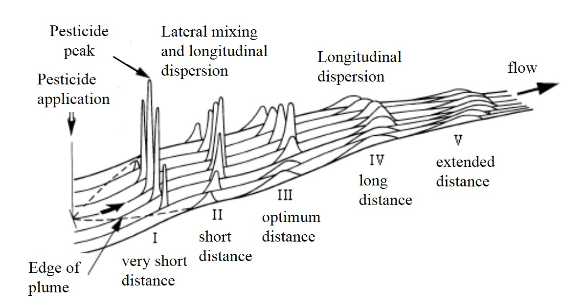
Figure 3-5. Effect of Pesticide Concentration via Advective Dispersion

Measures of terrestrial exposure

Introduction

Terrestrial animals may be exposed to chlorpyrifos through multiple routes of exposure, including diet, drinking water, dermal and inhalation. If the species consumes plants, invertebrates or vertebrates (amphibians, reptiles, birds or mammals) that inhabit terrestrial areas, T-REX is used by EFED. If the species consumes aquatic organisms, then KABAM is used. As noted in the Problem Formulation, to improve efficiency and expand EFED’s modeling capabilities to other, non-dietary routes of exposure for terrestrial organisms, the Terrestrial Effects Determination (TED) tool was developed. This tool integrates T-REX, T-HERPS and the earthworm fugacity model, along with several other models used by EFED. When this document indicates that T-REX or the earthworm fugacity models should be run for a species, the TED tool will be run. Assessors could also run the current version of T-REX. As discussed in the terrestrial exposure appendix, KABAM will not be run for chlorpyrifos, diazinon or malathion. In its place, BCF values will used to estimate exposure through consumption of aquatic food items. The spray drift model, AgDRIFT, will be used in the effects determinations to characterize the distance from the edge of the field to which exposure is at levels of concern for a species.

Two major parameters are used in Tier I modeling to represent species: body weight and diet. Estimates of body weights are necessary to estimate dose-based exposures through diet, drinking water, inhalation and dermal exposure routes. Information on the dietary requirements of listed species are necessary to determine relevant exposures through consumption of contaminated prey. Species-specific assumptions related to diet and body weight are provided in ATTACHMENTS 1-16 through 1-19.

This section characterizes the estimated exposures of chlorpyrifos on different food items in the terrestrial environment and in fish (which may be consumed by piscivorous mammals and birds). These values are used to generate dose-based dietary exposure estimates. Species specific dose-based exposures through diet, drinking water, dermal and inhalation routes will be provided in the TED tool outputs. ATTACHMENT 1-7 discusses the methods for estimating dose-based exposures. Upper bound exposure estimates are used in Step 1 of the ESA process, with upper bound and mean residues over time being used in Step 2.

Four different chlorpyrifos application scenarios were used to estimate terrestrial exposure: 1) a minimum single application rate (1.0 lb a.i./A); 2) an upper-bound single application rate (4.0 lb a.i./A); 3) a maximum single application rate (6.0 lb a.i./A); and 4) a multiple application scenario (2 applications at 4 lb a.i./A with 7 day intervals). These application scenarios are meant to be representative of the range of application rates and uses for chlorpyrifos. The first two scenarios are based on the range of single application rates allowed for a large majority of chlorpyrifos uses. The third rate is based on the maximum application rate allowed for chlorpyrifos, which is for foliar applications to citrus. The fourth application scenario represents an upper bound multiple application rate.

Estimated concentrations in terrestrial food items (mg a.i./kg-food)

The TED tool generates estimates of pesticide concentrations in above-ground terrestrial invertebrates, grass (tall and short), broadleaves, fruit and seeds. Recent additions to the model have allowed for calculation of pesticide concentrations in soil-dwelling invertebrates (using earthworm partitioning model) and in terrestrial vertebrates (i.e., birds and mammals; using the T-HERPS model).

The T-REX model is intended to simulate foliar spray applications of pesticides. The single foliar application rates modeled for chlorpyrifos range from 1.0 to 6.0 lb a.i./A. In order to bound exposure estimates, minimum and maximum application scenarios are used to run T-REX. These single rates will be modeled, along with two applications of 4 lb a.i./A, which is representative of higher application rates for more crops. The maximum application scenario modeled will be 2 applications (7 d interval) at a maximum rate of 4 lb a.i./A. T-REX accounts for dissipation of pesticide residues on food items. A foliar dissipation half-life of 4 days is used for chlorpyrifos, based on data reported by Willis and McDowell (1987). Table 3-21 summarizes the mean and upper bound dietary-based EECs. Additional description of the estimated chlorpyrifos concentrations on food items is provided in the following sections.

Table 3-21. Mean and upper bound dietary based EECs calculated for food items consumed by listed birds, terrestrial-phase amphibians or reptiles. Values represent potential exposures for animals feeding on the treated field or in adjacent habitat directly adjacent to the field.¹
Food Item | Model | Minimum single application rate modeled  (1.0 lb a.i./A) |  | Maximum application scenario modeled  (2 applications of 4.0 lb a.i./A) |  | Maximum single application rate modeled  (1 application of 6.0 lb a.i./A)
 |  | Mean | Upper bound | Mean | Upper bound | Mean | Upper bound
Terrestrial invertebrates (above ground) | T-REX | 65 | 94 | 260 | 376 | 390 | 564
Terrestrial invertebrates (soil dwelling) | Earthworm fugacity | NA | 16 | NA | 65 | NA | 97
Short grass | T-REX | 85 | 240 | 340 | 960 | 510 | 1440
Tall grass (surrogate for nectar and flowers) | T-REX | 36 | 110 | 144 | 440 | 216 | 660
Broadleaves | T-REX | 45 | 135 | 180 | 540 | 270 | 810
Seeds and fruit | T-REX | 7 | 15 | 28 | 60 | 42 | 90
Birds (small, insectivore)*** | T-HERPS | 74 | 107 | 296 | 428 | 444 | 642
Mammals (small, herbivore)*** | T-HERPS | 81 | 229 | 324 | 915 | 486 | 1373
Amphibians/reptiles (small, insectivore) | T-HERPS | 4 | 5 | 14 | 21 | 22 | 31
Aquatic plants | KABAM | 0.024-241**
Aquatic invertebrates | BCF* | 0.0080-80**
Fish | BCF* | 0.031-306**
¹ Additional EECs are available in the TED tool.
*Based on range of empirical BCFs.
**Varies based on EECs in water.
***Also represent residues in carrion.
NA = not applicable

Terrestrial invertebrates

For terrestrial invertebrates inhabiting the treated field (above ground), upper bound peak EECs range 94-564 mg a.i./kg-food. Mean values range 65-390 mg a.i./kg-food. Figure 3-5 depicts the estimated concentrations of chlorpyrifos on above ground terrestrial invertebrates over time. When chlorpyrifos is applied at a single application of 1.0 lb a.i./A, chlorpyrifos upper bound residues are <0.01 mg a.i./kg-food 52 days after the application. For the maximum use scenario, upper bound residues of chlorpyrifos reach <0.01 mg a.i./kg-food at 70 days after the first application. It should be noted that if the interval between applications were longer than 7 days, the residues would persist at levels >0.01 mg a.i./kg-food for a greater period of time.

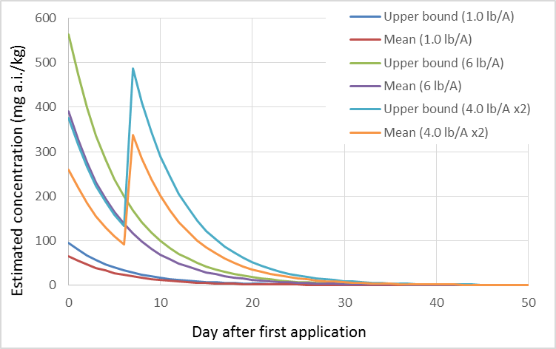
Figure 3-5. Mean and upper bound estimated concentrations of chlorpyrifos on above ground terrestrial invertebrates.

The earthworm fugacity model was used to estimate pesticide concentrations in soil-dwelling invertebrates located on treated fields. For applications of 1.0 and 6.0 lb/A, the steady state concentration of chlorpyrifos in soil-dwelling invertebrates is estimated at 16 and 95 mg a.i./kg-food, respectively. These values were estimated using a Koc of 6040 L/kg-soil and a Log Kow of 4.7 (see fate characterization).

Terrestrial plants (seeds, fruit, nectar and leaves)

Many listed species consume plant matter, including seeds, fruit, nectar and leaves. T-REX EECs for these food items are depicted in Figures 3-6 to 3-9. Among these food items, residues on short grass are the highest, followed by broadleaves, tall grass and then seeds and fruit. Since insufficient data are available for estimating pesticide residues in nectar, the tall grass EEC is used as a surrogate for this food item. This is based on an analysis completed for the risk assessment methodology for honey bees.

For seeds and fruit located on the treated field, upper bound peak EECs range 15-90 mg a.i./kg-food. Mean values range 7-42 mg a.i./kg-food. Figure 3-6 depicts the estimated concentrations of chlorpyrifos on seeds and fruit over time. When chlorpyrifos is applied at a single application of 1.0 lb a.i./A, chlorpyrifos upper bound residues are <0.01 mg a.i./kg-food 42 days after the application. For 2 applications at 4 lb a.i./A (7 d interval), upper bound residues of chlorpyrifos reach <0.01 mg a.i./kg-food at 59 days after the first application.

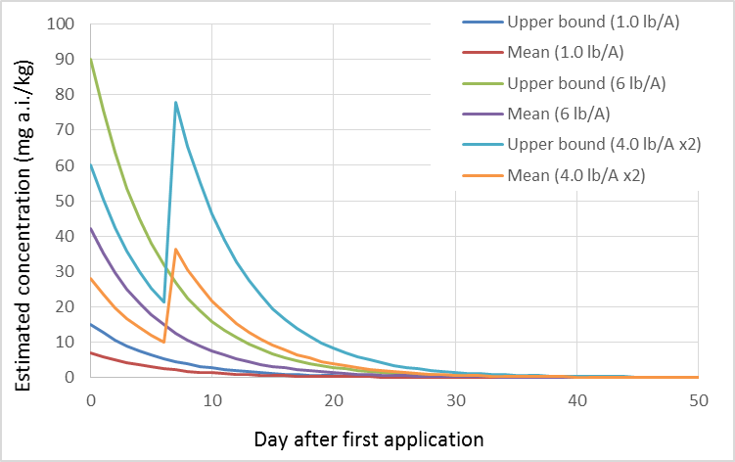
Figure 3-6. Mean and upper bound estimated concentrations of chlorpyrifos on seeds and fruit.

For broadleaf plants located on the treated field, upper bound peak EECs range 135-810 mg a.i./kg-food. Mean values range 45-270 mg a.i./kg-food. Figure 3-7 depicts the estimated concentrations of chlorpyrifos on broadleaf plants over time. When chlorpyrifos is applied at a single application of 1.0 lb a.i./A, chlorpyrifos upper bound residues are <0.01 mg a.i./kg-food 55 days after the application. For 2 applications at 4 lb a.i./A (7 d interval), upper bound residues of chlorpyrifos reach <0.01 mg a.i./kg-food at 72 days after the first application.

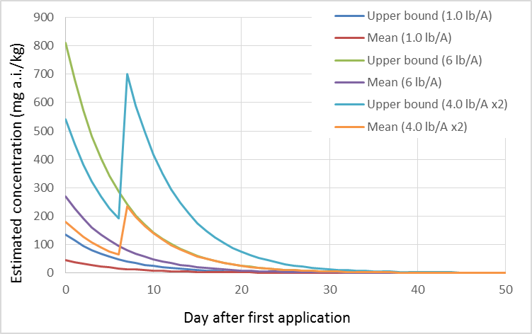
Figure 3-7. Mean and upper bound estimated concentrations of chlorpyrifos on broadleaves.

For grass located on the treated field, upper bound peak EECs range 110-660 mg a.i./kg-food for tall grass and 240-1440 for short grass. Mean values range 36-216 mg a.i./kg-food for tall grass and 85-510 for short grass. Figures 3-8 and 3-9 depicts the estimated concentrations of chlorpyrifos on grass over time. When chlorpyrifos is applied at a single application of 1.0 lb a.i./A, chlorpyrifos upper bound residues are <0.01 mg a.i./kg-food at 54 and 59 days after the application for tall and short grass, respectively. For 2 applications at 4 lb a.i./A (7 d interval), upper bound residues of chlorpyrifos reach <0.01 mg a.i./kg-food at 71 and 75 days after the first application for tall and short grass (respectively).

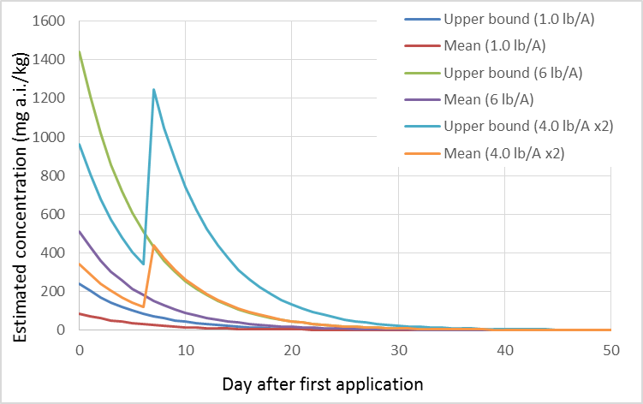
Figure 3-8. Mean and upper bound estimated concentrations of chlorpyrifos on short grass.

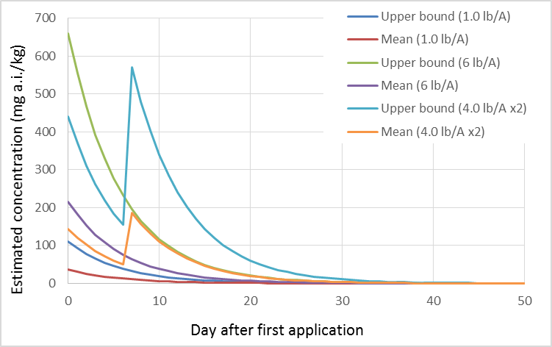
Figure 3-9. Mean and upper bound estimated concentrations of chlorpyrifos on tall grass. Note that tall grass EECs are used as a surrogate for nectar.

Terrestrial vertebrates (birds, mammals, amphibians, reptiles)

Chlorpyrifos concentrations in terrestrial vertebrate prey consuming grass or insects from treated areas are presented in Table 3-21. These estimates represent the peak values from mean and upper bound residues on food items directly sprayed with chlorpyrifos. As chlorpyrifos residues on grass and insects dissipate, residues would be expected to decrease in terrestrial vertebrate prey. In addition, chlorpyrifos residues would likely be metabolized by terrestrial vertebrates to the degradate, 3,5,6-trichloropyridonol (TCP). Therefore, EECs in Table 3-21 represent conservative estimates of chlorpyrifos concentrations in vertebrate prey.

The estimated concentrations of chlorpyrifos in terrestrial vertebrates are also used to represent concentrations in carrion. It is possible that exposed animals may die due to chlorpyrifos or other factors. For birds, some of the EECs overlap with levels where mortality is expected (LD50 values range from 2.5 to 545 mg a.i./kg-bw). For mammals, the LD50s range 60 to 500 mg a.i./kg-bw.

Estimated concentrations in aquatic food items (mg a.i./kg-food)

Aquatic plants

No empirical bioconcentration factor (BCF) values are available for aquatic plants exposed to chlorpyrifos, and no data are available to describe the metabolism of chlorpyrifos by aquatic plants. Therefore, the KABAM generated BCF for phytoplankton, 2407, is used to estimate chlorpyrifos concentrations in algae and aquatic plants that could potentially be consumed by listed species. Figure 3-10 depicts the estimated chlorpyrifos concentrations in aquatic plants exposed at different concentrations in water.

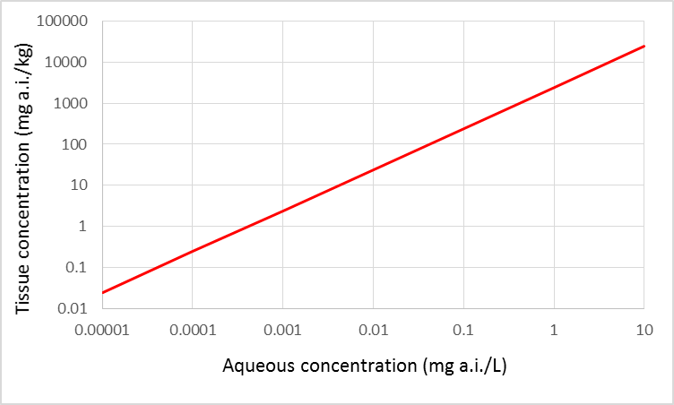
Figure 3-10. Chlorpyrifos concentrations in aquatic plants resulting from bioconcentration different aqueous concentrations.

Aquatic invertebrates

Because a reliable metabolism rate constant cannot be generated to parameterize KABAM, the empirical BCF values (90th percentile and mean) for aquatic invertebrates and fish are used to estimate chlorpyrifos concentrations in aquatic organisms. Empirical BCFs for chlorpyrifos range are as high as 874 in aquatic invertebrates, with a mean of 585. EECs in aquatic habitats range from the parts per trillion to the parts per million range. The estimated concentrations in aquatic organisms resulting from this range of EECs are used in combination with the mean and upper bound of BCFs to bracket the potential concentrations of chlorpyrifos in aquatic invertebrate tissues (at steady state). Figure 3-11 depicts the mean (blue) and upper (red) bounds (90th percentile). It should be noted that tissue concentrations in aquatic invertebrates will likely be bound by toxicity of chlorpyrifos on these organisms. For instance, the LC50 values for aquatic invertebrates exposed to chlorpyrifos range from 0.0138 µg/L to 21,700 µg a.i./L.

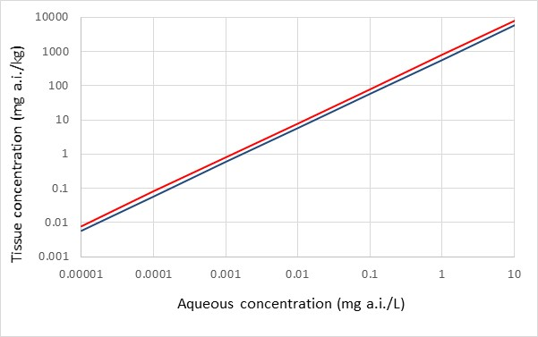
Figure 3-11. Upper (red) and mean (blue) of chlorpyrifos concentrations in aquatic invertebrates resulting from bioconcentration at different aqueous concentrations.

Fish

Empirical BCFs for chlorpyrifos are as high as 5100 in fish, with a mean of 1513. Figure 3-12 depicts the mean (blue) and upper (red) bounds (i.e., 90th percentile-3058) of chlorpyrifos concentrations in fish tissues resulting from environmentally relevant aqueous concentrations. Although fish are less sensitive to chlorpyrifos exposures compared to aquatic invertebrates, mortality to fish may also be a limitation of how much chlorpyrifos may be bioconcentrated in fish (available LC50 values for fish range from 0.17 - 7,012 µg/L ).

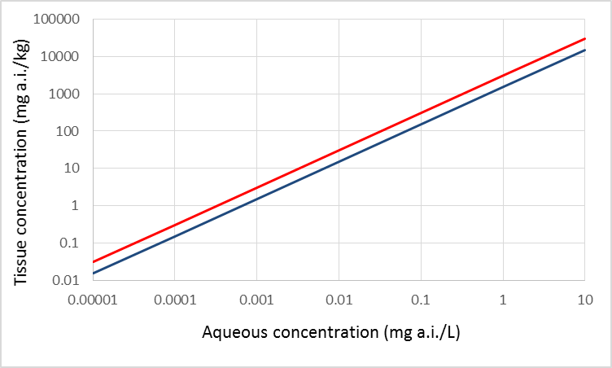
Figure 2-12. Upper (red) and mean (blue) of chlorpyrifos concentrations in fish resulting from bioconcentration at different aqueous concentrations.

USEPA. 2012a. Criteria Used by the PBT Profiler. September 4, 2012. Office of Chemical Safety and Pollution Prevention. United States Environmental Protection Agency. Available at http://www.pbtprofiler.net/criteria.asp
Jokanovic M. 2001. Biotransformation of organophosphorous compounds. Toxicology 166, 139-160
Bavcon Kralj, M., Franko, M., and Trebse, P. Photodegradation of Organophosphorus Insecticides - Investigations of Products and Their Toxicity Using Gas Chromatography-Mass Spectrometry and Ache-Thermal Lens Spectrometric Bioassay. Chemosphere. 2007, Feb; 67(1):99-107.
http://water.epa.gov/scitech/swguidance/fishstudies/lakefishtissue_index.cfm
Woodburn KB, Hansen SC, Roth GA, Strauss K (2003) The bioconcentration and metabolism of chlorpyrifos by the eastern oyster, Crassostrea virginica. Environ Toxicol Chem 22:276-284.
El-Amrani S, Pena-Abaurrea M, Sanz-Landaluze J, Ramos L, Guinea J, Camara C (2012) Bioconcentration of pesticides in zebrafish eleutheroembryos (Danio rerio). Sci Tot Environ 425:184-190
Varό, I, Serrano, R., Pitarch, E., Amat, F., Lόpez, F. J., Navarro, J. C. Bioaccumulation of Chlorpyrifos Through an Experimental Food Chain: Study of Protein HSP70 as Biomarker of Sublethal Stress in Fish Arch. Environ. Contam. Toxicol. 42, 229-235 (2002)
The exposure models can be found at: http://www.epa.gov/pesticides/science/models_pg.htm
http://www.epa.gov/oppefed1/models/water/input_parameter_guidance.htm (accessed April 11, 2014)
http://www.epa.gov/oppfead1/international/naftatwg/guidance/degradation-kin.pdf (accessed April 11, 2014)
http://www.regulations.gov/#!docketDetail;D=EPA-HQ-OPP-2013-0676 (accessed April 11, 2014)
Carbone, J.P., Havens, P.L., and Warren-Hicks, W, 2002. Validation of Pesticide Root Zone Model 3.12: Employing Uncertainty Analysis. Environmental Toxicology and Chemistry, Vol. 21, No. 8, pp. 1578–1590, 2002.
http://www.epa.gov/scipoly/sap/meetings/2004/march/chapter4.pdf.
Young, Dirk, 2014. The Variable Volume Water Model and the USEPA Standard Water Bodies for Pesticide Risk Assessments. Environmental Fate and Effects Division, Office of Pesticide Programs, U.S. Environmental Protection Agency, Washington, D.C. 20460.
Burns, L. 2 Exposure Analysis Modeling System (EXAMS): User Manual and System Documentation (EPA/600/R-00/081)004. September, 2000, Revision G (May 2004) (http://www2.epa.gov/sites/production/files/documents/EXAMREVG.PDF)
FIFRA Environmental Model Validation Task Force. 2001. Comparative Evaluation of PRZM to Measured Data. Main report and Appendices 1-4 and 6. (http://femvtf.com/femvtf/)
Luo, Y and Deng, X, 2012. Methodology for Evaluating Pesticides for Surface Water Protection II: Refined Modeling. CEPA, CDPR. Sacramento, CA.
The drainage of the Ohio River Basin, excluding the Tennessee River Basin. Includes parts of Illinois, Indiana, Kentucky, Maryland, New York, North Carolina, Ohio, Pennsylvania, Tennessee, Virginia and West Virginia.
Hourly samples were collected and composited over a 24-hour period; relatively large fluctuations in stream flow were anticipated during unattended operation of the auto samplers
Fields within 305 m buffer on either side of the mid-stream line
The term "303(d) list" is short for the list of impaired and threatened waters (stream/river segments, lakes) that the Clean Water Act requires all states to submit for EPA approval every two years on even-numbered years. The states identify all waters where required pollution controls are not sufficient to attain or maintain applicable water quality standards, and establish priorities for development of TMDLs based on the severity of the pollution and the sensitivity of the uses to be made of the waters, among other factors (40C.F.R. §130.7(b)(4)). States then provide a long-term plan for completing TMDLs within 8 to 13 years from first listing. More information is available at http://water.epa.gov/lawsregs/lawsguidance/cwa/tmdl/
Crawford, Kevin D; Weinstein, John E; Hemingway, Ronald E; Garner, Thomas R; Globensky, Gavin, and Crawford, Kevin D. A Survey of Metal and Pesticide Levels in Stormwater Retention Pond Sediments in Coastal South Carolina. 2010 Jan; 58, (1): 9-23.
Echols, K. R., Brumbaugh, W. G., Orazio, C. E., May, T. W., Poulton, B. C., and Peterman, P. H. ( Distribution of Pesticides, Pahs, Pcbs, and Bioavailable Metals in Depositional Sediments of the Lower Missouri River, Usa. Arch environ contam toxicol. 2008, aug; 55(2):161-72
Pait, Anthony S; Whitall, David R; Dieppa, Angel; Newton, Sarah E; Brune, Lia; Caldow, Chris; Mason, Andrew L; Apeti, Dennis a; Christensen, John D, and Pait, Anthony S. Characterization of Organic Chemical Contaminants in Sediments From Jobos Bay, Puerto Rico. 2012 Aug; 184, (8): 5065-5075.
Glotfelty, D. E.; Seiber, J. N., and Liljedahl, L. A. Pesticides in Fog. 1987; 325, 602-605.
Glotfelty, D. E.; Majewski, M. S.; Selber, J. N. Distribution of Several Organophosphorus Insecticides and Their Oxygen Analogues in a Foggy Atmosphere. Environ. Sci. Technol., 1990, 24 (3), 353-357.
Harnly, M. E.; Bradman, A.; Nishioka, M.; McKone, T. E.; Smith, D.; McLaughlin, R.; Kavanagh-Baird, G.; Castorina, R., and Eskenazi, B. Pesticides in Dust from Homes in an Agricultural Area. 2009; 43, (23): 8767-8774.
Mast, M Alisa; Alvarez, David a, and Zaugg, Steven D. Deposition and Accumulation of Airborne Organic Contaminants in Yosemite National Park, California. 2012 Mar; 31, (3): 524-533.
Zamora, Celia.; Kratzer, Charles R.; Majewski, Michael S.; Knifong, Donna L., “Diazinon and Chlorpyrifos Loads in Precipitation and Urban and Agricultural Storm Runoff during January and February 2001 in the San Joaquin River Basin, California”(2003) USGS
Vogel, J. R.; Majewski, M. S., and Capel, P. D. Pesticides in Rain in Four Agricultural Watersheds in the United States. 2008; 37, 1101-1115.
Fellers, G.M, L.L. McConnell, D. Pratt, S. Datta. 2004. Pesticides in Mountain Yellow-Legged Frogs (Rana Mucosa) from the Sierra Nevada Mountains of California, USA. Environ. Tox. Chem. 23 (9):2170-2177.
Sparling, D.W., Fellers, G.M., McConnell, L.L., 2001. Pesticides and amphibian population declines in California USA. Environ. Tox. Chem. 20: 1591-1595.
LeNoir, J.S., L.L. McConnell, G.M. Fellers, T.M. Cahill, J.N. Seiber. 1999. Summertime Transport of Current-use pesticides from California’s Central Valley to the Sierra Nevada Mountain Range, USA. Environmental Toxicology & Chemistry 18(12): 2715-2722.
Muir, D. C. G., Teixeira, C., Wania, F., 2004. Emperical and Modeling Evidence of Regional Atmospheric Transport of Current-Use Pesticides, Environ. Tox. Chem. 23 (10):2421-2432.
Primbs, T., Wilson, G., Schmedding, D., Higginbotham, C., and Simonich, S. M. Influence of Asian and Western United States Agricultural Areas and Fires on the Atmospheric Transport of Pesticides in the Western United States. Environ sci technol. 2008, Sept. 1; 42(17): 6519-25.
Hoferkamp, Lisa; Hermanson, Mark H; Muir, Derek Cg, and Hoferkamp, Lisa. Current Use Pesticides in Arctic Media; 2000-2007. 2010 Jul 1; 408, (15): 2985-2994.
Hageman, K. J.; Hafner, W. D.; Campbell, D. H.; Jaffe, D. A.; Landers, D. H., and Simonich, S. L. M. Variability in Pesticide Deposition and Source Contributions to Snowpack in Western US National Parks. 2010; 44, (12): 4452-4458.
Direct Flux Measurement of Chlorpyrifos and Chlorpyrifos-Oxon Emissions Following Applications of Lorsban Advanced Insecticide to Alfalfa; Authors: Aaron Rotondaro and Patrick Havens; Sponsor: Dow AgroSciences LLC, 9330 Zionsville Road Indianapolis, IN 46268-1054, 2012.
Leistra, M; Smelt, J. H.; Weststrate, J. H.; Van Den Berg, F; Aalderink, R. Environ. Sci. Technol. 2006, 40, 96-102.
USEPA. 2012. White Paper in Support of the Proposed Risk Assessment Process for Bees. Submitted to the FIFRA Scientific Advisory Panel for Review and Comment September 11 – 14, 2012. Office of Chemical Safety and Pollution Prevention Office of Pesticide Programs Environmental Fate and Effects Division, Environmental Protection Agency, Washington DC; Environmental Assessment Directorate, Pest Management Regulatory Agency, Health Canada, Ottawa, CN; California Department of Pesticide Regulation http://www.regulations.gov/#!documentDetail;D=EPA-HQ-OPP-2012-0543-0004

