Table of Contents
1 Introduction 11
2 Effects Characterization for Fish and Aquatic-Phase Amphibians 12
2.1 Introduction to Fish and Aquatic-Phase Amphibian Toxicity 12
2.2 Threshold Values for Fish and Aquatic-Phase Amphibians 12
2.3 Summary Data Arrays for Fish and Aquatic-Phase Amphibians 16
2.4 Lines of Evidence for Fish and Aquatic-Phase Amphibians 18
2.4.1 Effects on Mortality of Fish and Aquatic-Phase Amphibians 18
2.4.2 Sublethal Effects to Fish and Aquatic-Phase Amphibians 28
2.4.2.1 Effects on Growth of Fish and Aquatic-Phase Amphibians 29
2.4.2.2 Effects on Reproduction of Fish and Aquatic-Phase Amphibians 33
2.4.2.3 Effects on Behavior of Fish and Aquatic-Phase Amphibians 35
2.4.2.4 Effects on Sensory Function of Fish and Aquatic Phase Amphibians 37
2.4.2.5 Other Effects Reported for Fish and Aquatic-Phase Amphibians 38
2.4.2.6 Mesocosm Data for Fish and Aquatic-Phase Amphibians 45
2.5 Effects to Fish and Aquatic-Phase Amphibians Not Included in the Arrays 46
2.6 Concentrations Where No Effects Were Observed in Fish and Aquatic-Phase Amphibian Studies 47
2.7 Incident Reports for Fish and Aquatic-Phase Amphibians 49
2.8 Summary of Effects to Fish and Aquatic-Phase Amphibians 50
3 Effects Characterization for Aquatic Invertebrates 52
3.1 Introduction to Aquatic Invertebrate Toxicity 52
3.2 Threshold Values for Aquatic Invertebrates 52
3.3 Summary Data Arrays for Aquatic Invertebrates 55
3.4 Lines of Evidence for Aquatic Invertebrates 57
3.4.1 Effects on Mortality of Aquatic Invertebrates 57
3.4.2 Sublethal Effects to Aquatic Invertebrates 72
3.4.2.1 Effects on Growth of Aquatic Invertebrates 72
3.4.2.2 Effects on Reproduction of Aquatic Invertebrates 75
3.4.2.3 Effects on Behavior of Aquatic Invertebrates 77
3.4.2.4 Effects on Sensory Function of Aquatic Invertebrates 80
3.4.2.5 Other Effects Reported for Aquatic Invertebrates 80
3.4.3 Mesocosm Data for Aquatic Invertebrates 83
3.5 Effects to Aquatic Invertebrates Not Included in the Arrays 84
3.6 Concentrations Where No Effects Were Observed in Aquatic Invertebrate Studies 87
3.7 Incident Reports for Aquatic Invertebrates 88
3.8 Summary of Effects to Aquatic Invertebrates 89
4 Effects Characterization for Aquatic Plant 90
4.1 Introduction to Aquatic Plant Toxicity 90
4.2 Threshold Values for Aquatic Plants 90
4.3 Summary Data Arrays for Aquatic Plants 94
4.4 Lines of Evidence for Aquatic Plants 94
4.4.1 Effects on Mortality of Aquatic Plants 94
4.4.2 Sublethal Effects to Aquatic Plants 95
4.4.2.1 Effects on Growth of Aquatic Plants 95
4.4.2.1.1 Effects on Growth of Aquatic Plants (from Studies Conducted Using TGAI) 96
4.4.2.1.2 Effects on Growth of Aquatic Plants (from Studies Conducted Using TGAI or Formulated Products) 97
4.4.2.2 Effects on Growth of Non-Vascular Aquatic Plants 98
4.4.2.2.1 Effects on Growth of Non-Vascular Aquatic Plants (from Studies Conducted Using TGAI) 99
4.4.2.2.2 Effects on Growth of Non-Vascular Aquatic Plants (from Studies Conducted Using TGAI or a Formulated Product) 99
4.4.2.3 Effects on Growth of Vascular Aquatic Plants 99
4.4.2.3.1 Effects on Growth of Vascular Aquatic Plants (from Studies Conducted Using TGAI or a Formulated Product) 99
4.4.3 Other Effects Reported for Aquatic Plants 100
4.4.4 Other Effects Reported for Vascular Aquatic Plants 101
4.4.5 Effects Reported for Non-Vascular Aquatic Plants (Comparison of Estuarine/Marine and Freshwater Species) 101
4.5 Effects to Aquatic Plants Not Included in the Arrays 102
4.6 Concentrations Where No Effects Were Observed in Aquatic Plant Studies 102
4.7 Incident Reports for Aquatic Plants 104
4.8 Summary of Effects to Aquatic Plants 104
5 Effects Characterization for Birds 106
5.1 Introduction to Bird Toxicity 106
5.2 Threshold Values for Birds 106
5.3 Summary Data Arrays for Birds 108
5.4 Lines of Evidence for Birds 112
5.4.1 Effects on Mortality of Birds 112
5.4.2 Sublethal Effects to Birds 119
5.4.2.1 Effects on Growth of Birds 119
5.4.2.2 Effects on Reproduction of Birds 120
5.4.2.3 Effects on Behavior of Birds 122
5.4.2.4 Effects on Sensory Function of Birds 123
5.4.2.5 Other Effects Reported for Birds 123
5.4.3 Field and Semi-Field Data for Birds 126
5.5 Effects to Birds Not Included in the Arrays 128
5.5.1 Drinking water studies 128
5.5.2 Dermal studies 129
5.5.3 Inhalation studies 129
5.6 Concentrations Where No Effects Were Observed in Birds 129
5.7 Incident Reports for Birds 131
5.8 Summary of Effects to Birds 132
6 Effects Characterization for Reptiles 140
7 Effects Characterization for Terrestrial-Phase Amphibians 140
8 Effects Characterization for Mammals 141
8.1 Introduction to Mammal Toxicity 141
8.2 Threshold Values for Mammals 141
8.3 Summary Data Arrays for Mammals 142
8.4 Lines of Evidence for Mammals 146
8.4.1 Effects on Mortality of Mammals 146
8.4.2 Sublethal Effects to Mammals 147
8.4.2.1 Effects on Growth of Mammals 147
8.4.2.2 Effects on Reproduction of Mammals 149
8.4.2.3 Effects on Behavior of Mammals 150
8.4.2.4 Effects on Sensory Function of Mammals 151
8.4.2.5 Other Effects Reported for Mammals 151
8.4.2.5.1 Acetylcholinesterase Inhibition 151
8.4.2.5.2 Other Biochemical/Cellular/Physiology Effects 153
8.4.3 Field and Semi-Field Data for Mammals 154
8.5 Effects to Mammals Not Included in the Arrays 154
8.5.1 Drinking water studies 155
8.5.2 Dermal exposure studies 155
8.5.3 Inhalation studies 157
8.5.4 Other Reported Effects 158
8.6 Concentrations Where No Effects Were Observed in Mammals 158
8.7 Incident Reports for Mammals 161
8.8 Summary of Effects to Mammals 162
9 Effects Characterization for Terrestrial Invertebrates 163
9.1 Introduction to Terrestrial Invertebrate Toxicity 163
9.2 Threshold Values for Terrestrial Invertebrates 163
9.3 Summary Data Arrays for Terrestrial Invertebrates 166
9.4 Lines of Evidence for Terrestrial Invertebrates 170
9.4.1 Effects on Mortality of Terrestrial Invertebrates 170
9.4.1.1 Registrant-Submitted Terrestrial Invertebrate Toxicity Data 189
9.4.2 Sublethal Effects to Terrestrial Invertebrates 189
9.4.2.1 Effects on Growth of Terrestrial Invertebrates 189
9.4.2.2 Effects on Reproduction of Terrestrial Invertebrates 191
9.4.2.3 Effects on Behavior of Terrestrial Invertebrates 195
9.4.2.4 Effects on Sensory Function of Terrestrial Invertebrates 197
9.4.2.5 Other Effects Reported for Terrestrial Invertebrates 200
9.5 Effects to Terrestrial Invertebrates Not Included in the Arrays 203
9.6 Concentrations Where No Effects Were Observed in Terrestrial Invertebrate Studies 204
9.7 Incident Reports for Terrestrial Invertebrates 209
9.8 Summary of Effects to Terrestrial Invertebrates 216
10 Effects Characterization for Terrestrial Plants 218
10.1 Introduction to Terrestrial Plant Toxicity 218
10.2 Threshold Values for Terrestrial Plants 218
10.3 Summary Data Arrays for Terrestrial Plants 221
10.4 10.4 Lines of Evidence for Terrestrial Plants 221
10.4.1 Effects on Mortality of Terrestrial Plants 221
10.4.2 Sublethal Effects to Terrestrial Plants 222
10.4.2.1 Sublethal Effects to Terrestrial Plants (Pre-emergence Exposure) 223
10.4.2.2 Sublethal Effects to Terrestrial Plants (Post-emergence Exposure) 224
10.4.2.3 Sublethal Effects to Terrestrial Plants (Monocots) 225
10.4.2.4 Sublethal Effects to Terrestrial Plants (Dicots) 229
10.5 Effects to Terrestrial Plants Not Included in the Arrays 230
10.6 Concentrations Where No Effects Were Observed in Terrestrial Plant Studies 231
10.7 Incident Reports for Terrestrial Plants 235
10.8 Summary of Effects to Terrestrial Plants 243

Table of Tables

Table 2-1. Direct Effects Thresholds for Listed Fish and Aquatic-phase Amphibians. 14
Table 2-2. Indirect Effects Thresholds for Listed Species That Consume Fish and Aquatic-phase Amphibians. 15
Table 2-3. Available Median Lethal Concentration (LC₅₀) Data for Fish Exposed to Chlorpyrifos as TGAI or Formulation. 19
Table 2-4. Available Median Lethal Concentration (LC₅₀) Data for Amphibians Exposed to Chlorpyrifos as TGAI or Formulation. 23
Table 2-5. Summary Statistics for SSDs Fit to Chlorpyrifos Test Results 24
Table 2-6. Anti-cholinesterase Activity and Whole-Organism Effects in Fish 42
Table 2-7. Toxicity Data for Chlorpyrifos Based on lb a.i./A or kg a.i./ha (not in arrays) 46
Table 2-8. Data Excluded from Array Based on Units 46
Table 3-1. Direct Effects Thresholds for Determining Effects to Listed Aquatic Invertebrates 53
Table 3-2. Indirect Effects Thresholds for Determining Effects to Listed Species That Depend on Aquatic Invertebrates 54
Table 3-3. Available Median Lethal Concentration (LC₅₀) Data for Aquatic Invertebrates Exposed to Chlorpyrifos as TGAI or Formulation. 58
Table 3-4. Summary Statistics for Log-gumbel SSDs Fit to Chlorpyrifos Test Results 65
Table 3-5. Summary of NOAEC/LOAEC Values from Biever et al. (1994). 84
Table 3-6. Toxicity Data for Chlorpyrifos Based on lb a.i./A or kg a.i./ha (not in arrays). 86
Table 3-7. Data Excluded from Array Based on Units. 86
Table 3-8. Aquatic Invertebrate Incident Reports from EIIS . 89
Table 4-1. Chlorpyrifos Thresholds for Aquatic Plant Species (TGAI Studies Only). 92
Table 4-2. Chlorpyrifos Thresholds for Aquatic Plant Species (TGAI and Formulated Product Studies). 93
Table 4-3. Relative Growth Rates for Aquatic Vascular Plants Exposed to Chlorpyrifos. 99
Table 5-1. Direct Effects Thresholds for Determining Effects to Listed Birds. 107
Table 5-2. Indirect Effects Thresholds for Determining Effects to Listed Species That Depend upon Birds. 108
Table 5-3. Available Median Lethal Doses (LD₅₀, oral) for Birds Exposed to Chlorpyrifos as TGAI or Formulation Including Those Used in SSD. 112
Table 5-4. Available Median Lethal Doses (LC₅₀, dietary) for Birds Exposed to Chlorpyrifos as TGAI or Formulation. 114
Table 5-5. Summary Statistics for Triangular SSD Fit to Chlorpyrifos Test Results 118
Table 5-6. Measured Acetylcholinesterase Levels and Other Measured Effects in Studies at Low Dose Levels 126
Table 5-7. Bird Incident Reports from EIIS . 133
Table 5-8. Aggregate Wildlife Incidents for Chlorpyrifos Involving Currently Registered Products. 139
Table 8-1. Thresholds for Chlorpyrifos Effects on Mammals. 142
Table 8-2. Acute Dermal Exposure Studies for Chlorpyrifos 156
Table 8-3. Dermal Exposure Studies for Chlorpyrifos (reported in the 2000 RED and 2011 HED Human Health Risk Assessment) 156
Table 8-4. Inhalation Studies for Chlorpyrifos (reported in the 2000 RED and 2011 HED Human Health Risk Assessment) 157
Table 8-5. Terrestrial Mammal Incident Reports from EIIS 161
Table 8-6. Aggregate Wildlife Incidents for Chlorpyrifos Involving Currently Registered Products. 162
Table 9-1. Chlorpyrifos Thresholds for Terrestrial Invertebrate Species. 164
Table 9-2. LD₅₀ Values for Topical Dosing with Chlorpyrifos for A. orana Sampled from Apple Orchards in Kent, England. 171
Table 9-3. Dosage-Mortality Data for Honeybee Larvae Treated in the Brood Cell with Chlorpyrifos. 172
Table 9-4. Chlorpyrifos Toxicity to Larvae Corn Rootworm for Susceptible (S, Saunders County) and Resistant (R, Phelps County) NE Populations ..………………………………………………………………..180
Table 9-5. Toxicity of Chlorpyrifos (1-day Exposure) to Insects……………………………………………..182
Table 9-6. Mortality of M. hyperodae Adults Exposed for 24-hr to Ryegrass Treated with Chlorpyrifos 24 hr or 48 hr Previously 186
Table 9-7. Available Honey Bee (Apis mellifera) Toxicity Data from Guideline Studies (Acute Contact) 189
Table 9-8. Toxicity of Chlorpyrifos (28-day Exposure) to Earthworms in OECD Artificial Soil (AS) and Modified Soils (MAS) 192
Table 9-9. Terrestrial Invertebrate Incident Reports from EIIS. 211
Table 10-1. Thresholds for Chlorpyrifos and Terrestrial Plant Species 219
Table 10-2. Results for Effects of Chlorpyrifos on Sorghum Plants. 227
Table 10-3. Effects of Foliar-Applied Chlorpyrifos on Corn (0.999 lb a.i./acre) 228
Table 10-4. Terrestrial Plant Incident Reports from EIIS 237
Table 10-5. Aggregate Plant Incidents for Chlorpyrifos Involving Currently Registered Products 243

Table of Figures

Figure 2-1. Summary Data Array for Fish Exposed to Chlorpyrifos 16
Figure 2-2. Summary Data Array for Amphibians Exposed to Chlorpyrifos 17
Figure 2-3. Log-triangular SSD for Chlorpyrifos LC_{50s} for All Fish 25
Figure 2-4. Log-triangular SSD for Chlorpyrifos LC₅₀s for Freshwater Fish. 26
Figure 2-5. Log-gumbel SSD for Chlorpyrifos LC₅₀s for Saltwater Fish 27
Figure 2-6. Fish Data Array for Mortality-related Endpoints 28
Figure 2-7. Fish Data Array for Growth Effects 30
Figure 2-8. Amphibian Data Array for Growth Effects 32
Figure 2-9. Fish Data Array for Reproductive Effects 34
Figure 2-10. Fish Data Array for Behavioral Effects 36
Figure 2-11. Amphibian Data Array for Behavioral Effects. 37
Figure 2-12. Fish Data Array for Sensory Effects 38
Figure 2-13. Fish Data Array for Anticholinesterase Effects (Range ≤ 1000 µg/L). 39
Figure 2-14. Fish Data Array for Anticholinesterase Effects (Low end of distribution-Range ≤ 1 µg/L). 40
Figure 2-15. Amphibian Anticholinesterase Data Array. 43
Figure 2-16. Amphibian Other Biochemical (excluding AChE/ChE), Cellular, and Physiological Effects Data Array. 44
Figure 2-17. Concentrations Where No Effects Were Observed (Fish). 48
Figure 2-18. Concentrations Where No Effects Were Observed (Amphibians). 49
Figure 3-1. Summary Array for Aquatic Invertebrates (excluding Mollusks) Exposed to Chlorpyrifos 56
Figure 3-2. Summary Array for Mollusks Exposed to Chlorpyrifos 57
Figure 3-3. Log-gumbel SSD for Chlorpyrifos Toxicity Values for Pooled Freshwater and Estuarine/Marine Invertebrates. 67
Figure 3-4. Log-gumbel SSD for Chlorpyrifos Toxicity Values for Freshwater Invertebrates 68
Figure 3-5. Log-gumbel SSD for Chlorpyrifos Toxicity Values for Estuarine/Marine Invertebrates 69
Figure 3-6. Aquatic Invertebrates (excluding mollusks) Survival-Hatch Data Array . 70
Figure 3-7. Survival-Hatch Data Array for Mollusks. 71
Figure 3-8. Growth Data Array for Aquatic Invertebrates (excluding mollusks). 73
Figure 3-9. Growth Data Array for Mollusks…………………………………………………………………………….74
Figure 3-10. Reproduction Data Array for Aquatic Invertebrates (excluding mollusks). 76
Figure 3-11. Reproduction Data Array for Mollusks. 77
Figure 3-12. Behavior Data Array for Aquatic Invertebrates (excluding mollusks). 79
Figure 3-13. Aquatic Invertebrate (excluding mollusks) Anticholinesterase Data Array. 81
Figure 3-14. Mollusk Anticholinesterase Data Array. 82
Figure 3-15. Concentration Where No Effects Were Observed for Aquatic Invertebrates (excluding mollusks). 87
Figure 3-16. Concentrations Where No Effects Were Observed for Mollusks. 88
Figure 4-1. Summary Data Array for Aquatic Plants Exposed to Chlorpyrifos 94
Figure 4-2. Mortality Endpoints for Aquatic Plants Exposed to Chlorpyrifos . 95
Figure 4-3. Growth Endpoints for Non-Vascular Aquatic Plants Exposed to Chlorpyrifos 96
Figure 4-4. Suborganism Effects Endpoints for Aquatic Plants Exposed to Chlorpyrifos.. 101
Figure 4-5. Concentrations Where Effects Are Not Seen in Vascular Aquatic Plants Exposed to Chlorpyrifos 103
Figure 4-6. Concentrations Where Effects Are Not Seen in Non-Vascular Aquatic Plants Exposed to Chlorpyrifos 104
Figure 5-1. Dietary-based Ranges (mg a.i./kg-diet) of Bird Data for Major Effects Groups.. 109
Figure 5-2. Dose-based Ranges (mg a.i./kg-bw) of Bird Data for Major Effects Groups. 110
Figure 5-3. Dietary-based Endpoints (mg a.i./kg-diet) for Birds Exposed to Chlorpyrifos for Endpoints Less Than 150 mg a.i./kg-diet. 111
Figure 5-4. Dose-based Endpoints (mg a.i./kg-bw) for Birds Exposed to Chlorpyrifos for Sublethal Endpoints Less Than 12 mg a.i./kg-bw. 112
Figure 5-5. Dietary-based Mortality Endpoints (mg a.i./kg-diet) for Birds Exposed to Chlorpyrifos 116
Figure 5-6. Dose-based Mortality Endpoints (mg a.i./kg-bw) for Birds Exposed to Chlorpyrifos. 117
Figure 5-7. Log-triangular SSD for Chlorpyrifos Bird LD₅₀s 118
Figure 5-8. Dietary-based Growth Endpoints (mg a.i./kg-diet) for Birds Exposed to Chlorpyrifos. 120
Figure 5-9. Dose-based Growth Endpoints (mg a.i./kg-bw) for Birds Exposed to Chlorpyrifos. 120
Figure 5-10. Dietary-based Reproduction Endpoints (mg a.i./kg-diet) for Birds Exposed to Chlorpyrifos. 121
Figure 5-11. Dietary-based Behavioral Endpoints (mg a.i./kg-diet) for Birds Exposed to Chlorpyrifos. 122
Figure 5-12. Dose-based Behavioral Endpoints (mg a.i./kg-bw) for Birds Exposed to Chlorpyrifos. 123
Figure 5-13. Dietary-based Biochemical Endpoints (mg a.i./kg-diet) for Birds Exposed to Chlorpyrifos. 124
Figure 5-14. Dose-based Biochemical Endpoints (mg a.i./kg-bw) for Birds Exposed to Chlorpyrifos. 125
Figure 5-15. Application Rate Based Endpoints for Birds Exposed to Chlorpyrifos. 127
Figure 5-16. Drinking Water Endpoints (mg/kg-water) for Birds Exposed to Chlorpyrifos (E35986) 129
Figure 5-17. Dietary-based Endpoints (mg a.i./kg-diet) Reporting “no effect” for Birds Exposed to Chlorpyrifos. 130
Figure 5-18. Dose-based Endpoints (mg a.i./kg-bw) Reporting “no effect” for Birds Exposed to Chlorpyrifos. 131
Figure 8-1. Effects Endpoint Ranges (mg/kg-bw) of Chlorpyrifos Data for Major Effects Groups. 143
Figure 8-2. Dose-based Endpoints (mg/kg-bw) for Mammals Exposed to Chlorpyrifos for Sublethal Endpoints in the Physiological and Behavioral Effects Groups Less Than 40 mg a.i./kg-bw 144
Figure 8-3. Dose-based Endpoints (mg/kg-bw) for Mammals Exposed to Chlorpyrifos for Sublethal Endpoints in the Growth, Reproduction and Mortality Effects Groups Less Than 40 mg a.i./kg-bw 145
Figure 8-4. Mortality Endpoints for Chlorpyrifos Exposure Normalized to 15 g 147
Figure 8-5. Growth Endpoints for Chlorpyrifos Exposure Normalized to 15 g 148
Figure 8-6. Reproduction Endpoints for Chlorpyrifos Exposure Normalized to 15 g 150
Figure 8-7. Behavioral Endpoints for Chlorpyrifos Exposure Normalized to 15 g 151
Figure 8-8. Acetylcholinesterase Endpoints for Chlorpyrifos Exposure Normalized to 15 g. 153
Figure 8-9. Dose-based Ranges (mg a.i./kg-bw) of Mammalian Data for Other Biochemical/Cellular and Physiological Effects. 154
Figure 8-10. Biochemical, Cellular and Physiological Endpoints Reporting No Effect at the Test Concentrations for Mammals Exposed to Chlorpyrifos…………………………………………………………..159
Figure 8-11. Behavioral, Reproduction, Growth, Mortality and Population Endpoints Reporting No Effect at the Test Concentrations for Mammals Exposed to Chlorpyrifos . 160
Figure 9-1. Summary Data Array for Terrestrial Invertebrates Exposed to Chlorpyrifos (mg/e.u.). 166
Figure 9-2. Summary Data Array for Terrestrial Invertebrates Exposed to Chlorpyrifos (mg/kg-soil). 167
Figure 9-3. Mortality Endpoints for Terrestrial Invertebrates Exposed to Chlorpyrifos (mg/kg-bw). 168
Figure 9-4. Summary Data Array for Terrestrial Invertebrates Exposed to Chlorpyrifos (ppm). 169
Figure 9-5. Summary Data Array for Terrestrial Invertebrates Exposed to Chlorpyrifos (lb a.i./acre). 170
Figure 9-6. LD₅₀ Values for Terrestrial Invertebrates Exposed to Chlorpyrifos (mg/e.u.) ……………. ……………….…………………………………………………………………………………………………..………………………..174
Figure 9-7. LC₅₀ Values for Terrestrial Invertebrates Exposed to Chlorpyrifos (mg/e.u.)…………175
Figure 9-8. LD_{<50}/LC_{<50} Values for Terrestrial Invertebrates Exposed to Chlorpyrifos (mg/e.u.) 176
Figure 9-9. LD_{>50}/LC_{>50} Values for Terrestrial Invertebrates Exposed to Chlorpyrifos (mg/e.u.) 177
Figure 9-10. Mortality Endpoints for Terrestrial Invertebrates Exposed to Chlorpyrifos (mg/kg-soil).. 179
Figure 9-11. Mortality Endpoints for Terrestrial Invertebrates Exposed to Chlorpyrifos (mg/kg-bw).. 181
Figure 9-12. LC₅₀ and LD₅₀ Values for Terrestrial Invertebrates Exposed to Chlorpyrifos (ppm). 183
Figure 9-13. LD_{<50}/LC_{<50} Values for Terrestrial Invertebrates Exposed to Chlorpyrifos (ppm) 184
Figure 9-14. LD_{>50}/LC_{>50} Values for Terrestrial Invertebrates Exposed to Chlorpyrifos (ppm) 185
Figure 9-15. Mortality Endpoints for Terrestrial Invertebrates Exposed to Chlorpyrifos (lb a.i./acre).. 187
Figure 9-16. Population-Level Endpoints for Terrestrial Invertebrates Exposed to Chlorpyrifos (lb a.i./acre)…..……………………………….…………………………………………………………………………………………..188
Figure 9-17. Growth Endpoints for Terrestrial Invertebrates Exposed to Chlorpyrifos (mg/kg-soil).. 190
Figure 9-18. Growth Endpoints for Terrestrial Invertebrates Exposed to Chlorpyrifos (ppm) … 191
Figure 9-19. Reproduction Endpoints for Terrestrial Invertebrates Exposed to Chlorpyrifos (mg/kg-soil).. 193
Figure 9-20. Reproduction Endpoints for Terrestrial Invertebrates Exposed to Chlorpyrifos (ppm) .. 194
Figure 9-21. Reproduction Endpoints for Terrestrial Invertebrates Exposed to Chlorpyrifos (lb a.i./acre).. 195
Figure 9-22. Behavior Endpoints for Terrestrial Invertebrates Exposed to Chlorpyrifos(mg/e.u.).. 196
Figure 9-23. Behavior Endpoints for Terrestrial Invertebrates Exposed to Chlorpyrifos(ppm) . 197
Figure 9-24. Sensory Endpoints for Terrestrial Invertebrates Exposed to Chlorpyrifos (mg/kg-soil).. 198
Figure 9-25. Sensory Endpoints for Terrestrial Invertebrates Exposed to Chlorpyrifos (ppm)…. 199
Figure 9-26. Sensory Endpoints for Terrestrial Invertebrates Exposed to Chlorpyrifos (lb a.i./acre) .. 200
Figure 9-27. Biochemical Endpoints for Terrestrial Invertebrates Exposed to Chlorpyrifos (mg/kg-soil) .. 201
Figure 9-28. Biochemical and Cellular Endpoints for Terrestrial Invertebrates Exposed to Chlorpyrifos (ppm) .. 202
Figure 9-29. Biochemical Endpoints for Terrestrial Invertebrates Exposed to Chlorpyrifos (lb a.i./acre) .. 203
Figure 9-30. Concentrations Where Effects Are Not Seen in Terrestrial Invertebrates Exposed to Chlorpyrifos (mg/e.u.) 205
Figure 9-31. Concentrations Where Effects Are Not Seen in Terrestrial Invertebrates Exposed to Chlorpyrifos (mg/kg-soil). 206
Figure 9-32. Concentrations Where Effects Are Not Seen in Terrestrial Invertebrates Exposed to Chlorpyrifos (ppm). 207
Figure 9-33. Concentrations Where Effects Are Not Seen in Terrestrial Invertebrates Exposed to Chlorpyrifos (lb a.i./acre) (Non-Population Endpoints) 208
Figure 9-34. Concentrations Where Effects Are Not Seen in Terrestrial Invertebrates Exposed to Chlorpyrifos (lb a.i./acre) (Population Endpoints). 209
Figure 10-1. Summary Data Array for Terrestrial Plants Exposed to Chlorpyrifos…………………..221
Figure 10-2. Effects Endpoints for Terrestrial Plants Exposed to Chlorpyrifos. 223
Figure 10-3. Effects Endpoints for Monocots Exposed to Chlorpyrifos 226
Figure 10-4. Effects Endpoints for Dicots Exposed to Chlorpyrifos 229
Figure 10-5. Concentrations Where Effects Are Not Seen in Monocots Exposed to Chlorpyrifos 232
Figure 10-6. Concentrations Where Effects Are Not Seen in Dicots Exposed to Chlorpyrifos 233
Figure 10-7. Concentrations Where Effects Are Not Seen in Dicots Exposed to Chlorpyrifos 234
Figure 10-8. Concentrations Where Effects Are Not Seen in Other Plants (Non-Monocots and Non-Dicots) Exposed to Chlorpyrifos 235

Effects Characterization

Introduction

Chlorpyrifos is an insecticide that acts by inhibiting cholinesterase activity, thereby preventing the natural breakdown of various cholines and ultimately causing the neuromuscular system to seize. This may lead to a series of various effects, which may culminate in death. The effects of chlorpyrifos have been studied extensively in many taxa, particularly in fish and aquatic and terrestrial invertebrates. Studies include acute and chronic laboratory studies with either technical or formulated chlorpyrifos, and include both registrant-submitted and open literature studies. Discussions regarding toxicity to taxon from exposure to other chemical stressors of concern (i.e., chlorpyrifos oxon, mixtures) and non-chemical stressors (e.g., temperature) are discussed in Sections 1.4.2.2.e and 1.4.2.2.f of the Problem Formulation. Additionally, indirect effects to a particular taxon from effects to prey and/or habitat are described in their respective direct effect sections (e.g., effects to fish prey items (i.e., aquatic invertebrates) are discussed in the characterization section for aquatic invertebrates).

Toxicity studies, including registrant submitted studies as well as open literature studies and government reports contained within the ECOTOX database, are used to derive thresholds and to characterize effects to a taxon in a weight-of-evidence (WoE) approach. Thresholds are discussed in Sections 1.4.1.1.b and 1.4.2.2.b.1 of the Problem Formulation and the process for selecting thresholds is described in ATTACHMENT 1-4. More information on the ECOTOX database and methods for reviewing studies can be found in ATTACHMENT 1-8.

The following sections present direct effects thresholds for ESA-listed species and indirect effects thresholds for species which rely upon another taxon (e.g., as a food source). The sections discuss direct effects to a taxon for the different lines of evidence, when available, addressed in the WoE approach including mortality, decreases in growth, decreases in reproduction, altered behavior, and changes in sensory function. For aquatic taxa, separate thresholds may be provided for technical grade and formulated chlorpyrifos to address limitations in modeling the different fate characteristics of the formulated product components. In this situation the toxicity of the formulated product is compared to the exposure from spray drift while the technical a.i. toxicity is compared to the combined exposures from runoff and spray drift. This is only necessary when the lowest toxicity value for a particular taxon is from a study with the formulated product.

The toxicity data for each taxon are generally presented as summary data arrays developed using the Data Array Builder v.1.0. The arrays contain data from both laboratory and field experiments (e.g., mesocosm). Data in these arrays are grouped by the type of effect (e.g., behavior, reproduction, mortality), and present the range of LOAECs and NOAECs (NOAECs must have a corresponding LOAEC to be represented in array) for each effect type. Each of the effect types are discussed in further detail within each taxon effect characterization. For aquatic organisms, the data in the array represents exposure units of µg/L. For birds (and terrestrial-phase amphibians and reptiles) and mammals, the data is expressed in units of mg/kg-diet, mg/kg-body weight (bw), and/or lb a.i./acre. Toxicity data for terrestrial invertebrates are expressed as µg/bee, mg/kg-soil, mg/kg-bw, and lb a.i./acre. Data are expressed as lb a.i/acre for terrestrial plants. Data used in the arrays is available for each taxon in APPENDIX 2-1. Studies for which unit conversion to one of the above units for a particular taxon was not possible (e.g., %) were not included in the data arrays. However, a discussion of studies not converted to one of those units are presented further on the effect characterization (i.e., summary of data not included in the arrays). Reported endpoints in ECOTOX are presented in APPENDIX 2-2. Reviews of open literature studies reviewed for the effects characterization are presented in APPENDIX 2-3. Citations for registrant submitted studies are presented in APPENDIX 2-4. Citations for studies not included in this effects characterization are presented in APPENDIX 2-5.

Effects Characterization for Fish and Aquatic-Phase Amphibians

Introduction to Fish and Aquatic-Phase Amphibian Toxicity

The effects of chlorpyrifos have been studied extensively in fish. Acute, early-life-stage, and full life cycle studies for fish have been submitted by the registrant. It should be noted that EPA does not typically request toxicity studies for amphibians from pesticide registrants, but rather uses data on freshwater fish to represent potential effects to amphibians in the aquatic phase. The ECOTOX database contains approximately 181 open literature toxicity studies for fish and 26 for amphibians. APPENDIX 2-2 and APPENDIX 2-5 include the bibliographies of studies that are included in this effects characterization and those that were excluded, respectively, and ATTACHMENT 1-8 provides more information on the ECOTOX database and the methods for open literature review. Studies were excluded from the main analysis (i.e., Species Sensitivity Distribution and data arrays) if they were considered invalid or if the exposure units could not be converted into aqueous concentrations. In cases when information is lacking for amphibians, the fish endpoints will be referenced as a surrogate. Issues or uncertainties related to using surrogates to represent potential effects to individual listed species will be further discussed in the risk characterization portion of this document.

Studies from the open literature and registrant submissions are used to derive thresholds and to characterize effects to fish and aquatic-phase amphibians in a weight-of-evidence (WoE) approach. Thresholds are further discussed in Section 1.4.1.1.b of the Problem Formulation and the process for selecting thresholds is described in ATTACHMENT 1-4. This section presents the thresholds for direct effects to listed species of fish and aquatic-phase amphibians and for indirect effects to listed species that depend upon fish or aquatic-phase amphibians. This section also discusses the available data for different types of effects on fish and aquatic-phase amphibians, including lethality, growth, reproduction, AChE inhibition, effects to sensory systems, and impacts on behavior. A discussion of incident reports is also included in this characterization.

Threshold Values for Fish and Aquatic-Phase Amphibians

Direct and indirect effects thresholds for fish and aquatic-phase amphibians are presented in Tables 2-1 and 2-2. When the lowest values came from a study with the formulated product rather than the technical active ingredient, a separate threshold was listed because the exposure modeling methods for runoff can only be done on an active ingredient basis due to the limitations of modeling the differing fate characteristics of the components of the formulated product. Thus, the toxicity of a formulated product will only compared to the exposure from spray drift while the technical a.i. toxicity values will be compared to the combined exposures from runoff and spray drift. APPENDIX 2-3 provides the open literature reviews for studies with threshold values.
Table 2-1. Direct Effects Thresholds for Listed Fish and Aquatic-phase Amphibians.
Taxa | Threshold Type | Effect (endpoint) | Value (µg/L) | Duration of exposure/Species | Source
Freshwater and Estuarine/  Marine Fish | Mortality | Mortality  (1/million) | 0.075 | 4 days | HC₀₅₋1.44 µg/L  (FW and E/M fish) from SSD²
 | Sublethal | ↓Fecundity all treatments (52-71%)  /40%↓AChE at all treatments | 0.251 (LOAEC)³ | 21 day-Short term Fathead minnow (Pimephales promelas) | MRID 48615505; Thomas, 2011
 | Sublethal (Formulated product)¹ | 31% ↓AChE | 0.004 (LOAEC) ³ | 1 day  (C. jordani) | Dzul-Camal et al., 2012
Freshwater  Fish | Mortality | Mortality  (1/million) | 0.309 | 4 days | HC₀₅-5.94 µg/L  (FW) from SSD²
 | Sublethal | ↓Fecundity all treatments  (52-71%)/  40%↓AChE at all treatments | 0.251 (LOAEC) ³ | 21 day-Short term Fathead minnow (Pimephales promelas) | MRID 48615505; Thomas, 2011
 | Sublethal (Formulated product)¹ | 31% ↓AChE | 0.004 (LOAEC) ³ | 1 day  (C. jordani) | Dzul-Camal et al., 2012
Estuarine  Marine Fish | Mortality | Mortality  (1/million) | 0.041 | 4 days | HC₀₅₋0.79 µg/L  (SW fish) from SSD²
 | Sublethal | Fry Survival/Reduction in bodyweight | 0.28  (NOAEC) | 28 days-ELS  Atlantic silverside (Menidia menidia) | MRID 154718  (Goodman et al., 1985)
Amphibians | Mortality | Mortality  (1/million) | 10.7 | 4 days | SSD not available⁴-Based on lowest LC₅₀; Kirby (2006; E118706)
 | Sublethal | ↓ AChE all treatments  (21-79%) | 0.215 (LOAEC) ³ | 21 day  African clawed frog (Xenopus laevis) | MRID 48615501; Coady et al., 2011
¹ Formulation data are only used for evaluating risk based on spray drift exposure.
² Details on derivation of SSD are provided in APPENDIX 2-6 and in the “Mortality” characterization section below.
³ Definitive NOAEC values were not established in these studies.
⁴ An amphibian-specific SSD is not available, although, the “FW vertebrate SSD” (pooled FW fish and amphibian data) may serve as a conservative proxy. The mortality threshold using this source is 0.33 µg/L.

Table 2-2. Indirect Effects Thresholds for Listed Species That Consume Fish and Aquatic-phase Amphibians.
Taxa | Threshold Type | Effect (endpoint) | Value (µg/L) | Duration of exposure/Species | Source
Freshwater and Estuarine/  Marine Fish | Mortality | Mortality  (10% EC) | 0.649 | 4 days | HC₀₅ (FW and E/M fish) from SSD²
 | Sublethal | ↓Fecundity all treatments  (52-71%)/  40%↓AChE at all treatments | 0.251 (LOAEC) | 21 day-Short term Fathead minnow (Pimephales promelas) | MRID 48615505; Thomas, 2011)
 | Sublethal (Formulated product)¹ | 31% ↓in AChE | 0.004 (LOAEC) | 1 day  (C. jordani) | Dzul-Camal et al., 2012
Freshwater  Fish | Mortality | Mortality  (10% EC) | 2.677 | 4 days | HC₀₅ (FW) from SSD²
 | Sublethal | ↓Fecundity all treatments  (52-71%)/  40%↓AChE at all treatments | 0.251 (LOAEC) | 21 day-Short term Fathead minnow (Pimephales promelas) | MRID 48615505; Thomas, 2011)
 | Sublethal (Formulated product)¹ | 31% ↓ in AChE | 0.004 (LOAEC) | 1 day  (C. jordani) | Dzul-Camal et al., 2012
Estuarine/  Marine Fish | Mortality | Mortality  (10% EC) | 0.355 | 4 days | HC₀₅ (SW fish) from SSD²
 | Sublethal | Fry Survival/ Reduction in bodyweight | 0.48 (LOAEC) | 28 days  (ELS)  Atlantic silverside (Menidia menidia) | MRID 154718  (Goodman et al., 1985)
Amphibian | Mortality | Mortality  (10% EC) | 63.3 | 4 days | SSD not available³-Based on lowest LC₅₀; Kirby (2006; E118706)
 | Sublethal | ↓ AChE all treatments  (21-79%) | 0.215 (LOAEC) | 21 day  African clawed frog (Xenopus laevis) | MRID 48615501; Coady et al., 2011
¹ Formulation data are only used for evaluating risk based on spray drift exposure.
² Details on derivation of SSD are provided in APPENDIX 2-6 and in the “Mortality” characterization section below.
³An amphibian-specific SSD is not available, although, the “FW vertebrate SSD” (pooled FW fish and amphibian data) may serve as a conservative proxy. The mortality threshold using this source is 2.89 µg/L.

Summary Data Arrays for Fish and Aquatic-Phase Amphibians

Presented in Figures 2-1 and 2-2 are toxicity data summary arrays for both fish (freshwater and estuarine/marine) and aquatic-phase amphibians, respectively, from studies from the open literature and unpublished studies submitted by registrants. The data in the summary array represent exposure units of µg/L, and do not include studies for which unit conversion to µg/L was not possible (e.g., lb/acre). The data are grouped by the type of effect (e.g., behavior, reproduction, mortality), and present the range of values for each effect type. The square symbols represent mean endpoint values and the bars represent the data range. The arrays contain data from both laboratory and field experiments (e.g., mesocosms). It is noted that within the data arrays there are often studies that contain multiple endpoints that report similar data (e.g., acute LC₅₀ values for each day exposed with little variation in toxicity) or multiple LCx values (i.e., LC₅, LC₁₀, LC₅₀, LC₉₀) for a single exposure day. Each of these individual endpoints are maintained as a unique value in the data array; therefore, there is uncertainty regarding the extent to which inclusion of this data may impact the reported mean toxicity value for each effect type. Data arrays displaying individual reported endpoints in ECOTOX and registrant submitted studies are presented later in this document under the individual effect groups. APPENDIX 2-1 includes the data used to generate these arrays.

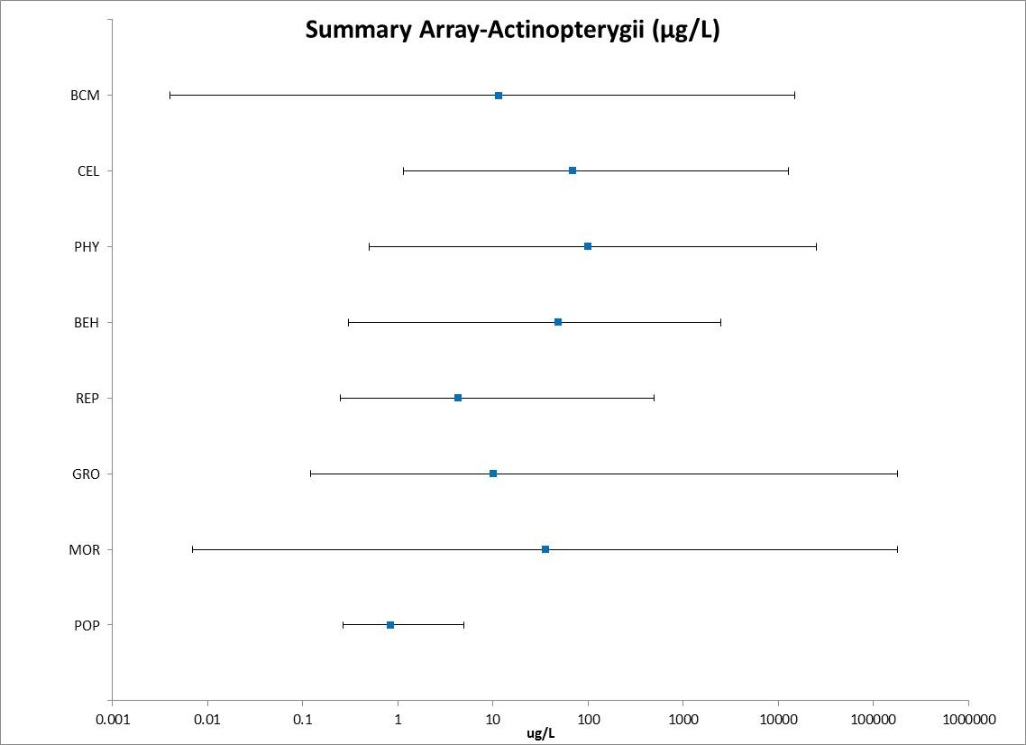
Figure 2-1. Summary Data Array for Fish Exposed to Chlorpyrifos.

Blue symbols represent mean endpoint values and bars represent the data range (BCM=Biochemical; CEL=Cellular; PHY=Physiological; BEH=Behavioral; REP=Reproduction; GRO=Growth; MOR=Mortality; POP=Population)

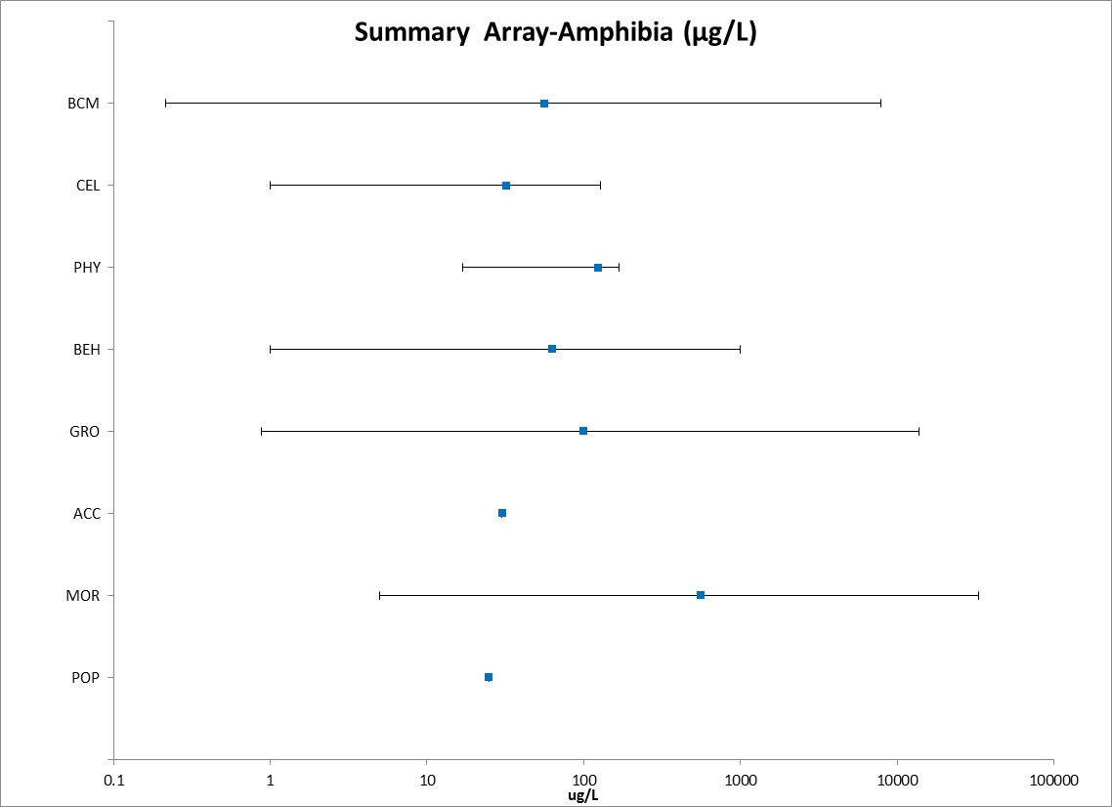

Figure 2-2. Summary Data Array for Amphibians Exposed to Chlorpyrifos.
Blue symbols represent mean endpoint values and bars represent the data range (BCM=Biochemical; CEL=Cellular; PHY=Physiological; BEH=Behavioral; REP=Reproduction; GRO=Growth; MOR=Mortality; POP=Population)

Lines of Evidence for Fish and Aquatic-Phase Amphibians

Effects on Mortality of Fish and Aquatic-Phase Amphibians

Acute mortality (LC₅₀) data for chlorpyrifos are available for 40 fish species and 8 amphibian species based on studies submitted by the registrant or identified in the ECOTOX database (Tables 2-3 and 2-4). The LC₅₀ values in Tables 2-3 and 2-4 are from studies with a 96-hour exposure duration, which is standard for acute aquatic vertebrate toxicity tests to ensure comparability of results. However, if a species was not represented with a 96 hour study and other values were available from shorter/longer duration studies (up to 10 days), then the data were included and the duration was listed next to the LC₅₀ value. All mortality data from other exposure durations are available in the data array and it is noted that there were no species that are not represented in Table 3 that had LC₅₀ values lower than 0.17 µg/L (the lowest value in Table 3). The mortality thresholds for Freshwater and Estuarine/Marine Fish (E/M) fish are based on the 1-in-a million of the HC₀₅ based on the Species Sensitivity Distribution (SSD).

Acute toxicity estimates (96-hour LC₅₀) for chlorpyrifos range from 0.17 - 7,012 µg/L and span four orders of magnitude (Table 2-3), indicating a wide range of sensitivity to chlorpyrifos among fish. The lowest LC₅₀ for chlorpyrifos is for a formulated product (44.4% a.i.) tested on Chirostoma jordani (LC₅₀ = 0.17 µg/L; Dzul-Caamal et al., 2012, E160182). The next lowest LC₅₀ value is for Tidewater silverside (Menidia peninsulae) tested with technical grade chlorpyrifos (LC₅₀=0.37 µg/L; Borthwick et al., 1985, E11868).

For the fish families for which chlorpyrifos toxicity data are available, Atheriniformes (families Atherinopsidae and Atherinidae), in general, appear to be the most sensitive to chlorpyrifos with LC₅₀ values ranging from 0.17-5 µg/L. Other families were more varied in sensitivities, for example, there was a 3-order of magnitude difference in toxicity for fish in the cyprinidae family (LC₅₀ ranges from 7.5-2,350 µg/L within the 96 hour studies).

Table 2-3. Available Median Lethal Concentration (LC₅₀) Data for Fish Exposed to Chlorpyrifos as TGAI or Formulation.
Family | Species | Common Name | LC₅₀ (µg/L)¹ | Reference Number
Atherinopsidae | Chirostoma jordani | Mesa Silverside | 0.17 (1d) | 160182
Atherinidae | Menidia peninsulae | Tidewater Silverside | 0.37* | 11868
Atherinidae | Menidia | Atlantic Silverside | 0.46* | 11868
Atherinidae | Menidia peninsulae | Tidewater Silverside | 0.46* | 11868
Clariidae | Clarias gariepinus | Zambezi Barbel | 0.5 | 121070
Atherinidae | Menidia peninsulae | Tidewater Silverside | 0.83* | 11868
Atherinidae | Menidia | Atlantic Silverside | 0.92* | 11868
Atherinidae | Leuresthes tenuis | California Grunion | 0.92* | 11868
Atherinidae | Leuresthes tenuis | California Grunion | 0.92* | 11868
Atherinidae | Leuresthes tenuis | California Grunion | 0.92* | 11868
Atherinidae | Menidia peninsulae | Tidewater Silverside | 0.96* | 3947
Atherinidae | Menidia | Atlantic Silverside | 1.0* | 11868
Atherinidae | Leuresthes tenuis | California Grunion | 1.2* | 11868
Atherinidae | Menidia peninsulae | Tidewater Silverside | 1.3* | 11427
Atherinidae | Leuresthes tenuis | California Grunion | 1.7* | 11868
Atherinidae | Menidia peninsulae | Tidewater Silverside | 1.7* | 11868
Centrarchidae | Lepomis macrochirus | Bluegill | 1.7* | 6797
Atherinidae | Menidia | Atlantic Silverside | 1.7* | 3947
Atherinidae | Menidia | Atlantic Silverside | 1.7* | 15639
Centrarchidae | Lepomis macrochirus | Bluegill | 1.8* | 6797
Cyprinodontidae | Fundulus grandis | Gulf Killifish | 1.8* | 3947
Atherinidae | Menidia peninsulae | Tidewater Silverside | 1.8* | 11868
Cichlidae | Tilapia guineensis | Speckled Tilapia | 2.0* | 86905
Atherinidae | Menidia | Atlantic Silverside | 2.2* | 11868
Atherinidae | Leuresthes tenuis | California Grunion | 2.4* | 11868
Centrarchidae | Lepomis macrochirus | Bluegill | 2.4* | 6797
Atherinidae | Leuresthes tenuis | California Grunion | 2.5* | 11868
Centrarchidae | Lepomis macrochirus | Bluegill | 2.5* | 6797
Atherinidae | Menidia | Atlantic Silverside | 2.6* | 11868
Atherinidae | Menidia | Atlantic Silverside | 2.8* | 11868
Salmonidae | Oncorhynchus mykiss | Rainbow Trout | 3.0* | MRID 95013
Centrarchidae | Lepomis macrochirus | Bluegill | 3.3* | MRID 95013
Atherinidae | Menidia peninsulae | Tidewater Silverside | 3.4* | 11868
Atherinidae | Menidia | Atlantic Silverside | 3.8* | 11868
Atherinidae | Menidia peninsulae | Tidewater Silverside | 3.9* | 11868
Cyprinodontidae | Fundulus similis | Longnose Killifish | 4.1* | 15639
Atherinidae | Menidia | Atlantic Silverside | 4.1* | 11868
Centrarchidae | Lepomis macrochirus | Bluegill | 4.2* | 6797
Atherinidae | Menidia beryllina | Inland Silverside | 4.2* | 11427
Gasterosteidae | Pungitius | Ninespine Stickleback | 4.7* | 8107
Cichlidae | Oreochromis mossambicus | Mozambique Tilapia | 4.8* | 13527
Atherinidae | Leuresthes tenuis | California Grunion | 5.1* | 11868
Poeciliidae | Gambusia yucatana | Yucatan Gambusia | 5.3 | 80447
Salmonidae | Oncorhynchus clarkii | Cutthroat Trout | 5.4* | 6797
Mugilidae | Mugil cephalus | Striped Mullet | 5.4* | 15639
Centrarchidae | Lepomis macrochirus | Bluegill | 5.8* | MRID 40840904
Salmonidae | Oncorhynchus mykiss | Rainbow Trout | 7.1* | 6797
Poeciliidae | Poecilia reticulata | Guppy | 7.2 | 72831
Centrarchidae | Lepomis macrochirus | Bluegill | 7.2 | 3124
Cyprinidae | Ctenopharyngodon idella | Grass Carp, White Amur | 7.5 | 159882
Salmonidae | Oncorhynchus mykiss | Rainbow Trout | 8.0* | MRID 155781
Cyprinidae | Cyprinus carpio | Common Carp | 8 | 87858
Gasterosteidae | Gasterosteus aculeatus | Threespine Stickleback | 8.5 | 8107
Cichlidae | Oreochromis mossambicus | Mozambique Tilapia | 10.4 | 303
Percidae | Sander vitreus | Walleye | 13-316 (2d) | 64958
Salmonidae | Oncorhynchus clarkii | Cutthroat Trout | 13.4* | 6797
Ictaluridae | Ictalurus punctatus | Channel Catfish | 13.4* | MRID 95013
Salmonidae | Oncorhynchus mykiss | Rainbow Trout | 15.0* | 6797
Cyprinodontidae | Aphanius iberus | Spanish Toothcarp | 16.7 (3d) | 57001
Salmonidae | Oncorhynchus clarkii | Cutthroat Trout | 18.4* | 6797
Cichlidae | Tilapia zillii | Tilapia | 22.7 | 71979
Adrianichthyidae | Oryzias latipes | Japanese Medaka | 25.0 (2d) | 17866
Cichlidae | Oreochromis mossambicus | Mozambique Tilapia | 25.7* | 71907
Cichlidae | Oreochromis mossambicus | Mozambique Tilapia | 25.8* | 109601
Salmonidae | Oncorhynchus clarkii | Cutthroat Trout | 26.0* | 6797
Cichlidae | Oreochromis niloticus | Nile Tilapia | 26.4 | 160295
Salmonidae | Oncorhynchus mykiss | Rainbow Trout | 27.0* | MRID 40840903
Cyprinidae | Cyprinus carpio | Common Carp | 32 | 121056
Cyprinidae | Cyprinus carpio | Common Carp | 32 | 121119
Cyprinidae | Cyprinus carpio | Common Carp | 32 | 120957
Cichlidae | Oreochromis niloticus | Nile Tilapia | 46.8 | 69824
Cichlidae | Oreochromis niloticus | Nile Tilapia | 47.4 | 150329
Cichlidae | Oreochromis niloticus | Nile Tilapia | 47.4 | 150329
Salmonidae | Oncorhynchus mykiss | Rainbow Trout | 51.0* | 6797
Cichlidae | Oreochromis mossambicus | Mozambique Tilapia | 52.0* | 54793
Batrachoididae | Opsanus beta | Gulf Toadfish | 68.0* | 3947
Salmonidae | Salvelinus namaycush | Lake Trout, Siscowet | 73.0* | 6797
Scophthalmidae | Psetta maxima | Left-Eyed Flounder, Turbot | 94.7 (6d) | 160292
Salmonidae | Salvelinus namaycush | Lake Trout, Siscowet | 98.0* | 6797
Melanotaeniidae | Melanotaenia fluviatilis | Crimson-Spotted Rainbowfish | 118* | 121117
Cyprinodontidae | Cyprinodon variegatus | Sheepshead Minnow | 136* | 15639
Salmonidae | Salvelinus namaycush | Lake Trout, Siscowet | 140* | 6797
Cyprinidae | Pimephales promelas | Fathead Minnow | 140* | MRID 154732
Cyprinidae | Cyprinus carpio | Common Carp | 150 | 121108
Cyprinidae | Pimephales promelas | Fathead Minnow | 150* | MRID 154732
Poeciliidae | Poecilia reticulata | Guppy | 176 | 159803
Cyprinidae | Pimephales promelas | Fathead Minnow | 200* | 12859
Cyprinidae | Pimephales promelas | Fathead Minnow | 203* | MRID 155781
Salmonidae | Salvelinus namaycush | Lake Trout, Siscowet | 205* | 6797
Salmonidae | Salvelinus namaycush | Lake Trout, Siscowet | 227* | 6797
Cichlidae | Tilapia zillii | Tilapia | 240* | 72744
Salmonidae | Salvelinus namaycush | Lake Trout, Siscowet | 244* | 6797
Cyprinodontidae | Cyprinodon variegatus | Sheepshead Minnow | 270* | 3947
Ictaluridae | Ictalurus punctatus | Channel Catfish | 280* | 6797
Poeciliidae | Gambusia affinis | Western Mosquitofish | 298* | 108871
Cyprinidae | Gibelion catla | Catla | 300* | 101291
Cyprinidae | Labeo rohita | Rohu | 300* | 101291
Cyprinidae | Gibelion catla | Catla | 350* | 101291
Channidae | Channa punctata | Snake-Head Catfish | 365 | 109575
Cyprinidae | Labeo rohita | Rohu | 470* | 101291
Poeciliidae | Gambusia affinis | Western Mosquitofish | 484* | 57001
Cyprinidae | Pimephales promelas | Fathead Minnow | 506* | 12859
Anguillidae | Anguilla | Common Eel | 524* | 11055
Cyprinidae | Cirrhinus mrigala | Carp, Hawk Fish | 550* | 101291
Cyprinidae | Cirrhinus mrigala | Carp, Hawk Fish | 650* | 101291
Clariidae | Clarias gariepinus | Zambezi Barbel | 920* | 120266
Cichlidae | Oreochromis niloticus | Nile Tilapia | 1023* | 121118
Cyprinidae | Gibelion catla | Catla | 1660 | 86097
Heteropneustidae | Heteropneustes fossilis | Indian Catfish | 2200* | 72755
Cyprinidae | Cirrhinus mrigala | Carp, Hawk Fish | 2350 | 86097
Cyprinidae | Labeo rohita | Rohu | 2350 | 86097
Cyprinidae | Danio rerio | Zebra Danio | 7012 (6d) | 158995
¹If a species was not represented with a 96 hour study, and other values were available from shorter/longer duration studies (up to 10 days) then the data were included and the duration was listed next to the LC₅₀ value as an indicator. If there were multiple other durations, the value from the study closer to a 96h duration was selected and if there were multiple values for the same duration, the range is indicated.
* = Value used to derive SSD

Amphibians- For amphibians, acute mortality (96 h-unless otherwise noted; LC₅₀) data for chlorpyrifos are available for 9 species. The values range from 19 -14,483 µg/L and span three orders of magnitude (Table 2-4). The lowest LC₅₀ value of 19 µg/L is for the Indian bullfrog (Hoplobatrachus tigrinus) (Abbasi, and Soni, 1991; E-61878), however, there was limited information reported on the testing methods (via another referenced study) and the test substance was unknown, thus, the study was classified as qualitative. The next two lowest TGAI LC₅₀ values are from a study with the Pacific Chorus Frog [Pseudacris regilla -LC₅₀=121.87 µg/L ± 346.68(SE)] and Foothill Yellow-Legged Frog [Rana boylii -LC₅₀=205.24 µg/L ± 543.75 (SE)], Kerby (2006; E118706 ) and while there were widely spaced treatments (50 ug/L, 500 ug/L and 5000 ug/L) and there is some uncertainty due to the variance observed, these values represent the low end of the available data. Therefore, the Pacific chorus frog LC₅₀ will be used quantitatively for deriving the mortality thresholds (Tables 2-1 and 2-2). The next lowest values for TGAI were from a study of the effects of Chlorpyrifos on two developmental stages of the African clawed frog (Xenopus laevis). In this study, the two stages used were “premetamorphs” which was defined by organogenesis initiation (NF-Nieuwkoop and Faber stage 14) and “metamorphs” defined as formation of a hind-limb bud (NF stage 46), and the LC₅₀ values were 556 (metamorphs) and 14,483 ug/L (premetamorphs) [Richards and Kendall (2002); E68227].

Table 2-4. Available Median Lethal Concentration (LC₅₀) Data for Amphibians Exposed to Chlorpyrifos as TGAI or Formulation.
Family | Species | Common Name | LC₅₀ (µg/L)¹ | Reference Number
Ranidae | Hoplobatrachus tigerinus | Indian Bullfrog | 19 | 61878
Hylidae | Pseudacris regilla | Pacific Chorus Frog | 122* | 118706
Bufonidae | Rhinella fernandezae | Toad | 151 | 159927
Ranidae | Rana boylii | Foothill Yellow-Legged Frog | 204* | 118706
Bufonidae | Bufo bufo ssp. Gargarizans | Toad | 320 | 121116
Pipidae | Xenopus laevis | African Clawed Frog | 556* | 68227
Rhacophoridae | Polypedates cruciger | Common Hourglass Tree Frog | 1210 (2d)* | 159829
Pipidae | Xenopus laevis | African Clawed Frog | 2410* | 73373
Bufonidae | Duttaphrynus melanostictus | Asian Common Toad | 3003 (7d)* | 159786
Ranidae | Rana dalmatina | Agile Frog | 5148* | 159867
Pipidae | Xenopus laevis | African Clawed Frog | 14483* | 68227
*Indicates study was conducted with TGAI
¹ If a species was not represented with a 96 hour study, and other values were available from shorter/longer duration studies (up to 10 days) the data were included and the duration was listed next to the LC₅₀ value as an indicator. If there were multiple other durations, the value from the study closer to a 96 hour duration was selected and if there were multiple values for the same duration, the range is indicated.

Species Sensitivity Distribution for Acute Mortality Data

The acute mortality studies conducted with technical grade chlorpyrifos were used to derive species sensitivity distributions (SSD). SSDs were fit to test results for fish exposed to chlorpyrifos. Five distributions were tested and a variety of methods were used to determine whether different subsets of data should be modeled independently. These results support separating the data into SSDs for freshwater and estuarine/marine fish (Table 2-5). APPENDIX 2-6 includes further the details of how these SSDs were derived.

Table 2-5. Summary Statistics for SSDs Fit to Chlorpyrifos Test Results
Statistic | All  Fish | FW  Fish | E/M  Fish
Best Distribution (by AIC_{c}) | triangular | triangular | gumbel
Goodness of fit  P-value | 0.92 | 0.83 | 0.51
CV of the HC₀₅ | 0.79 | 0.98 | 0.66
HC₀₅ | 1.44 | 5.94 | 0.79
HC₁₀ | 2.78 | 10.54 | 1.11
HC₅₀ | 44.41 | 118.34 | 5.28
HC₉₀ | 710.0 | 1328.7 | 61.0
HC₉₅ | 1369.2 | 2356.8 | 155.4
Mortality Thresh.¹  (slope = 4.5) | 0.075 | 0.309 | 0.041
Indirect Effects Threshold¹  (slope = 4.5) | 0.649 | 2.677 | 0.355
¹Slope of dose-response curve = 3.7, from Bluegill

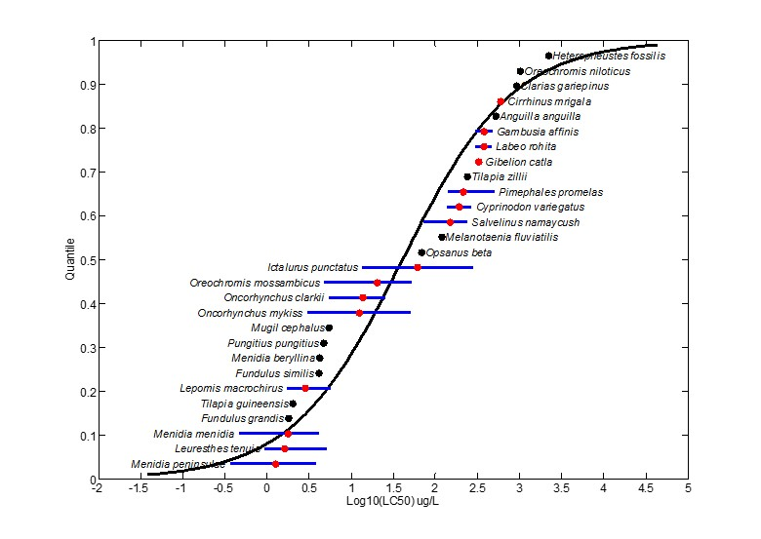 Figure 2-3. Log-triangular SSD for Chlorpyrifos LC_{50s} for All Fish. Black points indicate single toxicity values. Red points indicate multiple toxicity values for a single species. Blue line indicates full range of toxicity values for a single species.

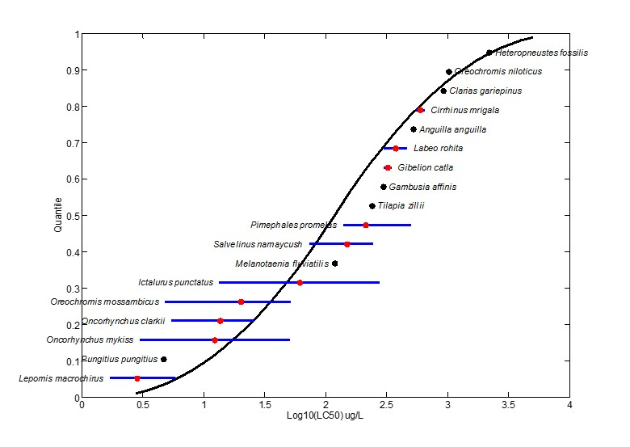
Figure 2-4. Log-triangular SSD for Chlorpyrifos LC₅₀s for Freshwater Fish. Black points indicate single toxicity values. Red points indicate multiple toxicity values for a single species. Blue line indicates full range of toxicity values for a single species.

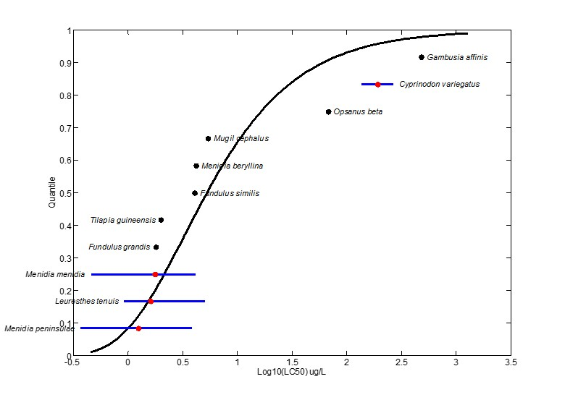
Figure 2-5. Log-gumbel SSD for Chlorpyrifos LC₅₀s for Saltwater Fish. Black points indicate single toxicity values. Red points indicate multiple toxicity values for a single species. Blue line indicates full range of toxicity values for a single species.

Amphibians- For amphibians, the data did not allow for a reliable SSD. Therefore, the lowest LC₅₀ from a test with TGAI was used in the IEC V 2.0 model to calculate the 1-in-a million mortality threshold for direct effects and the 10% effect concentration for the indirect effects threshold (i.e., effects to predators of such taxa). These values are reported in Tables 2-1 and 2-2 as the amphibian mortality thresholds.

Aside from the acute mortality endpoints, other mortality-related endpoints include reduced survival and hatch. For this group of data, there are 11 references in the open literature or registrant submitted studies, representing 3 orders and 9 species. The values range from a NOAEC/LOAEC of 0.28/0.48 µg/L for reduced offspring survival in the Atlantic silverside [M. menidia- Goodman et al., 1985; MRID 154718] to a NOAEC/LOAEC of 105/ 1,051 µg/L for reduced survival in the zebrafish (Danio rerio) larvae. Figure 2-6 presents the array of available data (Range: ≤ 1000 ug/L for presentation purposes).

Within this subgroup of effects, the lowest toxicity values were observed in the E/M Atlantic silverside (M. menidia) with a NOAEC/LOAEC of 0.28/0.48 µg/L based on reduced survival of the offspring (Goodman et al., 1985; MRID 154718). The two other species tested, tidewater silverside (M.-peninsulae) and inland silverside (M.-beryllina) also had effects to offspring survival at similar concentrations. With growth effects (see later discussion in the growth line of evidence) occurring at the same concentrations, this study provides the lowest sublethal effects endpoints for E/M species and is used as a threshold value (see Table 2-1 for a summary of the thresholds).

For a freshwater species, the lowest values were from a full life-cycle study conducted with the fathead minnow (Pimephales promelas) with NOAEC/LOAEC values (0.57/1.09 µg/L) based on a 14 and 35% reduction in the survival of young fry for the F0 and F1 generations, respectively (Mayes et al., 1993; MRID 42834401).

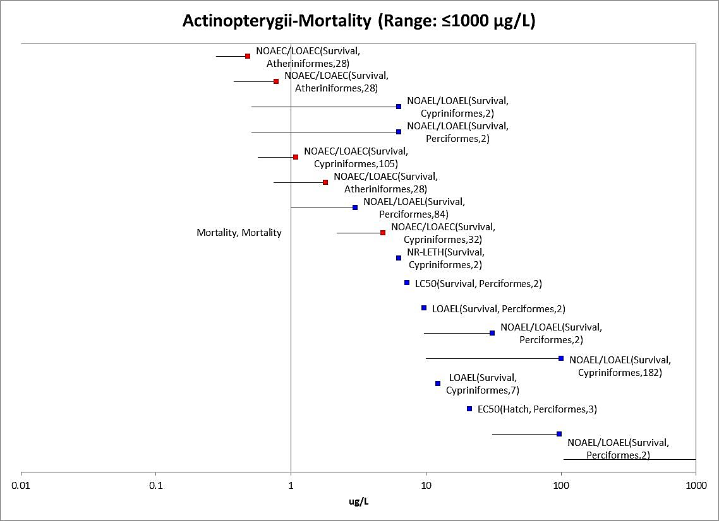

Figure 2-6. Fish Data Array for Mortality-related Endpoints (Range: ≤1000 µg/L)

Amphibians- For Amphibians, there was only one study available with effects to survival of the Sierra Nevada yellow-legged frog (Rana sierra) at 737 µg/L with a NOAEC of 500 µg/L (Dimitrie, 2010; E159871). The dataset is too small to make reliable conclusions on the effects to survival of amphibians, thus, the fish data will also be used as a surrogate in the risk assessment.

Sublethal Effects to Fish and Aquatic-Phase Amphibians

Major categories of sublethal effects (i.e., growth, reproduction, behavior, sensory effects, and acetylcholinesterase inhibition) and the studies with the lowest toxicity values for sublethal effects are discussed below.

Effects on Growth of Fish and Aquatic-Phase Amphibians

There were 26 studies (registrant-submitted and open-literature), representing 7 orders and 17 species available for effects of chlorpyrifos on fish growth. The values range from 0.12 to 7,012 µg/L, spanning 4 orders of magnitude (excluding one study for the tench (Tinca tinca), with a LOAEC of 180,000 µg/L based on structural changes (Gomez et al., 2002; E72787). Figure 2-7 provides a data array focusing on the lower end of the distribution (range ≤100 ug/L).

The lowest values for growth-related endpoints are from an EPA laboratory study (Jarvinen et al., 1982; MRID 00154721). In this study, fathead minnows (Pimephales promelas) were exposed to Dursban, a formulated product containing chlorpyrifos, for a full reproductive life cycle (200 days) at mean-measured concentrations of 0.12, 0.27, 0.63, 1.21, and 2.68 µg a.i./L. The most sensitive endpoint was for reduced growth (9 % reduction in body weight) in the 30-day old second generation fish at 0.12 µg/L. Additionally, there was a significant reduction in the number of sexually mature fathead minnows at all concentrations when compared to the controls at 136 days (25% fewer at 0.12 µg/L and 48% fewer at 2.68 µg/L). At 0.63 µg/L and above, total egg production was significantly reduced and at 0.27 µg/L and above, brain acetylcholinesterase was significantly inhibited. Fish tissues were reported to have concentrated chlorpyrifos approximately 1700X.

The next lowest toxicity value was from a 28-day early life stage (ELS) study conducted with TGAI (Goodman et al., 1985, MRID 154718). In this study three estuarine/marine species of atherinid fish (Menidia beryllina; M. menidia; M.-peninsulae) were continuously exposed from embryonic stage to 3 weeks or more into the exogenous feeding stage. The Atlantic silverside (Menidia peninsulae) was the most sensitive with effects to growth (32% reduction in bodyweight-although there is uncertainty because this endpoint was not analyzed statistically due to small sample size) and survival at 0.48 µg/L with a NOAEC of 0.28 µg/L for the study overall. The results were generally similar for the other two species with a NOAEC/LOAEC of 0.38/0.78 µg/L for the tidewater silverside (M.-peninsulae-based on offspring survival) and NOAEC/LOAEC of 0.75/1.8 µg/L for the inland silverside (M.-beryllina-based on growth and offspring survival).

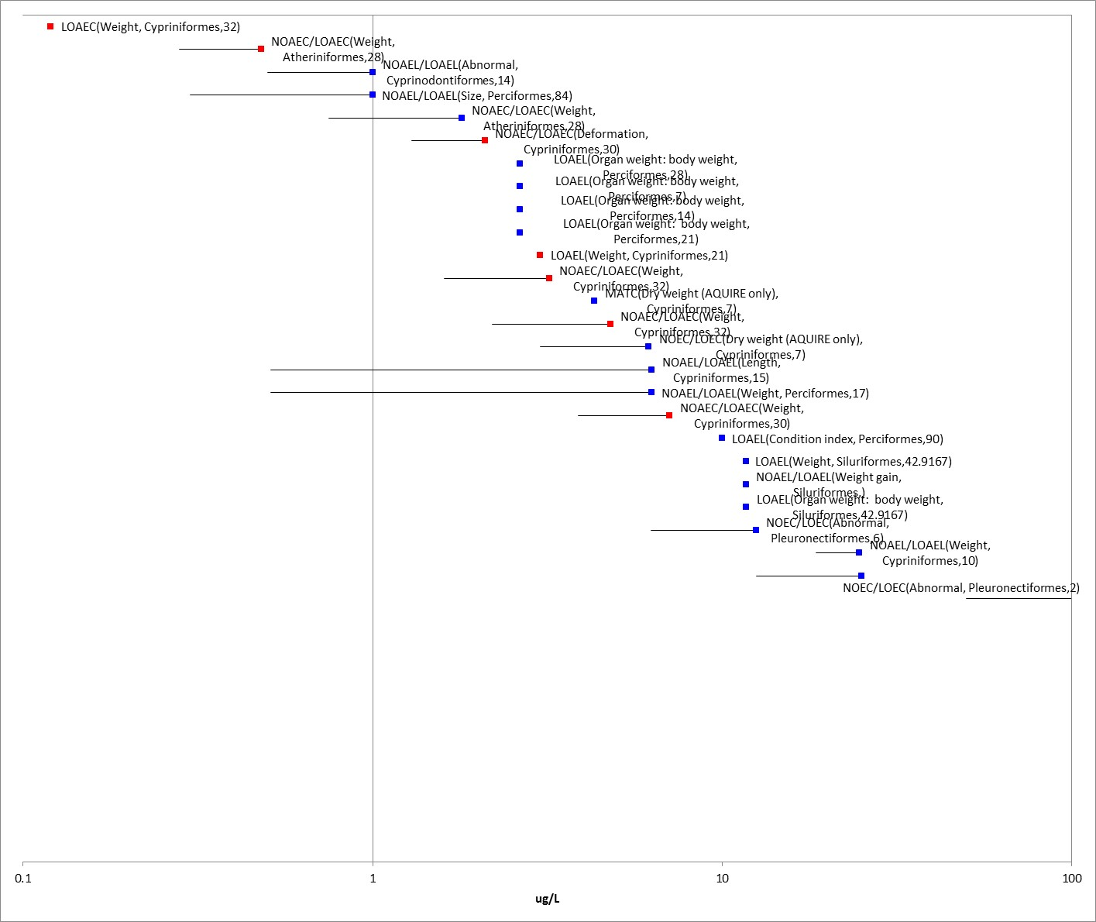
Figure 2-7. Fish Data Array for Growth Effects (Range ≤ 100 µg/L)

Amphibians-There are 19 studies representing 1 order and 15 species available for aquatic-phase amphibians. The growth endpoints in the dataset range from 0.88 to 13,860 µg/L. The lowest value was a LOAEC of 0.88 µg/L for a 4% reduction in length in Xenopus laevis in the submitted amphibian metamorphosis assay (MRID 48615501; Coady et al; 2011). The next lowest values are NOAEC/LOAEC values of 0.99/9.9 µg/L based on reductions in body length for Xenopus laevis exposed to chlorpyrifos for 4 days (Richards, 2000; E86343 and Richards et al. 2003; E71867). Similarly, in another study (formulated product), bodyweight of R. sphenocephala [same genus as the California red-legged frog (Rana aurora draytonii)] was significantly impaired at 10 µg/L resulting in a LOAEC of 10 µg/L and a NOAEC of 1 µg/L chlorpyrifos (Widder and Bidwell 2008; E101727). Figure 2-8 provides a data array focusing on the lower end of the distribution (range ≤1000 µg/L).

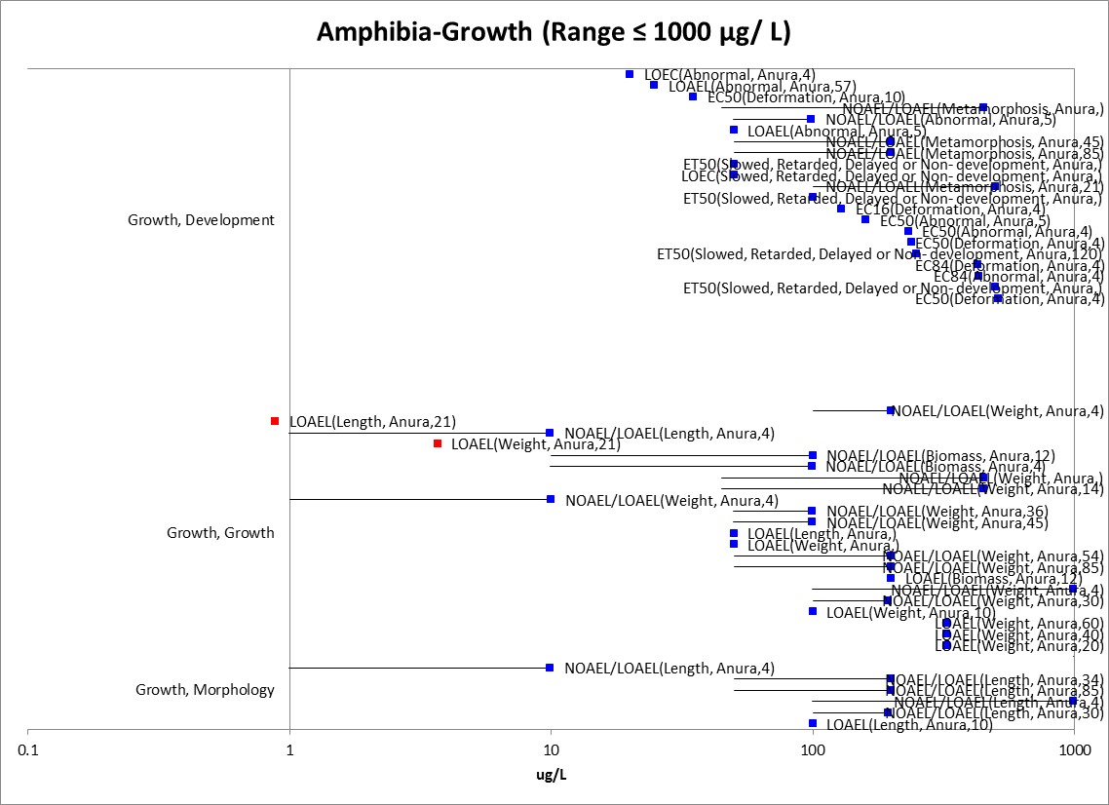
Figure 2-8. Amphibian Data Array for Growth Effects (Range ≤ 1000 µg/L).

Effects on Reproduction of Fish and Aquatic-Phase Amphibians

The reproductive effects of chlorpyrifos on fish identified from registrant-submitted studies and open-literature studies range from 0.251 -500 µg/L. There were four studies, representing two orders and three species. Figure 2-9 provides a data array focusing on the lower end of the distribution (range ≤1000 ug/L).

The lowest value is from a 21-day registrant submitted short term reproduction assay with the fathead minnow (Pimephales promelas) (MRID 48615506; Thomas. 2011). In this assay, adult fish (16 spawning groups: 2 males and 4 females formed a replicate and there were four replicates per treatment) were exposed to control, 0.251, 0.812, or 3.02 µg/L (TWA) chlorpyrifos for 21 days and fecundity was reduced (52-71%) at all treatment levels. There was also a reduction in male body weight at the highest dose and significant reductions in brain AChE at all treatment levels for the females (40-92%) and males at the two highest doses (72 and 90%). Based on the reduced fecundity at all treatment levels, this study provides a LOAEC of 0.25 µg/L which is also used to set the All FISH and FW fish threshold for runoff and drift.

Another low toxicity value came from a full life-cycle study with the fathead minnow (Pimephales promelas) (Jarvinen et al., 1982; MRID 154721). In this study, fathead minnows were exposed to chlorpyrifos (as a formulated product) for 200 days including a reproductive period of their life cycle. There was a statistically significant reduction in fecundity at 0.63 µg/L (64% reduction) and decreases of approximately 44% were observed at concentrations of 0.12 and 0.27 µg/L, however, these were not significant reductions when compared to the control.

There was one lower toxicity value from a study using a formulated product conducted with adult guppy (Poecilia reticulata) that were exposed to 0.002 and 2 µg/L chlorpyrifos concentrations to investigate the effects on reproductive performance (De Silva and Samayawardhena, 2005 E80955). Two endpoints were excluded from further analysis due to an inconsistent dosing regimen (males exposed 3 days and females exposed from 25-35 days-full review in Open Literature Review-APPENDIX 2-3), however, there is one endpoint for reproductive behavior that is considered useful for qualitative use. After 24 hours, the males were observed for a courtship/mating behavior known as gonopodial thrusts (GP) using a counting device. For the mean number of GP, both treatment groups were significantly different from the control group with mean values of 11, 8, and 4 for the control, 0.002, and 2 µg/L treatments, respectively. An uncertainty with this endpoint is that there are two types of mating behavior of the guppy, sigmoid displays and the gonopodial thrusts so the significance of the reduction in GP at the lowest dose is unclear with respect to reproductive performance. This endpoint is not depicted on the effects array.

For an estuarine/marine fish, the only reproductive endpoint available is for a reduction in percent viable hatch in the Ambon damselfish (Pomacentrus pomacentrus) with a NOAEC/LOAEC of 250 and 500 µg/L, respectively (Humphrey et al., 2004; E75183). While this study provides reproductive data for an E/M fish, the values are based on nominal concentrations, thus, the actual exposure could be lower. Given the uncertainty of the exposure and with only one E/M study available, the endpoint from the FW group will be used a surrogate in the lines of evidence analysis.

Amphibians-There are no data available in this effects category, thus, the fish data are used as a surrogate.

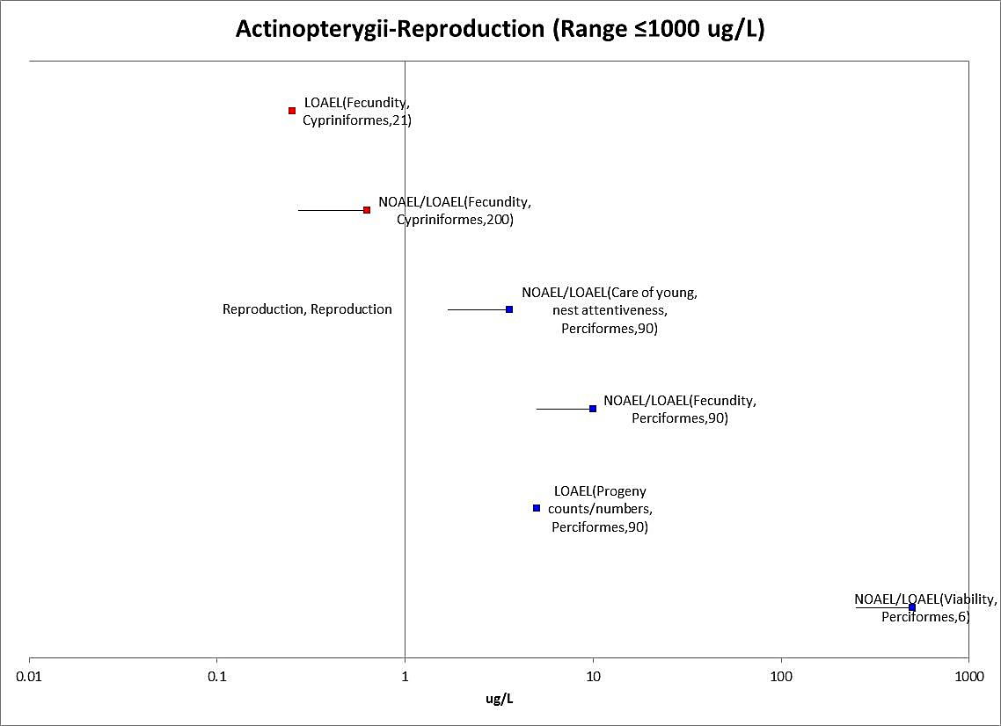

Figure 2-9. Fish Data Array for Reproductive Effects (Range ≤ 1000 µg/L).

Effects on Behavior of Fish and Aquatic-Phase Amphibians

For the group of behavioral effects, there are 18 references in the open literature, representing 4 orders and 7 species (all freshwater fish). The values range from a LOAEC of 0.3 µg/L (based on 10% benchmark concentration) for swimming behavior in the coho salmon [Oncorhynchus kisutch- Sandahl et al., 2005; E80431] to a LOAEC of 625 µg/L for the number of movements in the Zebrafish [Selderslaghs et al., 2010; E159916]. Figure 2-10 provides a data array focusing on the lower end of the distribution (≤100 ug/L).The lowest toxicity value (0.3 µg/L) for behavioral effects is based on a study designed to directly compare the effects of chlorpyrifos on AChE inhibition and salmon behavior (Sandahl et al., 2005; E80431). In this study, juvenile coho salmon (Oncorhynchus kisutch) were exposed to analytical grade chlorpyrifos at concentrations from 0-2.5 µg/L for 96 hours and spontaneous swimming and feeding behaviors were recorded using a computer assisted 3-dimensional video imaging system. Following the behavioral trials, brain and muscle tissues were then analyzed for AChE activity. Reductions in spontaneous swimming rate and total food strikes were significantly correlated with reductions in AChE activity (r² ⁼0.58, p<0.01 and r² 0.53, p<0.01, respectively). Using benchmark concentration estimates, a 10% inhibition of AChE activity in brain (at 0.4 µg/L) and muscle (0.6 µg/L) occurred at similar concentrations as the behavioral measures. For example, a 10% reduction in spontaneous swimming and food strikes occurred at concentrations of 0.3 and 0.4 µg/L, respectively. There are no behavioral studies with an E/M species, therefore, the freshwater data will serve as a surrogate.

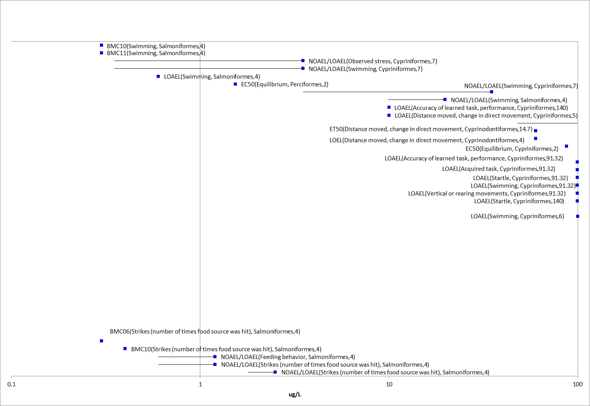
Figure 2-10. Fish Data Array for Behavioral Effects (Range ≤ 1000 µg/L).

Amphibians-There are 8 references for behavioral effects on aquatic phase amphibians, representing 2 orders, and 9 species and the values range from a NOAEC/LOAEC of 0.992/9.92 µg/L for the African flawed frog-NF stage -metamorphs (Xenopus laevis) to NOAEC/LOAEC of 99.2/992 µg/L in the 10 to 12 NF developmental stage (premetamorphs) with the same species (the highest and lowest values are from the same study; Richards SM, 2000; E86343). In this study there was a 32% decrease in swimming activity for the metamorphs at 9.92 µg/L (NOAEC = 0.992). Figure 2-11 provides the data array (range ≤1000 µg/L).

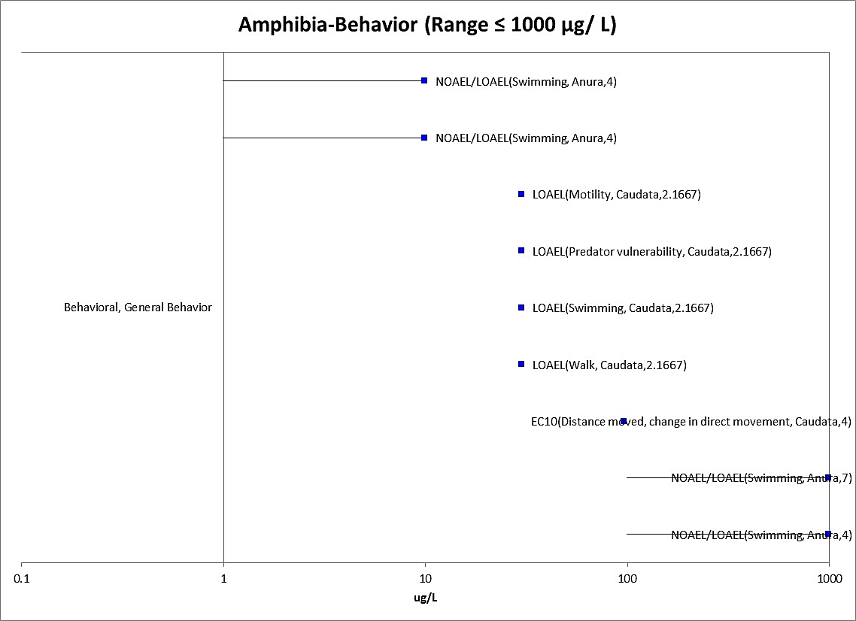
Figure 2-11. Amphibian Data Array for Behavioral Effects (Range ≤ 1000 µg/L).

Effects on Sensory Function of Fish and Aquatic Phase Amphibians

There were three references for sensory effects, representing four orders and species with values ranging from 0.6 µg/L (LOAEC) based on decreased olfactory function in coho salmon (Sandahl et al., 2004; E75184) to 149 µg/L for stimulus avoidance in the fathead minnow (Wacksman et. al, 2006, E91730). The lowest values for this effect group are from a study in which juvenile coho salmon (Oncorhynchus kisutch) lost 25, 50 and 50% of olfactory function following 7 d exposures to 0.625, 1.25, and 2.50 ug/L, respectively (Sandahl et al., 2004; E75184). AChE activity in coho salmon olfactory rosettes was inhibited by 25% at the highest exposure level tested, 2.5 ug/L. However, no significant correlation between AChE inhibition and olfactory impairment was found. These results indicate that olfaction is impaired by chlorpyrifos exposures below 1 µg/L, and olfactory AChE activity is reduced at 2.5 µg/L. This study measured olfactory response of a listed salmonid species, coho, exposed to chlorpyrifos using a well-executed experimental design. Figure 2-12 provides a data array for this effect group. There are no sensory effects data available for an E/M species, thus the freshwater data will serve as a surrogate.

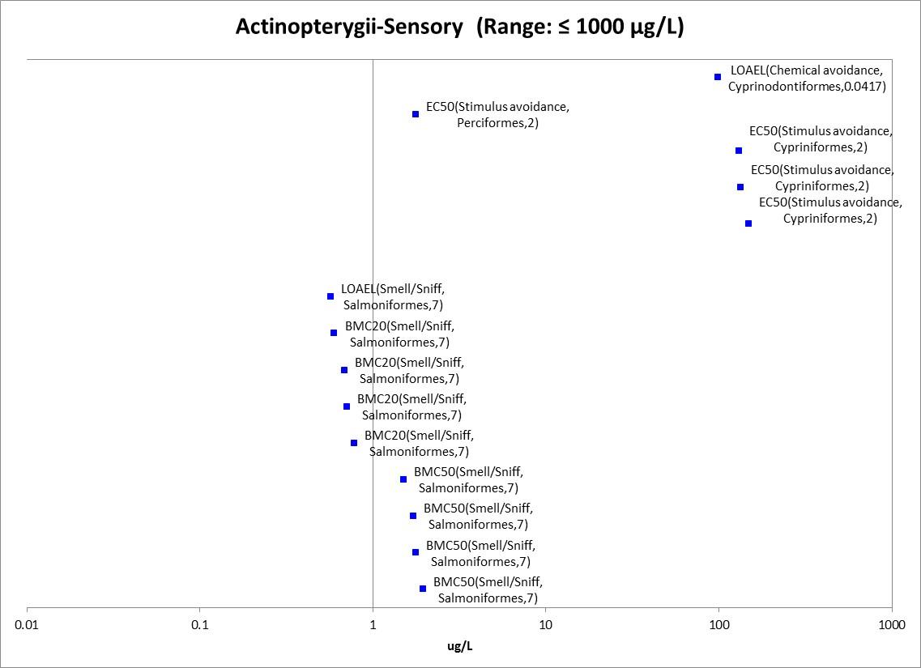
Figure 2-12. Fish Data Array for Sensory Effects (Range ≤ 1000 µg/L).

Amphibians- There is one study reporting sensory effects in amphibians, covering 1 order and 2 species. In this study, the reported endpoints were EC₅₀s for stimulus avoidance at 115 and 235 µg/L for the African clawed frog (Xenopus laevis) and the bronze from (Lithobates clamitans ssp. Clamitans) (Wacksman et al., 2006; E91730).

Other Effects Reported for Fish and Aquatic-Phase Amphibians

Anticholinesterase Effects

For fish, 41 studies are available from open literature and registrant submitted studies for evaluating the effects of chlorpyrifos on anti-cholinesterase activity, representing 6 orders and 23 species. There was a five -order-of-magnitude difference between the least and most sensitive AChE effects in the dataset ranging from a LOAEC of 0.004 µg/L for the Mesa silverside (C. jordani; Dzul-Caamal et al. 2012, E160182) to 828 µg/L for the guppy (Poecilia reticulata; Sharbidre et al., 2011; E159803). Figure 2-13 provides the range up to 1000 µg/L (without the labels) and Figure 2-14 provides an array of the lower end of the distribution (range ≤ 1 µg/L).

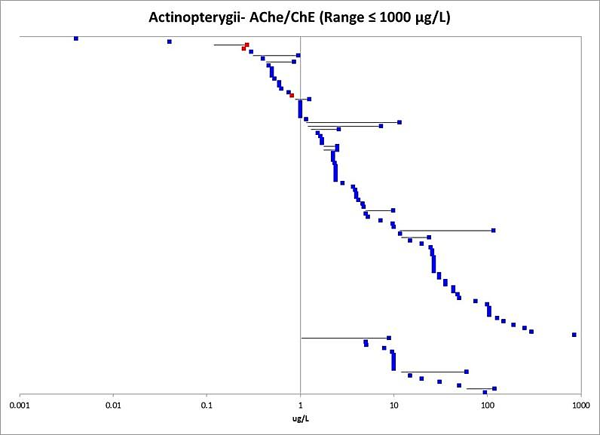 Figure 2-13. Fish Data Array for Anticholinesterase Effects (Range ≤ 1000 µg/L).

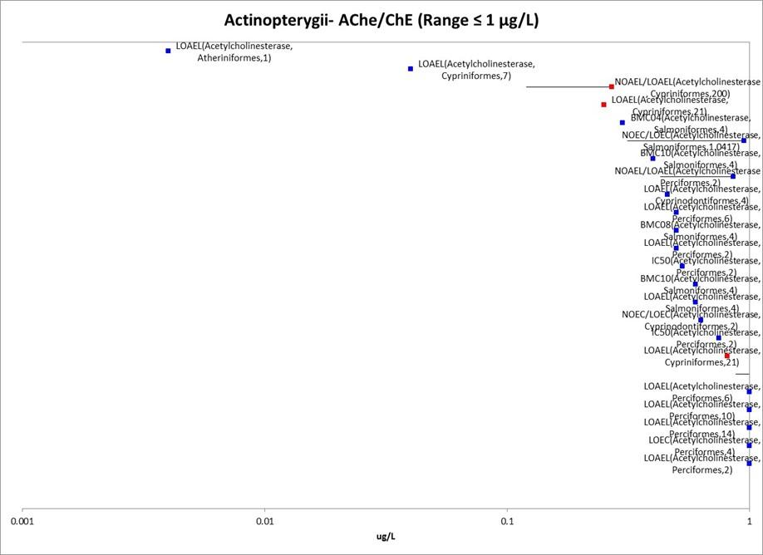
Figure 2-14. Fish Data Array for Anticholinesterase Effects (Low end of Distribution-Range ≤ 1 µg/L).

The study with the lowest value was conducted with the mesa silverside (C. jordani), (Dzul-Caamal et al., 2012). In this study, AChE activity in brain and muscle was measured in an acute toxicity study (24 h) using three doses (0.004, 0.04, and 4 µg/L) and the AChE activity in the survivors was significantly reduced at all doses. At 0.004 µg a.i./L chlorpyrifos (formulated product), there was a 31% and 20% inhibition in brain and muscle tissue, respectively. This value is approaching the estimated LC₁₀ from the same study (0.007 µg/L) and two orders of magnitude lower than the LC₅₀ (0.17 µg/L). In the sublethal component of the study, the fish were exposed to 0.007 µg/L for 32 hours and measurements were made at six intervals to study the AChE recovery kinetics. No mortality was observed throughout the exposure period, the maximum inhibition occurred at 4 h in both tissues (~59%), and at 8 hours there was tendency towards recovery that was more evident in muscle; however, by the end of the exposure period (32h), full recovery had still not taken place in either tissue. This study using a formulated product is compared to the exposures from spray drift as a sublethal threshold for freshwater fish and also the overall FW and E/M fish threshold.

The second lowest value was from a study conducted with fry stage common carp (C. carpio) that were exposed in groups of 50 to sublethal concentrations of chlorpyrifos (formulation-40% EC) in 70 L glass aquaria for 14 days (DeMel and Pathiratne, 2005; E87858). During the sublethal test, fish were exposed to chlorpyrifos at 0.04, 0.08 and 0.40 µg/L (which corresponds to 0.5, 1 and 5% of the LC₅₀, respectively). The aquaria were aerated and the test solutions were renewed at 96-h intervals. On exposure days 7 and 14, samples of fish from each concentration and the control were sacrificed to determine AChE activity of the brain tissues. At the end of day 14, the fish were transferred separately to clean aged tap water for recovery. After 7 days, the AChE activities of the exposed fish were inhibited at all doses (29–81% of the control). Greater inhibition of the AChE activity in brain tissues was recorded after 14 days of exposure. With respect to the recovery, the fish exposed to even to the lowest sublethal level of chlorpyrifos (0.5% LC₅₀) did not fully recover from the insecticide induced anticholinesterase action during the 21-day period. By the end of the 21 day test, the AChE activity was reported to be 36–78% of the normal activity. Based on the reported results, the LOAEC from this study is 0.04 µg/L (based on AChE inhibition at the lowest dose when compared to the control). The LC₅₀ value from the acute portion of the study (96-hour-6 doses) is 8 µg/L (2-16 µg/L) with a corresponding slope of 7.54.

In the full life-cycle study (also a formulated product) with the fathead minnow (discussed earlier for growth effects), a 21-40 % AChE inhibition in brain tissues was observed at 0.27 µg/L (Jarvinen et al., 1982; MRID 00154721). A more recent short-term (21d) fathead minnow reproductive assay (with technical a.i.) reported similar AChE effects (in brain tissue) with 40-92% significant reductions in brain AChE at all treatments (0.251, 0.812, and 3.02 µg/L) for females and 72-90% reductions in males at the 0.812 and 3.02 µg/L treatments (MRID48615505; Thomas, 2011). This study with an active ingredient is used to set the sublethal threshold for freshwater fish and also the overall FW and E/M fish threshold and is compared to the combined exposure values from runoff and spray drift modeling. Table 2-6 provides a summary of the lowest studies that are available and when possible makes a comparison to the anti-cholinesterase activity and the measured whole organism effects in fish.

Table 2-6. Anti-cholinesterase Activity and Whole-Organism Effects in Fish
Species | Anti-Cholinesterase Activity |  | Lowest Whole-Organism Endpoint  (µg/L) | Comments | Reference
 | Endpoint  (µg/L) | Inhibition at LOAEC  (Tissue Type)
Mesa silverside (Chirostoma jordani) | LOAEC=0.004  (Formulated product) | 31% (1 d brain)  20% (1 d muscle) | LC₁₀=0.007  LC₅₀=0.17  (Mortality) | No other whole organism measurements in study | Dzul-Caamal et al. 2012; E160182
Common carp (fry) (C.carpio) | 0.04 (LOAEC)  (Formulated product) | 29% (7d)  53% (14d)  (brain) | Not Assessed | No other whole organism measurements in study | DeMel and Pathiratne, 2005; E87858
Fathead minnow (Pimephales promelas) | 0.12 (NOAEC)  0.27 (LOAEC)  (Formulated product) | 21-41% (brain)  (measured at 60, 136, and 200d) | LOAEC= 0.12 (↓growth in second generation; decreased maturation 25% at 136 days) | First gen. repro effect ↓ fecundity at 0.63 µg/L  0.63 µg/L (AChE ↓59%)  1.21 µg/L (AChE ↓65-80%)  2.68 µg/L (AChE ↓77-89%) | Jarvinen et al., 1982 MRID 00154721
Fathead minnow (Pimephales promelas) | 0.251 (LOAEC)  (A.I) | 40% (brain-females) | ↓Fecundity all treatments | Female AChE ↓ (40-92% across treatments)  Males (72-90%↓ at 0.8 and 3.0ug/L) | MRID 48615505; Thomas, 2011)
Coho salmon | BMD10 0.3/0.6  (A.I.) | 10% relative departure  (4 d brain/muscle) | Swimming behavior (BMD10=0.3)  Feeding behavior (BMD10-0.4) | Effects seen at similar concentrations for enzyme and whole organism | E 80431 (Sandahl et al., 2005)

For Estuarine/Marine fish, there are data available from two species, the estuarine mummichog (Fundulus heteroclitus) and a tropical reef fish, the spiny damselfish (Acanthochromis polyacanthus). In Karen et al., 2001 (E62229), mummichog were exposed to chlorpyrifos in pulsed exposures (four daily or weekly 6-hour exposures at 2.5, 5 and 10 µg a.i./L). In this study, the daily 6 hour pulses were applied in reduced salinity seawater (5 g /kg) followed by 18 hr in clean (20g/L salinity) sea water and the weekly 6 hr pulses were followed by 162 hr clean sea water. At the end of the experiment, brain AChE was assayed and reactivation was also measured with pyridine-2-aldoxime. Both daily and weekly exposed fish had significantly reduced brain AChE activity at all doses. Because the individual measurements of the aqueous chlorpyrifos concentrations were variable throughout the study, the nominal values were used for statistical analysis.

In Botte et al., 2012 (E159760), juveniles of the tropical reef fish, spiny damselfish (Acanthochromis polyacanthus) were exposed to three concentrations of chlorpyrifos (1, 10 or 100 µg/L). After 96 h, muscle ChE activity was significantly inhibited by 26%, 49% and 53% when fish were exposed to 1, 10 or 100 μg a.i./L (nominal), respectively. ChE activity was measured and further ChE characterization (AChE/BuChE) was assayed using several substrates to determine AChE and/or BuChE substrate affinity. There were no effects to behavior observed (i.e., the fish retained balance and did not appear distressed). Considering there are data from only two species, the methods used (e.g., pulsed exposure experiment), and the use of nominal concentrations, the FW values are used as a surrogate for E/M species for this sublethal line of evidence.

Amphibians-For amphibians, there were ten studies representing two orders and eight species and the values ranged from 0.215 ug/L for the African clawed frog (Xenopus laevis) (MRID 48615501; Coady 2011) to 500 µg/L for the foothill yellow legged frog (Rana boylii) (Sparling and Fellers, 2007; E92498). The study with the lowest value was designed as a 21-day metamorphosis assay with African clawed frog (Xenopus laevis). In this study, the larvae were exposed to chlorpyrifos concentrations of 0.215, 0.881, 3.68, and 13.6 µg/L (measured) and there were significant reductions in AChE activity at all treatment levels (21-79% compared to the control) from hind limb tissue (MRID 48615501; Coady 2011). AChE activity was also reduced in tail tissue but at higher concentrations. This study is used to set the sublethal threshold for aquatic-phase amphibians. Figure 2-15 provides the data array for amphibians.

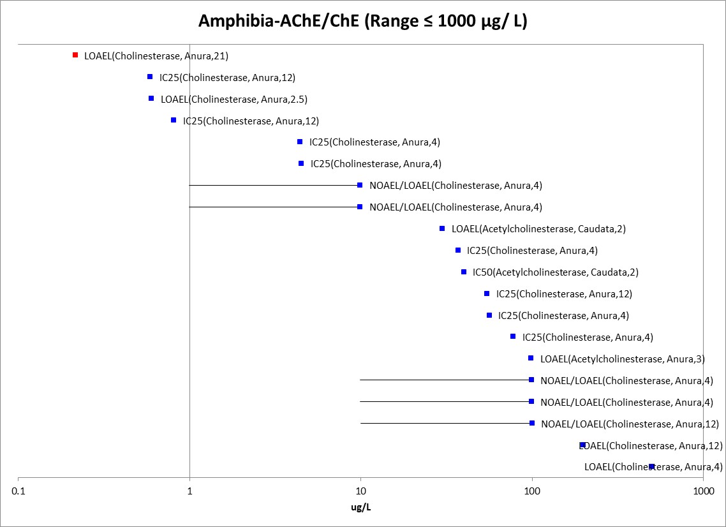
Figure 2-15. Amphibian Anticholinesterase Data Array (Range ≤ 1000 µg/L).

Other Biochemical/Cellular/Physiology Effects
Aside from anticholinesterase effects, there are also a vast array of other endpoints for biochemical, cellular, and physiology-based measurements in fish. To summarize the range of the “other” biochemical/physiological effects, the lowest endpoint was 0.03 µg/L (for increased melanomacrophage centers in spleen tissues; E112786) and ranged up to 25,000 µg/L (clotting time). Because of the large amount of data involved, an array with a range of ≤1000 µg/L is provided in APPENDIX 2-7. With respect to the biochemical effects seen at the lower end of the distribution, the types of effects reported were increases in melanomacrophage centers (in spleen), measures of heat shock protein, ATP, oxidative stress markers (e.g., thiobarbituric acid reactive substances/lipid peroxidation, glutathione), steroid hormones, and an array of other enzymes and clinical chemistries, such as protein content, hematocrit, cholesterol, etc. The types of cellular effects reported the lower end of the distribution were genetic markers (e.g., acetylcholinesterase mRNA, HSP70 mRNA, etc.) and gene expression, histologic effects (e.g., lesions) and various hematological parameters. Physiological effects included effects to mobility (at 0.5 µg/L), respiration, tensile strength, food conversion efficiency, ventilation, and heart rate.

Amphibians: For amphibians, the range of the “other” biochemical/physiological effects was 0.992 µg/L for DNA concentration (E68227) to 4554 µg/L (reduction in ornithine decarboxylase; E160018). Effects to mobility were noted in the toad (Rhinella fernandezae) at 62 µg/L (NOAEC=0.17 µg/L). Genetic effects included DNA concentration, damage, and effects to micronuclei. Biochemical effects included measurements of Ali esterase, ornithine decarboxylase, putrescine, and spermine. Figure 2-16 provides the data array for the distribution up to 1000 µg/L.

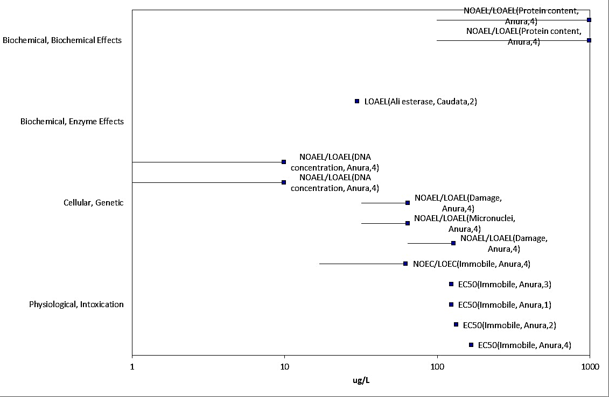
Figure 2-16. Amphibian Other Biochemical (excluding AChE/ChE), Cellular, and Physiological Effects Data Array (Range ≤ 1000 µg/L).

Mesocosm Data for Fish and Aquatic-Phase Amphibians

There were several mesocosm studies that examined effects to fish and although the ECOTOX database did not clearly identify the mesocosm-type studies in a fully searchable manner, in cases that low endpoints were from mesocosm or field-like studies, the results were included for summary in this section. Biever et al. (1994; E62037) conducted a study to focus on the direct effects on aquatic insects and other invertebrates and on the direct and indirect effects to the predatory bluegill sunfish (lepomis macrochirus). In this study fiberglass microcosms were submerged a water-filled basin and uncontaminated sediment and water from nearby ponds were added. The sediment and water contained native plankton and macroinvertebrate and macrophyte communities. Forty juvenile bluegill fish were stocked to each microcosm. The microcosms were treated with chlorpyrifos (Lorsban 4E) via spray boom directed to the surface of the water as a single application of 0.05 to 5% of a 1.12 kg Al/ha application (to yield 0.03 to 3.0 µg/L chlorpyrifos in water). At 0.3 µg/L, there were reductions in many groups of the invertebrates, but no effects to fish. At 1 µg/L, there were effects to invertebrates and also a reduction in fish length and total biomass (NOAEC=0.3/LOAEC=1 µg/L). The 3 µg/L treatment caused persistent effects on nearly all invertebrate taxa and significantly reduced fish survival. Most freshwater invertebrate and fish communities were able to recover within a few weeks with the possible exception of Chironominae, a subfamily of Chironomidae.

Giddings et al., (1997; E18134), includes the results from the experiment described in Biever et al., (1994-above), and also reports the results from two additional experiments (a slurry based application and also a combined spray and slurry). In the slurry application, 18 mesocosms were treated with slurry applications simulating surface runoff three times at 2-week intervals. Each treatment group included 5 treatment levels in triplicate plus 3 controls. The slurry application rates on each of the three treatment dates corresponded to the same nominal concentrations as the spray applications, equivalent to 0.005% to 0.5% runoff from a 1-lb/acre application into a 6-foot water column, with a 10:1 ratio of watershed area to pond area. The second experiment, was a combination of spray and slurry. In this experiment, the “combined” treatment level 1 consisted of three simulated spray drift applications at 2-week intervals alternating with three slurry applications. The “combined” treatment levels 2 and 3 consisted of six simulated spray drift applications (7-d intervals) alternating with six simulated runoff applications applied 4 days after each spray application. The spray application rates corresponded to nominal concentrations in water of 1.0 µg/L (levels 1 and 3) and 0.3 µg/L (level 2). The runoff application rate for all treatments corresponded to nominal concentrations in water of 0.6 µg/L.

For the slurry, the IC25 for bluegill survival was 1.20 µg/L (maximum), 0.837 µg/L (96-h maximum), and 0.5 µg/L (30d max) and the IC25 for biomass was 0.632 µg/L (maximum), 0.447 µg/L (96-hr max), and 0.264 µg/L (30d max). For the “combined” treatment, the IC25 for survival was 1.68 µg/L (maximum), 1.38 µg/L (96-h maximum), and 0.866 µg/L (30d max) and the IC25 for biomass was 1.60 µg/L (maximum), 1.32 µg/L (96-h maximum), and 0.794 µg/L (30d max). In summary, the inhibition concentrations (IC25) for bluegill survival and total biomass ranged from about 0.3 to 1.7 µg/L, depending on the type of treatment.

Effects to Fish and Aquatic-Phase Amphibians Not Included in the Arrays

All of the array data used throughout this effects characterization are in units that can be converted to microgram per liter. However, there were other studies that exposed the organisms on a per acre or per hectare rate. These studies are summarized below in Table 2-7. Additionally, there were a handful of studies that were based on other units that are less useful such as ml/L, nmol/g wet weight, ppm, and ug/day. These studies with “other units” do not present unique types of effects when compared to the full dataset (microgram per liter) but are provided in Table 2-8 as a reference.

Table 2-7. Toxicity Data for Chlorpyrifos Based on lb a.i./A or kg a.i./ha (not in arrays)
Species | Effect Group | Endpoint | Media | Duration (d) | Endpoint Concentration | UNITS | Exp Type | ECOTOX #
Western Mosquitofish | MOR | No Mortality | FW | 7 | 0.0167 | AI lb/acre | E | 60691
Common Puffer | MOR | No Mortality | SW | 3 | 0.038 | AI lb/acre | E | 13445
Sailfin Molly | MOR | No Mortality | FW | (1 hour) 0.0417 | 0.038 | AI lb/acre | E | 13445
Flounder | MOR | 100% mortality | SW | 1 | 0.038 | AI lb/acre | E | 13445
Mullet | MOR | No Mortality | SW | 1 | 0.038 | AI lb/acre | E | 13445
Flounder | MOR | No Mortality | SW | (4 hours) 0.1667 | 0.038 | AI lb/acre | E | 13445
Bluegill | MOR | 100% mortality | FW | 34 | 0.05 | AI lb/acre | E | 152771
Green Sunfish | MOR | 100% mortality | FW | 1 | 0.05 | lb/acre | E | 4501
Green Sunfish | MOR | 100% mortality | FW | 3.5 | 0.05 | lb/acre | E | 4501

Table 2-8. Data Excluded from Array Based on Units
Species | Effect Group | Measure | Endpoint | Media | Duration (d) | Endpoint Concentration | UNITS | Exp Type | ECOTOX #
Snake-Head Catfish | BCM | GLYC | LOAEL | FW | 1 | 0.02 | ml/L | S | 159924
Snake-Head Catfish | BCM | GLYC | LOAEL | FW | 4 | 0.02 | ml/L | S | 159924
Snake-Head Catfish | BCM | GLYC | LOAEL | FW | 3 | 0.02 | ml/L | S | 159924
Snake-Head Catfish | BCM | GLYC | LOAEL | FW | 2 | 0.02 | ml/L | S | 159924
Common Carp | PHY | OXYG | LOAEL | FW | 10 | 0.03 | ml/L | R | 121108
Common Carp | PHY | OXYG | LOAEL | FW | 15 | 0.03 | ml/L | R | 121108
Common Carp | PHY | OXYG | LOAEL | FW | 1 | 0.03 | ml/L | R | 121108
Common Carp | PHY | OXYG | LOAEL | FW | 5 | 0.03 | ml/L | R | 121108
Common Carp | PHY | OXYG | LOAEL | FW | 2 | 0.15 | ml/L | R | 121108
Common Carp | PHY | OXYG | LOAEL | FW | 3 | 0.15 | ml/L | R | 121108
Common Carp | PHY | OXYG | LOAEL | FW | 1 | 0.15 | ml/L | R | 121108
Common Carp | PHY | OXYG | LOAEL | FW | 4 | 0.15 | ml/L | R | 121108
Bluegill | BEH | EQUL | ER50 | FW | 2 | 2.87 | nmol/g wet wt | R | 103283
Bluegill | MOR | MORT | LR50 | FW | 2 | 11.05 | nmol/g wet wt | R | 103283
Fathead Minnow | BEH | EQUL | ER50 | FW | 2 | 102 | nmol/g wet wt | R | 103283
Spanish Toothcarp | BCM | HP70 | LOAEL | SW | 47 | 0.000495 | ppm | FD | 65921
Spanish Toothcarp | BCM | HP70 | LOAEL | SW | 47 | 0.000495 | ppm | FD | 65921
Spanish Toothcarp | BCM | HP70 | LOAEL | SW | 32 | 0.000495 | ppm | FD | 65921
Spanish Toothcarp | BCM | HP70 | LOAEL | SW | 32 | 0.000495 | ppm | FD | 65921
Spanish Toothcarp | MOR | MORT | No Mortality | SW | 47 | 0.000495 | ppm | FD | 65921
Zebra Danio | BCM | SRTN | LOAEL | FW | 23 | 10 | ug/d | FD | 112579

Concentrations Where No Effects Were Observed in Fish and Aquatic-Phase Amphibian Studies

For the environmentally relevant exposure units, there are data available from some studies that show no effects at the concentration(s) tested (in those particular studies). These endpoints include NOAEC/NOAEL and NR-Zero values as reported in ECOTOX. Below are the arrays showing the NE endpoints for chlorpyrifos and fish and aquatic-phase amphibians (see Figures 2-17 and 2-18). For fish, the available ‘NE’ endpoint concentrations generally range from 0.1 µg a.i./L to 25 mg/L (the four highest values which were over 5,000 µg a.i./L are excluded from the figure for presentation purposes). For aquatic-phase amphibians, the ‘NE’ concentrations range from 3.2 µg a.i./L to 13.9 mg/L (the four values over 5,000 µg a.i./L are excluded from the figure for presentation purposes).

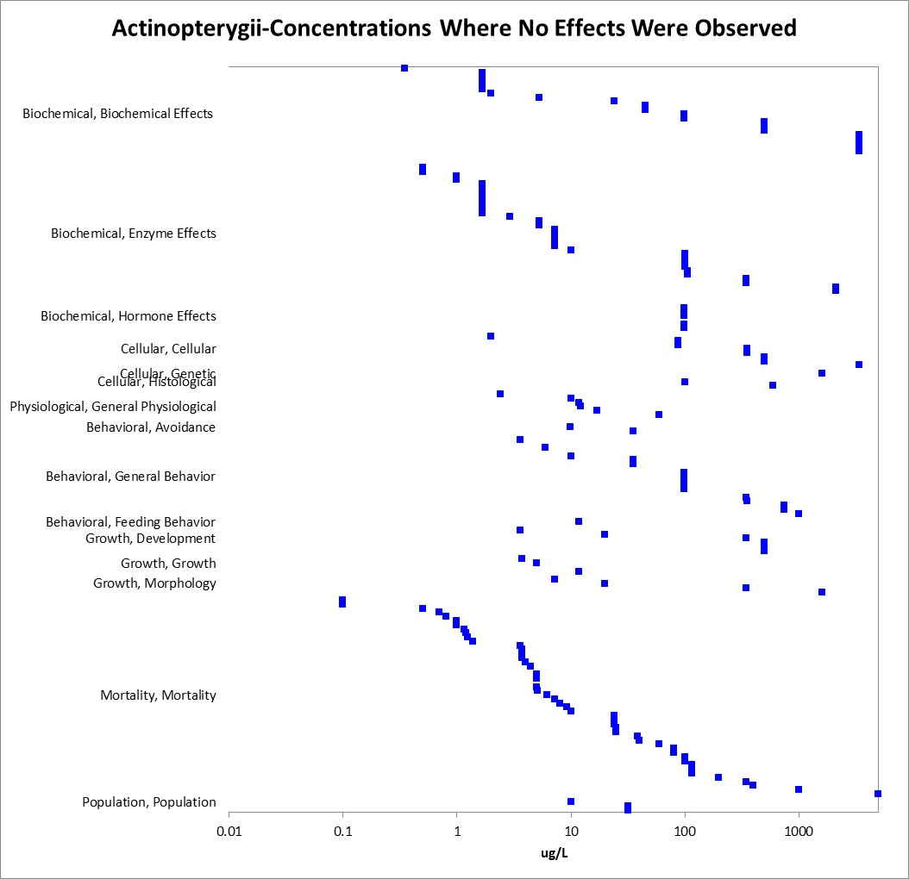
Figure 2-17. Concentrations Where No Effects Were Observed (Fish).

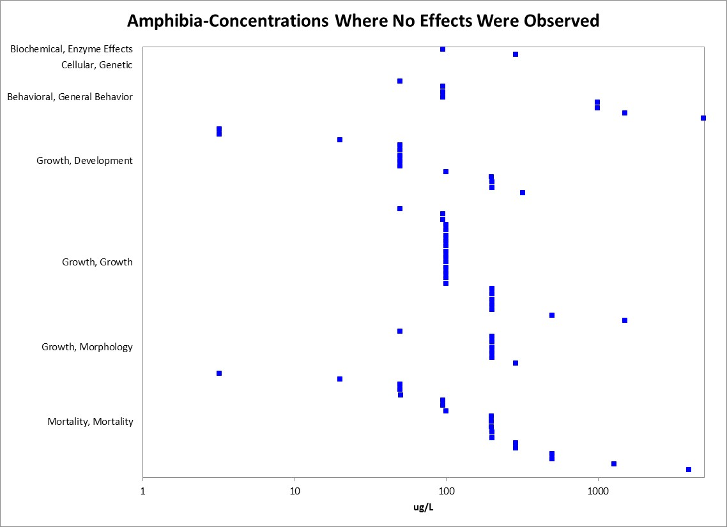
Figure 2-18. Concentrations Where No Effects Were Observed (Amphibians).

Incident Reports for Fish and Aquatic-Phase Amphibians

A detailed review of the incidents in EFED’s incident database (EIIS) was prepared for a previous assessment for the effects determination for listed species (Oct 16, 2009) and shows a total of 280 reported ecological incidents associated with the use of chlorpyrifos. Chlorpyrifos has been reported as the ‘probable’ or ‘highly probable’ causative agent for 110 (of the reported 123) adverse aquatic incidents (e.g., fish kills). These incidents were reported over the period of 1974 to 2009 and resulted from the legal, registered uses of chlorpyrifos as well as misuses. In addition, in some cases it could not be determined if the incident resulted from the legal use of chlorpyrifos or misuse. Overall, the incident data that are available indicate that exposure pathways for chlorpyrifos are complete and that exposure levels are sufficient to result in field-observable effects.

In 2007, Koi carp (Cyprinus carpio, <17 individuals) were killed (EIIS Incident No. I019051-003) in a backyard pond in a residential area, after 2-3 days of exposure to Mosquitomist 1.5 ULV Concentrate (active ingredient Chlorpyrifos). A wide area had been sprayed in the vicinity of the pond. The legality was undetermined and the certainty was classified as probable as chlorpyrifos is highly toxic to fish and the spray could have caused the mortality. The route of exposure was spray drift.

In 2008, the Iowa Department of Natural Resources reported a large fish kill (EIIS Incident No. I020252-001) in which dead fish were found along a five mile stretch of a stream in Louisa County, Iowa. The total number of dead fish were approximately 15,300 including an estimated 7000 minnows (Cyprinidae), 3000 stonerollers, 2700 Johnny darters (Percidae), 800 green sunfish (Lepomis cyanellus), 800 bullheads (Ameiurus sp), 1000 white suckers (Catostomus commersomi), 40 bluegills (Lepomis macrochirus), and 2 largemouth bass (Micropterus salmoides). Iowa Department of Natural Resources has not been able to determine exactly how the chemicals entered the stream; however, the report states that there was both aerial and ground spraying of Headline (active ingredient, pyraclostrobin, a fungicide, 099100), Lorsban (active ingredient, chlorpyrifos), and Cobalt (active ingredient, chlorpyrifos) on corn and soybean fields in the vicinity prior to the incident. Chlorpyrifos was measured at 1.8 ppb (which, coincidentally, is the 96-hr LC50 for bluegill sunfish) in a water sample taken close to the field that had been sprayed. Pyraclostrobin was measured in water samples at 29 ppb close to the field and at 13 ppb a couple of miles downstream. These levels were also greater than the LC50 for freshwater fish (6.2 - 11.4 ppb). No evidence was found of other stressors, including ammonia, low dissolved oxygen, manure runoff, or other pesticides (there were only "trace amounts" of other pesticides in the water samples). Legality was undetermined, certainty probable, but the role of chlorpyrifos vs. that of pryaclostrobin was unclear. Use was for corn and soybeans.

In 2009, two large fish kills occurred in Iowa. In July, 2009, approximately 540 fish were killed: 480 bluegills, 43 minnows, 9 largemouth bass, 8 Johnny darters, and 1 each slender madtom and yellow bullhead. Chlorpyrifos was almost certainly the primary cause of this kill. Measured concentrations of chlorpyrifos were as high as 12 ppb, several times the LC50 for bluegill sunfish (1.8 ppb). Pyraclostrobin was also present and cannot be ruled out as a possible contributing factor. Measured concentrations were as high as 1 ppb, which compares to a bluegill LC50 11.4 ppb. Myclobutanil was also detected at low levels but probably was not a factor considering its low toxicity to fish (bluegill LC50 2400 ppb). Causes for this incident were deemed "highly probable" for chlorpyrifos, "possible" for pyraclostrobin, and "unlikely" for myclobutanil. In the August 21, 2009 incident, approximately 945 fish were killed in a stream near Kanawha, Iowa. The dead fish were mostly suckers, along with darters, catfish, sunfish and minnows. The stream ran through soybean and corn farms with little to no buffers. The incident was attributed to the aerial spraying of chlorpyrifos. Chlorpyrifos was measured in the stream at concentrations as high as 1.7 ppb, which is very close to the LC50 for bluegill sunfish.

Two additional incidents were reported since the 2009 assessment (Query date: 2/15/15) and they were both classified as misuse (intentional). Incident (IO22084-001) occurred July 25, 2010 in Marion, AK after a ground treatment to golf course turf killed thousands of fish. The second incident (IO23486-008) occurred in Brazil (Oct 22, 2011) and was reported to have killed 200,000 fish in an outdoor breeding tank.

Summary of Effects to Fish and Aquatic-Phase Amphibians

In general, chlorpyrifos is highly toxic to fish. While there is a large range in the acute mortality data with LC₅₀ values ranging from 0.17 µg/L to 7,012 µg/L, over half of the values within the SSD data set were less than 100 µg/L which would fall under the category of “very highly toxic” according to the EPA classification. Sublethal effects such as effects to reproduction, behavior, and growth begin at concentrations of around 0.25 µg/L and sensory effects (e.g. olfaction) were noted at 0.6 µg/L. The lowest sublethal endpoint was for acetylcholinesterase inhibition (LOAEC of 0.004 µg a.i./L), based on a 31% decrease in brain AChE activity when compared to the control for the Mesa silverside (C. jordani), also a highly sensitive species according to the acute mortality data. Based on the incident data that are available, the exposure pathways for chlorpyrifos are complete and the exposure levels are sufficient to result in field-observable effects.

The dataset for amphibians is much smaller and in several cases the fish data are relied on as a surrogate. In general, the available data suggests that aquatic-phase amphibians may be less sensitive to chlorpyrifos than fish. The acute mortality LC₅₀ values range from 19 -14,483 µg/L. Sublethal effects such as growth and behavior were observed around 10 µg/L (NOAEC of 1 µg/L) and sensory effects were observed at 115 µg/L. The lowest sublethal endpoint was for acetylcholinesterase inhibition based on a 21% decrease in hind limb tissue AChE activity when compared to the control for the African clawed frog (Xenopus laevis).

Effects Characterization for Aquatic Invertebrates

Introduction to Aquatic Invertebrate Toxicity

The effects of chlorpyrifos on aquatic invertebrates have been studied extensively, including both freshwater and estuarine/marine (E/M) invertebrates. There are registrant submitted studies involving aquatic invertebrates, including acute and chronic laboratory studies with technical chlorpyrifos. Overall, there are approximately 332 open literature and registrant submitted studies available for use in this assessment. APPENDIX 2-2 includes the bibliography of studies that are included in this effects characterization and those that were excluded. Studies were excluded main analysis (i.e., Species Sensitivity Distribution and data arrays) if they were considered invalid or the exposure units could not be converted into aqueous concentrations.

Studies from the open literature and registrant submissions are used to derive thresholds and to characterize the effects to aquatic invertebrates in a weight-of-evidence approach. This section presents the thresholds for direct effects to listed species of aquatic invertebrates and for indirect effect to listed species that depend upon aquatic invertebrates. This section also discusses the weight of evidence (WoE) available for different types of effects on aquatic invertebrates, including lethality, decreased growth, decreased reproduction, AChE inhibition, and impacts on behavior/sensory effects. A discussion of incident reports is also included in this characterization.

In this effects characterization, when sufficient data are available for chlorpyrifos, different thresholds or lines of evidence are identified for freshwater and estuarine/marine invertebrates. Also, sensitivity of mollusks versus other aquatic invertebrates are discussed as lines of evidence, although, separate thresholds are not derived for mollusks in this assessment.

Threshold Values for Aquatic Invertebrates

Lethal thresholds are derived from SSDs of survival from aquatic invertebrate acute toxicity studies, while sublethal thresholds are based on the most sensitive sublethal effects identified among registrant-submitted studies and open literature in the ECOTOX database. As the most sensitive toxicity values used to derive thresholds are based on studies conducted with technical grade active ingredient, these endpoints may be used for evaluating exposures from runoff plus spray drift as well as from spray drift exposure alone. Studies from which threshold values are derived will be discussed in more detail in the respective section detailing lines of evidence for various types of effects (e.g., mortality, behavior, reproduction). The direct and indirect effects thresholds for aquatic invertebrates are presented in Tables 3-1 and 3-2. APPENDIX 2-3 provides the open literature reviews for studies with threshold values.

Table 3-1. Direct Effects Thresholds for Determining Effects to Listed Aquatic Invertebrates
Taxa | Threshold Type | Effect (endpoint) | Value (µg/L) | Duration of exposure | Source
Overall-Freshwater and E/M Invertebrates | Mortality | Mortality  (1/million) | 0.0036 | 48 or 96 hours | HC₀₅  (Pooled invertebrates) from SSD¹
 | Sublethal | ↓41% AChE  LC₀₁  (Hyalella azteca) | 0.0003 (LOAEC) ² | 96 hours | Anderson and Lydy, 2001; E64955
Freshwater Invertebrates | Mortality | Mortality  (1/million) | 0.0036 | 48 or 96 hours | HC₀₅  (Pooled invertebrates) from SSD¹
 | Sublethal | ↓41% AChE  LC₀₁  (Hyalella azteca) | 0.0003 (LOAEC) ² | 96 hours | Anderson and Lydy, 2001; E64955
 | Sublethal  (lowest above- provided for context) | ↓number of offspring per female at all concentrations (Daphnia magna) | 0.005 (LOAEC)² | 21 days | Zalizniak and Nugeoda, 2006; E107384
Estuarine/  Marine Invertebrates | Mortality | Mortality  (1/million) | 0.0036 | 48 or 96 hours | HC₀₅  (Pooled invertebrates) from SSD¹
 | Sublethal | Effects on reproduction at all concentrations  (Americamysis bahia) | <0.0046  LOAEC^{2,3} | 35 days (ELS) | MRID 42664901
¹ Details on derivation of SSD are provided in APPENDIX 2-8 and in the “Mortality” characterization section below.
² Definitive NOAEC values were not established in these studies.
³ A definitive value (NOAEC 0.002/LOAEC 0.004 µg/L) was reported in another reference based on reduced growth (same species), however, the report was a progress report (E3750; EPA Gulf Breeze report) and there was no final report, thus, these values are not used for the threshold.

Table 3-2. Indirect Effects Thresholds for Determining Effects to Listed Species That Depend on Aquatic Invertebrates
Taxa | Threshold Type | Effect (endpoint) | Value | Duration of exposure | Source
Overall-Freshwater and E/M Invertebrates | Mortality | Mortality  (1/million) | 0.0211 | 48 or 96 hours | HC₀₅  (Pooled invertebrates) from SSD¹
 | Sublethal | ↓41% AChE  LC₀₁  (Hyalella azteca) | 0.0003 (LOAEC) | 96 hours | Anderson and Lydy, 2001; E64955
Freshwater Invertebrates | Mortality | Mortality  (1/million) | 0.0211 | 48 or 96 hours | HC₀₅  (Pooled invertebrates) from SSD¹
 | Sublethal | ↓41% AChE  LC₀₁  (Hyalella azteca) | 0.0003 (LOAEC) | 96 hours | Anderson and Lydy, 2001; E64955
 | Sublethal (lowest above- provided for context) | ↓number of offspring per female at all concentrations (Daphnia) | 0.005 (LOAEC) | 21 days | Zalizniak and Nugegoda, 2006; E107384
Estuarine/  Marine Invertebrates | Mortality | Mortality  (1/million) | 0.0211 | 48 or 96 hours | HC₀₅  (Pooled invertebrates) from SSD¹
 | Sublethal | Effects on reproduction at all concentrations  (Americamysis bahia) | <0.0046  (LOAEC)² | 35 days (ELS) | MRID 42664901
¹ Details on derivation of SSD are provided in APPENDIX 2-8 and in the “Mortality” characterization section below.
² A definitive value (NOAEC 0.002/LOAEC 0.004 µg/L) was reported in another reference based on reduced growth (same species); however, the report was a progress report (E3750; EPA Gulf Breeze) and there was no final report, thus, these values are not used for the threshold.

Summary Data Arrays for Aquatic Invertebrates

Data arrays are used to present the entire spectrum of data available from either open literature or unpublished studies submitted by registrants. For the summary arrays and the individual line of evidence arrays, the data are grouped by the type of effect (e.g., behavior, reproduction, mortality) and endpoints were excluded if they were not reported in units that could be converted to µg/L (e.g., lb/acre). Any toxicity values that were excluded based on the units will be discussed in a separate section. The arrays contain data from both laboratory and field experiments (e.g., mesocosms). It is noted that within the data arrays there are often studies that contain multiple endpoints that report similar data (e.g., acute LC₅₀ values for each day exposed with little variation in toxicity) or multiple LCx values (i.e., LC₅, LC₁₀, LC₅₀, LC₉₀) for a single exposure day. Each of these individual endpoints are maintained as a unique value in the data array and there is uncertainty in to what degree this inclusion of data may impact the reported mean toxicity value for each effect type.

Due to the large number of listed mollusks, the data is divided into two categories, aquatic freshwater and saltwater invertebrates (excluding mollusks) and Mollusks. Figures 3-1 and 3-2 provide the data arrays for these two groups of toxicity data. Blue symbols represent mean endpoint values and bars represent the data range. APPENDIX 2-1 includes the all the data used to generate these arrays.

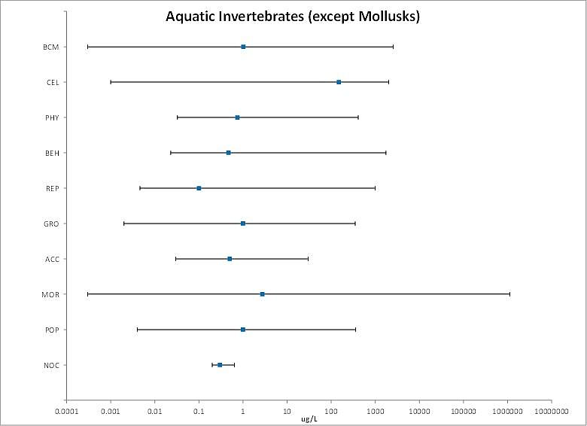
Figure 3-1. Summary Array for Aquatic Invertebrates (excluding Mollusks) Exposed to Chlorpyrifos. (BCM=Biochemical; CEL=Cellular; PHY=Physiological; BEH=Behavioral; REP=Reproduction; GRO=Growth; MOR=Mortality POP=Population)

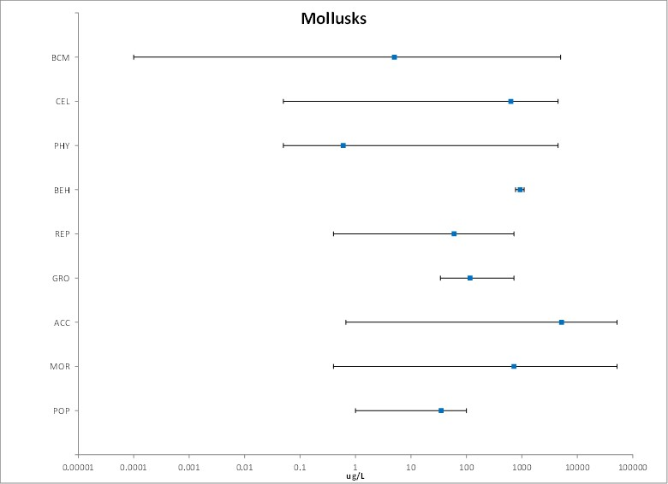

Figure 3-2. Summary Array for Mollusks Exposed to Chlorpyrifos. (BCM=Biochemical; CEL=Cellular; PHY=Physiological; BEH=Behavioral; REP=Reproduction; GRO=Growth; MOR=Mortality; POP=Population).

Lines of Evidence for Aquatic Invertebrates

Effects on Mortality of Aquatic Invertebrates

Mortality data (LC₅₀) are available from the ECOTOX database/open literature or registrant submitted studies for approximately 155 species of aquatic invertebrate representing 32 orders. Due to the large number of listed mollusks, there will be a separate discussion for the effects within the mollusk group. For aquatic invertebrates overall, when considering the acute mortality data from either a 48 or 96 hour exposure duration, there is a large range in sensitivity with a six order of magnitude difference in the values from 0.0138 µg/L [Scud (Hyalella azteca); MRID 44345601] to 20,925 µg/L [Mytilus galloprovinvialis; E14927]. The reported LC₅₀ values are from studies with either a 48 or 96-hour exposure duration, which is standard for acute aquatic invertebrate toxicity tests and ensures comparability of results. From the data available from the 48 and 96 hour exposure durations, the values from tests conducted with the active ingredient, chlorpyrifos, form the basis of the SSD. (Table 3-3; tests conducted with a.i. are indicated with a * in SSD column). All mortality data from other exposure durations will be available in the array, however, it is noted that there were no species that are not represented in Table 3-3 that had LC₅₀ values lower than 0.0138 µg/L (the lowest value in Table 3-3), with the exception of one study conducted on the Southern house mosquito (which had a 24-hour LC₅₀ of 0.009 µg/L; E 103416). The mortality thresholds for freshwater and E/M aquatic invertebrates are based on the 1-in a million of the HC₀₅ based on the SSD.

Mollusks-For mollusks, acute mortality (LC₅₀) data for chlorpyrifos are available for five bivalve species representing four families based on registrant submitted data and five available open literature references. The LC₅₀ values are included in Table 3-3 and are also in the SSD analysis for aquatic invertebrates. The acute toxicity estimates (LC₅₀) for chlorpyrifos range from 7.68 µg/L for the bivalve (Aulacomya ater) -to 20,925 µg/L for the Mediterranean mussel (Mytilus galloprovincialis). The lowest LC₅₀ (7.68 µg/L; Fuhrer, 2012, E159923), is for the bivalve Aulacomya ater tested with a formulated product (Lorsban 4E by Dow AgroSciences Chile S.A.; 48 % a.i.). The next most sensitive acute mortality endpoint is for the freshwater lamp mussel (Lampsillis siliquoidea), which was tested using both the a.i. and also a formulated product (44% a.i.) for comparison (Bringolf et al., 2007; E 99469). In this study, the reported LC₅₀ values were 250 µg/L (96 hour) and 430 µg/L (48 hour) for the technical chlorpyrifos and for the product, the 96 and 48 hour LC₅₀ values were 148 and 269 µg/L (after correcting to a.i.), respectively.

For oysters, shell deposition was used as a proxy for mortality with a reported LC₅₀ of 84 µg/L for the Eastern oyster (Crassostrea virginica) (MRID 42144905). While there were some issues with insufficient shell growth in the controls (1.8 and 1.6 mm for the negative and solvent controls vs 2mm as the recommended value), this study is considered more robust than the other available study for the oyster (Mayer, 1986; MRID 40228401), because of the lack of study details in the Mayer reference (for comparison, in Mayer (1986), the LC₅₀ values were 34 and 270 µg/L under different temperatures 13 and 28 ^{O}C ).

Table 3-3. Available Median Lethal Concentration (LC₅₀) Data for Aquatic Invertebrates Exposed to Chlorpyrifos as TGAI or Formulation.
Genus | Species | Endpoint | SSD | Conc. in ug/L | Ref # | Classification
Hyalella | azteca | MORT | * | 0.014 | MRID 44345601 | Acceptable
Daphnia | magna | IMBL |  | 0.032 | 160353 | NA¹
Americamysis | bahia | MORT | * | 0.035 | 15639 | NA¹
Daphnia | ambigua | MORT | * | 0.035 | 71674 | NA¹
Americamysis | bahia | MORT | * | 0.035 | MRID 40228401 | Supplemental
Hyalella | azteca | MORT | * | 0.038 | 352 | NA¹
Americamysis | bahia | MORT | * | 0.040 | 3947 | NA¹
Americamysis | bahia | MORT | * | 0.040 | MRID 40228401 | Supplemental
Hyalella | azteca | MORT | * | 0.043 | 64955 | Quantitative
Americamysis | bahia | MORT | * | 0.045 | MRID 42144906 | Acceptable
Ceriodaphnia | dubia | MORT | * | 0.048 | 158195 | NA¹
Hyalella | azteca | MORT | * | 0.050 | 16806 | NA¹
Simocephalus | vetulus | MORT | * | 0.050 | 16806 | NA¹
Haliplus | sp. | MORT | * | 0.050 | 16806 | NA¹
Cloeon | sp. | MORT | * | 0.050 | 16806 | NA¹
Ceriodaphnia | dubia | MORT | * | 0.050 | 73373 | NA¹
Deleatidium | sp. | MORT | * | 0.050 | 153793 | NA¹
Hyalella | azteca | MORT | * | 0.051 | 160294 | NA¹
Ceriodaphnia | dubia | MORT | * | 0.053 | 18190 | Quant. SSD
Ceriodaphnia | dubia | MORT | * | 0.055 | 18190 | Quant. SSD
Ceriodaphnia | dubia | MORT | * | 0.056 | 71674 | NA¹
Ceriodaphnia | dubia | MORT | * | 0.058 | 18190 | Quant. SSD
Hyalella | curvispina | MORT | * | 0.060 | 159934 | NA¹
Ceriodaphnia | dubia | MORT | * | 0.060 | 16844 | NA¹
Ceriodaphnia | dubia | MORT | * | 0.060 | 16844 | NA¹
Paratya | australiensis | MORT | * | 0.063 | 121117 | NA¹
Ceriodaphnia | dubia | MORT | * | 0.064 | 18190 | NA¹
Hyalella | azteca | MORT | * | 0.065 | 86411 | NA¹
Ceriodaphnia | dubia | MORT | * | 0.066 | 18190 | NA¹
Gammarus | pulex | MORT |  | 0.070 | 8107 | NA¹
Rhepoxynius | abronius | MORT | * | 0.070 | 56538 | NA¹
Hyalella | azteca | MORT | * | 0.070 | 86411 | NA¹
Ceriodaphnia | dubia | MORT | * | 0.070 | 108483 | Quant. SSD
Hyalella | azteca | MORT | * | 0.071 | 86411 | NA¹
Hyalella | azteca | MORT | * | 0.072 | 86411 | NA¹
Hyalella | azteca | MORT | * | 0.072 | 86411 | NA¹
Hyalella | azteca | MORT | * | 0.074 | 86411 | NA¹
Hyalella | azteca | MORT | * | 0.076 | 86411 | NA¹
Ceriodaphnia | dubia | MORT | * | 0.079 | 18190 | Quant. SSD
Gammarus | pulex | MORT |  | 0.080 | 8107 | NA¹
Paratya | australiensis | MORT | * | 0.080 | 18468 | NA¹
Paratya | australiensis | MORT | * | 0.080 | 18468 | NA¹
Ceriodaphnia | dubia | IMBL | * | 0.080 | 67777 | NA¹
Ceriodaphnia | dubia | MORT | * | 0.080 | 157799 | NA¹
Hyalella | azteca | MORT | * | 0.081 | 86411 | NA¹
Procloeon | sp. | MORT | * | 0.081 | 90039 | NA¹
Hyalella | azteca | MORT | * | 0.085 | 86411 | NA¹
Hyalella | azteca | MORT | * | 0.086 | 86411 | NA¹
Chironomus | riparius | MORT | * | 0.089 | 13342 | NA¹
Hyalella | azteca | MORT | * | 0.089 | 86411 | NA¹
Daphnia | carinata | MORT | * | 0.090 | 108483 | Acceptable
Simocephalus | vetulus | MORT | * | 0.090 | 108483 | Acceptable
Ceriodaphnia | dubia | MORT | * | 0.094 | 18190 | Quant. SSD
Paratya | australiensis | MORT | * | 0.10 | 18468 | NA¹
Hyalella | azteca | MORT |  | 0.10 | 18996 | NA¹
Rhepoxynius | abronius | MORT | * | 0.10 | 56538 | NA¹
Moina | australiensis | MORT | * | 0.10 | 108483 | NA¹
Daphnia | magna | IMBL | * | 0.10 | MRID 40840902 | Acceptable
Daphnia | magna | IMBL | * | 0.11 | 13342 | NA¹
Gammarus | lacustris | MORT | * | 0.11 | 6797 | NA¹
Ceriodaphnia | dubia | IMBL |  | 0.11 | 67777 | NA¹
Gammarus | lacustris | MORT | * | 0.11 | MRID 40098001 | Supplemental
Ceriodaphnia | dubia | MORT | * | 0.12 | 18190 | Quant. SSD
Neomysis | integer | MORT | * | 0.13 | 53635 | NA¹
Rhepoxynius | abronius | MORT | * | 0.14 | 56538 | NA¹
Paratya | australiensis | MORT | * | 0.15 | 18468 | NA¹
Paratya | australiensis | MORT | * | 0.15 | 18468 | NA¹
Neomysis | integer | MORT | * | 0.15 | 53635 | NA¹
Palaemonetes | pugio | MORT | * | 0.15 | 92616 | NA¹
Palaemonetes | pugio | MORT | * | 0.15 | 92616 | NA¹
Ampelisca | abdita | MORT | * | 0.16 | 56539 | NA¹
Palaemonetes | pugio | MORT | * | 0.16 | 72741 | NA¹
Hyalella | curvispina | MORT | * | 0.17 | 159934 | NA¹
Gammarus | palustris | MORT | * | 0.19 | 51439 | NA¹
Neomysis | integer | MORT | * | 0.19 | 53635 | NA¹
Daphnia | magna | IMBL | * | 0.19 | 96171 | NA¹
Culex | pipiens ssp. molestus | MORT |  | 0.20 | 5162 | NA¹
Cloeon | dipterum | IMBL |  | 0.20 | 8107 | NA¹
Farfantepenaeus | aztecus | MORT | * | 0.20 | MRID 40228401 | Supplemental
Daphnia | magna | IMBL | * | 0.21 | 13342 | NA¹
Daphnia | magna | IMBL | * | 0.22 | 13342 | NA¹
Gammarus | pulex | MORT | * | 0.23 | 159804 | NA¹
Daphnia | carinata | MORT | * | 0.23 | 107384 | Quantitative
Atalophlebia | australis | MORT | * | 0.24 | 108483 | Acceptable
Daphnia | carinata | MORT | * | 0.24 | 108495 | NA¹
Paratya | australiensis | MORT | * | 0.25 | 18468 | NA¹
Daphnia | pulex | MORT |  | 0.25 | 18477 | NA¹
Daphnia | pulex | IMBL |  | 0.25 | 18477 | NA¹
Ceriodaphnia | dubia | IMBL |  | 0.25 | 67777 | NA¹
Daphnia | magna | MORT | * | 0.25 | 157799 | NA¹
Chironomus | dilutus | IMBL | * | 0.25 | 160294 | NA¹
Daphnia | carinata | MORT | * | 0.28 | 107384 | NA¹
Paratya | australiensis | MORT | * | 0.28 | 18468 | NA¹
Paratya | australiensis | MORT | * | 0.28 | 18468 | NA¹
Paratya | australiensis | MORT | * | 0.28 | 18468 | NA¹
Simulium | vittatum | MORT | * | 0.28 | 71060 | NA¹
Atalophlebia | australis | MORT | * | 0.28 | 108483 | Acceptable
Chironomus | dilutus | MORT | * | 0.29 | 160294 | NA¹
Cloeon | dipterum | MORT |  | 0.30 | 8107 | NA¹
Daphnia | longispina | MORT |  | 0.30 | 8107 | NA¹
Daphnia | longispina | IMBL |  | 0.30 | 8107 | NA¹
Daphnia | longispina | IMBL |  | 0.30 | 8107 | NA¹
Gammarus | pulex | IMBL |  | 0.30 | 17254 | NA¹
Chironomus | tentans | MORT |  | 0.30 | 18996 | NA¹
Gammarus | palustris | MORT | * | 0.30 | 51439 | NA¹
Ceriodaphnia | dubia | IMBL | * | 0.30 | 67777 | NA¹
Culex | quinquefasciatus | MORT | * | 0.30 | 101101 | NA¹
Daphnia | carinata | MORT | * | 0.30 | 108495 | NA¹
Macrobrachium | rosenbergii | MORT |  | 0.30 | 116838 | NA¹
Chaoborus | obscuripes | MORT | * | 0.30 | 159804 | NA¹
Gammarus | fasciatus | MORT | * | 0.32 | 887 | NA¹
Daphnia | magna | MORT | * | 0.33 | 19813 | NA¹
Paratya | australiensis | MORT | * | 0.33 | 108483 | Quant. SSD
Chironomus | riparius | MORT | * | 0.34 | 13342 | NA¹
Ampelisca | abdita | MORT | * | 0.34 | 56539 | NA¹
Daphnia | magna | MORT | * | 0.34 | 19813 | NA¹
Cloeon | dipterum | MORT | * | 0.36 | 159804 | NA¹
Palaemonetes | pugio | MORT | * | 0.37 | 14848 | NA¹
Ampelisca | abdita | MORT | * | 0.39 | 4061 | NA¹
Ampelisca | abdita | MORT | * | 0.39 | 56539 | NA¹
Cloeon | dipterum | IMBL |  | 0.40 | 8107 | NA¹
Simocephalus | vetulus | IMBL |  | 0.40 | 8107 | NA¹
Simocephalus | vetulus | IMBL |  | 0.40 | 8107 | NA¹
Cloeon | dipterum | IMBL |  | 0.40 | 17254 | NA¹
Daphnia | pulex | IMBL |  | 0.42 | 18477 | NA¹
Gammarus | pulex | MORT |  | 0.43 | 159804 | NA¹
Palaemonetes | pugio | MORT | * | 0.44 | 14848 | NA¹
Chironomus | tentans | MORT | * | 0.45 | 352 | NA¹
Chironomus | dilutus | MORT | * | 0.46 | 117852 | NA¹
Chironomus | tentans | IMBL | * | 0.49 | 62472 | NA¹
Palaemonetes | argentinus | MORT |  | 0.49 | 101421 | NA¹
Simocephalus | vetulus | MORT |  | 0.50 | 8107 | NA¹
Caenis | horaria | IMBL |  | 0.50 | 8107 | NA¹
Lestes | sp. | MORT | * | 0.50 | 16806 | NA¹
Chaoborus | obscuripes | IMBL |  | 0.50 | 17254 | NA¹
Daphnia | carinata | MORT | * | 0.51 | 107384 | Quantitative
Macrobrachium | lar | MORT |  | 0.54 | 157374 | NA¹
Claassenia | sabulosa | MORT | * | 0.56 | MRID 40098001 | Supplemental
Claassenia | sabulosa | MORT | * | 0.57 | 6797 | NA¹
Daphnia | magna | IMBL | * | 0.57 | 13342 | NA¹
Daphnia | magna | MORT |  | 0.60 | 18996 | NA¹
Amphiascus | tenuiremis | MORT | * | 0.61 | 87778 | NA¹
Chironomus | dilutus | MORT |  | 0.63 | 160293 | NA¹
Palaemonetes | pugio | MORT | * | 0.69 | 14848 | NA¹
Chaoborus | obscuripes | IMBL |  | 0.70 | 8107 | NA¹
Caenis | horaria | IMBL |  | 0.70 | 8107 | NA¹
Diaptomus | forbesi | MORT |  | 0.72 | 303 | NA¹
Chironomus | tentans | MORT | * | 0.72 | 103283 | NA¹
Paratya | australiensis | MORT | * | 0.72 | 108483 | Quant. SSD
Daphnia | magna | IMBL | * | 0.73 | 108323 | NA¹
Peltodytes | sp. | MORT | * | 0.75 | 7775 | NA¹
Simocephalus | vetulus | MORT |  | 0.80 | 8107 | NA¹
Daphnia | longispina | MORT |  | 0.80 | 8107 | NA¹
Daphnia | pulex | MORT |  | 0.80 | 18477 | NA¹
Cloeon | dipterum | MORT |  | 0.81 | 159804 | NA¹
Daphnia | magna | MORT | * | 0.82 | 159804 | NA¹
Chironomus | dilutus | MORT | * | 0.83 | 117852 | NA¹
Anisops | sardeus | MORT |  | 0.90 | 59962 | NA¹
Daphnia | magna | IMBL | * | 0.90 | 159999 | NA¹
Cloeon | dipterum | MORT |  | 1.0 | 8107 | NA¹
Daphnia | magna | MORT | * | 1.0 | 16353 | NA¹
Anopheles | quadrimaculatus | MORT |  | 1.0 | 56989 | NA¹
Gammarus | fossarum | MORT | * | 1.0 | 116122 | NA¹
Daphnia | magna | IMBL | * | 1.1 | 62284 | NA¹
Chaoborus | obscuripes | MORT |  | 1.1 | 159804 | NA¹
Chironomus | plumosus | MORT | * | 1.3 | 118362 | NA¹
Chaoborus | obscuripes | IMBL |  | 1.4 | 8107 | NA¹
Culex | pipiens ssp. molestus | MORT |  | 1.5 | 5162 | NA¹
Palaemonetes | pugio | MORT | * | 1.5 | MRID 40228401 | Supplemental
Procambarus | sp. | MORT | * | 1.6 | 159804 | NA¹
Daphnia | pulex | MORT |  | 1.6 | 18477 | NA¹
Corixa | punctata | IMBL |  | 1.7 | 8107 | NA¹
Daphnia | magna | IMBL | * | 1.7 | MRID 102520 | NA¹
Plea | minutissima | MORT | * | 2.0 | 159804 | NA¹
Anax | imperator | MORT | * | 2.0 | 159804 | NA¹
Corixa | punctata | MORT |  | 2.0 | 8107 | NA¹
Sigara | arguta | MORT | * | 2.2 | 153793 | NA¹
Farfantepenaeus | duorarum | MORT | * | 2.4 | MRID 40228401 | Supplemental
Caenis | sp. | MORT | * | 2.5 | 16806 | NA¹
Macrobrachium | lanchesteri | MORT | * | 2.5 | 159754 | NA¹
Asellus | aquaticus | IMBL |  | 2.7 | 8107 | NA¹
Procambarus | sp. | MORT |  | 2.8 | 159804 | NA¹
Macrobrachium | lanchesteri | MORT | * | 2.8 | 159754 | NA¹
Daphnia | pulex | MORT |  | 2.9 | 18477 | NA¹
Corixa | punctata | IMBL |  | 3.2 | 8107 | NA¹
Anax | imperator | MORT |  | 3.3 | 159804 | NA¹
Gammarus | pulex | MORT | * | 3.4 | 115493 | NA¹
Asellus | aquaticus | IMBL |  | 3.4 | 17254 | NA¹
Streptocephalus | sudanicus | MORT |  | 3.5 | 59962 | NA¹
Amphiascus | tenuiremis | MORT | * | 3.6 | 87778 | NA¹
Limnephilus | indivisus | MORT | * | 3.6 | 16806 | NA¹
Diaptomus | forbesi | MORT | * | 3.6 | 54793 | NA¹
Amphiascus | tenuiremis | MORT | * | 3.6 | 87778 | NA¹
Asellus | aquaticus | IMBL |  | 4.3 | 8107 | NA¹
Litopenaeus | vannamei | MORT |  | 4.8 | 16892 | NA¹
Chironomus | plumosus | MORT | * | 5.0 | 118362 | NA¹
Callinectes | sapidus | MORT | * | 5.2 | MRID 40228401 | Supplemental
Gammarus | palustris | MORT |  | 5.2 | 51439 | NA¹
Enallagma | sp. | MORT | * | 5.3 | 16806 | NA¹
Plea | minutissima | MORT |  | 5.9 | 159804 | NA¹
Corixa | punctata | MORT |  | 6.0 | 8107 | NA¹
Neoplea | striola | MORT | * | 6.2 | 16806 | NA¹
Gammarus | palustris | MORT |  | 6.5 | 51439 | NA¹
Chaoborus | obscuripes | MORT |  | 6.6 | 8107 | NA¹
NR | Heptageniidae | MORT | * | 7.0 | 97793 | NA¹
Daphnia | magna | IMBL | * | 7.1 | 159936 | NA¹
Penaeus | monodon | MORT |  | 7.6 | 159862 | NA¹
Aulacomya | ater | MORT |  | 7.7 | 159923 | NA¹
Notonecta | maculata | MORT | * | 8.0 | 159804 | NA¹
Amphiascus | tenuiremis | MORT | * | 8.4 | 87778 | NA¹
Xanthocnemis | zealandica | MORT | * | 8.4 | 153793 | NA¹
Asellus | aquaticus | MORT | * | 8.6 | 159804 | NA¹
Chironomus | plumosus | MORT | * | 8.6 | 118362 | NA¹
Pteronarcys | californica | MORT | * | 10.0 | 6797 | NA¹
Pteronarcys | californica | MORT | * | 10.0 | MRID 40098001 | Supplemental
Ranatra | linearis | MORT |  | 12.0 | 159804 | NA¹
Procambarus | sp. | MORT | * | 12.9 | 159804 | NA¹
Branchiura | sowerbyi | MORT |  | 13.2 | 303 | NA¹
Chironomus | plumosus | MORT | * | 19.8 | 118362 | NA¹
Penaeus | monodon | MORT |  | 20.7 | 159862 | NA¹
Eriocheir | sinensis | MORT | * | 22.2 | 97350 | NA¹
Eriocheir | sinensis | MORT | * | 23.7 | 97350 | NA¹
Notonecta | maculata | MORT |  | 23.9 | 159804 | NA¹
Spiralothelphusa | hydrodroma | MORT |  | 24.0 | 108872 | NA¹
NR | Parathelphusidae | MORT |  | 24.0 | 108873 | NA¹
Parapoynx | stratiotata | MORT | * | 27.2 | 159804 | NA¹
Eriocheir | sinensis | MORT | * | 27.4 | 97350 | NA¹
Daphnia | magna | MORT |  | 27.4 | 159804 | NA¹
Penaeus | monodon | MORT |  | 28.2 | 159862 | NA¹
Parapoynx | stratiotata | MORT |  | 29.4 | 159804 | NA¹
Spiralothelphusa | hydrodroma | MORT |  | 30.8 | 108872 | NA¹
Crassostrea | virginica | MORT | * | 32.0 | MRID 40228401 | Supplemental
Spiralothelphusa | hydrodroma | MORT |  | 33.8 | 108872 | NA¹
NR | Parathelphusidae | MORT |  | 33.8 | 108873 | NA¹
Chironomus | plumosus | MORT | * | 34.5 | 118362 | NA¹
Procambarus | sp. | MORT |  | 34.8 | 159804 | NA¹
Chironomus | plumosus | MORT | * | 49.2 | 118362 | NA¹
Eriocheir | sinensis | MORT | * | 53.1 | 97350 | NA¹
Chironomus | plumosus | MORT | * | 63.7 | 118362 | NA¹
Branchiura | sowerbyi | MORT | * | 66.0 | 54793 | NA¹
Eriocheir | sinensis | MORT | * | 73.6 | 97350 | NA¹
Eriocheir | sinensis | MORT | * | 76.1 | 97350 | NA¹
Chironomus | plumosus | MORT | * | 78.6 | 118362 | NA¹
Crassostrea | virginica | MORT | * | 84.0 | MRID 42144905 | Supplemental
Chironomus | plumosus | MORT | * | 93.3 | 118362 | NA¹
Anisus | vortex | IMBL |  | 94.0 | 8107 | NA¹
Lymnaea | stagnalis | IMBL |  | 94.0 | 8107 | NA¹
Chironomus | plumosus | MORT | * | 108 | 118362 | NA¹
Chironomus | plumosus | MORT | * | 123 | 118362 | NA¹
Eriocheir | sinensis | MORT | * | 138 | 97350 | NA¹
Eriocheir | sinensis | MORT | * | 140 | 97350 | NA¹
Lampsilis | siliquoidea | MORT |  | 148 | 99469 | NA¹
Chironomus | plumosus | MORT | * | 174 | 118362 | NA¹
Chironomus | plumosus | MORT | * | 226 | 118362 | NA¹
Chironomus | plumosus | MORT | * | 236 | 118362 | NA¹
Donax | faba | MORT |  | 248 | 159921 | NA¹
Lampsilis | siliquoidea | MORT | * | 250 | 99469 | Quant. SSD
Chironomus | plumosus | MORT | * | 253 | 118362 | NA¹
Lampsilis | siliquoidea | MORT |  | 269 | 99469 | NA¹
Crassostrea | virginica | MORT | * | 270 | MRID 40228401 | Supplemental
Sialis | lutaria | MORT |  | 327 | 159804 | NA¹
Lampsilis | siliquoidea | MORT |  | 430 | 99469 | NA¹
Neocaridina | denticulata | MORT | * | 457 | 159804 | NA¹
Oziotelphusa | senex ssp. senex | MORT |  | 550 | 18025 | NA¹
Daphnia | magna | MORT | * | 580 | 159937 | NA¹
Neocaridina | denticulata | MORT |  | 660 | 159804 | NA¹
Ischadium | recurvum | MORT |  | 960 | 84369 | NA¹
Hydra | attenuata | MORT | * | 1000 | 159864 | NA¹
Hydra | attenuata | MORT | * | 1500 | 159864 | NA¹
Crassostrea | virginica | MORT | * | 2000 | MRID 40228401 | Supplemental
Litopenaeus | stylirostris | MORT | * | 2266 | 73317 | NA¹
Brachionus | calyciflorus | MORT | * | 12000 | 3963 | NA¹
Brachionus | calyciflorus | MORT | * | 12000 | 17689 | NA¹
Mytilus | galloprovincialis | MORT | * | 20925 | 14927 | Quant. SSD
NA = Studies are acceptable for ECOTOX but have not been formally reviewed by EFED scientists
* = Value used to derive SSD

Species Sensitivity Distribution

The available acute toxicity studies conducted with technical grade chlorpyrifos were used to derive SSDs for aquatic invertebrates. In order to generate SSDs, five potential distributions were considered (log-normal, log-logistic, log-triangular, log-gumbel, and Burr) and the log-gumbel distribution was found to provide the best fit. Tests also suggest that a single SSD should be fit to the pooled freshwater and saltwater results. Model-averaged SSDs and model-averaged quantiles, including the HC₀₅ were estimated and are presented in Table 3-4. The cumulative distribution function for the SSDs for Pooled Freshwater and E/M invertebrates, Freshwater invertebrates, and E/M invertebrates are presented in Figures 3-3, 3-4 and 3-5, respectively. APPENDIX 2-8 includes further the details of how these SSDs were derived.

Table 3-4. Summary Statistics for Log-gumbel SSDs Fit to Chlorpyrifos Test Results
Statistic |  |  | Pooled Results | Freshwater Results | Saltwater Results
Goodness of fit P-value | 0.7443 |  |  | 0.6144 | 0.9041
CV of the HC₀₅ |  | 0.47 |  | 0.47 | 2.03
UCp¹ of the HC₀₅ |  | 0.121 |  | 0.13 | 0.221
HC₀₅ |  | 0.041 |  | 0.044 | 0.034
HC₁₀ |  | 0.072 |  | 0.075 | 0.073
HC₅₀ |  | 0.98 |  | 0.79 | 2.43
HC₉₀ |  | 59.5 |  | 32.0 | 602
HC₉₅ |  | 285.0 |  | 131.9 | 4947.5
Mortality Threshold (slope = 4.5) |  | 0.0036 |  | 0.0039 | 0.0030
Indirect Effects Threshold (slope = 4.5) |  | 0.0211 |  | 0.0230 | 0.0174
¹ML=maximum likelihood, MO= moment estimators, and GR=graphical methods
¹ UCp=projections of the upper confidence limit of the HC₀₅ onto the cumulative distribution function of the fitted distribution.

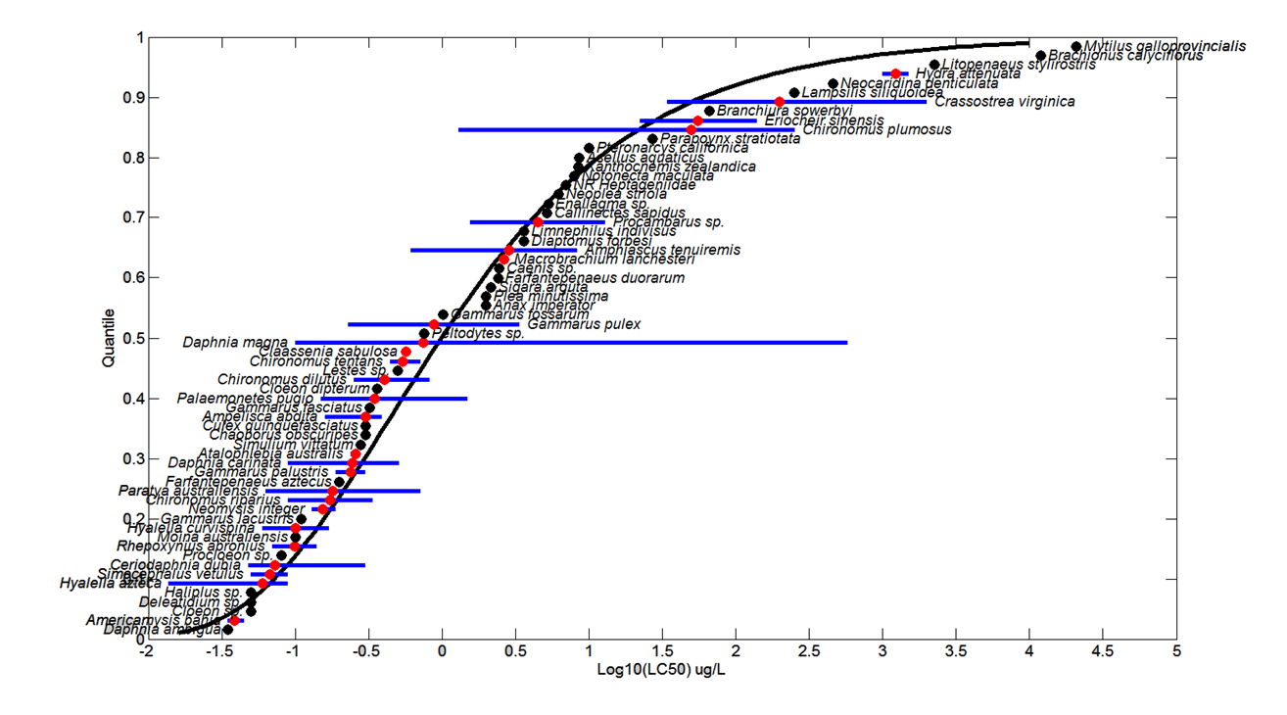

Figure 3-3. Log-gumbel SSD for Chlorpyrifos Toxicity Values for Pooled Freshwater and Estuarine/Marine Invertebrates. Black points indicate single toxicity values. Red points indicate average of multiple toxicity values for a single species. Blue line indicates full range of toxicity values for a single species.

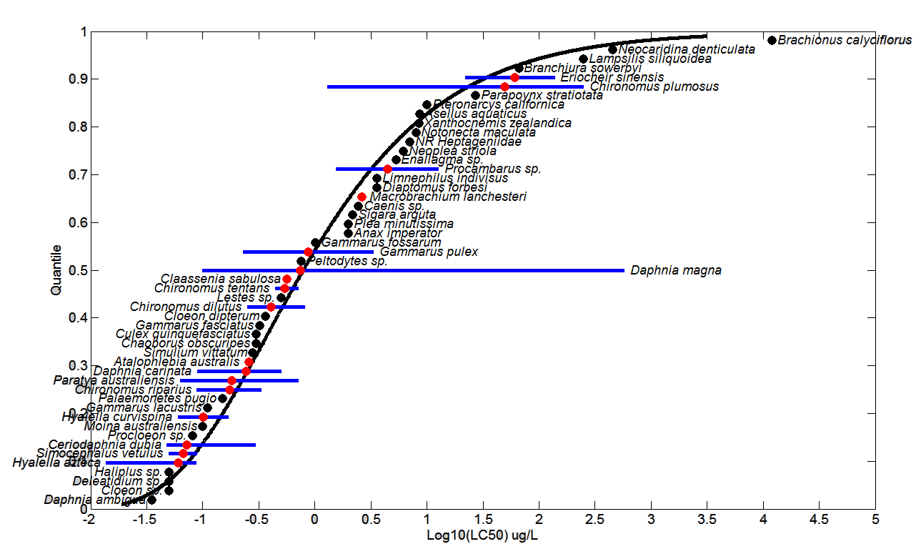

Figure 3-4. Log-gumbel SSD for Chlorpyrifos Toxicity Values for Freshwater Invertebrates. Black points indicate single toxicity values. Red points indicate multiple toxicity values for a single species. Blue line indicates full range of toxicity values for a single species.

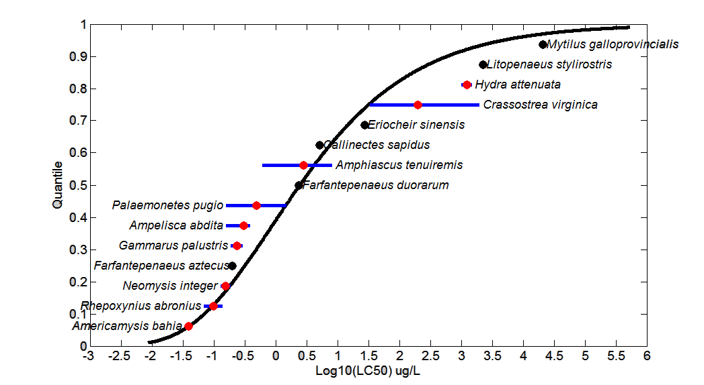

Figure 3-5. Log-gumbel SSD for Chlorpyrifos Toxicity Values for Estuarine/Marine Invertebrates. Black points indicate single toxicity values. Red points indicate multiple toxicity values for a single species. Blue line indicates full range of toxicity values for a single species.

Aside from the acute mortality endpoints, other mortality-related endpoints are for reduced survival/survivorship, hatch and lifespan. For this group of effects data, there are 20 references in the open literature, representing 6 Orders and 15 species. The values range from 0.02 µg/L for reduced survivorship in the midge [Chironomus tentans; E89548, Rakotondravelo et al., 2006] to 9,900 µg/L for reduced survival and hatching of brine shrimp [Artemia sp.; E92494, Varo et al., 2006]. Figure 3-6 presents the data array of available data and for presentation purposes, the two endpoints from concentrations >1000 µg/L were excluded from the array.

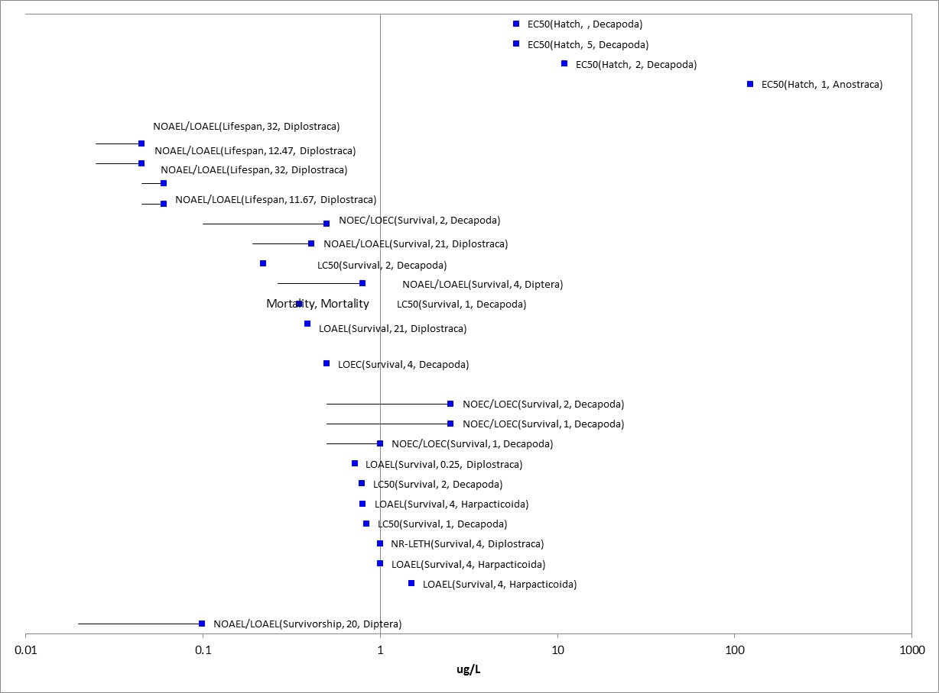
Figure 3-6. Aquatic Invertebrates (excluding mollusks) Survival-Hatch Data Array (Range: < 1000 µg/L).

For mollusks, the data ranged from 0.4 µg/L (NOAEC) for the orb snail [Coretus corneus; E160288, Rivadeneira et al., 2013-see more discussion of this study under the Reproduction section]-720 µg/L for reduced survival of the snail [Bulinus truncatus; E158174-Hasheesh et al., 2011]. Figure 3-7 presents the data array of available data for Mollusks.

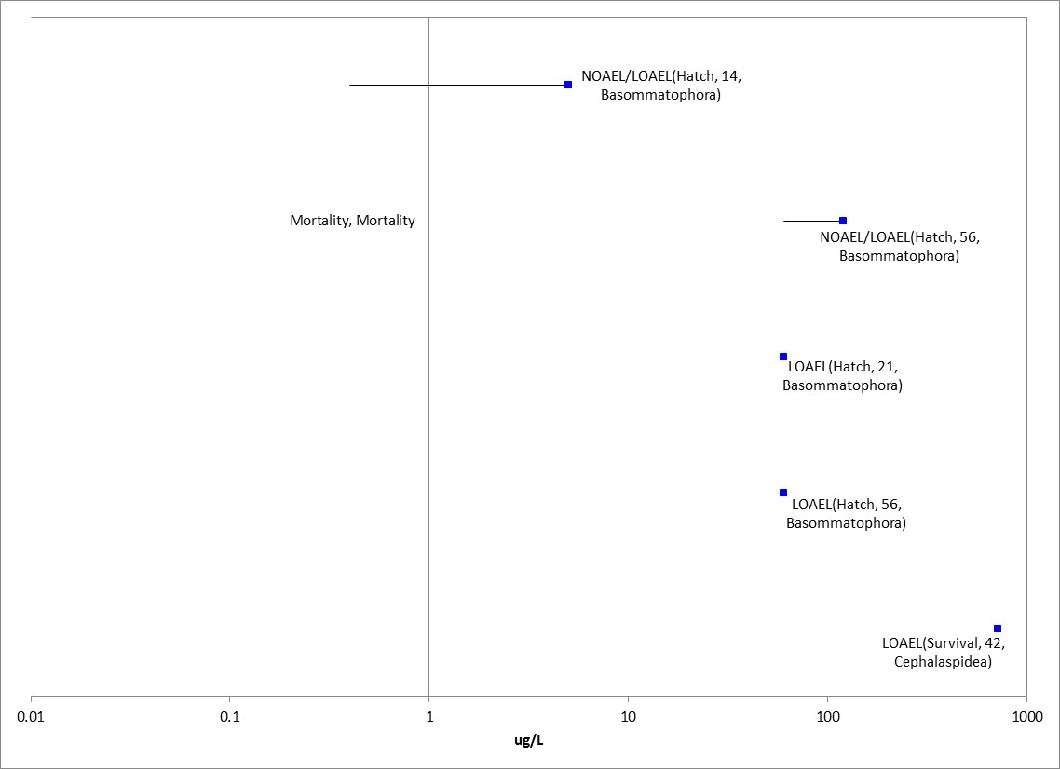
Figure 3-7. Survival-Hatch Data Array for Mollusks.

Sublethal Effects to Aquatic Invertebrates

Major categories of sublethal effects (i.e., growth, reproduction, behavior, sensory effects, and acetylcholinesterase inhibition) and the studies with the lowest toxicity values for sublethal effects are discussed below.

Effects on Growth of Aquatic Invertebrates

The data set for growth effects for aquatic invertebrates (excluding mollusks), includes 25 references from the open literature representing eight orders and 13 species. Growth endpoints ranged from a NOAEC/LOAEC of 0.002/0.004 µg/L based on decreased rostrum-telson length in mysid shrimp [M. bahia-qualitative only-based on an EPA lab provisional report; E3750]-to 350 µg/L based on decreased maturation in Sea Urchin (Paracentrotus lividus; E 121121). Other low endpoints include effects to pupation in the southern house mosquito (Culex quinquefasciatus; E103416, Aguilera et. al, 1995) and longer pupation time in Caridean shrimp (E101421; Montagna and Collins, 2007), both freshwater species, with LOAECs of 0.004 and 0.005 µg/L, respectively, however, both of these reports lack details for quantitative use. Another low-end effect for a freshwater species was for the water flea (D. magna; E121120, Palma et al., 2009), with a LOAEC of 0.007 µg/L based on abnormal growth. For an E/M species, the next lowest value is from a study with a coral species. In Markey et al., 2007 (E100575), the exposure of coral (Acropora millipora) larvae (6, 7, and 8 day) to chlorpyrifos and chlorpyrifos oxon (further discussion of oxon is in the Problem Formulation and APPENDIX 1-9), resulted in significant effects to metamorphosis (settlement). In this study, the 6-day larvae were exposed to 30, 100, and 300 µg/L of each toxicant and metamorphosis was completely inhibited. The 7 and 8-day larvae were exposed to (1.0, 3.0, 20, and 30 µg/L) and 0.1, 0.3, and 1 µg/L, respectively. Larvae settlement was reduced between 60-100% following 18 hour exposures and the LOAEC for chlorpyrifos was 1µg/L (NOAEC 0.3 µg/L ). In this study, the larvae were more sensitive than the adult life stage. Overall, the LOAEC of 0.007 µg/L from the FW species is used to represent the growth line of evidence for both FW and E/M invertebrates. Figure 3-8 provides an overview of the lower-end of the distribution (i.e., growth endpoint values from concentrations ≤ 10 µg/L).

Mollusks-For mollusks, data are available from seven references, representing five orders and species. The growth endpoints range from 34 µg/L for decreased shell deposition in the American oyster (Crassostrea virginica; E 56465, E14574) to 720 µg/L for growth retardation in snail (Bulinus truncatus; E158174 Hasheesh et al., 2011). Figure 3-9 provides the data array for growth effects in mollusks.

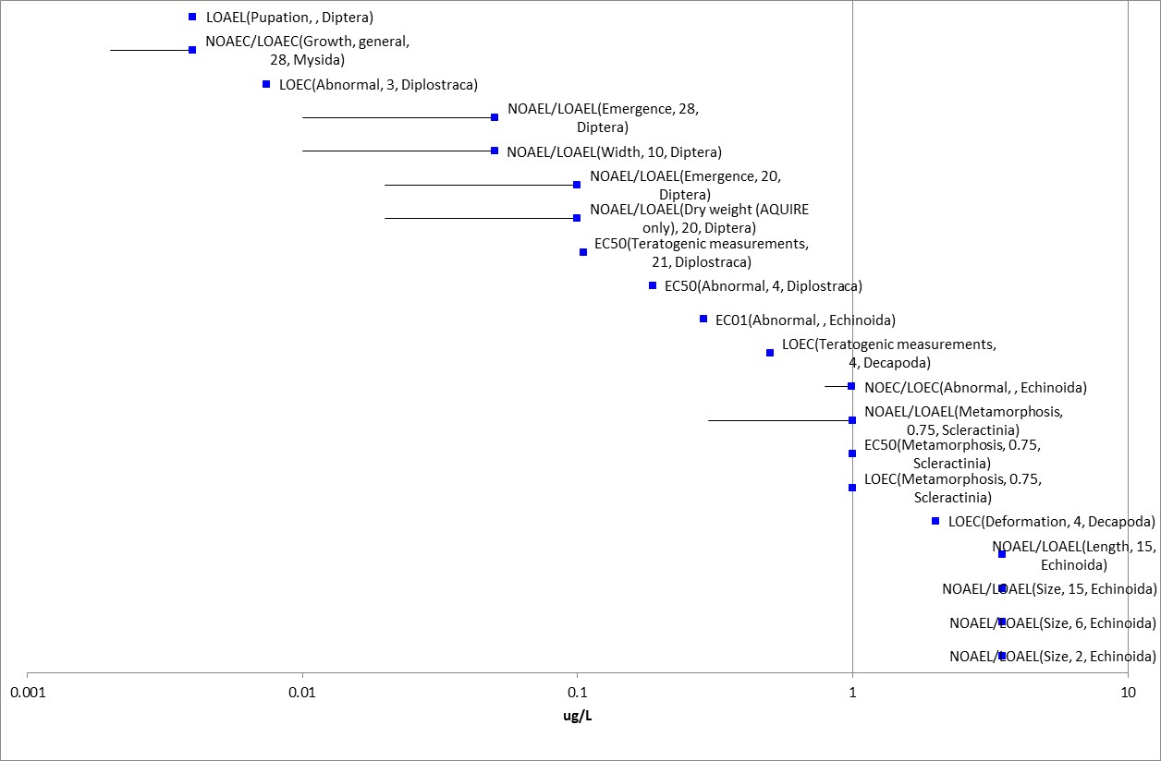

Figure 3-8. Growth Data Array for Aquatic Invertebrates (excluding mollusks) (Range <10 µg/L).

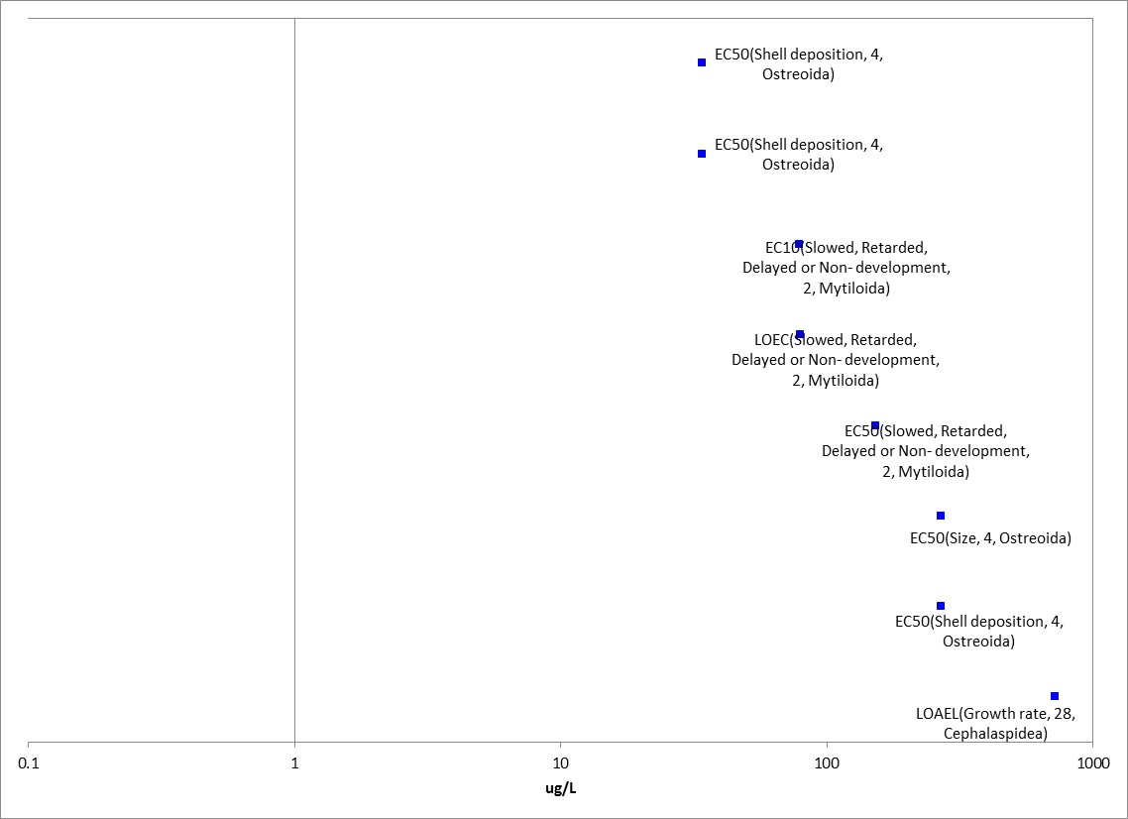

Figure 3-9. Growth Data Array for Mollusks (Range ≤1000 µg/L).

Effects on Reproduction of Aquatic Invertebrates

There were 25 studies (representing nine orders and ten species) reporting reproductive effects ranging from 0.005 µg/L up 999 µg/L. Figure 3-10 provides an overview of the lower-end of the distribution (range ≤10 µg/L).

For a freshwater invertebrate, Zalizniak and Nugegoda (2006; E107384), reported a reduction in the number of offspring per female at all concentrations in the 1st generation. In this study, Daphnia carinata were exposed to chlorpyrifos (active ingredient) concentrations ranging from 0.005-0.5 µg/L (corresponding to 0.01 of the LC₅₀, 0.05 of the LC₅₀, 0.1 of the LC₅₀, 0.5 of the LD₅₀ and 1 LC₅₀) for 21 days with subsequent testing over the two next generations. In this test, fifteen juveniles (24-hour old) were placed individually in 25 ml Mc Artney bottles with M4 medium, fed green algae and the medium was replaced daily. The endpoints for the 1st and 2nd generations observed were survival, fecundity, time to first brood, number of offspring per female, and size of the females after 21d of exposure. Based on the statistically significant reduction in number of offspring per female at all treatments for the first generation daphnids (~20% based on visual interpretation from the graphic), the LOAEC from this study is 0.005 µg a.i./L (nominal).

Reproductive effects were noted at similar concentrations for estuarine/marine aquatic invertebrates. The lowest reproductive endpoint was from a 35-day early life stage toxicity study (MRID 42664901). In this study, there were effects on reproduction at all concentrations (when compared to the negative control), resulting in a LOAEC of 0.0046 µg a.i./L and, thus, a NOAEC was not established (i.e., < 0.0046 µg a.i./L). While there is uncertainty with the solvent (acetone) effects observed in this study, the resulting value is similar to the reproductive effect values for the daphnid (above), thus, lending support to the reproductive effects from chlorpyrifos exposure to aquatic invertebrates. By providing the lowest sublethal endpoint for E/M invertebrates, this study was used to set the Estuarine/Marine invertebrate sublethal threshold.

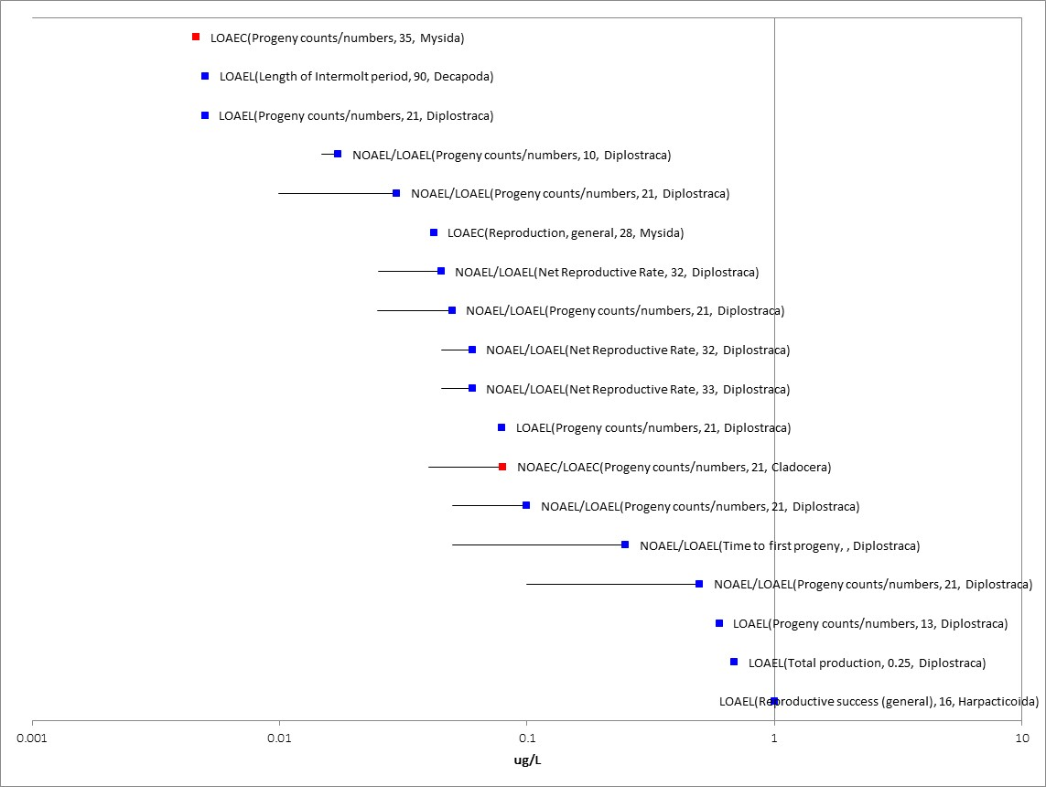
Figure 3-10. Reproduction Data Array for Aquatic Invertebrates (excluding mollusks) (Range <10 µg/L).
Mollusks-The lowest reproductive endpoint for the Mollusks is from Rivadeneira (2013) in which the Orb snail (Coretus corneus) was exposed to technical grade chlorpyrifos for 14 days at concentrations of 0.4 and 5 µg/L. The test concentrations were selected because 5 µg/L was reported as 50% inhibition and 0.4 did not result in inhibition of AChE in previous tests. In this study AChE, carboxylesterase (CES) and gluthionine transferase were measured in biomarker assays and there was an additional assay of reproductive effects reported as: number of egg masses, the number of egg masses without eggs, the number of eggs per egg mass, the number of non-embryonated eggs per mass, the time for hatching, the percentage of hatching and the percentage of survival of the offspring. At 14 days exposure to 0.4 µg/L caused an increase in the number of egg masses without eggs and a decrease in carboxylesterases measured with p-nitrophenyl butyrate. However the exposure to 5 µg/L also caused an increase in the time for hatching, a decrease in the % of hatching and survival and also inhibition of cholinesterases and carboxylesterases with p-nitrophenyl acetate and butyrate. Glutathione S-transferase was modified with the tested concentrations. The LOAEC from this test is 0.4 µg/L based on the effects to reproduction and also the decrease in carboxylesterase.

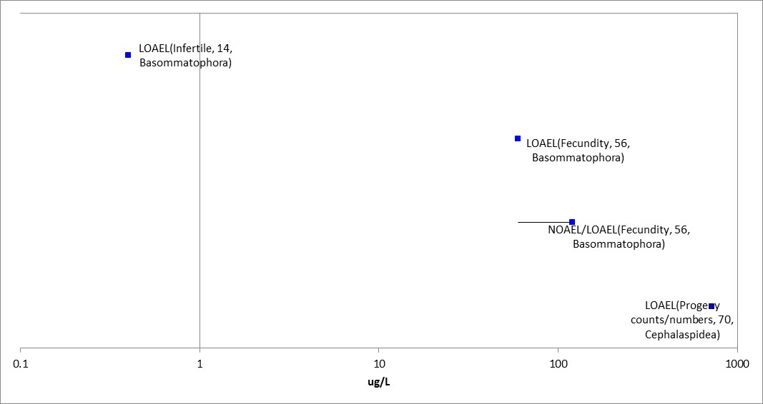
Figure 3-11. Reproduction Data Array for Mollusks (Range ≤1000 µg/L).

Effects on Behavior of Aquatic Invertebrates

Effects to behavior ranged from a NOAEC/LOAEC of 0.023/0.046 µg/L in the caridean shrimp [Palaemonetes argentines; Montagna and Collins, 2007; E101421] to 1,753 µg/L [Caenorhabditis elegans, Nematode; E75260] representing 11 Orders, 14 species from 25 open literature references. Figure 3-12 provides an overview of the lower-end of the distribution (i.e., behavioral endpoint values from concentrations ≤ 10 µg/L).

There were 17 studies with behavioral endpoints freshwater species and 9 for E/M invertebrates and the lowest value was from a study on caridean shrimp [Palaemonetes argentines; Montagna and Collins, 2007; E101421]. While measurements of prawn behavior and locomotion were observed, the reporting associated with the endpoint was too vague (e.g., some effects on behavior, namely excitation and jerky movements when stimulated), thus, this study is classified as qualitative without further details. The next lowest behavioral endpoint was a LOAEC for swimming behavior in the E/M opossum shrimp (Neomysis interger) following 7-day exposure to 0.038 µg/L chlorpyrifos [Roast et al., (2000); E53636]. In this study, mysids became hyperactive and a greater number of individuals swam forward into a slow current (3 cm/s than the control mysids. Despite this hyperactivity, pesticide-exposed mysids were unable to swim faster than 15 cm/s, whereas, control mysids were able to swim faster than 18 cm/s. Other changes in swimming behavior following pesticide exposure included fewer mysids maintaining position, and more mysids swimming with the current at high current velocities (18 cm/s), than control individuals. In a freshwater species, the lowest endpoints were also from effects to swimming behavior in (Midge larvae-Chironomus tentans) with EC₅₀ values of 0.17 and 0.21 µg/L from two different studies (E79402-Lydy and Austin, 2002; 81665-Schuler et al., 2005). Overall, the E/M LOAEC value of 0.038 µg/L is used to represent the behavioral line of evidence for both FW and EM invertebrates.

For mollusks, there was one endpoint for effects to filtration behavior in the Asiatic clam (Corbicula manilensis) with NOAEC/LOAEC values of 770/1100 µg/L (E89740; Cooper and Bidwell, 2006).

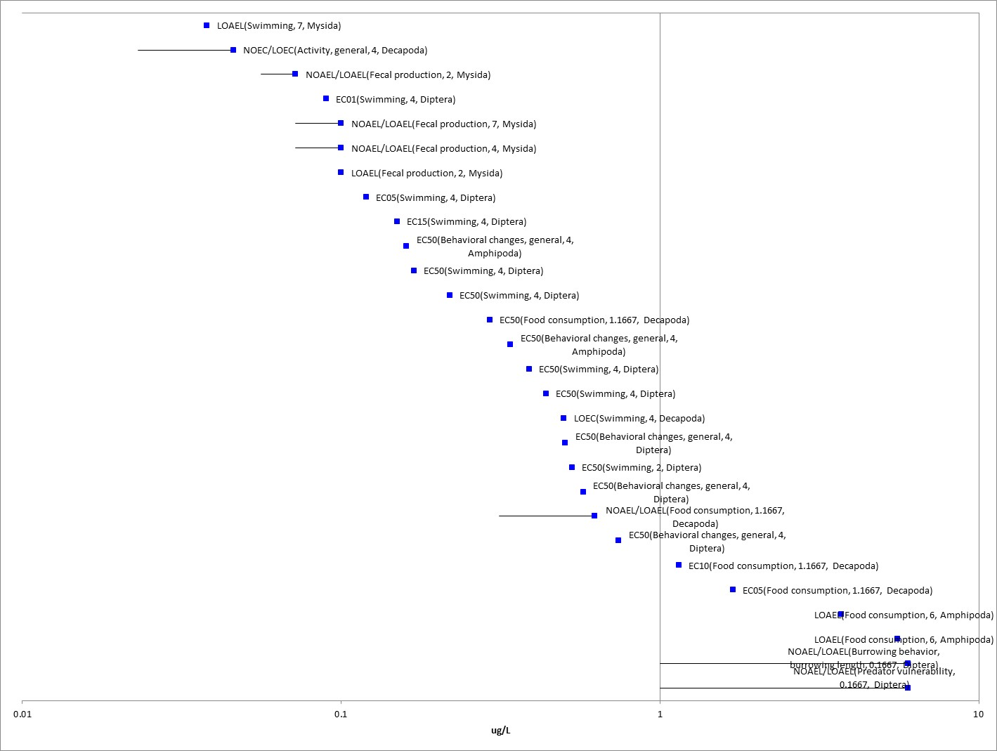
Figure 3-12. Behavior Data Array for Aquatic Invertebrates (Excluding Mollusks) (Range <10 µg a.i./L).

Effects on Sensory Function of Aquatic Invertebrates

There were no sensory effects reported. There was one study that studied the effects of chemical avoidance using the daggerblade grass shrimp (Palaemonetes pugio), reporting a NOAEC of 0.99 µg/L (E5146; Hansen et al., 1973).

Other Effects Reported for Aquatic Invertebrates

Anticholinesterase Effects
There were 30 studies (23 for freshwater species and 7 for E/M) in the open literature reporting anticholinesterase effects in aquatic invertebrates. Figure 3-13 provides the data array for aquatic invertebrates (excluding mollusks). The lowest endpoint for acetylcholinesterase inhibition is from a study of the effects of exposure to binary mixtures of atrazine and organophosphorus insecticides on the freshwater amphipod (Hyalla azteca) exposed in water (Anderson and Lydy, 2002; E64955). This endpoint is based on results for analytical grade chlorpyrifos alone, and the mixture component is discussed in APPENDIX 4-1. In this study, the authors tested various effect levels for chlorpyrifos (LC₁, LC₅, LC₁₅ and LC₅₀) with varying levels of atrazine (0 – 200 µg/L). To measure sublethal effects, 10 individuals were collected from each replicate after 96 hours of exposure and determination of AChE activity (on whole organism homogenate) was conducted according to Ellman et al., (1961) as modified by Zhu et al., (1996) using ATC as a substrate. From the acute portion of the study, the LC₅₀ reported for H. azteca was 0.042 µg/L (95% CI 0.033-0.049). The sublethal endpoint for chlorpyrifos alone was a 41% reduction in AChE at the chlorpyrifos LC₁ (0.0003 µg/L), and this endpoint is also considered a threshold value for aquatic invertebrates.

For an estuarine/marine invertebrate, the lowest endpoint was for AChE inhibition in gill tissue of Black Tiger Shrimp, (Penaeus monodon), however, there were poor recoveries of chlorpyrifos (formulation unknown) in the test concentrations and the actual exposures are uncertain beyond the initial measurement (E159862; Eamkamon et al., 2012). The NOAEC/LOAEC was 0.067 and 0.68 ug/L, based on a statistically significant reduction (51%) in AChE at the 72 hour interval. Another low E/M endpoint was from a study of daggerblade grass shrimp (palaemonetes pugio) embryos tested with technical grade chlorpyrifos. In this study (Lund et al., 2000; E51679), the reported EC₅₀ for AChE was 0.36 ug/L. Overall, the LOAEC of 0.0003 µg/L from the FW species is used to represent the AChE line of evidence for both FW and E/M invertebrates.

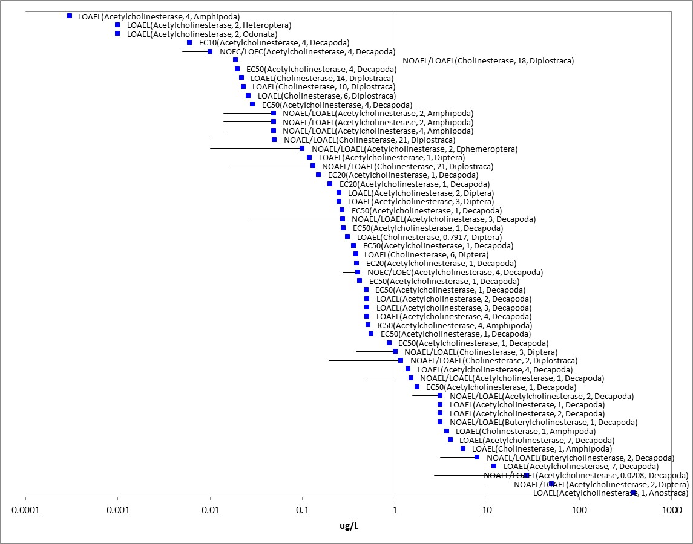
Figure 3-13. Aquatic Invertebrate (excluding mollusks) Anticholinesterase Data Array (Range ≤ 1000 µg/L).

Mollusks-For mollusks the most sensitive endpoint was for AChE inhibition in the tropical Zig zag scallop, (Euvola pecten) (Owen et al., 2002). In this study, wild caught scallops were exposed to chlorpyrifos (unknown formulation-Dursban) at concentrations of 0.1, 1 and 10 ngl/L under laboratory conditions. Acetylcholinesterase (AChE) and butyrylcholinesterase (BuChe) activity in scallop adductor muscle hemolymph was measured using the methods of Ellman et al. (1961) and Lundebye et al. (1997). Measurements were taken for 8 hours with a 2 hour interval for sampling. Enzyme inhibition was exhibited at all three concentrations of chlorpyrifos. Given that this is an unknown formulation and the endpoint of 0.0001 ug/L is very close to the all invertebrate 0.0003 ug/L value from a robust study with active ingredient, the aquatic invertebrate AChE value is used a surrogate for the threshold. Figure 3-14 provides the lower end of the distribution for mollusks (range ≤ 1000 µg/L).

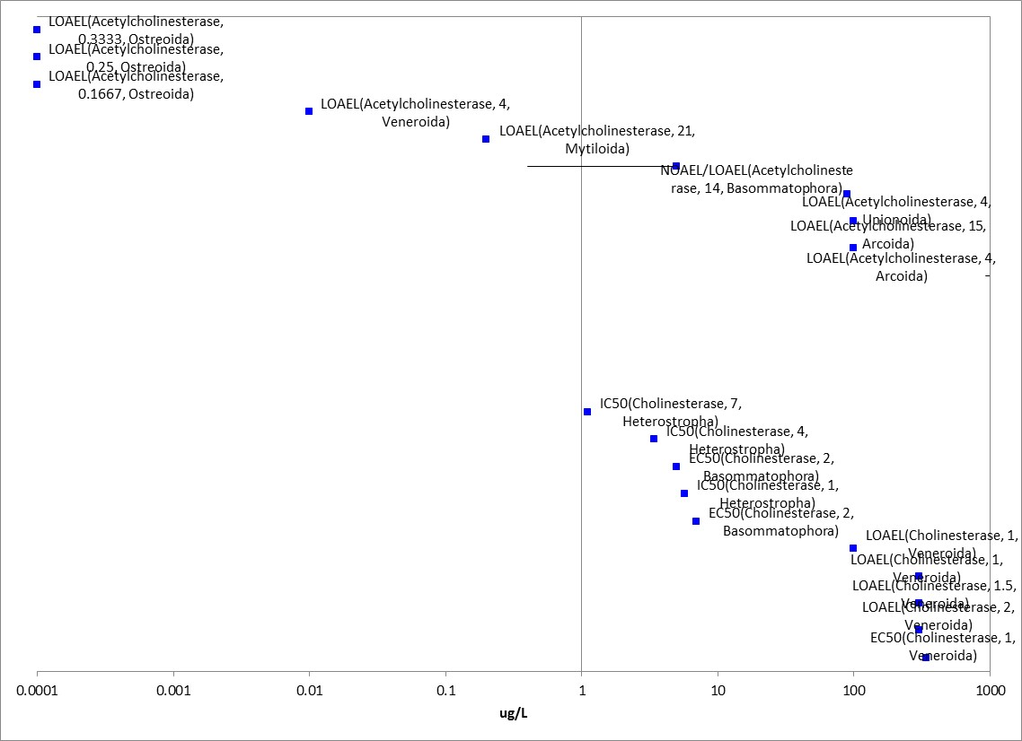
Figure 3-14. Mollusk Anticholinesterase Data Array (Range ≤ 1000 µg/L).
Other Biochemical/Cellular/Physiology Effects

Aside from anticholinesterase effects, there are also a vast array of other endpoints for biochemical, cellular, and physiology-based measurements. To summarize the range of the “other” biochemical/physiological effects, the lowest endpoint was 0.005 µg/L (genetic-HM4M) and generally ranged up to 4500 µg/L. Because of the large amount of data involved, an array with a range of <10 µg/L is provided in the APPENDIX 2-7. In general, some of the effects that were occurring on the lower end of the array were effects to gene expression, electron transfer activity, measures of oxidative stress, antioxidant activity, protein content, neural red uptake, steroid hormones, and an array of other enzymes and clinical chemistries such as lipids, cholesterol, etc. Physiological measurements include measures such as oxygen consumption and energy intake.

Mesocosm Data for Aquatic Invertebrates

There were several mesocosm studies that examined effects to aquatic invertebrates and although the ECOTOX database did not clearly identify the mesocosm-type studies in a fully searchable manner, in cases that low endpoints were from mesocosm or field like studies, the results were included for summary. In one study, (Daam, 2007; E101436), twelve microcosms consisting of a glass chamber filled with 8.5 L pond water (sieved over a 0.75-mm mesh) and maintained at 21º C. Treatments were made using a formulated product (Dursban 4E) and the test concentrations were: 0.005, 0.05, 0.5, and 5 µg a.i./L-nominal) with two microcosms for each concentration (four controls). On days 0, 3, and 14, 250-ml water samples were taken at mid-depth for analysis. Zooplankton samples were taken at the end of each experiment. Zooplankton data were expressed as number of individuals per liter. The differences in the structure of the zooplankton communities between the microcosms as sampled at the end of the experiments were visualized using principal component analysis (PCA). The PCA of the chlorpyrifos zooplankton data set revealed treatment-related differences in species composition. Numbers of Chydorus sphaericus, Simocephalus vetulus (water flea; both from Order Diplostraca), and Lepadella patella (rotifer) were significantly decreased at the higher treatment levels. C. sphaericus and S. vetulus were eliminated in the three highest concentrations. Taxa that occurred in significantly higher densities than in the controls were the rotifers, Cephalodella gibba, Lecane bulla, and Trichocerca. The overall NOAEC/LOAEC values were 0.005 and 0.05 µg/L, respectively, based on decreased abundance.

In Biever et al., (1994; E62037) (previously discussed in the Fish-Mesocosm section), sediment and water microcosms contained native plankton and macroinvertebrate and macrophyte communities and juvenile bluegill fish were stocked to each microcosm. The microcosms were treated with chlorpyrifos (Lorsban 4E) via spray boom directed to the surface of the water as a single application of 0.05 to 5% of a 1.12 kg Al/ha application (to yield 0.03 to 3.0 µg/L chlorpyrifos in water). At 0.3 µg/L, there were reductions in many groups of the invertebrates. The 3 µg/L treatment caused persistent effects on nearly all invertebrate taxa and significantly reduced fish survival. Most freshwater invertebrate and fish communities were able to recover within a few weeks with the possible exception of Chironominae, a subfamily of Chironomidae. The NOAEC/LOAEC values from this study are summarized in Table 3-5.

Table 3-5. Summary of NOAEC/LOAEC Values from Biever et al. (1994).
FW Insects  Chironomids  Ephemeroptera  FW Zooplankton  Copepods  Ostracods  Cladocera  FW Fish | LOAEC = 0.10  NOAEC = 0.03  LOAEC = 0.10  NOAEC = 0.03  LOAEC = 0.10  NOAEC = 0.03  LOAEC = 0.3  NOAEC = 0.1  LOAEC = 0.3  NOAEC = 0.1  LOAEC =>3.0  NOAEC = 3.0  LOAEC = 0.3  NOAEC = 0.1  LOAEC = 1.0  NOAEC = 0.3 | Ostracods were the LEAST sensitive taxon (LOAEC = >3.0). Chironominae was the MOST sensitive macroinvertebrate taxon, with significant affects in all treatments. The NOAEC may have been <0.03 but was not confirmed. Also, this group did not recover in the highest treatment by the end of the study, whereas most other communities did recover after two and a half months.

In a review, Van Wijngaarden et al. (2005) compared the results of several mesocosm studies conducted in running waters and static systems with their original results from a laboratory based microcosm design. In the three experiments conducted by Van Wingaarden et al., single applications of chlorpyrifos (from formulated product-Dursban 480) were made to give concentrations from 0.01 to 10 µg a.i./L in the microcosm water. The microcosms simulated plankton-dominated nutrient-rich freshwater systems and of glass cylinders (18 L), and contained a sediment layer of approximately 0.02m and a water layer of 0.3m (water volume ca 14L). Sediment and water were collected from an uncontaminated eutrophic ditch. Samples were taken from several positions and were filtered through a 20 um mesh net. The effects of chlorpyrifos treatment were analyzed by the principal response curves method (PRC). Microcrustaceans (cladocerans and copepod nauplii) were amongst the most sensitive organisms. All three experiments yielded community NOAEC of 0.1 μg a.i./L which was similar to those derived from more complex outdoor studies. For example, when comparing the results to other mesocosm studies, the reported NOAEC values were 0.1 µg/L (static) and LOAEC values were 0.3 and 0.5 µg/L for slight effects and 0.9- 1.0 µg/L for more severe effects. For running water systems, the reported chlorpyrifos NOAEC/LOAEC was 0.1 and 5 µg/L, respectively (Van Wijngaarden et al., 2005; E16005).

Effects to Aquatic Invertebrates Not Included in the Arrays

All of the array data used throughout this effects characterization are in units that could be converted to microgram per liter. However, there were other studies captured in ECOTOX that exposed the organisms on a per acre or per hectare rate. These studies are summarized below in Table 3-6. Additionally, there were a handful of studies that were based on other units that are less useful such as pmol, %, and nmol/g wet weight. It is noted that there were no unique effects observed in these studies when considering the available data from the microgram/L exposures. Table 3-7 provides a reference of the studies with other units.

One other consideration is for the sediment dwelling organisms. There were three studies available (two acute and one chronic) that reported on the toxicity to benthic organisms in terms of µg a.i./kg sediment. In Ankley et al., (1994; E4019), sediment toxicity was determined for the invertebrate, Chironomus tentans (larval), and the reported LC₅₀ values were in terms of mg a.i. /kg soil as dry weight (dw). In this study, LC₅₀ values for two different spiked sediment samples, were provided [468 and 299 µg chlorpyrifos per kilogram (dw)]. On an organic carbon-normalized basis (i.e., dry weight LC₅₀/f_{oc},), the respective LC₅₀ values were 5,506 and 9,956 µg/kg TOC. In this study, the water-only LC₅₀ of chlorpyrifos to C. tentans was 0.07 µg/L, whereas LC₅₀ values based on predicted pore-water concentrations in the two test sediments were 0.04 and 0.07 µg/L. Thus, the toxicity was similar to the water column based exposure.

In the other acute toxicity sediment study, the life-stage-specific toxicity of sediment-associated chlorpyrifos to the marine, infaunal copepod, Amphiascus tenuiremis, was assessed (Green et al., 1996a; not captured in ECOTOX). Duplicate 96-h tests were conducted with each major life stage of the copepod (adult, copepodite, and nauplius) exposed to sediments spiked with chlorpyrifos. Calculated median lethal concentrations (LC₅₀) were 66, 74, and 40 µg chlorpyrifos per kilogram sediment (1737, 1947, and 1053 µg/kg OC, when normalized of organic carbon), or the adult, copepodite, and nauplius stages, respectively. The predicted pore-water concentrations were reported as 0.013, 0.015, and 0.008 µg a.i./L using the sediment based LC₅₀ values for the respective stages. However, in previous work by the same authors (unpublished), the aqueous LC₅₀ for the adult stage was 1.28ug/L (based on nominal concentrations), thus, suggesting the equation for predicting the bioavailability of pore water chlorpyrifos is underestimating or the organism is receiving more exposure via sediment particles than from pore water. One difference between this study and the Ankley et al., study is the longer equilibrium period used by Ankley et al., (42 days) vs 3 days.

In addition to the acute toxicity test, there was one sediment toxicity study available for chronic effects to a benthic invertebrate (Green et al., 1996b; not captured in ECOTOX). In this study, the chronic toxicity to the marine, infaunal copepod, Amphiascus tenuiremis was assessed using population parameters and life table estimates. Significant effects (p <0.05) were observed at all concentrations tested (5, 14, and 22 ug-CHPY/kg-sed.) which represented 7, 21, and 32% of the 96-h LC₅₀ (68 ug-CHPY/kg-sed.) for total fecundity and weekly fecundity. Adult survivorship and life expectancy showed no significant differences for the chlorpyrifos treatments and controls, confirming that the concentrations tested were sublethal.

After considering that the pore-water LC₅₀ values predicted in the available studies are reasonably close to water-only values for the C. tetans and also that the aqueous threshold values previously selected for aquatic invertebrates generally cover the range of the predicted values, the aqueous thresholds are used as a proxy for the sediment based toxicity in the absence of a more robust data set.

Table 3-6. Toxicity Data for Chlorpyrifos Based on lb a.i./A or kg a.i./ha (not in arrays).
Genus | Species | Common Name | Endpoint | Days | Endpoint Concentration | Conc. Units | ECOTOX #
Culex | pipiens ssp. quinquefasciata | Mosquito | 100% Lethal | 1 | 0.1 | kg/ha | 2875
Aedes | sp. | Mosquito | 100% Lethal | 1,2 | 0.05-0.1 | AI lb/acre | 4224
Aedes | sp. | Mosquito | 100% Lethal | 30-45 | 0.05 | AI lb/acre | 4857
Insect Class | Insecta | Insect Class | LOAEL-  POP/ABD | 14 | 28.03 | AI g/ha | 6310
Penaeus | setiferus | Northern White Shrimp | 100% Lethal | ~0.5-2 | 0.038 | AI lb/acre | 13445
Psorophora | confinnis | Mosquito | LOAEL-  POP/ABD | 3,5 | 0.05-0.1 | lb/acre | 48426
Triops | longicaudatus | Tadpole Shrimp | NOAEL-  POP/ABD. | 3 | 0.006 (NOAEC) | AI kg/ha | 60194
Triops | longicaudatus | Tadpole Shrimp | LOAEL-  POP/ABD | 3 | 0.011-0.028 (LOAEC) | AI kg/ha | 60194
Culex | Tritaeniorhynchus | Mosquito | 100% Lethal | 1 | 0.01-0.11 | AI kg/ha | 100887
Culex | annulus | Mosquito | 100% Lethal | 1 | 0.03-0.11 | AI kg/ha | 100887

Table 3-7. Data Excluded from Array Based on Units.
Common Name | Measured Endpoint | Endpoint Descriptor | Endpoint Value | Conc. Units | ECOTOX #
Midge | Swimming | ER50 | 2.19 | nmol/g wet wt | 103283
Midge | Mortality | LR50 | 2.85 | nmol/g wet wt | 103283
Gastropod | Residue | BAF | 1.4 | pmol | 159919
Gastropod | Residue | BAF | 1.5 | pmol | 159919
Gastropod | Residue | BAF | 5.5 | pmol | 159919
Mosquito | Mortality | LD50 | 0.001 | % | 67077
Northern House Mosquito | Mortality | NR-LETH | 0.01 | % | 100867
Northern House Mosquito | Mortality | NR-LETH | 0.01 | % | 100867
Northern House Mosquito | Mortality | NR-LETH | 0.01 | % | 67754
Mosquito | Mortality | LD90 | 0.025 | % | 67077
Mosquito | Mortality | NR-LETH | 0.025 | % | 13956
Mosquito | Mortality | LD50 | 0.043 | % | 67077
Mosquito | Mortality | LD90 | 0.64 | % | 67077

Concentrations Where No Effects Were Observed in Aquatic Invertebrate Studies

For the exposure unit µg a.i./L, there are data available from some studies that show no effects at the concentration(s) tested (in those particular studies). These endpoints include NOAEC/NOAEL and NR-Zero values as reported in ECOTOX. Below are the arrays showing the ‘NE’ endpoints for chlorpyrifos and aquatic invertebrates (see Figures 3-15 and 3-16). For aquatic invertebrates (except mollusks), the available ‘NE’ endpoint concentrations generally range from 0.005 µg a.i./L to 2,537 µg/L. For mollusks, the ‘NE’ concentrations range from 0.01 to 54,900 µg/L (for presentation purposes, the 1 value over 5,000 µg a.i./L is excluded from the figure).

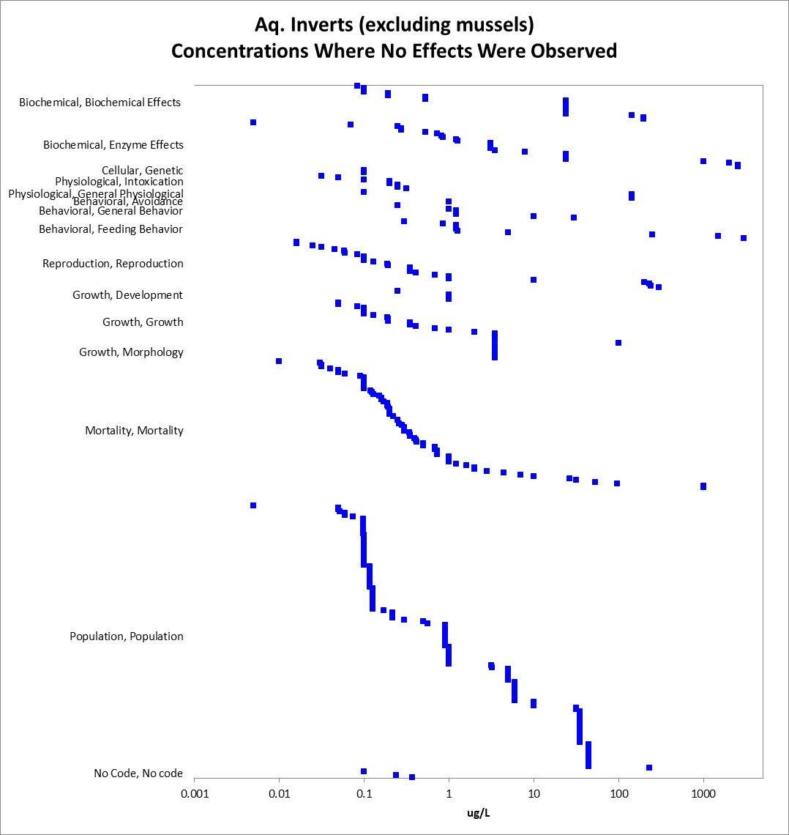
Figure 3-15. Concentration Where No Effects Were Observed for Aquatic Invertebrates (excluding mollusks).

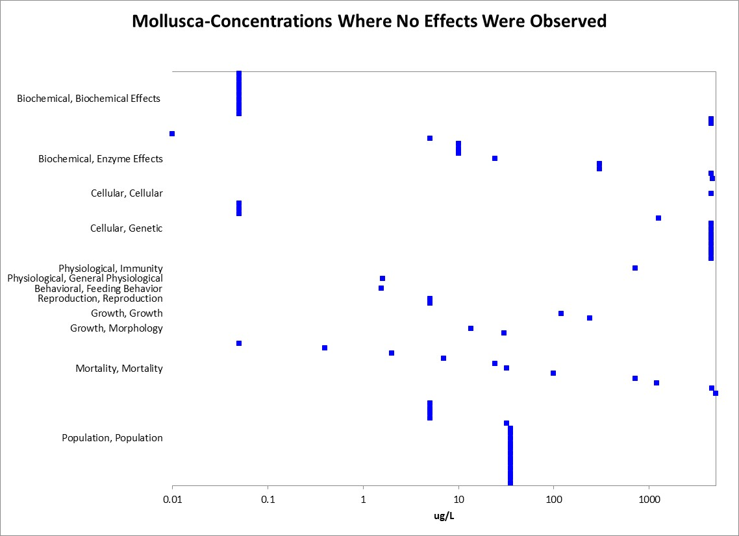
Figure 3-16. Concentrations Where No Effects Were Observed for Mollusks.

Incident Reports for Aquatic Invertebrates

There are currently (as of April 14, 2015), 9 aquatic invertebrate incident reports (8 for crayfish and one involves unidentified invertebrates) in the EIIS with a certainty index of ‘possible’, ‘probable’ or ‘highly probable’. Of these 9 incidents, 6 are from a misuse (either accidental or intentional), and in 3 of the incidents, the legality of use was undetermined (see Table 3-8). All of the aquatic invertebrate incidents occurred in the US. The following discussion only includes those incident reports with a certainty index of ‘possible’, ‘probable’ or ‘highly probable’ and a legality classification of ‘undetermined’ (the incidents that were caused by a misuse are not reported further). The dates of the incident reports range from 1993 to 1995. All of these aquatic invertebrate incident reports involve crayfish (with two also including fish) that were exposed via runoff from a nearby termiticide use. Two of these involved a termiticide use at a home and one involved treatment to a non-residential building. The chlorpyrifos product involved in the incidents is not specified beyond ‘Dursban’. In all of these incident reports, chlorpyrifos was the only pesticide noted in the report.

In addition to the aquatic invertebrate incident reports available in EIIS, there have also been a total of 4 aggregate ‘Other Non-Target’ (ONT) incidents reported to the Agency. Of these 4, only one is potentially associated with an active registration – the incident (from 2013) notes ‘chlorpyrifos’, but no registration number or product name is provided (3 involve products no longer registered).

Since 1998, incidents that are allowed to be reported aggregately by registrants [under FIFRA 6(a)(2)] as ‘ONT’ include those that are associated with an alleged effect to animals that are not birds, mammals, or fish. It is assumed that most aggregate incidents reported as ONT involve honey bees (although, they may also involve other invertebrates, such as, crayfish). Typically, the only information available for aggregate incidents is the date (i.e., the quarter) that the incident(s) occurred, the number of aggregate incidents that occurred in the quarter, and the PC code of the pesticide and the registration number of the product involved in the incident. Because of the limited amount of data available on aggregate incidents it is not possible to assign certainty indices or legality of use classifications to the specific incidents. Therefore, the incidents associated with currently registered products are assumed to be from registered uses unless additional information becomes available to support a change in that assumption.

Table 3-8. Aquatic Invertebrate Incident Reports from EIIS* (Those Classified as ‘Possible’, ‘Probable’, or ‘Highly Probable’ with Legality of Use = ‘Registered’ or ‘Undetermined’).
Number | Year | Product | Certainty Index | State | Legality | Use Site | Species | Distance | Effect/ Magnitude
I000671-001 | 1993 | Dursban TC | Probable | NR | Undetermined | Home (Termite control) | Crayfish | 40 ft (creek) | NR
 |  |  |  |  |  |  | unknown fish
I001108-001 | 1994 | Dursban | Possible | NR | Undetermined | Building (Termite control) | Crayfish | Adjacent | 28,000
I003600-001 | 1995 | Dursban | Highly probable | IN | Undetermined | Home (Termite control) | Crayfish | Adjacent | 20
 |  |  |  |  |  |  | Fish (Bluegill, catfish, bass) |  | Hundreds

Summary of Effects to Aquatic Invertebrates

In general, chlorpyrifos is highly toxic to aquatic invertebrates with less sensitivity exhibited in the mollusk group. While there is a large range in the acute mortality data with LC₅₀ values ranging from 0.014 µg/L (Scud -Hyalella azteca) to 20,925 µg/L (Mytilus galloprovinvialis) , the majority of the values within the SSD data set were less than 100 µg/L which would fall under the category of “very highly toxic” according to the EPA classification. The most sensitive whole organism sublethal effects were to reproduction and growth and the lowest toxicity values (LOAECs in this case) were generally around 0.005 µg/L for both freshwater and estuarine/marine invertebrates. Effects to behavior were noted at concentrations near 0.05 µg/L which is generally an order of magnitude lower than the reproduction and growth endpoints. Another sensitive effect is to acetylcholinesterase inhibition with a LOAEC of 0.0003 µg a.i./L based on a 41% decrease in activity when compared to the control for the Hyalella azteca, which is also a highly sensitive species according to the acute mortality data.

Effects Characterization for Aquatic Plant

Introduction to Aquatic Plant Toxicity

Chlorpyrifos is an insecticide used to kill a broad range of insects and mites that acts through inhibition of acetylcholinesterase. Chlorpyrifos, unlike many other organophosphate pesticides, does appear to show some toxicity in plants, however, its mechanism of action in plants is not well-understood. Most available toxicity studies with aquatic plants have focused on population-level endpoints (primarily biomass), however, there are also data available for describing biochemical, physical, other growth, and mortality effects. All but one of the available toxicity endpoints for aquatic plants involves non-vascular species.

The available toxicity data for chlorpyrifos are provided below for aquatic plants. The discussion of the data is formatted to broadly follow the lines of evidence, specifically those related to growth and mortality (since most of the available plant data relate to those effects). These data are used to assess the potential for direct effects to listed aquatic plants and their designated critical habitats (if applicable), and indirect effects for any listed species or critical habitat that relies on aquatic plants.

Threshold Values for Aquatic Plants

The threshold values for aquatic plants are based on experimentally determined endpoints for chlorpyrifos based on varying durations, exposure routes, and study designs. Threshold values for direct and indirect effects are provided in Tables 4-1 and 4-2. All of the threshold values for aquatic plants are based on effects to growth (i.e., weight and/or height) or photosynthesis.

Threshold values and effects data arrays in this assessment are based on endpoints expressed in, or readily converted to, environmentally relevant concentrations (i.e., mg a.i./L). However, the effects seen using other exposure units are also discussed. Across the exposure unit of mg a.i./L, toxicity data are available for chlorpyrifos and 2 different orders of vascular aquatic plants (i.e., Alismatales and Arales). Within these orders, toxicity data are available for 2 different families (i.e., Araceae and Lemnaceae) represented by 2 genera and species. For non-vascular aquatic plants, toxicity data are available for the ‘mg a.i./L’ exposure unit and 9 orders (i.e., Chlorococcales, Gymnodiniales, Hemiaulales, Isochrysidales, Naviculales, Nostocales, Pennales, Thalassiosirales, and volvocales), represented by 17 families (i.e., Bacillariaceae, Bellerocheaceae, Borziaceae, Chlamydomonadaceae, Chlorococcaceae, Dunaliellaceae, Gymnodiniaceae, Isochrysidaceae, Naviculaceae, Nostocaceae, Oocystaceae, Oscillatoriaceae, Phaeodactylaceae, Scenedesmaceae, Skeletonemaceae, Thalassiosiraceae, and Volvocaceae), 30 genera, and 40 species.

For chlorpyrifos, there are some studies which examine effects on aquatic communities (e.g., mesocoms evaluating effects on aquatic invertebrates, aquatic plants, and aquatic-phase amphibians). They may be particularly useful in evaluating potential indirect effects to a given taxon. In these studies, there are likely multiple interactions occurring simultaneously among the different organisms which can influence the effects seen across taxa. Because of this potential interaction, endpoints from toxicity studies involving exposure to multiple taxa may not be measuring direct toxicity to each taxon. Therefore, endpoints from cosm studies are not being considered for aquatic plant threshold values. These studies are used in addition to laboratory toxicity data to evaluate potential effects in the environment. Therefore, endpoints from cosm studies are included in the data arrays discussed below.

Because of the variability in study designs and endpoints, it was not possible to derive an SSD with the available plant data. Therefore, the aquatic plant thresholds are based on the most sensitive endpoints available for the taxon (see Tables 4-1 and 4-2, and the discussion below). Thresholds are provided for endpoints from studies conducted using technical grade chlorpyrifos (TGAI) – these are used to compare to aquatic EECs based on runoff and spray drift. Thresholds are also provided for endpoints from studies conducted using TGAI or formulated products – these endpoints are used to compare to aquatic EECs based on spray drift alone. Endpoints are provided for multiple groupings including aquatic plants, non-vascular aquatic plants and vascular aquatic plants.

Table 4-1. Chlorpyrifos Thresholds for Aquatic Plant Species (TGAI Studies Only).
TAXON | THRESHOLD | ENDPOINT | EFFECT(S) | SPECIES | STUDY ID | COMMENTS
All Aquatic Plants¹ | NOAEC/LOAEC | 0.037 mg a.i./L (IC₁₀) | Decreased photosynthesis | Marine diatom (Nitzschia closterium) | E080943 | This is a marine species
 | IC₅₀ | 0.14 mg a.i./L | Reduced growth | Alga (Isochrysis galbana) | MRID 40228401 | This is a marine species
All Non-Vascular Aquatic Plants¹
All Vascular Aquatic Plants | NOAEC/LOAEC | 0.5 mg a.i./L  1.0 mg a.i./L | Relative growth rate | Pistia stratiotes and Lemna minor | E155150 | The species tested are from Thailand. Not clear if TGAI or formulated product (% a.i. not reported), Only endpoint available for vascular aquatic plants
 | IC₅₀ | No data available
¹ The endpoints for ‘All Aquatic Plants’ and ‘All Aquatic Non-Vascular Plants’ are the same.

Table 4-2. Chlorpyrifos Thresholds for Aquatic Plant Species (TGAI and Formulated Product Studies).
TAXON | THRESHOLD | ENDPOINT | EFFECT(S) | SPECIES | STUDY ID | COMMENTS
Aquatic Plants¹ | NOAEC/LOAEC | 0.01 mg a.i./L  0.10 mg a.i./L | Reduced growth rate | Chlorella pyrenoidosa | E2704 | This is a freshwater non-vascular aquatic plant. Conducted with a formulated product (Dursban M-3633, 41% a.i.).
 | IC₅₀ | 0.013 mg a.i./L | % photosynthesis inhibition | Kamyophoron minutum | E159759 | This is an estuarine/marine non-vascular aquatic plant. The plants tested were from cultures originally collected in Pakistan. Not clear if TGAI or formulated product was used (% a.i. not reported).
Non-Vascular Aquatic Plants¹
Vascular Aquatic Plants | NOAEC/LOAEC | 0.5 mg a.i./L  1.0 mg a.i./L | Relative growth rate | Pistia stratiotes and Lemna minor | E155150 | The species tested are from Thailand. Not clear if TGAI or formulated product (% a.i. not reported), This is the only endpoint available for vascular aquatic plants
 | IC₅₀ | No data available
¹ The endpoints for ‘All Aquatic Plants’ and ‘All Aquatic Non-Vascular Plants’ are the same.

Summary Data Arrays for Aquatic Plants

When considering the available aquatic plant toxicity data for chlorpyrifos, there are a wide range of effects, from cellular to population-level effects, and concentrations at which effects occur, from 0.001 mg a.i./L to over 75 mg a.i./L. Most effects to aquatic plants occur at chlorpyrifos concentrations between 0.001 and 10 mg a.i./L (see Figure 4-1). Figure 4-1 shows the distribution of concentrations and effects to aquatic plants. Specific endpoints are discussed in more detail below (further details can be found in the ECOTOX ‘accepted’ table; see APPENDIX 2-2).

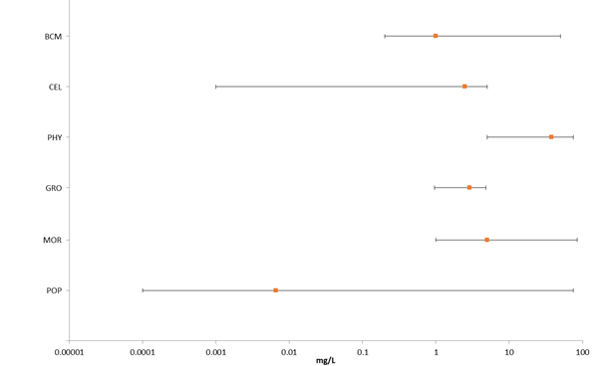
Figure 4-1. Summary Data Array for Aquatic Plants Exposed to Chlorpyrifos. BCM = biochemical; CEL = cellular; PHY = physiological; GRO = growth; MOR = mortality; POP = population.

Lines of Evidence for Aquatic Plants

Effects on Mortality of Aquatic Plants

There are only limited data available for the effects of chlorpyrifos on the mortality of aquatic plants. All of the available data involve non-vascular aquatic plants. For chlorpyrifos, effects on mortality are seen in aquatic plants at concentrations from 1 to 16 mg a.i./L (see Figure 4-2).

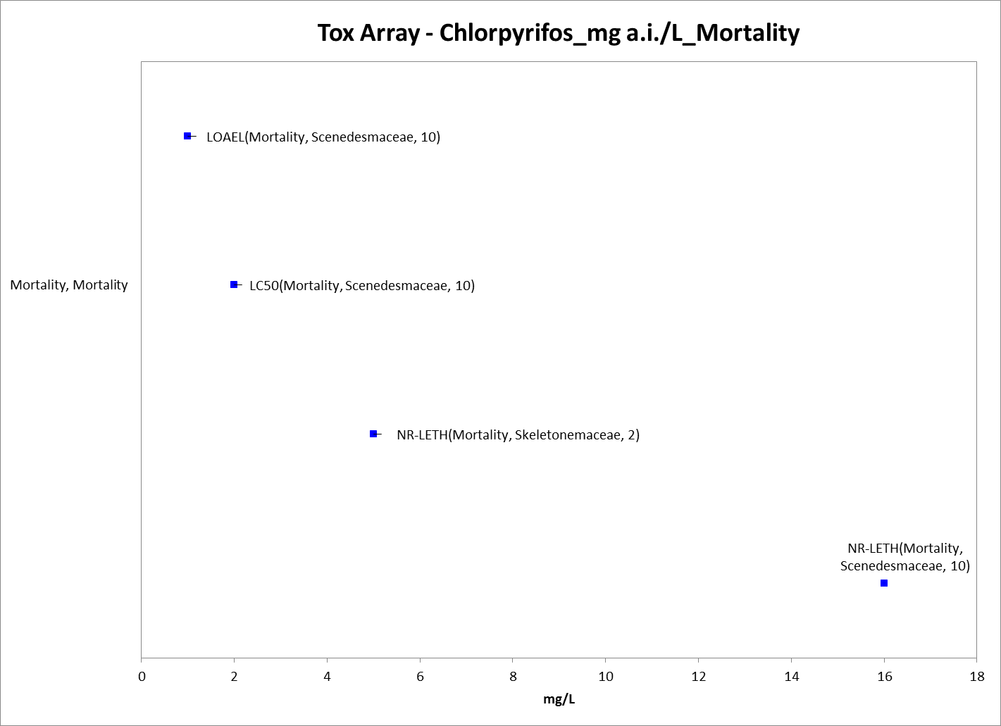
Figure 4-2. Mortality Endpoints for Aquatic Plants Exposed to Chlorpyrifos (mg a.i./L). Data label key: Endpoint (measured effect, family, duration in days).

Sublethal Effects to Aquatic Plants

Effects on Growth of Aquatic Plants

Endpoints related to growth, physiology (specifically effects to photosynthesis), and population (most of which are related to abundance) are considered as ‘growth’ effects for aquatic plants. For non-vascular aquatic plants, effects to growth are seen at chlorpyrifos concentrations from 0.013 to 75 mg a.i./L (see Figure 4-3). The IC₅₀ values for decreases in photosynthesis occur at concentrations between 0.013 mg a.i./L to 0.30 mg a.i./L and the EC₅₀ values for growth are from 0.14 mg a.i./L to 0.3 mg a.i./L. For vascular aquatic plants, the only endpoints available are for growth [NOAEC and LOAEC values of 0.5 and 1.0 mg a.i./L, respectively, based on relative growth rates (both wet and dry weights) in the water lettuce (Pistia stratiotes L.) and duckweed (Lemna minor L.)] (see below for details).

There are several studies available that show population-level effects to aquatic plants from chlorpyrifos exposure, with most effects occurring at concentrations between 0.001 mg a.i./L to 8 mg a.i./L (see Figure 4-1). Many of these endpoints, and all of the lowest endpoints, appear to come from micro- and mesocosm studies that explored effects of chlorpyrifos on aquatic communities. ECOTOX currently does not clearly indicate cosm studies, so it is not possible to identify such studies without reviewing each study. The mesocosm studies from ECOTOX were identified during the search for threshold values (i.e., in reviewing studies with the lowest endpoints, it was determined that the results were from mesocosm studies). In these studies, most of the effects to aquatic plants were attributed to changes in the composition of the animals in the studies that resulted in changes in grazing pressure; the effects were not attributed to direct toxicity of chlorpyrifos to aquatic plants. The types of population-level effects noted to aquatic plants from chlorpyrifos exposure include changes in chlorophyll A concentrations, reduced abundance, reduced diversity, changes in biomass, reduced growth rate, and general changes in the population.

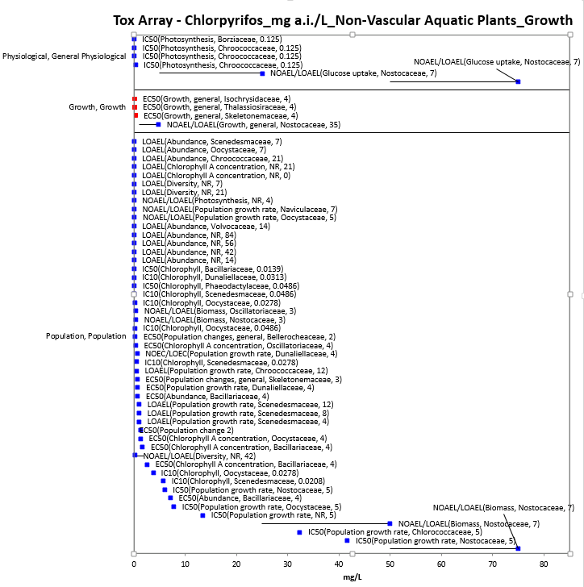
Figure 4-3. Growth Endpoints for Non-Vascular Aquatic Plants Exposed to Chlorpyrifos (mg a.i./L). Data from registrant submitted (red) and open literature (blue). Data label key: Endpoint (measured effect, family, duration in days).

Effects on Growth of Aquatic Plants (from Studies Conducted Using TGAI)

NOAEC/LOAEC Values:

The lowest endpoint for aquatic plants and chlorpyrifos (TGAI) is an IC₁₀ for decreased photosynthesis in the marine diatom Nitzschia (IC₁₀ = 0.037 mg a.i./L) (E080943). In this study, four chemicals (chlorpyrifos, copper, nonylphenol ethoxylate, and diuron) were tested on 9 algae species: six freshwater green algae species (Ankistrodesmus falcatus, Chlorella vulgaris, Monoraphidium arcuatum, Scenedesmus quadricauda, Scenedesmus subspicatus, Pseudokirchneriella subspicata (previously Selenastrum capricornutum)) one marine green algae (Dunaliella tertiolecta) and two marine diatoms (Phaeodactylum tricornutum and Nitzschia closterium). Toxicity was tested using a ToxY-PAM bioassay. A ToxY-PAM dual-channel yield analyzer was used to measure basal fluorescence to calculate photosynthetic efficiency, under ambient light conditions. Exposure durations were between 20 and 70 min., depending on the species being tested. The most sensitive species tested was the marine diatom N. closterium with an estimated IC₁₀ of ~37 µg/L and a time to peak response of >20 min. The second and third most sensitive species were D. tertiolecta and P. tricornutum with IC₁₀ values of ~41 and 130 µg/L and time to peak responses of >45 and >70 min, respectively. The least sensitive was P. subspicata, with an estimated IC₁₀ of 5,900 µg/L and a time to peak response of >30 min.

EC₅₀/IC₅₀ Values:

Based on the available data for aquatic plants (including vascular and non-vascular and freshwater and estuarine/marine species), the most sensitive EC₅₀/IC₅₀ for chlorpyrifos (TGAI) is 0.140 mg a.i./L for reduced growth in an estuarine/marine species of alga (Isochrysis galbans) (MRID 40228401). This endpoint is from a compilation of studies conducted on several estuarine/marine species and chemicals, including three aquatic non-vascular plants [alga (Isochrysis galbans) and diatoms (Skeletonema costatum and Thalassiosira pseudonana)] and chlorpyrifos (TGAI, 92% a.i.). Based on reduced growth, the 96-hr EC₅₀ values from this study are 0.140 mg a.i./L, 0.300 mg a.i./L, and 0.150 mg a.i./L for I. galbans, S. costatum and T. pseudonana, respectively.

Effects on Growth of Aquatic Plants (from Studies Conducted Using TGAI or Formulated Products)

NOAEC/LOAEC Values:

The lowest NOAEC and LOAEC values for aquatic plants and chlorpyrifos are for reduced growth in the freshwater green algae, Chlorella pyrenoidosa, (NOAEC = 0.01 mg a.i./L; LOAEC = 0.10 mg a.i./L) (E2704). In this study, the effect of chlorpyrifos on seven freshwater non-vascular aquatic plants was studied (Navicula minima, Navicula pelliculosa, Coccochloris peniocystis, Anabaena flos-aquae, Oscillatoria sp.’ Chlorella pyrenoidosa, and Chlamydomonas reinhardii). The blue-green alga, Anabaena flos-aquae, and the green alga, Chlamydomonas reinhardii, both showed stimulation of growth when exposed to chlorpyrifos (Dursban M-3633, 41% a.i.). The increase in growth was approximately 20% at 10 µg a.i./L and 60% at 100 µg a.i./L for A. flos-aquae; and 18% at 100 µg a.i./L for C. reinhardii. Statistically significant decreases in growth rate, when compared to the solvent controls, were seen in the diatom, Navicula pelliculosa (6% reduction) at 10 µg a.i./L, however, there was a poor dose response, with no effects at 100 µg a.i./L. For the green alga, Chlorella pyrenoidosa, there was a 12% reduction in the growth rate at 100 µg a.i./L. There were no statistically significant differences in growth rates at any concentration for the diatom (Navicula minima) or the blue-green alga (Coccochloris peniocystis) and Oscillatoria sp. Therefore, the NOAEC and LOAEC for chlorpyrifos in this study is 0.01 mg a.i./L and 0.10 mg a.i./L, respectively, based on reduced growth in Chlorella pyrenoidosa.

There is another endpoint, NOAEC = 0.001 mg a.i./L, identified in ECOTOX that is lower than the endpoint reported above for aquatic plants (E103387). This endpoint is from comet assays conducted on microalgae [dinoflagellates (Karenia mikimotoi and Alexandrium minimum) and a diatom (Chaetoceros gracilis)], that measured genotoxic effects – specifically DNA strand breaks. The results are from K. mikimotoi, the only species the comet assay was validated for in the study. Chlorpyrifos (in formulation, % a.i. not reported) induced statistically significant increases in DNA damage when compared to the controls at 0.01 mg a.i./L concentrations. Although the authors stated that, “…genotoxic insult can have long term consequences on algal growth and diversity” (p. 60), the level of DNA strand breakage required to cause growth effects was not described. It is not clear how much increase in DNA strand breakage is required to cause an organismal effects. Therefore, this endpoint is not used as a threshold, but will be included in the effects characterization for aquatic plants.

There are also some additional endpoints identified in ECOTOX that have similar endpoints as the NOAEC/LOAEC values reported above [i.e., NOAEC = 0.001 mg a.i./L for freshwater phytoplankton (E160005; E108318)]. However, these endpoints are from micro- or mesocosm studies and the effects noted in the phytoplankton were attributed to changes in the zooplankton (e.g., grazing pressure) instead of direct toxic effects to the aquatic plants. Therefore, they are not deemed adequate for use as a threshold for aquatic plants, however, the results are included in the data arrays and are considered in the effects characterization.

EC₅₀/IC₅₀ Values:

Based on the available data for aquatic plants (including vascular and non-vascular and freshwater and estuarine/marine species), the most sensitive EC₅₀/IC₅₀ for chlorpyrifos is 0.013 mg a.i./L for % photosynthesis inhibition in an estuarine/marine species of cyanobacteria (Komvophoron minutum) (E159759). In this study, four marine cyanobacteria (Synechocystis aquatilis, Komvophoron minutum, Gloeocapsa crepidinum and Gloeocapsa sanguinea) were used to assess the toxicity of chlorpyrifos using the ‘Light and Dark’ method to determine effects of chlorpyrifos on the primary productivity of the test organisms (rate of photosynthesis). The laboratory grown cultures used in the test were from isolated and purified cultures originally collected in Pakistan. There was a control (filtered seawater only) and five concentrations of chlorpyrifos (% a.i. not reported) prepared in seawater (0.01 to 1 mg a.i./L). Two sets of triplicate BOD bottles were prepared for the control and each test concentration; one set was incubated in light and the other set in dark for three hours [salinity (35±1), pH (7.60±1) and temperature (36±1ºC)]. After three hours, the samples were fixed for analysis of dissolved oxygen to calculate gross photosynthesis.

A more sensitive EC₅₀/IC₅₀ for aquatic plants than the one reported here was identified in ECOTOX. The lowest reported EC₅₀ value from the ECOTOX accepted studies for chlorpyrifos is 0.01 mg a.i./L for growth reduction based on chlorophyll a concentrations (E157805). However, because this endpoint is from exposure to a mixture of three aquatic plants species (Nitzschia sp., Oscillatoria sp., Chlorella sp.), instead of to a single test species, this endpoint is not deemed adequate for use as a threshold. The results are, however, included in the data arrays and are considered in the effects characterization. Other endpoints from this study (those conducted with a single chemical and a single species) were deemed adequate for quantitative use.

Effects on Growth of Non-Vascular Aquatic Plants

Effects on Growth of Non-Vascular Aquatic Plants (from Studies Conducted Using TGAI)

NOAEC/LOAEC and EC₅₀/IC₅₀ Values:

The thresholds for all non-vascular aquatic plants and chlorpyrifos (TGAI) are the same as the ‘All Aquatic Plant’ thresholds for TGAI [i.e., IC₁₀ value of 0.037 mg a.i./L for decreased photosynthesis in a marine diatom (N. closterium) (in lieu of a NOAEC/LOAEC value) (E080943); and EC₅₀ = 0.14 mg a.i./L decreased growth in an estuarine/marine algal species (I. galbana) (MRID 40228401)] (see above).

Effects on Growth of Non-Vascular Aquatic Plants (from Studies Conducted Using TGAI or a Formulated Product)

NOAEC/LOAEC and EC₅₀/IC₅₀ Values:

The thresholds for all non-vascular aquatic plants and chlorpyrifos are the same as the ‘All Aquatic Plant’ thresholds [i.e., NOAEC and LOAEC values of 0.01 mg a.i./L and 0.10 mg a.i./L based on reduced growth in green algae (Chlorella pyrenoidosa; E2704); and IC₅₀ = 0.013 mg a.i./L for % photosynthesis inhibition in an estuarine/marine species of cyanobacteria (Komvophoron minutum) (E159759)] (see above).

Effects on Growth of Vascular Aquatic Plants

Effects on Growth of Vascular Aquatic Plants (from Studies Conducted Using TGAI or a Formulated Product)

NOAEC/LOAEC Values:

There is only one study available that provides quantitative endpoints for vascular aquatic plants and chlorpyrifos [NOAEC and LOAEC values of 0.5 and 1.0 mg a.i./L, respectively, based on relative growth rates (both wet and dry weights) in the water lettuce (Pistia stratiotes L.) and duckweed (Lemna minor L.)] (E155150). In this study relative growth rates were determined for the plants over a 7-day period at concentrations of 0 (control), 0.1, 0.5, and 1.0 mg a.i./L chlorpyrifos (% a.i. not reported). In both species, there was a dose-dependent decline in relative growth rates, but the differences were statistically significantly different from controls only at the highest test concentration (1.0 mg a.i./L) (both wet and dry weights) (see Table 4-3).

Table 4-3. Relative Growth Rates for Aquatic Vascular Plants Exposed to Chlorpyrifos.
SPECIES | CHLORPYRIFOS (mg/L) | RGR_{FW}¹ (mg/g/day) | RGR_{DW}² (mg/g/day)
P. stratiotes | Control | 0.101 ± 0.081ª | 0.085 ± 0.012ª
 | 0.1 | 0.075 ± 0.048ª | 0.070 ± 0.024ª
 | 0.5 | 0.064 ± 0.032ª | 0.063 ± 0.039ª
 | 1.0 | - 0.036 ± 0.015^{b} | - 0.046 ± 0.022^{b}
L. minor | Control | 0.118 ± 0.057ª | 0.105 ± 0.018ª
 | 0.1 | 0.101 ± 0.073ª | 0.086 ± 0.019ª
 | 0.5 | 0.088 ± 0.029ª | 0.090 ± 0.043ª
 | 1.0 | - 0.023 ± 0.007^{b} | - 0.029 ± 0.011^{b}
Data are shown as the mean ±1 S.D.; means with different lower case superscript letters are significantly different.
¹ Relative growth rate – fresh weight
² Relative growth rate – dry weight

Although it is not clear if the study was conducted using TGAI or formulated product, because it represents the best available data (since it is the only study currently available that provides quantitative endpoints for vascular aquatic plants and chlorpyrifos), it will be used as the endpoint for both TGAI-only and TGAI/formulated products.

EC₅₀/IC₅₀ Values:

There are no EC₅₀/IC₅₀ endpoints currently available for chlorpyrifos and vascular aquatic plants.

Other Effects Reported for Aquatic Plants

When considering effects to aquatic plants at the cellular/biochemical level, most of the effects occur at chlorpyrifos concentrations between 0.001 mg a.i./L and 10 mg a.i./L (see Figure 4-4). All of the available data on these types of endpoints are from non-vascular aquatic plants. Effects include increased DNA strand breakage at chlorpyrifos concentrations as low as 0.001 mg a.i./L; biochemical effects (i.e., effects related to ascorbate, protein carbonyls, malondialdehyde, hydrogen peroxide, reactive oxygen species, and gluthion) and enzymatic effects (i.e., changes in ascorbate peroxidase, monodehydroascorbate reductase, glutathione reductase, and dehydroascorbate reductase) at concentrations of 0.2 mg a.i./L; and other biochemical effects (i.e., changes in chlorophyll A to chlorophyll B ratios, protein content, and carbohydrates) at chlorpyrifos concentrations of 1.0 mg a.i./L. Other cellular effects include increased heterocyst frequency in cells, changes in nitrogen content, changes in nitrogenase and nitrate reductase, and changes in glutamic pyruvic transaminase at concentrations ≥5 mg a.i./L. How these endpoints may specifically relate to mortality, growth, or reproduction is not clear.

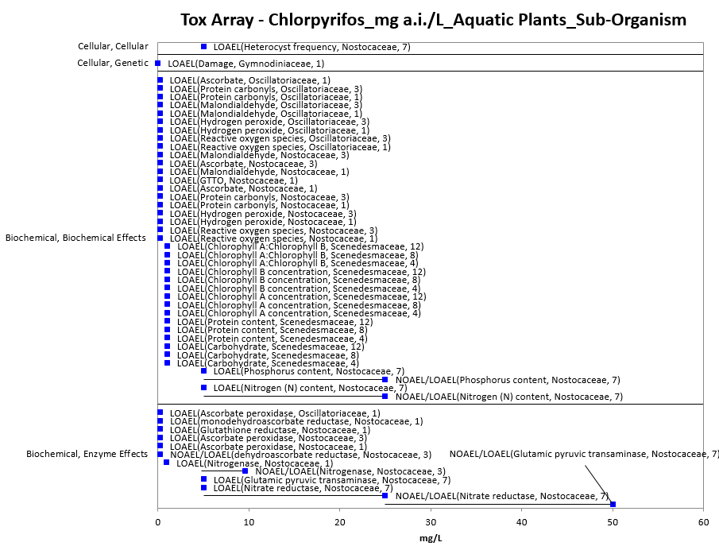 Figure 4-4. Suborganism Effects Endpoints for Aquatic Plants Exposed to Chlorpyrifos (mg a.i./L). Data label key: Endpoint (measured effect, family, duration in days).

Other Effects Reported for Vascular Aquatic Plants

As discussed above with the thresholds, there is one study available that provides quantitative endpoints for vascular aquatic plants and chlorpyrifos [NOAEC and LOAEC values of 0.5 and 1.0 mg a.i./L, respectively, based on relative growth rates (both wet and dry weights) at the population-level in the water lettuce (Pistia stratiotes L.) and duckweed (Lemna minor L.)] (E155150). In both species, there was a dose-dependent decline in relative growth rates, but the differences were statistically significantly different from controls only at the highest test concentration (1.0 mg a.i./L) (both wet and dry weights) (see Table 4-3, above). The NOAEC and LOAEC values of 0.05 and 1.0 mg a.i./L for growth and vascular aquatic plants are similar to the growth endpoints for non-vascular aquatic plants. There are currently not enough data available to determine whether vascular or non-vascular aquatic plant species are generally more or less sensitive to chlorpyrifos.

Effects Reported for Non-Vascular Aquatic Plants (Comparison of Estuarine/Marine and Freshwater Species)

Currently, there are not enough data available to determine whether freshwater or estuarine/marine non-vascular aquatic plant species are generally more or less sensitive to chlorpyrifos. The most sensitive NOAEC/LOAEC values for estuarine/marine and freshwater species are generally similar. For example, the freshwater speciesNOAEC and LOAEC values are 0.01 mg a.i./L and 0.1 mg a.i./L, respectively, and for an estuarine/marine species, the EC₁₀ is 0.037 mg a.i./L. In terms of IC₅₀ values the most sensitive endpoint for a freshwater species is 0.013 mg a.i./L (based on % photosynthesis inhibition) and for an estuarine/marine species, the IC₅₀ is 0.14 mg a.i./L based on reduced growth. Additionally, there are limited cellular/biochemical effects data available for estuarine/marine species. All of the endpoints categorized as ‘general physiological’ and ‘growth’ (at the non-population-level) are from estuarine/marine species. Therefore, comparisons to freshwater species cannot be made. Furthermore, the population-level effects seen in the estuarine/marine species fall within the range of those seen in the freshwater species.

Effects to Aquatic Plants Not Included in the Arrays

There are other aquatic plant data available that are not included in the data arrays because either the exposure units are not in or cannot be converted to aquatic concentrations, or there are NOAEC values available from a study without corresponding LOAEC or IC_{x} values (i.e., there were no effects noted in the study). There is only one exposure unit listed in the ECOTOX toxicity table that could not be converted to an environmentally-translatable unit for aquatic plants (i.e., ‘%’). In this study there were biochemical effects noted (i.e., effects to phytcobiliproteins) in freshwater blue-green algae (Anabaena sp.).

Concentrations Where No Effects Were Observed in Aquatic Plant Studies

For the exposure unit mg a.i./L (including both vascular and non-vascular species), there are data available from studies that show no effects at the concentration(s) tested (in those particular studies) (i.e., NOAEC/NOAEL and NR-Zero values as reported in ECOTOX). Below are the arrays showing these endpoints for chlorpyrifos and vascular aquatic plants and non-vascular aquatic plants (see Figures 4-5 and 4-6). For vascular aquatic plants, the available endpoints (n = 4) are all at chlorpyrifos concentrations of 0.5 mg a.i./L. For non-vascular aquatic plants, the concentrations where effects were not observed in particular studies range from 0.0001 to 100 mg a.i./L.

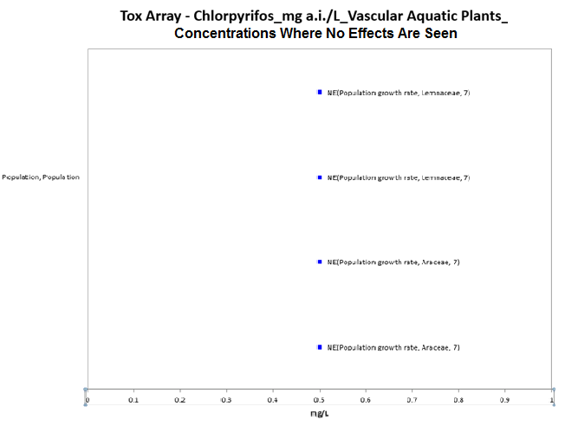
Figure 4-5. Concentrations Where Effects Are Not Seen in Vascular Aquatic Plants Exposed to Chlorpyrifos (mg a.i./L). Data label key: Endpoint (measured effect, family, duration in days). ‘NE’ refers to concentrations where effects were not observed.

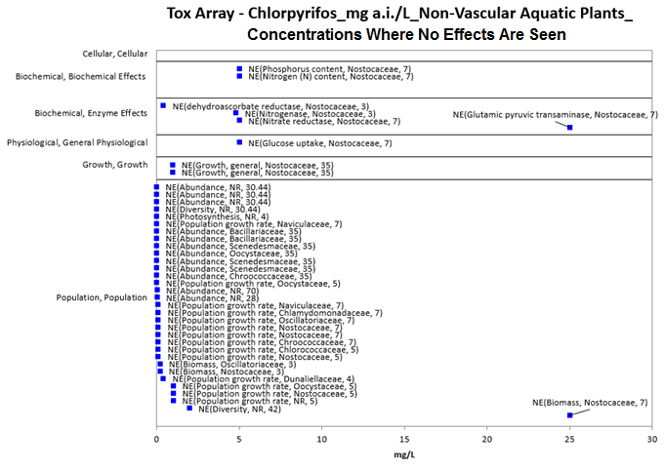
Figure 4-6. Concentrations Where Effects Are Not Seen in Non-Vascular Aquatic Plants Exposed to Chlorpyrifos (mg a.i./L). Data label key: Endpoint (measured effect, family, duration in days). ‘NE’ refers to concentrations where effects were not observed. There are 4 additional NE endpoints that are >30 mg a.i./L (they range from 50 – 100 mg a.i./L). These endpoints were removed from this figure for presentation purposes.

Incident Reports for Aquatic Plants

Pesticide incidents involving aquatic plants are not typically submitted to the Agency. There are no chlorpyrifos incident reports in the EIIS involving aquatic plants (based on a search conducted in January 2015).

Summary of Effects to Aquatic Plants

Chlorpyrifos does appear to show some toxicity in plants, however, its mechanism of action in plants is not well-understood. All but one of the available toxicity endpoints for aquatic plants and chlorpyrifos involves non-vascular species, therefore, our understanding of effects to aquatic plants is focused on non-vascular species. When considering effects to aquatic plants from chlorpyrifos exposures, there is a wide range of effects, from cellular to population-level effects, and concentrations at which effects occur, from 0.001 mg a.i./L to over 75 mg a.i./L. Most effects to aquatic plants occur at chlorpyrifos concentrations between 0.001 and 10 mg a.i./L. Effects on mortality are seen at concentrations from 1 to 16 mg a.i./L (although there are only limited data for chlorpyrifos and mortality in aquatic plants). Effects to growth are seen at chlorpyrifos concentrations from 0.013 to 75 mg a.i./L, with IC₅₀ values for decreases in photosynthesis occuring at concentrations between 0.013 mg a.i./L to 0.30 mg a.i./L and EC₅₀ values for growth occurring from 0.14 mg a.i./L to 0.3 mg a.i./L. Population-level effects occur at concentrations as low as 0.001 mg a.i./L, however, the lowest endpoints, appear to come from micro- and mesocosm studies that explored effects of chlorpyrifos on aquatic communities and the effects seen in aquatic plants are not attributed to direct toxicity of chlorpyrifos to aquatic plants (the effects are likely due to grazing pressure from changes in the composition of the animals in the studies. When considering effects to aquatic plants at the cellular/biochemical level, most of the effects occur at chlorpyrifos concentrations between 0.001 mg a.i./L and 10 mg a.i./L. There are currently no incident reports available for chlorpyrifos and aquatic plants. However, because of the nature of incident reporting, a lack of reports cannot be used as evidence that incidents may not be occuring (they simply may not be detected or reported).

Effects Characterization for Birds

Introduction to Bird Toxicity

The effects of chlorpyrifos on birds has been studied extensively. There are registrant submitted studies involving birds, including acute oral, sub-acute dietary, reproduction and field studies with technical or formulated chlorpyrifos. Overall, there are over 290 endpoints and 58 open literature and registrant submitted studies including data on 19 species available for use in this assessment. APPENDIX 2-2 and APPENDIX 2-5 include the bibliographies of studies that are included in this effects characterization and those that were excluded, respectively. Studies were excluded if they were considered invalid or not associated with an environmentally relevant exposure route. In addition to the reported studies, there are several ecological incident reports involving chlorpyrifos exposures to birds.

Studies from the open literature and registrant submissions are used to derive thresholds and to characterize the effects to birds. This section presents the thresholds for direct effects to listed species of birds and for indirect effect to listed species that depend upon birds. This section also discusses the data available for different types of effects on birds, including mortality, decreased growth, decreased reproduction, ChE inhibition, and impacts on behavior and sensory effects. A discussion of incident reports is also included in this characterization.

Threshold Values for Birds

There is sufficient bird toxicity data on multiple species for mortality (LD₅₀) to create a species sensitivity distribution (SSD) curve. The methodology for constructing SSD curves is described in ATTACHMENT 1-5. A list of studies used to create the curves, as well as the detailed SSD analysis, is found in APPENDIX 2-9. Thresholds based on LD₅₀ mortality studies are derived from these curves. There are not sufficient bird LC₅₀ toxicity data to calculate a species sensitivity distribution. Therefore, the LC₅₀ mortality thresholds are based on the lowest bird LC50 value. Sublethal thresholds are based on review of all toxicity data for the lowest relevant endpoint, as per the guidelines discussed in ATTACHMENT 1-4. (thresholds determination). Thresholds for direct and indirect effects are tabulated below and discussed in the following section. Open literature study reviews are contained in APPENDIX 2-3.

To determine the most sensitive endpoint, data tables generated by the data array builder are sorted for the major effects groups. The data are sorted based on endpoints normalized to 100 g body weight and displayed in arrays with the normalized value. However, for discussion purposes herein and in associated tables, the original study dose is used. As per the methodology for creating the arrays, reported NOAEL values without LOAELS are excluded from the arrays.

Table 5-1. Direct Effects Thresholds for Determining Effects to Listed Birds.
THRESHOLD | ENDPOINT | EFFECT(S) | SPECIES  (Common Name) | SPECIES (Scientific Name) | STUDY ID
Sublethal – dose based NOAEL/  LOAEL | 1 mg a.i./kg-bw  (0.77 mg a.i./kg-bw) ¹  2.5 mg a.i./kg-bw  (1.92 mg a.i./kg-bw) | Plasma cholinesterase inhibition | Rock Dove | Columba livia | E154172
Sublethal – dietary based NOAEC/  LOAEC | 25 mg a.i./kg-diet  125 mg a.i./kg-diet | Reproduction and mortality – multiple effects | Mallard Duck | Anas platyrhynchos | MRID 0046952
Mortality (1/million) – dose based from SSD | 0.58 mg a.i./kg-bw | Mortality | California Quail  Canada Goose  Chukar  Common Grackle  Domestic Chicken  House Sparrow  Japanese Quail (Coturnix quail)  Mallard Duck  Northern Bobwhite Quail  Red-winged blackbird  Ring-Necked Pheasant  Rock Dove (Common pigeon)  Sandhill Crane  Starling | -- | --
Mortality (1/million) – dietary | 1.6 mg a.i./kg-diet | Mortality | Mallard Duck | Anas platyrhynchos | MRID 40854702  LC₅₀ = 203 mg a.i./kg diet  Slope = 2.27
¹ Endpoints listed in the table are as reported in the study. However, in order to determine the lowest threshold, endpoints are normalized to 100 g bird body weight first then sorted for threshold determination. Values provided in parentheses for sublethal effects are normalized to 100 g, the same normalization used for creation of the SSD curves and determining mortality thresholds.

Table 5-2. Indirect Effects Thresholds for Determining Effects to Listed Species That Depend upon Birds.
THRESHOLD | ENDPOINT¹ | EFFECT(S) | SPECIES  (Common Name) | SPECIES (Scientific Name) | STUDY ID
Sublethal – dose based (LOAEL) | 2.5 mg a.i./kg-bw  (1.92 mg a.i./kg-bw)¹ | Plasma cholinesterase inhibition | Rock Dove | Columba livia | E154172
Sublethal – dietary based  (LOAEC) | 60 mg a.i./kg-diet | Weight and eggs lost | Mallard Duck | Anas platyrhynchos | MRID 42144901
Mortality (10%) – dose based from SSD | 3.4 mg a.i./kg-bw | Mortality | See Table 1 above | -- | --
Mortality (10%) – dietary | 55 mg a.i./kg-diet | Mortality | Mallard Duck | Anas platyrhynchos | MRID 40854702  LC₅₀ = 203 mg a.i./kg diet  Slope = 2.27
¹ Endpoints listed in the table are as reported in the study. However, in order to determine the lowest threshold, endpoints are normalized to 100 g bird body weight first then sorted for threshold determination. Values provided in parentheses for sublethal effects are normalized to 100 g, the same normalization used for creation of the SSD curves and determining mortality thresholds.

Summary Data Arrays for Birds

In order to capture the range of results available for the effects of chlorpyrifos on birds through laboratory as well as field studies, “data arrays”, or graphical representations of effects endpoints, are created based on registrant submitted and ECOTOX accepted literature. Methods used to construct the arrays are outlined in ATTACHMENT 1-22.

Figures 5-1 and 5-2 depict the range of concentrations reported based on major effects groups for registrant studies and open literature as found in ECOTOX accepted tables for dose based and dietary studies. In order to provide a more detailed look at the most sensitive endpoints together, data arrays for the low end of concentrations are provided in Figures 5-3 and 5-4. Data points include those from the open literature (depicted in blue) and registrant submissions (depicted in red). These figures differ by their units (note the x axis). Endpoints from the open literature are excluded from the array if they did not have environmentally relevant exposure routes (e.g., intraperitoneal injection) or do not have units that can be related to an environmentally relevant exposure; however, no bird data was identified that met these criteria. ECOTOX and registrant-submitted studies used to create the arrays are contained in APPENDIX 2-1. Data in these arrays are grouped by broad categories based on the type of effect (e.g., behavior, reproduction, mortality).

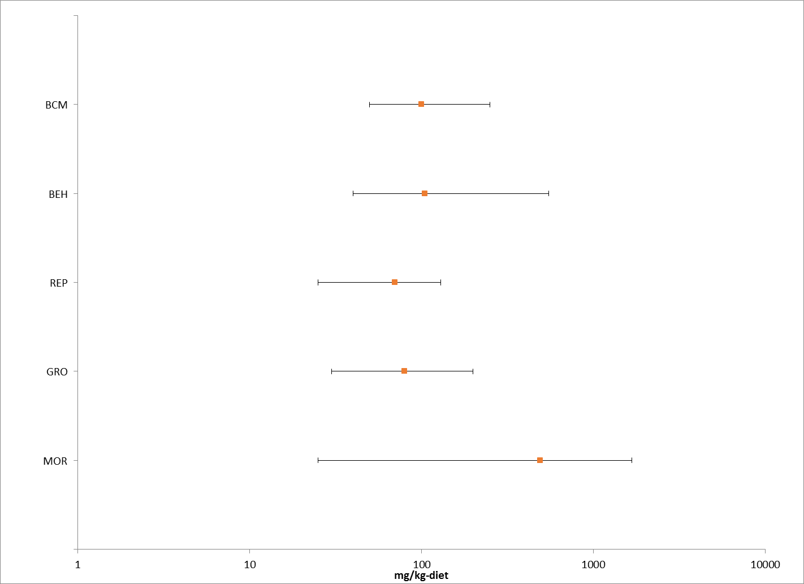

Figure 5-1. Dietary-based Ranges (mg a.i./kg-diet) of Bird Data for Major Effects Groups. Incorporates registrant submitted and ECOTOX accepted open literature studies. Orange dots indicate median values. (BCM = Biochemical, BEH = Behavioral, REP = Reproduction, GRO = Growth, MOR = Mortality).

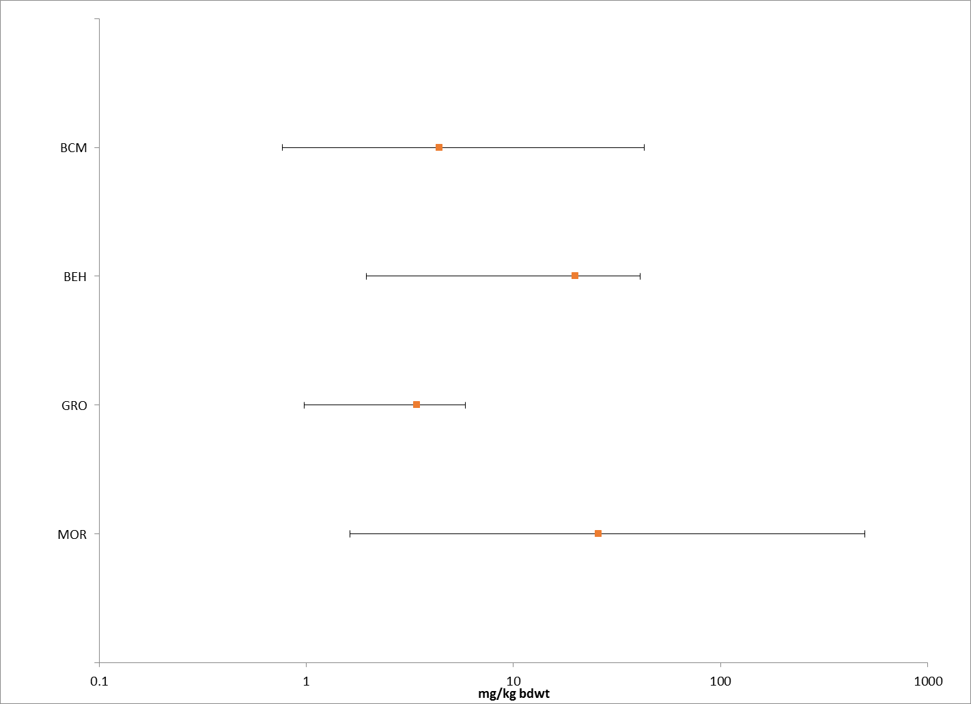

Figure 5-2. Dose-based Ranges (mg a.i./kg-bw) of Bird Data for Major Effects Groups. Incorporates registrant submitted and ECOTOX accepted open literature studies. Orange dots indicate median values. (BCM = Biochemical, BEH = Behavioral, GRO = Growth, MOR = Mortality).

As illustrated in the summary data arrays above, the available literature suggests a range of effects from sublethal effects to mortality in bird species from 0.99 to 545 mg a.i./kg-bw and 25 to 1600 mg a.i./kg-diet. Detailed data arrays containing individual data points and their specific effects within each major group are discussed below in each line of evidence.

Figures 5-3 and 5-4 provide a graphical illustration of the range of sublethal data points at the lower end of the x axis for dose and dietary based endpoints. For dietary studies in this data set, the array illustrates the occurrence of effects on reproduction and growth in the same range as those seen for cholinesterase and other enzymatic or biochemical changes. For dose-based studies, although fewer studies are available, effects include biochemical, behavioral (locomotion), growth and mortality in a similar dose range.

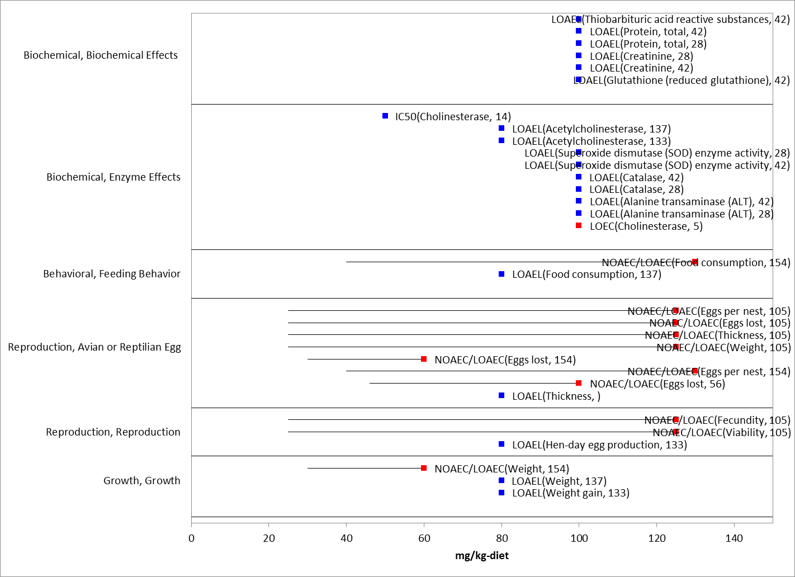
Figure 5-3. Dietary-based Endpoints (mg a.i./kg-diet) for Birds Exposed to Chlorpyrifos for Endpoints Less Than 150 mg a.i./kg-diet. Data from registrant submitted (red) and open literature (blue). Bars represent NOAEC/LOAEC range with the LOAEC value represented by the colored data point (studies where only a LOAEC was identified are represented with single data point). Data label key: Endpoint (measured effect, duration in days).

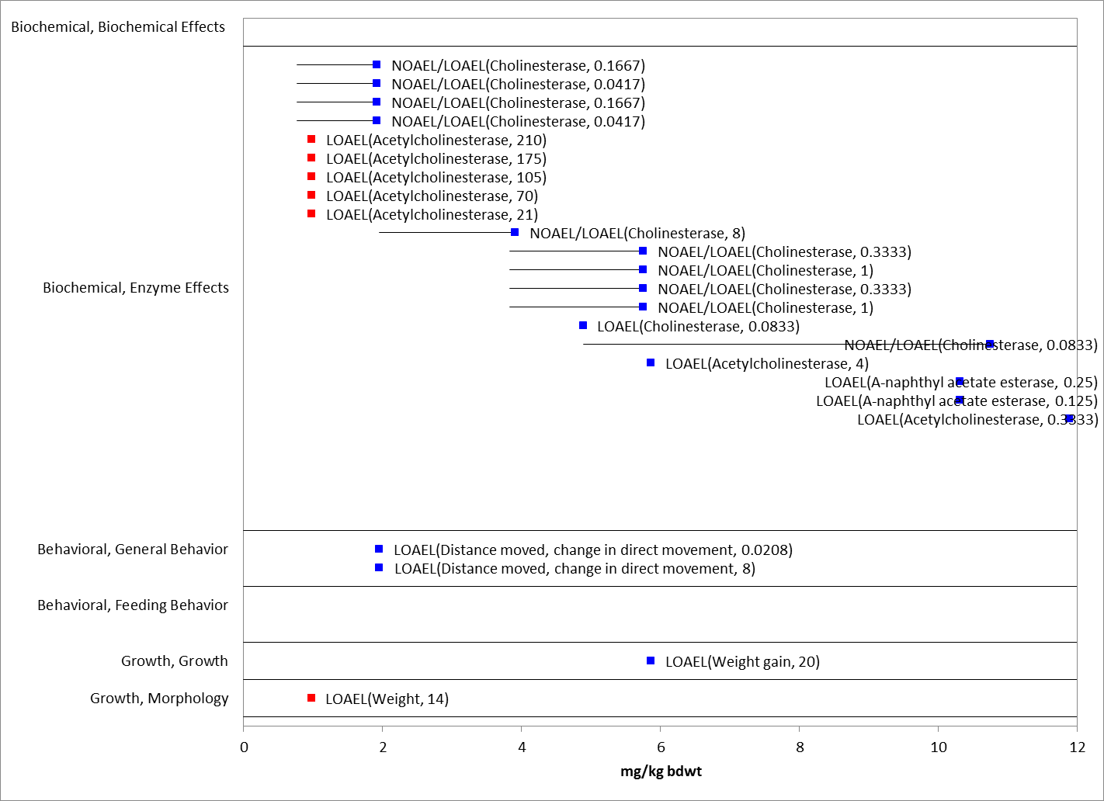
Figure 5-4. Dose-based Endpoints (mg a.i./kg-bw) for Birds Exposed to Chlorpyrifos for Sublethal Endpoints Less Than 12 mg a.i./kg-bw. Data from registrant submitted (red) and open literature (blue). Bars represent NOAEC/LOAEC range with the LOAEC value represented by the colored data point (studies where only a LOAEC was identified are represented with single data point). Data label key: Endpoint (measured effect, duration in days).

Lines of Evidence for Birds

Effects on Mortality of Birds

The data set for mortality to birds, includes 40 references representing 113 endpoints and 18 species. LD₅₀ and LC₅₀ values are listed in Table 5-3. All values for any reported mortality effect range from 2.5 to 545 mg a.i./kg-bw and 25 to 1670 mg a.i./kg-diet.

Table 5-3. Available Median Lethal Doses (LD₅₀, oral) for Birds Exposed to Chlorpyrifos as TGAI or Formulation Including Those Used in SSD.
Genus | Species | Common Name | LD50  (mg a.i./kg-bw) | TGAI/  Formulation (F) | Duration (d) | MRID/ECOTOX ref #
Quiscalus | quiscula | Common Grackle | 5.62* | TGAI | 14 | MRID 160000
Phasianus | colchicus | Ring-Necked Pheasant | 7.95* | TGAI | 14 | 35499
Columba | Livia | Common Pigeon | 10* | TGAI | 14 | MRID 160000
Passer | domesticus | House Sparrow | 10* | TGAI | 14 | MRID 160000
Agelaius | phoenicus | Red-winged blackbird | 13.1* | TGAI | 14 | MRID 160000
Coturnix | japonica | Coturnix quail | 13.3* | TGAI | 14 | MRID 40378401
Coturnix | japonica | Japanese Quail | 15.03* | TGAI | 14 | 35499
Grus | canadensis | Sandhill Crane | 25* | TGAI | 14 | MRID 40378401
Phasianus | colchicus | Ring-Necked Pheasant | 17.7* | TGAI | 14 | 50386
Coturnix | japonica | Japanese Quail | 17.8* | TGAI | 14 | 50386
Gallus | domesticus | Domestic Chicken | 18.14 | F | 1 | 108196
Passer | domesticus | House Sparrow | 19.85* | TGAI | 14 | 35499
Passer | domesticus | House Sparrow | 21* | TGAI | 14 | 50386
Grus | canadensis | Sandhill Crane | 25* | TGAI | 14 | 50386
Branta | canadensis | Canada Goose | 40* | TGAI | 14 | MRID 40378401
Columba | Livia | Rock Dove | 25.42* | TGAI | 14 | 35499
Branta | canadensis | Canada Goose | 40* | TGAI | 14 | 50386
Grus | canadensis | Sandhill Crane | 50* | TGAI | 14 | MRID 40378401
Colinus | virginianus | Northern Bobwhite Quail | 32* | TGAI | 7 | 37111
Gallus | domesticus | Domestic Chicken | 34.77* | TGAI | 1 | MRID 242149/37995
Alectoris | chukar | Chukar | 57.36* | TGAI | 14 | 35499
Alectoris | chukar | Chukar | 61.1* | TGAI | 14 | 50386
Callipepla | californica | California Quail | 68.3* | TGAI | 14 | 50386
Anas | Platyrhynchos | Mallard Duck | 71.44* | TGAI | 14 | 35499
Anas | Platyrhynchos | Mallard Duck | 108 | TGAI | 14 | MRID 41043901
Anas | Platyrhynchos | Mallard duck | 112* | TGAI | 14 | MRID 40378401
Sturnus | vulgaris | Starling | 75* | TGAI | 14 | MRID 40378401
Colinus | virginianus | Northern Bobwhite Quail | 93 | TGAI | 0.1667 | MRID 44585402/39749
Colinus | virginianus | Northern Bobwhite Quail | 108 | F | 7 | 37111
Passer | domesticus | House Sparrow | 94 | TGAI | 14 | MRID 44057102
Passer | domesticus | House Sparrow | 109 | F | 14 | MRID 44057101
Streptopelia | risoria | Ringed Turtle-Dove | 157 | TGAI | 7 | 37111
Anas | Platyrhynchos | Mallard Duck | 476* | TGAI | 14 | MRID 40854701
Colinus | virginianus | Northern Bobwhite Quail | 545 | F | 14 | MRID 41885201
* = Value used to derive SSD

Table 5-4. Available Median Lethal Doses (LC₅₀, dietary) for Birds Exposed to Chlorpyrifos as TGAI or Formulation.
Genus | Species | Common Name | LC50  (mg a.i./kg diet) | TGAI/  Formulation | Duration (d) | MRID/  ECOTOX ref #
Anas | platyrhynchos | Mallard Duck | 203 | TGAI | 8 | MRID 40854702
Colinus | virginianus | Northern Bobwhite Quail | 283 | TGAI | 5 | MRID 44585401/ 39628
Coturnix | japonica | Japanese Quail | 290.03 | TGAI | 8 | MRID 22923/35243
Coturnix | japonica | Japanese Quail | 293 | TGAI | 5 | 50181
Coturnix | japonica | Japanese Quail | 299 | TGAI | 8 | 35214
Colinus | virginianus | Northern Bobwhite Quail | 345 | TGAI | 5 | MRID 44585401/39628
Colinus | virginianus | Northern Bobwhite Quail | 347 | TGAI | 5 | MRID 44585401/39628
Colinus | virginianus | Northern Bobwhite Quail | 347 | TGAI | 5 | MRID 44585401/39628
Colinus | virginianus | Northern Bobwhite Quail | 353 | TGAI | 8 | 36788
Anas | platyrhynchos | Mallard Duck | 357 | TGAI | 11 | 35297
Colinus | virginianus | Northern Bobwhite Quail | 365 | TGAI | 5 | MRID 44585401/39628
Colinus | virginianus | Northern Bobwhite Quail | 365 | TGAI | 5 | MRID 44585401/39628
Colinus | virginianus | Northern Bobwhite Quail | 382 | TGAI | 5 | MRID 44585401/39628
Colinus | virginianus | Northern Bobwhite Quail | 387 | Formulation | 8 | MRID 41965502
Colinus | virginianus | Northern Bobwhite Quail | 392 | TGAI | 8 | 36788
Colinus | virginianus | Northern Bobwhite Quail | 397 | TGAI | 8 | 36788
Colinus | virginianus | Northern Bobwhite Quail | 421 | TGAI | 8 | 36788
Colinus | virginianus | Northern Bobwhite Quail | 423 | TGAI | 8 | MRID 46955
Colinus | virginianus | Northern Bobwhite Quail | 478.5 | TGAI | 28 | 39583
Coturnix | japonica | Japanese Quail | 492 | Formulation | 5 | 50181
Coturnix | japonica | Coturnix quail | 492 | TGAI | 8 | MRID 115301
Colinus | virginianus | Northern Bobwhite Quail | 497 | TGAI | 5 | MRID 44585401/MRID 44585401/39628
Colinus | virginianus | Northern Bobwhite Quail | 505 | TGAI | 8 | MRID 95123
Colinus | virginianus | Northern Bobwhite Quail | 506 | TGAI | 8 | MRID 40854703
Colinus | virginianus | Northern Bobwhite Quail | 531 | TGAI | 5 | MRID 44585401/39628
Phasianus | colchicus | Ring-Necked Pheasant | 536.41 | TGAI | 8 | MRID 22923/35243
Anas | platyrhynchos | Mallard Duck | 590 | TGAI | 8 | MRID 46954
Colinus | virginianus | Northern Bobwhite Quail | 608.18 | TGAI | 5 | 39691
Anas | platyrhynchos | Mallard Duck | 644 | TGAI | 1 | 35297
Anas | platyrhynchos | Mallard Duck | 671 | TGAI | 8 | 36788
Anas | platyrhynchos | Mallard Duck | 757 | TGAI | 8 | 36788
Anas | platyrhynchos | Mallard Duck | 803 | Formulation | 8 | MRID 41965501
Colinus | virginianus | Northern Bobwhite Quail | 851.8 | TGAI | 5 | 39583
Colinus | virginianus | Northern Bobwhite Quail | 863 | TGAI | 8 | MRID 44585403
Anas | platyrhynchos | Mallard Duck | 900 | TGAI | 8 | 36788
Anas | platyrhynchos | Mallard Duck | 911.8 | TGAI | 8 | MRID 22923/35243
Anas | platyrhynchos | Mallard Duck | 1080 | TGAI | 8 | 36788
Colinus | virginianus | Northern Bobwhite Quail | 1100 | TGAI | 8 | 39583

The endpoints considered for the mortality line of evidence are included in Figures 5-5. Based on the AOP for animals exposed to chlorpyrifos, endpoints representative of AChE inhibition are relevant to the mortality line of evidence. The range of acetylcholinesterase endpoints are discussed in more detail in Section 5.4.2.5 below whereas the mortality endpoints are discussed below.

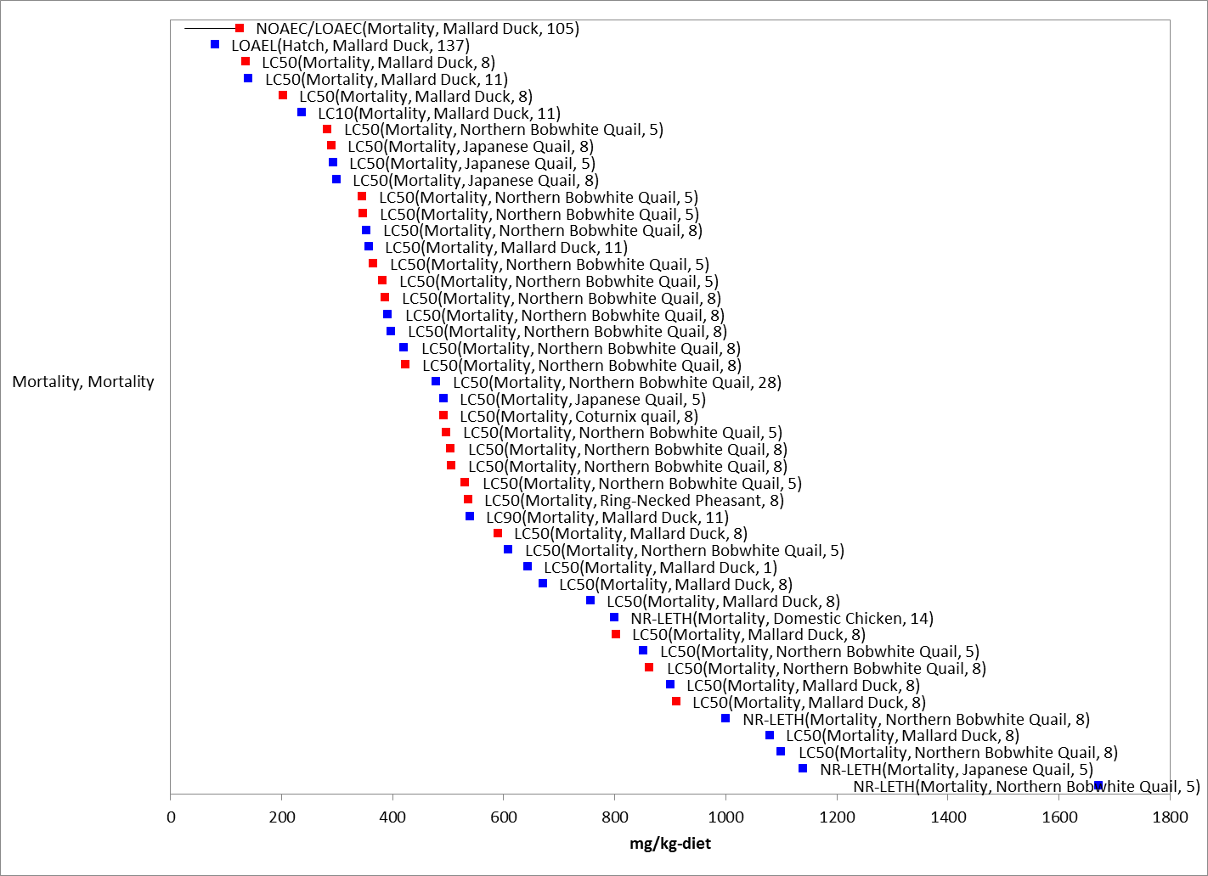

Figure 5-5. Dietary-based Mortality Endpoints (mg a.i./kg-diet) for Birds Exposed to Chlorpyrifos. Data from registrant submitted (red) and open literature (blue). (LCx=x% mortality, NR-LETH=100% mortality). Data label key: Endpoint (measured effect, species, duration in days).

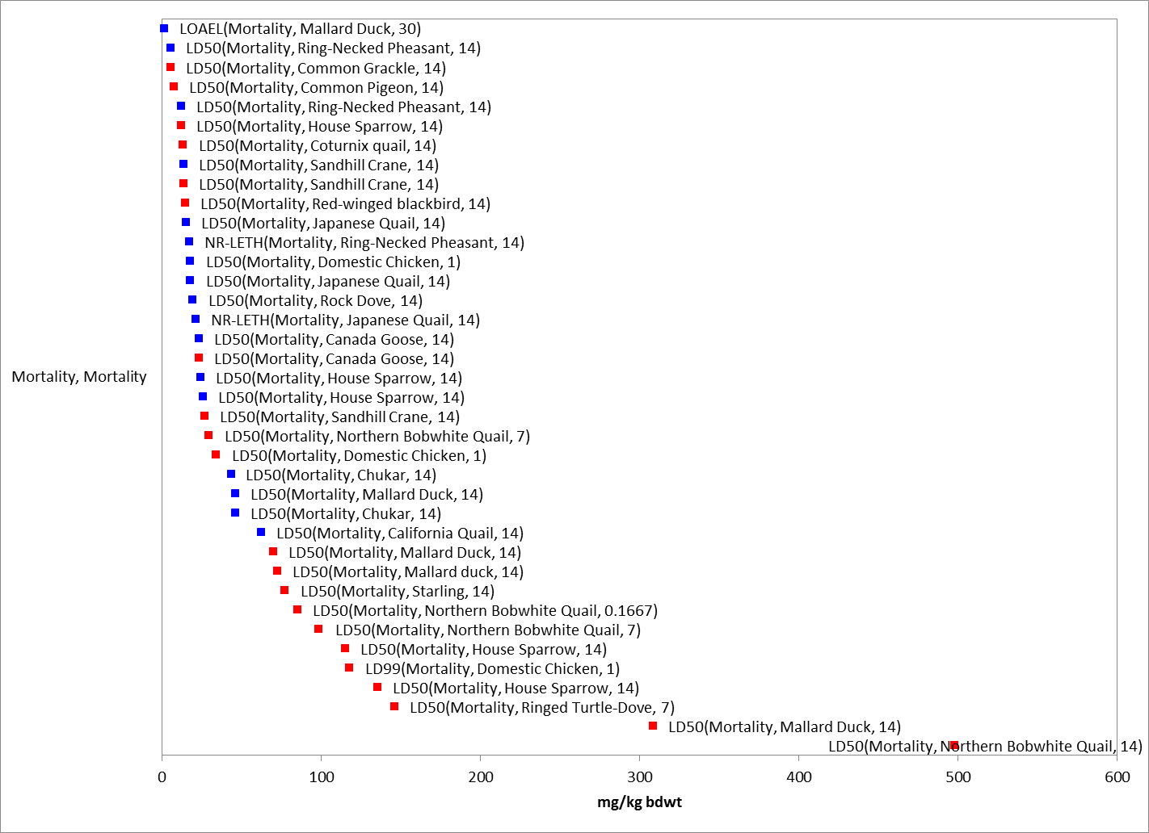
Figure 5-6. Dose-based Mortality Endpoints (mg a.i./kg-bw) for Birds Exposed to Chlorpyrifos. Data from registrant submitted (red) and open literature (blue). (LCx=x% mortality, NR-LETH=100% mortality). Data label key: Endpoint (measured effect, species, duration in days).

Multiple test species have been used in acute oral toxicity studies under varying conditions, yielding LD₅₀ values that range from 5.62-476 mg a.i./kg-bw for 13 species of birds tested. Based on the lowest LD₅₀ values, chlorpyrifos is considered very highly toxic (i.e., LD₅₀<10 mg a.i./kg-bw) to birds. Dietary-based LC₅₀ values are also available for several test species. Values range from 136-1100 mg a.i./kg-diet. Based on the lowest LC₅₀ values, chlorpyrifos is considered highly toxic to birds. Figures 5-5 and 5-6 provide a graphical illustration of the range of lethal data points for dose and dietary based endpoints.

A subset of the available mortality data were used to construct SSDs in order to derive dose-based thresholds. From the available data, LD₅₀ values were used in the SSD if they were conducted with TGAI. Studies used in the creation of the LD₅₀ SSD curve were assessed to determine if a minimum of one study from each quartile of the curve had been reviewed. In order to have the most representative slope for calculation of thresholds, studies around the HC₀₅ value were reviewed to obtain slope values, if available. Based on reviews using these criteria, two LD₅₀ values were removed from inclusion in the SSD. One dose based mortality study (MRID 44585402/E37995) was removed as the LD₅₀ was measured at 4 hours post dosing, which is not comparable with the other LD₅₀ measurements and may underestimate the final mortality that would have occurred in the study. Another LD₅₀ study with the house sparrow (MRID44057102; LD₅₀ = 94 mg a.i./kg-bw) was excluded due to concerns about regurgitation and dosing with capsules containing dry crystalline material without a carrier.

The species sensitivity distribution for dose-based exposures to birds are depicted in Figure 5-7. Summary statistics are provided in Table 5-5. APPENDIX 2-9 provides details of how the SSDs were derived, including a discussion of statistical variation and interpretation of the data set.

Table 5-5. Summary Statistics for Triangular SSD Fit to Chlorpyrifos Test Results

Statistic | ¹LD50s
Goodness of fit P-value | 1
CV of the HC₀₅ | 0.34
HC₀₅ | 6.6
HC₁₀ | 8.4
HC₅₀ | 23.4
HC₉₀ | 65.3
HC₉₅ | 83.3
Mortality Threshold (slope = 4.5)  (1/million) | 0.58
Indirect Effects Threshold (slope = 4.5)  (10% effect) | 3.4
¹mg a.i./kg body weight, standardized to a 100 g bird.
²mg a.i/kg diet
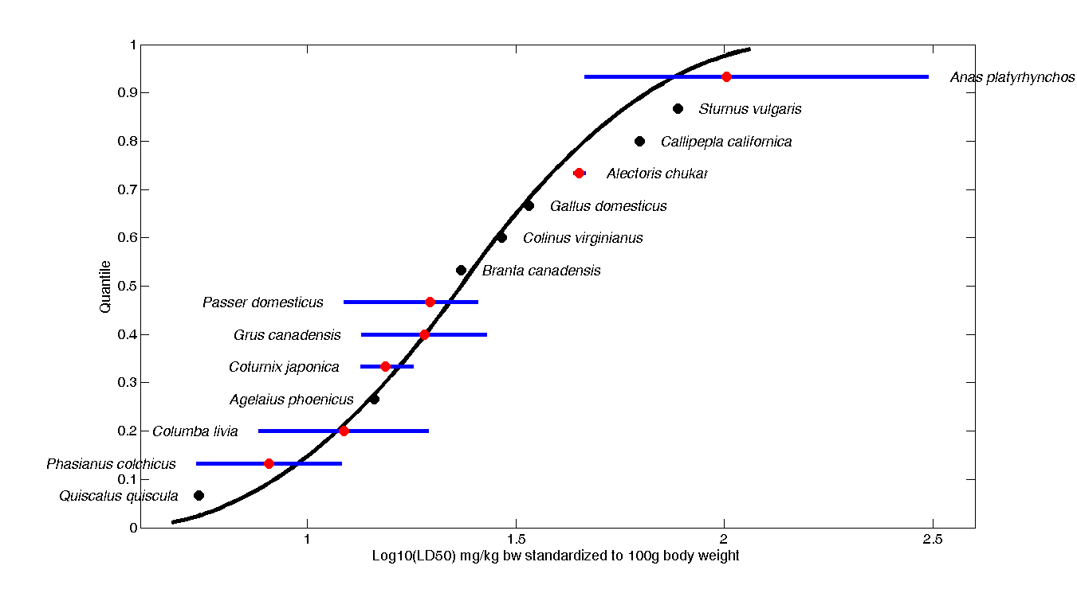
Figure 5-7. Log-triangular SSD for Chlorpyrifos Bird LD₅₀s. Black points indicate single toxicity values. Red points indicate geometric mean of multiple toxicity values for given species. Blue lines indicate full range of toxicity values for a given species.

The mortality threshold for direct effects, calculated using the 1 in a million value from the HC₀₅, is 0.58 mg a.i./kg-bw for dose based mortality studies (LD₅₀) and 1.6 mg a.i./kg-diet for dietary based mortality studies (LC₅₀). Mortality thresholds for indirect effects are 3.4 mg a.i./kg-bw for dose based mortality studies (LD₅₀) and 158 mg a.i./kg-diet for dietary based mortality studies (LC₅₀). Indirect effects thresholds are based on a 10% effect level from the SSD for LD50 values for acute oral exposure and from the lowest LC50 and slope for the sub-acute dietary based exposure.

Another study was identified in ECOTOX during review for thresholds that captured low dose mortality effects (E50386). This was information contained in Hudson et al., 1984, in a section entitled “Other Toxicity Data”, with a reported value for a 30-day EMLD (empirical minimum lethal dosage) for chlorpyrifos of <2.5 mg a.i./kg-bw. The 30-day EMLD is defined as the minimum oral dose needed to cause one or two deaths in a 30-day period when administered daily. Although it was noted that controls were used and three females and three males of each test species were used for each dose level, there was no additional information on test dosages or statistical methods and raw data were not provided. This information was not deemed acceptable for use as a threshold value but was retained in the data arrays for qualitative use.

Sublethal Effects to Birds

Effects on Growth of Birds

The data set for growth effects in birds includes 11 references representing 80 endpoints and 5 species. For dose-based endpoints, the range of reported effects are 0.99 to 50 mg a.i./kg-bw. The most sensitive growth endpoint is a LOAEL of 0.99 mg a.i./kg-bw based on decreased body weight in the domestic chicken (MRID 00028759). Cholinesterase inhibition is also reported at this level. This study was previously reviewed and qualified as supplemental. The cholinesterase and body weight LOAELs are deemed acceptable for inclusion in the risk assessment but are deemed not adequate for use as a threshold value due to lack of test animal information, lack of raw data, use of only one test concentration, inconsistent dose response, no reporting of weights of animals and inability to confirm the statistical analysis methods. The results are included in the effects arrays and are considered in the effects characterization.

For dietary studies, the range of reported effects are 30 to 80 mg a.i./kg-diet. The most sensitive endpoint is a NOAEC/LOAEC of 30/60 mg a.i./kg-diet based on decreased weight in the mallard duck (MRID 42144901; Discussed further in Section 5.4.2.2 Reproduction). The reported growth endpoints are displayed in Figure 5-8.

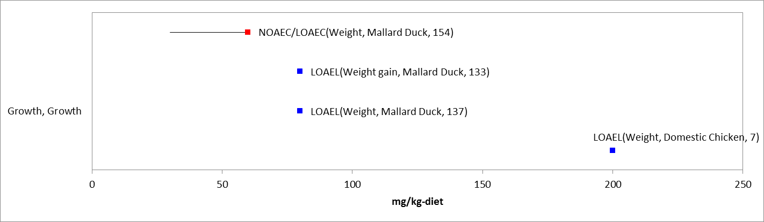
Figure 5-8. Dietary-based Growth Endpoints (mg a.i./kg-diet) for Birds Exposed to Chlorpyrifos. Data from registrant submitted (red) and open literature (blue). Bars represent NOAEC/LOAEC range with the LOAEC value represented by the colored data point (studies where only a LOAEC was identified are represented with single data point). Data label key: Endpoint (measured effect, duration in days).

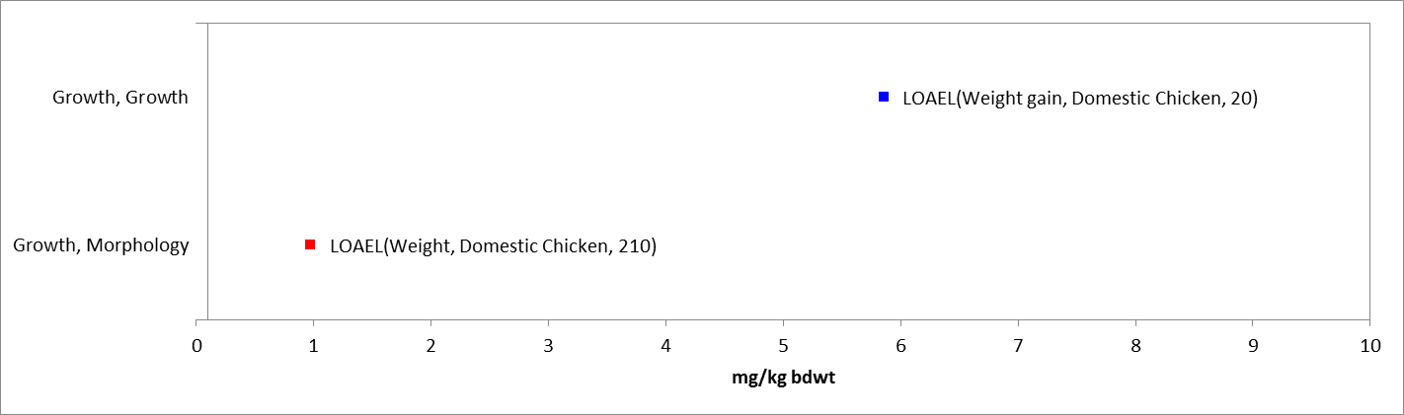

Figure 5-9. Dose-based Growth Endpoints (mg a.i./kg-bw) for Birds Exposed to Chlorpyrifos. Data from registrant submitted (red) and open literature (blue). Bars represent NOAEC/LOAEC range with the LOAEC value represented by the colored data point (studies where only a LOAEC was identified are represented with single data point). Data label key: Endpoint (measured effect, species, duration in days).

Effects on Reproduction of Birds

The data set for reproductive effects for birds includes 9 references representing 32 endpoints and 4 species. No acute oral dose based studies are available that captured reproductive endpoints. Reproductive endpoints for dietary studies ranged from 25 to 130 mg a.i./kg-diet. All reported reproductive effects endpoints are displayed in Figure 5-10.

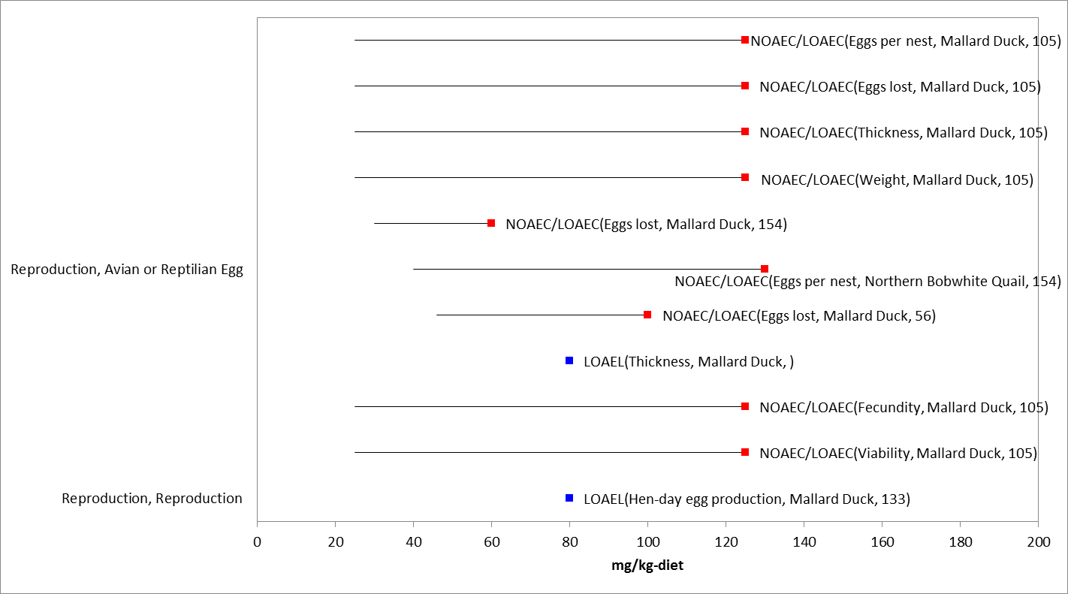

Figure 5-10. Dietary-based Reproduction Endpoints (mg a.i./kg-diet) for Birds Exposed to Chlorpyrifos. Data from registrant submitted (red) and open literature (blue). Bars represent NOAEC/LOAEC range with the LOAEC value represented by the colored data point (studies where only a LOAEC was identified are represented with single data point). (LCx=x% mortality, NR-LETH=100% mortality). Data label key: Endpoint (measured effect, species, duration in days).

The most sensitive NOAEC value for chlorpyrifos is 25 mg a.i./kg-diet (LOAEC = 125 mg a.i./kg-diet, MRID 0046952) for reproductive effects (83% reduction in number of eggs laid compared to controls, reductions in eggs set, viable embryos, live three-week embryos, normal hatchlings, 14-day old survivors, mean eggshell thickness and mean egg weight) and represents the sublethal threshold value for direct effects. Additional effects were seen in adults in this study at 125 mg a.i./kg-diet including locomotor dysfunction (high stepping, gate abnormalities, loss of balance and lack of coordination), poor feather condition, decreased food consumption, weight loss and death (23% mortality in 125 mg a.i./kg-diet group by end of study, no moralities in control or 25 mg a.i./kg-diet group). This study reports the measured concentration of chlorpyrifos in diet as a range of 76 – 108% with an average of 92% of nominal concentration. No adjustments were made to the reported NOAEC values.

Based on the available data for bird species for dietary based studies, the most sensitive LOAEC value for chlorpyrifos is 60 mg a.i./kg-diet for reduction in the number of eggs laid and adult body weight in the mallard duck (MRID 42144901). This study was previously reviewed and qualified as acceptable. The dietary concentration in this study was reduced from 90 mg a.i./kg-diet to 60 mg a.i./kg-diet at the beginning of week 8 of the study due to body weight losses and mortality; the LOAEC is subsequently reported as 60 mg a.i./kg-diet instead of the original test concentration. Although some uncertainty exists around the endpoint at 60 or 90 mg a.i./kg-diet, differences in body weight (11% difference between control and 60 mg a.i./kg-diet group at end of study) and reproductive changes persisted through the end of the study despite the reduction in test concentration during week 8. Therefore, this study is used to establish the threshold value for indirect effects based on dietary exposure at 60 mg a.i./kg-diet.

Effects on Behavior of Birds

The data set for behavior effects for birds includes 8 references representing 14 endpoints and 6 species. All values for any reported behavior effect ranged from 2 to 37 mg a.i./kg-bw and 40 to 550 mg a.i./kg-diet. The endpoints considered for the behavior line of evidence are included in Figures 5-6. Based on the AOP for animals exposed to chlorpyrifos, endpoints representative of AChE inhibition are relevant to the behavior line of evidence. The range of acetylcholinesterase endpoints are discussed in more detail in the Acetylcholinesterase Inhibition section. The behavior endpoints are discussed below.

The most sensitive behavioral endpoint is a LOAEL of 2 mg a.i./kg-bw based on locomotion effects in the domestic chicken (E108196, Al-Badrany, YMA, et al; 2007). One study, which was reviewed in the threshold analysis, included a behavioral study where juvenile domestic chickens exposed to 2 and 4 mg a.i./kg-bw chlorpyrifos as a single dose and repeated dosing over 7 days showed significant impairment in behavioral and locomotion effects, as measured by latency to move, number of lines crossed and distress calls as compared to control chicks. Cholinesterase was also measured in the 7 day portion of the study and varying degrees of inhibition were found, ranging from not significant for plasma cholinesterase at both test doses to significant inhibition in whole brain (36%) and liver (22%) cholinesterase at the 4 mg a.i./kg-bw dose.

The highest dose based behavior effect endpoint is decreased food consumption in the red-winged blackbird at 37 mg a.i./kg-bw (NOAEL = 18 mg a.i./kg-bw; E92506). All reported behavior effects endpoints are displayed in Figures 5-11.

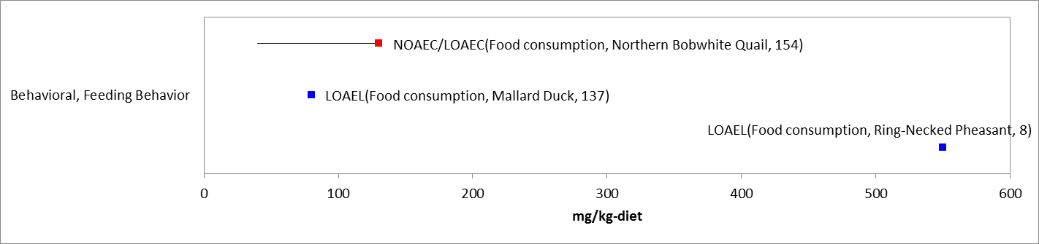
Figure 5-11. Dietary-based Behavioral Endpoints (mg a.i./kg-diet) for Birds Exposed to Chlorpyrifos. Data from registrant submitted (red) and open literature (blue). Bars represent NOAEC/LOAEC range with the LOAEC value represented by the colored data point (studies where only a LOAEC was identified are represented with single data point). Data label key: Endpoint (measured effect, species, duration in days).

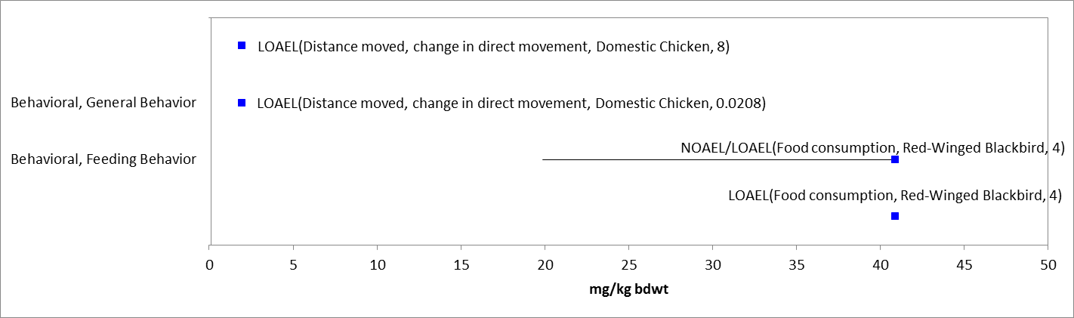
Figure 5-12. Dose-based Behavioral Endpoints (mg a.i./kg-bw) for Birds Exposed to Chlorpyrifos. Data from registrant submitted (red) and open literature (blue). Bars represent NOAEC/LOAEC range with the LOAEC value represented by the colored data point (studies where only a LOAEC was identified are represented with single data point). Data label key: Endpoint (measured effect, species, duration in days).

Another sensitive endpoint identified in ECOTOX during review for threshold analysis is a pond study with a reported NOAEC between 8 and 80 mg a.i./kg-diet for food consumption (E39578). This is titled as a “preliminary pond study” by the study authors. The study was deemed invalid for the first year of the study due to high control losses (37%). The results for the second year of the study (which only included controls and 80 mg a.i./kg-diet test groups) where control losses were still significant (17%) but lower, were considered qualitative and included in the effects arrays and effects characterization for a LOAEC of 80 mg a.i./kg-diet.

Although not recorded as a statistically significant effect, behavioral effects were seen in the reproduction study (MRID 0046952) discussed in the reproduction line of evidence. Adults exhibited locomotor dysfunction (high stepping, gait abnormalities, loss of balance and lack of coordination), poor feather condition and decreased food consumption at 125 mg a.i./kg-diet.

Effects on Sensory Function of Birds

No toxicity data are available to describe potential sensory effects of chlorpyrifos to birds.

Other Effects Reported for Birds

Given the mode of action of chlorpyrifos, it is expected that the chemical will have an impact on AChE. Inhibition of AChE interferes with proper neurotransmission in cholinergic synapses and neuromuscular junctions. This can lead to multiple effects, including mortality and behavioral effects (e.g., decreases in feeding and locomotion). Therefore, available effects data for AChE inhibition are considered in the mortality and behavioral lines of evidence. Many studies submitted by pesticide registrants and available in the open literature quantified AChE levels in the brains or blood (plasma) of birds exposed to chlorpyrifos. These data points are included in Figures 5-13 and 5-14. The data set for acetylcholinesterase inhibition and other biochemical effects ranges from 1 to 150 mg a.i./kg-bw and 50 to 800 mg a.i./kg-diet, including 9 references representing 32 endpoints and 4 species.

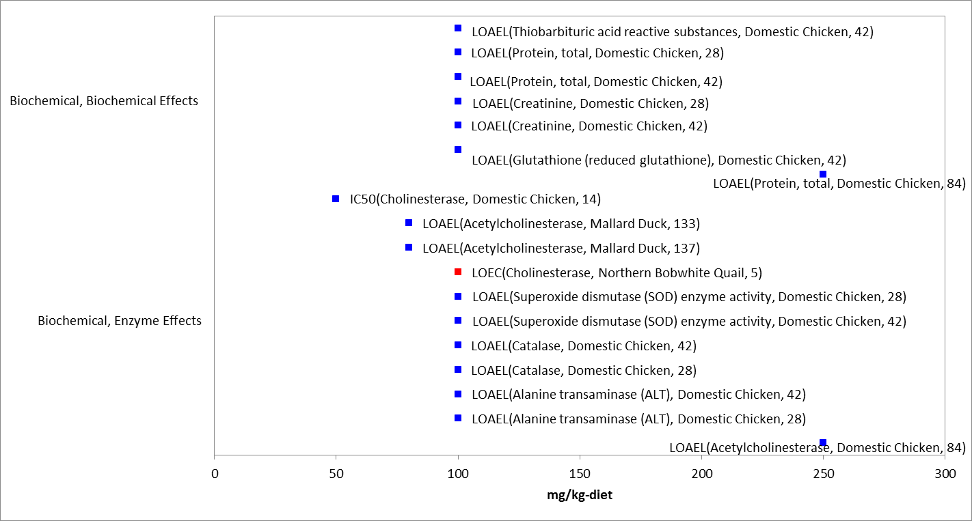
Figure 5-13. Dietary-based Biochemical Endpoints (mg a.i./kg-diet) for Birds Exposed to Chlorpyrifos. Data from registrant submitted (red) and open literature (blue). Bars represent NOAEC/LOAEC range with the LOAEC value represented by the colored data point (studies where only a LOAEC was identified are represented with single data point). Data label key: Endpoint (measured effect, species, duration in days).

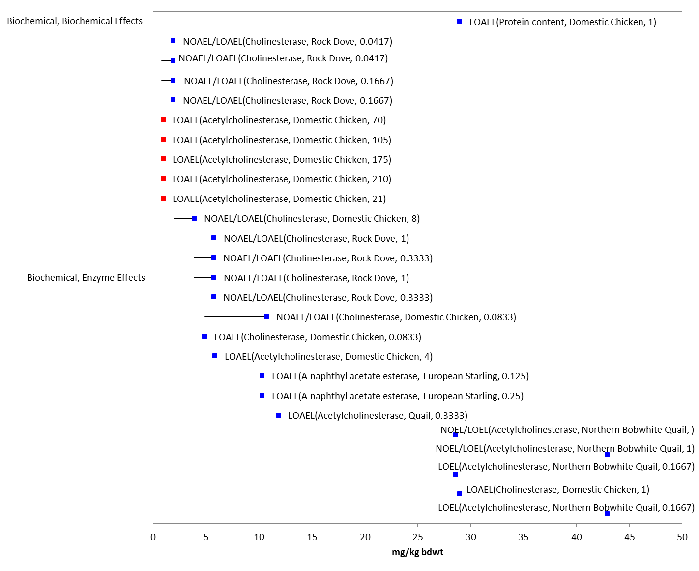
Figure 5-14. Dose-based Biochemical Endpoints (mg a.i./kg-bw) for Birds Exposed to Chlorpyrifos. Data from registrant submitted (red) and open literature (blue). Bars represent NOAEL/LOAEL range with the LOAEL value represented by the colored data point (studies where only a LOAEL was identified are represented with single data point). Data label key: Endpoint (measured effect, species, duration in days).

Based on the available bird data for acute oral dose-based studies, the most sensitive NOAEL value for chlorpyrifos, which is used to establish the direct sublethal threshold, is 1 mg a.i./kg-bw (LOAEL = 2.5 mg a.i/kg-bw, E154172) for plasma cholinesterase inhibition in the rock dove (Columba livia). In this study, rock doves (homing pigeons) were dosed with chlorpyrifos at 1.0, 2.5, 5.0, and 7.5 mg a.i./kg-bw. Blood samples were collected at 0, 1, 4, 8, 24 and 48 hours and plasma cholinesterase levels were analyzed. At 1 hour post dosing, plasma cholinesterase inhibition (as compared to controls) was approximately 25% in the 2.5 mg a.i./kg-bw group and 75% in the 5.0 and 7.5 mg a.i./kg-bw group. This study also represents the most sensitive reported LOAEL at 2.5 mg a.i./kg body weight for plasma cholinesterase inhibition and is therefore used to establish the indirect sublethal threshold.

A registrant study (MRID 00028759) was identified with a LOAEC = 0.99 mg a.i./kg-bw for cholinesterase inhibition and body weight at 1 week. This study was previously reviewed and qualified as supplemental. The cholinesterase and body weight LOAELs are deemed not adequate for use as a threshold value due to lack of test animal information, lack of raw data, use of only one test concentration, inconsistent dose response, no reporting of weights of animals and inability to confirm the statistical analysis methods. However, the study is still considered to provide some useful scientific information and is included in the effects arrays.

Table 5-6 illustrates dose based studies in the lower range of reported values where cholinesterase inhibition was reported along with other reported effects.

Table 5-6. Measured Acetylcholinesterase Levels and Other Measured Effects in Studies at Low Dose Levels
Study | Species/Age | Dose  (mg a.i./kg-bw) | Other effects measured | Duration | AChE inhibition | Comments
E154172  Moye et al., 2010 | Rock Dove (Homing Pigeon)  3 months to 5 years | 1 | None reported | 1 hr | NS (this is NOAEL) | Plasma cholinesterase; Recovery by all groups at 48 hours (lower doses recovered quicker)
 |  | 2.5 |  |  | 25%
 |  | 5 |  |  | 75%
 |  | 7.5 |  |  | 75%
MRID 242149  E37995  Miyazaki S;  Hodgson GC, 1972 | Domestic Chicken  15 days old | 1 | Weight | 14 - 21 days | NS -19% | Blood ChE reported
 |  |  | None | 21-210 days | NS - 35%
E50836  Hudson, RH, et al., 1984 | Mallard Duck  Unknown age | <2.5 | Mortality | 30 days | Not reported | EMDL study
E108194  Al-Badrany, YMA; Mohammad FK, 2007 | Domestic chicken  7-15 days old | 2 | Locomotion  (effects seen in all exposure groups for both durations) | 30, 60 and 90 min | Not reported
 |  | 4
 |  | 2 |  | 7 days daily dosing | 11-19 % (NS) | No significant change in whole brain, liver or plasma ChE
 |  | 4 |  |  | 8-37 % | Significant in whole brain (37%) and liver (22 %); plasma ChE not significant
NS = not significant as compared to controls

Field and Semi-Field Data for Birds

Data from field studies reported in the accepted ECOTOX studies and registrant submitted studies are represented in Figure 5-15 and are discussed below.

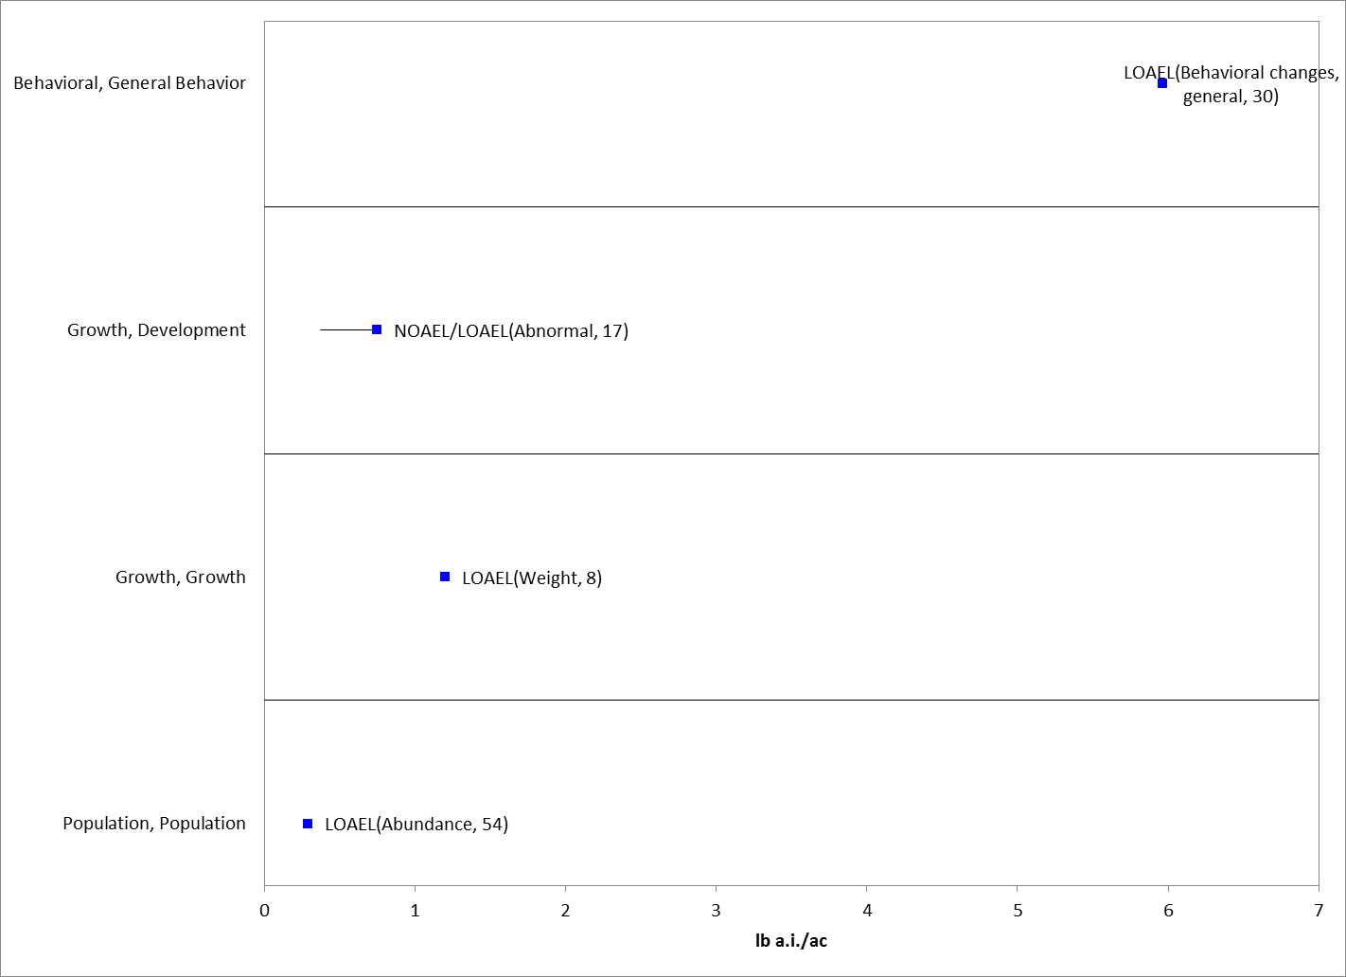

Figure 5-15. Application Rate Based Endpoints for Birds Exposed to Chlorpyrifos. Bars represent NOAEC/LOAEC range with the LOAEC value represented by the colored data point (studies where only a LOAEC was identified are represented with single data point). Data label key: Endpoint (measured effect, duration in days).

In an Iowa field study on corn (MRID 43483101), chlorpyrifos was applied as either Lorsban 4E, an emulsifiable concentrate formulation, to 4 fields (4 applications per field; 1.7 to 3.4 kg a.i./ha [1.5 - 3 lbs a.i./A]) or as Lorsban 15G, a granular formulation, to 4 fields (3 applications per field; 1.1 to 2.9 kg a.i./ha [1 - 2.6 lbs a.i./A]). Chlorpyrifos levels were measured in various environmental samples. Field investigators considered any death likely to be treatment-related if analytical analyses tested positive for chlorpyrifos residues in samples. Carcass searches made in the corn field study found evidence of 14 bird post-treatment casualties.

In a California citrus grove field study, chlorpyrifos (i.e., Lorsban 4 E) was applied with two spray regimes (MRID 43730301). Under regime A, 4 fields were treated with 2 applications each: 1.5 lbs a.i./A followed about 30 days later by a treatment at 6.0 lbs a.i./A. Regime B also treated each of 4 fields twice (sprayed once at 3.5 lbs a.i./A followed about 30 days later by a second treatment at 4.0 lbs a.i./A). Searches for dead wildlife identified 192 carcasses. Twenty-one carcasses were analyzed for the presence of chlorpyrifos. Six of the tested carcasses tested positive for chlorpyrifos residues (28.6%). Consequently, those deaths may be presumed to be associated with chlorpyrifos treatments. Species that tested positive for chlorpyrifos were a mockingbird, an unidentified passerine nestling, house mouse, ground squirrel, pocket gopher, and a western rattlesnake. While the number of dead wildlife found during carcass searches does not show a dose-relationship with treatment levels, the number of carcasses testing positive for chlorpyrifos suggests that there could be a dose-relationship (i.e., 4 carcasses at 6 lbs a.i./A, 1 each at 3.5 and 4 lbs a.i./A, and none at 1.5 lbs a.i./A). However, the number of positive carcasses is too small to verify this conclusion.

One additional registrant field study was identified (MRID 42144903) involving a large pen field study on turf with bobwhite quail. However, these data are the same as that captured in an ECOTOX study (E78023; Booth, 1989) and the effects are included in the array above.

Effects to Birds Not Included in the Arrays

As exposure modeling will incorporate multiple exposure pathways for birds in this assessment, the literature was also reviewed for any data on drinking water studies, dermal exposure and inhalation exposure for birds, as summarized below.

Drinking water studies

One study (E35986) is available for the effects of chlorpyrifos in drinking water to 1 day old domestic chickens (Gallus domesticus). The effects endpoints for this study are illustrated in the array below. Cholinesterase levels and growth were inhibited in juvenile chicks (exposed from Days 1 to 28) at drinking water concentrations of 80 mg a.i./kg-water. Mortality (100%) was reported at 320 mg a.i./kg-water.

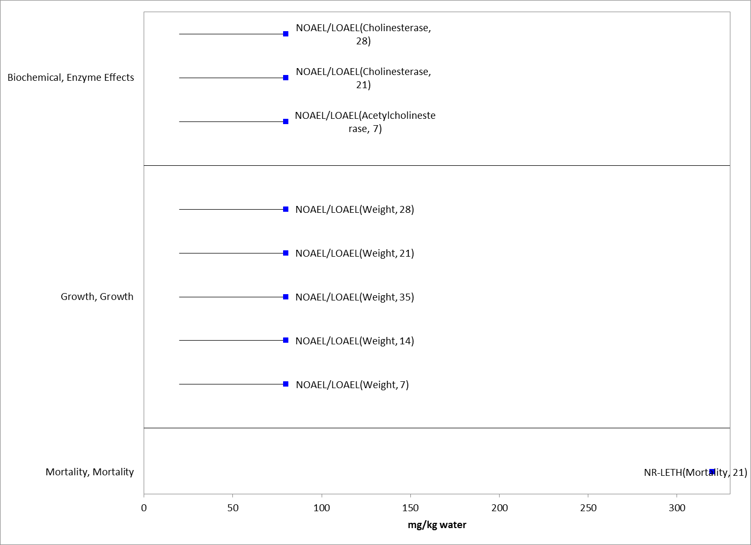
Figure 5-16. Drinking Water Endpoints (mg/kg-water) for Birds Exposed to Chlorpyrifos (E35986). Bars represent NOAEC/LOAEC range with the LOAEC value represented by the colored data point (studies where only a LOAEC was identified are represented with single data point). Data label key: Endpoint (measured effect, duration in days).

Dermal studies

No studies involving avian exposure via dermal exposure were identified in registrant studies or the ECOTOX database.

Inhalation studies

No studies involving avian exposure via drinking water were identified in registrant studies or the ECOTOX database.

Concentrations Where No Effects Were Observed in Birds

For the exposure units of mg a.i/kg-bw and mg a.i./kg-diet, there are data available that show concentrations where effects are not seen [i.e., ‘no effect’ (NE) concentrations]. The NE endpoints include NOAEC/NOAEL and NR-Zero values as reported in ECOTOX. Below are the arrays showing the NE endpoints for chlorpyrifos (see Figures 5-17 and 5-18).

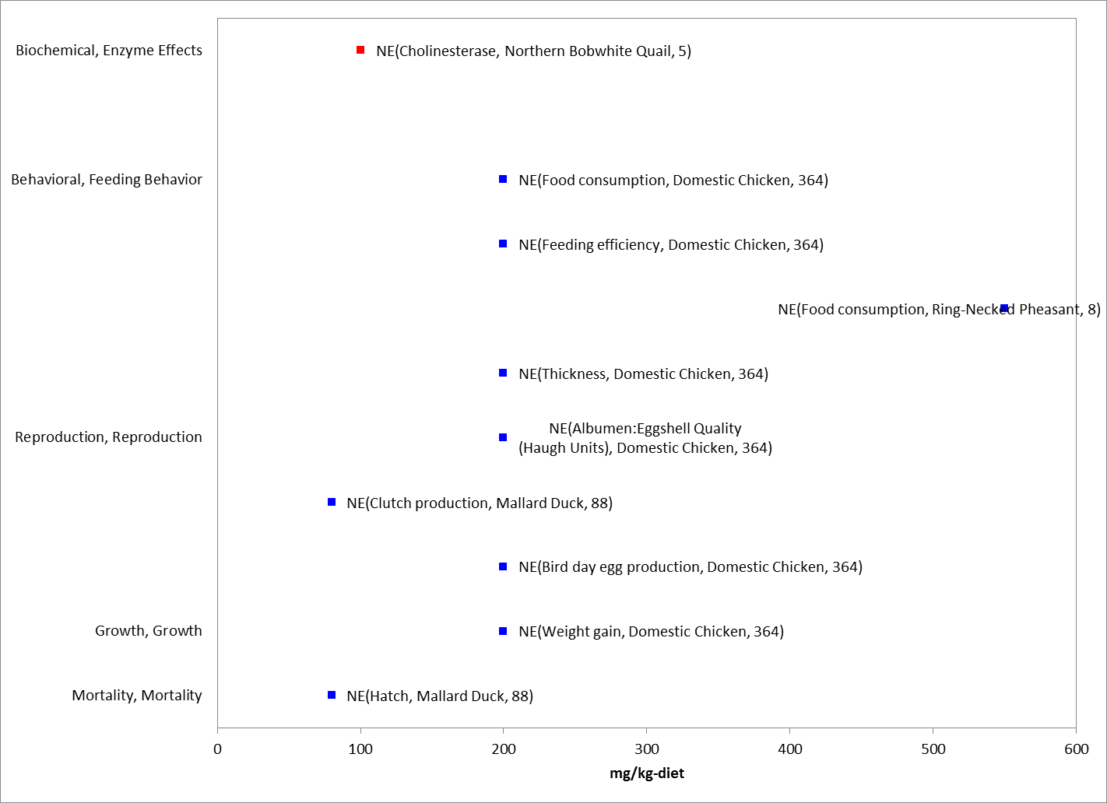
Figure 5-17. Dietary-based Endpoints (mg a.i./kg-diet) Reporting “no effect” for Birds Exposed to Chlorpyrifos. Data from registrant submitted (red) and open literature (blue). Data label key: Endpoint (measured effect, species, duration in days).

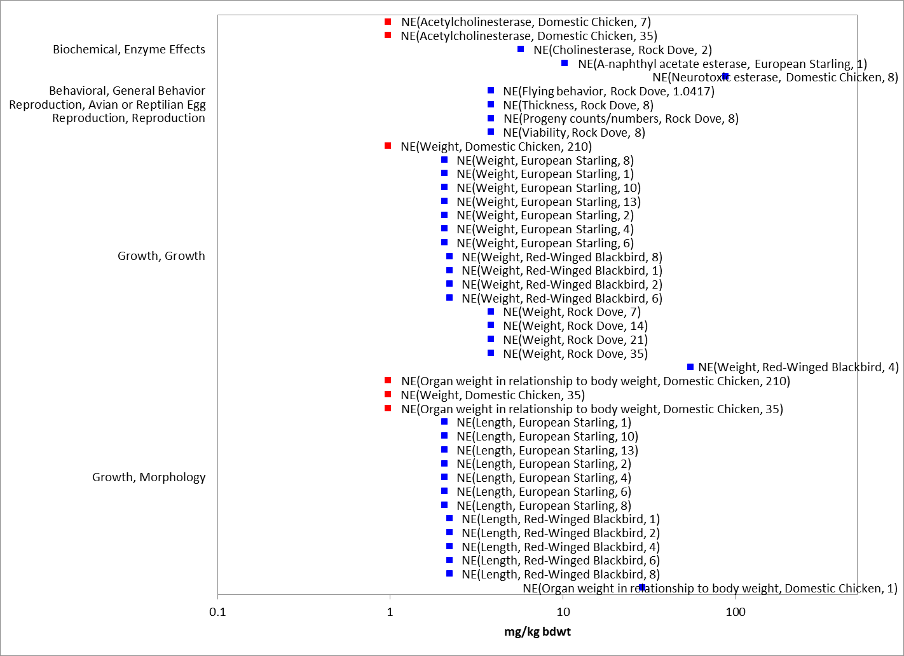
Figure 5-18. Dose-based Endpoints (mg a.i./kg-bw) Reporting “no effect” for Birds Exposed to Chlorpyrifos. Data from registrant submitted (red) and open literature (blue). Data label key: Endpoint (measured effect, species, duration in days).

Incident Reports for Birds

There are currently (as of May 11, 2015) 69 bird incident reports in the EIIS with a certainty index of ‘possible’, ‘probable’ or ‘highly probable’. Of these 69 incidents, 10 are from a registered use, 7 are from a misuse (either accidental or intentional), and in 52 of the incidents, the legality of use was undetermined (see Table 5-7 and ATTACHMENT 1-1, for details). All of the bird incidents occurred in the US (including Puerto Rico). The following discussion only includes those incident reports with a certainty index of ‘possible’, ‘probable’ or ‘highly probable’ and a legality classification of ‘registered’ and ‘undetermined’ (the incidents that were caused by a misuse are not reported further). There are 2 additional bird incidents attributed to chlorpyrifos in AIMS that were not from misuse (‘misuse’ or ‘abuse’). These are included in the discussion below.

The dates of the incident reports range from 1974 to 2014 (see Table 5-7). The bird incident reports involve a variety of different kinds of birds (e.g., songbirds, doves, raptors, ducks and geese). In most of the known incidents, the use site is not reported or is unknown. For those incidents that do report a use site, the incidents were associated with the following use sites: agricultural area (1); golf course (4); mosquito control (1); residential/residential lawn (20); and termite control (2). The chlorpyrifos product involved in the incidents is not reported or not specified beyond ‘Dursban’ in most of the incidents. In most of the incident reports, chlorpyrifos was the only pesticide noted in the report. There are, however, 22 incident reports that involve at least one pesticide in addition to chlorpyrifos (see Table 5-7).

Summary of Effects to Birds

In general, chlorpyrifos is highly toxic to birds. There is a wide range of endpoints in the acute mortality data, with LD₅₀ values ranging from 5.62 to 476 mg a.i./kg-bw and the lowest reported value of 5.62 mg a.i./kg-bw in the common grackle categoried as “very highly toxic” according to EPA classification guidelines. Using dietary based toxicity values, LC₅₀ values range from 136 to 1,100 mg a.i./kg-diet, which would be classified as “highly toxic” for the lowest values in the range according to the EPA classification.

Sublethal effects seen with chlorpyrifos include behavioral changes (locomotion changes, loss of balance and lack of coordination), decreased food consumption, decreased weight and various reproductive effects. Locomotion changes are seen at 2 mg a.i/kg-bw in the domestic chicken (E108196). On a dietary basis, dose levels as low as 60 mg a.i./kg-diet are associated with reduced weight gain and reproductive effects. The lowest reported sublethal endpoint for acetylcholinesterase inhibition is reported at 2.5 mg a.i/kg-bw based on a 25% decrease in plasma cholinesterase activity in the rock dove (E154172). Similar effects are also described in field studies and drinking water exposure studies. Based on the incident data that are available, the exposure pathways for chlorpyrifos are complete and the exposure levels are sufficient to result in field-observable effects.

Table 5-7. Bird Incident Reports from EIIS (Those Classified as ‘Possible’, ‘Probable’, or ‘Highly Probable’ with Legality of Use = ‘Registered’ or ‘Undetermined’).
INCIDENT NUMBER | YEAR | CHEMICAL(S) INVOLVED (PC CODE) | CERTAINTY INDEX (for chlorpyrifos) | STATE | LEGALITY (for chlorpyrifos) | USE SITE | SPECIES AFFECTED | DISTANCE | EFFECT/ MAGNITUDE | PRODUCT
I003131-001 | 1974 | Chlorpyrifos, | Probable | NY | Undetermined | Golf course | Canada geese | Vicinity | 43 | DURSBAN
 |  | Diazinon (057801)
B0000-501-23 | 1974 | Chlorpyrifos, | Possible | NY | Undetermined | Lawn | Canada geese | Vicinity | 12 | NR
 |  | Diazinon (057801)
B0000-400-21 | 1981 | Chlorpyrifos | Probable | FL | Undetermined | Residential lawn | American robins | NR | NR | NR
I003131-002 | 1985 | Chlorpyrifos | Highly Probable | NY | REGISTERED USE | Residential | American robins | Onsite | NR | DURSBAN
AIMS | 1985 | Chlorpyrifos | Certain | NY | Unknown | NR | Bluebird | NR | 1 | NR
I003131-003 | 1986 | Chlorpyrifos | Highly Probable | NY | Registered use | Residential | American robins | Onsite | 2 | INSECT CONTROL
I000103-015 | 1988 | Chlorpyrifos, | Probable | GA | UNDETERMINED | NR | Rock doves | NR | 7 | DURSBAN
 |  | Diazinon (057801)
I005417-009 | 1989 | Chlorpyrifos, | Highly Probable | CA | REGISTERED USE | Mosquito control | Ducks | Adjacent | 6 | DURSBAN
 |  | Carbofuran (090601)
I003131-006 | 1989 | Chlorpyrifos | Highly Probable | NY | REGISTERED USE | Residential lawn | American robins | Onsite | 2 | DURSBAN
B0000-400-66 | 1990 | Chlorpyrifos, | Possible | NY | Undetermined | NR | Mallard ducks | NR | 2 | DURSBAN
 |  | Diazinon (057801)
I000103-007 | 1990 | Chlorpyrifos | Highly Probable | GA | UNDETERMINED | Termite control (house) | American robins | Vicinity | 7 | DURSBAN
I004169-040 | 1991 | Chlorpyrifos | Highly Probable | VA | UNDETERMINED | Residential | American robins | Vicinity | 43 | DURSBAN
I000504-024 | 1991 | Chlorpyrifos | Highly Probable | GA | Undetermined | Termite control (house) | American robins | Vicinity | 16 | DURSBAN
I003176-003 | 1991 | Chlorpyrifos, | Possible | VA | Registered Use | Residential | Unknown birds | Vicinity | 23 | NR
 |  | Diazinon (057801)
B000177-001 | 1992 | Chlorpyrifos | Possible | VA | Undetermined | Golf course | Bluebird | Vicinity | 1 | DURSBAN 4 E
I000015-001 | 1992 | Chlorpyrifos | Possible | MD | Registered Use | Residential | Bluebird | Vicinity | 1 | N/R
I000504-002 | 1993 | Chlorpyrifos | Highly Probable | FL | Undetermined | Residential | American robins | NR | 115 | DURSBAN
I003654-001 | 1993 | Chlorpyrifos | Highly Probable | NC | UNDETERMINED | Residential | American robins | NR | 51 | DURSBAN
I003351-001 | 1993 | Chlorpyrifos | Highly Probable | CA | Undetermined | NR | Red-tailed hawk | NR | 1 | NR
I005042-001 | 1994 | Chlorpyrifos | Highly Probable | CA | Undetermined | Agricultural area | Red-tailed hawk | NR | 1 | N/R
I005042-003 | 1994 | Chlorpyrifos, | Highly Probable | CA | Undetermined | NR | Red-tailed hawk | NR | 1 | N/R
 |  | Diazinon (057801)
I005042-005 | 1994 | Chlorpyrifos, | Highly Probable | CA | Undetermined | NR | Red-tailed hawk | NR | 1 | N/R
 |  | Diazinon (057801)
I005042-006 | 1994 | Chlorpyrifos | Highly Probable | CA | Undetermined | NR | Red-tailed hawk | NR | 1 | NR
I005042-008 | 1994 | Chlorpyrifos | Highly Probable | CA | Undetermined | NR | Red-tailed hawk | NR | 1 | NR
I005042-007 | 1994 | Chlorpyrifos, | Possible | CA | Undetermined | NR | Red-tailed hawk | NR | 1 | NR
 |  | Diazinon (057801)
I005042-009 | 1994 | Chlorpyrifos | Possible | CA | Undetermined | NR | Barn owl | NR | 1 | NR
 |  | Diazinon (057801)
I005042-012 | 1994 | Chlorpyrifos | Possible | CA | Undetermined | NR | Red-tailed hawk | NR | 1 | NR
 |  | Diazinon (057801)
 |  | Methidathion (100301)
I005042-013 | 1994 | Chlorpyrifos | Possible | CA | Undetermined | NR | Red-tailed hawk | NR | 1 | NR
 |  | Diazinon (057801)
I005042-015 | 1994 | Chlorpyrifos | Possible | CA | Undetermined | NR | Red-tailed hawk | NR | 1 | NR
 |  | Diazinon (057801)
 |  | Methidathion (100301)
I001815-001 | 1994 | Chlorpyrifos | Probable | FL | Undetermined | NR | Grackles (most of dead birds); unknown birds | NR | 800 | NR
 |  | Diazinon (057801)
I003351-006 | 1994 | Chlorpyrifos | Probable | CA | Undetermined | NR | Red-tailed hawk | NR | 1 | NR
I003351-010 | 1994 | Chlorpyrifos | Probable | CA | Undetermined | NR | Red-tailed hawk | NR | 1 | NR
I003351-012 | 1994 | Chlorpyrifos | Probable | CA | Undetermined | NR | Red-tailed hawk | NR | 1 | NR
I003351-018 | 1994 | Chlorpyrifos | Probable | CA | Undetermined | NR | Red-tailed hawk | NR | 1 | NR
I005042-002 | 1994 | Chlorpyrifos | Probable | CA | Undetermined | NR | Red-tailed hawk | NR | 1 | NR
I005042-010 | 1994 | Chlorpyrifos | Probable | CA | Undetermined | NR | Red-tailed hawk | NR | 1 | NR
 |  | Diazinon (057801)
 |  | Methidathion (100301)
I001884-001 | 1995 | Chlorpyrifos | Highly Probable | FL | REGISTERED USE | Golf course | Grackles | NR | 1000 | DURSBAN
I002243-001 | 1995 | Chlorpyrifos | Highly Probable | GA | REGISTERED USE | Residential | American robins, Grackles | Vicinity | 20 (total) | DURSBAN
I002074-002 | 1995 | Chlorpyrifos | Highly Probable | FL | UNDETERMINED | Residential | American robin | Vicinity | 1 | DURSBAN
I002243-002 | 1995 | Chlorpyrifos | Highly Probable | GA | Undetermined | Residential | American robins (23), Blue jay (1) | Vicinity | 24 | DURSBAN
I002074-001 | 1995 | Chlorpyrifos | Highly Probable | FL | Undetermined | Residential | American robins | Vicinity | 60 | N/R
I005037-002 | 1996 | Chlorpyrifos | Highly Probable | NC | UNDETERMINED | NR | Grackles | NR | 7 | DURSBAN
I004701-001 | 1996 | Chlorpyrifos | Highly Probable | SC | REGISTERED USE | Residential | Grackles | Adjacent | 14 | DURSBAN
I005294-001 | 1996 | Chlorpyrifos | Highly Probable | CA | Undetermined | NR | Coopers hawk | NR | 1 | NR
 |  | Diazinon (057801)
I005293-001 | 1996 | Chlorpyrifos | Possible | CA | Undetermined | NR | Red-tailed hawk (likely captive) | NR | 1 | NR
 |  | Tetrachlorvinphos (083701)
I004993-013 | 1996 | Chlorpyrifos | Probable | CA | Undetermined | NR | Kestrel | NR | 1 | NR
I007107-006 | 1997 | Chlorpyrifos | Highly Probable | CA | Undetermined | NR | Geese | NR | 3 | N/R
 |  | Diazinon (057801)
I004934-001 | 1997 | Chlorpyrifos | Highly Probable | FL | Undetermined | Residential | American robins | NR | 4 | NR
I008779-002 | 1998 | Chlorpyrifos | Probable | LA | UNDETERMINED | Golf course | NR | Onsite | Many | LESCO DURSBAN 0.97%
I006595-001 | 1998 | Chlorpyrifos | Highly Probable | SC | UNDETERMINED | NR | Pelican | Vicinity | 1 | NR
I008164-001 | 1998 | Chlorpyrifos | Highly Probable | MI | Undetermined | NR | Mallard ducks | NR | 2 | NR
 |  | Diazinon (057801)
I008454-001 | 1999 | Chlorpyrifos | Possible | CA | Undetermined | Residential lawn | American robins (100); unknown birds (dozens) | Vicinity | >100 | DURSBAN
I010002-001 | 1999 | Chlorpyrifos | Probable | CA | Undetermined | NR | American robins (9); Cedar waxwings (3); House finch (1) | NR | 13 | NR
I018980-033 | 2000 | Chlorpyrifos | Highly Probable | OR | Undetermined | NR | Cackling geese | NR | 22 | NR
I011300-002 | 2001 | Chlorpyrifos | Highly Probable | GA | UNDETERMINED | NR | American robins | NR | 10 | N/R
I012661-001 | 2001 | Chlorpyrifos, | Highly Probable | NY | Undetermined | NR | Rock dove | NR | 1 | NR
 |  | 4-Aminopyridine (069201)
I018980-023 | 2001 | Chlorpyrifos | Possible | LA | Undetermined | NR | American robin (1); Blue jay (2); Brown-headed cowbird (151); Cardinal (22); Mourning dove (1); red-winged blackbird (unknown) | NR | 600 | NR
I011131-001 | 2001 | Chlorpyrifos | Probable | GA | Undetermined | NR | Grackles | NR | Many | NR
 |  | Diazinon (057801)
I011532-001 | 2001 | Chlorpyrifos | Probable | NY | Undetermined | NR | Blue jay | NR | 1 | NR
I011879-001 | 2001 | Chlorpyrifos | Probable | NY | Undetermined | NR | American crow | NR | 1 | NR
I013385-001 | 2001 | Chlorpyrifos | Possible | NJ | Registered use | Residential lawn | Canada geese | NR | 4 | NR
 |  | Imidacloprid (129099)
AIMS 1816 | 2002 | Chlorpyrifos | Highly likely | MI | Unknown | Residential | House finches | NR | 2 | NR
I021453-001 | 2009 | Chlorpyrifos | Highly Probable | GA | Undetermined | NR | Brown-headed cowbird (10); Eastern meadowlark (1) | NR | 11 | NR
I026953-003 | 2014 | Chlorpyrifos | Highly Probable | PA | Undetermined | Residential | Grackles | Vicinity | 15 | NR

In addition to the terrestrial incident reports available in EIIS, there have also been a total of 42 aggregate wildlife incidents reported to the Agency. Of these 42, 7 are associated with active registrations (35 involve products no longer registered or no registration number reported) (see ATTACHMENT 1-1 and Table 5-8).

Since 1998, incidents that are allowed to be reported aggregately by registrants [under FIFRA 6(a)(2)] include those that are associated with an alleged effect to wildlife (birds, mammals, or fish) without differentiation between species or terrestrial and aquatic environments. Typically, the only information available for aggregate incidents is the date (i.e., the quarter) that the incident(s) occurred, the number of aggregate incidents that occurred in the quarter, and the PC code of the pesticide and the registration number of the product involved in the incident. Because of the limited amount of data available on aggregate incidents it is not possible to assign certainty indices or legality of use classifications to the specific incidents. Therefore, the incidents associated with currently registered products are assumed to be from registered uses unless additional information becomes available to support a change in that assumption.

Table 5-8. Aggregate Wildlife Incidents for Chlorpyrifos Involving Currently Registered Products.
PRODUCT REGISTRATION NUMBER | PRODUCT NAME | NUMBER OF AGGREGATE WILDLIFE INCIDENTS | YEAR(S)
062719-00220 | LORSBAN-4E | 2 | 1999, 2010
062719-00072 | DURSBAN 50W | 1 | 1999
062719-00575 | COBALT INSECTICIDE | 1 | 2013
062719-00591 | LORSBAN ADVANCED | 1 | 2012
008329-00018 | MOSQUITOMIST TWO ULV | 1 | 2012
008329-00020 | MOSQUITOMIST 1.5 ULV | 1 | 2007

Effects Characterization for Reptiles

There is only one study available for reptiles exposed to chlorpyrifos (E159933). In this dietary study, lacertid lizards, Podarcis bocagei, were exposed to chlorpyrifos at doses of 0.12 mg a.i./kg bw (0.05 – 0.17 mg a.i./kg-bw) and 1.57 mg a.i./kg-bw (1.46 – 1.65 mg a.i./kg-bw) for 20 days through spiked food (corresponding to approximately 2.38 mg/kg-diet at low dose and 23.68 mg/kg-diet at high dose). Chlorpyrifos concentrations were measured in spiked mealworms fed to the lizards. Numerous biomarkers were evaluated including the activities of glutathione S-transferase and enzymes involved in the glutathione redox cycle, glutathione concentrations, activities of esterases, liver and testes histopathology, as well as locomotion and predatory behavior. Carboxylesterase inhibition, which is a believed to be a sensitive indicator of OP exposure but generally does not have pathologic consequences, was inhibited in a dose dependent manner in liver and intestine. Brain cholinesterase was significantly inhibited at 70% in the high dose group; no mortality was associated with this effect. Liver histopathological changes were noted in both groups, but were more prominent in the high dose group. Animals in both treatment groups were observed to take more time to capture and subdue prey items, with a longer time recorded in the high dose group. The NOAEC of 0.12 mg a.i./kg-bw for brain cholinesterase inhibition would correspond to a lower sublethal threshold for reptiles than the threshold for birds. Therefore, these reported values are used to establish thresholds, representing a direct sublethal threshold of 0.12 mg a.i./kg-bw and an indirect sublethal threshold of 1.57 mg a.i./kg-bw for reptiles.

As no additional data is available on reptilian toxicity to chlorpyrifos, the available toxicity data for birds are used as a surrogate for reptiles for all lines of evidence in addition to the study discussed above. Direct and indirect mortality thresholds are based on those established for birds. There is notable uncertainty in using birds as surrogates for terrestrial-phase reptiles as it is assumed that they will have similar responses to chlorpyrifos. Because only one study from one reptilian test species is available, the relative sensitivities of birds and reptiles cannot be quantified, although in this study cholinesterase inhibition occurred at similar exposure levels as reported in birds.

Effects Characterization for Terrestrial-Phase Amphibians

No toxicity data are available for terrestrial-phase amphibians exposed to chlorpyrifos. The available toxicity data and thresholds for birds are used as a surrogate for amphibians. There is notable uncertainty in using birds as surrogates for amphibians as it is assumed that they will have similar responses to chlorpyrifos.

Effects Characterization for Mammals

Introduction to Mammal Toxicity

The effects of chlorpyrifos on mammals have been studied extensively. There are registrant submitted studies involving mammals, including acute and chronic laboratory studies with technical chlorpyrifos. Overall, there are over 1300 endpoints and 163 open literature and registrant submitted studies available for use in this assessment. APPENDICES 2-2 and 2-5 include the bibliographies of studies that are included in this effects characterization and those that were excluded, respectively. Studies were excluded if they were considered invalid or not associated with an environmentally relevant exposure route.

Studies from the open literature and registrant submissions are used to derive thresholds and to characterize the effects to mammals. This section presents the thresholds for direct effects to listed species of mammals and for indirect effect to listed species that depend upon mammals. This section also discusses different lines of evidence, when available, addressed in the WoE approach including different types of effects on mammals, including mortality, decreased growth, decreased reproduction, AChE inhibition, and impacts on behavior/sensory effects. A discussion of incident reports is also included in this characterization.

Threshold Values for Mammals

As acute toxicity data was only available for three species and did not allow for a calculation of a species sensitivity distribution, thresholds are based on the most sensitive lethal and sublethal effects identified among registrant-submitted studies and open literature in the ECOTOX database. Studies from which threshold values are derived will be discussed in more detail in the respective section detailing lines of evidence for various types of effects (e.g., mortality, behavior, reproduction). If the endpoints were originally presented in terms of diet (i.e., mg a.i./kg-diet), then the effect concentrations were converted to a dose-based value (i.e., mg a.i./kg-bw) using a body weight, when available (i.e., WHO 2009 Dose Conversion Table).

To determine the most sensitive endpoint, data tables generated by the data array builder are sorted for the major effects groups. The data are sorted based on endpoints normalized to 15 g body weight and displayed in arrays with the normalized value. However, for discussion purposes herein and in associated tables, the original study dose is used. As per the methodology for creating the arrays, reported NOAEL values without LOAELS are excluded from the table.

The direct and indirect effects thresholds for mammals are presented in Table 8-1.

Table 8-1. Thresholds for Chlorpyrifos Effects on Mammals.
 | THRESHOLD | ENDPOINT | EFFECT(S) | SPECIES  (Common Name) | SPECIES (Scientific Name) | STUDY ID
Direct Effects | Sublethal – BMDL₁₀¹ | 0.03 mg a.i./kg-bw | 10% RBC Cholinesterase inhibition benchmark dose level¹ | Norway Rat | Rattus Norvegicus | MRID 44556901,  MRID 44648101 and MRID 48139301 (CCA study)¹
 | Mortality – dose based  (1 in million) | 5.2 mg a.i./kg-bw | Mortality | House Mouse | Mus Musculus | E93364  Based on LD₅₀=60 mg/kg-bw, slope = 4.5
Indirect Effects | Sublethal – LOAEL | 0.5 mg a.i./kg-bw | RBC cholinesterase inhibition | Norway Rat | Rattus Norvegicus | MRID 48139301/  E160403
 | Mortality – dose based  (10% effect level) | 31 mg a.i./kg-bw | Mortality | House Mouse | Mus Musculus | E93364  Based on LD₅₀=60 mg/kg-bw, slope = 4.5
¹ Benchmark dose level associated with 10% RBC Cholinesterase inhibition (BMDL₁₀); further described in cholinesterase inhibition section

Summary Data Arrays for Mammals

In order to better capture the range of results available for the effects of chlorpyrifos on mammalian species, “data arrays”, or graphical representations of effects endpoints, are created based on registrant-submitted and ECOTOX-accepted literature. Data arrays present the entire spectrum of data available from either open literature or unpublished studies submitted by registrants. Methods used to construct the arrays are outlined in ATTACHMENT 1-22.

Figure 8-1 depicts a summary data array for the range of concentrations reported based on major effects groups (e.g., behavior, reproduction, mortality). Endpoints from the open literature are excluded if they did not have environmentally relevant exposure routes (e.g., intraperitoneal injection) or are presented in units that cannot be related to an environmentally relevant exposure. These other effects data are discussed in Section 8.5. ECOTOX and registrant-submitted studies used to create the arrays are listed in APPENDIX 2-1.
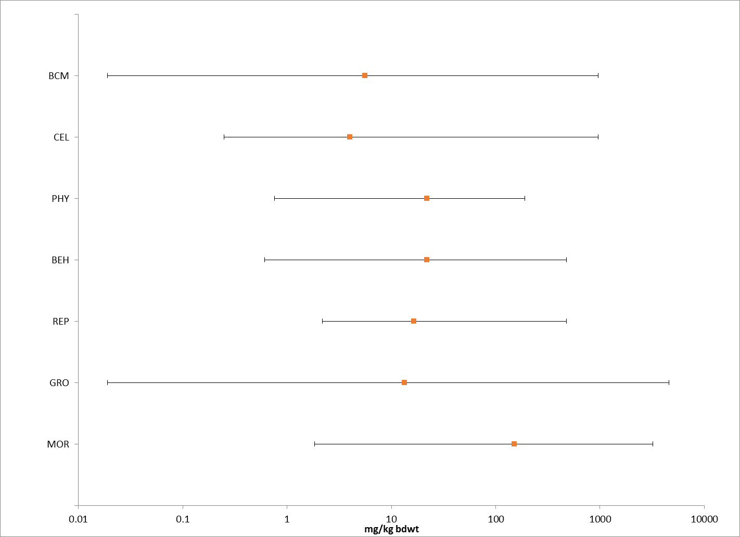
Figure 8-1. Effects Endpoint Ranges (mg/kg-bw) of Chlorpyrifos Data for Major Effects Groups, incorporating registrant submitted and ECOTOX accepted open literature studies. Orange dots indicate median values. (BCM = Biochemical, CEL = Cellular, PHY = Physiological, BEH = Behavioral, REP = Reproduction, GRO = Growth, MOR = Mortality).

As illustrated in the summary data arrays above, the available literature suggests a range of effects from sublethal to morality in mammalian species from 0.05 to 800 mg a.i./kg-bw. Although it is not possible to display all data points together, points below 40 mg/kg-bw are displayed in Figures 8-2 and 8-3. Results are discussed in more detail in each effects group section below on lines of evidence.

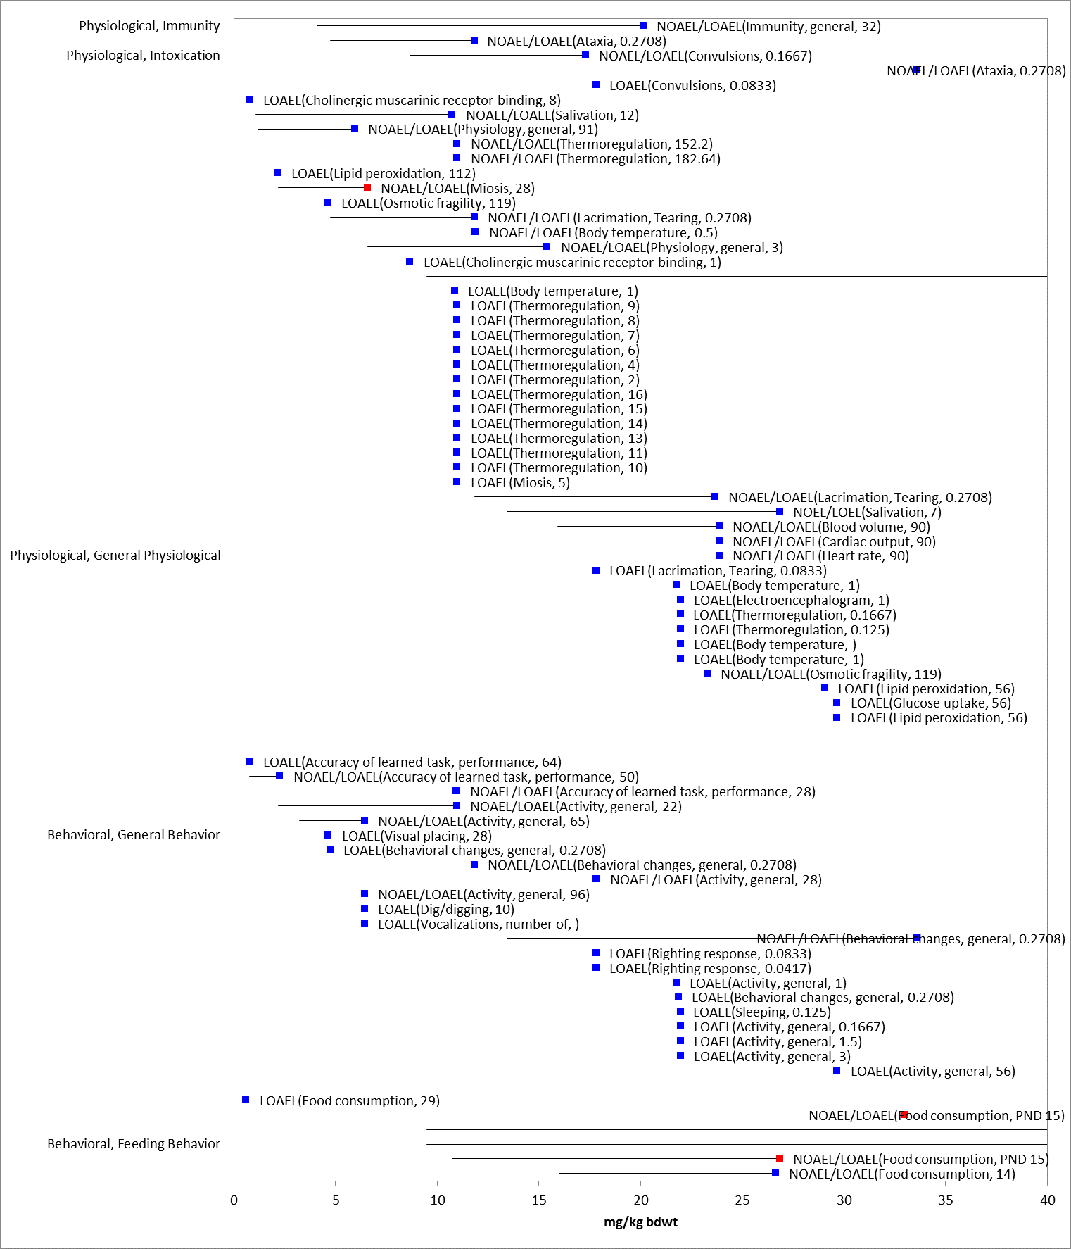
Figure 8-2. Dose-based Endpoints (mg/kg-bw) for Mammals Exposed to Chlorpyrifos for Sublethal Endpoints in the Physiological and Behavioral Effects Groups Less Than 40 mg a.i./kg-bw. Data are from registrant-submitted studies (red) and open literature (blue). Bars represent NOAEL/LOAEL range with the LOAEL value represented by the colored data point.

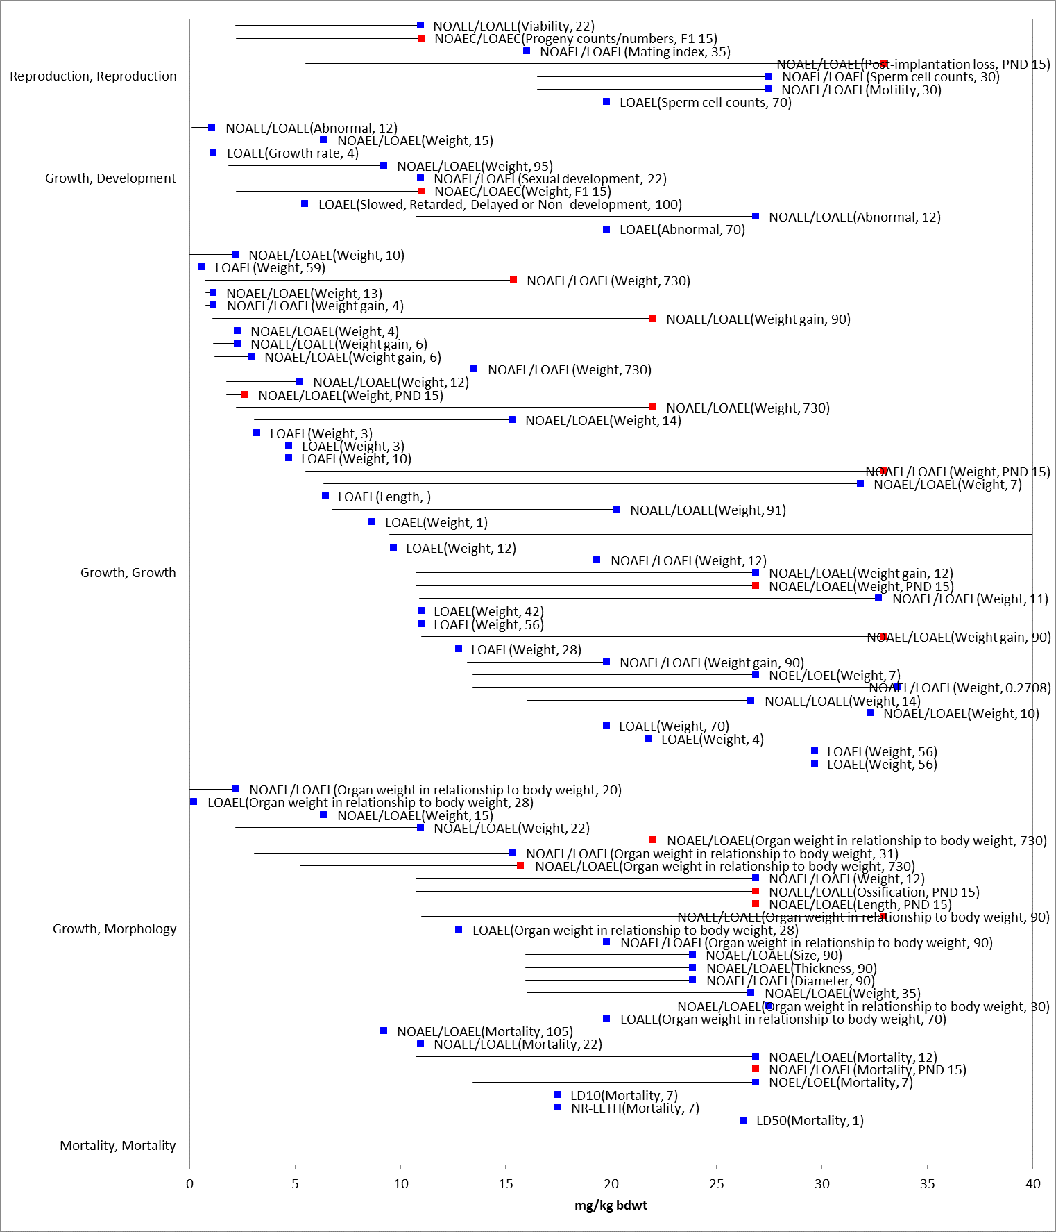
Figure 8-3. Dose-based Endpoints (mg/kg-bw) for Mammals Exposed to Chlorpyrifos for Sublethal Endpoints in the Growth, Reproduction and Mortality Effects Groups Less Than 40 mg a.i./kg-bw. Data are from registrant-submitted studies (red) and open literature (blue). Bars represent NOAEL/LOAEL range with the LOAEL value represented by the colored data point.

Figures 8-2 and 8-3 provide a graphical illustration of the range of organism-level sublethal data points at the lower end of the dose range (<40 mg a.i./kg-bw). Due to the large number of data points, all effects groups could not be displayed on one chart. Biochemical and cellular effects individual endpoints are not displayed on this array due to the large number of data points. These are contained in APPENDIX 2-1 for individual data points and are captured in the overall range of biochemical effects shown in Figure 8-1. The most common effect in the biochemical group was acetylcholinesterase inhibition. Further discussion of acetylcholinesterase effects is provided below.

Physiological and behavioral effects groups are displayed in Figure 8-2 while reproductive, growth and mortality endpoints are shown in Figure 8-3. As seen in these arrays, there are a variety of different endpoints captured in the available literature for sublethal effects of chlorpyrifos to mammals in this dose range. Physiological effects include thermoregulation disorders as well as typical organophosphate (OP) clinical signs (ataxia, lacrimation, etc.). Vocalization, reluctance to move and effects on ability to learn tasks are reported in the behavioral studies. Growth effects were seen in the lowest reported ranges and predominantly occurred as weight loss. Reproductive effects generally involved compromised survival and fertility. Effects were seen across all groups at concentrations less than 10 mg a.i./kg-bw. Individual data points for all effects groups at all concentrations are contained in the data array in APPENDIX 2-7. Those effects related to each line of evidence in the weight of evidence (WoE) analysis are discussed below.

Lines of Evidence for Mammals

Effects on Mortality of Mammals

The data set for mortality effects to mammals, include 31 references representing 57 endpoints and 4 species (dog, rat, mouse and goat). All values for any reported mortality effect range from 0.966 to 500 mg a.i./kg-bw. LD₅₀ data are available for 4 species of mammals (dog, rat, mouse and goat) with a reported range of 60 to 500 mg a.i./kg-bw. The endpoints considered for the mortality line of evidence are included in Figure 8-4. Based on the AOP for animals exposed to chlorpyrifos, endpoints representative of AChE inhibition are also considered in the mortality line of evidence. The range of acetylcholinesterase endpoints are included in the summary arrays in Figure 8-1, but are discussed in more detail in Section 8.4.2.5. The mortality endpoints are discussed below.

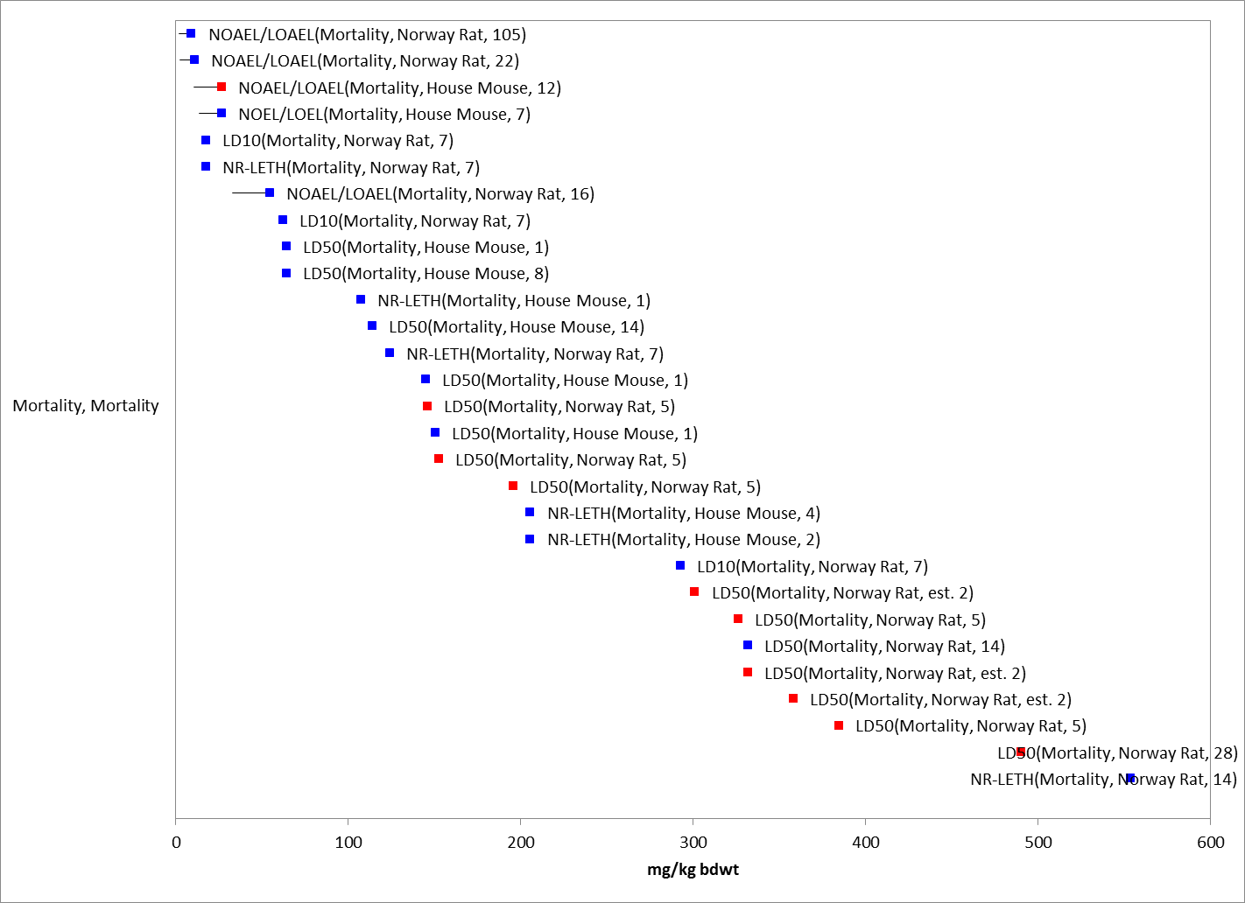
Figure 8-4. Mortality Endpoints for Chlorpyrifos Exposure Normalized to 15 g. Data are from registrant-submitted studies (red) and open literature (blue). Bars represent NOAEL/LOAEL range with the LOAEL value represented by the colored data point. Data label key: Endpoint (measured effect, species, duration in days). One normalized data point of 3,200 mg/kg-bw (non-normalized endpoint = 500 mg/kg-bw) in wild goat not included due to scaling.

Based on the available data for mortality studies, the most sensitive LD₅₀ for chlorpyrifos is 60 mg a.i./kg-bw in the house mouse (Mus musculus). Mice were exposed to chlorpyrifos in peanut oil at 25, 50, 75 and 100 mg a.i./kg-bw (E93364, Cometa et al. 2007). All deaths were observed within 24 hours (100% mortality observed in 100 mg a.i./kg treatment group at 24 hours). Based on this LD₅₀, a mortality threshold value was calculated using a default slope of 4.5. The morality threshold was calculated to be 5.2 mg a.i./kg-bw. The indirect effects mortality threshold was also based on this LD₅₀ and slope and was calculated to be 31 mg a.i./kg-bw.

Sublethal Effects to Mammals

Effects on Growth of Mammals

The data set for growth effects on mammals includes 47 references representing 135 endpoints and 5 species [dog, rat, mouse and rabbit (New Zealand and European)]. Growth endpoints range from 0.01 mg/kg-bw to 4286 mg/kg-bw (NOAELs). The lowest growth NOAEL/LOAEL of 0.01/1 mg/kg-bw is based on decreased body and organ weights in the Norway Rat (E160389). The highest growth endpoint reported in ECOTOX is a NOAEL of 4286 mg/kg-bw for growth in a house mouse (E49731); however, there is a large separation between this and the next highest endpoint (NOAEL of 81 mg/kg-bw) in the New Zealand rabbit for weight, length and ossification (MRID 40436408). The reported growth endpoints are displayed in Figure 8-5.

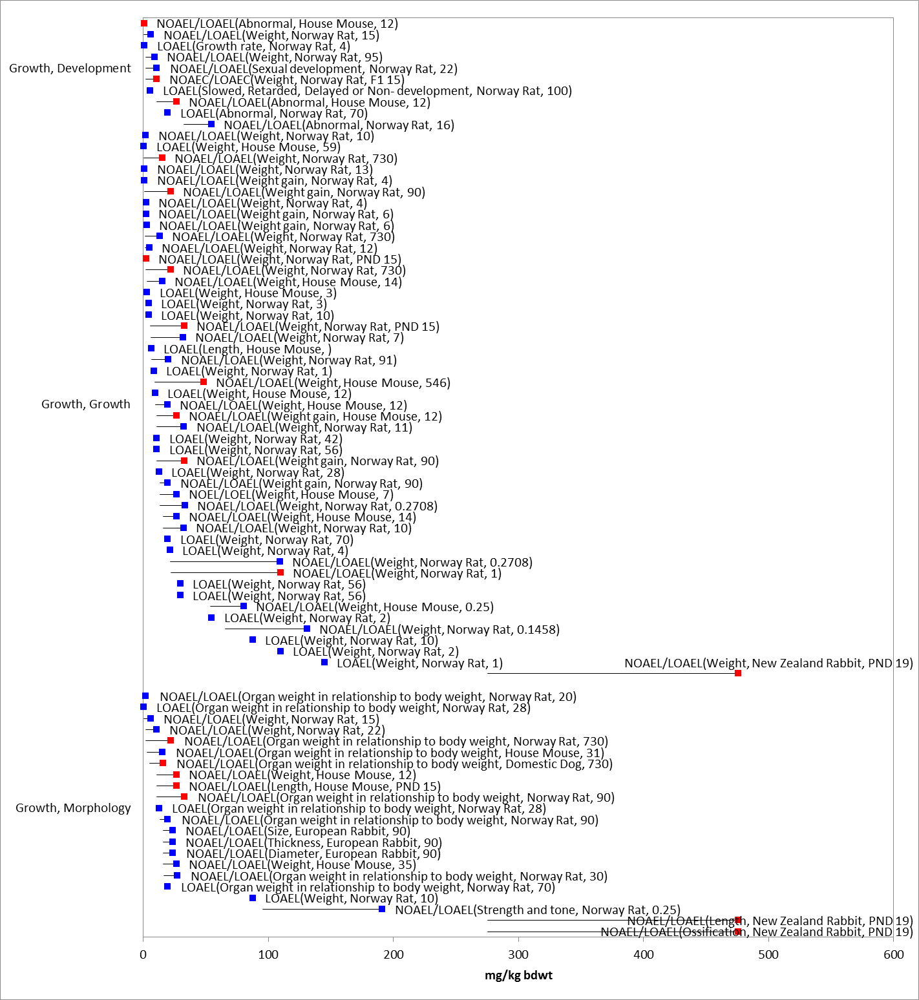
Figure 8-5. Growth Endpoints for Chlorpyrifos Exposure Normalized to 15 g. Data label key: Endpoint (measured effect, species, duration in days). Data are from registrant-submitted studies (red) and open literature (blue). Bars represent NOAEL/LOAEL range with the LOAEL value represented by the colored data point. One normalized data point of 4,605 mg/kg-bw in the house mouse was not included due to scaling.

Several of the more sensitive growth endpoint studies were reviewed when determining threshold values and are discussed below.

The most sensitive endpoint for growth related effects is a NOAEL/LOAEL of 0.01/1 mg/kg-bw (E160389, Mansour et al. 2011) for decreased body weight, biochemical changes, changes in relative organ weights and histopathological changes in the liver and kidney. Lactating rats were exposed to chlorpyrifos in corn oil from postnatal day 1 (PND1) thru postnatal day 20 (PND20) via oral gavage at doses equal to 0.01 mg a.i./kg-bw, 1 mg a.i./kg-bw and 1.35 mg a.i./kg-bw. Body weight was significantly decreased in exposed dams in both the 1 and 1.35 mg a.i./kg-bw treatment groups, with a 16 and 18% weight loss by PND 21, respectively. Two orders of magnitude separate the LOAEL and NOAEL in this study, leaving a large degree of uncertainty for interpretation of effects between these points. Due to the wide dose spacing, this NOAEL was determined to not be acceptable for a threshold given the number of studies available with dose ranges between 0.01 and 1 mg/kg for various endpoints. The study also noted an elevation in one liver enzyme at 0.01 mg a.i./kg-bw, but was not considered an endpoint of biological significance for use as a direct threshold. These data points are included in the summary and detailed arrays for characterization.

Decreased body weights (4-5%, males and females), cataracts and diffuse retinal atrophy (females only) was reported in a 2 year feeding study in the Norway rat with a LOAEL of 6.99 mg a.i./kg-bw (NOAEL = 0.33 mg a.i./kg-bw; MRID 42172802). This study was previously reviewed by HED and qualified as guideline/acceptable and was part of the toxicological database used in the 2011 Preliminary Human Health Risk Assessment (HHRA).

Jacobson et al. (2004, E93040) exposed mice to chlorpyrifos alone and as a mixture with four other pesticides commonly associated with food commodities. For the single agent exposure to chlorpyrifos, the author reported a slight but statistically significant decrease in hematocrit and an increase in thyroid weights (males only) in the 0.15 mg/kg exposure group as compared to the controls. A slight decrease in plasma cholinesterase over controls was also reported in this group for males only (graphically displayed but no numerical data provided); females had plasma cholinesterase levels three times as high as males in control and all treatment groups with no significant difference between control and treatment groups. No differences in brain acetylcholinesterase were reported or any other physiological or behavioral changes in the single a.i treatment group. Exposure to chlorpyrifos in any of the mixture combinations did not increase the magnitude of brain or plasma cholinesterase inhibition compared to exposure to chlorpyrifos alone.

Effects on Reproduction of Mammals

The data set for reproductive effects for mammals includes 14 references representing 22 endpoints and 3 species (rat, mouse and rabbit). Reproduction endpoints range from a NOAEL of 1 mg/kg-bw to a LOAEC of 140 mg a.i./kg-bw. The lowest NOAEL/LOAEL of 1/5 mg/kg-bw is based on viability in the Norway Rat (E82431). The highest reproduction effect endpoint reported are post implantation loss in the New Zealand rabbit at 140 mg a.i./kg-bw (NOAEL = 81 mg a.i./kg-bw; MRID 40436408). The reported effects endpoints in the reproduction group tend to be slightly less sensitive than other major effects group. All reported reproductive effects endpoints are displayed in Figure 8-6.

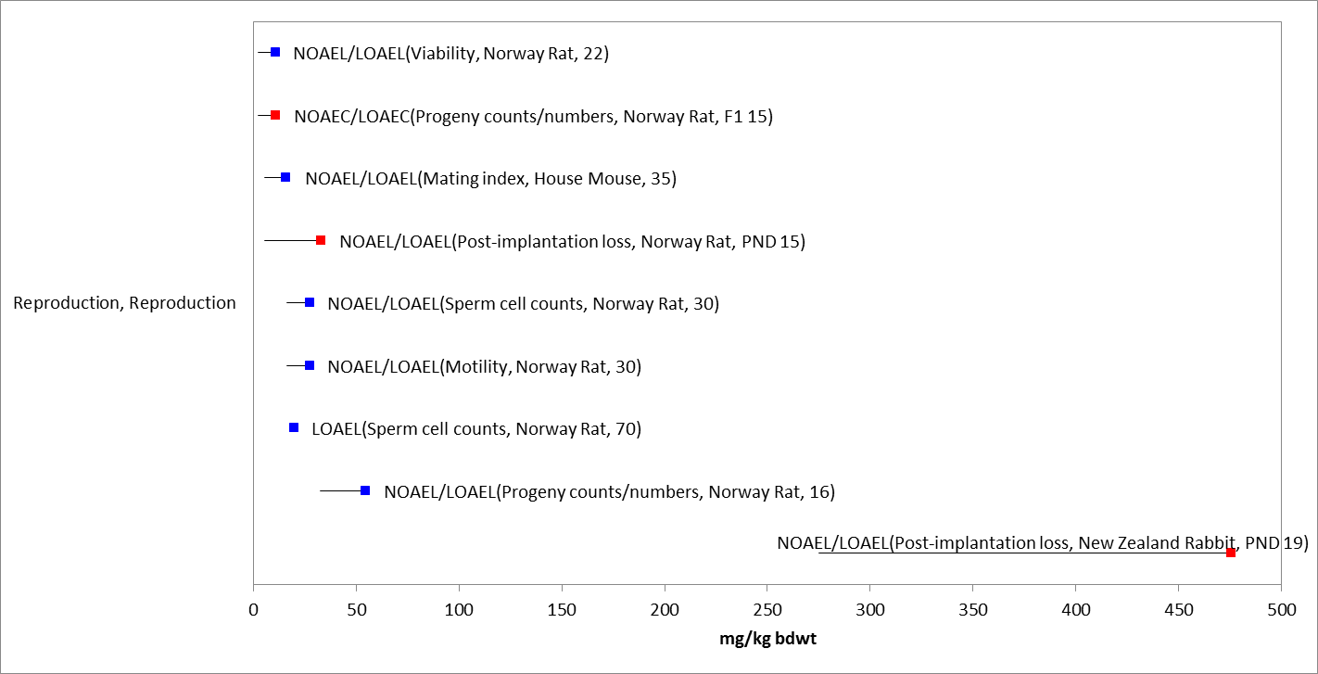
Figure 8-6. Reproduction Endpoints for Chlorpyrifos Exposure Normalized to 15 g. Data label key: Endpoint (measured effect, species, duration in days). Data are from registrant-submitted studies (red) and open literature (blue). Bars represent NOAEL/LOAEL range with the LOAEL value represented by the colored data point.

Effects on Behavior of Mammals

The data set for behavioral effects for mammals includes 33 references representing 167 endpoints and 5 species (rat, mouse, dog, cow and rabbit). Behavioral endpoints range from 0.156 mg/kg-bw (NOAEL) to 140 mg/kg-bw (LOAELs). The most sensitive behavioral endpoint is a LOAEL of 0.6 mg/kg-bw based on food consumption in the mouse (E160360). The highest behavioral effect endpoint reported is decreased food consumption in the New Zealand rabbit at 140 mg a.i./kg-bw (NOAEL = 81 mg a.i./kg-bw; MRID 40436408). All reported behavioral effects endpoints are displayed in Figure 8-7. Based on the AOP for animals exposed to chlorpyrifos, endpoints representative of AChE inhibition are also considered in the behavioral line of evidence. The range of acetylcholinesterase endpoints are included in the summary arrays in Figure 8-1 and are discussed in more detail in Section 8.4.2.5.

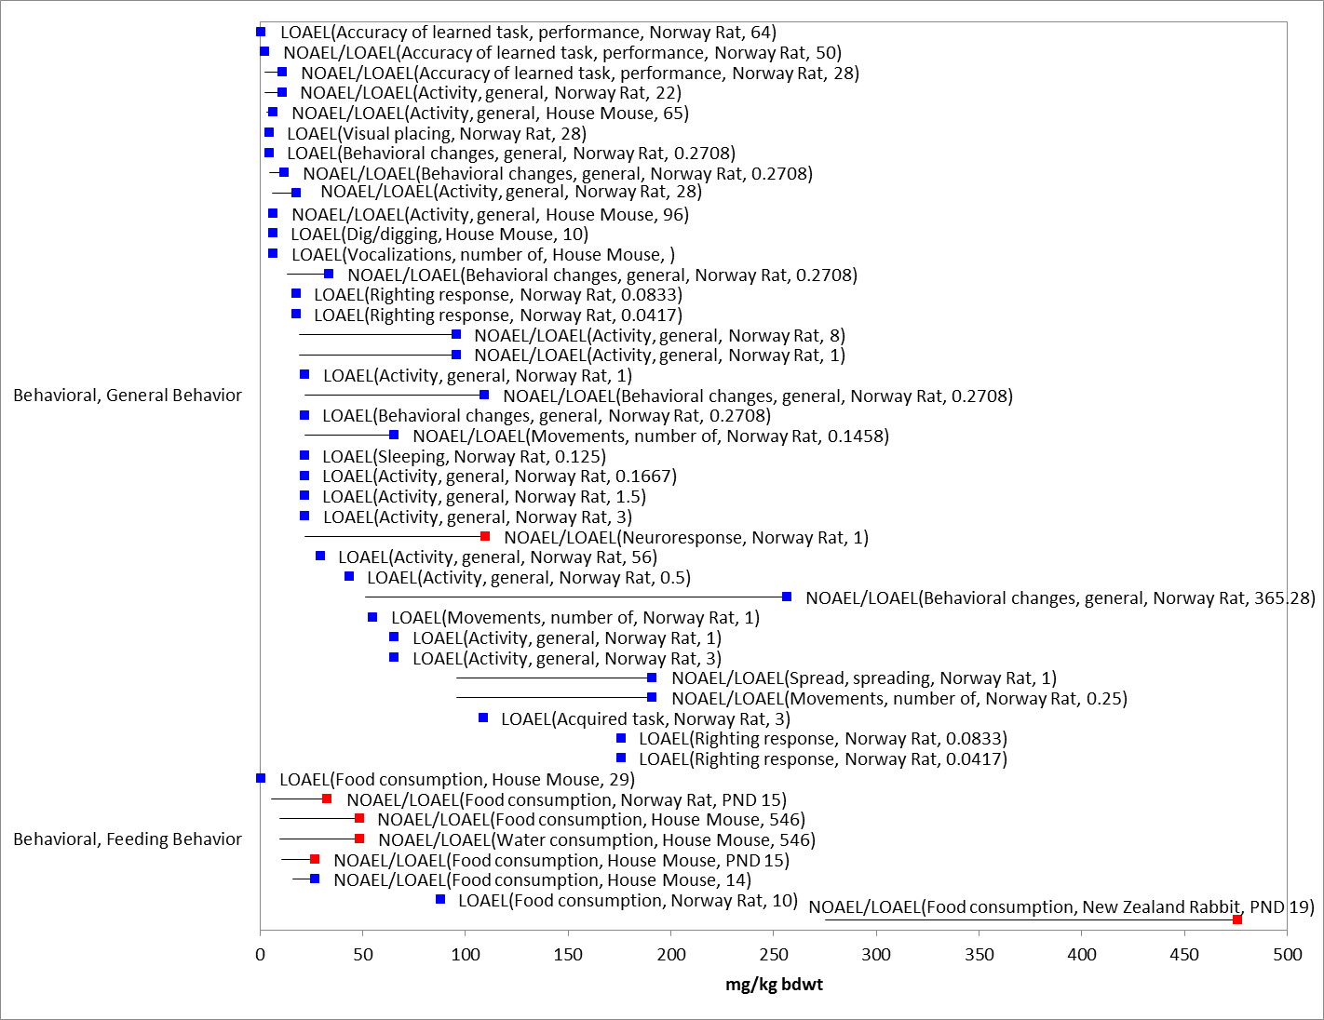

Figure 8-7. Behavioral Endpoints for Chlorpyrifos Exposure Normalized to 15 g. Data label key: Endpoint (measured effect, species, duration in days). Data are from registrant-submitted studies (red) and open literature (blue). Bars represent NOAEL/LOAEL range with the LOAEL value represented by the colored data point.

Effects on Sensory Function of Mammals

No toxicity data are available to describe potential sensory effects of chlorpyrifos to mammals.

Other Effects Reported for Mammals

Acetylcholinesterase Inhibition

Chlorpyrifos was evaluated by USEPA’s HED under the FIFRA registration review program, resulting in the 2011 PHHRA, and more recently the 2014 Revised Human Health Risk Assessment (RHHRA) (USEPA 2011, USEPA 2014). Data from Appendix A: Toxicology Profiles and Executive Summaries of the 2011 PHHRA were used to capture additional chlorpyrifos toxicity data for mammalian species in addition to that provided in ECOTOX. Due to the concern of developmental and neurotoxicity of chlorpyrifos to children, HED performed a thorough review of the effects of chlorpyrifos in several test species, including special studies on developmental toxicity and the toxicity of chlorpyrifos oxon in adults and juveniles under acute and chronic conditions. HED uses RBC ChE inhibition as the most reliable endpoint for chlorpyrifos exposure and was used to determine the point of departure (POD) for the human health risk assessments. Although plasma ChE data from animals for risk assessment is used when RBC ChE data are not reliable and/or when peripheral ChE measures are not available, this is not the case for chlorpyrifos. Reliable RBC and peripheral ChE data are both available and thus, the plasma data are not considered for POD determination. NOAELs in HED registrant studies for RBC cholinesterase inhibition ranged from 0.01 – 0.1 mg a.i./kg-bw and LOAELs ranged from 0.22 – 3 mg a.i./kg-bw across multiple species and multiple durations of exposure.

Based on the best available data, HED determined their BMD₁₀ (benchmark dose)/BMDL₁₀ (Benchmark Dose Lower Bound) levels. BMD/BMDL₁₀ levels were used as their POD, and corresponded to the dose at which a 10% decrease in cholinesterase was predicted (BMDL is the 95% lower confidence limit around the BMD). In Appendix E of the 2011 HHRA, HED provided analyses completed using both the R software program and USEPA Benchmark Dose Software for calculating BMD values based on the most robust submitted studies for acute and chronic exposures. Endpoints for 10% RBC and brain cholinesterase inhibition were presented in the Appendix E table. Several high quality oral studies are available for BMD analyses including a comparative cholinesterase (CCA) study (MRID 48139301) in the rat, a developmental neurotoxicity rat study (MRID 44556901) and a special ChE study in the rat (MRID 44648101). Based on these studies, a BMDL₁₀ value of 0.03 mg/kg-bw/day for repeated exposure to chlorpyrifos was derived. As this marked the most sensitive and robust data point for sublethal effects, including the review of ECOTOX endpoints, this was used as the sublethal threshold value for direct effects for this assessment.

Based on the available data, the lowest LOAEL for sublethal effects was for RBC cholinesterase inhibition at 0.5 mg a.i./kg-bw (MRID 48139301/E160403). This was the CCA study conducted by the registrant and also published in the open literature (E160403, Marty et al., 2011) for exposure of adult and juvenile rats to chlorpyrifos and chlorpyrifos oxon under various dosing regimens. Cholinesterase inhibition was seen in adult (18%) and PND21 male and female Norway rats (20%) with repeated exposure to chlorpyrifos in corn oil. This study was previously reviewed by HED and was considered acceptable. It was also considered one of the most robust studies providing high quality cholinesterase data and was utilized in BMD calculations. This study endpoint of 0.5 mg/kg-bw was used as the sublethal threshold value for indirect effects.

All of the reported endpoints for acetylcholinesterase are displayed in Figure 8-8.

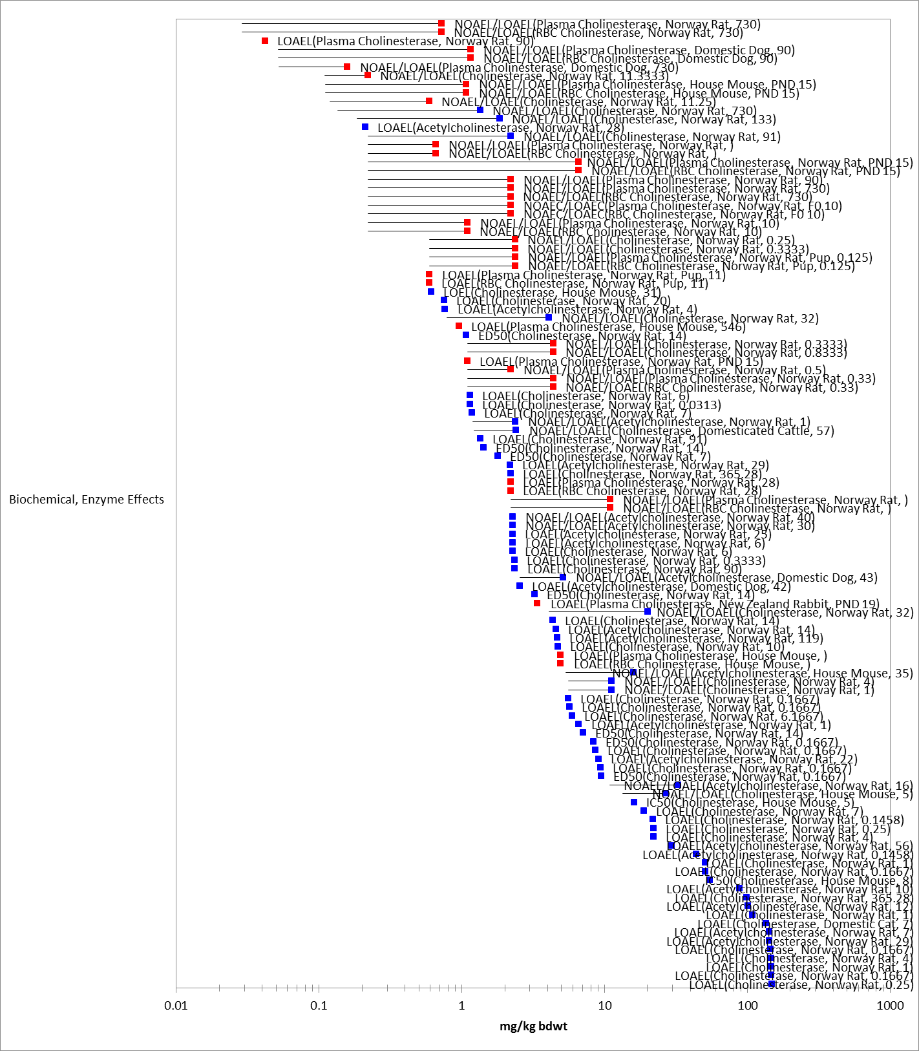
Figure 8-8. Acetylcholinesterase Endpoints for Chlorpyrifos Exposure Normalized to 15 g. Data label key: Endpoint (measured effect, species, duration in days). Data are from registrant-submitted studies (red) and open literature (blue). Bars represent NOAEL/LOAEL range with the LOAEL value represented by the colored data point. Note logarithmic scale.

Other Biochemical/Cellular/Physiology Effects

Aside from anticholinesterase effects, there is an array of other endpoints for biochemical, cellular, and physiology-based measurements. To summarize the range of the “other” biochemical/physiological effects, summary data arrays are presented below in Figure 8-9. Because of the large amount of data involved, an array with the full spectrum of effects is provided in APPENDIX 2-7. In general, some of the effects that occur on the lower end of the array include effects to hemoglobin, glutathione, malondialdehyde, BUN, creatinine, leukocyte counts and gene expression. Physiological effects include thermoregulation disorders as well as typical organophosphate (OP) clinical signs (ataxia, lacrimation, etc.) but these tended to occur at higher exposure concentrations.

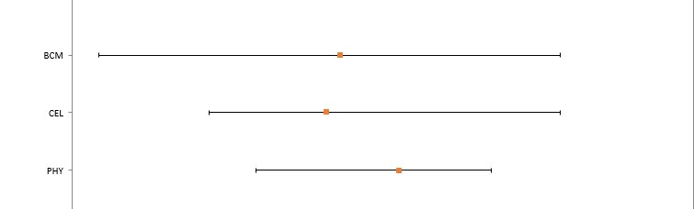
Figure 8-9. Dose-based Ranges (mg a.i./kg-bw) of Mammalian Data for Other Biochemical/Cellular and Physiological Effects. Orange dots indicate median values. (BCM = Biochemical, CEL = Cellular, PHY = Physiological)

Field and Semi-Field Data for Mammals

In an Iowa field study on corn (MRID 43483101), chlorpyrifos was applied as either Lorsban 4E, an emulsifiable concentrate formulation, to 4 fields (4 applications per field; 1.7 to 3.4 kg/ha [1.5 - 3 lbs ai/A]) or as Lorsban 15G, a granular formulation, to 4 fields (3 applications per field; 1.1 to 2.9 kg/ha [1 - 2.6 lbs ai/A]). Chlorpyrifos levels were measured in various environmental samples. Field investigators considered any death likely to be treatment-related if analytical analyses tested positive for chlorpyrifos residues in samples. Carcass searches made in the corn field study found evidence of 10 mammalian post-treatment casualties. The corn field study provides useful information which generally supports other available data on residue levels and mammalian mortality.

In a California citrus grove field study, chlorpyrifos (i.e., Lorsban 4 E) was applied with two spray regimes (MRID 43730301). Under regime A, 4 fields were treated with 2 applications each: 1.5 lbs ai/A followed about 30 days later by a treatment at 6.0 lbs ai/A. Regime B also treated each of 4 fields twice (sprayed once at 3.5 lbs ai/A followed about 30 days later by a second treatment at 4.0 lbs ai/A). Searches for dead wildlife identified 192 carcasses. Twenty-one carcasses were analyzed for the presence of chlorpyrifos. Six of tested carcasses tested positive for chlorpyrifos residues (28.6%). Consequently, those deaths may be presumed to be associated with chlorpyrifos treatments. Species that tested positive for chlorpyrifos were a mockingbird, an unidentified passerine nestling, house mouse, ground squirrel, pocket gopher, and a western rattlesnake. While the number of dead wildlife found during carcass searches does not show a dose-relationship with treatment levels, the number of carcasses testing positive for chlorpyrifos suggests that there could be a dose-relationship (i.e., 4 carcasses at 6 lbs ai/A, 1 each at 3.5 and 4 lbs ai/A, and none at 1.5 lbs ai/A). However, the number of positive carcasses is too small to verify this conclusion.

Effects to Mammals Not Included in the Arrays

As exposure modeling will incorporate multiple exposure pathways for terrestrial mammals in this assessment, the literature was also reviewed for any data on drinking water studies, dermal exposure and inhalation exposure for mammals, as summarized below.

Drinking water studies

No studies involving mammalian exposure via drinking water were identified in the ECOTOX database or in review of HED risk assessment documents.

Dermal exposure studies

Multiple studies for dermal exposure are available from data compiled by HED (see Tables 8-2 and 8-3). Dermal ChE inhibition data are available from a 21-day and 4-day probe study (MRID 40972801) in rats which together establish a NOAEL of 5 mg/kg/day and LOAEL of 10 mg/kg/day based on plasma and red blood cell ChE inhibition.

The 21-day rat dermal study is used with an adjustment for 3% dermal absorption to convert the NOAEL of 5 mg/kg/day resulting from topically applied chlorpyrifos to an internal absorbed NOAEL = 0.15 mg/kg/day (this is used in the human health risk assessment for comparison to biomonitoring data, which evaluates total exposure from oral, dermal and inhalation routes, in terms of absorbed dose). The dermal absorption factor of 3% was estimated based on the ratio of the oral LOAEL of 0.3 mg/kg/day from the rat developmental neurotoxicity study (MRIDs 44556901, 44661001) to the dermal LOAEL of 10 mg/kg/day from the 21-day rat dermal study (MRID 40972801) for plasma and red blood cell cholinesterase inhibition.

Table 8-2. Acute Dermal Exposure Studies for Chlorpyrifos
STUDY | MRID Number | RESULTS
Acute Dermal LD₅₀ - rat  Acute Dermal LD₅₀ - rabbit | Accession No. 112115  44209102 | 202 mg/kg  >5000 mg/kg
Eye Irritation - rabbit | 44209103 | slight irritation resolved within 24 hours
Dermal Irritation - rabbit | 44209104 | mild irritant; (irritation resolved within 7  days)
Dermal Sensitization - guinea pig | 44209105 | non-sensitizing

Table 8-3. Dermal Exposure Studies for Chlorpyrifos (reported in the 2000 RED and 2011 HED Human Health Risk Assessment)
EXPOSURE SCENARIO | DOSE  (mg/kg/day) | ENDPOINT | STUDY
Short-Term (Dermal) | Dermal NOAEL =5  Absorbed Dermal NOAEL = 0.15 (for biomonitoring)¹ | Plasma and RBC cholinesterase inhibition of 45 and 16%, respectively at 10 mg/kg/day after 4 days. (Dermal absorption factor not necessary for administered dermal NOAEL) | 21-day dermal rat study
Intermediate- and | Oral | Significant plasma and RBC | WoE from
Long-Term | NOAEL =0.03 (3% | cholinesterase inhibition at | 5 studies:
(Dermal) | dermal absorption) | 0.22 to 0.3 mg/kg/day | 2 year dog  90 day dog  2 year rat  90 day rat  DNT study (at 2 weeks)
¹ Use absorbed dermal NOAEL of 0.15 mg/kg/day (5 mg/kg/day * 0.03 dermal absorption factor) for comparison with absorbed biomonitoring exposure.

There are 16 studies associated with dermal exposure of chlorpyrifos in the ECOTOX database. These included studies on four species (dog, cow, rat and mouse) with most measured effects on enzymatic and cellular changes. There are five different units reported, making it difficult to do a direct comparison between reported results and those established by HED for dermal toxicity. However, a screen of the data did not indicate toxicity values that are more sensitive than the 0.03 mg/kg-bw on an oral equivalent basis listed by HED. These additional ECOTOX studies are listed in APPENDIX 2-2 and are available for reference if necessary for individual species assessments.

Inhalation studies

Multiple inhalation studies are available from data compiled by HED (Table 8-4). Two subchronic inhalation toxicity studies (MRID Nos.40013901, 40166501, 40908401) in the rat are available using vapor phase chlorpyrifos which show no ChE effects up to a concentration of 20.6 ppb (287 μg/m3 or 0.082 mg/kg/day). In a special acute inhalation study, female rats were exposed by nose only to atmospheric concentrations of up to 53.9 mg/m3 of particulate chlorpyrifos for six hours and allowed an additional 72 hours to recover (MRID No: 48139303 Hotchkiss et al. 2010, TXR # 0055409). Consistent and significant lung ChE inhibition were noted at the lowest concentration tested of 3.7 mg/m3, which is a LOAEL. RBC and brain ChE inhibition were noted at ≥ 12.9 mg/m3 and 53.9 mg/m3, respectively, indicating they are less sensitive than lung and plasma ChE inhibition following acute inhalation exposures.

Table 8-4. Inhalation Studies for Chlorpyrifos (reported in the 2000 RED and 2011 HED Human Health Risk Assessment)
EXPOSURE SCENARIO | DOSE  (mg/kg/day) | ENDPOINT | STUDY
Acute Inhalation LC₅₀ | LC50 > 0.2 mg/mL (200 mg/m³) (nominal concentration) | Mortality | MRID 00146507 and  Accession No. 257590 (rat)
Acute Inhalation | Inhalation LOAEL = 3.7 mg/m3 | Lung ChE inhibition. | Special 6 hour acute inhalation study in rat (MRID  48139303). (Aerosol)
Short- and  Intermediate-Term  (Inhalation) | Inhalation NOAEL = 0.1 | Lack of effects in 2 rat  inhalation studies at the  highest dose tested; 43% plasma and 41% RBC cholinesterase inhibition following oral doses of 0.3 mg/kg/day for 2 weeks in the  DNT study | Two 90-day inhalation  studies (rat)  DNT study (MRIDs 40908401; 40013901/  40166501). (Vapor study)
Long-Term  (Inhalation) | Oral NOAEL = 0.03  (assume inhalation absorption is 100% of oral absorption) | Significant plasma and RBC  cholinesterase inhibition at  0.22 to 0.3 mg/kg/day | WoE from  5 studies:  2 year dog  90 day dog  2 year rat  90 day rat  DNT (at 2 weeks)

Since the 2011 preliminary human health risk assessment, two acute inhalation studies on the saturated vapor phase have been performed on the parent chlorpyrifos and chlorpyrifos oxon (MRID 49119501 and 49210101, respectively). In these studies, female rats were exposed by nose only to a saturated vapor of chlorpyrifos or its oxon for 6 hours at a time-weighted concentration of 17.7 ppb (0.254 mg/m3) (MRID 49119501) or 2.58 ppb (35.3 μg/m3) (MRID 49210101), respectively. There were no statistically-significant decreases in ChE activity in the RBC, lung, brain or plasma tissues. These acute studies along with the subchronic inhalation studies with vapor phase chlorpyrifos support low toxicity from acute exposure to the saturated vapor of chlorpyrifos or its oxon.

Other Reported Effects

There are other mammalian data reported in ECOTOX that are not included in the toxicity arrays. Several studies are reported using subcutaneous injection of chlorpyrifos to lactating or pregnant rats and measured effects in the offspring. Other studies included cultured embryos or in vitro studies. These studies could not be related to an environmental exposure concentration or produce endpoints that are comparable to exposure estimates. These studies are listed in APPENDIX 2-2.

Concentrations Where No Effects Were Observed in Mammals

For the available mammalian data, there are data available that show concentrations where effects are not seen [i.e., ‘no effect’ (NE) concentrations]. The NE endpoints include NOAEC/NOAEL and NR-Zero values as reported in ECOTOX. Below are the arrays showing the NE endpoints for chlorpyrifos (see Figures 8-10 and 8-11). Due to the large number of data points, the data is divided into two figures based on effects groups.

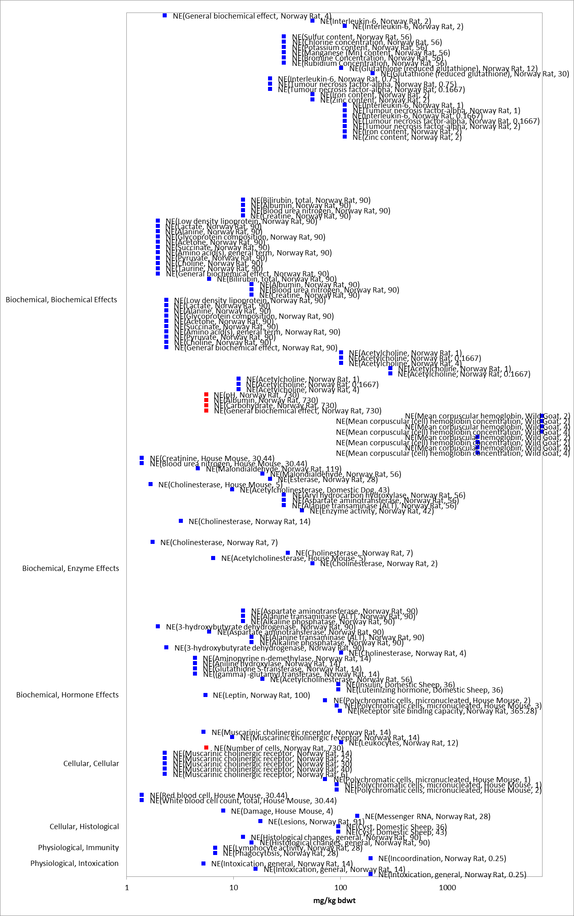

Figure 8-10. Biochemical, Cellular and Physiological Endpoints Reporting No Effect at the Test Concentrations for Mammals Exposed to Chlorpyrifos. Data from registrant submitted (red) and open literature (blue). Data label key: Endpoint (measured effect, species, duration in days). Note logarithmic scale.

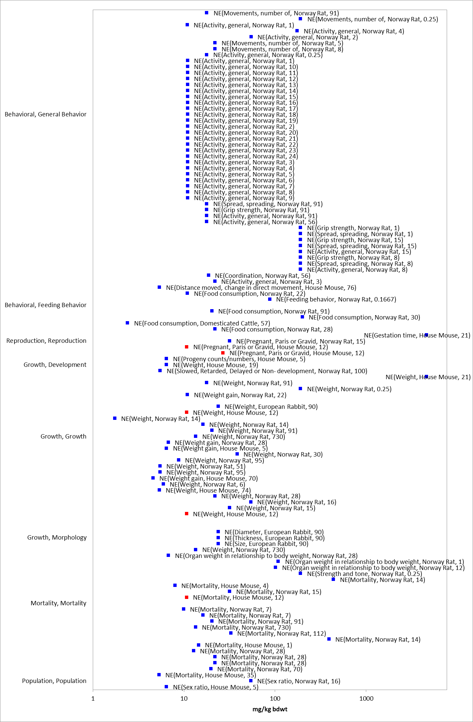

Figure 8-11. Behavioral, Reproduction, Growth, Mortality and Population Endpoints Reporting No Effect at the Test Concentrations for Mammals Exposed to Chlorpyrifos. Data from registrant submitted (red) and open literature (blue). Data label key: Endpoint (measured effect, species, duration in days). Note logarithmic scale.

Incident Reports for Mammals

A review of the incident databases showed a total of 280 reported ecological incidents associated with the use of chlorpyrifos, of which 108 are terrestrial incidents. Chlorpyrifos has been reported as the ‘probable’ or ‘highly probable’ causative agent for 80 terrestrial incidents, many of which are bird and honey bee kills. These incidents are reported over the period of 1974 to 2009 and resulted from the legal, registered uses of chlorpyrifos as well as misuses. Some cases were never resolved as to whether the cause was legal use of chlorpyrifos or misuse. Although the number of reported incidents has dropped considerably since mitigation measures were implemented following the 2002 Interim Registration Eligibility Decision (IRED), the absence of reported incidents in 2006 and 2007 should not be construed as the absence of incidents since EPA's registrant reporting requirements changed for incidents. Overall, the incident data that are available indicate that exposure concentrations of chlorpyrifos are sufficient to result in field-observable adverse effects.

Based on EPA’s most recent review of the Ecological Incident Information System (EIIS) database (May 11, 2015) only 3 incidents involving terrestrial mammals were identified. These are summarized in Table 8-5 below.

Table 8-5. Terrestrial Mammal Incident Reports from EIIS
NUMBER | YEAR | CHEMICAL  INVOLVED (PC CODE) | CERTAINTY INDEX | State | LEGALITY | USE SITE | SPECIES | DISTANCE | EFFECT/ MAGNITUDE | PRODUCT
I010962-001 | 1994 | Chlorpyrifos  (059101) | Probable | NR (Country: USA) | Misuse (accidental) | Building | Fox | N/R | N/R | Dursban TC
I010831-005 | 2000 | Chlorpyrifos  (059101) | Probable | FL | Misuse (accidental) | Home/Lawn (Exterminator) | Raccoon, Rat, Squirrel | N/R | 5 | Dursban Pro
I014889-001 | 2004 | Chlorpyrifos  (059101) | Probable | GA | Undetermined | N/R | Pig | N/R | N/R | Unknown

In addition to the terrestrial incident reports available in EIIS, there have also been a total of 42 aggregate wildlife incidents reported to the Agency. Of these 42, 7 are associated with active registrations (35 involve products no longer registered or no registration number reported) (see ATTACHMENT 1-1 and Table 8-6).

Since 1998, incidents that are allowed to be reported aggregately by registrants [under FIFRA 6(a)(2)] include those that are associated with an alleged effect to wildlife (birds, mammals, or fish) without differentiation between species or terrestrial and aquatic environments. Typically, the only information available for aggregate incidents is the date (i.e., the quarter) that the incident(s) occurred, the number of aggregate incidents that occurred in the quarter, and the PC code of the pesticide and the registration number of the product involved in the incident. Because of the limited amount of data available on aggregate incidents it is not possible to assign certainty indices or legality of use classifications to the specific incidents. Therefore, the incidents associated with currently registered products are assumed to be from registered uses unless additional information becomes available to support a change in that assumption.

Table 8-6. Aggregate Wildlife Incidents for Chlorpyrifos Involving Currently Registered Products.
PRODUCT REGISTRATION NUMBER | PRODUCT NAME | NUMBER OF AGGREGATE WILDLIFE INCIDENTS | YEAR(S)
062719-00220 | LORSBAN-4E | 2 | 1999, 2010
062719-00072 | DURSBAN 50W | 1 | 1999
062719-00575 | COBALT INSECTICIDE | 1 | 2013
062719-00591 | LORSBAN ADVANCED | 1 | 2012
008329-00018 | MOSQUITOMIST TWO ULV | 1 | 2012
008329-00020 | MOSQUITOMIST 1.5 ULV | 1 | 2007

Summary of Effects to Mammals

Chlorpyrifos is moderately toxic to mammals on an acute basis. There is a wide range of endpoints in the acute mortality data, with LD₅₀ values ranging from 60 to 500 mg a.i./kg-bw, with the lowest LD₅₀ of 60 mg a.i./kg-bw reported in the house mouse (E93364).

Sublethal effects in mammals seen with chlorpyrifos include thermoregulation disorders, ataxia, lacrimation, vocalization, reluctance to move, reduced ability to learn tasks, weight loss and reduced fertility, with effects observed at exposure concentrations less than 10 mg a.i./kg-bw. The most sensitive behavioral endpoint was a LOAEL of 0.57 mg a.i./kg-bw based on reduced food consumption in the Norway Rat (E90929) while decreased body weight, biochemical changes, changes in relative organ weights and histopathological changes in the liver and kidney were observed in exposed dams at 1 mg a.i/kg-bw. RBC cholinesterase inhibition in mammals occurred in the range of 0.22 – 3 mg a.i./kg-bw across multiple species and multiple durations of exposure. Only limited incident data is available to assess field-observable effects of chlorpyrifos to mammals.

Effects Characterization for Terrestrial Invertebrates

Introduction to Terrestrial Invertebrate Toxicity

Chlorpyrifos, is an insecticide that acts through inhibition of acetylcholinesterase and is used to kill a broad range of insects and mites. As an insecticide, chlorpyrifos’ effects on terrestrial invertebrates has been well documented in the literature. Most available studies have focused on mortality endpoints, however, there are also data available for describing sublethal effects, including those related to enzyme activity, growth, behavior, and reproduction. The available toxicity data available for chlorpyrifos are provided below for terrestrial invertebrates along with a discussion of the available incident reports for chlorpyrifos and terrestrial invertebrates. The discussion of the data is formatted to follow the lines of evidence, specifically those related to mortality, growth, reproduction, behavior, and sensory effects. These data will be used to help assess the potential for direct effects to listed terrestrial invertebrates and their designated critical habitats (if applicable), and indirect effects for any listed species or critical habitat that relies on terrestrial invertebrates.

Threshold Values for Terrestrial Invertebrates

The threshold values for terrestrial invertebrates are based on experimentally determined endpoints for chlorpyrifos based on varying durations, exposure routes, and study designs. Threshold values for direct and indirect effects are provided in Table 9-1. The acute mortality thresholds are based on the most sensitive LC₅₀ or LD₅₀ values (<96 hr exposure) available for terrestrial invertebrates, since a species sensitivity distribution (SSD) could not be derived using the available data. As described in the Problem Formulation (above), sublethal thresholds are also derived to represent the most sensitive non-acute mortality effects for both direct and indirect effects. In the case of chlorpyrifos and terrestrial invertebrates, however, the lowest endpoints, considering both lethal and sub-lethal effects, were almost always mortality endpoints. Therefore, they are used to represent the most sensitive non-acute thresholds. Studies from which threshold values were derived will be discussed in more detail in the respective line of evidence below.

Threshold values in this assessment are based on endpoints expressed in, or readily converted to, environmentally relevant concentrations that can be used to assess risks to terrestrial invertebrates using current methods [i.e., mg/kg-soil; mg/kg-bw (body weight); µg a.i./bee, and lb a.i./acre]. The effects data arrays include endpoints in these units and other environmentally relevant units [i.e., mg/e.u. (experimental unit – which in most cases is assumed to represent a test organism); mg/kg-soil; mg/kg-bw; ppm (parts per million); and lb a.i./acre]. However, the effects seen using other exposure units are also discussed.

Across the exposure units of mg/e.u., mg/kg-soil, mg/kg-bw, ppm, and lb a.i./acre, toxicity data are available for chlorpyrifos on 36 different terrestrial invertebrate orders (i.e., Actinedida, Araneae, Coleoptera, Collembola, Dermaptera, Diplura, Diptera, Dorylaimida, Ephemeroptera, Gamasida, Gamasina, Haplotaxida, Hemiptera, Heteroptera, Homoptera, Hymenoptera, Isopoda, Isoptera, Lepidoptera, Lumbriculida, Megaloptera, Mesostigmata, Neuroptera, Odonata, Opiliones, Orthoptera, Parasitiformes, Poduromorpha, Protura, Psocoptera, Rhabditida, Sarcoptiformes, Thysanoptera, Trichoptera, Trombidiformes, and Tylenchida). Within these orders, toxicity data are available for 158 different families represented by 318 genera and 429 species.

Table 9-1. Chlorpyrifos Thresholds for Terrestrial Invertebrate Species.
EXPOSURE UNIT | THRESHOLD VALUE |  |  | ENDPOINT | EFFECT(S) | SPECIES | STUDY ID | COMMENTS
Most Sensitive Endpoint (Relatable to Growth, Reproduction, and/or Mortality)
mg/kg-soil | Direct Effects |  | 0.03 mg a.i./kg dry soil¹ | EC₁₀ (28-day) = 0.03 mg a.i./kg dry soil | Number of young | Earthworm (Eisenia andrei) | E160284 | The most sensitive endpoint available is an EC₁₀; conducted under tropical conditions (26 ºC) in a modified artificial soil
 | Indirect Effects
mg/kg bw | Direct Effects |  | 3.16 mg/kg-bw¹ | LD₅₀ (contact) = 3.16 mg/kg-bw | Mortality | Corn rootworm (Diabrotica virgifera virgifera) | E58594 | The only endpoints available in this exposure unit are LD_{x} values; this is from a topical exposure; slope = 3.4 (±0.6, SE); 1-day exposure
 | Indirect Effects
µg a.i./bee | Direct Effects |  | 0.001 µg/bee¹ | LD₁₀ (oral) = 0.001 µg/bee | Mortality | Honey bee (Apis mellifera) | E070351 | The most sensitive endpoint available in this exposure unit is an LD₁₀ value; this is from an oral exposure to larvae
 | Indirect Effects
Lb a.i./acre | Direct Effects (NOAEC) |  | 0.00089 lb a.i./acre | NOAEC = 0.00089 lb a.i./acre  LOAEC = 0.0046 lb a.i./acre | Mortality | Parasitoid (Microctonus hyperodae) | E86585 | This was based on 24-hr exposure to ryegrass treated 1-hr before exposure (23% mortality at the LOAEC); no mortality when exposed to ryegrass treated 48-hr earlier
 | Indirect Effects (LOAEC) |  | 0.0046 lb a.i./acre
Most Sensitive LD₅₀/LC₅₀ Value(s)
mg/kg-soil | Direct Effects (1 in a million chance of mortality) | 12.5 mg a.i./kg dry soil² |  | LC₅₀ (28-day) = 142 mg a.i./kg dry soil | Mortality | Earthworm (Eisenia andrei) | E160284 | LC₅₀ values are only available from 28-day studies; conducted under tropical conditions (26 ºC) in a modified artificial soil
 | Indirect Effects (10% chance of mortality) | 73.7 mg a.i./kg dry soil²
mg/kg bw | Direct Effects (1 in a million chance of mortality) | 0.126 mg/kg-bw |  | LD₅₀ (contact) = 3.16 mg/kg-bw | Mortality | Corn rootworm (Diabrotica virgifera virgifera) | E58594 | This is from a topical exposure; slope = 3.4 (±0.6, SE); 1-day exposure
 | Indirect Effects (10% chance of mortality) | 1.33 mg/kg-bw
µg a.i./bee | Direct Effects (1 in a million chance of mortality) | 0.0052 µg a.i./bee |  | LD₅₀ (contact) = 0.059 µg a.i./bee | Mortality | Honey bee (Apis mellifera) | MRID 05001991 | This is from a contact exposure to adult bees; default slope = 4.5
 | Indirect Effects (10% chance of mortality) | 0.031 µg a.i./bee
Lb a.i./acre | None |  |  | An LC₅₀ is not available for this exposure unit | N/A | N/A | N/A | N/A
¹ Because the most sensitive endpoint is not a NOAEC/LOAEC value, the same endpoint is used for both direct and indirect effects.
² This is based on a default slope of 4.5.

Summary Data Arrays for Terrestrial Invertebrates

Exposure Unit: mg/e.u.:

For the exposure unit of ‘mg/e.u.’, terrestrial invertebrate toxicity data are available for 5 orders (i.e., Coleoptera, Diptera, Homoptera, Hymenoptera, and Lepidoptera) represented by 19 families, 32 genera, and 50 different species. For terrestrial invertebrates there is a wide range of effects, from behavioral to population-level effects, and concentrations at which effects occur, from 0.000001 mg/e.u. to over 500 mg/e.u. of chlorpyrifos (see Figure 9-1). Most effects to terrestrial invertebrates occur at chlorpyrifos concentrations between 0.000001 and 0.001 mg/e.u. Figure 9-1 is meant to show the distribution of effects to terrestrial invertebrates across different chlorpyrifos concentrations; the specific endpoints are discussed in more detail below (further details can be found in APPENDIX 2-1).

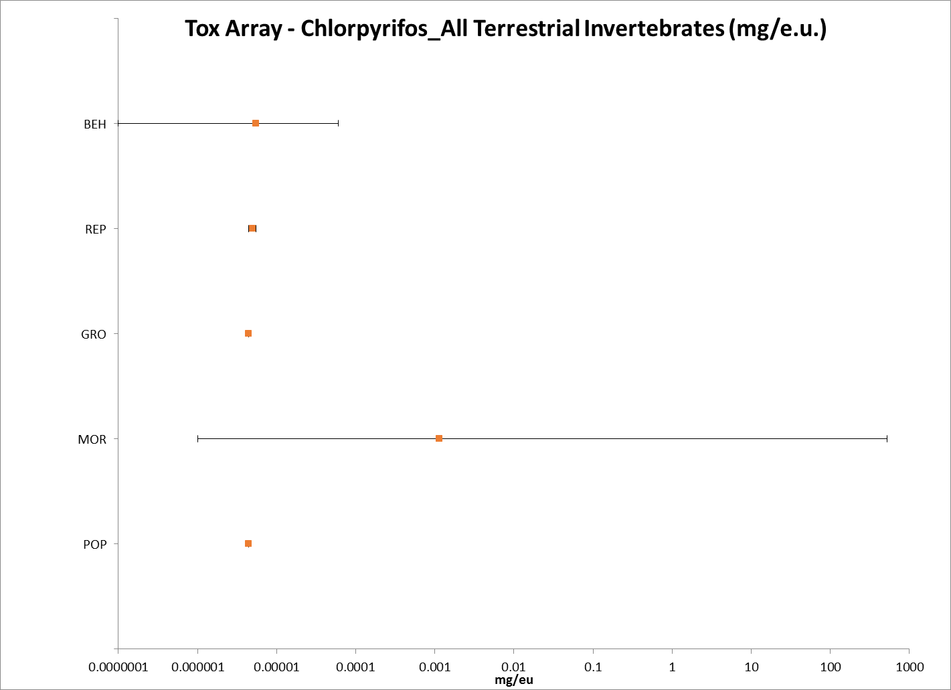
Figure 9-1. Summary Data Array for Terrestrial Invertebrates Exposed to Chlorpyrifos (mg/e.u.). BEH= behavior; REP = reproduction GRO = growth; MOR = mortality; POP = population. Note that this figure is shown in a logarithmic scale for presentation purposes.

Exposure Unit: mg/kg-soil:

For the exposure unit of ‘mg/kg-soil’, terrestrial invertebrate toxicity data are available for 5 orders (i.e., Araneae, Coleoptera, Collembola, Haplotaxida, and Lumbriculida) represented by 5 families, 6 genera, and 7 different species. For terrestrial invertebrates there is a wide range of effects, from biochemical to individual-level effects, and concentrations at which effects occur, from 0.03 mg/kg-soil to 900 mg/kg-soil (see Figure 9-2). Most effects to terrestrial invertebrates occur at chlorpyrifos concentrations between 0.03 and 150 mg/kg-soil. Figure 9-2 is meant to show the distribution of effects to terrestrial invertebrates across different chlorpyrifos concentrations; the specific endpoints are discussed in more detail below (further details can be found in APPENDIX 2-1).

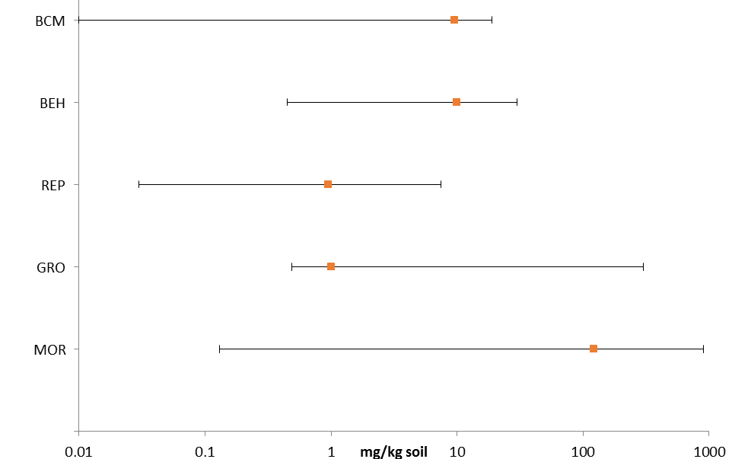
Figure 9-2. Summary Data Array for Terrestrial Invertebrates Exposed to Chlorpyrifos (mg/kg-soil). BCM = biochemical; BEH= behavior; REP = reproduction GRO = growth; MOR = mortality. Note that this figure is shown in a logarithmic scale for presentation purposes.

Exposure Unit: mg/kg-bw:

For the exposure unit of ‘mg/kg-bw’, terrestrial invertebrate toxicity data are available for 6 orders (i.e., Coleoptera, Diptera, Ephemeroptera, Lepidoptera, Odonata, and Trichoptera) represented by 8 families, 6 reported genera, and 8 reported species. For terrestrial invertebrates the only effects data available for the exposure unit mg/kg-bw are LD_{x} values for mortality (see Figure 9-3). All of the effects to terrestrial invertebrates occur at chlorpyrifos concentrations between 3.16 and 60 mg/kg-bw.

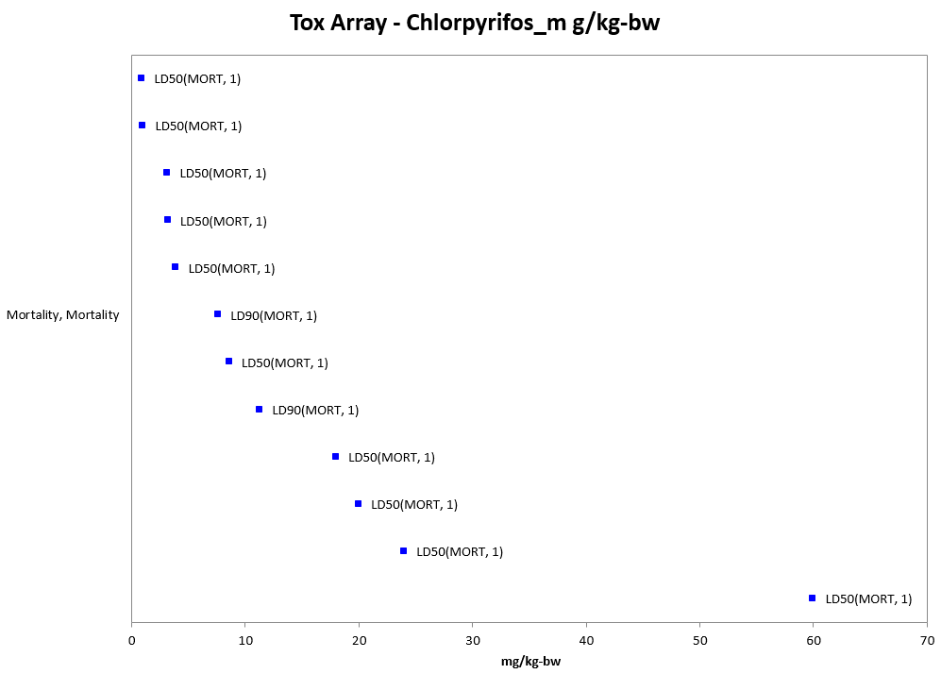
Figure 9-3. Mortality Endpoints for Terrestrial Invertebrates Exposed to Chlorpyrifos (mg/kg-bw). Data label key: Endpoint (measured effect, duration in days).

Exposure Unit: ppm:

For the exposure unit of ‘ppm’, terrestrial invertebrate toxicity data are available for 23 orders (i.e., Araneae, Coleoptera, Collembola, Dermaptera, Diptera, Haplotaxida, Hemiptera, Heteroptera, Homoptera, Hymenoptera, Isopoda, Isoptera, Lepidoptera, Lumbriculida, Megaloptera, Neuroptera, Orthoptera, Parasitiformes, Poduromorpha, Rhabditida, Thysanoptera, Trombidiformes, and Tylenchida) represented by 68 families, 119 genera, and 144 species. For terrestrial invertebrates there is a wide range of effects, from biochemical to population-level effects, and concentrations at which effects occur, from 0.008 to >5,000 ppm (see Figure 9-4). Most effects to terrestrial invertebrates occur at chlorpyrifos concentrations between 0.008 and 100 ppm. Figure 9-4 is meant to show the distribution of effects to terrestrial invertebrates across different chlorpyrifos concentrations; the specific endpoints are discussed in more detail below (further details can be found in APPENDIX 2-1).

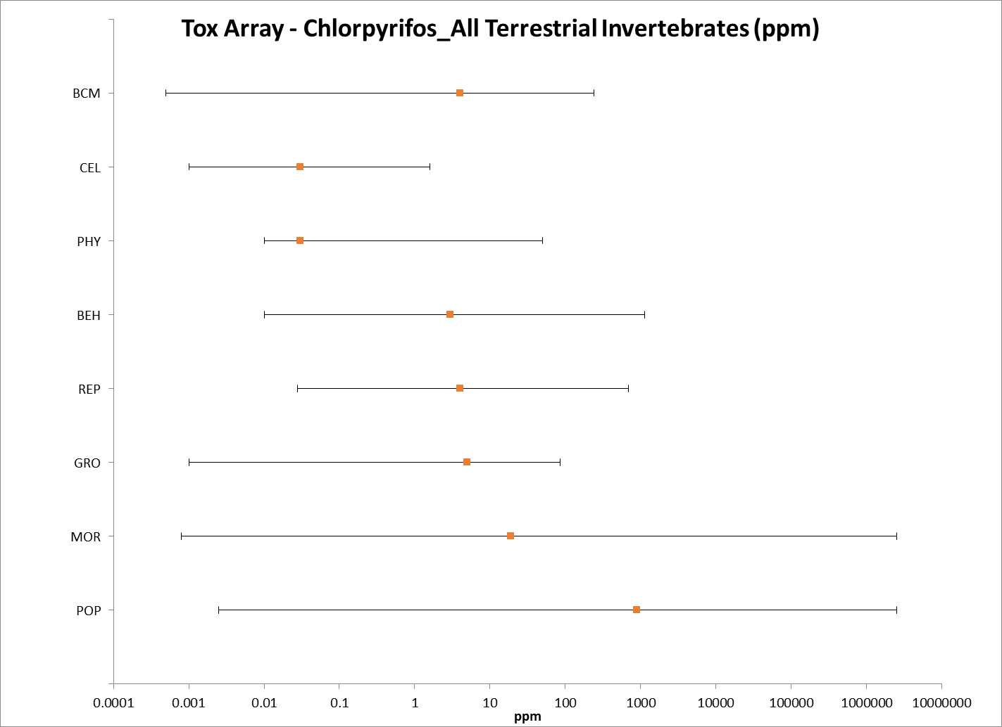
Figure 9-4. Summary Data Array for Terrestrial Invertebrates Exposed to Chlorpyrifos (ppm). BCM = biochemical; CEL = cellular; PHY = physiological; BEH= behavior; REP = reproduction GRO = growth; MOR = mortality; POP = population. Note that this figure is shown in a logarithmic scale for presentation purposes.

Exposure Unit: lb a.i./acre:

For terrestrial invertebrates there is a wide range of effects, from biochemical to population-level effects, and concentrations at which effects occur, from 0.00089 to >10 lb a.i./acre (see Figure 9-5). Most effects to terrestrial invertebrates occur at chlorpyrifos concentrations between 0.008 and 1 lb a.i./acre. Figure 9-5 is meant to show the distribution of effects to terrestrial invertebrates across different chlorpyrifos concentrations; the specific endpoints are discussed in more detail below (further details can be found in APPENDIX 2-1).

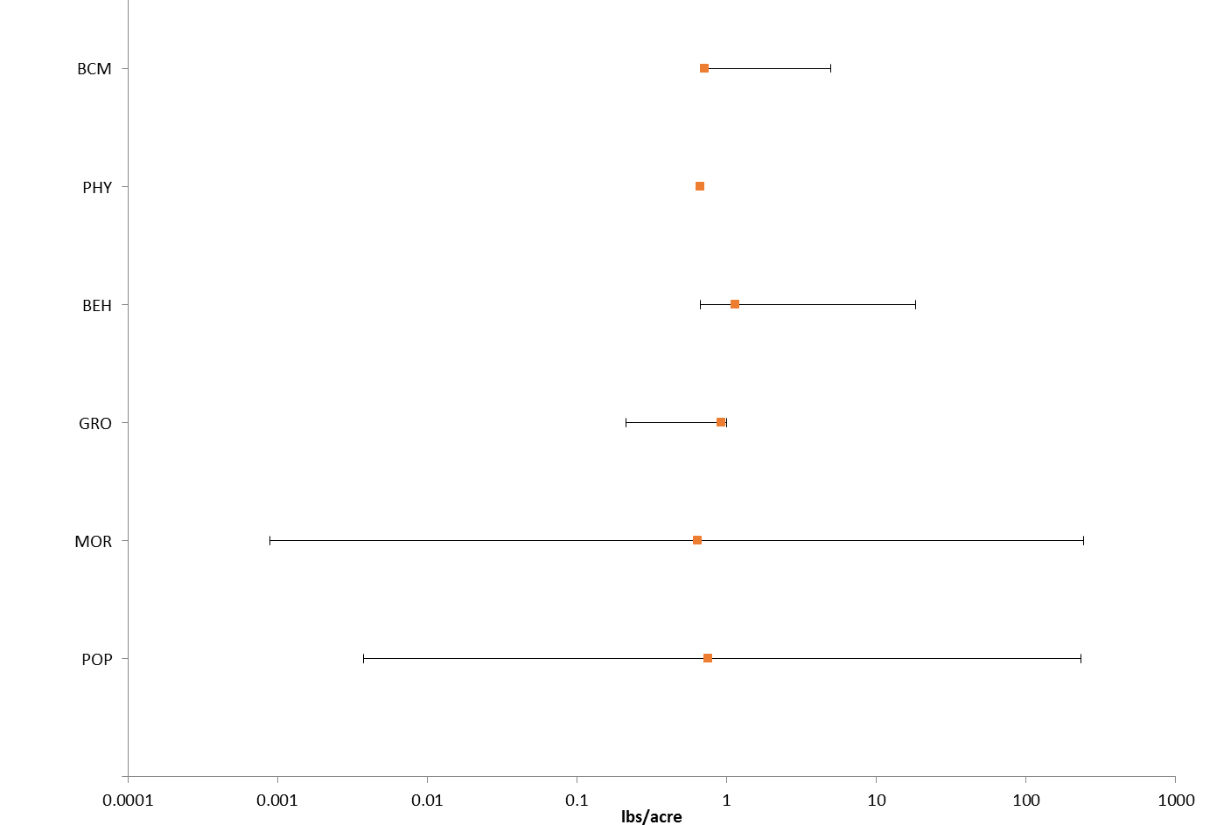
Figure 9-5. Summary Data Array for Terrestrial Invertebrates Exposed to Chlorpyrifos (lb a.i./acre). BCM = biochemical; PHY = physiological; BEH= behavior; GRO = growth; MOR = mortality; POP = population. Note that this figure is shown in a logarithmic scale for presentation purposes.

Lines of Evidence for Terrestrial Invertebrates

Effects on Mortality of Terrestrial Invertebrates

Most of the toxicity data available for chlorpyrifos and terrestrial invertebrates involve mortality endpoints. In most cases, mortality is actually the most sensitive endpoint available for the different environmentally relevant exposure units.

LC₅₀/LD₅₀ Value (mg/e.u.):

For the exposure unit of mg/e.u., the most sensitive LD₅₀ value available is 0.0016 µg/individual for contact exposure to adult fruit tortrix moths (E063259). In the tortrix study (E063259), bioassays of Adoxophyes orana individuals to topical dosing with chlorpyrifos were conducted using populations from apple orchards that had a long history of intensive insecticide use and orchards that had a long history of no insecticide use. All orchards were located in Kent, England. The study was conducted using first generation males in 1992, 1994, and 1995 and second generation males and females in 1992. Fourth stage larvae (L4) were also tested in 1992.

For the assays using the adult males, sex pheromone traps were used to catch moths. After being collected from the traps, the moths were transported to the laboratory and upon arrival, the moths were dosed topically in situ with 4 µl of one of a range of serial dilutions of chlorpyrifos (Dursban 4) in acetone. Mortality was assessed 24 hr later. At least 50, and up to 100, moths were dosed with each concentration at each site. For the second generation females (1992 only), moths were laboratory-reared using caterpillars collected in the field from four orchard sites. The caterpillars were kept in cardboard boxes and were fed apple leaves until they pupated. The pupae were transferred to clean boxes and were switched to a diet of sugar water after emergence. Two days after emergence, the moths were dosed (as described above). 50 individuals from each orchard was dosed with one of seven concentrations (including the control) (0, 0.94, 1.88, 2.81, 3.8, 7.5, 15 mg a.i./L). First generation fourth stage (L4) larvae were also collected in 1992 from the four orchards. A total of 30 to 40 individuals was dosed topically (on the leaf in which they were feeding) at the same seven concentrations as used on the adult females.

The results from this study for chlorpyrifos are reported below (see Table 9-2). The most sensitive LD₅₀ value is 1.6 ng/individual for first generation adult males (from a site with no known insecticidal use).

Table 9-2. LD₅₀ Values for Topical Dosing with Chlorpyrifos for A. orana Sampled from Apple Orchards in Kent, England.
SITE | INSECTICIDE MANAGEMENT | LIFE STAGE | YEAR | LD₅₀ (95% C.I.) (ng a.i./individual)
Loyterton Farm | Intensive | First generation males | 1992 | 6.8 (5.4 – 8.1)
 |  |  | 1994 | 12.0 (8.4 – 17.0)
 |  |  | 1995 | 18.2 (14.4 – 22.9)
 |  | Second generation males | 1992 | 8.2 (7.2 – 9.2)
 |  | Second generation females |  | 12.5 (10.8 – 14.4)
 |  | L4 larvae |  | 12.9 (11.4 – 14.6)
Perry Farm | Intensive | First generation males | 1992 | 6.7 (5.8 – 7.6)
 |  | Second generation males |  | 6.3 (5.4 – 7.0)
 |  | Second generation females |  | 15.0 (13.0 – 17.5)
 |  | L4 larvae |  | 14.8 (12.1 – 18.1)
Ewell Farm | Intensive | First generation males | 1994 | 13.6 (8.7 – 19.2)
 |  |  | 1995 | 23.2 (18.2 – 29.6)
Littlebourne Court | None | First generation males | 1992 | 2.0 (1.2 – 2.6)
 |  | Second generation males |  | 3.0 (3.2 – 3.7)
 |  | Second generation females |  | 4.3 (3.4 – 5.1)
 |  | L4 larvae |  | 4.4 (3.2 – 5.4)
Congelow Farm | None | First generation males | 1992 | 1.6 (0.8 – 2.3)
 |  |  | 1994 | 6.8 (3.6 – 10.4)
 |  | Second generation males | 1992 | 1.9 (0.8 – 2.8)
 |  | Second generation females |  | 2.1 (1.0 – 3.1)
 |  | L4 larvae |  | 2.7 (1.2 – 4.0)
Target Farm | None | First generation males | 1994 | 7.8 (4.1 – 11.6)
Broadwater Farm | None | First generation males | 1995 | 8.1 (4.8 – 13.6)

NOAEC/LOAEC Values (mg/e.u.):

For the exposure unit ‘mg/e.u.’, the most sensitive endpoint available for terrestrial invertebrates is an LD₁₀ value of 0.001 µg/individual for contact exposure to 3 to 4 day old larval honey bees (Apis mellifera) (E070351). This endpoint is more sensitive than any of the available NOAEC or LOAEC values, therefore, it will be used as the ‘sublethal’ threshold for direct and indirect effects (although this endpoint is based on mortality, it is more sensitive than any endpoint available for sublethal effects).

In this study, 31 pesticides [including chlorpyrifos (Lorsban 4E, % a.i. not reported)] were tested. In the test, the queen was confined over empty cells of brood comb inside a metal cage (containing approximately 500 worker cells). The cage, with the queen, was placed in the center of the brood nest – after 24-hr, the queen was released from the treatment frame by a queen excluder. The treatment solution was applied using a syringe (1 µl per cell). The droplet was directed to the food at the bottom of the cell. Pesticides were dissolved in acetone; and acetone was used in the control. 1 to 3 dilutions and a control were included in each test (100 larvae in 5 – 7 rows were treated with one of the dilutions. The larvae at the time of treatment were 1 – 2, 3 – 4, or 5 – 6 days old. After treatment, the colony was not disturbed until the brood cells had been capped. At that time, the number of surviving larvae was recorded. Bees were evaluated for survival following adult emergence.

For chlorpyrifos, the overall brood LD₅₀ value is reported as 0.051 µg/larva. The most sensitive age-group is 3 – 4 day old larvae, with an LD₅₀ of 0.001 ug/larva (see Table 9-3).

Table 9-3. Dosage-Mortality Data for Honeybee Larvae Treated in the Brood Cell with Chlorpyrifos.
DATUM | AGE OF TREATED LARVAE (DAYS)
 | 1 – 2 | 3 - 4 | 5 - 6 | ALL
SLOPE | 1.17 | 0.59 | 1.20 | 0.58
INTERCEPT | 5.79 | 5.85 | 6.42 | 5.75
LD₁₀ | 0.017 µg/larva | 0.001 µg/larva | 0.006 µg/larva | 0.001 µg/larva
LD₅₀ | 0.209 µg/larva | 0.302 µg/larva | 0.07 µg/larva | 0.051 µg/larva
LD₉₀ | 2.61 µg/larva | 4.73 µg/larva | 0.77 µg/larva | 8.32 µg/larva

Mortality Data Arrays (mg/e.u.):

Most of the data available for chlorpyrifos and terrestrial invertebrates in exposure units of mg/e.u. involve mortality endpoints. Mortality endpoints with this exposure unit are available for 5 terrestrial invertebrate orders (i.e., Coleoptera, Diptera, Homoptera, Hymenoptera, and Lepidoptera), represented by 19 families, 32 genera, and 50 species. The available LD₅₀ values for chlorpyrifos range from 0.0000016 to 0.61 mg/e.u. and the LC₅₀ values range from 0.00000421 to 327 mg/e.u.(see Figures 9-6 and 9-7).

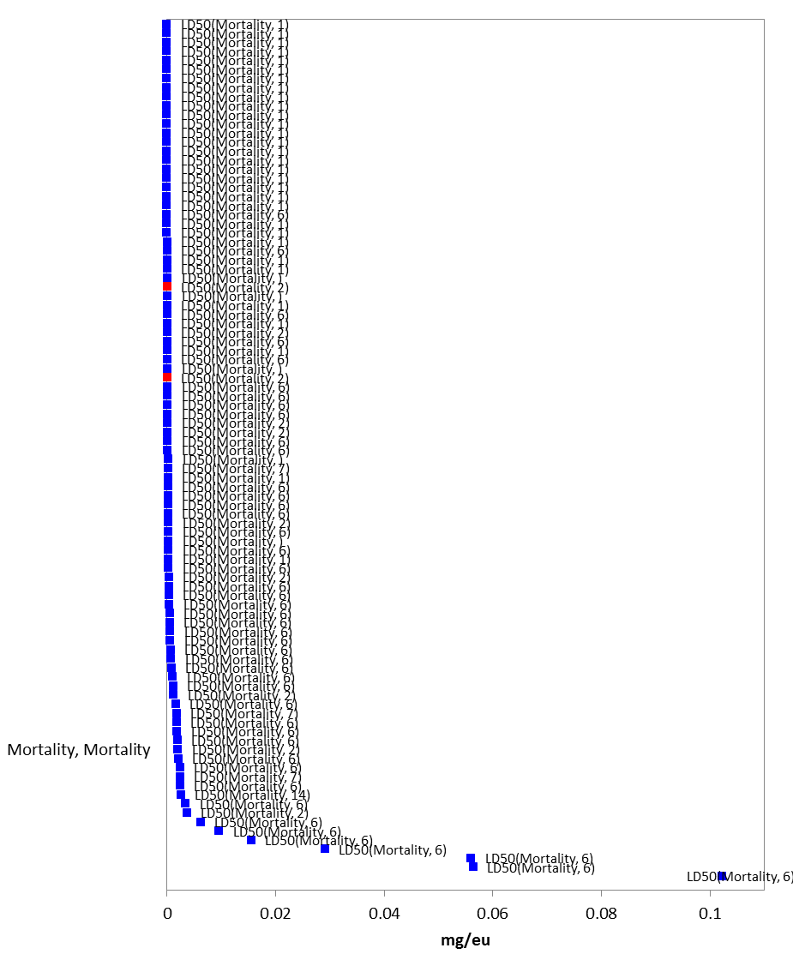
Figure 9-6. LD₅₀ Values for Terrestrial Invertebrates Exposed to Chlorpyrifos (mg/e.u.). Data from registrant submitted (red) and open literature (blue). Data label key: Endpoint (measured effect, duration in days).
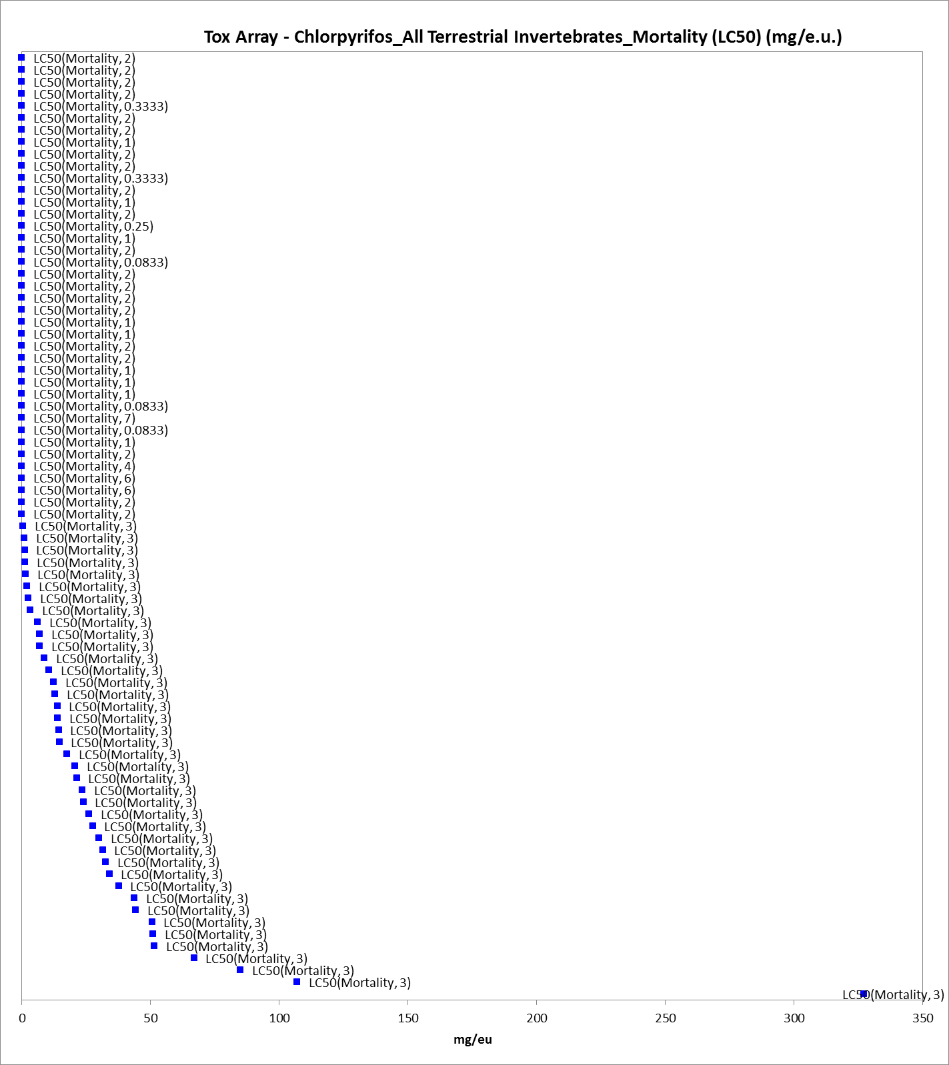
Figure 9-7. LC₅₀ Values for Terrestrial Invertebrates Exposed to Chlorpyrifos (mg/e.u.). Data label key: Endpoint (measured effect, duration in days).

There are also some mortality endpoints available for chlorpyrifos and LC_{x}/LD_{x} values that are less than (see Figure 9-8) or greater than (see Figure 9-9) LC₅₀/LD₅₀’s. For the less than LC₅₀/LD₅₀’s values, the endpoints range from 0.000001 to 0.0001 mg/e.u. For the greater than LC₅₀/LD₅₀’s values, the endpoints range from 0.0000323 to >500 mg/e.u.
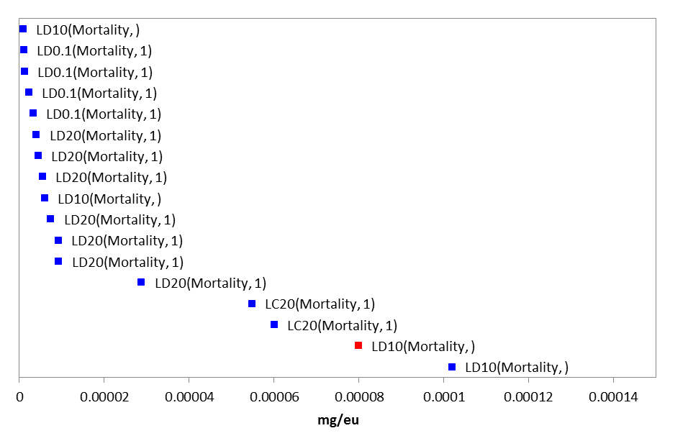

Figure 9-8. LD_{<50}/LC_{<50} Values for Terrestrial Invertebrates Exposed to Chlorpyrifos (mg/e.u.). Data from registrant submitted (red) and open literature (blue). Data label key: Endpoint (measured effect, duration in days).

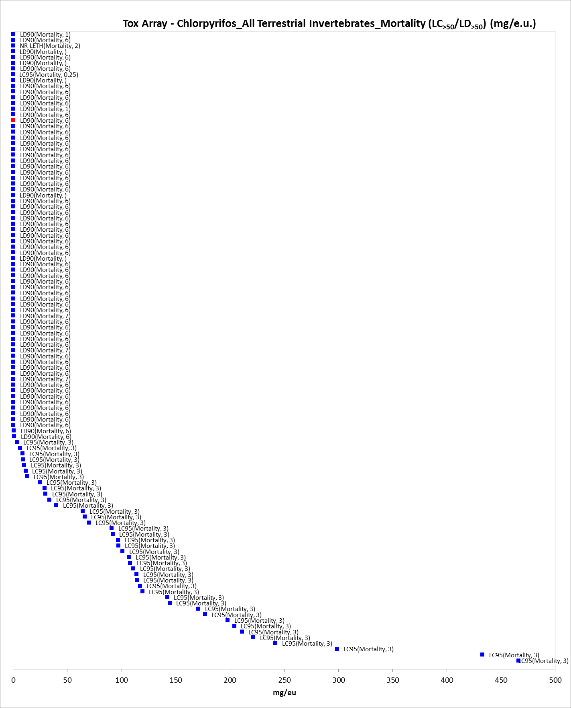
Figure 9-9. LD_{>50}/LC_{>50} Values for Terrestrial Invertebrates Exposed to Chlorpyrifos (mg/e.u.). Data from registrant submitted (red) and open literature (blue). Data label key: Endpoint (measured effect, family, duration in days).

LC₅₀/LD₅₀ Threshold Value (mg/kg-soil):

For the exposure unit of mg/kg-soil, the most sensitive LC₅₀ value available is 142 mg/kg-soil for earthworms (Eisenia andrei) (E160284). This results in mortality thresholds for direct and indirect effects of 12.5 and 73.7 mg/kg-soil, respectively (based on a default slope of 4.5). This LC₅₀ is from the same study as the reported EC₁₀ value for earthworms discussed below (see below for details). The mortality endpoint is from 28-day exposure to treated soil (all of the available LC₅₀ values for chlorpyrifos and terrestrial invertebrates with exposure units of mg/kg-soil are from 28-day studies).

Mortality Data Array (mg/kg-soil):

Mortality data associated with the exposure unit of mg/kg-soil are available for 5 orders (i.e., Araneae, Coleoptera, collembola, Haplotaxida, and Lumbriculida), represented by 5 families, 6 genera, and 7 species. Based on the available data, chlorpyrifos is associated with mortality of terrestrial invertebrates at concentrations ranging from 0.13 to 900 mg/kg-soil (Figure 9-10).

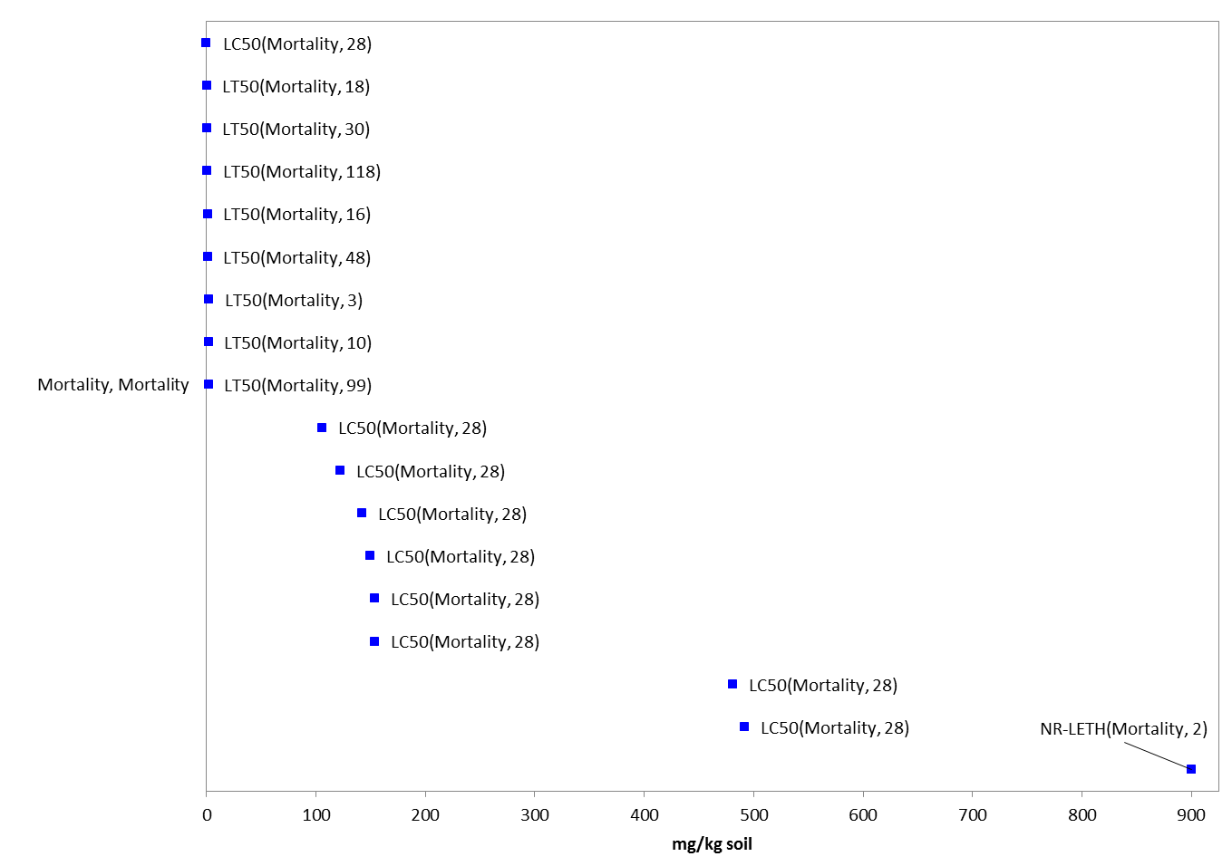
Figure 9-10. Mortality Endpoints for Terrestrial Invertebrates Exposed to Chlorpyrifos (mg/kg-soil). Data label key: Endpoint (measured effect, duration in days).

NOAEC/LOAEC and LC₅₀/LD₅₀ Thresholds (mg/kg-bw):

For the exposure unit ‘mg/kg-bw’, the most sensitive endpoint available for terrestrial invertebrates is an LD₅₀ value of 3.16 mg/kg-bw for corn rootworm (Diabrotica virgifera virgifera) (E58594). This endpoint is more sensitive than any of the available NOAEC or LOAEC values for terrestrial invertebrates, therefore, it will be used as the ‘sublethal’ threshold for direct and indirect effects for this exposure unit (although this endpoint is based on mortality, it is more sensitive than any endpoint available for sublethal effects). It will also be used for the acute mortality thresholds for direct and indirect effects. An LD₅₀ value of 3.16 mg/kg-bw results in mortality thresholds for direct and indirect effects of 0.126 and 1.33 mg/kg-bw, respectively (based on a slope of 3.4 from the study).

This study was conducted to evaluate soil insecticides against larvae of a resistant population (in the field and laboratory). The study looked at effects of methyl parathion, terbufos, chlorpyrifos, carbofuran, and tefluthrin on larval Western corn rootworm (Diabrotica virgifera virgifera). Only the results for chlorpyrifos are reported here. Adult corn rootworms were collected from a corn field near Holdrege, NE (Phelps County) and from a cornfield near Mead, NE (Saunders County). The resistance status of these populations has been previously documented. Standard procedures were used to collect and maintain eggs until termination of diapause to rear F₁ larvae.

For the topical bioassay portion of this study, chlorpyrifos (TGAI, 98% a.i.) was applied (in dilution with 0.5 µl acetone) to the dorsal abdomen of individual 3rd instars (control larvae were treated with 0.5 µl acetone alone). Mortality was recorded after 24-hrs. For each insecticide, 4 – 6 concentrations were tested (6 replicates of 10 larvae for each treatment level and control). Thirty randomly selected larvae were weighed per bioassay to allow for the calculation of dose on a body weight basis.

The results for chlorpyrifos are reported below (see Table 9-4).

Table 9-4. Chlorpyrifos Toxicity to Larvae Corn Rootworm for Susceptible (S, Saunders County) and Resistant (R, Phelps County) NE Populations (ng/mg bw).
POPULATION | NUMBER OF INDIVIDUALS TESTED (n) | SLOPE (± SE) | LD₅₀ (95% C.I.) | LD₉₀ (95% C.I.)
Saunders (S) | 239 | 3.4 (0.6) | 3.16 (2.37 – 3.89) | 7.63 (6.07 – 11.0)
Phelps (R) | 241 | 2.8 (0.4) | 3.92 (2.98 – 4.90) | 11.3 (8.71 – 16.54)

Mortality Data Array (mg/kg-bw):

For the exposure unit of ‘mg/kg-bw’, terrestrial invertebrate toxicity data are available for 6 orders (i.e., Coleoptera, Diptera, Ephemeroptera, Lepidoptera, Odonata, and Trichoptera) represented by 8 families, 6 reported genera, and 8 reported species. For terrestrial invertebrates the only effects data available for the exposure unit mg/kg-bw are LD_{x} values for mortality (see Figure 9-11). All of the effects to terrestrial invertebrates occur at chlorpyrifos concentrations between 3.16 and 60 mg/kg-bw.
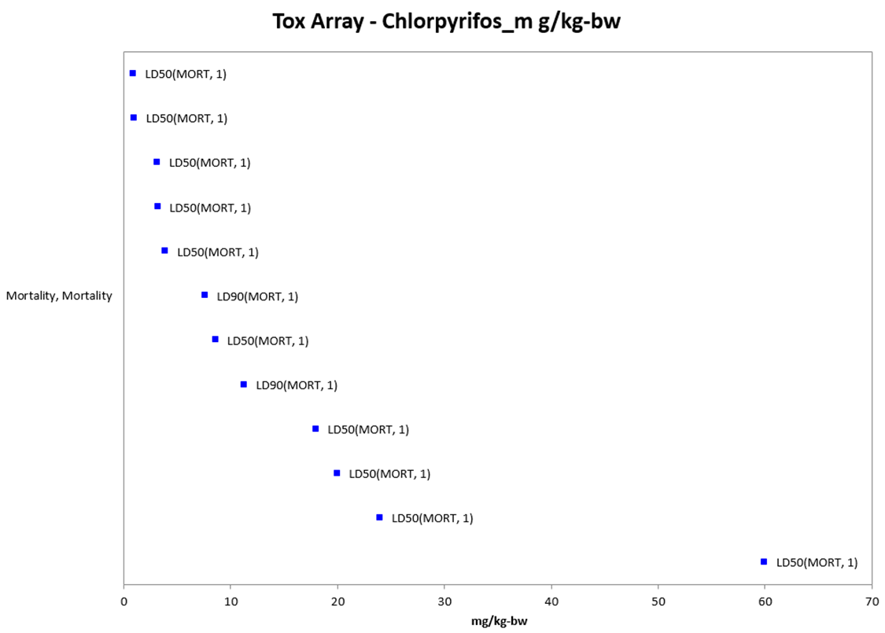
Figure 9-11. Mortality Endpoints for Terrestrial Invertebrates Exposed to Chlorpyrifos (mg/kg-bw). Data label key: Endpoint (measured effect, duration in days).

NOAEC/LOAEC and LC₅₀/LD₅₀ (ppm):

For the exposure unit ‘ppm’, the most sensitive endpoint available for terrestrial invertebrates is an LC₅₀ value of 0.0008 mg a.i./L (ppm) for a scale parasite (Aphytis melinus) (E108456). This endpoint is more sensitive than any of the available NOAEC or LOAEC values for terrestrial invertebrates. In this laboratory study the effects for seven insecticides (including chlorpyrifos) was tested on adults of four species of beneficial insects representing two families: Aphelinidae (Aphytis melinus, Eretmocerus eremicus, and Encarsia formosa) and Mymaridae (Gonatocerus ashmeadi). Only the results for chlorpyrifos are discussed here. G. ashmeadi used in the study were collected from citrus and willow trees in CA; A. meimus were obtained from a commercial insectary; and E. eremicus and E. formosa were supplied by Syngenta Bioline. The chlorpyrifos used in the study was a formulated product (Lorsban 4E, 0.479 kg a.i./L). The study was conducted using a petri dish bioassay technique. Freshly cut leaf discs (citrus for G. ashmeadi and A. melinus; cotton for E. eremicus and E. formosa), sized to fit the petri dish, were dipped in each insecticide concentration for 30 seconds and allowed to dry for 1 hr before being placed in the petri dishes. A small amount of honey was smeared on the lid for food. There were 10 G. ashmeadi, ~20 E. eremicus and E, formosa, and 25 – 50 A. melinus used per replicate. Each bioassay was replicated at least three times on each of three dates. Mortality for chlorpyrifos was recorded at 24-hr. There were at least 5 concentrations tested for each insecticide (diluted using deionized water) plus a water control.

Control mortality was always below 10% for all species tested. The results for chlorpyrifos and the four insect species are reported below (see Table 9-5).

Table 9-5. Toxicity of Chlorpyrifos (1-day Exposure) to Insects [in µg a.i./ml (ppm)].
SPECIES | NUMBER (n) | SLOPE (± SE) | LC₅₀
A. melinus | 4,148 | 1.4 ± 0.05 | 0.0008 (0.0006 – 0.001)
G. ashmeadi | 2,106 | 1.3 ± 0.06 | 0.006 (0.004 – 0.010)
E. eremicus | 1,782 | 1.6 ± 0.08 | 0.012 (0.008 – 0.018)
E. formosa | 1,807 | 1.2 ± 0.06 | 0.017 (0.009 – 0.029)

Mortality Data Arrays (ppm):

Data for mortality and an exposure unit of ppm are available for 19 terrestrial invertebrate orders (i.e., Coleoptera, Collembola, Dermaptera, Diptera, Haplotaxida, Hemiptera, Heteroptera, Homoptera, Hymenoptera, Isopoda, Isoptera, Lepidoptera, Lumbriculida, Megaloptera, Neuroptera, Parasitiformes, Rhabditida, Trombidiformes, and Tylenchida), represented by 43 families, 78 genera, and 93 species. For mortality endpoints, the available LC₅₀ and LD₅₀ values for chlorpyrifos and terrestrial invertebrates range from 0.0008 up to 20,000 ppm (Figure 9-12). There are also available data for LC_{x}/LD_{x} values less than or greater than LC₅₀/LD₅₀’s; the endpoints for these range from and LD₀₁ of 0.04 to an LC₂₅ of ~95 ppm, and LD₁₀₀ of 0.1 to LC₉₀ >2,000 ppm, respectively (see Figures 9-13 and 9-14).

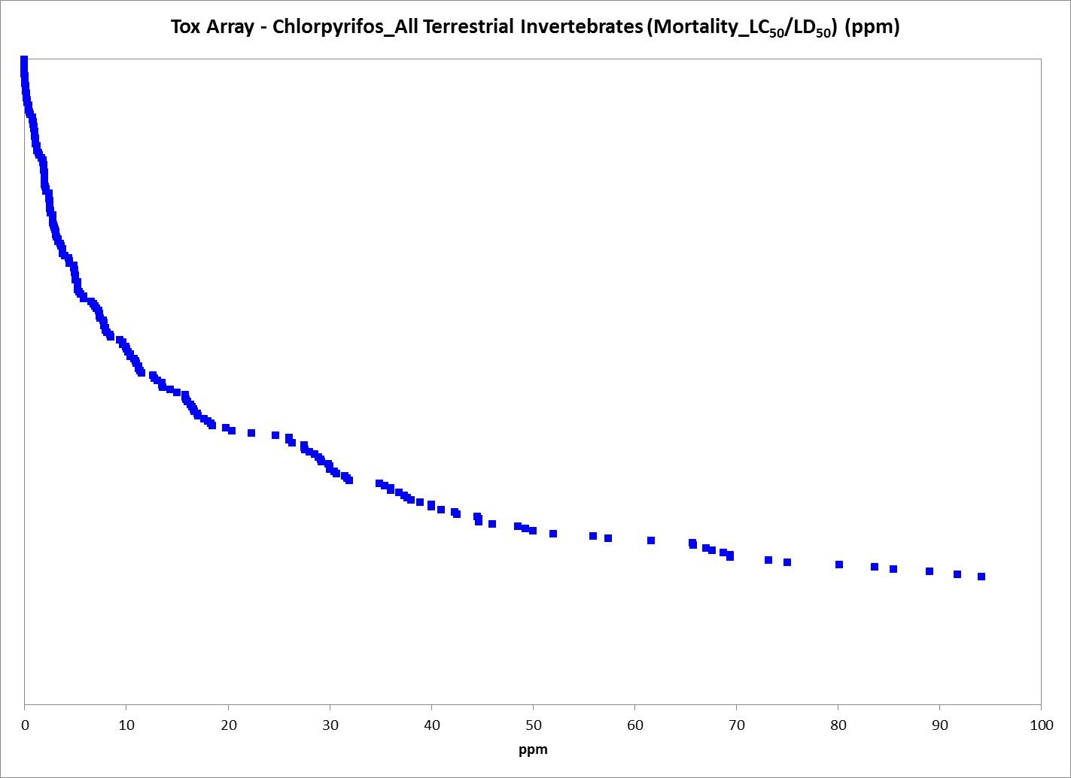
Figure 9-12. LC₅₀ and LD₅₀ Values for Terrestrial Invertebrates Exposed to Chlorpyrifos (ppm). For presentation purposes, the labels have been removed from this figure (due to the number of endpoints). Although most of the available LC₅₀/LD₅₀ values are <100 ppm, there are 53 LC₅₀/LD₅₀ values that are greater than 100 ppm (they range from 104 to 20,000 ppm) (these have been removed from the figure for presentation purposes).

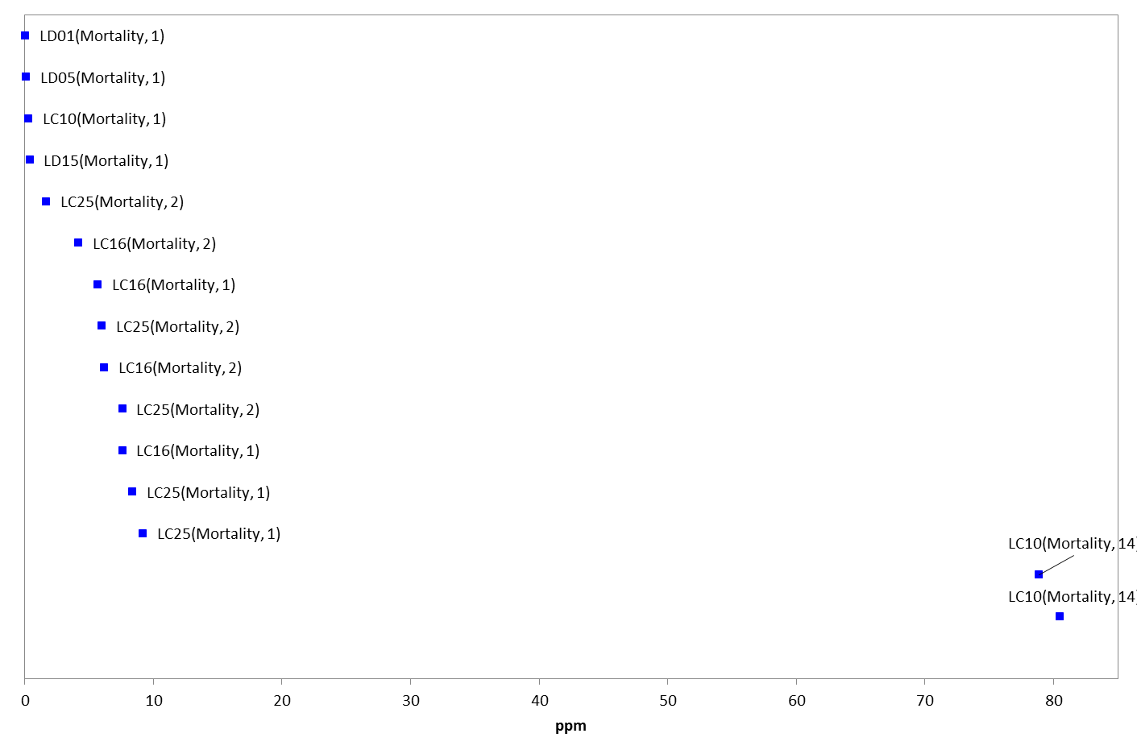
Figure 9-13. LD_{<50}/LC_{<50} Values for Terrestrial Invertebrates Exposed to Chlorpyrifos (ppm). Data label key: Endpoint (measured effect, duration in days).

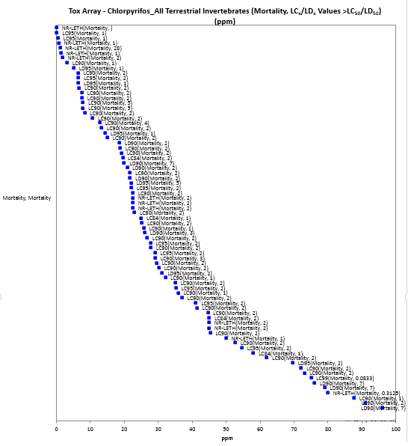
Figure 9-14. LD_{>50}/LC_{>50} Values for Terrestrial Invertebrates Exposed to Chlorpyrifos (ppm). Data label key: Endpoint (measured effect, duration in days). Although most of the available LC_{x}/LD_{x} values > than LC₅₀/LD₅₀ are <100 ppm, there are 32 LC_{x}/LD_{x} values that are greater than 100 ppm (they range from 107 to ~2,600 ppm) (these have been removed from the figure for presentation purposes).

Mortality Thresholds (lb a.i./acre):

For the exposure unit ‘lb a.i./acre’, the most sensitive terrestrial invertebrate NOAEC and LOAEC values are 0.00089 and 0.0046 lb a.i./acre, respectively, for mortality in a parasitoid (Microctonus hyperodae) based on 24-hr exposure to treated ryegrass (E86585). This endpoint is more sensitive than any of the available NOAEC or LOAEC values, therefore, it will be used as the ‘sublethal’ threshold for direct and indirect effects (although this endpoint is based on mortality, it is more sensitive than any endpoint available for sublethal effects).

In this study, four separate experiments were run to explore the effects of various pesticides on the parasitoid, Microctonus hyperodae (Hymenoptera) and the weevil, Listronotus bonariensis (Coleoptera). Only the laboratory study on the effects of chlorpyrifos on the survivorship of M. hyperodae are discussed here. A formulated chlorpyrifos product (Chlorpyrifos 48EC) was applied to four replicate plots (3 x 2 m) of perennial ryegrass-white clover pasture at rates of 0, 1, 5, 25, 50, or 100 g a.i./ha (which equate to application rates of 0, 0.00089, 0.0046, 0.022, 0.0446, and 0.089 lb a.i./acre) near Hamilton, New Zealand. After 1-hr, foliage was cut at ground level from five random areas in each plot and 20 - 30 ryegrass tillers (single-stem units) were placed in plastic pots in the laboratory. Ten M. hyperodae adults were placed with 20 L. bonariensis adults (confined to the pots with mesh covers) (five replicates per treatment). Parasitoid mortality was assessed after 24-hrs. Forty-eight hrs after the initial chlorpyrifos application, further foliage was cut from the plots and the bioassay was repeated. The L. bonariensis used in the study were collected from untreated pastures near Hamilton, New Zealand, and the M. hyperodae were reared to the adult stage from these weevils.

The results for chlorpyrifos and M. hyperodae survival are provided below (see Table 9-6).

Table 9-6. Mortality of M. hyperodae Adults Exposed for 24-hr to Ryegrass Treated with Chlorpyrifos 24 hr or 48 hr Previously.
RATE in g ai./ha (lb a.i./acre) | MEAN PERCENT DEAD
 | 1 hr | 48 hr
0 (0) | 3 | 0
1 (0.00089) | 0 | 0
5 (0.0046) | 23* | 0
25 (0.022) | 100* | 0
50 (0.0446) | 100* | 0
100 (0.089) | 100* | 0
* = significantly different from the control (p < 0.001).

Therefore, the NOAEC and LOAEC values in this study for mortality are 0.00089 and 0.0046 lb a.i./acre, respectively.

There is no LC₅₀ value currently available for terrestrial invertebrates with an exposure unit of lb a.i./acre. Therefore, the NOAEC and LOAEC values of 0.00089 and 0.0046 lb a.i./acre, respectively (as discussed above), will be used to assess the potential for direct and indirect effects related to the mortality of terrestrial invertebrates.

Mortality Data Arrays (lb a.i./acre):

Mortality data (including population-level effects on abundance) with an exposure unit of lb a.i./acre are available for 29 terrestrial invertebrate orders (i.e., Actinedida, Araneae, Coleoptera, Collembola, Dermaptera, Diplura, Diptera, Dorylaimida, Gamasida, Gamasina, Haplotaxida, Hemiptera, Heteroptera, Homoptera, Hymenoptera, Isoptera, Lepidoptera, Lumbriculida, Mesostigmata, Neuroptera, Opilliones, Orthoptera, Parasitiformes, Poduromorpha, Protura, Psocoptera, Sarcoptiformes, Thysanoptera, and Trombidiformes), represented by 127 families, 221 genera, and 296 species. Regarding mortality, chlorpyrifos is associated with increased mortality of terrestrial invertebrates at concentrations from 0.004 to > 6 lb a.i./acre (Figure 9-15). Most of the endpoints for chlorpyrifos and terrestrial invertebrates reported in the lb a.i./acre exposure unit are for population-level effects (all related to abundance/control which are assumed to be related to mortality; and are, therefore included in this mortality section). These effects are seen at concentrations from 0.004 to > 8 lb a.i./acre (Figure 9-16).

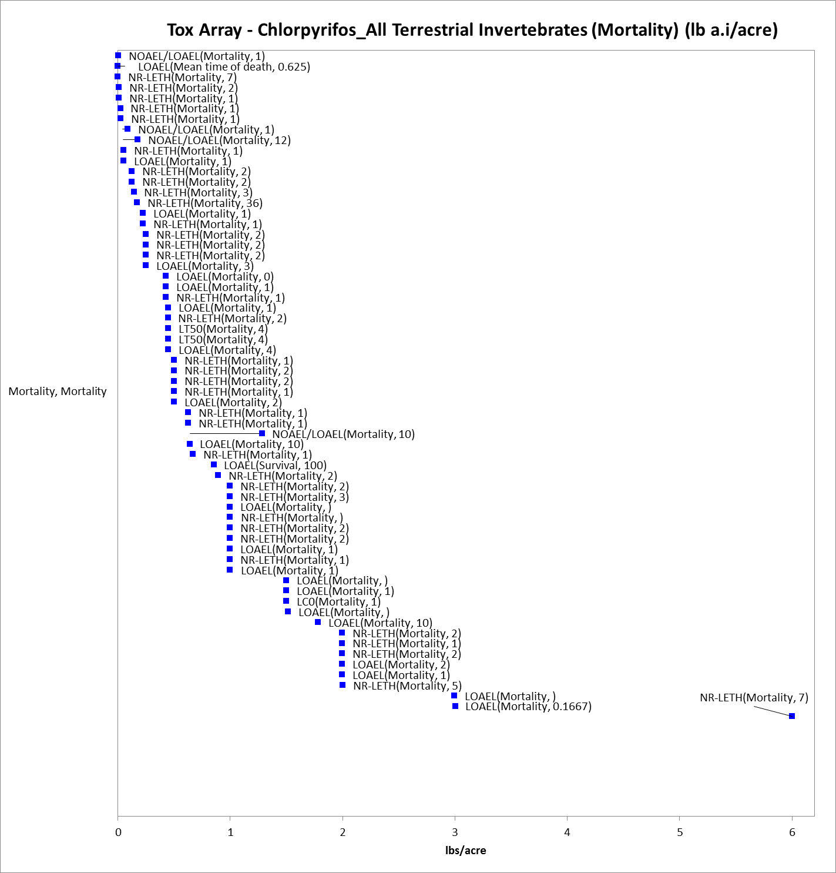
Figure 9-15. Mortality Endpoints for Terrestrial Invertebrates Exposed to Chlorpyrifos (lb a.i./acre). Data label key: Endpoint (measured effect, duration in days). Although most of the available mortality endpoints occur at concentration < 6 lb a.i./acre, there are 9 mortality endpoints that are greater than 6 lb a.i./acre (they range from 21.4 to 33.5 lb a.i./acre) (these have been removed from the figure for presentation purposes).

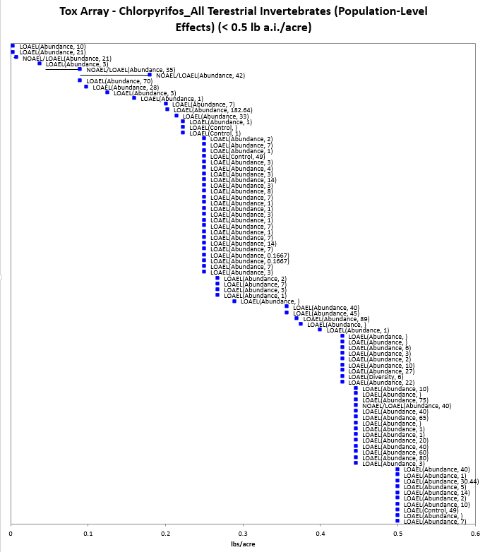
Figure 9-16. Population-Level Endpoints for Terrestrial Invertebrates Exposed to Chlorpyrifos (lb a.i./acre). Data label key: Endpoint (measured effect, duration in days). Most of the LOAELs for population-level effects (i.e., abundance/control) are at > 0.5 lb a.i./acre (but there are too many endpoints to clearly display in an array; therefore, the lower end of the distribution of endpoints are illustrate here).

Registrant-Submitted Terrestrial Invertebrate Toxicity Data

Because of the complexities associated with the terrestrial invertebrate toxicity data available in the open literature and screened through ECOTOX (e.g., variable methodologies, exposure routes, exposure units, species), a brief discussion of the available guideline studies conducted with honey bees (Apis mellifera) and submitted by the registrants is provided here. This discussion is meant to provide context for the available terrestrial invertebrate thresholds for chlorpyrifos.

Based on the submitted data, chlorpyrifos is classified as very highly toxic to bees. The LD₅₀ values from the acceptable acute honey bee (contact) studies are 0.059 µg a.i./bee (MRID 05001991) and 0.114 µg a.i./bee (MRID 00066220) (see Table 9-7). Additionally, a study in which bees were exposed to one concentration of chlorpyrifos (0.1 µg a.i./bee) has been submitted (MRID 0.5011163). In this study, there was 100% mortality at the tested concentration. This study is classified as supplemental because only one concentration was tested and an LD₅₀ value could not be calculated.

Table 9-7. Available Honey Bee (Apis mellifera) Toxicity Data from Guideline Studies (Acute Contact).
% AI | LD₅₀  (µg a.i./bee) | MRID | CLASSIFICATION | COMMENTS
TGAI | 0.059 | 05001991 | Acceptable | None
TGAI | 0.114 | 00066220 | Acceptable | None
TGAI | < 0.1 | 05011163 | Supplemental | Only one concentration was tested; there was 100% dead at 0.01 % solution; an LD₅₀ was not determined

Other submitted data indicate that residues on alfalfa foliage samples from application of Dursban 4EC at 0.5 and 1.0 lb a.i./acre were highly toxic through 8 hours to three bee species [honey bee (Apis mellifera); alkali bee (Nomea melanderi), and alfalfa leaf-cutter bee (Megachile rotundata)]. At 24 hours, residues on alfalfa foliage remained highly toxic to the honey bee and alfalfa leaf-cutter bee and moderately toxic to the alkali bee (MRID 00040602). Alfalfa foliage samples with chlorpyrifos residues from an application of Dursban 2 EC on alfalfa fields at 1 lb a.i./acre were highly toxic to the honey bees at 3 hours when placed in cages with bees, but foliage samples were not toxic at 24 hours (MRID 00060632). In the only available submitted field study, honey bee visitation was suppressed 46 percent for three days in alfalfa fields treated with Dursban 4EC at 0.5 lb a.i./acre. The overall hazard to bees was low (MRID 00074486).

There is also submitted data available that support chlorpyrifos as toxic to lady beetles when beetles are exposed to direct application. In the submitted study, survival of adult lady beetles (Stethorus punctum) was reduced to 30 percent, 48 hours after direct application of Dursban 4EC at 0.25 lb a.i. per 100 gallons of water (MRID 00059461).

Sublethal Effects to Terrestrial Invertebrates

Effects on Growth of Terrestrial Invertebrates

There are far fewer data available for growth effects compared to mortality when considering the available terrestrial invertebrate toxicity data for chlorpyrifos. Most of the growth data involve the ‘ppm’ exposure unit. For the exposure units ‘mg/e.u.’ and ’mg/kg-bw’, there are no effects data related to growth. For the ‘mg/kg-soil’ exposure unit, there are growth data available for 2 orders (i.e., Haplotaxida and Lumbriculida), represented by 2 families, genera and species (i.e., Megascolecidae Perionyx excavatus; and Lumbricicidae Eisenia andrei). Effects to growth are seen at concentrations from 1 to 300 mg/kg-soil (see Figure 9-17).

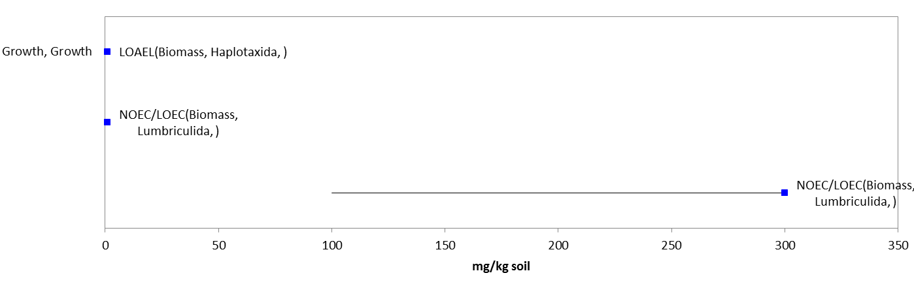
Figure 9-17. Growth Endpoints for Terrestrial Invertebrates Exposed to Chlorpyrifos (mg/kg-soil). Data label key: Endpoint (measured effect, order, duration in days).

For the ‘ppm’ exposure unit, there are growth data available 7 terrestrial invertebrate orders (i.e., Collembola, Haplotaxida, Hymenoptera, Isopoda, Lepidoptera, Lumbriculida, and Rhabditida), represented by 7 families, 10 genera, and 13 species. Endpoints range from 0.028 ppm to ~85 ppm (see Figure 9-18).

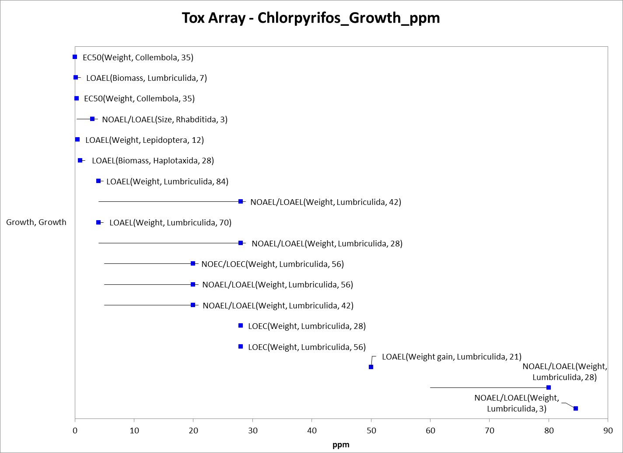
Figure 9-18. Growth Endpoints for Terrestrial Invertebrates Exposed to Chlorpyrifos (ppm). Data label key: Endpoint (measured effect, order, duration in days).

For the lb a.i./acre exposure unit, there are two toxicity endpoints available for grow and terrestrial invertebrates (both are LOAELs related to effects on weight). Both LOAELs are at the 1 lb a.i./acre application rate. One involves Bombus impatiens (Order: Hymenoptera; Family: Apidae) and the other involves Spodoptera exigua (Order: Lepidoptera; Family: Noctuidae).

Effects on Reproduction of Terrestrial Invertebrates

Most of the reproductive effects seen in terrestrial invertebrates with exposure to chlorpyrifos involve effects to the number of progeny produced and effects on emergence. Data on reproductive effects are available across the environmentally relevant exposure units except for the mg/kg-bw exposure unit.

mg/e.u.:

There are two toxicity endpoints available for the effects of chlorpyrifos on reproduction in terrestrial invertebrates with the ‘mg/e.u.’ exposure unit. Both involve LOAELs with the parasitic wasp, Trichogramma brassicae (Order: Hymennoptera; Family: Trichogrammatidae). One LOAEL is 0.00000443 mg/e.u for effects on general reproductive success, and the other is 0.00000547 mg/e.u. for effects on number of progeny.

mg/kg-soil:

For the exposure unit ‘mg/kg-soil’, the most sensitive endpoint available for terrestrial invertebrates is an EC₁₀ value of 0.03 mg/kg-soil for earthworms (Eisenia andrei) for effects on number of young produced (E160284). This endpoint is more sensitive than any available NOAEC or LOAEC values, therefore, it will be used as the sublethal threshold for direct and indirect effects for this exposure unit and terrestrial invertebrates.

This earthworm study was conducted to test the effects of three pesticides (chlorpyrifos, carbofuran, and carbendazim) using different soil types. Only the results for chlorpyrifos are reported here. The Eisenia andrei (Lumbricidae) used in the study were from a synchronized culture maintained at the University of Ruhuma, Sri Lanka. Modified artificial soil (MAS) was prepared according to standard OECD guidelines except the 10% sphagnum peat was replaced with a similar amount of finely ground non-composted coco peat (NCCP), composted coco peat (CCP), paddy husk (PH), or saw dust (SW).

The chlorpyrifos used in the study was TGAI (98% a.i.). The test containers were 750 ml glass containers; 5 g of food (cow manure) was added to each container. Earthworms (n = 10, four replicates) were introduced into the containers. The study was conducted at temperatures of 26 ± 2 ºC (simulating tropical conditions). After 28-days of exposure, adults were removed and mortality and biomass were determined. The soil was returned into the test containers and incubated for another 28 days. After 56 days, juveniles were removed from the soil. The final endpoints measured were adult mortality and biomass after 28 days and number of juveniles after 56 days.

There was no adult mortality in the modified soils except for 40% mortality in MAS_{NCCP}. Thick fungal layers formed in MAS_{SD} and MAS_{PH}. Additionally, there was aggregation of worms in the food in MAS_{SD} and MAS_{NCCP}. Therefore, only the results for AS_{OECD}, MAS_{CCP}, and MAS_{PH} are reported (see Table 9-8).

Table 9-8. Toxicity of Chlorpyrifos (28-day Exposure) to Earthworms in OECD Artificial Soil (AS) and Modified Soils (MAS) (in mg a.i./kg dry soil).
SOIL TYPE | LC₅₀ | EC₅₀ (number of juveniles) | EC₁₀ (number of juveniles)
AS_{OECD} | 150 (132 – 171) | 2.0 (1.4 – 2.6) | 0.09 (0.02 – 0.15)
MAS_{CCP} | 154 (134 – 177) | 2.0 (1.3 – 2.7) | 0.08 (0.01 – 0.15)
MS_{PH} | 142 (122 – 164) | 0.5* (0.4 – 0.6) | 0.03 (0.01 – 0.05)
* = significantly different from the AS; values in parentheses represent the corresponding 95% C.I.
CCP = Coco peat
PH = Paddy husk

Regarding all of the available data and this exposure unit, there are toxicity data for effects on reproduction available for 4 orders of terrestrial l invertebrate (i.e., Coleoptera, Collembola, Haplotaxida, and Lumbriculida), represented by 4 families, genera, and species. Reproductive effects (including effects to emergence, general reproductive success, and number of progeny) are seen at concentrations from 0.3 to 7.5 mg/kg-soil (see Figure 9-19).

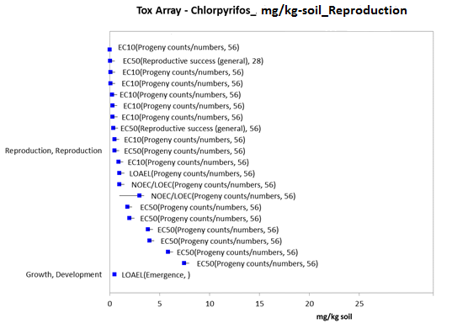
Figure 9-19. Reproduction Endpoints for Terrestrial Invertebrates Exposed to Chlorpyrifos (mg/kg-soil). Data label key: Endpoint (measured effect, duration in days).

ppm:

For the exposure unit ppm, in addition to the sublethal endpoint related to reproduction discussed above, there are toxicity data related to reproduction available for 5 orders of terrestrial invertebrates (i.e., Collembola, Haplotaxida, Hymenoptera, Lumbriculida, and Rhabditida), represented by 6 families, 8 genera, and 10 species. Reproductive effects are seen from concentrations of 0.028 ppm to 691 ppm and include endpoints related to number of progeny, fertile cocoons, time to first progeny, and viability (see Figure 9-20).

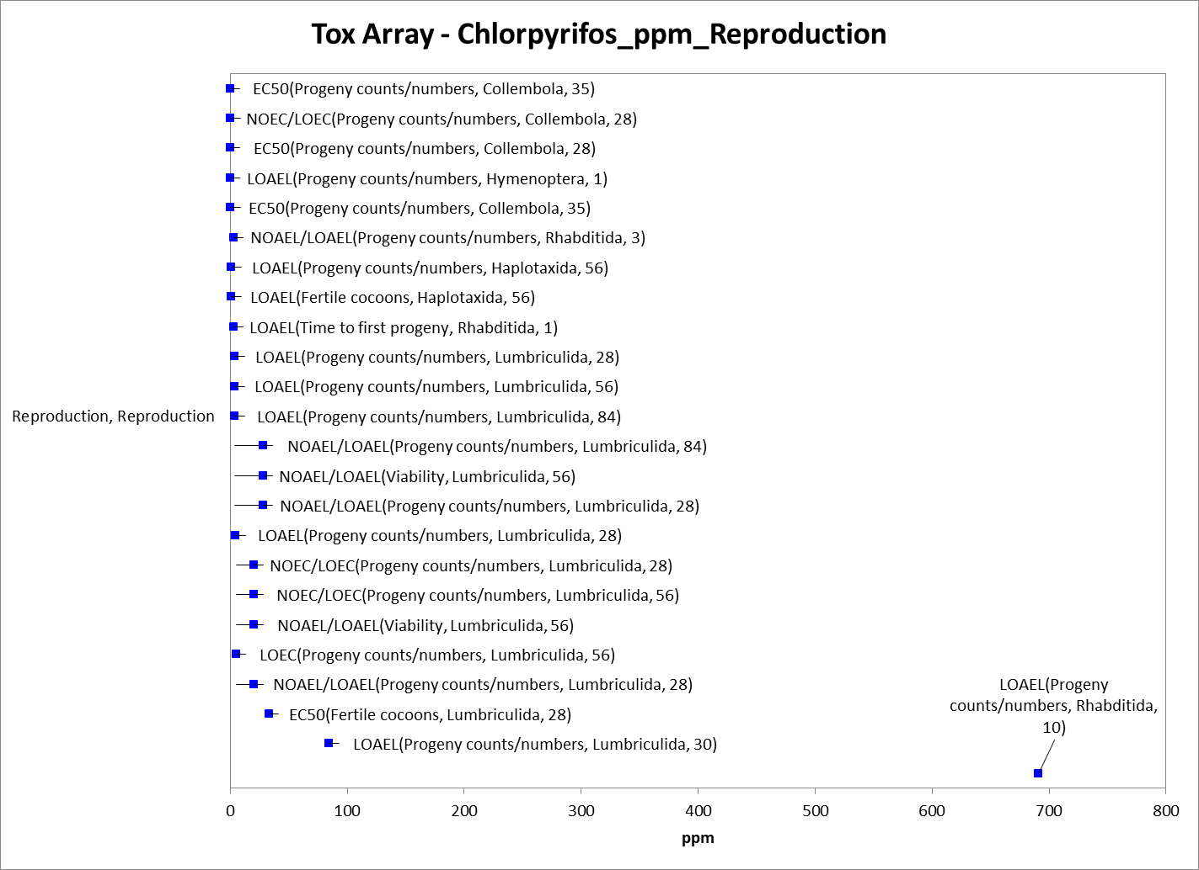
Figure 9-20. Reproduction Endpoints for Terrestrial Invertebrates Exposed to Chlorpyrifos (ppm). Data label key: Endpoint (measured effect, order, duration in days).

Lb a.i./acre:

For the lb a.i./acre exposure unit, effects data related to reproduction are available for 2 orders of terrestrial invertebrate (i.e., Coleoptera and Hymenoptera), represented by 3 families, 4 genera, and 4 species. Reproductive effects from chlorpyrifos (all related to emergence) are seen at 0.21 to 0.86 lb a.i./acre (see Figure 9-21).

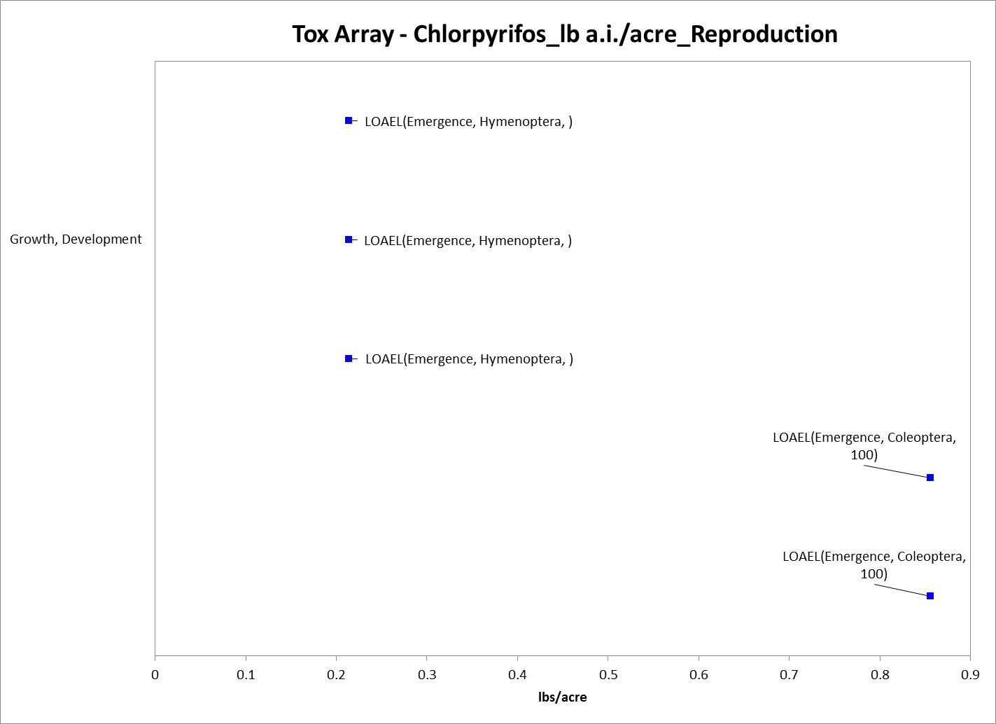
Figure 9-21. Reproduction Endpoints for Terrestrial Invertebrates Exposed to Chlorpyrifos (lb a.i./acre). Data label key: Endpoint (measured effect, order, duration in days).

Effects on Behavior of Terrestrial Invertebrates

There are only limited data available for chlorpyrifos and effects on behavior in terrestrial invertebrates. For the ‘mg/e.u.’ exposure unit, data are only available for one order (i.e., Hymenoptera), represented by 2 families and genera and 4 species. The only behavioral effect seen is effects on locomotion (specifically effects on the distance moved and/or changes in direct movement) at concentrations from 0.0000034 to 0.000029 mg/e.u. (see Figure 9-22). There are currently no toxicity data with behavioral endpoints available for chlorpyrifos and terrestrial invertebrates with the exposure units of mg/kg-soil or mg/kg-bw.

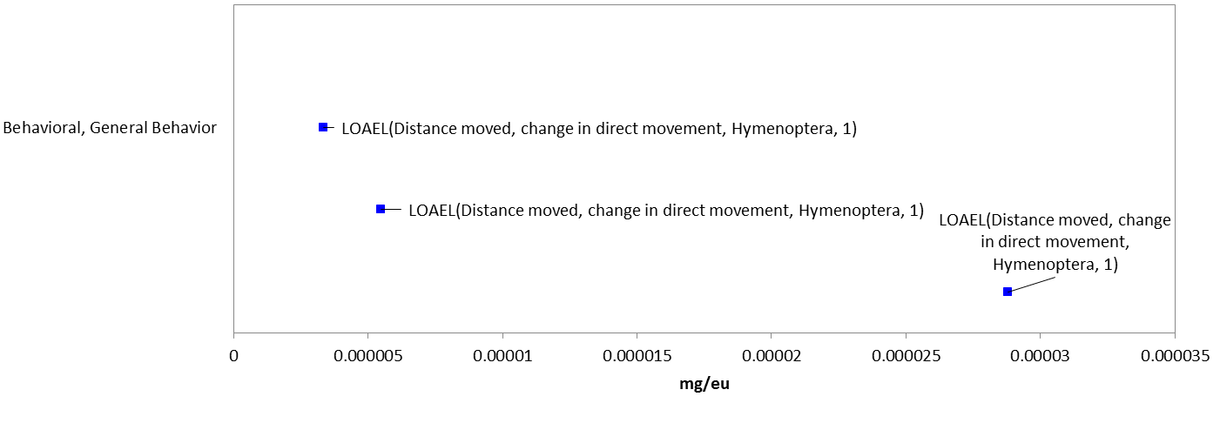
Figure 9-22. Behavior Endpoints for Terrestrial Invertebrates Exposed to Chlorpyrifos (mg/e.u.). Data label key: Endpoint (measured effect, order, duration in days).

For the exposure unit of ppm, there are behavioral effects data available for 4 orders of terrestrial invertebrates (i.e., Coleoptera, Isopoda, Lumbriculida, and Rhabditida), represented by 6 families, 7 genera, and 8 species. Behavioral effects seen include effects on locomotion (i.e., number of movements), feeding behavior and food consumption, and fecal production at concentrations from 0.01 to 0.135 ppm (see Figure 9-23). For the lb a.i./acre exposure unit, there are behavioral effects data available for 2 orders (i.e., Coleoptera and Hymenoptera), represented by 2 families, genera, and species. The only behavioral effect seen was for an activity endpoint in the order Coleoptera, with NOAEL and LOAEL values of 0.33 and 0.67 lb a.i./acre, respectively.

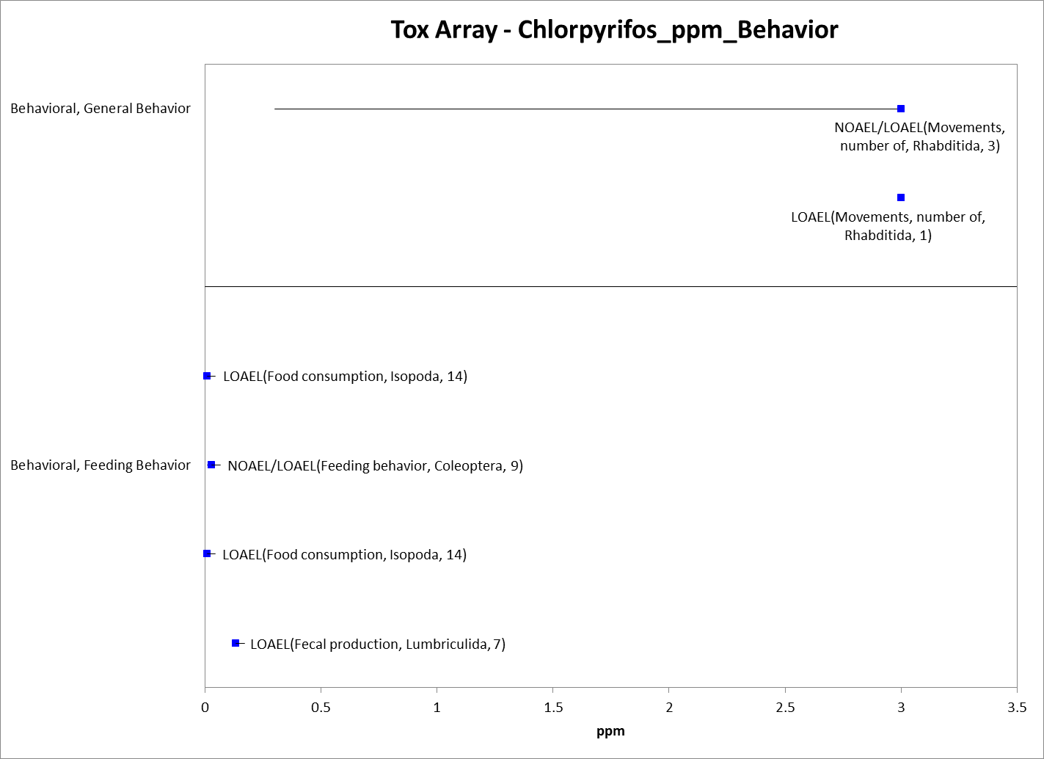
Figure 9-23. Behavior Endpoints for Terrestrial Invertebrates Exposed to Chlorpyrifos (ppm). Data label key: Endpoint (measured effect, order, duration in days).

Effects on Sensory Function of Terrestrial Invertebrates

There are limited toxicity data available for chlorpyrifos and sensory effects in terrestrial invertebrates. Almost all of the available data involve chemical avoidance. The exception involves data on effects to smell in wasps (order: Hymenoptera) with LOAEL values of 0.000055 and 0.00006 mg/e.u. These are the only sensory data available for the exposure unit of mg/e.u.

For the exposure unit of mg/kg-soil, all of the sensory endpoints available for chlorpyrifos and terrestrial invertebrates are related to chemical avoidance, and data are available for 3 orders (i.e., Collembola, Haplotaxida, and Lumbriculida), represented by 3 families, genera and species. Chemical avoidance is seen at concentrations from 0.45 to ~30 mg/kg-soil (see Figure 9-24). There are currently no data available for sensory endpoints and the exposure unit of mg/kg-bw.

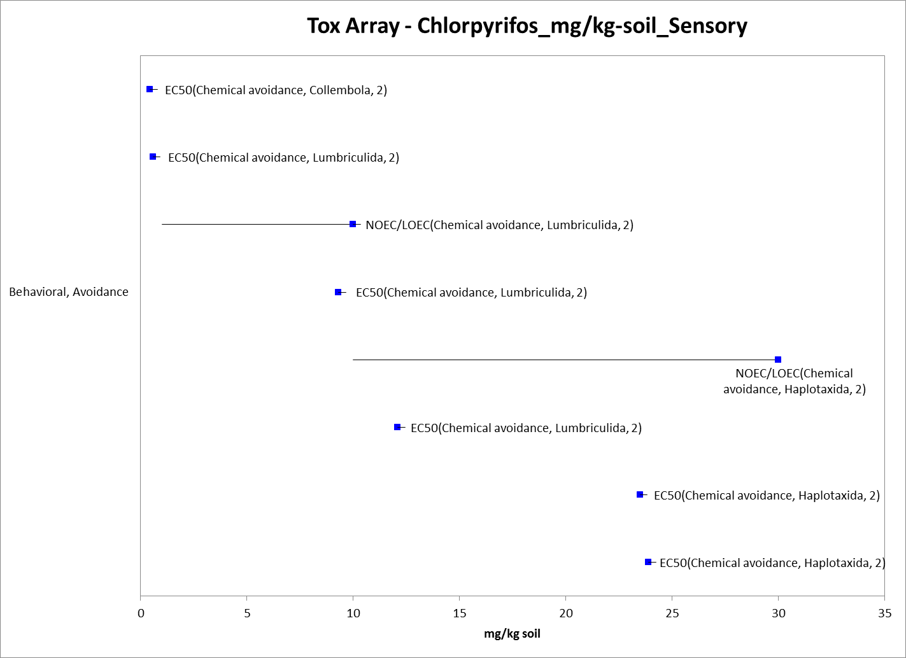
Figure 9-24. Sensory Endpoints for Terrestrial Invertebrates Exposed to Chlorpyrifos (mg/kg-soil). Data label key: Endpoint (measured effect, order, duration in days).

For the exposure unit of ppm, sensory data, all chemical avoidance, are available for 3 orders (i.e., Diptera, Haplotaxida, and Lumbriculida), represented by 3 families and genera and 5 species. Chemical avoidance is seen at concentrations from 0.02 to 1,125 ppm (see Figure 9-25). For the lb a.i./acre exposure unit, sensory data (again, all chemical avoidance) are available for 2 terrestrial invertebrate orders (i.e., Coleoptera and Hymenoptera), represented by 3 families, genera, and species. Effects are seen at concentrations from 1.1 to 18.4 lb a.i./acre (see Figure 9-26).

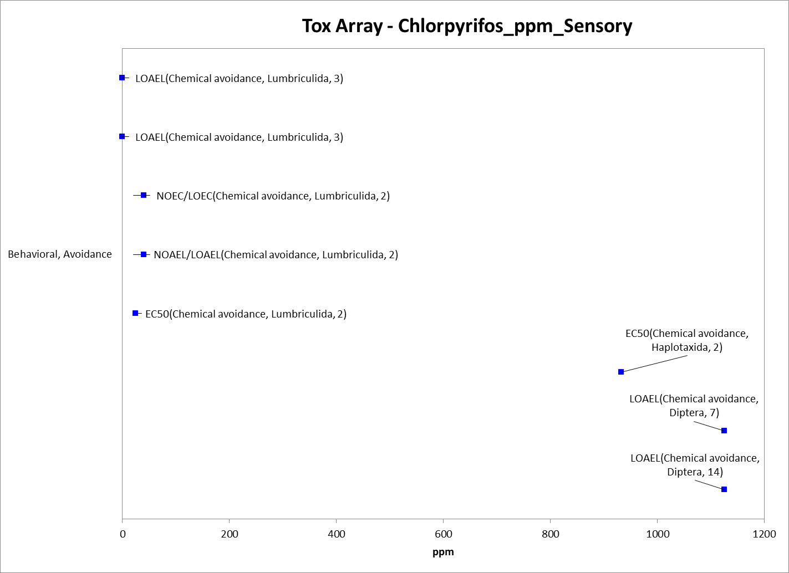
Figure 9-25. Sensory Endpoints for Terrestrial Invertebrates Exposed to Chlorpyrifos (ppm). Data label key: Endpoint (measured effect, order, duration in days).

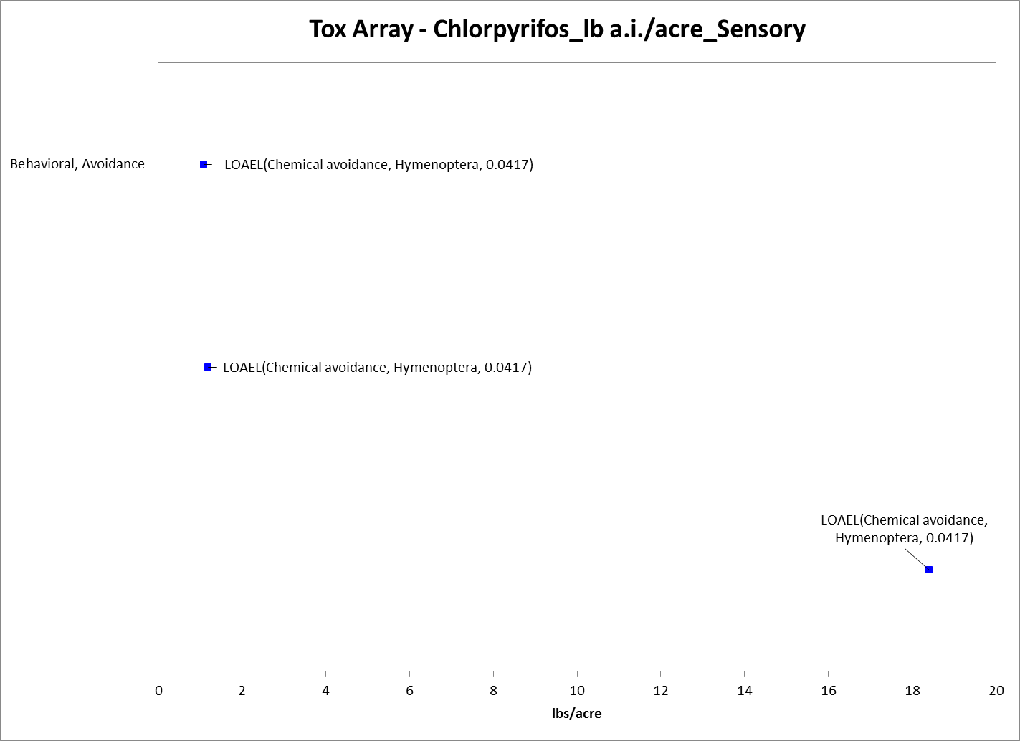
Figure 9-26. Sensory Endpoints for Terrestrial Invertebrates Exposed to Chlorpyrifos (lb a.i./acre). Data label key: Endpoint (measured effect, order, duration in days).

Other Effects Reported for Terrestrial Invertebrates

There are toxicity data available for chlorpyrifos and terrestrial invertebrates in addition to those directly related to mortality, growth, reproduction, behavior, and sensory effects. These are described below. These endpoints generally occur at concentrations similar to those seen for the endpoints discussed above; however, how these endpoints directly relate to mortality, growth, reproduction, behavior, and sensory effects in terrestrial invertebrates is unclear, including those impacting cholinesterase activity. Because chlorpyrifos’s known mode of action in insects is cholinesterase inhibition, there is a potential for the endpoints associated with this effect to be related to mortality or other sub-lethal effects. How the cholinesterase activity endpoints directly relate to the other effects is not clear based on the available data. However, none of the cellular or biochemical endpoints are lower than the most sensitive threshold values (for mortality or sublethal effects) for their respective exposure unit.

For chlorpyrifos and exposure via soil, there are biochemical effects to terrestrial invertebrates that involve differences in cholinesterase and catalase levels and/or enzyme activity (superoxide dismutase) at concentrations from 3 to ~40 m/kg-soil (Figure 9-27). Data are available for 2 orders (i.e., Araneae and Lumbriculida), represented by 2 families, 3 genera, and 3 species.

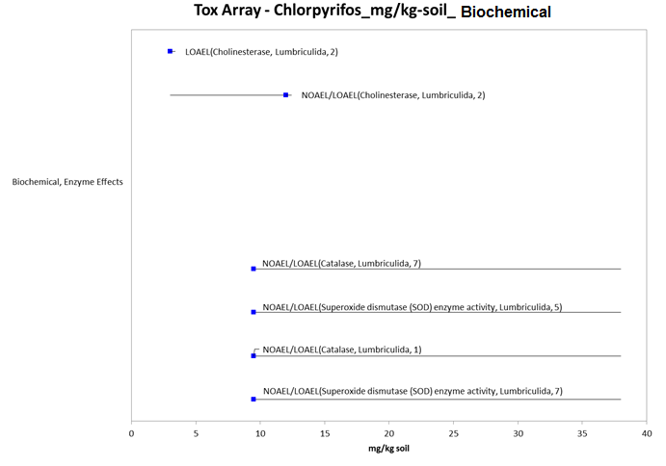
Figure 9-27. Biochemical Endpoints for Terrestrial Invertebrates Exposed to Chlorpyrifos (mg/kg-soil). Data label key: Endpoint (measured effect, order, duration in days).

For the ppm exposure unit, there are cellular/biochemical data available for 3 orders of terrestrial invertebrates (i.e., Hymenoptera, Lumbriculida, and Rhabditida), represented by 3 families, 5 genera, and 7 species. At the cellular/biochemical level, chlorpyrifos is shown to have effects at concentrations from 0.01 to 240 ppm (Figure 9-28). The effects seen include altered gene expression, cellular damage, apoptosis, and changes in enzyme levels (acetylcholinesterase, cholinesterase, and glutathione S-transferase).

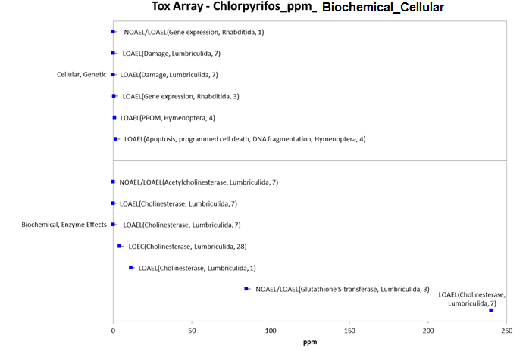
Figure 9-28. Biochemical and Cellular Endpoints for Terrestrial Invertebrates Exposed to Chlorpyrifos (ppm). Data label key: Endpoint (measured effect, order, duration in days).

For the lb a.i./acre exposure unit, biochemical toxicity data are available for 2 orders of terrestrial invertebrate (i.e., Araneae and Lumbriculida), represented by 2 families, genera, and species. The endpoints are for effects to cholinesterase levels that occur at concentrations from 0.7 to ~5 lb a.i./acre (Figure 9-29).
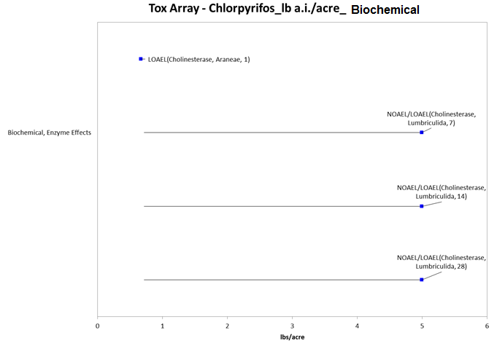
Figure 9-29. Biochemical Endpoints for Terrestrial Invertebrates Exposed to Chlorpyrifos (lb a.i./acre). Data label key: Endpoint (measured effect, order, duration in days).

Effects to Terrestrial Invertebrates Not Included in the Arrays

There are other terrestrial invertebrate data available that are not included in the data arrays because the exposure units are not in or cannot be converted to environmentally-relevant concentrations based on the information in the ECOTOX toxicity table; or, there are NOAEC values available from a study without corresponding LOAEC or IC_{x} values (i.e., there were no effects noted at all in the study).

There are several exposure units listed in the ECOTOX toxicity table that could not be converted to environmentally-relevant units; they include the following: units reported as mass/length (a measurement of mass per unit area is needed); % (including % w/v, and a.i. %), ml/liquid volume (e.g., ml/10L and ml/100L), and those reported as a mass unit alone (e.g., ng and µg).

The types of effects noted in the studies that are in units that could not be converted to environmentally-relevant concentrations are discussed below; these only include effects noted – and do not include those associated with a NOAEC value not associated with a LOAEC or IC_{x} value. See APPENDIX 2-2 for details. At the cellular/biochemical level, effects noted include changes in enzyme levels (i.e., acetylcholinesterase, catalase, cholinesterase, glutathione S-transferase, and superoxide dismutase) and cellular effects (i.e., cell damage, and gene expression). At the organism level, effects noted include behavioral changes (i.e., chemical avoidance, distance moved, feeding behavior, food consumption, number of movements, foraging behavior, and locomotion); reduced growth (i.e., biomass, length, size, weight, and weight gain); physiological changes (i.e., assimilation efficiency); changes in development (i.e., emergence, maturity, pupation); reproductive changes (i.e., gamete production, number of progeny, general reproductive success, and time to first progeny); and mortality (i.e., hatch, knockdown, lifespan, mortality, and survival). Population-level effects include changes in abundance, biomass, level of control, diversity, population growth rate, and sex ratios. Therefore, most of the effects associated with the organism or population are already captured in the terrestrial invertebrate data arrays presented above.

Concentrations Where No Effects Were Observed in Terrestrial Invertebrate Studies

For the environmentally relevant exposure units, there are data available from some studies that show no effects at the concentration(s) tested (in those particular studies). These endpoints include NOAEC/NOAEL and NR-Zero values as reported in ECOTOX. Below is an array for each environmentally relevant exposure unit and the corresponding endpoints for chlorpyrifos and terrestrial invertebrates (except for the mg/kg-bw exposure unit; there are no ‘no effect’ endpoints associated with this unit) (see Figures 9-30 to 9-34). Because of the number of NOAEC/NOAEL/NR-Zero endpoints associated with the lb a.i./acre exposure unit, the figures for that unit have been split into ‘population’ endpoints and ‘non-population’ endpoints.

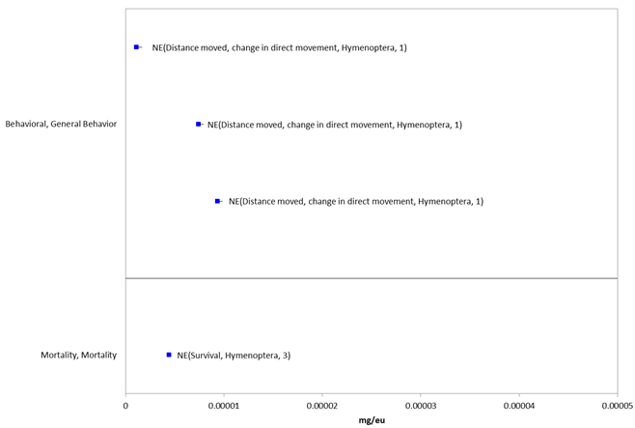
Figure 9-30. Concentrations Where Effects Are Not Seen in Terrestrial Invertebrates Exposed to Chlorpyrifos (mg/e.u.). Data label key: Endpoint (measured effect, order, duration in days). ‘NE’ refers to concentrations where effects were not observed.

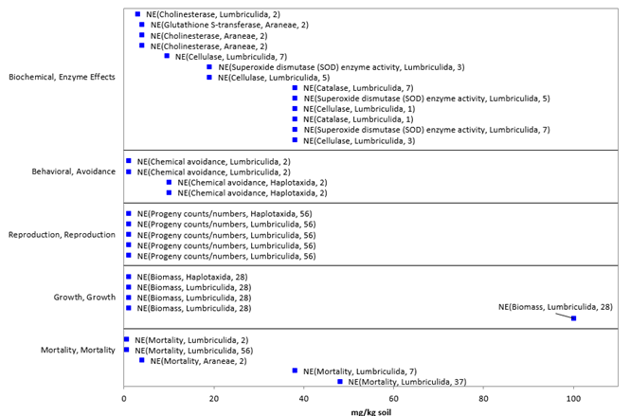
Figure 9-31. Concentrations Where Effects Are Not Seen in Terrestrial Invertebrates Exposed to Chlorpyrifos (mg/kg-soil). Data label key: Endpoint (measured effect, order, duration in days). ‘NE’ refers to concentrations where effects were not observed.
.

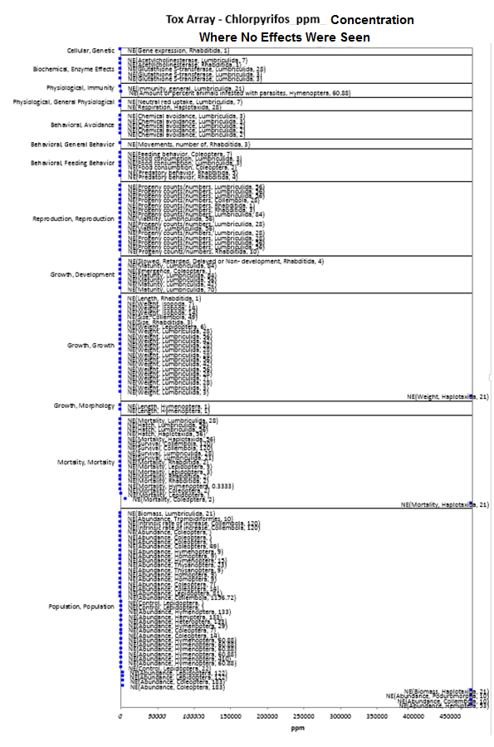
Figure 9-32. Concentrations Where Effects Are Not Seen in Terrestrial Invertebrates Exposed to Chlorpyrifos (ppm). Data label key: Endpoint (measured effect, order, duration in days). ‘NE’ refers to concentrations where effects were not observed.
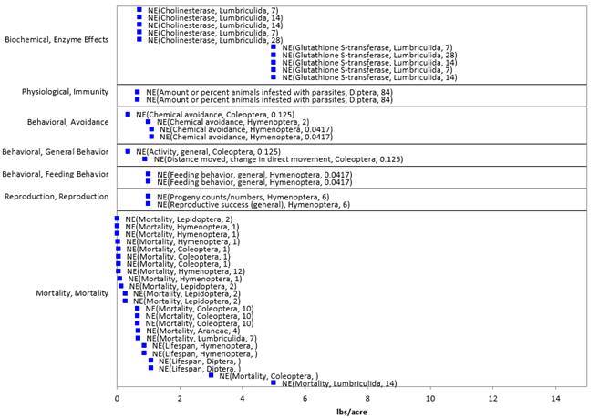
Figure 9-33. Concentrations Where Effects Are Not Seen in Terrestrial Invertebrates Exposed to Chlorpyrifos (lb a.i./acre) (Non-Population Endpoints). Data label key: Endpoint (measured effect, order, duration in days). ‘NE’ refers to concentrations where effects were not observed.

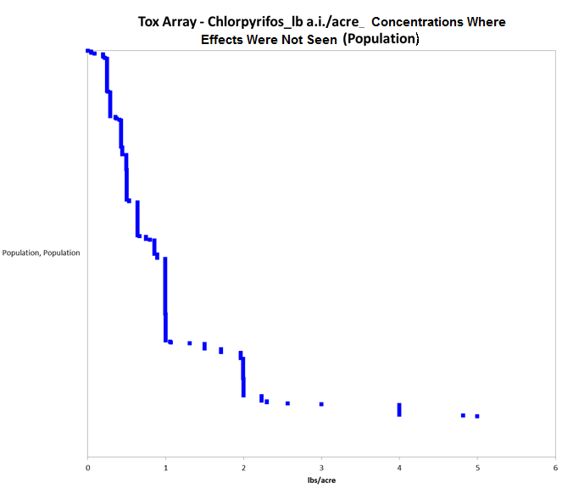
Figure 9-34. Concentrations Where Effects Are Not Seen in Terrestrial Invertebrates Exposed to Chlorpyrifos (lb a.i./acre) (Population Endpoints). For presentation purposes, the labels have been removed from this figure (due to the number of endpoints). Almost all of the endpoints relate to abundance. Additionally, there were 46 endpoints at concentrations > 6 lb a.i./acre (they ranged up to 250 lb a.i./acre) – these were removed for presentation purposes.

Incident Reports for Terrestrial Invertebrates

There are currently (as of March 3, 2015) 36 terrestrial invertebrate incident reports (all for bees) in the EIIS with a certainty index of ‘possible’, ‘probable’ or ‘highly probable’. Of these 36 incidents, 11 are from a registered use, 3 are from a misuse (either accidental or intentional), and in 22 of the incidents, the legality of use was undetermined (see Table 9-9 and ATTACHMENT 1-1 for details). One of these incidents was reported outside of the United States (Brazil). The following discussion only includes those US incident reports with a certainty index of ‘possible’, ‘probable’ or ‘highly probable’ and legality classifications of ‘registered use’ or ‘undetermined’.

The dates of the incident reports range from 1992 to 2012. All of the terrestrial invertebrate incident reports involve honey bees with bees being exposed via spray drift or by foraging on treated plants. Most of the bee incidents are associated with agricultural uses; however, there is one bee incident reported in a residential area. In most cases the chlorpyrifos product involved in the incident is not specified. In approximately half of the incidents, chlorpyrifos was the only pesticide noted in the report; 17 incidents involved other pesticides (including in most cases, other insecticides – see Table 9-9). In many of the incidents, chlorpyrifos residues were detected in bees, wax, and/or honey.

Information is also available from a recent incident involving chlorpyrifos and bees in CA. This incident is in the process of being entered into the EIIS, so the legality of use and certainty classification are not currently available. This incident, from 2014, involved 840 hives that were adjacent to a dormant almond orchard that was treated with chlorpyrifos in CA. The effected bees were foraging on flowering weeds located on the floor of the orchard (the application site).

Table 9-9. Terrestrial Invertebrate Incident Reports from EIIS (Those Classified as ‘Possible’, ‘Probable’, or ‘Highly Probable’ with Legality of Use = ‘Registered’ or ‘Undetermined’).
INCIDENT NUMBER | YEAR | CHEMICAL(S) INVOLVED (PC CODE) | CERTAINTY INDEX (for chlorpyrifos) | STATE | LEGALITY (for chlorpyrifos) | USE SITE | SPECIES AFFECTED | DISTANCE | EFFECT/ MAGNITUDE | PRODUCT
I014409-058 | 1992 | Chlorpyrifos | Possible | WA | Registered use | carrot | Honey bee | Application site (the crop was in bloom at application) | 48 colonies | Not reported (NR)
I014409-059 | 1992 | Chlorpyrifos | Possible | WA | Registered use | Carrot (for seed) | Honey bee | Application site (the crop was in bloom at application) | 72 colonies | NR
I014409-063 | 1992 | Chlorpyrifos | Possible | WA | Registered use | Carrot (for seed) | Honey bee | Application site (the crop was in bloom at application) | ~ 55 colonies | NR
I014407-009 | 1994 | Chlorpyrifos | Probable | WA | Undetermined | NR | Honey bee | Spray drift | 228 colonies | NR (residues detected in dead bees)
 |  | Carbaryl (056801)
I014407-011 | 1994 | Chlorpyrifos | Probable | WA | Undetermined | NR | Honey bee | Unknown | Unknown number | NR (residues detected in dead bees)
I014407-015 | 1994 | Chlorpyrifos | Probable | WA | Undetermined | NR | Honey bee | Unknown | 250 colonies | NR (residues detected in dead bees)
 |  | Carbaryl (056801)
I014407-018 | 1994 | Chlorpyrifos | Probable | WA | Undetermined | Orchard (unspecified) | Honey bee | Application site | 76 colonies | NR (residues detected in dead bees)
I014407-020 | 1994 | Chlorpyrifos | Probable | WA | Undetermined | N/R | Honey bee | Application site | 1000 colonies | NR (residues detected in dead bees)
I003826-010 | 1995 | Chlorpyrifos | Possible | NC | Registered use | ORCHARD | Honey bee | Vicinity | NR | NR (residues detected in dead bees)
 |  | Methyl parathion (053501)
I003826-012 | 1995 | Chlorpyrifos | Possible | NC | Undetermined | N/R | Honey bee | Vicinity | NR | NR (residues detected in dead bees)
 |  | Methyl parathion (053501)
I003826-013 | 1995 | Chlorpyrifos | Probable | NC | Undetermined | Agricultural Area | Honey bee | Vicinity | NR | LORSBAN, PENNCAP-M (residues detected in dead bees)
 |  | Methyl parathion (053501)
I003826-014 | 1995 | Chlorpyrifos | Probable | NC | Undetermined | Orchard (unspecified) | Honey bee | Vicinity | NR | LORSBAN, GUTHION, PENNCAP-M (residues detected in dead bees)
 |  | Methyl parathion (053501)
 |  | Azinphos-methyl (058001)
I014341-006 | 1996 | Chlorpyrifos | Possible | WA | Undetermined | Orchard (unspecified) | Honey bee | Application site | 1256 | NR
 |  | Dimethoate (035001)
I013883-001 | 1997 | Chlorpyrifos | Highly Probable | WA | Registered use | Apple | Honey bee | Spray drift | 90 hives | NR
I013883-031 | 1997 | Chlorpyrifos | Highly Probable | WA | Registered use | Orchard (unspecified) | Honey bee | Application site (application during dandelion bloom and before petal drop) | 84 bee hives | NR
 |  | Carbaryl (056801)
I005980-002 | 1997 | Chlorpyrifos | Probable | CA | Registered use | Agricultural Area | Honey bee | Spray drift | 700 hives | LORSBAN, DIBROM, MONITOR
 |  | Naled (034401)
 |  | Methamidophos (101201)
I014341-008 | 1997 | Chlorpyrifos | Possible | WA | Undetermined | Orchard (unspecified) | Honey bee | Application site | 20 hives | NR
I013884-028 | 1998 | Chlorpyrifos | Possible | WA | Registered use | Orchard (unspecified) | Honey bee | Application site | NR | NR (residues detected in dead bees)
 |  | Dimethoate (035001)
I007834-038 | 1998 | Chlorpyrifos | Possible | CA | Undetermined | Apple orchard | Honey bee | Application site | $98,700 | LORSBAN (applied 3 days prior to bee kill)
I014341-017 | 1998 | Chlorpyrifos | Possible | WA | Undetermined | Bean | Honey bee | Application site | 102 hives | NR (residues detected in dead bees)
 |  | Diazinon (057801)
 |  | Azinphos-methyl (058001)
 |  | Phosmet (059201)
I013884-005 | 1998 | Chlorpyrifos | Probable | WA | Undetermined | NR | Honey bee | Vicinity | ≥ 100 hives | NR (residues detected in dead bees)
 |  | Phosmet (059201)
I016479-001 | 1999 | Chlorpyrifos | Probable | CA | Registered use | Alfalfa | Honey bee | Application site | 164 | LOCK ON, STEWARD (residues detected in dead bees)
 |  | Indoxacarb (067710)
I016478-001 | 2000 | Chlorpyrifos | Probable | CA | Registered use | Alfalfa | Honey bee | Application site | 4 hives | LORSBAN, FURADAN (residues detected in dead bees)
 |  | Carbofuran (090601)
I014341-042 | 2000 | Chlorpyrifos | Probable | WA | Undetermined | NR | Honey bee | Unknown | 96 hives | NR (residues detected in dead bees)
 |  | Carbaryl (056801)
I020998-001 | 2002 | Chlorpyrifos | Possible | WA | Undetermined | Cherry orchard | Honey bee | NR | 4 bee hives | NR
 |  | Thiamethoxam (060109)
I020998-003 | 2002 | Chlorpyrifos | Possible | WA | Undetermined | cherry orchard | Honey bee | NR | NR | NR (chlorpyrifos residues were found in dead bees; thiamethoxam was applied to blooming pears in the area)
 |  | Thiamethoxam (060109)
I020441-001 | 2008 | Chlorpyrifos | Probable | CA | Registered Use | Corn | Honey bee | Spray drift (near the field) and kills within a mile (maybe from contaminated pollen) | 180 bee hives | LORSBAN-4E (corn treated with Lorsban; bees near field almost 100% died; some kills within a mile – stated that corn pollen was the only pollen available in the drought year)
I021587-001 | 2009 | Chlorpyrifos (plus 13 other pesticides – detected in bee tissue and wax) | Possible | UT | Undetermined | Agricultural area | Honey bee | Vicinity | 320 hives | NR (residues detected in dead bees and wax)
I021587-005 | 2009 | Chlorpyrifos (6 other pesticides detected in bee tissue and wax) | Probable | ND | Undetermined | Soybean | Honey bee | Spray drift (chlorpyrifos was applied during bloom to soybean) | 240 colonies | LORSBAN, GOVERN (residues detected in dead bees and wax)
I022297-002 | 2009 | Chlorpyrifos | Probable | CA | Undetermined | Cantaloupe | Honey bee | Vicinity | 32 colonies | Unknown (residues detected in dead bees)
I024936-004 | 2012 | Chlorpyrifos | Possible | CA | Undetermined |  | Honey bee | Residential area | NR | NR (residues detected in wax/honey)
 |  | Coumaphos (036501)
 |  | Fluvalinate (109302)
I024676-014 | 2012 | Chlorpyrifos | Possible | CA | Undetermined | Sugar beet | Honey bee | Vicinity | 132 hives | GOVERN 4E, ASANA (aerial applications of these were made nearby the hives)
 |  | Esfenvalerate (109303)

In addition to the terrestrial invertebrate incident reports available in EIIS, there have also been a total of 4 aggregate ‘Other Non-Target’ (ONT) incidents reported to the Agency. Of these 4, only one is potentially associated with an active registration – the incident notes ‘chlorpyrifos’, but no registration number or product name is provided (3 involve products no longer registered) (see ATTACHMENT 1-1).

Since 1998, incidents that are allowed to be reported aggregately by registrants [under FIFRA 6(a)(2)] as ‘ONT’ include those that are associated with an alleged effect to animals that are not birds, mammals, or fish. It is assumed that most aggregate incidents reported as ONT involve honey bees (although, they may also involve other invertebrates, such as, crayfish). Typically, the only information available for aggregate incidents is the date (i.e., the quarter) that the incident(s) occurred, the number of aggregate incidents that occurred in the quarter, and the PC code of the pesticide and the registration number of the product involved in the incident. Because of the limited amount of data available on aggregate incidents it is not possible to assign certainty indices or legality of use classifications to the specific incidents. Therefore, the incidents associated with currently registered products are assumed to be from registered uses unless additional information becomes available to support a change in that assumption. There is only one aggregate ONT incident associated with chlorpyrifos that potentially involves a currently registered chlorpyrifos product. In this incident, which occurred in 2013, a specific product is not identified.

Summary of Effects to Terrestrial Invertebrates

Most of the toxicity data available for chlorpyrifos and terrestrial invertebrates involve mortality endpoints. In most cases, mortality is actually the most sensitive endpoint available for the different environmentally relevant exposure units. For the exposure unit of ‘mg/kg-soil’, there is a wide range of effects, from biochemical to individual-level effects, and concentrations at which effects occur, from 0.03 mg/kg-soil to 900 mg/kg-soil. The most sensitive LC₅₀ value available is 142 mg/kg-soil for earthworms (Eisenia andrei) (E160284). For the exposure unit of ‘mg/kg-bw’, the only effects data available are LD_{x} values for mortality, all at chlorpyrifos concentrations between 3.16 and 60 mg/kg-bw. For the exposure unit ‘lb a.i./acre’, the most sensitive terrestrial invertebrate NOAEC and LOAEC values are 0.00089 and 0.0046 lb a.i./acre, respectively, for mortality in a parasitoid (Microctonus hyperodae) based on 24-hr exposure to treated ryegrass (E86585). Based on the submitted honey bee data, the LD₅₀ values from the acceptable acute honey bee (contact) studies are 0.059 µg a.i./bee (MRID 05001991) and 0.114 µg a.i./bee (MRID 00066220).

There are far fewer data available for sublethal effects compared to mortality when considering the available terrestrial invertebrate toxicity data for chlorpyrifos. The only exposure units considered here that have growth or reproductive endpoints are the mg/kg-soil unit and the lb a.i./acre. For the ‘mg/kg-soil’ exposure unit, effects to growth are seen at concentrations from 1 to 300 mg/kg-soil. For the lb a.i./acre exposure unit, there are two toxicity endpoints available for growth and terrestrial invertebrates (both are LOAELs related to effects on weight). Both LOAELs are at the 1 lb a.i./acre application rate. Most of the reproductive effects seen in terrestrial invertebrates with exposure to chlorpyrifos involve effects to the number of progeny produced and effects on emergence. For the exposure unit ‘mg/kg-soil’, the most sensitive endpoint available for terrestrial invertebrates is an EC₁₀ value of 0.03 mg/kg-soil for earthworms (Eisenia andrei) for effects on number of young produced (E160284). For the lb a.i./acre exposure unit, effects on reproduction are seen at 0.21 to 0.86 lb a.i./acre. The only exposure unit considered here that had behavioral endpoints was for the lb a.i./acre exposure unit, where there was an effect seen for an activity endpoint in the order Coleoptera, with NOAEL and LOAEL values of 0.33 and 0.67 lb a.i./acre, respectively. Data on sensory endpoints are available for the mg/kg-soil and lb a.i./acre exposure units. For the exposure unit of mg/kg-soil, all of the sensory endpoints available for chlorpyrifos and terrestrial invertebrates are related to chemical avoidance (seen at concentrations from 0.45 to ~30 mg/kg-soil). For the lb a.i./acre exposure unit, effects (chemical avoidance) are seen at concentrations from 1.1 to 18.4 lb a.i./acre.

The types of effects noted in the studies that are in units that could not be converted to environmentally-relevant concentrations include the following: at the cellular/biochemical level, effects noted include changes in enzyme levels (i.e., acetylcholinesterase, catalase, cholinesterase, glutathione S-transferase, and superoxide dismutase) and cellular effects (i.e., cell damage, and gene expression); at the organism level, effects noted include behavioral changes (i.e., chemical avoidance, distance moved, feeding behavior, food consumption, number of movements, foraging behavior, and locomotion); reduced growth (i.e., biomass, length, size, weight, and weight gain); physiological changes (i.e., assimilation efficiency); changes in development (i.e., emergence, maturity, pupation); reproductive changes (i.e., gamete production, number of progeny, general reproductive success, and time to first progeny); and mortality (i.e., hatch, knockdown, lifespan, mortality, and survival). Population-level effects include changes in abundance, biomass, level of control, diversity, population growth rate, and sex ratios. Therefore, most of the effects associated with the organism or population are already captured in the terrestrial invertebrate data arrays presented above. Based on the incident data that are available, the exposure pathways for chlorpyrifos are complete and the exposure levels are sufficient to result in field-observable effects to terrestrial invertebrates (largely based on honey bee incident reports).

Effects Characterization for Terrestrial Plants

Introduction to Terrestrial Plant Toxicity

Chlorpyrifos, unlike many other organophosphate pesticides, is toxic to terrestrial plants, however, its mechanism of action in plants is not well-understood. Most available toxicity studies with plants have focused on growth endpoints, however, there are also data available for describing biochemical, physical, and population-level effects. The available toxicity data available for chlorpyrifos are provided below for terrestrial plants along with a discussion of the available incident reports for chlorpyrifos and terrestrial plants. The discussion of the data is formatted to broadly follow the lines of evidence, specifically those related to growth. These data will be used to help assess the potential for direct effects to listed terrestrial plants and their designated critical habitats (if applicable), and indirect effects for any listed species or critical habitat that relies on terrestrial plants.

Threshold Values for Terrestrial Plants

The threshold values for terrestrial plants are based on experimentally determined endpoints for chlorpyrifos based on varying durations, exposure routes, and study designs. Threshold values for direct and indirect effects are provided in Table 10-1. Most of the threshold values are based on effects to growth (i.e., weight and/or height).

Threshold values and effects data arrays in this assessment are based on endpoints expressed in, or readily converted to, environmentally relevant concentrations (i.e., lb a.i./acre). However, the effects seen using other exposure units are also discussed. Across the exposure unit of lb a.i./acre, toxicity data are available for chlorpyrifos and three different orders of monocotyledon plants (monocots) (i.e., Cyperales, Juncales, and Liliales). Within these orders, toxicity data are available for four different families (i.e., Cyperaceae, Juncaceae, Liliaceae, and Poaceae) represented by 12 genera and 14 species. For dicotyledon plants (dicots), toxicity data are available for the ‘lb a.i./acre’ exposure unit and 10 orders (i.e., Apiales, Asterales, Capparales, Caryophyllales, Fabales, Malvales, Rosales, Rubiales, Solanales, and Violales), represented by 13 families (i.e., Apiaceae, Asteraceae, Brassicaceae, Caryophyllaceae, Chenopodiceae, Convolvulaceae, Cucurbitaceae, Fabaceae, Malvaceae, Rosaceae, Rubiaceae, and Solanaceae), 26 genera, and 31 species.

Because of the variability in study designs and endpoints, it was not possible to derive a species sensitivity distribution with the available plant data. Therefore, the terrestrial plant thresholds are based on the lowest toxicity values available for the taxon (see Table 10-1, and the discussion below). Threshold values are provided in exposure units of ‘lb a.i./acre’ and are provided for pre-emergent (e.g., seedling emergence studies) and post-emergence (e.g., vegetative vigor studies) exposures. Thresholds for all terrestrial plants, as well as for monocots and dicots are provided.

Table 10-1. Thresholds for Chlorpyrifos and Terrestrial Plant Species.
TAXON | THRESHOLD | EXPOSURE | ENDPOINT | EFFECT(S) | SPECIES | STUDY ID | COMMENTS
All Terrestrial Plants¹ | NOAEC/  LOAEC | Pre-emergence | NOAEC - 0.362 lb a.i./acre  LOAEC - 0.724 lb a.i./acre | Reduced weight | Lettuce (Lactuca sativa) | MRID 49307202 | This is a dicot species (20.1 to 36.5% inhibition in the four highest treatment levels
 |  | Post-emergence | 0.125 lb a.i./acre  0.25 lb a.i./acre | Reduced weight | Soybean (Glycine max) | E068422 | This is a dicot species (8% reduction)
All Dicots¹ | IC₂₅ | Pre-emergence | 2.03 lb a.i./acre | Reduced weight | Lettuce (Lactuca sativa) | MRID 49307202 | This is a dicot species
 |  | Post-emergence | >5.7 lb a.i./acre | Reduced weight | Cucumber (Cucumis sativus) | MRID 48602604 | This is a dicot species; the NOAEC is <5.7 lb a.i./acre (13% inhibition in weight)
All Monocots | NOAEC/  LOAEC | Pre-emergence | LOAEC = 0.5 lb a.i./acre | Reduced height | Sorghum (Sorghum bicolor) | E101148 | A more sensitive NOAEC is not available
 |  | Post-emergence | LOAEC = 0.999 lb a.i./acre | Reduced photosynthetic rate and stomatal conductance | Corn  (Zea mays L.) | E064451 | A more sensitive NOAEC is not available
 | IC₂₅ | Pre-emergence | >5.79 lb a.i./acre | None | onion (Allium cepa) | MRID 49307202 | There were no effects noted to monocots in the study
 |  | Post-emergence | >5.7 lb a.i./acre | None | onion (Allium cepa) | MRID 49307201 | There were no effects noted to monocots in the study
¹ The endpoints for ‘All Terrestrial Plants’ and ‘All Dicots’ are the same.

Summary Data Arrays for Terrestrial Plants

The ECOTOX toxicity table available for chlorpyrifos does not distinguish between exposures that are pre-emergent versus those that are post-emergent. Therefore, the data arrays provided below include effects from both pre- and post-emergent exposures.

For terrestrial plants there is a wide range of effects, from biochemical to population-level effects, and concentrations at which effects occur, from 0.125 lb a.i./acre to over 5 lb a.i./acre (see Figure 10-1). Most effects to terrestrial plants occur at chlorpyrifos concentrations between 0.125 and 2 lb a.i./acre (see Figure 10-1). Figure 10-1 is meant to show the distribution of effects to terrestrial plants across different chlorpyrifos concentrations; the specific endpoints are discussed in more detail below (further details can be found in APPENDIX 2-1).

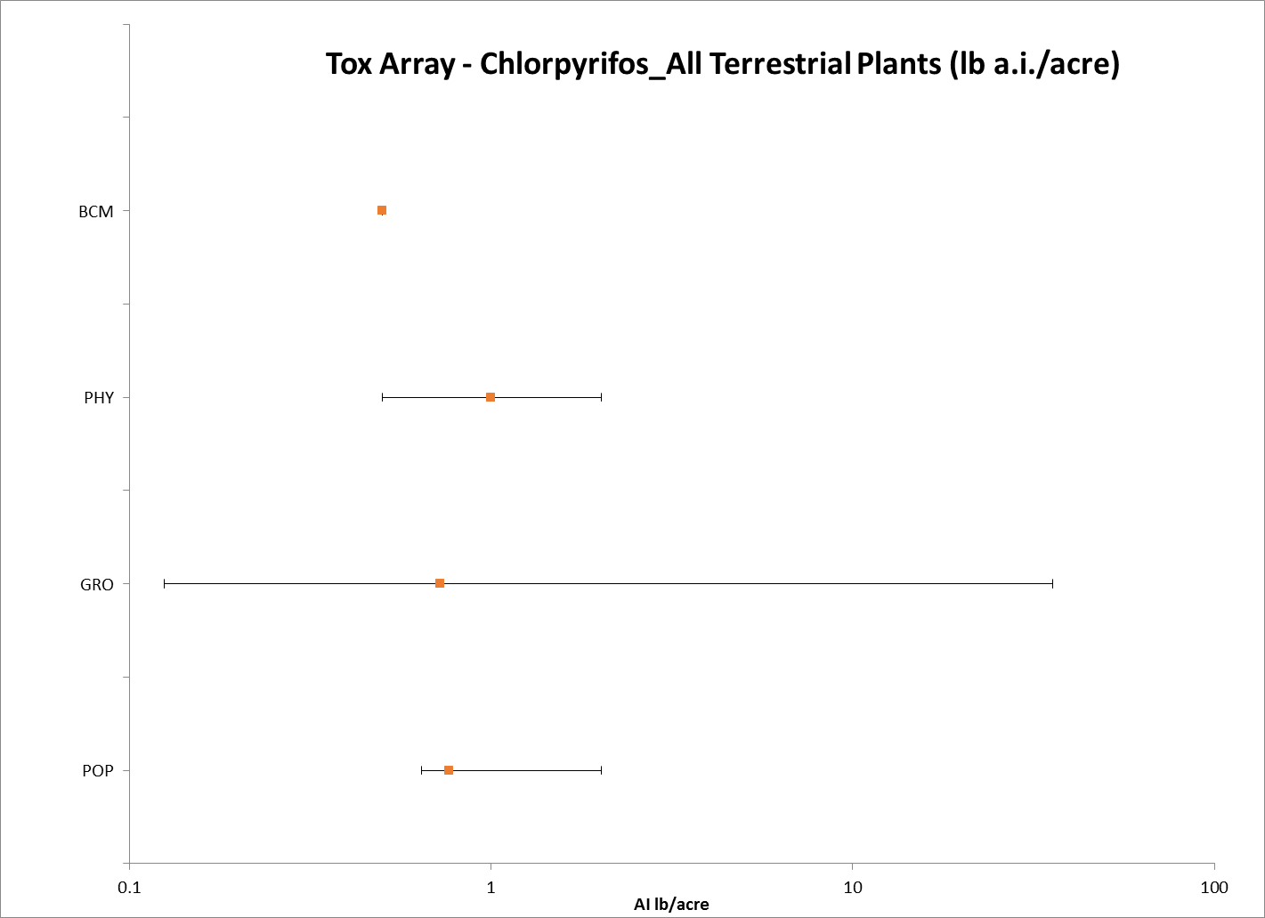
Figure 10-1. Summary Data Array for Terrestrial Plants Exposed to Chlorpyrifos (lb a.i./acre). BCM = biochemical; PHY = physiological; GRO = growth; POP = population. Note that this figure is shown in a logarithmic scale for presentation purposes.

10.4 Lines of Evidence for Terrestrial Plants

Effects on Mortality of Terrestrial Plants

There are currently no toxicity data available for terrestrial plants and chlorpyrifos that have mortality as an endpoint.

Sublethal Effects to Terrestrial Plants

There are only limited data available for effects to terrestrial plants at the cellular/biochemical level. The one biochemical effect seen with chlorpyrifos exposure includes a change in protein content in a dicot (Family: Fabaceae) at an application rate of 0.5 lb a.i./acre (see Figure 10-2).

Regarding whole organism effects to terrestrial plants from chlorpyrifos, most of the endpoints from the available studies occur at application rates of ≤ 2 lb a.i./acre (see Figure 10-2). The IC₂₅ values for decreases in growth (reduced weight) occur at application rates between ~2 lb a.i./acre to ~5 lb a.i./acre. Regarding organismal effects to plants, injury/damage to plants is seen at application rates of ~ 1 to 2 lb a.i./acre (based on the available NOAEL/LOAEL values). Effects to photosynthesis occur at application rates between 0.5 and 1 lb a.i./acre; the one available endpoint for delayed development was seen at 1.2 lb a.i./acre; and changes in growth (weight and/or height) are reported between 0.125 and 1.45 lb a.i./acre (again, based on the available NOAEC and LOAEC values). Population-level effects to terrestrial plants from chlorpyrifos exposure, occur at application rates between 0.64 lb a.i./acre to 2 lb a.i./acre (see Figure 10-2). The types of population-level effects noted to terrestrial plants from chlorpyrifos exposure include changes in abundance and biomass.

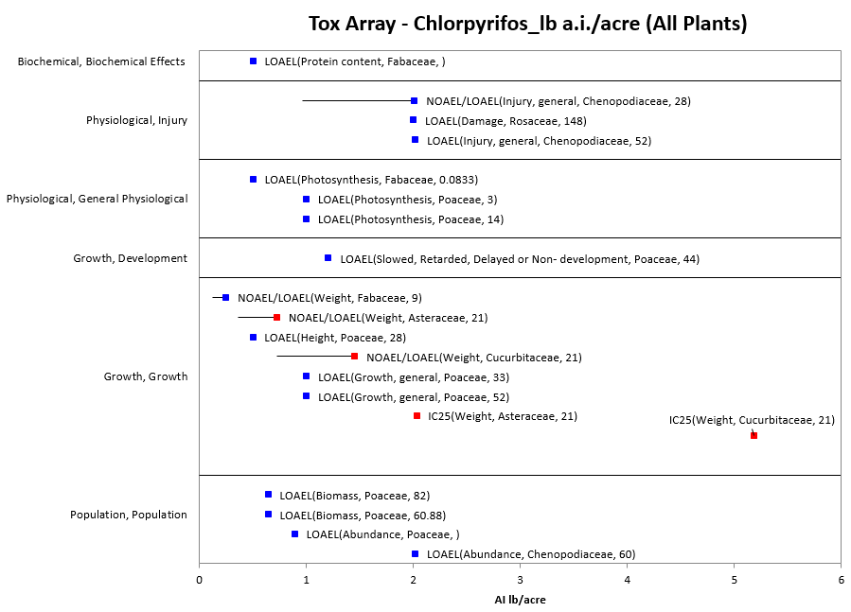
Figure 10-2. Effects Endpoints for Terrestrial Plants Exposed to Chlorpyrifos (lb a.i./acre). Data from registrant submitted (red) and open literature (blue). Data label key: Endpoint (measured effect, family, duration in days).

Sublethal Effects to Terrestrial Plants (Pre-emergence Exposure)

NOAEC/LOAEC Values:

lb a.i./acre:

Based on the available data for terrestrial plants, the most sensitive NOAEC and LOAEC values for chlorpyrifos (with a pre-emergence exposure) are 0.362 lb a.i./acre and 0.724 lb a.i./acre, respectively, based on reduced weight (fresh weight) in lettuce (Lactuca sativa) (MRID 49307202). In this Tier II seedling emergence study, the effect of Lorsban Advanced (GF-2153, EW; 37.9% a.i.) on one monocot [onion (Allium cepa)] and two dicot species [cucumber (Cucumis sativus) and lettuce] was studied at measured concentrations of 0 (negative and solvent control), 0.36, 0.72, 1.45, 2.9, and 5.79 lb a.i./acre. On day-21, the surviving plants per pot were recorded, and plant height and weight were measured. There was no difference in % emergence from control in any species or concentration tested and there were no effects to height or weight in the monocot tested (onion).

For the dicots, there was a statistically significant inhibition (20%) in lettuce height at the highest concentration tested (5.79 lb a.i./acre). For lettuce, there were also inhibitions in weight (range = 20.1 to 36.5% inhibition) at the four highest treatment concentrations tested (0.72, 1.45, 2.9, and 5.79 lb a.i./acre). There were also significant reductions in cucumber weight (inhibitions from 17 – 26%) at the three highest tested concentrations (1.45, 2.9, and 5.79 lb a.i./acre). Therefore, the NOAEC and LOAEC values for all terrestrial plants (pre-emergent exposure) are 0.362 lb a.i./acre and 0.724 lb a.i./acre, respectively.

EC₂₅/IC₂₅ Values:

(lb a.i./acre):

Based on the available data for terrestrial plants, the most sensitive EC₂₅/IC₂₅ for chlorpyrifos (pre-emergent exposure) is 2.03 lb a.i./acre based on reduced weight (fresh weight) in lettuce (Lactuca sativa) (MRID 49307202). In this study, the effect of Lorsban Advanced (GF-2153, EW; 37.9% a.i.) on the seedling emergence of one monocot [onion (Allium cepa)] and two dicots [cucumber (Cucumis sativus) and lettuce] was studied at measured concentrations of 0 (negative and solvent control), 0.36, 0.72, 1.45, 2.9, and 5.79 lb a.i./acre. On day-21, the surviving plants per pot were recorded, and plant height and weight were measured. There were no noted effects to the monocot tested (onion), resulting in NOAEC and IC₂₅ values of 5.79 and >5.79 lb a.i./acre, respectively.

For the dicots tested, the IC₂₅ values for lettuce and cucumber are 2.03 lb a.i./acre and 5.15 lb a.i./acre, respectively. The NOAEC and LOAEC values for lettuce are 0.362 lb a.i./acre and 0.724 lb a.i./acre, respectively, based on reduced weight (fresh weight) (see above). For cucumber, the NOAEC and LOAEC values are 0.724 lb a.i./acre and 1.45 lb a.i./acre, respectively, also based on reduced weight (fresh weight).

Sublethal Effects to Terrestrial Plants (Post-emergence Exposure)

NOAEC/LOAEC Values:

lb a.i./acre:

The lowest NOAEC and LOAEC values for terrestrial plants and chlorpyrifos (post-emergent exposure) are for a percent reduction in fresh weight in the dicot, soybean (Glycine max) (NOAEC = 0.125 lb a.i./acre; LOAEC = 0.25 lb a.i./acre) (E068422). In this study, soybeans were exposed to single chemicals (thifensulfuron, carbaryl, chlorpyrifos, malathion, and methomyl) and combinations of these insecticides with thifensulfuron (an herbicide) – formulations were not specified. Pesticidal combinations were also tested with kochia and yellow foxtail (species not specified). At harvest, injury was estimated visually (0% = no injury to 100% = complete necrosis), and fresh weight of shoots was determined after removal at soil level. For chlorpyrifos, there were no statistically significant differences from control in percent injury at any concentration tested. There was a 7, 8, and 9% reduction in weight at the 0.125, 0.25. and 0.5 lb/acre concentrations, respectively, when compared to controls. The differences were statistically significant from controls at the 0.25 and 0.5 lb/acre concentrations, resulting in NOAEC and LOAEC values of 0.125 lb/acre and 0.25 lb/acre, respectively, based on a reduction in weight.

EC₂₅/IC₂₅ Values:

lb a.i./acre:

Based on the available vegetative vigor data for terrestrial plants, definitive IC₂₅ values could not be determined for the monocot or dicot species tested (all of the available IC₂₅ values are ‘greater than’ values). In a Tier I vegetative vigor study, Lorsban Advanced, GF-2153 (39.7% a.i.) was tested at a concentration of 5.7 lb a.i./acre in monocot (onion, Allium cepa; corn, Zea mays; ryegrass, Lolium perenne; and oat, Avena sativa) and dicot (cucumber, Cucumis sativus; cabbage, Brassica oleracea; lettuce, Lactuca sativa; carrot, Daucus carota; soybean, Glycine max; and tomato, Lycopersicon esculentum) crops (MRID 48602604). Survival was not affected for any species tested. The % inhibition of fresh weight in the treated species as compared to the control ranged from -2 to 24% for treatment with 5.7 lb a.i./acre and ranged from -17-31% for the 5.7 + 1% adjuvant treatments.

The most sensitive monocot species was oat, based on reduced height, resulting in a NOAEC of <5.7 lbs a.i./acre and an EC₂₅ value >5.7 lb a.i./acre. The most sensitive dicot species was cucumber, based on fresh weight, resulting in a NOAEC of <5.7 lbs ai/acre and an EC₂₅ value of >5.7 lb a.i./acre. Although other endpoints had higher inhibitions, cucumber fresh weight and oat height were the only species that were statistically different from the control. For oat, there was an 11% inhibition in shoot length, and for cucumber there was a 13% inhibition in fresh weight. The only species that had a reported inhibition that was greater than 25% was the onion (31 % based on fresh weight with the 5.7 lb a.i. + 1% adjuvant/acre treatment), however due to high variability, this effect was not statistically significant when compared to controls.

The onion test was repeated in a Tier II study because the power in the Tier I test was insufficient to pick up a 31% reduction in fresh weight compared to the control. In the Tier II study (MRID 49307201), inhibition in onion height ranged from 1-5% and weight was mostly promoted in treated conditions (with a single inhibition <3% at the 2.90 lbs a.i./acre level). There were no significant effects observed for onion at any treatment level; therefore, the NOAEC and EC/IC₂₅ values are 5.79 and >5.79 lb a.i./acre, respectively.

Sublethal Effects to Terrestrial Plants (Monocots)

For monocot plants, there are no data available for chlorpyrifos at the cellular/biochemical level. Although toxicity data with a lb a.i./acre exposure unit are available for 4 different families (i.e., Cyperaceae, Juncaceae, Liliaceae, and Poaceae), effects are only reported in Poaceae. Regarding whole organism effects, effects to photosynthesis are seen at 0.999 lb a.i./acre; delayed development is seen at 1.2 lb a.i./acre; and growth effects are seen at concentrations between 0.5 and 1.0 lb a.i./acre (see Figure 10-3). At the population level, chlorpyrifos has been shown to have effects on biomass at a concentration of 0.64 lb a.i./acre and abundance at 0.89 lb a.i./acre.
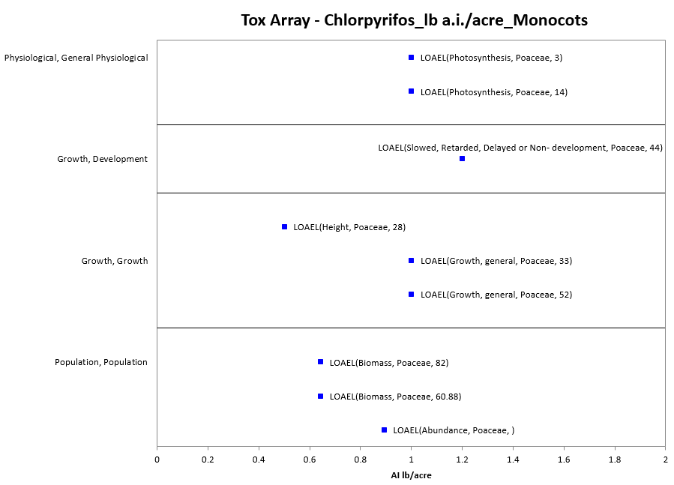
Figure 10-3. Effects Endpoints for Monocots Exposed to Chlorpyrifos (lb a.i./acre). Data label key: Endpoint (measured effect, family, duration in days).

NOAEC/LOAEC Values:

Pre-emergence (lb a.i./acre):

The lowest NOAEC/LOAEC value for monocot plants and chlorpyrifos with exposure units in lb a.i./acre is 0.5 lb a.i./acre based on reduced plant height in sorghum (Sorghum bicolor) (E101148). This study was conducted to determine the efficacy of selected insecticides for the management of red fire ants in no-till sorghum (Sorghum bicolor). Field plots of sorghum were treated with chlorpyrifos (various application methods and formulations). Chlorpyrifos was applied in the following formulations and application methods (% a.i. was not reported): Lorsban 15G (applied at plant, T-band; 0.5 lb a.i./acre), Lorsban 4EC (applied at plant, in-furrow spray; 0.5 lb a.i./acre), Lorsban 4EC (applied preplant, spray; 0.5 lb a.i./acre), and Lorsban 50SL (seed treatment; 8.00 oz of formulation/cwt – the % a.i. was not reported so the lb a.i./acre fr the seed treatment could not be calculated). Plant stand densities and plant heights were recorded on Day 21 and Day 27, respectively.

None of the seed yields for plots treated with chlorpyrifos differed significantly from the controls (see Table 10-2). Regarding stand density (number of plants/ft), none of the chlorpyrifos treatments differed significantly from the controls except for the Lorsban 4EC preplant spray treatment (0.5 lb a.i./acre) which had a statistically significantly higher stand density than the control. For plant height (inches per plant), the plant heights in the plots treated with chlorpyrifos using an in-furrow at plant spray (0.5 lb a.i./acre) were statistically significantly shorter than the plant heights in the control plots. There were no other differences among the control plots and any of the other chlorpyrifos treatments in plant height.

Table 10-2. Results for Effects of Chlorpyrifos on Sorghum Plants.
Treatment/ Formulation | Rate (lb a.i./acre) | Application Method | Stand Density (no./ft) | Plant Height (in/plant) | Seed Yield (lb/acre)
Lorsban 15G | 0.50 | T-Band at plant (granules) | 3.93 | 7.54 | 6,253
Lorsban 4EC | 0.50 | In-furrow spray at plant | 2.69 | 7.16* | 5,907
Lorsban 4EC | 0.50 | Pre-plant spray | 4.82* | 8.51 | 6,117
Lorsban 50SL | 8.00¹ | Seed treatment | 3.80 | 7.63 | 6.22
Control | N/A | N/A | 3.44 | 8.22 | 5,569
¹ This is in ounces of formulation/cwt (100 weight of seed); since the 5 a.i. for the formulation was not provided, this rate could not be converted to a lb a.i./acre rate.
* = the results are different than the control.

Post-emergence (lb a.i./acre):

The lowest NOAEC/LOAEC value for chlorpyrifos and monocot plants from post-emergence exposure is a LOAEC of 0.999 lb a.i./acre in corn (Zea mays L.) based on reduced photosynthetic rate and reduced stomatal conductance (E064451). In this study, effects of several pesticides to field corn (Zea mays L.) were assessed over two years [both soil incorporated (granular) and foliar (spray) applications were tested]. The results of the foliar portion for chlorpyrifos are reported here, because they represent the lowest endpoint for post-emergence exposure for a monocot.

The research was conducted near Mead, Nebraska. The corn (‘Pioneer 3377’) was planted on May 10 1988 and May 17 1989 at 60500 kernels/ha. Chlorpyrifos (Lorsban 4E, % a.i. not specified) was applied at a rate of 1.12 kg a.i./ha (0.999 lb a.i./acre). Pesticides were applied to an 11-m long row of four blocks in a randomized complete block design. Corn physiological parameters were evaluated with a portable photosynthesis system. In 1988, the foliar-applied chemicals were quantified at day 4, 10, and 14 after the first application (precipitation necessitated a second application 10 days after the first application; after the second plant physiological evaluation). In 1989, physiological evaluations were made at 3 and 8 days following the spray applications. Analyses were conducted using SAS [ANOVA (general linear models)] (alpha = 0.05).

In 1988, within the first 10 days after the first application, there were no effects on photosynthetic rate in corn treated with chlorpyrifos (see Table 10-3). Three days after the second chlorpyrifos application (and 14 days after the initial application), there was a statistically significant decrease in photosynthetic rate (a decrease of 7.2% when compared with controls). In 1989, a significant decrease in photosynthetic rate (~20%) occurred 3 days after the foliar application of chlorpyrifos. At 8 days following the application, there was no difference from the controls.

In 1988 and 1989, chlorpyrifos statistically significantly reduced the stomatal conductance in corn on day 14 (1988) and days 3 and 8 (1989). Therefore, the LOAEC value in this study is 0.999 lb a.i./acre.

Table 10-3. Effects of Foliar-Applied Chlorpyrifos on Corn (0.999 lb a.i./acre).
Treatment | Days After Treatment
 | 1988 |  |  | 1989
 | 4 | 10 | 14 | 3 | 8
Photosynthetic rate (µmol m⁻² s⁻¹)
Chlorpyrifos (Lorsban 4E) | 44.9 | 48.3 | 38.6* | 49.3* | 52.0
Control | 44.0 | 49.4 | 41.6 | 61.0 | 53.6
Stomatal conductance (mol m⁻² s⁻¹)
Chlorpyrifos (Lorsban 4E) | 0.48 | 0.40 | 0.35* | 0.51* | 0.45*
Control | 0.44 | 0.43 | 0.39 | 0.63 | 0.52
* = statistically significantly different from controls.

EC₂₅/IC₂₅ Values:

Pre-emergence (lb a.i./acre):

In a Tier I seedling emergence study, the effects of Lorsban Advanced, GF-2153 (39.7% a.i.) was tested on several monocots [corn (Zea mays); ryegrass (Lolium perenne); and oat (Avena sativa)] (MRID 48602603). In this study, there were no effects to the monocots tested at application rates of 5.6 lb a.i./acre in any of the endpoints measured (% emergence, shoot length, or fresh weight), resulting in IC₂₅ and NOAEC values of >5.6 and 5.6 lb a.i./acre, respectively. Because only three monocot species, instead of four, were tested, an additional seedling emergence study (Tier II) for onion was conducted. In this study, there were no effects on onion at any concentration tested, up to 5.79 lb a.i./acre; resulting in IC25 and NOAEC values of >5.79 and 5.79 lb a.i./acre (MRID 49307202) (see above).

Post emergence (lb a.i./acre):

In a Tier 1 vegetative vigor study with Lorsban Advanced, GF-2153 (39.7% a.i.), the IC₂₅ values for the monocots tested [onion (Allium cepa); corn (Zea mays); ryegrass (Lolium perenne); and oat (Avena sativa)] were all > 5.7 lb a.i./acre (the only concentration tested) (MRID 48602604). There was a statistically significant difference in height in oats (11% inhibition when compared to controls), resulting in a NOAEC of <5.7 lb a.i./acre for this species. The NOAEC values for all of the other monocot species tested were 5.7 lb a.i./acre. There was a 31% inhibition in fresh weight for onions when compared to controls, however, due to variation in the study this was not statistically significantly different from controls. Because the inhibition was >25% in this species, a Tier 2 study was completed for onions.

In the Tier 2 vegetative vigor study (MRID 49307201), inhibition in onion height was not dose-dependent and ranged from 1-5%, relative to the negative control. Onion weight was mostly promoted in treated conditions, relative to the negative control, with a single inhibition <3% at the 2.90 lbs a.i./acre level. There were no significant effects observed for onion at any treatment level; therefore, the most sensitive endpoint could not be determined due to a lack of toxicity with NOAEC and EC/IC₂₅ values of 5.79 and >5.79 lb a.i./acre, respectively.

Sublethal Effects to Terrestrial Plants (Dicots)

For dicots, chlorpyrifos had effects on protein content at a concentration of 0.5 lb a.i./acre (see Figure 10-4). At the organism level, chlorpyrifos caused injury in some species of dicot plants at concentrations between 1 and 2 lb a.i./acre; affected photosynthesis at a concentration of 0.5 lb a.i./acre; and impacted growth at concentrations between 0.125 lb a.i./acre and ~1.5 lb a.i./acre, based on NOAEC/LOAEC values. The available IC₂₅ values for dicots, based on growth, occur at concentrations of ~2 and 5 lb a.i./acre. Population level effects involved a change in abundance at a concentration of 2 lb a.i./acre.

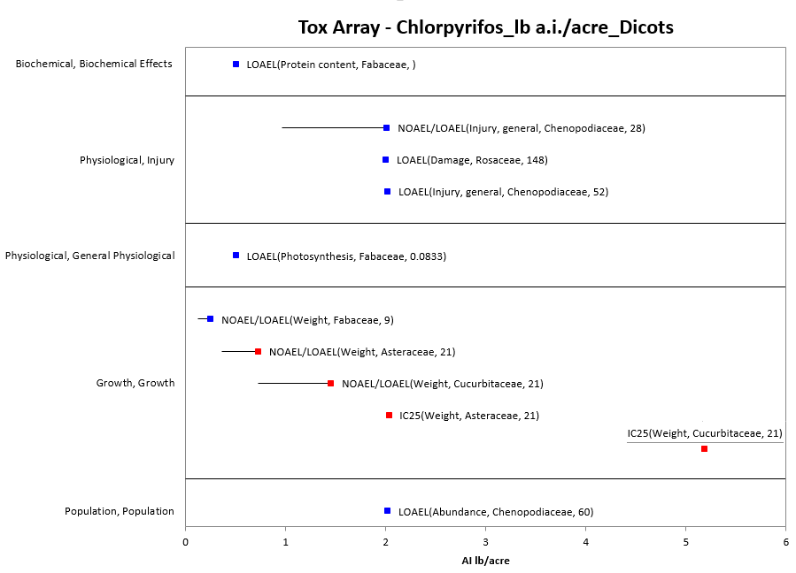
Figure 10-4. Effects Endpoints for Dicots Exposed to Chlorpyrifos (lb a.i./acre). Data from registrant submitted (red) and open literature (blue). Data label key: Endpoint (measured effect, family, duration in days).

NOAEC/LOAEC and EC₂₅/IC₂₅ Values:

The thresholds for dicot terrestrial plants and chlorpyrifos are the same as the ‘All Terrestrial Plant’ thresholds [i.e., Pre-emergence: NOAEC and LOAEC values of 0.362 lb a.i./acre and 0.724 lb a.i./acre based on reduced weight in lettuce (Lactuca sativa)(MRID 49307202) and IC₂₅ = 2.03 lb a.i./acre based on reduced weight in lettuce (Lactuca sativa) (MRID 49307202)]; Post-emergence: NOAEC and LOAEC values of 0.125 lb a.i./acre and 0.25 lb a.i./acre based on reduced weight in soybean (Glycine max)(E068422) and IC₂₅ > 5.7 lb a.i./acre based on reduced weight in cucumber (Cucumis sativus) (MRID 48602604)] (see above).

Effects to Terrestrial Plants Not Included in the Arrays

There are other terrestrial plant data available that are not included in the data arrays because the exposure units are not in or cannot be converted to environmentally-relevant concentrations based on the information in the ECOTOX toxicity table; there are NOAEC values available from a study without corresponding LOAEC or IC_{x} values (i.e., there were no effects noted at all in the study); and/or the data are from species other than monocots or dicots.

Exposure units listed in the ECOTOX toxicity table that could not be converted to environmentally-relevant units include the following: units related to seed treatments (since non-target seeds would not be treated with chlorpyrifos in the same way as a ‘seed treatment), units reported as mass/eu (’eu’ refers to ‘experimental unit’, and it is not clear what the unit is – e.g., single plant, field, acre, etc.); units reported as mass/length (a measurement of mass per unit area is needed); units reported as a volume/area (it is not clear how much mass is in the volume); and % or ‘ppm’ (‘ppm’ refers to ‘parts per million’; ppm and % can actually be reflective of different, specific concentration units - e.g., concentrations in soil, concentrations in the formulation applied, etc.)].

The types of effects noted in the studies that are in units that could not be converted to environmentally-translatable concentrations are discussed below. See APPENDIX 2-2 for details. At the cellular/biochemical level, effects noted include changes in dehydroascorbatase, proline, acetylene reduction rate, chromosomal aberrations, dmrt1 mRNA, micronuclei, and mitotic index. At the organism level, effects noted include abnormal, emergence, height, length, size, vigor, weight, damage, photosynthesis, stomatal conductance, symptom severity index, and germination. Population-level effects include changes in abundance, biomass, and weight. Therefore, most of the effects associated with a whole organism or population are already captured in the terrestrial plant data arrays presented above.

Regarding the effects data available for non-dicot and non-monocot plants, most of the available endpoints are associated with NOAEC values (i.e., no effects noted after exposure to chlorpyrifos). For moss, there is one data point – a NOAEL for a population effect (i.e., cover) in Bryophyta (species not reported) at a concentration of 0.64 lb a.i./acre. There were effects on length noted for grassland plants (Angiosperms, species not specified) with a granular treatment of chlorpyrifos at 0.11 lb a.i./acre. There are also data available for conifers: no effect in slash pine (Pinus elliottii) at concentrations up to 12.9 lb a.i./acre. Also, for conifers, there were some effects noted in studies with units that could not be converted to environmentally-relevant concentrations with the information available in the ECOTOX table: growth and reproductive effects in Aleppo pine (Pinus halepensis) (ppm); however, there were no effects noted in juniper (Juniperus pfitzeriana) (ppm). For other species, there were no effects noted to baby rubber trees (Peperomia obtusifolia) from chlorpyrifos exposure (ppm).

Concentrations Where No Effects Were Observed in Terrestrial Plant Studies

For the exposure unit lb a.i./acre (including both monocots and dicots), there are studies where effects were not seen at the concentration(s) tested (in those particular studies). The endpoints that relate to these concentrations include NOAEC/NOAEL and NR-Zero values as reported in ECOTOX. Below are the data arrays showing these endpoints for chlorpyrifos and monocots, dicots, and ‘other plants’ (see Figures 10-5 to 10-8). The ‘other plants’ are discussed further in the following section. Because of the number of NOAEC/NOAEL/NR-Zero endpoints associated with the lb a.i./acre exposure unit and dicots, the data arrays for dicots have been split into ‘non-population-’ and ‘population-level’ endpoints.

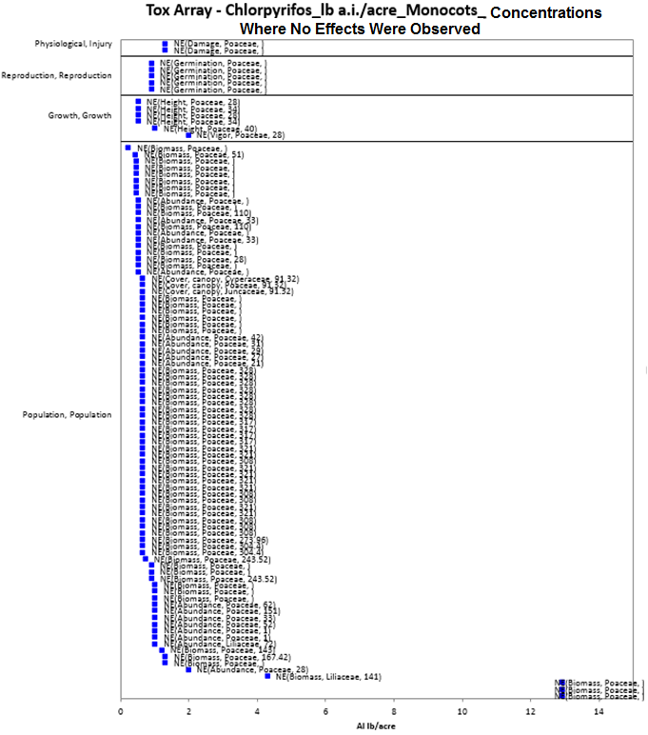
Figure 10-5. Concentrations Where Effects Are Not Seen in Monocots Exposed to Chlorpyrifos (lb a.i./acre). Data label key: Endpoint (measured effect, family, duration in days). ‘NE’ refers to concentrations where effects were not observed.
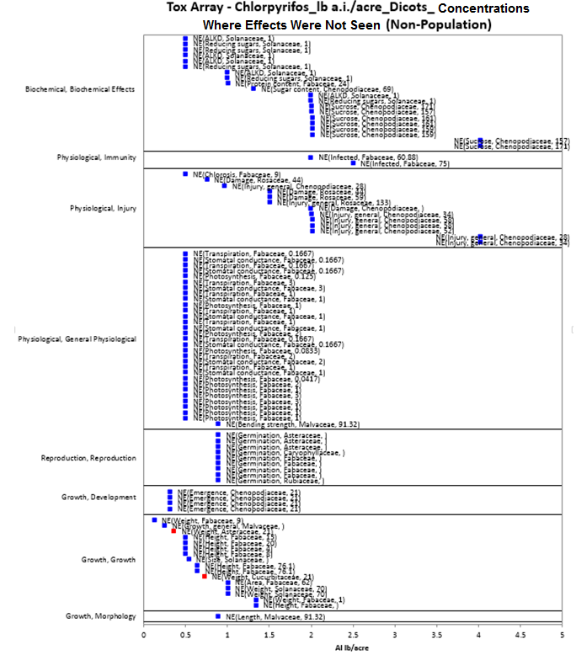
Figure 10-6. Concentrations Where Effects Are Not Seen in Dicots Exposed to Chlorpyrifos (lb a.i./acre) (Non-Population Effects). Data from registrant submitted (red) and open literature (blue). Data label key: Endpoint (measured effect, family, duration in days). ‘NE’ refers to concentrations where effects were not observed.
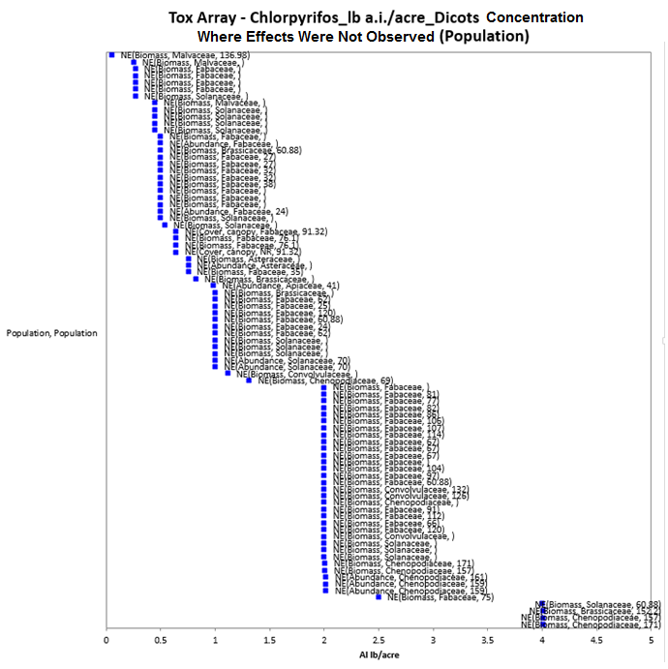
Figure 10-7. Concentrations Where Effects Are Not Seen in Dicots Exposed to Chlorpyrifos (lb a.i./acre) (Population Effects). Data label key: Endpoint (measured effect, family, duration in days). ‘NE’ refers to concentrations where effects were not observed.

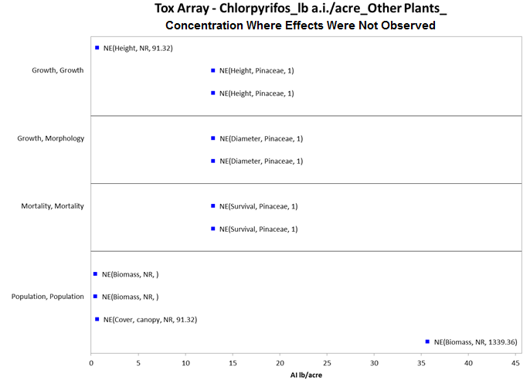
Figure 10-8. Concentrations Where Effects Are Not Seen in Other Plants (Non-Monocots and Non-Dicots) Exposed to Chlorpyrifos (lb a.i./acre). Data label key: Endpoint (measured effect, family, duration in days). ‘NE’ refers to concentrations where effects were not observed.

Incident Reports for Terrestrial Plants

There are currently (as of January 27, 2015) 43 terrestrial plant incident reports in the EIIS with a certainty index of ‘possible’, ‘probable’ or ‘highly probable’. Of these 43 incidents, 33 are from a registered use, 5 are from a misuse (either accidental or intentional), and in 5 of the incidents, the legality of use was undetermined (see Table 10-4 and ATTACHMENT 1-1 for details). The following discussion only includes those incident reports with a certainty index of ‘possible’, ‘probable’ or ‘highly probable’ and a legality classification of ‘registered use’ or ‘undetermined’.

The dates of the incident reports range from 1990 to 2010. Most of the terrestrial plant incident reports involve damage to the crop treated (i.e., from direct application). There is one report associated with spray drift, in which a wide area use (mosquito control) was reported to have damaged trees in a homeowner’s yard (I016728-002). There is also one report involving damage to alfalfa plants that was attributed to carryover [i.e., effects to newly planted alfalfa were attributed to a previous application of chlorpyrifos and permethrin to alfalfa on the same field (PC Code 109701)]. Most of the terrestrial plant incident reports are associated with Lorsban 4E (a flowable formulation); however, there are also a few reports associated with Lorsban 15G (a granular formulation). In a few cases the product is not specified beyond ‘Lorsban’. There is also a single report each associated with Homedef Ortho-Klor and Mosquitomist Two U.L.V. In most of the incidents, chlorpyrifos was the only pesticide noted in the report; however, twelve incidents involved other pesticides (including in some cases, herbicides – see Table 10-4). Therefore, in 12 of the incidents the specific effects to plants from chlorpyrifos use are unclear (especially for the reports associated with herbicides). Registration numbers are rarely provided in the EIIS database; however, based on the product names in the reports, it is assumed that all of the incidents involve currently registered products except for the incident involving Homedef Ortho-Klor (I009262-104).

Table 10-4. Terrestrial Plant Incident Reports from EIIS (Those Classified as ‘Possible’, ‘Probable’, or ‘Highly Probable’ with Legality of Use = ‘Registered’ or ‘Undetermined’).
INCIDENT NUMBER | YEAR | CHEMICAL(S) INVOLVED (PC CODE) | CERTAINTY INDEX | STATE | LEGALITY | USE SITE | SPECIES AFFECTED | DISTANCE | EFFECT/ MAGNITUDE | PRODUCT
I010927-002 | 1990 | Chlorpyrifos | Possible | CA | Registered | Orange | Orange | Direct application | Plant damage/30 acres | LORSBAN 4E
I002413-001 | 1995 | Chlorpyrifos | Possible | MI | Registered | Field | Blue Spruce | Vicinity | Loss of needles/NR | LORSBAN 4E
I007701-001 | 1996 | Chlorpyrifos | Probable | CO | Registered | Winter wheat | Winter wheat | Direct application | Plant damage and Yield loss/NR | LORSBAN
I006189-001 | 1997 | Chlorpyrifos | Probable | ND | Registered | Sugar Beet | Sugar Beet | N/R | Restricted roots and reduced stand count/NR | LORSBAN 15G
I006189-002 | 1997 | Chlorpyrifos | Probable | IA | Registered | Corn | Corn | N/R | Plant damage/NR | LORSBAN 15G
I006189-003 | 1997 | Chlorpyrifos | Probable | IA | Registered | Corn | Corn | N/R | Stunted growth/NR | LORSBAN 15G
I006194-001 | 1997 | Chlorpyrifos | Probable | WI | Registered | Alfalfa | Alfalfa | Direct application | Plant damage/NR | LORSBAN 4E
I006194-002 | 1997 | Chlorpyrifos | Probable | CA | Registered | Alfalfa | Alfalfa | Direct application | Curling, twisting, and leaf spotting/NR | LORSBAN 4E
I006194-003 | 1997 | Chlorpyrifos | Probable | AR | Registered | Corn | Corn | Direct application | Poor germination/NR | LORSBAN 4E
I006194-004 | 1997 | Chlorpyrifos | Probable | NY | Registered | Onion | Onion | Direct application | Stunted growth/NR | LORSBAN 4E
I006194-005 | 1997 | Chlorpyrifos | Probable | NY | Registered | Onion | Onion | Direct application | Uneven stand and growth/NR | LORSBAN 4E
I006194-006 | 1997 | Chlorpyrifos | Probable | NY | Registered | Onion | Onion | Direct application | Height and stand differences/NR | LORSBAN 4E
I007357-001 | 1998 | Chlorpyrifos | Probable | CA | Registered | Alfalfa | Alfalfa | Direct application | Foliage damage/NR | LORSBAN 4E
I007740-001 | 1997 | Chlorpyrifos | Possible | CA | Registered | Cotton | Cotton | Direct application | Bronzing/82 ACRES | LORSBAN 4E
 |  | Propargite (097601)
 |  | amitraz (106201)
I007755-015 | 1998 | Chlorpyrifos | Possible | MN | Registered | Corn | Corn | Direct application | Reduced emergence/ 300 ACRES | LORSBAN 15G
I007755-016 | 1998 | Chlorpyrifos | Possible | OR | Registered | Sugar beet | Sugar beet | Direct application | Mortality (30%)/40 ACRES | LORSBAN
I008078-001 | 1998 | Chlorpyrifos | Possible | IA | Registered | Corn | Corn | Direct application | Reduced yield/50 ACRES | LORSBAN 4E
I008078-002 | 1998 | Chlorpyrifos | Possible | IA | Registered | Corn | Corn | Direct application | Reduced yield/50 ACRES | LORSBAN 4E
I012366-026 | 1998 | Chlorpyrifos | Probable | MI | Undetermined | Blue spruce | Blue spruce | Direct application | Needle burn/82 acres (tree farm) | LORSBAN 4E
 |  | Bromoxynil (035301)
I009262-104 | 1999 | Chlorpyrifos | Probable | IL | Undetermined | Ornamental | Ornamental | Direct application | Mortality/ALL (home garden) | HOMEDEF ORTHO-KLOR
I009508-001 | 1999 | Chlorpyrifos | Probable | IA | Registered | Corn | Corn | Direct application | Plant damage/147 ACRES | LORSBAN 4E
I010927-003 | 1999 | Chlorpyrifos | Possible | WI | Registered | Alfalfa | Alfalfa | Carryover | Plant damage/NR | LORSBAN 4E
 |  | Permethrin (109701)
I010927-001 | 2000 | Chlorpyrifos | Possible | IA | Registered | Corn | Corn | Direct application | Mortality/70 acres | LORSBAN 15G
 |  | Nicosulfuron (129008)
 |  | Rimsulfuron (129009)
 |  | Flumestsulam (129016)
 |  | Dimethenamid (129051)
 |  | Clopyralid (117403)
I013563-010 | 2000 | Chlorpyrifos | Possible | CA | Registered | Orange | Orange | Direct application | Plant damage/10 acres | LORSBAN 4E
 |  | Dicofol (010501)
I011117-012 | 2000 | Chlorpyrifos | Probable | CO | Registered | Corn | Corn | Direct application | Plant damage/NR | LORSBAN 4E
 |  | Tank mix (other pesticides not reported)
I012366-025 | 2000 | Chlorpyrifos | Possible | CA | Undetermined | Cotton | Cotton | Direct application | Burnt leaves and reduced yield/140 acres | LORSBAN 4E
 |  | Naled (034401)
I013636-025 | 2001 | Chlorpyrifos | Possible | TN | Registered | Corn | Corn | Direct application | Plant damage/80 acres | LORSBAN 4E
 |  | Atrazine (080803)
 |  | Clopyralid (117403)
 |  | Acetochlor (121601)
 |  | Rimsulfuron (129009)
 |  | Flumestsulam (129016)
 |  | Nicosulfuron (129008)
I012366-027 | 2001 | Chlorpyrifos | Possible | SD | Undetermined | Corn | Corn | Direct application | Plant damage/140 acres | LORSBAN 4E
 |  | Diflufenzopyr (005108)
 |  | Dicamba (029807)
 |  | Atrazine (080803)
I012366-073 | 2001 | Chlorpyrifos | Probable | IL | Registered | Corn | Corn | Direct application | Plant damage/20 acres | LORSBAN 4E
 |  | Clopyralid (117403)
 |  | Flumestsulam (129016)
I013636-037 | 2001 | Chlorpyrifos | Possible | CA | Registered | Orange | Orange | Direct application | Plant damage (ridging)/135 acres | LORSBAN
I013636-039 | 2001 | Chlorpyrifos | Possible | CA | Registered | Orange | Orange | Direct application | Plant damage (ridging)/110acres | LORSBAN 4E
I013636-001 | 2002 | Chlorpyrifos | Possible | MO | Registered | Corn | Corn | Direct application | Plant damage/72 acres | LORSBAN 4E
 |  | Atrazine (080803)
 |  | Clopyralid (117403)
 |  | Acetochlor (121601)
 |  | Flumestsulam (129016)
I013636-034 | 2002 | Chlorpyrifos | Possible | CA | Registered | Orange | Orange | Direct application | Plant damage (ridging)/90 acres | LORSBAN 4E
I013636-035 | 2002 | Chlorpyrifos | Possible | CA | Registered | Orange | Orange | Direct application | Plant damage (ridging)/10 acres | LORSBAN 4E
I013636-036 | 2002 | Chlorpyrifos | Possible | CA | Registered | Orange | Orange | Direct application | Plant damage (spotting)/21 acres | LORSBAN 4E
 |  | Fenbutatin-oxide (104601)
 |  | Spinosad (110003)
I014702-051 | 2002 | Chlorpyrifos | Possible | CA | Registered | Orange | Orange | Direct application | Plant damage (ridging)/40 acres | LORSBAN
I014867-001 | 2003 | Chlorpyrifos | Possible | OR | Registered | Onion | Onion | Direct application | Reduced emergence/ NR | LORSBAN-4E
I016728-002 | 2005 | Chlorpyrifos | Possible | IL | Undetermined | Wide area (residential) | Trees (species not reported) | Spray drift | Plant damage/NR | Mosquitomist Two U.L.V

In addition to the terrestrial plant incident reports available in EIIS, there have also been a total of 69 aggregate plant incidents reported to the Agency. Of these 69, 7 are associated with active registrations (62 involve products no longer registered) (see ATTACHMENT 1-1 and Table 10-5).

Since 1998, plant incidents that are allowed to be reported aggregately by registrants [under FIFRA 6(a)(2)] include those that are associated with an alleged effect to plants that involves less than 45 percent of the acreage exposed to the pesticide. Typically, the only information available for aggregate incidents is the date (i.e., the quarter) that the incident(s) occurred, the number of aggregate incidents that occurred in the quarter, and the the PC code of the pesticide and the registration number of the product involved in the incident. Because of the limited amount of data available on aggregate incidents it is not possible to assign certainty indices or legality of use classifications to the specific incidents. Therefore, the incidents associated with currently registered products are assumed to be from registered uses unless additional information becomes available to support a change in that assumption.

Table 10-5. Aggregate Plant Incidents for Chlorpyrifos Involving Currently Registered Products.
PRODUCT REGISTRATION NUMBER | PRODUCT NAME | NUMBER OF AGGREGATE PLANT INCIDENTS | YEAR(S)
062719-00220 | Lorsban-4E | 4 | 1999 (3), 2000 (1)
062719-00072 | Dursban 50W | 1 | 2000
062719-00034 | Lorsban 15G | 1 | 2002
008329-00018 | Mosquitomist Two U.L.V. | 1 | 2005

Summary of Effects to Terrestrial Plants

Chlorpyrifos shows some toxicity to terrestrial plants, however, its mechanism of action in plants is not well-understood. For terrestrial plants there is a wide range of effects, from biochemical to population-level effects, and concentrations at which effects occur, from 0.125 lb a.i./acre to over 5 lb a.i./acre (most effects occur at concentrations between 0.125 and 2 lb a.i./acre). There are currently no chlorpyrifos toxicity data available for terrestrial plants and mortality, and there are only limited data available for effects to terrestrial plants at the cellular/biochemical level. The one biochemical effect seen with chlorpyrifos exposure includes a change in protein content in a dicot (Family: Fabaceae) at an application rate of 0.5 lb a.i./acre. The IC₂₅ values for decreases in growth (reduced weight) occur at application rates between ~2 lb a.i./acre to ~5 lb a.i./acre, and injury/damage to plants is seen at application rates of ~ 1 to 2 lb a.i./acre (based on the available NOAEL/LOAEL values). Population-level effects occur at application rates between 0.64 lb a.i./acre to 2 lb a.i./acre. The types of population-level effects noted to terrestrial plants from chlorpyrifos exposure include changes in abundance and biomass. Based on the incident data that are available, the exposure pathways for chlorpyrifos are complete and the exposure levels are sufficient to result in field-observable effects to terrestrial plants.

References:

For Full MRID citations, see Appendix 2-4.

For full ECOTOX citations, see Appendix 2-2.

Green AS, Chandler, GT (1996) Life Table Evaluation of Sediment-Associated Chlorpyrifos Chronic Toxicity to the Benthic Copepod, Amphiascus tenuiremis. Arch. Environ. Contam. Toxicol. (31), 77-83

Green AS, Chandler, GT, Piegorsch WW (1996) Life-stage Specific Toxicity of Sediment-Associated Chlorpyrifos to a Marine Infaunal Copepod. Environ. Toxicol. Chem. Vol 15 (7), pp 1182-1188

Last chlorpyrifos refresh, May 17, 2013

