Appendix 4-7. Refined risk analysis for 13 listed birds exposed to chlorpyrifos

- Introduction

The Terrestrial Investigation Model (TIM, version 3.0 beta) is a multimedia exposure/effects model that can be used to address avian mortality levels from acute pesticide exposure in generic or specific species over a user-defined exposure window. The time frame corresponds to one growing season of the treated crop or a single sub-annual pesticide application window. The spatial scale is at the field level, but specific field dimensions are undefined. In the current application of TIM, it is assumed that the model accounts for variability among fields and represents risks to listed birds exposed to chlorpyrifos on different fields and orchards that are treated at the same rates and methods. It is assumed that the field and surrounding area meet habitat and dietary requirements for the modeled species. During the simulation, birds use the treated field and edge habitat to meet their requirements for food and water. TIM also accounts for exposure via dermal and inhalation routes for birds on the field or for adjacent habitat that receives spray drift. It is expected that the relative importance of these routes of exposure will vary based on the properties of the pesticide, its use, as well as the characteristics of the simulated bird species. Risk, expressed as a function of exposure (dose) and toxicity, is assessed for liquid spray applications of a pesticide made to vegetation or bare ground in the field. Pesticide application methods that may be modeled in TIM v.3.0 include: aerial, ground broadcast, air blast, ground banded and ground in furrow. For all of these application methods, exposure can be assessed on the treated field and edge habitat where spray drift is transported. The model does not currently account for exposures due to seed treatments or granular formulations. A detailed description of TIM is available online at: http://www.epa.gov/pesticide-science-and-assessing-pesticide-risks/models-pesticide-risk-assessment#tim.

The MCnest (Markov Chain nest productivity) model, is a refined risk assessment model for estimating the chronic impact of pesticides on the reproductive success of bird populations (i.e., fecundity). This analysis relies upon an integrated application where MCnest utilizes the same exposure estimates generated by TIM (for individual birds and their offspring). MCnest integrates multiple effects (lines of evidence) attributed to pesticide toxicity (i.e., mortality, reproduction and behavior) along with life history characteristics of specific listed species.

This analysis includes a refined risk assessment for a subset of listed birds that are listed in Table B 4-7.1. This analysis was conducted using the Terrestrial Investigation Model and MCnest. For chlorpyrifos, “Likely to Adversely Affect” (LAA) determinations are made for all 13 species based on the weight of evidence analysis conducted using the Terrestrial Effects Determination (TED) tool. The purpose of this refined analysis is to explore the utility of currently available probabilistic, refined methods for use in biological evaluations of listed species. There is also potential utility for use of these methods in the biological opinions for these species. Only a subset of species were selected to demonstrate proof of concept and explore applications of the models that may inform future method development and identification of data needs.

Table B 4-7.1. Listed species that are included in this refined risk assessment.
Scientific Name | Common Name | Entity ID
Ammodramus savannarum floridanus | Florida grasshopper sparrow | 133
Amphispiza belli clementeae | San Clemente sage sparrow | 116
Coccyzus americanus | Yellow-billed Cuckoo (Western DPS) | 6901
Colinus virginianus ridgwayi | Masked bobwhite (quail) | 89
Dendroica chrysoparia | Golden-cheeked warbler (=wood) | 139
Empidonax traillii extimus | Southwestern willow flycatcher | 149
Pipilo crissalis eremophilus | Inyo California towhee | 137
Polioptila californica californica | Coastal California gnatcatcher | 145
Setophaga kirtlandii (= Dendroica kirtlandii) | Kirtland's Warbler | 94
Tympanuchus cupido attwateri | Attwater's greater prairie-chicken | 83
Tympanuchus pallidicinctus | Lesser prairie-chicken | 2691
Vireo atricapilla | Black-capped Vireo | 138
Vireo bellii pusillus | Least Bell's vireo | 123

As described in ATTACHMENT 1-16, selected species are consistent with the current domains of TIM and MCNest (i.e., diets include arthropods or terrestrial plants, reproduction based on 2 parents) and their breeding range is located in the 48 contiguous states. The gunnison sage grouse (Centrocercus minimus; entity ID 4064) was not included because the parameters used to represent the life history of this species are still under development. The other two species that are not included here represent separate populations of the greater sage-grouse (Centrocercus urophasianus). These were excluded here because they are no longer candidates for listing.

This analysis focuses on a refined risk assessment for direct effects to listed birds, including effects to mortality, growth, reproduction and behavior. This analysis does not consider indirect effects due to declines in prey or impacts to habitat.

Section 2 of this report describes the input parameters used in TIM and MCnest to simulate specific species and properties of chlorpyrifos, including use, fate and toxicity. Section 3 includes the results and discussion of the TIM/MCnest model runs for the 13 species.

- TIM and MCnest input parameters

For those species with individuals potentially exposed to chlorpyrifos, TIM and MCnest are run to estimate the probability and magnitude of mortality and decline in fecundity. This section describes the input parameters used to simulate the specific species, uses of chlorpyrifos and toxicity and physical/chemical properties of chlorpyrifos.

  - Species Life History

A species library has been developed to designate model parameters which are intended to be representative of the diets, body weights and reproductive timing associated with each species considered in this assessment. These parameter values are defined in Supplemental Information 1, along with source information.

  - Number of birds simulated

In order to sufficiently capture the stochasticity incorporated into TIM and MCnest, 10,000 individual birds are simulated initially. The fraction of mortality in these birds is used to calculate the probability associated with different magnitudes of mortality among exposed birds (referred to in model documentation as a “flock”). For this analysis, a flock size of 100 is used (as it represents percent).

  - Exposure routes simulated

TIM has the ability to account for exposures via multiple routes, including diet, drinking water, dermal and inhalation. Acute oral toxicity data with birds indicate that chlorpyrifos is very highly toxic via the oral route (chapter 2). This suggests that dietary and drinking water routes are potentially of concern. Toxicity data are not available for inhalation exposures involving birds; however, in an acute inhalation study with laboratory rats, no mortality was observed at 0.2 mg a.i./mL-air (200 mg/m³) (MRID 00146507) which is equivalent to >5,000 mg a.i./kg bw . Due to a lack of observed toxicity in this study, inhalation exposure is not considered to be of concern for this analysis.

The version of TIM/MCnest used in this assessment does not consider several possible routes of exposure, including ingestion of or dermal contact with contaminated soil.

One notable uncertainty associated with exposure through consumption of arthropods is the conservative nature of the residues. Since TIM is used to simulate exposures and resulting risks on a field scale, the arthropod residue values were selected to represent a 90th percentile field/orchard. For cases where risks are assessed to a small number of individuals exposed (e.g., <10), this conservative approach is not as influential on confidence in risk conclusions (as it is possible that they are only being exposed on one field). When a larger number of individuals is exposed, a landscape level approach is more appropriate, where individuals within the population are exposed to chlorpyrifos on multiple fields. In that case, it is unlikely that all individuals will be exposed to chlorpyrifos on 90th percentile fields. Therefore, there may be an overestimation in risk to the number of individuals impacted (overestimate in probabilities of mortality and fecundity declines). Since this analysis relies upon a beta version of TIM and MCnest, this uncertainty may be explored in future updates to the model.

  - Simulated Uses

Chlorpyrifos is used on a wide variety of terrestrial food and feed crops, terrestrial non-food crops, greenhouse food/non-food, and non-agricultural indoor and outdoor sites. A detailed description of the specific uses is provided in the problem formulation (APPENDIX 1-3). For each species, three uses are modeled for this analysis, mosquito adulticide, wide area and pasture, which generally have the highest degree of overlap with the ranges of the 13 species. Modeled uses and applications are listed in Table B 4-7.2. Maximum application rates corresponding to those uses are simulated.

Table B 4-7.2. Simulated uses for all species.

Use | Application rate (lb a.i./A) | Number of applications¹ | Application interval (days) ² | Type of application | Simulated Time frame
Mosquito Adulticide | 0.01 | 5 | 1 | Aerial | May – September
Wide Area | 1 | 5 | 30 | Ground
Pasture (Alfalfa) | 1 | 4 | 10 | Aerial
¹Maximum number of applications allowed in TIM-MCnest is 5; however, higher yearly application numbers are permitted for mosquito adulticide and wide area uses (mosquito adulticide can be applied up to 26 times and wide area use is undefined on label).
²For wide area use, retreatment interval not specified; assumed one application per month (30 days is the general recommended retreatment interval on label, but could be applied more frequently).

Mosquito Adulticide

Mosquito adulticide applications are made as an ultra-low volume (ULV) spray. This option is not available for TIM MCnest, so the aerial application with very fine to fine droplet spectrum is selected. An application efficiency factor was used in other analyses conducted for the mosquito adulticide use in the assessment (see Appendix 4.5). Initial analyses with TIM MCnest (results not shown) indicated little to no effect when an application efficiency factor was applied. Given the uncertainty in the efficiency factor methodology, analyses shown here use the labeled application rate (0.01 lb a.i./A) without an efficiency factor applied.

Timing of application does not impact TIM outputs; however it has a substantial influence on MCnest estimates of fecundity. A range of dates (from May-September) are simulated to explore the influence of application timing on fecundity.

Wide Area Use

Wide area uses for chlorpyrifos include general outdoor use for insect control at an application rate of 1 lb a.i./A via ground methods. A retreatment interval of 30 days is used for the analysis based on labeled recommendations. An initial application date of May 1 with 5 retreatments is simulated.

Pasture Uses

For pasture uses, applications may be made via aerial or ground spray. Given common practices, it is expected that aerial application will be the most likely method for pastures, and therefore, this method is simulated using TIM/MCnest.

A crop height of 1 m will be used for pastures and other crops. Since inhalation exposure is not of concern for chlorpyrifos, the crop biomass parameter is not needed, so a value of 1 will be used.

Timing of application does not impact TIM outputs; however it has a substantial influence on MCnest estimates of fecundity. In cases where MCnest is run for a species, a range of dates (from May-September) are simulated to explore the influence of application timing on fecundity.

  - Frequency on Field (FOF)

Frequency on field (FOF) is the amount of time in a simulation that a bird spends on the treated field. TIM requires input values for mean, minimum and maximum FOF values in order to generate a beta pert distribution of FOF values for the simulated species of birds. For each simulated bird, a unique FOF value is selected from this distribution. For this analysis, the species habitat and its relationship to potential chlorpyrifos use sites is used to derive the FOF parameters for each simulated species.

Based on the available information on species habitats (Table B4-7.3), and the modeled applications for chlorpyrifos, all of the simulated species could be expected to use chlorpyrifos target areas. Due to expected variability in species exposure to mosquito adulticide and wide area uses, the FOF values for mean, minimum and maximum values of the distribution will be 0.5, 0 and 1 to simulate a range of exposure to species on the field or target area. Higher on-field values may occur for some of the pasture uses for some species (e.g., Attwater’s prairie chicken, lesser prairie chicken, and the masked bobwhite). For all species, FOF values were altered in the excel spreadsheet representing the species library for the TIM-MCnest tool (provided on the provisional models page). Each of these species may also be exposed to chlorpyrifos through spray drift to edge habitats.

Table B 4-7.3. Habitat descriptions of 13 species.
Scientific Name | Common Name | Habitat*
Ammodramus savannarum floridanus | Florida grasshopper sparrow | large (>50 ha), treeless, relatively poorly-drained grasslands that have a history of frequent fires
Amphispiza belli clementeae | San Clemente sage sparrow | Canyon shrub/woodland and maritime desert scrub boxthorn habitat
Coccyzus americanus | Yellow-billed Cuckoo (Western DPS) | Open woodland with clearings and scrubs that are associated with watercourses. Breeds in riparian areas.
Colinus virginianus ridgwayi | Masked bobwhite (quail) | savanna grasslands
Dendroica chrysoparia | Golden-cheeked warbler (=wood) | Forest
Empidonax traillii extimus | Southwestern willow flycatcher | Breeding: Forested wetlands or scrub-shrub wetlands-dense riparian habitat of rivers, swamps, wetlands, lakes  Wintering: brushy savanna edges, second growth, shrubby clearings and pastures, woodlands near water
Pipilo crissalis eremophilus | Inyo California towhee | Riparian – nest and forage in areas of dense riparian vegetation dominated by willows, Fremont cottonwood, and desert olive with associated rubber rabbit brush and squaw waterweed. Also nest in shrubs of the upland community adjacent to riparian habitat
Polioptila californica californica | Coastal California gnatcatcher | Coastal scrub vegetation communities
Setophaga kirtlandii (= Dendroica kirtlandii) | Kirtland's Warbler | Forests
Tympanuchus cupido attwateri | Attwater's greater prairie-chicken | Grasslands and open space, woodland, brushland, fallow land, cultivated land
Tympanuchus pallidicinctus | Lesser prairie-chicken | shrub-mixed grass habitat associated with sandy soil; Mixed grass prairie and conservation reserve program land
Vireo atricapilla | Black-capped Vireo | Forest grassland ecotone; deciduous/evergreen shrubland
Vireo bellii pusillus | Least Bell's vireo | Woodland including cotton-wood willow forest, Oak wood lands, and mule fat scrub;  Scrub vegetation; Palm groves and hedgerows associated with agricultural fields and residential areas;  Breed in riparian habitat, typically inhabiting structurally diverse woodlands along watercourses
*Species specific sources provided in ATTACHMENT 1-16.

  - Pesticide Characteristics (Fate and Effects)

The chlorpyrifos specific input parameters that are used to define the physical, chemical and transport properties that define the fate of chlorpyrifos are provided in Table B 4-7.4. Several of these parameter values were selected to be consistent with the values used in aquatic models.

Table B 4-7.4. Fate input parameter values used for chlorpyrifos.
Parameter | Value | Source/comments
Pesticide half-life in puddles (days) | 170 | Table 3-5 of Chapter 3 (exposure characterization for chlorpyrifos)
Koc (L/kg-oc) | 6040 | Table 3-5 of Chapter 3
Kow | 50118 | Table 3-5 of Chapter 3
Henry’s law constant (atm/m3-mol) | 6.2E-06 | Calculated using the following formula  HENRY = (VP/760)/(Solubility/MW)  (TIM manual, appendix A), where:  MW = 330.36 g/mol (Table 3-5, chapter 3)  VP= 4×10⁻⁵ torr (Table 3-5, chapter 3)
Solubility in water (mg/L) | 1.40E+00 | Table 3-5 of Chapter 3
Dislodgeable foliar residue adjustment factor | 0.62 | Default (TIM manual, appendix A)
Dermal adsorption fraction | 1 | Default (TIM manual, appendix A)
Contaminated fractions of food items | 1 | Assume that 100% of food items are treated. Default (TIM manual, appendix A)
Half-life on food items (days) | 4 | Only two values (4, 2.9) reported by Willis and McDowell (1987) on corn and cotton; 4 used as higher value and not enough values available for statistical analysis.

Tables B 4-7.5 and B 4-7.6 include the parameter values used in TIM and MCnest to define the toxicity of chlorpyrifos. The results generated by TIM are sensitive to avian acute oral LD50 and the foliar dissipation half-life. Therefore, available alternative values are explored in this analysis in order to capture the influence of variability in the chlorpyrifos data on the model’s predictions. Different LD50 values are used in the analysis but only one foliar dissipation half-life is available so this parameter is not varied. Although the model is also sensitive to the fraction of the pesticide retained on an hourly basis, data are not available to determine chemical-specific variability in this parameter value.

Table B 4-7.5. TIM toxicity input parameter values used for chlorpyrifos.
Parameter (units) | Value | Source/comments
Avian acute oral LD50 (mg a.i./kg-bw) | 6.6, 23.4 and 83.3 | HC5, HC50 and HC95 from SSD used to bracket risk results. Details on the SSD are provided in Appendix 2-9.
Body weight of animals from LD50 (g) | 100 | SSD scaled to 100 g
Mineau scaling factor | 1.1573 | Chlorpyrifos specific value from Mineau et al. 1996.
Slope of avian oral LD50 | 4.5 (default) | Only 1 slope is available (2.9) for 1 avian species, but from upper end of SSD range (~HC95). Default value used for analysis.
Avian acute inhalation LD50 (mg a.i./kg-bw) (enter 0 if no value is available) | 0 | No value is available for chlorpyrifos.
Rat inhalation LD50 (mg a.i./kg-bw) | >5,000 | MRID 00146507
Rat acute oral LD50 (mg a.i./kg-bw) | 137 | MRID 41334607
Chemical specific avian dermal LD50 (enter 0 if no value is available) | 0 | No value is available for chlorpyrifos
Food matrix adjustment factor | 1 | Default (See TIM manual, appendix A)
Fraction of pesticide retained from one hour to the next | 0.995 | MRID 41225901
Ratio of juvenile to adult toxicity | 1 | Default (See TIM manual, appendix A)

Table B 4-7.6. MCnest toxicity input parameter values used for chlorpyrifos.
Parameter (units) | Value (for different treatments) |  |  | Source/comments
 | Level 1 | Level 2 | Level 3
Measured concentrations (mg a.i./kg-diet) | 9.8 | 39.2 | 123.7 | X indicates level where NOAEL was established for endpoint of interest. NOAELs at level 3 represent levels where LOAELs were not established.  Test species:  Bobwhite Quail  MRID 42144902  Effects observed at LOAECs:  1. Decrease in number of eggs laid per hen
Average food consumption (g/bird/day) | 17 | 18 | 17
Average initial female body weight (g) | 183 | 183 | 184
Average initial male body weight (g) | 194 | 189 | 190
Average final female body weight (g) | 212 | 203 | 197
Average final male body weight (g) | 197 | 194 | 190
NOAEL for # eggs laid |  | X
NOAEL for % viable eggs/eggs set |  |  | X
NOAEL for % live 3-wk embryos of viable eggs |  |  | X
NOAEL for % hatchlings of eggs set | NA | NA | NA
NOAEL for % 14-d chicks of hatchlings |  |  | X
NOAEL for % 14-d chicks of eggs set | NA | NA | NA
NOAEL for egg shell thickness |  |  | X
NOAEL for hatchling weight | NA | NA | NA
NOAEL for 14-d chick weight | NA | NA | NA
NOAEL for prelaying female weight |  |  | X
NOAEL for prelaying male weight |  |  | X
Alternative behavioral threshold (for adults) (mg a.i./kg-bw) | 2 |  |  | Behavioral LOAEL from study on domestic chicken where locomotion effects and AChE inhibition observed; Additional study available where AChE inhibition seen at 2.5 mg/kg-bw (NOAEL = 1 mg/kg-bw)
LC50 (mg a.i./kg-food) | 203 |  |  | Lowest available LC50
Fraction of LC50 | 0.5
Mean body weight (g) from LC50 test | 96.2
Mean food ingestion rate from LC50 test (g/day) | 14.2
NA = not available

  - Other Parameters

TIM uses a handful of additional parameters that are not described above. Those parameters are listed in Table B 4-7.7. Default assumptions are made for all of these parameters.

Table B 4-7.7. Additional parameters used by TIM.
Parameter | Value | Source/Comments
Random seed | 0 | No seed set by user
Fraction of edge habitat receiving drift | 1 | Default (See TIM manual, appendix A)
Length of in-field spray drift buffer (ft) | 0 | Default (See TIM manual, appendix A)
Fraction of organic carbon in soil | 0.015 | Default (See TIM manual, appendix A)*
Bulk density of soil (kg/L) | 1.5 | Default (See TIM manual, appendix A)*
Spray height (m) | 0.5 (ground/airblast)  3 (aerial) | Default (See TIM manual, appendix A); ground height is based on low boom
Spray duration (min) | 0.5 (ground/airblast)  1.5 (aerial) | Default (See TIM manual, appendix A)
Application time | 8 | It is assumed that all applications are made at 8 am.
*If drinking water from puddles is a substantial exposure route for birds, this parameter can be made more geographically specific based on the range of the species.

- Results and Discussion

  - TIM Analysis

Likelihood of mortality to an individual

TIM was run to examine the likelihood of mortality to birds exposed to chlorpyrifos from mosquito adulticide, wide area (e.g., general outdoor use on perimeters, ant mounds, etc.) and pasture uses. These uses generally correspond with the highest overlap with the 13 birds species ranges. As noted in section 2, the most sensitive input parameters for TIM include the LD50 and the foliar dissipation half-life (Table B 4-7.8). Only one foliar dissipation half-life (4 days) was available for chlorpyrifos so this parameter was not varied. Two values for the LD50 (HC05 = 6.6 mg a.i./kg-bw, conservative; HC50 = 23.4 mg a.i./kg-bw, central estimate) were used in the analyses. The following conclusions can be drawn:

- For mosquito adulticide, using the HC05 (conservative) value, probability of mortality to an exposed individual is variable, with several species (e.g., Attwater's greater prairie-chicken, Inyo California towhee, Lesser prairie-chicken and Masked bobwhite) having <0.01% chance of mortality to one or more individuals whereas other species (e.g., Kirtland's Warbler, Black-capped Vireo, Golden-cheeked warbler, Southwestern willow flycatcher and Coastal California gnatcatcher) have greater than 99.9% chance of mortality to one or more individuals. There is uncertainty in this analysis due to model limitations including the use of an aerial application with very fine to fine particle size to simulate the ultra-low volume application method used for mosquito adulticides and the model limit of 5 applications, when the number of applications could be higher. Applications were simulated using the labeled application rate for mosquito adulticide without an application efficiency factor applied.
- For wide area use, using the HC50 (central) value, there is a high probability (>99.9%) of mortality to an exposed individual for all simulated species.
- For pasture uses, using the HC50 (less conservative) value, there is a high probability (>99.9%) of mortality to an exposed individual for all simulated species.

Table B 4-7.8. Likelihood of mortality to > 1 individual out of 100 exposed per year.
Species | Likelihood of mortality at different estimates of LD50
 | Mosquito adulticide |  | Wide Area |  | Pasture
 | LD50 = 6.6 (HC05) | LD50 =23.4 (HC50) | LD50 = 6.6 (HC05) | LD50 =23.4 (HC50) | LD50 = 6.6 (HC05) | LD50 =23.4 (HC50)
Attwater's Prairie Chicken | <0.01 | <0.01 | 0.99 | 0.99 | 0.99 | 0.99
Kirtlands Warbler | 0.99 | 0.68 | 0.99 | 0.99 | 0.99 | 0.99
Black-capped Vireo | 0.99 | 0.99 | 0.99 | 0.99 | 0.99 | 0.99
Golden-cheeked Warbler | 0.99 | 0.99 | 0.99 | 0.99 | 0.99 | 0.99
Southwestern Willow Flycatcher | 0.99 | 0.99 | 0.99 | 0.99 | 0.99 | 0.99
California Gnatcatcher | 0.99 | 0.99 | 0.99 | 0.99 | 0.99 | 0.99
Inyo California Towhee | <0.01 | <0.01 | 0.99 | 0.99 | 0.99 | 0.99
San Clemente Sage Sparrow (Bell's) | 0.28 | 0.012 | 0.99 | 0.99 | 0.99 | 0.99
Florida Grasshopper Sparrow | 0.67 | 0.99 | 0.99 | 0.99 | 0.99 | 0.99
Yellow-billed Cuckoo | 0.07 | 0.046 | 0.99 | 0.99 | 0.99 | 0.99
Least Bell's Vireo | 0.99 | 0.99 | 0.99 | 0.99 | 0.99 | 0.99
Lesser Prairie Chicken | <0.01 | <0.01 | 0.99 | 0.99 | 0.99 | 0.99
Masked Bobwhite | <0.01 | <0.01 | 0.99 | 0.99 | 0.99 | 0.99

Dietary and dermal exposure were the greatest sources of exposure leading to mortality. Based on this information, it is likely that species diet is highly influential on the estimates of mortality. For instance, insectivore species (e.g., kirtland’s warbler, vireos) have greater likelihoods of mortality compared to the two prairie chicken species, which have diets that include seeds and leaves (these food items have lower pesticide residues compared to insects).

Magnitude of mortality in exposed individuals

Probability distribution functions (PDFs) can be used to identify the most likely magnitude of mortality to exposed birds from a given use. PDFs for different uses and species can also be compared when considering relative risks. PDFs for the 13 species are provided in the figures below. These figures depict the most likely magnitudes of mortality associated with the modeled chlorpyrifos applications for each of the evaluated species (Figures B 4-7.1 through B 4-7.4). This information is considered useful in estimating the magnitude of effect in the portion of the population that is exposed and may be used in evaluating potential population-level impacts of chlorpyrifos on listed birds. For mosquito adulticide use and conservative assumptions for the LD₅₀ value, the largest magnitudes of mortality are observed for the California gnatcatcher (68-87%), least Bell’s vireo (59-77%), black-capped vireo (55-73%) and golden-cheeked warbler (55-70%) whereas the smallest values are seen for the Attwater’s prairie chicken, Inyo California towhee, lesser prairie chicken and masked bobwhite, all having less than 1% mortality. The wide area and pasture uses result in greater mortality overall than the mosquito adulticide use and the same general species trends, with all species having greater than 80% mortality to exposed individuals except for the Attwater’s prairie chicken, lesser prairie chicken and masked bobwhite. This information is considered useful in estimating the magnitude of effect in the portion of the population that is exposed and may be used in evaluating potential population-level impacts of chlorpyrifos on listed birds.

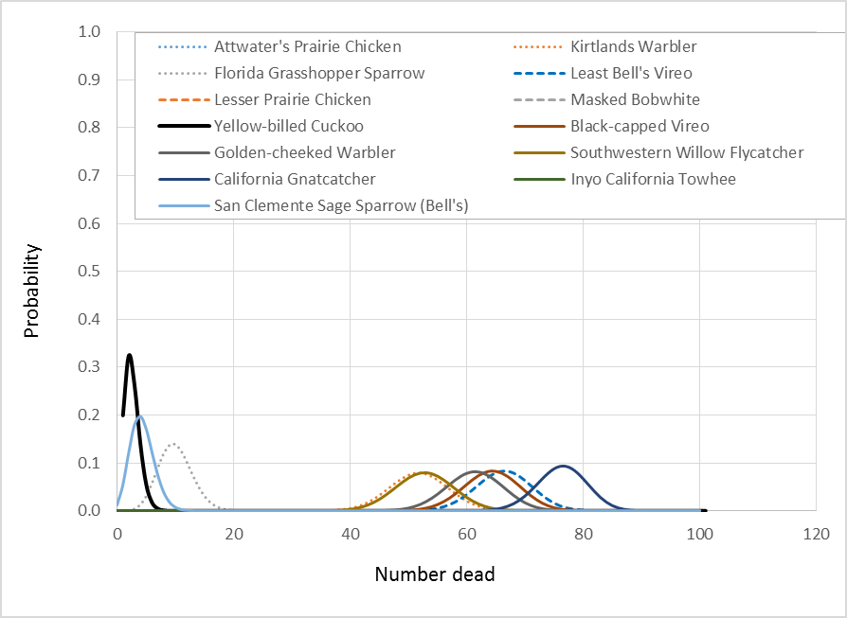

Figure 4-7.1. Probability distribution functions describing probability associated with killing x% of exposed simulated species. Exposure based on mosquito adulticide application [LD50 = HC05 value (conservative estimate)].

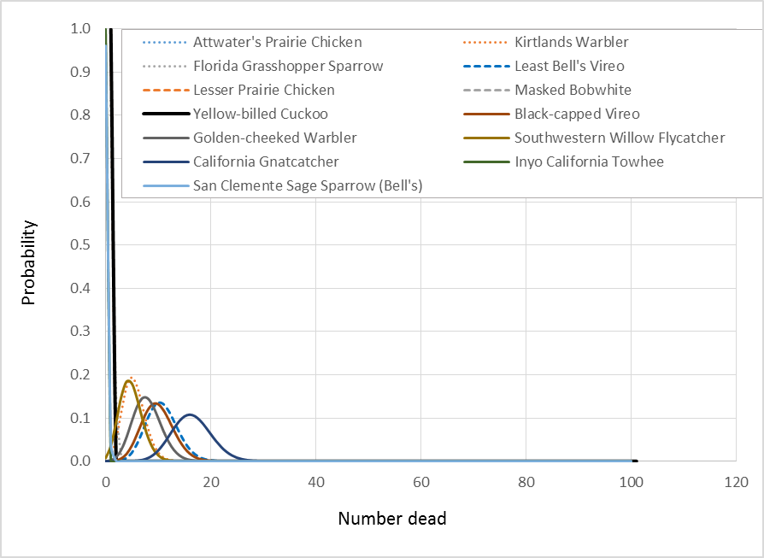
Figure 4-7.2. Probability distribution functions describing probability associated with killing x% of exposed simulated species. Exposure based on mosquito adulticide application [LD50 = HC50 value (central estimate)].

Figure 4-7.3. Probability distribution functions describing probability associated with killing x% of exposed simulated species. Exposure based on wide area uses [LD50 = HC50 value (central estimate)].

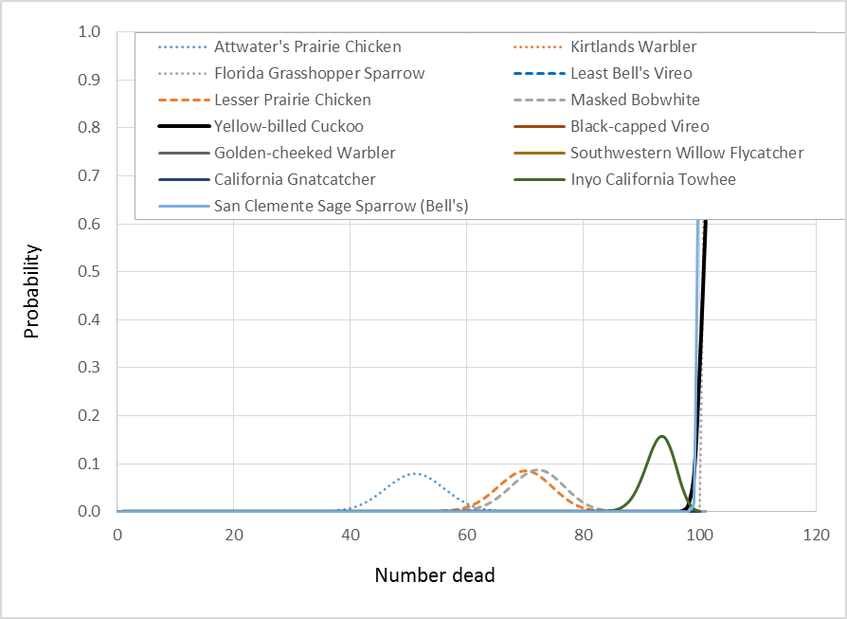

Figure 4-7.4. Probability distribution functions describing probability associated with killing x% of exposed simulated species. Exposure based on pasture uses [LD50 = HC50 value (central estimate)].

  - MCnest Analysis

When considering impacts to fecundity, mortality is the major contributor to declines for some of the species; however, reproductive effects do occur in surviving birds. In general, applications made after the breeding period occur do not result in declines in fecundity because exposed adults are able to successfully reproduce prior to exposures that lead to mortality. Reproductive impacts based on the modeled uses assuming a May 1st initial application date and the input parameters outlined above are shown in Figures 4-7.5 through Figure 4-7.8. Based on a lack of overlap between the lower confidence bound on the number of broods expected without pesticide application and the upper bound with application, approximately 6 out of 13 of the assessed species are impacted for the mosquito adulticide application using the LD50=6.6 mg a.i./kg b.w.(HC05 value) (Figures 4-7.5). The magnitude of reproductive decline varies widely between species. Large (80 -90%) reductions in number of broods are predicted for the golden-cheeked warbler and black capped vireo but no effect is predicted for the Attwater’s prairie chicken, Inyo California towhee and lesser prairie chicken. When the HC50 is used, no reproductive impacts are predicted (Figure 4-7.6). For the wide area and pasture uses, reproductive impacts are predicated even when using the less conservative central LD50 estimate (HC50) for the majority of species (Figures 4-7.7 and Figure 4-7.8). Magnitude of reproductive declines ranged from 60-100% for all species except the Inyo California towhee (~21%).

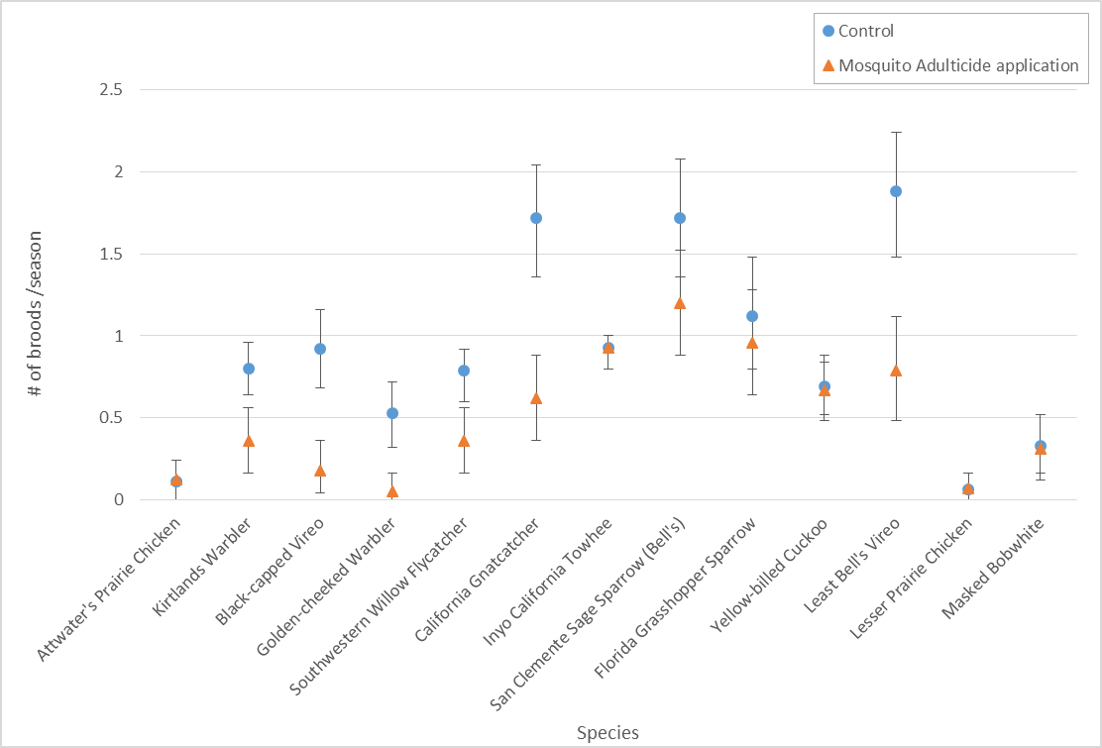
Figure 4-7.5. Reproductive impacts with and without mosquito adulticide application for 13 bird species [LD50 = HC05 value (conservative)].

Figure 4-7.6. Reproductive impacts with and without mosquito adulticide application for 13 bird species [LD50 = HC50 value (central estimate)].

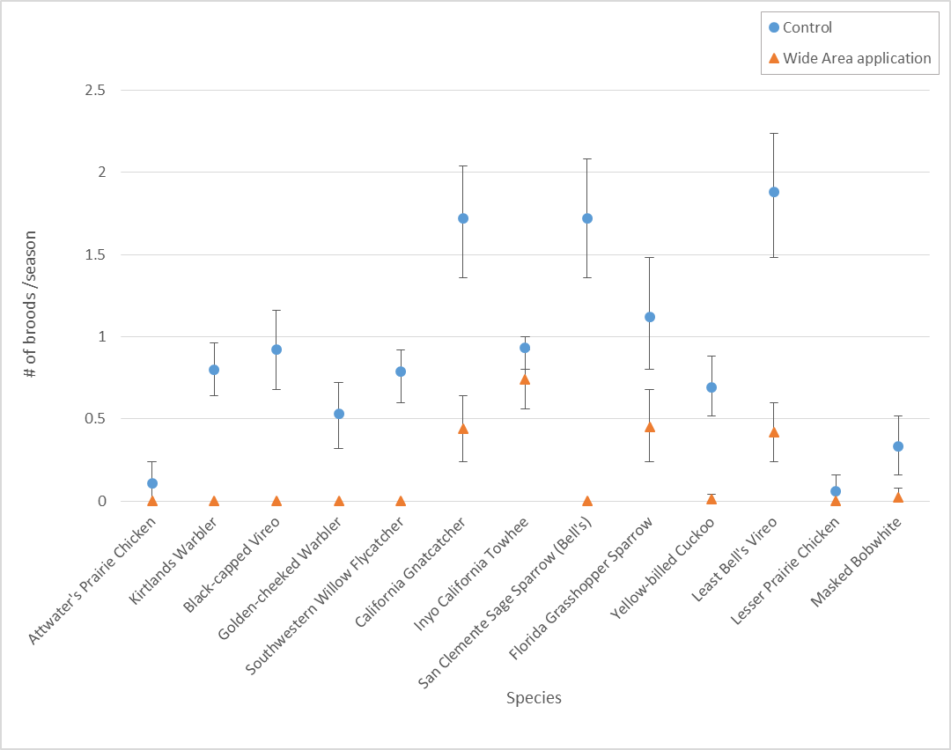
Figure 4-7.7. Reproductive impacts with and without wide area use application for 13 bird species [LD50 = HC50 value (central estimate)].

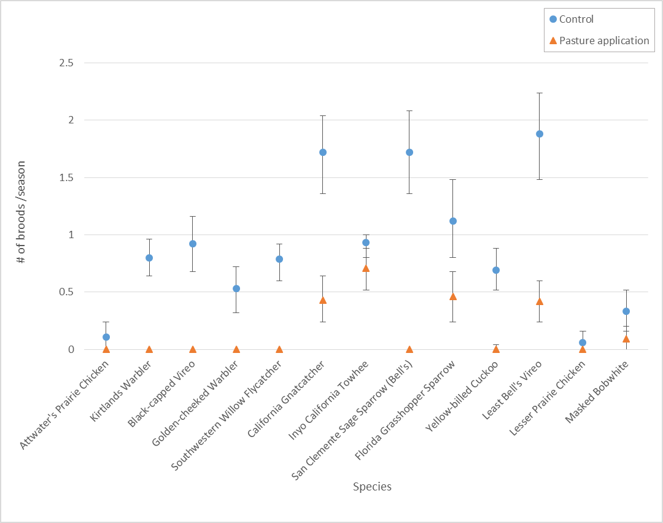
Figure 4-7.8. Reproductive impacts with and without pasture use application for 13 bird species [LD50 = HC50 value (central estimate)].

- Conclusions

Based on the analyses, there is a high likelihood (99% or greater for multiple scenarios) that exposure to chlorpyrifos from wide area and pasture will result in mortality to at least one individual for all thirteen assessed species. For mosquito adulticide use and conservative assumptions for the LD₅₀ value, the largest magnitudes of mortality are observed for the California gnatcatcher, least Bell’s vireo, black-capped vireo and golden-cheeked warbler whereas the smallest values are seen for the Attwater’s prairie chicken, Inyo California towhee, lesser prairie chicken and masked bobwhite, all having less than 1% mortality.

When considering impacts of chlorpyrifos to fecundity of the modeled birds, mortality is the major contributor to declines; however, reproductive effects do occur in surviving birds. Based on the MCnest analyses, approximately 6 of the 13 assessed species are impacted for the mosquito adulticide application using a conservative assumption for the LD₅₀ with no reproductive impacts predicted when the central estimate is used for the LD₅₀. For the wide area and pasture uses, reproductive impacts are predicted for the majority of species even when using the less conservative central LD₅₀ estimate. Effects may be ameliorated by avoiding chlorpyrifos applications during the breeding season.

Mineau, P., B.T. Collins, A. Baril. 1996. On the use of scaling factors to improve interspecies extrapolation to acute toxicity in birds. Reg. Toxicol. Pharmacol. 24:24-29.

