APPENDIX 3-1: Environmental transport and Fate Data Analysis for Chlorpyrifos

Physical chemical properties and dissipation parameters for chlorpyrifos and its environmental transformation product, chlorpyrifos-oxon, are provided in Table B 3-1.1. Chlorpyrifos will initially enter the environment via direct application (e.g., liquid spray and granulars) to use sites (e.g., soil, foliage, seed treatments, urban surfaces). It may move off-site via spray drift, volatilization, and runoff (generally by soil erosion rather than dissolution in runoff water).

Degradation of chlorpyrifos begins with cleavage of the phosphorus ester bond to yield 3,5,6-trichloro-2-pyridinol (TCP) or oxidative desulfonation to form chlorpyrifos-oxon as shown in Figure B 3-1.1. TCP may be converted to 3,5,6-trichloro-2-methoxypyridine (TMP) also shown in Figure B 3-1.1. Environmental fate studies (except field volatility and air photolysis studies) submitted to EPA do not identify chlorpyrifos-oxon as a transformation product, yet organophosphates that contain a phosphothionate group (P=S), such as chlorpyrifos, are known to transform to the corresponding oxon analogue containing a phosphorus-oxygen double bond (P=O) instead. This transformation occurs via oxidative desulfonation and can occur through photolysis and aerobic metabolism, as well as other oxidative processes. Chlorpyrifos-oxon is considered less persistent than chlorpyrifos and may be present in air, soil, water, and sediment. Environmental fate parameters for chlorpyrifos and chlorpyrifos-oxon are provided in Table B 3-1.1 and B 3-1.2, respectively.

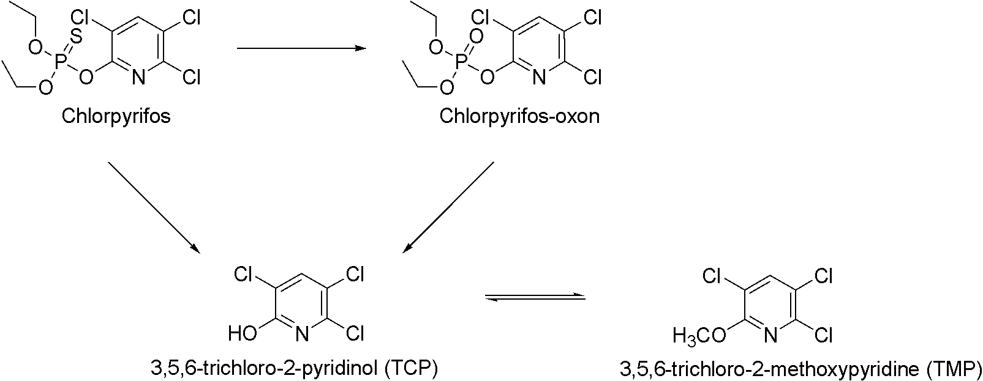

Figure B 3-1.1. Environmental transformation of chlorpyrifos

Table B 3-1.1 Summary of environmental fate and transport characteristics of chlorpyrifos
Parameter | Test System Name or Characteristics | NAFTA Representative Half-life Values  (fitting model) | Study ID | Study Status
Laboratory Data
Hydrolysis | pH 5, 25°C | 73 | MRID 00155577 | Acceptable
 | pH 7, 25°C | 72
 | pH 9, 25°C | 16
 | pH 7 | 81 | MRID 40840901 | Acceptable
Aqueous photolysis half-life (days) | pH 7 | 29.6 | MRID 41747206 | Acceptable
Soil photolysis half-life (days) | -- | Stable | MRID 42495403 | Supplemental
Air photolysis half-life (hours) | Indirect | 2 | MRID 48789701 | Acceptable
 | direct | 6
Aerobic Soil Metabolism  Half-life (t_{1/2}) | Commerce | 19 days (IORE) | Acc. 241547  MRID 00025619) | Acceptable
 | Barnes | 36.7 days (IORE)
 | Miami | 31.1 days (IORE)
 | Catlin | 33.4 days (SFO)
 | Norfolk | 156 days (DFOP)
 | Stockton Clay | 297 days (IORE)
 | German | 193 (IORE)
 | Sandy loam | 185 days (DFOP) | MRID 42144911 | Acceptable
Aerobic Aquatic Metabolism Half-life (t_{1/2}) | Water, pH 8.1  Sediment, pH 7.7  25 ˚C | 30.4 days (SFO) | MRID 44083401 | Supplemental
Anaerobic Soil Metabolism half-life (t_{1/2}) | Commerce,  loam | 78 (IORE) | MRID 00025619 | Acceptable
 | Stockton,  clay | 171 days (SFO)  Values represent only anaerobic phase
Anaerobic Aquatic Metabolism half-life (t_{1/2}) | Commerce  pH 7.4 | 50.2 days  (IORE) | MRID 00025619 | Supplemental
 | Stockton  pH 5.9 | 125 days  (SFO)
Field Data
Terrestrial Field Dissipation | Geneseo, Illinois  Silt loam; pH 5.7, 3.1% OC | 56 | MRID 40395201 | Supplemental
 | Midland, Michigan  Sandy clay loam; pH 7.7, 1.6% OC | 33
 | Davis, California Loam; 0.91% OC pH 7.8 | 46
An acceptable study is defined as a study that provides scientifically valid information that is fully document and which clearly addresses the study objectives as outline in the guidelines.
A supplemental study is defined as study is less than fully acceptable. A supplemental study provides scientifically valid information that address the study objectives as outlined in the guidelines but are missing certain critical data necessary for a complete evaluation-verification.

Table B 3-1.2. Summary of environmental fate and transport characteristics of chlorpyrifos-oxon
Parameter | Test System Name or Characteristics | NAFTA Representative Half-life Values  (fitting model) | Study ID | Study Status
Laboratory Data
Hydrolysis | pH 4, 20°C | 38 | MRID 48355201 | Supplemental
 | pH 7, 20°C | 5
 | pH 9, 20°C | 2
Air photolysis half-life (hours) | Indirect | 11 | MRID 48789701 | Acceptable
 | direct | 6
Aerobic Soil Metabolism  Half-life (t_{1/2}) | Missouri  Silty clay loam soil  (20°C, pH 5.9-6.2) | 0.03  (IORE) | MRID 48931501 | Supplemental
 | Georgia  Loamy sand soil  (20°C, pH 5.3-5.6) | 0.1  (IORE)
 | Texas  Sandy clay loam soil  (20°C, pH 7.6-7.9) | 0.02  (SFO)
 | California  Loam soil  (20°C, pH 6.1-6.3) | 0.06  (IORE)
An acceptable study is defined as a study that provides scientifically valid information that is fully document and which clearly addresses the study objectives as outline in the guidelines.
A supplemental study is defined as study is less than fully acceptable. A supplemental study provides scientifically valid information that address the study objectives as outlined in the guidelines but are missing certain critical data necessary for a complete evaluation-verification.

  - TRANSFORMATION RATES IN LABORATORY STUDIES

    - Hydrolysis

Abiotic hydrolysis is not expected to play a significant role in chlorpyrifos dissipation in the environment. Chlorpyrifos hydrolysis has been shown to be stable under neutral (half-life values 72 to 81 days) to acid conditions; however, under alkaline conditions (pH 9), laboratory studies (MRIDs 00155577) show chlorpyrifos is susceptible to hydrolysis with a half-life of approximately two weeks. The major hydrolysis products , TCP and O-ethyl O-(3,5,6-trichloror-2-pyridinol) phosphrothioate, are stable to hydrolysis. Hydrolytic degradation of chlorpyrifos in sterilized, ambient water from four the Chesapeake Bay tributaries demonstrated that pH alone cannot be used as a single parameter to predict hydrolysis of chlorpyrifos under field conditions. Reported half-live values ranged from 24 days in the Patuxent River to 126 days in the Susquehanna River.

The hydrolysis half-life of chlorpyrifos-oxon (5 days at pH 7) is substantially shorter than that observed for chlorpyrifos. Chlorpyrifos-oxon hydrolyzes to form TCP, a major environmental degradation product reported for chlorpyrifos.

    - Photolysis

      - Soil Photolysis

Chlorpyrifos is expected to be stable to photolysis in soil, as the calculated half-life values for the dark control and the irradiated soil experiments were similar (MRID 42495403). However, transformation was observed suggesting that degradation processes are possible in soil. The major transformation product observed is TCP which may photodegrade.

No data are available for the phototransformation of chlorpyrifos-oxon in soil.

      - Aquatic Photolysis
Chlorpyrifos is susceptible to photolysis in aqueous pH buffered solution (MRID 41747206), with an estimated environmental half-life of approximately 30 days. No phototransformation products were observed to form at concentrations greater than 5% of the applied material. In another aquatic photolysis study, chlorpyrifos was estimated to have a half-life of 13.3 minutes under the study conditions (125 W xenon lamp); however, the environmentally relevant half-life could not be derived. The only transformation product observed was chlorpyrifos-oxon; however, the maximum amount of chlorpyrifos did not exceed one percent at any point during the study. The degradation rate of chlorpyrifos-oxon was reported to be three times slower (half-life value of 42 minutes) than chlorpyrifos in a separate but similar study conducted by the same authors.

Based on the available data, photodegradation in aquatic environments is not expected to be a major route of chlorpyrifos dissipation.

      - Air Photolysis

Chlorpyrifos was reported to undergo indirect (chemical decomposition or change as a result of absorption of light by natural substance that then react with the chemical of interest) by and direct (chemical decomposition or change initiated by the absorption of light by the chemical of interest) photolysis [t_{1/2} = 2 h (indirect) and 5 h (direct)]. The result obtained for indirect photolysis is consistent with the Estimation Program Interface (EPI) Suite estimations. This study confirms the formation of chlorpyrifos-oxon via photolysis. Chlorpyrifos-oxon was reported to undergo indirect and direct photolysis [t_{1/2} = 8 h (indirect) and 6 h (direct)]. The EPI Suite estimated indirect photolysis was similar to the calculated value.

    - Aerobic Soil

Chlorpyrifos degrades in soil under aerobic conditions (half-life values range from 19 to 297 days). This suggests that under some environmental conditions chlorpyrifos is very persistent. The major transformation product (>10%) observed in the aerobic soil metabolism studies is TCP. Another transformation product, TMP, was not observed at concentrations greater than 10%. In general, transformation was observed to be biphasic. Aerobic soil metabolism data are summarized in Table B 3-1.2 while the kinetic analyses are presented at the end of this Appendix. Additional aerobic soil metabolism half-life values reported in the ECOTOX database are within the range of estimated half-life values derived from registrant submitted data for typical soil conditions.
Laboratory data suggest that chlorpyrifos-oxon is non-persistent in soil under aerobic conditions. Half-life values were less than one day at 20 ˚C. The major transformation products observed were TCP, carbon dioxide, and 3,5-dichloro-l-methylpyridin-2(lH)-one. Another major transformation product (C₅H₃Cl₂NO₄S) was observed to form and a chemical structure was proposed; however, the structure was not confirmed. There were also increasing amounts of unextracted residues. The kinetic analyses for chlorpyrifos-oxon are also presented at the end of this Appendix.

    - Anaerobic Soil

Chlorpyrifos was persistent in anaerobic (flooded-loam and clay) soils with estimated half-life values of 78 and 171 days. The major transformation product observed was TCP which was persistent under anaerobic conditions. Small amounts of TMP were observed.

No data are available for chlorpyrifos-oxon under anaerobic soil conditions.

    - Aerobic Aquatic

The half-life estimated for chlorpyrifos in aerobic aquatic conditions is approximately one month. This study was conducted under slightly basic conditions (pH 8.1). Chlorpyrifos has been shown to undergo hydrolysis under basic conditions and, as a result, hydrolysis is expected to occur at pH 8.1. The reported half-life value was not corrected for hydrolysis as no hydrolysis data were provided under the same conditions. Therefore, it is expected that some of the transformation of chlorpyrifos observed in this study is the result of hydrolysis in addition to metabolism. The major transformation product observed in this study was TCP. The aquatic metabolism data suggest that chlorpyrifos partitions to soil/sediment while its degradation products are more likely to partition to water. Kinetic analysis for the aerobic aquatic metabolism study are present at the end of this Appendix. An open literature study conducted with waters from four different sites in California suggest faster dissipation rates than one month. Half-life values ranged from 5.5 days 15.2 days at 21 ˚C (MRID 49630501). The pH of these waters were also slightly high 7.98 to 8.86. Sterilization of the waters prior to study initiation confirms that hydrolysis contributes to the transformation of chlorpyrifos in aquatic systems.
Another study that examined chlorpyrifos degradation in a nursery recycling pond sediment system (high organic matter content and high salinity) under aerobic aquatic conditions found chlorpyrifos half-life values ranged from 27 to 32 days at 22 ˚C for two different test systems.
No aerobic aquatic metabolism data are available for chlorpyrifos-oxon.

    - Anaerobic Aquatic

Anaerobic aquatic metabolism half-life values estimated for chlorpyrifos are 50 to 125 days. The major transformation product observed in this study was TCP.

Another study, previously sited in this document, examined chlorpyrifos degradation in a nursery recycling pond sediment system (high organic matter content and high salinity) under anaerobic aquatic conditions. The reported chlorpyrifos half-life values ranged from 41 to 53 days at 22 ˚C for two different test systems.⁵
No anaerobic aquatic metabolism data are available for chlorpyrifos-oxon.

  - Sorption and Mobility

Batch equilibrium data (summarized in Table B 3-1.3) for chlorpyrifos suggest that it is slightly mobile in soils and, therefore, is not expected to leach through the soil profiles (Acc. 260794). However, chlorpyrifos that is sorbed to soil may be transported off an application site. Soil binding was correlated with the organic carbon content (i.e., the coefficient of variation for K_{oc} values is less than that for K_{d} values) of the soil with k_{OC} values ranging from 4960 to 7300 mL/g_{oc}. An open literature batch equilibrium study reported at k_{OC} value of 5299 mL/g_{oc} for chlorpyrifos. This study also suggest that soil management practices may impact chlorpyrifos sorption and mobility in the environment. Chlorpyrifos sorption was significantly reduced with increasing amounts of dissolved organic matter (DOM); therefore, DOM may enhance transport of chlorpyrifos in soil. Chlorpyrifos partitioning in a nursery recycling pond reported k_{OC} values of 1550 and 7430 mL/g_{oc} for chlorpyrifos in the two different test systems.⁵ Sorption was reportedly correlated to both organic mater content and sediment texture.

Table B 3-1.3. Summary of sorption/mobility parameters for chlorpyrifos
Test System Name or Characteristics | K_{d} | K_{oc} | Study ID | Study Status
Commerce loam | 49.9 | 7300 | Acc. 260794 | Acceptable
Tracy sandy loam | 95.6 | 5860
Catlin silt loam | 99.7 | 4960
K_{d} = adsorption coefficient (mL/g)
Koc = organic carbon normalized adsorption coefficient (mL/g)

Chlorpyrifos-oxon is expected to be more mobile than chlorpyrifos in soil with K_{oc} values ranging from 146 to 270 mL/g_{oc} (MRID 48602601) as shown in Table B 3-1.4. Binding was observed to be slightly non-linear (1/n < 0.9).

Table B3-1.4. Summary of sorption/mobility parameters for chlorpyrifos-oxon
Test System Name or Characteristics | K_{f} (regressed) | K_{foc} | 1/n | Study ID | Study Status
Tift Sand  pH 4.8, 0.61% OC | 1.3 | 270 | 0.85 | MRID 48602601 | Supplemental
Hagen Loamy sand  pH 5.2 1.1 | 2.1 | 245 | 0.84
Ebbinghof Loam  pH 5.2, 1.5% OC | 4.0 | 191 | 0.89
Tehama Loam  pH 5.7, 4.4% OC | 4.2 | 301 | 0.89
Chelmorton Silt loam  pH 5.9, 2.9% OC | 4.3 | 146 | 0.88
%OC percent organic carbon in the soil
K_{f} = Freundlich adsorption coefficient (μg/g)/(μg/mL)^{1/n}
K_{Foc} = organic carbon normalized Freundlich adsorption coefficient (μg/g organic carbon)(μg/mL)^{1/n}
1/n = Freundlich exponent
  - Field Studies

    - Terrestrial Field Dissipation

Field dissipation data indicate that chlorpyrifos is moderately persistent under field conditions. Calculated half-life values for chlorpyrifos were 33 to 56 days in three soils planted with field corn. TCP was observed to form under field conditions. Additional field dissipation studies have been submitted to the Agency (MRIDs 40059001, 40356608, 40395201, 42874703, 42874704, 42924801, 42924802); however, these results are not discussed here due to the study design (i.e., repeated applications to crops) making the interpretation of the studies difficult. These studies are generally classified as supplemental but suggest that chlorpyrifos may persist under field conditions.

    - Aquatic Semi-Field Dissipation

The distribution of chlorpyrifos between sediment and water in an outdoor mesocosms study designed to simulate spray drift or partial overspray following spring and fall applications was examined by Bromilow et al. In general, chlorpyrifos is uniformly distributed in the 30 cm of overlying water within 24 h and moves into the sediment within 30 days but does not penetration below 2.5 cm depth. Chlorpyrifos was observed to persist beyond 30 d with a dissipation half-life of 20 days (spring applications) discounting the substantial decrease in the mass balance on day 1. The mass balance of chlorpyrifos at 1 day was roughly 40 to 60 percent of the applied material depending on the study. This initial loss was attributed to processes such as volatilization. Following the fall application, an increase in chlorpyrifos concentration was observed following a freezing spell that may have resulted in chlorpyrifos being released from plant materials. Chlorpyrifos only slowly degraded over the remaining winter period.

    - Field Volatility

While laboratory studies suggest that volatilization is not likely to play a significant role in the dissipation of chlorpyrifos in the environment, field data suggest otherwise. Chlorpyrifos has been detected in air samples and EPA has reviewed two field volatility studies (summarized below). Volatilization of chlorpyrifos and/or chlorpyrifos-oxon from treated crops is a pathway of dissipation in the environment that may result in exposure to the vapor phase or the redeposition of chlorpyrifos and chlorpyrifos-oxon downwind of a treated field. The two studies were conducted at rates lower than the current maximum single broadcast application. While the absolute flux for chlorpyrifos observed in the potato study is higher than the alfalfa study, the flux profiles are similar in both studies.
Study 1: Alfalfa
Dow AgroSciences (DAS) recently submitted a field volatility study that measured both vapor phase chlorpyrifos and chlorpyrifos-oxon in air samples following an application of a low VOC (volatile organic compounds or volatile organic chemicals) formulation,, of chlorpyrifos to alfalfa. Approximately 30% of the applied chlorpyrifos was emitted from the treated field in the first 24 hours (28% considering chlorpyrifos only; 30% considering chlorpyrifos and chlorpyrifos-oxon combined). The flux profile for chlorpyrifos is similar to those generally observed for fumigants in that there is a peak emission shortly after application during the warmer part of the day. The study measured chlorpyrifos for a period of 72 hours following application.
Study 2: Potato
A field volatility study published in the open literature was conducted with the application of a non-low VOC formulation of chlorpyrifos applied to potatoes., This study only measured parent chlorpyrifos and did not measure concentrations of chlorpyrifos-oxon. Approximately 71% of the applied chlorpyrifos was estimated to volatilize from the treated field within 24 hours following application, assuming continuous flux.

  - Bioconcentration Factor

For fish, chlorpyrifos bioaccumulates in tissue, however, the residues rapidly depurate when exposure to chlorpyrifos is ceased (MRID 40056401). In a fish bioconcentration study, chlorpyrifos bioaccumulated in rainbow trout with a maximum bioconcentration factor (BCF) of 1280x in edible tissues, 3903x in non-edible tissues, and 2729x in whole fish. After 16 days of depuration, residues were approximately 1% of the maximum observed concentration. The residues observed in tissue include TCP and two glucuronide conjugates of TCP. For this assessment, the whole fish BCF from this study is adjusted to exclude the TCP and conjugate residues as they are not considered as stressors of concern, thus, the BCF is based on 80% of the total radioactivity (adjusted BCF of 2183X). In addition to the registrant submitted study, there were also five other laboratory-based studies identified in the open literature (via the ECOTOX database) and the values ranged from 440-5100X for the parent only. Welling and De Vries reported a BCF ranging from 1600 to 1700X for Guppy (Poecilia reticulata) based on uptake/depuration kinetics from a 14-day exposure period. Similar results were also observed in a full life cycle study with the fathead minnow (Pimephales promelas), as the BCF was also reported as approximately 1700X after exposure to chlorpyrifos (MRID 00154721). Several early life stage (ELS) studies also provided BCF values for several species with values of 440X (Menidia Beryllina), 580X (Menidia Peninsula), and 450X and 1000X for the California grunion (Leuresthes tenuis) adult and fry., A final ELS study reported BCF values for the Gulf toadfish (Opsanus beta) from two separate ELS tests, one testing up to 200 µg/L and the other only up to 50 µg/L, and the respective BCF values were 5100 and 650X, respectively. In this ELS study, the authors noted that the increase in BCF with increasing concentration was not typical of similar (ELS) studies conducted with chlorpyrifos. Finally, a bioconcentration study with larvae (zebrafish eleutheroembryos -72 hours after hatching) was available. In this study, larvae were exposed to chlorpyrifos for 48 hours with a 72-hour depuration period and the resulting BCF values based on uptake/depuration kinetics was reported as a log BCF of 3.55 when exposed to 1 µg/L and log BCF of 3.84 when exposed at 10 µg/L.

Chlorpyrifos was also observed to bioaccumulate in the eastern oyster with maximum bioconcentration factors of 1900x for whole oyster, 2500x for oyster tissues, and 87x for oyster liquor (i.e., the liquid inside the oyster shell) (MRID 42495406). During the 14-day depuration, total residues in whole oysters declined steadily and were less than 10 ppb by day 10. The major degradate identified in whole oyster extracts was O,O-diethyl-O-(3,5-dichloro-6-methylthio-2-pyridyl)phosphorothioate (DMP). For this assessment, the whole oyster BCF is adjusted to the maximum percent of parent (46%-adjusted BCF value of 874X) to exclude the transformation products as these residues are not considered stressors of concern. Chlorpyrifos bioaccumulation was reported in the eastern oyster in another source and the BCF value for whole oyster based on uptake/depuration kinetics for [¹⁴C] activity was 565X. The parent [¹⁴C] chlorpyrifos accumulated to 135 µg/kg in whole oyster tissue, representing an empirical [¹⁴C] chlorpyrifos BCF value in the oyster of approximately 225 ml/g based on HPLC characterization of the metabolites. There were also six other laboratory-based aquatic invertebrate BCF studies available and reviewed from the open literature database (via ECOTOX). The BCF values for marine mollusks based on uptake/depuration kinetics ranged from 400X for M. galloprovinvalis to 482X for M. edulis., After a 24-hour exposure, the freshwater amphipod (Gammarus pulex), had a BCF of 412X based on uptake/depuration kinetics for parent chlorpyrifos. In this study, chlorpyrifos-oxon (minor amount formed), plus one other residue (authors suggest the hydrolyzed ester of chlorpyrifos), were quantified but not included in the total residues (TCP was also excluded). In another study with G. pulex, there was a higher BCF (1660X) that was calculated based on total radioactive residues. Additionally, BCF values for 15 aquatic invertebrate species were measured and the values ranged from 100X for Anax imperator to 13,930X for Culex pipens. These BCF values were based on total radioactive residues and were derived by modelling (described as forward Monte Carlo simulation based on the parameter sample).
BCF for Exposure Analysis (Aquatic food items)
The empirical bioconcentration factors that are used in the BCF analysis for selecting a single value for use in the food item residue calculations (e.g., residues in diet for birds that consume fish) are provided in Tables B3-1.5 and B3-1.6 for aquatic invertebrates and fish, respectively. These tables present whole-organism BCFs based on exposures that were ≥16 days in duration, which is representative of the time to steady-state in fish exposed to constant chlorpyrifos concentrations in water (estimated by KABAM).
Table B3-1.5- Chlorpyrifos BCF Values for Aquatic Invertebrates
Test species (Scientific name) | BCF (µg/kg-ww per µg/L; whole organism; steady state) | Source
American oyster (Crassostrea virginica) | 874* | MRID 42495406
Mediterranean mussel (Mytilus galloprovincialis) | 400 | E72696; Serrano et al., 1997
Blue mussel (Mytilus edulis) | 482 | E18413; Serrano et al., 1997
*Based on the maximum of parent (46% -excludes main degradate, DMP and 1 other)

Table B3-1.6 Chlorpyrifos BCF Values for Fish
Test species (Scientific name) | BCF (µg/kg-ww per µg/L; whole organism; steady state) | Source
Fathead minnow (Pimephales promelas) | 1700 | MRID 00154721
Inland silverside (Menidia Beryllina) | 440 | Goodman et al., 1985
Tidewater silverside (Menidia Peninsulae) | 580 | Goodman et al., 1985
California grunion (Leuresthes tenuis) | 1000 | Goodman et al., 1985
California grunion (Leuresthes tenuis) | 450 | Goodman et al., 1985
Gulf toadfish (Opsanus beta) | 5100 | Hanson et al., 1986
Gulf toadfish (Opsanus beta) | 650 | Hanson et al., 1986
Rainbow trout (Oncorhynchus mykiss) | 2183* | MRID 40056401
*Based on 80% of total radioactivity (to exclude TCP and conjugates)

The KABAM-estimated BCFs for invertebrates ranged from 1715—1873X and for fish the estimated BCF is 2409X. These estimates are based on mean Log Kow of 4.7 and the assumption that chlorpyrifos is not metabolized. The estimated factors are expected to overstate the bioconcentration of chlorpyrifos because the chemical metabolizes substantially in aquatic organisms. Because a reliable metabolism rate constant cannot be generated for KABAM, the empirical BCF values for aquatic invertebrates and fish (Tables B3-1.5 and B3-1.6, respectively) will be used to estimate chlorpyrifos concentrations in aquatic organisms (using the 90th percentile and mean values).
Several studies related to bioaccumulation of chlorpyrifos that were identified using ECOTOX (including the accepted and rejected bibliographies) are not included in this analysis (Table B3-1.7). Reasons for exclusion may include the following:
- Studies that reported BCFs or BAFs that were not whole organism (e.g., tissues or organs);
- BCFs or BAFs were from non-target monitoring studies or field studies;
- Studies that were based on total radioactive residues, and did not distinguish between chlorpyrifos and metabolites such as TCP or DMP (these data do not represent bioconcentration of residues of concern) or excluded chlorpyrifos oxon.
- BCFs or BAFs were based on measured concentrations not representative of steady state of chlorpyrifos (i.e., values collected <16 days after initiation of exposure).
Table B3-1.7 Studies in ECOTOX That Were Excluded from Bioconcentration Analysis
Citation | ECOTOX # | Reason for exclusion
Welling, W and De Vries, JW (1992). Bioconcentration Kinetics of the Organophosphate Insecticide Chlorpyrifos in Guppies (Poecilia reticulata). Ecotoxicol. Environ. Saf. (23) 64-75. | E3907 | 4 (14 day exposure)
El-Amrani S, Pena-Abaurrea M, Sanz-Landaluze J, Ramos L, Guinea J, Camara C (2012) Bioconcentration of pesticides in zebrafish eleutheroembryos (Danio rerio). Sci. Tot. Environ. 425:184-190. | N/A | 4 (2 day exposure to larvae)
Serrano R; Hernandez F; Pena JB; Dosda V; Canales J (1995). Toxicity of Bioconcentration of Selected Organophosphorus Pesticides in Mytilus galloprovincialis and Venus gallina. Arch. Environ. Contam. Toxicol. 29(3): 284-290 | 14927 | 4 (4 day exposure)
Woodburn KB, Hansen SC, Roth GA, Strauss K (2003) The bioconcentration and metabolism of chlorpyrifos by the eastern oyster, Crassostrea virginica. Environ.Toxicol. Chem. 22:276-284. | E68191 | Data reported in MRID 42495406.
Ashauer R; Hintermeister A; O'Connor I; Elumelu M; Hollender J; Escher BI (2012) Significance of Xenobiotic Metabolism for Bioaccumulation Kinetics of Organic Chemicals in Gammarus pulex. Environ. Sci. Technol. 46(6): 3498-3508 | E160013 | 4, 3 (1 day exposure)
Ashauer R; Boxall A; Brown C. (2006) Uptake and Elimination of Chlorpyrifos and Pentachlorophenol into the Freshwater Amphipod Gammarus pulex. Arch. Environ. Contam. Toxicol. 51(4): 542-548 (E92242) | E92242 | 4, 3 (3 day exposure)
Rubach, MN; Ashauer R; Maund SJ; Baird DJ; Baird DJ; Van den Brink, PJ (2010) Toxicokinetic Variation in 15 Freshwater Arthropod Species Exposed to the Insecticide Chlorpyrifos. Environ. Toxicol. Chem. 29(10): 2225-2234 (E 159805) | E159805 | 4, 3 (7 day exposure)
Tang JX; Siegfried BD. (1996) Bioconcentration and Uptake of a Pyrethroid and Organophosphate Insecticide by Selected Aquatic Insect. Bull. Environ. Contam. Toxicol. 57(6): 993-998 | 18226 | 4,3 (6 hour exposure)
Montanes JFC; Van Hattum B; Deneer J. (1995) Bioconcentration of Chlorpyrifos by the Freshwater Isopod Asellus aquaticus (L.) in Outdoor Experimental Ditches. Environ. Pollut. 88(2): 137-146 | 15133 | Field study
Neely WB; Blau GE. (1977) The Use of Laboratory Data to Predict the Distribution of Chlorpyrifos in a Fish Pond. In: M.A.Q. Khan, (Ed.), Pesticides in Aquatic Environments, Plenum Press, NY : 145-163 | 101019 | Field Study
Eaton J; Arthur J; Hermanutz R; Kiefer R; Mueller L; Anderson R; Erickson R; Nordling B (1985) Biological Effects of Continuous and Intermittent Dosing of Outdoor Experimental Streams with Chlorpyrifos.  In: R.C.Bahner and D.J.Hansen (Eds.), Aquatic Toxicology and Hazard Assessment, 8th Symp., ASTM STP 891, Philadelphia, PA : 85-118 | 7658 | Field Study

Kinetic Analysis

Half-life values were estimated according to the Standard Operating Procedure for Using the NAFTA Guidance to Calculate Representative Half-life Values and Characterizing Pesticide Degradation. November 30, 2012. Environmental Fate and Effects Division. Office of Pesticide Programs. U.S. Environmental Protection Agency. Available at https://www.epa.gov/pesticide-science-and-assessing-pesticide-risks/nafta-guidance-evaluating-and-calculating. The images from the kinetic analysis are provided below by study type. For all figures the time (x-axis) is in days while the concentration (y-axis) is provided in percent applied radioactivity.

Aerobic Soil Metabolism
Chlorpyrifos
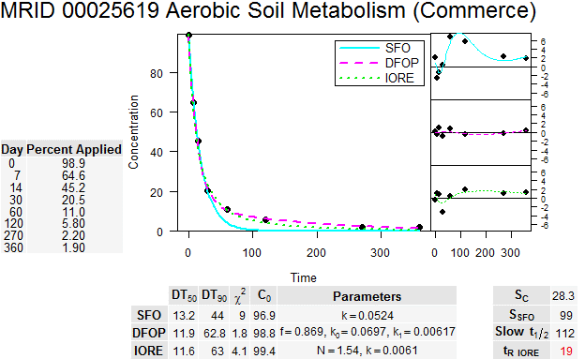
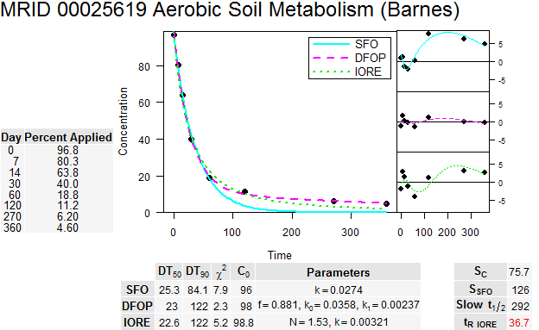
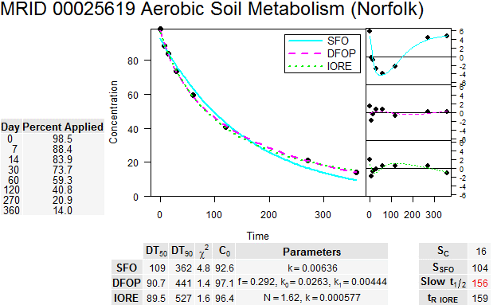
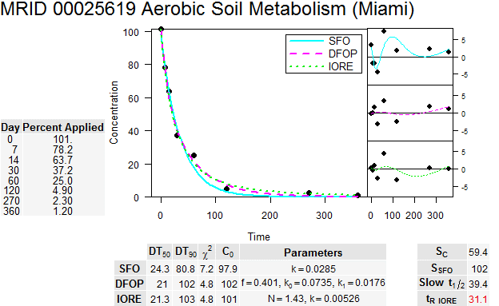
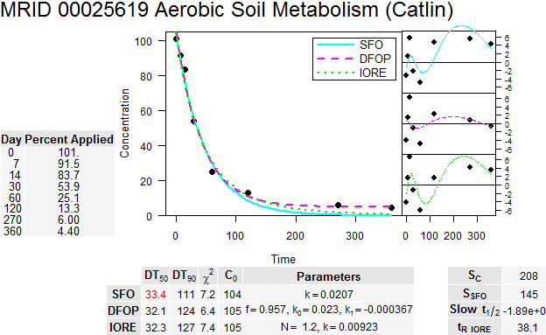
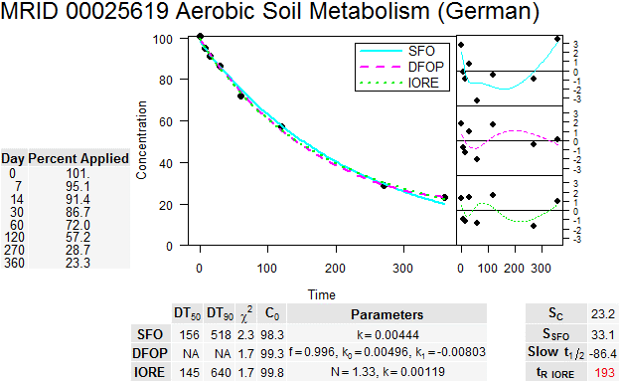
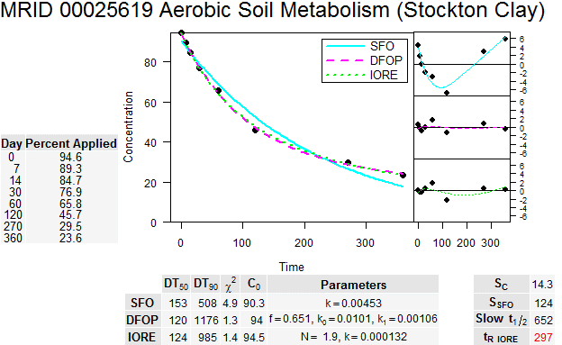
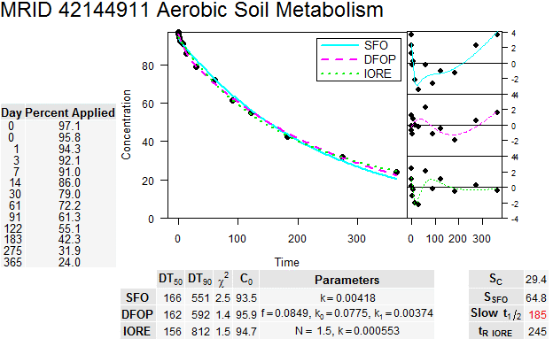
Chlorpyrifos-oxon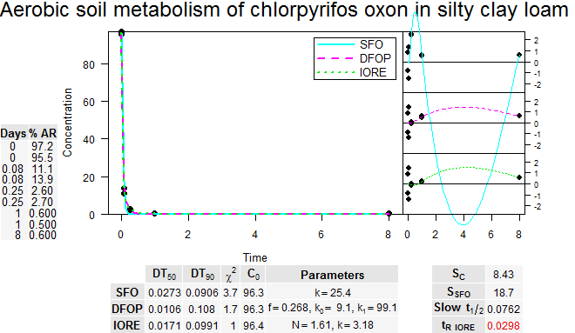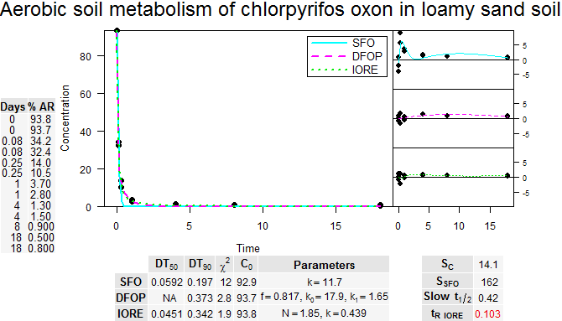
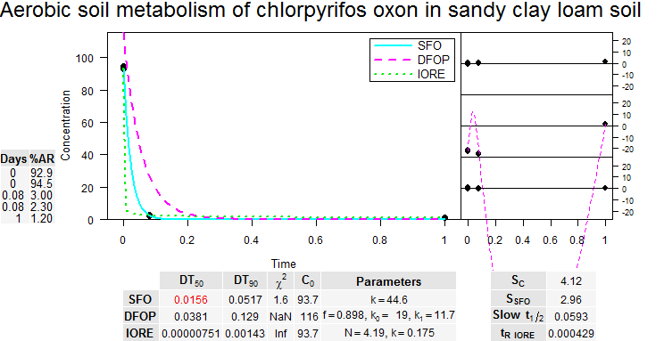

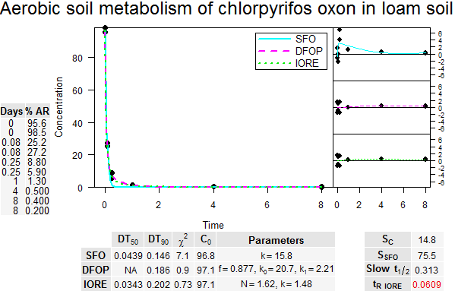

Anaerobic Soil Metabolism
Chlorpyrifos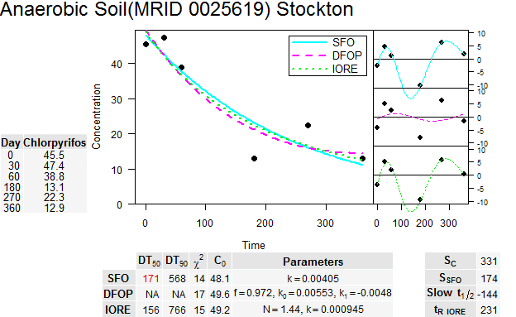
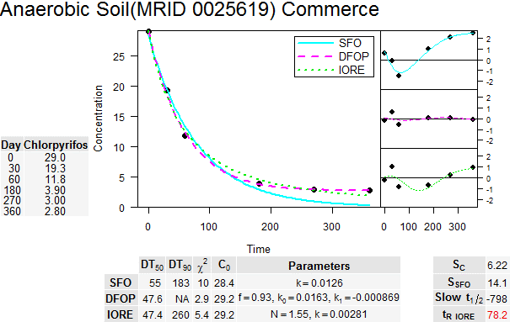
Aerobic Aquatic Metabolism
Chlorpyrifos
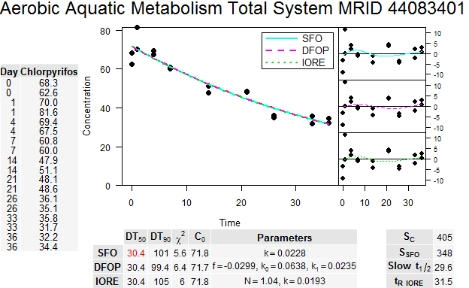
Anaerobic Aquatic Metabolism
Chlorpyrifos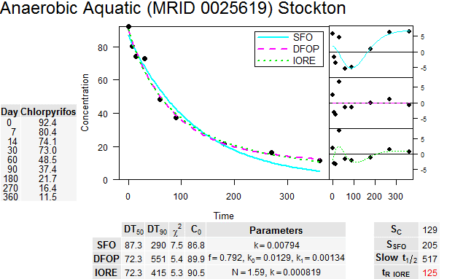
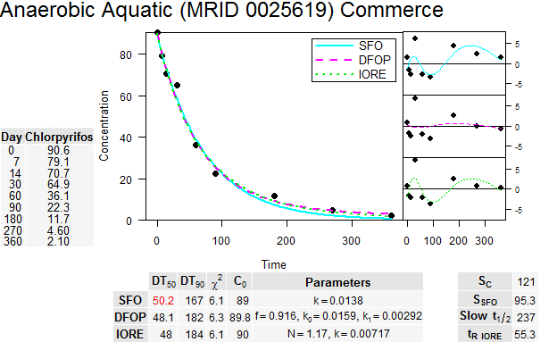

Liu, B., McConnell, L. L., and Torrents, A. (2001). Hydrolysis of chlorpyrifos in natural waters of the Chesapeake Bay. Chemosphere 44: 1315-1323.
Bavcon Kralj, M., Franko, M., and Trebse, P. Photodegradation of Organophosphorus Insecticides - Investigations of Products and Their Toxicity Using Gas Chromatography-Mass Spectrometry and Ache-Thermal Lens Spectrometric Bioassay. Chemosphere. 2007, Feb; 67(1):99-107.
EPA MRID 48789701: Gas-Phase Photolysis and Photo-oxidation of Chlorpyrifos and Chlorpyrifos oxon; Authors: Amalia Munoz; Sponsor: Dow AgroSciences European Development Centre, 3 Milton Park, Abington, Oxon, OX14 4RN
http://www.epa.gov/opptintr/exposure/pubs/episuite.htm; the version used in this assessment is 4.00.
Singh, Brajesh K., Walker, Allan, and Wright, Denis J. (2005). Cross-enhancement of accelerated biodegradation of organophosphorus compounds in soils: Dependence on structural similarity of compounds. Soil Biology and Biochemistry 37: 1675-1682.
Lu Jianhang , Wu Laosheng, Newman Julie, Faber, B. e. n., Merhaut DonaldJ. , and Gan Jianying (2006). Sorption and Degradation of Pesticides in Nursery Recycling Ponds. Journal of Environmental Quality [J. Environ. Qual.]. Vol. 35, no. 5, pp. 1795-1802. Sep 2006.
Li, Kun, Xing, Baoshan, and Torello, William A. (2005). Effect of organic fertilizers derived dissolved organic matter on pesticide sorption and leaching. Environmental Pollution 134: 187-194.
Bromilow, R. H., De Carvalho, R. F., Evans, A. A., and Nicholls, P. H. (2006). Behavior of Pesticides in Sediment/Water Systems in Outdoor Mesocosms. J.Environ.Sci.Health Part B 41: 1-16.
A flux profile is the emissions from a treated field over a defined period of time (i.e., an hourly time series of flux estimates during a period of measurement following application).
California's Department of Pesticide Regulation (Cal DPR) defines a low VOC pesticide formulation when the total emission potential (see footnote 53) is 25% or less (see footnote 54). The emission rate corresponds to total VOC emissions and not specially one component of the formulation (i.e., the active ingredient). EPA does not currently define low VOC pesticide formulations.
Emission potential is based on Thermogravimetric Analysis; Oros, D., Spurlock, F. California Department of Pesticide Regulation, ESTIMATING PESTICIDE PRODUCT VOLATILE ORGANIC COMPOUND OZONE REACTIVITY. PART 1: Speciating TGA-Based Volatile Organic Compound Emissions Using Confidential Statements Of Formula, January 27, 2011 http://www.cdpr.ca.gov/docs/emon/pubs/ehapreps/analysis_memos/2286_segawa.pdf
Proposed regulation can be found at: http://www.cdpr.ca.gov/docs/legbills/rulepkgs/12-001/text.pdf
EPA MRID 48998801: Volatilization of the Pesticides Chlorpyrifos and Fenpropimorph from a Potato Crop; Authors: Minze Leistra, Johan H. Smelt, J. Hilbrand Weststrate, Frederik VanDenBerg, and Rene Aalderink; Sponsor: This work was carried out within the framework of the EU APECOP project Effective Approaches for Assessing the Predicted Environmental Concentrations of Pesticides (QLK4-CT-1999-01338) and of Research Program 416, Pesticides and the Environment, of the Dutch Ministry of Agriculture, Nature and Food Quality; Citation: Leistra, M; Smelt, J. H.; Weststrate, J. H.; Van Den Berg, F; Aalderink, R. Environ. Sci. Technol. 2006, 40, 96-102.
Since the raw data for this study could not be obtained, the flux rates could not be independently verified by EPA and, thus, evaluation of experimental details and associated data quality review of this study is not as rigorous as that associated with the alfalfa study. The results from this study are presented in this assessment to provide another line of evidence of the potential volatility of chlorpyrifos, as demonstrated in the registrant submitted study, and to help describe the potential variability in chlorpyrifos flux rates due to different study conditions (e.g., crop canopy, formulation, and weather).
Sampling did not occur at night; therefore, in order to develop a 24 hour flux profile. EPA developed a flux rate for the missing sampling periods by averaging the flux rate prior to and after the time period when sample collection did not occur.
Welling, W and De Vries, JW (1992). Bioconcentration Kinetics of the Organophosphate Insecticide Chlorpyrifos in Guppies (Poecilia reticulata). Ecotoxicol. Environ. Saf. (23) 64-75. (E3907)
Goodman LR, Hansen, DJ, Middaugh, DP, Cripe GM, and Moore, JC (1985) Method for Early Life stage Tests Using Three Atherinid Fishes and Results with Chlorpyrifos. In RD Cardwell, Purdy R, and Bahner RC (Eds .) Aquatic Toxicology and Hazard Assessment. 7th Symposium, ASTMM STP 854, Philadelphia, PA 145-154. (E4225)
Goodman L.R., Hansen, D.J., Middaugh, D.P., Cripe G.M., and Moore J.C. (1985) A New Early Life Stage Toxicity Test Using the California Grunion (Leuresthes tenuis) and Results with Chlorpyrifos. Ecotoxicol. Environ. Saf. (10)12-21. (E12881)
Hansen D.J., Goodman, LR, Cripe, G.M., MaCauley S.F. (1986) Early Life Stage Toxicity Test Methods for Gulf Toadfish (Opsanus beta) and Results Using Chlorpyrifos. Ecotoxicol. Environ. Saf. (11)15-22.
El-Amrani S, Pena-Abaurrea M, Sanz-Landaluze J, Ramos L, Guinea J, Camara C (2012) Bioconcentration of pesticides in zebrafish eleutheroembryos (Danio rerio). Sci. Tot. Environ. 425:184-190.
Woodburn KB, Hansen SC, Roth GA, Strauss K (2003) The Bioconcentration and Metabolism of Chlorpyrifos by the Eastern Oyster, Crassostrea virginica. Environ. Toxicol. Chem. 22:276-284.
Serrano R;Hernandez F;Lopez FJ;Pena JB Bioconcentration and Depuration of Chlorpyrifos in the Marine Mollusc Mytilus edulis. Arch. Environ. Contam. Toxicol. 33(1): 47-52 (E18413)
Serrano R;Lopez FJ;Hernandez F;Pena JB (1997) Bioconcentration of Chlorpyrifos, Chlorfenvinphos, and Methidathion in Mytilus galloprovincialis (E72696)
Ashauer R;Hintermeister A;O'Connor I;Elumelu M;Hollender J;Escher BI (2012) Significance of Xenobiotic Metabolism for Bioaccumulation Kinetics of Organic Chemicals in Gammarus pulex. Environ. Sci. Technol. 46(6): 3498-3508 (E160013)
Ashauer R;Boxall A;Brown C. (2006) Uptake and Elimination of Chlorpyrifos and Pentachlorophenol into the Freshwater Amphipod Gammarus pulex. Arch. Environ. Contam. Toxicol. 51(4): 542-548 (E92242)
Rubach, MN; Ashauer R; Maund SJ; Baird DJ; Baird DJ; Van den Brink, PJ (2010) Toxicokinetic Variation in 15 Freshwater Arthropod Species Exposed to the Insecticide Chlorpyrifos. Environ. Toxicol. Chem. 29(10): 2225-2234 (E 159805)

