APPENDIX 2-9: Chlorpyrifos Species Sensitivity Distribution Analysis for Birds

Summary

SSDs were fit to LD₅₀ test results for birds exposed to TGAI chlorpyrifos. Five distributions were tested, including: gumbel, normal, logistic, triangular, and burr. For this dataset, the triangular distribution provided the best fit, and is the recommended distribution for inference of the hazard concentrations and quantiles. Table B 2-9.1 includes the summary statistics for this SSD and the resulting thresholds for direct and indirect effects.

Table B 2-9.1. Summary statistics for SSD fit to Chlorpyrifos test results for birds

Statistic | ¹LD₅₀s
Goodness of fit P-value | 1
CV of the HC₀₅ | 0.16
HC₀₅ | 6.6
HC₁₀ | 8.4
HC₅₀ | 23.4
HC₉₀ | 65.3
HC₉₅ | 83.3
Mortality Threshold (slope = 4.5) | 0.58
Indirect Effects Threshold (slope = 4.5) | 3.4
¹Mg/Kg body weight, standardized to a 100g bird.
²mg a.i/kg diet

Data

The data included in the SSD analysis are included in Table 5-3 in the effects characterization for chlorpyrifos. These data comprised 25 LD₅₀ estimates from 14 bird species. Replicate estimates within species were first summarized into a geometric mean estimate for the species prior to analysis. Very few slope values were provided in the available studies; therefore, the default slope (4.5) was used for threshold calculations.

Methods

SSDs were fit using five distributions (normal, logistic, triangular, gumbel, and burr) and three methods (maximum likelihood, graphical, and moment estimator). Data were first standardized to 100 g body weight using Eq (1):

- 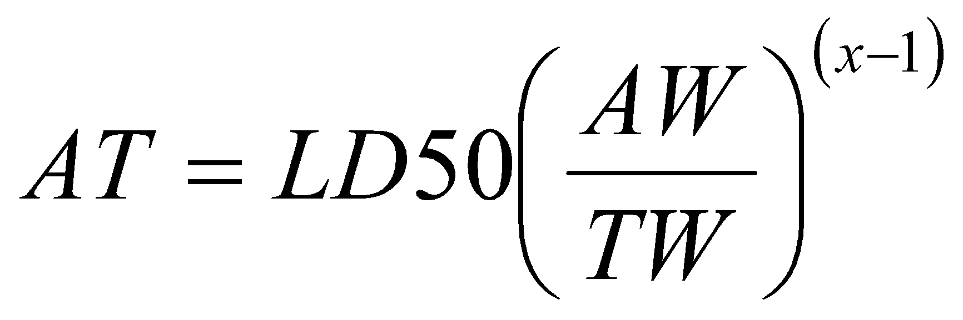
In Eq. (1), AT = adjusted toxicity value, AW = mean weight of the assessed birds, TW = the mean weight of the tested birds (i.e., from which the LD₅₀ estimate was derived), and x = 1.1573 = Mineau scaling factor (Mineau et al. 1996) for chlorpyrifos.

Results

AIC_{c} suggested that the triangular distribution provided the best fit to the chlorpyrifos LD₅₀ bird data, followed by the normal, logistic, gumbel and burr distributions (Table B 2-9.2).

Table B 2-9.2. AICc model selection results for LD₅₀ data
distribution | HC05 | AIC_{c} | ∆AIC_{c} | Weight
triangular | 6.5589 | 126.9751 | 0 | 1.0165
normal | 6.3451 | 128.2234 | 1.2484 | 2.1191
logistic | 5.8103 | 129.0242 | 2.0491 | 2.2042
gumbel | 7.0727 | 129.3169 | 2.3418 | 1.5761
burr | 6.7212 | 132.1071 | 5.132 | 2.4515

HC₀₅ estimates ranged from 4.61 to 8.29 mg a.i./kg-bw (Table B 2-9.3), with relatively large uncertainty. Table B 2-9.4 provides estimates of the HC₀₅ as well as other quantiles of the fitted SSDs. Table B 2-9.5 includes the direct and indirect effects thresholds that may be derived from the HC₀₅ values from Table B 2-9.4 based on a default slope of 4.5. Confidence bounds around these thresholds are also provided in Table B 2-9.5.

Table B 2-9.3. HC₀₅ estimates and diagnostic statistics for all LD₅₀ distributions and methods
distribution | method |  | HC05 | SE | CV | LCx | UCx | LCp | UCp | P
Normal | ML | 6.35 |  | 2.12 | 0.33 | 3.30 | 12.21 | 0.007 | 0.201 | 0.80
Normal | MO | 6.03 |  | 2.39 | 0.40 | 2.96 | 11.79 | 0.006 | 0.197 | 0.72
Normal | GR | 4.84 |  | 1.90 | 0.39 | 1.54 | 8.95 | 0.002 | 0.155 | 0.44
Logistic | ML | 5.81 |  | 2.20 | 0.38 | 2.76 | 12.22 | 0.011 | 0.199 | 0.54
Logistic | MO | 6.14 |  | 2.42 | 0.39 | 2.98 | 12.19 | 0.011 | 0.187 | 0.59
Logistic | GR | 4.47 |  | 2.01 | 0.45 | 0.84 | 8.36 | 0.003 | 0.136 | 0.32
triangular | ML | 6.56 |  | 1.02 | 0.16 | 4.84 | 8.89 | 0.012 | 0.115 | 1.00
triangular | MO | 5.88 |  | 2.32 | 0.40 | 3.19 | 12.39 | 0.0002 | 0.229 | 1.00
triangular | GR | 5.09 |  | 1.89 | 0.37 | 2.09 | 9.51 | 0.0000 | 0.174 | 0.99
Gumbel | ML | 7.07 |  | 1.58 | 0.22 | 4.57 | 10.95 | 0.0047 | 0.187 | 0.77
Gumbel | MO | 8.03 |  | 2.12 | 0.26 | 4.92 | 13.45 | 0.0018 | 0.254 | 0.87
Gumbel | GR | 6.62 |  | 2.03 | 0.31 | 2.65 | 10.47 | 0.0001 | 0.183 | 0.57
Burr | ML | 6.72 |  | 2.45 | 0.36 | 1.30 | 11.53 | 0.0003 | 0.179 | 0.97

Table B 2-9.4. Estimated quantiles of the fitted SSDs for Chlorpyrifos LD₅₀s for birds, standardized to 100 g body weight
Dist | method | HC05 | HC10 | HC50 | HC90 | HC95
Normal | ML | 6.35 | 8.53 | 24.18 | 68.55 | 92.12
Normal | MO | 6.03 | 8.20 | 24.18 | 71.30 | 96.89
Normal | GR | 4.84 | 6.90 | 24.18 | 84.67 | 120.79
Logistic | ML | 5.81 | 8.31 | 23.79 | 68.12 | 97.42
Logistic | MO | 6.14 | 8.70 | 24.18 | 67.20 | 95.14
Logistic | GR | 4.47 | 6.86 | 24.18 | 85.24 | 130.84
triangular | ML | 6.56 | 8.37 | 23.37 | 65.30 | 83.30
triangular | MO | 5.88 | 7.71 | 24.18 | 75.80 | 99.37
triangular | GR | 5.09 | 6.86 | 24.18 | 85.25 | 114.92
Gumbel | ML | 7.07 | 8.62 | 21.30 | 88.02 | 151.36
Gumbel | MO | 8.03 | 9.55 | 21.05 | 72.70 | 116.75
Gumbel | GR | 6.62 | 8.19 | 21.54 | 98.24 | 175.44
Burr | ML | 6.72 | 8.84 | 22.87 | 73.17 | 111.16

Table B 2-9.5. Thresholds for a hypothetical 100 g bird for chlorpyrifos LD₅₀ bird data estimated for all distributions and methods fit for slope from study (slope =4.5)
Distribution | Method | Direct effects threshold  (1 in a million) |  |  | Indirect effects threshold  (10% mortality)
 |  | median | lower | upper | median | lower | upper
Normal | ML | 0.56 | 0.03 | 1.88 | 3.29 | 1.45 | 4.57
Normal | MO | 0.53 | 0.03 | 1.79 | 3.13 | 1.38 | 4.35
Normal | GR | 0.43 | 0.02 | 1.43 | 2.51 | 1.11 | 3.49
Logistic | ML | 0.51 | 0.02 | 1.72 | 3.02 | 1.33 | 4.19
Logistic | MO | 0.54 | 0.03 | 1.82 | 3.19 | 1.40 | 4.43
Logistic | GR | 0.39 | 0.02 | 1.32 | 2.32 | 1.02 | 3.22
triangular | ML | 0.58 | 0.03 | 1.94 | 3.40 | 1.50 | 4.73
triangular | MO | 0.52 | 0.02 | 1.74 | 3.05 | 1.35 | 4.24
triangular | GR | 0.45 | 0.02 | 1.51 | 2.64 | 1.16 | 3.66
Gumbel | ML | 0.62 | 0.03 | 2.10 | 3.67 | 1.62 | 5.10
Gumbel | MO | 0.71 | 0.03 | 2.38 | 4.17 | 1.84 | 5.79
Gumbel | GR | 0.58 | 0.03 | 1.96 | 3.44 | 1.51 | 4.77
Burr | ML | 0.59 | 0.03 | 1.99 | 3.49 | 1.54 | 4.84

Mineau, P., Collins, B.T., and A. Baril. 1996. On the use of scaling factors to improve interspecies extrapolation of acute toxicity in birds. Regulatory Toxicology and Pharmacology, 24: 24-29

