Appendix 2-8: Chlorpyrifos Species Sensitivity Distribution Analysis for Aquatic Invertebrates

Summary

SSDs were fit to toxicity data for aquatic invertebrates exposed to Chlorpyrifos. Five distributions were tested and the gumbel distribution was found to provide the best fit. Tests also suggested that a single SSD should be fit to pooled saltwater and freshwater test results. Important summary statistics from the fitted SSDs are provided below in Table B 2-8.1. Detailed results follow.

Table B 2-8.1. Summary statistics for log-gumbel SSDs fit to Chlorpyrifos test results
Statistic |  |  | Pooled Results | Freshwater Results | Saltwater Results
Goodness of fit P-value | 0.7443 |  |  | 0.6144 | 0.9041
CV of the HC₀₅ |  | 0.47 |  | 0.47 | 2.03
UCp¹ of the HC₀₅ |  | 0.121 |  | 0.13 | 0.221
HC₀₅ |  | 0.041 |  | 0.044 | 0.034
HC₁₀ |  | 0.072 |  | 0.075 | 0.073
HC₅₀ |  | 0.98 |  | 0.79 | 2.43
HC₉₀ |  | 59.5 |  | 32.0 | 602
HC₉₅ |  | 285.0 |  | 131.9 | 4947.5
Mortality Threshold (slope = 4.5) |  | 0.0036 |  | 0.0039 | 0.0030
Indirect Effects Threshold (slope = 4.5) |  | 0.0211 |  | 0.0230 | 0.0174
¹ML=maximum likelihood, MO= moment estimators, and GR=graphical methods
¹ UCp=projections of the upper confidence limit of the HC₀₅ onto the cumulative distribution function of the fitted distribution.

- Data

Data used in this analysis are from an updated dataset (file date: 8-26-16), and are detailed in Table B 2-8.15 (end of document). The LC₅₀ values that are included in this analysis are from either 48 or 96-hour tests with technical grade active ingredient. This updated analysis also includes the EC₅₀ values for “Immobility” as a proxy for mortality from organisms tested under the same exposure criteria as noted above. Table B 2-8.2 provides the distribution of the test results and the number of species represented.

Table B 2-8.2. Distribution of test results available for Chlorpyrifos
Media | Test results | Species
All | 189 | 64
Freshwater | 151 | 51
Saltwater | 38 | 15
One species (Palaemonetes pugio) was tested in both saltwater and freshwater.

Figs. B 2-8.1, 2 and 3 show the distribution of test results among subsets of invertebrate test results. In general, most species have been tested once or twice, with a few species having been tested as many as 17 times.
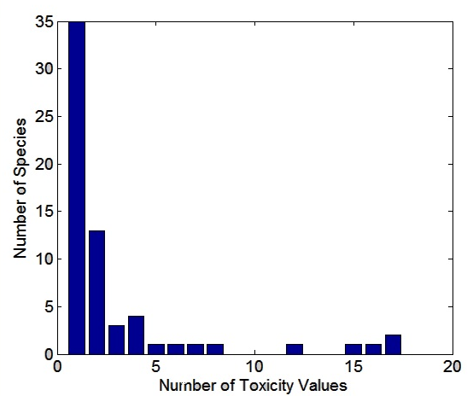
Figure B 2-8.1. Distribution of test results among taxa in all chlorpyrifos test results

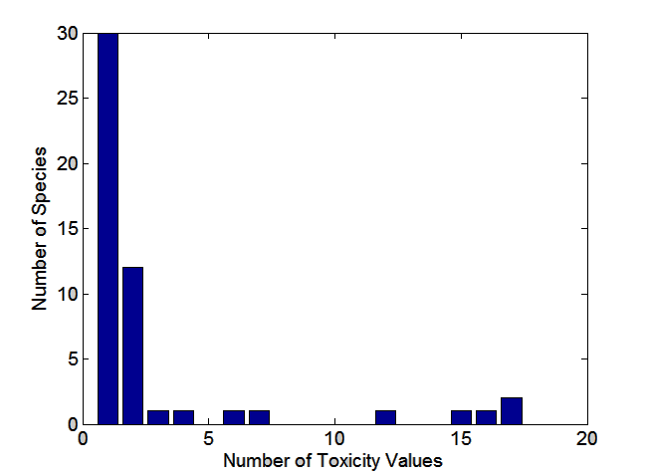

Figure B 2-8.2. Distribution of test results among taxa in freshwater chlorpyrifos test results

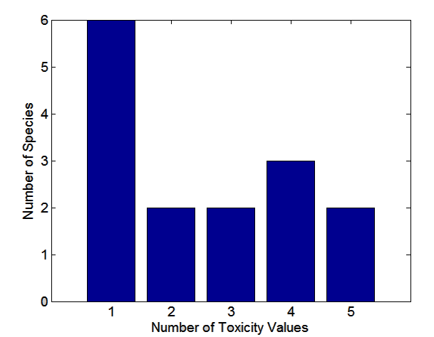
Figure B 2-8.3. Distribution of test results among taxa in saltwater chlorpyrifos test results

Five potential distributions for the Chlorpyrifos data were considered (log-normal, log-logistic, log-triangular, log-gumbel, and Burr). To fit each of the first four distributions, the toxicity values were first common log (log₁₀) transformed. The importance of separating the saltwater versus freshwater taxa was examined using a regression approach with examination of common plots. Finally, direct and indirect effect thresholds and five quantiles from the fitted SSDs (HC₀₅, HC₁₀, HC₅₀, HC₉₀, HC₉₅) were calculated and reported.

II. Comparison of distributions using AICc

Akaike’s Information Criterion corrected for sample size (AIC_{c} ) was used to compare the five distributions for all three datasets, the full dataset combining freshwater and saltwater tests, and then separately for freshwater and saltwater test results. For this comparison all SSDs were fit using maximum likelihood. Based on the AIC_{c} ranking (i.e., lowest value), for all three datasets, AIC_{c} suggested that the gumbel distribution provided the best fit (Tables B 2-8.3, 4 and 5).

Table B 2-8.3. Comparison of distributions for all aquatic invertebrate toxicity data for Chlorpyrifos
Distribution | AIC_{c} | ∆AIC_{c} | Weight | HC₀₅ | HC₀₅ (SE)
gumbel | 379.3427 | 0 | 0.7609 | 0.0407 | 0.0129
burr | 381.6609 | 2.3182 | 0.2387 | 0.0406 | 0.0177
logistic | 394.8018 | 15.4591 | 3.35E-04 | 0.0087 | 0.0052
normal | 397.8775 | 18.5348 | 7.19E-05 | 0.0109 | 0.0064
triangular | 406.8823 | 27.5396 | 7.96E-07 | 0.0089 | 0.0083

Table B 2-8.4. Comparison of distributions for freshwater invertebrate toxicity data for Chlorpyrifos
Distribution | AIC_{c} | ∆AIC_{c} | Weight | HC₀₅ | HC₀₅ (SE)
gumbel | 259.4553 | 0 | 0.7539 | 0.0444 | 0.0141
burr | 261.7608 | 2.3055 | 0.2381 | 0.0444 | 0.0157
logistic | 269.2362 | 9.7809 | 0.0057 | 0.0133 | 0.0079
normal | 271.0178 | 11.5624 | 0.0023 | 0.0162 | 0.0093
triangular | 284.6211 | 25.1658 | 2.59E-06 | 0.0113 | 0.0109

Table B 2-8.5. Comparison of distributions for saltwater invertebrate toxicity data for Chlorpyrifos
Distribution | AIC_{c} | ∆AIC_{c} | Weight | HC₀₅ | HC₀₅ (SE)
gumbel | 135.0104 | 0 | 0.5506 | 0.0336 | 0.0298
triangular | 137.5345 | 2.5241 | 0.1559 | 0.0112 | 0.0221
normal | 138.1906 | 3.1802 | 0.1123 | 0.0073 | 0.0115
burr | 138.3135 | 3.3031 | 0.1056 | 0.0321 | 0.0302
logistic | 138.9783 | 3.9679 | 0.0757 | 0.0034 | 0.0057

III. Test for the need to model results separately by medium

To test whether or not separate SSDs should be used, the individual freshwater and saltwater SSDs were plotted with their confidence limits, against the pooled all-invertebrate SSD (Fig. B 2-8.4). For both freshwater and saltwater, the 95% confidence limits around the SSDs, encompass the SSD for pooled results (the null model), thus, these plots provide support for considering a single pooled SSD.

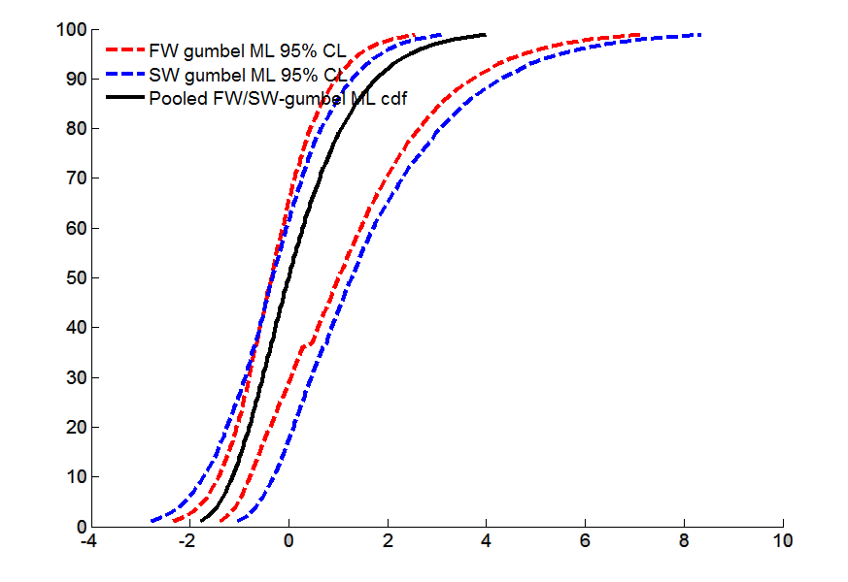

Figure B 2-8.4. Log-gumbel SSD for aquatic invertebrate test results (black line; SSD plot), freshwater invertebrates (red dashed lines; 95% confidence limits), and saltwater invertebrates (blue dashed lines; 95% confidence limits).

IV. Goodness of fit & Uncertainty

To test goodness-of-fit, all five distributions were fit to each of the three datasets (pooled, saltwater and freshwater toxicity data) and bootstrap goodness-of-fit tests with 5,000 bootstrap replicates were used. Three different fitting methods (maximum likelihood, moment estimators, and graphical methods) were used, though, not all methods are available for all distributions. Tables B 2-8.6, 7 and 8 give results of these fitting exercises. No distribution showed significant lack-of-fit, except the Burr distribution for all datasets. In general, the gumbel distribution (determined to be the best by AIC_{c}) also had the lowest coefficients of variation for the HC₀₅ (excluding the Burr distribution due to lack-of-fit). The gumbel distribution also tended to produce the highest estimates of the HC₀₅, and generally, the narrowest confidence intervals around the HC₀₅ (Tables B 2-8.6, 7 and 8, Figs. B 2-8.5, 6 and 7).

Table B 2-8.6. Range of HC₀₅ values for Chlorpyrifos SSDs fit to all invertebrates.
Distribution | Method¹ | HC₀₅ | SE | CV | LCx | Ucx | LCp | Ucp | P
normal | ML | 0.0109 | 0.0089 | 0.8151 | 0.0026 | 0.037 | 0.0176 | 0.1062 | 0.98
normal | MO | 0.0105 | 0.0083 | 0.7899 | 0.003 | 0.0322 | 0.0205 | 0.1001 | 0.992
normal | GR | 0.0081 | 0.0056 | 0.6932 | 0.0019 | 0.0232 | 0.0181 | 0.0934 | 0.989
logistic | ML | 0.0087 | 0.0072 | 0.8322 | 0.0024 | 0.0302 | 0.0234 | 0.1 | 0.9211
logistic | MO | 0.0112 | 0.0107 | 0.959 | 0.003 | 0.0416 | 0.0237 | 0.102 | 0.997
logistic | GR | 0.0074 | 0.0052 | 0.7029 | 0.0011 | 0.0202 | 0.0184 | 0.083 | 0.994
triangular | ML | 0.0089 | 0.009 | 1.0015 | 0.0043 | 0.034 | 0.0271 | 0.1086 | 1
triangular | MO | 0.0095 | 0.0065 | 0.687 | 0.0034 | 0.0288 | 0.016 | 0.1067 | 0.997
triangular | GR | 0.0083 | 0.0058 | 0.6967 | 0.0023 | 0.024 | 0.0113 | 0.1023 | 0.996
gumbel | ML | 0.0407 | 0.0191 | 0.4701 | 0.0194 | 0.087 | 0.0148 | 0.1209 | 0.7443
gumbel | MO | 0.0299 | 0.0149 | 0.4976 | 0.0122 | 0.0703 | 0.0131 | 0.1221 | 0.7363
gumbel | GR | 0.0231 | 0.0101 | 0.438 | 0.0064 | 0.0453 | 0.0075 | 0.0988 | 0.6114
burr | ML | 0.0406 | 0.0136 | 0.3354 | 0.0232 | 0.0766 | 0.0208 | 0.1064 | 0.1389

Table B 2-8.7. Range of HC₀₅ values for Chlorpyrifos SSDs fit to freshwater invertebrates.
Distribution | Method¹ | HC₀₅ | SE | CV | LCx | Ucx | LCp | Ucp | P
normal | ML | 0.0162 | 0.0125 | 0.7728 | 0.0034 | 0.0512 | 0.0127 | 0.1132 | 0.959
normal | MO | 0.0155 | 0.0108 | 0.6987 | 0.005 | 0.0463 | 0.0193 | 0.1084 | 0.972
normal | GR | 0.0119 | 0.008 | 0.6702 | 0.003 | 0.0331 | 0.0163 | 0.0997 | 0.9451
logistic | ML | 0.0133 | 0.0101 | 0.7603 | 0.004 | 0.0444 | 0.0226 | 0.1075 | 0.8462
logistic | MO | 0.0164 | 0.0138 | 0.8378 | 0.0046 | 0.0585 | 0.0217 | 0.1109 | 0.971
logistic | GR | 0.0109 | 0.0077 | 0.7125 | 0.0016 | 0.0293 | 0.0159 | 0.0888 | 0.9211
triangular | ML | 0.0113 | 0.0129 | 1.146 | 0.0048 | 0.0524 | 0.0228 | 0.1244 | 1
triangular | MO | 0.0143 | 0.0098 | 0.681 | 0.0054 | 0.0401 | 0.0138 | 0.1122 | 0.966
triangular | GR | 0.0124 | 0.0074 | 0.5982 | 0.004 | 0.0329 | 0.0109 | 0.1062 | 0.975
gumbel | ML | 0.0444 | 0.0207 | 0.4673 | 0.0189 | 0.0945 | 0.0098 | 0.1301 | 0.6144
gumbel | MO | 0.0384 | 0.018 | 0.4688 | 0.0158 | 0.0854 | 0.0101 | 0.13 | 0.5874
gumbel | GR | 0.0297 | 0.0134 | 0.4521 | 0.0084 | 0.06 | 0.0055 | 0.1111 | 0.4595
burr | ML | 0.0444 | 0.017 | 0.3824 | 0.0244 | 0.0923 | 0.0174 | 0.1268 | 0.3297
¹ML=maximum likelihood, MO= moment estimators, and GR=graphical methods
LCp and UCp=projections of the confidence limits of the HC₀₅ (LCx and UCx) onto the cumulative distribution function of the fitted distribution.

Table B 2-8.8. Range of HC₀₅ values for Chlorpyrifos SSDs fit to saltwater invertebrates.
Distribution | Method¹ | HC₀₅ | SE | CV | LCx | Ucx | LCp | Ucp | P
normal | ML | 0.00730 | 0.08000 | 10.96200 | 0.00047 | 0.23200 | 0.00990 | 0.21850 | 0.96500
normal | MO | 0.00580 | 0.06320 | 10.89880 | 0.00021 | 0.13760 | 0.00720 | 0.19010 | 0.97400
normal | GR | 0.00210 | 0.01360 | 6.56190 | 0.00001 | 0.03470 | 0.00280 | 0.14630 | 0.95500
logistic | ML | 0.00340 | 0.04590 | 13.69880 | 0.00011 | 0.10140 | 0.01200 | 0.18480 | 0.94810
logistic | MO | 0.00630 | 0.06060 | 9.57740 | 0.00015 | 0.18040 | 0.01000 | 0.18660 | 0.96500
logistic | GR | 0.00140 | 0.01120 | 7.80090 | 0.00000 | 0.03160 | 0.00300 | 0.13810 | 0.93610
triangular | ML | 0.01120 | 0.20010 | 17.88040 | 0.00200 | 0.29950 | 0.00880 | 0.22330 | 0.97500
triangular | MO | 0.00510 | 0.05880 | 11.48970 | 0.00032 | 0.13940 | 0.00093 | 0.20680 | 0.96400
triangular | GR | 0.00260 | 0.02890 | 11.03280 | 0.00004 | 0.03870 | 0.00000 | 0.15620 | 0.97000
gumbel | ML | 0.03360 | 0.06850 | 2.03910 | 0.00770 | 0.24840 | 0.00710 | 0.22050 | 0.90410
gumbel | MO | 0.02350 | 0.08170 | 3.47510 | 0.00260 | 0.23830 | 0.00270 | 0.23260 | 0.89110
gumbel | GR | 0.00950 | 0.02330 | 2.44240 | 0.00012 | 0.07260 | 0.00011 | 0.16830 | 0.85310
burr | ML | 0.03210 | 0.06470 | 2.01640 | 0.00410 | 0.24120 | 0.00290 | 0.21770 | 0.16280

¹ML=maximum likelihood, MO= moment estimators, and GR=graphical methods
LCp and UCp=projections of the confidence limits of the HC₀₅ (LCx and UCx) onto the cumulative distribution function of the fitted distribution.

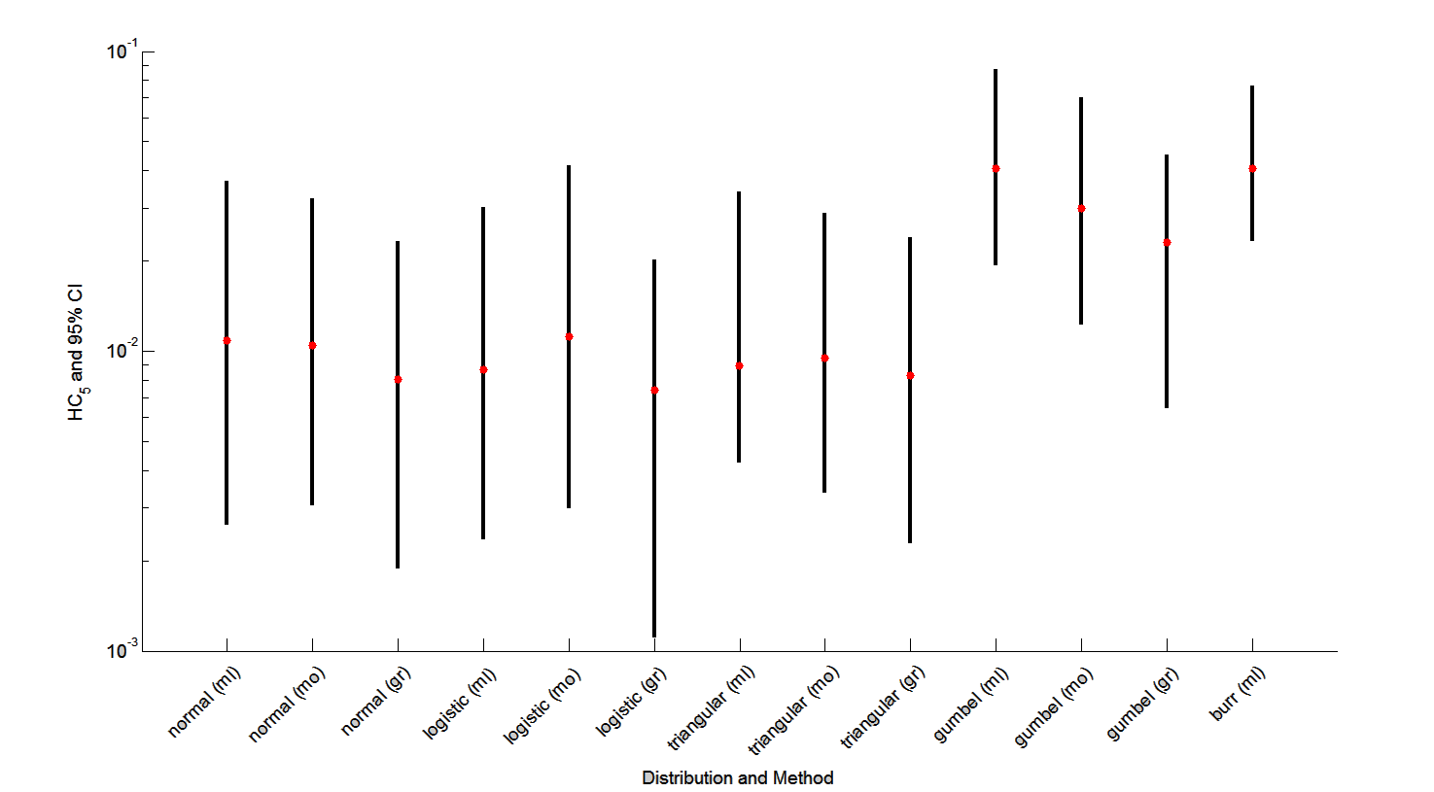

Figure B 2-8.5. Mean (red point) and range (black bar) of estimated HC₀₅s for all Chlorpyrifos invertebrate test results

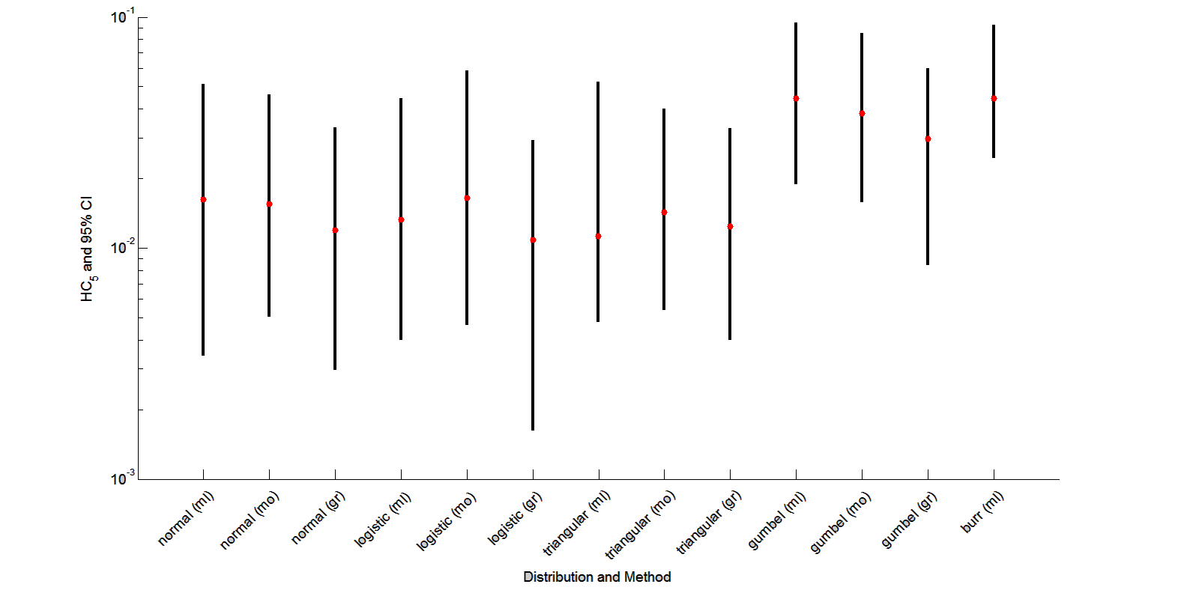
Figure B 2-8.6. Mean (red point) and range (black bar) of estimated HC₀₅s for all Chlorpyrifos freshwater invertebrate test results

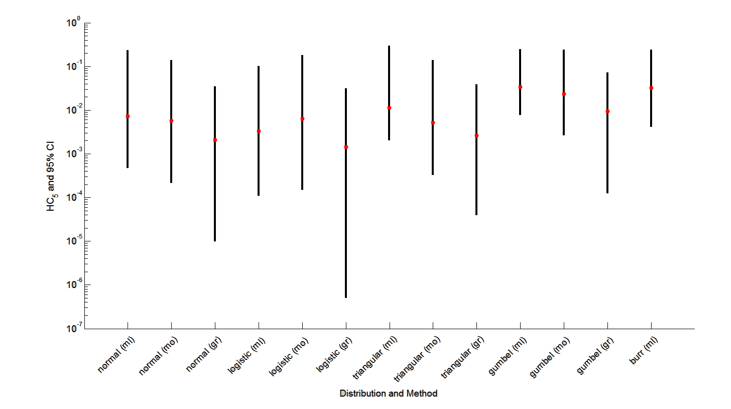

Figure B 2-8.7. Mean (red point) and range (black bar) of estimated HC₀₅s for all Chlorpyrifos saltwater invertebrate test results

Another step to assess goodness-of-fit was to visually inspect the fit for evidence of problems. Figures B 2-8.8, 9, and 10 below plot the data points against the fitted SSDs for pooled, freshwater and saltwater test results. These plots do show some evidence for lack-of-fit, especially at the higher quantiles. However, they seem to fit fairly well in the neighborhood of the HC₀₅.

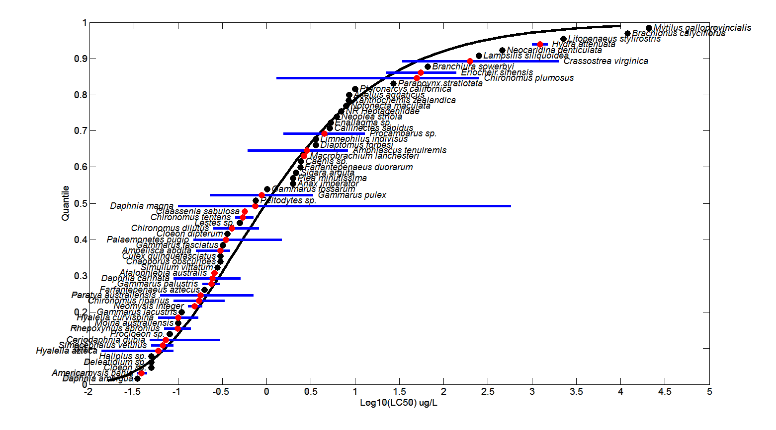

Figure B 2-8.8. Log-gumbel SSD for Chlorpyrifos toxicity values for pooled invertebrates. Black points indicate single toxicity values. Red points indicate average of multiple toxicity values for a single species. Blue line indicates full range of toxicity values for a given species.

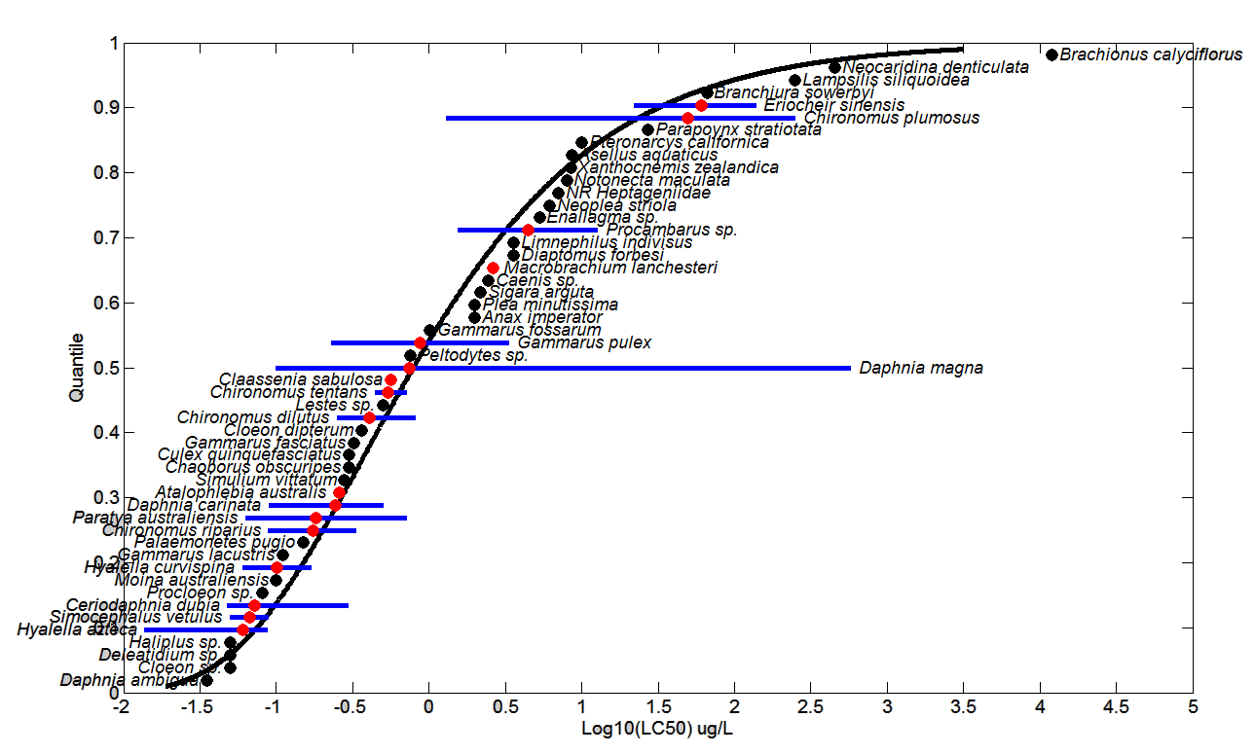
Figure B 2-8.9. Log-gumbel SSD for Chlorpyrifos toxicity values for freshwater invertebrates. Black points indicate single toxicity values. Red points indicate average of multiple toxicity values for a single species. Blue line indicates full range of toxicity values for a given species.
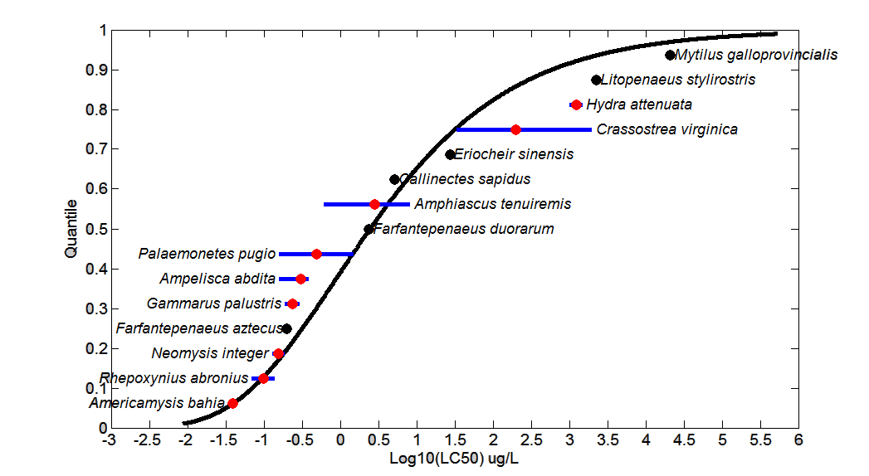

Figure B 2-8.10. Log-gumbel SSD for Chlorpyrifos toxicity values for saltwater invertebrates. Black points indicate single toxicity values. Red points indicate average of multiple toxicity values for a single species. Blue line indicates full range of toxicity values for a given species.

V. Calculation of other quantiles
Tables B 2-8.9, 10, and 11 provide estimates of the HC₀₅ as well as other quantiles of the fitted SSDs.

Table B 2-8.9. Estimated quantiles of the fitted SSDs for all invertebrate toxicity tests for Chlorpyrifos
Distribution | method | HC₀₅ | HC₁₀ | HC₅₀ | HC₉₀ | HC₉₅
normal | ML | 0.0109 | 0.0332 | 1.7058 | 87.5577 | 267.3999
normal | MO | 0.0105 | 0.0322 | 1.7058 | 90.3265 | 278.3013
normal | GR | 0.0081 | 0.0263 | 1.7058 | 110.4267 | 360.1725
logistic | ML | 0.0087 | 0.0301 | 1.163 | 44.8733 | 155.4108
logistic | MO | 0.0112 | 0.04 | 1.7058 | 72.6844 | 260.3725
logistic | GR | 0.0074 | 0.0294 | 1.7058 | 98.8087 | 392.9151
triangular | ML | 0.0089 | 0.0287 | 3.9518 | 543.576 | 1.75E+03
triangular | MO | 0.0095 | 0.0257 | 1.7058 | 113.0655 | 305.438
triangular | GR | 0.0083 | 0.0231 | 1.7058 | 126.1057 | 349.5911
gumbel | ML | 0.0407 | 0.0722 | 0.9847 | 59.4803 | 285.0498
gumbel | MO | 0.0299 | 0.0565 | 1.0255 | 96.9959 | 551.7237
gumbel | GR | 0.0231 | 0.0459 | 1.0486 | 142.1069 | 927.4016
burr | ML | 0.0406 | 0.0722 | 0.9842 | 58.4338 | 277.8289
Table B 2-8.10. Estimated quantiles of the fitted SSDs for freshwater invertebrate toxicity tests for Chlorpyrifos
dist | method | HC₀₅ | HC₁₀ | HC₅₀ | HC₉₀ | HC₉₅
normal | ML | 0.0162 | 0.0423 | 1.2519 | 37.0123 | 96.669
normal | MO | 0.0155 | 0.0409 | 1.2519 | 38.2808 | 100.9418
normal | GR | 0.0119 | 0.0333 | 1.2519 | 47.0424 | 131.5085
logistic | ML | 0.0133 | 0.0395 | 0.9679 | 23.7374 | 70.4697
logistic | MO | 0.0164 | 0.0494 | 1.2519 | 31.7441 | 95.3129
logistic | GR | 0.0109 | 0.0362 | 1.2519 | 43.2837 | 144.4133
triangular | ML | 0.0113 | 0.034 | 3.5444 | 369.6706 | 1.11E+03
triangular | MO | 0.0143 | 0.0337 | 1.2519 | 46.452 | 109.3676
triangular | GR | 0.0124 | 0.03 | 1.2519 | 52.1617 | 126.2309
gumbel | ML | 0.0444 | 0.0745 | 0.789 | 32.026 | 131.8531
gumbel | MO | 0.0384 | 0.0664 | 0.8075 | 40.7041 | 182.0372
gumbel | GR | 0.0297 | 0.0539 | 0.8269 | 59.9252 | 307.8839
burr | ML | 0.0444 | 0.0745 | 0.7891 | 31.7335 | 130.0851

Table B 2-8.11. Estimated quantiles of the fitted SSDs for saltwater invertebrate toxicity tests for Chlorpyrifos
dist | method | HC₀₅ | HC₁₀ | HC₅₀ | HC₉₀ | HC₉₅
normal | ML | 0.0073 | 0.0311 | 5.14 | 851.9 | 3626.3
normal | MO | 0.0058 | 0.0260 | 5.14 | 1019.2 | 4564.9
normal | GR | 0.0021 | 0.0117 | 5.14 | 2265.0 | 12722.0
logistic | ML | 0.0034 | 0.0192 | 3.24 | 546.0 | 3123.2
logistic | MO | 0.0063 | 0.0347 | 5.14 | 763.0 | 4177.3
logistic | GR | 0.0014 | 0.0114 | 5.14 | 2314.4 | 18480.0
triangular | ML | 0.0112 | 0.0380 | 6.62 | 1153.6 | 3918.0
triangular | MO | 0.0051 | 0.0192 | 5.14 | 1374.7 | 5167.5
triangular | GR | 0.0026 | 0.0112 | 5.14 | 2360.4 | 10086.0
gumbel | ML | 0.0336 | 0.0725 | 2.43 | 602.2 | 4947.5
gumbel | MO | 0.0235 | 0.0548 | 2.61 | 1120.7 | 11362.0
gumbel | GR | 0.0095 | 0.0267 | 2.90 | 4563.5 | 75969.0
burr | ML | 0.0321 | 0.0708 | 2.45 | 594.4 | 4812.3

VI. Calculation of thresholds
Thresholds were calculated assuming a probit dose-response with the HC₀₅ as the mean and a default slope of 4.5. Lower and upper confidence limits are calculated from the lower and upper confidence limits of the HC₀₅ estimates. Calculated thresholds are provided in Tables B 2-8.9.12, 13, and 14.

Table B 2-8.9.12. Morality and Indirect Effects Thresholds for Chlorpyrifos (all invertebrates)
distrib. | method | Mortality Threshold (10⁻⁶) |  |  | Indirect Effects Threshold (10⁻¹)
 |  | Expected | LCL | UCL | Expected | LCL | UCL
normal | ML | 0.00096 | 0.00023 | 0.00320 | 0.00560 | 0.00140 | 0.01920
normal | MO | 0.00092 | 0.00027 | 0.00280 | 0.00540 | 0.00160 | 0.01670
normal | GR | 0.00071 | 0.00016 | 0.00200 | 0.00420 | 0.00097 | 0.01210
logistic | ML | 0.00076 | 0.00021 | 0.00260 | 0.00450 | 0.00120 | 0.01570
logistic | MO | 0.00098 | 0.00026 | 0.00370 | 0.00580 | 0.00150 | 0.02160
logistic | GR | 0.00065 | 0.00010 | 0.00180 | 0.00380 | 0.00057 | 0.01050
triangular | ML | 0.00079 | 0.00037 | 0.00300 | 0.00460 | 0.00220 | 0.01760
triangular | MO | 0.00084 | 0.00030 | 0.00250 | 0.00490 | 0.00170 | 0.01490
triangular | GR | 0.00073 | 0.00020 | 0.00210 | 0.00430 | 0.00120 | 0.01250
gumbel | ML | 0.00360 | 0.00170 | 0.00760 | 0.02110 | 0.01000 | 0.04520
gumbel | MO | 0.00260 | 0.00110 | 0.00620 | 0.01550 | 0.00640 | 0.03650
gumbel | GR | 0.00200 | 0.00056 | 0.00400 | 0.01200 | 0.00330 | 0.02350
burr | ML | 0.00360 | 0.00200 | 0.00670 | 0.02110 | 0.01200 | 0.03980

Table B 2-8.9.13. Mortality and Indirect Effects Thresholds for Chlorpyrifos (freshwater invertebrates)
distrib. | method | Mortality Threshold (10⁻⁶) |  |  | Indirect Effects Threshold (10⁻¹)
 |  | Expected | LCL | UCL | Expected | LCL | UCL
normal | ML | 0.00140 | 0.00030 | 0.00450 | 0.00840 | 0.00180 | 0.02660
normal | MO | 0.00140 | 0.00044 | 0.00410 | 0.00810 | 0.00260 | 0.02400
normal | GR | 0.00100 | 0.00026 | 0.00290 | 0.00620 | 0.00150 | 0.01720
logistic | ML | 0.00120 | 0.00035 | 0.00390 | 0.00690 | 0.00210 | 0.02300
logistic | MO | 0.00140 | 0.00041 | 0.00510 | 0.00850 | 0.00240 | 0.03040
logistic | GR | 0.00095 | 0.00014 | 0.00260 | 0.00560 | 0.00084 | 0.01520
triangular | ML | 0.00099 | 0.00042 | 0.00460 | 0.00590 | 0.00250 | 0.02720
triangular | MO | 0.00130 | 0.00047 | 0.00350 | 0.00740 | 0.00280 | 0.02080
triangular | GR | 0.00110 | 0.00035 | 0.00290 | 0.00640 | 0.00210 | 0.01710
gumbel | ML | 0.00390 | 0.00170 | 0.00830 | 0.02300 | 0.00980 | 0.04910
gumbel | MO | 0.00340 | 0.00140 | 0.00750 | 0.01990 | 0.00820 | 0.04430
gumbel | GR | 0.00260 | 0.00074 | 0.00530 | 0.01540 | 0.00440 | 0.03110
burr | ML | 0.00390 | 0.00210 | 0.00810 | 0.02300 | 0.01270 | 0.04790

Table B 2-8.9.14. Thresholds for determination of action area for Chlorpyrifos (saltwater invertebrates)
distrib. | method | Mortality Threshold (10⁻⁶) |  |  | Indirect Effects Threshold (10⁻¹)
 |  | Expected | LCL | UCL | Expected | LCL | UCL
normal | ML | 0.0006 | 0.0000 | 0.0204 | 0.0038 | 0.0002 | 0.1204
normal | MO | 0.0005 | 0.0000 | 0.0121 | 0.0030 | 0.0001 | 0.0714
normal | GR | 0.0002 | 0.0000 | 0.0030 | 0.0011 | 0.0000 | 0.0180
logistic | ML | 0.0003 | 0.0000 | 0.0089 | 0.0017 | 0.0001 | 0.0526
logistic | MO | 0.0006 | 0.0000 | 0.0158 | 0.0033 | 0.0001 | 0.0937
logistic | GR | 0.0001 | 0.0000 | 0.0028 | 0.0007 | 0.0000 | 0.0164
triangular | ML | 0.0010 | 0.0002 | 0.0263 | 0.0058 | 0.0010 | 0.1554
triangular | MO | 0.0004 | 0.0000 | 0.0122 | 0.0027 | 0.0002 | 0.0724
triangular | GR | 0.0002 | 0.0000 | 0.0034 | 0.0014 | 0.0000 | 0.0201
gumbel | ML | 0.0030 | 0.0007 | 0.0218 | 0.0174 | 0.0040 | 0.1290
gumbel | MO | 0.0021 | 0.0002 | 0.0209 | 0.0122 | 0.0014 | 0.1237
gumbel | GR | 0.0008 | 0.0000 | 0.0064 | 0.0050 | 0.0001 | 0.0377
burr | ML | 0.0028 | 0.0004 | 0.0212 | 0.0167 | 0.0021 | 0.1252

Table B 2-8. 15 provides all of the available LC₅₀ values for aquatic invertebrates (within the 24 or 48 hour timeframe-unless otherwise noted). These data sets are the same as reported in the effects characterization and provide additional data for the formulated products. Values that were included in the SSD (i.e., TGAI) are marked with an *.

Table B 2-8.15. Available median lethal concentration (LC₅₀) data for aquatic invertebrates exposed (48 or 96 hr) to chlorpyrifos as TGAI or formulation.
Genus | Species | Endpoint | SSD | Conc. in ug/L | Ref # | Classification
Hyalella | azteca | MORT | * | 0.014 | MRID 44345601 | Acceptable
Daphnia | magna | IMBL |  | 0.032 | 160353 | NA¹
Americamysis | bahia | MORT | * | 0.035 | 15639 | NA¹
Daphnia | ambigua | MORT | * | 0.035 | 71674 | NA¹
Americamysis | bahia | MORT | * | 0.035 | MRID 40228401 | Supplemental
Hyalella | azteca | MORT | * | 0.038 | 352 | NA¹
Americamysis | bahia | MORT | * | 0.040 | 3947 | NA¹
Americamysis | bahia | MORT | * | 0.040 | MRID 40228401 | Supplemental
Hyalella | azteca | MORT | * | 0.043 | 64955 | Quantitative
Americamysis | bahia | MORT | * | 0.045 | MRID 42144906 | Acceptable
Ceriodaphnia | dubia | MORT | * | 0.048 | 158195 | NA¹
Hyalella | azteca | MORT | * | 0.050 | 16806 | NA¹
Simocephalus | vetulus | MORT | * | 0.050 | 16806 | NA¹
Haliplus | sp. | MORT | * | 0.050 | 16806 | NA¹
Cloeon | sp. | MORT | * | 0.050 | 16806 | NA¹
Ceriodaphnia | dubia | MORT | * | 0.050 | 73373 | NA¹
Deleatidium | sp. | MORT | * | 0.050 | 153793 | NA¹
Hyalella | azteca | MORT | * | 0.051 | 160294 | NA¹
Ceriodaphnia | dubia | MORT | * | 0.053 | 18190 | Quant. SSD
Ceriodaphnia | dubia | MORT | * | 0.055 | 18190 | Quant. SSD
Ceriodaphnia | dubia | MORT | * | 0.056 | 71674 | NA¹
Ceriodaphnia | dubia | MORT | * | 0.058 | 18190 | Quant. SSD
Hyalella | curvispina | MORT | * | 0.060 | 159934 | NA¹
Ceriodaphnia | dubia | MORT | * | 0.060 | 16844 | NA¹
Ceriodaphnia | dubia | MORT | * | 0.060 | 16844 | NA¹
Paratya | australiensis | MORT | * | 0.063 | 121117 | NA¹
Ceriodaphnia | dubia | MORT | * | 0.064 | 18190 | NA¹
Hyalella | azteca | MORT | * | 0.065 | 86411 | NA¹
Ceriodaphnia | dubia | MORT | * | 0.066 | 18190 | NA¹
Gammarus | pulex | MORT |  | 0.070 | 8107 | NA¹
Rhepoxynius | abronius | MORT | * | 0.070 | 56538 | NA¹
Hyalella | azteca | MORT | * | 0.070 | 86411 | NA¹
Ceriodaphnia | dubia | MORT | * | 0.070 | 108483 | Quant. SSD
Hyalella | azteca | MORT | * | 0.071 | 86411 | NA¹
Hyalella | azteca | MORT | * | 0.072 | 86411 | NA¹
Hyalella | azteca | MORT | * | 0.072 | 86411 | NA¹
Hyalella | azteca | MORT | * | 0.074 | 86411 | NA¹
Hyalella | azteca | MORT | * | 0.076 | 86411 | NA¹
Ceriodaphnia | dubia | MORT | * | 0.079 | 18190 | Quant. SSD
Gammarus | pulex | MORT |  | 0.080 | 8107 | NA¹
Paratya | australiensis | MORT | * | 0.080 | 18468 | NA¹
Paratya | australiensis | MORT | * | 0.080 | 18468 | NA¹
Ceriodaphnia | dubia | IMBL | * | 0.080 | 67777 | NA¹
Ceriodaphnia | dubia | MORT | * | 0.080 | 157799 | NA¹
Hyalella | azteca | MORT | * | 0.081 | 86411 | NA¹
Procloeon | sp. | MORT | * | 0.081 | 90039 | NA¹
Hyalella | azteca | MORT | * | 0.085 | 86411 | NA¹
Hyalella | azteca | MORT | * | 0.086 | 86411 | NA¹
Chironomus | riparius | MORT | * | 0.089 | 13342 | NA¹
Hyalella | azteca | MORT | * | 0.089 | 86411 | NA¹
Daphnia | carinata | MORT | * | 0.090 | 108483 | Acceptable
Simocephalus | vetulus | MORT | * | 0.090 | 108483 | Acceptable
Ceriodaphnia | dubia | MORT | * | 0.094 | 18190 | Quant. SSD
Paratya | australiensis | MORT | * | 0.10 | 18468 | NA¹
Hyalella | azteca | MORT |  | 0.10 | 18996 | NA¹
Rhepoxynius | abronius | MORT | * | 0.10 | 56538 | NA¹
Moina | australiensis | MORT | * | 0.10 | 108483 | NA¹
Daphnia | magna | IMBL | * | 0.10 | MRID 40840902 | Acceptable
Daphnia | magna | IMBL | * | 0.11 | 13342 | NA¹
Gammarus | lacustris | MORT | * | 0.11 | 6797 | NA¹
Ceriodaphnia | dubia | IMBL |  | 0.11 | 67777 | NA¹
Gammarus | lacustris | MORT | * | 0.11 | MRID 40098001 | Supplemental
Ceriodaphnia | dubia | MORT | * | 0.12 | 18190 | Quant. SSD
Neomysis | integer | MORT | * | 0.13 | 53635 | NA¹
Rhepoxynius | abronius | MORT | * | 0.14 | 56538 | NA¹
Paratya | australiensis | MORT | * | 0.15 | 18468 | NA¹
Paratya | australiensis | MORT | * | 0.15 | 18468 | NA¹
Neomysis | integer | MORT | * | 0.15 | 53635 | NA¹
Palaemonetes | pugio | MORT | * | 0.15 | 92616 | NA¹
Palaemonetes | pugio | MORT | * | 0.15 | 92616 | NA¹
Ampelisca | abdita | MORT | * | 0.16 | 56539 | NA¹
Palaemonetes | pugio | MORT | * | 0.16 | 72741 | NA¹
Hyalella | curvispina | MORT | * | 0.17 | 159934 | NA¹
Gammarus | palustris | MORT | * | 0.19 | 51439 | NA¹
Neomysis | integer | MORT | * | 0.19 | 53635 | NA¹
Daphnia | magna | IMBL | * | 0.19 | 96171 | NA¹
Culex | pipiens ssp. molestus | MORT |  | 0.20 | 5162 | NA¹
Cloeon | dipterum | IMBL |  | 0.20 | 8107 | NA¹
Farfantepenaeus | aztecus | MORT | * | 0.20 | MRID 40228401 | Supplemental
Daphnia | magna | IMBL | * | 0.21 | 13342 | NA¹
Daphnia | magna | IMBL | * | 0.22 | 13342 | NA¹
Gammarus | pulex | MORT | * | 0.23 | 159804 | NA¹
Daphnia | carinata | MORT | * | 0.23 | 107384 | Quantitative
Atalophlebia | australis | MORT | * | 0.24 | 108483 | Acceptable
Daphnia | carinata | MORT | * | 0.24 | 108495 | NA¹
Paratya | australiensis | MORT | * | 0.25 | 18468 | NA¹
Daphnia | pulex | MORT |  | 0.25 | 18477 | NA¹
Daphnia | pulex | IMBL |  | 0.25 | 18477 | NA¹
Ceriodaphnia | dubia | IMBL |  | 0.25 | 67777 | NA¹
Daphnia | magna | MORT | * | 0.25 | 157799 | NA¹
Chironomus | dilutus | IMBL | * | 0.25 | 160294 | NA¹
Daphnia | carinata | MORT | * | 0.28 | 107384 | NA¹
Paratya | australiensis | MORT | * | 0.28 | 18468 | NA¹
Paratya | australiensis | MORT | * | 0.28 | 18468 | NA¹
Paratya | australiensis | MORT | * | 0.28 | 18468 | NA¹
Simulium | vittatum | MORT | * | 0.28 | 71060 | NA¹
Atalophlebia | australis | MORT | * | 0.28 | 108483 | Acceptable
Chironomus | dilutus | MORT | * | 0.29 | 160294 | NA¹
Cloeon | dipterum | MORT |  | 0.30 | 8107 | NA¹
Daphnia | longispina | MORT |  | 0.30 | 8107 | NA¹
Daphnia | longispina | IMBL |  | 0.30 | 8107 | NA¹
Daphnia | longispina | IMBL |  | 0.30 | 8107 | NA¹
Gammarus | pulex | IMBL |  | 0.30 | 17254 | NA¹
Chironomus | tentans | MORT |  | 0.30 | 18996 | NA¹
Gammarus | palustris | MORT | * | 0.30 | 51439 | NA¹
Ceriodaphnia | dubia | IMBL | * | 0.30 | 67777 | NA¹
Culex | quinquefasciatus | MORT | * | 0.30 | 101101 | NA¹
Daphnia | carinata | MORT | * | 0.30 | 108495 | NA¹
Macrobrachium | rosenbergii | MORT |  | 0.30 | 116838 | NA¹
Chaoborus | obscuripes | MORT | * | 0.30 | 159804 | NA¹
Gammarus | fasciatus | MORT | * | 0.32 | 887 | NA¹
Daphnia | magna | MORT | * | 0.33 | 19813 | NA¹
Paratya | australiensis | MORT | * | 0.33 | 108483 | Quant. SSD
Chironomus | riparius | MORT | * | 0.34 | 13342 | NA¹
Ampelisca | abdita | MORT | * | 0.34 | 56539 | NA¹
Daphnia | magna | MORT | * | 0.34 | 19813 | NA¹
Cloeon | dipterum | MORT | * | 0.36 | 159804 | NA¹
Palaemonetes | pugio | MORT | * | 0.37 | 14848 | NA¹
Ampelisca | abdita | MORT | * | 0.39 | 4061 | NA¹
Ampelisca | abdita | MORT | * | 0.39 | 56539 | NA¹
Cloeon | dipterum | IMBL |  | 0.40 | 8107 | NA¹
Simocephalus | vetulus | IMBL |  | 0.40 | 8107 | NA¹
Simocephalus | vetulus | IMBL |  | 0.40 | 8107 | NA¹
Cloeon | dipterum | IMBL |  | 0.40 | 17254 | NA¹
Daphnia | pulex | IMBL |  | 0.42 | 18477 | NA¹
Gammarus | pulex | MORT |  | 0.43 | 159804 | NA¹
Palaemonetes | pugio | MORT | * | 0.44 | 14848 | NA¹
Chironomus | tentans | MORT | * | 0.45 | 352 | NA¹
Chironomus | dilutus | MORT | * | 0.46 | 117852 | NA¹
Chironomus | tentans | IMBL | * | 0.49 | 62472 | NA¹
Palaemonetes | argentinus | MORT |  | 0.49 | 101421 | NA¹
Simocephalus | vetulus | MORT |  | 0.50 | 8107 | NA¹
Caenis | horaria | IMBL |  | 0.50 | 8107 | NA¹
Lestes | sp. | MORT | * | 0.50 | 16806 | NA¹
Chaoborus | obscuripes | IMBL |  | 0.50 | 17254 | NA¹
Daphnia | carinata | MORT | * | 0.51 | 107384 | Quantitative
Macrobrachium | lar | MORT |  | 0.54 | 157374 | NA¹
Claassenia | sabulosa | MORT | * | 0.56 | MRID 40098001 | Supplemental
Claassenia | sabulosa | MORT | * | 0.57 | 6797 | NA¹
Daphnia | magna | IMBL | * | 0.57 | 13342 | NA¹
Daphnia | magna | MORT |  | 0.60 | 18996 | NA¹
Amphiascus | tenuiremis | MORT | * | 0.61 | 87778 | NA¹
Chironomus | dilutus | MORT |  | 0.63 | 160293 | NA¹
Palaemonetes | pugio | MORT | * | 0.69 | 14848 | NA¹
Chaoborus | obscuripes | IMBL |  | 0.70 | 8107 | NA¹
Caenis | horaria | IMBL |  | 0.70 | 8107 | NA¹
Diaptomus | forbesi | MORT |  | 0.72 | 303 | NA¹
Chironomus | tentans | MORT | * | 0.72 | 103283 | NA¹
Paratya | australiensis | MORT | * | 0.72 | 108483 | Quant. SSD
Daphnia | magna | IMBL | * | 0.73 | 108323 | NA¹
Peltodytes | sp. | MORT | * | 0.75 | 7775 | NA¹
Simocephalus | vetulus | MORT |  | 0.80 | 8107 | NA¹
Daphnia | longispina | MORT |  | 0.80 | 8107 | NA¹
Daphnia | pulex | MORT |  | 0.80 | 18477 | NA¹
Cloeon | dipterum | MORT |  | 0.81 | 159804 | NA¹
Daphnia | magna | MORT | * | 0.82 | 159804 | NA¹
Chironomus | dilutus | MORT | * | 0.83 | 117852 | NA¹
Anisops | sardeus | MORT |  | 0.90 | 59962 | NA¹
Daphnia | magna | IMBL | * | 0.90 | 159999 | NA¹
Cloeon | dipterum | MORT |  | 1.0 | 8107 | NA¹
Daphnia | magna | MORT | * | 1.0 | 16353 | NA¹
Anopheles | quadrimaculatus | MORT |  | 1.0 | 56989 | NA¹
Gammarus | fossarum | MORT | * | 1.0 | 116122 | NA¹
Daphnia | magna | IMBL | * | 1.1 | 62284 | NA¹
Chaoborus | obscuripes | MORT |  | 1.1 | 159804 | NA¹
Chironomus | plumosus | MORT | * | 1.3 | 118362 | NA¹
Chaoborus | obscuripes | IMBL |  | 1.4 | 8107 | NA¹
Culex | pipiens ssp. molestus | MORT |  | 1.5 | 5162 | NA¹
Palaemonetes | pugio | MORT | * | 1.5 | MRID 40228401 | Supplemental
Procambarus | sp. | MORT | * | 1.6 | 159804 | NA¹
Daphnia | pulex | MORT |  | 1.6 | 18477 | NA¹
Corixa | punctata | IMBL |  | 1.7 | 8107 | NA¹
Daphnia | magna | IMBL | * | 1.7 | MRID 102520 | NA¹
Plea | minutissima | MORT | * | 2.0 | 159804 | NA¹
Anax | imperator | MORT | * | 2.0 | 159804 | NA¹
Corixa | punctata | MORT |  | 2.0 | 8107 | NA¹
Sigara | arguta | MORT | * | 2.2 | 153793 | NA¹
Farfantepenaeus | duorarum | MORT | * | 2.4 | MRID 40228401 | Supplemental
Caenis | sp. | MORT | * | 2.5 | 16806 | NA¹
Macrobrachium | lanchesteri | MORT | * | 2.5 | 159754 | NA¹
Asellus | aquaticus | IMBL |  | 2.7 | 8107 | NA¹
Procambarus | sp. | MORT |  | 2.8 | 159804 | NA¹
Macrobrachium | lanchesteri | MORT | * | 2.8 | 159754 | NA¹
Daphnia | pulex | MORT |  | 2.9 | 18477 | NA¹
Corixa | punctata | IMBL |  | 3.2 | 8107 | NA¹
Anax | imperator | MORT |  | 3.3 | 159804 | NA¹
Gammarus | pulex | MORT | * | 3.4 | 115493 | NA¹
Asellus | aquaticus | IMBL |  | 3.4 | 17254 | NA¹
Streptocephalus | sudanicus | MORT |  | 3.5 | 59962 | NA¹
Amphiascus | tenuiremis | MORT | * | 3.6 | 87778 | NA¹
Limnephilus | indivisus | MORT | * | 3.6 | 16806 | NA¹
Diaptomus | forbesi | MORT | * | 3.6 | 54793 | NA¹
Amphiascus | tenuiremis | MORT | * | 3.6 | 87778 | NA¹
Asellus | aquaticus | IMBL |  | 4.3 | 8107 | NA¹
Litopenaeus | vannamei | MORT |  | 4.8 | 16892 | NA¹
Chironomus | plumosus | MORT | * | 5.0 | 118362 | NA¹
Callinectes | sapidus | MORT | * | 5.2 | MRID 40228401 | Supplemental
Gammarus | palustris | MORT |  | 5.2 | 51439 | NA¹
Enallagma | sp. | MORT | * | 5.3 | 16806 | NA¹
Plea | minutissima | MORT |  | 5.9 | 159804 | NA¹
Corixa | punctata | MORT |  | 6.0 | 8107 | NA¹
Neoplea | striola | MORT | * | 6.2 | 16806 | NA¹
Gammarus | palustris | MORT |  | 6.5 | 51439 | NA¹
Chaoborus | obscuripes | MORT |  | 6.6 | 8107 | NA¹
NR | Heptageniidae | MORT | * | 7.0 | 97793 | NA¹
Daphnia | magna | IMBL | * | 7.1 | 159936 | NA¹
Penaeus | monodon | MORT |  | 7.6 | 159862 | NA¹
Aulacomya | ater | MORT |  | 7.7 | 159923 | NA¹
Notonecta | maculata | MORT | * | 8.0 | 159804 | NA¹
Amphiascus | tenuiremis | MORT | * | 8.4 | 87778 | NA¹
Xanthocnemis | zealandica | MORT | * | 8.4 | 153793 | NA¹
Asellus | aquaticus | MORT | * | 8.6 | 159804 | NA¹
Chironomus | plumosus | MORT | * | 8.6 | 118362 | NA¹
Pteronarcys | californica | MORT | * | 10.0 | 6797 | NA¹
Pteronarcys | californica | MORT | * | 10.0 | MRID 40098001 | Supplemental
Ranatra | linearis | MORT |  | 12.0 | 159804 | NA¹
Procambarus | sp. | MORT | * | 12.9 | 159804 | NA¹
Branchiura | sowerbyi | MORT |  | 13.2 | 303 | NA¹
Chironomus | plumosus | MORT | * | 19.8 | 118362 | NA¹
Penaeus | monodon | MORT |  | 20.7 | 159862 | NA¹
Eriocheir | sinensis | MORT | * | 22.2 | 97350 | NA¹
Eriocheir | sinensis | MORT | * | 23.7 | 97350 | NA¹
Notonecta | maculata | MORT |  | 23.9 | 159804 | NA¹
Spiralothelphusa | hydrodroma | MORT |  | 24.0 | 108872 | NA¹
NR | Parathelphusidae | MORT |  | 24.0 | 108873 | NA¹
Parapoynx | stratiotata | MORT | * | 27.2 | 159804 | NA¹
Eriocheir | sinensis | MORT | * | 27.4 | 97350 | NA¹
Daphnia | magna | MORT |  | 27.4 | 159804 | NA¹
Penaeus | monodon | MORT |  | 28.2 | 159862 | NA¹
Parapoynx | stratiotata | MORT |  | 29.4 | 159804 | NA¹
Spiralothelphusa | hydrodroma | MORT |  | 30.8 | 108872 | NA¹
Crassostrea | virginica | MORT | * | 32.0 | MRID 40228401 | Supplemental
Spiralothelphusa | hydrodroma | MORT |  | 33.8 | 108872 | NA¹
NR | Parathelphusidae | MORT |  | 33.8 | 108873 | NA¹
Chironomus | plumosus | MORT | * | 34.5 | 118362 | NA¹
Procambarus | sp. | MORT |  | 34.8 | 159804 | NA¹
Chironomus | plumosus | MORT | * | 49.2 | 118362 | NA¹
Eriocheir | sinensis | MORT | * | 53.1 | 97350 | NA¹
Chironomus | plumosus | MORT | * | 63.7 | 118362 | NA¹
Branchiura | sowerbyi | MORT | * | 66.0 | 54793 | NA¹
Eriocheir | sinensis | MORT | * | 73.6 | 97350 | NA¹
Eriocheir | sinensis | MORT | * | 76.1 | 97350 | NA¹
Chironomus | plumosus | MORT | * | 78.6 | 118362 | NA¹
Crassostrea | virginica | MORT | * | 84.0 | MRID 42144905 | Supplemental
Chironomus | plumosus | MORT | * | 93.3 | 118362 | NA¹
Anisus | vortex | IMBL |  | 94.0 | 8107 | NA¹
Lymnaea | stagnalis | IMBL |  | 94.0 | 8107 | NA¹
Chironomus | plumosus | MORT | * | 108 | 118362 | NA¹
Chironomus | plumosus | MORT | * | 123 | 118362 | NA¹
Eriocheir | sinensis | MORT | * | 138 | 97350 | NA¹
Eriocheir | sinensis | MORT | * | 140 | 97350 | NA¹
Lampsilis | siliquoidea | MORT |  | 148 | 99469 | NA¹
Chironomus | plumosus | MORT | * | 174 | 118362 | NA¹
Chironomus | plumosus | MORT | * | 226 | 118362 | NA¹
Chironomus | plumosus | MORT | * | 236 | 118362 | NA¹
Donax | faba | MORT |  | 248 | 159921 | NA¹
Lampsilis | siliquoidea | MORT | * | 250 | 99469 | Quant. SSD
Chironomus | plumosus | MORT | * | 253 | 118362 | NA¹
Lampsilis | siliquoidea | MORT |  | 269 | 99469 | NA¹
Crassostrea | virginica | MORT | * | 270 | MRID 40228401 | Supplemental
Sialis | lutaria | MORT |  | 327 | 159804 | NA¹
Lampsilis | siliquoidea | MORT |  | 430 | 99469 | NA¹
Neocaridina | denticulata | MORT | * | 457 | 159804 | NA¹
Oziotelphusa | senex ssp. senex | MORT |  | 550 | 18025 | NA¹
Daphnia | magna | MORT | * | 580 | 159937 | NA¹
Neocaridina | denticulata | MORT |  | 660 | 159804 | NA¹
Ischadium | recurvum | MORT |  | 960 | 84369 | NA¹
Hydra | attenuata | MORT | * | 1000 | 159864 | NA¹
Hydra | attenuata | MORT | * | 1500 | 159864 | NA¹
Crassostrea | virginica | MORT | * | 2000 | MRID 40228401 | Supplemental
Litopenaeus | stylirostris | MORT | * | 2266 | 73317 | NA¹
Brachionus | calyciflorus | MORT | * | 12000 | 3963 | NA¹
Brachionus | calyciflorus | MORT | * | 12000 | 17689 | NA¹
Mytilus | galloprovincialis | MORT | * | 20925 | 14927 | Quant. SSD

NA = Studies are acceptable for ECOTOX but have not been formally reviewed by EFED scientists

