APPENDIX 2-7: Additional Effects Arrays for Chlorpyrifos
Legend for figures: Data from registrant submitted studies are denoted with a red square and open literature studies are denoted with a blue square. Data label key: Endpoint (measured effect, species, duration-in days). Bars represent NOAEL/LOAEL ranges with the LOAEL value represented by the colored data point. NE = No effect observed in study. All scales are logarithmic.
For aquatic invertebrates, due to the large number of data points for the physiology effects category for intoxication, a separate array without the data labels (Figure B 2-7.7) is included to show concentrations where there were effects for intoxication/immobility. The values ranged from 0.0324-410 µg/L. Because immobility is often used as a proxy for mortality for aquatic invertebrates, the values from studies for a 48 or 96-hour test with technical grade active ingredient (TGAI) are also included in the SSD analysis in the Effects Characterization (main document).

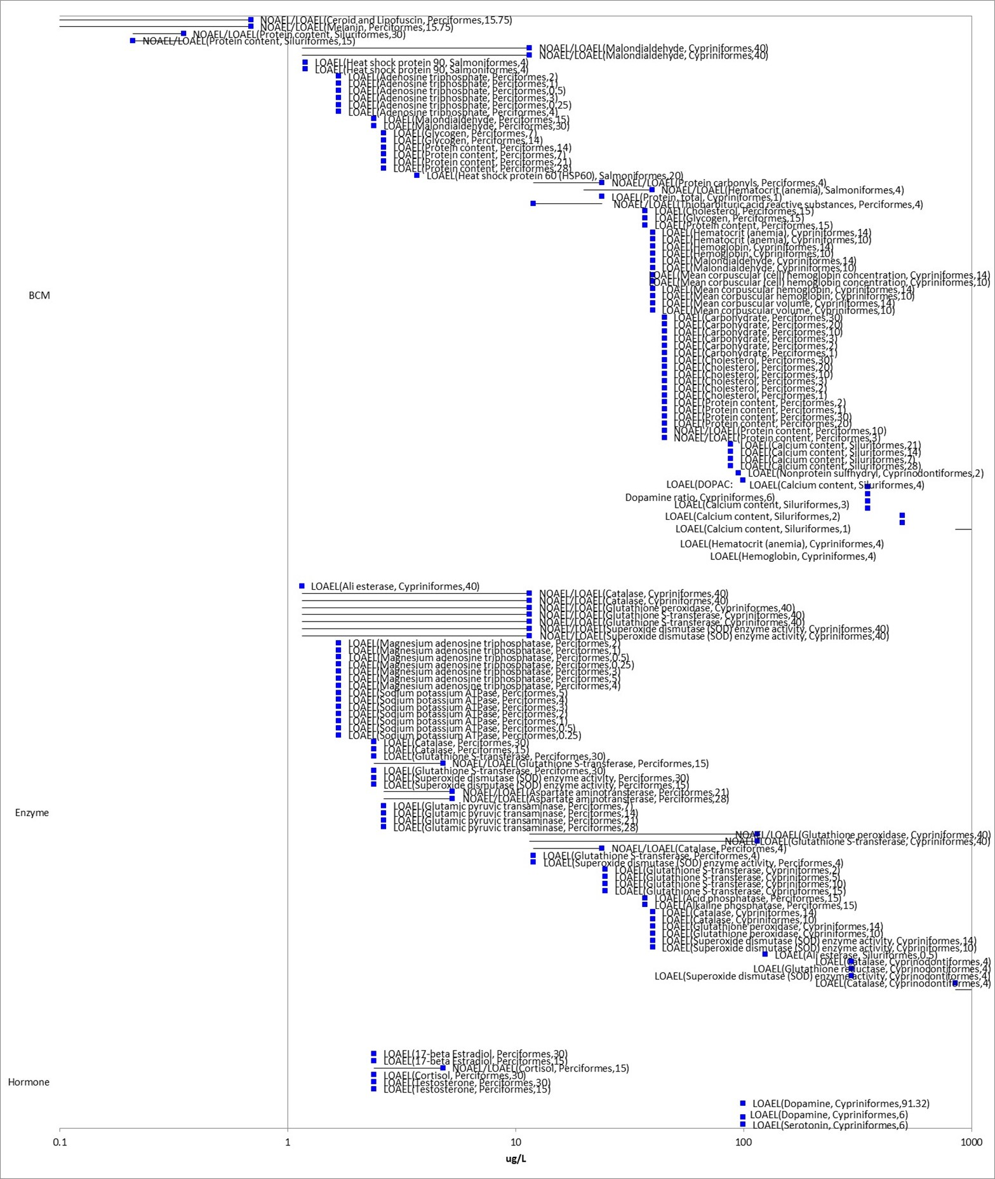Figure B 2-7.1. Fish-other effects - biochemical (range ≤ 1000 µg/L)

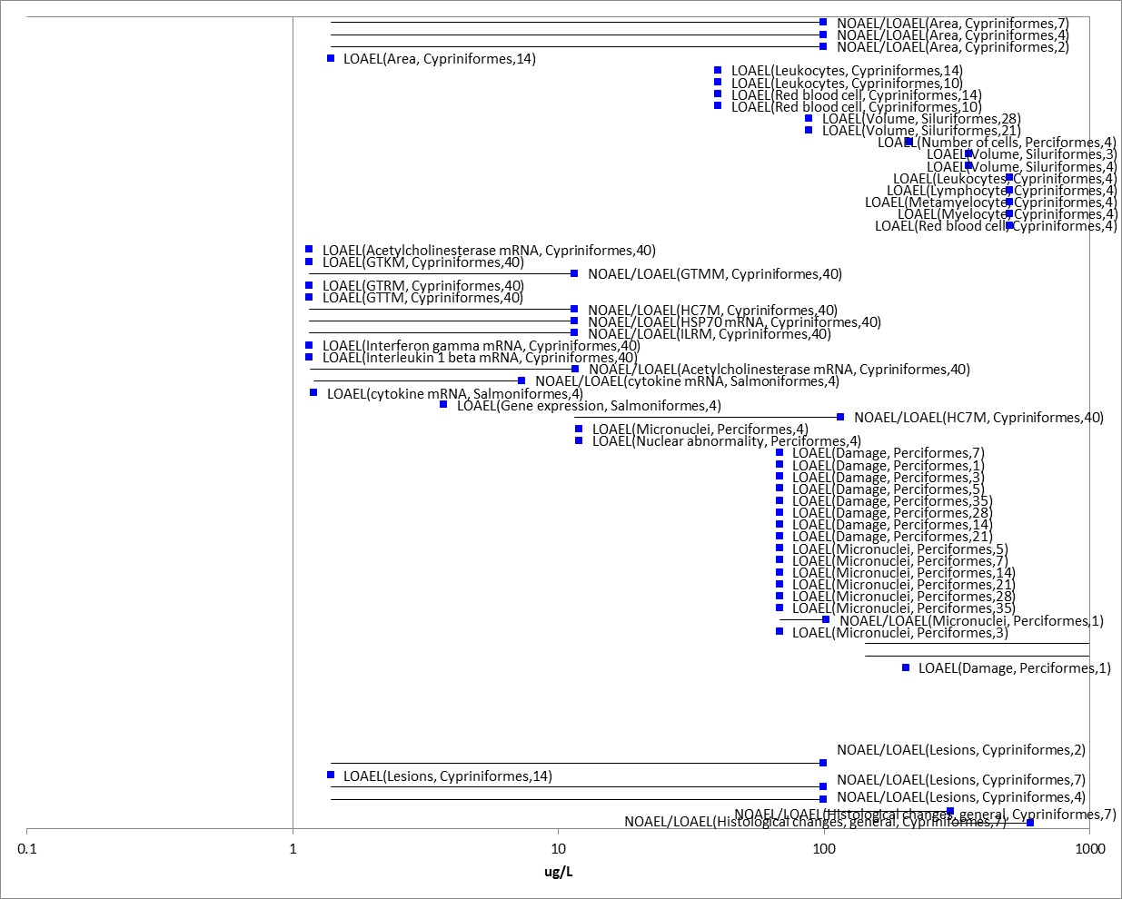
Figure B 2-7.2. Fish-other effects-cellular (range ≤ 1000 µg/L)

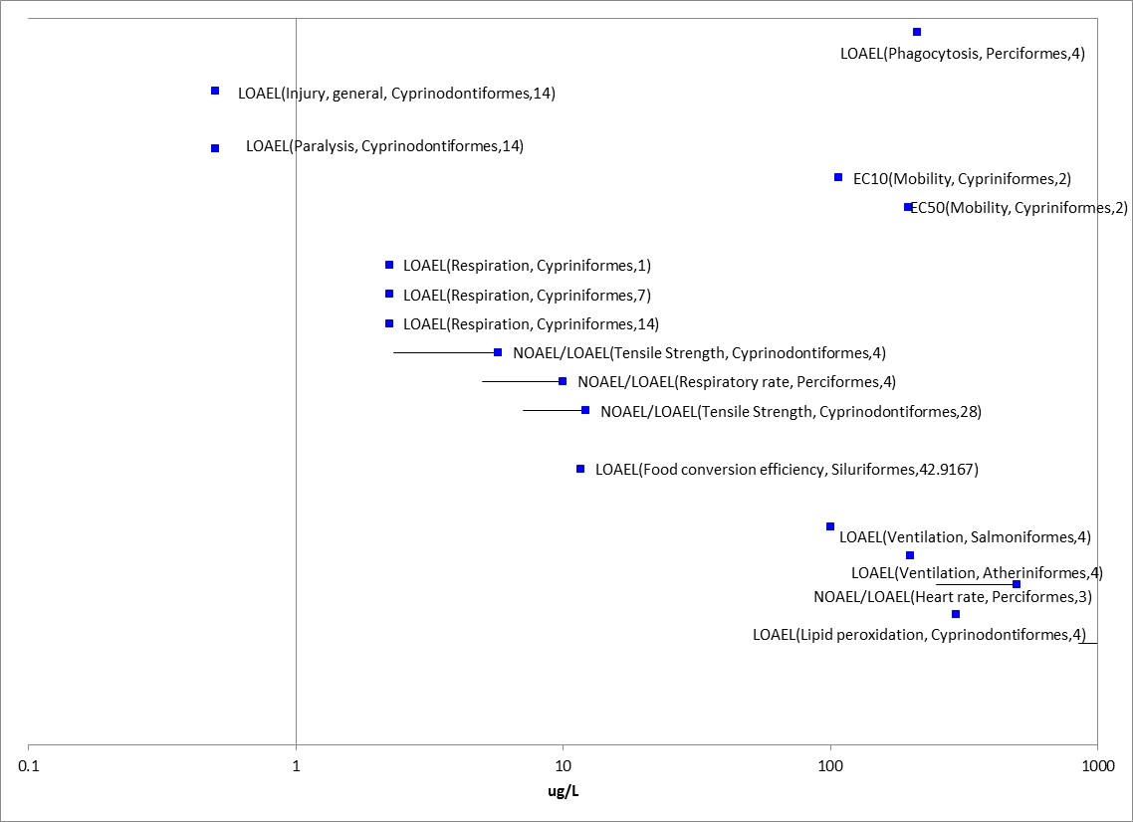
Figure B 2-7.3. Fish-other effects-physiology (range ≤ 1000 µg/L)

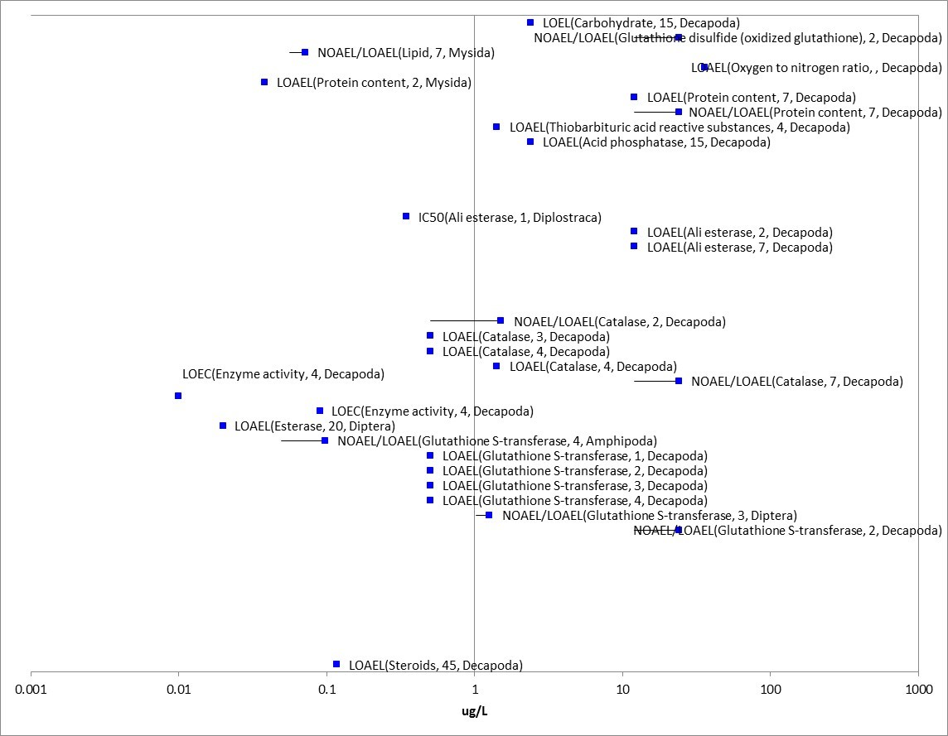
Figure B 2-7.4. Aquatic invertebrates (excluding mollusks)-other biochemical effects (range ≤ 1000 µg/L)
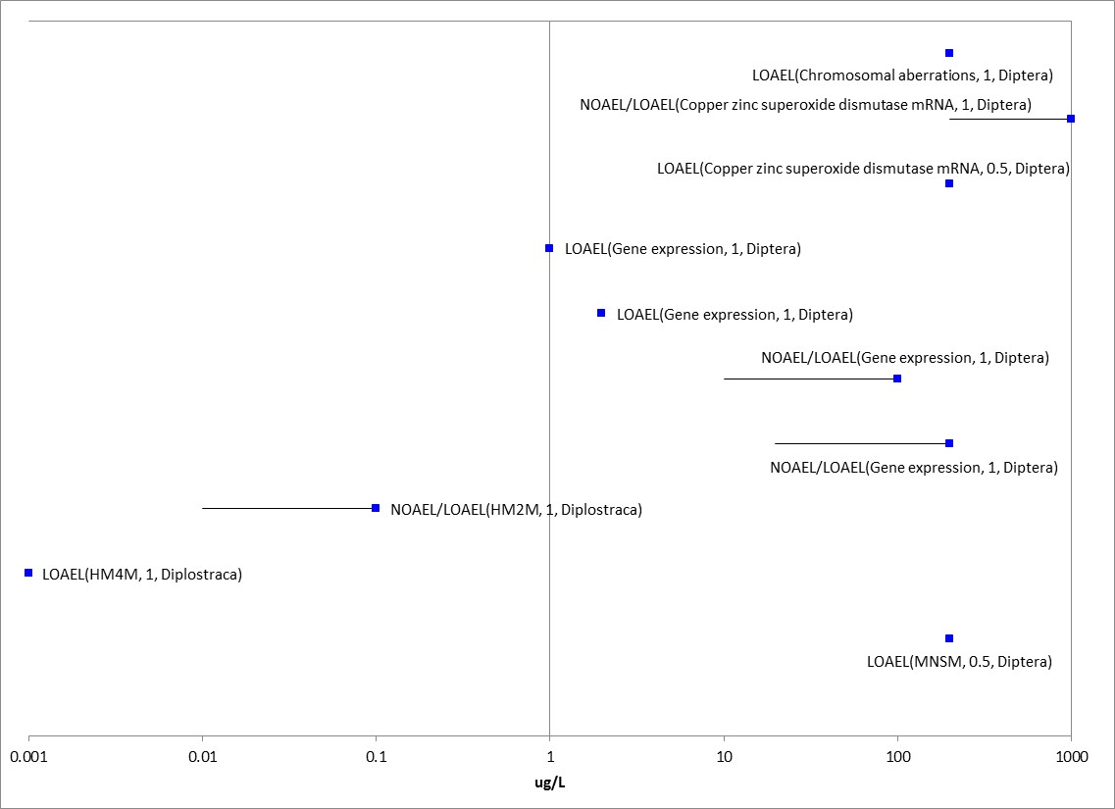
Figure B 2-7.5. Aquatic invertebrates (excluding mollusks)-cellular effects (range ≤ 1000 µg/L)

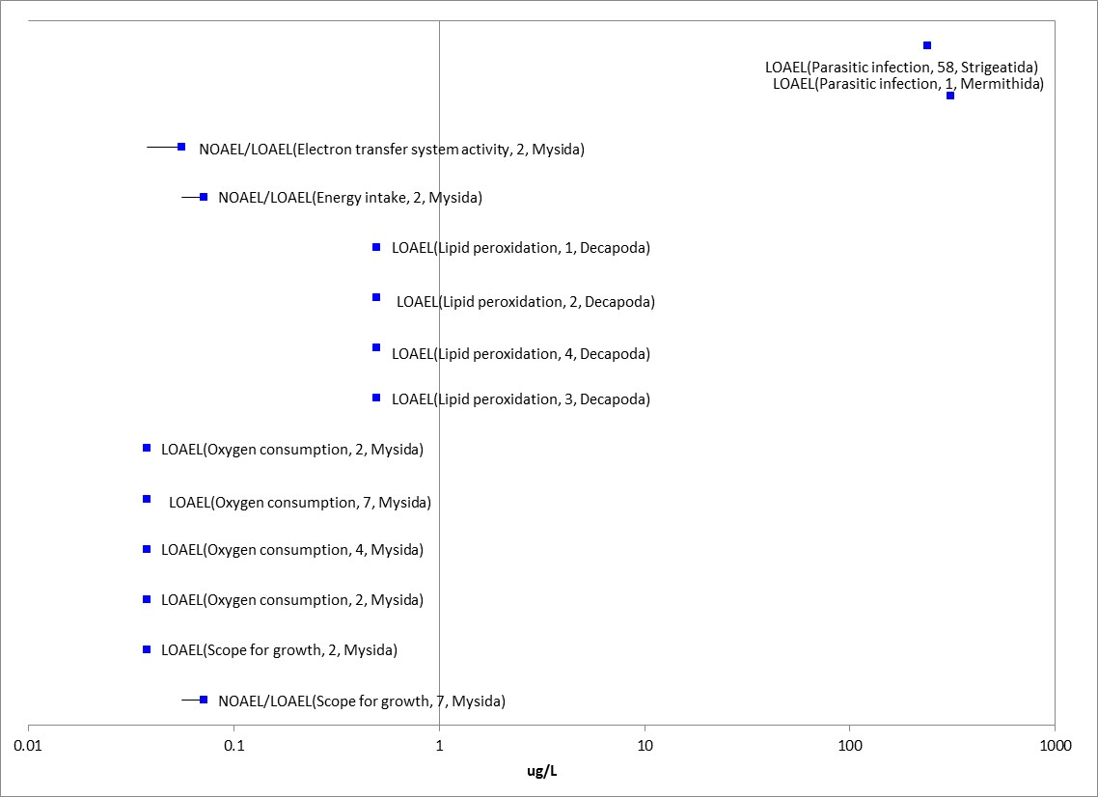
Figure B 2-7.6. Aquatic invertebrates (excluding mollusks)-physiological effects (range ≤ 1000 µg/L)

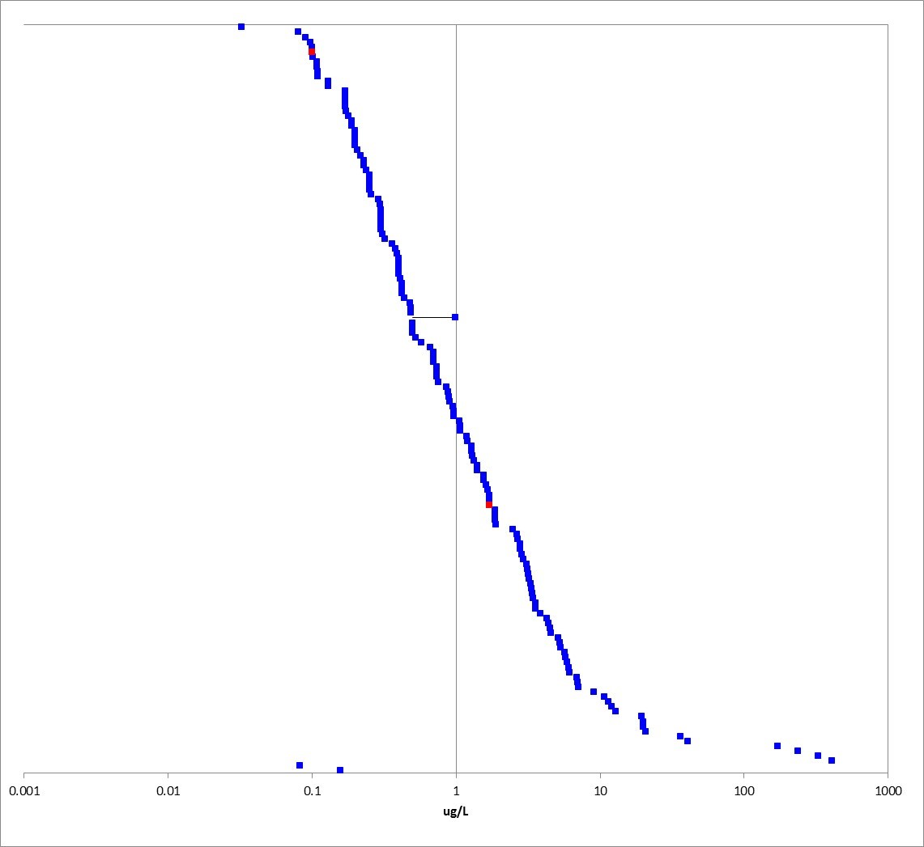
Figure B 2-7.7. Aquatic invertebrates (excluding mollusks)-physiological effects (intoxication) (range ≤ 1000 µg/L)
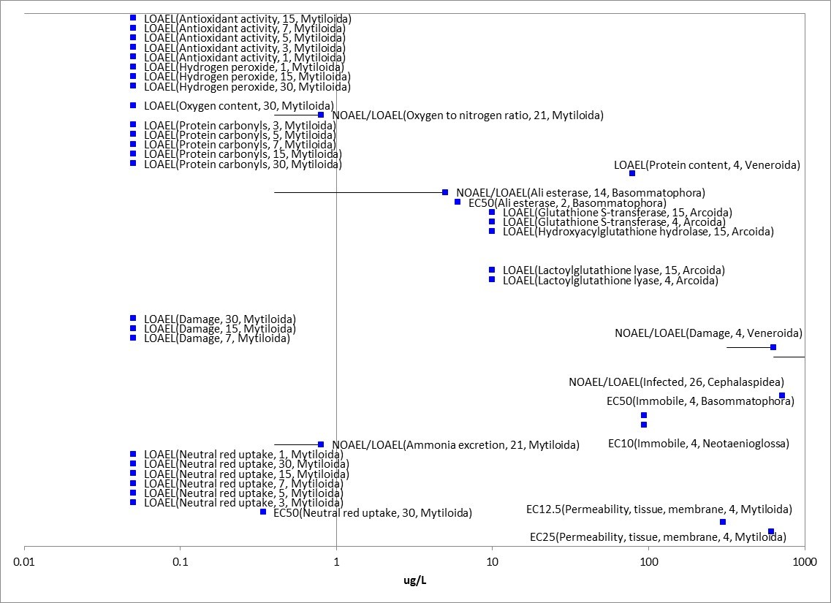
Figure B 2-7.8. Mollusks-other biochemical, cellular, and physiological effects (range ≤ 1000 µg/L)

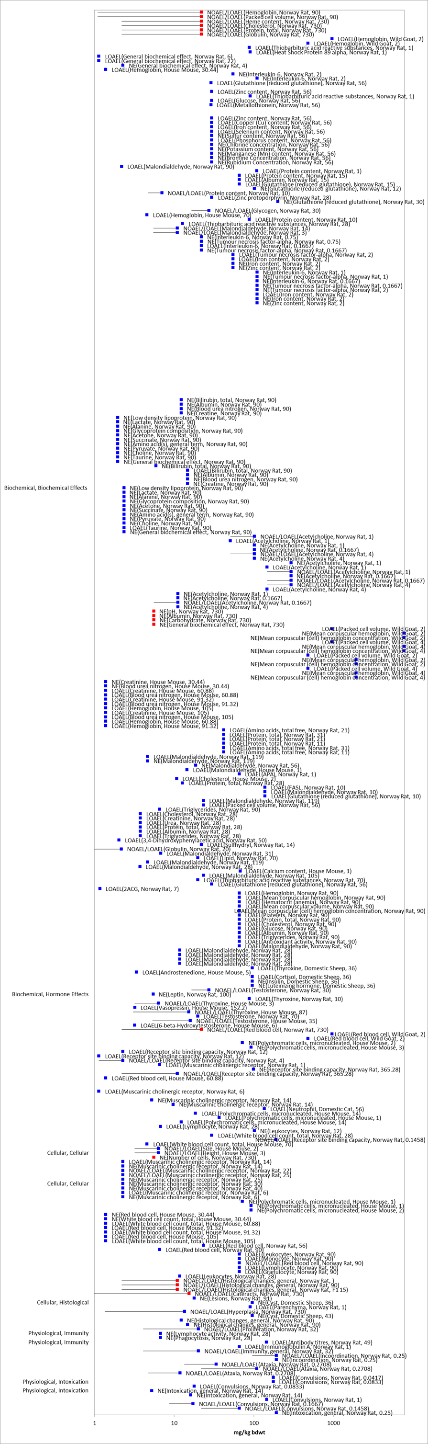
Figure B 2-7.9. Biochemical, cellular and physiological endpoints for mammals exposed to chlorpyrifos

