**APPENDIX 2-6. Chlorpyrifos Species Sensitivity Distribution Analysis for Fish**

SSDs were fit to toxicity data for freshwater and saltwater fish exposed to chlorpyrifos. Five distributions were tested and a variety of methods were used to determine whether different subsets of data should be modeled independently. These results support separating the data into SSDs for freshwater vertebrates and saltwater fish and if modeling fish only, the recommended thresholds are for freshwater fish and saltwater fish.  **Table B 2-6.1** provides a summary of the results.

**Table B 2-6.1. Summary statistics for SSDs fit to chlorpyrifos test results**

|  |  |  |  |  |  |
| --- | --- | --- | --- | --- | --- |
| Statistic | All  Vertebr. | FW  Vertebr. | All  Fish | FW  Fish | SW  Fish |
| Best Distribution (by AICc) | triangular | triangular | triangular | triangular | gumbel |
| Goodness of fit  P-value | 0.94 | 0.81 | 0.92 | 0.83 | 0.51 |
| CV of the HC05 | 0.75 | 0.82 | 0.79 | 0.98 | 0.66 |
| HC05 | 1.69 | 6.40 | 1.44 | 5.94 | 0.79 |
| HC10 | 3.41 | 11.72 | 2.78 | 10.54 | 1.11 |
| HC50 | 65.49 | 149.96 | 44.41 | 118.34 | 5.28 |
| HC90 | 1257.0 | 1919.3 | 710.0 | 1328.7 | 61.0 |
| HC95 | 2531.5 | 3511.5 | 1369.2 | 2356.8 | 155.4 |
| Mortality Thresh.1  (slope = 3.7) | 0.088 | 0.333 | 0.075 | **0.309** | **0.041** |
| Indirect Effects Threshold1  (slope = 3.7) | 0.763 | 2.885 | 0.649 | **2.677** | **0.355** |

1Slope of dose-response curve = 3.7, from Bluegill

**I. Data**

Data used in this analysis were received February 11, 2015 (file: FISH LC50 for SSD 2-8.xlsx), and are detailed in **Tables B 2-6.21** and **22** (end of document). **Table B 2-6.2** provides the distribution of the test results for chlorpyrifos including the number of species represented.

**Table B 2-6.2. Distribution of test results available for chlorpyrifos**

|  |  |  |
| --- | --- | --- |
| Data Subset | Test results | Species |
| All | 91 | 33 |
| Freshwater Vertebrates | 55 | 23 |
| All Fish1 | 84 | 28 |
| **Freshwater Fish** | **48** | **18** |
| **Saltwater Fish** | **36** | **11** |
| Aquatic Amphibians | 7 | 5 |

1Nile tilapia, *Oreochromis niloticus*, was tested in both fresh and saltwater.

**Figure B 2-6.1**  shows the distribution of test results among species, indicating that a few species have been repeatedly tested (four species have been tested at least 7 times each), but the majority of species have been tested six or fewer times, with 17 species having only one test result.

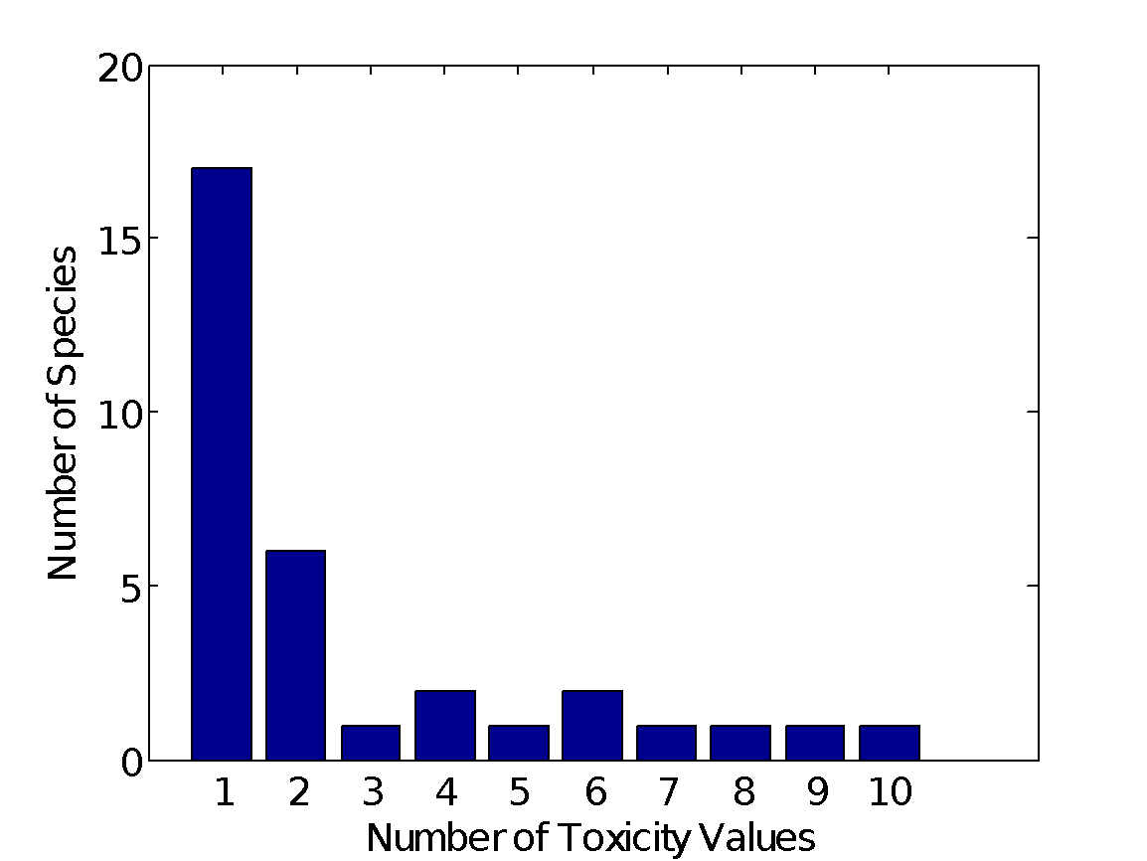

**Figure B 2-6.1. Distribution of the number of test results per species in Chlorpyrifos aquatic vertebrate data**

Five potential distributions for the chlorpyrifos data were considered, including log-normal, log-logistic, log-triangular, log-gumbel, and Burr. To fit each of the first four distributions, the toxicity values were first common log (log10) transformed. Finally, direct and indirect effect thresholds and five quantiles from the fitted SSDs (HC05, HC10, HC50, HC90, HC95) were calculated and reported.

**II. Comparison of distributions using AICc**

Akaike’s Information Criterion corrected for sample size (AICc ) was used to compare the five distributions for all six datasets (there are six datasets in this section because an analysis of amphibian data was initially included). For these comparisons all SSDs were fit using maximum likelihood. For all of the datasets (except saltwater fish), AICc suggested that the triangular distribution provided the best fit (**Tables B 2-6.3, 4, 5, 6,** and **8**). For saltwater fish, AICc suggested that the gumbel distribution provided the best fit (**Table B 2-6.7**).

**Table B 2-6.3. Comparison of distributions for all aquatic vertebrate toxicity data for chlorpyrifos**

| distribution | AICc | ∆AICc | Weight | HC05 |
| --- | --- | --- | --- | --- |
| triangular | 420.9 | 0.00 | 0.71 | 1.69 |
| normal | 423.7 | 2.80 | 0.18 | 1.01 |
| gumbel | 425.9 | 5.04 | 0.06 | 1.47 |
| logistic | 426.8 | 5.93 | 0.04 | 0.73 |
| burr | 428.4 | 7.48 | 0.02 | 1.46 |

**Table B 2-6.4. Comparison of distributions for freshwater vertebrate toxicity data for chlorpyrifos**

|  |  |  |  |  |
| --- | --- | --- | --- | --- |
| distribution | AICc | ∆AICc | Weight | HC05 |
| triangular | 332.3 | 0.00 | 0.57 | 6.40 |
| normal | 334.1 | 1.86 | 0.22 | 6.15 |
| logistic | 335.2 | 2.93 | 0.13 | 5.95 |
| burr | 337.1 | 4.81 | 0.05 | 3.44 |
| gumbel | 338.6 | 6.35 | 0.02 | 6.51 |

**Table B 2-6.5. Comparison of distributions for pooled fish toxicity data for chlorpyrifos**

|  |  |  |  |  |
| --- | --- | --- | --- | --- |
| distribution | AICc | ∆AICc | Weight | HC05 |
| triangular | 337.3 | 0.00 | 0.63 | 1.44 |
| normal | 339.6 | 2.27 | 0.20 | 0.84 |
| gumbel | 341.0 | 3.63 | 0.10 | 1.25 |
| logistic | 342.8 | 5.46 | 0.04 | 0.56 |
| burr | 343.5 | 6.21 | 0.03 | 1.25 |

**Table B 2-6.6. Comparison of distributions for freshwater fish toxicity data for chlorpyrifos**

|  |  |  |  |  |
| --- | --- | --- | --- | --- |
| distribution | AICc | ∆AICc | Weight | HC05 |
| triangular | 251.5 | 0.00 | 0.43 | 5.94 |
| normal | 252.6 | 1.14 | 0.24 | 5.65 |
| burr | 253.5 | 1.99 | 0.16 | 2.08 |
| logistic | 253.6 | 2.11 | 0.15 | 5.79 |
| gumbel | 257.0 | 5.52 | 0.03 | 5.50 |

**Table B 2-6.7. Comparison of distributions for saltwater fish toxicity data for chlorpyrifos**

|  |  |  |  |  |
| --- | --- | --- | --- | --- |
| distribution | AICc | ∆AICc | Weight | HC05 |
| gumbel | 93.6 | 0.00 | 0.65 | 0.79 |
| triangular | 97.4 | 3.78 | 0.10 | 0.31 |
| burr | 97.6 | 3.95 | 0.09 | 0.79 |
| normal | 97.7 | 4.05 | 0.09 | 0.28 |
| logistic | 97.9 | 4.30 | 0.08 | 0.19 |

**Table B 2-6.8. Comparison of distributions for aquatic amphibian toxicity data for chlorpyrifos**

|  |  |  |  |  |
| --- | --- | --- | --- | --- |
| distribution | AICc | ∆AICc | Weight | HC05 |
| triangular | 89.9 | 0.00 | 0.33 | 14.69 |
| normal | 90.4 | 0.54 | 0.25 | 12.28 |
| gumbel | 90.7 | 0.81 | 0.22 | 17.20 |
| logistic | 91.0 | 1.08 | 0.19 | 8.44 |
| burr | 110.7 | 20.81 | 0.00 | 17.20 |

**III. Test for the need to model results separately by medium or vertebrate class**

Determination of appropriate subsets of data for SSD fitting is difficult and the recommendation here is to use multiple parameters to make the determination. In particular, the question of whether to model saltwater fish test results separately from freshwater test results and the question of whether to model amphibians separate from other freshwater results are examined (Note: in the end amphibians were not included in SSD’s and the lowest LD50 was used to derive a threshold).

In the first case, examination of the cumulative distribution functions plotted on similar axes for all vertebrates (compared to separately modeling freshwater vertebrates and saltwater fish) lends support to modeling the datasets separately. The 95% bootstrap confidence intervals for the separate distributions do not overlap except at the extreme tails (**Figure B 2-6.2**). The confidence limits on the HC05 for both separate distributions are relatively precise, with the upper confidence limit falling at the 15th and 18th percentile, respectively **(Tables B 2-6.9** and **10**). Also, in both cases the CV of the HC05 is below 1.

In the second case, examination of the cumulative distribution functions plotted on similar axes for freshwater vertebrates (compared to separately modeling freshwater fish versus amphibians) does not support modeling the datasets separately. The 95% bootstraps confidence limits in both cases encompass the distribution for pooled freshwater vertebrates (**Figure B 2-6.3**). For the amphibian distribution, the 95% confidence limit on the HC05 extends to the 48th percentile of the fitted distribution. Also, for amphibians, the CV of the HC05, when the amphibian data are modeled separately is greater, than 5, indicating substantial uncertainty.

Taken together, these analyses perhaps tip the scales in favor of separating saltwater fish from other freshwater vertebrates, and also modeling amphibians with other freshwater vertebrates (if a SSD approach is used).

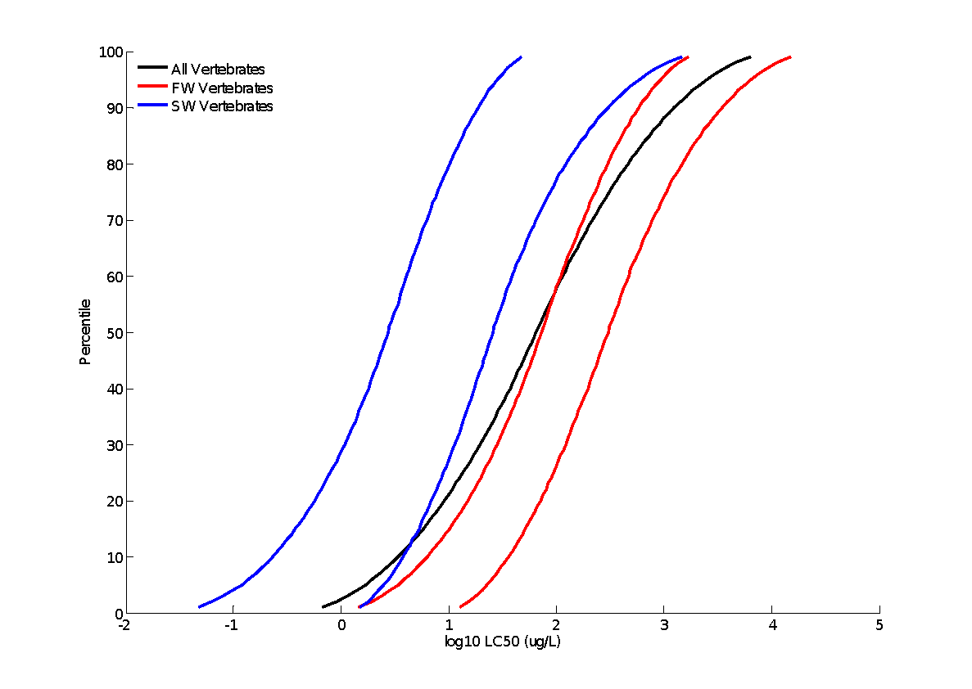

**Figure B 2-6.2. SSDs for freshwater (log-normal), saltwater (log-triangular), and combined (log-normal) vertebrate LC50s for Chlorpyrifos**. [Red lines show the upper and lower confidence interval for freshwater vertebrates. Blue lines show the upper and lower confidence interval for saltwater vertebrates]

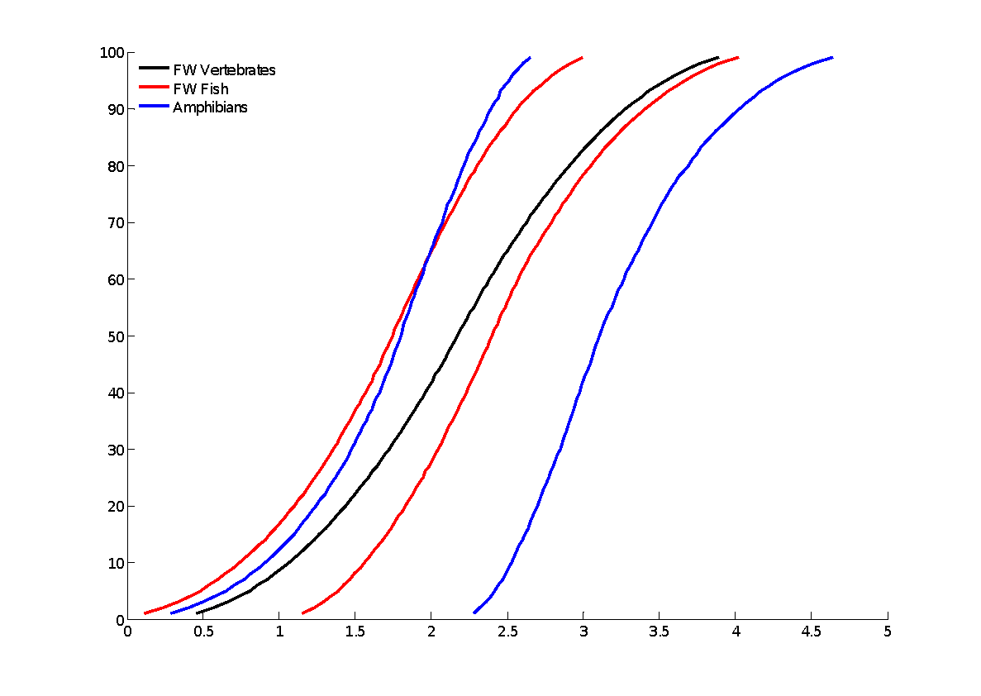

**Figure B 2-6.3. SSDs for freshwater vertebrates (log-normal), saltwater vertebrates (log-gumbel), and amphibian (log-triangular) LC50s for Chlorpyrifos.** [Red lines show the upper and lower confidence interval for freshwater fish. Blue lines show the upper and lower confidence interval for amphibians]

**IV. Goodness-of-fit**

Plots of the cumulative distribution functions for the best-fit distributions (as determined by AICc) suggest little evidence of lack-of-fit (**Figs. B 2-6.4, 5, 6, 7** and **8**). Similarly, bootstrap goodness-of-fit tests did not show evidence for lack-of-fit (P-values > 0.05, **Tables B 2-6.9, 10, 11, 12** and **13**), with the exception of the Burr distribution, which frequently showed significant lack-of-fit. In general, the coefficient of variation for the HC05 was below 1 for the competitive distributions.



**Figure B 2-6.4. Log-triangular SSD for chlorpyrifos toxicity values for all aquatic vertebrates pooled.** Black points indicate single toxicity values. Red points indicate average of multiple toxicity values for a single species. Blue line indicates full range of toxicity values for a given taxon.



**Figure B 2-6.5. Log-triangular SSD for chlorpyrifos toxicity values for freshwater aquatic vertebrates pooled.** Black points indicate single toxicity values. Red points indicate average of multiple toxicity values. Blue line indicates full range of toxicity values for a given species.

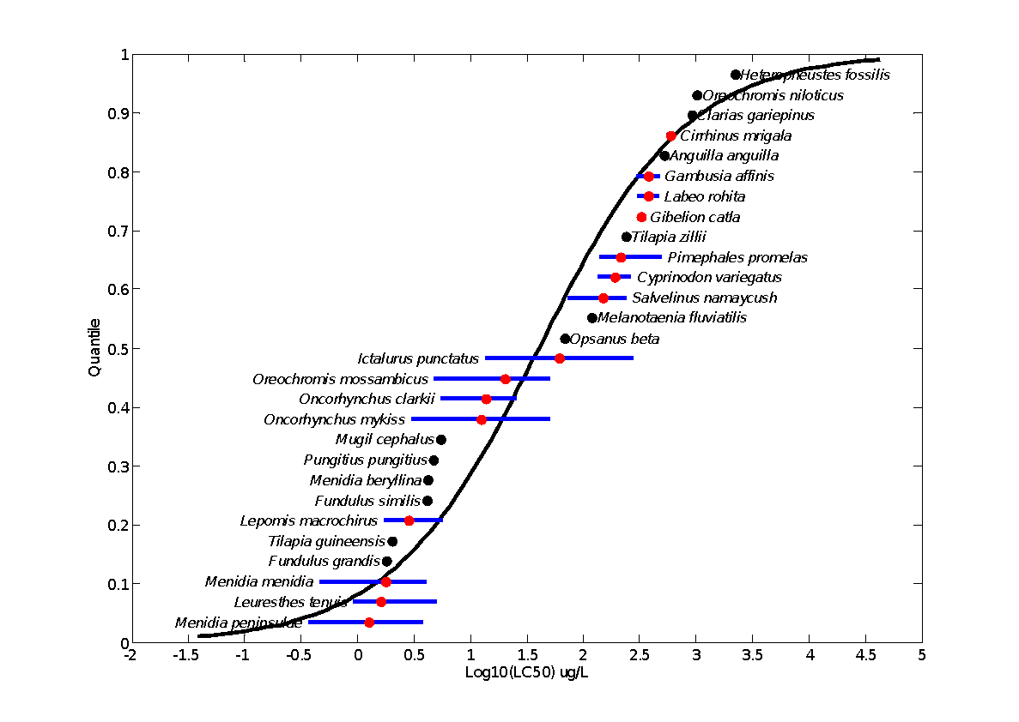

**Figure B 2-6.6. Log-triangular SSD for chlorpyrifos LC50s for all fish.** Black points indicate single toxicity values. Red points indicate average of multiple toxicity values for a single species. Blue line indicates full range of toxicity values for a given species.

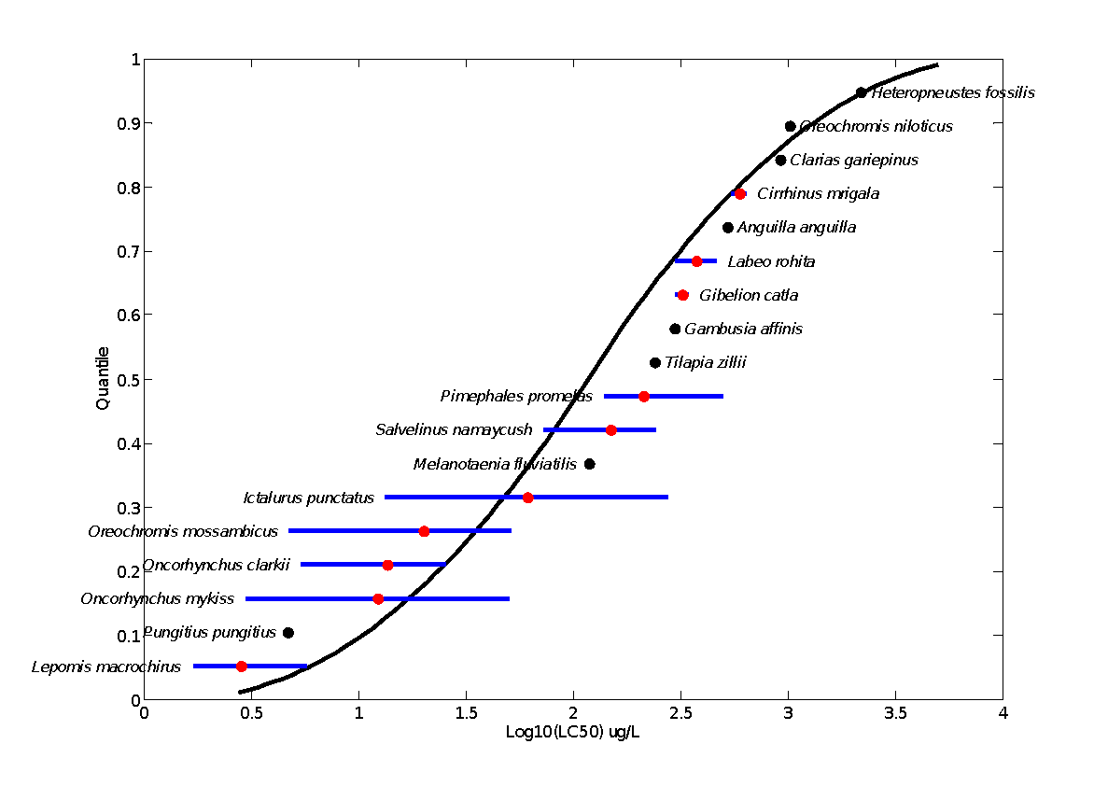

**Figure B 2-6.7. Log-triangular SSD for Chlorpyrifos LC50s for freshwater fish.** Red points indicate single toxicity values. Black points indicate average of multiple toxicity values for a single species. Blue line indicates full range of toxicity values for a given species.

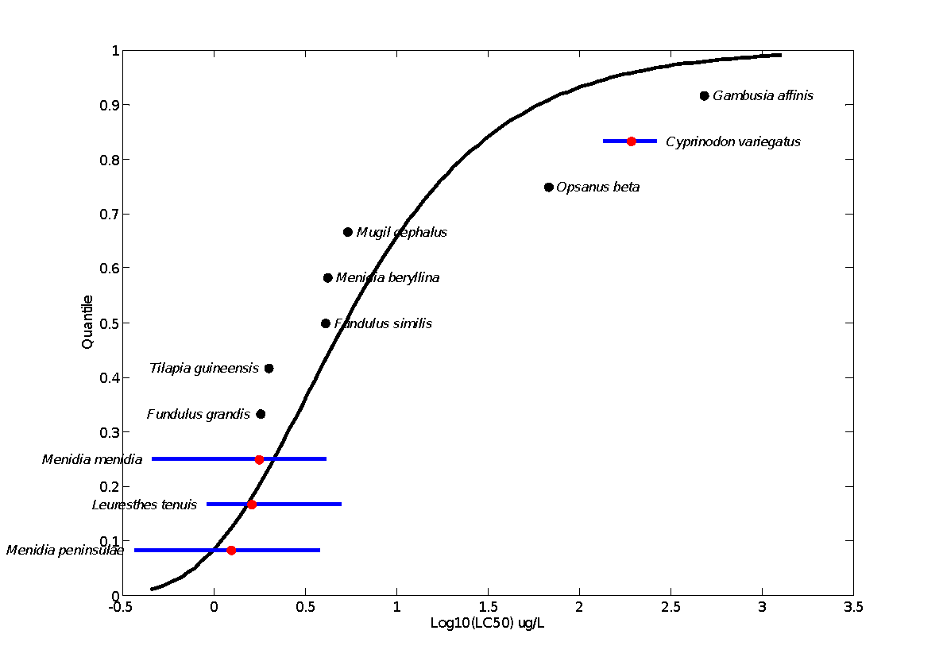

**Figure B 2-6.8. Log-gumbel SSD for chlorpyrifos LC50s for saltwater fish.** Black points indicate single toxicity values. Red points indicate average of multiple toxicity values for a single species. Blue line indicates full range of toxicity values for a given species.

**Table B 2-6.9. Range of HC05 values for Chlorpyrifos SSDs for all aquatic vertebrates**

|  |  |  |  |  |  |  |  |  |  |
| --- | --- | --- | --- | --- | --- | --- | --- | --- | --- |
| distribution | method | HC05 | SE | CV | LCx | UCx | LCp | UCp | P |
| normal | ML | 1.01 | 0.99 | 0.98 | 0.03 | 3.90 | 0.00 | 0.14 | 0.77 |
| normal | MO | 0.95 | 0.92 | 0.96 | 0.27 | 3.50 | 0.02 | 0.13 | 0.77 |
| normal | GR | 0.67 | 0.54 | 0.80 | 0.11 | 2.15 | 0.01 | 0.11 | 0.61 |
| logistic | ML | 0.73 | 0.90 | 1.24 | 0.17 | 3.39 | 0.02 | 0.13 | 0.74 |
| logistic | MO | 1.00 | 1.03 | 1.03 | 0.22 | 4.24 | 0.02 | 0.13 | 0.83 |
| logistic | GR | 0.59 | 0.52 | 0.88 | 0.05 | 1.94 | 0.01 | 0.10 | 0.65 |
| triangular | ML | 1.69 | 1.27 | 0.75 | 0.92 | 5.68 | 0.02 | 0.15 | 0.94 |
| triangular | MO | 0.88 | 0.80 | 0.90 | 0.27 | 3.13 | 0.01 | 0.14 | 0.65 |
| triangular | GR | 0.72 | 0.59 | 0.82 | 0.17 | 2.32 | 0.00 | 0.12 | 0.56 |
| gumbel | ML | 1.47 | 0.83 | 0.56 | 0.60 | 3.77 | 0.01 | 0.14 | 0.83 |
| gumbel | MO | 2.21 | 1.22 | 0.55 | 0.84 | 5.52 | 0.01 | 0.15 | 0.98 |
| gumbel | GR | 1.60 | 0.85 | 0.53 | 0.34 | 3.48 | 0.00 | 0.12 | 0.86 |
| burr | ML | 1.46 | 0.85 | 0.58 | 0.63 | 3.90 | 0.01 | 0.15 | 0.00 |

ML=maximum likelihood, MO= moment estimators, and GR=graphical methods

LCp and UCp=projections of the confidence limits of the HC05 (LCx and UCx) onto the cumulative distribution function of the fitted distribution.

**Table B 2-6.10. Range of HC05 values for Chlorpyrifos SSDs for freshwater vertebrates**

|  |  |  |  |  |  |  |  |  |  |
| --- | --- | --- | --- | --- | --- | --- | --- | --- | --- |
| distribution | method | HC05 | SE | CV | LCx | UCx | LCp | UCp | P |
| normal | ML | 6.15 | 5.76 | 0.94 | 0.90 | 23.18 | 0.00 | 0.17 | 0.61 |
| normal | MO | 5.71 | 5.08 | 0.89 | 1.72 | 20.61 | 0.01 | 0.16 | 0.58 |
| normal | GR | 3.97 | 3.22 | 0.81 | 0.60 | 12.54 | 0.01 | 0.13 | 0.42 |
| logistic | ML | 5.95 | 6.42 | 1.08 | 1.48 | 24.21 | 0.02 | 0.15 | 0.54 |
| logistic | MO | 5.97 | 5.91 | 0.99 | 1.34 | 22.95 | 0.01 | 0.15 | 0.54 |
| logistic | GR | 3.46 | 3.07 | 0.89 | 0.28 | 11.15 | 0.01 | 0.11 | 0.35 |
| triangular | ML | 6.40 | 5.23 | 0.82 | 3.40 | 22.84 | 0.02 | 0.18 | 0.81 |
| triangular | MO | 5.38 | 4.50 | 0.84 | 1.76 | 18.62 | 0.00 | 0.16 | 0.66 |
| triangular | GR | 4.30 | 3.36 | 0.78 | 1.04 | 13.15 | 0.00 | 0.14 | 0.51 |
| gumbel | ML | 6.51 | 4.18 | 0.64 | 2.90 | 18.82 | 0.01 | 0.17 | 0.79 |
| gumbel | MO | 11.34 | 6.34 | 0.56 | 4.34 | 29.08 | 0.00 | 0.19 | 0.98 |
| gumbel | GR | 8.13 | 4.30 | 0.53 | 1.58 | 18.26 | 0.00 | 0.15 | 0.88 |
| burr | ML | 3.44 | 8.97 | 2.61 | 0.31 | 31.61 | 0.01 | 0.18 | 0.69 |

ML=maximum likelihood, MO= moment estimators, and GR=graphical methods

LCp and UCp=projections of the confidence limits of the HC05 (LCx and UCx) onto the cumulative distribution function of the fitted distribution.

**Table B 2-6.11. Range of HC05 values for Chlorpyrifos SSDs for all fish pooled**

|  |  |  |  |  |  |  |  |  |  |
| --- | --- | --- | --- | --- | --- | --- | --- | --- | --- |
| distribution | method | HC05 | SE | CV | LCx | UCx | LCp | UCp | P |
| normal | ML | 0.84 | 0.86 | 1.03 | 0.11 | 3.38 | 0.01 | 0.15 | 0.74 |
| normal | MO | 0.78 | 0.78 | 1.00 | 0.20 | 3.07 | 0.01 | 0.14 | 0.74 |
| normal | GR | 0.54 | 0.47 | 0.87 | 0.07 | 1.75 | 0.01 | 0.12 | 0.58 |
| logistic | ML | 0.56 | 0.81 | 1.45 | 0.11 | 2.98 | 0.02 | 0.14 | 0.70 |
| logistic | MO | 0.82 | 0.91 | 1.11 | 0.17 | 3.60 | 0.02 | 0.14 | 0.80 |
| logistic | GR | 0.47 | 0.44 | 0.93 | 0.03 | 1.60 | 0.01 | 0.11 | 0.62 |
| triangular | ML | 1.44 | 1.13 | 0.79 | 0.77 | 4.96 | 0.02 | 0.16 | 0.92 |
| triangular | MO | 0.73 | 0.68 | 0.94 | 0.21 | 2.68 | 0.01 | 0.14 | 0.63 |
| triangular | GR | 0.58 | 0.52 | 0.90 | 0.12 | 1.96 | 0.00 | 0.13 | 0.52 |
| gumbel | ML | 1.25 | 0.80 | 0.64 | 0.48 | 3.62 | 0.01 | 0.16 | 0.79 |
| gumbel | MO | 1.76 | 1.10 | 0.62 | 0.66 | 4.86 | 0.01 | 0.17 | 0.94 |
| gumbel | GR | 1.24 | 0.68 | 0.55 | 0.23 | 2.81 | 0.00 | 0.13 | 0.77 |
| burr | ML | 1.25 | 0.74 | 0.59 | 0.52 | 3.31 | 0.01 | 0.15 | 0.00 |

ML=maximum likelihood, MO= moment estimators, and GR=graphical methods

LCp and UCp=projections of the confidence limits of the HC05 (LCx and UCx) onto the cumulative distribution function of the fitted distribution.

**Table B 2-6.12. Range of HC05 values for Chlorpyrifos SSDs for freshwater fish**

| distribution | method | HC05 | SE | CV | LCx | UCx | LCp | UCp | P |
| --- | --- | --- | --- | --- | --- | --- | --- | --- | --- |
| normal | ML | 5.65 | 5.92 | 1.05 | 0.89 | 23.91 | 0.00 | 0.19 | 0.67 |
| normal | MO | 5.16 | 5.40 | 1.05 | 1.28 | 20.43 | 0.01 | 0.17 | 0.63 |
| normal | GR | 3.39 | 3.32 | 0.98 | 0.38 | 11.58 | 0.00 | 0.14 | 0.45 |
| logistic | ML | 5.79 | 6.99 | 1.21 | 1.30 | 26.61 | 0.01 | 0.17 | 0.61 |
| logistic | MO | 5.38 | 6.47 | 1.20 | 1.05 | 25.22 | 0.01 | 0.18 | 0.61 |
| logistic | GR | 2.90 | 2.84 | 0.98 | 0.15 | 9.99 | 0.01 | 0.12 | 0.39 |
| triangular | ML | 5.94 | 5.84 | 0.98 | 3.04 | 24.41 | 0.01 | 0.20 | 0.83 |
| triangular | MO | 4.87 | 4.78 | 0.98 | 1.45 | 18.34 | 0.00 | 0.18 | 0.67 |
| triangular | GR | 3.73 | 4.13 | 1.11 | 0.67 | 13.62 | 0.00 | 0.16 | 0.50 |
| gumbel | ML | 5.50 | 4.51 | 0.82 | 2.21 | 18.51 | 0.01 | 0.20 | 0.76 |
| gumbel | MO | 9.97 | 6.12 | 0.61 | 3.90 | 27.59 | 0.00 | 0.22 | 0.98 |
| gumbel | GR | 6.85 | 4.11 | 0.60 | 1.11 | 16.27 | 0.00 | 0.16 | 0.85 |
| burr | ML | 2.08 | 10.50 | 5.05 | 0.01 | 38.02 | 0.00 | 0.22 | 0.82 |

ML=maximum likelihood, MO= moment estimators, and GR=graphical methods

LCp and UCp=projections of the confidence limits of the HC05 (LCx and UCx) onto the cumulative distribution function of the fitted distribution.

**Table B 2-6.13. Range of HC05 values for Chlorpyrifos SSDs for saltwater fish**

|  |  |  |  |  |  |  |  |  |  |
| --- | --- | --- | --- | --- | --- | --- | --- | --- | --- |
| distribution | method | HC05 | SE | CV | LCx | UCx | LCp | UCp | P |
| normal | ML | 0.28 | 0.59 | 2.09 | 0.04 | 2.05 | 0.01 | 0.25 | 0.36 |
| normal | MO | 0.24 | 0.51 | 2.11 | 0.04 | 1.81 | 0.01 | 0.24 | 0.34 |
| normal | GR | 0.12 | 0.26 | 2.08 | 0.00 | 0.82 | 0.00 | 0.18 | 0.29 |
| logistic | ML | 0.19 | 0.41 | 2.14 | 0.03 | 1.47 | 0.01 | 0.24 | 0.20 |
| logistic | MO | 0.25 | 0.56 | 2.22 | 0.02 | 1.92 | 0.01 | 0.23 | 0.38 |
| logistic | GR | 0.10 | 0.20 | 2.02 | 0.00 | 0.63 | 0.00 | 0.15 | 0.28 |
| triangular | ML | 0.31 | 0.72 | 2.30 | 0.12 | 2.50 | 0.01 | 0.28 | 0.41 |
| triangular | MO | 0.23 | 0.48 | 2.13 | 0.04 | 1.59 | 0.00 | 0.24 | 0.32 |
| triangular | GR | 0.14 | 0.32 | 2.23 | 0.01 | 0.93 | 0.00 | 0.20 | 0.30 |
| gumbel | ML | 0.79 | 0.52 | 0.66 | 0.35 | 2.31 | 0.00 | 0.27 | 0.51 |
| gumbel | MO | 0.50 | 0.52 | 1.06 | 0.13 | 2.05 | 0.00 | 0.28 | 0.35 |
| gumbel | GR | 0.28 | 0.31 | 1.11 | 0.02 | 1.05 | 0.00 | 0.20 | 0.24 |
| burr | ML | 0.79 | 0.55 | 0.70 | 0.00 | 2.31 | 0.00 | 0.27 | 0.01 |

ML=maximum likelihood, MO= moment estimators, and GR=graphical methods

LCp and UCp=projections of the confidence limits of the HC05 (LCx and UCx) onto the cumulative distribution function of the fitted distribution.

**V. Calculation of other quantiles**

**Tables B 2-6.14, 15, 16, 17** and **18** provide estimates of the HC05 as well as other quantiles of the fitted SSDs.

**Table B 2-6.14. Estimated quantiles of the fitted SSDs for Chlorpyrifos LC50s for all aquatic vertebrates**

| distribution | method | HC05 | HC10 | HC50 | HC90 | HC95 |
| --- | --- | --- | --- | --- | --- | --- |
| normal | ML | 1.01 | 2.46 | 56.75 | 1308.2 | 3184.1 |
| normal | MO | 0.95 | 2.35 | 56.75 | 1373.4 | 3389.2 |
| normal | GR | 0.67 | 1.80 | 56.75 | 1794.2 | 4776.1 |
| logistic | ML | 0.73 | 2.22 | 59.48 | 1590.3 | 4861.8 |
| logistic | MO | 1.00 | 2.79 | 56.75 | 1153.6 | 3212.8 |
| logistic | GR | 0.59 | 1.89 | 56.75 | 1704.6 | 5421.6 |
| triangular | ML | 1.69 | 3.41 | 65.49 | 1257.0 | 2531.5 |
| triangular | MO | 0.88 | 1.96 | 56.75 | 1644.7 | 3652.1 |
| triangular | GR | 0.72 | 1.67 | 56.75 | 1931.3 | 4455.0 |
| gumbel | ML | 1.47 | 2.63 | 37.56 | 2440.1 | 12024.0 |
| gumbel | MO | 2.21 | 3.68 | 37.72 | 1454.2 | 5870.6 |
| gumbel | GR | 1.60 | 2.84 | 38.97 | 2373.1 | 11408.0 |
| burr | ML | 1.46 | 2.63 | 37.63 | 2429.5 | 11933.0 |

**Table B 2-6.15. Estimated quantiles of the fitted SSDs for Chlorpyrifos LC50s for freshwater aquatic vertebrates**

|  |  |  |  |  |  |  |
| --- | --- | --- | --- | --- | --- | --- |
| distribution | method | HC05 | HC10 | HC50 | HC90 | HC95 |
| normal | ML | 6.15 | 12.59 | 158.22 | 1987.8 | 4073.4 |
| normal | MO | 5.71 | 11.90 | 158.22 | 2104.1 | 4381.9 |
| normal | GR | 3.97 | 8.95 | 158.22 | 2796.8 | 6313.6 |
| logistic | ML | 5.95 | 14.06 | 175.90 | 2200.9 | 5197.2 |
| logistic | MO | 5.97 | 13.71 | 158.22 | 1826.2 | 4195.7 |
| logistic | GR | 3.46 | 9.13 | 158.22 | 2741.0 | 7230.0 |
| triangular | ML | 6.40 | 11.72 | 149.96 | 1919.3 | 3511.5 |
| triangular | MO | 5.38 | 10.28 | 158.22 | 2435.8 | 4655.9 |
| triangular | GR | 4.30 | 8.58 | 158.22 | 2918.2 | 5821.9 |
| gumbel | ML | 6.51 | 10.96 | 118.39 | 4954.2 | 20635.0 |
| gumbel | MO | 11.34 | 17.15 | 113.55 | 2204.2 | 6845.6 |
| gumbel | GR | 8.13 | 13.14 | 117.75 | 3676.0 | 13689.0 |
| burr | ML | 3.44 | 11.09 | 205.48 | 1652.5 | 3098.5 |

**Table B 2-6.16. Estimated quantiles of the fitted SSDs for Chlorpyrifos LC50s for all fish**

|  |  |  |  |  |  |  |
| --- | --- | --- | --- | --- | --- | --- |
| distribution | method | HC05 | HC10 | HC50 | HC90 | HC95 |
| normal | ML | 0.84 | 1.97 | 40.70 | 839.0 | 1978.4 |
| normal | MO | 0.78 | 1.87 | 40.70 | 886.9 | 2124.6 |
| normal | GR | 0.54 | 1.39 | 40.70 | 1188.3 | 3092.5 |
| logistic | ML | 0.56 | 1.67 | 42.04 | 1060.9 | 3180.1 |
| logistic | MO | 0.82 | 2.21 | 40.70 | 749.2 | 2017.5 |
| logistic | GR | 0.47 | 1.45 | 40.70 | 1143.4 | 3555.0 |
| triangular | ML | 1.44 | 2.78 | 44.41 | 710.0 | 1369.2 |
| triangular | MO | 0.73 | 1.57 | 40.70 | 1055.8 | 2283.7 |
| triangular | GR | 0.58 | 1.31 | 40.70 | 1264.4 | 2854.2 |
| gumbel | ML | 1.25 | 2.18 | 27.01 | 1403.7 | 6351.0 |
| gumbel | MO | 1.76 | 2.89 | 27.42 | 937.3 | 3614.2 |
| gumbel | GR | 1.24 | 2.18 | 28.43 | 1594.4 | 7426.9 |
| burr | ML | 1.25 | 2.18 | 27.15 | 1368.5 | 6102.2 |

**Table B 2-6.17. Estimated quantiles of the fitted SSDs for Chlorpyrifos LC50s for freshwater fish**

|  |  |  |  |  |  |  |
| --- | --- | --- | --- | --- | --- | --- |
| distribution | method | HC05 | HC10 | HC50 | HC90 | HC95 |
| normal | ML | 5.65 | 11.20 | 125.40 | 1404.0 | 2784.5 |
| normal | MO | 5.16 | 10.44 | 125.40 | 1505.8 | 3046.3 |
| normal | GR | 3.39 | 7.52 | 125.40 | 2090.3 | 4640.8 |
| logistic | ML | 5.79 | 13.23 | 149.87 | 1698.0 | 3876.7 |
| logistic | MO | 5.38 | 11.97 | 125.40 | 1314.2 | 2921.9 |
| logistic | GR | 2.90 | 7.55 | 125.40 | 2083.7 | 5418.6 |
| triangular | ML | 5.94 | 10.54 | 118.34 | 1328.7 | 2356.8 |
| triangular | MO | 4.87 | 9.07 | 125.40 | 1733.1 | 3229.1 |
| triangular | GR | 3.73 | 7.31 | 125.40 | 2151.1 | 4218.5 |
| gumbel | ML | 5.50 | 9.18 | 95.25 | 3739.9 | 15203.0 |
| gumbel | MO | 9.97 | 14.84 | 91.19 | 1574.5 | 4676.1 |
| gumbel | GR | 6.85 | 10.99 | 95.19 | 2817.9 | 10283.0 |
| burr | ML | 2.08 | 8.24 | 205.49 | 988.0 | 1432.1 |

**Table B 2-6.18. Estimated quantiles of the fitted SSDs for Chlorpyrifos LC50s for saltwater fish**

|  |  |  |  |  |  |  |
| --- | --- | --- | --- | --- | --- | --- |
| distribution | method | HC05 | HC10 | HC50 | HC90 | HC95 |
| normal | ML | 0.28 | 0.59 | 7.91 | 105.4 | 219.7 |
| normal | MO | 0.24 | 0.52 | 7.91 | 119.6 | 258.4 |
| normal | GR | 0.12 | 0.31 | 7.91 | 200.2 | 500.4 |
| logistic | ML | 0.19 | 0.45 | 5.55 | 68.1 | 159.7 |
| logistic | MO | 0.25 | 0.61 | 7.91 | 103.1 | 246.9 |
| logistic | GR | 0.10 | 0.30 | 7.91 | 208.1 | 632.9 |
| triangular | ML | 0.31 | 0.59 | 8.40 | 119.8 | 224.9 |
| triangular | MO | 0.23 | 0.45 | 7.91 | 139.5 | 275.3 |
| triangular | GR | 0.14 | 0.31 | 7.91 | 200.9 | 432.6 |
| gumbel | ML | 0.79 | 1.11 | 5.28 | 61.0 | 155.4 |
| gumbel | MO | 0.50 | 0.77 | 5.58 | 125.6 | 412.7 |
| gumbel | GR | 0.28 | 0.49 | 5.99 | 306.3 | 1377.9 |
| burr | ML | 0.79 | 1.11 | 5.28 | 61.0 | 155.3 |

**VI. Calculation of thresholds**

Thresholds were calculated using a probit curve with the HC05 as the mean and three different slopes (2, 3.7, and 9). The slope of 3.7 is from a toxicity test with the Bluegill (Slopes of 2 and 9 are selected for bounding-see **ATTACHMENT 1-5**). Calculated thresholds are provided in **Tables B 2-6.19, 20, 21, 22** and **23**

**Table B 2-6.19. Thresholds for determination of action area for Chlorpyrifos LC50s for all aquatic vertebrates**

|  |  |  |  |  |  |  |  |
| --- | --- | --- | --- | --- | --- | --- | --- |
| distribution | method | Mortality Threshold (10-6) | | | Indirect Effects Threshold (10-1) | | |
| slope = 3.7 | slope = 2 | slope = 9 | slope = 3.7 | slope = 2 | slope = 9 |
| normal | ML | 0.053 | 0.004 | 0.300 | 0.456 | 0.231 | 0.729 |
| normal | MO | 0.049 | 0.004 | 0.282 | 0.428 | 0.217 | 0.685 |
| normal | GR | 0.035 | 0.003 | 0.200 | 0.304 | 0.154 | 0.486 |
| logistic | ML | 0.038 | 0.003 | 0.216 | 0.328 | 0.166 | 0.524 |
| logistic | MO | 0.052 | 0.004 | 0.297 | 0.452 | 0.229 | 0.722 |
| logistic | GR | 0.031 | 0.003 | 0.176 | 0.268 | 0.136 | 0.428 |
| triangular | ML | 0.088 | 0.007 | 0.502 | 0.763 | 0.388 | 1.221 |
| triangular | MO | 0.046 | 0.004 | 0.261 | 0.397 | 0.202 | 0.635 |
| triangular | GR | 0.038 | 0.003 | 0.214 | 0.326 | 0.165 | 0.521 |
| gumbel | ML | 0.076 | 0.006 | 0.435 | 0.661 | 0.335 | 1.057 |
| gumbel | MO | 0.115 | 0.009 | 0.655 | 0.995 | 0.505 | 1.592 |
| gumbel | GR | 0.083 | 0.007 | 0.474 | 0.721 | 0.366 | 1.153 |
| burr | ML | 0.076 | 0.006 | 0.434 | 0.659 | 0.335 | 1.055 |

**Table B 2-6.20. Thresholds for determination of action area for Chlorpyrifos LC50s for freshwater aquatic vertebrates**

|  |  |  |  |  |  |  |  |
| --- | --- | --- | --- | --- | --- | --- | --- |
| distribution | method | Mortality Threshold (10-6) | | | Indirect Effects Threshold (10-1) | | |
| slope = 3.7 | slope = 2 | slope = 9 | slope = 3.7 | slope = 2 | slope = 9 |
| normal | ML | 0.319 | 0.026 | 1.821 | 2.768 | 1.405 | 4.428 |
| normal | MO | 0.297 | 0.024 | 1.693 | 2.573 | 1.306 | 4.116 |
| normal | GR | 0.206 | 0.017 | 1.175 | 1.786 | 0.907 | 2.857 |
| logistic | ML | 0.309 | 0.025 | 1.764 | 2.682 | 1.361 | 4.289 |
| logistic | MO | 0.310 | 0.025 | 1.768 | 2.688 | 1.364 | 4.299 |
| logistic | GR | 0.180 | 0.015 | 1.026 | 1.560 | 0.792 | 2.495 |
| triangular | ML | 0.333 | 0.027 | 1.898 | 2.885 | 1.465 | 4.614 |
| triangular | MO | 0.279 | 0.023 | 1.594 | 2.422 | 1.230 | 3.874 |
| triangular | GR | 0.223 | 0.018 | 1.274 | 1.937 | 0.983 | 3.098 |
| gumbel | ML | 0.338 | 0.027 | 1.928 | 2.931 | 1.488 | 4.688 |
| gumbel | MO | 0.589 | 0.048 | 3.359 | 5.106 | 2.592 | 8.166 |
| gumbel | GR | 0.422 | 0.034 | 2.408 | 3.660 | 1.858 | 5.854 |
| burr | ML | 0.178 | 0.014 | 1.018 | 1.548 | 0.786 | 2.475 |

**Table B 2-6.21. Mortality and Indirect Thresholds for Chlorpyrifos LC50s for all fish**

| distribution | method | Mortality Threshold (10-6) | | | Indirect Effects Threshold (10-1) | | |
| --- | --- | --- | --- | --- | --- | --- | --- |
| slope = 3.7 | slope = 2 | slope = 9 | slope = 3.7 | slope = 2 | slope = 9 |
| normal | ML | 0.044 | 0.004 | 0.248 | 0.377 | 0.191 | 0.603 |
| normal | MO | 0.041 | 0.003 | 0.231 | 0.351 | 0.178 | 0.562 |
| normal | GR | 0.028 | 0.002 | 0.159 | 0.241 | 0.123 | 0.386 |
| logistic | ML | 0.029 | 0.002 | 0.165 | 0.250 | 0.127 | 0.400 |
| logistic | MO | 0.043 | 0.003 | 0.243 | 0.370 | 0.188 | 0.591 |
| logistic | GR | 0.024 | 0.002 | 0.138 | 0.210 | 0.107 | 0.336 |
| triangular | ML | 0.075 | 0.006 | 0.427 | 0.649 | 0.330 | 1.038 |
| triangular | MO | 0.038 | 0.003 | 0.215 | 0.327 | 0.166 | 0.523 |
| triangular | GR | 0.030 | 0.002 | 0.172 | 0.261 | 0.133 | 0.418 |
| gumbel | ML | 0.065 | 0.005 | 0.372 | 0.565 | 0.287 | 0.904 |
| gumbel | MO | 0.092 | 0.007 | 0.522 | 0.794 | 0.403 | 1.270 |
| gumbel | GR | 0.065 | 0.005 | 0.369 | 0.561 | 0.285 | 0.897 |
| burr | ML | 0.065 | 0.005 | 0.370 | 0.563 | 0.286 | 0.900 |

**Table B 2-6.22. Mortality and Indirect Thresholds for Chlorpyrifos LC50s for freshwater fish**

|  |  |  |  |  |  |  |  |
| --- | --- | --- | --- | --- | --- | --- | --- |
| distribution | method | Mortality Threshold (10-6) | | | Indirect Effects Threshold (10-1) | | |
| slope = 3.7 | slope = 2 | slope = 9 | slope = 3.7 | slope = 2 | slope = 9 |
| normal | ML | 0.293 | 0.024 | 1.674 | 2.544 | 1.292 | 4.069 |
| normal | MO | 0.268 | 0.022 | 1.530 | 2.325 | 1.181 | 3.719 |
| normal | GR | 0.176 | 0.014 | 1.004 | 1.526 | 0.775 | 2.441 |
| logistic | ML | 0.301 | 0.024 | 1.717 | 2.610 | 1.325 | 4.174 |
| logistic | MO | 0.279 | 0.023 | 1.595 | 2.424 | 1.231 | 3.878 |
| logistic | GR | 0.151 | 0.012 | 0.860 | 1.307 | 0.664 | 2.091 |
| triangular | ML | 0.309 | 0.025 | 1.761 | 2.677 | 1.359 | 4.281 |
| triangular | MO | 0.253 | 0.021 | 1.443 | 2.194 | 1.114 | 3.509 |
| triangular | GR | 0.194 | 0.016 | 1.105 | 1.679 | 0.853 | 2.686 |
| gumbel | ML | 0.286 | 0.023 | 1.630 | 2.478 | 1.258 | 3.963 |
| gumbel | MO | 0.518 | 0.042 | 2.955 | 4.491 | 2.280 | 7.182 |
| gumbel | GR | 0.355 | 0.029 | 2.029 | 3.084 | 1.565 | 4.932 |
| burr | ML | 0.108 | 0.009 | 0.616 | 0.936 | 0.475 | 1.497 |

**Table B 2-6.23. Mortality and Indirect Thresholds for Chlorpyrifos LC50s for saltwater fish**

| distribution | method | Mortality Threshold (10-6) | | | Indirect Effects Threshold (10-1) | | |
| --- | --- | --- | --- | --- | --- | --- | --- |
| slope = 3.7 | slope = 2 | slope = 9 | slope = 3.7 | slope = 2 | slope = 9 |
| normal | ML | 0.015 | 0.001 | 0.084 | 0.128 | 0.065 | 0.205 |
| normal | MO | 0.013 | 0.001 | 0.072 | 0.109 | 0.055 | 0.174 |
| normal | GR | 0.007 | 0.001 | 0.037 | 0.056 | 0.029 | 0.090 |
| logistic | ML | 0.010 | 0.001 | 0.057 | 0.087 | 0.044 | 0.139 |
| logistic | MO | 0.013 | 0.001 | 0.075 | 0.114 | 0.058 | 0.182 |
| logistic | GR | 0.005 | 0.000 | 0.029 | 0.045 | 0.023 | 0.071 |
| triangular | ML | 0.016 | 0.001 | 0.093 | 0.141 | 0.072 | 0.226 |
| triangular | MO | 0.012 | 0.001 | 0.067 | 0.102 | 0.052 | 0.164 |
| triangular | GR | 0.008 | 0.001 | 0.043 | 0.065 | 0.033 | 0.104 |
| gumbel | ML | 0.041 | 0.003 | 0.234 | 0.355 | 0.180 | 0.568 |
| gumbel | MO | 0.026 | 0.002 | 0.147 | 0.224 | 0.114 | 0.358 |
| gumbel | GR | 0.015 | 0.001 | 0.083 | 0.127 | 0.064 | 0.203 |
| burr | ML | 0.041 | 0.003 | 0.233 | 0.354 | 0.180 | 0.566 |

**Tables B 2-6.21** and **22** provide all of the available LC50 values for fish and amphibians, respectively (within the 96-hour timeframe-unless otherwise noted). These data sets are the same as reported in the effects characterization and provide additional data for the formulated products. Values that were included in the SSD (*i.e.,* TGAI) are marked with an *.

**Table B 2-6.21. Available median lethal concentration (LC50) data for fish exposed to chlorpyrifos as TGAI or formulation**

| **Family** | **Species** | **Common Name** | **LC50 (µg/L)1** | **Reference Number** | **Classification** |
| --- | --- | --- | --- | --- | --- |
| **Atherinopsidae** | *Chirostoma jordani* | Mesa Silverside | 0.17 (1d) | 160182 | Quantitative |
| **Atherinidae** | *Menidia peninsulae* | Tidewater Silverside | 0.37* | 11868 | Supplemental |
| **Atherinidae** | *Menidia menidia* | Atlantic Silverside | 0.46* | 11868 | Supplemental |
| **Atherinidae** | *Menidia peninsulae* | Tidewater Silverside | 0.46* | 11868 | Supplemental |
| Clariidae | *Clarias gariepinus* | Zambezi Barbel | 0.5 | 121070 | NA |
| **Atherinidae** | *Menidia peninsulae* | Tidewater Silverside | 0.83* | 11868 | Supplemental |
| **Atherinidae** | *Menidia menidia* | Atlantic Silverside | 0.92* | 11868 | Supplemental |
| **Atherinidae** | *Leuresthes tenuis* | California Grunion | 0.92* | 11868 | Supplemental |
| **Atherinidae** | *Leuresthes tenuis* | California Grunion | 0.92* | 11868 | Supplemental |
| **Atherinidae** | *Leuresthes tenuis* | California Grunion | 0.92* | 11868 | Supplemental |
| **Atherinidae** | *Menidia peninsulae* | Tidewater Silverside | 0.96* | 3947 | Supplemental |
| **Atherinidae** | *Menidia menidia* | Atlantic Silverside | 1.0* | 11868 | Supplemental |
| **Atherinidae** | *Leuresthes tenuis* | California Grunion | 1.2* | 11868 | Supplemental |
| **Atherinidae** | *Menidia peninsulae* | Tidewater Silverside | 1.3* | 11427 | Supplemental |
| **Atherinidae** | *Leuresthes tenuis* | California Grunion | 1.7* | 11868 | Supplemental |
| **Atherinidae** | *Menidia peninsulae* | Tidewater Silverside | 1.7* | 11868 | Supplemental |
| Centrarchidae | *Lepomis macrochirus* | Bluegill | 1.7* | 6797 | Supplemental |
| **Atherinidae** | *Menidia menidia* | Atlantic Silverside | 1.7* | 3947 | Supplemental |
| **Atherinidae** | *Menidia menidia* | Atlantic Silverside | 1.7* | 15639 | Supplemental |
| Centrarchidae | *Lepomis macrochirus* | Bluegill | 1.8* | 6797 | Supplemental |
| Cyprinodontidae | *Fundulus grandis* | Gulf Killifish | 1.8* | 3947 | Supplemental |
| **Atherinidae** | *Menidia peninsulae* | Tidewater Silverside | 1.8* | 11868 | Supplemental |
| Cichlidae | *Tilapia guineensis* | Speckled Tilapia | 2.0* | 86905 | NA |
| **Atherinidae** | *Menidia menidia* | Atlantic Silverside | 2.2* | 11868 | Supplemental |
| **Atherinidae** | *Leuresthes tenuis* | California Grunion | 2.4* | 11868 | Supplemental |
| Centrarchidae | *Lepomis macrochirus* | Bluegill | 2.4* | 6797 | Supplemental |
| **Atherinidae** | *Leuresthes tenuis* | California Grunion | 2.5* | 11868 | Supplemental |
| Centrarchidae | *Lepomis macrochirus* | Bluegill | 2.5* | 6797 | Supplemental |
| **Atherinidae** | *Menidia menidia* | Atlantic Silverside | 2.6* | 11868 | Supplemental |
| **Atherinidae** | *Menidia menidia* | Atlantic Silverside | 2.8* | 11868 | Supplemental |
| Salmonidae | *Oncorhynchus mykiss* | Rainbow Trout | 3.0* | MRID 95013 | Acceptable |
| Centrarchidae | *Lepomis macrochirus* | Bluegill | 3.3* | MRID 95013 | Acceptable |
| **Atherinidae** | *Menidia peninsulae* | Tidewater Silverside | 3.4* | 11868 | Supplemental |
| **Atherinidae** | *Menidia menidia* | Atlantic Silverside | 3.8* | 11868 | Supplemental |
| **Atherinidae** | *Menidia peninsulae* | Tidewater Silverside | 3.9* | 11868 | Supplemental |
| Cyprinodontidae | *Fundulus similis* | Longnose Killifish | 4.1* | 15639 | Supplemental |
| Atherinidae | *Menidia menidia* | Atlantic Silverside | 4.1* | 11868 | Supplemental |
| Centrarchidae | *Lepomis macrochirus* | Bluegill | 4.2* | 6797 | Supplemental |
| **Atherinidae** | *Menidia beryllina* | Inland Silverside | 4.2* | 11427 | Supplemental |
| Gasterosteidae | *Pungitius pungitius* | Ninespine Stickleback | 4.7* | 8107 | NA |
| Cichlidae | *Oreochromis mossambicus* | Mozambique Tilapia | 4.8* | 13527 | NA |
| **Atherinidae** | *Leuresthes tenuis* | California Grunion | 5.1* | 11868 | Supplemental |
| Poeciliidae | *Gambusia yucatana* | Yucatan Gambusia | 5.3 | 80447 | NA |
| Salmonidae | *Oncorhynchus clarkii* | Cutthroat Trout | 5.4* | 6797 | Supplemental |
| Mugilidae | *Mugil cephalus* | Striped Mullet | 5.4* | 15639 | Supplemental |
| Centrarchidae | *Lepomis macrochirus* | Bluegill | 5.8* | MRID 40840904 | Acceptable |
| Salmonidae | *Oncorhynchus mykiss* | Rainbow Trout | 7.1* | 6797 | Supplemental |
| Poeciliidae | *Poecilia reticulata* | Guppy | 7.2 | 72831 | Supplemental |
| Centrarchidae | *Lepomis macrochirus* | Bluegill | 7.2 | 3124 | NA |
| Cyprinidae | *Ctenopharyngodon idella* | Grass Carp, White Amur | 7.5 | 159882 | NA |
| Salmonidae | *Oncorhynchus mykiss* | Rainbow Trout | 8.0* | MRID 155781 | Acceptable |
| Cyprinidae | *Cyprinus carpio* | Common Carp | 8 | 87858 | Quantitative |
| Gasterosteidae | *Gasterosteus aculeatus* | Threespine Stickleback | 8.5 | 8107 | NA |
| Cichlidae | *Oreochromis mossambicus* | Mozambique Tilapia | 10.4 | 303 | NA |
| Percidae | *Sander vitreus* | Walleye | 13-316 (2d) | 64958 | NA |
| Salmonidae | *Oncorhynchus clarkii* | Cutthroat Trout | 13.4* | 6797 | Supplemental |
| Ictaluridae | *Ictalurus punctatus* | Channel Catfish | 13.4* | MRID 95013 | Acceptable |
| Salmonidae | *Oncorhynchus mykiss* | Rainbow Trout | 15.0* | 6797 | Supplemental |
| Cyprinodontidae | *Aphanius iberus* | Spanish Toothcarp | 16.7 (3d) | 57001 | NA |
| Salmonidae | *Oncorhynchus clarkii* | Cutthroat Trout | 18.4* | 6797 | Supplemental |
| Cichlidae | *Tilapia zillii* | Tilapia | 22.7 | 71979 | NA |
| Adrianichthyidae | *Oryzias latipes* | Japanese Medaka | 25.0 (2d) | 17866 | NA |
| Cichlidae | *Oreochromis mossambicus* | Mozambique Tilapia | 25.7* | 71907 | NA |
| Cichlidae | *Oreochromis mossambicus* | Mozambique Tilapia | 25.8* | 109601 | NA |
| Salmonidae | *Oncorhynchus clarkii* | Cutthroat Trout | 26.0* | 6797 | Supplemental |
| Cichlidae | *Oreochromis niloticus* | Nile Tilapia | 26.4 | 160295 | NA |
| Salmonidae | *Oncorhynchus mykiss* | Rainbow Trout | 27.0* | MRID 40840903 | Acceptable |
| Cyprinidae | *Cyprinus carpio* | Common Carp | 32 | 121056 | NA |
| Cyprinidae | *Cyprinus carpio* | Common Carp | 32 | 121119 | NA |
| Cyprinidae | *Cyprinus carpio* | Common Carp | 32 | 120957 | NA |
| Cichlidae | *Oreochromis niloticus* | Nile Tilapia | 46.8 | 69824 | NA |
| Cichlidae | *Oreochromis niloticus* | Nile Tilapia | 47.4 | 150329 | NA |
| Cichlidae | *Oreochromis niloticus* | Nile Tilapia | 47.4 | 150329 | NA |
| Salmonidae | *Oncorhynchus mykiss* | Rainbow Trout | 51.0* | 6797 | Supplemental |
| Cichlidae | *Oreochromis mossambicus* | Mozambique Tilapia | 52.0* | 54793 | NA |
| Batrachoididae | *Opsanus beta* | Gulf Toadfish | 68.0* | 3947 | Supplemental |
| Salmonidae | *Salvelinus namaycush* | Lake Trout, Siscowet | 73.0* | 6797 | Supplemental |
| Scophthalmidae | *Psetta maxima* | Left-Eyed Flounder, Turbot | 94.7 (6d) | 160292 | NA |
| Salmonidae | *Salvelinus namaycush* | Lake Trout, Siscowet | 98.0* | 6797 | Supplemental |
| Melanotaeniidae | *Melanotaenia fluviatilis* | Crimson-Spotted Rainbowfish | 118* | 121117 | NA |
| Cyprinodontidae | *Cyprinodon variegatus* | Sheepshead Minnow | 136* | 15639 | Supplemental |
| Salmonidae | *Salvelinus namaycush* | Lake Trout, Siscowet | 140* | 6797 | Supplemental |
| Cyprinidae | *Pimephales promelas* | Fathead Minnow | 140* | MRID 154732 | Supplemental |
| Cyprinidae | *Cyprinus carpio* | Common Carp | 150 | 121108 | NA |
| Cyprinidae | *Pimephales promelas* | Fathead Minnow | 150* | MRID 154732 | Supplemental |
| Poeciliidae | *Poecilia reticulata* | Guppy | 176 | 159803 | NA |
| Cyprinidae | *Pimephales promelas* | Fathead Minnow | 200* | 12859 | NA |
| Cyprinidae | *Pimephales promelas* | Fathead Minnow | 203* | MRID 155781 | Acceptable |
| Salmonidae | *Salvelinus namaycush* | Lake Trout, Siscowet | 205* | 6797 | Supplemental |
| Salmonidae | *Salvelinus namaycush* | Lake Trout, Siscowet | 227* | 6797 | Supplemental |
| Cichlidae | *Tilapia zillii* | Tilapia | 240* | 72744 | NA |
| Salmonidae | *Salvelinus namaycush* | Lake Trout, Siscowet | 244* | 6797 | Supplemental |
| Cyprinodontidae | *Cyprinodon variegatus* | Sheepshead Minnow | 270* | 3947 | Supplemental |
| Ictaluridae | *Ictalurus punctatus* | Channel Catfish | 280* | 6797 | Supplemental |
| Poeciliidae | *Gambusia affinis* | Western Mosquitofish | 298* | 108871 | NA |
| Cyprinidae | *Gibelion catla* | Catla | 300* | 101291 | NA |
| Cyprinidae | *Labeo rohita* | Rohu | 300* | 101291 | NA |
| Cyprinidae | *Gibelion catla* | Catla | 350* | 101291 | NA |
| Channidae | *Channa punctata* | Snake-Head Catfish | 365 | 109575 | NA |
| Cyprinidae | *Labeo rohita* | Rohu | 470* | 101291 | NA |
| Poeciliidae | *Gambusia affinis* | Western Mosquitofish | 484* | 57001 | NA |
| Cyprinidae | *Pimephales promelas* | Fathead Minnow | 506* | 12859 | NA |
| Anguillidae | *Anguilla anguilla* | Common Eel | 524* | 11055 | NA |
| Cyprinidae | *Cirrhinus mrigala* | Carp, Hawk Fish | 550* | 101291 | NA |
| Cyprinidae | *Cirrhinus mrigala* | Carp, Hawk Fish | 650* | 101291 | NA |
| Clariidae | *Clarias gariepinus* | Zambezi Barbel | 920* | 120266 | NA |
| Cichlidae | *Oreochromis niloticus* | Nile Tilapia | 1023* | 121118 | NA |
| Cyprinidae | *Gibelion catla* | Catla | 1660 | 86097 | Qualitative (not in SSD) |
| Heteropneustidae | *Heteropneustes fossilis* | Indian Catfish | 2200* | 72755 | Quantitative-SSD |
| Cyprinidae | *Cirrhinus mrigala* | Carp, Hawk Fish | 2350 | 86097 | Qualitative (not in SSD) |
| Cyprinidae | *Labeo rohita* | Rohu | 2350 | 86097 | Qualitative(not in SSD) |
| Cyprinidae | *Danio rerio* | Zebra Danio | 7012 (6d) | 158995 | NA |

1If a species was not represented with a 96 hour study, and other values were available from shorter/longer duration studies (up to 10 days) then the data were included and the duration was listed next to the LC50 value as an indicator. If there were multiple other durations, the value from the study closer to a 96h duration was selected and if there were multiple values for the same duration, the range is indicated.

* = Value used to derive SSD

NA = Studies are acceptable for ECOTOX but have not been formally reviewed by EFED scientists

**Table B 2-6.22. Available median lethal concentration (LC50) data for amphibians exposed to chlorpyrifos as TGAI or formulation**

| **Family** | **Species** | **Common Name** | **LC50 (µg/L)1** | **Reference Number** | **Classification** |
| --- | --- | --- | --- | --- | --- |
| Ranidae | *Hoplobatrachus tigerinus* | Indian Bullfrog | 19 | 61878 | Qualitative |
| Hylidae | *Pseudacris regilla* | Pacific Chorus Frog | 122* | 118706 | Quantitative-SSD |
| Bufonidae | *Rhinella fernandezae* | Toad | 151 | 159927 | NA |
| Ranidae | *Rana boylii* | Foothill Yellow-Legged Frog | 204* | 118706 | Quantitative-SSD |
| Bufonidae | *Bufo bufo ssp. Gargarizans* | Toad | 320 | 121116 | NA |
| Pipidae | *Xenopus laevis* | African Clawed Frog | 556* | 68227 | Supplemental |
| Rhacophoridae | *Polypedates cruciger* | Common Hourglass Tree Frog | 1210 (2d)* | 159829 | NA |
| Pipidae | *Xenopus laevis* | African Clawed Frog | 2410* | 73373 | NA |
| Bufonidae | *Duttaphrynus melanostictus* | Asian Common Toad | 3003 (7d)* | 159786 | NA |
| Ranidae | *Rana dalmatina* | Agile Frog | 5148* | 159867 | Quantitative |
| Pipidae | *Xenopus laevis* | African Clawed Frog | 14483* | 68227 | Supplemental |

*Indicates study was conducted with TGAI

1 If a species was not represented with a 96 hour study, and other values were available from shorter/longer duration studies (up to 10 days) the data were included and the duration was listed next to the LC50 value as an indicator. If there were multiple other durations, the value from the study closer to a 96 hour duration was selected and if there were multiple values for the same duration, the range is indicated.