APPENDIX 1-8: Usage Data for Chlorpyrifos

Chlorpyrifos (059101)
Screening Level Usage Analysis (SLUA)
Date: March 13, 2015

What is a Screening Level Usage Analysis (SLUA)?
- Available estimates of pesticide usage data for a particular active ingredient that is used on agricultural crops in the United States.
- Pesticide usage data obtained from various sources. The data are then merged, averaged, and rounded so that the presented information is not proprietary, business confidential, or trade secret.
What does it contain?
- Pesticide usage data for a single active ingredient only.
- Agricultural use sites (crops) that the pesticide is reported to be used on.
- Available pesticide usage information from U.S. states that produce 80% or more of a crop, in most cases, or less than 80%, in rare cases, depending on the scope of the survey and available resources.
- Annual percent of crop treated (average & maximum) for each agricultural crop.
- Average annual pounds of the pesticide applied for each agricultural crop (i.e., for the states surveyed, not for the entire United States).
What assumptions can I make about the reported data?
- Average pounds of active ingredient applied - Values are calculated by merging pesticide usage data sources together; averaging across all observations, then rounding. Note: If the estimated value is less than 500, then that value is labeled <500. Estimated values between 500 & <1,000,000 are rounded to 1 significant digit. Estimated values of 1,000,000 or greater are rounded to 2 significant digits.)
- Average percent of crop treated - Values are calculated by merging data sources together; averaging by year, averaging across all years, & rounding to the nearest multiple of 5. Note: If the estimated value is less than 2.5, then the value is labeled <2.5. If the estimated value is less than 1, then the value is labeled <1.
- Maximum percent of crop treated - Value is the single maximum value reported across all data sources, across all years, & rounded up to the nearest multiple of 5. Note: If the estimated value is less than 2.5, then the value is labeled <2.5.
What are the data sources used?
- USDA-NASS (United States Department of Agriculture’s National Agricultural Statistics Service) – pesticide usage data from 2004 to 2013.
- Private pesticide market research – pesticide usage data from 2004 to 2013.
- California Department of Pesticide Regulation (DPR) Pesticide Use Reporting (PUR) data for 2004 to 2012.
What are the limitations to the data?
- Additional registered uses may exist but are not included because the available surveys do not report usage (e.g., small acreage crops).
- Lack of reported usage data for the pesticide on a crop does not imply zero usage.
- Usage data on a particular site may be noted in data sources, but not quantified. In these instances, the site would not be reported in the SLUA.
- Non-agricultural use sites (e.g., turf, post-harvest, mosquito control, etc.) are not reported in the SLUA. A separate request must be made to receive these estimates.
- Some sites show some use, even though they are not on the label. This usage could be due to various factors, including, but not limited to Section 18 requests, existing stocks of the chemical, data collection errors, and experimental use permits (EUPs).

Date: March 13, 2015
Screening Level Estimates of Agricultural Uses of Chlorpyrifos (059101)
Sorted Alphabetically
Reporting Years: 2004-2013

 |  | Average Annual Pounds A.I. | Percent Crop Treated
 | Crop | Lbs. A.I. | Average | Maximum
1 | Alfalfa | 500,000 | 5 | 10
2 | Almonds | 400,000 | 25 | 40
3 | Apples | 300,000 | 60 | 70
4 | Apricots | 100,000 | 5 | 5
5 | Asparagus | 20,000 | 40 | 60
6 | Beans, Green | 3,000 | <2.5 | 5
7 | Broccoli | 80,000 | 40 | 60
8 | Brussels Sprouts* | 4,000 | NC | NC
9 | Cabbage | 10,000 | 10 | 25
10 | Canola | 40,000 | 10 | 10
11 | Cantaloupes+ | 2,000 | <2.5 | 5
12 | Cauliflower | 20,000 | 35 | 60
13 | Cherries | 70,000 | 30 | 45
14 | Corn | 1,400,000 | <2.5 | 5
15 | Corn (Seed Treatment) | <500 | <1 | <2.5
16 | Cotton | 100,000 | <2.5 | <2.5
17 | Cotton (Seed Treatment) | 1,000 | <2.5 | 5
18 | Cucumbers | 3,000 | <2.5 | 5
19 | Dry Beans/Peas | 9,000 | <2.5 | 5
20 | Grapefruit | 50,000 | 25 | 40
21 | Grapes | 200,000 | 10 | 20
22 | Hazelnuts | 6,000 | 15 | 25
23 | Lemons | 70,000 | 30 | 60
24 | Nectarines | 8,000 | 10 | 20
25 | Onions | 60,000 | 40 | 50
26 | Oranges | 500,000 | 20 | 35
27 | Peaches | 60,000 | 25 | 40
28 | Peanuts | 200,000 | 10 | 15
29 | Pears | 20,000 | 15 | 30
30 | Peas, Green | 2,000 | <2.5 | <2.5
31 | Pecans | 200,000 | 25 | 40
32 | Peppers | 2,000 | <2.5 | 5
33 | Pistachios+ | 2,000 | <2.5 | <2.5
34 | Plums/Prunes | 20,000 | 10 | 15
35 | Potatoes+ | 3,000 | <1 | <2.5
36 | Pumpkins | 2,000 | <2.5 | 5
37 | Sorghum | 20,000 | <2.5 | <2.5
38 | Sorghum (Seed Treatment) | <500 | <1 | <2.5
39 | Soybeans | 1,500,000 | 5 | 10
40 | Soybeans (Seed Treatment) | <500 | <1 | <2.5
41 | Squash+ | 1,000 | <2.5 | 10
42 | Strawberries | 10,000 | 20 | 35
43 | Sugar Beets | 100,000 | 10 | 20
44 | Sunflowers | 50,000 | 5 | 10
45 | Sweet Corn | 90,000 | 10 | 20
46 | Tangelos | 2,000 | 10 | 15
47 | Tangerines | 7,000 | 10 | 20
48 | Tobacco | 80,000 | 10 | 20
49 | Tomatoes+ | 3,000 | <2.5 | <2.5
50 | Walnuts | 400,000 | 45 | 55
51 | Wheat | 500,000 | 5 | 10
52 | Wheat (Seed Treatment) | <500 | <1 | <2.5

All numbers are rounded.
<500: less than 500 pounds of active ingredients.
<2.5: less than 2.5 percent of crop is treated.
<1: less than 1 percent of crop is treated.

* Based on CA DPR data only (80% or more of U.S. acres grown are in California)
NC: not calculated, only pounds a.i. available.

+: Crops not known to be listed on active end use product registrations or as Section 18 emergency
exemptions when this report was run. (EPA cancelled use of chlorpyrifos on tomatoes between 2000 and 2002)

SLUA data sources include:
USDA-NASS (United States Department of Agriculture's National Agricultural Statistics Service)
Private Pesticide Market Research
California DPR (Department of Pesticide Regulation)
These results reflect amalgamated data developed by the Agency and are releasable to the public.

APPENDIX 1-8 Supplemental Information 1: Usage Data for Food Handling Establishments and Chlorpyrifos

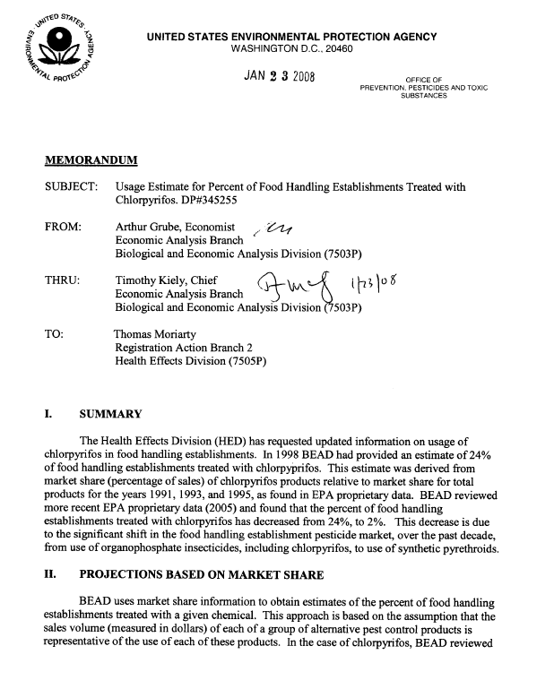
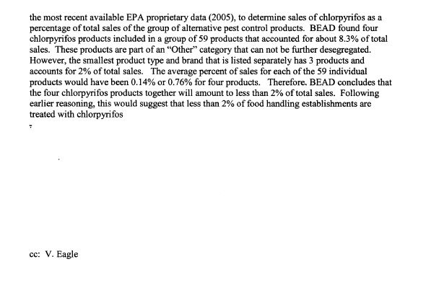

APPENDIX 1-8 Supplemental Information 2: Usage Data for Turf and Chlorpyrifos.

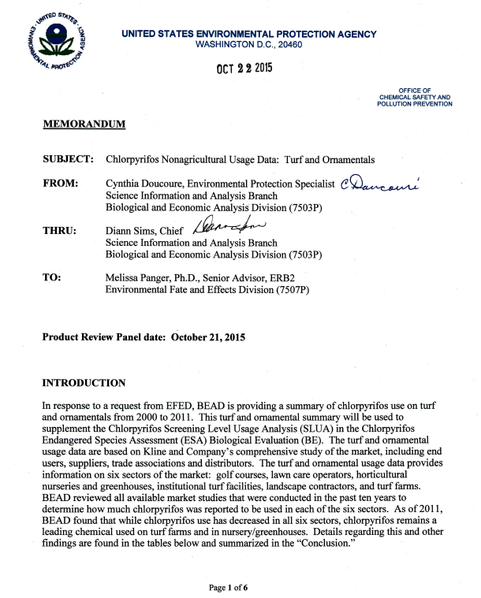
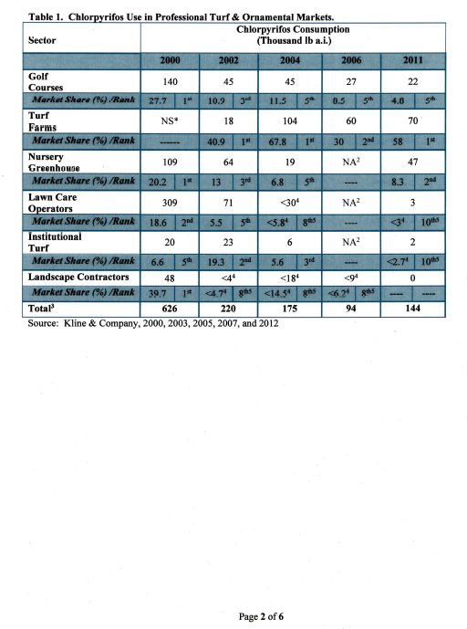
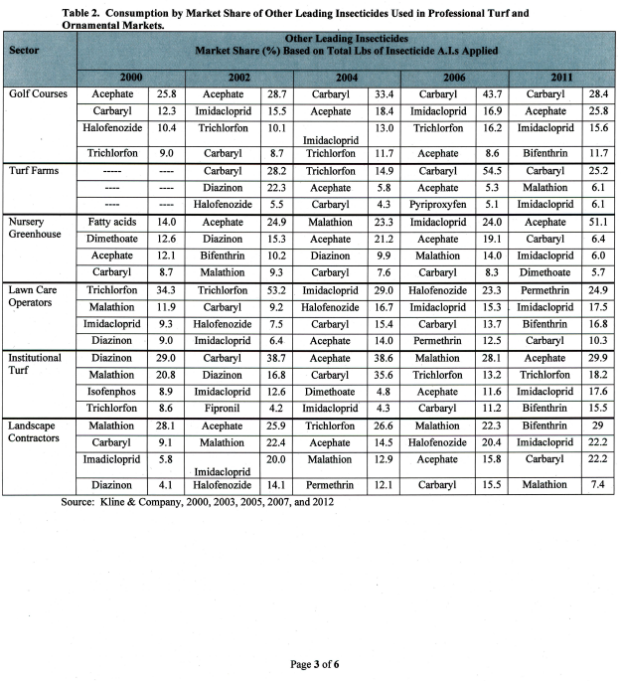

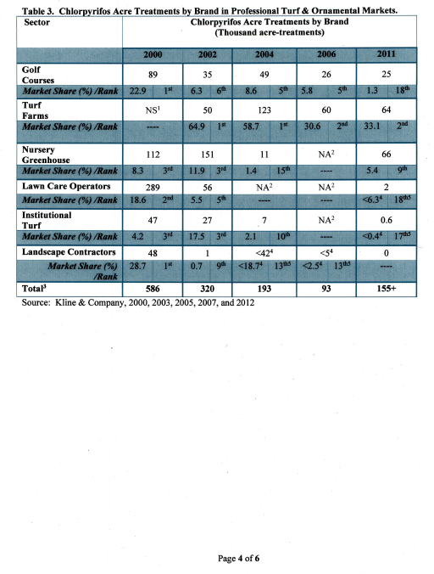

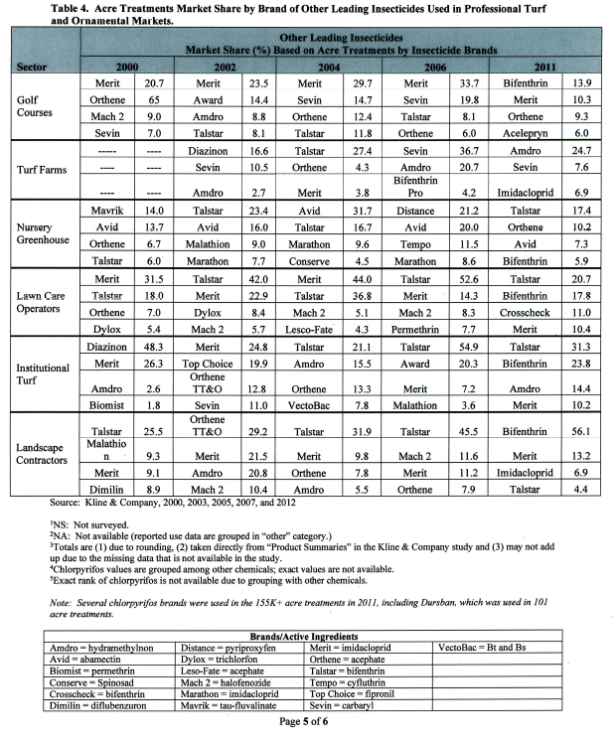

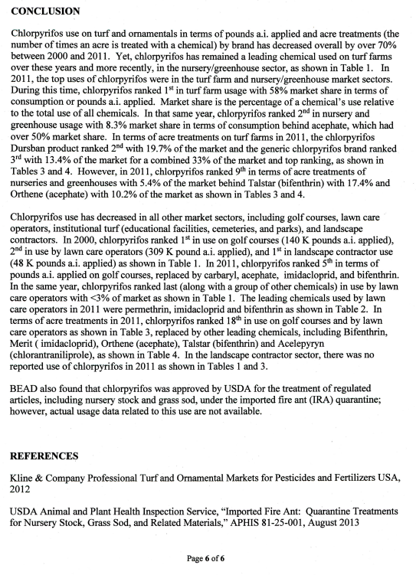

The Screening Level Usage Analysis (SLUA) uses two data sources: - USDA-NASS United States Department of Agriculture’s National Agricultural Statistics Service – pesticide usage data from 2003 to 2009: NASS data are based on surveys that focus on the top-producing states that together account for the majority of U.S. acres or production of the surveyed commodity. USDA NASS states in the August 1, 2012 Fruit Agricultural Chemical Usage Report (Methodology and Quality Measures) that “NASS aims to cover at a minimum 80 percent of the targeted fruit crop acres planted in the United States. Farm level data are combined during summary and, pending compliance with disclosure rules, published at the state and national levels. Data are published for 23 targeted fruit crops in 12 states”. The SLUA also covers 80% of crop production/acreage of field and vegetable crops in addition to fruit and nut crops. - Private pesticide market research – pesticide usage data from 2003 to 2010: The Private Pesticide Market Research data is also a survey that covers pesticide usage on agricultural crops. The survey data accounts for at least 80 percent of US acres/production of the surveyed commodities.
There have been two requests, we are aware of, for estimates of chlorpyrifos usage on non-agricultural use sites: 1. food handling estimates (2008), and 2. turf and ornamental estimates (2015) (see SUPPLEMENTAL INFORMATION 1 and 2).

