**Supporting Information**

Acute toxicity prediction to threatened and endangered species using Interspecies Correlation Estimation (ICE) models

Morgan M. Willming*†, Crystal R. Lilavois‡, Mace G. Barron‡, Sandy Raimondo‡

†Oak Ridge Institute for Science and Education, U.S. Environmental Protection Agency, Gulf Ecology Division, 1 Sabine Island Drive, Gulf Breeze, FL USA 32561

‡U.S. Environmental Protection Agency, National Health and Environmental Effects Laboratory, Gulf Ecology Division, 1 Sabine Island Drive, Gulf Breeze, FL USA 32561

Supporting Pages: 5

Supporting Figures: 1

Supporting Tables: 2

Additional Files: 1

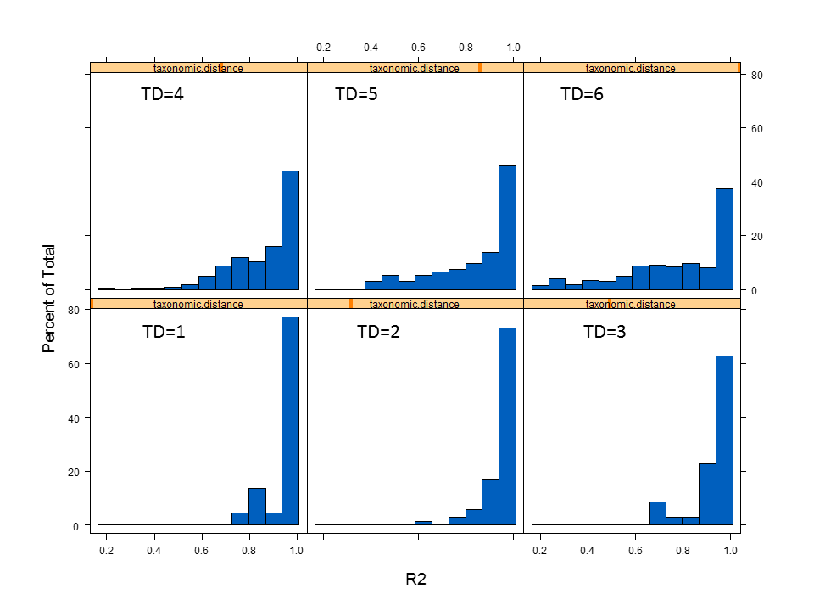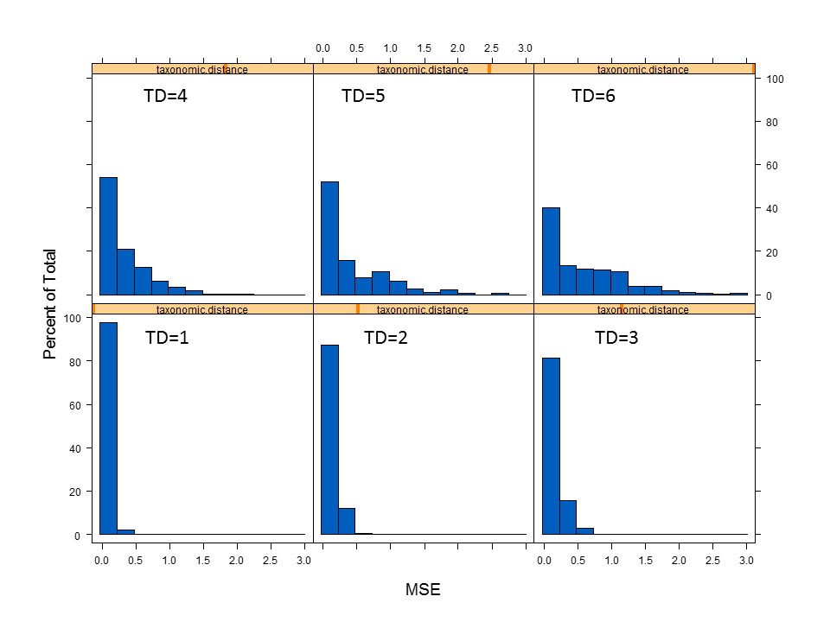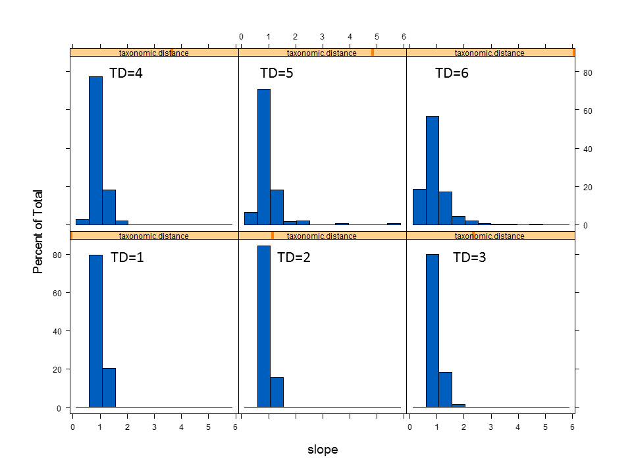

Fig. S1. Distribution of model attributes by taxonomic distance a) mean square error (MSE) b) R2, and c) slope used in optimization of user guidance.

Table S1. Number of available surrogate models (*N*) predicting to each genus or family for each chemical used in the case study of listed species from the Sacramento and Ohio River Valleys.

|  |  |  |  |  |
| --- | --- | --- | --- | --- |
|  | Genus Models | | Family Models | |
| Chemical | *N* surrogates | Genus | *N* surrogates | Family |
| Atrazine | 11 | Oncorhynchus | 11 | Salmonidae |
| Carbaryl | 42 | Oncorhynchus | 14 | Acipenseridae |
|  |  |  | 19 | Ranidae |
|  |  |  | 39 | Salmonidae |
| Chlorpyrifos | 19 | Oncorhynchus | 19 | Salmonidae |
|  | 8 | Lampsilis | 6 | Unionidae |
| Copper | 21 | Lampsilis | 13 | Acipenseridae |
|  | 14 | Lasmigona | 12 | Branchinectidae |
|  | 15 | Villosa | 17 | Ranidae |
|  | 31 | Oncorhynchus | 21 | Unionidae |
|  |  |  | 31 | Salmonidae |
| Cypermethrin | 9 | Oncorhynchus | 9 | Salmonidae |
| Diazinon | 12 | Oncorhynchus | 11 | Salmonidae |
| Fipronil | 7 | Oncorhynchus | 7 | Salmonidae |
| Glyphosate | 5 | Oncorhynchus | 5 | Salmonidae |
| Imidacloprid | 4 | Oncorhynchus | 3 | Ranidae |
|  |  |  | 4 | Salmonidae |
| Malathion | 27 | Oncorhynchus | 27 | Salmonidae |
| Methomyl | 13 | Oncorhynchus | 13 | Salmonidae |
| Permethrin | 22 | Oncorhynchus | 22 | Salmonidae |
|  |  |  | 16 | Ranidae |
| Thiobencarb | 10 | Oncorhynchus | 10 | Salmonidae |

Table S2. Toxicity estimations generated by the best available ICE models for each listed species and the most sensitive species value for the predicted taxon. Models selected were based on optimized user guidance.

| **Listed Species** | **Chemical** | **Surrogate** | **Surrogate toxicity (ug/L)** | **Taxa predicted by ICE** | **Estimated toxicity (ug/L)** | **95% Confidence Intervals** | **Most sensitive value for family (ug/L)** |
| --- | --- | --- | --- | --- | --- | --- | --- |
| Central Valley steelhead, Chinook salmon | Atrazine | *Oncorhynchus mykiss* | 13000 | Salmonidae | 6185.64 | 4548.85 - 8411.40 | 4900 |
| Carbaryl | *Oncorhynchus mykiss* | 1637.92045 | Salmonidae | 859.84 | 683.94 - 1080.97 | 988 |
| Chlorpyrifos | *Oncorhynchus mykiss* | 11.2399086 | Salmonidae | 7.47 | 5.50 - 10.15 | 11.2 |
| Copper | *Oncorhynchus mykiss* | 29.0040741 | Salmonidae | 18.44 | 14.14 - 24.04 | 5.7 |
| Cypermethrin | *Oncorhynchus mykiss* | 0.57226782 | Salmonidae | 0.44 | 0.28 - 0.70 | 0.6 |
| Diazinon | *Oncorhynchus clarkii* | 2166.10249 | Salmonidae | 88.45 | 65.72 - 119.02 | 602 |
| Fipronil | *Oncorhynchus mykiss* | 97.9489663 | Salmonidae | 58.77 | 46.88 - 73.68 | 98 |
| Glyphosate | *Oncorhynchus mykiss* | 155541.706 | Salmonidae | 65788.40 | 42505.16 - 101825.60 | 155542 |
| Malathion | *Oncorhynchus mykiss* | 59.2700258 | Salmonidae | 36.42 | 28.65 - 46.30 | 59 |
| Methomyl | *Oncorhynchus mykiss* | 1332.30364 | Salmonidae | 706.29 | 564.65 - 883.46 | 896 |
| Permethrin | *Oncorhynchus clarkii* | 1.95924169 | Salmonidae | 0.82 | 0.45 - 1.47 | 2.0 |
| Thiobencarb | *Oncorhynchus mykiss* | 1150 | Salmonidae | 613.92 | 492.36 - 765.47 | 1150 |
| Imidacloprid | *Oncorhynchus mykiss* | 229100 | Salmonidae | 95136.83 | 60139.73 - 150499.78 | 229100 |
|  |  |  |  |  |  |  |  |
| Red-legged frog | Carbaryl | *Oncorhynchus mykiss* | 1637.92045 | Ranidae | 2823.12 | 1996.25 - 3992.47 | 7964 |
| Copper | *Oncorhynchus mykiss* | 29.0040741 | Ranidae | 69.19 | 43.42 - 110.27 | 44 |
| Imidacloprid | *Oncorhynchus mykiss* | 229100 | Ranidae | 265179.99 | 173677.63 - 404890.54 | 129000 |
| Permethrin | *Oncorhynchus mykiss* | 4.93243793 | Ranidae | 13.57 | 7.84 - 23.49 | 20.00 |
|  |  |  |  |  |  |  |  |
| Southern green sturgeon | Carbaryl | *Gila elegans* | 3259.38031 | Acipenseridae | 1763.18 | 1125.49 - 2762.18 | 1878 |
| Copper | *Oncorhynchus mykiss* | 29.0040741 | Acipenseridae | 14.71 | 8.05 - 26.88 | 19 |
|  |  |  |  |  |  |  |  |
| Vernal pool fairy shrimp | Copper | *Thamnocephalus platyurus* | 10.3322663 | Branchinectidae | 15.56 | 3.68 - 65.87 | 13.6 |
|  |  |  |  |  |  |  |  |
| Pink mucket | Copper | *Lampsilis siliquoidea* | 19.0143177 | Unionidae | 11.19 | 6.46 - 19.35 | 3.7 |
| Pink mucket, rayed bean, Cumberland bean pearly mussel | Chlorpyrifos | *Lampsilis siliquoidea* | 250 | Unionidae | 150.47 | 100.07 - 226.26 | 250 |
| Rayed bean, Cumberland bean pearly mussel | Copper | *Megalonaias nervosa* | 13.0109661 | Villosa | 6.76 | 2.86 - 15.96 | 8.0 |