ATTACHMENT 4-1 TERRESTRIAL AND AQUATIC WEIGHT OF EVIDENCE (TerrWoE and AquaWoE) MATRICES: TOOL METHODOLOGY AND DESCRIPTION

The Terrestrial and Aquatic Weight of Evidence (TerrWoE and AquaWoE) matrices for making species effects determinations were constructed using Excel and programming relevant species relationships, as they pertain to the chemical use, into the spreadsheets. Each individual species spreadsheet was populated by linking root spreadsheet files to the individual species files. A database was constructed in the root data files that can be updated and maintained on a regular basis, including altering species information as well as changing the chemical of concern and its relevant chemical and toxicity properties and geospatial use data (e.g. relevant CDLs, etc.). When the root files are altered or updated, the individual species matrix files are automatically updated with relevant information for each line of evidence, the associated weighting of each line and the effects determination for the species. The file structure and individual composition of these matrices is described below.

File Structure for the Interactive TerrWoE and AquaWoE

The animal and plant matrices described below are contained in “Species Template” files. For the terrestrial animal and plant species analysis, the matrix file relies on 4 root files (TED tool “Base” file, TED tool “alt” file, the TerrWoE and the data matrix template) to populate, make comparisons of relevant estimated exposure concentrations (EECs) to thresholds, and make corresponding weighted risk and confidence calls. Links to all of these files can be found on the provisional models page at: https://www.epa.gov/endangered-species/provisional-models-endangered-species-pesticide-assessments.

- Terrestrial Effect Determination tool (TED tool) files (2 files): These files contain the input and outputs for terrestrial species modeling. Through the use of 2 root files, modeling was possible for 4 different application rates in the analysis. The application rates chosen for the chemical are meant to bracket the minimum, upper bound, and maximum single application rate, as well as provide a multiple application rate scenario (Described in more detail in Chapter 3 Exposure Analysis). The TED tool “base” file contains output based on the minimum and upper bound rates, whereas the TED tool “alt” (or alternate) file contains output based on the maximum single and multiple application rate. The TED tool files also contain all chemical input properties, toxicity information and output that is used in the terrestrial weight of evidence matrices.

- TerrWoE - This file contains several Excel worksheets that capture critical species and chemical information. Some of the information captured in this workbook include:
  - For animals, information regarding species habitat, dietary items, obligate relationships, aquatic/terrestrial dual habitat status, and aquatic EECs relevant to the species
  - For plants, information regarding pollinators, diaspore dispersal, habitat and obligate relationships
  - Output of the percent overlap analysis for the species range and critical habitats as compared to the relevant CDLs for the species
  - Spray drift analysis output and relative thresholds for aquatic bins
  - Range of application rates within each CDL for each chemical
- Data matrix template – This file captures the information contained in the inner columns of each species matrix addressing exposure and effects rationale. For exposure, information is compiled in the robustness column, and for effects, information is compiled in the relevance, surrogacy and robustness columns for each line of evidence for each taxa. Information in the relevance column for exposure is specific to an individual species and is updated in each matrix based on species specific information. Taxa are further divided into orders if there are order data available for one of the three pilot chemicals (chlorpyrifos, diazinon or malathion) at that level. Within this spreadsheet, based on the available data for each line of evidence, a weighted determination (HIGH, MED, LOW) is entered in the data matrix template file for confidence. This confidence rating is then linked to the individual species matrix based on the species grouping.

For the aquatic animal and plant species analysis, the matrix relies on 2 root files (i.e., AquaWoE and Data matrix template) to populate the matrix as listed below.

- AquaWoE – The AquaWoE worksheets are very similar to the TerrWoE worksheets described above. Relative inputs for chemical properties, use rates modeled for spray drift, and uses relevant to the species are captured on an input page in the AquaWoE, as the TED tool is not utilized in the AquaWoE. The species summary tab in the AquaWoE contains relevant aquatic EECs for a species, captured as minimum and maximum 1-in-15 year peak EECs for each of the CDLs modeled. Hydrologic unit code (HUC) level 2 and aquatic bin information are also provided on the species summary page for each species. This information is extracted directly from the species summary page into the AquaWoE (discussed later in this document). The AquaWoE file also includes spray drift analysis for each aquatic taxa considered and all relevant species information regarding dietary items, dual aquatic/terrestrial relationships and obligate relationships.
- Data matrix template – This is the same file as described for the terrestrial animals and plants. Relevant information for the inner columns of the species effects matrices addressing exposure and effects rationale are extracted from these sheets for the appropriate species group.

For both terrestrial and aquatic weight of evidence effects determinations, information is evaluated as part of one of the following lines of evidence:

Direct effects:
- Effects on mortality
- Effects on growth
- Effects on reproduction
- Effects on behavior (animals only)
- Effects to sensory function (animals only)

Indirect Effects:
- Effects to prey items (animals) or pollinators/diaspore dispersal vectors (plants)
- Effects to plant habitat
- Effects on obligate organism(s) (If applicable)

Chemical and Abiotic Stressors

These lines of evidence are fully described in APPENDIX 4-2. A description of how this information was used in both the TerrWoE and AquaWoE follows, including a detailed description and graphics for each of the cells in the matrices.

Terrestrial Weight of Evidence (TerrWoE) Matrices

TerrWoE Animal Matrices

The TerrWoE animal matrices describe the WoE analysis for terrestrial animals. Information captured in the WoE matrices cells is described below. Images are provided as a frame of reference for discussion of relevant cells.

Introductory Information (Cells B1 to H4):

Information in these cells gives basic information on the species of interest. Factors such as the species name, ID number, species order and taxa are described (as shown in Figure A 4-1.1). Additional species information on migration (only included for avian species), critical habitat and if an obligate relationship occurs is also provided. In cell H2, an indication is given if “alternate rate output” are provided. This refers to the TED tool alternate file, which captures the maximum application and multiple application rate for terrestrial modeling for the chemical. If exceedances occur through the comparison of thresholds and endpoints to EECs generated in the TED tool base file alone (which models the minimum and upper bound rates), “alternate rate output” is not included in the matrix. If exceedances do not occur at those rates, the alternate rate box will automatically update to say “Yes” and output from the maximum and multiple application rates is provided in each line of evidence.

Figure A 4-1.1. Image of introductory information on the species of interest (Cells B1 to H4) in the TerrWoE (Animal)

Direct Effects Lines of Evidence

Mortality line of Evidence (Cells A6 – H18)

The mortality line is captured in cells A6 through H18 in the terrestrial matrix. In order to allow for a clearer description of the contents of each cell, the line is divided into smaller sections as shown in each image below. The definition for information captured in the matrix columns (regarding relevance, robustness, and surrogacy) is described in the weight of evidence methodology section (ATTACHMENT 1-9). In the WoE matrices, dark green cells (shown in columns B and G) contain material that is specific to the individual species. The lighter green cells (inner columns) contain information on exposure and effects data and are generally specific to the species at the order level or higher. Blue cells are the risk and confidence weighting ranks, whereas the pink cells capture any explanation for the downgrading of risk from HIGH to MED or LOW.

The first section outlined below contains cells A5 through H10 as shown in Figure A 4-1.2.

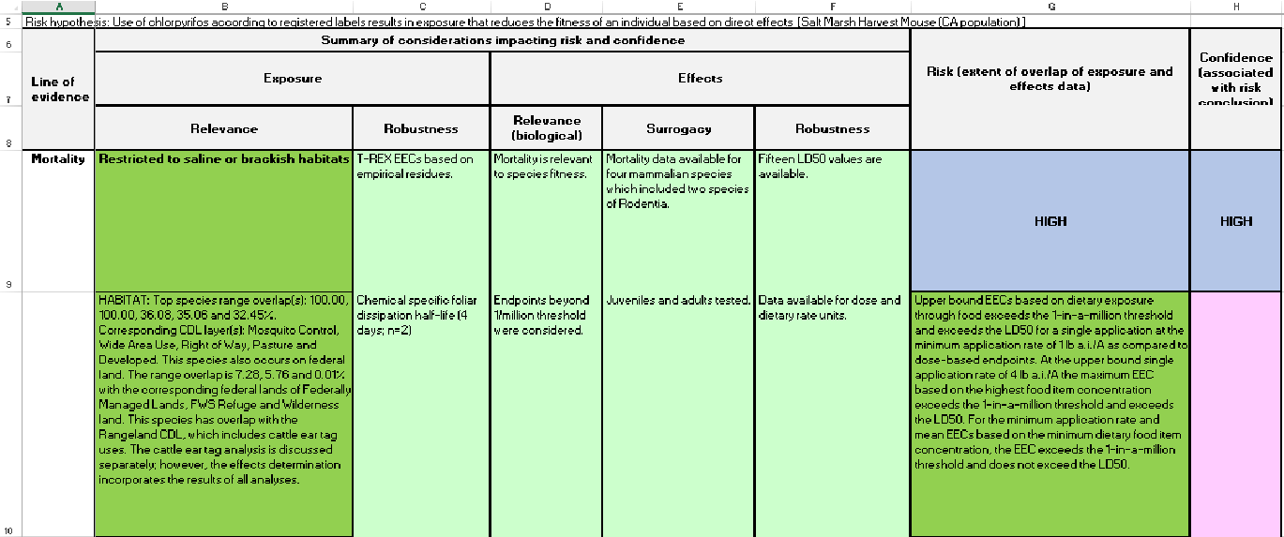
Figure A 4-1.2. Image of information regarding mortality line of evidence (Cells A5 to H10) in the TerrWoE (Animal)

- Cell A5 contains the risk hypothesis for direct effects to the species of interest.
- Cells A6 – H8 describe the information contained in each of the columns used in the matrix as they pertain to the effects and exposure characterization (see ATTACHMENT 1-9 for further description of these headings).
- Cell B9 describes any species information that was deemed relevant to the Step 2 analysis. This is generally limited to information on specific dietary items, unique species habitat (e.g., limited range, utilization of agricultural fields, etc.), elevation data and species observation data (e.g., when last seen, etc.).
- Cell B10 contains information on the CDLs that have the highest degree of overlap with the species range (maximum of top 5 displayed). If the species has overlap with federal lands, this information is also displayed. For chlorpyrifos and diazinon, if the species has overlap with the Rangeland CDL, which includes the cattle ear tag use, this is indicated in this cell as this is a separate qualitative analysis (APPENDIX 4-4).
- Cells C9-C10 contain information on the exposure analysis and the robustness of the available chemical fate data.
- Cells D9-F10 describe the effects data in the appropriate column, including information such as endpoints available, the number of studies and species tested, and if any field data or incident data are available for the species.
- Cells G9 and H9 contain the risk and confidence weighting for the applicable line of evidence. Criteria used to make the determination of HIGH, MED (medium) or LOW risk or confidence are described in ATTACHMENT 1-9.
- Cell G10 contains information on EECs for the species of interest and a comparison of these EECs to the relevant thresholds and effects values, which generally included the mortality thresholds (1 in million), the LD50 and/or the HC50. Specific exceedances at the minimum and upper bound application rates are captured in this cell for dose-based endpoints.

The second section outlined below contains cells A11 through H18 as shown in Figure A 4-1.3.

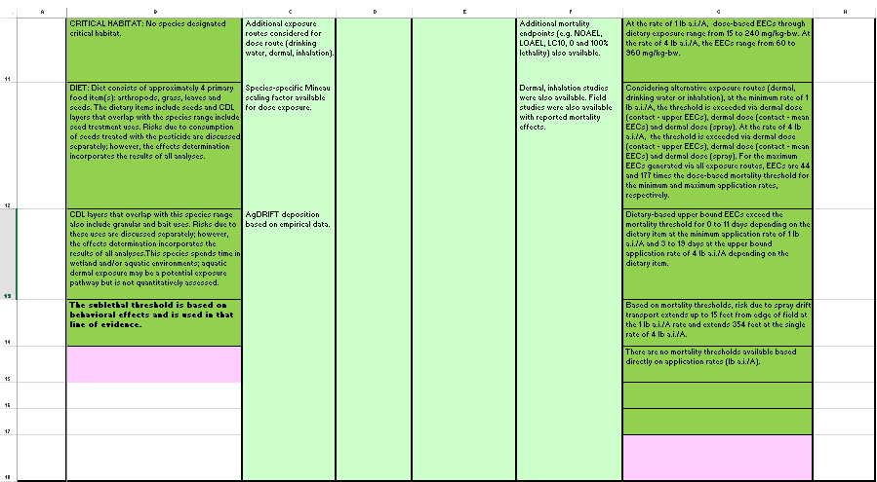
Figure A 4-1.3. Image of information regarding mortality line of evidence (Cells A11 to H18) in the TerrWoE (Animal)

- Cell B11 contains information on the CDLs that have the highest degree of overlap with the critical habitat of the species, if applicable (maximum of top 5 displayed).
- Cell B12 describes the dietary items of the species. For chlorpyrifos, if the species diet includes seeds and the species range overlaps with CDLs where seed treatment is applicable, this is also indicated in this cell, as this analysis was conducted separately (APPENDIX 4-6).
- Cell B13 describes additional ancillary information for the species. For chlorpyrifos, this includes if the species range overlaps with granular or bait uses, as these analyses were conducted separately (APPENDIX 4-6). Additional information captured in this cell includes if the species spends time in aquatic and/or wetland environments or if an aquatic weight of evidence analyses was also conducted for this species. For species that spend a significant portion of their life in aquatic environments and for which aquatic effects thresholds are available (e.g., amphibians, invertebrates), a separate aquatic weight of evidence matrix is completed.
- Cells C11 through F18 (light green cells) contain additional information regarding available exposure and effects data, as previously described.
- Continuing in cells G11 through G18 (dark green cells) is further information used to make the risk determination. As previously discussed, this analysis is based on the output generated in the TED tool for the species.
- Cell G11 provides the dose based range of EECs for the range of dietary items applicable to the species.
- Cell G12 provides information on alternate exposure pathways, including dermal, inhalation and drinking water, and reports if thresholds are exceeded and the magnitude of exceedance.
- Cell G13 provides a comparison of exposure to dietary based endpoints and the number of days these endpoints are exceeded. In addition, if the species consumes aquatic dietary items, a comparison of the peak EECs of the aquatic range of the species is compared to the aquatic dependent species thresholds provided in the TED tool workbook.
- Cell G14 contains output on spray drift analysis and the distance to reach mortality thresholds (1 in a million threshold values).
- Cell G15 describes if any thresholds are available in units of lb a.i./A and compares these thresholds, if available, to the modeled application rates.
- Cell G16 is populated if the alternate rate option is set to “Yes”. General information on threshold exceedances, based on alternate rates, is provided in this cell.
- Cell G17 is reserved for data on the TIM-MCnest analysis for a select number of avian species for which this analysis was completed (APPENDIX 4-7).
- Cell G18 (pink cell) provides information on reasons for modifying the risk call from HIGH to MED or LOW in accordance with the weighting criteria (ATTACHMENT 1-9).

Growth line of evidence (Cells A19 – H25)

The growth line is captured in cells A19 through H25 in the terrestrial matrix as shown in Figure A 4-1.4.

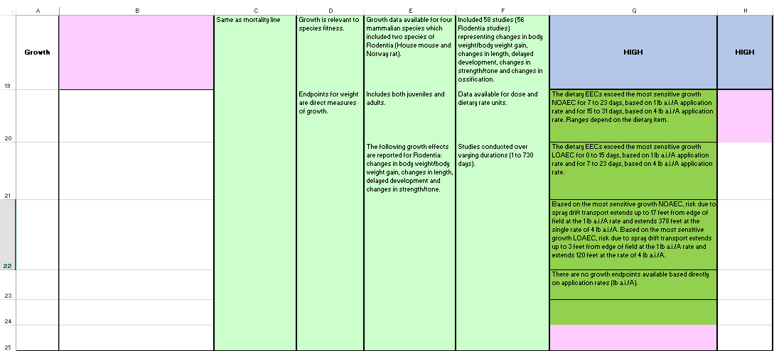
Figure A 4-1.4. Image of information regarding growth line of evidence (Cells A19 to H25) in the TerrWoE (Animal)

- Cell B19 contains any additional comments relevant to exposure in the growth line of evidence. In general, this cell is not populated as all information relevant to the mortality line regarding exposure is also relevant to the growth line. The same is true for cells C19 – C25 and the reader is referred to the information captured in the mortality line.
- Cells D19 – F25 contain information on effects data that are relevant to the growth line of evidence, similar to the discussions in the mortality line.
- Cells G19 and H19 contain risk and confidence calls for growth, similar to those described in the morality line, and the pink cells in these columns (Cells G25 and H20) contain any relevant explanation for the modifying calls from HIGH to MED or LOW.
- Cells G20 and G21 contains information on exceedance of the NOAEC and LOAEC growth endpoints, respectively, and the number of days that these endpoints are exceeded. For the growth line of evidence, and all other sublethal lines of evidence, NOAEC and LOAEC values are only based on dietary endpoints (units of mg/kg-diet). In contrast to the mortality line, comparisons of EECs to dose based endpoints (units of mg/kg-bw) are not provided for the sublethal lines of evidence. Also provided in this cell is any information on aquatic dietary items and the exceedance of aquatic dependent species thresholds as compared to relevant species range peak EECs.
- Cell G22 provides the spray drift distance to the NOAEC and LOAEC values.
- Cell G23 provides information on threshold exceedances (lb a.i./A) based directly on application rates, if available.
- Cell G24 provides any information on alternate rate comparisons, as discussed in the mortality line of evidence.

Additional sublethal lines of evidence: Reproduction (Cells A26 – H32), Behavior (A33 – H40) and Sensory (A41 – H47)

The other sublethal lines of evidence, reproduction, behavior and sensory, contain similar information as described previously in the growth line. The reader is referred to this section for a detailed discussion of each cell. Only information unique to the additional sublethal lines is discussed below.

Reproduction line of evidence

Cell G30 in the reproduction line provides information on output of the TIM-MCnest analysis as it pertains to reproductive function. This analysis is conducted for a select number of avian species (APPENDIX 4-7).

Behavior line of evidence

In addition to reported behavioral effects, the behavior line of evidence also includes endpoints relevant to effects on cholinesterase. Given that the mode of action for the three chemicals is acetylcholinesterase inhibition which can lead to alterations in behavior as well as other effects, effects on AChE were sometimes used as the sublethal threshold endpoint. Since effects on AChE are not a discrete line of evidence, in order to capture this endpoint, if the sublethal threshold was based on acetylcholinesterase inhibition, this was reported in the behavioral line of evidence in Cell G39.

Sensory line of evidence

The sensory line of evidence captures the same general information as other sublethal lines of evidence. However, for many taxa, there was no sensory effects information available for this line of evidence, and, therefore, its contribution to the effects determination is limited. For the purpose of this line of evidence, sensory data was limited to studies describing effects on smell/sniff, stimulus avoidance, and chemical avoidance.

Indirect Effect Lines of Evidence

Cell A50 contains the risk hypothesis for indirect effects to the species. The column headings are the same as the direct lines of evidence.

Indirect effects to prey/dietary items line of evidence

The line of evidence describing indirect effects to the species based on prey/dietary items is described in cells A51 through H60. As in the mortality line, in order to allow for a clearer description of the contents of each cell, the line is divided into smaller sections as shown in Figures A 4-1.5 and A 4-1.6 below.

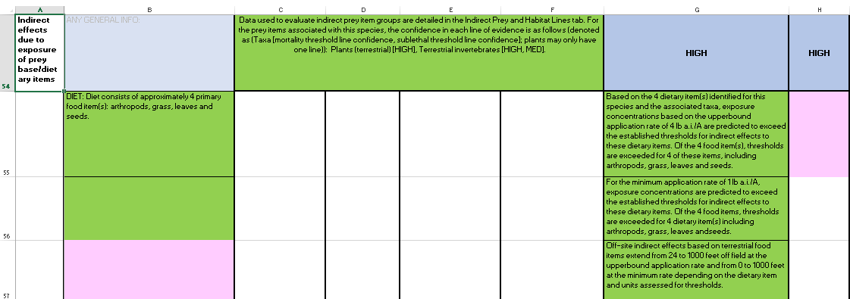
Figure A 4-1.5. Image of information regarding indirect line of evidence for effects to prey/dietary items (Cells A51 to H60) in the TerrWoE (Animal)

- Cell B55 describes the dietary items applicable to the species.
- Cells C54 through F54 lists the taxonomic groups that are used to characterize the dietary items of the species. In the same manner that the species are assessed for direct effects, the general taxonomic group for each prey item is assessed. These data are provided in the “Indirect Prey and Habitat Lines” tab within the species workbook. In cells C54 through F54, the group names and the confidence in the data for each prey item taxonomic group is provided.
- Cell G54 contains the weighting of the risk to the indirect prey items of the species.
- Cell H54 assigns an overall weighting for the confidence in the data used to assess indirect effects to prey items (this is based on the weightings provided in Cells C54 through F54 and any information available on the relative importance of one prey item to another; e.g., if a species has prey items in 3 taxonomic groups, but the primary food item is insects, the Terrestrial Invertebrate group weighting may be given greater consideration in the overall weighting of the line by the assessor).
- Cells G55 and G56 compare the minimum and upper bound application rates modeled to both the mortality indirect threshold (10% effect) and the sublethal indirect threshold (e.g., most sensitive LOAEC value) for each prey item’s taxonomic group and reports an exceedance if EECs are above either of these thresholds.
- Cell G57 reports spray drift distances for terrestrial food items. The range of spray drift distances depends on the dietary item assessed and the units assessed for thresholds. Aquatic dietary items would also be reported in these cells with threshold exceedances depending on the 1-in-15 year peak EECs and spray drift distances based on the aquatic bins associated with the species.

For species that rely on terrestrial invertebrates that emerge from an aquatic life stage, this is indicated in Cell G58, and an indication if aquatic concentrations, associated with the species range, are predicted to exceed thresholds for this aquatic stage (Figure 4-1.6). Cell G59 provides information if thresholds are exceeded for the species prey/dietary items at the alternate rates (maximum and multiple application) modeled. This information is provided regardless if an alternate rate is displayed in the other lines of evidence, as this could impact the risk weighting for the indirect line of evidence. As in the direct lines of evidence, the pink cell (G60) provides information on reasons for modifying the risk call from HIGH to MED or LOW in accordance with the weighting criteria.

Figure A 4-1.6. Image of information regarding indirect line of evidence for effects to prey/dietary items (Cells G58-60) in the TerrWoE (Animal)

Indirect effects to habitat line of evidence

The line of evidence describing indirect effects to the species habitat is captured in cells A61 through H65 (Figure 4-1.7). Species habitat effects considered in this line are limited to the impact to plants.

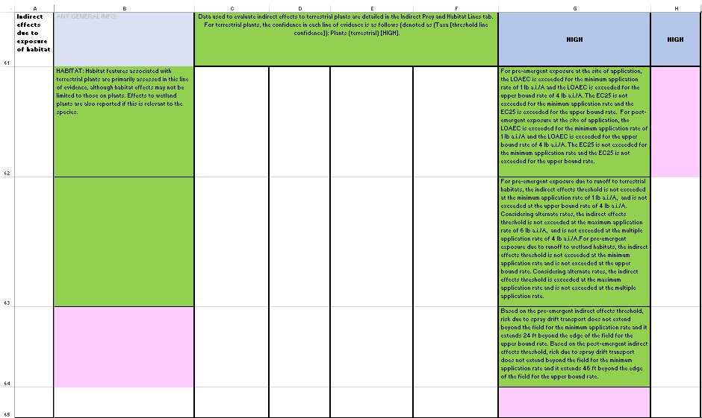
Figure A 4-1.7. Image of information regarding indirect line of evidence for effects to habitat (Cells A61 to H65) in the TerrWoE (Animal)

- Cell B62 provides information considered on habitat types included in this line of evidence.
- As in the prey item line of evidence, cells C61 through F61 provide information on the confidence in the data used to determine the effects to habitat.
- Cell G62 describes the risk due to pre- and post-emergent exposure of plants at the site of application, as compared to the most sensitive LOAEC or EC25, at the minimum and upper bound application rates.
- Cell G63 describes the risk to pre-emergent plants due to runoff to terrestrial habitats, as well as wetland environments if applicable to the species, as compared to the LOAEC and EC25.
- Cell G64 describes the spray drift distance to the same thresholds at the minimum and upper bound application rates.

Indirect effects due to obligate relationships

The line of evidence describing obligate relationships is captured in cells A66 through H69 (Figure A 4-1.8). This line of evidence describes indirect effects to the species due to effects to an organism(s) with which they have an obligate relationship.

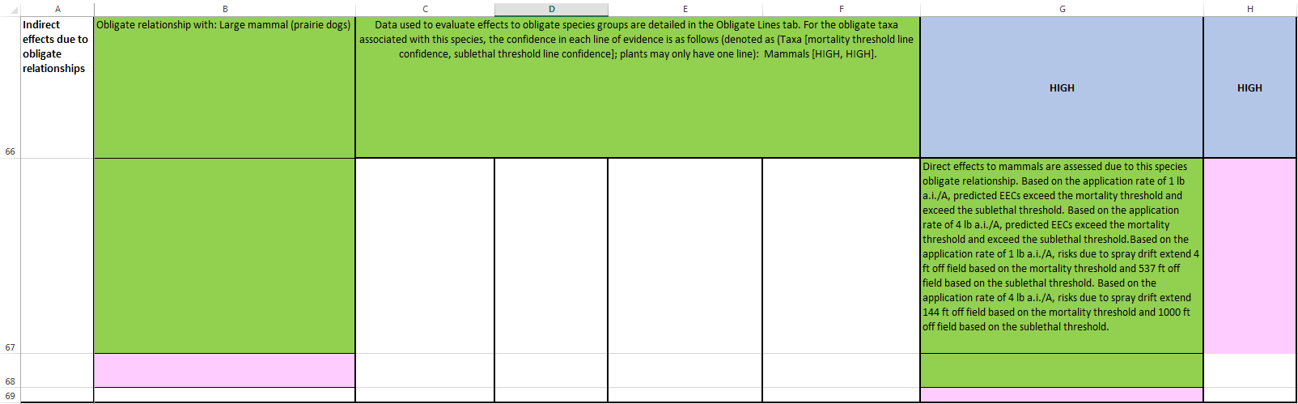
Figure A 4-1.8. Image of information regarding indirect line of evidence for effects due to obligate relationship (Cells A66 to H69) in the TerrWoE (Animal)

- Cell B66 indicates whether an obligate relationship exists for the species and, if it does, with which species. Some species have obligate relationships with organisms in more than one taxa; if so, the second organism is listed in cell B67.
- As in the previous indirect lines of evidence, cells C61 through F61 provide information on the confidence in the data used to determine the effects to the obligate organisms. These data are provided in the “Obligate Lines” tab worksheet within each species workbook.
- Cell G64 and H64 contain the weighting of risk and confidence in the obligate line or “NA” if no obligate relationship exists.
- Cell G67 describes the risk to the obligate organism based on EECs compared to direct mortality and sublethal thresholds for the applicable taxonomic group.
- Cell G64 describes the spray drift distance to the same thresholds at the minimum and upper bound application rates.

Chemical Stressor and Abiotic Lines of Evidence

In addition to the lines of evidence discussed above, included in the effects determination files is a tab entitled “Chemical and Abiotic Lines”. This tab includes two additional lines of evidence considered for the effects determinations: Chemical mixtures and stressors which addresses the likelihood that exposure to pesticide mixtures (i.e., environmental mixtures, tank mixes, formulated products and degradates) enhances the toxicity to listed species compared to the parent a.i. alone and Abiotic factors which addresses the likelihood that factors such as temperature, bacterial/viral prevalence, or pH in the environmental baseline enhances the susceptibility of listed species to the parent compound. Generally these lines do not impact the effects determination at the Step 2 level unless a determination is unclear based on the direct and indirect lines alone. The weighting for each of these lines of evidence for both risk and confidence is included in this tab and also in the individual effects rating for each species as provided on the “Summary Page” in the species workbooks. The weightings for these lines of evidence are characterized for all species in general. Although information may be available to delineate if these stressors are more or less significant for a particular taxa (e.g. impact of temperature changes to fish), weightings of risk and confidence in these lines are based on the overall evidence for all taxa combined. Future versions of this tool may allow for more refinement of these lines of evidence and the application and weighting of these lines to each taxa individually. Further discussion of these lines of evidence is provided in APPENDIX 4-2.

TerrWoE Plant Matrices

The structure of the plant matrices is similar to that described for the animal matrices; therefore, only information unique to plants will be discussed below.

Introductory Information (Cells B1 to H5):

Similar to the animal matrices, information in these cells gives basic information on the species of interest. Factors such as the species name, ID number, species order and taxa are described (as shown in Figure A 4-1.9). Additional species information on duration (i.e., perennial or annual), growth habit (e.g., forb, shrub, tree), critical habitat and if an obligate relationship occurs is also provided. Cells H2 through H4, indicate whether the species of interest is found in terrestrial, wetland and/or aquatic environments. Risks to plants in terrestrial and wetland environments are evaluated in the TerrWoE matrix, while risks to plants in aquatic environments are evaluated in the AquaWoE (described in Section 3.2 below). Minimum, upper bound, maximum and single maximum application rates are evaluated for all exposure scenarios.

Figure A 4-1.9. Image of introductory information on the species of interest (Cells B1 to H5) in the TerrWoE (Plants)

Direct Line of Evidence

Mortality line of evidence

The mortality line of evidence is described in cells A6 through H14 (Figure A 4-1.10). Risk of mortality resulting from direct application of the chemical to plants at the site of application is described in cell G11, while risk due to spray drift transport is described in cell G12. Due to the nature of the available data, risks of mortality are only evaluated based on post-emergent exposure to the plant. Cell G13 provides additional information on the endpoints used to evaluate risk.
Figure A 4-1.10. Image of information regarding mortality line of evidence (Cells A6 to H14) in the TerrWoE (Plant)

Growth line of evidence

The growth line of evidence is described in cells A15 through H20 (Figures A 4-1.11 and A 4-1.12 below). Similar to the mortality line of evidence, risk resulting from direct application of the chemical to plants at the site of application are described in cell G16. Unlike the mortality line of evidence, growth effects are evaluated based on pre-emergent and post-emergent exposure to the plant. Risk based on pre-emergent exposure to off-site terrestrial and/or wetland habitats from run-off is described in cell G17. For spray-drift transport, risk based on pre-emergent and post-emergent exposure are described in cells G18 and G19, respectively. Again, cell G20 provides additional information on the endpoints used to evaluate risk.

Figure A 4-1.11. Image of information regarding growth line of evidence (Cells A15 to H17) in the TerrWoE (Plant)

Figure A 4-1.12. Image of information regarding growth line of evidence (Cells A18 to H20) in the TerrWoE (Plant)

Reproduction live of evidence

The reproduction line of evidence is described in cells A21 through H25 and is the same as described in the mortality line of evidence.

Indirect Effects

Indirect effects to pollinators/seed dispersers line of evidence

The line of evidence describing indirect effects to the species based on pollinators/seed dispersers is described in cells A32 through H38 (Figure A 4-1.13).

Figure A 4-1.13. Image of information regarding indirect line of evidence for effects to pollinators/seed dispersers (Cells A18 to H20) in the TerrWoE (Plant)

- Cells B33 and B34 describe the pollination and diaspore dispersal mechanisms applicable to the species, respectively.
- Cells C32 through F32 list the taxonomic groups that are used to characterize the pollination and diaspore dispersal mechanisms of the species. In the same manner that the species are assessed for direct effects, the general taxonomic group for each pollinator/seed disperser is assessed. These data are provided in the “Indirect pollinator diaspore” tab within the species workbook. The confidence associated with the data for each relevant taxonomic group is identified in cells C32 through F32.
- Cell G32 contains the weighting of the risk to the indirect pollinator/seed disperser of the species.
- Cell H32 assigns an overall weighting for the confidence in the data used to assess indirect effects to pollinators/seed dispersers (this is based on the weightings provided in Cells C32 through F32. Cells G33 and G35 compare the minimum and upper bound application rates modeled to both the mortality threshold (10% effect) and the sublethal threshold (most sensitive LOAEC value) for each pollinator/seed disperser’s taxonomic group and reports an exceedance if EECs are above either of these thresholds.
- Cells G34 and G37 report spray drift distances for pollinators and seed dispersers, respectively. The range of spray drift distances depends on the taxonomic group assessed and the units assessed for thresholds. As in the direct lines of evidence, the pink cell (G37) provides information on reasons for downgrading the risk call from HIGH to MED or LOW in accordance with the weighting criteria.

Indirect effects to habitat line of evidence

The line of evidence describing indirect effects to the species habitat is captured in cells A39 through H45. A detailed description of each cell is provided in section 2.2.3.1 above.

Indirect effects due to obligate relationships

The line of evidence describing obligate relationships is captured in cells A46 through H49. A detailed description of each cell is provided in section 2.2.3.1 above.

Aquatic Weight of Evidence (AquaWoE) Matrices

AquaWoE Animal Matrices

The AquaWoE animal matrices are structured in the same format as the TerrWoE matrices. The primary exposure route is through aquatic exposure (i.e., respiration) and aquatic EECs are used in place of terrestrial EECs. The EECs used in the AquaWoE are based on output from analyses completed with the Pesticide in Water Calculator (PWC). The output from the PWC was used to generate “Species Summary” reports which are located in the PWC postprocessor (see Provisional Models website). The summary reports contain the lowest and highest (denoted as minimum and maximum in species summary sheet) 1-in-15 year peak EECs generated for each species for each HUC 2 and bin for each CDL relevant to the chemical modeled. This output sheet is the basis for information contained in the AquaWoE for the HUC 2s and bins in which the species are present, as well for comparison of EECs to the applicable species thresholds.

Each line of evidence for the AquaWoE is discussed below. As there are many similarities between the TerrWoE and AquaWoE, only those cells that differ from the TerrWoE are discussed in detail. Please refer to the TerrWoE section for discussion on common cells.

Introductory Information (Cells B1 to H4):

General information contained in these cells is the same as those provided in the TerrWoE.

Direct Effects Lines of Evidence

Mortality line of Evidence (Cells A6 – H18)

The mortality line is captured in cells A6 through H16 in the aquatic matrix. As in the TerrWoE, in order to allow for a clearer description of the contents of each cell, the line is divided into smaller sections as shown in each image below.

The first section outlined below contains cells A5 through H11 (Figure A 4-1.14).

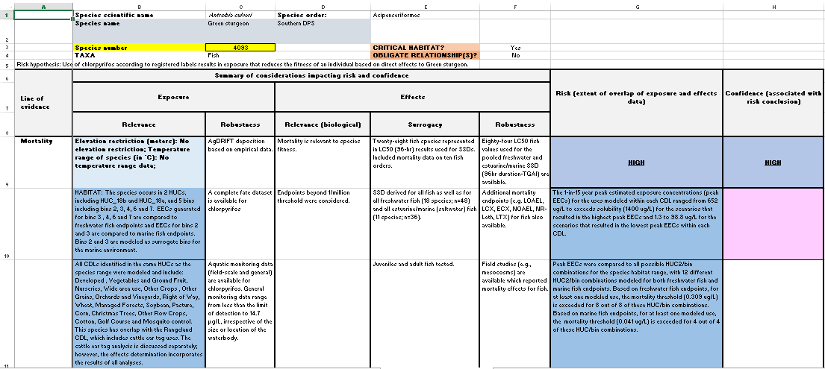
Figure A 4-1.14. Image of information regarding introduction information (Cells A1 to H4) and the mortality line of evidence (Cells A5 to H11) in the AquaWoE (Animal)

- Cell B10 contains information on which HUC 2s and bins are relevant to the species. If a surrogate bin was used to model the marine environment, it is indicated in this cell. Cell B11 describes which CDLs were modeled for the species and if the Rangeland analysis, as described in the TerrWoE section, was relevant to the species.
- Cells C9 through F11 contain the same information as described in the TerrWoE, except as it relates to the aquatic environment and aquatic species.
- Cell G10 contains information on the highest and lowest 1-in-15 year peak EECS generated for the species range. EECs were generated for each CDL that was relevant to the species and HUC 2, based on geospatial overlap of a species range with a given HUC 2. For many of these CDLs, multiple scenarios were modeled (e.g., multiple crops within a HUC 2 (e.g., Orchards and Vineyards CDL), variations in application rates and timing, etc.) resulting in a range of EECs for each CDL. The “highest” 1-in-15 year peak EECs represent the range of the highest 1-in-15 year peak EECs generated for each CDL considering all the scenarios modeled. The “”lowest” 1-in-15 year peak EECs represent the range of the lowest 1-in-15 year peak EECS generated for each CDL considering all the scenarios modeled.
- Cell G11 provides information on the number of HUC 2/bin combinations that were relevant to the species and how many of the peak EECs for these combinations exceeded the relevant mortality thresholds (value of threshold provided in this cell for reference). Many species belonged to more than one group based on their life history (e.g., freshwater fish and marine fish for an anadromous fish) and EEC and threshold comparisons were made to multiple groups, if applicable.

The second section outlined below contains cells A12 through H14 (Figure A 4-1.15).

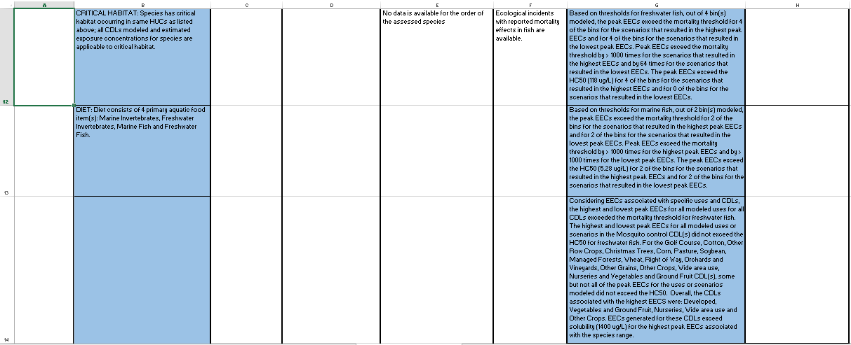
Figure A 4-1.15. Image of information regarding the mortality line of evidence (Cells A12 to H14) in the AquaWoE (Animal)

- Cell B12 indicates if the species has a critical habitat; if so, all CDLs modeled for the species are considered relevant to the critical habitat.
- Cell B14, although blank in Figure 4-1.14, is intended to capture information if the species spends time in terrestrial environment or if a terrestrial weight of evidence analyses was also conducted for this species. Some aquatic species may spend a portion of its life cycle under dry conditions. As such, these species may be exposed under a terrestrial-exposure scenario. While exposure may occur (e.g., from spray drift), biological factors may protect these species from exposure during dry periods, and therefore, their aquatic life phases may be more sensitive than during a terrestrial phase. Biological factors may include, but are not limited to, protective outer coverings, reduced respiration and feeding, and burying in sediment. For example, the Vernal pool fairy shrimp (Branchinecta lynchi), during the cystic phase of its life-cycle, may be exposed during periods of dry-down, and the black abalone (Haliotis cracherodii) may be exposed during an intertidal period. The protective nature of a cystic phase or an outer shell is anticipated to reduce potential risk from these exposures, but it is difficult to fully characterize the extent to which the risk may be reduced. As such, terrestrial exposure during these life cycle phases will not be quantitatively evaluated; however, these species will be identified in the aquatic matrix and qualitative consideration will be given to the potential terrestrial exposure phase during the analysis. Potential risk to these species during the aquatic phase is quantitatively evaluated. For species that spend a significant portion of their life in terrestrial environments and for which terrestrial effects thresholds are available (e.g., amphibians, invertebrates), a separate terrestrial weight of evidence matrix is completed.
- Cells G12 and G13 provides a comparison of relevant aquatic EECs to both the mortality threshold and the LC50 or HC50. It also provides the number of bins that exceed the threshold and the ratio of EECs to these thresholds.
- Cell G14 provides information on the exceedance of thresholds within each CDL. As multiple scenarios were typically modeled for each CDL, this cell indicates if all or only some of these scenarios exceeded applicable thresholds and/or LC50 or HC50 values. This cell also provides information on which CDLs are associated with the highest EECs and the range of these EECs.

The last section outlined below contains cells A15 through H18 (Figure A 4-1.16).

Figure A 4-1.16. Image of information regarding the mortality line of evidence (Cells A15 to H18) in the AquaWoE (Animal)

- Cells G15 and G16 describe the distance where risks due to spray drift extend off site based on mortality thresholds and either the LC50 or HC50. The modeled application rates for spray drift are the same as those used for terrestrial modeling for the minimum and upper bound application rates. If thresholds used to calculate spray drift distances were based on formulated product, it is indicated in the cell.
- Cell G17 provides information and considerations for Bins 3 and 4 EECs, if relevant to the species, as these EECs were not derived directly from the PWC.

Growth line of evidence (Cells A19 – H25)

The mortality line is captured in cells A19 through H25 in the aquatic matrix. As in the mortality line, the line of evidence is divided into smaller sections as shown in each image below.

The first section outlined below contains cells A19 through H21 (Figure A 4-1.17).

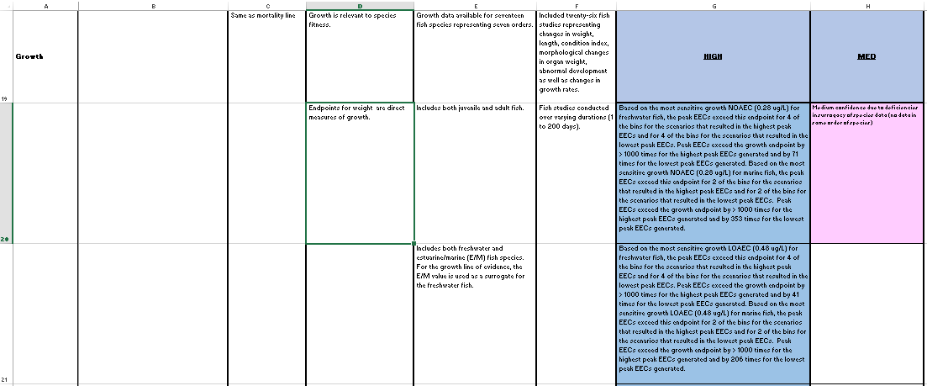
Figure A 4-1.17. Image of information regarding the growth line of evidence (Cells A19 to H21) in the AquaWoE (Animal)

- Cells G20 and G21 provide a comparison of the most sensitive growth NOAECs and LOAECs to the highest and lowest 1-in-15 year peak EECs. It also provides the number of bins that exceed the endpoints and the ratio of EECs to endpoints for the highest and lowest 1-in-15 year peak EECs.
- Cells G22 and G23 describe the distance to which risks due to spray drift extend off site based on these same endpoints, utilizing the same rates as specified in the mortality line.

The second section outlined below contains cells A22 through H25 (Figure A 4-1.18).

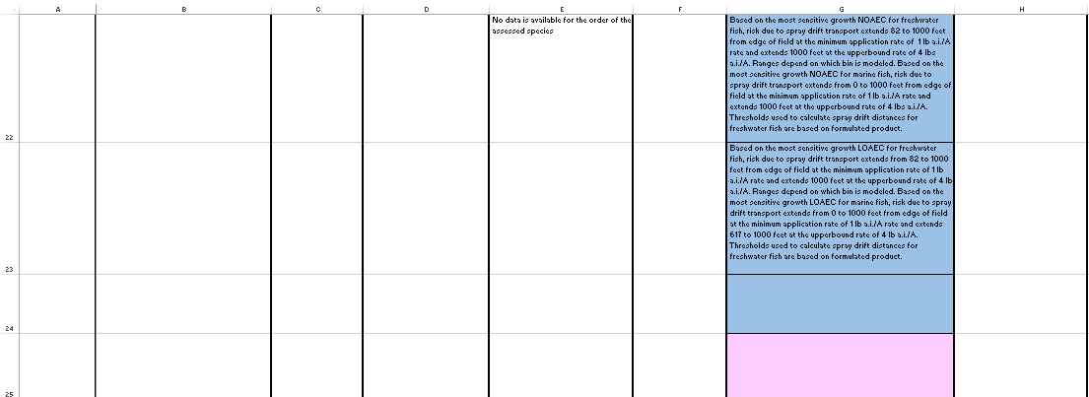
Figure A 4-1.18. Image of information regarding the growth line of evidence (Cells A22 to H25) in the AquaWoE (Animal)

Cells G22 and G23 provide information on spray drift distances as described in the mortality line of evidence, except the distances are based on growth NOAECs and LOAECs.

Additional sublethal lines of evidence: Reproduction (Cells A26 – H32), Behavior (A33 – H40) and Sensory (A41 – H47)

The other sublethal lines of evidence, including reproduction, behavior and sensory, contain the same information as described previously in the growth line and in the TerrWoE discussion. The reader is referred to these sections for more detail on each cell.

Indirect Effects Lines of Evidence

Indirect effects to prey/dietary items and habitat line of evidence

Indirect effects due to effects on prey/dietary items and habitat follow the same guidelines as presented in the TerrWoE. For habitat, the most sensitive endpoint for aquatic plants was used to compare to EECs and to base the weighting of risk.

Indirect effects due to obligate relationships

Indirect effects to a species due to an obligate relationship are assessed slightly differently in the AquaWoE than in the TerrWoE. The obligate line of evidence is structured similarly as the TerrWoE, where obligate relationships are identified and the confidence in the data available for assessing the obligate organism is weighted. However, the risk to the obligate organism is addressed in each line of evidence for direct effects (e.g., for mussels that have an obligate relationship with specific fish during the glochidia life stage, EECs in the direct effect lines were compared to thresholds for both mollusks and freshwater fish in order to address effects within each line of evidence to the obligate organism). Information on the thresholds or endpoints which are relevant to the obligate organism is specified in Cell G67 in the obligate line.

Aquatic Plant Weight of Evidence Matrices

Risks to aquatic plants are evaluated through the WoE analysis using the same general methodology as aquatic animals. Effects data for aquatic plants are grouped into non-vascular and vascular plants. For direct effects to listed plants that inhabit an aquatic environment, EECs are compared to thresholds and endpoints for each line of evidence for the most sensitive endpoints for vascular plants if data are available. Direct effects lines of evidence evaluated for aquatic plants are limited to mortality, growth and reproduction, if data are available. Indirect effects lines of evidence included effects to habitat (other plants) and obligate relationships, if applicable.

For indirect effects to aquatic plant habitats, the most sensitive indirect threshold (including vascular and non-vascular endpoints) is used to determine an exceedance of relevant EECs and for the weighting in that line of evidence.

Compiled weight of evidence matrices and summary worksheet

For presentation in the biological evaluations, matrix worksheets for terrestrial and aquatic animals and plants are compiled in workbooks according to species grouping, generally by taxa or order. Worksheet labels contain the species name and unique identification number (Figure A 4-1.19. Worksheets colored with an orange tab indicate information was available that suggested the species could be possibly extinct, but not yet included as an NLAA effects determination based on this information.

Figure 4-1.19 Image of compiled species workbook tabs

Each workbook contains a summary sheet (Figure A 4-1.20) that contains the weightings of risk and confidence for each line of evidence and the final effects determination for the species, and their critical habitats (as applicable), that are presented in the workbook.

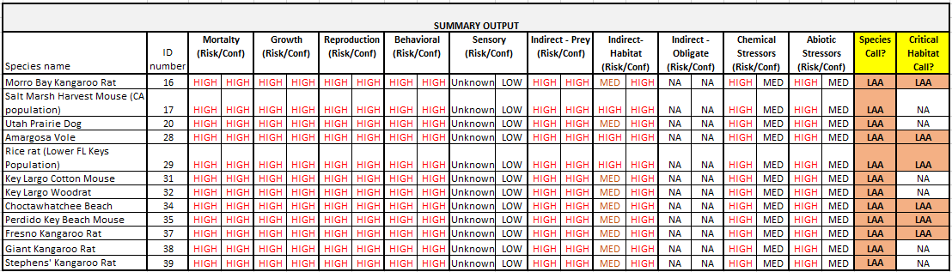
Figure A 4-1.20 Image of summary sheet from species workbooks

In the final two columns, the effects determination for each species is presented. In some cases, where an NE or NLAA determination was made, the user may need to refer to Chapter 4 for further information on the effects call. APPENDIX 4-1 contains a list of all species final effects determinations and the source of the effects determination.

In the matrices, crop data layers (CDLs) refers to relevant use layers, as defined in ATTACHMENT 1-3.

