ATTACHMENT 1-9. Applying a Weight-of-Evidence Approach to Support Step 2 Effect Determinations, i.e., Not Likely to Adversely Affect (NLAA) or Likely to Adversely Affect (LAA).
This is a framework for using a weight-of-evidence approach when making effects determinations (for listed species and designated critical habitats) for the three pilot ESA pesticides (chlorpyrifos, diazinon, malathion). The approach consists of the following general steps (explained in further detail below):

  - Establishment of Risk Hypotheses that link directly to the protection goals of Step 2
  - Establishment of “Lines of Evidence” (LOE) that assess the risk hypotheses
  - Use of the following criteria to evaluate each line of evidence:
    - Exposure
      - Relevance
      - Robustness
    - Effects data
      - Biological Relevance
      - Species surrogacy
      - Robustness
  - Use of the aforementioned criteria to assign weight (or confidence) in the data available for each line of evidence
  - Comparison of the exposure concentration data with effects data to establish overlap (or risk) and assign weight to that risk
  - Integration of results from each line of evidence to support or refute the associated risk hypothesis

Studies and data collected for step 1 are assigned to an appropriate line-of-evidence within each risk hypothesis.

The risk hypotheses are:
  - Use of pesticide X according to registered labels results in exposure that reduces the fitness of an individual from a listed species based on direct effects.

  - Use of pesticide X according to registered labels results in exposure that reduces the fitness of an individual from a listed species based on indirect effects.

  - Use of pesticide X according to registered labels results in effects to designated critical habitat by adversely impacting the essential physical and biological features (PBFs), such as primary constituent elements (PCE) or other important physical and biological features.

Collectively the risk hypotheses pose the question:
Do we expect that effects to individuals of a listed species or its designated critical habitat by pesticide X (according to registered labels) will not be discountable, insignificant, or completely beneficial?

Lines-of-evidence (LOE) are constructed based on assessment endpoints. General lines of evidence for the three organophosphate pesticides are described in the problem formulation section and are listed below:

A. Lines of evidence for direct effects are:
- Mortality to an individual of a listed species from direct, acute exposure from the use of pesticide X according to registered labels (includes parent active ingredient, formulations, and degradates of concern)

- Reduced growth of an individual (potential to decrease survival and/or reproduction) from the use of pesticide X according to registered labels

- Reduced or impaired reproduction of an individual from the use of pesticide X according to registered labels

- Impaired behavior that could result in increased mortality or decreased growth or reproduction of an individual from the use of pesticide X according to registered labels

- Impaired sensory function of an individual from the use of pesticide X according to registered labels
B. Lines of evidence for indirect effects:
- Decline in availability of prey/food of a listed species.

- Impacts to suitability of habitat of a listed species.
C. Lines of evidence for factors that could affect the magnitude of both direct and indirect effects:
- Potential effects due to degradates.

- Differences in effects observed when exposed to chemical mixtures (formulations, tank mixtures, environmental mixtures)

- Impacts of non-chemical stressors on the effects of the assessed pesticide, such as bacteria/viral prevalence, temperature, or pH in the environmental baseline.

The weight of a line-of-evidence is an expression of our confidence of our knowledge about the effects caused by pesticide x according to registered labels and the exposures which would lead to such effects. The weight of a line of evidence is based on the confidence in the available information and the level of risk.
Evaluation criteria for each line of evidence: Exposure and Effects
Exposure information
Criteria used to assess exposure estimates ultimately answer the question, “how confident are we that our exposure estimates represent environmental concentrations that could occur based on allowable labeled use?” Exposure data are evaluated using two criteria, “relevance” and “robustness”.

- Relevance of predicted EECs for species’ habitats:

• Higher confidence is given to EECs when they are derived from models that were developed to predict exposures in the habitat(s) relevant to the species or critical habitat being assessed
• Higher confidence is also given to EECs if they are based on exposure scenarios representative of the use patterns for the pesticide being assessed (e.g., was the PRZM scenario used to model EECs developed for the specific use being modeled?)
- Robustness of EECs derived from environmental fate models:

• The availability of a complete fate data set strengthens the confidence in EECs (by requiring fewer assumptions with model input parameters)
• Exposure results similar across lines of information (e.g., PRZM5/VVWM modeling results are consistent with available field-scale monitoring data and other model predictions) strengthens the confidence in EECs
Effects information
In the same way we evaluate the exposure data, the effects data are evaluated to answer the question, “how confident are we that our toxicity data will accurately predict an effect to the listed species?” Criteria used to evaluate this question include biological relevance, species surrogacy, and robustness, as defined below.

- Biological Relevance – Is there an established relationship between the measure of effect and the assessment endpoint?

- If there is a logical, well-established link, between a measured effect and an assessment endpoint (direct or indirect effects to growth, mortality, reproduction, behavior, or sensory function) more confidence is given to this information. In some cases the effects for a particular line of evidence may be indirect measures for the assessment endpoint (e.g., effects based on an AOP, brain AChE activity, acceleration or stamina to indicate effects on swimming or olfactory recordings to indicate impaired sensory function). The weight of a LOE will be dependent, in part, on how well established the relationship is between the measure of effect and the assessment endpoint. NOTE: Quantitative linkages between an indirect measure and the assessment endpoint are not necessary to establish this connection. However when available, they provide a clear linkage and therefore additional confidence.

- Relevance of Surrogates – how representative are the tested organisms used in the toxicity studies at informing the potential for adverse effects to the ESA-listed species or critical habitat being assessed?

- There is higher confidence that a toxicity endpoint is relevant if it comes from a species phylogenetically close to the species being assessed.

- There is higher confidence also if the toxicity endpoint comes from a species that shares similar life history or physiology with the species being assessed.

- Robustness – is there consistency within the line of evidence for the taxa grouping?

- Multiple, independent studies with consistent results increases confidence in our knowledge (i.e., the strength of our evidence) of whether or not the pesticide will cause the effect under the anticipated exposure conditions.

- There may be cases when a single, highly relevant and well-conducted study directly addresses a line-of-evidence for a species or a species grouping that alone would result in high confidence.

- Few studies and/or inconsistencies among the results decreases our confidence in the data.

Based on consideration of these criteria for the exposure and effects data, the weight (or confidence) in the line of evidence is assigned a rank of high, medium or low. More information on criteria used to determine if a line of evidence warranted a high, medium or low rating are described in SUPPLEMENTAL INFORMATION 1 to ATTACHMENT 1-9.

Overlap of exposure concentration data with effects data (risk estimate)
Risk is established by comparing the overlap of exposure with effect levels from toxicity studies for each line of evidence (e.g., see Figure A 1-9.1). Consideration is given to the degree of overlap between exposure and effects data. Both the number of pesticide uses that result in exceedances and their relative magnitudes are considered in assigning a low, medium, or high risk. Based on this analysis, risk is assigned a rank of high, medium or low.

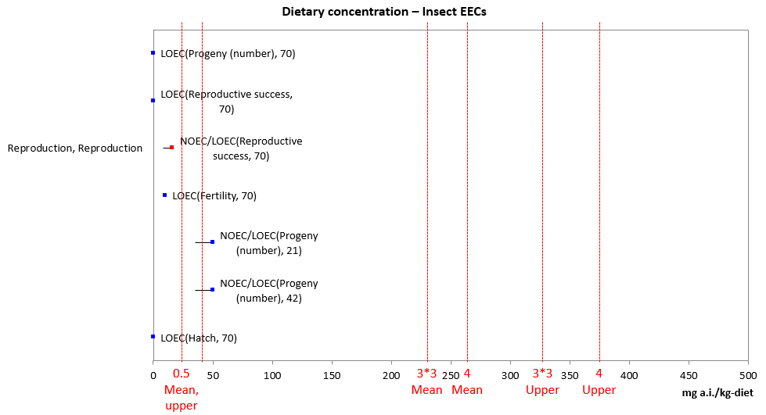
Figure A 1-9.1. Example of visually displaying the overlap between estimated environmental concentrations (EEC) with the range of values reported for an effect [the red numbers refer to application rates in lb a.i./acre (the number after the asterisk refers to the number of applications; if there is no asterisk, it refers to a single application; ‘upper’ and ‘mean’ refer to upper bound and mean Kenaga residue values from the model T-REX); the red lines depict the EECs associated with different application rates).

Integrating lines of evidence for a risk hypothesis
Based on the weighting (confidence) of the data and risk for each line of evidence, the risk hypothesis is assessed. First, a table is filled in to summarize the criteria evaluated for each line of evidence (Table A 1-9.1 and SUPPLEMENTAL INFORMATION 2 to ATTACHMENT 1-9). An overall risk finding (high, medium, low) and a finding on the overall confidence (high, medium, low) in the available exposure and effects data is made for each line of evidence.

Table A 1-9.1. Matrix for the evaluation of each line of evidence (for a complete example see Attachment A.)
Line of evidence | Considerations impacting risk and confidence |  |  |  |  | Risk  (extent of overlap of exposure and effects data) | Confidence  (in exposure and effects data)
 | Exposure |  | Effects
 | Relevance | Robustness | Relevance  (biological) | Surrogacy  (test species) | Robustness

Next, each line of evidence for a given risk hypothesis is plotted in a graph according to the risk and confidence associated with the line of evidence (e.g., Figure A 1-9.2). Each risk hypothesis is assessed to determine if the lines of evidence support or refute it. For species that have designated critical habitat, an additional risk hypothesis is evaluated.
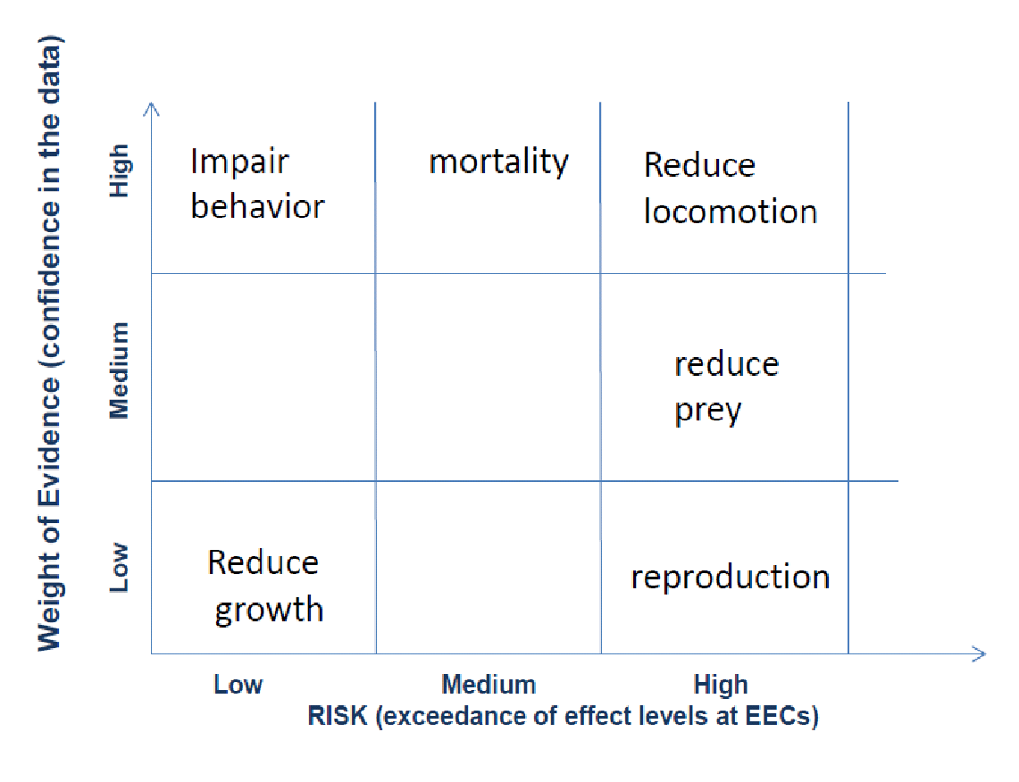
Figure A 1-9.2. Display of all lines of evidence for a risk hypothesis based on confidence and risk.

NLAA/LAA determinations from Lines of evidence supporting or refuting risk hypotheses:
Table A 1-9.2 shows the appropriate finding for pairings of confidences and risk estimates. The effect determination represents a finding for a listed species on whether the action, as proposed, is not likely to adversely affect (NLAA) or is likely to adversely affect (LAA). For the direct and indirect lines of evidence (i.e., LOEs A. 1 through 5 and B. 1 and 2, above), a combination that results in an LAA for any single line of evidence – as described in Table A 1-9.2 - is sufficient to make an LAA effects determination for the species (DPS/ESU) or critical habitat as a whole.

The lines of evidence that could impact the magnitude of direct or indirect effects (i.e., LOEs C. 1 through 3, above) will not be used solely to make NLAA/LAA determinations, but will be used in association with the other LOEs. If the available data provide evidence that the stressors related to these LOEs increase the effects of a pesticide to the level of a potential take, then this could result in an LAA determination.
For some ‘risk’ and ‘confidence’ pairings, the NLAA or LAA call will be made on a case-by-case basis (those denoted by an asterisk in Table A 1-9.2). When applicable, the EPA and the Services will discuss the available information further to decide on the appropriate effects determination (i.e., NLAA or LAA).

Table A 1-9.2. Effect determinations based on pairings of risk and confidence for a line of evidence.
Risk Estimate (for any line of evidence) | Confidence | Effect Determination
High | High | LAA
High | Med | LAA
High | Low | LAA
Medium | High | LAA
Medium | Medium | LAA
Medium | Low | NLAA or LAA*
Low | High | NLAA
Low | Medium | NLAA or LAA*
Low | Low | NLAA or LAA*
* The selection of the appropriate effects determination associated with this ‘risk’ and ‘confidence’ pairing may require additional discussion with FWS and NMFS.

SUPPLEMENTAL INFORMATION 1: General Guidance for Establishing Risk and Confidence Weights for Lines of Evidence for Direct and Indirect Effects of Pesticide Active Ingredient

The purpose of this guidance is to define general rules for determining whether to select HIGH, MEDIUM (MED) or LOW to represent the risk and confidence conclusions for individual lines of evidence used in the Step 2 analysis. This guidance was established to allow for clear and transparent methodology and to improve consistency in the work carried out by different risk assessors. This document provides general guidance that applies to the process; however, the risk assessor may consider other factors unique to a species when assigning risk and confidence conclusions for specific species.

Note that this guidance does not apply to lines of evidence which describe effects due to other chemical stressors (i.e., degradates, other pesticide ingredients) or abiotic factors. These lines of evidence are considered separately.

Establishing HIGH, MED and LOW conclusions for Risk:

The risk conclusion is based on the relationship between estimated exposures and effects endpoints/thresholds. Exposure includes all assessed methods related to exposure as applied to a given species (e.g., spray drift transport, runoff transport, dietary exposure, inhalation exposure). Endpoints and thresholds will vary by line of evidence based on availability of data and relative sensitivity of different sublethal thresholds (only one sublethal line of evidence has a threshold).

For assessing direct effects to animals and plants, the following conclusions may be made for a line of evidence:
- LOW: If exposure (based on any food item or habitat and any assessed application rate) does not exceed the lowest threshold or endpoint (if a threshold is not available)
- MED: If exposure exceeds the threshold or lowest endpoint (if a threshold is not available) but not an endpoint where effects were observed; e.g., EC25, LC50, LOAEC (specific endpoint varies based on availability of data)
- HIGH: If exposure (based on any food item or habitat and any assessed application rate) exceeds one or more endpoints where effects were observed e.g., EC25, LC50, LOAEC.

For indirect effects due to impacts on animals, the following conclusions may be made:
- LOW: If exposure is below both the mortality and sublethal indirect threshold for all animals considered in the indirect line (e.g., dietary items, pollinator)
- MED: If exposure is below both the mortality and sublethal indirect threshold for some animal taxa but above for other animal taxa. This may be influenced by available information on the relative importance of the animal taxa to the assessed species (e.g., primary dietary item).
- HIGH: If exposure is above either the mortality or sublethal indirect thresholds for all taxa upon which species relies or for multiple animal taxa upon which species relies.

For indirect effects due to impacts on plants, the following conclusions may be made:
- LOW: If exposure is below the lowest EC25 (terrestrial) or EC50 (aquatic) for all plant types assessed in the indirect line
- MED: If exposure is below the lowest EC25 (terrestrial) or EC50 (aquatic) for some plant types but above for other plant types. This may be influenced by available information on the relative importance of the plant type to the assessed species (e.g., wetland).
- HIGH: If exposure is above the lowest EC25 (terrestrial) or EC50 (aquatic) values for all plant types assessed.
If toxicity and/or exposure data relevant to the species are not available for comparison for a line of evidence, “UNKNOWN” may be indicated for the risk conclusion. If the line of evidence is not applicable (NA) to the species (e.g., obligate relationships), “NA” will be indicated for the risk call.

Establishing HIGH, MED and LOW conclusions for Confidence:

The confidence conclusion is meant to convey the risk assessor’s confidence in the risk conclusion. Uncertainties associated with estimates of exposure and effects data should be reflected in this conclusion. This conclusion considers multiple factors relating to the relevance, surrogacy and robustness of the available exposure and effects data. If a risk assessor’s confidence in both the exposure and effects data is high, then the confidence call is HIGH. In contrast, if the risk assessor’s confidence in the exposure and effects data is low, then the overall confidence call is LOW. If there are uncertainties associated with the exposure and effects data, a MED conclusion may be made. The table below provides guidance for making a confidence conclusion given different levels of confidence in exposure and effects data. Factors specific to exposure and effects data that influence confidence are provided below. If the risk determination (i.e., exposure and/or effects are unknown) was “UNKNOWN”, the confidence call will be LOW. If the line of evidence is not applicable to the species, “NA” will be indicated for the confidence call.

For CONFIDENCE determination (based on exposure and effects data)
Confidence Conclusion | Exposure | Effects
HIGH | HIGH | HIGH
 | HIGH | MED
 | MED | HIGH
MED | MED | MED
 | HIGH | LOW
 | LOW | HIGH
 | MED | LOW
 | LOW | MED
LOW | LOW | LOW
LOW | Unknown and/or Unknown
NA | NA | NA

When considering exposure data:
- HIGH: when the conceptual model of the exposure scenario (e.g., T-REX, habitat bin) is consistent with the habitat of the assessed species and chemical specific fate data are available to derive input parameters. Note that if a species occupies multiple habitats, some of which are well represented by the domain of the models, some of which are not well represented, the assessor may choose to decrease the certainty. This may rely upon the life history of the species (e.g., if the species is known to mostly use a habitat that is not well represented by the model domain).
- MED: when the conceptual model of the exposure scenario (e.g., T-REX dietary items, habitat bin) is consistent with the habitat of the assessed species but important fate data are missing such that chemical specific input parameters cannot be derived
- MED: when there is a disconnect between the conceptual model of the exposure scenario and the species habitat (e.g., freshwater bins are used as surrogates for marine species); sufficient fate data are available to derive chemical specific input parameters
- LOW: Important chemical-specific fate data are missing or inability to estimate exposures in habitat (e.g., open ocean, caves)

When considering Effects data:
- For animals:
  - HIGH: toxicity data are available for test species within the same order (i.e., confidence due to surrogacy); if not, a robust data set is available (e.g., SSD, many studies for different orders); there is an established AOP and the effects seen are consistent with the AOP; risk assessor should consider whether risk conclusions may be altered due to questions related to surrogacy
  - MED: toxicity data are not available for the same order; data set is not particularly robust (e.g., no SSD; few studies)
  - LOW: data are not available for species within the same taxon, limited data are available for the line of evidence
- For plants:
  - HIGH: Toxicity data are available for the same group (i.e., herbaceous dicot, woody dicot, monocot, other) for the species and data are available for more than six dicots/four monocots
  - MED: data are available for the same group (i.e., herbaceous dicot, woody dicot, monocot, other) for the species and data are only available for six dicots/four monocots
LOW: data are not available for the same group or data are available for less than six dicots/four monocots

The confidence conclusion may also consider other factors specific to a species or assessed pesticide that may impact the likelihood of an individual to be exposed or impacted. Some of these factors may include:
- percent of terrestrial species range that overlaps with potential areas where pesticide may occur (defined by use sites and off site transport buffers) (Note: cannot be used by itself to reduce the confidence conclusion to LOW). Based on the objectives of the assessment, overlap information may be used differently in Steps 2 and 3. Although not currently available, the percent overlap will be considered in context with various life history stages if the information becomes available.
- information on species use of particular habitats (e.g., agriculture),
- temporal use of different habitats by species (with consideration of migration and different life stages) and,
- elevation restrictions.

SUPPLEMENTAL INFORMATION 2. Example Matrix for the Evaluation of Each Line of Evidence:
The following three matrices provide an example of the types of information considered when using the weight-of-evidence approach to make effects determinations.
Conclusion: Use of diazinon is likely to adversely affect an individual Kirtland’s warbler (Setophaga kirtlandii).
Risk hypothesis: Use of diazinon according to registered labels results in exposure that reduces the fitness of an individual Kirtland’s warbler based on direct effects.

Risk hypothesis: Use of diazinon according to registered labels results in exposure that reduces the fitness of an individual Kirtland’s warbler based on indirect effects.

Risk hypothesis: Use of diazinon according to registered labels results in exposure that reduces the fitness of an individual Kirtland’s warbler based on potential increases in the magnitude of effects of diazinon.

Considers all of the known stressors of the action (e.g., parent active ingredient, formulations, mixtures, and degradates of concern) and abiotic or biotic factors likely present in the environment that may alter the toxicity of pesticide X to an individual of a listed species or their prey-base/habitat. These factors may include bacterial/viral prevalence, temperature, water quality parameters such as organic carbon, pH, DO, or salinity, or other environmental baseline factors (found in problem formulation section).
The exposure is related or translated into an environmental concentration
The AOP is used as scientific support for drawing logical connections between indirect measures and an assessment endpoint. An established relationship is one that is documented in the available literature. For example, the relationship may be documented by those papers reviewed that were retained in the analysis not to provide effects thresholds but for use in establishing mechanisms of effect.

