ATTACHMENT 1-8: Review of Open Literature Toxicity Studies for Pilot Chemical Biological Evaluations

The Endangered Species Act (ESA) mandates the use of the best available scientific and commercial data when determining the effects of pesticides on threatened and endangered species. The Environmental Fate and Effects Division (EFED) uses the EPA Ecotoxicity Database (ECOTOX) to obtain pesticide toxicity data from open literature sources, including scientific journals, books, government reports, and theses and dissertations. Data used to populate the ECOTOX database are reviewed and screened according to the current EPA’s Office of Research and Development (ORD) ECOTOX screening process. A description of this process and data limitations that would exclude a study from ECOTOX can be viewed at: http://cfpub.epa.gov/ecotox/help.cfm?help_id=limitations
&help_type=define). Studies are then further reviewed according to the Office of Pesticide Program’s (OPP’s) evaluation guidelines for ecological toxicity data in the open literature. For the national level listed species assessments for chlorpyrifos, diazinon and malathion, EFED followed these guidelines, with some modifications. This appendix describes those modifications. EFED implemented the following strategy for review and incorporation of open literature into the effects determinations. A flow diagram for this process is presented in Figure 1-8.1.

First, all data that passed the ECOTOX and OPP screens for acceptability, which included identifying studies with an exposed organism and measurable effect, were separated by taxon. Endpoints expressed in the database were converted to consistent, environmentally-relevant exposure units, when possible. For aquatic organisms (fish, invertebrates, amphibians and plants), environmentally-relevant exposure units are milligram active ingredient per liter (mg a.i./L). For terrestrial organisms (i.e., birds, mammals, invertebrates, plants), environmentally-relevant exposure units are mg a.i./kg-food, lb a.i./A, mg a.i./kg-body weight (kg-bw), and mg a.i./kg-soil. If endpoints in the database could not be converted to the above units, the studies were excluded from further review because they could not be expressed in environmentally-relevant exposure units, but were discussed in the Effects Characterization and included in APPENDIX 2-2 with the listed ECOTOX studies. The data with environmentally-relevant exposure units were used to build the taxa-specific arrays that appear in the effects characterizations for chlorpyrifos, diazinon and malathion.

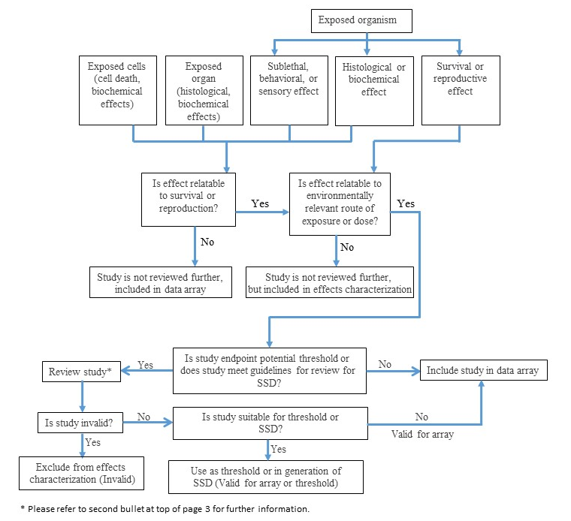
Figure 1-8.1. Flow diagram showing stepwise process for consideration and review of ECOTOX studies.

Data were generally used in one of three ways: used to derive an effect threshold; depicted in data arrays; or described qualitatively in the effects characterization. As indicated in the problem formulation, for each taxon, a mortality and sublethal thresholds were used in the Step 1 and Step 2 analyses. These thresholds are akin to the “quantitative” endpoints described in OPP’s evaluation guidelines for ecological toxicity data in the open literature. As such, EFED carried out intensive reviews of the studies that could be used as a threshold. Studies that were reviewed included the following:

- The lowest reported concentration/dose/rate for mortality or sublethal effects.
- A subset of studies used to assemble a species sensitivity distribution (SSD) for a given taxa (e.g., fish). Specifically, those studies that represent the tails and central area of the species sensitivity distribution (SSD) (i.e., values near the 5th, 50th and 95th percentiles and the median) were reviewed unless previously reviewed for prior assessments. If these studies were considered scientifically valid, they were considered appropriate for use in the SSD. Further details regarding review criteria for SSD studies are outlined in ATTACHMENT 1-5.

A full review of a study would result in one of three classifications (valid for consideration of threshold and array, valid for array, or invalid). Staff used the concepts outlined in OPP’s evaluation guidelines and best professional judgment when deciding the quality of a given open literature study and provided a discussion as to the justification for their decision.

- Valid for Consideration for Threshold and Array: Studies deemed to be relevant and of sufficient quality were used to derive an effects threshold (i.e., either in an SSD or by being the lowest reported effect for a given endpoint). Additionally, these studies are presented in the data array and considered in the weight of evidence analysis. This class of studies is referred to in the OPP’s evaluation guidelines as “quantitative”. If used in an SSD, these studies could also be referred to as “quantitative (SSD only)”. In the effects characterizations, studies classified as “quantitative” are considered valid for thresholds, SSDs and arrays.
- Valid for Array: Studies found to be relevant, but not of sufficient quality to derive an effects threshold or to be used in an SSD, were presented in the data array and considered in the weight of evidence analysis. This class of studies is referred to in the OPP’s evaluation guidelines as “qualitative”. In the effects characterizations, studies are classified as “qualitative” and are considered valid for arrays.
- Invalid: Studies rated as invalid (i.e., insufficient quality) were treated in a similar manner to those reviewed previously using the OPP’s evaluation guidelines. These studies are not used in the effects characterization.

In addition to the reviews for studies establishing thresholds, EFED’s reviews of studies that were conducted for past assessments were included in this assessment. This was done in order to present a complete picture of the reviewed studies to date. While creating the effects characterization discussion and lines of evidence, non-threshold studies were sometimes cited to build an understanding of the effects around each line of evidence. While not intensively reviewed in many cases, the studies were screened by EFED to ensure there were no fatal flaws prior to inclusion. Finally, EFED also considered studies rejected by ECOTOX according to the following codes: ACC, FATE, SEDIMENT, and MIXTURE. Studies with the code ACC were screened to determine if they could be used to describe the bioaccumulation of chlorpyrifos, diazinon or malathion in aquatic organisms. FATE and SEDIMENT studies were screened to determine whether they contained data that may be useful to the assessment and were not already available from the ECOTOX accepted studies or registrant submitted data. These studies were further reviewed if they provided information that represented a gap in the assessment. FATE study reviews are outlined in APPENDIX 3-2 and relevant SEDIMENT studies were incorporated directly into the effects characterizations. For MIXTURES, EFED evaluated the studies to determine if they were already available from the ECOTOX accepted studies. A tabular summary of studies is available in APPENDIX 1-12. A subset of these studies was assessed for information pertinent to mixture response (i.e., additivity, synergy, or antagonism) for the chemicals being evaluated in these BEs. Additional discussion of this subset of studies and exposure analysis regarding mixtures is included in APPENDIX TBD (to be included with the Effects Determinations).

A detailed description of ECOTOX is available online at: http://cfpub.epa.gov/ecotox/
These guidelines are described in detail online at: http://www.epa.gov/pesticides/science/efed/policy_guidance/team_authors/endangered_species_reregistration_workgroup/esa_evaluation_open_literature.htm.
A description of this process is available online at: http://cfpub.epa.gov/ecotox/help.cfm?help_id=limitations&help_type=define
This appendix refers specifically to study classification for open literature studies. Classifications for data submitted by registrants are termed “Acceptable, Supplemental, or Invalid”. For purposes herein, an Acceptable study is similar to “Valid for consideration for Threshold and Array”, Supplemental is similar to “Valid for consideration for Threshold and Array” and/or “Valid for Array” and ”Invalid” has the same meaning as “Invalid” discussed in this Appendix. Refer to “Overview of the Ecological Risk Assessment Process in the Office of Pesticide Programs, U.S. Environmental Protection Agency” (2004) (http://www2.epa.gov/sites/production/files/2014-11/documents/ecorisk-overview.pdf) for further information on registrant submitted study classification guidelines.
These guidelines are described in detail online at: http://www.epa.gov/pesticides/science/efed/policy_guidance/team_authors/endangered_species_reregistration_workgroup/esa_evaluation_open_literature.htm.

