Chapter 2 – Final Simazine Effects Characterization
Contents
1 Introduction 5
2 Endpoints used in Effects Determinations 6
3 Office of Water Aquatic Life Criteria 11
4 Effects Characterization for Fish and Aquatic-phase Amphibians 11
4.1 Introduction to Fish and Aquatic-phase Amphibian Toxicity 11
4.2 Effects on Mortality of Fish and Aquatic-phase Amphibians 11
4.3 Effects on Growth and Reproduction of Fish and Aquatic-phase Amphibians 13
4.4 Other Sublethal Effects to Fish and Aquatic-phase Amphibians 14
5 Effects Characterization for Aquatic Invertebrates 16
5.1 Introduction to Aquatic Invertebrate Toxicity 16
5.2 Effects on Mortality of Aquatic Invertebrates 17
5.3 Effects on Growth and Reproduction of Aquatic Invertebrates 20
5.1 Other Sublethal Effects to Aquatic Invertebrates 20
6 Effects Characterization for Aquatic Plant 20
6.1 Introduction to Aquatic Plant Toxicity 20
6.2 Effects on Aquatic Plants 21
6.2.1 Effects on Growth of Non-Vascular Aquatic Plants 22
6.2.2 Effects on Growth of Vascular Aquatic Plants 23
6.3 Effects on Aquatic Plant Communities 24
7 Effects Characterization for Birds 35
7.1 Introduction to Bird Toxicity 35
7.2 Effects on Mortality of Birds 35
7.3 Effects on Growth and Reproduction of Birds 36
7.4 Other sublethal effects to Birds 37
7.5 Drinking water studies 37
7.6 Dermal studies 37
7.7 Inhalation studies 37
8 Effect Characterization to Reptiles 37
9 Effect Characterization to Terrestrial-phase Amphibians 37
10 Effects Characterization for Mammals 38
10.1 Introduction to Mammal Toxicity 38
10.2 Effects on Mortality of Mammals 38
10.3 Effects on Growth and Reproduction of Mammals 38
10.4 Other Sublethal Effects to Mammals 41
10.5 Drinking water studies 42
10.6 Dermal exposure studies 42
10.6.1 Inhalation studies 43
11 Effects Characterization for Terrestrial Invertebrates 43
11.1 Introduction to Terrestrial Invertebrate Toxicity 43
12 Effects Characterization for Terrestrial Plants 44
12.1 Introduction to Terrestrial Plant Toxicity 44
12.2 Effects Data for Terrestrial Plants 44
12.3 Effects Data for Terrestrial Plant Communities 48
13 Incident Reports 50
13.1 Terrestrial Incidents 51
13.2 Plant Incidents 51
13.3 Aquatic Incidents 52
14 Alternative Toxicity endpoints 52
15 References 55

Tables
Table 2-1. Terrestrial mortality endpoints used to evaluate impacts to species and impacts to PPHD. 7
Table 2-2. Terrestrial sublethal endpoints used to evaluate impacts to species and impacts to PPHD. 8
Table 2-3. Aquatic mortality endpoints used to evaluate impacts to species and impacts to PPHD. 9
Table 2-4. Aquatic sublethal endpoints used to evaluate impacts to species and impacts to PPHD. 9
Table 2-5. Aquatic plant endpoints used to evaluate impacts to species and impacts to PPHD. 10
Table 2-6. Terrestrial plant endpoints used to evaluate impacts to species and impacts to PPHD. 10
Table 6-1. Summary Statistics for Aquatic Plant SSD Fit to Simazine Test Results. 25
Table 6-2. Simazine Field and Microcosm Studies. 27
Table 7-1 Avian Acute Toxicity Data for Simazine. 35
Table 7-2 Avian Subacute Toxicity Data for Simazine. 36
Table 10-1. Summary of the Most Sensitive Reproductive and Developmental Mammalian Endpoints for Simazine. 39
Table 10-2. Dermal Exposure Studies for Simazine. 43
Table 10-3. Inhalation Studies for Simazine 43
Table 12-1. Nontarget Terrestrial Plant Seedling Emergence and Vegetative Vigor Toxicity Endpoints (Tier II) for Simazine. 47
Table 12-2. Nontarget Terrestrial Plant Seedling Emergence and Vegetative Vigor Toxicity Endpoints for Simazine. 48
Table 12-3. Summary Statistics for Terrestrial Plant SSD Fit to Simazine Test Results. 49
Table 13-1. Overview of reported incidents by taxa. 51
Table 14-1. Alternative toxicity endpoints used in weight of evidence analysis. 53

Figures
Figure 4-1. Array of acute mortality (96 hour) toxicity data for freshwater fish expressed in terms of µg a.i./L. Blue squares represent LC₅₀ values from open literature studies found in the ECOTOX database. Red squares represent LC₅₀ values from registrant submitted studies. Parentheses present the endpoint measurement, species, study reference (i.e., MRID, ECOTOX #), and study duration. If endpoint is non-definitive, that is also noted. Note logarithmic scale on X-axis. 12
Figure 4-2. Array of toxicity data for fish and aquatic-phase amphibians expressed in terms of µg a.i./L (with NOAEC <4,000 µg a.i./L). Blue squares represent LOAEC values from open literature studies found in the ECOTOX database. Solid lines display the range between the LOAEC and NOAEC values. Parentheses present the effect, species, study duration and reference (i.e., MRID, ECOTOX #). 15
Figure 4-3. Array of toxicity data for fish and aquatic-phase amphibians expressed in terms of µg a.i./L (endpoints < 50 µg a.i./L). Blue squares represent LOAEC values from open literature studies found in the ECOTOX database. Solid lines display the range between the LOAEC and NOAEC values. Parentheses present the effect, species, study duration and reference (i.e., MRID, ECOTOX #). 16
Figure 5-1. Array of acute mortality toxicity data for freshwater aquatic invertebrates expressed in terms of µg a.i./L. Blue squares represent LOAEC values from open literature studies found in the ECOTOX database. Solid lines display the range between the LOAEC and NOAEC values. Parentheses present the endpoint measurement, species, study reference (i.e., MRID, ECOTOX #), and study duration. If endpoint is non-definitive, that is also noted. 18
Figure 5-2. Array of acute mortality toxicity data for freshwater aquatic invertebrates expressed in terms of µg a.i./L (up to 10,000 µg a.i./L). Blue squares represent LOAEC values from open literature studies found in the ECOTOX database. Solid lines display the range between the LOAEC and NOAEC values. Parentheses present the endpoint measurement, species, study reference (i.e., MRID, ECOTOX #), and study duration. If endpoint is non-definitive, that is also noted. 19
Figure 6-1. Summary array of toxicity data for vascular and non-vascular aquatic plants expressed in terms of µg a.i./L. Orange squares represent the mid-point of the data. Solid lines display the range between the LOAEC and NOAEC values. PHY = physiological; REP= reproduction; GRO = growth; POP = population. 21
Figure 6-2. Array of toxicity data for nonvascular aquatic plants expressed in terms of µg a.i./L. Blue squares represent LOAEC values from open literature studies found in the ECOTOX database. Red squares represent LOAEC values fromFigure 6-3. Array of toxicity data for nonvascular aquatic plants expressed in terms of µg a.i./L. registrant submitted studies. Solid lines display the range between the LOAEC and NOAEC values. The horizontal axis has been adjusted to better represent the most sensitive endpoints. Parentheses present the effect, aquatic plant grouping, study reference (i.e., MRID, ECOTOX #), and study duration. 23
Figure 6-4.Array of toxicity data for vascular aquatic plants expressed in terms of µg a.i./L. Blue squares represent LOAEC values from open literature studies found in the ECOTOX database. Red squares represent LOAEC values from registrant submitted studies. Solid lines display the range between the LOAEC and NOAEC values. The horizontal axis has been adjusted to better represent the most sensitive endpoints and is presented in log-scale. Parentheses present the effect, aquatic plant grouping, study reference (i.e., MRID, ECOTOX #), and study duration. 24
Figure 6-5. Species Sensitivity Distribution (SSD) for aquatic plants. Black points indicate single toxicity values. Red points indicate average of multiple toxicity values for a single species. Blue line indicates full range of toxicity values for a given taxon. 26
Figure 10-1. Array of toxicity data for sublethal effects to mammals expressed in terms of mg a.i./kg-bw. Blue squares represent LOAEC values from open literature studies found in the ECOTOX database. Solid lines display the range between the LOAEC and NOAEC values. Red dot represents registrant study used for threshold. Parentheses present the effect, species, duration of study and study reference (i.e., MRID, ECOTOX #). 42
Figure 12-1. Summary array of toxicity data for dicot terrestrial plants expressed in terms of lb a.i./A. Orange squares represent the mid-point of the data. Solid lines display the range between the LOAEC and NOAEC values. BCH = biochemical; CEL = cellular; PHY = physiological; REP= reproduction; GRO = growth; MOR = mortality; POP = population. 45
Figure 12-2. Summary array of toxicity data for monocot terrestrial plants expressed in terms of lb a.i./A. Orange squares represent the mid-point of the data. Solid lines display the range between the LOAEC and NOAEC values. BCH = biochemical; CEL = cellular; PHY = physiological; REP= reproduction; GRO = growth; MOR = mortality; POP = population. 46
Figure 12-3. Species sensitivity distribution of IC₂₅ vegetative vigor stage endpoints. Selected model was gumbel, fit using linearization, selected based on the lowest AIC and the highest p-value for model fit. Black points are single estimates. 49
Figure 12-4. Species sensitivity distribution of IC₂₅ seedling emergence stage endpoints. Selected model was logistic, fit using maximum likelihood, selected based on the lowest AIC and highest p-value for model fit. Black points are single estimates. 50

Introduction

In target pests (i.e., broadleaf and grassy weeds), simazine‘s mechanism of action involves inhibition of photosynthesis in photosystem II (PSII). Triazine herbicides such as simazine bind with a protein complex of the Photosystem II in chloroplast photosynthetic membranes (Schulz et al., 1990). The result is an inhibition in the transfer of electrons through the light reactions of photosynthesis that in turn inhibits the formation and release of oxygen, production of adenosine triphosphate, and the fixation of carbon dioxide into sugars.

Simazine is slightly toxic to birds and mammals and is practically non-toxic to terrestrial invertebrates on an acute exposure basis. In most terrestrial animal species, sublethal effects are the predominant concern and are discussed further below. Based on available toxicity data for birds and mammals, the primary degradate of concern for simazine (hydroxysimazine (HS)) is generally of equal toxicity or slightly more toxic than simazine. Based on the mechanism of action, i.e., disruption of photosynthesis, simazine is toxic to most photoautotroph organisms including unicellular algae and flowering plants.

Simazine is moderately toxic to freshwater and estuarine/marine fish and estuarine/marine invertebrates, and highly toxic to freshwater aquatic invertebrates on an acute exposure basis. Similar to terrestrial animals, sublethal effects are the predominant concern. Based on available toxicity data for aquatic organisms, including fish, aquatic invertebrates, aquatic phase amphibians, and aquatic plants, the chlorotriazine degradation products (deisopropyltriazine, deethyltriazine and diaminochlorotriazine) are not more toxic than simazine to aquatic organisms, with some of the reported toxicity levels exceeding the maximum solubility of the compound (see APPENDIX 1-8 for a complete discussion of degradate data).

The following sections discuss toxicity data available for simazine divided into major taxonomic groups of fish and aquatic amphibians, aquatic invertebrates, aquatic plants, birds, reptiles, terrestrial-phase amphibians, mammals, terrestrial invertebrates and terrestrial plants. Based on these data, mortality and sublethal effects (i.e., growth and reproduction) endpoints are determined and are used to evaluate direct effects to a listed species or effects to plants or animals that a species uses for prey, pollination, habitat, and/or dispersal (PPHD).

In establishing the sublethal thresholds and endpoints used in the analysis, EPA used the most sensitive sublethal endpoint based on growth or reproduction or any sublethal endpoints that are strongly linked to survival, growth or reproduction. In determining whether toxicity endpoints are strongly linked to apical endpoints, EPA staff used best professional judgement, also considering factors such as data quality and relevance to effects on survival and reproduction. Specific consideration was given to any endpoints associated with sensory or behavioral effects. It was determined that no other endpoints in these categories were more sensitive and relevant than the most sensitive growth or reproduction endpoint available for each taxon. The sublethal endpoint used for each taxon therefore represents a growth or reproductive endpoint directly. Information on additional endpoints is found in APPENDIX 2-1 and APPENDIX 2-2.

If sufficient data are available, the toxicity data for each taxon are presented as summary data arrays (developed using the Data Array Builder v.1.0; described in ATTACHMENT 2-1). Alternatively, data are presented in a tabular format if only limited data is available. The arrays contain data from both laboratory and field experiments (e.g., mesocosms). Data in these arrays are grouped by the type of effect (e.g., mortality, growth, and reproduction), and present the range of effects endpoints [e.g., LOAECs and NOAECs (NOAECs must have a corresponding LOAEC to be represented in array)] for each effect type. If limited data are available, they are presented in a tabular format. The effect related to mortality, growth, and reproduction are discussed in further detail within each taxon effects characterization. All endpoints are reported in terms of amount of active ingredient, unless otherwise specified. Data used in the arrays are available for each taxon in APPENDIX 2-1. Studies for which exposure units could not be converted to environmentally relevant units were not included in the data arrays. Endpoints reported in the ECOTOX database are presented in APPENDIX 2-2. Reviews of open literature studies are presented in APPENDIX 2-3. Citations for registrant submitted studies are presented in APPENDIX 2-4.

Endpoints used in Effects Determinations

Toxicity data available for simazine was reviewed and divided into major taxonomic groups, including: fish and aquatic amphibians, aquatic invertebrates, aquatic plants, birds, reptiles, terrestrial-phase amphibians, mammals, terrestrial invertebrates and terrestrial plants. For each of these groups, endpoints are determined for each taxon for mortality (animals only) and sublethal effects (i.e., growth or reproduction). These endpoints are used to establish thresholds, which are then used in conjunction with exposure data to make effects determinations based on the taxon with which they are associated. These data are described more fully in each relevant toxicity section below. Table 2-1 through Table 2-6
summarizes the simazine toxicity endpoints used in the effects determinations for all taxa. The available toxicity data for each taxon is discussed more later in this chapter.

Table 2-1. Terrestrial mortality endpoints used to evaluate impacts to species and impacts to PPHD.
Type of Threshold | Taxon | Test Species | Type of endpoint | Value | Units | Slope | Weight of test animal (g) | Comments | Reference
DOSE BASED MORTALITY | Mammals | Gray-Tailed Vole | LD₅₀ | 2014 | mg ai/kg-bw | 4.5 | 27.7 | Species was Gray-Tailed vole; 95% CI: 1401-2896; assumed slope | ECOTOX # 70756; Cholakis et al. 1978; USEPA ORD)
 | Birds | Mallard Duck | LD₅₀ | 4640 | mg ai/kg-bw | 4.5 | 1580 | Non-definitive (>) value, Mallard duck; assumed slope | MRID 00072798
 | Reptiles | Mallard Duck | LD₅₀ | 4640 | mg ai/kg-bw | 4.5 | 1580 | Non-definitive (>) value, Mallard duck; assumed slope | MRID 00072798
 | Terrestrial Invertebrates | Honeybee | LD₅₀ | 756 | mg ai/kg-bw | 4.5 | NA | Honeybee; non-definitive; assumed slope; calculated with Reverse BeeRex | MRID 00036935
DIETARY BASED MORTALITY | Mammals | No Data
 | Birds | Mallard Duck | LC₅₀ | 5000 | mg ai/kg-diet | 4.5 |  | Mallard duck; Non-definitive (>) value; slope assumed | MRID 00022923
 | Reptiles | Mallard Duck | LC₅₀ | 5000 | mg ai/kg-diet | 4.5 |  | bird used as a surrogate; Mallard duck; Non-definitive (>) value; slope assumed | MRID 00022923
MORTALITY | Terrestrial Invertebrates | Earthworm | LC₅₀ | 100 | mg ai/kg-soil | NA |  |  | ECOTOX #58170 Martin, 1982
 | Terrestrial Invertebrates | Honeybee | LD₅₀ | 96.7 | µg ai/bee | 4.5 |  | honeybee, non-definitive; assumed slope; contact exposure | MRID 00036935

Table 2-2. Terrestrial sublethal endpoints used to evaluate impacts to species and impacts to PPHD.
Type of Threshold | Taxon | Test Species | NOAEC (or LOAEC if no NOAEC) | MATC or LOAEC | Units | Comments | Reference
DOSE BASED SUBLETHAL ENDPOINTS | Mammals | Lab Rat | 0.54 | 1.77 | mg ai/kg-bw | rat; MATC used, LOAEC = 5.41; 6% decrease in body weight, 31% decrease in maternal body weight gain | MRID 41803601; MRID 40614405
 | Birds | Bobwhite Quail | 13 | 28 | mg ai/kg-bw | LOAEC = 61; Average BW female controls | MRID 43576901
 | Reptiles | Bobwhite Quail | 13 | 28 | mg ai/kg-bw | LOAEC = 61; Average BW female controls | MRID 43576901
DIETARY BASED SUBLETHAL ENDPOINTS | Mammals | Lab Rat | 10 | 32 | mg ai/kg-diet | rat; MATC used, LOAEC = 100; 6% decrease in body weight, 31% decrease in maternal body weight gain | MRID 41803601; MRID 40614405
 | Birds | Bobwhite Quail | 100 | 223 | mg ai/kg-diet | MATC used, LOAEC = 500; 32-33% reduction in 3-week old embryos, hatchling survival and 14-day old chick survival | MRID 43576901
 | Reptiles | Bobwhite Quail | 100 | 223 | mg ai/kg-diet | Bird used as a surrogate; MATC used, LOAEC = 500; 32-33% reduction in 3-week old embryos, hatchling survival and 14-day old chick survival | MRID 43576901
SUBLETHAL/Mortality | Terrestrial Invertebrates | Honeybee | 756 | 756 | mg ai/kg-bw | honeybee; Mortality (6.9%) | MRID 00036935
 | Terrestrial Invertebrates | Earthworm | 100 | 100 | mg ai/kg-soil | Earthworm, NOAEC values; No effects seen on growth over 7 days | MRID 00036935
 | Terrestrial Invertebrates | Honeybee | 96.7 | 96.7 | µg ai/bee | honeybee; Mortality (6.9%) | MRID 00036935

Table 2-3. Aquatic mortality endpoints used to evaluate impacts to species and impacts to PPHD.
Taxon | Test Species | Type of endpoint | Value  (ug ai/L) | Slope | Duration of study (days) | Reference
FW FISH | Fathead Minnow | LC₅₀ | 6400 | 4.5 | 4 | MRID 00033309
E/M FISH | Sheepshead Minnow (Cyprinodon variegatus) | LC₅₀ | 4300 | 4.5 | 4 | MRID 42503702
AQ AMPHIBIANS | Western Clawed Frog | LC₅₀ | 7550 | 4.5 | 4 | ECOTOX # 178499; Saka et al. 2018
FW INVERTEBRATES | Stonefly (Pteronarcys californiaca) | LC₅₀ | 1900 | 4.5 | 4 | MRID 40098001; ECOTOX # 6797
E/M INVERTEBRATES | Stonefly (Pteronarcys californiaca) | LC₅₀ | 1900 | 4.5 | 4 | MRID 40098001; ECOTOX # 6797
MOLLUSKS | Eastern Oyster (Crassostrea virginica) | LC₅₀ | 3700 | 4.5 | 4 | MRID 42503703

Table 2-4. Aquatic sublethal endpoints used to evaluate impacts to species and impacts to PPHD.
Taxon | Test Species | NOAEC | MATC or LOAEC | Units | Duration of study (days) | Comments | Reference
FW FISH | African clawed frog | 1.2 | 3.6 | ug ai/L | 100 | MATC used as input; LOAEC = 11.1; 19% increase in morality; decrease in gonad weight and time reach metamorphosis; amphibian used as surrogate | ECOTOX # 178653; Sai et al. 2016
E/M FISH | African clawed frog | 1.2 | 3.6 | ug ai/L | 100 | MATC used as input; LOAEC = 11.1; 19% increase in morality; decrease in gonad weight and time reach metamorphosis; amphibian used as surrogate | ECOTOX # 178653; Sai et al. 2016
AQ AMPHIBIANS | African clawed frog | 1.2 | 3.6 | ug ai/L | 100 | MATC used as input; LOAEC = 11.1; 19% increase in morality; decrease in gonad weight and time reach metamorphosis | ECOTOX # 178653; Sai et al. 2016
FW INVERTEBRATES | Saltwater mysid (Americamysis bahia) | 63 | 98 | ug ai/L | 21 | MATC used as input; LOAEC = 151; EM invertebrate used as surrogate; 15% reduction in F₀ survival | MRID  48680006
E/M INVERTEBRATES | Saltwater mysid (Americamysis bahia) | 63 | 98 | ug ai/L | 21 | MATC used as input; LOAEC = 151; 15% reduction in F₀ survival | MRID 48680006
MOLLUSKS | Saltwater mysid (Americamysis bahia) | 63 | 98 | ug ai/L | 21 | MATC used as input; LOAEC = 151; EM invertebrate used as surrogate; 15% reduction in F₀ survival | MRID 48680006
Table 2-5. Aquatic plant endpoints used to evaluate impacts to species and impacts to PPHD.
EPA Category | Species | NOAEC | MATC or LOAEC | IC₅₀ | Units | Comments | Reference
NON-VASCULAR | Green Algae (Anabaena flos aqua) | 5.4 | 5.4 | 12.19 | ug ai/L | reduced growth rate; IC₀₅ used for both NOAEC and LOAEC; 96 -hour exposure; HC₀₅ species from all aquatic plant SSD used for IC₅₀ | MRID 42662401
VASCULAR | Lemna gibba | 50 | 74 | 12.19 | ug ai/L | 39% reduction in number of fronds; MATC used for Step 2 threshold; 7-d exposure; endpoints from same study; HC₀₅ from all aquatic plant SSD used for IC₅₀ | MRID 42503704

Table 2-6. Terrestrial plant endpoints used to evaluate impacts to species and impacts to PPHD.
EPA Category | Species | NOAEC | MATC or LOAEC | IC₂₅ | Units | Comments | Reference
MONOCOT | Oat | 0.016 | 0.028 | 0.0129 | lb ai/A | 20% reduction in dry weight at the LOAEC; NOAEC/MATC based on reductions in weight for oat; IC₅₀ based on HC₀₅ species of the SSD for seedling emergence | MRID 42634603
DICOT | Lettuce | 0.0018 | 0.0031 | 0.0129 | lb ai/A | 25% reduction in dry weight at the LOAEC; NOAEC/MATC based on reductions in weight for lettuce; IC₅₀ based on HC₀₅ species of the SSD for seedling emergence | MRID 42634603

Office of Water Aquatic Life Criteria

The U.S. EPA’s Office of Water (OW) may develop ambient water quality criteria for chemicals, including pesticides, that can be adopted by states and tribes to establish water quality standards under the Clean Water Act. At this time, OW has not published ambient water quality criteria for simazine.

Effects Characterization for Fish and Aquatic-phase Amphibians

Introduction to Fish and Aquatic-phase Amphibian Toxicity

Acute and chronic studies for fish have been submitted by the registrant and are available in the open literature. Data for amphibians are also available in the open literature. Studies were excluded from the main analysis if they were considered invalid or if the exposure units could not be converted into aqueous concentrations (mass a.i./volume).

Effects on Mortality of Fish and Aquatic-phase Amphibians

The available data for acute mortality to fish and aquatic-phase amphibians are provided in Figure 4.1 below. Mortality values for fish reported in registrant submitted studies and the open literature varied by several orders of magnitude and they ranged from 90 µg a.i./L to >910,000 µg/L. Although several low concentrations were reported in ECOTOX, these were reviewed for this assessment or previous assessments and found to be unacceptable for varying reasons, most often due to lack of control data (USEPA, 2009; California Red-legged Frog BE for Simazine, Appendix G). The most sensitive reliable endpoint was used to represent thresholds for mortality effects.

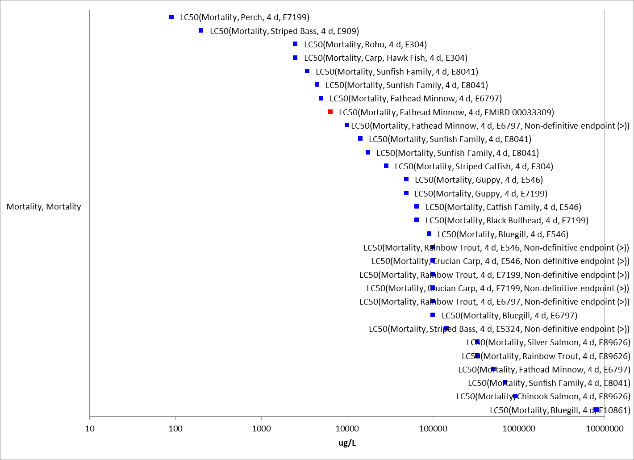
Figure 4-1. Array of acute mortality (96 hour) toxicity data for freshwater fish expressed in terms of µg a.i./L. Blue squares represent LC₅₀ values from open literature studies found in the ECOTOX database. Red squares represent LC₅₀ values from registrant submitted studies. Parentheses present the endpoint measurement, species, study reference (i.e., MRID, ECOTOX #), and study duration. If endpoint is non-definitive, that is also noted. Note logarithmic scale on X-axis.

For freshwater fish, the lowest reliable LC₅₀ for simazine based on the TGAI (Technical Grade Active Ingredient) was an LC₅₀ value of 6.4 mg a.i./L tested on the fathead minnow (MRID 00033309). This value will be used to derive the acute mortality threshold for freshwater fish. Toxicity data for simazine when tested as a formulated product are also available but were either unacceptable or not suitable for use as a threshold due to study uncertainty or not more sensitive than the TGAI.

During the public comment period for the draft ecological risk assessment (DRA) for the registration review of simazine, an acute study in the common carp was submitted, which reported an LC₅₀ value of >34 mg a.i./L. Based on this study and additional comments provided on the DRA, the Acute to Chronic Ratio (ACR) value for the LC₅₀ utilized in the DRA based on a chronic study in the carp is not used in the ESA assessment.

For estuarine/marine fish, limited acute mortality data were available. The most sensitive endpoint for estuarine/marine fish was an LC₅₀ value of 4.2 mg a.i./L (Seabream larvae; ECOTOX# 76270 (Arufe et al., 2004); however, this was conducted with a formulated product. The most sensitive endpoint for TGAI was an LC₅₀ value of 4.3 mg a.i./L (Sheepshead minnow, Cyprinodon variegatus, MRID 42503702), which is nearly identical to the value from the formulated product. This value will be used to derive the acute mortality threshold for estuarine/marine fish.

Although no registrant data was available for aquatic-phase amphibians, recent aquatic-phase amphibian data was available in the ECOTOX report. The most sensitive acute endpoint for aquatic-phase amphibians was an LC₅₀ value of 7.55 mg a.i./L (ECOTOX#178499, Saka et al. 2018). This value will be used to derive the acute mortality threshold for aquatic-phase amphibians.

Effects on Growth and Reproduction of Fish and Aquatic-phase Amphibians

The most sensitive chronic exposure endpoint for fish was reported in an early life-stage study with common carp (Cyprinus carpio L.; Velisek et al. 2012). The authors reported no effects on hatchability or embryo viability; however, there were statistically significant reductions in body weights (29% decrease) following exposures at 600 µg a.i./L (NOAEC = 60 µg a.i./L). At the highest test concentration of 600 µg a.i./L there was also a decrease in the total length of carp. Fish exposed to the three highest levels (6, 60 and 600 µg a.i./L) of simazine showed alteration of tubular systems of the caudal kidney. Additionally, in another study with the carp, conducted at one test concentration of 45 µg a.i./L, very similar histopathological changes in the kidney were reported; however, no changes associated with apical endpoints were noted in the study (E#118302, Oropesa et al, 2009).

No chronic data is available for simazine for estuarine/marine fish.

Although no new registrant data was available for chronic endpoints relevant to aquatic-phase amphibians, recent aquatic-phase amphibian data was available in the ECOTOX report. The most sensitive chronic endpoint for aquatic-phase amphibians was a NOAEC value of 1.2 µg a.i./L (LOAEC = 11.1 µg a.i./L, MATC = 3.6 µg a.i./L (Maximum Acceptable Toxicant Concentration, equal to geomean of NOAEC/NOAEL and LOAEC/LOAEL; ECOTOX# 178652, Sai et al. 2015) associated with a 19% increase in mortality and 57% reduction in gonad weight and GSI% (gonadosomatic index) in Xenopus laevis. Histopathological changes in testicular tissue were noted at all concentrations, with most notable changes at the highest test concentration (100.9 ug ai/L).

An additional paper (ECOTOX# 178653, Sai et al., 2016) was published using the same research, with the same NOAEC and LOAEC values, but associated with a significant reduction (22%) in tadpoles completing metamorphosis on Days 80 and 90 of the study (8.1 % lower on Day 80, and 22.2 % lower on Day 90 as compared to the controls in 11.1 µg a.i./L group; 13.5 % lower on Day 80, and 21.8% lower on Day 90 as compared to the controls in 100.9 µg a.i./L group). Additionally, the number of days required to complete metamorphosis was statistically increased in the 11.1 ug ai/L (6.3 %) and the 100.9 ug ai/L group (8.7 %).
Based on the available data, the sublethal toxicity threshold for aquatic-phase amphibians is a NOAEC value of 1.2 µg a.i./L (LOAEC = 11.1 µg a.i./L; MATC 3.6 µg a.i./L) associated with a 19% increase in mortality and 57% reduction in gonad weight and GSI% (gonadosomatic index) from one study, additionally, a 22% reduction in tadpoles completing metamorphosis on Day 90 of the study and a 6.3% reduction in the number of days required to complete metamorphosis were found at this LOAEC value in an accompanying study. Due to the limited data on chronic effects of simazine to fish, the new amphibian endpoint was used as a surrogate for effects to fish, given the effects observed (morality, growth effects) could be translatable to other aquatic vertebrate species. In the use of alternative endpoints (see Section 14), the available fish endpoint in the common carp, a NOAEC value of 60 µg a.i./L (LOAEC = 600 µg a.i./L, MATC = 190 µg a.i./L), is considered as a surrogate for both taxa.

Other Sublethal Effects to Fish and Aquatic-phase Amphibians

Additional literature is available on the sublethal effects of simazine on fish and aquatic-phase amphibians. No endpoints were identified from studies in the ECOTOX acceptable database that were either more sensitive than the endpoints identified above or reliable for use as a threshold and relatable to an apical endpoint. Figure 4.2 illustrates the data available for endpoints with a NOAEC less than 4,000 µg a.i./L (slightly above the solubility limit of simazine). Figure 4.3 displays endpoints less than 50 µg a.i./L in order to provide more granularity to lower effects endpoints.

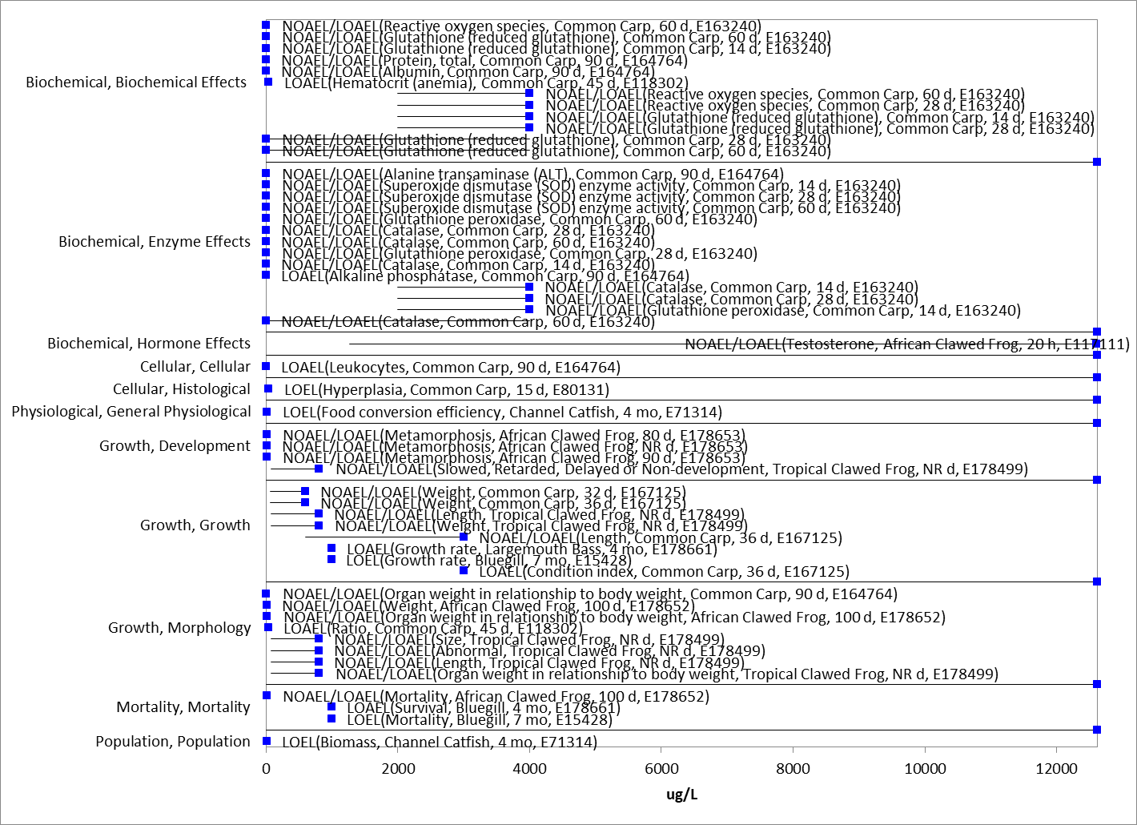
Figure 4-2. Array of toxicity data for fish and aquatic-phase amphibians expressed in terms of µg a.i./L (with NOAEC <4,000 µg a.i./L). Blue squares represent LOAEC values from open literature studies found in the ECOTOX database. Solid lines display the range between the LOAEC and NOAEC values. Parentheses present the effect, species, study duration and reference (i.e., MRID, ECOTOX #).

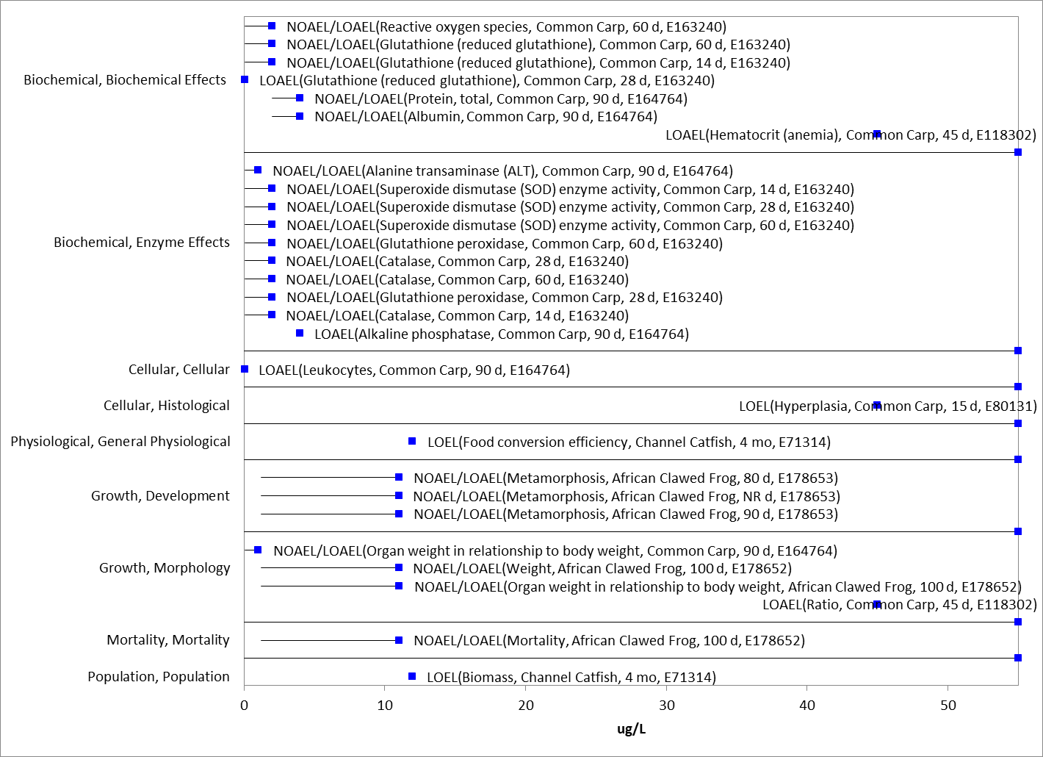
Figure 4-3. Array of toxicity data for fish and aquatic-phase amphibians expressed in terms of µg a.i./L (endpoints < 50 µg a.i./L). Blue squares represent LOAEC values from open literature studies found in the ECOTOX database. Solid lines display the range between the LOAEC and NOAEC values. Parentheses present the effect, species, study duration and reference (i.e., MRID, ECOTOX #).

Effects Characterization for Aquatic Invertebrates

Introduction to Aquatic Invertebrate Toxicity

Studies available on the effects of simazine on aquatic invertebrates were reviewed, including both freshwater and estuarine/marine (E/M) invertebrates. APPENDIX 2-2 includes the bibliography of studies that are included in this effects characterization and those that were excluded. Studies were excluded from the main analysis if they were considered invalid or the exposure units could not be converted into environmentally relevant concentrations. In this effects characterization, when sufficient data are available for simazine, different endpoints are identified for freshwater and estuarine/marine invertebrates. Where available, sensitivity of mollusks versus other aquatic invertebrates are considered, and separate endpoints are derived for mollusks.

Effects on Mortality of Aquatic Invertebrates

The available data for acute mortality to freshwater invertebrates is provided in Figure 5.1 and Figure 5.2 below. Figure 5.1 represents the full range of data, whereas Figure 5.2 focuses on reported results less than 10 mg/L, providing more granularity on lower endpoints, which are closer to environmentally relevant concentrations. For freshwater aquatic invertebrates (non-mollusks), the most sensitive mortality endpoint reported is an EC₅₀=1,000 µg a.i./L in the water flea (Daphnia magna). In the public comment period on the simazine draft risk assessment, additional questions regarding the reliability of the study (including the lack of measured test concentrations) and a comparison of this study to all other mortality studies available on Daphnia sp. were raised. An additional study on the acute toxicity of Daphnia was submitted which established an EC₅₀ >4,300 µg a.i./L. With the inclusion of this study, based on data submitted in public comments on the 2016 DRA, there are 9 studies available on Daphnia with EC₅₀ values ranging from >3,500 to 60,000 µg a.i./L based on testing with both TGAI and the formulated product. For these reasons, the lowest endpoint of 1,000 µg a.i./L is not used as the most sensitive endpoint due to lack of confidence in the study results. The next lowest available endpoint for acute mortality is in the stonefly (Pteronarcys californica) and has an LC₅₀ of 1,900 µg a.i./L (MRID 40098001/ECOTOX#6797, Mayer & Ellersieck). This value will be used to derive the acute mortality threshold for freshwater invertebrates. An additional lower endpoint was identified in the ECOTOX screen (1,000 µg a.i./L, Calanoid Copepod, ECOTOX#10460) which was not used as a quantitative endpoint due to significant study deficiencies.

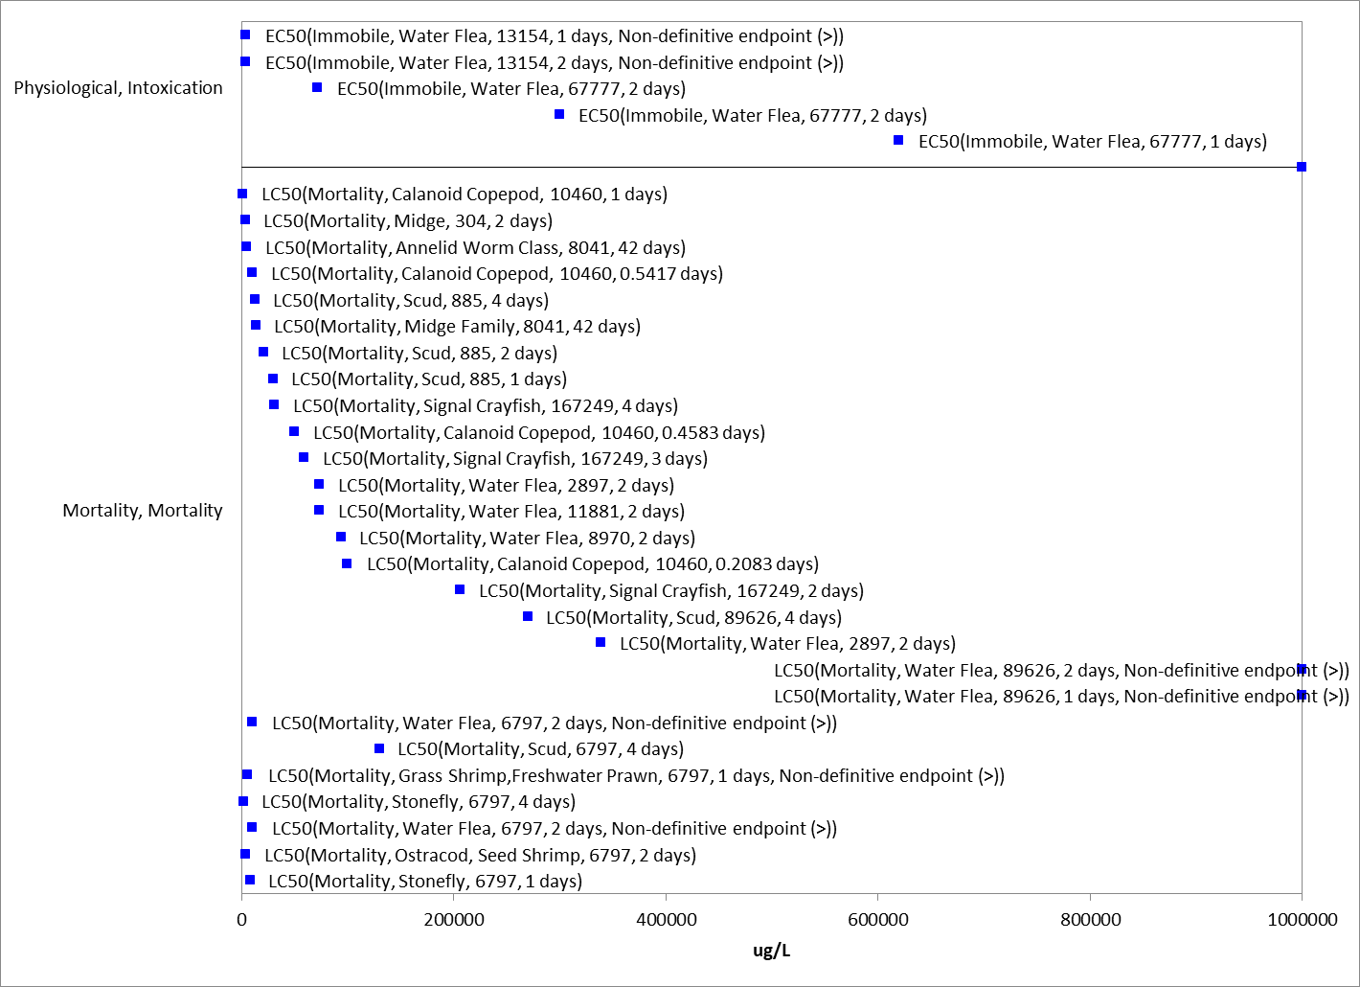
Figure 5-1. Array of acute mortality toxicity data for freshwater aquatic invertebrates expressed in terms of µg a.i./L. Blue squares represent LOAEC values from open literature studies found in the ECOTOX database. Solid lines display the range between the LOAEC and NOAEC values. Parentheses present the endpoint measurement, species, study reference (i.e., MRID, ECOTOX #), and study duration. If endpoint is non-definitive, that is also noted.

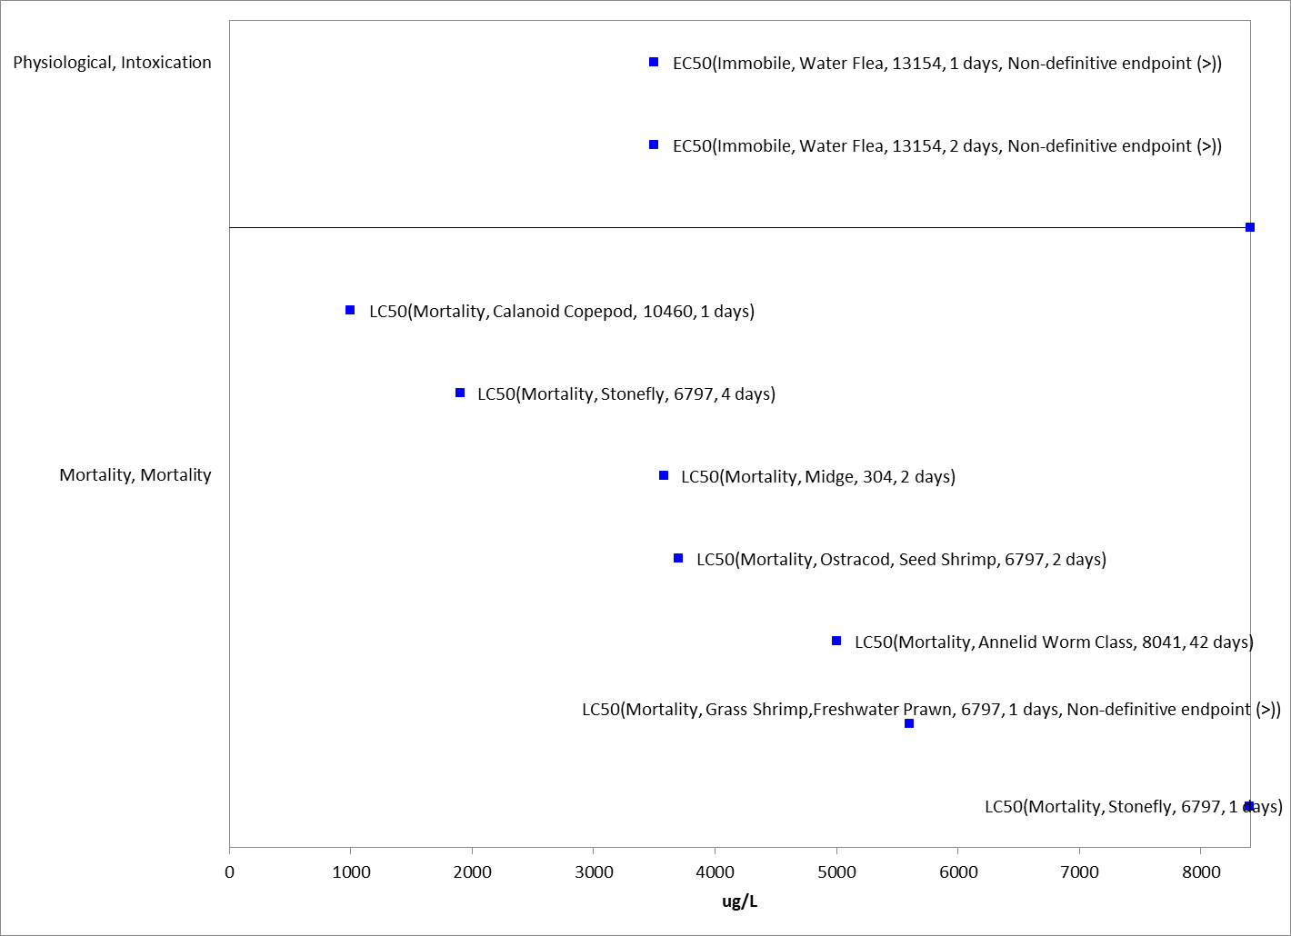
Figure 5-2. Array of acute mortality toxicity data for freshwater aquatic invertebrates expressed in terms of µg a.i./L (up to 10,000 µg a.i./L). Blue squares represent LOAEC values from open literature studies found in the ECOTOX database. Solid lines display the range between the LOAEC and NOAEC values. Parentheses present the endpoint measurement, species, study reference (i.e., MRID, ECOTOX #), and study duration. If endpoint is non-definitive, that is also noted.

There are limited acute toxicity data available for estuarine/marine invertebrates in the ECOTOX database and available data is of limited utility (endpoints non-definitive or exceeding solubility by 10x or greater). Therefore, the acute freshwater endpoint referenced above (1,900 µg a.i./L (MRID 40098001/ECOTOX#6797, Mayer & Ellersieck) will be used as a surrogate to derive the acute mortality threshold for estuarine/marine invertebrates.

An acute toxicity study is available for the Eastern Oyster (Crassostrea virginica) tested with TGAI and a reported EC₅₀ value >3,700 µg a.i./L (MRID 42503703). There was a 6.8% reduction in shell growth reported at the highest test concentration in the study. Although non-definitive, this represents the most sensitive acute endpoint for mollusks and will be conservatively used as the mortality threshold for mollusks.

Effects on Growth and Reproduction of Aquatic Invertebrates

No freshwater invertebrate life-cycle test using the TGAI was submitted for simazine. A freshwater aquatic invertebrate life-cycle test using the formulated product Aquazine (80% formulation) was submitted for simazine (MRID 00043676) with Daphnia magna. No treatment-related adverse effects to parental mortality and production of offspring occurred during the 21-day study at the highest test concentration of 2,000 µg a.i./L. The only treatment-related effect was a significant stimulation of offspring produced at the 800 µg a.i./L test concentration. Therefore, the NOAEC value is 2,000 µg a.i./L.

A registrant-submitted chronic mysid toxicity study (850.1300) using the saltwater mysid (Americamysis bahia) and TGAI was available for review (MRID 48680006). The chronic exposure study resulted in statistically significant reductions in the number of offspring produced per day, and total adult male and female length at 608 µg a.i./L. Additionally, biologically significant (15%) reduction in F₀ survival was reported at 151 µg a.i./L (NOAEC = 63 µg a.i./L).

Based on the lack of registrant data for a freshwater invertebrate life-cycle test using the TGAI and the demonstrated lack of sensitivity of the daphnia to simazine in the acute studies, the registrant-submitted chronic mysid toxicity is used as a surrogate for chronic effects to freshwater invertebrates. The sublethal toxicity threshold based on reproductive effects in the saltwater mysid (Americamysis bahia) is a NOAEC value of 63 µg a.i./L (LOAEC = 151 µg a.i./L, MATC = 98 µg a.i./L). This value is used to derive the sublethal threshold for both freshwater and aquatic invertebrates, including mollusks.

Other Sublethal Effects to Aquatic Invertebrates

No studies were reported in the ECOTOX database for additional sublethal effects to aquatic invertebrates. The few studies (3 total) for aquatic invertebrates in ECOTOX were associated with population, growth or reproduction effects. No endpoints were identified from studies in the ECOTOX acceptable database that were either more sensitive than the endpoints identified above or reliable for use as a threshold and relatable to an apical endpoint. A data array was not produced for these studies due to the paucity of data.

Effects Characterization for Aquatic Plant

Introduction to Aquatic Plant Toxicity

Most of the available toxicity studies with aquatic plants have focused on growth, reproduction, physiological effects, and population effects. Threshold values and effects data arrays in this assessment are based on endpoints expressed in, or readily converted to, environmentally relevant concentrations in terms of the amount of the simazine (i.e., µg a.i./L).

Discussion of endpoints are provided for effects on aquatic plants and aquatic plant communities. These serve as a surrogate for effects on an individual of a listed species and the effects on the pollination, prey, habitat, or dispersal of a listed species.

Effects on Aquatic Plants

Single-species aquatic plant toxicity studies are used as one of the measures of effect to evaluate whether simazine may affect primary production and diversity in aquatic ecosystems. Numerous aquatic vascular plant toxicity studies have been submitted to the EPA and/or published in the open literature. Figure 6.1 presents a summary of the range of toxicity values available for vascular and nonvascular aquatic plants.

Physiological (PHY) endpoints include measures of various sub-organismal effects, including tissue permeability, photosynthesis, carbon fixation, water uptake, and photosystem II inhibition. While several of these measures are clearly relevant to apical endpoints, especially growth, these endpoints are naturally variable with potential for rapid recovery and the study designs generally do not allow for connection to apical endpoints or are for short durations that would not capture the potential for recovery. This was particularly true for the most sensitive endpoints from these groupings (point to appendix with annotations for review). For these reasons, the following discussions of the single species aquatic toxicity data will focus on growth effects. These are sometimes captured under population level effects.

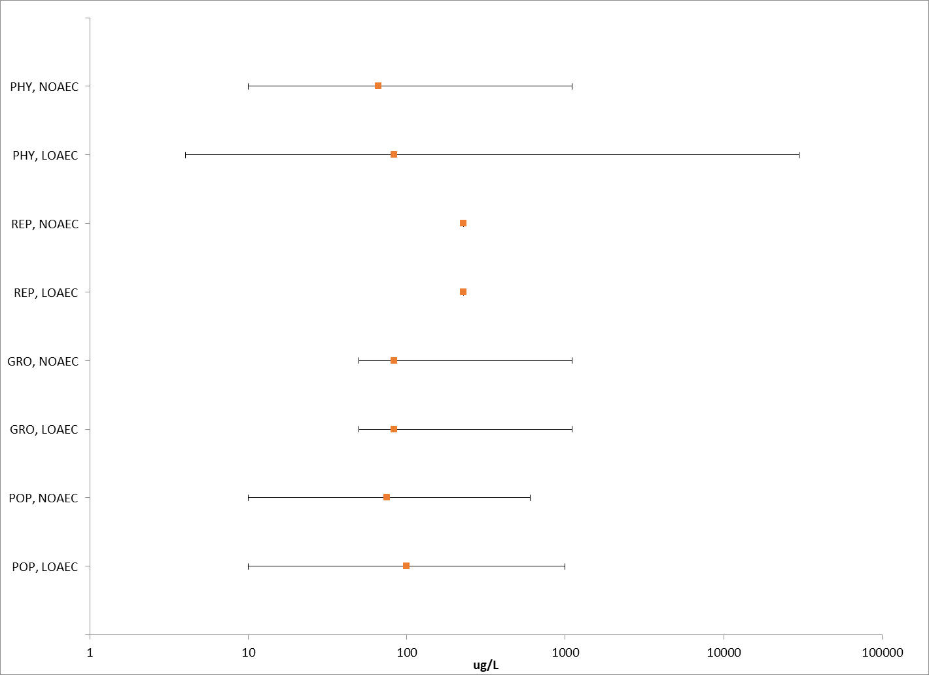
Figure 6-1. Summary array of toxicity data for vascular and non-vascular aquatic plants expressed in terms of µg a.i./L. Orange squares represent the mid-point of the data. Solid lines display the range between the LOAEC and NOAEC values. PHY = physiological; REP= reproduction; GRO = growth; POP = population.

Effects on Growth of Non-Vascular Aquatic Plants

Numerous aquatic non-vascular plant toxicity studies have been submitted to EPA and/or published in the open literature (APPENDIX 2-5), representing a broad diversity of unicellular and multicellular organisms collectively referred to as “non-vascular aquatic plants.” These include Eubacteria (e.g., blue-green algae), Archaeoplastida (e.g., red algae, glaucophytes, green algae, and aquatic bryophytes), Chromalveolates (e.g., aveolates, cryptomonads, dinoflagellates, diatoms, water molds, and brown algae), Excavates (e.g., euglena), and a few lineages of the Unikonts (e.g., fungi, and collared-flagellates). These single-species toxicity studies serve as the foundation for evaluating whether atrazine may affect primary production and diversity in the aquatic ecosystem.

Figure 6.2 presents the range of toxicity data for nonvascular aquatic plants available from registrant submitted and open literature studies. Effects were observed on various measures of physiology and growth at the individual and population level. The most sensitive endpoints were generally related to effects on growth and measures of photosynthesis. The most sensitive quantitative endpoint comes from the registrant submitted toxicity test with Anabaena flos aqua (MRID 42662401). For this study, a 28% reduction in cell density was observed at the lowest test concentration of 20 μg a.i./L so the threshold is based on the IC₀₅ value of 5.4 μg a.i./L.

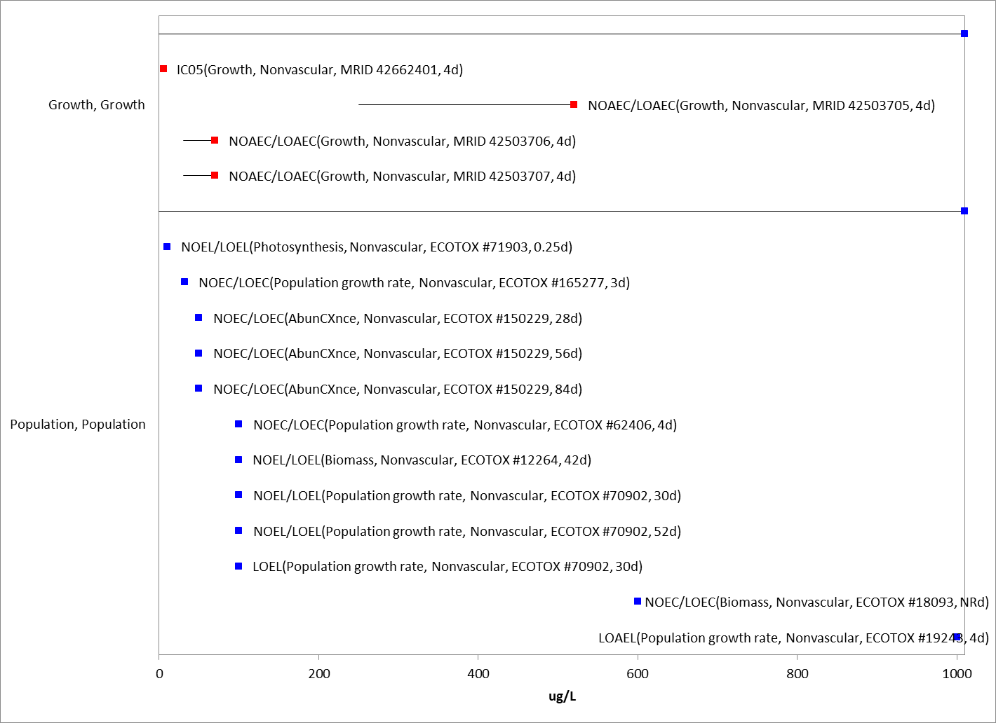
Figure 6-2. Array of toxicity data for nonvascular aquatic plants expressed in terms of µg a.i./L. Blue squares represent LOAEC values from open literature studies found in the ECOTOX database. Red squares represent LOAEC values fromFigure 6-3. Array of toxicity data for nonvascular aquatic plants expressed in terms of µg a.i./L. registrant submitted studies. Solid lines display the range between the LOAEC and NOAEC values. The horizontal axis has been adjusted to better represent the most sensitive endpoints. Parentheses present the effect, aquatic plant grouping, study reference (i.e., MRID, ECOTOX #), and study duration.

Effects on Growth of Vascular Aquatic Plants

Figure 6.4 presents the range of toxicity data for vascular aquatic plants available from registrant submitted and open literature studies. Effects were observed on various measures of physiology, reproduction, and growth at the individual and population level. The most sensitive endpoints were generally related to effects on growth. The threshold for aquatic plants comes from the registrant submitted toxicity test with Lemna gibba (MRID 42503704) with a NOAEC and LOAEC of 50 and 110 μg/L, respectively, based on a 39% decrease in frond number.

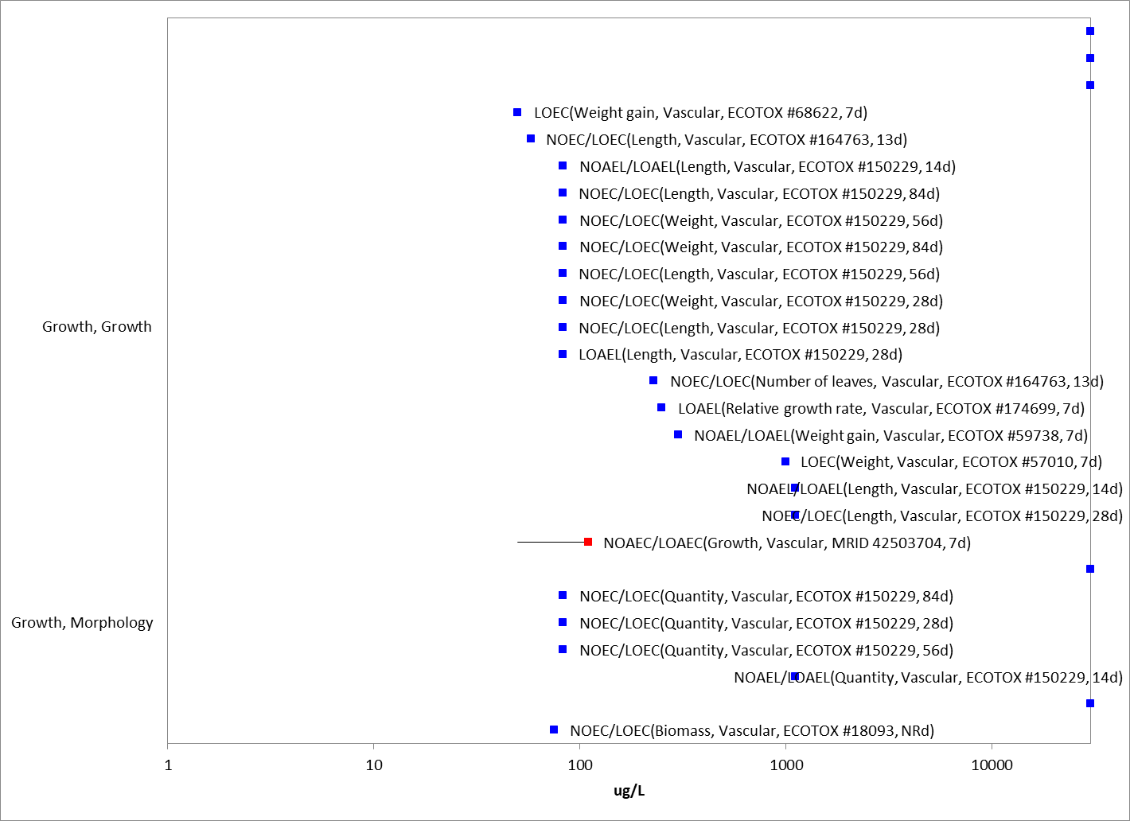
Figure 6-4.Array of toxicity data for vascular aquatic plants expressed in terms of µg a.i./L. Blue squares represent LOAEC values from open literature studies found in the ECOTOX database. Red squares represent LOAEC values from registrant submitted studies. Solid lines display the range between the LOAEC and NOAEC values. The horizontal axis has been adjusted to better represent the most sensitive endpoints and is presented in log-scale. Parentheses present the effect, aquatic plant grouping, study reference (i.e., MRID, ECOTOX #), and study duration.

Effects on Aquatic Plant Communities

Median effect concentration (EC₅₀) values for aquatic plants are used to derive the threshold for effects to the PPHD of an individual of a listed species. Studies with effects on measures of growth (e.g., biomass, cell counts, number of fronds, etc); were conducted with technical grade simazine; and had 4-day, 7-day, or 14-day exposure durations were used to derive a Species Sensitivity Distribution (SSD). These parameters were selected to maximize comparability of results. Studies used to derive the SSD are compiled in APPENDIX 2-5.

Toxicity estimates for simazine range from 8 – 28,000 µg a.i./L and span three orders of magnitude (APPENDIX 2-5), indicating a wide range of sensitivity to simazine among aquatic plants. The most sensitive non-vascular aquatic plant endpoint is from Bednarz 1981, with an IC₅₀ value of 8.0 μg a.i./L for the green alga, Chlorococcum sp., based on reductions in growth rate. The most sensitive species from the registrant submitted 850.4500 guideline was for the blue-green algae Anabaena flos-aqaue with an IC₅₀ value of 36 µg a.i./L (MRID 42662401). Vascular plants have a similar sensitivity to simazine as non-vascular plants, with the most sensitive vascular plant EC₅₀ having a value of 67 µg a.i./L, based on fresh weight reduction (biomass reduction) in Vallisneria americana (Wilson and Wilson 2010). In comparison, the registrant submitted 850.4550 guideline study using Lemna gibba (MRID 42503704) reported an IC₅₀ of 140 µg a.i./L based on a reduction in frond number.

For the SSD, five distributions were tested, and a variety of methods were used. The logistic distribution and maximum likelihood (ML) method were ultimately chosen to represent HC₀₅ through HC₉₅ values for vascular and nonvascular aquatic plants. Table 6-1 and Figure 6.5 provide a summary of the results. The threshold for species that rely upon aquatic plants for their PPHD is based on the HC₀₅ from the species sensitivity distribution (SSD).

Table 6-1. Summary Statistics for Aquatic Plant SSD Fit to Simazine Test Results.
Statistic | All Aquatic Plants  (µg a.i./L)
Best Distribution (by AIC) | Logistic
Goodness of fit  P-value | 0.33
CV of the HC₀₅ | 0.94
HC₀₅ | 12.19
HC₁₀ | 25.31
HC₅₀ | 217
HC₉₀ | 1856
HC₉₅ | 3854

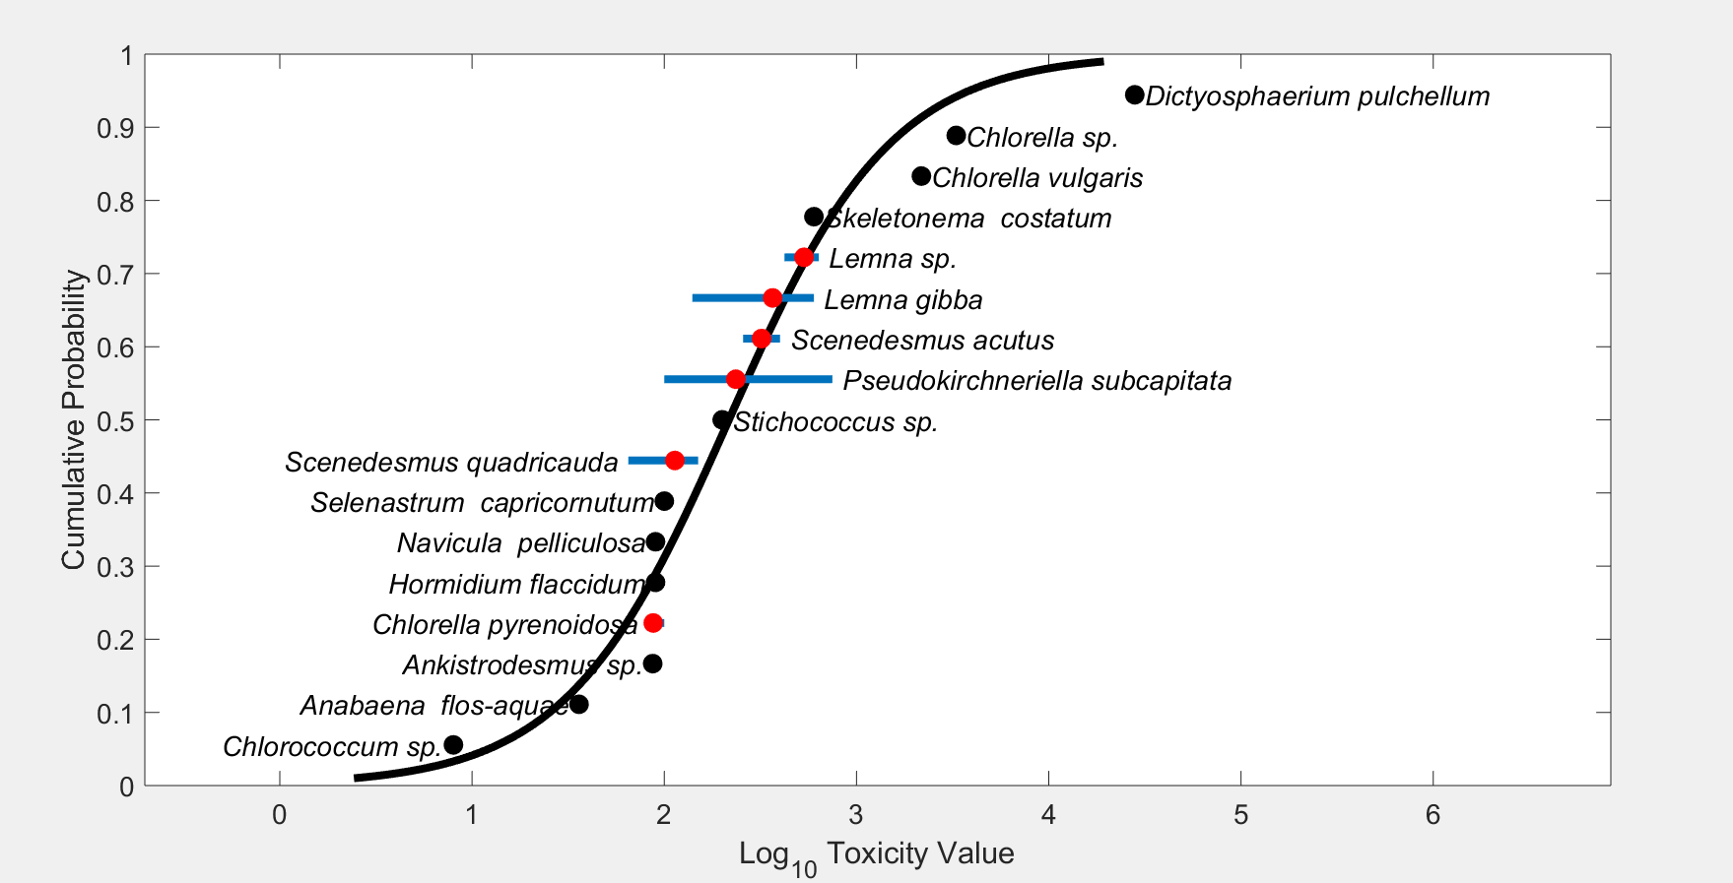
Figure 6-5. Species Sensitivity Distribution (SSD) for aquatic plants. Black points indicate single toxicity values. Red points indicate average of multiple toxicity values for a single species. Blue line indicates full range of toxicity values for a given taxon.

In addition to reviewing the toxicity data for individual species and deriving SSDs, the toxicity of simazine to aquatic plant communities is evaluated by considering microcosm and mesocosm (cosm) data available in the open literature. Cosm studies conducted with simazine provide measurements of primary productivity that incorporate the aggregate responses of multiple species in aquatic plant communities. Because plant species vary widely in their sensitivity to simazine, the overall response of the plant community may be different from the responses of the individual species measured in laboratory toxicity tests. Cosm studies allow observation of population and community recovery from atrazine effects and of indirect effects on higher trophic levels. In addition, cosm studies, especially those conducted in outdoor systems, incorporate partitioning, degradation, and dissipation, factors that are not usually accounted for in laboratory toxicity studies, but that may influence the magnitude of ecological effects. The available freshwater cosm studies for simazine are summarized in Table 6-2
below. From these studies, effects on the aquatic community, including reductions in survival and biomass, have been observed at concentrations of 50 µg a.i./L and greater. This exposure value approximates the HC₂₅ species of the SSD for all aquatic plants.

Table 6-2. Simazine Field and Microcosm Studies.
Study type/  Test material | Study  Design | Test  Organism | Effects | Citation  (ECOTOX #) | Rationale for Use in Risk Assessment⁽¹⁾
Field Study  84 days  Simazine  (% a.i. NR) | 0.05, 0.5, and 5 mg/L simazine applied to outdoor pond microcosm systems for 84 days. Biological and water quality components measured 14, 28, 56, and 84 days. | Submerged rooted vegetation (Myriophyllum spicatum and Elodea canadensis)  Emergent rooted vegetation (Persicaria amphibia and Glyceria maxima)  Floating aquatic vegetation (Lemna minor)  Phytoplankton | The simazine application rate of 0.05 mg/L caused significant reduction in various measures of growth (length, number of shoots, biomass, number of cells) as well as photosynthetic yield and floral development after 28 days of exposure.  Decreases in DO and pH were also recorded after application of simazine. | Vervliet-Scheebaum et al., 2010  (150229) | QUAL (field study; concentrations not measured over time)
Field study  210 days  Simazine (% a.i. NR) | 1.0 mg/L simazine applied to <0.4 ha pond (control pond also tested). Biological and water quality components measured 3, 5, 7, 10, and 18 days after application, and biweekly and monthly (210 d). | Phytoplankton  Macrophytes  Zooplankton  Macroinvertebrates  Largemouth bass (Micropterus salmoides)  Bluegill (Lepomis macrochirus) | The simazine application rate of 1.0 mg/L caused significant reduction in the growth and survival rate of freshwater fish, although the effects are attributed to a combination of low DO and reduced food resources.  Application of simazine to the pond produced die-off of the macrophytes, which resulted in decreased D.O., and increase in CO₂, TSS, total carbon, and specific conductivity. Decreases in DO were concurrent with increased mortality of both phytoplankton and macrophytes.  Zooplankton biomass decreased.  No significant differences were seen in total abundance or biomass of macroinvertebrates, although the taxa of Ostracoda increased.  Significantly fewer yield of young-of-the-year (YOY) bluegills survived in the simazine-treated ponds, although the mean weight increase of the survivors was 3x greater than YOY in the control pond. YOY largemouth bass showed comparable growth in simazine-treated and control ponds; however juvenile and adult bass grew slower. | Gordon, R.W., et al., 1982  (15428) | QUAL (field study; application rates higher than those currently allowed under label requirements for direct applications; simazine concentrations over time not provided)
Field study  20 wks  Simazine (% a.i. NR) | - 9 x 0.01-A rectangular concrete pools w/MS river water (3 ft deep).  - Bottom covered w/3” layer loam soil.  - 4 lbs Elodea canadensis in each pool.  - 3 pools treated once at 1, 2.5, and 5 ppm; 3 pools treated w/1, 2.5 and 5 ppm every 4 wks for total of 5 treatments/each; and 3 controls (untreated) | Algae  Elodea candensis  Zooplankton  Macroinvertebrates  Goldfish  Bluegill (Lepomis macrochirus) | Elodea candensis and algae eliminated from all treated pools for duration of study.  Levels of fish survival were erratic. Goldfish survivors showed reduction at 2.5 and 5.0 ppm treatment levels; survival was higher in monthly-treated pools than pools treated 1x/yr. Reduction in bluegill survival was dose-related in pools treated once; survival was similar (not dose-related) in pools treated monthly Bluegill survival was significantly reduced as compared to control in pools treated at 5 ppm and in the monthly-treated pool at 2.5 ppm.  The mean number of zooplankton and benthic fauna showed no dose-response effects following simazine treatments of 1, 2.5, and 5 ppm. | Gilderhaus, 1969  (MRID# 00025433) | QUAL (no water quality parameters reported; tested fish were larger than recommended size for acute studies and sensitive life stages were not tested; given erratic response in fish survival, it is not possible to derive NOAEC or LOAEC values; no analysis of individual invertebrate populations by species was conducted).
Microcosm  126 days  Simazine (% a.i. NR) | 1.0 mg/L simazine applied to 4 circular fiberglass pools (4.12 m², depth = 45 cm) at 0, 24, 56, 87, and 106 days after pools were stocked with 100 Tilapia nilotica swim-up fry each. Four untreated pools were used as controls.  Pools were not cleaned and only water lost by evaporation was replaced. | Nile tilapia  (Tilapia nilotica)  (swim-up fry, <12mm in length) | Yield of tilapia fingerlings after 126 days was 52% less in fiberglass pools treated periodically with 1 mg/L simazine as compared to the untreated ponds. Study author attributes 32% of this reduction to the low abundance of natural foods (phytoplankton) in treated pools. The additional 20% reduction is attributed to a combination of the direct effect of simazine and poor water quality.  There were no significant differences in survival between the control pools (91%) and the treated pools (87%). After 42 days, the average weight per 10 fish was significantly less in the treated pools (269 g) as compared to the control pools (388 g). | McGinty, 1984  (10969) | QUAL (field study; application rates higher than those currently allowed under label requirements for direct applications; simazine concentrations over time not provided; no water quality data)
Field study of catfish ponds  60 days  Simazine (% a.i. NR) | 1.3 mg/L simazine applied to channel catfish ponds infested with Chara vulgaris. Catfish were stocked into 0.06 ha earthen ponds at 12,350 fish /ha. Four heavily infested ponds were treated w/simazine and 4 ponds containing little or no Chara were monitored for changes in water quality before and after simazine treatment. The ponds were equipped with emergency aeration that was initiated when DO fell below 2.5 mg/L. | Channel catfish  (Ictalurus punctatus) (average weight = 55 g) | Fish production was reduced 20% compared to untreated ponds, although DO levels did not reach lethal levels due to emergency aeration. The feeding response of fish stopped immediately after simazine application. Reduced feeding persisted even after water quality variables in treated ponds returned to control pond levels. This suggests a possible direct effect of simazine on the feeding response.  Water quality changes following treatment included decreased DO, increased ammonia-nitrogen, nitrite-nitrogen, and CO₂ (and decreased pH). The magnitude of effects was greatest in 2 weeks following treatment. Temporal changes in DO, CO₂, pH, TA-N in treated pools are related to the response of the plant community to simazine. | Tucker et al., 1983  (10669) | QUAL (field study; application rates higher than those currently allowed under label requirements for direct applications; simazine concentrations over time not provided; emergency aeration provided)
Field study of catfish and bluegill ponds  ~120 days  Aquazine (80% a.i.) | 14 earthen ponds (0.04 - 0.06 ha) used; 6 ponds stocked w/7400 channel catfish fingerlings, and 8 ponds stocked with 5000 bluegill. Prior to filling ponds w/water, 3 of the 6 catfish ponds treated with Aquazine at rate of 13.4 kg/ha (~12 lb/A). Aquazine was applied as a suspension in water and applied evenly over the entire pond bottom. Four of the 8 bluegill ponds were treated w/ 1.5 mg/L (1.88 mg/L Aquazine 80W). A slurry of the chemical was dispersed over the pond surface. | Channel catfish  (Ictalurus punctatus)  Bluegill (Lepomis macrochirus) | Catfish ponds: In catfish ponds treated w/Aquazine prior to flooding, simazine concentrations in water remained above 200 ppb for more than 4 months. Persistence resulted in lower chlorophyll a and percentage of pond bottoms covered by macrophytes in treated ponds as compared to controls. Use of simazine resulted in an extended period of decreased DO as compared to control ponds. Catfish yield from treated ponds was 19% less (P<0.01) than control ponds. Feed conversion efficiency of fish from treated ponds was poorer than controls. Prolonged exposure to lowered DO may be responsible for adverse effects.  Bluegill ponds: DO decreased rapidly following Aquazine application. The average yield of bluegills from treated ponds was 11% less than the controls, however not significant (P> 0.1). Although bluegill production was not reduced as much as catfish production by simazine, the single application of simazine to the water did not result in season-long control of macrophytes. | Tucker and Boyd, 1978  (71314) | QUAL (field study; application rates higher than those currently allowed under label requirements for direct applications)
In situ enclosures of marsh water  27 days  Simazine (>98%) | Littoral enclosures (240 x 120 cm sheets of 1.5-mm PVC plastic on long axis w/ends cemented together) placed in water ~ 60-cm depth and embedded into sediment to depth of 45 cm. Artificial substrata placed upright in sediments. Concentrations of 0.1, 1.0, and 5.0 mg/L simazine dispensed in 300-l enclosure volume. Sampled substrata 9 days following simazine application and at weekly intervals for 5 wks. Colonization of substrata by periphyton was monitored by measuring chlorophyll a and carbon assimilation rate. | Periphyton | Data suggests that the EC₅₀ of chlorophyll synthesis by marsh periphyton must lie between 0.1 and 1.0 mg/L simazine. No change to chlorophyll a accumulation and carbon assimilation rate were observed at simazine concentrations of 0.1 mg/L, relative to the control. Algal biomass increased over time in all treatments w/the most notable increases in treated enclosures following flooding. Secondary effects include reduction in DO and pH, and increases in dissolved Ca, Mg, K, ammonia, nitrate, and phosphate. No detrimental long-term effect on productivity of periphyton may be predicted. | Goldsborough and Robinson, 1983  (11289) | QUAL (field study, simazine concentrations over time not provided)
In situ marsh enclosures  42 days  Simazine (>98%) | Littoral enclosures (diameter = 78 cm; volume ~300 l) situated in a marsh. Rods used as substrata for periphyton growth were positioned vertically. Simazine added to enclosures at concentrations of 0.1, 1.0, and 5.0 mg/L (plus one control). Substrata collected 9 days after simazine application and at weekly intervals for 6 weeks. Measurements included carbon assimilation, chlorophyll a concentration, densities of algal taxa, and total algal biovolume. Flooding during the experiment provided opportunity to monitor extent and rate of recovery of the community. | Periphyton | No reduction in total biovolume was observed at the 0.1 mg/L simazine concentration, with increasing inhibition (94 - 98%) at pre-flood concentrations of 1.0 and 5.0 mg/L. This suggests that the community LC₅₀ (herbicide concentration yielding 50% reduction in biovolume) lies between 0.1 and 1.0 mg/L simazine. Following flooding and removal of herbicide, increases in biovolume were observed in all but the highest treatment levels, with rates of colonization similar to control. After flooding, substratum colonization dominated by Cocconeis placentula. There was no evidence that a clearly herbicide resistant/ tolerant community had developed in the 2.5 week period prior to flooding, although the lower relative abundance of filamentous green algae at 5.0 mg/L suggests that this taxa were selectively inhibited to a greater extent than the others. High abundance of periphytic blue-green alga suggests that this taxon possesses some means of herbicide tolerance. | Goldsborough and Robinson, 1986  (12264) | QUAL (field study, simazine concentrations over time not provided)
In situ enclosures of marsh water  18 days  Simazine (>97.7%) | Cylindrical enclosures placed in marsh water ~ 60-cm depth and embedded into sediment to depth of 45 cm. Artificial substrata placed vertically in enclosures. Simazine dispensed to give ~1.0 mg/L in 300-l enclosure volume. Treatment consisted of 7-day exposure before flooding, and an 11-day exposure following re-addition of simazine 9 days after the flood. Sampled substrata @ 1-, 3-, and 5-week intervals. Substrata segments received 0.1, 0.5, 1.0, 2.5, or 5.0 mg/L (3 reps/ treatment plus 3 controls). Colonization of substrata by periphyton was monitored by measuring chlorophyll a and carbon assimilation rate. | Periphyton | Rates of specific photosynthesis (carbon fixed per unit chlorophyll) of periphyton samples from simazine treated enclosures were generally equal to or greater than corresponding rates of samples from control enclosures. The findings indicate that herbicide resistance can develop in lentic periphyton after short (7 days) exposure; however, this can occur only at simazine concentrations > 0.8 mg/L (comparisons of treated enclosure EC₅₀s w/ ambient concentrations show that significant increases in EC₅₀ occur when simazine concentration was greater than 0.8 mg/L. | Goldsborough and Robinson, 1988  (3136) | QUAL (field study, simazine concentrations over time not provided; application rates higher than those currently allowed under label requirements for direct applications)
Mesocosm study on succession of aquatic plants  6 months  Simazine granules (%a.i.NR) | 25 lb dose of granular simazine applied to alternate halves of a 1/5 acre (3-ft deep) pond on 2 consecutive weekends. Changes in aquatic plant communities over time were observed. | Aquatic plants | Specific endpoints or effect values were not reported.  A 4-yr old farm pond containing Najas flexilis and Potamogeton foliosus was treated in the spring. After decay of the higher plants, phytoplankton did not dominate, but instead herbicide resistant seeds and subsurface structures of Potamogeton foliosus developed. Benthic algae covered and stabilized the bottom. Following stabilization, the water cleared and Chlara vulgaris became established in a portion of the pond where the substrate was firm.  Treatment of the pond with simazine resulted in death of the majority of macrophytes. However, recovery of the macrophytes was noted within two to three months post application. Seeds and tubers of P. foliosus maybe resistant to simazine. | Crawford, 1981  (MRID 45088203) | QUAL (no endpoints reported; use of simazine granular formulations has been cancelled; paper discusses succession, recovery, and possible resistance of aquatic plant species in a natural farm pond)
Mesocosm study of algal succession  85 days  Simazine (Princep) (%a.i.NR) | Microcosms consisted of 12 x 3 liter Erlenmeyer flask plugged w/cotton. Algal cultures were obtained from a chicken processing oxidation pond allowed to grow to stationary phase. Nominal concentrations of 50, 150, 400 ppb simazine were used. Photosynthesis, respiration, dry weights, diversity, species dominance, and chlorophyll a were measured. | Aquatic plants | Simazine caused a shift in time of highest productivity peaks by about 2 weeks at 150 and 400 ppb. A lag in net productivity, but larger peaks of productivity, were seen in the higher doses. Pigments and dry weights were relatively unaffected. Although it was stated that successional sequence was affected, there were very few organisms on which to base this observation.  Algal species exposed to the highest concentration had delayed net and gross productivity and respiration, which was followed by rate increases in both that exceeded the same rates for algal species exposed to lower concentrations. Gross productivity was greatest for the high exposure group at the end of the bioassay. Algal biomass in control and lower treatment groups were not different.  The type of successional sequence of species was affected by treatment level with Chlorella dominating at the higher levels. Uncertainty exists as to whether this community shift remains in the absence of simazine. | Bryfogle and McDiffett, 1979  (MRID 45088205) | QUAL (paper discusses succession and recovery of algae; endpoints are less sensitive; measured concentrations of simazine over time are not reported)
⁽¹⁾ QUAL = The paper is not appropriate for quantitative use but is of good quality, addresses issues of concern to the risk assessment and is used in the risk characterization discussion.

Effects Characterization for Birds

Introduction to Bird Toxicity

There are open literature and registrant-submitted studies involving birds, including acute oral, sub-acute dietary and chronic reproduction with technical grade or formulated simazine. APPENDIX 2-4 includes the bibliographies of studies that are included in this effects characterization. Studies were excluded if they were considered invalid or not associated with an environmentally relevant exposure route. Thresholds are based on the most sensitive lethal and sublethal effects identified among registrant-submitted studies and open literature in the ECOTOX database.

Effects on Mortality of Birds

Acute oral toxicity data are summarized in Table 7-1. Simazine is classified as practically non-toxic to birds on an acute exposure basis. The acute oral toxicity of simazine is based on a 14-day study to 14-day old mallard ducks (Anas platyrhynchos) (MRID 00072798). No mortality was observed during the study and the LD₅₀ exceeded the highest dose tested (>4640 mg a.i./kg bw). This value is conservatively used to derive the acute mortality threshold for birds. While mortality was not observed, reduced reaction to external stimuli (sound and movement), wing droop, and depression were observed at the 1,000, 2,150, and 4,640 mg a.i./kg doses one hour after dosing, as compared to the control group. As a result, the observational NOAEC from this study is 464 mg ai/kg bw.

Table 7-1 Avian Acute Toxicity Data for Simazine.
Surrogate  Species | % a.i. | LD₅₀, mg/kg-bw (probit slope) | NOAEC mg/kg-bw | Effects | MRID, Author, Year
Mallard duck  (Anas platyrhynchos) | Tech. | >4640  Slope = none | 464 | No mortality at the highest test concentration; however, reduced reaction to external stimuli, wing droop, and depression were observed at concentrations as low as 1,000 mg a.i./kg-bw one hour after dosing. | 00072798, Fink, 1976.
Young chickens  (Gallus sp.) (mean wt. = 43 grams) | Tech. | >5000  Slope = none | <5000 | 40% mortality at 5000 mg/kg | 00037750, Ciba-Geigy Corp., 1958a
Pigeon (Columba livida) (mean wt. = 249 grams) | Tech. | >5000  Slope = none | 5000 | No adverse effects or symptoms | 00037751, Ciba-Geigy Corp., 1958b
Subacute avian dietary toxicity values for the technical grade and 80% formulation indicate that simazine is practically non-toxic (Table 7-2). Hill et al. (1975) reported no mortality in four species of birds at the highest concentrations of technical simazine tested (MRID 00022923). Corresponding LC₅₀ values for the mallard duck, bobwhite quail, and ring-necked pheasant (Phasianus colchicus) are > 5000 mg/kg; the LC₅₀ value for the Japanese quail (Coturnix coturnix japonica) is >3720 mg/kg. No mortality was observed during the study and the LD₅₀ exceeded the highest dose for each species tested. The LC₅₀ value of 5000 mg/kg-diet based on the mallard duck and bobwhite quail is conservatively used to derive the acute mortality threshold for birds.

Table 7-2 Avian Subacute Toxicity Data for Simazine.
Species | % a.i. | LC₅₀ (ppm) (conf. interval) | NOAEC (ppm) | Effects | MRID, Author, Year
Japanese quail  (Coturnix coturnix japonica) | 99.1 | >3720 | 3720 | No mortality or sublethal effects | 00022923, Hill et al., 1975
Mallard duck  (Anas platyrhynchos) | 99.1 | > 5000 | 5000 | No mortality or sublethal effects | 00022923, Hill et al., 1975
Bobwhite quail  (Colinus virginianus) | 99.1 | >5000 | 5000 | No mortality or sublethal effects | 00022923, Hill et al., 1975
Ring-necked Pheasant (Phasianus colchicus) | 99.1 | >5000 | 5000 | No mortality or sublethal effects | 00022923, Hill et al., 1975
Bobwhite quail  (Colinus virginianus) | 98.9 | >20000 | <1250 | Reduction in body weight and food consumption at all treatment levels | 00139393, Gough and Shellenberger, 1972
Bobwhite quail  (Colinus virginianus) | 80  WP* | 8800 (5985 - 12936) | <4000 | Reduction in body weight gain and food consumption at all treatment levels | 00023318, Woodard Research Corp., 1965
Mallard duck  (Anas platyrhynchos) | 80  WP* | >25600 | <800 | Reduction in body weight gain and food consumption at all treatment levels | 00023319, Woodard Research Corp., 1965

Effects on Growth and Reproduction of Birds

The available avian reproductive studies determined NOAECs of 100 mg a.i./kg-diet (MRID 00163134) and 150 mg a.i./kg-diet (MRID 43576901), based on effects to growth and reproduction. In MRID 00163134, a one-generation reproduction study with the bobwhite quail, effects noted at 500 mg a.i./kg-diet included reduction in number of eggs laid (20% reduction), viable embryos (28% reduction), 3-week embryos (33% reduction) , hatchling survival (33% reduction), and 14-day old chick survivors (32%). Results were statistically significant for 3-week embryos, hatchling survival, and 14-day old chick survivors.

No additional studies on growth and reproduction effects due to oral simazine exposure in birds were identified in the ECOTOX database.

Based on the available data on growth and reproduction, the sublethal toxicity threshold based on reproductive effects in the bobwhite quail is a NOAEC value of 100 mg a.i./kg-diet (LOAEC = 500 mg a.i./kg-diet, MATC = 223 mg a.i./kg-diet).

Other sublethal effects to Birds

No additional studies on other sublethal effects due to oral dietary simazine exposure in birds were identified in registrant studies or the ECOTOX database.

Drinking water studies

No studies involving avian exposure via drinking water were identified in registrant studies or the ECOTOX database that identified effects, although one study was reported where no behavioral effects were noted up to 50 ppm exposure to simazine in water in the mallard duck.

Dermal studies

No studies involving avian exposure via dermal exposure were identified in registrant studies or the ECOTOX database.

Inhalation studies

No studies involving avian exposure via inhalation were identified in registrant studies or the ECOTOX database.

Effect Characterization to Reptiles

As no additional data are available on reptilian toxicity to simazine, the available toxicity data for birds are used as a surrogate for reptiles.

Effect Characterization to Terrestrial-phase Amphibians

As no additional data are available on terrestrial-phase amphibians to simazine, the available toxicity data for birds are used as a surrogate for terrestrial-phase amphibians.

Effects Characterization for Mammals

Introduction to Mammal Toxicity

The effects of simazine on mammals has been studied extensively. APPENDICES 2-2 and 2-3 include the bibliographies of studies that are included in this effects characterization and those that were excluded, respectively. Studies were excluded if they were considered invalid or not associated with an environmentally relevant exposure route. Thresholds are based on the most sensitive lethal and sublethal effects identified among the available registrant-submitted studies and open literature in the ECOTOX database.

Effects on Mortality of Mammals

The most sensitive acute toxicity endpoint was an acute LD₅₀ study on the gray-tailed vole (Microtonus canicaudus), LD₅₀ values with TGAI were 2,014 and 2,363 mg a.i./kg-bw for males and females, respectively. Additional signs noted in the study included hind limb extension, lethargy, muscle spasm, lacrimation and depression (ECOTOX#70756, Cholakis et al. 1978, USEPA ORD). The corresponding LD₅₀ value for the TGAI in rats is >5,000 mg a.i./kg-bw (MRID 00148897). Although a definitive LD₅₀ was not established in the study with rats, mortality was noted.

Acute mammalian oral toxicity data are also available for one degradate of simazine, DIA (MRID 43012301). In this study both the female and male LD₅₀ values for the degradate showed that the degradate appears to be more toxic to laboratory rats than technical grade values for the parent simazine with respective values of 810 mg a.i./kg for the female and 2,290 mg a.i./kg for the male. The combined LD₅₀ value for males and females is 1,240 mg a.i./kg.

Based on the available acute mammalian toxicity data, the endpoint used to derive the acute oral toxicity threshold, based on mortality observed in the male gray-tailed vole, is 2,014 mg a.i./kg-bw. Although there is degradate data with a lower LD₅₀ value in females, there is a wide range in the degradate toxicity between males and females and the range of values overlaps with those of the toxicity threshold being used. Additionally, there is uncertainty around the degree to which this degradate will form in the terrestrial environment.

Effects on Growth and Reproduction of Mammals

Reproductive and developmental mammalian toxicity studies provide adequate toxicity data on chronic developmental and reproductive effects of simazine (Table 10-1). Chronic studies using laboratory rats show consistent reductions in adult body weight gain and adult body weight at simazine concentrations of 100 mg a.i./kg-diet. The corresponding NOAEL value for these studies is 10 mg a.i./kg-diet (0.56 and 0.7 mg a.i./kg/day for males and females respectively; MRIDs 41803601 and 40614405). Body weight gains for the 100 mg a.i./kg-diet P males were decreased during Days 0-70 (≈↓13%) and during Days 7-14 (≈↓11%) for the 100 mg a.i./kg-diet F₁ males at first mating, but were increased from rest period to term for F₁ males at second mating. In the 100 mg a.i./kg-diet group, decreased body weights were observed during the premating phase in P and F₁ first mating females (approximately 6%).

Additional studies are listed in Table 10-1 below. In addition, reproductive effects including increased abortions, reduced fetal weight, and increased skeletal variations were observed in New Zealand white rabbits at a concentration of 200 mg a.i./kg/day, with a corresponding NOAEL value of 75 mg a.i./kg/day (MRID 00161407).

Based on the available data on growth and reproduction, the sublethal toxicity threshold based on decreased body weight (6%) and decreased body weight gain (13%) is a NOAEC value of 0.56 mg a.i./kg-bw (LOAEC = 5.61 mg a.i./kg-bw, MATC = 1.77 mg a.i./kg-bw).

Table 10-1. Summary of the Most Sensitive Reproductive and Developmental Mammalian Endpoints for Simazine.
Guideline No./ Study Type | MRID No. (year)/ Classification /Doses | Results
870.3100  90-Day oral toxicity (rat) | 00143265 (1985)  0, 14.25, 142, or 276 mg/kg/day | NOAEL = not identified.  LOAEL = 14.25 mg/kg/day, based on decreased body weight gain, decreased food consumption and hematological changes.
870.3150  13-Week dietary  toxicity (dog) | 00146655  M: 6.9, 65.2, 133.6  F: 8.2, 64.3, 136.7 | NOAEL = 6.9 mg/kg/day (M); 8.2 mg/kg/day (F)  LOAEL = 65.2 mg/kg/day (M); 64.3 mg/kg/day (F) based on decreased body weight/body weight gain, decreased food consumption, organ weight changes, decreased serum glutamate oxaloacetate (SGOT) and reduced alkaline phosphatase activities (females).
870.3700a  Prenatal developmental in Rat | 40614403 (1986)  0, 30, 300 or 600 mg/kg/day | Maternal NOAEL = 30 mg/kg/day  LOAEL = 300 mg/kg/day based on decreased body weight/body weight gain, and decreased food utilization.  Developmental NOAEL = 30 mg/kg/day  LOAEL = 300 mg/kg/day based on skeletal variations.
870.3700b  Prenatal developmental in Rabbit | 00161407 (1984)  0, 5, 75 or 200 mg/kg/day | Maternal NOAEL = 5 mg/kg/day  LOAEL = 75 mg/kg/day based on decreased body weight gain, decreased food consumption, increased tremors, and stool alterations.  Developmental NOAEL = 75 mg/kg/day  LOAEL = 200 mg/kg/day based decreased fetal weight and increased skeletal variations.
870.3800  Reproduction and fertility effects  (Rat) | 41803601 (1991)  0, 10, 100, or 500 ppm  M: 0, 0.56, 5.61, 28.9 mg/kg/day  F: 0, 0.7, 7.04, 34.96 mg/kg/day | Parental/Systemic NOAEL = 0.56 mg/kg/day (M); 0.7 (F)  LOAEL = 5.61 mg/kg/day (M); 7.04 mg/kg/day (F), based on decreased body weight/body weight gain.  Offspring NOAEL = 31.93 mg/kg/day  LOAEL = not identified
870.4100b  Chronic toxicity (dog) | 40614402  Acceptable-guideline  M: 0, 0.68, 3.41, 42.9 mg/kg/day  F: 0, 0.76, 3.64, 44.9 mg/kg/day | NOAEL = 3.41 mg/kg/day (M); 0.76 mg/kg/day (F)  LOAEL = 42.9 mg/kg/day (M) based on decreased body weight gains, increased platelet counts, and increased adrenal/brain weight ratio; 3.64 mg/kg/day (F), based on decreased body weight gain, hematological effects (decreased levels of red blood cell counts, hemoglobin and hematocrit) and increased adrenal weight, adrenal/brain weight ratio, and adrenal/body weight ratio.
Special Study - in vivo endocrine effects in rats.  Acceptable-Non-guideline | 43598614 | In a special study (MRID 43598614) on in vivo endocrine effects, atrazine and simazine (>96 % a.i.) were administered to 11 female rats/dose/strain (both Sprague-Dawley and Fischer 344 rats were used) by oral gavage at dose levels of 0, 100, and 300 mg/kg/day for 14 to 23 days depending on time to achieve proestrus.  The LOAEL for systemic toxicity is 100 mg/kg/day for both atrazine and simazine, based on body weight effects and reproductive organ weight effects for atrazine. The NOAEL for toxicity cannot be determined.  The LOAEL for endocrine effects of atrazine is 100 mg/kg/day based on organ weight effects, plasma hormone changes (estradiol), estrus cycle lengthening, and vaginal cytology. The NOAEL for endocrine effects of atrazine cannot be determined.  The LOAEL for endocrine effects of simazine is 300 mg/kg/day based on organ weight effects and vaginal cytology. The NOAEL for endocrine effects of simazine is 100 mg/kg/day.
Special Study - LH surge in rats  Acceptable-Nonguideline | 45471002 | In a special study (MRID 45471002) on the effects of chlorotriazines on luteinizing hormone (LH) surge, simazine (100%, batch no. SG202028GB10), diaminochlorotriazine (DACT) (96.8%, batch no. GP720301) and atrazine (97.1% , batch no. SG8029BA10) were administered to 20 Sprague-Dawley Crl:CD BR female rats/dose/group by oral gavage at dose levels of 0, 2.5, 5, 40, 200 mg/kg bw/day (equivalent to 12.4, 24.8, 198.3, and 991.6 µmol//kg/day for simazine; for 17.2, 34.4, 274.9, 1374.6 µmol//kg/day for DACT; and 11.6, 23.2, 185.4, 927.2 µmol//kg/day for atrazine) once daily for at least 4 weeks.  The LOAEL for systemic toxicity is 40 mg/kg/day for simazine, DACT, and atrazine, based on body weight effects. The NOAEL for all three compounds is 5 mg/kg/day.  The LOAEL for endocrine effects for simazine, atrazine, and DACT is 40 mg/kg/day, based on analyses of pre-peak, peak, and post-peak LH concentrations, adjusted peak LH response, and comparison of responses between compounds (at the same dose levels). The NOAEL for endocrine effects for simazine atrazine, and DACT is 5.0 mg/kg/day.

Other Sublethal Effects to Mammals

Additional literature is available on the sublethal effects of simazine on mammalian species. No apical endpoints were identified from studies in the ECOTOX acceptable database that were more sensitive than the endpoints identified above, reliable for use as a threshold and/or relatable to an apical endpoint. Figure 10.1 illustrates the data available for dose based (mg a.i./kg-bw) endpoints for the data as entered in ECOTOX.

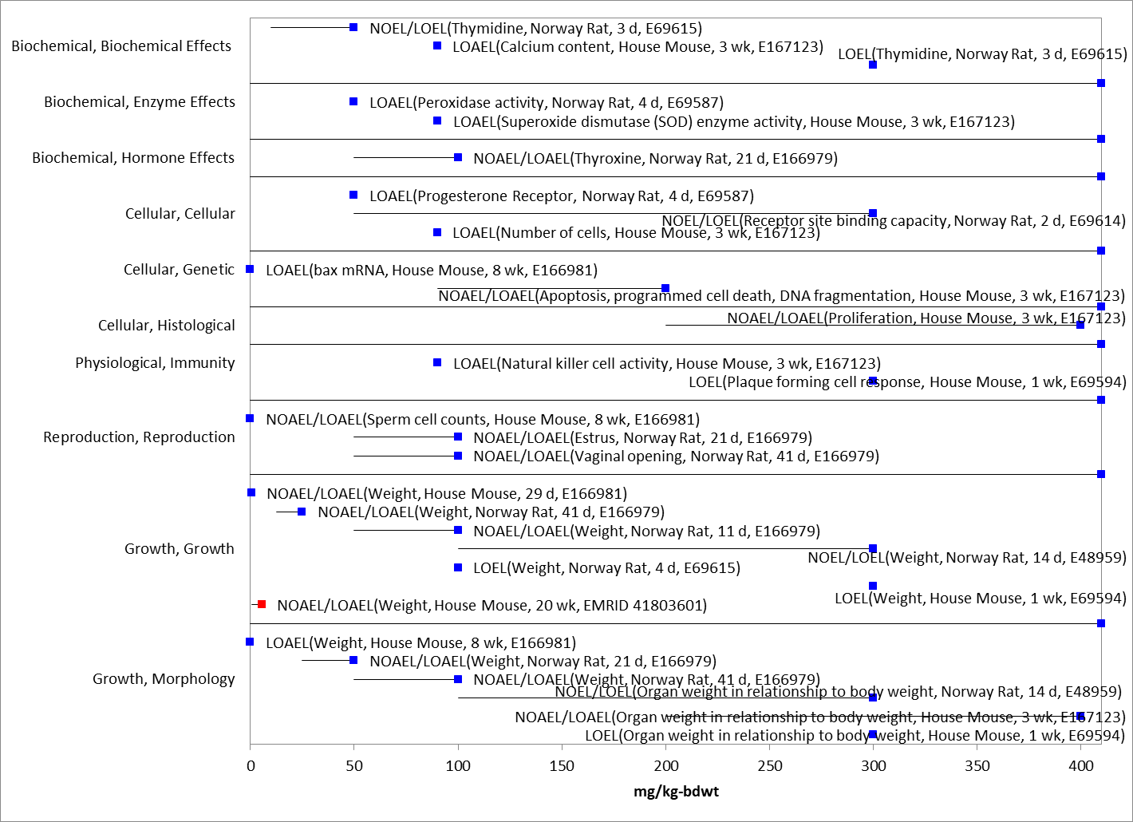
Figure 10-1. Array of toxicity data for sublethal effects to mammals expressed in terms of mg a.i./kg-bw. Blue squares represent LOAEC values from open literature studies found in the ECOTOX database. Solid lines display the range between the LOAEC and NOAEC values. Red dot represents registrant study used for threshold. Parentheses present the effect, species, duration of study and study reference (i.e., MRID, ECOTOX #).

Drinking water studies

No studies involving mammalian exposure via drinking water were identified in the ECOTOX database or in review of registrant submitted studies.

Dermal exposure studies

Table 10-2 presents the acute and longer-term dermal exposure data available from registrant-submitted data. No effects were noted in any of the available dermal exposure studies.

Table 10-2. Dermal Exposure Studies for Simazine.
Exposure Scenario | Dose  (mg a.i./kg/day) | Endpoint | Study
Acute Dermal | LD₅₀ > 5050 mg/kg/day | Mortality | MRID 43474102
Dermal toxicity (rat) | 0, 10, 100 or 1000 mg/kg/day | Systemic NOAEL = 1000 mg/kg/day; systemic LOAEL = not identified | 870.3200; 21/28-Day dermal toxicity (rat)  MRID 00005767 (1980)
Dermal Absorption (rat) | Male rats were received doses of 0.1 or 0.5 mg/cm2 radiolabeled simazine for 2, 4, 10 or 24 hours. | Dermal absorption was less than 1% at both doses and all time points. However, 11-20% of the low dose and 31-41% of the high dose remained on skin, and potentially absorbable. | 40614409 (1988)

Inhalation studies

Table 10-3 presents the available inhalation studies for mammals.

Table 10-3. Inhalation Studies for Simazine
Exposure Scenario | Dose  (mg a.i./L) | Endpoint | Study
Acute inhalation-rat test model | LC₅₀>1.22 mg/L | Mortality | MRID 43474103

Effects Characterization for Terrestrial Invertebrates

Introduction to Terrestrial Invertebrate Toxicity

The results of acute contact toxicity testing of simazine on the adult honey bee (Apis mellifera) show that by 48 hours in the contact test (MRID 00036935), 6.5% mortality was observed in the 96.7 µg a.i./bee treatment group; therefore, the LD₅₀ value for the contact test is >96.7 µg a.i./bee. As a result, simazine is categorized as practically non-toxic to honeybees on an acute contact basis.

Three open literature studies on simazine effects to non-target insects including earthworms and beetles and are further summarized in the 2007 California Red-legged Frog assessment (USEPA 2007). The results of two earthworm studies (Martin, 1982: ECOTOX #58170; Lydy and Linck, 2003; ECOTOX #71459) showed no adverse effects of mortality and growth, following 96-hours of exposure at 10 µg a.i./cm² and 7 days of exposure at 100 mg/kg-soil, the highest simazine concentrations tested. Samsoe-Peterson (1987; ECOTOX # 70278) evaluated the effects of Gesatop 50-WP (50% simazine) on the rove beetle, Aleochara bileneata. Following 5-days of exposure, no mortality or reduction in egg production were observed in the simazine-treated adult female beetles at an application rate of 600 L/ha. According to the standard used by the International Organization of Biological Control (IOBC) working group “Pesticides and Beneficial Organisms,” simazine was classified as “harmless” to the rove beetle.

Based on the available terrestrial invertebrate toxicity data, the endpoint used to establish the mortality toxicity threshold is 96.7 µg a.i./bee (equal to 756 mg a.i./kg-bw, using assumptions for body weight from the BeeRex model). This value is also used as the sublethal threshold based on observed mortality (6.5%) at this concentration. No data was available for terrestrial invertebrates for exposure units of mg a.i./kg-diet.

Effects Characterization for Terrestrial Plants

Introduction to Terrestrial Plant Toxicity

Plant toxicity data from both registrant-submitted studies and studies in the scientific literature have been reviewed for this assessment. Registrant-submitted studies are conducted under conditions and with species defined in OCSPP test guidelines. Sub-lethal endpoints such as plant growth, dry weight, and biomass are evaluated for both monocots and dicots, and effects are evaluated at both seedling emergence and vegetative life stages. Studies were excluded if they were considered invalid or not associated with an environmentally relevant exposure route.

Discussion of endpoints are provided for effects on terrestrial plants and terrestrial plant communities. These serve as a surrogate for effects on an individual of a listed species and the effects on the pollination, prey, habitat, or dispersal of a listed species, respectively. Based on the results of the submitted and available open literature terrestrial plant toxicity tests, it appears that the seedling emergence stage of plant development is more sensitive to simazine than the vegetative vigor stage of development. However, all tested plants, with the exception of corn in the seedling emergence and vegetative vigor tests, exhibited adverse effects following exposure to simazine. The registrant submitted data represents the most sensitive endpoints for effects to listed species and effects to the PPHD of a listed species.

Effects Data for Terrestrial Plants

Single-species terrestrial plant toxicity studies are used as one of the measures of effect to evaluate whether simazine may affect primary production and diversity in terrestrial ecosystems. Numerous terrestrial plant toxicity studies have been submitted to the EPA and/or published in the open literature. Figure 12.1 and Figure 12.2 presents a summary of the range of toxicity values available for dicot and monocot plants, respectively.

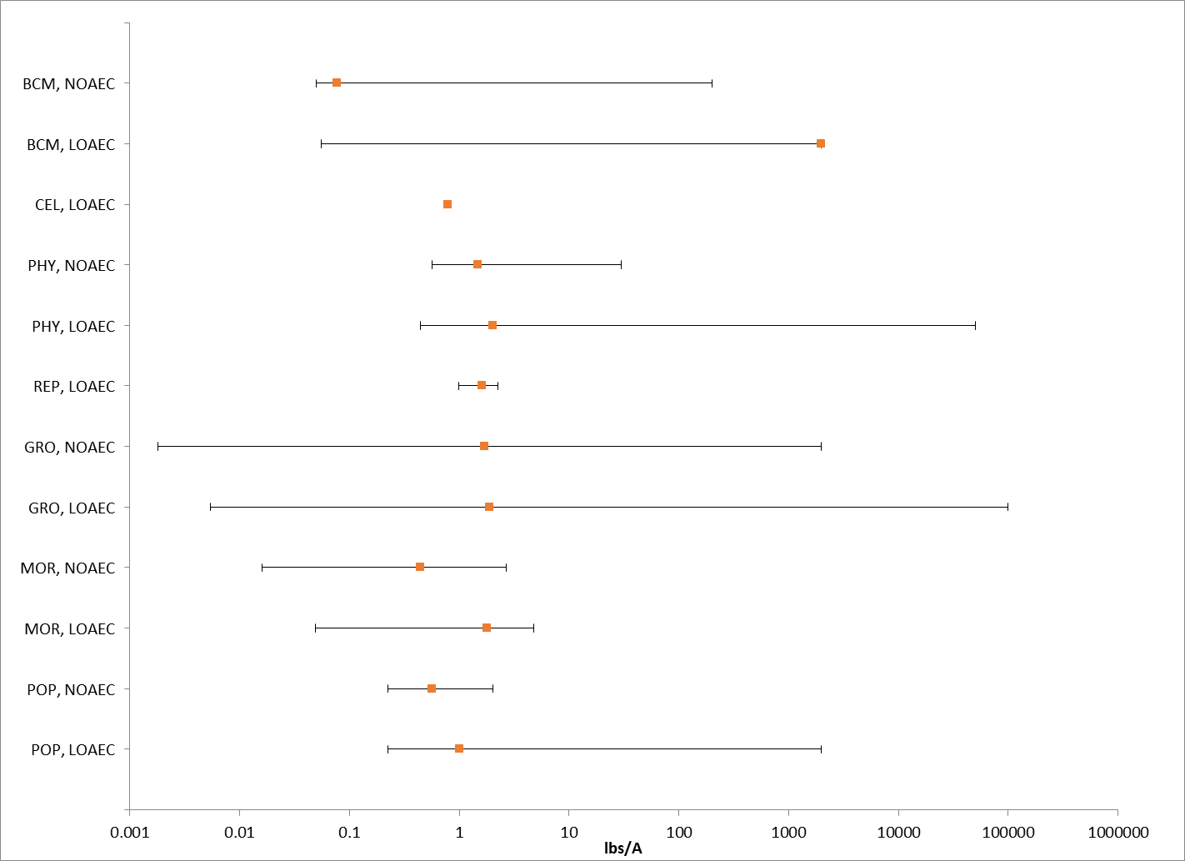
Figure 12-1. Summary array of toxicity data for dicot terrestrial plants expressed in terms of lb a.i./A. Orange squares represent the mid-point of the data. Solid lines display the range between the LOAEC and NOAEC values. BCH = biochemical; CEL = cellular; PHY = physiological; REP= reproduction; GRO = growth; MOR = mortality; POP = population.

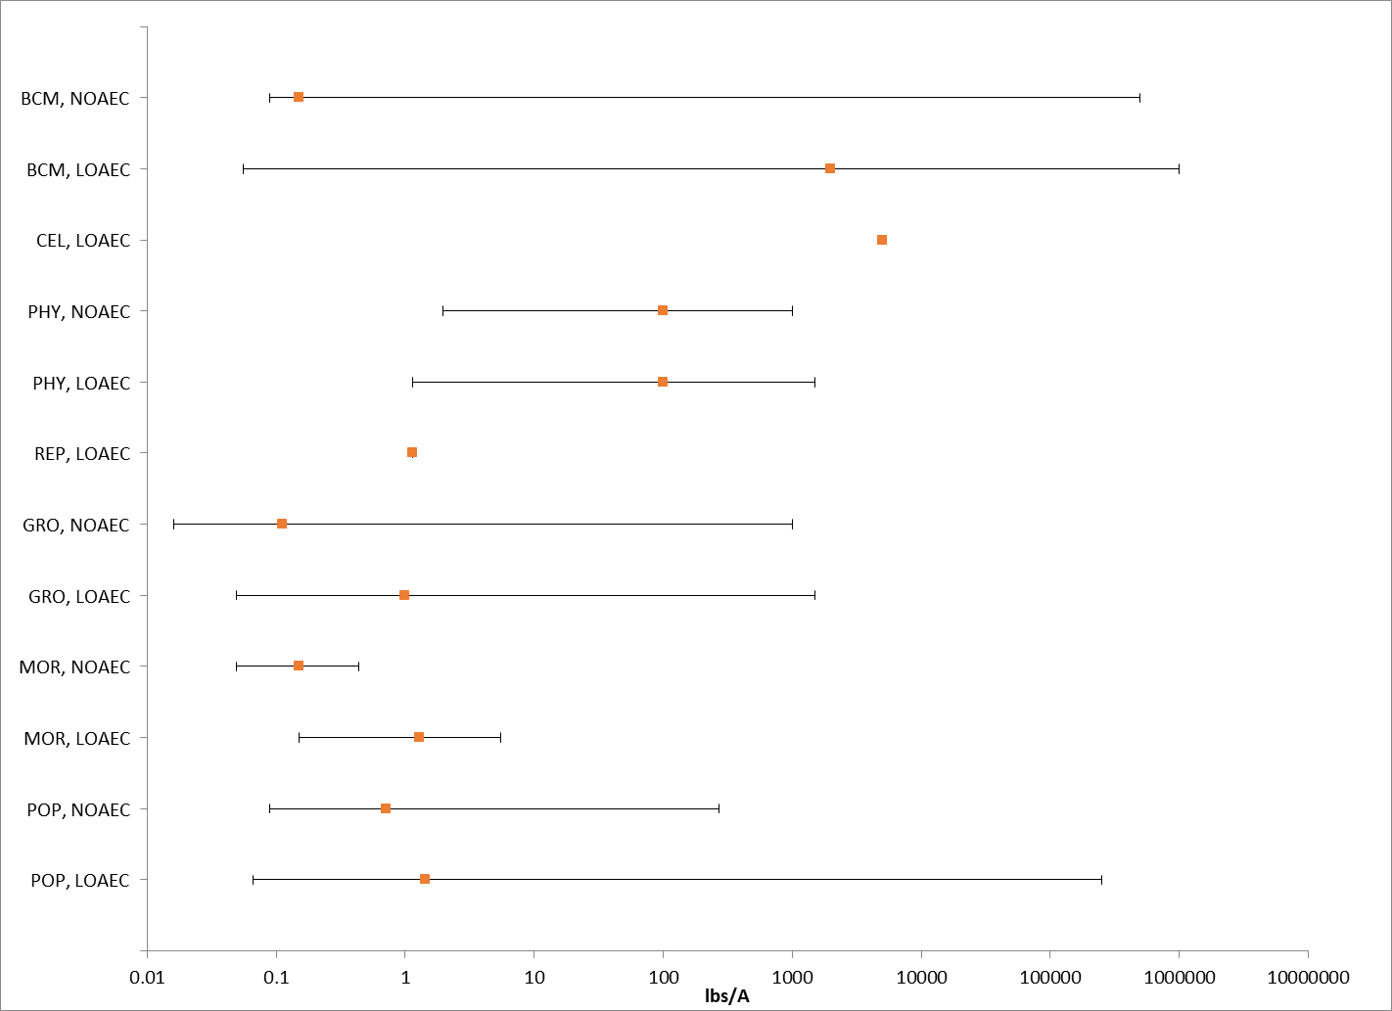
Figure 12-2. Summary array of toxicity data for monocot terrestrial plants expressed in terms of lb a.i./A. Orange squares represent the mid-point of the data. Solid lines display the range between the LOAEC and NOAEC values. BCH = biochemical; CEL = cellular; PHY = physiological; REP= reproduction; GRO = growth; MOR = mortality; POP = population.

The registrant submitted data represents the most sensitive endpoints for effects to listed species. The results of the seedling emergence and vegetative vigor toxicity tests on non-target plants are summarized below in Table 12-1. Seedling emergence and vegetative vigor were studied on ten non-target crops (including soybean, lettuce, radish, tomato, cucumber, cabbage, oat, ryegrass, corn, and onion) following application of Princep 4L herbicide (simazine) at 4 lb a.i./A (MRIDs 42634603 and 42634604).

For seedling emergence, the most sensitive dicot is lettuce with NOAEC, LOAEC, and MATC values of 0.0018, 0.0054, and 0.0031 lb a.i./A, respectively. The most sensitive monocot is oat, with NOAEC, LOAEC, and MATC values of 0.016, 0.049, and 0.028 lb a.i/A, respectively. For vegetative vigor, the most sensitive dicot and monocot are also lettuce and oat with NOAEC, LOAEC, and MATC values of 0.016, 0.049, and 0.028 lb a.i/A.

Table 12-1. Nontarget Terrestrial Plant Seedling Emergence and Vegetative Vigor Toxicity Endpoints (Tier II) for Simazine.
Species | Seedling Emergence |  |  |  | Vegetative Vigor
 | MRID 42634603 |  |  |  | MRID 42634604
 | Endpoint | NOAEC  (lb a.i./A) | LOAEC  (lb a.i./A) | MATC  (lb a.i./A) | Endpoint | NOAEC  (lb a.i./A) | LOAEC  (lb a.i./A) | MATC  (lb a.i./A)
Monocots
Corn (Zea mays) | No Effect | 4 | >4 | 4 | No Effect | 4 | >4 | 4
Oat (Avena sativa) | Biomass | 0.016^{b} | 0.049 | 0.028 | Biomass | 0.016 | 0.049 | 0.028
Onion (Allium cepa) | Biomass | 0.016^{b} | 0.049^{b} | 0.028 | Biomass | 0.016^{b} | 0.049^{b} | 0.049
Ryegrass (Lolium perenne) | Biomass | 0.016^{b} | 0.049^{b} | 0.028 | Biomass | 0.016^{b} | 0.049^{b} | 0.049
Dicots
Radish (Raphanus sativus) | Biomass | 0.049 | 0.15 | 0.086 | Biomass | 0.049^{b} | 0.15^{b} | 0.086
Soybean (Glycine max) | Biomass | 0.016^{b} | 0.049^{b} | 0.028 | Biomass | 0.049 | 0.15 | 0.086
Lettuce (Lactuca sativa) | Biomass | 0.0018 | 0.0054 | 0.0031 | Biomass | 0.016 | 0.049 | 0.028
Cabbage (Brassica oleracea alba) | Biomass | 0.016^{b} | 0.049^{b} | 0.028 | Biomass | 0.016 | 0.049 | 0.028
Tomato (Solanum lycopersicum) | Biomass | 0.016^{b} | 0.049^{b} | 0.028 | Biomass | 0.049^{b} | 0.15 | 0.15
Cucumber (Cucumis sativus) | Biomass | 0.016^{b} | 0.049^{b} | 0.028 | Biomass | 0.016 | 0.049 | 0.028
ª The IC₂₀ is presented because the NOAEC was not determined or was greater than the IC₂₅ and is considered unreliable.
^{b} results based on Chetram 1993 reported values, statistics could not be verified because of illegible raw data in the available report

Effects Data for Terrestrial Plant Communities

Twenty five percent inhibition concentration (IC₂₅) values for terrestrial plants are used to derive the threshold for effects to the PPHD of an individual of a listed species. Studies with effects on measures of growth (e.g., height, weight, and biomass) for both monocots and dicots; were conducted with technical grade simazine; and had 14- and 21-d exposure durations were used to derive Species Sensitivity Distributions (SSD). These parameters were selected to maximize comparability of results. Studies used to derive the SSDs are compiled in APPENDIX 2-6. SSDs were developed for both seedling emergence and vegetative life stages.

Toxicity estimates for simazine range from 0.009 to greater than 4 lb a.i./A and span three orders of magnitude (APPENDIX 2-6), indicating a range of sensitivity to atrazine among terrestrial plants. Based on the results of the submitted terrestrial plant toxicity tests, it appears that the seedling emergence stage of plant development is more sensitive to simazine than the vegetative vigor stage of development.

For seedling emergence, the most sensitive dicot is lettuce and the most sensitive monocot is onion. IC₂₅ values, on an equivalent application rate basis, for lettuce and onion, which are based on a reduction in dry weight, are 0.009 and 0.02 lb a.i./A, respectively. For vegetative vigor studies, the most sensitive dicot is lettuce with an IC₂₅ and the most sensitive monocot with a definitive IC₂₅ was oat (IC₂₅ = 0.033 lb a.i./A). Table 12-2 summarizes the terrestrial plant seedling emergence and vegetative vigor toxicity data.

Table 12-2. Nontarget Terrestrial Plant Seedling Emergence and Vegetative Vigor Toxicity Endpoints for Simazine.
Species | Seedling Emergence |  | Vegetative Vigor
 | MRID 42634603 |  | MRID 42634604
 | Endpoint | EC₂₅  (lb a.i./A) | Endpoint | EC₂₅  (lb a.i./A)
Monocots
Corn (Zea mays) | No Effect | >4.0 | No Effect | >4.0
Oat (Avena sativa) | Biomass | 0.031ª | Biomass | 0.033
Onion (Allium cepa) | Biomass | 0.02 | Biomass | >0.016ª
Ryegrass (Lolium perenne) | Biomass | 0.045 | Biomass | >0.016ª
Dicots
Radish (Raphanus sativus) | Biomass | >0.049 | Biomass | 0.063ª
Soybean (Glycine max) | Biomass | 0.057 | Biomass | 0.085
Lettuce (Lactuca sativa) | Biomass | 0.009 | Biomass | 0.033
Cabbage (Brassica oleracea alba) | Biomass | >0.016ª | Biomass | 0.041
Tomato (Solanum lycopersicum) | Biomass | 0.038ª | Biomass | 0.054ª
Cucumber (Cucumis sativus) | Biomass | 0.046ª | Biomass | 0.036
ª results based on Chetram 1993 reported values, statistics could not be verified because of illegible raw data in the available report

For the SSD, five distributions were tested, and a variety of methods were used. The gumbel distribution and linearization (GR) method were selected to represent HC05 through HC95 values for vegetative vigor endpoints and the logistic distribution and maximum likelihood (ML) method were selected to represent the HC₀₅ through HC₉₅ values for seedling emergence endpoints. Table 12-3, Figure 12-3, and Figure 12-4 provide a summary of the results. The threshold for species that rely upon terrestrial plants for their PPHD is 0.0129 lb a.i./A based on the HC₀₅ from the SSD for seedling emergence.

Table 12-3. Summary Statistics for Terrestrial Plant SSD Fit to Simazine Test Results.
Statistic | Vegetative Vigor | Seedling Emergence
Best Distribution (by AIC) | Gumbel | Logistic
Goodness of fit  P-value | 0.6533 | 0.5045
CV of the HC₀₅ | 0.2218 | 0.3976
HC₀₅ | 0.0256 | 0.0129
HC₁₀ | 0.0283 | 0.0164
HC₅₀ | 0.0445 | 0.0335
HC₉₀ | 0.09702 | 0.0683
HC₉₅ | 0.0119 | 0.0871

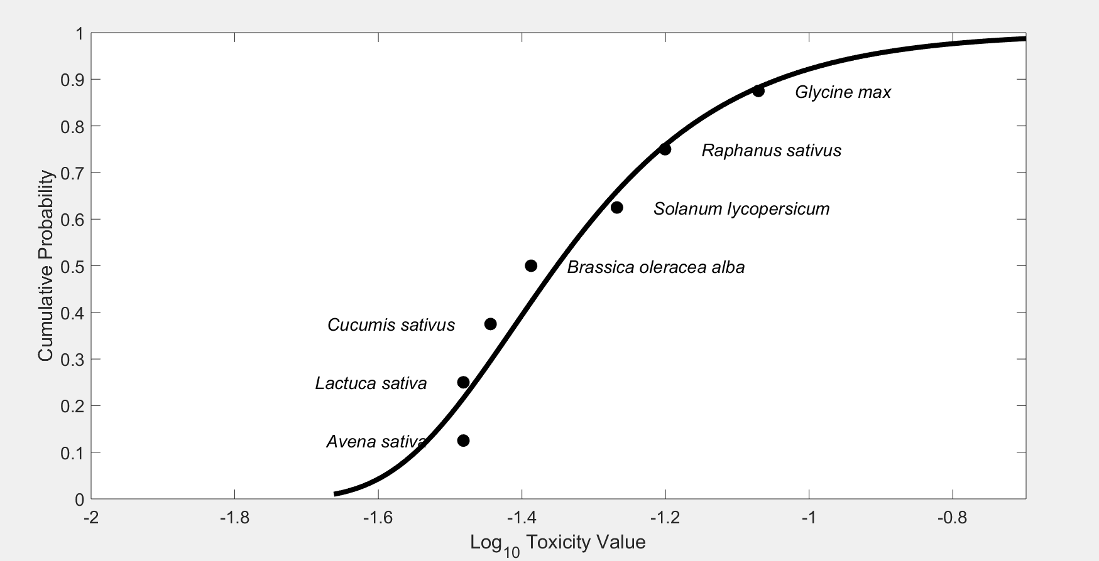
Figure 12-3. Species sensitivity distribution of IC₂₅ vegetative vigor stage endpoints. Selected model was gumbel, fit using linearization, selected based on the lowest AIC and the highest p-value for model fit. Black points are single estimates.

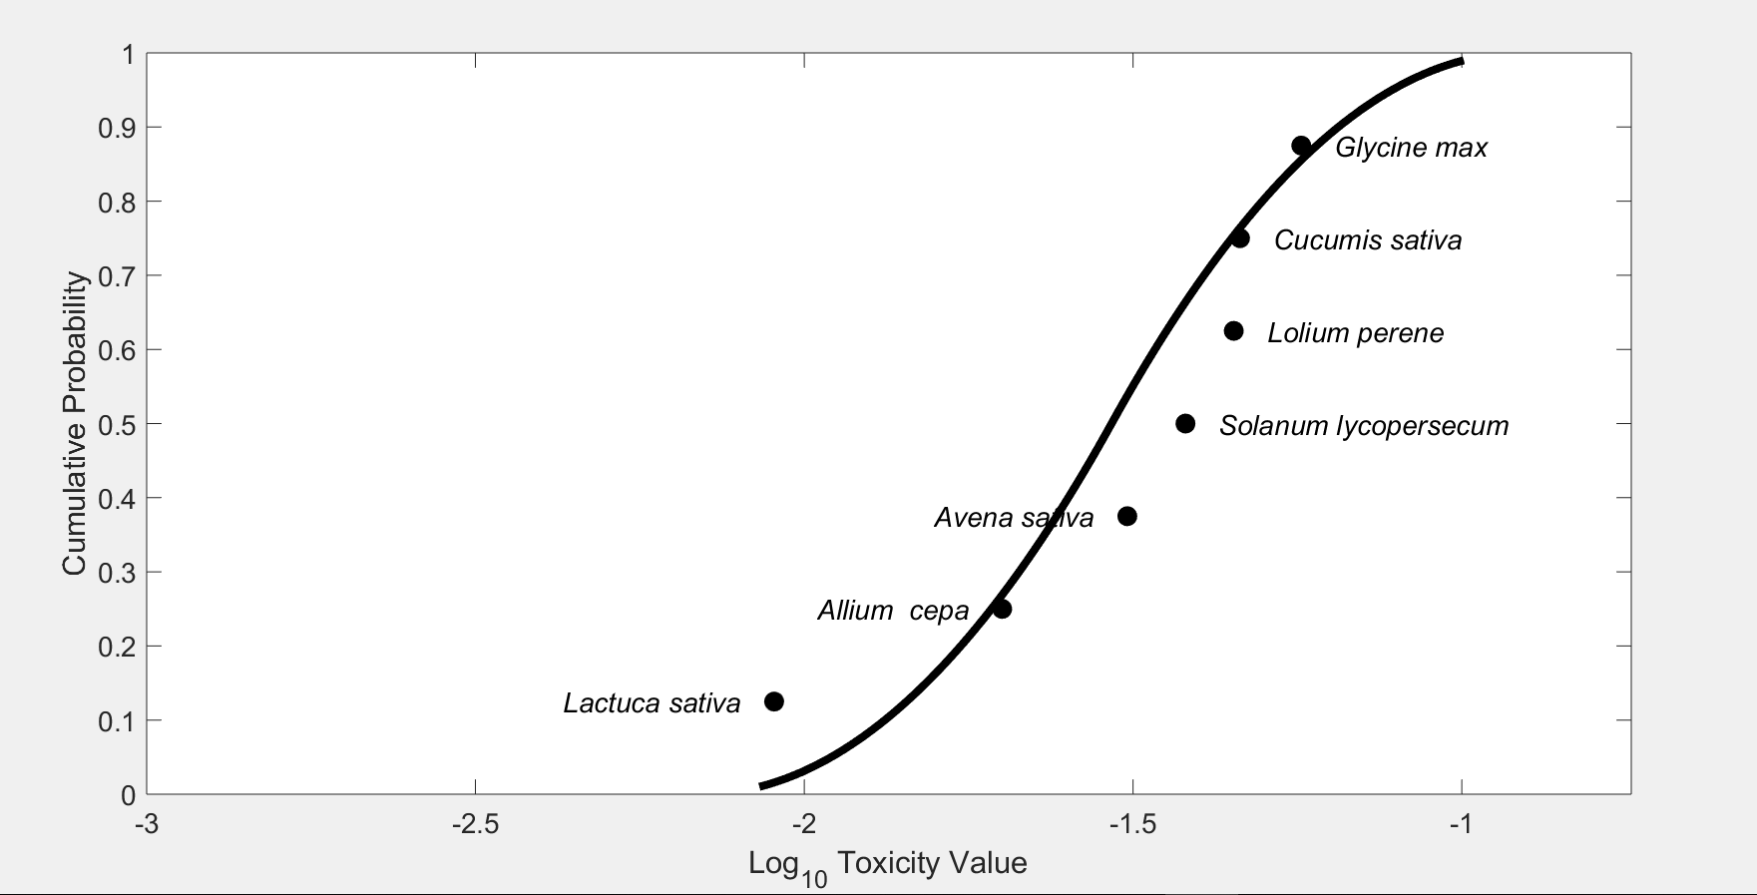
Figure 12-4. Species sensitivity distribution of IC₂₅ seedling emergence stage endpoints. Selected model was logistic, fit using maximum likelihood, selected based on the lowest AIC and highest p-value for model fit. Black points are single estimates.

A summary of available data evaluating the phytotoxicity of simazine to woody plants was submitted to the Agency in 2007 (Wall, 2007). A total of 79 species were tested in 110 separate trials at application rates of 0.5 to 12 lbs a.i./acre. Signs of phytotoxicity were summarized and reported. Fifty-four species exhibited either no or negligible (<10%) phytotoxicity. Further examination of data for the remaining 25 woody species showing phytotoxicity values > 10% indicates that the species were exposed to simazine concentrations greater than those expected to be present at environmentally relevant concentrations.

The data indicate that simazine is not likely to have an adverse effect on woody plants when used at labeled application rates (or even at higher rates, which is often tested in field phytotoxicity trials). The species were exposed to simazine in a direct application, which represents a worst-case exposure scenario. It is expected that woody plant species adjacent to treated areas would not be exposed to simazine at the tested rates. Furthermore, simazine is labeled for use around numerous wood species including citrus, tree nuts, grapes. Based on the available data and expected lower predicted concentrations away from the treated field, it is unlikely that simazine will cause adverse effects to non-target woody plant species.

Incident Reports

A review of the Incident Data System (IDS) for ecological incidents involving simazine was completed on July 6, 2020. The results of this review for terrestrial animal, plant, and aquatic animal incidents are discussed below. The Aggregate Incident Summary report in IDS shows six simazine related incidents, including two involving plant damage; and the others were single reports involving moderate property damage, minor to moderate effects on domestic animals, fatal domestic animal event, and one unspecified human event (Table 13-1). The simazine incidents listed in this database are also in the IDS.

Table 13-1. Overview of reported incidents by taxa.
Terrestrial or Aquatic | Taxa | Incident Data Available? (Yes/No)
Terrestrial | Plants | Yes
 | Mammals | Yes
 | Birds | Yes
 | Reptiles | No
 | Amphibians | No
 | Terrestrial Invertebrates | Yes
Aquatic | Amphibians | No
 | Freshwater Fish | Yes
 | Estuarine/Marine Fish | Yes
 | Aquatic Invertebrates | No
 | Mollusks | No
 | Aquatic Plants | No

Terrestrial Incidents

Only three simazine incidents have been reported involving terrestrial animals, two with an “unlikely” certainty index and one “probable.” In the incident with a certainty index of “probable,” which occurred on June 26, 1998, five Canada geese were found dead in a corn field in Rockingham County, Virginia, following spray application of Princep 4L (#I008168-001). Soil and vegetative samples were collected along the bank near the creek in which the dead geese were found. Substantial concentrations of simazine and atrazine were found in the samples. Simazine detections ranged from 0.16 to 2.3 ppm in soil and 8.5 to 20.5 ppm in foliage.

Plant Incidents

Four simazine incidents have been reported for terrestrial plants, with two rated as being “unlikely” a result of simazine. In one incident, water from a simazine-treated swimming pool affected a section of lawn grass. The certainty index for the lawn incident (# I003567-001) is “highly probable.” Another incident report from New York, was a Syngenta 6(a)2 submission regarding an allegation that the spraying of three herbicide formulations (a.i. included were atrazine, simazine and primisulfuron-methyl) caused loss of milk production and loss of corn and hay production. The treatment site nor the magnitude of the incident were given, neither was the magnitude or any analysis (IO16790-007, September 20, 2005). The certainty index for the incident involving simazine is listed as “probable.”

Aquatic Incidents

Ten freshwater aquatic incidents involving fish kills have been reported for simazine between the years of 1976 and 2004. Seven incidents have a certainty index of “highly probable” or “probable,” and the other three have certainty indices of “possible” and “unlikely.” One incident resulted from runoff into a lake due to a valve failure in a chemical application hose that was dispensing glyphosate and simazine to golf course turf. The incident resulted in the death of 6 unknown species of fish. Six incidents resulted from treatment of a lake, pond, or lagoon; two incidents were associated with simazine use on corn and from simazine use along railroad tracks; one was due to a spill from golf course use, and the treatment site for the other incident was not reported. In a number of the incidents involving direct application of simazine to lakes, ponds, and lagoons, the legality of use was listed as “misuse” or “undetermined.” For those incidents where the legality of use is reported as “registered use,” the volume of the water bodies is not provided; therefore, it is unclear whether simazine was applied in accordance with its intended use. The six incidents involving direct application of simazine to water all occurred prior to 1996, when label language was clarified to restrict direct applications to ornamental ponds and aquaria. It is important to note that in a number of the incidents involving direct application of simazine to water, low dissolved oxygen, caused by decaying aquatic vegetation, is attributed as an indirect effect related to the fish kills. The certainty index associated with the remaining three incidents (those resulting from use on corn, railroad tracks, and an unspecified treatment site) was reported as “unlikely.”

Of the ten reported incidents, three were reported in California, two were reported in Nebraska, two were reported in South Carolina, and one was reported in Michigan, Oklahoma, and in Tennessee. Fish species listed in these kills include smelt, bullheads, stickleback, striped bass, bluegills, channel catfish, croaker, menhaden, mullet, northern pike, pinfish, yellow perch, sea trout, black bullhead, and fathead minnows.

The total number of actual incidents associated with the use of simazine may be higher than what is reported to the EPA. Incidents may go unreported since effects may not be immediately apparent and/or readily attributed to the use of a chemical.

Alternative Toxicity endpoints

In addition to the thresholds provided in Table 2-1 through Table 2-6 above, alternative toxicity endpoints were also developed to use in the weight of evidence analysis for a species where appropriate (see Revised Methods Document). The alternative toxicity endpoints provide consideration of endpoints that may reflect variation in the available data (such as using the HC₅₀ values from the SSD instead of an HC₀₅ value or considering other endpoints within the data set for a particular taxon). Alternatively, if a taxon did not include enough data to select a specific alternative toxicity endpoint, a 10x factor was applied to the original threshold. The alternative endpoints allow for consideration of the possibility a listed species is toxicologically less sensitive than the tested species in the alternative weight of evidence analysis, which is captured for the analysis of any species that reaches that point of the analysis. Alternative endpoints are listed in Table 14-1 and brief additional comments are provided to clarify the alternative endpoint selection, as appropriate. Endpoints are analyzed for a subset of available units.

Table 14-1. Alternative toxicity endpoints used in weight of evidence analysis.
Alternative toxicity endpoints - Mortality |  | Type of endpoint (HC₅₀, etc.) | Value | Slope | Weight of test animal (g) | Comments
Units | Taxa
mg ai/kg-bw | Mammals | LD₅₀ | 20140 | 4.5 | 27.7 | 10x applied
mg ai/kg-bw | Birds | LD₅₀ | 99999 | 4.5 | 120 | No change, non-definitive
mg ai/kg-bw | Reptiles/Terrestrial Amphibian | LD₅₀ | 99999 | 4.5 | 120 | No change, non-definitive
mg ai/kg-bw | Terrestrial inverts | LD₅₀ | 99999 | 4.5 |  | No change, non-definitive
µg ai/L | FW FISH | LC₅₀ | 64,000 | 4.5 |  | 10x applied
µg ai/L | E/M FISH | LC₅₀ | 43,000 | 4.5 |  | 10x applied
µg ai/L | AQ AMPHIBIANS | LC₅₀ | 75,500 | 4.5 |  | 10x applied
µg ai/L | FW INVERTEBRATES | LC₅₀ | 19000 | 4.5 |  | 10x applied
µg ai/L | E/M INVERTEBRATES | LC₅₀ | 37000 | 4.5 |  | 10x applied
µg ai/L | Mollusks | LC₅₀ | 37000 | 4.5 |  | 10x applied
Alternative toxicity endpoints - Sublethal |  | Type of endpoint (HC₅₀, etc.) | MATC or LOAEC | Description of effect | Duration of study (days) | Comments
Units | Taxa
mg ai/kg-diet | Mammals | MATC | 320 |  |  | 10x applied
mg ai/kg-diet | Birds | MATC | 2230 |  |  | 10x applied
mg ai/kg-diet | Reptiles/Terrestrial Amphibian | MATC | 2230 |  |  | 10x applied
mg ai/kg-diet | Terrestrial inverts | LOAEC | 99999 |  |  | No data available in these units; alternative endpoint anticipated to be high based on mg/kg bw endpoint
µg ai/L | FW FISH | MATC | 190 |  |  | Fish endpoint MATC used as alternative to amphibian endpoint used in base run
µg ai/L | E/M FISH | MATC | 190 |  |  | Fish endpoint MATC used as alternative to amphibian endpoint used in base run
µg ai/L | AQ AMPHIBIANS | MATC | 190 |  |  | Fish endpoint MATC used as alternative to amphibian endpoint used in base run
µg ai/L | FW INVERTEBRATES | MATC | 980 |  |  | 10x applied
µg ai/L | E/M INVERTEBRATES | MATC | 980 |  |  | 10x applied
µg ai/L | Mollusks | MATC | 980 |  |  | 10x applied
TERRESTRIAL PLANTS |  | Type of endpoint (HC₅₀, etc.) | MATC or LOAEC | IC₂₅ | Description of effect | Comments
lb ai/A | SUBLETHAL- Monocots | MATC | 0.28 | 0.0335 |  | 10x applied; HC₅₀ species of SSD
lb ai/A | SUBLETHAL- Dicots | MATC | 0.031 | 0.0335 |  | 10x applied; HC₅₀ species of SSD
AQUATIC PLANTS (TGAI) |  | Type of endpoint (HC₅₀, etc.) | MATC or LOAEC | IC50 | Description of effect | Comments
µg ai/L | Non-vascular | IC05 | 54 | 217 |  | 10x applied; HC₅₀ species of SSD
µg ai/L | Vascular | MATC | 740 | 217 |  | 10x applied; HC₅₀ species of SSD

References

Norberg-King, T. 1993. A Linear Interpolation Method for Sublethal Toxicity: The Inhibition Concentration (ICp) Approach. Version 2. Technical Report 03-93. July 1993. Environmental Research Laboratory-Duluth. U.S. Environmental Protection Agency.
Suntio, L. R., Shiu, W. Y., Mackay, D., Seiber, J. N., & Glotfelty, D. E. 1988. Critical review of Henry's Law constants of pesticides. Reviews in Environmental Contamination and Toxicology, 103, 1-59.
USEPA. 2007. Effects Determinations for Simazine Relative to the California Red-Legged Frog and Designated Critical Habitat. October 17, 2007. Environmental Fate and Effects Division. Office of Pesticide Programs. U.S. Environmental Protection Agency.
USEPA. 2016a. Preliminary Ecological Risk Assessment for Simazine. April 13, 2016. Office of Pesticide Programs. U.S. Environmental Protection Agency.
USEPA. 2016b. Aquatic Life Benchmarks and Ecological Risk Assessments for Registered Pesticides. September 30, 2019. Office of Pesticide Programs. U.S. Environmental Protection Agency. Available at https://www.epa.gov/pesticide-science-and-assessing-pesticide-risks/aquatic-life-benchmarks-and-ecological-risk#relationship.

