Chapter 2 – Final Glyphosate Effects Characterization

Contents
1 Introduction 7
1.1 Endpoints used in Effects Determinations 8
2 Office of Water Aquatic Life Criteria 13
3 Effects Characterization for Fish and Aquatic-phase Amphibians 13
3.1 Introduction to Fish and Aquatic-phase Amphibian Toxicity 13
3.2 Effects on Mortality of Fish and Aquatic-phase Amphibians 13
3.2.1 Fish 13
3.2.2 Aquatic-Phase Amphibians 21
3.3 Effects on Growth and Reproduction of Fish and Aquatic-phase Amphibians 24
3.3.1 Fish 24
3.3.2 Aquatic-Phase Amphibians 27
3.4 Other Sublethal Effects to Fish and Aquatic-phase Amphibians 29
4 Effects Characterization for Aquatic Invertebrates 30
4.1 Introduction to Aquatic Invertebrate Toxicity 30
4.2 Effects on Mortality of Aquatic Invertebrates 31
4.3 Effects on Growth and Reproduction of Aquatic Invertebrates 39
5 Effects Characterization for Aquatic Plant toxicity 43
5.1 Introduction to Aquatic Plant Toxicity 43
5.2 Effects on Aquatic Plants 44
5.2.1 Effects on Growth of Non-Vascular aquatic plants 45
5.2.2 Effects on Growth of Aquatic Vascular Plants 47
5.3 Effects on Aquatic Plant Communities 49
6 Effects Characterization for Birds 51
6.1 Introduction to Bird Toxicity 51
6.2 Effects on Mortality of Birds 51
6.3 Effects on Growth and Reproduction of Birds 53
6.4 Other sublethal effects to Birds 54
6.5 Drinking water studies 54
6.6 Dermal studies 54
6.7 Inhalation studies 54
7 Effect Characterization to Reptiles 54
8 Effect Characterization to Terrestrial-phase Amphibians 54
9 Effects Characterization for Mammals 55
9.1 Introduction to Mammal Toxicity 55
9.2 Effects on Mortality of Mammals 55
9.3 Effects on Growth and Reproduction of Mammals 56
9.4 Other Sublethal Effects to Mammals 59
9.5 Drinking water studies 62
9.6 Dermal exposure studies 62
9.6.1 Inhalation studies 62
10 Effects Characterization for Terrestrial Invertebrates 62
10.1 Introduction to Terrestrial Invertebrate Toxicity 62
10.2 Effects on Mortality of Terrestrial Invertebrates 63
10.3 Sublethal Effects on Terrestrial Invertebrates 66
11 Effects Characterization for Terrestrial Plants 71
11.1 Introduction to Terrestrial Plant Toxicity 71
11.1 Effects Data for Terrestrial Plants 72
11.2 Effects Data for Terrestrial Plant Communities 76
12 Incident Reports 79
13 Alternative Toxicity endpoints 84
14 References: 86

Tables
Table 2-1. Terrestrial mortality endpoints used to evaluate impacts to species and impacts to PPHD. 9
Table 2-2. Terrestrial sublethal endpoints used to evaluate impacts to species and impacts to PPHD. 9
Table 2-3. Aquatic mortality endpoints used to evaluate impacts to species and impacts to PPHD. 11
Table 2-4. Aquatic sublethal endpoints used to evaluate impacts to species and impacts to PPHD. 11
Table 2-5. Aquatic plant endpoints used to evaluate impacts to species and impacts to PPHD. 12
Table 2-6. Terrestrial plant endpoints used to evaluate impacts to species and impacts to PPHD. 12
Table 2-7. Acute toxicity of POEA (MON 0818) on freshwater fish. 19
Table 2-8. Acute toxicity of technical and formulated glyphosate to the sheepshead minnow (Cyprinodon variegatus). 20
Table 2-9. Acute toxicity of technical and formulated glyphosate to aquatic-phase amphibians. 23
Table 2-10. Summary of the most sensitive endpoints for invertebrates acute and chronic toxicity data for glyphosate. 31
Table 2-11. Summary Statistics for Aquatic Plant SSD Fit to Glyphosate Test Results. 49
Table 2-12. Avian acute dose-based toxicity data for technical and formulated glyphosate. 52
Table 2-13. Avian acute dietary-based toxicity data for technical and formulated glyphosate. 52
Table 2-14. Effects of technical grade glyphosate on avian growth and reproduction. 53
Table 2-15. Effects of technical grade glyphosate on mammalian growth and reproduction. 57
Table 2-16. Effects of technical grade glyphosate on other sublethal effects in mammals. 59
Table 2-17. Dermal Exposure Studies for Glyphosate. 62
Table 2-18. Honeybee mortality data. 64
Table 2-19. Summary statistics for Terrestrial Plant SSD Fit to Glyphosate Test Results. 78
Table 2-20. Aggregate Incidents for Glyphosate Involving Currently Registered Products. 79
Table 2-21. Alternative toxicity endpoints used in weight of evidence analysis. 84

Figures
Figure 2-1. Array of most sensitive technical glyphosate toxicity data for acute mortality to freshwater fish expressed in terms of mg a.i./L. Blue squares represent LOAEC values from open literature studies found in the ECOTOX database. Red squares represent LOAEC values from registrant submitted studies. Solid lines display the range between the LOAEC and NOAEC values. Parenthesis describe the endpoint, species common name, % active ingredient, and study reference (MRID or ECOTOX #). If endpoint is non-definitive, that is also noted. 14
Figure 2-2. Array of most sensitive formulated glyphosate toxicity data for acute mortality to freshwater fish expressed in terms of mg a.i./L. Blue squares represent LOAEC values from open literature studies found in the ECOTOX database. Red squares represent LOAEC values from registrant submitted studies. Solid lines display the range between the LOAEC and NOAEC values. The horizontal axis has been adjusted to better represent the most sensitive endpoints. Parenthesis describe the endpoint, species common name, % active ingredient, and study reference (MRID or ECOTOX #). If endpoint is non-definitive, that is also noted. 15
Figure 2-3. Data array of the acute toxicity of technical and formulated glyphosate to rainbow trout (Oncorhynchus mykiss). Blue squares represent studies conducted with technical glyphosate and red squares represent studies conducted with formulated glyphosate. The information presented in parentheses includes the endpoint; whether technical or formulated glyphosate was tested; the percent active ingredient; the study reference; and an indication of endpoints that are non-definitive (>) values. 16
Figure 2-4. Data array of the acute toxicity of technical and formulated glyphosate to fathead minnow (Pimephales promelas). Blue squares represent studies conducted with technical glyphosate and red squares represent studies conducted with formulated glyphosate. The information presented in parentheses includes the endpoint; whether technical or formulated glyphosate was tested; the percent active ingredient; the study reference; and an indication of endpoints that are non-definitive (>) values. 17
Figure 2-5. Data array of the acute toxicity of technical and formulated glyphosate to bluegill sunfish (Lepomis macrochirus). Blue squares represent studies conducted with technical glyphosate and red squares represent studies conducted with formulated glyphosate. The information presented in parentheses includes the endpoint; whether technical or formulated glyphosate was tested; the percent active ingredient; the study reference; and an indication of endpoints that are non-definitive (>) values. 18
Figure 2-6. Data array of the acute toxicity of technical and formulated glyphosate to channel catfish (Ictalurus punctatus). Blue squares represent studies conducted with technical glyphosate and red squares represent studies conducted with formulated glyphosate. The information presented in parentheses includes the endpoint; whether technical or formulated glyphosate was tested; the percent active ingredient; the study reference; and an indication of endpoints that are non-definitive (>) values. 19
Figure 2-7. Array of most sensitive technical glyphosate toxicity data for acute mortality to aquatic-phase amphibians expressed in terms of mg a.i./L. Blue squares represent LC₅₀ values from open literature studies found in the ECOTOX database. Red squares represent LC₅₀ values from registrant submitted studies. Parenthesis describe the endpoint, species common name, % active ingredient, and study reference (MRID or ECOTOX #). If endpoint is non-definitive, that is also noted. 21
Figure 2-8. Array of most sensitive formulated glyphosate toxicity data for acute mortality to aquatic-phase amphibians expressed in terms of mg a.i./L. Blue squares represent LC₅₀ values from open literature studies found in the ECOTOX database. Red squares represent LC₅₀ values from registrant submitted studies. The horizontal axis has been adjusted to better represent the most sensitive endpoints and is presented in log-scale. Parenthesis describe the endpoint, species common name, % active ingredient, and study reference (MRID or ECOTOX #). If endpoint is non-definitive, that is also noted. 22
Figure 2-9. Detailed array of growth, reproduction, and mortality toxicity data for fish in terms of mg a.e./L. Blue squares represent LOAEC values from open literature studies found in the ECOTOX database. Solid lines display the range between the LOAEC and NOAEC values. Parentheses present the effect, species, study duration and reference (i.e., MRID, ECOTOX #). 25
Figure 2-10. Detailed array of growth, reproduction, and mortality data less than 1 mg a.e./L for fish. Blue squares represent LOAEC values from open literature studies found in the ECOTOX database. Solid lines display the range between the LOAEC and NOAEC values. Parentheses present the effect, species, study duration and reference (i.e., MRID, ECOTOX #). 27
Figure 2-11. Detailed array of growth, reproduction, and mortality data less than 1 mg a.e./L for aquatic-phase amphibians. Blue squares represent LOAEC values from open literature studies found in the ECOTOX database. Solid lines display the range between the LOAEC and NOAEC values. Parentheses present the effect, species, study duration and reference (i.e., MRID, ECOTOX #). 29
Figure 2-12. Summary array of other sublethal toxicity data for fish in terms of mg a.e./L. BCM = biochemical; CEL = cellular; PHY = physiological; BEH = behavioral; REP = reproduction; GRO = growth; MOR = mortality; POP = population. 29
Figure 2-13. Summary array of other sublethal toxicity data for aquatic-phase amphibians in terms of mg a.e./L. BCM = biochemical; CEL = cellular; PHY = physiological; BEH = behavioral; GRO = growth; MOR = mortality; POP = population. 30
Figure 2-14. Glyphosate TGAI toxicity to freshwater invertebrates. Blue squares represent LC₅₀ values from open literature studies found in the ECOTOX database, red squares represent registrant-submitted data. The information in parentheses includes the species, endpoint, reference (MRID or ECOTOX ID), and study duration in days. 32
Figure 2-15. Detailed array of mortality data ≤ 5 mg a.e./L for freshwater invertebrates exposed to glyphosate formulations. Blue squares represent LC₅₀ values from open literature studies found in the ECOTOX database, red squares represent registrant-submitted data. The information in parentheses includes the species, endpoint, reference (MRID or ECOTOX ID), and study duration in days. 34
Figure 2-16. Data array of the acute toxicity of technical and formulated glyphosate to Water Fleas (Daphnia magna), X-axis presented in log scale. Blue squares represent studies conducted with technical glyphosate, red squares represent studies conducted with formulated glyphosate. The information presented in parentheses includes the endpoint; whether technical or formulated glyphosate was tested; the percent active ingredient (when reported); the study reference; and study duration in days. 36
Figure 2-17. Detailed array of growth and mortality data < 10 mg a.e./L for estuarine/marine invertebrates exposed to glyphosate formulations. Blue squares represent LOAEC values from open literature studies found in the ECOTOX database, red squares represent registrant-submitted data. Solid lines display the range between the LOAEC and NOAEC values. Parentheses present the species, effect, reference (i.e., MRID, ECOTOX #), and study duration. 37
Figure 2-18. Data array of the acute toxicity of technical and formulated glyphosate to mollusks. Blue squares represent LOAEC values from open literature studies found in the ECOTOX database, red squares represent registrant-submitted data. Solid lines display the range between the LOAEC and NOAEC values. Parentheses present the test material, species, effect, reference (i.e., MRID, ECOTOX #), and study duration. 38
Figure 2-19. Summary of glyphosate formulation sublethal toxicity data for freshwater invertebrates. Bars show the range between the NOAEC and the LOAEC. BCM = biochemical; CEL = cellular; PHY = physiological; BEH = behavioral; REP = reproduction; GRO = growth; MOR = mortality; POP = population. 40
Figure 2-20. Summary of TGAI sublethal toxicity data for freshwater invertebrates in terms of mg a.e./L. Bars show the range between the NOAEC and the LOAEC. BCM = biochemical; CEL = cellular; PHY = physiological; BEH = behavioral; REP = reproduction; GRO = growth; MOR = mortality; POP = population. 41
Figure 2-21. Summary of glyphosate formulation sublethal toxicity data for estuarine/marine invertebrates. BCM = biochemical; CEL = cellular; PHY = physiological; BEH = behavioral; REP = reproduction; GRO = growth; MOR = mortality; POP = population. 42
Figure 2-22. Summary of TGAI sublethal toxicity data for estuarine/marine invertebrates in terms of mg a.e./L. Bars show the range between the NOAEC and the LOAEC. BCM = biochemical; CEL = cellular; PHY = physiological; BEH = behavioral; REP = reproduction; GRO = growth; MOR = mortality; POP = population. 43
Figure 2-23. Summary array of single-species toxicity data for non-vascular aquatic plants expressed in terms of mg a.e./L. CEL = cellular; GRO = growth; MOR = mortality; PHY = physiology; POP = population; 44
Figure 2-24. Summary array of single-species toxicity data for vascular aquatic plants expressed in terms of mg a.e./L. BCM = biochemical; GRO = growth; MOR = mortality; PHY = physiology; POP = population; 45
Figure 2-25. Detailed array of toxicity of technical and formulated glyphosate on aquatic nonvascular plants. Blue squares represent LOAEC values from open literature studies found in the ECOTOX database, red squares represent registrant-submitted data. Solid lines display the range between the LOAEC and NOAEC values. Parentheses present the test material, species, effect, reference (i.e., MRID, ECOTOX #), and study duration. 47
Figure 2-26. Detailed array of toxicity of technical and formulated glyphosate on aquatic vascular plants. Blue squares represent LOAEC values from open literature studies found in the ECOTOX database, red squares represent registrant-submitted data. Solid lines display the range between the LOAEC and NOAEC values. Parentheses present the test material, species, effect, reference (i.e., MRID, ECOTOX #), and study duration. 48
Figure 2-27. Log-logistic SSD for glyphosate toxicity values for all aquatic plants pooled. Black points indicate single toxicity values. Red points indicate average of multiple toxicity values for a single species. Blue line indicates full range of toxicity values. 50
Figure 2-28. Mammalian acute dose-based toxicity data array. Red square is the endpoint selected to derive the acute mortality threshold. Parenthesis describe the endpoint, whether the study was conducted with technical or formulation glyphosate, % active ingredient, and study reference (MRID or ECOTOX #). If endpoint is non-definitive, that is also noted. 56
Figure 2-29. Formulation sublethal toxicity to terrestrial invertebrates in lb a.e./A. Text in parentheses represents (taxonomic class, measured parameter, reference number, duration). 68
Figure 2-30. Formulation sublethal toxicity to terrestrial invertebrates in mg a.e./kg soil. Text in parentheses represents (taxonomic class, measured parameter, reference number, duration). 69
Figure 2-31. Technical glyphosate sublethal toxicity in mg a.e/kg soil. Text in parentheses represents (measured parameter, refence number, duration). 70
Figure 2-32. Glyphosate formulation effects on population abundance. 71
Figure 2-33. Summary array of formulation toxicity data for monocot terrestrial plants. 72
Figure 2-34. Summary array of formulation toxicity for dicot terrestrial plants. 73
Figure 2-35. Detailed array of formulation toxicity data for terrestrial dicots. Blue squares represent LOAEC values from open literature studies found in the ECOTOX database, red squares represent registrant-submitted data. Solid lines display the range between the LOAEC and NOAEC values. Parentheses present the effect, reference (i.e., MRID, ECOTOX #), and study duration. 75
Figure 2-36. Detailed array of toxicity of formulated glyphosate on terrestrial plants. Blue squares represent IC₂₅ values from open literature studies found in the ECOTOX database, red squares represent registrant-submitted data. Parentheses present the species, effect, reference (i.e., MRID, ECOTOX #), and study duration. 77
Figure 2-37. Species Sensitivity Distribution (SSD) for terrestrial plants vegetative vigor. Black points indicate single toxicity values. Red points indicate average of multiple toxicity values for a single species. Blue line indicates full range of toxicity values for a given taxon. 78

Introduction

Glyphosate acid (CAS number 1071-83-6) [N-(phosphonomethyl)glycine] is an herbicide belonging to the phosphono amino acid class of pesticides. Glyphosate is a foliar, non-selective, systemic herbicide widely used to control weeds in agricultural crops and non-agricultural sites. Glyphosate is a potent and specific inhibitor of the enzyme 5-enolpyruvylshikimate 3-phosphate (ESPS) synthase. This enzyme is the sixth enzyme on the shikimate pathway and it is essential for the biosynthesis of aromatic amino acids (e.g., tyrosine, tryptophan, and phenylalanine) and other aromatic compounds in algae, higher plants, bacteria and fungi. Inhibition of this enzyme leads to plant cell death. The shikimate pathway is absent in mammals.

Glyphosate is an acid which can be associated with different counter cations to form salts. For comparison purposes, in this assessment, each salt is considered in terms of its “glyphosate equivalent,” (acid equivalent; ae) as determined by multiplying the glyphosate salt endpoint value by the acid equivalence ratio (the ratio of the molecular weight of N-(phosphonomethyl)glycine to the molecular weight of the salt). For the assessment of risk to glyphosate, both application rates and the toxicity endpoint values are expressed as acid equivalents.

Pesticides of high solubility in water, such as glyphosate, do not “wet” (cover) properly the waxy (hydrophobic) surfaces of plants. To attain proper coverage of plant surfaces and distribution of the herbicide, surfactants are added into the formulation of the pesticide. Proper coverage arises from hydrophobic interactions between the surfactant tail (usually long carbon chains) and the waxy surfaces of plants. Therefore, the ecological effects of the pesticide-surfactant combination may differ from that of the single pesticide or the single surfactant. Glyphosate labels also recommend using a nonionic surfactant in the tank mix to further enhance the “wettability” of glyphosate.

Toxicity studies, particularly acute aquatic toxicity studies, show that these formulated products can be up to 2 orders of magnitude more toxic than the glyphosate active ingredient alone. Given the potential for increased toxicity of formulated glyphosate (discussed in detail below), thresholds are selected based on the most sensitive endpoints from studies conducted with either technical or formulated glyphosate. Thresholds based on studies conducted with formulated glyphosate were limited to those that could be reasonably linked to current U.S. registered products. In those cases where thresholds are based on studies conducted with formulated glyphosate, the most sensitive endpoints from studies conducted with technical glyphosate are used as alternative toxicity endpoints in the weight of evidence analysis as appropriate (see Revised Methods Document; (USEPA, 2020)).

The following sections discuss toxicity data available for glyphosate divided into major taxonomic groups of fish and aquatic amphibians, aquatic invertebrates, aquatic plants, birds, reptiles, terrestrial-phase amphibians, mammals, terrestrial invertebrates and terrestrial plants. Based on these data, mortality and sublethal effects (i.e., growth and reproduction) endpoints are determined and are used to evaluate direct effects to a listed species or effects to plants or animals that a species uses for prey, pollination, habitat, and/or dispersal.

In establishing the sublethal thresholds and endpoints used in the analysis, EPA used the most sensitive sublethal endpoint based on growth or reproduction or any sublethal endpoints that are strongly linked to survival, growth or reproduction. In determining whether toxicity endpoints are strongly linked to apical endpoints, EPA staff used best professional judgement, also considering factors such as data quality and relevance to effects on survival and reproduction. Specific consideration was given to any endpoints associated with sensory or behavioral effects. It was determined that no other endpoints in these categories were more sensitive and relevant than the most sensitive growth or reproduction endpoint available for each taxon. The sublethal endpoint used for each taxon therefore represents a growth or reproductive endpoint directly. Information on additional endpoints is found in APPENDIX 2-1 and APPENDIX 2-2.

If sufficient data are available, the toxicity data for each taxon are presented as summary data arrays (developed using the Data Array Builder v.1.0; described in ATTACHMENT 2-1). Alternatively, data are presented in a tabular format if only limited data is available. The arrays contain data from both laboratory and field experiments (e.g., mesocosms). Data in these arrays are grouped by the type of effect (e.g., mortality, growth, and reproduction), and present the range of effects endpoints [e.g., LOAECs and NOAECs (NOAECs must have a corresponding LOAEC to be represented in array)] for each effect type. If limited data are available, they are presented in a tabular format. The effect related to mortality, growth, and reproduction are discussed in further detail within each taxon effects characterization. All endpoints are reported in terms of active ingredient, unless otherwise specified. Data used in the arrays are available for each taxon in APPENDIX 2-1. Studies for which exposure units were not in or could not be converted to environmentally relevant units were not included in the data arrays. Endpoints reported in the ECOTOX database are presented in APPENDIX 2-2. Reviews of open literature studies are presented in APPENDIX 2-3. Citations for registrant submitted studies are presented in APPENDIX 2-4.

Endpoints used in Effects Determinations

Toxicity data available for glyphosate was reviewed and divided into major taxonomic groups, including: fish and aquatic amphibians, aquatic invertebrates, aquatic plants, birds, reptiles, terrestrial-phase amphibians, mammals, terrestrial invertebrates and terrestrial plants. For each of these groups, endpoints are determined for each taxon for mortality (animals only) and sublethal effects (i.e., growth or reproduction). These endpoints are used to establish thresholds, which are then used in conjunction with exposure data to make effects determinations based on the taxon with which they are associated. These data are described more fully in each relevant toxicity section below. Table 2- 1 through Table 2- 6 summarizes the glyphosate toxicity endpoints used in the effects determinations for all taxa. The available toxicity data for each taxon is discussed more later in this chapter.

Table 2-1. Terrestrial mortality endpoints used to evaluate impacts to species and impacts to PPHD.
Type of Threshold | Taxon | Test Species | Type of endpoint | Value | Units | Slope | Weight of test animal (g) | Comments | Reference
DOSE BASED MORTALITY | Mammals | Norway Rat | LD₅₀ | 357 | mg ai/kg-bw | 4.5 | 350 | TEP (11.4% formulation) | MRID 00024706
 | Birds | Bobwhite quail (Colinus virginianus) | LD₅₀ | 1,131 | mg ai/kg-bw | 4.5 | 120 | TEP (68.5% formulation) | MRID 00024721
 | Reptiles | Bobwhite quail (Colinus virginianus) | LD₅₀ | 1,131 | mg ai/kg-bw | 4.5 | 120 | TEP (68.5% formulation); bird used as surrogate | MRID 00024721
 | Terrestrial Invertebrates | Honeybee | LD₅₀ | >757 | mg ai/kg-bw | 4.5 | NA | TEP (65.6% formulation) | MRID 00036935
DIETARY BASED MORTALITY | Mammals | No Data
 | Birds | Bobwhite quail (Colinus virginianus) | LC₅₀ | >4971 | mg ai/kg-diet | 4.5 | NA | TGAI | MRID 00059214
 | Reptiles | Bobwhite quail (Colinus virginianus) | LC₅₀ | >4971 | mg ai/kg-diet | 4.5 | NA | TGAI; bird used as a surrogate | MRID 00059214
MORTALITY | Terrestrial Invertebrates | Honeybee | LC₅₀ | >1128 | mg ai/kg-diet | 4.5 | NA |  | MRID 00026489
 | Terrestrial Invertebrates | Earthworm | LC₅₀ | >6560 | mg ai/kg-soil | 4.5 | NA | TEP (64.9% formulation) | MRID 4576109
 | Terrestrial Invertebrates | Honeybee | LD₅₀ | >97 | ug ai/bee | 4.5 | NA | TEP (65.6% formulation) | MRID 00036935

Table 2-2. Terrestrial sublethal endpoints used to evaluate impacts to species and impacts to PPHD.
Type of Threshold | Taxon | Test Species | NOAEC (or LOAEC if no NOAEC) | MATC or LOAEC | Units | Comments | Reference
DOSE BASED SUBLETHAL ENDPOINTS | Mammals | Norway Rat | 408 | 709.56 | mg ai/kg-bw | Delayed age and increased weight at male sexual development; TGAI; rat; MATC used as input, LOAEC = 1234 mg a.e./kg-bw | MRID 48865101; MRID 48865105
 | Birds | Mallard Duck (Anas platyrhynchos) | 64.6 | 64.6 | mg ai/kg-bw | NA; Calculated based on average BW and food consumption from MRID 48876602 | MRID 48876602
 | Reptiles | Mallard Duck (Anas platyrhynchos) | 64.6 | 64.6 | mg ai/kg-bw | NA; Calculated based on average BW and food consumption from MRID 48876602 | MRID 48876602
DIETARY BASED SUBLETHAL ENDPOINTS | Mammals | Norway Rat | 5000 | 8660 | mg ai/kg-diet | Delayed age and increased weight at male sexual development; TGAI; rat; MATC used as input; LOAEC= 15,000 | MRID 48865101; MRID 48865105
 | Birds | Mallard Duck (Anas platyrhynchos) | 501 | 501 | mg ai/kg-diet | 10% decrease in 14-d survivor body weight; TGAI; mallard duck; LOAEC used as input | MRID 48876602
 | Reptiles | Mallard Duck (Anas platyrhynchos) | 501 | 501 | mg ai/kg-diet | 10% decrease in 14-d survivor body weight; TGAI; bird used as surrogate | MRID 48876602
SUBLETHAL/Mortality | Terrestrial Invertebrates | Honeybee | 39.8 | 54.4 | mg ai/kg-bw | Reduced food consumption; TEP (46.1% formulation); NOAEC and MATC; honey bee; daily dose divided by default bee weight (0.128g) | MRID 50603803
 | Terrestrial Invertebrates | Honeybee | 2.5 | 2.5 | mg ai/kg-diet | Reduced gustatory response and olfactory learning; TGAI | E179312; E179310
 | Terrestrial Invertebrates | Earthworm (Octolasion tyrtaeum) | 5000 | 5000 | mg ai/kg-soil | Reduced Biomass and fecundity, no mortality; TGAI | E170666
 | Terrestrial Invertebrates | Honeybee | 5.1 | 6.96 | ug ai/bee | Reduced food consumption; TEP (46.1% formulation); NOAEC and MATC | MRID 50603803
 | Terrestrial Invertebrates | Predatory mite (Typhlodromus pyri) | 0.193 | 0.193 | lb ai/A | 85% reduction in number of eggs laid at LOAEL; TEP (64.9% formulation) | MRID 45767105

Table 2-3. Aquatic mortality endpoints used to evaluate impacts to species and impacts to PPHD.
Taxon | Test Species | Type of endpoint | Value | Slope | Duration of study (days) | Comments | Reference
 |  |  | (ug ai/L)
FW FISH | Rainbow Trout (Oncorhynchus mykiss) | LC₅₀ | 1,000 | 4.5 | 4 | TEP (30% formulation) | MRID 40098001
E/M FISH | Sheepshead Minnow (Cyprinodon variegates) | LC₅₀ | 2,700 | 4.5 | 4 | TEP (30.75% formulation) | MRID 48934205
AQ AMPHIBIANS | Wood frog (Lithobates sylvaticus) | LC₅₀ | 580 | 4.5 | 4 | TEP (5.18 g a.e/L formulation) | E173391
FW INVERTEBRATES | San Diego Fairy Shrimp (Branchinecta sandiegonensis) | LC₅₀ | 8.7 | 4.5 | 1 | TEP (1% formulation) | E178782
E/M INVERTEBRATES | Mysid (Americamisis bahia) | LC₅₀ | 765 | 4.5 | 4 | TEP | MRID 48934292
Mollusks | Freshwater mussel (Utterbackia imbecillis) | LC₅₀ | 13,542 | 4.5 | 1 | TEP (18% formulation) | E74236

Table 2-4. Aquatic sublethal endpoints used to evaluate impacts to species and impacts to PPHD.
Taxon | Test Species | NOAEC | MATC or LOAEC | Units | Duration of study (days) | Comments | Reference
FW FISH | Characin (Leporinus obtusidens) | 704 | 704 | ug ai/L | 90 | LOAEC only based on reduced body length and weight gain; TEP (48% formulation); LOAEC used as input | E1618033
E/M FISH | Characin (Leporinus obtusidens) | 704 | 704 | ug ai/L | 90 | LOAEC only based on reduced body length and weight gain; TEP (48% formulation); LOAEC used as input; FW fish used as surrogate | E1618033
AQ AMPHIBIANS | Wood frog (Lithobates sylvaticus) | 580 | 580 | ug ai/L | 4 | LC₅₀; TEP (5.18 g/L formulation); LC50 used as input | E173391
FW INVERTEBRATES | Daphnia magna | 333 | 576.8 | ug ai/L | 55 | MATC; TGAI | E161204
E/M INVERTEBRATES | Blue crab (Callinectes sapidus) | 4070 | 4070 | ug ai/L | 1 | LOAEC based on reduced time to metamorphosis and 20% mortality; TEP (50.2% formulation); LOAEC used as input | E161498
Mollusks | Eastern oyster (Crassostrea virginica) | 930 | 930 | ug ai/L | 2 | EC₅₀; EC₅₀ used as input; TEP (30.75% formulation) | MRID 48934204

Table 2-5. Aquatic plant endpoints used to evaluate impacts to species and impacts to PPHD.
EPA Category | Species | NOAEC | MATC or LOAEC | IC₅₀ | Units | Comments | Reference
Non-vascular | Anabaena flos-aqua | 17.3 | 25.2 | 100 | ug ai/L | Cell density; TEP; 96-hr IC₅₀ and NOAEC/LOAEC; Anabaena flos aqua; uncertain whether it contains POEA, MRID 45666703 | MRID 44578305
Vascular | Lemna gibba | 290 | 580 | 1500 | ug ai/L | frond number; TEP; 14d IC₅₀; Lemna gibba; formulation assumed to contain POEA, MRID 44125714. | MRID 44578303

Table 2-6. Terrestrial plant endpoints used to evaluate impacts to species and impacts to PPHD.
EPA Category | Species | NOAEC | MATC or LOAEC | IC₂₅ | Units | Comments | Reference
Monocot | Oat (Triticum aestivum) | 0.049 | 0.086 | 0.021 | lb ai/A | aboveground dry weight; LOAEC used to derive MATC: Triticum aestivum, MRID 44125715, for formulation; IC₂₅: the HC₀₅ of an SSD, all terrestrial plant vegetative vigor data | MRID 44125715
Dicot | Radish (Raphanus sativus) | 0.07 | 0.07 | 0.021 | lb ai/A | aboveground dry weight; Formulation LOAEC: Raphanus sativus, MRID 44125715, non-definitive (<) for formulation; IC₂₅: the HC₀₅ of an SSD, all terrestrial plant vegetative vigor data | MRID 44125715

Office of Water Aquatic Life Criteria

The U.S. EPA’s Office of Water (OW) may develop ambient water quality criteria for chemicals, including pesticides, that can be adopted by states and tribes to establish water quality standards under the Clean Water Act. At this time, OW has not published ambient water quality criteria for glyphosate.

Effects Characterization for Fish and Aquatic-phase Amphibians

Introduction to Fish and Aquatic-phase Amphibian Toxicity

A considerable number of aquatic toxicity and field studies are available for glyphosate. Acute and chronic studies for fish and amphibians have been submitted by the registrant and are available in the open literature. Studies were excluded from the main analysis (i.e., data arrays) if they were considered invalid or if the exposure units could not be converted into aqueous concentrations (mass/volume).

Effects on Mortality of Fish and Aquatic-phase Amphibians

Fish

Numerous acute toxicity studies for fish are available for both technical grade and formulated glyphosate, representing a wide variety of species (APPENDIX 2-5). Figure 2- 1 and Figure 2- 2 present arrays of the median lethal concentration (LC₅₀) values for technical and formulated glyphosate, respectively. LC₅₀ values for technical glyphosate range from 43 to 128 mg a.e./L and values for formulated glyphosate range from 0.53 to 3,610 mg a.e./L.

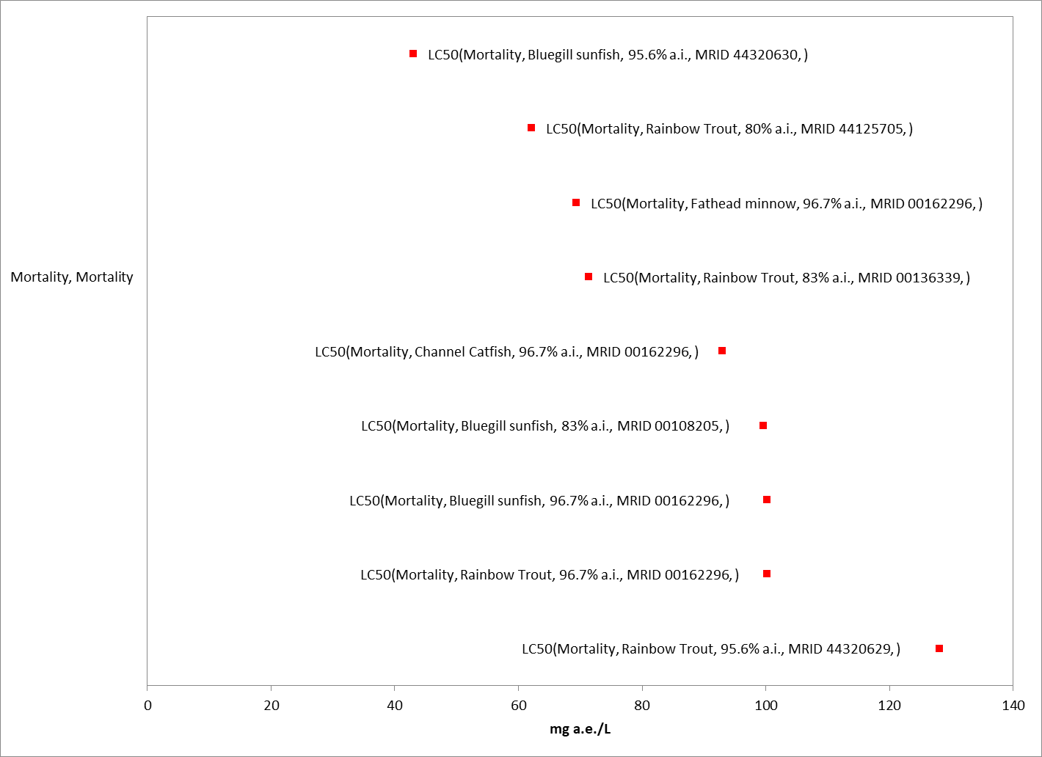
Figure 2-1. Array of most sensitive technical glyphosate toxicity data for acute mortality to freshwater fish expressed in terms of mg a.i./L. Blue squares represent LOAEC values from open literature studies found in the ECOTOX database. Red squares represent LOAEC values from registrant submitted studies. Solid lines display the range between the LOAEC and NOAEC values. Parenthesis describe the endpoint, species common name, % active ingredient, and study reference (MRID or ECOTOX #). If endpoint is non-definitive, that is also noted.

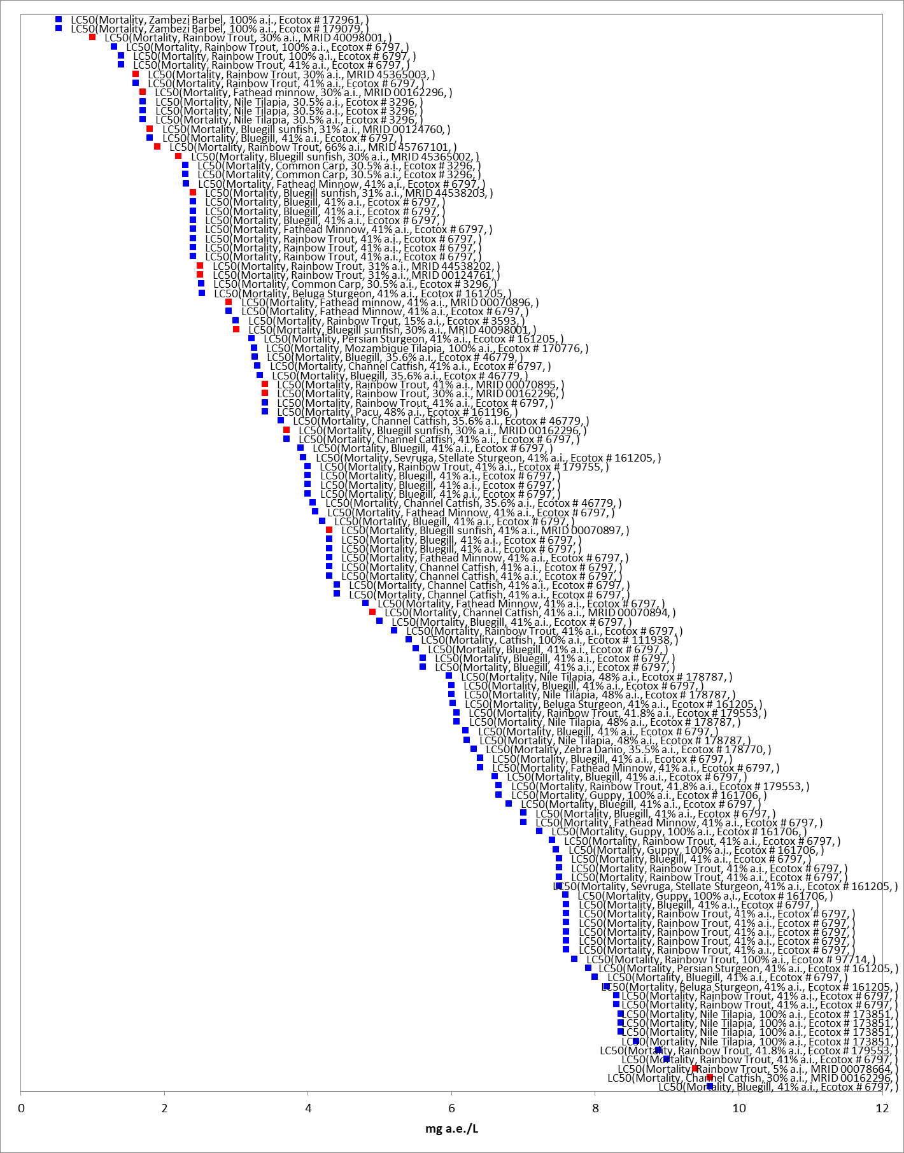
Figure 2-2. Array of most sensitive formulated glyphosate toxicity data for acute mortality to freshwater fish expressed in terms of mg a.i./L. Blue squares represent LOAEC values from open literature studies found in the ECOTOX database. Red squares represent LOAEC values from registrant submitted studies. Solid lines display the range between the LOAEC and NOAEC values. The horizontal axis has been adjusted to better represent the most sensitive endpoints. Parenthesis describe the endpoint, species common name, % active ingredient, and study reference (MRID or ECOTOX #). If endpoint is non-definitive, that is also noted.
To evaluate the relative difference in toxicity of technical grade and formulated glyphosate, available toxicity endpoints for rainbow trout (Oncorhynchus mykiss), fathead minnow (Pimphales promelas), bluegill sunfish (Lepomis macrochirus), and channel catfish (Ictalurus punctatus) are arrayed in Figure 2- 3, Figure 2- 4, Figure 2- 5, and Figure 2- 6, respectively. These figures show that endpoints from studies conducted with technical glyphosate (identified with blue squares), are approximately 1 to 2 orders of magnitude less sensitive than the most sensitive endpoints from studies conducted with formulated glyphosate (red squares). It is important to note that for the largest dataset, rainbow trout, the sensitivity of formulated glyphosate varied widely (>2 orders of magnitude) and approximately half of the available endpoints are less sensitive than the endpoints for technical glyphosate. There is no discernible trend in the amount of active ingredient and the relative toxicity, suggesting the range of sensitivities may be due to the individual components of the formulations (i.e., inert ingredients, surfactants).

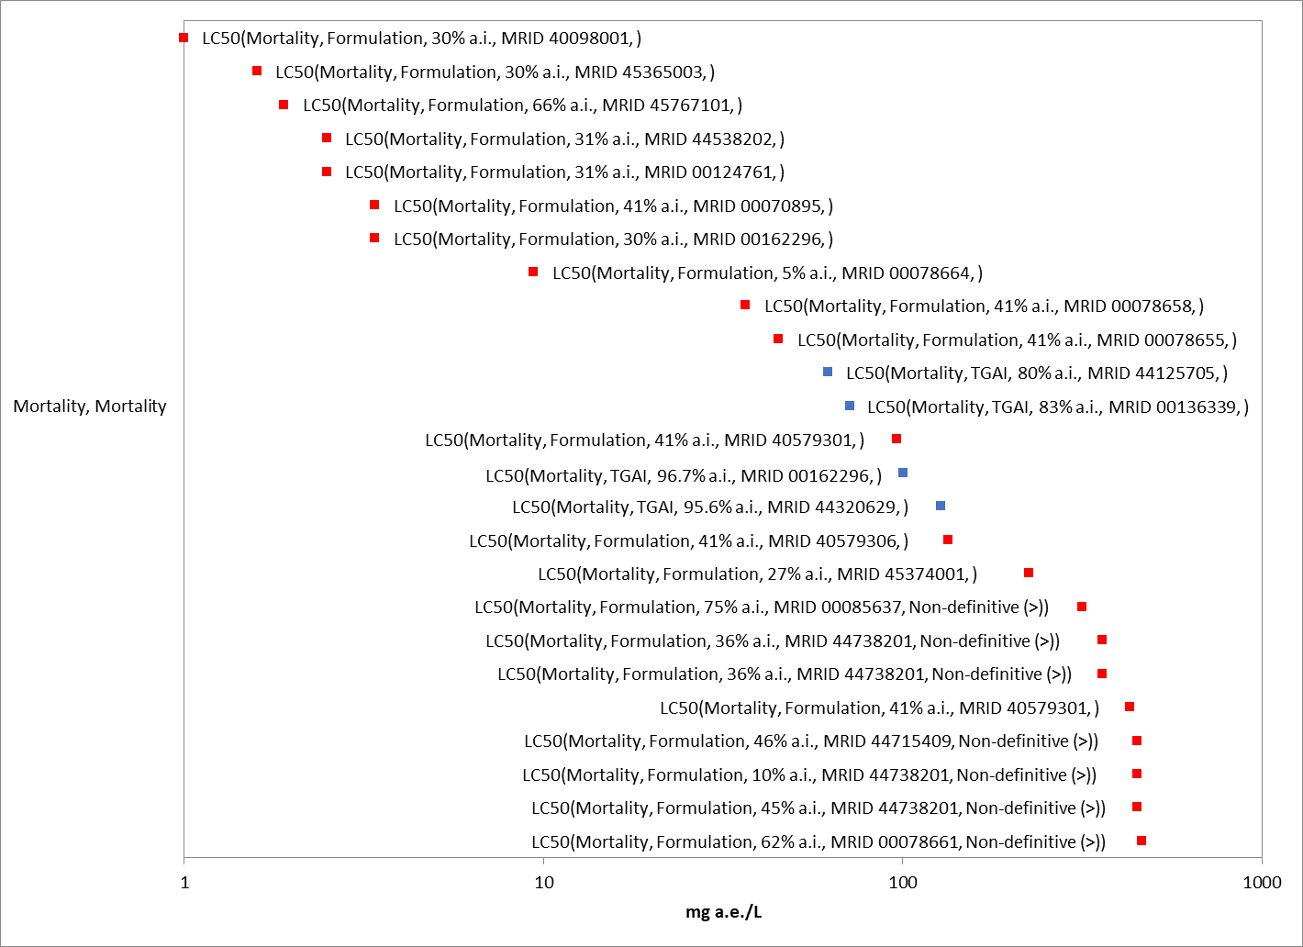
Figure 2-3. Data array of the acute toxicity of technical and formulated glyphosate to rainbow trout (Oncorhynchus mykiss). Blue squares represent studies conducted with technical glyphosate and red squares represent studies conducted with formulated glyphosate. The information presented in parentheses includes the endpoint; whether technical or formulated glyphosate was tested; the percent active ingredient; the study reference; and an indication of endpoints that are non-definitive (>) values.

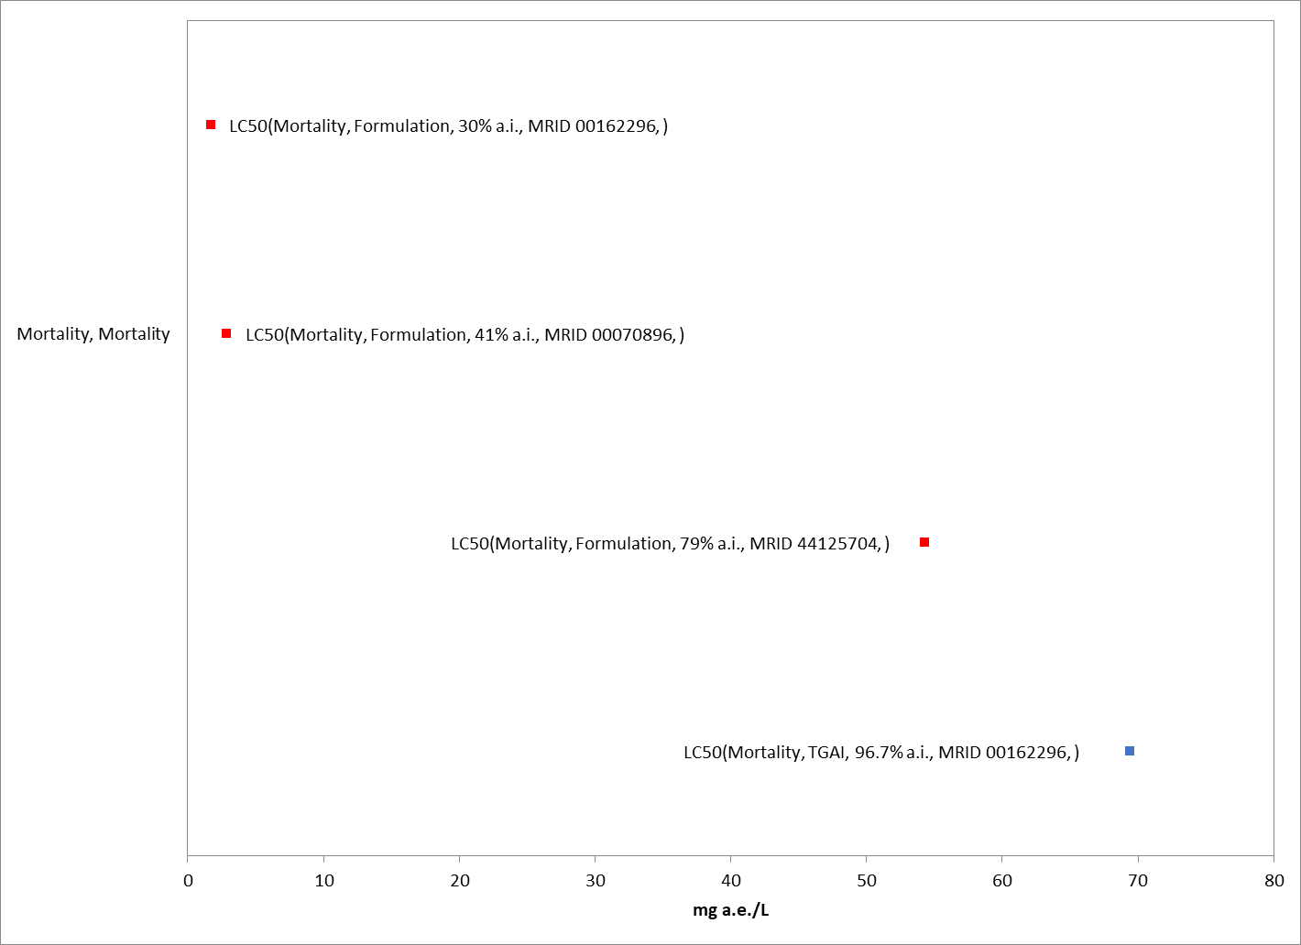
Figure 2-4. Data array of the acute toxicity of technical and formulated glyphosate to fathead minnow (Pimephales promelas). Blue squares represent studies conducted with technical glyphosate and red squares represent studies conducted with formulated glyphosate. The information presented in parentheses includes the endpoint; whether technical or formulated glyphosate was tested; the percent active ingredient; the study reference; and an indication of endpoints that are non-definitive (>) values.

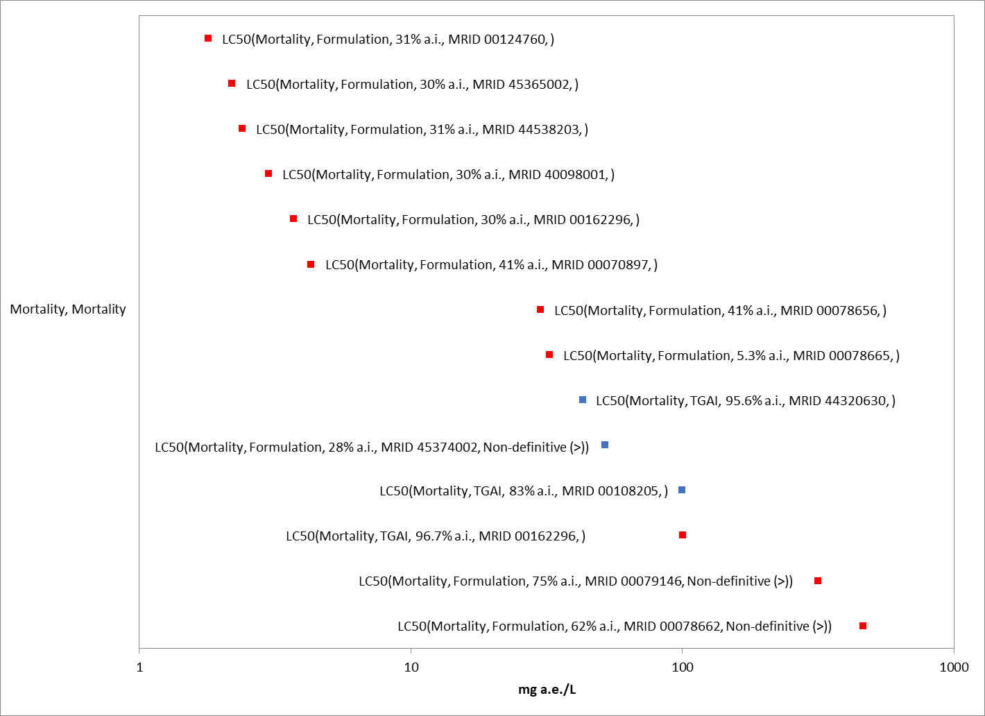
Figure 2-5. Data array of the acute toxicity of technical and formulated glyphosate to bluegill sunfish (Lepomis macrochirus). Blue squares represent studies conducted with technical glyphosate and red squares represent studies conducted with formulated glyphosate. The information presented in parentheses includes the endpoint; whether technical or formulated glyphosate was tested; the percent active ingredient; the study reference; and an indication of endpoints that are non-definitive (>) values.

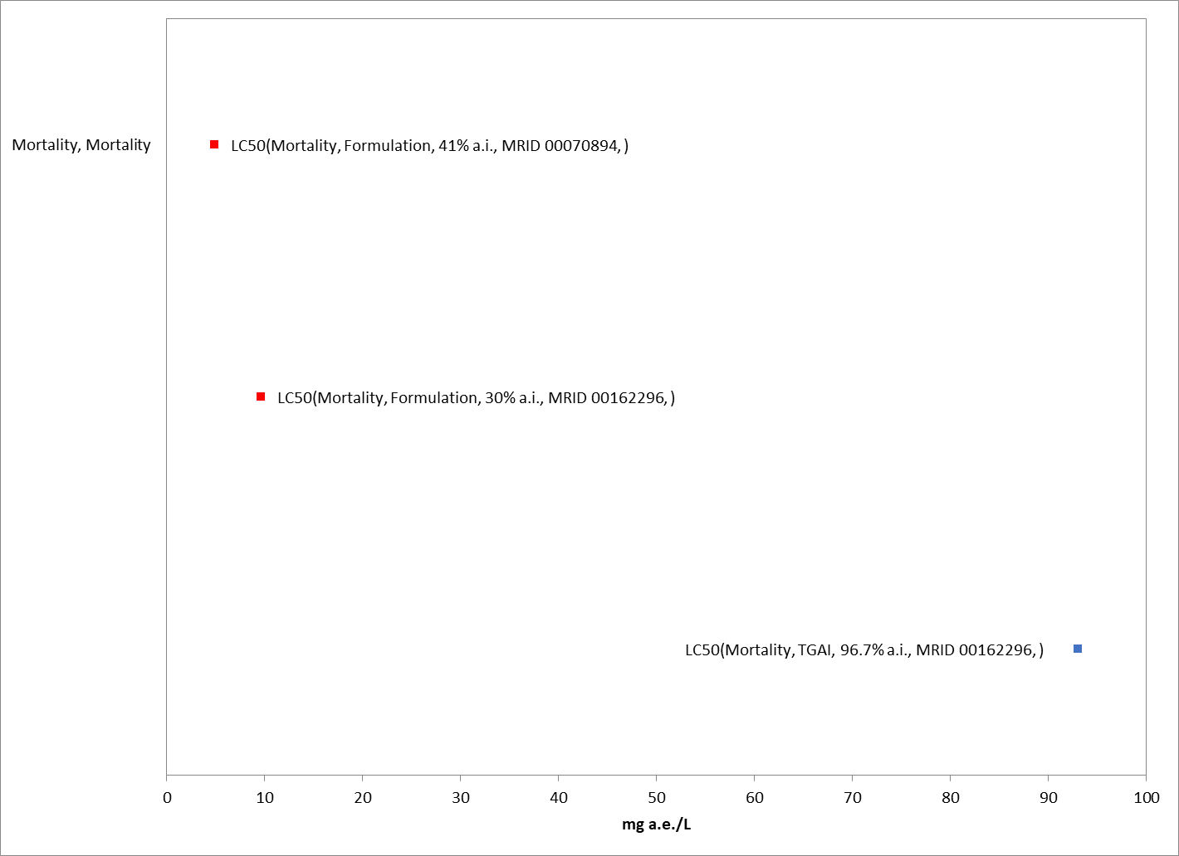
Figure 2-6. Data array of the acute toxicity of technical and formulated glyphosate to channel catfish (Ictalurus punctatus). Blue squares represent studies conducted with technical glyphosate and red squares represent studies conducted with formulated glyphosate. The information presented in parentheses includes the endpoint; whether technical or formulated glyphosate was tested; the percent active ingredient; the study reference; and an indication of endpoints that are non-definitive (>) values.

The potential for increased toxicity of surfactants has been explored in previous assessments (US EPA 2015) with a group of surfactants, the polyethoxylated tallow amines (POEA), which has been shown to be more toxic to aquatic animals than glyphosate alone (Table 2- 7). This data suggests that the MON 0818 formulation, which contains 70% POEA and 30% additional inert ingredients, is 10 to 99 times more toxic than technical glyphosate. Based on the comparison of technical and formulated glyphosate presented above, the toxicity observed in the formulation studies could be at least partially driven by the surfactants. However, other formulations may contain a different class of surfactant or no surfactant at all. The nature of the surfactant included in the formulation is considered Confidential Business Information (CBI) and is not included on product labels.

Table 2-7. Acute toxicity of POEA (MON 0818) on freshwater fish.
Species | % POEA¹ | 96-h LC₅₀  (mg a.i./L) | MRID | Fold Difference from TGAI²
Fathead minnow  (Pimephales promelas) | 70 | 0.7  (0.84 - 1.19) | 00162296 | 99
Rainbow trout  (Oncorhynchus mykiss) | 70 | 1.4  (1.05 – 1.89) | 00162296 | 44
Bluegill sunfish  (Lepomis macrochirus) | 70 | 2.1  (1.75 – 2.59) | 00162296 | 20
Channel catfish  (Ictalurus punctatus) | 70 | 9.1  (7.0 – 11.9) | 00162296 | 10
¹ Based on information provided by Registrant, the test material, MON 0818, contains 70% POEA and 30% inert ingredients; (comment from Monsanto Co. September 21, 2009; http://www.regulations.gov/#!documentDetail;D=EPA-HQ-OPP-2009-0361-0013 )
² Based on 96-h LC₅₀ values of: 69.4 mg a.e./L for fathead minnow; 62 mg a.e./L for rainbow trout; 43 mg a.e/L for bluegill sunfish; and 93 mg a.e./L for channel catfish

Given the variability in the components of the formulations used in the acute toxicity studies, it is not possible to derive a species sensitivity distribution (SSD). The most sensitive endpoint from a study conducted with formulated glyphosate is a 96-h LC₅₀ of 0.53 mg a.e./L for the Zambezi Barbel (Clarias gariepinus; E172961). However, the test material is not clearly identified, and it is not possible to determine whether the formulation is relevant to US formulations. In addition, there is uncertainty in the exposures as measured values are not provided. Therefore, the freshwater fish mortality threshold for formulated glyphosate is based on the most sensitive acute 96-h LC₅₀ value of 1 mg a.e./L for rainbow trout (CI = 0.8 – 1.2 mg a.e./L; 30% TEP; MRID 40098001). There is uncertainty in the representativeness of this formulation for all glyphosate formulations as well as whether the formulation will reach the aquatic waterbody intact, therefore, an alternative threshold is selected based on the endpoints available for technical glyphosate. The alternative endpoint for freshwater fish mortality for technical glyphosate is based on the most sensitive acute 96-h LC₅₀ value of 43 mg a.e./L for bluegill sunfish (CI = 30.6 – 53.5 mg a.e/L; MRID 44320630).

Substantially less data is available on the acute toxicity of technical and formulated glyphosate to estuarine/marine fish, but the available data suggests similar sensitivity as freshwater fish. Table 2- 8 presents the 96-h LC₅₀ data for technical and formulated glyphosate to the sheepshead minnow (Cyprinodon variegatus). The estuarine/marine fish mortality threshold for formulated glyphosate is based on the most sensitive acute 96-h LC₅₀ value of 2.7 mg a.e./L (30.75% TEP; MRID 48934205). The alternative endpoint for technical glyphosate is based on the acute 96-h LC₅₀ value of 240 mg a.e./L (MRID 44320632).

Table 2-8. Acute toxicity of technical and formulated glyphosate to the sheepshead minnow (Cyprinodon variegatus).
Chemical | % a.i. | 96-h LC₅₀  (mg a.e./L) | Reference | Fold Difference from TGAI
TGAI | 96 | 240 | MRID  44320632 | NA
Glyphosate (MON 2139) | 30.75 | 2.7 | MRID 48934205 | 89
Glyphosate SL formulation | 28.3 | >50.9 | MRID 45374005 | <4.7

Aquatic-Phase Amphibians

Similar to fish, numerous acute toxicity studies for aquatic-phase amphibians are available for both technical grade and formulated glyphosate, representing a wide variety of species (Appendix 2-5). Figure 2- 7 and Figure 2- 8 present arrays of the median lethal concentration (LC₅₀) values for technical and formulated glyphosate, respectively. LC₅₀ values for technical glyphosate range from >17.9 to 103 mg a.e./L and values for formulated glyphosate range from 0.085 to 7,297 mg a.e./L.

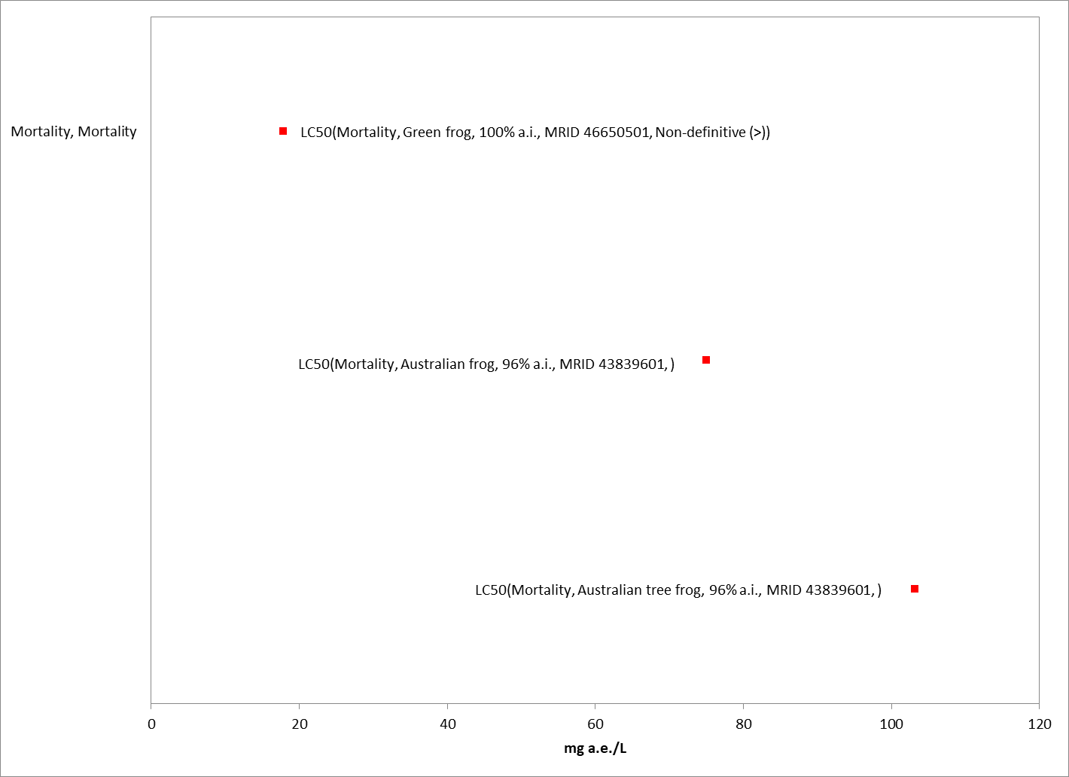
Figure 2-7. Array of most sensitive technical glyphosate toxicity data for acute mortality to aquatic-phase amphibians expressed in terms of mg a.i./L. Blue squares represent LC₅₀ values from open literature studies found in the ECOTOX database. Red squares represent LC₅₀ values from registrant submitted studies. Parenthesis describe the endpoint, species common name, % active ingredient, and study reference (MRID or ECOTOX #). If endpoint is non-definitive, that is also noted.

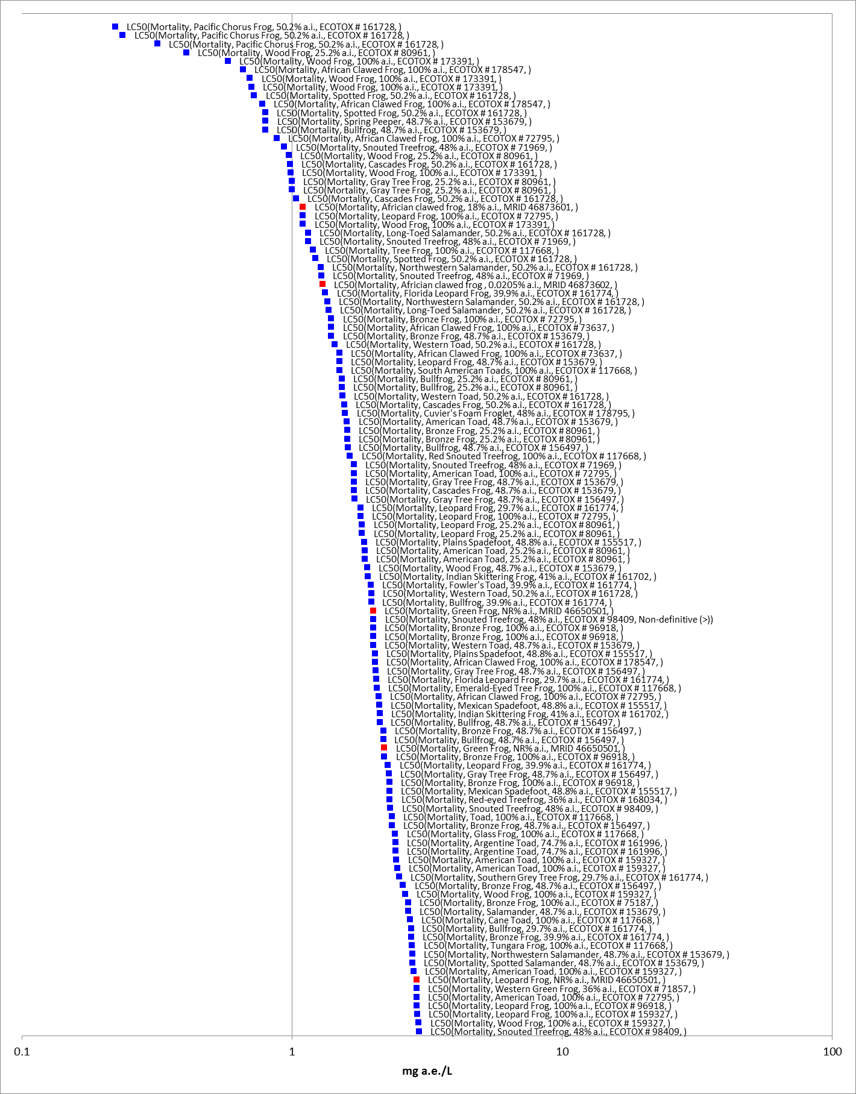
Figure 2-8. Array of most sensitive formulated glyphosate toxicity data for acute mortality to aquatic-phase amphibians expressed in terms of mg a.i./L. Blue squares represent LC₅₀ values from open literature studies found in the ECOTOX database. Red squares represent LC₅₀ values from registrant submitted studies. The horizontal axis has been adjusted to better represent the most sensitive endpoints and is presented in log-scale. Parenthesis describe the endpoint, species common name, % active ingredient, and study reference (MRID or ECOTOX #). If endpoint is non-definitive, that is also noted.
Limited data are available to compare the acute toxicity of technical and formulated glyphosate for aquatic-phase amphibians, but the data suggests formulated glyphosate is 2 to >9 times more sensitive than technical glyphosate (Table 2- 9). Therefore, thresholds for aquatic-phase amphibians will be based on the most sensitive endpoint from the available data conducted with formulated glyphosate.

Table 2-9. Acute toxicity of technical and formulated glyphosate to aquatic-phase amphibians.
Species | Test Material | % a.i. | LC50 (mg a.e./L) | Study Reference | Factor Difference from TGAI¹
Australian Frog | TGAI | 96 | 75 | MRID 43839601 | NA
Australian frog | Glyphosate IPA (Roundup 360) | 30.3 | 30.4 | MRID 43839601 | 2.5
Australian frog | Glyphosate IPA (Roundup 360) | 30.3 | 38.2 | MRID 43839601 | 2
Australian tree frog | Glyphosate IPA (Roundup 360) | 30.3 | 5.6 | MRID 43839601 | 13
Green Frog | TGAI | 96 | >17.9 | MRID 46650501 | NA
Green Frog | Glyphosate IPA (Roundup Original with 15% POEA) | NR | 2 | MRID 46650501 | >9
Green Frog | Glyphosate IPA (Roundup Transorb with 15% POEA) | NR | 2.2 | MRID 46650501 | >8
Green frog | Glyphosate IPA (Roundup Original with 15% POEA) | NR | 7.1 | MRID 46650501 | >2.5
Green Frog | Glyphosate IPA (Glyphos AU with 3-7% POEA) | NR | 8.9 | MRID 46650501 | >2
Green frog | Glyphosate IPA (Roundup Biactive with 10-20% unspecified surfactant) | NR | >17.9 | MRID 46650501 | NA
Green Frog | Glyphosate IPA (Glyphos BIO with <10% POEA) | NR | >17.9 | MRID 46650501 | NA
¹ Based on 96-h LC50 values of: 75 mg a.e./L for Australian frog; >17.9 mg a.e./L for green frog

Given the variability in the components of the formulations used in the acute toxicity studies, it is not possible to derive a species sensitivity distribution (SSD). Several of the most sensitive endpoints are not suitable for deriving thresholds because they do not provide definitive endpoints (E98409); they do not describe control performance (E161728); or effects were only observed in the presence of another stressor, confounding the effects of glyphosate (E80961).
The aquatic-phase amphibian mortality threshold for formulated glyphosate is based on the acute 96-h LC₅₀ value of 0.58 mg a.e./L from an open literature study by Edge et. al (E173391). In this study, larval wood frogs (Lithobates sylvaticus) from four distinct populations were exposed to two glyphosate-based formulations, Roundup Weed and Grass Control® and Roundup WeatherMax® at concentrations of 0 (control), 0.5, 1.0, 1.5, 2.0, 2.5, 3.0, 3.5, and 4.0 mg a.e./L for four days. Mortality was reported and LC₅₀ values were estimated for each population. The most sensitive LC₅₀ value of 0.085 mg a.e./L was not suitable for deriving the threshold because of large variability in the measured response as evidenced by the large confidence intervals (3 orders of magnitude). Therefore, the threshold is based on the next most sensitive endpoint from this study. There is uncertainty in the representativeness of this formulation for all glyphosate formulations as well as whether the formulation will reach the aquatic waterbody intact, therefore, an alternative threshold is selected based on the endpoints available for technical glyphosate. The alternative endpoint for aquatic-phase amphibian mortality for technical glyphosate is based on the most sensitive acute 96-h LC₅₀ value of 103.2 mg a.e./L for the green frog (CI = 43.2 – 172.8 mg a.e/L; MRID 46650501).

Effects on Growth and Reproduction of Fish and Aquatic-phase Amphibians

Fish

While numerous toxicity studies reporting effects on growth and/or reproduction of freshwater and estuarine/marine fish are available for formulated glyphosate, limited data on the effects of technical glyphosate are available. In a chronic fish life cycle study conducted with technical glyphosate and fathead minnows, there were no reported effects up to the highest concentration tested, 25.7 mg a.e./L (MRID 00108171). In a 42-d exposure study by Le Mer et al., 2013, the effects of technical glyphosate exposure on estuarine/marine threespine stickleback larvae (Gasterosteus aculeatus) was examined in two consecutive years, with no reported effects up to the highest concentration tested, 0.1 mg a.e./L. In contrast, Figure 2- 9 presents a detailed array of growth, reproduction, and mortality endpoints available for freshwater and estuarine/marine fish conducted with formulated glyphosate. For better visualization only studies with endpoints of less than 1 mg a.e./L are presented in Figure 2- 10. The most sensitive endpoints (0.05 to <0.704 mg a.e./L) are conducted with formulations that are not relevant to US formulations and are not suitable for use as thresholds. The limited data suggests that, similar to the mortality endpoints, freshwater and estuarine/marine fish are more sensitive to formulated glyphosate than technical glyphosate.

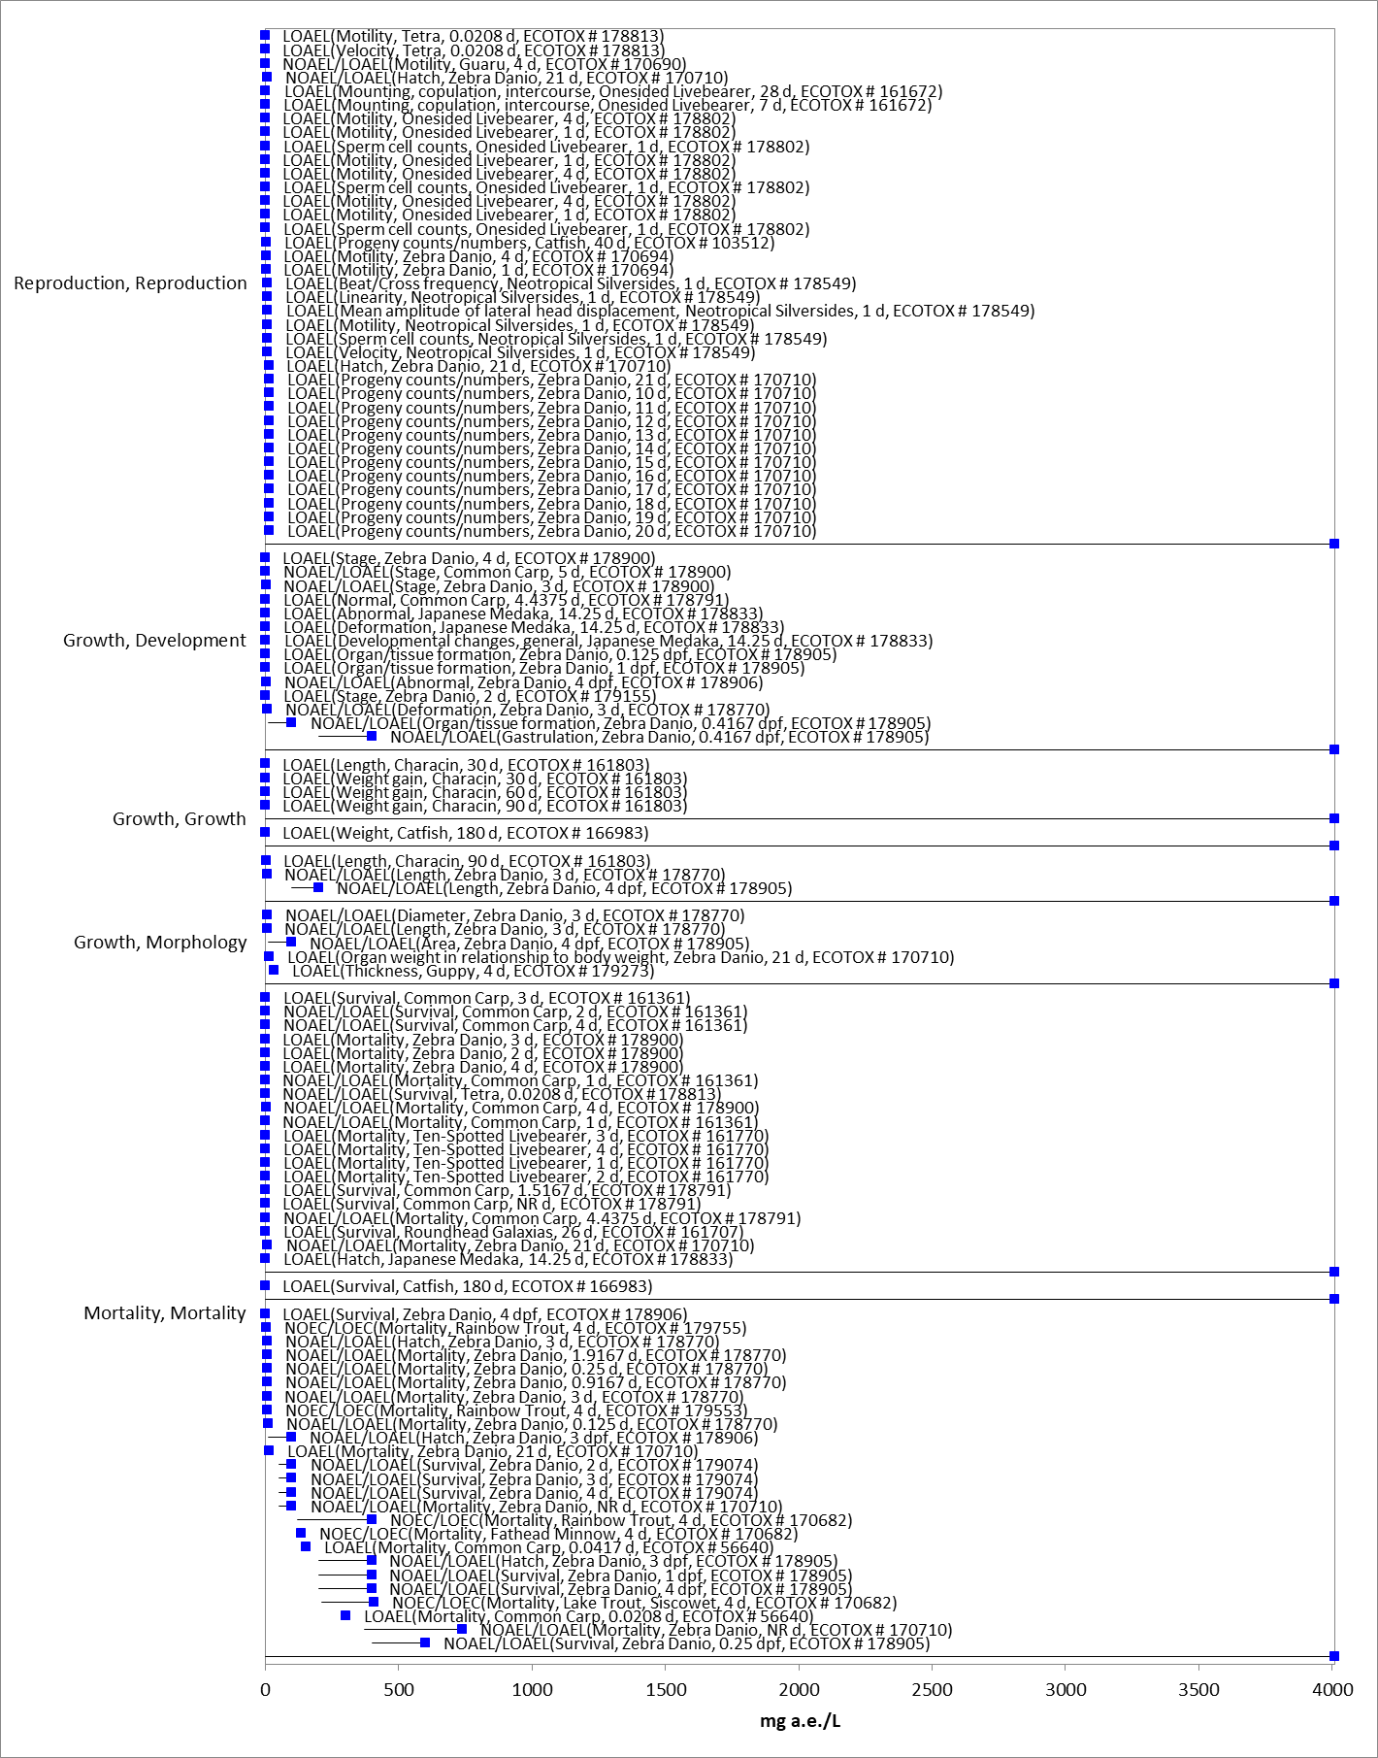
Figure 2-9. Detailed array of growth, reproduction, and mortality toxicity data for fish in terms of mg a.e./L. Blue squares represent LOAEC values from open literature studies found in the ECOTOX database. Solid lines display the range between the LOAEC and NOAEC values. Parentheses present the effect, species, study duration and reference (i.e., MRID, ECOTOX #).

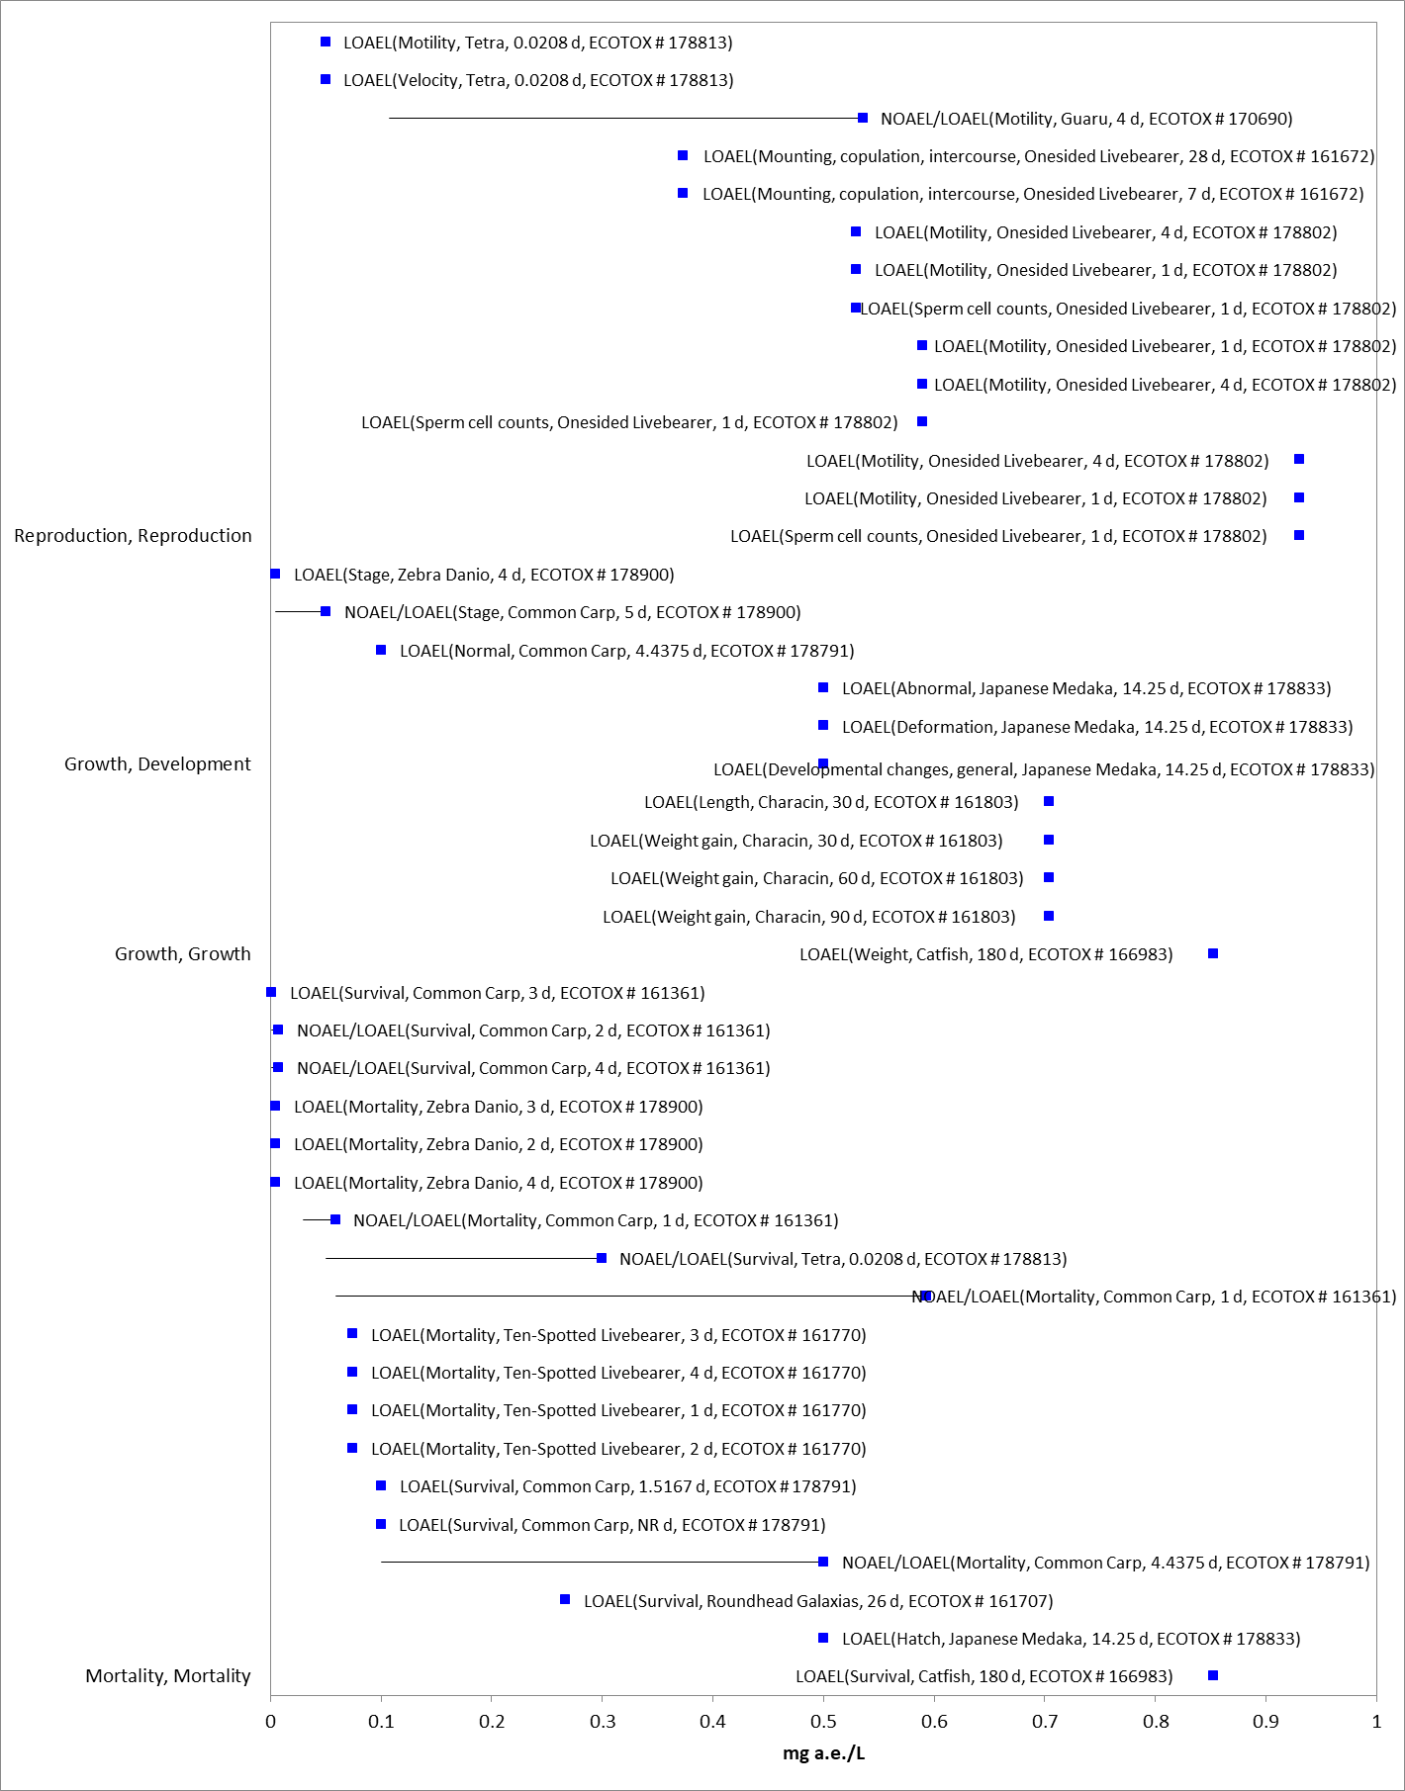
Figure 2-10. Detailed array of growth, reproduction, and mortality data less than 1 mg a.e./L for fish. Blue squares represent LOAEC values from open literature studies found in the ECOTOX database. Solid lines display the range between the LOAEC and NOAEC values. Parentheses present the effect, species, study duration and reference (i.e., MRID, ECOTOX #).

The sublethal threshold for formulated glyphosate is based on a LOAEC of 0.704 mg a.e./L from a study by Salbego et al. (2010; E161803) in which statistically significant decreases in 90-d body weight gain (44-65%) and body length (10-15%) was observed in Characin fish, Leporinus obtusidens, at the lowest concentration tested. There is uncertainty in the representativeness of this formulation for all glyphosate formulations as well as whether the formulation will reach the aquatic waterbody intact, therefore, an alternative threshold is selected based on the endpoints available for technical glyphosate. The alternative endpoint for technical glyphosate is a NOAEC of 25.7 mg a.e./L from a chronic fish life cycle study conducted with technical glyphosate and fathead minnows, where there were no reported effects up to the highest concentration tested (MRID 00108171).

Aquatic-Phase Amphibians

Similar to fish, the vast majority of the available growth and reproduction data is from studies conducted with formulated glyphosate. In the only available study conducted with technical glyphosate, no effects were observed in the leopard frog (Rana pipiens) at concentrations up to 1.8 mg a.e./L (MRID 46650501). In contrast, effects from formulated glyphosate were observed at concentrations ranging from 0.004 to 7900 mg a.e./L. Figure 2- 11 presents the detailed array for effects on growth, reproduction, and mortality observed in aquatic-phase amphibians after exposure to formulated glyphosate. To better show the most sensitive endpoints, the horizontal access has been adjusted to show endpoints below 1 mg a.e./L. There is substantial overlap in concentrations with observed effects on growth and mortality. The sublethal threshold for formulated glyphosate is based on the acute 96-h LC₅₀ value of 0.58 mg a.e./L from an open literature study by Edge et. al (E173391), which represents the most sensitive endpoint that is suitable for use as a threshold. There are more sensitive endpoints that are not considered suitable for use as a threshold because: they were conducted with formulations that are not relevant to US formulations; did not measure test concentrations; did not report on control performance; or represent study designs with multiple stressors that may confound the effect of glyphosate (see Appendix 2-5 for details of studies not considered suitable as a threshold).
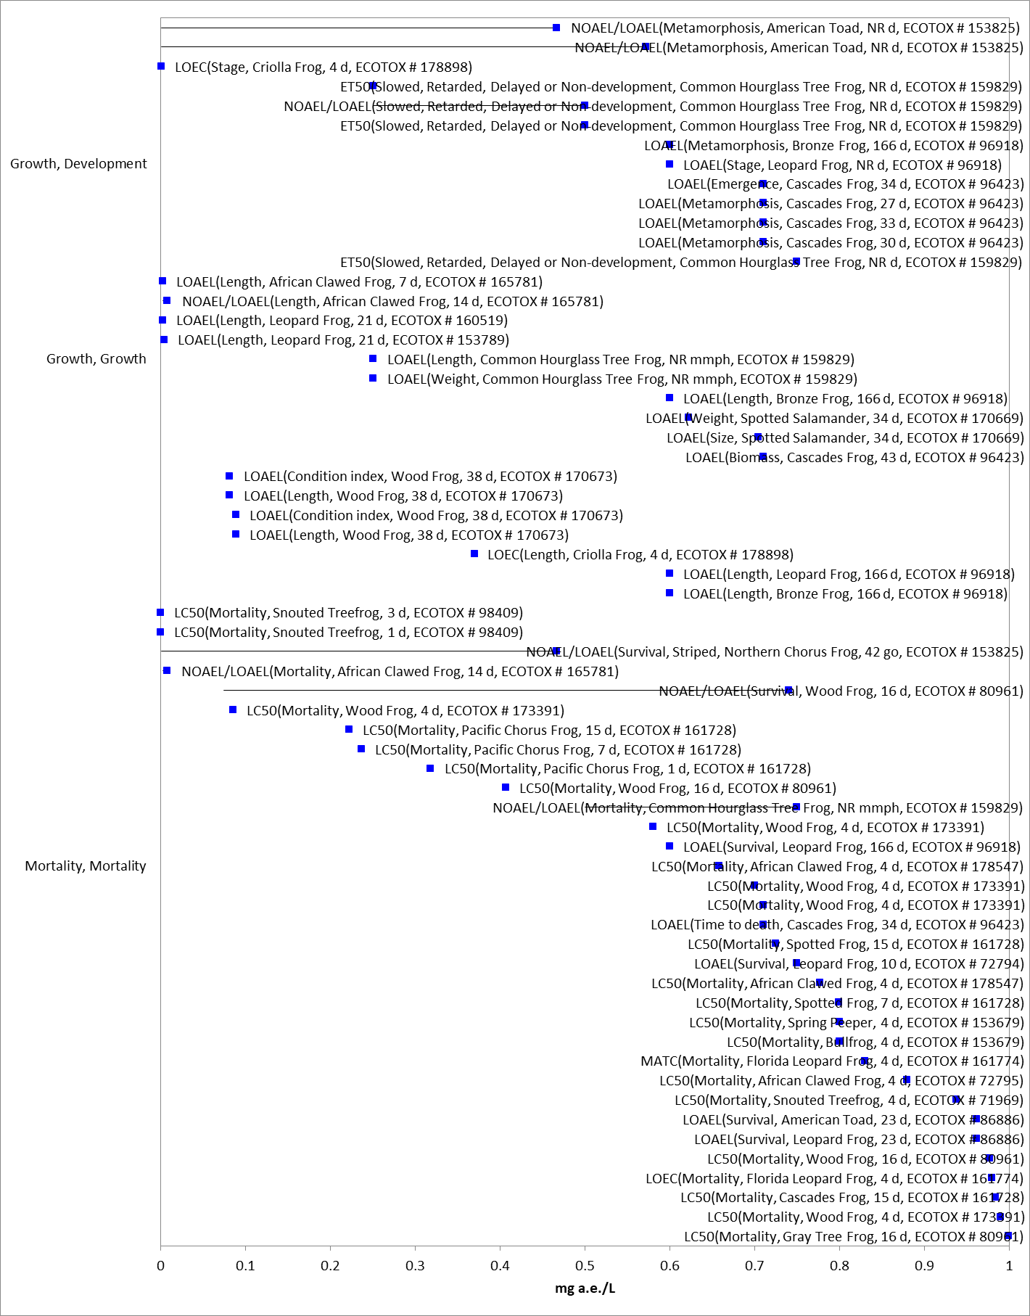
Figure 2-11. Detailed array of growth, reproduction, and mortality data less than 1 mg a.e./L for aquatic-phase amphibians. Blue squares represent LOAEC values from open literature studies found in the ECOTOX database. Solid lines display the range between the LOAEC and NOAEC values. Parentheses present the effect, species, study duration and reference (i.e., MRID, ECOTOX #).

Other Sublethal Effects to Fish and Aquatic-phase Amphibians

Sublethal effects are reported in the ECOTOX literature for a number of other parameters, such as biochemical indicators and physiological effects. The range of effects concentrations observed in the ECOTOX literature is displayed in Figure 2- 12 and Figure 2- 13 for fish and aquatic-phase amphibians, respectively. For fish, although some studies report LOAEC values that are more sensitive than the threshold values for cellular and biochemical markers, most LOAEC values span a concentration range similar to that of the threshold values selected.

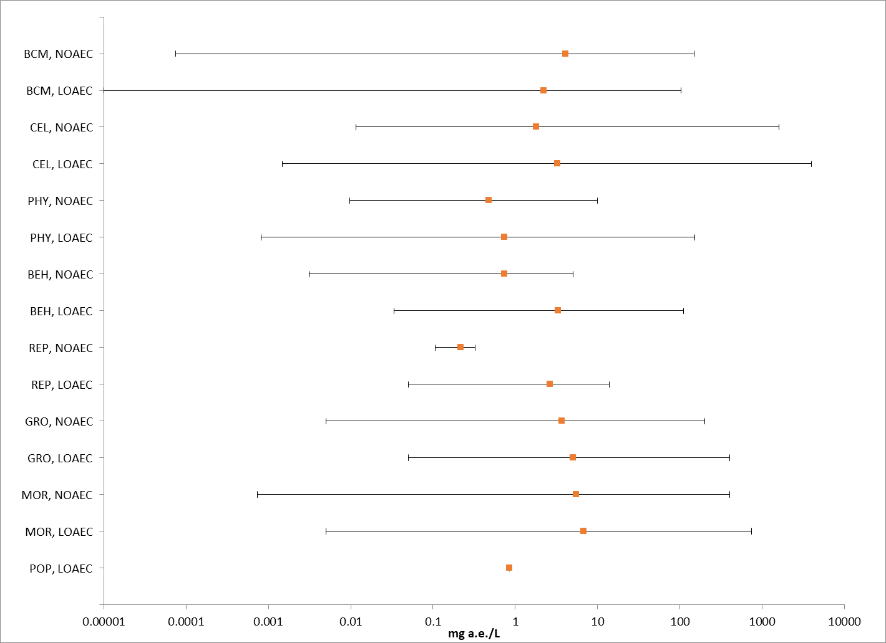
Figure 2-12. Summary array of other sublethal toxicity data for fish in terms of mg a.e./L. BCM = biochemical; CEL = cellular; PHY = physiological; BEH = behavioral; REP = reproduction; GRO = growth; MOR = mortality; POP = population.

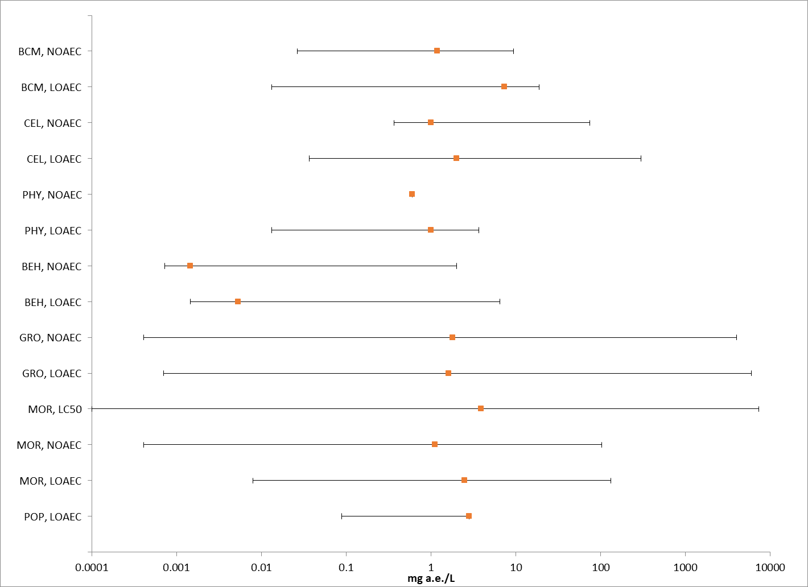
Figure 2-13. Summary array of other sublethal toxicity data for aquatic-phase amphibians in terms of mg a.e./L. BCM = biochemical; CEL = cellular; PHY = physiological; BEH = behavioral; GRO = growth; MOR = mortality; POP = population.

Effects Characterization for Aquatic Invertebrates

Introduction to Aquatic Invertebrate Toxicity

The effects of glyphosate on aquatic invertebrates have been studied extensively, including both freshwater and estuarine/marine (E/M) invertebrates with technical grade or formulated glyphosate. APPENDIX 2-2 includes the bibliography of studies that are included in this effects characterization and those that were excluded. Studies were excluded from the main analysis (i.e., data arrays) if they were considered invalid or the exposure units could not be converted into environmentally relevant concentrations. In this effects characterization, when sufficient data are available for glyphosate, different endpoints are identified for freshwater and estuarine/marine invertebrates. Also, sensitivity of mollusks versus other aquatic invertebrates are discussed, and separate endpoints are derived for mollusks.

The endpoints used to derive mortality and sublethal (i.e., growth and reproduction) thresholds for direct and PPHD effects for aquatic invertebrates are presented in Table 2-10. APPENDIX 2-3 provides the reviews for open literature studies with endpoints used to derive threshold values.

Table 2-10. Summary of the most sensitive endpoints for invertebrates acute and chronic toxicity data for glyphosate.
TAXON | ENDPOINT | TEST SUBSTANCE | REFERENCE | COMMENTS
ACUTE
Freshwater Invertebrates
San Diego Fairy Shrimp  (Branchinecta sandiegonensis) | 24-hour LC₅₀ = 8.7 µg a.e./L | Glyphosate  1 % | E178782  Ripley et al., 2002 | Formulation. No raw data reported
Estuarine/Marine Invertebrates
Mysid shrimp (Americamysis bahia) | LC₅₀ = 765 µg a.e./L | Glyphosate  30.75% | MRID 48934202 | Formulation
Mollusks
Eastern oyster  (Crassostrea virginica) | LC₅₀ = 930 µg a.e./L | Glyphosate  30.75% | MRID 48934204 | Formulation, shell deposition
Freshwater Mussel (Utterbackia imbecillis) | LC₅₀ = 13,542 µg a.e./L | Glyphosate  18% | E74236 | Formulation, mortality
CHRONIC
Freshwater Invertebrates
Water flea  (Daphnia magna) | NOAEC = 333 µg a.e./L  LOAEC = 999 µg a.e./L  (MATC = 576.8 µg a.e./L) | Glyphosate-IPA | E161204 | TGAI; reduced juvenile weight.
Estuarine/Marine Invertebrates
Blue crab  (Callinectes sapidus) | LOAEC = 4070 µg a.e./L | Glyphosate-IPA  50.2% | E161498  Osterberg et al. 2013 | Formulation. Based on delayed metamorphosis and ~20% mortality.

Effects on Mortality of Aquatic Invertebrates

Numerous acute toxicity studies for aquatic invertebrates are available for both technical grade and formulated glyphosate, representing a wide variety of species (Appendix 2-5). LC₅₀ values for technical glyphosate range from 0.10 to 648 mg a.e./L and values for formulated glyphosate range from 0.0087 to 957.3 mg a.e./L.

Freshwater Invertebrates
Figure 2- 14 and Figure 2- 15 present arrays of the most sensitive median lethal concentration (LC₅₀) values for technical and formulated glyphosate, respectively, for freshwater invertebrates.

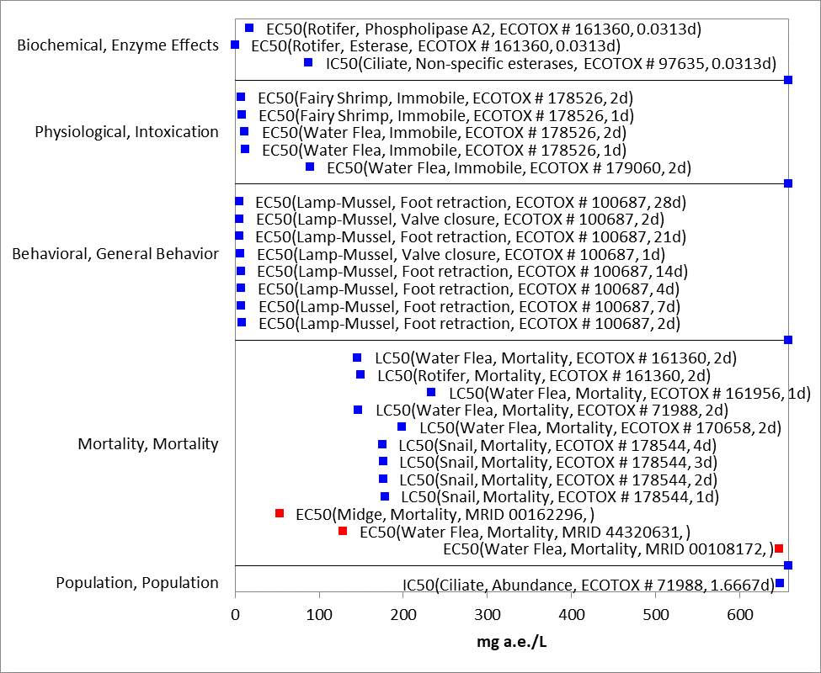
Figure 2-14. Glyphosate TGAI toxicity to freshwater invertebrates. Blue squares represent LC₅₀ values from open literature studies found in the ECOTOX database, red squares represent registrant-submitted data. The information in parentheses includes the species, endpoint, reference (MRID or ECOTOX ID), and study duration in days.

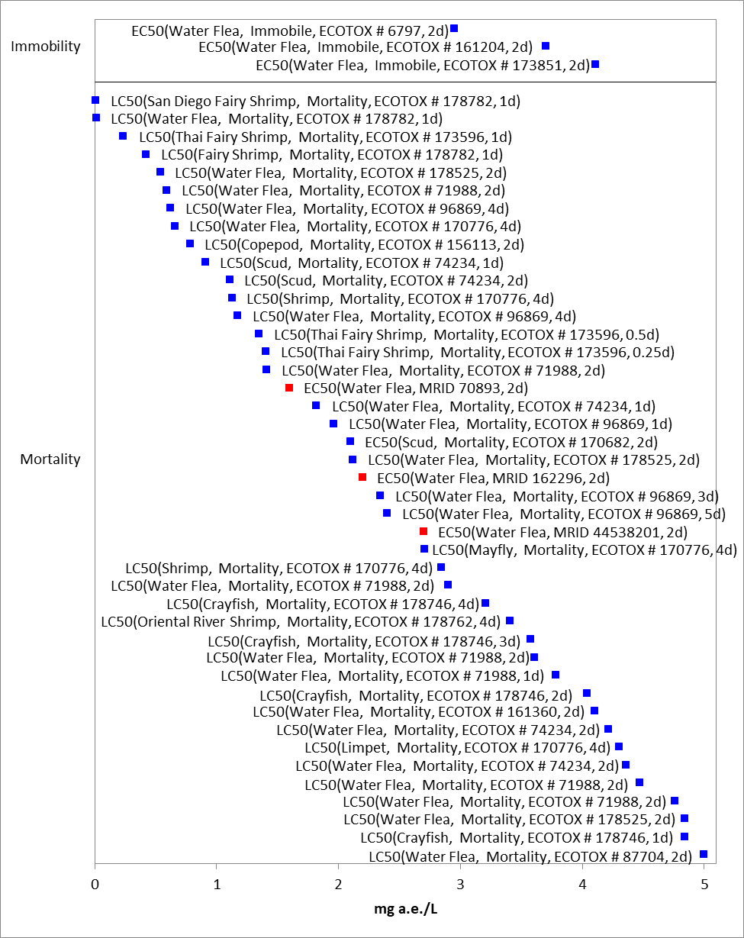
Figure 2-15. Detailed array of mortality data ≤ 5 mg a.e./L for freshwater invertebrates exposed to glyphosate formulations. Blue squares represent LC₅₀ values from open literature studies found in the ECOTOX database, red squares represent registrant-submitted data. The information in parentheses includes the species, endpoint, reference (MRID or ECOTOX ID), and study duration in days.

To evaluate the relative difference in toxicity of technical grade and formulated glyphosate, available acute toxicity endpoints for Daphnia magna are compared in Figure 2- 16. This figure shows measurements of both mortality data and immobility. This figure shows that endpoints from studies conducted with the technical glyphosate (identified with blue squares) are less sensitive than the most sensitive endpoints from studies conducted with the formulated product (identified with red squares). Like toxicity in aquatic vertebrates, there is no discernible trend in the amount of active ingredient and relative toxicity, suggesting the range of sensitivities may be due to the individual components of the formulations (i.e., inert ingredients, surfactants).

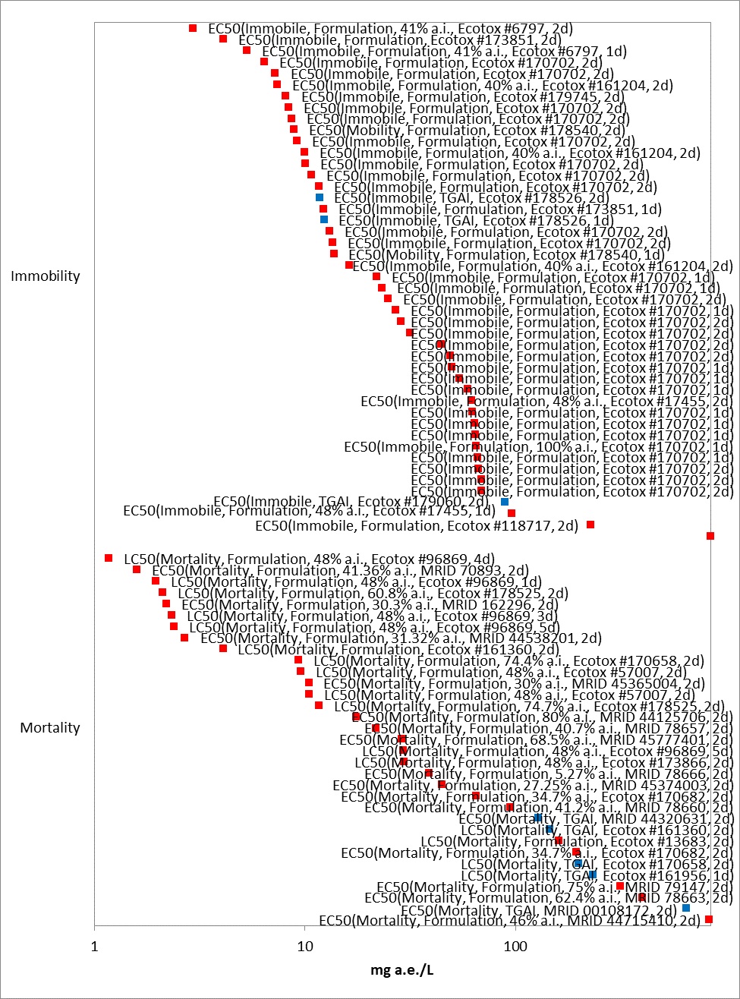

Figure 2-16. Data array of the acute toxicity of technical and formulated glyphosate to Water Fleas (Daphnia magna), X-axis presented in log scale. Blue squares represent studies conducted with technical glyphosate, red squares represent studies conducted with formulated glyphosate. The information presented in parentheses includes the endpoint; whether technical or formulated glyphosate was tested; the percent active ingredient (when reported); the study reference; and study duration in days.

Given the variability in the components of the formulations used in the acute toxicity studies, it is not possible to derive a species sensitivity distribution (SSD). The most sensitive endpoint from a study conducted with formulated glyphosate is 8.7 µg a.e./L, from an open literature study conducted with the San Diego Fairy Shrimp (Branchinecta sandiegonensis) (E178782). The San Diego Fairy Shrimp is a listed anostracan crustacean species found in vernal pools in the Pacific Southwest Region of the United States. Appropriate husbandry practices require study conditions that deviate from standard EPA protocols, otherwise the experimental conditions followed EPA recommendations current at the time of publication. Additional open literature studies conducted abroad also point to relatively high sensitivity of freshwater anostracans to glyphosate formulations, though the formulations tested may be different from U.S. registrations (Boonsoong and Bullangpoti 2012, E173596; Morgan et al. 2019, E178834). The endpoint was used in the analysis because the study is scientifically sound and directly relevant to endangered species. The alternative endpoint for freshwater invertebrate mortality for technical glyphosate is based on the most sensitive acute 48-h LC₅₀ value of 7 mg a.e./L for Fairy Shrimp (Dendrocephalus brasiliensis) for immobility (E178526).

Substantially fewer studies are available on the acute toxicity of technical and formulated glyphosate to estuarine/marine invertebrates. Figure 2- 17 presents the most sensitive toxicity values for estuarine/marine acute toxicity. The estuarine/marine invertebrate mortality threshold for formulated glyphosate is based on the most sensitive acute 96-h LC₅₀ value of 0.765 mg a.e./L for Mysid Shrimp (Americamysis bahia) tested with a 30.75% a.i. formulation (MRID 48934202). The alternative endpoint for technical glyphosate is based on the acute 48-h LC₅₀ value of 35.3 mg a.e./L, from a test using Calenoid Copepods (Arcatia tonsa) (E71988). Separate endpoints were derived for aquatic mollusks, which are further discussed below.

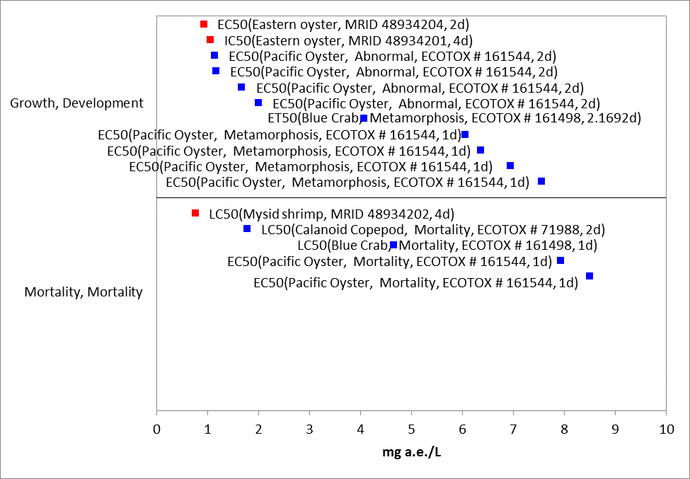
Figure 2-17. Detailed array of growth and mortality data < 10 mg a.e./L for estuarine/marine invertebrates exposed to glyphosate formulations. Blue squares represent LOAEC values from open literature studies found in the ECOTOX database, red squares represent registrant-submitted data. Solid lines display the range between the LOAEC and NOAEC values. Parentheses present the species, effect, reference (i.e., MRID, ECOTOX #), and study duration.

Mollusks
Mortality data for aquatic mollusks is sparse. Most of the available glyphosate toxicity tests examined sublethal effects, rather than mortality. The available acute toxicity data, including both mortality and sublethal effects, are presented in Figure 2- 18. The most sensitive mortality endpoint is an LC50 of 13.54 mg a.e./L in Freshwater Mussel (Utterbackia imbecillis) glochidia exposed to a formulated product (18% a.i.) (E74236). The alternative endpoint, toxicity of the technical grade, was LC50 = 175.1 mg a.e./L using Golden Apple Snail (Pomacea canaliculata) (E178544).

Many acute studies report sublethal effects of technical grade glyphosate and formulations on aquatic mollusks, as shown above in figure 5. The sublethal endpoint for a glyphosate formulation was a 48h EC50 = 0.930 mg a.e./L; (30.75% formulation); Eastern oyster (Crassostrea virginica); MRID 48934204. The alternative endpoint, toxicity of the technical grade, was EC₅₀ = 40 mg a.e./L for shell deposition in Pacific oyster (Crassostrea gigas); MRID 44320634.

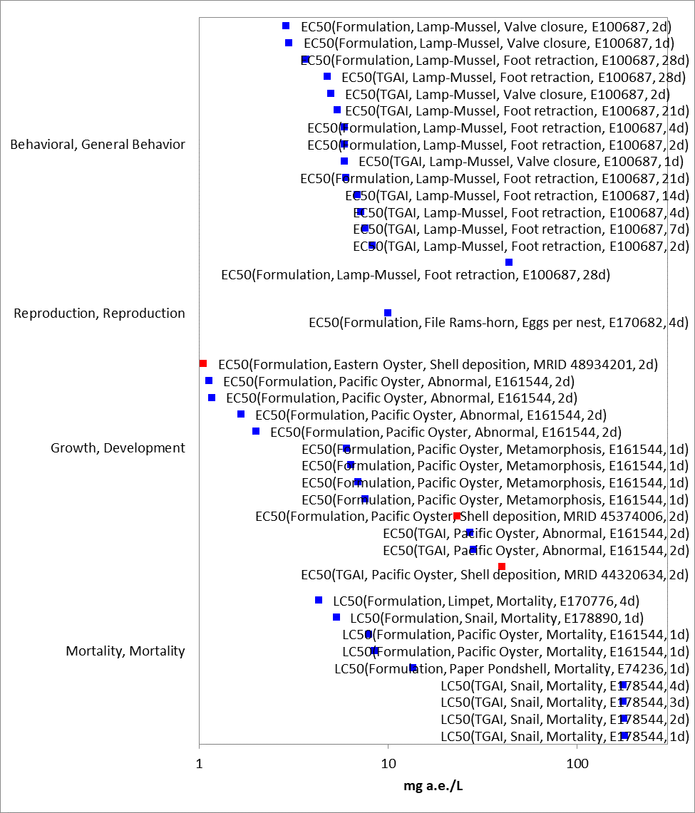
Figure 2-18. Data array of the acute toxicity of technical and formulated glyphosate to mollusks. Blue squares represent LOAEC values from open literature studies found in the ECOTOX database, red squares represent registrant-submitted data. Solid lines display the range between the LOAEC and NOAEC values. Parentheses present the test material, species, effect, reference (i.e., MRID, ECOTOX #), and study duration.

Effects on Growth and Reproduction of Aquatic Invertebrates

Chronic tests were significantly more sparse than acute tests. Sublethal effects for TEP registered in the United States were not available for freshwater invertebrates; Figure 2- 19 presents a summary of toxicity data from non-US registered products. Figure 2- 20 presents a summary of toxicity of technical glyphosate to freshwater invertebrates.

The selected endpoint for sublethal effects on freshwater invertebrates was therefore NOAEC = 0.333, LOAEC = 0.999 mg a.e./L, MATC = 0.577 mg a.e./L, from an open literature study on Daphnia magna using technical grade glyphosate (E161204).

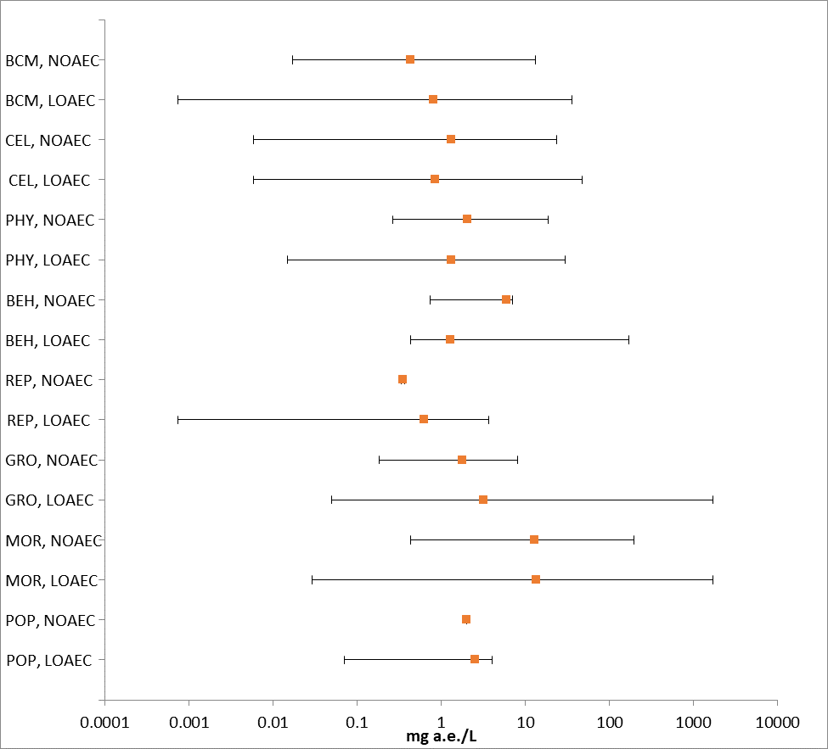
Figure 2-19. Summary of glyphosate formulation sublethal toxicity data for freshwater invertebrates. Bars show the range between the NOAEC and the LOAEC. BCM = biochemical; CEL = cellular; PHY = physiological; BEH = behavioral; REP = reproduction; GRO = growth; MOR = mortality; POP = population.

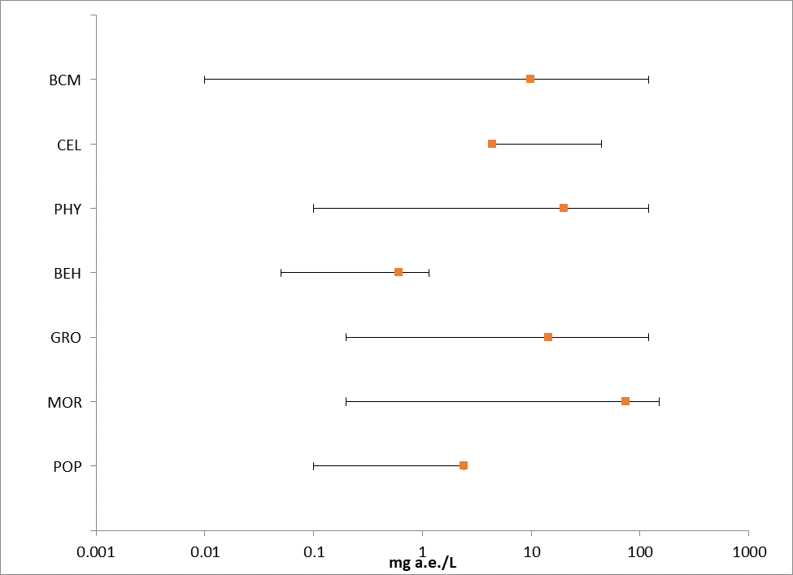
Figure 2-20. Summary of TGAI sublethal toxicity data for freshwater invertebrates in terms of mg a.e./L. Bars show the range between the NOAEC and the LOAEC. BCM = biochemical; CEL = cellular; PHY = physiological; BEH = behavioral; REP = reproduction; GRO = growth; MOR = mortality; POP = population.

Figure 2- 21 and Figure 2- 22, below, present summaries of formulated and technical grade glyphosate toxicity to estuarine/marine invertebrates, respectively. The endpoint for sublethal effects to estuarine/marine invertebrates was a LOAEC of 4.07 mg a.e./L based on delayed development and 20% mortality upon exposure to a 50.2% a.i. glyphosate formulation at the LOAEC (E161498). The freshwater TGAI value is used as the alternative endpoint.

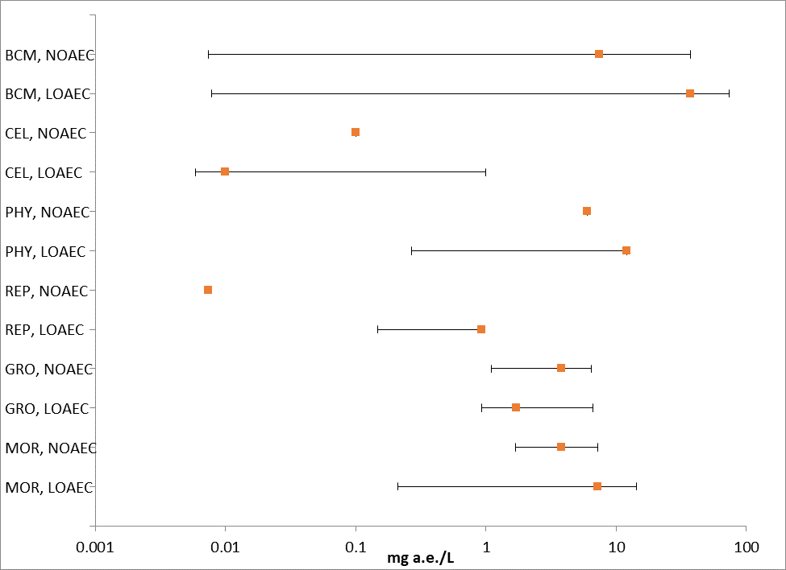
Figure 2-21. Summary of glyphosate formulation sublethal toxicity data for estuarine/marine invertebrates. BCM = biochemical; CEL = cellular; PHY = physiological; BEH = behavioral; REP = reproduction; GRO = growth; MOR = mortality; POP = population.

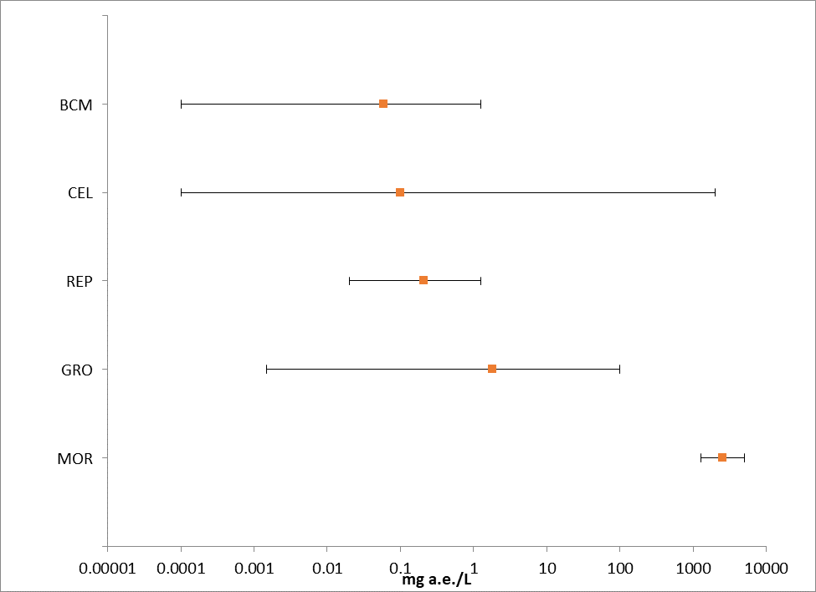
Figure 2-22. Summary of TGAI sublethal toxicity data for estuarine/marine invertebrates in terms of mg a.e./L. Bars show the range between the NOAEC and the LOAEC. BCM = biochemical; CEL = cellular; PHY = physiological; BEH = behavioral; REP = reproduction; GRO = growth; MOR = mortality; POP = population.

Effects Characterization for Aquatic Plant toxicity

Introduction to Aquatic Plant Toxicity

Most of the available toxicity studies with aquatic plants have focused on growth, reproduction, physiological effects, and population effects. Threshold values and effects data arrays in this assessment are based on endpoints expressed in, or readily converted to, environmentally relevant concentrations in terms of the amount of glyphosate (i.e., µg a.i./L).

Discussion of endpoints are provided for effects on aquatic plants and aquatic plant communities. These serve as a surrogate for effects on an individual of a listed species and the effects on PPHD of a listed species, respectively.

Effects on Aquatic Plants

Single-species aquatic plant toxicity studies are used as one of the measures of effect to evaluate whether glyphosate may affect primary production and diversity in aquatic ecosystems. Numerous aquatic plant toxicity studies have been submitted to the EPA and/or published in the open literature. Figure 2- 23 and Figure 2- 24 present a summary of the range of toxicity values available for non-vascular and vascular aquatic plants, respectively.

Biochemical (BCM) and cellular (CEL) endpoints include measures of various enzymatic responses; carbon assimilation; oxygen production; fluorescence; photosystem II inhibition; chlorophyll a/b production; chloroplast size; photosynthesis. While several of these measures are clearly relevant to apical endpoints, especially growth, these endpoints are naturally variable with potential for rapid recovery and the study designs generally do not allow for connection to apical endpoints or are for short durations that would not capture the potential for recovery. This was particularly true for the most sensitive endpoints from these groupings. For these reasons, the following discussions of the single species aquatic toxicity data will focus on growth effects. These are sometimes captured under population level effects and represent the most sensitive endpoints. For unicellular plants, the population effects are typically measures of the numbers of individual cells in a population, such that decreases in population are considered equivalent to measures of increased mortality.

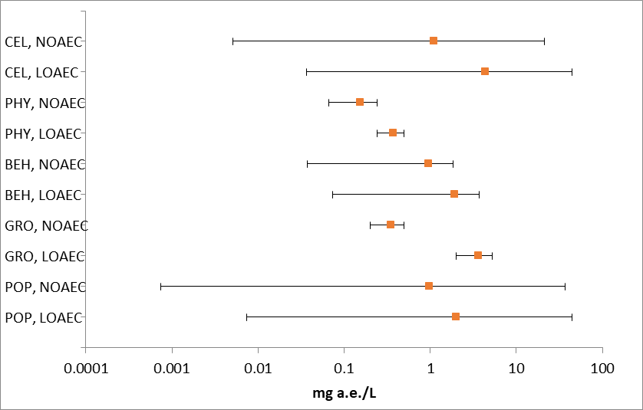
Figure 2-23. Summary array of single-species toxicity data for non-vascular aquatic plants expressed in terms of mg a.e./L. CEL = cellular; GRO = growth; MOR = mortality; PHY = physiology; POP = population;

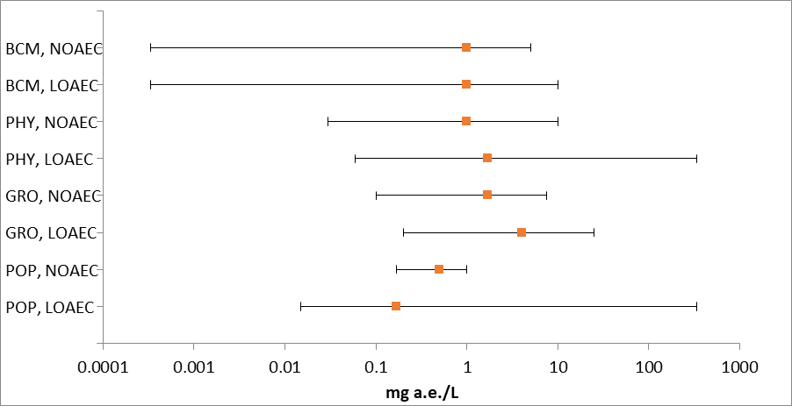
Figure 2-24. Summary array of single-species toxicity data for vascular aquatic plants expressed in terms of mg a.e./L. BCM = biochemical; GRO = growth; MOR = mortality; PHY = physiology; POP = population;

Effects on Growth of Non-Vascular aquatic plants

Numerous aquatic non-vascular plant toxicity studies have been submitted to EPA and/or published in the open literature, representing a broad diversity of unicellular and multicellular organisms collectively referred to as “non-vascular aquatic plants”. These include Eubacteria (e.g., blue-green algae), Archaeoplastida (e.g., red algae, glaucophytes, green algae, and aquatic bryophytes), Chromalveolates (e.g., aveolates, cryptomonads, dinoflagellates, diatoms, water molds, and brown algae), Excavates (e.g., euglena), and a few lineages of the Unikonts (e.g., fungi, and collared-flagellates). These single-species toxicity studies serve as the foundation for evaluating whether glyphosate may affect primary production and diversity in the aquatic ecosystem.

Figure 2- 25 presents the range of toxicity data for non-vascular aquatic plants available from registrant submitted and open literature studies for both technical and formulated glyphosate.

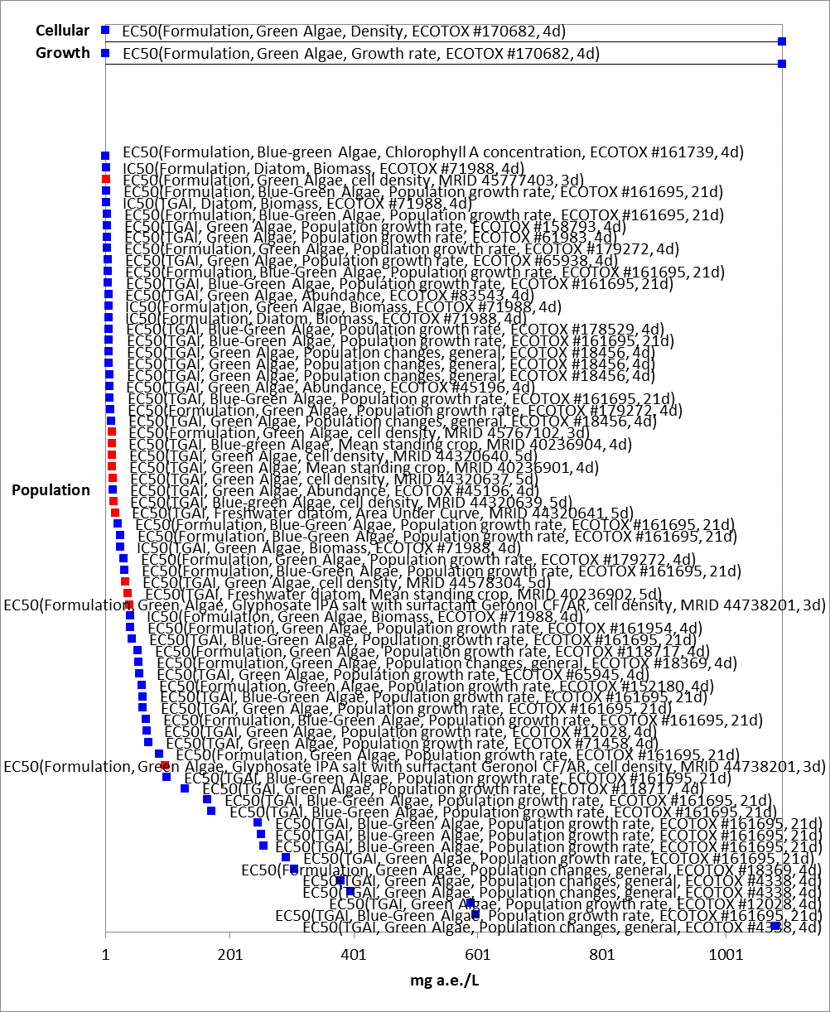
Figure 2-25. Detailed array of toxicity of technical and formulated glyphosate on aquatic nonvascular plants. Blue squares represent LOAEC values from open literature studies found in the ECOTOX database, red squares represent registrant-submitted data. Solid lines display the range between the LOAEC and NOAEC values. Parentheses present the test material, species, effect, reference (i.e., MRID, ECOTOX #), and study duration.

Effects were observed on various measures of growth, including abundance (number of cells, cell density), volume, growth rate, population growth rate, and biomass. A study and species combination may be represented multiple times based on what was being measured and/or time of observation.

The thresholds for aquatic non-vascular plants are derived from a registrant-submitted study that reported effects of a formulated product on cell density of Skeletonema costatum, with a 96-h IC₅₀ of 100 µg a.e./L and NOAEC and LOAEC of 17.3 µg a.e./L and 36.8 µg a.e./L respectively, which results in a MATC of 25.2 µg a.e./L. The formulation contained 31% a.i., and it is uncertain whether it contains POEA (MRID 45666703).

The threshold MATC of 0.841 mg a.e./L for the alternative analysis came from the most sensitive registrant-submitted test that used technical glyphosate (glyphosate trimesium, a glyphosate salt) in a toxicity test with Anabaena flos-aquae (MRID 44578305). The IC₅₀ for the alternative analysis is derived from the HC₀₅ from an SSD, detailed below.

While there are more sensitive endpoints in the ECOTOX database, they are not suitable for use as a threshold due to study deficiencies or insufficient information provided in the study report to evaluate the methods or results (see Appendix 2-5 for details). These studies are displayed on Figure 2- 25.

Effects on Growth of Aquatic Vascular Plants

Glyphosate toxicity to vascular plants has been tested in both registrant-submitted and open literature studies. The most commonly tested aquatic vascular plants are Duckweed (Lemna minor), Inflated Duckweed (L. gibba), and Lesser Duckweed (L. aequinoctialis). The data array below (Figure 2- 26) shows the available acute toxicity data for the TGAI and multiple formulations. The TGAI EC₅₀s range from 0.70 mg a.e./L to 65.4 mg a.e./L. The formulation EC₅₀s range from 0.22 mg a.e./L to 34.7 mg a.e./L.

The selected endpoints for formulation toxicity to aquatic vascular plants were derived from effects on L. gibba frond number, with a NOAEC of 0.29 mg a.e./L, a MATC of 0.59 mg a.e./L, and a 14d IC₅₀ of 1.5 mg a.e./L; (MRID 44125714).

The alternative endpoint for the IC₅₀ for aquatic plants was derived from the SSD for technical glyphosate, described below. The MATC, 0.77 mg a.e./L is derived from a test using L. gibba (MRID 44578303).

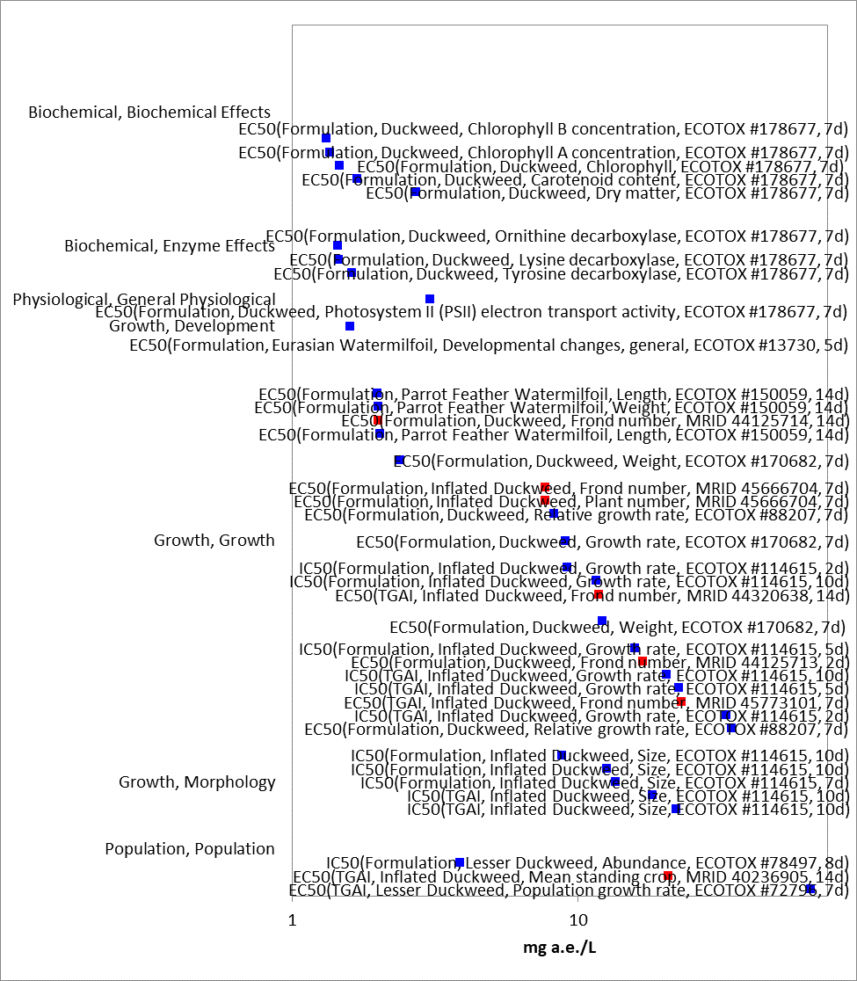
Figure 2-26. Detailed array of toxicity of technical and formulated glyphosate on aquatic vascular plants. Blue squares represent LOAEC values from open literature studies found in the ECOTOX database, red squares represent registrant-submitted data. Solid lines display the range between the LOAEC and NOAEC values. Parentheses present the test material, species, effect, reference (i.e., MRID, ECOTOX #), and study duration.

In addition, toxicity studies that evaluated survival and growth were available for several species of emergent aquatic plants. Studies were conducted either in a greenhouse or outdoors using a glyphosate formulation (MON 78087; 31.2% glyphosate acid equivalent) in which plants were over-sprayed. Wetland species are discussed further in the terrestrial plant section due to similarities in exposure (overspray in lb a.e./A units). Waterlily (Nymphea odorata) fresh weight EC₂₅ was 0.044 kg a.e./ha (0.039 lb a.e./A) (PMRA 494460).

Effects on Aquatic Plant Communities

Median effect concentration (EC₅₀) values for aquatic plants are used to derive the threshold for effects to the PPHD of an individual of a listed species. Studies with effects on measures of growth (e.g., biomass, cell counts, number of fronds, etc); were conducted with technical grade glyphosate or glyphosate salt; and had 4-day, 7-day, or 14-day exposure durations were used to derive a Species Sensitivity Distribution (SSD). These parameters were selected to maximize comparability of results. Studies used to derive the SSD are compiled in APPENDIX 2-5.

Table 2-11. Summary Statistics for Aquatic Plant SSD Fit to Glyphosate Test Results.
Statistic | All  Aquatic Plants  (mg a.e./L)
Best Distribution (by AIC_{c}) | Gumbel
Goodness of fit  P-value | 0.1269
CV of the HC₀₅ | 0.15
HC₀₅ | 5.0
HC₁₀ | 5.5
HC₅₀ | 8.4
HC₉₀ | 16.4
HC₉₅ | 21.1

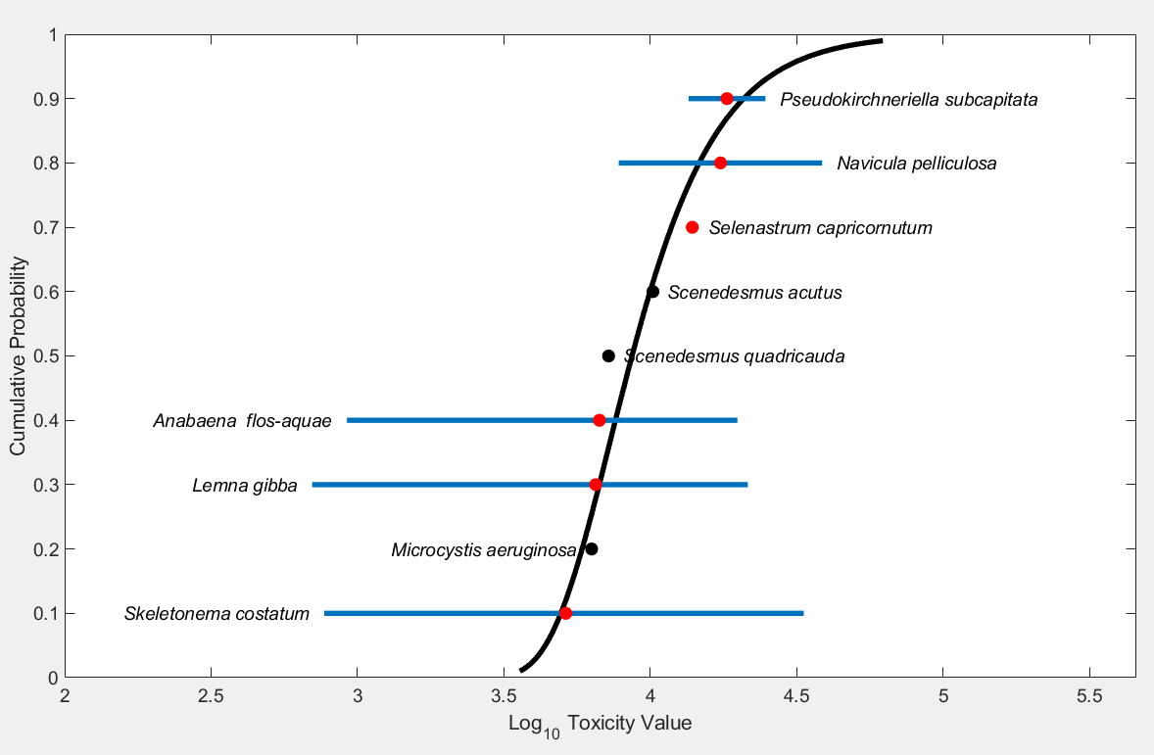
Figure 2-27. Log-logistic SSD for glyphosate toxicity values for all aquatic plants pooled. Black points indicate single toxicity values. Red points indicate average of multiple toxicity values for a single species. Blue line indicates full range of toxicity values.

The HC₀₅ was less sensitive than the lowest formulation endpoint, an EC50 of 0.77 mg a.e./L for population growth rate at 2.1 mg a.e./L described for Anabaena catenula in Lipok et al. 2010 (E161695). The lowest available formulation endpoint for Skeletonema costatum, the most sensitive species in the SSD, was an IC₅₀ of 1.85 mg a.e./L for biomass (E71988).

In addition to reviewing the toxicity data for individual species and deriving SSDs, the toxicity of glyphosate to aquatic plant communities is evaluated by considering microcosm and mesocosm (cosm) data available in the open literature. Cosm studies conducted with glyphosate provide measurements of primary productivity that incorporate the aggregate responses of multiple species in aquatic plant communities. Because plant species vary widely in their sensitivity to glyphosate, the overall response of the plant community may be different from the responses of the individual species measured in laboratory toxicity tests. Cosm studies allow observation of population and community recovery from glyphosate effects and of indirect effects on higher trophic levels. In addition, cosm studies, especially those conducted in outdoor systems, incorporate partitioning, degradation, and dissipation, factors that are not usually accounted for in laboratory toxicity studies, but that may influence the magnitude of ecological effects.
Several mesocosm studies on technical and formulated glyphosate showed suppression of periphyton assemblages and biofilm communities by technical glyphosate and several formulations. Perez et al., 2007, assessed the effect of a glyphosate formulation using artificial earthenware mesocosms. Phytoplankton abundance decreased in the treated mesocosms, with a 1d NOAEC of 5.45 mg a.e./L, while cyanobacteria abundance increased. Periphyton assemblages showed an increased proportion of dead : live individuals and about a 4.5 fold increased abundance of cyanobacteria (E103499). Sura et al., 2012, reported that application of a glyphosate formulation suppressed algal biomass and production in pelagic and biofilm communities in a 22-d study using outdoor mesocosms, with a LOAEC of 0.166 mg a.e./L (E161755). Gattas et al., 2016, reported that application of a glyphosate formulation initially increased the abundance of picoplankton (at day 13), but growth had slowed and abundance declined by the end of the study period (at day 34), with a LOAEC between 3 and 7 mg a.e./L. Bacterial populations were initial depressed by application of the formulation but recovered to meet or slightly exceed control populations by the end of the study. In the presence of freshwater mussels (Limnoperna fortunei), bacterial populations were not able to recover from the initial reduction.

Because the phytoplankton community represents the primary producers (food items) for the aquatic ecosystem, reduced and delayed growth would have negative effects on the organisms that rely upon phytoplankton for food and could cause effects throughout the trophic system. Reduction and/or delays in the growth of macrophytes and metaphyton (algae mats) growth, would result in a delay in the habitat structural maturation for use by amphibian, fish and invertebrate taxa. The taxa that may be most affected by these delays or reductions would likely be those taxa that rely upon the macrophytes and metaphyton for reproduction and protection of young during primary glyphosate runoff periods, which includes a wide diversity of animal lineages.

Effects Characterization for Birds

Introduction to Bird Toxicity

The effects of glyphosate on birds have been studied extensively. Studies were excluded if they were considered invalid or not associated with an environmentally relevant exposure route.

Effects on Mortality of Birds

Acute dose-based toxicity data on selected avian species are available for technical glyphosate, several formulations and the AMPA degradate (Table 2- 12). No mortality was observed in the available dose-based acute studies conducted with technical glyphosate at concentrations up to 4570 mg a.e./kg-bw. The acute dose-based mortality threshold is based on the LD₅₀ value of 1131 mg a.e./kg-bw from a study where bobwhite quail were orally gavaged with a 68.5% glyphosate formulation (MRID 45777402). The difference in sensitivity between technical and formulated glyphosate may also be due to the individual components of the formulations (i.e., inert ingredients, surfactants). It is uncertain how representative the tested formulation is of all glyphosate formulations. Given the limited number of formulations tested, it is possible that the available data due not capture the most toxic formulations. The alternative endpoint for avian mortality for technical glyphosate is based on the highest concentration with no mortalities of 4570 mg a.e./kg-bw for the bobwhite quail (MRID 00076492).

Table 2-12. Avian acute dose-based toxicity data for technical and formulated glyphosate.
Test Substance | Species | % a.i.¹ | LD₅₀  mg a.e./kg bw^{1,2}  (Confidence Intervals) | Reference
Technical Glyphosate | Bobwhite quail (Colinus virginianus) | 83 | >3196.3 (N.A.) | MRID 00108204
Technical Glyphosate | Bobwhite quail (Colinus virginianus) | 98.5 | >4570 (N.A.) | MRID 00076492
Technical Glyphosate | Canary (Serinus canaria) | 96 | >2,000 | MRID 4893406
Trisodium diglyphosate/Urea (Polado formula; MON 8000) | Bobwhite quail (Colinus virginianus) | 75 | >780 (N.A.) | MRID 00085638
Glyphosate monoammonium salt (MON 14420) | Bobwhite quail (Colinus virginianus) | 68.5 | 1131 (925 - 1541) | MRID 45777402
1 a.e. = acid equivalent
2 N.A. = not available, N.R. = not reported

Acute dietary-based toxicity data on selected avian species are available for technical glyphosate and two formulations (Table 2- 13). No mortalities were observed in the available sub-acute dietary-based exposure studies conducted with technical grade or formulated glyphosate at concentrations up to 4971 mg a.e./kg-diet. Given the limited number of formulations tested, it is possible that the available data due not capture the most toxic formulations.

Table 2-13. Avian acute dietary-based toxicity data for technical and formulated glyphosate.
Test Substance | Species | % a.i.¹ | LC₅₀  mg a.e./kg diet¹ | Reference
Technical Glyphosate | Mallard duck (Anas platyrhynchos) | 98.5 | >4570.4 | 108107/37765
Technical Glyphosate | Bobwhite quail (Colinus virginianus) | 95.6 | >1912 | MRID 44320626
Technical Glyphosate | Mallard duck (Anas platyrhynchos) | 95.6 | >4971.2 | MRID 44320627
Technical Glyphosate | Bobwhite quail (Colinus virginianus) | 95.6 | >4971.2 | MRID 44320628
Trisodium diglyphosate/Urea (Polado formula; MON 8000) | Bobwhite quail (Colinus virginianus) | 75 | >1770 | MRID 00085639
Trisodium diglyphosate/Urea (Polado formula; MON 8000) | Mallard duck (Anas platyrhynchos) | 75 | >1770 | MRID 00085640
Glyphosate isopropylamine salt (MON65005) | Mallard duck (Anas platyrhynchos) | 31.32 | > 1760 | MRID 44465701
Glyphosate isopropylamine salt (MON65005) | Bobwhite quail (Colinus virginianus) | 31.32 | > 1760 | MRID 44465702
1 a.e. = acid equivalent

Effects on Growth and Reproduction of Birds

Limited data are available on the effects of technical or formulated glyphosate on the growth and reproduction of birds (Table 2- 14). In an avian reproduction study evaluating the toxicity of technical glyphosate on mallard duck, significant decreases of 99%, 59%, and 127% in male body weight gain were observed at the low-, mid-, and high- test concentration, respectively (LOAEC = 501 mg a.e./kg; MRID 48876602). Treatment-related decreases in hatchling and 14-day body weights were observed at the highest and lowest test concentrations. There were no treatment-related effects on eggs laid, embryo viability, or eggshell thickness in this study. An additional qualitative study from the open literature, Kubena et al. 1981, reports effects of 50% reduction in male and female body weights for domesticated chickens (Gallus gallus domesticus) at glyphosate concentrations of 4505 mg a.e./kg-diet. There are two additional registrant submitted studies conducted with technical glyphosate, where effects on growth or reproduction were not observed following exposure to either mallards or bobwhite quail up to concentrations of 830 mg a.e./kg-diet (MRID 00111953 and 00108207).

Based on the available data on growth and reproduction, the sublethal toxicity threshold for Step 1 and 2 is 501 mg a.e./kg-diet based on growth effects observed in the mallard duck. Given the limited number of formulations tested, it is possible that the available data due not capture the most toxic formulations.

Table 2-14. Effects of technical grade glyphosate on avian growth and reproduction.
Test Substance | Species | % a.i.¹ | NOAEC  mg a.e./kg diet¹ | LOAEC  mg a.e./kg diet¹ | Effect | Reference
Technical Glyphosate | Mallard duck (Anas platyrhynchos) | 96 | <501 | 501 | based on effects to male weight gain and offspring weight. | MRID 48876602
Glyphosate isopropylamine | Chicken (Gallus gallus domesticus) | NR | 608 | 6080 | 50% reduction in male and female body weight by day 7 | E162010/Kubena et al. 1981
1 a.e. = acid equivalent

Other sublethal effects to Birds

There is one study available in the open literature that described sublethal effects other than growth and reproduction. In Oliveira et al. (2007; E97136), mallard duck drakes were exposed to a Brazilian formulation of Roundup containing 360 g/L of glyphosate and 480 g/L of the IPA salt in drinking water. Study authors reported significant reductions (90%, p< 0.05) in plasma testosterone at 5 and 100 mg/kg-bw as well as alterations in the structure of the testis and epididymal region. It is uncertain how these sublethal effects may relate to apical endpoints. In addition, this study is suitable for qualitative use only as it is uncertain whether the formulation tested is representative of US formulations.

Drinking water studies

The only study that evaluated drinking water exposure in birds is Oliveira et al. 2007 (E97136) and is discussed above.

Dermal studies

No studies involving avian dermal exposure were identified in registrant studies or the ECOTOX database.

Inhalation studies

No studies involving avian exposure via inhalation were identified in registrant studies or the ECOTOX database.

Effect Characterization to Reptiles

As no additional data are available on reptilian toxicity to glyphosate in relevant units, the available toxicity data for birds are used as a surrogate for reptiles.

Effect Characterization to Terrestrial-phase Amphibians

There are two studies in the open literature that evaluated the effects of glyphosate on terrestrial-phase amphibians that were in relevant units. They are considered for qualitative use only because of limitations in study reporting. In an acute oral study by McComb et al. 2008 (E162011), the 96-hr LD₅₀ value for field-collected (prior exposure history unknown) rough-skinned newts (Taricha granulosa) exposed to technical glyphosate was greater than 2,600 mg/kg-bw (unsure if adjusted to acid equivalents). This value is consistent with the endpoints for birds from studies conducted with technical glyphosate. Control mortality was not reported in the study. In a field study (Bernal et al. 2009, E11766) where eight species of juvenile frogs (in Columbia) received a direct spray of a mixture of glyphosate formulations Glyphos and Cosmo-flux, reported 96-hr LC₅₀ values ranged from 4.0 – 20.3 lb a.e./A.

As no additional quantitative data are available on terrestrial-phase amphibian toxicity to glyphosate, the available toxicity data for birds are used as a surrogate for terrestrial-phase amphibians.

Effects Characterization for Mammals

Introduction to Mammal Toxicity

The effects of glyphosate on mammals have been studied extensively. Studies were excluded if they were considered invalid or not associated with an environmentally relevant exposure route.

Effects on Mortality of Mammals

Numerous acute toxicity studies for mammals are available for both technical grade and formulated glyphosate, representing a wide variety of species (Appendix 2-4). To evaluate the relative difference in toxicity of technical grade and formulated glyphosate, available toxicity endpoints for the laboratory rat are arrayed in Figure 2- 28. While the vast majority of endpoints presented in the figure are non-definitive regardless of whether the study was conducted with technical or formulated glyphosate, the most sensitive definitive endpoint for formulated glyphosate is more than an order of magnitude less sensitive than the highest concentration tested with technical glyphosate that resulted in no effects. When comparing endpoints across studies conducted with formulated glyphosate, it appears that the % active ingredient has an influence on toxicity, with the most sensitive endpoints for formulations with the least amount of active ingredient. This suggests that sensitivities may be an artifact of correcting for percent active ingredient. However, given the limited number of definitive endpoints in the available data, it is not possible to definitively conclude this. The range in sensitivities may also be due to the individual components of the formulations (i.e., inert ingredients, surfactants).

The acute dose-based mortality threshold is based on the LD₅₀ value of 357 mg a.e./kg-bw from a study where laboratory rats were orally gavaged with an 11.4% glyphosate formulation (MRID 46714802). It is uncertain how representative the tested formulation is of all glyphosate formulations. The alternative endpoint for mammalian mortality for technical glyphosate is based on the highest concentration with no mortalities of 4860 mg a.e./kg-bw for the lab rat (MRID 46760505).

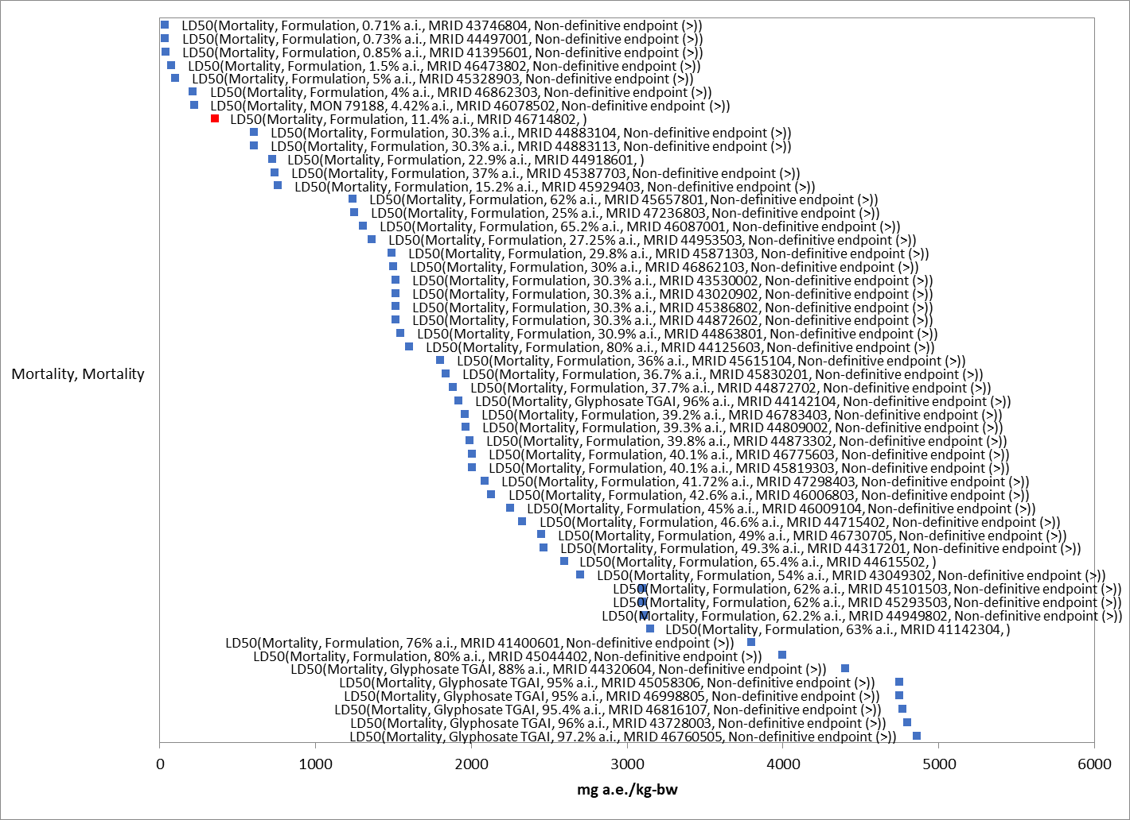
Figure 2-28. Mammalian acute dose-based toxicity data array. Red square is the endpoint selected to derive the acute mortality threshold. Parenthesis describe the endpoint, whether the study was conducted with technical or formulation glyphosate, % active ingredient, and study reference (MRID or ECOTOX #). If endpoint is non-definitive, that is also noted.

Effects on Growth and Reproduction of Mammals

Two 2-generation mammalian reproduction studies with the rat are available for glyphosate (Table 2- 15). In the first study (MRID 41621501, 1990), the parental/systemic NOAEL is 500 mg/kg/day in both sexes and the LOAEL is 1,500 mg/kg/day based on decreased body weight gain and food consumption. The reproductive NOAEL is 1,500 mg/kg/day in both sexes. The offspring NOAEL is 500 mg/kg/day in both sexes with a LOAEL of 1,500 mg/kg/day based on decreased body weight gain during lactation. In the second 2-generation reproduction study using the rat (MRID 48865101-48865105, 2007/2012), the parental/systemic NOAEL is 15,000 mg/kg-diet in both sexes (equivalent to 1,234/1,273 mg/kg/day in males/females, respectively) as parental toxicity was not observed. The reproductive NOAEL is 15,000 mg/kg-diet in both sexes; no reproductive toxicity was observed in study. The offspring NOAEL is 5,000 mg/kg-diet (equivalent to 408/423 mg/kg/day in males/females, respectively) with a LOAEL of 15,000 mg/kg-diet based on delayed age at sexual maturation.

In addition, there are two reproduction studies by Romano et al. (2010 and 2012) using Wistar rats that report reproductive effects on male rats. In one study (2010; E155939), newly weaned male rats were orally gavaged with Roundup Transorb from post-natal day 23 to 53. Significant effects on sexual development (increase in age of sexual maturity and hormone changes) were reported at 50 mg a.i./kg-bw (NOAEL = 5 mg a.i./kg-bw). In the other study (E161810), parental females were orally dosed with Roundup Transorb from gestational day 18 to post-natal day (PND) 5. Significant sexual development effects at 50 mg a.i./kg-bw were reported in male offspring (decrease in age of sexual maturity, changes in hormone and sexual behavior). It is noted that in the study with the newly weaned rats there was a delay in the age to sexual maturity whereas in the other study, the male offspring were observed to have a decrease in the age to sexual maturity. These studies were conducted with Brazilian formulations of glyphosate and it is uncertain whether they are representative of US formulations. Therefore, these endpoints are considered qualitative.

Based on the available data on growth and reproduction, the sublethal toxicity threshold based on delayed age and decreased weight at sexual maturity is a NOAEC value of 408 mg a.i./kg-bw (LOAEC = 1234 mg a.i./kg-bw, MATC = 709.56 mg a.i./kg-bw).

Table 2-15. Effects of technical grade glyphosate on mammalian growth and reproduction.
Guideline No. | Study Type | MRID No. (year)/ Classification /Doses | Results
870.3100 | 90-Day Oral Toxicity (Mice) | 00036803 (1979)  Acceptable/guideline  0, 5000, 10000, 50000 ppm  (0, 944/ 1530, 1870/2740, 9710/ 14800 mg/kg/day [M/F]) | NOAEL = 1870/2740 mg/kg/day [M/F].  LOAEL = 9710/14800 mg/kg/day [M/F] based on decreased body weight.
870.3150 | 90-Day oral toxicity (Rat) – AMPA | 00241351 (1979)  Acceptable/guideline  0, 400, 1200, 4800 mg/kg/day [M/F] | NOAEL = 400 mg/kg/day [M/F].  LOAEL = 1200 mg/kg/day [M/F] based on body-weight loss.
870.3700a | Prenatal developmental in rodents (Rat) | 00046362 (1980)  Acceptable/guideline  0, 300, 1000, 3500 mg/kg/day via gavage during Gestation Days (GD) 6-19 | Maternal NOAEL = 1000 mg/kg/day.  LOAEL = 3500 mg/kg/day based on based on reduced body-weight gain.  Developmental NOAEL = 1000 mg/kg/day.  LOAEL = 3500 mg/kg/day based on decreased fetal body weight.
870.3700a | Prenatal developmental in rodents (Rat) - AMPA | 43334705 (1991)  Guideline  0, 150, 400, or 1000 mg/kg/day via gavage during GD 6-19 | Maternal NOAEL = 150 mg/kg/day.  LOAEL = 400 mg/kg/day based clinical signs (hair loss, soft stools and mucoid feces).  Developmental NOAEL = 400 mg/kg/day.  LOAEL = 1000 mg/kg/day based on decreased fetal body weight.
870.3800 | Reproduction and fertility effects, two-generation (Rat) | 41621501 (1990)  Acceptable/guideline  0, 2000, 10,000, or 30,000 ppm  (0, 250, 500, and 1500 mg/kg/day) in the diet. | Parental/Systemic NOAEL = 500 mg/kg/day in males and females.  LOAEL = 1500 mg/kg/day in males and females based on soft stools, decreased body-weight gain and food consumption.  Reproductive NOAEL = 1500 mg/kg/day (HDT) in males and females.  Offspring NOAEL = 500 mg/kg/day in males and females.  LOAEL = 1500 mg/kg/day in males and females based on decreased body-weight gain during lactation.
870.3800 | Reproduction and fertility effects, two-generation (Rat) | 48865101 (2012)  Acceptable/guideline  0, 1500, 5000, or 15,000 ppm (0/0, 121/126, 408/423, or 1234/1273 mg/kg/day [M/F]) in the diet | Parental/Systemic NOAEL = 1234/1273 mg/kg/day in males and females.  The LOAEL for parental toxicity was not observed.  Reproductive NOAEL = 1234/1273 mg/kg/day (HDT) in males and females.  Offspring NOAEL = 408/423 mg/kg/day in males and females.  LOAEL = 1234/1273 mg/kg/day in males and females based on delayed age and increased weight at attainment of PPS.
870.4200 | Combined Chronic Toxicity/Carcinogenicity (Rat) | 41643801, 41728701 (1990)  Acceptable/guideline  0, 2000, 8000, or 20000 ppm  0, 362/447, or 940/1183 mg/kg/day [M/F] in the diet. | NOAEL = 362/447 mg/kg/day [M/F].  LOAEL = 940/1183 mg/kg/day[M/F] based on decreased body-weight gain in females.
870.4200 | Combined Chronic Toxicity/Carcinogenicity (Rat) | 50017103, 50017104, 50017105 (1997)  Acceptable/guideline  0, 3000, 10000, or 30000 ppm  0, 104/115, 354/393 and 1127/1247 mg/kg bw/day  [M/F] in the diet. | NOAEL = 3000 ppm (104/115 mg/kg/day)  LOAEL = 10000 ppm (354/393 mg/kg/day) based upon retarded growth in males throughout the study.
870.4300 | Carcinogenicity  (Mouse) | 41643801, 41728701 (1990)  Acceptable/guideline  0, 1000, 5000, or 30000 ppm  0, 150, 750, or 4500 mg/kg/day [M/F] in the diet. | NOAEL = 750 mg/kg/day [M/F].  LOAEL = 4500 mg/kg/day [M/F] based on significant decreased body-weight gain in both sexes.
870.4300 | Carcinogenicity  (Mouse) | 50017108, 50017109 (1997)  Acceptable/guideline  0, 1600, 8000, or 40000 ppm  0, 165/153.2, 838.1/786.8, or 4348/4116 mg/kg bw/day [M/F] in the diet. | NOAEL = 8000/1600 ppm (838.1/153.2 mg/kg/day [M/F])  LOAEL = 40000 ppm (4116 mg/kg/day [M]) based on a significant increase in overall incidence of anal prolapse which corresponded to erosion/ulcer of the anus histopathologically.  LOAEL = 8000 (838.1 mg/kg/day [F]) based upon retarded growth with statistically significant decreases in weight at week 6 and weeks 9-24.

Other Sublethal Effects to Mammals

Additional sublethal effects are available from the registrant submitted studies and summarized in Table 2- 16. The prenatal developmental study with rabbits resulted in a NOAEL and LOAEL of 75 and 175 mg a.e./kg-bw/day based on effects on mortality, diarrhea, and soft stool (MRID 00046363). In a second prenatal developmental study with rabbits (MRID 44320616) conducted at similar doses, effects on mortality were not observed but the effects on diarrhea and soft stool were conserved (NOAEL and LOAEL of 100 and 175 mg a.e./kg-bw/day). Given the uncertainty in the mortality effect, the threshold for growth and reproduction discussed in Section 10.3 above is considered the most sensitive sublethal threshold for glyphosate.

Table 2-16. Effects of technical grade glyphosate on other sublethal effects in mammals.
Guideline No. | Study Type | MRID No. (year)/ Classification /Doses | Results
870.3100 | 90-Day oral toxicity range finding (Rat) | 40559401 (1987)  Acceptable/guideline  0, 1000, 5000, or 20000 ppm  (0, 63, 317, 1267 mg/kg/day) | NOAEL = 1267 mg/kg/day.  LOAEL = not established.
870.3150 | 90-Day oral toxicity (Rat) – AMPA | 00241351 (1979)  Acceptable/guideline  0, 400, 1200, 4800 mg/kg/day [M/F] | NOAEL = 400 mg/kg/day [M/F].  LOAEL = 1200 mg/kg/day [M/F] based on histopathological lesions of the urinary bladder.
870.3150 | 90-Day oral toxicity  (Dog)- AMPA | 43334702  0, 8.8, 26.4, 88, or 264 mg/kg/day | NOAEL= 264 mg/kg/day.  LOAEL= not established.  No toxicity at the highest dose tested.
870.3700a | Prenatal developmental in rodents (Rat) | 00046362 (1980)  Acceptable/guideline  0, 300, 1000, 3500 mg/kg/day via gavage during Gestation Days (GD) 6-19 | Maternal NOAEL = 1000 mg/kg/day.  LOAEL = 3500 mg/kg/day based on based on inactivity, mortality and stomach hemorrhages.  Developmental NOAEL = 1000 mg/kg/day.  LOAEL = 3500 mg/kg/day based on increased incidence in the number of fetuses and litters with unossified sternebrae
870.3700a | Prenatal developmental in rodents (Rat) | 44320615 (1996)  Acceptable/guideline  0, 250, 500, or 1000 mg/kg/day via gavage during gestation days (GD) 6-15 | Maternal NOAEL = 1000 mg/kg/day.  LOAEL = not established.  Developmental NOAEL = not established.
870.3700a | Prenatal developmental in rodents (Rat) - AMPA | 43334705 (1991)  Guideline  0, 150, 400, or 1000 mg/kg/day via gavage during GD 6-19 | Maternal NOAEL = 150 mg/kg/day.  LOAEL = 400 mg/kg/day based clinical signs (hair loss, soft stools and mucoid feces).
870.3700b | Prenatal developmental in (Rabbit) | 00046363 (1980)  Acceptable/guideline  0, 75, 175, or 350 mg/kg/day via gavage during GD 6-27 | Maternal NOAEL = 75 mg/kg/day.  LOAEL = 175 mg/kg/day based on based on mortality, diarrhea, soft stools, and nasal discharge.  Developmental NOAEL = 350 mg/kg/day (HDT).  LOAEL = not established.
870.3700b | Pre-natal Developmental Toxicity-Rabbit | (1996)  Acceptable/guideline  44320616  0, 100, 175, or 300 day via gavage during GD7-19 | Maternal NOAEL = 100 mg/kg/day.  Maternal LOAEL = 175 mg/kg/day based on dose-dependent clinical signs (diarrhea, few/no feces).  Developmental NOAEL = 300 mg/kg/day.  Developmental LOAEL = not established.
870.3800 | Reproduction and fertility effects, three-generation (Rat) | 00105995 (1981)  Acceptable/guideline  0, 3, 10, or 30 mg/kg/day in the diet. | Parental/Systemic NOAEL = 30 mg/kg/day (HDT).  Reproductive NOAEL = 30 mg/kg/day (HDT).  Offspring NOAEL = 10 mg/kg/day.  LOAEL = 30 mg/kg/day based on focal dilation of the kidney in male F3b pups.
870.4100a | Chronic toxicity (dog) | 00153374 (1985)  Acceptable/guideline  0, 20, 100, or 500 mg/kg/day [M/F] via gelatin capsule | NOAEL = 500 mg/kg/day [M/F].  LOAEL = not established.
870.4200 | Combined Chronic Toxicity/Carcinogenicity (Rat) | 00093879 (1981)  Minimum  0, 3, 10, or 34 mg/kg/day in the diet | NOAEL = 34 mg/kg/day.  LOAEL = not established. High dose not adequate to assess carcinogenicity. Another study requested (see below).
870.4200 | Combined Chronic Toxicity/Carcinogenicity (Rat) | 41643801, 41728701 (1990)  Acceptable/guideline  0, 2000, 8000, or 20000 ppm  0, 362/447, or 940/1183 mg/kg/day [M/F] in the diet. | NOAEL = 362/447 mg/kg/day [M/F].  LOAEL = 940/1183 mg/kg/day[M/F] based on decreased urinary pH in males, increased incidence of cataracts and lens abnormalities in males, and increased absolute and relative (to brain) liver weight in males.
870.4200 | Combined Chronic Toxicity/Carcinogenicity (Rat) | 49631701 (1993)  Acceptable/guideline  0, 10, 100, 300, or 1000 mg/kg/day [M/F] in the diet. | NOAEL=100 mg/kg bw/day [M/F].  LOAEL = 300 mg/kg bw/day [M/F] based on pronounced cellular alterations of the parotid and mandibular salivary glands.
870.4200 | Combined Chronic Toxicity/Carcinogenicity (Rat) | 49704601 (2001)  Acceptable/guideline  0, 2000, 6000, or 20,000 ppm  0,121/145, 361/437, and 1214/1498 mg/kg/day [M/F] in the diet. | NOAEL = 361/437 mg/kg bw/day [M/F].  LOAEL = 1214/1498 mg/kg bw/day [M/F] based on kidney papillary necrosis.
870.4200 | Combined Chronic Toxicity/Carcinogenicity (Rat) | 40214007, 41209905, 41209907 (1987)  Acceptable/guideline  0, 100, 500, and 1000 ppm  0, 4.2/5.4, 21.2/27 or 41.8/55.7 mg/kg/day [M/F] in the diet. | NOAEL = 100 ppm (4.2/5.4 mg/kg/day [M/F])  LOAEL = 500 ppm (21.2/27.0 mg/kg/day [M/F) based upon decreased LDH levels at 6 and 12 months.
870.4200 | Combined Chronic Toxicity/Carcinogenicity (Rat) | 49987401 (1994)  Acceptable/guideline  0, 6.3/8.6, 59.4/88.5, and 595.2/886 mg/kg/day [M/F] in the diet. | NOAEL ≥ 10,000 ppm (740.6 mg/kg/day)  A LOAEL was not established.
870.4200 | Combined Chronic Toxicity/Carcinogenicity (Rat) | 49957404 (2009)  Acceptable/guideline  0, 1500, 5000, and 15,000 ppm  0, 86/105, 285/349 or 1077/1382 mg/kg/day [M/F] in the diet. | NOAEL is ≥ 1077/1382 mg/kg/day.  A LOAEL was not established. Transient liver enzyme activity for mid-dose males and high-dose males and females were observed, in addition to increased adipose infiltration of the bone marrow in high-dose males. Both effects were not considered adverse.
870.4300 | Carcinogenicity  (Mouse) | 00130406 (1983)  Acceptable/guideline  0, 1000, 5000, or 30,000 ppm  0, 161/195, 835/968, 4945/6069 mg/kg bw/day [M/F] in the diet. | NOAEL = 835/968 mg/kg bw/day [M/F].  LOAEL = 4945/6069 mg/kg bw/day [M/F] based on increased centrilobular hepatocellular necrosis in high-dose males and proximal tubular epithelial basophilia in high-dose females.
870.4300 | Carcinogenicity  (Mouse) | 41643801, 41728701 (1990)  Acceptable/guideline  0, 1000, 5000, or 30000 ppm  0, 150, 750, or 4500 mg/kg/day [M/F] in the diet. | NOAEL = 750 mg/kg/day [M/F].  LOAEL = 4500 mg/kg/day [M/F] based on hepatocyte necrosis and interstitial nephritis in males, and increased incidence of proximal tubule epithelial basophilia and hypertrophy in the kidney of females.
870.4300 | Carcinogenicity  (Mouse) | 49631702 (1993)  Acceptable/guideline  0, 98/102, 297/298, 988/1000  mg/kg bw/day [M/F] in the diet. | NOAEL = 1000 mg/kg bw/day.  A LOAEL was not identified.
870.4300 | Carcinogenicity  (Mouse) | 49957402 (2009)  Acceptable/guideline  0, 500, 1500, or 5000 ppm  0, 71.4/97.9, 234.2/299.5, or 810/1081.2 mg/kg bw/day [M/F] in the diet. | NOAEL ≥ 5000 ppm (234.2/299.5 mg/kg/day)  A LOAEL was not established.
870.4300 | Carcinogenicity  (Mouse) | 50017108, 50017109 (1997)  Acceptable/guideline  0, 1600, 8000, or 40000 ppm  0, 165/153.2, 838.1/786.8, or 4348/4116 mg/kg bw/day [M/F] in the diet. | NOAEL = 8000/1600 ppm (838.1/153.2 mg/kg/day [M/F])  LOAEL = 40000 ppm (4116 mg/kg/day [M]) based on a significant increase in overall incidence of anal prolapse which corresponded to erosion/ulcer of the anus histopathologically.
870.4300 | Carcinogenicity  (Mouse) | 40214006, 41209907 (1987)  Acceptable/guideline  0, 11.7/16, 118/159, and 991/1341 mg/kg bw/day [M/F] in the diet. | NOAEL = 1000 ppm (11.7/16 mg/kg/day [M/F])  LOAEL = 8000 ppm (118/159 mg/kg/day [M/F) based upon an increased incidence of white matter degeneration in the lumbar region of the spinal cord in males, and an increased incidence of epithelial hyperplasia of the duodenum in females.
870.6200a | Acute neurotoxicity screening battery | 44320610 (1996)  Acceptable/guideline  0, 500, 1000, 2000 mg/kg [M/F] | Neurotoxicity NOAEL = 2000 mg/kg/day [M/F].  Neurotoxicity LOAEL was not observed.  Systemic NOAEL = 2000 mg/kg/day [M/F].  Systemic LOAEL was not observed.
870.6200b | Subchronic neurotoxicity screening battery | 44320612 (1996)  Acceptable/guideline  0, 2000, 8000, 20000 ppm  (0, 155.5/ 166.3, 617.1/672.1, 1546.5/1630.6 mg/kg/day [M/F]) | Neurotoxicity NOAEL = 1546.5/1630.6 mg/kg/day [M/F].  Neurotoxicity LOAEL was not observed.  Systemic NOAEL = 1546.5/1630.6 mg/kg/day [M/F].  Systemic LOAEL was not observed.
870.7800 | Immunotoxicity  (Mouse) | 48934207 (2012)  Acceptable/guideline  0, 500, 1500, 5000 ppm  (0, 150, 499, 1448 mg/kg/day [F]) | Immunotoxicity NOAEL = 1448 mg/kg/day.  Immunotoxicity LOAEL was not observed.  Systemic NOAEL = 1448 mg/kg/day.  Systemic LOAEL was not observed.

Drinking water studies

No studies involving mammalian exposure via drinking water were identified in the ECOTOX database or in review of registrant submitted studies.

Dermal exposure studies

Table 2- 17 presents the acute and longer-term dermal exposure data available from registrant-submitted data.

Table 2-17. Dermal Exposure Studies for Glyphosate.
Exposure Scenario | Dose  (mg/kg/day) | Endpoint | Study
Acute dermal toxicity (Rabbit) | LD₅₀ > 5000 mg/kg/day | Mortality | MRID 41400602
21-d dermal toxicity (Rabbit) | Systemic NOAEL = 1000  Systemic LOAEL = 5000 mg/kg/day | Based on slight erythema and edema on intact and abraded skin of both sexes and decreased food consumption in females | MRID 00098460

Inhalation studies

The acute inhalation data requirement was waived for glyphosate. No effects were observed in the 28-d inhalation study with the laboratory rat based on exposures up to 0.36 mg/L, six hours per day, five days per week for four weeks. This indicates that glyphosate is not toxic to mammals on an inhalation exposure basis.

Effects Characterization for Terrestrial Invertebrates

Introduction to Terrestrial Invertebrate Toxicity

The effects of glyphosate on terrestrial invertebrates have been studied extensively. Both registrant-submitted and open literature studies on terrestrial invertebrates provide information used in the risk characterization for glyphosate. APPENDICES 2-2 and 2-3 provide further detail on open literature studies that are included in this effects characterization. Studies were excluded if they were considered invalid or not associated with an environmentally relevant exposure route. Note that studies from open literature that did not provide sufficient information to allow for conversion of exposure values to units used in risk estimation were not included. Effects of formulations not registered in the U.S. are discussed but are not used quantitatively where the formulations could not be compared to U.S. registered formulations.

Effects on Mortality of Terrestrial Invertebrates

Toxicity of formulated products and technical grade glyphosate have been tested with variety of invertebrate taxa. Data are available on multiple routes of exposure, including overspray (lb a.e./A), dose and dietary oral exposure (µg a.e./organism, mg a.e./kg-diet, mg a.e./kg-bodyweight), soil exposure (mg a.e./kg-soil), and direct contact exposure (µg a.e./organism). Studies that test toxicity to honeybees (Apis mellifera) are collected in Table 2- 18.

Acute dose and dietary-based toxicity thresholds for technical and formulated glyphosate
No acute studies, either registrant-submitted or from the open literature, resulted in >50% mortality, so an LC₅₀ could not be established. The mortality endpoints for oral exposure to both formulations and technical glyphosate are therefore non-definitive (>) for dose and dietary exposure. Both the formulated product and technical grade glyphosate showed little or no effect on mortality in most tests on honeybees (Table 2- 18).

An oral and contact study conducted with bumblebees (Bombus terrestris) reported no treatment-related mortality or behavioral abnormalities up to the highest dose of a glyphosate formulation (MON0139), resulting in a non-definitive LD50 and NOAEC that were both > 412 μg a.e./org (MRID 50603801).

Open literature studies are also available on technical and formulated glyphosate toxicity to honeybees. Tests of formulation toxicity have largely been conducted abroad with formulations that are not known to be comparable to U.S. formulations. Two open literature studies report some TGAI toxicity to larvae reared in vitro. Vazquez et al. 2018 reported between-colony variation in honeybee sensitivity to glyphosate sensitivity, with a nonmonotonic response to larval exposure to technical glyphosate over five days. This study resulted in a larval mortality LOAEL of 550 ng a.e./larva, with a corresponding NOAEL of 275 ng a.e./larva and reported delayed moulting in glyphosate-treated larvae. This study was not conducted according to OECD guidelines or EPA recommendations, and no control larvae survived to adult emergence, therefore this study is not used quantitatively. Dai et al. 2018 reported a clear dose response of larval mortality with a LOAEL of 4 mg a.e./kg diet and a corresponding NOAEL of 0.8 mg a.e./kg diet at the end of a nine-day study (<20% mortality at the LOAEL). Negative control survival was >90% and survival in a dimethoate positive control was <30%.

In addition to the acute contact and oral toxicity studies for honeybees, a semi-field study (conducted in greenhouses) is also available for honeybees (Thompson et al. 2014). A glyphosate formulation (MON 52276; 30.68% a.e. as a glyphosate salt, GLY-IPA), was applied to flowering Phacelia tanacetifolia at 1.92 lb a.e/A (2.88 kg a.e./ha nominal, 2.16 kg a.e./ha measured), and pollen and nectar were collected from foraging honeybees for residue analysis. In a second experiment, honeybee colonies were fed treated sucrose (a salt of technical glyphosate, GLY-IPA) with test concentrations based on the mean residue concentration after 3 days, (75 mg a.e/L nominal; 73 mg a.e./L measured), the highest residue concentration (150 mg a.e./L nominal; 138 mg a.e./L measured), and twice the highest residue concentration (301 mg a.e./L nominal; 255 mg a.e./L measured); the concentrations were also reported as mg a.e./kg. Evaluation of mortality/morbidity, appearance, larval weight and residue were conducted (16-day test duration). There was no significant effect on survival of eggs, young or old larvae or on larvae weight.
Acute contact toxicity thresholds for technical and formulated glyphosate
The threshold for formulated glyphosate (64.9% formulation) overspray contact toxicity was a 7d LC50 = 1.1 lb a.e./A, from a study with predatory mites, Typhlodromus pyri (MRID 45767105). This study also reported an 85% reduction in eggs laid at the tested concentration, resulting in a non-definitive LOAEL < 216 g a.e./ha (0.193 lb a.e./A).

An acute contact study that evaluated toxicity of a formulated product to the stingless bee Osmia bicornis reported a maximum of 6.7% mortality at the highest dose level, which resulted in a non-definitive LD50 > 412 μg a.e./org (MRID 50603802). Acute contact toxicity tests with honeybees (Table 10-1) and other terrestrial invertebrates therefore did not reach 50% mortality for either the technical or formulated product. The mortality endpoints for contact exposure in µg a.e./organism are therefore non-definitive (>) for glyphosate formulations and technical glyphosate.

A contact toxicity test on plant bugs (Eccritotarsus catarinensis) conducted using several Australian glyphosate formulations reported LC50s ranging from <144 µg/org (5d post-exposure, Roundup Ultra®) to 727.2 µg/org (1d post-exposure, Mamba 360®). The addition of an adjuvant (Add-2) to the glyphosate formulation Touchdown® resulted in increased plant bug mortality, but an LC50 for this combination was not reported. The contact LC50 for the Mottled Water Hyacinth Weevil (Neochetina eichhorniae) was 1360.1 µg/org (5d post exposure, Roundup Ultra®) (Hill et al. 2012). These are not used quantitatively but demonstrate variability in toxicity by species, by formulation, and increased toxicity with the inclusion of an adjuvant.

Soil exposure toxicity thresholds for technical and formulated glyphosate
Soil exposure tests have been conducted for annelids and several arthropod species. In these studies, 50% mortality was not reached, so an LC₅₀ could not be established. The highest test level for formulated product came from a study on Earthworms (Eisenia fetida), which showed no mortality up to 6560 mg a.e./L (MRID 4576109). An acute toxicity test with technical glyphosate also showed no mortality effects up to the highest level tested, resulting in a non-definitive LC50 > 472.8 mg a.e/kg soil (MRID 50603804). A review of the open literature provided no definitive LC50 for technical or formulated glyphosate. The mortality endpoint for soil exposure is therefore non-definitive (>).

Table 2-18. Honeybee mortality data.
TEST TYPE | ENDPOINT | TEST SUBSTANCE | Reference | STUDY CLASS-IFICATION | COMMENTS
Adult
Acute Oral | 48 hr LD₅₀: >100 µg/bee  NOAEL: N.R. | TGAI (98.5%) | MRID 00026489 | Acceptable
 | 48 hr LD₅₀: >182 µg/bee  NOAEL: 182 | TGAI (97.6%)  +  Adjuvant  (Agral 90) | MRID 48876603 | Acceptable | No mortality or clinical signs of toxicity reported
 | 48 hr LD₅₀: >30 µg/bee  NOAEL: 15 | Formulation  (MON 77360, 30% glyphosate IPA salt) | MRID 45370302 | Supplemental | 12% mortality observed at the highest test level
 | 48 hr LD₅₀: >76.23 µg a.e./bee  NOAEL: <76.23 µg a.e./bee | Formulation (MON78568, 65.6% glyphosate monoammonium salt) | MRID 45767104 | Not classified | 20% mortality after correction for control mortality
Acute Contact | 48 hr LD₅₀: >103 µg/bee  NOAEL: 103 | TGAI (97.6%)  +  Adjuvant  (Agral 90) | MRID 48876603 | Acceptable | No mortality or clinical signs of toxicity reported
 | 48 hr LD₅₀: >100 µg/bee  NOAEL: N.R. | TGAI (98.5%) | MRID 00026489 | Acceptable | 27% mortality after correcting for control mortality at the limit dose
 | 48 hr LD₅₀: >100 µg/bee  NOAEL: 100 | Formulation (MON78568, 65.6% glyphosate monoammonium salt) | MRID 45767104 | Not classified | 20% mortality at the limit dose.
 | 48 hr LD₅₀: >100 µg/bee  NOAEL: N.R. | Formulation  (MON 2139, 36% glyphosate IPA salt) | MRID 00026489 | Acceptable
 | 48 hr LD₅₀: >31.3 µg a.e./bee  NOAEL: 319 | Formulation  (MON 65005, 31.32% glyphosate IPA salt) | MRID 44465703 | Acceptable
 | 48 hr LD₅₀: >30 µg/bee  NOAEL: 30 | Formulation (MON 77360, 30% glyphosate IPA salt) | MRID 45370301 | Acceptable
Chronic oral | LD₅₀: > 170 μg a.e./bee/day  NOAEL: 170 μg a.e./bee/day | Formulation  (MON 0139, GLY-IPA, 46.1% a.e.) | MRID 50603803 | Not classified | No statistically significant levels of mortality reported.
Larvae
Oral | NOAEL = 0.8 mg a.e./kg diet  LOAEL = 4 mg a.e./kg diet | TGAI (99.5%) | Dai et al. 2018 | Not classified | 9d study; <20% mortality at the LOAEL.
Colony-level
Semi-field (greenhouse) | No significant effects on survival of eggs, young or old larvae or on larvae weight, up to highest dose level. | Formulation (MON5227, 30.68% a.e. as glyphosate IPA);  technical grade IPA salt of glyphosate (46.14% w/w glyphosate ae) | MRID 5060385/Thompson et al 2014 | Not classified | Stage 1. Residue analysis in pollen and nectar of flowering Phacelia tanacetifolia treated with 1.92 lb a.e./A formulation;  Stage 2. Colonies supplied sucrose solution spiked with TGAI.

Sublethal Effects on Terrestrial Invertebrates

Registrant-submitted and open literature studies report effects on growth, reproduction, and behavior in terrestrial arthropods and effects on growth in gastropods as a result of overspray applications of glyphosate formulations. Growth and reproductive effects are more sensitive parameters than mortality for glyphosate and AMPA toxicity to terrestrial invertebrates, in both registrant-submitted and open literature data. Behaviors related to PPHD (e.g. related to predator avoidance, reproduction, foraging, and prey capture) can also be more sensitive than mortality endpoints.

Sublethal dose and dietary-based toxicity thresholds for technical and formulated glyphosate
The endpoints for dose and dietary exposure (mg/kg-bw and µg a.e./bee) were based on reduced food consumption in adult honeybees exposed to a glyphosate formulation (46.1% ai). This study resulted in a NOAEL and MATC of 5.1 and 6.96 µg a.e./bee, respectively. The daily dose was divided by a default assumed bee weight (0.128g), using Reverse BeeRex to provide a NOAEL and MATC of 39.8 and MATC of 54.4 mg a.e./kg-bw.

In addition to the reduced food consumption, several open literature studies report effects on honeybee feeding or foraging behavior following exposure to technical glyphosate at sublethal levels. Balbuena et al. 2015 reports effects on honeybee homing ability after feeding on 10 mg a.e./L diet, including increased time to navigate to the hive and reduced ability to learn routes. Two studies reported a sublethal LOAEL of 2.5 mg a.e/kg diet for effects on honeybee behavior related to feeding and foraging (Gonalons et al. 2018, Herbert et al. 2014). These proboscis extension studies demonstrate a reduced ability to react to sucrose solutions and impaired learning of odor-reward associations, both of which are important behavioral parameters for feeding and foraging success. In honeybees, this may or may not translate to detrimental effects on apical endpoints at the individual or colony levels. However, impacts of foraging effects may be mitigated by large honeybee colony sizes, while solitary bees or small colonies of non-Apis bees (e.g. Bombus affinis) could be more sensitive to reductions in feeding or foraging efficiency. These effects are therefore relevant for evaluating potential effects on endangered species and are used quantitatively. For the alternative analysis, a 10x factor was applied to produce the endpoint of 25 mg a.e./kg diet.

Dai et al. reports effects on the honeybee gut microbiome as well as the larval mortality discussed above. The connection between microbiome characteristics and apical endpoints is not straightforward, however, and these results are not used quantitatively.

Sublethal contact toxicity thresholds for technical and formulated glyphosate
The threshold for formulated glyphosate came from a study with predatory mites, Typhlodromus pyri (MRID 45767105). This study reported an 85% reduction in eggs laid at the tested concentration, resulting in a non-definitive LOAEL < 216 g a.e./ha (0.193 lb a.e./A). No alternative endpoint was selected for this unit.

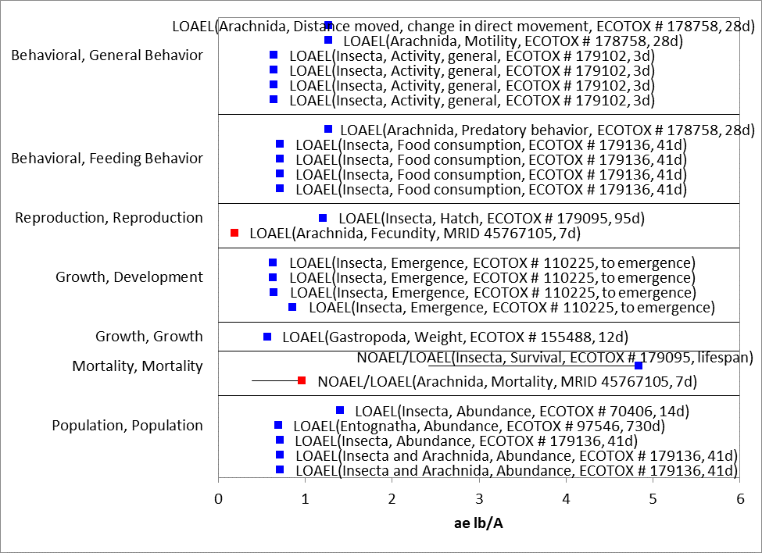
Figure 2-29. Formulation sublethal toxicity to terrestrial invertebrates in lb a.e./A. Text in parentheses represents (taxonomic class, measured parameter, reference number, duration).

Soil exposure toxicity thresholds for technical and formulated glyphosate
Tests of soil exposure to formulations registered in the U.S. were not available for sublethal endpoints. The selected endpoint was based on toxicity of technical glyphosate, with reduced biomass and fecundity noted in Earthworms (E. fetida) at the LOAEL, 5000 mg a.e./kg soil (E170666). No mortality was reported.

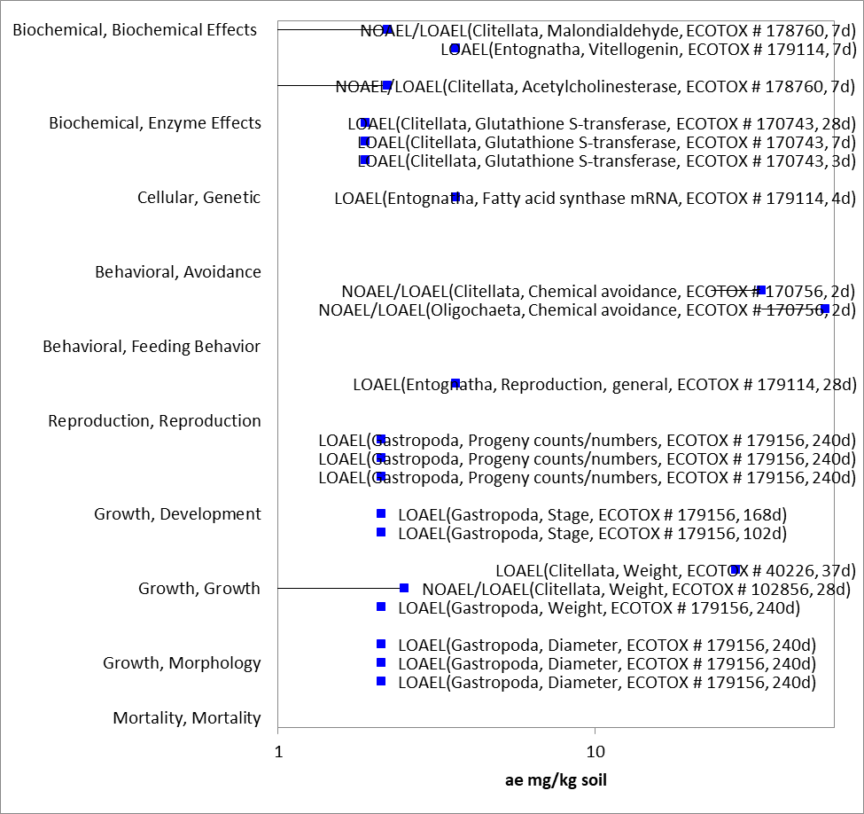
Figure 2-30. Formulation sublethal toxicity to terrestrial invertebrates in mg a.e./kg soil. Text in parentheses represents (taxonomic class, measured parameter, reference number, duration).

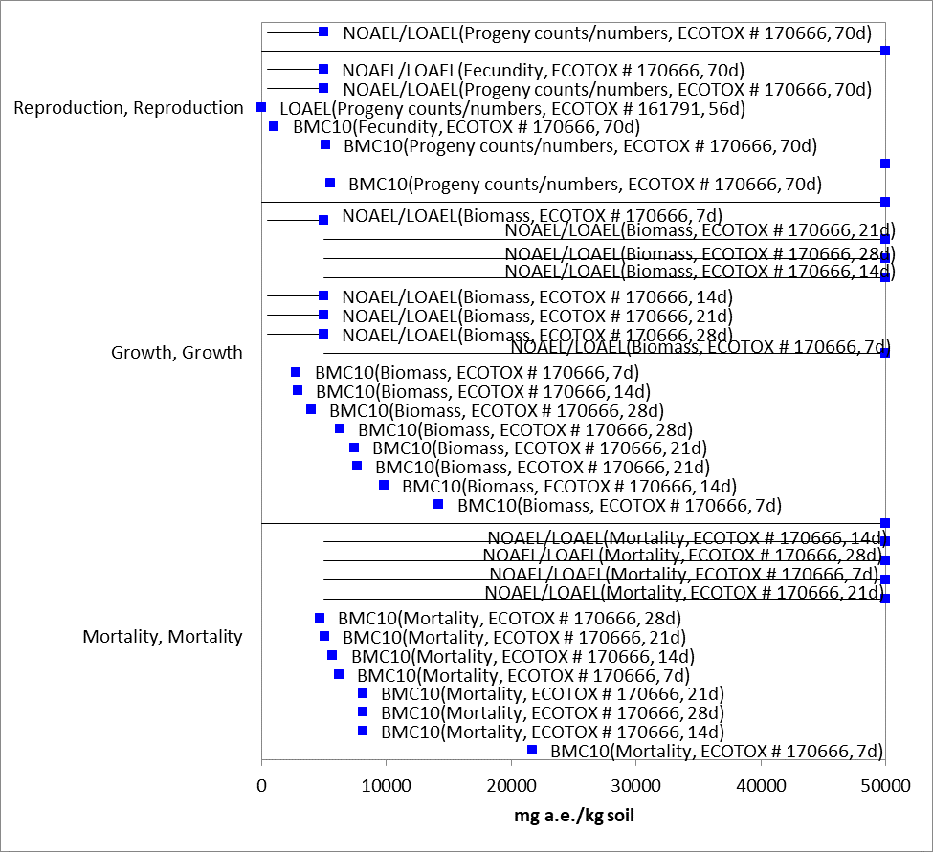
Figure 2-31. Technical glyphosate sublethal toxicity in mg a.e/kg soil. Text in parentheses represents (measured parameter, refence number, duration).

In addition to direct effects of sublethal exposure, population reductions in insects and arachnids are reported in the open literature, including predatory arthropods relevant to biological control of agricultural pests (Figure 2- 32). It is not clear whether these reductions result from direct sublethal effects, avoidance of the treated area, or habitat disruption due to herbicidal effects. In combination with the low mortality effects reported, this suggests that sublethal effects rather than direct mortality are important drivers of potential ecological risks associated with glyphosate application.
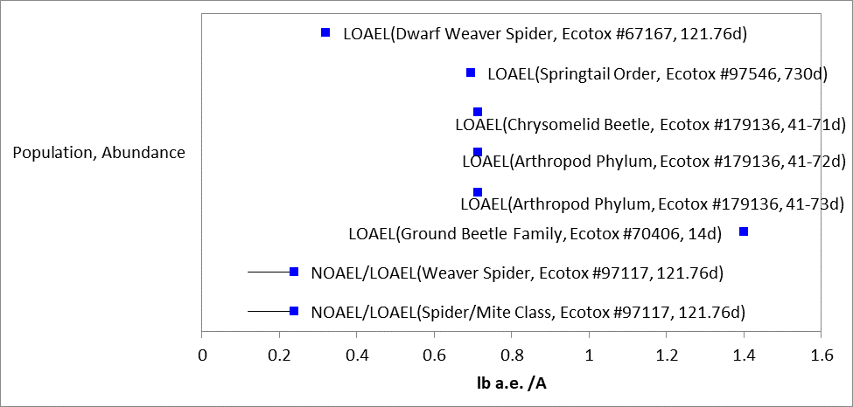
Figure 2-32. Glyphosate formulation effects on population abundance.

AMPA toxicity:
Sublethal effects of a major glyphosate degradate, AMPA, have been reported for earthworms. Von Merey et al, 2016 (E179154; MRID 50603804) reported no mortality on adult E. fetida survival up to 1000 mg/kg soil for earthworms, soil mites, and springtails. A clear dose response was reported for a reduced number of juvenile earthworms, with an EC50 of 654.7 mg/kg soil (56d). The NOAEL and LOAEL were 198.1 and 297.1 mg/kg soil, respectively (28d).

Dominguez et al. 2016 (E179126) also reported reduced fecundity in another earthworm species (E. andrei) with a NOAEL and LOAEL of 0.75 and 1.0 mg/kg soil, respectively. This study showed reduced fecundity (fewer cocoons) at 14d, then an increased number of juveniles and cocoons, but with lower biomass per cocoon/juvenile, at 56 days. No mortality effects were reported.

Effects Characterization for Terrestrial Plants

Introduction to Terrestrial Plant Toxicity

Plant toxicity data from both registrant-submitted studies and studies in the scientific literature have been reviewed for this assessment. Registrant-submitted studies are conducted under conditions and with species defined in OCSPP test guidelines. Sub-lethal endpoints such as plant growth, dry weight, and biomass are evaluated for both monocots and dicots, and effects are evaluated at both seedling emergence and vegetative life stages. APPENDICES 2-2 and 2-3 include the bibliographies of studies that are included in this effects characterization and those that were excluded, respectively. Studies were excluded if they were considered invalid or not associated with an environmentally relevant exposure route. Studies evaluating efficacy, rather than toxicity, are not included in quantitative analysis. Efficacy tests generally did not test concentrations low enough to result in lower LOAELs than toxicity tests.

Discussion of endpoints are provided for effects on terrestrial plants and terrestrial plant communities. These serve as a surrogate for effects on an individual of a listed species and the effects on the PPHD of a listed species, respectively. Based on the results of the submitted and available open literature terrestrial plant toxicity tests, it appears that the seedling emergence stage of plant development is less sensitive to glyphosate than vegetative stages of development. For seedling emergence, the IC₂₅ values were greater than the highest concentrations tested (up to 5 lb a.e./A).

Effects Data for Terrestrial Plants

Single-species terrestrial plant toxicity studies are used as one of the measures of effect to evaluate whether glyphosate may affect primary production and diversity in terrestrial ecosystems. Numerous terrestrial plant toxicity studies have been submitted to the EPA and/or published in the open literature. Figure 2- 33 and Figure 2- 34 presents a summary of the range of formulation toxicity values available for monocot and dicot plants, respectively.

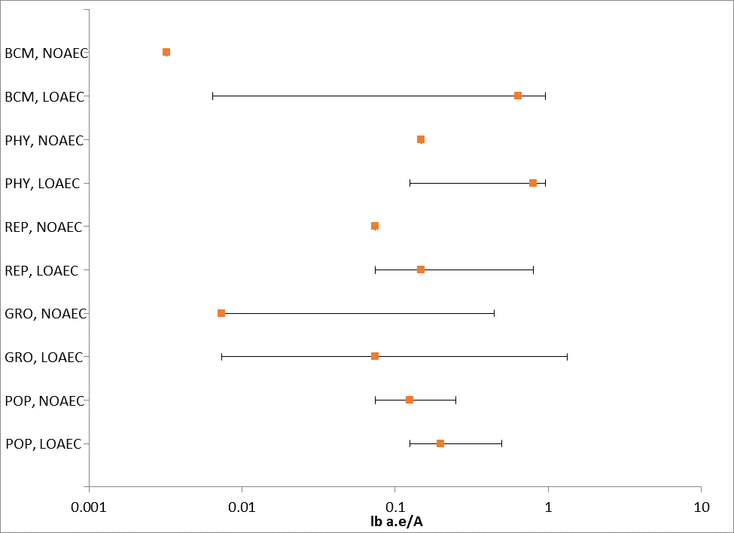
Figure 2-33. Summary array of formulation toxicity data for monocot terrestrial plants.

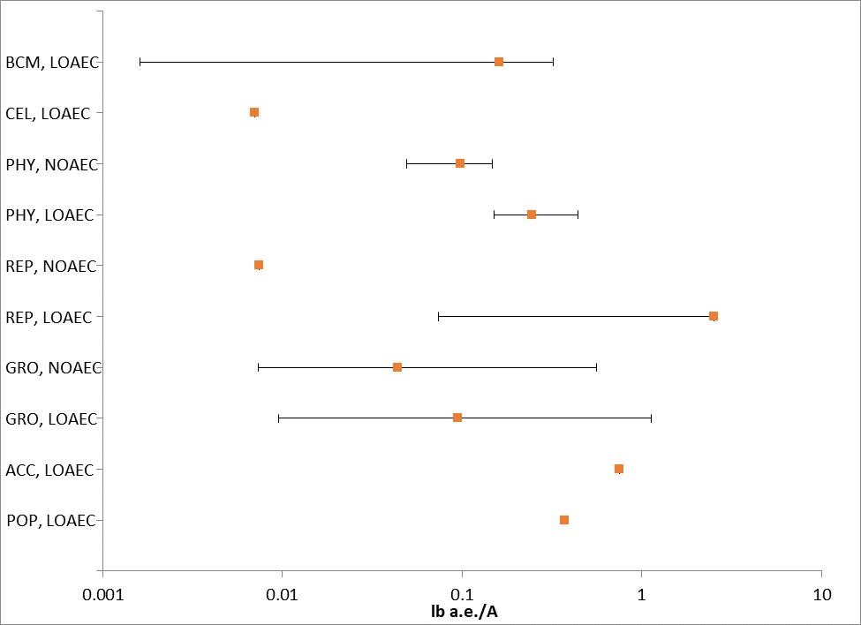
Figure 2-34. Summary array of formulation toxicity for dicot terrestrial plants.

The registrant submitted data represents the most sensitive endpoints. In species tested across all three registrant submitted studies, the technical grade was less toxic than the two tested formulations. In general, monocots were less sensitive than dicots. Based on this information, the most sensitive species across the available data are used to derive thresholds for effects to listed terrestrial plants exposed to glyphosate during the vegetative life stage. Phytotoxicity endpoints were not used quantitatively.

The most sensitive dicot was radish (Raphanus sativus) and the most sensitive monocot was wheat (Triticum aestivum). Application of a TEP reduced aboveground dry weight in radish at the lowest level tested, resulted in a non-definitive LOAEC < 0.07 lb a.e./A (MRID 44125715/45045101). A MATC could not be calculated, so the LOAEC is used as the endpoint. For wheat, the formulation NOAEC was 0.049 lb a.e./A and the MATC was 0.086 lb a.e./A for effects on dry weight (MRID 44125715/45045101).

Several open literature studies tested the toxicity of TEPs to terrestrial plants. Some studies tested toxicity of technical grade glyphosate to dicots, but data were not available for monocots from the open literature.

Open literature studies point to many factors that influence glyphosate toxicity, including adjuvant effects and soil conditions. The variety of conditions under which tests were conducted likely contributes to the variability in toxicity reported in the open literature. The most sensitive endpoints for formulations registered in the U.S. and tested using EPA recommended protocols came from the registrant submitted data.

In addition to evaluating growth parameters, studies examining reproductive parameters are also available. In a study evaluating pea seed production using Roundup Original®, Olszyk et al. 2009, the EC₂₅, based on pea seed weight was 0.0074 lb a.i./A, but the reported NOEC for the same endpoint was very close to the EC₂₅ value. These endpoints appear to be from a combination of four independent studies (two study designs repeated). Healthy leaf area was also affected, with EC₂₅s of 0.063 or 0.137 x 833 g a.i./ha. In an additional study comparing the effects of greenhouse versus field grown potatoes (Pfleeger et al. 2011), generally most endpoints were affected at 0.1 x 832 g/ha and the most sensitive endpoint was aboveground biomass with an EC₂₅ of 0.003 lb/A using plants that were grown in the greenhouse and exposed at tuber initiation; the study author reported that the study results were similar between plants grown inside or outside in pots.

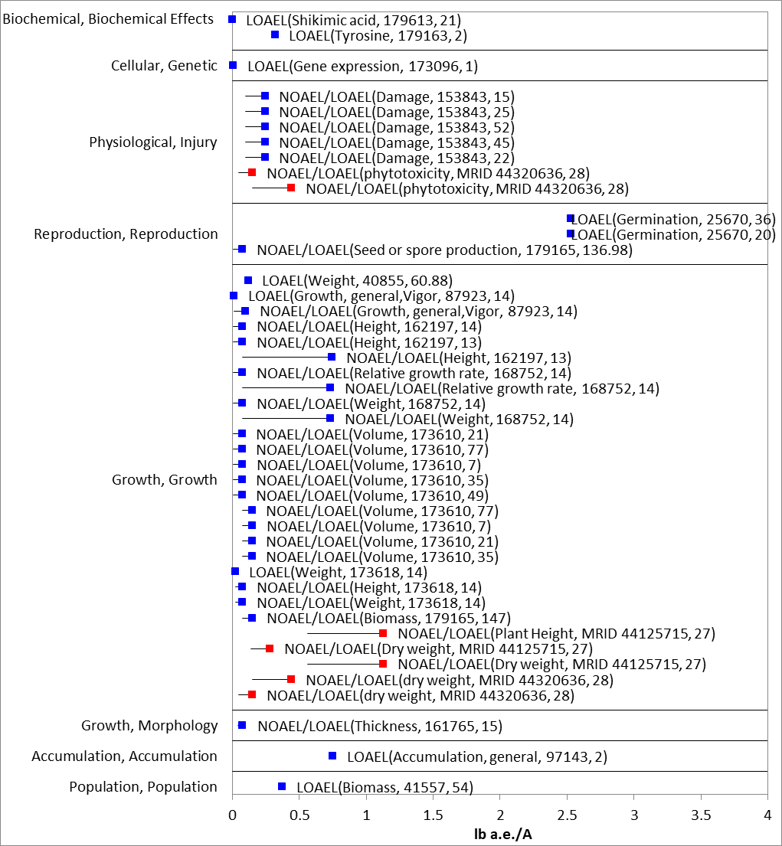
Figure 2-35. Detailed array of formulation toxicity data for terrestrial dicots. Blue squares represent LOAEC values from open literature studies found in the ECOTOX database, red squares represent registrant-submitted data. Solid lines display the range between the LOAEC and NOAEC values. Parentheses present the effect, reference (i.e., MRID, ECOTOX #), and study duration.

Effects Data for Terrestrial Plant Communities

Inhibitory Concentration (IC25) values from both monocots and dicots are used to derive the threshold for effects to the PPHD of an individual of a listed species (Figure 2- 36). Studies that reported effects on aboveground biomass, conducted with glyphosate formulations and 27- and 28-day exposure durations, were used to derive a Species Sensitivity Distribution (SSD). These parameters were selected to maximize comparability of results. Studies used to derive the SSD are compiled in APPENDIX 2-6.
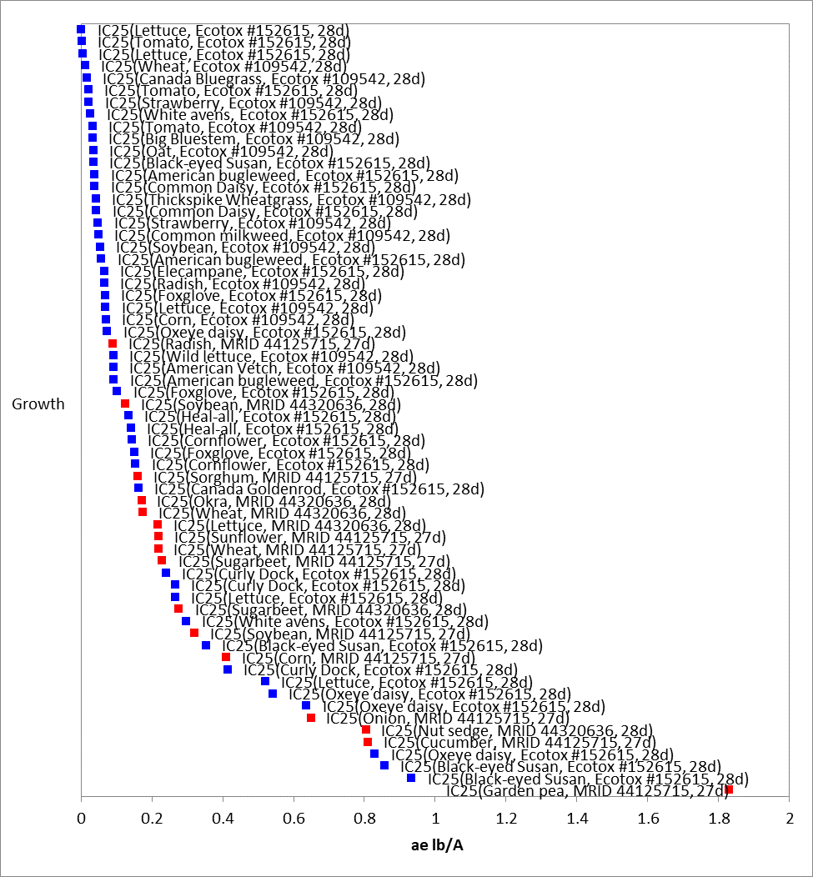
Figure 2-36. Detailed array of toxicity of formulated glyphosate on terrestrial plants. Blue squares represent IC₂₅ values from open literature studies found in the ECOTOX database, red squares represent registrant-submitted data. Parentheses present the species, effect, reference (i.e., MRID, ECOTOX #), and study duration.

Toxicity estimates for glyphosate range from 0.0021 – 0.93 lb a.e./A (APPENDIX 2-6), indicating a wide range of sensitivity to glyphosate among terrestrial plants for vegetative vigor. The lowest endpoints for foliar exposure to glyphosate formulation come from dicots, with IC₂₅ values ranging from 0.002 to 1.83 lb a.e./A. For monocots, IC₂₅ values ranged from 0.013 to 0.80 lb a.e./A. Seedling emergence was not affected up to the highest concentration tested (5 lb ae/A).

Additionally, several emergent wetland species were included in the terrestrial plant SSD. These are included in the terrestrial plant analysis because glyphosate is applied via overspray to vegetative tissues that are not submerged. In the freshwater sedge (Carex comosa) study, the most sensitive endpoint was fresh weight with an EC₂₅ value of 0.26 kg a.e./ha (0.23 lb a.e./A) (PMRA DER 49440). For the pickerel weed (Pontederia cordata), the most sensitive endpoint was also fresh weight with an EC₂₅ value of 0.53 kg a.e./ha (0.47 lb a.e./A) (PMRA DER 49445). Further information on the individual studies used to derive the SSD can be found in APPENDIX 2-5.

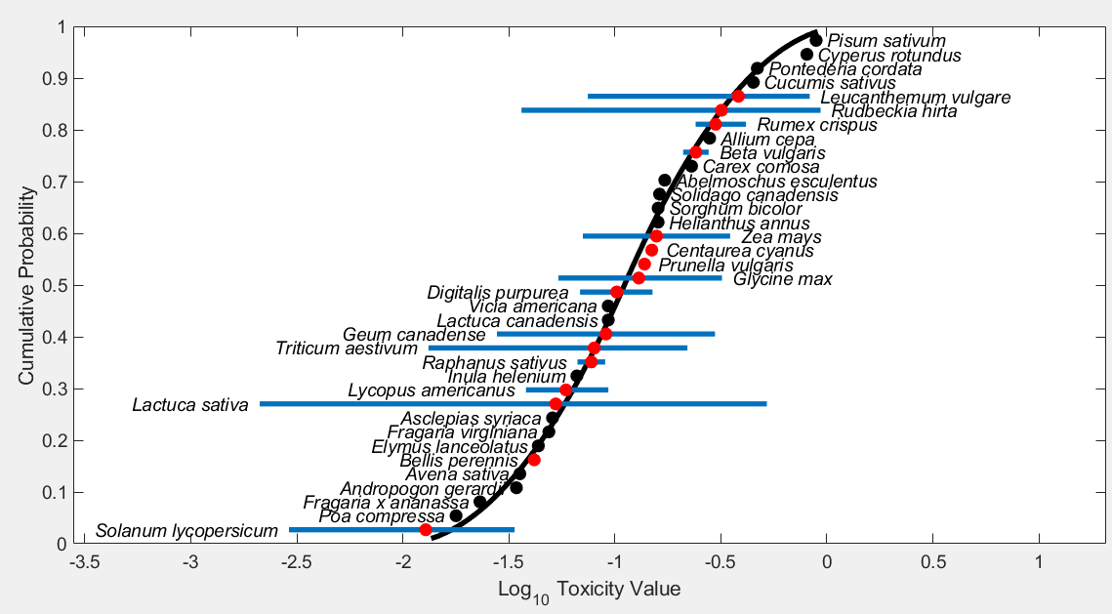
Figure 2-37. Species Sensitivity Distribution (SSD) for terrestrial plants vegetative vigor. Black points indicate single toxicity values. Red points indicate average of multiple toxicity values for a single species. Blue line indicates full range of toxicity values for a given taxon.

Table 2-19. Summary statistics for Terrestrial Plant SSD Fit to Glyphosate Test Results.
Statistic | All  Terrestrial Plants  (lb a.e./A)
Best Distribution (by AIC_{c}) | Triangular
Goodness of fit  P-value | 0.995
CV of the HC₀₅ | 0.24
HC₀₅ | 0.021
HC₁₀ | 0.029
HC₅₀ | 0.11
HC₉₀ | 0.43
HC₉₅ | 0.59

Incident Reports

As part of the draft ecological risk assessment (USEPA, 2015), the Ecological Incident Information System (EIIS) and the Avian Incident Monitoring System (AIMS) were searched for incidents of adverse effects to wildlife, fish, invertebrates, and plants resulting from exposure to glyphosate since the registration of glyphosate through February 2014. This search was updated to reflect incidents contained within the Incident Data System (IDS), which houses all incidents, through September 2020.

Since the registration of glyphosate and its salts (PC Codes 417300, 103601, 103604, 103607 and 103608 and 103613 (all active registrations)) there have been 1136 incidents, mostly involving damage to terrestrial plants. In addition, 337 separate aggregate incident reports were returned which included reports for glyphosate (Table 2- 20). However, multiple reports of injury to plants, wildlife or other non-target organisms were sometimes contained within each separate report.

Table 2-20. Aggregate Incidents for Glyphosate Involving Currently Registered Products.
Registration # | Product Name | Sum of Aggregate Incidents
000100-01117 | TOUCHDOWN IQ | 1
000100-01121 | TOUCHDOWN PRO HERBICIDE | 1
000100-01169 | TOUCHDOWN TOTAL | 2
000100-01182 | TOUCHDOWN HITECH | 1
000100-01185 | SEQUENCE | 35
000100-01282 | HALEX GT | 47
000100-01282 | HALEX GT HERBICIDE | 20
000100-01325 | FLEXSTAR GT | 1
000100-01325 | FLEXSTAR GT HERBICIDE | 4
000100-01385 | FLEXSTAR GT 3.5 | 1
000100-01385 | FLEXSTAR GT 3.5 HERBICIDE | 164
000228-00365 | AQUANEAT AQUATIC HERBICIDE | 1
000228-00367-008959 | SHORE KLEAR PLUS AQUATIC HERBICIDE | 1
000239-02466 | ORTHO SYSTEMIC SPOT WEED & GRASS KILLER | 1
000239-02467 | ORTHO READY-TO-USE SPOT WEED & GRASS KILLER | 1
000239-02509 | KLEENUP GRASS AND WEED KILLER | 21
000239-02516 | GROUNDCLEAR SUPER EDGER GRASS & WEED CONTROL | 1
000239-02516 | ORTHO FENCE & GRASS EDGER FORMULA II | 2
000239-02516 | SEASON LONG MAX GRAS & WEED KILLER RTU | 3
000239-02516 | SEASON LONG MAX GRASS & WEED KILLER RTU | 3
000239-02516 | SEASON LONG MAX GRASS& WEED KILLER RTU | 1
000239-02516 | SEASON-LONG GRASS & WEED KILLER | 5
000239-02516 | SEASON-LONG GRASS & WEED KILLER 32 OZ READY-TO-USE | 1
000239-02516 | SEASON-LONG GRASS & WEED KILLER READY-TO-USE | 6
000239-02516 | SEASON-LONG GRASS AND WEED KILLER READY-TO-USE | 1
000239-02516 | SEASON-LONG GROUND CLEAR | 3
000239-02629 | KLEERAWAY CONCENTRATE WEED & GRASS KILLER | 29
000239-02636 | ROUNDUP CONCENTRAATE WEED & GRASS KILLER | 45
000239-02637 | ROUNDUP SUPER CONCENTRATE WEED & GRASS KILLER | 3
000239-02638 | ROUNDUP L & G READY-TO-USE FAST ACTING FORMULA GRASS & WEED KILLER | 62
000239-02652 | ROUNDUP GARDEN FOAM GRASS & WEED KILLER | 70
000239-02653 | ROUNDUP RAINFAST CONCENTRATE WEED & GRSS KILLER | 6
000239-02657 | GROUNDCLEAR COMPLETE VEGETATION KILLER (CONC) | 1
000239-02657 | GROUNDCLEAR COMPLETE VEGETATION KILLER CONCENTRATE | 9
000239-02657 | GROUNDCLEAR COMPLETE VEGETATION KILLER CONCENTRATE, GROUNDCLEAR TRIOX TOTAL VEGETATION KILLER1 | 3
000239-02657 | GROUNDCLEAR COMPLETE VEGETATION KILLER CONCENTRATE/TRIOX TOTAL VEGETATION KILLER 1/TRIOX LIQUID VEGE | 1
000239-02657 | GROUNDCLEAR CONCENTRATE | 27
000239-02657 | GROUNDCLEAR TOTAL VEGETATION KILLER | 3
000239-02657 | GROUNDCLEAR TRIOX TOTAL VEGETATION KILLER 1 | 4
000239-02657 | GROUNDCLEAR TRIOX VEGETATION KILLER1 | 1
000239-02657 | ORTHO GROUNDCLEAR TOTAL VEGETATION KILLER | 2
000239-02657 | ORTHO GROUNDCLEAR TOTAL VEGETATION KILLER / TRIOX LIQUID VEGETATION KILLER | 5
000239-02657 | TRIOX LIQUID VEGETATION KILLER | 3
000239-02686 | GROUND CLEAR RTU | 1
000239-02686 | GROUNDCLEAR COMPLETE VEGETATION KILLER RTU | 1
000239-02686 | GROUNDCLEAR READY TO USE | 6
000239-02686 | ORTHO GROUNDCLEAR COMPLETE VEGETATION KILLER READY-TO-USE | 1
000239-02736 | GROUNDCLEAR TOTAL VEGETATION KILLER READY-TO-USE | 4
000239-02737 | GROUNDCLEAR S RTU | 1
000241-00405 | EXTREME | 58
000241-00405 | EXTREME HERBICIDE | 2
000352-00607 | DUPONT GLYPHOSATE HERBICIDE | 1
000352-00609-001812 | EAGRE | 1
000432-01528 | ESPLANADE MUNI | 1
000524-00370 | ROUNDUP L & G CONCENTRATE GRASS & WEED KILLER | 96
000524-00445 | ROUNDUP | 5
000524-00451 | ROUNDUP L & G READY TO USE FAST ACTING FORMULA GRASS & WEED KILLER | 17
000524-00475 | ROUND UP (MONSANTO) | 1
000524-00475 | ROUNDUP PRO | 2
000524-00475 | ROUNDUP PRO HERBICIDE | 1
000524-00475 | ROUNDUP ULTRA | 7
000524-00512 | MONSANTO ROUNDUP ULTRAMAX | 1
001381-00192 | CORNERSTONE PLUS | 1
002217-00847 | GORDON'S PRONTO BIG N' TUF NONSELECTIVE HERBICIDE | 1
002217-00852 | GORDON'S PRONTO FAST ACTING BRUSH KILLER | 1
004787-00023-002217 | PRONTO BIG N'TUF NONSELECTIVE HERBICIDE | 1
009688-00168 | CHEMSICO RTU HERBICIDE G 11 | 1
010182-00324 | TOUCHDOWN | 6
010182-00324 | TOUCHDOWN HERBICIDE | 7
010182-00429 | TOUCHDOWN 5 | 12
010182-00429 | TOUCHDOWN 5 HERBICIDE | 1
042750-00147 | THUNDER MASTER | 1
062719-00322 | GLYPHOMAX PLUS | 1
062719-00322 | GLYPHOMAX PLUS HERBICIDE | 1
062719-00322 | GLYPHOMAX* PLUS | 1
062719-00324 | DURANGO HERBICIDE | 1
062719-00324 | GLYPRO HERBICIDE | 2
062719-00324 | RODEO | 1
062719-00324 | RODEO HERBICIDE | 19
062719-00517 | ACCORD XRT | 2
062719-00517 | ACCORD XRT HERBICIDE | 1
062719-00537 | MILESTONE VM | 2
062719-00695 | ENLIST ONE HERBICIDE | 30
067760-00061-072155 | GRASS & WEED KILLER RTU (24 OZ) | 1
070829-00003-042750 | GLY STAR PLUS | 4
071368-00020 | ABUNDIT EXTRA HERBICIDE | 9
071368-00043 | EXTRA CREDIT 5 HERBICIDE | 4
071995-00006 | ROUNDUP CONCENTRATE WEED & GRASS KILLER | 2
071995-00008 | ROUNDUP READY TO USE W & G KILLER | 3
071995-00008 | ROUNDUP READY-TO-USE W & G KILLER | 1
071995-00008 | ROUNDUP WEED & GRASS KILLER READY TO USE | 8
071995-00008-000239 | TOTAL KILL WEED & GRASS KILLER READY TO USE | 1
071995-00010-073327 | GRASS & WEED KILLER READY-TO-USE | 1
071995-00016 | ROUNDUP SURE-SHOT FOAM | 6
071995-00017 | ROUNDUP CONCENTRATE W & G KILLER1 | 1
071995-00017 | ROUNDUP CONCENTRATE WEED & GRASS KILLER 1 | 3
071995-00017 | ROUNDUP RAINFAST CONCENTRATE WEED & GRASS KILLER | 1
071995-00020 | ROUNDUP BRUSH KILLER CONCENTRATE | 1
071995-00020 | ROUNDUP BRUSHKILLER CONCENTRATE | 1
071995-00023 | ROUNDUP W & G KILLER READY TO USE | 2
071995-00023 | ROUNDUP W & G KILLER READY-TO-USE | 2
071995-00025 | ROUNDUP SUPER CONCENTRATE W & G KILLER 1 | 1
071995-00025 | ROUNDUP W & G KILLER SUPER CONCENTRATE | 3
071995-00025 | ROUNDUP WEED & GRASS KILLER SUPER CONCENTRATE | 3
071995-00026 | ROUNDUP W & G KILLER CONCENTRATE | 1
071995-00026 | ROUNDUP WEED & GRASS KILLER CONCENTRATE | 6
071995-00027-000239 | WEED & GRASS KILLER | 1
071995-00029 | ROUNDUP READY-TO-USE EXTENDED CONTROL WEED & GRASS KILLER 1 PLUS WEED PREVENTER | 1
071995-00029 | ROUNDUP W & G KILLER CONCENTRATE PLUS | 7
071995-00029 | ROUNDUP WEED & GRASS KILLER CONCENTRATE PLUS | 10
071995-00029 | ROUNDUP WEED AND GRASS KILLER CONCENTRATE PLUS | 6
071995-00033 | ROUNDUP W & G KILLER READY-TO-USE PLUS | 10
071995-00033 | ROUNDUP W & G READY-TO-USE PLUS | 2
071995-00033 | ROUNDUP WEED & GRASS KILLER READY-TO-USE PLUS | 26
071995-00033 | ROUNDUP WEED AND GRASS KILLER READY TO USE PLUS | 7
071995-00036 | ROUNDUP READY TO USE POISON IVY AND TOUGH BRUSH KILLER PLUS | 1
071995-00036 | ROUNDUP RTU POISON IVY & TOUGH BRUSH KILLER PLUS | 2
071995-00037 | ROUNDUP CONCENTRATE POISON IVY & TOUGH BRUSH KILLER PLUS | 2
071995-00040 | ROUNDUP CONCENTRATE EXTENDED CONTROL WEED & GRASS KILLER PLUS WEED PREVENTER | 2
071995-00040 | ROUNDUP CONCENTRATE WEED & GRASS KILLER PLUS EXTENDED WEED CONTROL | 2
071995-00047 | ROUNDUP READY TO USE WEED AND GRASS KILLER EXTENDED CONTROL PLUS WEED PREVENTER II | 1
071995-00047 | ROUNDUP READY-TO-USE EXTENDED CONTROL WEED & GRASS KILLER PLUS WEED PREVENTER | 1
071995-00047 | ROUNDUP READY-TO-USE EXTENDED CONTROL WEED & GRASS KILLER PLUS WEED PREVENTER II | 1
071995-00051 | ROUNDUP READY-TO-USE MAX CONTROL 365 | 1
085827-00009 | COM-PLEET | 1

Alternative Toxicity endpoints

In addition to the thresholds provided in Table 2-1 through Table 2-6 above, alternative toxicity endpoints were also developed to use in the weight of evidence analysis for a species where appropriate (see Revised Methods Document). The alternative toxicity endpoints provide consideration of endpoints that may reflect variation in the available data (such as using the HC₅₀ values from the SSD instead of an HC₀₅ value or considering other endpoints within the data set for a particular taxon). There can be large differences in toxicity between technical grade and formulated product for glyphosate. Toxicity values for the technical grade were used for the alternative analysis, when available and less sensitive than the formulated product. Alternatively, if a taxon did not include enough data to select a specific alternative toxicity endpoint, a 10x factor was applied to the original threshold. The alternative endpoints allow for consideration of the possibility a listed species is toxicologically less sensitive than the tested species in the alternative weight of evidence analysis, which is captured for the analysis of any species that reaches that point of the analysis. Alternative endpoints are listed in Table 2-21 and brief additional comments are provided to clarify the alternative endpoint selection, as appropriate. Endpoints are analyzed for a subset of available units.

Table 2-21. Alternative toxicity endpoints used in weight of evidence analysis.
Alternative toxicity endpoints - Mortality |  | Type of endpoint (HC₅₀, etc.) | Value | Slope | Weight of test animal (g) | Comments
Units | Taxa
mg ai/kg-bw | MAMMALS | LD₅₀ | 99999 | 4.5 | 350 | TGAI endpoint; non-definitive >4860 mg/kg-bw; lab rat; MRID 46760505
mg ai/kg-bw | BIRDS | LD₅₀ | 99999 | 4.5 | 158 | TGAI endpoint; non-definitive > 4570 mg/kg-bw; bobwhite quail; MRID 0076492
mg ai/kg-bw | REPTILES/TERRESTRIAL AMPHIBIAN | LD₅₀ | 99999 | 4.5 | 158 | Bird as surrogate; TGAI endpoint; non-definitive > 4570 mg/kg-bw; bobwhite quail; MRID 0076492
mg ai/kg-bw | TERRESTRIAL INVERTS | LD₅₀ | 99999 | 4.5 | 0.128 | TGAI endpoint; non-definitive > 805 mg/kg-bw; Honeybee; MRID 48876603; calculated with Reverse BeeRex
ug ai/L | FW FISH | LC₅₀ | 43000 | 4.5 |  | TGAI endpoint; Bluegill sunfish; MRID 44320630
ug ai/L | E/M FISH | LC₅₀ | 240000 | 4.5 |  | TGAI endpoint; Sheepshead minnow; MRID 44320632
ug ai/L | AQ AMPHIBIANS | LC₅₀ | 103200 | 4.5 |  | TGAI endpoint; Green frog; MRID 46650501
ug ai/L | FW INVERTEBRATES | LC₅₀ | 7000 | 4.5 |  | TGAI endpoint; Immobility; Fairy Shrimp (Dendrocephalus brasiliensis); 178526
ug ai/L | E/M INVERTEBRATES | LC₅₀ | 35300 | 4.5 |  | TGAI endpoint; Calenoid Copepod (Arcatia tonsa); E71988
ug ai/L | MOLLUSKS | LC₅₀ | 175100 | 4.5 |  | TGAI endpoint; Golden Apple Snail (Pomacea canaliculata); E178544
Alternative toxicity endpoints - Sublethal
Units | Taxa | Type of endpoint (HC₅₀, etc.) | MATC or LOAEC | Description of effect | Duration of study (days) | Comments
mg ai/kg-diet | MAMMALS | MATC | 7090 |  |  | 10x factor applied to endpoint
mg ai/kg-diet | BIRDS | LOAEC | 5010 |  |  | 10x factor applied to endpoint
mg ai/kg-diet | REPTILES/TERRESTRIAL AMPHIBIAN | LOAEC | 5010 |  |  | 10x factor applied to endpoint
mg ai/kg-diet | TERRESTRIAL INVERTS | LOAEC | 25 |  |  | 10x factor applied to endpoint
µg ai/L | FW FISH | NOAEC | 99999 |  |  | TGAI endpoint; no effects observed up to 25700 ug ai/L; fathead minnow; MRID 00108171
µg ai/L | E/M FISH | NOAEC | 99999 |  |  | Freshwater fish as surrogate; TGAI endpoint; no effects observed up to 25700 ug ai/L; fathead minnow; MRID 00108171
µg ai/L | AQ AMPHIBIANS | NOAEC | 99999 |  |  | TGAI endpoint; no effects observed up to 1800 ug ai/L; leopard frog; MRID 46650501
µg ai/L | FW INVERTEBRATES | MATC | 5768 | Reproduction (fecundity) | 55 | TGAI; Daphnia magna; 10x factor applied; E161204
µg ai/L | E/M INVERTEBRATES | MATC | 5768 | Reproduction (fecundity) | 55 | Using FW as surrogate; TGAI; 10x factor applied; Daphnia magna; 161204
µg ai/L | MOLLUSKS | EC50 | 40000 | Shell deposition | 2 | TGAI: Pacific oyster (Crassostrea gigas); MRID 44320634
TERRESTRIAL PLANTS |  | Type of endpoint (HC₅₀, etc.) | MATC or LOAEC | IC₂₅ | Description of effect | Comments
lb ai/A | SUBLETHAL- MONOCOTS | MATC | 2 | 0.11 |  | MATC: 10x factor applied to endpoint; IC₂₅: the HC₅₀ of an SSD, all terrestrial plant vegetative vigor data
lb ai/A | SUBLETHAL- DICOTS | MATC | 0.49 | 0.11 |  | MATC: 10x factor applied to endpoint; IC₂₅: the HC₅₀ of an SSD, all terrestrial plant vegetative vigor data
AQUATIC PLANTS (TGAI) |  | Type of endpoint (HC₅₀, etc.) | MATC or LOAEC | IC₅₀ | Description of effect | Comments
µg ai/L | NON-VASCULAR | MATC | 841 | 5007 | IC₅₀: Reduced yield; MATC: cell density | TGAI; HC₀₅ from SSD used for IC₅₀; MATC, MRID 44578305, glyphosate trimesium, Anabaena flos-aquae
µg ai/L | VASCULAR | MATC | 770 | 5007 | IC₅₀: Reduced frond size, number, and biomass | TGAI; HC05 from SSD used for IC₅₀; MATC MRID 44578303, Lemna gibba

References:

USEPA. 2015. Registration Review - Preliminary Ecological RIsk Assessment for Glyphosate and It Salts. Memorandum From to Environmental Fate and Effects Division.
USEPA. 2020. Revised Method for National Level Listed Species Biological Evaluations of Conventional Pesticides. Environmental Fate and Effects Division.

