Chapter 2 – Final Atrazine Effects Characterization
Contents
1 Introduction 5
2 Endpoints used in Effects Determinations 6
3 Office of Water Aquatic Life Criteria 12
4 Effects Characterization for Fish and Aquatic-phase Amphibians 12
4.1 Introduction to Fish and Aquatic-phase Amphibian Toxicity 12
4.2 Effects on Mortality of Fish and Aquatic-phase Amphibians 13
4.3 Effects on Growth and Reproduction of Fish and Aquatic-phase Amphibians 14
4.3.1 Fish 14
4.3.2 Amphibians 16
4.4 Other Sublethal Effects to Fish and Aquatic-phase Amphibians 17
5 Effects Characterization for Aquatic Invertebrates 20
5.1 Introduction to Aquatic Invertebrate Toxicity 20
5.2 Effects on Mortality of Aquatic Invertebrates 21
5.2.1 Sublethal Effects to Aquatic Invertebrates 22
5.2.1 Other Sublethal Effects to Aquatic Invertebrates 24
6 Effects Characterization for Aquatic Plant 24
6.1 Introduction to Aquatic Plant Toxicity 24
6.2 Effects on Aquatic Plants 24
6.2.1 Effects on Growth of Non-Vascular Aquatic Plants 26
6.2.2 Effects on Growth of Vascular Aquatic Plants 29
6.3 Effects on Aquatic Plant Communities 31
7 Effects Characterization for Birds 36
7.1 Introduction to Bird Toxicity 36
7.2 Effects on Mortality of Birds 38
7.3 Effects on Growth and Reproduction of Birds 39
7.1 Other sublethal effects to Birds 40
7.2 Drinking water studies 41
7.3 Dermal studies 41
8 Effect Characterization to Reptiles 42
9 Effect Characterization to Terrestrial-phase Amphibians 42
10 Effects Characterization for Mammals 42
10.1 Introduction to Mammal Toxicity 42
10.2 Effects on Mortality of Mammals 44
10.3 Effects on Growth and Reproduction of Mammals 44
10.4 Other Sublethal Effects to Mammals 45
10.5 Drinking water studies 47
10.6 Dermal exposure studies 47
10.7 Inhalation studies 47
11 Effects Characterization for Terrestrial Invertebrates 47
11.1 Introduction to Terrestrial Invertebrate Toxicity 47
12 Effects Characterization for Terrestrial Plants 49
12.1 Introduction to Terrestrial Plant Toxicity 49
12.2 Effects on Terrestrial Plants 50
12.3 Effects on Terrestrial Plant Communities 56
13 Incident Data 60
14 Alternative Toxicity endpoints 62
15 References: 64

Tables
Table 2-1. Terrestrial mortality endpoints used to evaluate impacts to species and impacts to PPHD. 7
Table 2-2. Terrestrial sublethal endpoints used to evaluate impacts to species and impacts to PPHD. 8
Table 2-3. Aquatic mortality endpoints used to evaluate impacts to species and impacts to PPHD. 9
Table 2-4. Aquatic sublethal endpoints used to evaluate impacts to species and impacts to PPHD. 10
Table 2-5. Aquatic plant endpoints used to evaluate impacts to species and impacts to PPHD. 10
Table 2-6. Terrestrial plant endpoints used to evaluate impacts to species and impacts to PPHD. 11
Table 4-1. Summary of the most sensitive endpoints for fish acute and chronic toxicity data for atrazine and degradation products 12
Table 4-2. Summary of the most sensitive endpoints for aquatic-phase amphibians acute and chronic toxicity data for atrazine and degradation products 13
Table 5-1. Summary of the most sensitive endpoints for invertebrates acute and chronic toxicity data for atrazine. 20
Table 6-1. Summary Statistics for Aquatic Plant SSD Fit to Atrazine Test Results. 31
Table 6-2. The taxonomic distribution of reported species in COSM studies. 33
Table 7-1. Summary of most sensitive toxicity data for atrazine for birds. 36
Table 7-2. Summary of most sensitive toxicity data for atrazine degradates for birds. 38
Table 10-1. Summary of the Most Sensitive Mammalian Endpoints for Atrazine 42
Table 10-2. Summary of the Most Sensitive Endpoints for Atrazine Degradates 43
Table 11-1. Summary of Available Terrestrial Invertebrate Toxicity Studies 48
Table 12-1. Registrant submitted nontarget terrestrial plant Seedling Emergence toxicity expressed in terms of lbs a.i./A. All definitive endpoints are used quantitatively, bold endpoints identify the most sensitive monocot and dicot species. 53
Table 12-2. Registrant submitted nontarget terrestrial plant Vegetative Vigor toxicity expressed in terms of lbs a.i./A. All definitive endpoints are used quantitatively, bold endpoints identify the most sensitive monocot and dicot species. 55
Table 12-3. Nontarget Terrestrial Plant Seedling Emergence Toxicity (Tier II). All definitive endpoints are used quantitatively 56
Table 12-4. Nontarget Terrestrial Plant Vegetative Vigor Toxicity (Tier II). All definitive endpoints are used quantitatively 57
Table 12-5. Summary Statistics for Terrestrial Plant SSD Fit to Atrazine Test Results. 58
Table 13-1. Aggregate Incidents for Atrazine Involving Currently Registered Products. 60
Table 14-1. Alternative toxicity endpoints used in weight of evidence analysis. 62

Figures
Figure 4-1. Detailed array of ECOTOX toxicity data for other sublethal effects less than 200 µg a.i./L for fish. 15
Figure 4-2. Summary array of ECOTOX toxicity data for other sublethal effects for fish and aquatic-phase amphibians expressed in terms of µg a.i./L. BCM = biochemical; CEL = cellular; PHY= physiological; BEH = behavioral. 18
Figure 4-3. Detailed array of subset of ECOTOX toxicity data for other sublethal effects for fish and aquatic-phase amphibians expressed in terms of µg a.i./L. BCM = biochemical; CEL = cellular; PHY= physiological; BEH = behavioral. 19
Figure 5-1. Reported freshwater and saltwater invertebrate effects endpoints < 500 µg/L from ECOTOX database; note variation in study durations as denoted in parentheses (Effect, Study duration in days). [Acute freshwater endpoint not depicted as >500 µg/L (720 µg)]. 23
Figure 6-1. Summary array of single-species toxicity data for non-vascular aquatic plants expressed in terms of µg a.i./L. BCM = biochemical; GRO = growth; MOR = mortality; POP = population; SYS = ecological system/ecosystem process. 25
Figure 6-2. Summary array of single-species toxicity data for vascular aquatic plants expressed in terms of µg a.i./L. BCM = biochemical; CEL = cellular; PHY= physiological GRO = growth; MOR = mortality; POP = population. 26
Figure 6-3. Array of toxicity data for nonvascular aquatic plants expressed in terms of µg a.i./L. Blue squares represent LOAEC values from open literature studies found in the ECOTOX database. Red squares represent LOAEC values from registrant submitted studies. Solid lines display the range between the LOAEC and NOAEC values. The horizontal axis has been adjusted to better represent the most sensitive endpoints. 28
Figure 6-4. Array of toxicity data for vascular aquatic plants expressed in terms of µg a.i./L. Blue squares represent LOAEC values from open literature studies found in the ECOTOX database. Red squares represent LOAEC values from registrant submitted studies. Solid lines display the range between the LOAEC and NOAEC values. The horizontal axis has been adjusted to better represent the most sensitive endpoints. 30
Figure 6-5. Species Sensitivity Distribution (SSD) for all aquatic plants. Black points indicate single toxicity values. Red points indicate average of multiple toxicity values for a single species. Blue line indicates full range of toxicity values for a given taxon. 32
Figure 6-6. Distribution of Effect and No-Effect endpoints as related to initial study concentration and reported duration. 35
Figure 7-1. Array of toxicity data for sublethal effects to birds expressed in terms of mg a.i./kg-diet. Blue squares represent LOAEC values from open literature studies found in the ECOTOX database. Red squares represent LOAEC values from registrant submitted studies. Solid lines display the range between the LOAEC and NOAEC values. Parentheses present the effect, species, duration of study and study reference (i.e., MRID, ECOTOX #). 40
Figure 7-2. Array of toxicity data for sublethal effects to birds expressed in terms of mg a.i./kg-bw. Blue squares represent LOAEC values from open literature studies found in the ECOTOX database. Solid lines display the range between the LOAEC and NOAEC values. Parentheses present the effect, species, duration of study and study reference (i.e., MRID, ECOTOX #). 41
Figure 10-1. Subset of mammalian effects endpoints from ECOTOX database Blue squares represent LOAEC values from open literature studies found in the ECOTOX database. Solid lines display the range between the LOAEC and NOAEC values. Parentheses present the effect and study reference (i.e., MRID, ECOTOX #). 46
Figure 12-1. Summary array of toxicity data for dicot terrestrial plants expressed in terms of lb a.i./A. 50
Figure 12-2. Summary array of toxicity data for monocot terrestrial plants expressed in terms of lb a.i./A. 51
Figure 12-3. Species sensitivity distribution of IC₂₅ vegetative vigor stage endpoints. Selected model was normal, fit using maximum likelihood estimation, selected based on the lowest AIC and the highest p-value for model fit. Horizontal blue lines indicate the range of toxicity values. Red points are geometric means for taxa with multiple estimates. Black points are single estimates. 58
Figure 12-4. Species sensitivity distribution of IC₂₅ seedling emergence stage endpoints. Selected model was gumbel fit using maximum likelihood, selected based on the lowest AIC and highest p-value for model fit. Horizontal blue lines indicate the range of toxicity values. Red points are geometric means for taxa with multiple estimates. Black points are single estimates. 59

Introduction

In target pests (e.g., various weed species), atrazine has a mechanism of action of inhibiting photosynthesis in photosystem II (PSII). Triazine herbicides such as propazine bind with a protein complex of the Photosystem II in chloroplast photosynthetic membranes (Schulz et al., 1990). The result is an inhibition in the transfer of electrons through the light reactions of photosynthesis that in turn inhibits the formation and release of oxygen, production of adenosine triphosphate, and the fixation of carbon dioxide into sugars.

Atrazine is slightly toxic to birds and mammals and is practically non-toxic to terrestrial invertebrates on an acute exposure basis. In most terrestrial animal species, chronic effects are the predominant concern and are discussed further below. Based on the mechanism of action in target plants, i.e., disruption of photosynthesis, atrazine is toxic to most photoautotroph organisms including unicellular algae and flowering plants.
Atrazine is moderately toxic to freshwater and estuarine/marine fish, highly toxic to freshwater aquatic invertebrates and very highly toxic to estuarine/marine aquatic invertebrates on an acute exposure basis. Chronic exposure studies for freshwater and estuarine/marine fish, aquatic phase amphibians and aquatic invertebrates resulted in effects on survival, growth or reproduction. Based on available toxicity data for aquatic organisms, including fish, aquatic invertebrates, aquatic phase amphibians, and aquatic plants, the chlorodegradation products (deisopropylatrazine (DIA) and deethylatrazine (DEA) are not more toxic than atrazine to aquatic organisms, with some of the reported toxicity levels exceeding the maximum solubility of the compound. Based on available toxicity data for birds and mammals, the primary degradates of concern for atrazine (DIA and diadealkylatrazine (DDA)) are generally of equal toxicity or slightly more toxic than atrazine. A complete discussion of degradate data is provided in APPENDIX 1-8.
The following sections discuss toxicity data available for atrazine divided into major taxonomic groups of fish and aquatic amphibians, aquatic invertebrates, aquatic plants, birds, reptiles, terrestrial-phase amphibians, mammals, terrestrial invertebrates and terrestrial plants. Based on these data, mortality and sublethal effects (i.e., growth and reproduction) endpoints are determined and are used to evaluate direct effects to a listed species or effects to plants or animals that a species uses for prey, pollination, habitat, and/or dispersal.
In establishing the sublethal thresholds and endpoints used in the analysis, EPA used the most sensitive sublethal endpoint based on growth or reproduction or any sublethal endpoints that are strongly linked to survival, growth or reproduction. In determining whether toxicity endpoints are strongly linked to apical endpoints, EPA staff used best professional judgement, also considering factors such as data quality and relevance to effects on survival and reproduction. Specific consideration was given to any endpoints associated with sensory or behavioral effects. It was determined that no other endpoints in these categories were more sensitive and relevant than the most sensitive growth or reproduction endpoint available for each taxon. The sublethal endpoint used for each taxon therefore represents a growth or reproductive endpoint directly. Information on additional endpoints is found in APPENDIX 2-1 and APPENDIX 2-2.
If sufficient data are available, the toxicity data for each taxon are presented as summary data arrays (developed using the Data Array Builder v.1.0; described in ATTACHMENT 2-1). Alternatively, data are presented in a tabular format if only limited data is available. The arrays contain data from both laboratory and field experiments (e.g., mesocosms). Data in these arrays are grouped by the type of effect (e.g., mortality, growth, and reproduction), and present the range of effects endpoints [e.g., LOAECs and NOAECs (NOAECs must have a corresponding LOAEC to be represented in array)] for each effect type. If limited data are available, they are presented in a tabular format. The effect related to mortality, growth, and reproduction are discussed in further detail within each taxon effects characterization. All endpoints are reported in terms of active ingredient, unless otherwise specified. Data used in the arrays are available for each taxon in APPENDIX 2-1. Studies for which exposure units were not in or could not be converted to environmentally relevant units were not included in the data arrays. Endpoints reported in the ECOTOX database are presented in APPENDIX 2-2. Reviews of open literature studies are presented in APPENDIX 2-3. Citations for registrant submitted studies are presented in APPENDIX 2-4.

Endpoints used in Effects Determinations

Toxicity data available for atrazine was reviewed and divided into major taxonomic groups, including fish and aquatic amphibians, aquatic invertebrates, aquatic plants, birds, reptiles, terrestrial-phase amphibians, mammals, terrestrial invertebrates and terrestrial plants. For each of these groups, endpoints are determined for each taxon for mortality (animals only) and sublethal effects (i.e., growth or reproduction). These endpoints are used to establish thresholds, which are then used in conjunction with exposure data to make effects determinations based on the taxon with which they are associated. These data are described more fully in each relevant toxicity section below. Tables 2-1 through Table 2-6 summarizes the atrazine toxicity endpoints used in the effects determinations for all taxa. The available toxicity data for each taxon is discussed more later in this chapter.

Table 2-1. Terrestrial mortality endpoints used to evaluate impacts to species and impacts to PPHD.
Type of Threshold | Taxon | Test Species | Type of endpoint | Value | Units | Slope | Weight of test animal (g) | Comments | Reference
DOSE BASED MORTALITY | Mammals | Norway Rat | LD₅₀ | 1,869 | mg ai/kg-bw | 4.5 | 350 | Norway rat; no slope available, default slope | MRID 00024706
 | Birds | Bobwhite quail (Colinus virginianus) | LD₅₀ | 783 | mg ai/kg-bw | 3.8 | 35 | Northern Bobwhite quail (Colinus virginianus); MRID 00024721 | MRID 00024721
 | Reptiles | Bobwhite quail (Colinus virginianus) | LD₅₀ | 783 | mg ai/kg-bw | 3.8 | 35 | bird used as surrogate; Northern Bobwhite quail | MRID 00024721
 | Terrestrial Invertebrates | Honeybee | LD₅₀ | >757 | mg ai/kg-bw | 4.5 | NA | Non definitive endpoint; honeybee, contact exposure | MRID 00036935
DIETARY BASED MORTALITY | Mammals | No Data
 | Birds | Bobwhite quail (Colinus virginianus) | LC₅₀ | 5760 | mg ai/kg-diet | 4.5 | NA | No slope reported in study, default value used; Bobwhite quail | MRID 00059214
 | Reptiles | Bobwhite quail (Colinus virginianus) | LC₅₀ | 5760 | mg ai/kg-diet | 4.5 | NA | bird used as a surrogate; Bobwhite quail | MRID 00059214
MORTALITY | Terrestrial Invertebrates | Honeybee | LC₅₀ | >756 | mg ai/kg-bw | NA | NA |  | MRID 00036935
 | Terrestrial Invertebrates | Earthworm | LC₅₀ | 273 | mg ai/kg-soil | 4.5 | NA | earthworm, default slope | E40493; Haque  and Ebing 1983
 | Terrestrial Invertebrates | Honeybee | LD₅₀ | >97 | µg ai/bee | 4.5 | NA | Non definitive endpoint; honeybee, contact exposure | MRID 00036935

Table 2-2. Terrestrial sublethal endpoints used to evaluate impacts to species and impacts to PPHD.
Type of Threshold | Taxon | Test Species | NOAEC (or LOAEC if no NOAEC) | MATC or LOAEC | Units | Comments | Reference
DOSE BASED SUBLETHAL ENDPOINTS | Mammals | Norway Rat | 3.7 | 12 | mg ai/kg-bw | 12%-15% reduction in body weight; Norway rat; MATC used, LOAEC = 39 | MRID 40431306
 | Birds | Mallard Duck  (Anas platyrhynchos) | 7 | 7 | mg ai/kg-bw | 5.3% reduction in hatchling weight; Mallard; LOAEC only; dose endpoint derived from dietary study | MRID 42547101
 | Reptiles | Mallard Duck  (Anas platyrhynchos) | 7 | 7 | mg ai/kg-bw | 5.3% reduction in hatchling weight; Bird surrogate; Mallard; LOAEC only; dose endpoint derived from dietary study | MRID 42547101
DIETARY BASED SUBLETHAL ENDPOINTS | Mammals | Norway Rat | 50 | 158 | mg ai/kg-diet | 12%- 15% reduction in body weight; rat; MATC used; LOAEC= 500 | MRID 40431306
 | Birds | Mallard Duck  (Anas platyrhynchos) | 75 | 75 | mg ai/kg-diet | 5.3% reduction in hatchling weight; Mallard; LOAEC only | MRID 42547101
 | Reptiles | Mallard Duck  (Anas platyrhynchos) | 75 | 75 | mg ai/kg-diet | 5.3% reduction in hatchling weight; Bird surrogate; Mallard; LOAEC only | MRID 42547101
SUBLETHAL/  Mortality | Terrestrial Invertebrates | Honeybee | 756 | 756 | mg ai/kg-bw | 5% mortality; honeybee, contact exposure | MRID 00036935
 | Terrestrial Invertebrates | NA | NA | NA | mg ai/kg-diet | NA | NA
 | Terrestrial Invertebrates | Springtails | 2.5 | 2.5 | mg ai/kg-soil | 2.5 mg/kg-soil, 18% mortality; Exposure to springtail (O. apuanicus) at 2.5 mg/kg-soil, 18% mortality | E71417; Mola et a. 1987
 | Terrestrial Invertebrates | Honeybee | 97 | 97 | µg ai/bee | 5% mortality; honeybee, contact exposure | MRID 00036935

Table 2-3. Aquatic mortality endpoints used to evaluate impacts to species and impacts to PPHD.
Taxon | Test Species | Type of endpoint | Value  (ug ai/L) | Slope | Duration of study (days) | Reference
FW FISH | Rainbow Trout  (Oncorhynchus mykiss) | LC₅₀ | 5,300 | 4.5 | 4 | MRID 00024716
E/M FISH | Sheepshead Minnow (Cyprinodon variegates) | LC₅₀ | 2,000 | 4.5 | 4 | MRID 45208303; MRID 45227711
AQ AMPHIBIANS | American Bullfrog  (Lithobates catesbeianus) | LC₅₀ | 410 | 4.5 | 4 | E6187; Birge et al.
FW INVERTEBRATES | Midge (Chironomus tentans) | LC₅₀ | 720 | 4.5 | 4 | MRID 00024377
E/M INVERTEBRATES | Opposum shrimp  (Neomysis integer) | LC₅₀ | 48 | 4.5 | 4 | E103334; Noppe et al. 2007
MOLLUSKS | Eastern oyster  (Crassostrea virginica) | LC₅₀ | >1,700 | 4.5 | 4 | MRID 46648201

Table 2-4. Aquatic sublethal endpoints used to evaluate impacts to species and impacts to PPHD.
Taxon | Test Species | NOAEC | MATC or LOAEC | Units | Duration of study (days) | Comments | Reference
FW FISH | Atlantic Salmon (Salmo salar) | 8.5 | 26.7 | ug ai/L | 30 | decreased weight (5.6%), decreased length (~18%), decreased growth rate based on weight (60% reduction), mortality (9%) and decreased food consumption (12-15%); MATC used as input; LOAEC = 84.3 | Nieves-Puigdoller et al. 2007
E/M FISH | Atlantic Salmon (Salmo salar) | 8.5 | 26.7 | ug ai/L | 30 | decreased weight (5.6%), decreased length (~18%), decreased growth rate based on weight (60% reduction), mortality (9%) and decreased food consumption (12-15%); MATC used as input; LOAEC = 84.3 | Nieves-Puigdoller et al. 2007
AQ AMPHIBIANS | African clawed frog (Xenopus laevis) | 9.7 | 30.8 | ug ai/L | 30 | ~27% decrease in gonad weight and GSI; MATC used as input; LOAEC = 97.7 | Sai et al. 2016
FW INVERTEBRATES | Scub  (Gammarus fasciatus) | 60 | 92 | ug ai/L | 21 | Based on reduced development (% effect) of F1 to seventh instar; MATC used as input; LOAEC = 140 µg a.i./L | MRID 00024377
E/M INVERTEBRATES | Copepod (Amphiascus tenuiremis) | 3.5 | 3.5 | ug ai/L | 21 | Based on 32% reduction in offspring in F1 females; LOAEC used; no NOAEC available | E73333; Bejarano et al.
MOLLUSKS | Copepod (Amphiascus tenuiremis) | 3.5 | 3.5 | ug ai/L | 21 | Based on 32% reduction in offspring in F1 females; LOAEC used; no NOAEC available | E73333; Bejarano et al.

Table 2-5. Aquatic plant endpoints used to evaluate impacts to species and impacts to PPHD.
EPA Category | Species | NOAEC | MATC or LOAEC | IC₅₀ | Units | Comments | Reference
NON-VASCULAR | Cyanobacteria (Pseudanabaena galeata) | 3 | 3.87 | 14.4 | ug ai/L | 4% reduction in average growth rate at LOAEC; NOAEC and MATC for Pseudanabaena galeata; MATC used for threshold; IC₅₀ based on HC₀₅ species from all plant SSD | E6712; Carrasco and Sabater 1997
VASCULAR | Canadian waterweed  (Elodea canadensis) | 4.6 | 4.6 | 14.4 | ug ai/L | 50% decrease in biomass for Elodea canadensis; Threshold based on lowest EC₅₀; IC₅₀ based on HC₀₅ species from all plant SSD | MRID 48261124

Table 2-6. Terrestrial plant endpoints used to evaluate impacts to species and impacts to PPHD.
EPA Category | Species | NOAEC | MATC or LOAEC | IC₂₅ | Units | Comments | Reference
MONOCOT | Onion (Allium cepa) | 0.0011 | 0.0011 | 0.0037 | lb ai/A | Dry weight; Step 1 and 2 thresholds based on IC₁₅ for soybean; IC₂₅ based on HC₀₅ species from SSD for seedling emergence | MRID 49639102
DICOT | Soybean (Glycine max) | 0.018 | 0.018 | 0.0037 | lb ai/A | Dry weight; Step 1 and 2 thresholds based on IC₁₅ for onion; IC₂₅ based on HC₀₅ species from SSD for seedling emergence | MRID 49639102

Office of Water Aquatic Life Criteria

The U.S. EPA’s Office of Water (OW) may develop ambient water quality criteria for chemicals, including pesticides, that can be adopted by states and tribes to establish water quality standards under the Clean Water Act. At this time, there are no current ambient water quality criteria for atrazine.

Effects Characterization for Fish and Aquatic-phase Amphibians

Introduction to Fish and Aquatic-phase Amphibian Toxicity

There are open literature and registrant-submitted studies involving fish and aquatic amphibians available for atrazine, including both technical grade or formulated atrazine. Studies were excluded from the main analysis if they were considered invalid or if the exposure units could not be converted into aqueous concentrations (mass/volume).

A summary of acute and chronic fish and aquatic-phase amphibian data, including data from the open literature, is provided in the following sections (Table 4-1 and Table 4-2). From the review of available parent and degradate toxicity information for aquatic animals, the parent atrazine was found to be generally of equal or greater toxicity than the tested degradates. Therefore, the most sensitive endpoints and the following discussion focus largely on the parent compound.

Table 4-1. Summary of the most sensitive endpoints for fish acute and chronic toxicity data for atrazine and degradation products
TAXON | ENDPOINT | TEST SUBSTANCE | MRID | COMMENTS
ACUTE
Freshwater Fish
Rainbow Trout  (Oncorhynchus mykiss) | LC₅₀ = 5,300 µg a.i./L | Atrazine  98.8 % | 00024716  Beliles & Scott 1965
Estuarine/Marine Fish
Sheepshead minnow  (Cyprinodon variegates) | LC₅₀ = 2,000 µg a.i./L | Atrazine  97.1% | MRID 45208303 &  45227711
CHRONIC
Atlantic Salmon  (Salmo salar) | NOAEC = 8.5 µg a.i./L  LOAEC = 84.3 µg a.i./L  (MATC =26.7 ug ai/L) | Atrazine  98% | Nieves-Puigdoller et al. 2007 | Decreased weight (5.6%), decreased length (~18%), decreased growth rate based on weight (60% reduction), mortality (9%) and decreased food consumption (12-15%)
Table 4-2. Summary of the most sensitive endpoints for aquatic-phase amphibians acute and chronic toxicity data for atrazine and degradation products
TAXON | ENDPOINT | TEST SUBSTANCE | MRID | COMMENTS
ACUTE
American Bullfrog  (Lithobates catesbeianus) | LC₅₀ = 410 µg a.i./L | Atrazine  98.8 % | E6187  Birge et al.
CHRONIC
African clawed frog  (Xenopus laevis) | NOAEC = 9.7 µg a.i./L  LOAEC = 97.7 µg a.i./L  (MATC = 30.8 µg a.i./L) | Atrazine  97% | Sai et al. 2016 | Based on 27% decrease in gonad weight and gonadosomatic index (GSI)

Effects on Mortality of Fish and Aquatic-phase Amphibians

Atrazine toxicity has been evaluated in numerous fish species, and the results of these studies demonstrate a wide range of sensitivity. LC₅₀ values range from 2,000 to 60,000 µg/L. Therefore, atrazine is classified as moderately to slightly toxic to fish on an acute basis. Several of the higher concentrations noted in some studies exceed the solubility limit (33,000 µg a.i./L).
Acute toxicity data for freshwater fish are available for at least 8 different species; however, many of these endpoints were non-definitive. The most sensitive freshwater fish acute study is the rainbow trout with a 96-hour LC₅₀ of 5,300 µg a.i./L, which appears to be based on nominal concentrations (MRID 43344901).
Atrazine toxicity data have been submitted for two estuarine/marine fish species: sheepshead minnow and spot (Leiostomus xanthurus). A sheepshead study (MRID 45208303; 45227711; LC₅₀ = 2,000 µg a.i./L) and the spot study (MRID 45202920; LC₅₀ = 8,500 µg a.i./L) only reported the LC₅₀ value with no summary mortality data reported. Another sheepshead minnow acute study reported a 96-hour LC₅₀ of 13,400 µg a.i./L, based on measured concentrations (MRID 00024716).
Toxicity studies using atrazine formulations are available for freshwater fish. The acute LC₅₀ values range from 12,600 to 42,000 µg a.i./L and are classified as slightly toxic. As in the TGAI acute studies, several of the higher concentrations noted in these studies exceeded the solubility limit. Based on comparison of acute toxicity data for technical grade atrazine and formulated products of atrazine, it appears that freshwater fish are more sensitive to the TGAI. Acute studies with atrazine formulations for estuarine/marine fish were not available.

Available acute data for aquatic-phase amphibians with technical grade atrazine result in acute LC₅₀ values generally > 10,000 µg/L for juveniles and embryos (e.g., Birge et al. 1980; Howe et al. 1998; Kloas et al. 2009, Morgan et al. 1996; Wan et al. 2006). Teratogenic effects were also evaluated for amphibian embryos with EC₅₀ values ≥2,100 µg/L (Fort et al., 2004). The lowest acute value was reported by Birge et al. (1980) in which the reported LC₅₀ at 4 days post hatching (embryo-larval stage) for Lithobates (formerly Ranus) catesbeiana was 410 µg/L; this value represents both lethality as well as observed abnormalities expected to result in mortality under natural conditions.

Based on the available toxicity data for mortality in fish and aquatic-phase amphibians, the acute mortality threshold for freshwater fish is an LC₅₀ value of 5,300 µg a.i./L , for estuarine/marine fish an LC₅₀ value of 2,000 µg a.i./L and for amphibians an LC₅₀ value of 410 µg a.i./L. No slope data was available for any of the LC₅₀ values.

Effects on Growth and Reproduction of Fish and Aquatic-phase Amphibians

Fish

In the 2016 Draft Risk Assessment (DRA) for the registration review of atrazine, extensive discussion of the available data for atrazine was presented. Additionally, in the California Red-Legged Frog (CRLF) Assessment, presentations and discussion of numerous studies and data have been provided. For this BE, a review of any new data either from open literature or submitted studies was conducted. A discussion of the body of additional literature available around the selected endpoint for fish is provided in APPENDIX 2-7.
As part of the public comment period on the 2016 DRA, the registrant submitted 2 additional fish studies with both the fathead minnow and Japanese medaka (MRIDs 50349204 and 50349203, respectively). Both of these studies were conducted in accordance with the USEPA 890.1350 Fish Short-term Reproduction Assay developed under the Endocrine Disruption Screening Program. These studies are designed to measure the reproductive potential of groups of fathead minnows as a primary indicator of endocrine disruption. Measurements include those of survival, reproductive behavior, secondary sex characteristics, fecundity and fertilization success as well as a number of endpoints reflective of the status of the reproductive endocrine system, including the gonado-somatic index (GSI), gonadal histology and plasma concentrations of vitellogenin (Vtg). These studies are summarized in more detail in APPENDIX 2-7. There were no effects noted to survival or fecundity in these studies, although there were noted effects to growth and Vtg.

With the submission of these studies there are now 3 additional studies on reproduction in fish not previously available that did not find any significant effects to fecundity or fertility in either the Japanese Medaka (in two studies) or the fathead minnow. In addition, as part of the public comment period, the registrant submitted additional discussion of the uncertainties related to the Papoulious study used in the 2016 DRA as a quantitative endpoint. With the addition of 2 new reproductive studies in the Japanese Medaka that addressed and corrected issues and concerns raised by the EPA in the Papoulious study review, additional uncertainty is raised on the reproducibility and reliability of the endpoint from the Papoulious study. Due to these uncertainties, additional endpoints were considered for use as a threshold value.

A new ECOTOX run was conducted and the comprehensive data set is presented in APPENDIX 2-2. A subset of the data available from ECOTOX are presented in Figure 4-1, including effects to mortality, growth or reproduction. For better visualization only studies with endpoints of <200 µg a.i./L are presented and only include studies that had a reported effect in the study.

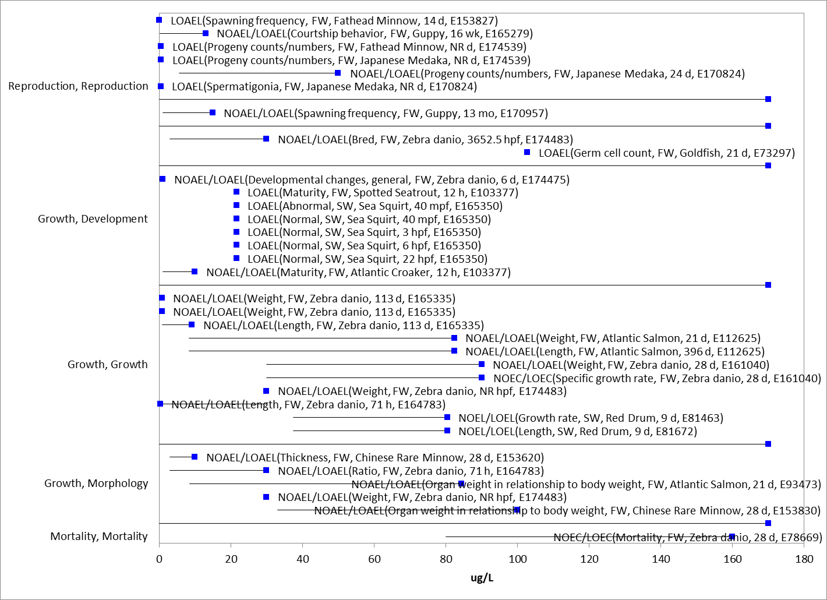
Figure 4-1. Detailed array of ECOTOX toxicity data for other sublethal effects less than 200 µg a.i./L for fish.

In a recent study reported in ECOTOX (Wirbisky et al, 2016, E#174483), zebrafish were exposed to 0, 0.3, 3, or 30 µg a.i./L atrazine through embryogenesis and then allowed to mature to adulthood. A decrease in spawning was observed in the adult fish, with morphological alterations in their offspring. In addition, adult females displayed an increase in ovarian progesterone and follicular atresia. While no significant differences were observed for mortality or hatching rate, a decrease in head length-to-body ratio in offspring from the 30 µg a.i./L treatment group and an increase in head width-to-body ratio in offspring from the 0.3 and 3 µg a.i./L treatment groups was observed. [A previous study from the same laboratory (Weber et al, 2013, E#164783) reported an increase in head length and head-to-body ratio in zebrafish larvae exposed to 0.3, 3, or 30 µg a.i./L atrazine through embryogenesis.] The average number of breeding pairs that spawned was significantly lower in the 30 µg a.i./L treatment group as compared to other treatment groups, but the average number of embryos per pair and total number of live embryos in each treatment were not statistically different among treatments. Approximately 5% of the females from the 30 µg a.i./L treatment groups displayed an increase in abdominal swelling. Two of these individuals had severe swelling to the point of rupture. Pathological assessment indicated swelling was due to the inability to release eggs. Several endpoints were then assessed to further investigate this observation. No significant differences were observed in the total weight of females in the 30 µg a.i./L treatment groups compared to the control treatment group but there was a significant increase in ovarian weight.

In another study by Nieves-Puigdoller et al. (2007; E#93473; supporting PhD thesis, E# 112625) investigators studied the effects of atrazine exposure to Atlantic Salmon smolts through freshwater exposure to atrazine for 21 days at 10 and 100 µg a.i./L (measured concentrations of 8.5 and 84.3 µg a.i./L) and subsequent saltwater challenge. During the freshwater exposure period, 9% of the fish exposed to atrazine at 100 µg a.i./L died (compared to 0% mortality in control and 10 µg a.i./L groups). Fish in this treatment group also exhibited significantly reduced feeding after 10 days of exposure (69-88% decrease by Day 10 as compared to control and 100% decrease (zero food consumption reported) when measured on day 15), decreased growth rate in freshwater and decreased growth after the first month in saltwater. A compensatory growth period occurred in the second and third month in saltwater. There was also an increase in the hepatosomatic Index (HSI) in females in the 100 µg a.i./L group and a decrease in the male gonadosometic index (GSI) in this group after 21 days of atrazine exposure. The study authors also reported decreased activity and response to external stimuli in the 100 µg a.i./L treatment group during freshwater exposure.

Based on the available data on growth and reproduction, the sublethal toxicity threshold based on decreased weight (5.6%), decreased length (~18%), decreased growth rate based on weight (60% reduction), mortality (9%) and decreased food consumption (12-15%) in both freshwater and saltwater is a NOAEL value of 8.5 µg a.i./L (LOAEL = 84.3 µg a.i./L, MATC = 26.7 µg a.i./L; Nieves-Puigdoller et al. 2007; E#93473). This threshold value, particularly the MATC value to be used, is further supported by the study by Wirbinsky et al, where changes to spawning and morphological changes in embryos were reported at 30 µg a.i./L. When the threshold is evaluated in terms of all data available in the open literature, considering the uncertainty of studies with lower endpoints reported, this threshold is considered protective for sublethal effects to fish in both a freshwater and saltwater environment. The review of all available studies in the context of the threshold values is discussed further in APPENDIX 2-7. Additional available endpoints are also considered through the alternative endpoint analysis, discussed further in Section 14.

Amphibians

EPA has an extensive history of evaluating aquatic-phase amphibian literature for atrazine. The amphibian data has been given notable consideration in the past through various analyses and FIFRA SAPs. Much of this history and data was discussed in the 2016 DRA. For this assessment, in addition to the data available from the 2016 DRA, ECOTOX was reviewed for any new studies on the effects of atrazine to amphibians. The studies used for endpoint selection are discussed below; however, review of all available studies in the context of the threshold values selected is discussed further in APPENDIX 2-7.

In a study by Sai et al. (2016, E178653), developing tadpoles (Xenopus laevis) were exposed to concentration of atrazine at 0.1, 1, 10 or 100 µg a.i./L continuously for 90 days (measured concentrations of 0.10 ± 0.02, 0.9 ± 0.4, 9.7 ± 1.9, and 97.7 ± 7.5 µg a.i./L). Compared with froglets in the control group, there were no significant differences in body length, body weight, liver weight and hepatosomatic index (HSI) of males. Atrazine treatment at 100 µg a.i./L caused a significant reduction of gonad weight and gonadosomatic index (GSI) of males. In addition, atrazine at all dose levels caused testicular degeneration based on histopathological evaluation especially in froglets from the groups with 0.1 and 100 µg a.i./L.

In addition to this study, Saka et al. (2018, E178499) exposed amphibian tadpoles (Silurana tropicalis) to seven 1,3,5-triazine (s-triazine) herbicides (ametryn, prometryn, dimethametryn, simazine, atrazine, propazine, and cyanazine). Tadpoles were exposed to atrazine at 101 and 996 µg a.i./L (measured concentration) until all tadpoles in the control group reached either the late prometamorphic stages or the initial stage of metamorphic climax. Statistically significant developmental effects were noted in atrazine in both test concentration groups. Developmental changes included delay in developmental stage reached by end of study (57 in treatment group vs 58 in control), hind limb length (25% decrease), ratio of hindlimb length to body length (22% decrease) and thyroid gland size (30% decrease). A significant decrease in total body length and body mass and significant increase in the degree of scoliosis present were noted at the highest test concentration.

Based on the body of evidence on the mortality, growth and reproduction, the sublethal toxicity threshold is established from the study from Sai et al. 2016 based on a ~27% decrease in gonad weight and GSI, with a NOAEC value = 9.7 µg a.i./L (LOAEC = 97.7 µg a.i./L; MATC = 30.8 µg a.i./L). This endpoint is further supported by the developmental effects found at the lowest test concentration of 101 µg a.i./L in Saka et al. 2018, with no NOAEC defined in the study. Additional discussion of other available amphibian data is provided in APPENDIX 2-7.

Other Sublethal Effects to Fish and Aquatic-phase Amphibians

Sublethal effects are reported in the ECOTOX literature for a number of other parameters, such as biochemical indicators and physiological effects. The range of effects concentrations observed in the ECOTOX literature is displayed in Figure 4.2 and a detailed array with some of the specific endpoints captured in ECOTOX is displayed in Figure 4.3. Although some studies report a few low LOAEC values for cellular and biochemical markers, most LOAEC values span a concentration range similar to that of the threshold values selected.
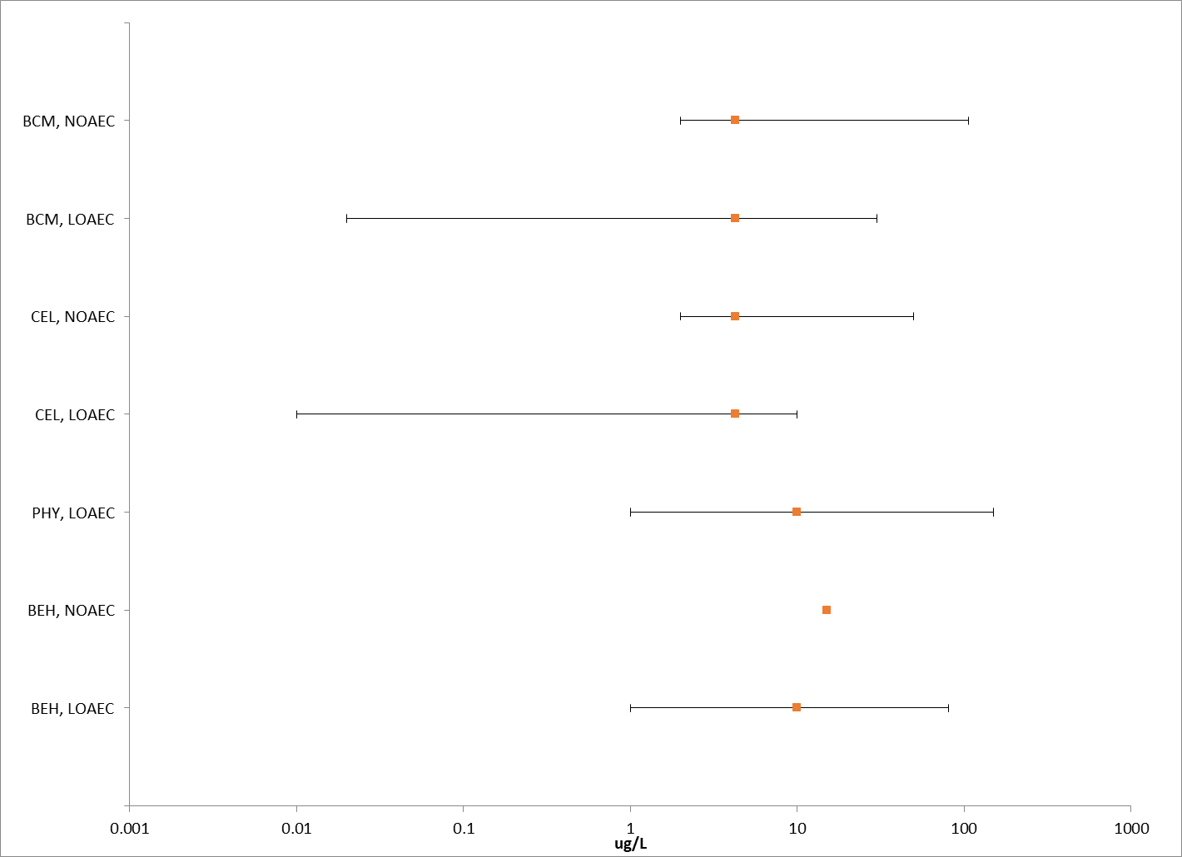
Figure 4-2. Summary array of ECOTOX toxicity data for other sublethal effects for fish and aquatic-phase amphibians expressed in terms of µg a.i./L. BCM = biochemical; CEL = cellular; PHY= physiological; BEH = behavioral.

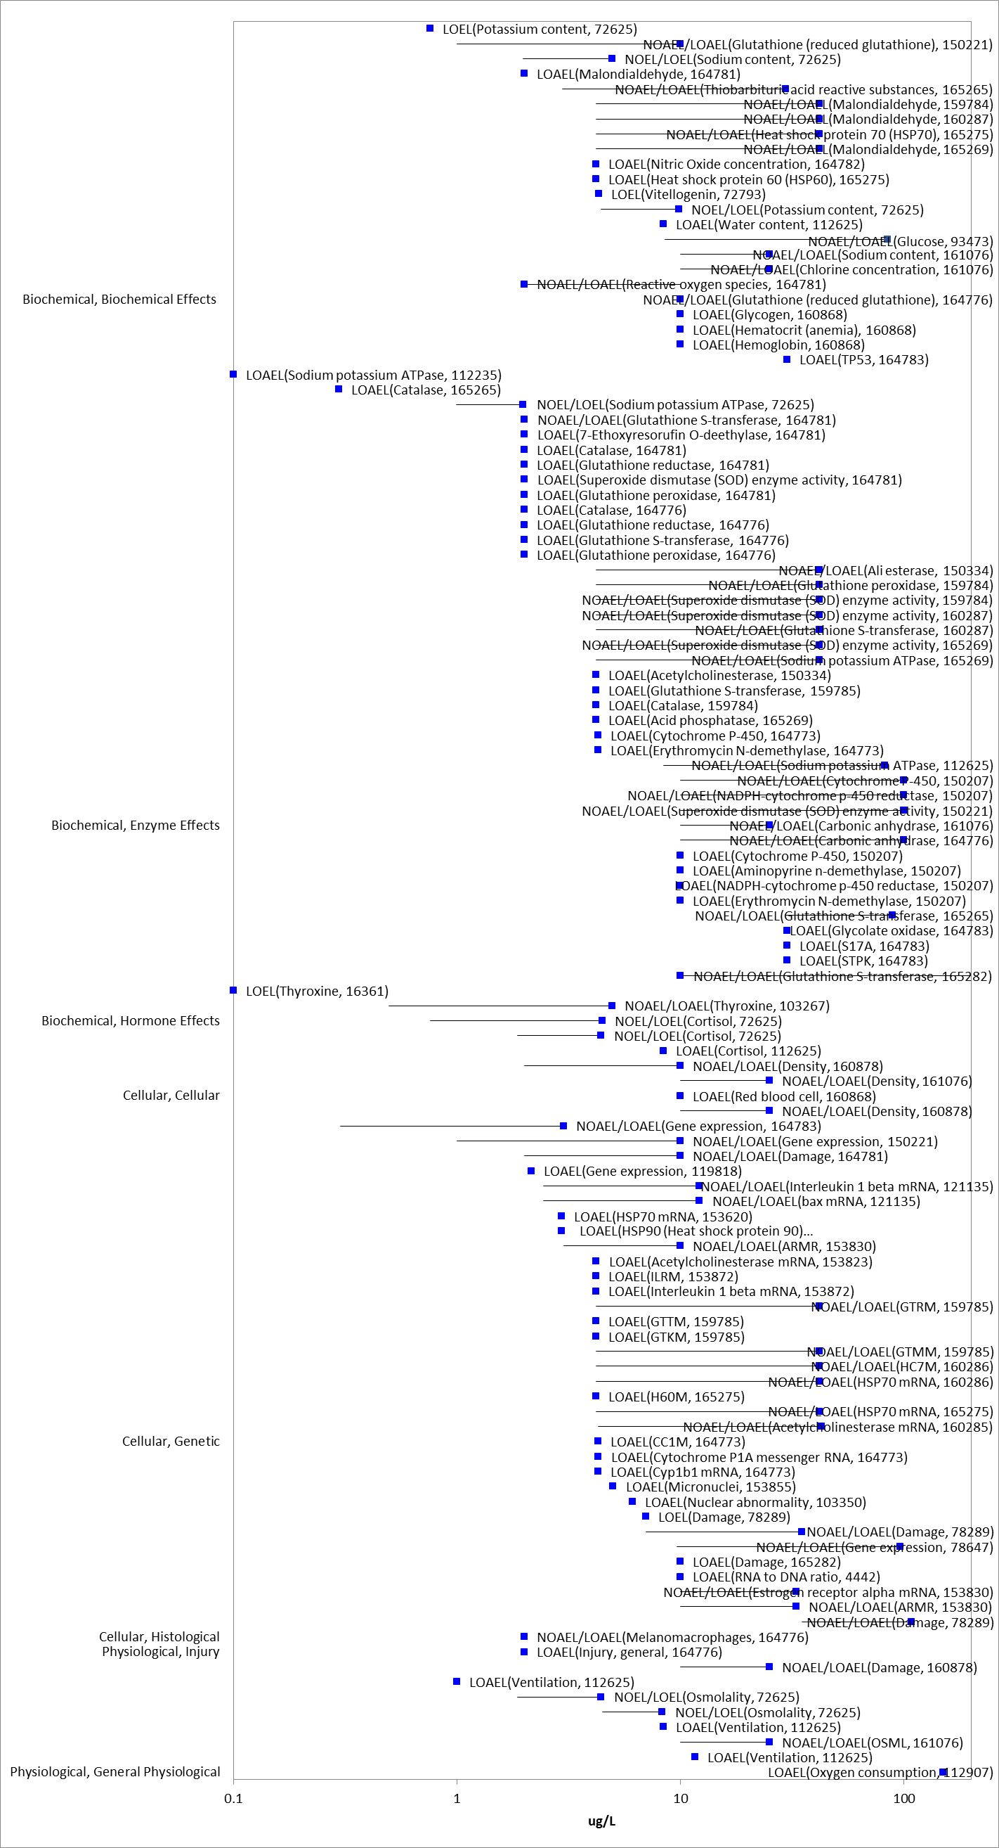
Figure 4-3. Detailed array of subset of ECOTOX toxicity data for other sublethal effects for fish and aquatic-phase amphibians expressed in terms of µg a.i./L. BCM = biochemical; CEL = cellular; PHY= physiological; BEH = behavioral.

Effects Characterization for Aquatic Invertebrates

Introduction to Aquatic Invertebrate Toxicity

There are open literature and registrant-submitted studies involving aquatic invertebrates available for atrazine, including both freshwater and estuarine/marine (E/M) invertebrates with technical grade or formulated atrazine. Studies were excluded if they were considered invalid or not associated with an environmentally relevant exposure route. Thresholds are based on the most sensitive lethal and sublethal effects identified among registrant-submitted studies and open literature in the ECOTOX database. When sufficient data are available, different endpoints are identified for freshwater and estuarine/marine invertebrates. Also, sensitivity of mollusks versus other aquatic invertebrates are discussed, and separate endpoints are derived for mollusks if data are available.
The endpoints used to derive mortality and sublethal (i.e., growth and reproduction) thresholds for direct and PPHD effects for aquatic invertebrates are presented in Table 5-1. APPENDIX 2-3 provides the open literature reviews for studies with endpoints used to derive threshold values.

Table 5-1. Summary of the most sensitive endpoints for invertebrates acute and chronic toxicity data for atrazine.
TAXON | ENDPOINT | TEST SUBSTANCE | MRID | COMMENTS
ACUTE
Freshwater Invertebrates
Midge  (Chironomus tentans) | 96-hour LC₅₀ = 720 µg a.i./L | Atrazine  94 % | MRID 00024377 | No 48-hour LC₅₀ or raw data reported
Estuarine/Marine Invertebrates
Opposum shrimp  (Neomysis integer) | LC₅₀ = 48 µg a.i./L | Atrazine  98-99% | E103334  Noppe et al., 2007 | No raw data reported
Mollusks
Eastern oyster (juvenile)  (Crassostrea virginica) | LC₅₀ > 1,700 µg a.i./L | Atrazine  97.1% | MRID 46648201  Caferalla, 2005b | None
Freshwater mussel  (Lampsilis siliquoidea) | LC₅₀ > 12,200 µg a.i./L | Aatrex 4L  40.8% a.i. | E99469  Bringolf et al., 2007 | Formulation
CHRONIC
Freshwater Invertebrates
Scud  (Gammarus fasciatus) | NOAEC = 60 µg a.i./L  LOAEC = 140 µg a.i./L  (MATC = 92 µg a.i./L) | Atrazine  94% | MRID 00024377 | Based on reduced development of F₁ to seventh instar.
Estuarine/Marine Invertebrates
Copepod  (Amphiascus Tenuiremis) | LOAEC = 3.5 µg a.i./L | Atrazine  97.4% | E73333  Bejarano et al. | Based on 32% reduction in offspring in F₁ females

Effects on Mortality of Aquatic Invertebrates

Atrazine toxicity has been evaluated in numerous aquatic invertebrate species, and the results of these studies demonstrate a wide range of sensitivity. Definitive EC/LC₅₀ values range from 48 to 30,000 µg a.i./L, with several other studies reporting non-definitive EC/LC₅₀ values >4,900 to >100,000 µg a.i./L. Therefore, atrazine is classified as highly to slightly toxic to aquatic invertebrates on an acute basis. An SSD was not generated for this data due to the high number of non-definitive endpoints and study quality concerns, including exceeding solubility at some of the higher test concentrations. Similar to the acute fish studies, several of the higher concentrations noted in these studies exceed the solubility limit of atrazine (33,000 µg a.i./L).

There are acute toxicity studies using atrazine for freshwater invertebrate species with a range of toxicity values. The acute LC/EC₅₀ values range from 720 to greater than 30,000 µg a.i./L. For the available studies, while acute LC/EC₅₀ values are reported, summary data for the controls and individual treatment groups are often not reported. Also, for some studies, details on the test design and/or environmental conditions were not well documented. The most sensitive freshwater invertebrate acute toxicity value is for the midge, Chironomus tentans, with a 48-hour LC₅₀ value of 720 µg a.i./L (MRID 00024377).

As with the freshwater invertebrates, there are acute toxicity tests available for estuarine/marine invertebrates, and like the freshwater invertebrate studies, the studies primarily only report LC/EC₅₀ values with no documentation of test concentration toxicity data. The reported range of acute LC/EC₅₀ values for estuarine-marine organisms range from 48 to 13,300 µg/L, with several non-definitive endpoints. The most sensitive organism tested was the juvenile estuarine/marine shrimp, Neomysis integer (LC₅₀ of 48 µg a.i./L; Noppe et al. 2007; E103334).
Two 48-hour acute toxicity studies with Daphnia for atrazine formulations (80WP and 40.8 4L) are available with acute LC₅₀ values ranging from 36,500 to 49,000 µg/L and >31,000 µg a.i./L (MRID 42041401; 45227712). These studies were conducted above the limit of solubility for atrazine (33,000 µg a.i./L). Another study reported a 96-hour LC₅₀ of 16,000 µg a.i./L for Hyalella azteca (Wan et al., 2006). An acute study with glochidia and juvenile stage freshwater mussels, Lampsilis siliquoidea, was conducted using Aatrex 4L (40.8% a.i.) (Bringolf et al., 2007; E99469). The reported 96-hour LC₅₀ value for both stages was >30,000 µg/L (12,200 µg a.i./L).

There were several acute toxicity studies conducted with atrazine formulations for estuarine/marine invertebrates including eastern oyster (Crassostrea virginica), Pacific oyster (Crassostrea gigas), fiddler crab (Uca pugilator), and European brown shrimp (Crangon crangon) and cockle (Cardium edule). Several studies resulted in non-definitive values, LC₅₀ >100 to >100,000 µg a.i./L (MRID 00024720; 45227728), while others resulted in definitive LC₅₀ values, 10,000 to 239,000 µg a.i./L (MRID 45227728; 00024395), of which some are above the solubility of atrazine.

Based on the available toxicity data for mortality in aquatic invertebrates, the acute mortality threshold for freshwater invertebrates is an LC₅₀ value of 720 µg a.i./L, for estuarine/marine invertebrates an LC₅₀ value of 48 µg a.i./L and for mollusks an LC₅₀ > 12,200 µg a.i./L. No slope data was available for any of the LC₅₀ values.

Sublethal Effects to Aquatic Invertebrates

Effects on Growth of Aquatic Invertebrates

There are several chronic toxicity tests for freshwater invertebrates. The most sensitive chronic endpoint for freshwater invertebrates was based on a 30-day flow-through study on the scud, Gammarus fasciatus, with a NOAEC of 60 µg a.i./L, based on reduced development of F1 to seventh instar stage (MRID 00024377). Results were available for freshwater invertebrate species (D. magna, C. tentans) from the same document, MRID 00024377. The reported NOAEC and LOAEC for D. magna and C. tentans was 140 and 250 µg a.i./L (based on reproduction and survival) and 120 and 230 µg a.i./L (based on reduced pupating and emergence), respectively. Several other chronic toxicity studies were also available with NOAECs ranging from 200 to 5,000 µg a.i./L.
In a study by Bejarano et al. (2007; E73333) copepods were exposed to atrazine for 40 days at 0, 2.5, 25, and 250 µg a.i./L. Endpoints evaluated included survival rates, time to successful maturation to reproductive adult, and sex ratios. Compared to controls, total nauplii production per female were reduced at all test concentrations, with an approximately 32% reduction in F1 females exposed to 2.5 ug a.i/L.
In order to estimate chronic aquatic invertebrate risks, data are usually required from the most sensitive species based on an acute basis. This represents an uncertainty in the chronic toxicity data as chronic toxicity data suitable for risk quotient derivation are not available on the most acutely sensitive marine invertebrate, the opposum shrimp (Neomysis integer). For characterization purposes, an estimated acute to chronic ratio of 12.5 was derived for mysid shrimp based on an acute LC₅₀ of 1000 µg/L (MRID 45202920) and a chronic NOAEC of 80 µg/L (MRID 45202920). Applying this ACR to the acute LC₅₀ in opossum shrimp of 48 µg/L results in an estimated chronic NOAEC of 3.8 µg/L. This estimate is consistent with the chronic endpoint available from Bejarno et al (E73333) and supports the use of the endpoint from this study.

Additional data from ECOTOX on aquatic invertebrate exposure to atrazine are displayed in Figure 2-4.

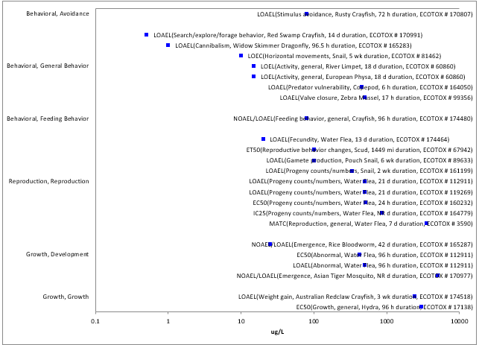
Figure 5-1. Detailed array of ECOTOX toxicity data for sublethal effects for aquatic invertebrates expressed in terms of µg a.i./L.

Based on the available data on growth and reproduction in aquatic invertebrates, the sublethal threshold for freshwater invertebrates is a NOAEC of 60 µg a.i./L based on reduced growth and for estuarine/marine invertebrates a LOAEC = 3.5 µg a.i./L based on a 32% reduction in offspring (no NOAEC established in study). No chronic data is available for mollusks; therefore, the estuarine/marine invertebrate endpoint is used as a surrogate.

Other Sublethal Effects to Aquatic Invertebrates

Limited data is available on other sublethal effects in the ECOTOX literature for aquatic invertebrates. No non-apical endpoints were identified that are more sensitive than the threshold values selected.

Effects Characterization for Aquatic Plant

Introduction to Aquatic Plant Toxicity

Most of the available toxicity studies with aquatic plants have focused on growth, reproduction, physiological effects, and population effects. Threshold values and effects data arrays in this assessment are based on endpoints expressed in, or readily converted to, environmentally relevant concentrations in terms of the amount of the atrazine (i.e., µg a.i./L).

Discussion of endpoints are provided for effects on aquatic plants and aquatic plant communities. These serve as a surrogate for effects on an individual of a listed species and the effects on PPHD of a listed species, respectively.

Effects on Aquatic Plants

Single-species aquatic plant toxicity studies are used as one of the measures of effect to evaluate whether atrazine may affect primary production and diversity in aquatic ecosystems. Numerous aquatic plant toxicity studies have been submitted to the EPA and/or published in the open literature. Figure 6.1 and Figure 6.2 present a summary of the range of toxicity values available for non-vascular and vascular aquatic plants, respectively.

Biochemical (BCM) and cellular (CEL) endpoints include measures of various enzymatic responses; carbon assimilation; oxygen production; fluorescence; photosystem II inhibition; chlorophyll a/b production; chloroplast size; photosynthesis. While several of these measures are clearly relevant to apical endpoints, especially growth, these endpoints are naturally variable with potential for rapid recovery and the study designs generally do not allow for connection to apical endpoints or are for short durations that would not capture the potential for recovery. This was particularly true for the most sensitive endpoints from these groupings. For these reasons, the following discussions of the single species aquatic toxicity data will focus on growth effects. These are sometimes captured under population level effects and represent the most sensitive endpoints. For unicellular plants, the population effects are typically measures of the numbers of individual cells in a population, such that decreases in population are considered equivalent to measures of increased mortality.

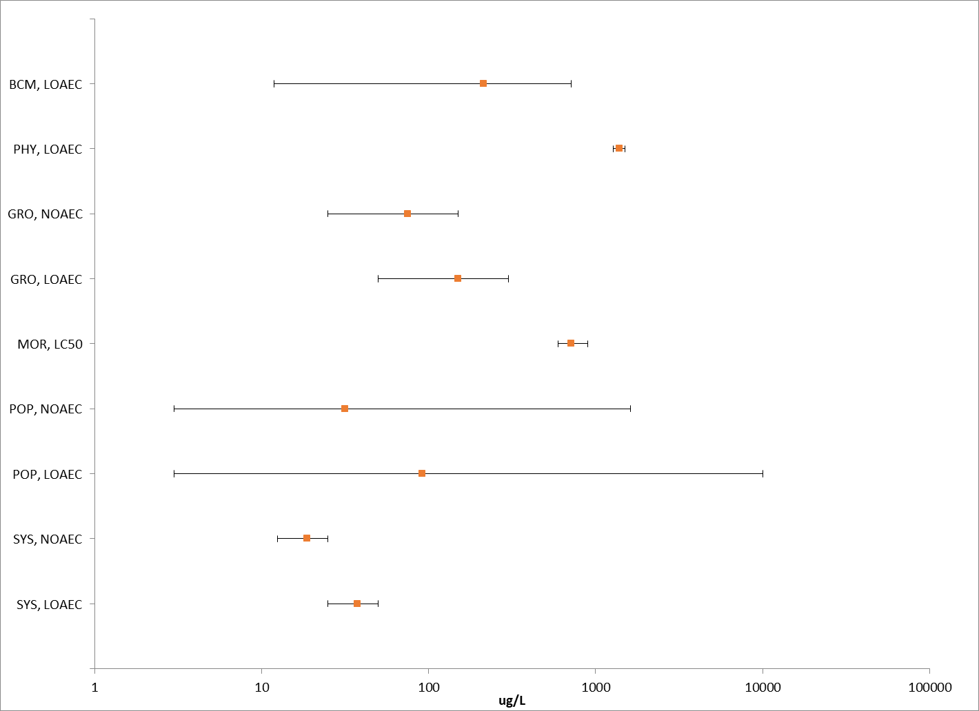
Figure 6-1. Summary array of single-species toxicity data for non-vascular aquatic plants expressed in terms of µg a.i./L. BCM = biochemical; GRO = growth; MOR = mortality; POP = population; SYS = ecological system/ecosystem process.

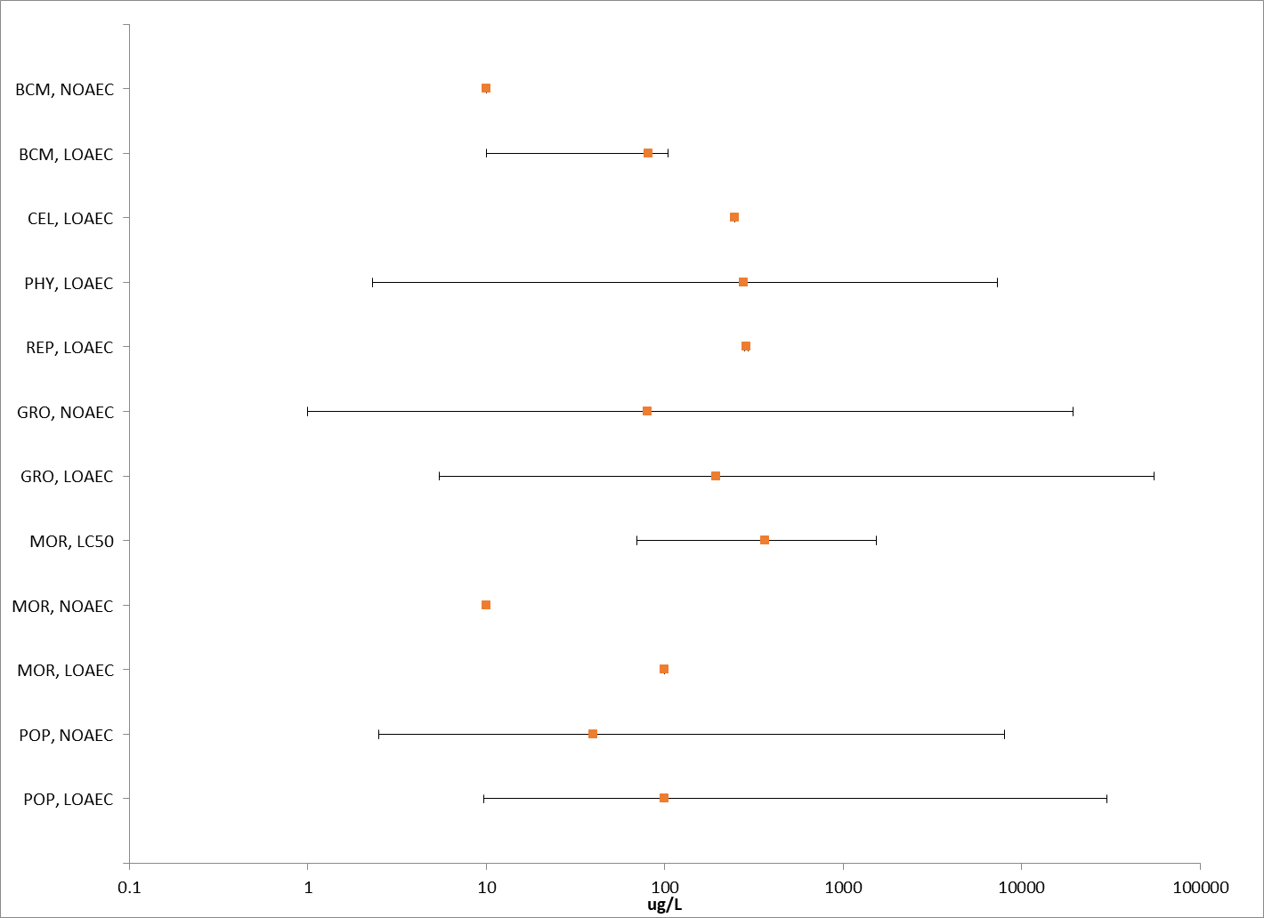
Figure 6-2. Summary array of single-species toxicity data for vascular aquatic plants expressed in terms of µg a.i./L. BCM = biochemical; CEL = cellular; PHY= physiological GRO = growth; MOR = mortality; POP = population.

Effects on Growth of Non-Vascular Aquatic Plants

Numerous aquatic non-vascular plant toxicity studies have been submitted to EPA and/or published in the open literature, representing a broad diversity of unicellular and multicellular organisms collectively referred to as “non-vascular aquatic plants”. These include Eubacteria (e.g., blue-green algae), Archaeoplastida (e.g., red algae, glaucophytes, green algae, and aquatic bryophytes), Chromalveolates (e.g., aveolates, cryptomonads, dinoflagellates, diatoms, water molds, and brown algae), Excavates (e.g., euglena), and a few lineages of the Unikonts (e.g., fungi, and collared-flagellates). These single-species toxicity studies serve as the foundation for evaluating whether atrazine may affect primary production and diversity in the aquatic ecosystem.

Figure 6.3 presents the range of toxicity data for non-vascular aquatic plants available from registrant submitted and open literature studies. Effects were observed on various measures of growth, including abundance (number of cells, cell density), volume, growth rate, population growth rate, weight, and biomass. A study and species combination may be represented multiple times based on what was being measured and/or time of observation. In the figure, the frequency of rate of change (growth rate) endpoints increases as you move up in concentration. Cell count/cell density (abundance) and other similar direct measures may be more sensitive than the measure for growth rate. The threshold for non-vascular aquatic plants comes from a study by Carrasco and Sabater (1997; ECOTOX # 6712), that evaluated the toxicity of technical grade (98% active ingredient) atrazine on two species of green algae, Chlorella vulgaris and Scenedesmus acutus, and the cyanobacterium Pseudanabaena galeata. The 96-h study followed Organization for Economic Coordination and Development (OECD) methods and measured effects of atrazine on the average specific growth rate. Based on the results of this study, NOAEC, LOAEC, and MATC values are 3, 5 and 3.87 µg a.i./L, respectively, based on a statistically significant decrease (4%; p-value < 0.05) in the average specific growth rate for P. galeata. While the percent effect in the selected study is relatively small, there are numerous studies where effects were observed at concentrations <10 µg a.i./L and similar concentrations (3.9 µg a.i./L) resulted in 50% reductions in measures of growth.

While there are more sensitive endpoints in the ECOTOX database, they are not suitable for use as a threshold due to study deficiencies (e.g., control contamination) or insufficient information provided in the study report to evaluate the methods or results. These studies are displayed on Figure 6.3.

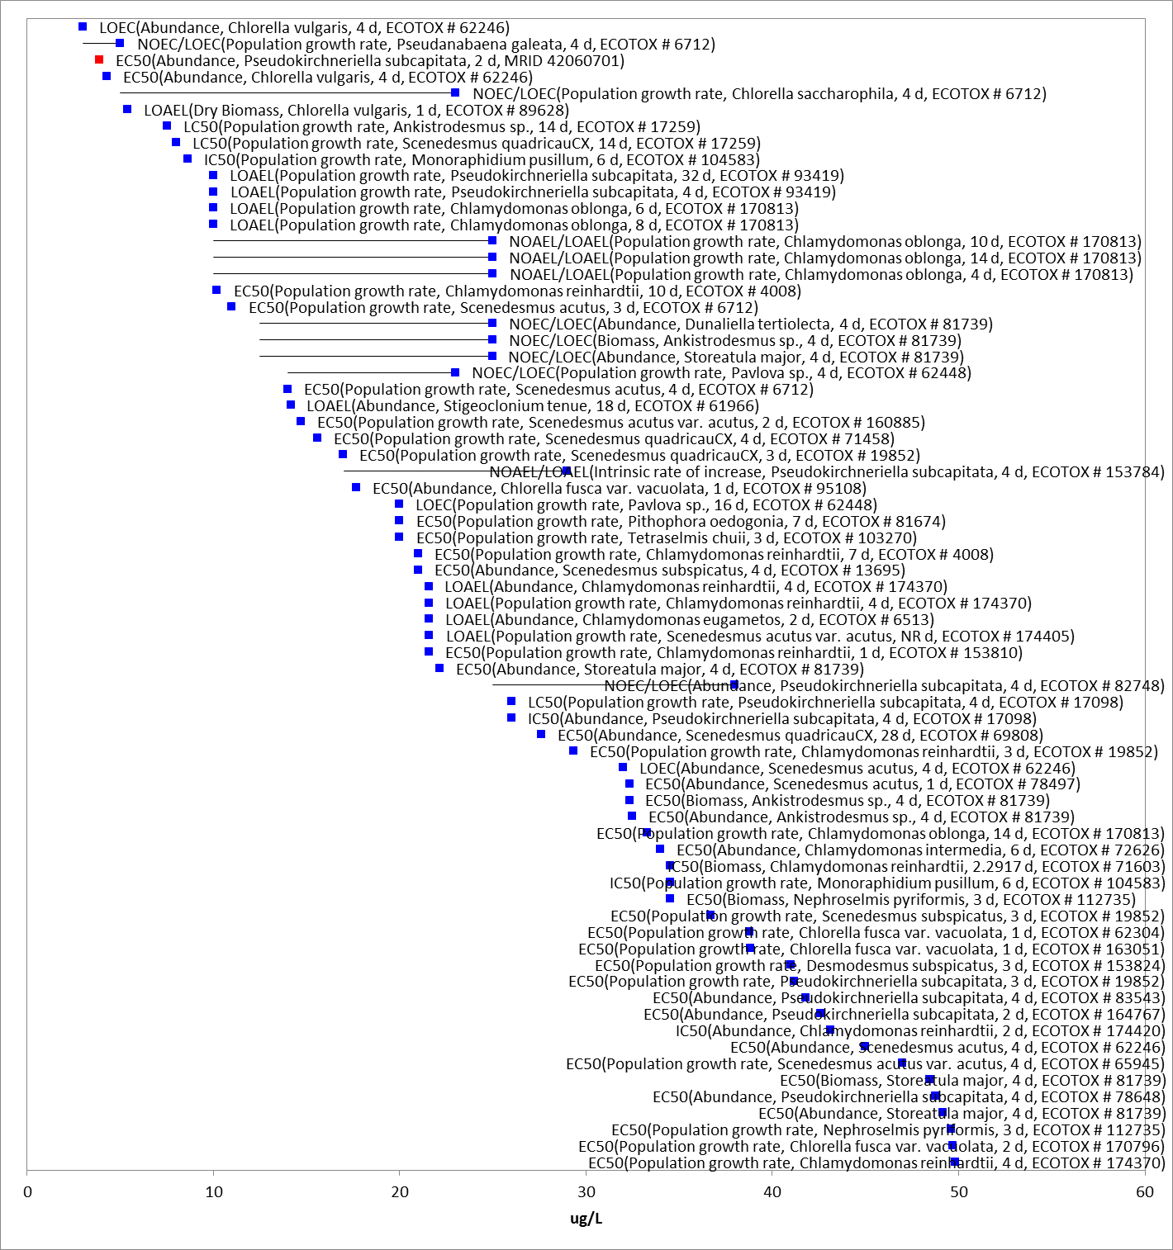
Figure 6-3. Array of toxicity data for nonvascular aquatic plants expressed in terms of µg a.i./L. Blue squares represent LOAEC values from open literature studies found in the ECOTOX database. Red squares represent LOAEC values from registrant submitted studies. Solid lines display the range between the LOAEC and NOAEC values. The horizontal axis has been adjusted to better represent the most sensitive endpoints.

Effects on Growth of Vascular Aquatic Plants

Figure 6.4 presents the range of toxicity data for vascular aquatic plants available from registrant submitted and open literature studies. Effects were observed on various measures of physiology, reproduction, and growth at the individual and population level. The threshold for vascular aquatic plants comes from a study by McGregor et al. (2008; MRID 48261124), that evaluated the toxicity of atrazine on Myriophyllum spicatum (watermilfoil) and Elodea canadensis (Canadian waterweed). The study evaluated the sensitivity of M. spicatum and E. canadensis to atrazine under three exposure conditions: individuals planted in separate pots, low-density population of individuals in each pot, and high-density population of individuals in each pot. The results for the individuals planted in separate pots are invalid due to uneven and poorly monitored herbivory in the control plants. For the low-density and high-density population tests, responses varied across measurement endpoints and exposure durations. The study results suggest measured of dry weight are the most sensitive and that there is a potential for recovery for some responses as observed by the higher EC₅₀ values reported for the longer study durations. The most sensitive EC₅₀ is 4.6 µg a.i./L based on 14-d root dry-weight observed during the low-density population test. There are several other studies that have effects occurring at similar levels (e.g., <10 µg a.i./L).

There are more sensitive endpoints in the database, but they are not suitable for use as a threshold due to study deficiencies (e.g., control contamination) or insufficient information provided in the study report to evaluate the methods or results.
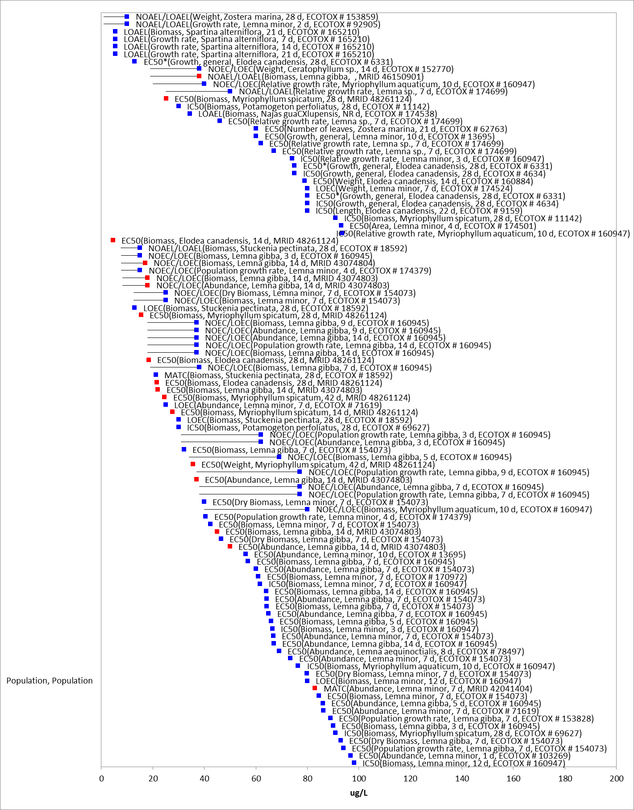
Growth, Growth
Figure 6-4. Array of toxicity data for vascular aquatic plants expressed in terms of µg a.i./L. Blue squares represent LOAEC values from open literature studies found in the ECOTOX database. Red squares represent LOAEC values from registrant submitted studies. Solid lines display the range between the LOAEC and NOAEC values. The horizontal axis has been adjusted to better represent the most sensitive endpoints.

Effects on Aquatic Plant Communities

Median effect concentration (EC₅₀) values for aquatic plants are used to derive the threshold for effects to the PPHD of an individual of a listed species. Studies with effects on measures of growth (e.g., biomass, cell counts, number of fronds, etc); were conducted with technical grade atrazine; and had 3- and 4-day (non-vascular) or 7-day (vascular) exposure durations were used to derive Species Sensitivity Distributions (SSD). These parameters were selected to maximize comparability of results. Studies used to derive the SSDs are compiled in APPENDIX 2-5.

Toxicity estimates for atrazine range from 4.3 – 84,000 µg a.i./L and span four orders of magnitude (APPENDIX 2-5), indicating a wide range of sensitivity to atrazine among aquatic plants.
The most sensitive non-vascular aquatic plant endpoint is from Seguin et al. 2001, with an IC₅₀ value of 4.3 μg a.i./L for the green alga, Chlorella vulgaris, based on reductions in abundance. Vascular plants have a similar sensitivity to atrazine as non-vascular plants, with the most sensitive vascular plant EC₅₀ having a value of 32.1 µg a.i./L, based on a reduction in biomass in Leman gibba (Rentz 2009).

For the SSD, five distributions were tested, and a variety of methods were used. The gumbel distribution and moment estimator (MO) method were selected to represent HC₀₅ through HC₉₅ values for all aquatic plants. Table 6-1 and Figure 6.5 provide a summary of the results. The threshold for species that rely upon aquatic plants for their PPHD is 14.4 µg a.i./L based on the HC₀₅ from the SSD for all aquatic plants.

Table 6-1. Summary Statistics for Aquatic Plant SSD Fit to Atrazine Test Results.
Statistic | All Aquatic Plants  (µg a.i./L)
Best Distribution (by AIC_{c}) | Gumbel
Goodness of fit  P-value | 0.13
CV of the HC₀₅ | 0.49
HC₀₅ | 14.4
HC₁₀ | 22.4
HC₅₀ | 164
HC₉₀ | 3758
HC₉₅ | 12427

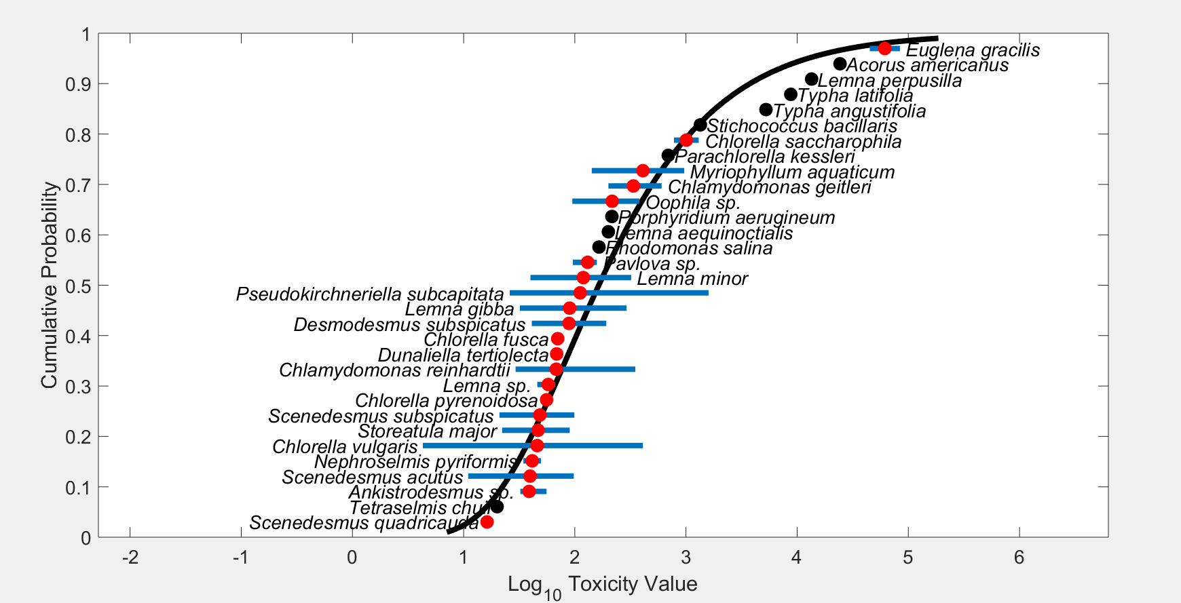
Figure 6-5. Species Sensitivity Distribution (SSD) for all aquatic plants. Black points indicate single toxicity values. Red points indicate average of multiple toxicity values for a single species. Blue line indicates full range of toxicity values for a given taxon.

In addition to reviewing the toxicity data for individual species and deriving SSDs, the toxicity of atrazine to aquatic plant communities is evaluated by considering microcosm and mesocosm (cosm) data available in the open literature. Cosm studies conducted with atrazine provide measurements of primary productivity that incorporate the aggregate responses of multiple species in aquatic plant communities. Because plant species vary widely in their sensitivity to atrazine, the overall response of the plant community may be different from the responses of the individual species measured in laboratory toxicity tests. Cosm studies allow observation of population and community recovery from atrazine effects and of indirect effects on higher trophic levels. In addition, cosm studies, especially those conducted in outdoor systems, incorporate partitioning, degradation, and dissipation, factors that are not usually accounted for in laboratory toxicity studies, but that may influence the magnitude of ecological effects.

Thresholds used to determine if federally listed aquatic plants or species that may depend on them for PPHD are derived as described in USEPA (2020). Given the large dataset available for atrazine, there are many possible ways to establish potential thresholds for environmental effects. For example, the refined ecological risk assessment for atrazine (USEPA 2016) conducted for registration review under FIFRA used the available cosm data to estimate a concentration equivalent level of concern (CELOC). Although both methods have merits, EPA followed the established process for deriving thresholds used in a biological evaluation as described in USEPA (2020) and not the CELOC method.
Like the individual species toxicity data, a wide variety of aquatic plant taxonomic groups are represented by the available cosm data (Table 6-2). An extensive set of cosm studies have documented effects of atrazine on plant community structure and productivity (Appendix B of the DRA [USEPA 2016] contains details of the cosm studies). Examples of atrazine-related effects observed in the cosm studies included reductions in aquatic plant biomass, concentration of chlorophyll A, rate of photosynthesis (¹⁴C uptake and oxygen production), and shifts in aquatic plant community structure (e.g., species composition and diversity) relative to a control. Percent effects observed in these studies include up to 100% decline in endpoints related to biomass, up to 90% decline in measures of photosynthesis, and up to 15% decline in measures of species diversity. These cosm studies have been extensively reviewed previously (USEPA, 2016).

Table 6-2. The taxonomic distribution of reported species in COSM studies.
Taxonomic Group |  | Genera | Species
EUBACTERIA: | CYANOBACTERIA:  (Blue-Green Algae) | 14 | 27
EUKARYOTES
ARCHAEOPLASTIDA | GREEN PLANTS:
 | EMBRYOPHYTA:  (Non-Vascular Land Plants) | - | -
 | EMBRYOPHYTA: (Vascular Land Plants) | 11 | 20
 | CHLOROPHYTA and STREPTOPHYTA:  (Green Algae) | 43 | 86
 | PRASINOPHYTA:  (Prasinophytes) | 1 | 1
CHROMALVEOLATES | HACROBIA:
 | HAPTOPHYTA:  (Coccolithophorads) | 2 | 4
 | CRYPTOPHYTA:  (Cryptomonads) | 4 | 13
 | STRAMENOPILES:
 | BACILLARIOPHYTA:  (DIATOMS) | 24 | 67
 | CHRYSOPHYTA:  (Golden Algae) | 7 | 12
 | XANTHOPHYTA:  (Yellow-Green Algae) | 2 | 2
 | AVEOLATES:
 | PYRROPHYCOPHYTA (Dinoflagellates): | 4 | 4
EXCAVATES | EUGLENOZOA:  (Euglenoids) | 1 | 1
UNIKONTS | FUNGI: | 2 | 2
 | CHOANOFLAGELLIDA: | 3 | 3
 | ANIMALS:
 | VERTEBRATES: | 9 | 15
 | INVERTEBRATES: | 137 | 196

Atrazine has been the subject of various microcosm and mesocosm (cosm) studies in which such effects have been documented. These studies serve as the foundation for identifying atrazine exposures that are detrimental to aquatic plant communities. However, the concentration and length of exposure varied markedly among these cosm studies. The lengths of the studies varied from one week to one year, and the concentrations remained constant or steadily declined over the exposure period. Figure 6.6 presents the distribution of effect and no effect endpoints from the available cosm studies as related to the initial test concentration and study duration. To understand how the cosm endpoints compare to the individual species data, Figure 6.6 also presents the HC₀₅, HC₂₅, HC₅₀, and HC₇₅ species from the all aquatic plant SSD. There is considerable overlap between the percentiles of the all aquatic plant SSD and the range of effect endpoints from the cosm studies. This supports using the all aquatic plant SSD to derive the threshold for effects to the PPHD of a listed species.

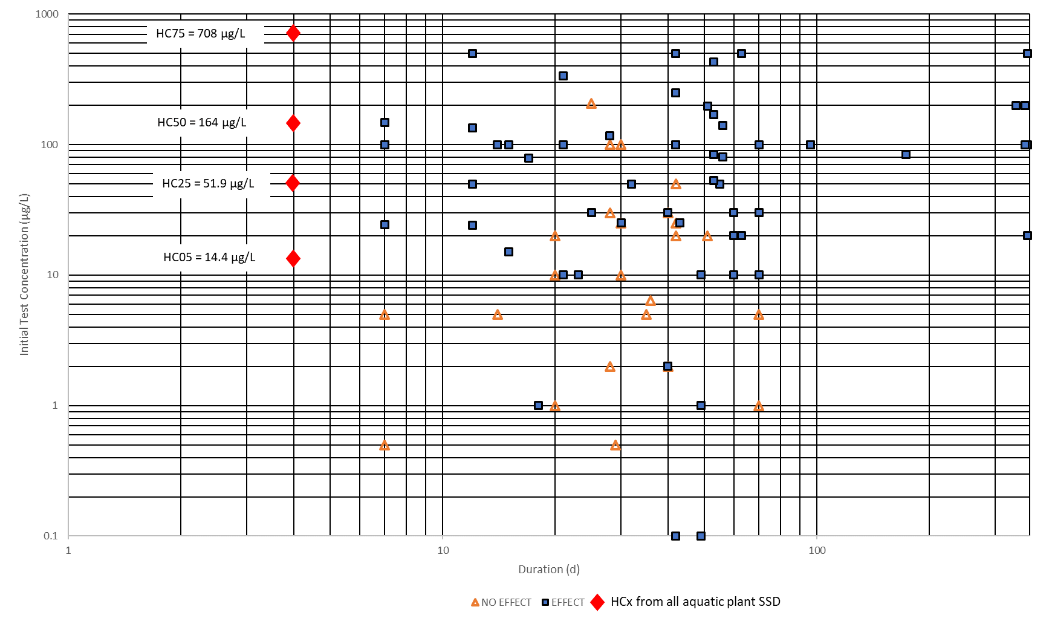
Figure 6-6. Distribution of Effect and No-Effect endpoints as related to initial study concentration and reported duration.

Because the phytoplankton community represents the primary producers (food items) for the aquatic ecosystem, reduced and delayed growth would have negative effects on the organisms that rely upon phytoplankton for food and could cause effects throughout the trophic system. Reduction and/or delays in the growth of macrophytes and metaphyton (algae mats) growth, would result in a delay in the habitat structural maturation for use by amphibian, fish and invertebrate taxa. The taxa that may be most affected by these delays or reductions would likely be those taxa that rely upon the macrophytes and metaphyton for reproduction and protection of young during primary atrazine runoff periods midwestern corn uses in the months of April, May, and June. This timing is likely to include a wide diversity of taxa from these animal lineages that depend on the structural components of the aquatic plant community. Other consequences of the atrazine exposures have been shown to manifest in the form of more complex ecosystem responses (e.g., Rohr et al. 2009, Boone et al. 2012). These cosm studies have indicated that atrazine can increase light penetration to the below water surfaces by reducing phytoplankton populations. Covering these surfaces are periphyton communities, dominated by diatoms. These periphyton communities have been shown to benefit from the increased light penetration to the surfaces following low dose exposure to atrazine. The increased periphyton growth has been connected in cosm experiments to increased populations invertebrates (snails) which forage on the periphyton. These authors stress that the increased population of snails may lead to increased disease (trematode infection) in aquatic amphibians, as the snail is the infection transmission vector.
Streams, rivers, reservoirs and other similar water bodies, have an annual cycle of community structure that can be influenced by many different environmental factors in addition to the components of the community at various times of the year (Baker and Baker 1981, Cardinale 2011, Dalton et al. 2015, Andrus et al. 2013, Hall et al. 2014, Andrus et al. 2015). Impacts of atrazine and recovery from exposure on relatively fast-growing populations of unicellular photoautotrophs are very different from their slower growing relatives in the non-vascular and vascular embryophytes. Reductions in growth on a macrophyte may take a great while longer to recover to control conditions than the recovery times that are published for unicellular phytoplankton and periphyton (e.g., Prosser et al. 2013, Brain et al. 2012). The repeated annual atrazine non-lethal exposures to macrophytes and other embryophytes, would manifest themselves over greater time periods and would be difficult to attribute to an individual year of atrazine exposure and would be equally difficult to attribute to atrazine exposure as the sole cause of the declining population. However, evidence from the available individual species toxicity tests and the cosm studies suggests that significant impacts to macrophytes would be expected and these effects would carry over to the next growing season and would likely negatively impact asexual and sexual reproduction.

Effects Characterization for Birds

Introduction to Bird Toxicity

There are open literature and registrant-submitted studies involving birds, including acute oral, sub-acute dietary and chronic reproduction with technical grade or formulated atrazine. Studies were excluded if they were considered invalid or not associated with an environmentally relevant exposure route. Thresholds are based on the most sensitive lethal and sublethal effects identified among registrant-submitted studies and open literature in the ECOTOX database.

A summary of the most sensitive toxicity data for birds used to derive mortality and sublethal (i.e., growth and reproduction) thresholds for direct and PPHD effects are presented in Table 7-1.

Table 7-1. Summary of most sensitive toxicity data for atrazine for birds.
TAXON | ENDPOINT | TEST SUBSTANCE | MRID | COMMENTS
ACUTE ORAL
Northern Bobwhite quail (Colinus virginianus) | LD₅₀ = 783 mg a.i./kg-bw  Slope = 3.8 | Atrazine  TGAI (unknown %) | 00024721  (Fink, 1976) | Conducted with 14-day old chicks and study only conducted for 8 days; no deaths occurred after the fourth day
Northern Bobwhite quail (Colinus virginianus) | LD₅₀ >2,000 mg/kg-bw (1,772 mg a.i./kg-bw) | Atrazine  Atrazine WG (90) (88.7%) | MRID 50449403 | Formulation (more recent study). Birds in the treatment group were noted with ruffled appearance and lethargy. from the afternoon of Day 1 until the morning of Day 10, as well as reduced food consumption and weight loss. No mortality noted in study.
Mallard Duck  (Anas platyrhynchos) | LD₅₀ >2,000 mg/kg-bw (1,520 mg a.i./kg-bw) | Atrazine 80 WP  76 % | 00160000  Hudson, Tucker & Haegle 1984 | Formulation; 3 birds used; 6-months old; 14-day test
SUB-ACUTE DIETARY
Mallard duck (Anas platyrhynchos) | LC₅₀ >5,000 mg a.i./kg-diet | Atrazine TGAI (99%) | 00022923  (Hill et al. 1975) | Conducted with 10-day old ducklings; 30% mortality at 5,000 mg a.i./kg-diet
Northern bobwhite  (Colinus virginianus) | LC₅₀ >5,000 mg a.i./kg-diet | Atrazine TGAI (99%) | 00022923  (Hill et al. 1975) | Conducted with 9-days old chicks
Northern bobwhite  (Colinus virginianus) | LC₅₀ = 5,760 mg a.i./kg-diet  Slope = 3.25 | Atrazine 80W  76 % | 00059214  Beliles & Scott 1965 | Formulation; 6-week old birds
Mallard duck (Anas platyrhynchos) | LC₅₀ = 19,560 mg a.i./kg-diet | Atrazine 80W  76 % | 00059214  Beliles & Scott 1965 | Formulation
CHRONIC
Mallard duck (Anas platyrhynchos) | NOAEC <75 mg a.i./kg-diet  LOAEC = 75 mg a.i./kg-diet | Atrazine  TGAI (97.1%) | 42547101 | Based on reduced hatchling weight (5.3 to 12.3%) at 75 mg a.i./kg –diet; effects seen on egg production and food consumption at 225 mg a.i./kg-diet
Northern Bobwhite quail (Colinus virginianus) | NOAEC = 225 mg a.i./kg-diet  LOAEC = 675 mg a.i./kg-diet | Atrazine  TGAI (97.1%) | 42547102 | Based on egg production and embryo viability

Table 7-2. Summary of most sensitive toxicity data for atrazine degradates for birds.
TAXON | ENDPOINT | TEST SUBSTANCE | MRID | COMMENTS
ACUTE ORAL
Northern bobwhite quail  (Colinus virginianus) | LD₅₀ >2,000 mg a.i./kg-bw | Degradate:  Deisopropylatrazine  (DIA)  96% | 46500007  Stafford, 2005a | 18-week old chicks; 14-day test
Northern bobwhite quail  (Colinus virginianus) | LD₅₀ >2,000 mg a.i./kg-bw | Degradate:  Hydroxyatrazine  (HA)  97.1% | 46500008  Stafford, 2005b | 18-week old chicks; 14-day test
Northern bobwhite quail  (Colinus virginianus) | LD₅₀ = 768 mg a.i./kg-bw | Degradate:  Deethylatrazine  (DEA)  96% | 46500009  Stafford, 2005c | 16-week old chicks; 14-day test

Effects on Mortality of Birds

The available data in birds suggest that atrazine is slightly toxic to avian species on an acute oral exposure basis. For parent atrazine, the lowest reported acute oral LD₅₀ is 783 mg a.i./kg-bw (bobwhite quail, Colinus virginianus) (MRID 00024721), conducted using 14-day old birds. In 2019, as part of public comments on the 2016 DRA, an additional acute oral toxicity study with the formulation Atrazine WG (90) was conducted on the northern bobwhite quail, where no mortality was seen at the limit test of 2,000 mg a.i./kg-bw nominal (1,772 mg a.i./kg-bw measured). Another acute study with an atrazine formulation, the resulting LD₅₀ values were >2,000 mg/kg-bw nominal (>1,520 mg a.i./kg-bw measured), in mallards (Anas platyrhynchos) and in ring-necked pheasants (Phasianus colchicus) (U.S. EPA, 2003a; MRID 00160000). Acute toxicity data on passerines is not available for atrazine.
Because all subacute avian LC₅₀ values are greater than 5,000 mg a.i./kg-diet, atrazine is categorized as practically non-toxic to avian species on a subacute dietary basis. In the subacute dietary study in mallard ducks (A. platyrhynchos), 30% mortality was observed at the highest test concentration of 5,000 mg a.i./kg-diet (MRID 00022923); one mortality was observed in the Japanese quail (Coturnix japonica) study at 5,000 mg/kg-diet. The time to death was Day 3 for the one Japanese quail (C. japonica) and Day 5 for three mallard ducks (U.S. EPA, 2003a; MRID 00022923 and 0002292; J. Spann at Patuxent Wildlife Center, 1999, personal communication). Four species of birds were tested in the Hill et al., (1975) (MRID 00022923) study. The lowest definitive LC₅₀ values was 5,760 mg a.i./kg-diet in the northern bobwhite quail (Colinus virginianus) (MRID 00059214).

Based on the available toxicity data for mortality in birds, the acute mortality threshold for birds is an LD₅₀ value of 783 mg a.i./kg-bw based on mortality in the bobwhite quail. Although a newer study was available on the Bobwhite with atrazine formulation, an LD₅₀=783 mg a.i./kg-bw is used as the threshold to account for the uncertainty in the lack of diverse species data, as well as the degradate data with a similar LD₅₀ value (DEA, LD₅₀ = 768 mg a.i./kg-bw). Based on the available subacute avian toxicity data, the mortality threshold is established at 5,760 mg a.i./kg-diet, the lowest definitive toxicity value.

Effects on Growth and Reproduction of Birds

Sublethal effects to birds were reported in the available acute studies. In acute oral toxicity study with the formulation Atrazine WG (90) with the northern bobwhite quail, birds in the highest treatment group were noted with signs of toxicity from the afternoon of Day 1 until the morning of Day 10. Signs of toxicity noted were ruffled appearance and lethargy. Birds also exhibited decreased food consumption and weight loss. For the atrazine formulation in mallards (Anas platyrhynchos) discussed above, signs of toxicity first appeared 1 hour after treatment and persisted up to 11 days, and in ring-necked pheasants, (Phasianus colchicus), remission of signs of intoxication occurred by 5 days after treatment (U.S. EPA, 2003a; MRID 001600-00). Signs of toxicity included weakness, hyper-excitability, ataxia, and tremors; weight loss also occurred in mallards.

Reproduction studies in birds have reported effects at atrazine concentrations of 75 mg a.i./kg-diet and higher. Both northern bobwhite quail (C. virginianus) and mallard duck (A. platyrhynchos) reproduction studies were conducted using atrazine. In the northern bobwhite study, the following endpoints were affected at 675 mg a.i./kg-diet: egg production and embryo viability, and a reduction in weight gain in the males (MRID 42547102). The number of cracked eggs in the control was about three times the accepted threshold noted in the OCSPP 850.2300 guideline. The NOAEC in the bobwhite study was 225 mg a.i./kg-diet. In the mallard study, decreased hatchling weight was significant at all concentrations tested, with decreases ranging from 5.3 to 12.3% at 75 to 675 mg a.i./kg-diet, respectively. At a concentration of ≥225 mg a.i./kg-diet, there were effects on egg production and mean food consumption while live embryos and hatchlings per eggs set and male weight gain were affected at 675 mg a.i./kg-diet (MRID 42527101).

Based on the available data on growth and reproduction, the sublethal toxicity threshold based on reproductive effects in the mallard duck is a LOAEC = 75 mg a.i./kg-diet (no NOAEC established in study). These endpoints were also converted to dose-based endpoints for use in the analysis, based on data available in the study on body weights and food consumption of test animals (LOAEC = 7 mg a.i./kg-bw).

Several public comments were received on the above study when published with the 2016 DRA. Comments included concern about the statistical analysis method utilized in the analysis, the relevance of the endpoint of hatchling weight to risk analysis and the inclusion of a deceased hen in the statistical analysis. These comments were considered in the re-evaluation of the endpoint. Although removal of the deceased hen from the statistical analysis changes the endpoint to a NOAEC = 75 mg a.i./kg-diet and LOAEC = 225 mg a.i./kg-diet, the hen was found dead at week 20, well after the egg laying/setting period and at the end of the exposure. Removal of the hen from the analysis is not appropriate given the effect endpoint of hatchling weight. Additionally, the relevance of the endpoint and the statistical analysis chosen were reevaluated and determined to be suitable; there is variability across the control and treatment groups, but the effects are both dose dependent and biologically and statistically significant. The impact of alternative endpoints selection is considered in the weight of evidence analysis and is discussed further in Section 14.

Other sublethal effects to Birds

Data arrays for the available data from ECOTOX are displayed below, displaying other sublethal effects as well as growth endpoints.

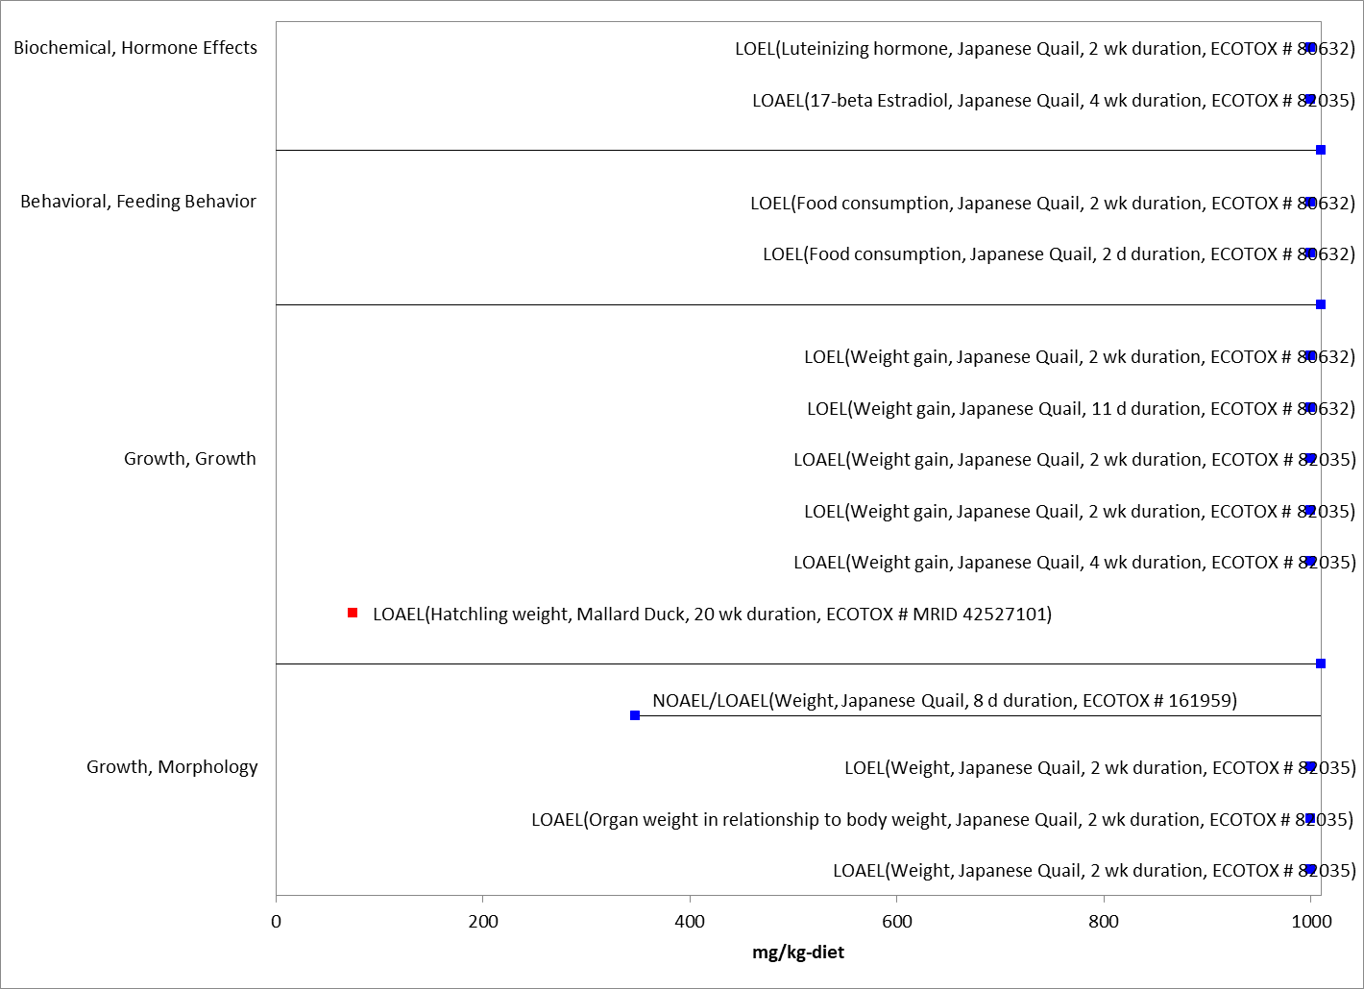
Figure 7-1. Array of toxicity data for sublethal effects to birds expressed in terms of mg a.i./kg-diet. Blue squares represent LOAEC values from open literature studies found in the ECOTOX database. Red squares represent LOAEC values from registrant submitted studies. Solid lines display the range between the LOAEC and NOAEC values. Parentheses present the effect, species, duration of study and study reference (i.e., MRID, ECOTOX #).

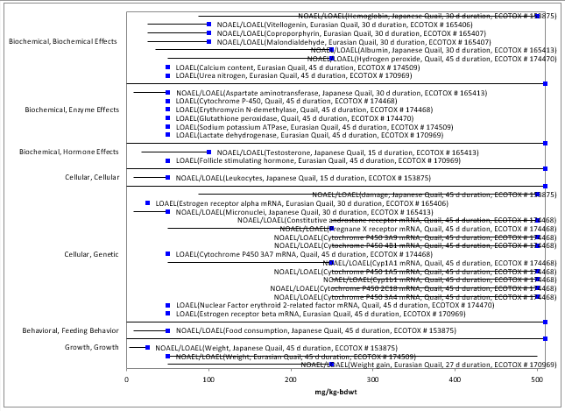

Figure 7-2. Array of toxicity data for sublethal effects to birds expressed in terms of mg a.i./kg-bw. Blue squares represent LOAEC values from open literature studies found in the ECOTOX database. Solid lines display the range between the LOAEC and NOAEC values. Parentheses present the effect, species, duration of study and study reference (i.e., MRID, ECOTOX #).

Drinking water studies

No studies involving avian exposure via drinking water were identified in registrant studies or the ECOTOX database.

Dermal studies

No toxicity studies involving dermal exposure were identified in registrant studies or the ECOTOX database. However, non-guideline dermal absorption study was submitted by the registrant as part of the public comments on the 2016 DRA. This is further discussed in Chapter 3.

Effect Characterization to Reptiles

Studies available for reptiles were discussed in the 2016 DRA and are captured in the ECOTOX summary (APPENDIX 2-2). None of these studies were suitable for use as quantitative endpoints in this analysis. Therefore, the available toxicity data for birds are used as a surrogate for reptiles and are considered protective based on the available data.

Effect Characterization to Terrestrial-phase Amphibians

Studies available for terrestrial-phase amphibians are captured in the ECOTOX summary (APPENDIX 2-2). None of these studies were suitable for use as quantitative endpoints in this analysis. Therefore, the available toxicity data for birds are used as a surrogate for terrestrial-phase amphibians and are considered protective based on the available data.

Effects Characterization for Mammals

Introduction to Mammal Toxicity

The effects of atrazine on mammals has been studied extensively. Studies were excluded if they were considered invalid or not associated with an environmentally relevant exposure route. As acute toxicity data were only available for two species within the order Rodentia, thereby preventing calculation of a species sensitivity distribution, thresholds are based on the most sensitive lethal and sublethal effects identified among the available registrant-submitted studies and open literature in the ECOTOX database.

Table 10-1. Summary of the Most Sensitive Mammalian Endpoints for Atrazine
TAXON | ENDPOINT | TEST SUBSTANCE | MRID | STUDY CLASS-IFICATION | COMMENTS
ACUTE ORAL
Norway Rat  (Rattus Norvegicus) | LD₅₀ = 1,869 mg/kg-bw | Atrazine | 00024706 | Acceptable | Only overall male (M) & female (F) LD₅₀ reported (not reported for M & F individually)
CHRONIC
Norway Rat  (Rattus Norvegicus) | NOAEL = 50 mg/kg-diet (3.7 mg/kg-bw)  LOAEL = 500 mg/kg-diet (39 mg/kg-bw) | Atrazine  TGAI (97.1%) | 40431306 | Acceptable | 2-generation reduction study in rat; Based on decreased body weights (12 - 15%), body weight gains, and food consumption.
Norway Rat  (Rattus Norvegicus) | NOAEL = 3.3 mg/kg-bw  LOAEL = 34.5 mg/kg-bw | Atrazine  TGAI (97.1%) | 44723701 | Acceptable | 90-day oral toxicity in rodents (870.3100)  Based on decreased body weights

Table 10-2. Summary of the Most Sensitive Endpoints for Atrazine Degradates
TAXON | ENDPOINT | TEST SUBSTANCE | MRID | STUDY CLASS-IFICATION | COMMENTS
ACUTE ORAL
Norway Rat  (Rattus Norvegicus) | LD₅₀ = 1,240 mg/kg-bw | Degradate:  Deisopropylatrazine  (DIA) (G-28279)  96% | 43013201 | Acceptable | Overall M & F reported to be consistent with parent reporting; LD₅₀ for M = 2290 mg a.i./kg-bw; F = 810 mg a.i./kg-bw
Norway Rat  (Rattus Norvegicus) | LD₅₀ = 1,110 mg/kg-bw | Degradate:  Deethylatrazine  (DEA) (G-30033)  96% | 43013202 | Acceptable | Overall M & F reported to be consistent with parent reporting; LD₅₀ for M = 1890 mg a.i./kg-bw; F = 668 mg a.i./kg-bw
CHRONIC
Norway Rat  (Rattus Norvegicus) | NOAEL = 2.5 mg/kg-bw  LOAEL = 25 mg/kg-bw | Degradate:  DACT (GS-28273)  TGAI (97.1%) | 41392402 | Acceptable | Prenatal developmental toxicity in rodents  (870.3700a)  Based on decreased body weight gain during initial dosing period
Norway Rat  (Rattus Norvegicus) | NOAEL = 3.2 mg/kg-bw  LOAEL = 34.9 mg/kg-bw | Degradate:  DIA (G-28279)  TGAI (97.1%) | 43013205 | Acceptable | 90-day oral toxicity in rodents (870.3100)  Based on decreased body weights and body weight gains
Norway Rat  (Rattus Norvegicus) | NOAEL = 3.2 mg/kg-bw  LOAEL = 35.1 mg/kg-bw | Degradate:  DEA (G-30033)  TGAI (97.1%) | 43013206 | Acceptable | 90-day oral toxicity in rodents (870.3100)  Based on decreased body weights and food efficiency
Norway Rat  (Rattus Norvegicus) | NOAEL = 1.0 mg/kg-bw  LOAEL = 7.8 mg/kg-bw | Degradate:  Hydroxyatrazine  (GS-17794)  TGAI (97.1%) | 43532001 | Acceptable | Combined chronic toxicity/oncogenicity- rats  (870.4100a)  Based on gross and histopathological changes in the kidneys.

Effects on Mortality of Mammals

The acute oral LD₅₀ value for parent atrazine in the rat (Rattus norvegicus) is 1,869 mg a.i./kg-bw (MRID 00024706). Acute oral data for degradates DEA and DIA indicate similar acute toxicity as the parent compound for males and females combined; however, females appear more sensitive to both degradates. No data is available on acute toxicity of degradates DACT and HA.
Based on the available acute mammalian toxicity data, the endpoint used to derive the acute oral toxicity threshold, based on mortality observed in the Norway rat, is 1,869 mg a.i./kg-bw.

Effects on Growth and Reproduction of Mammals

The mammalian LOAEL in reproduction toxicity studies was 500 mg a.i./kg-diet based on significant reductions in adult rat body weight and adult food consumption (NOAEL 50 mg a.i./kg-diet) (U.S. EPA, 2003a; MRID 40431303). In the 2-generation reproduction study (MRID 40431303), technical grade atrazine was administered to rats (Rattus norvegicus) in the diet at concentrations of 0, 10, 50, and 500 mg a.i./kg-diet. Parental body weights, body weight gain, and food consumption were statistically significantly reduced at the 500 mg a.i./kg-diet dose in both sexes and both generations throughout the study. Compared to controls, body weights for F₀ males and females at 70 days into the study were decreased by 12% and 15%, respectively, while F₁ body weight for the same time period was decreased by 15% and 13% for males and females, respectively. The only other parental effect, which may have been treatment related was a slight, but statistically significant increase in relative testes weight, occurring in both generations exposed to the high dose. There did not appear to be any reproductive effects from compound exposure. Measured reproductive parameters from both generations did not appear to be altered in a dose-related manner. The LOAEL was 500 mg/kg-diet (39 mg/kg/day in males, 43 mg/kg/day in females) based on decreased body weights, body weight gains, and food consumption. The NOAEL was 50 mg/kg-diet (3.8 mg/kg/day in males, and 3.7 mg/kg/day in females).

Additional reproduction/developmental toxicity data are available for atrazine and it’s degradates (U.S. EPA, 2011a). Table 2- 11 above lists the most sensitive mammalian data for these compounds. Between atrazine and the degradate data, there are 16 studies which report NOAECs in the range of 2.5 to 3.7 mg/kg-bw based primarily on decreased body weight or body weight gain (LOAECs range from 9.9 to 39 mg/kg-bw). As noted in Table 2- 12, one study for hydroxyatrazine reported a NOAEC of 1.0 mg/kg-bw (LOAEC = 7.8 mg/kg-bw) for gross and histopathological changes in the kidneys. Although not a specific apical endpoint and not used as a threshold in the analysis, animals in the next higher concentration died from kidney failure and kidney changes noted in the lower concentrations tested could be indicators of early development of this disease; however, impacts to mortality, growth or reproduction were not observed at the lower test concentrations in this study. Based on the available studies, kidney disease appears to be a more sensitive endpoint for hydroxyatrazine compared to weight gain.

Based on the available data on growth and reproduction, the sublethal toxicity threshold based on decreased body weight (12-15%) is a NOAEL value of 3.7 mg a.i./kg-bw (LOAEL = 39 mg a.i./kg-bw, MATC = 12 mg a.i./kg-bw ), corresponding to a NOAEC value of 50 mg a.i./kg-diet (LOAEC = 500 mg a.i./kg-bw, MATC = 158 mg a.i./kg-diet).

Other Sublethal Effects to Mammals

A large body of literature is available on the sublethal effects of atrazine on mammalian species. No non-apical endpoints were identified from studies in the ECOTOX acceptable database that were more sensitive than the endpoints identified above; however, a large body of data is reported on a variety of effects to mammalian species in ECOTOX for atrazine. Figure 10.1 illustrates the data available for dose based (mg a.i./kg-bw) endpoints for some of the organism level effects (mortality, growth, reproduction, behavior and physiology) as entered in ECOTOX.

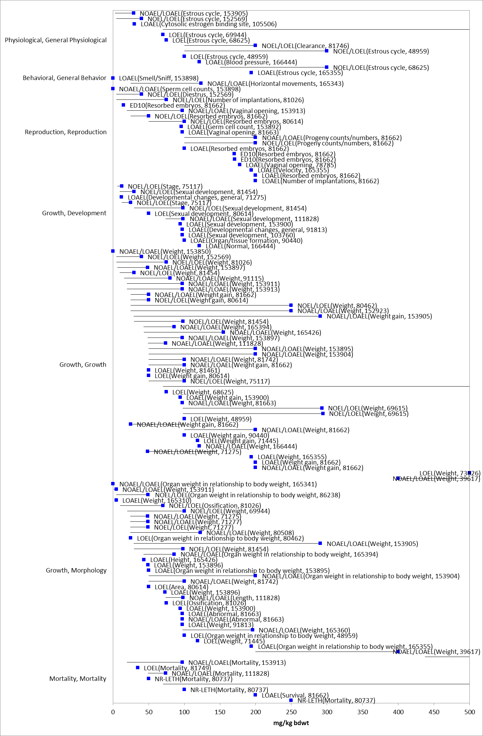
Figure 10-1. Subset of mammalian effects endpoints from ECOTOX database Blue squares represent LOAEC values from open literature studies found in the ECOTOX database. Solid lines display the range between the LOAEC and NOAEC values. Parentheses present the effect and study reference (i.e., MRID, ECOTOX #).

Drinking water studies

Two studies were identified in ECOTOX describing exposure of mice to atrazine in drinking water. No effects to mortality, growth or reproduction were reported in either study. In one of the studies (Lin et al. 2014, E170817), behavioral effects were noted in mouse offspring and dams exposed to 3 mg/L atrazine in drinking water from gestational day 6 to postnatal day 23 (PND 23), corresponding to an exposure of 0.6 to 2.2 mg/kg/d based on measured water consumption and body weight. Atrazine treated dams exhibited decreased novel object recognition performance and a trend toward hyperactivity. Juvenile offspring (PND 35) from atrazine exposed dams were hyperactive (both sexes), spent less time swimming (males), and buried more marbles (females). In adult offspring (PND70), the only behavioral change was a sex-specific (females) decreased novel object recognition performance.

Dermal exposure studies

Atrazine has a low toxicity by the dermal route as indicated by an acute dermal toxicity study and by a 21-day dermal toxicity study using New Zealand white rabbits. The acute dermal study with atrazine in the Norway rat found an LD₅₀ > 2,000 mg/kg (MRID 00024708). The 21-day study in the rabbit found a LOAEL at the limit dose of 1,000 mg/kg/day and had a NOAEL at 100 mg/kg/day.

Inhalation studies

Atrazine has a low toxicity by the inhalation route as indicated by the LC₅₀ > 5.8 mg/L (M&F combined) in the acute inhalation study (MRID 42089901 and 43016502).

Effects Characterization for Terrestrial Invertebrates

Introduction to Terrestrial Invertebrate Toxicity

A summary of the available terrestrial invertebrate data is presented in Table 11-1.

Table 11-1. Summary of Available Terrestrial Invertebrate Toxicity Studies
Species | Toxicity Summary | Comment | Citation
Beetles | NOAECs ranged from 0.8 lbs a.i./Acre to 8 lbs a.i./Acre | Soil sprayed with atrazine at levels that ranged from 0.8 to 8 lbs a.i./Acre did not result in statistically significant (p<0.05) reductions in survival.  LOAEC: Not achieved | Kegel, 1989  ECOTOX No. 64007  Brust, 1990  ECOTOX No. 70406  Samsoe-Petersen, 1995  ECOTOX No. 63490
Earthworms | 28-day LC₅₀:  381 mg a.i./kg-soil  14-Day LC₅₀:  273- 926 mg a.i./kg-soil | Spiked soil studies; endpoints included mortality and body mass | Mosleh et al., 2003  ECOTOX No. 77549  Haque and Ebing, 1983  ECOTOX No. 40493
Micro arthropods | NOAEC: 0.9 – 1.8 lbs a.i./Acre  LOAEC: 5.4 lbs a.i./Acre | The LOAEC was based on reduced abundance from a field study (Fretello et al., 1985); it could not be determined if reduced abundance was caused by migration (repellency), by toxic effects, or both. | Cortet et al., 2002  ECOTOX No. 75784  Fratello et. al., 1985  ECOTOX No.  59428
Springtails | 30-Day LD₅₀: 17 mg a.i./kg-soil to 20 mg a.i./kg-soil (approximately 7 lbs a.i./Acre)ª  LOAEC: 2.5 - 20 mg a.i./kg-soil  (approx. 1 – 7 lbs a.i./Acre)ª | Exposure occurred via treated soil; mortality rate at 2.5 mg a.i./kg-soil and 20 mg a.i./kg-soil was 18% and 51%, respectively, compared with 0% in controls. | Mola et al., 1987.  ECOTOX No. 71417
Fruit flies  Drosophila | NOAEC: 15 ug/fly | No increased mortality occurred in groups exposed to atrazine alone relative to controls. | Lichtenstein et al., 1973  Ecotox No. 2939
Honey bees | LD₅₀: >97 ug a.i./bee (contact) | 5% mortality occurred at the highest dose tested (97 ug a.i./bee) | MRID 00036935
Earthworm | LOAEC: 8 lb/acre  NOAEC: Not achieved | Field study examining the impacts of several herbicides on soil invertebrate populations. The endpoint measured was abundance of several species. Study authors suggested that reduced abundance was likely caused by repellency and not direct toxicity. | Fox, 1964  ECOTOX No. 36668
Wire worm
Springtail
ª Application rate was estimated from soil concentration by assuming a soil density of 1.3 grams/cm³ and a soil depth of 3 cm.
Atrazine is practically non-toxic to adult honeybees (Apis mellifera L.); the reported LD₅₀ value is >97 µg a.i./bee with 5% mortality reported at the highest dose tested (MRID 00036935). Atrazine also did not cause adverse effects in fruit flies (Drosophila melanogaster), houseflies (Musca domestica), and mosquito larvae (Aedes aegypti) exposed to 15 µg/fly (Lichtenstein et al., 1973). LC₅₀ values in earthworms ranged from 273 to 926 mg/kg-soil (Mosleh et al., 2003; Haque and Ebing, 1983). Atrazine did not produce statistically significant (p>0.05) adverse effects in studies on several beetle species at any level tested, which ranged from application rates of approximately 1 lb a.i./A to 8 lbs a.i./A (Kegel, 1989; Brust, 1990; Samsoe-Petersen, 1995).

The most sensitive terrestrial invertebrate species tested was the springtail (Onychiurus apuanicus and O. armatus). Exposure to O. apuanicus at 2.5 mg/kg-soil resulted in 18% mortality, and exposure to O. armatus at 20 mg/kg-soil resulted in 51% mortality (Mola et al., 1987); lower levels were not tested. These soil concentrations are associated with an application rate of approximately 1 lb a.i./Acre and 7 lbs a.i./Acre, respectively, assuming a soil density of 1.3 grams/cm³ and a soil depth of 3 cm.

These studies were used to derive the thresholds for terrestrial invertebrates for the units of ug ai/bee (LD₅₀ >97, LOAEC = 97), mg a.i./kg-bw (LD₅₀ >757, LOAEC = 757, based on conversion of bee endpoint in ug a.i/bee for contact study) and mg a.i./kg-soil (LC₅₀ value = 273, LOAEC = 2.5).

Effects Characterization for Terrestrial Plants

Introduction to Terrestrial Plant Toxicity

Plant toxicity data from both registrant-submitted studies and studies in the scientific literature have been reviewed for this assessment. Registrant-submitted studies are conducted under conditions and with species defined in OCSPP test guidelines. Sub-lethal endpoints such as plant growth, dry weight, and biomass are evaluated for both monocots and dicots, and effects are evaluated at both seedling emergence and vegetative life stages. Studies were excluded if they were considered invalid or not associated with an environmentally relevant exposure route.

Discussion of endpoints are provided for effects on terrestrial plants and terrestrial plant communities. These serve as a surrogate for effects on an individual of a listed species and the effects on the PPHD of a listed species, respectively. Based on the results of the submitted terrestrial plant toxicity tests, it appears that the seedling emergence stage of plant development is more sensitive to atrazine than the vegetative vigor stage of development. However, all tested plants, with the exception of corn in the seedling emergence and vegetative vigor tests and ryegrass in the vegetative vigor test, exhibited adverse effects following exposure to atrazine. The registrant submitted data represents the most sensitive endpoints for effects to listed species and effects to the PPHD of a listed species.

Effects on Terrestrial Plants

Single-species terrestrial plant toxicity studies are used as one of the measures of effect to evaluate whether atrazine may affect primary production and diversity in terrestrial ecosystems. Numerous terrestrial plant toxicity studies have been submitted to the EPA and/or published in the open literature. Figure 12.1 and Figure 12.2 presents a summary of the range of toxicity values available for dicot and monocot plants, respectively.

Figure 12-1. Summary array of toxicity data for dicot terrestrial plants expressed in terms of lb a.i./A.

Figure 12-2. Summary array of toxicity data for monocot terrestrial plants expressed in terms of lb a.i./A.

The registrant-submitted data represents the most sensitive endpoints for effects to listed species. In addition to the standard vegetative vigor and seedling emergence studies, the registrant submitted continuation studies that explore the potential for tested species to recovery from atrazine inhibitions of biomass (i.e., height and weight; MRID 49639102). This study also evaluated the toxicity of an atrazine formulation, while MRID 42041403 was conducted with technical grade atrazine. The most sensitive endpoints from the continuation studies are summarized along with the most sensitive endpoints from the standard studies in Table 12-1 and Table 12-2 for seedling emergence and vegetative vigor, respectively.

When considering the potential for recovery, while most species in the study conducted with formulated product did not experience an effect in measures of biomass in either the 14-d or 28-d study, for lettuce and onion endpoints measured 28-d post exposure were lower than those measured 14-d post exposure. This suggests that, at least for some species, there is a potential for long term impacts on growth after an exposure during the seedling emergence life stage. When considering the difference in toxicity of technical grade and formulated atrazine, while the formulated product appears to be approximately 10-20x less toxic than technical grade atrazine for several species, the sensitivity of cabbage and onion were similar (within an order of magnitude). Based on this information, the most sensitive species across the available data are used to derive thresholds for effects to listed terrestrial plants exposed to atrazine during the seedling emergence life stage. Table 12-1 summarizes the most sensitive terrestrial plant seedling emergence toxicity data for atrazine.

For seedling emergence, the most sensitive dicot is carrot and the most sensitive monocot is oat. NOAEC values for carrot and oat are 0.0025 lb a.i./A based on a 43% and 34% decrease in dry weight, respectively, at 0.005 lb a.i./A. The MATC for both species is 0.0035 lb a.i./A.

Table 12-1. Registrant submitted nontarget terrestrial plant Seedling Emergence toxicity expressed in terms of lbs a.i./A. All definitive endpoints are used quantitatively, bold endpoints identify the most sensitive monocot and dicot species.
Species | MRID 42041403 (14-d) |  |  |  | MRID 49639102 (14-d) |  |  |  | MRID 49639102 (28-d)
 | Endpoint | NOAEC | LOAEC | MATC | Endpoint | NOAEC | LOAEC | MATC | Endpoint | NOAEC | LOAEC | MATC
Monocot
Corn | No Effect | 4 | >4 | - | - | - | - | - | - | - | - | -
Oat | Dry Weight | 0.0025 | 0.005 | 0.0035 | Dry Weight | 0.021 | 0.047 | 0.031 | No Effect | 0.047 | >0.047 | -
Onion | Dry Weight | 0.005 | 0.01 | 0.0071 | No Effect | 0.1 | >0.1 | - | Dry Weight | 0.025 | 0.047 | 0.034
Ryegrass | Dry Weight | 0.005 | 0.01 | 0.0071 | No Effect | 0.1 | >0.1 | - | No Effect | 0.1 | >0.1 | -
Dicot
Cabbage | Dry Weight | 0.01 | 0.02 | 0.014 | Dry Weight | 0.097 | 0.26 | 0.16 | Dry Weight | 0.0099 | 0.022 | 0.015
Carrot | Dry Weight | 0.0025 | 0.005 | 0.0035 | No Effect | 0.049 | >0.049 | - | No Effect | 0.049 | >0.049 | -
Cucumber | Dry Weight | 0.005 | 0.01 | 0.0071 | No Effect | 0.1 | >0.1 | - | Dry Weight | 0.0047 | 0.0099 | 0.0068
Lettuce | Dry Weight | 0.0025 | 0.005 | 0.0035 | No Effect | 0.049 | >0.049 | - | No Effect | 0.049 | >0.049 | -
Soybean | Dry Weight | 0.025 | 0.05 | 0.035 | No Effect | 0.44 | >0.44 | - | No Effect | 0.44 | >0.44 | -
Tomato | Dry Weight | 0.01 | 0.02 | 0.014 | Dry Weight | 0.047 | 0.095 | 0.067 | Dry Weight | 0.095 | 0.31 | 0.17

When considering the potential for recovery, the continuation study showed that after 42-days some species may have recovered to control biomass and growth levels. However, several species had continued impact on dry-weight and height endpoints, and plant survival was the most sensitive endpoint for several species. In the case of oat and soybean, endpoints after 42-days of post treatment recovery were more sensitive than those at 21-days. When considering the difference in toxicity of technical grade and formulated atrazine, results suggest that the formulation is of similar or greater toxicity than the technical grade. Based on this information, the most sensitive species across the available data are used to derive thresholds for effects to listed terrestrial plants exposed to atrazine during the seedling emergence life stage. Table 12-2 summarizes the most sensitive terrestrial plant vegetative vigor toxicity data for atrazine. In general, dicots appear to be more sensitive than monocots via foliar routes of exposure.

For vegetative vigor studies, the most sensitive dicot is soybean and the most sensitive monocot is onion, with IC₁₅ values for dry weight of 0.0011 and 0.018 lb a.i./A, respectively. For both species, statistically significant effects were observed at all test concentrations for the most sensitive effect, dry weight, so the IC₁₅ is used per the discussion in Chapter 1.

Table 12-2. Registrant submitted nontarget terrestrial plant Vegetative Vigor toxicity expressed in terms of lbs a.i./A. All definitive endpoints are used quantitatively, bold endpoints identify the most sensitive monocot and dicot species.
Species | MRID 42041403 (14-d) |  |  |  | MRID 49639102 (28-d) |  |  |  | MRID 49639102 (42-d)
 | Endpoint | NOAEC | LOAEC | MATC | Endpoint | NOAEC | LOAEC | MATC | Endpoint | NOAEC | LOAEC | MATC
Monocot
Corn | No Effect | 4 | >4 | - | - | - | - | - | - | - | - | -
Oat | Dry Weight | 2 | 4 | 2.83 | Dry Weight | 0.45 | 0.91 | 0.64 | Survival | 0.047 | 0.094 | 0.07
Onion | Dry Weight | 0.5 | 1 | 0.71 | Dry Weight | 0.018ª | - | - | Dry Weight | 0.092 | 0.22 | 0.14
Ryegrass | Dry Weight | 4 | >4 | - | Dry Weight | 0.22 | 0.51 | 0.33 | Survival | 0.97 | 2.4 | 1.53
Dicot
Cabbage | Dry Weight | 0.005 | 0.01 | 0.01 | Dry Weight | 0.044 | 0.092 | 0.06 | No Effect | 0.22 | >0.22 | -
Carrot | Dry Weight | 2 | 4 | 2.83 | Dry Weight | 0.02ª | - | - | Survival | 0.22 | 0.45 | 0.31
Cucumber | Dry Weight | 0.005 | 0.01 | 0.01 | Dry Weight | 0.0046ª | - | - | Survival | 0.047 | 0.092 | 0.07
Lettuce | Dry Weight | 0.25 | 0.4 | 0.32 | Dry Weight | 0.0044 | 0.092 | 0.02 | Dry Weight | 0.0095 | 0.022 | 0.01
Soybean | Dry Weight | 0.02 | 0.05 | 0.03 | Dry Weight | 0.0074 | 0.021 | 0.01 | Dry Weight | 0.0011ª | - | -
Tomato | Dry Weight | 0.5 | 1 | 0.71 | Dry Weight | 0.0074 | 0.021 | 0.01 | Dry Weight | 0.094 | 0.24 | 0.15
ª Alternative endpoint of the IC₁₅ used as Statistically significant effects were observed at all test concentrations.

Effects on Terrestrial Plant Communities

Twenty five percent inhibition concentration (IC₂₅) values for terrestrial plants are used to derive the threshold for effects to the PPHD of an individual of a listed species. Studies with definitive effects on measures of growth (e.g., height, weight, and biomass) for both monocots and dicots; were conducted with technical grade or typical end use product atrazine; and had 14-, 28-, and 42-d exposure durations were used to derive Species Sensitivity Distributions (SSD). These parameters were selected to maximize comparability of results. Studies used to derive the SSDs are compiled in APPENDIX 2-6. SSDs were developed for both seedling emergence and vegetative life stages.

Toxicity estimates for simazine range from 0.00357 to greater than 4 lb a.i./A and span three orders of magnitude (APPENDIX 2-6), indicating a range of sensitivity to atrazine among terrestrial plants. Based on the results of the submitted terrestrial plant toxicity tests, it appears that the seedling emergence stage of plant development is more sensitive to atrazine than the vegetative vigor stage of development. However, all tested plants, with the exception of corn in the seedling emergence and vegetative vigor tests and ryegrass in the vegetative vigor test, exhibited adverse effects following exposure to atrazine.

For seedling emergence, the most sensitive dicot is carrot and the most sensitive monocot is oat. IC₂₅ values, on an equivalent application rate basis, for oats and carrots, which are based on a reduction in dry weight, are 0.003 and 0.004 lb a.i./A, respectively. Table 12-3 summarizes the most sensitive terrestrial plant seedling emergence toxicity data.

Table 12-3. Nontarget Terrestrial Plant Seedling Emergence Toxicity (Tier II). All definitive endpoints are used quantitatively
Species | MRID 42041403 (14-d) |  | MRID 49639102 (14-d) |  | MRID 49639102 (28-d)
 | Endpoint | IC₂₅ | Endpoint | IC₂₅ | Endpoint | IC₂₅
Monocot
Corn | No Effect | >4
Oat | Dry Weight | 0.004 | Dry Weight | 0.0403 | No Effect | >0.047
Onion | Dry Weight | 0.009 | No Effect | >0.1 | Dry Weight | 0.034
Ryegrass | Dry Weight | 0.007 | No Effect | >0.1 | No Effect | >0.1
Dicot
Cabbage | Dry Weight | 0.014 | Dry Weight | 0.03 | Dry Weight | 0.018
Carrot | Dry Weight | 0.003 | No Effect | >0.049 | No Effect | >0.049
Cucumber | Dry Weight | 0.013 | No Effect | >0.1 | Height | >0.1
Lettuce | Dry Weight | 0.0025 | No Effect | >0.049 | Dry Weight | 0.048
Soybean | Dry Weight | 0.19 | No Effect | >0.44 | No Effect | >0.44
Tomato | Dry Weight | 0.034 | Dry Weight | 0.053 | Dry Weight | 0.15

For vegetative vigor studies, the most sensitive dicot is cucumber, and the most sensitive monocot is onion. In general, dicots appear to be more sensitive than monocots via foliar routes of exposure with all tested monocot species showing a significant reduction in dry weight and plant height at IC₂₅ values ranging from 0.008 to 1.7 lb a.i./A. In contrast, two of the four tested monocots showed no effects from atrazine (corn and ryegrass), while IC₂₅ values for onion and oats were 0.61 and 2.4 lb a.i./A, respectively. Table 12-4 summarizes the most sensitive terrestrial plant vegetative vigor toxicity data used to derive risk quotients in this assessment.

Table 12-4. Nontarget Terrestrial Plant Vegetative Vigor Toxicity (Tier II). All definitive endpoints are used quantitatively
Species | MRID 42041403 (14-d) |  | MRID 49639102 (28-d) |  | MRID 49639102 (42-d)
 | Endpoint | IC₂₅ | Endpoint | IC₂₅ | Endpoint | I_{C25}
Monocot
Corn | No Effect | >4 | - | - | - | -
Oat | Dry Weight | 2.4 | Dry Weight | 0.35 | Survival | 0.2
Onion | Dry Weight | 0.61 | Dry Weight | 0.038 | Dry Weight | 0.1
Ryegrass | Dry Weight | >4 | Dry Weight | 0.24 | Survival | 2.08
Dicot
Cabbage | Dry Weight | 0.014 | Dry Weight | 0.059 | No Effect | >0.22
Carrot | Dry Weight | 1.7 | Dry Weight | 0.054 | Survival | 0.31
Cucumber | Dry Weight | 0.008 | Dry Weight | 0.015 | Survival | 0.13
Lettuce | Dry Weight | 0.33 | Dry Weight | 0.022 | Dry Weight | 0.061
Soybean | Dry Weight | 0.026 | Dry Weight | 0.018 | Dry Weight | 0.004
Tomato | Dry Weight | 0.72 | Dry Weight | 0.029 | Dry Weight | 0.12

For the SSD, five distributions were tested, and a variety of methods were used. The normal distribution and maximum likelihood (ML) method were selected to represent HC₀₅ through HC₉₅ values for vegetative vigor endpoints and the gumbel distribution and ML method were selected to represent the HC₀₅ through HC₉₅ values for seedling emergence endpoints. Table 12-5, Figure 12.3, and Figure 12.4 provide a summary of the results. The threshold for species that rely upon terrestrial plants for their PPHD is 0.0037 lb a.i./A based on the HC₀₅ from the SSD for seedling emergence.

Table 12-5. Summary Statistics for Terrestrial Plant SSD Fit to Atrazine Test Results.
Statistic | Vegetative Vigor | Seedling Emergence
Best Distribution (by AIC_{c}) | Normal | Gumbel
Goodness of fit  P-value | 0.813 | 0.7602
CV of the HC₀₅ | 0.2717 | 0.4707
HC₀₅ | 0.0242 | 0.0037
HC₁₀ | 0.0347 | 0.0047
HC₅₀ | 0.1233 | 0.0146
HC₉₀ | 0.4376 | 0.0855
HC₉₅ | 0.6958 | 0.169

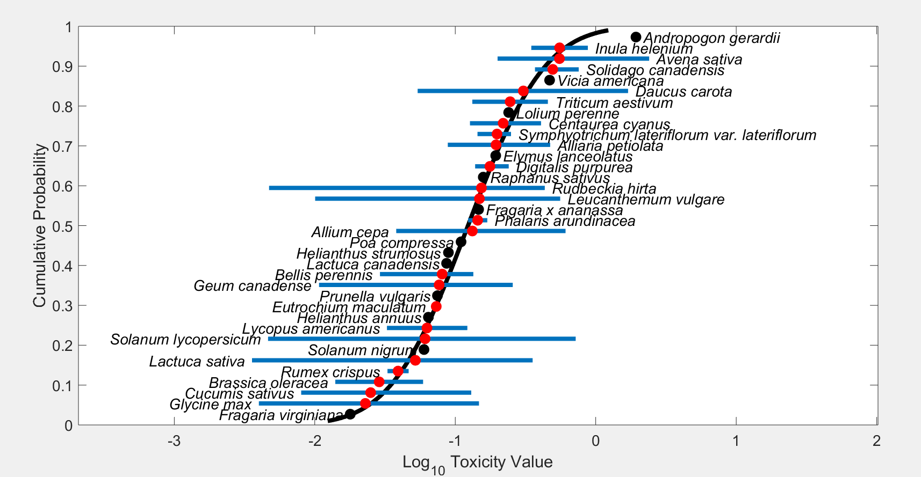
Figure 12-3. Species sensitivity distribution of IC₂₅ vegetative vigor stage endpoints. Selected model was normal, fit using maximum likelihood estimation, selected based on the lowest AIC and the highest p-value for model fit. Horizontal blue lines indicate the range of toxicity values. Red points are geometric means for taxa with multiple estimates. Black points are single estimates.

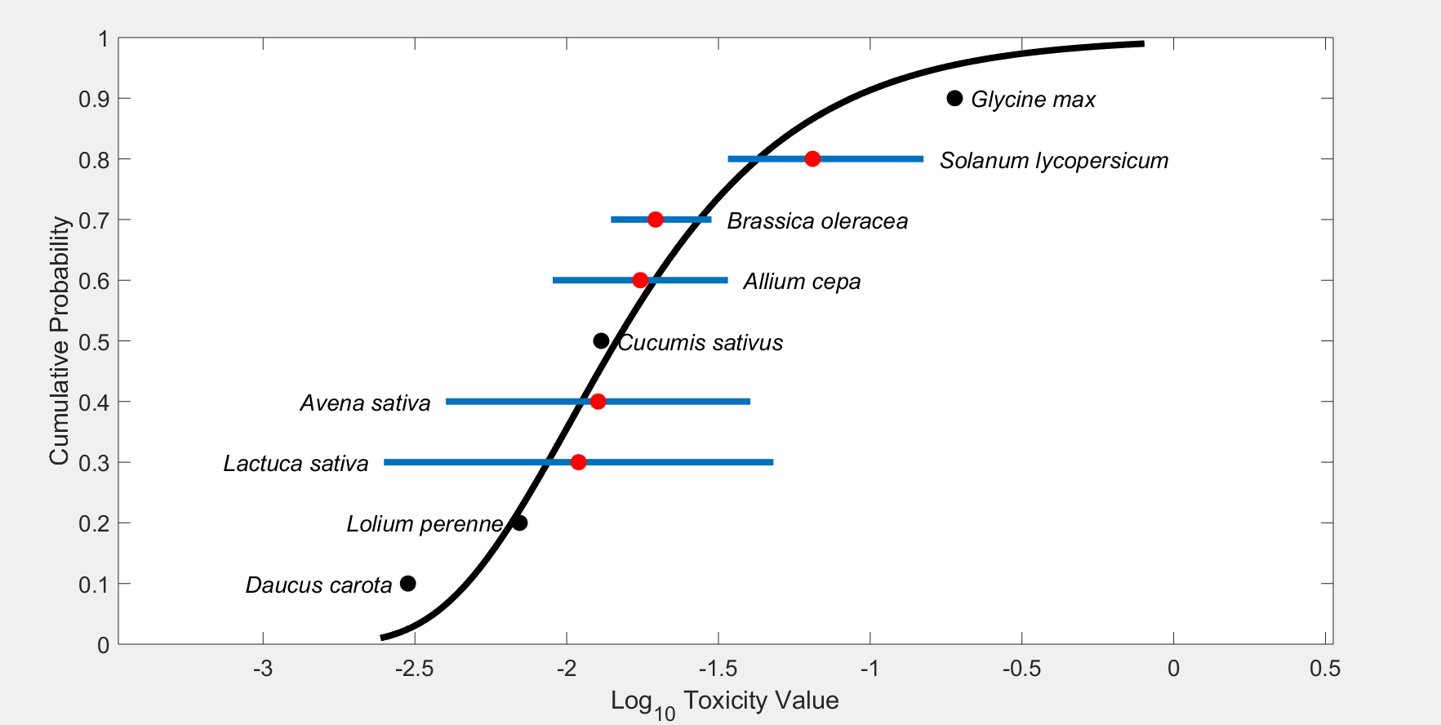
Figure 12-4. Species sensitivity distribution of IC₂₅ seedling emergence stage endpoints. Selected model was gumbel fit using maximum likelihood, selected based on the lowest AIC and highest p-value for model fit. Horizontal blue lines indicate the range of toxicity values. Red points are geometric means for taxa with multiple estimates. Black points are single estimates.

In addition, a report on the toxicity of atrazine to woody plants (Wall et al., 2006; MRID 46870401) was reviewed. A total of 35 species were tested at application rates ranging from 1.5 to 4.0 lb a.i./A. Twenty-eight species exposed to atrazine as mature plants exhibited either no or negligible phytotoxicity. Seven of 35 species exhibited >10% phytotoxicity. However, further examination of the data indicates that atrazine application was clearly associated with severe phytotoxicity in one species (Shrubby Althea, Hybiscus sp.). These data suggest that, although sensitive woody plants exist, atrazine exposure to most established or mature woody plant species at application rates of 1.5 to 4.0 lb a.i./A is not expected to cause significant adverse effects. This study does not specifically address the seedling emergence of these woody species, which based upon the submitted guideline studies, and the species sensitivity distributions (Figure 12.4) is a more sensitive life-stage to atrazine exposure.

In addition to the traditional seedling emergence and vegetative vigor exposures, a field-scale spray drift bioassay with atrazine was submitted by the registrant (MRID 50683101; Brain et al., 2019). This study evaluated spray drift deposition, airborne interception and corresponding biological effects on two plant species (cucumber and lettuce). Applications of AAtrex 4L (atrazine) were made using ultra-coarse nozzles. Spray drift deposition were measured using stainless-steel discs out to 400 ft and stainless-steel rods out to 75 ft. Potential direct plant effects at 5, 15, 25, 35, and 45 ft from the downwind edge of the spray swath were also measured. On average, each 10% increase in distance from the field resulted in approximately 14% less deposited atrazine, with measurements on rods being greater than discs. Cucumber and lettuce plants exposed to spray drift were monitored for effects for three weeks. Endpoints of survival, weight (biomass), and shoot length were statistically analyzed for significant effects. Overall, when trials were combined, study authors concluded the 5-foot distance was the aggregate LOAEC and 15 ft the aggregate NOAEC, with cucumbers affected the most; however, significant effects on weight and length were noted in some of the plants at further distances, but were either only in one of the trials or did not follow a monotonic trend. Additionally, two swaths were used for applications in the study, wind speeds varied from 9 to 20 mph and the wind direction varied from 14 to 130 degrees (target parameter set for wind direction of 90° ± 30° to the spray track). This study provides characterization for drift deposition and plant effects under the prescribed conditions but may not be representative of drift deposition under different application conditions.

Incident Data

As part of the refined ecological risk assessment (EPA 2016), the Ecological Incident Information System (EIIS) and the Avian Incident Monitoring System (AIMS) were searched for incidents of adverse effects to wildlife, fish, invertebrates, and plants resulting from exposure to atrazine since the registration of atrazine through May 2015. This search was updated to reflect incidents contained within the Incident Data System (IDS), which houses all incidents, through August 2020.
Since the registration of atrazine in 1970 there have been 916 incidents, mostly involving damage to terrestrial plants. However, 48 involved aquatic animals and 20 involved terrestrial animals. There were 25 incidents associated with aquatic or terrestrial animal kills. The presence of atrazine in water at levels high enough to cause effects was confirmed in 3 aquatic incidents, and there were 14 incidents in which atrazine’s presence in water was not confirmed, but the timing of application correlated with the incident. In addition, 421 aggregate incidents have been reported to the agency through IDS with dates ranging from 1995 to 2020. The AIMS database included 3 reports of bird incidents involving atrazine, which are already captured in the IDS database.

Table 13-1. Aggregate Incidents for Atrazine Involving Currently Registered Products.
PRODUCT REGISTRATION NUMBER | PRODUCT NAME | NUMBER OF AGGREGATE INCIDENTS | FORMULATION
000100-00497 | AATREX 4L HERBICIDE | 3 | Emulsifiable Concentrate
000100-00817 | BICEP II MAGNUM | 16 | Soluble Concentrate
000100-00827 | BICEP LITE II MAGNUM | 4 | Soluble Concentrate
000100-01152 | LUMAX | 17 | Emulsifiable Concentrate
000100-01201 | LEXAR | 12 | Emulsifiable Concentrate
000100-01414 | LEXAR EZ | 6 | Emulsifiable Concentrate
000100-01442 | LUMAX EZ | 4 | Pressurized Liquid
000352-00585 | DUPONT BASIS GOLD HERBICIDE | 2 | Water Dispersible Granule
000352-00624 | DUPONT CINCH ATZ HERBICIDE | 5 | Emulsifiable Concentrate
000352-00723 | DUPONT BREAKFREE ATZ LITE HERBICIDE | 1 | Emulsifiable Concentrate
000352-00724 | DUPONT BREAKFREE ATZ HERBICIDE | 1 | Emulsifiable Concentrate
000524-00329 | LARIAT HERBICIDE | 1 | Flowable Concentrate
000538-00018 | BONUS S | 108 | Granular
000538-00018-062355 | WEED & FEED FOR ST. AUGUSTINE | 14 | Granular
000538-00229 | SUPER BONUS S | 16 | Granular
000538-00234 | LAWN CARE SYSTEM-SOUTH | 1 | Granular
000538-00234-000239 | WEED-B-GON SPOT WEED KILLER FOR ST. AUGUSTINE LAWNS | 12 | Granular
000538-00301 | BONUS S MAX | 20 | Ready-to-Use Solution
000538-00307 | BONUS S MAX | 15 | Granular
000538-00315 | SNAP PAC SOUTHERN WEED & FEED | 8 | Granular
007969-00136 | MARKSMAN | 12 | Water Dispersible Granule
007969-00192 | GUARDSMAN MAX HERBICIDE | 8 | Emulsifiable Concentrate
007969-00200 | GUARDSMAN MAX LITE | 3 | Emulsifiable Concentrate
008660-00012 | STA-GREEN CRABGRASS PREVENTER WITH FERTILIZER | 15 | Granular
009688-00227-008845 | VIGORO ULTRA TURF SOUTHERN WEED & FEED | 4 | Granular
009688-00263 | CHEMSICO HERBICIDE CONCENTRATE 48A | 5 | Soluble Concentrate
010404-00039 | ST. AUGUSTINE GRASS/17-3-11 WEED & FEED (LESCO) | 1 | Granular
062719-00368 | KEYSTONE* HERBICIDE | 8 | Emulsifiable Concentrate
062719-00371 | FULTIME SELECTIVE HERBICIDE | 5 | Emulsifiable Concentrate
062719-00479 | KEYSTONE LA HERBICIDE | 4 | Emulsifiable Concentrate
073327-00003 | VIGORO ULTRA TURF SOUTHERN WEED & FEED | 27 | Granular

The lack of documented incidents in any of these databases does not necessarily mean that such incidents did not occur. Mortality incidents must be seen, reported, investigated, and submitted to the Agency in order to be recorded in the incident databases. In addition, incident reports for non-target organisms typically provide information only on mortality events and plant damage. Sublethal effects in organisms such as abnormal behavior, reduced growth and/or impaired reproduction are rarely reported, except for phytotoxic effects in terrestrial plants. Given the primary concern of chronic risks to terrestrial and aquatic animals from atrazine, these effects would be difficult to capture through typical incident data reporting.

Alternative Toxicity endpoints

In addition to the thresholds provided in Table 2-1 through Table 2-6 above, alternative toxicity endpoints were also developed to use in the weight of evidence analysis for a species where appropriate (see Revised Methods Document). The alternative toxicity endpoints provide consideration of endpoints that may reflect variation in the available data (such as using the HC₅₀ values from the SSD instead of an HC₀₅ value or considering other endpoints within the data set for a particular taxon). Alternatively, if a taxon did not include enough data to select a specific alternative toxicity endpoint, a 10x factor was applied to the original threshold. The alternative endpoints allow for consideration of the possibility a listed species is toxicologically less sensitive than the tested species in the alternative weight of evidence analysis, which is captured for the analysis of any species that reaches that point of the analysis. Alternative endpoints are listed in Table 14-1 and brief additional comments are provided to clarify the alternative endpoint selection, as appropriate. Endpoints are analyzed for a subset of available units.

Table 14-1. Alternative toxicity endpoints used in weight of evidence analysis.
Alternative toxicity endpoints - Mortality |  | Type of endpoint (HC₅₀, etc.) | Value | Slope | Weight of test animal (g) | Comments
Units | Taxa
mg ai/kg-bw | MAMMALS | LD₅₀ | 18,690 | 4.5 | 27.7 | 10x applied
mg ai/kg-bw | BIRDS | LD₅₀ | 7830 | 4.5 | 120 | 10x applied
mg ai/kg-bw | REPTILES/TERRESTRIAL AMPHIBIAN | LD₅₀ | 7830 | 4.5 | 120 | 10x applied
mg ai/kg-bw | TERRESTRIAL INVERTS | LD₅₀ | 99999 | 4.5 |  | No change, non-definitive
ug ai/L | FW FISH | LC₅₀ | 53,000 | 4.5 |  | 10x applied
ug ai/L | E/M FISH | LC₅₀ | 20,000 | 4.5 |  | 10x applied
ug ai/L | AQ AMPHIBIANS | LC₅₀ | 4,100 | 4.5 |  | 10x applied
ug ai/L | FW INVERTEBRATES | LC₅₀ | 7200 | 4.5 |  | 10x applied
ug ai/L | E/M INVERTEBRATES | LC₅₀ | 480 | 4.5 |  | 10x applied
ug ai/L | MOLLUSKS | LC₅₀ | 99999 | 4.5 |  | 10x applied
Alternative toxicity endpoints - Sublethal
Units | Taxa | Type of endpoint (HC₅₀, etc.) | MATC or LOAEC | Description of effect | Duration of study (days) | Comments
mg ai/kg-diet | MAMMALS | MATC | 1580 |  |  | 10x applied
mg ai/kg-diet | BIRDS | MATC | 750 |  |  | 10x applied
mg ai/kg-diet | REPTILES/TERRESTRIAL AMPHIBIAN | MATC | 750 |  |  | 10x applied
mg ai/kg-diet | TERRESTRIAL INVERTS | LOAEC | 99999 |  |  | No data available in these units; alternative endpoint anticipated to be high based on mg/kg bw endpoint
µg ai/L | FW FISH | MATC | 267 |  |  | 10x applied
µg ai/L | E/M FISH | MATC | 267 |  |  | 10x applied
µg ai/L | AQ AMPHIBIANS | MATC | 308 |  |  | 10x applied
µg ai/L | FW INVERTEBRATES | MATC | 920 |  |  | 10x applied
µg ai/L | E/M INVERTEBRATES | MATC | 35 |  |  | 10x applied
µg ai/L | MOLLUSKS | MATC | 92 |  |  | Use FW endpoint instead of EM
TERRESTRIAL PLANTS |  | Type of endpoint (HC₅₀, etc.) | MATC or LOAEC | IC₂₅ | Description of effect | Comments
lb ai/A | SUBLETHAL- MONOCOTS | IC₁₅ | 0.18 | 0.0146 |  | 10x applied; HC₅₀ species from seedling emergence SSD
lb ai/A | SUBLETHAL- DICOTS | IC₁₅ | 0.011 | 0.0146 |  | 10x applied; HC₅₀ species from seedling emergence SSD
AQUATIC PLANTS (TGAI) |  | Type of endpoint (HC50, etc.) | MATC or LOAEC | IC50 | Description of effect | Comments
µg ai/L | NON-VASCULAR | MATC | 38.7 | 164 |  | 10x applied; HC₅₀ species from all aquatic plant SSD
µg ai/L | VASCULAR | EC₅₀ | 46 | 164 |  | 10x applied; HC₅₀ species from all aquatic plant SSD

References:

USEPA. 2009. Effects Determinations for Atrazine Relative to the California Red-Legged Frog, the Delta Smelt, and their Designated Critical Habitat. February 19, 2009. Environmental Fate and Effects Division. Office of Pesticide Programs. U.S. Environmental Protection Agency.
USEPA. 2016. Refined Ecological Risk Assessment for Atrazine. April 12, 2016. Environmental Fate and Effects Division. Office of Pesticide Programs. U.S. Environmental Protection Agency.
USEPA, 2020. Revised Method for National Level Listed Species Biological Evaluations of Conventional Pesticides. March 12, 2020. Environmental Fate and Effects Division. Office of Pesticide Programs. U.S. Environmental Protection Agency.

